Commonwealth Environmental Water Holder’s Flow Monitoring, Evaluation and Research Project 2019–2024:
Lower Murray
Technical Report

A report prepared for the Commonwealth Environmental Water Holder by the South Australian Research and Development Institute, Aquatic and Livestock Sciences

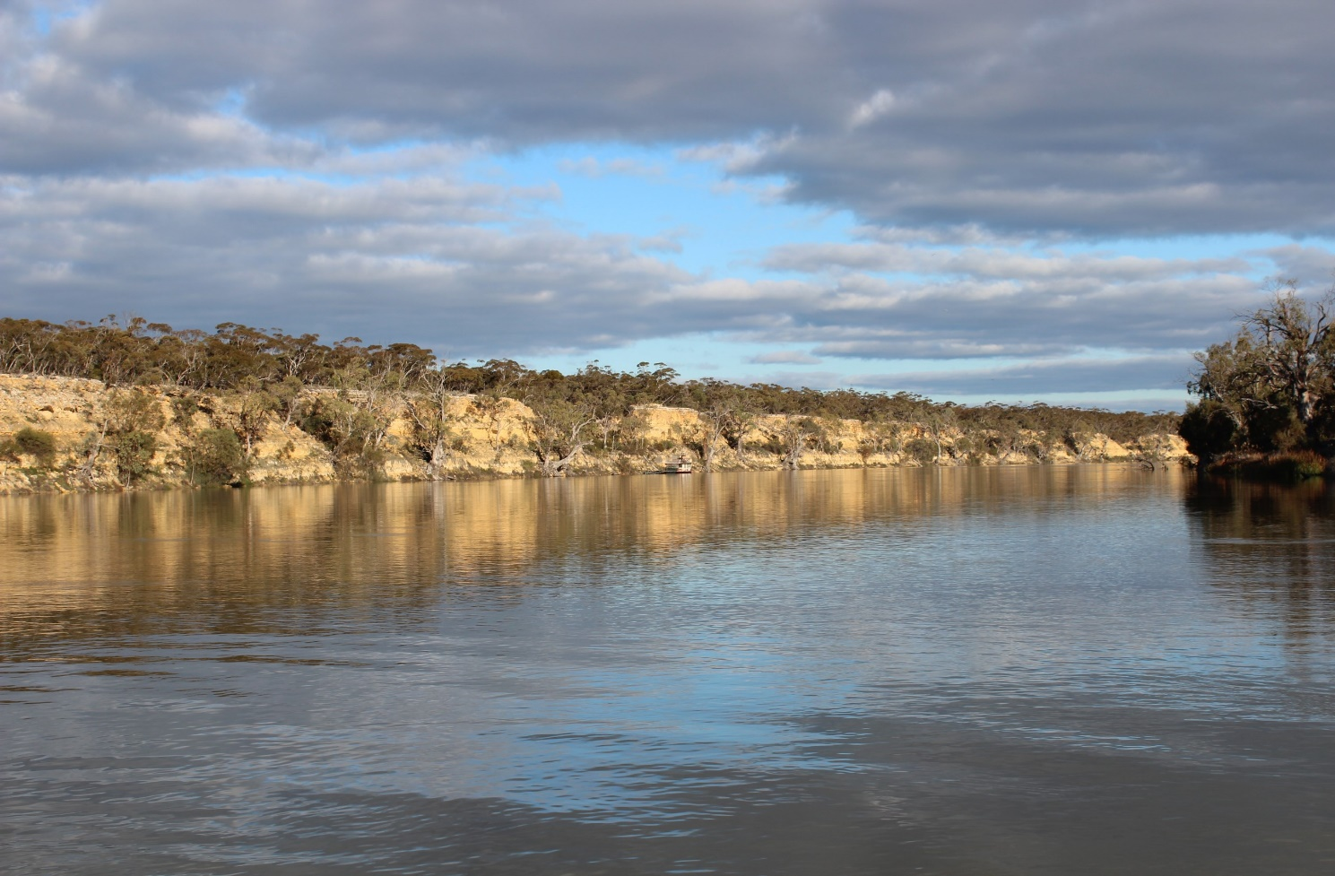


September 2025

Ye, Q.¹, Giatas, G.¹, Bice, C.¹, Brookes, J.², Furst, D. ², Gibbs, M.⁴, Nicol, J.¹, Oliver, R.², Zampatti, B.⁴, Bucater, L.¹, Deane, D.², Frahn, K.¹, Hipsey, M.⁶, Huang, P.⁶, Lorenz, Z.², Mills, J.², Shiel, R.⁵ and Zhai, S.⁶ (2025). Commonwealth Environmental Water Holder’s Flow Monitoring, Evaluation and Research Project 2019–2024: Lower Murray Technical Report. A report prepared for the Commonwealth Environmental Water Holder by the South Australian Research and Development Institute, Aquatic and Livestock Sciences.
¹ South Australian Research and Development Institute (Aquatic and Livestock Sciences)
² The University of Adelaide
³ Department for Environment and Water
⁴ Commonwealth Scientific and Industrial Research Organisation
⁵ Wetland Research and Management
⁶ The University of Western Australia





This project was commissioned and funded by the Commonwealth Environmental Water Holder (CEWH) with additional in-kind support from the South Australian Research and Development Institute (SARDI) and South Australian Department for Environment and Water (DEW). The authors of this report as well as the CEWH respectfully acknowledge the traditional owners of Country in the Murray–Darling Basin, their Elders past and present, their Nations, and their cultural, social, environmental, spiritual and economic connection to their lands and waters. In particular, the Ngarrindjeri Nation and the First Peoples of the River Murray and Mallee as traditional owners of the land and water on which this publication is focused.
Cover photo: SARDI Aquatic and Livestock Sciences.
Disclaimer
The views and opinions expressed in this publication are those of the authors and do not necessarily reflect those of the Australian Government or the Minister for the Environment. While reasonable efforts have been made to ensure that the contents of this publication are factually correct, the Commonwealth does not accept responsibility for the accuracy or completeness of the contents, and shall not be liable for any loss or damage that may be occasioned directly or indirectly through the use of, or reliance on, the contents of this publication.
 © Copyright Commonwealth of Australia, 2025
‘Commonwealth Environmental Water Holder’s Flow Monitoring, Evaluation and Research Project 2019–2024: Lower Murray Technical Report’ – this report is licensed by the Commonwealth of Australia for use under a Creative Commons By Attribution 3.0 Australia licence with the exception of the Coat of Arms of the Commonwealth of Australia, the logo of the agency responsible for publishing the report, content supplied by third parties, and any images depicting people. For licence conditions see: http://creativecommons.org/licenses/by/3.0/au/.

Table of contents
Table of contents i
List of figures ii
List of tables viii
Acknowledgements x
Executive summary xi
1 Introduction 1
1.1 Flow regimes and riverine ecology 1
1.2 CEWH’s Flow Monitoring, Evaluation and Research Project 1
1.3 Expected outcomes in the Lower Murray 3
1.4 Environmental water delivery 6
1.5 Purpose of the CEWH Flow-MER report for 2019–2024 13
2 Indicators 14
2.1 Hydraulic Regime 14
2.2 Stream Metabolism and Water Quality 32
2.3 Matter Transport and Coorong Habitat 61
2.3.1 Matter Transport 61
2.3.2 Coorong Habitat 81
2.4 Littoral Vegetation Diversity and Productivity 95
2.5 Microinvertebrate Assemblage 110
2.6 Flow-cued Spawning Fish Reproduction 130
2.7 Murray Cod Recruitment 149
2.8 Fish Assemblage 164
3 Synthesis and Evaluation 173
4 General Management Recommendations 181
5 References 187
6 Appendices 203
Appendix A: Expected outcomes of Commonwealth environmental water in the LOWER MURRAY RIVER, Lower Lakes and Coorong 203
Appendix B: Overview of other management activities from 2019–2024 207
Appendix C: Supplementary information for indicators 238
Appendix D: DEW evaluation questions 276
Acronyms 283
Glossary 284

List of figures
Figure 1. Map of the Lower Murray Selected Area showing the Lower Murray River floodplain (blue), gorge (green) and swamplands (orange) geomorphic zones, and the Lower Lakes and Coorong (yellow). 3
Figure 2. The various flow types of the Lower Murray River (LMR) as described in the Murray–Darling Basin Plan (MDBA 2011) and how flow volumes translate to lotic habitat in the contemporary LMR (Lock 1 to Lock 6 reach). 4
Figure 3. Cause and effect diagram of flow for the main channel of the Lower Murray with respect to the proposed indicators. Magnitude, timing and duration are factors of flow (in black). 5
Figure 4. Daily flow (ML/d) in the Lower Murray River (LMR) at the South Australian border (blue solid line) from July 1996 to July 2024, compared to modelled flow under natural conditions (grey dashed line). 6
Figure 5. Flow to South Australia from 1 July 2019 to 30 June 2024 showing the contribution of environmental water (eWater). 9
Figure 6. Flow to South Australia from 1 July 2019 to 30 June 2024 showing the source of all (environmental and consumptive) water (MDBA). 12
Figure 7. a) Discharge (flow at the South Australian border), b) inundated area between Wellington and Lock 6, and length of river with faster flowing velocities (c) v>0.2 m/s and d) v>0.3 m/s) for the Lower Murray River (LMR) between Locks 1 and 6 (excluding anabranches). 18
Figure 8. Median modelled velocity in each weir pool (line), with the range in velocities within the weir pool (the shaded area), defined by the 10th and 90th percentiles, in the Lower Murray River. 19
Figure 9. Modelled upper weir pool water level (i.e. downstream of each lock, e.g. Lock 2 for Weir Pool 1) in the Lower Murray River. 20
Figure 10. Lower weir pool water level (i.e. above the locks/weirs, e.g. above the Lock and Weir 1 for Weir Pool 1, and at Wellington for below Lock 1) of each weir pool in the Lower Murray River. 21
Figure 11. Percentage of river between Lock 6 and Wellington with lotic habitat (v>0.3 m/s) for a given flow discharge to South Australia (SA). 26
Figure 12. Flow at the South Australian border over the 10 years of LTIM and Flow-MER reporting. 27
Figure 13. Baseflow requirement for the Basin-wide Environmental Watering Strategy expected environmental outcome at flow to SA, compared to the flow delivered (all water) and that expected without Commonwealth environmental water. 29

Figure 14. a) Discharge (flow at the South Australian border), b) inundated area between Wellington and Lock 6, and length of river with faster flowing velocities (c) v>0.2 m/s and d) v>0.3 m/s) for the Lower Murray River (LMR) between Locks 1 and 6 (excluding anabranches) over the 10 years of LTIM and Flow-MER evaluation. 30
Figure 15. Water discharge at sites below Lock 6, Lock 4 and Lock 1 for each monitoring period from 2014 to 2024. 36
Figure 16. Average depth and average cross-sectional area downstream Lock 6, Lock 4 and Lock 1 for each monitoring period from 2014 to 2024. 37
Figure 17. Incident PAR dose, mean PAR irradiance in the water column and average water temperature below Lock 6, representative of all sites, for each monitoring period from 2014 to 2024. 38
Figure 18. Dissolved oxygen concentrations and percent saturation at sites downstream of Lock 6, Lock 4, and Lock 1 for each monitoring period from 2014 to 2024. 39
Figure 19. Daily gross photosynthesis (GPP, positive rates) and ecosystem respiration (ER, negative rates) at sampling sites downstream of (a) Lock 6, (b) Lock 4 and (c) Lock 1, on day number from July 1 for each monitoring period. 40
Figure 20. Annual time series of daily gross photosynthesis (GPP, positive rates) and ecosystem respiration (ER, negative rates) at sampling sites downstream of Lock 6, Lock 4 and Lock 1, for each monitoring period from 2014 to 2024. 41
Figure 21. The relationship between the gas exchange coefficient (K) and water velocity at sampling sites downstream of Lock 6, Lock 4 and Lock 1 for all monitoring periods from 2014 to 2024. 42
Figure 22. The relationship between gross primary production per unit chlorophyll (GPP(b)) and the mean irradiance (lm) of the water column for all monitoring periods from 2014 to 2024. 42
Figure 23. Fractional changes in volumetric GPP cross-sectional area and cross-sectional GPP and the number of days each season that the decrease in volumetric GPP due to Commonwealth environmental water was greater than 10%. 44
Figure 24. Integrated volumetric and cross-sectional GPP with and without Commonwealth environmental water, and the difference due to the additional flow, below Lock 6 (a) and Lock 4 (b). 46
Figure 25. Reliance of ecosystem respiration (ER) on gross primary productivity (GPP) within the river channel for all monitored periods from 2014 to 2024, with velocities downstream of Lock 1 ≥ 0.18 m/s. 47
Figure 26. Net production rates of phytoplankton (PNP), bacteria (BNP), the combined total (CNP), and the fraction of combined due to phytoplankton for all dates during 2014–2024 with matching DOC measurements. 48
Figure 27. (a) Vertical attenuation (k_{d}), (b) Turbidity, (c) Dissolved organic carbon (DOC), (d) Chlorophyll-a, (e) Total phosphorus, and (f) Total nitrogen, below Locks 6, 4 and 1 during 2014–2024. 50
Figure 28. Changes in dissolved organic carbon (DOC) (a), total phosphorus (TP) (b), and total nitrogen (TN) (c) in response to flow volumes during 2014–2024 with discharge <40,000 ML/d. 51
Figure 29. Changes in dissolved oxygen (DO) in response to increasing dissolved organic carbon (DOC) concentrations at sampling sites downstream of Lock 6, Lock 4 and Lock 1 during 2014–2024. 52
Figure 30. Summary of flow discharge through the barrages, from July 2015 until June 2024, spanning the large 2016-17 and 2021-22–2023-24 flow events, categorised based on water source. 65
Figure 31. Yearly composition of barrage flow, spanning the modelling period from July 2017 to June 2024. 66
Figure 32. Summary of flow through each barrage, spanning the modelling period from July 2017 to June 2024. 66
Figure 33. Time series of mean salinity variation in a) the Coorong North Lagoon, and b) the Coorong South Lagoon. The base-case scenario is compared with the ‘No CEW’ and ‘No eWater’ scenarios, spanning the modelling period from July 2017 to June 2024. 68
Figure 34. Transect comparison of simulated mean salinity from the ‘No CEW’ scenarios, ‘No eWater’ scenarios, and ‘base-case’ scenario along the Coorong in July 2023–June 2024. 69
Figure 35. Cumulative salt flux with and without environmental water delivery through Pelican Point and Parnka Point sites for July 2017–June 2024. 72
Figure 36. Cumulative total nitrogen (TN) flux with and without environmental water delivery through Pelican Point and Parnka Point sites for July 2017–July 2024. 75
Figure 37. Habitat area suitable for Ruppia tuberosa (overall sexual, asexual and individual life-stages), comparing the base-case and NC7/NE7 scenarios from 2018–2023…. 84
Figure 38. Habitat area suitable for Ruppia tuberosa (overall sexual only, asexual only and dual life-stages), comparing the base-case and all NC7/NE7 scenarios between 2018–2023, and NC1/NE1 scenarios in 2023.. 85
Figure 39. Differences of Ruppia tuberosa HSI (habitat suitability index) values for sexual reproduction in 2023 between the no Commonwealth environmental water since 2017 (No CEW 7 years) and the ‘All Water’ (base-case) conditions. 86
Figure 40. Differences of Ruppia tuberosa HSI (habitat suitability index) values for asexual reproduction in 2023 between the no Commonwealth environmental water since 2017 (No CEW 7 years) and the ‘All Water’ (base-case) conditions. 87
Figure 41. Habitat area of juvenile stages of key fish species for the scenarios showing the cumulative effect of environmental water delivery (i.e. 7 years for 2023-24). 88

Figure 42. Monthly habitat area “lost” for black bream during July 2023–June 2024 if there was no Commonwealth environmental water delivery since 2017 (calculated as the difference between habitat in the ‘All Water’ (base-case) and ‘No CEW 7 years’ scenarios). 89
Figure 43. Position of quadrats in relation to the maximum water level the prior spring/summer. 97
Figure 44. nMDS ordination comparing the plant community downstream of a) Lock 1, b) Lock 4, and c) Lock 6 in each inundation zone for the December 2019, February 2021 and June 2024 surveys. 100
Figure 45. Native species richness in each inundation zone in each reach in June 2024……... 101
Figure 46. Percentage of cells occupied by each functional group in each inundation zone in in the Lower Murray River in June 2024. 102
Figure 47. nMDS ordination comparing the plant community in each inundation zone in each reach in June 2024. 103
Figure 48. Above ground biomass in each inundation zone in each reach in June 2024…….. 104
Figure 49. Annual mean observed density (individuals/litre, ind/L) and taxonomic richness (number of taxa) for 2014–2024, except 2018-19. 115
Figure 50. Observed density (individuals/litre, ind/L) and taxonomic richness (number of taxa) for 2023-24 sampling downstream of each lock. 116
Figure 51. Functional group density (individuals/litre, ind/L) by sampling date and location for the 2023-24 season. 117
Figure 52. Modelled (a) microinvertebrate density (individuals/litre, ind/L) and (b) taxonomic richness (number of taxa) by water year over the period 2014−2024 (2018-19 not sampled). 118
Figure 53. Observed and modelled density (individuals/litre, ind/L) with and without environmental water (a) microinvertebrate taxa associated with lateral connectivity to floodplains and backwaters and (b) microinvertebrate taxa associated with longitudinal transport and connectivity with upstream areas by water year over the period 2014−2024. 120
Figure 54. Modelled density (individuals/litre, ind/L) of microinvertebrate prey taxa for large-bodied fish larvae in the Lower Murray during spring–early summer (mid-October to late-December) for 2014−2024. 121
Figure 55. Map showing the location of the Murray–Darling Basin (MDB) and the major rivers that comprise the southern MDB, the numbered Locks (L) and Weirs (up to Lock 26, Torrumbarry), the Darling, Lachlan, Murrumbidgee, Edward–Wakool, Campaspe and Goulburn rivers and Lake Victoria, an off-stream storage used to regulate flows in the Murray River below Lock 9. 131

Figure 56. (a) Mean ⁸⁷Sr/⁸⁶Sr (with minimum and maximum values as error bars) in water samples collected from spring–summer in the Murray (Barmah, Torrumbarry and Locks 11, 9, 6 and 1) and Darling rivers from 2011–2024, and (b) annual discharge (GL) in the Murray River at the South Australian border (QSA) and the proportion of discharge from the Darling River at Burtundy that contributed to QSA. 135
Figure 57. (a) Mean daily flow (by month) in the Murray River at the South Australian (SA) border and in the Darling River at Burtundy; and mean catch-per-unit-effort (CPUE, individuals per net per trip) ± standard error of (b) fish eggs, (c) silver perch larvae and (d) golden perch larvae collected at long-term sites downstream of Locks 4 (2020–2024 only), 6 and 1, in the Lower Murray River, from 2010–2024 during larval tow sampling 137
Figure 58. Back-calculated spawn dates (frequency) for larval golden perch (red bars) and silver perch (blue bars) captured at long-term sites downstream of Locks 4 (2020–2024 only), 6 and 1, in the Lower Murray River during spring/summer 2014–2024. 138
Figure 59. Recruitment strength of (a) golden perch and (b) silver perch in the gorge geomorphic zone (10 sites) of the Lower Murray River from 2014–2023. 139
Figure 60. Mean catch-per-unit-effort (CPUE) ± standard error of (a) golden perch and (b) silver perch captured during Category 1 Fish Assemblage electrofishing (individuals per 90 second shot) in the gorge geomorphic zone (10 sites) of the Lower Murray River in autumn from 2015–2024. 140
Figure 61. Age frequency distribution of golden perch from the Lower Murray River from 2015–2024 showing the natal origins of dominant cohorts inferred from otolith core signatures of the sampled fish in comparison to the water sample reference collection. 142
Figure 62. Age frequency distribution of silver perch from the Lower Murray River from 2015–2024 showing the natal origins of dominant cohorts inferred from otolith core signatures of the sampled fish in comparison to the water sample reference collection. 143
Figure 63. Total catch-per-unit-effort of Murray cod larvae in the Lower Murray River from (a) targeted light trap sampling (CPUE, larvae per 30 traps) in the tailwaters below Locks 3 and 4, and (b) day-time egg and larval fish bongo tow sampling (CPUE, larvae per 30 net tows) in the tailwaters below Locks 1, 4 and 6. 154
Figure 64. The relationship between weight and total length (TL) of YOY Murray cod in the Lower Murray River predicted by a cubic linear regression model. 156
Figure 65. Mean relative condition index (Krel) ± S.E. of YOY Murray cod in the Lower Murray River (excludes Chowilla anabranch) during autumn/winter. 156
Figure 66. The relationship between total length (TL) and estimated age of YOY Murray cod in the Lower Murray River from 2017–2024. 157
Figure 67. Mean (a) non-targeted and (b) targeted electrofishing catch-per-unit-effort (CPUE) ± S.E. of Murray cod in the weir pools downstream of Locks 2, 3, 4 and 5 of the Lower Murray River. 158
Figure 68. Total length frequencies of Murray cod in the main channel of the Lower Murray River during autumn/winter from 2013–2024, based on CEWH LTIM and Flow-MER data. 159
Figure 69. Target species for the Lower Murray River: (a) Murray cod and (b) freshwater catfish (equilibrium life history); (c) golden perch and (d) silver perch (periodic life history); and (e) carp gudgeon, (f) Murray rainbowfish and (g) bony herring (opportunistic life history). 164
Figure 70. Mean catch-per-unit-effort (CPUE) ± standard error of large-bodied fish species captured using electrofishing (individuals per 90 second shot) in the gorge geomorphic zone (10 sites) of the Lower Murray River from 2015–2024. 167
Figure 71. Mean catch-per-unit-effort (CPUE) ± standard error of small-bodied fish species captured using fine-mesh fyke nets (individuals per net per hour) in the gorge geomorphic zone (10 sites) of the Lower Murray River in autumn from 2015–2024……. 168
Figure 72. Non-metric multi-dimensional scaling (MDS) plot of (a) large-bodied fish assemblages sampled by electrofishing and (b) small-bodied fish assemblages sampled by fyke netting in the gorge geomorphic zone of the Lower Murray River from 2015–2024. 169
Figure 73. Key monitoring and evaluation outcomes in the Lower Murray River (black text) and Coorong, Lower Lakes and Murray Mouth (blue text) in relation to the flow regime (to South Australia) from 1 July 2019 to 30 June 2024, including the contribution of Commonwealth (CEW) and other environmental water (eWater).. 178

List of tables
Table 1. Total annual volumes (gigalitres, GL) of environmental water (eWater), including Commonwealth environmental water (CEW), delivered to the Lower Murray River (LMR) channel (excludes wetland use*) and the proportion contribution towards total flow to the LMR (QSA) from 2014-15 to 2023-24. 7
Table 2. Annual flow through the Murray barrages (total volume, GL) from 2014-15 to 2023-24, showing contribution by Commonwealth environmental water (CEW). 7
Table 3. Specific Commonwealth environmental water (CEW) watering events and expected outcomes for the Lower Murray River and Coorong, Lower Lakes and Murray Mouth from 2019–2024. 10
Table 4. Hydraulic Regime evaluation questions and answers. CEW = Commonwealth environmental water. SA = South Australia. SA border = South Australian border…... 22
Table 5. Stream Metabolism evaluation questions and answers relating to Commonwealth environmental water (CEW) and environmental water (eWater). DS = downstream. 53
Table 6. Summary of modelling scenarios for investigating the environmental water (eWater) effects. CEW = Commonwealth environmental water. 63
Table 7. Summary of salt flux (tonnes) though barrages, Murray Mouth, Pelican Point (North Lagoon) and Parnka Point (South Lagoon) in 2017–2024. Refer to Table 6 for scenarios. 71
Table 8. Predicted mean and median salinity at Murray Mouth (MM), North Lagoon (NL) (at Long Point), and South Lagoon (SL) (at Woods Well) in all investigated scenarios. 74
Table 9. Summary of total nitrogen flux (tonnes) though barrages, Murray Mouth, Pelican Point (North Lagoon) and Parnka Point (South Lagoon) in 2017–2024. 76
Table 10. Matter Transport evaluation questions and answers. 77
Table 11. Coorong habitat evaluation questions and answers. CEW = Commonwealth environmental water. 90
Table 12. Littoral Vegetation Diversity and Productivity evaluation questions and answers. CEW = Commonwealth environmental water. 105
Table 13. Microinvertebrate sampling dates from 2019–2024 in the Lower Murray River. 111
Table 14. Details of microinvertebrate sampling sites in the Lower Murray River. 112
Table 15. Taxa used to quantify the influence of environmental water on lateral and longitudinal connectivity. 113
Table 16. Microinvertebrate prey species for fish larvae of large-bodied native species (Murray cod, golden perch and silver perch) identified from gut content analysis used in modelling fish prey species density. Nauplii of calanoid and cyclopoid were excluded in calculations. 114
Table 17. Microinvertebrate Assemblage evaluation questions and answers. 122
Table 18. Location of water sample collection for ⁸⁷Sr/⁸⁶Sr analysis from 2020–2024. 132
Table 19. Egg and larval fish sampling details in the Lower Murray River from 2019–2024…….. 132
Table 20. Flow-cued Spawning Fish Reproduction evaluation questions and answers. 144
Table 21. Sampling trips targeting Murray cod in the main channel of the Lower Murray River from 2019–2024. 151
Table 22. Spawn dates of Murray cod in the main channel of the Lower Murray River from 2019–2024, as determined by back-calculated daily ages from larvae and age 0+ juveniles and an incubation period of 7 days. 155
Table 23. Murray Cod Recruitment evaluation questions and answers. 160
Table 24. Commonwealth Enviornmental Water Holder evaluation questions by indicators for the Lower Murray, which includes the Lower Murray River (LMR) and the Coorong, Lower Lakes and Murray Mouth (CLLMM). 179
Table 25. The magnitude, timing and duration of the main spring–summer flow pulses from 2014-15 to 2023-24. 184

Acknowledgements
This project was funded by the Commonwealth Environmental Water Holder (CEWH) from 2019–2024 with in-kind contributions from the South Australian Research and Development Institute (SARDI) and South Australian Department for Environment and Water (DEW). SARDI provided project leadership, undertook the fish and vegetation components of this study and sub-contracted other components to the University of Adelaide (UoA), Commonwealth Scientific and Industrial Research Organisation (CSIRO), University of Western Australia and Australian Limnological Services (ALS) (Wetland Research and Management, WRM). SA Water and DEW provided water quality data for the indicators of ‘Matter Transport and Coorong Habitat’ and ‘Stream Metabolism and Water Quality’.
Thanks to numerous SARDI staff, including Arron Strawbridge, Travis Howson, David Short, Mark Sutcliffe, Anthony Newbery, Josh Fredberg, Noah Kiriakou and Courtney Wallace for providing technical assistance in the field or laboratory. SA Water, Goulburn–Murray Water, Water NSW and NSW Department of Primary Industries staff assisted with collecting water samples for ⁸⁷Sr/⁸⁶Sr analysis. Dr Roland Maas from the University of Melbourne conducted water ⁸⁷Sr/⁸⁶Sr analysis, while Dr Aleksey Sadekov and Dr Peter Scott from the University of Western Australia (2018–2024) conducted otolith ⁸⁷Sr/⁸⁶Sr analysis. Dr Daniel McCullough (DEW) provided hydraulic model outputs that support the analysis undertaken for the Hydraulic Regime indicator.
Additional samples of Murray cod larvae and juveniles for analysis in the Murray cod recruitment indicator were accessed from sampling undertaken in the Katarapko, Pike and Chowilla Anabranches. This sampling was funded by The Living Murray coordinated by the Murray–Darling Basin Authority (MDBA) at Chowilla and by DEW at Katarapko and Pike. Data collection for the Stream Metabolism indicator was extended to June 2023 through the Murray Channel Monitoring Program, conducted in conjunction with CSIRO and funded through the MDBA. Thanks to the Arthur Rylah Institute for the hire of an electrofishing vessel during the 2023-24 monitoring season.
Thanks to Adam Cotterill, Lucy Carlile, Kyle McGrath, Jess Dober, Richard Mintern, and Anthony Moore (CEWH) for providing project management and support to the Lower Murray Selected Area. Jim Foreman and Aftab Ahmad (MDBA) provided detailed flow and environmental flow data. The Lower Murray Selected Area Working Group (SAWG) provided a forum for the exchange of information and intelligence that supported the CEWH Flow-MER Project, through effective coordination of environmental watering, and monitoring and evaluation. The authors also thank the Lower Murray SAWG including staff from the CEWH, MDBA and DEW for providing most welcome and constructive feedback on a draft version of this report. Adam Cotterill, Lucy Carlile, Richard Mintern and Kyle McGrath (CEWH), and Dr Sarah Catalano (SARDI) reviewed a final draft of this report.

Executive summary
From 2019-20 to 2023-24, the Commonwealth Environmental Water Holder’s (CEWH) Flow Monitoring, Evaluation and Research (Flow-MER) Project monitored and evaluated ecological outcomes of environmental water delivery in the Lower Murray, along with six other Selected Areas in the Murray–Darling Basin (MDB). This project extended the monitoring activities of the Long-Term Intervention Monitoring Project (2014-15 to 2018-19) and aimed to demonstrate the ecological outcomes of Commonwealth environmental water delivery and support adaptive management.
Over the period 2019–2024, the flow regime of the Lower Murray River (LMR) was highly variable, with two hydrologically dry years (i.e. flow <18,000 ML/d at the South Australian border), followed by three years characterised by unregulated flow, including a year of elevated in-channel flow (2021-22, spring–summer flow peak 37,500 ML/d) and two years with overbank flows (2022-23, 187,600 ML/d; 2023-24, 52,800 ML/d). Commonwealth environmental water (~4,366 GL over five years, 73% of total environmental water use) predominantly contributed to baseflows and freshes, including generating flow pulses (up to ~18,000 ML/d) and supplementing unregulated flows to maintain high in-channel flows (>20,000 ML/d), during spring–early summer.
Nine indicators were used to evaluate the ecological response to Commonwealth environmental water in the Lower Murray. Three indicators (Hydrology (channel), Stream Metabolism and Water Quality, and Fish (channel)) primarily aimed to evaluate Basin-scale objectives and outcomes, and in some instances, also local (Selected Area) objectives, following basin-wide standard protocols. Six indicators (Hydraulic Regime, Matter Transport and Coorong Habitat, Littoral Vegetation Diversity and Productivity, Microinvertebrate Assemblage, Murray Cod Recruitment and Flow-cued Spawning Fish Reproduction) aimed to address local evaluation questions, using area-specific methods. Due to sustained high-water levels, monitoring for Littoral Vegetation Diversity and Productivity was not undertaken in 2021-22 and 2022-23.
Key findings and ecological outcomes
Commonwealth environmental water delivery contributed to a range of ecological improvements in the Lower Murray from 2019-20 to 2023-24:
- Connectivity: Commonwealth environmental water increased annual flow discharge in the LMR in all years, including helping to meet the Basin-wide environmental watering target of >30% increase in flows in the Murray River (calculated at the South Australian border) in 2019-20; and improved longitudinal connectivity in all years, providing an additional river distance and time period with flow velocity >0.2 m/s of between 2,152 km d in 2022-23 to 13,056 km d in 2023-24. This likely promoted downstream transport of plankton and fish eggs/larvae. In most years, lateral connectivity also improved with increased inundation of the littoral zone of the river channel, including via weir pool raisings, and in August 2022, Commonwealth environmental water delivery increased the inundation of low-level floodplain by 5,027 Ha.
- Hydraulic diversity: Commonwealth environmental water increased the extent and duration of flowing water (lotic) conditions (mean velocity >0.3 m/s) in the LMR in most years, with up to an extra 84 km (25%) of river length transforming to lotic habitat for at least 14 days in a dry year (2020-21). Due to unregulated flow, contribution by Commonwealth environmental water to lotic conditions was negligible (<1 km, <1%) in 2023-24. Flowing water habitat is favoured by riverine species including Murray cod.
- Water level variability: In most years, minor to moderate increases in water level variability (-0.29 to +0.14 m IQR; -0.08 m in 2023-24) occurred in the upper weir pools of the LMR due to Commonwealth environmental water delivery, including via its support to weir pool manipulations.
- Littoral vegetation: Native plant species diversity increased by 38–100% at multiple spatial scales following increased water levels and the resulting inundation of littoral zones by spring–early summer flows during 2019–2021. Environmental water also supported the germination and survival of river red gum in these years. Variable water levels also produced conditions suitable for the recruitment of specialised riparian species, increasing plant functional diversity. However, in 2023-24, environmental water showed no effect on littoral vegetation, likely due to the greater influence of prolonged unregulated flows (2021–2024).
- Water quality: Commonwealth environmental water increased water mixing (velocities >0.2 m/s) and oxygen exchange at the water surface, reducing the potential low dissolved oxygen (DO) period by 1–3 months (varying among reaches) in the LMR each year, except for 2021–2023. This mainly occurred during the spring–summer period, which corresponds with highest ecosystem respiration rates and the primary reproductive season of many species that generally favour DO >5 mg/L.
- River productivity: Changes in primary production, which supports aquatic food webs (e.g. invertebrates and fish), were negligible (-1–+3% across sites) due to Commonwealth environmental water because its influence on channel volume is constrained by generally stable weir pool levels in the regulated LMR. Decomposition rates increased by between 1% in 2022-23 to 11% in 2020-21 and 2023-24, suggesting negligible to moderate increases in basal food resources to the river due to Commonwealth environmental water.
- Microinvertebrates: Density and taxonomic richness generally responded positively to flow (including environmental water) in the LMR, with highest records during overbank flows in 2022-23 and 2023-24. The effects of Commonwealth environmental water on microinvertebrates varied across years. Some taxa (littoral rotifers) were more ‘flow responsive’, generally showing increased presence corresponding with high flows/flood and increased hydrological connectivity and extent of lotic habitat (including environmental water contribution) in the LMR.
- Flow-cued spawning fish: Increased spawning of golden perch was associated with elevated in-channel (>20,000 ML/d) and overbank (>45,000 ML/d) flows when coincident with water temperatures ≥20ºC during spring–summer. Recruitment was episodic, with a strong cohort recruited in 2021-22 and low–moderate strength cohorts from 2020-21 and 2022–2024. Ageing and otolith microchemistry indicated spawning in association with elevated in-channel flows in the Murray River below the Murray–Darling junction and Darling River. Silver perch recruitment was more consistent and derived from spawning in the Murray River (below the Murray–Darling junction) and mid-Murray River, but overall population abundance remained low. In most years, environmental water contributed to spring-summer flows during the peak spawning period of both species.
- Murray cod recruitment: Recruitment occurred in most years in the LMR, with the contribution of the flow regime (including environmental water) being substantial in 2019-20, and negligible to moderate in other years (e.g. 2023-24). Strong recruitment in 2019-20 was associated with a spring flow pulse (peaked in mid-October) supported by environmental water delivery, which increased the extent of lotic habitat during spawning in this low, in-channel flow year (<20,000 ML/d). Over the last decade, more regular recruitment of Murray cod has contributed to Murray cod population resilience in the LMR.
- Barrage flows: Commonwealth environmental water played a critical role during dry years to support end-of-system flows (e.g. 100% in 2019-20 and 65% in 2020-21) and maintain connectivity between the river and estuary. In 2023-24, a year of relatively higher unregulated flows, Commonwealth environmental water contributed to 19% of barrage flows.
- Salt export and reducing import: In 2019–2021, Commonwealth environmental water contributed annually to the export of ~0.4 million tonnes of salt (64–100%) out of the Basin (via barrage flows), reduced ~4 million tonnes of salt import per year from the Southern Ocean into the Coorong and substantially reduced salt accumulation in the North and South lagoons. In wetter years (2021–2024), although the effect of environmental water on salt transport reduced due to greater proportion (up to 95% in 2022-23) of unregulated flows, the Basin Plan target of salt export (>2 million tonnes per year) was achieved in 2022-23 (~3.1 million tonnes out of the Basin).
- Ruppia tuberosa and fish habitats: Commonwealth environmental water delivery contributed to salinity reduction in the Coorong and expanded suitable habitat for fish and aquatic plants. If no Commonwealth environmental water was delivered since 2017-18, the area of suitable habitat in 2023-24 for mulloway, black bream, yelloweye mullet, greenback flounder (key commercial fishery species), Tamar goby, congolli and smallmouth hardyhead (ecologically important species) would have declined by 51%, 40%, 40%, 44%, 52%, 27% and 18%, respectively. Similarly, the area suitable for Ruppia tuberosa sexual reproduction would have reduced by 47% in 2024. This highlights the importance of the cumulative benefit of environmental water to maintain and restore the ecosystem in the Coorong.
Key learnings and management implications
- In the highly regulated LMR, environmental water can be used to help reinstate key features of the natural hydrograph, particularly spring–early summer flow pulses, to support hydrodynamic and ecosystem restoration. During dry years, in-channel pulses (15,000–20,000 ML/d) can be promoted by environmental water, which could benefit the LMR ecosystem at local scale (e.g. Murray cod recruitment).
- In the LMR, increasing flows to >20,000 ML/d significantly improves hydraulic conditions (>60% lotic habitat with velocity >0.3 m/s between Lock 1 and Lock 6) and promotes extensive longitudinal connectivity across the riverine system to achieve substantial ecological outcomes. For example, spawning and recruitment of golden perch in the LMR occurred in 2021–2024, with natal origins from a variety of spatially distinct spawning sources, including the LMR and Darling rivers. Reaching and sustaining flows >20,000 ML/d in the LMR is challenging with existing volumes of environmental water and delivery constraints, and may only be possible via coordinating flow deliveries across the southern MDB, and through water delivery that is responsive and flexible to rain events. During wetter years, environmental water can be delivered in conjunction with unregulated flows to sustain high in-channel flows (>20,000 ML/d) and maintain lotic conditions as demonstrated in 2021–2024.
- Maintaining flow integrity (i.e. flow characteristics including volume, water quality and constituents) from upstream reaches (e.g. Darling River or mid-Murray) downstream to the LMR is important to support broad-scale ecological processes and promote positive outcomes.
- Overbank flows are an integral part of the natural flow regime that are important in maintaining the ecological integrity of floodplain rivers. Within current constraints of flow management, environmental water is mainly used to reduce the rate of flow recessions and maintain lotic conditions to support ecological outcomes in the LMR. More recently, however, environmental water has been delivered in conjunction with unregulated bankfull flows to increase floodplain inundation area. Continuing to opportunistically test the mechanisms and processes to deliver environmental water during high flows is likely to benefit riverine and floodplain ecosystems.
- The timing of flow delivery is important and should continue to align with ecological objectives and consider biological processes and species’ life history requirements. For example, flow pulses from mid-October to mid-November may benefit Murray cod recruitment, compared to those that occur later in November–January which better align with the spawning season of golden perch. To achieve multiple species outcomes, a holistic approach in flow regime design will be required.
- In the heavily regulated LMR, the general influence of environmental water on aquatic primary production is restricted by the stable water levels that characterise weir pool environments during in-channel flows. However, findings from recent high flow years (2021–2023) highlight that river productivity was dominated by heterotrophic production (‘external’ supplies), through 50–100% increase in dissolved organic carbon supplies compared to previous dry years, increasing the overall food resources in the LMR. Riverine food webs are not only dependant on autotrophic (e.g. algae and plants) production, particularly during sustained high flows which may include environmental water. Below bankfull flows, increases in flow to 18,000–35,000 ML/d in spring–summer can result in a step-change increase (+45–80%) in dissolved carbon and other nutrients, due to interaction with low-level floodplains, contributing to riverine productivity.
- Environmental water plays a key role in maintaining barrage flows and promoting end-of-system connectivity in the MDB, particularly during dry years. Barrage flows are essential to export salt out of the MDB, reduce salt import to the Coorong, maintain suitable salinity levels and estuarine habitat (e.g. for aquatic plants and fish), and support migration of diadromous fishes. Annual environmental water delivery is required as the cumulative impacts of reduced flows on estuarine ecosystem are substantial. Barrage flows also reduce the risk of Murray Mouth closure.
More specific management considerations are provided in Section 2 and 4, based on ecological outcomes and findings from indicators.

Introduction

Flow regimes and riverine ecology
River regulation and flow modification have severely impacted riverine ecosystems throughout the world, including the Murray–Darling Basin (MDB) (Maheshwari et al. 1995; Kingsford 2000; Grill et al. 2019). The southern MDB is highly regulated, where natural flow regimes have been substantially altered, leading to decreased hydrological (e.g. discharge) and hydraulic (e.g. water level and velocity) variability, and reduced floodplain inundation (Maheshwari et al. 1995; Bice et al. 2017). The Murray River downstream of the Darling River junction is modified by a series of low-level (<3 m) weirs (Figure 1), changing a connected flowing river to a series of weir pools (Walker 2006). The flow regime has been further exacerbated by upstream diversions and increased extraction. These have had profound impacts on riverine processes and ecosystems (Walker 1985; Walker and Thoms 1993; Wallace et al. 2014).
Flow regimes play a critical role in determining the distribution and abundance of native aquatic biota (Koehn et al. 2020a, 2020b), and the ecological integrity of floodplain rivers (Junk et al. 1989; Poff et al. 1997; Bunn and Arthington 2002). Lotic (flowing water) habitats, characteristic of the Murray River before weir construction, are integral to the ecological and life history processes of many native biota that are adapted to flowing riverine environments. For example, they provide stimuli for the spawning of flow-cued species (e.g. silver perch, Bidyanus bidyanus) (Tonkin et al. 2019), facilitate downstream drift and transportation of plankton, microinvertebrates and fish larvae (Stuart and Sharpe 2020), and provide diverse hydraulic habitats that are suitable for a range of species (e.g. Murray cod, Maccullochella peelii and Murray crayfish, Euastacus armatus) (Mallen-Cooper and Zampatti 2018). Increased variability in water levels improve lateral connectivity and increase transport of material from off-channel habitats to enhance productivity and support food webs (Baldwin et al. 2016), benefit fringing and floodplain vegetation (e.g. Cooling et al. 2010), and assist in the regular “re-setting” of biofilms (Steinman and McIntire 1990), which are key components of riverine food webs (Bice et al. 2023).
In the MDB, environmental water (i.e. water for the environment) have been used to re-establish key features of the natural flow regime (MDBA 2012a; Koehn et al. 2014; Stewardson and Guarino 2018; Chen et al. 2021). In South Australia, the main channel of the Lower Murray River (LMR) represents a significant ecological asset that can currently be targeted for environmental flow management (MDBC 2006; DEW 2020a). To achieve the greatest ecological benefits from available environmental water, it is important to understand biological and ecological responses to flow regimes. This provides critical knowledge to underpin environmental flow management in the LMR.

CEWH’s Flow Monitoring, Evaluation and Research Project
From 2019-20 to 2023-24, the Commonwealth Environmental Water Holder’s (CEWH) Flow Monitoring, Evaluation and Research (Flow-MER) Project monitored and evaluated ecological outcomes of Commonwealth environmental water delivery in the MDB. The project was implemented across seven Selected Areas throughout the MDB, including the Lower Murray, to assess and evaluate both Basin-scale and Selected Area (local) responses to environmental flows. The overall aim of this project is to demonstrate the ecological outcomes of Commonwealth environmental water delivery and support adaptive management. The current CEWH Flow-MER Project extends the monitoring activities commenced under the 2014–2019 Long-Term Intervention Monitoring (LTIM) Project.
In the Lower Murray, the CEWH Flow-MER Project focuses on the main river channel between the South Australian border and Wellington (LMR), with one indicator (i.e. Matter Transport and Coorong Habitat) extending to the Lower Lakes and Coorong (Figure 1). The riverine monitoring sites (for indicators) cover three geomorphic zones (floodplain, gorge and swamplands) (Figure 1).
A total of nine indicators were established to assess ecological responses to environmental water delivery in the Lower Murray. Three indicators (Hydrology (channel), Stream Metabolism and Water Quality and Fish (channel)) followed standard protocols to support quantitative Basin-wide and Selected Area evaluation, where applicable (Hale et al. 2014). Six indicators (Hydraulic Regime, Matter Transport and Coorong Habitat, Littoral Vegetation Diversity and Productivity, Microinvertebrate Assemblage, Murray Cod Recruitment and Flow-cued Spawning Fish Reproduction) were developed to address Selected Area-specific objectives and test a series of hypotheses with respect to biological/ecological response to environmental flows. Under the Flow-MER Project, an integrated research project explores the links between key indicators to improve our understanding of how flow influences the ecological processes that drive recruitment of key fish species (Murray cod) (Bice et al. 2023). Contingency monitoring activities (i.e. spawning and natal origin of flow-cued spawning fishes in 2020–2024 (Ye et al. 2022, 2023, 2024, this report), monitoring lamprey migration in 2019-20 (Ye et al. 2021), and soil seed bank composition of the littoral zone in 2020-21 (Ye et al. 2022) were also undertaken in response to opportunities as they arose to complement current monitoring and evaluation, and/or to inform environmental water use planning and management.
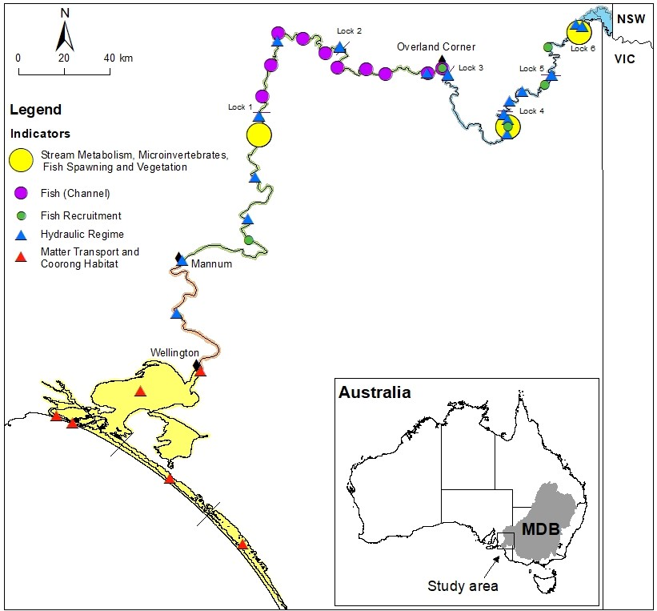
Figure 1. Map of the Lower Murray Selected Area showing the Lower Murray River floodplain (blue), gorge (green) and swamplands (orange) geomorphic zones, and the Lower Lakes and Coorong (yellow). Sampling sites are indicated by coloured circles (field monitoring) and triangles (modelling).

Expected outcomes in the Lower Murray
During the five-year period of the Flow-MER Project (2019-20 to 2023-24), Commonwealth environmental water in the Lower Murray was primarily used to contribute to base flows and freshes in the LMR channel (Figure 2), and maintain river flows to the Lower Lakes and Coorong. These particular flows aimed to achieve a variety of environmental outcomes including those relating to fish, vegetation, birds, water quality and river function, Lower Lakes water levels, salt export and connectivity between freshwater, estuarine and marine environments (Table 3; Appendix A), although only some of these are monitored through this project.
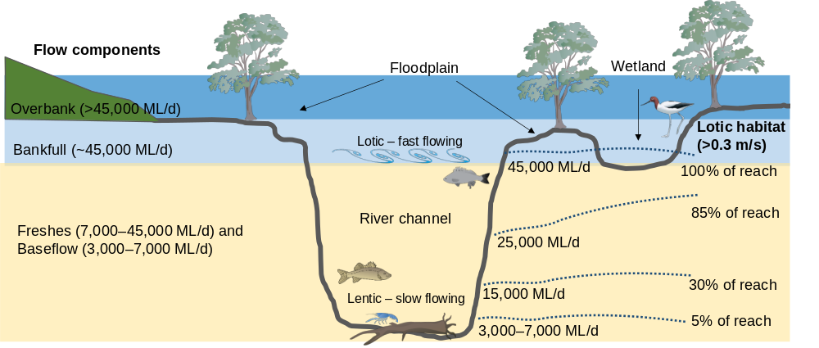
Figure 2. The various flow types of the Lower Murray River (LMR) as described in the Murray–Darling Basin Plan (MDBA 2011) and how flow volumes translate to lotic habitat in the contemporary LMR (Lock 1 to Lock 6 reach).
In the Lower Murray, it was anticipated that environmental water delivery that contributed to base flows and freshes would: increase stream velocity, mixing and dilution; increase variability in water levels; increase the inundated area of the littoral zone of channels, low-lying wetlands and floodplains; and improve connectivity between freshwater, estuarine and marine environments (Ye et al. 2020a). These changes to hydrological/hydraulic conditions in the LMR were expected to lead to:
- Maintained dissolved oxygen and water quality due to increased mixing and discharge;
- Increased productivity due to lateral transport of organic material;
- Increased transport of dissolved and particulate matter (salt and nutrients) downstream due to mobilisation and increased discharge;
- Increased littoral understorey vegetation diversity, productivity and community resilience due to increased water level variability;
- Increased microinvertebrate (and egg-bank) diversity and abundance due to increased inundated area in littoral and off-channel habitats from increased water levels and discharge;
- Increased abundance of microinvertebrate taxa common to upstream areas and those that have been found to proliferate during times of high velocity and longitudinal connectivity due to entrainment and downstream transportation;
- Increased larval abundance of flow-cued spawning fish species (golden perch, Macquaria ambigua and silver perch) due to the provision of flow-cues for spawning and increased larval drift and dispersion;
- Increased recruitment of flow-cued spawning fish species due to increased spawning and larval drift, and enhanced survival rate due to increased productivity;
- Improved recruitment and population resilience of main channel specialist fish species (Murray cod) due to increase in lotic habitat and productivity;
- Increased salt export out of the MDB, reduced salt import into the Coorong, and reduced salinities; and
- Improved fish habitats in the Coorong, and Ruppia tuberosa habitats at higher flow.
Over the long-term (decades), environmental water delivery is expected to make a significant contribution to achieving ecosystem outcomes in the Lower Murray, through restoring ecological processes and improving habitat for biota in the main channel and floodplain/wetlands. A consolidated view of the expected outcomes driven by flow for the Lower Murray is presented in Figure 3, which includes core monitoring indicators of the Flow-MER Project. The conceptual diagram demonstrates the inter-relationships between the changes of hydrological/hydraulic regime and riverine productivity (stream metabolism, vegetation, microinvertebrates) and matter transport, and how these may influence fish spawning and recruitment and the overall fish assemblage in the Lower Murray.
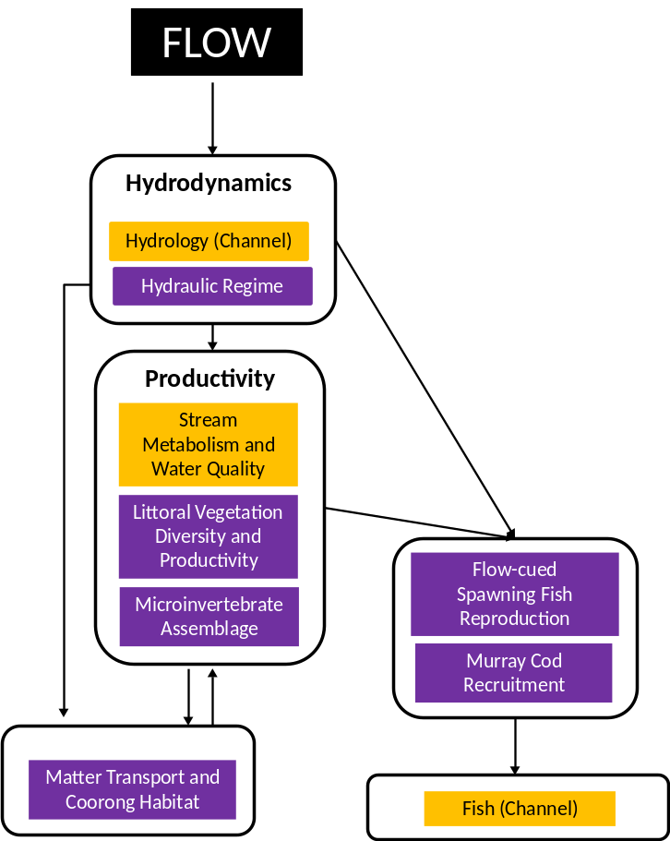
Figure 3. Cause and effect diagram of flow for the main channel of the Lower Murray with respect to the proposed indicators. Magnitude, timing and duration are factors of flow (in black). Yellow indicators followed standard protocols to support quantitative Basin-wide and Selected Area evaluation, where applicable. Purple indicators were developed to address objectives and test Selected Area-specific hypotheses with respect to biological/ecological response to environmental flows.

Environmental water delivery
Since 2011-12, environmental water has been delivered to the LMR to increase or maintain river flows (Figure 4) and improve ecological health (https://www.dcceew.gov.au/water/cewo). During the LTIM and Flow-MER Project period (2014-15 to 2023-24), an average of ~781 GL/y of Commonwealth environmental water has been delivered to the LMR, in conjunction with other environmental flows (i.e. water from The Living Murray (TLM) Initiative, Victorian Environmental Water Holder, River Murray Increased Flows, and New South Wales Department of Planning, Industry and Environment) (Table 1), with an average of ~716 GL/y of Commonwealth environmental water flowing through the barrages into the Coorong (Table 2). In 2023-24, the volume of Commonwealth environmental water delivered to the LMR has been the highest (1,384 GL/y) with 1,146 GL/y to support barrage flows. Across the ten-year period, environmental water deliveries to the LMR largely occurred as return flows, during winter and spring–early summer, through coordinated watering events across the southern connected Basin to achieve multi-site environmental outcomes. Direct orders of environmental water to the South Australian border also occurred for specific purposes, often during summer−autumn, to provide flow for the Lower Lakes and Coorong.
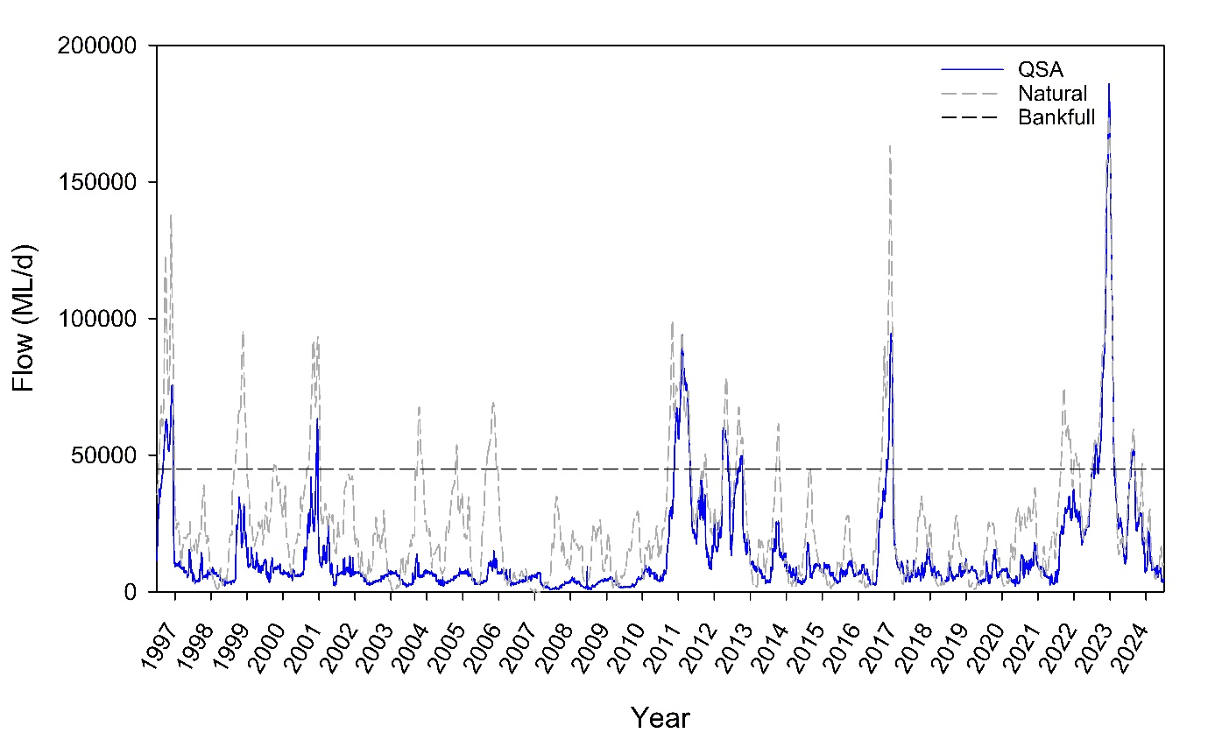
Figure 4. Daily flow (ML/d) in the Lower Murray River (LMR) at the South Australian border (blue solid line) from July 1996 to July 2024, compared to modelled flow under natural conditions (grey dashed line). Approximate bankfull flow in the main channel of the LMR is shown (black dashed line).

Table 1. Total annual volumes (gigalitres, GL) of environmental water (eWater), including Commonwealth environmental water (CEW), delivered to the Lower Murray River (LMR) channel (excludes wetland use*) and the proportion contribution towards total flow to the LMR (QSA) from 2014-15 to 2023-24. Accounted volumes are provided by the CEWH, include the environmental components of the South Australian entitlement (Ent.) and exclude environmental water delivered from the South Australian Minister for Environment and Water and Accolade Wines (predominantly for wetlands). TLM = The Living Murray, VEWH = Victorian Environmental Water Holder, RMIF = River Murray Increased Flows, NSW = NSW Office of Environment and Heritage and NSW Department of Planning, Industry and Environment, Other SA = other South Australian sources including Tolderol Wetland, Loveday Wetland, PCMW (Banrock), PCMW (Minister) and Minister's Reserve (Desal agreement).
Water year | 2014-15 | 2015-16 | 2016-17 | 2017-18 | 2018-19 | 2019-20 | 2020-21 | 2021-22 | 2022-23 | 2023-24*
CEW | 581 | 798 | 618 | 898 | 549 | 750 | 687 | 781 | 764 | 1,384
TLM | 107 | 101 | 234 | 176 | 96 | 68 | 175 | 246 | 310 | 293
VEWH | 26 | 15 | 43 | 30 | 35 | 60 | 56 | 64 | 38 | 50
RMIF |  |  | 100 | 53 | 111 | 52 | 5 | 23 | 4 | 16
NSW |  |  |  | 9 |  |  |  | 28 | 20 | 24
Other SA |  |  |  |  |  |  |  | 60
Total eWater (% QSA) | 714 (25%) | 914 (37%) | 996 (11%) | 1,167 (43%) | 791 (32%) | 931 (39%) | 922 (31%) | 1,202  (13%) | 1,136  (5%) | 1,767  (24%)
*Approximately 9.7, 12.5, 11.6, <1 and 21.7 GL of CEW were also delivered for wetland watering in 2019-20, 2020-21, 2021-22, 2022-23 and 2023-24, respectively.
Table 2. Annual flow through the Murray barrages (total volume, GL) from 2014-15 to 2023-24, showing contribution by Commonwealth environmental water (CEW). CEW and total flow volumes are based on South Australian barrage dashboard accounting data. Matter transport results in Section 2.3.1 are based on barrage-specific modelled data, and may differ slightly compared to the accounting data presented here.
Water year | 2014-15 | 2015-16 | 2016-17 | 2017-18 | 2018-19 | 2019-20 | 2020-21 | 2021-22 | 2022-23 | 2023-24
Total | 987 | 561 | 6,484 | 854 | 377 | 685 | 1,247 | 6,161 | 21,597 | 5,185
CEW* | 454 | 561 | 802 | 757 | 377 | 685 | 808 | 841 | 753 | 1,146
* CEW represented 100, 91, 61, 68 and 63% of the eWater in 2019-20, 2020-21, 2021-22, 2022-23 and 2023-24, respectively. In 2023-24, other eWater included 444.8 GL of TLM and 237.7 GL of other sources (data source: CEWH). See Table 1 for abbreviations.

The first two years of monitoring were hydrologically dry (i.e. flow <18,000 ML/d at the South Australian border, Figure 4) and environmental water contributed primarily to freshes in the LMR, particularly as winter and spring–early summer flow pulses (Figure 5), following upstream watering events. Winter flows (11,000 ML/d) in 2019 consisted of return flows from the Goulburn River, whilst return flows from the Murray and Goulburn rivers and Barmah–Millewa Forest supported a flow pulse (15,600 ML/d) in the LMR during October 2019 (Figure 6). Multiple flow pulses during spring–summer 2020-21, peaking in late November (17,900 ML/d), were attributed to return flows from the Murray, Goulburn, Murrumbidgee and Darling rivers (Figure 6).
In contrast, the last three years were characterised by unregulated flows, resulting in high, in-channel flows in 2021-22 (37,500 ML/d in late December) and overbank flows during 2022-23 (187,600 ML/d in late December) and 2023-24 (52,800 ML/d in early September). In 2021-22, environmental water was delivered to South Australia between early September and early February to fill gaps in the hydrograph and maintain flow rates >20,000 ML/d (Figure 5). Environmental water delivery during this period comprised of return flows from the upper Murray and Goulburn rivers, and a directed release from Lake Victoria (Figure 6). In 2022-23, environmental water delivery during late July 2022, through directed releases from Lake Victoria, maintained flow ≥42,000 ML/d and supported an overbank flow event (54,500 ML/d) in mid-August (Figure 5). Later in that year, from late December to June, environmental water originating from mixed upstream sources including the Goulburn and Murrumbidgee rivers, and Barmah-Millewa Forest, assisted in reducing the rate of the flow recession and maintaining lotic conditions as flow reduced (Figure 5; Figure 6).
Unregulated flows continued in 2023-24, with flow increasing from 25,000 ML/d in early July 2023 to a peak of 52,800 ML/d in early September 2023. Return flows from environmental water delivery in the Goulburn and Murrumbidgee rivers and Barmah–Millewa Forest, in conjunction with unregulated flows and directed releases from Lake Victoria, maintained flow to South Australia >25,000 ML/d from late September to early December 2023. In this water year, an unregulated flow pulse occurred in early February (peak 30,300 ML/d), following return flows from northern Victoria and the Darling River, direct trade at the South Australian border supported end of system flows in summer/early autumn.
During 2020, 2021 and 2024, environmental water delivery to the LMR from summer–late autumn was through direct trades at the South Australian border and/or return flows from upstream watering events (Figure 5; Figure 6). During this period, Commonwealth environmental water played a critical role in maintaining barrage releases and contributing to >60% of total barrage flow for these water years (Table 2).
The physical source of flows to the LMR are presented in Figure 6. During most years, flow to South Australia mainly comprised flow from the Murray, Goulburn and Murrumbidgee rivers. However, Darling River flow to South Australia increased during unregulated flows from December 2022 to May 2023. Key watering events in the LMR over the last five years and the targeted expected outcomes of these deliveries are presented in Table 3 and the annual South Australian River Murray Water for the Environment reports (e.g. DEW 2024). These events are also marked on Figure 5. Environmental water supported other complementary management actions to achieve ecological outcomes in the LMR. These included weir pool manipulations, operation of environmental regulators and wetland watering by pumping, with key activities summarised in Appendix B.

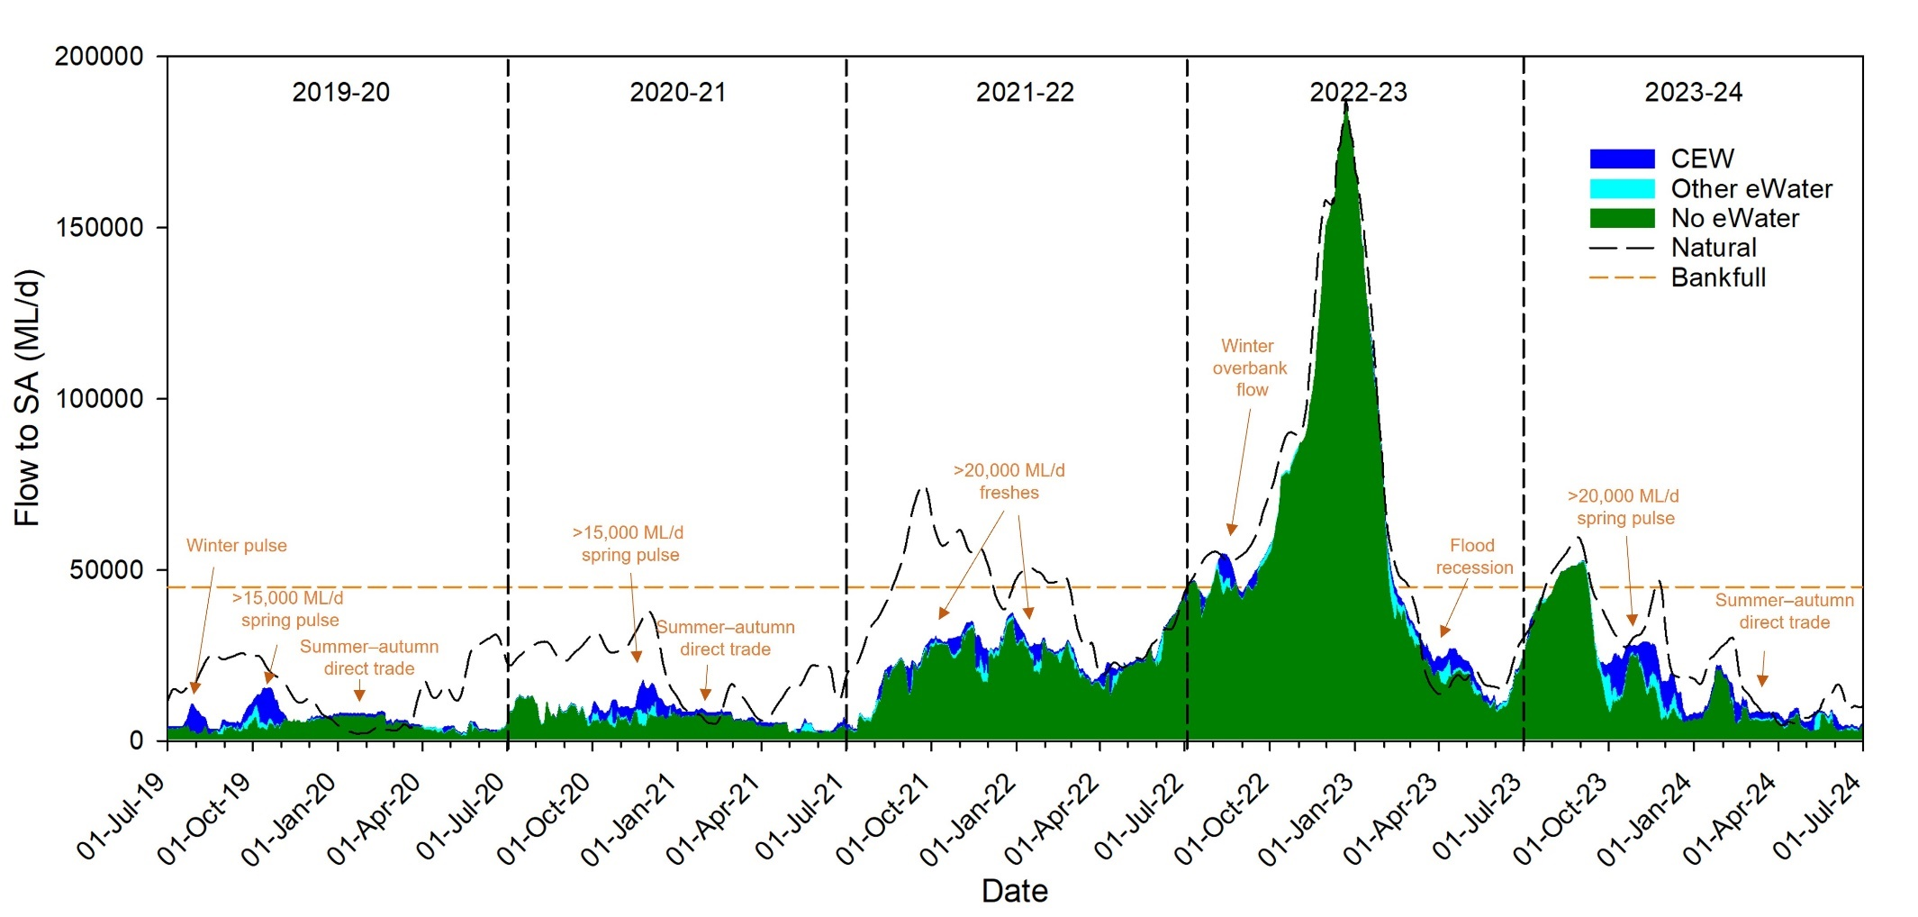
Figure 5. Flow to South Australia from 1 July 2019 to 30 June 2024 showing the contribution of environmental water (eWater). CEW = Commonwealth environmental water. Other eWater = The Living Murray (TLM), Victorian Environmental Water Holder, New South Wales Department of Planning, Industry and Environment and water delivered as part of River Murray Increased Flows. Specific watering events for 2019–2024 (Table 3) are shown, except base flows and weir pool manipulations. The ‘no eWater’ component includes South Australian entitlement held by the Commonwealth Environmental Water Holder and by TLM. Approximate bankfull flow (orange dotted line) is shown. Modelled flow under natural conditions (dotted black line) is not reliable for 2022-23. Refer to Ye et al. (2020a) for eWater delivery and timing of events from 2014–2019.
Table 3. Specific Commonwealth environmental water (CEW) watering events and expected outcomes for the Lower Murray River and Coorong, Lower Lakes and Murray Mouth from 2019–2024 (source, CEWH). Some outcomes are specific to 2019-20 (ª), 2020-21 (^{b}), 2021-22 (^{c}) and 2023-24 (^{d}). Refer to Figure 5 for timing of events and Ye et al. (2020a) for expected outcomes from 2014–2019.
Flow event | Flow event delivered |  |  |  |  | Expected outcomes
Flow event | 2019-20 | 2020-21 | 2021-22 | 2022-23 | 2023-24 | Expected outcomes
Base flows (<7,000 ML/d) and/or small freshes (7,000–15,000 ML/d) throughout the year | Y | Y | Y | Y | Y | Refer to Appendix A.
Winter pulse (small, <15,000 ML/d) | Y |  |  |  |  | - Coorong water quality/habitat suitability  - Riverine/ecosystem function  - Lamprey and congolli migration  - Increase lake levels in advance of spring pulse  - Fish habitat and condition
Winter overbank flows (>45,000 ML/d) |  |  |  | Y |  | - Maintain extent and condition of long-lived and understorey floodplain vegetation
Spring–early summer pulse/freshes (>15,000 ML/d, >20,000 ML/d) | Y | Y | Y |  | Y | - Coorong water quality ^{a,b}  - Estuarine habitat ^{a,b}  - Fish habitat and condition ^{a,b}  - Riverine function and productivity ^{a,b}  - Lamprey and congolli migration ^{a,b}  - Lower lakes fish recruitment ^{a,b}  - Support spawning and recruitment of flow-cued spawning fish species (golden and silver perch) ^{c}  - Appendix A ^{c}

Flow event | Flow event delivered |  |  |  |  | Expected outcomes
Flow event | 2019-20 | 2020-21 | 2021-22 | 2022-23 | 2023-24 | Expected outcomes
Summer–autumn direct trade | Y | Y |  |  | Y | Base flows in river, fishway flow and connection through barrages December–February:  - Protect assets and avoid damage in the river channel, Lower Lakes and Coorong ^{a,b}  Base flows and opportunistic pulses through the barrages March–June:  - Coorong water quality, estuarine habitat, fish habitat and condition, riverine function and productivity ^{a,b,d}
Flood recession flows |  |  |  | Y |  | - Maintain extent and condition of long-lived and understorey floodplain vegetation
Weir pool (WP) raising and Katarapko (Kat) and Pike floodplain regulators | Y  WP2, 6# | Y  WP4, 5  Kat, Pike | Y*  WP2, 4, 5  Kat, Pike | Y*  WP2, 5  Pike | N | Refer to Appendix A.
*No Commonwealth environmental water was delivered but it underwrote the requirement of the weir-pools re-filling, which enabled the river operators to undertake the manipulations (See Appendix B).
# Flow rates were insufficient to support the Weir Pool 6 action and the pool was returned to normal level by 18 August 2020.
Minor lowering of weir pools occurred in 2020-21, 2021-22 and 2023-24 (Appendix B).
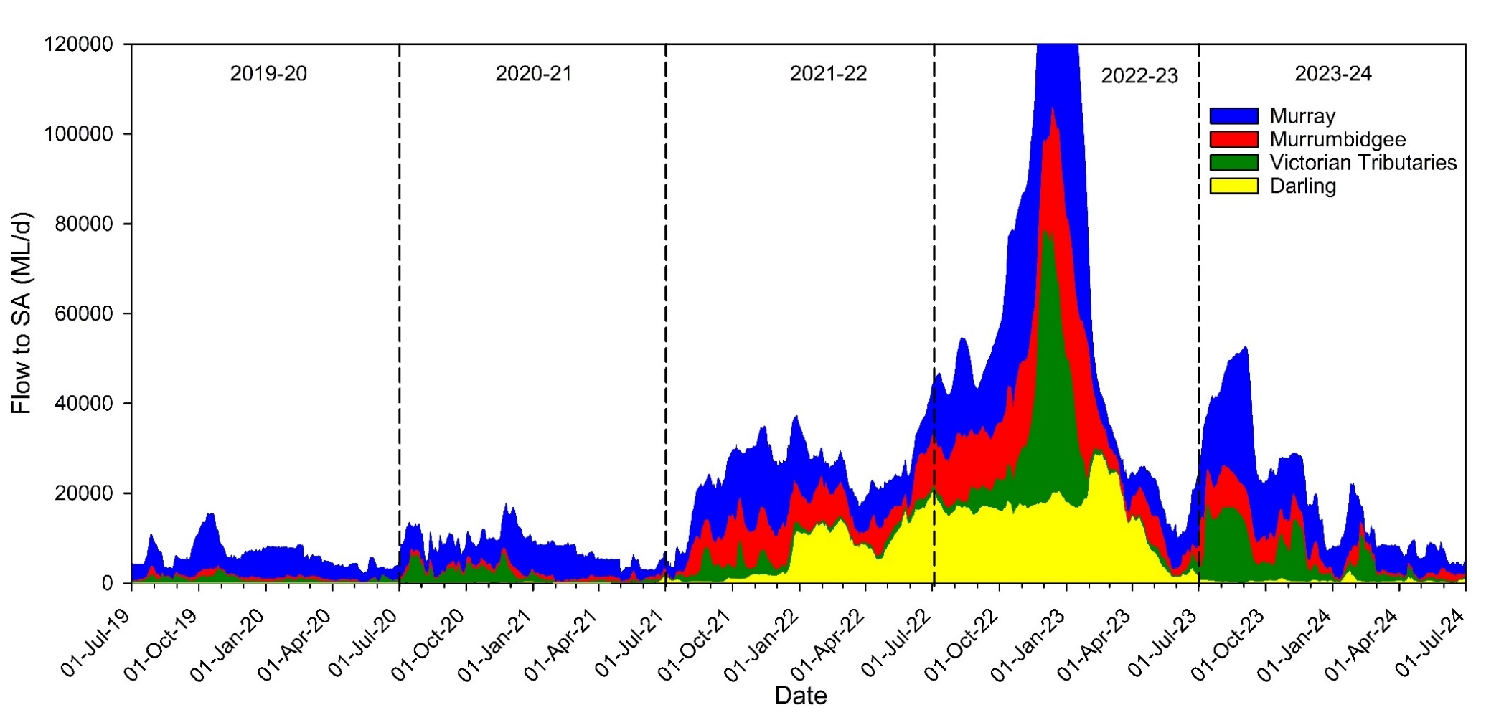
Figure 6. Flow to South Australia from 1 July 2019 to 30 June 2024 showing the source of all (environmental and consumptive) water (MDBA). Flow peaked at 187,600 ML/d in December 2022. ‘Bigmod salinity routines’ was used as a proxy for transport of biological matter, to estimate the proportion of the flow that originated at different upstream tributaries. Refer to Ye et al. (2020a) for flow source information from 2014–2019.

Purpose of the CEWH Flow-MER report for 2019–2024
This report presents the key findings from monitoring in the Lower Murray over the five years of Flow-MER, including 2023-24, and answers CEWH evaluation questions about ecological responses to Commonwealth environmental water deliveries (Sections 2 and 3). Refer to the five-year LTIM report (Ye et al. 2020a) and previous annual reports (Ye et al. 2021, 2022, 2023, 2024) for Lower Murray monitoring findings from 2014-15 to 2022-23, and the Monitoring, Evaluation and Research Plan for the Lower Murray (SARDI et al. 2024) for a detailed description of methods for current activities. Specific management recommendations for environmental flows in the Lower Murray are provided in Section 2, with general management implications summarised in Section 4, based on monitoring and evaluation outcomes, and expert knowledge. Monitoring and evaluation of Commonwealth environmental water delivery in the Lower Murray from 2019-20 to 2023-24 focussed on the main watering period of spring−summer; therefore, our findings and recommendations on environmental water management are most relevant to this period.

Indicators

Hydraulic Regime

Background
The discharge, or hydrology, in the LMR was determined through routine monitoring. The hydrology expected to have occurred without environmental water components was determined by the MDBA using operational records of environmental water delivered to the South Australian border, and modelled throughout SA accounting for travel time, losses and differences in diversions and environmental water use for the different scenarios with and without environmental water.
The hydraulic characteristics (e.g. depth/water level and flow velocity) of fluvial ecosystems result from the interaction of discharge and physical features (e.g. channel morphology, woody debris, man-made structures, etc.), and have a profound influence on river ecosystem structure and function (Statzner and Higler 1986; Biggs et al. 2005; Bice et al. 2017) (also see Section 1.1). It is these hydraulic characteristics that biota can sense and respond to, i.e. a change in velocity or water level, rather than a change in discharge.
The purpose of the ‘Hydraulic Regime’ indicator was to quantify the changes in hydraulics due to the delivery of environmental water using hydraulic models, to provide a basis to assess or infer ecological changes caused by environmental water. This approach is particularly important in the LMR where a given discharge may not produce the same hydraulic response, as downstream structures (weirs) will also influence the hydraulics occurring.
Hypothesis
Commonwealth environmental water will promote greater extent of lotic/flowing water habitat as evidenced by increased water velocities and variability in water levels.

Methods
A steady-state modelling approach was adopted as in previous evaluation years, similar to that used in the Goulburn (Webb et al. 2015) and Edward-Wakool (Watts et al. 2015) Selected Areas. The steady state approach is expected to be appropriate up to approximately bankfull flows, as experienced in 2023-24. For each weir pool within the LMR, i.e. Weir Pools 1 to 5, as well as the river between Lock 1 and Wellington, a range of steady state flow scenarios were simulated in the hydraulic models (2,000–100,000 ML/d) with a range of weir pool levels. The models used were the same as those outlined in Ye et al. (2024).
A range of hydraulic metrics were computed for each day, including the 10th, 50th and 90th percentile velocities within the weir pool, the proportion of the weir pool exceeding 0.2 and 0.3 metres per second (m/s), and water levels at regular locations along the weir pool. The former water velocity (>0.2 m/s) represents favourable velocities that entrain and transport/disperse phytoplankton, zooplankton and fish larvae (Gibbs et al. 2023) and allow gas exchange at the water surface (Ye et al. 2021), and the latter (>0.3 m/s) represents flowing water (lotic) conditions for riverine biota (Bice et al. 2017; Gibbs et al. 2023).
The Hydraulic Regime indicator has focused on in-channel velocity changes due to environmental water. The area used for velocity analysis for each weir pool comprised the inundated area at flows of 5,000 ML/d and normal pool level conditions. As changes to in-channel velocities were the focus of this analysis, this approach of eliminating additional areas inundated was used to avoid the influence of slow, or not, flowing backwaters on the calculated in-channel velocity of interest.
Post-processing correction to the modelled water levels downstream of each lock was undertaken. A linear regression relationship between flow and the difference in modelled and recorded water level was used to correct for any systematic bias introduced by errors in the hydraulic model. Following this correction, the remaining residual error between the modelled and recorded data each day was applied to all scenarios, which represents random error introduced by other factors, such as wind setup. This results in modelled water levels that are the same as the observed water level downstream of each lock for the scenario representing observed conditions (All Water) with consistent corrections applied to the without environmental water scenarios.
Environmental water scenarios
With the metrics derived from the hydraulic models, the time series of discharge for each of the environmental water scenarios presented in Section 1.4. and the downstream water level each day for each weir pool, time series of hydraulic parameters were interpolated using linear bivariate interpolation (R version 4.4.1 and akima package 0.6-3.4). Five scenarios were considered:
- All Water, with all environmental water representing observed conditions,
- No CEW, without Commonwealth environmental water,
- No eWater, without any environmental water,
- No Locks, the observed discharge as used for the All Water scenario, but the influence of the weir and locks across the Murray River removed, to provide an indication of the maximum hydraulic changes that could be expected for the delivered flow regime, and
- WoD, or Without Development, a representation of natural conditions, which has the locks/weirs removed as used for the No Locks scenario, but also a modelled flow representing no storage or diversions across the Murray River.
The discharge time series for these scenarios were provided by the MDBA, and the data account for changes in diversions expected within South Australia by assuming full utilisation of the South Australian held entitlements recovered for the environment in the ‘without environmental water’ scenarios (e.g. No CEW and No eWater). WoD and No Locks results were not simulated downstream of Lock 1, due to limited information on a suitable downstream water level for this scenario.
The observed water levels at each lock and at Wellington (station A4261159) were used as inputs for the All Water scenario. In 2023-24, weir pool operations were undertaken using unregulated flows, and as such the observed water levels upstream of each weir were also used for the without environmental water scenarios. As regulated conditions returned in late 2023 water levels in the Lower Lakes started to fall, and the influence of environmental water on water levels in Lake Alexandrina from late December onwards has been incorporated into the results below Lock 1.

Results
A summary of the Lower Murray Selected Area results can be seen in Figure 7. This figure includes the discharge at the South Australian border for the different scenarios, the resulting area inundated (from Lock 6 to Wellington), and length of the river between Lock 6 and Lock 1 (total length 335 km) experiencing lotic conditions, based on thresholds of velocity >0.2 m/s and >0.3 m/s. For the velocity metrics, only results above Lock 1 were presented here to compare to the No Locks and WoD scenarios.

Velocity
After two years with high discharge creating periods of extensive lotic conditions in 2021-22 (110 days where over 300 km of river between Lock 1 and Lock 6 experienced a velocity >0.3 m/s) and 2022-23 (220 days), 2023-24 also commenced with practically the whole length of the LMR experiencing lotic conditions (Figure 7 and Figure 8). Over the 30 days following 24 September 2023, when flow would have started to recede without environmental water, 225 GL of Commonwealth environmental water was delivered to increase the average flow to SA from 17,136 ML/d to 24,620 ML/d. Increases in flow to SA in this range result in proportionally larger increases in velocity, resulting in the increase in the average length of river with a velocity > 0.3 m/s from 132 km to 259 km, and a maximum daily increase of 215 km, representing 64% of the reach considered. Commonwealth environmental water continued to have a substantial influence on the length of lotic reach during the month following the return of regulated flow conditions on 23 November 2023, over the following 30 days the average flow to SA increased from 10,384 ML/d to 16,809 ML/d, increasing the average length of river experiencing lotic conditions from 40 km to 141 km.

Water level and area
The two periods of increase in flow outlined above, from late September into October and again over November and December, were large enough to create increases in water levels in tailwaters of the weir pools (Figure 9), even when the water level at the weir downstream was assumed to be the same with or without environmental water (Figure 10). The magnitude of the water level increase was similar for each period at the upper end of each weir pool, ranging from approximately 0.6 m below Lock 1 up to 0.9 m at the upper end of the Weir Pools 1 and 2.
These increase in water level were sufficient to create additional low-level inundation. This increase peaked at more than 2,000 Ha of additional inundation was created by environmental water from 15–22 November 2023. This was a result of flow to SA over 27,700 ML/d from 19 October to 22 November 2023, which without Commonwealth environmental water would have receded to 15,166 ML/d. Peak flow to SA of 52,758 ML/d was 105 ML/d higher due to Commonwealth environmental water, resulting in a slight increase (195 Ha) in the maximum inundation extent (Figure 7).
Environmental water was not expected to influence the water level at the downstream end of weir pools in 2023-24 as all weir pool manipulation events were undertaken with unregulated flow. However, the delivery of Commonwealth environmental water was modelled to increase water levels in Lake Alexandrina, by up to 0.078 m at the end of January. It should be noted this result is highly dependent on the assumed barrage releases in the counterfactual scenario.

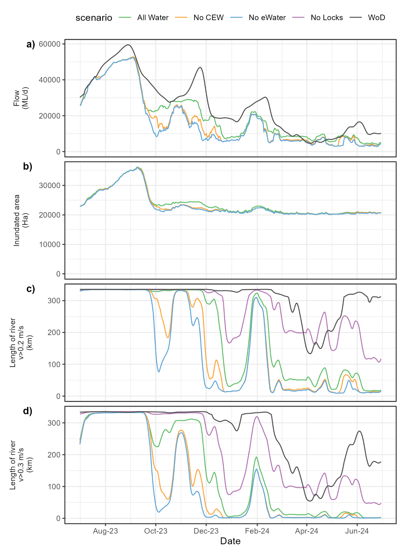
Figure 7. a) Discharge (flow at the South Australian border), b) inundated area between Wellington and Lock 6, and length of river with faster flowing velocities (c) v>0.2 m/s and d) v>0.3 m/s) for the Lower Murray River (LMR) between Locks 1 and 6 (excluding anabranches). Total length of river assessed for the length of river metrics in the LMR = 335 km. Note there are no WoD or No Locks results below Lock 1, and hence these scenarios are not included on b).
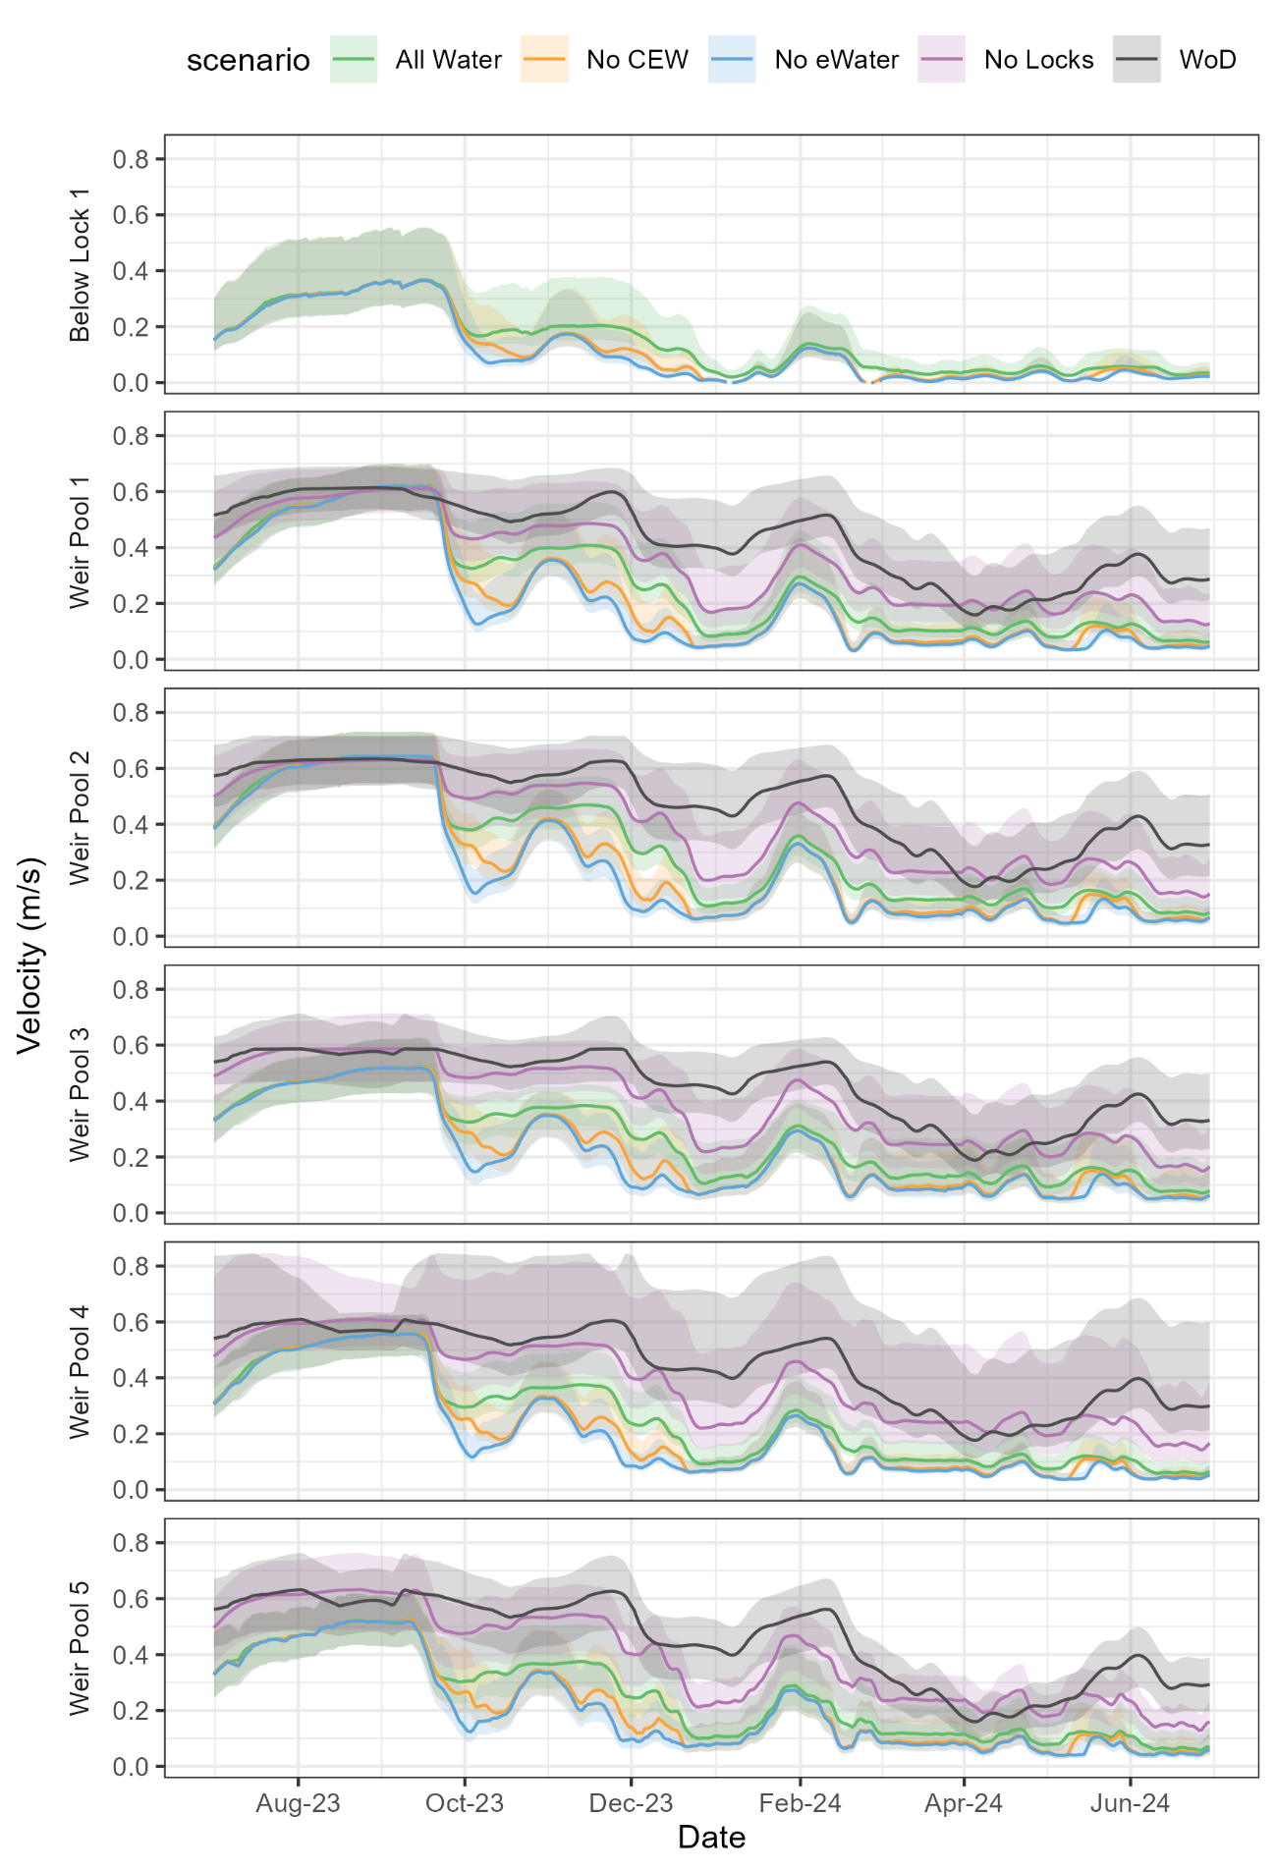
Figure 8. Median modelled velocity in each weir pool (line), with the range in velocities within the weir pool (the shaded area), defined by the 10th and 90th percentiles, in the Lower Murray River.
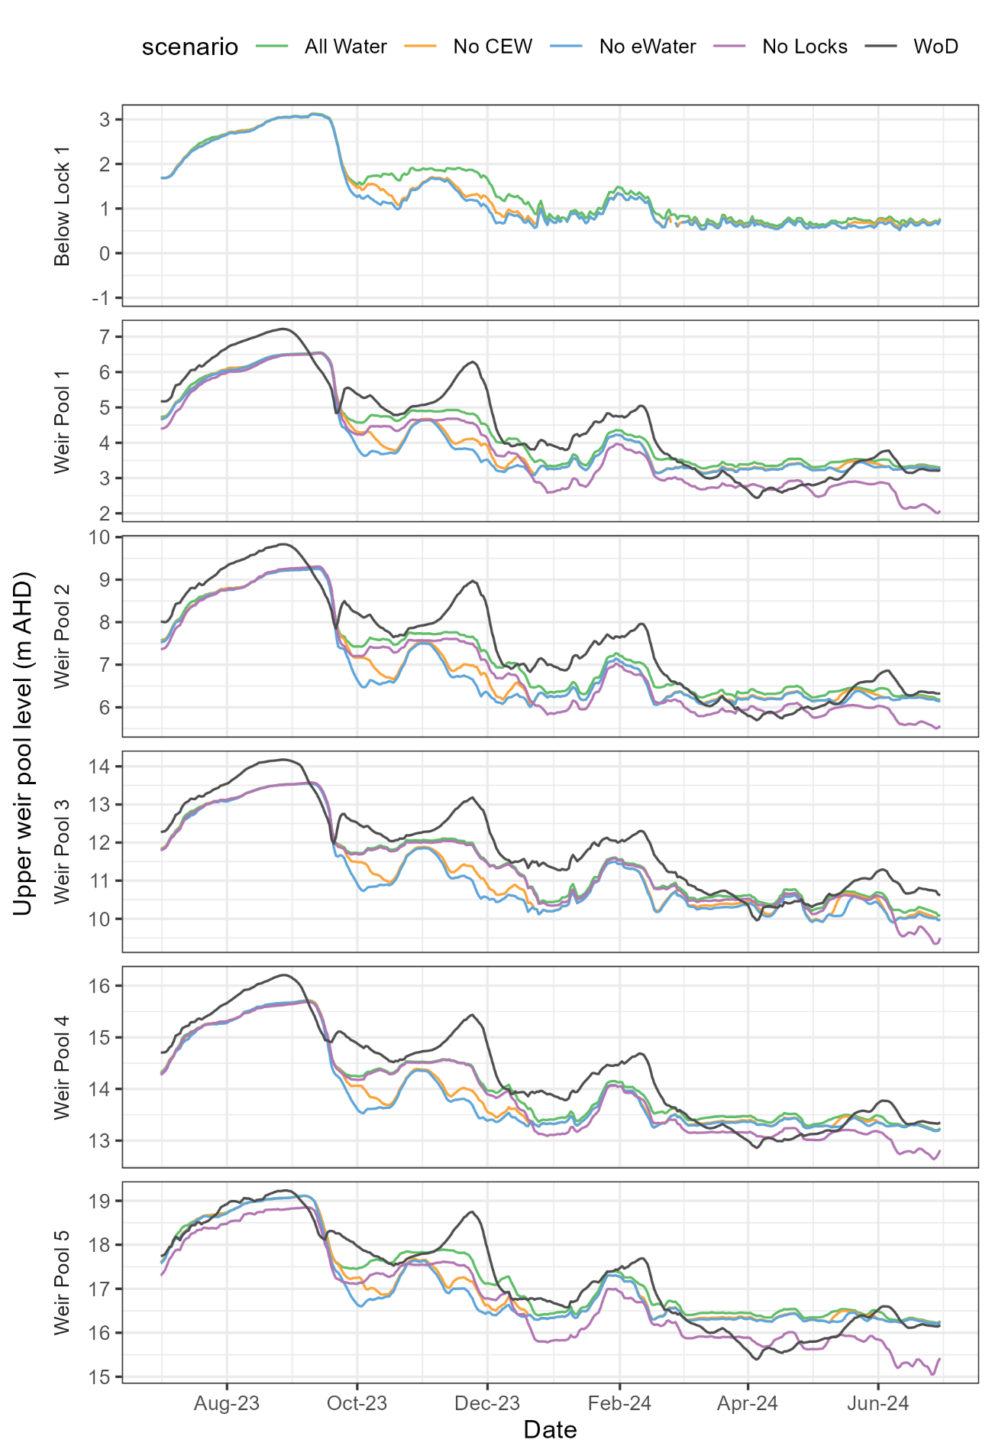
Figure 9. Modelled upper weir pool water level (i.e. downstream of each lock, e.g. Lock 2 for Weir Pool 1) in the Lower Murray River.

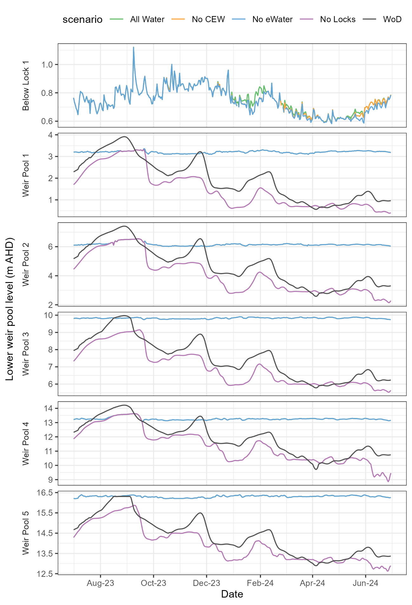
Figure 10. Lower weir pool water level (i.e. above the locks/weirs, e.g. above the Lock and Weir 1 for Weir Pool 1, and at Wellington for below Lock 1) of each weir pool in the Lower Murray River. The All Water and No CEW lines coincide with the No eWater line for all sites except below Lock 1.

Evaluation

To evaluate the contribution of Commonwealth environmental water towards a short (annual) or long-term (multi-year) outcome, a contribution significance level was assigned to each evaluation question. The level was viewed as ‘to what extent Commonwealth environmental water contributed towards that observed outcome, with the ecological significance of the outcome considered where possible’. For example, the level assigned may be similar for an ecologically significant outcome of which Commonwealth environmental water had minor contribution towards versus an outcome that was considered minor of which Commonwealth environmental water had major contribution towards. The thresholds for assigning the significance vary among indicators and questions, ranging from using defined percentages or values of change, to qualitative assessment based on expert opinion (e.g. Flow-cued Spawning Fish Reproduction and Murray Cod Recruitment). The thresholds may be adjusted in response to developing understanding of these processes.
Table 4. Hydraulic Regime evaluation questions and answers. CEW = Commonwealth environmental water. SA = South Australia. SA border = South Australian border.
CEWH evaluation questions | Outcomes of CEW delivery
CEWH evaluation questions | 2014-15 | 2015-16 | 2016-17 | 2017-18 | 2018-19 | 2019-20 | 2020-21 | 2021-22 | 2022-23 | 2023-24
What did CEW contribute to hydraulic diversity within weir pools? | 13 km, 4% (17 km, 5%) | 18 km,  5% (22 km, 6%) | 20 km, 6% (53 km, 15%) | 36 km,  10% (49 km, 14%) | 15 km, 4% (19 km, 6%) | 33 km, 10% (73 km, 22%) | 31 km, 9%  (84 km 25%) | 24 km, 8%  (1 km,  <1%) | <1 km, <1%  (<1 km, <1%) | CEW increased the maximum length of river with lotic conditions (v>0.3 m/s) for at least 30 days by less than 1 km or <1% (an additional <1 km or <1% for at least 14 days)
The unregulated flow event of flow to SA >48,000 ML/d for 30 days over late August – early September created lotic conditions throughout the LMR for a duration exceeding 30 days, without environmental water. Hence there was little scope for CEW to contribute further to hydraulic diversity as defined by this metric and a negligible contribution is determined. However, CEW did increase the hydraulic diversity over the water year, with the length of river with velocity > 0.3 m/s totalled over the year increasing from 41,600 km d to 54,186 km d, an increase of 30%.
Length of river with lotic conditions (velocity >0.3 m/s) has been used to represent hydraulic diversity. If there is some fast-flowing water, it is expected there will be greater hydraulic diversity due to changes in habitat complexity (bends, backwaters, benches, etc.). Length of river with lotic conditions exceeded for 30 days over the year is presented, and 14 days in brackets. The time periods represent a number of flow-related ecological or life history processes that could occur over periods of ~2−4 weeks. Total length of river assessed in the LMR = 335 km. A substantial contribution was considered an increase in the maximum length of river with lotic conditions for at least 30 days by 20% or greater, moderate 9–19%, minor 4–8%, negligible <4%.
This is not a long-term evaluation question.
What did CEW contribute to variability in water levels within weir pools? | 0.03 m | 0.06 m | 0.01 m | 0.14 m | 0.09 m | 0.06 m | 0.12 m | 0.01 m | -0.29 m | Interquartile range (IQR) in water level decreased by 0.08 m (6%) due to CEW.
Despite maintaining relatively constant flow to SA over October and November, CEW made a minor contribution to water level variability in 2023-24, as calculated by the IQR in the upper weir pool water level (i.e. just downstream of each weir) across Weir Pools 1–5. IQR is a measure of variability, as the difference between the 75th and 25th percentile values for water level over the year. A substantial contribution was considered an increase in the IQR in water level by 0.2 m or greater, moderate 0.1–0.2 m, minor 0.01–0.1 m, negligible <0.01 m. Negative contribution was assessed qualitatively depending on the objectives in the watering year, e.g. in 2022-23, it was not desirable to further increase variability in water levels.
This is not a long-term evaluation question.

CEWH evaluation questions | Outcomes of CEW delivery
CEWH evaluation questions | 2014-15 | 2015-16 | 2016-17 | 2017-18 | 2018-19 | 2019-20 | 2020-21 | 2021-22 | 2022-23 | 2023-24
What did CEW contribute to hydrological connectivity? | 28 Ha  20% (26%)  7,159  km d (41%) | 1,287 Ha  37%  (63%)  9,036  km d (123%) | 122 Ha  5%  (7%)  6,929  km d  (10%) | 904 Ha  39%  (70%)  11,568  km d (118%) | 1,398 Ha  20% (39%)  6,327  km d (77%) | 1,621 Ha  33%  (71%)  9,569  km d (148%) | 1,397 Ha  22% (34%)  10,392 km d (58%) | 734 Ha  7%  (9%)  3,119  km d (3%) | 0 Ha  3%  (3%)  2,152  km d  (2%) | CEW increased maximum inundated area by 195 Ha (<1%).  Increase in volume by 16% at the SA border (19% increase at Lock 1).  Total increase in connectivity (v>0.2 m/s) of 13,056 km d, an increase of 22%
What did CEW contribute to hydrological connectivity? | Long-term (2014–2024) outcome = minor.  CEW contribution to connectivity has been assessed laterally, as the increase in maximum inundated area over the year, and longitudinally, as the percentage increase in annual flow volume and as the total increase in river length over a number of days with velocity exceeding 0.2 m/s. The increase of annual flow volume at the SA border is reported (as used for Basin-scale assessment) as well as at Lock 1, where the percentages increase further down the system due to the losses and consumption, and water recovery within SA. In 2023-24, CEW made a negligible contribution to maximum lateral connectivity, with a <1% increase in maximum inundated area. The increase in flow due to CEW was minor, due to large unregulated flow events reducing the proportional contribution of the environmental water volume. The increase in connectivity, based on length-day of river with velocity >0.2 m/s, was the highest over the 10-year period, but again due to unregulated flows, the percentage increase was lower and considered minor due to connectivity created by unregulated flow events. Over the last ten years, the contribution of CEW to hydrological connectivity was ‘minor’ based on a median value of the annual evaluation outcome. A substantial contribution was considered an increase in discharge at the SA border by 50% or greater and/or an increase in connectivity (v>0.2 m/s) of 200% or greater, moderate 21–49% and/or 100–199%, minor 6–20% and/or 3–100%, negligible <6% and/or <3%.

Contribution (to what extent CEW contributed towards the outcome, with the significance of the outcome considered):
 | Unknown |  | None/negligible |  | Minor |  | Moderate |  | Substantial

Discussion
Unregulated flow to the Lower Murray Selected Area ended on 23 November 2023 after commencing on 15 July 2021, a period of 861 days. Further short duration unregulated flow events occurred over the remainder of 2023-24. The hydraulic diversity metrics were designed to quantify the benefit from a flow peak created or enhanced using environmental water, similar to assessing an environmental water requirement where a flow threshold is exceeded for a given duration. These assessment metrics are less sensitive to the conditions that occurred in 2023-24 (and 2022-23), where the peak flow for the year occurred (predominantly) due to unregulated flow. However, following the unregulated flow event that peaked in September 2023, Commonwealth environmental water did contribute substantially to hydraulic diversity and at a more ecologically beneficial time of year over October to December.
The longitudinal connectivity metric, the increase in the length and days of river experiencing velocities greater than 0.2 m/s over the year due to Commonwealth environmental water, was greatest in 2023-24 than any other year in the ten years of LTIM and Flow-MER evaluation. For a velocity threshold of 0.3 m/s, the increase due to Commonwealth environmental water was 12,586 km d, by far the largest increase in the past ten years and 45% larger than the next biggest contribution to lotic conditions in 2021-22. Hence, while the evaluation in Table 4 suggests a minor contribution from Commonwealth environmental water to hydraulic diversity within weir pools based on the metric used for evaluation, by another metric, Commonwealth environmental water made a substantial contribution to lotic conditions in 2023-24, and the largest increase since long-term evaluation commenced in 2014-15.
The results for the increase in lotic conditions in 2023-24 demonstrate the relatively larger increases in velocity that occur as flow discharge to South Australia increases above 20,000 ML/d. Figure 11 presents the length of river with lotic conditions (v>0.3 m/s) for different flow discharges to South Australia. The green diamonds represent the steady state result from the hydraulic models, which would be the case if the relevant flow rate persisted throughout the LMR. The black dots represent the results from each day of evaluation over the past ten years, which generally follow the same pattern, but the differences are caused by the shape of the hydrograph, e.g. a rising or falling limb of a flow event being at different stages along the Selected Area on a given day. Flow of 20,000 ML/d at the South Australian border can result in approximately 60% of the river considered with lotic conditions, but shorter events often result in this not occurring concurrently across the LMR (as the black dots tend to be below the steady state result for a flow of 20,000 ML/d). At 30,0000 ML/d, almost all of the LMR experiences lotic conditions, assuming weir pools are at normal levels. Hence, it is increases in this range above 20,000 ML/d, and especially up to 30,000 ML/d, that result in creation of substantial extent of lotic conditions, as was the case in 2023-24.
At bankfull conditions, approximately 45,000 ML/d, practically the whole reach is lotic. In 2022-23, the peak of the flood event resulted in some of the main river channel experiencing lower modelled velocities, as extensive overbank inundation created additional flow paths (Ye et al. 2024). It is not considered that increasing discharge is a negative outcome for the transport of propagules and matter along the River Murray. Ultimately, the lotic velocity thresholds are likely to be informative up to bankfull conditions (as represented in Figure 11), and once the maximum length of lotic habitat occurs, and for overbank flow, the metrics are considered less meaningful.
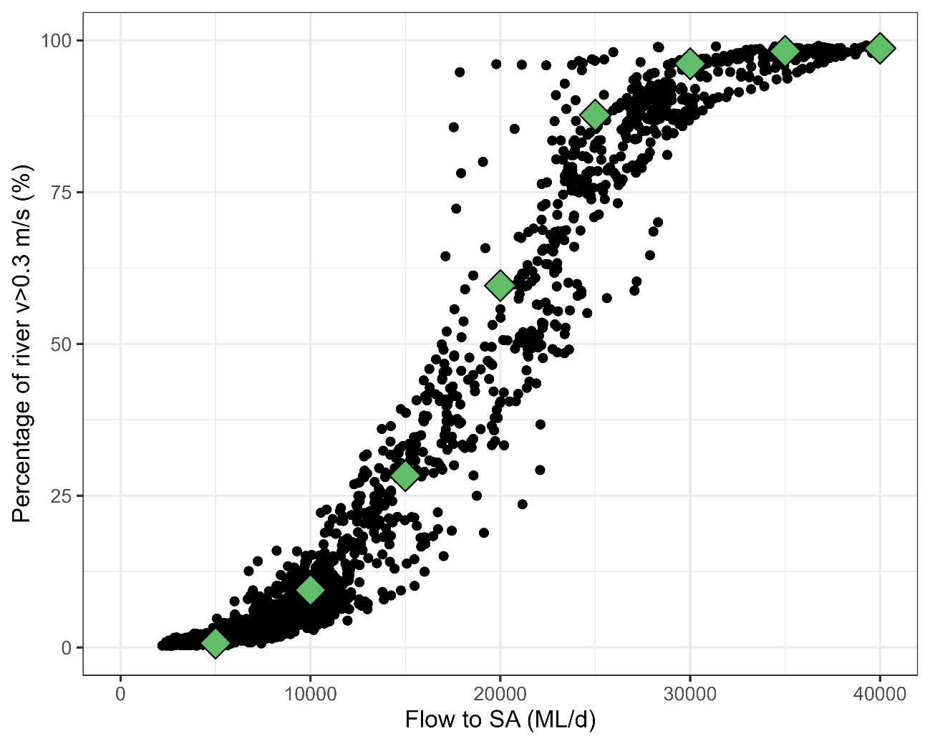
Figure 11. Percentage of river between Lock 6 and Wellington with lotic habitat (v>0.3 m/s) for a given flow discharge to South Australia (SA). Green diamonds represent steady state conditions and black dots the results from each day of evaluation over the past 10 years, indicating the influence of the shape of the hydrograph over time.
A range of metrics have been considered to assess the evaluation questions in Table 4. Relevant velocity thresholds, proportions of the river, timing/season of year and duration required to promote different ecological processes are the focus of further research, as the empirical evidence relating the hydrological/hydraulic conditions occurring and ecological responses continues to improve. It is expected that this hydraulic information, and the methodology developed to derive it for the future, will help to develop eco-hydraulic relationships. The commencement of Flow-MER 2.0 to evaluate outcomes in 2024-25, including expanding the upstream boundary of the Hydraulic Regime indicator from Lock 6 to Lock 10, provides an opportunity to refine the metrics based on learning over the last decade.

Management implications
The 2023-24 report marks ten years of evaluation since the start of LTIM and provides an opportunity to review improvements in hydraulic conditions from Commonwealth environmental water over an extended time horizon. Years 2021-22 to 2023-24 represented a particularly high flow period, with the only other year being 2016-17 when flow to SA exceeded 25,000 ML/d (Figure 12). These high flow conditions have enabled Commonwealth environmental water to maintain high flows and contribute to greater increases in lotic conditions, with an increase in the length of river with velocity greater than 0.3 m/s by an average of 8,935 km d each year over the last three years, compared to 2,736 km d each year over the preceding seven years. In the drier years, targeted environmental water delivery has created events with some sections of river turning to lotic for the duration of the watering event (Figure 14). This may have benefits for some outcomes that operate at commensurate scales (possibly triggering some biological responses), but there may be reduced responses for objectives that require more extensive lotic conditions along the river (e.g. propagule transport) or continuously over time (e.g. habitat for Murray cod).
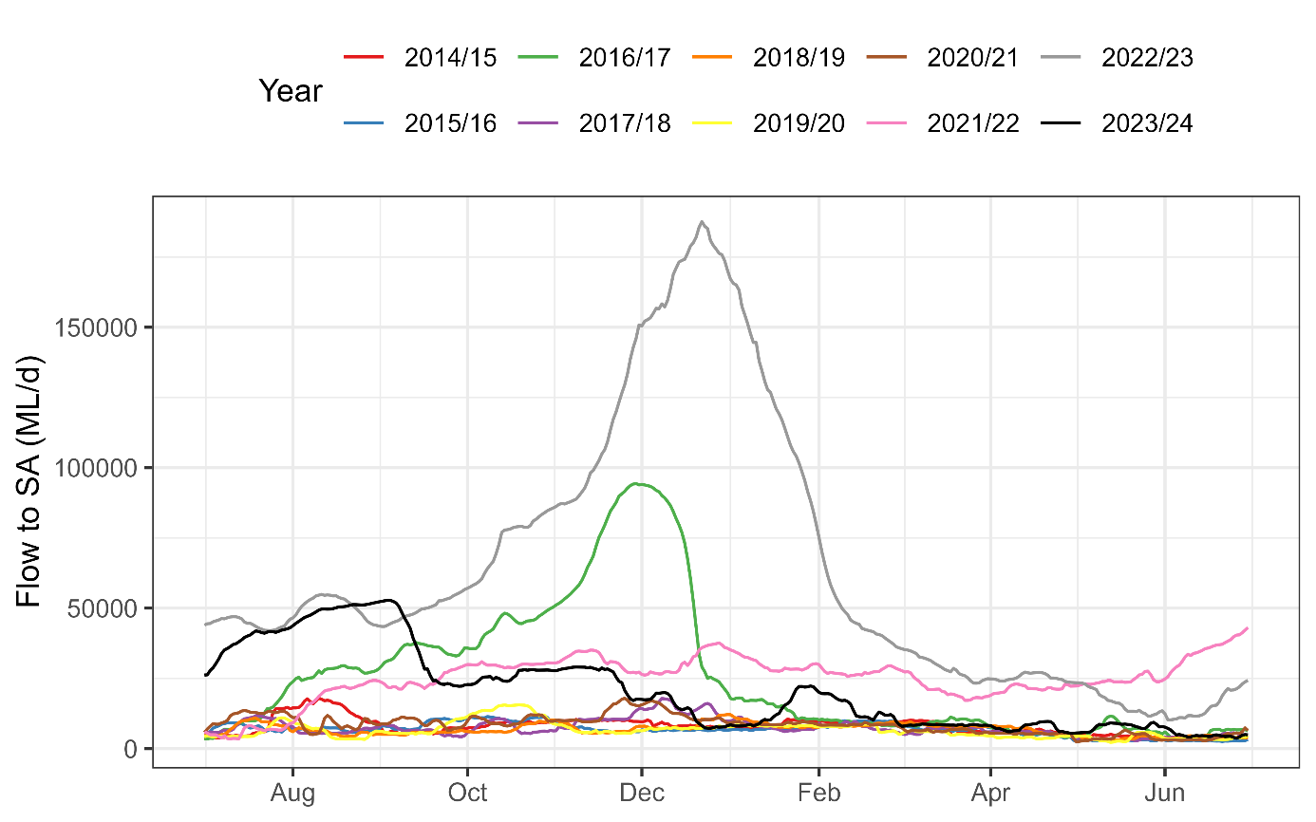
Figure 12. Flow at the South Australian border over the 10 years of LTIM and Flow-MER reporting.
Undoubtfully, some of the increase in lotic conditions created in more recent years is a result of increased coordination of delivery of Commonwealth environmental water from different tributaries, as well as coordination between different water holders, enabling higher flows to be delivered into the LMR. The contributions reported here are primarily based only on Commonwealth environmental water, assuming any other environmental water would have been delivered in the same manner and underpins the Commonwealth environmental water contributions. Further analysis in future years, during more regulated conditions, may allow this distinction between improved coordination of environmental water delivery and increased water resource availability (i.e. unregulated flow in the past three years) to be further untangled.
Over past years, broad scale inundation across the LMR has been the result of unregulated flows rather than environmental water, occurring at flow magnitudes far larger than that can be released under regulated conditions. The increases in flow due to Commonwealth environmental water up to 29,025 ML/d in 2023-24 resulted in increased water levels, in the tailwater of some weir pools by up to 0.9 m, creating over 2,000 Ha of low-lying inundation (Figure 7 and Figure 9). Over the ten years of evaluation, the event preceding the flood peak in 2022-23 was the largest contribution by Commonwealth environmental water to increased floodplain inundation in the Lower Murray Selected Area without the use of infrastructure. During this event, mean flow to SA increased from 46,786 to 52,242 ML/d between 7 and 27 August 2022, resulting in inundation of an additional 5,027 Ha of the floodplain.
With ten years of results, relevant Basin-wide Environmental Watering Strategy (BEWS) (MDBA 2025) expected outcomes can also be reviewed:
- For longitudinal connectivity, the expected environmental outcome is a 30% overall increase in flows in River Murray tributaries, and a 30 to 40% increase in flows to the Murray Mouth. As a total volume over the ten years, this increase has been 10% at the South Australian Border and 23% at the barrages.
- Another expected environmental outcome for longitudinal connectivity is to increase baseflows to at least 60% of the natural level. The definition of this metric used in MDBA (2012b) has been adopted here, with a baseflow index (BFI) derived from the Basin Plan WoD scenario (MDBA 2012a), and different BFI proportions for the low flow and high flow seasons. The resulting baseflow requirement at flow to SA is seen in Figure 13, along with the recorded flows (All Water) and the No CEW scenario. There are 21 of 120 months where the baseflow requirement is not met without Commonwealth environmental water, which reduces to 12 months with all environmental water delivered. The average deficit over months with some deficit in the No CEW scenario was 61 GL/month, with the average over the same 21 months reduced to 28 GL/month with Commonwealth environmental water delivered. The timing of the deficits ranged from May to October, where of the 12 months with some deficit with all environmental water delivered, four occurred during September, three in June, two in May, with one in each of the remaining months.
- There is a lateral connectivity expected outcome of a 30 to 60% increase in the frequency of freshes, bankfull and lowland floodplain flows. It is unclear how to evaluate this expected outcome, however the evaluation of DEW EWRs in Appendix D provides some indication of increases in these events. There has been at least one additional EWR met in five of the ten years, indicating an increase within this expected frequency. However, in three of these five years there was only one additional EWR met, the 10,000 ML/d for 60 days indicator, which is too low of a discharge to represent lateral connectivity or a fresh event. The additional EWRs met in 2021-22 and 2023-24 due to Commonwealth environmental water are more representative of freshes, but not creating bankfull or lowland floodplain flows.
Hence there has been progress toward achievement of the BEWS expected outcomes for river flows and connectivity. However, the outcomes have not been fully realised over the past ten years of evaluation. Basin Plan implementation is ongoing with the long-term diversion equivalent volume (LTDE) held by the CEWH increasing from 1,585 GL in 2014-15 to 2,034 GL in 2023-24. Hence, these BEWS expected outcomes may not be anticipated to be achieved yet as the Basin Plan is not fully implemented (referred to as time bound outcomes in the BEWS). The BEWS outcomes are based on a modelled scenario over the historical climate period of 1895–2009 with 2,750 GL of water recovery. Under different conditions, e.g. a drier climate or a lower LTDE volume of Commonwealth environmental water holdings, these volume-based outcomes would also be expected to reduce. The recent revision to the BEWS flags that Expected Environmental Outcomes will be revised in the next review of the strategy due to improved understanding of hydrological and ecological processes since the first draft of BEWS in 2014 while being guided by broader policy and planning issues under consideration through the 2026 Basin Plan Review and 2027 Water Act Review (MDBA 2025).
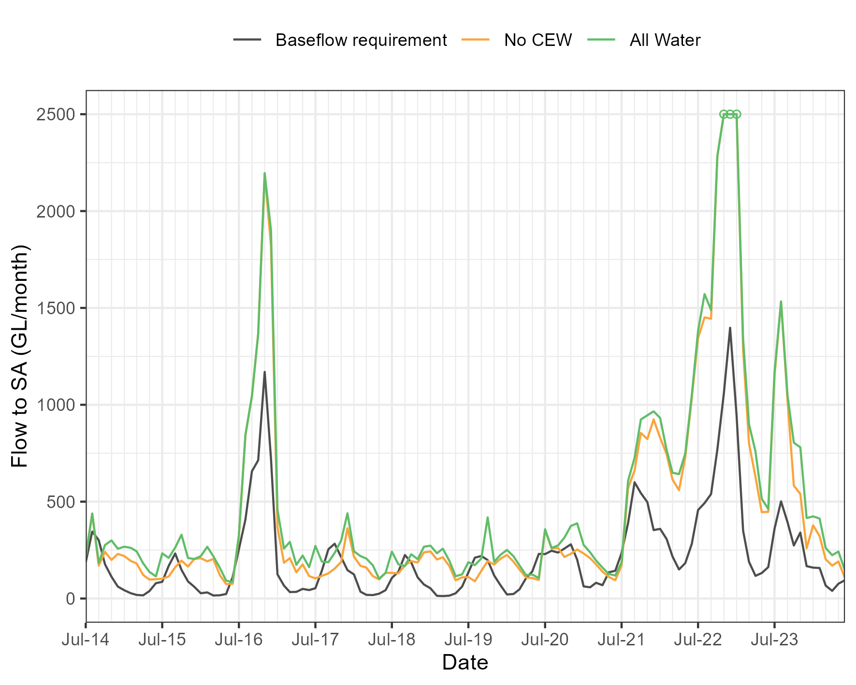
Figure 13. Baseflow requirement for the Basin-wide Environmental Watering Strategy expected environmental outcome at flow to SA, compared to the flow delivered (all water) and that expected without Commonwealth environmental water. Note the y-axis is limited to 2,500 GL/month to enhance detail, with the high flow months in 2022-23 that exceeded this volume (peaked at 5,272 GL/month) indicated by circles.

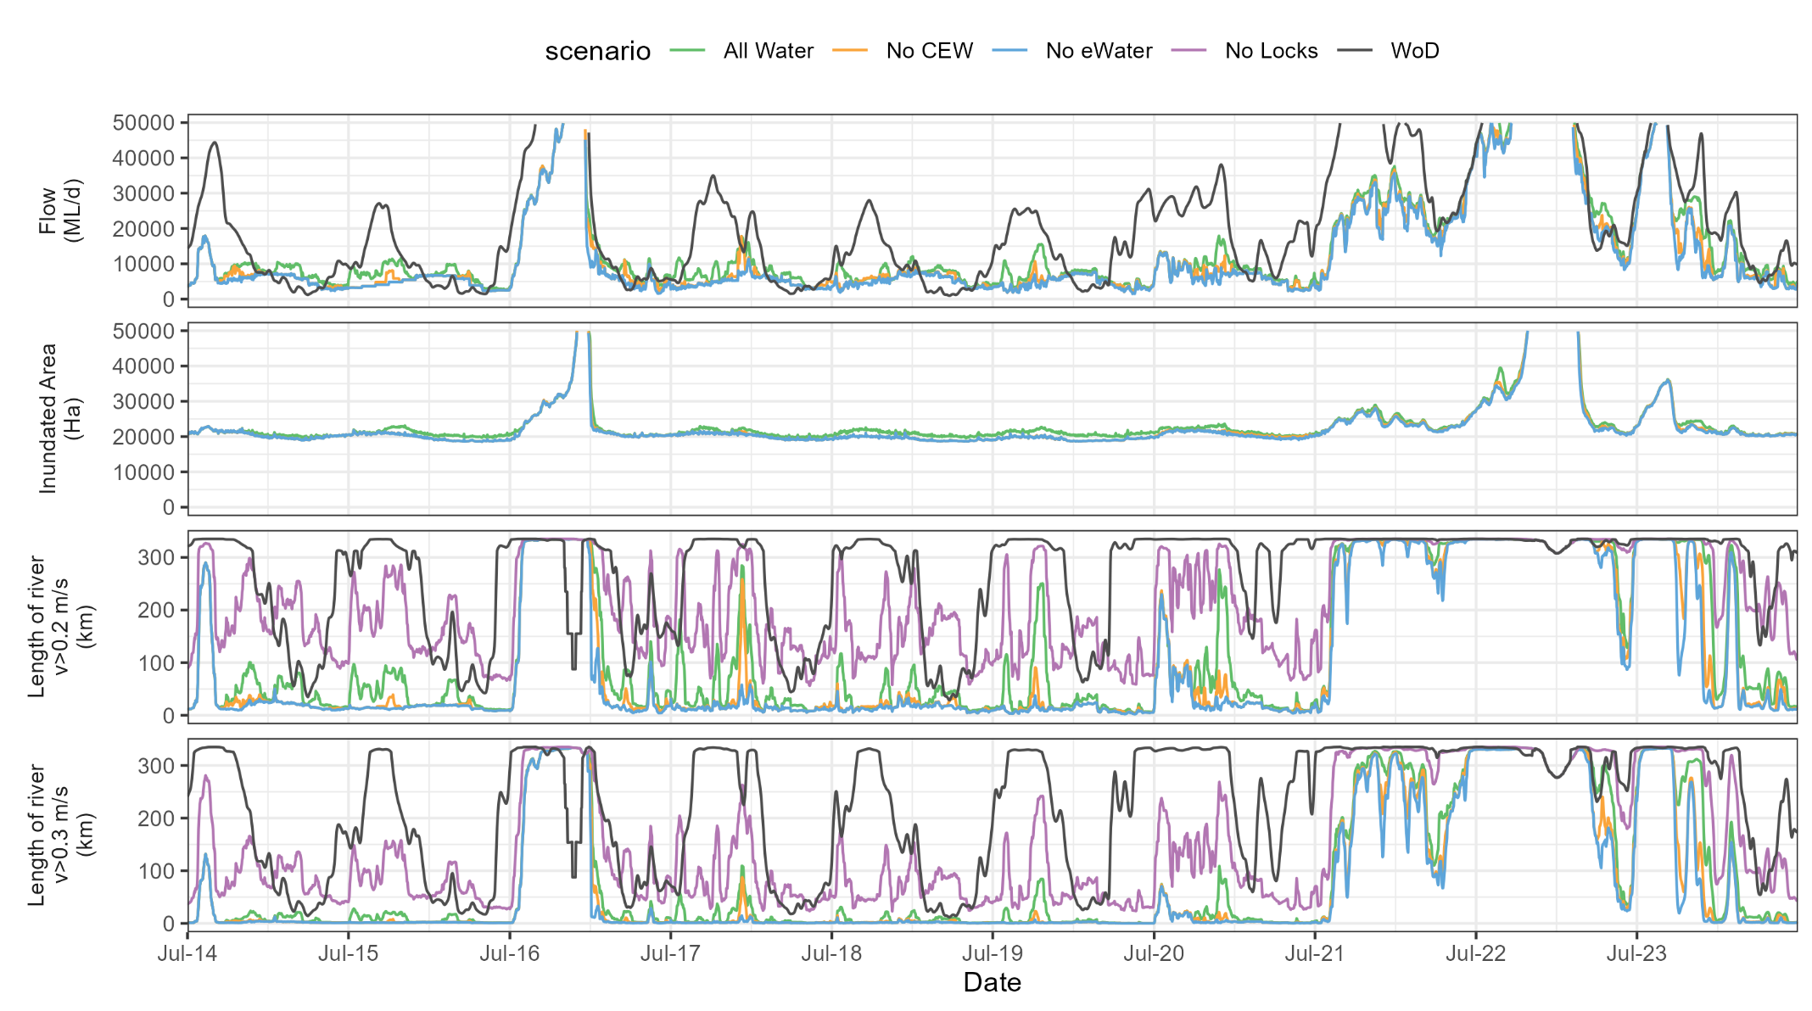
Figure 14. a) Discharge (flow at the South Australian border), b) inundated area between Wellington and Lock 6, and length of river with faster flowing velocities (c) v>0.2 m/s and d) v>0.3 m/s) for the Lower Murray River (LMR) between Locks 1 and 6 (excluding anabranches) over the 10 years of LTIM and Flow-MER evaluation. Maximum discharge and surface area shown limited to a maximum value of 50,000 ML/d.

Conclusion
The 1,384 GL of Commonwealth environmental water delivered to the LMR in 2023-24 is the largest volume in the past ten years. Over the 30 days following 24 September 2023, when flow would have started to recede without environmental water, 225 GL of Commonwealth environmental water was delivered to increase the average flow to SA from 17,136 ML/d to 24,620 ML/d, at an ecologically beneficial time over spring. Increases in flow to SA in this range result in proportionally larger increases in velocity, with the increase in the average length of river with a velocity >0.3 m/s from 132 km to 259 km, and a maximum daily increase of 215 km, 64% of the reach considered.
Over the ten years of LTIM and Flow-MER evaluation, the largest increase in the extent of river experiencing velocities greater than 0.2 m/s over the year, due to Commonwealth environmental water, was in 2023-24, at 13,056 km d. For a velocity threshold of 0.3 m/s, the increase due to Commonwealth environmental water was 12,586 km d, by far the largest increase in the past ten years, 45% larger than the next biggest contribution to lotic conditions in 2021-22.
These increased discharge rates also contributed to increased water levels in tailwaters of weir pools with maximum increases due to Commonwealth environmental water from approximately 0.6 m below Lock 1 up to 0.9 m at the upper end of Weir Pools 1 and 2. Combined along the river from Lock 6 to Wellington, the higher water levels were sufficient to create additional low-level inundation, with more than 2,000 Ha of additional inundated area over 15–22 November 2023.
The year 2023-24 marks ten years of evaluation since the start of LTIM and provides an opportunity to review longer term expected outcomes as defined in the BEWS. Commonwealth environmental water has made a clear contribution toward each of these expected outcomes relevant to the River Flows and Connectivity theme in the Lower Murray Selected Area. However, with Basin Plan implementation ongoing, the expected outcomes are not considered to have been fully achieved to date.

Stream Metabolism and Water Quality

Background
River food webs require basal supplies of organic food resources to sustain their structure and function. The two fundamental sources of basal organic materials are internal (autochthonous) supplies generated by planktonic and benthic photoautotrophs, and external (allochthonous) supplies of terrestrial organic carbon imported from the surrounding catchment (Berggren and del Giorgio 2015; Whitworth and Baldwin 2016). Understanding the influence of environmental flows on these carbon supply processes is important if flows are to be managed to enhance the river environment.
Aquatic photoautotrophs comprised of microalgae, cyanobacteria and submerged macrophytes, form new organic materials through photosynthesis (Sellers and Bukaveckas 2003; Oliver and Merrick 2006; Oliver and Lorenz 2010; Várbíró et al. 2018). In the Murray River, increased water extractions and substantial flow modifications have reduced the areas of macrophytes and littoral benthic autotrophs, with most primary production attributed to phytoplankton (Oliver and Merrick 2006; Oliver and Lorenz 2010). The availability of light for phytoplankton photosynthesis is determined by the relative depth of light penetration and the intensity of water mixing that circulates phytoplankton through upper illuminated surface layers. The photosynthetic formation of organic materials is also regulated by nutrient availability (Reynolds 1984) which depends on the water quality coming from the various supply catchments. Environmental water contributions affect flow rates and water quality, influencing the supply of autotrophic basal food resources.
Terrestrial organic material enters rivers from wind movement, or from overhanging or fringing vegetation, but in floodplain rivers like the Murray, the major source is accumulated floodplain terrestrial material transported to the river through floods (McGinness and Arthur 2011; Whitworth and Baldwin 2016). Terrestrial carbon enters in particulate and dissolved forms but dissolved organic carbon (DOC) predominates and is a major driver of heterotrophic respiration and production, largely due to bacteria (Graeber et al. 2018). Flow patterns are important in determining the sources and supply of terrestrial organic carbon and nutrients from the floodplain. Environmental flows influence these connections and impact the allochthonous supplies of carbon and nutrients to the river food web (Oliver and Merrick 2006; Baldwin et al. 2016).
To explore the links between carbon supply processes and environmental flows, river metabolism measurements were used to estimate in-stream rates of gross primary production (GPP) and ecosystem respiration (ER) (Odum 1956; Young and Huryn 1996; Oliver and Merrick 2006). Comparing rates of photosynthesis and respiration identifies the fundamental trophic energy connections that characterise different food web types. They indicate whether production or decomposition processes predominate, and whether the organic food materials have come from within the river or from the surrounding landscape. The magnitude and characteristics of the metabolic processes indicate the size of the food web and its capacity to support higher trophic levels (Odum 1956; Sellers and Bukaveckas 2003; Oliver and Merrick 2006; Oliver and Lorenz 2010). As concentrations of dissolved oxygen (DO) are monitored to estimate rates of stream metabolism, the measurements provide ancillary information on the suitability of oxygen levels for aquatic biota.
Net ecosystem production (NEP), the difference between GPP and ER, is a measure of the system carbon balance. NEP has been used as an estimate of the basal food resource supply (Odum 1956; Young and Huryn 1996; Oliver and Merrick 2006) but this implicitly assumes that photosynthetic carbon fixation is the primary source of organic material catabolised in respiration which is not usually the case. Ecosystem respiration also includes contributions from the heterotrophic decomposition of organic materials and should not be subtracted from GPP. Laboratory studies show that organic carbon recently fixed through photosynthesis is a primary source for phytoplankton respiration (Beardall and Raven 1990). In contrast, heterotrophic respiration that underpins heterotrophic production depends on the decomposition of preformed organic materials sourced from the environment. This component of respiration supports heterotrophic production, an additional food resource not considered in the NEP calculation. Identifying separately the respiration associated with phototrophs and heterotrophs is essential to estimating the net production that each contributes to basal food resources (Graeber et al. 2018).
The primary objectives of this study were to determine the specific influences of environmental flows (especially Commonwealth environmental water) on river metabolism and basal food supplies. Field measurements were made under flow conditions that included contributions of environmental water so assessing their specific influence required an estimate of the counterfactual conditions of flows without environmental contributions. To achieve this, the major drivers of metabolism were identified and linked to river discharge, so that the specific effects of increased flows due to environmental water could be detected. A wide range of flow conditions were investigated with monitoring undertaken for a ten-year period from 2014 to 2024.
Major hypotheses
The following major hypotheses were addressed by the monitoring.
In the spring/summer period, the increased flows and improved patterns of delivery into the LMR due to contributions of environmental water would:
- Increase phytoplankton photosynthesis and the supply of autochthonous organic carbon to food webs if the flow changes improved growth conditions, for example through enhanced light and nutrient availability.
- Enhance ER rates and heterotrophic production if flows increased the supply of organic carbon either through improved primary production or by better connecting the channel with riparian, wetland or floodplain areas so improving the supply from allochthonous sources.
- Reduce the likelihood of low DO concentrations by increasing water mixing and oxygen exchange at the water surface in otherwise low flow zones.

Methods
Field sites and sampling
The three monitoring sites in the Lower Murray River were downstream of Locks 6, 4 and 1, respectively 616, 501 and 265 river kilometres upstream of the Murray Mouth (Figure 1). Each monitoring site was several kilometres below the corresponding lock (7, 15 and 10 km respectively), to ensure that flow conditions had re-established, as higher water velocities and increased turbulence enhance the likelihood that single station metabolism measurements represent river channel conditions. Monitoring occurred continuously from September to February/March each year (2014–2024), with interruptions of one day every 2 to 4 weeks for probe maintenance.
Rates of stream metabolism were estimated using the single station DO method, with a probe deployed at a depth of 0.5 m monitoring DO concentration and temperature at ten-minute intervals. Matching incident Photosynthetically Active Radiation (PAR) was monitored at unshaded shore stations.
Two metre, depth-integrated water samples were collected during site field trips (~fortnightly), and analysed for chlorophyll-a, total nitrogen, combined nitrate and nitrite, ammonium, total phosphorus, dissolved forms of phosphorus, and DOC (Hale et al. 2014; Ye et al. 2018). In addition, the vertical light attenuation for PAR was measured on each occasion using LiCOR underwater sensors. Collected water quality data were supplemented with monitoring data from nearby sites provided by the Australian Water Quality Centre of SA Water.
The sampling regime resulted in a limited number of dates per monitoring season (~8–12 per site) when water quality measurements coincided with metabolism measurements. To increase sample numbers, water quality measurements and vertical attenuation coefficients were considered relevant for three days before and three days after sampling in some analyses.
Estimating metabolic rates
Daily volumetric rates (gO₂/m³/d) for GPP and ER were estimated from midnight to midnight with the BASE program (Grace et al. 2015). This uses Bayesian regression routines to fit the measured changes in DO concentrations to a widely applied model describing daily fluctuations in water column DO concentrations (Odum 1956; Young and Huryn 1996; Oliver and Merrick 2006):
$$∆DO=GPP(I)+ER+k(DOsat-DO) (1)$$
The change in DO is determined by the balance between GPP, a function of light intensity (I), ER, considered constant over the day, and the exchange of oxygen at the water surface, a function of the gas exchange coefficient (k) and the oxygen deficit, calculated as the difference between the actual DO concentration and the expected saturation concentration at the water temperature (DOsat).
Despite metabolism measurements being derived from reliably modelled daily DO data, their suitability for exploring responses to environmental conditions required that they represented conditions in the river. To gauge their veracity, the estimated time-based gas exchange coefficients (K/min) were compared with flow velocities, as these are correlated when water turbulence is velocity driven (Ulseth et al. 2019; Ye et al. 2023).
Daily flows measured during the monitoring periods were adjusted using hydrological modelling to estimate the flows and water levels that would have occurred without Commonwealth environmental water, or without any environmental water (Figure 5a and Figure 9). The analyses of hydrological influences on metabolism assumed that modelled flows without environmental water had the same water quality. Volumetric rates of metabolism were integrated over river depth and width based on channel dimensions derived from morphometric models linked to water level at each of the sites (Section 2.1). Cross-sectional metabolic rates were calculated as the product of the volumetric rate and the average cross-sectional area (m²), yielding cross-sectional rates for a 1 m length of river. Metabolic rates were integrated over time by summing daily rates. Oxygen-based metabolic rates were converted to carbon units by assuming photosynthetic and respiratory quotients were equal to one.
The influence of light on photosynthesis was determined from the mean light intensity encountered by phytoplankton mixed through the water column (Oliver and Merrick 2006) which depends on the incident irradiance (I₀), the vertical attenuation of light in the water column (k_{d}), and the average water depth (z_{ave}). As the average depth was always greater than the depth of the illuminated surface layer, the mean irradiance (Im) could be calculated as:

$$Im=Io/(kd*Zave) (2)$$

Phytoplankton biomass was estimated from the chlorophyll concentration. Chlorophyll was converted to carbon by assuming it comprised 2.5% of cell ash-free dry weight and that cell carbon comprised 50% of ash-free dry weight (Reynolds 1984), resulting in a multiplier of 20.
NEP, the difference between GPP and ER, gave an integrated system measure of the metabolic balance. The separate contributions to ER by photosynthetic and heterotrophic microbiota were assessed using multiple regression with potential respiratory sources as explanatory variables. GPP measured the organic carbon produced by photosynthesis, considered a major source of phytoplankton respiration (Beardall and Raven 1990). DOC concentrations measured the resource supply for respiration of heterotrophic microbes, considered to be mainly bacteria. The phytoplankton net production (PNP) was calculated as the difference between the measured GPP and the phytoplankton community respiration (PCR) estimated from the multiple regression model. Bacterial gross production and net production could not be estimated directly from metabolism measurements. Instead, bacterial net production rates (BNP) were determined from the relationship between bacterial community respiration (BCR), estimated from the multiple regression model, and bacterial growth efficiency (BGE):

$$BNP=(BGE*BCR)/(1-BGE) (3)$$

The BGE is influenced by a range of environmental conditions, including the chemical composition of DOC, and ranges from 0.05 to 0.4 (Rivkin and Legendre 2001; Marra and Barber 2004; Berggren and del Giorgio 2015). An average value of 0.2 was considered appropriate for the Murray River from its typical temperature and water quality characteristics (Rivkin and Legendre 2001; Marra and Barber 2004; Berggren and del Giorgio 2015).
Data selection
Rivers are complex environments with a multitude of interactions influencing the DO. Many of these are not captured in Equation 1, and it did not always reliably model the observed diel changes in DO, at times yielding regression coefficients of the wrong sign (±) and of unlikely magnitude. Analyses of metabolic rates were restricted to days when modelled daily DO fluctuations closely matched the observed data.

Results
Monitoring conditions
Flows differed between years, with peaks occurring in different months depending on water supply requirements and at times occurrences of high unregulated flows (Figure 15). Within seasons, flow volumes were similar across the three sites and were predominantly below 15,000 ML/d, apart from the flood years of 2016-17 and 2022-23, and the high flow years of 2021-22 and 2023-24. Sometimes, flows below Lock 6 were lower than at other sites, especially during high flow periods, when larger volumes entered the Chowilla anabranch, returning to the river downstream of the monitoring site below Lock 6. The peak flow of 185,860 ML/d in 2022-23 was the highest measured since the maximum recorded flows of 1956, and the ten-year monitoring period captured the range of historical flows.
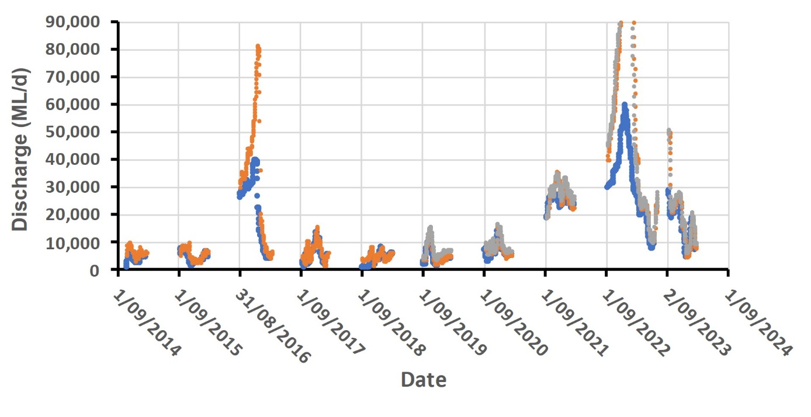
Figure 15. Water discharge at sites below Lock 6 (●), Lock 4 (●) and Lock 1 (●) for each monitoring period from 2014 to 2024. Peak discharge in 2022-23 was 186,000 ML/d at Lock 4 and Lock 1.
Apart from the flood and high flow years, cross-sectional areas and average depths remained relatively stable at each monitoring site due to low flows and the regulating weirs (Figure 16). There were marked differences between sites, with water depths and cross-sectional areas ~1.5 times larger below Lock 1 than Lock 6, while the site below Lock 4, added in 2019-20, spanned the other two sites during low flows but was comparable with Lock 1 during high flows (Figure 16). Morphometric differences between sites created a range of hydrological and hydraulic conditions to assess patterns of metabolic responses to changing flows.
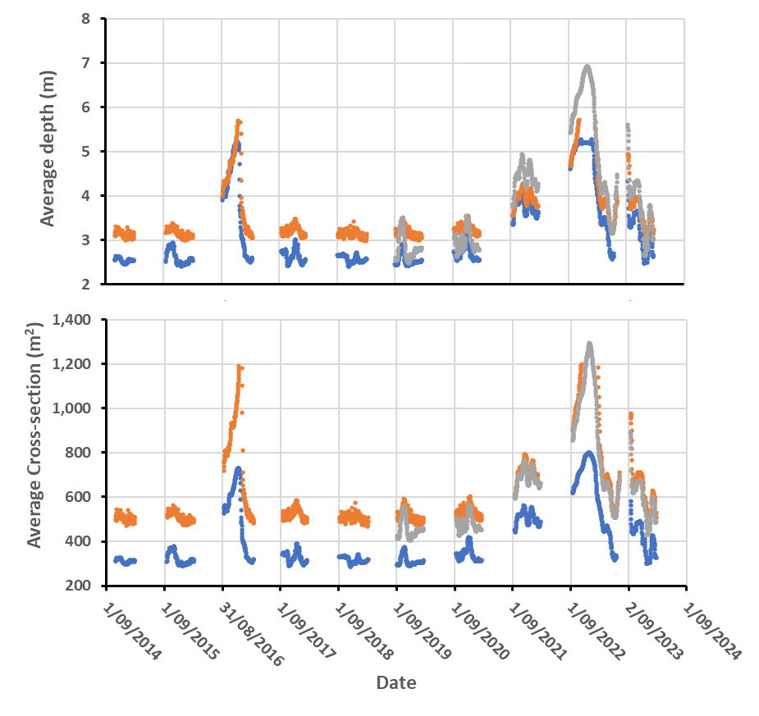
Figure 16. Average depth and average cross-sectional area downstream Lock 6 (●), Lock 4 (●) and Lock 1 (●) for each monitoring period from 2014 to 2024.

Within year changes in incident irradiance and water temperature were similar across sites, and interannual differences were relatively small, the typical pattern demonstrated with data from below Lock 6 (Figure 17). Water temperatures increased over the monitoring periods by 10 to 15⁰C with maxima near 28⁰C (Figure 17).

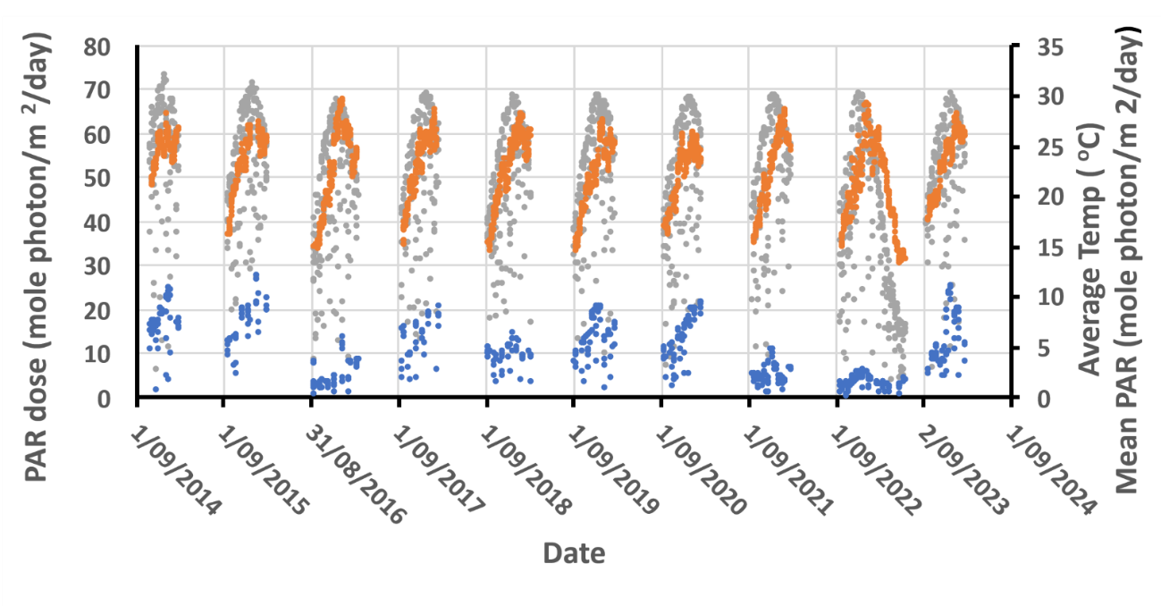
Figure 17. Incident PAR dose (●), mean PAR irradiance in the water column (●) and average water temperature (●) below Lock 6, representative of all sites, for each monitoring period from 2014 to 2024.

Dissolved oxygen (DO)
Average daily DO concentrations during the 2014–2024 monitoring seasons were typically close to saturation levels except during the flood years of 2016-17 and 2022-23, when concentrations declined precipitously as water level increased (Figure 18). During the 2016-17 flood, DO reduced to 0 gO₂/m³ (0% saturation) below Lock 6, and 1.8 gO₂/m³ (21% saturation) below Lock 4. Similar reductions occurred during the 2022-23 flood, to 1, 2 and 3 gO₂/m³, 11%, 27% and 39% saturation respectively downstream of Locks 6, 4, and 1 (Figure 18). In both floods, DO remained below the 5 gO₂/m³ level considered critical to the support of aquatic organisms for ~2 months.
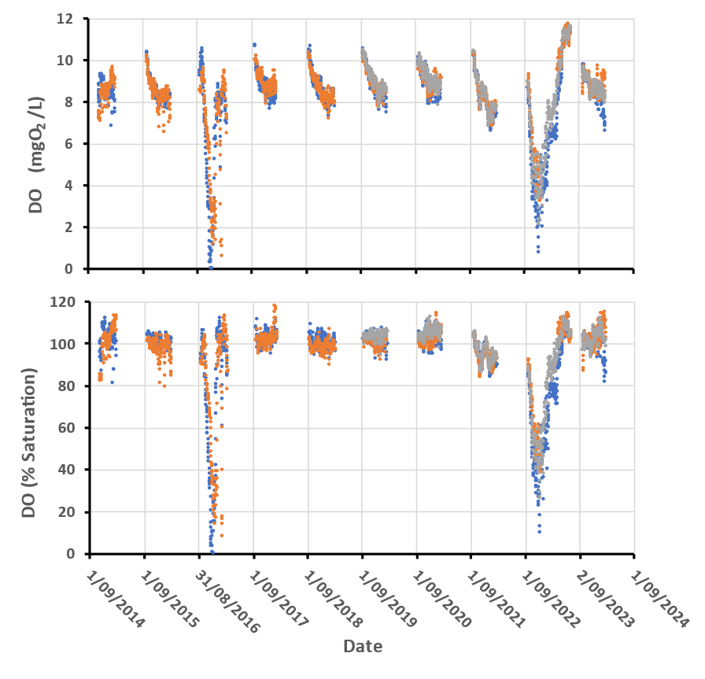
Figure 18. Dissolved oxygen (DO) concentrations and percent saturation at sites downstream of Lock 6 (●), Lock 4 (●), and Lock 1 (●) for each monitoring period from 2014 to 2024.
Metabolism estimates
During the ten years of monitoring, there were periods when metabolism measurements were unavailable due to probe failures, reduced access by flooding, and changed hydraulics due to flow management strategies, totaling a loss of 661 data days. In addition, diel DO patterns were not always well described by Equation 2, with more complex DO fluctuations yielding poor regression fits and unreliable coefficients. Daily data that did not fit the model were removed from analyses, leaving a total of 2,552 data days, respectively 919, 557, and 1,076 below Locks 6, 4 and 1, with data reductions of 41%, 35%, and 28% across the sites.
Daily metabolic rates
In each monitoring period, river metabolism typically started at low rates near (±)1 gO₂/m³/day, positive for GPP and negative for ER, then typically increased in magnitude (±) to maxima that were sustained over the final few months (Figure 19). The extent of rate increases differed between years with 2021-22 showing little change over the season, whereas 2020-21 and 2023-24 reached maxima between 4 and 6 gO₂/m³/day (Figure 19; Figure 20). Daily variations within seasons were sometimes large as metabolism responded to rapid shifts in environmental conditions. Seasonal differences reflected large-scale environmental changes, with metabolism rates during 2021-22 curtailed, and those during the final 2023-24 season expanded in range (Figure 20). This expanded range covered many of the earlier periods and provided a means of confirming whether responses to environmental conditions from earlier restricted ranges concurred and could be combined into a single model.
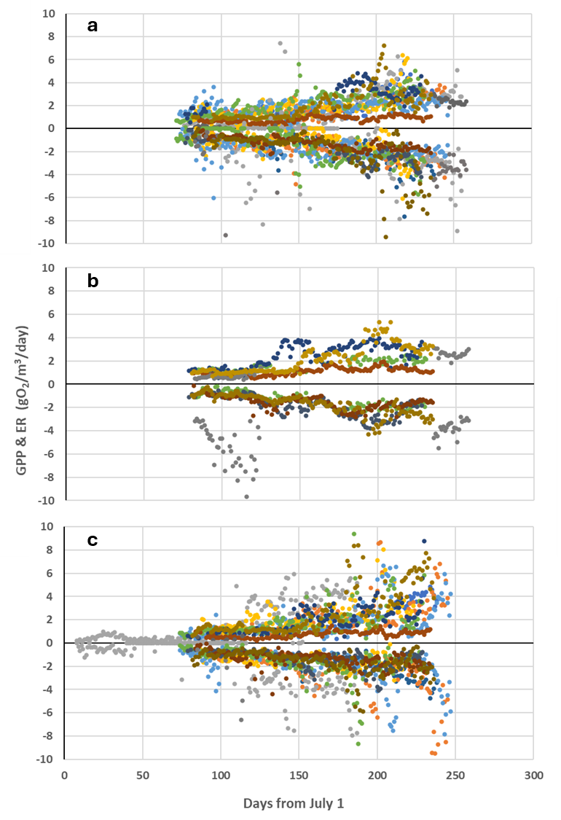
Figure 19. Daily gross photosynthesis (GPP, positive rates) and ecosystem respiration (ER, negative rates) at sampling sites downstream of (a) Lock 6, (b) Lock 4 and (c) Lock 1, on day number from July 1 for each monitoring period: 2014-15 (●), 2015-16 (●), 2016-17 (●), 2017-18 (●), 2018-19 (●), 2019-20 (●), 2020-21 (●), 2021-22 (●), 2022-23 (●), 2023-24 (●).

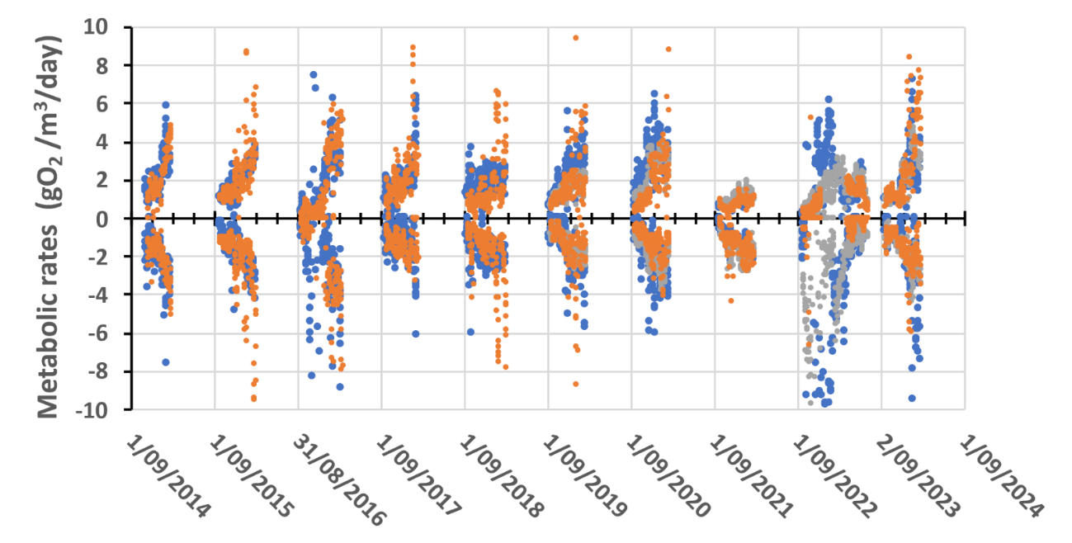
Year
Figure 20. Annual time series of daily gross photosynthesis (GPP, positive rates) and ecosystem respiration (ER, negative rates) at sampling sites downstream of Lock 6 (●), Lock 4 (●) and Lock 1 (●), for each monitoring period from 2014 to 2024.

Gas exchange estimates
Across all sites, the patterns in the gas exchange coefficient (K) were remarkably similar, with K increasing smoothly as mean water velocities increased from 0.18 to 0.4 m/s (discharge range ~7,000 to 20,000 ML/d), in a manner equivalent to reported relationships (Ulseth et al. 2019). Below the lower velocity boundary, the highly variable and at times unlikely values of K, suggested potentially unreliable river metabolism estimates (Figure 21). These responses were attributed to the increasing potential for reduced mixing and thermal stratification as flow declined below 7,000 ML/d (Bormans et al. 1998). The upper flow velocity boundaries, (0.52, 0.43 and 0.4 m/s below Locks 6, 4, and 1, respectively), marked unexpected declines in gas exchange coefficients that suggested potentially unreliable river metabolism estimates. These declines were attributed to the increasing interaction between the river channel and low-lying floodplain areas at the corresponding discharge rates (~19,000–24,000 ML/d).

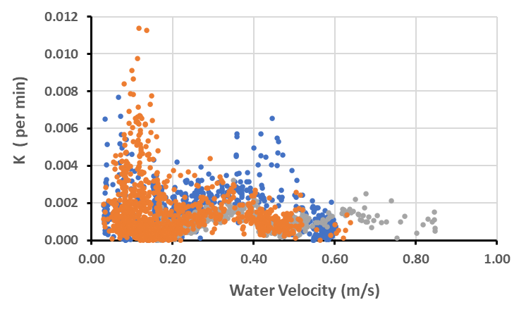
Figure 21. The relationship between the gas exchange coefficient (K) and water velocity at sampling sites downstream of Lock 6 (●), Lock 4 (●) and Lock 1 (●) for all monitoring periods from 2014 to 2024.

Influence of flow on light and gross primary production
Rates of GPP were standardised to the chlorophyll concentration (GPP(b)) and compared with corresponding mean irradiances (Im). The sample size was increased by assuming that chlorophyll concentrations were constant for three days before and after the sampling date to include a wider range of GPP values. Reductions in this time range had minor effects on the derived relationship. The data of 794 days (267, 206, 321 below Locks 6, 4 and 1 respectively), demonstrated a significant correlation between GPP(b) and Im (Figure 22).

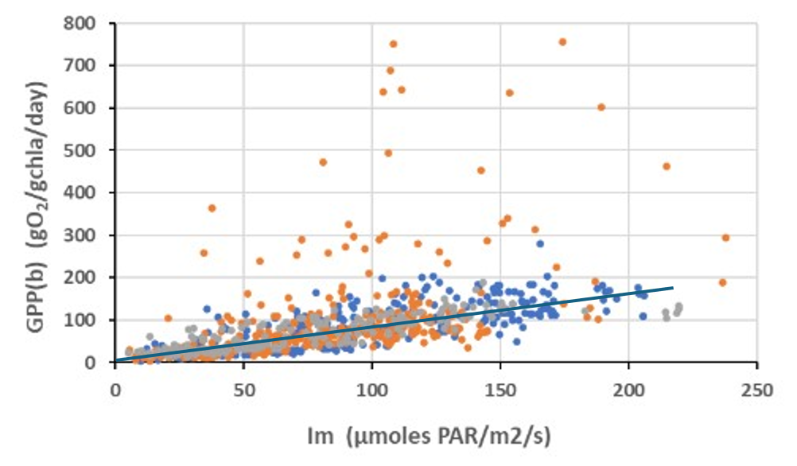
Figure 22. The relationship between gross primary production per unit chlorophyll (GPP(b)) and the mean irradiance (lm) of the water column for all monitoring periods from 2014 to 2024 at sampling sites downstream of Lock 6 (●), Lock 4 (●) and Lock 1 (●), and the linear regression for all data except when water velocity was <0.18 m/s below Lock 1.
A few samples downstream of Lock 1 did not match the general relationship, with high specific production rates unresponsive to changes in irradiance. These 33 dates occurred when water velocity was less than 0.18 m/s. Not all data below the low velocity boundary at Lock 1 showed this disparity, but an environmental cue to enable their objective separation could not be identified and all were removed from the correlation. The remaining data across all sites yielded the regression:
GPP(b) = 0.81(±0.02)*Im + 4.34(±2.29) r²=0.63
As GPP(b) was expected to be zero when Im was zero, and the regression constant was not significantly different from zero, a linear regression was forced through the origin and yielded a slope of 0.85, not significantly different from the full regression. This relationship was used to assess the influence of different flow scenarios on relative changes in GPP(b). As incident irradiance and the vertical attenuation coefficient were considered unchanged when comparing daily actual and counterfactual flow scenarios, Im (Equation 2), and so GPP(b), depended inversely on the average depth. The ratio of GPP(b) estimates from daily flow scenarios was then equivalent to the ratio of the different average depths as:
GPP(b) = 0.85 Im/(kd*zave)
GPP(b)1/GPP(b)2 = zave2/zave1
Conversion of modelled GPP(b) rates to estimates of GPP required knowledge of the chlorophyll concentration, but as this was assumed to be the same with and without environmental water, relative daily changes in GPP(b) and GPP were equivalent. This approach aligned with the general assumption that on any day the supply of water to the LMR had the same water quality characteristics under all flow scenarios.
Delivery of environmental water increased water depth and reduced Im with associated reductions in GPP(b) and GPP (Figure 23). Relative reductions due to Commonwealth environmental water ranged from almost zero to 26%, with the smallest ranges below Lock 1 (maximum 11%), then below Lock 6 (maximum 19%) and the largest below Lock 4 (maximum 26%), reflecting different depth responses to discharge. The number of days with reductions in GPP greater than 10% illustrated the integrated impacts across sites, with those below Locks 6 and 4 in some years having reductions for 4 to 11 weeks (Figure 23). Such prolonged reductions in primary production are expected to reduce basal food resource concentrations.
Rates of GPP described the volumetric primary production supply but not the total supply to the river, which was estimated from the product of GPP and the cross-sectional area of the flow. Relative changes in cross-sectional GPP due to Commonwealth environmental water were estimated from the relative change in average depth, and the corresponding relative change in cross-sectional areas. Despite some large reductions in the volumetric GPP due to environmental water (Figure 22), the cross-sectional production per linear metre was less impacted, as relative increases in cross-sectional areas were often of similar size or larger than the relative reductions in GPP. These opposite effects were a function of the relationship between depth and cross-sectional area at the different sites. The changes in cross-sectional production due to Commonwealth environmental water were increases of up to 6.4% below Lock 6, decreases of 3% to increases of 1% below Lock 4, and increases of up to 6% below Lock 1 (Figure 23). The longest period in any season when cross-sectional GPP increased by more than 5% was 17 days.

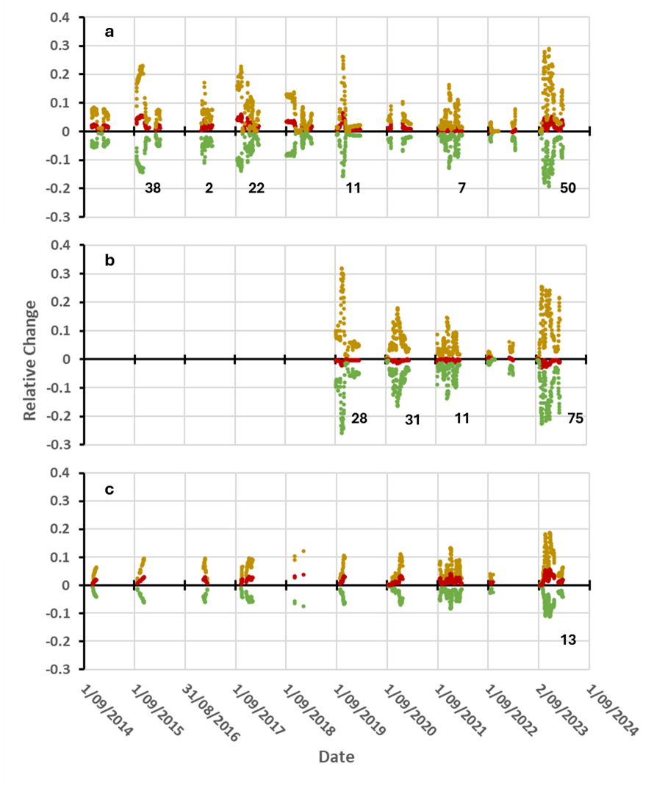
Figure 23. Fractional changes in volumetric GPP (●) cross-sectional area (●) and cross-sectional GPP (●) and the number of days each season that the decrease in volumetric GPP due to Commonwealth environmental water was greater than 10% at the sites downstream of Lock 6 (a), Lock 4 (b) and Lock 1 (c).
The seasonally integrated effects of Commonwealth environmental water delivery on volumetric and cross-sectional GPP were estimated by comparing the adjusted rates summed over available days with the measured rates summed over the same days. In some monitoring periods, the number of data days were similar to the deployment days and seasonal integrals were estimated, whereas at other times the data days were substantially less, and sums did not estimate seasonal integrals but indicated the influence of additional flows on metabolism. This is depicted for the sites below Locks 6 and 4, that were most strongly affected (Figure 24).
The largest relative reduction in integrated volumetric GPP was by 10% below Lock 4 during 2019-20 and 2023-24, while the largest relative reduction below Lock 6 was by 6% in 2023-24. The largest relative increase in cross-sectional GPP was by 2% below Lock 6 over each studied period from 2014-15 to 2018-19 and then again in 2023-24 with insignificant changes in other seasons. Below Lock 4, all seasonal changes in cross-sectional GPP were insignificant.

Determinants of ecosystem respiration and net production
A primary source of organic carbon within the river channel was GPP that supported autotrophic respiration and growth, with net production contributing to basal food supplies. A plot of the dependence of ER on GPP across all sites indicated extended periods of strong correlation, but with times of significant variation (Figure 25). Bacterial catabolism of DOC from autotrophs or external sources also contributed to ER, supporting heterotrophic production and returning an additional basal food source for consumers. To apportion ER between these two pathways, a multiple linear regression was applied with GPP and DOC in carbon units (gC/m³/day) as explanatory variables. Metabolism data with matching DOC measurements from all sites and years (n = 343) yielded the relationship:

$$ER = 0.76 (±0.05)*GPP + 0.07 (±0.02)* DOC - 0.23 (±0.13), { r}^{2}=0.44$$

The significant regression coefficients were used to estimate the separate contributions to respiration, from which were calculated the corresponding phytoplankton net production (PNP), and bacterial net production (BNP).

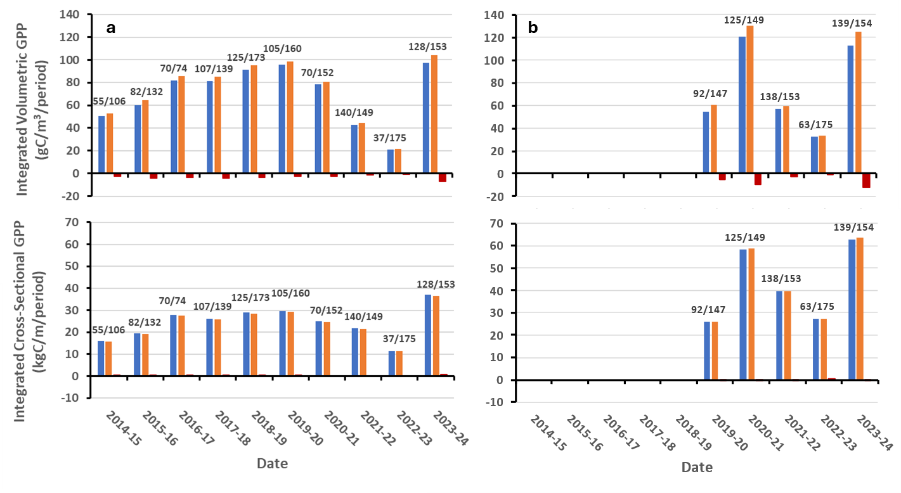
Figure 24. Integrated volumetric and cross-sectional GPP with (●) and without (●) Commonwealth environmental water, and the difference due to the additional flow (●), below Lock 6 (a) and Lock 4 (b). Number ratios indicate days with reliable data over the total days monitored.

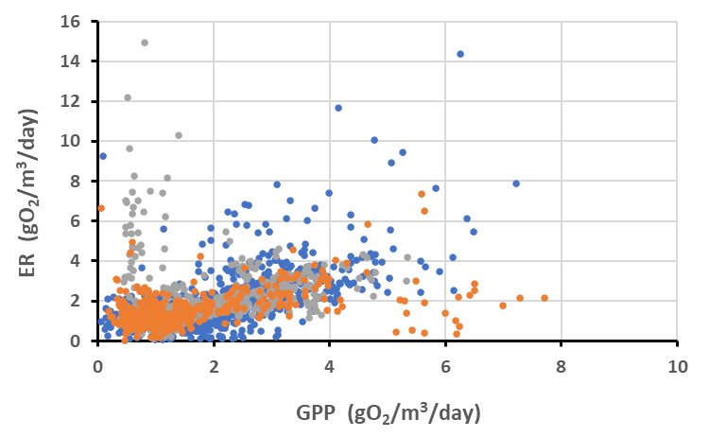
Figure 25. Reliance of ecosystem respiration (ER) on gross primary productivity (GPP) within the river channel for all monitored periods from 2014 to 2024 at sampling sites downstream of Lock 6 (●), Lock 4 (●) and Lock 1 (●), with velocities downstream of Lock 1 ≥ 0.18 m/s.

Seasonal patterns in PNP and BNP were similar across sites and both responded to flow conditions (Figure 26). During low flow years, <15,000 ML/d (Figure 15), BNP remained relatively stable and ranged from 0.04–0.1 gC/m³/day (Figure 26). Early in the season PNP was of similar magnitude but increased significantly as the season progressed and GPP increased, reaching a maximum of 0.57 gC/m³/day below Lock 6. PNP typically contributed 60–80% of the combined net production (CNP) due to phytoplankton and bacteria (Figure 26).
In contrast, during the four high flow seasons (>15,000 ML/d), BNP was larger due to increased DOC concentrations, with rates above 0.1 gC/m³/day that ranged up to 0.26 gC/m³/day below Lock 6 in 2022. In some high flow years, BNP contributed more than 50% of CNP (PNP < 50%, Figure 26), and in 2021-22 BNP was mostly larger than PNP and contributed 60 to 80% of a CNP similar in magnitude to those of the low flow years (Figure 26). During the 2023-24 season, flows reduced from a high of 51,000 ML/d down to ~6,000 ML/d, overlapping flows observed across the previous monitoring seasons. The contribution of BNP reduced from 70 to 15% as DOC concentrations reduced, and PNP increased in response to improved irradiance levels as depth decreased.

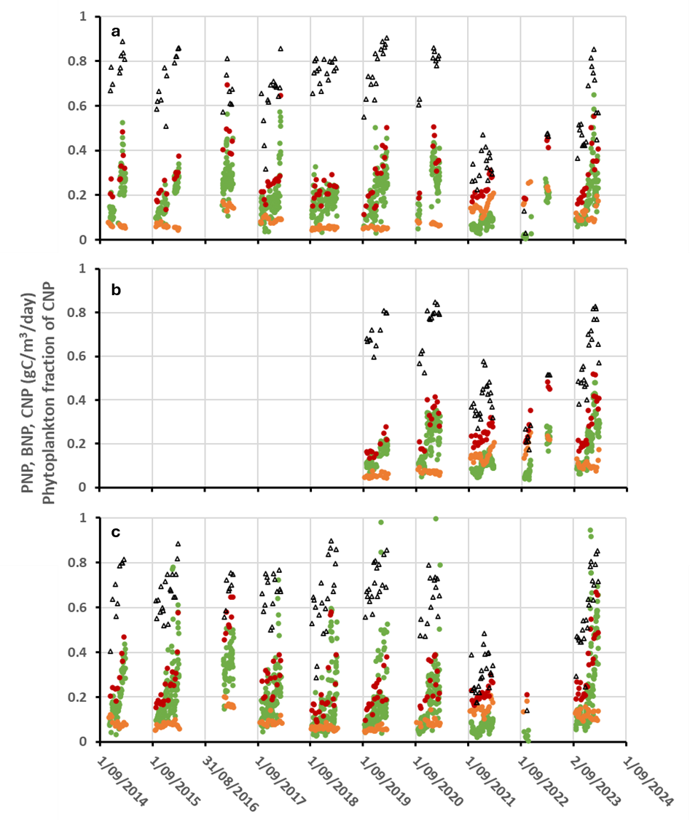
Date
Figure 26. Net production rates of phytoplankton (PNP, ●), bacteria (BNP, ●), the combined total (CNP, ●), and the fraction of combined due to phytoplankton (Δ), downstream of Lock 6 (a), Lock 4 (b) and Lock 1 (c), for all dates during 2014–2024 with matching DOC measurements.

Water quality
Water quality was comparable across sites within seasons (Figure 27). Between seasons, water quality differed markedly, especially during the two flood years and the high flow years (Figure 15), but also in low flow years in response to changes in upstream water sources. For example, turbidity was high during the 2018-19 season due to enhanced flows from turbid Lake Victoria (Figure 27).
The water column mean irradiance (Im) was a major driver of GPP and depended on I₀, k_{d} and z_{ave} (Equation 2). Changes in Im were inversely related to k_{d} which was largely influenced by turbidity and DOC, with little effect from chlorophyll-a concentration (Figure 27). A multiple regression with DOC and NTU as explanatory variables for k_{d} yielded:
Kd = 0.05(±0.001)* NTU + 0.2(±0.01)*DOC + 0.6(±0.09) r²=0.91
In 2021-22, the high k_{d} was associated with enhanced turbidity, whereas in 2022-23 a similar k_{d} was associated with increased DOC concentrations (Figure 27).
The consistently higher DOC concentrations of 2021-22, 2022-23 and 2023-24 were associated with higher concentrations of chlorophyll-a, TP and TN (Figure 27). Data from all sites and seasons over the ten-year monitoring showed abrupt increases of between 45 and 80% in DOC, TP, and TN as flows exceeded 18,000 ML/d, with the step change continuing up to 35,000 ML/d (Figure 28). These increased levels were linked with floodplain inundation and associated with a decline in gas exchange coefficients. Further increases in water levels increased DOC concentrations that between 10 and 25 mgC/L led to steep declines in DO (Figure 29).

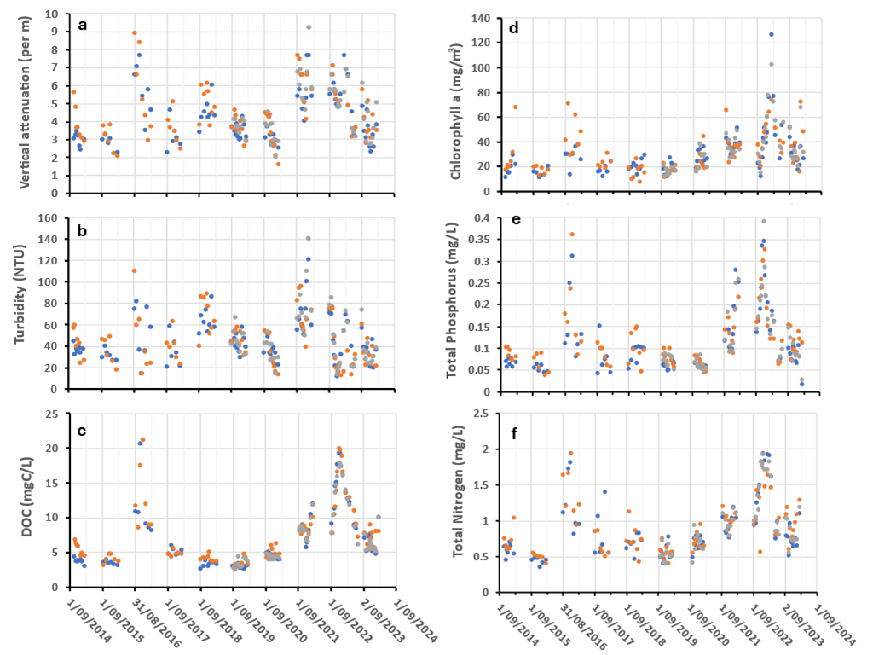
Figure 27. (a) Vertical attenuation (k_{d}), (b) Turbidity, (c) Dissolved organic carbon (DOC), (d) Chlorophyll a, (e) Total phosphorus, and (f) Total nitrogen, below Locks 6 (●), 4 (●) and 1 (●) during 2014–2024.

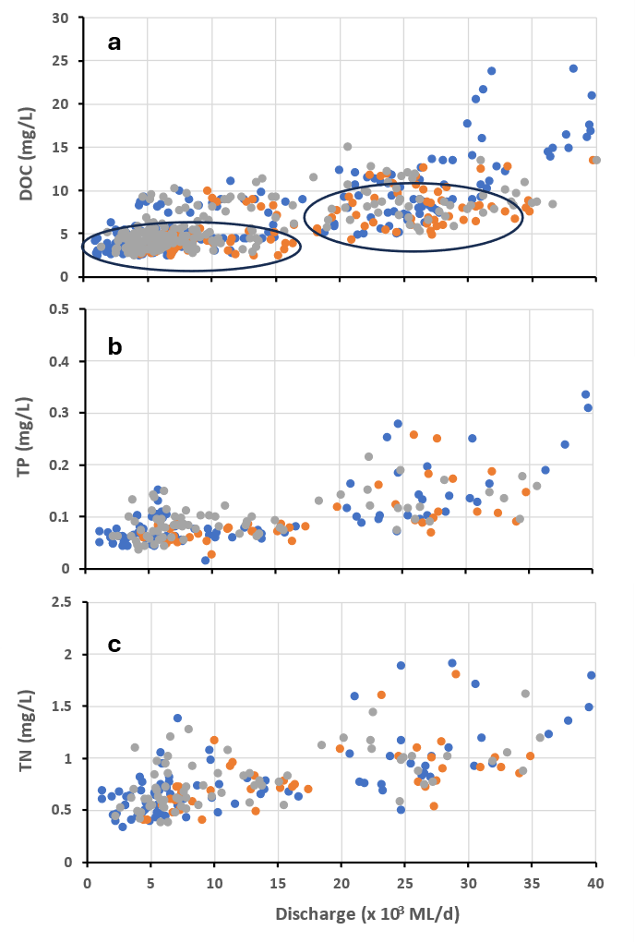
Figure 28. Changes in dissolved organic carbon (DOC) (a), total phosphorus (TP) (b), and total nitrogen (TN) (c) in response to flow volumes at sampling sites downstream of Lock 6 (●), Lock 4 (●) and Lock 1 (●)during 2014–2024 with discharge <40,000 ML/d. Circled DOC results indicate stable or rising flows, other DOC data points indicate high or falling flows.

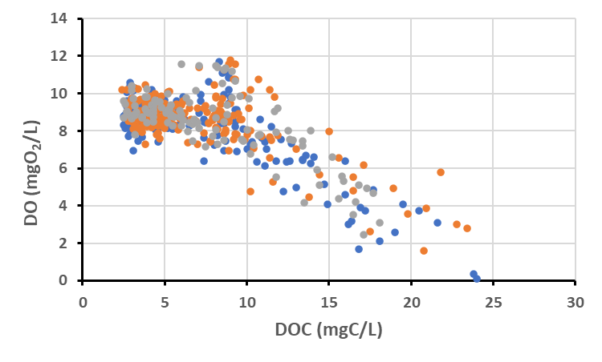
Figure 29. Changes in dissolved oxygen (DO) in response to increasing dissolved organic carbon (DOC) concentrations at sampling sites downstream of Lock 6 (●), Lock 4 (●) and Lock 1 (●) during 2014–2024.

Evaluation
Changes in river metabolism and water quality were linked with flows of Commonwealth environmental water, but evaluating the environmental outcomes was difficult. This reflected a paucity of knowledge regarding the interpretation of river metabolism measurements, and the complexity of system linkages. An informative example is the expected reduction in GPP with increased flows due to increased water depths reducing light availability. Although reductions in volumetric GPP were at times substantial and expected to impact food supplies, the total GPP per metre of river (cross-sectional GPP) remained largely unchanged or even increased slightly. The implications for river food webs of these changes in food resource distributions are unknown, making simple evaluation difficult.
To provide some evaluation of environmental outcomes, a set of metrics was constructed that attributed potential benefits of Commonwealth environmental water to changes in gas exchange rates, and total river primary production and decomposition. Significance levels were assigned to each evaluation question based on the extent that Commonwealth environmental water contributed towards the observed outcome, in one case the length of time of an enhanced effect, and in the other cases a percentage estimate of the extent of influence. The thresholds for significance levels among the indicators were based on expert opinion and may be adjusted in response to developing understanding of these processes.

Table 5. Stream Metabolism evaluation questions and answers relating to Commonwealth environmental water (CEW) and environmental water (eWater). DS = downstream.
CEWH evaluation questions | Outcomes of CEW delivery
CEWH evaluation questions | Site | eWater type | 2014-15 | 2015-16 | 2016-17 | 2017-18 | 2018-19 | 2019-20 | 2020-21 | 2021-22 | 2022-23 | 2023-24
What did CEW contribute to dissolved oxygen levels? | DS Lock 6 | All eWater | 54 | 68 | 36 | 69 | 46 | 40 | 92 | 0 | 0 | 45
What did CEW contribute to dissolved oxygen levels? | DS Lock 6 | CEW | 0 | 52 | 22 | 51 | 26 | 30 | 78 | 0 | 0 | 29
What did CEW contribute to dissolved oxygen levels? | DS Lock 4 | All eWater |  |  |  |  |  | 52 | 100 | 0 | 0 | 37
What did CEW contribute to dissolved oxygen levels? | DS Lock 4 | CEW |  |  |  |  |  | 48 | 79 | 0 | 0 | 20
What did CEW contribute to dissolved oxygen levels? | DS Lock 1 | All eWater | 24 | 21 | 12 | 53 | 3 | 36 | 56 | 0 | 0 | 45
What did CEW contribute to dissolved oxygen levels? | DS Lock 1 | CEW | 24 | 21 | 12 | 38 | 3 | 36 | 54 | 0 | 0 | 26
What did CEW contribute to dissolved oxygen levels? | Long-term (2014–2024) outcome = moderate.  Contributions of eWater and CEW can help decrease the likelihood of low DO during low flow periods by increasing water mixing and oxygen exchange at the surface. This was assessed as the extra days per monitoring period with water velocities >0.18 m/s due to CEW, and the total for all eWater. In 2023-24, CEW contributed 29 days of flow that moved velocities above 0.18 m/s, while All eWater supported 45 days above 0.18 m/s. A substantial CEW contribution was considered greater than 30 days, moderate 15–30 days, minor 7–14 days and negligible < 7days.

CEWH evaluation questions | Outcomes of CEW delivery
CEWH evaluation questions | Site | eWater type | 2014-15 | 2015-16 | 2016-17 | 2017-18 | 2018-19 |  | 2019-20 | 2020-21 | 2021-22 | 2022-23 | 2023-24
What did CEW contribute to patterns and rates of primary productivity? | DS Lock 6 | All eWater | 1.5 | 2.5 | 1 | 2.5 | 2 | 1.5 | 3 | 0.5 | 0 | 3
 | DS Lock 6 | CEW | 1 | 2.5 | 0 | 2 | 1.5 | 1.5 | 2.5 | 0.5 | 0 | 2
 | DS Lock 4 | All eWater |  |  |  |  |  | 0 | 0 | -0.5 | 0 | -1.5
 | DS Lock 4 | CEW |  |  |  |  |  | 0 | 0 | -0.5 | 0 | -1
 | DS Lock 1 | All eWater | 1.5 | 2.5 | 1.5 | 2 | 3 | 2 | 2 | 2 | 1 | 3
 | DS Lock 1 | CEW | 1.5 | 2.5 | 1 | 1.5 | 3 | 1.5 | 1.5 | 1.5 | 0.5 | 2
Long-term (2014–2024) outcome = none/negligible.
Increased eWater delivery generally reduced the volumetric rate of primary production but increased the cross-sectional rate. This increased the overall “carrying capacity” of the river, although the implications of changes in the ratios of these two measures are unknown. The estimated average percentage change in cross-sectional GPP due to eWater/CEW over a monitoring period was used to assess primary productivity. In 2023-24, despite relatively large increases in cross-sections, small positive changes in cross-sectional GPP were predicted in response to eWater/CEW delivery below Locks 6 and 1, with small negative changes below Lock 4. This was the result of similar sized relative reductions in volumetric GPP due to increases in depth. A substantial contribution was considered an increase in average cross-sectional GPP of 20% or greater, moderate 11–19%, minor 5–10%, negligible <5%.

CEWH evaluation questions | Outcomes of CEW delivery
CEWH evaluation questions | Site | eWater type | 2014-15 | 2015-16 | 2016-17 | 2017-18 | 2018-19 | 2019-20 | 2020-21 | 2021-22 |  | 2022-23 | 2023-24
What did CEW contribute to patterns and rates of decomposition? | DS Lock 6 | All eWater | 5 | 9 | 5 | 10 | 6 | 6 | 13 | 6 | 1 | 15
 | DS Lock 6 | CEW | 5 | 9 | 3 | 8 | 6 | 5 | 11 | 4 | 1 | 10
 | DS Lock 4 | All eWater |  |  |  |  |  | 5 | 12 | 6 | 1 | 12
 | DS Lock 4 | CEW |  |  |  |  |  | 5 | 9 | 4 | 1 | 11
 | DS Lock 1 | All eWater | 5 | 8 | 5 | 6 | 10 | 7 | 6 | 6 | 3 | 12
 | DS Lock 1 | CEW | 5 | 8 | 4 | 5 | 9 | 4 | 4 | 5 | 3 | 9
Long-term (2014–2024) outcome = Minor
Bacterial respiration (BCR), a measure of decomposition, was directly related to DOC concentrations. As it was assumed that daily DOC concentrations were the same with and without eWater, volumetric BCR was unaffected by flow. Evaluation was based on the average percentage change in river cross-sectional BCR due to eWater/CEW and determined from the average change in cross-sectional area. From 2014 to 2022, increases were generally small due to the largely constant water level maintained by the weirs and by the short flow pulses. The exception was 2020-21 when moderate environmental flows were prolonged. In 2022-23, the high flood flows reduced the relative influence of eWater/CEW on cross-sectional changes resulting in negligible responses. In 2023-24, sustained high water levels due to eWater/CEW resulted in moderate increases. A substantial contribution was considered an increase in cross-sectional BCR of 20% or greater, moderate 11–19%, minor 5–10%, negligible <5%.
Contribution (to what extent CEW contributed towards the outcome, with the significance of the outcome considered):

 | Unknown |  | None/negligible |  | Minor |  | Moderate |  | Substantial

Discussion
The primary objectives were to investigate the influences of environmental flows (especially Commonwealth environmental water delivery) on river metabolism and basal food supplies, and to assess the benefits for the river ecosystem. To accomplish this, the major drivers of metabolism were linked to river discharge through hydraulic characteristics including water velocity, average depth and cross-sectional area. This enabled the specific effects of increased flows due to environmental water to be identified from their partial contribution to total flow. The analyses of hydrological influences on metabolism assumed that modelled flows without environmental water had the same water quality.
Daily rates of gross primary production (GPP) followed the seasonal changes in incident irradiance, initially increasing before plateauing later in the summer. However, the extent of change was not determined by incident irradiance, which was similar between years, but the light encountered by phytoplankton within the water column. The mean irradiance of the water column was inversely related to water depth and the vertical light attenuation which depended on turbidity (NTU) and dissolved organic carbon (DOC). The mean irradiance largely accounted for different seasonal responses in GPP over the ten years of monitoring, highlighting the importance of differences in water depth and optical water quality.
Estimated gas exchange coefficients were used to investigate the reliability of the modelled data to represent river conditions. This was based on their known reliance on water velocity (Ulseth et al. 2019), and they were correlated at water velocities between 0.18 and 0.5 m/s. Below the lower velocity boundary (discharge ~5,000 to 7,000 ML/d), reduced turbulent mixing and enhanced thermal stratification associated with declining flow increases the risks of cyanobacterial blooms and hypoxic conditions (Bormans et al. 1998). These characteristics reduced the reliability and representativeness of the single station metabolism measurements reflected in the unrealistic gas exchange estimates. Environmental flows that increased velocities above the lower boundary assisted in reducing these occurrences and increased surface oxygen exchange to buffer against dissolved oxygen (DO) declines.
Reductions in gas exchange coefficients beyond the upper flow velocity boundary (discharge ~15,000–20,000 ML/d) were attributed to increasing interactions with low-lying floodplains. The increases in channel complexity and flow segmentation diminished the representativeness of single-station metabolism measurements suggesting caution in their interpretation.
Despite these concerns, the chlorophyll-specific gross primary production (GPP(b)) was linearly correlated with the daily mean irradiance (Im) of the water column, with only a few measurements from below Lock 1 deviating significantly. These samples were from periods with water velocities below the 0.18 m/s lower boundary, and this was the basis for their removal. The unexpected consistency of the GPP(b) measurements, even outside the gas exchange velocity boundaries, was attributed to the metabolism model using changes in incident irradiance as a template for GPP. However, due to possible stratification at low velocities or reduced connectivity at high velocities, measurements outside the velocity bounds may not be representative of the whole river but rather reflect the responses at the monitoring sites.
The inverse dependency of Im on the average water depth meant that the influence of additional environmental flows on reductions in GPP(b) and GPP could be estimated from the associated depth changes. Daily reductions in volumetric GPP due to Commonwealth environmental water varied from near zero up to 26%, the latter a large proportion of the production, although such high rates typically lasted only a few days. The length of impact was assessed from the number of days with a 10% or more reduction in GPP and ranged from 0 up to 75 days. Prolonged reductions were expected to result in reduced basal resource supply, but even the longest period of 75 days below Lock 4 in 2023-24 reduced the total seasonal integrated carbon production of 125 gC/m³/season by only 12 gC/m³/season. These results indicated that daily flow changes could significantly impact daily production for specific periods and be expected to influence food web structure. However, seasonally-integrated changes were small because environmental flows were a small fraction of the total flow. Seasonal changes may not reflect the impacts of environmental flows as they dilute their expected short-term effects.
A measure of the total river production was calculated as the product of GPP and the cross-sectional area of the flow. Additions of environmental water decreased volumetric rates of GPP due to depth increases but simultaneously increased cross-sectional area. GPP per metre of river (cross-sectional GPP) depended on the relative changes in depth and cross-section, a function of channel morphometry. Flows and water levels were controlled by the weirs in the LMR, and these curtailed the extent of depth and cross-section changes expected in a free-flowing channel, particularly under reduced flow conditions.
Commonwealth environmental water increased cross-sections by up to 30%, but changes in cross-sectional GPP were small due to associated reductions in volumetric GPP and ranged from decreases by 3% up to increases by 6%. These changes in food resource distributions resulting from reductions in volumetric supplies but with sustained total supplies were expected to influence food web composition by reducing concentrations of weakly motile, food density dependent grazers, while supporting more motile cruising grazers, but confirmation of this awaits further analyses of the zooplankton community composition data. Seasonal integrals indicated that environmental flows caused only minor changes to total river production, again reflecting its small flow contribution to seasonal flows. In contrast, differences in total discharge and water quality between sites and seasons markedly altered integrated total river production, with estimates ranging from 20 up to 60 kgC/m, a three-fold difference. This highlighted the potential for managing flows and water quality to influence river production.
GPP and DOC were combined in a regression model that estimated their contributions to ecosystem respiration (ER), with GPP representing the respiratory substrate for autotrophs, predominantly phytoplankton, and DOC the respiratory substrate for heterotrophs, predominantly bacteria. The specific respiration estimates underpinned calculations of the autotrophic net production (PNP) and heterotrophic net production (BNP), both of which were important sources of basal organic carbon supplies providing combined net production rates of up to 0.6 gC/m³/day. During low flow years (<15,000 ML/d), PNP typically contributed 60 to 80% of the combined net production while in higher flow periods BNP contributions increased, and in 2021-22 BNP predominated contributing 60 to 80%. During 2023-24 when flow reduced from a high of 51,000 ML/d down to ~6,000 ML/d, overlapping flows observed in previous monitoring seasons, the contribution of BNP reduced from 70 to 15% as DOC concentrations reduced and PNP increased with light. These are crucial connections for developing flow regime patterns aimed at supplying basal food resources to the river food web.
External supplies of DOC were critical in enhancing heterotrophic production (Ye et al. 2018). When flows increased to between 18,000 and 35,000 ML/d, a step change increase was observed of between 45 and 80% in DOC, TP and TN due to interaction with low level floodplains. The increased DOC supply enhanced bacterial net production at a time when volumetric GPP declined due to the increased water depth, but overall there was an increase in the combined net production. During the seasons between 2021 and 2024, Commonwealth environmental water contributed to maintaining flows above 18,000 ML/d late in each season, sustaining increased concentrations of DOC, and supporting increased rates of BNP and CNP. For example, during March to June 2023, flows without environmental water would have fallen to 16,000 ML/d, but the delivery of environmental water kept river flows above 20,000 ML/d and extended the period of higher nutrient concentrations by ~45 days from mid-March to late April. Alignment of environmental water contributions with this flow-sensitive threshold benefited river net production and is a target that should be considered when flow and environmental conditions are suitable. The largest benefits for river channel productivity are likely to be achieved through targeting such flow sensitive responses.
The associated respiration driven by the step increases in DOC, at times supported by environmental flows, resulted in small reductions in DO, but not to unacceptable levels. However, larger increases associated with higher flows (e.g. greater than 30,000 ML/d) deleteriously depleted DO concentrations as DOC increased from 10 to 25 mgC/L. A DOC concentration of 15 mgC/L supported the DO concentration of 5 mgO₂/L that is considered a critical level for aquatic biota. During floods, DO concentrations were reduced to near zero levels due to the large deliveries of organic material and DO depletion in floodplain waters.
An important consideration for environmental water delivery was to maintain the supply of basal food resources and sustain the structure and functioning of the river food web. The main drivers of the production and delivery of food resources were identified, but it was not practicable to assess the effects of changes in the distribution, form and quantity of the basal food resources on food web composition, although taxonomic and molecular DNA barcoding data were collected for this purpose (Bice et al. 2023). These analyses are challenging but are slowly being advanced to provide the knowledge of food web interactions required to inform flow management to support the river biota.

Management implications
The selected evaluation metrics attributed potential benefits of Commonwealth environmental water to changes in gas exchange rates, and total river primary production and decomposition. These do not capture the full scope of reported findings, as developing reliable metrics typically requires extensive datasets to establish critical boundaries. The ten years of monitoring is not a long observation period in a hydrologically variable system where flow models require many decades of data to approach consistency. Metabolism and water quality responded to hydrology and so have a similar variability requiring prolonged data accumulation to underpin management application, but key findings are listed here as a basis for further development.
Environmental flows were often relatively small (≤13,800 ML/d) with short periods of influence, so their impacts were greatest in the short-term but diluted over longer periods. This was evident in the metabolism data where short-term reductions in GPP due to environmental flows were substantial but had only minor effects on seasonally-integrated rates. The extent to which short-term changes reverberate through the food web are not known, but seasonal changes that swamp the effects of short-term responses may not be the best indicators of the influences of environmental flows.
Although GPP was reduced by increased flows, the total cross-sectional river production was not greatly altered as increases in cross-section area countered the reductions in GPP due to depth increases. The short-term changes in GPP reduced the volumetric supply of production which was expected to impact food web resources and community composition, but the impact of changing balances between food resource concentration and the total food resource on grazer communities are not well understood.
Gas exchange coefficients were a linear function of water velocity between 0.18 and 0.5 m/s but inconsistent outside these boundaries. The lower boundary accords with discharge rates in the LMR below which the potential for reduced mixing, increased thermal stratification and development of cyanobacterial blooms increases. To minimise the potential for such occurrences, average velocities should be maintained above this level. Increased water velocities increase gas exchange and help buffer against DO depletion that may occur when respiration rates are enhanced by supplies of organic materials from internal or external sources. Velocities should be managed to maintain DO concentrations at suitable levels. The processes of GPP, ER and gas exchange, that determine the DO balance, were linked to measurable environmental characteristics and should assist in improving river models predicting DO concentration changes.
Primary production (GPP) is strongly influenced by the mean irradiance of the water column (Im) which depends directly on the incident irradiance, and inversely on the average water depth (z_{ave}) and the vertical attenuation of light (k_{d}), with light attenuation largely influenced by turbidity (NTU) and DOC. Management actions can influence water depth through control of flows (i.e. water delivery, weir pool manipulation), and modify the levels of turbidity and DOC through selection of water supply sources, and through water quality improvement initiatives. Environmental flows offer opportunities to improve water quality through selection of water supply sources. If food webs are to be sustained at levels suitable to support iconic species, then primary production needs to be maintained at appropriate levels. Analyses of historical water quality and depth data using the relationships developed in this study should assist in identifying suitable targets.
Bacterial net production from heterotrophic utilisation of DOC was identified as an important basal food resource that at times exceeded the supply from GPP. When both were suitably supported by environmental conditions, then the combined net production was enhanced. Increases in external supplies of DOC were instrumental in supporting BNP and were linked to flow increases that enhanced floodplain connections. Sustaining external supplies of DOC to support suitable levels of BNP should be a river management target.
The study has shown that an important step increase in supply of DOC in the LMR occurred when flows increased to between 18,000 and 35,000 ML/d. In three seasons between 2021 and 2024, Commonwealth environmental water played a critical role in ensuring the sustained delivery of DOC by maintaining falling flows above the 18,000 ML/d level and enhancing BNP. The identification of flow-sensitive ecological responses that can be targeted by environmental water delivery when conditions are suitable is an effective way to maximise their benefits.
Care is required in identifying management targets, and the DOC supply is a good example. Increased flows to between 18,000 and 35,000 ML/d enhanced the DOC concentration and BNP. It resulted in increased respiration rates but only small reductions in DO and did not severely reduce light penetration to impact GPP. These were positive outcomes. Larger increases in DOC associated with flood flows were less beneficial to the river channel as GPP was reduced to low levels due to poor light transmission, and DO concentrations fell precipitously as DOC concentrations increased from 10 to 25 mgC/L. A DOC concentration of 15 mgC/L maintained a DO concentration of 5 mgO₂/L, considered a critical level for aquatic biota.
Beneficial effects of environmental flows on metabolism and basal food resources were identified, including hydrological and water quality attributes amenable to management. The application of the relationships developed in this study should help with considerations of water source supply and flow planning, not only for environmental water, but for managed flows in general.

Conclusion
The study has assessed the influence of changing river flows on autotrophic and heterotrophic metabolism and evaluated the role of environmental flows in modifying these responses. The linkages described could help better manage hydrological conditions and improve the production and supply of basal food resources to the food web through the improved understanding of the:
- effects on GPP and ER of interactions between flow and channel morphometry;
- reliance of phytoplankton GPP and ER on the mean light intensity;
- dependence of the mean light intensity on water depth, turbidity and DOC;
- reliance of bacterial respiration and production on DOC concentrations;
- influence of flows on DOC and nutrient concentrations;
- effects of DOC concentrations on DO depletion and manageable DOC concentrations;
- effect of water velocity on surface oxygen exchange; and
- contributions of phytoplankton and bacteria to net production.
Understanding these interactions is necessary for predicting the changes in metabolism and net production resulting from the delivery of environmental flows of given volume and water quality. Over the last decade in the LMR, at daily to weekly scales, Commonwealth environmental water had substantial impacts on rates of metabolism, whereas at the seasonal scale, influences were generally small. Further knowledge regarding the impacts of metabolic responses on river food web composition and functionality is required to support a more complete critical evaluation in the future.

Matter Transport and Coorong Habitat

2.3.1 Matter Transport

Background
Freshwater flows to estuaries shape habitat, transport nutrients to drive productivity, and generate a salinity gradient that impacts water quality and provides spawning cues for fish (Brookes et al. 2022). Reduced flow may increase the intrusion of salt into the river system from the ocean whilst simultaneously decreasing the export of salt from inland reaches (Chilton et al. 2021). As there is continual deposition of salt onto the landscape (predominately from rainfall and irrigation induced actions), it can accumulate if not transported by flow and exported from the system. Additionally, a change in the flow regime will alter the mobilisation of nutrients from the floodplain and change the subsequent primary productivity within the river. Environmental flows can be used to reinstate some of the natural processes or to increase the magnitude of the processes that control the availability and transport of dissolved and particulate matter. Salinity, dissolved and particulate organic nutrients, and chlorophyll-a are often measured or modelled to understand the influence of flows on the concentrations and transport of matter.
In general, restoring river flow to an estuary is an important tool for salinity management by limiting seawater intrusion into the estuary (Chilton et al. 2021). In the case of the Murray River, it is further complicated as seawater entering the Murray Mouth is highly dependent on how river water is released from the barrages, and these dynamics impact salinity in the connected Coorong. The Coorong is a 120 km long shallow reverse estuary that runs parallel to the coast and is separated from the Southern Ocean by the Younghusband and Sir Richard Peninsulas (Figure 1). As water evaporates from the North and South lagoons, it is replaced with water coming from the ocean and rivers. When river water exits the barrages, it reduces seawater intrusion and maintains fresher conditions around the Murray Mouth which enables fresher water to replenish water evaporated in the Coorong. When there is more seawater intrusion into the Murray Mouth, considerable amounts of salt are transported into the Coorong as this seawater flows south-east to replenish water evaporated from the lagoons. The salinity of the Coorong is a key determinant of habitat suitability for macrophytes, invertebrates and fish. At times the higher salinity water can essentially get trapped in the South Lagoon when water levels decline over summer unless there are flood conditions and reasonably high water levels persisting over summer.
Nutrients drive system productivity and so understanding how they are transported between the various components of riverine ecosystems can offer insights into river and estuarine productivity (assessed as chlorophyll-a concentration). Dissolved inorganic nutrients are essential resources for the growth and survival of biota and are readily assimilated (Poff et al. 1997). In healthy ecosystems, mobilisation of nutrients can enhance productivity and support ecosystems, however, in poorly flushed or over-enriched systems, the addition of nutrients leads to eutrophication and numerous undesirable consequences. The amount of river water coming through the barrages has been shown to be a major factor affecting the nutrient retention in the Coorong, particularly in the North Lagoon (Huang et al. 2024).
To assess the contribution of environmental water delivery to matter transport in the Coorong from 1 July 2019 to 30 June 2024, a hydrodynamic-biogeochemical model was applied for the Coorong. This study period included a relatively dry period (1 July 2019 to 30 June 2021) and a particularly wet period (1 July 2022 to 30 June 2024) with a flooding event occurring in the summer of 2023. The environmental water delivery was a major component to the total barrage flow during dry period (July 2019–June 2021). During this period, water flow through the barrages to the Coorong was relatively smaller (572–1,335 GL/year), of which Commonwealth environmental water contributed a much higher portion to the total barrage flows (65.4%–100%, Figure 31). In comparison, the water flow over the barrages during wet period (July 2021–June 2024) reached 5,974–16,593 GL/year, during which Commonwealth environmental water represented a small portion to the total barrage flows (3.7%–19.2%, Figure 31). Therefore, the impact of environmental water delivery on the hydrologic and water quality responses within the Coorong during 2019–2024 has been assessed with a view to compare the relative benefits between the dry and wet periods. The model has been validated with water quality data, and is used to understand salt, nutrient and phytoplankton movement.
Major hypotheses
Commonwealth environmental water will:
- Increase the mobilisation of salt, nutrients, and organic matter (including phytoplankton biomass) from the Basin and increase the transport of this material through the barrages and through the Murray Mouth; and
- Decrease the rate of salt and nutrient accumulation in the North and South lagoons of the Coorong.
Through the modelling undertaken in the LTIM Project (Ye et al. 2020a), it was well established that environmental flows dilute the concentration of nutrients and salinity in the reach between Lock 1 and the barrages, including within Lake Alexandrina and Lake Albert. Furthermore, these flows increased the load (load equals volume x concentration) of nutrients and salt that was exported from the reach. Given the particular sensitivity of the Coorong, this analysis has focused on developing an understanding of the contribution of the environmental water to the salt and nutrient export from the Basin to the Coorong through the barrages, the export from the Coorong to the Southern Ocean through the Murray Mouth, and also the transport of material between the North and South lagoons. The mean and median salinity and nutrient concentrations predicted from the modelling scenarios with and without the environmental water are also presented. This addresses the hypotheses above acknowledging the contribution of environmental flow to the transport of salt and nutrients. The impact of environmental water on the suitable habitat for fish and Ruppia tuberosa was also assessed based on the predicted changes in salinity, water depth and light conditions, which is outlined in Section ‘2.3.2 Coorong Habitat’.

Methods
Environmental water modelling assessment scenarios
A total of five simulations were considered in this modelling study to investigate the impacts of Commonwealth environmental water and all environmental water on the salt transport, salinity and water quality of the Coorong. The first model run was an ‘All Water’ base-case simulation which represented the ‘actual condition’ in the Coorong with the barrage flows as observed from July 2017 to June 2024. Four ‘counter-factual’ scenarios were then simulated to assess the cases with Commonwealth environmental water or all environmental water removed from the observed barrage flows in one year or over seven years (Table 6), with an additional scenario of ‘two years’ without Commonwealth environmental water for the period from July 2022 to June 2024 run specifically for Ruppia tuberosa habitat assessment (Section 2.3.2). The ‘seven years’ scenario was simulated to distinguish between the cumulative effect of multiple years of environmental water (July 2017–June 2024) relative to water delivery just for an individual water year (‘one year’ scenario, July–June each year). The start time of July 2017 was chosen based on the consideration that the high flow in year 2016–17 helped to ‘reset’ the conditions within the Coorong, and to include the period in 2017–18 and 2018–19 when environmental water was the major component of the barrage flow.

Table 6. Summary of modelling scenarios for investigating the environmental water (eWater) effects. CEW = Commonwealth environmental water.
Scenario | Scenario ID | Description
All Water | Base-case | This simulation represents observed conditions and was run with the compiled barrage flows from 1 July 2017 to 30 June 2024.
No CEW 1 year | NC1 | These scenarios were run with assumption that there was no CEW through the barrages in one individual water year (July–June each year). This is undertaken to isolate the effect of any single year’s CEW effect, relative to the cumulative effect of previous years water;
No CEW 2 years  i.e. for the past two water years  (07/22–06/24) | NC2 | This scenario was s made specifically for Ruppia habitat assessment, with the assumption that there was no CEW through the barrages in the last two water years (July 2022–June 2024). This was undertaken to isolate the effect of recent CEW delivery on Ruppia habitat in the Coorong, which was assessed over a calendar year (January to December 2023) rather than water year.
No CEW 7 years  (07/17–06/24) | NC7 | This scenario was run with assumption that there was no CEW through the barrages from 1 July 2017 to 30 June 2024, aiming to investigate the cumulative effect of CEW for the last seven years.
No eWater 1 year  (07/23–06/24) | NE1 | This scenario was run with assumption that there was no eWater through the barrages in the last water year from 1 July 2023 to 30 June 2024, aiming to isolate the effect of the combined eWater delivery in the last year only.
No eWater 7 years  (07/17–06/24) | NE7 | This scenario was run with assumption that there was no eWater through the barrages from 1 July 2017 to 30 June 2024, aiming to investigate the cumulative effect of all eWater for the last seven years.
This report section presents the outcomes from the modelling assessment, with deliveries of:
- Barrage flow analysis in the ‘All Water’, ‘No CEW’ and ‘No eWater’ scenarios;
- Time series and transect comparisons of salinity and nutrient concentrations between the scenarios;
- Detailed salt and nutrient flux analysis through the barrages, Murray Mouth, Pelican Point transect (southward to North Lagoon), and Parnka Point transect (southward to South Lagoon) in all scenarios; and
- Mean and median salt and nutrient concentrations at the Murray Mouth, middle of North Lagoon (Long Point), and middle of South Lagoon (Woods Well) in all scenarios.
Hydrodynamic-biogeochemical models
The high-resolution Coorong Dynamics Model (CDM) was used to assess the effects of environmental water delivery on salt and nutrient transport. The CDM has been used in the environmental water assessments for 2020-21 to 2022-23 (Ye et al. 2022, 2023, 2024) and undergone developments during the Healthy Coorong, Healthy Basin (HCHB) Program (Hipsey et al. 2022; Huang et al. 2024; Ye et al. 2024). The modelling platform consists of a hydrodynamic model, TUFLOW-FV, developed by BMT Global Pty Ltd., which is coupled with the biogeochemical model, AED, developed by the University of Western Australia. Details of the CDM development (model version: Generation 2) including model sensitivity analysis and model performance assessment, is summarised in the online CDM manual (http://aquaticecodynamics.github.io/cdm/index.html). Further improvements to the model mesh, bathymetry, and boundary conditions as more annual data became available in recent years was described in the last environmental water assessment report (Ye et al. 2024).
For the current modelling investigation, the boundary conditions driving the model include barrage flows (from the five barrages), Salt Creek inflows, weather conditions, and ocean tidal forcing. These were set the same as to the modelling work reported in the 2022-23 report (Ye et al. 2024) but extended to cover the period from July 2017 to June 2024. For the period from July 2023 to June 2024, the barrage flows, including environmental water through the barrages, were updated from MDBA data and scaled using the DEW barrage calculator to distribute flow between the barrages. Tidal forcing at Victor Harbor and water quality at the barrages and within the Coorong were updated from DEW monitoring, and weather conditions were updated from the NRM/AWS (Natural Resource Management Automatic Weather Station) weather network. Note that there was down-time of the Victor Harbor tide gauge instrument during July 2023 to early January 2024, and so we filled the gap in this period using the Bureau of Meteorology predicted tide data for the same period at the same site.
The model performance in reproducing the key water quality parameters within the Coorong from July 2017 to June 2024 were assessed with a set of model skill metrics, including calculation of regression coefficients (R), mean absolute errors (MAE), and bias, and the results are provided in the supplementary information for indicators (see Table C1 for the CDM performance summary in Appendix C, Figure C3 for plots comparing model results with observations). Overall, the CDM reproduced the physics (water level, salinity and temperature) in the North and South lagoons over the seven-year modelling period to a high degree of accuracy, with a regression coefficient of >0.9 and relatively low MAE (mean absolute error) for most of the assessed hydrologic variables of all sites. However, the model tends to overpredict the salinity in the North Lagoon and underpredict the salinity in the South Lagoon in the period of late 2023, coincident with the time when the tide gauge at Victor Harbor was not operational. The model also captured the variations of dissolved oxygen and the key nutrient pools such as TN, TP and TOC. Reasonable predictions were obtained for turbidity, total chlorophyll-a and other nutrient pools. The model performance on the water quality components is consistent in dry and wet years, suggesting that it is suitable for assessing management scenarios associated with environmental water delivery under a wide range of hydrologic conditions.
Barrage flow analysis
The analysis of the flow through the barrages and the contribution of environmental water to the total barrage flow are shown in Figure 30 and Figure 31, where it is evident that environmental water dominated the barrage flows over the period from 1 July 2017 to 30 June 2021 when the total barrage flows were relatively low (dry years). In contrast, the environmental water made a relatively small contribution to the total barrage flow when there were large natural (unregulated flow) flow events in 2016–17 and 2021–2024. The daily environmental flow volumes through each individual barrage are shown in Figure 32, which indicate the dominance of flows through Goolwa and Tauwitchere barrages over the period of interest, with some minor pulses through Mundoo Barrage.

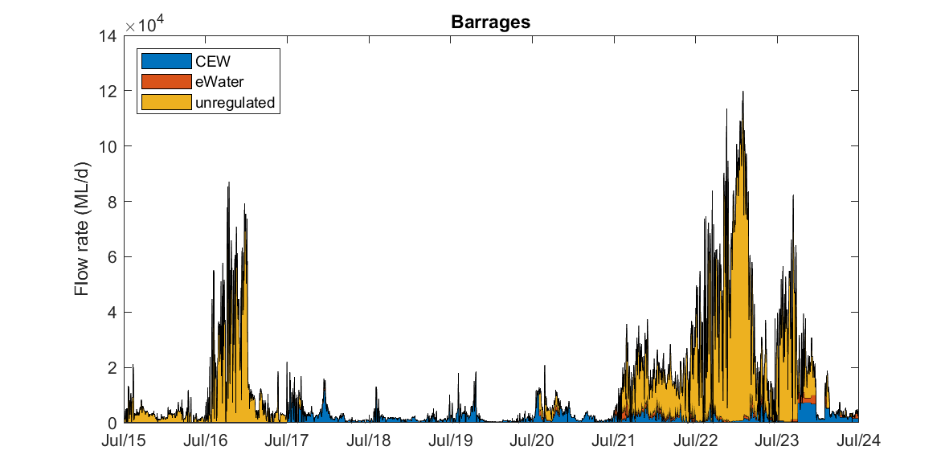
Date
Figure 30. Summary of flow discharge through the barrages, from July 2015 until June 2024, spanning the large 2016-17 and 2021-22–2023-24 flow events, categorised based on water source. CEW = Commonwealth environmental water, other eWater = other environmental water.

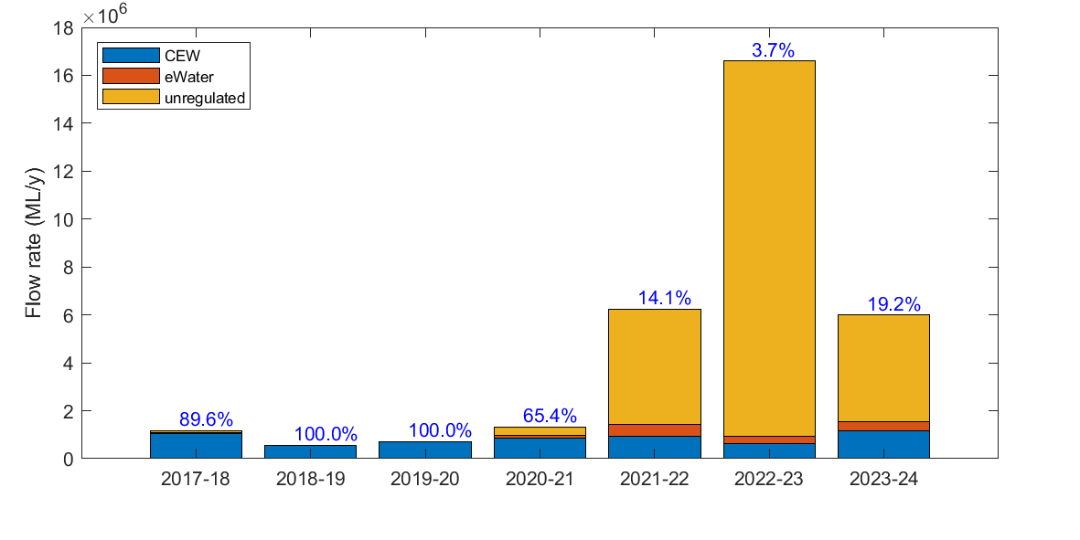
Year
Figure 31. Yearly composition of barrage flow, spanning the modelling period from July 2017 to June 2024. The numbers over the bars indicate the percentage of Commonwealth environmental water (CEW) to the total barrage flow in each year. Other eWater = other environmental water.
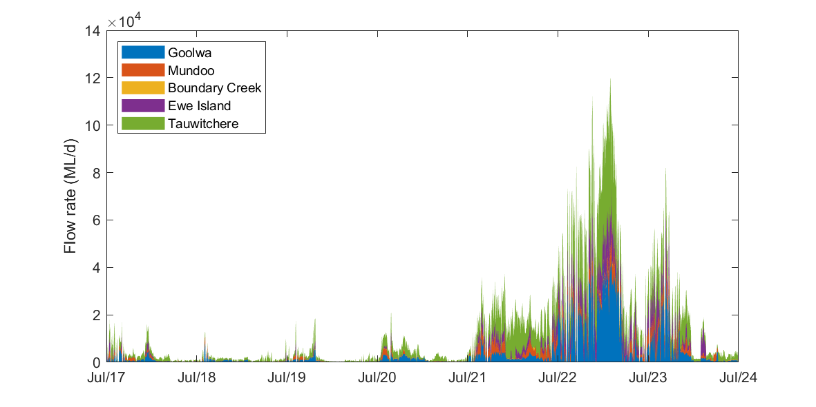
Year
Figure 32. Summary of flow through each barrage, spanning the modelling period from July 2017 to June 2024.

Results
Salinity dynamics in the Coorong
Changes in flow conditions affect the salinity at the Murray Mouth region and so influence the salinity of the water that flows south to replace evaporative water losses across the length of the Coorong. Consequently, salinity in the North lagoon in all ‘No CEW’ and ‘No eWater’ scenarios was higher than the base case (Figure 33a). The value of Commonwealth environmental water and other environmental flows for is even more evident in the simulations of salinity in the South Lagoon (Figure 33b). Environmental water maintains salinity at appropriate levels, rarely exceeding 100 PSU. However, the absence of environmental water enables excursions of salinity to damagingly high concentrations approaching 160 PSU (Figure 33b). In 2023-24, there was a benefit of salinity reduction up to 10.3 PSU in the South Lagoon (visible by comparing the red and blue lines), associated with a 19.2% contribution by Commonwealth environmental water to the barrage flow over that period. Environmental water also made an important long-term shift in the salinity, with the water deliveries from previous years providing a legacy benefit year-on-year. The cumulative impact over the seven years (July 2017–June 2024) on the salinity reduction in the South Lagoon reached over 49 PSU in the 2020-21 water year, which gradually reduced to about 26 PSU at the end of 2023-24, due to the stronger flushing effect of the more recent low salinity flows from the LMR (Figure 33b; comparing the orange and red lines). The salinity shows a clear seasonal pattern with higher salinity in summer and lower salinity in winter, in response to the seasonal variations in barrage flows, oceanic water levels, air temperature and water exchange through the air-water interface (precipitation and evaporation) (Figure C2, Appendix C). The time series plots of predicted salinity in different zones in all ‘No CEW’ and ‘No eWater’ scenarios, for comparison to the ‘base-case’ scenario, are provided in the supplementary material appended to this report. It is evident that environmental water had direct impacts on the salinity across all sites along the Coorong (not just in the South Lagoon), and the salinity generally increased in the scenarios from ‘No CEW 1 year’ to ‘No CEW 7 years’ and from ‘No eWater 1 year’ to ‘No eWater 7 years’ scenarios, indicating the cumulative benefit of environmental water on salinity of the Coorong. Importantly, the cumulative benefit of environmental water delivery in the dry years persists in the Coorong, even after the high flow period in the 2021-22 water year, highlighting the “memory-effect” of past water allocation in this ecosystem.
To demonstrate the spatial effect of environmental water on salinity levels, a transect plot of predicted mean salinity in all ‘No CEW’ and ‘No eWater’ scenarios in comparison with the ‘All Water’ scenario along the length of the Coorong for the period between 1 July 2023 and 30 June 2024 is presented in Figure 34. The results highlight the spatial salinity gradient with salinity generally increasing from Goolwa to the South Lagoon. The water became fresher at Goolwa (left of Murray Mouth in Figure 34) and Pelican Point sites than the Murray Mouth site due to the flushing from the barrage flows in this year. Environmental water delivery in 2023-24 helped to reduce the mean salinity by about 8.8 PSU in the North Lagoon, though the effect diminished with distance to the South Lagoon. Environmental water delivery had a significant cumulative impact substantially reducing salinity over the seven years, and the impact increased with distance from the barrages and Murray Mouth. Without environmental water from 2017–2024, the average salinity increase of ~26 PSU in 2023-24 is seen at the southern end of the South Lagoon between Parnka Point and Salt Creek. Interestingly, the 2023-24 environmental water, if supplied in isolation (for one year only), had little effect below Parnka Point, highlighting that sustained multi-year provision of additional water results in benefits being realised throughout the full length of the Coorong lagoon.
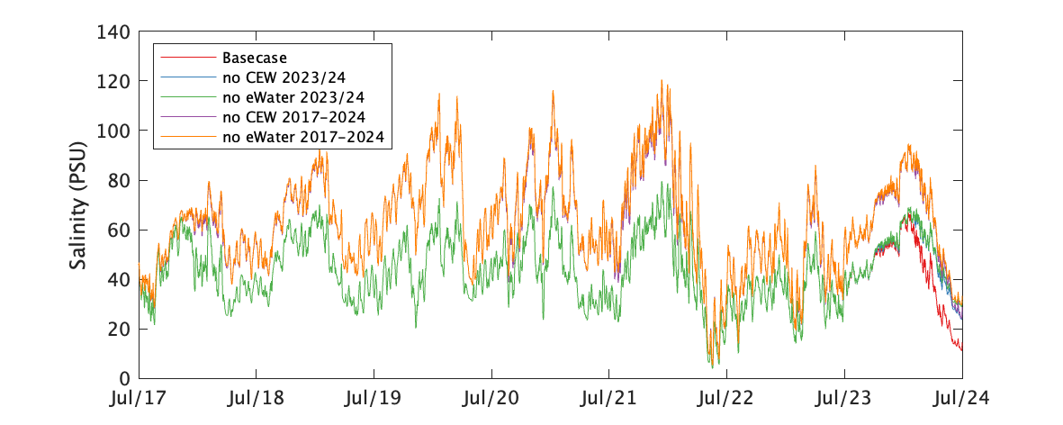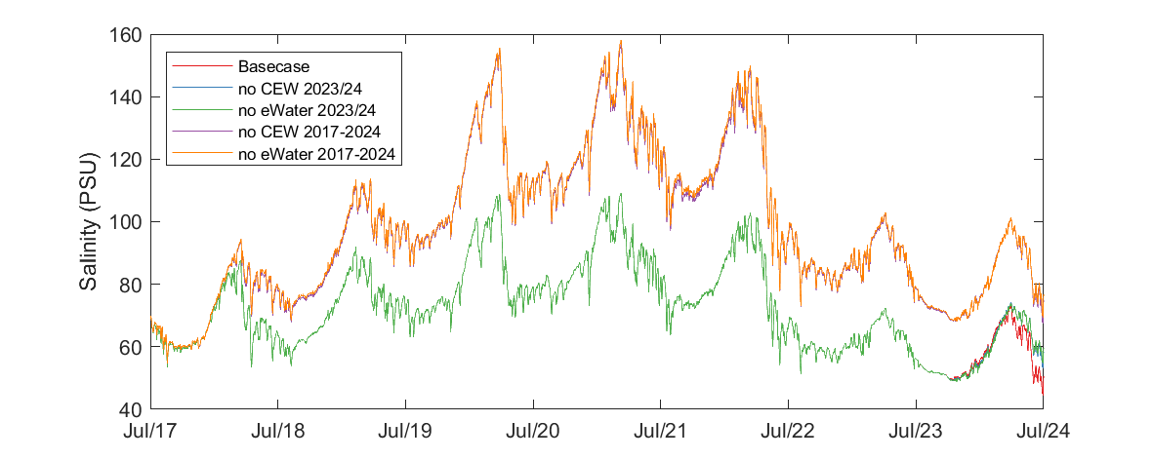
(b)
(a)
Date
Figure 33. Time series of mean salinity variation in a) the Coorong North Lagoon, and b) the Coorong South Lagoon. The base-case scenario is compared with the ‘No CEW’ and ‘No eWater’ scenarios, spanning the modelling period from July 2017 to June 2024 (refer to Table 6 for scenario details). Note that the lines of ‘Base-case’ and ‘No CEW 2023-24 (NC1 in 2023-24)’ were largely overlayed by ‘No eWater 2023-24 (NC1)’ from July 2017 to June 2023 because they were using the same barrage flow condition in years prior to July 2023, and the line of ‘No CEW 2017–2024 (NC7)’ was largely overlayed by ‘No eWater 2017–2024 (NE7)’ because the environmental water was mostly contributed by Commonwealth environmental water (CEW) over the seven-year study period.

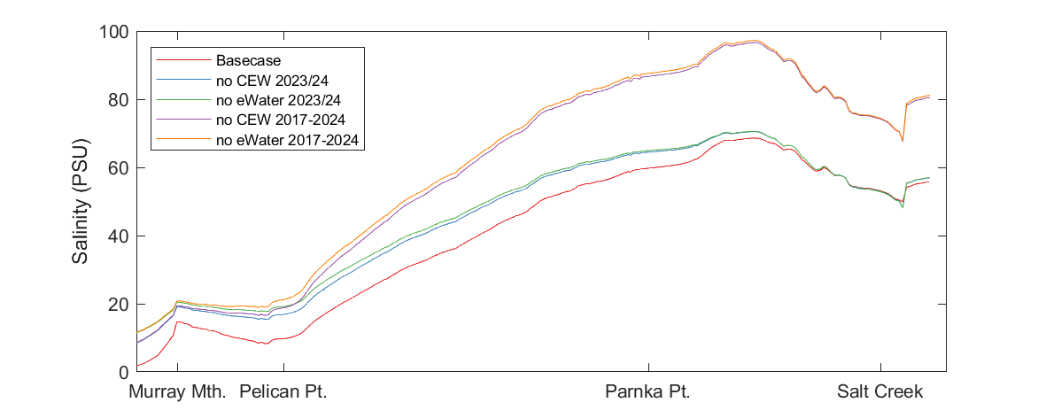
Site
Figure 34. Transect comparison of simulated mean salinity from the ‘No CEW’ scenarios, ‘No eWater’ scenarios, and ‘base-case’ scenario along the Coorong in July 2023–June 2024 (refer to Table 6 for scenarios). The x-axis positions are based on distance from the mouth (in km).

Salt flux through the Murray barrages, Murray Mouth and Coorong
Salt loads moving through the system for each modelling year from July 2017 to June 2024 are summarised in Table 7. The total salt load exported from the Basin into the Coorong (i.e. through the barrages) varied each year dependent on the amount of water flow and salinity levels in the waters upstream of the barrages in the centre of Lake Alexandrina. For the “dry" period between July 2017 and June 2021, the annual total salt load through the barrages with no environmental water was estimated to have ranged between 0 to 163,860 tonnes, compared to between 338,428 to 579,468 tonnes in the ‘All Water’ scenario. This demonstrates the significant role of environmental water to salt export under low-flow conditions. From 2021-22 to 2023-24, the natural (unregulated) flows dominated barrage flows and the proportional contribution of environmental water to the salt export was therefore relatively small. In 2023-24 water year, a total salt load of 1.24 million tonnes was estimated by modelling to be exported from the Basin through the barrages. Without environmental water, this value was estimated to be 0.95 million tonnes, and therefore environmental water contributed to the salt export of 291,495 tonnes, of which 221,272 tonnes was specifically attributed to Commonwealth environmental water.
The salt fluxes through the Murray Mouth and is transported southward. Variations in salt flux occur each year and are dependent upon barrage flows, tidal forcing, sea level anomalies, and the existing salinity gradient along the Coorong. The net exchange of salt through the Murray Mouth in the ‘All Water’ scenario varied each year, but environmental water significantly reduced salt intrusion from the Southern Ocean into the Coorong in all years. Without Commonwealth environmental water since July 2017, there would have been ~6 million tonnes of additional salt transported from the Southern Ocean into the Coorong each water year from July 2017 to June 2021 (Table 7), which was reduced by ~4 million tonnes per year with Commonwealth environmental water (Table 10). In 2021-22 and 2022-23, unregulated water dominated barrage flows and there was a net export of 4.32 and 4.14 million tonnes of salt, respectively, from the Coorong into the Southern Ocean through the Murray Mouth due to the high catchment flow flushing the hypersaline water out of the Coorong into the ocean. In 2023-34, there was a net export of 2.88 million tonnes of salt from the Coorong to the ocean, whereas without environmental water, there would have been a net import of 1.10 million tonnes of salt from the Southern Ocean to the Coorong. Therefore, environmental water increased salt export to the ocean by approximately 3.98 million tonnes in 2023-24, a large portion of which was attributable to Commonwealth environmental water (2.85 million tonnes).
The southward transport of salt from the Murray Mouth region to the North Lagoon varied each year with an annual flux rate of 1.38–2.67 million tonnes during the dry years of 2017-2021. In the wet years of 2021–2024, there was a northward export of salt with an annual flux rate of 1.17–2.16 million tonnes. This export from the North Lagoon to the Murray Mouth during the high catchment flow events accompanied a reduction of salinity concentrations within the North and South lagoons (Figure 33 and Table 8). This indicates that, in the wet years, the strong flushing events through the barrages helped to significantly reduce the salinity in the Coorong that accumulated over the dry years. Environmental water generally helps to reduce salt transport to the North and South lagoons, particularly during the dry years. Comparing the ‘All Water’ and the ‘No eWater 2023-24 (NE1)’ scenarios, environmental water helped to reduce the salt flux from the Murray Mouth region to the North Lagoon by 3.13 million tonnes, 2.44 million of which was contributed by the Commonwealth environmental water.

Table 7. Summary of salt flux (tonnes) though barrages, Murray Mouth, Pelican Point (North Lagoon) and Parnka Point (South Lagoon) in 2017–2024. Refer to Table 6 for scenarios.
Site | Scenarios/Year | 17-18 | 18-19 | 19-20 | 20-21 | 21-22 | 22-23 | 23-24
Barrages  (from lakes to Coorong) | Base-case | 441,792 | 338,428 | 373,797 | 579,468 | 1,818,314 | 3,112,925 | 1,241,811
Barrages  (from lakes to Coorong) | NC1 | 44,708 | 0 | 0 | 206,681 | 1,537,470 | 2,961,673 | 1,020,539
Barrages  (from lakes to Coorong) | NC7 | 44,708 | 0 | 0 | 206,681 | 1,537,470 | 2,961,673 | 1,020,539
Barrages  (from lakes to Coorong) | NE1 | 29,800 | 0 | 0 | 163,860 | 1,381,994 | 2,889,612 | 950,316
Barrages  (from lakes to Coorong) | NE7 | 29,800 | 0 | 0 | 163,860 | 1,381,994 | 2,889,612 | 950,316
Murray Mouth  (from Southern Ocean to Coorong) | Base-case | 2,137,023 | 2,137,931 | 2,285,666 | 1,607,901 | -4,317,197 | -4,137,762 | -2,876,270
Murray Mouth  (from Southern Ocean to Coorong) | NC1 | 6,153,004 | 6,407,573 | 6,089,326 | 5,719,788 | -4,157,941 | -4,021,248 | -21,305
Murray Mouth  (from Southern Ocean to Coorong) | NC7 | 6,153,004 | 5,401,572 | 4,529,739 | 4,344,994 | -6,048,951 | -4,684,491 | -1,747,350
Murray Mouth  (from Southern Ocean to Coorong) | NE1 | - | - | - | - | - | - | 1,101,679
Murray Mouth  (from Southern Ocean to Coorong) | NE7 | 6,344,622 | 5,372,396 | 4,523,983 | 4,512,901 | -5,976,787 | -4,634,279 | -633,412
North Lagoon  (from Pelican Point southward) | Base-case | 1,378,024 | 2,132,772 | 2,669,144 | 1,825,895 | -2,044,759 | -1,168,148 | -2,158,143
North Lagoon  (from Pelican Point southward) | NC1 | 4,844,517 | 5,777,005 | 5,654,687 | 5,300,136 | -2,184,329 | -1,217,359 | 282,878
North Lagoon  (from Pelican Point southward) | NC7 | 4,844,517 | 4,970,188 | 4,410,353 | 4,290,622 | -3,760,164 | -1,894,973 | -1,413,631
North Lagoon  (from Pelican Point southward) | NE1 | - | - | - | - | - | - | 971,104
North Lagoon  (from Pelican Point southward) | NE7 | 5,023,800 | 4,938,341 | 4,406,133 | 4,417,755 | -3,847,463 | -1,928,113 | -735,199
South Lagoon (Parnka Point southward) | Base-case | 792,854 | 2,378,063 | 1,294,496 | 2,802,295 | -827,932 | -2,816,988 | -192,002
South Lagoon (Parnka Point southward) | NC1 | 2,602,467 | 3,563,330 | 3,043,574 | 4,404,517 | -908,973 | -2,849,328 | 782,671
South Lagoon (Parnka Point southward) | NC7 | 2,602,467 | 3,911,785 | 3,641,554 | 4,836,538 | -1,209,009 | -4,055,613 | 314,130
South Lagoon (Parnka Point southward) | NE1 | - | - | - | - | - | - | 790,826
South Lagoon (Parnka Point southward) | NE7 | 2,724,620 | 3,907,908 | 3,631,329 | 4,951,965 | -1,303,928 | -4,092,026 | 322,413

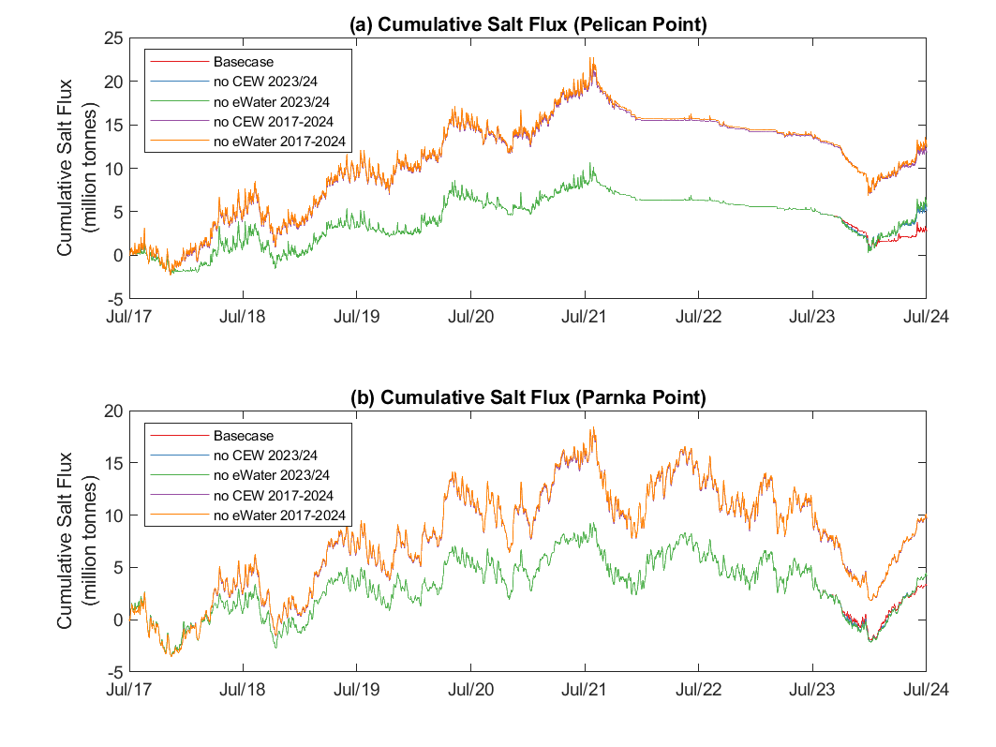
Date
Figure 35. Cumulative salt flux with and without environmental water delivery through Pelican Point and Parnka Point sites for July 2017–June 2024. The results from the ‘base-case’, ‘No CEW 2023-24 (NC1 in 2023-24)’ and ‘No eWater 2023-24 (NE1)’ scenarios are overlapped in the first six years and show only slight differences in the last year (2023-24) due to the small contribution of environmental water to the total barrage flows in this year and the line of ‘No CEW 2017–2024 (NC7)’ was largely overlayed by ‘No eWater 2017–2024 (NE7)’ because the environmental water was mostly contributed by Commonwealth environmental water (CEW) over the seven-year study period. Refer to Table 6 for scenarios.
Further analysis on the cumulative salt flux though Pelican Point to the North Lagoon and through Parnka Point to the South Lagoon (Figure 35) showed the salt accumulation generally increased with time from July 2017 to July 2021 at both sites. In the years 2021–2023, the cumulative salt flux through Pelican Point decreased in the first few months then remained relatively constant due to the relatively flat salinity gradient from Murray Mouth region to the North Lagoon. In contrast, the cumulative salt flux through Parnka Point fluctuated but in general decreased to the end of 2022-23. In 2023-24, the cumulative salt flux dropped during the first six months then increased from January–June 2024 at both sites, corresponding to the strong barrage flows till late 2023 and reduced barrage flows in January–June 2024. Overall, there was still a net decrease of cumulative salt flux through Pelican Point and Parnka Point in 2023-24. The cumulative salt fluxes increased from the ‘No CEW 1 year’ to ‘No CEW 7 years’, and from the ‘No eWater 1 year’ to ‘No eWater 7 years’ scenarios, indicating cumulative effects of the environmental water on the salt transport.
The mean and median salinity at Murray Mouth, North Lagoon and South Lagoon in each year are summarised in Table 8. The mean and median salinity at the Murray Mouth and North/South lagoons showed a dynamic variation corresponding to external forcings with a general increase from 2017 to 2021, then a general decrease from 2021 to 2023. In 2023-24, the mean and median salinity increased at the Murray Mouth and North Lagoon, and slightly decreased in the South Lagoon. Environmental water reduced the salinity in the Coorong, which is particularly evident in the South Lagoon, where the median salinity in 2023-24 would have increased from 59.64 PSU to 82.90 PSU if there was no Commonwealth environmental water since 2017.
Nutrients and chlorophyll-a
Predicted nutrient and chlorophyll-a loads in all scenarios at barrages, Murray Mouth, Pelican Point and Parnka Point are summarised in the supplementary material enclosed with this report. The total nitrogen loads in each year between July 2017–June 2024 are summarised in Table 9 below as an example, which showed the barrage flow transported large amount of nutrients from the Basin into the Coorong, most of which (>84%) were then exported to the Southern Ocean through the Murray Mouth. Relatively small amounts of nutrients were transported southward during the dry years. During the wet years, the interactions of barrage flows, Salt Creek flow, and tide forcing may either transport nutrient to or flush out from the South and North lagoons. Environmental water had a large and ecologically significant impact on nutrient import from Lower Lakes to the Coorong and export from Coorong to the ocean, particularly during the dry years. However, the contribution of environmental water to the southward nutrient and chlorophyll-a fluxes varied in different years and were small compared to barrage loads and export to the Southern Ocean (supplementary material). The fluxes of nutrients in the North and South lagoons did not show significant differences between the ‘All Water’, ‘No CEW’ and ‘No eWater’ scenarios (Figure 36 and supplementary material), indicating the nutrient cycling dynamics in the North and South lagoons are more dominated by local biogeochemical reactions than hydrodynamic transport.

Table 8. Predicted mean and median salinity at Murray Mouth (MM), North Lagoon (NL) (at Long Point), and South Lagoon (SL) (at Woods Well) in all investigated scenarios. Units are practical salinity units (PSU). Refer to Table 6 for scenarios.
Scenarios |  | 2017-18 |  |  | 2018-19 |  |  | 2019-20 |  |  | 2020-21 |  |  | 2021-22 |  |  | 2022-23 |  |  | 2023-24
 |  | MM | NL | SL | MM | NL | SL | MM | NL | SL | MM | NL | SL | MM | NL | SL | MM | NL | SL | MM | NL | SL
Mean | Base-case | 17.79 | 25.47 | 68.73 | 22.69 | 31.73 | 72.95 | 22.14 | 27.06 | 80.80 | 17.66 | 26.23 | 89.13 | 4.24 | 19.70 | 83.20 | 2.02 | 13.69 | 63.37 | 9.39 | 30.85 | 58.78
Mean | NC1 | 27.37 | 39.70 | 73.59 | 30.26 | 42.74 | 76.96 | 29.61 | 41.94 | 86.97 | 25.28 | 38.84 | 92.81 | 5.48 | 21.13 | 83.46 | 2.39 | 14.09 | 63.48 | 13.87 | 38.41 | 59.67
Mean | NE1 | - | - | - | - | - | - | - | - | - | - | - | - | - | - | - | - | - | - | 15.28 | 39.66 | 59.58
Mean | NC7 | 27.37 | 39.70 | 73.59 | 30.67 | 47.59 | 91.29 | 30.37 | 50.50 | 112.38 | 25.87 | 45.49 | 127.61 | 5.84 | 32.31 | 121.03 | 2.42 | 20.20 | 89.75 | 14.07 | 49.06 | 81.54
Mean | NE7 | 28.00 | 40.68 | 73.91 | 30.68 | 47.78 | 92.09 | 30.37 | 50.60 | 113.04 | 26.40 | 46.50 | 128.65 | 7.05 | 33.91 | 122.40 | 2.63 | 20.55 | 90.24 | 15.51 | 50.50 | 81.83
Median | Base-case | 19.99 | 24.90 | 70.94 | 27.42 | 29.48 | 74.92 | 27.44 | 30.41 | 81.95 | 19.17 | 23.60 | 92.90 | 0.73 | 15.34 | 85.09 | 0.22 | 12.02 | 67.44 | 1.88 | 27.82 | 59.64
Median | NC1 | 34.71 | 39.04 | 75.65 | 35.18 | 41.01 | 78.62 | 35.10 | 40.52 | 88.35 | 34.69 | 39.16 | 97.41 | 1.23 | 20.41 | 85.61 | 0.22 | 12.28 | 67.56 | 5.76 | 31.76 | 60.24
Median | NE1 | - | - | - | - | - | - | - | - | - | - | - | - | - | - | - | - | - | - | 8.95 | 32.44 | 60.21
Median | NC7 | 34.71 | 39.04 | 75.65 | 35.26 | 43.06 | 93.75 | 35.21 | 47.41 | 112.99 | 35.05 | 41.26 | 133.74 | 1.35 | 27.34 | 124.91 | 0.23 | 17.89 | 95.65 | 6.49 | 41.92 | 82.90
Median | NE7 | 35.04 | 40.21 | 75.73 | 35.26 | 43.15 | 94.56 | 35.21 | 47.48 | 113.63 | 35.06 | 41.59 | 134.85 | 1.81 | 33.47 | 126.66 | 0.23 | 18.05 | 96.19 | 9.81 | 42.56 | 83.35

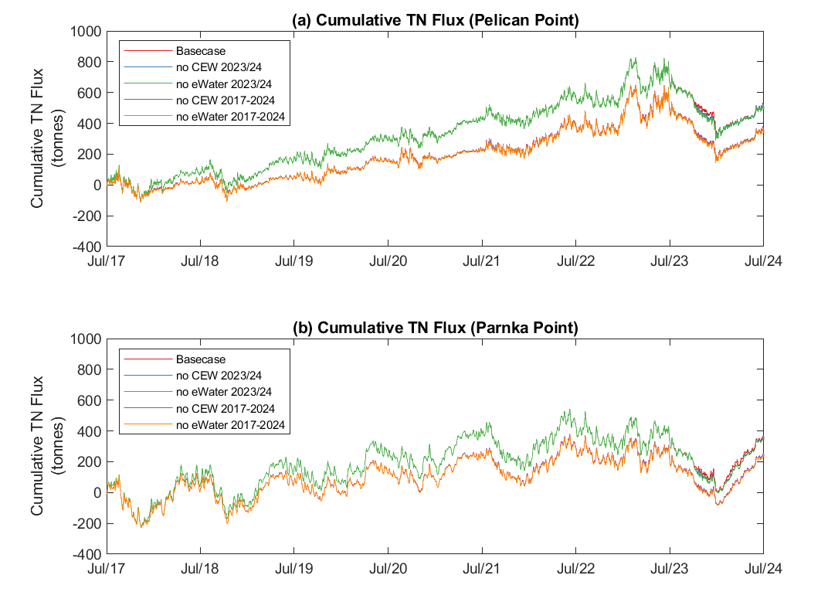
Date
Figure 36. Cumulative total nitrogen (TN) flux with and without environmental water delivery through Pelican Point and Parnka Point sites for July 2017–July 2024. Similar to Figure 35, the results from the ‘base-case’, ‘No CEW 2023-24 (NC1 in 2023-24)’ and ‘No eWater 2023-24 (NE1)’ scenarios are overlapped in the first 6 years and show only slight differences in the last year (2023-24) due to the small contribution of environmental water to the total barrage flows in this year and the line of ‘No CEW 2017–2024 (NC7)’ was largely overlayed by ‘No eWater 2017–2024 (NE7)’ because the environmental water was mostly contributed by Commonwealth environmental water (CEW) over the 7-year study period. Refer to Table 6 for scenarios.

Table 9. Summary of total nitrogen flux (tonnes) though barrages, Murray Mouth, Pelican Point (North Lagoon) and Parnka Point (South Lagoon) in 2017–2024. Refer to Table 6 for scenarios.
Site | Scenarios/Year | 17-18 | 18-19 | 19-20 | 20-21 | 21-22 | 22-23 | 23-24
Barrage (from lakes to Coorong) | Base-case | 1,480.35 | 696.37 | 894.91 | 1,682.68 | 8,033.86 | 31,157.28 | 6,660.97
Barrage (from lakes to Coorong) | NC1 | - | - | - | - | - | 29,882.14 | 5,548.47
Barrage (from lakes to Coorong) | NE1 | - | - | - | - | - | 29,304.95 | 5,161.14
Barrage (from lakes to Coorong) | NC7 | 157.57 | 0.00 | 0.00 | 601.15 | 6,833.85 | 29,882.14 | 5,548.47
Barrage (from lakes to Coorong) | NE7 | 107.36 | 0.00 | 0.00 | 476.76 | 6,206.37 | 29,304.95 | 5,161.14
Murray Mouth (from Southern Ocean to Coorong) | Base-case | -1,410.46 | -587.32 | -770.60 | -1,547.06 | -7,802.56 | -30,907.84 | -6,885.43
Murray Mouth (from Southern Ocean to Coorong) | NC1 | - | - | - | - | - | -29,641.27 | -5,774.60
Murray Mouth (from Southern Ocean to Coorong) | NE1 | - | - | - | - | - | -29,072.36 | -5,401.69
Murray Mouth (from Southern Ocean to Coorong) | NC7 | -153.68 | 41.26 | 105.47 | -532.37 | -6,581.60 | -29,628.60 | -5,743.97
Murray Mouth (from Southern Ocean to Coorong) | NE7 | -105.76 | 41.66 | 105.48 | -411.06 | -5,957.25 | -29,056.63 | -5,363.55
North Lagoon (Pelican Point southward) | Base-case | 83.15 | 98.83 | 104.62 | 130.32 | 150.94 | 102.14 | -144.22
North Lagoon (Pelican Point southward) | NC1 | - | - | - | - | - | 98.76 | -148.67
North Lagoon (Pelican Point southward) | NE1 | - | - | - | - | - | 94.11 | -158.83
North Lagoon (Pelican Point southward) | NC7 | 20.20 | 37.12 | 92.94 | 69.29 | 170.62 | 111.00 | -121.07
North Lagoon (Pelican Point southward) | NE7 | 17.22 | 37.45 | 92.98 | 68.50 | 168.81 | 109.13 | -125.42
South Lagoon (Parnka Point southward) | Base-case | 49.74 | 82.60 | 69.62 | 153.92 | 67.00 | -90.72 | 38.81
South Lagoon (Parnka Point southward) | NC1 | - | - | - | - | - | -94.30 | 32.40
South Lagoon (Parnka Point southward) | NE1 | - | - | - | - | - | -97.20 | 25.46
South Lagoon (Parnka Point southward) | NC7 | 15.46 | 38.66 | 44.32 | 119.99 | 64.21 | -63.13 | 37.34
South Lagoon (Parnka Point southward) | NE7 | 13.39 | 38.47 | 44.54 | 118.88 | 60.52 | -63.28 | 32.30

Evaluation
The evaluation approach is described in the evaluation section for Hydraulic Regime (Section 2.1). Additional assessment criteria are presented in the footnote**.
Table 10. Matter Transport evaluation questions and answers. CEW = Commonwealth environmental water.
CEWH evaluation questions |  | Outcomes of CEW delivery*
 |  | 14-15 | 15-16 | 16-17 | 17-18 | 18-19 | 19-20 | 20-21 | 21-22 | 22-23 | 23-24
What did CEW contribute to salinity: | Levels?  Reduction due to CEW (Median salinity presented, PSU)  at the Murray Mouth | From 34.6 to 24.0 | From 35.1 to 29.7 | From 21.6 to 11.3 | From 34.7 to 20.0 | From 35.2 to 27.4 | From 35.1 to 27.4 | From 34.7 to 19.2 | From 1.2 to 0.7 | From 0.220 to 0.218 | From 5.8 to 1.9
What did CEW contribute to salinity: | In the North Lagoon (Long Point, LP) |  |  |  | From  39.0 to 24.9 | From  41.0 to 29.5 | From  40.5 to 30.4 | From  39.2 to 23.6 | From 20.4 to 15.3 | From 12.3 to 12.0 | From  31.8 to 27.8
What did CEW contribute to salinity: | In the South Lagoon (Woods Well, WW) |  |  |  | From  75.7 to 70.9 | From  78.6 to 74.9 | From  88.3 to 82.0 | From  97.4 to 92.9 | From 85.6 to 85.1 | From 67.6 to 67.4 | From  60.2 to 59.6
What did CEW contribute to salinity: | Transport?  (tonnes salt per year) Additional export through the barrages due to CEW  (% of total salt export) | 285,064  (64%) | 251,632  (87%) | 120,867  (8%) | 397,084  (90%) | 338,428  (100%) | 373,797  (100%) | 372,787  (64%) | 280,844  (15%) | 151,252  (5%) | 221,272  (18%)
 | Reduction of salt import at the Murray Mouth | 3,044,70 | 4,591,269 | 519,292 | 4,015,981 | 4,269,643 | 3,803,660 | 4,111,887 | 159,256 | 116,514 | 2,854,965
 | Reduction of southward salt flux into the North Lagoon (Pelican Point) |  |  |  | 3,466,493 | 3,644,233 | 2,985,534 | 3,474,241 | -139,570 | -49,211 | 2,441,021
 | Reduction of southward salt flux into the South Lagoon  (Parnka Point) |  |  |  | 1,809,613 | 1,185,267 | 1,749,078 | 1,602,222 | -81,041 | -32,340 | 974,673
What did CEW contribute to the salinity regime? |  | Long-term (2017–2024) outcome = substantial.  Overall, CEW increased salt export through the barrages; and reduced salt intrusion into the Murray Mouth from the ocean, which reduced salinity in the Coorong. The contribution of CEW to the inflows to the Coorong was significant during dry years from July 2017 to June 2021, for example, with 100% of barrage releases being CEW in 2018-19 and 2019-20. Salt export remains below the Basin Plan target of 2 million tonnes per year except for 2022-23 (estimated ~3.1 million tonnes). In 2023-24, unregulated water dominated the barrage flows, and CEW contributed to 221,272 tonnes of salt export through the barrages which was 17.8% of all salt exported in that water year. CEW reduced salt import through the Murray Mouth and significantly reduced salt accumulation in the Coorong over the last seven years with less salt flux to the North Lagoon and South Lagoon by 8.81 million and 6.61 million tonnes, respectively.
* The salt export and salinity data reported for years 2014-15 to 2016-17 are from a large domain model previously used in the LTIM reporting (Ye et al. 2020) that has since been superseded by the improved CDM platform. The numbers presented for the period from 2017-18 to 2023-24 are from the latest calibrated model by comparing the ‘All Water’ scenario to the ‘No CEW 1 year’ scenario for each reporting year (denoted NC1 in Table 6). The yearly counterfactual simulations enable quantification of the contribution of CEW to increased export through the barrages and changes to transport within the Coorong for that year’s water. Table 7 also presents results from the continuous model (NC7/NE7) that reflects an accumulated impact of CEW and eWater. Note that an annual improvement in the model’s calibration due to additional monitoring and improvement in barrage flow estimates means that the above numbers for some water years are different from what were previously reported (see Table C2 in Appendix C). The numbers presented in this table are the result of the best overall calibration when assessing the model against 7-years of observed Coorong monitoring data compiled for the period from 2017‒2024.
**Contribution (to what extent CEW contributed towards the outcome, with the significance of the outcome considered). For salinity levels, substantial, moderate, minor and negligible contributions, respectively, were considered to be reductions of: ≥15, 10–14, 5–9 and <5 PSU for the Murray Mouth; ≥10, 5–9, 2–4, and <2 PSU at the North Lagoon; and ≥5, 3–4, 1–2, and <1 PSU at the South Lagoon. For salt transport, contribution scores were based on the annual salt export target of 2 million t: substantial = ≥500,000 (25%), moderate = 300,000–499,999, minor = 100,000–299,999 and negligible = <100,000 tonnes. Substantial contributions were also considered if CEW contributed >50% of total barrage flow. For reduction of salt import/southward flux, substantial, moderate, minor and negligible contributions, respectively, were considered to be reductions of: ≥3, 1–2.99, 0.5–0.99 and <0.5 million tonnes for the Murray Mouth; ≥2, 0.8–1.99, 0.2–0.79, and <0.2 million tonnes at the North Lagoon; and ≥1, 0.5–0.99, 0.1–0.49, and <0.1 million tonnes at the South Lagoon:
 | Unknown |  | None/negligible |  | Minor |  | Moderate |  | Substantial

Discussion
Salinity
Commonwealth environmental water accounted for 65–100% of total annual flow through the barrages during the dry years (between 2017-18 and 2020-21). The years 2021-22 to 2023-24 were wet with unregulated flow comprising a larger proportion of the total Murray River flow. In 2023-24 the Commonwealth environmental water accounted for 19.2% of the annual barrage flow (MDBA modelled data). Environmental water during the dry years was a major contributor to salt export from the Basin, and fresher conditions at the Murray Mouth acted as a barrier to influx of salt from the Southern Ocean to the Coorong, serving to prevent hyper-salinisation. In high flow years, unregulated flows dominated the barrage flows and the contribution from Commonwealth environmental water to salt export was relatively small, but nonetheless the legacy effect of sustained water delivery in the previous years continues to keep salinity within a lower range.
Salinity in the Coorong is primarily a function of riverine inflows through barrages and tidal movement. When barrage flows are low, seawater enters the Murray Mouth and more salt is then transported to the Coorong where it concentrates subject to evapo-concentration. Environmental water through the barrages reduced the salt load into the North and South lagoons, measured as salt flux southward which varies with the barrage flow rates, sea levels, and salinity gradient from Goolwa to the South Lagoon. It is evident that environmental water flowing through the barrages is required in every year to reduce excessive salt accumulation within the Coorong, especially in dry years. If Commonwealth environmental water had not been delivered from 2017–2024, more than 6.5 million tonnes of additional salt would have accumulated in the South Lagoon. This would have been higher without considerable freshening due to the large flood late in this period.
During the Millennium Drought, and particularly from 2007-08 to 2009-10, flow through the barrages ceased and the import of salt into the Coorong resulted in salinity in the South Lagoon that was five times seawater, and demise of much of the aquatic life (Brookes et al. 2009). Water through the barrages provides freshening flows but also acts to inhibit seawater intrusions, thereby maintaining more appropriate salinity conditions for estuarine biota in the Coorong. Given that barrage releases almost entirely (up to 100%) depend on Commonwealth environmental water in dry years, environmental water is critical for limiting salt flux to the North and South lagoons. Even one year without barrage flow can result in a large flux of salt southwards in these dry years. The high barrage flow during July 2021–June 2024 flushed the Coorong lagoons and reduced the salinity concentration. The median salinity in the South Lagoon reduced from 92.9 PSU in 2020-21 to 59.6 PSU in 2023-24. Interestingly, the benefit of cumulative Commonwealth environmental water delivery on the median South Lagoon salinity (i.e. comparing the ‘No CEW 7 years’ and ‘All Water’ scenario) only reduced from 40.8 PSU in 2020-21 to 28.2 PSU in 2022-23, indicating the high unregulated barrage flows in 2021-22 and 2022-23 did not “reset” the system and highlighting the importance of the cumulative impacts of Commonwealth environmental water on salt concentrations in the South Lagoon. As salinity is a key determinant of Ruppia tuberosa and fish habitat, this is explored further in Section 2.3.2.

Nutrients
Environmental water contributed considerably to the transport of nutrients from the Murray River to the Coorong and export to sea, and this was primarily due to additional water volume delivered by the environmental water rather than a change in the nutrient concentrations within the Coorong. The median concentrations of nitrogen and phosphorus did not vary considerably with or without environmental water in 2023-24. Unlike salt concentration, which is only subjected to water transportation and mixing, nutrient concentrations in the Coorong are also strongly affected by biogeochemical activities such as assimilation by phytoplankton and settling/release at the water-sediment interface (Huang et al. 2024). However, the flushing effect brought by the high flows reduced the nutrient and phytoplankton concentrations in the South Lagoon.

Management implications
There are approximately 10¹¹ tonnes of salt in groundwater in the MDB and an additional 1.5 million tonnes of salt is deposited in the Basin each year by rainfall (Herczeg et al. 2001). Unless salt is exported from the Basin with flow, there will be a net accumulation of salt within the Basin. The Basin Plan sets out a salt export objective (Section 9.09) to ensure adequate flushing of salt from the Murray River system into the Southern Ocean. The Basin Plan’s indicative target for salt export from the Basin is 2 million tonnes per year. The last seven years of salt export modelling enables the contribution of environmental flows to salt export to be scrutinised.
Commonwealth environmental water played a key role in salt export from the Basin to the Coorong and Southern Ocean during the dry years, accounting for 64–100% of total salt export in July 2017–June 2021, depending on the volume of unregulated flows and other environmental water. In the high flow years (2021-22, 2022-23 and 2023-24), 1.82, 3.11 and 1.24 million tonnes were exported and Commonwealth environmental water contributed 15%, 5%, and 18% of the salt exported, respectively (Table 10).
It is generally accepted that elevated nutrients in the South Lagoon of the Coorong are contributing to the formation and persistence of algal mats (Mosley et al. 2022). In fact, the legacy nutrients in the sediments are contributing to this issue (Huang et al. 2022; Priestley et al. 2022), whereas it is evident nutrients delivered by environmental flows do not alter nutrient concentrations significantly. On the other hand, environmental flows played an important role in the nutrient loading through barrages and export through the Murray Mouth to the ocean during the dry years. Maximum exports of matter from the Murray Mouth are likely to be achieved by delivering environmental water during periods of low oceanic water levels (e.g. summer). In contrast, environmental water delivery from the Murray River at times of high oceanic water levels, which peak in the Austral winter, is likely to increase the exchange of water and associated nutrients and salt through the Coorong, rather than predominately through the Murray Mouth. Targeted barrage discharges during high tide, swell and appropriate wind direction events are important to improve water quality in the Coorong and particularly in the South Lagoon. If fresher river water is discharged through southern barrages (i.e. Tauwitchere/Ewe Island barrages), then the wind and tide can force this fresher water south, reducing the salinity in the South Lagoon. The Coorong Dynamic Model could be used to test these scenarios. Alternatively, or additionally, targeted field investigation of trial releases could be employed to determine the impact of such releases on salinity in the South Lagoon.

Conclusion
The main conclusions from the current study remain similar to previous LTIM findings (Ye et al. 2020a), that the contributions of environmental water have significantly increased the export of salt from the Basin, especially during the dry years (2017–2021). During wet years, the impacts of environmental water on salt and nutrient export are relatively small due to environmental water being only a small portion of the total barrage flows (14.1% in 2021-22, 3.7% in 2022-23, and 19.2% in 2023-24, MDBA modelled data). Cumulatively from 2017–2024, environmental water increased salt export from the Lower Lakes to the Coorong by 2.49 million tonnes, and decreased salt import from the Southern Ocean to the Coorong by approximately 12.67 million tonnes in seven years, most of which was attributable to Commonwealth environmental water (11.11 million tonnes). Environmental water also helped to reduce the salt flux southward to the North and South lagoons by 9.64 million tonnes and 6.71 million tonnes, respectively, from 2017 to 2024. Commonwealth environmental water contributed 8.81 million tonnes and 6.61 million tonnes, respectively.

2.3.2 Coorong Habitat

Background
The Coorong is an estuarine lagoonal system with a natural salinity gradient ranging from freshwater to hyper-saline at the southern extremity. Freshwater flows are important in maintaining estuarine habitat and ecosystem health and preventing extreme hyper-salinity (Brookes et al. 2009). Ruppia tuberosa is an important macrophyte in the Coorong that provides habitat for fish and food for herbivorous birds (Phillips and Muller 2006; Giatas et al. 2022). Ruppia tuberosa can tolerate a range of salinity conditions and is the dominant macrophyte in the Coorong, particularly in the region where salinity is higher than natural seawater. The germination and growth of R. tuberosa is known to be governed largely by changes in salinity and water level regimes, which are influenced by flows through the barrages (Kim et al. 2013). Other factors that influence R. tuberosa growth include nutrient availability, water temperature, sediment quality and interactions with algae, including shading of light and interference with flowers and fruits on the surface (Collier et al. 2017). Flows during spring and into early summer are likely to be particularly beneficial as they delay the drop in water level in the South Lagoon and can prevent extremely high salinities emerging, thereby improving the probability that R. tuberosa will complete its reproductive cycle. In addition, salinity has also been identified as a key driver of fish distribution and assemblage structure by influencing the extent of estuarine fish habitat in the Coorong (Ye et al. 2011, 2016a; Bice et al. 2018). This sub-indicator aims to assess the benefits of environmental flows for the enhancement of R. tuberosa habitat, particularly those that are delivered in late spring and early summer, and the improvement of estuarine fish habitat throughout the year for several key species with different salinity tolerance.
Major hypothesis
Increased freshwater flow through the barrages and into the Coorong due to environmental water delivery will prevent areas of extreme salinity and maintain water levels in the Coorong, thus expanding the extent of R. tuberosa and fish habitats.

Methods
The habitat extent of R. tuberosa and fish was estimated using previously reported environmental thresholds (Ye et al. 2016a; see Zhai et al. 2025 for a summary of R. tuberosa environmental thresholds). For R. tuberosa, the thresholds are consistent with the Generation 2 Coorong Dynamics Model (CDM, Hipsey et al. 2022), in which the latest findings from the HCHB Program were incorporated. The R. tuberosa ecological response model has capability to account for habitat suitability of critical life stages, and is designed to estimate the probability of turion survival during summer dormancy, turion sprouting, seedling development to juvenile plants, and adult plant flowering and turion formation (Zhai et al. 2025). Each stage (viability, seed, sprout, adult, flowering, turion) is assigned a habitat suitability based on cell specific light, depth, salinity, temperature and filamentous algae density, which results in a combined probability of sexual life-cycle completion, asexual life-cycle completion, or dual life-cycle where both sexual and asexual completions are possible, at the end of each calendar year (corresponding to the end of its annual life-cycle). Where the index was above 0.5, we computed a suitable area of habitat, by multiplying the habitat score by the cell area, and summing over all cells within both North and South lagoons excluding the area surrounding the Murray Mouth.
The fish habitat model was implemented to calculate spatio-temporal probabilities of habitat suitability for juveniles of seven key species, mulloway (Argyrosomus japonicus), black bream (Acanthopagrus butcheri), greenback flounder (Rhombosolea tapirina), yelloweye mullet (Aldrichetta forsteri), congolli (Pseudaphritis urvillii), Tamar goby (Afurcagobius tamarensis) and smallmouth hardyhead (Atherinosoma microstoma), based on experiment-derived lethal concentration salinity thresholds and temperature sensitivity to the salinity thresholds (McNeil et al. 2013, Table C3 in Appendix C). The model adopts a seasonal effect by account for temperature sensitivity to the salinity thresholds (higher salinity tolerance at lower temperatures) to calculate the habitat suitability index (Brookes et al. 2022, see Table C4 for model functions). A suitable habitat area for each species in each month was calculated using the same method as R. tuberosa for the North and South lagoons. The monthly area was then averaged over each water year to assess inter-annual variability.

Results
The modelled R. tuberosa habitat areas in the Coorong from 2018–2023 are summarised in Figure 37, including the suitable habitat area for different life stages. The comparison of the overall area of habitat to complete a full life-cycle of sexual reproduction showed a decrease of 47% in 2023 in the ‘No CEW 7 years’ scenario when compared to the ‘All Water’ scenario (i.e. seven-year cumulative effect), and this appears to be mainly limited to the area suitable for successful flowering (Figure 37 and Figure 39). The total suitable habitat area for asexual reproduction showed a 20% increase if there was no Commonwealth environmental water for seven years continuously. However, this was mainly driven by an increase in habitat in the northern Coorong, while most of the southern Coorong observed a decrease of suitable habitat (Figure 40). Overall, habitat area suitable for both sexual and asexual reproduction (‘dual’) showed a similar response to scenarios as that of sexual reproduction (Figure 38), with a 25% reduction in habitat area in 2023 under the ‘No CEW 7 years’ scenario. The degree of benefit from environmental water for sexual, asexual and dual reproduction varied each year across 2018–2021, and appears to be negligible between 2022–2023 (Table 11).
The modelled suitable habitat area for each fish species is presented in Figure 41, which showed environmental water had led to fresher conditions in the Coorong and an expansion of suitable fish habitat area. Reductions in area of fish habitat of between 18–52% (species dependent) were predicted in 2023-24 if there was no Commonwealth environmental water for seven years continuously (i.e. ‘No CEW 7 years’ scenario, Figure 41). The reduced area mostly occurred in the middle and southern Coorong during April–October, and in the northern Coorong as well during November–February (Figure 42), showing black bream as an example. Reductions of 0.2–22% per year (species and year dependent) in fish habitat area were predicted in the Coorong for each year Commonwealth environmental water was not delivered (Table 11).

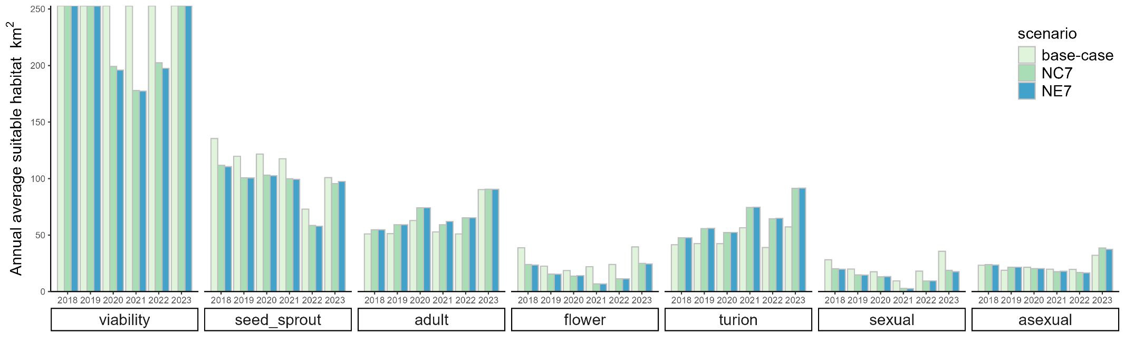
Year
Figure 37. Habitat area suitable for Ruppia tuberosa (overall sexual, asexual and individual life-stages), comparing the base-case and NC7/NE7 scenarios from 2018–2023. Refer to Table 6 for scenarios.

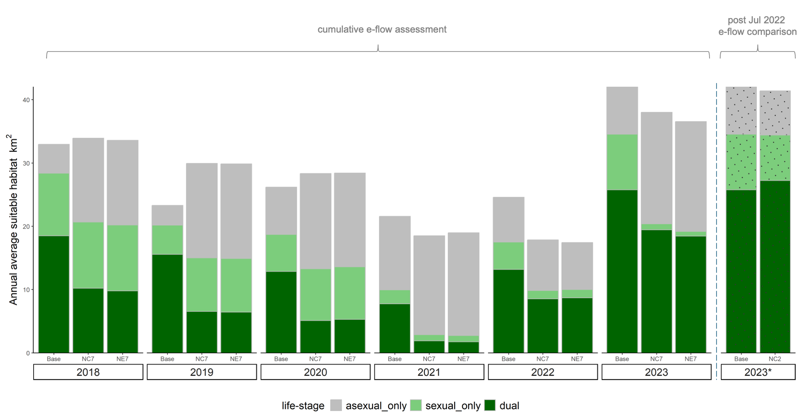
Figure 38. Habitat area suitable for Ruppia tuberosa (overall sexual only, asexual only and dual life-stage completion), comparing the base-case against the NC7 and NE7 scenarios to assess the effect of cumulative environmental water delivery between 2018–2023, and also comparing the base-case to the NC2 scenario to isolate the effect of recent CEW water from Jul 2022 to Dec 2023 on the 2023 growth year (denoted as 2023*); refer to Table 6 for scenario definition. Note that the ‘sexual only’ scenario excludes area suitable for asexual or dual reproduction, and ‘asexual only’ excludes area suitable for sexual or dual reproduction, thus are different to the ‘sexual’ and ‘asexual’ in Figure 37.
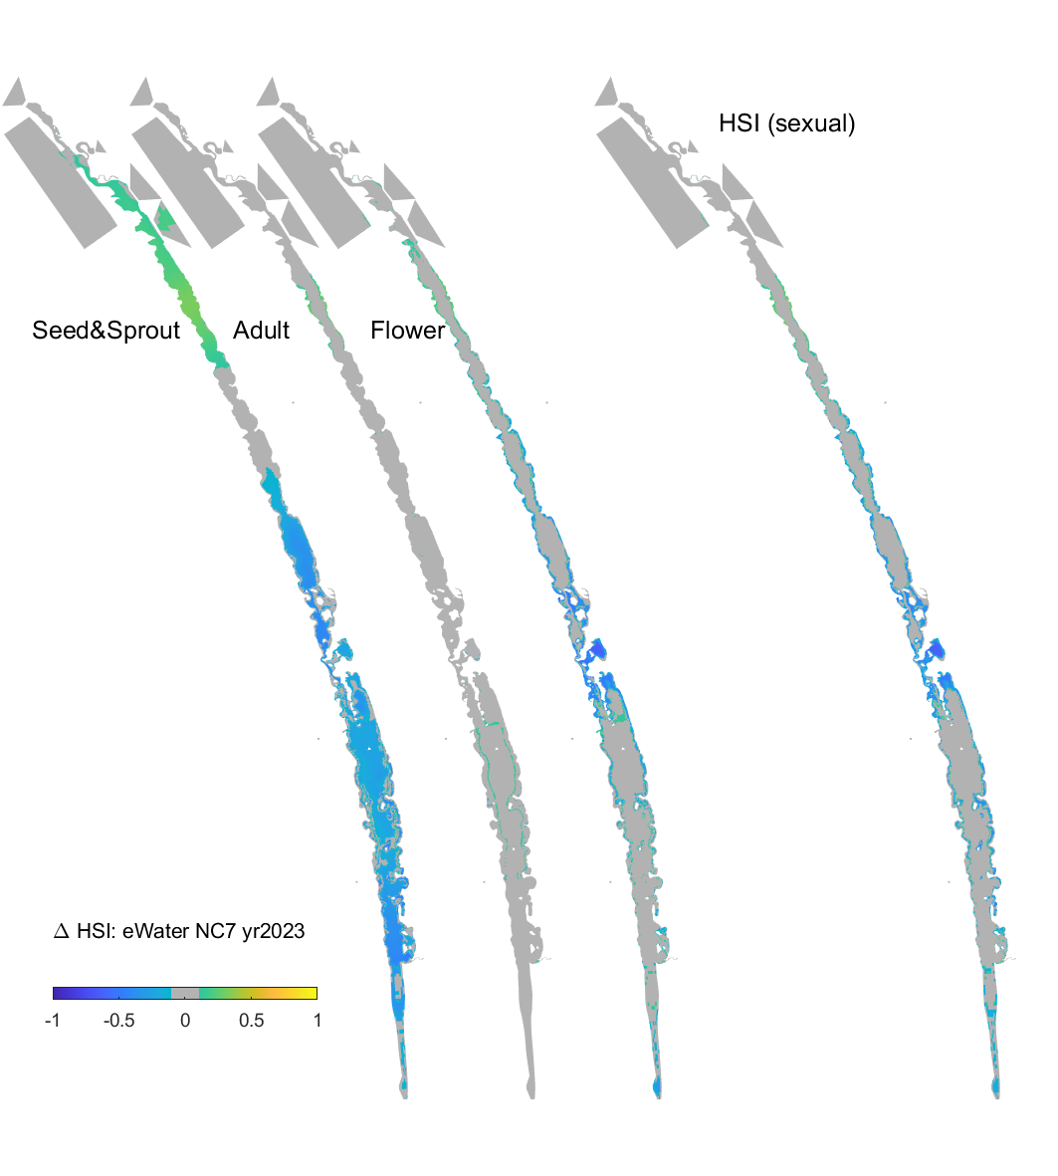
loss gain
Figure 39. Differences of Ruppia tuberosa HSI (habitat suitability index) values for sexual reproduction in 2023 between the no Commonwealth environmental water since 2017 (No CEW 7 years) and the ‘All Water’ (base-case) conditions. The index is computed for each stage (seed germination and turion sprout, adult, flower) of the life-cycle, and the overall suitability (HSI sexual) is based on where all life-stage requirements are met for sexual reproduction. More saline conditions in the ‘No CEW 7 years” scenario led to a loss of good habitat in the middle of the Coorong and South Lagoon (blue indicates contraction, orange indicates expansion) that meets the requirements of all life-stages.

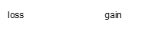
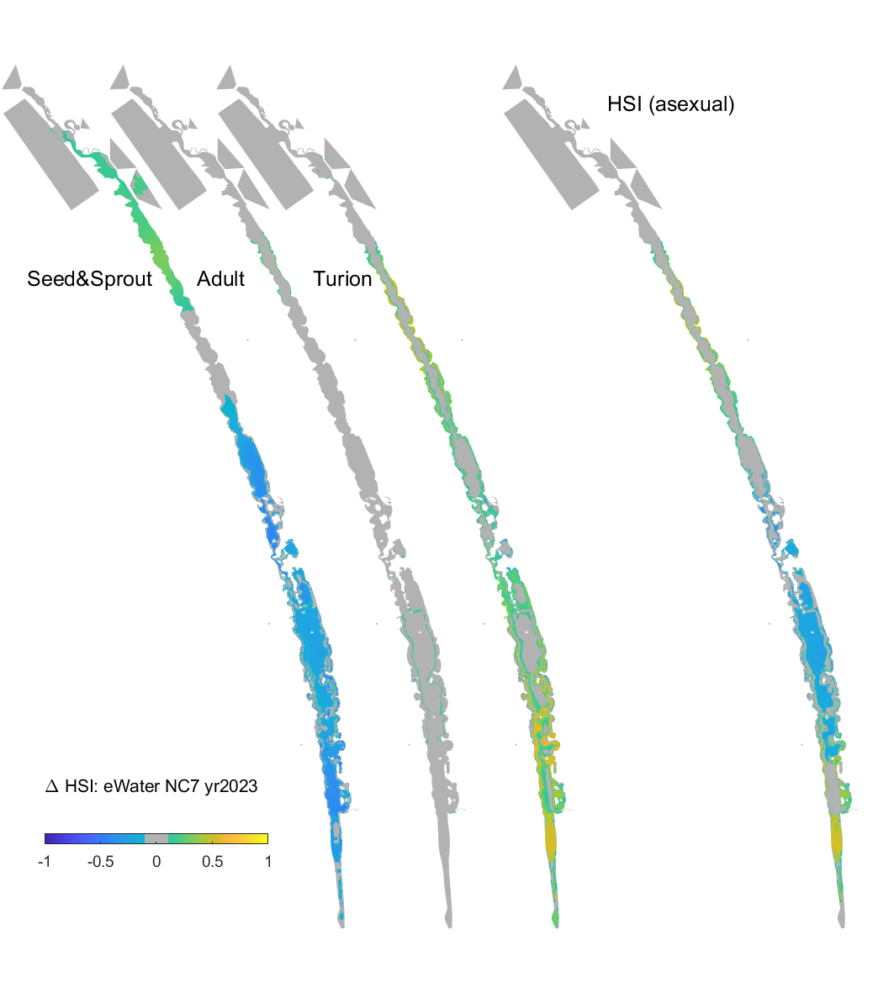
Figure 40. Differences of Ruppia tuberosa HSI (habitat suitability index) values for asexual reproduction in 2023 between the no Commonwealth environmental water since 2017 (No CEW 7 years) and the ‘All Water’ (base-case) conditions. The index is computed for each stage (seed germination and turion sprout, adult, turion formation) of the life-cycle, and the overall suitability (HSI asexual) is based on where all life-stage requirements are met for asexual reproduction. More saline conditions in the ‘No CEW 7 years’ scenario led to a loss of good habitat in the middle of the Coorong and South Lagoon except near the southern tip (i.e. Salt Creek) but a gain in the North Lagoon (blue indicates contraction, orange indicates expansion) that meets the requirements of all life-stages.
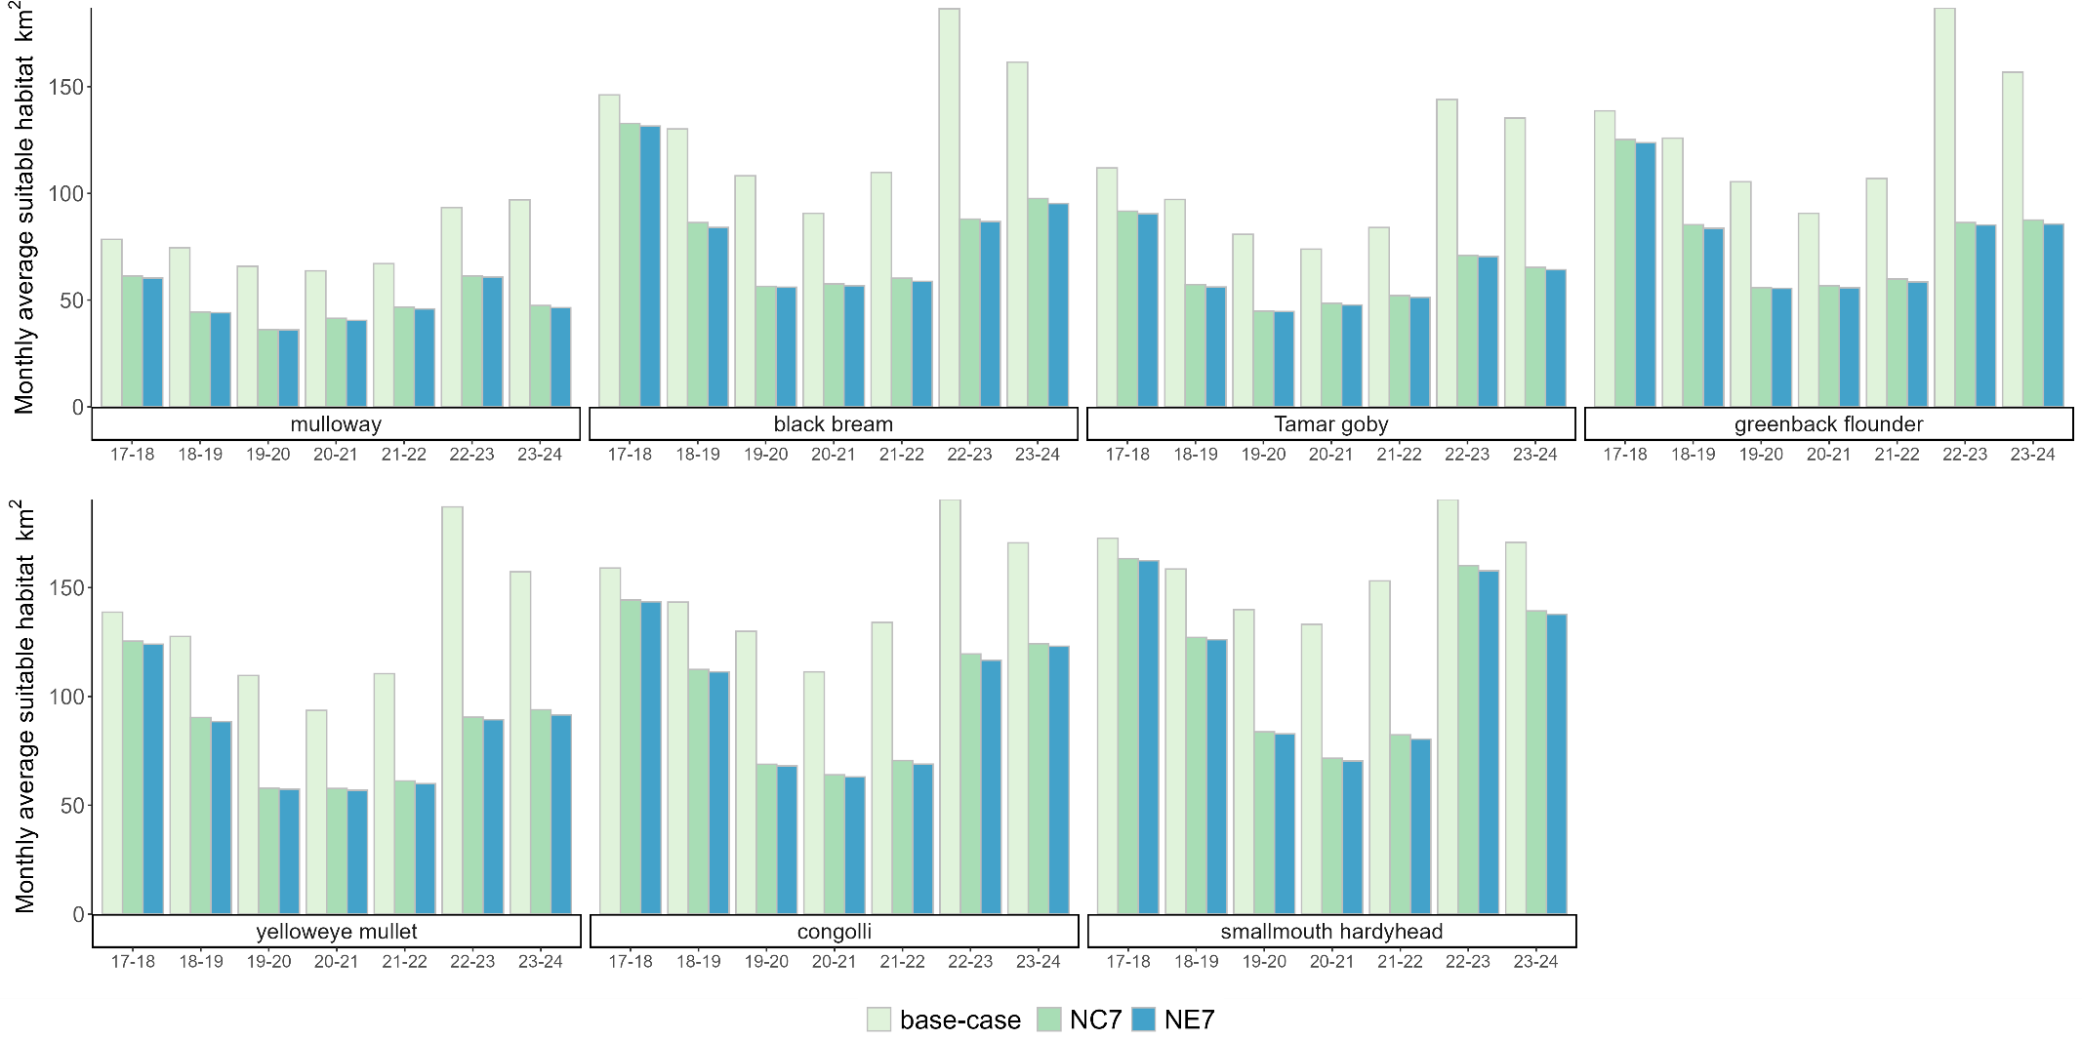
Year
Figure 41. Habitat area of juvenile stages of key fish species for the scenarios showing the cumulative effect of environmental water delivery (i.e. 7 years for 2023-24). Environmental water gives a large habitat expansion for all species. Refer to Table 6 for scenarios.

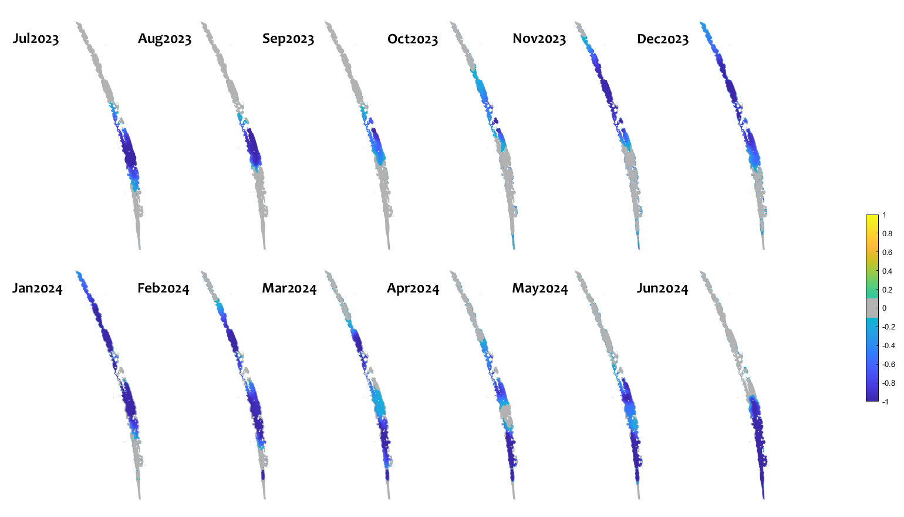
Figure 42. Monthly habitat area “lost” for black bream during July 2023–June 2024 if there was no Commonwealth environmental water delivery since 2017 (calculated as the difference between habitat in the ‘All Water’ (base-case) and ‘No CEW 7 years’ scenarios). Large areas of the Coorong, particularly the South Lagoon have a decrease in habitat quality, highlighting areas that have benefited from environmental water.

Evaluation
The evaluation approach, including assessment criteria, is described in the evaluation section for Hydraulic Regime (Section 2.1).
Table 11. Coorong habitat evaluation questions and answers. CEW = Commonwealth environmental water. TBC = to be confirmed at the end of the calendar year.
CEWH evaluation questions | Outcomes of CEW delivery
CEWH evaluation questions | Life-stage | 2018* | 2019* | 2020* | 2021* | 2022* | 2023* | 2024*
What did CEW contribute to improving predicted Ruppia tuberosa habitat in the Coorong? (HSI-weighted area in km², with percentage change in brackets) | Sexual | 7.9 (28%) | 3.0 (15%) | 2.4 (14%) | 5.0 (53%) | -0.2 (-1%) | 0.5 (1%) | TBC*
 | Asexual | -0.6 (-3%) | -4.2 (-22%) | 1.0 (5%) | 0 (0%) | 2.6 (13%) | -1.4 (-4%) | TBC*
 | Dual | 8.3 (45%) | 7.3 (47%) | 6.4 (50%) | 4.3 (56%) | 2.1 (16%) | -1.5 (-6%) | TBC*
Long-term (2018–2023) outcome = moderate.
Habitat suitable for overall sexual and dual life-cycle completion of R. tuberosa was substantially improved with CEW during the dry years from 2018–2021. The contribution of CEW to habitat area in 2022 and 2023 was minor to negligible due to naturally fresh conditions. Small negative changes in during some conditions are due to the asexual habitat area expanding, which is consider acceptable when sexual habitat is expanding.
Overall, without CEW since July 2017, the area suitable for R. tuberosa sexual and dual life-cycle completion would have been 47.1%, and 24.5% less, respectively. This highlights the importance of the cumulative benefit of environmental water to maintain and restore the ecosystem in the Coorong, particularly via the sexual reproduction pathway.

What did CEW contribute to improving predicted fish habitat in the Coorong? (HSI-weighted area in km², with percentage change in brackets) | Species | 2017-18 | 2018-19 | 2019-20 | 2020-21 | 2021-22 | 2022-23 | 2023-24
 | Mulloway | 17.1 (22%) | 11.1 (15%) | 14.3 (22%) | 9.1(14%) | 0.9 (1%) | 0.9 (1%) | 6.7 (7%)
 | Black bream | 13.3 (9%) | 11.6 (9%) | 17.1 (16%) | 7.7 (9%) | 2.1 (2%) | 0.5 (0.2%) | 7.3 (5%)
 | Tamar goby | 20.3 (18%) | 10.9 (11%) | 14.3 (18%) | 9.0(12%) | 1.4 (2%) | 1.3 (0.9%) | 6.8 (5%)
 | Greenback flounder | 13.5 (10%) | 10.6 (8%) | 16.9(16%) | 7.7 (9%) | 2.4 (2%) | 0.5 (0.3%) | 8.3 (5%)
 | Yelloweye mullet | 13.2 (10%) | 10.3 (8%) | 16.0(15%) | 7.6 (8%) | 2.1 (2%) | 0.6 (0.3%) | 8.0 (5%)
 | Congolli | 14.6 (9%) | 8.8 (6%) | 12.1 (9%) | 9.7 (9%) | 2.3 (2%) | 0.5 (0.2%) | 4.5 (3%)
 | Smallmouth hardyhead | 9.4 (6%) | 11.3 (7%) | 8.7 (6%) | 9.2(7%) | 2.5 (2%) | 0.5 (0.2%) | 2.6 (2%)
Long-term (2017–2024) outcome = substantial.
CEW led to fresher conditions in the Coorong and a substantial expansion of predicted suitable fish habitat area over seven years. Without CEW from 2017-18 to 2023-24, the area of suitable habitat in 2023-24 for mulloway, black bream, yelloweye mullet and greenback flounder (four key commercial fishery species) would have declined by 51%, 40%, 40% and 44%, respectively. A similar trend is evident for Tamar goby, congolli and smallmouth hardyhead (ecologically important species) with a respective decrease of 52%, 27% and 18%.
A major expansion of suitable habitat into the southern Coorong is critically important to restore biodiversity in this recovering ecosystem.

*The calculation of the overall R. tuberosa HSI requires a full calendar year of simulation (corresponding to its annual life-cycle). As only January–July was simulated for 2024, habitat area for R. tuberosa could not be calculated for this year. The annual evaluation was based on ‘No CEW’ during that calendar year and six months prior.
Contribution (to what extent CEW contributed towards the outcome, with the significance of the outcome considered): for Ruppia, a substantial contribution was considered an increase in habitat area of 30% or greater, moderate 20–29%, minor 10–19%, negligible -2–10%, negative < -2%; For fish, a substantial contribution was considered an increase in habitat area of 15% or greater, moderate 10–14%, minor 5–9%, negligible 0–5%, negative <0:
 | Unknown |  | Negative |  | None/negligible |  | Minor |  | Moderate |  | Substantial

Discussion
Salinity is a key determinant of habitat suitability in the Coorong and is primarily a function of riverine inflows through barrages, seawater ingress and tidal movement. When barrage flows are low, more seawater enters the Murray Mouth and more salt is then transported to the Coorong. It is evident that environmental water is critical for maintaining appropriate salinity in the Coorong and maintaining suitable habitat, especially in the middle Coorong and South Lagoon.
The comparison of the overall modelled area of suitable habitat for R. tuberosa, based on the completion of a sexual reproduction life-cycle, indicated that without Commonwealth environmental water continuously between 2017–2023, there would have been a 47% reduction in habitat area suitable for sexual reproduction in 2023. The main reduction appears to be driven by the area suitable for successful flowering (Figure 39), since flowering has a lower tolerance to high salinities than other life-stages (Zhai et al. 2025). The habitat area suitable for asexual reproduction in the South Lagoon would also have reduced markedly without environmental water, primarily due to loss of quality habitat for seed germination and turion sprouting early in the life-cycle (Figure 40). Although there would be an increase in habitat area for asexual reproduction in the North Lagoon without environmental water (due to higher salinity tolerances of turions, Figure 40), priority should be given to the South Lagoon, which has been the target area for R. tuberosa management or restoration.
Similar to sexual reproduction outcomes, habitat area suitable for both sexual and asexual reproductions (‘dual’) would have decreased by 25% (or 6.3 km², HSI-weighted) if there was no environmental water delivery continuously between 2017–2023. Having habitat suitable for both sexual and asexual reproduction is likely beneficial for long-term resilience of R. tuberosa populations and thus overall health of the Coorong for several reasons: 1) Sexual reproduction is crucial for maintaining genetic diversity; 2) Seeds produced are able to tolerate higher salinity conditions than turions through summer dormancy (Kim et al. 2013) making populations more resilient under extreme conditions; 3) Providing a variety of food source (both seeds and turions) for waterbirds; 4) Turion development may improve sediment quality (Waycott et al. 2022). Therefore overall, environmental water is critical for the long-term resilience of the R. tuberosa population in the Coorong, especially in the middle of the Coorong and South Lagoon.
The benefits of Commonwealth environmental water for R. tuberosa in 2022 and 2023 were minor to negligible due to the naturally fresh conditions. Overall contribution of environmental water to R. tuberosa habitat for asexual reproduction was slightly negative (-4 %) in 2023 because salinity levels in the North Lagoon without environmental water were already close to the lower end of R. tuberosa’s tolerances during the adult growth and reproductive stages, and thus delivering additional freshwater would not have expanded R. tuberosa habitat in the North Lagoon. However, without Commonwealth environmental water in 2023, R. tuberosa habitat for sexual reproduction would suffer a small loss in both the North and South lagoons. Additionally, lower salinity in the North Lagoon would favour R. megacarpa and charophytes (Brock 1981), which were not assessed in this study, but would provide alternative habitat in the Coorong.
The estuarine fish species that inhabit the Coorong vary in their tolerance to salinity with yelloweye mullet, congolli and smallmouth hardyhead able to tolerate more saline conditions (McNeil et al. 2013). Fish differ from R. tuberosa in that they can move in response to changing salinity and habitat suitability. However, they can be constrained to larger spatial scales (i.e. lagoons) depending on the degree of connectivity e.g. between the North and South lagoons, between the South Lagoon and Salt Creek, and/or between the Coorong and the Southern Ocean. Therefore, it is generally considered advantageous to have a greater area of habitat with suitable water quality (e.g. salinity) and abundant food resources to support the maintenance of fish populations. Estuaries are important feeding, spawning, nursery and refuge grounds for many estuarine-dependent fish species (Bice et al. 2018). Without environmental water, fish habitat contracts quickly and significantly. Even after the high flow year in 2016-17, if there was no environmental water delivered in 2017-18, significant habitat contraction would have occurred. This would have been particularly the case for mulloway and Tamar goby, which are less tolerant to high salinities and thus their area of suitable habitat would be most impacted by salinity increases. Even for the more salt-tolerant congolli and smallmouth hardyhead, the reduction in their suitable habitat areas would occur in 2017-18 without environmental water and a large area in the South Lagoon would have salinities exceeding their tolerance thresholds. Consecutive years of no Commonwealth environmental water from 2017-18 to 2023-24 would have reduced suitable fish habitat by 18–52%. Without environmental water, it was evident that the greatest contraction in habitat occurred between 2017-18 and 2019-20, whereas the 2022-23 period showed the smallest contraction for all species, likely due to the already large unregulated freshwater flows to the Coorong.

Management implications
Barrage flow is critical to maintain both sexual and asexual reproduction success of R. tuberosa in the middle of the Coorong and South Lagoon, and the benefit of environmental water is particularly prominent in drier years. The health of R. tuberosa in the system, the extent of cover and the prevailing salinity would need to be considered, and environmental flow could be tailored to improve habitat suitability for R. tuberosa. The model provides a tool for scenario comparison to optimise environmental water delivery through the barrages to maximise the area of suitable R. tuberosa habitat based on the available volume of water. Water level maintenance is also necessary for R. tuberosa to complete its life-cycle. If Coorong water level drops too quickly in early summer, then the plants can become stranded and desiccate. Environmental water delivered during spring and summer, can help maintain or reduce the rate of water level reduction in the South Lagoon and promote R. tuberosa reproduction. A targeted investigation could determine the flow volumes required to maintain water level in the South Lagoon to ensure plants can complete their life cycle. This investigation could use a combination of historical data, modelled flow scenarios, and/or a field trial. The rate at which the South Lagoon would drain is dependent upon the evaporation rate and the size of the Murray Mouth.
The area of suitable estuarine fish habitat is highly sensitive to river flow via the barrages. Environmental flows lead to reduced salinities in the Coorong and an expansion of suitable fish habitat area. Without environmental flows, the suitable habitat contracts for a range of fish species (e.g. mulloway, black bream, Tamar goby, greenback flounder, yelloweye mullet and congolli). Smallmouth hardyhead are more salt-tolerant and have been the most abundant prey fish species in the southern Coorong (Ye et al. 2020b). Their habitat also contracts with no environmental water but the major impact on habitat suitability for this species (mainly reflected in the South Lagoon) took about one year longer to manifest than the other species. To maintain fish habitat for the range of estuarine species, environmental flows are essential to support barrage releases every year, particularly during spring and summer to enhance spawning/nursery habitat suitability and food availability. Just one year (e.g. 2017-18 and 2019-20) without environmental flows would have reduced mulloway habitat by 22%.

Conclusion
Environmental water was critical in lowering salinity in the Coorong and maintaining estuarine habitat to support ecological functions and biodiversity during the dry years of 2018–2021, whilst the impacts in 2022 and 2023 were negligible due to the small portion of environmental water to the total flow. Cumulatively, the overall area of R. tuberosa habitat for sexual reproduction showed a general decrease of up to 47% in 2023 if there was no Commonwealth environmental water delivery from July 2017–December 2023. Similarly, the overall habitat area for R. tuberosa asexual reproduction also decreased significantly in the middle Coorong and South Lagoon if there were no environmental water since July 2017. Annual reductions of ~0.2–22% in area of fish habitat were predicted for each year if Commonwealth environmental water was not delivered between 2017–2024, and the reduction area focused on the middle and south Coorong. Reductions of 18–52% in the habitat area for key fish species were predicted in the Coorong if there was no Commonwealth environmental water for seven years continuously since July 2017. Environmental flow delivery during periods when there would otherwise be negligible water exchange between the Lower Lakes and Coorong is critical for maintaining the connectivity between freshwater and marine environments and promoting fresher conditions in the Coorong with more favourable habitat for estuarine fish and plants.

Littoral Vegetation Diversity and Productivity

Background
Littoral (streambank) vegetation is an important component of the biota of riverine ecosystems. It is a key primary producer for both the riverine and terrestrial ecosystem (e.g. Roberts and Ganf 1986; Froend and McComb 1994), can improve water quality (e.g. Li et al. 2010; Borin and Salvato 2012), oxygenate the sediment and water column (e.g. Blom et al. 1990; Sorrell and Hawes 2010; Dickopp et al. 2011), provide habitat for water birds (e.g. Jansen and Robertson 2001; Kapa and Clarkson 2009) and invertebrates (e.g. Papas 2007; Walker et al. 2013) and stabilise banks (e.g. Abernethy and Rutherfurd 1998). Littoral zones are also hot spots for biodiversity because they contain a specialised group of species adapted to wetting and drying not found in aquatic or terrestrial systems and therefore, increase the species pool at the landscape scale (Sabo et al. 2005).
Littoral vegetation responds rapidly to changes in water level (e.g. Nicol et al. 2018a), as inundation changes the physicochemical environment and acts as an environmental sieve (sensu van der Valk 1981) producing conditions that are hostile to some species but favourable to others (e.g. Nicol et al. 2003). In riparian zones, inundation often acts as disturbance, removing the existing vegetation and providing an environment almost free of competition with high soil moisture (e.g. Pettit and Froend 2001; Bagstad et al. 2005; Beauchamp and Stromberg 2008). Due to the unpredictable nature of flooding regimes in arid Australian systems (Puckridge et al. 1998, 2000), many littoral species are short-lived annuals that are adapted to take advantage of these brief periods of favourable conditions. They germinate as water levels recede, complete their life cycle whist soil moisture is high, and competition is low and replenish the seed bank (e.g. Nicol 2004; Capon 2007). These species persist in the soil seed bank whilst conditions are unfavourable and are examples of Grime’s (1979) r-selected species. Many species have more in common with desert annuals than aquatic species (e.g. Nicol 2004; Capon 2007). Emergent and amphibious species (sensu Brock and Casanova 1997; Casanova 2011) are also present and are typically perennial taxa (Cunningham et al. 1992) adapted to persist or respond to inundation and exposure. These species have a requirement of variable water levels to establish and/or reproduce (e.g. Brock and Casanova 1997; Casanova 2011; Nicol et al. 2018b).
Management of water levels in the LMR has typically focussed on maintaining stable water levels in lower weir pools, which can result in small increases in flow causing large water level rises in tailwaters immediately downstream of weirs (Maheshwari et al. 1995). Therefore, tailwaters represent areas where flood dependent and amphibious vegetation can persist, in the absence of high flows, over a wider range of the elevation gradient (Blanch et al. 1999, 2000). This makes tailwaters an ideal location to assess the influence of Commonwealth environmental water as the volumes available for delivery will have a significant impact on water levels in these areas. The response of the vegetation along the elevation gradient in tailwaters can be exploited to evaluate the benefit of Commonwealth environmental water.
Littoral vegetation monitoring was undertaken in the LMR during 2019-20, 2020-21 and 2023-24. The first two years were characterised as low flow years (maximum flow to South Australia <18,000 ML/d). In 2023-24, flow discharge was higher (up to bankfull level in spring) during the first eight months but decreased to <8,000 ML/d after March, enabling the monitoring to be undertaken in early winter. Vegetation monitoring was not undertaken in 2021-22 and 2022-23 due to sustained high flows and water levels.
The aim of this study was to investigate the response of littoral vegetation to Commonwealth environmental water delivery by testing the hypotheses in the following section. This will be undertaken by comparing species composition and biomass between areas inundated and not inundated by environmental water delivered in spring and summer.
Major hypotheses
- Increases in flow will result in increased water level variability in the littoral zone that will facilitate the recruitment of floodplain and amphibious understorey species and in turn increase biological and functional diversity of the littoral zone plant community.
- The increase in water level variability due to increases in flow will result in increased productivity of littoral vegetation compared to non-inundated areas.

Methods
Study sites and hydrology
Vegetation surveys were undertaken on the banks of the LMR in weir pool tailwaters downstream of Lock 1, Lock 4 and Lock 6 (referred to herein as reaches) to correspond with the locations of other indicators (Figure 1).
The 2023-24 flow pulse (peak 52,618 ML/d) resulted in water level increases of approximately 2.6, 3.0 and 2.4 m above normal pool level (at 5,000 ML/d QSA) in the tailwater reaches downstream of Lock 6, 4 and 1, respectively (Figure 9). Environmental water (comprised mainly of Commonwealth environmental water) was delivered to slow drawdown following the peak and reduce the dip in water levels between this peak and smaller peak predicted for early November (Figure 5). Water levels remained around 1.0, 1.1 and 0.9 m above normal pool level in the tailwater reaches downstream of Lock 6, 4 and 1 respectively until early December 2023 (Figure 9). The increase in water levels due to environmental water delivery during this period were 0.25 m downstream of Lock 6, 0.24 m downstream of Lock 4 and 0.23 m downstream of Lock 1 (Figure 9).
Environmental water delivery in 2023-24 was markedly different to 2019-20 and 2020-21, when the two previous rounds of vegetation monitoring were undertaken. Environmental water was delivered in 2019-20 and 2020-21 to produce a small in-channel flow pulse (peaking at 15,000–18,000 ML/d). All flows above South Australian entitlements were due to environmental water delivery (primarily Commonwealth environmental water). For a detailed description of the hydrology and environmental water delivery see Section 1.4.
Vegetation surveying protocol
Vegetation sampling during the Flow-MER Project was typically undertaken 4 to 6 weeks after a flow pulse supported by environmental water delivery, once water levels returned to normal pool level. In 2019-20 and 2020-21, sampling occurred in December 2019 and February 2021, respectively, to coincide with these conditions.
Sampling of littoral vegetation occurred in June 2024 because it represented the longest period when water levels were at or close to normal pool level in 2023-24. There was insufficient time to sample between flow pulses in early January 2024, after which flows remained above entitlement with higher-than-normal water levels. There was another pulse (peaking at 14,218 ML/d) predicted for July 2024; hence, sampling was undertaken in June 2024 prior to inundation of monitoring sites.
Transects were established in December 2019 in each reach (Ye et al. 2021) and resurveyed in February 2021 and June 2024 (Table C5, Appendix C). Quadrats with dimensions of 15 x 1 m were positioned on each transect (the long side parallel to elevation contours) in relation to the maximum water level recorded in the spring/summer of that water year (Figure 9). One quadrat was located at normal pool level (herein referred to as Pool level), three in the area inundated during spring/summer (Inundated), one at the high-water mark of the area inundated (Inundation extent) and two above the high-water mark (Not inundated) (Figure 43). Each quadrat was divided into 15, 1 x 1 m cells to determine species frequency in each quadrat (i.e. each species will have a score of zero (not present) to 15 (present in each cell). In addition, a 50 x 50 cm (0.25 m²) section of each quadrat was harvested and dried at 40⁰C to a constant weight to determine above ground biomass.
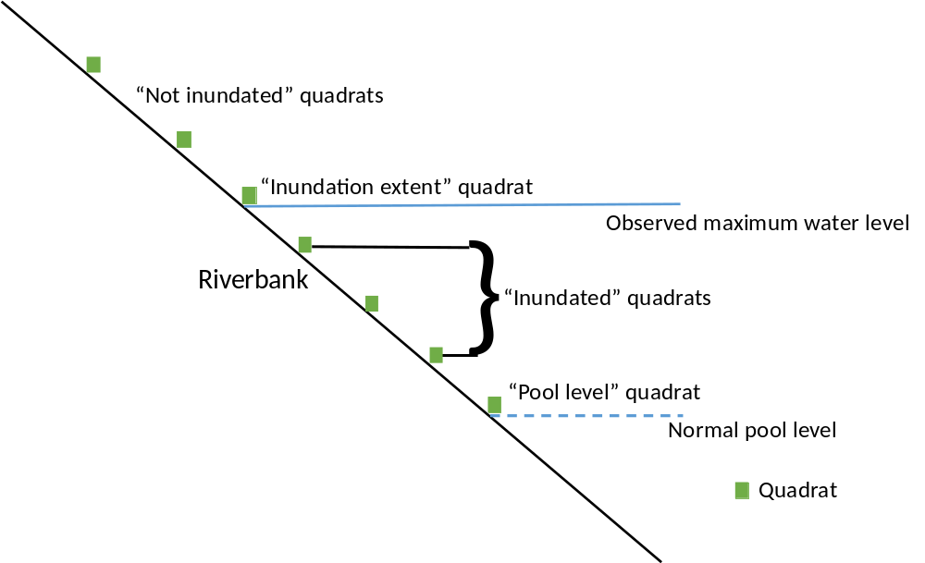
Figure 43. Position of quadrats in relation to the maximum water level the prior spring/summer.
For all vegetation surveys, the Inundated and Inundation extent zones were impacted by the delivery of Commonwealth environmental water. However, in 2023-24 it was not possible to sample the small area inundated exclusively by environmental water. In this year, the Inundated zone was the area on the riverbank between normal pool level and the highest elevation of the flow that peaked in November 2023 (Figure 9). The Inundation extent zone corresponded to the elevation of the aforementioned peak. Furthermore, quadrats in the Not inundated zone were inundated by the natural flow pulse in early spring 2023 (Figure 5) and by the 2022-23 flood prior to that. Finally, the Pool level quadrats were inundated continuously from August 2021 to June 2024 (Figure 5). In contrast to 2023-24, the Not inundated zones for the 2019-20 and 2020-21 surveys were last inundated by the 2016-17 flood.
Plant identification and nomenclature
Plants were identified using keys in Jessop and Toelken (1986), Cunningham et al. (1992), Sainty and Jacobs (1981, 2003) and Jessop et al. (2006). In some cases, due to immature individuals or lack of floral structures, plants were identified to genus only. Nomenclature follows the Centre for Australian National Biodiversity Research and Council of Heads of Australasian Herbaria (2025). A comprehensive list of all species recorded, their functional classification, growth form, life history strategy and conservation status are presented in Table C6, Appendix C.
Plant functional groups
The functional classification used to assess targets for The Living Murray Chowilla condition and intervention monitoring programs was used in this study to assess the response of littoral vegetation to environmental water. The functional classification was based on the classification framework devised by Brock and Casanova (1997), which was based on species present in wetlands in the New England Tablelands region of New South Wales and modified by Nicol et al. (2010) to reflect the vegetation of the Chowilla system.
The functional classification used for this study splits species into four groups (terrestrial, flood dependent, amphibious and emergent) based on their response to inundation. The description of each functional group is presented in Table C7, Appendix C.
Data analysis
Comparison of species composition between the different inundation zones (Not inundated, Inundation extent, Inundated and Pool level) at each reach for the three surveys (2019-20, 2020-21 and 2023-24) was undertaken using nMDS Ordination and two-factor Multivariate PERMANOVA. For the 2023-24 survey, species composition between the different inundation zones and reaches (Lock 1, Lock 4 and Lock 6) were compared using nMDS Ordination, two-factor Multivariate PERMANOVA and Indicator Species Analysis. Bray-Curtis (1957) similarities were used to calculate the similarity matrix for nMDS Ordination and Multivariate PERMANOVA (Anderson and Ter Braak 2003) analyses, which were undertaken using the Package PRIMER version 7.0.12. (Clarke and Gorley 2015) and PERMANOVA+ for PRIMER (Anderson et al. 2008). Indicator Species Analysis (Dufrene and Legendre 1997) was undertaken using the package PCOrd version 5.12 (McCune and Mefford 2006). Above ground biomass for the 2023-24 survey was compared between the different inundation zones and reaches using two-factor univariate PERMANOVA using the package PERMANOVA+ for PRIMER (Anderson et al. 2008). Euclidean distances were used to calculate the similarity matrix for the univariate PERMANOVA analysis.
Dufrene and Legendre’s (1997) indicator species analysis combines information on the concentration of species abundance in a particular group (inundation zone) and the faithfulness of occurrence of a species in a particular group (McCune et al. 2002). A perfect indicator of a particular group should be faithful to that group (always present) and exclusive to that group (never occurring in other groups) (McCune et al. 2002). This test produces indicator values for each species in each group based on the standards of the prefect indicator. Statistical significance of each indicator value is tested by using a Monte Carlo (randomisation) technique, where the real data are compared against (in this case) 5,000 runs of randomised data (Dufrene and Legendre 1997). For this study, the groups were assigned according to inundation zone within a reach (planned comparison). A species that is deemed not to be a significant indicator of a particular group is either uncommon or widespread. An uncommon species is only found in one group but in low numbers, and a widespread species is found in more than one group in similar numbers (Dufrene and Legendre 1997). Whether a species was classed as a widespread or uncommon non-significant species was determined by examination of the raw data.

Results
Littoral plant communities 2019–2024
Native species richness was variable between reaches and inundation zones for the three surveys over the study period. No clear patterns with regards to response to unregulated flows or environmental water delivery between 2019 and 2024 were discernible (Figure C4, Appendix C). Similarly, there were no clear patterns for above ground biomass relating to unregulated flows or environmental water delivery (Figure C5).
Contrastingly, the plant community showed similar patterns at each reach when environmental water was delivered as a lower–moderate flow pulse in spring–early summer 2019 and 2020, but was different following the 2022-23 flood and bankfull flow pulse in spring 2023 (Figure 44). Each survey for each reach detected vegetation zonation related to elevation, but the plant community was different in the 2023-24 survey following the flood and bankfull flow. Patterns through time at each reach were confirmed with two-factor PERMANOVA detecting a significant interaction between survey year and inundation zone (Table C8, Appendix C). This indicated that the response of the vegetation each year along the elevation gradient was not consistent. At each reach, similar plant communities were present at most elevations in 2019-20 and 2020-21 with a different community in 2023-24 following high flows (Figure 44).
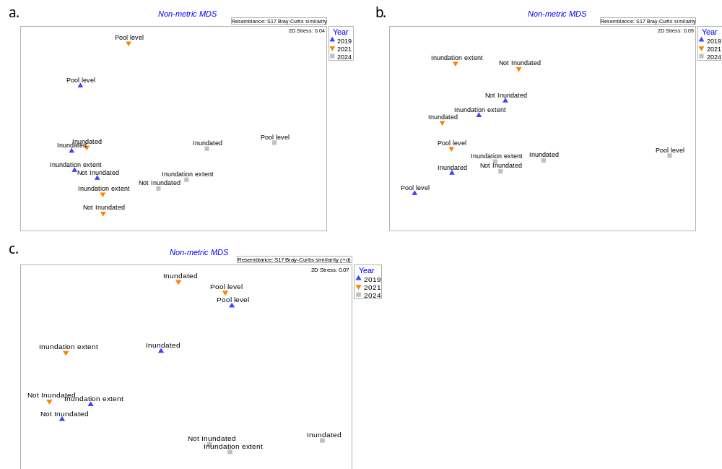
Figure 44. nMDS ordination comparing the plant community downstream of a) Lock 1, b) Lock 4, and c) Lock 6 in each inundation zone for the December 2019, February 2021 and June 2024 surveys (the 2024 Pool level data downstream of Lock 6 were omitted due to it being an outlier that unduly influenced the nMDS analysis).
Littoral plant communities 2023-24
Native species richness was variable between reaches, with the reach downstream of Lock 6 having the highest native species richness (32), followed by Lock 4 (27) and Lock 1 (24) (Table C9, Appendix C). Despite the variability among reaches, there were common patterns of native species richness within reaches. The Not inundated zone had the highest species richness across all reaches and the Pool level zones had the lowest in all reaches, with the Pool level zones downstream of Lock 4 and Lock 6 being devoid of vegetation (Figure 45).
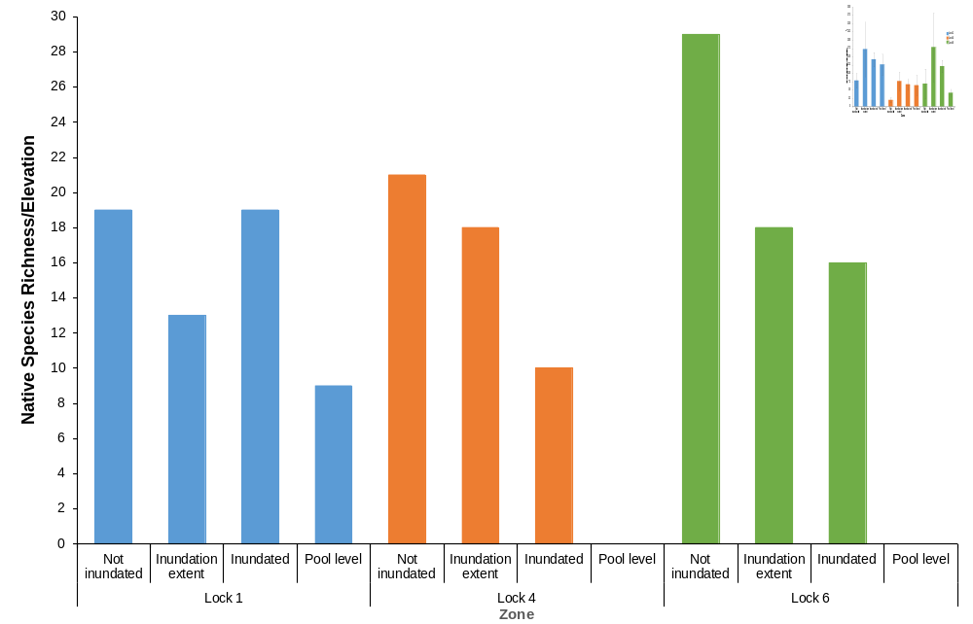
Figure 45. Native species richness in each inundation zone in each reach in June 2024.
The abundance of functional groups (percentage of cells occupied by species from each functional group) in each zone was variable between reaches (Figure 46). Nevertheless, there were similar patterns among reaches with the abundance of flood dependent taxa being highest across all Not inundated zones, decreasing in abundance with decreasing elevation except downstream of Lock 6. Flood dependent and amphibious taxa were widespread and present in all zones in each reach except Pool level downstream of Lock 4 and Lock 6 (Figure 46). Abundance of emergent taxa were low, only occurring downstream of Lock 1. Terrestrial taxa had the highest abundance in the Inundation extent zone across all reaches with the highest being downstream of Lock 1 (Figure 46).

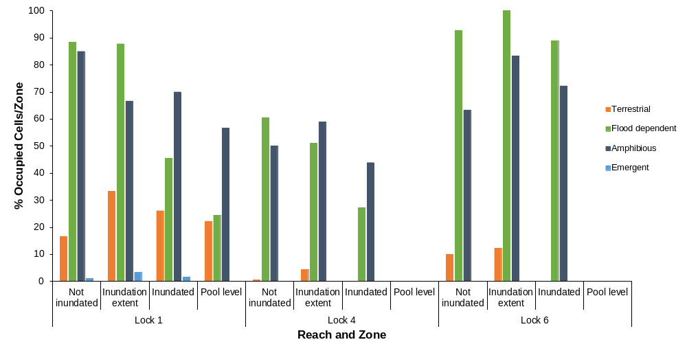
Figure 46. Percentage of cells occupied by each functional group in each inundation zone in in the Lower Murray River in June 2024.
nMDS ordination showed that the vegetation was different between elevation zones and reaches (Figure 47). This was supported with PERMANOVA detecting significant differences in the plant community between reaches and inundation zones, with a significant interaction (Table C10, Appendix C). This provides evidence that the plant community responded differently to inundation between reaches.
PERMANOVA multiple comparisons showed that the plant community was significantly different between reaches for each inundation zone, except the Pool level between the Lock 4 and Lock 6 reaches (Figure 47; Table C11, Appendix C). In the reach downstream of Lock 1, all zones were significantly different except the Inundated and Inundation extent zones (Table C11a). In the reach downstream of Lock 4, all zones were significantly different to the Pool level zone but there were no significant differences between the other zones (Table C11b). All zones were significantly different except the Not inundated and Inundation extent zones in the reach downstream of Lock 6 (Table C11c).
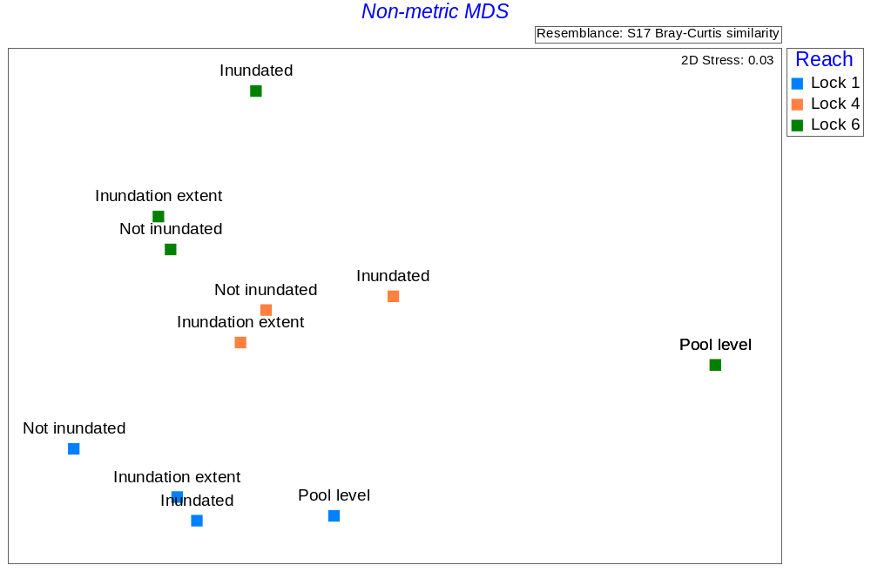
Figure 47. nMDS ordination comparing the plant community in each inundation zone in each reach in June 2024 (the pool level points on the ordination for Lock 6 and Lock 4 occupy the same space due to all quadrats being devoid of vegetation).
Indicator species analysis comparing the different inundation zones within each reach showed that Brachyscome paludicola, Eucalyptus camaldulensis, Sporobolus mitchellii, Symphyotrichum subulatum and Wahlenbergia fluminalis were significant indicators of the Not inundated zone and Pseudognaphalium luteoalbum of the Inundation extent zone downstream of Lock 1 (Table C9a, Appendix C). For downstream of Lock 4, there was only one significant indicator: bare soil at Pool level (Table C9b). For downstream of Lock 6, Eucalyptus camaldulensis and Euchiton involucratus were significant indicators of the Inundated zone, Centipeda cunninghamii of the Inundation extent zone and bare soil of Pool level (Table C9c).
Several exotic species were recorded in the Not Inundated and Inundation extent zones. Symphyotrichum subulatum was recorded downstream of Lock 1 and Lock 6 and Xanthium occidentale downstream of Lock 6 in the Not inundated zone (Table C9, Appendix C). Heliotropium curassavicum was present in the Inundation extent zone across all reaches.
Eucalyptus camaldulensis seedlings were widespread across all reaches and zones except Pool level in the reaches downstream of Lock 4 and Lock 6. Extended flooding in 2022-23 resulted in the mortality of the 2019-20 cohort; however, the high flows that drowned the 2019-20 cohort provided conditions for widespread germination across the LMR floodplain.
Above ground biomass 2023-24
Above ground biomass was not significantly different between reaches (Table C12, Appendix C) but there were similar patterns between zones across reaches (Figure 48). Biomass was typically highest in the Not inundated zone, except the reach downstream of Lock 4 but there was no significant difference between the Not inundated and Inundation extent zones (Figure 48, Table C12). The lowest biomass at all reaches was at Pool level (Figure 48), with the reaches downstream of Lock 4 and Lock 6 being devoid of vegetation.
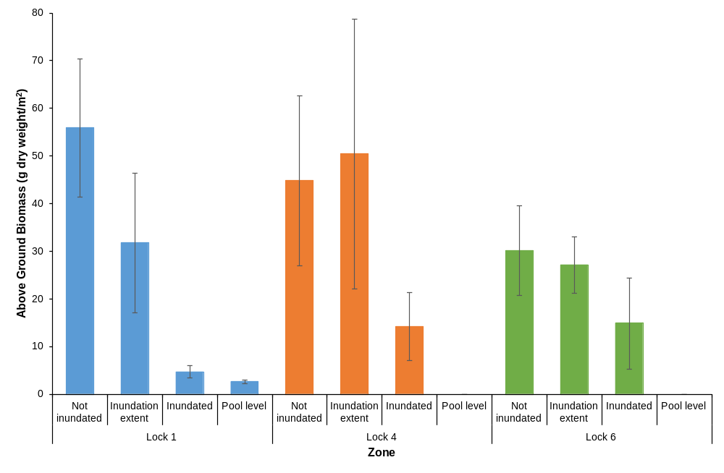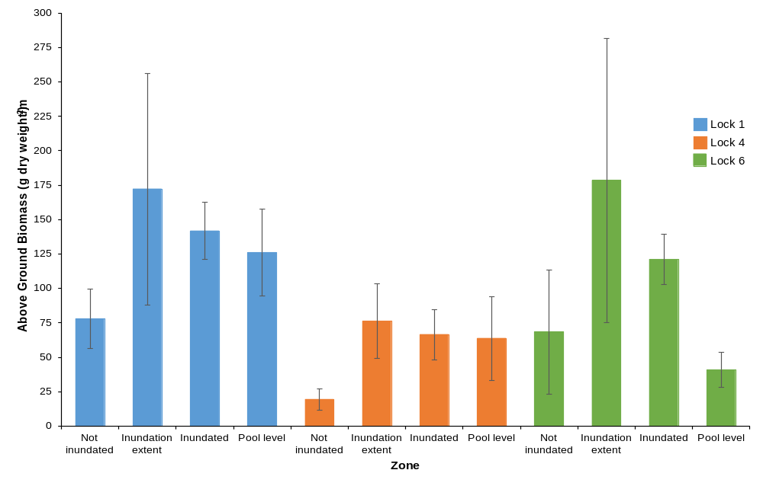
Figure 48. Above ground biomass in each inundation zone in each reach in June 2024 (error bars = ± 1 SE).

Evaluation
Table 12. Littoral Vegetation Diversity and Productivity evaluation questions and answers. CEW = Commonwealth environmental water.
CEWO evaluation questions | Outcomes of CEW delivery
CEWO evaluation questions | 2019-20 | 2020-21 | 2023-24
What did CEW contribute to littoral understorey vegetation diversity? | CEW delivery increased native plant species diversity by 40–100% across all reaches in the LMR. This was evidenced by consistently higher native species richness in inundated zones in each reach compared to non-inundated areas, higher native species richness (albeit lower than inundated zones) on the edge of the inundation footprint, where there was increased soil moisture due to capillary action, and different plant communities in the inundated zones (despite there being few significant indicators) compared to non-inundated zones. CEW delivery in the form of a spring pulse produced conditions suitable for the recruitment of specialised riparian species that are adapted to fluctuating water levels and do not inhabit terrestrial or truly aquatic habitats, increasing plant functional diversity.  Twenty-four native species responded positively to delivery of CEW either by recruitment or increased abundance (Ye et al. 2021). | CEW delivery increased native plant species diversity by 42–82% across all reaches in the LMR. This was evidenced by consistently higher native species richness in inundated zones in each reach compared to non-inundated areas and different plant communities in the inundated zones compared to non-inundated zones. CEW delivery in the form of a spring pulse produced conditions suitable for the recruitment of specialised riparian species that are adapted to fluctuating water levels and do not inhabit terrestrial or truly aquatic habitats, increasing plant functional diversity.  Twenty-eight native species responded positively to delivery of CEW either by recruitment or increased abundance (Ye et al. 2022). | CEW delivery had no impact on species diversity at any of the assessed reaches in the LMR. Native species richness was either the same or lower in areas inundated by CEW compared to areas not inundated.  However, environmental water delivery in 2023-24 may have prevented a “false start” for some species. Maintaining water levels at elevations where decreasing water levels will expose the sediment (providing conditions for breaking seed dormancy and germination) but then inundating the same sediment drowning plants before they have the opportunity to complete their life cycle and replenish the seed bank.
What did CEW contribute to above-ground biomass produced by understorey littoral vegetation? | Biomass production due to CEW was inconclusive and varied depending on reach with no clear pattern in relation to CEW delivery. The only reach that responded as hypothesised was Lock 6 with greater biomass in the Inundated and Inundation extent zones. | CEW delivery increased above-ground biomass by 121–292% via increasing soil moisture in the Inundation extent zone. Increased above-ground biomass was also observed in the Inundated zone across all reaches and at Pool level downstream of Locks 1 and 4, compared to the Not inundated zone. | CEW delivery had no impact on biomass with the highest biomass across all reaches (except downstream of Lock 4) being in the zone not inundated by CEW. Biomass generally decreased with decreasing elevation at each reach.
Contribution (to what extent CEW contributed towards the outcome, with the significance of the outcome considered):
 | Unknown |  | Negative |  | None/negligible |  | Minor |  | Moderate |  | Substantial

Discussion
Delivery of Commonwealth environmental water in 2023-24 was markedly different compared to the two previous water years (2019-20 and 2020-21) when vegetation was assessed in the LMR. In 2019-20 and 2020-21, Commonwealth environmental water was delivered to produce a small in-channel pulse during spring/early summer that was added to entitlement flows. Most of the water used to create the peak was Commonwealth environmental water (Ye et al. 2021, 2022). Water delivered in this way causes water levels to rise in weir tailwaters, in turn inundating the littoral zone and providing conditions favourable for the recruitment of amphibious and flood dependent species, primarily when water levels recede. Furthermore, the water level increase recharges soil moisture within and adjacent to the inundation footprint. This provides conditions favourable for growth for species that can tolerate or respond to inundation or can access the increased soil moisture adjacent to the inundation footprint.
Contrastingly, in 2023-24, environmental water was delivered to slow the recession following a large, unregulated in-channel flow, prevent water levels from falling between flow pulses and enhance the smaller peak (both magnitude and duration). For most of the remainder of the water year, flow was enhanced by environmental water.
The surveys in December 2019 and February 2021 were undertaken during a period of low flows with the previous overbank flood occurring in late 2016. The flow pulses delivered to the LMR that were comprised almost entirely of environmental water, inundated what was predominantly a dry landscape. Therefore, much of the area suitable for the recruitment of floodplain and amphibious species was due to the delivery of environmental water. The remainder of the floodplain remained dry and was a hostile environment for all but the most drought tolerant amphibious and floodplain taxa.
Contrastingly, the 2023-24 survey was undertaken at the end of a period of high flows, which included the third largest flood in the LMR in recorded history, peaking in December 2022, and a large (bankfull) in-channel flow pulse that peaked in September 2023. Environmental water delivery increased inundation duration in an already wet landscape, when conditions on the floodplain and upper littoral zone were already suitable for the recruitment and growth of amphibious and flood dependent species. The Not inundated zone in each reach, whilst not inundated with environmental water, was inundated by an unregulated flow pulse eight months prior to the surveys (and the third largest natural flood on record 14 months prior) and was the most species rich zone across all reaches. In addition, this zone had the highest biomass in the reaches downstream of Lock 1 and Lock 6. Besides high flows, above average rainfall was recorded for the Riverland region of South Australia (Bureau of Meteorology 2025), including an intense rainfall event of over 100 mm in less than 24 hours at Lock 6. Whilst local rainfall usually has little impact on river levels, it contributes to soil moisture and in turn plant survivorship.
The Inundation extent zone in the first two surveys typically had less species than the Inundated zone but often had the highest biomass because increased soil moisture in the root zone of existing vegetation, increasing plant growth. However, in the 2023-24 survey, species richness was even lower than the Not inundated zone and biomass was similar (not statistically significant), indicating that the Inundation extent zone was no more favourable for plant growth than the Not inundated zone.
The Inundated zone was highly variable in 2023-24. The lowest elevation quadrats were often devoid of vegetation; hence, lower species richness (except downstream of Lock 1) and biomass. Plants were present in the mid and upper elevation quadrats, but plants were smaller, cover was lower and there were usually less species than the adjacent quadrats in the upper two zones. The duration that the quadrats at the different elevations in this zone were inundated was variable. The low elevation quadrats were inundated continuously for the 2023-24 water year (and prior) and were not exposed until approximately two weeks before the surveys were undertaken. The mid and upper elevation quadrats were continuously inundated until December 2023, with the mid elevation quadrats inundated again in February 2024 for four weeks.
For the 2023-24 monitoring season, the quadrats at Pool level were continuously inundated for 1,037 days and exposed for only 14 days prior to the surveys being undertaken (and inundated again 14 days later). Therefore, there was a small window with conditions suitable for the surveys to be undertaken, which was not sufficient for plants to germinate and grow. Typically, four to six weeks post inundation are minimal for plants to germinate and grow to a size they can be detected and identified.
Whilst the delivery of environmental water in 2023-24 did not result in a clear benefit for the vegetation in terms of diversity or productivity, it may have prevented a “false start” from occurring for some species. Modelled water levels without environmental water in tailwaters showed water levels decreasing around 100 cm (compared to with environmental water) in early October followed by water levels increasing by approximately 80 cm in early November (Figure 9). Environmental water delivery maintained (and enhanced) water levels during this period (Figure 9) preventing seeds from germinating (many amphibious and floodplain species require exposure for breaking of seed dormancy and germination) (Nicol 2004) but not having sufficient time to complete their life cycle and replenish the seed bank. Most native floodplain and amphibious species are adapted to unpredictable, fluctuating water levels and can cope with false starts without completely depleting their seed banks (i.e. Thompson and Grime (1979) Type IV seed banks) (Leck and Brock 2000; Nicol 2004). However, repeated “false starts” will in time deplete the soil seed bank and in turn reduce resilience of the plant community. There is little risk that the six weeks of extended inundation by environmental water delivery in 2023-24 resulted in propagule mortality as the seeds and asexual propagules of most native species will remain viable whilst submerged for longer periods (for example, Cyperus gymnocaulos rhizomes were observed sprouting after seven years of inundation) (Nicol 2004).
Given the ability of the propagule banks of amphibious and floodplain species to persist through extended inundation as well as desiccation, it is expected that the littoral vegetation at low elevations close to and at pool level will recover. Furthermore, environmental water delivery in 2023-24 may have maintained littoral vegetation resilience by avoiding a “false start”, which may have occurred without environmental water delivery.
River red gums that germinated in response to the spring 2019 flow pulse (Ye et al. 2021) and had reached sapling stage in February 2021 (Ye et al. 2022) did not survive the extended inundation due to the 2022-23 flood. However, red gum seedlings and small saplings that were recruited following the 2022-23 flood were observed widespread across reaches and elevations in 2023-24.

Management implications
In contrast to the 2019-20 and 2021-22 water years, results from 2023-24 did not show a noticeable benefit to the littoral vegetation. However, with the antecedent conditions of the second largest recorded flood and large in-channel flow pulse, the best use of environmental water in the 2023-24 water year for the LMR was to slow water level recession after the in-channel pulse and maintain and enhance flows (and water levels) between the two peaks. In addition to having benefits for other riverine biota, it is likely that environmental water delivery prevented a “false start” for some plant species, maintaining the soil seed bank, and resilience.
Whilst the red gums that germinated in response to the 2019-20 flow pulse did not survive past sapling stage due to the 2022-23 flood, there was widespread germination after the flood. Future spring pulses, which are now a feature of environmental water delivery in the LMR during dry years, will be important in providing water for the long-term survival of red gums at lower elevations in weir pool tailwaters in years without unregulated flows. Whilst these plants may not persist as seedlings and saplings during periods of high flows, spring pulses will be important in ensuring their survival during droughts to reach a size when they will persist during floods.
In the immediate years, we recommend monitoring in the reaches downstream of Lock 4 and Lock 6 under a hydrologically dry scenario with a typical in-channel spring flow pulse comprising of environmental water. This monitoring will determine whether the vegetation at the lower elevations has recovered and whether red gums have persisted as a result of the flow pulse delivered in spring 2024.

Conclusions
The dry scenario management of environmental water in the LMR, to produce an in-channel spring flow pulse, had benefits for vegetation in tailwaters. This management action produces a rise in water levels downstream of the weirs (tailwaters), resulting in a maximum increase in inundated area of 1,621 ha and 1,397 ha in 2019-20 and 2020-21, respectively (Table 4) due to Commonwealth environmental water. Water level variability also increased, providing conditions suitable for recruitment of flood dependent and amphibious species. The vegetation zonation patterns observed in the littoral zones of tailwaters in December 2019 and February 2021, were due to the presence of species only observed in the areas inundated by the spring flow pulses. The areas outside of the inundation footprints were often species intolerant of inundation or drought tolerant amphibious and flood dependent species that recruited after previous unregulated flows.
Whilst vegetation zonation was evident in June 2024, following a period of high flows, the vegetation was different from the communities observed in 2019-20 and 2020-21. Species with higher water requirements (amphibious and flood dependent taxa) were more abundant at the higher elevations and the vegetation was generally denser at these elevations. The lower elevations were generally less densely vegetated due to extended inundation and less exposure time prior to the survey.
Environmental water delivery in 2023-24 did not have a noticeable benefit to the littoral vegetation, but it may have prevented a “false start”, which may have depleted the seed bank and reduced resilience. The pattern of environmental water delivery in 2023-24 to manage flow and water level recession has benefits for other riverine biota. Such water delivery should not be seen as a trade-off between vegetation and other biota as it likely has no negative impacts and has probably benefitted the vegetation in the longer-term.

Microinvertebrate Assemblage

Background
To date, more than 400 species of planktonic and littoral microinvertebrates (protists, rotifers and microcrustaceans) have been identified in the LMR and Lower Lakes. This assemblage provides an important food resource for a range of higher order consumers such as macroinvertebrates, fish and birds (Shiel et al. 1982; Shiel and Aldridge 2011; Shiel and Tan 2013a, 2013b; Bice et al. 2023). Different habitat types support different assemblages of microinvertebrates within riverine ecosystems, and at the simplest level can be classified as either littoral, limnetic, lotic or benthic.
Microinvertebrates are rapid responders to flows. Within habitats that undergo wetting and drying cycles (e.g. the littoral zone and floodplains), these organisms start to emerge from an egg-bank and begin to reproduce within hours of inundation (Tan and Shiel 1993). Therefore, a healthy egg-bank, which is primarily a result of a long-term flooding regime, is an important driver of the magnitude of response to inundation (Boulton and Lloyd 1992). Once inundated, longer water residence times will result in higher density and biomass of organisms and result in a shift from rotifer to crustacean dominated communities (e.g. Basu and Pick 1996; Baranyi et al. 2002; Obertegger et al. 2007). Therefore, habitats such as littoral zones and floodplains favour the development of abundant and diverse microinvertebrate communities which can then be transferred between habitats, through hydrological mixing, connectivity and exchange. Once in the pelagic zone of main river channel, only some organisms will survive, with a component of the persistent community, reproducing within areas of the main river channel. Which component persists will largely depend on factors such as season and hydraulics.
Therefore, Commonwealth environmental water can facilitate the maintenance and development of microinvertebrate assemblages within the Lower Murray region by:
- Inundating areas adjacent to the main river channel and therefore supporting populations that can act as a source to the main river channel community;
- Improving lateral and longitudinal hydrological connectivity which promotes the dispersal of organisms; and
- Improving the flow regime over the long-term to promote a more diverse and dense egg-bank and thus a more diverse and dense community dispersed through lateral and longitudinal connectivity.
To determine the responses of the microinvertebrate community to Commonwealth environmental water deliveries in the LMR from 2014–2024 (except 2018-19), their diversity and density was assessed, with a focus on rotifers and microcrustaceans, every year over the spring–summer period. These data were then used to develop models of the response of different microinvertebrate taxa to flow, floodplain inundation and water quality. The microinvertebrate response models were subsequently used with different modelled flow scenarios to evaluate the contribution of Commonwealth environmental water to microinvertebrate outcomes (for more details on the modelling approach see Appendix D in Ye et al. 2021).
Major hypotheses
- H1: Overall microinvertebrate density (H1a), and taxonomic richness (H1b), will increase with environmental water delivery due to the combined effects of longitudinal transport and improved lateral connectivity with off-channel habitats;
- H2: The density will increase for ‘floodplain associated’ microinvertebrates during periods of greater floodplain inundation (H2a) and for those that are likely to be transported to the LMR from upstream during periods of high longitudinal connectivity (H2b) due to environmental water; and
- H3: Environmental water delivery during spring and early summer will increase the density of preferred microinvertebrate prey species for large-bodied fish larvae.

Methods

Sampling sites and procedure
Microinvertebrate sampling was conducted approximately two weeks apart between October and January 2019–2024 (Table 13) at three core sites, concurrently with stream metabolism sampling (Table 14; Figure 1).
Table 13. Microinvertebrate sampling dates from 2019–2024 in the Lower Murray River. Refer to Ye et al. (2020a) for microinvertebrate sampling from 2014–2018.
Trip | Sampling dates
 | 2019-20 | 2020-21 | 2021-22 | 2022-23 | 2023-24
1 | 8–11/10/2019 | 11–13/10/2020 | 11–13/10/2021 | 12–14/10/2022 | 10–11/10/2023
2 | 21–24/10/2019 | 25–27/10/2020 | 25–27/10/2021 | 24–26/10/2022 | 24–26/10/2023
3 | 4–6/11/2019 | 9–11/11/2020 | 8–10/11/2021 | 7–9/11/2022 | 7–9/11/2023
4 | 18–19/11/2019 | 24–26/11/2020 | 22–24/11/2021 | 21–23/11/2022 | 21-23/11/2023
5 | 2–4/12/2019 | 7–9/12/2020 | 6–8/12/2021 | 5–7/12/2022 | 5–7/12/2023
6 | 16–18/12/2019 | 21–23/12/2020 | 20–22/12/2021 | 19–21/12/2022 | 18-19/12/2023
7 | 7–9/01/2020 | 6–7/01/2021 | 5–7/01/2022 | 4–6/01/2023 | 9-10/01/2024
8 |  |  |  | 17–19/01/2023

A Perspex Haney plankton trap (4.5 L capacity) was used in mid-channel (by boat) to collect a composite sample from surface, middle and bottom (two traps each) resulting in the total volume of 27 L per replicate. Three replicate samples were taken at each site. The samples were filtered through a 37 µm-mesh plankton net suspended in a bucket and rinsed into a 200 ml PET bottle screwed to a purpose-built ferrule at the net end. The filtrate was then preserved in the field (100% ethanol) to a final concentration of ~75%, and a volume of <200 ml. In the laboratory, the sample was decanted into a measuring cylinder, the volume noted, the cylinder agitated, and a 1 ml aliquot withdrawn using a Gilson auto pipette. This aliquot was run into a Pyrex 1 ml Sedgewick-Rafter cell, and the microinvertebrates present were counted and identified. Counts for each sample were based on a single subsample.
Table 14. Details of microinvertebrate sampling sites in the Lower Murray River.
Zone | Site | Latitude | Longitude
Floodplain | 5 km downstream of Lock 6 | S-34.0190 | E-140.87572
Floodplain | 15 km downstream of Lock 4 | S-34.3892 | E-140.59477
Gorge | 5 km downstream of Lock 1 | S-34.4052 | E-139.61723

Modelling and statistical analyses
Both categorical and continuous predictors were used to build a model to predict the response of microinvertebrates to flow. Categorical predictors were month, water year, and lock/site, while continuous predictors were: (1) flow, (2) flow variability, (3) water quality and (4) inundated floodplain area (Appendix C). For flow, we calculated both short-term (mean flow on the date of sampling) and long-term flow (mean flow over the preceding 12-week period) predictors. Flow variability was quantified as the change in flow over the preceding 10-days prior to sampling (denoted ‘flow trend’ or ‘dQ10’). Water quality parameters used were daily temperature and electrical conductivity. Floodplain inundated area was quantified using the DEW MIKE model outputs (M. Gibbs, pers comm; see Appendix C for details). Values were summed over 28- and 60-day periods to estimate inundated floodplain area corresponding to an estimated minimum period required for the majority of taxa to emerge from the egg-bank and complete one or two life-cycles (pers. comms Russell Shiel). A global model including all predictors was fit first, then optimised using an automated procedure. Model predictive performance was assessed prior to use in modelling scenarios (see Appendix D in Ye et al. 2021 for details).
To assess the influence of Commonwealth environmental water on microinvertebrate density, taxonomic richness and community structure (including rotifers, cladocerans and copepods) over the long-term (9 years), variation between sampling years (i.e. 2014-15 to 2023-24 except 2018-19) and sites (2023-24, presented below) was investigated. Firstly, models were fit to all existing data using observed flow conditions, and other predictors (see above) (for more details see Ye et al. 2021). Secondly, the predictors were re-calculated using the modelled flow data for scenarios of without Commonwealth environmental water (hereafter “No CEW”) and without any environmental water (hereafter “No eWater”). Finally, models were re-run using the predictors observed and those calculated on modelled flow scenarios and the predicted microinvertebrate metrics (see below) were compared between the three scenarios using paired t-tests to determine whether predicted changes in microinvertebrates differed from observed variability (i.e. whether such a result would be expected at random). The overall contribution of environmental water was calculated as the difference between the observed and modelled No eWater scenarios. The difference between the observed and No CEW scenarios was the contribution of Commonwealth environmental water. Models were built to test each hypothesis above using following microinvertebrate metrics:
- H1: (a) density of microinvertebrates (estimated as the mean of three replicates) and (b) taxonomic richness (total taxa within the three replicates);
- H2: Density of microinvertebrate taxa with assumed greater dependence on: (i) lateral connectivity (due to the longer period of time to complete their life cycle), and (ii) longitudinal transport. Category (i) taxa were littoral and pelagic cladocerans, and calanoid and cyclopoid copepods, comprising 32 taxa (Table 15a). Category (ii) taxa (Table 15b) were primarily pelagic rotifers, with their dependence inferred from their known biogeographical range (R. Shiel, pers comm, 2020) along with prior reports indicating the importance of upstream taxa in influencing the turnover of Lower Murray microinvertebrate assemblages (Ye et al. 2020a);
- H3: Density of microinvertebrate taxa identified as preferred prey species for larval fish of large-bodied native species, based on findings from the LTIM (Ye et al. 2020a) and the Flow-MER Research Project (Bice et al. 2023) (Table 16).

Table 15. Taxa used to quantify the influence of environmental water on lateral and longitudinal connectivity.
Dependence group | Taxa
(a) Lateral connectivity | Acanthocyclops cf. vernalis, Armatalona macrocopa, Australocyclops australis, Boeckella triarticulata, Bosmina meridionalis, Calamoecia ampulla, Calamoecia sp., calanoid and cyclopoid copepodites, Ceriodaphnia cornuta, Ceriodaphnia sp., Chydorus cf. eurynotus, Daphnia carinata s.l., D. galeata, D. lumholtzi, Daphnia sp., Diaphanosoma excisum, Gladioferens sp., Ilyocryptus sp., Leberis diaphanus, Macrothrix sp., Mesocyclops notius, Microcyclops varicans, Moina cf. australiensis, Moina cf. tenuicornis, Moina micrura, Neothrix sp., Pseudochydorus globosus, Pseudomonospilus diporus, Simocephalus sp., Thermocyclops sp.
(b) Longitudinal connectivity | Anuraeopsis coelata, Anuraeopsis fissa, Brachionus bidens, B. calyciflorus amphiceros, B. diversicornis, B. falcatus, Cephalodella catellina, Collotheca cf. tenuilobata, Conochilus dossuarius, C. natans, C. unicornis, Filinia longiseta, F. pejleri, F. terminalis, Keratella australis, K. cochlearis, K. lenzi, K. procurva, K. slacki, Polyarthra remata, P. vulgaris, Synchaeta oblonga, S. pectinata, Trichocerca pusilla complex, T. similis, T. similis grandis

Table 16. Microinvertebrate prey species for fish larvae of large-bodied native species (Murray cod, golden perch and silver perch) identified from gut content analysis used in modelling fish prey species density. Nauplii of calanoid and cyclopoid were excluded in calculations.
Taxon | Family | Phylum/Order
Bosmina meridionalis | Bosminidae | Cladocera
Daphniidae species | Daphniidae | Cladocera
Chydoridae species | Chydoridae | Cladocera
Ilyocryptidae species | Ilyocryptidae | Cladocera
Macrothricidae species | Macrothricidae | Cladocera
Moinidae species | Moinidae | Cladocera
Neotrichidae species | Neotrichidae | Cladocera
Sididae species | Sididae | Cladocera
Calanoida species | Centropagidae | Calanoida
Cyclopoida species | Cyclopidae | Cyclopoida

Results
All year’s density and diversity (taxonomic richness) patterns
In general, low-flow years (2014-15 to 2020-21) yielded lower mean annual densities (between 610 and 1,058 ind/L) and taxonomic richness (between 13 and 19 taxa), while higher flow years (2021-22 to 2023-24) — especially those resulting in overbank flows—were associated with greater densities (between 1,188 and 2,185 ind/L) and taxonomic richness (between 17 and 23 taxa) (Figure 49). However, the flood year 2016-17 presented an exception, showing unexpectedly low densities (mean [± 95% CI] = 713 [524, 901] ind/L) and taxonomic richness (17 [15, 19] taxa).

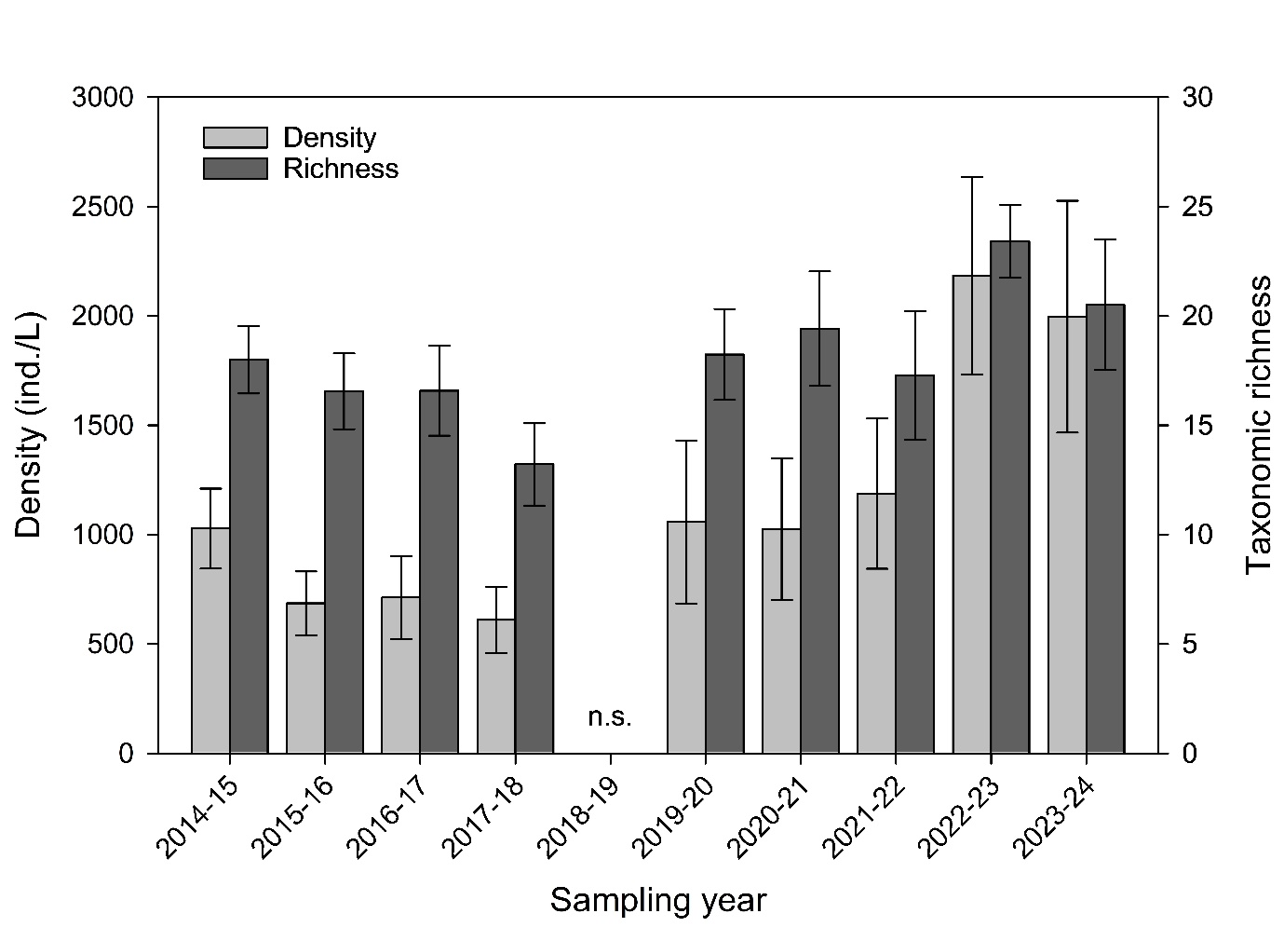
Figure 49. Annual mean observed density (individuals/litre, ind/L) and taxonomic richness (number of taxa) for 2014–2024, except 2018-19 (no sampling, n.s.). (a) annual mean density and (b) annual mean taxonomic richness and date. Error bars show 95% confidence limits.
2023-24 density patterns
During 2023-24, mean observed density ranged from 129 [106, 151] to 4,496 [2,571, 6,421] ind/L (mean [± 95% CI]) (Figure 50a), with an annual mean of 1,996 ind/L (Figure 49). Generally, sites downstream of Lock 1 and Lock 4 tended to have comparable mean densities from early October to late November; however, Lock 1 had lower densities from early December (Figure 50a). For Lock 6, the mean density was below the overall mean for all but the early December sampling (Figure 50a). The highest mean density recorded for the study period occurred on 6 December 2023, downstream of Lock 4, peaking at 4,496 [2,571, 6,421] ind/L. Mean density downstream of Lock 6 also peaked on 6 December 2023 with 3,486 [923, 6,050] ind/L, whereas it peaked on 25 October 2023 at downstream of Lock 1 with 3,670 [3,594, 3,747] ind/L.
2023-24 diversity patterns (taxonomic richness)
Mean taxonomic richness ranged from 9 [8, 10] taxa to 32 [30, 34] (Figure 50b), with an annual mean of 21 taxa/L (Figure 49), and generally had overlapping confidence intervals at all sites throughout the 2023-24 water year except at Lock 1 on 10 January 2024 (Figure 50b). Taxonomic richness peaked at all sites on 19 December 2023.
Figure 50. Observed density (individuals/litre, ind/L) and taxonomic richness (number of taxa) for 2023-24 sampling downstream of each lock. (a) mean density and (b) mean taxonomic richness of three sub-samples at each site (lock, indicated by colour) and date. Error bars show 95% confidence limits, horizontal dotted black lines show mean for the water year and solid grey lines show flow to SA.

Functional group density
The distribution of functional group density among sampling sites during 2023-24 shows the dominance of littoral (facultatively pelagic) and pelagic rotifers with Lock 1 and 4 having similar density patterns in the first half of the sampling period (Figure 51).
Figure 51. Functional group density (individuals/litre, ind/L) by sampling date and location for the 2023-24 season. Three sub-samples were collected at a single sampling site located 5–15 km downstream of each lock shown in the panel caption. Solid lines represent river flow to SA (black) and below Lock 4 (red) and Lock 1 (blue).

Modelled responses to environmental flows
H1: Density and taxonomic richness
The modelling for 2023-24 estimated that environmental water increased mean microinvertebrate density by 269 [18, 519] ind/L (t = 2.24, df = 20, p-value = 0.037) and that Commonwealth water contributed 76% of this increase (Figure 52a). Mean taxonomic richness for 2023-24 was estimated to have had a negligible change due to environmental water (-0.41 [-3.97, 3.16] species/L (t = -0.24, df = 20, p-value = 0.814) or CEW (-1.4 [-4.7, 1.9] species/L; t = -0.88, df = 20, p = 0.39) (Figure 52b).
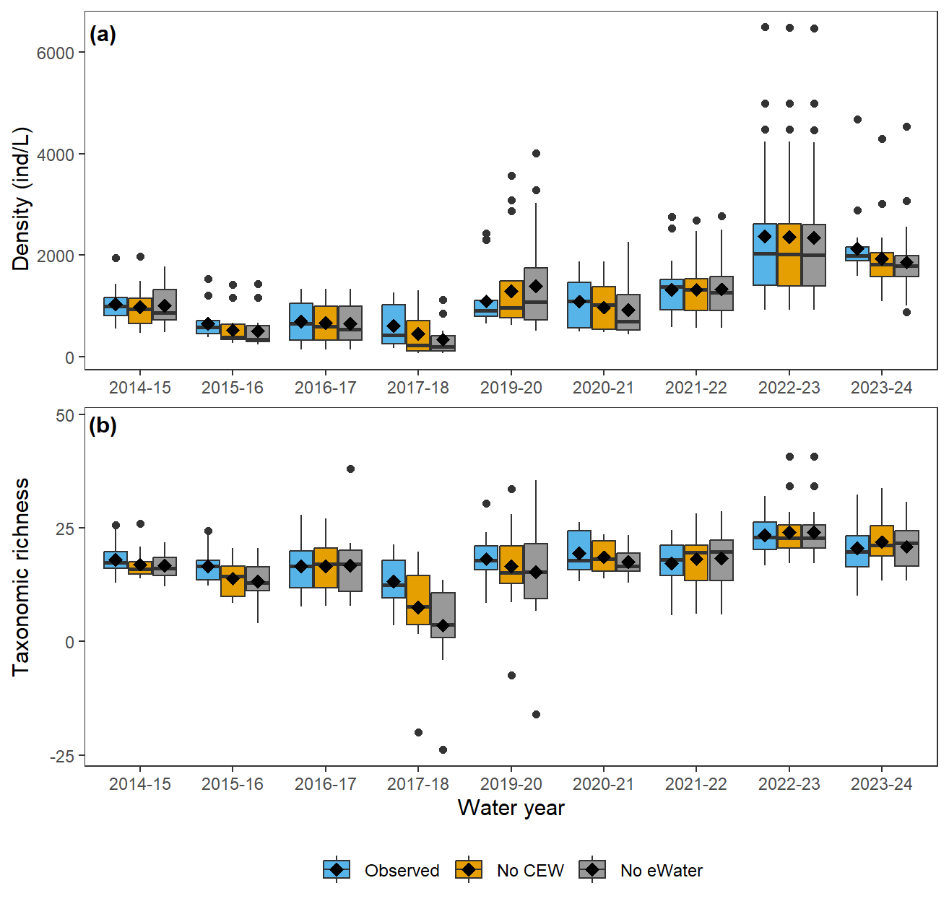
Figure 52. Modelled (a) microinvertebrate density (individuals/litre, ind/L) and (b) taxonomic richness (number of taxa) by water year over the period 2014−2024 (2018-19 not sampled). In each panel, modelled observed data (‘Observed’; blue bars) for all samples in the water year shown on the x-axis are compared with modelled expectations under two environmental flow scenarios: Under no Commonwealth environmental water delivery (‘No CEW’; orange bars) and if no environmental water was provided (‘No eWater’; grey bars). Black dots represent outliers. Black diamonds represent mean values and black dashes represent median values. Results of the generalised linear models used to run the scenarios are given in Tables C13 (density) and C14 (taxonomic richness) in Appendix C.
H2: Lateral and longitudinal connectivity
The modelling for 2023-24 estimated that environmental water decreased mean density of microinvertebrate taxa associated with lateral connectivity by 57 [78, 35] ind/L; t = -5.45 df = 20, p = < 0.0010) and that Commonwealth water contributed to 52 % of this decrease (Figure 53a). Modelling indicated that environmental water increased mean microinvertebrate density of taxa common to upstream areas by 25 [-553, 603] ind/L; t = 0.09, df = 20, p = 0.93) (Figure 53b), however, Commonwealth water increased modelled observed density by 23% (275 [79, 471] ind/L; t = 2.93, df = 20, p = 0.008). Nevertheless, it should be noted that for several years, including 2023-24, modelled densities with no environmental water delivery for these subset ecological groups had large and unexplained outliers that did not occur in the modelled observed densities. These outliers skewed the means far from the medians in these years.

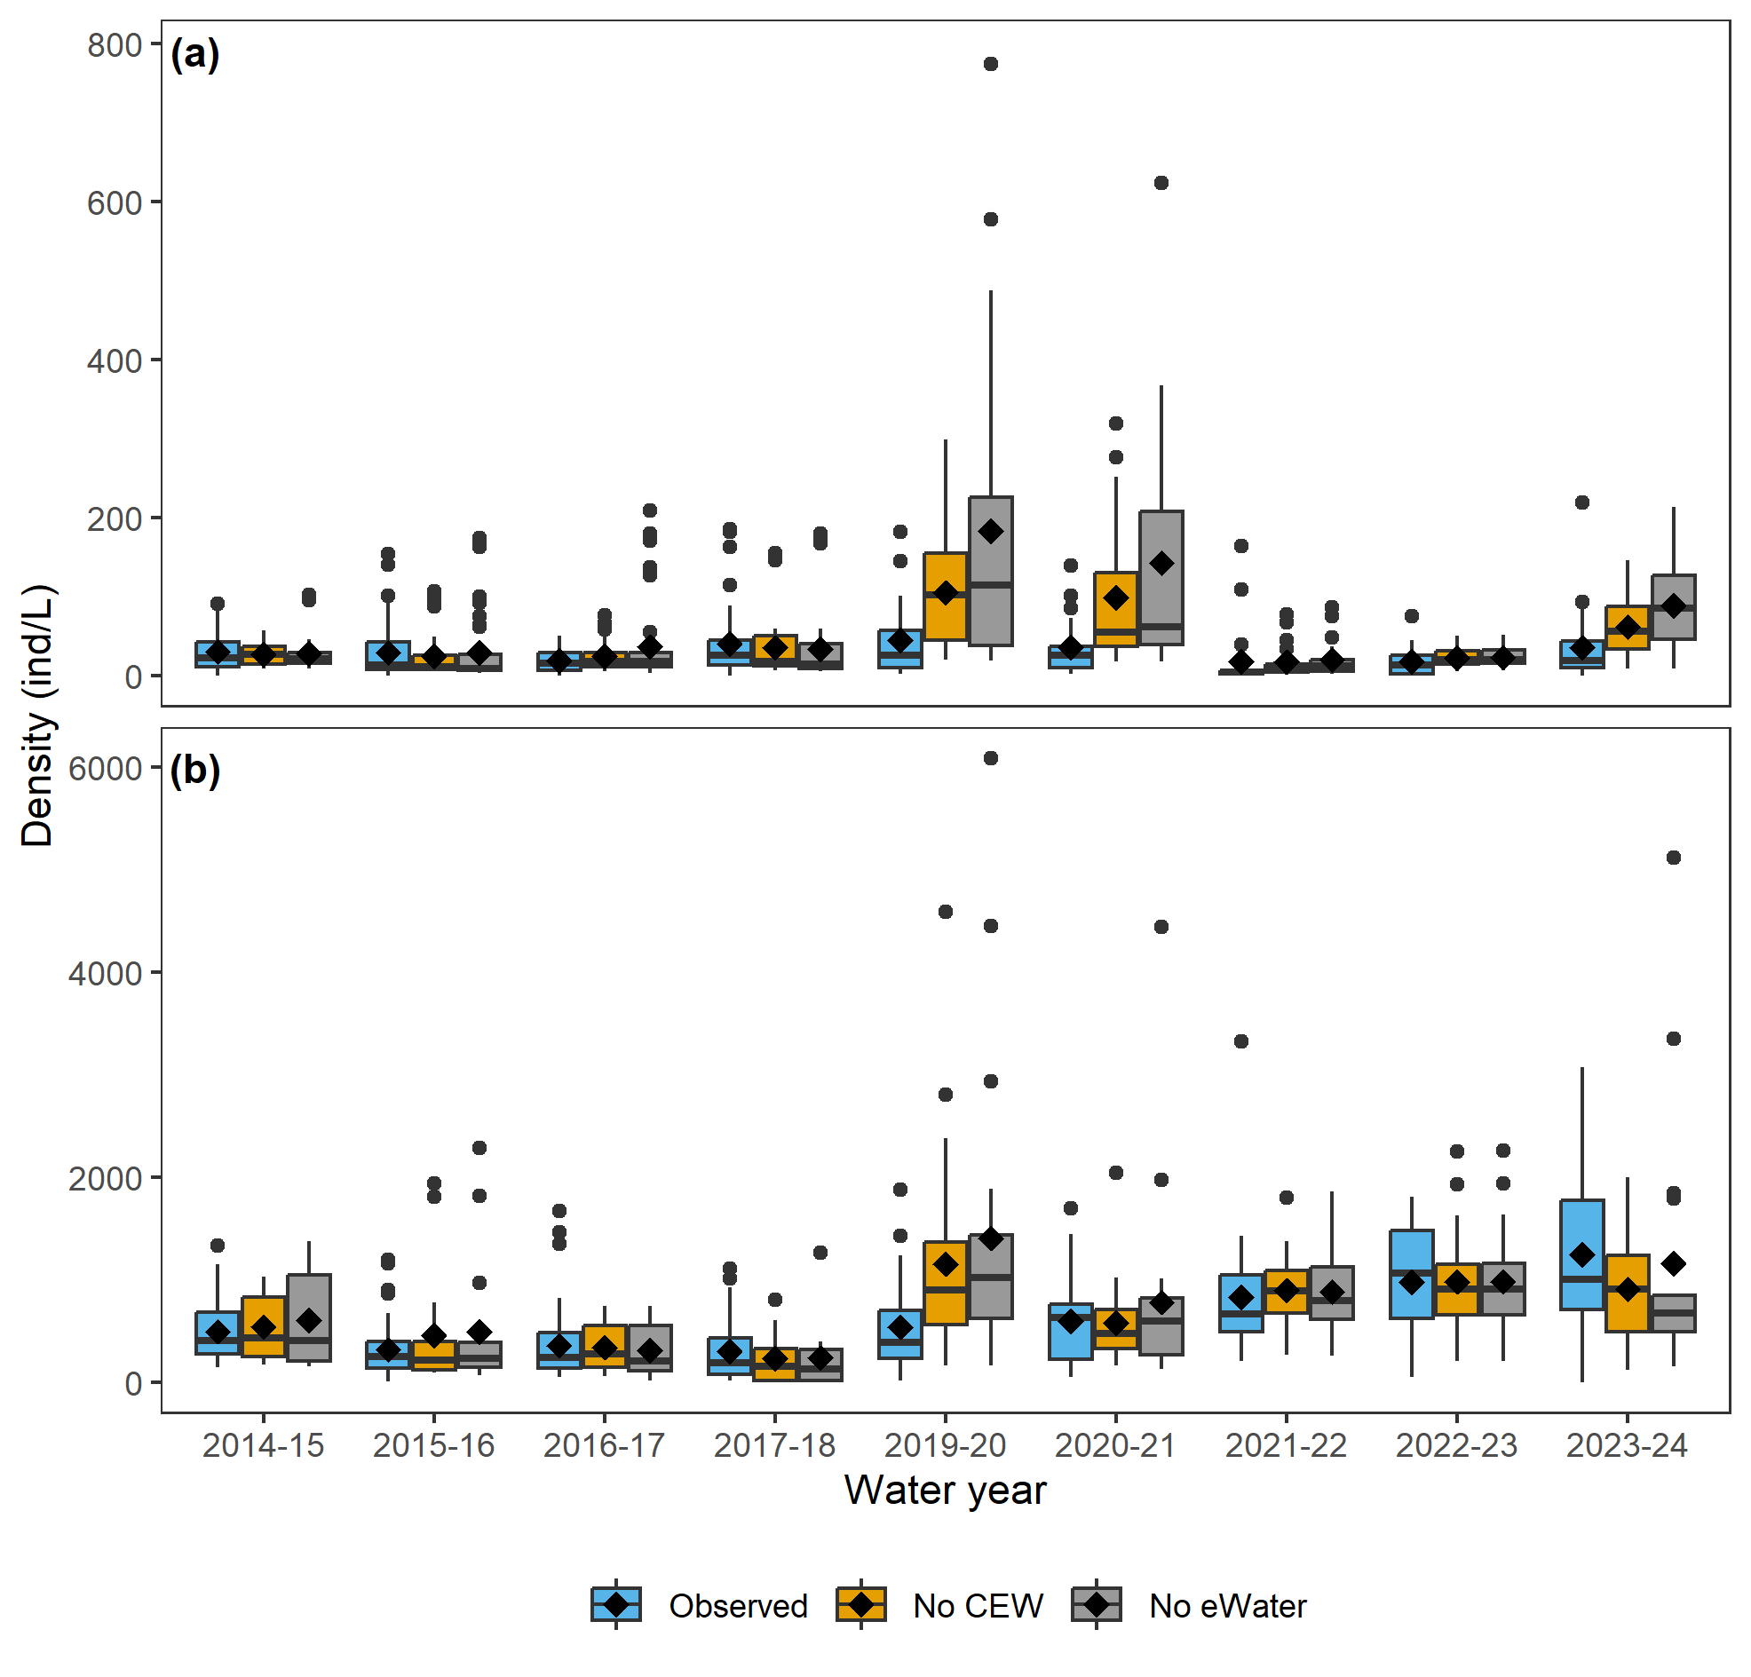
Figure 53. Observed and modelled density (individuals/litre, ind/L) with and without environmental water (a) microinvertebrate taxa associated with lateral connectivity to floodplains and backwaters and (b) microinvertebrate taxa associated with longitudinal transport and connectivity with upstream areas by water year over the period 2014−2024 (2018-19 not sampled). In each panel, modelled observed data (‘Observed’; blue bars) for all samples in the water year shown on the x-axis are compared with modelled expectations under two environmental flow scenarios: Under no Commonwealth environmental water delivery (‘No CEW’; orange bars) and if no environmental water was provided (‘No eWater’; grey bars). Black dots represent outliers. Black diamonds represent mean values and black dashes represent median values. Results of the generalised linear models used to run the scenarios are given in Tables C15 (taxa associated with lateral connectivity to floodplains and backwaters) and C16 (taxa associated with longitudinal transport and connectivity) in Appendix C.

H3: Spring-early summer microinvertebrate prey species density
For the 2023-24 sampling season, mean modelled density of spring prey species for large-bodied fish larvae was decreased by 53 (ind/L) [95% CI -74, -32] at the mainstream, sampling sites when compared to the modelled no environmental water delivery scenario (t = -5.3, df = 17, p = <0.0010), and Commonwealth environmental water contributed to 51 % of this decrease (Figure 54).
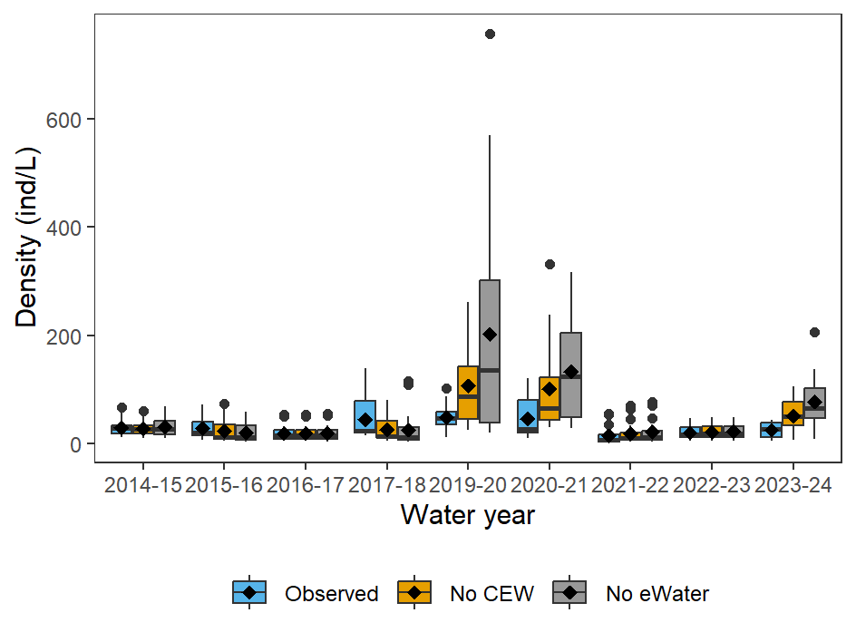
Figure 54. Modelled density (individuals/litre, ind/L) of microinvertebrate prey taxa for large-bodied fish larvae in the Lower Murray during spring–early summer (mid-October to late-December) for 2014−2024 (2018-19 not sampled). In each panel, modelled observed data (‘Observed’; blue bars) for all samples in the water year shown on the x-axis are compared with modelled expectations under two environmental flow scenarios: Under no Commonwealth environmental water delivery (‘No CEW’; orange bars) and if no environmental water was provided (‘No eWater’; grey bars). Black dots represent outliers. Black diamonds represent mean values and black dashes represent median values. Results of the generalised linear models used to run the scenarios are given in Table C17 in Appendix C.

Evaluation
The evaluation approach, including assessment criteria, is described in the evaluation section for Hydraulic Regime (Section 2.1).
Table 17. Microinvertebrate Assemblage evaluation questions and answers. CEW = Commonwealth environmental water, eWater = environmental water. Hypotheses: H1a, H1b, H2a, H2b and H3. The mean [95% CI] and % attributable to CEW contributions for each water year are detailed for each evaluation question. The significance of the contribution was classified as negative if the contribution was ≤-9%, none/negligible = -9–9%, minor = 10–19%, moderate =20–29% and substantial = ≥30%.
CEWH evaluation questions | Outcomes of CEW delivery
CEWH evaluation questions | 2014-15* | 2015-16* | 2016-17 | 2017-18* | 2019-20* | 2020-21* | 2021-22 | 2022-23 | 2023-24
What did CEW contribute to microinvertebrate density (H1a)? | 55 [12, 97]  (+5%) | 116 [100, 132]  (+18%) | 25 [8.8, 41]  (+4%) | 148 [94, 202]  (+25%) | -201 [-354, 49]  (-19%) | 117 [-16, 249]  (+11%) | -5.8 [-42, 31]  (0%) | 14 [7.0, 20]  (+1%) | 203 [-1.6, 408]  (+10%)
What did CEW contribute to microinvertebrate density (H1a)? | Over the past decade, CEW largely had negligible to minor effects on overall microinvertebrate density, with the exception of 2017-18, when a moderate positive effect was observed (+25%), and 2019-20, when a negative effect occurred (-19%).
What did CEW contribute to microinvertebrate diversity (taxonomic richness) (H1b)? | 1.0 [0.14, 1.9]  (+6%) | 2.6 [2.2, 3.1]  (+16%) | -0.02 [-0.59, 0.54]  (0%) | 5.7 [3.7, 7.8]  (+43%) | 1.7 [-0.99, 4.4]  (+9%) | 0.84 [-0.10, 1.8]  (0%) | -0.89 [-2.4, 0.65]  (-5%) | -0.68 [-2.5, 1.1]  (-3%) | -1.4 [-4.7, 1.9]  (-7%)
 | Over the past decade, CEW generally had negligible to minor effects on microinvertebrate diversity, with the exception of 2017-18, when a substantial positive effect was observed (+43%).
What did CEW contribute to microinvertebrate communities of the LMR via lateral connectivity (H2a)? | 2.1 [1.1, 3.0]  (+7%) | -0.98 [-5.0, 3.1]  (-4%) | -2.7 [-4.9, -0.45]  (-12%) | 5.5 [-6.0, 17]  (+14%) | -58 [-91, -24]  (-126%) | -56 [-83, -29]  (-133%) | -4.4 [-6.5, -2.3]  (-35%) | -1.0 [-1.6, -0.3]  (-5%) | -29 [-41, -18]  (-93%)
 | Over the past decade, CEW predominantly had negligible to negative effects on microinvertebrate communities of the LMR via lateral connectivity, although with a minor positive effect observed in 2017-18 (+14%).
What did CEW contribute to microinvertebrate communities of the LMR via longitudinal connectivity (H2b)? | -38 [-91, 14]  (-8%) | -139 [-251, -27]  (-43%) | 24 [9.4, 39]  (+7%) | 61 [19, 102]  (+20%) | -608 [-1007, -210]  (-111%) | -26 [-192, 141]  (-5%) | -30 [-82, 23]  (-3%) | 5.5 [-0.7, 12]  (0%) | 275 [79, 471]  (+23%)
 | Over the past decade, CEW predominantly had negligible effects on microinvertebrate communities of the LMR via longitudinal connectivity, but with moderate positive effects observed in 2017-18 (+20%) and 2023-24 (+23%), and negative effects in 2015-16 (-43%) and 2019-20 (-111%).
What did CEW contribute to spring-early summer microinvertebrate fish prey species density (H3)? | 2.4 [1.4, 3.5]  (+8%) | 4.7 [2.5, 6.9]  (+17%) | 0.03 [-0.23, 0.29]  (+1%) | 19 [8.3, 30]  (+43%) | -59 [-94, -23]  (-122%) | -55 [-81, -29]  (-122%) | -4.3 [-6.3, -2.4]  (-30%) | -1.3 [-2.1, -0.5]  (-7%) | -27 [-35, -18]  (-107%)
 | Over the past decade, CEW predominantly had negligible or negative effects on spring-early summer microinvertebrate fish prey species density, although there was a substantial positive effect in 2017-18 (+43%).
* = additional management levers were also used (Appendix B)

Contribution (to what extent CEW contributed towards the outcome, with the significance of the outcome considered):
 | Unknown |  | Negative |  | None/negligible |  | Minor |  | Moderate |  | Substantial

Discussion
In the 2023-24 assessment of the microinvertebrate community's response to environmental water delivery, as in previous years, a comprehensive approach combining raw data analysis and ecological modelling was used. Data comparison revealed that the densities and species richness in 2023-24 were similar to those in 2022-23. Both years exhibited much higher densities and species richness than previous water years (e.g. mean water year densities for 2022-23 and 2023-24 were 2,373 and 2,136 ind/L, respectively in comparison to between 605 and 1,320 ind/L between 2014-15 and 2021-22 (except 2018-19 when microinvertebrate sampling did not occur)). Some aspects of the temporal pattern in density were like previous years’, with the highest densities late in the sampling season. However, a significant increase in both microinvertebrate density and taxonomic richness occurred between mid-October and the end of October (like 2022-23). Two primary factors likely contributed to these findings: unregulated flows in early spring facilitating the transportation of microorganisms from upstream and more productive off-channel habitats, and the carry-over effects of high flows in the preceding years (2021-22 and 2022-23), which likely replenished microinvertebrate propagules both upstream and in the LMR. Notably, high densities of littoral (facultatively pelagic) rotifers, which respond to changes in flow dynamics, were observed in 2023-24 throughout the whole sampling season in the highest proportions seen across all years (approximately 50% of the total community). The ecological modelling showed mixed results regarding the influence of environmental water delivery on the microinvertebrate community in the LMR. In 2023-24, Commonwealth environmental water positively impacted total density, similar to a number of previous years (2015-16, 2017-18, and 2020-21). However, environmental water did not affect taxonomic richness in 2023-24, consistent with all years since 2019-20. In 2023-24, although the modelled observed mean density of microinvertebrate taxa associated with longitudinal transport and connectivity was higher than those without environmental water or Commonwealth environmental water, the difference was not significant. In several years, including 2023-24, the modelled densities without environmental water delivery for this microinvertebrate group had large and unexplained outliers that were not present in the modelled observed abundances. These outliers skewed the means away from the medians in those years. Since 2019-20 (excluding 2022-23 with no/negligible contribution), environmental water delivery negatively impacted the density of 'floodplain associated' and 'preferred microinvertebrate prey species for large-bodied fish larvae' in the main channel of the LMR.
Density and taxonomic richness and patterns
Overall, the densities and taxonomic richness observed in 2023-24 surpassed all other monitored years (excluding 2022-23), with 2023-24 exhibiting a mean density of 2,136 ind/L and taxonomic richness of 21 taxa/L (in comparison to 605–1,320 ind/L and 13–19 taxa/L across other monitored years). These findings can be attributed to several factors. Firstly, unregulated flows were high in the lead up to the sampling season, exceeding 50,000 ML/d in late August/early September 2023 and returning in-channel (<45,000 ML/d) by mid-September. High discharge promotes greater longitudinal and lateral connectivity. Longitudinal connectivity fosters the movement/transport of organisms from upstream areas to the LMR. Lateral connectivity promotes mixing between in-channel and off-channel habitats both upstream and locally. Off-channel habitats often support denser and more diverse microinvertebrate communities and/or of a different community assemblage than in-channel habitats (e.g. Baranyi et al. 2002). Therefore, enhanced mixing, connectivity and exchange of microorganisms between these areas and their movement downstream likely influenced these positive results in the LMR. Furthermore, the consistently high flows in the preceding water years, 2021-22 (maintained at around 30,000 ML/d for the whole sampling season), and 2022-23 (between ~50,000 and 180,000 ML/d) is likely to have had lasting effects. Sequential floods play a crucial role in the replenishment of the propagules (density and taxonomic richness) of plants (which provide important habitat for microinvertebrates) and microorganisms, amplifying responses upon inundation in subsequent years (Boulton and Lloyd 1992; Leigh et al. 2010). Furthermore, it is possible that hydrological connectivity with temporary habitats (e.g. wetlands) that were still inundated from the previous year, responded more rapidly to higher spring flows than those that are freshly inundated. Each of these processes are likely to have contributed to the heightened productivity in the microinvertebrate community observed in 2023-24.
The density patterns observed in 2023-24 exhibited some similarities in general seasonal trends compared to previous years, showing the highest densities and taxonomic richness in December in comparison to earlier in the sampling season. These high densities and taxonomic richness align with expectations, as aquatic productivity typically increases with higher temperatures (Heinle 1969; White et al. 1991). Similar to that seen in previous years, when flow pulses were present in any manner (e.g. rising limb, peak or receding limb) in early spring, a distinctive increase in both microinvertebrate density and taxonomic richness occurred at the end of October (e.g. 2019-20). In 2023-24, this coincided with the recession of floodwater that peaked in early September at approximately 50,000 ML/d, and the expected significant transfer or organisms from off-channel areas to the main channel.
Functional group density
In 2023-24, littoral rotifers (facultatively pelagic) had their highest contribution (about 50%) to the total community. Littoral rotifers (facultatively pelagic), such as Trichocerca spp., are thought to respond to changes in flow dynamics, with population density variations in the main river channel influenced by turbulence and water velocity. This is further evidenced by the water years of 2019-20 and 2020-21, where, despite the predominance of pelagic rotifers, littoral rotifers (facultatively pelagic) either temporarily dominated or increased their dominance during flow pulses. The general presence of these rotifers has increased over recent years and corresponds with high discharge/floods, and with increased extent of lotic habitat in the LMR. This is evident by an average annual increase of 8,935 km d in river velocity greater than 0.3 m/s due to Commonwealth environmental water over the last three years of evaluation, compared to 2,736 km d annually over the preceding seven years (Section 2.1).
Transitions between functional groups could have significant implications for the food web. For instance, the littoral rotifer (facultatively pelagic) functional group, which includes several Trichocerca spp., may serve as crucial prey for Murray cod larvae in the LMR (Bice et al. 2023). Different functional groups are also likely to exhibit distinct fatty acid compositions, in-turn impacting the growth, disease resistance, and general well-being of juvenile fish (e.g. Adams 1999; Olsen 1999; Sargent et al. 1999). A study conducted in 2012-13 showed temporal changes in the fatty acid composition of the zooplankton community during a high flow year, suggesting conditions that were likely to favour taxa from the littoral rotifer (facultatively pelagic) functional group (Ye et al. 2015b). However, the differences in fatty acid composition among taxa and functional groups have yet to be isolated and quantified, highlighting the need for more comprehensive future research.
Modelled effects of environmental flows for microinvertebrates
The year-to-year modelling was reviewed and adjusted (e.g. using negative binomial distribution instead of Poisson) in 2023-24, because it initially showed a poor fit with the data. Although the revisions may alter the annual modelling output, they are expected to improve the accuracy of overall model. Of the three hypotheses tested, two were partially supported and one was not supported.
The first hypothesis was that overall microinvertebrate density (H1a), and taxonomic richness (H1b), will increase with environmental water due to the combined effects of longitudinal transport and improved lateral connectivity with off-channel habitats. This hypothesis was partially supported.
H1a was supported, with modelling estimating that, in 2023-24, environmental water increased mean microinvertebrate density by (equates to 10% due to Commonwealth environmental water, categorised as minor). This increase was similar to that observed in 2020-21 (11% increase due to Commonwealth environmental water), when environmental water was also delivered during November and December.
Interestingly, the updated model indicated that in 2019-20, a large decrease in density occurred due to environmental water. During this year, environmental water was primarily delivered in October, which generated a notable positive response in microinvertebrates (see Figure 5, Ye et al. 2021), however, on only a single sampling occasion. Contrary to this, densities from early November until early January were low and consisted of few littoral rotifers (facultatively pelagic) in comparison to what has been observed in other years around this time (e.g. 2014-15, 2020-21, 2021-22, 2022-23 and 2023-24). A large proportion of flows during this period, including some environmental water in December, came from Lake Victoria. Higher flows passing through Lake Victoria have been shown to disrupt longitudinal connectivity in the River Murray, impacting the downstream transportation of rotifer communities and introducing organisms that don't survive long in flowing environments (Furst et al. 2018). Thus, the decrease in densities indicated by the 2019-20 modelling may be linked to the environmental flow deliveries from Lake Victoria.
H1b was not supported, with modelling estimating that environmental water did not contribute to changes in taxonomic richness in 2023-24. This was similar to all years since 2019-20, indicating that with the current volumes of environmental water available and delivery constraints, it is difficult to significantly impact microinvertebrate taxonomic richness. An interesting standout from this trend however was 2017-18, where modelling indicated a substantial increase in taxonomic richness. A number of factors might have contributed to this result. This year followed a year of large overbank flows (2016-17), which would have substantially replenished the egg bank. Also, Commonwealth environmental water delivery in 2017-18 contributed to two distinct flow peaks during the sampling season, one in October (consisting of return flows from the Goulburn) and one throughout November, December and January (consisting of a combination of unregulated flows and return flows from the Goulburn, Barmah-Millewa Forest and Hattah Lakes) (see Figure 5, Ye et al. 2020a). Return flows from floodplain environments like Barmah-Millewa Forest and Hattah Lakes are likely to drive more microinvertebrate productivity in the LMR than environments such as Lake Victoria (e.g. Furst et al. 2018, 2020). This is due to a number of reasons including denser and more diverse eggbanks and more complex habitat such as aquatic and riparian vegetation and detritus. These factors combined, are expected to have contributed to the observed unusually significant incursions of littoral rotifers and pelagic cladocerans, particularly at Lock 6, in 2017-18, and in turn high taxonomic richness (see Figure 25, Ye et al. 2020a).
The second hypothesis was: The density will increase for ‘floodplain associated’ microinvertebrates during periods of greater floodplain inundation (H2a) and for those that are likely to be transported to the LMR from upstream during periods of high longitudinal connectivity (H2b).
H2a was not supported in 2023-24, with modelling estimating that environmental water substantially decreased mean density of ‘floodplain associated’ microinvertebrates. These results were consistent with the updated modelling for 2019-20, 2022-21 and 2021-22. There are several mechanisms possibly contributing to these results. Firstly, numerous taxa included in this group commonly thrive in weir pools (lake like environments) (pers. comms Russell Shiel) during low flows, and likely seed downstream habitats (e.g. Boeckella copepod, some cladocera species). These taxa may be flushed from the weir pools as flows increase with environmental water delivery, driving densities down. Secondly, Bosmina meridionalis, another species included in this category has been found to thrive within the main channel during low flows (Furst 2020). This may be due to its ability to utilise narrow strips of slower-flowing water and riparian vegetation along the banks of the main river channel to sustain its populations and seed downstream environments. These narrow strips of habitat may also be moved, reduced or eliminated as flows increase with environmental water delivery. Thirdly, it is suspected that many of the remaining species included in this category, require larger areas of slow/still water with the presence of considerable stands of riparian vegetation to develop and support dense and persistent populations. It is possible, that increases in flow, due to environmental water, were currently not sufficient (magnitude and/or length of time) to support the conditions needed for these taxa. Compounding the influence of these mechanisms, and the sensitivity of these results to changes in a small number of species, sampling was only conducted in the main river channel. It is also important to note, that all prey species are not necessarily equal. For example, a study conducted in 2020, found that many of the microinvertebrate species that commonly occur in weir pools (e.g. calanoid copepods) and Bosmina meridionalis are not preferred by Murray cod larvae in the presence of a number of the species that are believed to require larger areas of slow/still water (e.g. cyclopoid copepods) (Gibbs et al. 2020). Therefore, in the future, the sampling design, the taxa that are included, and how the question is evaluated should be investigated and revised.
H2b was not supported in 2023-24. Modelling indicated that the density of taxa common to upstream areas was unaffected by environmental water delivery as the mean difference was not significant. However, this was in part due to the large and unexplained outliers for modelled densities with no environmental water, skewing the mean.
Similar to that seen for taxonomic richness, a distinctive positive response in relation to environmental water delivery was detected in this group (transported from upstream) in 2017-18. As previously mentioned, the large overbank flows in the preceding year and the two distinct flow peaks during the sampling season, comprised of return flows from the Goulburn, Barmah-Millewa Forest and Hattah Lakes and unregulated flows, are likely to have been responsible for this positive response.
The third hypothesis was that environmental water delivery during spring and early summer will increase the density of preferred microinvertebrate prey species for large-bodied fish larvae (H3).
H3 was not supported in 2023-24, with modelling estimating that environmental water substantially decreased the mean density of prey species for large-bodied fish larvae during spring–early summer. These decreases were likely caused by the same mechanisms discussed above in relation to decreases in ‘floodplain associated’ microinvertebrates as there is significant overlap in the taxa that compose these two categories.

Management implications
This project has revealed new findings and expanded our understanding of the dynamics of the microinvertebrate community in the LMR and its response to environmental water deliveries under varying conditions. The insights gained from this monitoring will guide future environmental water management, with the aim of fostering a positive response in the LMR microinvertebrate community. These changes are anticipated to support ecosystem functions in the LMR and have a cascading effect, benefiting a range of higher trophic organisms throughout the aquatic food web.
The results across years provided multiple points of evidence that littoral rotifers (facultatively pelagic) are associated with high flows and water velocity and that environmental water delivery during spring–summer can influence the densities of these organisms in low (e.g. in early 2019-20) and high flow (e.g. 2023-24) periods. There was, however, some evidence that during periods when a high proportion of flows was coming from Lake Victoria, responses in these organisms may be muted and/or eliminated (e.g. in late 2019-20). The littoral rotifer (facultatively pelagic) functional group, which includes several Trichocerca spp., may serve as important prey for Murray cod larvae in the LMR (Bice et al. 2023).
All years since 2019-20 have demonstrated a negligible level of influence of Commonwealth environmental water on taxonomic richness. This implies that it is difficult to substantially impact microinvertebrate taxonomic richness with limited volumes of Commonwealth environmental water and under current delivery constraints. However, the results from 2017-18 suggest that in years following a large flood, which has driven system wide egg bank replenishment, return flows from upstream sources such as Hattah Lakes and Barmah-Millewa Forrest, may be able to generate a substantial positive result.
Taxa associated with lateral connectivity to floodplains and backwaters and prey taxa for large-bodied fish larvae were only detected in relatively low densities and were primarily negatively influence by environmental water. However, the results were likely an artefact due to sampling constraint (e.g. misalignment of the location of where larvae are feeding in comparison to where microinvertebrate samples were collected). It is recommended that the evaluation questions for these taxa be carefully reconsidered, and different approach be taken.
Due to the ability of many microorganisms to produce diapause eggs, the very high densities and taxonomic richness observed in 2022-23 and 2023-24 will provide a legacy effect and are expected to enhance the impact that environmental water has in the following years.

Conclusion
The findings from this project have enhanced our understanding of the microinvertebrate community in the LMR and its responses to environmental water deliveries under varying flow conditions. The findings indicated that environmental water, including Commonwealth environmental water, had varying effects on microinvertebrate density, ranging from negligible to moderate, between 2014-15 and 2023-24. Environmental water played a more significant role in shaping the dynamics of taxa such as littoral rotifers, particularly in response to in-channel pulses during late spring and early summer. In general, low-flow years yielded lower mean annual densities of microinvertebrate, while higher flow years—especially those resulting in overbank flows—were associated with greater densities. However, the flood year 2016-17 presented an exception, showing unexpectedly low densities, likely impacted by a significant blackwater event.
While the influence of environmental water on taxonomic richness has been limited under current constraints, some evidence suggests that strategic return flows following major flooding events may yield substantial benefits. Furthermore, some taxa linked to lateral connectivity and prey availability for larger fish larvae showed low densities, but the relationship between river flow and food resource availability warrants further investigation. Ultimately, these insights will inform future environmental water management strategies, ensuring that water allocations are optimised to support ecosystem health and promote a thriving aquatic food web in the LMR.

Flow-cued Spawning Fish Reproduction

Background
In the southern MDB, spawning and recruitment of golden perch corresponds with increases in water temperature and discharge, either in-channel or overbank (Mallen-Cooper and Stuart 2003; Zampatti and Leigh 2013a, 2013b). Silver perch display similar life history characteristics and population dynamics, although in the lotic reaches of the Murray River, silver perch may spawn circa-annually (Tonkin et al. 2019). Annual increases in flow (spring flow pulses) were a distinct hydrological feature of the unregulated Murray River (Mallen-Cooper and Zampatti 2018). In regions where these features remain intact (e.g. the mid-Murray River), golden perch display more consistent recruitment (Zampatti et al. 2018b). In the Murray River downstream of the Darling junction, however, spring flow pulses are compromised by river regulation. Commonwealth environmental water may be used to partially restore these pulses.
Since 2012, >500 GL/y of Commonwealth environmental water has been delivered to the LMR to enhance the flow regime and rehabilitate the health of aquatic ecosystems. In the LMR, Commonwealth environmental water has been primarily used to contribute to increased base flows and freshes to 18,000 ML/d (Section 1.4). One of the ecological objectives of flow augmentation is to contribute to increased spawning and/or recruitment of flow-dependent fish species. As part of the Flow-MER Project, the recruitment of golden perch and silver perch in the LMR was investigated through age structure analysis to assess the impact of the flow regime (including environmental water) on population dynamics. In addition, from 2020–2024, contingency monitoring supported the monitoring and evaluation of golden perch and silver perch reproduction (including spawning) through egg/larval sampling and otolith microstructure and chemistry.
Over the ten-year term of this project, we aimed to identify potential associations between reproduction (spawning and recruitment) of golden perch and silver perch and environmental water delivery. Our specific objective was to identify timing of spawning and the source (i.e. natal origin) of successful recruits to enable association of ecological response with hydrology, and to explore population connectivity between regions of the southern connected MDB.
Hypotheses
- Increased spring–summer flow (nominally >20,000 ML/d), either in-channel or overbank, will promote the spawning and recruitment (to young-of-year, YOY) of golden perch and silver perch; and
- Multiple years of enhanced spring–summer flow will increase the resilience of golden perch and silver perch populations in the LMR by promoting a more diverse age structure.

Methods
From 2019–2024, to evaluate golden perch and silver perch reproduction (spawning and recruitment), and its association with flow, including environmental water, we: (1) sampled larval and YOY fish in the LMR (Figure 1); (2) used otolith microstructure and chemistry, specifically strontium (Sr) isotope ratios (⁸⁷Sr/⁸⁶Sr), to retrospectively determine the time and place of spawning; and (3) used electrofishing to assess interannual variability in the relative abundance, and collect representative sub-samples of golden perch and silver perch to determine population age structures in the LMR. In 2019-20, evaluation was restricted to recruitment because larval sampling was not resourced. Some analyses for silver perch were not presented in this report due to low numbers.
Analysis of water ⁸⁷Sr/⁸⁶Sr at sites across the southern MDB
To determine spatio-temporal variation in water ⁸⁷Sr/⁸⁶Sr over the spring–summer of 2020–2024 to assign natal origins to individual fish, water samples were collected fortnightly from nine sites across the southern MDB (Figure 55). At most sites, water samples were collected from late September to early March. A subset of these samples (Table 18) were analysed. Water sample filtration and strontium isotope analysis procedures are described in full in Ye et al. (2016b).
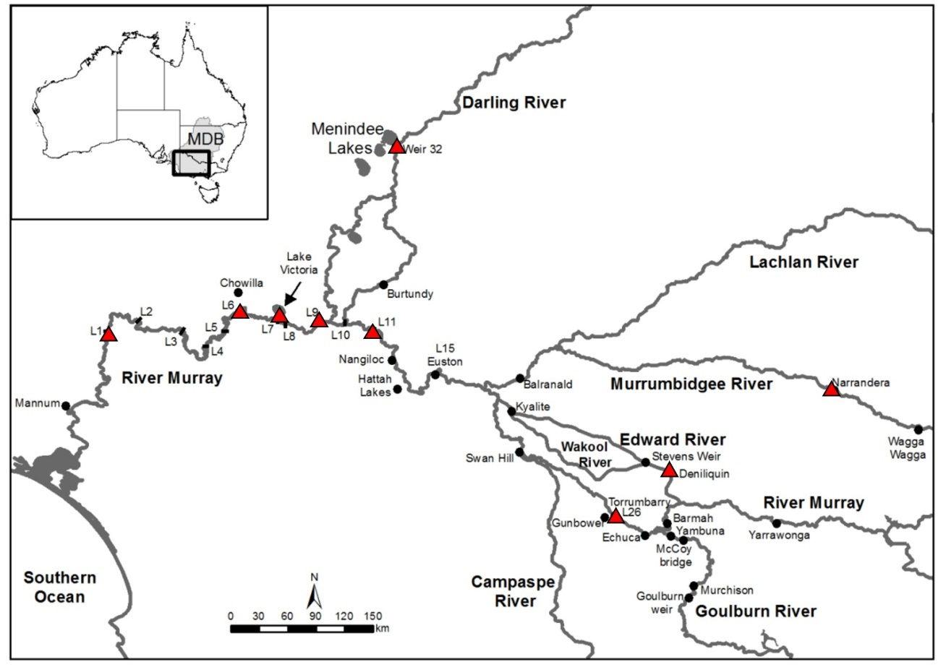
Figure 55. Map showing the water sampling locations (red triangles) in the Murray–Darling Basin (MDB), the major rivers that comprise the southern MDB, the numbered Locks (L) and Weirs (up to Lock 26, Torrumbarry), the Darling, Lachlan, Murrumbidgee, Edward–Wakool, Campaspe and Goulburn rivers and Lake Victoria, an off-stream storage used to regulate flows in the Murray River below Lock 9.
Table 18. Location of water sample collection for ⁸⁷Sr/⁸⁶Sr analysis from 2020–2024. Refer to Ye et al. (2020a) for water sample collection from 2014–2019.
River | Location | Sampling years
Murray | Lock 1 | 2020–2024
Murray | Lock 6 | 2020–2024
Murray | Lock 9 | 2020–2024
Murray | Lock 11 | 2020–2024
Murray | Torrumbarry | 2020–2023
Lake Victoria | Rufus River | 2020-21
Darling | Weir 32 | 2020–2023

Sampling eggs and larvae
From 2019–2024, in the LMR, egg/larval fish sampling was conducted approximately fortnightly between late October and late January (Table 19). Sampling was undertaken at three sites, located 5–15 km downstream of Locks 1, 4 and 6, respectively (Figure 1). At each site, four daytime plankton tows were conducted using a pair of square-framed bongo nets with 500 µm mesh; each net was 0.5 x 0.5 m and 3 m long. The volume of water (m³) filtered through each net was determined using a calibrated flow meter (General Oceanics™, model 2030R) placed in the centre of the mouth openings. Samples were preserved (70–95% ethanol) in the field and returned to the laboratory for processing. Samples were sorted using a dissecting microscope. Larvae were identified, and where possible, classified as pre-flexion (i.e. early-stage larvae with notochord predominately straight) or post-flexion (i.e. the start of upward flexion of the notochord and appearance of fin rays and fin fold) following Serafini and Humphries (2004). When golden perch and/or silver perch eggs were present, they were enumerated.
Table 19. Egg and larval fish sampling details in the Lower Murray River from 2019–2024. *In 2020-21 only, weekly sampling was undertaken around the flow pulse from late November to early January. Refer to Ye et al. (2020a) for egg and larval fish sampling from 2014–2019.
Year | Number of trips | Date range
2019-20 | 0 | No sampling
2020-21* | 7 | 9/11/20 – 20/1/21
2021-22 | 6 | 27/10/21 – 7/1/22
2022-23 | 8 | 24/10/22 – 23/2/23
2023-24 | 7 | 24/10/23 – 25/1/24

Sampling YOY and population age structure
From 2019–2024, sampling was undertaken in May/June to complement Category 1 Fish Assemblage sampling and to maximise the likelihood of collecting YOY golden perch and silver perch from the previous spring–summer spawning season. Adult and juvenile golden perch and silver perch were sampled using a 7.5 kW Smith Root (Model GPP 7.5) boat electrofishing unit at approximately five sites in the LMR (Figure 1). Electrofishing was conducted during daylight hours and all available littoral habitats were surveyed. At each site, the total time during which electrical current was applied (on-time effort) ranged from 160 to 1,534 seconds. All individuals were measured to the nearest mm (total length, TL) and a sub-sample of golden perch proportionally representing the length-frequency of golden perch collected was retained for ageing.
Ageing
Golden perch larvae and YOY were measured for TL to the nearest millimetre and sagittal otoliths were removed. To estimate the spawn date of larval and YOY fish, daily increments in otolith microstructure were examined. Otoliths were mounted individually in crystal bondTM, proximal surface upwards, and polished down to the primordium using a graded series of wetted lapping films (9 and 3 μm). Sections were then polished using to a thickness of ~50 µm. Otoliths from larger YOY fish were prepared in transverse sections which involved grinding and polishing, with 16 μm lapping film, from the anterior margin towards the core before turning over and grinding/polishing from the posterior side. Otoliths were adhered to the centre of a microscope slide with crystal bond™ with the proximal surface facing upwards. Sections were examined using a compound microscope (x 200) fitted with a digital camera and Olympus Stream image analysis software (version 2.3). Estimates of age were determined by counting the number of increments from the primordium to the otolith edge (Zampatti and Leigh 2013b). Two readers examined each otolith on separate occasions and each reader performed two counts of the increments. Counts from each reader were compared and if they differed by more than 10%, the otolith was rejected; but if count variation was within 10%, the mean of all counts was accepted as the daily increment number and estimate of age. Spawn dates were determined by subtracting the estimated age from the capture date (Brown and Wooden 2007).
We used age-frequency distributions to assess the age structure and year-class strength of golden perch. Golden perch retained for ageing were euthanised and sagittal otoliths were removed. Whole otoliths were embedded in clear casting resin and a single 400 to 600 µm transverse section was prepared. Sections were examined using a dissecting microscope (x25) under transmitted light. Estimates of age were determined independently by two readers by counting the number of discernible opaque zones (annuli) from the primordium to the otolith edge. If a consensus was not reached for otoliths with initial counts that differed among readers, then the otolith was rejected. YOY (<1 year old) fish were defined as individuals lacking clearly discernible annuli.
Otolith ⁸⁷Sr/⁸⁶Sr analysis
The second of the paired sagittal otoliths from each aged individual were used for otolith ⁸⁷Sr/⁸⁶Sr analysis. Otoliths were set in resin overnight before being cut with a Buehler Isomet Low Speed cutting machine in 400–500 µm sections. Sections were then transferred to a master slide and fixed onto a thin smear of clear casting resin, with the side closest to the core arranged facing upwards, and allowed to set overnight before being placed in a drying oven at 500°C for 4 hours and then sonicated in Milli-Q water. Individual locations of each otolith were recorded on a slide map along with preferred ablation path for each otolith. In situ microsampling analysis of ⁸⁷Sr/⁸⁶Sr in the otoliths of juvenile golden perch was achieved by laser ablation – inductively coupled plasma mass spectrometry (LA-MC-ICPMS). The laser ablation and mass spectrometry procedure is described in full in Zampatti et al. (2021). To investigate the natal origin and migration history of new recruits (larvae and YOY) and prominent younger cohorts golden perch and silver perch in the LMR, we analysed ⁸⁷Sr/⁸⁶Sr from the otolith core to edge in a subsample of fish. We compared these transects to water ⁸⁷Sr/⁸⁶Sr measured at sites across the southern MDB from 2011–2019 (Ye et al. 2020a) and 2019–2024.
Data analyses
For relevant data analyses, we integrated data from the CEWH Short-Term Intervention Monitoring (Ye et al. 2015a, 2015b, 2016a) and LTIM Projects (Ye et al. 2020a) to assess temporal variability. To compare golden perch and silver perch egg and larval abundances across years, we calculated catch-per-unit-effort (CPUE, individuals per trip) ± standard error using two long-term sites: 5 km downstream Lock 1 and 5 km downstream Lock 6, between early October and late January. Data were represented graphically as bar charts with the natal origin of larvae expressed as proportions in pie charts.
Temporal variability in the relative abundance of golden perch was investigated by assessing changes in Category 1 electrofishing CPUE data (see Section 2.8 ‘Fish Assemblage’). Differences in the relative abundance (individuals per 90 seconds of electrofishing on-time effort) between years were analysed using univariate single-factor PERMANOVA (permutational ANOVA and MANOVA) in the software package PRIMER v. 6.1.12 and PERMANOVA+ (Anderson et al. 2008). These analyses were performed on untransformed, standardised relative abundance data. Data were represented graphically as bar charts.
To assess the influence of the flow regime on recruitment of golden perch and silver perch, we investigated the temporal variability in annual recruitment strength, as determined by the relative abundance of age 1+ individuals in the following year. Young-of-year (age 0+) were not considered to accurately reflect recruitment strength due to electrofishing sampling inefficiencies. Recruitment strength was calculated by multiplying the proportion of age 1+ individuals in the population age structure by the mean CPUE of golden perch from the Category 1 electrofishing dataset. Data were represented graphically as bar charts.

Results
Water ⁸⁷Sr/⁸⁶Sr and hydrology
From 2011–2024, water ⁸⁷Sr/⁸⁶Sr was measured at sites across the southern MDB. Throughout this period, water ⁸⁷Sr/⁸⁶Sr remained reasonably stable in the Darling River and the Murray River and its tributaries upstream of the Darling River junction. Water ⁸⁷Sr/⁸⁶Sr was highest in the Murray River at Barmah and Torrumbarry (>0.7180), and lowest in the Darling River (<0.7080) (Figure 56a). Water ⁸⁷Sr/⁸⁶Sr generally decreased longitudinally along the Murray River, particularly during low Darling River flow contribution, as tributaries with distinct and relatively temporally stable ⁸⁷Sr/⁸⁶Sr (e.g. Goulburn River) contribute to flow (Figure 5).
Water ⁸⁷Sr/⁸⁶Sr in the Murray River from Lock 9–Lock 1 was spatio-temporally variable, with water ⁸⁷Sr/⁸⁶Sr generally decreasing and becoming more similar with greater contributions of Darling River flow (e.g. 2011-12, 2021-22 and 2022-23) (Figure 56b). In contrast, during years of negligible Darling River flow (i.e. 2018-19), variation in water ⁸⁷Sr/⁸⁶Sr across sites in the LMR increased, while water ⁸⁷Sr/⁸⁶Sr at Lock 9 was similar to water ⁸⁷Sr/⁸⁶Sr at Lock 11 in the mid-Murray River.
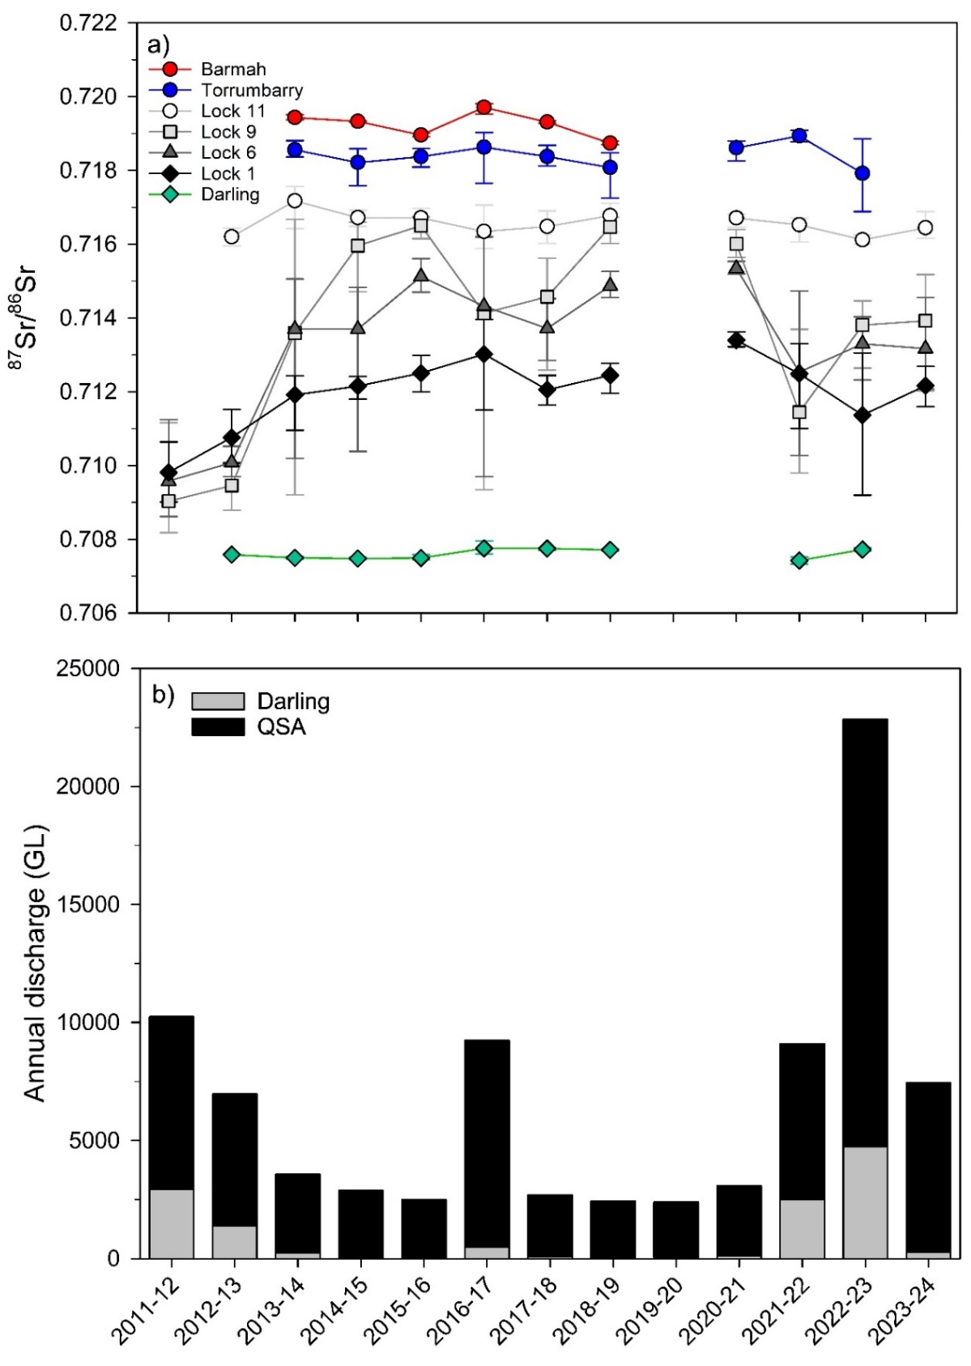
Figure 56. (a) Mean ⁸⁷Sr/⁸⁶Sr (with minimum and maximum values as error bars) in water samples collected from spring–summer in the Murray (Barmah, Torrumbarry and Locks 11, 9, 6 and 1) and Darling rivers from 2011–2024, and (b) annual discharge (GL) in the Murray River at the South Australian border (QSA) and the proportion of discharge from the Darling River at Burtundy that contributed to QSA.
Larvae and eggs
Abundance
Catch-per-unit-effort (CPUE) of larvae and eggs was temporally variable from 2010–2024. No sampling was conducted in 2019-20 and there were no larvae sampled in 2022-23, despite eggs being present. High egg abundances (>7 ind./net/trip) from 2010–2014, 2016-17 and 2020–2024 were associated with years of elevated flow (Figure 57a, b). Generally, egg abundance did not reflect larval abundances, although lower abundances of eggs (<5 ind./net/trip) from 2014–2016 and 2017–2019 were associated with low abundances of golden perch and silver perch larvae (Figure 57). Perch eggs (golden or silver perch) were not differentiated from other eggs prior to 2015-16. Nevertheless, total egg abundance is considered indicative of perch egg abundance because they formed the majority (97%) of the sampled pelagic fish egg community from 2015-16–2018-19.
Abundance of golden perch larvae was relatively high (>0.7 ind./net/trip) from 2010–2014 and in 2021-22, peaking in 2011-12 (6.4 ± 4.2 ind./net/trip) (Figure 57). In contrast, abundance was consistently low (<0.3 ind./net/trip) from 2014–2021 and in 2022–2024. Higher abundance (>0.6 ind./net/trip) of silver perch larvae occurred in 2020–2022.
Spawn date and origin
Ages of golden perch larvae collected in the LMR from 2014–2024 ranged from 2–42 days old, corresponding to spawn dates between 26 September and 7 January (Figure 58). Most golden perch larvae collected across the ten-year period originated from spawning that occurred in association with flow pulses (peaks ≥20,000 ML/d) and water temperatures ≥20ºC (e.g. 2016-17, 2021-22 and 2023-24). Ages of silver perch larvae collected in the LMR from 2014–2024 ranged from 2–47 days old, corresponding to spawn dates between 14 October and 17 January (Figure 58). Most silver perch larvae originated from spawning that occurred between mid-November and mid-January, in association with flow pulses (peaks ≥10,000 ML/d) and water temperatures ≥20ºC (e.g. 2020–2022 and 2023-24). The timing of higher egg abundances, an indicator of local spawning, generally aligned with peak spawn dates of golden perch and/or silver perch (Figure 58).
Golden perch larvae collected from 2014–2024 exhibited otolith core ⁸⁷Sr/⁸⁶Sr indicative of Murray River downstream of the Darling River junction (herein, lower River Murray), Mid-Murray River (Murray River upstream of the Darling River junction) and Darling River natal origins (Figure 56; Figure 57). Golden perch predominantly exhibited otolith core ⁸⁷Sr/⁸⁶Sr comparable to water ⁸⁷Sr/⁸⁶Sr in the lower River Murray. However, during years when Darling River flow comprised a greater proportion (or something like this) of River Murray flow to South Australia (i.e. 2016-17 and 2021-22), a greater of proportion larvae exhibited otolith core ⁸⁷Sr/⁸⁶Sr comparable to water ⁸⁷Sr/⁸⁶Sr in the Darling River. In contrast, silver perch larvae predominantly exhibited otolith core ⁸⁷Sr/⁸⁶Sr comparable to water ⁸⁷Sr/⁸⁶Sr in the Mid-Murray River and lower River Murray (Figure 56; Figure 57).
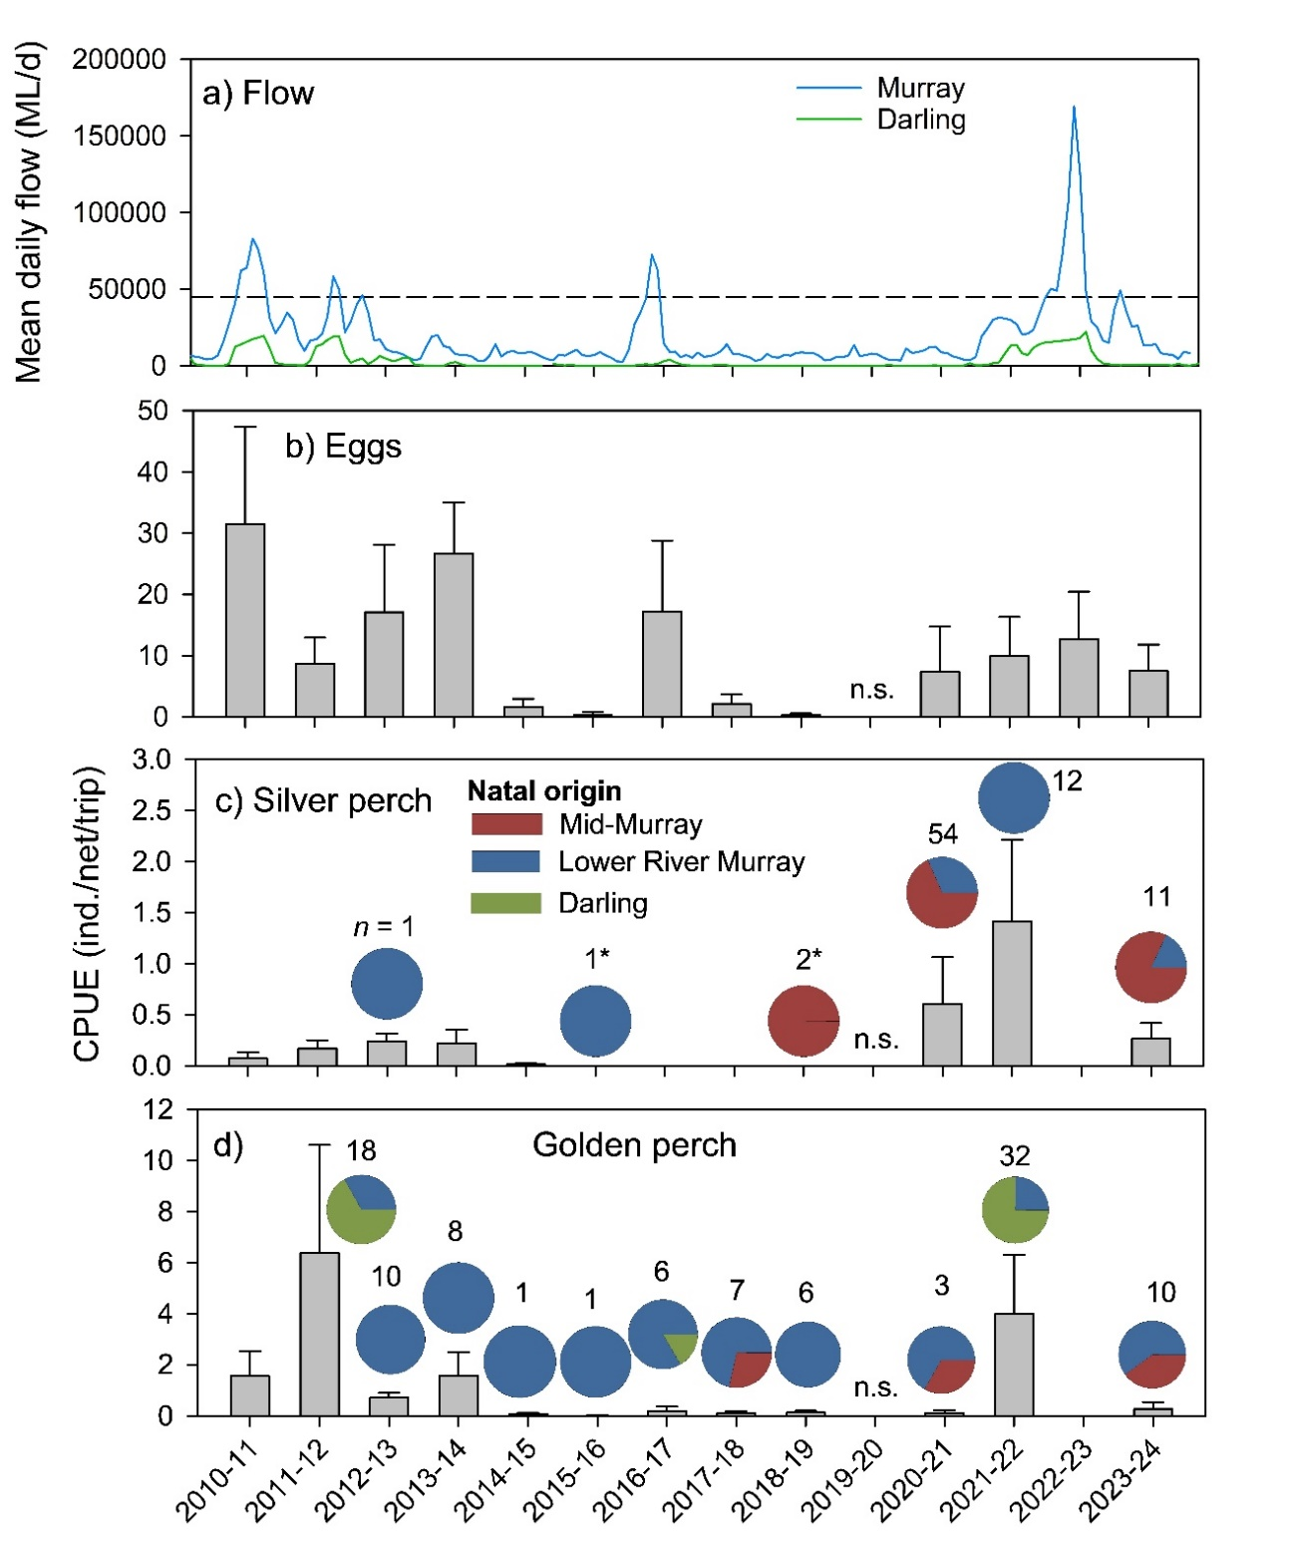
Figure 57. (a) Mean daily flow (by month) in the Murray River at the South Australian (SA) border and in the Darling River at Burtundy; and mean catch-per-unit-effort (CPUE, individuals per net per trip) ± standard error of (b) fish eggs, (c) silver perch larvae and (d) golden perch larvae collected at long-term sites downstream of Locks 4 (2020–2024 only), 6 and 1, in the Lower Murray River, from 2010–2024 during larval tow sampling. No sampling (n.s.) occurred in 2019-20. From 2011-12, natal origins of larvae (expressed as proportions in pie charts with sample sizes in text) were inferred through a subsample of otolith core ⁸⁷Sr/⁸⁶Sr from larvae of that spawn year. *Silver perch sampled in 2015-16 and 2018-19 were included for natal origin assessment but excluded from CPUE calculations due to the way data were analysed. These individuals were analysed for natal origin and presented in the pie charts above. Perch (i.e. silver or golden perch) eggs were not differentiated from other eggs prior to 2015-16 and so all eggs are presented during this period while perch eggs are presented from 2015-16. Approximate bankfull flow for the South Australian Murray River (dotted black line) is shown in (a). Lower River Murray = Murray River, below the Darling River junction.
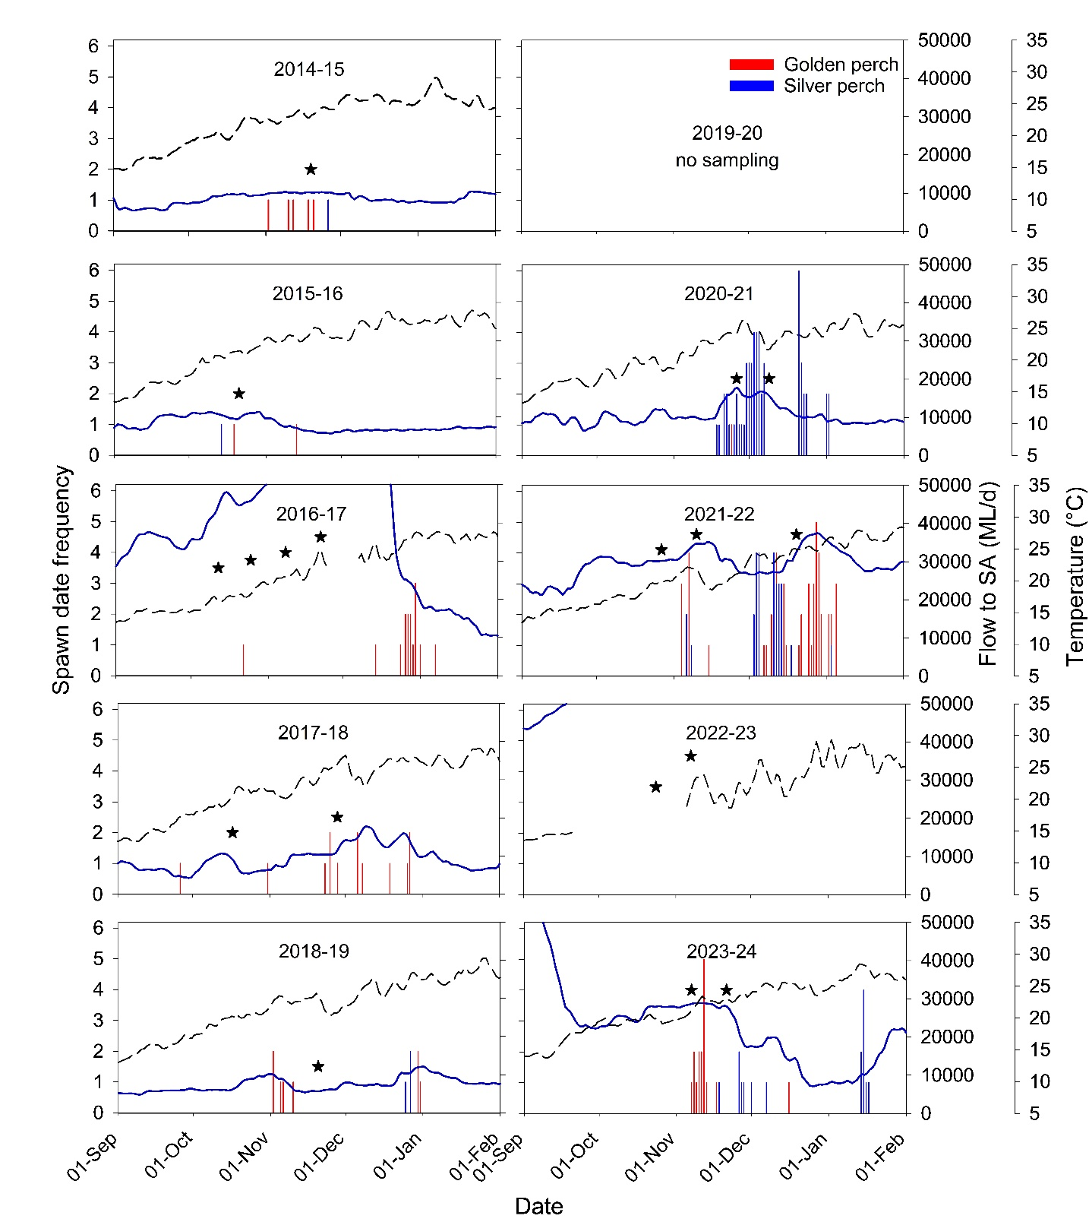
Figure 58. Back-calculated spawn dates (frequency) for larval golden perch (red bars) and silver perch (blue bars) captured at long-term sites downstream of Locks 4 (2020–2024 only), 6 and 1, in the Lower Murray River during spring/summer 2014–2024. Spawn dates are plotted against discharge (ML/d) at the South Australian (SA) border (solid blue line) and water temperature (°C) (dotted black line). Black stars represent the periods when golden perch and/or silver perch eggs were sampled in higher (>50/trip) quantities. Flow to SA peaked at 94,600 ML/d on 29 November 2016 and at 187,600 ML/d on 22 December 2022.
Recruitment strength
Recruitment strength, as determined by the relative abundance of age 1+ individuals in the following year, was temporally variable for both species from 2014 to 2023 (Figure 59). Stronger recruitment was observed for golden perch and silver perch during 2021-22 and 2020-21. Lower-level recruitment was observed for golden perch from 2016–2019 and in 2022-23, and for silver perch in 2016-17.
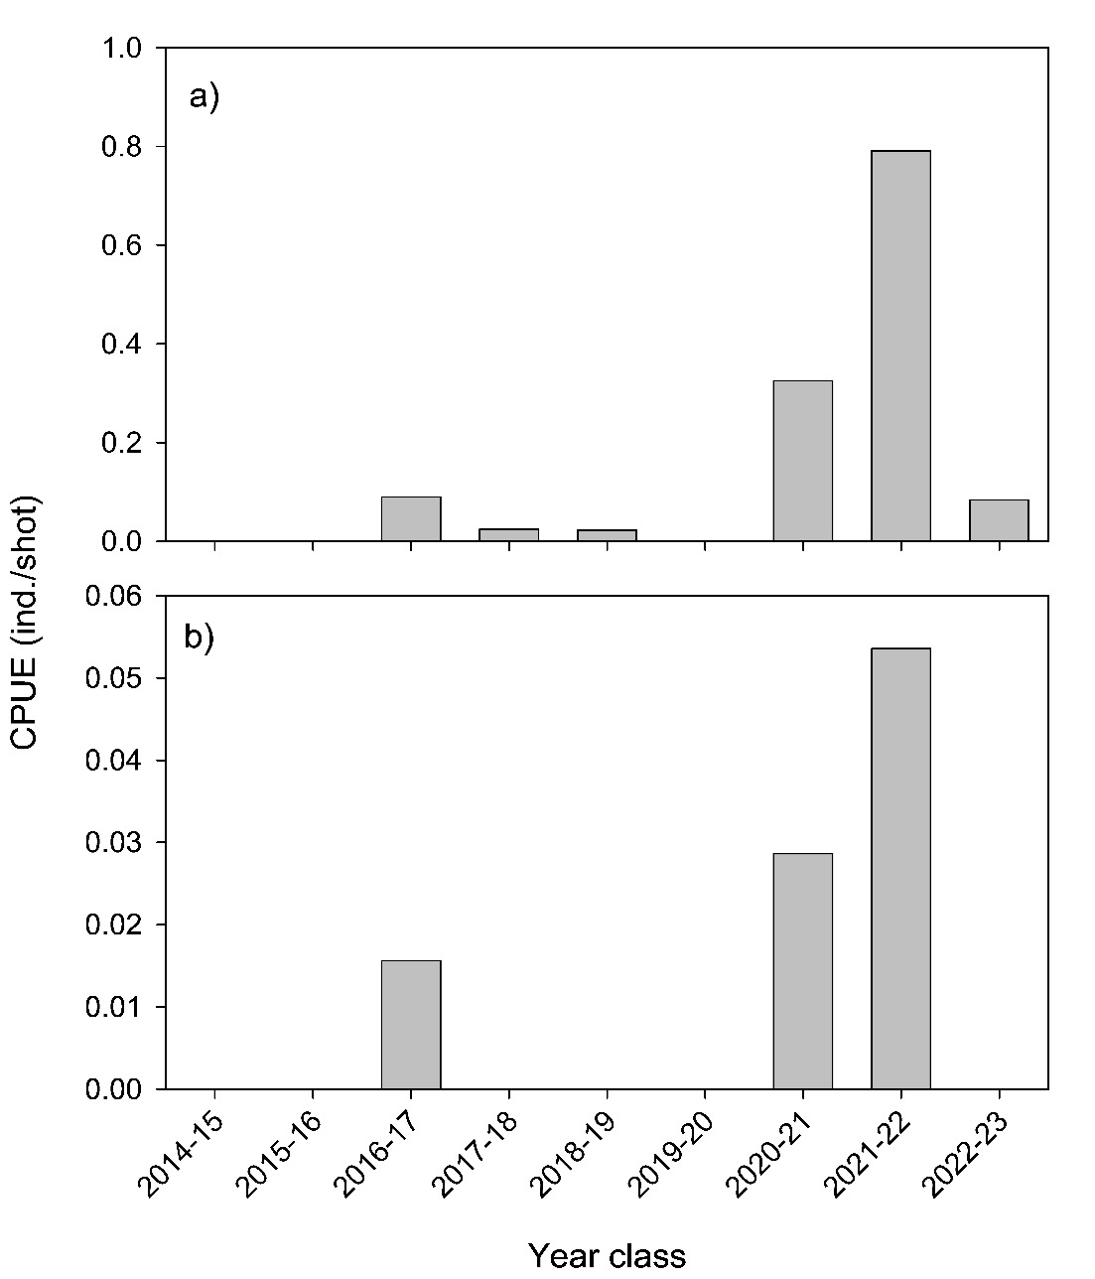
Figure 59. Recruitment strength of (a) golden perch and (b) silver perch in the gorge geomorphic zone (10 sites) of the Lower Murray River from 2014–2023, as determined by the mean Category 1 Fish Assemblage electrofishing catch-per-unit-effort (CPUE, individuals per 90 second shot) of age 1+ captured in the following sampling season (2015–2024). Recruitment strength for 2024 could not be yet determined because sampling in autumn 2025 has not been undertaken. Recruitment strength is calculated for 2017 using data from five sites sampled in autumn 2017.
Juvenile/adult abundance
From 2015–2024, there was a general decline in the relative abundance of golden perch from 0.57 ± 0.08 ind./shot in 2015 to 0.28 ± 0.04 ind./shot in 2024. The exception was an increase in abundance in 2022 (0.58 ± 0.13 ind./shot), driven by an increase in the abundance of age 0+ individuals in the population (Figure 61). This was supported by PERMANOVA which demonstrated significant differences between years (Pseudo-F_{8,94} = 4.7065, P = 0.0001). Pair-wise comparisons revealed significant differences between 2016 and 2019, and 2019 and 2023, but not between any other years (Table C18 in Appendix C).
Silver perch relative abundance was relatively low (<0.02 ind./shot) from 2015–2024, except for 2022 (0.03 ± 0.01 ind./shot) (Figure 60b). No statistical comparisons were made due to low sample sizes and high variability in silver perch CPUE data.
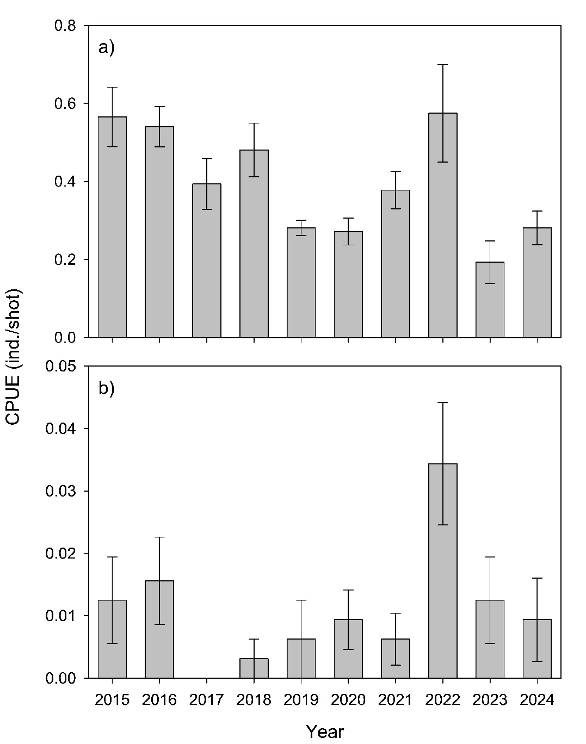
Figure 60. Mean catch-per-unit-effort (CPUE) ± standard error of (a) golden perch and (b) silver perch captured during Category 1 Fish Assemblage electrofishing (individuals per 90 second shot) in the gorge geomorphic zone (10 sites) of the Lower Murray River in autumn from 2015–2024. CPUE data from five sites are presented for 2017 as other sites were sampled post June 2017.
Age structure
In 2015, the sampled population of golden perch ranged in age from 2+ to 18+ years, with dominant cohorts of age 3+, 4+, 5+, 14+ and 18+ fish, born in 2011-12, 2010-11, 2009-10, 2000-01 and 1996-97, respectively (Figure 61). In 2015, these cohorts comprised 5, 30, 35, 9 and 10% of the sampled population in the LMR, respectively. These five cohorts have persisted in the population from 2015–2024, but their relative contribution in the population have diminished. In 2022, strong recruitment was observed for the first time across the sampling period. The sampled population during that year ranged in age from 0+ to 21+ years, with dominant cohorts of age 0+, 3+, 5+ and 11+ fish, born in 2021-22, 2018-19, 2016-17 and 2010-11, respectively, and comprising 24, 9, 14 and 11% of the sampled population in the LMR, respectively (Figure 61). In 2024, the population was dominated by age 2+ from the 2021-22 cohort (40%) and consisted of several other cohorts from age 0+ to 14+, including the 2018-19 and 2016-17 cohorts, which both represented 10% of the sampled population.
From 2015–2024, silver perch collected in the LMR ranged in age from 0+ to 7+ years (Figure 62). Low sample numbers were present in most years, except 2022, when the sampled population comprised of six cohorts from age 0+ to 5+ years, and age 3+ fish, born in 2018–19, represented 46% of the population.
Natal origin of prominent cohorts
From 2015–2024, a total of 351 golden perch and 77 silver perch (excluding larvae) were analysed for natal origin and migration history (Table C19 in Appendix C). Golden perch from the four most dominant year classes of 2021-22, 2011-12, 2010-11 and 2009-10 exhibited otolith core ⁸⁷Sr/⁸⁶Sr comparable to water ⁸⁷Sr/⁸⁶Sr in the lower River Murray (Murray River downstream of the Darling River junction) and the Darling River (Figure 56; Figure 61). Otolith transects indicated that some fish from these cohorts were born and spent their entire lives in the lower River Murray, whilst others originated from the Darling River and transitioned into the lower River Murray in their first (i.e. age 0+) or second year (i.e. age 1+) and remained in this region until capture.
Golden perch cohorts from 2016–2021, 2000-01 and 1996-97, generally exhibited otolith core ⁸⁷Sr/⁸⁶Sr comparable to water ⁸⁷Sr/⁸⁶Sr in the lower River Murray (Figure 56; Figure 61). Golden perch from the 2005-06 cohort exhibited otolith core ⁸⁷Sr/⁸⁶Sr comparable to water ⁸⁷Sr/⁸⁶Sr in the lower River Murray and the mid-Murray River (Figure 56; Figure 61). Otolith transects indicated that some fish from this cohorts were born and spent their entire lives in the lower River Murray, whilst others originated from the mid-Murray River, upstream of the Darling River junction, and transitioned into the lower River Murray early in their first year (i.e. age 0+), and remained in this region until capture.
Silver perch sampled from 2015–2024 predominantly exhibited otolith core ⁸⁷Sr/⁸⁶Sr comparable to water ⁸⁷Sr/⁸⁶Sr in the lower River Murray and the mid-Murray River (Figure 56; Figure 62). Otolith transects indicated that some fish from these cohorts were born and spent their entire lives in the lower River Murray, whilst others originated from the mid-Murray River, upstream of the Darling River junction, and transitioned into the lower River Murray early in their first year (i.e. age 0+), and remained in this region until capture.
Two individual silver perch sampled in 2016, from 2009-10 and 2011-12 year classes, exhibited otolith core ⁸⁷Sr/⁸⁶Sr comparable to water ⁸⁷Sr/⁸⁶Sr in the Darling River. Otolith transects indicated that some fish originated from the Darling River and transitioned into the lower River Murray in their first (i.e. age 0+, 2011-12) or second year (i.e. age 1+, 2009-10), and remained in this region until capture.

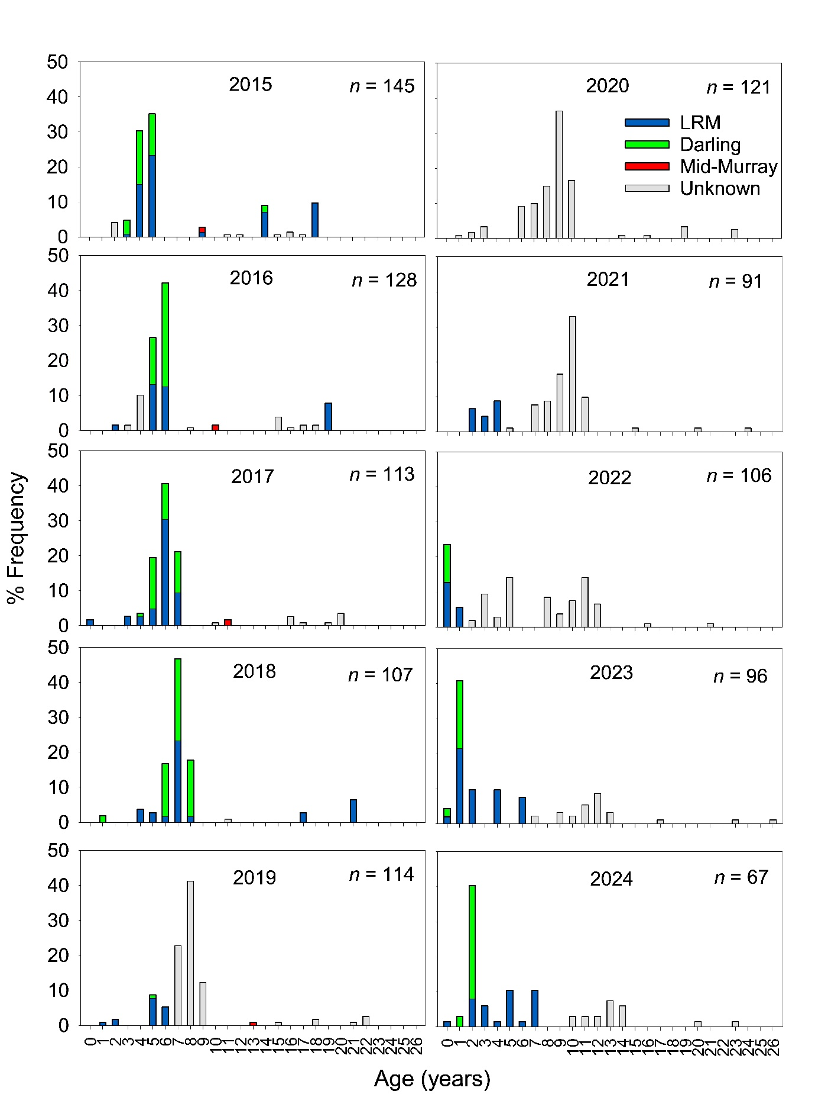
Figure 61. Age frequency distribution of golden perch from the Lower Murray River from 2015–2024 showing the natal origins of dominant cohorts inferred from otolith core signatures of the sampled fish in comparison to the water sample reference collection (Figure 56). LRM = Murray River, below the Darling River junction. Percentage of origin for each cohort are based on the subsampled population. Age cohorts with grey bars were not assessed for natal origin.
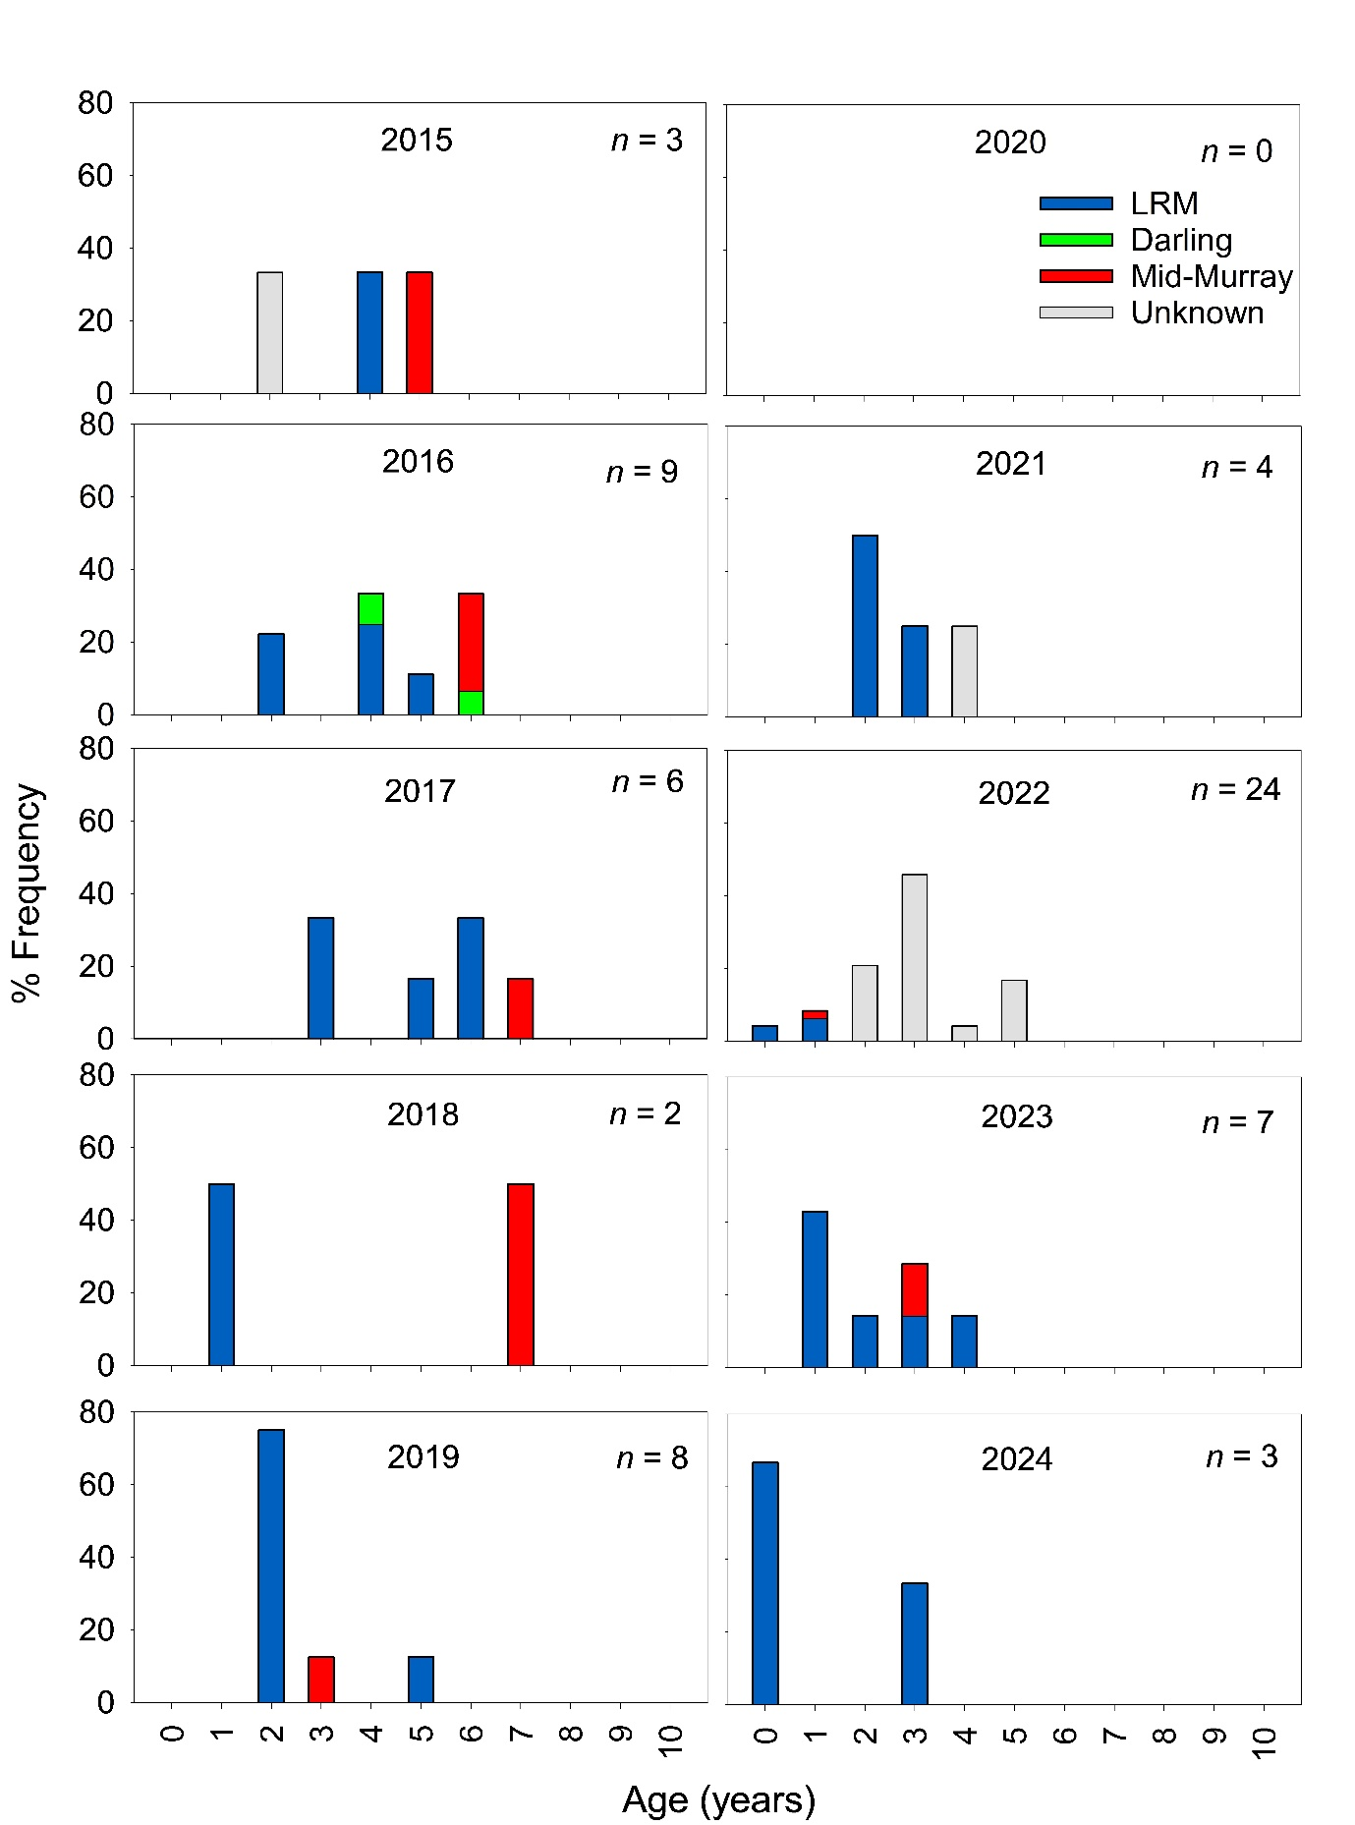
Figure 62. Age frequency distribution of silver perch from the Lower Murray River from 2015–2024 showing the natal origins of dominant cohorts inferred from otolith core signatures of the sampled fish in comparison to the water sample reference collection (Figure 56). LRM = Murray River, below the Darling River junction. Percentage of origin for each cohort are based on the subsampled population. Age cohorts with grey bars were not assessed for natal origin.

Evaluation
The evaluation approach, including assessment criteria, is described in the evaluation section for Hydraulic Regime (Section 2.1).
Table 20. Flow-cued Spawning Fish Reproduction evaluation questions and answers.
CEWH evaluation questions | Outcomes of flow delivery
CEWH evaluation questions | 2014-15 | 2015-16 | 2016-17 |  |  | 2017-18 | 2018-19 |  | 2019-20* | 2020-21 | 2021-22 | 2022–23 | 2023-24
Did the flow regime (including environmental water) contribute to reproduction (spawning and recruitment#) of golden perch? | Coincident spawning, negligible recruitment | Coincident spawning, negligible recruitment | Coincident spawning and minor recruitment |  |  | Coincident spawning and minor recruitment | Coincident spawning and minor recruitment |  | Negligible recruitment | Coincident spawning, minor recruitment | Coincident spawning and strong recruitment | Coincident spawning and minor recruitment | Coincident spawning and minor recruitment
In 2023-24, spawning in the LMR between early November and mid-December was coincident with environmental water delivery in the mid-Murray River and Murray River, downstream of the Darling River junction, which contributed to November and December flow pulses (>20,000 ML/d). Environmental water contributed to 33% of total flow during the peak spawning period (early November to mid-December). One YOY golden perch was sampled in autumn 2024 (1% of the population), but spawn dates could not be calculated from this individual. Nevertheless, the overall flow regime in 2023-24 supported spawning and recruitment of golden perch in the LMR and supported the downstream dispersal of larvae from the Mid-Murray River.
This is not a long-term evaluation question.
Did the flow regime (including environmental water) contribute to the resilience of golden perch populations? | Long-term (2014–2024) outcome = minor.  In the LMR in 2024, golden perch ranging in age from 0+ to 7+ years (75% of the population) can be associated with recruitment coincident with spring-summer flows that included environmental water. The presence of these cohorts contributes to population resilience via promoting a more diverse age structure, although abundance in the LMR has generally declined since 2015.
Did the flow regime (including environmental water) contribute to reproduction (spawning and recruitment#) of silver perch? | None/negligible spawning and recruitment | None/negligible spawning and recruitment |  | None/negligible spawning and minor recruitment | None/negligible spawning and recruitment |  |  | None/negligible spawning and recruitment | Negligible recruitment | Coincident spawning and minor recruitment | Coincident spawning and moderate recruitment | None/negligible spawning and recruitment | Coincident spawning and minor recruitment
In 2023-24, spawning of silver perch in the LMR between mid-November and mid-January was coincident with environmental water delivery in the mid-Murray River and Murray River, downstream of the Darling River junction, which contributed to November and January flow pulses (>20,000 ML/d). Environmental water contributed to 33% of total flow during the peak spawning period (mid-November to mid-January). Two YOY silver perch were sampled in autumn 2024 (67% of the sampled population), but spawn dates could not be calculated from these individuals. Nevertheless, the overall flow regime in 2023-24 coincided with spawning and recruitment of silver perch in the LMR and supported the downstream dispersal of larvae from the Mid-Murray River.
This is not a long-term evaluation question.
Did the flow regime (including environmental water) contribute to the resilience of silver perch populations? | Long-term (2014–2024) outcome = unknown.  In the LMR from 2021–2024, the silver perch population was comprised of fish <6 years old derived from spawning during the monitoring period from 2016-17 to 2023-24 and coincident with spring–summer flows that included environmental water. Due to low abundance and otolith sample size in most years, there is low confidence in assessing the contribution of the flow regime (including environmental water) to the resilience of silver perch populations

*Contribution of the flow regime to spawning was not investigated in 2019-20.
#Spawning considers the CPUE of perch eggs and larvae (Figure 57). Recruitment considers the CPUE of age 1+ in the following year (‘recruitment strength’, Figure 59), the presence and percentage contribution of that cohort to the population through time (golden perch only due to low sample size of silver perch, Figure 61) and, in the absence of multi-year data, the CPUE of YOY in the autumn following spawning (Figure 61, Figure 62).
Assignment of contribution (to what extent the flow regime [including environmental water] contributed towards the outcome, with the significance of the outcome considered) is semi-quantitative.
 | Unknown |  | None/negligible |  | Minor |  | Moderate |  | Substantial

Discussion
Over the CEWH LTIM and Flow-MER projects, we aimed to identify potential associations between recruitment of golden perch and silver perch and flow, including environmental water delivery. We hypothesise that (1) increased flow (nominally >20,000 ML/d) in spring–summer will promote spawning and recruitment to YOY, and (2) multiple years of enhanced spring–summer flow will increase the resilience of golden perch and silver perch populations in the LMR by promoting a diverse age structure.
Golden perch
From 2014–2024, increased spawning of golden perch, as indicated by the abundance of eggs and/or larvae, was generally associated with elevated in-channel (>20,000 ML/d) and overbank (>45,000 ML/d) flows in concert with water temperatures ≥20ºC during spring–summer. Despite sampling few or no larvae during overbank spring–summer flow years in 2016-17 (peak 94,600 ML/d) and 2022-23 (187,600 ML/d), respectively, these years were associated with high egg abundance, relative to low flow years (2014-15, 2015-16, 2017-18, 2018-19), except for 2020-21. Larvae abundance in the LMR main channel during overbank flow years may be underestimated due to sampling inefficiencies from dilution effects and changes in spatial distribution of larvae due to lateral connectivity and inundation. It is also possible that a hypoxic blackwater event associated with overbank floods in 2016 (Ye et al. 2018) compromised the survival of eggs and larvae, resulting in low abundance of larvae during sampling.
Trends in recruitment of golden perch in the LMR generally followed those for spawning (larval abundance). Strong recruitment, as indicated by the abundance of age 1+ year olds in the following year, was observed for the 2021-22 cohort spawned during high, in-channel flows (peak 37,500 ML/d in late December). Lower levels of recruitment in this reach also occurred in the overbank (>45,000 ML/d) flow years of 2016-17 and 2022-23, a high (>20,000 ML/d) in-channel flow year in 2023-24 and in-channel (<20,000 ML/d) spring-summer flow years 2017–2019 and 2020-21. During most of these in-channel flow years, environmental water assisted in promoting and maintaining elevated spring-summer flow during periods coincident with peak spawning (Table 20; Ye et al. 2020a, 2021, 2022, 2023, 2024). In 2024, the 2021-22, 2020-21, 2018-19 and 2016-17 cohorts (i.e. 2+, 3+, 5+ and 7+ year olds) were apparent in the age structure, and collectively comprised 67% of the sample. The increased prominence of some of these cohorts (e.g. 2018-19 and 2016-17) as older fish in the population, reinforces the need for a long-term perspective (5–10 years) for detecting population responses of long-lived fishes to flow variability and management interventions.
Recruitment and the establishment of distinct cohorts of golden perch in the LMR is influenced by local spawning and the downstream transport and migration of larvae/YOY (age 0+) and juveniles (predominantly age 1+) from spatially distinct spawning areas (Zampatti 2019). Fish originating from years of high flow (i.e. 2009-10, 2010-11 and 2011-12 and 2021-22) in the Darling River contributed substantially to prominent age cohorts in the LMR. Thus, spawning and recruitment in the Darling River, and physical and hydrological connectivity between the Darling and Murray rivers, are substantial drivers of golden perch population dynamics of the lower River Murray. Whilst some downstream transport of eggs, larvae and early-stage juveniles from the Darling River to the lower River Murray may occur during low-intermediate flows, it appears that high in-channel–overbank flows in both the Darling and Murray rivers are associated with significant downstream dispersal of juvenile golden perch from recruitment sources in the Darling River (Zampatti and Leigh 2013; Zampatti et al. 2021).
In association with an ageing population, abundance of golden perch in the LMR steadily declined by almost half from 2015 to 2020. Potential factors that contributed to the decline are limited recruitment, mortality (fishing and natural) and upstream emigration of adults (Zampatti et al. 2018b). In 2022, however, abundances of golden perch increased to levels comparable to 2015, due mainly to greater abundances of YOY fish and increased prominence of the age 3+ and 5+ cohorts. The decline in abundance during 2023 and 2024, following recruitment during 2022-23 and 2023-24, may reflect emigration of adults (e.g. 2009–2014 year classes; Zampatti et al. 2018a; Bice et al. 2021) or fishing mortality.
Silver perch
From 2014–2024, silver perch were sampled in low abundance which limits confidence in interpretations and informing management for this species. Increased spawning, as determined by the abundance of larvae, and recruitment, as determined by the presence of YOY or age 1+ individuals in the following year, was observed during in-channel flows >20,000 ML/d (2021-22 and 2023-24) but also a 17,900 ML/d in-channel flow year (2020-21). Nonetheless, based on age structures from 2014–2024, it appears recruitment of silver perch in the LMR is less episodic than golden perch. As above for golden perch, environmental water has played a key role in promoting in-channel spring–summer flows that have coincided with spawning of silver perch.
Recruitment and the establishment of distinct cohorts of silver perch in the LMR is influenced by local spawning and the downstream transport and migration, of larvae predominantly, from the mid-Murray River. Thus, spawning in the mid-Murray River, and longitudinal connectivity between the mid- and lower Murray rivers, are substantial drivers of silver perch population dynamics of the lower River Murray.

Management implications
Over the past ten years, golden perch recruitment in the LMR has been episodic, aligning with the periodic life history characteristics of this species. Evidence from the current investigation and allied studies suggest that, in the highly regulated lower River Murray, flow pulses >20,000 ML/d within the spawning season of golden perch (typically with peak spawning between November and January in the LMR), that coincide with water temperatures >20°C, are likely required to significantly influence local golden perch spawning and recruitment. Annual spring–summer in-channel flow pulses of this magnitude were a key feature of the hydrograph of the LMR prior to regulation (Mallen-Cooper and Zampatti 2018), and would have occurred in recent years under natural, unregulated conditions.
Nuanced understanding of the spawning, downstream dispersal and recruitment of silver perch in the LMR lags that for golden perch. Nevertheless, the collection of silver perch larvae and evidence of recruitment (from detection of YOY or age 1+ in the following year) from 2020–2022 and 2023-24 suggests that the spring–summer hydrograph during these years in the Murray River between Lock 1 and Lock 15 was conducive to silver perch spawning and the downstream drift of early-stage juveniles to the LMR.

Conclusion
Since 2013-14, there has been episodic recruitment of golden perch in the LMR. In 2024, the population was characterised by a strong cohort derived from spawning in 2021-22 (currently aged 2+) and several small cohorts ranging from age 0+ to 7+. Since 2015, there has been an overall decline in golden perch abundance in the LMR. Silver perch abundance in the LMR was low and variable, although a low level of near-annual recruitment was evident. To improve the resilience of golden perch and silver perch populations in the LMR, it is pertinent to consider flows that may facilitate spawning and recruitment. Specifically, Commonwealth environmental water could contribute to spring/early summer flow pulses (November–January) along the Murray River (nominally >20,000 ML/d QSA) to promote spawning, recruitment and subsequent dispersal of golden perch and silver perch.

Murray Cod Recruitment

Background
Murray cod has great recreational and cultural significance in the MDB. Nonetheless, populations have declined due to human impacts that include alteration of flow regimes, barriers to movement, overharvesting and habitat (hydraulic and physical) degradation (Lintermans and Phillips 2005), and the species is currently considered vulnerable under the Australian EPBC Act (1999). In the Murray River downstream of the Darling River junction, the fragmentation of the river by sequential weirs, alteration to hydraulics and loss of lotic habitats are considered primary threats to the persistence of Murray cod populations (Zampatti et al. 2014; Mallen-Cooper and Zampatti 2018). Indeed, under low flows, lotic environments that provide favourable juvenile and adult habitat, and support key life history processes (spawning and recruitment) are restricted to select anabranch systems (e.g. Chowilla) and lock and weir tailwaters. During elevated flows (e.g. >20,000 ML/d), however, lotic conditions are returned to considerable reaches of the LMR (Bice et al. 2017).
Murray cod spawn annually over a well-defined period from October–December, irrespective of flow (Davis 1977; Rowland 1998), but recruitment in the LMR main channel has been positively associated with flow (Ye and Zampatti 2007; Zampatti et al. 2014). Indeed, from 2003–2010 during the Millennium Drought, discharge in the LMR was predominantly <10,000 ML/d, and Murray cod recruitment, measured as abundances of YOY in autumn, was negligible in the predominantly lentic main channel. Subsequently, recruitment was observed in association with spawning that occurred in high flow years from 2010–2013 (Zampatti et al. 2014).
In the LMR, mechanisms that facilitate recruitment of Murray cod (to YOY) likely relate to increased spawning habitat and survival of early life stages associated with improved riverine hydraulics and productivity. Survival is likely mediated by enhanced habitat availability, fish growth rates and condition, and ultimately determines recruitment and population abundance. This indicator explored these mechanisms, by assessing aspects of Murray cod recruitment (e.g. abundance, growth, condition) in association with flow. Understanding the magnitude of recruitment, and links between recruitment and flow (hydraulic habitat and food resources), is critical for informing future environmental flow management and will help evaluate ecological outcomes of Commonwealth environmental water.
Hypotheses
- Elevated spring–summer flow, either in-channel or overbank, and associated increase in lotic habitat, will enhance recruitment (to YOY) of Murray cod;
- Elevated spring–summer flow, either in-channel or overbank, and associated increase in lotic habitat, will enhance growth rates and morphometric condition of Murray cod; and
- Multiple years of elevated spring–summer flow will result in broad size/age distributions of Murray cod and increased population resilience in the LMR.

Methods
To evaluate the contribution of flow, including Commonwealth environmental water, to the morphometric condition, growth and recruitment of Murray cod in the LMR from 2019–2024, we used: (1) length–weight relationships and associated metrics to assess body condition; (2) otolith microstructure analysis (including daily otolith growth increments) to determine the time of spawning, along with seasonal and daily growth rates; and (3) electrofishing to quantify the abundance of YOY to assess recruitment, and to establish a length frequency distribution of the Murray cod population in the LMR to determine population structure. Reference data collected in numerous past monitoring projects and presented in Ye et al. (2021) were used and presented in this indicator section.

Sampling
Murray cod were sampled in the main channel of the LMR at several stages during early ontogeny, from larvae through to YOY (>120 d of age) (Table 21). Sampling for larvae (<30 mm TL) in November comprised a combination of passive (light traps) and active (bongo net tows) methods. Sampling effort varied across sites but included setting ~30 quatrefoil light traps (225 x 225 x 255 mm, 5 mm mesh) and 2–4 drift nets (1.5 m long x 0.5 m diameter, 500 µm mesh) overnight for 2–3 nights (set time of ~15 hours). Larval tows were performed opportunistically with a paired bongo net (0.5 x 0.5 m x 3 m long, 500 µm mesh) (Ye et al. 2018). Larvae were preserved (70–95% ethanol) in the field and returned to the laboratory for processing.
Electrofishing was used specifically to collect juveniles (~30–160 mm) and sample the broader population (Table 21). All sampling was performed using a 7.5 kW Smith Root (Model GPP 7.5) boat electrofishing unit during daylight hours. Sampling in January and February was targeted towards preferred habitat of early juveniles (e.g. root complexes of snags and rock crevices). Two complementary types of sampling were used to assess YOY abundance and population structure: 1) autumn (typically March–April) non-targeted Fish (Channel) electrofishing (see Section 2.8 ‘Fish Assemblage’) and 2) autumn (typically May) habitat-specific (targeted) electrofishing. Electrofishing during May targeted a wider range of Murray cod habitats, including snags in flowing habitat extending beyond the riverbank (preferred by sub-adults and adults). At each site, electrofishing ‘on-time’ effort was variable, and depended on the available habitat. All individuals were measured for TL (nearest mm) and weight (to 0.5 kg), and a sub-sample of juvenile (~<180 mm) fish were retained for morphometric and otolith analyses.

Table 21. Sampling trips targeting Murray cod in the main channel of the Lower Murray River from 2019–2024.
Typically sampling period | Methods | Indicator
November | Light traps, larval tows, drift nets | Growth, condition, larval abundance
Januaryª | Electrofishing | Growth, condition
February | Electrofishing | Growth, condition
March/April^{b} | Electrofishing | Condition, YOY abundance, population structure
May | Electrofishing | Condition, YOY abundance, population structure
ª Due to consistent low catch rates, January sampling was not undertaken in 2022-23 and 2023-24.
^{b} Fish (Channel) sampling in the Gorge zone (see Section 2.8 ‘Fish Assemblage’ for details).
Sampling for larvae (November) and early juveniles (February–March) was conducted in the tailwaters (<15 km downstream) of Lock 3 (Gorge zone) and Lock 4 (Floodplain zone) (Figure 1). Sampling to assess YOY abundance and population structure in May occurred at sites in the tailwaters of Locks 3 (Gorge zone), 4 and 5 (Floodplain zone), and was supplemented by non-targeted sampling in March/April at ten sites between Locks 1 and 3 in the Gorge zone (Fish (Channel) sampling). In addition to the sampling described above, Murray cod larvae and juveniles were opportunistically collected through other MER field sampling (e.g. Section 2.6 ‘Flow-cued Spawning Fish Reproduction’) and sampling from other projects (e.g. Chowilla TLM condition and targeted cod monitoring). Samples from the main river channel were included in all analyses, while samples from anabranches were used solely to supplement age analyses to determine the range of spawn dates for Murray cod in the LMR.

Otolith preparation and increment counts and measurements
Larval/juvenile Murray cod were measured for TL to the nearest millimetre, weighed to 0.001 of a gram, and sagittal otoliths were removed. Larval otoliths were prepared in sagittal sections. Larger otoliths were ground on the distal surface first before grinding and polishing, with 9 and 3 μm lapping film, from the proximal surface to produce sections of ~50 μm thickness. Smaller otoliths required only grinding the proximal surface or not at all. Sagittae were embedded in crystal bond™ with the proximal surface facing upwards. Larger juveniles from January were prepared in transverse sections which involved grinding and polishing, with 16 μm lapping film, from the anterior margin towards the core before flipping and grinding/polishing from the posterior side. Otoliths were adhered to the centre of a microscope slide using crystal bond™ with the proximal surface facing upwards.
Prominent hatch marks were evident on most sectioned otoliths, providing a reliable reference point to begin increment counts. As such, daily increment counts were made from the hatch mark along the maximum growth axis towards the ventral apex. Two readers examined each otolith on separate occasions and each reader performed two counts of the increments. Counts from each reader were compared and if they differed by more than 10%, the otolith was rejected; but if count variation was within 10%, the mean of all counts was accepted as the daily increment number and estimate of age. Hatch dates were determined by subtracting estimated age from capture dates. Prior to increment counts, otolith readers were calibrated by reading a reference collection of otoliths from known-age Murray cod larvae and achieving 90% agreement. Otolith sections were examined using a compound microscope (x 200) fitted with a digital camera and Olympus Stream image analysis software (version 2.3). YOY Murray cod collected in April and May were omitted from age analyses due to unreliability in daily increment estimates for fish >150 days.

Data analyses
Spawning
To compare the magnitude of Murray cod spawning across years, temporal variability in the abundance of Murray cod larvae was investigated. We used two separate datasets: 1) targeted light trap sampling during November 2019–2024 in two reaches, downstream of Locks 3 and 4; and 2) day-time egg and larval fish bongo tow sampling described in Section 2.6. Abundance was presented as total CPUE (total catch/total effort). No statistical comparisons were made due to the low sample numbers and/or low numbers of replicates.
Morphometric condition
Length–weight relationships for juvenile (0+ year old, typically <160 mm) Murray cod were described using linear regression, following the methods outlined in Tonkin et al. (2008). Linear and non-linear relationships were examined with non-linearity modelled by fitting polynomial terms of increasing order (up to 4) to length. The relative support for each of the models was assessed using Akaike’s Information Criterion, corrected for small sample size (AICc) (Burnham and Anderson 2002). AICc values were rescaled as differences between the model and the model with the lowest AICc value, with the likelihood of the model calculated (see Tonkin et al. 2008 for equation). Morphometric condition was estimated by calculating the relative condition factor (Krel) of an individual fish, using the estimated weight calculated from the selected model equation: Krel = Wt_{actual}/Wt_{estimated}. To determine if the condition of Murray cod differed among years (i.e. 2015–2024) of different flow regimes, differences in Krel of individuals sampled between March and August were assessed using a single-factor univariate PERMANOVA (permutational ANOVA and MANOVA) in the software package PRIMER v. 6.1.12 and PERMANOVA+ (Anderson et al. 2008). Data from 2022 were not analysed statistically due to low (n = 2) sample size. A significance value of α = 0.05 was adopted for all statistical comparisons, acknowledging an increased likelihood of type 1 errors for multiple comparisons. Comparisons of morphometric condition, seasonal growth rate and CPUE between weir pools were not explored as they were not of interest in this study.
Growth rate
Mean seasonal growth was described by fitting linear and non-linear models to length-at-age data. Three models were considered for fish growth rate: linear, Gompertz and Von Bertalanffy. Model selection procedures using AICc, as described above, were used to select the model with most support. For YOY (excluding larvae), mean seasonal growth rate was calculated as the function of TL and age (days) at capture. No statistical comparisons between years (2019–2024) were made due to the low number of replicates (n ≤ 2) during 2021-22, 2022-23 and 2023-24.
Recruitment
To compare recruitment and abundance of Murray cod across years (2013–2024), temporal variability in the relative abundance of YOY and all Murray cod was assessed using two datasets: 1) non-targeted Category 1 electrofishing CPUE data (see Section 2.8 ‘Fish Assemblage’); and 2) targeted electrofishing CPUE data. For the first dataset, sites (n = 10) were grouped and represented as two reaches, namely downstream of Lock 3 and downstream of Lock 2. For the second data set, numerous ‘shots’ (n = 1–5) were undertaken across broad sites downstream of Locks 3, 4 and 5, and CPUE data presented as per the first dataset. Differences in relative abundance of YOY (individuals per minute of electrofishing on-time effort) among years at each reach were analysed using univariate single-factor PERMANOVA. These analyses were performed on untransformed, standardised relative abundance data. For the first dataset, YOY CPUE data from downstream of Lock 2 and Lock 3 were amalgamated to represent the gorge geomorphic zone because there were no significant effects of reach or an interaction between reach and year. For the second dataset, data from downstream of Lock 4 were used to represent the floodplain geomorphic zone because sampling downstream of Locks 5 and 3 had low replication in multiple years (n < 3) or these sites were not sampled across all years.

Results

Catch summary
During Flow-MER sampling in the main channel of the LMR from 2019 to 2024, a total of 187 Murray cod (excluding larvae) estimated to be age 0+ were collected. Most of these individuals (n = 158/187), and several others (n = 28) sampled in the main channel and anabranches of the LMR in other projects (e.g. Chowilla TLM Icon Site Condition Monitoring, MDBA’s Murray–Darling Basin Fish Survey, DEW Katarapko and Pike Condition Monitoring), were retained for morphometric, age and growth assessments.

Spawning
Abundance
Trends in larval abundance (CPUE) were consistent among sampling techniques (Figure 63). Larval abundance was temporally and spatially variable but observed during most years. Increased abundance of larvae occurred during 2014-15, 2016-17, 2018-19, as determined by bongo tow sampling, and during 2019-20 as determined by light trap sampling. Of the four sites, larvae were most consistently sampled downstream of Locks 1 and 4, noting that bongo tow sampling did not occur downstream of Lock 4 until 2020-21.
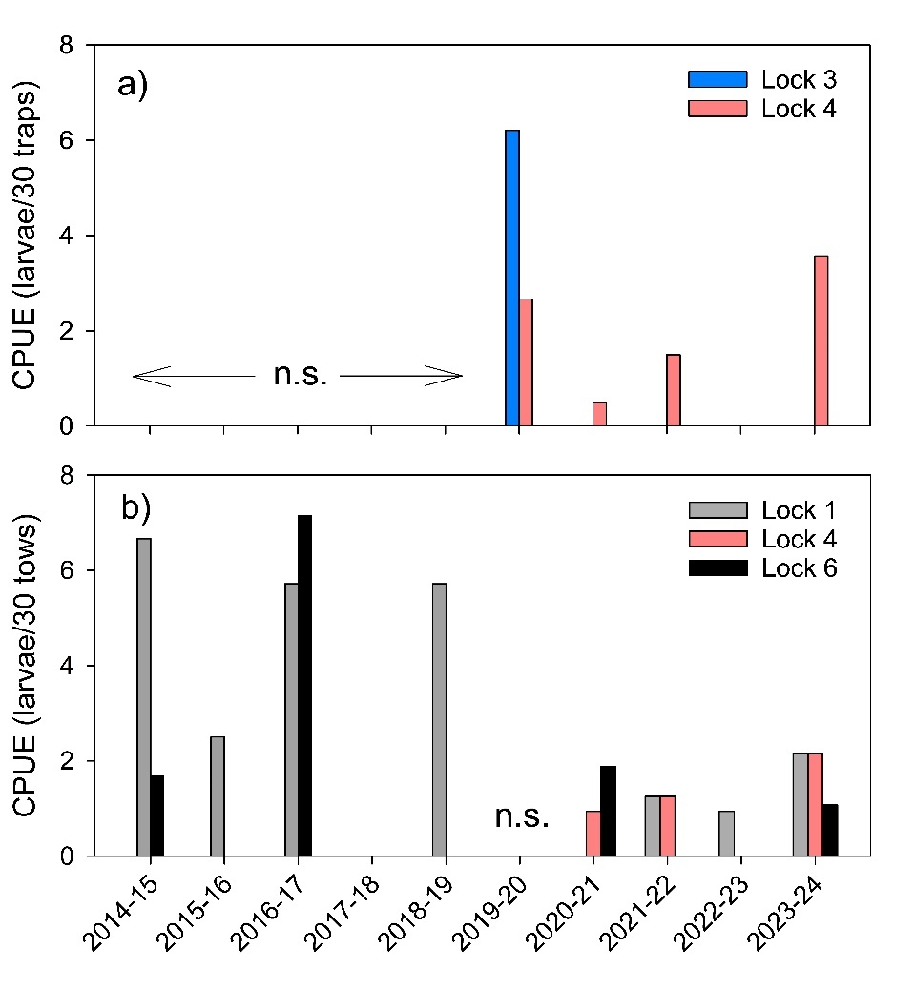
Figure 63. Total catch-per-unit-effort of Murray cod larvae in the Lower Murray River from (a) targeted light trap sampling (CPUE, larvae per 30 traps) in the tailwaters below Locks 3 and 4, and (b) day-time egg and larval fish bongo tow sampling (CPUE, larvae per 30 net tows) in the tailwaters below Locks 1, 4 and 6. No sampling (n.s.) occurred between 2014–2019 for light traps and 2019-20 for bongo tows. Bongo tow sampling did not occur downstream of Lock 4 prior to 2020-21.
Spawn dates
From 2019–2024, daily ages were assigned to a total of 96 Murray cod larvae and age 0+ juveniles sampled from the LMR main channel during Flow-MER sampling. These individuals ranged in length from 9–117 mm TL, corresponding to 8–152 days of age and hatch dates from 11 October to 1 December. Assuming an incubation period of seven days (Ingram et al. 2012), these individuals were estimated to be derived from spawning that occurred from 4 October to 24 November (Table 22).

Table 22. Spawn dates of Murray cod in the main channel of the Lower Murray River from 2019–2024, as determined by back-calculated daily ages from larvae and age 0+ juveniles and an incubation period of 7 days (Ingram et al. 2012).
Spawning year | Spawn dates range | n
2019-20 | 6 October–11 November* | 64
2020-21 | 19 October–24 November | 10
2021-22 | 20 October–12 November | 7
2022-23 | 7–20 October | 3
2023-24 | 4 October–2 November | 12
*Two individuals with hatch dates (4 and 9 December 2019) corresponding to those of known stocked fish in the LMR from February 2020 are assumed to be stocked fish and not presented in the table above.

Morphometrics and seasonal growth
Using the model selection procedure, a cubic polynomial of TL was applied to model length–weight relationships for larval/juvenile (0+ year old) Murray cod for all years (reference data, 2004–2024), and for 2019-20, 2020-21, 2021-22, 2022-23 and 2023-24 (Figure 64). Comparison of the length–weight relationships from each year to the reference curve indicates that the condition of Murray cod during 2022-23 was similar to, or slightly above, the ‘average’ condition, while other years (2019–2022 and 2023-24) were similar to, or slightly below, the ‘average’ condition. To further investigate this, differences in the relative condition index (Krel) of YOY (sampled autumn/winter) Murray cod among sampling years (2015 to 2024) (Figure 65) were assessed using PERMANOVA. There was a significant effect of sampling year on Krel (PERMANOVA, Pseudo-F_{8,143} = 6.6697, p < 0.001), with pairwise comparisons suggesting the Krel of YOY was significantly greater in 2023 (mean = 1.02) than in 2016, 2018, 2019, 2020 and 2021, significantly higher in 2017 (mean = 0.99) compared to 2016 and 2020, and significantly lower in 2020 (mean = 0.82) than in 2015, 2019 and 2021 (Figure 65).
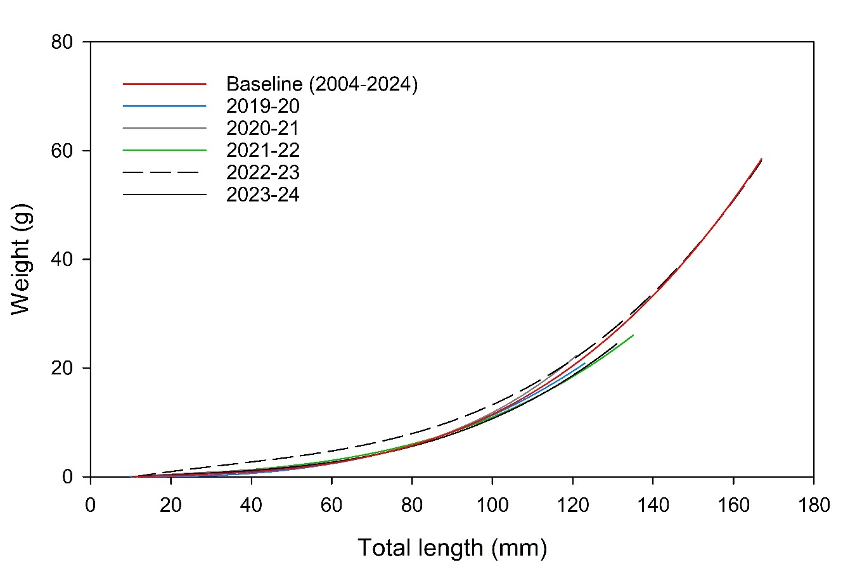
Figure 64. The relationship between weight and total length (TL) of YOY Murray cod in the Lower Murray River predicted by a cubic linear regression model (y=-0.4615+0.515x–0.0009x²+0.000014805x³) for 2023-24 (solid black line, n = 12), 2022-23 (dotted black line, Ye et al. 2024), 2021-22 (green line, Ye et al. 2023), 2020-21 (grey line, Ye et al. 2022), 2019-20 (blue line, Ye et al. 2021) and all years (2004–2024, ‘stocked’ fish removed, red line). See Table C20 in Appendix C for statistics.
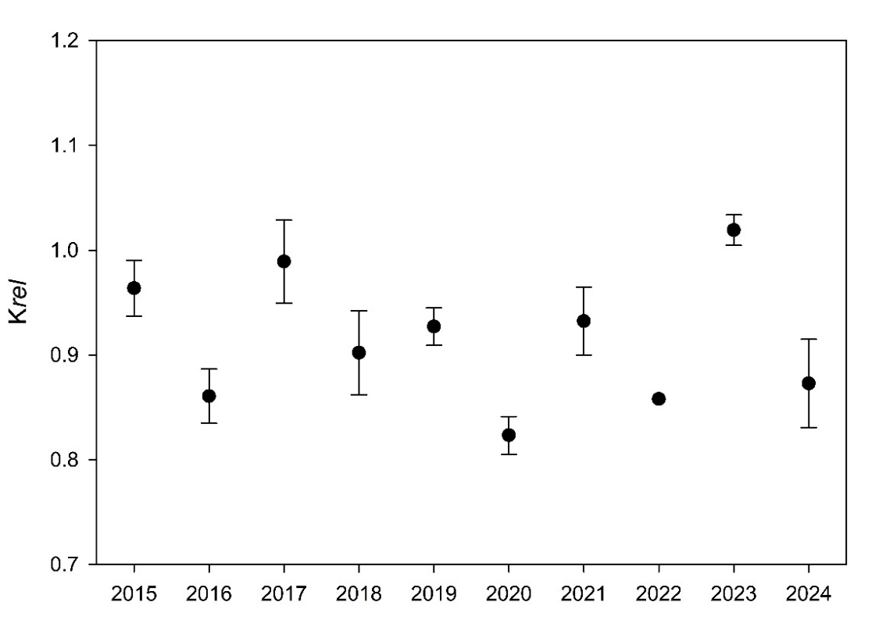
Figure 65. Mean relative condition index (Krel) ± S.E. of YOY Murray cod in the Lower Murray River (excludes Chowilla anabranch) during autumn/winter 2015 (n = 11), 2016 (n = 14), 2017 (n = 6), 2018 (n = 11), 2019 (n = 25), 2020 (n = 51), 2021 (n = 9), 2022 (n = 2), 2023 (n = 12) and 2024 (n = 5). S.E not presented for 2022 due to low sample size. See Table C21 in Appendix C for statistics.
Model selection indicated that the Gompertz model was the best fit for the 2017–2024 Murray cod age–length data (Figure 66). Mean seasonal growth rate in 2022-23 (mean = 0.814 mm/d, n = 2) was higher than 2019-20 (mean + S.E. = 0.694 ± 0.017 mm/d, n = 39), 2020-21 (0.769 ± 0.029 mm/d, n = 6), 2021-22 (0.672 mm/d, n = 2) and 2023-24 (0.6604 mm/d, n = 1).
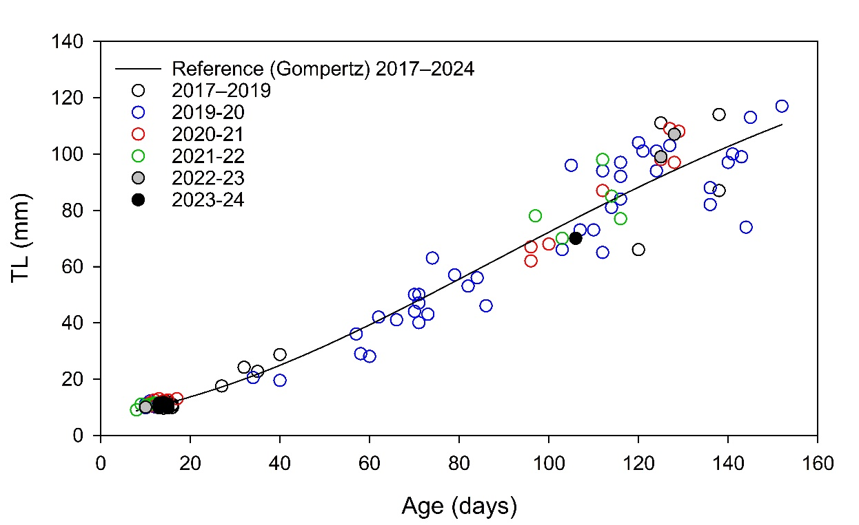
Figure 66. The relationship between total length (TL) and estimated age of YOY Murray cod in the Lower Murray River from 2017–2024, predicted by the Gompertz model. See Table C22 in Appendix C for statistics.

Recruitment and population structure
Mean relative abundances (non-targeted CPUE) of Murray cod in the weir pools below Locks 2 and 3 varied among years. Abundance remained relatively consistent from 2015 to 2019 (<0.05 fish/min). In 2020, there was a four-fold increase in mean abundance below Lock 3, driven by an increase in the abundance of YOY fish (Figure 67 and Figure 68). From 2020 to 2024, mean abundance below Locks 2 and 3 generally declined. The proportional abundance of YOY from these sites was relatively high (mean 77%) from 2015–2020, but lower from 2021–2024 (mean 24%) (Figure 67 and Figure 68). Relative abundances of YOY between Locks 1 and 3 varied among years (PERMANOVA, Pseudo-F_{9, 99} = 3.5221, p = 0.011). PERMANOVA pair-wise comparisons revealed significantly higher recruitment (YOY abundance) in 2015, 2019 and 2020 compared to 2017, 2023 (except 2015) and 2024, and significantly lower recruitment in 2022 compared to 2015, 2016, 2018, 2019 and 2020, but no difference for any other comparisons between years (Figure 67; Table C23, Appendix C).
Relative abundances (targeted CPUE) of Murray cod in the tailwaters of Locks 4 and 5 varied among years and showed a general increasing trend in abundance from 2013 to 2016, before a decline in abundance in 2017. This was followed by an increase in relative abundances in 2020, which persisted through to 2022. In 2023 and 2024, mean abundances at sites were <0.4 fish/min. Consistent with the non-targeted CPUE data from below Lock 3, the increase in relative abundance below Lock 4 in 2020 was driven by an increase in abundance of YOY (Figure 67 and Figure 68). Relative abundances of YOY downstream of Lock 4 varied among years (PERMANOVA, Pseudo-F_{9, 39} = 6.4281, p < 0.001). PERMANOVA pair-wise comparisons revealed significantly higher recruitment (YOY abundance) in 2020 compared to years 2013–2015, 2017 and 2021–2022, but no difference for any other comparisons between years (Figure 67; Table C24, Appendix C).
Excluding years with low sample sizes (n<10; 2013 and 2014), Murray cod generally exhibited broad length frequency distributions, comprised of juveniles (including YOY), sub-adults (300–600 mm) and adults (>600 mm) (Figure 68). YOY fish (i.e. <160 mm, except for 2023 = <180 mm) dominated the sampled population in 2019 (69%) and 2020 (67%). In 2024, YOY fish represented 13% of the sampled population, and individuals 230–310 mm TL (presumably age 1+) made up 37% of the population. From 2015 to 2024, new (YOY) cohorts can be seen to persist and progress through the population each year through to adult size (>600 mm).
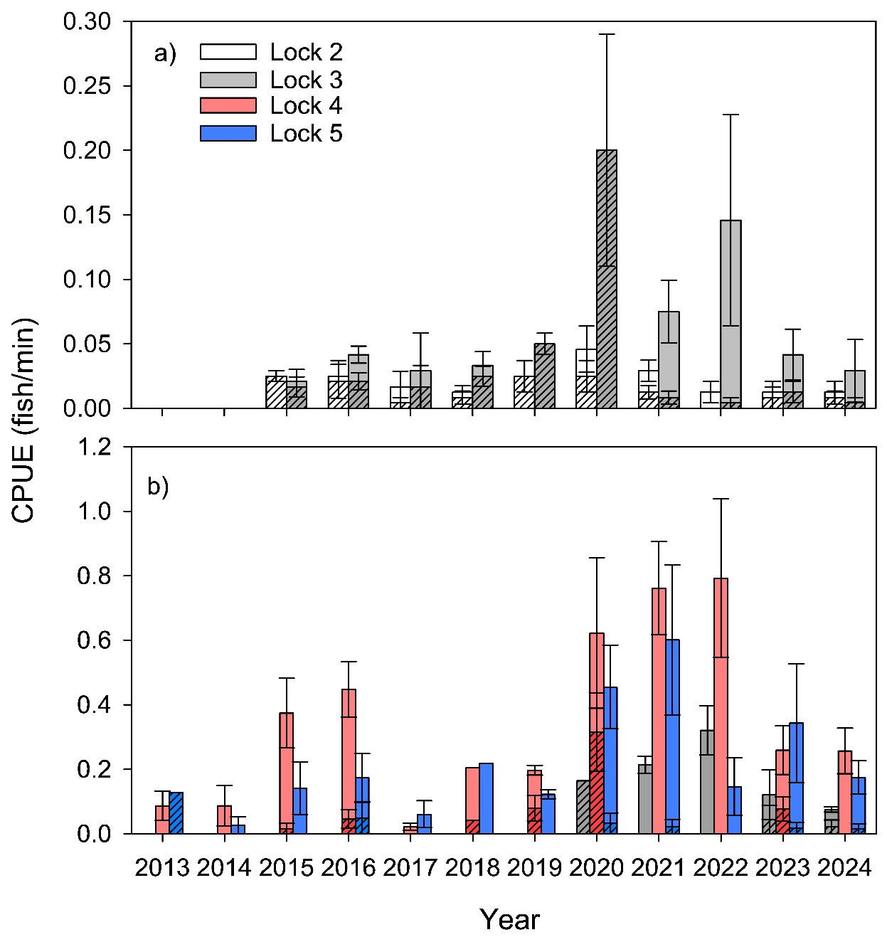
Figure 67. Mean (a) non-targeted and (b) targeted electrofishing catch-per-unit-effort (CPUE) ± S.E. of Murray cod in the weir pools downstream of Locks 2, 3, 4 and 5 of the Lower Murray River. Dashed bars represent the proportion of YOY to the total CPUE. Note the different scales on the CPUE-axis for the different methods of electrofishing. See Tables C23 and C24 in Appendix C for statistics.
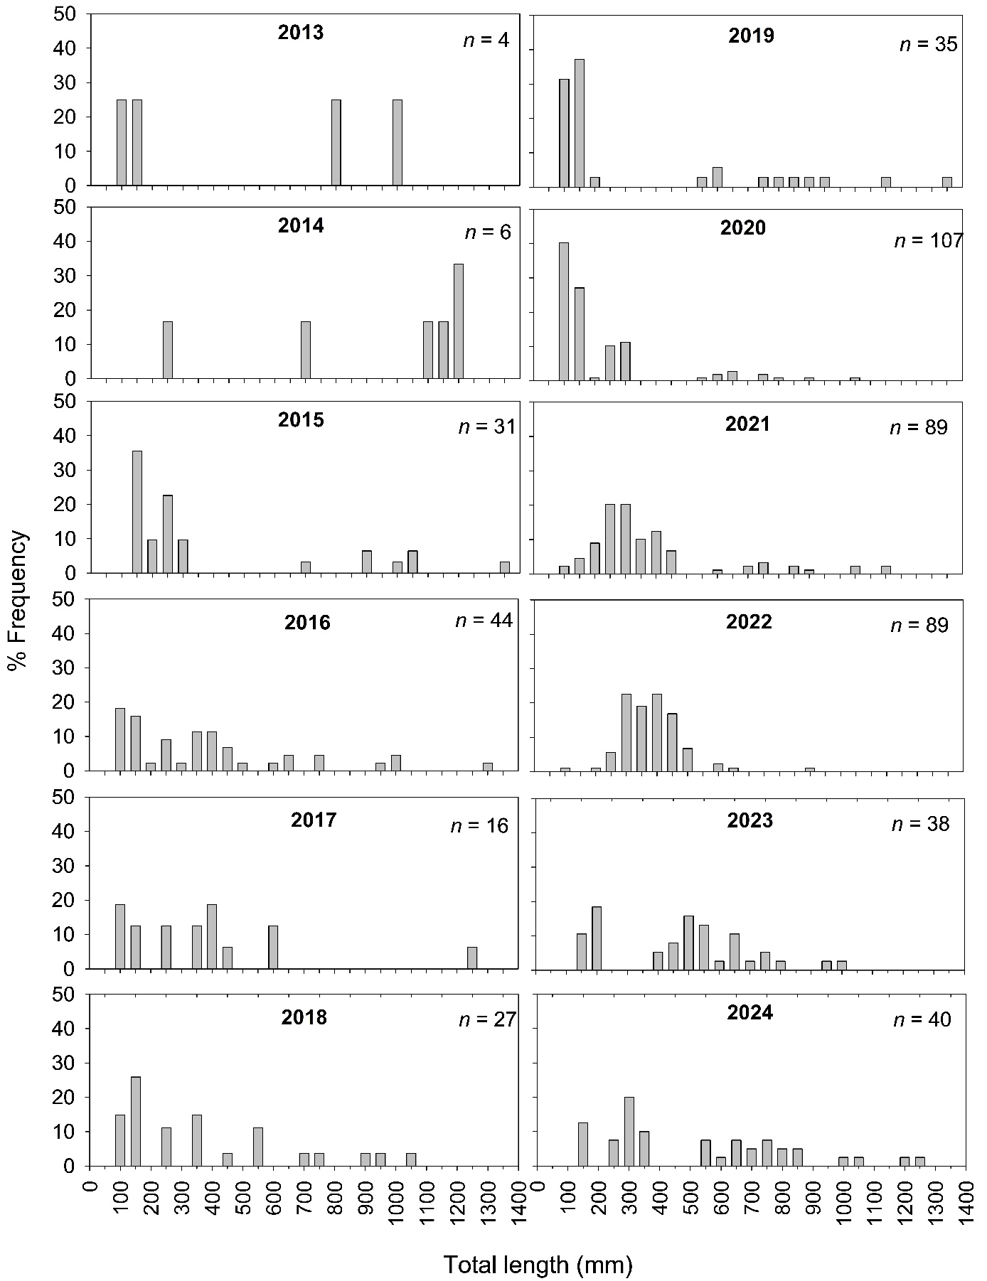
Figure 68. Total length frequencies of Murray cod in the main channel of the Lower Murray River during autumn/winter from 2013–2024, based on CEWH LTIM and Flow-MER data.

Evaluation
The evaluation approach, including assessment criteria, is described in the evaluation section for Hydraulic Regime (Section 2.1). The assessment for Murray Cod Recruitment in this report took a different approach to previous years due to difficulty in assessing Commonwealth environmental water contribution, because the main drivers of Murray cod recruitment in the LMR are not fully understood. The assessment for recruitment and resilience takes a similar approach to Flow-cued Spawning Fish Reproduction (Table 20) and evaluates what the flow regime (including environmental water) contributed to Murray cod outcomes.
Table 23. Murray Cod Recruitment evaluation questions and answers. CEW = Commonwealth environmental water.
CEWH evaluation questions | Outcomes of CEW delivery
CEWH evaluation questions | 2019-20 | 2020-21 | 2021-22 | 2022-23 | 2023-24
What did CEW contribute to the growth and morphometric condition of Murray cod? | Unknown | Unknown | Unknown | Unknown | Unknown
The influence of CEW on the growth and condition of Murray cod in 2023-24 is unknown.
This is not a long-term evaluation question.
What did the flow regime (including environmental water) contribute to recruitment of Murray cod? | Recruitment | Negligible recruitment | Negligible recruitment | Recruitment | Recruitment
In 2023-24, minor recruitment of Murray cod (YOY representing 13% of sampled population) was associated with high in-channel (20,000–30,000 ML/d) flow and lotic conditions. Environmental water contributed to 42% of total flow (CEW 31% of total) during the spawning and early life history period from October to mid-December 2023. However, due to unregulated flows, CEW had negligible influence on the maximum length of river characterised as lotic (mean water velocity >0.3 m/s) (i.e. increase of <1 km and <1% for at least 30 days).
This is not a long-term evaluation question.
What did the flow regime (including environmental water) contribute to the resilience of Murray cod populations? | Long-term (2019–2024) outcome = moderate.  In 2024, recent recruits and sub-adults (<600 mm) from 2019-20 to 2023-24 represented 60% of the sampled population. Recruitment during these years (except 2022-23) was associated with in-channel spring flow pulses, supported by environmental water. The presence of these cohorts has contributed to the population resilience of Murray cod in the LMR.

Assignment of contribution (to what extent the flow regime [including environmental water] contributed towards the outcome, with the significance of the outcome considered) is semi-quantitative.
 | Unknown |  | None/negligible |  | Minor |  | Moderate |  | Substantial

Discussion
Over the course of the Flow-MER Project (2019-20 to 2023-24), we aimed to identify associations between hydrology and hydraulics, and the recruitment of Murray cod in the LMR, and ultimately evaluate the contribution of environmental water delivery. Flow may influence the spawning and early life history of Murray cod in the MDB via several mechanisms, and responses to flow likely differ among river systems (Tonkin et al. 2018). For the LMR, we hypothesise that elevated spring–summer flow, either in-channel or overbank, and an accompanying increase in lotic habitat, may: (1) enhance the area of suitable spawning habitat; (2) be associated with enhanced growth rates and morphometric condition of Murray cod; and (3) enhance recruitment (to YOY). Further, we hypothesise that multiple years of enhanced spring–summer flow will contribute to broad size/age distributions of Murray cod and increased population resilience in the LMR.
Across the Basin, Murray cod spawn annually over a well-defined period from October–December, irrespective of flow (Davis 1977; Rowland 1998) and in the LMR the key period, based on this study, appears to be from early October to mid-November. Past broad-scale recruitment in the LMR, has been qualitatively associated with spring–summer flow and lotic habitats (Zampatti et al. 2014). In the Upper Murray River, specifically spring flows and antecedent maximum (e.g. bankfull) flow conditions (i.e. flows preceding and during the spawning period) have been quantitatively shown to be positively associated with recruitment strength (Tonkin et al. 2018). Potential mechanisms driving this pattern could be increased extent and quality of spawning and nursery habitat (e.g. Koehn 2009; Baumgartner et al. 2014; Stuart et al. 2019) or provision of favoured food resources for larvae. A similar mechanism appears likely for the LMR, although sample sizes thus far limit our ability to quantitatively test some of these hypotheses.
From 2014–2024, the LMR experienced variable hydrology including two spring-summer overbank floods (2016-17 and 2022-23), two years of high (20,000–40,000 ML/d) in-channel spring-summer flow (2021-22 and 2023-24) and several years of low in-channel flows, peaking at 10,000–18,000 ML/d during spring–summer (2014–2016, 2017–2021). Across these different flow regimes, recruitment of Murray cod occurred annually. However, recruitment strength, as indicated by the abundance of YOY, was variable and did not show any consistent pattern in association with hydrology. The strongest recruitment in the LMR occurred in 2019-20, which was also observed throughout the MDB (e.g. Goulburn, Lachlan and Edward-Wakool rivers, Hladyz et al. 2021). In the LMR, recruitment during this year was associated with an in-channel flow pulse that peaked at 15,600 ML/d in mid-October 2019, coinciding with the period immediately preceding and during the key spawning period. In contrast, poorest recruitment was observed in 2021-22, associated with elevated in-channel discharge (~25,000–38,000 ML/d) throughout spring–summer. In turn, in 2023-24, a year of similar flow magnitude (~25,000–30,000 ML/d) to 2021-22, recruitment was observed. Results for 2021-22 were thus, somewhat unexpected and contradict our hypothesis that elevated spring–summer flow, either in-channel or overbank, and associated increase in lotic habitat, will enhance recruitment (to YOY) of Murray cod. Excepting this result, our data generally suggest that, for years with low, in-channel flows <20,000 ML/d, small increases in flow (e.g. from 10,000–20,000 ML/d) and associated increases in lotic habitat in early spring, immediately prior to and during spawning, are positively associated with recruitment of Murray cod in the LMR. Water delivered mostly after the spawning season with similar flow volumes may not elicit the same response. As further years of recruitment data are compiled, sophisticated modelling is planned to identify the drivers of recruitment, and better evaluate the influence of environmental water on Murray cod recruitment.
Analysis of morphometric condition and growth from 2015–2024 demonstrates the positive influence of large-scale overbank flow events (2016-17 and 2022-23). Potential mechanisms driving these patterns may be related to increases in productivity/food resources (allochthonous sources) and/or hydraulic changes that improve habitat quality and increased feeding efficiency. Low samples sizes of Murray cod larvae and YOY in specific years (2020-21, 2021-22 and 2023-24), however, limits assessment of the influence of Commonwealth environmental water on these parameters.
Through 2013–2024, abundance (CPUE) of Murray cod in the LMR was variable. During 2017, a decline in abundance, notably adults (>600 mm TL), was associated with a hypoxic blackwater event in the LMR (Ye et al. 2018). Following this widespread blackwater event, declines in the abundance of adult Murray cod were also observed throughout the Murray River and some of its tributaries and attributed to fish kills (e.g. Lachlan River, Murrumbidgee River, Edward–Wakool River system) (Dyer et al. 2017; Wassens et al. 2017; Watts et al. 2017; Stoffels et al. 2018). After 2017, abundance of Murray cod in the LMR increased over the subsequent two years and remained high through to 2022. Increased abundance was associated with strong recruitment in 2019-20 and the persistence of this cohort as age 1+ in 2021 and age 2+ in 2022. There was an apparent decline in abundance in 2023 and 2024 to levels similar to 2015–2019. Reasons for this are unclear but may be associated with: reduced sampling efficiency due to high flows (>20,000 ML/d) in 2023 and delayed sampling in 2024, compared to preceding years; broader emigration/dispersal of sub-adults to alternate habitats with lower densities to reduce intra-specific competition; and/or mortality of sub-adults.
From 2015–2024, length frequency distributions showed a broad size distribution comprising juveniles (including YOY), sub-adults and adults. In 2024, YOY fish represented 13% of the sampled population, and juveniles (230–310 mm, presumably age 1+) and sub-adults 500–600 mm TL (presumably age 3+) collectively comprised 48% of the population. These sub-adults represent individuals spawned in spring 2019, and have exhibited high levels of survival and annual growth through the population. The length-frequency derived from 2024 contrasts with the Millennium Drought when length frequency distributions in the main channel of the LMR were dominated by larger adults (>800 mm TL), indicating a lack of recruitment from 2003–2010 (Zampatti et al. 2014). Contemporary length frequency distributions in the LMR main channel likely infer population resilience to future environmental perturbations such as hypoxic blackwater events.

Management implications
Murray cod show a preference for lotic habitats. In the LMR, the extent of lotic habitat available immediately prior to and during spawning (August–November), during low, in-channel flows (<20,000 ML/d), is positively associated with recruitment. Flows delivered mostly after the spawning season (e.g. 2020-21) may not elicit the same response. For flows >20,000 ML/d, the relationship between increased extent of lotic habitat and recruitment is not clear. Ultimately, a greater time-series of data across a full range of hydrological variability and further modelling with biotic (e.g. spawning adult abundance, food resources) and other abiotic factors are required to identify the main drivers of recruitment, and to better evaluate the influence of environmental water on Murray cod recruitment.
Murray cod morphometric condition appeared to be most influenced by large magnitude flows (i.e. floods), while smaller magnitude flows events (e.g. small freshes) appeared to elicit commensurate minor improvements in condition, likely due to limited increases in productivity. As such, delivering flow pulses may support enhanced recruitment of Murray cod more so through expansion of lotic habitat favoured for spawning and by increasing the survival of early life stages rather than substantial productivity benefits. Nonetheless, further analysis and comparison of otolith daily growth increments could inform on the finer temporal-scale influence of flow on growth.
In addition to the delivery of environmental water, other actions that support the maintenance/enhancement of lotic (e.g. weir pool lowering) and physical habitats (e.g. re-snagging) in the LMR may further benefit Murray cod recruitment and population resilience.

Conclusion
From 2019–2024, evaluation of the contribution of Commonwealth environmental water towards Murray cod growth and condition was conservatively designated as unknown. Since 2014-15, Murray cod recruitment has occurred in most years. The contribution of the flow regime (including environmental water) to recruitment from 2019–2024 ranged from negligible in 2020–2022 to substantial in 2019-20. The 2019-20 cohort comprised a large proportion (67%) of the sampled population in 2020 and continued to contribute ~10% in 2024. Over the last decade, more regular recruitment of Murray cod has contributed to the resilience of the population. However, the main drivers of Murray cod recruitment in the LMR are not fully understood. In future years, a more robust evaluation will be informed by multiple years of data and improved understanding.

Fish Assemblage

Background
From 2015–2024, we collected fish assemblage data in the main channel of the LMR to inform Basin-scale evaluation of fish community responses to Commonwealth environmental water. The evaluation under the LTIM Project (2015–2019) was undertaken by the Centre for Freshwater Ecosystems at La Trobe University, while the evaluation under the Flow-MER Project (2020–2024) is being undertaken by a team of fish ecologists and biometricians, led by the Arthur Rylah Institute for Environmental Research (ARI) (Hladyz et al. 2024).
Objectives
In this section, our objectives are to: (1) provide summary statistics of the catch rates and population demographics for nominated species; (2) describe temporal variation in fish assemblage structure from 2015–2024; and (3) discuss key findings based on published research and a contemporary understanding of fish life histories and population dynamics in the LMR. Our interpretations of the data for this indicator do not infer association with environmental water delivery.

Methods

Sampling
During autumn 2015–2024, small- and large-bodied fish assemblages were sampled from the gorge geomorphic zone of the LMR (Figure 1) using fyke nets and electrofishing, respectively. Prescribed methods (Hale et al. 2014) were used to obtain population structure data for seven target species (Figure 69). Refer to SARDI et al. (2024) for detailed sampling design and methodology. In 2017, electrofishing at half of the sites (sites 1, 3, 4, 6, 7) was delayed to late July/early August. Similarly, in 2024, electrofishing at nine sites (except site 1) was delayed to mid-May to mid-June. Both delays were due to electrofishing generator issues.
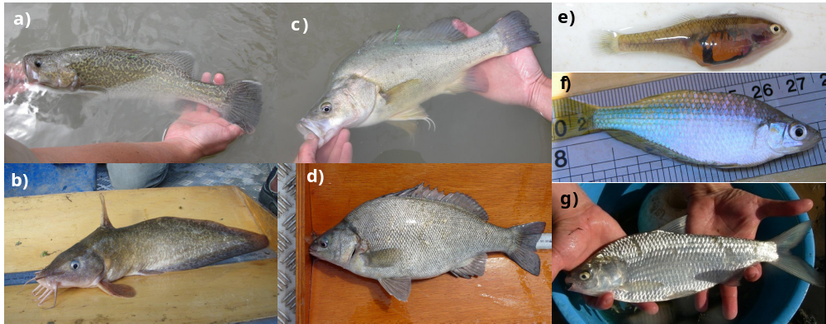
Figure 69. Target species for the Lower Murray River: (a) Murray cod and (b) freshwater catfish (equilibrium life history); (c) golden perch and (d) silver perch (periodic life history); and (e) carp gudgeon, (f) Murray rainbowfish and (g) bony herring (opportunistic life history).

Ageing
In addition to golden perch, silver perch (Section 2.6) and Murray cod (Section 2.7), an annual age structure was determined for large-bodied target species bony herring (Nematalosa erebi) (2016–2024) and freshwater catfish (Tandanus tandanus) (2015–2024). Individuals retained for ageing were euthanised and sagittal otoliths were removed. Methods for otolith preparation and ageing followed that described in Section 2.6.

Data analyses
Temporal variation in fish assemblage structure (species composition and abundance), between sampling years (i.e. 2015–2024), was investigated using non-metric Multi-Dimensional Scaling (MDS), permutational multivariate analysis of variance (PERMANOVA) and Similarity Percentages (SIMPER) analysis in the software package PRIMER v. 6.1.12 (Clarke and Gorley 2015) and PERMANOVA + v.1.02 (Anderson et al. 2008). Catch-per-unit-effort (CPUE) data for small-bodied (individuals/fyke net/hour) and large-bodied species (individuals/90 second electrofishing shot) were analysed separately and square-root transformed prior to statistical analyses. Analyses of large-bodied assemblage data were restricted to sampling that occurred in March/April because data were significantly different among seasons for 2017 (i.e. winter vs. autumn). Furthermore, data from 2024 were not analysed due to 90% of sites being sampled from late May 2024. To determine temporal variation in recruitment and population structure, length frequency histograms were qualitatively compared among sampling years.
To investigate recruitment of large-bodied species, we calculated the CPUE of age 0+ individuals using length structure data. Recruitment length thresholds, representing the minimum size of age 1+, were assigned to each species (golden perch = 85 mm TL (total length), silver perch = 100 m FL (fork length), freshwater catfish = 90 mm TL, Murray cod = 155 m TL, bony herring = 120 mm FL, common carp and goldfish = 155 m FL, redfin perch = 150 mm FL) based on data from Hladyz et al. (2024) and SARDI unpublished data. Due to increased growth rates during the 2022-23 flood year, length thresholds were adjusted for some species in 2023 (i.e. golden perch = 135 mm TL, Murray cod = 170 mm TL, bony herring = 150 mm FL, and redfin perch = 205 mm FL). Data were represented graphically as histograms.

Results
Catch summary
From 2015–2024, a total of 112,727 individuals (ind.) from eight large-bodied fish species were collected by electrofishing. Across all years, bony herring was consistently the most abundant species (59–97% of the catch/annum), followed by common carp (Cyprinus carpio), but for this species, proportion of the total catch varied greatly across sampling years (1% in 2015 to 39% in 2022) (Figure 70).
A total of 152,216 individuals from seven small-bodied species were collected using fyke nets. The total abundance of small-bodied species varied considerably across sampling years (598 ind. in 2023 to 37,678 ind. in 2018), but the proportional abundance of individual species remained similar. Carp gudgeon (Hypseleotris spp.) was the most abundant species (42–94% of catch/annum), followed by eastern gambusia (Gambusia holbrooki) (1–36%/annum) (Figure 71).
Temporal variability in fish assemblage structure
MDS ordination of large-bodied fish assemblage data demonstrated separation of 2017, 2022 and 2023 from all other years (Figure 72a). PERMANOVA indicated that large-bodied fish assemblages were significantly different among years (Pseudo-F_{8,85} = 20.052, P ≤ 0.001). Pairwise comparisons revealed significant differences between 2023 and all other years, between 2022 and all other years except 2017, and between 2017 and most other years. There were also significant differences between 2015 and 2021, and 2020 and 2021, but not for any other pairs of years (Figure 72a).
For small-bodied fish assemblages, there were also significant differences among years (Pseudo-F_{9,99} = 14.457, P ≤ 0.001). PERMANOVA pairwise comparisons revealed significant differences in assemblages between 2024 and all other years except 2017, 2023, between 2022 and all other years, and between 2017 and 2016, 2018, 2020 and 2021, but not for any other pairs of years (Figure 72b).
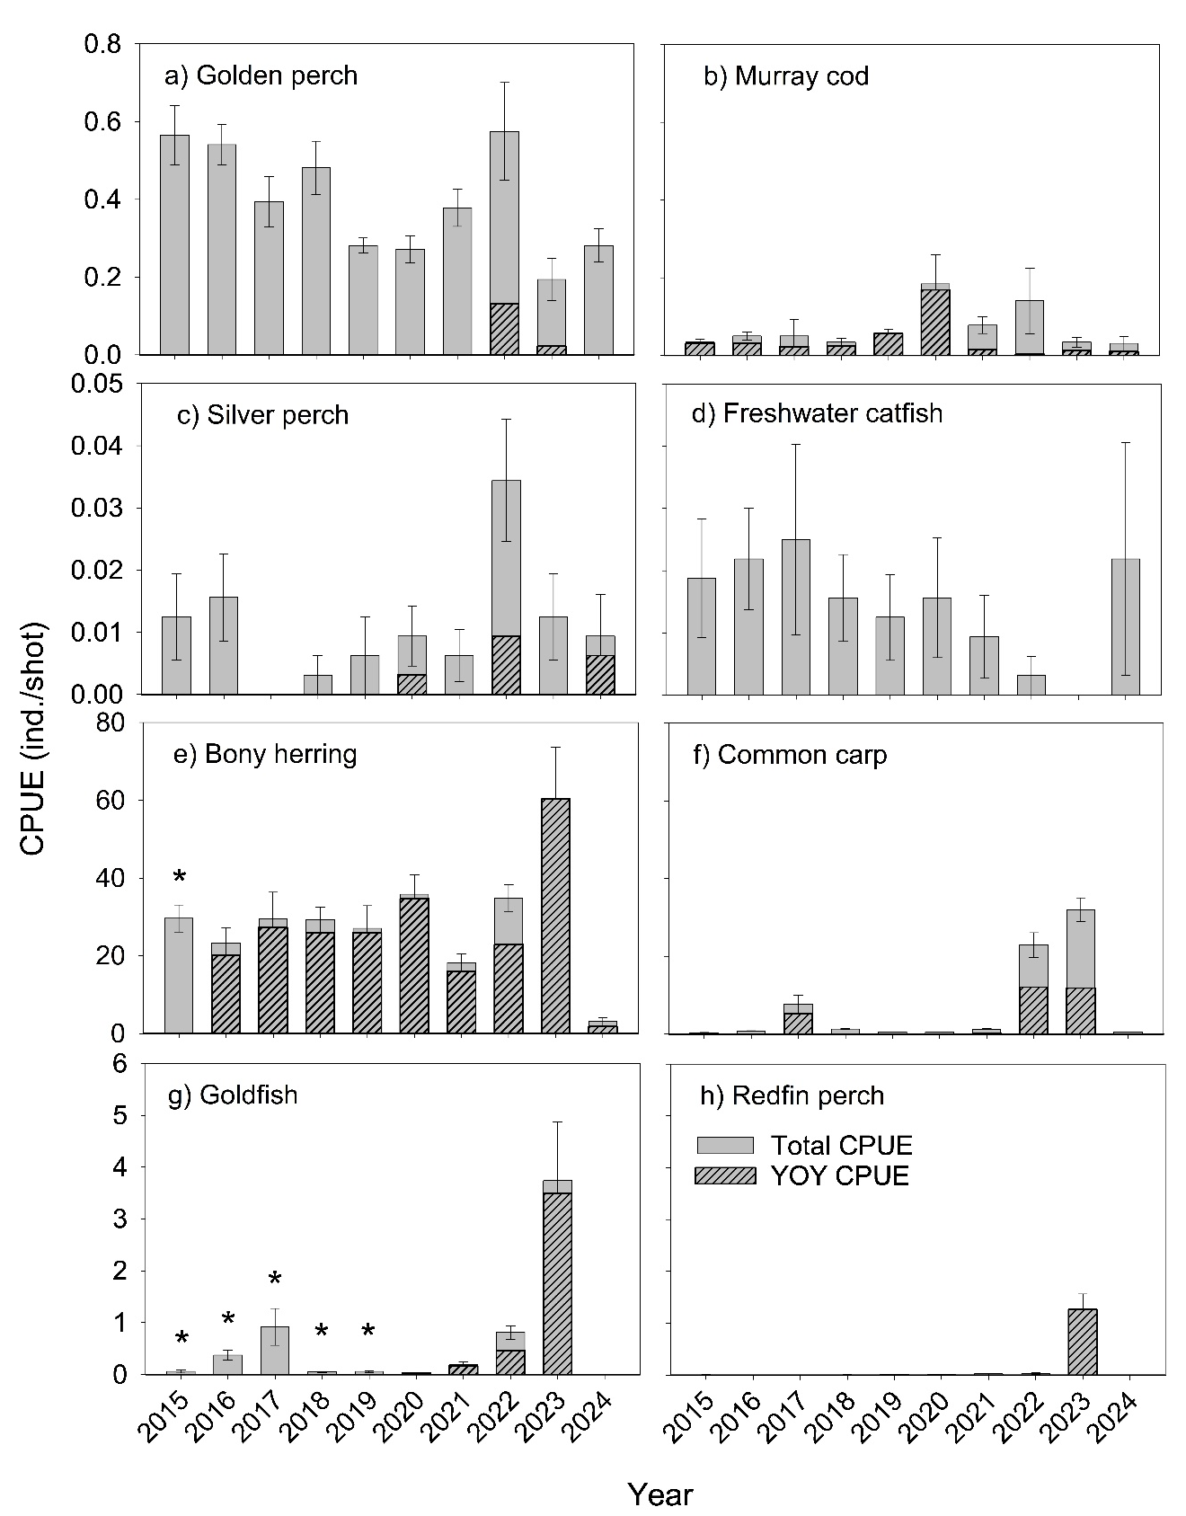
Figure 70. Mean catch-per-unit-effort (CPUE) ± standard error of large-bodied fish species captured using electrofishing (individuals per 90 second shot) in the gorge geomorphic zone (10 sites) of the Lower Murray River from 2015–2024. The proportion of the catch that is estimated to be age 0+ years is presented as hashed bars. * The proportion of age 0+ are not presented for bony herring in 2015 or goldfish from 2015–2019. For 2017, CPUE data from five out of ten sites are presented as other sites were sampled during winter 2017. CPUE data from 2024 are presented but should be treated with caution because 90% of sites were sampled from late May. See Table C25 in Appendix C for statistics.
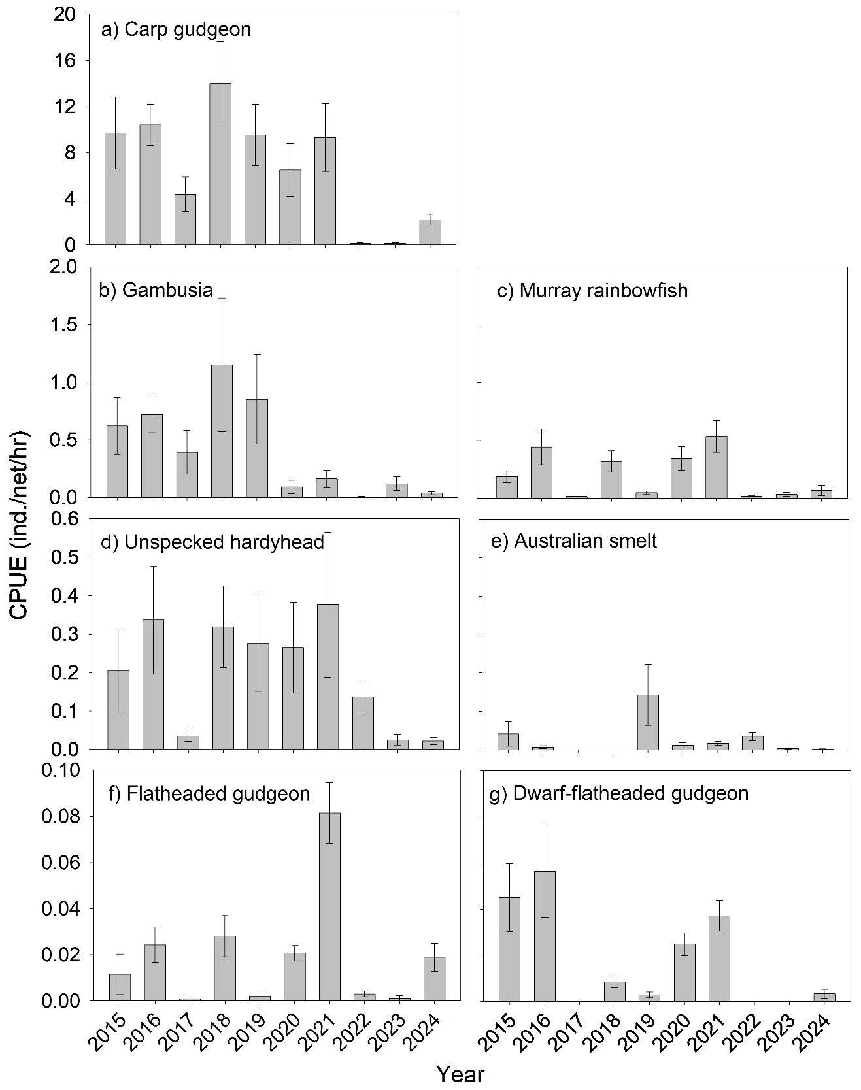
Figure 71. Mean catch-per-unit-effort (CPUE) ± standard error of small-bodied fish species captured using fine-mesh fyke nets (individuals per net per hour) in the gorge geomorphic zone (10 sites) of the Lower Murray River in autumn from 2015–2024. See Table C25 in Appendix C for statistics.
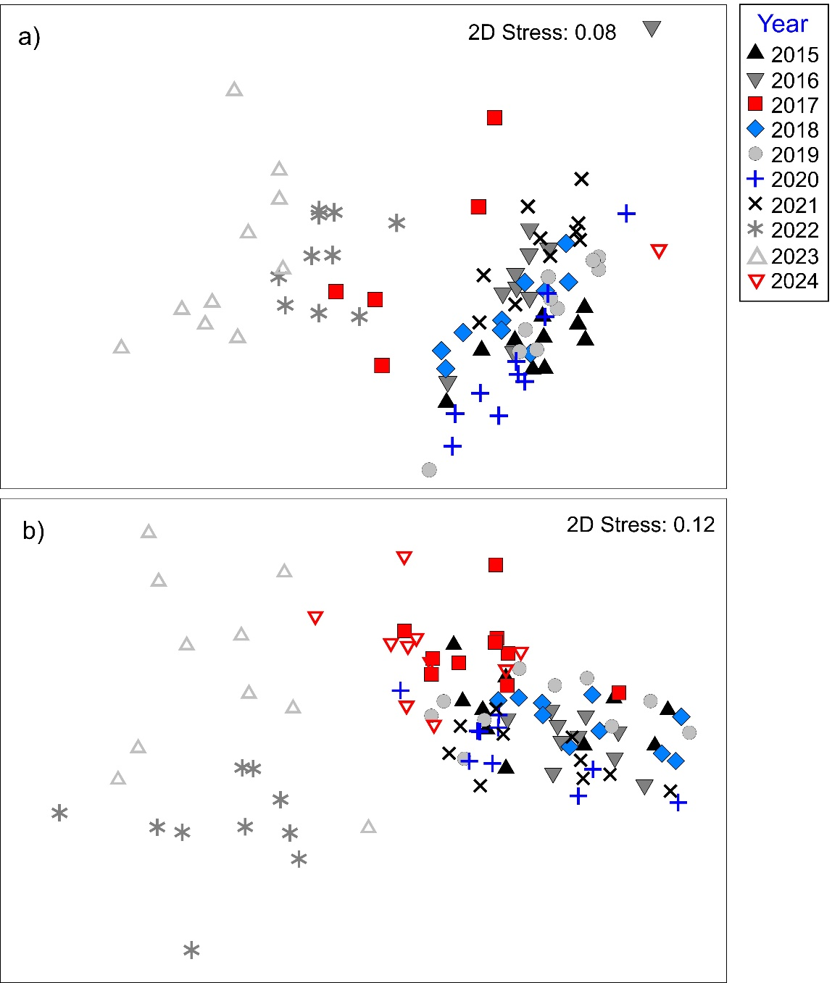
Figure 72. Non-metric multi-dimensional scaling (MDS) plot of (a) large-bodied fish assemblages sampled by electrofishing and (b) small-bodied fish assemblages sampled by fyke netting in the gorge geomorphic zone of the Lower Murray River from 2015–2024. For (a), sites sampled in winter 2017 (n = 5) and late autumn/winter 2024 (n = 9) were removed from the ordination.
SIMPER indicated that differences between years for large-bodied fish assemblages were primarily driven by higher abundances of common carp and goldfish in 2017, 2022 and 2023, lower abundance of bony herring in 2021, and higher abundance of redfin perch and bony herring in 2023 (Figure 70). SIMPER indicated that differences between years for small-bodied fish assemblages were mostly driven by lower relative abundances of carp gudgeon in 2023 and 2022, and to a lesser extent, in 2024 and 2017 (Figure 70).

Temporal variation in length/age structure of large-bodied species
Changes in the demographics of golden perch, silver perch and Murray cod populations in the LMR from 2015–2024 are discussed in Sections 2.6 and 2.7. From 2015–2024, in the LMR, freshwater catfish were sampled in low abundance and age 0+ were not detected. In 2024, when the largest sample of freshwater catfish was aged, the population ranged in age from 3+ to 15+ years.
From 2016–2024, the sampled bony herring population ranged in age from 0+ to 11+ years. Age 0+ fish dominated the population (83–99%) in most years except for 2022 (59%) and 2024 (47%), when age 1+ to 3+ fish represented 37 and 47% of the populations, respectively (Figure C10, Appendix C).
Annually from 2015–2024, common carp typically ranged from 100–700 mm FL. Episodic recruitment events in 2016-17, 2021-22 and 2022-23, as indicated by the dominance of carp <155 mm FL in the following autumn/winter (Figure C11), were associated with increased abundance of the species from sampling in 2017, 2022 and 2023, respectively.

Evaluation
There are no CEWH evaluation questions for this indicator for the Lower Murray Selected Area. Data and samples collected from this indicator, however, are incorporated into the evaluation for the ‘Flow-cued Spawning Fish Reproduction’ (Section 2.6) and ‘Murray Cod Recruitment’ (Section 2.7) indicators. Additionally, for this report, fish monitoring data from this standardised sampling, and other fish indicators were consolidated to evaluate a number of fish targets of the Long-Term Environmental Watering Plan (LTWP) for the South Australian Murray River (DEW 2020a) and the Basin Plan Matter 8 Report (DEW 2020b) in Appendix D.

Discussion
From 2015–2024, the main channel fish assemblage of the LMR exhibited considerable variability. During relatively low (<20,000 ML/d) in-channel flow years of 2014-15, 2015-16 and 2017-18–2020-21, small-bodied fish abundances were generally high. During these years of predominantly low in-channel flows, relatively stable water levels and low water velocities promote submerged vegetation in the main channel of the LMR, and these conditions are conducive to small-bodied fish recruitment. Abundances of small-bodied species declined in 2017, following flooding in spring–summer 2016 (peak flow ~94,600 ML/d), and were low in: 2022, following a prolonged period of elevated in-channel flow (~30,000–40,000 ML/d); 2023, following an extended period (September–February) of overbank flows (peak 187,600 ML/d); and 2024, following overbank flows in late winter/early spring (peak 54,500 ML/d). A reduction in submerged vegetation in the main channel of the LMR during these higher flow years, due to a combination of increased water depth/decreased light penetration and physical scour, likely resulted in a decrease in habitat availability and abundance of small-bodied fishes (Bice et al. 2014).
Trends in abundance of large-bodied species from 2015–2023 differed among species. Increased abundances of invasive common carp and goldfish in 2017, 2022 and 2023 were driven by recruitment events likely associated with floodplain inundation from unregulated flooding in 2016-17 and 2022-23, and high in-channel flows during 2021-22. Unlike patterns observed for large-bodied native species, the abundances of common carp and goldfish, in years following recruitment events (i.e. 2017), typically have declined to levels similar to prior to the recruitment event. This may suggest poor survival of fish in the main channel and/or movement of fish to alternate habitats (e.g. off-channel). Redfin perch also exhibited a strong recruitment and abundance response in association with flooding in 2022-23. This invasive species is not typically considered ‘flow-responsive’, but results from monitoring in 2023 suggest the opposite and warrant further investigation into life history in the LMR given potential for impact on native species (Wedderburn and Barnes 2016). Due to delayed sampling in 2024, abundances of large-bodied fish, in particular bony herring and common carp, are likely to be underestimated due to changes in fish behaviour in association with lower water temperatures. Therefore, interpretations of large-bodied fish community and abundance trends in this report section are limited to 2015–2023.
In 2016-17, recruitment of native, large-bodied flow-cued spawners, as determined by the presence of YOY, was negligible despite a flow regime putatively conducive to spawning of these species (Mallen-Cooper and Stuart 2003; Zampatti and Leigh 2013a). It is likely that recruitment in 2016-17 was compromised by hypoxia associated with blackwater during the spring–early summer spawning season (Ye et al. 2018), impacting the survival of eggs and larvae. As a consequence of a lack of observed recruitment of golden perch, abundance generally declined from 2015–2020. Nevertheless, in 2022, recruitment of golden perch and silver perch, in association with high in-channel flows, led to an increase in abundance of both species during this year. In 2023 and 2024, recruitment of golden perch and silver perch, respectively, occurred in conjunction with overbank flows and elevated in-channel flows, although overall abundance of both species declined. Reasons for this are unclear but may be associated with upstream emigration/movement of adults (Zampatti et al. 2018a; Bice et al. 2021) or reduced sampling efficiency associated with high flows (>20,000 ML/d) in 2023 compared to preceding years or delayed sampling in 2024.
Based on electrofishing length frequency data, no recruitment (to YOY) was observed for freshwater catfish in the LMR from 2015–2024. Nevertheless, the presence of age 3+ to 9+ year olds in 2024 suggests some recruitment in the LMR occurred at least between 2015–2021 or there was movement of juveniles/adults from other reaches. In the LMR, the spawning biomass of freshwater catfish is low (Ye et al. 2015c) and their recruitment dynamics are poorly understood. Furthermore, electrofishing may be an inefficient method for sampling this species, particularly for YOY, as evidenced by the sampling of new cohorts as older individuals. This highlights the importance of assessing recruitment over longer periods for some species.
From 2015–2024, recruitment of Murray cod has occurred in the LMR during most years. Most notable was strong recruitment to YOY in 2020, which was associated with an in-channel flow pulse that peaked at 15,600 ML/d in mid-October 2019. This cohort contributed to the high abundances observed from 2020–2023. Based on length frequencies, there was evidence of cohorts recruited in most sampling years persisting in the population in subsequent years (Section 2.7).

Management implications
Prolonged low, in-channel flows (<20,000 ML/d) in the LMR promote hydraulic (e.g. lentic) and structural (submerged plant) habitat conditions suitable for low flow generalist fishes such as small-bodied carp gudgeon and unspecked hardyhead. Conversely, in-channel flows >20,000 ML/d facilitate a shift towards more natural riverine hydraulic characteristics that benefit flow-dependant species such as golden perch and Murray cod. Increased variability in the annual flow regime that includes large, overbank (>45,000 ML/d) flows will lead to increased recruitment of a range of species with different life histories (e.g. flow-dependant), promoting diverse fish assemblages and resilience in populations.

Conclusion
High flows (>20,000 ML/d) in 2021-22 and 2022-23, and to a lesser extent in 2016-17 and 2023-24, changed the fish assemblage towards one characteristic of floodplain inundation and a flowing riverine environment. This included low abundances of small-bodied species, high abundances of invasive species (common carp and goldfish) and bony herring, following enhanced recruitment. Recruitment of golden perch and silver perch occurred in conjunction with high in-channel and overbank flows in some of these years, while recruitment of Murray cod occurred on an almost-annual basis. Freshwater catfish were sampled in low abundance across the ten-year period and recruitment was limited but evident.

Synthesis and Evaluation
To assess ecological responses to Commonwealth environmental water in the Lower Murray from 2019–2024 (Flow-MER, this report) and from 2014–2019 (LTIM, Ye et al. 2020a), a series of evaluation questions were investigated (SARDI et al. 2024) (Table 24). The contribution of environmental water to Hydraulic Regime, Matter Transport and Coorong Habitat was assessed throughout the year using a modelling approach, whereas indicators of specific ecological responses (Stream Metabolism and Water Quality, Littoral Vegetation Diversity and Productivity, Microinvertebrate Assemblage, Flow-cued Spawning Fish Reproduction and Murray Cod Recruitment) were assessed through empirical monitoring during targeted seasons.
Since 2014-15, the LMR has experienced variable hydrological conditions, from low in-channel to extensive overbank flows (Ye et al. 2020a). The last five-year period (2019-20–2023-24) comprised two hydrologically dry years (i.e. flow <18,000 ML/d at the South Australian border), followed by three wet years with unregulated flows including an in-channel flow year (2021-22, spring–summer flow peak 37,500 ML/d) and two overbank flow years (2022-23, 187,600 ML/d; 2023-24, 52,800 ML/d). Commonwealth environmental water primarily contributed to baseflows and freshes in the LMR, particularly as spring–early summer flow pulses (Figure 5), mostly via return flows from upstream watering events.
Environmental water helped to promote flow pulses up to 15,600 and 17,900 ML/d during spring–summer during October 2019 and November 2020, respectively, where flow would have otherwise been low (~3,000–9,000 ML/d). Environmental water also supplemented unregulated flows to maintain flow >20,000 ML/d during the entire spring–summer period in 2021-22 and from September–November 2023. In 2022-23, during the third highest overbank flow recorded in the LMR, environmental water supplemented unregulated flows to support an overbank flow event (54,500 ML/d) in mid-August, and extended the flood recession after late December, maintaining flow >20,000 ML/d for an additional 45 days.
Over the last five years, Commonwealth environmental water also facilitated weir pool manipulations at Locks 1, 2, 4, 5 and 6, and Katarapko and Pike regulator operations (Appendix B). Furthermore, Commonwealth environmental water supplemented freshwater flows to the Lower Lakes and Coorong throughout most years. Environmental water delivery, in combination with infrastructure operation, contributed to a number of ecological outcomes in the Lower Murray Selected Area. Key outcomes from the ten years of monitoring and evaluation, including the LTIM period (2014–2019, Ye et al. 2020a), are summarised below, whilst a summary of the evaluated outcomes is presented in Table 24. Additionally, a summary of the key monitoring and evaluation outcomes from the flow regime during Flow-MER, including environmental water, is presented in Figure 73. Refer to each indicator evaluation section (Section 2) for a more detailed interpretation and criteria for assessment.
Environmental water delivery over the last decade contributed to increased longitudinal connectivity. Greater contribution was observed during dry years (2015-16, 2017-18 and 2019-20), when increases in annual discharge to the LMR, due to Commonwealth environmental water, achieved the Basin-wide environmental watering strategy target of >30% flow increase in the Murray River (here calculated at the South Australian border). In each year except 2022-23, Commonwealth environmental water contributed minor to moderate increases in riverine hydrological connectivity (by 3%–148%, or 3,119–13,056 km d), indicated by river length over a number of days with velocity exceeding 0.2 m/s. During these years, increased inundation of the littoral zone of the river channel and low-level floodplains, via increased flows and/or weir pool raisings with support by Commonwealth environmental water, improved lateral connectivity.
Environmental water increased water velocities and introduced some hydraulic variability in the LMR that would not have otherwise occurred over the last decade, excluding high unregulated flow periods (e.g. in 2016-17, 2021–2024). This was better demonstrated during spring–early summer of some dry years, such as 2019-20 and 2020-21, when an extra 73 km (22%) and 84 km (25%) of river was transformed to lotic (flowing water, velocities >0.3 m/s) conditions for at least 14 days, or 33 km (10%) and 31 km (9%) of river for at least 30 days, respectively, due to the Commonwealth environmental water delivery. The timeframe of ~14 days may correspond with more rapid, flow-related ecological processes or biological responses such as mobilisation of carbon and nutrients, microinvertebrate reproduction and community turn over, or fish egg/larval drift and dispersal, whereas ~30 days, for example, generally coincides with the time period from spawning to the completion of larval development for golden perch and Murray cod (Lake 1967; Humphries 2005; Tonkin et al. 2006). This implies potential benefits of environmental water to the LMR ecosystem, although the spatial/temporal scale of effect may be limited in dry years, even in 2019-20 and 2020-21. However, in wetter years with unregulated flows, environmental water delivery helped to maintain high in-channel flows (>20,000 ML/d), transforming >60% of the LMR to lotic conditions such as during the entire spring–summer period in 2021-22 and in the spring of 2023-24. Improving riverine hydraulics is critical for ecological restoration in the LMR. Many native biota with life history strategies adapted to a flowing river are currently extinct or have suffered major declines due to the largely weir pool environment in this region (Mallen-Cooper and Zampatti 2018). Pre-regulation, the LMR was characterised by lotic, riverine habitats, with water velocities ranging ~0.2–0.5 m/s, even at discharges <10,000 ML/d (Bice et al. 2017).
Commonwealth environmental water, in combination with weir pool manipulations, also had minor to moderate contribution to increased water level variability in the LMR. Periodic increases in water levels could increase biofilm diversity (Steinman and McIntire 1990), which is a key component of riverine food webs, and improve the condition of littoral vegetation (Gehrig et al. 2016). Vegetation monitoring in 2019-20 and 2020-21 demonstrated increased native plant species diversity at multiple spatial scales following the inundation of littoral zones by spring–early summer flows in the LMR, supported by environmental water. The above-ground biomass of understory vegetation also increased in 2020-21, due to increased soil moisture, indicating increased littoral vegetation productivity. Furthermore, environmental water delivery also provided hydrological conditions to support river red gum (Eucalyptus camaldulensis) germination in 2019-20, with many seedlings surviving and developing into saplings in 2020-21. In contrast, in 2023-24, following an extended period of high unregulated flows (2021–2024), the vegetation community changed, with species of high water requirements established due to antecedent flow conditions. While environmental water showed no effect on the littoral vegetation in the LMR in this year, its assistance with maintaining flow >20,000 ML/d may have prevented a “false start” for germination, which may have depleted the seed bank and reduced resilience.
In most years, particularly during spring–summer periods, environmental water made a significant contribution, to reducing the risk of low dissolved oxygen (DO) in the LMR, by increasing water mixing (velocities >0.2 m/s) and oxygen exchange at the surface. The potential low oxygen period was reduced for 1–3 months in the reaches downstream of Locks 4 and 6 each year (except for 2021-22 and 2022-23). This is critical because the spring–summer period corresponds with high ecosystem respirations rates and is the primary reproductive season of many species that generally favour DO >5 mg/L. The impacts of low DO on survival of aquatic biota are evident by extensive fish kills during the 2016-17 hypoxic flood event in the Murray River (Stoffels et al. 2018), and more recent fish kills in the Darling River during 2018–2020 (Stocks et al. 2022).
Commonwealth environmental water had negligible effect on aquatic primary production in the heavily regulated LMR over the last decade, as indicated by 1–3% increases in cross-sectional GPP in the reaches downstream of Locks 1 and 6. This was likely due to the largely stable water levels that characterise weir pool environments during in-channel flows, and the much smaller proportion of overall discharge that environmental water comprised in the LMR during overbank flows. In contrast, in ‘less regulated’ river reaches of the Murray River (e.g. adjacent to the Hattah Lakes), environmental water could lead to substantial increases in riverine production (e.g. modelled +31% in cross-sectional GPP, during 2017-18) (Ye et al. 2020a). Similarly, in the LMR in most years, Commonwealth environmental water contributed to small increases (≤10%) in seasonal decomposition rates, estimated as bacterial respiration, although the contribution was up to 11% in 2020-21 and 2023-24. Bacterial decomposition reflects the breakdown of organic carbon into simpler compounds for the food web, implying there were moderate increases in basal food resources in the river due to Commonwealth environmental water in 2020-21 and 2023-24.
The microinvertebrate assemblage varied between years from 2014-15 to 2023-24 (2018-19 not monitored), associated with variability in flow (which included environmental water) to the LMR. The mean density and taxonomic richness were generally low during low flow years, but increased during years of high unregulated flow, especially those with overbank flows (e.g. 2022-23 and 2023-24). Microinvertebrates are important prey items for a range of higher trophic organisms and increases in their density and diversity are likely to have positive impacts on food webs (Cooper and Goldman 1980; Vinyard 1980). Across the nine years monitored, environmental water effects on microinvertebrates varied, with Commonwealth environmental water contributing to ‘negative to moderate’ (-19% to +25%) increases in density, and ‘negligible to substantial’ (-7% to +43%) increases in taxa richness. For some taxa such as littoral rotifers, environmental water played a more significant role influencing the dynamics, particularly through promoting reproduction and facilitating transport and dispersion in response to spring–early summer flow pulses. In recent years (2022–2024), the general presence of littoral rotifers has increased, corresponding with high flows/floods, increased hydrological connectivity and extent of lotic habitat (including environmental water contribution) in the LMR. In 2023-24, they were observed in high densities throughout the sampling season in the highest proportions (~50% of the total community) among all years. Some littoral rotifers (i.e. Trichocerca spp.) may serve as prey for Murray cod larvae in the LMR (Bice et al. 2023). However, modelling predicted decreased prey species (which are predominantly microcrustaceans, Bice et al. 2023) associated with Commonwealth environmental water during most years from 2019–2024. In some cases (e.g. for 2020-21), this was almost solely due to the decline in a single species (e.g. Bosmina meridionalis). Nevertheless, strong recruitment of large-bodied species occurred during this period in the LMR (e.g. Murray cod in 2019-20 and golden perch in 2021-22), suggesting that there were sufficient food resources available to support recruitment. Microcrustaceans often require slow/still water to reproduce, and they may be mobilised along the channel by flow pulses. Further research to improve our understanding of what conditions promote or reduce certain taxa will shed light on which flow regime is likely to produce a more desirable outcome for higher trophic organisms.
From 2014–2024, spawning of golden perch was associated with elevated in-channel (>20,000 ML/d) and overbank (>45,000 ML/d) flows, in concert with water temperatures ≥20ºC during spring–summer in the LMR. Recruitment across the decade was episodic, with strong recruitment observed in 2021-22, during sustained high, in-channel flows (peak 37,500 ML/d in late December). Lower levels of recruitment occurred during years characterised by overbank flooding (2016-17 and 2022-23), high (>20,000 ML/d) in-channel flow year (2023-24) and some years characterised by moderate increases in in-channel flow (<20,000 ML/d; i.e. 2017–2019 and 2020-21). During most of these years, environmental water contributed to spring–summer flow pulses and coincident spawning. Year classes in the golden perch population of the LMR were derived from local spawning as well as the downstream transport and migration of larvae/YOY (age 0+) and juveniles (predominantly age 1+) from spatially distinct spawning areas. In particular, fish spawned in the Darling River during high flows (e.g. 2009–2012 and 2021-22) contributed substantially to the LMR population. For silver perch, recruitment was more consistent, although population abundance remained low. Year classes in the LMR population were derived from local spawning and the downstream movement of larvae, predominantly from the mid-Murray River. Environmental water has supported in-channel spring–summer flows during the spawning period of silver perch and promoted longitudinal connectivity to facilitate downstream transport and dispersion of larvae.
Since 2014-15, Murray cod recruitment has occurred in most years in the LMR, with variable recruitment strength (to YOY). The evaluation from 2019–2024 indicated variable contributions of the flow regime (including environmental water) to recruitment, ranging from negligible in 2020–2022, minor in 2023-24, moderate in 2022-23, to substantial in 2019-20. Increased extent of lotic habitat available immediately prior to and during spawning (August–November) was generally correlated with Murray cod recruitment in the LMR during low, in-channel flows (<20,000 ML/d). This was evident in 2019-20, when strong recruitment was associated with a spring flow pulse (peaked in mid-October) supported by environmental water delivery. For flows >20,000 ML/d, the relationship between increased extent of lotic habitat and recruitment is not clear, and the main drivers of Murray cod recruitment in the LMR warrant further study. Over the last decade, more regular recruitment of Murray cod has contributed to the population resilience in the LMR.
Commonwealth environmental water has played a critical role in providing end-of-system flows, which promoted the connectivity between the river, estuary and marine environments, increased salt export out of the Basin and maintained estuarine habitats. The most significant impact was during low flow years. In 2017–2021, Commonwealth environmental water contributed annually to the export of ~0.4 million tonnes of salt (64–100%) out of the Basin (via barrage flows), reduced ~4 million tonnes of salt import per year from the Southern Ocean into the Coorong, and substantially reduced salt accumulation in the North and South lagoons. In wetter years (2021–2024), the effect of environmental flows generally reduced due to their smaller proportion to the total barrage discharge (e.g. 5% in 2022-23). However, 2022-23 was the only year when the Basin Plan target of salt export (>2 million tonnes per year) was achieved, with the estimated export being 3.1 million tonnes out of the Basin, largely by unregulated flows. In 2023-24, Commonwealth environmental water increased the export of 2.9 million tonnes of salt through the Murray Mouth into the Coorong.
Environmental water has reduced salinity levels in the Coorong, expanding suitable habitat for fish and aquatic plants. In particular, the cumulative impacts on fish habitat across years are substantial. In 2023-24, if no Commonwealth environmental water was delivered since 2017-18, the area of suitable habitat for mulloway, black bream, yelloweye mullet, greenback flounder (key commercial fishery species), Tamar goby, congolli and smallmouth hardyhead (ecologically important species) would have declined by 51%, 40%, 40%, 44%, 52%, 27% and 18%, respectively. Similarly, without Commonwealth environmental water from 2018–2023, the area suitable for Ruppia tuberosa sexual reproduction and dual life-cycle would have reduced by 47% and 25%, respectively. This highlights the importance of the cumulative benefit of environmental water to maintain and restore the ecosystem in the Coorong.

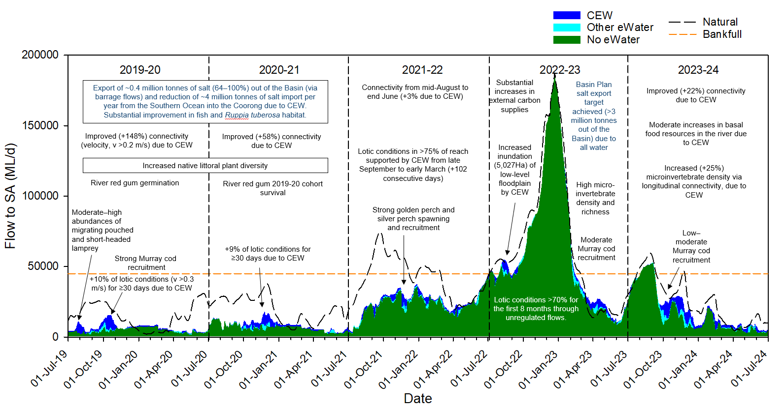
Figure 73. Key monitoring and evaluation outcomes in the Lower Murray River (black text) and Coorong, Lower Lakes and Murray Mouth (blue text) in relation to the flow regime (to South Australia) from 1 July 2019 to 30 June 2024, including the contribution of Commonwealth (CEW) and other environmental water (eWater). Only a subset of outcomes are presented above. Refer to Figure 5 and Table 3 for timing of watering events and expected outcomes. Approximate bankfull flow (orange dotted line) and modelled flow under natural conditions (dotted black line) are shown.
Table 24. Commonwealth Environmental Water Holder evaluation questions by indicators for the Lower Murray, which includes the Lower Murray River (LMR) and the Coorong, Lower Lakes and Murray Mouth (CLLMM). Evaluation questions are sourced or adapted from Gawne et al. (2014). Evaluation of Commonwealth environmental water (CEW) for hydraulic and matter transport questions is based on modelled data. Refer to the evaluation in respective indicator sections (Section 2) for more detail.
Lower Murray River
CEWH evaluation questions | 14-15 | 15-16 | 16-17 | 17-18 | 18-19 | 19-20 | 20-21 | 21-22 | 22-23 | 23-24
What did CEW contribute to hydraulic diversity within weir pools?
What did CEW contribute to variability in water levels within weir pools?
What did CEW contribute to hydrological connectivity?
What did CEW contribute to dissolved oxygen levels? #
What did CEW contribute to patterns and rates of primary productivity? #
What did CEW contribute to patterns and rates of decomposition? #
What did CEW contribute to littoral understorey vegetation diversity and productivity?
What did CEW contribute to above-ground biomass produced by understorey littoral vegetation?
What did CEW contribute to microinvertebrate density? *
What did CEW contribute to microinvertebrate diversity?
What did CEW contribute to spring microinvertebrate fish prey species density?
What did the flow regime (including CEW) contribute to the spawning and recruitment of golden perch?
What did the flow regime (including CEW) contribute to the spawning and recruitment of silver perch?
Did the flow regime (including CEW) contribute to the resilience of golden perch populations? *
What did CEW contribute to the growth and morphometric condition of Murray cod?
What did the flow regime (including CEW) contribute to recruitment of Murray cod? *
What did the flow regime (including CEW) contribute to the resilience of Murray cod populations?

Coorong, Lower Lakes and Murray Mouth
CEWH evaluation questions | 14-15 |  | 15-16 |  | 16-17 |  | 17-18 |  | 18-19 |  | 19-20 |  | 20-21 |  | 21-22 |  |  | 22-23 |  | 23-24
What did CEW contribute to salinity levels at the Murray Mouth? *
What did CEW contribute to salinity levels in the North Lagoon? *
What did CEW contribute to the salt transport through the barrages?
What did CEW contribute to reduction of salt import at the Murray Mouth? *
What did CEW contribute to reduction of salt flux to the North Lagoon? *
What did CEW contribute to the salinity regime?
What did CEW contribute to improving mulloway habitat? *
What did CEW contribute to improving black bream habitat? *
What did CEW contribute to improving smallmouth hardyhead habitat? *
What did CEW contribute to improving fish habitat in the Coorong over the long-term?
What did CEW contribute to improving predicted Ruppia tuberosa (sexual life-cycle) habitat? *ª
What did CEW contribute to improving predicted Ruppia tuberosa (all life stages) habitat over the long-term? ª
 |  | 2015 |  | 2016 |  | 2017 |  | 2018 |  | 2019 |  | 2020 |  | 2021 |  |  | 2022 |  | 2023

* = not all evaluation questions are presented here for this indicator. # = evaluation results presented for downstream of Lock 6 in the LMR. ª Evaluation for Ruppia tuberosa habitat is by financial year.
Contribution (to what extent CEW contributed towards the outcome, with the significance of the outcome considered). See respective indicator evaluation sections (Section 2) for selection criteria:
 | Not assessed |  | Unknown |  | Negative |  | None/  negligible |  | Minor |  | Moderate |  | Substantial

General Management Recommendations
Environmental water delivery to the Lower Murray during dry years has typically involved contributing to base flows (~SA entitlement flows), promoting in-channel flow pulses (i.e. increasing magnitude, duration and/or frequency of freshes), and supporting end-of-system flows to maintain Lower Lakes levels and support barrage/fishway operation. During wet years, such as 2016-17 and 2021–2024, environmental water delivery has aimed to fill gaps in the hydrograph to maintain high flow volumes or reduce the rate of flow recessions. The overall aims of the water delivery are maintaining/improving habitat, connectivity and populations, and restoring ecosystem health in the LMR and CLLMM region. General recommendations for flow management in the LMR are provided below, based on monitoring outcomes from the LTIM and Flow-MER projects, in conjunction with our contemporary understanding of flow-related ecology in the LMR. More specific management considerations are provided in Section 2, based on ecological outcomes and findings from indicators. Our findings and recommendations on flow management are most relevant to the spring–summer period, as this is the primary period driving biological response of selected indicators in the LMR.
Spring–early summer in-channel flow pulses
Spring–early summer in-channel flow pulses were key features of the natural hydrograph in the LMR but are absent or reduced from the contemporary flow regime (Figure 4). These flow pulses improve hydrological connectivity, increase hydraulic diversity, and support a broad range of ecological processes and outcomes in riverine and estuarine ecosystems (e.g. lotic habitat, matter transport, food webs, spawning cues for riverine fishes, zooplankton/fish larvae drift, littoral vegetation diversity and productivity, fish recruitment). Such outcomes have been demonstrated to different levels via the ecological indicators in the Lower Murray over the monitoring years since 2014-15.
Under the predominantly dry conditions from 2014-15 to 2020-21 (except 2016-17), environmental water represented 25–43% of the annual total volumes (mean ~2,700 GL/y, QSA) in the LMR, noting the total volume would have been 89% (modelled) greater prior to river regulation. In these years, environmental flows, typically delivered via return flows from upstream watering events, have supported multiple in-channel flow pulses (10,000–18,000 ML/d) in the LMR during spring–early summer (Figure 12). These small freshes elicited minor to moderate improvement in hydraulic conditions in the LMR and have led to positive ecological responses at ‘reach scale’. For example, increased water level variability by environmental flow supported the recruitment of native littoral understorey vegetation and the germination (2019-20) and survival (2020-21) of river red gums in river reaches downstream of weirs, improved hydrological connectivity, indicated by increased river length and duration with flowing velocity >0.2 m/s, promoted downstream microinvertebrate transport and facilitated larval drift of flow-cued spawners (e.g. silver perch larvae from the lower mid-Murray to the LMR in 2020-21). Furthermore, spring flows of 10,000–18,000 ML/d have been associated with recruitment of Murray cod in most years since 2014-15. Flows of this volume result in an increased extent of lotic habitat, relative to entitlement flows, and may promote prey abundance in individual weir pools. The life history of Murray cod operates over these smaller spatial scales (10s of km), and as such, their recruitment may have been benefited by improved lotic habitat at ‘reach scale’, along with appropriate food supplies, supported by environmental water delivery.
Higher flow rates (>20,000 ML/d) and/or longer durations are required to substantially reinstate flowing river characteristics. For instance, modelling indicated from late September to late October 2023, a relatively small increase in flow discharge from 17,136 ML/d to 24,620 ML/d (QSA) by Commonwealth environmental water increased the average length of lotic habitat (velocity >0.3 m/s) from 132 to 259 km, equating to an increase of 127 km (64% of the reach) in the LMR. Significant hydraulic improvement is required to achieve greater ecological outcomes (e.g. riverine production and recruitment of flow-cued spawning fishes) in the LMR. With existing volumes of environmental water and delivery constraints, reaching and sustaining flows >20,000 ML/d in the LMR during dry years is largely reliant on coordinating flow deliveries across much of the southern MDB, including flows from the Murray, Goulburn, Murrumbidgee and Darling rivers. Such concerted effort has been increasing in recent years (e.g. Southern Spring Flow 2020, Rees et al. 2021). Under wetter scenarios, flows >20,000 ML/d may be achieved by delivering environmental water in conjunction with unregulated flows. The latter was well demonstrated in 2021-22, when unregulated flows to the LMR, supplemented by environmental water, promoted a sustained, in-channel flow pulse (20,000–37,600 ML/d) that extended over a broad period from August 2021 to March 2022. This transformed 257–327 km of the LMR (up to 95%) into a flowing river (velocity >0.3 m/s) and promoted spawning and strong recruitment of golden perch for the first time since 2013-14.
Overbank flows
Overbank flows are an integral part of the natural flow regime that are important in maintaining the ecological integrity of floodplain rivers. As observed in 2022-23 and other studies in the LMR (e.g. Murray Flood Ecology, Ye et al. 2014), natural overbank flows substantially improved lateral and longitudinal connectivity, increased riverine productivity, and promoted recruitment, abundance, growth and condition of key native biota (e.g. golden perch in 2010-11 and 2011-12). In August 2022, 115 GL of Commonwealth environmental water was used to build on unregulated bankfull flows and inundated 5,027 Ha of low-level floodplain with current constrains in the system. This was a substantial achievement and the first time overbank conditions had been created by environmental water without downstream infrastructure (as opposed to managing the recession from higher unregulated flow). Continuing to opportunistically test the mechanisms and processes to deliver environmental water during high flows is likely to benefit floodplain ecosystems.
There are a number of recent examples of environmental water being used to reduce the rate of high flow recessions and maintain/extend the period of lotic conditions in the LMR. Given the magnitude and duration of some large overbank flow events (e.g. 2022-23), the additional ecological benefit from maintaining or extending the duration of inundation or lotic conditions for a relatively short timeframe (days to weeks), after a prolonged period of experiencing those conditions, using environmental water is largely unknown and requires further investigation.

Timing of flow delivery
The timing of flow delivery is important and should continue to be considered with regard to its effect on achieving ecological objectives and meeting biological processes and species’ life history requirements. For example, in 2017-18, 2019-20 and 2020-21, the spring–early summer flow pulses were of a similar magnitude in the LMR, but the flow pulse in 2019-20 occurred earlier in the season (peak in mid-October) (Table 25), coinciding with the spawning period of Murray cod (i.e. October to November). Stronger recruitment of Murray cod was evident in 2019-20, compared to 2017-18 and 2020-21, suggesting that elevated flow in early spring, immediately prior to and during spawning, may be beneficial to Murray cod reproduction, potentially by improving the extent/quality of spawning habitat and providing favoured food resources for early life stages. Alternatively, flow pulses delivered mostly after the spawning season may not elicit the same response by Murray cod.
Flow pulses during late spring and summer generally coincide with higher water temperatures (>20°C) and, if of sufficient magnitude, may promote spawning of golden perch. While the spawning and recruitment of this species was relatively low in the LMR from 2014-15 to 2020-21 during flows <20,000 ML/d and the hypoxic blackwater event (2016-17; 94,600 ML/d), extensive spawning and strong recruitment occurred during 2021-22, in association with high in-channel flows (20,000–38,000 ML/d) throughout the spawning season. Furthermore, spawning and recruitment occurred during high overbank flows (187,600 ML/d) in 2022-23 and high in-channel spring flows (>20,000 ML/d) in 2023-24. Peak spawning of golden perch during 2021–2024 and previous wet years (2010–2013) occurred in the LMR between late October and January.
To achieve outcomes for lamprey migration through the barrages, the delivery of environmental water should be considered during the peak timing of migration for pouched (July–August) and short-headed (September–October) lamprey. To accomplish multiple species outcomes, a holistic approach in flow regime design will be required. This can be informed by better understanding of the effect of specific aspects of flow (e.g. timing, magnitude and duration) on life-history processes, the hydraulic requirements of flow-dependant species, and the availability of food resources. Whilst the timing of flow is important, a large proportion of environmental water is delivered to the LMR as return flows (e.g. in winter/spring/early summer). This reinforces that a collaborative and coordinated approach to environmental water planning and delivery across the southern Basin is essential. This includes aligning the timing and delivery of water, that is responsive and flexible to rain events, to achieve multi-site ecological outcomes.

Table 25. The magnitude, timing and duration of the main spring–summer flow pulses from 2014-15 to 2023-24. Duration is calculated based on the number of consecutive days that exceeded the threshold for a given period.
Water year | Spring–summer peak (ML/d) | Peak date | Season | Duration (days, d) >X GL/d
 |  |  |  | >10 | >15 | >20 | >25 | >45
2014-15 | 10,200 | 23/11/2014 | Mid-–late spring; mid-summer | 4 d;  7 d
2015-16 | 11,600 | 28/10/2015 | Early–mid-spring | 17 d
2016-17 | 94,600 | 29/11/2016 | Early spring–early summer | 204 d | 175 d | 155 d | 139 d | 59 d
2017-18 | 17,800 | 8/12/2017 | Mid-spring; late spring–early summer | 6 d;  51 d | 0 d;  7 d
2018-19 | 12,100 | 1/1/2019 | Mid-summer | 17 d
2019-20 | 15,600 | 19/10/2019 | Mid-spring | 34 d | 11 d
2020-21 | 17,900 | 25/11/2020 | Late spring–early summer | 43 d | 18 d
2021-22 | 37,600 | 28/12/2021 | Early spring–early autumn | 333 d | 329 d | 217 d | 165 d
2022-23 | 187,600 | 22/12/2022 | Early spring–early autumn | 365 d | 321 d | 312 d | 267 d | 161 d
2023-24 | 29,000 | 5/09/2023 | Late winter–early spring | 172 d | 166 d | 148 d | 80 d | 38 d

Restoring riverine hydraulics
Improving riverine hydraulics (e.g. water velocity and turbulence) is fundamental for ecological restoration in the LMR. Flows of >20,000 ML/d can significantly improve hydraulic conditions, by transforming >60% of a weir pool from lentic (slower flowing water, median velocities ≤0.3 m/s) to lotic habitat (faster flowing water, >0.3 m/s) (Figure 11). Restoring such hydrodynamic conditions will promote riverine ecological processes and support the rehabilitation of many declining biota that are adapted to a flowing environment in the LMR (Mallen-Cooper and Zampatti 2017). Pre-regulation, the LMR was characterised by lotic, riverine habitats, with water velocities ranging ~0.2–0.5 m/s, even at flows <10,000 ML/d (Bice et al. 2017). With limited volumes of environmental water, infrastructure management such as weir pool lowering could be considered to complement flows to achieve hydraulic restoration in this region. Modelling indicates a substantial hydrodynamic impact by weirs in the LMR, and the improvements in lotic habitat from weir pool lowering is commensurate with the size of lowering across multiple weir pools. A Weir Pool Operations Plan has been developed for Lock 1 to 6 (Muller and Creeper 2021) and small weir pool lowering within the operational range have been undertaken in recent years including 2021-22 and 2023-24 (Appendix B).

Longitudinal and lateral connectivity
Overall, increased longitudinal and lateral connectivity will enhance productivity in the LMR through increased carbon and nutrient inputs and matter transport. This was reflected by the high dissolved organic carbon and nutrient concentrations, and density and diversity of microinvertebrates observed in 2022-23, during the third highest flood on record. For below bankfull flows, increases in flow to 18,000–35,000 ML/d can result in a step-change increase (+45–80%) in dissolved nutrients due to interaction with the littoral zone and low-level floodplains. Water delivery, in conjunction with weir pool manipulation, can promote greater water level variability and potentially enhance in-channel productivity. Increasing water level variability may also improve abundance and diversity of seed banks and thus the resilience of littoral vegetation, noting the seed bank is currently depauperate in the LMR (Ye et al. 2022). Furthermore, flow management to increase connection and inundation of littoral habitats, wetlands and floodplain, and provide return flows to the main channel, may enhance food subsidy for riverine species via mobilising microinvertebrates. Slow flowing slackwaters in littoral and off-channel habitats provide a conducive environment for the reproduction of microcrustaceans, which have been reported as the main prey for large-bodied native fish larvae (e.g. Murray cod, golden perch). A flow regime that promotes the delivery of abundant prey during and following the reproductive season of these fish species, along with favourable hydraulic conditions, could support their recruitment. Furthermore, longitudinal connectivity of river flow is important for the transport and dispersal of aquatic biota (e.g. microinvertebrates, larvae of flow-cued spawning fish) to and throughout the LMR, which can be supported by environmental water delivery. As demonstrated by LTIM and Flow-MER, downstream transport of microinvertebrates increased species diversity and/or abundance in the LMR. These increases likely contributed to improved productivity and community resilience in the LMR, which is important for aquatic food webs.
Flow integrity
Managing environmental water releases across broad ‘riverscape’ scales is critical not only to achieve desired flow volumes in the LMR, but also consider the effects on water quality and the transport of biota. Indeed, water quality (e.g. turbidity, DOC, the amount and form of nutrients) and entrained biota (e.g. plankton, fish larvae/juveniles) may vary from different sources of water (dependent on ecological processes occurring at those sources), therefore, influencing ecological outcomes (e.g. microinvertebrate assemblage composition, recruitment of golden perch or silver perch) in downstream ecosystems in the LMR. Consequently, maintaining flow integrity (i.e. flow characteristics including volume, water quality and constituents) from upstream (e.g. Darling River or mid-Murray) to the LMR is important to support broad-scale ecological processes and promote positive outcomes (e.g. improving productivity, supporting spawning and recruitment of flow-dependent fishes). In this regard, consideration for environmental flow management needs to include: (1) maintaining hydrological integrity (i.e. magnitude, variability and source) of flow from upstream; and (2) the potential effects on water quality and biological attributes by river operations that re-route (e.g. through floodplains or wetlands) or fragment the flow (e.g. by diversions or water storages), which could lead to changes in ecological response and the structure and function of aquatic food webs.

Barrage flows
Commonwealth environmental water is pivotal, particularly during dry years, in maintaining barrage flows and end-of-system connectivity to support a functioning river system and species’ life history processes (e.g. migration/recruitment of diadromous and estuarine-dependent fishes). Barrage flows increase salt export out of the Basin, contributing to the Basin Plan salt export objective/target of two million tonnes per year. They also play an important role in reducing salt import from the ocean into the Coorong and reducing salt flux into the North and South lagoons. Environmental flow through the barrages is required every year for salt reduction in the Coorong and for maintenance of estuarine habitat. Under dry conditions, even one year without flow through the barrages results in millions of tonnes of salt entering the Coorong and a contraction of fish habitat (e.g. 22% modelled reduction of mulloway habitat in 2017-18 and 2019-20). Consecutive years of environmental water delivery to this region is essential to support Ruppia tuberosa recruitment and maintain ecosystem health. Without Commonwealth environmental water from 2017-18, extensive reductions of estuarine habitat (47% for R. tuberosa (sexual life-cycle) and up to 52% for fish) would have occurred in 2023-24 even after three consecutive years (2021–2024) of high unregulated flows with the 2022-23 being the largest flood year since 1956. This would have led to a detrimental impact on the ecological functions and biodiversity in the Coorong. Barrage flows also reduce the risk of Murray Mouth closure. Our work reinforces the critical role of water for the environment to the maintenance and restoration of the Coorong ecosystem.

References
Abernethy, B. and Rutherfurd, I.D. (1998). Where along a river's length will vegetation most effectively stabilise stream banks? Geomorphology 23, 55–75.
Adams, S.M. (1999). Ecological Role of Lipids in the Health and Success of Fish Populations. In: Lipids in Freshwater Ecosystems. Eds. Arts, M.T. and Wainman, B.C. Springer New York: New York, NY.
Anderson, M.J. and Ter Braak, C.J.F. (2003). Permutation tests for multi-factorial analysis of variance. Journal of Statistical Computation and Simulation 73, 85–113.
Anderson, M.J., Gorley, R.N. and Clarke, K.R. (2008). PERMANOVA+ for PRIMER: guide to software and statistical methods. PRIMER-E, Plymouth, UK.
Bagstad, K.J., Stromberg, J.C. and Lite, S.J. (2005). Response of herbaceous riparian plants to rain and flooding on the San Pedro River, Arizona, USA. Wetlands 25, 210–223.
Baldwin, D.S., Colloff, M.J., Mitrovic, S.M., Bond, N.R. and Wolfenden, B. (2016). Restoring dissolved organic carbon subsidies from floodplains to lowland river food webs: a role for environmental flows? Marine and Freshwater Research 67, 1387–1399.
Baranyi, C., Hein, T., Holarek, C., Keckeis, S. and Schiemer, F. (2002). Zooplankton biomass and community structure in a Danube River floodplain system: effects of hydrology. Freshwater Biology 47, 473–482.
Barker, W.R., Barker, R.M. Jessop, J.P. and Vonow, H.P. (2005). Census of South Australian Vascular Plants. 5.00 edition. Botanic Gardens of Adelaide and State Herbarium, Adelaide.
Basu, B.K. and Pick, F.R. (1996). Factors regulating phytoplankton and zooplankton biomass in temperate rivers. Limnology and Oceanography 41, 1572–1577.
Baumgartner, L.J., Conallin, J., Wooden, I., Campbell, B., Gee, R., Robinson, W.A. and Mallen-Cooper, M. (2014). Using flow guilds of freshwater fish in an adaptive management framework to simplify environmental flow delivery for semi-arid riverine systems. Fish and Fisheries 15, 410–427.
Beardall, J. and Raven, J.A. (1990). Pathways and mechanisms of respiration in microalgae. Marine Microbial Food Webs 4, 7–30.
Beauchamp, V.B. and Stromberg, J.C. (2008). Changes to herbaceous plant communities on a regulated desert river. River Research and Applications 24, 754–770.
Berggren, M. and del Giorgio, P.A. (2015). Distinct patterns of microbial metabolism associated to riverine dissolved organic carbon of different source and quality. Journal of Geophysical Research: Biogeosciences 120, 989–999.
Bice, C.M., Butler, G.L., Fanson, B., Harding, D., Hodges, K., Koster, W., Thiem, J.D., Woods, R. and Zampatti, B.P. (2021). Hydrology and movement of adult golden perch (Macquaria ambigua) in the Murray and Darling rivers determined by acoustic telemetry. South Australian Research and Development Institute (Aquatic Sciences), Adelaide. SARDI Publication No. F2021/000076-1. SARDI Research Report Series No. 1104. 66pp.
Bice, C.M., Gehrig, S.L., Zampatti, B.P., Nicol, J.M., Wilson, P., Leigh, S.L. and Marsland, K. (2014). Flow-induced alterations to fish assemblages, habitat and fish-habitat associations in a regulated lowland river. Hydrobiologia 722, 205–222.
Bice, C.M, Giatas, G.C, Brewer, E.A., Catalano, S., Furst, D., Oliver, R., Revill, A.T., Shiel, R., Ye, Q. and Zampatti, B. (2023). Commonwealth Environmental Water Office Monitoring, Evaluation and Research Project: Lower Murray 2019–2022 Research Report: Diet and basal carbon sources of early life stage Murray cod in the Lower Murray River. A report prepared for the Commonwealth Environmental Water Office by the South Australian Research and Development Institute, Aquatic Sciences.
Bice, C.M., Gibbs, M.S., Kilsby, N.N., Mallen-Cooper, M. and Zampatti, B.P. (2017). Putting the “river” back into the lower River Murray: quantifying the hydraulic impact of river regulation to guide ecological restoration. Transactions of the Royal Society of South Australia, DOI: 10.1080/03721426.2017.1374909.
Bice, C.M., Wedderburn, S.D., Hammer, M.P., Ye, Q. and Zampatti, B.P. (2018). Fishes of the Lower Lakes and Coorong: A Summary of Life-History, Population Dynamics and Management. In: Natural History of The Coorong, Lower Lakes, and Murray Mouth Region (Yarluwar-Ruwe). Eds. Mosley, L., Ye, Q., Shepherd, S., Hemming, S. and Fitzpatrick, R. Royal Society of South Australia, University of Adelaide Press. Adelaide. pp 371–399.
Biggs, B.J.F., Nikora, V.I. and Snelder, T.H. (2005). Linking scales of flow variability to lotic ecosystem structure and function. Regulated Rivers: Research & Management 21, 283–298.
Blanch, S.J., Ganf, G.G. and Walker, K.F. (1999). Tolerance of riverine plants to flooding and exposure by water regime. Regulated Rivers: Research and Management 15, 43–62.
Blanch, S.J., Walker, K.F. and Ganf, G.G. (2000). Water regimes and littoral plants in four weir pools of the River Murray, Australia. Regulated Rivers Research and Management 16, 445–456.
Blom, C.W.P.M., Bogemann, G.M., Laan, P., Van Der Sman, A.J.M., Van De Steeg, H.M. and Voesenek, L.A.C.J. (1990). Adaptations to flooding in plants from river areas. Aquatic Botany 38, 29–48.
Borin, M. and Salvato, M. (2012). Effects of five macrophytes on nitrogen remediation and mass balance in wetland mesocosms. Ecological Engineering 46, 34–42.
Bormans, M., Maier, H., Burch, M. and Baker, P. (1998). Temperature stratification in the lower River Murray, Australia: implication for cyanobacterial bloom development. Marine and Freshwater Research 48, 647–654.
Boulton, A.J. and Lloyd L.N. (1992). Flooding frequency and invertebrate emergence from dry floodplain sediments of the River Murray, Australia. Regulated Rivers: Research & Management 7, 137–151.
Bray, J.R. and Curtis, J.T. (1957). An ordination of the upland forest communities of southern Wisconsin. Ecological Monographs 27, 325–349.
Brock, M.A. (1981). The ecology of halophytes in the south-east of South Australia. Hydrobiologia 81, 23–32.
Brock, M.A. and Casanova, M.T. (1997). Plant life at the edge of wetlands: ecological responses to wetting and drying patterns. In Klomp, N. and Lunt, I. (eds), Frontiers in Ecology: Building the Links. pp. 181–192. Elsevier Science, Oxford.
Brookes, J.D., Huang, P., Thai, S.Y., Gibbs, M.S., Ye, Q., Aldridge, K.T., Busch, B. and Hipsey, M. (2022). Environmental Flows to estuaries and coastal lagoons shape the salinity gradient and generate suitable fish habitat: Predictions for the Coorong Australia. Frontiers in Environmental Science 10, 20. doi.org/10.3389/fenvs.2022.796623.
Brookes, J.D., Lamontagne, S., Aldridge, K.T., Benger, S., Bissett, A., Bucater, L., Cheshire, A., Cook, P.L.M., Deegan, B.M., Dittmann, S., Fairweather, P.G., Fernandes, M.B., Ford, P.W., Geddes, M.C., Gillanders, B.M., Grigg, N.J., Haese, R.R., Krull, E., Langley, R.A., Lester, R.F., Loo, M., Munro, A.R., Noell, C.J., Nayar, S., Paton, D.C., Revill, A.T., Rogers, D.J., Rolston, A.N., Sharma, S.K., Short, D.A., Tanner, J.E., Webster, I.T., Wellmann, N.R. and Ye, Q. (2009). An Ecosystem Assessment Framework to Guide Management of the Coorong. Final Report of the CLLAMMecology Research Cluster. CSIRO: Water for a Healthy Country National Research Flagship, Canberra.
Brown, P. and Wooden, I. (2007). Age at first increment formation and validation of daily growth increments in golden perch (Macquaria ambigua: Percichthyidae) otoliths. New Zealand Journal of Marine and Freshwater Research 47, 157–161.
Bunn, S. and Arthington, A.H. (2002). Basic principles and ecological consequences of altered flow regimes for aquatic biodiversity. Environmental Management 30, 492–507.
Bureau of Meteorology (2025). Climate averages for Renmark. http://www.bom.gov.au/climate/averages/tables/cw_024048.shtml
Burnham, K.P. and Anderson, D.R. (2002). Model selection and multimodel inference: a practical information-theoretic approach. Springer-Verlag, New York.
Capon, S.J. (2007). Effects of flooding on seedling emergence from the soil seed bank of a large desert floodplain. Wetlands 27, 904–914.
Casanova, M.T. (2011). Using water plant functional groups to investigate environmental water requirements. Freshwater Biology 56, 2637–2652.
Centre for Australian National Biodiversity Research and Council of Heads of Australasian Herbaria (2025). Australian Plant Census, IBIS database, http://www.chah.gov.au/apc/index.html.
Chen, Y., Colloff, M.J., Lukasiewicz, A. and Pittock, J. (2021). A trickle, not a flood: environmental watering in the Murray–Darling Basin, Australia. Marine and Freshwater Research 72, 601–619.
Chilton, D., Hamilton, D.P., Nagelkerken, I., Cook, P., Hipsey, M.R., Reid, R., Sheaves, M., Waltham, N.J. and Brookes, J.D. (2021). Environmental Flow requirements of estuaries: providing resilience to current and future climate change and direct anthropogenic changes. Frontiers in Environmental Science 9, 764218. doi: 10.3389/fenvs.2021.764218.
Chow, V.T., Maidment, D.R. and Mays, L.W. (1988). Applied Hydrology. McGraw Hill International Editions, Singapore.
Clarke, K.R. and Gorley, R.N. (2015). PRIMER Version 7.0.12: User Manual/Tutorial, p. 296, PRIMER-E, Plymouth.
Collier, C., van Dijk, K.-J., Erftemeijer, P., Foster, N., Hipsey, M., O'Loughlin, E., Ticli, K. and Waycott, M. (2017). Optimising Coorong Ruppia habitat: Strategies to improve habitat conditions for Ruppia tuberosa in the Coorong (South Australia) based on literature review, manipulative experiments and predictive modelling. In: Waycott, M. (Ed.), Reports to Department of Environment and Natural Resources (DEWNR). The University of Adelaide, School of Biological Sciences, Adelaide, South Australia, p. 169 pp.
Cooling, M.P., Lloyd, L.N. and Walker, K.F. (2010). SA River Murray Weir Operating Strategy. Lloyd Environmental report to the SA Murray-Darling Basin NRM Board, Syndal, Victoria.
Cooper, S.D. and Goldman C.R. (1980). Opossum shrimp (Mysis relicta) predation on zooplankton. Canadian Journal of Fisheries and Aquatic Sciences 37, 909–919.
Cunningham, G.M., Mulham, W.E., Milthorpe, P.L. and Leigh, J.H. (1992). Plants of Western New South Wales. 1 edn. CSIRO Publishing, Collingwood.
Davis, T.L.O. (1977). Reproductive biology of the freshwater catfish, Tandanus tandanus Mitchell, in the Gwydir River, Australia. II. Gonadal cycle and fecundity. Australian Journal of Marine and Freshwater Research 28, 159–169.
Department for Environment and Water (2020a). Long-term environmental watering plan for the South Australian River Murray water resource plan area. November 2020.
Department for Environment and Water (2020b). South Australian River Murray Basin Plan Environmental Outcome Evaluation: SA Channel and Floodplain Priority Environmental Assets, DEW Technical report 2020/19. Government of South Australia, Department for Environment and Water, Adelaide.
Department for Environment and Water (2024). South Australian River Murray Water for the Environment Report 2022-23. Government of South Australia, Department for Environment and Water, Adelaide.
Dickopp, J., Kazda, M., Cizkova, H. (2011). Differences in rhizome aeration of Phragmites australis in a constructed wetland. Ecological Engineering 37 1647–1653.
Dufrene, M. and Legendre, P. (1997). Species assemblages and indicator species: the need for a flexible asymmetrical approach. Ecological Monographs 67, 345–366.
Dyer, F., Broadhurst, B., Tschierschke, A., Thiem, J., Thompson, R., Bowen, S., Asmus, M., Brandis, K., Lyons, M., Spencer, J., Callaghan, D., Driver, P. and Lenehan, J. (2017). Commonwealth Environmental Water Office Long Term Intervention Monitoring Project: Lower Lachlan river system Selected Area 2016-17 Monitoring and Evaluation Report. Commonwealth of Australia, 2017.
Froend, R.H. and McComb, A.J. (1994). Distribution, productivity and reproductive phenology of emergent macrophytes in relation to water regimes at wetlands of south-western Australia. Australian Journal of Marine and Freshwater Research 45, 1491–1508.
Furst, D. (2020). The influence of weir pool raising on microinvertebrate communities in the lower Murray River at Lock 2 in spring 2019. A report to the Department for Environment and Water.
Furst, D., Aldridge, K., Bice, C., Zampatti, B. and Ye, Q. (2018). Ecological response to the Lake Victoria bypass trial 2015–2017. Report to the Commonwealth Environmental Water Office, Canberra.
Furst, D., Ye, Q., Bice, C., McInerny, P., Biswas, T., Rees, G. and Watts, R. (2020). Zooplankton response to a multi-site environmental watering event during spring 2019 in the River Murray. A report to the Commonwealth Environmental Water Office, Canberra. Project number: CEWO- 2000007157.
Gawne, B., Hale, J., Butcher, R., Brooks, S., Roots, J., Cottingham, P., Stewardson, M. and Everingham, P. (2014). Commonwealth Environmental Water Office Long Term Intervention Monitoring Project: Evaluation Plan. Final Report prepared for the Commonwealth Environmental Water Office by The Murray–Darling Freshwater Research Centre. MDFRC Publication 29/2014.
Gehrig, S.L., Frahn, K.A. and Nicol, J.M. (2016). Monitoring the response of littoral and floodplain vegetation and soil moisture flux to weir pool raising – 2015. South Australian Research and Development Institute (Aquatic Sciences), Adelaide. SARDI Publication No. F2015/000390-2.
Giatas, G., Catalano, S., Dittmann, S., Ye, Q., Jackson, M., Mott, R. and Markos, K. (2022). Primary food resources for key waterbird and benthic fish in the Coorong. Goyder Institute for Water Research Technical Report Series No. 22/02.
Gibbs, M.S., Bice, C., Brookes, J., Furst, D., Gao, L., Joehnk, K. Marklund, M. Nicol, J. Zampatti, B. and Wallace, T. (2020). Ecological connectivity of the River Murray: Managing ecological outcomes and water quality risks through integrated river management. Goyder Institute for Water Research Technical Report Series No. 20/03.
Gibbs, M., Bice, C., Furst, D., Gao, L., Joehnk, K., McCullough, D., Montazeri, M., Nicol, J., Smart, J., Wallace, T., Zampatti, B. and Brookes, J. (2023). Using hydraulics to evaluate ecological benefits, risks, and trade-offs from engineered flooding. Hydrological Processes 37, e15024.
Grace, M.R., Giling, D.P., Hladyz, S., Caron, V., Thompson, R.M. and Mac Nally, R. (2015). Fast processing of diel oxygen curves: estimating stream metabolism with BASE (Bayesian Single-station Estimation). Limnology & Oceanography: Methods 13, 103–114.
Graeber, D., Poulsen, J.R., Heinz, M., Rasmussen, J.J., Zak, D., Gücker, B., Kronvang, B. and Kamjunke, N. (2018). Going with the flow: Planktonic processing of dissolved organic carbon in streams. Science of The Total Environment 625, 519–530.
Grill, G., Lehner, B., Thieme, M., Geenen, B., Tickner, D., Antonelli, F., Babu, S., Borrelli, P., Cheng, L., Crochetiere, H., Ehalt Macedo, H., Filgueiras, R., Goichot, M., Higgins, J., Hogan, Z., Lip, B., McClain, M. E., Meng, J., Mulligan, M., Nilsson, C., Olden, J.D., Opperman, J.J., Petry, P., Liermann, C. R., Sa´enz, L., Salinas-Rodrı´guez, S., Schelle, P., Schmitt, R.J.P., Snider, J., Tan, F., Tockner, K., Valdujo, P.H., van Soesbergen, A. and Zarfl, S.C. (2019). Mapping the world’s free flowing rivers. Nature 569, 215–221.
Grime, J.P. (1979). Plant Strategies and Vegetation Processes, John Wiley and Sons Ltd, Chichester.
Hale, J., Stoffels, R., Butcher, R., Shackleton, M., Brooks, S. and Gawne, B. (2014). Commonwealth Environmental Water Office Long Term Intervention Monitoring Project – Standard Methods. Final Report prepared for the Commonwealth Environmental Water Office by The Murray-Darling Freshwater Research Centre. Murray-Darling Freshwater Research Centre, MDFRC Publication 29.2/2014.
Heinle, D.R. (1969). Temperature and zooplankton. Chesapeake Science 10, 186–209.
Herczeg, A.L., Dogramaci, S.S. and Leaney, F.W.J. (2001). Origin of dissolved salts in a large, semi-arid groundwater system: Murray Basin, Australia. Marine and Freshwater Research 52, 41–51.
Hipsey, M.R., Huang, P., Zhai, S., Busch, B., Paraska, D. and Sims, C. (2022). The Coorong Dynamics Model. Available from frmics.github.io/cdm-science/index.html.
Hladyz, S., Baumgartner, L., Bice, C., Broadhurst, B., Butler, G., Fanson, B., Giatas, G., Koster, W., Lyon, J., McCasker, N., Stocks, J., Stuart, I., Thiem, J., Tonkin, Z., Ye, Q., Yen, J. and Zampatti, B. (2024). Basin-scale evaluation of 2022–23 Commonwealth environmental water: Fish. Flow-MER Program. Commonwealth Environmental Water Holder, Department of Climate Change, Energy, the Environment and Water, Australia.
Hladyz, S., Baumgartner, L., Bice, C., Butler, G., Fanson, B., Giatas, G., Koster, W., Lyon, J., Stuart, I., Thiem, J., Tonkin, Z., Ye, Q., Yen, J. and Zampatti, B. (2021). Basin-scale evaluation of 2019-20 Commonwealth environmental water: Fish. Flow-MER Program. Commonwealth Environmental Water Office (CEWO): Monitoring, Evaluation and Research Program, Department of Agriculture, Water and the Environment, Australia. 106pp.
Huang, P., Mosley, L., Brookes, J. D., Sims, C., Waycott, M., Paraska, D., Zhai, S.Y. & Hipsey, M.R. (2024). Hydrologic versus biogeochemical control of nutrient dynamics in a shallow hypersaline coastal lagoon: Insight from a coupled hydrodynamic‐water quality model. Journal of Geophysical Research: Biogeosciences, 129, e2023JG007497.
Huang, J., Welsh, D., Erler, D., Ferguson, A., Brookes, J., Keneally, C., Chilton, D., Dittmann, S., Lam-Gordillo, O., Southgate, M., Simpson, S. and Mosley, L.M. (2022). Coorong nutrient cycling and fluxes. Goyder Institute for Water Research Technical Report Series No. 22/07.
Humphries, P. (2005). Spawning time and early life history of Murray cod, Maccullochella peelii peelii (Mitchell) in an Australian river. Environmental Biology of Fishes 72, 393–407.
Ingram, B.A., Ho, H.H., Turchini, G.M. and Holland, M. (2012). Gamete quality and spawning in captive Murray cod broodstock. Fisheries Victoria Research Report Series No. 58.
Jansen, A and Robertson, A.I. (2001). Riparian bird communities in relation to land management practices in floodplain woodlands of south-eastern Australia. Biological Conservation 100, 173-185.
Jessop, J.P. and Toelken, H.R. (1986). The Flora of South Australia, Government of South Australia Printer, Adelaide.
Jessop, J., Dashorst, G.R.M. and James, F.R. (2006). Grasses of South Australia. An illustrated guide to the native and naturalised species, Wakefield Press, Adelaide.
Junk, W.J., Bayley, P.B. and Sparks, R.E. (1989). The flood pulse concept in river-floodplain systems. Canadian Special Publication of Fisheries and Aquatic Sciences 106, 110–127.
Kapa, M. M and Clarkson, B. D. (2009). Biological flora of New Zealand 11. Eleocharis sphacelate, kuta, paopao, bamboo spike sedge. New Zealand Journal of Botany 47, 43-52.
Kim, D.H., Aldridge, K.T., Brookes, J.D. and Ganf, G. (2013). The effect of salinity on the germination of Ruppia tuberosa and Ruppia megacarpa and implications for the Coorong: A coastal lagoon of southern Australia. Aquatic Botany 111, 81–88.
Kingsford, R.T. (2000). Ecological impacts of dams, water diversions and river management on floodplain wetlands in Australia. Austral Ecology 25, 109–127.
Koehn, J.D. (2009). Multi-scale habitat selection by Murray cod Maccullochella peelii peelii in two lowland rivers. Journal of Fish Biology 75, 113–129.
Koehn, J. D., Balcombe, S. R., Baumgartner, L. J., Bice, C. M., Burndred, K., Ellis, I., Koster, W. M., Lintermans, M., Pearce, L., Sharpe, C., Stuart, I., and Todd, C. (2020a). What is needed to restore native fishes in the Murray–Darling Basin? Marine and Freshwater Research 71, 1464–1468. doi:10.1071/MF20248.
Koehn, J.D., King, A.J., Beesley, L., Copeland, C., Zampatti, B.P. and Mallen-Cooper, M. (2014). Flows for native fish in the Murray–Darling Basin: lessons and considerations for future management. Ecological Management and Restoration 15, 40–50.
Koehn, J.D., Raymond, S.A., Stuart, I., Todd, C.R., Balcombe, S.R., Zampatti, B.P., Bamford, H., Ingram, B.A., Bice, C., Burndred, K., Butler, G., Baumgartner, L., Clunie, P., Ellis, I., Forbes, J., Hutchison, M., Koster, W., Lintermans, M., Lyon, J.P., Mallen-Cooper, M., McLellan, M., Pearce, L., Ryall, J., Sharpe, C., Stoessel, D.J., Thiem, J.D., Tonkin, Z., Townsend, A., and Ye, Q. (2020b). A compendium of ecological knowledge for restoration of freshwater fishes in the Murray– Darling Basin. Marine and Freshwater Research 71, 1391–1463. doi:10.1071/MF20127.
Lake, J.S. (1967). Rearing experiments with five species of Australian freshwater fishes. II. Morphogenesis and ontogeny. Australian Journal of Marine and Freshwater Research 18,155-173.
Leck, M.A. and Brock, M.A. (2000) Ecological and evolutionary trends in wetlands: evidence from seeds and seed banks in New South Wales, Australia and New Jersey, USA. Plant Species Biology 15, 97–112.
Leigh, C., Sheldon, F., Kingsford, R.T. and Arthington, A.H. (2010). Sequential floods drive ‘booms’ and wetland persistence in dryland rivers: a synthesis. Marine and Freshwater Research 61, 896–908.
Li, E.H., Li, W., Wang, X.L., Xue, H.P. and Xiao, F. (2010). Experiment of emergent macrophytes growing in contaminated sludge: implication for sediment purification and lake restoration. Ecological Engineering 36, 427–434.
Lintermans, M. and Phillips, B. (2005). Management of Murray Cod in the Murray-Darling Basin (pp. 64–69). Australia: Murray-Darling Basin Commission.
Maheshwari, B.L., Walker, K.F. and McMahon, T.A. (1995). Effects of regulation on the flow regime of the Murray River, Australia. Regulated Rivers: Research and Management 10, 15–38.
Mallen-Cooper, M. and Stuart, I.G. (2003). Age, growth and non-flood recruitment of two potamodromous fishes in a large semi-arid/temperate river system. River Research and Applications 19, 697–719.
Mallen-Cooper, M. and Zampatti, B.P. (2018). History, hydrology and hydraulics: Rethinking the ecological management of large rivers. Ecohydrology 11, e1965 https://doi.org/10.1002/eco.1965.
Marra, J. and Barber, R.T. (2004). Phytoplankton and heterotrophic respiration in the surface layer of the ocean. Geophysical Research Letters 31. Doi:10.1029/2004GL019664.
McCune, B. and Mefford, M.J. (2006). PC-ORD. Multivariate Analysis of Ecological Data, Version 5.12, MjM Software Design, Glenden Beach, Oregon, USA.
McCune, B., Grace, J.B. and Urban, D.L. (2002). Analysis of Ecological Communities, MjM Software Design, Gleneden Beach, Oregon.
McGinness, H.M. and Arthur, A.D. (2011). Carbon dynamics during flood events in a lowland river: the importance of anabranches. Freshwater Biology 56, 1593–1605.
McNeil, D.G., Westergaard, S., Cheshire, K.J.M., Noell, C.J. and Ye, Q. (2013). Effects of hypersaline conditions upon six estuarine fish species from the Coorong and Murray Mouth. South Australian Research and Development Institute (Aquatic Sciences), Adelaide. SARDI Publication No. F2009/000014-4. SARDI Research Report Series No. 700. 27pp.
Mosley, L.M., Brookes, J., Dittmann, S., Huang, L., Lam-Gordillo, O., Priestley, S., Simpson, S., Welsh, D., and Waycott, M. (2022). A scientific evaluation to inform nutrient removal options for the Coorong. Goyder Institute for Water Research Technical Report Series No. 22/06.
Muller K.L. and Creeper N.L. (2021). Weir Pool Operations Plan for River Murray Locks 6 to 1. Part Two: Operating Plan for Locks 6 to 1. A report for Department of Environment and Water, Government of South Australia, Adelaide SA 5000.
Murray–Darling Basin Authority (2011). The proposed “environmentally sustainable level of take” for surface water of the Murray-Darling Basin: Methods and outcomes. MDBA Publication No. 226/11, Murray Darling Basin Authority, Canberra.
Murray–Darling Basin Authority (2012a). Basin Plan. Murray–Darling Basin Authority, Canberra.
Murray-Darling Basin Authority (2012b). Hydrologic modelling to inform the proposed Basin Plan - methods and results, MDBA publication no: 17/12, Murray-Darling Basin Authority, Canberra.
Murray-Darling Basin Authority (2025). Basin-wide environmental watering strategy, Murray‒Darling Basin Authority Canberra, 2024.
Murray–Darling Basin Commission (2006). The River Murray channel icon site environmental management plan. Murray–Darling Basin Commission, Canberra.
Narum, S.R. (2006). Beyond Bonferroni: Less conservative analyses for conservation genetics. Conservation Genetics 7, 783–787.
Nicol, J.M. (2004) Vegetation Dynamics of the Menindee Lakes with Reference to the Seed Bank. PhD, The University of Adelaide, Adelaide.
Nicol, J.M., Frahn, K.A., Fredberg, J.F., Gehrig, S.L., Marsland, K.B. and Weedon, J.T. (2018a). Chowilla Icon Site – Floodplain Vegetation Monitoring 2018 Interim Report, p. 70, South Australian Research and Development Institute (Aquatic Sciences), Adelaide.
Nicol, J.M., Ganf, G.G. and Pelton, G.A. (2003). Seed banks of a southern Australian wetland: the influence of water regime on final species composition. Plant Ecology 168, 191-205.
Nicol, J.M., Ganf, G.G., Walker, K.F. and Gawne, B. (2018b). Response of three arid zone floodplain plant species to inundation. Plant Ecology 219, 57-67.
Nicol, J.M., Marsland, K.B. and Weedon, J.T. (2010). Understorey vegetation monitoring of Chowilla environmental watering sites 2004-08, p. 87, South Australian Research and Development Institute, Adelaide.
Obertegger, U., Flaim, G., Braioni, M., Sommaruga, R., Corradini, F. and Borsato, A. (2007). Water residence time as a driving force of zooplankton structure and succession. Aquatic Sciences - Research Across Boundaries 69, 575–583.
Odum, H.T. (1956). Primary production in flowing waters. Limnology and Oceanography 1, 102–117.
Oliver, R.L. and Lorenz, Z. (2010). Flow and metabolic activity in the channel of the Murray River. In: Ecosystem Response Modelling in the Murray-Darling Basin. Eds. N. Saintilan and I. Overton, CSIRO Publishing: 267–280.
Oliver, R. L. and Merrick, C. (2006). Partitioning of river metabolism identifies phytoplankton as a major contributor in the regulated Murray River (Australia). Freshwater Biology 51, 1131–1148.
Olsen, Y. (1999). Lipids and essential fatty acids in aquatic food webs: what can freshwater ecologists learn from mariculture? In: Arts, M.T., Wainman, B.C. (eds) Lipids in Freshwater Ecosystems. Springer, New York, NY.
Papas, P. (2007). Effect of macrophytes on aquatic invertebrates – a literature review, p. 21, Arthur Rylah Institute for Environmental Research, Department of Sustainability and Environment and Melbourne Water, Melbourne.
Pettit, N.E. and Froend, R.H. (2001). Variability in flood disturbance and the impact on riparian tree recruitment in two contrasting river systems. Wetlands Ecology and Management 9, 13–25.
Phillips, W. and Muller, K. (2006). Ecological character of the Coorong, Lakes Alexandrina and Albert Wetland of International Importance. South Australian Department for Environment and Heritage.
Poff, N.L., Allan, J.D., Bain, M.B., Karr, J.R., Prestegaard, K.L., Richter, B.D., Sparks, R.E. and Stromberg, J.C. (1997). The natural flow regime: A paradigm for river conservation and restoration BioScience 47, 769–784.
Priestley, S., Mosley, L., Farkas, J., Tyler, J., Shao, Y., Shanafield, M., Banks, E., Wong, W.W., and Leyden, E. (2022). Sources and transport of nutrients in the Coorong. Goyder Institute for Water Research Technical Report Series No. 22/01.
Puckridge, J.T., Sheldon, F., Walker, K.F. and Boulton, A.J. (1998). Flow variability and the ecology of large rivers. Marine and Freshwater Research 49, 55–72.
Puckridge, J.T., Walker, K.F. and Costelloe, J.F. (2000). Hydrological persistence and the ecology of dryland rivers. Regulated Rivers Research and Management 16, 385–402.
Rees, G.N., Biswas, T.K., Gilling, D., Watts, R.J., Liu, X., Oliver, R., Pengelly, J., Zygmunt, L., Ye, Q., McInerney, P., Thompson, R., Malthus, T. and Joehnk, K. (2021). River Murray Channel Productivity Monitoring 2020. CSIRO Land & Water, Canberra, ACT 2601
Reynolds, C.S. (1984). The Ecology of Freshwater Phytoplankton. Cambridge University Press. Cambridge. 384p.
Rivkin, R.B. and Legendre, L. (2001). Biogenic carbon cycling in the upper ocean: Effects of microbial respiration. Science 291, 2398–2400.
Roberts, J. and Ganf, G.G. (1986). Annual production of Typha orientalis Persl. in inland Australia. Australian Journal of Marine and Freshwater Research 37, 659–668.
Rowland, S. (1998). Aspects of the reproductive biology of Murray cod, Maccullochella peelii peelii. In: Proceedings-Linnean Society of New South Wales, 1998. vol 120. Linnean Society of New South Wales, p. 147–162.
Sabo, J.L., Sponseller, R., Dixon, M., Gade, K., Harms, T., Heffernan, J., Jani, A., Katz, G., Soykan, C., Watts, J. and Weltera, J. (2005). Riparian zones increase regional species richness by harboring different, not more, species. Ecology 86, 56–62.
Sainty, G.R. and Jacobs, S.W.L. (1981). Waterplants of New South Wales, Water Resources Commission NSW, Sydney, N.S.W., Australia.
Sainty, G.R. and Jacobs, S.W.L. (2003). Waterplants in Australia, Sainty and Associates, Darlinghurst, N.S.W., Australia.
Sargent, J., McEvoy, L., Estevez, A., Bell, G., Bell, M., Henderson, J. and Tocher, D. (1999). Lipid nutrition of marine fish during early development: current status and future directions. Aquaculture 179, 217–229.
Sellers, T. and Bukaveckas, P.A. (2003). Phytoplankton production in a large, regulated river: A tetractys and mass balance assessment. Limnology and Oceanography 48, 1476–1487.
Serafini, L.G. and Humphries, P. (2004). Preliminary guide to the identification of larvae of fish, with a bibliography of their studies, from the Murray-Darling basin. Cooperative Research Centre for Freshwater ecology, Murray-Darling Freshwater Research Centre, Albury and Monash University, Clayton, No. Identification and Ecology Guide No. 48.
Shiel, R.J. and Aldridge, K.T. (2011). The response of zooplankton communities in the North lagoon of the Coorong and Murray Mouth to barrage releases from the Lower Lakes, November 2010–April 2011. Report for DENR and DWSA. June, 49 pp.
Shiel, R.J. and Tan, L.W. (2013a). Zooplankton response monitoring: Lower Lakes, Coorong and Murray Mouth October 2011 – April 2012. Report for DEWNR SA. June, 49 pp.
Shiel, R.J. and Tan, L.W. (2013b). Zooplankton response monitoring: Lower Lakes, Coorong and Murray Mouth September 2012– March2013. Report for DEWNR SA. September, 41 pp.
Shiel, R., Walker, K. and Williams, W. (1982). Plankton of the lower River Murray, South Australia. Marine and Freshwater Research 33, 301–327.
Sorrell, B.K. and Hawes, I. (2010). Convective gas flow development and the maximum depths achieved by helophyte vegetation in lakes. Annals of Botany 105, 165–174.
South Australian Research and Development Institute Aquatic Sciences, University of Adelaide and Department of Environment and Water (2024). Commonwealth Environmental Water Office: Lower Murray Monitoring, Evaluation and Research Plan (2019–2024). Prepared by the South Australian Consortium for the Commonwealth Environmental Water Office.
Statzner, B. and Higler, B. (1986). Stream hydraulics as a major determinant of benthic invertebrate zonation patterns. Freshwater Biology 16, 127–139.
Steinman, A.D. and McIntire, C.D. (1990). Recovery of lotic periphyton communities after disturbance. Environmental Management 14, 589–604.
Stewardson, M.J. and Guarino, F. (2018). Basin-scale environmental water delivery in the Murray Darling, Australia: A hydrological perspective. Freshwater Biology 63: 969–985.
Stocks, J.R, Ellis, I.M., van der Meulen, D.E., Doyle, J.I. and Cheshire, K.J.M. (2022). Kills in the Darling: assessing the impact of the 2018–20 mass fish kills on the fish communities of the Lower Darling–Baaka River, a large lowland river of south-eastern Australia. Marine and Freshwater Research 73, 159–177.
Stoffels, R., Stratford, D., Bond, N. and Hale, J. (2018). 2016–17 Basin-scale evaluation of Commonwealth environmental water – Fish. Report prepared for the Commonwealth Environmental Water Office by La Trobe University, Publication 192/2018, October, 42pp.
Stuart, I. and Sharpe, C. (2020). Riverine spawning, long distance larval drift, and floodplain recruitment of a pelagophilic fish: A case study of golden perch (Macquaria ambigua) in the arid Darling River, Australia. Aquatic Conservation 30, 675–690.
Stuart, I., Sharpe, C., Stanislawski, K., Parker, A., Mallen-Cooper, M. (2019). From an irrigation system to an ecological asset: adding environmental flows establishes recovery of a threatened fish species. Marine and Freshwater Research 70, 1295–1306.
Tan, L.-W. and Shiel, R.J. (1993). Responses of billabong rotifer communities to inundation. Hydrobiologia 255, 361–369.
Thompson, K. and Grime, J.P. (1979). Seasonal variation in the seed banks of herbaceous species in ten contrasting habitats. Journal of Ecology 67, 893-921.
Tonkin, Z., Humphries, P. and Pridmore, P.A. (2006). Ontogeny of feeding in two native and one alien fish species from the Murray-Darling Basin, Australia. Environmental Biology of Fishes 76, 303–315.
Tonkin, Z.D., Ramsey, D.S.L. and King, A.J. (2008). Larval and juvenile Australian smelt Retropinna semoni somatic and otolith growth parameters – implications for growth interpretation of wild fish. Ecology of Freshwater Fish 17, 489–494.

Tonkin, Z., Stuart, I., Kitchingman, A., Thiem, J.D., Zampatti, B., Hackett, G., Koster, W., Koehn, J., Morrongiello, J., Mallen-Cooper, M. and Lyon, J. (2019). Hydrology and water temperature influence recruitment dynamics of the threatened silver perch Bidyanus bidyanus in a regulated lowland river. Marine and Freshwater Research 70, 1333–1344.
Tonkin, Z., Yen, J., Lyon, J., Kitchingman, A., Koehn, J.D., Koster, W.M., Lieschke, J., Raymond, S., Sharley, J., Stuart, I. and Todd, C. (2021). Linking flow attributes to recruitment to inform water management for an Australian freshwater fish with an equilibrium life-history strategy, Science of the Total Environment 752, 141863. doi.org/10.1016/j.scitotenv.2020.141863.
Ulseth, A.J., Hall, R.O., Boix Canadell, M., Madinger, H.L., Niayifar, A. and Battin, T.J. (2019). Distinct air–water gas exchange regimes in low- and high-energy streams. Nature Geoscience 12, 259–263.
van der Valk, A.G. (1981). Succession in wetlands: a Gleasonian approach. Ecology 62, 688–696.
Várbíró, G., Padisák, J., Nagy-László, Z., Abonyi, A., Stanković, I., Gligora Udovič, M., Béres, V.B. and Borics, G. (2018). How length of light exposure shapes the development of riverine algal biomass in temperate rivers? Hydrobiologia 809, 53–63.
Vilizzi, L. and Walker, K.F. (1999). Age and growth of common carp, Cyprinus carpio, in the River Murray, Australia: validation, consistency of age interpretation and growth models. Environmental Biology of Fishes 54, 77–106.
Vinyard, G.L. (1980). Differential prey vulnerability and predator selectivity: effects of evasive prey on bluegill (Lepomis macrochirus) and pumpkinseed (L. gibhosus) predation. Canadian Journal of Fisheries and Aquatic Sciences 37, 2294–2299.
Walker, K.F. (1985). A review of the ecological effects of river regulation in Australia. Hydrobiologia 125, 111–129.
Walker, K.F. (2006). Serial weirs, cumulative effects: the Lower Murray River, Australia. In: Ecology of Desert Rivers. Ed. R. Kingsford. Cambridge University Press, Cambridge: 248–279.
Walker, K.F. and Thoms, M.C. (1993). Environmental effects of flow regulation on the Lower Murray River, Australia. Regulated Rivers: Research and Management 8, 103–119.
Walker, P.D., Wijnhoven, S., van der Velde, G. (2013). Macrophyte presence and growth form influence macroinvertebrate community structure. Aquatic Botany 104, 80-87.
Wallace, T.A., Daly, R., Aldridge, K.T., Cox, J., Gibbs, M.S., Nicol, J.M., Oliver, R.L., Walker, K.F., Ye, Q. and Zampatti, B.P. (2014). River Murray Channel Environmental Water Requirements: Hydrodynamic Modelling Results and Conceptual Models, Goyder Institute for Water Research Technical Report Series No. 14/5.
Wassens, S., Spencer, J., Wolfenden, B., Thiem, J., Thomas, R., Jenkins, K., Brandis, K., Lenon, E., Hall, A., Ocock, J., Kobayashi, T., Bino, G., Heath, J. and Callaghan, D. (2017). Commonwealth Environmental Water Office Long-Term Intervention Monitoring project Murrumbidgee River system Selected Area evaluation report, 2014–17. Canberra, Commonwealth of Australia.

Watts, R.J., McCasker, N., Howitt, J.A., Thiem, J., Grace, M., Kopf, R.K., Healy, S. and Bond, N. (2017). Commonwealth Environmental Water Office Long Term Intervention Monitoring Project: Edward-Wakool River System Selected Area Evaluation Report, 2016-17. Report prepared for Commonwealth Environmental Water Office. Commonwealth of Australia.
Watts, R.J., McCasker, N., Thiem, J., Howitt, J.A., Grace, M., Kopf, R.K., Healy, S. and Bond, N. (2015). Commonwealth Environmental Water Office Long Term Intervention Monitoring Project: Edward-Wakool Selected Area Technical Report, 2014-15. Institute for Land, Water and Society, Charles Sturt University, Prepared for Commonwealth Environmental Water.
Waycott, M., Lewis, R., O’Loughlin, E.J., Urgl, C., van Dijk, K.J., Calladine, A., Collier, C., Mosley, L., Priestley, S., Leterme, S., Conran, J.G., Thornhill, A., Hipsey, M. and Nicol, J. (2022). Growth, phenology, nutrient responses and ecological limits of the Ruppia Community and associated filamentous algal blooms of the southern Coorong. Goyder Institute for Water Research Technical Report Series No. 23/01.
Webb, A., Vietz, G., Windecker, S., Hladyz, S., Thompson, R., Koster, W. and Jones, M. (2015). Monitoring and reporting on the ecological outcomes of Commonwealth environmental water delivered in the lower Goulburn River and Broken Creek in 2013/14. The University of Melbourne for the Commonwealth Environmental Water Office.
Wedderburn, S.D. and Barnes, T.C. (2016). Piscivory by alien redfin perch (Perca fluviatilis) begins earlier than anticipated in two contrasting habitats of Lake Alexandrina, South Australia. Australian Journal of Zoology 64, 1–7.
White, P.A., Kalff, J., Rasmussen, J.B. and Gasol, J.M. (1991). The effect of temperature and algal biomass on bacterial production and specific growth rate in freshwater and marine habitats. Microbial Ecology 21, 99–118.
Whitworth, K.L. and Baldwin, D.S. (2016). Improving our capacity to manage hypoxic blackwater events in lowland rivers: The Blackwater Risk Assessment Tool. Ecological Modelling 320, 292–298.
Ye, Q. and Zampatti, B. (2007). Murray cod stock status – the Lower River Murray, South Australia. Stock status report to PIRSA Fisheries. South Australian Research and Development Institute (Aquatic Sciences), Adelaide. SARDI Publication No. F2007-000211-1. SARDI Report Series No. 208.
Ye, Q., Bucater, L. and Short, D. (2011). Coorong fish intervention monitoring during barrage releases in 2010/11. South Australian Research and Development Institute (Aquatic Sciences), Adelaide. SARDI Publication No. F2011/000309-1. SARDI Research Report Series No. 559.
Ye, Q., Aldridge, K., Bucater, L., Bice, C., Busch, B., Cheshire, K.J.M, Fleer, D., Hipsey, M., Leigh, S.J., Livore, J.P., Nicol, J., Wilson, P.J. and Zampatti, B.P. (2015a). Monitoring of ecological responses to the delivery of Commonwealth environmental water in the lower River Murray, during 2011-12. Final report prepared for Commonwealth Environmental Water Office. South Australian Research and Development Institute, Aquatic Sciences.

Ye, Q., Bucater, L., Zampatti, B., Bice, C., Wilson, P., Suitor, L., Wegener, I., Short, D. and Fleer, D. (2015c). Population dynamics and status of freshwater catfish (Tandanus tandanus) in the lower River Murray, South Australia. South Australian Research and Development Institute (SARDI) Aquatic Sciences, Adelaide. SARDI Publication No. F2014/000903-1. SARDI Research Report Series No. 841.
Ye, Q., Giatas, G.C. Aldridge, K.T., Benger, S.N., Bice, C.M., Brookes, J.D., Bucater, L.B, Cheshire, K.J.M., Cummings, C.R., Doody, T.M., Fairweather, P.G., Frahn, K.A., Fredberg, J.F. Gehrig, S.L., Holland, K.L., Leigh, S.J., Lester, R.E., Lorenz, Z., Marsland, K.B., Nicol, J.M., Oliver, R.L., Overton, I.C., Pritchard, J.L., Strawbridge, A.D., Thwaites, L.A, Turnadge, C.J., Wilson, P.J. and Zampatti, B.P. (2014). Ecological responses to flooding in the lower River Murray following an extended drought. Synthesis report of the Murray Flood Ecology Project. South Australian Research and Development Institute (Aquatic Sciences), Adelaide. Goyder Institute for Water Research Technical Report Series No. 14/6. 47pp.
Ye, Q., Giatas, G., Aldridge, K., Busch, B., Brookes, J., Gibbs, M., Hipsey, M., Lorenz, Z., Maas, R., Oliver, R., Shiel, R., Woodhead, J. and Zampatti, B. (2018). Long-Term Intervention Monitoring of the Ecological Responses to Commonwealth Environmental Water Delivered to the Lower Murray River Selected Area in 2016/17. A report prepared for the Commonwealth Environmental Water Office. South Australian Research and Development Institute, Aquatic Sciences.
Ye, Q., Giatas, G., Aldridge, K.T., Busch, B., Gibbs, M., Hipsey, M.R., Lorenz, Z., Oliver, R., Shiel, R.J. and Zampatti, B. (2016b). Long-term Intervention Monitoring for the Ecological Responses to Commonwealth Environmental Water Delivered to the Lower Murray River Selected Area in 2014/15: A Report Prepared for the Commonwealth Environmental Water Office by the South Australian Research and Development Institute, Aquatic Sciences, SARDI Aquatic Sciences.
Ye, Q., Giatas, G., Bice, C., Brookes, J., Furst, D., Gibbs, M., Nicol, J., Oliver, R., Shiel, R., Zampatti, B., Bucater, L., Deane, D., Hipsey, M., Huang, P., Lorenz, Z. and Zhai, S. (2021). Commonwealth Environmental Water Office Monitoring, Evaluation and Research Project: Lower Murray 2019-20 Technical Report. A report prepared for the Commonwealth Environmental Water Office by the South Australian Research and Development Institute, Aquatic Sciences.
Ye, Q., Giatas, G., Bice, C., Brookes, J., Furst, D., Gibbs, M., Nicol, J., Oliver, R., Zampatti, B., Bucater, L., Deane, D., Frahn, K., Hipsey, M., Kok, C., Huang, P., Lorenz, Z., Mills, J., Shiel, R. and Zhai, S. (2022). Commonwealth Environmental Water Office Monitoring, Evaluation and Research Project: Lower Murray 2020-21 Technical Report. A report prepared for the Commonwealth Environmental Water Office by the South Australian Research and Development Institute, Aquatic Sciences.
Ye, Q., Giatas, G., Bice, C., Brookes, J., Furst, D., Gibbs, M., Nicol, J., Oliver, R., Zampatti, B., Bucater, L., Deane, D., Frahn, K., Hipsey, M., Kok, C., Huang, P., Lorenz, Z., Mills, J., Shiel, R. and Zhai, S. (2023). Commonwealth Environmental Water Office Monitoring, Evaluation and Research Project: Lower Murray 2021-22 Technical Report. A report prepared for the Commonwealth Environmental Water Office by the South Australian Research and Development Institute, Aquatic Sciences.
Ye, Q., Giatas, G., Bice, C., Brookes, J., Furst, D., Gibbs, M., Nicol, J., Oliver, R., Zampatti, B., Bucater, L., Deane, D., Frahn, K., Hipsey, M., Kok, C., Huang, P., Lorenz, Z., Mills, J., Shiel, R. and Zhai, S. (2024). Commonwealth Environmental Water Office Monitoring, Evaluation and Research Project: Lower Murray 2022-23 Technical Report. A report prepared for the Commonwealth Environmental Water Office by the South Australian Research and Development Institute, Aquatic Sciences.
Ye, Q., Giatas, G., Brookes, J., Furst, D., Gibbs, M., Oliver, R., Shiel, R., Zampatti, B., Aldridge, K., Bucater, L., Busch, B., Hipsey, M., Lorenz, Z., Maas, R., and Woodhead, J. (2020a). Commonwealth Environmental Water Office Long-Term Intervention Monitoring Project 2014–2019: Lower Murray River Technical Report. A report prepared for the Commonwealth Environmental Water Office by the South Australian Research and Development Institute, Aquatic Sciences.
Ye, Q., Giatas, G., Dittmann, S., Baring, R., Bucater, L., Deane, D., Furst, D., Brookes, J., Rogers, D. and Goldsworthy, S. (2020b). A synthesis of current knowledge of the food web and food resources for waterbird and fish populations in the Coorong. Goyder Institute for Water Research Technical Report Series No. 20/11.
Ye, Q., Livore, J.P., Aldridge, K., Bradford, T., Busch, B., Earl, J., Hipsey, M., Hoffmann, E., Joehnk, K., Lorenz, Z., Nicol, J., Oliver, R., Shiel, R., Suitor, L., Tan, L., Turner, R., Wegener, I., Wilson, P.J. and Zampatti, B.P. (2015b). Monitoring the ecological responses to Commonwealth environmental water delivered to the Lower Murray River in 2012-13. Report 3, prepared for Commonwealth Environmental Water Office. South Australian Research and Development Institute, Aquatic Sciences.
Ye, Q., Livore, J., Aldridge, K., Giatas, G., Hipsey, M., Joehnk, K., Nicol, J., Wilson, P. and Zampatti, B. (2016a). Monitoring ecological response to Commonwealth environmental water delivered to the Lower Murray River in 2013-14. Final Report prepared for the Commonwealth Environmental Water Office. South Australian Research and Development Institute.
Young, R.G. and Huryn, A.D. (1996). Interannual variation in discharge controls ecosystem metabolism along a grassland river continuum. Canadian Journal of Fisheries and Aquatic Sciences 53, 2199–2211.
Zampatti, B.P. and Leigh, S.J. (2013a). Effects of flooding on recruitment and abundance of Golden Perch (Macquaria ambigua ambigua) in the lower River Murray. Ecological Management and Restoration 14, 135–143.
Zampatti, B.P. and Leigh, S.J. (2013b). Within-channel flows promote spawning and recruitment of golden perch, Macquaria ambigua ambigua: implications for environmental flow management in the River Murray, Australia. Marine and Freshwater Research 64, 618–630.
Zampatti, B.P., Bice, C.M., Wilson, P.J. and Ye, Q. (2014). Population dynamics of Murray cod (Maccullochella peelii) in the South Australian reaches of the River Murray: A synthesis of data from 2002–2013. South Australian Research and Development Institute (Aquatic Sciences), Adelaide. SARDI Publication No. F2014-000089-1. SARDI Research Report Series No. 761.
Zampatti B., Fanson B., Strawbridge A., Tonkin, Z., Thiem,J., Butler, G., Balcombe, S., Koster, W., King, A., Crook, D., Woods, S., Lyon, J., Baumgartner, L. and Doyle, K. (2019) Basin-scale population dynamics of Golden Perch and Murray Cod: Relating flow to provenance, movement and recruitment in the Murray-Darling Basin. In: Murray-Darling Basin Environmental Water Knowledge and Research Project — Fish Theme Research Report (eds A. Price, S. Balcombe, P. Humphries, A. King and B. Zampatti), p. 42. Centre for Freshwater Ecology, La Trobe University, Wodonga, Victoria.
Zampatti, B.P., Leigh, S.J., Bice, C.M. and Rogers, P.J. (2018a). Multiscale movements of golden perch (Percichthyidae: Macquaria ambigua) in the River Murray, Australia. Austral Ecology 43, 763–774.
Zampatti, B.P., Leigh, S.J., Wilson, P.J., Crook, D.A., Gillanders, B.M., Maas, R., Macdonald, J.I. and Woodhead, J. (2021). Otolith chemistry delineates the influence of natal origin, dispersal and flow on the population dynamics of golden perch (Macquaria ambigua) in a regulated river. Marine and Freshwater Research 72, DOI: 10.1071/MF20280.
Zampatti, B.P., Strawbridge, A., Thiem, J., Tonkin, Z., Mass, R., Woodhead, J. and Fredberg, J. (2018b). Golden perch (Macquaria ambigua) and silver perch (Bidyanus bidyanus) age demographics, natal origin and migration history in the River Murray, Australia. South Australian Research and Development Institute (Aquatic Sciences), Adelaide. SARDI Publication No. F2018/000116-1. SARDI Research Report Series No. 993.
Zhai, S., Waycott, M., Lewis, R., O’Loughlin, E., Erftemeijer, P.L.A, Huang, P., Brookes, J.D., Sims, C., Zhang, Z. and Hipsey, M.R. (2025). A life stage resolved habitat model for guiding seagrass restoration in coastal lagoons. Ecological indicators 170, DOI: 10.1016/j.ecolind.2025.113095.

Appendices

Appendix A: Expected outcomes of Commonwealth environmental water in the LOWER MURRAY RIVER, Lower Lakes and Coorong
Table A1. Expected outcomes of Commonwealth environmental watering actions at the catchment (asset) scale for the Lower Murray River, Lower Lakes and Coorong (Source: CEWH).
Lower Murray River channel
- Maintaining current species diversity, extending distributions and improving breeding success and numbers of short, moderate and long-lived native fish species by:
- Providing opportunities for spawning during spring and recruitment (subject to appropriate seasonal conditions).
- Providing in-stream habitat for fish and thereby supporting recruitment of fish, particularly by increasing the availability of food resources and habitat through water level variability and improved hydraulics.
- Improving the body condition of mature fish during winter/spring (‘pre-spawning conditioning’) and providing opportunities for spawning during spring (subject to appropriate seasonal conditions).
- Where feasible, increasing the presence of lotic conditions along the Murray River and, where feasible, increased lateral connectivity with anabranches and low elevation floodplain wetlands.
- Maintaining the extent and condition of riparian and in-channel vegetation by:
- Increasing periods of growth for non-woody vegetation communities that closely fringe or occur within the Murray River channel, anabranches and low elevation floodplain wetlands.
- Contributing to riverine functioning by:
- Supporting primary and secondary production along the Murray River through the mobilisation and transport of nutrients, carbon cycling and biotic dispersal.
- Supporting the managed export of salt and nutrients from the Murray River system.
- Maintaining water quality and reducing risks of low dissolved oxygen levels, stratification and algal blooms by increasing the extent and duration of flowing water in the river channel.
- Under the wetter scenarios, maintain the extent and condition of long-lived vegetation and understorey vegetation on the broader floodplain by:
- Increasing the extent and duration of inundation, improving the soil moisture and salinity conditions and freshening the groundwater.
- Slowing the recession of the flow peak, supporting the establishment and expansion of vegetation.

This watering action also aimed to contribute to the following rolling multi-year priorities identified in the Basin annual environmental watering priorities:
- Support lateral and longitudinal connectivity along the river system.
- Allow opportunities of growth of non-woody riparian vegetation that fringe or occur within main river corridors.
- Support Basin-scale population recovery of native fish by reinstating flows that promote key ecological processes across local, regional and system scales in the southern connected Basin.
- Support viable populations of threatened native fish, maximise opportunities for range expansion and establish new populations.
- Improve the abundance and maintain the diversity of the Basin’s waterbird population.
- Maintain the extent, improve the condition and promote recruitment of forests and woodlands (wet scenario).
- Maintain the extent and improve the condition of lignum shrublands (wet scenario).
Lower Lakes and Coorong
- Maintain current species diversity, extend distributions and improve breeding success and numbers of short, moderate and long-lived native fish species by:
- Maintaining sufficient flows through the barrage fishways at all times, and additional barrage openings whenever possible, to maintain connectivity between the Murray River channel, Lower Lakes and Coorong.
- Providing attractant and connecting flows to support movement of diadromous fish species, subject to appropriate seasonal conditions.
- Contributing to the maintenance of critical habitat, water quality, water level, and the provision where possible of localised refuge sites as required, in both the Lower Lakes and Coorong.
- Maintain the extent and condition of key habitat, specifically:
- Maintaining the diversity, condition and extent of aquatic and littoral vegetation in the Lower Lakes (which in turn provides habitat for fauna, including the threatened southern bell frog, Murray hardyhead (Endangered EPBC), and the southern pygmy perch (Endangered in South Australia)).
- If season and conditions are appropriate, and sufficient water is available, protecting the current extent of Ruppia tuberosa by contributing to flows that support suitable habitat conditions (salinity and water levels) within the Coorong South Lagoon (and suitable parts of the North Lagoon) to promote flowering and seed set, and growth and survival of newly established plants over successive years.
- Maintain current species diversity, extend distributions and improve breeding success and numbers of water dependent bird species by:
- Supporting suitable habitat conditions and food resources for waterbird growth and survival, maintenance of population condition and diversity along the Murray River valley, Lower Lakes and within the Coorong lagoons.
- Supporting waterbird breeding events where feasible.
- Provide water quality benefits for the river and Lower Lakes through salt export from the Murray River.
- Maintain and, where possible, expand estuarine habitat conditions that support the entire Coorong food web by:
- providing flows to maintain appropriate salinity levels in the Murray estuary and North Lagoon through both dilution and by minimising salt import through the Murray Mouth.
Watering actions also aimed to contribute to the following rolling multi-year priorities identified in the Basin annual environmental watering priorities:
- Support lateral and longitudinal connectivity along the river system.
- Support freshwater connectivity through the Lower Lakes, Coorong and Murray Mouth.
- Expand the extent and improve resilience of Ruppia in the southern Coorong.
- Allow opportunities for growth of non-woody wetland vegetation.
- Improve the abundance and maintain the diversity of the Basin’s waterbird population.
- Maintain the abundance of key shorebird species in the Lower Lakes and Coorong.
- Support Basin-scale population recovery of native fish by reinstating flows that promote key ecological processes across local, regional and system scales in the southern connected Basin.
- Support viable populations of threatened native fish, maximise opportunities for range expansion and establish new populations.
Weir pool manipulation
2019-20:
The ecological objectives for the weir pool raisings at Weir Pools 2 and 6 under a ‘Moderate’ scenario were:
- Growth and expansion of littoral vegetation including Juncus, Cyperus gymnocaulos, Schoenoplectus Validus.
- Understorey plant community sustained and productive.
- Create diverse and productive biofilm and macroinvertebrate communities.
- Provide breeding habitat for small fish (in littoral vegetation) and reed-dependent waterbirds.
- Groundwater exchange with river and relieve soil salinity stress in littoral zone.
- Contribute to in-channel flows during drawdown in late spring to assist in delivering water to the Coorong, Lower Lakes and Murray Mouth (CLLMM).

Under the ‘Near Average’ and ‘Wet’ scenarios the ecological objectives were:
- Wetland inundation, connectivity and production.
- Health, growth and reproduction of floodplain vegetation.
- Access for aquatic fauna to floodplain and wetland habitats, particularly during key breeding and foraging periods.
- Transfer of particulate organic matter from the floodplain to the river channel.

2020–2024:
Weir pool manipulation activities are expected to contribute to the following ecological outcomes:
- Maintaining current species diversity, extending distributions and improving breeding success and numbers of short, moderate and long-lived native fish species by:
- Increasing lateral connectivity with anabranches and low elevation floodplain wetlands.
- Providing in-stream and littoral habitat for fish and thereby supporting recruitment of fish.
- Improving the body condition of mature fish during winter/spring ("pre-spawning conditioning') and providing opportunities for spawning during spring (subject to appropriate seasonal conditions).
- Maintaining the extent and condition of riparian and in-channel vegetation by:
- Increasing periods of growth for vegetation communities that closely fringe or occur within the Murray River channel, anabranches and low elevation floodplain wetlands (in turn providing habitat for other species).
- Contributing to riverine functioning by:
- Supporting primary and secondary production along the Murray River through the mobilisation and transport of nutrients, carbon cycling and biotic dispersal, including via groundwater exchange with the river.
- Creating diverse and productive biofilm and macroinvertebrate communities.
- Supporting the managed export of salt and nutrients from the Murray River system.

This watering action also aimed to contribute to the following rolling multi-year priorities identified in the Basin annual environmental watering priorities:
- Manage water to maximise lateral and longitudinal connectivity along the river systems and provide opportunities for high ecological productivity.
- Maintain the extent, improve condition and promote recruitment of forests and woodlands.
- Allow opportunities for growth of non-woody wetland vegetation.
- Allow opportunities of growth of non-woody riparian vegetation.
SA floodplains
SA floodplain watering is expected to contribute to the following ecological outcomes:
- Maintain viable river red gum, black box, river cooba and lignum populations.
- Establish and maintain a diverse native flood dependent and/or amphibious species plant communities.
- Create conditions for successful, small scale breeding events for waterbirds.
- Provide habitat conducive to supporting communities of native reptiles and mammals, woodland birds and riparian frogs.
- Implement a seasonal hydrograph that encompasses variation in discharge, velocity and water levels and provide diverse hydraulic conditions and complex habitat for flow dependent biota and processes.
- Provide for carbon and nutrient movement from the floodplain to the creek and river to generate localised fluctuations in productivity.
- Promote bacterial rather than algal dominance of biofilms.
- Support resilient populations of foraging generalist native fish.

This watering action also aimed to contribute to the following rolling multi-year priorities identified in the Basin annual environmental watering priorities:
- Manage water to maximise lateral and longitudinal connectivity along the river systems and provide opportunities for high ecological productivity.
- Maintain the extent, improve condition and promote recruitment of forests and woodlands.
- Allow opportunities for growth of non-woody wetland vegetation.
- Allow opportunities of growth of non-woody riparian vegetation.

Appendix B: Overview of other management activities from 2019–2024
In addition to environmental water deliveries to the Lower Murray (Section 1.4), the following management actions are relevant to the analyses and interpretations in this report.
Other watering and management activities in the Lower Murray
Manipulation of water levels in weir pools
In the LMR, water levels in weir pools 1, 2, 4, 5 and 6 were manipulated from 2019–2024 (Table B1; Figure B1). Annual raising events (0.3–0.6 m above normal pool level, NPL) have generally commenced in late winter, with peak water levels reached in early to mid-spring, and most water levels returning to normal pool level before summer. During 2020 and 2021, water levels in weir pools were also lowered 0.08–0.15 m below NPL in late November/December.
During 2019-20 and 2020-21, Commonwealth environmental water supported weir pool raisings in weir pools 2, 4, 5 and 6 by accounting for losses (e.g. evaporation). For all other cases, weir pools were re-filled by unregulated flow following weir pool manipulations. However, it was Commonwealth environmental water underwriting the requirement of the weir-pools re-filling that enabled the river operators to undertake the manipulations.
Table B1. Weir pool manipulation timing and magnitude details in the LMR from 2019–2024. *indicates when Commonwealth environmental water accounted for losses.
Year | Weir pool
Year | 1 | 2 | 4 | 5 | 6
2019-20 |  | +0.5 m NPL*. Raising between early August and mid October 2019. Peak levels in August/September before drawdown in late September. |  |  | +0.3 m NPL*. Raising commenced in early August, but curtailed as flow to SA declined and returned normal level by mid-August.
2020-21 | Minor lowering (-0.11 m NPL) from late November to December. | Minor lowering (-0.09 m NPL) from late November to December. | +0.335 NPL*. Raising between 7 September and 29 November. Drawdown in November 2020. Minor lowering (-0.06 m) from late November to December. | +0.46 NPL*. Raising between 17 September and 29 December. Drawdown in December.
2021-22 | Minor lowering (-0.11 m) of water levels below NPL in December. | +0.6 m NPL. Raising occurred in mid-July and peaked in early October, before undergoing a drawdown to NPL in mid- to late October. Minor lowering (-0.08 m) of water levels below NPL in December. | +0.3 m NPL. Raising began late July, while drawdown of water levels occurred in late October/early November with levels retuning to NPL by late November. Minor lowering (-0.08 m) of water levels below NPL in December. | +0.5 m NPL. Raising began late July, while drawdown of water levels occurred late November, with levels returning to NPL by early December. | +0.42 m NPL. Raising began late July, while drawdown of water levels occurred between early to mid-November. Minor lowering (-0.15 m) of water levels below NPL in December.
2022-23 |  | +0.55 m NPL. Raising began in mid-July and peaked in late August, before undergoing a drawdown to NPL in late September. | No intervention was required, unregulated flows met targeted action. | +0.5 m NPL. Raising occurred between early July and mid-October, before being overtaken by the flood. | +0.45 m NPL. Raising occurred between late July and early October. The peak was reached in mid-September. Manipulations were overtaken by the flood during October.
2023-24 ª | Minor lowering (-0.10 m) of water levels below NPL from early October to early December. | Minor lowering (-0.08 m) of water levels below NPL from early October to early December. | Minor lowering (-0.04 m) of water levels below NPL from early October to early December. | Minor lowering (-0.10 m) of water levels below NPL from early October to early December. | Minor lowering (-0.18 m) of water levels below NPL from early October to mid-December.
ª From early October to early December 2023, there was also minor lowering (-0.03 m) of water levels below NPL in Weir Pool 3.
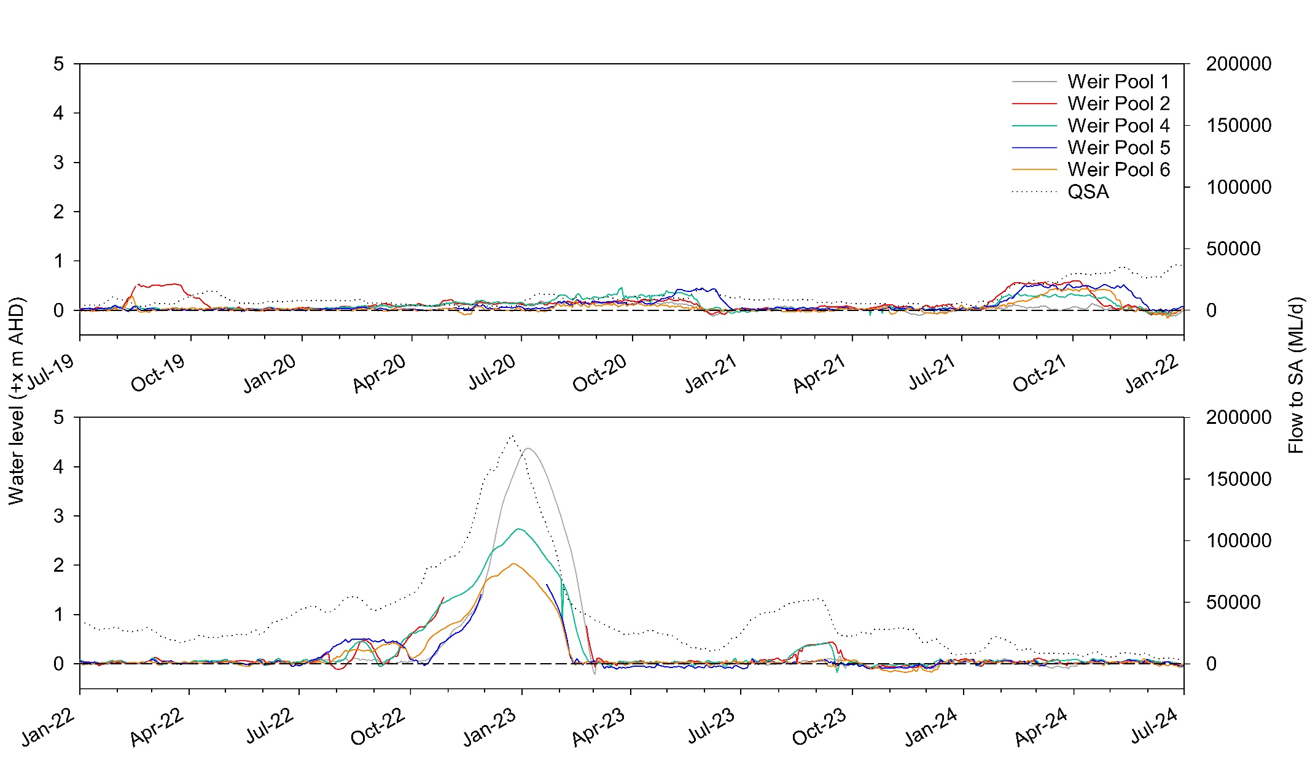
Figure B1. Water levels in the Lock 1, 2, 4, 5 and 6 weir pools from July 2019 to July 2024, showing weir pool manipulations (DEW). Water levels are measured at Lock 1 US (A4260902) + 3.1 m AHD, Lock 2 US (A4260518) + 6.1 m AHD, Lock 4 US (A4260514) +13.2 m AHD, Lock 5 US (A4260512) + 16.3 m AHD and Lock 6 US (A4260510) + 19.25 m AHD sites.
Floodplain regulator operation
From 2020–2023, regulated in-channel rises in water level and inundations of floodplains occurred using the Katarapko, Pike and Chowilla regulators, in conjunction with the raising of weir pools 4, 5 and 6, respectively. These regulator operations generally commenced in winter–spring, with the recession commonly occurring in mid- to late spring, and water levels returning to NPL by late December.
During 2020-21, Commonwealth environmental water, in conjunction with SA Ministers Reserve, supported Pike and Katarapko regulator operations by accounting for losses (e.g. seepage and evaporation). For all other years, the targeted action was met through unregulated flows. Refer to the five-year LTIM report (Ye et al. 2020a), the annual technical reports (Ye et al. 2021, 2022, 2023, 2024) and http://www.environment.sa.gov.au for more detail.
Table B2. Floodplain regulator event details from 2019–2024 (Source: MDBA).
Year | Regulator | Peak water level (above NPL) | Timing | Supporting environmental water
2020-21 | Pike | +0.7 m | Water levels in the Pike anabranch were raised in conjunction with the raising of Weir Pool 5, which commenced in mid-September (Table B1). Water levels were held at a maximum for 19 days during late November–early December before returning to NPL by end December. | 433 ML CEW, 1,000 ML SA Ministers Reserve.
2020-21 | Katarapko | +2.8 m | In conjunction with the operation of Lock 4 (Table B1), water levels in Katarapko creek were raised and held at the peak water levels for 6 days during late November–early December, before returning to normal levels by late December. | 4,910 ML CEW
2021-22 | Chowilla | +3.2 m | Water levels were raised from late July/early August, in conjunction with the raising of the respective weir pools (Table B1). Water levels were held at a maximum height for approximately 4 weeks before undergoing drawdown in late November/late December – operation at Katarapko was curtailed early as water levels equilibrated with elevated river flows. | 0 ML CEW
2021-22 | Pike | +1.25 m |  | 0 ML CEW
2021-22 | Katarapko | +3.2 m |  | 0 ML CEW
2022-23 | Pike | +1.5 m | The operation of the Pike regulator occurred in conjunction with Weir Pool 5 raising between early July and mid-October, before being overtaken by the flood. | 0 ML CEW
2022-23 | Katarapko | N/A | No intervention was required, unregulated flows inundated areas greater than could be achieved through operation of the floodplain infrastructure. | 0 ML CEW
2022-23 | Chowilla | +3.25 m | Regulator operation was undertaken between late July and early October. The peak was reached in mid-September. During October, the regulator and Weir Pool 6 manipulations were overtaken by the flood. | 0 ML CEW

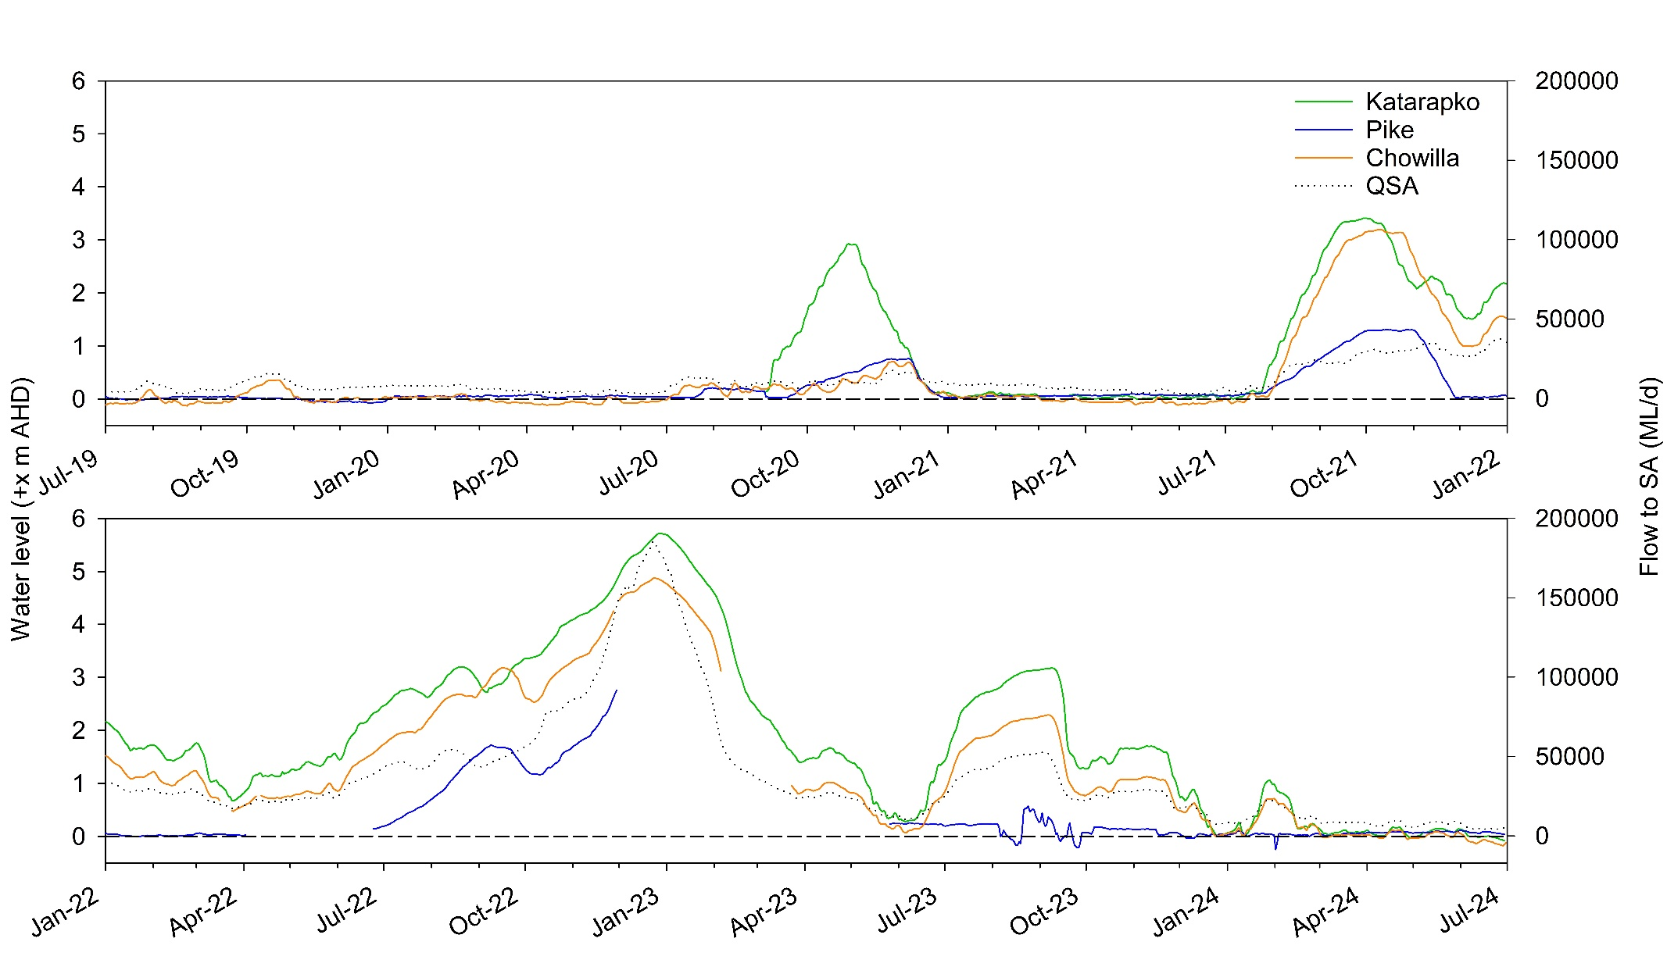
Figure B2. Water levels upstream of the Katarapko Creek regulator (A4261790) +9.9 m AHD, Pike River regulator (A4261053) +14.5 m AHD and Chowilla Creek regulator (A4261091) +16.4 m AHD from 2019–2024, showing regulator operations (DEW). Flow to South Australia (QSA) is presented. Water level data for Katarapko are not available prior to September 2020. Water level data for Pike between 30 November 2022 and 25 May 2023 were omitted due to unreliability.

Watering and management activities outside of the Lower Murray
Manipulation of water levels in Weir Pools 7, 8, 9 and 15
Water levels in Weir Pools 7, 8, 9 and 15 have been raised and/or lowered annually from 2019–2024 (Table B3). During 2019-20, 2020-21, 2021-22 and 2023-24, Commonwealth environmental water was used to account for ‘net’ use, i.e. combined loss from raising and savings from lowering for the duration of the environmental watering event and for all weirs involved in the event. In 2022-23, there was no net use because only weir pool lowerings were undertaken and net water savings cannot be credited to the CEWH.
Refer to the five-year LTIM report (Ye et al. 2020a) for a summary of weir pool manipulations from 2014–2019 and the annual technical reports (Ye et al. 2021, 2022, 2023, 2024) for more detail regarding the timing and magnitude of the events from 2019–2024.
Table B3. Timing of water manipulation actions for weir pools upstream of the Lower Murray Selected Area from 2019–2024 (source, MDBA). Lowering is below full supply level (FSL).
 | Weir pool
 | 7 | 8 | 9 | 15
2019-20 | Raising of weir pool to +60 cm: August to December 2019 (modelled use: 509 ML)  Lowering of weir pool to -55 cm: December 2019 to April 2020 (modelled gain: 357 ML) | Raising of weir pool to +95 cm: September to December 2019  (modelled use: 1,738 ML)  Lowering of weir pool to -100 cm: January to May 2020  (modelled gain: 2,335 ML) | Raising of weir pool to +20 cm: August 2019, May 2020 (modelled use: N/A*)  Lowering of weir pool to -10 cm: February to May 2020  (modelled gain: 1,450 ML) | Raising of weir pool to +60 cm: August to December 2019  (modelled use: 3,238 ML)  Lowering of weir pool to -30 cm: June-July 2019 and April-May 2020  (modelled gain: 568 ML)
2020-21 | Lowering of weir pool to -50 cm: December 2020 to April 2021 (modelled gain: 244 ML)  Raising of weir pool to +60 cm: April to June 2021 (modelled use: 203 ML) | Lowering of weir pool to -80 cm (then -60 cm): June to August 2020 and January to June 2021 (modelled gain: 1,825 ML)  Raising of weir pool to +10 cm: August 2020 to January 2021 (modelled use: 0 ML)* | Raising of weir pool to +5 cm: June 2020 to January 2021 (modelled use: 281 ML)  Lowering of weir pool to -10 cm: January to June 2021 (modelled gain: 968 ML) | Lowering of weir pool to -30 cm: June to August 2021 and May 2021 (modelled gain: 549 ML)
2021-22 | Raising of weir pool to +60 cm: 1 June to 17 September 2021  (modelled use: 3,317 ML) | Raising of weir pool to +85 cm: 13 August 2021 to 16 November 2021  (modelled use: 5,827 ML)  Lowering of weir pool to -40 cm: 1 June – 28 July 2021 (modelled gain: 65 ML) | Lowering of weir pool to -10 cm: 1 June to 9 July 2021 and  10 December 2021 to 27 January 2022  (modelled gain: 656 ML) | Lowering of weir pool to -30 cm: 1 June to 31 July 2021  (modelled gain: 234 ML)
2022-23# | Lowering of weir pool to -40 cm: 9 May to 22 June 2023 (modelled use/gain: 0 ML) | Lowering of weir pool to -40 cm: 8 March – 30 June 2023 (modelled use/gain: 0 ML) | Lowering of weir pool to -10 cm: 23 February to 26 June 2023 (modelled use/gain: 0 ML) | Lowering of weir pool to -40 cm: 1 July to 18 September 2022 (modelled use/gain: 0 ML)
2023-24# | Lowering of weir pool to -15 cm: 9 April to 1 June 2024 (modelled use/gain: 0 ML) | Lowering of weir pool to -10 cm: 5 April – 1 June 2024 (modelled use/gain: 0 ML) | Lowering of weir pool to -10 cm: 8 April to 31 May 2024 (modelled use/gain: 0 ML) | Lowering of weir pool to -30 cm: 8 April to 18 May 2024 (modelled use/gain: 0 ML)
*Raising of Lock 9 in 2019-20 and Lock 8 in 2020-21 was operational only and therefore resulted in no modelled ‘use’.
#In most years, hydrodynamic models are employed to estimate the incremental inundated area associated with raising and lowering of the weir pools at Lock 7, 8, 9 and 15. An estimate of net water use across the pools is determined by identifying ‘losses’ during raising and ‘gains’ from lowering. This was not undertaken for 2022-23 and 2023-24 as there were no raising actions, only weir pool lowerings that produce a water saving. As net water savings cannot be credited to the CEWH, the modelling was not undertaken and water use was determined as 0 ML.
Other watering events and management actions
From 2019–2024, environmental water was delivered to the LMR channel, primarily as deliveries from return flows through coordinated watering events across the southern connected Basin, to achieve multi-site environmental outcomes. The major upstream watering events that were supported by environmental water and may be relevant to the evaluation in this report are summarised in Table B4. Refer to the five-year LTIM report (Ye et al. 2020a) for a summary of upstream watering events from 2014–2019.
Table B4. Details for upstream watering events and management actions supported by environmental water (eWater) from 2019–2024 (source: CEWH). CEW = Commonwealth environmental water, TLM = The Living Murray, VEWH = Victorian Environmental Water Holder, MAA = Murray Additional Environmental Water Allowance, NSW AEW = Adaptive Environmental Water, NSW EWA = NSW Environmental Water, IVT = Inter-Valley Transfer, RMIF = River Murray Increased Flows, BM-EWA = Barmah Millewa Environmental Watering Allowance. SA border = South Australian border.
Year | Event | Event description and timing | Supporting eWater
2019-20 | ‘Southern Spring Flow’ | - Between July and October 2019, nearly 330,000 ML of environmental water was delivered from Hume Dam targeting environmental outcomes along 2,000 km of the Murray River.  - This water provided benefits at Barmah-Millewa Forest, Gunbower Creek, Koondrook-Perricoota Forest, Lake Kramen at Hattah Lakes, Chowilla, the Edward-Kolety-Wakool and the Lower Lakes and Coorong, as well as the Murray River channel itself.  - Environmental flows targeted up to 15,000 ML/d downstream of Yarrawonga, about half of what would have occurred naturally in winter/spring 2019-20. Based on inflows over winter and spring, flows would have naturally reached about 30,000 ML/d, with overbank flows from July to October 2019.  - The flows were designed to support a broad range of outcomes. In the Mid-Murray, this includes providing water to the wetland vegetation in Barmah-Millewa Forest (such as Moira grass), and improving habitat and food availability for native fish, such as Murray cod.  - The flows were timed to align with environmental flows from the Lower Goulburn, creating a pulse down the Murray River. This pulse aimed to improve productivity in the river (that is, supporting the river food chain (or food web)). | CEW, TLM, RMIF
 | Goulburn winter and spring freshes | - Following base flows in June 2019, the winter fresh commenced at Murchison on 01 July 2019 and finished on 1 August 2019. Flows peaked at 9,549 ML/d at Murchison, boosted by natural inflows. At McCoys Bridge the winter flow commenced on 6 July with a lower peak of 8,503 ML/d.  - Expected outcome of winter fresh: remove terrestrial vegetation and re-establish flood tolerant native vegetation; inundate benches to encourage plant germination; provide carbon (e.g. leaf litter) to the channel; and improve water quality and waterbug habitat.  - The Goulburn spring fresh delivered 135,923 ML from Eildon with the pulse commencing on 21 September and ending 19 October at McCoys Bridge. Before and after the spring pulse there was additional environmental water delivered as part of maintaining increased base flows for the Goulburn River.  - Expected outcome of summer fresh: inundate vegetation on benches and the lower banks to facilitate recruitment, sustain growth, and encourage flowering, seed development and distribution. | CEW, TLM, VEWH
 | Barmah-Millewa Forest inundation | - Given that Barmah forest received the majority of flows in 2018-19, Millewa forest was the priority asset to receive water in 2019-20. The objective was to completely fill the Gulpa Wetlands (Reed Beds Swamp, Coppingers Swamp and Duck Lagoon) to provide optimal bittern nesting habitat over October–November 2019 and into December 2019.  - Spring pulse started 1 September 2019 targeting 6+ weeks at 15,000 ML/d downstream of Yarrawonga, with a planned completion date of 28 October 2019 (at Yarrawonga). An estimated 25% of Barmah-Millewa Forest was inundated as part of this flow event.  - Forest regulators on the Barmah Forest (Victoria) side of the Murray River were closed on 31 October 2019 to control giant rush encroachment and discourage unwanted colonial bird breeding. A small number of regulators in Millewa Forest (NSW) remained open until 30 November to allow Murray Cod and other native fish to complete their breeding cycle and have time to exit the forest creeks. Environmental water was used to cover additional use in the forest during this period.  - Further deliveries proceeded into December 2019 in the Gulpa Creek region (Coppingers swamp, duck lagoon and Reed Beds swamp) to support Australasian Bittern breeding. NSW TLM and NSW PEW covered this additional water use. | CEW, TLM, RMIF, NSW MAA (PEW)
2020-21 | ‘Southern Spring Flow’ | - Spring/summer large fresh targeting 12–15,000 ML/d for a minimum of 10 days, for faster flowing fish habitat, improved groundwater and surface water quality, increased golden and silver perch spawning response and aquatic productivity.  - Timing of the Murray fresh/overbank pulse (October–December) was coordinated with the Goulburn and Murrumbidgee rivers as they main opportunity to provide for a system-scale pulse. Increased magnitude and duration of this event would provide improved outcomes; however, this would likely only be possible through high unregulated flow contributions from upstream tributaries including the Baaka (Lower-Darling).  - A combination of coordinated return flows from the Murray, Murrumbidgee (TLM) and Goulburn an order at the SA border, helped to shape the flows in the Lower Murray. As a result, a flow duration of >15,000 ML/d for 3 weeks was achieved at the SA border with a peak just under 18,000 ML/d.  - The peak of the flow at the SA border was reduced by increased operational transfers from Hume and IVT delivery in the Goulburn (both of which reduced the amount of environmental water and subsequent return flows). Expert advice indicates that maximising both the height and duration of the peak flow into SA (to expand the amount of lotic habitat) will likely increase the potential for successful recruitment of native perch.  - To complement returns flows, maintain the peak and slow recession of the pulse, an additional 40 GL was ordered at the SA border and delivered during early December. This water was originally planned to be delivered later as part of the summer/autumn direct trade but was brought forward to coincide with the back part of the spring pulse. The earlier release specifically aimed to support perch spawning activity in the SA Murray detected by the Flow-MER program. | CEWO, TLM, VEWH and RMIF
 | Barmah-Millewa Forest regulator operation | - The higher river levels from the spring watering action inundated around 25% of Barmah-Millewa Forest before returning to the Murray River. These flows were timed to coordinate with flows from the Goulburn, Murrumbidgee and Baaka (Lower-Darling) to create a flow pulse along the Murray River from Yarrawonga the Coorong in South Australia.  - Deliveries to the Barmah-Millewa forest (between August and December) were provided via various combinations of translucent regulator delivery, followed by overbank flows, then a return to translucent regulators with a total 31,834 ML delivered. This volume includes a small additional in-channel flow that was delivered to Barmah Forest between December and February to support waterbird breeding.  - On 14 August 2020 environmental water holders decided to open regulators on both sides of the Barmah-Millewa forest as part of the planned in-channel open regulator strategy. Regulators were opened before flows exceeded 5,000 ML/d downstream of Yarrawonga to avoid delivery of a potentially damaging surge of water entering the creek network within the forest.  - Regulators remained open on both sides of the river till 23 December 2020 to allow native fish to exit the forest and return to the Murray. Millewa Forest (NSW) regulators were closed on 23 December 2020 while some Barmah Forest (Victoria) regulators remained open until 22 February 2021 to allow small, extended deliveries to the Boals Deadwoods wetland to support colonial waterbird breeding – mainly white and straw-necked Ibis. | VEWH, TLM and RMIF
 | Goulburn spring fresh | - Wet conditions from May 2020 continued into the new water year with high natural flows negating the need for a winter fresh and e-water used to extend a natural flow in October to deliver a spring fresh.  - Natural high flows at Murchison continued from June 2020 until 7 September 2020. To slow the recession of the natural high flow, e-water was released from Murchison commencing on 8 Sept 2020.  - A series of watering actions in the Goulburn River delivered over 250 GL of environmental water from September to November (at McCoys Bridge). At McCoys the peak of the fresh was 9,768 ML/d on 14 October. Additional environmental water was delivered to maintain increased baseflows for the Goulburn River both before and after the spring flows.  - IVT flows commenced on 14 Nov 2020, contributing water to the spring fresh together with CEW, VEWH and TLM.  - A combination of flow constraints and the delivery of Goulburn IVT (14 Nov 2020–27 May 2021) displaced environmental water from the hydrograph. Both of these issues resulted in a continued reduction of flows through the Goulburn, but also into the downstream Murray and across the SA border. | CEWO, VEWH, TLM and IVT
 | Lower Darling/Baaka channel | - Through the first half of 2021, additional inflows (with protection of inflows in the northern NSW basin via new ‘first flush’ rules) resulted in the Menindee Lakes filling to over 1,000 gigalitres total storage (~63%), including inflows to the bottom lakes (Menindee and Cawndilla) for the first time since 2016-17. The increase in water availability provided an opportunity to deliver elevated baseflows to provide additional food resources and habitat for growing young fish that were spawned during the spring event.  - Commonwealth and TLM environmental allocations were used to increase minimum baseflows from 200 ML/d to 500 ML/d from 1 May to 30 June 2021 (and into 2021-22).  - As Menindee Lakes storage had risen above 640 GL during autumn and returned to MDBA control, the MDBA was able to call on releases from Menindee Lakes for operational purposes in the Murray River. Environmental releases were paused during late May/mid-June while operational releases were made by MDBA.  - Environmental releases resumed once MDBA’s order was complete.  - The May to June 2021 watering action was expected to:  - inundate more of the river channel, providing increased food and habitat for growing young fish.  - support the connection between the north and south of the Basin by ensuring some of the increased flows coming down the Barwon-Darling River make it all the way to the Murray River. | CEW and TLM
2021-22 | Barmah-Millewa Forest regulator operation | Spring pulse  - Expected outcomes: Supply nutrients and carbon to rivers to support aquatic food webs; Mobilise and export organic matter from low lying wetlands in cooler months (reducing risk of low-oxygen water events); Build native fish condition, movement and spawning; Boost productivity; Support riparian vegetation fringing the river and creeks, and in low-lying wetlands; Increase the availability of habitat and food for native fish and waterbirds; Support native fish spawning.  - Wetter antecedent conditions provided natural cues in preceding months. Modelled natural flows downstream of Yarrawonga showed a late June pulse of ~30,000 ML/d and two pulses >45,000 ML/d in late July and in early August.  - Environmental releases were made between airspace operations. Water order was reduced to 12,000 ML/d for 12 days to conserve the water resource for the primary Spring Action but returned to 15,000 ML/d once resource availability improved. Environmental water was made available for use when airspace operations ceased as part of a ‘managed recession’ strategy to avoid a ‘cliff-drop’ hydrograph. Note: the planned flow target of 18,000 ML/d downstream of Yarrawonga could not be delivered due to Bullatale Creek community concerns. | CEW, TLM, VEWH, BM-EWA
 | Goulburn winter and spring freshes | Winter fresh  - Expected outcomes: To: provide cues to platypus to build their nests higher on the bank; start channel forming processes if flows are over 7,500 ML/d; benefit lamprey migration from South Australia when delivered during July/August; improve abundance of macroinvertebrates; maintain lower and mid-bank vegetation; and increase instream habitat complexity e.g. movement of sediment through the system and maintenance of deep pools.  - A winter fresh was delivered with a peak over 7,076 ML/d at Murchison on 22 July 2022 and 9,306 ML/d on 25 July 2022 at McCoys Bridge. At McCoys Bridge there were 12 days over 7,300 ML/d with the target flow being met and ecological outcomes likely achieved.  - Following the delivery of the planned winter fresh natural flows achieved a second, smaller winter fresh with a peak of 4,684 ML per day on 9 Aug 2021 at Murchison and 6,001 on 11 Aug at McCoys Bridge. The average flow at Murchison was 2,977 ML/d and McCoys 4,242 ML/d. This natural flow met the target of delivering variable flows over winter and the ecological outcomes were likely met.  Early spring fresh  - Expected outcomes: Prime the system and drive the food cycle by provide conditions for lower bank vegetation establishment and maintenance including: transporting plant propagules; increasing moisture in bank soils; driving germination; establishing new plants and encouraging the growth of existing plants.  - Improves macroinvertebrate habitat by scouring and transporting fine sediment.  - Provide cues for spawning and migration for flood-specialist native fish. The spring fresh at Murchison reached a peak of 7,604 ML/d on 10 Oct 2022, with 4 days above 7,300 ML/d. With added tributary inflows, the peak at McCoys was 7,963 ML/d on 13 Oct, with 6 days above 7,300 ML/d. With the systems being wet as a result of high winter flows, this slightly reduced spring fresh is likely to have achieved the expected ecological outcomes.  Late spring fresh  - Expected outcomes: For native fish spawning (including golden perch and silver perch). To: scour old biofilms from hard substrates, improving food resources for macroinvertebrates; transport fine sediments, to maintain instream habitat.  - Murchison: Low flows below 1,000 ML/d after the spring fresh were delivered for 12 days before a natural event occurred, commencing on 10 Nov and peaking at 4,419 on 15 Nov 2022. The flow was of a short, sharp duration and CEW delivery recommenced on 20 Nov to reduce the steep recession and avoid damage to the riverbank. This natural flow, although lower than if flows for a late spring fresh had been planned, may have achieved some fish spawning outcomes. This natural flow also interrupted the managed low flows being delivered and may have adversely impacted the vegetation growth.  - McCoys Bridge: Flows had not fallen back to low flow levels (average 1,186 over the first 12 days) before flows increased due to the natural flow event. A peak of 4,066 was on 19 Nov, and CEW was delivered to slow the recession of the fresh. | CEW, TLM
 | Lower Darling/Baaka & Great Darling Anabranch | Primary outcomes: Support native fish (primarily Murray cod (Maccullochella peelii)) spawning, recruitment and larval dispersal in the Lower Darling/Baaka main channel; Support golden perch (Macquaria ambigua) and silver perch (Bidyanus bidyanus) spawning and dispersal to both the Lower Darling/Baaka and Great Darling Anabranch and ultimately to the River Murray. Other expected outcomes include: Contribute to the maintenance of critical habitat, water quality, food resources and the provision of localised refuge sites; Improve water quality by managing algal blooms and/or hypoxic blackwater events as needed and where feasible; Support riparian vegetation (e.g. river red gums), waterbirds, invertebrates and frogs; Transport propagules and nutrients to the lower River Murray; Contribute to longitudinal connectivity, including connectivity with the Murray and contribution to end of system flows to the Coorong and Murray Mouth.  Lower Darling/Baaka channel  - Environmental water releases of 300 ML/d added to water sharing plan minimum baseflows of 200 ML/d to achieve elevated baseflows of 500 ML/d for 59 days.  - On 30 August 2021, environmental water releases (TLM and CEW) were increased towards a target flow rate of 1,200 ML/d at Weir 32 to begin providing additional food resources and breeding habitat to support the spring Murray cod nesting period.  - By sourcing a portion of these flows from Lake Wetherell, an additional benefit was provided enroute in terms of flushing an algal bloom near the township of Menindee.  - The size of the elevated baseflows were planned based on current water management plans, available water allocations, forecasts of Menindee Lakes storage longevity and advice from fisheries scientists.  - On 25 September operational ‘spill’ releases commenced to manage lake levels and allow river operators to capture surplus inflows arriving at Menindee Lakes following considerable rainfall in the Barwon-Darling system.  - Following a period of operational spill from 25 September to 23 October 2022, operational spill releases would have been reduced to 1,900 ML/d.  - Water for the environment (TLM) was added to maintain flows around 2,500 ML/d between 24 October and 27 November, to avoid a drop in flows following the operational spill and associated risk of Murray cod nest abandonment.  - From 28 November 2021 onwards, the Menindee Lakes were managed for flood operations as a result of continuing high flows from the northern Basin system.  Darling Anabranch  - Following high inflows to the Menindee Lakes which filled all lakes including Lake Cawndilla, releases from Lake Cawndilla using operational ‘spill’ commenced on 25 September 2022 targeting approximately 1,000 ML/d.  - This was the first flow to the Anabranch in almost 5 years.  - Operational spill ceased on 23 October, so CEW was used to continue the target flow of 1,000 ML/d to continue the flow’s path to the River Murray.  - Kangaroo and Packers Lakes were partly filled with a mix of operational spill followed by environmental water, as both lakes no longer have regulating structures. The filling of these lakes is expected to have been beneficial to fish and waterbird populations, vegetation and the overall health of the local ecosystem.  - From 28 November, operational spill recommenced, targeting 2,000 ML/d as part of Menindee Lakes flood operations.  - Following three months of flood operational releases to the Anabranch, operational flows were planned to cease.  - NSW environmental water was provided from 2 March 2022 to ensure that river flow was maintained and benefits to local ecology would continue to be provided.  - From 19 March 2022, operational spill recommenced and continued for the remainder of the water year. | CEW, TLM and NSW AEW
 | Hattah Lakes floodplain and wetland inundation | - Expected outcomes: Stimulating growth and improve the condition of river red gums; Stimulating new growth of aquatic vegetation; Inundating dry wetlands to release carbon and nutrients to increase food web productivity; Providing breeding habitat for waterbirds; Providing spawning and recruitment habitat for small-bodied native fish; Providing modest connections to allow native fish and carbon and nutrients to move between the lakes to the Murray River.  - Commencement of the watering action was delayed due to an issue with power cables, which was resolved in time for the watering action to proceed during spring. The River Murray was unregulated due to high flow conditions during the period Hattah was filled. This meant that unregulated entitlements held by VEWH and TLM were used preferentially to VEWH and CEWO regulated allocations that can be used outside of the unregulated flow event.  - Following delivery (7 October–25 November 2021), water was retained in the lakes for approximately 10 days until both Messengers and Oatey’s Regulators were opened in stages to draw water back off the floodplain. The release continued until mid-February when the retention level of the lakes was reached (~42.5m AHD).  - A height of 44.07 m AHD was achieved across the system, exceeding the target of 43.5 m AHD (Mallee CMA 2022). | No eWater
2022-23 | Barmah-Millewa Forest inundation | Winter pulse  - Expected outcomes: Supply nutrients and carbon to rivers to support aquatic food webs; Mobilise and export organic matter from low lying wetlands in cooler months (reducing risk of low-oxygen water events); Build native fish condition, movement and spawning; Boost productivity; Support riparian vegetation fringing the river and creeks, and in low-lying wetlands; Increase the availability of habitat and food for native fish and waterbirds; Support native fish spawning.  - Water for the environment was used for a large fresh in winter (~85 GL) which commenced in July as part of a managed a recession following June pre-releases. This Watering Action was targeting flows at 15,000 ML/d downstream of Yarrawonga. The overbank delivery action was short-lived (19 days - 20 July to 6 August) as significant rainfall in the upper Murray catchment resulted in higher flows and ‘unregulated’ conditions which persisted to December.  - Environmental releases were made between airspace operations. No BMF ‘initial use’ due to wetter conditions in June and July before environmental deliveries commenced. Wetter winter conditions and high portfolio availability enabled the large fresh to be commenced in July. Late in the water year MDBA RMO reported that flow rates through the Barmah-Choke were likely to alter (i.e. reduce) due to changes in geomorphology as a result of flooding. Note: as in previous years, the planned flow target of 18,000 ML/d downstream of Yarrawonga could not be delivered due to Bullatale Creek community concerns.  In-channel managed deliveries  - Expected outcomes: Support colonial waterbird breeding in Boals Deadwoods (Barmah Forest); Support waterbird breeding in the Gulpa wetlands complex (Millewa Forest); Provide cues to native fish—Fish Exit Strategy—to support fish departure from the forest once all forest regulators are closed.  - Environmental water deliveries recommenced in late December 2022 to support colonial waterbird breeding in Boals Deadwoods (Barmah Forest) and in the Reed Bed wetlands (Millewa Forest) (~115 GL, 39 days). Once again environmental water deliveries were interrupted due to pre-releases. Delivery recommenced in early February to provide cues to for native fish to leave the Barmah Millewa Forest (BMF) once all forest river regulators were closed (~8 GL, 12 days). BMF regulators were opened at the beginning of the water year with regulators on both side of the forest remaining open until 17 February 2023.  - Environmental water was made available for use when airspace operations ceased as part of a ‘managed recession’ strategy to avoid a ‘cliff-drop’ hydrograph. See discussion below for detail. Environmental water releases were not continuous during these dates due to interruptions from pre-releases. | CEW, TLM, MAA, VEWH and RMIF
 | Goulburn winter fresh and spring–winter low flows | Winter fresh  - Primary expected outcomes: Encourage the establishment of stream bank and in-channel vegetation by supporting the recruitment of aquatic and riparian vegetation to improve stream bank stability; Support native fish by providing suitable habitat and food resources during the year for supporting recruitment success; Maintain water quality and suitable habitat to support native fish survival and condition and macroinvertebrate abundance and diversity (through submergence of snags, increasing the availability of slack and deep-water habitat and encouraging aquatic vegetation and planktonic production for food). Secondary expected outcomes: Support longitudinal connectivity along Victorian rivers and to the River Murray for environmental functions such as nutrient and sediment transport, organism dispersal and water quality.  - A winter fresh was delivered from the 22 July to the 22 August 2022 with CEW, TLM water and other flows. Tributary inflows were intended to be used to reach the peak flow rate, however due to dry conditions in July, Lake Eildon was the main water source (with releases peaking at 7,700 ML/d). The maximum flow rate at McCoy’s Bridge was approximately 8,700 ML/d. There were also minor (200-300 ML/d) tributary contributions in the lower Goulburn from Seven Creeks and the Broken River.  - Following the winter fresh variable baseflows were delivered using tributary flows to reach flow targets downstream of Goulburn Weir.  - From September until mid-December very high natural flows were observed, with a peak of over 80,000 ML/d at McCoy’s Bridge in October. These unregulated spring flows provided several freshes that were substantially larger than what is possible through environmental water deliveries. Flows met and well exceeded the early spring fresh targets (10,500 ML/d for 7 days), and late spring fresh targets (up to 7,500 ML/d for 2 days). Record rainfall and river flows resulted in low demand for IVT delivery and environmental water was used to meet watering actions over summer and autumn.  - Following the delivery of the planned winter fresh natural flows achieved a second, smaller winter fresh with a peak of 4,684 ML/d on 9 Aug 2021 at Murchison and 6,001 on 11 Aug at McCoys Bridge. The average flow at Murchison was 2,977 ML/d and McCoys 4,242 ML/d. This natural flow met the target of delivering variable flows over winter and the ecological outcomes were likely met.  Spring/autumn/winter low flows  - Provide cues to Platypus to build their nests higher on the bank to prevent later flooding; Encourage the establishment of stream bank and in-channel vegetation by supporting the recruitment of aquatic and riparian vegetation to improve stream bank stability. Secondary expected outcomes: Disrupt biofilms, move fine sediment and entrain organic matter in-stream to support ecosystem function. Support longitudinal connectivity along Victorian rivers and to the River Murray for environmental functions such as nutrient and sediment transport, organism dispersal and water quality.  - Following floodplain inundation and the slow recession leading into summer, Goulburn Water Quality Reserve (WQR) was used from early December to provide refuge habitat from potential hypoxic conditions in the lower Goulburn River. Water was delivered through irrigation outfalls to provide discrete refuge.  - From early January 2023, this water was switched from WQR to environmental water. The use of environmental water for this purpose is considered delivery of baseflows and was included in the total order for Goulburn River baseflows. A maximum of 100 ML/d can be delivered through irrigation outfalls.  - Variable baseflow deliveries targeting 700–1,000 ML/d resumed on 6 January 2023 after the high unregulated flows in Spring. CEW and TLM environmental water were delivered alongside other flows to target this variable flow rate.  - An Autumn fresh was planned March/April 2023 to attract golden and silver perch into the river. This was not delivered due to concerns from multiple stakeholders that the fresh may lead to adverse outcomes, in particular movement of large numbers of carp into the Goulburn River and damage to late littoral vegetation germination. Scientists advised that many of the ecological outcomes usually targeted for vegetation, fish and instream condition had already been met by natural flows.  - After the cancellation of the Autumn fresh, an IVT pulse with a peak flow of 2,939 ML/d was delivered in Autumn 2023 from the 22 March to 5 April 2023.  - The short IVT pulse did not appear to have any adverse outcomes on vegetation.  - Following the IVT pulse, VEWH environmental water was used to deliver baseflows targeting 700 ML/d to 1000 ML/d from 11 May to 4 June 2023. CEW was then delivered to meet baseflow targets from 5–12 June. From 12 June high natural flows came through the system and environmental water delivery deliveries were paused. | CEW, TLM, VEWH
 | Lower Darling/Baaka & Great Darling Anabranch | Lower Darling/Baaka channel baseflows  - Expected outcomes: Support native fish in the lower Darling/Baaka during the autumn 2023 fish deaths event, by contributing to the maintenance of critical habitat, water quality and the provision of localised refuge site from hypoxic water (primary outcome); Support surviving native fish, by providing additional habitat and food resources for mature and juvenile fish; Facilitate continued movement and dispersal of golden perch and other native fish within the lower Darling/Baaka; Contribute to mobilisation and transport of nutrients, carbon cycling and biotic dispersal; Extend post-flood inundation of riparian and low-lying wetland vegetation; Contribute to providing feeding habitat for water-dependent bird species.  - Following an extended period of flooding, a hypoxic event commenced in the lower Darling/Baaka river in February 2023, primarily in the 30km reach immediately downstream of Lakes Pamamaroo and Wetherell at Menindee.  - 30,000 ML of Environmental Water Allowance (EWA) under the NSW Murray Lower-Darling Water Sharing Plan was released from 24 February to 15 March 2023, to provide sufficient flow to maintain dissolved oxygen at levels critical for native fish survival.  - Upon exhaustion of the EWA, a combination of TLM, Commonwealth and NSW held environmental water was used for the remainder of the water year to continue mitigating the risk of further fish deaths.  - The flow rate of water releases was informed by intensive water quality monitoring, modelling of dissolved oxygen behaviour and expert advice via the NSW-led hypoxic water response group that CEWH staff participated in.  - Return flows 83,204 ML CEW (40,322 ML NSW and 42,881 ML Victorian allocation) and 75,356 ML (61,062 ML NSW and 14,294 ML Victorian).  Darling Anabranch baseflows  - Expected outcomes: Facilitate continued dispersal of golden perch along the Great Darling Anabranch to the River Murray post-flood; Support native fish and other aquatic biota by maintaining critical habitat, water quality and localised refuge from potential algae and hypoxic water issues; Support surviving native fish, by providing additional habitat and food resources for mature and juvenile fish; Contribute to mobilisation and transport of nutrients, carbon cycling and biotic dispersal; Extend post-flood inundation of riparian and low-lying wetland vegetation along the Great Darling Anabranch and connected lakes including river red gum, black box, lignum and non-woody vegetation; Contribute to providing feeding habitat for water dependent bird species and adjacent woodland bird communities.  - Following an extended period of flooding, environmental water was used to provide continued connection from Lake Cawndilla through to mid-way down the Anabranch where flows continued to move back into the channel from floodplain lakes for the remainder of the water year.  - The flow rate was adaptively managed in response to field observations and water quality monitoring.  - To reduce the risk of hypoxic conditions occurring, releases were maintained at ~1,000 ML/d initially then 700 ML/d, then 350 ML/d until mid-May, before being gradually reduced to a baseflow of around 50 ML/d over winter.  - While 50 ML/d would not normally enable connectivity through the Anabranch, on the recession of a large flood with substantial volumes returning from the Anabranch lakes to the channel, the flow rate was sufficient to maintain connectivity through the upper Anabranch upstream of the draining lakes.  - Return flows 59,530 ML CEW. | CEW, TLM and NSW AEW
2023-24 | Goulburn River spring freshes and unregulated flood | Expected outcomes: Primary: Encourage the establishment of stream bank and in-channel vegetation by supporting the recruitment of aquatic and riparian vegetation to improve stream bank stability; Provide breeding and movement opportunities for native fish by providing flow cues, suitable habitat and food resources during the year to support recruitment success; Maintain water quality and suitable habitat to support native fish survival and condition and macroinvertebrate abundance and diversity (through submergence of snags, increasing the availability of slack and deep-water habitat and encouraging aquatic vegetation and planktonic production for food). Secondary: Disrupt biofilms, move fine sediment and entrain organic matter in-stream to support ecosystem function. Support longitudinal connectivity along Victorian rivers and to the River Murray for environmental functions such as nutrient and sediment transport, organism dispersal and water quality; Use return flows in the lower River Murray to contribute to the protection, maintenance and improvement of the diversity and condition of water dependent native flora and fauna (such as native fish species), water quality and ecosystem functions.  Early spring fresh  - High river flows through winter generated by rainfall in June resulted in unregulated flow events in the Goulburn from July to the end of August.  - In anticipation of potential future unregulated flow events, the spring fresh was delivered early from the 4 September – 6 October using 73.8 GL of CEW. Environmental water holders and the Goulburn Broken CMA showed foresight in delivering the spring fresh early to achieve both environmental and portfolio outcomes prior to unregulated flows.  - Following the delivery of the spring fresh, heavy rainfall in October caused major storages to spill and inundate floodplains, although not to the extent of 2022–23.  Late spring fresh  - Upon the return to regulated conditions, variable low flows and a late spring fresh were delivered throughout November and December.  - Variable low flows were delivered between 31 October 2023–16 November 2024 and 17 February–28 June 2024 using a total of 56.8 GL of CEW, with breaks in between delivery due to the delivery of IVT pulses and unregulated flows.  Flood recession flow  - An unseasonal heavy rain event occurred in January 2024 that resulted in a return to unregulated conditions and overbank flows in the Lower Goulburn. Environmental water was used to provide recession flow from 26 January 2024 – 16 February 2024 using 44.5 GL of CEW to slow the decrease of flow peaks to protect river banks and address water quality issues. Variable baseflows continued after the recession flow was delivered.  - The overbank events throughout much of the year were much higher than what could have been achieved using environmental water and as such environmental objectives were met or exceeded planned outcomes in the Lower Goulburn. As a result, the autumn fresh was not delivered in 2024 due to the overbank event in January which had met or exceeded ecological requirements of the Autumn fresh. | IVT, TLM, CEWH and VEWH
2023-24 | Murrumbidgee River flows | Expected outcomes: Primary: Maintain native fish populations by providing limited variation in river height (<10% daily discharge variation) to support breeding and cod nesting; provide opportunities for lateral and longitudinal movement and dispersal through temporary floodplain-river connection and removal of lower Murrumbidgee weirs; Maintain elevated end of system baseflows at Balranald to avoid poor water quality and increasing available fish habitat; Contribute flows to end-of-basin flow outcomes (including critical flowing water in the Lower Murray). Secondary: Promote mobilisation, transport and dispersal, of biotic and abiotic material (e.g. sediment, nutrients and organic matter) as well as enabling migration/dispersal of water dependent animals between in-channel and wetland/floodplain habitats through increasing lateral and longitudinal connectivity.  Spring flows  - Delivery of environmental water commenced on 2 September to provide steady flows down the Murrumbidgee River channel to support cod nesting. This was followed by a dispersal pulse in late November.  - CEWH SA Lower Murray Delivery Officer advised that water levels were likely to drop below targeted SA 20,000ML/d mid-October to November. Requested Murrumbidgee water to be used to fill the gap before Goulburn water met demand and therefore help maintain critical flowing water habitat at the border and beyond. Flow rates increased from 4,500 ML/d to 9,700 ML/d on 5/10/2023 at Darlington Point. Because of these large flows, e-water was used to allow for a steady recession rate of 500 ML/d until the river came back to 4,500 ML/d.  - Spring cod nesting flows and dispersal: 254,070 ML (149,630 ML CEW).  Opportunistic summer flows  - At the end of January 2024, environmental water was opportunistically delivered from Tombullen, Hay and Maude weirs to piggyback on surplus flows. The objective of this flow was to target native fish movement, including creating a temporary floodplain-river interaction with the Lowbidgee Lakes (Yanga Lake and possibly Tala Lake). Opportunistic fish pulse in January: 13,206 ML CEW.  Autumn pulse  - From the end of February to 4 April, consistent with Murrumbidgee LTWP, CEW was delivered to maintain flows of 500 ML/d at Balranald above end of system (EOS) 180 ML/d requirements to provide expanded fish habitat and maintain water quality. From 4 April, flows were increased to increase in-stream habitat and speed up the drawdown of Redbank and Maude weir pools to get them out ahead of the planned fish Autumn fish pulse. Elevated baseflow at Balranald - 500 ML/d, increasing to 1,000 ML from 4/4: 24,569 ML (13,399 ML CEW).  - The Autumn fish pulse targeted 5,000-5,500 ML/d for 5-10 days with 15% recession at Balranald. Autumn fish pulse: 91,684 ML (27,000 ML CEW). | CEW, NSW EWA, TLM
2023-24 | Barmah-Millewa Forest | Unregulated flows  - Unregulated conditions June, July and August (10 June–1 September) of 2023 meant environmental water requirements were largely met by unregulated flow events. During this time Barmah-Millewa Forest regulators were fully open to allow water to enter low-lying areas of the floodplain to support riparian vegetation fringing the river and creeks, and in low-lying wetlands, increase the availability of habitat and food for native fish and waterbirds, and maintain water quality in Barmah–Millewa creeks.  Spring Fresh  - Expected outcomes: Supply nutrients and carbon to rivers to support aquatic food webs; Mobilise and export organic matter from low lying wetlands in cooler months (reducing risk of low-oxygen water events); Build native fish condition, movement and spawning; Boost ecosystem productivity; Support riparian vegetation fringing the river and creeks, and in low-lying wetlands; Increase the availability of habitat and food for native fish and waterbirds; Support native fish spawning.  - When the river returned to regulated conditions, environmental water mangers began delivering managed overbank flows targeting 3.0 m at Tocumwal as a winter/spring fresh.  - Unregulated conditions reduced on 7 October 2023 (7 October – 21 October) and winter/spring environmental water deliveries were paused for 11 days from 3 October and recommenced on 13 October. The spring fresh was then delivered uninterrupted until 5 December. The event had a total duration of 82 days.  - In December 2023, a total of 7.4 of NSW and Victorian TLM environmental water was delivered to Barmah-Millewa Forest to facilitate fish exit from the forest back into the Murray River. | CEW, TLM, VEWH, NSW and Vic EWA
2023-24 | Great Darling Anabranch | Releases from Lake Cawndilla  - Expected outcomes: These flows aimed to maintain connectivity for native fish movement in the upper Anabranch while also supporting riparian vegetation and providing food and habitat for fish, birds and other fauna.  - Novel arrangements were trialled in 2023-24 where during the period 11 December to 11 January 2024 some of the MDBA’s operational call on water from Menindee Lakes was transferred from Lake Cawndilla down the Anabranch, with CEW used to cover the marginal additional losses associated with the flow compared to if the same operational release had been supplied via the lower Darling/Baaka. CEW: 16,194 ML (8,097 ML each NSW and Victorian allocation) | CEW

Appendix C: Supplementary information for indicators
Matter Transport and Coorong Habitat
This supplementary document includes supporting information and materials for Section 2.3 ‘Matter Transport and Coorong habitat’. The following figures and tables are provided in this appendix:
- Figure C1: (upper panel) CDM model domain with bathymetry and site map for boundary inputs; and (lower panel) zonal definition of areas for sediment materials and model performance analysis.
- Figure C2: Overview of boundary conditions from July 2017 to June 2024.
- Figure C3: Example of the 7-year model validation at the centre of the Coorong South Lagoon for elevation, salinity, temperature and nitrogen.
- Table C1: CDM performance overview.
- Table C2: Matter Transport evaluation questions and answers from previous annual reports.
- Table C3: Summary of lethal concentration of salinity for seven fish species.
- Table C4: Fish habitat suitability functions.
Further supporting materials of plots and summary tables for result comparison between the modelling scenarios are available on request including:
- Model performance summary: time series plots of key water quality parameters from the ‘base-case’ scenario against observations in selected zones (zonal definition provided in Figure C2), and model performance scores; enclosed in the supplementary folder ‘CDM performance’;
- Scenarios – timeseries: time series plots of key water quality parameters predicted from the ‘no CEW’ and ‘no eWater’ scenarios against the ‘base-case’ scenario in selected zones; enclosed in the supplementary folder ‘Scenarios – timeseries’;
- Scenarios – transect: transect plots of key water quality parameters predicted from the ‘no CEW’ and ‘no eWater’ scenarios against the ‘base-case’ scenario in selected zones; enclosed in the supplementary folder ‘Scenarios – transect;
- Salt and nutrient transport summary: summary tables of salt and nutrient fluxes through barrages, Murray Mouth, Pelican Point (southward to North Lagoon), and Parnka Point (southward to South Lagoon) of all 5 scenarios; enclosed in the supplementary folder ‘Salt and nutrient transport summary’;
- Salinity and nutrient mean/median concentration summary: summary tables of mean and median salinity and nutrient concentrations at Murray Mouth, Long Point (North Lagoon), and Woods well (South Lagoon) of all 5 scenarios; enclosed in the supplementary folder ‘salinity and nutrient mean median concentration summary’.

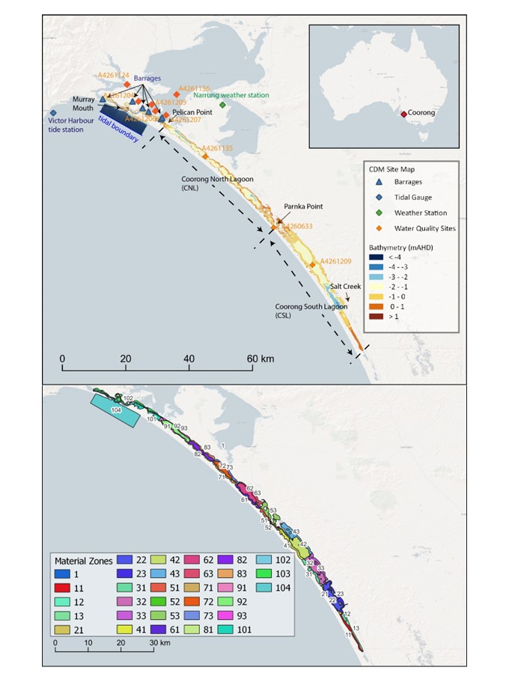
Figure C1. (upper panel) CDM model domain with bathymetry and site map for boundary inputs; and (lower panel) zonal definition of areas for sediment materials and model performance analysis.

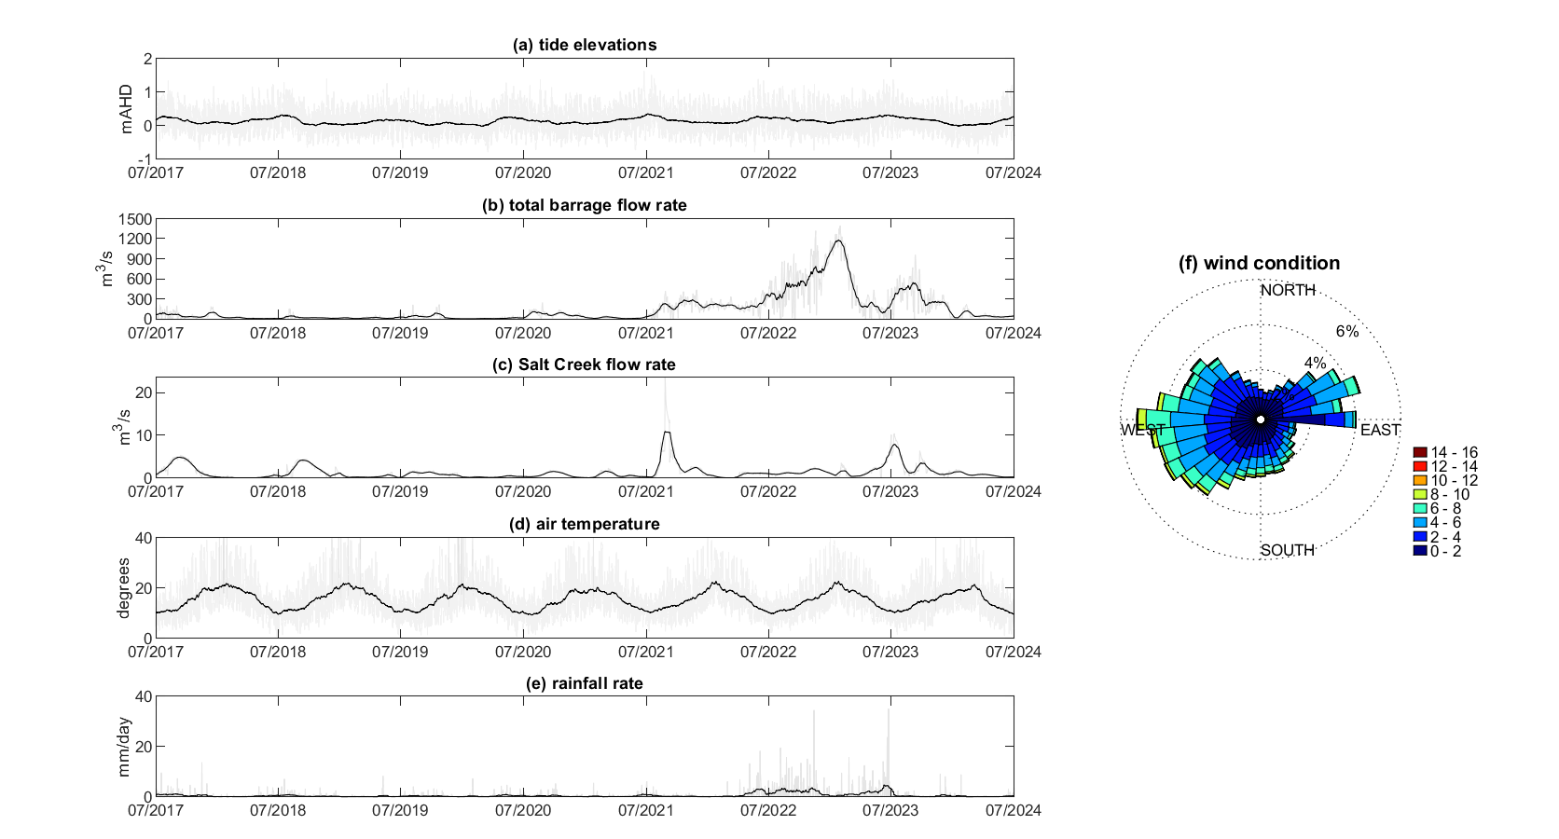
Figure C2. Overview of boundary conditions from July 2017 to June 2024. (a) Tidal elevations at Victor Harbor; (b) total barrage flow rate; (c) Salt Creek flow rate; (d) air temperature; (e) daily rainfall rate, and (f) rose-chart of wind conditions. The gray lines in figure (a) – (e) indicate the raw data and the dark lines indicate the monthly-average boundary conditions.

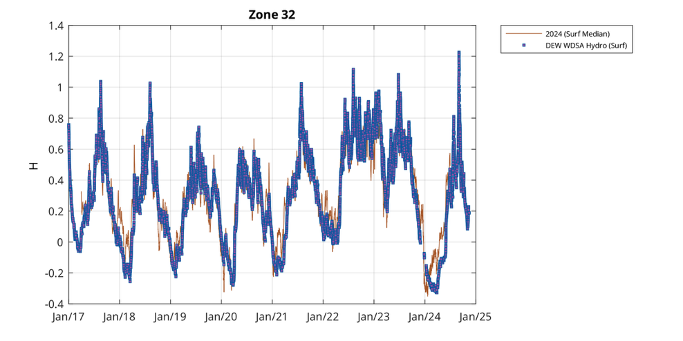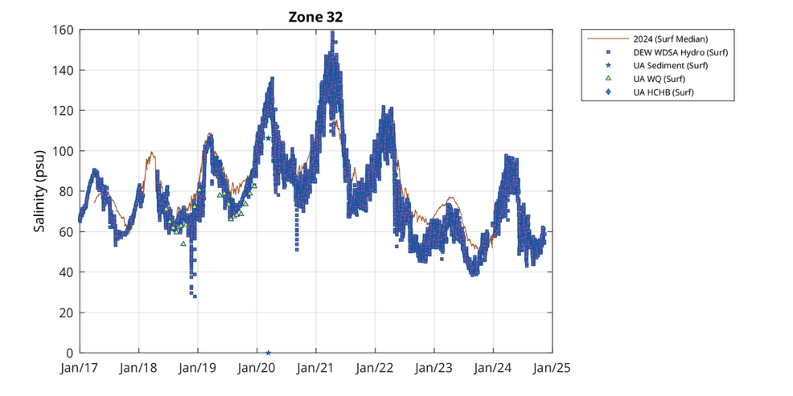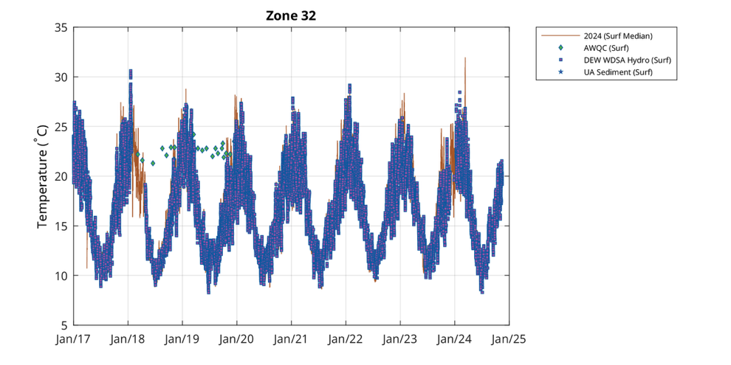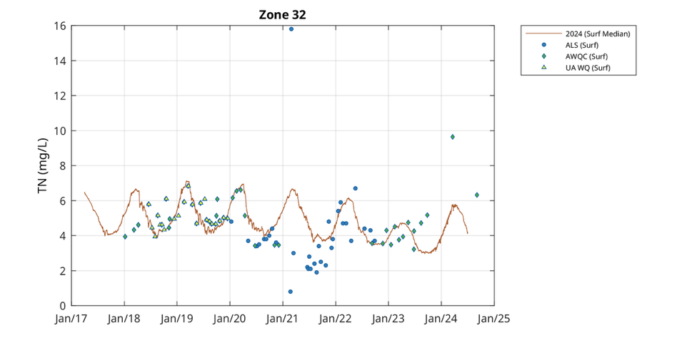
Figure C3. Example validation plots comparing conditions in the South Lagoon for water level (upper panel), salinity (second panel), temperature (third panel) and nitrogen (bottom panel), for the 7-year assessment period. See Table C1 for detailed error statistics.
Table C1. Coorong Dynamics Model performance summary.
The model outputs are validated against measured data on water elevation, salinity and temperature. R is the correlation coefficient. MAE is mean absolute error, a measure of errors between paired observations expressing the same phenomenon, i.e. the model and the monitored data. The bias is an estimation of the difference between these models expected value and the true value of the parameter being simulated (water elevation is mAHD).
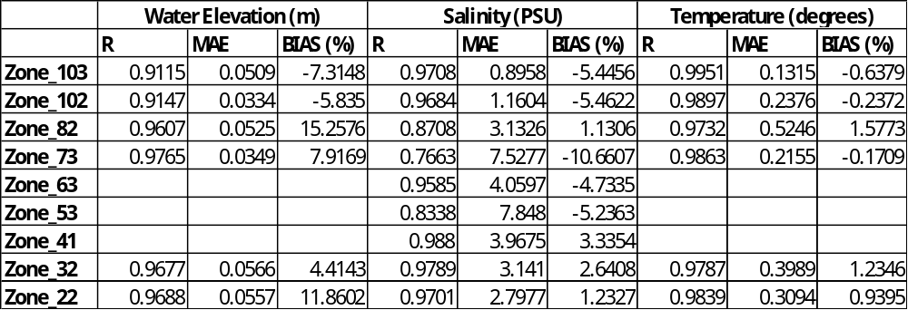

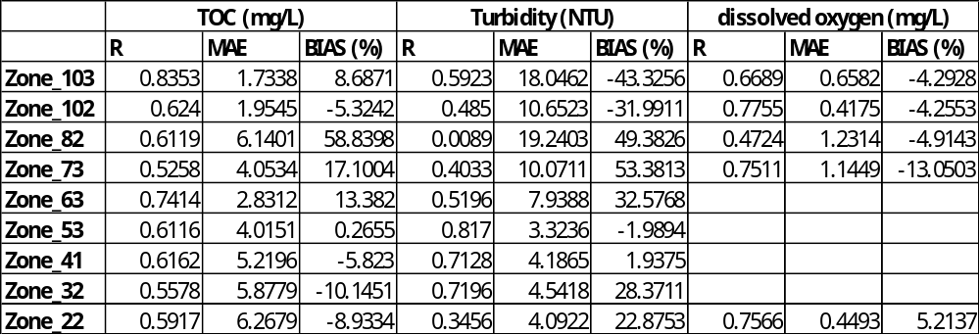

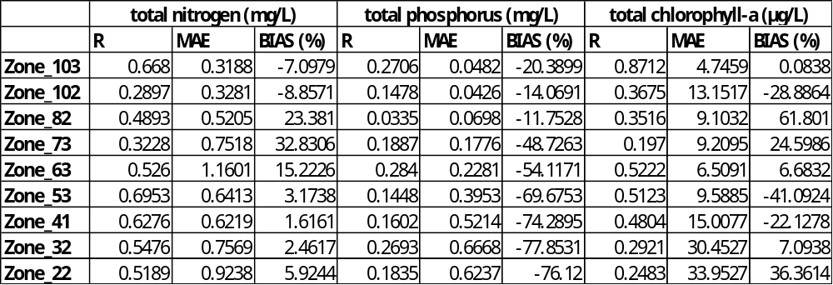

Table C2 shows the salt export and salinity data due to the contribution by Commonwealth environmental water reported in the previous annual report (Ye et al. 2023). The numbers reflect the most updated modelling approach in that evaluation year. Data reported for years 2014-15 to 2016-17 are from the large domain model previously used in the LTIM reporting (Ye et al. 2020). The numbers for 2017-18 to 2021-22 are from an updated model approach, incorporating the CDM model (Ye et al. 2023). The numbers for 2022-23 are from the current (2023-24) modelling approach, which uses a different salinity reference site in the middle of Lake Alexandrina, and utilises the most recent version of the barrage calculator for flow estimation. In previous annual reports, higher salinities were predicted to go through the barrage due to salt-water leakage through the barrages causing high salinities immediately upstream of the barrage structures that were not representative of the general river water flowing over the domain and leading to an overestimation of the salt delivered out of the wider basin.

Table C2. Matter Transport evaluation questions and answers from the previous annual report (e.g. Ye et al. 2024), prior to the remodeling of data in July 2025, using the updated model. This evaluation table presents annual values taken from those respective annual reports and does not reflect the model updates that have occurred since that year. CEW = Commonwealth environmental water.
CEWH evaluation questions |  | Outcomes of CEW delivery*
 |  | 14-15 | 15-16 | 16-17 | 17-18 | 18-19 | 19-20 | 20-21 | 21-22 | 22-23
What did CEW contribute to salinity: | Levels?  Reduction due to CEW (Median salinity presented, PSU)  At the Murray Mouth | From 34.6 to 24.0 | From 35.1 to 29.7 | From 21.6 to 11.3 | From 31.3 to 12.0 | From 35.8 to 18.9 | From 35.5 to 21.1 | From 33.9 to 13.2 | From 0.8 to 0.6 | From 0.220 (without CEW) to 0.218 (with CEW)
What did CEW contribute to salinity: | In the North Lagoon (Long Point) |  |  |  | From 39.7 to 20.8 | From 42.1 to 22.4 | From 35.7 to 15.4 | From 36.4 to 15.9 | From 10.7 to 7.3 | From 14.1 (without CEW) to 13.7 (with CEW)
What did CEW contribute to salinity: | In the South Lagoon (Woods Well) |  |  |  | From 80.9 to 77.0 | From 93.2 to 84.3 | From 96.7 to 85.4 | From 103.7 to 97.2* | From 88.0 to 85.3 | From 63.5 (without CEW) to 63.4 (with CEW)
What did CEW contribute to salinity: | Transport?  (tonnes salt per year) Additional export through the barrages due to CEW  (% of total salt export) | 285,064  (64%) | 251,632  (87%) | 120,867  (8%) | 685,354  (90%) | 782,742  (100%) | 677,122  (100%) | 601,890  (69%) | 596,979  (18%) | 151,252  (4.9%)
 | Reduction of salt import at the Murray Mouth | 3,044,70 | 4,591,269 | 519,292 | 3,773,721 | 5,114,634 | 3,994,755 | 4,351,454 | 570,010 | 117,688
 | Reduction of southward salt flux at the North Lagoon (LP) |  |  |  | 2,813,578 | 3,862,317 | 2,817,820 | 3,368,827 | 8,966 | -49,266
 | Reduction of southward salt flux at South Lagoon (PP) |  |  |  | 1,204,714 | 1,272,485 | 1,550,087 | 1,070,588 | 9,821 | -33,497
What did CEW contribute to the salinity regime? |  | CEW increased salt export through the barrages; and reduced salt intrusion into the Murray Mouth from the ocean, which reduced salinity in the Coorong. CEW played a key role in delivering flow to the Coorong from July 2017 to June 2021, particularly during dry years of 2018-19 and 2019-20 with up to 100% of barrage releases being CEW. CEW has played a key role in salt export from the Basin, however, salt export remains below the Basin Plan target of 2 million tonnes of salt per year except for 2022-23 (estimated ~3.1 million tonnes). In 2022-23, unregulated water dominated the barrage flows, and CEW contributed to 151,252 tonnes of salt export through the barrages which was 4.9% of all salt exported. CEW plays a significant role in reducing salt import through the Murray Mouth and reducing salt transport into the North and South lagoons of the Coorong in the low flow years (July 2017–June 2021) and has significant cumulative impact on the salinity over the last six years.
*Contribution (to what extent CEW contributed towards the outcome, with the significance of the outcome considered). For salinity levels, substantial, moderate, minor and negligible contributions, respectively, were considered to be reductions of: ≥15, 10–14, 5–9 and <5 PSU for the Murray Mouth; ≥10, 5–9, 2–4, and <2 PSU at the North Lagoon; and ≥5, 3–4, 1–2, and <1 PSU at the South Lagoon. For salt transport, contribution scores were based on the annual salinity export target of 2 million t: substantial = ≥500,000 (25%), moderate = 300,000–499,999, minor = 100,000–299,999 and negligible = <100,000 tonnes. Substantial contributions were also considered if CEW contributed >50% of total barrage flow. For reduction of salt import/southward flux, substantial, moderate, minor and negligible contributions, respectively, were considered to be reductions of: ≥3, 1–2.99, 0.5–0.99 and <0.5 million tonnes for the Murray Mouth; ≥2, 0.8–1.99, 0.2–0.79, and <0.2 million tonnes at the North Lagoon; and ≥1, 0.5–0.99, 0.1–0.49, and <0.1 million tonnes at the South Lagoon:
 | Unknown |  | Negative |  | None/negligible |  | Minor |  | Moderate |  | Substantial

Table C3. Summary of lethal concentration for 50% of the population, LC₅₀, and 10% of the population, LC₁₀ estimates of salinity (expressed as PSU) for seven species at 14°C (LC¹⁴) and 23°C (LC²³) temperatures used to inform the habitat suitability.
Common name | $${LC}_{50}^{14}$$ | $${LC}_{50}^{23}$$ | $${LC}_{10}^{14}$$ | $${LC}_{10}^{23}$$
Mulloway | 64 | 59 | 60 | 51
Tamar goby | 73 | 71 | 68 | 66
Black bream | 85 | 88 | 79 | 82
Greenback flounder | 88 | 79 | 81 | 73
Yelloweye mullet | 91 | 82.4* | 84 | 68
Congolli | 100 | 94 | 90 | 87
Smallmouth hardyhead | 108 |  | 100 | 97
*possibly affected by another unknown water quality factor.

Table C4. Fish habitat suitability functions based on salinity and temperature.
$HSI$ =$\left\{\frac{S_{c50}-S}{S_{c50}-S_{c10}}\begin{aligned}1, 0≤S<S_{c10} \\ ,S_{c10}≤S<S_{c50} \\ 0, S≥S_{c50}\end{aligned}\right.$ | where:  $S_{c10}^{}$ = $\left\{(\frac{{LC}_{10}^{23}-{LC}_{10}^{14}}{23-14})\left(T-14\right)+{LC}_{10}^{14}\begin{aligned}{LC}_{10}^{14}, 0≤T<14 \\ ,14≤T<23 \\ {LC}_{10}^{23}, T≥23\end{aligned}\right.$  $S_{c50}^{}$ = $\left\{(\frac{{LC}_{50}^{23}-{LC}_{50}^{14}}{23-14})\left(T-14\right)+{LC}_{50}^{14}\begin{aligned}{LC}_{50}^{14}, 0≤T<14 \\ ,14≤T<23 \\ {LC}_{50}^{23}, T≥23\end{aligned}\right.$
where:
S: salinity.
$S_{c50}^{}$: $L_{c50}^{}$ (concentration of salinity that kills 50% of the test animals).
$S_{c10}^{}$: $L_{c10}^{}$ (concentration of salinity that kills 10% of the test animals).
${LC}_{50}^{23}$ or ${LC}_{50}^{14}$: concentration of salinity that kills 50% of the test animals at 23°C or 14°C. Parameter values are based on Table C3.
${LC}_{10}^{23}$ or ${LC}_{10}^{14}$: concentration of salinity that kills 10% of the test animals at 23°C or 14°C. Parameter values are based on Table C3.
T: water temperature (monthly average to represent seasonal conditions).

Littoral Vegetation Diversity and Productivity
Table C5. GPS coordinates for the lowest elevation of each transect.
Reach | Transect | Latitude | Longitude
Lock 1 | 1 | -34.479019 | 139.596311
Lock 1 | 2 | -34.477575 | 139.598798
Lock 1 | 3 | -34.446681 | 139.609714
Lock 1 | 4 | -34.419635 | 139.613482
Lock 1 | 5 | -34.41855 | 139.61395
Lock 1 | 6 | -34.391968 | 139.619028
Lock 4 | 1 | -34.361848 | 140.565262
Lock 4 | 2 | -34.355854 | 140.576385
Lock 4 | 3 | -34.355763 | 140.568069
Lock 4 | 4 | -34.350657 | 140.562584
Lock 4 | 5 | -34.343043 | 140.553056
Lock 4 | 6 | -34.342492 | 140.554519
Lock 6 | 1 | -34.021533 | 140.867416
Lock 6 | 2 | -34.01918 | 140.876627
Lock 6 | 3 | -34.016288 | 140.88713
Lock 6 | 4 | -33.997601 | 140.879789
Lock 6 | 5 | -33.995581 | 140.880611
Lock 6 | 6 | -33.994623 | 140.882183

Table C6. Species list, functional classification, life history strategy, conservation status recorded in the June 2024 monitoring (state conservation status from listings in Barker et al. (2005) (*denotes exotic species, **denotes proclaimed pest plant in South Australia).
Species | Family | Status | Life history strategy/growth form | Functional Group
Acacia stenophylla | Fabaceae | Native | Perennial tree | Amphibious
Alternanthera denticulata | Amaranthaceae | Native | Annual herb | Flood dependent
Ammannia multiflora | Lythraceae | Native | Annual herb | Flood dependent
Apium graveolens* | Apiaceae | Exotic, Naturalised | Annual herb | Terrestrial
Atriplex suberecta | Chenoppodiaceae | Native | Annual herb | Flood dependent
Bolboschoenus caldwellii | Cyperaceae | Native | Perennial sedge | Emergent
Brachyscome paludicola | Asteraceae | Native | Annual herb | Flood dependent
Callistemon brachyandrus# | Myrtaceae | Native, Rare in South Australia | Perennial shrub | Amphibious
Centaurea calcitrapa* | Asteraceae | Exotic, Naturalised | Annual herb | Terrestrial
Centipeda minima | Asteraceae | Native | Annual herb | Flood dependent
Cyperus gymnocaulos | Cyperaceae | Native | Perennial sedge | Amphibious
Dittrichia graveolens* | Asteraceae | Exotic, Naturalised | Annual herb | Terrestrial
Duma florulenta | Polygonaceae | Native | Perennial shrub | Amphibious
Einadia nutans | Chenoppodiaceae | Native | Perennial sub-shrub | Terrestrial
Eleocharis acuta | Cyperaceae | Native | Perennial sedge | Emergent
Enchylaena tomentosa | Chenoppodiaceae | Native | Perennial sub-shrub | Terrestrial
Erigeron bonariensis* | Asteraceae | Exotic, Naturalised | Annual herb | Terrestrial
Eucalyptus camaldulensis | Myrtaceae | Native | Perennial tree | Amphibious
Euphorbia drummondii | Euphorbiaceae | Native | Annual herb | Flood dependent
Gazania rigens** | Asteraceae | Exotic, Declared Pest Plant in South Australia | Perrennial herb | Terrestrial
Glinus lotoides | Aizoaceae | Native | Annual herb | Flood dependent
Glycyrrhiza acanthocarpa | Fabaceae | Native | Annual herb | Flood dependent
Haloragis aspera | Haloragaceae | Native | Perennial herb | Flood dependent
Heliotropium curassavicum* | Boraginaceae | Exotic, Naturalised | Annual herb | Terrestrial
Heliotropium europaeum* | Boraginaceae | Exotic, Naturalised | Annual herb | Terrestrial
Isoetopsis graminifolia | Asteraceae | Native | Annual herb | Flood dependent
Isolepis australiensis | Cyperaceae | Native | Perrennial herb | Amphibious
Juncus usitatus | Juncaeae | Native | Perrennial rush | Amphibious
Lachnagrostis filiformis | Poaceae | Native | Annual grass | Flood dependent
Limosella australis | Scrophulariaceae | Native | Perrennial herb | Flood dependent
Ludwigia peploides | Onagraceae | Native | Perrennial herb | Amphibious
Lythrum hyssopifolia | Lythraceae | Native | Annual herb | Flood dependent
Maireana | Chenoppodiaceae | Native | Perennial sub-shrub | Terrestrial
Medicago* | Fabaceae | Exotic, Naturalised | Annual herb | Terrestrial
Melaleuca lanceolata | Myrtaceae | Native | Perennial tree | Terrestrial
Melilotus albus* | Fabaceae | Exotic, Naturalised | Annual herb | Terrestrial
Melilotus indicus* | Fabaceae | Exotic, Naturalised | Annual herb | Terrestrial
Myoporum montanum | Myoporaceae | Native | Perennial tree | Terrestrial
Myriophyllum papillosum# | Haloragaceae | Native, Rare in South Australia | Perrennial herb | Amphibious
Oxalis* | Oxalidaceae | Exotic, Naturalised | Perrennial herb | Terrestrial
Paspalidium jubiflorum | Poaceae | Native | Perrennial grass | Flood dependent
Paspalum distichum | Poaceae | Native | Perrennial grass | Amphibious
Persicaria lapathifolia | Polygonaceae | Native | Perrennial herb | Amphibious
Phragmites australis | Poaceae | Native | Perrennial grass | Emergent
Phyllanthus lacunarius | Euphorbiaceae | Native | Annual herb | Flood dependent
Picris angustifolia | Asteraceae | Native | Annual herb | Terrestrial
Polygonum plebeium | Polygonaceae | Native | Annual herb | Flood dependent
Pseudognaphalium luteoalbum | Asteraceae | Native | Annual herb | Flood dependent
Rhodanthe pygmaea | Asteraceae | Native | Annual herb | Flood dependent
Rorippa palustris* | Brassicaeae | Exotic, Naturalised | Annual herb | Flood dependent
Schoenoplectus pungens | Cyperaceae | Native | Perennial sedge | Amphibious
Schoenoplectus tabernaemontani | Cyperaceae | Native | Perennial sedge | Emergent
Sclerolaena divaricata | Chenoppodiaceae | Native | Perennial sub-shrub | Terrestrial
Senecio cunninghamii | Asteraceae | Native | Perennial shrub | Flood dependent
Senecio runcinifolius | Asteraceae | Native | Perrennial herb | Flood dependent
Silene nocturna* | Caryophyllaceae | Exotic, Naturalised | Annual herb | Terrestrial
Sphaeromorphaea australis | Asteraceae | Native | Annual herb | Flood dependent
Sporobolus mitchellii | Poaceae | Native | Perrennial grass | Flood dependent
Stemodia florulenta | Scrophulariaceae | Native | Perrennial herb | Flood dependent
Symphyotrichum subulatum* | Asteraceae | Exotic, Naturalised | Annual herb | Flood dependent
Teucrium racemosum | Lamiaceae | Native | Perrennial herb | Flood dependent
Typha domingensis | Typhaeae | Native | Perennial sedge | Emergent
Wahlenbergia fluminalis | Campanulaceae | Native | Annual herb | Flood dependent
Xanthium occidentale** | Asteraceae | Exotic, Declared Pest Plant in South Australia | Annual herb | Amphibious

Table C7. Response to inundation for each functional group.
Functional Group | Inundation Response
Terrestrial | Intolerant of either partial or complete inundation
Flood dependent | Intolerant of complete inundation as mature or juvenile plants but germinate on newly exposed soil after inundation but not in response to rainfall. Many of these species are short-lived annuals that take advantage of the bare soil (lack of competition) and high soil moisture after inundation and can complete their life cycle in a matter of weeks (Nicol 2004)
Amphibious | Requires fluctuating water levels and are adapted to survive inundation and exposure as juvenile or adult plants. Brock and Casanova (1997) split this group into five different groups based on their anatomical responses to inundation; however, they all have similar water regime requirements
Emergent | Have a requirement for permanent shallow water or continuous high soil moisture in the root zone to survive. Unlike amphibious species these species are well adapted to static water levels and can displace amphibious species under these conditions

Table C8. PERMANOVA results comparing the plant community in each inundation zone over the study period for each reach.
 | Lock 1
Factor | DF | Pseudo-F | P
Year | 2,111 | 6.11 | 0.001
Inundation zone | 3,111 | 3.6 | 0.001
Year x Inundation zone | 6,111 | 1.57 | 0.013
 | Lock 4
Factor | DF | Pseudo-F | P
Year | 2,107 | 8.74 | 0.001
Inundation zone | 3,107 | 2.5 | 0.003
Year x Inundation zone | 6,107 | 1.87 | 0.006
 | Lock 6
Factor | DF | Pseudo-F | P
Year | 2,113 | 7.34 | 0.001
Inundation zone | 3,113 | 6.34 | 0.001
Year x Inundation zone | 6,113 | 3.86 | 0.001

Table C9. Indicator Species Analysis results comparing plant community in each inundation zone downstream of a. Lock 1, b. Lock 4 and c. Lock 6 in June 2024, * denotes exotic species, ** denotes declared pest plant in South Australia, bolded rows denote significant indicators; blue highlighting denotes not significant but exclusive to the Pool level and Inundated zones.
a.
Species | Zone | P
Acacia stenophylla | Inundation extent | 0.3327
Alternanthera denticulata | Inundation extent | 0.4847
Ammannia multiflora | Pool level | 0.3331
Bare soil | Pool level | 0.121
Bolboschoenus caldwellii | Pool level | 0.3461
Brachyscome paludicola | Not inundated | 0.0032
Calotis cuneifolia | Inundation extent | 0.5913
Calotis hispidula | Not inundated | 1
Centaurea calcitrapa* | Inundation extent | 0.2765
Centipeda cunninghamii | Not inundated | 0.2394
Cyperus gymnocaulos | Not inundated | 0.9068
Duma florulenta | Not inundated | 0.5749
Eucalyptus camaldulensis | Not inundated | 0.0382
Euphorbia drummondii | Not inundated | 0.8694
Heliotropium curassavicum* | Inundation extent | 0.4045
Hypochaeris glabra | Not inundated | 1
Lachnagrostis filiformis | Not inundated | 0.1674
Lactuca saligna | Inundation extent | 0.7117
Ludwigia peploides | Pool level | 0.3461
Medicago* | Pool level | 0.4071
Melilotus albus* | Inundation extent | 0.4929
Paspalum distichum | Not inundated | 0.1072
Phragmites australis | Inundation extent | 0.8042
Pseudognaphalium luteoalbum | Inundation extent | 0.0282
Reichardia tingitana | Inundation extent | 0.7075
Rorippa palustris* | Inundated | 1
Rumex bidens | Not inundated | 1
Senecio runcinifolius | Not inundated | 1
Sphaeromorphaea australis | Pool level | 0.1806
Sporobolus mitchellii | Not inundated | 0.036
Stemodia florulenta | Inundated | 0.966
Symphyotrichum subulatum* | Not inundated | 0.0354
Teucrium racemosum | Not inundated | 0.234
Trachymene cyanopetala | Pool level | 0.3281
Trifolium | Inundated | 0.873
Unknown | Not inundated | 1
Wahlenbergia fluminalis | Not inundated | 0.01

b.
Species | Zone | P
Alternanthera denticulata | Inundation extent | 0.0778
Ammannia multiflora | Inundated | 1
Atriplex lindleyi | Inundation extent | 0.3497
Bare soil | Pool level | 0.002
Bolboschoenus caldwellii | Inundated | 0.1614
Brachyscome paludicola | Not inundated | 0.3187
Calotis cuneifolia | Not inundated | 0.1454
Centipeda cunninghamii | Inundation extent | 0.3675
Cyperus gymnocaulos | Inundation extent | 0.0776
Dysphania pumilio | Inundation extent | 0.7089
Einadia nutans | Not inundated | 1
Eucalyptus camaldulensis | Inundated | 0.1522
Euchiton involucratus | Inundated | 0.5641
Heliotropium curassavicum* | Inundation extent | 0.4815
Isolepis australiensis | Inundated | 1
Juncus usitatus | Not inundated | 0.1444
Lactuca saligna | Inundation extent | 0.3497
Ludwigia peploides | Inundation extent | 0.3351
Mollugo cerviana | Inundation extent | 0.3395
Paspalum distichum | Not inundated | 1
Persicaria lapathifolia | Inundation extent | 0.4811
Pseudognaphalium luteoalbum | Inundation extent | 0.072
Rorippa palustris* | Inundation extent | 0.7173
Rumex bidens | Not inundated | 1
Senecio runcinifolius | Not inundated | 1
Solanum nigrum* | Inundation extent | 0.3497
Sphaeromorphaea australis | Inundation extent | 0.1742
Stemodia florulenta | Not inundated | 0.1336
Symphyotrichum subulatum* | Not inundated | 1
Unknown | Not inundated | 1
Wahlenbergia fluminalis | Inundation extent | 0.3579
c.
Species | Zone | P
Alternanthera denticulata | Not inundated | 0.2412
Ammannia multiflora | Inundated | 0.2795
Atriplex suberecta | Not inundated | 1
Bare soil | Pool level | 0.0002
Bolboschoenus caldwellii | Not inundated | 0.2496
Calotis cuneifolia | Not inundated | 1
Centipeda cunninghamii | Inundation extent | 0.0038
Cyperus difformis | Inundation extent | 0.3417
Cyperus gymnocaulos | Inundation extent | 0.0686
Dysphania pumilio | Not inundated | 0.2591
Eragrostis dielsii | Inundation extent | 0.3417
Erigeron bonariensis* | Inundation extent | 0.4935
Eucalyptus camaldulensis | Inundated | 0.0028
Euchiton involucratus | Inundated | 0.0156
Euphorbia drummondii | Not inundated | 0.2547
Glinus lotoides | Not inundated | 0.2531
Glycyrrhiza acanthocarpa | Not inundated | 1
Heliotropium curassavicum* | Inundation extent | 0.1232
Hypochaeris glabra | Not inundated | 1
Isolepis australiensis | Not inundated | 1
Juncus usitatus | Inundation extent | 0.5931
Lachnagrostis filiformis | Inundation extent | 0.3253
Lactuca saligna | Not inundated | 1
Ludwigia peploides | Not inundated | 0.3891
Lysimachia arvensis* | Not inundated | 1
Lythrum hyssopifolia | Inundated | 0.1468
Nicotiana velutina | Not inundated | 1
Paspalum distichum | Not inundated | 0.2569
Persicaria lapathifolia | Not inundated | 1
Polygonum plebeium | Inundation extent | 0.3417
Pseudognaphalium luteoalbum | Not inundated | 0.4211
Reichardia tingitana* | Not inundated | 1
Ricciocarpus natans | Inundated | 0.1376
Rorippa palustris* | Not inundated | 1
Senecio cunninghamii | Not inundated | 1
Senecio runcinifolius | Not inundated | 1
Solanum nigrum* | Not inundated | 1
Sphaeromorphaea australis | Inundated | 0.16
Sporobolus mitchellii | Inundated | 1
Stemodia florulenta | Inundation extent | 0.0572
Symphyotrichum subulatum* | Inundation extent | 0.774
Teucrium racemosum | Not inundated | 1
Wahlenbergia fluminalis | Not inundated | 0.2549
Xanthium occidentale** | Not inundated | 0.2503

Table C10. PERMANOVA results comparing plant community in each inundation zone in each reach in June 2024.
Factor | DF | Pseudo-F | P
Reach | 2, 107 | 10.26 | 0.001
Inundation zone | 3, 107 | 8.20 | 0.001
Reach x Inundation zone | 6, 107 | 2.11 | 0.004

Table C11. PERMANOVA multiple comparisons comparing the plant community in each inundation zone for a) the reach downstream of Lock 1, b) downstream of Lock 4 and c) downstream of Lock 6 in June 2024.
a.
Inundation extent | 0.041
Inundated | 0.013 | 0.479
Pool level | 0.003 | 0.026 |  | 0.033
 | Not inundated | Inundation extent |  | Inundated
b.
Inundation extent | 0.862
Inundated | 0.219 | 0.401
Pool level | 0.003 | 0.037 | 0.007
 | Not inundated | Inundation extent | Inundated
c.
Inundation extent | 0.860
Inundated | 0.008 | 0.030
Pool level | <0.001 | <0.001 | <0.001
 | Not inundated | Inundation extent | Inundated

Table C12. PERMANOVA results comparing above ground biomass in each inundation zone in each reach in June 2024.
Factor | DF | Pseudo F | P
Reach | 2, 107 | 0.44 | 0.622
Inundation zone | 3, 107 | 8.70 | 0.001
Reach x Inundation zone | 6, 107 | 0.64 | 0.709

a.
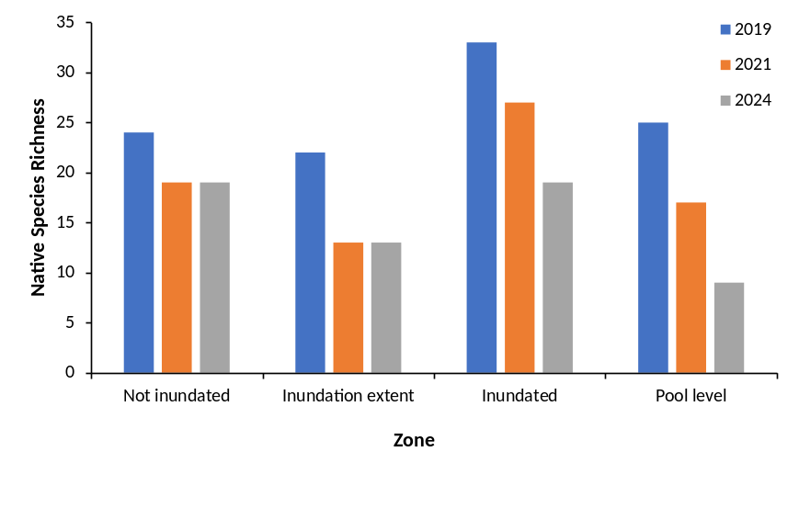
b.
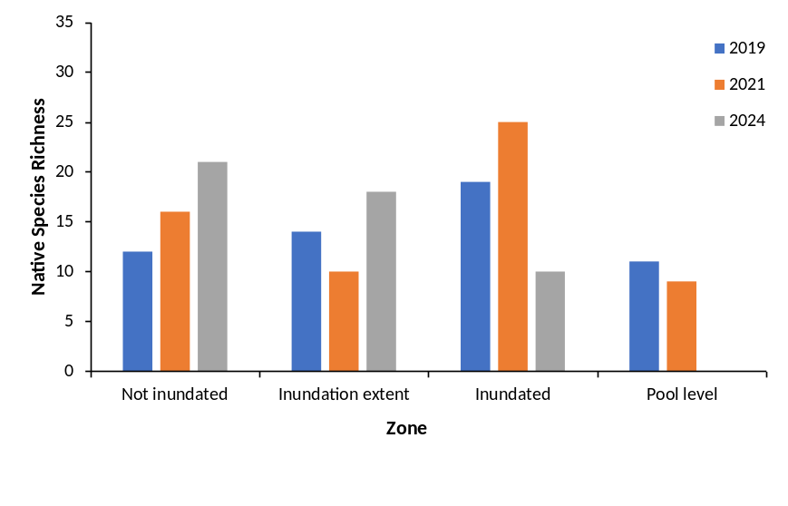
c.
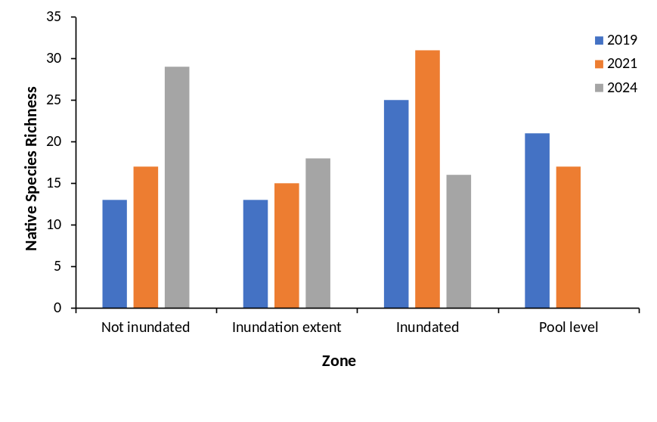
Figure C4. Native species richness in each inundation zone over the study period for a. Lock 1, b. Lock 4 and c. Lock 6.

a.
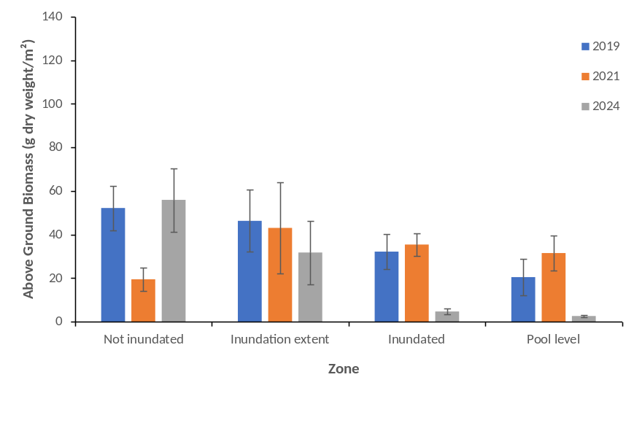
b.
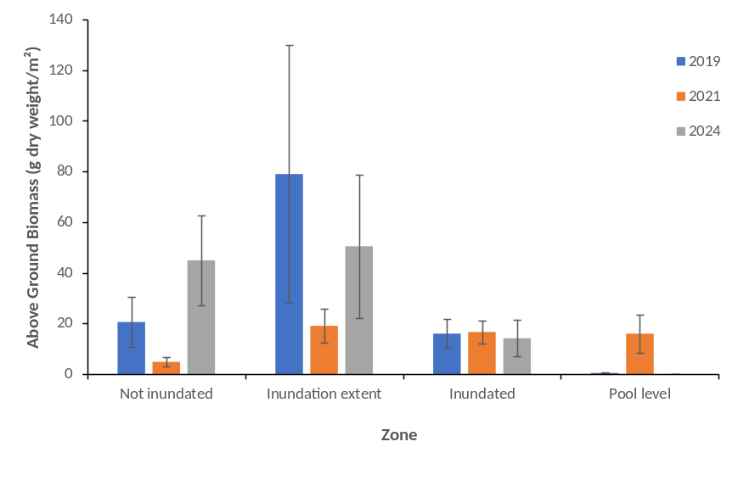
c.
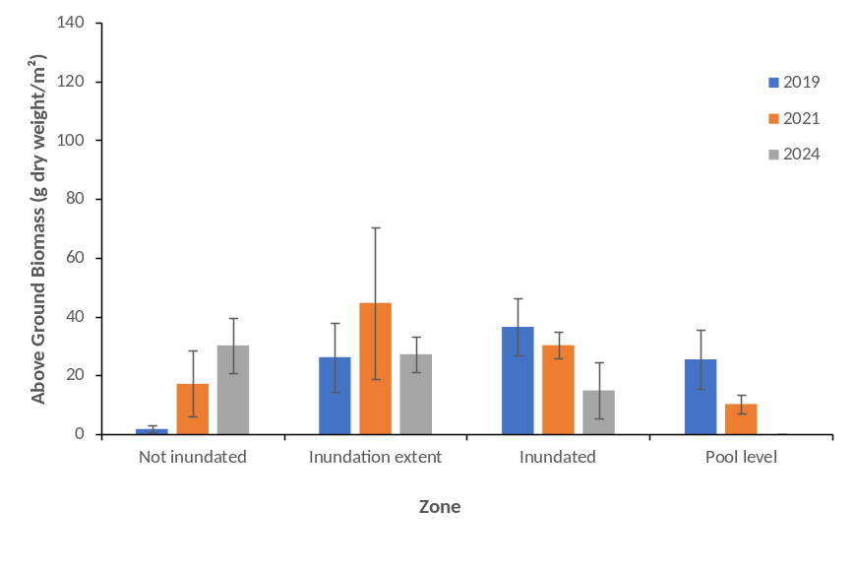
Figure C5. Above ground biomass in each inundation zone over the study period for a. Lock 1, b. Lock 4 and c. Lock 6 (error bars ± 1 S.E.).
Microinvertebrate assemblage – statistical outputs
Table C13. Results of negative binomial generalised linear model for microinvertebrate density (individuals per litre) showing selected predictors, estimated coefficients (Estimate), standard errors in estimation (std.Error) and Type I Error probability (p-value). Flow data were log transformed prior to modelling. AveQ90 is the average flow over the previous 90 days. FPA60 quantifies the area of floodplain inundated over the last 60 days. (see Methods for full description of predictor calculation). Negative binomial distribution dispersion parameter (theta) = 3.35 , standard error = 0.27.
Predictor | Estimate | Std. Error | p-value
(Intercept) | -3.67 | 10.73 | 0.732
Month [Oct] | 0.35 | 0.30 | 0.240
Month [Nov] | 0.45 | 0.35 | 0.201
Month [Dec] | 0.62 | 0.38 | 0.104
Month [Jan] | 1.01 | 0.41 | 0.014
Water year [2015] | -0.04 | 0.14 | 0.759
Water year [2016] | -0.30 | 0.45 | 0.496
Water year [2017] | -0.22 | 0.16 | 0.171
Water year [2019] | 0.26 | 0.25 | 0.303
Water year [2020] | 0.07 | 0.20 | 0.725
Water year [2021] | 0.35 | 0.39 | 0.362
Water year [2022] | 0.58 | 0.54 | 0.278
Water year [2023] | 0.83 | 0.41 | 0.042
Mean daily flow (ML/d) | -0.81 | 0.97 | 0.403
Long-term average flow (AveQ90) | 3.47 | 1.66 | 0.036
Temperature | 0.11 | 0.19 | 0.551
Electrical conductivity (EC) | -0.06 | 0.02 | 0.001
FPA60 | -7.9e-04 | 2.7e-04 | 0.004
Mean daily flow:AveQ90 | -0.20 | 0.11 | 0.058
Mean daily flow:Temperature | 0.15 | 0.04 | < 0.001
Mean daily flow:Salinity | -3.3e-03 | 2.0e-03 | 0.099
Mean daily flow:FPA60 | 1.2e-04 | 3.1e-05 | < 0.001
AveQ90:Temperature | -0.15 | 0.04 | < 0.001
AveQ90:EC | 9.7e-03 | 2.6e-03 | < 0.001
EC:FPA60 | -2.5e-06 | 5.4e-07 | < 0.001

Table C14. Results of Gaussian microinvertebrate taxonomic richness generalised linear model, showing selected predictors, estimated coefficients (Estimate), standard error in the coefficient estimate (std. Error) and Type I error probability (p-value). Flow data were log transformed prior to modelling. AveQ90 is the average flow over the previous 90 days. FPA60 quantifies the area of floodplain inundated over the last 60 days. (see Methods for full description of predictor calculation). Gaussian distribution Shapiro-Wilk test W = 0.99, p-value = 0.17.
Predictor | Estimate | Std. Error | p-value
(Intercept) | -130.7 | 72.10 | 0.071
Average abundance | 3.8e-03 | 3.5e-04 | < 0.001
Water year [2015] | 1.04 | 0.91 | 0.254
Water year [2016] | 3.46 | 2.74 | 0.208
Water year [2017] | -2.01 | 1.00 | 0.045
Water year [2019] | -1.40 | 1.41 | 0.322
Water year [2020] | -0.70 | 1.30 | 0.594
Water year [2021] | -2.81 | 2.37 | 0.236
Water year [2022] | 9.88 | 3.47 | 0.005
Water year [2023] | -0.07 | 2.58 | 0.979
Mean daily flow (ML/d) | -11.53 | 6.26 | 0.067
Long-term average flow (AveQ90) | 45.42 | 11.09 | < 0.001
Temperature | -1.59 | 1.28 | 0.218
Electrical conductivity (EC) | -0.04 | 9.97e-03 | < 0.001
10-day flow trend (dQ10) | 58.69 | 14.56 | < 0.001
FPA60 | 4.3e-04 | 2.8e-03 | 0.879
Mean daily flow:AveQ90 | -2.16 | 0.69 | 0.002
Mean daily flow:Temperature | 1.24 | 0.24 | < 0.001
Mean daily flow:dQ10 | 2.86 | 1.64 | 0.082
Mean daily flow:FPA60 | 1.2e-03 | 3.9e-04 | 0.002
AveQ90:Temperature | -0.94 | 0.27 | < 0.001
AveQ90:dQ10 | -9.46 | 2.08 | < 0.001
AveQ90:FPA60 | -9.9e-04 | 4.2e-04 | 0.018
Temperature:FPA60 | -1.2e-04 | 7.4e-05 | 0.102
dQ10:FPA60 | 1.7e-03 | 8.6e-04 | 0.045

Table C15. Results of negative binomial generalised linear model for microinvertebrate density (individuals per litre) of taxa dependent upon lateral connectivity showing selected predictors, estimated coefficients (Estimate), standard errors in estimation (std.Error) and Type I Error probability (p-value Flow data were log transformed prior to modelling. AveQ90 is the average flow over the previous 90 days. FPA28 quantifies the area of floodplain inundated over the last 28 days. (see Methods for full description of predictor calculation). Negative binomial distribution dispersion parameter (theta) = 1.59, standard error = 0.15.
Predictor | Estimate | Std. Error | p-value
(Intercept) | -23.82 | 15.95 | 0.135
Water year [2015] | -0.54 | 0.23 | 0.017
Water year [2016] | 2.62 | 0.71 | < 0.001
Water year [2017] | -0.35 | 0.24 | 0.142
Water year [2019] | -1.26 | 0.42 | 0.003
Water year [2020] | -0.35 | 0.32 | 0.263
Water year [2021] | 1.38 | 0.62 | 0.025
Water year [2022] | 3.45 | 0.86 | < 0.001
Water year [2023] | 1.54 | 0.64 | 0.016
Lock 4 | 0.25 | 0.20 | 0.209
Lock 6 | -1.79 | 0.32 | < 0.001
Month [Oct] | 1.10 | 0.44 | 0.013
Month [Nov] | 0.15 | 0.53 | 0.783
Month [Dec] | 0.52 | 0.58 | 0.375
Month [Jan] | 0.28 | 0.64 | 0.663
Mean daily flow (ML/d) | 6.00 | 1.40 | < 0.001
Long-term average flow (AveQ90) | 6.54 | 1.86 | < 0.001
Temperature | -0.90 | -0.27 | < 0.001
Electrical conductivity (EC) | -0.11 | 0.02 | < 0.001
10-day flow trend (dQ10) | -9.39 | 2.63 | < 0.001
FPA28 | -5.7e-03 | 1.2e-03 | < 0.001
Mean daily flow: AveQ90 | -1.00 | 0.17 | < 0.001
Mean daily flow:EC | 0.01 | 2.2e-03 | < 0.001
Mean daily flow:dQ10 | 0.91 | 0.35 | 0.009
Mean daily flow:FPA28 | 4.9e-04 | 1.1e-04 | < 0.001
AveQ90:Temperature | 0.09 | 0.03 | 0.002
Temperature:dQ10 | 0.11 | 0.07 | 0.104
dQ10:FPA28 | -6.3e-04 | 3.5e-04 | 0.069

Table C16. Results of negative binomial generalised linear model for microinvertebrate density (individuals per litre) of taxa dependent upon longitudinal connectivity showing selected predictors, estimated coefficients (Estimate), standard errors in estimation (std.Error) and Type I Error probability (p-value). Flow data were log transformed prior to modelling. AveQ90 is the average flow over the previous 90 days (see Methods for full description of predictor calculation). Negative binomial distribution dispersion parameter (theta) = 2.97, standard error = 0.24.
Predictor | Estimate | Std. Error | p-value
(Intercept) | -54.38 | 38.56 | 0.158
Lock 4 | 0.31 | 0.13 | 0.016
Lock 6 | 0.45 | 0.12 | < 0.001
Month [Oct] | 90.63 | 37.40 | 0.015
Month [Nov] | 99.67 | 37.48 | 0.009
Month [Dec] | 97.77 | 37.44 | 0.009
Month [Jan] | 97.27 | 37.48 | 0.009
Mean daily flow (ML/d) | 13.22 | 3.69 | < 0.001
Long-term average flow (AveQ90) | -8.51 | 1.43 | < 0.001
Temperature | -1.16 | 0.37 | 0.001
Electrical conductivity (EC) | -0.05 | 0.02 | 0.041
10-day flow trend (dQ10) | 9.46 | 5.22 | 0.070
Month [Oct]: Mean daily flow | -13.56 | 3.66 | < 0.001
Month [Nov]: Mean daily flow | -11.64 | 3.63 | 0.001
Month [Dec]: Mean daily flow | -11.61 | 3.65 | 0.001
Month [Jan]: Mean daily flow | -9.55 | 3.63 | 0.009
Month [Oct]: AveQ90 | 5.38 | 0.67 | < 0.001
Month [Nov]: AveQ90 | 2.71 | 0.45 | < 0.001
Month [Dec]: AveQ90 | 2.72 | 0.48 | < 0.001
Month [Oct]: Temperature | -0.08 | 0.13 | 0.548
Month [Nov]: Temperature | -0.365 | 0.11 | 0.001
Month [Dec]: Temperature | -0.26 | 0.11 | 0.024
Month [Oct]: EC | -0.02 | 4.4e-03 | < 0.001
Month [Nov]: EC | 1.5e-03 | 3.0e-03 | 0.625
Month [Dec]: EC | -4.3e-03 | 2.2e-03 | 0.052
Month [Oct]: dQ10 | -0.92 | 1.23 | 0.454
Month [Nov]: dQ10 | 0.78 | 0.75 | 0.297
Month [Dec]: dQ10 | 0.81 | 0.64 | 0.207
Mean daily flow:EC | -4.4e-03 | 2.8e-03 | 0.117
Mean daily flow:dQ10 | -0.99 | 0.39 | 0.012
AveQ90:Temperature | 0.16 | 0.04 | < 0.001
AveQ90:EC | 0.01 | 3.9e-03 | 0.016
AveQ90:dQ10 | 0.86 | 0.48 | 0.074
Temperature: dQ10 | -0.45 | 0.17 | 0.011
EC: dQ10 | 0.01 | 4.3e-03 | 0.096

Table C17. Results of negative binomial generalised linear model for spring microinvertebrate prey-species density (individuals per litre) showing selected predictors, estimated coefficients (Estimate), standard errors in estimation (std.Error) and Type I Error probability (p-value). Flow data were log transformed prior to modelling. AveQ90 is the average flow over the previous 90 days. FPA60 quantifies the area of floodplain inundated over the last 60 days (see Methods for full description of predictor calculation). Negative binomial distribution dispersion parameter (theta) = 1.57, standard error = 0.15.
Predictor | Estimate | Std. Error | p-value
(Intercept) | -32.89 | 17.05 | 0.054
Lock 4 | 0.29 | 0.20 | 0.153
Lock 6 | -1.96 | 0.37 | < 0.001
Water year [2015] | -0.56 | 0.23 | 0.015
Water year [2016] | 2.25 | 0.71 | 0.002
Water year [2017] | -0.31 | 0.24 | 0.197
Water year [2019] | -1.06 | 0.42 | 0.012
Water year [2020] | -0.30 | 0.32 | 0.346
Water year [2021] | 1.13 | 0.62 | 0.067
Water year [2022] | 2.94 | 0.86 | < 0.001
Water year [2023] | 1.10 | 0.64 | 0.088
Month [Oct] | 0.98 | 0.45 | 0.027
Month [Nov] | -0.03 | 0.53 | 0.948
Month [Dec] | 0.33 | 0.59 | 0.570
Month [Jan] | 0.03 | 0.65 | 0.961
Mean daily flow (ML/d) | 5.92 | 1.44 | < 0.001
Long-term average flow (AveQ90) | 7.64 | 2.06 | < 0.001
Temperature | -0.66 | 0.28 | 0.018
Electrical conductivity (EC) | -0.11 | 0.02 | < 0.001
10-day flow trend (dQ10) | -9.51 | 2.67 | < 0.001
FPA60 | -3.1e-03 | 7.2e-04 | < 0.001
Mean daily flow:AveQ90 | -1.01 | 0.18 | < 0.001
Mean daily flow:EC | 0.01 | 2.2e-03 | < 0.001
Mean daily flow:dQ10 | 0.93 | 0.35 | 0.007
Mean daily flow:FPA60 | 2.5e-04 | 6.2e-05 | < 0.001
AveQ90:Temperature | 0.07 | 0.03 | 0.025
Temperature:dQ10 | 0.11 | 0.07 | 0.101
dQ10:FPA60 | -3.1e-04 | 1.7e-04 | 0.063

Fish indicators – statistical outputs
Table C18. PERMANOVA pairwise comparison test results for golden perch electrofishing abundance (individuals per 90 second shot) in the gorge geomorphic zone (10 sites) of the Lower Murray River in autumn from 2015–2024. P-values presented in bold are significant comparisons, using Bonferroni corrected α = 0.0011 (Narum 2006) for comparisons between years (forty-five comparisons).
Comparison | t | P (perm)
2015, 2016 | 0.2726 | 0.8141
2015, 2017 | 1.4563 | 0.1764
2015, 2018 | 0.8253 | 0.4366
2015, 2019 | 3.6323 | 0.0014
2015, 2020 | 3.5222 | 0.0022
2015, 2021 | 2.0927 | 0.0574
2015, 2022 | 0.0641 | 0.9699
2015, 2023 | 3.9802 | 0.0014
2015, 2024 | 3.2609 | 0.0057
2016, 2017 | 1.6998 | 0.1188
2016, 2018 | 0.6930 | 0.5156
2016, 2019 | 4.7217 | 0.0005
2016, 2020 | 4.3351 | 0.0012
2016, 2021 | 2.3178 | 0.0363
2016, 2022 | 0.2541 | 0.8229
2016, 2023 | 4.6281 | 0.0005
2016, 2024 | 3.8694 | 0.0023
2017, 2018 | 0.8086 | 0.4484
2017, 2019 | 2.1526 | 0.0591
2017, 2020 | 1.8277 | 0.1123
2017, 2021 | 0.1913 | 0.8587
2017, 2022 | 0.9762 | 0.3724
2017, 2023 | 2.2180 | 0.0479
2017, 2024 | 1.4777 | 0.1824
2018, 2019 | 2.8114 | 0.0125
2018, 2020 | 2.7290 | 0.0184
2018, 2021 | 1.2362 | 0.2414
2018, 2022 | 0.6573 | 0.5468
2018, 2023 | 3.2848 | 0.0059
2018, 2024 | 2.4738 | 0.0271
2019, 2020 | 0.2371 | 0.8720
2019, 2021 | 1.8870 | 0.0886
2019, 2022 | 2.3209 | 0.0223
2019, 2023 | 1.5146 | 0.1641
2019, 2024 | Negative | N/A
2020, 2021 | 1.8059 | 0.0936
2020, 2022 | 2.3355 | 0.0210
2020, 2023 | 1.2108 | 0.2666
2020, 2024 | 0.1701 | 0.9113
2021, 2022 | 1.4708 | 0.1713
2021, 2023 | 2.5481 | 0.0235
2021, 2024 | 1.5108 | 0.1675
2022, 2023 | 2.7940 | 0.0083
2022, 2024 | 2.2208 | 0.0320
2023, 2024 | 1.2612 | 0.2416

Table C19. Cohorts of golden perch and silver perch (excluding larvae) collected from the Lower Murray River from 2015–2024 that were analysed for natal origin and migration history.
 | Species
Spawn year | Golden perch | Silver perch
1996/97 | 15 | 0
2000/01 | 8 | 0
2005/06 | 9 | 0
2009/10 | 46 | 8
2010/11 | 56 | 9
2011/12 | 41 | 6
2012/13 | 20 | 3
2013/14 | 26 | 15
2014/15 | 1 | 4
2015/16 | 0 | 1
2016/17 | 17 | 10
2017/18 | 6 | 1
2018/19 | 15 | 2
2019/20 | 1 | 2
2020/21 | 12 | 6
2021/22 | 55 | 6
2022/23 | 19 | 0
2023/24 | 4 | 4

Table C20. Results of the model selection procedure for linear regression models fitted to Murray cod length–weight reference data (2004–2024).
Model | AICc | Npar | ∆AICc | Likelihood
Exponential | 380.4888 | 2 | 553.7537 | <0.001
Linear | 1765.565 | 3 | 1938.8299 | 0
Cubic | -173.2649 | 5 | 0 | 1
Quadratic | 200.4627 | 6 | 373.7276 | <0.001

Table C21. PERMANOVA pairwise comparisons of the relative condition index (Krel) of YOY Murray cod between years (weir pools pooled). P-values presented in bold are significant comparisons (α = 0.05).
Comparison | t | p value
2015, 2016 | 2.7466 | 0.0097
2015, 2017 | 0.5474 | 0.5789
2015, 2018 | 1.2836 | 0.2235
2015, 2019 | 1.1412 | 0.2661
2015, 2020 | 3.4543 | 0.0012
2015, 2021 | 0.7592 | 0.4616
2015, 2023 | 1.8736 | 0.0727
2015, 2024 | 2.4963 | 0.0257
2016, 2017 | 2.7151 | 0.0142
2016, 2018 | 0.9046 | 0.3723
2016, 2019 | 2.1638 | 0.0395
2016, 2020 | 1.0112 | 0.3195
2016, 2021 | 1.7305 | 0.1040
2016, 2023 | 5.1005 | 0.0001
2016, 2024 | 0.2754 | 0.7897
2017, 2018 | 1.4051 | 0.1808
2017, 2019 | 1.5062 | 0.1384
2017, 2020 | 3.0597 | 0.0046
2017, 2021 | 1.1104 | 0.2872
2017, 2023 | 0.8785 | 0.3895
2017, 2024 | 2.5763 | 0.0286
2018, 2019 | 0.6636 | 0.5162
2018, 2020 | 1.8399 | 0.0718
2018, 2021 | 0.5684 | 0.5907
2018, 2023 | 2.8469 | 0.0076
2018, 2024 | 0.8453 | 0.4072
2019, 2020 | 3.6359 | 0.0004
2019, 2021 | 0.1478 | 0.8833
2019, 2023 | 3.3183 | 0.0029
2019, 2024 | 1.8470 | 0.0781
2020, 2021 | 2.4266 | 0.0185
2020, 2023 | 5.1793 | 0.0001
2020, 2024 | 0.4064 | 0.6844
2021, 2023 | 2.6751 | 0.0136
2021, 2024 | 1.6508 | 0.1273
2023, 2024 | 5.3333 | 0.0001

Table C22. Results of the model selection procedure for linear regression models fitted to 2017–2024 Murray cod age–length data.
Model | AICc | Npar | ∆AICc | Likelihood
Linear | 690.737 | 1 | 19.869 | <0.001
Gompertz | 670.867 | 3 | 0.000 | 1.000
Von Bertalanffy | 693.068 | 2 | 22.201 | <0.001

Table C23. PERMANOVA main test comparisons of Murray cod young-of-year catch-per-unit-effort (CPUE) between years for non-targeted electrofishing. P-values presented in bold are significant comparisons (α = 0.05).
Factor | df | Pseudo-F |  | p value
Year | 9 | 3.5221 |  | 0.011
Residuals | 99
Pairwise comparisons  (between years) |  | t | p value
2015, 2016 |  | 0.7226 | 0.5926
2015, 2017 |  | 2.7524 | 0.0230
2015, 2018 |  | 0.8877 | 0.5426
2015, 2019 |  | 0.5806 | 0.5800
2015, 2020 |  | 0.7447 | 0.4524
2015, 2021 |  | 1.5441 | 0.1642
2015, 2022 |  | 4.2531 | 0.0038
2015, 2023 |  | 2.2371 | 0.0608
2015, 2024 |  | 2.5808 | 0.0365
2016, 2017 |  | 1.7321 | 0.1410
2016, 2018 |  | 0.1241 | 0.8889
2016, 2019 |  | 1.1886 | 0.2180
2016, 2020 |  | 1.2224 | 0.2267
2016, 2021 |  | 0.6806 | 0.4525
2016, 2022 |  | 2.7083 | 0.0351
2016, 2023 |  | 1.3101 | 0.2819
2016, 2024 |  | 1.5401 | 0.1439
2017, 2018 |  | 1.6528 | 0.1521
2017, 2019 |  | 3.1057 | 0.0122
2017, 2020 |  | 2.6752 | 0.0248
2017, 2021 |  | 1.1063 | 0.3414
2017, 2022 |  | 0.7366 | 0.7368
2017, 2023 |  | 0.4049 | 0.8597
2017, 2024 |  | 0.2615 | 1.0000
2018, 2019 |  | 1.3556 | 0.1652
2018, 2020 |  | 1.3463 | 0.1832
2018, 2021 |  | 0.5702 | 0.5346
2018, 2022 |  | 2.6671 | 0.0395
2018, 2023 |  | 1.2194 | 0.3605
2018, 2024 |  | 1.4538 | 0.1987
2019, 2020 |  | 0.3012 | 0.7955
2019, 2021 |  | 1.9780 | 0.0615
2019, 2022 |  | 4.4741 | 0.0023
2019, 2023 |  | 2.6199 | 0.0226
2019, 2024 |  | 2.9516 | 0.0106
2020, 2021 |  | 1.8172 | 0.0787
2020, 2022 |  | 3.4707 | 0.0060
2020, 2023 |  | 2.3214 | 0.0351
2020, 2024 |  | 2.5314 | 0.0216
2021, 2022 |  | 2.0580 | 0.1349
2021, 2023 |  | 0.6755 | 0.6505
2021, 2024 |  | 0.8847 | 0.6476
2022, 2023 |  | 1.1914 | 0.3387
2022, 2024 |  | 1.0954 | 0.5798
2023, 2024 |  | 0.1641 | 0.7743

Table C24. PERMANOVA main test and pairwise comparisons of young-of-year Murray cod catch-per-unit-effort (CPUE) between years for targeted electrofishing downstream of Lock 4. P-values presented in bold are significant comparisons (α = 0.05). * = denominator is zero, i.e. CPUE was nil.
Factor | df | Pseudo-F | p value
Year | 10 | 6.4281 | <0.001
Residuals | 44
Pairwise comparisons  (between years) |  | t | p value
2013, 2014 |  | *
2013, 2015 |  | 0.8452 | 1.0000
2013, 2016 |  | 1.4535 | 0.4383
2013, 2017 |  | *
2013, 2019 |  | 1.9997 | 0.3940
2013, 2020 |  | 8.4074 | 0.0279
2013, 2021 |  | *
2013, 2022 |  | *
2013, 2023 |  | 1.8154 | 0.1979
2013, 2024 |  | *
2014, 2015 |  | 1.0000 | 1.0000
2014, 2016 |  | 1.7198 | 0.4297
2014, 2017 |  | *
2014, 2019 |  | 2.3901 | 0.1437
2014, 2020 |  | 9.9478 | 0.0281
2014, 2021 |  | *
2014, 2022 |  | *
2014, 2023 |  | 2.1348 | 0.1662
2014, 2024 |  | *
2015, 2016 |  | 0.7204 | 0.7136
2015, 2017 |  | 0.8452 | 1.0000
2015, 2019 |  | 1.1979 | 0.2522
2015, 2020 |  | 4.0759 | 0.0278
2015, 2021 |  | 1.1386 | 0.4457
2015, 2022 |  | 1.1386 | 0.4509
2015, 2023 |  | 1.1436 | 0.2874
2015, 2024 |  | 1.1386 | 0.4430
2016, 2017 |  | 1.4535 | 0.4402
2016, 2019 |  | 0.4820 | 0.6470
2016, 2020 |  | 2.5711 | 0.0595
2016, 2021 |  | 1.9581 | 0.1734
2016, 2022 |  | 1.9581 | 0.1712
2016, 2023 |  | 0.3815 | 0.6735
2016, 2024 |  | 1.9581 | 0.1615
2017, 2019 |  | 1.9997 | 0.4006
2017, 2020 |  | 8.4074 | 0.0314
2017, 2021 |  | *
2017, 2022 |  | *
2017, 2023 |  | 1.8154 | 0.2036
2017, 2024 |  | *
2019, 2020 |  | 1.7689 | 0.1142
2019, 2021 |  | 2.7381 | 0.1074
2019, 2022 |  | 2.7381 | 0.1071
2019, 2023 |  | 0.1542 | 0.7386
2019, 2024 |  | 2.7381 | 0.1062
2020, 2021 |  | 11.3260 | 0.0082
2020, 2022 |  | 11.3260 | 0.0080
2020, 2023 |  | 2.0497 | 0.0889
2020, 2024 |  | 11.3260 | 0.0094
2021, 2022 |  | *
2021, 2023 |  | 2.4206 | 0.1708
2021, 2024 |  | *
2022, 2023 |  | 2.4206 | 0.1672
2022, 2024 |  | *
2023, 2024 |  | 2.4206 | 0.1659

Table C25. PERMANOVA pairwise comparison test results for large- and small-bodied fish assemblages in the gorge geomorphic zone of the Lower Murray River from autumn 2015–2024. P-values presented in bold are significant comparisons, using Bonferroni corrected α (Narum 2006) for comparisons between years for large-bodied (a = 0.0014, thirty-six comparisons) and small-bodied species (a = 0.0011, forty-five comparisons).
Comparison | Large-bodied |  | Small-bodied
Comparison | t | P (perm) | t | P (perm)
2015 vs. 2016 | 2.0305 | 0.0073 | 1.1526 | 0.2561
2015 vs. 2017 | 3.5839 | 0.0002 | 2.0765 | 0.0115
2015 vs. 2018 | 1.7638 | 0.0383 | 1.2070 | 0.2077
2015 vs. 2019 | 1.2874 | 0.1793 | 1.0302 | 0.3243
2015 vs. 2020 | 1.4718 | 0.1022 | 1.2146 | 0.2109
2015 vs. 2021 | 3.4391 | 0.0001 | 1.2215 | 0.1976
2015 vs. 2022 | 6.6678 | 0.0001 | 4.9582 | 0.0001
2015 vs. 2023 | 7.9687 | 0.0002 | 4.5121 | 0.0001
2015 vs. 2024 |  |  | 3.1317 | 0.0001
2016 vs. 2017 | 2.2942 | 0.0030 | 3.7883 | 0.0002
2016 vs. 2018 | 1.7945 | 0.0291 | 0.8127 | 0.5851
2016 vs. 2019 | 1.6992 | 0.0422 | 1.7025 | 0.0441
2016 vs. 2020 | 2.6474 | 0.0024 | 2.2132 | 0.0103
2016 vs. 2021 | 1.4695 | 0.0865 | 1.7320 | 0.0456
2016 vs. 2022 | 4.9623 | 0.0002 | 6.3011 | 0.0001
2016 vs. 2023 | 6.3974 | 0.0001 | 5.7958 | 0.0001
2016 vs. 2024 |  |  | 5.0610 | 0.0001
2017 vs. 2018 | 2.6821 | 0.0010 | 3.1583 | 0.0005
2017 vs. 2019 | 3.1843 | 0.0008 | 1.9555 | 0.0219
2017 vs. 2020 | 3.2180 | 0.0005 | 2.8131 | 0.0004
2017 vs. 2021 | 3.0598 | 0.0026 | 3.2642 | 0.0002
2017 vs. 2022 | 2.2904 | 0.0026 | 5.2524 | 0.0002
2017 vs. 2023 | 3.4730 | 0.0005 | 4.2054 | 0.0001
2017 vs. 2024 |  |  | 2.0698 | 0.0079
2018 vs. 2019 | 1.7619 | 0.0411 | 1.4932 | 0.0982
2018 vs. 2020 | 1.9635 | 0.0207 | 2.1635 | 0.0132
2018 vs. 2021 | 2.3149 | 0.0101 | 1.7722 | 0.0382
2018 vs. 2022 | 5.8862 | 0.0001 | 5.8626 | 0.0001
2018 vs. 2023 | 7.2781 | 0.0001 | 5.3050 | 0.0001
2018 vs. 2024 |  |  | 4.3408 | 0.0001
2019 vs. 2020 | 1.6608 | 0.0704 | 2.0557 | 0.0153
2019 vs. 2021 | 2.2504 | 0.0072 | 2.0570 | 0.0144
2019 vs. 2022 | 6.3609 | 0.0001 | 4.8373 | 0.0001
2019 vs. 2023 | 7.3982 | 0.0001 | 4.5441 | 0.0001
2019 vs. 2024 |  |  | 3.3645 | 0.0001
2020 vs. 2021 | 3.6386 | 0.0007 | 1.1674 | 0.2414
2020 vs. 2022 | 5.9153 | 0.0001 | 4.8493 | 0.0001
2020 vs. 2023 | 7.1131 | 0.0001 | 4.7862 | 0.0001
2020 vs. 2024 |  |  | 2.8884 | 0.0005
2021 vs. 2022 | 6.8574 | 0.0002 | 5.2949 | 0.0001
2021 vs. 2023 | 7.8982 | 0.0001 | 5.0288 | 0.0001
2021 vs. 2024 |  |  | 3.6027 | 0.0001
2022 vs. 2023 | 2.7758 | 0.0001 | 2.3034 | 0.0002
2022 vs. 2024 |  |  | 4.5958 | 0.0001
2023 vs. 2024 |  |  | 4.0268 | 0.0001

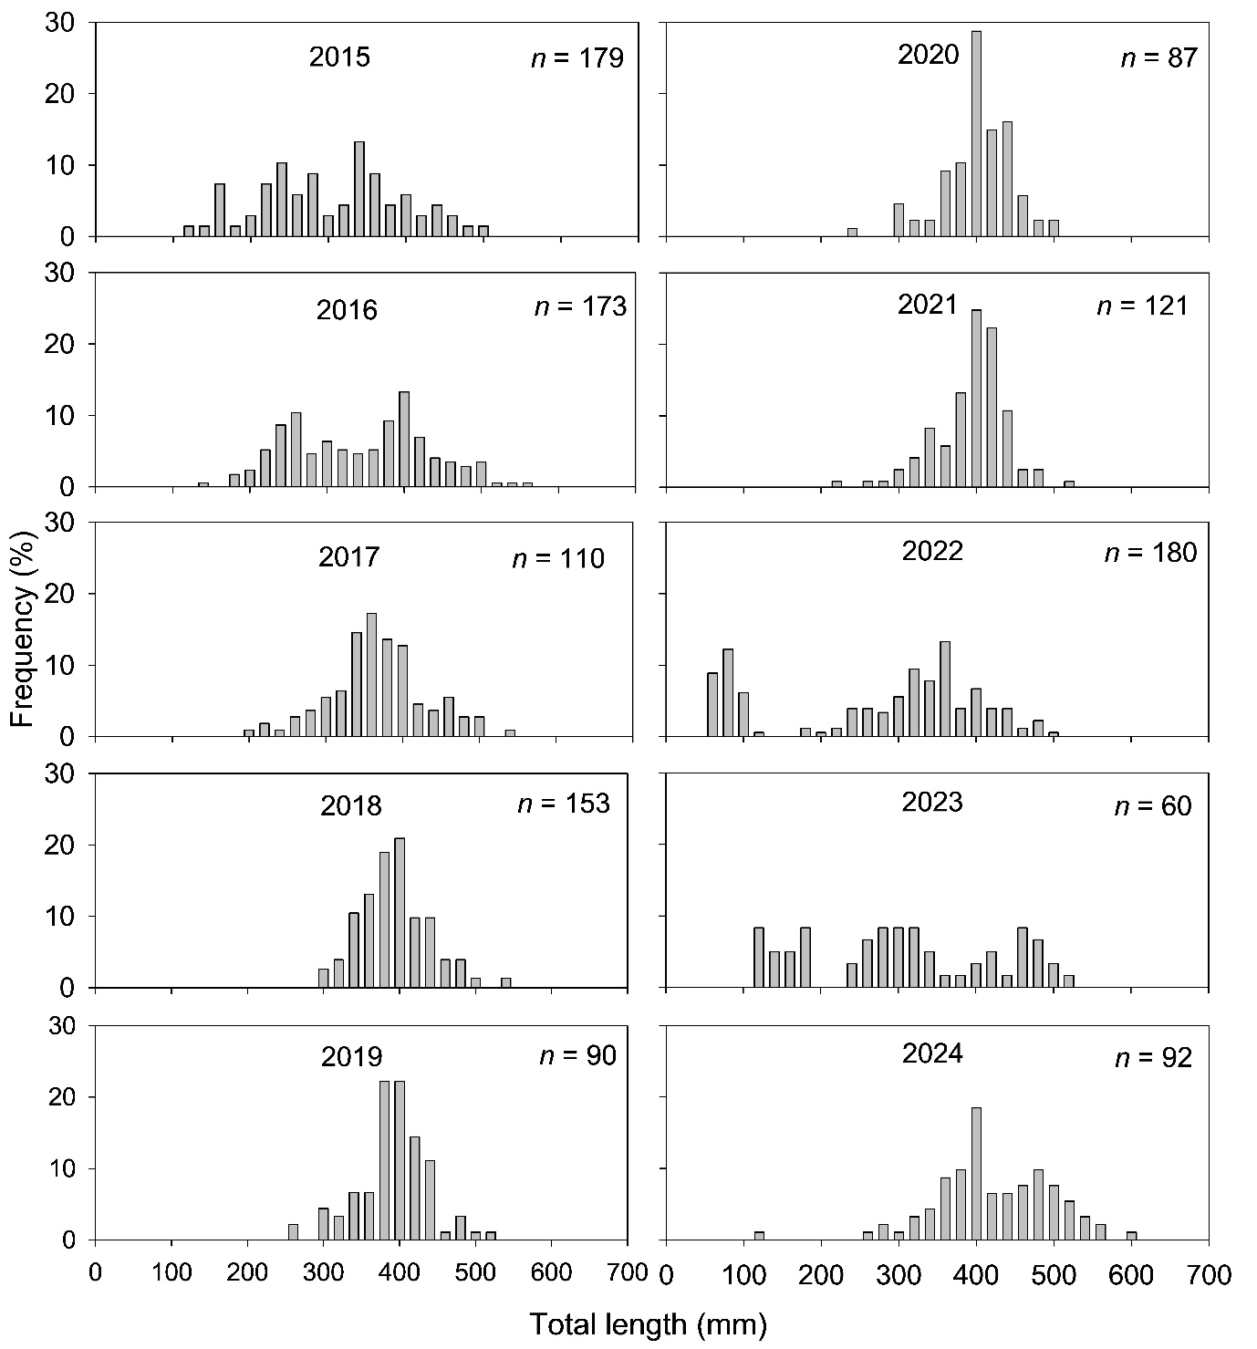
Figure C6. Length frequency distributions of golden perch collected from the gorge geomorphic zone of the Lower Murray River from 2015–2024.
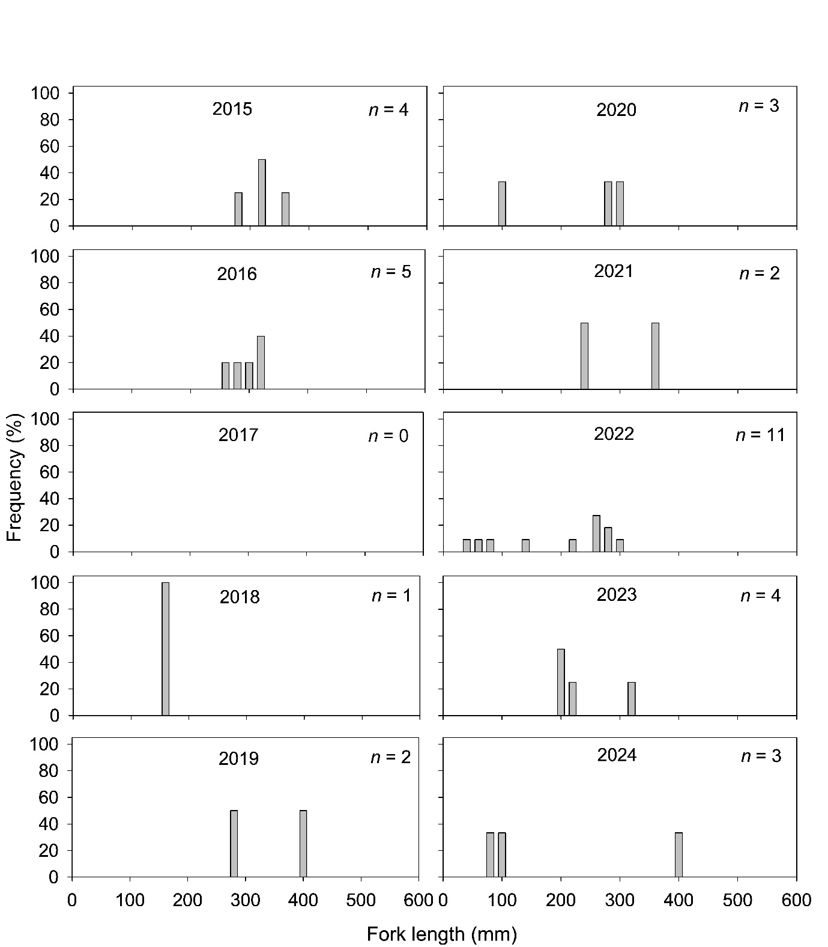
Figure C7. Length frequency distributions of silver perch collected from the gorge geomorphic zone of the Lower Murray River from 2015–2024.
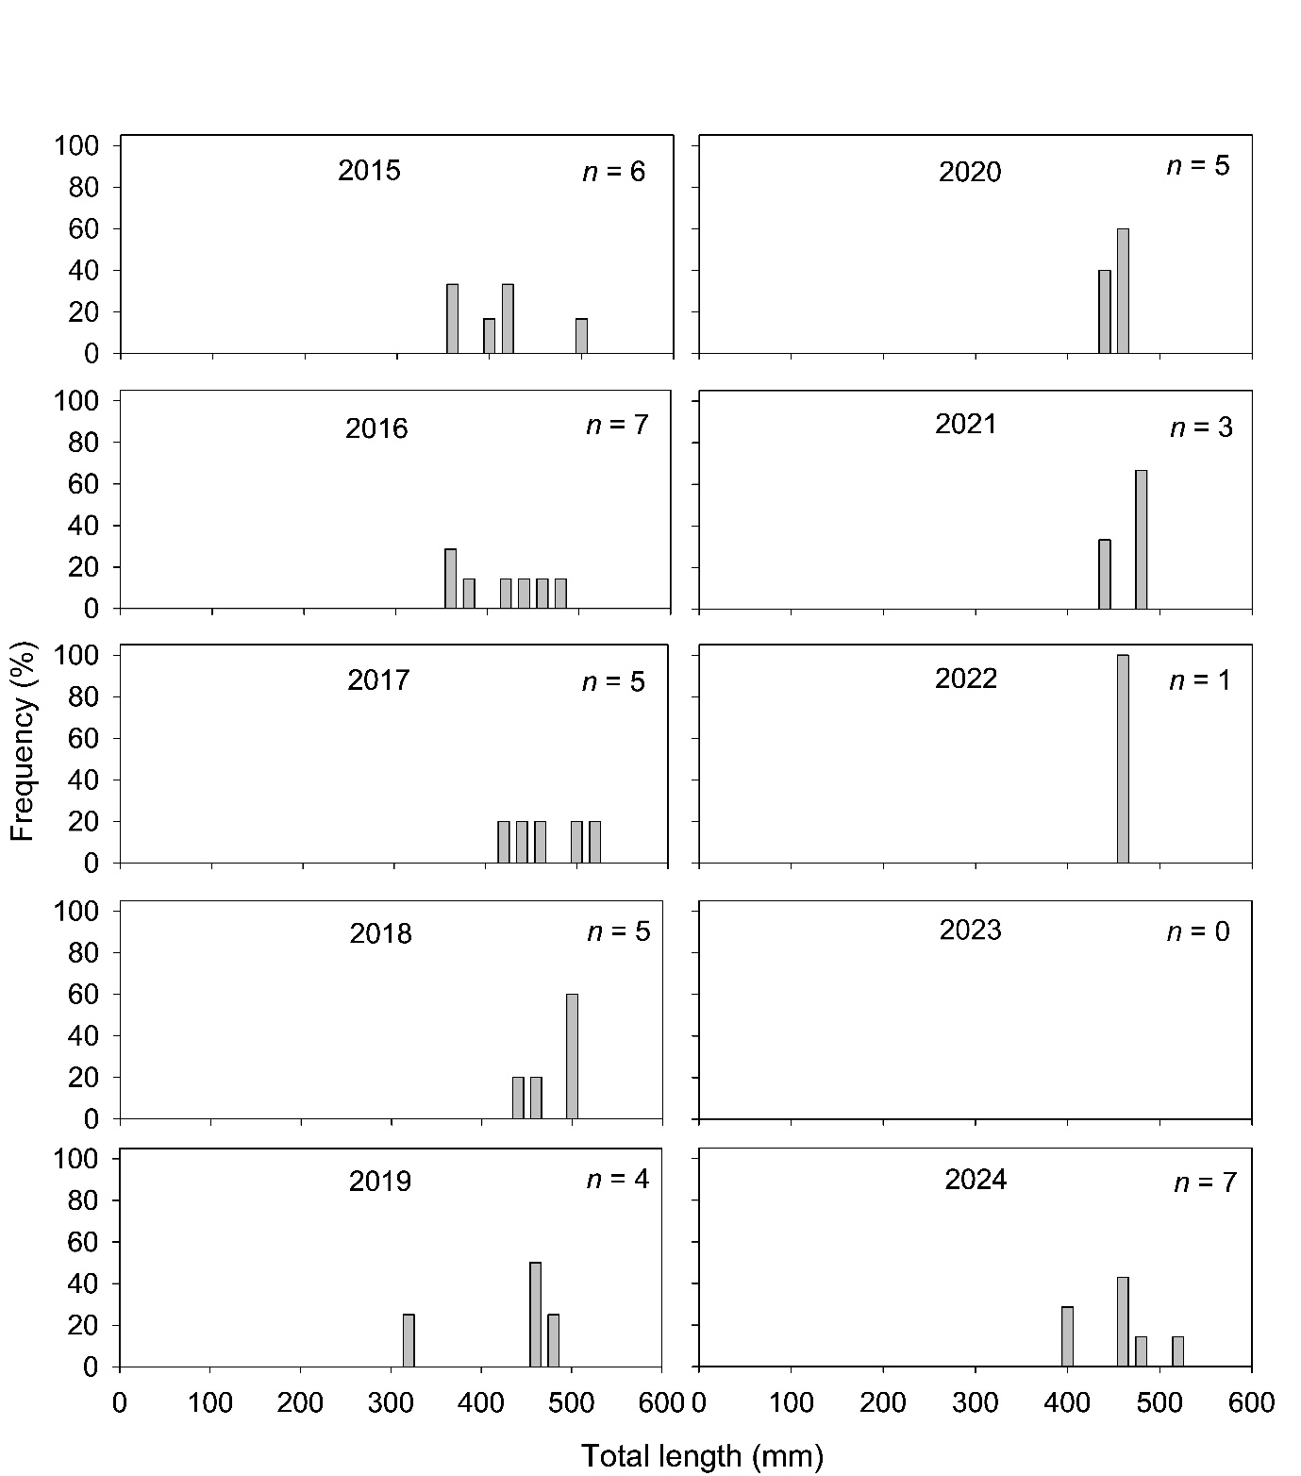
Figure C8. Length frequency distributions of freshwater catfish collected from the gorge geomorphic zone of the Lower Murray River from 2015–2024.

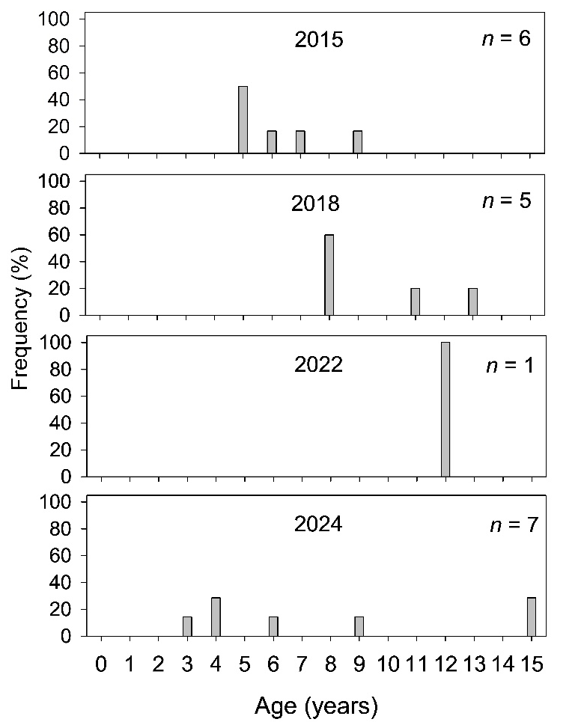
Figure C9. Age structures of freshwater collected from the gorge geomorphic zone of the Lower Murray River from 2015–2024.

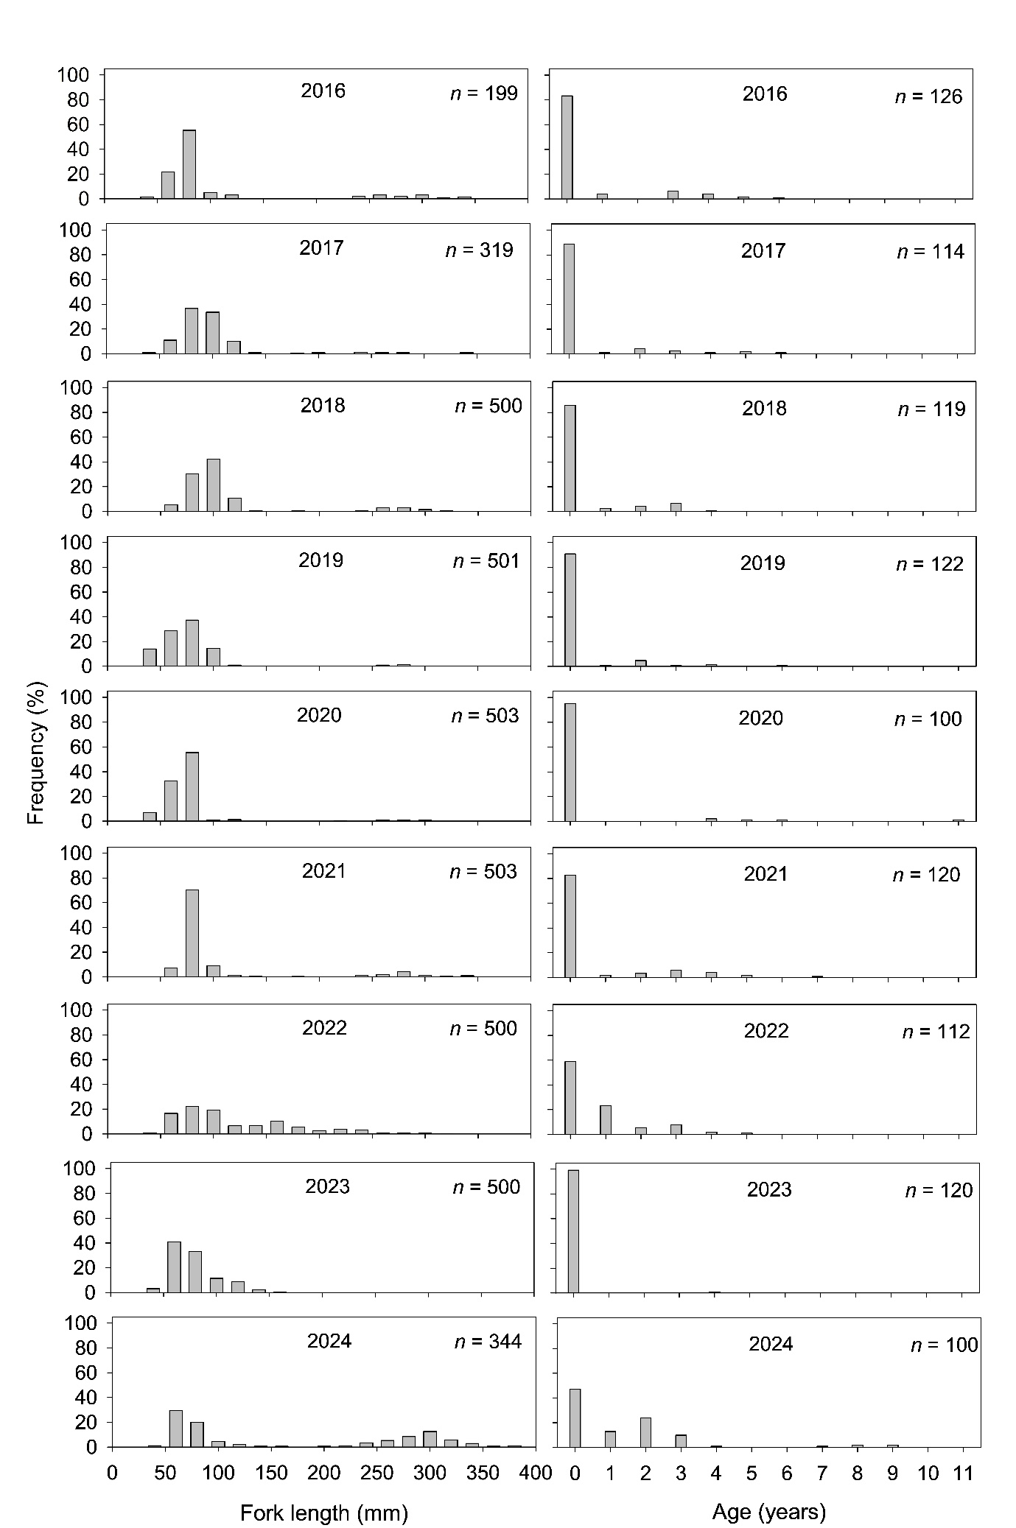
Figure C10. Length frequency distributions and age structures of bony herring collected from the gorge geomorphic zone of the Lower Murray River from 2016–2024.
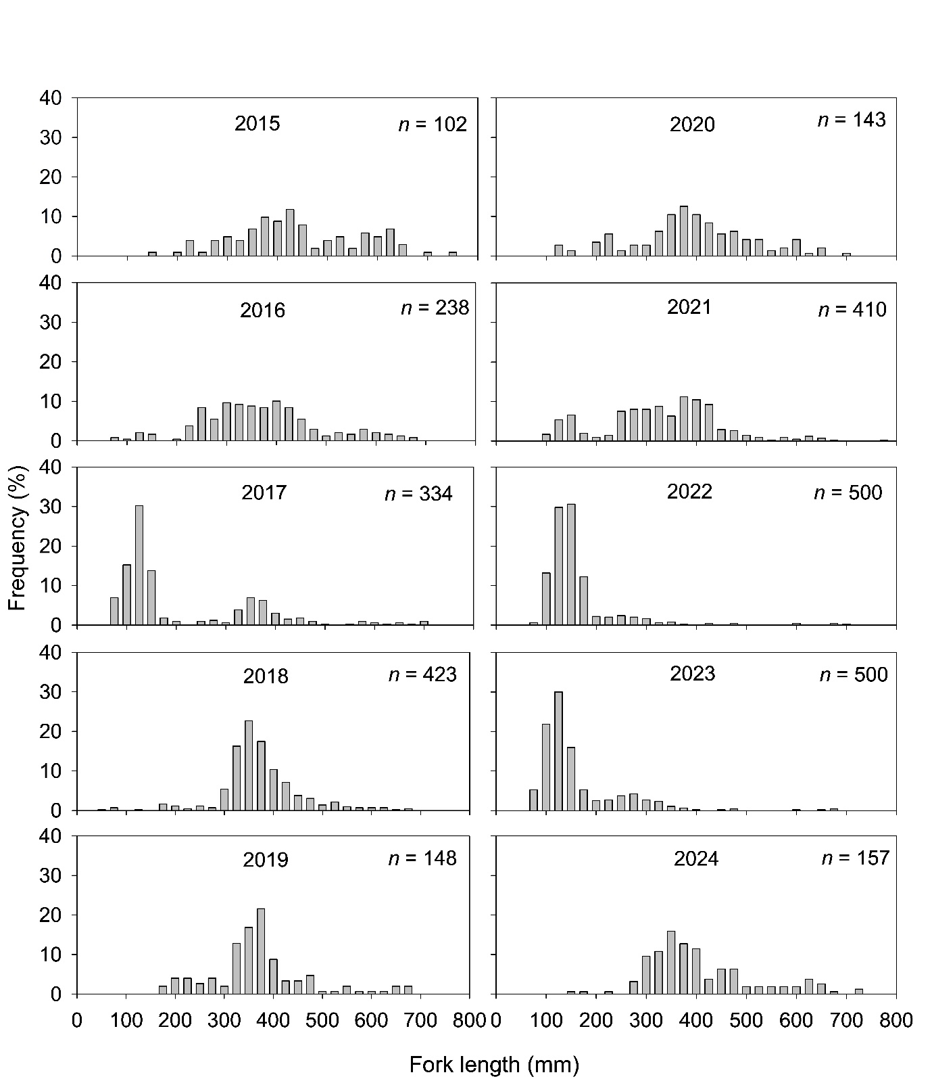
Figure C11. Length frequency distributions of common carp collected from the gorge geomorphic zone of the Lower Murray River from 2015–2024.

Appendix D: DEW evaluation questions
Table D1. DEW short-term (one-year) and long-term (five-year) evaluation questions for CEWH LTIM/MER indicators. Evaluation questions are based on ecological targets from the Long-Term Environmental Watering Plan (LTWP) for the South Australian Murray River and Basin Plan Matter 8 report. DEW evaluation questions serve as ‘additional’ questions as there may be some CEWH questions that are also relevant to DEW’s targets from the LTWP and/or the Matter 8 report. CEW = Commonwealth environmental water; eWater = environmental water.
Contribution (to what extent CEW contributed towards the outcome, with the significance of the outcome considered):
 | Unknown |  | None/negligible |  | Minor |  | Moderate |  | Substantial

Hydrology (Channel) and Hydraulic Regime (modelling)
DEW evaluation questions | Outcomes of CEW delivery (2014–2023)
DEW evaluation questions | 2014-15 | 2015-16 |  | 2016-17 |  | 2017-18 |  | 2018-19 |  | 2019-20 |  | 2020-21 |  | 2021-22 |  | 2022-23 |  |  | 2023-24
To what extent did CEW contribute to meeting the EWRs (all metrics) for the Lower Murray Channel? | 0/0 | 1/0 |  | 9/9 |  | 1/0 |  | 0/0 |  | 0/0 |  | 1/0 |  | 5/3 |  | 12/12 |  |  | 4 EWR met with CEW/1 EWR met without CEW
With CEW, the highest median flow over a 60-day period (90-day period in brackets) between September 2023 and March 2024 was 27,844 ML/d (27,893 ML/d), with a minimum flow over this period of 22,172 ML/d (17,113 ML/d). Without CEW, the median flow was 22,224 ML/d (19,814 ML/d) with the minimum flow over the period 12,843 ML/d (9,584 ML/d). Hence, only IC1 was met without CEW, but IC1, IC2, IC3 and IC4 were met with CEW.
Floodplain EWRs are evaluated over September to December and were not met in 2023-24.
Total number of EWRs is 7 for the channel + 5 floodplain = 12 (DEW 2020a).
To what extent did CEW contribute to meeting the expected outcome for velocity in the Lower Murray?  The majority of lower third weir pools will have median cross-sectional velocities of >0.3 m/s for at least 60 consecutive days between September–March. | 0/0 |  | 0/0 |  | 1/1 |  | 0/0 |  | 0/0 |  | 0/0 |  | 0/0 |  | 1/0 |  | 1/1 | 1 EWR met with CEW/0 EWR met without CEW
Assuming significant weir pool manipulations are not occurring, analysis of velocity results and expert elicitation has identified that this evaluation question is met by the 20,000 ML/d for the 60 days EWR. The analysis above indicates that this criterion was met with CEW in 2023-24, but would not have been met without CEW.
This is not a long-term evaluation question.

Stream Metabolism and Water Quality
DEW evaluation questions | Outcomes of CEW delivery (2014–2023)
DEW evaluation questions | 14-15 | 15-16 | 16-17 | 17-18 | 18-19 | 19-20 | 20-21 | 21-22 | 22-23 | 23-24
To what extent did CEW contribute to managing the concentrations of cyanobacteria? | As the concentrations of cyanobacteria were not measured in the LTIM/Flow-MER projects, the extent to which CEW contributed to managing them is unknown.
To what extent did CEW contribute to open-water productivity in the Lower Murray?* | 1 | 2.5 | 0 | 2 | 2 | 1 | 2 | 1 | 0 | 1
 | Increased flows generally reduced the volumetric rate of primary production but increased the cross-sectional rate. This increased the overall “carrying capacity” of the river, although the implications of changes in the ratios of these two measures are unknown. For each monitoring period evaluation was based on the average percentage change in cross-sectional GPP across sites due to eWater. These were negligible due to the largely stable water levels set by weirs. A substantial contribution was considered an increase in cross-sectional GPP of 20% or greater, moderate 11–19%, minor 5–10%, negligible <5%.
To what extent did CEW contribute to maintaining dissolved oxygen levels above 50% saturation throughout the water column at all times in the Lower Murray?* | 0 | 37 | 17 | 45 | 15 | 30 | 70 | 0 | 0 | 50
 | CEW decreased the likelihood of low DO by increasing water mixing and oxygen exchange at the surface and was assessed as the average across sites (see Table 5) of the extra days per year with water velocities >0.18 m/s due to CEW. This metric was modified because of the 2021-22 findings that, at velocities >0.4 m/s, gas exchange decreased significantly and was independent of velocity. In 2021-22 and 2022-23 velocities were always above the upper limit and environmental flows did not influence gas exchange. In 2014-15 the addition of CEW did not increase the number of days where velocities moved from below to above 0.18 m/s. In all other years, contributions were significant, ranging from moderate to substantial across the sites. A substantial contribution was considered greater than 30 days, moderate 15–30 days, minor 7–14 days and negligible < 7days.
*Refer to the evaluation in Section 2.2 for details.

Littoral Vegetation Diversity and Productivity
DEW evaluation questions | Outcomes of CEW delivery
DEW evaluation questions | 2019-20 | 2020-21 | 2023-24
To what extent did CEW (and other environmental water) contribute to littoral understorey vegetation diversity and productivity? | CEW delivery increased native plant species diversity by 40–100% across all reaches in the LMR. This was evidenced by consistently higher native species richness in inundated zones in each reach compared to non-inundated areas; higher native species richness (albeit lower than inundated zones) on the edge of the inundation footprint, where there was increased soil moisture due to capillary action, compared to non-inundated zones (where soil moisture was not increased) was also observed. Environmental water delivery in the form of a spring pulse produced conditions suitable for the recruitment of specialised riparian species that are adapted to fluctuating water levels and do not inhabit terrestrial or truly aquatic habitats, increasing plant functional diversity.  There were no clear patterns of above ground biomass with regards to environmental water delivery; therefore, the influence of environmental water delivery on understorey productivity is inconclusive. | CEW delivery increased native plant species diversity by 42–82% across all reaches in the LMR. This was evidenced by consistently higher native species richness in inundated zones in each reach compared to non-inundated areas. Environmental water delivery in the form of a spring pulse produced conditions suitable for the recruitment of specialised riparian species that are adapted to fluctuating water levels and do not inhabit terrestrial or truly aquatic habitats, increasing plant functional diversity.  Environmental water delivery increased above-ground biomass by delivery of increased soil moisture in the root zone at the edge of the inundation footprint. Increased above-ground biomass was also observed in inundated areas across all reaches and at pool level downstream of Locks 1 and 4, compared to areas not inundated. | CEW delivery had no impact on species diversity at any of the assessed reaches in the LMR. Native species richness was either the same or lower in areas inundated by CEW compared to areas not inundated.  However, environmental water delivery in 2023-24 may have prevented a “false start” for some species. Maintaining water levels at elevations where decreasing water levels will expose the sediment (providing conditions for breaking seed dormancy and germination) but then inundating the same sediment drowning plants before they have the opportunity to complete their life cycle and replenish the seed bank.  CEW delivery had no impact on biomass with the highest biomass across all reaches (except downstream of Lock 4) being in the zone not inundated by CEW. Biomass generally decreased with elevation at each reach.

Microinvertebrate Assemblage
DEW evaluation questions | Outcomes of CEW delivery (2014–2024)
DEW evaluation questions | 14-15 | 15-16 | 16-17 | 17-18 | 18-19 | 19-20 | 20-21 | 21-22 | 22-23 | 23-24
To what extent did CEW contribute to increased dispersal of organisms between river and wetlands in the Lower Murray? | +7% | -4% | -12% | +14% | N/A | -126% | -133% | -35% | -5% | -93%
 | Over the past decade, CEW predominantly had negligible to negative effects on microinvertebrate communities of the LMR via lateral connectivity, although with a minor positive effect observed in 2017-18 (+14%). The significance of the contribution was classified as negative if the contribution was ≤-9%, none-negligible = -9–9%, minor = 10–19%, moderate =20–29% and substantial = ≥30%. Refer to the evaluation in Section 2.5 for details.

Fish (all indicators)
Fish data have been consolidated to evaluate a number of fish targets of DEW’s LTWP. These questions and answers do not relate to evaluation of flow or Commonwealth environmental water. Furthermore, the LTIM Fish monitoring program is not designed to determine what is facilitating changes in population dynamics of fish species for DEW’s LTWP evaluation questions, e.g. spawning and recruitment of freshwater catfish or common carp. NA = not applicable.
Outcome: = negative; = positive; = unable to be detected.
DEW evaluation questions | Answers to evaluation questions (2015 to 2024)
DEW evaluation questions | 15 | 16 | 17 | 18 | 19 | 20 | 21 | 22 | 23 | 24
Did the population age structure of Murray cod include recent recruits (i.e. <300 mm TL), sub-adults (300–600 mm) and adults (>600 mm) in the Lower Murray? | X | √ | √ | √ | √ | √ | √ | √ | √ | √  (Figure 68)
Did the length-frequency distribution for Murray cod indicate a large recruitment event, demonstrated by a YOY cohort representing >50% of the population from the Lower Murray? | X | X | X | X | √ | √ | X | X | X | X  (13%, Figure 70)
Did the abundance of Murray cod in the Gorge zone increase by ≥20% over a 5-year period? | NA | NA | NA | NA | NA | √ | √ | √ | X | X  (-80%, Figure 70)
Did the population age structure of golden perch include adults (age ≥4+) and sub-adults (age 1+–3+)? | √ | √ | √ | √ | √ | √ | √ | √ | √ | √  (Figure 61)
Was there a large recruitment event of golden perch, demonstrated by a YOY cohort representing >30% of the population from the Lower Murray. | X | X | X | X | X | X | X | X | X | X  (1%, Figure 61)
Did the abundance of golden perch in the Gorge zone increase by >30% over a 5-year period? | NA | NA | NA | NA | NA | X | X | √ | X | X  (+0%, Figure 70)
Did the abundance of silver perch in the Gorge zone increase by >30% over a 5-year period?* | NA | NA | NA | NA | NA | X | √ | √ | √ | √  (+33%, Figure 70)
Did the abundance of freshwater catfish in the Gorge zone increase by ≥30% over a 5-year period?* | NA | NA | NA | NA | NA | X | X | X | X | √  (+43%, Figure 70)
Did the length-frequency distribution for bony herring** in the Gorge zone include size classes representing YOY? | NA | √ | √ | √ | √ | √ | √ | √ | √ | √  (Figure C10, Appendix C)
Did the length-frequency distribution for Murray rainbowfish and carp gudgeon, include size classes representing YOY in the Gorge zone? | √ | √ | √ | √ | √ | √ | √ | √ | √ | √
Did the relative abundance of common carp in the Gorge zone increase during the current year, relative to the previous year, in the absence of an increase in the relative abundances of flow-dependent native species decreased?*** | NA | √ | √ | X | X | X | X | X | √ | NA
Did the estimated biomass of common carp in the Gorge zone increase during the current year, relative to the previous year, in the absence of an increase in the estimated biomass of flow-dependent native species decreased?*** | NA | √ | X | X | X | X | X | √ | √ | NA
* These results should be interpreted with caution, given the large error estimate.
** Bony herring were not assessed as a target species during 2014.
*** Since the 2019-20 report, the calculations used to answer the evaluation question were changed from an approach using ratios to better reflect the ecological target of the LTWP. To remove sampling season bias, only sites sampled during autumn 2017 were used in comparisons against other years. Questions were not evaluated for 2024 because all sites except one were sampled after late May. Common carp were not weighed as part of the Fish (channel) sampling, so biomass was estimated by converting fork lengths (Figure C11 in Appendix C) to weights based on a FL–mass equation in Vilizzi and Walker (1999).

Acronyms
AHD | Australian Height Datum
BCR | Bacterial community respiration
BGE | Bacterial growth efficiency
BNP | Bacterial net production
CDM | Coorong Dynamic Model
CEW | Commonwealth environmental water
CEWH | Commonwealth Environmental Water Holder
CI | Confidence interval
CLLMM | Coorong, Lower Lakes and Murray Mouth
CPUE | Catch-per-unit-effort
CSIRO | Commonwealth Scientific and Industrial Research Organisation
DEW | Department for Environment and Water
DO | Dissolved oxygen
DOC | Dissolved organic carbon
ER | Ecosystem respiration
GPP | Gross primary production
HCHB | Healthy Coorong, Healthy Basin
LMR | Lower Murray River (South Australian section of the Murray River).
LTIM | Long-Term Intervention Monitoring
M&E | Monitoring and Evaluation
MDB | Murray–Darling Basin
MDBA | Murray–Darling Basin Authority
MER | Monitoring, Evaluation and Research
NEP | Net ecosystem production
NPL | Normal pool level
NSW DPIE | New South Wales Department of Planning, Industry and Environment
PCR | Phytoplankton community respiration
PNP | Phytoplankton net production
PSU | Practical salinity units
RMIF | River Murray Increased Flows
SARDI | South Australian Research and Development Institute
TL | Total length
TLM | The Living Murray
TN | Total nitrogen
TP | Total phosphorus
VEWH | Victorian Environmental Water Holder
WoD | Without development
YOY | Young-of-year

Glossary
Allochthonous | Refers to foreign or outside sources. For example, organic matter of an allochthonous source is that which has been produced outside of the river channel, e.g. terrestrial or floodplain material.
Autochthonous | Refers to local sources. For example, organic matter of an autochthonous source is that which has been produced within the river channel.
Base flow | Flows that are confined to the low flow part within the river channel.
Biofilm | A collection of microorganisms (e.g. bacteria) attached as a ‘film’ on living (e.g. tree root) and non-living (e.g. wooden pylon) surfaces.
Direct trade | “Direct trade” refers to an order for a specified volume of environmental water to be delivered at the South Australian border. Typically a timing and profile for the delivery is specified and river operators can meet the order by providing water from any available source.
Flood or flooding | Refers to flows that are overbank. In South Australia, this is deemed to be above bankfull flow (45,000 ML/d).
Flow integrity | The preservation of flow characteristics of a parcel of water, including the flow volume and water quality (constituents), from its upstream source to downstream river systems or reaches.
Freshes (flow) | Flows greater than base flow but below bank level.
Epibenthic | Organisms living on the surface of sediment.
Epiphytic | Organisms that are attached to plants.
Hatch date | The date at which fish emerge from their eggs, which is one day prior to a fish laying its first daily growth increment on an otolith.
Heleoplankton | Plankton derived from billabongs and other floodplain still, generally-vegetated, waters.
In situ | Used to describe monitoring in the field.
Lentic | Refers to slower water velocities associated with ‘pool water’ habitat in highly regulated systems, typically median velocities of approximately ≤0.3 m/s.
Littoral  Lotic | The margin along the bank of the river.  Refers to flowing water, typically with median velocities of approximately >0.3 m/s.
Lower Murray | Term used to describe the Selected Area of monitoring, which includes the Lower Murray River (see below) and the Coorong, Lower Lakes and Murray Mouth (CLLMM).
Lower Murray River (LMR) | Defined as the main channel of the Murray River between Wellington and the South Australian border, unless otherwise specified in text (e.g. Murray River downstream of the Darling River junction).
Primary productivity | The rate at which energy is converted to organic substances by autotrophs (e.g. algae and plants) during photosynthesis.
Pulse (flow)  QSA | A description given to the shape of a hydrograph that is characterised by an increase in discharge, followed by a decrease in discharge, often of similar slope.  Murray River discharge (Q) to South Australia at the SA-NSW border.
Recruitment (reproduction) | Refers to individuals passing the critical stages of early life (e.g. larval) and becoming juveniles in a population, described here as age 0+ years.
Respiration (ecosystem) | Ecosystem respiration is the measure of oxygen depletion in water by respiring animals.
RMIF | River Murray Increased Flows: a type of environmental water. Water entitlements recovered under the Snowy Water Initiative (established in 2002) via infrastructure upgrades and water purchase, which receive annual allocations and are used to supply environmental water to the Snowy River (Snowy River Increased Flows, SRIF) and River Murray (RMIF).
Salt flux | The measure (mass/time) of the movement of salt over a given area or point.
Slackwater | Waters with mean velocities <0.1 m/s. Slackwater habitats are typically associated with proximity to broader fast-flowing reaches and high velocity differences (e.g. >0.3 m/s). Murray cod larvae show a preference for these habitats.
Southern connected Basin | The southern connected Basin is a network of the Murray River and all tributaries that flow into it between the Hume Dam and the sea. The Lower Darling (below Menindee Lakes) is considered part of the Southern Connected Basin, whilst all rivers upstream of Menindee Lakes are considered as the Northern Basin.
Unregulated flows | Unregulated flows occur when water in the system exceeds demands and are declared to be unregulated by the appropriate authority (source: http://www.bom.gov.au/water/awid/id-1026.shtml). They can be driven by substantial rainfall from upper tributaries, spills from headwork storages and rainfall rejection events.
Weir pool | The area of water upstream of a weir that is influenced by the weir. In this report, a weir pool is often referred to as the stretch of river between two weirs and includes tailwater habitat. For example, Weir Pool 1 is the stretch of river between Weir 1 and 2.

Flow data in this report are modelled data (MDBA) calculated at the South Australian border.
Environmental water volumes and percentages provided here are sourced from CEWH accounting data and exclude wetland pumping as this investigation focuses on the main channel of the LMR. See Table 1 for more information.
Interquartile range (IQR) is a measure of variability, as the difference between the 75th and 25th percentile values for water level over the year. If the IQR increases, the variability must have increased.
The CEWH Flow-MER Project in the Lower Murray focuses on assessing ecological responses to environmental water delivery along the main river channel. Indicators are not set up to evaluate other types of actions such as floodplain regulator operation and wetland pumping.
Hydrology (Channel) does not directly address any specific CEWH evaluation question, but provides fundamental information for analysis and evaluation of monitoring outcomes against hydrological conditions and environmental water delivery for all other indicators. Results for this indicator are presented in Section 1.4.
Molecules of water, nutrients, and the biological matter transported downstream often move slower than the wave front that is recorded as the change in flow discharge (Chow et al. 1988). To account for this, the Murray–Darling Basin Authority (MDBA) has used Bigmod salinity routines as a proxy for transport of biological matter, to estimate the proportion of the flow at the South Australian border that originated at different upstream tributaries. While acknowledging potential difference in travel time between salt and other matter, this approach is preferred over estimating travel times based on observed changes in flow along the main channel.
‘Floodplain associated’ microinvertebrates are those that are thought to benefit from floodplain environments.

