Lower Murray and Coorong, Lower Lakes and Murray Mouth Area
Commonwealth Environmental Water Holder’s Science Program (Flow Monitoring, Evaluation and Research)
Annual Report 2024-25
22 May 2026

© Commonwealth of Australia 2026
Ownership of intellectual property rights
Unless otherwise noted, copyright (and any other intellectual property rights) in this publication is owned by the Commonwealth of Australia (referred to as the Commonwealth).
Creative Commons licence
All material in this publication is licensed under a Creative Commons Attribution 4.0 International Licence, except content supplied by third parties and Basin First Nations people, logos and the Commonwealth Coat of Arms. Basin First Nations people’s data and ICIP are identified throughout this report, and explicit permission must be provided to share or adapt their content.
Inquiries about the licence and any use of this document should be emailed to copyright@dcceew.gov.au.

Basin First Nations People’s Knowledge Statement
Indigenous Cultural and Intellectual Property (ICIP) must be respected. One of the objectives of the First Nations people MER Strategy is Recognising, valuing, and protecting the use of Basin First Nations people’s knowledges in Flow-MER. We recognise and respect the rights of Indigenous peoples to control, own, maintain, protect and develop their data and ICIP in accordance with Article 31 of the United Nations Declaration on the Rights of Indigenous Peoples. It is important to note that First Nations people and communities across the Basin have their own distinct cultures and connections to Country, and information and views shared are not reflective or applicable to all Basin First Nations communities.
The data and ICIP shared by Basin First Nations people in this report is exempt from the Creative Commons Attribution 4.0 International Licence conditions. Basin First Nations people’s data and ICIP are identified throughout this report. Explicit permission to share Basin First Nations people’s material (copy and redistribute the material in any medium or format for any purpose, including commercial purposes) and to adapt the material (to remix, transform and build upon the material for any purpose, including commercial purposes) must be sought from the relevant Basin First Nations contributors.
Cataloguing data
This publication (and any material sourced from it) should be attributed as: Ye, Q., Giatas, G., Bice, C., Brookes, J., Gibbs, M., Nicol, J., Gervais, C., Giles, S., Hipsey, M., Hoang, V., Kartinyeri, A., Kurucz, K., Montazeri, M., Sutcliffe, M., Wallace, C., Wilson, W., Zampatti, B. and Zhai, S. (2026). Lower Murray and Coorong, Lower Lakes and Murray Mouth Annual Report 2024-25, Flow-MER Program, Department of Climate Change, Energy, the Environment and Water, Canberra, 2026.
This publication is available via email ewater@dcceew.gov.au
Commonwealth Environmental Water Holder
Department of Climate Change, Energy, the Environment and Water
GPO Box 3090 Canberra ACT 2601
Telephone 1800 218 478
Email ewater@dcceew.gov.au
Web dcceew.gov.au/water/cewo
Cover photo credit: Rebecca Salcole (nee Harris), Wiradjuri woman (Commonwealth Environmental Water Office, 2022). The artwork represents the people, plants and animals of the Murray–Darling Basin.
Disclaimer
The Australian Government acting through the Department of Climate Change, Energy, the Environment and Water has exercised due care and skill in preparing and compiling the information and data in this publication. Notwithstanding, the Department of Climate Change, Energy, the Environment and Water, its employees and advisers disclaim all liability, including liability for negligence and for any loss, damage, injury, expense or cost incurred by any person as a result of accessing, using or relying on any of the information or data in this publication to the maximum extent permitted by law.
Acknowledgements
This report was prepared by Ye, Q., Giatas, G., Bice, C., Brookes, J., Gibbs, M., Nicol, J., Gervais, C., Giles, S., Hipsey, M., Hoang, V., Kartinyeri, A., Kurucz, K., Montazeri, M., Sutcliffe, M., Wallace, C., Wilson, W., Zampatti, B. and Zhai, S.
This project was funded by the Commonwealth Environmental Water Holder (CEWH) from 2024–2029 with in-kind contributions from the South Australian Research and Development Institute (SARDI) and South Australian Department for Environment and Water (DEW). SARDI provided project leadership, and worked with collaborative partners including Adelaide University, Commonwealth Scientific and Industrial Research Organisation (CSIRO), University of Western Australia, Ngarrindjeri Aboriginal Corporation (NAC) and River Murray and Mallee Aboriginal Corporation (RMMAC) for this project. SA Water and DEW provided water quality data for the ‘Matter Transport and Coorong Habitat’ indicator.
Thanks to numerous staff, including Arron Strawbridge, Travis Howson, David Short, Anthony Newbery, Josh Fredberg, Noah Kiriakou (SARDI), Ruan Gannon and Sophie Gilbey (CSIRO) for providing technical assistance in the field or laboratory. SA Water, Goulburn–Murray Water, Water NSW and New South Wales Department of Primary Industries staff assisted with collecting water samples for ⁸⁷Sr/⁸⁶Sr analysis. Dr Roland Maas from the University of Melbourne conducted water ⁸⁷Sr/⁸⁶Sr analysis, while Dr Aleksey Sadekov from the University of Western Australia conducted otolith ⁸⁷Sr/⁸⁶Sr analysis. Daniel McCullough (DEW) and Andrew Keogh (Murray–Darling Basin Authority, MDBA) for providing hydraulic models and outputs to support the Hydraulic Regime indicator. Special thanks to Kate Mason, Sam Hardy (Murraylands and Riverland Landscape Board, MRLB), Tracey Steggles, Adrienne Rumbelow, Jan Whittle and Alison Stokes (DEW) for providing input and support on Cultural Outcomes evaluations.
The evaluation for the indicators of Lower Lakes Aquatic and Littoral Vegetation and Diadromous Fish Movement and Recruitment was based on the field data collected from relevant The Living Murray (TLM) monitoring projects in the CLLMM region funded by the MDBA and DEW. TLM is a joint initiative funded by the NSW, Victorian, South Australian, and Commonwealth Governments and coordinated by the MDBA.
Larval fish components for the Flow-cued Fish Spawning and Recruitment indicator and targeted electrofishing for the Murray Cod Recruitment indicator were undertaken by SARDI and CSIRO, in conjunction with the River Murray Monitoring Program, led by the CSIRO, funded by the CEWH and TLM initiative, and coordinated by the MDBA. Electrofishing data and otolith samples collected through complementary monitoring programs were included in the Flow-MER fish indicator analyses. These programs included: Chowilla Anabranch and Lindsay-Mulcra-Wallpolla Islands Icon Site Condition Monitoring, funded by TLM and Mallee Catchment Management Authority coordinated by the MDBA; Katarapko and Pike Condition Monitoring, funded by DEW; and Murray–Darling Basin Fish Survey, funded by the MDBA.
Thanks to Will Barrett, Lucy Carlile, Jess Dober, Adam Cotterill, Kyle McGrath, Alana Wilkes, Sara Ormond, Claire Settre, Richard Mintern and Tim Field (CEWH) for providing project management and support to the Lower Murray and Coorong, Lower Lakes and Murray Mouth (CLLMM) Area. Aftab Ahmad (MDBA) provided detailed flow and environmental flow data. The Lower Murray and CLLMM Area Working Group (AWG) provided a forum for the exchange of information and intelligence that supported the CEWH Flow-MER Program, through effective coordination of environmental watering, and monitoring and evaluation. The authors also thank the Lower Murray AWG including staff from the CEWH, MDBA, DEW, Murraylands and Riverland Landscape Board, SA Water, PIRSA Fisheries and Aquaculture, NSW Department for Climate Change, Energy, the Environment and Water and Mallee Catchment Management Authority for providing most welcome and constructive feedback on a draft version of this report. The authors would also like to thank the reviewers from the CEWH Independent Advisory Group for feedback on a draft version of this report. Lucy Carlie, Claire Settre, William Barrett, Jess Dober and Alana Wilkes (CEWH) and Hector Lozano-Montes (SARDI) reviewed a final draft of this report.

Acknowledgement of First Nations people
The Commonwealth Environmental Water Holder and Flow-MER Program Providers acknowledge the First Nations communities of the Murray‒Darling Basin and pay respect to their Elders past and present. We acknowledge First Nations people as the Traditional Owners of the land, water and sky Country across the Basin and value their expertise, wisdom and enduring connections that have informed their care for Country over millennia.
The First Nations communities in the Lower Murray and Coorong, Lower Lakes and Murray Mouth Area include the Ngarrindjeri people represented by the Ngarrindjeri Aboriginal Corporation (NAC); the First Nations of the South East (FNSE) represented by the First Nation of the South East Aboriginal Focus Group (SEAFG) and supported by Burrandies Aboriginal Corporation; First Peoples of the River Murray and Mallee (FPRMM), represented by the River Murray and Mallee Aboriginal Corporation (RMMAC); Nganguraku represented by the Sugar Shack Aboriginal Corporation (SSAC); the Peramangk represented by the Peramangk Aboriginal Corporation (PAC); and First Nations groups represented by the First People of the Millewa-Mallee Aboriginal Corporation (FPMMAC) and Barkandji Native Title Group Aboriginal Corporation (BNTGAC) across the Murray River between the South Australian border and Mildura.
We recognise the intrinsic connection of First Nations people to Country, and we value their enduring cultural, social, environmental, spiritual, and economic connection to the rivers, wetlands, and floodplains of the Basin.
We are committed to working with First Nations people to build relationships in a meaningful and genuine way to support and empower them in reaching their aspirations.
Contents
Acknowledgement of First Nations people 4
1 Preamble 13
1.1 Background 13
1.2 Purpose of report 13
2 Lower Murray and Coorong, Lower Lakes and Murray Mouth description and monitoring locations 15
2.1 The Lower Murray and Coorong, Lower Lakes and Murray Mouth (CLLMM) description……. 15
2.2 Monitoring sites 18
3 Flows and environmental watering 20
3.1 Overview of flows 20
3.2 Expected outcomes and objectives 22
3.3 Commonwealth environmental watering actions 24
3.4 Evaluation approach 25
4 Data management 27
5 River Flows and Connectivity 29
5.1 Hydraulic Regime 29
5.2 Matter Transport and Coorong Habitat 46
Matter Transport 46
Coorong Habitat 69
6 Native Vegetation 83
6.1 Lower Lakes Aquatic and Littoral Vegetation 83
7 Waterbirds 94
8 Native Fish 95
8.1 Native Fish 95
8.2 Flow-cued Fish Spawning and Recruitment 104
8.3 Murray Cod Recruitment 119
8.4 Diadromous Fish Movement and Recruitment 130
9 Cultural Outcomes 141
9.1 Cultural outcomes 141
10 Responsive Monitoring 151
11 Alignment with Basin Plan and Basin-wide Environmental Watering Strategy 152

12 Research 153
12.1 Development of a repository of hydraulic parameters for weir pools 7, 8 and 9 ………………………………………………………………………………………………153
13 Knowledge Exchange, Communication and Engagement 165
13.1 Overview 165
13.2 Activities undertaken in 2024-25 166
13.3 Opportunities for improvement, future collaboration and activities undertaken in 2024-25………… 166
14 References 172
15 Appendices 185
15.1 Summary of key outcomes and recommendations 185
15.2 Alignment of Basin and Area KEQs with Basin Plan and BEWS 196
15.3 Commonwealth environmental water use and watering actions in the Lower Murray……………….. 235
15.4 Hydraulic regime weir pool results 250
15.5 Matter Transport and Coorong Habitat supplementary information 260
15.6 Native Fish theme supplementary information 265
15.7 Case Study – Cultural Knowledge Exchange: Pondi (Murray cod) Monitoring Project and Electrofishing Demonstration Day 2025 275

Tables
Table 1. Key evaluation questions for assessing the Hydraulic Regime responses to Commonwealth environmental water (CEW).. 30
Table 2. The proportion of the time (% of days) the water level in the Lower Lakes has been above 0.4 m AHD for each scenario, in the 2024-25 evaluation period as well as since 2014. 40
Table 3. Area-scale evaluation questions for Hydraulic Regime. 42
Table 4. Key evaluation questions for assessing the Matter Transport responses to Commonwealth environmental water (CEW). 49
Table 5. Summary of modelling scenarios for investigating the environmental water (eWater) effects.. 50
Table 6. Summary of salt flux (tonnes) though barrages (from lakes to Coorong), Murray Mouth (from Southern Ocean to Coorong), North Lagoon (from Pelican Point southward) and South Lagoon (Parnka Point southward) in 2017–2025. 55
Table 7. Predicted (a) mean and (b) median salinity at Murray Mouth, North Lagoon (at Long Point), and South Lagoon (at Woods Well) in all investigated scenarios. Units are practical salinity units (PSU).. 60
Table 8. Summary of total nitrogen flux (tonnes) though barrages (from lakes to Coorong), Murray Mouth (from Southern Ocean to Coorong), North Lagoon (from Pelican Point southward) and South Lagoon (Parnka Point southward) in 2017–2025.. 62
Table 9. Summary of Matter Transport evaluation questions to be addressed at the Area scale for Flow-MER2.0. 63
Table 10. Key evaluation questions for assessing the Coorong Habitat responses to Commonwealth environmental water (CEW).. 69
Table 11. Annual contribution of Commonwealth environmental water to Ruppia tuberosa and fish habitat area (HSI-weighted area in km², with percentage change relative to ‘All water’ in brackets). 78
Table 12. Coorong habitat evaluation questions and answers. 79
Table 13. Key evaluation questions for assessing the Lower Lakes Aquatic and Littoral Vegetation responses to Commonwealth environmental water (CEW). 84
Table 14. Species richness (for all states) and species present (in the ‘Optimal’ state) for submergent vegetation and diverse reed beds in the Lower Lakes. 86
Table 15. Number (No.) of days Lake Alexandrina water levels were below model thresholds (0.5 and 0.2 m AHD) from 2014-15 to 2024-25 and the 2024-25 water year under observed conditions and modelled water levels with no Commonwealth environmental water (CEW) and no environmental water (eWater). 87
Table 16. Model states and number of days with water levels below 0.5 and 0.2 m AHD from the 2014-15 to 2024-25 water years under observed conditions and predicted states under modelled Lake Alexandrina water levels with no Commonwealth environmental water (CEW) and no environmental water (eWater). 90
Table 17. Area-scale evaluation questions for Lower Lakes aquatic and littoral vegetation. Commonwealth environmental water (CEW) evaluation of water levels in Lake Alexandrina and aquatic and littoral vegetation status in the Lower Lakes. 91
Table 18. Key evaluation questions for assessing the Native Fish responses to Commonwealth environmental water (CEW) (McInerney et al. 2024).. 96
Table 19. Condition monitoring sites in the Lower Murray River channel for autumn 2025, including those for complementary programs outside of Flow-MER monitoring. 97
Table 20. Fish species presence (black cell) across weir pools (WP, e.g. Lock 1 to Lock 2 weir pool = 1) in the Lower Murray River during autumn 2025 condition monitoring. 98
Table 21. Key evaluation questions for assessing the Flow-cued Fish Spawning and Recruitment responses to environmental water (eWater), and specifically Commonwealth environmental water (CEW). 104
Table 22. Location of water sample collection for ⁸⁷Sr/⁸⁶Sr analysis during 2024-25. 106
Table 23. Area-scale evaluation questions for Flow-cued Fish Spawning and Recruitment. 114
Table 24. Key evaluation questions for assessing the Murray Cod Recruitment responses to Commonwealth environmental water (CEW). 120
Table 25. Area-scale evaluation questions for Murray Cod Recruitment. Refer to ‘Key Evaluation Questions for Basin and Area’ and Table 24 for a description of the evaluation approach.. 126
Table 26. Key evaluation questions for assessing the Diadromous Fish Movement and Recruitment responses to Commonwealth environmental water (CEW).. 131
Table 27. Details of fishways sampled at the Murray Barrages, including site name, abbreviated name used throughout, latitude and longitude, and season sampled (Y/N). 132
Table 28. Total numbers of pouched lamprey and short-headed lamprey sampled from the Murray Barrages annually during targeted winter sampling from 2015–2024. 136
Table 29. Area-scale evaluation questions for Diadromous Fish Movement and Recruitment. Refer to ‘Key Evaluation Questions for Basin and Area’ and Table 26 for a description of the evaluation approach. 138
Table 30. Key evaluation questions for assessing the Cultural Outcomes relating to the planning and delivery of Commonwealth environmental water (CEW) and First Nations participation in Flow-MER Program.. 143
Table 31. Integrated First Nations activities supporting the planning, delivery and management of Commonwealth environmental water (CEW).. 145
Table 32. Key Cultural Outcomes of Flow-MER Pondi monitoring and associated First Nations engagement activities with supporting evidence in the Lower Murray and CLLMM Area during 2024-25 (Section 15.7, Appendix; RMMAC 2025; Cameron 2025). 147
Table 33. Area-scale evaluation questions for Cultural Outcomes.. 148
Table 34. Model configurations at the Mullaroo Creek regulator (Reg). 155
Table 35. Combinations of upstream discharge and weir pool manipulation simulated. 156
Table 36. Knowledge Exchange, Communication and Engagement activities undertaken for project governance, coordination and communication during 2024-25. 168
Table 37. Knowledge Exchange, Communication and Engagement additional activities undertaken during 2024-25. 169

Figures
Figure 1. Map of the Lower Murray and Coorong, Lower Lakes and Murray Mouth (CLLMM) Area, showing the Valley (pink), Gorge (green) and Swamplands (orange) riverine zones, and the Lower Lakes, Coorong and Murray Mouth (yellow), along with monitoring locations for indicators (the indicator of Cultural Outcomes is for the whole Area). 16
Figure 2. Daily flow (ML/d) in the Lower Murray River (LMR) at the South Australian border (blue solid line) from July 1996 to July 2025, compared to modelled flow under natural conditions (grey dashed line). 18
Figure 3. The various flow types of the Lower Murray River as described in the Murray–Darling Basin Plan (MDBA 2011) and how flow volumes translate to lotic habitat in the contemporary LMR (Lock 1 to Lock 6 reach). 20
Figure 4. Flow to South Australia from 1 July 2024 to 30 June 2025 showing the (a) contribution of environmental water (eWater) and (b) source of all (environmental and consumptive) water (MDBA). 22
Figure 5. Commonwealth environmental watering (CEW) actions in the Lower Murray during 2024-25, expressed as (a) number of actions and (b) volume of water (gigalitres, GL) delivered for targeted objectives by flow components. 25
Figure 6. Flow with and without environmental water (and specifically CEW) along the Lower Murray Area, from Mildura, to the South Australian border (Flow to SA) and to the barrages. 37
Figure 7. Change in area from normal pool level (Ha) and length of river (km) exceeding 0.2 and 0.3 m/s with and without environmental water (and specifically CEW).. 38
Figure 8. Environmental water (and specifically CEW) contributions to evaluation metrics. Values shown on each subfigure are the percentage increase due to CEW, in the total volume over the year at different locations (A), the additional inundated area (B), length of river exceeding velocity thresholds (C) and water level variability at each weir pool, as the median absolute difference (MAD) of the daily water level in the tailwater from the normal pool level (NPL) (D). 39
Figure 9. Water level in Lake Alexandrina with all eWater (as recorded at Milang) and modelled without environmental water (and specifically CEW). 41
Figure 10. Flows and water levels for the period of weir pool lowering at weir pools 7, 8 and 9. The resulting median velocity, and percentage of the weir pool with velocities greater than 0.2 and 0.3 m/s for scenarios of with all environmental water, without Commonwealth environmental water (CEW), and without CEW and the weir pool lowering. 45
Figure 11. (a) Summary of flow discharge through the barrages, from July 2017 until June 2025, spanning the 2021-22–2023-24 flow events, categorised based on water source. (b) Yearly composition of barrage flow, spanning the period from July 2017 to June 2025.. 48
Figure 12. Composition of barrage flow, spanning the period from July 2017 to June 2025, as distributed in the model to the five main barrages. 52
Figure 13. Comparison of each-year’s barrage flow conditions used as input to the CDM base-case simulations to contextualize the 2024-2025 water year. 52
Figure 14. Cumulative salt flux with and without environmental water delivery through Pelican Point (a) and Parnka Point (b) sites for July 2017–July 2025. 56
Figure 15. Transect comparison of simulated mean salinity from the “No CEW” scenarios, “No eWater” scenarios, and “All Water” scenario along the Coorong in July 2024–June 2025 57
Figure 16. Time series of mean salinity variation in the Coorong North Lagoon a) during 2017–2025, and b) during 2023–2025. 58
Figure 17. Time series of mean salinity variation in the Coorong South Lagoon a) during 2017 - 2025, and b) during 2023‒2025.. 59
Figure 18. Cumulative total nitrogen (TN) flux with and without environmental water delivery through Pelican Point and Parnka Point sites for July 2017–June 2025.. 61
Figure 19. Habitat area suitable for Ruppia tuberosa (overall sexual, asexual and individual life-stages), comparing the base-case and NC8/NE8 scenarios from 2018–2024. 72
Figure 20. Habitat area suitable for Ruppia tuberosa (overall sexual only, asexual only and dual life-stage completion), comparing the base-case (i.e. ‘All Water’) against the NC8 and NE8 scenarios to assess the effect of cumulative environmental water delivery between 2018–2024, and also comparing the base-case to the NC2 scenario to isolate the effect of recent CEW water from Jul 2023 to Dec 2024 on the 2024 growth year 73
Figure 21. Differences of Ruppia tuberosa HSI (habitat suitability index) values for sexual reproduction in 2024 between the no Commonwealth environmental water since 2017 (No CEW 8 years) and the ‘All Water’ (base-case) conditions. 74
Figure 22. Differences of Ruppia tuberosa HSI (habitat suitability index) values for asexual reproduction in 2024 between the no Commonwealth environmental water since 2017 (No CEW 8 years) and the ‘All Water’ (base-case) conditions. 75
Figure 23. Habitat area for juvenile stages of key fish species for the scenarios showing the cumulative effect of environmental water delivery (i.e. 8 years for 2024-25).. 76
Figure 24. Monthly habitat area that would be “lost” for black bream during July 2024–June 2025 if there had not been Commonwealth environmental water delivery since 2017 (calculated as the difference between habitat in the ‘All Water’ (base-case) and ‘No CEW 8 years’ scenarios); -1 indicates complete loss of suitability at that location. 77
Figure 25. State and transition model summarising status of submergent vegetation and diverse reed beds under different water level scenarios. 85
Figure 26. Observed and modelled Lake Alexandrina water levels without Commonwealth environmental water and all environmental water from 1 July 2014 to 30 June 2025, showing model state thresholds of +0.5 m AHD for the ‘Optimal’ state and +0.2 m AHD for the ‘Degraded’ state. 88
Figure 27. Non-metric multi-dimensional scaling (MDS) plot of fish assemblages sampled by condition monitoring in the Lower Murray River from 2023–2025. 99
Figure 28. Mean catch-per-unit-effort (CPUE) ± standard error of fish species captured using electrofishing (individuals per 90 second shot) at sites between locks 1 and 3 in the Lower Murray River from 2015–2025. 100
Figure 29. Age structure of freshwater catfish collected from the Lower Murray River in 2025. 101
Figure 30. Abundance of (a) golden perch larvae and (b) silver perch larvae, as determined by the mean catch-per-unit-effort (CPUE, individuals (ind.)/net) ± standard error of larvae collected in the Lower Murray River from 2010-11 to 2024-25. 108
Figure 31. Recruitment strength of (a) golden perch and (b) silver perch in the Lower Murray River from 2014-15 to 2023-24, as determined by the estimated electrofishing catch-per-unit-effort (CPUE, individuals per 90 second shot) of age 1+ captured in the following sampling season (2016–2025).. 109
Figure 32. Mean catch-per-unit-effort (CPUE, individuals per 90 seconds of electrofishing on-time effort) ± standard error of (a) golden perch and (b) silver perch captured in the Lower Murray River in autumn from 2015–2025. 110
Figure 33. Age frequency distribution of golden perch from the Lower Murray River from 2015–2025, showing the natal origins of dominant cohorts inferred from otolith core signatures of the sampled fish in comparison to water sample reference collection 112
Figure 34. Age frequency distribution of silver perch from the Lower Murray River from 2015–2025, showing the natal origins of dominant cohorts inferred from otolith core signatures of the sampled fish in comparison to the water sample reference collection 113
Figure 35. a) Mean (± standard error) annual and long-term (2015–2025, dashed line) body condition, as indicated by Fulton’s condition factor, for Murray cod in the Lower Murray River from 2015–2025 and b) median predicted body condition (± 95% Credible Intervals) for 2025 under observed and counterfactual flow scenarios. 122
Figure 36. Mean targeted electrofishing catch-per-unit-effort (CPUE) ± S.E. of Murray cod in the weir pools downstream of (a) Lock 4 and (b) Lock 5 of the Lower Murray River. Dashed bars represent the proportion of YOY to the total CPUE and the dashed line represents the mean YOY CPUE from 2015 to 2024. 123
Figure 37. Predicted median recruitment (young-of-year (YOY) per shot) for 2025 under observed and counterfactual flow scenarios.. 124
Figure 38. Total length frequencies of Murray cod in the main channel of the Lower Murray River during autumn/winter from 2013–2025, based on CEWH STIM, LTIM and Flow-MER data. 125
Figure 39. A map of a portion of the Coorong and Lake Alexandrina at the terminus of the Murray River, southern Australia showing the study area in the Coorong estuary, highlighting the Murray Barrages (bold lines) and fishways (red dots). 132
Figure 40. Observed (grey bar) and estimated counterfactual (hashed bar) ‘Without Commonwealth environmental water (CEW)’ flow metrics at the Murray Barrages in including a) daily discharge (ML/d) and summary metrics for b) winter (June–August) 2024 and c) spring–summer (October–January) 2025. 135
Figure 41. Mean (± standard error) Frequency of Encounter (FoE) of pouched lamprey (black symbols) and short-headed lamprey (blue symbols) at fishways on the Murray Barrages during targeted winter sampling from 2015–2024. 136
Figure 42. Length-frequency distributions in spring–summer 2024-25 (left-hand panels; grey shading indicates length of YOY) and mean abundance of YOY (fish.hour⁻¹ ± standard error; middle panels) from 2006–2025 for a) common galaxias and b) congolli sampled at vertical-slot fishways on the Murray Barrages. 137
Figure 43. Domains of the MIKE-FLOOD models used to derive hydraulic statistics in weir pools 7, 8 and 9. 153
Figure 44. Relationship between Lock 9 two-monthly maximum discharge and estimated inundation area in Weir Pool 8. 154
Figure 45. Example of 100 m sections used to summarise averaged velocities at higher resolution for flow rates of 20,000 (top) and 30,000 ML/d (bottom). 157
Figure 46. Comparison of modelled and observed water levels (WL), upstream (US) and downstream (DS) of each lock. 159
Figure 47. Correlation plots comparing MDBA and NEW modelled outputs across flow bands in Weir Pool 7. 160
Figure 48. Correlation plots comparing MDBA and NEW modelled outputs across flow bands in Weir Pool 8. 161
Figure 49. Proportion of Weir Pool 7 that falls within various velocity increments, across different flows and weir pool levels. 162
Figure 50. Proportion of Weir Pool 8 that falls within various velocity increments, across different flows and weir pool levels. 163
Figure 51. Proportion of Weir Pool 9 that falls within various velocity increments, across different flows and weir pool levels. 164

- Preamble
  - Background
Under the Water Act 2007, the Commonwealth Environmental Water Holder (CEWH) is responsible for managing Commonwealth environmental water (CEW) holdings to protect or restore the environmental assets of the Murray–Darling Basin (MDB), and other areas where the Commonwealth holds water. The Basin Plan 2012 further requires that the holdings must be managed in a way that is consistent with the Basin Plan’s Environmental Watering Plan (EWP). The Water Act and the Basin Plan also impose obligations to report on the contribution of CEW to the environmental objectives of the Basin Plan. Monitoring and evaluation are critical for supporting effective and efficient use of CEW, and provide important information to support the CEWH in meeting their reporting obligations.
From 2014 to 2019, the CEWH invested in the Long-Term Intervention Monitoring (LTIM) Project and the Environmental Water Knowledge and Research (EWKR) Project to inform CEWH legislative reporting requirements and the adaptive management of CEW. Activities from the LTIM and EWKR Projects were continued and refined under a single program from July 2019 to June 2024 called the Flow-Monitoring, Evaluation and Research Program (herein, Flow-MER). The current iteration of the Flow-MER Program will be undertaken from 1 July 2024 to 30 June 2029, with the objectives to monitor and evaluate ecological responses to the delivery of CEW in the MDB, and to inform adaptive management. Over the next five years, a suite of foundational documents (CEWO 2013; Brooks et al. 2023; DCCEEW 2023; King et al. 2023; DCCEEW 2024a, 2024b; McInerny et al. 2024), developed collaboratively by the CEWH, Basin-scale and Area-scale Providers and relevant partners, will guide program delivery. The Flow-MER Program continues to evaluate responses to CEW at the Basin-scale and in ten Areas within the Basin, with Area data contributing to Basin-scale evaluation.
  - Purpose of report
The Lower Murray and Coorong Lower Lakes and Murray Mouth (CLLMM) is one of the ten Areas of Flow-MER. A five-year MER Plan (Ye et al. 2024a) and Annual Implementation Plans (e.g. Ye et al. 2024b) guide monitoring, evaluation, and research activities in this Area from 2024-25 to 2028-29. A range of indicators under Basin themes for River Flows and Connectivity (Hydraulic Regime, Matter Transport and Coorong Habitat), Native Vegetation (Lower Lakes Aquatic and Littoral Vegetation), Native Fish (Native Fish, Flow-cued Fish Spawning and Recruitment, Murray Cod Recruitment, Diadromous Fish Movement and Recruitment) and Cultural Outcomes (Cultural Outcomes) are being used to assess and evaluate ecological responses to CEW delivery in the Lower Murray and CLLMM. The outcomes are reported annually in an annual report (this report), which includes technical details, and in an accompanying Summary Report (Ye et al. 2026), which includes a synthesis of outcomes and general management implications.
This report presents the key findings from Flow-MER activities in the Lower Murray and CLLMM during 2024-25 and answers CEWH evaluation questions about ecological responses to CEW deliveries, in line with objectives from the Basin Plan and Basin-wide Environmental Watering Strategy. This report incorporates data and learnings from previous years of CEWH monitoring (Ye et al. 2015a, 2015b, 2016b, 2020a, 2025). Monitoring and evaluation of CEW delivery in the Lower Murray and CLLMM Area during 2024-25 primarily focused on the main watering period of spring–summer. Consequently, the findings and recommendations for environmental water management presented here are most relevant to this period.

- Lower Murray and Coorong, Lower Lakes and Murray Mouth description and monitoring locations
  - The Lower Murray and Coorong, Lower Lakes and Murray Mouth (CLLMM) description
The Lower Murray and CLLMM Area encompasses the mainstem Murray River beginning from Lock 11 (Mildura) in New South Wales (NSW) and extending to and including the Lower Lakes, Coorong and Murray Mouth in South Australia (see Ye et al. 2024a for Area description). Within the Area, the Murray River has been modified by several low-level (<3 m) weirs, changing a connected flowing river to a series of weir pools (Walker 2006). Based on geomorphology, the river can be divided into three riverine geomorphic zones: the Valley, Gorge and Swamplands (Walker and Thoms 1993) (Figure 1).
Figure 1. Map of the Lower Murray and Coorong, Lower Lakes and Murray Mouth (CLLMM) Area, showing the Valley (pink), Gorge (green) and Swamplands (orange) riverine zones, and the Lower Lakes, Coorong and Murray Mouth (yellow), along with monitoring locations for indicators (the indicator of Cultural Outcomes is for the whole Area). Not all floodplain areas are depicted in the map, despite being part of the Area.
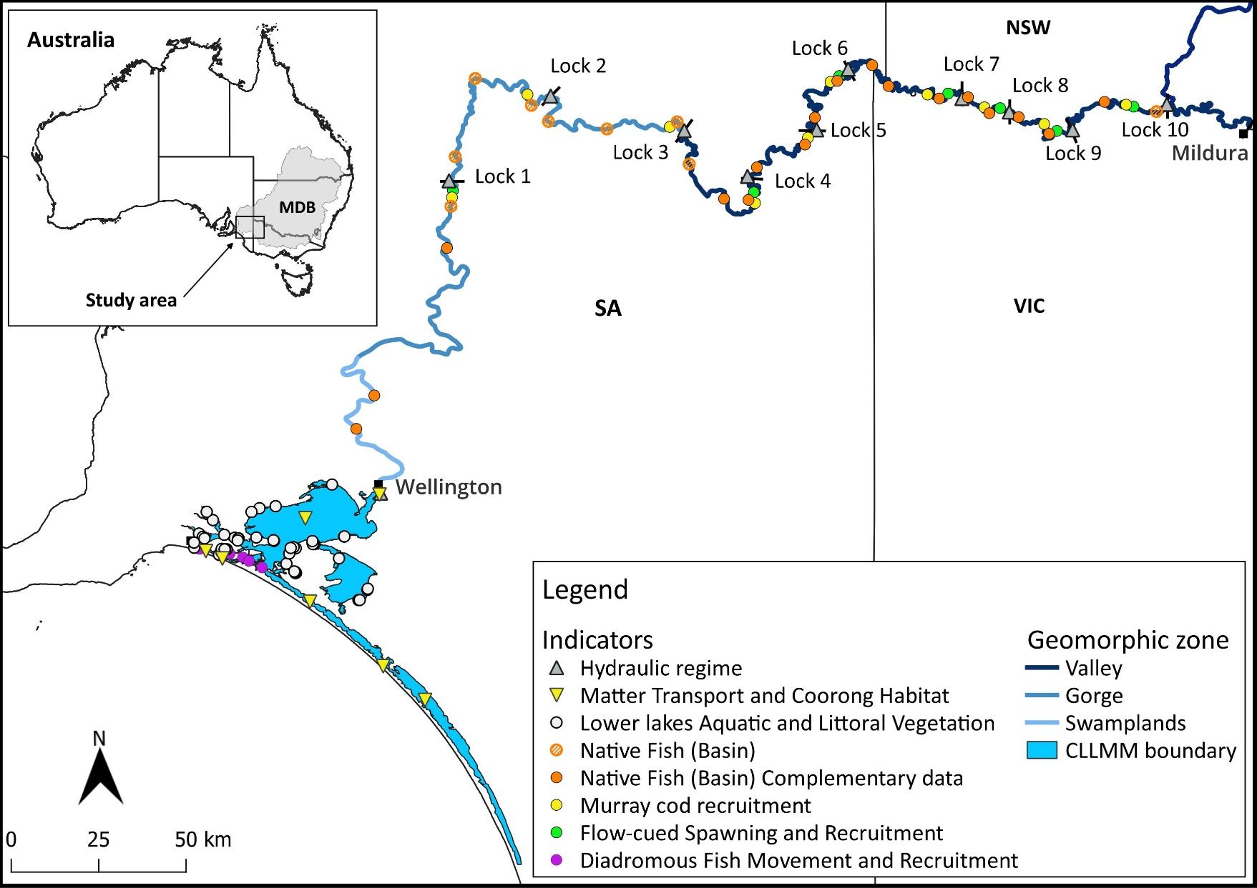
The Lower Murray River (LMR) is often defined as the 830 km of the Murray River from the junction of the Darling River to the Murray Mouth. The reach of the Murray River from the Darling River junction upstream to Lock 11 is morphologically similar to the LMR and represents the most upstream of ten sequential weir pools. The Lower Lakes comprise two large, shallow, freshwater lakes, Lake Alexandrina (~65,300 ha; 1,620 GL) and Lake Albert (~17,300 ha; ~280 GL). They are physically separated from the Coorong estuary by five barrages, constructed between a series of islands from 1935 and 1940. The Coorong is a shallow (typically <3 m), narrow (<4 km) and long (about 110 km) estuarine lagoon system with a constricted channel connection (Murray Mouth) to the sea (Figure 1). The North and South lagoons are ‘separated’ at Parnka Point with a narrow width down to ~100 m. A strong north-south salinity gradient in the Coorong, typically exists, ranging from brackish to marine conditions in the Murray Estuary near the Murray Mouth to hypersaline in the North and South lagoons (Geddes and Butler 1984; Geddes 1987). The Lower Murray and CLLMM Area includes the adjacent wetlands, anabranches and floodplain of the LMR, Coorong, Lower Lakes and Murray Mouth. The Area excludes tributaries to the main channel/Lower Lakes such as the Darling River/Great Darling Anabranch, Currency Creek, Bremer River, Reedy Creek and Finnis River.
The natural flow regime of the LMR is highly variable because of the variable rainfall within the MDB associated with the El Niño Southern Oscillation and other atmospheric phenomena (McMahon et al. 1992) (Figure 2). In addition, as the end of the MDB system, flow to the Lower Murray and CLLMM Area is affected by flow from both the northern and southern basins. The hydrology of the Area, however, has been altered significantly by regulation and diversions, including the establishment of the weirs and tidal barrages (Maheshwari et al. 1995). The ecologically significant effects of regulation and diversions are: reduced frequency magnitude of spring pulse (e.g. Mallen-Cooper and Zampatti 2018); loss of flowing water habitat (e.g. Bice et al. 2017); habitat fragmentation; permanent inundation of channel margins and low-lying wetlands and floodplain areas in the vicinity of the weir pools, and reduction in the frequency of inundation in higher wetlands and floodplain areas (e.g. Walker 2006); and reduced connectivity and end of system flows at the Murray Mouth and to the Coorong (e.g. Kingsford et al. 2011). Despite these changes, the Lower Murray and CLLMM Area retains high habitat and biological diversity and provides important habitat for numerous species protected under state or federal legislations. These include large-bodied (Murray cod, freshwater catfish, silver perch) and small-bodied native fish (Murray hardyhead, southern pygmy perch, purple spotted gudgeon), southern bell frog and numerous migratory and other waterbird species (e.g. fairy tern).

Figure 2. Daily flow (ML/d) in the Lower Murray River (LMR) at the South Australian border (blue solid line) from July 1996 to July 2025, compared to modelled flow under natural conditions (grey dashed line). Approximate bankfull flow in the main channel of the LMR is shown (black dashed line).
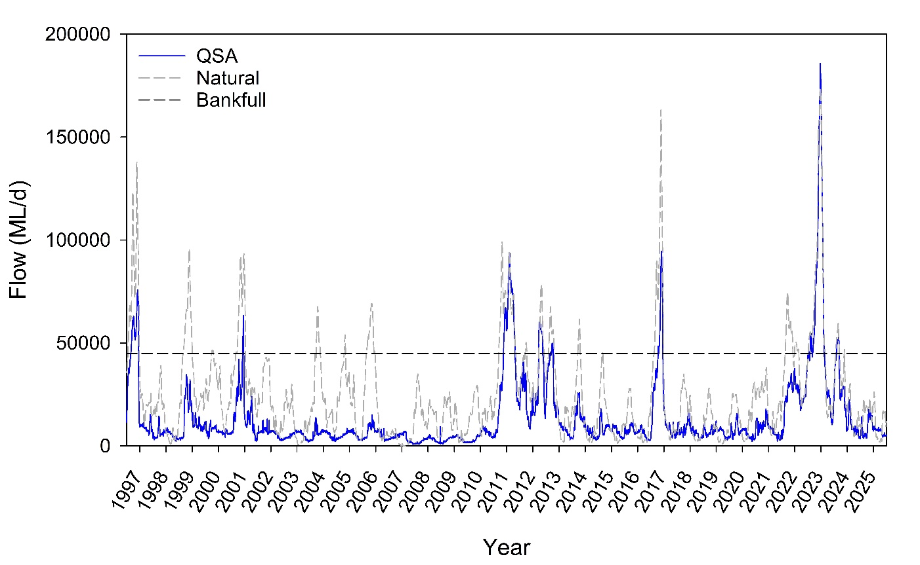
The Lower Murray and CLLMM (River Murray downstream of the Darling River, and associated aquatic and floodplain systems, River Murray—Darling to Sea) ecological community is listed as ‘Critically Endangered’ under the Environment Protection and Biodiversity Conservation Act 1999 (EPBC Act). Within this Area are key environmental assets including the Riverland (including Chowilla Anabranch), Banrock Station and Lower Lakes and Coorong Ramsar sites, and a number of large, ecologically important wetlands and floodplains (e.g. Katarapko, Pike and Lindsay–Mulcra–Wallpolla Islands).
  - Monitoring sites
In the Lower Murray and CLLMM Area, data used for evaluation are collected through field monitoring (including complementary monitoring) or are the outputs from modelling. A map of the monitoring sites, including those from complementary projects, are presented in Figure 1 and described below for the Basin themes.
River Flows and Connectivity
The Hydraulic Regime indicator uses observed and counterfactual hydrological data (e.g. discharge) to model hydraulic parameters between Wellington and Lock 10 (Wentworth). Similarly, for Matter Transport and Coorong Habitat, a hydrodynamic-biogeochemical model assesses the effect of CEW on the concentrations and transport of dissolved and particulate matter (particularly salt) at representative sites across the CLLMM zone, and to evaluate the subsequent effects on fish and Ruppia habitat in the Coorong.

Native Vegetation
Field data are collected through complementary The Living Murray (TLM) Lower Lakes vegetation surveys at 53 sites in the CLLMM zone.
Native Fish
In conjunction with the allied River Murray Monitoring Program (RMMP), larval fish sampling for the Flow-cued Fish Spawning and Recruitment indicator is undertaken at seven tailwater (upper weir pool) sites across the Valley and Gorge zones of the Murray River. Electrofishing is conducted across approximately 800 km of river between Wellington to Lock 10 and consist of two types of monitoring approaches: condition and targeted. Condition monitoring (Native Fish) is undertaken at 26 sites across the Valley, Gorge and Swamplands zones and includes monitoring being undertaken through complementary programs (e.g. TLM Icon Site Fish Condition Monitoring and MDB Fish Survey, Section 8.1). In conjunction with the RMMP, targeted (Murray Cod Recruitment) monitoring is undertaken at ten tailwater sites in the Valley and Gorge zones. For Diadromous Fish Movement and Recruitment, sites from complementary TLM barrage fishway monitoring are located at or near the Goolwa, Hunters Creek, Mundoo, Ewe Island, Boundary Creek and Tauwitchere barrages in the CLLMM zone.
Cultural Outcomes
The indicator of Cultural Outcomes covers the entire Lower Murray and CLLMM Area. In 2024-25, a specific project (Pondi monitoring) involved electrofishing with First Nations rangers at multiple sites between Swan Reach and Renmark in the South Australian section of the Murray River.

- Flows and environmental watering
  - Overview of flows
Since 2011-12, environmental water has been delivered to the Lower Murray to increase or maintain river flows and improve ecological health (https://www.dcceew.gov.au/water/cewo). During the LTIM and Flow-MER Program period (2014-15 to 2023-24), an average of ~781 GL/y of CEW was delivered to the LMR, in conjunction with other environmental flows (i.e. water from TLM Initiative, Victorian Environmental Water Holder (VEWH), River Murray Increased Flows (RMIF), and allocations managed by the NSW Department of Climate Change, Energy, the Environment and Water (NSW DCCEEW), with an average of ~716 GL/y of CEW flowing through the barrages into the Coorong (Ye et al. 2025) (Table 15.3.1, Appendix). During this period, CEW delivery in the Lower Murray was primarily used to contribute to base flows and freshes in the LMR channel and maintain river flows to the Lower Lakes and Coorong (Figure 3).
Figure 3. The various flow types of the Lower Murray River as described in the Murray–Darling Basin Plan (MDBA 2011) and how flow volumes translate to lotic habitat in the contemporary LMR (Lock 1 to Lock 6 reach).
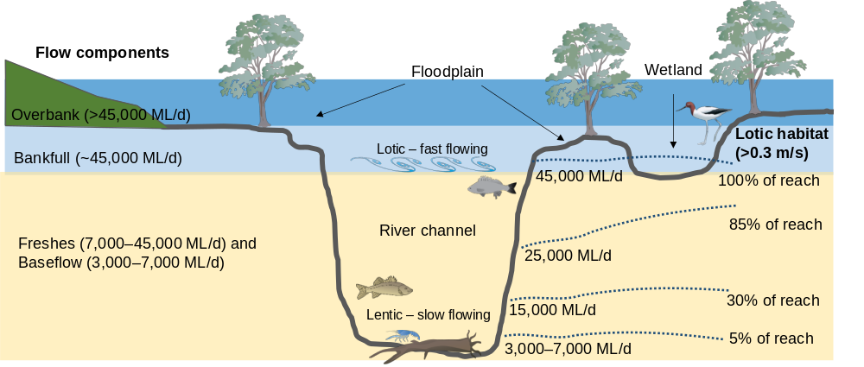
CEW can be delivered to the Lower Murray and CLLMM Area through flows from Hume Dam, Lake Victoria and from the various Murray River tributaries, including the Goulburn, Loddon and Campaspe rivers in Victoria, and the Murrumbidgee and Darling rivers in NSW. Return flows from upstream watering events supplement deliveries made specifically for LMR (particularly at the South Australian border). There are two established methods for providing environmental water to supplement flow at the South Australian border: during unregulated conditions, directed releases from Lake Victoria (Figure 1); and, during regulated conditions, direct trade environmental water from Victoria or NSW to South Australia.
For the Flow-MER Program period (2024-25 to 2028-29), most CEW deliveries to the Lower Murray are expected to continue supporting baseflows and freshes, and/or enhancing flow events in conjunction with unregulated flows, depending on prevailing climatic conditions. CEW can be delivered, with other sources of environmental water and consumptive water, to create freshes or to complement natural freshes and in doing so increase the magnitude and/or duration of an event. Furthermore, should suitable climatic and hydrological conditions transpire during the coming five years, CEW may also be used to complement natural overbank flows by maintaining/enhancing high flow rates or extending the duration of these events (Figure 3).
In 2024-25, ~1,287 GL of environmental water (42% of the total river flow, excluding off-channel use) was delivered in the Lower Murray to South Australia. This comprised of ~959 GL of CEW, ~276 GL of TLM, ~26 GL of VEWH, ~16 GL of Vic RMIF and ~7 GL of NSW RMIF and ~3 GL of allocations managed by the NSW DCCEEW. Much of the environmental water was delivered to the Area as return flows from upstream actions, providing distinctive winter and spring–summer flow pulses (Figure 4). The winter flow pulse, peaking at 14,300 ML/d in late July 2024, was supported by environmental water delivery (predominantly TLM) in the Goulburn River (Figure 4). In 2024-25, the majority of CEW delivery occurred between early October and early December 2024 (51% of total flow during this period) through a multi-site action and consisted of return flows from the Goulburn, Murrumbidgee and Murray rivers. CEW during this period assisted in maintaining flow above 13,000 ML/d from 16 October to 12 December 2024 (peak 18,600 ML/d on 25 October 2024). In addition to return flows, CEW also supported flows to South Australia through direct trades to the South Australian border in 2024-25, with 180 GL provided from December 2024 to April 2025.
During 2024-25, barrage releases were composed entirely of environmental water, of which CEW accounted for 79%. Flow to South Australia mainly comprised flow from Lake Victoria and the Murray River, with increased proportional contributions from the Darling River during July, late October and May, Goulburn River during August and from late October to early November, and Murrumbidgee River from late November to early December (Figure 4). Water stored in Lake Victoria originated from multiple upstream sources and was released based on Lake Victoria Operating Strategy (MDBC 2002). CEW supported other complementary management actions to achieve ecological outcomes in the Lower Murray and CLLMM Area. These included weir pool manipulations, operation of environmental regulators and wetland watering by pumping (Table 15.3.3, Appendix).

Figure 4. Flow to South Australia from 1 July 2024 to 30 June 2025 showing the (a) contribution of environmental water (eWater) and (b) source of all (environmental and consumptive) water (MDBA). CEW = Commonwealth environmental water. Approximate bankfull flow (orange dashed line) and modelled flow under natural conditions (black dashed line) are shown. ‘Bigmod salinity routines’ was used as a proxy for transport of biological matter, to estimate the proportion of the flow that originated at different upstream tributaries and the Lake Victoria storage.
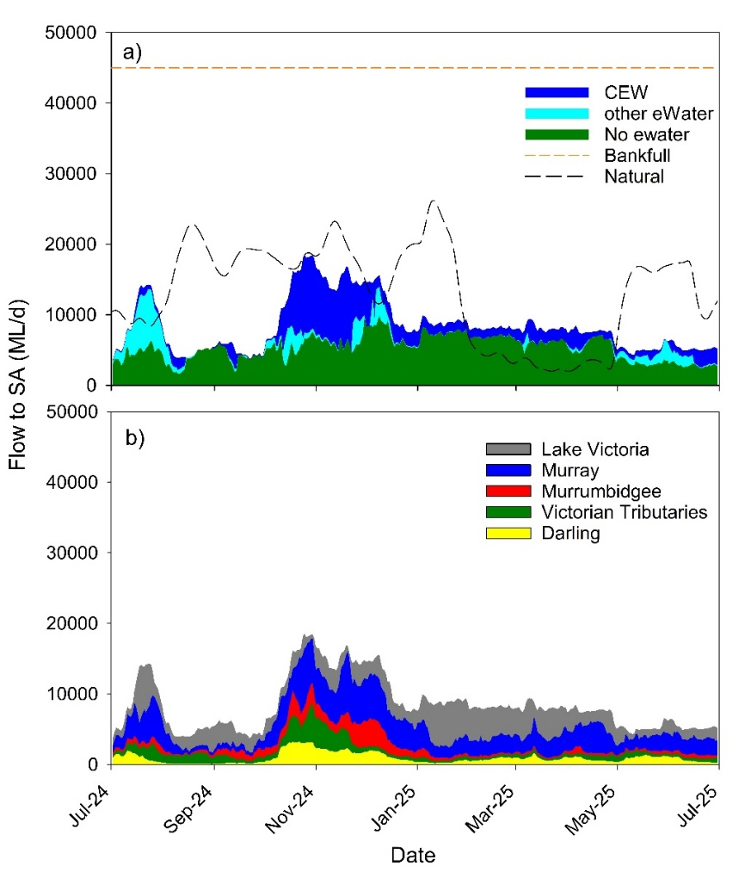
  - Expected outcomes and objectives
CEW deliveries to the Lower Murray and CLLMM Area aim to achieve a broad range of environmental outcomes, including those related to fish, vegetation, birds, water quality and river function (Ye et al. 2024a). Expected outcomes of 2024-25 watering actions at the catchment (asset) scale for the Lower Murray and CLLMM Area are presented in the 2024-2025 Annual Implementation Plan (Ye et al. 2024b). The outcomes evaluated through the core indicators (excluding research and responsive monitoring) are summarised below.
Lower Murray River (from Mildura to Wellington)
Lower Murray River watering activities were expected to contribute to the following outcomes:
- Maintaining current species diversity, extending distributions and improving breeding success and numbers of short, moderate and long-lived native fish species by:
- Providing opportunities for spawning during spring and recruitment (subject to appropriate seasonal conditions).
- Providing in-stream habitat for fish and thereby supporting recruitment of fish, particularly by increasing the availability of food resources and habitat through water level variability and improved hydraulics.
- Increasing the presence of lotic conditions along the Murray River and, where feasible, increased lateral connectivity with wetlands and low elevation floodplain areas.
- Providing opportunities for native fish to move along the length of the Murray River and with its tributaries, including for juvenile golden perch to move from the Lower Murray to Mid Murray to replenish ageing populations.
- Contributing to riverine functioning by:
- Supporting the managed export of salt and nutrients from the Murray River system.
This watering action also aimed to contribute to the following rolling multi-year priorities identified in the Basin annual environmental watering priorities:
- Support lateral and longitudinal connectivity along the river system.
- Support Basin-scale population recovery of native fish by reinstating flows that promote key ecological processes across local, regional and system scales in the southern connected Basin.
Lower Murray River Weir Pools and Floodplains
Weir pool manipulation (weir pools 1–9)
Weir pool manipulation activities were expected to contribute to the following ecological outcomes:
- Maintaining current species diversity, extending distributions and improving breeding success and numbers of short, moderate and long-lived native fish species by:
- Increasing lateral connectivity with anabranches and low elevation floodplain wetlands (via weir pool raising).
- Increasing the presence of fast flowing fish habitat along the Murray (via weir pool lowering).^{c}
CLLMM
The following arrangements (set out in the 2024-25 Commonwealth watering schedule) guide delivery of a hydrological regime that sought to maximise the following outcomes:
- Maintain current species diversity, extend distributions and improve breeding success and numbers of short, moderate and long-lived native fish species by:
- Providing attractant and connecting flows to support movement of diadromous fish species, subject to appropriate seasonal conditions.
- Contributing to the maintenance of critical habitat, water quality, water level, and the provision where possible of localised refuge sites as required, in both the Lower Lakes and Coorong.
- Maintain the extent and condition of key habitat, specifically:
- Maintaining the diversity, condition and extent of aquatic and littoral vegetation in the Lower Lakes (which in turn provides habitat for fauna, including the threatened southern bell frog, Murray hardyhead (Endangered EPBC), and the southern pygmy perch (Endangered in SA)).
- If season and conditions are appropriate, and sufficient water is available, protecting the current extent of Ruppia tuberosa by contributing to flows that support suitable habitat conditions (salinity and water levels) within the Coorong South Lagoon (and suitable parts of the North Lagoon) to promote flowering and seed set, and growth and survival of newly established plants over successive years.
- Maintain and, where possible, expand estuarine habitat conditions that support the entire Coorong food web by:
- Providing flows to maintain appropriate salinity levels in the Murray estuary and North Lagoon through both dilution and by minimising salt import through the Murray Mouth.
This watering action was expected to contribute to the following rolling multi-year priorities identified in the Basin annual environmental watering priorities:
- Manage water to maximise lateral and longitudinal connectivity along the river systems and provide opportunities for high ecological productivity.
- Support freshwater connectivity through and between the Lower Lakes, Coorong and Murray Mouth.
- Support Basin-scale population recovery of native fish by reinstating flows that promote key ecological processes across local, regional and system scales in the southern connected Basin.
  - Commonwealth environmental watering actions
In 2024-25, 60 CEW watering actions were undertaken in the Lower Murray, comprising nine targeting outcomes in the main river channel and 51 targeting outcomes in off-channel habitats (wetland, floodplain and anabranches) (Figure 5a). A large number of watering actions (23%) were associated with vegetation objectives (Figure 5a) and primarily involved small volumes delivered to off-channel wetland watering (Figure 5b). In contrast, baseflows and small freshes delivered in the main channel of the LMR under four watering actions (959 GL, 98% of total CEW use in the Lower Murray) had a range of objectives (Figure 5) that were related to the expected outcomes listed in Section 3.2. Refer to Table 15.3.3 in the Appendix for information on the volumes, objectives and delivery details of each watering action in the Lower Murray and CLLMM Area.

Figure 5. Commonwealth environmental watering (CEW) actions in the Lower Murray during 2024-25, expressed as (a) number of actions and (b) volume of water (gigalitres, GL) delivered for targeted objectives by flow components. Flow components are separated into main and off-channel actions. No CEW was accounted as being delivered for weir pool lowering and raising watering actions. Data are provided by the CEWH through the Watering Actions Table (WAT). Refer to table 15.3.3 in the Appendix for details of watering actions.
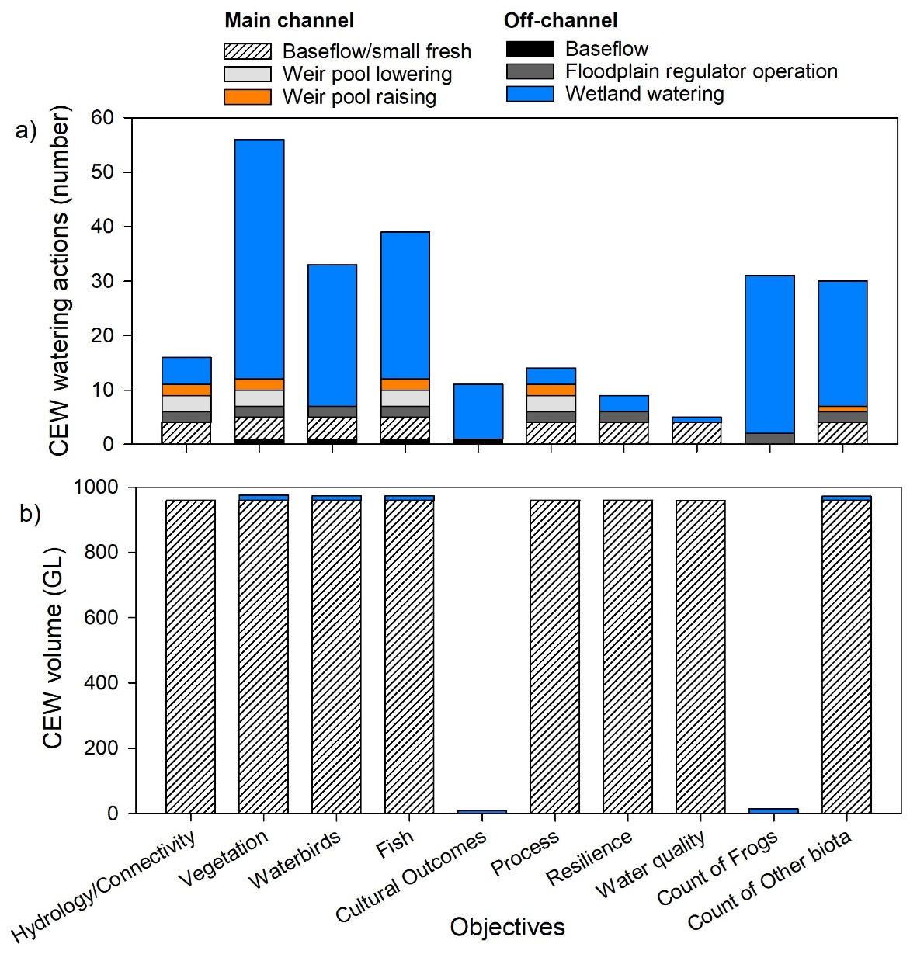
  - Evaluation approach
The contribution of environmental water (and specifically CEW) to expected outcomes in the Lower Murray and CLLLMM Area (Section 3.2) was determined by answering Key Evaluation Questions (KEQs) (Table 15.2.2, Appendix). For annual (2024-25) and long-term (multi-year) outcomes, a significance level was assigned to the contributions of all environmental water and CEW for each KEQ. Significance was assessed as to what extent all environmental water (including CEW) or CEW contributed towards that observed outcome, compared to what the predicted outcome under a counterfactual scenario, i.e. in the absence of all environmental water or CEW.
A key objective of this project is to specifically evaluate the contribution of CEW and not other sources of environmental water in isolation. To evaluate the contribution of CEW to an outcome, the evaluation assumes that all other water (including other environmental water) was delivered under the counterfactual scenario. This approach represents CEW as being delivered ‘after’ or ‘on top’ of other water. It is acknowledged that this approach may over- or under-estimate the influence of CEW, depending on the circumstance and evaluation metrics being assessed.
For KEQs, the criteria for assigning the significance levels vary among indicators and KEQs, ranging from using defined percentages or values of change, to qualitative assessment based on expert opinion (e.g. Flow-cued Fish Spawning and Recruitment). The criteria are described in the ‘Key Evaluation Questions for Basin and Area’ and ’Evaluation’ sections for each indicator (Sections 5–9). The contribution of environmental water/CEW to Cultural Outcomes is evaluated using a different approach, not assigned with a significance level, because the KEQs relate to broader First Nations engagement activities associated with CEW delivery.
- Data management
The approach for data management in the Lower Murray and CLLMM Area is presented in Section 10 of the MER Plan (Ye et al. 2024a) and closely follow the protocols, policies and principles described in the Data Management Strategy (Brooks et al. 2023). Key aspects are summarised below.
- The Lower Murray and CLLMM Area Consortium partners have established quality assurance/quality control (QA/QC) processes for field sampling, laboratory analysis, experimental data collection, data entry and reporting.
- All program data are being managed to prevent unauthorised access to sensitive information and to guard against accidental loss (e.g. with off-site backup and a register of data custodians and storage locations). Individual sub-contractors are responsible for managing all primary (raw) data including governance, storage, backup, version control and custodianship. Complementary data are being stored and managed by the agencies sharing them. Program data collected in the Lower Murray and CLLMM Area are being stored and managed within:
- SARDI Inland Waters databases – Fish, Cultural Outcomes, KECE
- South Australian Department for Environment and Water (DEW) – Hydrological database – River Flows and Connectivity and Hydraulic Regime
- University of Western Australia internal project repository – Matter Transport and Coorong Habitat.
- Data are also being stored on secure centralised storage that allows it to be managed and used by the Basin-scale team and other data users to meet their evaluation and reporting requirements. Data storage and access are currently provided by two independent platforms:
- Monitoring Data Management System (MDMS) – used for storing monitoring and research data as individual location x date records. Raw data conforming to the Data Standards is being loaded by the Lower Murray and CLLMM Data Manager into the MDMS.
- Data Portal – a digital file repository that provides additional capability to manage data that do not conform to the data record structure of the MDMS and offers streamlined user access to shared data.
- Specifically, for First Nations engagement and data collection, we followed the principles of Free, Prior and Informed Consent (FPIC) and Indigenous Cultural and Intellectual Property (ICIP) and adhered to Indigenous Data Sovereignty. These included:
  - Engaging Ngarrindjeri Aboriginal Corporation (NAC) and River Murray and Mallee Aboriginal Corporation (RMMAC) Cultural Advisors and rangers early to co-design the project and activities (Pondi monitoring, Elders engagement, yarning circle, etc,), ensuring participation was voluntary; co-developed plain-language program and information sheets and explaining purpose, risks, benefits, and data use; and consent was treated as an ongoing process at key stages (data/information collection, and use for publication).
  - Cultural knowledge shared by participants remained the intellectual property of the NAC and RMMAC; permissions were negotiated for any use beyond the immediate project; sensitive cultural information (e.g. stories, sites, practices) was either excluded from publication or de-identified according to community guidance; outputs (article/reports, Pondi video, dataset) were co-reviewed with community representatives prior to dissemination to ensure accurate and respectful representation.
  - NAC and RMMAC rangers were involved in data collection and were provided with copies of data while the data are also stored on SARDI Inland Waters databases. NAC and RMMAC have the right to control their data and information, including how they are stored, used, and shared.
- Throughout the Program, a Data Working Group consisting of the CEWH Data Manager, Basin-scale Data Manager, First Nations Knowledge Broker and ten Area-scale Data Managers is maintaining data standards, policies and management procedures, while coordinating the provision and publication of data in accordance with the Data Management Strategy.
- River Flows and Connectivity
  - Hydraulic Regime
Introduction
Discharge data are readily available and relatively easy to measure and/or simulate. However, it is the hydraulic characteristics of flow (i.e., a change in velocity or water level) that biota can sense and respond to. These hydraulic characteristics result from the interaction of discharge and physical features (e.g. channel morphology, woody debris, man-made structures, etc.) and have a profound influence on river ecosystem structure and function (Statzner and Higler 1986; Biggs et al. 2005; Bice et al. 2017). In simple systems that are free flowing and have consistent morphology, discharge and hydraulic characteristics are typically monotonically related and, in this case, both hydraulic parameters can provide similar relationships to discharge (e.g. Webb et al. 2022). However, in reaches with variable morphology, or where there are backwater effects from downstream infrastructure, the same discharge can result in very different hydraulic characteristics across space and time (Gibbs et al. 2023).
Many riverine biota have life histories that are fundamentally linked to river hydraulics and often display adaptations (e.g. drifting eggs and larvae) that depend on lotic (flowing water) environments. In the Lower Murray, however, flow regulation - through a combination of reduction in overall discharge and construction of serial main channel weirs - has transformed what was once a predominantly lotic environment into one that is largely lentic (lake-like) in character (Bice et al. 2017). In association, there have been declines and local extinction of lotic biota (Mallen-Cooper and Zampatti 2018). Promoting lotic habitats is critical to ecosystem rehabilitation in the Lower Murray and may be achieved by two primary mechanisms: 1) increasing discharge volumes; and 2) lowering weir pools.
Ecological indicators that are likely to have detectable change in response to hydraulic characteristics have been intentionally selected as part of this project. As such, detailed spatial and temporal information on the change in hydraulic regime due to changes in hydrology, i.e. flow and the delivery of (Commonwealth) environmental water, and supported management actions, i.e. weir pool manipulation, is beneficial to report on hydraulic indicators, as well as to inform the assessment and interpretation of the ecological responses.
Hypotheses
- Environmental water, including CEW, will promote greater extent of lotic habitat as evidenced by increased water velocities and variability in water levels.
Key Evaluation Questions for Basin and Area
Area-scale
A summary of the key evaluation questions, parameters used to quantify changes and evaluation methods for the Hydraulic Regime indicator are summarised in Table 1. Details on methods and evaluation metrics are provided in the Methods section.
Table 1. Key evaluation questions for assessing the Hydraulic Regime responses to Commonwealth environmental water (CEW). Parameters and evaluation approaches used to answer the evaluation questions are provided. eWater = environmental water.
Key Evaluation Questions | Parameter | Evaluation Approaches
What was the longitudinal hydrological connectivity (modelled) under the annual flow regime? What did eWater (and specifically CEW) contribute to this outcome? | Increase (as percentage) of annual volume at Lock 10, Flow to SA, Lock 1 and Barrages.  Length of river supporting longitudinal transport (velocity > 0.2 m/s). | Hydrological modelling for counterfactual flow time series.  Hydrodynamic modelling for velocity.
What was the lateral hydrological connectivity (modelled) under the annual flow regime? What did eWater (and specifically CEW) contribute to this outcome? | Additional area inundated from normal pool level. | Hydrological modelling for counterfactual flow time series.  Hydrodynamic modelling for area.
What was the hydraulic diversity (modelled) within weir pools under the annual flow regime? What did eWater (and specifically CEW) contribute to this outcome? | Length of river representing lotic habitat  (velocity > 0.3 m/s). | Hydrological modelling for counterfactual flow time series.  Hydrodynamic modelling for velocity.
What was the variability in water levels (modelled) within weir pools under the annual flow regime? What did eWater (and specifically CEW) contribute to this outcome? | Median absolute difference from normal pool level in water levels in tailwater of weir pools. | Hydrological modelling for counterfactual flow time series.  Hydrodynamic modelling for water level.
Methods
The river flows and water levels with environmental water, i.e. observed conditions, are based on recorded data extracted from the Water Data SA portal. The counterfactual flows, without CEW and without all eWater, are modelled by the MDBA using the Source Murray Model. The scenario is configured using accounting of environmental water into the Area and at the South Australian border, with the change in flows at each Lock, at Wellington and the barrages simulated using the Source model. The scenarios considered are:
- With all eWater, with all environmental water representing observed conditions,
- Without CEW, without CEW,
- Without eWater, without any environmental water,
- No Locks, the observed discharge as used for the All Water (i.e. with all eWater) scenario, but the influence of the weir and locks across the Murray River removed, to provide an indication of the maximum hydraulic changes that could be expected for the delivered flow regime, and
- WoD, or Without Development, a representation of natural conditions, which has the locks removed as used for the No Locks scenario, but also a modelled flow representing no storage or diversions across the Murray River.
Two key assumptions are made in the modelling:
- The environmental water allocated to South Australian entitlements is assumed to still be delivered to South Australia in the without environmental water scenarios, under the assumption that this water would still have been delivered to South Australia as Entitlement Flow if held for consumptive use. Instead, in the without environmental water scenarios, diversions within South Australia are increased in the model to represent 100% utilisation of this allocation for consumptive use.
- To model the Lake Alexandrina water level in the without environmental scenarios, it is assumed that the observed lake level would still have the main objective for barrage operations, and without environmental water there would have been less barrage flow. If there is insufficient flow into the lakes to maintain the observed lake level, barrage flow ceases until the modelled lake level recovers to the observed level. The without CEW and without eWater scenarios are modelled separately, which effectively results in CEW being passed as barrage flow before other eWater if the modelled lake level does not support all eWater being passed as barrage flow on any given day.
Detailed hydrodynamic models have been developed for the Lower Murray and CLLMM Area (herein this section, Lower Murray Area) over the past decade. These models compute hydraulic parameters with high spatial and temporal resolution based on upstream discharge, structure settings (for example weir pool levels) as well as other static inputs such as bathymetry and surface roughness. These models are computationally demanding, typically taking a number of days to simulate a number of months in the model, over the domain of one weir pool. A large number of pre-computed steady state scenarios of inflow and weir pool height conditions have been simulated in these models previously and have been used to underpin the Lower Murray River Hydraulic Regime indicator since the start of LTIM in 2014-15, with regular refinements and updates over time.
For the Hydraulic Regime indicator pre-processed outputs from hydrodynamic models were interpolated on a daily basis to estimate changes in hydraulic parameters under scenarios with and without (Commonwealth) environmental water. By comparing the observed, no environmental water and no CEW discharge time series, along with any associated weir pool manipulations, this modelling provides a direct indication of the contribution of (Commonwealth) environmental water to hydraulic changes in the river, metrics based on velocity, water level and inundated area.
Hydraulic metrics were interpolated using linear bivariate interpolation for each scenarios considered. If a weir pool manipulation event was supported by environmental water, the without CEW and without eWater scenarios assumed the weir pool was constant at normal pool level (NPL) for the duration of the event. If the weir pool manipulation was not supported by environmental water, for example a raising undertaken using unregulated flow, then the observed water levels are used in all scenarios.
A range of hydraulic metrics were calculated, including median (50th percentile) water velocity within the weir pool, the proportion of the weir pool exceeding velocities of 0.2 and 0.3 m/s, and water levels at regular intervals along the weir pool. The former water velocity (>0.2 m/s) represents favourable velocities that entrain and transport/disperse phytoplankton, zooplankton and fish larvae (Gibbs et al. 2023) and allow gas exchange at the water surface (Ye et al. 2021). The latter (>0.3 m/s) represents flowing water (lotic) conditions for riverine biota (Bice et al. 2017; Gibbs et al. 2023).
In previous iterations of LTIM/Flow-MER, the spatial range of the Hydraulic Regime indicator extended from Lock 1 to Lock 6, and in most recent years Wellington to Lock 6. The models that cover these reaches are high resolution 2D flexible mesh models. South Australian DEW commissioned a similar model to represent Weir Pool 6 and outputs from this model have been used to underpin this work (Asha and Yamagata 2024; McCullough 2025).
With the extension of the Lower Murray Area in Flow-MER, models developed by the MDBA representing weir pools 7, 8 and 9 have been used to produce the same hydraulic metrics to cover the Murray River up to Lock 10. See Section 12.1 for details of a research project on the development of hydraulic model outputs for weir pools 7, 8 and 9.
Evaluation metrics
Several metrics have been designed to answer the Hydraulic Regime evaluation questions. In each case, the percentage increase in the evaluation metric over the scenario without Commonwealth (or all) environmental water was computed as:
$$Contribution=\frac{(with all eWater-without CEW)}{without CEW} ×100$$

What was the longitudinal hydrological connectivity (modelled) under the annual flow regime? What did environmental water (and specifically CEW) contribute to this outcome?

The Basin-wide environmental watering strategy (BEWS, Section 15.2, Appendix) has expected outcomes for longitudinal connectivity relevant to the Lower Murray Area of:
- A 30% overall increase in flows in the Murray River from increased tributary contributions from the Murrumbidgee, Goulburn, Campaspe, Loddon and Lower Darling catchments collectively.
- A 30 to 40% increase in flows to the Murray Mouth.
These outcomes were evaluated using the total volume over the water year at:
- Lock 10 – which is the first site that includes all the tributary contributions listed in the expected outcomes (Section 3.2),
- Flow to South Australia – which includes the benefit of direct trade to SA, for example if released from Lake Victoria,
- Lock 1 – which includes some of the benefits of SA Entitlement flow held as environmental water, where the counterfactual modelling assumes this water would still have been delivered to South Australia if not held for the environment but would have been 100% utilised within South Australia through increased diversions,
- Barrages – to represent the Coorong and Murray Mouth expected outcomes.
Expected outcomes based solely on annual volume provide a relatively coarse representation of longitudinal connectivity, with no explicit representation of persistence of an event or consideration to transport processes along the river. The average length of river exceeding 0.2 m/s over the water year has been used as another measure of longitudinal connectivity. Velocities exceeding 0.2 m/s are associated with increased entrainment and transport or dispersal of phytoplankton, zooplankton and fish larvae (Gibbs et al. 2023), and support gas exchange at the water surface (Ye et al. 2021). This represents the same metric as used previously for the Lower Murray River Selected Area (e.g. Ye et al. 2021), only in this case by taking the average, the metric value is normalised by the number of days in the year to result in a more intuitive value.
What was the lateral hydrological connectivity (modelled) under the annual flow regime? What did environmental water (and specifically CEW) contribute to this outcome?
Lateral connectivity has been assessed using the increase in inundated area, defined as the modelled surface area greater than that inundated at NPL. The area assumed to be inundated at NPL was a constant value for each weir pool, based on the modelled surface area for the lowest flow available in the hydraulic model scenario summary outputs (1,000 ML/d for weir pools 7–9, 3,000 ML/d for Weir Pool 6, and 5,000 ML/d Weir Pool 5 and downstream). This NPL assumption only influences the zero level for the figure of the increase in area (Figure 7), and the calculation of the percentage increase due to CEW.
The floodplain environmental water requirements (EWRs) for the South Australian River Murray (DEW Environmental Watering Unit 2025) have durations of greater than between 10 and 40 days with a seasonality of September to December. The inundation area exceeded for a continuous period of 40 days (within September to December coinciding with EWR FP1) has therefore been used as a metric for lateral connectivity.
The increase in maximum inundated area over the water year due to (Commonwealth) environmental water has also been used as second measure of lateral connectivity. The lateral connectivity results only consider changes in area resulting from changes in river flow and weir pool level. Other watering actions that create inundation, such as anabranch regulator operations or wetland pumping, are not represented in the results. These actions are discussed separately, based on information available in Watering Action Acquittal reports.
What was the hydraulic diversity (modelled) within weir pools under the annual flow regime? What did environmental water (and specifically CEW) contribute to this outcome?
Hydraulic diversity is assumed to be achieved when the cross section average velocity exceeds 0.3 m/s. At these velocities, the influence of local geomorphology features (such as banks and bars), instream structure (such as woody debris) and vegetation is expected to produce diverse conditions across and along the river at the small scale if the average velocity exceeds 0.3 m/s (Gibbs et al. 2023). Previous studies have identified velocities >0.3 m/s as indicative of flowing water (lotic) conditions suitable for riverine biota (Bice et al. 2017) and as supporting dispersal of Murray cod larvae (Gibbs et al. 2023).
The timing and seasonality for this evaluation metric has been informed by the in-channel EWRs for the South Australian River Murray Channel Priority Environmental Asset, which have a minimum duration of 60 days over the period from October to December (for all but EWR IC1) (DEW Environmental Watering Unit 2025). The hydraulic diversity within weir pools has been calculated as the maximum value of the length of river with a cross section average velocity greater than 0.3 m/s exceeded for 60 continuous days from 1 October to 31 December.
What was the variability in water levels (modelled) within weir pools under the annual flow regime? What did environmental water (and specifically CEW) contribute to this outcome?

Each weir pool has an NPL, and historically the water level upstream of each weir has been managed close to this NPL. Variability around this level is desirable for many ecological responses, including to support vegetation processes (Blanch et al. 2000) and providing allochthonous carbon and other nutrients to the food web (Walker and Thoms 1993). It is assumed water level variability is desirable year-round, as opposed to prioritised to a particular season or duration for the year.
To summarise the variability over the year, the Median Absolute Difference (MAD) metric has been used. The water level in the tailwater of each weir pool, at the upstream end, was used to calculate the metric for each weir pool, as the location least influenced by the weir and most sensitive to changes in environmental water. To quantify the water level variability across the Lower Murray Area (WL_{var}), the median of the MAD value for each weir pool has been used. Hence, water level variability is quantified as:
$${MAD}_{WP}=median\left(\left|{WL}_{i,WP}-{NPL}_{WP}\right|\right)$$
$${WL}_{var}=median\left({MAD}_{WP}\right)$$
Where, WL_{i,WP} is the daily water level at the upstream end of a weir pool, WP, for day i, NPL_{WP} is the normal pool level for weir pool WP. In previous reports, the water level variability metric was the interquartile range (75th percentile – 25th percentile) in daily water levels over the year. The metric has been revised to represent the intent of the objective to have water level variability around a static weir pool level, rather than the statistical measure of absolute variability. For example, a high-flow event or a long weir pool raising may have low variability when quantified using the interquartile range, however, the revised MAD statistic would calculate a difference in water level from the normal weir pool level and indicate higher variability. Given the very different management of the barrages compared to the weirs along the Murray River, the water level below Lock 1 has not been included in this analysis.
Results
Hydraulic regime results for each weir pool, including discharge, increase in inundated area, water level, median velocity as well as percentage of the weir pool exceeding velocity thresholds of 0.2 and 0.3 m/s are provided in Section 15.4 (Appendix). These figures include results for without development inflows and observed flows without locks in place where possible.
Longitudinal connectivity
Environmental water contributed to a “fresh” flow event in the Lower Murray Area from mid-October to mid-December 2024, more than doubling the average flow at Mildura from 7,627 ML/d without environmental water or 8,741 ML/d without CEW to 15,876 ML/d (Figure 6). This event persisted throughout the Area, with over half of the length of the Murray River between Lock 10 and Wellington (i.e. more than 374 river km) having a velocity > 0.2 m/s from 17 November to 13 December 2024 (Figure 7). These faster flowing sections of river would have been reduced to less than 10% of the Area without environmental water (length of 55 and 44 km exceeding 0.2 m/s for the same period without Commonwealth, and all, environmental water, respectively).
The increase in flow across the Area also resulted in sustained flow through the barrages, with all flows through the barrages in 2024-25 accounted as environmental water (Figure 6). Additional, smaller contributions of CEW were delivered via direct trade over December 2024 to April 2025 (Figure 4b) that increased the Flow to South Australia and maintained some connectivity over the barrages (Figure 6) and Lake Alexandrina water levels above 0.55 m AHD (Figure 9).
Lateral connectivity
Environmental water created an additional 1426 Ha of inundated area (616 Ha of which due to CEW) through increases in flow, weir pool manipulation and increased water level in the Lower Lakes (Figure 7 and Figure 8b). The area that experienced inundated for 40 days increased by 1726 Ha due to environmental water, with the majority of this due to CEW (1502 Ha, Figure 8b).
As well as the increases in area represented in the modelling, CEW contributed to the inundation of an additional 2,616 Ha of wetlands and floodplains through infrastructure operations (Table 15.3.3, Appendix). This included:
- 1,943 Ha through pumping and regulator operations by the Murraylands and Riverland Landscape Board
- 40 Ha through pumping and syphoning by Murray-Darling Wetlands Working Group for NSW Murray wetlands
- 105 Ha through pumping by Australian Landscape Trust
- 68 Ha through pumping by the Renmark Irrigation Trust
- 335 Ha through operation of the Pike floodplain regulators
- 125 Ha through operation of the Katarapko floodplain regulators.
It should be noted that these areas are only those contributed to by CEW, and any wetlands inundated by other environmental water (e.g. held South Australian Minister’s licence or TLM) without CEW are not included. This resulted in a total increase in inundated area of 3,232 Ha due to CEW (4042 Ha due to all environmental water). It is noted that some of the infrastructure operations, pumping in particular, do not provide all the processes associated with lateral connectivity compared to inundation created through changes in water level in the river or anabranches.
Hydraulic diversity
The length of river exceeding velocities of 0.3 m/s indicates that sections of the Lower Murray Area supported increased hydraulic diversity during parts of the year (Figure 7). A cross section averaged velocity greater than 0.3 m/s was exceeded for 60 continuous days between October and December for 131 km of the reach (18%), suggesting that these sections experienced enhanced hydraulic diversity within the river. Environmental water, and CEW in particular, made a substantial contribution to this event, with an increase by a factor of 22, where without CEW or any environmental water, the length of river meeting this metric would have been only 6 km (1%) (Figure 8c).
Water level variability
The variability in water level in tailwaters compared to the NPL differs substantially between weir pools. The highest variability was in Weir Pool 6, as one of the longest weir pools in the floodplain zone (82 km), followed by the slightly longer (85 km) but deeper, Weir Pool 3, and then Weir Pool 9 (60 km long). Water level variability was lower in the deeper gorge zone, below Lock 1 (Weir Pool 0), and weir pools 1 and 2 (Figure 8d). Water level variability was also lower in the shorter weir pools, for example Weir Pool 7 is 24 km long, and hence the tailwaters were under the influence of the relatively static weir levels for much of 2024-25. The increase in water level variability due to CEW and all environmental water for each weir pool can be seen in Figure 8d. The median MAD metric across the weir pools increased from 0.13 m to 0.21 m, an increase of 61% due to CEW; while it increased from 0.12 m to 0.21 m (79% increase) due to all environmental water.

Figure 6. Flow with and without environmental water (eWater) (and specifically CEW) along the Lower Murray Area, from Mildura, to the South Australian border (Flow to SA) and to the barrages. Operation of Lake Victoria generates differences between Mildura and Flow to South Australia.
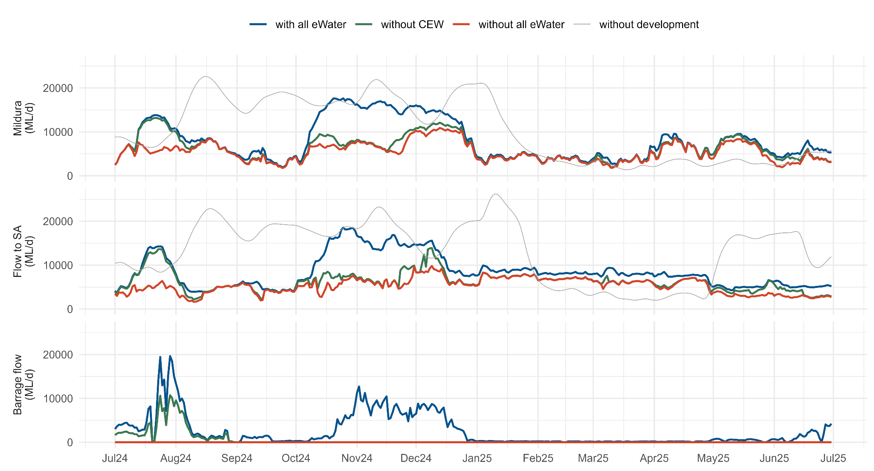

Figure 7. Change in area from normal pool level (Ha) and length of river (km) exceeding 0.2 and 0.3 m/s with and without environmental water (eWater) (and specifically CEW). Negative areas in 2025 are a result of the Lake Alexandrina water level below the assumed normal pool level of 0.4 m AHD. The length of river considered is from Lock 10 to Wellington, 747.2 km in total.
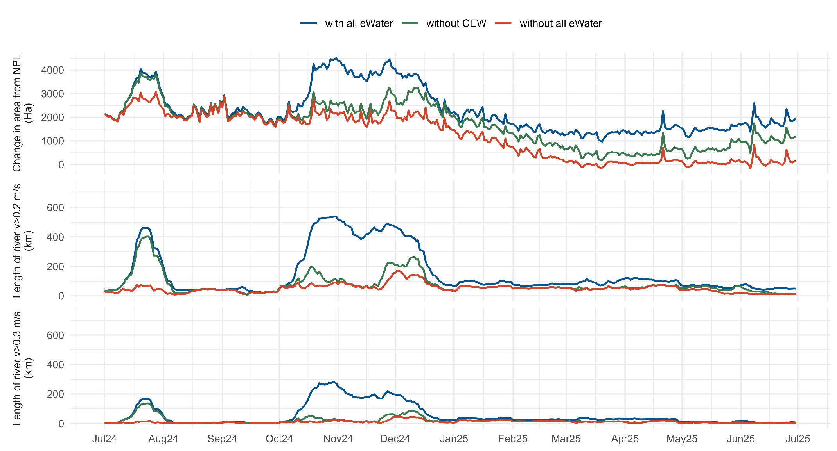

Figure 8. Environmental water (eWater) (and specifically CEW) contributions to evaluation metrics. Values shown on each subfigure are the percentage increase due to CEW, in the total volume over the year at different locations (A), the additional inundated area (B), length of river exceeding velocity thresholds (C) and water level variability at each weir pool, as the median absolute difference (MAD) of the daily water level in the tailwater from the normal pool level (NPL) (D).
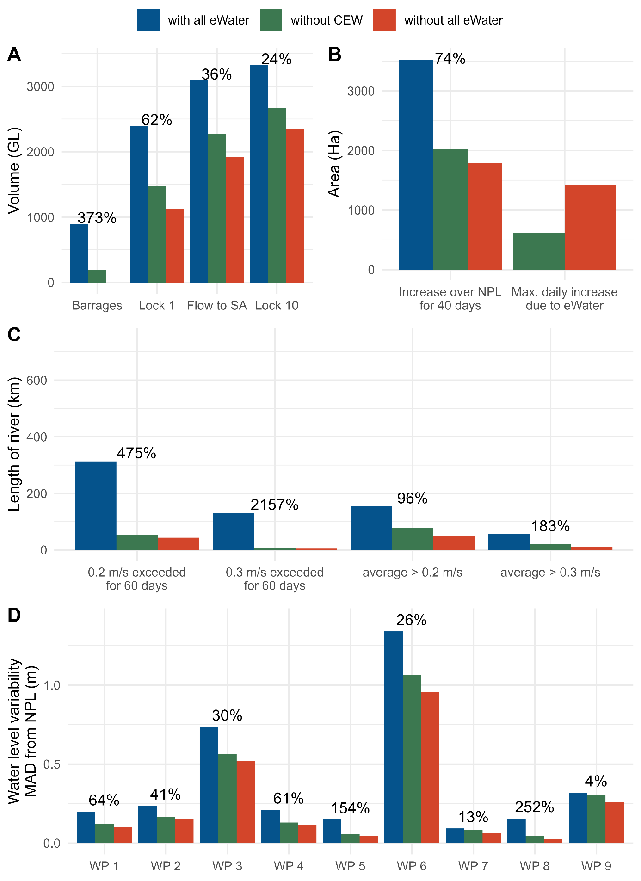
BEWS Expected Environmental Outcomes
The BEWS has an expected outcome of barrage flows greater than 2,000 GL/year on a three-year rolling average basis for 95% of the time, with a two-year minimum of 600 GL at any time. With large volumes of barrage flow in 2023-24 (4,842 GL without CEW), the two-year minimum was met this year, even with low volumes in 2024-25 (189 GL without CEW). Since 2014, 2,000 GL/year over a three-year rolling average has been met in 78% of years, for all scenarios (with or without environmental water, based on MDBA water balance modelling). The 600 GL over two years component of the expected outcomes was not met in two of the two-year periods since 2014-15, which would have been a third two-year period without CEW.
Water levels in Lake Alexandrina would have fallen below 0.4 m AHD, reaching 0.39 without CEW and 0.26 m AHD without any environmental water (Figure 9). CEW resulted in this BEWS outcome being met, over the 2024-25 evaluation period as well as since the start of LTIM in 2014, where without CEW the lake level would have dropped below 0.4 m AHD for 19% of the time over the longer period (Table 2). This outcome demonstrates a clear contribution of CEW to achieving the BEWS end-of-Basin objective of maintaining Lower Lakes water levels above 0.4 metres AHD for 95% of the time, where practicable, to support barrage releases.
Table 2. The proportion of the time (% of days) the water level in the Lower Lakes has been above 0.4 m AHD for each scenario, in the 2024-25 evaluation period as well as since 2014.
Scenario | 2014–2025 | 2024-25
Observed | 100 | 100
Without CEW | 81 | 93
Without all environmental water | 78 | 63

The expected outcome to keep baseflows to at least 60% of the natural level has been evaluated using a similar method to that used in Ye et al. (2025), based on the original method outlined in MDBA (2012). Baseflow separation of the without development time series was undertaken using a Lynne-Hollick filter with the recession constant estimated based the without development time series since 1 July 2014. The monthly Flow to South Australia volume, with and without environmental water, was compared to 60% of the without development baseflow monthly volume. Ten out of the twelve months exceeded the baseflow level with environmental water in 2024-25, with August and September 2024 being the months not met. This reduced to eight months, meeting the baseflow requirement without CEW, and six months without all environmental water. While this outcome was not achieved in all months, environmental water, and specifically CEW, made a substantial contribution to the outcome.

Figure 9. Water level in Lake Alexandrina with all environmental water (eWater) (as recorded at Milang) and modelled without eWater (and specifically CEW). The 0.4 m AHD expected outcome is shown as a horizontal dashed line, and the start of the 2024-25 water year as a vertical dashed line.
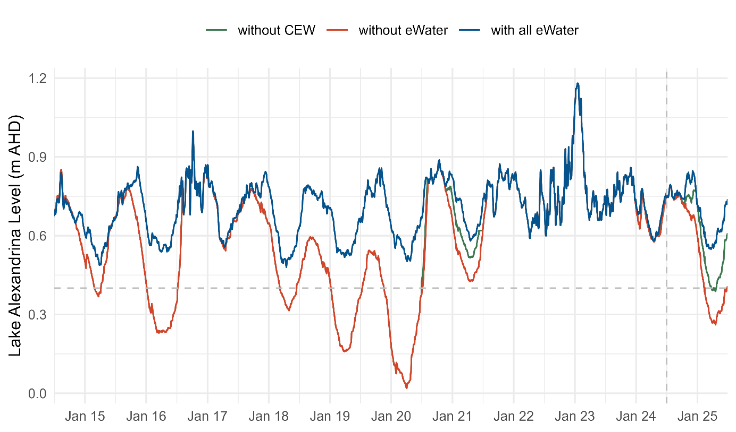
Evaluation
The outcomes for the KEQs for 2024-25 are summarised in Table 3 and Figure 8. The contribution to the outcome for the Hydraulic Regime indicator was based on the percentage increase due to the environmental water, with an increase of greater than 50% deemed substantial, 25‒50% moderate, 10‒24% minor and less than 10% a negligible contribution. The thresholds may be adjusted in response to developing understanding of these processes.
As outlined in the Methods section, the percentage change is a metric calculated as the difference due to environmental water over the metric value without that environmental water. Hence, the baseline for comparison (denominator) is different between the with all eWater and only the CEW component, which in some cases can result in larger percentage changes than might be expected based on changes in the difference (numerator) alone.
The evaluation for the longitudinal connectivity question is based on the length of river supporting transport (velocity > 0.2 m/s), with the BEWS annual volume metric also reported for context in Table 3, and at other locations in Figure 8. Figure 8 also includes other metrics not used in the evaluation classification (Table 3) but provide additional context, such as water level variability for each weir pool and the length of river exceeding 0.2 m/s for 60 days.

Table 3. Area-scale evaluation questions for Hydraulic Regime. The evaluation is based on one key metric for each Key Evaluation Question, with additional metrics outlined in Figure 8. Refer to ‘Key Evaluation Questions for Basin and Area’ and Table 1 for a description of the evaluation approach. eWater = environmental water.
Key Evaluation Questions | Outcome for 2024-25 | eWater contribution | CEW contribution
What was the longitudinal hydrological connectivity (modelled) under the annual flow regime? What did eWater (and specifically CEW) contribute to this outcome? | The average length of river over the year with velocity > 0.2 m/s of 154 km is 21% of the region. | Without all eWater the average length of river over the year with velocity > 0.2 m/s was 51 km (increase of 202%). | Without all CEW the average length of river over the year with velocity > 0.2 m/s was 79 km (increase of 96%).
What was the lateral hydrological connectivity (modelled) under the annual flow regime? What did eWater (and specifically CEW) contribute to this outcome? | The modelled area beyond normal pool level due to river flow and weir pool manipulation for 40 days was 3,519 Ha. | Without all eWater the modelled area inundated for 40 days was 1,793 Ha (increase of 96%). | Without CEW modelled area inundated for 40 days was 2,107 Ha (increase of 74%).
What was the hydraulic diversity (modelled) within weir pools under the annual flow regime? What did eWater (and specifically CEW) contribute to this outcome? | The hydraulic diversity, defined as the length river exceeding 0.3 m/s for 60 days continuously between October and December, was 131 km, 18% of the Area. | Without all eWater the average length of river that exceeded 0.3 m/s over 60 days was 6 km (increase of 2,157%). | Without CEW the average length of river that exceeded 0.3 m/s over 60 days was 6 km (increase of 2,157%).
What was the variability in water levels (modelled) within weir pools under the annual flow regime? What did eWater (and specifically CEW) contribute to this outcome? | The median of the Median Absolute Difference in water level from normal pool level over the nine weir pools in the tailwaters was 0.21 m. | Without all eWater median water level variability in tailwaters was 0.118 m (increase of 79%). | Without CEW eWater median water level variability in tailwaters was 0.131 m (increase of 61%).
Contribution (to what extent CEW contributed towards the outcome, with the significance of the outcome considered):
 | Unknown |  | None/negligible  (<10%) |  | Minor  (10–24%) |  | Moderate  (25–50%) |  | Substantial  (>50%)

Discussion
The 2024-25 water year was exceptionally dry, with only 8% of water years since 1896 recording lower total inflows to the Murray River system. Total inflows were less than half the long-term median (MDBA 2025b). In low water availability years like this, environmental water plays a critical role in maintaining longitudinal connectivity throughout the Lower Murray Area. In 2024-25, CEW substantially increased the extent of riverine habitat with hydraulic conditions suitable for the transport of phytoplankton, zooplankton and fish larvae (increase in length of river exceeding 0.2 m/s for 60 days of 221%). CEW also helped maintain sufficient water volume and water levels in the Lower Lakes was sufficient to keep fishways at the barrages operational, by supporting water level >0.4 m AHD. Each of the evaluation questions are discussed in more detail in this section.
What was the longitudinal hydrological connectivity (modelled) under the annual flow regime? What did environmental water (and specifically CEW) contribute to this outcome?
The total volume to South Australia in 2024-25 exceeded in 60% of years based on historical record since 1968-69. Without CEW, the total volume at the South Australian border would have been 36% lower with a lower volume recorded in 17% of years since 1963. Longitudinal connectivity was representative of a dry year, with the average length of river over the year with velocity > 0.2 m/s of 154 km (21% of the Lower Murray Area). The average length of river with velocities expected to promote transport and connectivity (0.2 m/s) was close to doubled due to CEW (96% increase). Hence, CEW made a substantial contribution to longitudinal connectivity in the Lower Murray Area in 2024-25.
What was the lateral hydrological connectivity (modelled) under the annual flow regime? What did environmental water (and specifically CEW) contribute to this outcome?
Dry conditions in 2024-25 provided limited opportunities for broad scale lateral connectivity. With river flows remaining below bankfull, lateral connectivity was limited, with an additional 1,412 Ha inundated for 40 days continuously over September to December due to increases in flow and weir pool manipulation. When considering all increases in inundation across the full year and through all delivery mechanisms -including pumping- CEW contributed an additional 3,232 Ha of inundated area (4042 Ha due to all eWater).
What was the hydraulic diversity (modelled) within weir pools under the annual flow regime? What did environmental water (and specifically CEW) contribute to this outcome?
Hydraulic diversity within weir pools was limited to some sections of river in the Lower Murray Area in 2024-25 (Figure 7 and Figure 8). The addition of CEW resulted in the vast majority of the hydraulic diversity that did occur, with an increase in the length of river from 6 to 131 km, more than a 20-fold increase.
What was the variability in water levels (modelled) within weir pools under the annual flow regime? What did environmental water (and specifically CEW) contribute to this outcome?
Water level variability was variable across the Lower Murray Area, depending on the length and location of the weir pool (Figure 8), ranging from a small increase in the median variability from the normal pool level at Weir Pools 7 and 9 (less than 0.015 m), up to a 0.28 m increase at Weir Pool 6. . CEW increased the water level variability metric across the weir pools by more than 50%, resulting in a substantial contribution.
Management implications
Environmental water can create large increases in longitudinal connectivity and hydraulic diversity in dry years in the LMR such as 2024-25, albeit from a low base. Weir pool lowering (WPL) events were also undertaken at locks 7, 8 and 9 in 2024-25, which can also increase these in-channel processes. The water level at the weirs were reduced by up to -0.15 m at Lock 9, -0.2 m at Lock 7 and -0.25 m at Lock 8, and produced water savings of 1,652 ML, 60 ML and 1,016 ML, respectively.
The changes in velocities from just the WPL (i.e. with the observed flows) are included in Figure 10, along with the without CEW scenario (also without WPL). The weir pool lowering alone increased the proportion of Weir Pool 9 with a velocity greater than 0.2 m/s by 5.6% (3.3 km) and a 2.9% increase (1.7 km) in the river with a velocity greater than 0.3 m/s. Proportions of the river with velocity greater than 0.2 m/s were limited in weir pools 7 and 8 due to lower flows compared to Weir Pool 9, with a proportion of the flow passing through Frenchman’s Creek toward Lake Victoria (Figure 10). Increases in median velocity during the lowering event across these two weir pools were minimal, up to approximately 0.006 m/s. While this is a modest improvement in an already faster flowing river, the WPL did result in water savings through reduced surface water areas.
These findings are consistent with previous evaluations of WPL within South Australia, that operations of this magnitude of less than 0.25 m have limited influence on flow velocity, being a relatively small proportion of the total water depth (see Ye et al. 2020a, 2021). Ye et al. (2021) investigated the scale of weir pool lowering to create similar lotic conditions within South Australia for a LMR flow of 15,000 ML/d, representing a flow that can be achieved with environmental water under regulated conditions, to 20,000 ML/d at normal pool level, a flow rate expected to facilitate a shift towards more natural riverine hydraulic characteristics that benefit flow-dependent species such as golden perch (Macquaria ambigua) and Murray cod (Maccullochella peelii) (see Section 8). While WPL of 0.3 m or 0.6 m at each lock provided increases in the length of river with a cross section averaged velocity greater than 0.3 m/s, WPL in the order of 1 m and a flow of 15,000 ML/d was required to provide an equivalent length of lotic habitat as at a flow of 20,000 ML/d and normal pool levels. The continuity equation gives that velocity is equal to the flow divided by cross sectional area, and to achieve the same velocity as an increase in flow of 33% (from 15,000 ML/d to 20,000 ML/d), a reduction in cross sectional area of the same magnitude is required. Due to the relatively deep sections in the LMR, a large weir pool lowering such as this (i.e. 1 m) is required to provide a similar increase in velocity as an increase in flow from 15,000 ML/d to 20,000 ML/d. These results provided an indication of the scale of increase in flow or weir pool lowering required to take the next step in providing lotic conditions within South Australia, while a similar analysis could be undertaken for upstream reaches of the LMR.

Figure 10. Flows and water levels for the period of weir pool lowering at weir pools 7, 8 and 9. The resulting median velocity, and percentage of the weir pool with velocities greater than 0.2 and 0.3 m/s for scenarios of with all environmental water (eWater), without Commonwealth environmental water (CEW), and without CEW and the weir pool lowering.
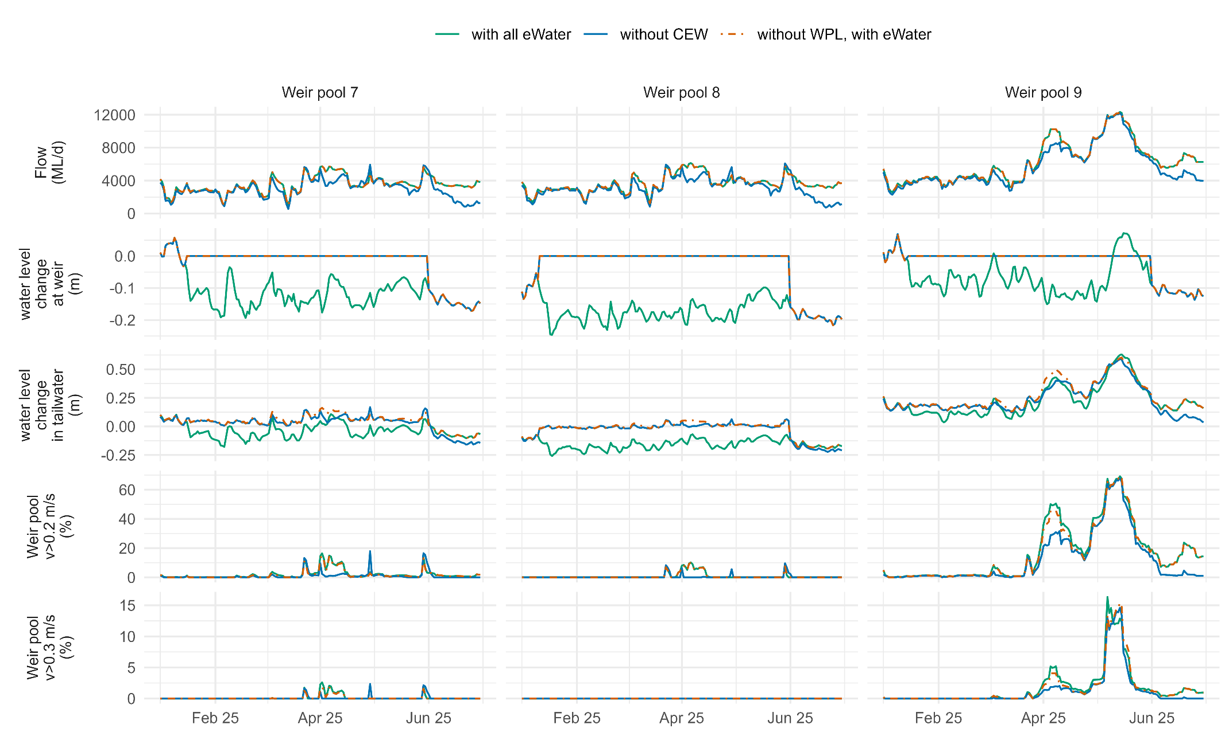

  - Matter Transport and Coorong Habitat

Matter Transport
Introduction
Freshwater flows to estuaries shape habitat, transport nutrients to drive productivity, and generate a Salinity gradient that impacts water quality and provides spawning cues for fish (Brookes et al. 2022). Reduced flow may increase the intrusion of salt into the river system from the ocean whilst simultaneously decreasing the export of salt from inland reaches (Chilton et al. 2021). As there is continual deposition of salt onto the landscape (predominantly from rainfall and irrigation-induced actions), it can accumulate if not transported by flow and exported from the system. Changes in flow regime can also alter nutrient mobilisation from the floodplain, and change the subsequent primary productivity within the river. Environmental flows can be used to reinstate some of the natural ecological processes or enhance the magnitude of processes that control the availability and transport of dissolved and particulate matter. Indicators such as salinity, dissolved and particulate organic nutrients, and chlorophyll-a are often measured or modelled to assess the influence of flows on the concentrations and transport of matter.
In general, restoring river flow to an estuary is an important tool for salinity management by limiting seawater intrusion into the estuary and adding freshwater to the system (Chilton et al. 2021). In the case of the Murray River, it is further complicated as seawater entering the Murray Mouth is highly dependent on how river water is released from the barrages, and these dynamics impact salinity in the connected Coorong. The Coorong is a 120 km long shallow reverse estuary that runs parallel to the coast and is separated from the Southern Ocean by the Younghusband and Sir Richard Peninsulas (Figure 1). As water evaporates from the North and South lagoons, it is replaced with water coming from the ocean and river. When river water exits the barrages, it reduces seawater intrusion and maintains fresher conditions around the Murray Mouth which enables fresher water to replenish water evaporated in the Coorong. When there is more seawater intrusion into the Murray Mouth, considerable amounts of salt are transported into the Coorong as this seawater flows south-east to replenish water evaporated from the lagoons. The salinity of the Coorong is a key determinant of habitat suitability for macrophytes, invertebrates and fish (Mosley et al. 2018). At times, the higher salinity water can be trapped in the South Lagoon when water levels decline over summer unless there are flood conditions and reasonably high water levels persisting over summer.
Nutrients are fundamental drives of ecosystem productivity, and understanding how they are transported among the various components of riverine ecosystems can provide important insights into river and estuarine productivity, often assessed as chlorophyll-a concentration-. Dissolved inorganic nutrients are essential resources for the growth and survival of biota and are readily assimilated (Poff et al. 1997). In healthy ecosystems, nutrient mobilisation can enhance productivity and support ecological function, however, in poorly flushed or nutrient-enriched systems, excessive nutrient inputs can promote eutrophication and lead to a range of undesirable ecological consequences. The amount of river water coming through the barrages has been shown to be a major factor affecting the nutrient retention in the Coorong, particularly in the North and South Lagoons (Huang et al. 2024).
The Basin Plan outlines an environmental watering plan for the protection and restoration of the rivers, wetlands and other environmental assets of the MDB (Section 15.4, Appendix). There are a number of objectives and desired environmental outcomes in the Basin Plan that relate directly to the Coorong:
1) Salt export: The Basin Plan sets out a salt export objective (Section 9.09) to ensure adequate flushing of salt from the River Murray system into the Southern Ocean. The Basin Plan’s indicative figure for salt export from the basin is an average of 2 million tonnes per year.
2) Salinity levels: There is a salinity level objective for the Coorong which is intended to be achieved through delivery of environmental water through the barrages. The target is for a maximum average daily salinity in the Coorong’s South Lagoon at less than 100 g/L, and 50 g/L in the North Lagoon.
3) Open Murray Mouth: the Murray Mouth should remain open at frequencies, and for durations, sufficient to ensure that the tidal exchanges maintain the Coorong’s water quality (in particular salinity levels) within the tolerance of the Coorong ecosystem’s resilience (Section 8.06, 3c).
4) Flora and fauna health: Environmental water delivery outcomes also aim to reduce salinity levels in the Coorong and Lower Lakes so improved water quality contributes to the health of macroinvertebrates, fish and plants that form important parts of the food chain (see Schedule 5 Basin plan – Appendix)
The Coorong hydrodynamic-biogeochemical model enables assessment of salt export through the barrages and Murray Mouth, while also predicting salinity levels in the Coorong. The salt export, salinity gradient in the Coorong and habitat for fish and aquatic plants can be predicted for different barrage flow scenarios enabling a comparison of outcomes with and without environmental water. This enables the evaluation of how environmental water (particularly CEW) delivery is contributing towards the ecological outcomes in the Coorong, aligning with objectives in the Basin Plan. Salinity in this report is presented as psu (practical salinity units) but is equivalent to g/L and PPT.
To assess the contribution of environmental water delivery to matter transport in the Coorong during 2024-25, a high-resolution hydrodynamic-biogeochemical model was applied to the system. The analysis incorporated a range of hydrological conditions, including relatively dry periods (1 July 2017 to 30 June 2021 and July 2024 to June 2025) and a particularly wet period (1 July 2022 to 30 June 2024), which included a major flooding event during the summer of 2023. The environmental water delivery was a major component of the total barrage flow during the dry periods (July 2017–June 2021 and July 2024 to June 2025). During these periods, barrage flow to the Coorong was relatively small (572–1,335 GL/year), of which CEW contributed a much higher portion to the total barrage flows (65.4%–100%, Figure 11). In comparison, barrage flow during the wet period (July 2021–June 2024) reached 5,974–16,593 GL/year, during which CEW represented a small portion of the total barrage flows (3.7%–19.2%, Figure 11). The range of high flows and low flows through the barrages from 2017 to 2025 (Figure 11) enables a comparison of the impacts of environmental water delivery on the water quality responses within the Coorong between dry and wet periods. The model has been validated with water quality data, and is used to understand salt and nutrient movement.
Figure 11. (a) Summary of flow discharge through the barrages, from July 2017 until June 2025, spanning the 2021-22–2023-24 flow events, categorised based on water source. (b) Yearly composition of barrage flow, spanning the period from July 2017 to June 2025. The numbers above the bars indicate the percentage of Commonwealth environmental water (CEW) to the total barrage flow in each year. Other eWater = other environmental water.
(a)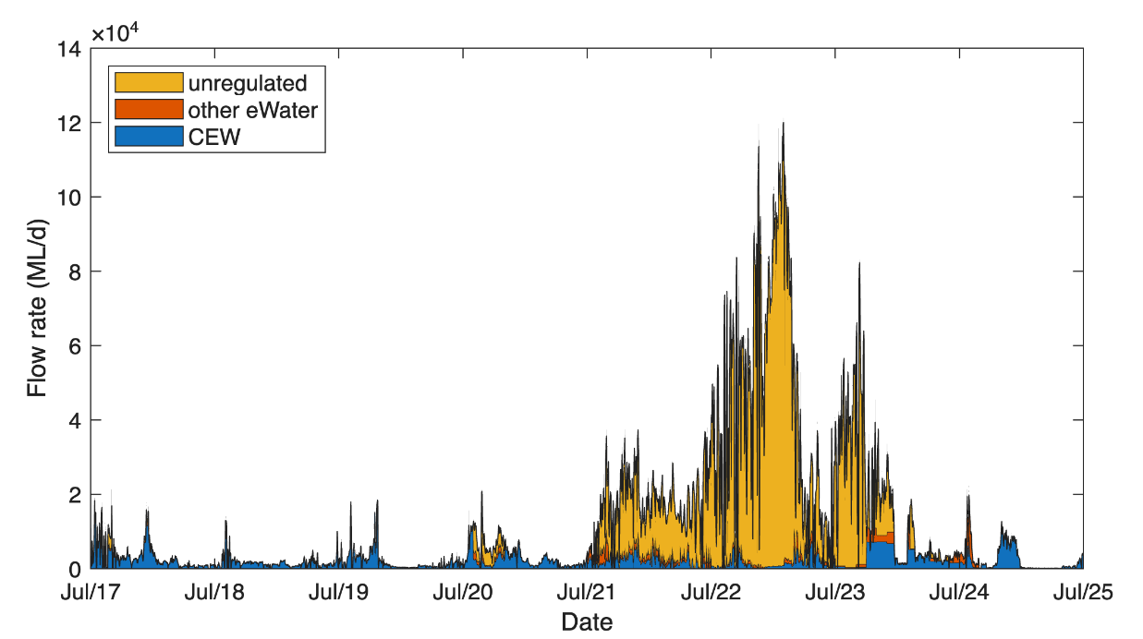
(b)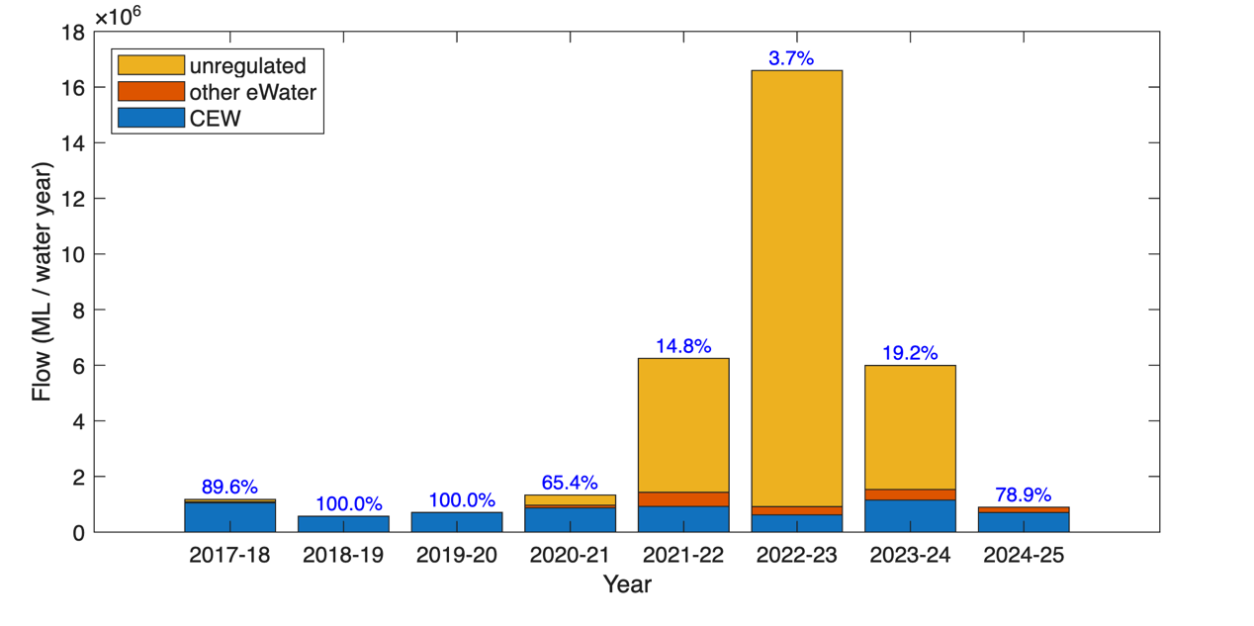

Hypotheses
Increased flow by delivering water for the environment (including CEW) will:
- Increase the mobilisation of salts from the Basin and increase the transport of salt through the barrages and through the Murray Mouth
- Increase the mobilisation of nutrients and phytoplankton biomass from the Basin and increase nutrient loads through the barrages and through the Murray Mouth
- Decrease the rate of salt and nutrient accumulation in the North and South lagoons of the Coorong.
Through the modelling undertaken in the LTIM Project (Ye et al. 2020a), it was well established that environmental flows dilute salinity and nutrient concentrations in the reach between Lock 1 and the barrages, including within Lake Alexandrina and Lake Albert. These flows also increase total loads (where load = volume x concentration) of nutrients and salt exported from the reach. Given the particular sensitivity of the Coorong, this analysis has focused on developing an understanding of the contribution of the environmental water to the salt and nutrient export from the Basin to the Coorong through the barrages, the export from the Coorong to the Southern Ocean through the Murray Mouth, and also the transport of material between the North and South lagoons. The mean and median salinity and nutrient concentrations predicted from the modelling scenarios with and without the environmental water are also presented. This addresses the hypotheses above, acknowledging the contribution of environmental flow to the transport of salt and nutrients. The impact of environmental water on the suitable habitat for fish and Ruppia tuberosa was also assessed based on the predicted changes in salinity, water depth and light conditions, which is outlined in the Coorong Habitat section.
Key Evaluation Questions for Basin and Area
Area-scale
Table 4. Key evaluation questions for assessing the Matter Transport responses to Commonwealth environmental water (CEW). Parameters and evaluation approaches used to answer the evaluation questions are provided. eWater = water for the environment
Key Evaluation Questions | Parameter | Evaluation Approaches
What was the salinity level (modelled) under the annual flow regime? What did eWater (and specifically CEW) contribute to this outcome in the: Murray Estuary, North Lagoon and South Lagoon | Modelled (mean and median) salinity concentrations | Hydrodynamic biogeochemical modelling of flow and salinity
What was the salt transport (modelled) under the annual flow regime? What did eWater (and specifically CEW) contribute to this outcome: Out of the Basin (through the barrages); salt import at the Murray Mouth; southward salt flux to the North Lagoon; southward salt flux to the South Lagoon | Modelled salt load | Hydrodynamic biogeochemical modelling of flow and salt transport
What was the salt load/transport (modelled) in the Coorong under the multi-year flow regime? What did eWater (and specifically CEW) contribute to this outcome? | Modelled salt transport (loads) | Hydrodynamic biogeochemical modelling for flow and salt load/transport
What was the salinity regime (modelled) in the Coorong under the multi-year flow regime? What did eWater (and specifically CEW) contribute to this outcome? | Salinity timeseries from 2017–2025 | Hydrodynamic biogeochemical modelling for flow and salinity

Methods
Environmental water modelling assessment scenarios
A total of five model simulations were undertaken to assess the impacts of CEW and total environmental water on salt transport, salinity and water quality in the Coorong. The first simulation, an ‘All Water’ base-case, represented observed conditions, incorporating measured barrage flows from July 2017 to June 2025.
Four ‘counter-factual’ scenarios were then developed to assess the cases with CEW or all environmental water removed from the observed barrage flows in one year (i.e. 2024-25) or over eight years (Table 5), with an additional scenario of ‘two years’ without CEW for the period from July 2023 to June 2025 run specifically for Ruppia tuberosa habitat assessment. The ‘eight years’ scenario was simulated to assess the cumulative effect of multiple years of environmental water or CEW (July 2017–June 2025). The start time of July 2017 was chosen based on the consideration that the high flow in 2016-17 helped to ‘reset’ the conditions within the Coorong, and to include 2017-18 and 2018-19 when environmental water was the major component of the barrage flow.
Table 5. Summary of modelling scenarios for investigating the environmental water (eWater) effects. CEW = Commonwealth environmental water.
Scenario | Scenario ID | Description
All Water | Base-case | This simulation represents observed conditions and was run with the total barrage flows from 1 July 2017 to 30 June 2025.
No CEW 1 year | NC1 | This scenario was run with the assumption that there was no CEW through the barrages for the one individual water year (July–June each year). This is undertaken to isolate the effect of any single year’s CEW effect, relative to the cumulative effect of previous years' water.
No CEW 2 years  i.e. for the past two water years (07/23–06/25) | NC2 | This scenario was made specifically for Ruppia habitat assessment, with the assumption that there was no CEW through the barrages in the last two water years (July 2023–June 2025). This was undertaken to isolate the effect of recent CEW delivery on Ruppia habitat in the Coorong, which was assessed over a calendar year (January to December 2024) rather than a water year.
No CEW 8 years  (07/17 – 06/25) | NC8 | This scenario was run with the assumption that there was no CEW through the barrages from 1 July 2017 to 30 June 2025, aiming to investigate the cumulative effect of CEW on the Coorong for the last eight years.
No eWater 1 year  (07/24 – 06/25) | NE1 | This scenario was run with the assumption that there was no eWater through the barrages in the last water year from 1 July 2024 to 30 June 2025, aiming to isolate the effect of the combined eWater delivery on the Coorong in 2024-25r only, except for that counterfactual modelling for salt export through barrages was run for each individual water year.
No eWater 2 years  i.e. for the past two water years (07/23–06/25) | NE2 | This scenario was made specifically for Ruppia habitat assessment, with the assumption that there was no eWater through the barrages in the last two water years (July 2023–June 2025). This was undertaken to isolate the effect of recent eWater delivery on Ruppia habitat in the Coorong, which was assessed over a calendar year (January to December 2024) rather than a water year.
No eWater 8 years  (07/17 – 06/25) | NE8 | This scenario was run with the assumption that there was no eWater through the barrages from 1 July 2017 to 30 June 2025, aiming to investigate the cumulative effect of all eWater on the Coorong for the last eight years.
This report section presents the outcomes from the modelling assessment, including:
- Barrage flow analysis in the ‘All Water’, ‘No CEW’ and ‘No eWater’ scenarios;
- Time series and transect comparisons of scenario salinity and nutrient concentrations;
- Detailed salt and nutrient flux analysis through the barrages, Murray Mouth, Pelican Point transect (southward to North Lagoon), and Parnka Point transect (southward to South Lagoon) in all scenarios; and
- Mean and median salt concentrations at the Murray Mouth, middle of North Lagoon (Long Point), and middle of South Lagoon (Woods Well) in all scenarios.

Hydrodynamic-biogeochemical models
The high-resolution Coorong Dynamics Model (CDM) was used to assess the effects of environmental water delivery on salt and nutrient transport. The CDM has been used in the environmental water assessments for Flow-MER1.0 (Ye et al. 2025) and undergone developments during the Healthy Coorong, Healthy Basin (HCHB) Program (Hipsey et al. 2022; Huang et al. 2024). The modelling platform consists of a hydrodynamic model, TUFLOW-FV, developed by BMT Global Pty Ltd., coupled with the biogeochemical mode, AED, developed by the University of Western Australia. Details of the CDM development (Generation 2), including sensitivity analysis and model performance assessment, are summarised in the online CDM manual (http://aquaticecodynamics.github.io/cdm/index.html). Further improvements to the model mesh, bathymetry, and boundary conditions as more annual data became available in recent years were described in the last environmental water assessment report (Ye et al. 2025).
For the model simulation, the boundary conditions driving the model include barrage flows (resolved through each of the five barrages), Salt Creek inflows, weather conditions, and ocean tidal forcing. These were set using the same methodology as in the modelling work reported in the 2022-23 and 2023-24 reports (Ye et al. 2024d, 2025), but here extended to cover the full period from 1 July 2017 to 30 June 2025. Tidal forcing at Victor Harbor and water quality at the barrages and within the Coorong were updated from DEW monitoring, and weather conditions were updated from the NRM/AWS (Natural Resource Management Automatic Weather Station) weather network. Note that there was down-time of the Victor Harbor tide gauge instrument during July 2023 to early January 2024, and the series was gap-filled in this period using the Bureau of Meteorology predicted tide data for the same period at the same site.
For the period July 2023 to June 2025, barrage flows - including environmental water through the barrages - were updated from MDBA datasets and scaled with data from the DEW barrage calculator to distribute flow between the barrages (Figure 12). The flow in 2024-25 was notably low, with extended low-flow periods compared to previous years (Figure 13).

Figure 12. Composition of barrage flow, spanning the period from July 2017 to June 2025, as distributed in the model to the five main barrages.
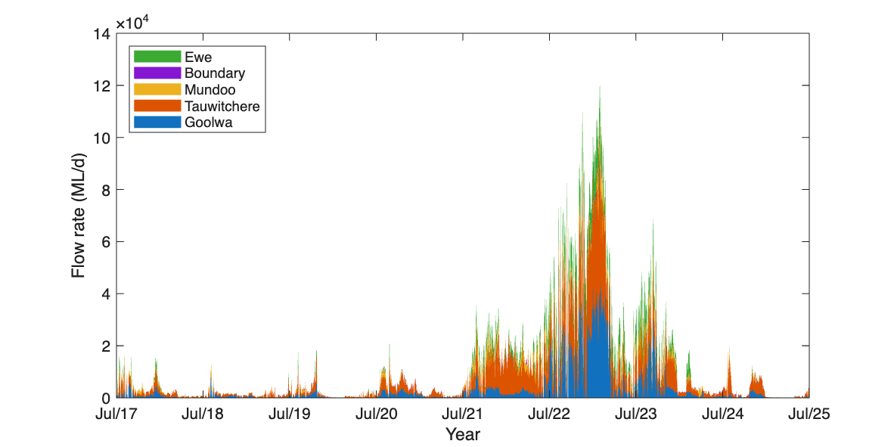

Figure 13. Comparison of each-year’s barrage flow conditions used as input to the CDM base-case simulations to contextualize the 2024-2025 water year. (a) Annual flow duration curve for total combined barrage flows as input to the CDM base-case simulations. (b) Annual salinity exceedance curves for each water- year. 2024-2025 data is the highlighted thick-black line.
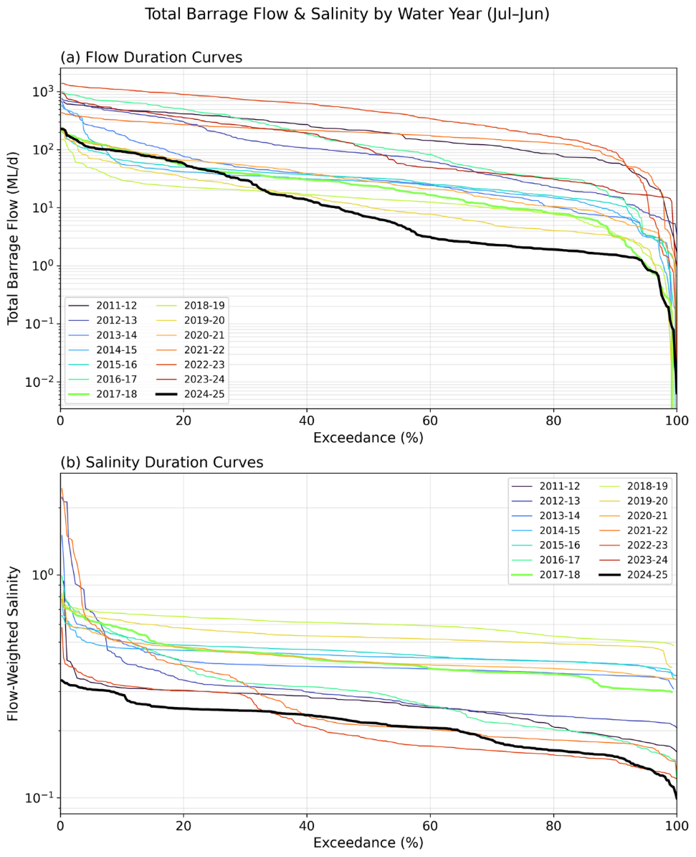

The model performance in reproducing the key water quality parameters within the Coorong from July 2017 to June 2025 were assessed with a set of model skill metrics, including calculation of regression coefficients (R), mean absolute errors (MAE), and bias, and the results are provided in the supplementary information for indicators (see Figure 15.5.3, Appendix, for plots comparing model results with observations). Overall, the CDM reproduced the physics (water level, salinity and temperature) in the North and South lagoons over the eight-year modelling period to a high degree of accuracy, with a regression coefficient of >0.9 and relatively low MAE (mean absolute error) for most of the assessed hydrologic variables of all sites. However, the model tends to overpredict the salinity in the North Lagoon and underpredict the salinity in the South Lagoon in the period of late 2023, coincident with the time when the tide gauge at Victor Harbor was not operational. The model also captured the variations of dissolved oxygen and the key nutrient pools such as TN, TP and TOC. Reasonable predictions were obtained for turbidity, total chlorophyll-a and other nutrient pools. The model performance on the water quality components is consistent in dry and wet years, suggesting that it is suitable for assessing management scenarios associated with environmental water delivery under a wide range of hydrologic conditions.
Results
Salt loads through the barrages, Murray Mouth and Coorong
Salt loads entering the Coorong vary in response to freshwater discharge, upstream salinity conditions in Lake Alexandrina, and oceanic conditions. Salt loads transported through the system from July 2017 to June 2025 are summarised in Table 6. The salt export through the barrages in 2024-25 was 197,419 tonnes. This is the lowest salt export recorded since modelling on this variable commenced, which is attributed to lower salt concentrations in the lakes due to freshening of the river system from the three previous years with elevated flow combined with a low annual barrage flow volume in this dry year. 160,818 tonnes of salt export through the barrages, equating to 81% of total salt export, is attributable to CEW.
Environmental water delivery significantly modified salt exchange processes by increasing the contribution of barrage-derived freshwater inflows, leading to a substantial reduction in salt intrusion from the Southern Ocean. The effect of environmental water on salt export was more significant under low-flow conditions. For the “dry" period between July 2017 and June 2021, the annual total salt load through the barrages with no CEW was estimated to have ranged between 0 to 0.16 million tonnes, compared to between 0.33 to 0.58 million tonnes in the ‘All Water’ scenario. Though this freshwater flow has added a limited salt load to the Murray Estuary, it is evident that the environmental water significantly reduced marine salt intrusion by 2.24‒4.02 million tonnes per year. Of the total environmental water, CEW accounted for approximately 95–100% of this reduction, highlighting its central contribution to salinity management during dry periods. In contrast, from 2021 to 2023, high unregulated catchment inflows dominated barrage flows and flushed hypersaline water from the Coorong into the Southern Ocean. This resulted in net salt exports of 4.32 and 4.14 million tonnes, respectively, with ‘All Water’ (including environmental water), which temporarily reduced salt accumulation within the Coorong lagoons. In 2023-34, there was a net export of 2.88 million tonnes of salt from the Coorong to the ocean, whereas without environmental water, there would have been a net import of 1.10 million tonnes of salt from the Southern Ocean to the Coorong. Therefore, environmental water effectively reduced the salt load to the Coorong by approximately 3.98 million tonnes in 2023-24. Model simulations for 2024-25 indicated with all environmental water, marine salt intrusion reduced by 2.45 million tonnes, and most of this benefit was attributable to CEW.
Salinity dynamics in the Coorong
Southward transport and accumulation of salt from the Murray Mouth into the North Lagoon (through Pelican Point) and South Lagoon (through Parnka Point) are presented in Table 6 and Figure 14. During the dry period from 2017 to 2021, annual salt transport at Pelican Point ranged from 1.4 to 2.7 million tonnes and cumulative transport reached approximately 10 million tonnes (Figure 14) under the “All Water” scenario, compared with around 22 million tonnes in the absence of environmental water. At Parnka Point, cumulative transport reached approximately 9 million tonnes under “All Water”, compared with 19 million tonnes without environmental water.
In the wet years of 2021–2024, a northward export of salt occurred, with annual flux rate of 1.2–2.2 million tonnes from the North Lagoon towards the Murray Mouth in “All Water” scenario. This northward export during the high catchment flow events accompanied a reduction of salinity concentrations within the North and South lagoons. During the 2024–25 water year, drier conditions increased annual southward salt transport at Pelican Point to approximately 5.9 million tonnes under the “All Water” scenario, resulting in cumulative transport of around 12 million tonnes over eight years. Without environmental water, annual transport would have increased by a further 1.9 million tonnes, increasing cumulative transport by approximately 13 million tonnes. At Parnka Point, environmental water similarly reduced annual transport by approximately 1.3 million tonnes in 2024-25, with around 1.2 million tonnes attributable to CEW.

Table 6. Summary of salt flux (tonnes) though barrages (from lakes to Coorong), Murray Mouth (from Southern Ocean to Coorong), North Lagoon (from Pelican Point southward) and South Lagoon (Parnka Point southward) in 2017–2025. Refer to Table 5 for scenarios.
Site | Scenarios/Year | 17-18 | 18-19 | 19-20 | 20-21 | 21-22 | 22-23 | 23-24 | 24-25
Barrages | Base-case | 441,792 | 338,428 | 373,797 | 579,468 | 1,818,314 | 3,112,925 | 1,241,811 | 197,419
Barrages | NC1 | 44,708 | 0 | 0 | 206,681 | 1,537,470 | 2,961,673 | 1,020,539 | 36,601
Barrages | NC8 | 44,708 | 0 | 0 | 206,681 | 1,537,470 | 2,961,673 | 1,020,539 | 36,601
Barrages | NE1 | 29,800 | 0 | 0 | 163,860 | 1,381,994 | 2,889,612 | 950,316 | 0
Barrages | NE8 | 29,800 | 0 | 0 | 163,860 | 1,381,994 | 2,889,612 | 950,316 | 0
Murray Mouth | Base-case | 2,137,023 | 2,137,931 | 2,285,666 | 1,607,901 | -4,317,197 | -4,137,762 | -2,876,270 | 6,256,698
Murray Mouth | NC1 | 6,153,004 | 6,407,573 | 6,089,326 | 5,719,788 | -4,157,941 | -4,021,248 | -21,305 | 8,501,074
Murray Mouth | NC8 | 6,153,004 | 5,401,572 | 4,529,739 | 4,344,994 | -6,048,951 | -4,684,491 | -1,747,350 | 7,399,324
Murray Mouth | NE1 | - | - | - | - | - | - | 1,101,679 | 8,701,659
Murray Mouth | NE8 | 6,344,622 | 5,372,396 | 4,523,983 | 4,512,901 | -5,976,787 | -4,634,279 | -633,412 | 7,038,885
North Lagoon | Base-case | 1,378,024 | 2,132,772 | 2,669,144 | 1,825,895 | -2,044,759 | -1,168,148 | -2,158,143 | 5,901,484
North Lagoon | NC1 | 4,844,517 | 5,777,005 | 5,654,687 | 5,300,136 | -2,184,329 | -1,217,359 | 282,878 | 7,625,739
North Lagoon | NC8 | 4,844,517 | 4,970,188 | 4,410,353 | 4,290,622 | -3,760,164 | -1,894,973 | -1,413,631 | 6,702,552
North Lagoon | NE1 | - | - | - | - | - | - | 971,104 | 7,811,909
North Lagoon | NE8 | 5,023,800 | 4,938,341 | 4,406,133 | 4,417,755 | -3,847,463 | -1,928,113 | -735,199 | 6,669,502
South Lagoon | Base-case | 792,854 | 2,378,063 | 1,294,496 | 2,802,295 | -827,932 | -2,816,988 | -192,002 | 3,083,013
South Lagoon | NC1 | 2,602,467 | 3,563,330 | 3,043,574 | 4,404,517 | -908,973 | -2,849,328 | 782,671 | 4,261,360
South Lagoon | NC8 | 2,602,467 | 3,911,785 | 3,641,554 | 4,836,538 | -1,209,009 | -4,055,613 | 314,130 | 4,419,806
South Lagoon | NE1 | - | - | - | - | - | - | 790,826 | 4,426,031
South Lagoon | NE8 | 2,724,620 | 3,907,908 | 3,631,329 | 4,951,965 | -1,303,928 | -4,092,026 | 322,413 | 4,811,519

Figure 14. Cumulative salt flux with and without environmental water (eWater) delivery through Pelican Point (a) and Parnka Point (b) sites for July 2017–July 2025. The results from the “All Water” “No CEW 2024-25 (NC1 in 2024-25)” and “No eWater 2024-25 (NE1)” scenarios are overlapped in the first seven years and show only slight differences in the last year (2024-25) due to the small contribution of other eWater to the total barrage flows in this year. The line of “No CEW 2017–2025 (NC8)” was largely overlayed by “No eWater 2017–2025 (NE8)” because the eWater was mostly contributed by Commonwealth environmental water (CEW) over the eight-year study period. Refer to Table 5 for scenarios.
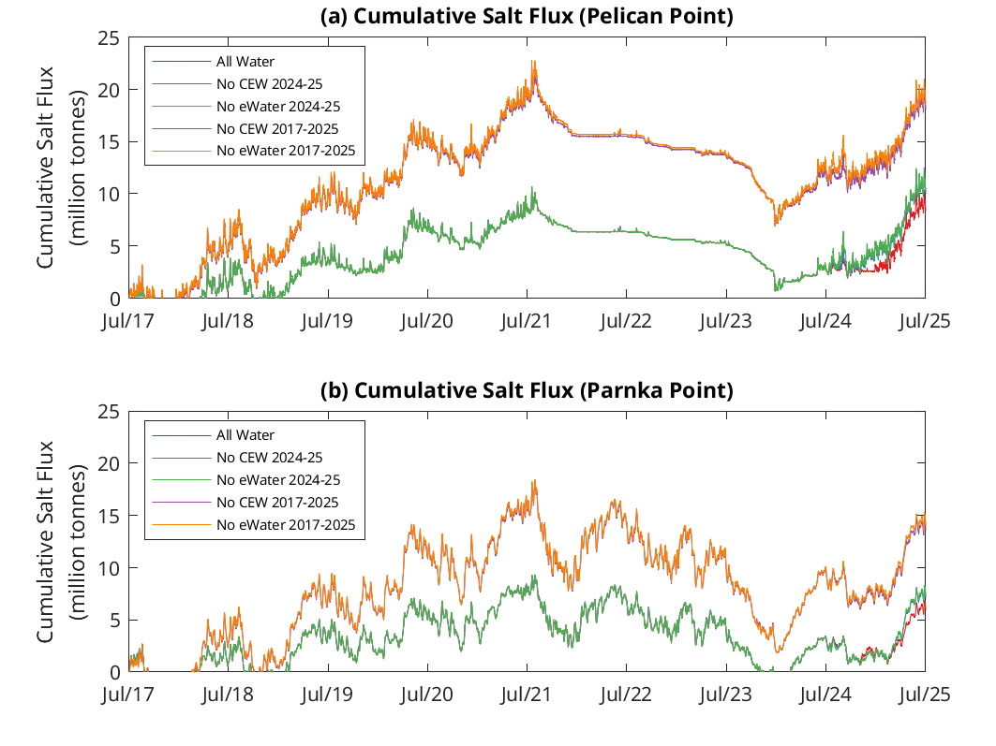
Sustained environmental water delivery has substantially reduced hypersaline conditions and supported long-term ecosystem health across the system over the period from July 2017 to June 2025. To demonstrate the spatial influence of environmental water on salinity, a longitudinal transect of predicted mean salinity for all “No CEW” and “No eWater” scenarios in comparison with the “All Water” scenario is presented in Figure 15. Environmental water delivery in 2024-25 reduced the mean salinity from 35 psu (No eWater) to 12 psu (All Water). At the Murray Mouth, where marine inflows periodically introduce saline ocean water into the lagoon, environmental water partially offset marine intrusion and reduced salinity amplification by approximately 5 psu. Moving downstream from Murray Mouth to Salt Creek, the cumulative effect of environmental water became increasingly pronounced. At Parnka Point, salinity under the “All water” scenario was approximately 30 psu lower than under the “No eWater 2017-2025” scenario, while at Salt Creek environmental water reduced salinity by approximately 45 psu.

Figure 15. Transect comparison of simulated mean salinity from the “No CEW” scenarios, “No eWater” scenarios, and “All Water” scenario along the Coorong in July 2024–June 2025 (refer to Table 5 for scenarios). The x-axis positions are based on distance from the Murray Mouth (Mth) (in km).
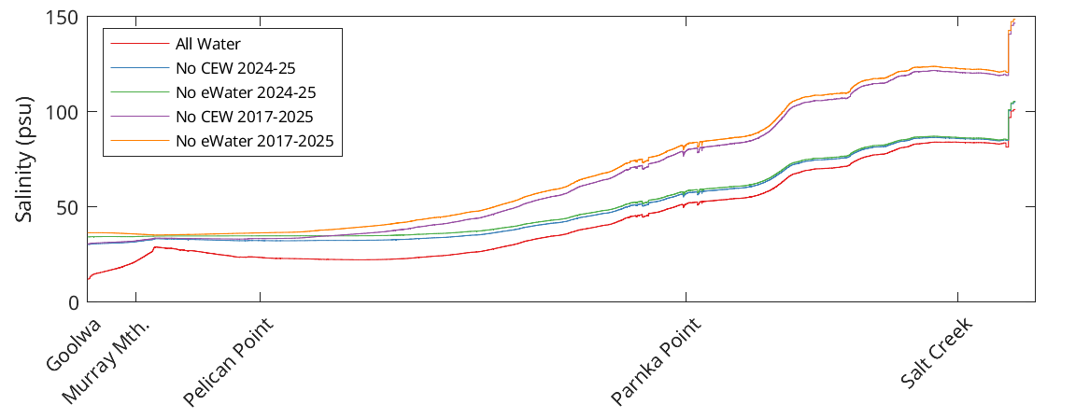
The influence of environmental water on salinity in the Coorong was most significant during dry periods, which was mainly due to the CEW. From 2017–2025, CEW accounted for between 4% and 19% of total annual barrage flows in wetter years (2021–2024). In contrast, during dry years (2017–2020 and 2024-25), CEW contributed up to 100% of barrage flows, effectively sustaining barrage discharge when other environmental water sources and natural water were low (0). In the North Lagoon, CEW reduced salinity by approximately 10–20 psu during wet years, whereas this reduction increased to 30–40 psu during dry years (Figure 16). In the South Lagoon, the influence of CEW was even more pronounced, with salinity reductions of approximately 40–50 psu relative to the “No CEW” scenario which establishes during dry years and persists (Figure 17).
During 2024-25, environmental water, comprised of approximately 80% CEW (Figure 11), effectively maintained salinity in the Coorong below 100 psu (Figure 14). Both the North and South lagoons exhibited substantially lower salinity under the “All Water” scenario compared with the “No eWater” and “No CEW” scenarios, continually demonstrating the importance of freshwater inflows supported by environmental water. Notably, the effects of environmental water showed a delayed response in the South Lagoon due to travel time and mixing processes within the lagoon system. Although relative higher barrage flows occurred between late October and mid-December 2024, in the North Lagoon, salinity reductions commenced in November 2024 and were most pronounced between December 2024 and March 2025, with decreases of approximately 25–30 psu relative to the “No eWater” scenario (Figure 16b). In contrast, the response in the South Lagoon was delayed, beginning in March 2025 and extending into April 2025 (Figure 17b).

Figure 16. Time series of mean salinity variation in the Coorong North Lagoon a) during 2017–2025, and b) during 2023–2025. The “All Water” base-case scenario is compared with the “No CEW” and “No eWater” scenarios, spanning the modelling period from July 2017 to June 2025 (refer to Table 5 for scenario details). Note that the lines of “All Water/Basecase” and “No CEW 2024-25 (NC1)” were largely overlayed by “No eWater 2024-25 (NE1)” from July 2017 to June 2024 because they were using the same barrage flow condition in years prior to July 2024, and the line of ‘No CEW 2017–2025 (NC8)’ was largely overlayed by ‘No eWater 2017–2025 (NE8)’ because the environmental water (eWater) was mostly contributed by Commonwealth environmental water (CEW) over the eight-year study period.
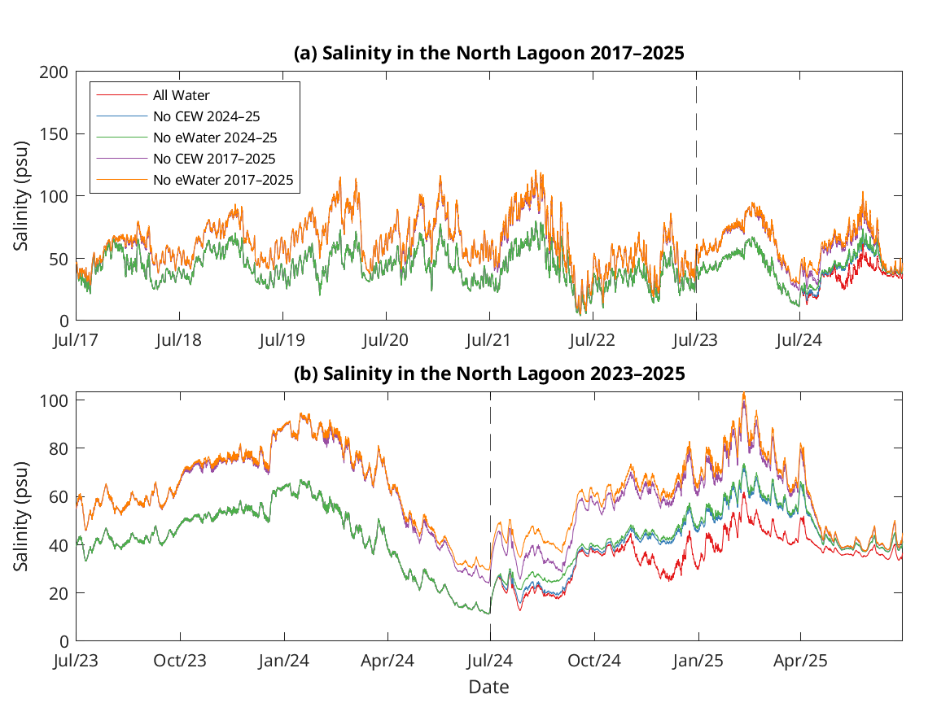

Figure 17. Time series of mean salinity variation in the Coorong South Lagoon a) during 2017 - 2025, and b) during 2023‒2025. The “All Water” base-case scenario is compared with the “No CEW” and “No eWater” scenarios, spanning the modelling period from July 2017 to June 2025 (refer to Table 5 for scenario details). Note that the lines of “All Water” and “No CEW 2024-25 (NC1)” were largely overlayed by “No eWater 2024-25 (NE1)” from July 2017 to June 2024 because they were using the same barrage flow condition in years prior to July 2024, and the line of ‘No CEW 2017–2025 (NC8)’ was largely overlayed by ‘No eWater 2017–2025 (NE8)’ because the environmental water (eWater) was mostly contributed by Commonwealth environmental water (CEW) over the eight-year study period.
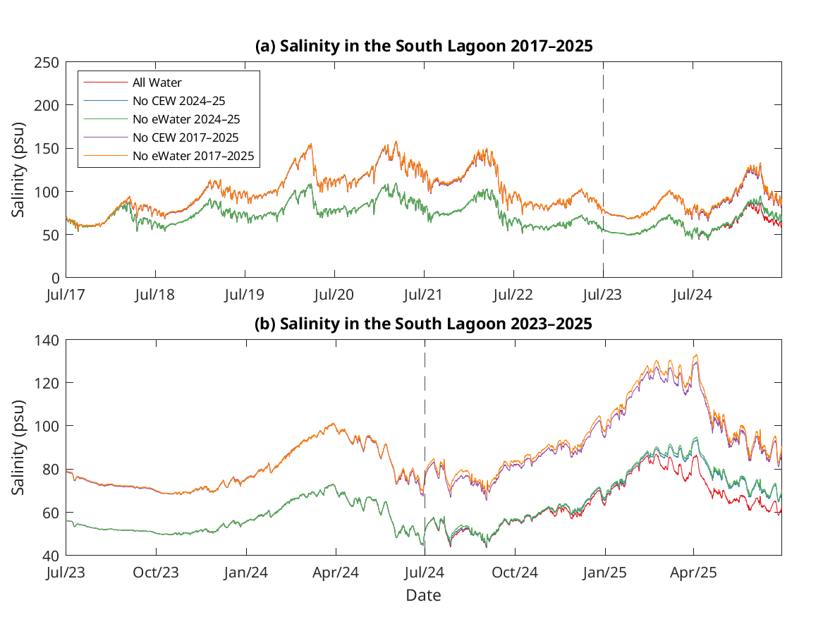

The mean and median salinity at the Murray Mouth, and in the North and South Lagoons exhibited interannual variability (Table 7). The mean and median salinity at the Murray Mouth and North/South lagoons showed a dynamic variation with a general increase from 2017 to 2021, then a general decrease from 2021 to 2023 corresponding to wetter conditions. In 2023-24, the mean and median salinity increased at the Murray Mouth and North Lagoon, and slightly decreased in the South Lagoon. Environmental water reduced the salinity in the Coorong, which is particularly evident in the South Lagoon, where the median salinity in 2023-24 would have increased from 59.6 psu to 82.9 psu if there was no CEW since 2017. In 2024-25, mean salinity increased to 22.2 at the Murray Mouth and 63.7 at the South Lagoon, while slightly decreasing to 23.8 at the North Lagoon under “All Water” scenario. Environmental water in 2024-25 has reduced mean salinity up to 11.5 psu at North lagoon and 3.7 psu at the South Lagoon.
Table 7. Predicted (a) mean and (b) median salinity at Murray Mouth, North Lagoon (at Long Point), and South Lagoon (at Woods Well) in all investigated scenarios. Units are practical salinity units (PSU). Refer to Table 5 for scenarios.
a) Mean
Site | Year | 2017-18 | 2018-19 | 2019-20 | 2020-21 | 2021-22 | 2022-23 | 2023-24 | 2024-25
Murray Mouth | Base-case | 17.8 | 22.7 | 22.1 | 17.7 | 4.2 | 2.0 | 9.4 | 22.2
Murray Mouth | NC1 | 27.4 | 30.3 | 29.6 | 25.3 | 5.5 | 2.4 | 13.9 | 27.9
Murray Mouth | NE1 | - | - | - | - | - | - | 15.3 | 29.6
Murray Mouth | NC8 | 27.4 | 30.7 | 30.4 | 25.9 | 5.8 | 2.4 | 14.1 | 28.2
Murray Mouth | NE8 | 28.0 | 30.7 | 30.4 | 26.4 | 7.1 | 2.6 | 15.5 | 30.3
North Lagoon | Base-case | 25.5 | 31.7 | 27.1 | 26.2 | 19.7 | 13.7 | 30.9 | 23.8
North Lagoon | NC1 | 39.7 | 42.7 | 41.9 | 38.8 | 21.1 | 14.1 | 38.4 | 33.1
North Lagoon | NE1 | - | - | - | - | - | - | 39.7 | 35.3
North Lagoon | NC8 | 39.7 | 47.6 | 50.5 | 45.5 | 32.3 | 20.2 | 49.1 | 39.9
North Lagoon | NE8 | 40.7 | 47.8 | 50.6 | 46.5 | 33.9 | 20.6 | 50.5 | 43.6
South Lagoon | Base-case | 68.7 | 73.0 | 80.8 | 89.1 | 83.2 | 63.4 | 58.8 | 63.7
South Lagoon | NC1 | 73.6 | 77.0 | 87.0 | 92.8 | 83.5 | 63.5 | 59.7 | 66.8
South Lagoon | NE1 | - | - | - | - | - | - | 59.6 | 67.4
South Lagoon | NC8 | 73.6 | 91.3 | 112.4 | 127.6 | 121.0 | 89.8 | 81.5 | 93.9
South Lagoon | NE8 | 73.9 | 92.1 | 113.0 | 128.7 | 122.4 | 90.2 | 81.8 | 96.1
b) Median
Site | Year | 2017-18 | 2018-19 | 2019-20 | 2020-21 | 2021-22 | 2022-23 | 2023-24 | 2024-25
Murray Mouth | Base-case | 20.0 | 27.4 | 27.4 | 19.2 | 0.7 | 0.2 | 1.9 | 28.3
Murray Mouth | NC1 | 34.7 | 35.2 | 35.1 | 34.7 | 1.2 | 0.2 | 5.8 | 35.0
Murray Mouth | NE1 | - | - | - | - | - | - | 9.0 | 35.1
Murray Mouth | NC8 | 34.7 | 35.3 | 35.2 | 35.1 | 1.4 | 0.2 | 6.5 | 35.1
Murray Mouth | NE8 | 35.0 | 35.3 | 35.2 | 35.1 | 1.8 | 0.2 | 9.8 | 35.1
North Lagoon | Base-case | 24.9 | 29.5 | 30.4 | 23.6 | 15.3 | 12.0 | 27.8 | 26.3
North Lagoon | NC1 | 39.0 | 41.0 | 40.5 | 39.2 | 20.4 | 12.3 | 31.8 | 36.4
North Lagoon | NE1 | - | - | - | - | - | - | 32.4 | 36.7
North Lagoon | NC8 | 39.0 | 43.1 | 47.4 | 41.3 | 27.3 | 17.9 | 41.9 | 39.5
North Lagoon | NE8 | 40.2 | 43.2 | 47.5 | 41.6 | 33.5 | 18.1 | 42.6 | 41.6
South Lagoon | Base-case | 70.9 | 74.9 | 82.0 | 92.9 | 85.1 | 67.4 | 59.6 | 65.2
South Lagoon | NC1 | 75.7 | 78.6 | 88.4 | 97.4 | 85.6 | 67.6 | 60.2 | 68.6
South Lagoon | NE1 | - | - | - | - | - | - | 60.2 | 69.0
South Lagoon | NC8 | 75.7 | 93.8 | 113.0 | 133.7 | 124.9 | 95.7 | 82.9 | 94.9
South Lagoon | NE8 | 75.7 | 94.6 | 113.6 | 134.9 | 126.7 | 96.2 | 83.4 | 96.9

Nutrients and chlorophyll-a
Predicted nutrient and chlorophyll-a loads in all scenarios at the barrages, Murray Mouth, Pelican Point and Parnka Point are summarised in the supplementary material enclosed with this report (Appendix 15.5). The total nitrogen loads in each year between July 2017–June 2025 are summarised in Table 8 as an example, which showed the barrage flow transported large amount of nutrients from the Basin into the Coorong, most of which (>72%) were then exported to the Southern Ocean through the Murray Mouth. Environmental water has prevented nutrient import (41–105 tonnes) from the ocean, and relatively small amounts of nutrients were transported southward during the dry years. Environmental water had a large and ecologically significant impact on nutrient import from Lower Lakes to the Coorong and export from Coorong to the ocean, particularly during the dry years. However, the contribution of environmental water to the southward nutrient and chlorophyll-a fluxes varied among years and was relatively small compared to barrage loads and export to the Southern Ocean (supplementary material Section 15.5). Nutrient fluxes within the North and South lagoons did not show significant differences between the ‘All Water’, ‘No CEW’ and ‘No eWater’ scenarios (Figure 18 and supplementary material), indicating the nutrient cycling dynamics in the North and South lagoons are more dominated by local biogeochemical reactions than hydrodynamic transport.
Figure 18. Cumulative total nitrogen (TN) flux with and without environmental water (eWater) delivery through Pelican Point and Parnka Point sites for July 2017–June 2025. The results from the ‘base-case’, ‘No CEW 2024-25 (NC1 in 2024-25)’ and ‘No eWater 2024-25 (NE1)’ scenarios are overlapped in the first six years and show only slight differences in the last year (2024-25) due to the small contribution of eWater to the total barrage flows in this year and the line of ‘No CEW 2017–2025 (NC8)’ was largely overlayed by ‘No eWater 2017–2025 (NE8)’ because the eWater was mostly contributed by Commonwealth environmental water (CEW) over the eight-year study period. Refer to Table 5 for scenarios.
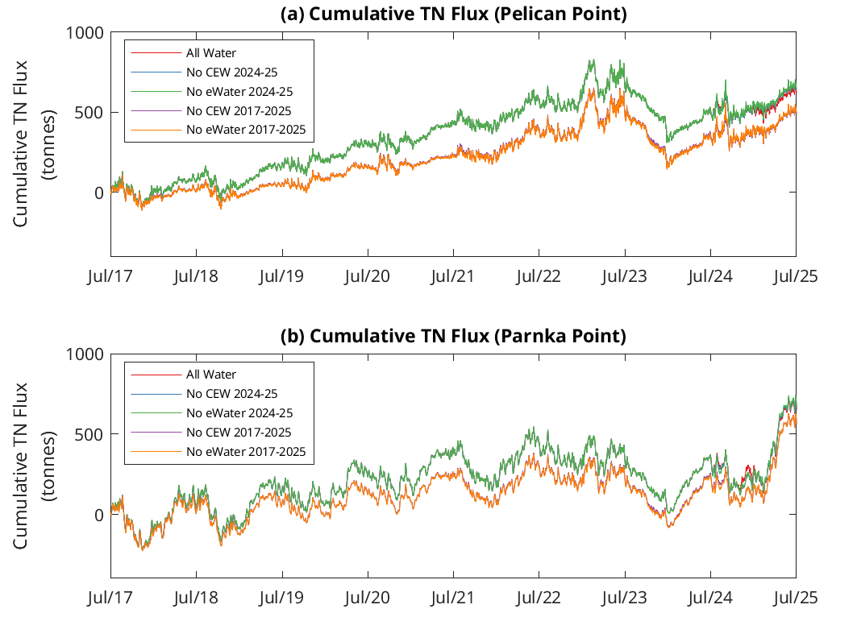

Table 8. Summary of total nitrogen flux (tonnes) though barrages (from lakes to Coorong), Murray Mouth (from Southern Ocean to Coorong), North Lagoon (from Pelican Point southward) and South Lagoon (Parnka Point southward) in 2017–2025. Refer to Table 5 for scenarios.
Site | Scenarios/Year | 17-18 | 18-19 | 19-20 | 20-21 | 21-22 | 22-23 | 23-24 | 24-25
Barrages | Base-case | 1,480.4 | 696.4 | 894.9 | 1,682.7 | 8,033.9 | 31,157.3 | 6,661.0 | 1,006.0
Barrages | NC1 | - | - | - | - | - | 29,882.1 | 5,548.5 | 236.4
Barrages | NE1 | - | - | - | - | - | 29,305.0 | 5,161.1 | 0.00
Barrages | NC8 | 157.6 | 0.00 | 0.00 | 601.2 | 6,833.9 | 29,882.1 | 5,548.5 | 236.4
Barrages | NE8 | 107.4 | 0.00 | 0.00 | 476.8 | 6,206.4 | 29,305.0 | 5,161.1 | 0.0
Murray Mouth | Base-case | -1,410.5 | -587.3 | -770.6 | -1,547.1 | -7,802.6 | -30,907.8 | -6,885.4 | -957.9
Murray Mouth | NC1 | - | - | - | - | - | -29,641.3 | -5,774.6 | -170.7
Murray Mouth | NE1 | - | - | - | - | - | -29,072.4 | -5,401.7 | 72.3
Murray Mouth | NC8 | -153.7 | 41.3 | 105.5 | -532.4 | -6,581.6 | -29,628.6 | -5,744.0 | -170.0
Murray Mouth | NE8 | -105.8 | 41.7 | 105.5 | -411.1 | -5,957.3 | -29,056.6 | -5,363.6 | 86.0
North Lagoon | Base-case | 83.2 | 98.8 | 104.6 | 130.3 | 150.9 | 102.1 | -144.2 | 130.2
North Lagoon | NC1 | - | - | - | - | - | 98.8 | -148.7 | 148.2
North Lagoon | NE1 | - | - | - | - | - | 94.1 | -158.8 | 154.7
North Lagoon | NC8 | 20.2 | 37.1 | 92.9 | 69.3 | 170.6 | 111.0 | -121.1 | 147.9
North Lagoon | NE8 | 17.2 | 37.5 | 93.0 | 68.5 | 168.8 | 109.1 | -125.4 | 163.7
South Lagoon | Base-case | 49.7 | 82.6 | 69.6 | 153.9 | 67.0 | -90.7 | 38.8 | 329.6
South Lagoon | NC1 | - | - | - | - | - | -94.3 | 32.4 | 334.6
South Lagoon | NE1 | - | - | - | - | - | -97.2 | 25.5 | 344.1
South Lagoon | NC8 | 15.5 | 38.7 | 44.3 | 120.0 | 64.2 | -63.1 | 37.3 | 350.6
South Lagoon | NE8 | 13.4 | 38.5 | 44.5 | 118.9 | 60.5 | -63.3 | 32.3 | 360.6

Evaluation
The outcomes for the annual and long-term (2017-18 to 2024-25) KEQs are summarised in Table 9. The contribution of CEW to the outcome for the Coorong Habitat sub-indicator was based on the modelled percentage increase due to environmental water/CEW. For salinity levels, substantial, moderate, minor and negligible contributions, respectively, were considered to be reductions of: ≥15, 10–14, 5–9 and <5 psu for the Murray Mouth; ≥10, 5–9, 2–4, and <2 psu at the North Lagoon; and ≥5, 3–4, 1–2, and <1 psu at the South Lagoon. For salt transport through the barrages, contribution scores were based on the annual salt export target of 2 million tonnes: substantial = ≥500,000 (25%), moderate = 300,000–499,999, minor = 100,000–299,999 and negligible = <100,000 tonnes per year. Substantial contributions were also considered if CEW contributed >50% of total barrage flow. For reduction of salt import/southward flux, substantial, moderate, minor and negligible contributions, respectively, were considered to be annual reductions of: ≥3, 1–2.99, 0.5–0.99 and <0.5 million tonnes for the Murray Mouth; ≥2, 0.8–1.99, 0.2–0.79, and <0.2 million tonnes at the North Lagoon; and ≥1, 0.5–0.99, 0.1–0.49, and <0.1 million tonnes at the South Lagoon. For the long-term evaluation, these thresholds are applied to annual average reductions. Percentages for salt import and southward flux reductions represent the proportion of the counterfactual (without eWater or CEW) that was prevented.
Table 9. Summary of Matter Transport evaluation questions to be addressed at the Area scale for Flow-MER2.0. eWater = Environmental water, CEW = Commonwealth environmental water.
Annual
Evaluation Questions | Parameters | Outcome for 2024-25 | eWater contribution | CEW contribution
What was the salt transport (modelled) under the annual flow regime?  What did eWater (and specifically CEW) contribute to this outcome? | Salt export out of the Basin through the barrages with % export by eWater or CEW | 197,419 tonnes | 100% (197,419 tonnes) | 81% (160,818 tonnes)
As above | Salt import from the Ocean through the Murray Mouth with % of total import relative to the “No eWater” case , and reductions by eWater or CEW | 6.3 million tonnes (72%) | 28% (2.4 million tonnes) | 26% (2.2 million tonnes)
As above | Southward salt flux into the North Lagoon (Pelican Point) with % of total import relative to the “No eWater” case, and reductions by eWater or CEW | 5.9 million tonnes (76%) | 24% (1.9 million tonnes) | 23% (1.7 million tonnes)
As above | Southward salt flux into the South Lagoon (Parnka Point) with % of total import relative to the “No eWater” case, and reductions by eWater or CEW | 3.1 million tonnes (70%) | 30% (1.3 million tonnes) | 28% (1.2 million tonnes)
What was the salinity level (modelled) under the annual flow regime?  What did eWater (and specifically CEW) contribute to this outcome? | Salinity levels (annual mean psu) and reduction by eWater or CEW  At the Murray Mouth | 22.2 | From 29.6 to 22.2 (by 7.4) | From 27.9 to 22.2 (by 5.7)
As above | In the North Lagoon (Long Point) | 23.8 | From 35.3 to 23.8 (by 11.5) | From 33.1 to 23.8 (by 9.3)
As above | In the South Lagoon (Woods Well) | 63.7 | From 67.4 to 63.7 (by 3.7) | From 66.8 to 63.7 (by 3.1)
Long-term
Evaluation Questions | Parameters | Outcome | eWater contribution | CEW contribution
What was the salt load/transport (modelled) in the Coorong under the multi-year flow regime?  What did eWater (and specifically CEW) contribute to this outcome? | Total salt export out of the Basin through the barrages (8-year total) with %, and annual average export.  % and tonnes by eWater or CEW. | 8.1 million tonnes (100%)  (1.0 million tonnes per year) | 33% (2.7 million tonnes)  (0.34 million tonnes per year | 28% (2.3 million tonnes)  (0.29 million tonnes per year)
As above | Total salt import from the Ocean through the Murray Mouth (8-year total) with % of total import relative to the “No eWater” case, and annual average import.  Reductions by eWater or CEW (% and tonnes). | 2.9 million tonnes (18%)  (0.4 million tonnes per year) | 82% (13.1 million tonnes)  (1.6 million tonnes per year) | 81% (12.1 million tonnes)  (1.5 million tonnes per year)
As above | Southward salt flux into the North Lagoon (Pelican Point) (8-year total) with % of total import relative to the “No eWater” case, and annual average export.  Reductions by eWater or CEW (% and tonnes). | 8.4 million tonnes (45%)  (1.0 million tonnes per year) | 55% (10.3 million tonnes)  (1.3 million tonnes per year) | 54% (9.7 million tonnes)  (1.2 million tonnes per year)
As above | Southward salt flux into the South Lagoon (Parnka Point) (8-year total) with % of total import relative to the “No eWater” case, and annual average export.  Reductions by eWater or CEW (% and tonnes). | 5.9 million tonnes (42%)  (0.7 million tonnes per year) | 58% (8.1 million tonnes)  (1.01 million tonnes per year) | 56% (7.6 million tonnes)  (0.95 million tonnes per year)
What was the salinity regime (modelled) in the Coorong under the multi-year flow regime? What did eWater (and specifically CEW) contribute to this outcome? | Salinity levels (2024-25 annual mean psu) and reduction by eWater or CEW over eight years.  At the Murray Mouth | 22.2 | From 30.3 to 22.2 (by 8.1) | From 28.2 to 22.2 (by 6.0)
As above | In the North Lagoon (Long Point) | 23.8 | From 43.6 to 23.8 (by 19.8) | From 39.9 to 23.8 (by 16.1)
As above | In the South Lagoon (Woods Well) | 63.7 | From 96.1 to 63.7 (by 32.4) | From 93.9 to 63.7 (by 33.2)
Contribution (to what extent CEW contributed towards the outcome, with the significance of the outcome considered):
 | Unknown |  | None/negligible |  | Minor |  | Moderate |  | Substantial

Discussion
Salt transport and salinity
What was the salt transport (modelled) under the annual flow regime and salt load/transport (modelled) under the multi-year flow regime? What did environmental water (and specifically Commonwealth) contribute to this outcome?
Environmental water during the dry years was a major contributor to salt export from the Basin, while fresher conditions at the Murray Mouth acted as a barrier to the influx of salt from the Southern Ocean to the Coorong, thereby helping to prevent hyper-salinisation.
CEW accounted for 65–100% of total annual flow through the barrages during the dry years (2017–2021) and about 80% of the annual barrage flow (MDBA modelled data) in 2024-25. In contrast, the period 2021–2024 was characterised by wet conditions, during which unregulated flow comprising a larger proportion (82–96%) of the total Murray River flow. Though the contribution of CEW to salt export was relatively smaller than that of unregulated water, the legacy effect of sustained water delivery in the previous dry years continues to keep salinity within a lower range. Of the 197,419 tonnes of salt transported by all environmental water out of the Basin, CEW accounted for 160,818 tonnes (81% of total salt export).
Salinity in the Coorong is primarily a function of riverine inflows through barrages and tidal movement. When barrage flows are low, seawater enters the Murray Mouth and more salt is then transported to the Coorong where it concentrates, subject to evapo-concentration. Environmental water through the barrages reduced the salt load into the North and South lagoons, measured as salt flux southward which varies with the barrage flow rates, sea levels, and salinity gradient from Goolwa to the South Lagoon. It is evident that barrage flows are required every year to reduce excessive salt accumulation within the Coorong and environmental water flowing through the barrages are an important contributor particularly in dry years. If CEW had not been delivered from 2017–2025, 7.9 million tonnes of additional salt would have accumulated in the South Lagoon. This would have been higher without considerable freshening due to the large flood late in this period.
What was the salinity level (modelled) under the annual flow regime and salinity regime (modelled) under the multi-year flow regime? What did environmental water (and specifically Commonwealth) contribute to this outcome?
During the Millennium Drought, and particularly from 2007-08 to 2009-10, flow through the barrages ceased and the import of salt into the Coorong resulted in salinity in the South Lagoon that was five times seawater, and demise of much of the aquatic life (Brookes et al. 2009). Water through the barrages provides freshening flows but also acts to inhibit seawater intrusions, thereby maintaining more appropriate salinity conditions for estuarine biota in the Coorong. Given that barrage releases almost entirely (up to 100%) depend on CEW in dry years, environmental water is critical for limiting salt flux to the North and South lagoons. Even one year without barrage flow can result in a large flux of salt southwards in these dry years. The high barrage flow during July 2021–June 2024 flushed the Coorong lagoons and reduced the salinity concentration. The median salinity in the South Lagoon reduced from 92.9 PSU in 2020-21 to 59.6 PSU in 2023-24. The 2024-25 flows were distributed over only a few months. Consequently, 6.3 million tonnes of salt entered through the Murray Mouth and was transported down the Coorong. Additionally, the substantial increase in the size (width/depth) of the Murray Mouth following the massive 2022-23 flood likely increased in ocean water (and salt) input. Interestingly, this did not lead to a problematic level of salt as the high flows in the three previous years has reduced the salinity in the South Lagoon. The median salt concentration in the South Lagoon was only 6 psu higher in 2024-25 than the previous year. The high unregulated flow preceding 2024-25 meant that the system was resilient to a lower flow period highlighting the importance of high flow events in building resilience in the system.
As salinity is a key determinant of Ruppia tuberosa and fish habitat, this is explored further in the Coorong Habitat section.
Nutrients
Environmental water contributed considerably to the transport of nutrients from the Murray River to the Coorong and export to sea, and prevented nutrient import from the sea. This was primarily due to additional water volume delivered as environmental water rather than a change in the nutrient concentrations within the Coorong. In 2024-25, the median concentrations of nitrogen and phosphorus did not vary considerably with or without environmental water. Unlike salinity concentration, which is only subjected to water transportation and mixing, nutrient concentrations in the Coorong are also strongly affected by biogeochemical activities such as assimilation by phytoplankton and settling/release at the water-sediment interface (Huang et al. 2024). A nutrient budget is currently under development via a Flow-MER research project to quantify nutrient loads and fluxes within the Coorong under ‘All water’ and ‘No CEW’ scenarios. This work will enable determination of what flow is required to reduce nutrients loads to the South Lagoon and what nutrient reduction might be possible from water draining northward.
Management implications
There are approximately 10¹¹ tonnes of salt in groundwater in the MDB and an additional 1.5 million tonnes of salt is deposited in the Basin each year by rainfall (Herczeg et al. 2001). Unless salt is exported from the Basin with flow, there will be a net accumulation of salt within the Basin. The Basin Plan sets out a salt export objective (Section 9.09) to ensure adequate flushing of salt from the Murray River system into the Southern Ocean. The Basin Plan’s indicative target for salt export from the Basin is 2 million tonnes per year. The last eight years of salt export modelling enable the contribution of environmental flows to salt export to be scrutinised.
CEW played a key role in salt export from the Basin to the Coorong and Southern Ocean during dry years, accounting for approximately 64–100% of total salt export in 2017-18 to 2020-21 and 2024-25, depending on the volume of unregulated flows and other environmental water conditions. In the high flow years (2021-22, 2022-23 and 2023-24), 1.8, 3.1 and 1.2 million tonnes were exported and CEW contributed 15%, 5%, and 18% of the salt exported, respectively.
It is generally accepted that elevated nutrients in the South Lagoon of the Coorong are contributing to the formation and persistence of algal mats (Mosley et al. 2022). In fact, the legacy nutrients in the sediments are contributing to this issue (Huang et al. 2022; Huang et al. 2024; Priestley et al. 2022), whereas it is evident nutrients delivered by environmental flows do not alter nutrient concentrations significantly. On the other hand, environmental flows played an important role in the nutrient loading through barrages and export through the Murray Mouth to the ocean during the dry years. Maximum exports of matter from the Murray Mouth are likely to be achieved by delivering environmental water during periods of low oceanic water levels (e.g. summer). In contrast, environmental water delivery from the Murray River at times of high oceanic water levels, which peak in the Austral winter, is likely to increase the exchange of water and associated nutrients and salt through the Coorong, rather than predominately through the Murray Mouth. Targeted barrage discharges during high tide, swell and appropriate wind direction events are important to improve water quality in the Coorong and particularly in the South Lagoon. If fresher river water is discharged through southern barrages (i.e. Tauwitchere/Ewe Island barrages), then the wind and tide can force this fresher water south, reducing the salinity in the North and South lagoons. The Coorong Dynamic Model could continue to be used to test these scenarios. Alternatively, or additionally, targeted field investigation of trial releases could be employed to determine the impact of such releases on salinity in the Coorong.

Coorong Habitat
Introduction
The Coorong is an estuarine lagoonal system with a natural salinity gradient ranging from freshwater to hyper-saline at the southern extremity. Freshwater flows are important in maintaining estuarine habitat and ecosystem health and preventing extreme hyper-salinity (Brookes et al. 2009). Ruppia tuberosa is an important macrophyte in the Coorong that provides habitat for fish and food for herbivorous birds (Phillips and Muller 2006; Giatas et al. 2022). Ruppia tuberosa can tolerate a range of salinity conditions and is the dominant macrophyte in the Coorong, particularly in the region where salinity is higher than seawater. The germination and growth of R. tuberosa is known to be governed largely by changes in salinity and water level regimes, which are influenced by flows through the barrages (Kim et al. 2013). Other factors that influence R. tuberosa growth include nutrient availability, water temperature, sediment quality and interactions with algae, including shading of light and interference with flowers and fruits on the surface (Collier et al. 2017). Flows during spring and into early summer are likely to be particularly beneficial as they slow the rate of water level change, delay the drop in water level in the South Lagoon and can prevent extremely high salinities emerging, thereby improving the probability that R. tuberosa will complete its reproductive cycle. In addition, salinity has also been identified as a key driver of fish distribution and assemblage structure by influencing the extent of estuarine fish habitat in the Coorong (Ye et al. 2011, 2016a; Bice et al. 2018). This sub-indicator aims to assess the benefits of environmental flows (and especially CEW) for the enhancement of R. tuberosa habitat, particularly those that are delivered in late spring and early summer, and the improvement of estuarine fish habitat throughout the year for several key species with different salinity tolerance.
Hypotheses
- Increased freshwater flow through the barrages and into the Coorong due to environmental watering (including CEW) will reduce salinity and influence other environmental conditions including water levels, light, temperature and algae in the Coorong, thus enhancing the extent of Ruppia tuberosa and fish habitats.
Key Evaluation Questions for Basin and Area
Area-scale
Table 10. Key evaluation questions for assessing the Coorong Habitat responses to Commonwealth environmental water (CEW). Parameters and evaluation approaches used to answer the evaluation questions are provided. eWater = environmental water.
Key Evaluation Questions | Parameter | Evaluation Approaches
What was the area of suitable habitat (modelled) for Ruppia tuberosa in the Coorong under the annual flow regime? What did eWater (and specifically CEW) contribute to this outcome? | Salinity, water level, light, temperature, macroalgae density, Ruppia tuberosa habitat suitability index | Hydrodynamic biogeochemical modelling
What was the area of suitable habitat (modelled) for Ruppia tuberosa in the Coorong under the multi-year flow regime? What did eWater (and specifically CEW) contribute to this outcome? | Salinity, water level, light, temperature, macroalgae density, Ruppia tuberosa habitat suitability index | Hydrodynamic biogeochemical modelling
What was the area of suitable habitat (modelled) for fish in the Coorong under the annual flow regime? What did eWater (and specifically CEW) contribute to this outcome? | Salinity, fish habitat  suitability index | Hydrodynamic biogeochemical modelling
What was the area of suitable habitat (modelled) for fish in the Coorong under the multi-year flow regime? What did eWater (and specifically CEW) contribute to this outcome? | Salinity, fish habitat  suitability index | Hydrodynamic biogeochemical modelling

Methods
The habitat extent of R. tuberosa between 2018–2024 and juvenile fish stages between July 2017–July 2025 was estimated using previously reported environmental thresholds (Ye et al. 2016a; see Zhai et al. 2025 for a summary of R. tuberosa environmental thresholds). For R. tuberosa, the thresholds are consistent with the Generation 2 Coorong Dynamics Model (CDM, Hipsey et al. 2022), in which the latest findings from the HCHB Program were incorporated. The R. tuberosa ecological response model has the capability to account for habitat suitability of critical life stages, and is designed to estimate the probability of turion survival during summer dormancy, turion sprouting, seedling development to juvenile plants, and adult plant flowering and turion formation (Zhai et al. 2025). Each stage (viability, seed, sprout, adult, flowering, turion) is assigned a habitat suitability based on cell specific light, depth, salinity, temperature and filamentous algae density, which results in a combined probability of sexual life-cycle completion, asexual life-cycle completion, or dual life-cycle where both sexual and asexual completions are possible, at the end of each calendar year (corresponding to the end of its annual life-cycle). Where the index was above 0.5, we computed a suitable area of habitat, by multiplying the habitat score by the cell area, and summing over all cells within both North and South lagoons excluding the area surrounding the Murray Mouth. Refer to Zhai et al. (2025) for detailed description of the habitat suitability model and how it is coupled to the hydrodynamic-biogeochemical model.
The fish habitat model was implemented to calculate spatio-temporal probabilities of habitat suitability for juveniles of seven key species, mulloway (Argyrosomus japonicus), black bream (Acanthopagrus butcheri), greenback flounder (Rhombosolea tapirina), yelloweye mullet (Aldrichetta forsteri), congolli (Pseudaphritis urvillii), Tamar goby (Afurcagobius tamarensis) and smallmouth hardyhead (Atherinosoma microstoma), based on experiment-derived lethal concentration salinity thresholds and temperature sensitivity to the salinity thresholds (McNeil et al. 2013, Table 15.5.1 in Appendix). The model adopts a seasonal effect by accounting for temperature sensitivity to the salinity thresholds (higher salinity tolerance at lower temperatures) to calculate the habitat suitability index (Brookes et al. 2022, see Table 15.5.2 in Appendix for model functions). A suitable habitat area for each species in each month was calculated using the same method as R. tuberosa for the North and South lagoons. The monthly area was then averaged over each water year to assess inter-annual variability.
Results
The modelled R. tuberosa habitat areas in the Coorong from 2018 to 2024 are summarised in Figure 19, including the suitable habitat area for different life stages. The comparison of the overall area of habitat to complete a full life-cycle of sexual reproduction showed a decrease of 45% in 2024 in the ‘No CEW 8 years’ scenario when compared to the ‘All Water’ scenario (i.e. eight-year cumulative effect), and this appears to be mainly limited to the area suitable for successful flowering, seed germination and turion sprouting (Figure 19 and Figure 21). Habitat area suitable for both sexual and asexual reproduction (‘dual’) showed a similar response to scenarios as that of sexual reproduction (Figure 20), with a 37% reduction in habitat area in 2024 under the ‘No CEW 8 years’ scenario. For asexual reproduction, there would have been an 7% reduction in habitat area under the ‘No CEW 8 years’ scenario, with most reductions occurring in the South Lagoon (Figure 21). The total habitat area suitable for reproduction (including sexual only, asexual only and dual) would have decreased by 22% if there was no CEW for eight years continuously (Figure 20). The degree of benefit from environmental water for sexual, asexual and dual reproduction varied each year across 2018–2021, and appears to be negligible or negative in 2023 and 2024; Area of habitat suitable for reproduction of Ruppia with ‘All Water’ and 2 years without CEW were respectively 3.23 km² and 3.94 km² for asexual only reproduction, 4.62 km² and 3.19 km² for sexual only reproduction and 12 km² and 13.89 km² for dual reproduction (Figure 19). Note that while total habitat area for asexual only reproduction (and as a result, dual reproduction also) appeared to be reduced in ‘All Water’ scenario, this was driven by the reduction in the North Lagoon due to conditions that were already fresh for Ruppia tuberosa asexual reproduction without environmental water (Figure 21). In the South Lagoon, environmental water delivery had a positive effect on habitat suitability for all reproduction pathways.
The modelled suitable habitat area for each fish species is presented in Figure 23, which showed environmental water had led to fresher conditions in the Coorong and an expansion of suitable fish habitat area. Reductions in the area of fish habitat of between 25–44% (species dependent) were predicted in 2024-25 if there was no CEW for eight years continuously (i.e. ‘No CEW 8 years’ scenario, Figure 23). The reduced area mostly occurred in the mid Coorong and South Lagoon during April–October, and in the northern Coorong as well during November–February (Figure 24), when looking at black bream as an example. Reductions of 0.2–22% per year (species and year dependent) in fish habitat area were predicted in the Coorong for each year if CEW was not delivered (Table 11).

Figure 19. Habitat area suitable for Ruppia tuberosa (overall sexual, asexual and individual life-stages), comparing the base-case and NC8/NE8 scenarios from 2018–2024. Refer to Table 5 for scenarios.
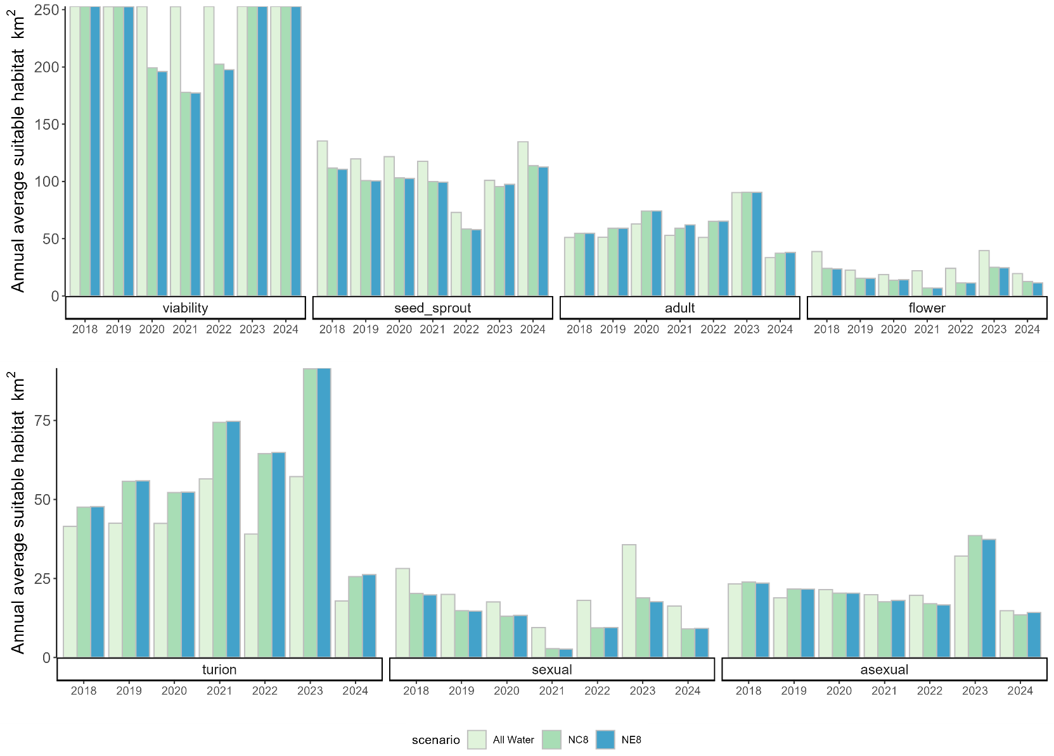

Figure 20. Habitat area suitable for Ruppia tuberosa (overall sexual only, asexual only and dual life-stage completion), comparing the base-case (i.e. ‘All Water’) against the NC8 and NE8 scenarios to assess the effect of cumulative environmental water delivery between 2018–2024, and also comparing the base-case to the NC2 scenario to isolate the effect of recent CEW watering from Jul 2023 to Dec 2024 on the 2024 growth year (dotted bars denoted as 2024*); refer to Table 5 for scenario definition. Note that the ‘sexual only’ area excludes area suitable for asexual or dual reproduction, and ‘asexual only’ excludes area suitable for sexual or dual reproduction, thus are different to the ‘sexual’ and ‘asexual’ in Figure 19.
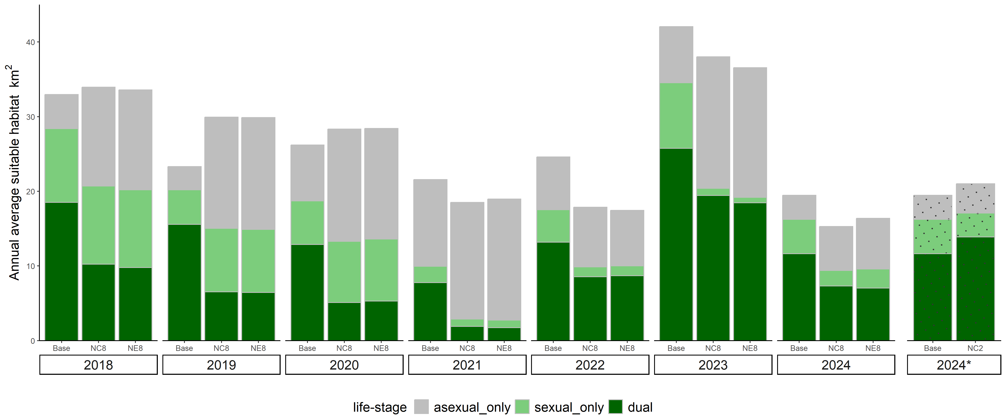

Figure 21. Differences of Ruppia tuberosa HSI (habitat suitability index) values for sexual reproduction in 2024 between the no Commonwealth environmental water since 2017 (No CEW 8 years) and the ‘All Water’ (base-case) conditions. The index is computed for each stage (seed germination and turion sprout, adult, flower) of the life-cycle, and the overall suitability (HSI sexual) is based on where all life-stage requirements are met for sexual reproduction. More saline conditions in the ‘No CEW 8 years” scenario led to a loss of good habitat in the middle of the Coorong and South Lagoon (blue indicates contraction, orange indicates expansion) that meets the requirements of all life-stages.
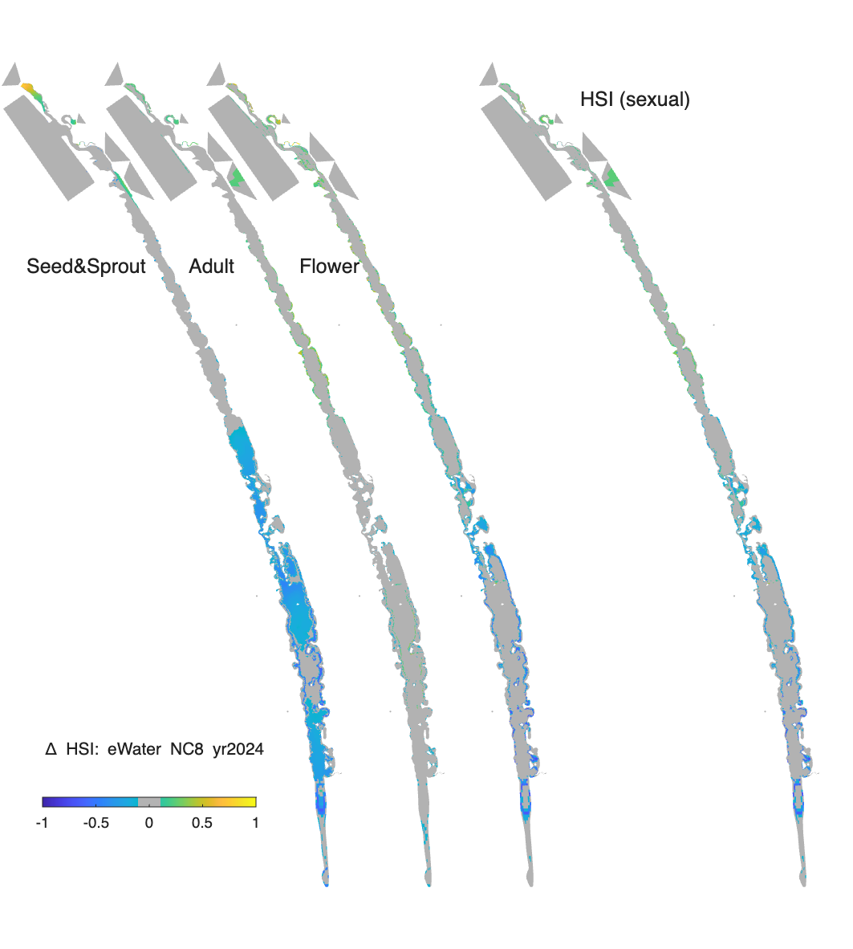

Figure 22. Differences of Ruppia tuberosa HSI (habitat suitability index) values for asexual reproduction in 2024 between the no Commonwealth environmental water since 2017 (No CEW 8 years) and the ‘All Water’ (base-case) conditions. The index is computed for each stage (seed germination and turion sprout, adult, turion formation) of the life-cycle, and the overall suitability (HSI asexual) is based on where all life-stage requirements are met for asexual reproduction. More saline conditions in the ‘No CEW 8 years’ scenario led to a loss of good habitat in the middle of the Coorong and South Lagoon except near the southern tip (i.e. Salt Creek) but a gain in the North Lagoon (blue indicates contraction, orange indicates expansion) that meets the requirements of all life-stages.
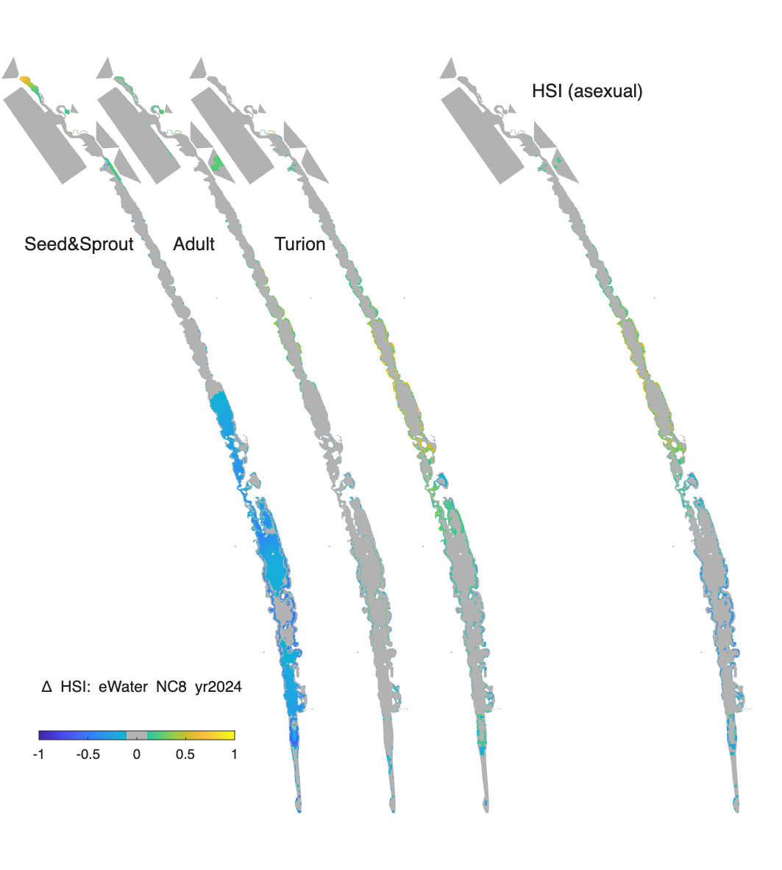
Figure 23. Habitat area for juvenile stages of key fish species for the scenarios showing the cumulative effect of environmental water delivery (i.e. 8 years for 2024-25). Environmental water contributes to a large habitat expansion for all species. Refer to Table 5 for scenarios.
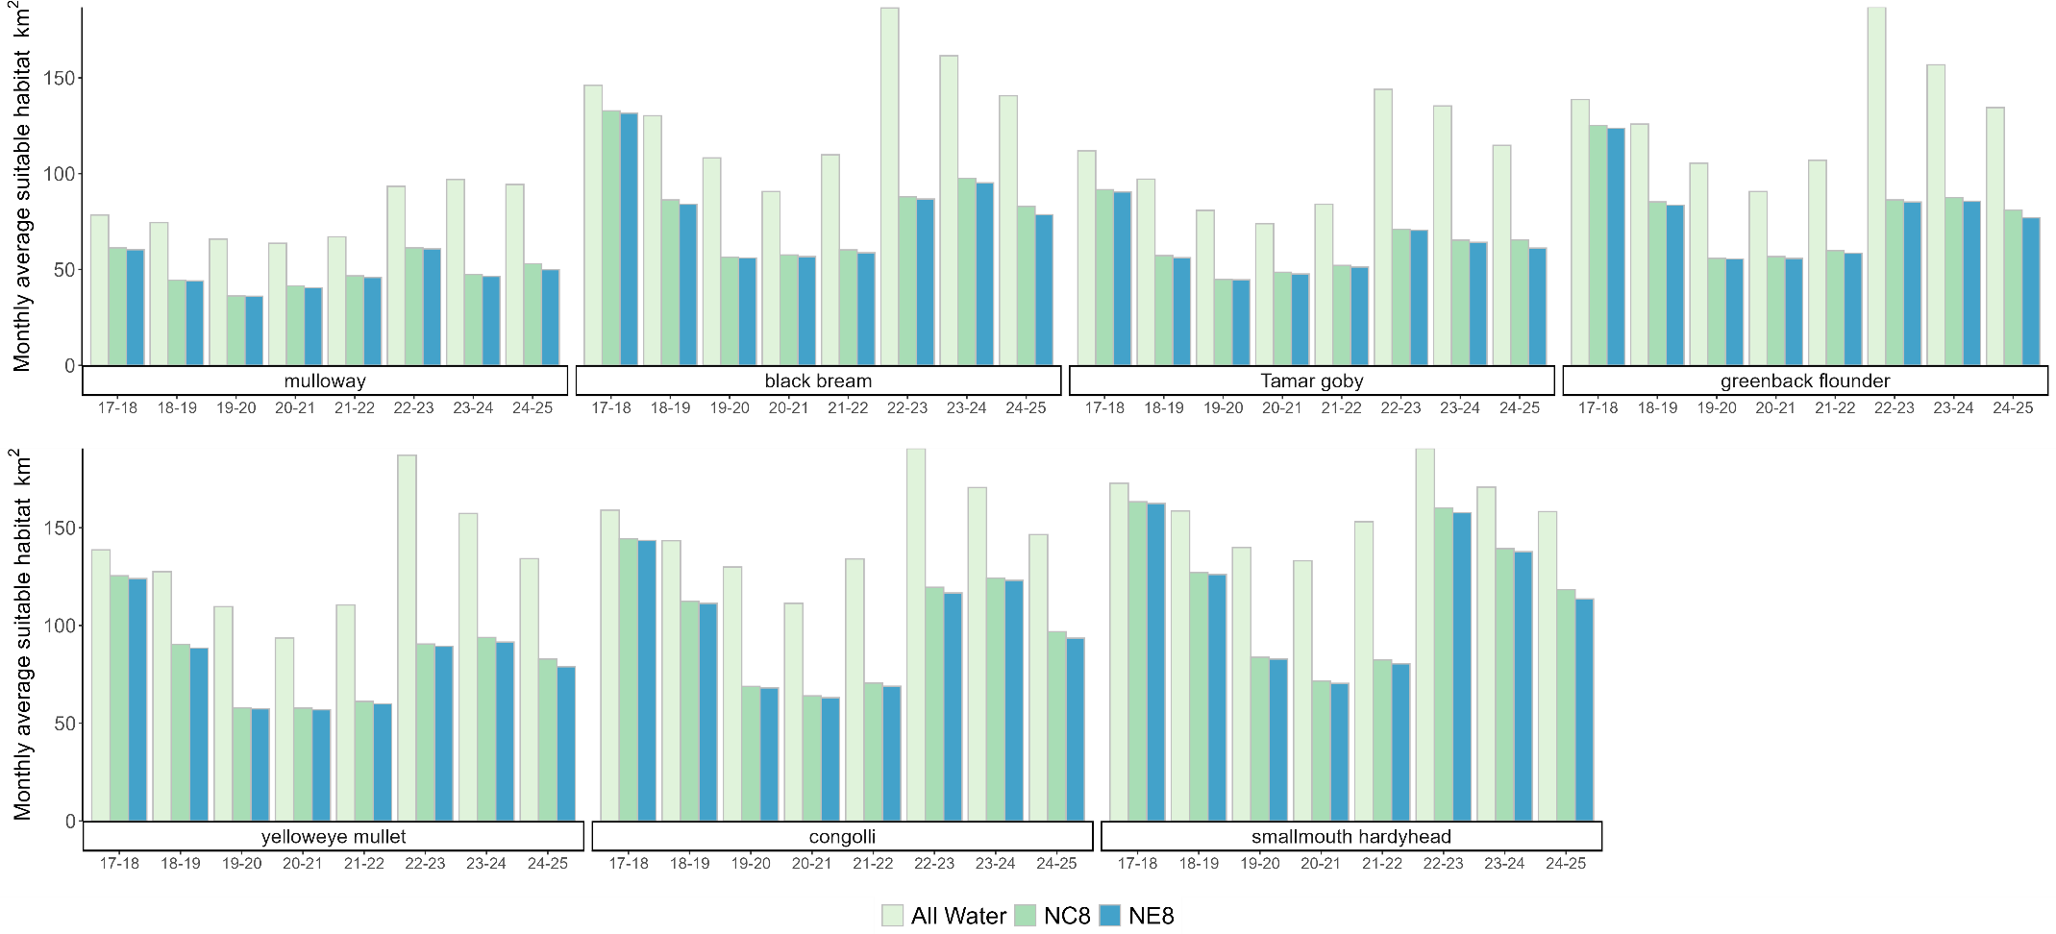

Figure 24. Monthly habitat area that would be “lost” for black bream during July 2024–June 2025 if there had not been Commonwealth environmental water delivery since 2017 (calculated as the difference between habitat in the ‘All Water’ (base-case) and ‘No CEW 8 years’ scenarios); -1 indicates complete loss of suitability at that location. Large areas of the Coorong, particularly the South Lagoon have a decrease in habitat quality, highlighting areas that have benefited from environmental water.
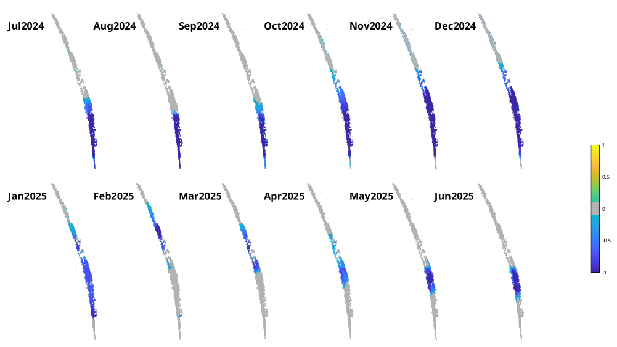

Table 11. Annual contribution of Commonwealth environmental water to Ruppia tuberosa and fish habitat area (HSI-weighted area in km², with percentage change relative to ‘All water’ in brackets).
Ruppia life-stage | 2018* | 2019* | 2020* | 2021* | 2022* | 2023* | 2024* | 2025*
Sexual | 7.9 (28%) | 3.0 (15%) | 2.4 (14%) | 5.0 (53%) | -0.2 (-1%) | 0.5 (1%) | -0.4 (-2%) | TBC*
Asexual | -0.6 (-3%) | -4.2 (-22%) | 1.0 (5%) | 0 (0%) | 2.6 (13%) | -1.4 (-4%) | -3.4 (-23%) | TBC*
Dual | 8.3 (45%) | 7.3 (47%) | 6.4 (50%) | 4.3 (56%) | 2.1 (16%) | -1.5 (-6%) | -2.3 (-19%) | TBC*
Fish species | 2017-18 | 2018-19 | 2019-20 | 2020-21 | 2021-22 | 2022-23 | 2023-24 | 2024-25
Mulloway | 17.1 (22%) | 11.1 (15%) | 14.3 (22%) | 9.1(14%) | 0.9 (1%) | 0.9 (1%) | 6.7 (7%) | 11.5 (12%)
Black bream | 13.3 (9%) | 11.6 (9%) | 17.1 (16%) | 7.7 (9%) | 2.1 (2%) | 0.5 (0.2%) | 7.3 (5%) | 7.7 (5%)
Tamar goby | 20.3 (18%) | 10.9 (11%) | 14.3 (18%) | 9.0(12%) | 1.4 (2%) | 1.3 (0.9%) | 6.8 (5%) | 10.8 (9%)
Greenback flounder | 13.5 (10%) | 10.6 (8%) | 16.9(16%) | 7.7 (9%) | 2.4 (2%) | 0.5 (0.3%) | 8.3 (5%) | 6.9 (5%)
Yelloweye mullet | 13.2 (10%) | 10.3 (8%) | 16.0(15%) | 7.6 (8%) | 2.1 (2%) | 0.6 (0.3%) | 8.0 (5%) | 7.3 (5%)
Congolli | 14.6 (9%) | 8.8 (6%) | 12.1 (9%) | 9.7 (9%) | 2.3 (2%) | 0.5 (0.2%) | 4.5 (3%) | 7 (5%)
Smallmouth hardyhead | 9.4 (6%) | 11.3 (7%) | 8.7 (6%) | 9.2 (7%) | 2.5 (2%) | 0.5 (0.2%) | 2.6 (2%) | 8.9 (6%)
*The calculation of the overall R. tuberosa HSI requires a full calendar year of simulation (corresponding to its annual life-cycle). As only January–July was simulated for 2025, habitat area for R. tuberosa could not be calculated for this year. The annual evaluation was based on ‘No CEW’ during that calendar year and six months prior.

Evaluation
The outcomes for the annual and long-term (2017-18 to 2024-25) KEQs are summarised in Table 12. The contribution of CEW to the outcome for the Coorong Habitat sub-indicator was based on the modelled percentage increase due to environmental water/CEW.
Table 12. Coorong habitat evaluation questions and answers. CEW = Commonwealth environmental water. eWater = environmental water. Note the evaluation for Ruppia tuberosa was based on calendar year (e.g. 2024) while for fish was based on water year (e.g. 2024-25). The percentage contribution of eWater and CEW were relative to “No eWater” and “No CEW” cases, respectively.
Annual
Key Evaluation Questions | Ruppia tuberosa and fish | Outcome for 2024-25 | eWater contribution | CEW contribution
What was the area of suitable habitat (modelled) for Ruppia tuberosa in the Coorong under the annual flow regime? What did eWater (and specifically CEW) contribute to this outcome? | Sexual reproduction | 16.3 km² | -9% | -2%
As above | Asexual reproduction | 14.8 km² | -24% | -19%
As above | Dual reproduction | 11.6 km² | -23% | -16%
What was the area of suitable habitat (modelled) for fish in the Coorong under the annual flow regime? What did eWater (and specifically CEW) contribute to this outcome? | Mulloway | 94.3 km² | 16% | 14%
As above | Black bream | 140.7 km² | 8% | 5%
As above | Tamar goby | 114.8 km² | 12% | 10%
As above | Greenback flounder | 134.5 km² | 6% | 5%
As above | Yelloweye mullet | 134.2 km² | 8% | 5%
As above | Congolli | 146.5 km² | 6% | 5%
As above | Smallmouth hardyhead | 158.2 km² | 8% | 6%
Long-term
Key Evaluation Questions | Ruppia tuberosa and fish | Outcome | eWater contribution | CEW contribution
What was the area of suitable habitat (modelled) for Ruppia tuberosa in the Coorong under the multi-year flow regime (since July 2017)? What did eWater (and specifically CEW) contribute to this outcome? | Sexual reproduction | 16.3 km² | 79% | 82%
As above | Asexual reproduction | 14.8 km² | 4% | 8%
As above | Dual reproduction | 11.6 km² | 67% | 59%
What was the area of suitable habitat (modelled) for fish in the Coorong under the multi-year flow regime? What did eWater (and specifically CEW) contribute to this outcome? | Mulloway | 94.3 km² | 89% | 79%
As above | Black bream | 140.7 km² | 79% | 69%
As above | Tamar goby | 114.8 km² | 89% | 75%
As above | Greenback flounder | 134.5 km² | 75% | 67%
As above | Yelloweye mullet | 134.2 km² | 69% | 61%
As above | Congolli | 146.5 km² | 56% | 52%
As above | Smallmouth hardyhead | 158.2 km² | 39% | 33%
Contribution (to what extent CEW contributed towards the outcome, with the significance of the outcome considered):
 | Unknown |  | Negative (<-5%) |  | None/negligible  (-5–4%) |  | Minor  (5–-9%) |  | Moderate (10–20%) |  | Substantial (>20%)

Discussion
Salinity is a key determinant of habitat suitability in the Coorong and is primarily driven by riverine inflows through barrages, seawater ingress and tidal exchange. When barrage flows are low, greater volumes of seawater enter the Murray Mouth, resulting in increased salt transport into the Coorong. It is evident that environmental water is critical for maintaining appropriate salinity in the Coorong and maintaining suitable habitat, especially in the middle Coorong and South Lagoon.
What was the area of suitable habitat (modelled) for Ruppia tuberosa in the Coorong under the annual and multi-year flow regime? What did environmental water (and specifically Commonwealth) contribute to this outcome?
The comparison of the overall modelled area of suitable habitat for R. tuberosa, based on the completion of a sexual reproduction life-cycle, indicated that without any CEW delivered between 2017–2024, there would have been a 45% reduction in habitat area suitable for sexual reproduction in 2024. The main reduction appears to be driven by the area suitable for successful flowering, seed germination and turion sprouting, since these life stages have a lower tolerance to high salinities than other life-stages (Zhai et al. 2025). The habitat area suitable for asexual reproduction in the South Lagoon would also have reduced markedly without environmental water, primarily due to loss of quality habitat for seed germination and turion sprouting early in the life cycle. Although there would be an increase in habitat area for asexual reproduction in the North Lagoon without environmental water (due to higher salinity tolerances of turions), priority should be given to the South Lagoon, which has been the target area for R. tuberosa management or restoration.
Similar to sexual reproduction outcomes, habitat area suitable for both sexual and asexual reproductions (‘dual’) would have decreased by 37% (or 4.3 km², HSI-weighted) if there was no environmental water delivery between 2017–2025. Having habitat suitable for both sexual and asexual reproduction is likely beneficial for long-term resilience of R. tuberosa populations and thus overall health of the Coorong for several reasons: 1) Sexual reproduction is crucial for maintaining genetic diversity; 2) Seeds produced are able to tolerate higher salinity conditions than turions through summer dormancy (Kim et al. 2013) making populations more resilient under extreme conditions; 3) Providing a variety of food source (both seeds and turions) for waterbirds; 4) Turion development may improve sediment quality (Waycott et al. 2022). Therefore overall, environmental water is critical for the long-term resilience of the R. tuberosa population in the Coorong, especially in the middle of the Coorong and South Lagoon.
The benefits of CEW for R. tuberosa in 2022 and 2023 were minor to negligible. In 2023, the overall contribution of environmental water to suitable habitat for asexual reproduction was slightly negative (-4%), and remained low in 2024 (-8% for total suitable habitat area for reproduction). These results indicate that salinity levels in the North Lagoon without environmental water were already close to the lower tolerance limit for R. tuberosa during the adult growth and reproductive stages. As a result, additional freshwater inputs did not further expand suitable habitat in the North Lagoon. However, without CEW in 2024, R. tuberosa habitat for sexual reproduction would suffer a small loss in the South Lagoon. Additionally, lower salinity in the North Lagoon would favour R. megacarpa and charophytes (Brock 1981), which were not assessed in this study, but would provide alternative habitat in the Coorong.
What was the area of suitable habitat (modelled) for fish in the Coorong under the annual and multi-year flow regime? What did environmental water (and specifically Commonwealth) contribute to this outcome?
The estuarine fish species that inhabit the Coorong vary in their tolerance to salinity; yelloweye mullet, congolli and smallmouth hardyhead are able to tolerate more saline conditions (McNeil et al. 2013). Fish differ from R. tuberosa in that they can move in response to changing salinity and habitat suitability. However, they can be constrained to larger spatial scales (i.e. lagoons) depending on the degree of connectivity, e.g. between the North and South lagoons, between the South Lagoon and Salt Creek, and/or between the Coorong and the Southern Ocean. Therefore, it is generally considered advantageous to have a greater area of habitat with suitable water quality (e.g. salinity) and abundant food resources to support the maintenance of fish populations. Estuaries are important feeding, spawning, nursery and refuge grounds for many estuarine-dependent fish species (Bice et al. 2018). Without environmental water, fish habitat contracts quickly and significantly. Even after the high flow year in 2016-17, if there was no environmental water delivered in 2017-18, significant habitat contraction would have occurred. This would have been particularly the case for mulloway and Tamar goby, which are less tolerant to high salinities and thus their area of suitable habitat would be most impacted by salinity increases. Even for the more salt-tolerant congolli and smallmouth hardyhead, the reduction in their suitable habitat areas would occur in 2017-18 without environmental water and a large area in the South Lagoon would have salinities exceeding their tolerance thresholds. Consecutive years of no CEW from 2017-18 to 2024-25 would have reduced suitable fish habitat by 25–44%. Without environmental water, it was evident that the greatest contraction in habitat occurred between 2017-18 and 2019-20, whereas the 2022-23 period showed the smallest contraction for all species, due to the already large unregulated freshwater flows to the Coorong.
Management implications
Barrage flow is critical to maintain both sexual and asexual reproduction success of R. tuberosa in the middle of the Coorong and South Lagoon, and the benefit of environmental water is particularly prominent in drier years. The health of R. tuberosa in the system, the extent of cover and the prevailing salinity would need to be considered, and environmental flow could be tailored to improve habitat suitability for R. tuberosa. The model provides a scenario-testing tool to optimise environmental water delivery through the barrages, with the aim of maximising the area of suitable R. tuberosa habitat given available water volumes. Water level maintenance is also necessary for R. tuberosa to complete its life-cycle. If Coorong water level drops too quickly in early summer, then the plants can become stranded and desiccate. Environmental water delivered during spring and summer, can help maintain or reduce the rate of water level reduction in the South Lagoon and promote R. tuberosa reproduction. The rate at which the South Lagoon would drain is dependent upon the evaporation rate and the size of the Murray Mouth.
The area of suitable estuarine fish habitat is highly sensitive to river flow via the barrages. Environmental flows lead to reduced salinities in the Coorong and an expansion of suitable fish habitat area. Without environmental flows, the suitable habitat contracts for a range of fish species (e.g. mulloway, black bream, Tamar goby, greenback flounder, yelloweye mullet and congolli). Smallmouth hardyhead are more salt-tolerant and have been the most abundant prey fish species in the southern Coorong (Ye et al. 2020b). Their habitat also contracts with no environmental water but the major impact on habitat suitability for this species (mainly reflected in the South Lagoon) took about one year longer to manifest than the other species. To maintain fish habitat for the range of estuarine species, environmental flows are essential to support barrage releases every year, particularly during spring and summer to enhance spawning/nursery habitat suitability and food availability. Just one year (e.g. 2017-18 and 2019-20) without environmental flows would have reduced mulloway habitat by 22%, and for eight years continuously without environmental flows the reduction would have been 47%.
- Native Vegetation
  - Lower Lakes Aquatic and Littoral Vegetation
Introduction
Lakes Alexandrina and Albert (the Lower Lakes) are large, shallow freshwater lakes that receive inflows predominantly from the Murray River and discharge into the Coorong through a series of five barrages separating Lake Alexandrina from the Coorong which prevent seawater intrusion into the lakes. Historically, the shorelines of lakes Alexandrina and Albert were extensively vegetated with reeds extending up to 1.6 km from the shoreline into the water and “water weed” (likely submergent vegetation) extending up to 1 km past the reeds (Sim and Muller 2004). In early 20th century, seawater intrusions during low Murray River flows had largely caused the death of most lakeshore vegetation prompting the construction of the barrages to return the lakes to a freshwater ecosystem (Sim and Muller 2004). Whilst the aquatic and shoreline vegetation did not recover to the extent present in the 1800s (Sim and Muller 2004), it still provides important ecosystem services such as habitat (Wedderburn et al. 2007, Fairweather et al. 2013, Wedderburn et al. 2017) and erosion control (PIRSA Spatial Information Services 2009). Water level was identified as a major driver of vegetation composition in the Lower Lakes (Nicol 2016) and can be controlled to a limited extent by barrage operations; however, Murray River flows sufficient to offset evaporation and provide flows into the Coorong are required to maintain favourable water levels for aquatic and littoral freshwater vegetation.
Vegetation has been monitored every spring and autumn since spring 2008 as part of The TLM condition monitoring program (Nicol et al. 2026). This period entailed low water levels due to the Millennium Drought (flows over Lock 1 between 2007 and 2010 were insufficient to offset evaporation and maintain water levels) with interventions to prevent acid sulfate soil formation including the construction of regulators to manipulate water levels. The 2010-11 flood broke the Millennium Drought and water levels returned to historical levels. Since then, managed lake level cycling, to remove salt from Lake Albert, followed by seasonal water level manipulation with raising in spring/summer and drawdown in autumn to improve littoral vegetation, was undertaken; two further floods occurred in 2016 and 2022-23, along with the Tinderbox Drought (2017–2021). Condition monitoring over this period has improved our understanding of the vegetation dynamics of the Lower Lakes under different hydrological and management regimes.
The Lower Lakes also form part of the Coorong, Lower Lakes and Murray Mouth Ramsar site. A review of the Ramsar Criteria and Limits of Acceptable Change for vegetation identified the freshwater submergent plant community and diverse reed beds as two critical ecosystem components (Nicol 2016). Data from the condition monitoring program showed that these two components were most at risk if water levels fell to levels like during the Millennium Drought (<0 m AHD) and were amongst the last to recover when water levels were reinstated (Nicol et al. 2026). Submergent vegetation is intolerant of drying and typically inhabits a band around the lakeshores and permanent wetlands between +0.5 and 0 m AHD but may be found in deeper water in wetlands and Goolwa Channel (the reach between Clayton and Goolwa Barrage). Condition monitoring data showed that submergent vegetation was completely lost during the Millennium drought and took over ten years to reach TLM targets after water levels were reinstated (Nicol et al. 2026). Diverse reed beds inhabit lakeshores and the edges of permanent wetlands typically between +0.8 and +0.2 m AHD. They differ from other reed beds as they contain a diverse assemblage of amphibious, emergent and (sometimes) submergent species other than Typha domingensis and Phragmites australis, which can form dense monospecific stands on lakeshores. Typha domingensis and Phragmites australis persisted during the Millennium Drought (albeit being disconnected from the water) but other emergent and amphibious species were generally extirpated. Recovery of amphibious species to levels where TLM targets were met typically occurred five years after water levels were reinstated and emergent species other than Typha domingensis and Phragmites australis generally have not yet recovered (Nicol et al. 2026).
Objectives and hypotheses
Objective:
- Compare water levels in the Lower Lakes under scenarios with and without CEW (and other environmental water) to predict status of submergent vegetation and diverse reed beds under different water delivery regimes.
Hypothesis:
- During droughts and times of low Murray River flow, CEW and other environmental water maintains water levels in the Lower Lakes above +0.5 m AHD and submergent vegetation and diverse reed beds in optimal condition.
Key Evaluation Questions for Basin and Area
Area-scale
Table 13. Key evaluation questions for assessing the Lower Lakes Aquatic and Littoral Vegetation responses to Commonwealth environmental water (CEW). Parameters and evaluation approaches used to answer the evaluation questions are provided. eWater = environmental water.
Key Evaluation Questions | Parameter | Evaluation Approaches
What was the vegetation status in the Lower Lakes? What did water levels contribute to vegetation status? What did eWater (and specifically CEW) contribute to this outcome? | Status of submergent vegetation and diverse reed beds in the Lower Lakes. | State and transition model providing qualitative comparison of vegetation status under observed conditions and modelled water levels without CEW and all eWater.
Methods
A state and transition model (sensu Lester and Fairweather 2009, 2010; Lester et al. 2013), comprising of four states (‘Optimal’, ‘Sub-optimal’, ‘Degraded’ and ‘Recovering’) was developed in this project for aquatic (submergent), emergent and amphibious vegetation in the Lower Lakes (Figure 25). The model was based on data collected from TLM vegetation condition monitoring, which commenced in 2008 (Nicol et al. 2026), lakeshore habitat mapping (Seaman 2003), a biological survey of reserves adjacent to the Murray Mouth (Brandle et al. 2002) and a survey of the vegetation of the freshwater shoreline of Hindmarsh Island (Renfrey et al. 1989). These data showed that the most favourable conditions for submergent vegetation and diverse reed beds are when water levels are cycled seasonally between +0.5 and +1 m AHD with high water levels in spring and low water levels in autumn. In the ‘Optimal’ model state, it is expected that there is abundant submergent vegetation and more than four native submergent species present throughout the Lower Lakes (Table 14). Furthermore, there are abundant diverse reed beds with more than 12 native amphibious or emergent species other than Typha domingensis and Phragmites australis present in these habitats throughout the Lower Lakes (Table 14). A list of expected species present in the submergent vegetation and diverse reed beds in the optimal state is presented in Table 14.
When water levels fall below +0.5 m AHD as result of extended low-flow conditions, the state changes from the ‘Optimal’ state to the ‘Sub-optimal’ state (Figure 25). In this state, species richness for submergent vegetation and diverse reed beds is lower (Table 14) but it is expected that if water levels are reinstated the vegetation will return to the ‘Optimal’ state; however, this scenario is untested as it has not occurred during TLM condition monitoring (Nicol et al. 2026). If water levels decline further and fall below +0.2 m AHD, the system switches to the ‘Degraded’ state (Figure 25). Submergent vegetation is extirpated and species richness of reed beds declines (Table 14) with reed beds often containing only Typha domingensis and Phragmites australis and disconnected from the water (Nicol et al. 2026). Once the system is in the ‘Degraded’ state, it does not revert to the ‘Optimal’ state if water levels are reinstated but it transitions to the ‘Recovering” state or the ‘Sub-optimal’ state if water levels do not reach +0.5 m AHD (Figure 25). Species richness is lower compared to the ‘Optimal’ state (Table 14) and monitoring data suggested the system may remain in the ‘Recovering’ state for ten years before transitioning to the ‘Optimal’ state (Nicol et al. 2026).
Figure 25. State and transition model summarising status of submergent vegetation and diverse reed beds under different water level scenarios.
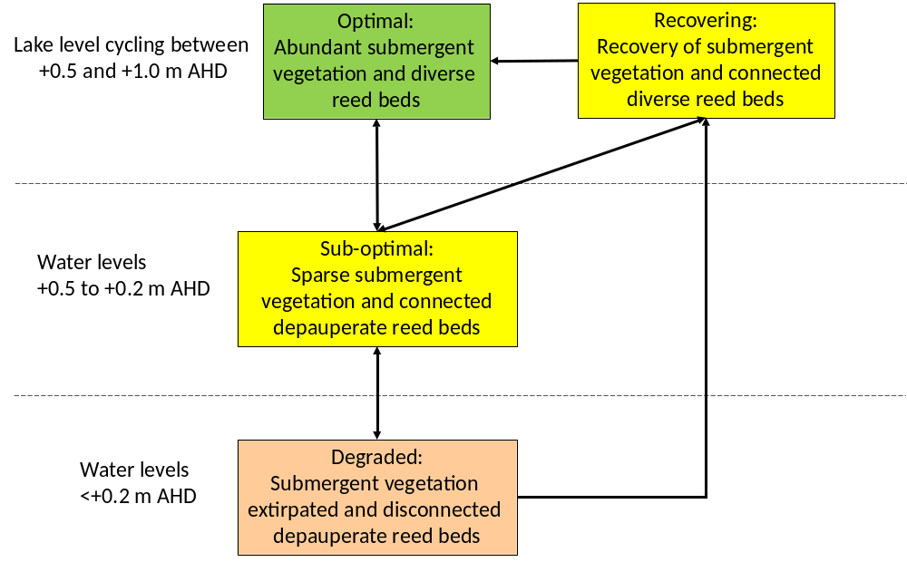

Table 14. Species richness (for all states) and species present (in the ‘Optimal’ state) for submergent vegetation and diverse reed beds in the Lower Lakes.
State | Submergent species richness | Example submergent species present | Native diverse reed bed species richness (other than Typha domingensis and Phragmites australis) | Example native diverse reed bed species present (other than Typha domingensis and Phragmites australis)
Optimal (TLM condition score “Good” or “Very Good”) | >4 | Ceratophyllum demersum, Myriophyllum caput-medusae, Myriophyllum salsugineum, Potamogeton crispus, Potamogeton pectinatus, Vallisneria australis | >12 | Bolboschoenus caldwellii, Azolla filiculoides, Calystegia sepium, Carex fasicularis, Centella asiatica, Crassula helmsii, Cycnogeton procera, Duma florulenta, Eleocharis acuta, Epilobium pallidiflorum, Isolepis producta, Juncus kraussii, Lemna sp., Ludwigia peploides, Lycopus australis, Myriophyllum muelleri, Persicaria lapathifolia, Rumex bidens, Schoenoplectus pungens, Schoenoplectus tabernaemontani
Sub-optimal  (TLM condition score “Poor” or “Fair”) | <3 | As above | 5–10 | As above
Degraded  (TLM condition score “Poor”) | 0 |  | <4 | As above
Recovering  (TLM condition score “Poor” or “Fair”) | >1 | As above | 5–10 | As above
Observed water levels in Lake Alexandrina (a proxy for water levels throughout the Lower Lakes) were compared with modelled water levels without CEW and without all environmental water. The state and transition model provided a qualitative assessment of vegetation in the Lower Lakes under different environmental water delivery scenarios (Table 13).
Results
Water levels
Under observed conditions (with environmental water delivered), water levels in Lake Alexandrina fell below +0.5 m AHD on only two occasions between 2014-15 and 2024-25 (Figure 26) for a total of 27 days (Table 15). During this period, the minimum recorded water level was +0.48 m AHD. In contrast, modelled water levels without CEW were predicted to have been below +0.5 m AHD on seven occasions and below +0.2 m AHD twice (Figure 26) for a total of 1,127 and 214 days, respectively (Table 15). If no environmental water was delivered between the 2014-15 and 2024-25 water years, modelled water levels were predicted to be below +0.5 m AHD on seven occasions and below +0.2 m AHD twice (Figure 26) for a total of 1,287 and 214 days, respectively (Table 15).
In the 2024-25 water year, the water level in Lake Alexandrina remained above +0.5 m AHD for the whole year with the lowest water level of 0.55 m AHD on 23 March 2025 (Figure 26). However, without CEW, modelled water levels were below +0.5 m AHD from 15 February 2025 to 6 June 2025 (Figure 26) for 109 days (Table 15) with a minimum water level of +0.39 m AHD. With no environmental water delivered, the water level was predicted to fall below +0.5 m AHD on 20 January 2025 and remain below this level for the remainder of the water year (Figure 26), for 162 days (Table 15) with a minimum water level of +0.26 m AHD.
Table 15. Number (No.) of days Lake Alexandrina water levels were below model thresholds (0.5 and 0.2 m AHD) from 2014-15 to 2024-25 and the 2024-25 water year under observed conditions and modelled water levels with no Commonwealth environmental water (CEW) and no environmental water (eWater).
Year | Scenario | No. days < +0.5 m AHD | No. days < +0.2 m AHD
2014-15 to 2024-25 | Observed | 27 | 0
2014-15 to 2024-25 | No CEW | 1127 | 214
2014-15 to 2024-25 | No eWater | 1287 | 214
2024-25 | Observed | 0 | 0
2024-25 | No CEW | 109 | 0
2024-25 | No eWater | 162 | 0

Figure 26. Observed and modelled Lake Alexandrina water levels without Commonwealth environmental water and all environmental water from 1 July 2014 to 30 June 2025, showing model state thresholds of +0.5 m AHD for the ‘Optimal’ state and +0.2 m AHD for the ‘Degraded’ state.
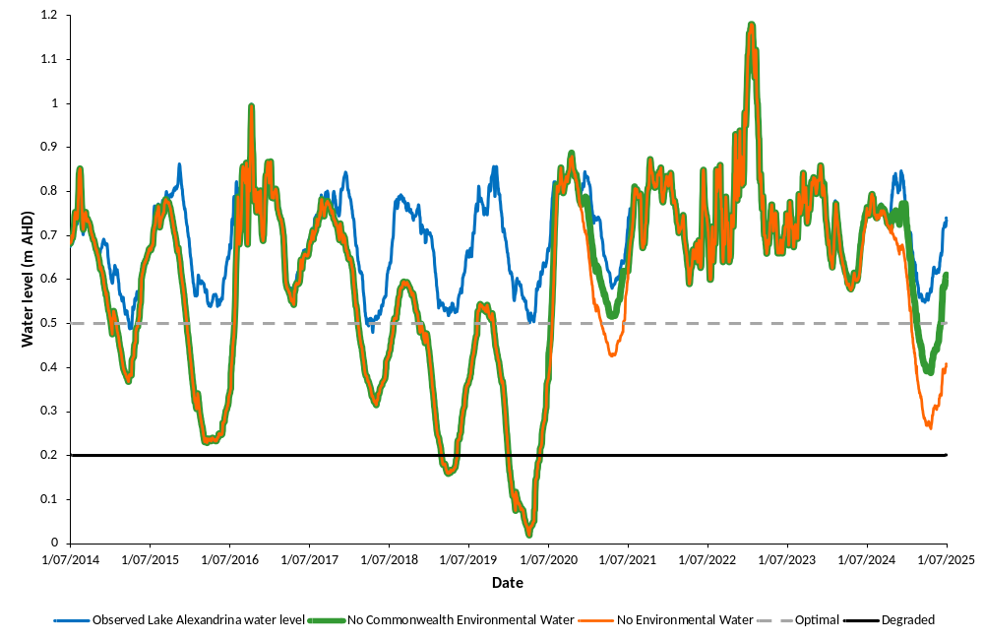
Vegetation status
Under observed conditions (Figure 26), vegetation in the Lower Lakes remained in the ‘Recovering’ state from 2014-15 to 2019-20 (Table 16), due to the extended low water levels from 2007 to 2010 during the Millennium drought. In the 2020-21 water year, the whole of lakes vegetation condition score (developed as part of TLM condition monitoring review (Robinson 2014)) exceeded the threshold for ‘Good’ condition (Nicol et al. 2026) signalling a change to the ‘Optimal’ model state (Table 16). Water levels remained above +0.5 m AHD to the end of the 2024-25 water year; hence, the vegetation remained in the ‘Optimal’ model state (Table 16). In contrast, if environmental water (including CEW) was not delivered during this period, the vegetation would not have achieved the ‘Optimal’ state (Table 16).
If CEW was not delivered between 2014-15 and 2024-25, the vegetation was predicted to be in the ‘Sub-optimal’ state for those water years (Table 16), due to the modelled water levels falling below +0.5 m AHD (Figure 26). In 2016-17, the modelled water level remained above +0.5 m AHD (Figure 26) and the vegetation moved to the ‘Recovering’ state (Table 16). However, in 2017-18 modelled water levels fell below +0.5 m AHD (Figure 26) and the state changed to “Sub-optimal (Table 16). In 2018-19 and 2019-20, the vegetation changed to the “Degraded” state (Table 16), with modelled water levels predicted to be below +0.2 m AHD on one occasion each year (Figure 26). Modelled water levels were predicted to be above +0.5 m AHD from 2020-21 to 2023-24 (Figure 26) and the vegetation would be in the ‘Recovering’ state during this period (Table 16). In 2024-25, modelled water levels fell below +0.5 m AHD (Figure 26) and the vegetation would have switched to the ‘Sub-optimal’ state (Table 16).
If no environmental water was delivered between 2014-15 and 2024-25, vegetation status would have been the same as under the ”no CEW” scenario, except during the 2020-21 water year (Table 16). Environmental water not part of the CEWH’s portfolio delivered to the Lower Lakes would have resulted in water levels remaining above +0.5 m AHD for that water year (Figure 26). However, if no environmental water was delivered to the site, levels were predicted to fall below +0.5 m AHD (Figure 26) for 160 days (Table 15) and the vegetation transitioning to the ‘Sub-optimal’ state (Table 16).

Table 16. Model states and number of days with water levels below 0.5 and 0.2 m AHD from the 2014-15 to 2024-25 water years under observed conditions and predicted states under modelled Lake Alexandrina water levels with no Commonwealth environmental water (CEW) and no environmental water (eWater).
Water year | Observed | No. days <+0.5 m AHD/<+0.2 m AHD | No CEW | No. days <+0.5 m AHD/<+0.2 m AHD | No eWater | No. days <+0.5 m AHD/<+0.2 m AHD
2014-15 | Recovering | 14/0 | Sub-optimal | 108/0 | Sub-optimal | 108/0
2015-16 | Recovering | 0/0 | Sub-optimal | 199/0 | Sub-optimal | 199/0
2016-17 | Recovering | 0/0 | Recovering | 20/0 | Recovering | 20/0
2017-18 | Recovering | 13/0 | Sub-optimal | 142/0 | Sub-optimal | 142/0
2018-19 | Recovering | 0/0 | Degraded | 247/71 | Degraded | 247/71
2019-20 | Recovering | 0/0 | Degraded | 292/143 | Degraded | 292/143
2020-21 | Optimal | 0/0 | Recovering | 11/0 | Sub-optimal | 118/0
2021-22 | Optimal | 0/0 | Recovering | 0/0 | Recovering | 0/0
2022-23 | Optimal | 0/0 | Recovering | 0/0 | Recovering | 0/0
2023-24 | Optimal | 0/0 | Recovering | 0/0 | Recovering | 0/0
2024-25 | Optimal | 0/0 | Sub-optimal | 109/0 | Sub-optimal | 162/0

Evaluation
The outcomes for the KEQs for 2024-25 are summarised in Table 17. The definition of the categories of none/negligible, minor, moderate and substantial contribution of environmental water or CEW to vegetation condition in the Lower Lakes vegetation are outlined below:
- None/negligible: Environmental water/CEW made no measurable contribution to water levels in Lake Alexandrina.
- Minor: Environmental water or CEW contributed to increased water levels in Lake Alexandrina; however, modelled water levels without environmental water or CEW were above +0.5 m AHD and the system remained in the ‘Optimal’ state.
- Moderate: Environmental water or CEW contributed to maintaining the system in the ‘Optimal’ state and modelled water levels without environmental water or CEW would have resulted in a state change to the ‘Sub-optimal’ state.
- Substantial: Environmental water or CEW contributed to maintaining the system in the ‘Optimal’ state and modelled water levels without environmental water or CEW would have resulted in a state change to the ‘Degraded’ state.

Table 17. Area-scale evaluation questions for Lower Lakes aquatic and littoral vegetation. Commonwealth environmental water (CEW) evaluation of water levels in Lake Alexandrina and aquatic and littoral vegetation status in the Lower Lakes. Refer to ‘Key Evaluation Questions for Area’ and Table 13 for a description of the evaluation approach. eWater = environmental water.
Key Evaluation Questions | Outcome for 2024-25 | eWater contribution | CEW contribution
What was the vegetation status in the Lower Lakes? What did water levels contribute to vegetation status? What did eWater (and specifically CEW) contribute to this outcome? | Water levels remained above +0.5 m AHD for the 2024-25 water year and vegetation status was maintained in the “Optimal” state. | Without eWater, water level in Lake Alexandrina would have fallen below +0.5 m AHD from 20 January to 30 June 2025 (162 days) with a minimum water level of +0.26 m AHD. Consequently, the vegetation would have been in the ’Sub-optimal‘ state. | Without CEW, lake levels were predicted to be below +0.5 m AHD for 109 days with a minimum water level of +0.39 m AHD, linking to ‘Sub-optimal’ vegetation state. Therefore, CEW was considered to contribute moderately to maintaining vegetation condition.
Contribution (to what extent CEW contributed towards the outcome, with the significance of the outcome considered):
 | Unknown |  | None/negligible |  | Minor |  | Moderate |  | Substantial

Discussion
What was the vegetation status in the Lower Lakes? What did water levels contribute to vegetation status? What did environmental water (and specifically CEW) contribute to this outcome?
Environmental water has made a substantial contribution to maintaining water levels in the Lower Lakes since the implementation of the Basin Plan, in particular during dry years. Water level and salinity are the two major drivers of aquatic and littoral vegetation composition in the Lower Lakes (Nicol 2016).
TLM vegetation condition monitoring in the Lower Lakes has shown that submergent vegetation typically occurs within an elevation band between +0.5 and 0 m AHD. When water levels fall below +0.2 m AHD, submergent vegetation may be extirpated due to lower localised water levels brought about by seiching, and recruit does not typically occur further down the elevation gradient (Nicol et al. 2026). Reed beds (whilst they persisted when water levels were low) also did not recruit further down the elevation gradient, were disconnected from the water, had lower species richness and were largely unable to fulfil their ecosystem services (Nicol et al. 2026). Therefore, it is important that water levels are maintained above 0.5 m AHD to protect submergent and littoral vegetation and enable it to provide ecosystem services, which would not have been achieved without environmental water.
Under observed conditions, from 2014-15 to 2024-25, the water level in Lake Alexandrina fell below +0.5 m AHD on two occasions for a total of 27 days, with a minimum water level of +0.48 m AHD. In contrast, without environmental water, water levels were predicted to have been frequently below +0.5 m AHD (seven out of 11 years) for prolonged periods typically exceeding 100 days. Given that recovery of vegetation to the ‘Good’ condition as defined by TLM (Robinson 2014) required ten years of almost continuous water levels above +0.5 m AHD (Nicol et al. 2026) after the Millennium Drought, it would be expected that the vegetation had been significantly impacted by the Drought. Submergent vegetation would be the most impacted as it cannot survive exposure but there is also a chance that the seed bank would be depleted. Seed bank assessments undertaken during the Millennium Drought showed that all submergent species recorded during the condition monitoring program were present in the soil seed bank (Nicol and Ward 2010a, 2010b). Without environmental water to maintain lake levels, repeated exposure and inundation may cause ‘false starts’ when seed from the seed bank germinates whilst inundated, but the duration is not sufficient for plants to complete their life cycle resulting in reproductive failure and the seed bank is not replenished. Through time the depletion of the seed bank will impact the resilience of the ecosystem and reduce the capacity to recover after disturbance.
The two occasions during the Tinderbox Drought when modelled water levels were predicted to fall below +0.2 m AHD further highlighted the importance of environmental water. Whilst water levels were not as low or for the duration experienced during the Millennium Drought, it is likely that submergent vegetation would have been extirpated from the Lower Lakes. Repeated cycles of drying and inundation during this period may also have depleted seed banks at lower elevations, which function as important refuges for submergent plant communities. In addition, without environmental water, water levels were sufficiently low to disconnect most of the shoreline reed beds from the water (Nicol et al. 2026).
In 2024-25 environmental water played a moderate role in maintaining water levels and vegetation. Whilst modelled water levels without environmental water predicted the threshold for the ‘Degraded’ state would not be reached (Figure 26), it would have got close (+0.26 m AHD). Under these conditions, it would be expected that the impact on vegetation (in particular submergent plants) would be significant with most of the potential habitat for these species exposed, likely having negative impact on their ecosystem services (e.g. fish habitat, Wedderburn et al 2017).
Vegetation is not the only biotic group that benefits from the maintenance of water levels due to environmental water delivery. Three small-bodied threatened fishes (Murray hardyhead, southern pygmy perch and Yarra pygmy perch) are dependent on areas with submergent vegetation in the Lower Lakes and went locally extinct during the Millennium Drought due to habitat loss requiring reintroduction via a captive breeding program from when water levels were reinstated (Wedderburn et al. 2007, Wedderburn et al. 2017). Without environmental water, it is likely that these species would have been lost from the system.
The state and transition model uses water level as a proxy for vegetation state and does not take into consideration other factors that impact the distribution and abundance of vegetation in the Lower Lakes. Salinity is an important factor; however, if water levels are higher than +0.5 m AHD it is unlikely that salinity is going to negatively impact vegetation. The only time salinity was above the reported thresholds for common species (Bailey et al. 2002) was during the Millennium Drought when water levels were low (Nicol et al. 2026). Another factor that impacted vegetation was the cyanobacterium (Raphidiopsis (Cylindrospermopsis) raciborskii) bloom that occurred in the previous two summers in Lake Alexandrina. The bloom likely caused a reduction in species richness and abundance of submergent vegetation, which resulted in the decline in the whole of lakes condition score from ‘Good’ in spring 2024 to ‘Fair’ in autumn 2025 (Nicol et al. 2026), despite favourable hydrology.
The state and transition model has hard boundaries between states. For example, water levels falling from +0.5 to +0.49 m AHD would result in a change of state from ‘Optimal’ to ‘Sub-optimal’, but this would probably have no significant impact on vegetation in the Lower Lakes; however, limits need to be defined in the model and more than 15 years of monitoring data showed that +0.5 m AHD is likely the upper limit of submergent plant habitation (Nicol et al. 2026).
All model states, except the ‘Sub-optimal’ state, are supported by data collected by TLM condition monitoring for the Lower Lakes (Nicol et al. 2026). Surveys undertaken during low water levels during the Millennium Drought showed that submergent vegetation is extirpated from the lakes and reed beds have lower species richness lower species richness supporting the characterisation of the ‘Degraded’ state. Monitoring continued after water levels were reinstated and showed that ten years of favourable hydrology were required for vegetation to recover supporting the ‘Recovery’ state. Continuation of the monitoring showed that favourable hydrology is required to maintain and improve vegetation condition supporting the ‘Optimal’ state; however, other factors such as cyanobacteria blooms that can impact vegetation condition are not taken into consideration. The conditions characterising the ‘Sub-optimal’ state have not been observed in the TLM monitoring program, as water levels below +0.5 m AHD have not been observed in Lake Alexandrina since the 2017-18 water year (Figure 26). Nevertheless, it is a reasonable assumption that vegetation condition would decline with sustained water levels below +0.5 m AHD as reported during the Millennium Drought (Nicol et al. 2026).
Management implications
The Lower Lakes being at the end of the system means that interventions to improve condition are limited and reliant on flow from upstream. Barrage operations can provide variation in water levels, which may enhance the diversity of littoral vegetation and increases potential depth for colonisation by submergent species (Nicol et al. 2026). However, flow is required to increase water levels and maintain outflows into the Coorong and connectivity.
The availability of environmental water (including CEW) is often required to underwrite the refilling of the Lower Lakes (if other water is unavailable) after managed draw down when these management actions are proposed. In addition, modelled lake levels indicated that during dry years, environmental water delivery is important to maintain favourable lake levels above +0.5 m AHD, which support submergent and littoral vegetation (in particular diverse reed beds) and the ecosystem services they provide.

- Waterbirds
This theme is not included in core monitoring in this Area due to resource constraints (Ye et al. 2024a).

- Native Fish
  - Native Fish
Introduction
River flow regimes influence life-history processes and population dynamics of freshwater fishes and ultimately fish assemblage structure (species composition and abundance) (Koehn et al. 2020). In the MDB, historical declines of native fishes were associated with river regulation and alteration of flow regimes, and other anthropogenic perturbations including overfishing (Koehn and Lintermans 2012; Koehn et al. 2020). The Basin Plan (Commonwealth of Australia 2012) lists several objectives (Environmental Watering Plan, Chapter 8) and long-term targets (Schedule 7) related to the recovery of native fish populations. These include protecting and restoring biodiversity that is dependent on Basin water resources (8.05(3)) and improving recruitment and populations of native water-dependent species, including fish (Schedule 7 (2)(f)) (Section 15.2, Appendix). The BEWS (MDBA 2025a) has more specific Expected Environmental Outcomes related to the biodiversity outcomes of the Basin Plan (Section 15.2, Appendix). Environmental water, including CEW, is being used to improve flow regimes and ecosystem functions to restore native fish populations and meet Basin Plan objectives and targets.
In this section of the report, we investigated (1) temporal variation in fish assemblage structure and (2) the size and age compositions of key species in the LMR. Observed patterns are discussed based on published literature and current conceptual understanding of fish life histories and population dynamics in the LMR. In this report, our interpretation of the data for this indicator does not explicitly address association with environmental water delivery – this is performed as part of Basin-scale evaluation.
Objectives and hypotheses
Objective:
- Collect fish assemblage data in the main channel of the LMR to inform Basin-scale evaluation of native fish population responses to CEW, which is being undertaken by a team of fish ecologists and biometricians, led by the CSIRO (Hladyz et al. 2026; Table 18).
Hypotheses:
- Prolonged low, in-channel flows (<20,000 ML/d) will promote hydraulic (e.g. lentic) and structural (submerged plant) habitats conducive to low-flow generalist fishes such as small-bodied carp gudgeon (Hypseleotris spp.) and unspecked hardyhead (Craterocephalus fulvus).
- In-channel flows >20,000 ML/d will facilitate a shift towards more natural riverine hydraulic characteristics that benefit flow-dependent species such as golden perch (Macquaria ambigua) and Murray cod (Maccullochella peelii).
- Increased variability in annual flow that includes large, overbank (>45,000 ML/d) flows will lead to increased recruitment of a range of species with different life histories (e.g. flow-dependent), promoting diverse fish assemblages and resilience in populations.
Key Evaluation Questions for Basin and Area
Basin-scale
Table 18. Key evaluation questions for assessing the Native Fish responses to Commonwealth environmental water (CEW) (McInerney et al. 2024). Indicators and evaluation approaches used to answer the evaluation questions are provided. The bolded question is the primary question. *Priority species are those listed in the BEWS (MDBA 2025a).
Key Evaluation Questions | Parameter | Evaluation Approaches
What did CEW contribute to native fish populations? | See below. | See below.
What did CEW contribute to native fish recruitment? | For priority species*:  Year class strength (e. g. young-of-year year-class strength for medium- to long-lived species or small bodied fish abundance for annual recruiters).  Catch curve data. | Quantitative modelling using counterfactual flow time series.
What did CEW contribute to native fish population structure? | For priority species*:  For medium- to long-lived species only -proportion of juveniles, adults and number of year classes in a population with detailed metrics to undergo further refinement by working group. | Quantitative modelling using counterfactual flow time series.
What did CEW contribute to native fish abundance? | For priority species*:  Common species – catch-per-unit-effort (detection).  Rarer species – reporting rates (frequency of occurrence). | Quantitative modelling using counterfactual flow time series.
What did CEW contribute to native fish movement? | Integration of various indicators -these may range from field measurements of movement (e.g. diadromous fish movement through Murray barrages) to the use of flow-related movement models developed in Flow-MER1.0. | Quantitative modelling using counterfactual flow time series.
What did CEW contribute to native fish condition? | Body condition of medium-long lived priority species*. | Quantitative modelling using counterfactual flow time series.

Area-scale
There are no CEWH evaluation questions for this indicator at the Lower Murray and CLLMM Area scale, therefore no evaluation will be undertaken for this Area. Nonetheless, data contribute to Area-scale evaluation for the Flow-cued Fish Spawning and Recruitment (Section 8.2) and Murray Cod Recruitment indicators (Section 8.3) and could be used by Basin states, in consultation with the Lower Murray Consortium, to meet the State’s Basin Plan reporting obligations under Schedule 12 (Matter 8) on the achievement of environmental outcomes at the asset scale (South Australian River Murray Water Resource Plan Area (WRPA), DEW 2020; NSW Murray–Lower Darling WRPA, NSW DPIE 2020; and the Victorian Murray WRPA, Victorian DELWP 2021). This reporting and evaluation contribute to the MDBA’s evaluation of Basin Plan environmental outcomes at the Basin-scale.
Methods
Sampling
During autumn 2025, fish assemblages in the LMR were sampled using non-targeted, standardised boat electrofishing (12 shots, 90 seconds (s) per shot; McInerney et al. 2024), hereafter referred to as condition monitoring. A total of 26 sites were sampled in the main river channel between Murray Bridge and Lock 10 (Figure 1), including: six long-term sites, between Locks 1 and 3, previously sampled under LTIM and Flow-MER1.0 (Ye et al. 2025); three new sites; and 17 sites sampled under existing complementary monitoring programs (Table 19). Individuals (up to 50 per species per site) were measured for length (nearest mm, fork length [FL] or total length [TL]) and weight (to nearest g) for priority species (Murray cod, golden perch, silver perch (Bidyanus bidyanus) and freshwater catfish (Tandanus tandanus)). A sub-sample of golden perch, silver perch and freshwater catfish, proportionally representing the sizes of fish sampled, was euthanised and retained for ageing.
Table 19. Condition monitoring sites in the Lower Murray River channel for autumn 2025, including those for complementary programs outside of Flow-MER monitoring.
No. of sampling sites | Monitoring program | Reference
9 | Flow-MER monitoring | This report
5 | Murray–Darling Basin Fish Survey (MDBFS, funded by the MDBA) | N/A
2 | Chowilla Icon Site Fish Condition Monitoring (funded under TLM, MDBA, and facilitated by South Australia DEW) | Fredberg et al. 2025
1 | Pike Fish Assemblage Condition Monitoring (funded by South Australian DEW) | Fredberg and Bice 2025b
2 | Katarapko Fish Assemblage Condition Monitoring (funded by South Australian DEW) | Fredberg and Bice 2025a
7 | Lindsay–Mulcra–Wallpolla Islands Icon Site Fish Condition Monitoring (funded under TLM, MDBA, and facilitated by Mallee Catchment Management Authority) | Butler et al. 2024
Ageing
We used age-frequency distributions to assess age structure and year-class strength of golden perch (Section 8.2), silver perch (Section 8.2) and freshwater catfish (this Section). Sagittal otoliths were removed from individuals retained for ageing from condition monitoring and Murray cod targeted monitoring (Section 8.3). Whole otoliths were embedded in clear casting resin and a single 400 to 600 µm transverse section was prepared. Sections were examined using a dissecting microscope (x25) under transmitted light. Estimates of age were determined independently by two readers by counting the number of discernible opaque zones (annuli) from the primordium to the otolith edge. If a consensus was not reached for otoliths with initial counts that differed among readers, then the otolith was rejected. Young-of-year (YOY, <1 year old) fish were defined as individuals lacking clearly discernible annuli.
Data analyses
We integrated condition monitoring (formerly Category 1 electrofishing) data from LTIM (Ye et al. 2020a) and Flow-MER1.0 (Ye et al. 2025) to assess temporal variability in fish assemblage structure and recruitment of large-bodied species. Temporal variation in fish assemblage structure (species composition and abundance), between sampling years, was investigated using non-metric Multi-Dimensional Scaling (MDS), permutational multivariate analysis of variance (PERMANOVA) and Similarity Percentages (SIMPER) analysis in the software package PRIMER v. 6.1.12 (Clarke and Gorley 2015) and PERMANOVA + v.1.02 (Anderson et al. 2008). Statistical analyses were restricted to 2023–2025 because small-bodied fish species were not enumerated by electrofishing prior to 2023. Abundance was measured as electrofishing catch-per-unit-effort (CPUE) (individuals/90 s electrofishing shot) and data were square-root transformed prior to statistical analyses.
To investigate recruitment of large-bodied species, we calculated the CPUE of YOY using length structure data. Recruitment length thresholds, representing the minimum size of age 1+, were assigned to each species (golden perch = 85 mm TL, silver perch = 100 m FL, freshwater catfish = 90 mm TL, Murray cod = 155 m TL, bony herring = 120 mm FL, common carp and goldfish = 155 mm FL, redfin perch = 150 mm FL) based on data from Hladyz et al. (2025) and SARDI unpublished data. Due to increased growth rates during the 2022-23 flood year, length thresholds were adjusted for some species in 2023 (i.e. golden perch = 135 mm TL, Murray cod = 170 mm TL, bony herring = 150 mm FL, and redfin perch = 205 mm FL). We adopted the approach used for past Basin-scale fish evaluations (e.g. Hladyz et al. 2025) and assumed all small-bodied individuals sampled were YOY because sampling occurs at the end of the breeding period for those species. Temporal variation (2015–2025) in total and YOY CPUE (recruitment) for all species were visualised using histograms. These analyses were restricted to sites sampled between locks 1 and 3 to ensure long-term comparability.
Results
Catch summary
In 2025, a total of 11,027 individuals representing 16 species were sampled across the 26 sites (Table 20). Among large-bodied species, bony herring (Nematalosa erebi) was the most abundant (73% of total catch), followed by common carp (Cyprinus carpio) at 3% and golden perch at 2%. For small-bodied species, unspecked hardyhead was the most abundant (13%), followed by Murray rainbowfish (Melanotaenia fluviatilis) and Australian smelt (Retropinna semoni), each comprising 4% of the total catch.
Table 20. Fish species presence (black cell) across weir pools (WP, e.g. Lock 1 to Lock 2 weir pool = 1) in the Lower Murray River during autumn 2025 condition monitoring. Exotics are marked with asterisks.
Species | WP 0 | WP 1 | WP 2 | WP 3 | WP  4 | WP  5 | WP  6 | WP  7 | WP  8 | WP  9
Golden perch Macquaria ambigua
Murray cod Maccullochella peelii
Silver perch Bidyanus bidyanus
Freshwater catfish Tandanus tandanus
Bony herring Nematalosa erebi
Common carp Cyprinus carpio*
Goldfish Carassius auratus*
Redfin perch Perca fluviatilis*
Unspecked hardyhead Craterocephalus fulvus
Australian smelt Retropinna semoni
Murray rainbowfish Melanotaenia fluviatilis
Carp gudgeon Hypseleotris spp.
Flathead gudgeon Philypnodon grandiceps
Common galaxias Galaxias maculatus
Gambusia Gambusia holbrooki*
Oriental weatherloach Misgurnus anguillicaudatus*
Sites sampled | 4 | 3 | 3 | 3 | 2 | 2 | 3 | 2 | 2 | 2

Fish assemblage structure
MDS ordination of fish assemblage data and PERMANOVA tests demonstrated differences in fish assemblages between years (Pseudo-F_{2,25} = 28.297, P = 0.0001) but not weir pools (Pseudo-F_{1,25} = 0.97959, P = 0.3524) and there was no significant interaction between years and weir pools (Pseudo-F_{2,25} = 0.44173, P = 0.8159) (Figure 27). Pairwise comparisons revealed significant differences between 2023 and 2024 (t = 7.0995, P = 0.0001), 2023 and 2025 (t = 4.5806, P = 0.0002) and 2024 and 2025 (t = 3.1986, P = 0.0005). SIMPER indicated that differences between years were primarily driven by higher abundances of common carp, bony herring and goldfish in 2023 and lower abundances of bony herring and unspecked hardyhead in 2024 (Figure 28). In 2023, high relative abundances of common carp, bony herring and goldfish were driven primarily by strong recruitment (to age 0+) of those species (Figure 28).
Figure 27. Non-metric multi-dimensional scaling (MDS) plot of fish assemblages sampled by condition monitoring in the Lower Murray River from 2023–2025. Weir pool numbers (e.g. 1 = Lock 1 to Lock 2) are shown for each data point (mean site abundance). Years 2023–2024 are represented by data from 10 sites between locks 1 and 3 (Ye et al. 2025), while 2025 is represented by data from 26 sites between Wellington and Lock 10. Statistical tests were undertaken using data from weir pools 1 and 2 only.
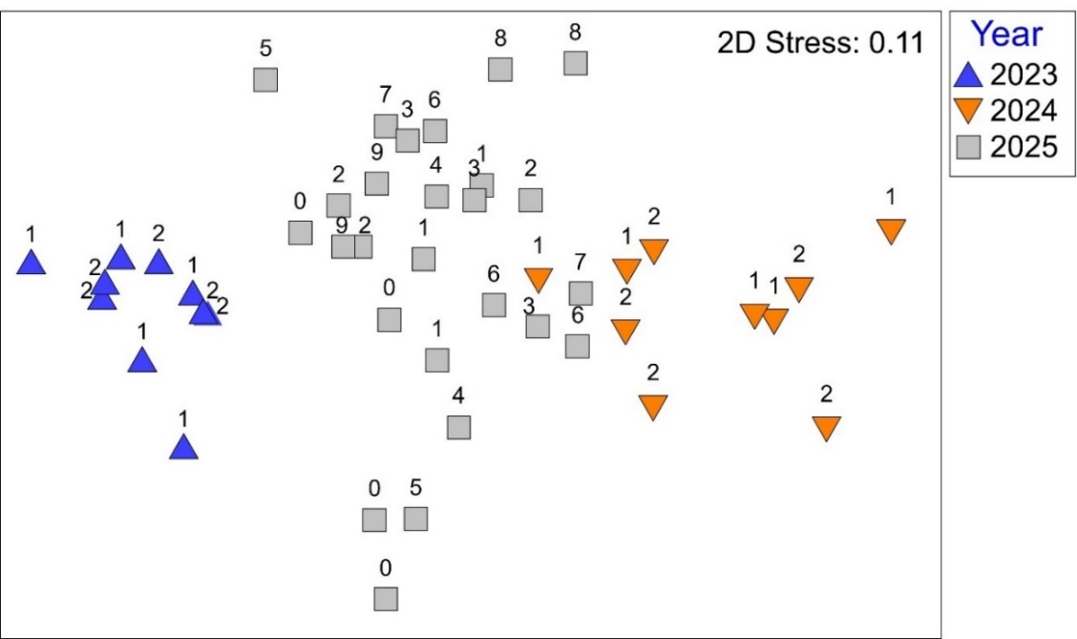
Figure 28. Mean catch-per-unit-effort (CPUE) ± standard error of fish species captured using electrofishing (individuals per 90 second shot) at sites between locks 1 and 3 in the Lower Murray River from 2015–2025. The proportion of the catch that is estimated to be young-of-year (YOY) is presented as hashed bars. Small-bodied species (i–m) were not enumerated from 2015–2022.* The proportion of YOY are not presented for bony herring in 2015 or goldfish from 2015–2019 because length data were not collected. CPUE data from 2017 and 2024 should be viewed with caution because sampling at three and five sites, respectively, was delayed to cooler months due to equipment malfunction.
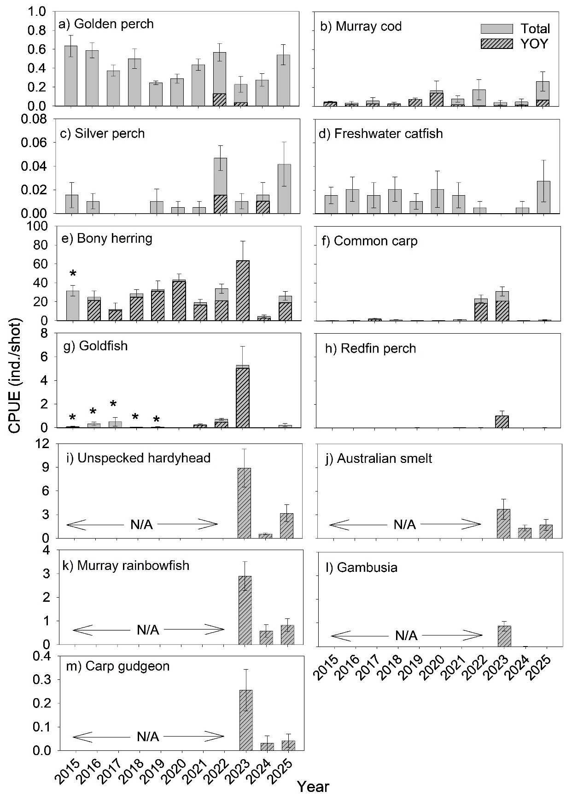

Population demographics of priority species
Changes in population demographics of priority species golden perch, silver perch and Murray cod are discussed in Sections 8.2 and 8.3. In 2025, the sampled freshwater catfish population ranged in age from 8+ to 16+ years (Figure 29).
Figure 29. Age structure of freshwater catfish collected from the Lower Murray River in 2025.
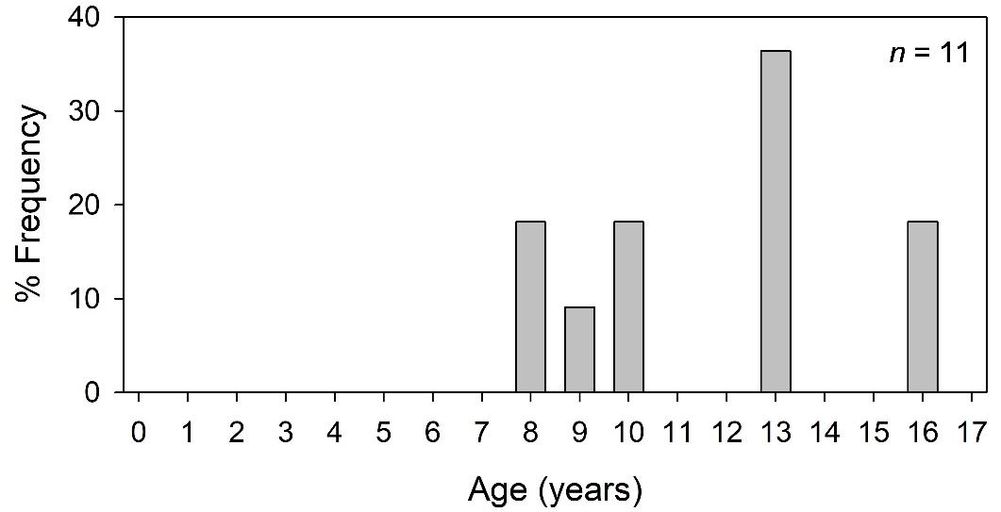

Discussion
In this section, we discuss (1) temporal variation in fish assemblage structure and (2) the size and age compositions of key species in the LMR. We also provide commentary on selected BEWS Expected Environmental Outcomes for Native Fish (All Native Fish: F1, F2 and F5) that are relevant to the Lower Murray and CLLMM Area condition monitoring dataset.
Our hypotheses are that: (1) prolonged low, in-channel flows (<20,000 ML/d) promote hydraulic (e.g. lentic) and structural (submerged plant) habitats conducive to low-flow generalist fishes (submerged vegetation cover was not assessed); (2) in-channel flows >20,000 ML/d facilitate a shift towards more natural riverine hydraulic characteristics that benefit flow-dependent species; and (3) increased variability in annual flow that includes large, overbank (>45,000 ML/d) flows lead to increased recruitment of a range of species with different life histories (e.g. generalists, flow-cued spawners, and other flow-dependent species), promoting diverse fish assemblages and resilience in populations.
F1: No loss of native fish species currently present within the Basin
A total of 69 native species are present in the MDB, of which 35 occur in the LMR (Wedderburn et al. 2017). In 2025, Native Fish condition monitoring in the LMR detected five large- and six small-bodied native species. During the ten years of LTIM and Flow-MER1.0, ten of these native species were detected, as well as dwarf flathead gudgeon (Philypnodon macrostomus), which was absent in 2025 (Ye et al. 2025). In addition, during 2025, spangled perch (Leiopotherapon unicolor) was sampled during targeted monitoring (Section 8.3) and diadromous species congolli (Pseudaphritis urvillii) and pouched lamprey (Geotria australis) were detected during Murray Barrage fishway monitoring (Section 8.4). To adequately assess F1, targeted monitoring is required to detect other native species such as wetland specialist (e.g. dwarf flathead gudgeon Philypnodon macrostomus), small-bodied threatened (e.g. Murray hardyhead Craterocephalus fluviatilis), diadromous and estuarine species.
F2: Improved population structure of key fish species through regular recruitment
Changes in the structure of golden perch, silver perch and Murray cod populations in the LMR are discussed in Sections 8.2 and 8.3. In the LMR, the spawning biomass of freshwater catfish is low compared to historical levels (Ye et al. 2015c) and their recruitment dynamics are poorly understood. Based on electrofishing size/age structure data from 2015–2025, negligible recruitment was observed for freshwater catfish in the LMR from 2015–2024 (Ye et al. 2025), noting that there may be some sampling inefficiencies with this method. In 2025, the sampled freshwater catfish were representative of an ageing adult population (ages 8+ to 16+ years), albeit based on a low sample size (n = 11). The maximum age recorded in this study (16+ years) exceeds that previously reported for this species in the literature (Ye et al. 2015c; Koehn et al. 2020). These population characteristics suggest potentially low resilience to future environmental perturbations. In the future, integrating catch data from other sampling methods (e.g. netting surveys) may provide improved insight into population demography, while flow-ecology relationships in the LMR remain an important knowledge gap in understanding of the species ecology.
F5: Improved community structure of key native fish species
In this study, whole-of-assemblage analyses using electrofishing data were restricted to 2023–2025 due to small-bodied species not being enumerated from electrofishing sampling prior to 2023. LTIM and Flow-MER1.0 investigated temporal variability (2015–2024) in small-bodied and large-bodied assemblages separately, using fyke nets and electrofishing, respectively (Ye et al. 2025). These studies demonstrated that the LMR fish assemblage has undergone changes in structure from 2015 to 2025, with the most pronounced being in response to overbank (2016-17 and 2022-23) and high in-channel (2021-22) flows. During these years (2022, 2023 and to a lesser extent 2017), the fish assemblage changed from one characterised by high relative abundance of low flow generalist fishes such as small-bodied carp gudgeon and unspecked hardyhead into one characterised by high relative abundance of invasive common carp and goldfish, following enhanced recruitment associated with floodplain inundation (increased spawning habitat). Nonetheless, in years following recruitment events (e.g. 2018 and 2024), the abundances of common carp and goldfish typically have declined to levels similar to those preceding recruitment events. This may suggest poor survival of juveniles and/or movement of juveniles to alternate habitats (e.g. off-channel).
We hypothesised that in-channel flows >20,000 ML/d that promote more natural riverine hydraulic characteristics will benefit flow-dependant native species such as golden perch and Murray cod. While these flows have led to improved population structure, in particular golden perch (Section 8.2), they have not led to significantly increased abundances of these key species, and thus not significantly improved overall native fish community structure.

Management implications
Increased variability in the annual flow regime, including high in-channel and overbank flows, is expected to enhance recruitment across a range of species with different life histories (e.g. generalists, flow-cued spawners, and other flow-dependent species), promoting diverse fish assemblages and resilience in populations. However, floodplain inundation during overbank flows is also associated with undesired recruitment of invasive species such as common carp and goldfish. Increased flows (>20,000 ML/d under current river operations) facilitate a shift towards more natural riverine hydraulic characteristics that benefit flow-dependant species such as golden perch and Murray cod. Multiple years and longer durations of these flows are required to substantially reinstate flowing river characteristics.
With existing volumes of environmental water and delivery constraints, reaching and sustaining flows >20,000 ML/d in the LMR during dry years may be difficult and is largely reliant on coordinating flow deliveries across much of the southern MDB, including flows from the Murray, Goulburn, Murrumbidgee and Darling rivers. Under wetter scenarios, flows >20,000 ML/d may be achieved by delivering environmental water in conjunction with unregulated flows.
  - Flow-cued Fish Spawning and Recruitment
Introduction
In the southern MDB, spawning and recruitment of golden perch corresponds with increases in water temperature and discharge, either in-channel or overbank (Mallen-Cooper and Stuart 2003; Zampatti and Leigh 2013a; 2013b). Silver perch display similar life history characteristics and population dynamics, although in the lotic reaches of the Murray River, silver perch may spawn circa-annually (Tonkin et al. 2019). In-channel increases in flow (spring flow pulses) were an annual feature of the hydrological regime of the unregulated Murray River (Mallen-Cooper and Zampatti 2018). In regions where these features remain intact (e.g. the mid-Murray River, above the Darling River junction), golden perch populations display more consistent recruitment (Zampatti et al. 2018b). In the LMR, downstream of the Darling junction, spring flow pulses are compromised by river regulation, but restoration of this facet of the hydrological regime is possible with environmental water delivery.
This indicator, together with the RMMP (SCBEWC 2021), will assess aspects of golden perch and silver perch spawning and recruitment in association with flow. To assess the influence of the flow regime (including environmental water and particularly CEW) on populations of flow-cued spawning fishes in the LMR, the spawning and recruitment of golden perch and silver perch will be investigated through sampling of eggs and larvae, age structure analysis and natal origin assessment. Whilst this indicator will focus on two flow-cued spawning species (golden perch and silver perch), low abundances of silver perch may preclude assessment.
Hypotheses
- Increased spring–summer flow (nominally >20,000 ML/d), either in-channel or overbank, promote the spawning and recruitment (to YOY) of golden perch and silver perch.
- Multiple years of enhanced spring–summer flow increase the resilience of golden perch and silver perch populations in the LMR.
Key Evaluation Questions for Basin and Area
Area-scale
Table 21. Key evaluation questions for assessing the Flow-cued Fish Spawning and Recruitment responses to environmental water (eWater), and specifically Commonwealth environmental water (CEW). Indicators and evaluation approaches used to answer the evaluation questions are provided.
Key Evaluation Questions | Parameter | Evaluation Approaches
Under the annual flow regime, what was the level of reproduction (spawning and recruitment) of golden perch and silver perch? What did eWater (and specifically CEW) contribute to this outcome? | Larval abundance  Age 1+ abundance in the following year | Semi-quantitative assessment in relation to counterfactual flow time series.
What was the resilience of golden perch and silver perch populations? What did the multi-year flow regime (including eWater, and specifically CEW) contribute to this outcome? | Proportion of juveniles, adults and number of year classes in a population | Semi-quantitative assessment in relation to counterfactual flow time series.
Methods
To evaluate golden perch and silver perch reproduction (spawning and recruitment), and its association with flow, including environmental water, we undertook three key components: 1) assessment of spawning by sampling of eggs and larvae, including the collection of larvae for otolith analyses (daily ageing and microchemistry); 2) sampling of the broader population to assess abundance (catch-per-unit-effort, CPUE) and collect individuals for otolith analyses (annual ageing); 3) (a) daily ageing of larvae to identify the time of spawning and (b) annual ageing of juveniles and adults to assess population age structure; and 4) otolith microchemistry analysis to assess natal origin and migration histories. Data collection was facilitated through the combined resources of the Flow-MER Lower Murray and CLLMM Area and RMMP.
Sampling of eggs and larvae
Sampling of fish eggs and larvae was conducted approximately fortnightly (6 trips) between 21 October 2024 and 9 January 2025. Sampling was undertaken at seven sites in the LMR, located 5–15 km downstream of locks 1, 4, 6, 7, 8, 9 and 10 (Figure 1). At each site, four daytime plankton tows were conducted using a pair of square-framed bongo nets with 500 µm mesh; each net was 0.5 x 0.5 m and 3 m long. The volume of water (m³) filtered through each net was determined using a calibrated flow meter (General Oceanics™, model 2030R) placed in the centre of the mouth openings. Samples were preserved (70–95% ethanol) in the field and returned to the laboratory for processing. Samples were sorted using a dissecting microscope. Larvae were identified, and where possible, classified as pre-flexion (i.e. early-stage larvae with notochord predominately straight) or post-flexion (i.e. the start of upward flexion of the notochord and appearance of fin rays and fin fold) following Serafini and Humphries (2004). When golden perch and/or silver perch eggs (not differentiated) were present, they were counted.
Population sampling
Sampling of the broader population of golden perch and silver perch, and collection of individuals for otolith analysis, was achieved through condition monitoring (Section 8.1) and targeted monitoring (Section 8.3). A sub-sample of the golden perch and silver perch populations, representative of the size structure, were retained, euthanised and sagittal otoliths removed.
Ageing
Golden perch and silver perch larvae and YOY were measured for total length (TL) to the nearest millimetre, and sagittal otoliths were extracted for age determination. To estimate spawning dates, daily increments in otolith microstructure were examined.
Due to their small size (≤5 mm TL), most golden perch larvae (89%) were not suitable for daily increment analysis. Methods for otolith preparation for daily ageing are described in Ye et al. (2025). Sections were examined using a compound microscope (x 200) fitted with a digital camera and Olympus Stream image analysis software (version 2.3). Estimates of age were determined by counting the number of increments from the primordium to the otolith edge (Zampatti and Leigh 2013b). Two readers examined each otolith on separate occasions and each reader performed two counts of the increments. Counts from each reader were compared and if they differed by more than 10%, the otolith was rejected; but if count variation was within 10%, the mean of all counts was accepted as the daily increment number and estimate of age. Spawn dates were determined by subtracting the estimated age from the capture date (Brown and Wooden 2007).
We used age-frequency distributions to assess the age structure and year-class strength of golden perch. Methods for annual otolith preparation and ageing followed that described in Section 8.1.
Microchemistry analyses
Water
To determine spatio-temporal variation in water ⁸⁷Sr/⁸⁶Sr over spring–summer 2024-25 to assign natal origins to individual fish, we analysed water samples collected fortnightly from five sites across the southern MDB (Table 22). At most sites, water samples were collected from early October 2024 to late January 2025. Water sample filtration and strontium isotope analysis procedures are described in full in Ye et al. (2016b).
Table 22. Location of water sample collection for ⁸⁷Sr/⁸⁶Sr analysis during 2024-25.
Location | River | Number of samples | Sampling date range
Lock 1 | Lower Murray | 8 | 21/10/2024–27/01/2025
Lock 6 | Lower Murray | 8 | 22/10/2024–28/01/2025
Lock 9 | Lower Murray | 8 | 21/10/2024–27/01/2025
Lock 11 | Mid-Murray | 7 | 22/10/2024–28/01/2025
Lock 26 | Upper Murray | 4 | 24/10/2024–14/01/2025

Otoliths
The second of the paired sagittal otoliths from each aged individual was used for otolith ⁸⁷Sr/⁸⁶Sr analysis. Otoliths were prepared for analysis following methods described in Ye et al. (2025). In situ microsampling analysis of ⁸⁷Sr/⁸⁶Sr in the otoliths of juvenile golden perch was achieved by laser ablation – multi-collector – inductively coupled plasma mass spectrometry (LA-MC-ICPMS). The laser ablation and mass spectrometry procedure is described in full in Zampatti et al. (2021). To investigate the natal origin and migration history of new recruits (larvae and YOY) and prominent younger cohorts of golden perch and silver perch, we analysed ⁸⁷Sr/⁸⁶Sr from the otolith core to edge in a sub-sample of fish from 2025 (Table 15.6.1, Appendix). We compared these transects to water ⁸⁷Sr/⁸⁶Sr measured at sites across the southern MDB from 2011–2024 (Ye et al. 2025) and 2024-25 (Table 22).
Data analyses
For relevant data analyses, we integrated data from Goyder Murray Flood Ecology (Ye et al. 2014), CEWH Short-Term Intervention Monitoring (STIM) (Ye et al. 2015a, 2015b, 2016a), LTIM (Ye et al. 2020a) and Flow-MER1.0 (Ye et al. 2025) to assess temporal variability and determine long-term baselines for comparison. To assess spawning of golden perch and silver perch in 2024-25, we compared annual mean (October–January) larval abundances (CPUE (individuals per net) ± standard error) to the long-term average from 2010-11 to 2023-24.
Temporal variability (2015–2025) in the relative abundance of golden perch and silver perch was investigated through the Flow-MER condition monitoring electrofishing dataset (Section 8.1), formerly Category 1 electrofishing (Ye et al. 2025). From 2015–2024, ten sites between locks 1 and 3 were sampled (Ye et al. 2025). In 2025, 26 sites between Wellington and Lock 10 were sampled to cover the expanded Area of monitoring and evaluation for Flow-MER (Section 8.1). Differences in the relative abundance (individuals per 90 seconds of electrofishing on-time effort) between years were analysed using univariate single-factor PERMANOVA (permutational ANOVA and MANOVA) in the software package PRIMER v. 6.1.12 and PERMANOVA+ (Anderson et al. 2008). These analyses were performed on untransformed, standardised relative abundance data.
YOY golden perch and silver perch are not considered reliable indicators of recruitment strength due to potential sampling inefficiencies associated with electrofishing at this life stage. Therefore, we determined the level of recruitment of golden perch and silver perch as the relative abundance of age 1+ individuals in the following year, calculated by multiplying the proportion of age 1+ individuals in the population age structure by the mean CPUE of golden perch from the condition monitoring electrofishing dataset. We compared annual recruitment strength to the long-term average from 2014-15 to 2022-23.

Results
Eggs and larvae
From 21 October 2024 to 9 January 2025, a total of 398 golden perch and/or silver perch eggs (not differentiated), 55 golden perch larvae and 73 silver perch larvae were collected at sites sampled downstream of locks 1, 4, 6, 7, 8, 9 and 10 in the LMR. Golden perch and/or silver perch eggs were sampled in high abundance during early November 2024, downstream of locks 1 (n = 240) and 9 (n = 145) (Figure 15.6.1, Appendix). Most golden perch (76%, n = 42) were sampled downstream of locks 9 and 10 in late October 2024, while most silver perch (64%, n = 47) were sampled downstream of locks 9 and 10 in mid-December 2024 (Figure 15.6.1, Appendix).
In 2024-25, abundance of golden perch larvae (CPUE ± standard error) was 0.31 ± 0.09 ind./net and below the long-term (2010-11 to 2023-24) mean of 1.11 (Figure 30a). In 2024-25, silver perch larval abundance was 0.44 ± 0.12 ind./net and above the long-term mean of 0.22 (Figure 30b).
Figure 30. Abundance of (a) golden perch larvae and (b) silver perch larvae, as determined by the mean catch-per-unit-effort (CPUE, individuals (ind.)/net) ± standard error of larvae collected in the Lower Murray River from 2010-11 to 2024-25. No sampling (n.s.) occurred in 2019-20. Data are presented for sites sampled downstream of locks 1 (2010-11 to 2024-25), 4 (2020-21 to 2024-25), 6 (2010-11 to 2024-25), 7, 8, 9 and 10 (2024-25). Mean abundance from 2010-11 to 2023-24 is indicated by the dashed line.
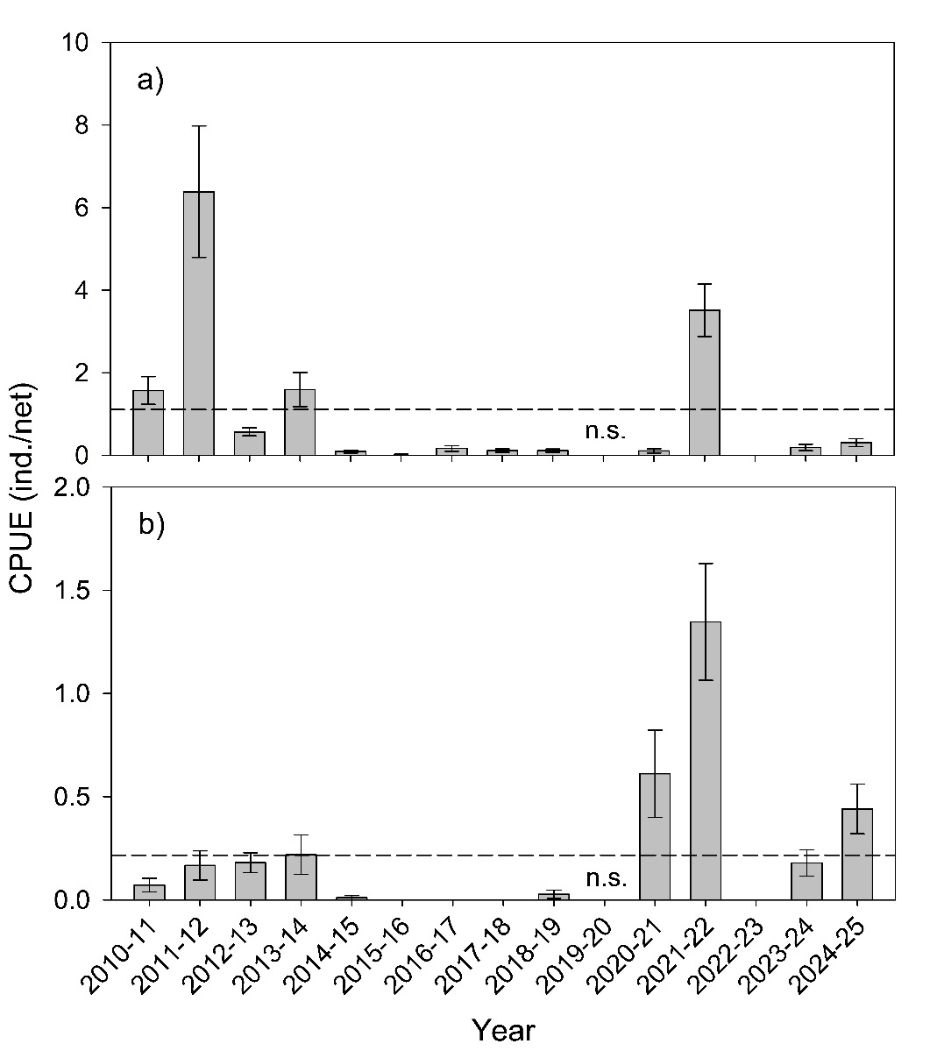
Spawn dates
Ages of golden perch larvae collected in the LMR from early November to late December 2024 ranged from 1–65 days old, corresponding to spawn dates between 15 October and 15 December 2024 (Figure 15.6.2, Appendix). Ages of silver perch larvae collected in the LMR from mid-November 2024 to early January 2025 ranged from 3–22 days old, corresponding to spawn dates between 13 November and 28 December 2024 (Figure 15.6.2, Appendix).
Natal origin of larvae and YOY
Otoliths from golden perch larvae (n = 2) and silver perch larvae (n = 40), as well as one YOY, collected between 7 November 2024 and 30 April 2025, were analysed for ⁸⁷Sr/⁸⁶Sr. All larvae were assigned estimated spawn dates and are presented in Figure 15.6.3 (Appendix).
Otoliths of larvae <7 mm (approximately 96% and 20% of golden perch and silver perch, respectively), many of which were captured downstream of locks 9 and 10 prior to December 2024 (Figure 15.6.1, Appendix), were too small for analysis. Nevertheless, larvae of this size would only be a few days old (<8 days) and are likely to be indicative of spawning in the general region (upstream) of where they were collected.
All golden perch larvae and most silver perch larvae (n = 39, 98%) exhibited otolith core ⁸⁷Sr/⁸⁶Sr (i.e. 0.7128–0.7175) indicative of the mid-Murray River, above the Darling River junction (Figure 15.6.3, Appendix). The remaining silver perch larva had otolith core ⁸⁷Sr/⁸⁶Sr (i.e. 0.7114) indicative of the LMR, downstream of the Darling River junction.
Recruitment strength
Recruitment strength, as determined by the relative abundance of age 1+ individuals in the following year, was temporally variable for both species from 2014-15 to 2023-24 (Figure 31). Nonetheless, for both species, recruitment of age 1+ derived from 2023-24 approximated or exceeded the long-term average. Recruitment strength could not yet be determined for 2024-25 because sampling in autumn 2026 has not been undertaken.
Figure 31. Recruitment strength of (a) golden perch and (b) silver perch in the Lower Murray River from 2014-15 to 2023-24, as determined by the estimated electrofishing catch-per-unit-effort (CPUE, individuals per 90 second shot) of age 1+ captured in the following sampling season (2016–2025). Mean recruitment strength from 2014-15 to 2022-23 is indicated by the dashed line. Recruitment strength for 2024-25 could not yet be determined because sampling in autumn 2026 has not been undertaken. Years 2014-15 to 2022-23 are represented by data from 10 sites between locks 1 and 3 (Ye et al. 2025), while 2023-24 is represented by data from 26 sites between Wellington and Lock 10. For 2015-16, 2017 CPUE data from five sites are presented because other sites were sampled after June.
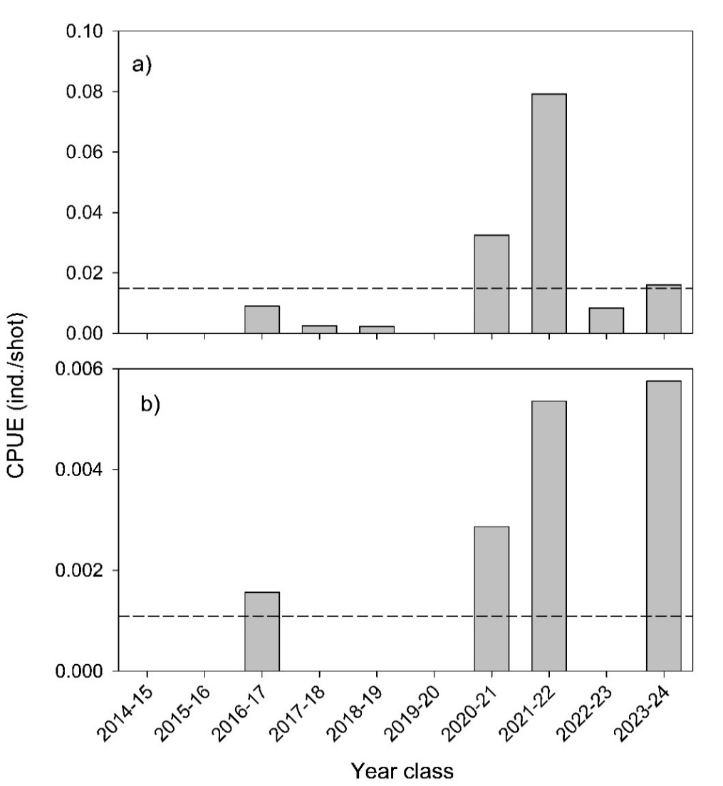
Juvenile/adult abundance
In 2025, relative abundance (mean CPUE ± S.E.) of golden perch was 0.58 ± 0.09 fish/shot (Figure 32a). Abundance was variable across years (PERMANOVA, Pseudo-F_{10,125} = 3.224, p = 0.0019). PERMANOVA pair-wise comparisons revealed significantly higher abundance in 2015 and 2016 compared to 2019, 2020, 2023 and 2024, and significantly lower abundance in 2023 compared to 2018 and 2022 (Table 15.6.2, Appendix).
In 2025, mean relative abundance of silver perch was 0.03 ± 0.01 fish/shot (Figure 32b). Silver perch abundance was relatively low (<0.02 ind./shot) from 2015–2024, except for 2022 and 2025. No statistical comparisons were undertaken due to low sample sizes and high variability in silver perch CPUE data.
Figure 32. Mean catch-per-unit-effort (CPUE, individuals per 90 seconds of electrofishing on-time effort) ± standard error of (a) golden perch and (b) silver perch captured in the Lower Murray River in autumn from 2015–2025. Years 2015–2024 are represented by data from 10 sites between locks 1 and 3 (Ye et al. 2025), while 2025 is represented by data from 26 sites between Wellington and Lock 10. Refer to Figure 28 (Section 8.1) for comparisons of locks 1 to 3 data only.
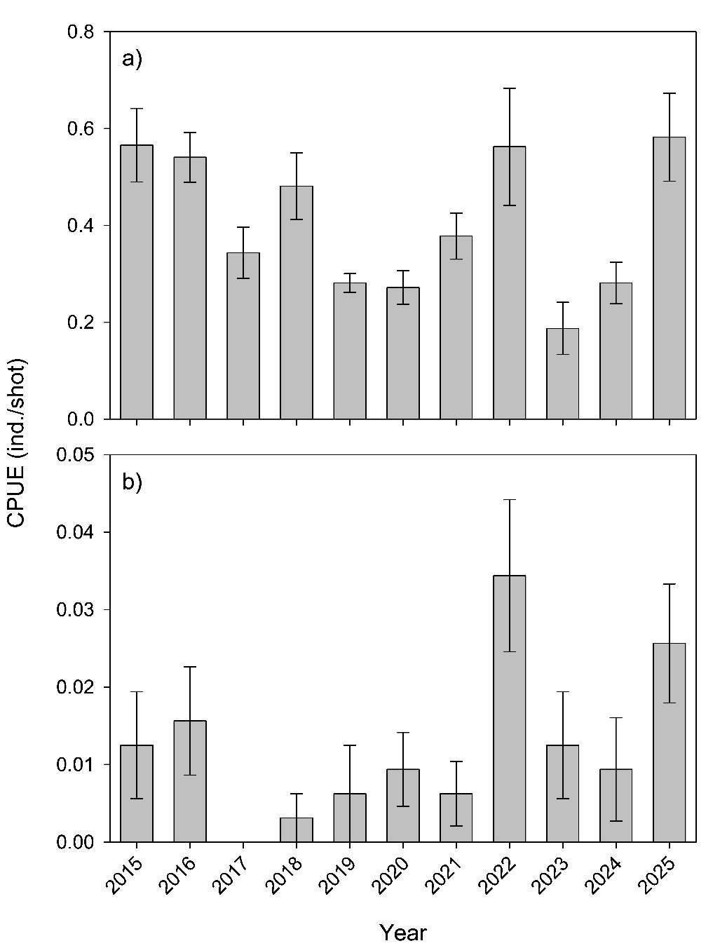
Age structure and natal origin of prominent cohorts
In 2025, the sampled golden perch population ranged in age from 1+ to 27+ years and was dominated by age 3+ from the 2021-22 cohort (50% of population) (Figure 33). In 2025, age 1+ to 19+ golden perch predominantly exhibited otolith core ⁸⁷Sr/⁸⁶Sr comparable to water ⁸⁷Sr/⁸⁶Sr from either the Darling River or LMR (Figure 33).
In 2025, the silver perch population ranged in age from 0+ to 8+ years and was composed of several cohorts including age 3+ from the 2021-22 cohort (33% of population) (Figure 34). In 2025, age 0+–8+ silver perch predominantly exhibited otolith core ⁸⁷Sr/⁸⁶Sr comparable to water ⁸⁷Sr/⁸⁶Sr from the LMR or the mid-Murray River (Figure 34).
Figure 33. Age frequency distribution of golden perch from the Lower Murray River from 2015–2025, showing the natal origins of dominant cohorts inferred from otolith core signatures of the sampled fish in comparison to water sample reference collection (Figure 15.6.3 in this report (Appendix) and Figure 56 in Ye et al. (2025)). Percentages of origin for each cohort are based on the sub-sampled population. Age cohorts with grey bars were not assessed for natal origin. From 2025, samples include the NSW (Lock 7 to Lock 10) reach of the Murray River in addition to the South Australian (SA) reach.
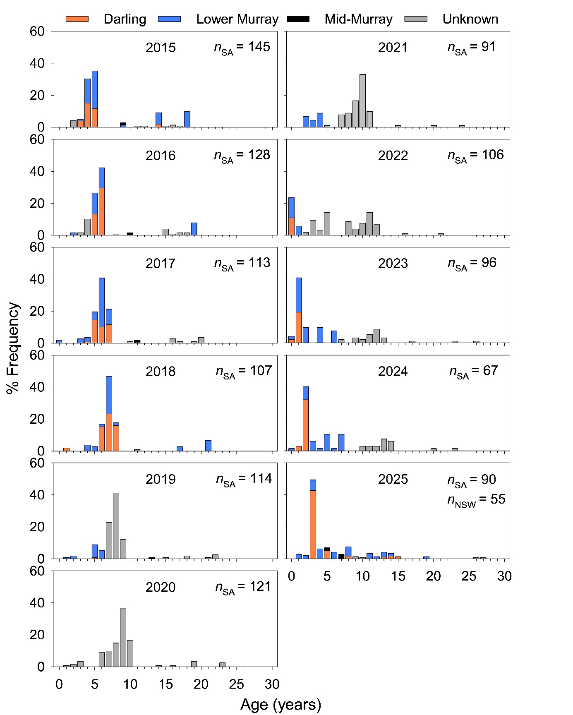

Figure 34. Age frequency distribution of silver perch from the Lower Murray River from 2015–2025, showing the natal origins of dominant cohorts inferred from otolith core signatures of the sampled fish in comparison to the water sample reference collection (Figure 15.6.3 in this report (Appendix) and Figure 56 in Ye et al. (2025)). Percentages of origin for each cohort are based on the sub-sampled population. Age cohorts with grey bars were not assessed for natal origin. From 2025, samples include the NSW (Lock 7 to Lock 10) reach of the Murray River in addition to the South Australian (SA) reach.
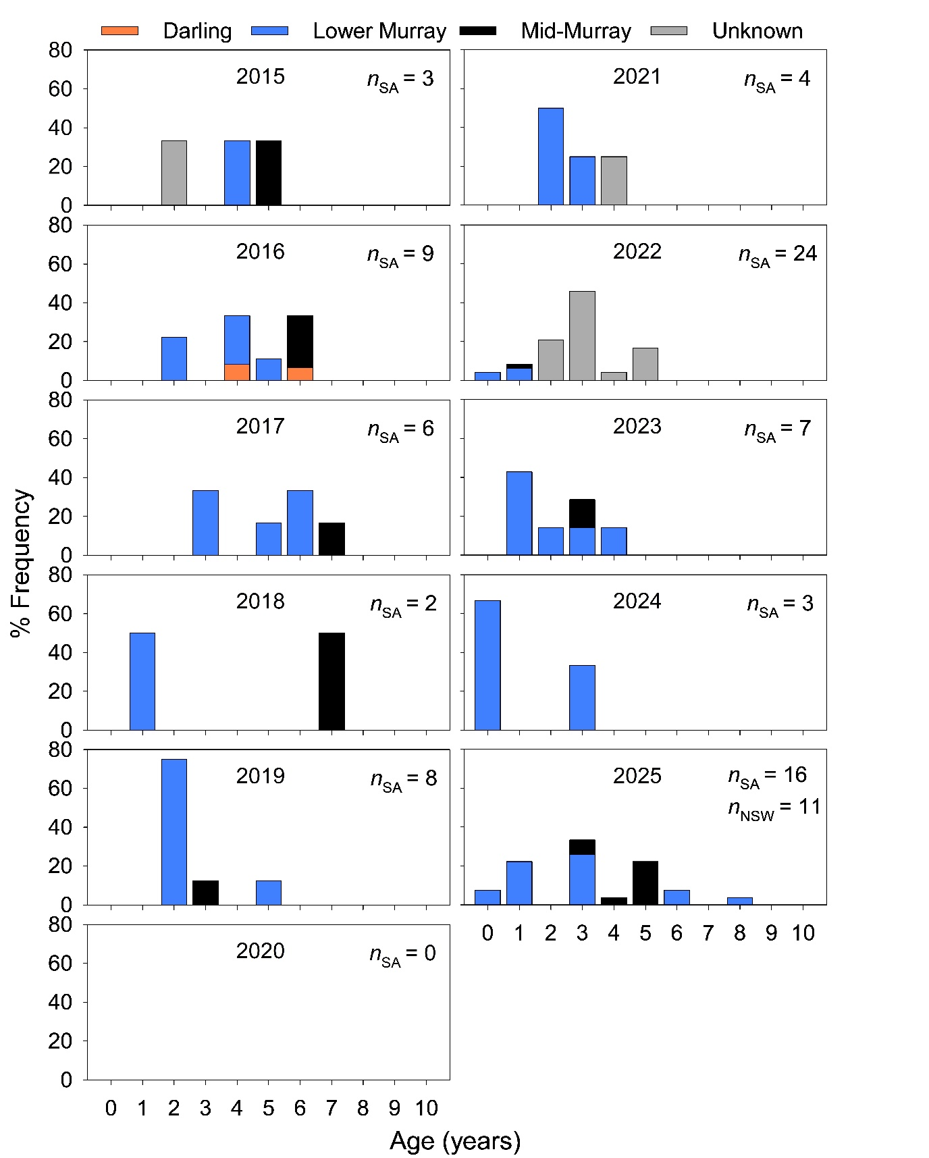

Evaluation
The outcomes for the annual and long-term (2014-15 to 2024-25) KEQs are summarised in Table 23. In the absence of counterfactual modelling to explicitly estimate response under a no environmental water/CEW scenario, environmental water/CEW contribution for the Flow-cued Fish Spawning and Recruitment indicator was assessed qualitatively. This approach is based on eco-hydrological conceptual understanding and expert opinion, and considers: (1) the contribution of environmental water/CEW to ecologically relevant flow metrics likely to influence biological responses; (2) comparison of the observed outcome against the estimated outcome under a no environmental water/CEW scenario; and (3) for long-term KEQs, evaluation outcomes for previous years included in the period of assessment. Thus, there are no defined quantitative thresholds for the different significance level categories. The reproduction KEQ for 2024-25 was assessed based on spawning outcomes alone. Recruitment strength, as determined by the abundance of age 1+, will be included in the 2024-25 reproduction assessment in next year’s annual report.
Table 23. Area-scale evaluation questions for Flow-cued Fish Spawning and Recruitment. Refer to ‘Key Evaluation Questions for Basin and Area’ in Table 21 for a description of the evaluation approach. CEW = Commonwealth environmental water. eWater = environmental water.
Annual
Key Evaluation Questions | Outcome for 2024-25 | eWater contribution | CEW contribution
Under the annual flow regime, what was the level of reproduction (spawning and recruitment) of golden perch? What did eWater (and specifically CEW) contribute to this outcome? | Spawning magnitude was below the long-term mean and considered low.  Otolith microchemistry and the occurrence of most young larvae (<8 days old) immediately downstream of locks 9 and 10 indicated a predominantly mid-Murray natal origin. The flow regime in the mid-Murray River supported spawning.  No YOY were detected through autumn electrofishing. | eWater contributed to 55% of total flow at Lock 11 during the spawning period (mid-October to mid-December) and supported low-level spawning in the mid-Murray River and downstream transport of larvae to the LMR. | CEW contributed to 48% of the total flow in the mid-Murray (Lock 11) during the spawning period (mid-October to mid-December) and supported low-level spawning and downstream transport of larvae to the LMR.
Under the annual flow regime, what was the level of reproduction (spawning and recruitment) of silver perch? What did the annual flow regime (including eWater, and specifically CEW) contribute to this outcome? | Spawning magnitude was above the long-term mean and considered moderate.  Otolith microchemistry indicated a predominantly mid-Murray natal origin of larvae. The flow regime in the mid-Murray River supported spawning.  YOY (7% of population) were detected through autumn electrofishing. | eWater contributed to 68% of the total flow at Lock 11 during the spawning period (mid-November to late December) and supported moderate-level spawning in the mid-Murray River and downstream transport of larvae to the LMR | CEW contributed to 60% of the total flow in the mid-Murray (Lock 11) during the spawning period (mid-November to late December) and supported moderate-level spawning and downstream transport of larvae to the LMR.
Long-term
Key Evaluation Questions | Outcome | eWater contribution | CEW contribution
What was the resilience of golden perch populations? What did the multi-year flow regime (including eWater, and specifically CEW) contribute to this outcome? | The 2025 population included juveniles and adults and was composed of continuous cohorts from age 1+ to 15+, indicating regular recruitment.  Total abundance in 2025 was high relative to previous years.  Age 1+ to 10+ cohorts (83% of the population), particularly those from low flow years (e.g. 2017–2021), can be associated with recruitment coincident with spring-summer flows that included eWater. | As per the evaluation of CEW | Age 1+ to 10+ cohorts (83% of the population), particularly those from low flow years (e.g. 2017–2021), can be associated with recruitment coincident with spring-summer flows supported by CEW. Cohorts recruited in years characterised by spring-summer pulses supported by CEW contributed to promoting a diverse age structure and population resilience.
What was the resilience of silver perch populations? What did the multi-year flow regime (including eWater, and specifically CEW) contribute to this outcome? | The 2025 population includes juveniles and adults and is composed of several cohorts from age 0+ to 8+, indicating regular recruitment.  Total abundance in 2025 was high relative to previous years.  Age 0+ to 8+ cohorts (100% of the population), particularly those from low flow years (e.g. 2017–2021), can be associated with recruitment coincident with spring-summer flows that included eWater. | As per the evaluation of CEW | Age 0+ to 8+ cohorts (100% of the population), particularly those from low flow years (e.g. 2017–2021), can be associated with recruitment coincident with spring-summer flows supported by CEW. Due to low abundance and otolith sample size in most years, there is low confidence in assessing the contribution of CEW to population resilience.
Contribution (to what extent CEW contributed towards the outcome, with the significance of the outcome considered):
 | Unknown |  | None/negligible |  | Minor |  | Moderate |  | Substantial
Discussion
During Flow-MER, we aim to assess the reproduction (spawning and recruitment) and population resilience of golden perch and silver perch in the LMR in relation to the flow regime, and to determine the contribution of environmental water and specifically CEW to those outcomes.
We hypothesise that: (1) increased flow (nominally >20,000 ML/d) in spring–summer promotes spawning and recruitment to YOY, and (2) multiple years of enhanced spring–summer flows increase the resilience of populations by promoting a diverse age structure. For 2024-25, a semi-qualitative evaluation approach was applied. In future years, this will be replaced by a quantitative counterfactual modelling framework. Due to the expanded Lower Murray and CLLMM Area in Flow-MER, the Native Fish theme evaluation now includes the use of data from the South Australian border to Lock 10. Therefore, caution needs to be taken when making comparisons to historical data.
Under the annual flow regime, what was the level of reproduction (spawning and recruitment) of golden perch and silver perch? What did environmental water (and specifically CEW) contribute to this outcome?
Golden perch
The magnitude (level) of spawning was determined by comparing the abundance of larvae to long-term averages since 2010-11 (CEWH monitoring and allied projects). In 2024-25, the flow regime, particularly in the mid-Murray River, supported low-level spawning of golden perch and downstream drift to the LMR. Spawning in the mid-Murray occurred between mid-October to mid-December 2024, in association with in-channel flow (14,000–17,600 ML/d) and water temperatures >19.5°C in the mid-Murray (Lock 11). During this period, all environmental water and CEW contributed to 55% and 48% of total flow, respectively. Nonetheless, CEW was considered to have a minor contribution to the outcome, given the outcome was at a low level. Undifferentiated (golden perch and/or silver perch) eggs were sampled downstream of Lock 1 during early November 2024, indicating local spawning also occurred in the LMR. Spawning coincided with an in-channel flow peak of 15,700 ML/d (at Lock 1 on 2 November 2024) and water temperature ~21°C. While species were not identified, the timing aligned with that of golden perch spawning (rather than silver perch) in the mid-Murray River, providing support for eggs belonging to this species (Figure 15.6.2, Appendix). In future years, a molecular approach will be used to determine the identity of eggs.
The evaluation for recruitment is delayed to the following reporting year because abundance of age 1+ individuals is being used as the evaluation metric. During autumn 2025 electrofishing, no YOY golden perch were detected. In previous water years with in-channel spring–summer flow <20,000 ML/d (e.g. 2017-18, 2018-19, 2020-21 and 2023-24), low-level recruitment has been detected in subsequent monitoring years, as determined by the presence of these cohorts as age 1+ and older.
Silver perch
In 2024-25, the flow regime, particularly in the mid-Murray River, supported moderate-level spawning of silver perch. Spawning in the mid-Murray occurred in mid-November to late December 2024, in association with in-channel flow (8,000–17,000 ML/d) and water temperatures >22°C in the mid-Murray (Lock 11). During this period, all environmental water and CEW contributed to 68% and 60% of total flow at Lock 11, respectively. Taking the magnitude of spawning into account, CEW was considered to have a moderate contribution to the outcome. Most silver perch (and golden perch) larvae were sampled upstream of the South Australian border, closer to the more lotic reaches of the mid-Murray River, where silver perch are understood to spawn on a near-annual basis (Tonkin et al. 2019). The reach of the LMR, upstream of the South Australian border, was not previously sampled during LTIM/Flow-MER1.0. The evaluation outcome for 2024-25 would have been negligible if considering the equivalent data from the South Australian reach only.
Two YOY silver perch were detected during autumn monitoring in the South Australian border to Lock 10 monitoring reach of the LMR, indicating recruitment. One of these individuals was assessed for natal origin and reflected a LMR origin.
What was the resilience of golden perch and silver perch populations? What did the multi-year flow regime (including environmental water, and specifically CEW) contribute to this outcome?
Golden perch
Recruitment and the establishment of distinct cohorts of golden perch in the LMR is influenced by local spawning and the downstream transport and migration of larvae/YOY and juveniles (predominantly age 1+) from spatially distinct spawning areas (Zampatti et al. 2019). The contemporary (2025) golden perch age structure reflected annual recruitment over the last decade and a half, although the strength of recruitment was variable across years. Over this period, hydrological conditions in the LMR were variable, ranging from in-channel flow years (<45,000 ML/d), where environmental water assisted in promoting and maintaining elevated spring-summer flow, to overbank (>45,000 ML/d) flow years that were dominated by unregulated flow (e.g. 2016-17 and 2022-23) (Ye et al. 2025). Furthermore, the population was predominantly composed of fish with LMR (downstream of the Darling) and Darling River origins.
The 2025 population was dominated by the 2021-22 cohort (50% of population) originated from both the Darling River and LMR. During spring–summer of 2021-22, the LMR experienced sustained high in-channel flows, with a peak of 37,500 ML/d at the South Australian border (QSA) and, from mid-December to early April, there was increased Darling River discharge (>6,000 ML/d at Burtundy) and flow contribution to the LMR (>30% QSA) (Ye et al. 2023). As seen with other cohorts (e.g. 2009-10, 2010-11 and 2011-12) that have previously been dominant in the LMR population, spawning and recruitment in the Darling River, and physical and hydrological connectivity between the Darling and Murray rivers, are substantial drivers of golden perch population dynamics of the LMR. Whilst some downstream transport of eggs, larvae and early-stage juveniles from the Darling River to the LMR may occur during low-intermediate flows, it appears that high in-channel and overbank flows in both the Darling and Murray rivers are associated with significant downstream dispersal of juvenile golden perch from recruitment sources in the Darling River (Zampatti and Leigh 2013; Zampatti et al. 2021).
From 2015 to 2025, abundance of golden perch in the LMR was variable and trends of increased abundance generally reflected those for abundance of age 1+ and thus a one-year lag in recruitment. Declines in abundance from 2015 to 2020 and 2022 to 2024 may reflect upstream emigration of adults (e.g. 2009–2014 cohorts; Zampatti et al. 2018a, 2018b; Bice et al. 2021), low-level recruitment from 2014–2021 and/or fishing mortality. Increased abundance of golden perch (and silver perch) in 2025 should be viewed with caution due to changes in sampling design, including electrofishing effort and the longitudinal extent of the monitoring area.
Considering the evidence presented above, including the persistence of cohorts in the population originating from low–moderate flow years with spring–summer CEW delivery and evidence of localised spawning in the LMR, CEW was considered to have a minor influence on the resilience of golden perch populations. Evaluation of population resilience will be quantitatively assessed using a counterfactual approach in future years.
Silver perch
From 2015–2025, silver perch was sampled in low abundance, which limits confidence in interpretations and informing management for this species. As such, the contribution of CEW to the resilience of silver perch populations was not assessed. Based on age structures, it appears recruitment of silver perch in the LMR is annual and the strength of recruitment is more consistent across years than golden perch. Recruitment and the establishment of distinct cohorts of silver perch in the LMR is influenced by local spawning and the downstream transport and migration of larvae, predominantly from the mid-Murray River. Thus, spawning in the mid-Murray River, and longitudinal connectivity between the mid-Murray River and LMR, are substantial drivers of silver perch population dynamics of the LMR. In 2024-25, sampling for larvae and age structure included the NSW reach of the Murray River from the South Australian border to Lock 10. Assessments for this year are therefore likely to reflect higher proportions of fish with Mid-Murray River natal origins, compared to other years of assessment from 2014–2024.
Management implications
Evidence from the current investigation and allied studies suggests that, in the highly regulated LMR, flow pulses of 15,000–20,000 ML/d during the golden perch spawning season (typically with peak spawning between November and January in the LMR), when water temperatures exceed 20°C, are likely to trigger low-levels of localised spawning and recruitment. Substantial recruitment events that result in prominent age classes, however, are associated with flow pulses exceeding 20,000 ML/d. Annual spring–summer in-channel flow pulses of this magnitude were a key feature of the hydrograph of the LMR prior to regulation (Mallen-Cooper and Zampatti 2018), and would have occurred in recent years under natural, unregulated conditions. Additionally, periods of high Darling River flows that coincide with high in-channel or overbank flows in the LMR are associated with significant downstream dispersal of juvenile (age 0+ and 1+) golden perch originating from recruitment sources in the Darling River.
Nuanced understanding of the spawning, downstream dispersal and recruitment of silver perch in the LMR lags that for golden perch. Nevertheless, the collection of silver perch larvae and evidence of recruitment (from detection of YOY or age 1+ in the following year) from 2020–2022 and 2023–2025 suggests that the spring–summer hydrographs during these years in the Murray River between Lock 1 and Lock 15 were conducive to silver perch spawning and the downstream drift of early-stage juveniles to the LMR.
  - Murray Cod Recruitment
Introduction
Murray cod has great recreational and cultural significance in the MDB. Nonetheless, populations have declined because of human impacts including alteration of flow regimes, barriers to movement, overharvesting and habitat (hydraulic and physical) degradation (Lintermans and Phillips 2005). In LMR, fragmentation by sequential weirs, alteration to hydraulics and loss of lotic habitats are considered primary threats to Murray cod populations (Zampatti et al. 2014; Mallen-Cooper and Zampatti 2018). Indeed, under low flows, lotic environments that provide favourable juvenile and adult habitat, and support key life history processes (spawning and recruitment), can only be found in select anabranch systems (e.g. Chowilla) and lock and weir tailwaters. During elevated flows (e.g. >20,000 ML/d), however, lotic conditions are returned to considerable reaches of the LMR.
Murray cod spawn annually over a well-defined period from October–December, irrespective of flow (Davis 1977; Rowland 1998), but recruitment in the LMR main channel is positively associated with flow (Ye and Zampatti 2007; Zampatti et al. 2014). Indeed, from 2003–2010 during the Millennium Drought, Murray cod recruitment was limited in the predominantly lentic main channel habitats. Subsequently, recruitment was observed in high flow years from 2010–2013 (Zampatti et al. 2014). In more recent years (2015–2024), regular recruitment of Murray cod has been observed in the LMR, including following in-channel flow pulses (15,000–18,000 ML/d) and high overbank flows (>90,000 ML/d), but also during three years of low, stable, in-channel flows (e.g. 9,000–12,000 ML/d) (Ye et al. 2020a, 2025). Furthermore, these cohorts have generally persisted in the population, particularly the 2019-20 cohort (Ye et al. 2025).
The mechanisms that facilitate recruitment of Murray cod to YOY stage in the LMR are likely related to enhanced survival of early life stages driven by riverine hydraulics and productivity. Survival is likely mediated by enhanced growth rates and condition, ultimately influencing recruitment success and population abundance. This indicator, together with the RMMP (SCBEWC 2021), will explore these mechanisms by assessing aspects of Murray cod recruitment in association with flow. Understanding the magnitude of recruitment, and causal links between recruitment and flow, are critical for informing future environmental flow management and will help evaluate ecological outcomes of CEW.
Hypotheses
- Elevated spring–summer flow, either in-channel or overbank, and associated increase in lotic habitat, will enhance body condition of Murray cod.
- Elevated spring–summer flow, either in-channel or overbank, and associated increase in lotic habitat, will enhance recruitment (to YOY) of Murray cod.
- Multiple years of enhanced spring–summer flow will result in broad size/age distributions of Murray cod and increased population resilience in the LMR.

Key Evaluation Questions for Basin and Area
Area-scale
Table 24. Key evaluation questions for assessing the Murray Cod Recruitment responses to Commonwealth environmental water (CEW). Indicators and evaluation approaches used to answer the evaluation questions are provided. eWater = environmental water.
Key Evaluation Questions | Parameter | Evaluation Approaches
Under the annual flow regime, what was the body condition of Murray cod? What did eWater (and specifically CEW) contribute to this outcome? | Body condition (Fulton’s condition factor, K). | Quantitative modelling using counterfactual flow time series.
Under the annual flow regime, what was the level of recruitment of Murray cod? What did eWater (and specifically CEW) contribute to this outcome? | YOY abundance. | Quantitative modelling using counterfactual flow time series.
What was the resilience of Murray cod populations? What did the multi-year flow regime (including eWater, and specifically CEW) contribute to this outcome? | Proportion of juveniles, adults and number of year classes in a population. | Semi-quantitative assessment in relation to counterfactual flow time series.

Methods
To evaluate the body condition, recruitment and population resilience of Murray cod, and their association with flow, including environmental water, we used: 1) electrofishing to quantify the abundance of YOY to assess recruitment and to establish a length frequency distribution of the Murray cod population in the LMR to determine population structure; and 2) length–weight relationships and associated metrics to assess body condition.
Population sampling
In May 2025, targeted sampling of the Murray cod population was undertaken at ten sites in the Murray River in the tailwater (downstream vicinity, ~10 km) of locks 1, 2, 3, 4, 5, 6, 7, 8, 9 and 10 (Figure 1). At each site, approximately five 400 s (power on time) electrofishing shots were undertaken using a 7.5 kW Smith Root (Model GPP 7.5) boat electrofishing unit. Electrofishing was conducted during daylight hours and sampled habitat preferred by the species (e.g. snags in flowing water). All individuals were measured for total length (TL) (nearest mm) and weight (nearest g), and a sub-sample of juvenile (~100–250 mm TL) fish were retained for YOY age confirmation. Methods for otolith preparation for annual ageing followed that described in Section 8.1.
Data analyses
For relevant data analyses, we integrated data from the CEWH Short-Term Intervention Monitoring (Ye et al. 2015a, 2015b, 2016a), LTIM (Ye et al. 2020a) and Flow-MER1.0 (Ye et al. 2025) to assess temporal variability and determine long-term baselines for comparison.
To investigate recruitment of Murray cod, we calculated CPUE (individuals per minute of electrofishing on-time effort) of YOY individuals using length structure data. Recruitment length thresholds, representing the minimum size of age 1+, were assigned to Murray cod (155 mm TL for all years except 2023 [170 mm TL]) based on length-age data (see Methods in Section 8.1). To compare recruitment of Murray cod across years (2013–2024), temporal variability in the CPUE of YOY was assessed for two long-term sites located downstream of locks 4 and 5. Data from 2013 (Lock 5) and 2018 (locks 4 and 5) were omitted from analyses because of low replication. Differences in relative abundance of YOY among years at each site were analysed using univariate single-factor PERMANOVA in the software package PRIMER v. 6.1.12 (Clarke and Gorley 2015) and PERMANOVA+ (Anderson et al. 2008). These analyses were performed on untransformed, standardised relative abundance data.
Evaluation metrics
Fulton’s condition factor (K) was used to assess the relative body condition of Murray cod captured during condition monitoring and targeted sampling. This index provides a size-standardised metric of individual body condition.
$$K =100,000 x \frac{Weight (g)}{{TL (mm)}^{3}}$$
Recruitment was represented by the number of YOY Murray cod, defined as individuals <155 mm TL or <170 mm during 2022-23 (Hladyz et al. 2025), captured during condition monitoring and targeted sampling.
Statistical analyses
Evaluating contribution of environmental water (both CEW and total environmental water) to Murray cod body condition and recruitment followed a counterfactual modelling approach adapted from the Flow-MER Basin-scale evaluation (Fanson 2024). All statistical analyses in this section were performed using the rstanarm package in R (v4.5, 2025).
Bayesian mixed models were first fitted to characterise the relationships between Murray cod body condition and recruitment (number of YOY) and ecologically relevant flow variables (Tables 15.6.4 and 15.6.5, Appendix). The flow variables, considered to influence body condition and recruitment of Murray cod, were calculated to address distinct time periods corresponding to key life-history stages and processes in the LMR:
- Spawning period (including pre-spawning habitat selection to the last hypothetical spawn date): preceding 1 September to 30 November
- Early life period: nominated cohort birthday (preceding 1 October) to 31 December
- YOY growth and survival period: nominated cohort birthday (preceding 1 October) to date of capture
- Adult pre-spawning condition period: 15-month period, prior to spawning season (July [prior water year] to nominated cohort birthday of 1 October [current water year])
- General growth period: preceding 9–10 months [preceding 1 July] to date of capture
Flow metrics were calculated for three scenarios: 1) With all environmental water/Observed, with all environmental water representing observed conditions; 2) Without CEW, without CEW (‘counterfactual’); and 3) Without environmental water, without any environmental water (‘counterfactual’) (see Hydrological Regime, Section 5.1).
These models describe the expected response of each species under observed flow conditions (With all environmental water). The fitted models were then used to generate posterior predictive distributions under two counterfactual scenarios: (a) Without CEW; and (b) Without environmental water. All other covariates were held constant between scenarios, ensuring that differences reflected only changes in environmental water.
Posterior predictions of expected body condition and recruitment were generated for each scenario using posterior_epred() with the same posterior draws used across observed and counterfactual scenarios to allow direct draw-by-draw comparison. Posterior distributions of annual effects were summarised using medians and 95% credible intervals, allowing uncertainty in parameter estimates and predicted responses.
Results
Body condition
In 2025, the body condition (mean Fulton’s condition factor ± standard error) of Murray cod was 1.38 ± 0.01, above the long-term average of 1.31. Counterfactual modelling indicated that, in 2024-25, CEW had negligible influence on the median predicted body condition of Murray cod in 2025. In contrast, in the absence of all environmental water, model outputs suggested that predicted body condition would have been slightly lower. Specifically, under the Without CEW scenario, the median predicted change in body condition was -0.022 (95% credible interval: -0.031 to -0.014), and under the Without environmental water scenario, the median predicted change was -0.065 (95% credible interval: -0.05 to -0.08), representing a 2% and 5% increase in body condition with CEW and all environmental water, respectively (Figure 35b).
Figure 35. a) Mean (± standard error) annual and long-term (2015–2025, dashed line) body condition, as indicated by Fulton’s condition factor, for Murray cod in the Lower Murray River from 2015–2025 and b) median predicted body condition (± 95% Credible Intervals) for 2025 under observed and counterfactual flow scenarios. CEW = Commonwealth environmental water, eWater = environmental water.
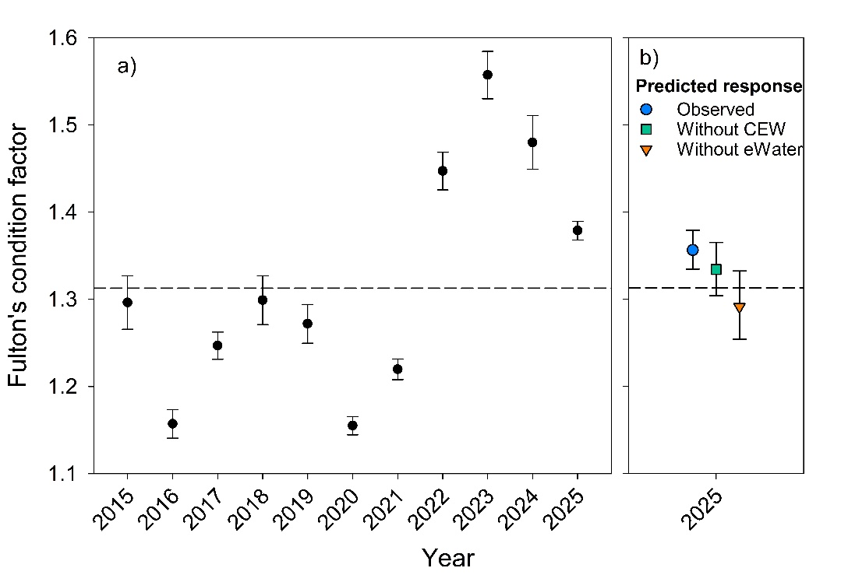
Recruitment
In 2025, mean total and YOY relative abundance (mean CPUE ± S.E.) of Murray cod across the ten tailwater sites was 0.39 ± 0.11 fish/min and 0.06 ± 0.02 fish/min, respectively (Figure 15.6.4, Appendix). No YOY were sampled at the long-term monitoring sites downstream of locks 4 and 5, and so YOY CPUE (recruitment) was below the long-term means of 0.06 and 0.01 fish/min below locks 4 and 5, respectively (Figure 36). Abundance of YOY was variable across years downstream of Lock 4 (PERMANOVA, Pseudo-F_{11,49} = 5.520, p = 0.0004) but not Lock 5 (PERMANOVA, Pseudo-F_{10,47} = 0.5293, p = 0.9268) (Figure 36). PERMANOVA pair-wise comparisons revealed, for downstream of Lock 4, significantly higher recruitment (YOY abundance) in 2020 compared to 2021, 2022, 2024 and 2025, but no difference for any other comparisons between years (Table 15.6.3, Appendix).
Counterfactual modelling indicated that, in 2024-25, all environmental water (including CEW) had a positive influence on the median predicted recruitment of Murray cod in 2025. Under the Without CEW scenario, the median predicted change in YOY abundance was -0.41 (95% credible interval: -0.44 to -0.36), and under the Without environmental water scenario, the median predicted change was -0.40 (95% credible interval: -0.42 to -0.12), representing an 18% decrease in recruitment under both scenarios (Figure 37). However, there was high uncertainty in modelled outputs as reflected by the large ±95% credible intervals, and as such, there were no significant differences between observed and counterfactual scenarios for recruitment.
Figure 36. Mean targeted electrofishing catch-per-unit-effort (CPUE) ± S.E. of Murray cod in the weir pools downstream of (a) Lock 4 and (b) Lock 5 of the Lower Murray River. Dashed bars represent the proportion of YOY to the total CPUE and the dashed line represents the mean YOY CPUE from 2015 to 2024. See Table 15.6.3 in Appendix for statistics.
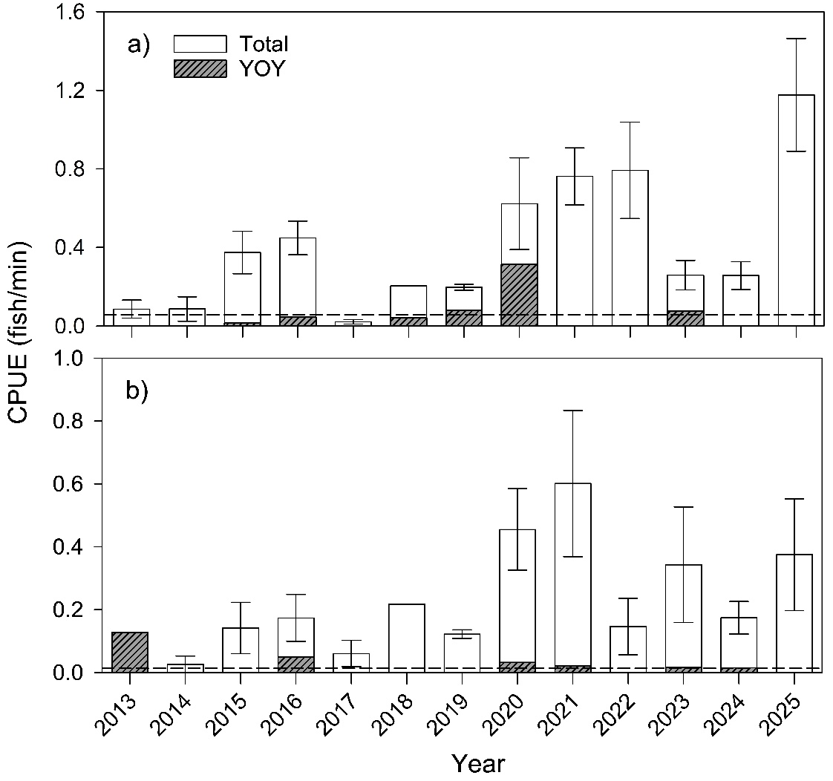

Figure 37. Predicted median recruitment (young-of-year (YOY) per shot) for 2025 under observed and counterfactual flow scenarios. CEW = Commonwealth environmental water, eWater = environmental water. Error bars represent 95% Credible Intervals.
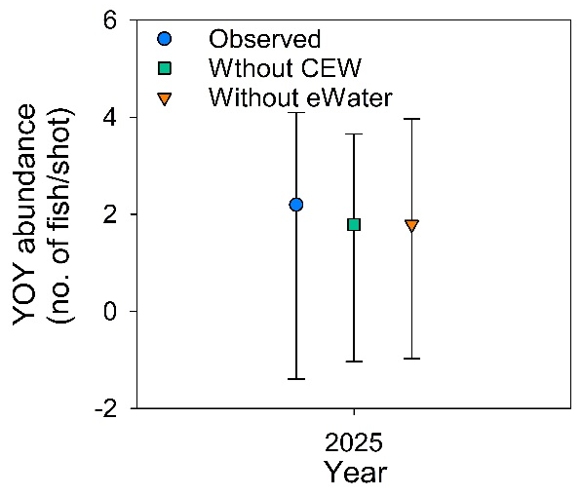
Population structure
In 2025, the sampled Murray cod population exhibited broad length frequency distributions, comprised of juveniles (including YOY), sub-adults and adults (Figure 38). During this year, YOY fish represented 19% of the sampled population, and individuals 155–399 mm TL (presumably age 1+ and 2+) made up 39% of the population.

Figure 38. Total length frequencies of Murray cod in the main channel of the Lower Murray River during autumn/winter from 2013–2025, based on CEWH STIM, LTIM and Flow-MER data. From 2025, samples include the New South Wales (NSW) (Lock 7 to Lock 10) reach of the Murray River in addition to the South Australian (SA) reach. Approximate young-of-year (YOY, <155 mm), juveniles/sub-adults (1–4 years, 155–659 mm) and adult (≥5 years, >659 mm) life stages are indicated, based on length-age estimates and known length at maturity.
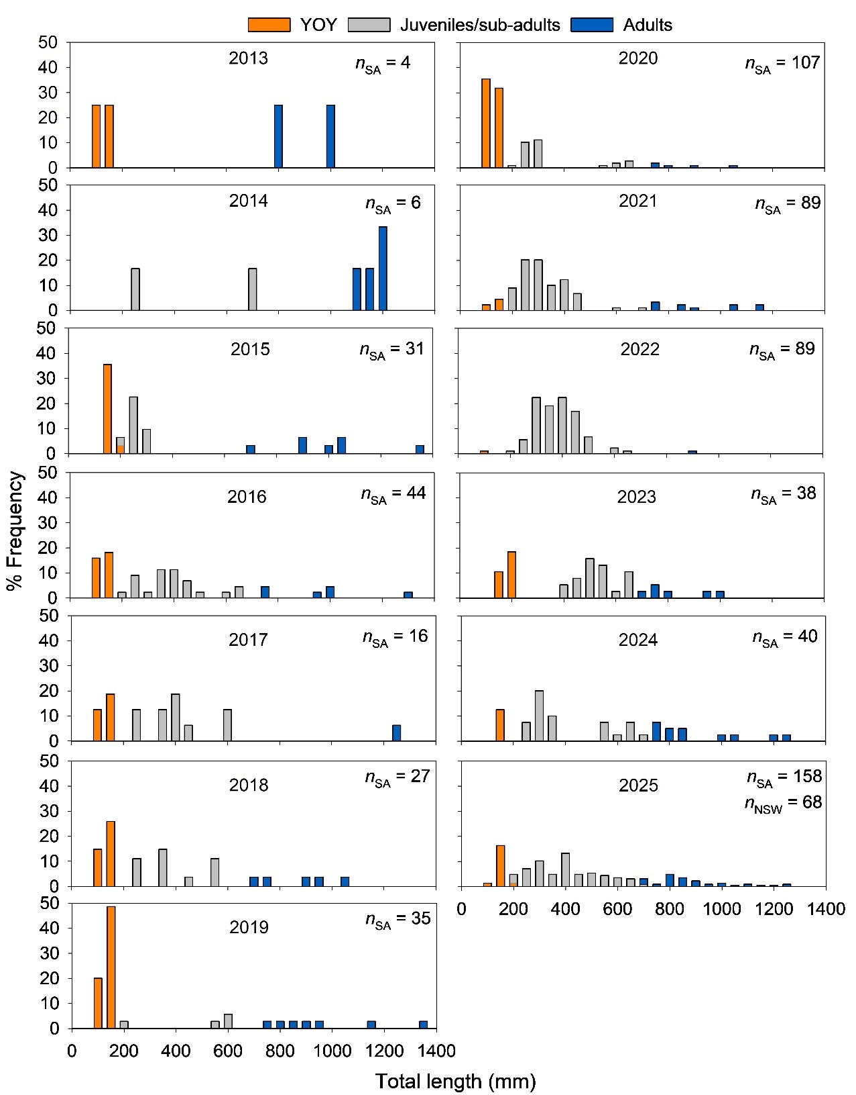

Evaluation
The outcomes for the annual and long-term (2014-15 to 2024-25) KEQs are summarised in Table 25. Environmental water/CEW contribution to body condition was based on the modelled percentage increase due to environmental water/CEW, with an increase of greater than 18% deemed substantial, 9–18% moderate, 4–8% minor and less than 4% a negligible contribution. Percentage thresholds were re-scaled against the maximum theoretical increase in body condition of +36% (i.e. difference between the lower (25%) and the upper (75%) confidence intervals of mean body condition from the LTIM/Flow-MER dataset). Environmental water/CEW contribution to recruitment was estimated, based on the modelled percentage increase attributable to environmental water/CEW, with contributions classified as: >50% substantial, 25‒50% moderate, 10‒24% minor, and <10% negligible. However, due to high uncertainty associated with counterfactual model outputs, quantitative assessment of the contribution of environmental water/CEW in 2024-25 was considered uncertain and therefore classified as “unknown”.
In the absence of counterfactual modelling, which estimates response under a no environmental water/CEW scenario, environmental water/CEW contribution to population resilience was qualitatively assessed. This approach is based on eco-hydrological conceptual understanding and expert opinion, and considers: (1) the contribution of environmental water/CEW to ecologically meaningful metrics that may influence population resilience; (2) comparison of the observed outcome against the estimated outcome under a no environmental water/CEW scenario; and (3) for long-term KEQs, evaluation outcomes for previous years includinged in the period of assessment. Thus, there are no defined quantitative thresholds for the different significance level categories for population resilience.
Table 25. Area-scale evaluation questions for Murray Cod Recruitment. Refer to ‘Key Evaluation Questions for Basin and Area’ and Table 24 for a description of the evaluation approach. CEW = Commonwealth environmental water, eWater = environmental water, SA = South Australian, YOY = young-of-year.
Annual
Key Evaluation Questions | Outcome for 2024-25 | eWater contribution | CEW contribution
Under the annual flow regime, what was the body condition of Murray cod? What did eWater (and specifically CEW) contribute to this outcome? | The mean body condition of Murray cod during 2025 was 1.38 ± 0.01 and exceeded the long-term average. | Counterfactual modelling indicated that there was a minor positive influence of eWater on body condition (+5%). | Counterfactual modelling indicated that there was a negligible positive influence of CEW on body condition (+2%).
Under the annual flow regime, what was the level of recruitment of Murray cod? What did eWater (and specifically CEW) contribute to this outcome? | Mean YOY abundance (CPUE) was 0.06 ± 0.02 fish/min and YOY represented 19% of the sampled population. Recruitment was classified as moderate.  Recruitment was associated with increased spring-summer flow (peak 18,600 ML/d on 25 October 2024). | During the spawning and early life history period (September to December), eWater contributed to 48% of total flow at the SA border. Due to high error estimates in counterfactual modelling, quantitative assessment of the contribution of eWater was uncertain and classified as unknown. | During the spawning and early life history period (September to December), CEW contributed to 39% of total flow at the SA border and YOY subsequently comprised 19% of the sampled population. Due to high error estimates in counterfactual modelling, quantitative assessment of the contribution of CEW was uncertain and classified as unknown.
Long-term
Key Evaluation Questions | Outcome | eWater contribution | CEW contribution
What was the resilience of Murray cod populations? What did the multi-year flow regime (including eWater, and specifically CEW) contribute to this outcome? | The population includes juveniles and adults and is composed of multiple cohorts across the full size distribution of the species, indicating regular recruitment.  Total abundance in 2025 was high relative to previous years.  Age 1+ and 2+ cohorts (39% of the population) can be associated with recruitment coincident with 2023-24 spring-summer flows >20,000 ML/d that included eWater and the large flood event in 2022-23. Age 3+ to 10+ cohorts are evident in the population and, for most of these years (except 2016-17), recruitment was coincident with in-channel spring flow pulses, supported by eWater. | As per the evaluation of CEW | Age 0+–10+ cohorts are estimated to make up ~97% of the population, and for most of these cohorts, recruitment was coincident with spring flows that included CEW.

Contribution (to what extent CEW contributed towards the outcome, with the significance of the outcome considered):
 | Unknown |  | None/negligible |  | Minor |  | Moderate |  | Substantial

Discussion
During Flow-MER, we aim to assess the body condition, recruitment and population resilience of Murray cod in the LMR in association with the annual flow regime and determine the contribution of environmental water, and specifically CEW, to those outcomes. We hypothesise that elevated spring–summer flow, either in-channel or overbank, and associated increase in lotic habitat, will enhance (1) body condition and (2) recruitment (to YOY); and (3) multiple years of enhanced spring–summer flow will increase the resilience of the LMR population by promoting a diverse size/age structure. To evaluate the contribution of CEW to body condition and recruitment, we used a quantitative modelling approach using counterfactual flow time series. Evaluation for population resilience will adopt the quantitative approach in future years.
Under the annual flow regime, what was the body condition of Murray cod? What did environmental water (and specifically CEW) contribute to this outcome?
Increased river flows can positively influence body condition of fishes via multiple mechanisms, including enhancing laterally connectivity, productivity and food resource quantity, and concentrating food resources in association with hydraulic changes (Balcombe et al. 2012; Humphries et al. 2020; Mallett et al. 2025). During 2025, body condition of Murray cod in the LMR was above the long-term mean, indicating good relative body condition. Without CEW, body condition was predicted to be slightly less (2%) than observed. Without all environmental water, median body condition was predicted to be 5% less and below the long-term average. High annual body condition values across the broader period of 2022–2024 were generally correlated with increased annual median flow in the LMR. While 2024-25 was not a high flow year, above-average body condition in 2025 may reflect prolonged positive effects of favourable antecedent (productivity) conditions.
Under the annual flow regime, what was the level of recruitment of Murray cod? What did environmental water (and specifically CEW) contribute to this outcome?
Murray cod spawn annually over a well-defined period from October–December, irrespective of flow (Davis 1977; Rowland 1998), but recruitment in the LMR main channel has been positively associated with flow (Ye and Zampatti 2007; Zampatti et al. 2014; Ye et al. 2025). In 2024-25, CEW contributed to 39% of total flow at the South Australian border during the spawning and early life period (September to December 2024), maintaining discharge above 13,000 ML/d from 16 October to 12 December 2024, with a peak of 18,600 ML/d on 25 October 2024.This elevated discharge had a marked influence on the spatial extent of lotic conditions across the LMR (Section 5). While recruitment (YOY) was not detected at the two long-term sites used for evaluation, it was detected at the majority (60%) of sites surveyed, indicating widespread recruitment across the monitored Area, and YOY represented 19% of the sampled population, indicating moderate level recruitment.
The counterfactual modelling approach used to evaluate the contribution of environmental water (including Commonwealth) to recruitment exhibited high uncertainty in predicted numbers of YOY for the observed and counterfactual scenarios, and as such, the contribution of CEW to Murray cod recruitment was conservatively classified as ‘unknown’. This uncertainty is likely related to the model construct rather than the influence of environmental water on Murray cod recruitment. The background data used to generate eco-hydrological relationships for Murray cod recruitment were collected from 2014–2024; this period is after implementation of the Basin Plan and annual delivery of large volumes of CEW, and was characterised by relatively consistent recruitment of Murray cod. It excludes the period 2003–2010, when discharge in the LMR was predominantly <10,000 ML/d and recruitment of Murray cod was limited (Zampatti et al. 2014). As such, the predictive power of our models at discharge <10,000 ML/d, which is common to counterfactual scenarios, is limited. Subsequent model refinement will seek to incorporate pre-2014 data and improve predictive power for annual evaluation. Based on qualitative comparison of recruitment in 2024-25 to the period 2003–2010, in conjunction with our conceptual understanding of the species life history and population dynamics in the LMR, and previous evaluation approach under Flow-MER1.0, CEW likely had a minor–moderate positively influence on Murray cod recruitment.
What was the resilience of Murray cod populations? What did the multi-year flow regime (including environmental water, and specifically CEW) contribute to this outcome?
The contemporary (2025) length distributions of Murray cod in the LMR is comprised of juveniles (including YOY), sub-adults and adults, and reflects annual recruitment. These population characteristics imply strong population resilience to future environmental perturbations such as hypoxic events associated with floods. The 2025 population structure, notwithstanding the greater relative spatial sampling effort, contrasts with the Millennium Drought when length-frequency distributions in the main channel of the LMR were dominated by larger adults (>800 mm TL), indicating a lack of recruitment from 2003–2010 (Zampatti et al. 2014). During the Millennium Drought, flow in the LMR was predominantly <10,000 ML/d and the main river channel was predominantly lentic (water velocity <0.2 m/s).
In 2025, age 1+ and 2+ cohorts represented 39% of the population and age 3+ to 10+ cohorts were evident in the population. Recruitment in these years was associated with variable annual spring–summer flows >10,000 ML/d in the LMR, including overbank flows, and recruitment strength did not show any consistent pattern in association with hydrology (Ye et al. 2025). Several of these cohorts, in particular age 5+ (2019-20), were associated with in-channel spring flow pulses (e.g. from 10,000–20,000 ML/d) and increases in lotic habitat supported by environmental water, including CEW. The survival and persistence of these cohorts in the population has contributed to increased abundance and population resilience in 2025.
Considering the evidence above, CEW was considered to have a moderate influence on the resilience of Murray cod populations. Evaluation of population resilience will be quantitatively assessed using a counterfactual approach in future years.
Management implications
In the LMR, Murray cod exhibit a strong preference for lotic habitats. Over the past decade, including 2024-25, discharge in the range of approximately 12,000–20,000 ML/d, together with an increased extent of lotic habitat during the spawning and early-life stage period (September–December), have been positively associated with recruitment (Ye et al. 2025). In contrast, flows delivered mostly after the spawning season (e.g. 2020-21) may not elicit comparable recruitment responses. Regular recruitment since 2014 contrasts a lack of recruitment during the period 2003–2010 when discharge was predominantly <10,000 ML/d. Notwithstanding, there is a need to refine counterfactual models to quantify this association. In addition to the delivery of environmental water, other actions that support the maintenance/enhancement of lotic (e.g. weir pool lowering) and physical habitats (e.g. re-snagging) in the LMR may further benefit Murray cod recruitment and population resilience.
  - Diadromous Fish Movement and Recruitment
Introduction
Diadromous fishes must migrate between freshwater and marine environments to complete their lifecycles (McDowall 1988). In the MDB, four diadromous species – pouched lamprey (Geotria australis), short-headed lamprey (Mordacia mordax), congolli (Pseudaphritis urvillii) and common galaxias (Galaxias maculatus) – are commonly recorded, particularly in the lower reaches of the Murray River and CLLMM region. These species represent two contrasting forms of diadromy. Both lamprey species are anadromous, a life history characterised by adult marine residence prior to long-distance upstream migration (often 100s kms) into freshwater habitats for spawning, freshwater development of larvae and juveniles, and corresponding downstream migrations of juveniles/sub-adults to marine habitats. Congolli and common galaxias are catadromous, a life history characterised by predominantly freshwater residence, downstream adult reproductive migrations, marine or estuarine spawning, marine larval development, and corresponding upstream juvenile migrations into freshwater habitats.
Diadromous fishes of the MDB have been substantially impacted by river regulation, particularly through the construction of the Murray Barrages and numerous weirs that have obstructed migratory pathways (Bice et al. 2018). However, initiatives such as the Sea to Hume Program and related projects have supported the construction of fishways designed to improve fish passage past these barriers (Baumgarter et al. 2014). This includes a total of eleven fishways on the Murray Barrages specifically designed to facilitate the passage of diadromous fishes under a range of hydrological conditions (Bice et al. 2023). Of all barriers to diadromous fishes in the MDB, the Murray Barrages are most critical. They represent the transition point between estuarine/marine and freshwater components of the Basin, and discharge and fishway function at the barrages are highly sensitive to water availability (see Zampatti et al. 2010), including the delivery of environmental water.
Since 2014, 370–1,150 GL/yr of CEW has been delivered through the Murray Barrages for numerous ecological objectives, including to facilitate fishway function and promote migrations of diadromous fishes. Regarding migration and requirements for connectivity, there are two critical periods: 1) winter (June–August) which encompasses the primary upstream spawning migration season for the lamprey species and downstream spawning migration season for congolli and common galaxias; and 2) spring–summer (October–January), which encompasses the key upstream juvenile migration period for congolli and common galaxias.
Pouched lamprey, short-headed lamprey, congolli and common galaxias are key species under the BEWS and are the focus of specific ecological objectives and targets for the CLLMM Icon Site under the TLM Program (MDBA 2011). As such, these species are a focus of annual TLM Condition Monitoring that occurs at fishways on the Murray Barrages (see Gervais et al. 2025). These complementary data are used herein to evaluate the influence of the flow regime and CEW on diadromous fish movement and recruitment.
Hypotheses
- Elevated winter flow, and fishway operation, will be associated with upstream migration of pouched lamprey and short-headed lamprey.
- Elevated spring–summer flow, and fishway operation, will be associated with upstream migration and elevated abundance of YOY congolli and common galaxias.
Key Evaluation Questions for Basin and Area
Area-scale
Table 26. Key evaluation questions for assessing the Diadromous Fish Movement and Recruitment responses to Commonwealth environmental water (CEW). Indicators and evaluation approaches used to answer the evaluation questions are provided. eWater = environmental water.
Key Evaluation Questions | Indicator | Evaluation Approaches
Under the annual flow regime, what was the level of upstream spawning migration of adult pouched lamprey and short-headed lamprey in winter? What did eWater (and specifically CEW) contribute to fishway function, connectivity and migration? | Adult presence and Frequency of Encounter (FoE) for pouched lamprey and short-headed lamprey at the Murray Barrages.  Upstream movement extent of pouched lamprey and short-headed lamprey. | Semi-quantitative assessment in relation to counterfactual flow time series.
Under the annual flow regime, what was the level of upstream migration of YOY congolli and common galaxias in spring-summer? What did eWater (and specifically CEW) contribute to fishway function, connectivity and migration? | YOY abundance for congolli and common galaxias at the Murray Barrages. | Quantitative modelling using counterfactual flow time series.

Methods
To evaluate the contribution of flow (including environmental water and specifically CEW) to diadromous fish movement and recruitment, we used data derived from targeted monitoring of the Murray Barrage fishways under the TLM Program to: 1) assess temporal variability in presence, Frequency or Encounter (FoE) and/or abundance of upstream migrating diadromous fishes during seasons relevant to species life history, with comparison of past data (2005–present); and 2) apply a counterfactual approach to evaluate the influence of CEW on the recruitment and upstream migration of common galaxias and congolli in 2024-25.
Sampling
In 2024-25, targeted fish sampling occurred over two distinct periods: 1) monitoring of upstream migrating anadromous lamprey in winter–early spring (9 July–6 September 2024); and 2) monitoring upstream migration and recruitment of catadromous fish (congolli and common galaxias) in spring–summer (16 October 2024–16 January 2025). Winter sampling involved the periodic trapping of six fishways on Goolwa, Mundoo, Boundary Creek and Tauwitchere barrages (Figure 39 and Table 27; n = 6–8 sampling events per fishway). Spring–summer sampling involved trapping of four fishways on Tauwitchere and Goolwa Barrages and the Hunters Creek causeway (Figure 39 and Table 27), across four monthly sampling weeks. During each week, fishway sites were sampled overnight three times.

Figure 39. A map of a portion of the Coorong and Lake Alexandrina at the terminus of the Murray River, southern Australia showing the study area in the Coorong estuary, highlighting the Murray Barrages (bold lines) and fishways (red dots). 1 = Goolwa vertical-slot (GVS), 2 = Goolwa vertical-slot 2 (GVS2, 2), 3 = Hunters Creek vertical slot (Hunters Creek), 4 = Mundoo dual vertical-slot (MDVS), 5 = Ewe Island dual vertical-slot (EIVS), 6 = Boundary Creek vertical-slot (BCVS), 7 = Tauwitchere trapezoidal (Trap.), 8 = Tauwitchere large vertical-slot (TVS) and 9 = Tauwitchere small vertical-slot (TSVS).
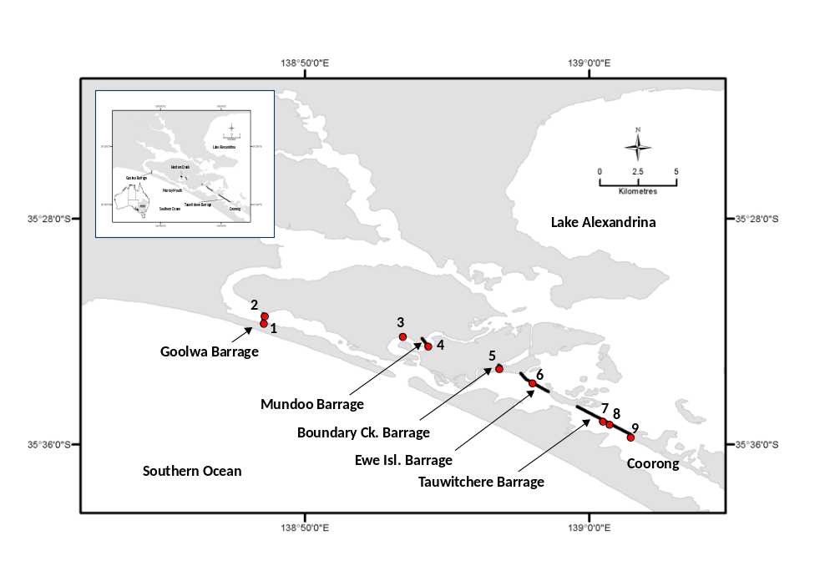
Table 27. Details of fishways sampled at the Murray Barrages, including site name, abbreviated name used throughout, latitude and longitude, and season sampled (Y/N). Fishway design and hydraulic details are presented in Gervais et al. (2025).
Barrage/fishway | Abbrev. | Map no. | Latitude | Longitude | Jul–Sept sampling | Oct–Jan sampling
Goolwa vertical-slot | GVS | 1 | -35.526 | 138.809 | Y | Y
Goolwa vertical-slot 2 | GVS2 | 2 | -35.524 | 138.809 | Y | N
Hunters Creek vertical-slot | Hunters | 3 | -35.535 | 138.885 | N | Y
Mundoo dual vertical-slot | MDVS | 4 | -35.541 | 138.905 | Y | N
Boundary Creek small vertical-slot | BCVS | 5 | -35.554 | 138.947 | Y | N
Ewe island dual vertical-slot fishway | EIVS | 6 | -35.563 | 138.964 | N | N
Tauwitchere trapezoidal | Trap. | 7 | -35.586 | 139.008 | Y | N
Tauwitchere large vertical-slot | TVS | 8 | -35.586 | 139.009 | Y | Y
Tauwitchere small vertical-slot | TSVS | 9 | -35.590 | 139.016 | N | Y

The entrances of the vertical-slot fishways were sampled using aluminium-framed cage traps designed to fit into the first cell of each fishway; thus, each trap has differing overall dimensions (see Gervais et al. 2025). All traps are clad with a combination of 6 mm knotless mesh and perforated aluminium. The traps for large vertical-slot fishways at Tauwitchere and Goolwa have a double cone–shaped entrance configuration to maximise entry and minimise escapement, while smaller vertical-slot fishway traps typically comprise single cone–shaped entrances. Traps are deployed overnight and retrieved manually or by use of mobile crane, depending on size.
During winter sampling, all pouched lamprey and short-headed lamprey captured were enumerated, measured for total length (TL, mm) and weight (g), and implanted with PIT (passive integrated transponder) tags prior to release upstream (see Bice et al. 2020 for tagging approach). In spring–summer, during each sampling event, all fish captured in traps were removed, placed in aerated holding tanks, identified to species level and counted before being released upstream. For common galaxias and congolli, a random sub-sample of up to 50 individuals were measured (TL or fork length [FL], mm) to represent the size structure of the population. For later analysis, the number of YOY common galaxias and congolli captured per sampling event was estimated as the total number of fish × proportion of the population <60 mm in TL. Common galaxias and congolli of this size in spring–summer have previously been aged (otolith microstructure analysis) and determined to be YOY (Bice et al. 2012).
Monitoring lamprey riverine movements
All main channel weirs of the Murray River comprise fishways to facilitate upstream passage (see Baumgartner et al. 2014 for fishway details) and PIT reader systems to record the passage of PIT tagged fish. The PIT detection database was interrogated to assess upstream migration of lamprey tagged in winter 2024.
Evaluation metrics
Several flow metrics considered important to the life history and migration of diadromous species are presented to summarise the influence of environmental water delivery, and specifically CEW, on hydrology and connectivity at the Murray Barrages. These flow metrics were calculated to address distinct time periods corresponding to key life-history stages and processes: winter (1 June–31 August) – corresponds to upstream spawning migration season for lamprey species and downstream spawning migration season of common galaxias and congolli; and spring–summer (1 October–31 January) – corresponds to upstream migration season of newly recruited YOY of common galaxias and congolli.
The flow variables considered included the 1) median, 10th, 25th, 75th and 90th percentile discharge (ML/d); 2) proportion of days with ‘no flow’ (i.e. no discharge from fishways or barrage gates = no connectivity); 3) proportion of days of ‘fishway only’ operation (i.e. discharge restricted to fishways with no discharge via barrage gates); and 4) proportion of days of ‘low flow’ (i.e. below long-term 10th percentile). These metrics were calculated for three scenarios: 1) With all environmental water/Observed, with all environmental water representing observed conditions; 2) Without CEW, without CEW (‘counterfactual’); and 3) Without environmental water, without any environmental water (‘counterfactual’) (see Section 5.1).
For pouched lamprey and short-headed lamprey, to assess temporal patterns in migration, total catch numbers and mean FoE from winter 2024 were compared with the period 2015–2023 when targeted winter sampling also occurred. Mean FoE was calculated following Equation 1 using only data derived from targeted winter sampling and the ‘large’ fishways on the Murray Barrages sampled in given years (i.e. GVS, GVS2, MDVS, EIVS, TVS, Trap.; Figure 39 and Table 27). Annual FoE was compared to the long-term average. Evaluation involved analysis of the influence of CEW on key hydrological and connectivity metrics and qualitative assessment on relationship with FoE.
Equation 1.
Mean FoE = mean(Fishway 1(N _{events lamprey detected}/ N _{events sampled}) + Fishway 2(N _{events lamprey detected}/ N _{events sampled}) + ……….Fishway N (N _{events lamprey detected}/ N _{events sampled}))
Statistical analysis
The contribution of environmental water (both CEW and total environmental water) on the upstream migration of YOY catadromous common galaxias and congolli followed a counterfactual modelling approach (Fanson 2024). All statistical analyses in this section were performed using the rstanarm package in R (v4.5, 2025).
Bayesian generalised additive mixed models (GAMMs) were first fitted to characterise the relationships between YOY abundance and ecologically relevant flow variables (Table 15.6.6, Appendix; these differ slightly from the descriptive flow metrics described above). These models describe the expected response of each species under observed (With all environmental water) flow conditions. The fitted models were then used to generate posterior predictive distributions under alternate Without CEW and Without environmental water scenarios. All other covariates were held constant between scenarios, ensuring that differences reflected only changes in environmental water.
Posterior predictions of expected YOY abundance were generated for each scenario using posterior_epred() with the same posterior draws used across observed and counterfactual scenarios to allow direct draw-by-draw comparison. Posterior distributions of annual effects were summarised using medians and 95% credible intervals, allowing uncertainty in parameter estimates and predicted responses.
Results
CEW contribution to flow metrics
Throughout 2024-25, discharge through the Murray Barrages was variable, with a distinct peak in late July (~20,000 ML/d) and a broader period of elevated discharge from late October to late December, reaching a peak of approximately 13,000 ML/d in early November (Figure 40a). Environmental water, including CEW, contributed substantially to barrage discharge and connectivity in winter 2024, with all water discharged in July–August classified as environmental water, and accounting for 100% of all water discharged through the barrages during spring–summer 2024-25. In winter 2024 (June–August), observed median discharge was approximately double the Without CEW scenario, while median discharge was zero under the Without environmental water scenario (Figure 40b). Under the observed and Without CEW scenarios, there were zero ‘no flow’ days, ‘fishway only’ operation occurred 3% and 10% of the time, and low flows occurred 8% and 12% of the time, respectively. Under the Without environmental water scenario, ‘no flow’, ‘fishway only’ operation and ‘low flows’ occurred 67, 32 and 98% of the time, respectively.
In spring–summer 2024-25, discharge from the Murray Barrages was comprised entirely of CEW. As such, under the Without CEW and Without environmental water scenarios, estimated median discharge was zero ‘no flow’ estimated to occur 100% of the time (Figure 40c). As such, there was estimated to be no fishway function or connectivity under both scenarios (Figure 40c).
Figure 40. Observed (grey bar) and estimated counterfactual (hashed bar) ‘Without Commonwealth environmental water (CEW)’ flow metrics at the Murray Barrages in including a) daily discharge (ML/d) and summary metrics for b) winter (June–August) 2024 and c) spring–summer (October–January) 2025. Left hand panels represent median (line), 25th and 75th percentiles (boxes), and 10th and 90th percentiles (whiskers). No estimates are provided for the No CEW and No environmental water (eWater) scenarios in spring–summer as discharge was zero through this period. Right hand plots depict the number of days of no flow (i.e. zero discharge from Murray Barrages), days of fishway only operation (i.e. discharge was restricted to that via fishways with no discharge via barrage gates) and low flows (<10th percentile of discharge over the defined winter and spring–summer periods from 2011–2025.
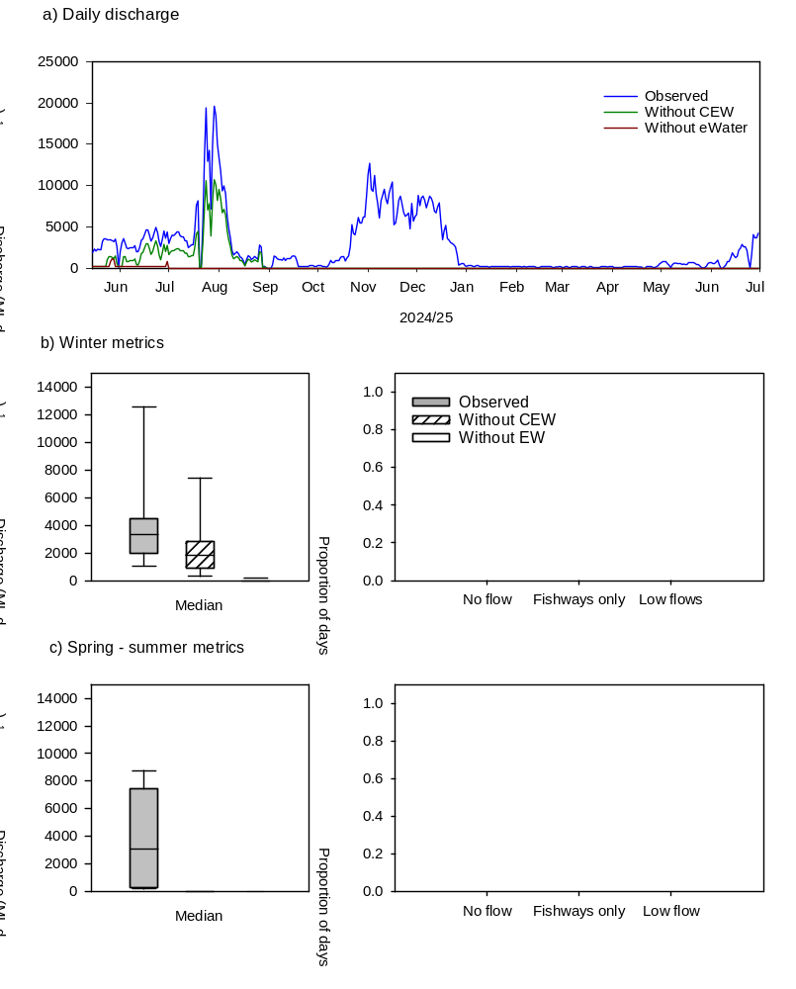
Lamprey migration
During targeted sampling in winter 2024, 26 pouched lamprey were captured from fishways across Goolwa, Mundoo, and Tauwitchere barrages, and tagged before release, while no short-headed lamprey were captured (Table 28). Overall numbers and FoE of pouched lamprey were moderate relative to the period 2015–2024 (Figure 41). Six pouched lamprey were subsequently detected moving through fishways on main channel weirs of the Murray River at Lock 1 (n = 6, first detection dates 23/07/2024–15/10/2024) and Lock 2 (n = 4, first detection dates 26/07/2024–09/09/2024), a distance of ≥362 km from the Murray Mouth.
Table 28. Total numbers of pouched lamprey and short-headed lamprey sampled from the Murray Barrages annually during targeted winter sampling from 2015–2024. No sampling was undertaken in winter 2022.
Species | 2015 | 2016 | 2017 | 2018 | 2019 | 2020 | 2021 | 2022 | 2023 | 2024
Pouched lamprey | 57 | 7 | 53 | 6 | 45 | 101 | 22 | - | 11 | 26
Short-headed lamprey | 0 | 0 | 0 | 0 | 13 | 3 | 0 | - | 0 | 0

Figure 41. Mean (± standard error) Frequency of Encounter (FoE) of pouched lamprey (black symbols) and short-headed lamprey (blue symbols) at fishways on the Murray Barrages during targeted winter sampling from 2015–2024. No sampling was undertaken in winter 2022. Dashed lines represent average FoE of pouched lamprey (black line) and short-headed lamprey (blue line) from 2015–2024.
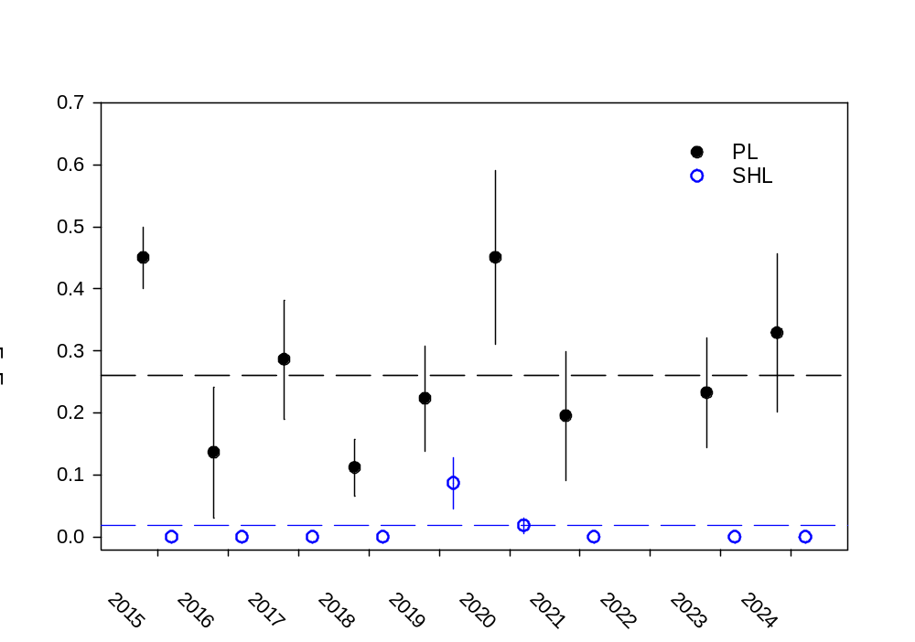
Recruitment and migration of congolli and common galaxias
In spring–summer 2024-25, a total of 4,231 common galaxias and 20,552 congolli were sampled from fishways across the Murray Barrages and for both species, YOY (<60 mm in TL) comprised >75% of sampled individuals (Figure 42a). Relative to the long-term mean (2006–2024), in 2024-25, abundances of YOY common galaxias and congolli were low and low–moderate, respectively (Figure 42b). Counterfactual modelling indicated that in 2024-25 CEW and all environmental water delivery likely had a strong positive influence on the median predicted abundance of congolli and to a lesser extent for common galaxias. Specifically, under the Without CEW scenario, predicted change in congolli abundance was -0.95 (95% credible interval: −1.0 to -0.25) and under the Without environmental water scenario, the median predicted change was -0.94 (95% credible interval: −1.0 to −0.04), representing >15-fold increase in abundance and migration under both CEW and all environmental water, respectively. Median abundances of common galaxias were also greater under the With all environmental water/Observed scenario but exhibited greater uncertainty around modelled outputs. Predicted change in common galaxias abundance under the Without CEW scenario was -0.50 (95% credible interval: −0.96 to 1.81) and under the Without environmental water scenario -0.25 (95% credible interval: −0.91 to 3.92), representing 1.3- and 2-fold increases in abundance and migration under both CEW and all environmental water, respectively.
Figure 42. Length-frequency distributions in spring–summer 2024-25 (left-hand panels; grey shading indicates length of YOY) and mean abundance of YOY (fish.hour⁻¹ ± standard error; middle panels) from 2006–2025 for a) common galaxias and b) congolli sampled at vertical-slot fishways on the Murray Barrages. No sampling occurred in 2012-13. Dashed lines represent long-term average abundance (2006–2024). Right-hand panels depict modelled median abundances and 90% credible intervals for observed, Without Commonwealth environmental water (CEW) and Without environmental water (eWater) scenarios.
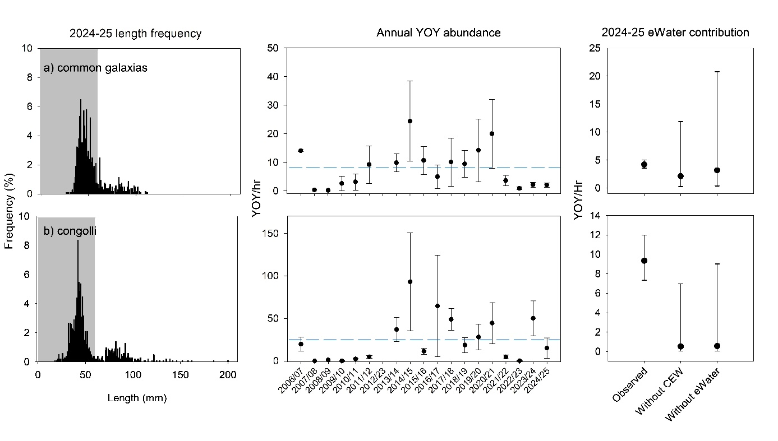

Evaluation
The outcomes for the KEQs for 2024-25 are summarised in Table 29 and are presented separately for (1) pouched lamprey and short-headed lamprey, and (2) common galaxias and congolli.
In the absence of counterfactual modelling to estimate responses under a no environmental water/CEW scenario, the contribution of environmental water/CEW to outcomes for lamprey species was assessed qualitatively by evaluating its influence on fishway function (and therefore migratory opportunity) and median barrage discharge (i.e. level of attraction). For congolli and common galaxias, a counterfactual modelling approach was adopted which estimated responses in abundance of YOY under a no environmental water/CEW scenario. An increase of greater than 50% was deemed substantial, 25‒50% moderate, 10‒24% minor and less than 10% a negligible contribution. Additionally, the influence of environmental water/CEW on fishway function, and hence opportunity for migration, was also qualitatively considered.
Table 29. Area-scale evaluation questions for Diadromous Fish Movement and Recruitment. Refer to ‘Key Evaluation Questions for Basin and Area’ and Table 26 for a description of the evaluation approach. CEW = Commonwealth environmental water, eWater = environmental water.
Key Evaluation Questions | Outcome for 2024-25 | eWater contribution | CEW contribution
Under the annual flow regime, what was the level of upstream spawning migration of adult pouched lamprey and short-headed lamprey in winter? What did eWater (and specifically CEW) contribute to fishway function, connectivity and migration? | In winter 2024, pouched lamprey was captured at four of five large vertical-slot fishways sampled and mean frequency of encounter was similar to the long-term average (2015–2023). Individuals were detected migrating upstream as far as Lock 2 (362 km from the Murray Mouth). No short-headed lamprey were captured. | eWater substantially increased median discharge and had a substantial influence on fishway function, connectivity and migration. All eWater increased fishway operation from 32% to 100% of the defined winter migration period (June–August). | At the Murray Barrages during winter, CEW increased median discharge by 100% and likely contributed to stimulating upstream migrations of pouched lamprey.
Under the annual flow regime, what was the level of upstream migration of YOY congolli and common galaxias? What did eWater (and specifically CEW) contribute to fishway function, connectivity and migration? | In spring–summer 2024-25, YOY common galaxias were captured in low abundance and YOY congolli in low–moderate abundance, relative to the long-term average (2006–2025).  The observed flow regime supported fishway function, connectivity and upstream migration throughout spring–summer. | As per evaluation of CEW. | In spring–summer, water discharged from the Murray Barrages was comprised entirely of CEW, which supported fishway function, connectivity and attraction flows. CEW also contributed to discharge and connectivity during the winter adult downstream migration season. Counterfactual modelling suggested substantial influence of CEW on abundance. As CEW contributed 100% to fishway function and connectivity, it also contributed 100% to migration outcomes for YOY common galaxias and congolli.
Contribution (to what extent CEW contributed towards the outcome, with the significance of the outcome considered):
 | Unknown |  | None/negligible |  | Minor |  | Moderate |  | Substantial

Discussion
At the Murray Barrages, discharge and fishway operation are critical for maintaining connectivity and supporting diadromous fish migration. Environmental water, and specifically CEW, often constitutes large proportions of total discharge and thus, may contribute substantially to migration outcomes, particularly during years of relatively low discharge. This was the case in 2024-25, when CEW contributed to elevated median discharge and connectivity in winter 2024, and during spring–summer 2024-25, accounted for all water discharged through the barrages, thereby supporting fishway operation and maintaining connectivity.
Under the annual flow regime, what was the level of upstream spawning migration of adult pouched lamprey and short-headed lamprey? What did environmental water (and specifically CEW) contribute to this outcome?
In winter 2024, pouched lamprey FoE was similar to the long-term average, while short-headed lamprey was not detected (last detected in winters of 2019 and 2020). Over the period 2015–2024, when targeted winter monitoring occurred, pouched lamprey was present in all years, albeit typically in greatest numbers and FoE during years of moderate winter discharge (median discharge 2,000–5,000 ML/d), often supported by return flows from watering actions in the Goulburn River. In winter 2024, CEW contributed all barrage discharge in July–August, increasing winter median discharge from ~1,800 ML/d to ~3,300 ML/d and potentially supporting this outcome by stimulating upstream migration. All environmental water had a marked influence on fishway operation (increasing operation from 32% to 100% of the time), supporting connectivity and migration outcomes. Diadromous lampreys have highly developed olfactory systems and transition from marine to estuarine and freshwater habitats are cued by stimuli of freshwater origin (Meckley et al. 2014) and as such, upstream migration is typically linked to discharge (Moser et al. 2015). Years of high median winter discharge may be associated with low numbers and FoE yet are unlikely to reflect low absolute abundance because sampling efficiency is likely reduced under such conditions. Periods of high discharge reduce fishway attraction efficiency due to their minor proportion of overall discharge, while generally reduced headloss (i.e. the difference in water level between upstream and downstream of the barrages) means individuals may at times pass directly via barrage gates.
Under the annual flow regime, what was the level of upstream migration of YOY congolli and common galaxias? What did environmental water (and specifically CEW), contribute to this outcome?
In spring–summer 2024-25, YOY common galaxias and congolli were captured in low and low–moderate abundance, respectively, relative to the long-term average. Counterfactual modelling predicted abundances of congolli would have been ~95% lower than observed, while common galaxias abundances would have been 25–50% lower than observed without environment water (including CEW). However, confidence intervals for common galaxias were broad, indicating greater uncertainty in those modelled estimates. Nonetheless, fishway function over this period, and subsequently connectivity for upstream migration and recruitment for these species, was 100% supported by CEW. As such, despite model outputs, abundances of congolli and common galaxias passing through fishways on the Murray Barrages would have been zero without CEW. With regard to downstream winter spawning migrations, environmental water contributed to reducing the number of zero flow days and fishway only days, which likely facilitated greater connectivity and downstream migration.
Since 2006-07, abundances of YOY common galaxias and congolli at the Murray Barrages have been highly variable and likely related to several factors. Notably, no individuals passed the Murray Barrages for much of the period 2007–2010 due to the absence of freshwater discharge and fishway closure, and thus, complete loss of connectivity (Zampatti et al. 2010). Since this time, abundance has fluctuated, likely more so in response to other factors including adult spawning biomass, influence of hydrology on downstream spawning and upstream recruit migrations, and sampling efficiency. As for lamprey species, periods of elevated discharge (e.g. 2022-23) can be associated with low abundance of catadromous species, but this pattern is likely related to poor fishway attraction efficiency and upstream migration via barrage gates.
Management implications
Flow regimes at the Murray Barrages that support fishway function, connectivity and attraction flow are critical to migrations of diadromous fishes in the Lower Murray and CLLMM, and MDB more broadly. Recommendations for delivery of CEW to support these outcomes include:
- Delivering of water to support operation of all fishways on the Murray Barrages should occur, at a minimum, from June‒January to: 1) facilitate upstream spawning migrations of pouched lamprey and short-headed lamprey from June to September; and 2) facilitate upstream migrations of YOY congolli and common galaxias from October to January. Coordination of upstream environmental water deliveries is critical to achieving these discharge and connectivity objectives at the Murray Barrages
- In addition to the operation of fishways from June to September, flow should be delivered to allow operations of barrage gates to provide attraction for anadromous lamprey and facilitate downstream migrations of catadromous. Barrage gates are likely to facilitate greater levels of downstream movement of catadromous fish than fishways.
- When greater volumes of water are available, discharge should be provided from barrage gates immediately adjacent to fishways as attraction flow.
- Cultural Outcomes
  - Cultural outcomes
Introduction
CEW delivery in the Lower Murray and CLLMM Area included the aim to achieve Cultural Outcomes through effective partnership and engagement with First Nations people in this region. This included First Nations people’s participation in planning, delivery and monitoring of environmental water, and other engagement activities related to CEW delivery.
There are multiple First Nations groups in the Lower Murray and CLLMM Area. In South Australia, these include the First Peoples of the River Murray and Mallee Region (FPRMMR), represented by the River Murray and Mallee Aboriginal Corporation (RMMAC); Nganguraku, represented by Sugar Shack Aboriginal Corporation (SSAC); Peramangk, represented by the Peramangk Aboriginal Corporation (PAC); Ngarrindjeri, represented by the Ngarrindjeri Aboriginal Corporation (NAC); the First Nations of the South East (FNSE), represented by the First Nations of the South East Aboriginal Focus Group (SEAFG) and supported by Burrandies Aboriginal Corporation. Along the Murray River between the South Australian border and Mildura, First Nations groups include those represented by the First People of the Millewa-Mallee Aboriginal Corporation (FPMMAC) and Barkandji Native Title Group Aboriginal Corporation (BNTGAC).
These groups or through the Murray Lower Darling Rivers Indigenous Nations (MLDRIN) – a coalition of many First Nations across the Southern MDB – have been actively engaged by CEWH, MDBA and State water delivery partners (South Australian DEW, NSW DCCEEW, VEWH, DEECA, Murraylands and Riverland Landscape Board (MRLB), Australian Landscape Trust, Remark Irrigation Trust, Mallee Catchment Management Authority) in environmental water planning, recognising Traditional Owners’ cultural, spiritual and ecological connections to Country and aiming to ensure environmental watering supports both ecological outcomes and cultural values (e.g. Commonwealth of Australia 2023; DEW 2023). Engagement activities also included environmental water delivery and monitoring activities (e.g. DEW 2025).
Over the past years, the Lower Murray and CLLMM Area team (herein, Area team) has established good working relationships with RMMAC and NAC, and numerous First Nations engagement activities were undertaken during Flow-MER from 2019–2024 with demonstrated success in this region (Ye et al. 2025). Building on these strong relationships, our work in 2024-25 continued to focus on engaging FPRMMR and Ngarrindjeri people to co-design and implement activities that reflected cultural values, priorities, and aspirations, and contribute to Cultural Outcomes in this region. Engagement and collaboration were guided and strongly supported by two Cultural Advisors, Aunty Sheryl Giles from RMMAC and William Wilson from NAC, employed through Flow-MER. These Cultural Advisors are also part of the Flow-MER Program’s Cultural Network, through which interactions and knowledge sharing with Cultural Advisors from the Knowledge Exchange, Basin-scale and other Area-scale teams have been promoted to support the First Nations participation in Flow-MER to achieve Cultural Outcomes.
This section outlines key activities of First Nations participation in environmental water (particularly CEW) planning and delivery based on water delivery partners’ reports, and Flow-MER monitoring and engagement activities that contributed to Cultural Outcomes in the Lower Murray and CLLMM Area in 2024-25. The evaluation approach and results for Cultural Outcomes are also reported.
Objectives
This component aimed to address below two objectives in order to evaluate Cultural Outcomes, in line with the Basin-scale Evaluation Approach (McInerney et al. 2024):
- To report on how First Nations were engaged in environmental water (including CEW) planning and delivery to achieve Cultural Outcomes.
- To engage First Nations in Flow-MER activities to achieve Cultural Outcomes.
The First Nations people MER Strategy (DCCEEW 2024b) provides a framework for evaluating Cultural Outcomes across four categories: community engagement, cultural indicators, cultural places and cultural activities. Cultural Outcomes in the Lower Murray and CLLMM Area encompass the following key areas:
- Embedding First Nations cultural values in environmental water planning.
- Increasing meaningful First Nations participation in monitoring and research.
- Identifying and improving key cultural indicators, including living species, culturally significant places and cultural activities.
- Strengthening and maintaining cultural practices connected to land, water, species and cultural knowledge transmission.
- Strengthening collaborative relationships and partnerships between First Nations, CEWH and scientific partners to support shared learning, integrated knowledge and long-term care for Country.

Key Evaluation Questions for Basin and Area
Area-scale
Table 30. Key evaluation questions for assessing the Cultural Outcomes relating to the planning and delivery of Commonwealth environmental water (CEW) and First Nations participation in Flow-MER Program. Parameters and evaluation approaches used to answer the evaluation questions are provided. eWater = environmental water.
Key Evaluation Questions | Parameter | Evaluation Approaches
How did First Nations contribute to eWater (including CEW) planning and how many watering events were identified as for cultural outcomes? | Number of workshops, meetings or events for cultural outcomes.  Number of watering events for cultural outcomes. | 2024-25 Watering Action Acquittal Reports for the Lower Murray and CLLMM Area (DCCEEW- CEWH).  South Australian River Murray Water for the Environment Report 2024-25 (DEW).
What activities did First Nations participate in the delivery of eWater (including CEW) for their cultural values? | Activities of First Nations participation in eWater (including CEW) delivery. | 2024-25 Watering Action Acquittal Reports for the Lower Murray and CLLMM Area (DCCEEW-CEWH).  South Australian River Murray Water for the Environment Report 2024-25 (DEW).
What cultural engagement activities were undertaken as part of Flow-MER? How did they contribute to Cultural Outcomes that were influenced by CEW? | Number of Cultural Advisors.  Number of First Nations people and engagement activities, co-designed monitoring, yarning circles.  Cultural values and outcomes. | Recount on First Nations participation in Flow-MER.  Identifying the link to Cultural values and outcomes.
Engagement activities to achieve Cultural Outcomes
In the Lower Murray and CLLMM Area, First Nations groups were engaged by Commonwealth and State water delivery partners through formal partnerships, joint planning mechanisms, and culturally informed decision-making processes to ensure cultural values and outcomes were included in environmental water (including CEW) planning along with broader ecological outcomes in 2024-25. The First Nations activities for environmental water planning and delivery are summarised in Table 31, which included strategic environmental water planning, governance and coordination, engagement and training, and infrastructure and on-ground works.
Throughout the 2024-25, Cultural Outcomes were embedded across 19 CEW delivery sites targeting wetlands, with 12 sites eventually receiving CEW. These outcomes placed strong emphasis on reaffirming First Nations connection to Country, alongside supporting the health of totems or special animals (e.g. Ngartjis) and other culturally significant species. A clear priority was to prevent the further decline of nationally listed threatened species by facilitating breeding opportunities and improving ecological conditions. This included enhancing habitat values for waterbirds, migratory shorebirds and diverse aquatic and amphibious vegetation communities to promote long-term ecosystem resilience and cultural wellbeing.
For the Flow-MER Program, two Cultural Advisors (Aunty Sheryl Giles from RMMAC and Uncle William Wilson from NAC) have been engaged, who provided strong support and guidance for First Nations MER activities in this Area. In 2024-25, there were numerous meetings and discussions involving the Cultural Advisors and other staff from NAC and RMMAC, Lower Murray Project Leader, First Nations Engagement Coordinator, KECE Coordinator, and CEWH staff (including Local Engagement Officers). A major initiative, ‘Pondi monitoring’, was identified as a priority by NAC and RMMAC, aligning with CEW delivery and Flow-MER work in this Area.
Pondi (Murray cod) holds deep cultural significance for First Nations people of the Lower Murray and CLLMM region, featuring prominently in the creation story of the Murray River itself. Populations of Pondi have declined substantially in this region over the past seven decades (Ye and Zampatti 2007; Ye et al. 2024c) with river regulation (e.g. weirs), and associated alteration of hydraulic habitat (loss of lotic/flowing habitats) considered major impacts in the Lower Murray (Zampatti et al. 2014; Mallen-Cooper and Zampatti 2018). CEW, as a major part of the environmental water, plays a significant role to improve river connectivity and flowing water habitats to promote Pondi recruitment and maintain river ecosystem health in the LMR. Pondi is also an ecological indicator under the Flow-MER Program (see Section 8.3), which provides additional opportunities for collaboration and knowledge sharing between First Nations rangers and scientists.

Table 31. Integrated First Nations activities supporting the planning, delivery and management of Commonwealth environmental water (CEW). eWater = environmental water; CAP = Community Advisory Panel; CEWH = Commonwealth Environmental Water Holder; CLLMM = Coorong, Lower Lakes Murray Mouth; DEW = South Australian Department for Environment and Water; FPRMMR = First Peoples of the River Murray and Mallee Region; MMAC = Mid-Murray Mallee Aboriginal Corporation; MRLB = Murraylands and Riverland Landscape Board; NAC= Ngarrindjeri Aboriginal Corporation; REWC = Renmark Environmental Watering Committee; RMMAC = River Murray Mallee Aboriginal Corporation; RIT = Renmark Irrigation Trust; SAG = Science Advisory Group; SCBEWC = Southern Connected Basin Environmental Watering Committee; SSAC = Sugar Shack Aboriginal Corporation. Activities in italics indicate First Nations participation in CEW delivery and associated actions; activities not in italics represent planning actions for eWatering including CEW.
Strategic eWater planning | Governance and Coordination | Engagement and training | Infrastructure and on-ground works
- A major water yarning circle meeting was run by DEW, and hosted by NAC in May 2025 in Murray Bridge, including about 15 community members to engage Ngarrindjeri people for CLLMM water planning and delivery in 2024-25 and 2025-26¹.  - NAC was also part of the CLLMM CAP to contribute to eWater planning for 2024-25 and 2025-26, which included joint meetings with the CLLMM CAP-SAG facilitated by DEW and included CEWH managers¹.  - eWater on-Country planning workshops was run by DEW and MRLB staff, in March 2025 with FPRMMR at Murtho Park Flats watering site and discussed proposals for the 2025-26 and partnership with the RMMAC Ranger team. Additional planning days were held at the RMMAC office, with approximately 10 community members, discussing further input into the MRLB 2025-26 watering proposal².  - Consultation with FPRMMR and RMMAC occurred through a Climate Change Yarning Circle held on 12 March 2025 with 19 participants, where discussions focused on the declining health of the Murray River and Elders reflected on the condition of the river prior to the widespread establishment of carp^{2,5}.  - Aboriginal Waterways Assessments (AWA) were held at Werta Wert and Lake Littra during the delivery of water in 2024. AWAs were also conducted at four additional water delivery sites; Ngak Indau Wetland, Katarapko Floodplain, Mundic Floodrunner and Pike Floodplain¹.  - In March 2025, AWAs were also conducted in Murtho Park, by FPRMMR. This program allows for Traditional owners to participate effectively in water planning and Basin management^{2,6}.  - Workshops also held with RMMAC during summer-autumn to discuss the ecological condition of Chowilla, Katarapko and Pike floodplains and potential options for management with support of RMMAC Rangers¹.  - A workshop including NAC and Raukkan Community Council in April 2024 reviewed co management of planning and delivering wetland water regimes, infrastructure operations and pumping logistics (also co-planned proposed actions for 2025-26 in the CLLMM watering proposal)¹.  - Following the workshop, DEW, TLM and NAC staff worked with the MRLB staff to explore smaller-scale watering options. Discussions at Narrung Wetland covered various wetting and drying strategies and identifying additional sites for eWater delivery (i.e., Teringie East, Tolderol Game Reserve and Milang Snipe Sanctuary)¹.  - Cultural Outcomes were embedded across 19 CEW delivery wetland sites with 12 eventually receiving CEW in 2024-25².  - MLDRIN members are represented on the SCBEWC and provide input to eWater priorities, and flows are coordinated for the southern Basin⁷. | - NAC Yarluwar Project Coordinator met weekly with DEW staff throughout the year, discussing First Nation water interests and watering actions for the CLLMM¹.  - Chowilla Floodplain staff regularly liaised with the FPRMMR and Maraura Nation to discuss plans for eWater, updates were provided throughout the year regarding outcomes from watering actions at Chowilla, Pike and Katarapko floodplains, weir pool manipulation and River Murray channel at First Peoples Working Group meetings, On Country meetings, tours, workshops and via email. This included weekly meetings with the RMMAC Project Officer and bi-monthly meetings with the FPRMMR to provide regular updates on monitoring and site activities and to gain the First Peoples input into project and planning¹.  - Across the 2024-25 watering year, two REWC meetings were held and facilitated by the RIT. The committee includes members from RMMAC, CEWH, DEW, MRL Board, RIT, Renmark Paringa Council, expert advisors and community groups³.  - MMMAC attended a workshop run by the MRLB in Mannum, May 2025. MMMAC expressed a strong interest in the involvement of the project and were provided with an update of the work from the MRL Board wetlands team².  - The SSAC and the MRLB co-planned watering and monitoring activities on-Country. This led to further collaboration with the MRLB Landscape Resilience Team’s, Murray–Darling Carpet Python Project, and bird survey training².  - During December 2025, MLDRIN signed a multi-year partnership agreement with CEWH to strengthen First Nations engagement in eWatering across the southern Basin⁸. | - Over the 2024-25 water year, three wetland tours were held by the MRLB with 20 community members visiting three wetland complexes selected by the FPRMMR working group members. CEW was delivered to two of the wetland complexes (i.e., Overland Corner and Maize Corner)².  - Yarning circle attended by 25 Ngarrindjeri community members, scientists and MRLB staff (covering eWater planning, Coorong flows, lake level management and fringing wetlands of Lake Albert and Alexandrina)².  - RMMAC wetland tour day, meet-n-greet with neighbouring landholders. Occurred twice in May 2025 at Maize Island Conservation Park².  - The environmental watering and floodplain restoration program was used to train the Calperum Indigenous Ranger Team⁴. | - First Peoples contributed to infrastructure investigations with DEW for the Sustaining Riverine Environment Project and SA Constraints Project via three monthly meetings from January to March in 2025 at Gerard Lignum Basin by DEW².  - Ongoing collaboration between MRLB and First Nations on concept planning, community liaison and project delivery for improved wetland and floodplain infrastructure. Co-planning for Teringie, Tauwitchere, Yaiwaiparrung, Mundaringa, Murangong, Nurra Nurra².  - The Riverland Indigenous Ranger team supported eWater delivery through a range of on-ground management actions, including constructing and maintaining smaller retention banks, grading and repairing access tracks to watered sites, and assisting Millewa Pumping with pump installation. Their involvement was prioritised to help achieve the project objective of protecting and restoring the Aboriginal cultural values of local wetlands, floodplains and waterways⁴.  - The NAC and Raukkan Community Council co-managed the water delivery and monitoring of Teringie Wetlands in partnership with MRLB and the CEWH in assistance of Millewa Pumping Pty Ltd. This included managing pump outflow, water levels, operating infrastructure and ecological monitoring. Ngarrindjeri elders celebrated water returning to Teringie East Wetland for the first time in 50 years, a place previously used for fishing yabbies and collecting swan eggs².  - The SSAC undertook water delivery at Sugar Shack Wetland Complex in partnership with MRLB. Using a MRLB-owned pump, SSAC managed the portable pump with community helpers which included regular pump checks, refuelling and monitoring water levels and water quality².

References
¹ DEW (2026): South Australian River Murray Water for the Environment Report 2024-25 – Partnering with First Nations (section)
² DCCEEW-CEWH: 2024-25 Watering Action Acquittal Report – Lower Murray Wetlands (MRLB)
³ DCCEEW-CEWH: 2024-25 Watering Action Acquittal Report – Renmark Irrigation Trust
⁴ DCCEEW-CEWH: 2024-25 Watering Action Acquittal Report – Australian Landscape Trust
⁵ SA Drought Hub (2024) Ngarrindjeri climate yarning circles. SA Drought Hub. SA Drought Hub - Supporting SA farmers and regional communities. Ngarrindjeri Climate Yarning Circles - SA Drought Hub
⁶ Murray Darling Basin Authority (2017). Aboriginal Waterways Assessment Program. Murray–darling basin authority, Aboriginal Waterways Assessment Program. Aboriginal Waterways Assessment Program | Murray–Darling Basin Authority
⁷ Commonwealth of Australia (2023). Commonwealth Environmental Water Holder Water Management Plan 2023–24: Murray River Valley Water Plan, Canberra.
⁸ https://www.dcceew.gov.au/cewh/resources-media/news/strengthening-first-nations-partnerships-environmental- water-management

In 2024-25, the Area team worked closely with NAC/Raukkan and RMMAC rangers, supported by the Cultural Advisors and CEWH managers, to co-design and implement the Pondi monitoring project in the LMR, incorporating an Electrofishing Demonstration Event to Elders and broader First Nations communities and a yarning circle to broaden engagement and foster transgenerational knowledge sharing and across all partners. Refer to Section 15.7 (Appendix) and Cameron (2025) for more details of the Pondi monitoring and engagement activities.
There were six rangers working with two researchers over a week to conduct Pondi electrofishing in the LMR during February 2025. In addition, about 50 elders and community members participated in the Electrofishing Demonstration Event, supported by researchers and other government staff. There was numerous positive feedback from the rangers, elders and other participants after the event, which was reflected at the yarning circle and supported by rangers’ reports (RMMAC 2025) and quotes (Cameron 2025). Key cultural outcomes from Pondi monitoring and First Nations engagement events are presented in Table 23, along with supporting evidence and activities.
Overall, this project strengthened cultural identity for First Nations people, restored hope in the health of Pondi and the LMR, deepened trust between First Nations people and scientific and water delivery partners, built ranger capacity, and reinforced a shared commitment to Caring for Country through integrated knowledge and long-term collaboration.
Table 32. Key Cultural Outcomes of Flow-MER Pondi monitoring and associated First Nations engagement activities with supporting evidence in the Lower Murray and CLLMM Area during 2024-25 (Section 15.7, Appendix; RMMAC 2025; Cameron 2025).
Cultural Outcomes | Supporting evidence and activities
Cultural Connection to Pondi and Country | - Many rangers saw and held a live Pondi for the first time, describing the experience as emotional and spiritually meaningful.  - Observing and handling juvenile and large (up to 1.2 m) Pondi strengthened cultural connection and reinforced the species’ importance to Country.  - Seeing multiple size classes increased confidence that Pondi are present and breeding in the Lower Murray.
Hope for River Health and Future Generations | - Catching 18 Pondi from one site provided reassurance to rangers that species recovery is possible.  - Rangers and Elders expressed renewed optimism about the long-term sustainability of the Murray River and its native fish.  - Yarning circle discussions focused on supporting Pondi recovery through environmental water delivery, habitat restoration and continued monitoring.
Strengthened Partnerships and Cross-Border Connections | - The project strengthened partnerships between First Nations groups (NAC and RMMAC), scientists, and water managers through active collaboration on Country.  - It demonstrated an effective First Nations-led partnership model delivering shared outcomes.  - Strong support was expressed for continuing and expanding partnerships to care for Country.
Integration of Cultural Knowledge and Western Science | - Elders shared cultural knowledge, historical river conditions and stories of past Pondi abundance.  - Scientists shared ecological knowledge, monitoring objectives and techniques.  - Joint discussions demonstrated how integrated knowledge systems can inform river restoration and sustainable natural resource management.
Community Engagement and Intergenerational Knowledge Sharing | - The Electrofishing Demonstration Event engaged more than 50 participants, including Elders, rangers, community members and government representatives.  - Cultural protocols were observed through Welcome to Country and smoking ceremonies.  - Yarning circles enabled open dialogue and shared knowledge and learning.  - Elders observed rangers working on Country, foster pride and intergenerational knowledge transfer.
Ranger Capacity Building and Pride | - Rangers gained hands-on experience in electrofishing, fish handling, measuring, tagging and species identification.  - Initial scepticism about electrofishing transitioned to confidence after observing fish recovery and understanding the scientific method.  - Rangers took active roles in netting and demonstrating monitoring techniques to community members, building pride and leadership capability.

Evaluation
Table 33. Area-scale evaluation questions for Cultural Outcomes. Refer to Table 30 for a description of the evaluation approach. CAP = Community advisory panel; eWater = environmental water; CEW = Commonwealth environmental water; DEW= South Australian Department for Environment and Water; FPRMMR = First Peoples of the River Murray and Mallee Region; MRLB= Murraylands and Riverland Landscape Board; NAC = Ngarrindjeri Aboriginal Corporation; REWC= Renmark environmental watering committee; RMMAC = River Murray Mallee Aboriginal Corporation; SAG = Science advisory group; SSAC = Sugar Shack Aboriginal Corporation.
Key Evaluation Questions | Outcomes for 2024-25
How did First Nations contribute to eWater (including CEW) planning and how many watering events were identified as for cultural outcomes? | Three major workshops: eWater planning workshops/yarning with First Nation groups, DEW and the MRLB to inform 2025-26 proposals, water regimes, ecological assessments and project updates.  Numerous meetings: Regular informal and liaison meetings (e.g. CAP, SAG, REWC, RMMAC), quarterly infrastructure meetings with DEW, and planning sessions between NAC and Raukkan Community Council.  Two Yarning Circles: For the FPRMMR and RMMAC River Murray Climate Change & Ngarrindjeri people planning for CLLMM  Aboriginal Water Assessment: Across seven water delivery sites; Werta Wert, Lake Littra, Ngak Inda Wetland, Katarapko Floodplain, Mundic Floodrunner, Pike Floodplain and Murtho Park.  Five wetland tours: Two at Maize Island Conservation Park and three at CEW delivery sites including Banrock Station and Overland Corner.  Cultural Outcomes were identified across 19 wetlands for CEW delivery and 12 eventually received CEW, prioritising strengthening First Nations connection to Country and support for totems or special animals (e.g. Ngartjis) and culturally significant species, and to prevent the decline of nationally listed threatened species.
What activities did First Nations participate in the delivery of eWater (including CEW) for their cultural values? | Watering and on-ground work by the Indigenous Rangers:  The Riverland Indigenous Ranger team participated in eWater delivery, with the aims to protect and restore the Aboriginal cultural values of local wetlands, floodplains, and waterways.  The NAC and Raukkan Community Council co-managed the water delivery and monitoring of Teringie Wetlands in partnership with MRLB and the CEWH. Ngarrindjeri elders celebrated water returning to Teringie East Wetland for the first time in 50 years, a place previously used for fishing yabbies and collecting swan eggs.  The SSAC undertook water delivery at Sugar Shack Wetland Complex in partnership with MRLB, with SSAC playing a leading role in watering and monitoring.
What cultural engagement activities were undertaken as part of Flow-MER? How did they contribute to Cultural Outcomes that influenced by CEW? | Two Cultural Advisors: Aunty Sheryl Giles (RMMAC) and William Wilson (NAC) engaged for Flow-MER.  Pondi monitoring: 30 First Nations ranger days  Electrofishing Demonstration Event: 50 elders and community members participated.  One yarning circle with elders and First Nations rangers.  In 2024-25, Pondi monitoring was identified by NAC and RMMAC as a priority. Pondi has a significant cultural/spiritual value for the First Nations communities in this region. This collaborative project contributed to below Cultural Outcomes:  - Cultural Connection to Pondi and Country  - Hope for River Health and Future Generations  - Strengthened Partnerships and Cross-Border Connections  - Integration of Cultural Knowledge and Western Science  - Community Engagement and Intergenerational Knowledge Sharing  - Ranger Capacity Building and Leadership.

Discussion
Since 2019-20, a range of First Nations engagement activities have been undertaken in the Lower Murray via Flow-MER. In 2024-25, with the commencement of the current iteration of the Flow-MER Program, Cultural Outcomes are being formally evaluated. In the Lower Murray and CLLMM Area, part of the evaluation involved assessing how First Nations were engaged in environmental water (particularly CEW) planning and delivery, to ensure cultural values, perspectives and priorities are considered alongside environmental objectives. As water delivery partners (CEWH, MDBA and State water management agencies) are responsible for environmental water planning and delivery, they have been working with First Nations through a range of mechanisms and provided annual reports that include First Nations engagement activities and outcomes (e.g. DEW 2025, 2026; DCCEEW-CEWH Watering Action Acquittal Reports). Therefore, these reports were used to inform the evaluation of how First Nations contributed to environmental water planning and delivery, particularly with 19 wetland sites identified for Cultural Outcomes during planning and 12 of these eventually received CEW in 2024-25. It is envisaged that this approach will continue to be adopted for future reporting and evaluation.
As for Flow-MER, the 2024-25 Pondi monitoring project marked a significant milestone, demonstrating the strength of First Nations engagement and partnership in advancing Cultural Outcomes in the Lower Murray and CLLMM Area. Several important learnings are provided below:
- Co-design and genuine partnership with respect and trust deliver stronger outcomes.
- On-Country participation builds capacity and pride.
- Transparent engagement builds trust and shared understanding.
- Ecological outcomes strengthen cultural wellbeing and partnership.
- Partnerships require continuity with long-term commitments.
These learnings are consistent with the guiding principles for engagement with First Nations peoples in The Interim First Nations Peoples MER Strategy (DCCEEW 2024b) (see Section 15.7, Appendix). The Area team has applied and will continue to follow these guidelines in all interactions with our First Nations partners to support meaningful and successful collaborations, such as the Pondi monitoring project. Our engagement and data collection followed the principles of FPIC and ICIP, and adhered to Indigenous Data Sovereignty (see details in Section 4). This ensures activities or knowledge sharing were conducted in a culturally safe manner and respected community authority, ownership, and control over cultural knowledge and data.
- Responsive Monitoring
In 2024-25, the responsive monitoring budget was allocated to supporting larval fish sampling and sorting/identification components of the Flow-cued Fish Spawning and Recruitment indicator (Section 8.2; Ye et al. 2024b).
- Alignment with Basin Plan and Basin-wide Environmental Watering Strategy
A range of evaluation questions across four Flow-MER themes -. River Flows and Connectivity, Native Vegetation, Native Fish and Cultural Outcomes – have been addressed in the Lower Murray and CLLMM Area using appropriate indicators. See Table 15.2.2 in Section 15.2 (Appendix) for detailed information regarding the alignment of Area-scale evaluation questions with the Basin Plan (Chapter 8 – Environmental Water Plan objectives and Schedule 7 targets) and the Basin-wide Environmental Watering Strategy outcomes.

- Research
  - Development of a repository of hydraulic parameters for weir pools 7, 8 and 9
Background
In the LTIM and the Flow-MER1.0 programs, the Hydraulic Regime indicator for the Lower Murray Selected Area was underpinned by outputs from hydraulic scenario modelling conducted for weir pools downstream of Lock 6 on the Murray River (DHI 2014; McCullough et al. 2017). These outputs were summarised in a large repository of hydraulic outputs, consisting of statistics such as areas meeting certain velocity classes and total area of inundation, across a range of upstream discharge rates and weir operating heights for steady-state conditions.
In Flow-MER, this research project was undertaken to enable the same approach to be extended further upstream given current expanded Lower Murray Area. As such, similar sets of scenarios were simulated using existing MIKE-FLOOD models for weir pools 7, 8, and 9. These simulations aimed to quantify the changes in hydraulics from changes in river flow and weir pool height to enabling evaluation of the contribution of Commonwealth environmental water to the hydraulic regime in these weir pools and answer the Key Evaluation Questions in Table 1 (Section 5.1).
The MIKE-FLOOD models used in this study cover the Murray River and most of its floodplains between Lock 10 and Linsday point (Figure 43). These models were previously developed by MDBA (2016) and updated by Water Technology (2019). In that study model results were validated against flows, depth-averaged velocities and cross section data derived using an Acoustic Doppler Current Profiler (ADCP) along weir pools 7, 8 and 9. The results from that study found these hydrodynamic models accurately represent the physical behaviour of the system for the conditions considered.
Figure 43. Domains of the MIKE-FLOOD models used to derive hydraulic statistics in weir pools 7, 8 and 9.

Methods
Model updates
The impact of weir pool manipulations on channel velocities for weir pools 7 and 8 was the main focus in the development of the models in MDBA (2016). Proportions of the weir pool in different velocity classes for different flow and weir pool levels were calculated. These results have been used to validate if the models still perform correctly in the more recent version of the MIKE-FLOOD software used in this study. For the purposes of this study, velocity classes in line with previous Flow-MER1.0 work have been used, slightly different to the MDBA (2016) analysis.
Along with velocity, changes in extent of inundation resulting from variation in river flows and weir operating heights are a key output of interest. Therefore, the ability of the models to accurately represent the extent of inundation has also been validated. The modelled inundation extents under a range of flows at normal pool levels were compared with available observed inundation derived from satellite images. Initial comparisons revealed discrepancies when permanently connected wetlands, or those connected at low flows, were inundated.
To improve the representation of wetland inundation, additional bathymetric data, including sill level information for adjacent floodplains, were extracted from a 2 m Digital Elevation Model (DEM) and incorporated into the model mesh. This refinement was applied to areas that are known to be influenced by weir pool manipulation, typically the most downstream proportion.
Adjustments to the floodplain mesh (i.e. not influencing in-channel velocities that were the initial focus of model development in MDBA (2016)), including changes in Manning’s n values and mesh elevations, were made repetitively until good agreement was achieved between the observed and modelled data. Downstream water level boundaries for high-flow scenarios, when weirs are overtopped, were derived from similar work undertaken in another study (McCullough 2025), where MIKE-FLOOD was used to simulate the extent of inundation for a range of flows under steady state conditions.
The upper section of Weir Pool 8 is not covered by the model mesh and as a result, the model is unable to simulate the full extent of inundation for Weir Pool 8 directly (Figure 43). To address this gap, remote sensing derived inundation extents developed by Teng et al. (2024) were used to supplement the model. This remote sensing dataset provides two-monthly spatial layers representing the maximum surface water extent and water depth within each two-month period across the MDB from 1988 to 2024.
Maximum two-monthly discharges downstream of Lock 9 were calculated using observed data, while inundation extents for Weir Pool 8 were derived from remote sensing dataset. These data were combined by plotting inundated areas against discharges downstream of Lock 9, revealing a trend where overbank inundation begins to emerge at flows exceeding 30,000 ML/d (Figure 44). This relationship was then used to estimate maximum inundation areas in Weir Pool 8, corresponding to specific steady-state flow scenarios at Lock 9. Finally, these estimated inundation extents were used to infill the missing area in the model mesh, enabling estimation of the total inundated area for all of Weir Pool 8.
Figure 44. Relationship between Lock 9 two-monthly maximum discharge and estimated inundation area in Weir Pool 8.
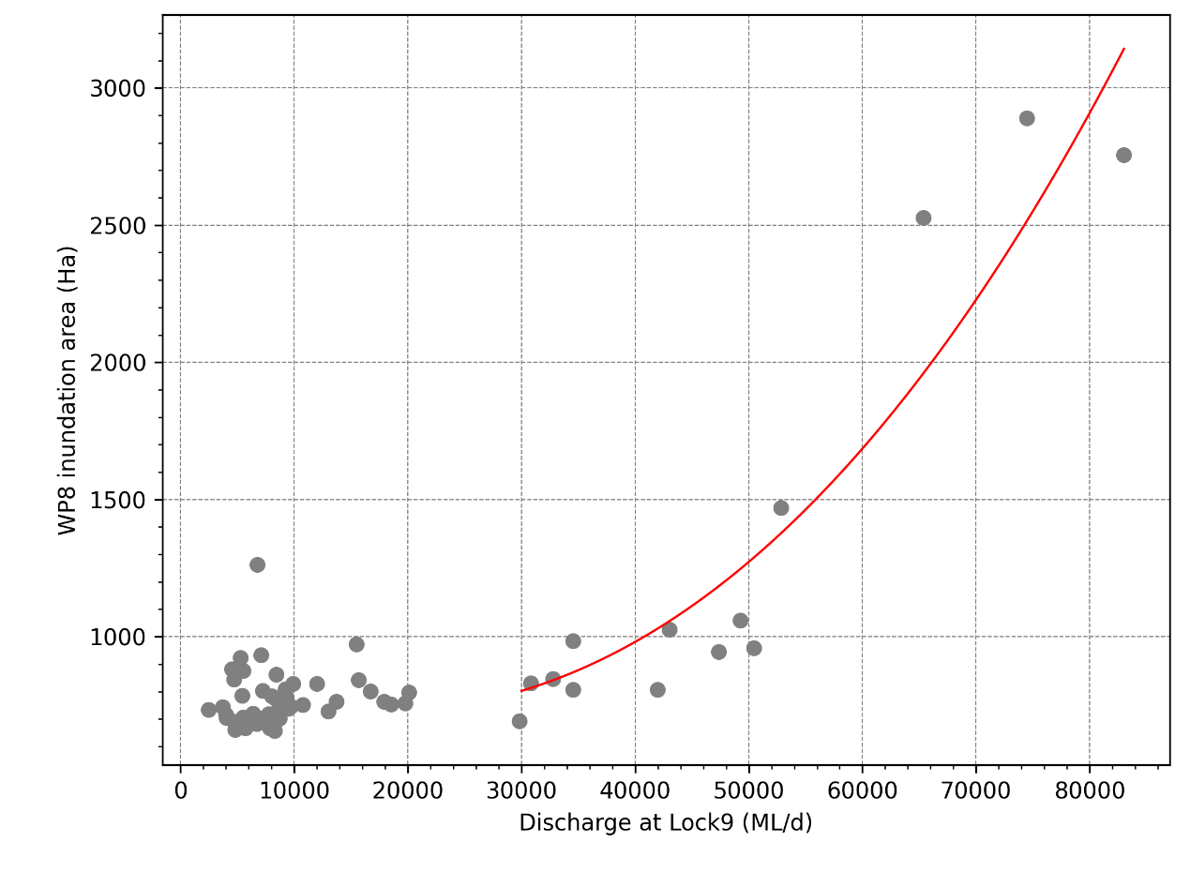

Model updates
Model configurations and additional calibrations were tested through a series of steady state scenarios representing ranges of river flows (1,000, 3,000, 5,000, 10,000, 15,000, 20,000, 30,000, 40,000, 50,000, 60,000, 70,000 and 80,000 ML/d). These scenarios were run under no operating conditions (i.e. normal pool levels) and modelled water levels upstream and downstream of each lock were compared against the available observed data. All inlet structures were set to fully open condition across all river flows, except for the Mullaroo Creek regulator (located approximately 10 km upstream of Lock 7), which gradually closes when river flows fall below 15,000 GL/d as shown in Table 34.
Table 34. Model configurations at the Mullaroo Creek regulator (Reg).
Discharge, ML/d | Branch name | Chainage | ID | Gate | Blockage | Factor
1,000 | MULLAROO_CK | 140 | Mullaroo Reg | Fully closed | - | -
3,000 | MULLAROO_CK | 140 | Mullaroo Reg | Fully closed | - | -
5,000 | MULLAROO_CK | 140 | Mullaroo Reg | Fully open | TRUE | 0.70
10,000 | MULLAROO_CK | 140 | Mullaroo Reg | Fully open | TRUE | 0.70
> 15,000 | MULLAROO_CK | 140 | Mullaroo Reg | Fully open | FALSE | 1.00

Evaporation and infiltration were set to zero in all scenarios, and each simulation was run for a sufficient duration to allow water levels to stabilise across inundated areas (typically seven days per increment). These steady-state conditions are intended to represent the maximum possible inundation extent for a given river flow and lock level.
Scenario modelling
Following suitable model calibration and representation of normal pool operations, a similar approach was used to simulate the effects of weir pool manipulation. Numerous steady state scenarios for a range of hydraulic conditions representing combinations of upstream discharge into each weir pool and downstream water levels defined at each lock. Maximum and minimum weir pool levels were selected based on the current operational limits of each structure.
Table 35 summarises the combinations of upstream discharge and weir pool manipulation simulated in the scenario modelling. In addition, to provide context on the potential benefits that could be restored through weir pool manipulations, without lock conditions (i.e. near to natural conditions) were simulated for a range of river flows (5,000 ML/d to 80,000 ML/d) by removing all structures and locks.
Postprocessing modelled outputs
A number of postprocessing steps were implemented to convert the raw model outputs into a repository of hydraulic metrics for given flow and weir pool level conditions. The 1D model results were converted into 2D grids using the model’s built-in functionalities, enabling their integration with the 2D model outputs. Shapefiles were then generated for all simulated scenarios to represent the modelled inundation extents, containing hydraulic parameters such as surface elevation, depth, area, volume, and velocity. The higher spatial resolution velocity results from the hydraulic model were summarised to average velocities every 100 m, considering depth and cross section average velocities (Figure 45). This is the same approach taken previously for the downstream of Lock 6 results available, producing directly comparable metrics, and is intended to be related to cross-section averaged velocity values that are typically used to infer ecological responses (e.g. Gibbs et al. 2023).
Table 35. Combinations of upstream discharge and weir pool manipulation simulated.
 | Weir pool manipulations—Shift in cm away from Normal Pool Level (NPL) | Weir pool manipulations—Shift in cm away from NPL | Weir pool manipulations—Shift in cm away from NPL
Upstream Discharge, ML/d | Lock 7 (NPL = 22.1 m AHD) | Lock 8 (NPL = 24.6 m AHD) | Lock 9 (NPL = 27.4 m AHD)
1,000 | -80 to 30 at 10 cm intervals | -80 to 30 at 10 cm intervals | -80 to 30 at 10 cm intervals
3,000 | -80 to 30 at 10 cm intervals | -80 to 30 at 10 cm intervals | -80 to 30 at 10 cm intervals
5,000 | -80 to 120 at 10 cm intervals | -80 to 110 at 10 cm intervals | -80 to 120 at 10 cm intervals
10,000 | -80 to 120 at 10 cm intervals | -80 to 110 at 10 cm intervals | -80 to 120 at 10 cm intervals
15,000 | -80 to 120 at 10 cm intervals | -80 to 110 at 10 cm intervals | -80 to 120 at 10 cm intervals
20,000 | -80 to 120 at 10 cm intervals | -80 to 110 at 10 cm intervals | -80 to 120 at 10 cm intervals
25,000 | -80 to 120 at 10 cm intervals | -80 to 110 at 10 cm intervals | -80 to 120 at 10 cm intervals
30,000 | 0 | -80 to 110 at 10 cm intervals | 0
35,000 | 0 | -80 to 110 at 10 cm intervals | 0
40,000 | 0 | 0 | 0
50,000 | 0 | 0 | 0
60,000 | 0 | 0 | 0
70,000 | 0 | 0 | 0
80,000 | 0 | 0 | 0

Figure 45. Example of 100 m sections used to summarise averaged velocities at higher resolution for flow rates of 20,000 (top) and 30,000 ML/d (bottom).

Results
Figure 46 shows comparison of observed and modelled water levels upstream and downstream of each lock under a range of flows, for normal weir pool operating conditions. The steady state results from the model can be seen to fit well within the range of observed values, where the variability in observed values can be due to additional factors such as wind seiche, not represented by the model scenarios as configured.
As further validation of model simulations, the results were initially summarised using the same velocity classes as MDBA (2016) to enable direct comparison: <0.1 m/s, 0.11–0.17 m/s, 0.18–0.29 m/s, 0.30–0.39 m/s, 0.40–0.49 m/s and >0.5 m/s. Scatterplots were then produced for each flow band to compare the proportion of weir pools 7 (Figure 47) and 8 (Figure 48) with velocities falling within specified classes. These plots provide a visual assessment of agreement between the two datasets across a range of flow conditions.
The correlation analysis indicates that both weir pools demonstrate strong agreement between the two datasets across most flow bands. For Weir Pool 8, the statistics are consistently high, with R² values ≥ 0.94 and RMSE ≤ 0.05 across all flows, indicating very close alignment between the model simulation. However, Weir Pool 7 shows stronger agreement at lower flows (Q = 5–10; R² ≥ 0.96, RMSE ≤ 0.06) but there is a reduction in performance at higher flows (Q = 15–25), where R² decreases to 0.71–0.88 and RMSE increases to 0.08–0.13. This difference, with the new results generally slower than the MDBA results, is likely due to improving the representation of pool-connected wetlands based on satellite imagery. Overall, the results demonstrate strong consistency between the datasets, indicating the models have been used as originally intended (Figure 47 and Figure 48), as well as providing an accurate representation of observed water levels (Figure 46).
The modelled outputs were reprocessed to the equally spaced velocity classes in line with the weir pools downstream: <0.1 m/s, 0.1–0.2 m/s, 0.2–0.2 m/s, 0.3–0.4 m/s, 0.4–0.5 m/s and >0.5 m/s. Inundated area and storage volume were also summarised, creating the data repository that will be used for evaluation in the Hydraulic Regime indicator for Flow-MER. Figure 49, Figure 50 and Figure 51 present a summary of these results as stacked bar charts for weir pool 7, 8 and 9 respectively, illustrating the proportion of each weir pool that falls within various velocity increments, across different flows and weir pool levels.
Discussion
The research project was primarily undertaken to enable the Hydraulic Regime indicator to extend the evaluation approach upstream from Lock 6 up to Lock 10. The evaluation, covering the broader area from Lock 1 to Mildura, has been undertaken for the first time in 2024-25 as part of Flow-MER (Section 5.1). The modelling undertaken has extended the original work by the MDBA and could be used to inform planning of weir pool manipulation operations and environmental water delivery in this part of the LMR. The results in Figure 49 to Figure 51 outline the expected velocity response along each of the three weir pools under different combinations of river flow and weir pool height. The results highlight the strong relationship between flow, weir pool height, and velocity. In all weir pools, higher flows lead to increased velocities, while lower weir pool levels also result in higher velocities. Both factors elevate the hydraulic gradient between upstream and downstream weirs, thereby increasing velocity and promoting hydraulic diversity in the river, which would contribute to ecological outcomes for riverine species.
Figure 46. Comparison of modelled and observed water levels (WL), upstream (US) and downstream (DS) of each lock.
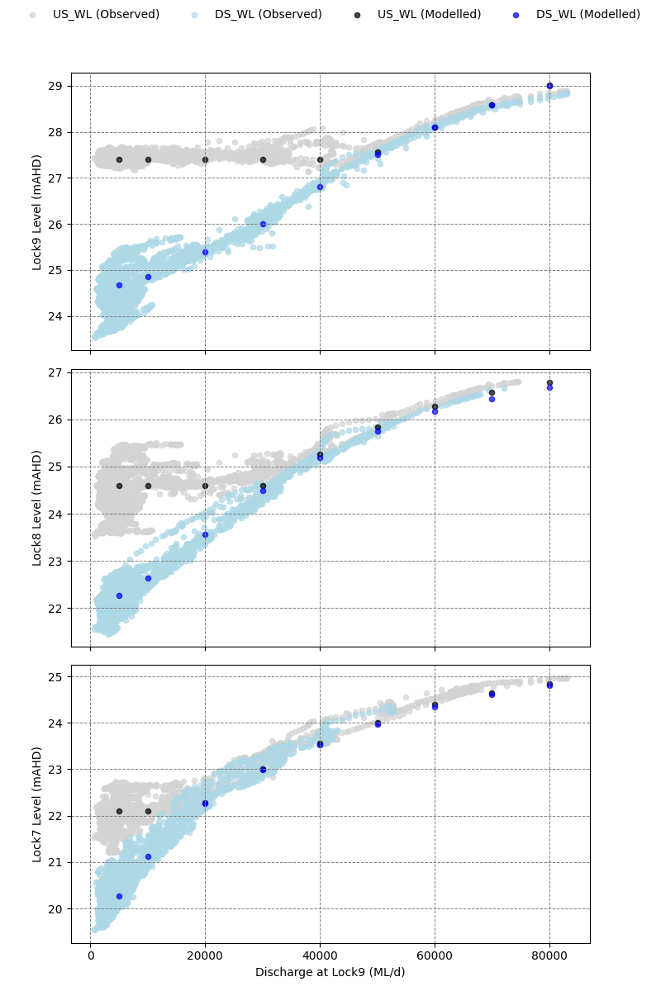

Figure 47. Correlation plots comparing MDBA and NEW modelled outputs across flow bands in Weir Pool 7.
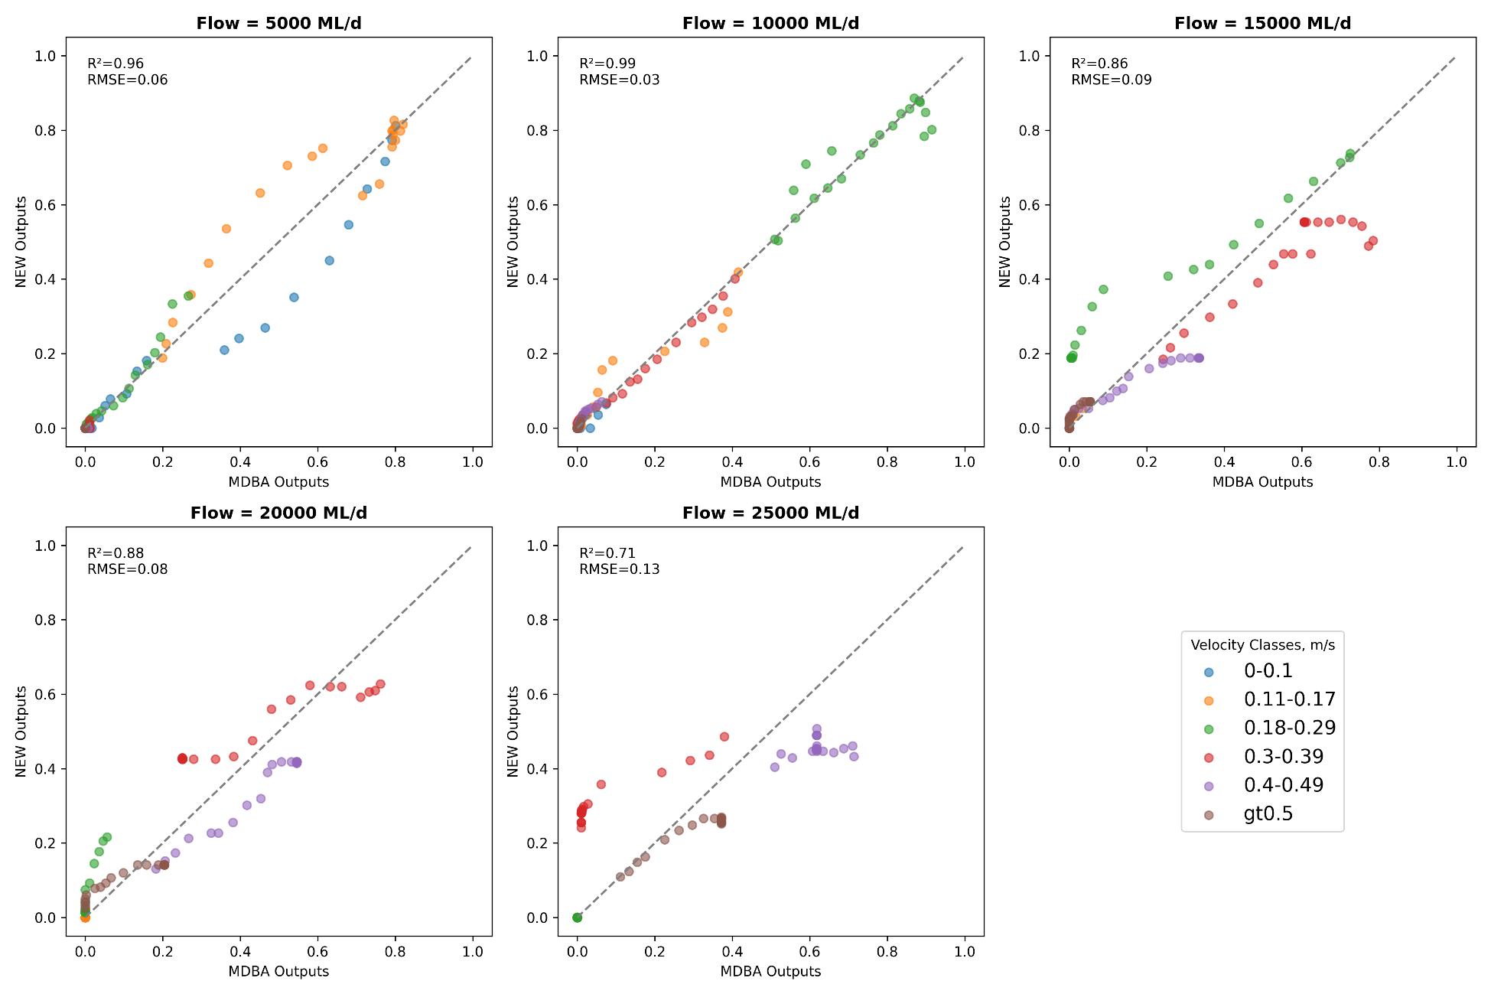
Figure 48. Correlation plots comparing MDBA and NEW modelled outputs across flow bands in Weir Pool 8.
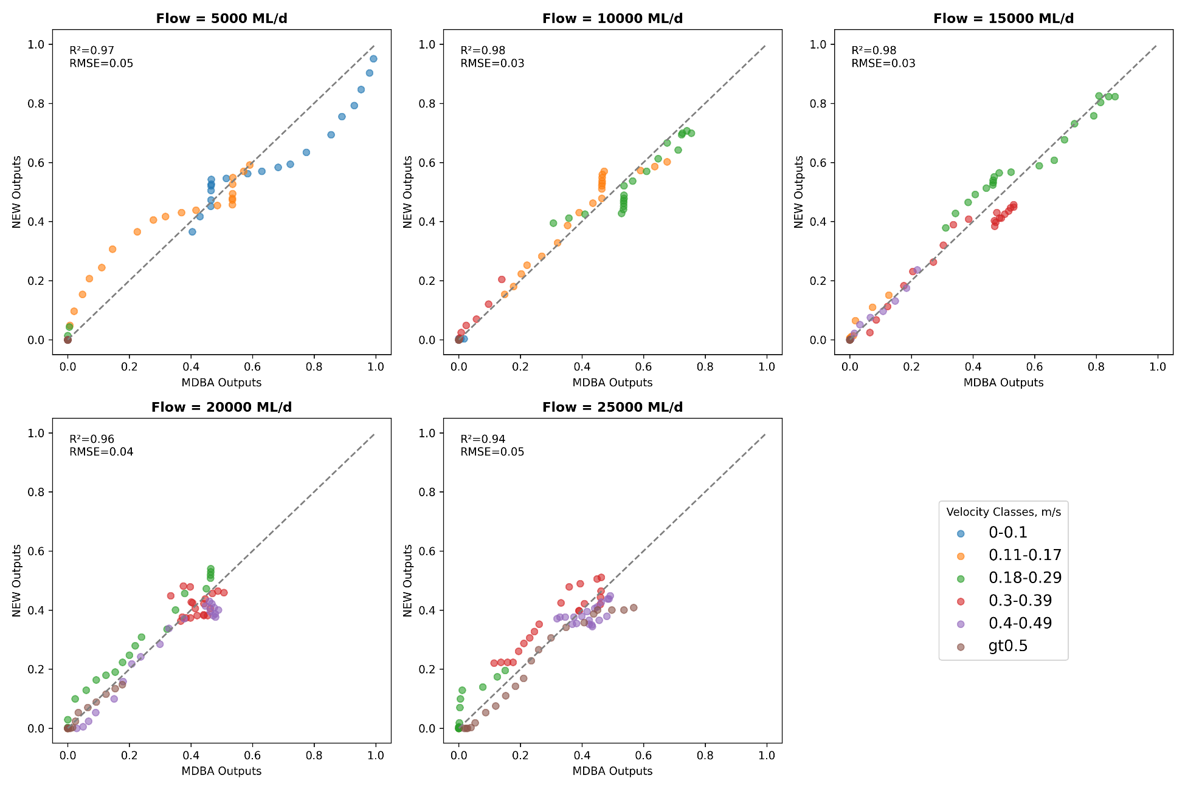
Figure 49. Proportion of Weir Pool 7 that falls within various velocity increments, across different flows and weir pool levels.
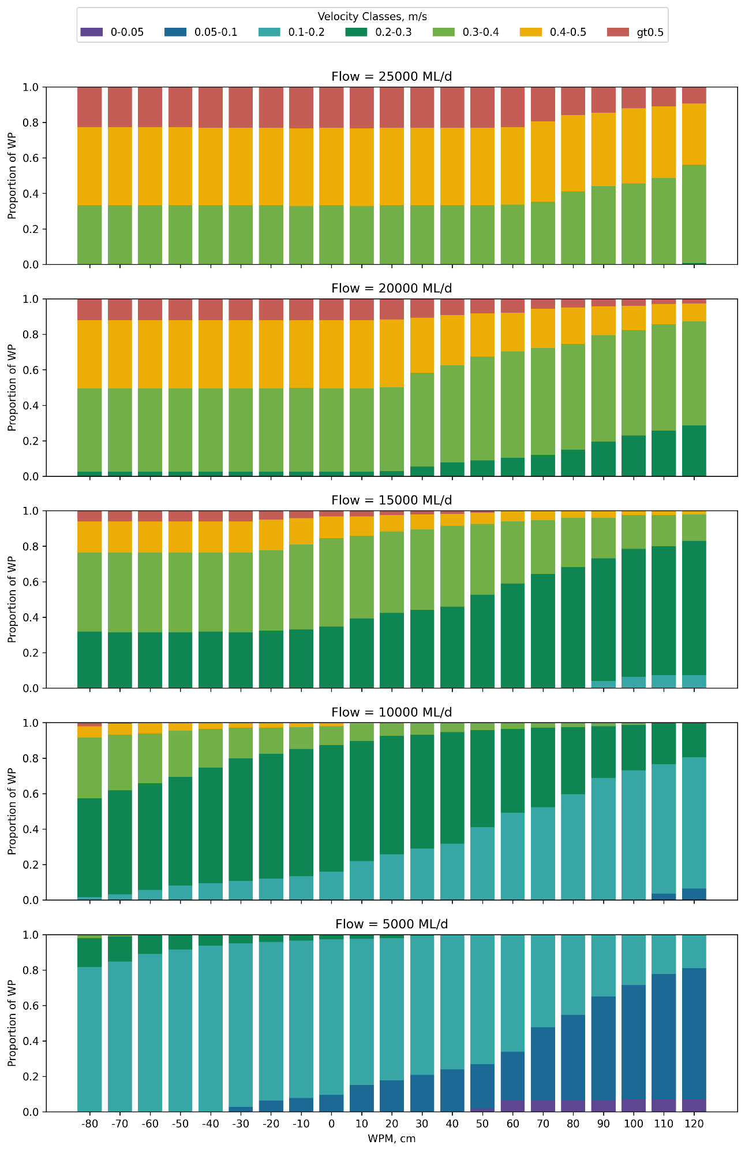
Figure 50. Proportion of Weir Pool 8 that falls within various velocity increments, across different flows and weir pool levels.
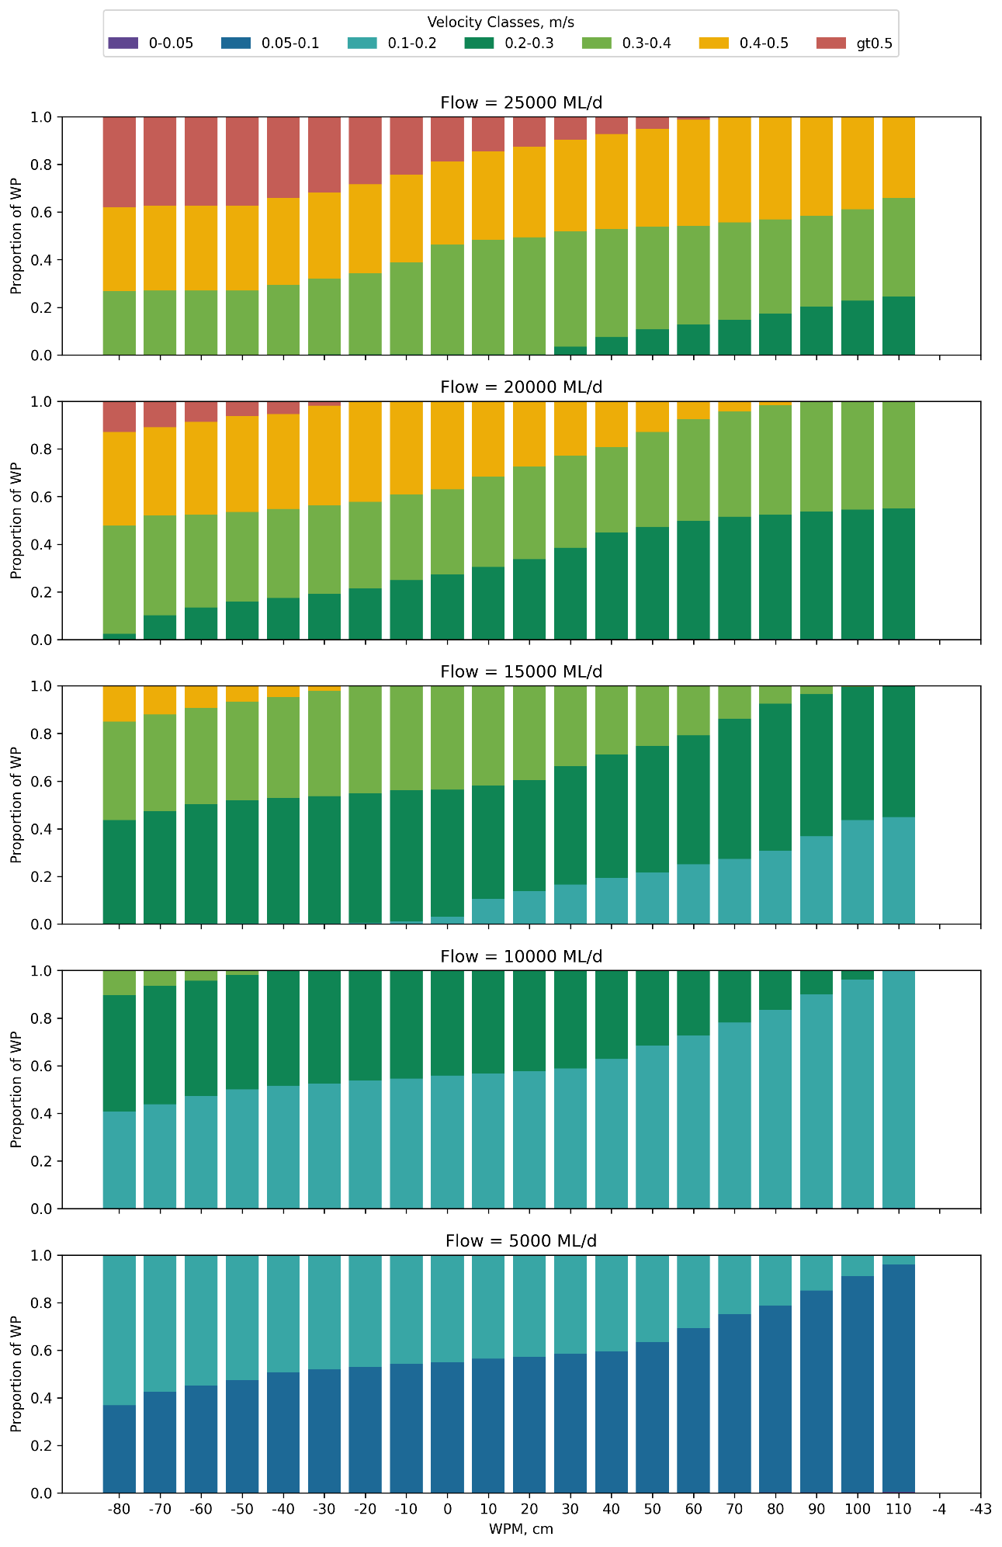
Figure 51. Proportion of Weir Pool 9 that falls within various velocity increments, across different flows and weir pool levels.
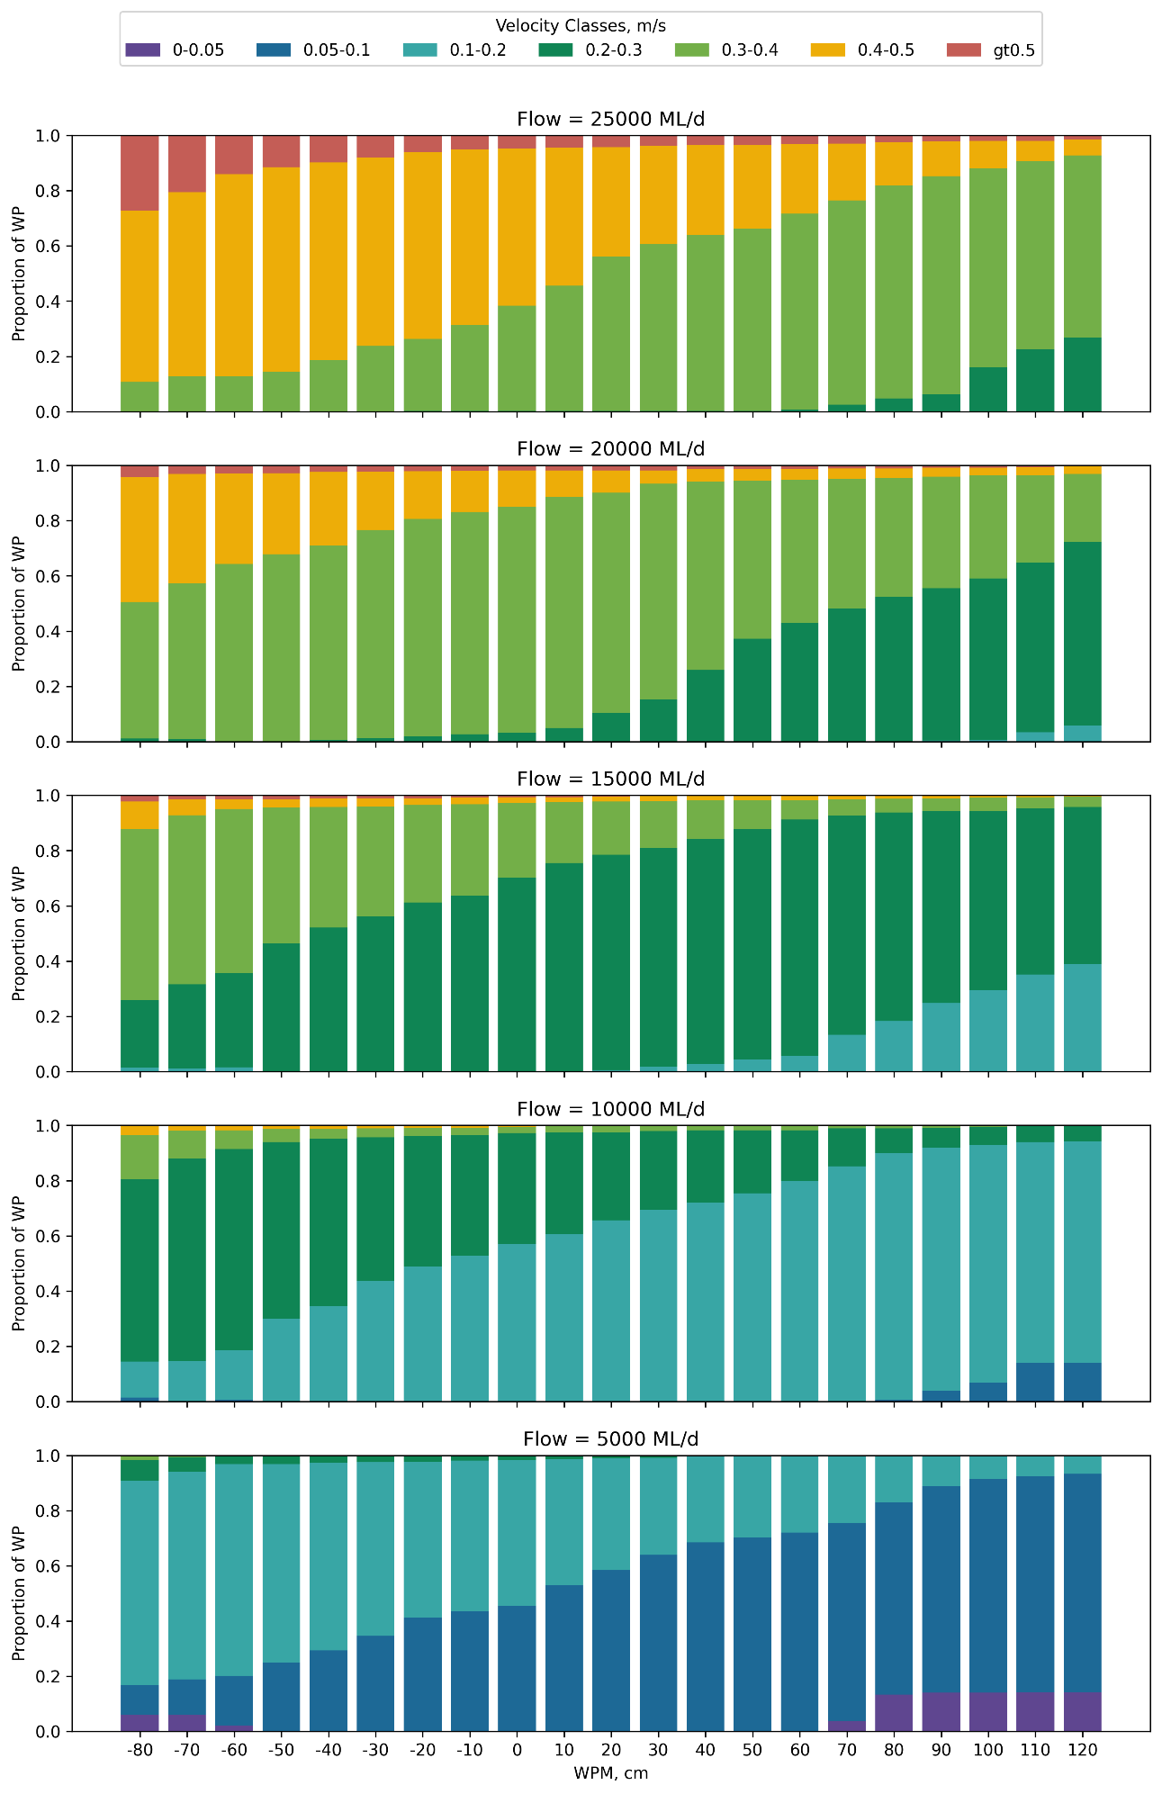
- Knowledge Exchange, Communication and Engagement
  - Overview
The Flow-MER Program plays a critical role in improving understanding of the relationships between environmental water flows and ecological outcomes across the MDB. Effective knowledge exchange, communication and engagement (KECE) are essential to maximising the impact of the Program. The KECE approach and activities for the Lower Murray and CLLMM Area is guided by a KECE Plan developed for the Area (MER Plan, Ye et al. 2024a), which builds on past activities and relationship established during Flow-MER 1.0 in the Lower Murray Selected Area (2019-2024). The approach in the Lower Murray and CLLMM Area seeks to achieve the overall aim and objectives of the Program (Knowledge Exchange Strategy, DCCEEW 2024):
Aim
- Improve understanding, decision-making and environmental and cultural outcomes through a knowledge generation and sharing network based on trust, collaboration, and long-term relationships.
Objectives
- Adaptative management:
  - Make Flow-MER Knowledge relevant and available to CEWH and other environmental water managers to support their decision-making.
  - Increase recognition of the Flow-MER Program with the broader scientific and management communities.
- Local awareness:
- Make Flow-MER knowledge available, accessible and relevant to local communities.
- Involve local communities to improve Flow-MER activities, facilitate ownership and empower champions.
- Basin-wide understanding and transparency:
  - Communicate Flow-MER Knowledge to the broader community to build support for environmental water.
  - Communicate Commonwealth environmental water outcomes to support legislative reporting.
- Internal collaboration and coordination:
  - Support project delivery through fostering internal collaborative relationships and strong networks.
This section outlines the KECE approach and activities that were undertaken during 2024-25, in the Lower Murray and CLLMM Area. It describes how Flow-MER findings were shared, collaboration was strengthened, and awareness raised among key stakeholders. This included Flow-MER practitioners, water and natural resource managers, the broader scientific community, First Nations people, recreational fishing groups, and local and broader communities within the Lower Murray and CLLMM Area. Reflections are also provided regarding opportunities for improvement and future collaboration and activities.
  - Activities undertaken in 2024-25
A summary of the KECE activities undertaken in 2024-25, including the specific objectives and key outcomes, are provided in Table 36 and Table 37. Project governance, coordination and communication activities (Table 36), consisting of formal meetings, workshops and quarterly project update publications (snapshots), were undertaken to ensure good internal communication with the CEWH, Lower Murray and CLLMM Project team, Area Working Group, and Basin-scale, Knowledge Exchange and other Area-scale teams.
Additional communication activities were undertaken to target key stakeholders (First Nations communities, recreational fishers and the broader community) to improve engagement. These activities involved the production of communication materials, mostly in the form of online content such as website, media releases and social media. In-person engagement activities included attending a major conference to promote Flow-MER work (i.e. the 11th Australian Stream Management Conference in Victor Harbour), participating in meetings/workshops and undertaking collaborative projects with First Nations people. More details on a major engagement activity with NAC and RMMAC Elders and rangers undertaken in 2024-25 (Pondi monitoring) is provided in the ‘Cultural Outcomes’ section (Section 9) and the Appendix (Section 15.7).
  - Opportunities for improvement, future collaboration and activities undertaken in 2024-25
The Area team has placed a strong emphasis on communication, knowledge exchange and collaboration throughout the first year of Flow-MER 2.0. While this approach has produced effective outcomes, the team is committed to continuous improvement.
A reflective approach on KECE: What we did well?
Consistent and regular meetings with our project partners have allowed the timely flow of information in both directions. This has provided all parties with clarity and updates on project progress and provided consistent and responsive problem solving. In particular, the following have assisted program coordination:
- Area Working Group meetings: These have been particularly constructive as they have supported responsive management to water delivery.
- Monthly Project Meetings: Frequent meetings with our CEWH project managers have been constructive and have allowed regular updates and steering program delivery.
- First Nations collaboration: Significant staff time has been dedicated to meeting with our Cultural Advisors and First Nations partners both from RMMAC and NAC. Many meetings have been in person and in regional areas. This approach has been very successful, fostering trust and mutual respect with key community leaders.
- Quarterly Snapshot: While maintaining the two-page format was sometimes challenging, it encouraged us to be more selective with content each quarter, ensuring the snapshots were impactful, relevant and effective in communicating key information. Snapshots were generally delivered on time, with accessible content for the public about recent activities and field observations.
- Social and other media: The Area team has done well to leverage support from PIRSA-SARDI media group in highlighting several activities in 2024-25. Most notably, social media posts about Pondi Monitoring. Additional input was provided to InDaily for an article about the Pondi Monitoring project (Cameron 2025).
A reflective approach on KECE, opportunities: Where could we improve?
Media and communication opportunities: While the Area team has generally done well covering our activities, there is always opportunity to increase exposure of information and key outcomes to the public. Action: Be proactive and engage media with sufficient lead-in time to cover events. This might include PIRSA Communications, CEWH-KECE support and local media outlets in the area. Media and story content may be delivered in many forms and may include Flow-MER Program, CEWH and PIRSA socials and other social media updates, Flow-MER and SARDI website contents, Flow-MER webinars, print media or local radio.
First Nations engagement: The excellent relationships already established with our Cultural Advisors and First Nations partners, represented by the RMMAC and NAC, have produced meaningful and impactful involvement in Flow-MER. While strong engagement has been achieved with First Nations groups in South Australia, there are opportunities to expand involvement with First Nations people in the upper reaches of the Lower Murray to reflect the extended Area in Flow-MER. The focus will be primarily with the First Nations groups represented by the First People of the Millewa-Mallee Aboriginal Corporation (FPMMAC) and Barkandji Native Title Group Aboriginal Corporation (BNTGAC). For all engagement activities and data collections, we will continue to follow principles of FPIC and ICIP, and adhered to Indigenous Data Sovereignty. Action: Renew attempts to contact key staff of FPMMAC and BNTGAC to explore future opportunities to work together. With the Flow-MER2.0 littoral vegetation monitoring in Weir Pools 7, 8 and 9, and additional monitoring in anabranches and wetlands funded by Mallee Catchment Management Authority in 2025-26, this provides an opportunity for engaging and collaboration with FPMMAC.

Table 36. Knowledge Exchange, Communication and Engagement activities undertaken for project governance, coordination and communication during 2024-25.
Activity | Objective | Groups | Goal | Action | Outcomes
Project meetings – CEWH and Flow-MER Area Provider | Facilitate communication, knowledge exchange, address needs/concerns | CEWH, Flow-MER Area Provider | Ensure timely information flow | 9 meetings attended x 2–4 staff plus CEWH managers | Regular project meetings allowing feedback and up-to-date info exchange to support project management and delivery.
Area-scale Project Team/Working Group meetings | Information, knowledge exchange, share project progress, early findings, inform adaptive management | Area Working Group Members | Enhance internal collaboration and among stakeholders | 4 meetings hosted x multiple staff/members attended | Good information and knowledge exchange with strong collaboration to ensure successful project implementation and the support to adaptive management (noting the Area Working Group included key water delivery partners in this Area: CEWH, MDBA, DEW, MRLB, NSW DCCEEW and Mallee CMA).
Flow-MER Steering Committee meetings | Project direction, collaboration, consistency | CEWH, Flow-MER Providers – Knowledge Exchange, Basin-scale & Area Leaders | Align efforts across Program | 2 meetings attended x 1 staff | Ensured project direction, collaboration, consistency with potential issues/risks identified early. Best practices shared across the Flow-MER Program.
Thematic Working Group meetings | Theme-specific approach, methods, guidance, cross-project knowledge sharing | Basin-scale thematic Leads, Area-scale theme leads | Ensure consistent monitoring/evaluation | 2 River Flows and Connectivity meetings attended x 1 staff  3 Native Fish meetings attended x 2–3 staff  1 Cultural Outcomes meeting x 1 staff  1 Native Vegetation meeting x 1 staff  3 Waterbird meetings attended x 1–2 staff | The theme MER implemented successfully, collaboration promoted, potential issues/risks/opportunities identified early.
Data Management Working Group meetings | Project direction, collaboration, consistency | CEWH, Flow-MER Providers – Data management leads within Basin-scale & Area-scale | Align efforts across projects | 1 meeting attended x 1 staff | Good communication to resolve issues for data management. Ensuring quality and timely data loading to meet the project requirements.
Cultural Network meetings | Address Cultural Outcomes | Knowledge Exchange Provider (Lead), CEWH, MER Providers Area First Nations Engagement Coordinator and Cultural Advisors | Effective knowledge sharing, engagement, ensure cultural outcomes evaluation | 4 meetings attended x 1–4 staff , including 1 x Cultural Network In-Person meeting attended by Cultural Advisor – Mildura, 30 April and 1 May 2025 | Cultural knowledge and information shared, relationships with First Nations built and strengthened, and collaboration improved. Supported the provision of safe space for cultural advisors to come together and share activities in their areas.
Knowledge Exchange Working Group meetings | Address KE Outcomes | Knowledge Exchange, Basin-scale,Area-scale, and CEWH KE leads | Effective knowledge sharing, engagement | 2 meetings attended x 2 staff | Cross-project knowledge sharing and collaboration, has resulted in more consistent program messaging.
Flow-MER Annual Forum | Major knowledge exchange event | Knowledge Exchange, Basin & Area Providers, CEWH, Cultural Advisors | Showcase project outcomes, foster collaboration | 1 forum attended x 6 staff  –Canberra, 27 and 28 August 2024  Presentations:  Qifeng Ye – Monitoring ecological responses over a decade: What have we learned from environmental water delivery in the Lower Murray River? | Knowledge exchange and networking between Flow-MER practitioners and relationships built across Program
Maintaining project pictures and images | High-quality visual communication materials | SARDI, Area team | Enhance communication, reporting | Ongoing | Maintaining a gallery of high-quality visual communication materials  >1,000 still pictures and videos in SARDI storage
Quarterly snapshot | Provide quarterly updates and highlights of the project | KECE Coordinator, Area team | Ensure timely communication | 4 x Quarterly snapshots published | CEWH has been regularly informed about environmental watering outcomes in a timely manner.

Table 37. Knowledge Exchange, Communication and Engagement additional activities undertaken during 2024-25.
Activity | Objective | Groups | Goal | Action | Outcomes
Media releases | Disseminate project information to a wider audience | Media outlets, public | Raise awareness of project goals, outcomes | 1x Indaily article – Pondi monitoring  https://www.indailysa.com.au/news/in-depth/2025/09/18/collaboration-supports-the-flow-of-culture-and-knowledge | Raising awareness, project information and outcomes disseminated to wider audience
Fact sheets and brochures | Provide accessible information about the project | Stakeholders, public | Clearly communicate project aims, methods, results | Produced a major poster for the 11th Australian Stream Management Conference (ASMC) held in Victor Harbour (11-14 August 2024).  - Monitoring ecological response to CEW in the Lower Murray River | Flow-MER Program was promoted with outcomes disseminated to broader audience.  The poster we presented at the 11th ASMC attracted considerable interest and engagement, and was recognised with the Best Conference Poster award.
Social media engagement | Share updates, engage with audiences | Social media platforms, public | Increase project visibility, foster online interaction | 3x PIRSA social media articles – Pondi monitoring  https://www.facebook.com/share/v/1CgVyQ5yX4/  https://www.facebook.com/share/p/1BGk7mNkZV/  https://www.facebook.com/share/p/1GPpKA74rc/ | The social media posts generated moderate online engagement, and received positive responses from viewers, including reactions, comments and re-shares to external pages such as CEWH, Ultimate Irrigation – Barmera, Loxton Irrigation Centre, South Australian Recreational Fishers and the Whyalla Fishing Page. These shares helped extend the reach of the posts to audiences beyond the PIRSA profile. The Pondi Facebook video generated particularly strong engagement, receiving over 3,000 views, 24 positive reactions, and several comments and re-shares.
Flow-MER website | Provide/maintain central information hub | Project stakeholders, public | Easy access to project information, resources | Worked with Knowledge Exchange Provider and CEWH to update content for the refreshed Flow-MER website | Audiences use and promote website as a central location for sharing Flow-MER knowledge. High satisfaction among website users (e.g. accessing information, finding contacts).  Website Analytics:  Lower Murray Pages (combined)  Page views – 2,427  Users – 1,848  Videos (combined)  Impressions – 5,525  Views-113
Knowledge exchange community engagement | Gather valuable insights from the community.  Foster stewardship and collaboration.  Communicate project outcomes. | Project Leader, scientists, managers, industry leads, community members with a diverse attendees. | Promote knowledge sharing and collaboration events.  Disseminate project information. | Project Leader attended the 11th ASMC in Victor Harbour (11-14 August 2024). A poster was presented to promote Flow-MER Program:  - Monitoring ecological response to CEW in the Lower Murray River | Raising awareness, project information and outcomes disseminated to wider audience.  The poster we presented at the 11th ASMC attracted considerable interest and engagement, and was recognised with the Best Conference Poster award.
First Nations people Flow-MER Activities | Ensure meaningful First Nations engagement and participation in Flow-MER activities | Cultural Advisors, NAC/Raukkan and RMMAC rangers, Project Team | Address cultural values and aspirations | Numerous meetings and discussion with Cultural Advisors and CEWH managers to develop Pondi monitoring project  3 staff met with NAC and  2 staff met with RMMAC to co-design and plan for Pondi Monitoring  6 First Nations rangers and 2 researchers worked collaboratively from 24–28 February 2025 to conduct Pondi monitoring (Section 15.7, Appendix). | First Nations initiated Pondi monitoring that involved co-designed and collaborative activities to strengthen relationships, knowledge exchange and meaningful outcomes. The key outcomes of the Pondi Monitoring activity, in relation to the governing principles from the Interim First Nations Peoples MER Strategy (DCCEEW 2024b), are discussed in Section 15.7 of the Appendix.
Cultural knowledge exchange in the Area | Foster understanding, knowledge sharing, relationship building with First Nations People | Cultural Advisors, First Nations elders and communities, Project Team | Cultural knowledge sharing and integration into project | Pondi Electrofishing Demonstration Event with 50 elders and community members at Loxton on 26 February 2025.  A yarning circle held with elders and rangers on 26 February 2025. | Cultural knowledge and information shared, relationships with First Nations built and strengthened, and collaboration improved.

- References
Anderson MJ, Gorley RN and Clarke KR (2008) PERMANOVA+ for PRIMER: Guide to software and statistical methods. PRIMER-E, Plymouth, UK.
Asha S and Yamagata K (2024) Lock 6-Lock 7 model calibration, Technical Notes. DHI Water & Environment Pty Ltd.
Bailey P, Boon P and Morris K (2002) Salt sensitivity database. Land and Water Australia.
Balcombe SR, Lobegeiger JS, Marshall SM, Marshall JC, Ly D and Jones DN (2012) Fish body condition and recruitment success reflect antecedent flows in an Australian dryland river, Fisheries Science, 78: 841-847. Doi:10.1007/s12562-012-0519-z.
Baumgartner L, Zampatti B, Jones M, Stuart I and Mallen-Cooper M (2014) Fish passage in the Murray-Darling Basin, Australia: Not just an upstream battle, Ecological Management and Restoration, 15 (SUPPL1): 28–39. Doi: 10.1111/emr.12093.
Benjamini Y and Yekutieli D (2001) The control of the false discovery rate in multiple testing under dependency, Annals of Statistics, 29: 1165–1188. Doi: 10.1214/aos/1013699998.
Bice CM, Butler GL, Fanson B, Harding D, Hodges K, Koster W, Thiem JD, Woods R and Zampatti BP (2021) Hydrology and movement of adult golden perch (Macquaria ambigua) in the Murray and Darling rivers determined by acoustic telemetry. South Australian Research and Development Institute (Aquatic Sciences), Adelaide. SARDI Publication No. F2021/000076-1. SARDI Research Report Series No. 1104.
Bice CM, Wedderburn SD, Hammer MP, Ye Q and Zampatti BP (2018) Fishes of the Lower Lakes and Coorong: A Summary of Life-History, Population Dynamics and Management. In: Natural History of The Coorong, Lower Lakes, and Murray Mouth Region (Yarluwar-Ruwe), Mosley L, Ye Q, Shepherd S, Hemming S and Fitzpatrick R (eds.). Royal Society of South Australia, University of Adelaide Press, Adelaide. 371–399.
Bice CM, Zampatti BP and Fredberg J (2024) Condition monitoring of fish movement and recruitment at the Murray Barrages 2022/23, South Australian Research and Development Institute (Aquatic and Livestock Sciences), Adelaide, SARDI Publication No. F2011/000186-13, SARDI Research Report Series No. 1207.
Bice CM, Schmarr DW, Zampatti B and Fredberg J (2020) Fish assemblage structure, movement and recruitment in the Coorong and Lower Lakes in 2019/20, South Australian Research and Development Institute (Aquatic Sciences), Adelaide, SARDI Publication No. F2011/000186-10, SARDI Research Report Series No. 1081.
Bice CM, Zampatti BP, Jennings PR and Wilson P (2012) Fish assemblage structure, movement and recruitment in the Coorong and Lower Lakes in 2011/12, South Australian Research and Development Institute (Aquatic Sciences), Adelaide, SARDI Publication No. F2011/000186-3, SARDI Research Report Series No. 680.
Bice CM, Gibbs MS, Kilsby NN, Mallen-Cooper M and Zampatti BP (2017) Putting the “river” back into the Lower River Murray: Quantifying the hydraulic impact of river regulation to guide ecological restoration. Transactions of the Royal Society of South Australia, 141(2): 108–131. Doi:10.1080/03721426.2017.1374909.
Biggs BJF, Nikora VI and Snelder TH (2005) Linking scales of flow variability to lotic ecosystem structure and function, Regulated Rivers: Research & Management, 21: 283–298. Doi: 10.1002/rra.847.
Blanch SJ, Walker KF and Ganf GG (2000) Water regimes and littoral plants in four weir pools of the River Murray, Australia. Regul. Rivers: Res. Mgmt., 16: 445-456. Doi: 10.1002/1099-1646(200009/10)16:5<445::AID-RRR596>3.0.CO;2-L.
Brandle R, Hammer M, Wedderburn S, Seaman R, Noye R and Queale L (2002) A biological survey of the Murray Mouth Reserves, South Australia March 2002. Department for Environment and Heritage, Adelaide.
Brock MA (1981) The ecology of halophytes in the south-east of South Australia. Hydrobiologia, 81: 23–32.
Brookes JD, Lamontagne S, Aldridge KT, Benger S, Bissett A, Bucater L, Cheshire A, Cook PLM, Deegan BM, Dittmann S, Fairweather PG, Fernandes MB, Ford PW, Geddes MC, Gillanders BM, Grigg NJ, Haese RR, Krull E, Langley RA, Lester RF, Loo M, Munro AR, Noell CJ, Nayar S, Paton DC, Revill AT, Rogers DJ, Rolston AN, Sharma SK, Short DA, Tanner JE, Webster IT, Wellmann NR and Ye Q (2009) An Ecosystem Assessment Framework to Guide Management of the Coorong. Final Report of the CLLAMMecology Research Cluster. CSIRO: Water for a Healthy Country National Research Flagship, Canberra.
Brookes JD, Huang P, Thai SY, Gibbs MS, Ye Q, Aldridge KT, Busch B and Hipsey M (2022) Environmental Flows to estuaries and coastal lagoons shape the salinity gradient and generate suitable fish habitat: Predictions for the Coorong Australia, Frontiers in Environmental Science, 10:20. Doi.org/10.3389/fenvs.2022.796623.
Brooks S, King A, Pollino C, Thompson R, Bino G, Bond N, Carver J, Cuddy S, Downey-Bechelet M, Dyer F, Flett D, Frost L, Giatas G, Hall A, McCasker N, Mika S, Nolan M, Short D, Tschierschke A, Wealands S, Webb A and Wignell E (2023) Flow-MER Data Management Strategy, CSIRO in partnership with the Flow-MER Data Working Group, for Department of Climate Change, Energy, the Environment and Water, Canberra, 2024.
Brown P and Wooden I (2007) Age at first increment formation and validation of daily growth increments in golden perch (Macquaria ambigua: Percichthyidae) otoliths. New Zealand Journal of Marine and Freshwater Research, 47:157–161.
Butler F, Palmer G, Bloink C, Ewing A, Halliday B, Walker G, Lewis S, McPhan L (2024) The Living Murray Condition Monitoring: LMW 2023-24, Part A, report to Mallee Catchment Management Authority, Ecology Australia Pty. Ltd., Thomastown, Victoria.
Cameron L (18 September 2025) ‘Collaboration supports the flow of culture and knowledge’ Indaily, accessed 16 February 2026. https://www.indailysa.com.au/news/in-depth/2025/09/18/collaboration-supports-the-flow-of-culture-and-knowledge.
Chilton D, Hamilton DP, Nagelkerken I, Cook P, Hipsey MR, Reid R, Sheaves M, Waltham NJ and Brookes JD (2021) Environmental Flow requirements of estuaries: providing resilience to current and future climate change and direct anthropogenic changes. Frontiers in Environmental Science, 9: 764218. Doi: 10.3389/fenvs.2021.764218.
Chow VT, Maidment DR and Mays LW (1988) Applied Hydrology. McGraw Hill International Editions, Singapore.
Clarke KR and Gorley RN (2015) PRIMER Version 7.0.12: User Manual/Tutorial, PRIMER-E, Plymouth.
Collier C, van Dijk KJ, Erftemeijer P, Foster N, Hipsey M, O'Loughlin E, Ticli K and Waycott M (2017) Optimising Coorong Ruppia habitat: Strategies to improve habitat conditions for Ruppia tuberosa in the Coorong (South Australia) based on literature review, manipulative experiments and predictive modelling, In: Waycott M (eds.), Reports to Department of Environment and Natural Resources (DEWNR), The University of Adelaide, School of Biological Sciences, Adelaide, South Australia, p. 169 pp.
Commonwealth Environmental Water Office (2013) Commonwealth Environmental Water - Monitoring, Evaluation, Reporting and Improvement Framework, Version2.0, Commonwealth Environmental Water.
Commonwealth of Australia (2023) Commonwealth Environmental Water Holder Water Management Plan 2023–24: Murray River Valley Water Plan, Canberra.
Davis TLO (1977) Reproductive biology of the freshwater catfish, Tandanus tandanus Mitchell, in the Gwydir River, Australia. II. Gonadal cycle and fecundity. Australian Journal of Marine and Freshwater Research, 28(2): 159–169. Doi: 10.1071/MF9770139.
DCCEEW (2023) Flow-MER2.0: Program Framework, Department of Climate Change, Energy, the Environment and Water, Canberra.
DCCEEW (2024a) Knowledge Exchange Strategy, Flow-MER Program, Department of Climate Change, Energy, the Environment and Water, Canberra.
DCCEEW (2024b) Interim First Nations People MER Strategy, Flow-MER Program, Department of Climate Change, Energy, the Environment and Water, Canberra.
DEW (2020) Long-term environmental watering plan for the South Australian River Murray water resource plan area, Department for Environment and Water Government of South Australia, Adelaide.
DEW (2023) 2023-24 Water for the Environment Annual Plan For the South Australian River Murray, South Australian Department for Environment and Water, Government of South Australia
DEW (2025) South Australian River Murray Water for the Environment Report 2023-24, Department for Environment and Water, Government of South Australia.
DEW (2026) South Australian River Murray Water for the Environment Report 2024-25, Department for Environment and Water, Government of South Australia.
DHI (2014) Lower Murray Hydrodynamic Model: Model Development and Calibration Report.
Environmental Watering Unit (2025). Long-Term Environmental Watering Plan for the South Australian River Murray Water Resource Plan Area, DEW Technical report 2025-2, Government of South Australia, Department for Environment and Water, Adelaide.
Fairweather PG, Whitmarsh SK and Hall SG (2013) Habitat assessment monitoring of revegetated areas in the Lower Lakes: a pilot study in autumn 2013, School of Biological Sciences, Flinders University, Adelaide.
Fanson B (2024) Technical supplement to Basin-scale evaluation of 2022–23 Commonwealth environmental water: Fish. Flow-MER Program, Commonwealth Environmental Water Holder (CEWH): Monitoring, Evaluation and Research Program, Department of Climate Change, Energy, Environment and Water, Australia, Canberra, 84pp.
Fredberg J and Bice CM (2025a) Katarapko Fish Assemblage Condition Monitoring 2025, South Australian Research and Development Institute (Aquatic and Livestock Sciences), Adelaide, SARDI Publication No. F2021/000517-5, SARDI Research Report Series No. 1260, 47pp.
Fredberg J. and Bice CM (2025b) Pike Fish Assemblage Condition Monitoring 2025, South Australian Research and Development Institute (Aquatic and Livestock Sciences), Adelaide, SARDI Publication No. F2021/000433-5, SARDI Research Report Series No. 1259. 49pp.
Fredberg J, Bice CM and Zampatti BP (2026) Chowilla Icon Site Fish Assemblage Condition Monitoring 2025, South Australian Research and Development Institute (Aquatic and Livestock Sciences), Adelaide. SARDI Publication No. F2008/000907-16. SARDI Research Report Series No. 1283. 67pp.
Geddes MC (1987) Changes in salinity and in the distribution of macrophytes, macrobenthos and fish in the Coorong Lagoons, South Australia, following a period of River Murray flow, Transactions of the Royal Society of South Australia, 111: 173–181.
Geddes MC and Butler AJ (1984) Physiochemical and biological studies on the Coorong Lagoons, South Australia, and the effect of salinity on the distribution of the macrobenthos, Transactions of the Royal Society of South Australia, 108: 51–62.
Gervais CR, Bice CM, Strawbridge A, Zampatti BP and Fredberg J (2025) Condition monitoring of fish movement and recruitment at the Murray Barrages 2024/25, South Australian Research and Development Institute (Aquatic and Livestock Sciences), Adelaide. SARDI Publication No. F2011/000186-15. SARDI Research Report Series No. 1275. 55pp.
Giatas G, Catalano S, Dittmann S, Ye Q, Jackson M, Mott R and Markos K (2022) Primary food resources for key waterbirds and benthic fish in the Coorong, Goyder Institute for Water Research Technical Report Series No. 22/02, Goyder Institute for Water Research.
Gibbs M, Bice C, Furst D, Gao L, Joehnk K, McCullough D, Montazeri M, Nicol J, Smart J, Wallace T, Zampatti B and Brookes J (2023) Using hydraulics to evaluate ecological benefits, risks, and trade-offs from engineered flooding, Hydrological Processes, 37(11): e15024. Doi: 10.1002/hyp.15024.
Hale J, Stoffels R, Butcher R, Shackleton M, Brooks S and Gawne B (2014) Commonwealth Environmental Water Office Long Term Intervention Monitoring Project – Standard Methods, Final Report prepared for the Commonwealth Environmental Water Office by The Murray-Darling Freshwater Research Centre , Murray-Darling Freshwater Research Centre, 175pp.
Herczeg AL, Dogramaci SS and Leaney FWJ (2001) Origin of dissolved salts in a large, semi-arid groundwater system: Murray Basin, Australia, Marine and Freshwater Research 52(1): 41–52. Doi: 10.1071/MF00040.
Hipsey MR, Huang P, Zhai S, Busch B, Paraska D and Sims C (2022) The Coorong Dynamics Model (CDM): Model Description and performance assessment. Doi: 10.5281/zenodo.7778773
Hladyz S, Bice C, Bond N, Broadhurst B, Butler G, Fanson B, Giatas G, Harding D, Hodges K, Kennard M, Koster W, Lyon J, McCasker N, O’Brien G, Stocks J, Suthers I, Thiem J, Tonkin Z, Ye Q, Yen J, Zampatti B. (2026) Basin-scale evaluation of 2024–25 Commonwealth environmental water: Fish. Flow-MER Program, Department of Climate Change, Energy, the Environment and Water, Canberra.
Hladyz S, Baumgartner L, Bice C, Broadhurst, B, Butler G, Fanson B, Giatas G, Koster W, Lyon J, McCasker N, Stocks, J, Stuart I, Thiem J, Tonkin Z, Ye Q, Yen J and Zampatti B (2025) Basin-scale evaluation of 2023–24 Commonwealth environmental water: Fish. Flow-MER Program. Commonwealth Environmental Water Holder, Department of Climate Change, Energy, the Environment and Water, Australia, 146pp.
Huang P, Mosley L, Brookes JD, Sims C, Waycott M, Paraska D, Zhai SY and Hipsey MR (2024) Hydrologic versus biogeochemical control of nutrient dynamics in a shallow hypersaline coastal lagoon: Insight from a coupled hydrodynamic‐water quality model. Journal of Geophysical Research: Biogeosciences, 129: e2023JG007497. Doi: 10.1029/2023JG007497.
Huang J, Welsh D, Erler D, Ferguson A, Brookes J, Keneally C, Chilton D, Dittmann S, Lam-Gordillo O, Southgate M, Simpson S and Mosley LM (2022) Coorong nutrient cycling and fluxes, Goyder Institute for Water Research Technical Report Series No. 22/07.
Humphries P, King A, McCasker N, Kopf RK, Stoffels R, Zampatti B and Price A (2020) Riverscape recruitment: a conceptual synthesis of drivers of fish recruitment in rivers, Canadian Journal of Fisheries and Aquatic Sciences, 77(2): 213-225. Doi: 10.1139/cjfas-2018-0138.
Koehn JD and Lintermans M (2012) A strategy to rehabilitate fishes of the Murray-Darling Basin, south-eastern Australia, Endangered Species Research, 16: 165–181. Doi: 10.3354/esr00398.
Koehn JD, Raymond SA, Stuart I, Todd CR, Balcombe SR, Zampatti BP, Bamford H, Ingram BA, Bice C, Burndred K, Butler G, Baumgartner L, Clunie P, Ellis I, Forbes J, Hutchison M, Koster W, Lintermans M, Lyon JP, Mallen-Cooper M, McLellan M, Pearce L, Ryall J, Sharpe C, Stoessel DJ, Thiem JD, Tonkin Z, Townsend A and Ye Q (2020) A compendium of ecological knowledge for restoration of freshwater fishes in the Murray– Darling Basin, Marine and Freshwater Research, 71: 1391–1463. Doi:10.1071/MF20127.
Kim DH, Aldridge KT, Brookes JD and Ganf G (2013) The effect of salinity on the germination of Ruppia tuberosa and Ruppia megacarpa and implications for the Coorong: A coastal lagoon of southern Australia, Aquatic Botany, 111: 81–88. Doi: 10.1016/j.aquabot.2013.06.008.
King AJ, Pollino C, Thompson R, Brooks S, Campbell C, Duncan P, Dyer F, Flett D, Hale J, McGinness H, McInerney P, Sengupta A, Thurgate N and Zampatti B (2023) Flow-MER Research Strategy, CSIRO in consortium with partners, for Department of Climate Change, Energy, the Environment and Water, Canberra.
Kingsford RT, Walker KF, Lester RE, Young WJ, Fairweather PG, Sammut J, and Geddes MC (2011) A Ramsar wetland in crisis – the Coorong, Lower Lakes and Murray Mouth, Australia. Marine and Freshwater Research, 62: 255–265. Doi: 10.1071/MF09315.
Lester RE and Fairweather PG (2009) Modelling future conditions in the degraded semi-arid estuary of Australia's largest river using ecosystem states, Estuarine, Coastal and Shelf Science, 85(1): 1-11. Doi: 10.1016/j.ecss.2009.04.018.
Lester RE and Fairweather PG (2010) Ecosystem response modelling of the Murray Mouth and Coorong Lagoons, In: Saintilan N and Overton I (eds.), Ecosystem Response Modelling in the Murray Darling Basin, CSIRO Publishing, Collingwood, Victoria. 373-390.
Lester RE, Fairweather PG, Webster IT and Quin RA (2013) Scenarios involving future climate and water extraction: ecosystem states in the estuary of Australia's largest river, Ecological Applications, 23: 984-998. Doi: 10.1890/12-1331.1.
Lintermans M and Phillips B (2005) Management of Murray Cod in the Murray-Darling Basin, Australia: Murray-Darling Basin Commission, Canberra. 64–69
Maheshwari BL, Walker KF and McMahon TA (1995) Effects of regulation on the flow regime of the River Murray, Australia, Regulated Rivers Research and Management, 10 (1):15–38. Doi: 10.1002/rrr.3450100103.
Mallen-Cooper M and Stuart IG (2003) Age, growth and non-flood recruitment of two potamodromous fishes in a large semi-arid/temperate river system, River Research and Applications, 19(7):697–719. Doi: 10.1002/rra.714.
Mallen-Cooper M and Zampatti BP (2018) History, hydrology and hydraulics: Rethinking the ecological management of large rivers, Ecohydrology, 11(5):e1965. Doi: 10.1002/eco.1965.
Mallett MC, Thiem JD, Butler GL, Carpenter-Bundhoo L and Kennard MJ (2025) Freshwater fish condition responses to hydrological disturbance are species- and scale dependent, Journal of Fish Biology, 107(2):493–510. Doi: 10.1111/jfb.70033.
McDowall RM (1988) Diadromy in Fishes - Migrations between Freshwater and Marine Environments, Croom Helm, London, UK.
McCullough DP (2025) SA River Murray flood inundation modelling from Wellington to Lock 7 – Updated modelling informed by the 2022–23 flood event, DEW Technical report DEW-TR-2025-13, Government of South Australia, Department for Environment and Water, Adelaide.
McInerney P, King A, Brandis K, Brooks S, Campbell C, Doody T, Duncan P, Dyer F, Flett D, Hladyz S, Lovett S, McGinness H, O’Sullivan J, Pollino C, Sengupta A, Thompson R, Thurgate N, Tonkin Z and Zampatti B (2024) Flow-MER Basin-scale Evaluation Approach, Commonwealth Environmental Water Holder’s Science Program: Monitoring, Evaluation and Research Program, DCCEEW, Australia.
McMahon TA, Finlayson B L, Haines AT and Srikanthan R (1992) Global Runoff: Continental Comparisons of Annual Flows and Peak Discharges, Catena Paperback, Cremlingen-Destedt.
McNeil DG, Westergaard S, Cheshire KJM, Noell CJ and Ye Q (2013) Effects of hypersaline conditions upon six estuarine fish species from the Coorong and Murray Mouth, South Australian Research and Development Institute (Aquatic Sciences), Adelaide, SARDI Publication No. F2009/000014-4, SARDI Research Report Series No. 700, 27pp.
Murray–Darling Basin Authority (2011) The proposed “environmentally sustainable level of take” for surface water of the Murray-Darling Basin: Methods and outcomes, MDBA Publication No. 226/11, Murray Darling Basin Authority, Canberra.
MDBA (2016) The impact of varying flows and weir levels on channel velocities, unpublished.
MDBA (2025a) Basin-wide environmental watering strategy, Murray‒Darling Basin Authority Canberra.
MDBA (2025b) River Murray Annual Operating Outlook, MDBA publication no: 18/25, Murray‒Darling Basin Authority, Canberra.
MDBC (2002). Lake Victoria Operating Strategy. MDBC Technical Report No. 2002/01. Murray–Darling Basin Council, Canberra.
Meckley TD, Wagner CM and Gurarie E (2014) Coastal movements of migrating sea lamprey (Petromyzon marinus) in response to partial pheromone added to river water: Implications for management of invasive populations. Canadian Journal of Fisheries and Aquatic Sciences, 71(5): 533–544. Doi: 10.1139/cjfas-2013-0453.
Moser ML, Almeida PR, Kemp PS and Sorenson PW (2015) Lamprey spawning migration. Lampreys: biology, conservation and control, In: Docker MF (eds.), Fish & Fisheries Series, Springer, 1: 215-263.
Mosley LM, Brookes J, Dittmann S, Huang L, Lam-Gordillo O, Priestley S, Simpson S, Welsh D and Waycott M (2022) A scientific evaluation to inform nutrient removal options for the Coorong, Goyder Institute for Water Research Technical Report Series No. 22/06.
Mosley L, Ye Q, Shepherd S, Hemming S and Fitzpatrick R (2018) Natural History of the Coorong. Lower Lakes and Murray Mouth Region (Yarluwar-Ruwe), In: Mosley L, Ye Q, Shepherd S, Hemming S and Fitzpatrick R (eds.), South Australia: University of Adelaide Press, Adelaide.
New South Wales Department of Planning, Industry and Environment (2020) Murray–Lower Darling Long Term Water Plan. Part A: Murray–Lower Darling catchment.
Nicol J and Ward R (2010a) Seed bank assessment of Dunn’s and Shadow’s Lagoons, South Australian Research and Development Institute (Aquatic Sciences), Adelaide, SARDI Publication Number F2010/000594-1, SARDI Research Report Series No. 472, 21pp.
Nicol J and Ward R (2010b) Seed bank assessment of Goolwa Channel, Lower Finniss River and Lower Currency Creek, South Australian Research and Development Institute (Aquatic Sciences), Adelaide, SARDI Publication No. F2010/000303-1, SARDI Research Report Series No. 489, 39pp.
Nicol JM (2016) An assessment of Ramsar criteria and Limits of Acceptable Change for aquatic and littoral vegetation in the Coorong and Lakes Alexandrina and Albert Ramsar Wetland, South Australian Research and Development Institute (Aquatic Sciences), Adelaide, SARDI Publication No. F2016/000262-1. SARDI Research Report Series No. 910, 63pp.
Nicol JM, Frahn KA, Gehrig SL, Marsland KB and Bucater L (2026) Lower Lakes Vegetation Condition Monitoring 2024-25, report to the Department for Environment and Water, South Australian Research and Development Institute (Aquatic and Livestock Sciences), Adelaide, SARDI Publication No. F2009/000370-16. SARDI Research Report Series No. 1273, 115pp.
Phillips W and Muller K (2006) Ecological character of the Coorong, Lakes Alexandrina and Albert Wetland of International Importance, report prepared by the South Australian Department for Environment and Heritage.
P.S.I (PIRSA Spatial Information Services) (2009) Erosion mapping of the shorelines of Lakes Alexandrina and Albert, Primary Industries and Resources South Australia (Spatial Information Services) and Goolwa to Wellington Local Action Planning Board Adelaide, 17pp.
Poff NL, Allan JD, Bain MB, Karr JR, Prestegaard KL, Richter BD, Sparks RE and Stromberg JC (1997) The natural flow regime: A paradigm for river conservation and restoration, BioScience 47: 769–784.
Renfrey APC, Rea N and Ganf GG (1989) The aquatic flora of Hindmarsh Island, South Australia, Department of Environment and Planning, Adelaide.
RMMAC (2025). River Murray and Mallee Aboriginal Corporation Rangers Report.
Robinson WA (2014) The Living Murray Condition Monitoring Plan Refinement Project: Summary Report, Technical Report to the MDBA, Murray-Darling Basin Authority, 95pp.
Rowland S (1998) Aspects of the reproductive biology of Murray cod, Maccullochella peelii peelii. In: Proceedings-Linnean Society of New South Wales 1998, Linnean Society of New South Wales, 120: 147–162.
Seaman RL (2003) Coorong and Lower Lakes Ramsar habitat mapping program, South Australian Department for Environment and Heritage, Adelaide, 100pp.
Serafini LG and Humphries P (2004) Preliminary guide to the identification of larvae of fish, with a bibliography of their studies, from the Murray-Darling basin, Identification and Ecology Guide No. 48, Murray-Darling Freshwater Research Centre, Albury and Monash University, Clayton.
Sim T and Muller K (2004) A fresh history of the lakes: Wellington to the Murray Mouth 1800s to 1935, River Murray Catchment Water Management Board, Strathalbyn, 70pp.
Southern Connected Basin Environmental Watering Committee (2021) River Murray Channel Five-Year Monitoring Plan 2021-22 to 2025-26, SCBEWC Monitoring sub-group, Canberra.
Statzner B and Higler B (1986) Stream hydraulics as a major determinant of benthic invertebrate zonation patterns. Freshwater Biology, 16:127–139.
Teng J, Ticehurst C, Bridgart R, Yang A, Marvanek S, Penton D, Austin J, Vaze J, Khanam F, Brennan E, Davis S, Townsend A, Price R and Miles M (2024) Two-monthly Maximum Flood Water Depth Spatial Timeseries for the Murray-Darling Basin Version 2024 v1, CSIRO. https://doi.org/10.25919/t3rv-zx73
Tonkin Z, Stuart I, Kitchingman A, Thiem JD, Zampatti B, Hackett G, Koster W, Koehn J, Morrongiello J, Mallen-Cooper M and Lyon J (2019) Hydrology and water temperature influence recruitment dynamics of the threatened silver perch Bidyanus bidyanus in a regulated lowland river, Marine and Freshwater Research 70:1333–1344.
Victorian Department of Environment, Land, Water and Planning (2021) Victorian Murray Long-term Watering Plan.
Water Technology (2019) MIKE FLOOD Model Conversion to Flexible Mesh – Lindsay, Wallpolla and Mulcra Islands, Report to Malley Catchment Management Authority.
Walker KF (2006) Serial weirs, cumulative effects: the Lower Murray River, Australia. In: Ecology of Desert Rivers, In: Kingsford R (eds.), Cambridge University Press, Cambridge, 248–279.
Walker KF and Thoms MC (1993) Environmental effects of flow regulation on the lower river Murray, Australia, Regul. Rivers: Res. Mgmt., 8: 103-19. Doi: 10.1002/rrr.3450080114.
Waycott M, Lewis R, O’Loughlin EJ, Urgl C, van Dijk KJ, Calladine A, Collier C, Mosley L, Priestley S, Leterme S, Conran JG, Thornhill A, Hipsey M and Nicol J (2022) Growth, phenology, nutrient responses and ecological limits of the Ruppia Community and associated filamentous algal blooms of the southern Coorong, Goyder Institute for Water Research Technical Report Series No. 23/01.
Webb JA, Guo D, Koster WM, Lauchlan-Arrowsmith C and Vietz GJ (2022) Can hydraulic measures of river conditions improve our ability to predict ecological responses to changing flows? Flow velocity and spawning of an iconic native Australian fish. Frontiers in Environmental Science, 10: 882495. Doi:10.3389/fenvs.2022.882495
Wedderburn S, Nicol J and Shiel R (2017) Assessing obligate habitat of threatened pygmy perches in Lake Alexandrina, The University of Adelaide and the Department of Environment, Water and Natural Resources, Adelaide, 15pp.
Wedderburn SD, Walker KF and Zampatti BP (2007) Habitat separation of Craterocephalus (Atherinidae) species and populations in off-channel areas of the lower River Murray, Australia, Ecology of Freshwater Fish, 16:442-449. Doi: 10.1111/j.1600-0633.2007.00243.x.
Ye Q and Zampatti B (2007) Murray cod stock status – the Lower River Murray, South Australia. Stock status report to PIRSA Fisheries, South Australian Research and Development Institute (Aquatic Sciences), Adelaide, SARDI Publication No. F2007-000211-1, SARDI Report Series No. 208.
Ye Q, Aldridge K, Bucater L, Bice C, Busch B, Cheshire KJM, Fleer D, Hipsey M, Leigh SJ, Livore JP, Nicol J, Wilson PJ and Zampatti BP (2015a) Monitoring of ecological responses to the delivery of Commonwealth environmental water in the lower River Murray, during 2011-12, final report prepared for Commonwealth Environmental Water Office, South Australian Research and Development Institute, Aquatic Sciences.
Ye Q, Beitzel S, Hart T, Miles N, Victorian Fisheries Authority, Giatas G, Lintermans M, Lyon J and Zampatti B (2024c) Murray Cod Maccullochella peelii, In: Status of key Australian fish stocks reports (2024) Roelofs A, Piddocke T, Ashby C, Conron S, Hartmann K, Hesp A, Hone P, Jacobsen I, Jesson-Kerr M, Mayfield S, Stewart J, Usher M, Woodhams J and Wright D (eds.), Fisheries Research and Development Corporation, Canberra.
Ye Q, Giatas GC, Aldridge KT, Benger SN, Bice CM, Brookes JD, Bucater LB, Cheshire KJM, Cummings CR, Doody TM, Fairweather PG, Frahn KA, Fredberg JF, Gehrig SL, Holland KL, Leigh SJ, Lester RE, Lorenz Z, Marsland KB, Nicol JM, Oliver RL, Overton IC, Pritchard JL, Strawbridge AD, Thwaites LA, Turnadge CJ, Wilson PJ and Zampatti BP (2014) Ecological responses to flooding in the lower River Murray following an extended drought: Synthesis report of the Murray Flood Ecology Project, South Australian Research and Development Institute (Aquatic Sciences), Adelaide. Goyder Institute for Water Research Technical Report Series No. 14/6.
Ye Q, Giatas G, Bice C, Brookes J, Furst D, Gibbs M, Nicol J, Oliver R, Zampatti B, Bucater L, Deane D, Frahn K, Hipsey M, Kok C, Huang P, Lorenz Z, Mills J, Shiel R and Zhai S (2024d) Commonwealth Environmental Water Office Monitoring, Evaluation and Research Project: Lower Murray 2022-23 Technical Report, report prepared for the Commonwealth Environmental Water Office by the South Australian Research and Development Institute, Aquatic Sciences.
Ye Q, Bucater L and Short D (2011) Coorong fish intervention monitoring during barrage releases in 2010/11, South Australian Research and Development Institute (Aquatic Sciences), Adelaide, SARDI Publication No. F2011/000309-1. SARDI Research Report Series No. 559.
Ye Q, Giatas G, Dittmann S, Baring R, Bucater L, Deane D, Furst D, Brookes J, Rogers D and Goldsworthy S (2020b) A synthesis of current knowledge of the food web and food resources for waterbird and fish populations in the Coorong, Goyder Institute for Water Research Technical Report Series No. 20/11.
Ye Q, Livore J, Aldridge K, Giatas G, Hipsey M, Joehnk K, Nicol J, Wilson P and Zampatti B (2016a) Monitoring ecological response to Commonwealth environmental water delivered to the Lower Murray River in 2013-14, final Report prepared for the Commonwealth Environmental Water Office, South Australian Research and Development Institute.
Ye Q, Bucater L, Zampatti B, Bice C, Wilson P, Suitor L, Wegener I, Short D and Fleer D (2015c) Population dynamics and status of freshwater catfish (Tandanus tandanus) in the lower River Murray, South Australia, South Australian Research and Development Institute (SARDI) Aquatic Sciences, Adelaide, SARDI Publication No. F2014/000903-1. SARDI Research Report Series No. 841.
Ye Q, Giatas G, Aldridge KT, Busch B, Gibbs M, Hipsey MR, Lorenz Z, Oliver R, Shiel RJ and Zampatti B (2016b) Long-term Intervention Monitoring for the Ecological Responses to Commonwealth Environmental Water Delivered to the Lower Murray River Selected Area in 2014/15, a report Prepared for the Commonwealth Environmental Water Office by the South Australian Research and Development Institute, Aquatic Sciences.
Ye Q, Giatas G, Brookes J, Furst D, Gibbs M, Oliver R, Shiel R, Zampatti B, Aldridge K, Bucater L, Busch B, Hipsey M, Lorenz Z, Maas R and Woodhead J (2020a) Commonwealth Environmental Water Office Long-Term Intervention Monitoring Project 2014–2019: Lower Murray River Technical Report, a report prepared for the Commonwealth Environmental Water Office by the South Australian Research and Development Institute, Aquatic Sciences.
Ye Q, Giatas G, Bice C, Brookes J, Gibbs M, Nicol J, Gervais C, Giles S, Hipsey M, Hoang V, Kartinyeri A, Kurucz K, Montazeri M, Sutcliffe M, Wallace C, Wilson W, Zampatti B and Zhai S (2026) Lower Murray and Coorong, Lower Lakes and Murray Mouth Summary Report 2024-2025, Flow-MER Program, Department of Climate Change, Energy, the Environment and Water, Canberra, 2026.
Ye Q, Giatas G, Bice C, Brookes J, Furst D, Gibbs M, Nicol J, Oliver R, Shiel R, Zampatti B, Bucater L, Deane D, Hipsey M, Huang P, Lorenz Z and Zhai S (2021) Commonwealth Environmental Water Office Monitoring, Evaluation and Research Project: Lower Murray 2019-20 Technical Report, a report prepared for the Commonwealth Environmental Water Office by the South Australian Research and Development Institute, Aquatic Sciences.
Ye Q, Giatas G, Bice C, Brookes J, Furst D, Gibbs M, Nicol J, Oliver R, Zampatti B, Bucater L, Deane D, Frahn K, Hipsey M, Huang P, Lorenz Z, Mills J, Shiel R and Zhai S (2025) Commonwealth Environmental Water Holder’s Flow Monitoring, Evaluation and Research Project 2019–2024: Lower Murray Technical Report, a report prepared for the Commonwealth Environmental Water Holder by the South Australian Research and Development Institute, Aquatic and Livestock Sciences.

Ye Q, Giatas G, Bice C, Brookes J, Furst D, Gibbs M, Nicol J, Oliver R, Zampatti B, Bucater L, Deane D, Frahn K, Hipsey M, Kok C, Huang P, Lorenz Z, Mills J, Shiel R and Zhai S (2023) Commonwealth Environmental Water Office Monitoring, Evaluation and Research Project: Lower Murray 2021-22 Technical Report, a report prepared for the Commonwealth Environmental Water Office by the South Australian Research and Development Institute, Aquatic Sciences.
Ye Q, Giatas G, Brookes J, Furst D, Gibbs M, Oliver R, Shiel R, Zampatti B, Aldridge K, Bucater L, Busch B, Hipsey M, Lorenz Z, Maas R and Woodhead J (2020) Commonwealth Environmental Water Office Long-Term Intervention Monitoring Project 2014–2019: Lower Murray River Technical Report, a report prepared for the Commonwealth Environmental Water Office by the South Australian Research and Development Institute, Aquatic Sciences.
Ye Q, Giatas G, Bucater L, Barker B, Bice C, Brookes J, Furst D, Gibbs M, Herbert T, Hipsey M, Huang P, Nicol J, O’Connor J, Oliver R, Rogers D, Rumbelow A, Sims C, Steggles T, Stokes A, Wallace T, Wedge K, Whittle J, Wilson W, Zampatti B and Zhai S (2024a) Lower Murray and Coorong, Lower Lakes and Murray Mouth Area Monitoring, Evaluation and Research Plan 2024–2029. Commonwealth Environmental Water Holder’s Science Program: Monitoring, Evaluation and Research Program, Department of Climate Change, Energy, the Environment and Water, Canberra.
Ye Q, Giatas G, Bucater L, Barker B, Bice C, Brookes J, Furst D, Gibbs M, Herbert T, Hipsey M, Huang P, Nicol J, O’Connor J, Oliver R, Rogers D, Rumbelow A, Sims C, Steggles T, Stokes A, Wallace T, Wedge K, Whittle J, Wilson W, Zampatti B and Zhai S (2024b) Lower Murray and Coorong, Lower Lakes and Murray Mouth Area Annual Implementation Plan 2024–2025. Commonwealth Environmental Water Holder’s Science Program: Monitoring, Evaluation and Research Program, Department of Climate Change, Energy, the Environment and Water, Canberra.
Ye Q, Livore JP, Aldridge K, Bradford T, Busch B, Earl J, Hipsey M, Hoffmann E, Joehnk K, Lorenz Z, Nicol J, Oliver R, Shiel R, Suitor L, Tan L, Turner R, Wegener I, Wilson PJ and Zampatti BP (2015b) Monitoring the ecological responses to Commonwealth environmental water delivered to the Lower Murray River in 2012-13, Report 3, prepared for Commonwealth Environmental Water Office, South Australian Research and Development Institute, Aquatic Sciences.
Ye Q, Livore J, Aldridge K, Giatas G, Hipsey M, Joehnk K, Nicol J, Wilson P and Zampatti B (2016) Monitoring the ecological response to Commonwealth environmental water delivered to the Lower Murray River in 2013-14, final Report prepared for the Commonwealth Environmental Water Office, South Australian Research and Development Institute.
Zampatti BP, Wilson PJ and Jennings PR (2010) Temporal variability in fish assemblage structure and recruitment in a freshwater-deprived estuary: The Coorong, Australia. Marine and Freshwater Research, 61: 1298–1312.
Zampatti BP and Leigh SJ (2013a) Effects of flooding on recruitment and abundance of Golden Perch (Macquaria ambigua ambigua) in the lower River Murray, Ecological Management and Restoration, 14: 135–143.
Zampatti BP and Leigh SJ (2013b) Within-channel flows promote spawning and recruitment of golden perch, Macquaria ambigua ambigua: implications for environmental flow management in the River Murray, Australia, Marine and Freshwater Research, 64: 618–630.
Zampatti BP, Bice CM, Wilson PJ and Ye Q (2014) Population dynamics of Murray cod (Maccullochella peelii) in the South Australian reaches of the River Murray: A synthesis of data from 2002–2013, South Australian Research and Development Institute (Aquatic Sciences), Adelaide, SARDI Publication No. F2014-000089-1, SARDI Research Report Series No. 761.
Zampatti B, Fanson B, Strawbridge A, Tonkin Z, Thiem J, Butler G, Balcombe S, Koster W, King A, Crook D, Woods S, Lyon J, Baumgartner L and Doyle K (2019) Basin-scale population dynamics of Golden Perch and Murray Cod: Relating flow to provenance, movement and recruitment in the Murray-Darling Basin, In: Murray-Darling Basin Environmental Water Knowledge and Research Project — Fish Theme Research Report, Price A, Balcombe S, Humphries P, King A and Zampatti B (eds.), Centre for Freshwater Ecology, La Trobe University, Wodonga, Victoria p. 42.
Zampatti BP, Leigh SJ, Bice CM and Rogers PJ (2018a) Multiscale movements of golden perch (Percichthyidae: Macquaria ambigua) in the River Murray, Australia. Austral Ecology 43: 763–774.
Zampatti BP, Leigh SJ, Wilson PJ, Crook DA, Gillanders BM, Maas R, Macdonald JI and Woodhead J (2021) Otolith chemistry delineates the influence of natal origin, dispersal and flow on the population dynamics of golden perch (Macquaria ambigua) in a regulated river. Marine and Freshwater Research, 72. Doi: 10.1071/MF20280.
Zampatti BP, Strawbridge A, Thiem J, Tonkin Z, Mass R, Woodhead J and Fredberg J (2018b) Golden perch (Macquaria ambigua) and silver perch (Bidyanus bidyanus) age demographics, natal origin and migration history in the River Murray, Australia, South Australian Research and Development Institute (Aquatic Sciences), Adelaide. SARDI Publication No. F2018/000116-1. SARDI Research Report Series No. 993.
Zhai S, Waycott M, Lewis R, O’Loughlin E, Erftemeijer PLA, Huang P, Brookes JD, Sims C, Zhang Z and Hipsey MR (2025) A life stage resolved habitat model for guiding seagrass restoration in coastal lagoons. Ecological indicators 170. Doi: 10.1016/j.ecolind.2025.113095.

- Appendices
  - Summary of key outcomes and recommendations
Table 15.1.1. Key evaluation questions (KEQ) and outcomes of Commonwealth environmental water (CEW) delivery in the Lower Murray and Coorong, Lower Lakes and Murray Mouth Area. Refer to the ‘Evaluation’ section in Sections 5–9 of the Annual Report (Ye et al. 2026) for an explanation of the evaluation approach, the observed outcomes under the flow regime and key outcomes of all environmental water (eWater, including other sources). LMR = Lower Murray River, SA = South Australian, YOY = young-of-year.
Theme | KEQ (Table.2a/2b ID) | Key outcomes (CEW contribution) | Recommendations/implications for future watering actions
River Flows and Connectivity | What was the longitudinal hydrological connectivity under the annual flow regime? What did eWater (and specifically CEW) contribute (modelled) to this outcome? (LM-RFC-HR-A1) | Without CEW the average length of river over the year with velocity > 0.2 m/s was 79 km (increase of 96%). | CEW can create large increases in longitudinal connectivity and hydraulic diversity in dry years, albeit from a low base.  Weir pool lowering (WPL) can also increase these in-channel processes. Operations of less than 0.25 m have limited influence on the velocity, being a relatively small proportion of the total water depth.
River Flows and Connectivity | What was the lateral hydrological connectivity (modelled) under the annual flow regime? What did eWater (and specifically CEW) contribute to this outcome? (LM-RFC-HR-A2) | Without CEW modelled area inundated for 40 days was 2,107 Ha (increase of 74%). | Along with the modelled increase in inundated area from the increase in river flow, pumping and regulator operations increased inundated area by an additional 2,616 Ha. Further work could investigate which ecological functions are supported through lateral connectivity created in this way, when direct connectivity with the river may be more limited.
River Flows and Connectivity | What was the hydraulic diversity (modelled) within weir pools under the annual flow regime? What did eWater (and specifically CEW) contribute to this outcome? (LM-RFC-HR-A3) | Without CEW the average length of river that exceeded 0.3 m/s over 60 days was 6 km (increase of 2,157%). | See LM-RFC-HR-A1 above.
River Flows and Connectivity | What was the variability in water levels (modelled) within weir pools under the annual flow regime? What did eWater (and specifically CEW) contribute to this outcome? (LM-RFC-HR-A4) | Without CEW eWater median water level variability in tailwaters was 0.131 m (increase of 61%). | Weir pool lowering at locks 7, 8 and 9 provided small, but observable increases in water level variability. Along with the delivery of eWater, exploring opportunities to increase the magnitude and frequency of these infrastructure operations will increase water level variability further.
River Flows and Connectivity | What was the salt transport (modelled) under the annual flow regime? What did eWater (and specifically CEW) contribute to this outcome: Out of the Basin (additional export through the barrages); salt import at the Murray Mouth; southward salt flux to the North Lagoon; southward salt flux to the South Lagoon? (LM-RFC-MT&CH-A1) | 81% (160,818 tonnes) | CEW plays a key role in salt export from the Basin to the Coorong and Southern Ocean during the dry years.  Maximum exports of matter from the Murray Mouth are likely to be achieved by delivering eWater during periods of low oceanic water levels (e.g. summer). In contrast, eWater delivery from the Murray River at times of high oceanic water levels, which peak in the Austral winter, is likely to increase the exchange of water and associated salt (and nutrients) through the Coorong, rather than predominately through the Murray Mouth. Targeted barrage discharges during high tide, swell and appropriate wind direction events are important to improve water quality in the Coorong and particularly in the South Lagoon. If fresher river water is discharged through southern barrages (i.e. Tauwitchere/Ewe Island), then the wind and tide can force this fresher water south, reducing the salinity in the North and South lagoons.
River Flows and Connectivity | What was the salt transport (modelled) under the annual flow regime? What did eWater (and specifically CEW) contribute to this outcome: Out of the Basin (additional export through the barrages); salt import at the Murray Mouth; southward salt flux to the North Lagoon; southward salt flux to the South Lagoon? (LM-RFC-MT&CH-A1) | 26% (2.2 million tonnes) | See LM-RFC-MT&CH-A1 above.
River Flows and Connectivity | What was the salt transport (modelled) under the annual flow regime? What did eWater (and specifically CEW) contribute to this outcome: Out of the Basin (additional export through the barrages); salt import at the Murray Mouth; southward salt flux to the North Lagoon; southward salt flux to the South Lagoon? (LM-RFC-MT&CH-A1) | 23% (1.7 million tonnes) | See LM-RFC-MT&CH-A1 above.
River Flows and Connectivity | What was the salt transport (modelled) under the annual flow regime? What did eWater (and specifically CEW) contribute to this outcome: Out of the Basin (additional export through the barrages); salt import at the Murray Mouth; southward salt flux to the North Lagoon; southward salt flux to the South Lagoon? (LM-RFC-MT&CH-A1) | 28% (1.2 million tonnes) | See LM-RFC-MT&CH-A1 above.
River Flows and Connectivity | What was the salinity level (modelled) under the annual flow regime? What did eWater (and specifically CEW) contribute to this outcome in the: Murray Estuary, North Lagoon and South Lagoon?  (LM-RFC-MT&CH-A2) | From 27.9 to 22.2 (by 5.7) | CEW restricts salt import through the Murray Mouth which would otherwise be transported into the North and South lagoons and accumulate to levels exceeding the salinity objectives in the Basin Plan (50g/L in the North Lagoon and 100 g/L in the South Lagoon).  2024-25 was a relatively low flow year, however, a disproportionate amount of salt entered the Muray Mouth. While there was elevated flow in spring, this decreased in late spring and negligible flow passed through the barrages. It is evident that the flow distributed across a longer time period is important to restrict seawater input and subsequent salt transport into the Coorong.
River Flows and Connectivity | What was the salinity level (modelled) under the annual flow regime? What did eWater (and specifically CEW) contribute to this outcome in the: Murray Estuary, North Lagoon and South Lagoon?  (LM-RFC-MT&CH-A2) | From 33.1 to 23.8 (by 9.3) | See LM-RFC-MT&CH-A2 above.
River Flows and Connectivity | What was the salinity level (modelled) under the annual flow regime? What did eWater (and specifically CEW) contribute to this outcome in the: Murray Estuary, North Lagoon and South Lagoon?  (LM-RFC-MT&CH-A2) | From 66.8 to 63.7 (by 3.1) | See LM-RFC-MT&CH-A2 above.
River Flows and Connectivity | What was the salt load/transport (modelled) in the Coorong under the multi-year flow regime?: What did eWater (and specifically CEW) contribute to this outcome: Out of the Basin (additional export through the barrages); salt import at the Murray Mouth; southward salt flux to the North Lagoon; southward salt flux to the South Lagoon? (LM-RFC-MT&CH-A3) | 28% (2.3 million tonnes)  (0.29 million tonnes per year) | See LM-RFC-MT&CH-A1 above.
River Flows and Connectivity | What was the salt load/transport (modelled) in the Coorong under the multi-year flow regime?: What did eWater (and specifically CEW) contribute to this outcome: Out of the Basin (additional export through the barrages); salt import at the Murray Mouth; southward salt flux to the North Lagoon; southward salt flux to the South Lagoon? (LM-RFC-MT&CH-A3) | 81% (12.1 million tonnes)  (1.5 million tonnes per year) | See LM-RFC-MT&CH-A1 above.
River Flows and Connectivity | What was the salt load/transport (modelled) in the Coorong under the multi-year flow regime?: What did eWater (and specifically CEW) contribute to this outcome: Out of the Basin (additional export through the barrages); salt import at the Murray Mouth; southward salt flux to the North Lagoon; southward salt flux to the South Lagoon? (LM-RFC-MT&CH-A3) | 54% (9.7 million tonnes)  (1.2 million tonnes per year) | See LM-RFC-MT&CH-A1 above.
River Flows and Connectivity | What was the salt load/transport (modelled) in the Coorong under the multi-year flow regime?: What did eWater (and specifically CEW) contribute to this outcome: Out of the Basin (additional export through the barrages); salt import at the Murray Mouth; southward salt flux to the North Lagoon; southward salt flux to the South Lagoon? (LM-RFC-MT&CH-A3) | 56% (7.6 million tonnes)  (0.95 million tonnes per year) | See LM-RFC-MT&CH-A1 above.
River Flows and Connectivity | What was the salinity regime (modelled) in the Coorong under the multi-year flow regime? What did eWater (and specifically CEW) contribute to this outcome in the: Murray Estuary, North Lagoon and South Lagoon? (LM-RFC-MT&CH-A4) | From 28.2 to 22.2 (by 6.0) | The salinity regime in the Coorong is a key determinant of fish, plant and waterbird habitat. It is evident that flow through the barrages every year is necessary to prevent salt accumulating in the Coorong.
River Flows and Connectivity | What was the salinity regime (modelled) in the Coorong under the multi-year flow regime? What did eWater (and specifically CEW) contribute to this outcome in the: Murray Estuary, North Lagoon and South Lagoon? (LM-RFC-MT&CH-A4) | From 39.9 to 23.8 (by 16.1) | See LM-RFC-MT&CH-A4 above.
River Flows and Connectivity | What was the salinity regime (modelled) in the Coorong under the multi-year flow regime? What did eWater (and specifically CEW) contribute to this outcome in the: Murray Estuary, North Lagoon and South Lagoon? (LM-RFC-MT&CH-A4) | From 93.9 to 63.7 (by 33.2) | See LM-RFC-MT&CH-A4 above.
River Flows and Connectivity | What was the area of suitable habitat (modelled) for Ruppia tuberosa in the Coorong under the annual flow regime? What did eWater (and specifically CEW) contribute to this outcome for: sexual reproduction, asexual reproduction, dual reproduction? (LM-RFC-MT&CH-A5) | -2% | The habitat suitability model provides a tool for scenario comparison to optimise eWater delivery through the barrages to maximise the area of suitable R. tuberosa habitat based on the available volume of water. Water level maintenance is also necessary for R. tuberosa to complete its life-cycle. If Coorong water level drops too quickly in early summer, then the plants can become stranded and desiccate. eWater delivered during spring and summer, can help maintain or reduce the rate of water level reduction in the South Lagoon and promote R. tuberosa reproduction. The rate at which the South Lagoon would drain is dependent upon the evaporation rate and the size of the Murray Mouth.
River Flows and Connectivity | What was the area of suitable habitat (modelled) for Ruppia tuberosa in the Coorong under the annual flow regime? What did eWater (and specifically CEW) contribute to this outcome for: sexual reproduction, asexual reproduction, dual reproduction? (LM-RFC-MT&CH-A5) | -19% | See LM-RFC-MT&CH-A5 above.
River Flows and Connectivity | What was the area of suitable habitat (modelled) for Ruppia tuberosa in the Coorong under the annual flow regime? What did eWater (and specifically CEW) contribute to this outcome for: sexual reproduction, asexual reproduction, dual reproduction? (LM-RFC-MT&CH-A5) | -16% | See LM-RFC-MT&CH-A5 above.
River Flows and Connectivity | What was the area of suitable habitat (modelled) for fish in the Coorong under the annual flow regime? What did eWater (and specifically CEW) contribute to this outcome for: mulloway, black bream, Tamar goby, greenback flounder, yelloweye mullet, congolli, smallmouth hardyhead? (LM-RFC-MT&CH-A6) | 14% | Without eWater, the suitable habitat contracts for a range of fish species (e.g. mulloway, black bream, Tamar goby, greenback flounder, yelloweye mullet and congolli). To maintain fish habitat for the range of estuarine species, eWater is essential to support barrage releases every year, particularly during spring and summer to enhance spawning/nursery habitat suitability and food availability.
River Flows and Connectivity | What was the area of suitable habitat (modelled) for fish in the Coorong under the annual flow regime? What did eWater (and specifically CEW) contribute to this outcome for: mulloway, black bream, Tamar goby, greenback flounder, yelloweye mullet, congolli, smallmouth hardyhead? (LM-RFC-MT&CH-A6) | 5% | See LM-RFC-MT&CH-A6 above.
River Flows and Connectivity | What was the area of suitable habitat (modelled) for fish in the Coorong under the annual flow regime? What did eWater (and specifically CEW) contribute to this outcome for: mulloway, black bream, Tamar goby, greenback flounder, yelloweye mullet, congolli, smallmouth hardyhead? (LM-RFC-MT&CH-A6) | 10% | See LM-RFC-MT&CH-A6 above.
River Flows and Connectivity | What was the area of suitable habitat (modelled) for fish in the Coorong under the annual flow regime? What did eWater (and specifically CEW) contribute to this outcome for: mulloway, black bream, Tamar goby, greenback flounder, yelloweye mullet, congolli, smallmouth hardyhead? (LM-RFC-MT&CH-A6) | 5% | See LM-RFC-MT&CH-A6 above.
River Flows and Connectivity | What was the area of suitable habitat (modelled) for fish in the Coorong under the annual flow regime? What did eWater (and specifically CEW) contribute to this outcome for: mulloway, black bream, Tamar goby, greenback flounder, yelloweye mullet, congolli, smallmouth hardyhead? (LM-RFC-MT&CH-A6) | 5% | See LM-RFC-MT&CH-A6 above.
River Flows and Connectivity | What was the area of suitable habitat (modelled) for fish in the Coorong under the annual flow regime? What did eWater (and specifically CEW) contribute to this outcome for: mulloway, black bream, Tamar goby, greenback flounder, yelloweye mullet, congolli, smallmouth hardyhead? (LM-RFC-MT&CH-A6) | 5% | See LM-RFC-MT&CH-A6 above.
River Flows and Connectivity | What was the area of suitable habitat (modelled) for fish in the Coorong under the annual flow regime? What did eWater (and specifically CEW) contribute to this outcome for: mulloway, black bream, Tamar goby, greenback flounder, yelloweye mullet, congolli, smallmouth hardyhead? (LM-RFC-MT&CH-A6) | 6% | See LM-RFC-MT&CH-A6 above.
River Flows and Connectivity | What was the area of suitable habitat (modelled) for Ruppia tuberosa in the Coorong under the multi-year flow regime? What did eWater (and specifically CEW) contribute to this outcome for: sexual reproduction, asexual reproduction, dual reproduction? (LM-RFC-MT&CH-A7) | 82% | See LM-RFC-MT&CH-A5 above.
River Flows and Connectivity | What was the area of suitable habitat (modelled) for Ruppia tuberosa in the Coorong under the multi-year flow regime? What did eWater (and specifically CEW) contribute to this outcome for: sexual reproduction, asexual reproduction, dual reproduction? (LM-RFC-MT&CH-A7) | 8% | See LM-RFC-MT&CH-A5 above.
River Flows and Connectivity | What was the area of suitable habitat (modelled) for Ruppia tuberosa in the Coorong under the multi-year flow regime? What did eWater (and specifically CEW) contribute to this outcome for: sexual reproduction, asexual reproduction, dual reproduction? (LM-RFC-MT&CH-A7) | 59% | See LM-RFC-MT&CH-A5 above.
River Flows and Connectivity | What was the area of suitable habitat (modelled) for fish in the Coorong under the multi-year flow regime? What did eWater (and specifically CEW) contribute to this outcome for: mulloway, black bream, Tamar goby, greenback flounder, yelloweye mullet, congolli, smallmouth hardyhead? (LM-RFC-MT&CH-A8) | 79% | See LM-RFC-MT&CH-A6 above.
River Flows and Connectivity | What was the area of suitable habitat (modelled) for fish in the Coorong under the multi-year flow regime? What did eWater (and specifically CEW) contribute to this outcome for: mulloway, black bream, Tamar goby, greenback flounder, yelloweye mullet, congolli, smallmouth hardyhead? (LM-RFC-MT&CH-A8) | 69% | See LM-RFC-MT&CH-A6 above.
River Flows and Connectivity | What was the area of suitable habitat (modelled) for fish in the Coorong under the multi-year flow regime? What did eWater (and specifically CEW) contribute to this outcome for: mulloway, black bream, Tamar goby, greenback flounder, yelloweye mullet, congolli, smallmouth hardyhead? (LM-RFC-MT&CH-A8) | 75% | See LM-RFC-MT&CH-A6 above.
River Flows and Connectivity | What was the area of suitable habitat (modelled) for fish in the Coorong under the multi-year flow regime? What did eWater (and specifically CEW) contribute to this outcome for: mulloway, black bream, Tamar goby, greenback flounder, yelloweye mullet, congolli, smallmouth hardyhead? (LM-RFC-MT&CH-A8) | 67% | See LM-RFC-MT&CH-A6 above.
River Flows and Connectivity | What was the area of suitable habitat (modelled) for fish in the Coorong under the multi-year flow regime? What did eWater (and specifically CEW) contribute to this outcome for: mulloway, black bream, Tamar goby, greenback flounder, yelloweye mullet, congolli, smallmouth hardyhead? (LM-RFC-MT&CH-A8) | 61% | See LM-RFC-MT&CH-A6 above.
River Flows and Connectivity | What was the area of suitable habitat (modelled) for fish in the Coorong under the multi-year flow regime? What did eWater (and specifically CEW) contribute to this outcome for: mulloway, black bream, Tamar goby, greenback flounder, yelloweye mullet, congolli, smallmouth hardyhead? (LM-RFC-MT&CH-A8) | 52% | See LM-RFC-MT&CH-A6 above.
River Flows and Connectivity | What was the area of suitable habitat (modelled) for fish in the Coorong under the multi-year flow regime? What did eWater (and specifically CEW) contribute to this outcome for: mulloway, black bream, Tamar goby, greenback flounder, yelloweye mullet, congolli, smallmouth hardyhead? (LM-RFC-MT&CH-A8) | 33% | See LM-RFC-MT&CH-A6 above.  Smallmouth hardyhead are more salt-tolerant than other species. Their habitat also contracts with no eWater but the major impact on habitat suitability for this species (mainly reflected in the South Lagoon) took about one year longer to manifest than the other species.
Native Vegetation | What was the vegetation status in lakes Alexandrina and Albert? What did water levels contribute to vegetation status? What did eWater (and specifically CEW) contribute to this outcome? (LM-NV-A1) | Without CEW, lake levels were predicted to be below +0.5 m AHD for 109 days with a minimum water level of +0.39 m AHD, linking to ‘Sub-optimal’ vegetation state. Therefore, CEW was considered to contribute moderately to maintaining vegetation condition. | During dry years, eWater delivery is important to maintain favourable lake levels above 0.5 m AHD, which support submergent and littoral vegetation (in particular diverse reed beds) and the ecosystem services they provide.
Native Fish | Under the annual flow regime, what was the level of reproduction (spawning and recruitment) of golden perch and silver perch? What did eWater (and specifically CEW) contribute to this outcome? (LM-NF-FSFR-A1) | CEW contributed to 48% of the total flow in the mid-Murray (Lock 11) during the spawning period (mid-October to mid-December) and supported low-level spawning and downstream transport of larvae to the LMR. | Flow pulses 15,000–20,000 ML/d within the spawning season of golden perch (typically with peak spawning between November and January in the Mid-Murray and LMR), that coincide with water temperatures >20°C, may elicit low-levels of local golden perch spawning and recruitment. Discharge >20,000 ML/d is likely required to elicit stronger responses.  High Darling River flows that coincide with high in-channel or overbank flows in the LMR are associated with significant downstream dispersal of juvenile golden perch from recruitment sources in the Darling River.
Native Fish | Under the annual flow regime, what was the level of reproduction (spawning and recruitment) of golden perch and silver perch? What did eWater (and specifically CEW) contribute to this outcome? (LM-NF-FSFR-A1) | CEW contributed to 60% of the total flow in the mid-Murray (Lock 11) during the spawning period (mid-November to late December) and supported moderate-level spawning and downstream transport of larvae to the LMR. | Flow pulses 15,000–20,000 ML/d within the spawning season of silver perch (typically with peak spawning between December and January in the Mid-Murray and LMR), that coincide with water temperatures >20°C, may elicit moderate levels of silver perch spawning and recruitment.
Native Fish | What was the resilience of golden perch and silver perch populations? What did the multi-year flow regime (including eWater, and specifically CEW) contribute to this outcome? (LM-NF-FSFR-A2) | Age 1+ to 10+ cohorts (83% of the population), particularly those from low flow years (e.g. 2017–2021), can be associated with recruitment coincident with spring-summer flows supported by CEW. Cohorts recruited in years characterised by spring-summer pulses supported by CEW contributed to promoting a diverse age structure and population resilience. | See LM-NF-FSFR-A1 (golden perch) above.  Spawning and recruitment in the Darling River, and physical and hydrological connectivity between the Darling and Murray rivers, are substantial drivers of golden perch population dynamics of the LMR.
Native Fish | What was the resilience of golden perch and silver perch populations? What did the multi-year flow regime (including eWater, and specifically CEW) contribute to this outcome? (LM-NF-FSFR-A2) | Age 0+ to 8+ cohorts (100% of the population), particularly those from low flow years (e.g. 2017–2021), can be associated with recruitment coincident with spring-summer flows supported by CEW. Due to low abundance and otolith sample size in most years, there is low confidence in assessing the contribution of CEW to population resilience. | See LM-NF-FSFR-A1 (silver perch) above.  Spawning in the mid-Murray River, and longitudinal connectivity between the mid-Murray River and LMR, are substantial drivers of silver perch population dynamics of the LMR.
Native Fish | Under the annual flow regime, what was the morphometric condition of Murray cod? What did eWater (and specifically CEW), contribute to this outcome? (LM-NF-MCR-A1) | Counterfactual modelling indicated that there was a negligible positive influence of CEW on body condition (+2%). | High body condition values are generally correlated with increased annual median flow (high in-channel and overbank) in the LMR.  There is evidence for prolonged positive effects of favourable antecedent (productivity) conditions.
Native Fish | Under the annual flow regime, what was the level of recruitment of Murray cod? What did eWater (and specifically CEW) contribute to this outcome? (LM-NF-MCR-A2) | During the spawning and early life history period (September to December), CEW contributed to 39% of total flow at the SA border and YOY subsequently comprised 19% of the sampled population. Due to high error estimates in counterfactual modelling, quantitative assessment of the contribution of CEW was uncertain and classified as unknown. | The extent of lotic habitat available during spawning and early life (September–December), during low, in-channel flows (<20,000 ML/d), is positively associated with recruitment. Flows delivered mostly after the spawning and early-life history period season (e.g. 2020-21) may not elicit the same response Prior to the advent of CEW, during years when spring discharge was <10,000 ML/d Murray cod recruitment was largely absent from the LMR.
Native Fish | What was the resilience of Murray cod populations? What did the multi-year flow regime (including eWater, and specifically CEW) contribute to this outcome? (LM-NF-MCR-A3) | Age 0+–10+ cohorts are estimated to make up ~97% of the population, and for most of these cohorts, recruitment was coincident with spring flows that included CEW. | See LM-NF-MCR-A2 above.  Continued delivery of spring pulses is likely to see continued regular recruitment of Murray cod. In addition to the delivery of eWater, other actions that support the maintenance/enhancement of lotic (e.g. weir pool lowering) and physical habitats (e.g. re-snagging) in the LMR may further benefit Murray cod recruitment and population resilience.
Native Fish | Under the annual flow regime, what was the level of upstream spawning migration of adult pouched lamprey and short-headed lamprey in winter? What did eWater (and specifically CEW) contribute to fishway function, connectivity and migration? (LM-NF-DFMR-A1) | At the Murray Barrages during winter, CEW increased median discharge by 100% and likely contributed to stimulating upstream migrations of pouched lamprey. | Delivery of water to support operation of all fishways on the Murray Barrages should occur, at a minimum, from June to September to facilitate upstream spawning migrations of pouched lamprey and short-headed lamprey.  In addition, flow should be delivered to allow operations of barrage gates to provide attraction for anadromous lamprey.
Native Fish | Under the annual flow regime, what was the level of upstream migration of YOY congolli and common galaxias? What did eWater (and specifically CEW) contribute to fishway function, connectivity and migration? (LM-NF-DFMR-A2) | In spring–summer, water discharged from the Murray Barrages was comprised entirely of CEW, which supported fishway function, connectivity and attraction flows. CEW also contributed to discharge and connectivity during the winter adult downstream migration season. Counterfactual modelling suggested substantial influence of CEW on abundance. As CEW contributed 100% to fishway function and connectivity, it also contributed 100% to migration outcomes for YOY common galaxias and congolli. | Delivering of water to support operation of all fishways on the Murray Barrages should occur, at a minimum, from October to January to facilitate upstream migrations of YOY congolli and common galaxias.  In addition, flow should be delivered to allow operations of barrage gates to facilitate downstream migrations of catadromous species during winter. Barrage gates are likely to facilitate greater levels of downstream movement than fishways.
Cultural Outcomes | How did First Nations contribute to eWater (including CEW) planning and how many watering events were identified as for cultural outcomes? (LM-CO-A1) | First Nations contribution to planning via 3 workshops, numerous meetings, 2 yarning circles, 1 water assessment and 5 wetland tours.  19 CEW delivery wetlands identified for cultural values/outcomes, with 12 receiving CEW. | Water delivery partners should continue to work with First Nations groups to embed cultural objectives in water planning.  Early engagement, co-design and co-management will deliver better outcomes.
Cultural Outcomes | What activities did First Nations participate in the delivery of eWater (including CEW) for their cultural values? (LM-CO-A2) | Contribution to delivery at Teringie Wetlands, Sugar Shack Wetland Complex and, via Indigenous Ranger Team involvement, at other locations. | See LM-CO-A1 above.
Cultural Outcomes | What cultural engagement activities were undertaken as part of Flow-MER? How did they contribute to Cultural Outcomes that were influenced by CEW? (LM-CO-A3) | 2 Cultural Advisors engaged, 3 major activities (Pondi Monitoring, electrofishing demonstration, yarning circle).  Contribution to connection, hope, strengthened partnerships, knowledge integration, community engagement and capacity building. | Co-design and genuine partnership with respect and trust deliver stronger outcomes.  On-Country participation builds capacity and pride.  Transparent engagement builds trust and shared understanding.  Ecological outcomes strengthen cultural wellbeing and partnership.  Partnerships require continuity with long-term commitments.

Contribution (to what extent CEW contributed towards the outcome, with the significance of the outcome considered). The Key outcome cells for Cultural Outcomes are not coloured because CEW-related First Nations engagement activities were reported separately, and Cultural Outcomes were assessed using a different evaluation approach.
 | Unknown |  | Negative |  | None/negligible |  | Minor |  | Moderate |  | Substantial

  - Alignment of Basin and Area KEQs with Basin Plan and BEWS

8.03 Effect of environmental watering plan on Commonwealth Environmental Water Holder
(1) The Commonwealth Environmental Water Holder must perform its functions and exercise its powers in a way that is consistent with:
(a) the environmental watering plan; and
(b) the Basin-wide environmental watering strategy.
(2) When performing its functions and exercising its powers, the Commonwealth Environmental Water Holder must have regard to the Basin annual environmental watering priorities.

Note: The Act imposes other obligations onto the Commonwealth Environmental Water Holder that relate to the environmental watering plan. See sections 105, 106 and 114 of the Act.

Schedule7
Longer term targets from 1 July 2019
(2) There are improvements in the following:
(a) flow regimes which include relevant flow components set out in paragraph 8.51(1)(b);
Note: The improvements in flow regimes will be measured by progress towards natural flow regimes, having regard to the Basin-wide environmental watering strategy.
(b) hydrologic connectivity between the river and floodplain and between hydrologically connected valleys;
(c) river, floodplain and wetland types including the condition of priority environmental assets and priority ecosystem functions;
(d) condition of the Coorong and Lower Lakes ecosystems and Murray Mouth opening regime;
(e) condition, diversity, extent and contiguousness of native water-dependent vegetation;
(f) recruitment and populations of native water-dependent species, including vegetation, birds, fish and macroinvertebrates;
(g) the community structure of water-dependent ecosystems.

Table 15.2.1. Basin Plan objectives – Chapter 8.
EWP objective code | EWP objective
Protection and restoration of water-dependent ecosystems (ecosystem type and biodiversity)
8.05,2(a) | An objective is to protect and restore a subset of all water-dependent ecosystems of the Murray–Darling Basin, including by ensuring that: declared Ramsar wetlands that depend on Basin water resources maintain their ecological character; and (Note: see paragraph 21(3)(c) of the Act
8.05,2(b) | An objective is to protect and restore a subset of all water-dependent ecosystems of the Murray–Darling Basin, including by ensuring that: water-dependent ecosystems that depend on Basin water resources and support the life cycles of species listed under the Bonn Convention, CAMBA, JAMBA or ROKAMBA continue to support those species; and
8.05,2(c) | An objective is to protect and restore a subset of all water-dependent ecosystems of the Murray–Darling Basin, including by ensuring that: water-dependent ecosystems are able to support episodically high ecological productivity and its ecological dispersal.
8.05,3(a) | An objective is to protect and restore biodiversity that is dependent on Basin water resources by ensuring that: water-dependent ecosystems that support the life cycles of a listed threatened species or listed threatened ecological community, or species treated as threatened or endangered (however described) in State law, are protected and, if necessary, restored so that they continue to support those life cycles; and
8.05,3(b) | An objective is to protect and restore biodiversity that is dependent on Basin water resources by ensuring that: representative populations and communities of native biota are protected and, if necessary, restored.
Protection and restoration of ecosystem functions of water-dependent ecosystems
8.06,2 | An objective is that the water quality of Basin water resources does not adversely affect water-dependent ecosystems and is consistent with the water quality and salinity management plan
8.06,3(a) | An objective is to protect and restore connectivity within and between water-dependent ecosystems, including by ensuring that: the diversity and dynamics of geomorphic structures, habitats, species and genes are protected and restored; and
8.06,3(b)(i) | An objective is to protect and restore connectivity within and between water-dependent ecosystems, including by ensuring that: ecological processes dependent on hydrologic connectivity: (i) longitudinally along watercourses;
8.06,3(b)(ii) | An objective is to protect and restore connectivity within and between water-dependent ecosystems, including by ensuring that: ecological processes dependent on hydrologic connectivity: (ii) laterally between watercourses and their floodplains (and associated wetlands);
8.06,3(b)(iii) | An objective is to protect and restore connectivity within and between water-dependent ecosystems, including by ensuring that: ecological processes dependent on hydrologic connectivity: (iii) vertically between the surface and subsurface; are protected and restored; and
8.06,3(c) | An objective is to protect and restore connectivity within and between water-dependent ecosystems, including by ensuring that: the Murray Mouth remains open at frequencies, for durations, and with passing flows, sufficient to enable the conveyance of salt, nutrients and sediment from the Murray–Darling Basin to the ocean; and
8.06,3(d) | An objective is to protect and restore connectivity within and between water-dependent ecosystems, including by ensuring that: the Murray Mouth remains open at frequencies, and for durations, sufficient to ensure that the tidal exchanges maintain the Coorong’s water quality (in particular salinity levels) within the tolerance of the Coorong ecosystem’s resilience; and Note: This is to ensure that water quality is maintained at a level that does not compromise the ecosystem and that hydrologic connectivity is restored and maintained.
8.06,3(e)(i) | An objective is to protect and restore connectivity within and between water-dependent ecosystems, including by ensuring that: the levels of the Lower Lakes are managed to ensure sufficient discharge to the Coorong and Murray Mouth and help prevent river bank collapse and acidification of wetlands below Lock 1, and to avoid acidification and allow connection between Lakes Alexandrina and Albert, by: (i) maintaining levels above 0.4 metres Australian Height Datum for 95% of the time, as far as practicable; and
8.06,3(e)(ii) | An objective is to protect and restore connectivity within and between water-dependent ecosystems, including by ensuring that: the levels of the Lower Lakes are managed to ensure sufficient discharge to the Coorong and Murray Mouth and help prevent river bank collapse and acidification of wetlands below Lock 1, and to avoid acidification and allow connection between Lakes Alexandrina and Albert, by: (ii) maintaining levels above 0.0 metres Australian Height Datum all of the time; and
8.06,3(f) | An objective is to protect and restore connectivity within and between water-dependent ecosystems, including by ensuring that: barriers to the passage of biological resources (including biota, carbon and nutrients) through the Murray–Darling Basin are overcome or mitigated.
8.06,4 | An objective is that natural in-stream and floodplain processes that shape landforms (for example, the formation and maintenance of soils) are protected and restored.
8.06,5 | An objective is to support habitat diversity for biota at a range of scales (including, for example, the Murray–Darling Basin, riverine landscape, river reach and asset class).
8.06,6(a) | An objective is to protect and restore ecosystem functions of water-dependent ecosystems that maintain populations (for example recruitment, regeneration, dispersal, immigration and emigration) including by ensuring that: flow sequences, and inundation and recession events, meet ecological requirements (for example, cues for migration, germination and breeding); and
8.06,6(b) | An objective is to protect and restore ecosystem functions of water-dependent ecosystems that maintain populations (for example recruitment, regeneration, dispersal, immigration and emigration) including by ensuring that: habitat diversity, extent, condition and connectivity that supports the life cycles of biota of water-dependent ecosystems (for example, habitats that protect juveniles from predation) is maintained.
Ensuring water-dependent ecosystems are resilient to climate change and other risks and threats
8.06,7 | An objective is to protect and restore ecological community structure, species interactions and food webs that sustain water-dependent ecosystems, including by protecting and restoring energy, carbon and nutrient dynamics, primary production and respiration.
8.07,2 | An objective is that water-dependent ecosystems are resilient to climate change, climate variability and disturbances (for example, drought and fire).
8.07,3 | An objective is to protect refugia in order to support the long-term survival and resilience of water-dependent populations of native flora and fauna, including during drought to allow for subsequent re-colonisation beyond the refugia.
8.07,4 | An objective is to provide wetting and drying cycles and inundation intervals that do not exceed the tolerance of ecosystem resilience or the threshold of irreversible change.
8.07,5 | An objective is to mitigate human-induced threats (for example, the impact of alien species, water management activities and degraded water quality).
8.07,6 | An objective is to minimise habitat fragmentation.

Table 15.2.2. Lower Murray and Coorong, Lower Lakes and Murray Mouth Area-scale Key Evaluation Questions and their alignment with the Environmental Watering Plan (EWP) (Chapter 8) objectives, Schedule 7 targets (Commonwealth of Australia 2012) and Basin-wide Environmental Watering Strategy (BEWS) outcomes (MDBA 2025a). CEW = Commonwealth environmental water. eWater = environmental water.
Area-scale ID | Key Evaluation Questions (Area) | Flow-MER parameters | Environmental Watering Plan (Chapter 8) objectives and Schedule 7 targets (Commonwealth of Australia 2012) | Basin-wide Environmental Watering Strategy outcomes (MDBA 2025a)
LM-RFC-HR-A1 | What was the longitudinal hydrological connectivity under the annual flow regime? What did eWater (and specifically CEW) contribute (modelled) to this outcome? | Hydraulic Regime  Increase (as percentage) of annual volume at Lock 10, Flow to SA, Lock 1 and Barrages.  Length of river supporting longitudinal transport (velocity > 0.2 m/s). | EWP  8.06 (3) An objective is to protect and restore connectivity within and between water-dependent ecosystems, including by ensuring that:  (b) ecological processes dependent on hydrologic connectivity: (i) longitudinally along watercourses;  Schedule 7  Longer term targets from 1 July 2019  (2) There are improvements in the following:  (b) hydrologic connectivity between the river and floodplain and between hydrologically connected valleys; | BEWS (2025) draft- River flows and connectivity  Longitudinal connectivity  Basin-wide  FC1: To keep base flows at least 60% of the natural level (note: this will be especially important during dry years).  River Murray tributaries  FC3: A 30% overall increase in flows.  From increased tributary contributions from the Murrumbidgee, Goulburn, Campaspe, Loddon and Lower Darling catchments collectively.  River Murray tributaries  FC4: A 30 to 40% increase in flows to the Murray mouth.  End-of-Basin flows  Lower Lakes, Coorong & Murray Mouth  FC8: The barrage flows are greater than 2,000 GL/yr on a 3-year rolling average basis for 95% of the time, with a two-year minimum of 600 GL at any time.
LM-RFC-HR-A2 | What was the lateral hydrological connectivity (modelled) under the annual flow regime? What did eWater (and specifically CEW) contribute to this outcome? | Hydraulic Regime  Additional area inundated from normal pool level. | EWP  8.06 (3) An objective is to protect and restore connectivity within and between water-dependent ecosystems, including by ensuring that:  (b) ecological processes dependent on hydrologic connectivity: (ii) laterally between watercourses and their floodplains (and associated wetlands);  Schedule 7  Longer term targets from 1 July 2019  (2) There are improvements in the following:  (b) hydrologic connectivity between the river and floodplain and between hydrologically connected valleys; | BEWS (2025) draft  Lateral connectivity  Murray, Murrumbidgee, Goulburn–Broken and Condamine–Balonne  FC5: A 30 to 60% increase in the frequency of freshes, bank-full and lowland floodplain flows.
LM-RFC-HR-A3 | What was the hydraulic diversity (modelled) within weir pools under the annual flow regime? What did eWater (and specifically CEW) contribute to this outcome? | Hydraulic Regime  Length of river representing lotic habitat  (velocity > 0.3 m/s). | EWP  806 (5) An objective is to support habitat diversity for biota at a range of scales (including, for example, the Murray–Darling Basin, riverine landscape, river reach and asset class). | BEWS (2025) draft  There is no specific BEWS outcome for hydraulic habitat.
LM-RFC-HR-A4 | What was the variability in water levels (modelled) within weir pools under the annual flow regime? What did eWater (and specifically CEW) contribute to this outcome? | Hydraulic Regime  Median absolute difference from normal pool level in water levels in tailwater of weir pools. | EWP  807 (4) An objective is to provide wetting and drying cycles and inundation intervals that do not exceed the tolerance of ecosystem resilience or the threshold of irreversible change.  Schedule 7  Longer term targets from 1 July 2019  (2) There are improvements in the following:  (b) hydrologic connectivity between the river and floodplain and between hydrologically connected valleys; | BEWS (2025) draft - River flows and connectivity  End-of-Basin flows  Lower Lakes, Coorong & Murray Mouth  FC9: The water levels in the Lower Lakes are maintained above:  a) sea level (0 m AHD)  b) 0.4 metres AHD, for 95% of the time, as far as practicable, to allow for barrage releases
LM-RFC-MT&CH-A1 | What was the salt transport (modelled) under the annual flow regime? What did eWater (and specifically CEW) contribute to this outcome: Out of the Basin (additional export through the barrages); salt import at the Murray Mouth; southward salt flux to the North Lagoon; southward salt flux to the South Lagoon. | Matter Transport  Modelled salt load | EWP  8.06 (2) An objective is that the water quality of Basin water resources does not adversely affect water-dependent ecosystems and is consistent with the water quality and salinity management plan  8.06 (3) An objective is to protect and restore connectivity within and between water-dependent ecosystems, including by ensuring that:  (c) the Murray Mouth remains open at frequencies, for durations, and with passing flows, sufficient to enable the conveyance of salt, nutrients and sediment from the Murray–Darling Basin to the ocean; and  (d) the Murray Mouth remains open at frequencies, and for durations, sufficient to ensure that the tidal exchanges maintain the Coorong’s water quality (in particular salinity levels) within the tolerance of the Coorong ecosystem’s resilience; and Note: This is to ensure that water quality is maintained at a level that does not compromise the ecosystem and that hydrologic connectivity is restored and maintained.  Schedule 7  Longer term targets from 1 July 2019  (2) There are improvements in the following:  (c) river, floodplain and wetland types including the condition of priority environmental assets and priority ecosystem functions;  (d) condition of the Coorong and Lower Lakes ecosystems and Murray Mouth opening regime; | BEWS (2025) draft- River flows and connectivity  End-of-Basin flows  Lower Lakes, Coorong & Murray Mouth  FC10: Salinity in the Coorong and Lower Lakes remains below critical thresholds for key flora and fauna including:  a) salinity in Lake Alexandrina is lower than 1,000 EC 95% of the time and less than 1,500 EC all the time  b) salinity in the Coorong’s south lagoon is less than 100 grams per litre 95% of the time
LM-RFC-MT&CH-A2 | What was the salinity level (modelled) under the annual flow regime? What did eWater (and specifically CEW) contribute to this outcome in the: Murray Estuary, North Lagoon and South Lagoon? | Matter Transport  Modelled (mean and median) salinity concentrations | EWP  8.06 (2) An objective is that the water quality of Basin water resources does not adversely affect water-dependent ecosystems and is consistent with the water quality and salinity management plan  8.06 (3) An objective is to protect and restore connectivity within and between water-dependent ecosystems, including by ensuring that:  (c) the Murray Mouth remains open at frequencies, for durations, and with passing flows, sufficient to enable the conveyance of salt, nutrients and sediment from the Murray–Darling Basin to the ocean; and  (d) the Murray Mouth remains open at frequencies, and for durations, sufficient to ensure that the tidal exchanges maintain the Coorong’s water quality (in particular salinity levels) within the tolerance of the Coorong ecosystem’s resilience; and Note: This is to ensure that water quality is maintained at a level that does not compromise the ecosystem and that hydrologic connectivity is restored and maintained.  Schedule 7  Longer term targets from 1 July 2019  (2) There are improvements in the following:  (d) condition of the Coorong and Lower Lakes ecosystems and Murray Mouth opening regime; | BEWS (2025) draft- River flows and connectivity  End-of-Basin flows  Lower Lakes, Coorong & Murray Mouth  FC10: Salinity in the Coorong and Lower Lakes remains below critical thresholds for key flora and fauna including:  a) salinity in Lake Alexandrina is lower than 1,000 EC 95% of the time and less than 1,500 EC all the time  b) salinity in the Coorong’s south lagoon is less than 100 grams per litre 95% of the time  c) the Murray Mouth is open 90% of the time to an average annual depth of one metre.
LM-RFC-MT&CH-A3 | What was the salt load/transport (modelled) under the multi-year flow regime? What did eWater (and specifically CEW) contribute to this outcome: Out of the Basin (additional export through the barrages); salt import at the Murray Mouth; southward salt flux to the North Lagoon; southward salt flux to the South Lagoon? | Matter Transport  Modelled salt load | EWP  8.06 (2) An objective is that the water quality of Basin water resources does not adversely affect water-dependent ecosystems and is consistent with the water quality and salinity management plan  8.06 (3) An objective is to protect and restore connectivity within and between water-dependent ecosystems, including by ensuring that:  (c) the Murray Mouth remains open at frequencies, for durations, and with passing flows, sufficient to enable the conveyance of salt, nutrients and sediment from the Murray–Darling Basin to the ocean; and  (d) the Murray Mouth remains open at frequencies, and for durations, sufficient to ensure that the tidal exchanges maintain the Coorong’s water quality (in particular salinity levels) within the tolerance of the Coorong ecosystem’s resilience; and Note: This is to ensure that water quality is maintained at a level that does not compromise the ecosystem and that hydrologic connectivity is restored and maintained.  Schedule 7  Longer term targets from 1 July 2019  (2) There are improvements in the following:  (c) river, floodplain and wetland types including the condition of priority environmental assets and priority ecosystem functions;  (d) condition of the Coorong and Lower Lakes ecosystems and Murray Mouth opening regime; | BEWS (2025) draft- River flows and connectivity  End-of-Basin flows  Lower Lakes, Coorong & Murray Mouth  FC10: Salinity in the Coorong and Lower Lakes remains below critical thresholds for key flora and fauna including:  a) salinity in Lake Alexandrina is lower than 1,000 EC 95% of the time and less than 1,500 EC all the time  b) salinity in the Coorong’s south lagoon is less than 100 grams per litre 95% of the time
LM-RFC-MT&CH-A4 | What was the salinity regime (modelled) in the Coorong under the multi-year flow regime? What did eWater (and specifically CEW) contribute to this outcome in the: Murray Estuary, North Lagoon and South Lagoon? | Matter Transport  Salinity timeseries from 2017–2025 | EWP  8.06 (2) An objective is that the water quality of Basin water resources does not adversely affect water-dependent ecosystems and is consistent with the water quality and salinity management plan  8.06 (3) An objective is to protect and restore connectivity within and between water-dependent ecosystems, including by ensuring that:  (c) the Murray Mouth remains open at frequencies, for durations, and with passing flows, sufficient to enable the conveyance of salt, nutrients and sediment from the Murray–Darling Basin to the ocean; and  (d) the Murray Mouth remains open at frequencies, and for durations, sufficient to ensure that the tidal exchanges maintain the Coorong’s water quality (in particular salinity levels) within the tolerance of the Coorong ecosystem’s resilience; and Note: This is to ensure that water quality is maintained at a level that does not compromise the ecosystem and that hydrologic connectivity is restored and maintained.  Schedule 7  Longer term targets from 1 July 2019  (2) There are improvements in the following:  (d) condition of the Coorong and Lower Lakes ecosystems and Murray Mouth opening regime; | BEWS (2025) draft- River flows and connectivity  End-of-Basin flows  Lower Lakes, Coorong & Murray Mouth  FC10: Salinity in the Coorong and Lower Lakes remains below critical thresholds for key flora and fauna including:  a) salinity in Lake Alexandrina is lower than 1,000 EC 95% of the time and less than 1,500 EC all the time  b) salinity in the Coorong’s south lagoon is less than 100 grams per litre 95% of the time  c) the Murray Mouth is open 90% of the time to an average annual depth of one metre.
LM-RFC-MT&CH-A5 | What was the area of suitable habitat (modelled) for Ruppia tuberosa in the Coorong under the annual flow regime? What did eWater (and specifically CEW) contribute to this outcome for: sexual reproduction, asexual reproduction, dual reproduction? | Coorong Habitat  Salinity, water level, light, temperature, macroalgae density, Ruppia tuberosa habitat suitability index | EWP  8.06 (2) An objective is that the water quality of Basin water resources does not adversely affect water-dependent ecosystems and is consistent with the water quality and salinity management plan  8.06 (3) An objective is to protect and restore connectivity within and between water-dependent ecosystems, including by ensuring that:  (d) the Murray Mouth remains open at frequencies, and for durations, sufficient to ensure that the tidal exchanges maintain the Coorong’s water quality (in particular salinity levels) within the tolerance of the Coorong ecosystem’s resilience; and Note: This is to ensure that water quality is maintained at a level that does not compromise the ecosystem and that hydrologic connectivity is restored and maintained.  Schedule 7  Longer term targets from 1 July 2019  (2) There are improvements in the following:  (d) condition of the Coorong and Lower Lakes ecosystems and Murray Mouth opening regime; | BEWS (2025) draft - River flows and connectivity  End-of-Basin flows  Lower Lakes, Coorong & Murray Mouth  FC10: Salinity in the Coorong and Lower Lakes remains below critical thresholds for key flora and fauna including:  b) salinity in the Coorong’s south lagoon is less than 100 grams per litre 95% of the time  BEWS (2025) draft - Native vegetation  Non-woody vegetation  Lower Lakes, Coorong & Murray Mouth  V10: A sustained and adequate population of Ruppia tuberosa in the south lagoon of the Coorong, including:  a) Ruppia tuberosa to occur in at least 80% of sites across at least a 43 km extent  b) By 2029, the seed bank to be sufficient for the population to be resilient to major disturbances
LM-RFC-MT&CH-A6 | What was the area of suitable habitat (modelled) for fish in the Coorong under the annual flow regime? What did eWater (and specifically CEW) contribute to this outcome for: mulloway, black bream, Tamar goby, greenback flounder, yelloweye mullet, congolli, smallmouth hardyhead? | Coorong Habitat  Salinity, fish habitat  suitability index | EWP  8.06 (2) An objective is that the water quality of Basin water resources does not adversely affect water-dependent ecosystems and is consistent with the water quality and salinity management plan  8.06 (3) An objective is to protect and restore connectivity within and between water-dependent ecosystems, including by ensuring that:  (d) the Murray Mouth remains open at frequencies, and for durations, sufficient to ensure that the tidal exchanges maintain the Coorong’s water quality (in particular salinity levels) within the tolerance of the Coorong ecosystem’s resilience; and Note: This is to ensure that water quality is maintained at a level that does not compromise the ecosystem and that hydrologic connectivity is restored and maintained.  Schedule 7  Longer term targets from 1 July 2019  (2) There are improvements in the following:  (d) condition of the Coorong and Lower Lakes ecosystems and Murray Mouth opening regime; | BEWS (2025) draft - River flows and connectivity  End-of-Basin flows  Lower Lakes, Coorong & Murray Mouth  FC10: Salinity in the Coorong and Lower Lakes remains below critical thresholds for key flora and fauna including:  b) salinity in the Coorong’s south lagoon is less than 100 grams per litre 95% of the time  BEWS (2025) draft - Native fish  All native fish  Basin-wide  F4: Expanded distribution of key fish species and populations in the northern and southern Basin.  Short-lived species  Basin-wide  F6: Restored distribution and abundance to levels recorded pre-2007 (prior to major losses caused by extreme drought). This will require annual or biennial recruitment events depending on the species.  Estuarine species  Lower Lakes, Coorong & Murray Mouth  F12: Detection of a broad spatial distribution of black bream and greenback flounder; with adult black bream and all life stages of greenback flounder present across >50% of the Coorong in 8 out of 10 years.
LM-RFC-MT&CH-A7 | What was the area of suitable habitat (modelled) for Ruppia tuberosa in the Coorong under the multi-year flow regime? What did eWater (and specifically CEW) contribute to this outcome for: sexual reproduction, asexual reproduction, dual reproduction? | Coorong Habitat  Salinity, water level, light, temperature, macroalgae density, Ruppia tuberosa habitat suitability index | EWP  8.06 (2) An objective is that the water quality of Basin water resources does not adversely affect water-dependent ecosystems and is consistent with the water quality and salinity management plan  8.06 (3) An objective is to protect and restore connectivity within and between water-dependent ecosystems, including by ensuring that:  (d) the Murray Mouth remains open at frequencies, and for durations, sufficient to ensure that the tidal exchanges maintain the Coorong’s water quality (in particular salinity levels) within the tolerance of the Coorong ecosystem’s resilience; and Note: This is to ensure that water quality is maintained at a level that does not compromise the ecosystem and that hydrologic connectivity is restored and maintained.  Schedule 7  Longer term targets from 1 July 2019  (2) There are improvements in the following:  (d) condition of the Coorong and Lower Lakes ecosystems and Murray Mouth opening regime; | BEWS (2025) draft - River flows and connectivity  End-of-Basin flows  Lower Lakes, Coorong & Murray Mouth  FC10: Salinity in the Coorong and Lower Lakes remains below critical thresholds for key flora and fauna including:  b) salinity in the Coorong’s south lagoon is less than 100 grams per litre 95% of the time  BEWS (2025) draft - Native vegetation  Non-woody vegetation  Lower Lakes, Coorong & Murray Mouth  V10: A sustained and adequate population of Ruppia tuberosa in the south lagoon of the Coorong, including:  a) Ruppia tuberosa to occur in at least 80% of sites across at least a 43 km extent  b) By 2029, the seed bank to be sufficient for the population to be resilient to major disturbances
LM-RFC-MT&CH-A8 | What was the area of suitable habitat (modelled) for fish in the Coorong under the multi-year flow regime? What did eWater (and specifically CEW) contribute to this outcome for: mulloway, black bream, Tamar goby, greenback flounder, yelloweye mullet, congolli, smallmouth hardyhead? | Coorong Habitat  Salinity, fish habitat  suitability index | EWP  8.06 (2) An objective is that the water quality of Basin water resources does not adversely affect water-dependent ecosystems and is consistent with the water quality and salinity management plan  8.06 (3) An objective is to protect and restore connectivity within and between water-dependent ecosystems, including by ensuring that:  (d) the Murray Mouth remains open at frequencies, and for durations, sufficient to ensure that the tidal exchanges maintain the Coorong’s water quality (in particular salinity levels) within the tolerance of the Coorong ecosystem’s resilience; and Note: This is to ensure that water quality is maintained at a level that does not compromise the ecosystem and that hydrologic connectivity is restored and maintained.  Schedule 7  Longer term targets from 1 July 2019  (2) There are improvements in the following:  (d) condition of the Coorong and Lower Lakes ecosystems and Murray Mouth opening regime; | BEWS (2025) draft - River flows and connectivity  End-of-Basin flows  Lower Lakes, Coorong & Murray Mouth  FC10: Salinity in the Coorong and Lower Lakes remains below critical thresholds for key flora and fauna including:  b) salinity in the Coorong’s south lagoon is less than 100 grams per litre 95% of the time  BEWS (2025) draft - Native fish  All native fish  Basin-wide  F4: Expanded distribution of key fish species and populations in the northern and southern Basin.  Short-lived species  Basin-wide  F6: Restored distribution and abundance to levels recorded pre-2007 (prior to major losses caused by extreme drought). This will require annual or biennial recruitment events depending on the species.  Estuarine species  Lower Lakes, Coorong & Murray Mouth  F12: Detection of a broad spatial distribution of black bream and greenback flounder; with adult black bream and all life stages of greenback flounder present across >50% of the Coorong in 8 out of 10 years.
LM-NV-A1 | What was the vegetation status in lakes Alexandrina and Albert? What did water levels contribute to vegetation status? What did eWater (and specifically CEW) contribute to this outcome? | Lower Lakes Aquatic and Littoral Vegetation  Status of submergent vegetation and diverse reed beds in the Lower Lakes. | EWP  8.05 (2) An objective is to protect and restore a subset of all water-dependent ecosystems of the Murray–Darling Basin, including by ensuring that: declared Ramsar wetlands that depend on Basin water resources maintain their ecological character;  8.05 (3) An objective is to protect and restore biodiversity that is dependent on Basin water resources by ensuring that:  (a) water-dependent ecosystems that support the life cycles of a listed threatened species or listed threatened ecological community, or species treated as threatened or endangered (however described) in State law, are protected and, if necessary, restored so that they continue to support those life cycles; and  (b) representative populations and communities of native biota are protected and, if necessary, restored.  Schedule 7  Longer term targets from 1 July 2019  (2) There are improvements in the following:  (c) river, floodplain and wetland types including the condition of priority environmental assets and priority ecosystem functions;  (d) condition of the Coorong and Lower Lakes ecosystems and Murray Mouth opening regime;  (e) condition, diversity, extent and contiguousness of native water-dependent vegetation;  (f) recruitment and populations of native water-dependent species, including vegetation, birds, fish and macroinvertebrates; | BEWS (2025) draft – River flows and connectivity  End-of-Basin flows  Lower Lakes, Coorong & Murray Mouth  FC9: The water levels in the Lower Lakes are maintained above:  a) sea level (0m AHD)  b) 0.4 metres AHD, for 95% of the time, as far as practicable, to allow for barrage releases.  BEWS (2025) draft – Native vegetation  Non-woody vegetation  Basin-wide  V7: To maintain the extent of non-woody vegetation.  V8: Increased periods of growth for communities that closely fringe or occur within the main river corridors.
LM-NF-FSFR-A1 | Under the annual flow regime, what was the level of reproduction (spawning and recruitment) of golden perch and silver perch? What did eWater (and specifically CEW) contribute to this outcome? | Flow-cued Spawning Fish Reproduction  Larval abundance  Age 1+ abundance in the following year | EWP  8.05 (3) An objective is to protect and restore biodiversity that is dependent on Basin water resources by ensuring that:  (a) water-dependent ecosystems that support the life cycles of a listed threatened species or listed threatened ecological community, or species treated as threatened or endangered (however described) in State law, are protected and, if necessary, restored so that they continue to support those life cycles; and  (b) representative populations and communities of native biota are protected and, if necessary, restored.  8.06 (6) An objective is to protect and restore ecosystem functions of water-dependent ecosystems that maintain populations (for example recruitment, regeneration, dispersal, immigration and emigration) including by ensuring that:  (a) flow sequences, and inundation and recession events, meet ecological requirements (for example, cues for migration, germination and breeding);  (b) habitat diversity, extent, condition and connectivity that supports the life cycles of biota of water-dependent ecosystems (for example, habitats that protect juveniles from predation) is maintained.  Schedule 7  Longer term targets from 1 July 2019  (2) There are improvements in the following:  (f) recruitment and populations of native water-dependent species, including vegetation, birds, fish and macroinvertebrates. | BEWS (2025) draft – Native fish  All native fish  Basin-wide  F2: Improved population structure of key fish species through regular recruitment.  Moderate to long lived species  Basin-wide  F7: Improved population structure (i.e. a range of size/age classes for all species and stable sex ratios where relevant) in key sites. This will require annual recruitment events in at least 8 out of 10 years at 80% of key sites, with at least 4 of these being ‘strong’ recruitment events.
LM-NF-FSFR-A2 | What was the resilience of golden perch and silver perch populations? What did the multi-year flow regime (including eWater, and specifically CEW) contribute to this outcome? | Flow-cued Spawning Fish Reproduction  Proportion of juveniles, adults and number of year classes in a population | EWP  8.05 (3) An objective is to protect and restore biodiversity that is dependent on Basin water resources by ensuring that:  (a) water-dependent ecosystems that support the life cycles of a listed threatened species or listed threatened ecological community, or species treated as threatened or endangered (however described) in State law, are protected and, if necessary, restored so that they continue to support those life cycles; and  (b) representative populations and communities of native biota are protected and, if necessary, restored.  8.06 (6) An objective is to protect and restore ecosystem functions of water-dependent ecosystems that maintain populations (for example recruitment, regeneration, dispersal, immigration and emigration) including by ensuring that:  (a) flow sequences, and inundation and recession events, meet ecological requirements (for example, cues for migration, germination and breeding);  (b) habitat diversity, extent, condition and connectivity that supports the life cycles of biota of water-dependent ecosystems (for example, habitats that protect juveniles from predation) is maintained.  Schedule 7  Longer term targets from 1 July 2019  (2) There are improvements in the following:  (f) recruitment and populations of native water-dependent species, including vegetation, birds, fish and macroinvertebrates. | BEWS (2025) draft – Native fish  All native fish  Basin-wide  F2: Improved population structure of key fish species through regular recruitment.  Moderate to long lived species  Basin-wide  F7: Improved population structure (i.e. a range of size/age classes for all species and stable sex ratios where relevant) in key sites. This will require annual recruitment events in at least 8 out of 10 years at 80% of key sites, with at least 4 of these being ‘strong’ recruitment events.  F8: A 10–15% increase of mature fish (of legal take size) for recreational target species (Murray cod and golden perch) in key populations.
LM-NF-MCR-A1 | Under the annual flow regime, what was the morphometric condition of Murray cod? What did eWater (and specifically CEW) contribute to this outcome? | Murray Cod Recruitment  Body condition (Fulton’s condition factor, K). | EWP - There is no EWP objective relating to native fish condition.  Schedule 7 - There is no Schedule 7 target relating to native fish condition. | BEWS (2025) draft - There is no specific BEWS outcome for native fish condition.
LM-NF-MCR-A2 | Under the annual flow regime, what was the level of recruitment of Murray cod? What did eWater (and specifically CEW) contribute to this outcome? | Murray Cod Recruitment  YOY abundance. | EWP  8.05 (3) An objective is to protect and restore biodiversity that is dependent on Basin water resources by ensuring that:  (a) water-dependent ecosystems that support the life cycles of a listed threatened species or listed threatened ecological community, or species treated as threatened or endangered (however described) in State law, are protected and, if necessary, restored so that they continue to support those life cycles; and  (b) representative populations and communities of native biota are protected and, if necessary, restored.  8.06 (6) An objective is to protect and restore ecosystem functions of water-dependent ecosystems that maintain populations (for example recruitment, regeneration, dispersal, immigration and emigration) including by ensuring that:  (a) flow sequences, and inundation and recession events, meet ecological requirements (for example, cues for migration, germination and breeding);  (b) habitat diversity, extent, condition and connectivity that supports the life cycles of biota of water-dependent ecosystems (for example, habitats that protect juveniles from predation) is maintained.  Schedule 7  Longer term targets from 1 July 2019  (2) There are improvements in the following:  (f) recruitment and populations of native water-dependent species, including vegetation, birds, fish and macroinvertebrates. | BEWS (2025) draft – Native fish  All native fish  Basin-wide  F2: Improved population structure of key fish species through regular recruitment.  Moderate to long lived species  Basin-wide  F7: Improved population structure (i.e. a range of size/age classes for all species and stable sex ratios where relevant) in key sites. This will require annual recruitment events in at least 8 out of 10 years at 80% of key sites, with at least 4 of these being ‘strong’ recruitment events.
LM-NF-MCR-A3 | What was the resilience of Murray cod populations? What did the multi-year flow regime (including eWater, and specifically CEW) contribute to this outcome? | Murray Cod Recruitment  Proportion of juveniles, adults and number of year classes in a population. | EWP  8.05 (3) An objective is to protect and restore biodiversity that is dependent on Basin water resources by ensuring that:  (a) water-dependent ecosystems that support the life cycles of a listed threatened species or listed threatened ecological community, or species treated as threatened or endangered (however described) in State law, are protected and, if necessary, restored so that they continue to support those life cycles; and  (b) representative populations and communities of native biota are protected and, if necessary, restored.  8.06 (6) An objective is to protect and restore ecosystem functions of water-dependent ecosystems that maintain populations (for example recruitment, regeneration, dispersal, immigration and emigration) including by ensuring that:  (a) flow sequences, and inundation and recession events, meet ecological requirements (for example, cues for migration, germination and breeding);  (b) habitat diversity, extent, condition and connectivity that supports the life cycles of biota of water-dependent ecosystems (for example, habitats that protect juveniles from predation) is maintained.  Schedule 7  Longer term targets from 1 July 2019  (2) There are improvements in the following:  (f) recruitment and populations of native water-dependent species, including vegetation, birds, fish and macroinvertebrates. | BEWS (2025) draft – Native fish  All native fish  Basin-wide  F2: Improved population structure of key fish species through regular recruitment.  Moderate to long lived species  Basin-wide  F7: Improved population structure (i.e. a range of size/age classes for all species and stable sex ratios where relevant) in key sites. This will require annual recruitment events in at least 8 out of 10 years at 80% of key sites, with at least 4 of these being ‘strong’ recruitment events.  F8: A 10–15% increase of mature fish (of legal take size) for recreational target species (Murray cod and golden perch) in key populations.
LM-NF-DFMR-A1 | Under the annual flow regime, what was the level of upstream spawning migration of adult pouched lamprey and short-headed lamprey in winter? What did eWater (and specifically CEW) contribute to fishway function, connectivity and migration? | Diadromous Fish Movement and Recruitment  Adult presence and Frequency of Encounter (FoE) for pouched lamprey and short-headed lamprey at the Murray Barrages.  Upstream movement extent of pouched lamprey and short-headed lamprey. | EWP  8.05 (2) An objective is to protect and restore a subset of all water-dependent ecosystems of the Murray–Darling Basin, including by ensuring that: declared Ramsar wetlands that depend on Basin water resources maintain their ecological character;  8.05 (3) An objective is to protect and restore biodiversity that is dependent on Basin water resources by ensuring that:  (b) representative populations and communities of native biota are protected and, if necessary, restored.  8.06(3) An objective is to protect and restore connectivity within and between water-dependent ecosystems, including by ensuring that:  (f) barriers to the passage of biological resources (including biota, carbon and nutrients) through the Murray–Darling Basin are overcome or mitigated.  8.06 (6) An objective is to protect and restore ecosystem functions of water-dependent ecosystems that maintain populations (for example recruitment, regeneration, dispersal, immigration and emigration) including by ensuring that:  (a) flow sequences, and inundation and recession events, meet ecological requirements (for example, cues for migration, germination and breeding);  (b) habitat diversity, extent, condition and connectivity that supports the life cycles of biota of water-dependent ecosystems (for example, habitats that protect juveniles from predation) is maintained.  Schedule 7  Longer term targets from 1 July 2019  (2) There are improvements in the following:  (f) recruitment and populations of native water-dependent species, including vegetation, birds, fish and macroinvertebrates. | BEWS (2025) draft – Native fish  All native fish  Basin-wide  F3: Increased movement of key fish species.  Moderate to long lived species  Basin-wide  F9: Annual detection of species and life stages representative of the whole fish community through key fish passages; with an increase in passage of Murray cod, trout cod, golden perch, silver perch, Hyrtl’s tandan, congolli, short-headed lamprey and pouched lamprey through key fish passages to be detected in 2019–2027; compared to passage rates detected in 2014–2019.  Estuarine species  Lower Lakes, Coorong & Murray Mouth  F13: Detection in 9 out of 10 years of bi-directional seasonal movements of diadromous species through the barrages and fishways between the Lower Lakes and Coorong.  F14: Increased rates of native fish passage in 2019–2027 compared to 2014–2019.
LM-NF-DFMR-A2 | Under the annual flow regime, what was the level of upstream migration of YOY congolli and common galaxias? What did eWater (and specifically CEW) contribute to fishway function, connectivity and migration? | Diadromous Fish Movement and Recruitment  YOY abundance for congolli and common galaxias at the Murray Barrages. | EWP  8.05 (2) An objective is to protect and restore a subset of all water-dependent ecosystems of the Murray–Darling Basin, including by ensuring that: declared Ramsar wetlands that depend on Basin water resources maintain their ecological character;  8.05 (3) An objective is to protect and restore biodiversity that is dependent on Basin water resources by ensuring that:  (b) representative populations and communities of native biota are protected and, if necessary, restored.  8.06(3) An objective is to protect and restore connectivity within and between water-dependent ecosystems, including by ensuring that:  (f) barriers to the passage of biological resources (including biota, carbon and nutrients) through the Murray–Darling Basin are overcome or mitigated.  8.06 (6) An objective is to protect and restore ecosystem functions of water-dependent ecosystems that maintain populations (for example recruitment, regeneration, dispersal, immigration and emigration) including by ensuring that:  (a) flow sequences, and inundation and recession events, meet ecological requirements (for example, cues for migration, germination and breeding);  (b) habitat diversity, extent, condition and connectivity that supports the life cycles of biota of water-dependent ecosystems (for example, habitats that protect juveniles from predation) is maintained.  Schedule 7  Longer term targets from 1 July 2019  (2) There are improvements in the following:  (f) recruitment and populations of native water-dependent species, including vegetation, birds, fish and macroinvertebrates. | BEWS (2025) draft – Native fish  All native fish  Basin-wide  F3: Increased movement of key fish species.  Moderate to long lived species  Basin-wide  F9: Annual detection of species and life stages representative of the whole fish community through key fish passages; with an increase in passage of Murray cod, trout cod, golden perch, silver perch, Hyrtl’s tandan, congolli, short-headed lamprey and pouched lamprey through key fish passages to be detected in 2019–2027; compared to passage rates detected in 2014–2019.  Estuarine species  Lower Lakes, Coorong & Murray Mouth  F13: Detection in 9 out of 10 years of bi-directional seasonal movements of diadromous species through the barrages and fishways between the Lower Lakes and Coorong.  F14: Increased rates of native fish passage in 2019–2027 compared to 2014–2019.
LM-CO-A1 | How did First Nations contribute to eWater (including CEW) planning and how many watering events were identified as for cultural outcomes? | Cultural Outcomes  Number of workshops, meetings or events for cultural outcomes.  Number of watering events for cultural outcomes. | See https://www.mdba.gov.au/publications-and-data/publications/first-nations-participation-environmental-watering | BEWS (2025) draft  See outcomes relating to involvement and agency of First Nations in eWater planning at the bottom of Table 15.2.3.
LM-CO-A2 | What activities did First Nations participate in the delivery of eWater (including CEW) for their cultural values? | Cultural Outcomes  Activities of First Nations participation in eWater (including CEW) delivery. | See https://www.mdba.gov.au/publications-and-data/publications/first-nations-participation-environmental-watering | BEWS (2025) draft  See outcomes relating to involvement and agency of First Nations in eWater planning at the bottom of Table 15.2.3.
LM-CO-A3 | What cultural engagement activities were undertaken as part of Flow-MER? How did they contribute to Cultural Outcomes that were influenced by CEW? | Cultural Outcomes  Number of Cultural Advisors.  Number of First Nations people and engagement activities, co-designed monitoring, yarning circles.  Cultural values and outcomes. | See https://www.mdba.gov.au/publications-and-data/publications/first-nations-participation-environmental-watering | BEWS (2025) draft  See outcomes relating to involvement and agency of First Nations in eWater planning at the bottom of Table 15.2.3.

Table 15.2.3. Basin-scale Key Evaluation Questions and their alignment with the Environmental Watering Plan (EWP) (Chapter 8) objectives, Schedule 7 targets (Commonwealth of Australia 2012) and Basin-wide Environmental Watering Strategy (BEWS) outcomes (MDBA 2025a). eWater = environmental water.
Basin-scale ID | Key Evaluation Questions (Basin) | Flow-MER parameters | Environmental Watering Plan (Chapter 8) objectives and Schedule 7 targets (Commonwealth of Australia 2012) | Basin-wide Environmental Watering Strategy outcomes (MDBA 2025a)
BRFC1 | What did CEW contribute to the regime of low flow conditions, freshes, and bank-full flows? | Baseflow  Flow freshes, bank-full  Longitudinal hydrological connection - type of connection (e.g. low flow, fresh)  Salinity | EWP  8.06 (3) An objective is to protect and restore connectivity within and between water-dependent ecosystems, including by ensuring that:  (b) ecological processes dependent on hydrologic connectivity: (i) longitudinally along watercourses are protected and restored  8.07 (2) An objective is that water-dependent ecosystems are resilient to climate change, climate variability and disturbances (for example, drought and fire).  8.07 (3) An objective is to protect refugia in order to support the long-term survival and resilience of water-dependent populations of native flora and fauna, including during drought to allow for subsequent re-colonisation beyond the refugia.  8.07 (4) An objective is to provide wetting and drying cycles and inundation intervals that do not exceed the tolerance of ecosystem resilience or the threshold of irreversible change.  Schedule 7  Longer term targets from 1 July 2019  (2) There are improvements in the following:  (a) flow regimes which include relevant flow components set out in paragraph 8.51(1)(b);  Note: The improvements in flow regimes will be measured by progress towards natural flow regimes, having regard to the Basin-wide environmental watering strategy. | BEWS (2025) draft – Longitudinal connectivity  Basin-wide  FC1: To keep base flows at least 60% of the natural level (note: this will be especially important during dry years).  Barwon–Darling tributaries  FC2: A 10% overall increase in flows. From increased tributary contributions from the Condamine–Balonne, Border Rivers, Gwydir, Namoi and Macquarie–Castlereagh catchments collectively.  River Murray tributaries  FC3: A 30% overall increase in flows. From increased tributary contributions from the Murrumbidgee, Goulburn, Campaspe, Loddon and Lower Darling catchments collectively.  Lower Lakes, Coorong & Murray Mouth  FC4: A 30 to 40% increase in flows to the Murray mouth.  BEWS (2025) draft – End-of-Basin flows  Lower Lakes, Coorong & Murray Mouth  FC8: The barrage flows are greater than 2,000 GL/yr on a 3-year rolling average basis for 95% of the time, with a two-year minimum of 600 GL at any time.  FC9: The water levels in the Lower Lakes are maintained above: Murray–Darling Basin Authority Basin-wide environmental watering strategy  a) sea level (0m AHD)  b) 0.4 metres AHD, for 95% of the time, as far as practicable, to allow for barrage releases  FC10: Salinity in the Coorong and Lower Lakes remains below critical thresholds for key flora and fauna including:  a) salinity in Lake Alexandrina is lower than 1,000 EC 95% of the time and less than 1,500 EC all the time  b) salinity in the Coorong’s south lagoon is less than 100 grams per litre 95% of the time  c) the Murray Mouth is open 90% of the time to an average annual depth of one metre.
BRFC2 | What did CEW contribute to connectivity, including overbank inundation? | Lateral hydrological connections - timing, duration, depth  Connection between habitats (ecological connections) | EWP  8.06 (3) An objective is to protect and restore connectivity within and between water-dependent ecosystems, including by ensuring that:  (a) the diversity and dynamics of geomorphic structures, habitats, species and genes are protected and restored; and  (b) ecological processes dependent on hydrologic connectivity: (ii) laterally between watercourses and their floodplains (and associated wetlands) are protected and restored  8.07 (2) An objective is that water-dependent ecosystems are resilient to climate change, climate variability and disturbances (for example, drought and fire).  8.07 (3) An objective is to protect refugia in order to support the long-term survival and resilience of water-dependent populations of native flora and fauna, including during drought to allow for subsequent re-colonisation beyond the refugia.  8.07 (4) An objective is to provide wetting and drying cycles and inundation intervals that do not exceed the tolerance of ecosystem resilience or the threshold of irreversible change.  Schedule 7  Longer term targets from 1 July 2019  (2) There are improvements in the following:  (a) flow regimes which include relevant flow components set out in paragraph 8.51(1)(b);  Note: The improvements in flow regimes will be measured by progress towards natural flow regimes, having regard to the Basin-wide environmental watering strategy.  (b) hydrologic connectivity between the river and floodplain and between hydrologically connected valleys;  (d) condition of the Coorong and Lower Lakes ecosystems and Murray Mouth opening regime | BEWS (2025) draft – Lateral connectivity  Murray, Murrumbidgee, Goulburn–Broken and Condamine–Balonne  FC5: A 30 to 60% increase in the frequency of freshes, bank-full and lowland floodplain flows.  Border Rivers, Gwydir, Namoi, Macquarie-Castlereagh, Barwon-Darling, Lachlan, Campaspe, Loddon and Wimmera  FC6: A 10 to 20% increase of freshes and bank-full events.  Paroo, Moonie, Nebine, Kiewa, Ovens and Warrego  FC7: Current levels of connectivity maintained.
BNV1 | What did CEW contribute to maintaining representative of native vegetation communities across the Basin? | Extent and frequency of inundation of vegetation community types (ANAE classes) | EWP  8.05 (3) An objective is to protect and restore biodiversity that is dependent on Basin water resources by ensuring that: (b) representative populations and communities of native biota are protected and, if necessary, restored.  Schedule 7  Longer term targets from 1 July 2019  (2) There are improvements in the following:  (c) river, floodplain and wetland types including the condition of priority environmental assets and priority ecosystem functions | BEWS (2025) – draft  No BEWS outcomes regarding representativeness or ecosystem type
BNV2 | What did CEW contribute to maintaining or improving the condition of forests and woodlands? | Tree condition (satellite derived metrics e.g. fractional cover, greenness, evapotranspiration) | EWP  8.05 (3) An objective is to protect and restore biodiversity that is dependent on Basin water resources by ensuring that: (b) representative populations and communities of native biota are protected and, if necessary, restored.  Schedule 7  Longer term targets from 1 July 2019  (2) There are improvements in the following:  (e) condition, diversity, extent and contiguousness of native water-dependent vegetation | BEWS (2025) - draft  Basin-wide  V3: No decline in the condition of river red gum, black box and coolabah across the Basin.
BNV3 | What did CEW contribute to maintaining or improving the condition of lignum shrublands? | Lignum condition (drone measures) | EWP  8.05 (3) An objective is to protect and restore biodiversity that is dependent on Basin water resources by ensuring that: (b) representative populations and communities of native biota are protected and, if necessary, restored.  Schedule 7  Longer term targets from 1 July 2019  (2) There are improvements in the following:  (e) condition, diversity, extent and contiguousness of native water-dependent vegetation | BEWS (2025) - draft  Basin-wide  V6: Improvement in the condition of lignum shrublands.
BNV4 | What did CEW contribute to maintaining or improving representative populations and communities of non-woody vegetation? | Richness/cover of water dependent groundcover species, including those known to be used by First Nations People  Community structure | EWP  8.05 (3) An objective is to protect and restore biodiversity that is dependent on Basin water resources by ensuring that: (b) representative populations and communities of native biota are protected and, if necessary, restored.  Note: there are no objectives or targets for community structure of vegetation. Community structure in the Basin Plan relates to food webs.  Schedule 7  Longer term targets from 1 July 2019  (2) There are improvements in the following:  (e) condition, diversity, extent and contiguousness of native water-dependent vegetation | BEWS (2025) – draft  No BEWS outcomes regarding groundcover or vegetation community structure  Basin-wide  V7: To maintain the extent of non-woody vegetation.  V8: Increased periods of growth for communities that closely fringe or occur within the main river corridors.  Regional  V9: Increased periods of growth for communities that form extensive stands within wetlands and floodplains including (but not limited to) Moira grassland in Barmah Millewa Forest; common reed and cumbungi in the Great Cumbung Swamp and Macquarie Marshes; water couch on the floodplains of the Macquarie and Gwydir rivers; and marsh club-rush sedgelands in the Gwydir.  Lower Lakes, Coorong & Murray Mouth  V10: A sustained and adequate population of Ruppia tuberosa in the south lagoon of the Coorong, including: a) Ruppia tuberosa to occur in at least 80% of sites across at least a 43 km extent  b) By 2029, the seed bank to be sufficient for the population to be resilient to major disturbances
BWB1 | What did CEW contribute to the abundance of waterbirds? | Number of waterbirds total  Number of waterbirds per species | EWP  8.05 (3) An objective is to protect and restore biodiversity that is dependent on Basin water resources by ensuring that: (b) representative populations and communities of native biota are protected and, if necessary, restored.  Schedule 7  Longer term targets from 1 July 2019  (2) There are improvements in the following:  (f) recruitment and populations of native water-dependent species, including vegetation, birds, fish and macroinvertebrates | BEWS (2025) – draft  Basin-wide  B1: The number and type of waterbird species present in the Basin will not fall below current observations.  B2: A significant improvement in waterbird populations in the order of 20-25% over the baseline scenario, with increases in all waterbird functional groups.  Lower Lakes, Coorong & Murray Mouth  B5: At a minimum, maintain populations of the following 4 key species: curlew sandpiper, greenshank, red-necked stint and sharp-tailed sandpiper, at levels recorded between 2000 and 2014.
BWB2 | What did CEW contribute to the species diversity of waterbirds? | Number of species together with their relative abundance  Number of listed species; presence/absence of individual listed species | EWP  8.05 (3) An objective is to protect and restore biodiversity that is dependent on Basin water resources by ensuring that:  (a) water-dependent ecosystems that support the life cycles of a listed threatened species or listed threatened ecological community, or species treated as threatened or endangered (however described) in State law, are protected and, if necessary, restored so that they continue to support those life cycles  (b) representative populations and communities of native biota are protected and, if necessary, restored.  Schedule 7  Longer term targets from 1 July 2019  (2) There are improvements in the following:  (c) river, floodplain and wetland types including the condition of priority environmental assets and priority ecosystem functions  (f) recruitment and populations of native water-dependent species, including vegetation, birds, fish and macroinvertebrates | BEWS (2025) – draft  Basin-wide  B1: The number and type of waterbird species present in the Basin will not fall below current observations.  B2: A significant improvement in waterbird populations in the order of 20-25% over the baseline scenario, with increases in all waterbird functional groups.  Lower Lakes, Coorong & Murray Mouth  B5: At a minimum, maintain populations of the following 4 key species: curlew sandpiper, greenshank, red-necked stint and sharp-tailed sandpiper, at levels recorded between 2000 and 2014.
BWB3 | What did CEW contribute to waterbird breeding occurrence? | Number of pairs/nests total, per species, and per group  Number of species total and per group recorded breeding | EWP  8.06 (6) An objective is to protect and restore ecosystem functions of water-dependent ecosystems that maintain populations (for example recruitment, regeneration, dispersal, immigration and emigration) including by ensuring that:  (a) flow sequences, and inundation and recession events, meet ecological requirements (for example, cues for migration, germination and breeding); and  (b) habitat diversity, extent, condition and connectivity that supports the life cycles of biota of water-dependent ecosystems (for example, habitats that protect juveniles from predation) is maintained.  8.05 (3) An objective is to protect and restore biodiversity that is dependent on Basin water resources by ensuring that:  (b) representative populations and communities of native biota are protected and, if necessary, restored.  Schedule 7  Longer term targets from 1 July 2019  (2) There are improvements in the following:  (c) river, floodplain and wetland types including the condition of priority environmental assets and priority ecosystem functions  (f) recruitment and populations of native water-dependent species, including vegetation, birds, fish and macroinvertebrates | BEWS (2025) – draft  Basin wide  B3: Breeding events (the opportunities to breed rather than the magnitude of breeding per se) of group-nesting waterbirds to increase by up to 50% compared to the baseline scenario.  B4: Breeding abundance (nests and broods) for all of the other functional groups to increase by 30-40% compared to the baseline scenario, especially locations where the Basin Plan improves over-bank flows.
BWB4 | What did CEW contribute to waterbird breeding success? | For large ibis and spoonbill-nesting events: Number of eggs; Number of chicks;  Reproductive success | EWP  8.06 (6) An objective is to protect and restore ecosystem functions of water-dependent ecosystems that maintain populations (for example recruitment, regeneration, dispersal, immigration and emigration) including by ensuring that:  (a) flow sequences, and inundation and recession events, meet ecological requirements (for example, cues for migration, germination and breeding); and  (b) habitat diversity, extent, condition and connectivity that supports the life cycles of biota of water-dependent ecosystems (for example, habitats that protect juveniles from predation) is maintained.  8.05 (3) An objective is to protect and restore biodiversity that is dependent on Basin water resources by ensuring that:  (b) representative populations and communities of native biota are protected and, if necessary, restored.  Schedule 7  Longer term targets from 1 July 2019  (2) There are improvements in the following:  (c) river, floodplain and wetland types including the condition of priority environmental assets and priority ecosystem functions  (f) recruitment and populations of native water-dependent species, including vegetation, birds, fish and macroinvertebrates | BEWS (2025) – draft  There is no specific BEWS outcome for breeding success
BWB5 | What did CEW contribute to providing waterbird habitats? | Number of known breeding sites inundated  Number of sites at which breeding occurred per species group  How many and which foraging sites were affected / benefited by eWater | EWP  8.06 (5) An objective is to support habitat diversity for biota at a range of scales (including, for example, the Murray-Darling Basin, riverine landscape, river reach and asset class).  8.06 (6) An objective is to protect and restore ecosystem functions of water-dependent ecosystems that maintain populations (for example recruitment, regeneration, dispersal, immigration and emigration) including by ensuring that:  (a) flow sequences, and inundation and recession events, meet ecological requirements (for example, cues for migration, germination and breeding); and  (b) habitat diversity, extent, condition and connectivity that supports the life cycles of biota of water-dependent ecosystems (for example, habitats that protect juveniles from predation) is maintained.  8.07 (3) An objective is to protect refugia in order to support the long-term survival and resilience of water-dependent populations of native flora and fauna, including during drought to allow for subsequent re-colonisation beyond the refugia.  Schedule 7  Longer term targets from 1 July 2019  (2) There are improvements in the following:  (c) river, floodplain and wetland types including the condition of priority environmental assets and priority ecosystem functions | BEWS (2025) – draft  There is no specific BEWS outcome for waterbird foraging or refuge habitat availability
BNF1 | What did CEW contribute to native fish recruitment? | For priority species:  Year class strength (e. g. YOY year-class strength medium-long lived species or small bodied fish abundance for annual recruiters)  Catch curve data | EWP  8.05 (3) An objective is to protect and restore biodiversity that is dependent on Basin water resources by ensuring that:  (a) water-dependent ecosystems that support the life cycles of a listed threatened species or listed threatened ecological community, or species treated as threatened or endangered (however described) in State law, are protected and, if necessary, restored so that they continue to support those life cycles  (b) representative populations and communities of native biota are protected and, if necessary, restored.  Schedule 7  Longer term targets from 1 July 2019  (2) There are improvements in the following:  (c) river, floodplain and wetland types including the condition of priority environmental assets and priority ecosystem functions  (f) recruitment and populations of native water-dependent species, including vegetation, birds, fish and macroinvertebrates | BEWS (2025) – draft  Basin-wide  F1: No loss of native fish species currently present within the Basin.  F2: Improved population structure of key fish species through regular recruitment.  F5: Improved community structure of key native fish species.  Short-lived species  F6: Restored distribution and abundance to levels recorded pre-2007 (prior to major losses caused by extreme drought). This will require annual or biennial recruitment events depending on the species  Moderate to long lived species  F7: Improved population structure (i.e. a range of size/age classes for all species and stable sex ratios where relevant) in key sites. This will require annual recruitment events in at least 8 out of 10 years at 80% of key sites, with at least 4 of these being ‘strong’ recruitment events.  F8: A 10–15% increase of mature fish (of legal take size) for recreational target species (Murray cod and golden perch) in key populations.  F9: Annual detection of species and life stages representative of the whole fish community through key fish passages; with an increase in passage of Murray cod, trout cod, golden perch, silver perch, Hyrtl’s tandan, congolli, short-headed lamprey and pouched lamprey through key fish passages to be detected in 2019–2027; compared to passage rates detected in 20142019.  Lower Lakes, Coorong & Murray Mouth  F10: Detection of all estuarine-dependent fish families throughout 2014–2027.  F11: Maintenance of annual population abundance (Catch Per Unit Effort – CPUE) of key estuarine prey species (sandy sprat and small-mouthed hardyhead) throughout the Coorong.  F12: Detection of a broad spatial distribution of black bream and greenback flounder; with adult black bream and all life stages of greenback flounder present across >50% of the Coorong in 8 out of 10 years.  F13: Detection in 9 out of 10 years of bi-directional seasonal movements of diadromous species through the barrages and fishways between the Lower Lakes and Coorong.  F14: Increased rates of native fish passage in 2019–2027 compared to 2014–2019. F15. Improved population structure of mulloway, including spawning aggregations at the Murray Mouth in 6 out of 10 years and recruitment in at least 5 out of 10 years.
BNF2 | What did CEW contribute to native fish population structure? | For priority species:  For med-long lived species only -proportion of juveniles, adults and number of year classes in a population with detailed metrics to undergo further refinement by working group. | EWP  8.05 (3) An objective is to protect and restore biodiversity that is dependent on Basin water resources by ensuring that:  (b) representative populations and communities of native biota are protected and, if necessary, restored.  8.06 (6) An objective is to protect and restore ecosystem functions of water-dependent ecosystems that maintain populations (for example recruitment, regeneration, dispersal, immigration and emigration) including by ensuring that:  (a) flow sequences, and inundation and recession events, meet ecological requirements (for example, cues for migration, germination and breeding);  Schedule 7  Longer term targets from 1 July 2019  (2) There are improvements in the following:  (f) recruitment and populations of native water-dependent species, including vegetation, birds, fish and macroinvertebrates | BEWS (2025) – draft  Basin-wide  F1: No loss of native fish species currently present within the Basin.  F2: Improved population structure of key fish species through regular recruitment.  Moderate to long lived species  F7: Improved population structure (i.e. a range of size/age classes for all species and stable sex ratios where relevant) in key sites. This will require annual recruitment events in at least 8 out of 10 years at 80% of key sites, with at least 4 of these being ‘strong’ recruitment events.  F8: A 10–15% increase of mature fish (of legal take size) for recreational target species (Murray cod and golden perch) in key populations.  F9: Annual detection of species and life stages representative of the whole fish community through key fish passages; with an increase in passage of Murray cod, trout cod, golden perch, silver perch, Hyrtl’s tandan, congolli, short-headed lamprey and pouched lamprey through key fish passages to be detected in 2019–2027; compared to passage rates detected in 20142019.  Lower Lakes, Coorong & Murray Mouth  F10: Detection of all estuarine-dependent fish families throughout 2014–2027.  F11: Maintenance of annual population abundance (Catch Per Unit Effort – CPUE) of key estuarine prey species (sandy sprat and small-mouthed hardyhead) throughout the Coorong.
BNF3 | What did CEW contribute to native fish abundance? | For priority species:  Common species – catch per unit effort (detection)  Rarer species – reporting rates (frequency of occurrence) | EWP  8.05 (3) An objective is to protect and restore biodiversity that is dependent on Basin water resources by ensuring that:  (a) water-dependent ecosystems that support the life cycles of a listed threatened species or listed threatened ecological community, or species treated as threatened or endangered (however described) in State law, are protected and, if necessary, restored so that they continue to support those life cycles  (b) representative populations and communities of native biota are protected and, if necessary, restored.  Schedule 7  Longer term targets from 1 July 2019  (2) There are improvements in the following:  (c) river, floodplain and wetland types including the condition of priority environmental assets and priority ecosystem functions  (f) recruitment and populations of native water-dependent species, including vegetation, birds, fish and macroinvertebrates | BEWS (2025) – draft  Basin-wide  F1: No loss of native fish species currently present within the Basin.  F2: Improved population structure of key fish species through regular recruitment.  F5: Improved community structure of key native fish species.  Short-lived species  F6: Restored distribution and abundance to levels recorded pre-2007 (prior to major losses caused by extreme drought). This will require annual or biennial recruitment events depending on the species  Moderate to long lived species  F7: Improved population structure (i.e. a range of size/age classes for all species and stable sex ratios where relevant) in key sites. This will require annual recruitment events in at least 8 out of 10 years at 80% of key sites, with at least 4 of these being ‘strong’ recruitment events.  F8: A 10–15% increase of mature fish (of legal take size) for recreational target species (Murray cod and golden perch) in key populations.  F9: Annual detection of species and life stages representative of the whole fish community through key fish passages; with an increase in passage of Murray cod, trout cod, golden perch, silver perch, Hyrtl’s tandan, congolli, short-headed lamprey and pouched lamprey through key fish passages to be detected in 2019–2027; compared to passage rates detected in 20142019.  Lower Lakes, Coorong & Murray Mouth  F10: Detection of all estuarine-dependent fish families throughout 2014–2027.  F11: Maintenance of annual population abundance (Catch Per Unit Effort – CPUE) of key estuarine prey species (sandy sprat and small-mouthed hardyhead) throughout the Coorong.
BNF4 | What did CEW contribute to native fish movement? | Integration of various parameters -these may range from field measurements of movement (e.g. diadromous fish movement through Murray barrages) to the use of flow-related movement models developed in Flow-MER1.0. | EWP  8.05 (3) An objective is to protect and restore biodiversity that is dependent on Basin water resources by ensuring that:  (a) water-dependent ecosystems that support the life cycles of a listed threatened species or listed threatened ecological community, or species treated as threatened or endangered (however described) in State law, are protected and, if necessary, restored so that they continue to support those life cycles  (b) representative populations and communities of native biota are protected and, if necessary, restored.  Schedule 7  Longer term targets from 1 July 2019  (2) There are improvements in the following:  (c) river, floodplain and wetland types including the condition of priority environmental assets and priority ecosystem functions | BEWS (2025) – draft  Basin-wide  F3: Increased movement of key fish species.  F4: Expanded distribution of key fish species and populations in the northern and southern Basin.  Short-lived species  F6: Restored distribution and abundance to levels recorded pre-2007 (prior to major losses caused by extreme drought). This will require annual or biennial recruitment events depending on the species  Moderate to long lived species  F9: Annual detection of species and life stages representative of the whole fish community through key fish passages; with an increase in passage of Murray cod, trout cod, golden perch, silver perch, Hyrtl’s tandan, congolli, short-headed lamprey and pouched lamprey through key fish passages to be detected in 2019–2027; compared to passage rates detected in 20142019.  Lower Lakes, Coorong & Murray Mouth  F13: Detection in 9 out of 10 years of bi-directional seasonal movements of diadromous species through the barrages and fishways between the Lower Lakes and Coorong.  F14: Increased rates of native fish passage in 2019–2027 compared to 2014–2019. F15. Improved population structure of mulloway, including spawning aggregations at the Murray Mouth in 6 out of 10 years and recruitment in at least 5 out of 10 years.  Northern Basin  F16: A doubling of the current (mostly restricted) distributions of key species in the northern Basin. This may be achieved through the use of re-introductions of species into suitable sites.  Southern Basin  F17: Significant increases in the distributions of key species in the southern Basin. This may be achieved through the use of re-introductions of species into suitable sites.
BNF5 | What did CEW contribute to native fish condition? | Body condition of medium-long lived priority species | EWP  There is no EWP objective relating to native fish condition  Schedule 7  There is no Schedule 7 target relating to native fish condition | BEWS (2025) – draft  There is no specific BEWS outcome for native fish condition
BCO1 | What cultural engagement activities were undertaken to better inform use of CEW? |  | https://www.mdba.gov.au/publications-and-data/publications/first-nations-participation-environmental-watering | BEWS (2025) – draft  See outcomes relating to involvement and agency of First Nations in eWater planning below
BCO2 | What did CEW contribute to supporting cultural outcomes? |  |  | BEWS (2025) – draft  See outcomes relating to involvement and agency of First Nations in eWater planning below
The outcomes to be achieved by strengthening involvement and agency of First Nations in environmental water planning are (MDBA 2025a):
- First Nations have their rights and cultural obligations recognised and considered, through increased inclusion, decision making and action for the use of water for the environment on their Country.
- Improved outcomes for Country and First Nations, which may include benefits in environmental, cultural and socio-economic values.
- Improved connection of First Nations to their Country and waters and to progress towards healthier Country and healthier people; through collaborative projects and programs.
- First Nations contribute to the achievement, monitoring and reporting of Expected Environmental Outcomes identified in this Strategy.
- First Nations aspirations are considered as part of long-term adaptive management of environmental water at Ramsar sites.
- Water managers work to increase their understanding of First Nations goals and objectives; and strengthen their relationships with First Nations people.
- The number of formal partnerships and other agreements for shared decision making between environmental water holders and First Nations’ organisations is increased over the life of the Strategy.
See also the Southern Basin First Nations shared objectives for environmental water in MDBA (2025a, Table 3, p34).
draft-basin-wide-environmental-watering-strategy.pdf
  - Commonwealth environmental water use and watering actions in the Lower Murray
Table 15.3.1. Total annual volumes (gigalitres, GL) of environmental water (eWater), including Commonwealth environmental water (CEW), delivered to the Lower Murray River (LMR) channel (excludes wetland use*) and the proportion contribution towards total flow to the LMR (% QSA) from 2014-15 to 2024-25. Accounted volumes are provided by the CEWH, include the environmental components of the South Australian entitlement (Ent.) and exclude environmental water delivered from the South Australian Minister for Environment and Water and Accolade Wines (predominantly for wetlands) and the Living Murray South Australian-held water used for wetlands. TLM = The Living Murray, VEWH = Victorian Environmental Water Holder, RMIF = River Murray Increased Flows, NSW = NSW Office of Environment and Heritage and NSW Department of Planning, Industry and Environment, Other SA = other South Australian sources including Tolderol Wetland, Loveday Wetland, PCMW (Banrock), PCMW (Minister) and Minister's Reserve (Desal agreement).
Water year | 2014-15 | 2015-16 | 2016-17 | 2017-18 | 2018-19 | 2019-20 | 2020-21 | 2021-22 | 2022-23 | 2023-24 | 2024-25
CEW | 581 | 798 | 618 | 898 | 549 | 750 | 687 | 781 | 764 | 1,384 | 959
TLM | 107 | 101 | 234 | 176 | 96 | 68 | 175 | 246 | 310 | 293 | 276
VEWH | 26 | 15 | 43 | 30 | 35 | 60 | 56 | 64 | 38 | 50 | 26
RMIF |  |  | 100 | 53 | 111 | 52 | 5 | 23 | 4 | 16 | 16
NSW |  |  |  | 9 |  |  |  | 28 | 20 | 24 | 10
Other SA |  |  |  |  |  |  |  | 60
Total eWater (% QSA) | 714 (25%) | 914 (37%) | 996 (11%) | 1,167 (43%) | 791 (32%) | 931 (39%) | 922 (31%) | 1,202  (13%) | 1,136  (5%) | 1,767  (24%) | 1,287  (42%)
*Approximately 9.7, 12.5, 11.6, <1, 2.2 and 15.9 GL of CEW were also delivered for wetland watering in 2019-20, 2020-21, 2021-22, 2022-23, 2023-24 and 2024-25, respectively. Refer to Ye et al. (2020a) for wetland watering in previous years.
Table 15.3.2. Annual flow through the Murray barrages (total volume, GL) from 2014-15 to 2024-25, showing contribution by Commonwealth environmental water (CEW). CEW and total flow volumes are based on South Australian barrage dashboard accounting data. Matter transport results in Section 5.2 are based on barrage-specific modelled data, and may differ slightly compared to the accounting data presented here.
Water year | 2014-15 | 2015-16 | 2016-17 | 2017-18 | 2018-19 | 2019-20 | 2020-21 | 2021-22 | 2022-23 | 2023-24 | 2024-25
Total | 987 | 561 | 6,484 | 854 | 377 | 685 | 1,247 | 6,161 | 21,597 | 5,185 | 894
CEW* | 454 | 561 | 802 | 757 | 377 | 685 | 808 | 841 | 753 | 1,146 | 705
* CEW represented 100, 91, 61, 68, 63 and 79% of the environmental water in 2019-20, 2020-21, 2021-22, 2022-23, 2023-24 and 2024-25, respectively. Refer to Ye et al. (2020a) for the CEW proportion of total environmental water in previous years.

Table 15.3.3. Completed Commonwealth environmental water (CEW) watering actions in the Lower Murray and CLLMM Area during 2024-25 (https://www.dcceew.gov.au/cewh/water-region/river-murray-valley/science-monitoring/water-use#_202425). Data are provided by the CEWH through the Watering Actions Table (WAT) (30 March 2026 version). DEW = Department for Environment and Water.
Watering action (flow component) | CEW (ML) | Other eWater (ML) | Start date | End date | Objectives | Actual delivery details
Calperum Station: Widewaters (Wetland) | 217.19 |  | 28/01/2025 | 20/03/2025 | Primary: Recovery/support of upland Black Box woodlands and maintenance of Black Box recruits  Secondary: Assist with restoration actions | Watering: 28/01/2025 to 20/03/2025  Refill: 30/04/2025 to 12/05/2025
Calperum Station: Thookle Thookle (Wetland) | 191.7 |  | 11/11/2024 | 25/11/2024 | Primary: Support/recovery of Red Gum/Black Box riparian vegetation  Secondary: The recovery of lignum floodplain community across inundated area. Creates temporary wetland for waterbirds that generates temporal and spatial diversity of wetland habitats across the Calperum floodplain | Watering: 11/11/2024 to 25/11/2024  Refill: 25/03/2025 to 05/04/2025
Calperum Station: Reny Lagoon (Wetland) | 58.21 |  | 04/12/2024 | 10/12/2024 | Primary: Recovery/support for fringing black box woodland  Secondary: Recovery/support for grass/herbfield community including threatened species on the alluvial fan | Watering: 04/12/2024 to 10/12/2024
Calperum Station: Woolpolool South (Wetland) | 25.58 |  | 13/05/2025 | 19/05/2025 | Primary: Recovery/support of upland Black Box woodlands and maintenance of Black Box recruits. Support area of new Black Box & Red Gum recruits  Secondary: Recovery of wetland community from high salinity conditions | Watering: 13/05/2025 to 19/05/2025
Lower River Murray, Lower Lakes, Coorong and Murray Mouth: River Murray channel, Lower Lakes and Coorong (Baseflow/Fresh) | 551761 |  | 01/10/2024 | 31/12/2024 | Hydrology  Longitudinal/lateral connectivity  Fish  Provide habitat  Support spawning and recruitment  Improve condition  Support movement, particularly connection and flow cues for lamprey and congolli migration  Vegetation  Support diversity, extent and condition of riparian vegetation  Support diversity, extent and condition of aquatic and littoral veg in Lower Lakes and Coorong, including Ruppia  Waterbirds  Provide habitat and food resources  Riverine/Ecosystem Function  Enhance productivity  Mobilisation and transport of nutrients, carbon cycling and biotic dispersal  Export salt and excess nutrients  Maintain appropriate salinity levels in the Lower Lakes and Coorong to support the entire food web, including plants, invertebrates and vertebrates | Fishways remained open during the entire quarter  Direct Trade was delivered in December (40,000 ML) and none in other months during the quarter  A rapid reduction in lake levels occurred through December in response to reducing inflows (and the multisite ending earlier than planned); redistribution of December direct trade volume to start of month; and high temperatures and evaporative losses
Lower River Murray, Lower Lakes, Coorong and Murray Mouth: River Murray channel, Lower Lakes and Coorong (Baseflow/Fresh) | 184726 |  | 01/01/2025 | 31/03/2025 | Hydrology  Longitudinal/lateral connectivity  Fish  Provide habitat  Support spawning and recruitment  Improve condition  Support movement, particularly connection and flow cues for lamprey and congolli migration  Vegetation  Support diversity, extent and condition of riparian veg  Support diversity, extent and condition of aquatic and littoral veg in Lower Lakes and Coorong, including Ruppia  Waterbirds  Provide habitat and food resources  Riverine/Ecosystem Function  Enhance productivity  Mobilisation and transport of nutrients, carbon cycling and biotic dispersal  Export salt and excess nutrients  Maintain appropriate salinity levels in the Lower Lakes and Coorong to support the entire food web, including plants, invertebrates and vertebrates | Fishways remained open during the entire quarter  Direct Trade was delivered in January (40,000 ML), February (30,000 ML) and March (50,000 ML)  The additional volume of Lake Victoria direct trade in March was critical for slowing the rate of decline in the Lakes
Lower River Murray, Lower Lakes, Coorong and Murray Mouth: River Murray channel, Lower Lakes and Coorong (Baseflow/Fresh) | 134210 |  | 01/04/2025 | 30/06/2025 | Hydrology  Longitudinal/lateral connectivity  Fish  Provide habitat  Support recruitment  Improve condition  Support movement, particularly connection and flow cues for lamprey and congolli migration  Vegetation  Support diversity, extent and condition of riparian veg  Support diversity, extent and condition of aquatic and littoral veg in Lower Lakes and Coorong, including Ruppia  Waterbirds  Provide habitat and food resources  Riverine/Ecosystem Function  Enhance productivity  Mobilisation and transport of nutrients, carbon cycling and biotic dispersal  Export salt and excess nutrients  Maintain appropriate salinity levels in the Lower Lakes and Coorong to support the entire food web, including plants, invertebrates and vertebrates | Fishways remained open during the entire quarter  Direct Trade was delivered in April (20,000 ML)  Delivery of additional direct trade in March and April assisted Lake level recovery and ability to open barrage gates at end of April  Winter storm surges persisted through June which required barrage operations to be adaptive to release equivalent volumes of water, whilst mitigating saltwater ingress into Lake Alexandrina
Lower River Murray, Lower Lakes, Coorong and Murray Mouth: River Murray channel, Lower Lakes and Coorong (Baseflow/Fresh) | 88338 |  | 01/07/2024 | 30/09/2024 | Hydrology  Longitudinal/lateral connectivity  Fish  Provide habitat  Support spawning and recruitment  Improve condition  Support movement, particularly connection and flow cues for lamprey and congolli migration  Vegetation  Support diversity, extent, and condition of riparian and floodplain vegetation  Support diversity, extent and condition of aquatic and littoral veg in Lower Lakes and Coorong, including Ruppia  Waterbirds  Provide habitat and food resources  Riverine/Ecosystem Function  Enhance productivity  Mobilisation and transport of nutrients, carbon cycling and biotic dispersal  Export salt and excess nutrients  Maintain appropriate salinity levels in the Lower Lakes and Coorong to support the entire food web, including plants, invertebrates and vertebrates | Fishways remained open during the entire quarter  At Ewe Island all gates were closed for the quarter  Other barrage gates were closed/opened as needed (Goolwa, Mundoo, Boundary Creek, Tauwitcherie)
Lower River Murray weirpools and floodplains: Pike floodplain (Wetland) | 1120.4 |  | 19/08/2024 | 17/12/2024 | Primary: supporting water dependent communities including supporting low level germinates and thereby providing habitat for fauna in particular for frogs (as per 1, 2, 3 and 6 as per section 2 above)  Secondary: support diversity and ecological processes Pike River system (as per 4, 5, 7, 8, 9, 10 and 11 as per section 2 above) | Lower level operation up to 15.1 mAHD (55 cm above normal pool level) with Lock 5 at NPL  Peak water levels were maintained for 7 weeks from 25/9/2024 to 12/11/2024  Pumping also occurred at Tanyaca Horseshoe floodplain and Mundic Wetland through the MRL Board watering schedule
Lower River Murray weirpools and floodplains: Katarapko floodplain (Wetland) | 268.4 |  | 03/09/2024 | 17/12/2024 | Primary: supporting water dependent communities including supporting low level germinates and thereby providing habitat for fauna in particular for frogs (as per 1, 2, 3 and 6 as per section 2 above)  Secondary: support diversity and ecological processes Pike River system (as per 4, 5, 7, 8, 9, 10 and 11 as per section 2 above) | Low level operation - The Splash regulator raised to 12 m AHD (2 metres raise) with Lock 4 remaining at NPL. Commenced start of Sept with Ngak Indau and Piggy Creek wetland structures remaining closed to continue the drying phase  Peak water level was maintained for 4 weeks from 8/10/2024 to 8/11/2024
Lower Murray Wetlands: Beldora/Spectacle Lakes - Pool level surcharge (Wetland) | 2848.04 | 3166.51 | 13/03/2025 | 27/05/2025 | Primary objective:  Prevent loss of long-lived vegetation (as per 2 in section 2 above) and support birds (as per 3, 5 and 7 in section 2 above)  Secondary objective:  Biodiversity and cultural outcomes (as per 1, 8 and 3 in section 2 above) | 3166.51 ML of Class 9 gravity fed to fill to pool level, 2848.04 ML of CEW pumped to extend inundation  Additional volume required and allocated from under use at other sites to enable full refill  Successful black swan breeding observed across the complex in June and early July  Large expanses of clear water and diverse aquatic plant communities including flowering ribbonweed (Vallisneria spiralis) observed at Beldora/Spectacle Lakes Wetland Complex in April 2025 as a result of hydrological management and environmental watering
Lower Murray Wetlands: Banrock Lagoon (Wetland) | 2256.66 | 1380 | 01/01/2025 | 30/06/2025 | Primary objective:  Prevent loss of long-lived vegetation (as per 2 in section 2 above) and support birds (as per 3, 5 and 7 in section 2 above)  Secondary objective:  Biodiversity and cultural outcomes (as per 1, 8 and 3 in section 2 above) | Class 9 used via gravity to inundate to pool level. CEW pumped 'on top' to extend inundation
Lower Murray Wetlands: Teringie East (Wetland) | 1548.7 | 118.03 | 05/02/2025 | 30/05/2025 | Primary objective:  Support waterbirds and migratory shorebirds (as per 5 and 7 in section 2 above)  Secondary objective:  Support biodiversity and cultural outcomes (as per 1 and 8 in section 2 above) | Class 9 used via gravity to inundate to pool level. CEW pumped 'on top' to extend inundation  Works to improve flow to East Basin completed. Additional volume allocated (from under use at other sites) to enable water levels to reach target 0.9mAHD
Lower Murray Wetlands: Molo Flat Western Basin (Wetland) | 1443.4 |  | 13/02/2025 | 07/04/2025 | Primary objective:  Prevent loss of long-lived vegetation (as per 2 in section 2 above)  Secondary objective:  Biodiversity outcomes (as per 8, 5 and 3 in section 2 above) | Pumped as planned, with return flow of 275.4 ML  Inundated area exceeded expectations  Very clear water, excellent waterbird response including cryptic species. Return flows providing clear plume into River Murray
Lower Murray Wetlands: Nilkra (Taylor Flat) (Wetland) | 1294.1 |  | 10/12/2024 | 12/05/2025 | Primary objective:  Prevent loss of long-lived vegetation (as per 2 in section 2 above)  Secondary objective:  Support threatened species including regent parrots (as per 3 in section 2 above) | Over use, top-up volume was required to achieve an initial fill due to dry and hot conditions. An Additional volume as also required to achieve a top-up and spill into the upstream flood runners
Lower Murray Wetlands: Berri evaporation basin (Wetland) | 1024.73 | 212.86 | 12/10/2024 | 30/04/2025 | Primary objective:  Support threatened fish (Murray Hardy-head) (as per 3 and 4in section 2 above)  Secondary objective:  Support migratory shorebirds and waterbird (as per 7 and 5 in section 2 above) | Ministers Reserve accounted for water needs up until 11 October. Inflows stopped 1 May to increase salinity levels and remove carp as per annual Murray Hardyhead management plan
Lower Murray Wetlands: Overland Corner - Lignum Basins and Main Basin (Wetland) | 971.54 |  | 11/12/2024 | 28/03/2025 | Primary objective:  Prevent loss of long-lived vegetation (as per 2 in section 2 above)  Secondary objective:  Support threatened species (including southern bell frogs and regent parrots) waterbirds and cultural outcomes (as per 1, 3 and 5 in section 2 above) | Pumped as planned  Swan breeding recorded. No southern bell frogs recorded which was surprising. Its thought that earlier watering across the river at Banrock may have provided habitat for local populations  Return flow of 264 ML
Lower Murray Wetlands: Hogwash South Basin (Wetland) | 549.9 |  | 07/01/2025 | 14/04/2025 | Primary objective:  Prevent loss of long-lived vegetation (as per 2 in section 2 above)  Secondary objective:  Biodiversity and cultural outcomes (as per 1, 5, 8 and 3 in section 2 above) | Managing to slightly lower level to reduce leakage at pipe culvert. Excellent frog, veg and bird response
Lower Murray Wetlands: Qualco QLC1 (Wetland) | 517.6 |  | 16/05/2025 | 02/06/2025 | Primary objective:  Prevent loss of long-lived vegetation (as per 2 in section 2 above)  Secondary objective:  Support biodiversity (as per 5, 3 and 8 in section 2 above) | Delayed due to DEW final works on regulator, so full watering was unable to be achieved
Lower Murray Wetlands: CAD1 Cadell Temporary Wetland (Wetland) | 478.55 |  | 05/12/2024 | 14/05/2025 | Primary objective:  Prevent loss of long-lived vegetation (as per 2 in section 2 above)  Secondary objective:  Biodiversity outcomes (as per 5 and 3 in section 2 above) | Pumped as planned with excellent submerged plant and waterbird response including nesting swans
Lower Murray Wetlands: Murtho/Wiela Connector (Wetland) | 396.5 |  | 11/12/2024 | 18/05/2025 | Primary objective:  Prevent loss of long-lived vegetation (as per 2 in section 2 above)  Secondary objective:  Biodiversity outcomes (as per 8 and 3 in section 2 above) | Water fed into Murtho park flat. Additional volume (from under use at other sites) allocated to this site to maintain inundation through winter to achieve objectives
Lower Murray Wetlands: Bookmark Creek (Baseflow) | 314.3 | 59.43 | 11/10/2024 | 30/06/2025 | Primary:  Flowing habitat for fish (as per 6 in section 2 above)  Secondary:  Support long lived vegetation, waterbird populations and cultural outcomes (as per 1, 2 and 5 in section 2 above) | Ministers reserve accounted for use to 11 October. Continuous delivery to enable flow-through conditions, gravity fed  Healthy golden perch captured during fish surveys in March 2025
Lower Murray Wetlands: Akuna (Wetland) | 235.1 |  | 19/12/2024 | 16/05/2025 | Primary objective:  Prevent loss of long-lived vegetation (as per 2 in section 2 above)  Secondary objective:  Biodiversity outcomes (as per 5 and 3 in section 2 above) | Pumped as planned, though slightly delayed due to infrastructure works
Lower Murray Wetlands: Murtho Park Flats (Wetland) | 206.6 |  | 20/12/2024 | 18/05/2025 | Primary objective:  Prevent loss of long-lived vegetation (as per 2 in section 2 above)  Secondary objective:  Biodiversity and cultural outcomes (as per 1, 8, 5 and 3 in section 2 above) | Pumped as planned. Nardoo and young milfoils observed during vegetation surveys post-watering at Murtho Park Flats in June 2025  Supported successful swan breeding at Murtho Park Flats. Hardhead ducks observed as well
Lower Murray Wetlands: Sweeney's Lagoon (Wetland) | 190.4 |  | 20/12/2024 | 30/05/2025 | Primary objective:  Prevent loss of long-lived vegetation (as per 2 in section 2 above)  Secondary objective:  Support frogs in particular Southern Bell Frogs and aquatic plants (as per 3 and 8 in section 2 above) | Pumped as planned with return flow of 9.6 ML. Small return flow prior to last top-up to export salts, fish food  Mature river red gums have responded very well
Lower Murray Wetlands: Pike - Horseshoe Bank (Wetland) | 149.55 |  | 29/10/2024 | 14/11/2024 | Primary objective:  Prevent loss of long-lived vegetation (as per 2 in section 2 above)  Secondary objective:  Support waterbird outcomes (as per 5 in section 2 above) | Pumping as planned
Lower Murray Wetlands: Gerard Lignum Basins (Wetland) | 148.3 |  | 15/01/2025 | 27/05/2025 | Primary objective:  Prevent loss of long-lived vegetation (as per 2 in section 2 above)  Secondary objective:  Biodiversity and cultural outcomes (as per 1, 8, 5 and 3 in section 2 above) | Pumped over 3 events. Positive lignum response observed in June 2025
Lower Murray Wetlands: Pike - Mundic Wetland (Wetland) | 145.01 |  | 29/10/2024 | 10/01/2025 | Primary objective:  Prevent loss of long-lived vegetation (as per 2 in section 2 above)  Secondary objective:  Support frogs in particular Southern Bell Frogs and aquatic plants (as per 3 and 8 in section 2 above) | Pumping. Underuse from Horseshoe bank used at Mundic to support frog breeding and recruitment  Provided foraging habitat for water birds. Spotted crake observed, excellent frog response
Lower Murray Wetlands: Yaiwaiparrung (Wetland) | 108.1 |  | 11/02/2025 | 22/04/2025 | Primary objective:  Support waterbirds and migratory shorebirds (as per 5 and 7 in section 2 above)  Secondary objective:  Support biodiversity and cultural outcomes (as per 1 and 8 in section 2 above) | Additional volume allocated (from under use at other sites) to enable an additional top-up in response to water quality and waterbird observations
Lower Murray Wetlands: Whirlpool Corner (Wetland) | 86.7 |  | 14/01/2025 | 26/03/2025 | Primary objective:  Prevent loss of long-lived vegetation (as per 2 in section 2 above)  Secondary objective:  Biodiversity outcomes (as per 8, 5 and 3 in section 2 above) | Pumped over two events  Additional water allocated to Whirlpool (from underuse at Lyrup) to support southern bell frog recruitment  Southern bell frog tadpoles captured during surveys in February 2025
Lower Murray Wetlands: Martin Bend Temp 1 and 2 (Wetland) | 86 |  | 06/12/2024 | 21/03/2025 | Primary objective:  Prevent loss of long-lived vegetation (as per 2 in section 2 above)  Secondary objective:  Biodiversity and cultural outcomes (as per 1, 8, and 5 in section 2 above) | Pumped over 3 watering events. Black box canopy growth observed following watering
Lower Murray Wetlands: Banrock floodrunner (Wetland) | 82.56 |  | 08/01/2025 | 14/05/2025 | Primary objective:  Prevent loss of long-lived vegetation (as per 2 in section 2 above) | Additional area was able to be inundated, additional volume was used (from underuse at other sites) to achieve this  Pumped over 3 events  Inundated river red gum recruits
Lower Murray Wetlands: CAD2 Cadell Ephemeral Wetland (Wetland) | 81.57 |  | 25/05/2025 | 02/06/2025 | Primary objective:  Prevent loss of long-lived vegetation (as per 2 in section 2 above)  Secondary objective:  Biodiversity outcomes (as per 5 and 3 in section 2 above) | Under use as unable to take earthen bank to original planned height this year, reduced target inundation height
Lower Murray Wetlands: Murbpook Northern Floodrunners (Wetland) | 74.17 |  | 29/04/2025 | 23/05/2025 | Primary objective:  Prevent loss of long-lived vegetation (as per 2 in section 2 above)  Secondary objective:  Support threatened species including regent parrots (as per 3 in section 2 above) | Under use as planned spring and summer watering at this site was not needed as originally planned
Lower Murray Wetlands: Markaranka Floodrunner 5 + overspill (Wetland) | 60 |  | 06/05/2025 | 27/05/2025 | Primary objective:  Prevent loss of long-lived vegetation (as per 2 in section 2 above)  Secondary objective:  Support regent parrot, nesting, feeding and recruitment (as per 3 in section 2 above) | Pumped as planned
Lower Murray Wetlands: GUR2 Lyrup Lagoon (Wetland) | 56.47 |  | 19/05/2025 | 02/06/2025 | Primary objective:  Support threatened fish (Murray Hardy-head) (as per 3 and 4 in section 2 above)  Secondary objective:  Support waterbirds (as per 5 in section 2 above) | Under use as summer watering was not required
Lower Murray Wetlands: Wigley Reach - Lignum Basin (Wetland) | 45.97 |  | 17/12/2024 | 04/04/2025 | Primary objective:  Prevent loss of long-lived vegetation (as per 2 in section 2 above)  Secondary objective:  Support biodiversity outcomes (as per (3 in section 2 above) | Pumping as planned though delayed  Small abundances of southern bell frog tadpoles were detected
Lower Murray Wetlands: Disher Creek (Wetland) | 40 |  | 31/01/2025 | 14/02/2025 | Primary objective:  Support threatened fish (Murray Hardy-head) (as per 3 and 4 in section 2 above)
Lower Murray Wetlands: Sugar Shack - Wetland 6 (Wetland) | 39.46 |  | 14/01/2025 | 02/04/2025 | Primary objective:  Prevent loss of long-lived vegetation (as per 2 in section 2 above)  Secondary objective:  Support biodiversity and cultural outcomes (as per 1, 3 and 8 in section 2 above) | Pumped as planned though delayed
Lower Murray Wetlands: Molo Flat Eastern Channel (Wetland) | 37.69 |  | 07/01/2025 | 26/02/2025 | Primary objective:  Prevent loss of long-lived vegetation (as per 2 in section 2 above)  Secondary objective:  Support threatened species including regent parrots (as per 3 in section 2 above) | First fill completed, then access was cut off from filling of western Basin
Lower Murray Wetlands: Maize Island 'Floodrunners' (Wetland) | 30.5 |  | 12/05/2025 | 29/05/2025 | Primary objective:  Prevent loss of long-lived vegetation (as per 2 in section 2 above) | Underuse due to difficulty delivering to downstream end of wetland (downstream pipe culvert 8-10cm higher than upstream culvert)
Lower Murray Wetlands: Molo Flat Western Channel (Wetland) | 20.9 |  | 10/12/2024 | 21/12/2024 | Primary objective:  Prevent loss of long-lived vegetation (as per 2 in section 2 above)  Secondary objective:  Support threatened species including regent parrots (as per 3 in section 2 above) | First fill complete, excellent tree health response. Access was cut off from the filling of the western Basin
Lower Murray Wetlands: Markaranka - Regent Parrot Strip (Wetland) | 18 |  | 10/04/2025 | 23/05/2025 | Primary objective:  Prevent loss of long-lived vegetation (as per 2 in section 2 above)  Secondary objective:  Support regent parrot, nesting, feeding and recruitment (as per 3 in section 2 above) | Pumped as planned
Lower Murray Wetlands: Old Parcoola Floodrunner 1 and Flood Runner 2 (Wetland) | 5.97 |  | 23/05/2025 | 02/06/2025 | Primary objective:  Prevent loss of long-lived vegetation (as per 2 in section 2 above)  Secondary objective:  Support regent parrot, nesting, feeding and recruitment (as per 3 in section 2 above) | Pumped as planned
NSW Lower Murray-Lower Darling Wetlands: Lake Henry and Henry Creek (Wetland) | 150 | 300 | 01/08/2024 | 30/05/2025 | Provide habitat to support breeding and recruitment of frogs, SBF  Contribute to frog diversity and increase SBF populations  Maintain refuge habitats for waterbirds and frogs (SBF) during drought  Provide habitat for small-bodied fish species  Provide recruitment opportunities for Murray Hardyhead  Improve native wetland vegetation | Temporary AS4747 compliant metered pump (300 mm metered pump) with 0.3mm fish screen to exclude pest fish, drawing water directly from the River Murray
NSW Lower Murray-Lower Darling Wetlands: Lake Roly Poly (Wetland) | 10 | 66 | 01/08/2024 | 30/06/2025 | Provide habitat to support breeding and recruitment of SBF and other common frogs  Maintain refuge habitats for waterbirds and frogs (SBF) during drought  Improve lignum condition | Metered siphon, drawing from Frenchmans Creek
NSW Lower Murray-Lower Darling Wetlands: Rick Webster's Wetland (Wetland) | 30 | 27.45 | 01/09/2024 | 30/03/2025 | Provide habitat to support breeding and recruitment of SBF and other frogs  Contribute to frog diversity  Maintain refuge habitats for waterbirds and frogs (SBF) during drought | 6-inch temporary pump, drawing from the flow delivered to Lake Henry through Henry Creek
Renmark Floodplain Wetlands: Bookmark Creek Wetlands - Main Basin (Wetland) | 38.82 |  | 11/04/2025 | 12/06/2025 | Primary:  Maintain and improve health of long-lived vegetation, regeneration of long-lived vegetation  Secondary:  Increased vegetation diversity, increased abundance and diversity of birds and frogs, improved connectivity and cycling of nutrients between floodplain and waterway | Watering:  11/04/2025 to 12/06/2025
Renmark Floodplain Wetlands: Twentysixth Street (Wetland) | 33.42 |  | 01/05/2025 | 10/06/2025 | Primary:  Maintain and improve health of long-lived vegetation, regeneration of long-lived vegetation  Secondary:  Increased vegetation diversity, increased abundance and diversity of birds and frogs | Watering:  1/05/2025 to 10/06/2025
Renmark Floodplain Wetlands: Bookmark Creek Wetlands - NW Basin (Wetland) | 12.64 |  | 20/05/2025 | 11/06/2025 | Primary:  Maintain and improve health of long-lived vegetation, regeneration of long-lived vegetation  Secondary:  Increased vegetation diversity, increased abundance and diversity of birds and frogs, improved connectivity and cycling of nutrients between floodplain and waterway | Watering:  20/05/2025 to 11/06/2025
Renmark Floodplain Wetlands: Johnson Waterhole (Wetland) | 116.18 |  | 08/04/2025 | 12/06/2025 | Primary:  Maintain and improve health of long-lived vegetation, regeneration of long-lived vegetation  Secondary:  Increased vegetation diversity, increased abundance and diversity of birds and frogs, improved connectivity and cycling of nutrients between floodplain and waterway | Watering:  8/04/2025 to 12/06/2025
Renmark Floodplain Wetlands: Namoi Street (Wetland) | 73.21 |  | 21/03/2025 | 12/06/2025 | Primary:  Maintain and improve health of long-lived vegetation, regeneration of long-lived vegetation  Secondary:  Increased vegetation diversity, increased abundance and diversity of birds and frogs | Watering:  21/03/2025 to 12/06/2025  Postponed to Autumn due to delays in getting arrangements in place
Renmark Floodplain Wetlands: Warrego Street (Wetland) | 37.5 |  | 05/05/2025 | 12/06/2025 | Primary:  Maintain and improve health of long-lived vegetation, regeneration of long-lived vegetation  Secondary:  Increased vegetation diversity, increased abundance and diversity of birds and frogs | Watering:  5/05/2025 to 12/06/2025
Renmark Floodplain Wetlands: Paroo Street (Wetland) | 19.37 |  | 23/10/2024 | 30/11/2024 | Primary:  Maintain and improve health of long-lived vegetation, regeneration of long-lived vegetation  Secondary:  Increased vegetation diversity | Watering:  23/10/2024 to 30/11/2024
Renmark Floodplain Wetlands: Begara Street (Wetland) | 15.47 |  | 23/10/2024 | 09/12/2024 | Primary:  Maintain and improve health of long-lived vegetation, regeneration of long-lived vegetation  Secondary:  Increased vegetation diversity | Watering:  23/10/2024 to 09/12/2024
Murray Weir Pools : Lock 7 raising (Fresh) | 0 |  | 29/09/2024 | 24/10/2024 | Raise weir pool levels to:  provide increased habitat and food resources for Native fish and other aquatic animals  increase lateral connectivity with anabranches (particularly Mullaroo Creek) and low elevation floodplain wetlands  increase periods of growth for non-woody vegetation communities that closely fringe  Contribute to riverine functioning | Raising the pool supported flows into the Lindsay River and Mullaroo Creek (Figure 5)  Water use 26 ML
Murray Weir Pools : Lock 7 lowering (Fresh) | 0 |  | 16/01/2025 | 31/05/2025 | Lower weir pool levels to:  increase velocity and hydraulic complexity for native fish  stabilise sediment and promote growth of vegetation on exposed floodplain and riverbanks  export carbon from floodplain and benches to the River Murray | Lowering of the weir pool reduced connection with the Upper Lindsay River and supported drying of off-channel habitats, more variable flow patterns in the Murray River and connected wetlands  Water saving 60 ML
Murray Weir Pools : Lock 8 raising (Fresh) | 0 |  | 04/11/2024 | 15/12/2024 | Raise weir pool levels to:  provide increased habitat and food resources for Native fish and other aquatic animals  increased lateral connectivity with anabranches (particularly Potterwalkagee Creek) and low elevation floodplain wetlands  increase periods of growth for non-woody vegetation communities that closely fringe  contribute to riverine functioning | Raising the pool supported flows into the Pottwerwalkagee Creek (Figure 5)  Water use 372 ML
Murray Weir Pools : Lock 8 lowering (Fresh) | 0 |  | 11/01/2025 | 31/05/2025 | Lower weir pool levels to:  increase velocity and hydraulic complexity for native fish  stabilise sediment and promote growth of vegetation on exposed floodplain and riverbank  export carbon from floodplain and benches to the River Murray | Lowering of the weir pool reduced connection with the Potterwalkagee Creek and supported drying of off-channel habitats, more variable flow patterns in the Murray River and connected wetlands  Water saving 1,016 ML
Murray Weir Pools : Lock 9 lowering (Fresh) | 0 |  | 15/01/2025 | 31/05/2025 | Lower weir pool levels in summer and autumn to:  increase velocity and hydraulic complexity for native fish  stabilise sediment and promote growth of vegetation on exposed floodplain and riverbanks  export carbon from floodplain and benches to the River Murray | Lock 9 was managed to vary the level between to 15cm below FSL during late autumn. This was a 5cm increase on previous lowering's, following the completion of work at the Cullulleraine pump station to tolerate greater water level variability  Water saving 1,652 ML

  - Hydraulic regime weir pool results

Figure 15.4.1. Hydraulic regime results for the River Murray below Lock 1 (“Weir Pool 0”), with the discharge at Lock 1 with and without (Commonwealth) environmental water, the change in surface area from a water level of 0.4 m AHD, median velocity and percentage of the river with velocity exceeding 0.2 and 0.3 m/s between Lock 1 and Wellington, and water level at Wellington (labelled ‘at weir’) and in the tailwater (downstream of Lock 1).
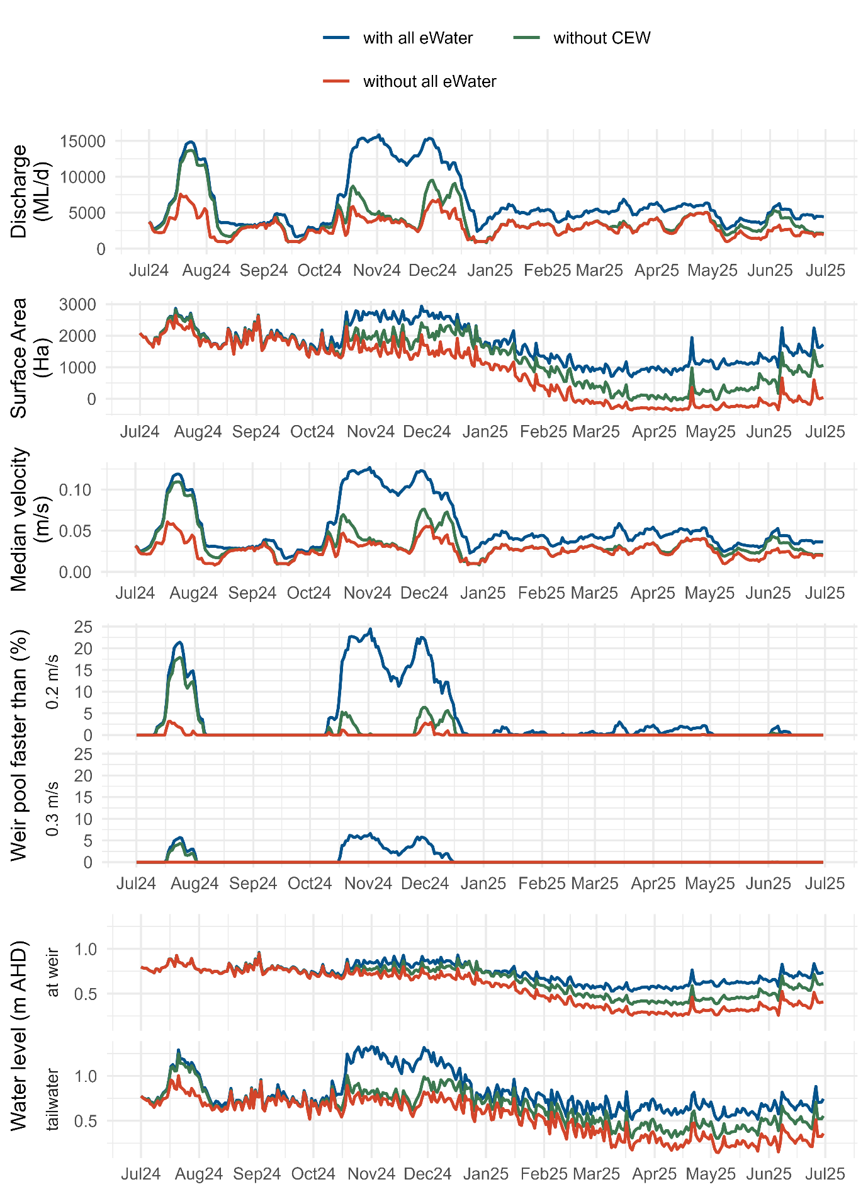
Figure 15.4.2. Hydraulic regime results for Weir Pool 1, with the discharge at Lock 2 with and without (Commonwealth) environmental water, the change in surface area from a water level of 3.2 m AHD, median velocity and percentage of the river with velocity exceeding 0.2 and 0.3 m/s between Lock 1 and Lock 2, and water level at the weir (upstream Lock 1) and in the tailwater (downstream of Lock 2).
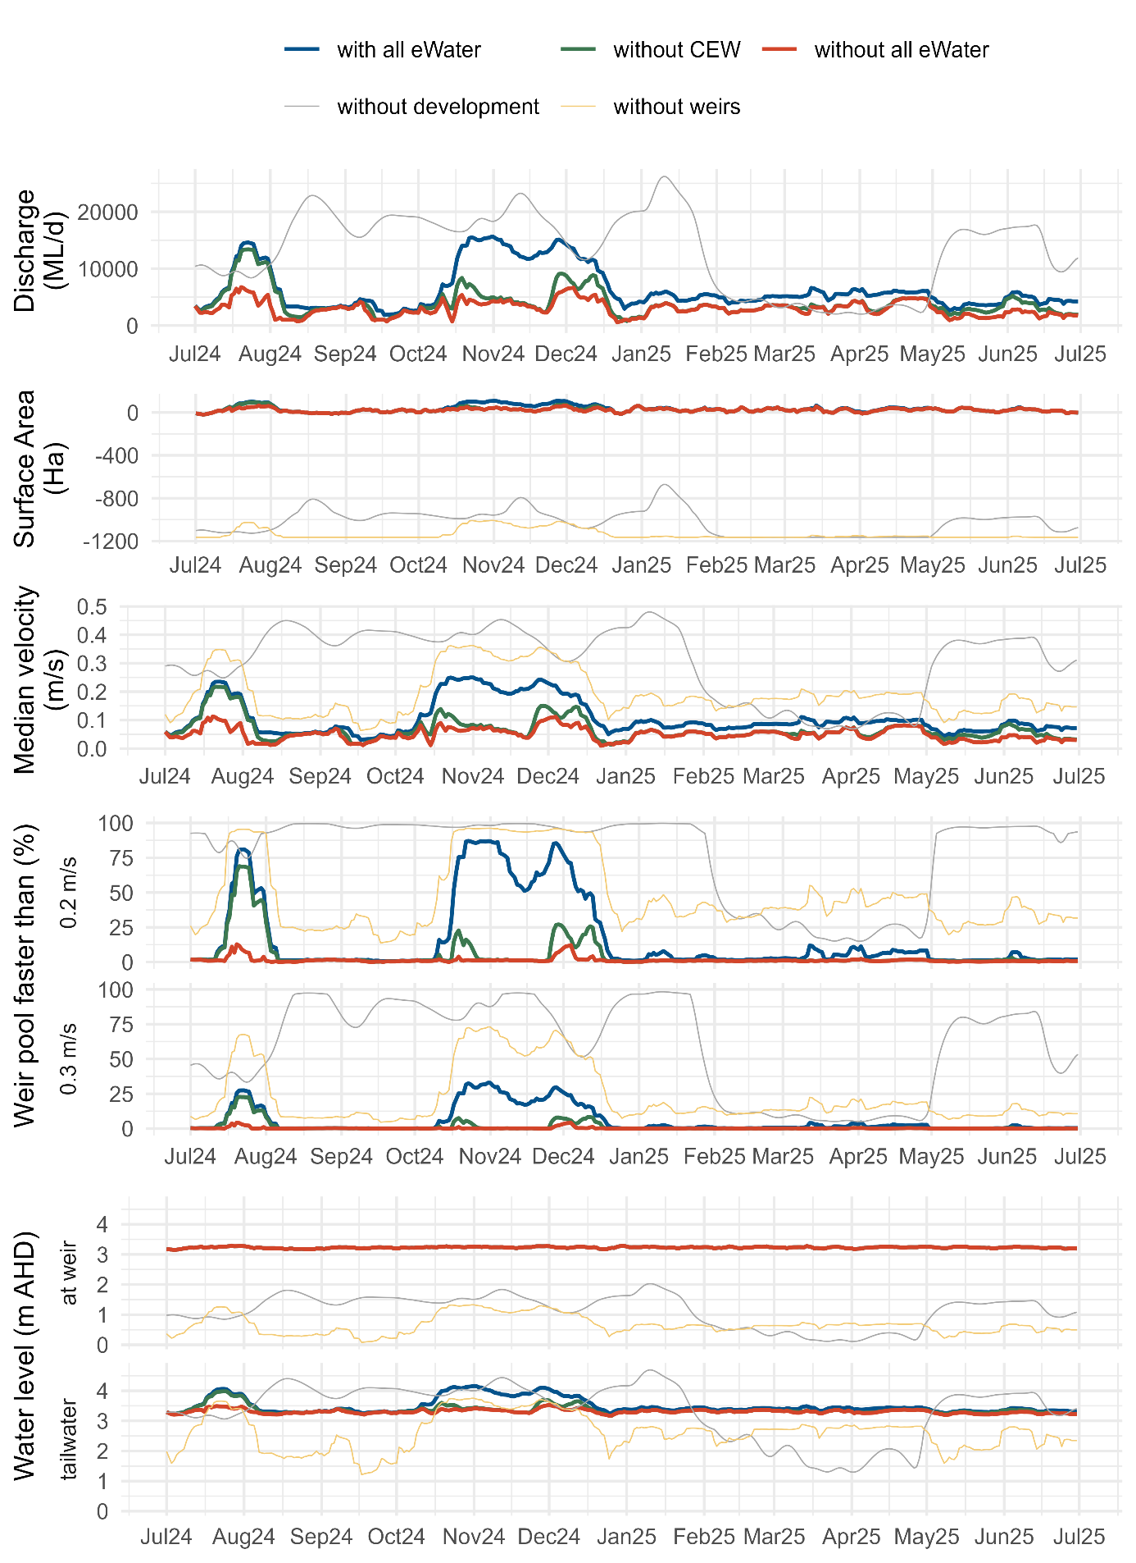

Figure 15.4.3. Hydraulic regime results for Weir Pool 2, with the discharge at Lock 3 with and without (Commonwealth) environmental water, the change in surface area from a water level of 6.1 m AHD, median velocity and percentage of the river with velocity exceeding 0.2 and 0.3 m/s between Lock 2 and Lock 3, and water level at the weir (upstream Lock 2) and in the tailwater (downstream of Lock 3).
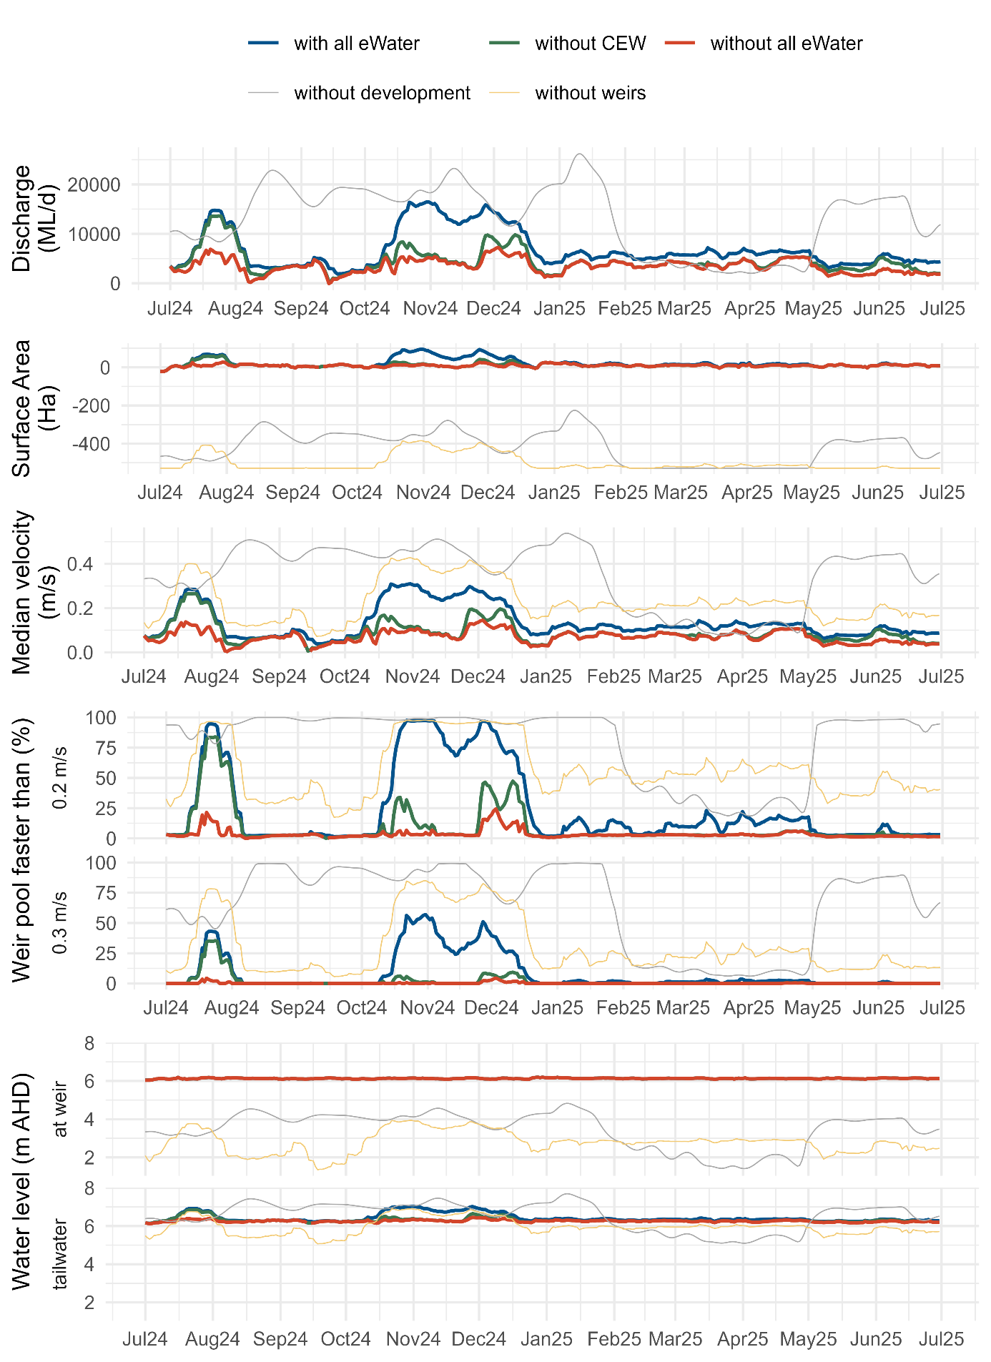

Figure 15.4.4. Hydraulic regime results for Weir Pool 3, with the discharge at Lock 4 with and without (Commonwealth) environmental water, the change in surface area from a water level of 9.8 m AHD, median velocity and percentage of the river with velocity exceeding 0.2 and 0.3 m/s between Lock 3 and Lock 4, and water level at the weir (upstream Lock 3) and in the tailwater (downstream of Lock 4).
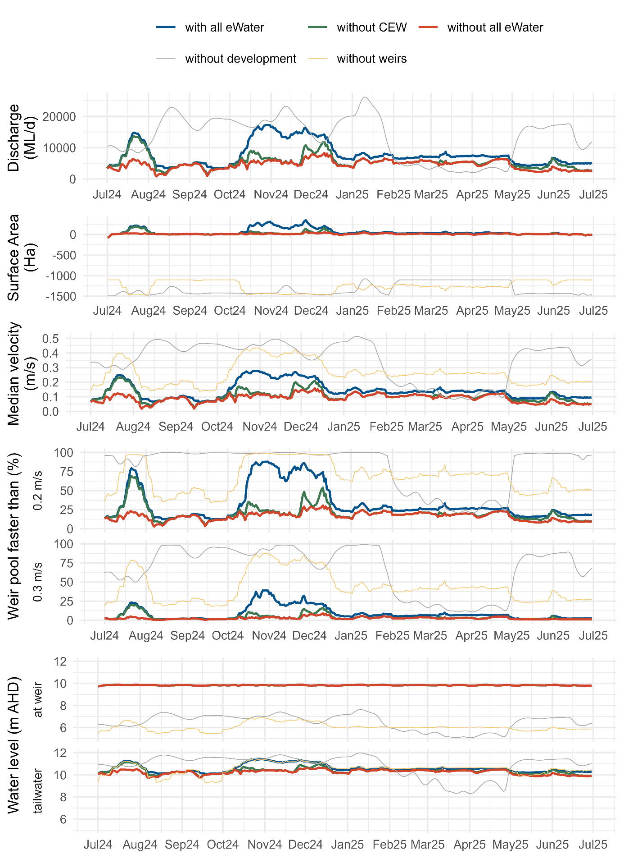

Figure 15.4.5. Hydraulic regime results for Weir Pool 4, with the discharge at Lock 5 with and without (Commonwealth) environmental water, the change in surface area from a water level of 13.2 m AHD, median velocity and percentage of the river with velocity exceeding 0.2 and 0.3 m/s between Lock 4 and Lock 5, and water level at the weir (upstream Lock 4) and in the tailwater (downstream of Lock 5).
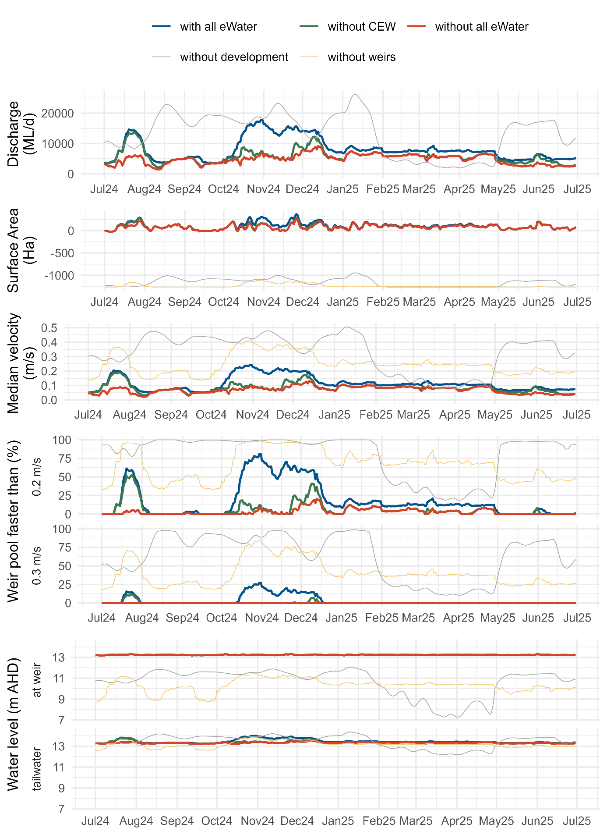

Figure 15.4.6. Hydraulic regime results for Weir Pool 5, with the combined discharge at Lock 6 and Chowilla Creek with and without (Commonwealth) environmental water, the change in surface area from a water level of 16.3 m AHD, median velocity and percentage of the river with velocity exceeding 0.2 and 0.3 m/s between Lock 5 and Lock 6, and water level at the weir (upstream Lock 5) and in the tailwater (downstream of Lock 6).
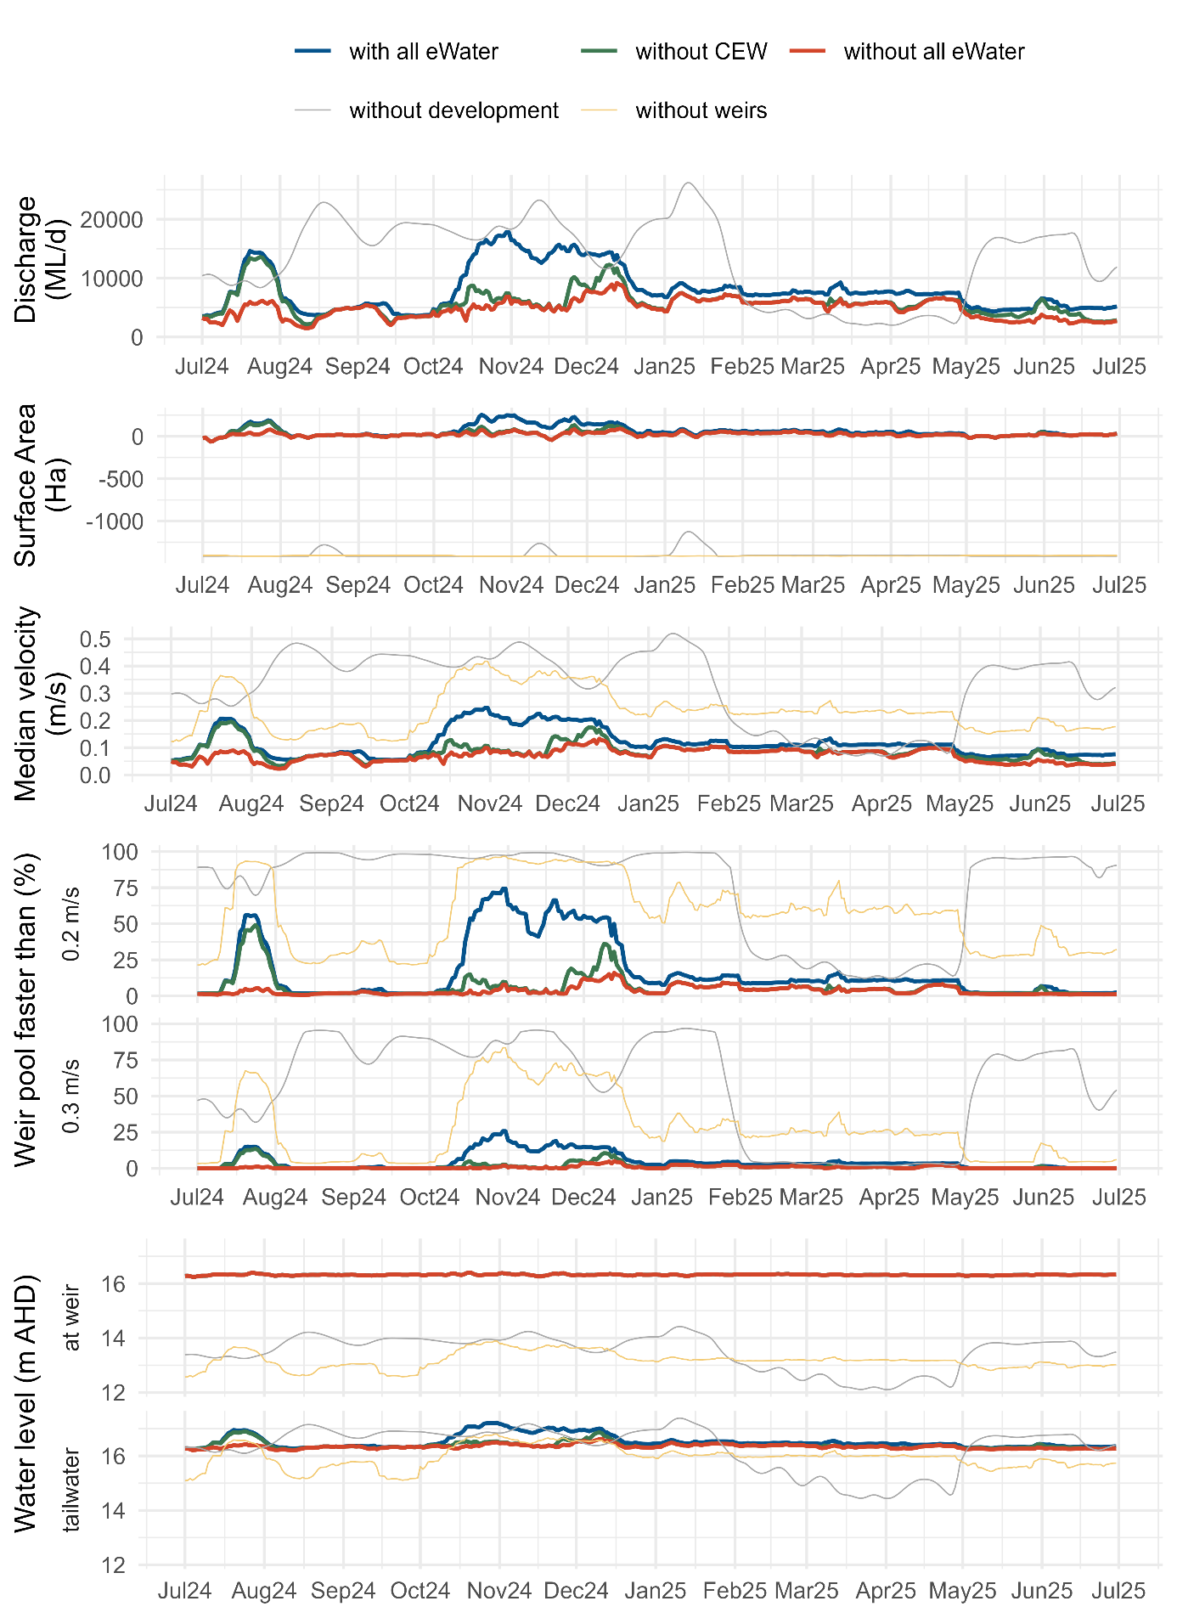

Figure 15.4.7. Hydraulic regime results for Weir Pool 6, with the discharge at Lock 7 with and without (Commonwealth) environmental water, the change in surface area from a water level of 19.25 m AHD, median velocity and percentage of the river with velocity exceeding 0.2 and 0.3 m/s between Lock 6 and Lock 7, and water level at the weir (upstream Lock 6) and in the tailwater (downstream of Lock 7).
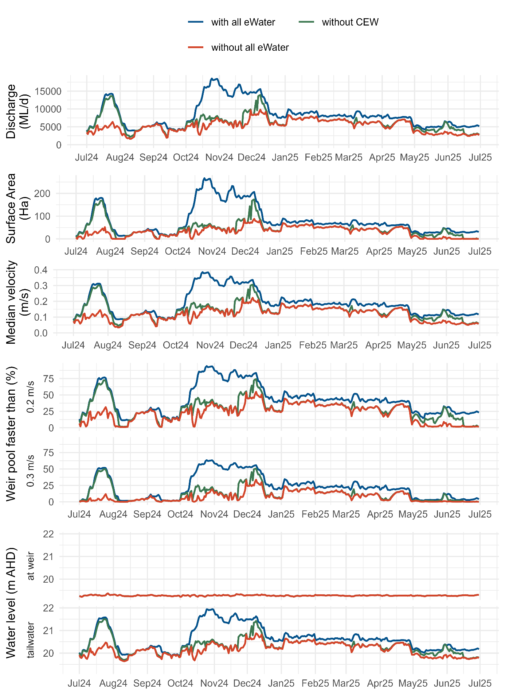

Figure 15.4.8. Hydraulic regime results for Weir Pool 7, with the discharge at Lock 8 with and without (Commonwealth) environmental water, the change in surface area from a water level of 22.1 m AHD, median velocity and percentage of the river with velocity exceeding 0.2 and 0.3 m/s between Lock 7 and Lock 8, and water level at the weir (upstream Lock 7) and in the tailwater (downstream of Lock 8).
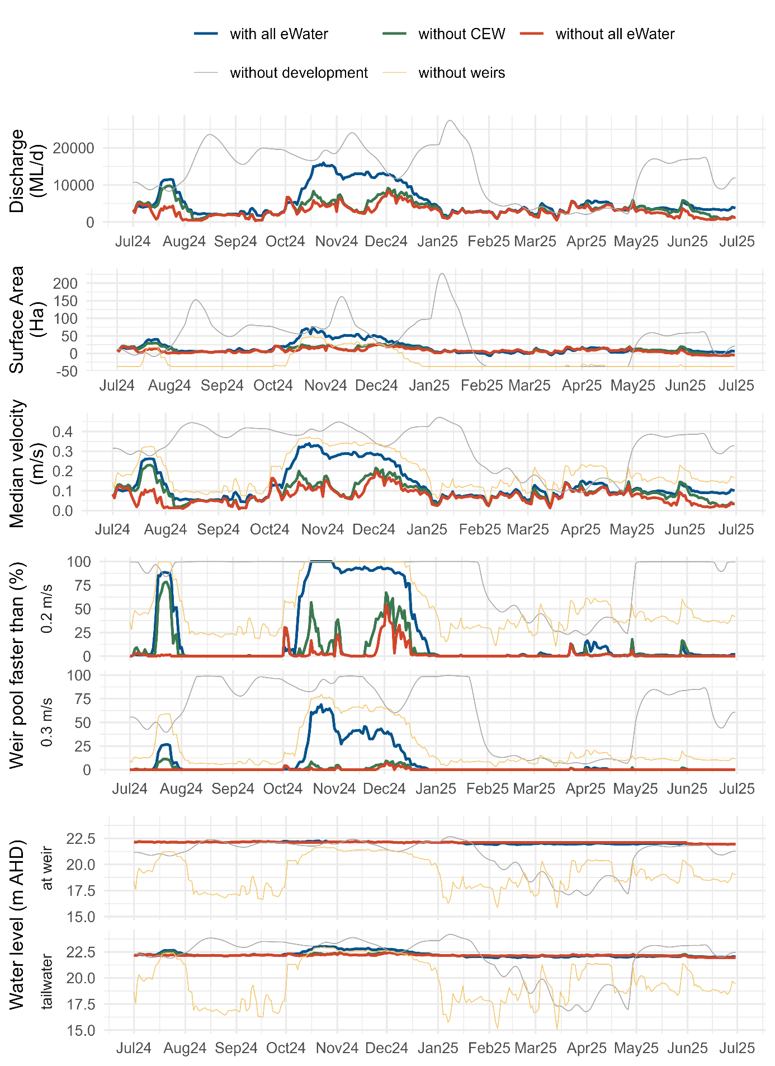

Figure 15.4.9. Hydraulic regime results for Weir Pool 8, with the discharge at Lock 9 with and without (Commonwealth) environmental water, the change in surface area from a water level of 24.6 m AHD, median velocity and percentage of the river with velocity exceeding 0.2 and 0.3 m/s between Lock 8 and Lock 9, and water level at the weir (upstream Lock 8) and in the tailwater (downstream of Lock 9).
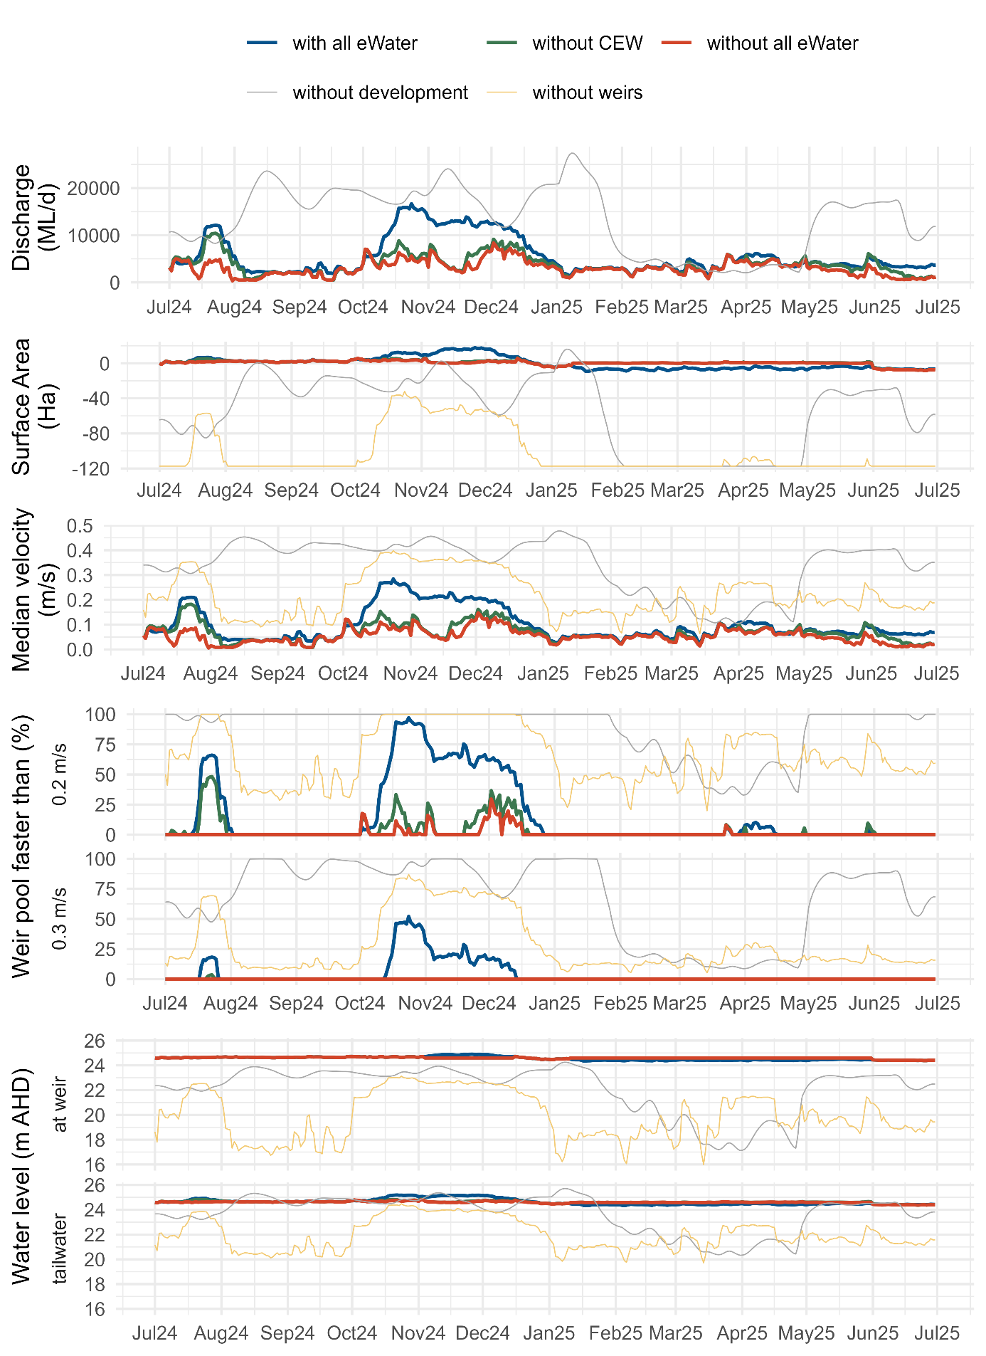

Figure 15.4.10. Hydraulic regime results for Weir Pool 9, with the discharge at Lock 10 with and without (Commonwealth) environmental water, the change in surface area from a water level of 27.4 m AHD, median velocity and percentage of the river with velocity exceeding 0.2 and 0.3 m/s between Lock 9 and Lock 10, and water level at the weir (upstream Lock 9) and in the tailwater (downstream of Lock 10).
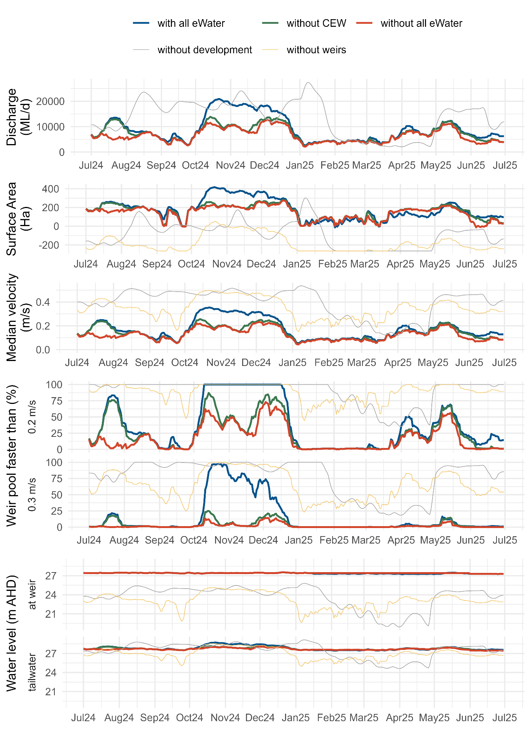

  - Matter Transport and Coorong Habitat supplementary information
This supplementary document includes supporting information and materials for Section 5.2 Matter Transport and Coorong Habitat. The following figures and tables are provided in this appendix:
- Figure 15.5.1: (upper panel) CDM model domain with bathymetry and site map for boundary inputs; and (lower panel) zonal definition of areas for sediment materials and model performance analysis.
- Figure 15.5.2: Overview of boundary conditions from July 2017 to June 2025.
- Figure 15.5.3: Example of the 8-year model validation at the centre of the Coorong South Lagoon for elevation, salinity, temperature and nitrogen.
- Table 15.5.1: Summary of lethal concentration of salinity for seven fish species.
- Table 15.5.2: Fish habitat suitability functions.
Further supporting materials of plots and summary tables for result comparison between the modelling scenarios are available on request including:
- Model performance summary: time series plots of key water quality parameters from the ‘base-case’ scenario against observations in selected zones (zonal definition provided in Figure 15.5.2), and model performance scores; enclosed in the supplementary folder ‘CDM performance’;
- Scenarios – timeseries: time series plots of key water quality parameters predicted from the ‘no CEW’ and ‘no environmental water’ scenarios against the ‘base-case’ scenario in selected zones; enclosed in the supplementary folder ‘Scenarios – timeseries’;
- Scenarios – transect: transect plots of key water quality parameters predicted from the ‘no CEW’ and ‘no environmental water’ scenarios against the ‘base-case’ scenario in selected zones; enclosed in the supplementary folder ‘Scenarios – transect;
- Salt and nutrient transport summary: summary tables of salt and nutrient fluxes through barrages, Murray Mouth, Pelican Point (southward to North Lagoon), and Parnka Point (southward to South Lagoon) of all 5 scenarios; enclosed in the supplementary folder ‘Salt and nutrient transport summary’;
- Salinity and nutrient mean/median concentration summary: summary tables of mean and median salinity and nutrient concentrations at Murray Mouth, Long Point (North Lagoon), and Woods well (South Lagoon) of all 5 scenarios; enclosed in the supplementary folder ‘salinity and nutrient mean median concentration summary’.

Figure 15.5.1. (upper panel) CDM model domain with bathymetry and site map for boundary inputs; and (lower panel) zonal definition of areas for sediment materials and model performance analysis.
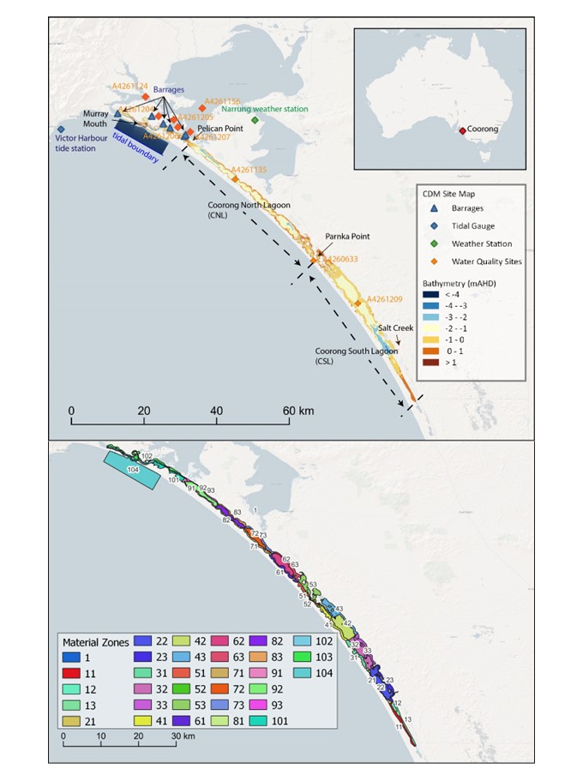
Figure 15.5.2. Overview of boundary conditions from July 2017 to June 2025. (a) Tidal elevations at Victor Harbor; (b) total barrage flow rate; (c) Salt Creek flow rate; (d) air temperature; (e) daily rainfall rate, and (f) rose-chart of wind conditions. The gray lines in figure (a) – (e) indicate the raw data and the dark lines indicate the monthly-average boundary conditions.
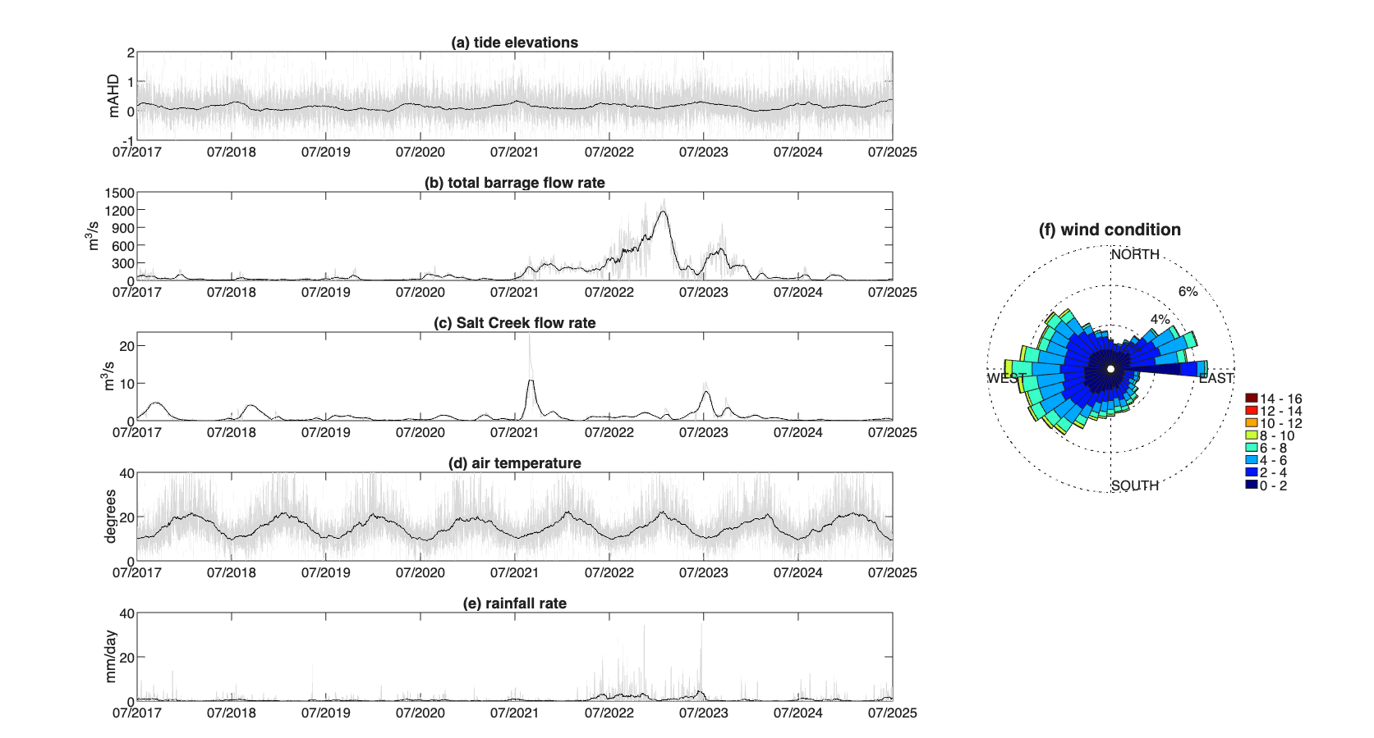

Figure 15.5.3. Example validation plots comparing conditions in the North and South Lagoon for water level (a and b), salinity (c and d), temperature (e and f) and total nitrogen (g and h) from July 2023 to December 2025. The past FLOW-MER model is shown from July 2023 to June 2024 for benchmarking.
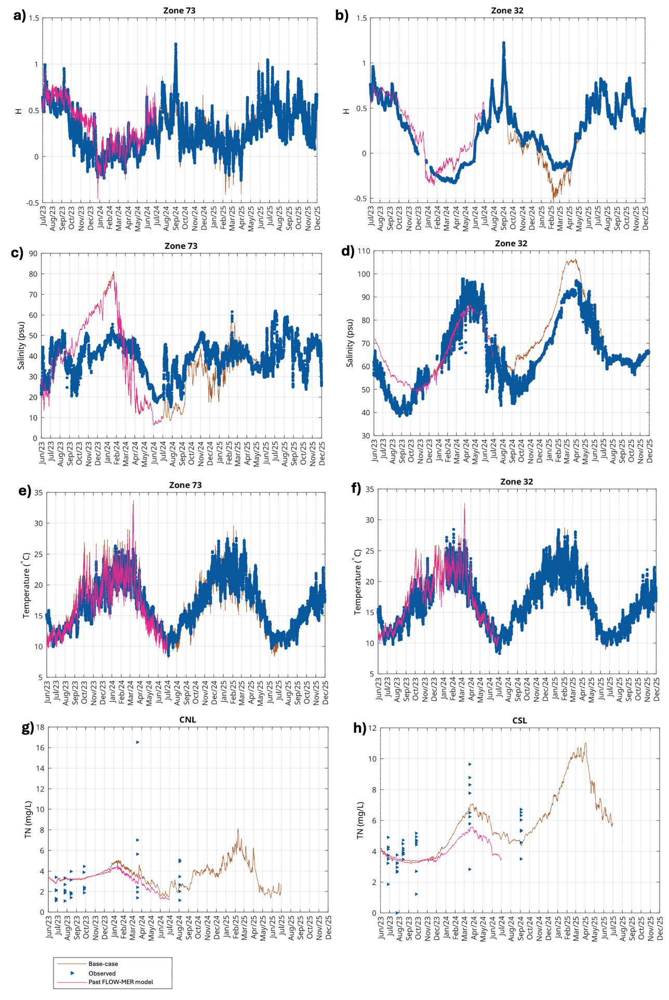
Table 15.5.1. Summary of lethal concentration for 50% of the population, LC₅₀, and 10% of the population, LC₁₀ estimates of salinity (expressed as PSU) for seven species at 14°C (LC¹⁴) and 23°C (LC²³) temperatures used to inform the habitat suitability.
Common name | $${LC}_{50}^{14}$$ | $${LC}_{50}^{23}$$ | $${LC}_{10}^{14}$$ | $${LC}_{10}^{23}$$
Mulloway | 64 | 59 | 60 | 51
Tamar goby | 73 | 71 | 68 | 66
Black bream | 85 | 88 | 79 | 82
Greenback flounder | 88 | 79 | 81 | 73
Yelloweye mullet | 91 | 82.4* | 84 | 68
Congolli | 100 | 94 | 90 | 87
Smallmouth hardyhead | 108 |  | 100 | 97
*possibly affected by another unknown water quality factor.

Table 15.5.2. Fish habitat suitability functions based on salinity and temperature.
$HSI$ =$\left\{\frac{S_{c50}-S}{S_{c50}-S_{c10}}\begin{aligned}1, 0≤S<S_{c10} \\ ,S_{c10}≤S<S_{c50} \\ 0, S≥S_{c50}\end{aligned}\right.$ | where:  $S_{c10}^{}$ = $\left\{(\frac{{LC}_{10}^{23}-{LC}_{10}^{14}}{23-14})\left(T-14\right)+{LC}_{10}^{14}\begin{aligned}{LC}_{10}^{14}, 0≤T<14 \\ ,14≤T<23 \\ {LC}_{10}^{23}, T≥23\end{aligned}\right.$  $S_{c50}^{}$ = $\left\{(\frac{{LC}_{50}^{23}-{LC}_{50}^{14}}{23-14})\left(T-14\right)+{LC}_{50}^{14}\begin{aligned}{LC}_{50}^{14}, 0≤T<14 \\ ,14≤T<23 \\ {LC}_{50}^{23}, T≥23\end{aligned}\right.$
where:
S: salinity.
$S_{c50}^{}$: $L_{c50}^{}$ (concentration of salinity that kills 50% of the test animals).
$S_{c10}^{}$: $L_{c10}^{}$ (concentration of salinity that kills 10% of the test animals).
${LC}_{50}^{23}$ or ${LC}_{50}^{14}$: concentration of salinity that kills 50% of the test animals at 23°C or 14°C. Parameter values are based on Table 15.5.1.
${LC}_{10}^{23}$ or ${LC}_{10}^{14}$: concentration of salinity that kills 10% of the test animals at 23°C or 14°C. Parameter values are based on Table 15.5.1.
T: water temperature (monthly average to represent seasonal conditions).

  - Native Fish theme supplementary information

Table 15.6.1. Cohorts of golden perch and silver perch (excluding larvae) collected from the Lower Murray River from 2025 that were analysed for natal origin. Sample sizes (n) for years 2015–2024 are presented in Ye et al. (2025).
Spawn year | Golden perch n | Silver perch n
2005-06 | 2
2009-10 | 2
2010-11 | 4
2011-12 | 4
2012-13 | 2
2013-14 | 2
2016-17 | 5 | 1
2017-18 | 2
2018-19 | 3 | 2
2019-20 | 4 | 5
2020-21 | 3 | 1
2021-22 | 15 | 9
2022-23 | 2
2023-24 | 4 | 6
2024-25 |  | 1

Figure 15.6.1. Mean catch-per-unit-effort (CPUE, individuals per net) ± standard error of golden perch, silver perch and fish eggs (suspected to be golden perch or silver perch) collected downstream of locks (L) 1, 4, 6, 8, 9 and 10 in the Lower Murray River Area between late October 2024 and early January 2025. Mean daily discharge (ML/d, solid line) and water temperature (°C, dashed line) at the South Australian border (QSA) and Lock 11 (L11) are shown. Approximate bankfull at the South Australian border is 45,000 ML/d (y-axis maximum).
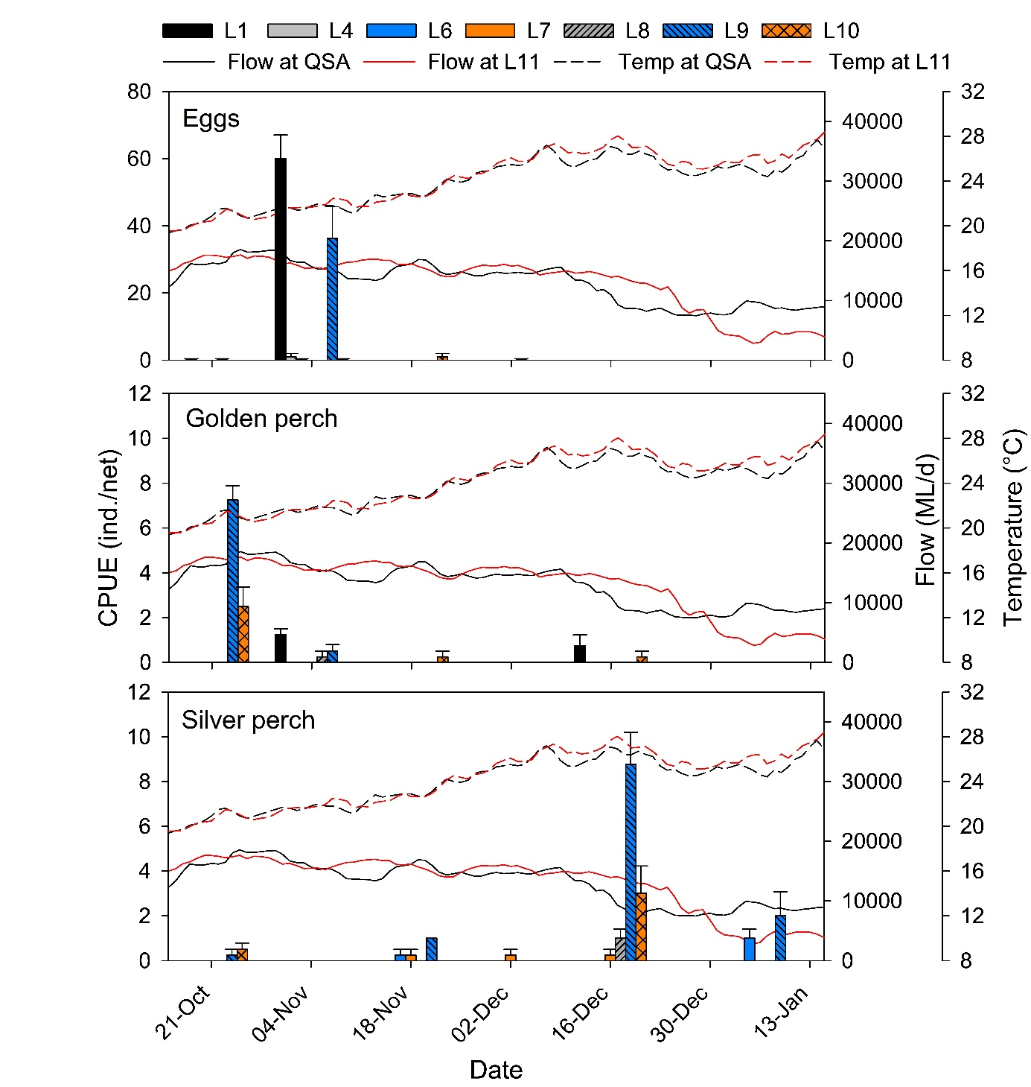

Figure 15.6.2. Back-calculated spawn dates (frequency) for golden perch larvae/YOY (red bars) and silver perch larvae (blue bars) captured in the Lower Murray River between late October 2024 to early January 2025. Spawn dates are plotted against discharge (ML/d) at the South Australian (SA) border (solid blue line) and water temperature (°C) (dashed black line). Stars represent the period(s) when golden perch and/or silver perch eggs were sampled in higher (>50/trip) quantities. Two golden perch with spawn dates of 11 and 15 December are hidden behind spawn date bars for silver perch. Due to small size (≤5 mm total length), most golden perch (89%) were not assessed for daily age.
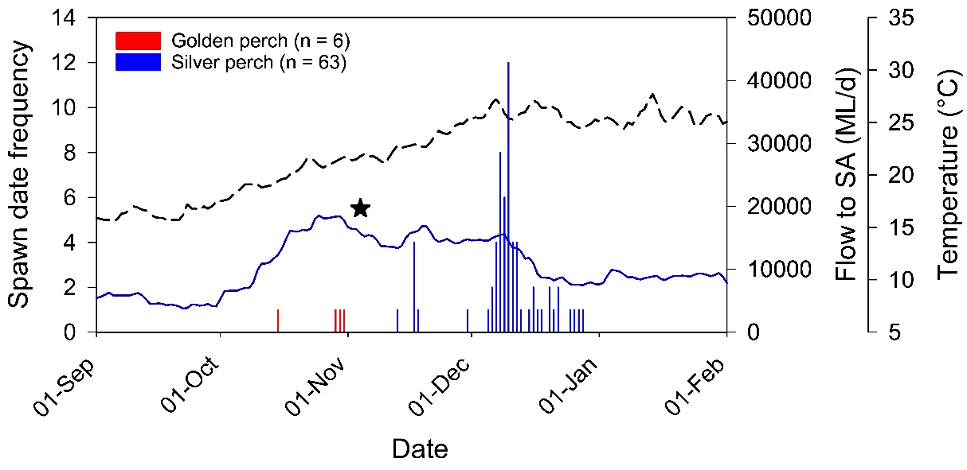
From late October 2024 to late January 2025, water ⁸⁷Sr/⁸⁶Sr was generally temporally stable in the Murray River, with increased variability downstream of Lock 9 and Lock 6 from December 2024 (Figure 15.6.3). Clear distinction in water ⁸⁷Sr/⁸⁶Sr between the mid-Murray and Murray River downstream of the Darling River junction (locks 1, 6 and 9) (Figure 15.6.3) was associated with increased Darling River flow contribution to Murray River flow from mid-October (Figure 4).
Figure 15.6.3. Strontium (⁸⁷Sr/⁸⁶Sr) in water samples collected from late October 2024 to late January 2025 at sites in the southern MDB. ⁸⁷Sr/⁸⁶Sr in the Murray River at Barmah (0.7192) and Darling River (0.7075) is presented as a dashed straight line and based on long-term averages (Ye et al. 2025). Coloured symbols represent spawn date and otolith core ⁸⁷Sr/⁸⁶Sr of larval and young-of-year golden perch (red triangles) and silver perch (blue circles) collected in the Lower Murray River from 7 November 2024 to 9 January 2025.
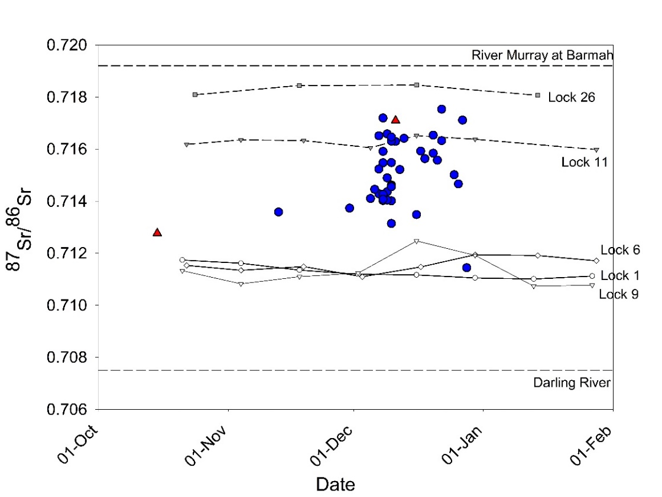
Table 15.6.2. PERMANOVA pairwise comparison test results for golden perch electrofishing abundance (individuals per 90 second shot) in the Lower Murray River from 2015–2025. P-values presented in bold are significant comparisons, using B-Y corrected α = 0.0109 (Benjamini and Yekutieli 2001) for 55 comparisons between years.
Pairwise comparisons (between years) | t | p value
2015, 2016 | 0.2726 | 0.8231
2015, 2017 | 2.4012 | 0.0281
2015, 2018 | 0.8253 | 0.4396
2015, 2019 | 3.6323 | 0.0010
2015, 2020 | 3.5222 | 0.0020
2015, 2021 | 2.0927 | 0.0532
2015, 2022 | 0.0219 | 1.0000
2015, 2023 | 4.0663 | 0.0011
2015, 2024 | 3.2609 | 0.0055
2015, 2025 | 0.1074 | 0.9187
2016, 2017 | 2.6726 | 0.0150
2016, 2018 | 0.6930 | 0.5236
2016, 2019 | 4.7217 | 0.0001
2016, 2020 | 4.3351 | 0.0006
2016, 2021 | 2.3178 | 0.0366
2016, 2022 | 0.1664 | 0.8936
2016, 2023 | 4.7465 | 0.0002
2016, 2024 | 3.8694 | 0.0035
2016, 2025 | 0.2754 | 0.7950
2017, 2018 | 1.5909 | 0.1407
2017, 2019 | 1.1142 | 0.3114
2017, 2020 | 1.1404 | 0.2864
2017, 2021 | 0.4840 | 0.6630
2017, 2022 | 1.6581 | 0.1172
2017, 2023 | 2.0761 | 0.0602
2017, 2024 | 0.9193 | 0.3943
2017, 2025 | 1.5758 | 0.1200
2018, 2019 | 2.8114 | 0.0129
2018, 2020 | 2.7290 | 0.0173
2018, 2021 | 1.2362 | 0.2447
2018, 2022 | 0.5846 | 0.6101
2018, 2023 | 3.3744 | 0.0044
2018, 2024 | 2.4738 | 0.0255
2018, 2025 | 0.6574 | 0.5273
2019, 2020 | 0.2371 | 0.8685
2019, 2021 | 1.8870 | 0.0916
2019, 2022 | 2.2967 | 0.0222
2019, 2023 | 1.6432 | 0.1338
2019, 2024 | Negative
2019, 2025 | 2.0282 | 0.0471
2020, 2021 | 1.8059 | 0.0970
2020, 2022 | 2.3105 | 0.0219
2020, 2023 | 1.3208 | 0.2225
2020, 2024 | 0.1701 | 0.9139
2020, 2025 | 2.0771 | 0.0388
2021, 2022 | 1.4185 | 0.1872
2021, 2023 | 2.6555 | 0.0216
2021, 2024 | 1.5108 | 0.1527
2021, 2025 | 1.3542 | 0.1926
2022, 2023 | 2.8337 | 0.0060
2022, 2024 | 2.1914 | 0.0359
2022, 2025 | 0.1197 | 0.9074
2023, 2024 | 1.3630 | 0.2028
2023, 2025 | 2.6058 | 0.0111
2024, 2025 | 2.0037 | 0.0470
Figure 15.6.4. Mean targeted electrofishing catch-per-unit-effort (CPUE) ± S.E. of Murray cod in the weir pools downstream (DS) of Lock 1–10 of the Lower Murray River. Dashed bars represent the proportion of young-of-year (YOY) to the total CPUE. ns = no sampling. Data from 2022–2024 for DS locks 7–10 sites are taken from the River Murray Monitoring Program.
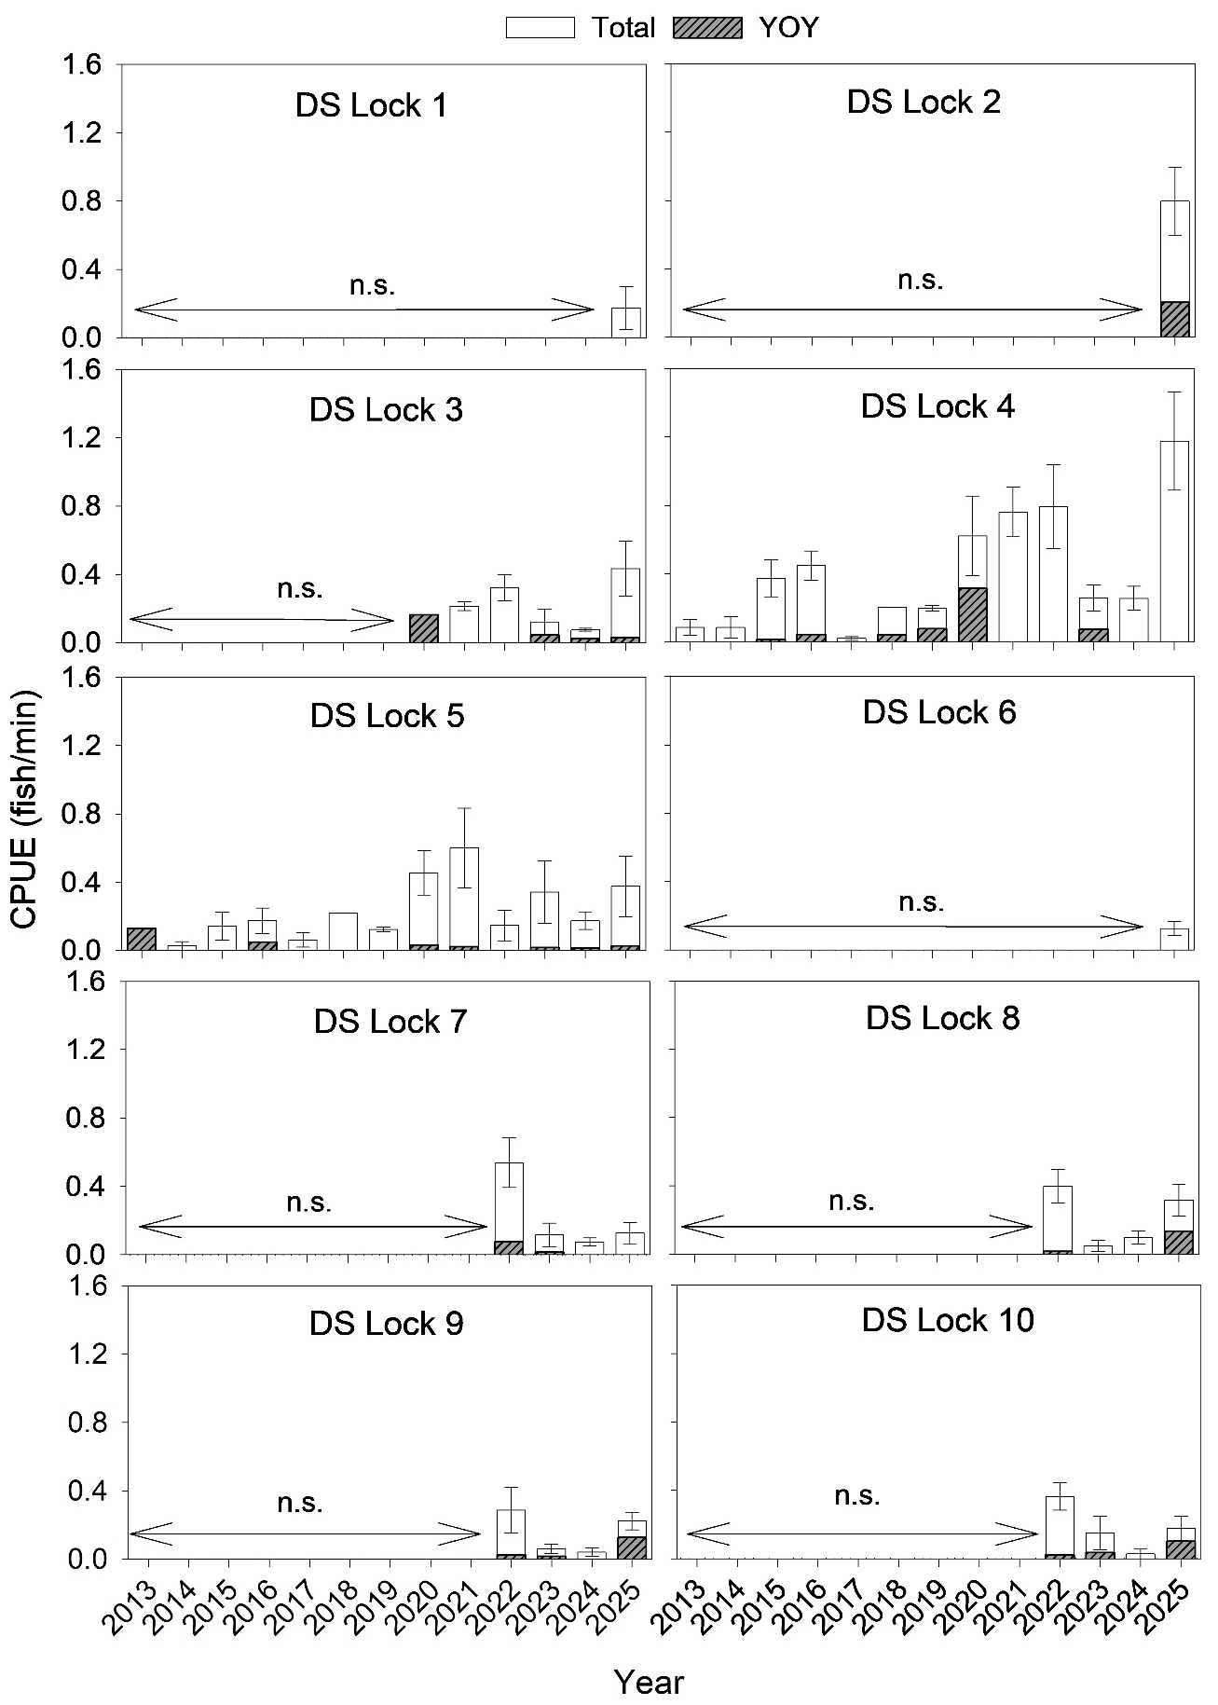
Table 15.6.3. PERMANOVA pairwise comparisons of young-of-year Murray cod electrofishing catch-per-unit-effort (CPUE) between years downstream of Lock 4. P-values presented in bold are significant comparisons, using B-Y corrected α = 0.0105 (Benjamini and Yekutieli 2001) for comparisons between years (sixty-six comparisons).* = denominator is zero, i.e. CPUE was nil.
Pairwise comparisons (between years) | t | p value
2013, 2014 | *
2013, 2015 | 0.8452 | 1.0000
2013, 2016 | 1.3293 | 0.4300
2013, 2017 | *
2013, 2019 | 1.9946 | 0.4005
2013, 2020 | 2.1908 | 0.0554
2013, 2021 | *
2013, 2022 | *
2013, 2023 | 1.5404 | 0.2862
2013, 2024 | *
2013, 2025 | *
2014, 2015 | 1.0000 | 1.0000
2014, 2016 | 1.5728 | 0.4282
2014, 2017 | *
2014, 2019 | 2.3840 | 0.1480
2014, 2020 | 2.5922 | 0.0281
2014, 2021 | *
2014, 2022 | *
2014, 2023 | 1.8114 | 0.1642
2014, 2024 | *
2014, 2025 | *
2015, 2016 | 0.8842 | 0.7117
2015, 2017 | 0.8452 | 1.0000
2015, 2019 | 1.6453 | 0.2610
2015, 2020 | 2.4383 | 0.0291
2015, 2021 | 1.1386 | 0.4364
2015, 2022 | 1.1386 | 0.4480
2015, 2023 | 1.3588 | 0.2465
2015, 2024 | 1.1386 | 0.4385
2015, 2025 | 1.1386 | 0.4373
2016, 2017 | 1.3293 | 0.4296
2016, 2019 | 0.7099 | 0.5771
2016, 2020 | 2.1596 | 0.0570
2016, 2021 | 1.7907 | 0.1682
2016, 2022 | 1.7907 | 0.1657
2016, 2023 | 0.6407 | 0.5510
2016, 2024 | 1.7907 | 0.1655
2016, 2025 | 1.7907 | 0.1735
2017, 2019 | 1.9946 | 0.4030
2017, 2020 | 2.1908 | 0.0561
2017, 2021 | *
2017, 2022 | *
2017, 2023 | 1.5404 | 0.2800
2017, 2024 | *
2017, 2025 | *
2019, 2020 | 1.5991 | 0.1429
2019, 2021 | 2.7312 | 0.1115
2019, 2022 | 2.7312 | 0.1123
2019, 2023 | 0.0357 | 1.0000
2019, 2024 | 2.7312 | 0.1093
2019, 2025 | 2.7312 | 0.1086
2020, 2021 | 2.9514 | 0.0078
2020, 2022 | 2.9514 | 0.0096
2020, 2023 | 2.0719 | 0.0480
2020, 2024 | 2.9514 | 0.0091
2020, 2025 | 2.9514 | 0.0082
2021, 2022 | *
2021, 2023 | 2.0539 | 0.1618
2021, 2024 | *
2021, 2025 | *
2022, 2023 | 2.0539 | 0.1710
2022, 2024 | *
2022, 2025 | *
2023, 2024 | 2.0539 | 0.1707
2023, 2025 | 2.0539 | 0.1655
2024, 2025 | *

Counterfactual modelling statistical analyses
Table 15.6.4. Bayesian linear mixed models formula fitted to characterise the relationships between Murray cod body condition and ecologically relevant flow variables. The ecological relevance of variables is provided in the form of hypotheses, adapted from Hladyz et al. (2025).
Statistical formula |  | Link function | Family
log_fulton_factor ~ flow_low + flow_max + flow_cv + flow_median + month + is_yoy + (1 | site) + (1 | weir_pool:wateryear) |  | Identity | Gaussian (lognormal)
Variables | Definition and hypothesis
Response variable  log_fulton_factor | Log-transformed measure of overall body condition  $\left(Fulton^{'}s condition Factor =100,000 x \frac{Weight (g)}{{Length (mm)}^{3}}\right)$
Flow variables  flow_low | Number of low flow days (below 10th percentile of data – July 2014 –June 2025) during preceding 9–10 months (preceding 1 July) to date of capture  Hypothesis: Low flows reduce habitat and food resources, decreasing fish body condition.
flow_max | Maximum flow experienced during preceding 9–10 months (preceding 1 July) to date of capture)  Hypothesis: Very large flows provide increased lateral connectivity, which increases productivity and connectivity to wetlands and floodplains that provide refuges and feeding opportunities, improving fish body condition.
flow_median | Median daily flow during preceding 9–10 months (preceding 1 July) to date of capture  Hypothesis: Increased flow stimulates productivity, improving food availability and fish body condition.
Other variables  month | Month of sampling  Hypothesis: Month of sampling may influence metabolism, behaviour and food availability, and thus fish condition.
is_yoy | Indicator variable to assess young-of-year (YOY) age class independently of older age classes  Hypothesis: The body condition of YOY fish differs significantly from older, adult fish due to contrasting life history demands, specifically the trade-offs between rapid growth and energy storage for reproduction.
site | Sampling site within weir pool  Hypothesis: Habitat or food availability may differ across sampling sites within weir pool, which may influence body condition.
weir_pool | Weir pool and closest upstream lock to sampling site  Hypothesis: Habitat or food availability may differ across weir pool, which may influence body condition.
wateryear | The 1 July – 30 June period during which sampling took place

Table 15.6.5. Bayesian linear mixed models formulas fitted to characterise the relationships between Murray cod recruitment and ecologically relevant flow variables. Ecological relevance of variables is provided in the form of hypotheses, adapted from Hladyz et al. (2025).
Statistical formula |  | Link function | Family
yoy_count ~ flow_low_yoy + flow_median_spawning_early_life + flow_cv_spawning + flow_max_prev + weir_pool + ad_cpue + effort_s + project + (1 | site) + (1 | weir_pool:wateryear) |  | log | Negative binomial
Variables | Definition and ecological relevance
Response variable  yoy_count | Number of young-of-year (individuals < 155 mm total length (TL) or <170 mm TL in 2022-23)
Flow variables  flow_low_yoy | Number of low flow days (below 10th percentile of data – July 2014 – June 2025) during young-of-year early life history (from nominated cohort birthday –[preceding 1 October] to date of capture)  Hypothesis: Low flows reduce habitat and food resources, decreasing fish body condition, growth and survival of young-of-year, and thus recruitment.
flow_median_spawning_early_life | Median daily flow during spawning and larval period (preceding 1 September to 31 December)  Hypothesis: Increased flow prior to and during the spawning season (September to November) results in an expansion of area with suitable spawning (lotic) habitat, and an increase in spawning output (abundance of larvae). Increased flow during the larval period (October to December) increases dispersal of larvae, reducing intraspecific competition, and stimulates productivity, improving food availability, body condition, growth and survival of larvae.
flow_cv_spawning | Coefficient of variability (flow variability) in daily flow during spawning period (preceding 1 September to 30 November)  Hypothesis: Rapid changes in flow during the spawning period may increase likelihood of nest abandonment and mortality of eggs and larvae.
flow_max_prev | Maximum flow experienced over 15-month period, prior to spawning season (1 July [prior water year] to 1 October [current water year])  Hypothesis: Very large antecedent flows provide increased lateral connectivity, which increases productivity and connectivity to wetlands and floodplains that provide refuges and feeding opportunities, improving fish body condition. Improved body condition of adults will result in increased spawning output (abundance of larvae) and quality of eggs and larvae. High flow events may lead to flooding conditions and hypoxic events which may negatively influence recruitment.
Other variables  weir_pool | Weir pool and closest upstream lock to sampling site  Hypothesis: Habitat, food availability or other factors that influence recruitment may differ across weir pool.
ad_cpue | CPUE (fish/min) of adult cod (>659 mm TL) sampled in weir pools 3, 4 and 5, during the previous wateryear  Hypothesis: Larger adult population size will result in greater spawning output (abundance of larvae).
effort_s | Sampling effort reported as electrofishing seconds  Hypothesis: Greater sampling effort equates to greater detection rate.
project | Cod sampling projects (targeted sampling or condition monitoring)  Hypothesis: Likelihood of young-of-year detection may differ among sampling types.
site | Sampling site within weir pool  Hypothesis: Habitat, food availability or other factors that influence recruitment may differ across site within weir pool.
wateryear | The wateryear in which sampling took place  Hypothesis: Likelihood that factors other than hydrology and connectivity within specific years influences response variable.

Table 15.6.6. Bayesian linear mixed models formulas fitted to characterise the relationships between congolli and common galaxias recruitment and ecologically relevant flow variables. Ecological relevance of variables is provided in the form of hypotheses, adapted from Hladyz et al. (2025).
Statistical formula |  | Link function | Family
log_cpue ~ s(flow_capture, k = 6, bs = "ts") + s(flow_median_diad_yoy, k = 5, bs = "ts") + flow_low_spawning + barrage + month +  (1|wateryear) + (1|barrage) |  | Identity | Gaussian (lognormal)
Variables | Definition and hypothesis
Response Variable  log_cpue | Log-transformed, estimated young-of-year abundance.
Flow Variables  s(flow_capture) | Daily flow rate (ML/ day) on day of survey (smoother applied to reflect non-linear relationship).  Hypothesis: Flow rate on the day of survey can indicate fishway operation/non-operation and sampling efficiency. Low flow rate results in high attraction to fishways and sampling efficiency, while high flow rate results in lower attraction to fishways and sampling efficiency.
s(flow_median_yoy) | Median daily flow during young-of-year early life history (1 July to date of capture) (smoother applied to reflect non-linear relationship).  Hypothesis: Higher median seasonal discharge may result in greater overall attraction and immigration to the Coorong, and productivity.
flow_low_spawning | Number of low flow days (below 10th percentile of data – July 2014- June 2025) during winter.  Hypothesis: Low flow days indicate levels of connectivity during the downstream spawning migration in winter. Fewer low flow days indicate high levels of connectivity and opportunities for migration and is associated with enhanced recruitment.
Other variables  barrage | Murray River barrage sampled.  Hypothesis: Likelihood detection may differ among barrages.
wateryear | The water year in which sampling took place.  Hypothesis: Likelihood that factors other than hydrology and connectivity within specific years influence response variable.
month | Month of sampling.  Hypothesis: Likelihood that month of sampling influences response variable.

  - Case Study – Cultural Knowledge Exchange: Pondi (Murray cod) Monitoring Project and Electrofishing Demonstration Day 2025
Pondi Monitoring in 2024-25
Pondi (Murray cod) monitoring was identified as a priority for caring for Country by the Ngarrindjeri Aboriginal Corporation (NAC) and the River Murray and Mallee Aboriginal Corporation (RMMAC). Pondi holds deep cultural significance for First Nations people of the Lower Murray and CLLMM region, featuring prominently in the creation story of the Murray River itself. Strongly supported by the Cultural Advisors and CEWH managers, the Lower Murray and CLLMM Area team (herein, Area team) worked closely with NAC and RMMAC rangers to co-design a Pondi monitoring project with additional activities to engage Elders and broader community. During the week 24‒28 February 2025, six First Nations rangers from NAC and RMMAC and two SARDI researchers conducted collaborative Pondi monitoring using an internationally standardised boat electrofishing method. Four sites were assessed across river reaches between Renmark and Swan Reach. A new site was surveyed each day, with Rangers positioned at the front of the boat to net stunned fish under the guidance of SARDI staff. Captured Pondi were weighed and measured, tagged with both passive integrated transponder (PIT) and external dart tags, and a DNA sample was collected. Fish were then released close to their point of capture.
This project was unique in its collaborative approach, bringing together two First Nations groups, scientists and water managers. The partnership supported the sharing of traditional knowledge alongside western scientific methods to inform native fish restoration and broader river health outcomes.
Pondi Electrofishing Demonstration Event and Yarning Circle
A complementary electrofishing demonstration event was held in Loxton during the Pondi monitoring project. The mid-week event was attended by approximately 50 participants, including First Nations Elders and community members from the NAC and RMMAC, as well as representatives from the Commonwealth and South Australian governments. The event opened with a Welcome to Country delivered by RMMAC Elder Uncle Eric Cook, followed by a smoking ceremony conducted by Uncles Phillip Johnson and Dale Abdulla. Elder Alban Kartinyeri (NAC) acknowledged the invitation to visit and work on RMMAC Country.
Elders and other participants boarded a pontoon boat that closely followed the SARDI electrofishing vessel, allowing attendees to safely observe the electrofishing process used to capture Pondi. Three pontoon boat sessions were conducted throughout the day. Each session successfully resulted in the capture of a Pondi by First Nations Rangers, providing a rare opportunity for Elders and participants to view the fish and observe the data collection process firsthand. For many attendees, this marked their first sighting of Pondi in decades, with some Elders reporting they hadn’t seen a Pondi in 60 years (Cameron 2025). Additional species, including Pilaki (golden perch) and Pyberry (bony herring), were also captured during the demonstration. These encounters supported further discussion, learning, and the sharing of cultural and scientific knowledge among participants.
After the Electrofishing demonstration, a yarning circle was undertaken. This provided First Nations Elders, rangers and other participants with an opportunity to discuss the demonstration event and the Pondi monitoring project.
Discussions and sharing included Elders’ observations of the changes observed in the Murray River in their lifetime, including a reduction in the number of Pondi. Rangers recounted their week of electrofishing as being interesting and rewarding.
Participating ranger Lucille Sumner (RMMAC) recounted her experience with the following quote “For most of us we’ve never seen a Pondi that’s alive,” she said. “It was the best experience ever. Hoping that the future of our Murray cod is sustainable for our great Murray River.” (Cameron 2025).
Steven Rigney (NAC) who works for the Aboriginal Land Trust, expressed his feelings about participating in the project “That was my first time electrofishing and my first time ever seeing and catching a Pondi, he said. “It felt beautiful to hold it. I can’t explain, but it felt good to me.” (Cameron 2025).
Key outcomes
The Interim First Nations Peoples MER Strategy (DCCEEW 2024b) provides guidelines for engagement with First Nations peoples across all project areas. The strategy contains five guiding principles by which to assist and shape respectful and constructive interactions and collaboration. The key outcomes of the Pondi Monitoring activity are discussed below, in relation to the governing principles.
Principle 1: Uphold the right of self-determination, recognising that communities are the experts in their own affairs.
- The Area team successfully engaged both NAC and RMMAC First Nations groups, by establishing a community driven approach to collaboration. Our team listened to our First Nations advisors and partners about what was important to them, and how we might collaborate to achieve it.
Principle 2: Recognise the importance of building and maintaining long-term relationships based on trust and respect.
- Long-term and productive relationships have been developed between the Area team and our First Nations partners. Trust has been cultivated by following words by actions, and respect by sharing our understanding of the Pondi both from a cultural and western scientific viewpoint.
Principle 3: Allow diverse voices to be heard in planning, decision-making and delivery.
- The Area team has been open and accepting of all voices and opinions when co-developing projects with our First Nations colleagues. Decision making and delivery of projects has been mindful of the internal processes and protocols of both RMMAC and NAC.

Principle 4: Provide a culturally safe space and respect for cultural protocols.
- Projects and activities have been jointly planned and delivered. This has ensured that activities were delivered in a culturally sensitive manner with respect to cultural protocols required. For example, prior to Pondi monitoring, NAC and RMMAC worked closely to establish cultural protocols for rangers to work across cultural boundary; during the Pondi electrofishing demonstration, elders were engaged to perform a Welcome to Country and a smoking ceremony. These activities were instigated by our First Nations partners and were facilitated by good communication and positive working relationships.
Principle 5: Be open and realistic about what is achievable.
- The Area team is highly aware of the many demands that can placed on our First Nations colleagues. Co-planning activities has been conducted with good communication and clear expectations agreed to. This has allowed realistic project goals and outcomes to be achieved and resulted in success for all.
These principles have been broadly applied to all interactions between the Area team and our First Nations partners, supporting meaningful and successful collaboration, such as the Pondi Monitoring Project.

Aspects of the Flow-MER Program are undertaken in concert with the River Murray Monitoring Project (RMMP) (SCBEWC 2021). The RMMP, funded by the CEWH, MDBA and Basin States, shares monitoring activities and data with the Flow-MER Lower Murray and CLLMM Area. The aim of the RMMP is to investigate River Murray system-scale (Yarrawonga to Wellington) relationships between ecosystem function, fish population dynamics, and river flow. The outputs of the RMMP and Flow-MER will be used together to better inform coordinated environment water delivery across the Southern Connected MDB.
We acknowledge that the term “channel” may be considered offensive by some individuals. Its use in this report is not intended to cause offence. The term is used in its technical context to describe a physical characteristic of a river system, and no alternative terminology has been identified that preserves the precise meaning. Additionally, this term is consistent with language used in relevant state and federal legislation referenced in this report.
Accounted volumes are provided by the CEWH and include all CEW delivered to South Australian border (minus CEW delivered to off-channel assets in South Australia) and other environmental water delivered to South Australian border as return flows. This volume does not include South Australian Ministers environmental water or TLM South Australian-held water. Refer to Section 15.3 (Appendix) for more information.
Flow data presented in this section are based on the MDBA’s hydrological modelling counterfactual flow time series data presented in Figure 4a.
Molecules of water, nutrients, and the biological matter transported downstream often move slower than the wave front that is recorded as the change in flow discharge (Chow et al. 1988). To account for this, the Murray–Darling Basin Authority (MDBA) has used Bigmod salinity routines as a proxy for transport of biological matter, to estimate the proportion of the flow at the South Australian border that originated at different upstream tributaries and the Lake Victoria storage. While acknowledging potential difference in travel time between salt and other matter, this approach is preferred over estimating travel times based on observed changes in flow along the main channel.
The effect of weir pool manipulations supported by CEW will be considered under the Hydraulic Regime indicator.
Category 1 electrofishing used a different sampling method to the current (2024–2029) Flow-MER condition monitoring. This monitoring involved increased effort (32 shots of 90 seconds of on-time effort per site) over the same spatial extent per site (Hale et al. 2014).
Increased or enhanced compared to stable baseflows. Environmental water and/or unregulated flow has the ability to increase or enhance spring–summer flow.
CEWH Watering Action Acquittal Report 2024-25 – Lower Murray Wetlands (MRLB)

