Mid-Murray Area
Commonwealth Environmental Water Holder’s Science Program (Flow Monitoring, Evaluation and Research)
Summary Report 2024-2025
March 2026

© Commonwealth of Australia 2026
Ownership of intellectual property rights
Unless otherwise noted, copyright (and any other intellectual property rights) in this publication is owned by the Commonwealth of Australia (referred to as the Commonwealth).
Creative Commons licence
All material in this publication is licensed under a Creative Commons Attribution 4.0 International Licence except content supplied by third parties, logos and the Commonwealth Coat of Arms.
Inquiries about the licence and any use of this document should be emailed to copyright@dcceew.gov.au.


Cataloguing data
This publication (and any material sourced from it) should be attributed as: DCCEEW 2026, Mid-Murray Area, Summary Report 2024-2025, Flow-MER Program, Department of Climate Change, Energy, the Environment and Water, Canberra, 2025.
This publication is available via email ewater@dcceew.gov.au
Commonwealth Environmental Water Holder
Department of Climate Change, Energy, the Environment and Water
GPO Box 3090 Canberra ACT 2601
Telephone 1800 218 478
Email ewater@dcceew.gov.au
Web dcceew.gov.au/water/cewo
Cover photo credit: Rebecca Salcole (nee Harris), Wiradjuri woman (Commonwealth Environmental Water Office, 2022). The artwork represents the people, plants and animals of the Murray-Darling Basin
Disclaimer
The Australian Government acting through the Department of Climate Change, Energy, the Environment and Water has exercised due care and skill in preparing and compiling the information and data in this publication. Notwithstanding, the Department of Climate Change, Energy, the Environment and Water, its employees and advisers disclaim all liability, including liability for negligence and for any loss, damage, injury, expense or cost incurred by any person as a result of accessing, using or relying on any of the information or data in this publication to the maximum extent permitted by law.
Acknowledgements
The Mid-Murray Area Summary Report was coordinated by Professor Robyn Watts (Charles Sturt University) with contributions from Mrs Jeanette Crew (Yarkuwa Indigenous Knowledge Centre), Ms Pearl Elgindy (Streamology), Ms Sascha Healy (Murray-Darling Wetlands Working Group), Dr Christine Lauchlan-Arrowsmith (Streamology), Dr Xiaoying Liu (Charles Sturt University), Dr Nicole McCasker (Charles Sturt University), Dr Jerom Stocks (NSW DPIRD), Dr Zeb Tonkin (Arthur Rylah Institute for Environmental Research), Mr John Trethewie (Charles Sturt University), and Dr Brenton Zampatti (CSIRO).

Acknowledgement of First Nations people
The Commonwealth Environmental Water Holder and Flow-MER Program Providers acknowledge the First Nations communities of the Murray-Darling Basin and pay respect to their Elders past and present. We acknowledge First Nations people as the Traditional Owners of the land, water and sky Country across the Basin and value their expertise, wisdom and enduring connections that have informed their care for Country over millennia.
We acknowledge the First Nations groups in the Mid-Murray Area: Duduroa Dhargal, Wiradjuri, Bangerang, Yorta Yorta, Barapa Barapa (Perepa Perepa), Wamba Wamba (Wemba Wemba), Mutthi Mutthi, Nyeri Nyeri, Tati Tati, Wadi Wadi, Barkindji, Maraura, Kureinji, Latji Latji and Ngintait Peoples. We recognise the intrinsic connection of First Nations people to Country, and we value their enduring cultural, social, environmental, spiritual, and economic connection to the rivers, wetlands, and floodplains of the Basin.
We are committed to working with First Nations people to build relationships in a meaningful and genuine way to support and empower them in reaching their aspirations.

Executive summary
This document summarises the outcomes of monitoring and research undertaken in the first year of the Flow-MER Mid-Murray Area-scale Project. Detailed results are presented in the Mid-Murray Area Flow-MER Annual Report.
In 2024-25 a total of 342,542 ML of Commonwealth Environmental Water was delivered to the Murray River system from Hume Dam. Additional Commonwealth environmental water entered the Murray River system from the Goulburn River and Murrumbidgee River. A total of 92,787 ML of Commonwealth environmental water was delivered to the Edward/Kolety-Wakool system in 2024-25.
Summary of Key Outcomes
- River Flows and Connectivity: Commonwealth environmental water delivery to the Murray River extended the duration of a winter baseflow and a large fresh at Yarrawonga and Torrumbarry. The environmental water increased total annual discharge at Yarrawonga by 13%, at Torrumbarry by 25% and at Euston by 13%. Commonwealth environmental water approximately doubled total annual discharge in the Edward/Kolety-Wakool system.
- River Flows and Connectivity: Commonwealth environmental water was not delivered to the Wakool/Yallakool and Colligen-Niemur systems during the operational shut-down period in winter 2024. However, prior to the operational shut-down, environmental water maintained elevated baseflows, likely prolonging pool longevity during the cease-to-flow period. Following the shut-down period, environmental water supported the reconnection of remnant pools and reinstatement of longitudinal connectivity.
- River Flows and Connectivity: Commonwealth environmental water combined with opening of the Tumudgery Creek and Reedy Bed Creek regulators inundated 370.6 ha of the eastern Werai Lands (part of NSW Central Forests Ramsar site) for 86 days, and 270.5 ha of the western Werai Lands for a minimum of 75 days. Without environmental water delivery, no inundation of Werai Lands would have occurred under regulated flow conditions in 2024-25.
- Native Vegetation: Commonwealth environmental water delivered to Werai Lands (part of NSW Central Forests Ramsar site) during the Edward River Flow Trial increased abundance of Warrego grass, lippia, common spikerush and tall sedge in plots that received environmental water compared to plots that did not receive environmental water.
- Native Fish: Commonwealth environmental water delivered to the Murray River and upper Edward/Kolety River in spring during the Murray multi-site watering event coincided with localised spawning of the Nationally listed silver perch in the upper Edward/Kolety River.
- Cultural Outcomes: The planning and delivery of several Commonwealth environmental watering actions was undertaken in partnership with First Nations peoples. For example, the planning and delivery of the Edward River Flow Trial was undertaken in collaboration with Werai Land and Water Aboriginal Corporation. The Kolety Werkul Indigenous River Rangers partnered with the Mid-Murray Project Team in monitoring floodplain inundation, river flows, water quality and native vegetation during the flow trial. The planning and delivery of Commonwealth environmental water to Ryans Lagoon is another example of successful collaboration, undertaken through the partnership of North-East Catchment Management Authority, Victorian Environmental Water Holder, North-East Water, the CEWH and the Duduroa Dhargal Aboriginal Corporation.
- Water Quality: Commonwealth environmental watering actions maintained dissolved oxygen (DO) above 4 mg/L (the range of concern for native fish) in several river reaches of the Edward/Kolety-Wakool system. Watering actions that had a positive effect on DO included a spring fresh to the Wakool River, an autumn pulse in the Edward/Kolety River downstream of Stevens Weir, and Commonwealth environmental water delivered through the Niemur, Wakool and Finley escapes to the Niemur River, Wakool River and Billabong Creek.
Alignment and key contributions to Basin Plan objectives with reference to Schedule 7 targets and BEWS outcomes
The key outcomes of Commonwealth environmental water delivered to the Mid-Murray Area in 2024-25 contributed to Basin Plan Environmental Watering Plan objectives, Schedule 7 targets and Basin-Wide Environmental Watering Strategy outcomes.
- River Flows and Connectivity: Commonwealth environmental water increased discharge and longitudinal and lateral connectivity, contributing to the Schedule 7 target 8.06 (3) To protect and restore connectivity within and between water-dependent ecosystems and Schedule 7 target 8.07 (3) To protect refugia in order to support the long-term survival and resilience of water-dependent populations of native flora and fauna, including during drought, to allow for subsequent re-colonisation beyond the refugia.
- Native Vegetation: Commonwealth water contributed to maintaining extent of non-woody vegetation BEWS outcome V7 and increasing periods of growth for communities that closely fringe or occur within the main river corridors BEWS outcome V8.
- Native Fish: Commonwealth environmental water supported localised spawning of the Nationally listed silver perch in the upper Edward/Kolety River, contributing to the BEWS outcomes F2 Improved population structure of key fish species through regular recruitment.
- Water Quality: Commonwealth environmental water helped to maintain dissolved oxygen concentrations, contributing to the BEWS Basin-wide outcome Prevent hypoxic blackwater, blue-green algae and high salinity events by providing suitable flow regimes (this includes regular ‘flushing’ of floodplains to move food sources to the river and prevent build-up of organic material).
Informing adaptive management
The Mid-Murray Flow-MER team worked with the CEWH and stakeholders in 2024-25 to inform the adaptive management of Commonwealth environmental water.
Through providing advice on the movement of water through Werai Lands during the Edward River Flow Trial, the Mid-Murray Flow-MER team informed water delivery and timing of flow gauging.
During the environmental watering actions from the Niemur, Wakool and Finley escapes and the autumn pulse in the Edward/Kolety River, advice provided to water managers of real-time changes in dissolved oxygen assisted the adaptive management of the duration of water delivery during the watering actions.
Contents
Acknowledgement of First Nations people 3
Executive summary 4
1 Monitoring and evaluation of environmental water 8
1.1 Description of Mid-Murray Area 8
1.2 Key activities 9
1.3 Monitoring sites 9
2 Environmental watering summary 10
3 Key outcomes from environmental water use 12
3.1 Monitoring outcomes 12
3.2 Responsive monitoring outcomes 18
3.3 Research outcomes 18
3.4 Knowledge exchange and engagement outcomes 19
4 Adaptive management and implications for environmental watering 20
4.1 Informing adaptive management 20
4.2 Long-term management considerations 20
4.3 Recommendations for future environmental watering and management 20
4.4 Monitoring enhancements to improve data accuracy and relevance 21
5 References 22
6 Appendices 23

Tables
Table 1 Commonwealth environmental watering actions delivered from Hume Dam in 2024-25. 10
Table 2 Commonwealth environmental watering actions delivered to the EKW system in 2024-25. 10
Table 3. Summary of key outcomes in the Mid-Murray Area in 2024-25 and recommendations……… 24

Figures
Figure 1 The Mid-Murray Area 8
Figure 2 Hydrograph for the Murray River downstream of Yarrawonga (gauge 409025) in 2024-25, delivered from Hume for the Murray River and Edward/Kolety-Wakool system. Grey = non environmental water, hatched blue = other e-water, blue = CEW. 11
Figure 3 Hydrograph of the Murray River at Euston (gauge 414203C) for 2024-25. Grey = non environmental water, hatched blue = other e-water, blue = CEW. 11
Figure 4 Maps of the south-eastern portion of Werai Lands showing area inundated under four flows (3,000 ML/d, 4,000 ML/d, 5,250 ML/d and 7,000 ML/d) at the gauge downstream of Stevens Weir. The map at the top left shows the distribution of ANAE vegetation types. Black hatching indicates the area inundated under different modelled flows at Stevens Weir. 13
Figure 6 Eggs and larvae collected from drift nets in the upper Edward River in November and December 2024. a) silver perch eggs, b) silver perch larvae; c) Murray cod larvae and d) trout cod larvae (with parasitic lernia). (Photos J. Trethewie)…………………………………………………………………………..15
Figure 7 Werai Land and Water Board Chairperson Stewart Taylor, Werai Land and Water Board members, Simon Banks (CEWH), Kolety Werkul Rangers, CEWH staff, NSW DCCEEW staff and CSU scientists discuss flow gauging monitoring at Reedy Bed Creek in Werai Lands during the Edward/Kolety River Flow Trial…………………………………………………………………………………………………………16
Figure 8 Matrix of daily hypoxia risk shown using a traffic light scheme to indicate dissolved oxygen conditions of the Niemur River at Barham-Moulamein Road (WaterNSW #409048) from 01 July 2024 to 30 June 2025. Dark green – no risk, light green – acceptable, yellow – low risk, orange – possible risk, red – high risk, purple – extreme risk………………………………………………………………………………………..17

Monitoring and evaluation of environmental water

Description of Mid-Murray Area
The Mid-Murray Area (Figure 1) encompasses the main stem of the Murray River from downstream of Hume Dam to Lock 11 including adjacent low-lying wetlands and floodplains. It includes the Edward/Kolety-Wakool River system which begins in the Millewa Forest and travels north and the northwest before discharging into the Murray River, forming a wedge between the Edward/Kolety (EKW) River to the north, the Murray River to the south and their confluence to the west near Kyalite. The Edward/Kolety-Wakool River system includes a complex network of interconnected creeks including the Edward/Kolety River, Wakool River, Yallakool Creek, Colligen-Niemur Creek and Merran Creek.
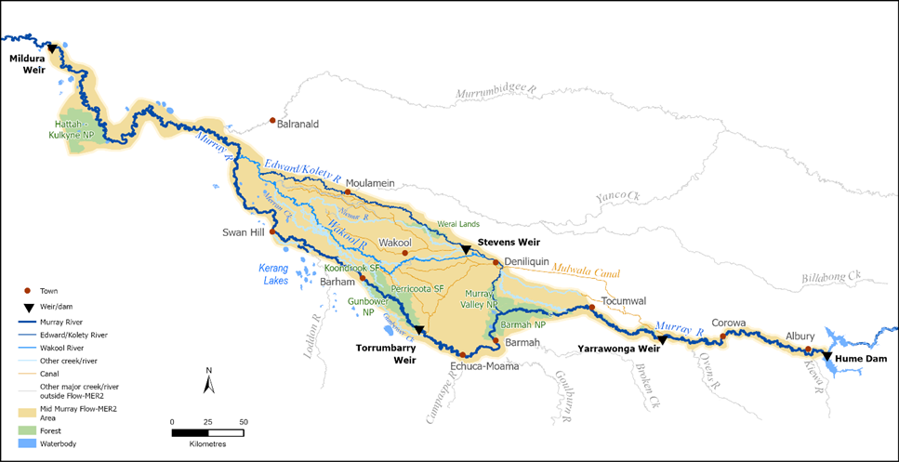
Figure 1 The Mid-Murray Area
The Mid-Murray supports river red gum forests, wetlands and floodplains including Barmah-Millewa, Gunbower, Koondrook-Perricoota Forests and Werai Lands. Collectively, these forests support 550 plant and 270 animal species, including threatened species such as the Australasian bittern, superb parrot, Mueller daisy, swamp wallaby grass, silver perch and Murray and trout cod (CEWH 2024). The Mid-Murray includes areas of national environmental significance; Millewa Forest, Koondrook-Perricoota Forest and Werai Lands make up the NSW Central Murray Forests Ramsar site. Other Ramsar sites in the Mid-Murray Area are Barmah Forest, Gunbower Forest, and Hattah-Kulkyne Lakes.
The Mid-Murray Area has a long Indigenous history and First Nations peoples of the Mid-Murray maintain strong connections to Country. The Mid-Murray Area also has significant economic and social values. Its waterways provide water for domestic use, and support diverse agriculture, tourism and recreational activities.
Ecological objectives and associated environmental watering requirements for the Mid-Murray area are specified in the Murray-Lower Darling Long Term Watering plan (DPIE, 2020a; DPIE 2020b). The expected ecological outcomes for watering actions in the Murray River are:
- Improve fish conditions, movement and recruitment, connectivity and in-channel vegetation
- To connect with the Barmah-Milewa Forest for a range of ecological outcomes
- Maintain current species diversity, extending distributions and improving breeding success and numbers of short, moderate and long-lived native fish species through weir-pool lowering.
The expected ecological outcomes for watering actions in the Edward/Kolety-Wakool system are:
- Maintain current species diversity, extend distributions and improve breeding success and numbers of short, moderate and long-lived native fish species, and water dependent bird species
- Maintain the extent and condition of riparian and in-channel vegetation
- Contributing to riverine functioning.

Key activities
Four themes (River Flows and Connectivity, Native fish, Native Vegetation, and Cultural Outcomes) are the focus of monitoring and evaluation in the Mid-Murray Area. These themes align with those of the Basin-Wide Environmental Watering Strategy (BEWS) (MDBA, 2019). The project also includes sentinel surveillance of dissolved oxygen, and knowledge exchange, communications and engagement activities. In 2024-25 two responsive monitoring projects were also undertaken in the Mid-Murray Area; ‘Water quality outcomes of the Edward/Kolety River Flow Trial to Werai Lands 2024-25’ (Liu and Watts 2025), and ‘Flow gauging on Werai Lands’ (Arrowsmith et al. 2025). One research project ‘Mid-Murray Area Wetland Inundation Research’ (Lachlan-Arrowsmith and Elgindy 2025a) was undertaken in 2024-25.

Monitoring sites
Detailed methods and analysis are described in the Mid-Murray Annual Report (DCCEEW 2026).
River Flows and Connectivity: Flow data were obtained from six gauges in the Murray River, ten gauges in the Edward/Kolety-Wakool system, and irrigation escape flows from Murray Irrigation Limited. Counterfactual (natural) flow scenarios were modelled by the Murray-Darling Basin Authority. Satellite imagery was used to assess lateral and longitudinal connectivity and fragmentation in selected river reaches. Flow data is linked to the evaluation methods for native fish, native vegetation and water quality monitoring with river gauges matched to the sampling locations.
Native Vegetation: - Lignum health and condition were monitored using drone and field-based methods at three locations near Mildura. Non-woody vegetation species richness and percent cover of non-woody vegetation was evaluated was monitored at 20 plots in Werai Lands.
Native Fish: The fish community was monitored using standardised boat electrofishing at four sites within each of eight hydrological zones in the Mid-Murray Area. Fish spawning was monitored using drift nets and light traps at four sites in the upper Edward/Kolety River.
Water Quality: In 2024-25 a Dissolved Oxygen Index and traffic light reporting method for the sentinel surveillance of dissolved oxygen was developed and subsequently tested using data from four WaterNSW automated gauging sites. In future years the Dissolved Oxygen Index and traffic light reporting will be applied to 23 automated dissolved oxygen monitoring gauges and five additional real-time monitoring sites that have been established in reaches in the Edward/Kolety-Wakool system.

Environmental watering summary
The main source of Commonwealth environmental water for Murray River watering actions is Hume Dam. Environmental water is also delivered from Yarrawonga Weir and Torrumbarry Weir. Inflows of environmental water from the Goulburn River, Broken River, Campaspe River and Loddon River in Victoria and Murrumbidgee River in New South Wales influence the flows in the Mid-Murray Area. Water diverted into the Mulwala Canal from Lake Mulwala was delivered into the Edward/Kolety-Wakool River system through irrigation ‘escapes’ or outfalls managed by the irrigator-owned company Murray Irrigation Limited (MIL).
A total of 342,542 ML of CEW was delivered to the Murray River system from Hume Dam in 2024-25 (CEWH, 2025b)(Table 1). Additional CEW entered the Murray River system from the Goulburn and Murrumbidgee system as a result of environmental water actions in those systems. A total of 92,787 ML of CEW was delivered to the Edward/Kolety-Wakool system in 2024-25 (CEWH, 2025a) (Table 2).
Table 1 Commonwealth environmental watering actions delivered from Hume Dam in 2024-25.
Watering action | Delivery dates | Watering action description | CEW Volume delivered (ML) | Other ewater Volume delivered (ML)
River Murray Valley (ordered from Hume) | 1/7/2024 - 15/9/2024 | Elevated winter baseflows | 11,060 | 20,130 (TLM)
River Murray Valley (ordered from Hume) | 2/9/2024 - 15/9/2024 | In-channel managed deliveries via regulators to targeted wetlands in Barmah-Millewa Forests. | 0 | 3,950 (VEWH)  12,390 (TLM)  5,773 (EWA)
River Murray Valley  (ordered from Hume) | 15/9/2024 - 23/11/2024 | Winter/Spring fresh following natural or actual overbank event | 280,000 | 7,068 (VEWH)  8,520 (TLM)  29,442 (RMIF)  45,000 (EWA)
River Murray Valley  (ordered from Hume) | 1/6/2025 - 30/6/2025 | Elevated winter baseflows | 51,482 | 30,360 (TLM)
River Murray Valley | 21/3/2025 - 31/5/2025 | Lower weir pool levels in summer and autumn in Lock 15 | 0 | 0
Total |  |  | 342,542 | 162,633

Table 2 Commonwealth environmental watering actions delivered to the EKW system in 2024-25.
Watering action | Delivery dates | Watering action description | CEW Volume delivered (ML) | Other ewater Volume delivered (ML)
Wakool-Yallakool-Colligen (WaterNSW) | 01/10/2024 - 30/11/2024 | Spring pulses in the Wakool River, Yallakool and Colligen creeks. | 5,950.0 | 22,281 (NSW)
Edward/Kolety River trial (WaterNSW) | 04/10/2024 - 26/10/2025 | Watering trial to inundate Werai forest in spring that aligned with the Murray multi-site watering event. | 24,689.0 | 0
MIL in-stream escapes | 02/09/2024 - 01/05/2025 | Flows delivered through the Niemur, Wakool and Finley escapes to target in-stream pulses in the Niemur River, Wakool River and Billabong Creek. | 18,118.9 | 0
The Pollack | 01/09/2024 - 01/01/2025 | Pumping to Pollack wetland in the Koondrook-Perricoota Forest. | 2,142.0 | 0
Edward-Kolety River system (WaterNSW) | 02/04/2025 - 01/05/2025 | Autumn pulse in the Edward/Kolety River downstream of Stevens Weir | 17,164.3 | 3,413 (NSW)
MIL ephemeral creeks and wetlands | 02/09/2024 - 01/05/2025 | Deliveries throughout the year to ephemeral creeks and wetlands. | 24,723.5 | 0
Total |  |  | 92,787.7 | 25,694 (NSW)

The delivery of the environmental water is shown for the following locations for the 2024-25 water year:
- Yarrawonga (Figure 2): deliveries from Hume for the Murray River and Edward/Kolety-Wakool system
- Euston (Figure 3): Environmental water at Euston includes significant additional environmental water from Goulburn, Murrumbidgee systems and Edward/Kolety-Wakool system.
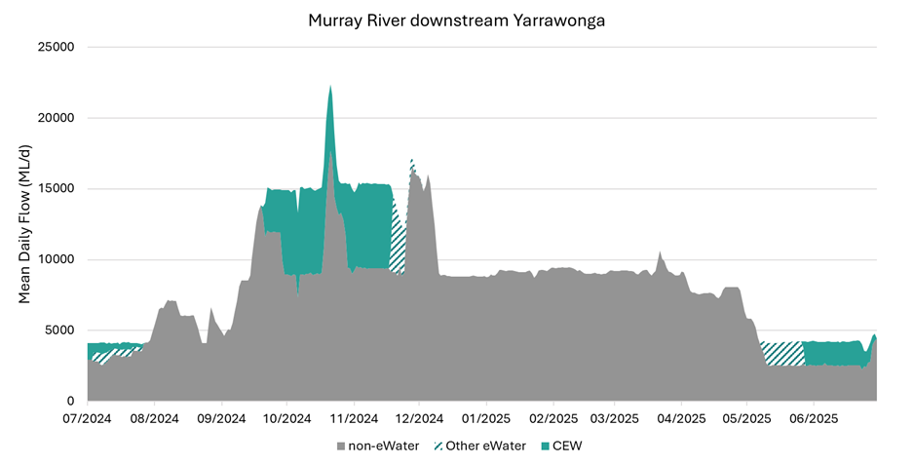
Figure 2 Hydrograph for the Murray River downstream of Yarrawonga (gauge 409025) in 2024-25, delivered from Hume for the Murray River and Edward/Kolety-Wakool system. Grey = non environmental water, hatched blue = other e-water, blue = CEW.
Environmental water over the 2024-25 water year at Murray River downstream Yarrawonga (gauge 409025), delivered from Hume for the Murray River and Edward/Kolety-Wakool system.
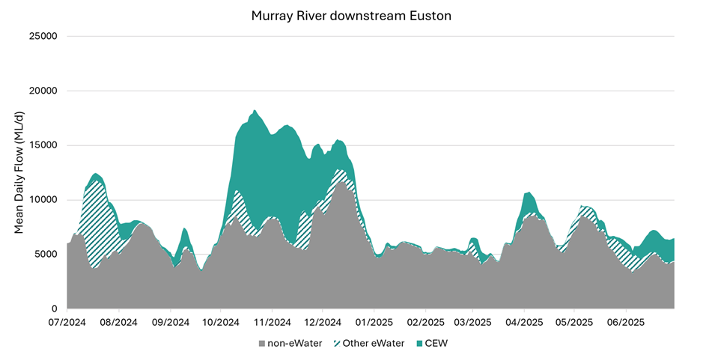
Figure 3 Hydrograph of the Murray River at Euston (gauge 414203C) for 2024-25. Grey = non environmental water, hatched blue = other e-water, blue = CEW.

Key outcomes from environmental water use

Monitoring outcomes

River Flows and Connectivity
River flows
Environmental water increased total annual discharge and maximum discharge at all study locations. In the Edward/Kolety-Wakool system. Commonwealth environmental water had no effect on minimum discharge, which occurred during the winter shut-down period outside the period of environmental water delivery.
Along the Murray River, Commonwealth environmental water extended the duration of the partially successful BF2 and the successful LF2 at Yarrawonga and Torrumbarry, and enabled weir pool lowering at Euston (Lock 15).
In the Edward/Kolety-Wakool system, environmental water enabled five of eight targeted EWRs to be fully or partially successful that would otherwise not have been met. For two additional EWRs, environmental water extended the duration above the EWR threshold.
Longitudinal connectivity
Commonwealth environmental water was not delivered during the shut-down periods. However, environmental water contributed in two ways:
- Prior to shut-down, environmental water maintained elevated baseflows, likely prolonging pool longevity during the cease-to-flow period. This could not be quantified for 2024-25 and will be investigated further.
- Following the shut-down period, environmental water delivery approximately doubled discharge in the Wakool and Yallakool systems and increased discharge in the Colligen-Niemur system by 60-100%, supporting the reconnection of remnant pools and reinstatement of longitudinal connectivity.
Overbank inundation
Without the delivery of CEW and the opening of the creek regulators, no inundation of the Werai Lands would have occurred during 2024-25 under the observed low-inflow conditions. The delivery of Commonwealth environmental water combined with opening of the Tumudgery Creek and Reedy Bed Creek regulators resulted in inundation of 370.6 ha of the eastern Werai Lands for 86 days and 270.5 ha of the western Werai Lands for a minimum of 75 days.

Native Vegetation
Lignum cover and condition
The 2024-25 monitoring period provides a baseline for future evaluation of lignum cover and condition. There was no Commonwealth environmental water delivered to the monitored lignum sites in 2024-25. Most of the surveyed lignum plots were classified as being in moderate or good condition. There was considerable difference in lignum condition evident among plots. In future years the trajectory of change for each individual plot will be evaluated against inundation history.
Species richness and cover of non-woody vegetation
A total of 47 non-woody species were recorded following the environmental watering of Werai Lands during the Edward River Flow Trial. There was higher abundance of Warrego grass, lippia, common spikerush and tall sedge recorded in plots that received Commonwealth environmental water compared to plots that did not receive environmental water. Several amphibious species including Myriophyllum crispatum (upright water milfoil), Damasonium minus (star fruit), and Cycnogeton procerum (water ribbons) and wetland responders including Centipeda minima (spreading sneezeweed), Cyperus difformis (dirty dora), Persicaria decipiens (knotweed), Rorippa eustylis (dwarf bitter cress) were only recorded in plots in lower lying temporary river red gum swamp, but were absent from plots in river red gum forest.
Inundation model outputs showed that flows of 3000 ML/day and 4000 ML/day at the gauge downstream of Stevens Weir mainly inundated temporary river red gum swamp and a relatively small area of river red gum forest. The models showed that increasing the flow downstream of Stevens Weir from 4000 ML/d to 5250 ML/day would more than double the area of red gum forest inundated (Figure 4). Increasing the flow downstream of Stevens Weir from 5,250 ML/d to 7,000 ML/d would result in a further doubling of the area of red gum forest inundated (Figure 4).
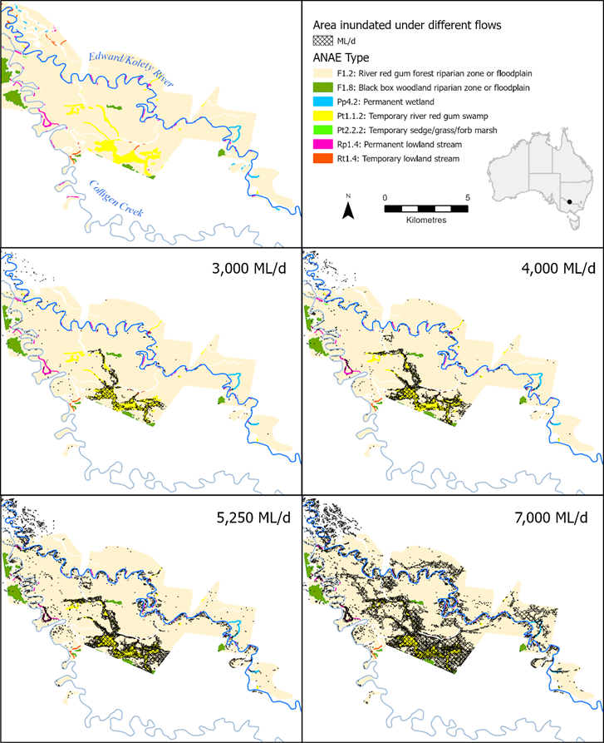
Figure 4 Maps of the south-eastern portion of Werai Lands showing area inundated under four flows (3,000 ML/d, 4,000 ML/d, 5,250 ML/d and 7,000 ML/d) at the gauge downstream of Stevens Weir. The map at the top left shows the distribution of ANAE vegetation types. Black hatching indicates the area inundated under different modelled flows at Stevens Weir.

Waterbirds
No waterbird monitoring or evaluation was undertaken in the Mid-Murray Area in 2024-25 as part of the Mid-Murray Flow-MER Project

Native Fish
2024-25 was the first year of the Mid-Murray Area scale monitoring for the Native Fish theme. Associations between fish indicators (recruitment, population structure, abundance and condition) and flow conditions cannot be assessed with only one year of monitoring data. Here we provide an overview of the native species trends observed in 2024-25 in the Mid-Murray Area. These data set a benchmark for future years’ monitoring and evaluation.
Recruitment of native fish
Evidence of native fish recruitment in the Mid-Murray Area in 2024-25 was strongly species-specific. Young-of-year (YOY) individuals were detected for several moderate- to long-lived native species, including Murray cod, trout cod and bony herring, indicating successful spawning and early survival for these taxa. Recruits of all short-lived native species were recorded, consistent with their life-history strategies and capacity to reproduce under a broad range of flow conditions. In contrast, there were no YOY golden perch, silver perch or river blackfish recorded during autumn 2025, suggesting limited or unsuccessful recruitment. Overall, recruitment during 2024-25 supported maintenance of some native fish populations but highlighted ongoing limitations for flow-dependent species under moderate flow conditions.
Population structure of native fish
Native fish population structure in the Mid-Murray Area in 2024-25 suggested adult populations of some species were maintained, but there was limited recent recruitment for several key species. There were multiple size cohorts present for Murray cod, trout cod and bony herring, indicating persistence of populations supported by recruitment over multiple previous years. In contrast, golden perch populations were dominated by sub-adult and adult individuals with an absence of juveniles. This is consistent with episodic recruitment and a reliance on infrequent high-flow events to drive successful spawning and early survival. Silver perch and river blackfish were captured at very low abundances. Short-lived native species displayed size structures characteristic of rapid turnover, with both juvenile and mature individuals present across most zones.
Abundance of native fish
Fish abundance in the Mid-Murray Area in 2024-25 varied markedly among species and river reaches and provides baseline conditions for the study. Native fish abundance was comparatively low and spatially variable. There were higher numbers of alien species, particularly common carp. Among native taxa, small-bodied species such as unspecked hardyhead and Australian smelt contributed the most to total native fish abundance. Large-bodied species, including Murray cod and golden perch, occurred at relatively low abundance across the Mid-Murray Area. Murray cod abundance was highest in the Murray River at Barmah and the upper Edward/Kolety River, while golden perch abundance was moderate and relatively uniform across the monitored sites.
Condition of native fish
Fish community condition indices derived from Sustainable Rivers Audit metrics classified most zones as “poor” to “extremely poor”. These values were driven by low native fish biomass, limited recent recruitment, and the dominance of alien species. There was variation in native fish body condition among study sites.
Spawning of native fish in the upper Edward/Kolety River
Silver perch eggs (n=103) and larvae (n=2) (Figure 5) were detected in the upper Edward/Kolety River, providing strong evidence of localised spawning of silver perch in this reach. The first appearance of silver perch eggs (6 November 2024) was associated with water temperatures reaching 21°C. Environmental water (including Commonwealth environmental water) return flows from Millewa Forest (part of NSW Central Forests Ramsar site) to the upper Edward/Kolety River added a significant spring fresh to the reach. Mean flow velocities during the entire study period exceeded 0.25 m/s. There was no evidence of golden perch spawning the upper Edward/Kolety River during the study period.
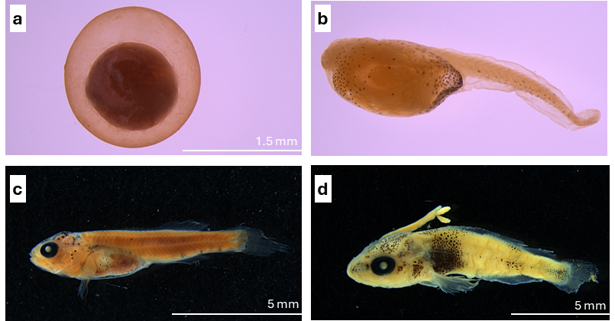
Figure 5 Eggs and larvae collected from drift nets in the upper Edward River in November and December 2024. a) silver perch eggs, b) silver perch larvae; c) Murray cod larvae and d) trout cod larvae (with parasitic lernia). (Photos J. Trethewie).

Cultural Outcomes
The Mid-Murray Project supported First Nations activities and contributed to building capacity in First Nations groups, building relationships, trust and a shared understanding of environmental water. In 2024-25 activities undertaken in partnership with First Nations peoples in the Mid-Murray Area involved consultation, collaboration and empowerment of First Nations peoples through participation in monitoring, research and cultural networks.
In 2024-25 the Mid-Murray Area Project supported ten First Nations activities;
- Appointment of Cultural Advisor
- Collaboration of Area-scale River Flows and Connectivity monitoring
- Collaboration on Area-scale Native Vegetation monitoring
- Collaboration on Area-scale Native Fish monitoring
- Collaboration on Area-scale Sentinel Surveillance of Dissolved Oxygen
- Participation in the Flow-MER Program Cultural Network
- Establishment of the Murrumbidgee/Mid-Murray Area First Nations Network
- Collaboration on two Area-scale responsive monitoring projects
  - Water quality outcomes of the Edward/Kolety River Flow Trial to Werai Lands
  - Flow gauging on Werai Lands
- Preliminary work on planning a First Nations weaving plants field guide
- e-DNA biodiversity pilot survey of vertebrates and decapods in Tumudgery Creek
The Mid-Murray Area Cultural Advisor played an important role in advising the Mid-Murray Team on building relationships, supporting First Nations engagement and developing First Nations activities in the Mid-Murray Area.
Several of the activities in 2024-25 were undertaken by the Mid-Murray Flow-MER team in partnership with the Kolety Werkul Rangers from Yarkuwa Indigenous Knowledge Centre in Deniliquin, Werai Land and Water Board, and the Barkandji Maraura Elders Environment Team Rangers. The Mid-Murray team had pre-existing relationships with each of these groups prior to the commencement of Flow-MER project. The Mid-Murray team is developing partnerships and collaborative activities with other First Nations organisations and peoples, noting it will take time to develop new partnerships. New partnerships with First Nations will continue to be developed through the Murrumbidgee/Mid-Murray Flow-MER First Nations Area Network and other strategies.
There are many different organisations at Federal, State and catchment level involved in the planning and delivery of environmental water in the Mid-Murray Area. First Nations peoples participated in the planning and delivery of Commonwealth environmental water through membership of range of different committees (e.g. Southern Connected Basin Environmental Water Committee, Murray Lower Darling Environmental Water Advisory Group, Edward/Kolety-Wakool Environmental Water Reference Group). In 2024-25 were several examples of First Nations partnerships in planning, delivery and monitoring of environmental water:
- The planning and delivery of the Edward River Flow Trial in collaboration with Werai Land and Water Aboriginal Corporation is an example of the successful partnership between water managers, First Nations peoples and scientists. During the Flow Trial the Kolety Werkul Indigenous River Rangers partnered with the Mid-Murray Project team in monitoring floodplain inundation, river flows, water quality and native vegetation (Figure 6).
- The planning and delivery of CEW to Ryans Lagoon is an example of successful partnership between North-East Catchment Management Authority, Victorian Environmental Water Holder, North-East Water, CEWH and the Duduroa Dhargal Aboriginal Corporation.
- The CEWH engaged with Tati Tati First Nations peoples regarding the potential for future water planning and delivery of watering to Margooya Lagoon.
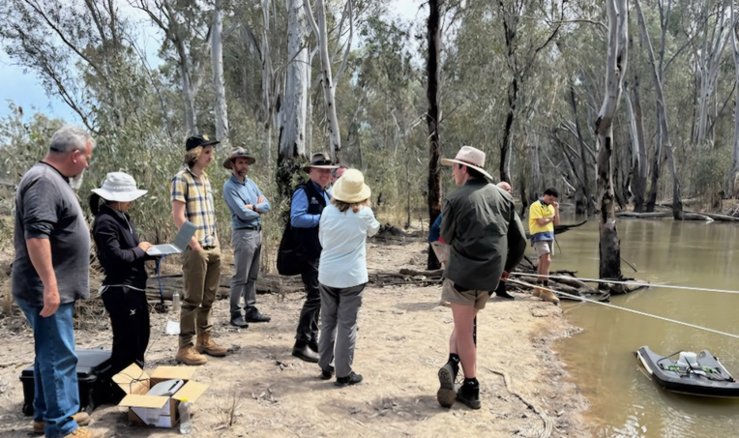
Figure 6 Werai Land and Water Board Chairperson Stewart Taylor, Werai Land and Water Board members, Simon Banks (CEWH), Kolety Werkul Rangers, CEWH staff, NSW DCCEEW staff and CSU scientists discuss flow gauging monitoring at Reedy Bed Creek in Werai Lands during the Edward/Kolety River Flow Trial.

Sentinel surveillance of dissolved oxygen for early detection of hypoxia
In 2024-25 the Sentinel Surveillance of dissolved oxygen activity was established. Real-time monitoring equipment were installed at five sites in addition to the existing WaterNSW automated gauging network. A Dissolved Oxygen Index and traffic light reporting method for the sentinel surveillance and real-time daily reporting of dissolved oxygen was developed.
The Dissolved Oxygen Index and traffic light reporting methods were tested using daily data from four WaterNSW automated gauging sites. The results showed that the DO Index and traffic light reporting matrix provided a visual summary of conditions throughout the year and highlighted the time of year at highest risk of low DO conditions (Figure 7).
In 2024-25 Commonwealth environmental water maintained dissolved oxygen (DO) above 4 mg/L (the range of concern for native fish) in several river reaches in the Edward/Kolety-Wakool system. Watering actions that had a positive effect on DO include a spring fresh to the Wakool River, an autumn pulse in the Edward/Kolety River downstream of Stevens Weir, and Commonwealth environmental water delivered through the Niemur, Wakool and Finley escapes to the Niemur River, Wakool River and Billabong Creek.
In future years, real-time monitoring data and the Dissolved Oxygen Index and traffic light reporting method will be reported for 23 WaterNSW automated dissolved oxygen monitoring gauges and the five additional real-time monitoring sites that have been established in the Edward/Kolety-Wakool system.
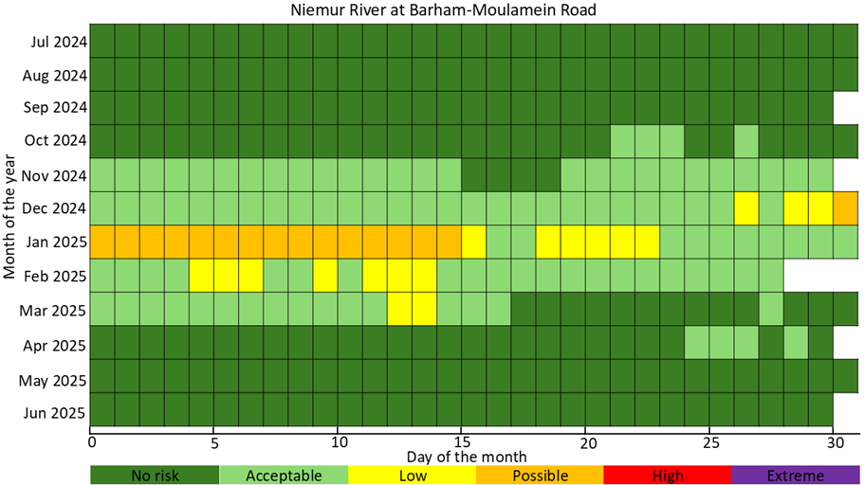
Figure 7 Matrix of daily hypoxia risk shown using a traffic light scheme to indicate dissolved oxygen conditions of the Niemur River at Barham-Moulamein Road (WaterNSW #409048) from 01 July 2024 to 30 June 2025. Dark green – no risk, light green – acceptable, yellow – low risk, orange – possible risk, red – high risk, purple – extreme risk.

Responsive monitoring outcomes

Water quality outcomes of the Edward River Flow Trial to Werai Lands
This activity investigated how environmental water delivered during the Edward River Flow Trial influenced the water quality of Tumudgery Creek within Werai Lands and the water quality of Colligen Creek that receives outflows from Werai Lands. Full details are published in Liu and Watts (2025).
The environmental water delivery through Werai Lands wetted Tumudgery Creek and dry low-lying sections of the adjacent floodplain and facilitated the release of carbon and nutrients from the floodplain to Tumudgery Creek. Dissolved oxygen (DO) levels in Tumudgery Creek Downstream remained above 4 mg/L (the threshold for fish stress) for most of the flow trial and briefly dropped below 4 mg/L between late November and late December 2024.
During the flow trial that carbon and nutrients were flushed from Tumudgery Creek into Colligen Creek, however the DO levels in Colligen Creek Downstream remained above 4.6 mg/L during the flow trial. This had a small positive impact on supporting productivity and increasing food availability of Colligen Creek and no lasting negative impacts on the water quality. No fish kill was observed or reported at any time during the monitoring.

Flow gauging on Werai Lands
Flow gauging was undertaken during the Edward River flow trial at five sites to generate flow-depth relationships, and to quantify the volume of environmental water that entered and exited Werai Lands. Depth loggers and fixed cameras were used for on-ground verification of water movement through the wetland. Full results are published in Lauchlan-Arrowsmith et al. (2025).
It was found that 24.5 GL of water entered Werai Lands via Tumudgery Creek, 17.9 GL entered Werai Lands via Reedy Bed Creek, and 46.2 GL entered the Niemur River through the Niemur offtake. Of water delivered to the eastern Werai Lands, 18.1 GL returned to Colligen Creek and 3.4 GL returned to the Edward/Kolety River. Approximately 13% of delivered water was retained on the floodplain.
The results of this project directly supported Mid-Murray Area Flow-MER monitoring and evaluation, including modelling wetland inundation extent in Werai Lands, assessing the contribution of Commonwealth environmental water to wetland and floodplain forest inundation in Werai Lands and Niemur Forest, and evaluating water quality responses to floodplain inundation.

Research outcomes

Werai Lands inundation mapping
This research project involved a review of remote sensing approaches, collation of satellite imagery, validation of the selected approach against field data, and preliminary investigation of a flow-wetland inundation extent relationship for Werai Lands. Results indicate that a hybrid analysis approach gave the best outputs to improve identification of open water in smaller and less vegetated waterways. Photos from fixed-point cameras and depth loggers provided a valuable source of data for confirming wetland inundation extent and connectivity.
The research demonstrated the usefulness and accuracy of the selected remote sensing approach for monitoring vegetated river red gum forest wetland inundation. The approach can be used to map daily inundation extents to support real-time monitoring and adaptive management during watering actions. Inundation maps can be used as a communication and engagement tool to discuss environmental watering options with landholders. Full results are published in Lauchlan-Arrowsmith and Elgindy (2025).

Knowledge exchange and engagement outcomes
The Mid-Murray Area Project undertakes Knowledge Exchange, Communication and Engagement activities that support 1) internal project communication and engagement, 2) external communication and engagement, and 3) activities that involve First Nations and community participation in Mid-Murray Flow-MER activities.
In 2024-25 internal project communication and engagement activities were undertaken to support the Mid-Murray Project and inform and collaborate with the CEWH and other Flow-MER Providers. Activities included Mid-Murray Project team meetings, and meetings with CEWH staff and water delivery stakeholders. In 2024-25 the Mid-Murray Leadership team had fortnightly meetings with the CEWH to discuss project management and provide timely updates on observations from field monitoring and engagement activities. The Mid-Murray team contributed to the internal monthly Flow-MER Communique. Mid-Murray theme Leaders attended Flow-MER thematic Working Groups to discuss activities and support collaboration among the CEWH and Flow-MER Providers.
In 2024-25 external communications were undertaken to inform stakeholders including agency staff, landholders, local communities, and the wider scientific community. External communication activities included production of Mid-Murray Quarterly Snapshots, creation of content for the Flow-MER website, presentation at webinars and workshops, and updates to the Mid-Murray online interactive map. Members of the Mid-Murray team presented project findings at national conferences. External engagement activities included participation in the Flow-MER Annual Forum, the Murray Lower Darling Environmental Water Advisory Group (EWAG), the Edward/Kolety-Wakool Environmental Water Reference Group and interagency operational advisory group meetings to assist the adaptive management of environmental water.
In 2024-25 activities were undertaken that involved the community in Mid-Murray Area monitoring and research and contributed data to the project. Involving the community in Flow-MER activities increases engagement and knowledge, and engagement with the Mid-Murray Project and the Flow-MER Program. In 2024-25 First Nations peoples participated in several monitoring and research activities (see section 3.1.5). In 2024-25 the Mid-Murray Area team planned and developed resources to establish the Mid-Murray Citizen Science Project that will enable a larger number of citizens to participate in the Mid-Murray Project and learn about environmental water and the Flow-MER Program. The Mid-Murray Citizen Science Project involved collection of water level data from static gauges at sites in the Mid-Murray Area where there are no automated flow gauging. Citizen Science training workshops will be undertaken in 2025-26 and monitoring and data collection will continue through the following years of Mid-Murray Project.

Adaptive management and implications for environmental watering

Informing adaptive management
The Mid-Murray Flow-MER team worked with the CEWH and stakeholders in 2024-25 through formal stakeholder group meetings and informal meetings to inform the adaptive management of Commonwealth environmental water. Through providing advice on the movement of water through Werai Lands during the Edward River Flow Trial, the Mid-Murray Flow-MER team informed water delivery and timing of flow gauging. During the environmental watering actions from the Niemur, Wakool and Finley escapes and the autumn pulse in the Edward/Kolety River, advice provided to water managers about real-time changes in dissolved oxygen assisted the adaptive management of the magnitude and duration of water delivery during the watering actions.

Long-term management considerations
Observed water retention in Werai Lands should be considered by water managers when planning future environmental watering actions, particularly in relation to expected return flows. Environmental water delivered to Tumudgery Creek triggered extraction under unregulated water licence conditions, presenting a risk to watering outcomes. Engagement between CEWH, NSW Water Managers and the Natural Resources Access Regulator is recommended to identify mechanisms to protect environmental water during future watering actions.
The potential for environmental water delivered prior to the winter shut-down to prolong pool longevity and assist in reconnecting the system after maintenance is complete warrants further investigation in future years.
During the winter maintenance shutdown of Stevens Weir, flowing water conditions along the Yallakool, Wakool and Colligen systems are reduced. The ability to alter the maintenance shut-down period is limited. Where possible, water managers should continue to explore options for the delivery of environmental water to some of the tributaries in the Edward/Kolety-Wakool system during winter to minimise negative impacts of operational winter system shutdown. Future management should also focus on complementary actions, such as stock exclusion and feral animal control, to minimise the impacts of reduced flow connectivity over the winter period.

Recommendations for future environmental watering and management
Environmental water managers should work closely with river operators to ensure that the desired ecological outcomes of the watering actions can be achieved. They should continue to help provide inputs on adjustments to water management where operations constrain or delay water deliveries.
We recommend environmental watering actions to inundate Werai Lands be delivered to inundate a larger portion of Werai Lands to benefit a larger number of vegetation types and water-dependent species. Where operationally possible, delivery of environmental water to Werai Lands should commence earlier in the water year, in late winter/early spring, and include multiple pulses to support the germination, recruitment and growth of plants. This would also improve the water quality of return flows from Werai to receiving waterways and minimise risk of hypoxia.
We recommend that the CEWH work with water managers and local communities to deliver environmental water to lignum sites in the Mid-Murray, where there is a demand consistent with the watering requirement for those sites, and that demand is not met by other sources of flow such as unregulated overbank flows. Dense lignum stands provide habitat that is important for waterbirds and other animals, offering shelter, nesting sites, and protection from predators.

Monitoring enhancements to improve data accuracy and relevance
We recommend that analysis of EWRs be expanded to all gauged locations for each water year, regardless of whether a water action has targeted that reach.
Expand flow trials and monitoring to other floodplain wetlands of interest, to improve accuracy of inundated wetland area data. Expand fixed point camera monitoring to enhance accuracy of inundated wetland area data.
Upgrades to the Tumudgery, Niemur, and Reedy Bed Creek regulators planned for 2025-26 will require post-upgrade flow gauging to validate or update existing rating tables. Additional gauging at return flow locations to the Edward/Kolety River and Colligen Creek under a range of flow conditions is needed to further refine estimates of floodplain retention and return flows.
We recommend monitoring of ecosystem responses to environmental watering in ephemeral creeks be established, to complement monitoring currently undertaken by NSW agencies.
The presence of silver perch eggs in the upper Edward/Kolety River indicate this may be an important spawning area for the threatened species. However, it is not known if fish spawned in the upper Edward/Kolety River successfully recruit downstream, and if Stevens Weirpool acts as a source or sink of larval fish survival and recruitment. It is recommended that targeted larval and early juvenile fish sampling be undertaken in Stevens Weir in early summer to help address this knowledge gap.
We recommend that water managers increase opportunities for First Nations peoples to be engaged in the planning and delivery of environmental water and improve the documentation of their involvement, provided First Nations peoples provide consent to do so.

References
Bond, N., Grigg, N., Roberts, J., McGinness, H., Nielsen, D., O’Brien, M., Overton, I., Pollino, C., Reid, J., and Stratford, D. (2018) Assessment of environmental flow scenarios using state-and-transition models. Freshwater Biology 63, 804-816. doi:10.1111/FWB.13060
Campbell, C.J., Freestone, F.L., Duncan, R.P., Higgisson, W., Healy, S.J. (2021) The more the merrier: using environmental flows to improve floodplain vegetation condition. Marine and Freshwater Research 72(8) 1185-1195. https://doi.org/10.1071/MF20303
Commonwealth Environmental Water Holder (2025a) Watering Action Acquittal Report Edward/Kolety-Wakool River System 2024-25. Commonwealth of Australia.
Commonwealth Environmental Water Holder (2025b) Watering Action Acquittal Report, River Murray Valley 2024-25. Commonwealth of Australia.
Commonwealth Environmental Water Holder (2025c) Watering Action Acquittal Report, Weir pool manipulation 2024-25 (Locks 7,8,9 and 15). Commonwealth of Australia.
DCCEEW (2024) Knowledge Exchange Strategy, Flow-MER Program, Department of Climate Change, Energy, the Environment and Water, Canberra, 2024.
DCCEEW 2026, Mid-Murray Area, Annual Report 2024-2025, Flow-MER Program, Department of Climate Change, Energy, the Environment and Water, Canberra, 2026.
Department of Planning, Industry and Environment (2020a) Murray-Lower Darling Long-Term Water Plan Part A: Murray-Lower Darling catchment. NSW Department of Planning, Industry and Environment.
Department of Planning, Industry and Environment (2020b) Murray-Lower Darling Long-Term Water Plan Part A: Murray-Lower Darling planning units. NSW Department of Planning, Industry and Environment.
Lachlan Arrowsmith, C., Davidson, S. and Elgindy, P. (2025) Mid-Murray Area, Flow gauging on Werai Lands in 2024-2025, Flow-MER Program, Department of Climate Change, Energy, the Environment and Water, Canberra, 2025.
Lauchlan-Arrowsmith, C. and Elgindy, P. (2025) Mid-Murray Area Wetland Inundation Research Report, 2024-2025, Flow-MER Program, Department of Climate Change, Energy, the Environment and Water, Canberra, 2025.
Liu, X. and Watts, R.J. (2025) Water quality outcomes of the Edward/Kolety River Flow Trial to Werai Lands in 2024-25, Mid-Murray Area, Flow-MER Program, Department of Climate Change, Energy, the Environment and Water, Canberra, 2025.
Watts R.J., Crew J., Elgindy P., Healy S., Lachlan-Arrowsmith C., Liu X., McCasker N., Stocks J., Tonkin Z., Trethewie J., Zampatti B. 2026, Mid-Murray Area, Annual Report 2024-2025, Flow-MER Program, Department of Climate Change, Energy, the Environment and Water, Canberra, 2026.
Watts, R.J., McCasker, N., Arrowsmith, C.L., Bond, N., Childs, P., Crew, J., Crew, D., Healy, S., Knight, R., Liu, X., Spencer, J. and Stocks, J. (2024a) Mid-Murray Area, Monitoring, Evaluation and Research Plan 2024-2029, Flow-MER Program, Department of Climate Change, Energy, the Environment and Water, Canberra, 2024
Watts, R., McCasker, N., Arrowsmith, C.L., Bond, N., Childs, P., Crew, J., Crew, D., Healy, S., Knight, R., Liu, X., Spencer, J. and Stocks, J. (2024b) Mid-Murray Area, Annual Implementation Plan 2024-2025. Flow-MER Program, Department of Climate Change, Energy, the Environment and Water, Canberra, 2024.

Appendices
Table 3. Summary of key outcomes in the Mid-Murray Area in 2024-25 and recommendations.
Theme | KEQ | Key outcomes | Recommendations
River Flows and Connectivity | B1. What did CEW contribute to the regime of low flow conditions, freshes, bank-full flows? | Environmental water (including CEW) contributed to four targeted annual EWRs on the Murray River (BF2 and LF2 at Yarrawonga; BF2 at Torrumbarry). While the EWR outcome category (partial success or success) was the same with or without CEW, delivery extended the duration above the EWR threshold for both flow categories at Yarrawonga and Torrumbarry.  In the Edward/Kolety-Wakool system, environmental water contributed to seven targeted EWRs. Five were fully successful and two were partially successful. Environmental water approximately doubled total annual discharge across much of the system. | See text below in A1
River Flows and Connectivity | B2. What did CEW contribute to connectivity, including overbank inundation? | CEW contributed to connectivity in two ways:  - Delivery of sufficient flow to inundate the Werai Lands via the Tumudgery Creek and Reedy Bed Creek regulators (370.6 ha eastern, 270.5 ha western Werai Lands over 86 and ≥75 days respectively). Without environmental water, no inundation would have occurred.  - Post-shutdown, environmental water delivery approximately doubled discharge in the Wakool and Yallakool systems, supporting reconnection of remnant pools and reinstatement of longitudinal connectivity.  Assessment of CEW’s contribution to overbank inundation of the Barmah-Millewa Forest and other mainstem Murray forests is undertaken by the River Murray monitoring plan. | See text below in A2
River Flows and Connectivity | A1a. What low flow conditions and freshes occurred in the Mid-Murray Area? | Under total flow conditions (environmental water and other water combined), a range of annual EWRs from cease-to-flow through to large fresh were assessed. For targeted EWRs:  Murray River: BF2 was partially successful at Yarrawonga and Torrumbarry; LF2 was successful at Yarrawonga.  Edward/Kolety-Wakool: Small Fresh 1 was successful at the Yallakool offtake, Wakool offtake, Colligen Creek and Edward/Kolety River downstream Stevens Weir. Small Fresh 2 was successful at the Wakool Offtake and partially successful at Colligen Creek. Large Fresh 3 at Edward/Kolety River downstream Stevens Weir was partially successful. Small Fresh 2 at the Yallakool offtake was not met. | We recommend environmental water managers continue to provide environmental water orders with detailed delivery instructions that describe the intent of the environmental water delivery.  Environmental water managers should work closely with river operators to ensure that the desired ecological outcomes of the watering actions can be achieved. They should continue to help provide inputs on adjustments to water management where operations constrain or delay water deliveries.
River Flows and Connectivity | A1b. What did water for the environment (and specifically CEW) contribute to low flows and freshes in the Mid-Murray Area? | Water for the environment increased the total annual discharge (ML) and maximum discharge in all study reaches.  Environmental water increased total annual discharge and maximum discharge at all study locations. In the Edward/Kolety-Wakool system, CEW had no effect on minimum discharge, which occurred during the winter shut-down period outside the period of environmental water delivery.  Murray River: CEW extended the duration of the partially successful BF2 and the successful LF2 at Yarrawonga and Torrumbarry, and enabled weir pool lowering at Euston (Lock 15).  Edward/Kolety-Wakool: Environmental water enabled five of eight targeted EWRs to be fully or partially successful that would otherwise not have been met. For two additional EWRs, environmental water extended the duration above the EWR threshold. Detailed attribution between CEW and other environmental water sources in the Edward/Kolety-Wakool system will be further developed in future years as modelling data improve. | CEW is used to deliver specific planned watering actions, however environmental watering requirements are sometimes met as a byproduct of rainfall runoff, or delivery of operational irrigation flows across the system. We recommend that analysis of EWRs be expanded to all gauged locations for each water year, regardless of whether a water action has targeted that reach.
River Flows and Connectivity | A2a. During winter shut-down conditions, was longitudinal connectivity maintained in Wakool River, Yallakool Creek and Colligen-Niemur river system? | Longitudinal connectivity was not maintained during the winter shut-down period. In 2024, the maximum lengths of waterway experiencing cease-to-flow conditions were: Yallakool Creek 51.9 km (86.9%); Wakool River 47.7 km (88.5%); Colligen Creek 18.1 km (24.2%). Remnant pools of varying sizes remained present throughout the affected reaches throughout the maintenance period.  In 2025, a single image was available for analysis (16 June, mid-maintenance, following 5 mm of local rainfall). Comparable lengths to 2024 appeared to be not free flowing in the Yallakool and Wakool systems; the Colligen system appeared to have remained connected, though results should be interpreted with caution given the rainfall prior to image capture. | During the winter maintenance shutdown of Stevens Weir, flowing water conditions along the Yallakool, Wakool and Colligen systems are reduced. The ability to alter the maintenance shut-down period is limited. Where possible, water managers should continue to explore options for the delivery of environmental water to some of the tributaries in the Edward/Kolety-Wakool system during winter to minimise negative impacts of operational winter system shutdown. Future management should also focus on complementary actions, such as stock exclusion and feral animal control, to minimise the impacts of reduced flow connectivity over the winter period.
River Flows and Connectivity | A2b. What did water for the environment (and specifically CEW) contribute to maintaining longitudinal connectivity in Wakool River, Yallakool Creek and Colligen-Niemur river system? | CEW was not delivered during the shut-down periods. However, environmental water contributed in two ways:  - Prior to shut-down, environmental water maintained elevated baseflows, likely prolonging pool longevity during the cease-to-flow period. This could not be quantified for 2024-25 and will be investigated further.  - Following the shut-down period, environmental water delivery approximately doubled discharge in the Wakool and Yallakool systems and increased discharge in the Colligen-Niemur system by 60-100%, supporting the reconnection of remnant pools and reinstatement of longitudinal connectivity. | As above
River Flows and Connectivity | A3a. What wetland and floodplain inundation occurred in the Mid-Murray Area, specifically Werai Lands and Niemur Forest | In the eastern Werai Lands, 370.6 ha (12.4% of the eastern forest) was inundated over 86 days. Of this, 32% (approximately 119 ha) was inundated for 60-80% of the watering event, representing the core wetland area receiving sustained inundation.  In the western Werai Lands, 270.5 ha (6.1% of the western forest) was inundated for a minimum of 75 days, with 13% of the inundated area persistently wet throughout the event.  The Niemur Forest was not assessed in 2024-25 as no watering actions specifically targeted it. Testing of the inundation method indicates that assessment can be expanded to the Niemur Forest in future years. | The ability to provide sustained overbank inundation of the Werai Lands through environmental flow delivery to Tumudgery Creek requires flows in Colligen Creek to maintain suitable downstream flow conditions.  We recommend that watering objectives incorporate multiple pulses into watering actions in order to mimic natural flow sequencing. For example, extend watering objectives to include outcomes where a target area of plant communities is inundated for a targeted duration.  Explore opportunities to transfer operational flow through the Werai Lands to achieve ecological objectives.  CEWH and NSW DCCEEW should discuss unregulated water license triggers for environmental water extraction with NRAR to explore how environmental water can be protected from extraction in future events.  Expand flow trials and monitoring to other floodplain wetlands of interest, to improve accuracy of inundated wetland area data. Expand fixed point camera monitoring to enhance accuracy of inundated wetland area data.
River Flows and Connectivity | A3b. What did water for the environment (and specifically CEW) contribute to wetland and floodplain inundation in these locations? | Without the delivery of CEW and the opening of the creek regulators, no inundation of the Werai Lands would have occurred during 2024-25 under the observed low-inflow conditions. All inundation reported in A3a is attributable to environmental water delivery.  The contribution of CEW specifically was defined using results of the Year 1 research project and historic imagery analysis to separate CEW inundation extents from total inundation. This analysis will be refined in future years as additional imagery becomes available. | As above
Native Vegetation | Vegetation-B3, A3. What did CEW contribute to maintaining or improving the condition of lignum shrublands? | There was no CEW delivered to the monitored lignum sites in 2024-25. The contribution of CEW to maintaining or improving the condition of lignum shrublands was not evaluated in 2024-25.  The 2024-25 monitoring period provides a baseline for future evaluation of lignum cover and condition. There was considerable difference in lignum condition evident among plots. In future years the trajectory of change for each individual plot will be evaluated against inundation history. | None of the surveyed plots received environmental water in 2024-25 and only Gol Gol Swamp (watered) plots had received environmental water in 2023-24. The condition of lignum at all sites would improve if they were inundated more regularly by unregulated flows or environmental water.  We recommend that environmental water managers deliver environmental water to lignum sites in the Mid-Murray in 2025-26 and beyond, where there is a demand consistent with the watering requirement for those sites, and that demand is not met by other sources of flow, such as unregulated overbank flows.
Native Vegetation | Vegetation-B4, A4. What did CEW contribute to maintaining or improving representative populations and communities of non-woody vegetation? | A total of 47 non-woody species were recorded following the environmental watering in Werai Lands. There were differences in the species present among plots and ANAE types. Several amphibious species including Myriophyllum crispatum (upright water milfoil), Damasonium minus (star fruit), and Cycnogeton procerum (water ribbons) and several wetland responders including Centipeda minima (spreading sneezeweed), Cyperus difformis (dirty dora), Persicaria decipiens (knotweed), Rorippa eustylis (dwarf bitter cress) were detected only in temporary river red gum swamp plots.  There was higher abundance of Warrego grass, lippia, common spikerush and tall sedge recorded in river red gum forest plots that received CEW compared to plots that did not receive CEW.  Inundation model outputs showed that flows of 3000 ML/day and 4000 ML/day at the gauge downstream of Stevens Weir mainly inundated temporary river red gum swamp and a relatively small area of river red gum forest. The area of red gum forest inundated at discharge of 5,250 ML/d downstream of Stevens Weir was 446.8 hectares, more than double the 191.5 hectares inundated at a discharge of 4,000 ML/d downstream of Stevens Weir. Increasing the flow downstream of Stevens Weir from 5,250 ML/d to 7,000 ML/d more than doubled the area of red gum forest inundated to 1,087 hectares. | We recommend that environmental water continue to be delivered to Werai Lands to maintain and improve the diversity and cover of non-woody vegetation. We recommend larger flows (at least 5000 ML/d downstream of Stevens Weir) be delivered to inundate a large portion of Werai Lands and benefit a larger number of ANAE vegetation types.  Where operationally possible, delivery of environmental water to Werai Lands should commence earlier in the water year, in late winter/early spring, and include multiple pulses to support the germination, recruitment and growth of plants. This would also improve the water quality of return flows from Werai to receiving waterways and minimise risk of hypoxia.
Waterbirds |  | No waterbird monitoring or evaluation was undertaken as part of the Mid-Murray Flow-MER Project. | N/A
Native Fish | Fish-B1, A1. What did CEW contribute to native fish recruitment? | During the 2024-25 sampling year, evidence of native fish recruitment in the Mid-Murray Area was mixed and strongly species-specific.  Young-of-year (YOY) individuals were detected for several moderate- to long-lived native species, including Murray cod, trout cod and bony herring, indicating successful spawning and early survival for these taxa under prevailing hydrological conditions. All short-lived native species also exhibited recruitment, consistent with their life-history strategies and capacity to reproduce under a broad range of flow conditions. In contrast, no YOY golden perch, silver perch or river blackfish were captured during autumn 2025 surveys, suggesting limited or unsuccessful recruitment.  Overall, recruitment during 2024-25 supported maintenance of some native fish populations but highlighted ongoing limitations for flow-dependent species under moderate flow conditions. | 2024-25 was the first year of Mid-Murray Area-scale monitoring for the Native Fish theme. Associations between fish indicators (recruitment, population structure, abundance and condition) and flow conditions cannot be assessed with only one year of monitoring data.  However, initial spatial comparisons of fish indicators highlight that flow conditions in Gunbower Creek in 2024-2045 (augmented by environmental flows), supported strong Murray cod fish recruitment and population abundance and biomass compared with many other of the hydrological zones. We recommend continued application of the ‘native fish hydrograph’ (~200 ML/d), stable spring-summer flows (300-400 ML/d) during the Murray cod breeding period, and littoral zone flows to inundate fringing habitats for juvenile fish in Gunbower Creek.
Native Fish | Fish-B2, A2. What did CEW contribute to native fish population structure? | Native fish population structure in the Mid-Murray Area during 2024-25 reflected a mix of maintained adult populations and limited recent recruitment for several key species.  Murray cod, trout cod and bony herring exhibited broad length-frequency distributions with multiple size cohorts present, indicating persistence of established populations supported by recruitment over multiple previous years. In contrast, golden perch populations were dominated by sub-adult and adult individuals with a complete absence of juveniles, consistent with episodic recruitment and a reliance on infrequent high-flow events to drive successful spawning and early survival. Silver perch and river blackfish were captured at very low abundances, preventing robust assessment of their population structures and suggesting ongoing demographic constraints. Short-lived native species displayed size structures characteristic of rapid turnover, with both juvenile and mature individuals present across most zones. | As above
Native Fish | Fish-B3, A3. What did CEW contribute to native fish abundance? | Native fish abundance in the Mid-Murray Area in 2024-25 varied markedly among species and river reaches and provides baseline data for the Flow-MER2.0 Program.  Overall fish assemblages were numerically dominated by alien species, particularly common carp, while native fish abundance was comparatively low and spatially variable. Among native taxa, small-bodied species such as unspecked hardyhead and Australian smelt contributed most to total native abundance, whereas large-bodied species, including Murray cod and golden perch, occurred at relatively low densities across most zones. Murray cod abundance was highest in the Murray River @ Barmah and the Edward/Kolety River downstream of the offtake, while golden perch abundance was generally moderate and relatively uniform across zones. | As above
Native Fish | Fish-B4, A4. What did CEW contribute to native fish condition? | Native fish body condition in the Mid-Murray Area in 2024-25 showed spatial variation among species and river reaches.  Fulton’s condition factor (K) indicated significant differences among zones for golden perch and common carp, with golden perch in Gunbower Creek exhibiting higher condition than individuals in several Murray River reaches, likely reflecting improved local habitat quality or food availability.  Fish community condition indices derived from Sustainable Rivers Audit metrics classified most zones as “poor” to “extremely poor”, driven by low native fish biomass, limited recent recruitment, and the dominance of alien species. | As above
Native Fish | Fish-A5 What hydrological, temperature and other environmental conditions are associated with golden perch and silver perch spawning in the Edward/Kolety River? | CEW delivered to the Murray River that entered Millewa Forest and returned to the upper Edward River assisted the localised spawning of silver perch. CEW delivered to the Edward/Kolety River in spring that aligned with the Murray multi-site watering event assisted localised spawning of silver perch in the upper Edward/Kolety River.  Silver perch eggs (n=103) and larvae (n=2) were detected in the upper Edward/Kolety River, providing strong evidence of localised spawning of silver perch in this reach. The first appearance of silver perch eggs (6 November) was associated with water temperatures reaching 21°C. Return flows from Millewa Forest added a significant spring fresh to the reach, beyond the consistent flows coming down the Edward/Kolety via the offtake. Mean flow velocities during the entire study period exceeding 0.25 m/s. There was no evidence of golden perch spawning the upper Edward/Kolety River during the study period (6 Nov - 12 Dec 2024). | The presence of silver perch eggs in the upper Edward/Kolety River indicate this may be an important spawning area for the threatened species. However, it is not known if fish spawned in the upper Edward/Kolety River successfully recruit downstream, and if Stevens Weirpool acts as a source or sink of larval fish survival and recruitment. It is recommended that targeted larval and early juvenile fish sampling be undertaken in Stevens Weir in early summer to help address this knowledge gap.
Cultural Outcomes | Cultural-B1. How has CEW contributed to Cultural Outcomes?  Cultural-A1 How did the CEWH and the Mid-Murray Flow-MER Program support First Nations engagement and outcomes activities over the water year?  Cultural-A2 How have the CEWH and the Mid-Murray Flow-MER Program planned, delivered and evaluated Commonwealth environmental watering actions with involvement of First Nations peoples? | The Cultural Outcomes theme is a new addition to the Flow-MER Program. One of the key learnings from the first year of the Cultural Outcomes theme is that it takes time and commitment to build and maintain respectful and enduring relationships. We recognise the importance of spending time together with First Nations peoples on Country as part of meaningful collaboration and to create opportunities for two-way knowledge exchange. The appointment of a Mid-Murray Cultural Advisor and Cultural Liaison Officer was critical in assisting the Mid-Murray team to build relationships, support First Nations engagement and develop First Nations activities in the Mid-Murray Area.  The Mid-Murray Flow-MER project supported a range of Cultural Outcomes activities designed to build relationships, build capacity in First Nations groups, develop trust and a shared understanding of Flow-MER, and identify local First Nations priorities for future years. Ten activities were undertaken in partnership with First Nations people in 2024-25.  The planning and delivery of CEW to Ryans Lagoon is an example of successful partnership between North-East Catchment Management Authority, Victorian Environmental Water Holder, North-East Water, CEWH and the Duduroa Dhargal Aboriginal Corporation.  The planning and delivery of CEW during the Edward River Flow Trial is an example of successful partnership between CEWH, NSW DCCEES and the Werai Land and Water Aboriginal Corporation. Kolety Werkul River Rangers from Yarkuwa Indigenous Knowledge Centre monitored the outcomes of this event. | It is recommended to ensure consistent and adequate time is dedicated to building relationships with First Nations peoples.  We recommend that water managers develop strategies to increase opportunities for First Nations peoples to be engaged in the planning and delivery of environmental water and improve the documentation of their involvement, provided First Nations peoples provide consent to do so.  We recommend that the Mid-Murray Area Team continue to develop partnerships with First Nations organisations and peoples and increase the number of First Nations led activities and opportunities for First Nations peoples to be involved in Mid-Murray monitoring and research.  We recommend that water managers and Flow-MER practitioners provide opportunities for First Nations peoples to be involved in authorship of publications relating to the planning, delivery and monitoring of environmental water in the Mid-Murray Area.
Sentinel Surveillance of Dissolved Oxygen | Dissolved oxygen-A1. How effective was the sentinel surveillance monitoring of dissolved oxygen for early detection of hypoxia in enabling CEWH and other stakeholders to adaptively manage Commonwealth environmental water in the Mid-Murray Area?  Dissolved oxygen-A2. How effective was the contribution of citizen science and First Nations science to the sentinel surveillance monitoring? | In 2024-25, stage 1 (establishment) of the sentinel surveillance project was completed. This included planning, project design, purchase of selected equipment, installation of equipment at selected sites, and development of an index of dissolved oxygen concentrations for real-time daily reporting. Testing the developed Dissolved Oxygen Index retrospectively on 2024-25 data from the existing automated hydrometric gauges was conducted. The following results:  - The spring fresh maintained dissolved oxygen (DO) in Wakool River above the range of concern for native fish. CEW delivered to Werai Lands during the Edward River Flow Trial (WAR10145-02) had a positive impact on supporting productivity and increasing food availability of Colligen Creek and maintained DO levels above 4 mg/L (level of concern for native fish).  - CEW delivered through the Niemur, Wakool and Finley escapes to target in-stream pulses in the Niemur River, Wakool River and Billabong Creek maintained and improved DO levels in these systems. For example, at Stoney Crossing CEW increased DO levels from below 4 mg/L (level of concern for native fish) to above 5 mg/L.  - CEW delivered as an autumn pulse in the Edward/Kolety River downstream of Stevens Weir improved DO conditions in this system. | We recommend that water managers and the Mid-Murray team closely monitor the DO levels reported on the online DO risk tool. This would enable them to work together and with communities to consider strategies to manage hypoxic conditions before DO reaches critical thresholds.

