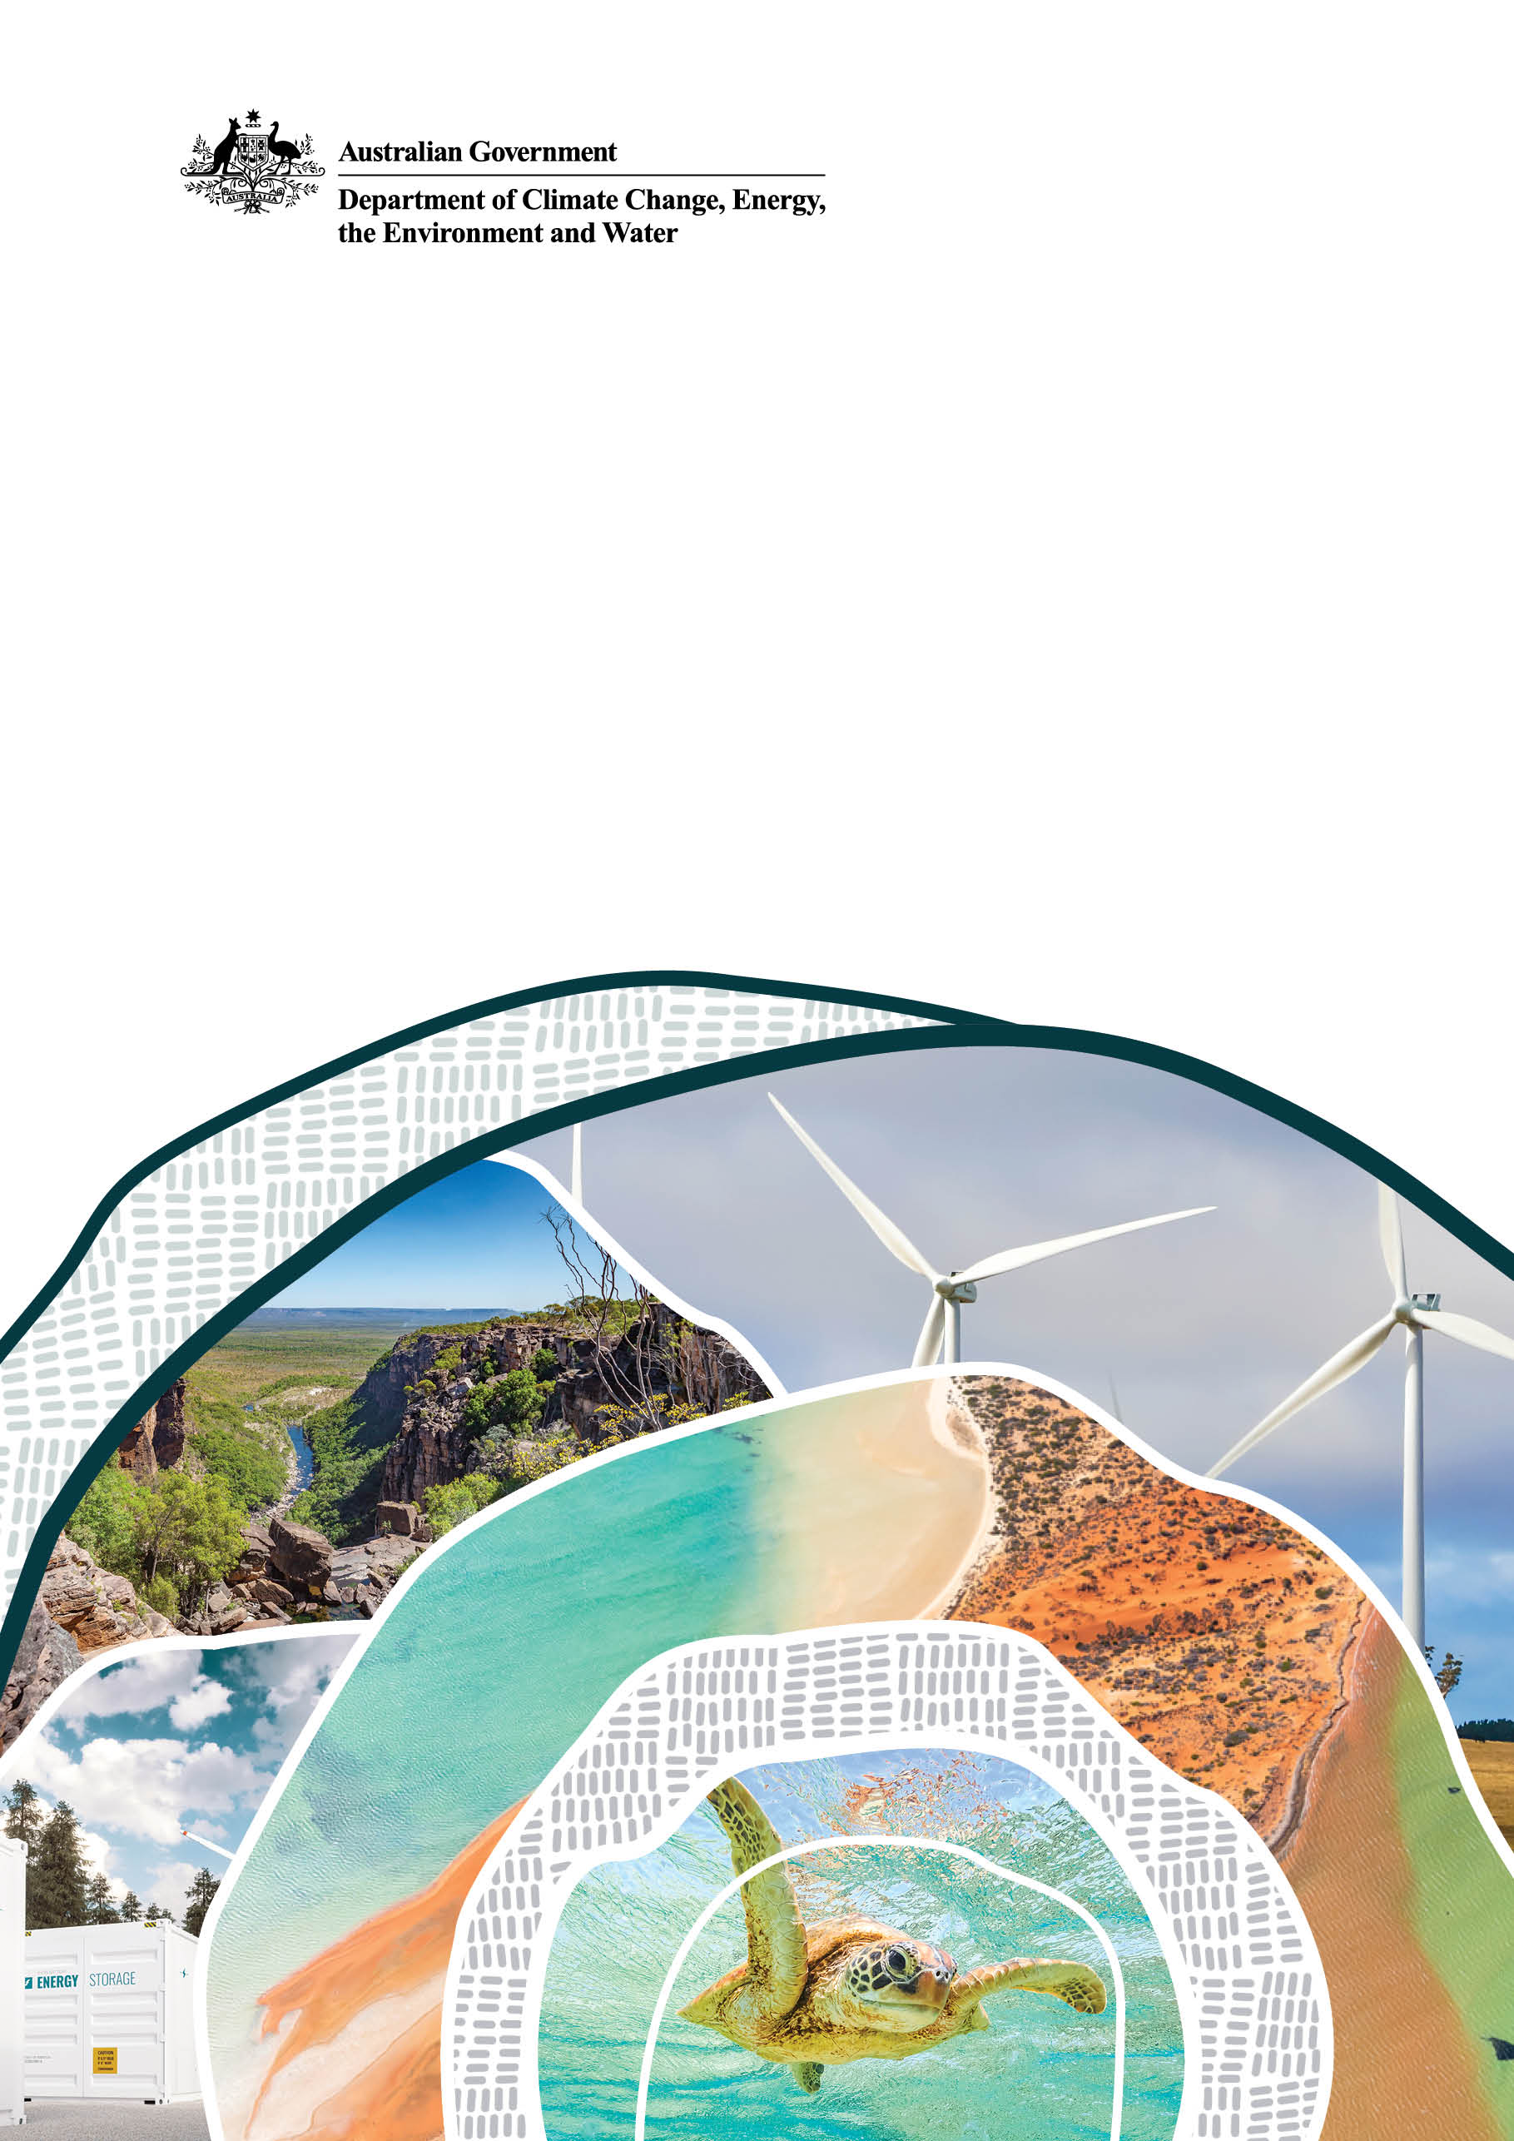
Emissions Reduction Plan
2025-2030

© Commonwealth of Australia 2025
Ownership of intellectual property rights
Unless otherwise noted, copyright (and any other intellectual property rights) in this publication is owned by the Commonwealth of Australia (referred to as the Commonwealth).
Creative Commons licence
All material in this publication is licensed under a Creative Commons Attribution 4.0 International Licence except content supplied by third parties, logos and the Commonwealth Coat of Arms.
Inquiries about the licence and any use of this document should be emailed to copyright@dcceew.gov.au.

Cataloguing data
This publication (and any material sourced from it) should be attributed as: DCCEEW 2025, Emissions Reduction Plan, Department of Climate Change, Energy, the Environment and Water, Canberra, August. CC BY 4.0.
This publication is available at https://www.dcceew.gov.au/about/reporting/emissions-reduction-plan-2024.https://www.dcceew.gov.au/about/reporting/emissions-reduction-plan-2024
Department of Climate Change, Energy, the Environment and Water
GPO Box 3090 Canberra ACT 2601
Telephone 1800 920 528
Web dcceew.gov.au
Disclaimer
The Australian Government acting through the Department of Climate Change, Energy, the Environment and Water has exercised due care and skill in preparing and compiling the information and data in this publication. Notwithstanding, the Department of Climate Change, Energy, the Environment and Water, its employees and advisers disclaim all liability, including liability for negligence and for any loss, damage, injury, expense or cost incurred by any person as a result of accessing, using or relying on any of the information or data in this publication to the maximum extent permitted by law.
Acknowledgement of Country
We acknowledge the Traditional Owners of Country throughout Australia and recognise their continuing connection to land, waters and culture. We pay our respects to their Elders past and present.

Declaration and sign off
The Australian Government released the Net Zero in Government Operations Strategy in November 2023, setting out the overall approach and action required by Commonwealth entities to achieve the APS Net Zero 2030 target.
The Net Zero in Government Operations Strategy represents a strong commitment by the Australian Government to lead by example on emissions reduction and contribute to the decarbonisation of Australia’s economy.
We are committed to achieving the government’s APS Net Zero 2030 target in full, as per the Net Zero in Government Operations Strategy.
This Emissions Reduction Plan describes the priorities and actions we are taking to reduce our operational emissions and contribute to the APS Net Zero 2030 target.

Mike Kaiser
Secretary
Department of Climate Change, Energy, the Environment and Water

Emissions Reduction Plan

Purpose
The Department of Climate Change, Energy, the Environment and Water (DCCEEW) has a strong commitment to managing and implementing the emissions reduction initiatives set by the government’s Net Zero in Government Operations Strategy (the Strategy), both in our functional responsibilities and our operations.
The goal of this Emissions Reduction Plan is to provide a pathway for us to contribute to achieving the APS Net Zero 2030 target through existing and new emissions reduction priorities and activities.
This Emissions Reduction Plan has been developed in accordance with the Strategy, associated guidance and reporting standards for annual emissions reporting.

Net zero greenhouse gas emissions
APS Net Zero 2030 is the target set by the Australian Government to achieve net zero greenhouse gas emissions from government operations by the year 2030. It includes Scope 1 and Scope 2 emissions from activities in Australia and its territories, as described in the Strategy. The APS Net Zero 2030 target applies at the aggregate level to Commonwealth non-corporate entities and generally covers the entirety of the entity’s organisation. From an organisational perspective, this means minimising the greenhouse gas emissions that are within our control.
Reducing Australia’s greenhouse emissions is a key activity under our corporate plan with implications across all the department’s outcomes. We are committed to reduce emissions to the greatest extent possible and minimising our reliance on offsets in 2030 and beyond to achieve and maintain net zero.

Governance
This plan will be reviewed annually to ensure relevancy to department operations and alignment with government disclosure requirements. A summary of progress against targets published in our annual report which combined with annual emissions reporting will to measure our progress towards APS Net Zero 2030. Annual emissions data will be submitted to the Department of Finance as part of the Net Zero in Government Operations Annual Progress Report on Whole of Australian Government (WoAG) aggregated emissions reductions activities.

DCCEEW operational context
We lead the integrated delivery of the Australian Government’s agenda across the areas of climate change, energy, the environment, heritage and water.
We work to deliver the priorities the government has set to:
- help Australia adapt to climate change
- meet or exceed Australia’s legislated emissions reduction goals
- ensure a smooth and secure transformation to renewable energy while maintaining reliable and affordable energy supply
- drive environmental regulation reforms to protect the environment and streamline decision-making
- drive ongoing water reforms to improve the security of Australia’s water resources and safeguard the future of the Murray–Darling Basin
- partner with First Nations people to achieve these priorities while contributing to Closing the Gap targets and priority reforms
- deliver Australia’s commitment to conserving the Antarctic environment and deliver Australia’s scientific research and operations in Antarctica and the Southern Ocean.
We are responsible for the specialist functions of the Office of the Supervising Scientist and the Australian Antarctic Division (AAD). We also deliver shared services for 7 portfolio agencies, such as the Director of National Parks (DNP) and Australian Renewable Energy Agency.
More information about DCCEEW can be found in our Annual Report and Corporate Plan.

People
Under the DCCEEW Enterprise Agreement 2024–2027, flexible working arrangements are now available to all staff where operational requirements allow. This significant shift will change office accommodation requirements and building performance, while also having implications for Scope 3 emissions as more staff reduce commuting times and increase the number of days working from home offices.
We also have staff in regional or remote locations with operational roles who do not work out of traditional office accommodation or have traditional office duties.
We empower staff to get involved with our sustainability and emissions reductions efforts through our Environmental Contact Officer Network (ECONet). ECONet operates as a voluntary network within the department, consisting of proactive departmental officers committed to the promotion and implementation of environmentally sustainable practices within the workplace and encouraging staff to continue these practices at home.

Buildings and facilities
The department’s building and facilities are located across all Australian states and territories, with offices in all capital cities and some regional locations. We have a range of specialist facilities associated with the property portfolio including the Australian Antarctic Program’s warehouse and storage, biosecurity and cargo handling facilities, and the Supervising Scientist research laboratories in Darwin. Making up the property portfolio are remote residential properties for staff working in our National Parks and other sites across the nation. The majority of our buildings are leased with several residential properties owned by the department.

Energy
We have multiple sources of energy for our buildings and facilities. Energy is obtained through direct arrangements with suppliers, supply through landlords in lease agreements, or participation in WoAG electricity supply arrangements. Multiple sites have diesel generators for back-up power and the Kingston, Tasmania site has a solar PV system which is managed by the landlord.

Vehicle fleet
Our vehicle fleet consists of both leased and owned vehicles, primarily supporting operations in regional and rural locations.
Most leased vehicles are classified as light commercial, which are not subject to the Commonwealth Fleet Vehicle Selection Policy. Of the leased passenger vehicles, all but one are classified as Low Emission Vehicles (LEVs).
We are currently meeting the Commonwealth target of ensuring that at least 75 per cent of new passenger vehicle orders, including sports utility vehicles, are LEVs by 2025.

Travel
DCCEEW travel is covered under WoAG arrangements administered by the Department of Finance. Official travel must only be undertaken where other communication tools, such as teleconferencing and videoconferencing are not an effective option. Our travel policies include the requirement to consider the environmental impact, including emissions, of any proposed travel as part of the approval process.

Australian Antarctic Program
The department’s coordination of the Australian Antarctic Program presents unique challenges to achieving net zero emissions within DCCEEW. The operation of the Australian Antarctic Program represented over 90% of DCCEEW’s emissions footprint in the baseline year (2022-23).
The department maintains 3 year-round research stations in Antarctica and one on sub-Antarctic Macquarie Island and a seasonal station at Wilkins Aerodrome. The department supports scientific activities and operations in the Australian Antarctic Territory, the Southern Ocean and the Territory of Heard Island and McDonald Islands. The Australian Antarctic Program primarily relies on fossil fuels for power generation on stations and for transport in all areas of its operations.
Australia’s Antarctic icebreaker RSV Nuyina is a state-of-the-art platform for conducting marine science in the Southern Ocean. The RSV Nuyina provides a critical life sustaining connection between Australia and our stations in Antarctica and the sub-Antarctic.
The Australian Antarctic program operations are also supported by a variety of small to medium vessels, inter and intracontinental aircraft, light commercial, 4WD and specialist vehicles, forklifts, cranes and other plant and equipment. Activities include the transport of expeditioners to and from stations, and carrying out marine and terrestrial scientific research, including an overland traverse and operation of a temporary station 1,200 km inland from Casey research station in Antarctica to support the Million Year Ice Core campaign.

Our emissions profile
The financial year 2022-23 serves as the baseline year for emissions reporting for all Commonwealth entities. Baseline emissions are a record of greenhouse gasses that have been produced in the past and prior to the introduction of any strategies to reduce emissions. The baseline emissions are the reference point against which emissions reduction can be measured.
The APS Net Zero 2030 target includes Scope 1 and Scope 2 emissions, and this plan focuses on those emissions. Our annual emissions and progress against our Emission Reduction Plan are reported in our Annual Report each year.
Baseline year | Financial year 2022–23
Scope 1 emissions | 51,786 tCO₂e
Scope 2 emissions | 2,866 tCO₂e
Total emissions | 54,651 tCO₂e
Our emissions profile is heavily dominated by emissions from our Antarctic program. The figure below shows the sources of Scope 1 and 2 emissions in the 2022–23 baseline year.

Engagement
In the development of this plan, we have engaged with:
- Department of Finance – to ensure that this plan aligns with the Net Zero in Government Operations Strategy and the Commonwealth Climate Disclosure requirements
- Other Australian Government entities – to share lessons learnt and provide a consistent approach to lowering emissions across the portfolio, including:
- Fleet provider – to discuss options associated with low emissions vehicles.
- Property Service Provider – to discuss options associated with our property assets

Emissions reduction targets
We are committed to achieving the APS Net Zero 2030 target. We are working to reduce emissions in our Antarctic Program operations while acknowledging that technology limitations, long lead times, logistical constraints and significant costs mean this may prove challenging to achieve by 2030. We aim to have a credible way forward in our Antarctic Program operations, to make a meaningful reduction in our baseline emissions and reduce reliance on offsets where economically and technically feasible.

Priorities and actions
Our primary focus to achieve net zero is to reduce our emissions through both WoAG and DCCEEW-led measures. The fast tracking or expansion of existing measures, and introduction of new measures will reduce the future offset liability for DCCEEW.
DCCEEW’s priority action themes will target both our areas of greatest emissions and the areas offering the biggest opportunities to improve our performance.
Our priorities and actions are included in the table below. This includes the broad activities that will be undertaken to 2030 and the actions that we aim to achieve in the next 12 months.
Theme | Summary | Our Priorities to 2030 | Our actions for 2025-26 | Responsible area
Australian Antarctic Program – Infrastructure and assets | The Australian Antarctic Program primarily relies on fossil fuels for power generation on stations and for transport in all areas of its operations. This provides opportunities to reduce emissions through efficiency and electrification coupled with increased renewable energy. | - Incorporate energy efficiency measures, renewable energy and battery storage in station infrastructure renewal and modernisation where practical.  - Commence transition to the use of sustainable fuels on station. | - Plan a sustainable fuel demonstration project for diesel plant and equipment at AAD headquarters in Kingston, Tasmania. | AAD and Property & Infrastructure Branch
Australian Antarctic Program – Shipping | The RSV Nuyina relies on fossil fuel to perform its critical functions in the Australian Antarctic Program. Reducing emissions from RSV Nuyina would have a substantial impact on our emissions profile. | - Work with the Tasmanian Government to ensure delivery of renewable shore side power in upgrades to Macquarie Wharf, for use by the RSV Nuyina during berthing and lay-up periods at the Port of Hobart.  - Improve fuel efficiency in vessel operations and investigate options for multiple station resupply in single voyages.  - Commence transition to the use of sustainable shipping fuel. | - Develop a sustainable shipping fuel transition plan.  - Plan a sustainable fuel demonstration project for the RSV Nuyina. | AAD and Property & Infrastructure Branch
Australian Antarctic Program – Aviation | Aviation plays an important role in our Antarctic operations. Reducing emissions from our aviation fleet would have a tangible impact on our emissions profile. | - Improve efficiency of aviation fleet and investigate alternative aviation technologies as they arise.  - Commence transition to the use of sustainable aviation fuel. | - Develop a sustainable aviation fuel transition plan.  - Plan a sustainable fuel demonstration project for aviation. | AAD and Property & Infrastructure Branch
Buildings | Our diverse property portfolio provides opportunities to model new requirements and improve sustainability outcomes. | - Continue uplift of the department’s property management framework to improve performance of the property portfolio.  - Implement sustainability measures to reduce the emissions footprint of our building portfolio at all stages of life – from new leases, operations, mid-life upgrades, stay-or go decisions and make good provisions.  - Meet leasing requirements of the Strategy including adoption of Green Lease Schedules and building certifications and explore opportunities to exceed minimum leasing requirements.  - Work with our Property Service Provider (PSP), landlords and other tenants to implement sustainability measures to improve the performance of tenancies and uplift operational practices. | - Consolidate our Canberra property assets.  - Attain building certifications for state office fit outs.  - Ensure appropriate sustainability requirements are integrated into procurements and contracts established by our PSP.  - Establish a program of Building Management Committees as required under Green Lease Schedules.  - Implement sustainability initiatives, such as waste, across the property portfolio. | Property & Infrastructure Branch
Energy | Renewable energy will play a role in reducing our Scope 2 emissions, with the intention to procure renewable electricity through new WoAG arrangements for selected sites. | - Procure renewable electricity through new WoAG arrangements as they commence.  - Explore options to increase renewable energy across the property portfolio through renewable energy procurement or on-site generation.  - Investigate alternative back-up power options, such as alternative fuels, for sites where diesel generators are currently the source of back-up power. | - Review existing contracts for options to purchase renewable electricity.  - Determine feasibility of using renewable diesel in existing generators. | Property & Infrastructure Branch
Travel | While travel is not currently part of the 2030 net zero target, it forms a significant part of our emissions footprint.  Our travel policies include the requirement to consider the environmental impact, including associated emissions, of proposed travel as part of the approval process. We will continue to align with the Strategy on travel initiatives. | - Continue to build our understanding of the department’s travel profile to enable identification of emission reduction measures beyond current WoAG requirements.  - Continue to review and refine our travel policies to facilitate sustainable travel.  - Support managers and staff to make more sustainable travel choices in line with our travel policies. | - Develop sustainable travel guidance for staff and managers.  - Develop resources to visualise the emissions impacts of our travel. | Financial Services Branch and Property & Infrastructure Branch
Fleet | While a minor part of our emission profile, we are transitioning our passenger vehicle fleet to low emissions vehicles in accordance with the Commonwealth Fleet Vehicle Selection Policy.  While there is no requirement relating to non-passenger vehicles, they make up the bulk of the department’s vehicle fleet and remain a focus area for emissions reductions. | - Continue to adopt electric or low emissions passenger vehicles where operational requirements allow.  - Continue to monitor availability and suitability of approved low emissions light commercial and 4WDs vehicles under the Commonwealth Fleet Vehicles Selection Policy.  - Undertake change management work associated with vehicle electrification. | - Integrate charging infrastructure into formal site selection processes. | Property & Infrastructure Branch
Procurement | We have updated our central procurement templates to ensure consideration of the WoAG Environmentally Sustainable Procurement Policy.  The Commonwealth Sustainable Procurement Advisory and Resource Centre continues to support our sustainable procurement capability including - but not limited to - net zero considerations. | - Work with internal stakeholders and suppliers to promote sustainable procurement practices and supply chains. | - Embed sustainability and circular economy principles into procurement and contract management lifecycle materials.  - Promote existing and new resources to improve staff capability and understanding of procurement sustainability. | Financial Services Branch
Data | Data plays a key role in meeting obligations, measuring performance and tracking our progress to meet our emissions targets | - Work with internal stakeholders and service providers to improve data collection of sources which have a material impact on DCCEEW’s emissions profile and environmental sustainability. | - Increase scope and accuracy of data collection in the property portfolio. | Property & Infrastructure Branch
People | The Net Zero in Government Operations Strategy highlights the important role of Australian Government officials at all levels in reducing emissions from government operations.  We are committed to creating a strong corporate sustainability culture, and undertaking capability uplift where required | - Develop our people and improving our capabilities in net zero and emissions reduction.  - Support our Chief Sustainability Officer to champion the Net Zero in Government Operations Strategy and related initiatives that support climate action in our operations.  - Maintain a sustainability team to deliver on key elements of APS Net Zero 2030, and coordinate and implement DCCEEW’s emissions reduction and environmental sustainability activities.  - Continue to support staff involvement through our Environmental Contact Officer Network (ECONet). | - Undertake a climate skills assessment on internal competencies as per Commonwealth Climate Disclosure requirements.  - Promote resources to improve staff capabilities in sustainability, climate risk and emissions reduction.  - Incorporate sustainability modules into staff onboarding and training. | Property & Infrastructure Branch
Information and communications technology (ICT) | DCCEEW uses ICT throughout its operations, (including data centres) contributing to electricity usage.  Effective management of our ICT assets (including e-waste) contributes to our emissions reduction and broader sustainability goals. | - Rationalise and consolidate technology including decommissioning of redundant ICT.  - Consolidate our cloud footprint to reduce redundant cloud storage and improve efficiency.  - Incorporate sustainability clauses into ICT procurements and aligning with requirements under the Environmentally Sustainable Procurement Policy.  - Embed circular economy principles into asset refreshes and effectively managing our e-waste.  - Work with data centre providers to improve transparency of their sustainability initiatives (e.g. net zero commitments, NABERS ratings). | - Develop guidelines around the efficient use of resource intensive ICT processes (e.g. AI, analytics). | ICT, Portfolio Strategy

