Australia’s Circular Economy Framework
An entry point for business

What is a circular economy?
A circular economy:

Designs out waste and pollution
When things are designed from the beginning to be repaired, reused and recycled, it’s much easier to do so. For example, products that are made to be taken apart are easier to fix and use for longer.

Keeps things in use at their highest value
By targeting how we use and dispose of products and materials, we can keep using them. This can mean buying durable products, reusing and repairing, and recycling.

Conserves natural resources and regenerates nature
The speed at which we’re using up resources is damaging our environment. A circular economy considers ways to reduce the environmental impact of products and materials throughout their lifecycle.

Our goal is to double Australia’s circularity by 2035.
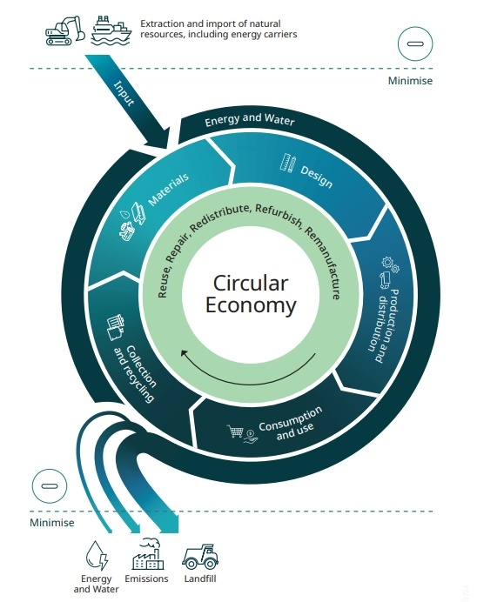
Figure 1: Circular economy diagram

Priority 1 – Industry

Priorities

Circular packaging
Packaging is a priority because of its significant environmental impact and the potential for improvement through sustainable design, recovery, re-use and recycling. In 2020–21, Australia produced 6.74 million tonnes of packaging, 44% of which was disposed of in landfills.

Durable, re-usable and sustainable goods
Australia has globally competitive capabilities in manufacturing high-technology products that are durable, re-useable and sustainable. These products are higher value, and require less replacement, supporting both a circular economy and net zero transition.

Enablers

Circular product design
The design stage of a product determines around 80% of its environmental impact. Design priorities include durability, reusability, modularity, upgradability, repairability, and reducing the use of chemicals of concern in products.

Understanding where recycled materials come from, what they are made of, and how well they work
Australia has developed a National Framework for Recycled Content Traceability to ensure materials used in products are verifiably sourced from recycled inputs, promoting transparency and consumer confidence.

Green chemistry and advanced technology
The chemicals used in materials are key to safe recycling and remanufacturing in the circular economy. Chemicals of concern can cause problems during recycling, leading to unsafe emissions or residues. Ensuring safer product design helps build trust in the safety and quality of recycled products for consumers and businesses.

Case Study: Samsara Eco
Founded in 2021, Samsara Eco addresses the growing problem of plastic waste by developing advanced recycling technologies that convert end-of-life plastics and textiles back into their original monomers, to be used in remanufacturing. Their collaboration with Lululemon successfully demonstrated the practical application of their technology.

Priority 2 - Built Environment

Priorities

Refurbishing and adaptive re-use
Refurbishment and adaptive re-use are circular economy strategies that maintain existing buildings and infrastructure assets for longer, reducing waste and emissions associated with demolition and re-builds.

Manufacture and use of circular, low carbon, and climate resistant construction materials and fit outs
In Australia, the market for green steel and other sustainable building materials is projected to grow at a compound annual growth rate of 12.1% from 2021 to 2026.

Enablers

Embedding the circular economy in new builds
Australia is undergoing a national infrastructure upgrade, focused on projects that improve long term productivity, supply chains and economic growth. This includes modernising to support clean energy and boost technology, housing and local services infrastructure and investments.
Infrastructure Australia estimates that using recycled alternatives in road construction could cut project costs by up to 83%, with as much as 43% of conventional materials replaceable by recycled ones.

Developing recycled content markets
Scaling the use of recycled materials in the built environment paves the way for materials innovation elsewhere in the economy. Priority materials that will significantly lift national recycling rates and reduce material footprint include secondary concrete and steel, ash from coal-combustion, and asphalt.

Better design
Circular design strategies can substantially reduce waste and carbon emissions associated with new developments throughout their lifecycle.

Better design tips:
- Design to re-use or refurbish existing assets or materials
- Design to enable disassembly
- Design for longevity
- Design for modularity
- Design for best practice operational waste management
- Design with recycled content
- Design with others to make use of waste outputs as material inputs.

Case Study: Burwood Brickworks - Melbourne
Burwood Brickworks is a sustainable urban development known for its innovative design and resource reuse. It features 100% renewable energy, 100% repurposed rainwater, 99% of construction waste diverted from landfill, a rooftop farm and closed-loop organic waste system.

Priority 3 - Food and Agriculture

Priorities

Reducing food waste
Australia has a current goal of halving preventable food waste by 2030. Australia creates more than 7.6 million tonnes of food waste each year, costing the Australian economy over $36.6 billion.

Turning agriculture waste into valuable products
Turning agricultural waste into valuable products can boost efficiency and meet the needs of growing regional markets. For example, agricultural and forestry residues such as stalks, leaves, husks, woodchips and branches can be used as biofuel feedstocks, creating value from these previously low-value products.

Enablers

Shared infrastructure, equipment, data and resources
Place-based hubs for circular economy activity, including shared equipment schemes and infrastructure, can unlock these opportunities close to where waste is generated.

Higher quality recycled organics
Improving the quality of recycled organics requires that organic waste streams are free from contaminants and are properly sorted and processed, supporting market development and confidence in these products.

Cold-chain transport
Australia's agricultural exports depend heavily on efficient cold chain logistics, yet these systems often result in significant energy consumption and waste. Energy-efficient refrigeration, smart logistics management, and reusable packaging solutions can help save food, money and emissions.

Case study: Bega Valley Shire Circular Economy
Bega Valley Shire in New South Wales embraces practices to enhance sustainability and resilience. Farmers play a key role, turning organic waste like manure into compost to improve soil health and reduce chemical fertilisers. Collaboration is vital, with farmers, councils, and businesses working together.

Priority 4 – Resources

Priorities

Recovering minerals from waste
Australia has the potential to leverage our competitive advantage in resource extraction and technology innovation to develop new methods and technologies to extract valuable minerals from wastes (such as mining tailings) and renewables technologies (such as batteries and solar PVs).

Co-extraction and resource sharing through precincts
Mineral co-extraction involves extracting multiple minerals from the same ore or material. Partnerships between big mining companies and smaller businesses that can run side operations for secondary extraction are key to making these opportunities possible.

Re-deploying products containing minerals
Second-use means re-using things like end-of-life EV batteries for stationary household energy storage. This helps extend the life of products, without requiring complete recycling and re-manufacturing.

Enablers

ESG frameworks and standards
ESG frameworks and international standards that incorporate and recognise circular economy principles help motivate further industry investment in innovation.

Tracing valuable waste
Geoscience Australia’s Atlas of Mine Waste identifies 1,050 possible sites where critical minerals could be extracted from the waste of existing projects, including mine tailings, waste rock, smelter residues and related mine waste materials. The Atlas helps companies like Heritage Minerals find new value in waste deposits. Visit: portal.ga.gov.au/persona/minewaste

Case study: Heritage Minerals
Heritage Minerals is advancing sustainable resource management through its Mount Morgan Tailings Processing and Rehabilitation program, funded by the Northern Australia Infrastructure Facility.
By recovering gold, copper, and pyrite from the tailings, the project reduces environmental hazards while generating economic value from previously untapped resources.

Here to help
Find more information about Australian Government policies and funding programs that can support a circular economy below.

$15 billion National Reconstruction Fund
Aimed at revitalising Australia's manufacturing capabilities across 7 priority areas, the fund has a clear focus on sustainability and circular economy solutions.

$7 billion Northern Australia Infrastructure Facility
This fund is open for projects focused on sustainability and circular economy solutions, helping build a strong, future-focused industry in Northern Australia.

$1.6 billion Australia’s Economic Accelerator
Australia’s Economic Accelerator supports university-led projects with high commercial opportunity that are aligned with national research priorities, including circular economy.

$250 million Recycling Modernisation Fund
Invests in new and upgraded recycling infrastructure and increased recycling capacity including to sort, process and remanufacture glass, plastic, tyres, paper and cardboard.

Clean Energy Finance Corporation
The Clean Energy Finance Corporation is backing circular economy-aligned projects like the $300 million Timber Building Program, which promotes renewable timber construction and refurbishment initiatives.

Industry Growth Program
Innovative SMEs and startups play a crucial role in the economy but many have difficulty bringing their ideas to market. The Industry Growth Program supports early-stage businesses in their most challenging development phase.

Regional Programs
Various programs are available to support sustainable and strong regional development, including the $600 million Growing Regions Program, and $400 million Regional Precincts and Partnerships Program.

Environmentally Sustainable Procurement Policy
The Environmentally Sustainable Procurement Policy applies circular economy principles to government purchases, boosting demand for recycled content and circular goods in construction, furniture, ICT, and textiles.

Sustainable Tourism Toolkit
Designed to support the National Sustainability Framework for the Visitor Economy. It has clear and simple advice to help tourism businesses become more sustainable.

Who needs to act?
All Australians have a role to play in bringing Australia’s transition to a circular economy to life.

Australians – the change makers
Australians contribute by making sustainable product choices and supporting local circular initiatives such as repair cafés, libraries, and second-hand marketplaces.

Investors - the catalysts
By directing capital toward circular solutions, investors can help scale innovative business models, technologies, and infrastructure that support resource efficiency and waste reduction.
- Prioritising circular economy investments
- Embedding circularity into ESG frameworks
- Engaging in active ownership and stewardship
- Partnering to de-risk circular economy investments.

Businesses - the innovators
Can lead by example, adopting circular practices to meet growing stakeholder expectations and capitalise on new market opportunities. This can be done through:
- Strategy, planning and reporting
- Product redesign for circularity
- Collaboration and partnerships
- Investing in new business models.

Governments - the enablers
Governments set the direction and provide the foundation for a successful transition to a circular economy.
- Creating supportive policies and regulations
- Aligning the economy with circular principles
- Driving behavioural change.

Researchers and NGOs - the thought leaders
Research institutions, universities, and non-government organisations (NGOs) provide the necessary research, education, and advocacy to drive the circular economy forward.
- Advancing research and development
- Raising awareness and advocating for change.

Read the full framework here:
Australia’s Circular Economy Framework

