Summer 2024 Issue 18

The Bidgee Bulletin

Welcome to Issue 18 of The Bidgee Bulletin. In this issue we update you on the recent field work, including a summary from wetland vegetation surveys.
A new series featuring land managers in the Murrumbidgee starts with an interview with Hamish Cullenward owner of Nap Nap Station in the Lower Murrumbidgee wetlands and his involvement with water for the environment.
An exciting new biodiversity survey is underway in creeks and tributaries of the Murrumbidgee including Yanco, Cudgel, Sandy and Old Man Creeks. We discuss the new eDNA technologies and how they can be used for research.
The Bidgee Bulletin is a quarterly newsletter designed to provide updates on our progress as we monitor the ecological outcomes of Commonwealth environmental water flows in the Murrumbidgee Selected Area. The 2023-2024 program builds on the previous nine years of wetland monitoring (LTIM 2014-2019 and MER 2019-2023).
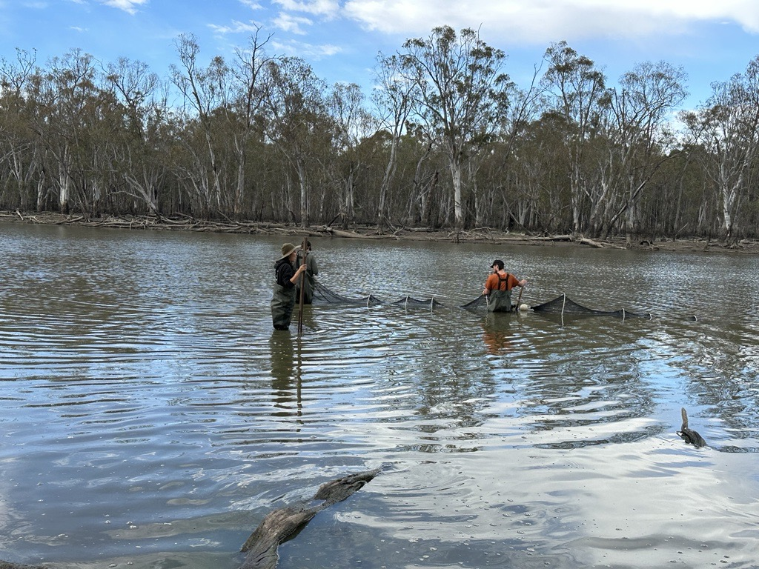
Cover photo: CSU field team setting large fyke nets at Mantangery Lagoon, Nov 2023. Credit: Sarah Talbot

Update from the field
The CSU field team were out monitoring wetlands in the mid-Murrumbidgee in early November, and the Lower Murrumbidgee wetlands in early December.
Core wetland sites are starting to dry down, with some too shallow to net for fish so we had to monitor some alternative sites as replacements. Just when we thought the rain had stopped, it rained in in late November causing river levels to rise again, tracks to get wet and we had to postpone the Lowbidgee trip until December.

Highlights:

Lowbidgee floodplain
Wetland monitoring was conducted from the 11-15th December at sites in Yanga National Park and Gayini Nimmie-Caira wetlands. Highlights include a large number of Southern bell frogs (n=213) and tadpoles (n=16) at Bala, magpie geese (n=2) flying overhead at Waugorah Lake, a grey snake at Piggery Lake, and a rakali sighted at Uara Creek. Fish caught during the week included bony bream, flat-headed gudgeon, carp gudgeon, smelt, carp, goldfish, oriental weatherloach and we also netted plenty of yabbies and shrimp.

mid-Murrumbidgee
Wetland monitoring was conducted from 20th to 22nd November at Gooragool Lagoon west, Mangangery Lagoon, Coononcoocabil Lagoon and Yarradda Lagoon. Water levels at Sunshower and McKenna’s Lagoon have receded since September monitoring and were too shallow to net for fish. Highlights include a silver perch (290 mm) at Mantangery Lagoon; a rakali (native rodent), and large numbers of yellow-billed spoonbills (n=42) and Eastern egrets (n=51) at Gooragool Lagoon west. Macquarie River turtles, broad-shelled turtles and Eastern long-necked turtles were detected at Mantangery Lagoon. Other native fish species caught across the mid-Murrumbidgee wetlands included Australian smelt, bony herring, carp gudgeon and flat-headed gudgeon.

Vegetation surveys
Wetland vegetation surveys were conducted in early November across the mid- and lower Murrumbidgee sites. Vegetation surveys in the Yanco Creek system were also conducted in October (postponed from May) to conclude the Yanco 2022-23 monitoring project.

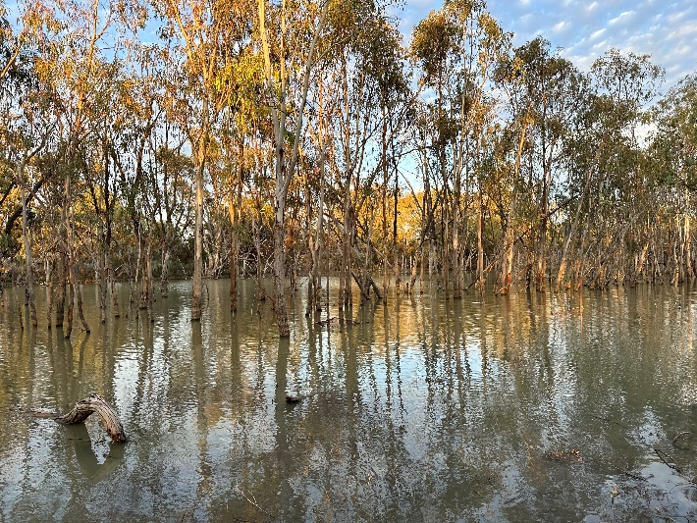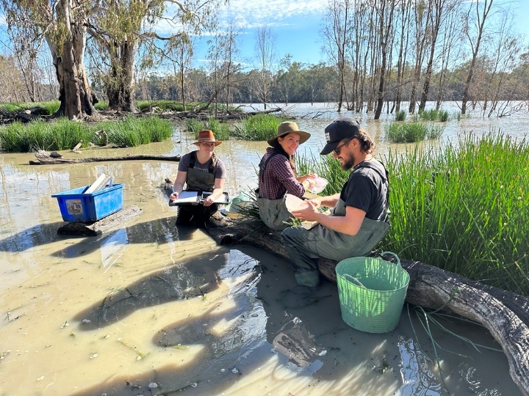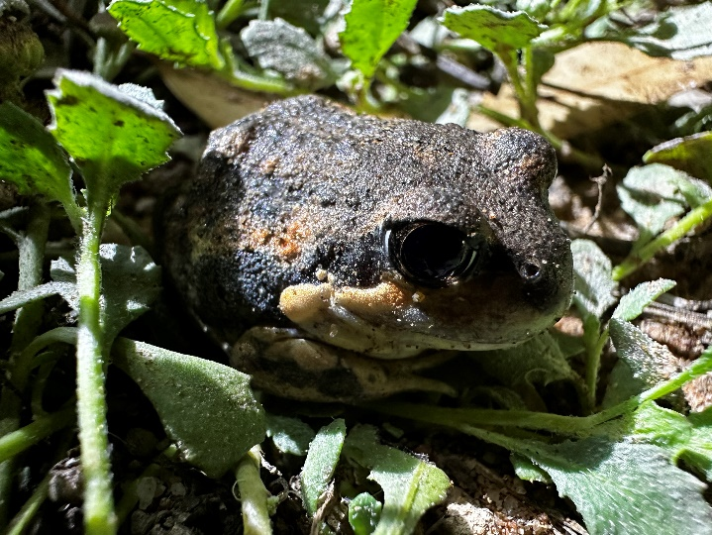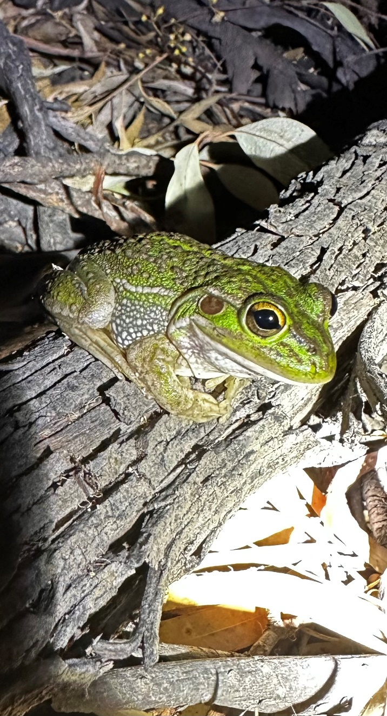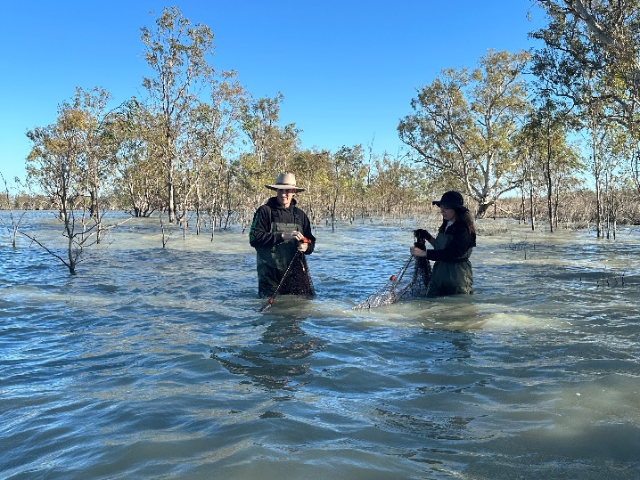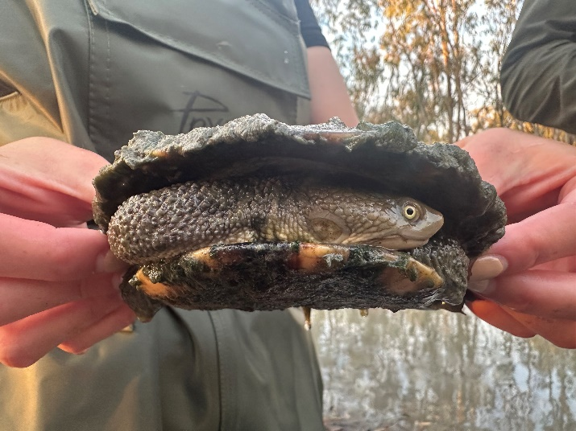
Top to bottom:
1) CSU field monitoring team Emmalie Sanders, Audrey Beard and Nick Cardwell counting and measuring fish at Yarradda Lagoon (Credit: Sarah Talbot).
2) Banjo frog at Uara Creek (Credit: Sarah Talbot).
3) Southern bell frog at Bayil Creek (Credit: Jess Ljubojevic)
4) Chris and Jess bringing in fyke nets at Loorica (Credit: Sarah Talbot).
5) Eastern long-necked turtle at Yanga Lake Inflow (Credit: Sarah Talbot)
6) Small fyke nets set at Yanga Lake Inflow (credit: Sarah Talbot)

Creeks and Tributaries Biodiversity study - Our first foray into eDNA
The CSU team has been monitoring wetlands and creeks in the Yanco-Billabong Creek system for the past two field seasons (2021-22 and 2022-23). This involved fish, frog, waterbird and vegetation monitoring methods aligned with the core MER wetland monitoring in the mid- and lower Murrumbidgee. Additionally, ultrasonic call recorders have been deployed at wetlands to detect bats. Some interesting findings have come out of those two seasons including detection of freshwater catfish, silver and golden perch, Murray cod, and unspecked hardyhead. The Southern myotis (fisher bat, Vulnerable in NSW) and southern bell frogs were recorded on the call recorders at three different sites.
To build further on these research findings and better inform the delivery of Commonwealth water for the environment, the CSU MER team, in collaboration with Yanco Creek and Tributaries Advisory Council (YACTAC) and Local Land Service (LLS) Refreshing Rivers program, are collecting water samples for environmental DNA (eDNA) analysis in the Yanco-Billabong system, Cudgel Creek, Sandy Creek and Old Man/Beavers Creek.
Every living creature leaves traces of DNA in their surrounding environment (skin cells, hair follicles and other bodily secretions), which is called Environmental DNA, or eDNA for short. A single water sample can include DNA from many different species who inhabit the creek or wetland. eDNA metabarcoding is the process where this DNA is extracted and compared to known DNA sequences which identify a species.
eDNA analysis is increasingly used in biodiversity assessments as it can detect a range of species which can provide us with information on the occurrence of target species including, rakali, platypus, trout cod, freshwater catfish, southern bell frogs and macroinvertebrate community composition. The method can complement conventional field survey techniques and can verify the detection of hard-to-find species.
The CSU field team were out in early December collecting water samples. The samples will be processed in a laboratory in New Zealand called Wilderlab. This data will be supported by on-ground electrofishing and fyke net surveys in the Yanco-Billabong system during March 2024. The combination of the eDNA and on-ground surveys will help to validate this emerging technology for future research purposes and help inform the delivery of water for the environment in these creek systems.
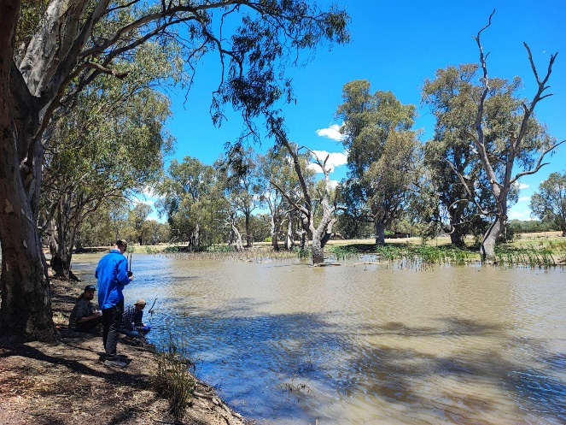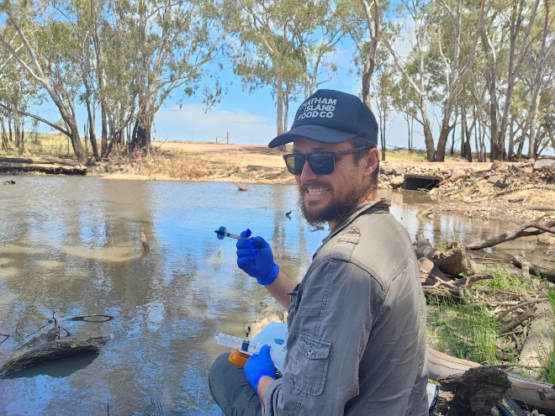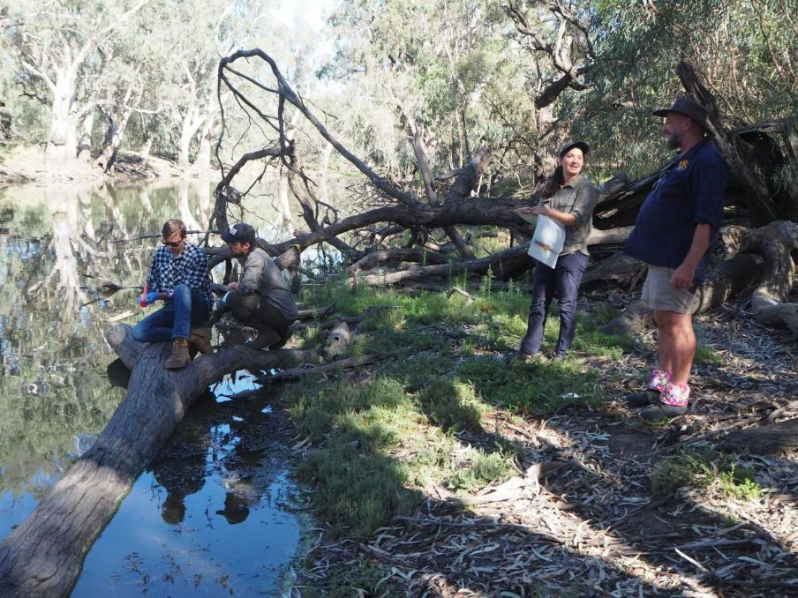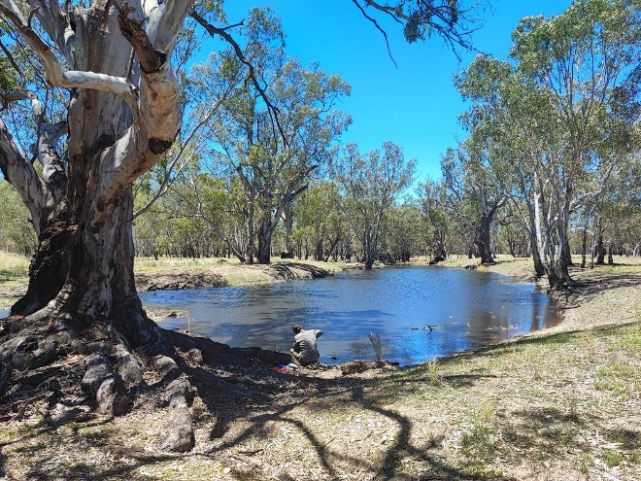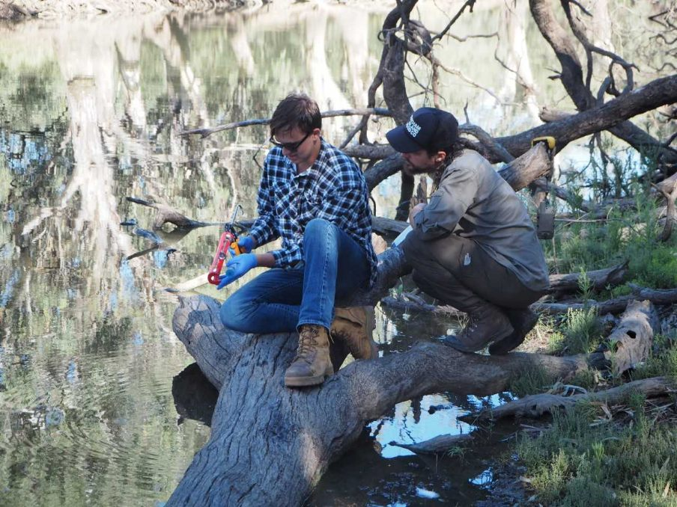
Nick (CSU), Josh (LLS), Leigh (MLS) and Audrey (CSU) were out at Sandy Creek, Cudgel Creek, and Yanco and Billabong Creeks during early December collecting water samples for eDNA analysis and doing rapid vegetation assessments. Photo credit Audrey Beard and Josh Campbell.

Land Managers of the Murrumbidgee wetlands – Nap Nap Swamp
This is the first of a series featuring wetlands throughout the Murrumbidgee Selected Area and the land managers who play an integral role in their management. We thank all landholders for their continued support and allowing our research teams to regularly access these valuable sites. We would love to feature your wetland. If you are keen to have it featured in the Bulletin please contact Anna on aturner@csu.edu.au.
Name: Hamish Cullenward
Wetland monitored under the FlowMER program: Nap Nap Swamp
Where is your wetland located along the Murrumbidgee?
Nap Nap is located south of the Murrumbidgee River on the Lowbidgee Floodplain. It is approximately 30 km downstream from the township of Maude.
What is the method of environmental water delivery for your wetland (pumping, channel, regulator etc.)? Through a regulator from the Nimmie Creek then via a channel system.
What is your favourite thing about the wetland?
It is a little bit different to many of the wetlands on the Lowbidgee Floodplain; being quite diverse both in vegetation type and the animal species it supports as you move through the Swamp. Also, there is plenty of cultural sites on its perimeter, suggesting it has been an important wetland well before our time.
What would you like to see for your wetland in the future?
Essentially more of the same!
We have been fortunate to have had environmental water delivered to the site for many years now. In the dry times this has sustained and in more favourable times, enhanced the habitat and species populations of the wetland. Long-term monitoring has coincided with the enviro water delivery to now give us a solid knowledge base of the Nap Nap Swamp and enable well informed decisions on its management.
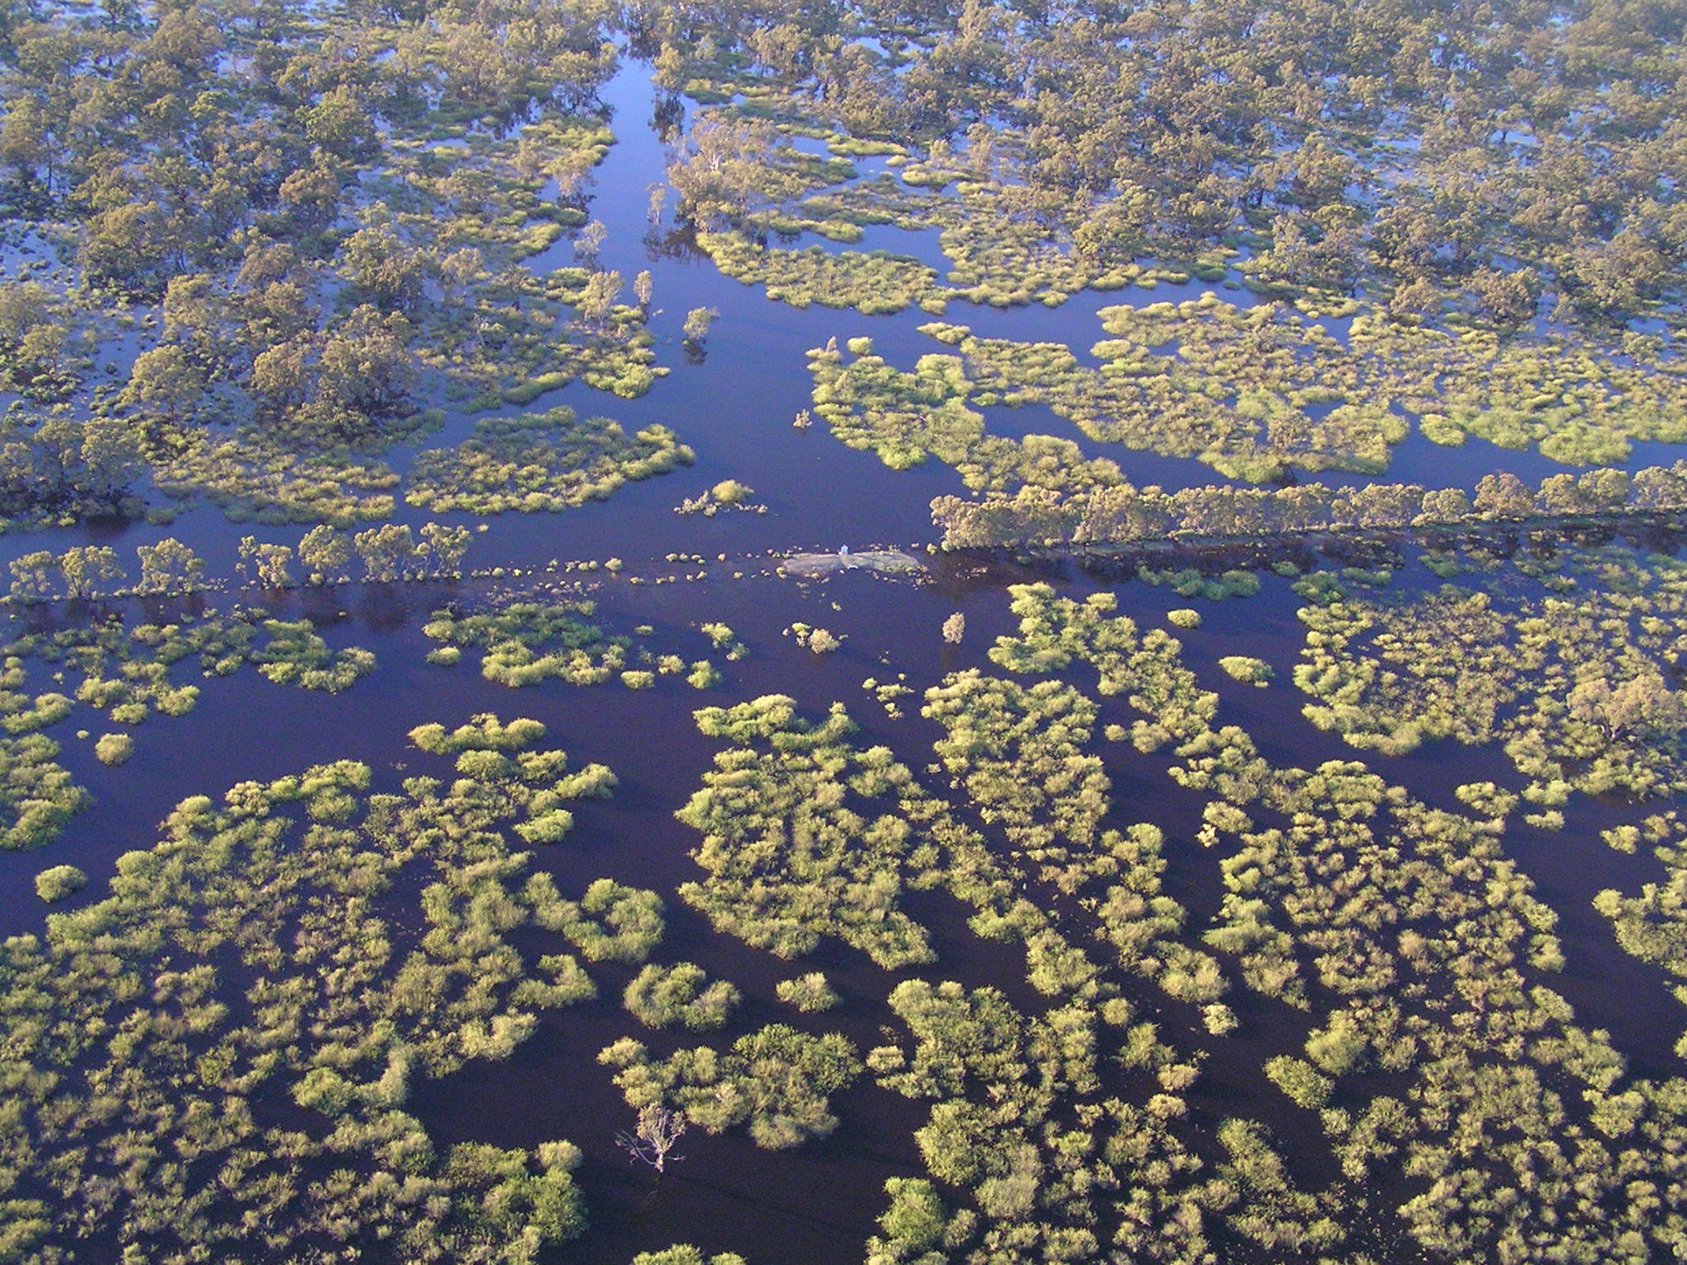
Aerial view of Nap Nap swamp during November 2022. Photo credit: Hamish Cullenward via helicopter
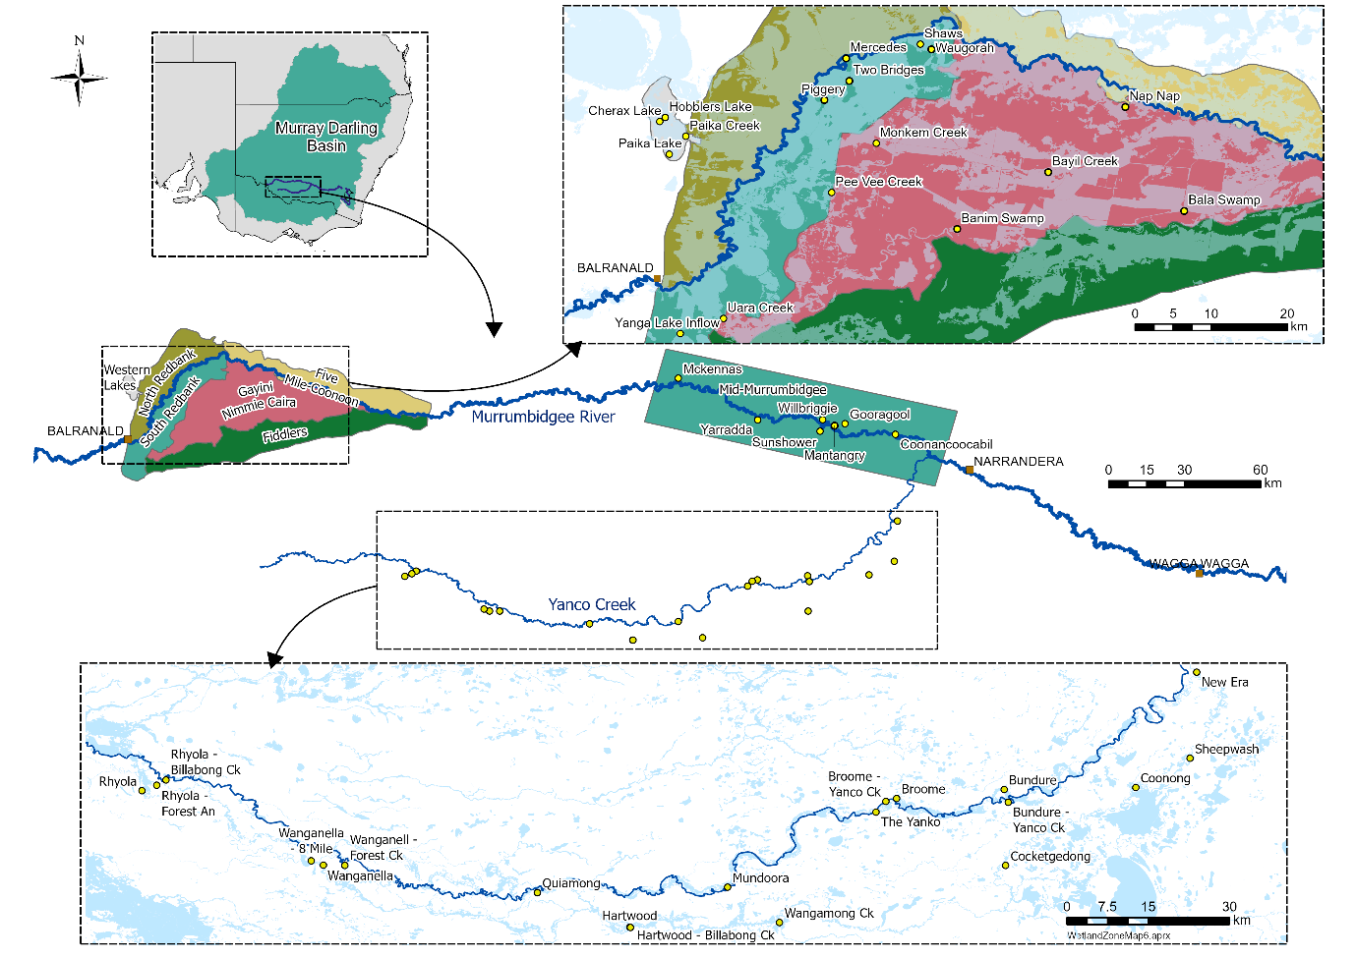
Map showing monitored wetlands within the Murrumbidgee zones: Lower Murrumbidgee, mid-Murrumbidgee and Yanco Creek Systems.
Authors: Anna Turner, Sarah Talbot, Audrey Beard, Christopher Sundblom and Professor Skye Wassens
The next issue of The Bidgee Bulletin is out in Autumn 2024.
We're on social media too!
Stay up to date with our adventures on Instagram and Twitter:

@BidgeeMER
The Murrumbidgee MER team would like to acknowledge the consortium partners and local landholders with whom we work.
We respectfully acknowledge the Wiradjuri, Nari Nari, Wamba Wamba, Bpangerang, Barapa Barapa and Muthi Muthi peoples, traditional owners of the lands on which this publication is focused
