Autumn 2024 Issue 19

The Bidgee Bulletin

Welcome to Issue 19 of The Bidgee Bulletin. In this issue we update you on the recent field work conducted in the mid and lower Murrumbidgee wetlands during January 2024.
You will read about the waterbird monitoring conducted by University of New South Wales who detected 183,000 active waterbird nests in the Murrumbidgee Selected area during the 2022-23 water year.
Enjoy the highlights of our Wetland Field Day held at Hartwood wetland in early March. The field day attracted a good number of people and we heard from Skye Wassens about wetland and riparian vegetation, from Anna Turner about frog species in the region and from Emmalie Sanders about the charismatic Rakali that inhabits the creek.
The Bidgee Bulletin is a quarterly newsletter designed to provide updates on our progress as we monitor the ecological outcomes of Commonwealth environmental water flows in the Murrumbidgee Selected Area. The 2023-2024 program builds on the previous nine years of wetland monitoring (Long-Term Intervention Monitoring Project 2014-2019 and Monitoring, Evaluation and Research Program 2019-2023).

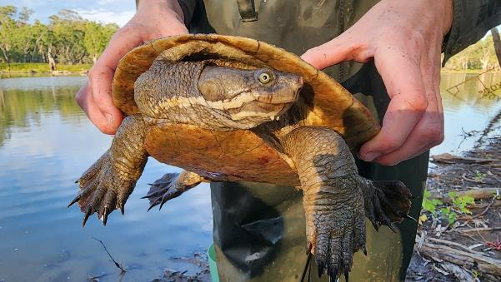
Photo: Murray River short-necked turtle detected during surveys at Mantangery Lagoon during January monitoring. Credit: Emmalie Sanders.
1. Update from the field
Rainfall in the Murrumbidgee catchment fluctuated between above and below average in the lead up to the 2023-24 monitoring season but was almost double the long term-average for December 2023. Consequently, there was a brief increase in river height and discharge rate but water levels during the January monitoring period were still lower than during November/December 2023 monitoring.
Core wetland sites are starting to dry down, with some too shallow to net for fish. Alternative sites were monitored as replacement. The final wetland monitoring for the 2023-24 water year will take place in late March and will be featured in the Winter Bidgee Bulletin.

Highlights:

Lowbidgee floodplain
Fish, frog, waterbird and water quality monitoring was conducted at Pee Vee Creek, Kieeta Creek, Waugorah Lagoon, Yanga Lake Inflow, Bala Swamp, Bayil Creek, Emu (Loorica) Lake and Fairfax Swamp. Southern bell frogs were detected at Bala Swamp, Waugorah Lagoon, Pee Vee Creek and Fairfax swamp. Other frog species included Peron’s tree frogs, spotted and barking marsh frogs and giant banjo frogs. Native fish species included bony herring, carp gudgeon, flat-headed gudgeon and Australian smelt.

mid-Murrumbidgee
Sites monitored included Yarradda, Mantangery and Coonancoocabil Lagoons. Water quality was too low at Gooragool west to net for fish, however frog surveys were conducted. Southern bell frogs were heard at Gooragool west and have not been recorded in the mid-Murrumbidgee since 2021. All three species of freshwater turtles were detected at Mantangery Lagoon with three Murray River short-necked, four broad-shelled and one Eastern long-necked turtle. Native fish species included bony herring, carp gudgeon and flat-headed gudgeon.

Vegetation surveys
Wetland vegetation surveys were conducted the first week of January at all twelve core monitoring sites across the mid and lower Murrumbidgee wetlands. Water has receded at all core sites and semi-aquatic plants on the wetland margins have responded to the inundation period with increased growth.

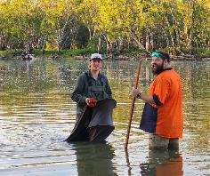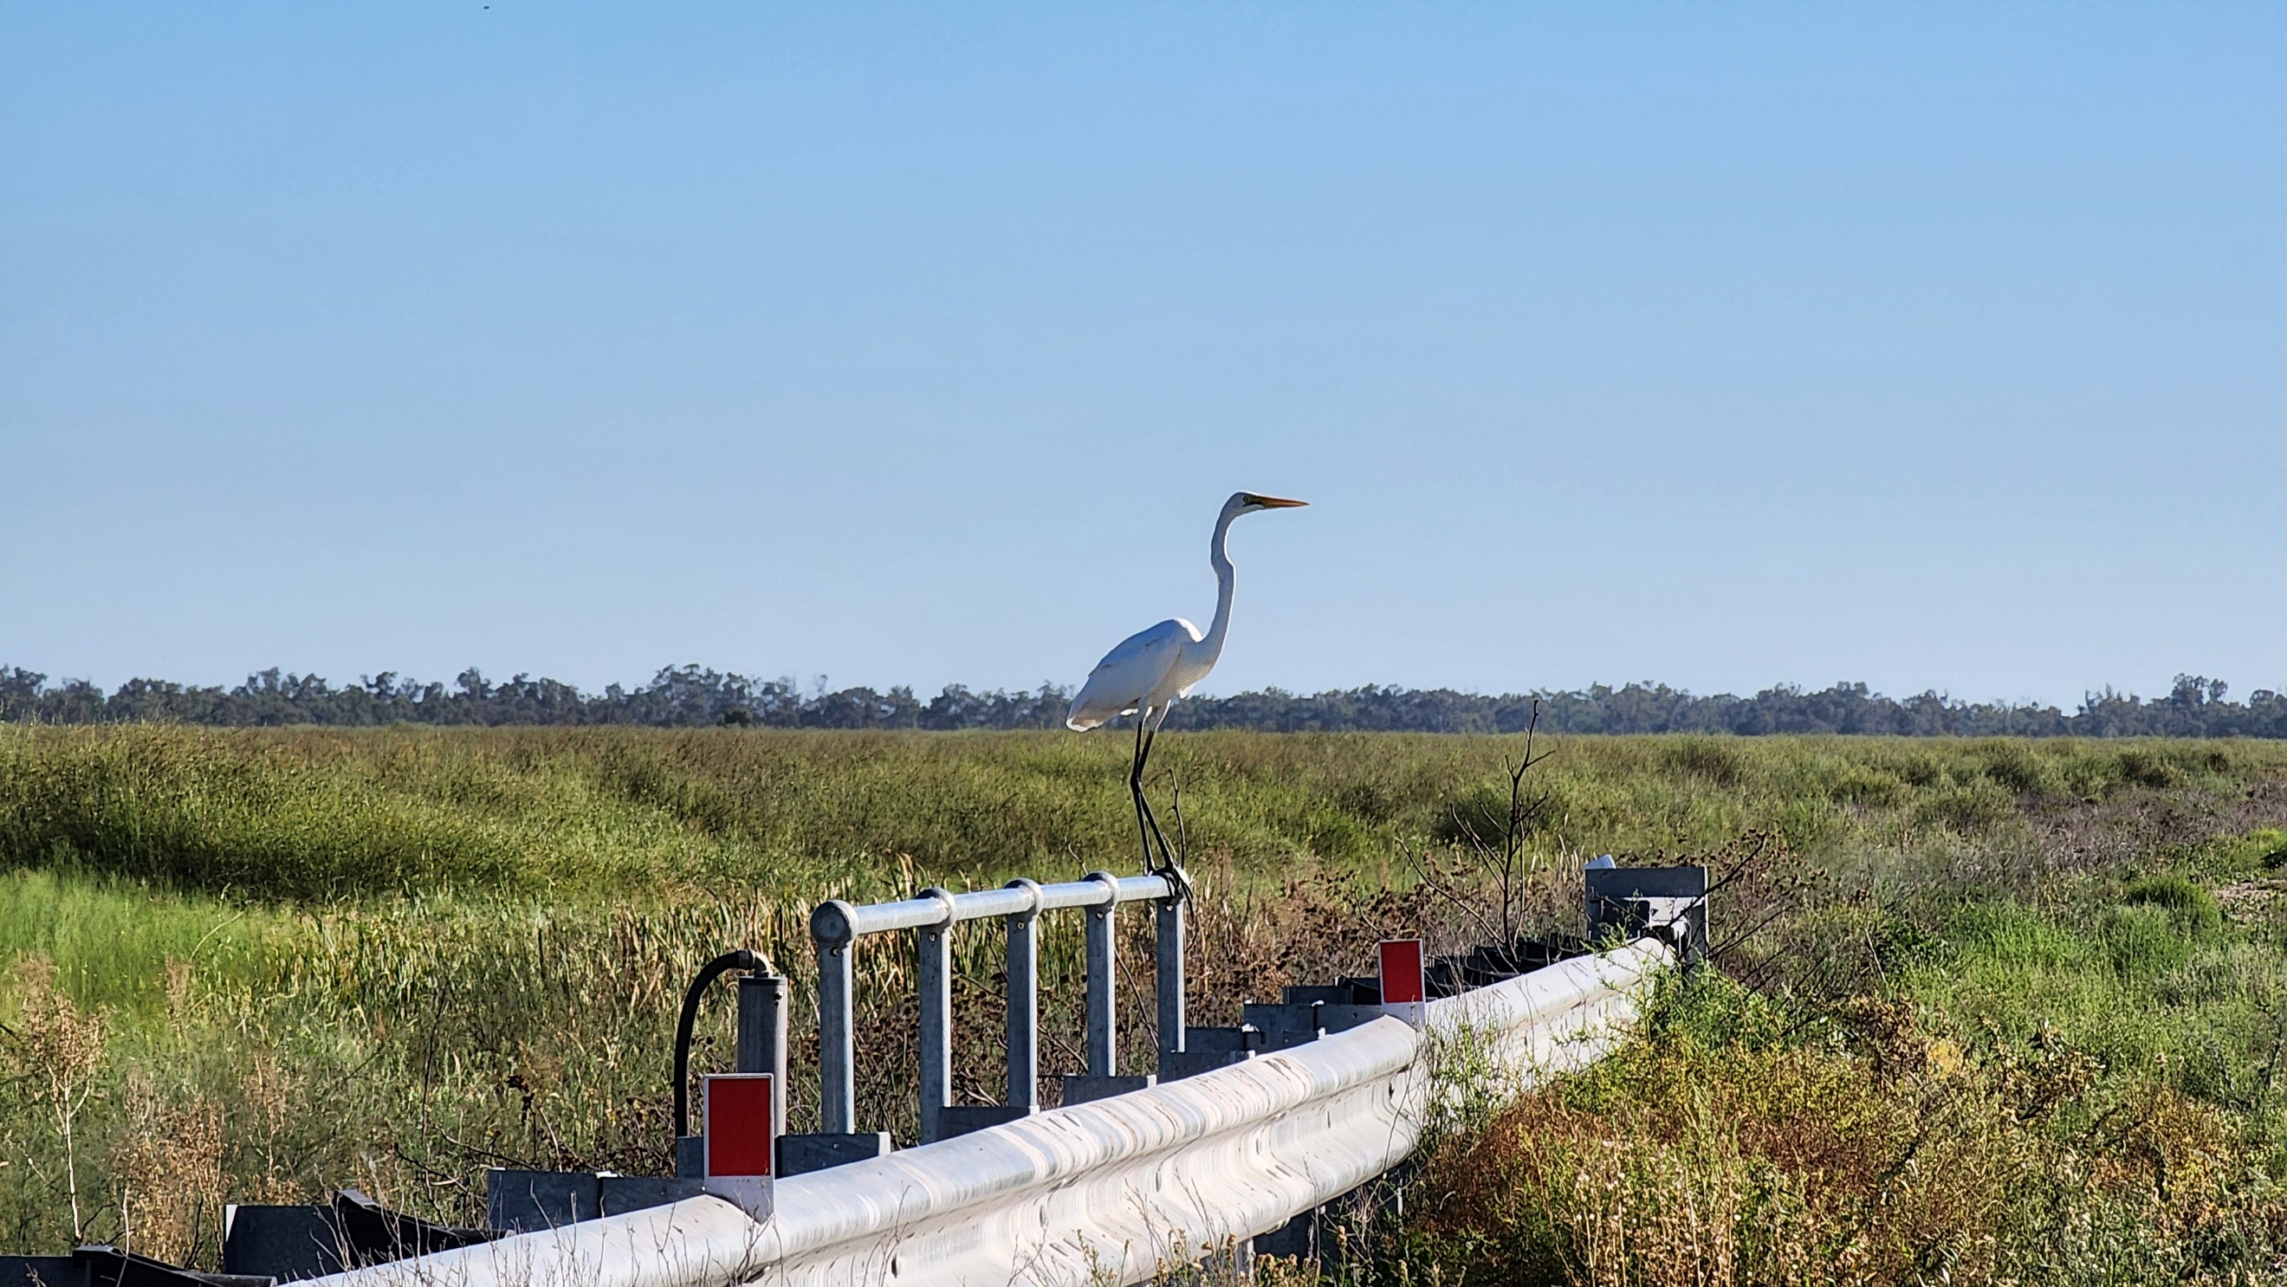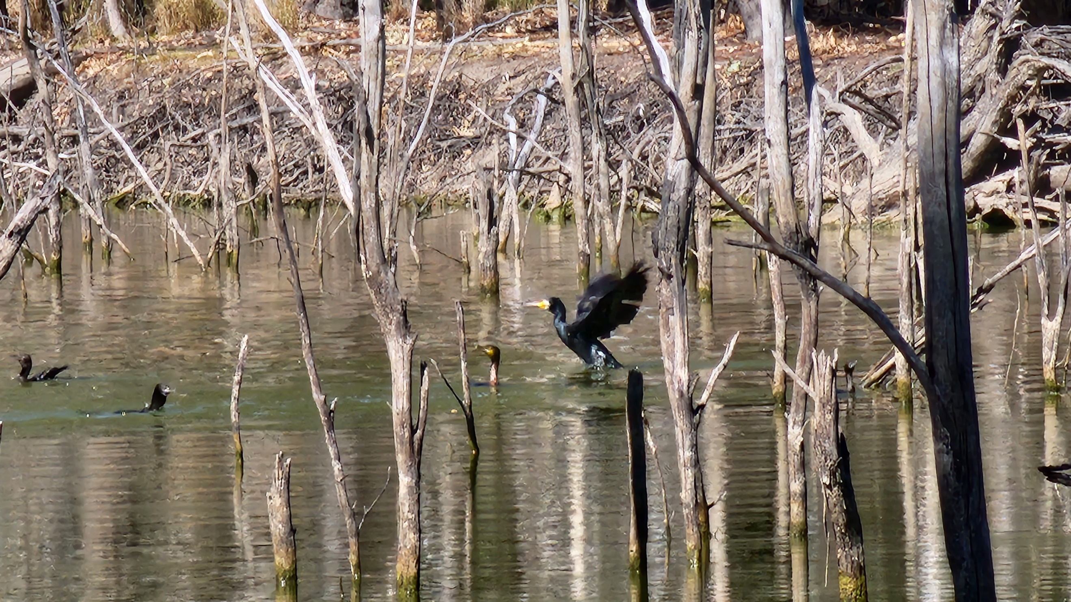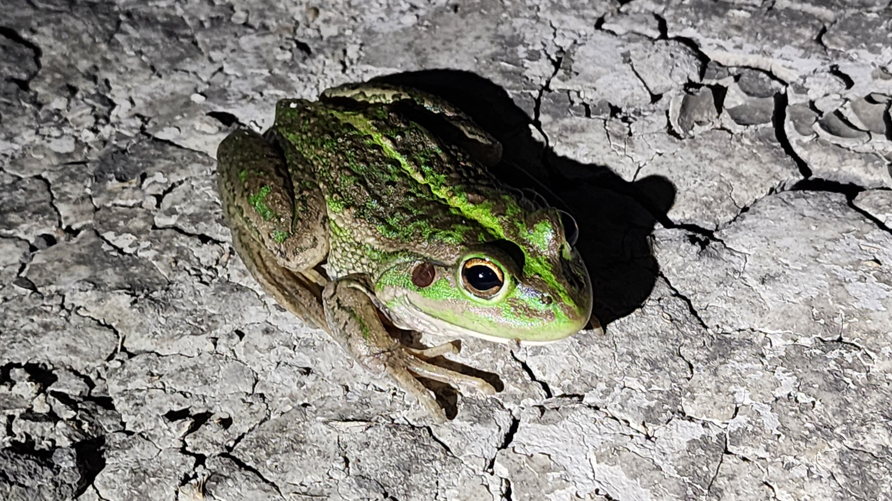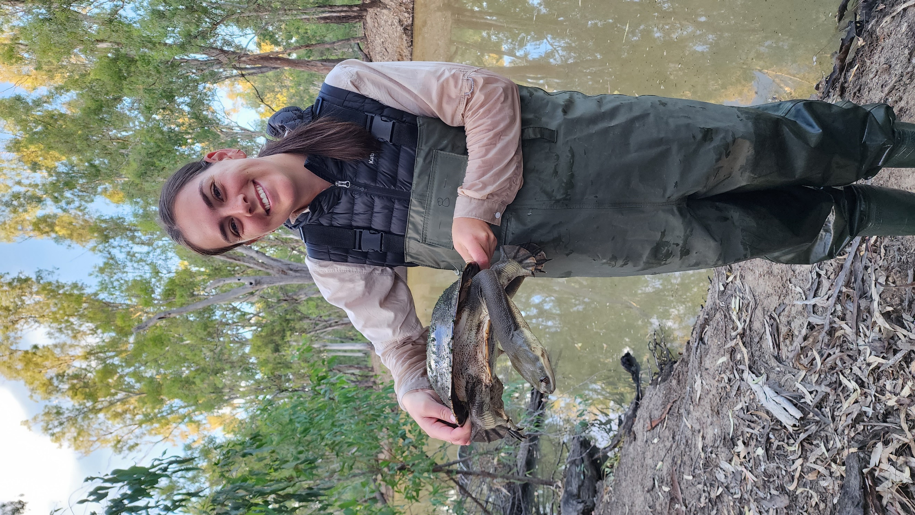
Photo: Top to bottom (all photos credit: Emmalie Sanders)
1) CSU field tech Chris and student cadet Josh bringing in a small fyke net at Mantangery Lagoon.
2) Great egret perched on the regulator at Gayini Nimmie-Caira, January 2024.
3) Great cormorant coming in to land on Kieeta Lake, January 2024.
4) Southern bell frog detected at Bala Swamp.
5) CSU Environmental Management student Becky Groat with a Broad-shelled turtle at Coonancoocabil Lagoon.

Waterbird breeding in the Lower Murrumbidgee wetlands
Many waterbird species nest together, often in very large numbers. These include cormorants, pelicans, ibis, egrets and herons. We closely monitor waterbird breeding events so that water managers can adjust flows, ensuring chicks have the very best chance of survival and quantifying the success of each breeding event.
Widespread La Niña weather conditions in 2021-22 and 2022-23 water years resulted in above average rainfall and extensive flooding. These large events can be a trigger for waterbird breeding events, but sometimes need Commonwealth and NSW environmental water releases to guarantee water remains under nests long enough to ensure successful fledging. A combination of survey methods were used to monitor the 2021-22 and 2022-23 breeding events. This included aerial surveys completed by NSW Department of Climate Change, Energy, the Environment and Water (DCEEW, formerly DPE) staff in fixed-wing aircraft; on ground surveys by Charles Sturt University (CSU) and NSW DCCEEW staff on foot or kayak; intensive on ground monitoring of ibis breeding sites led by Dr. Kate Brandis at University of NSW (UNSW); and with the use of drone surveys led by Dr. Roxane Francis (UNSW).
During the 2022-23 breeding season, 28 active breeding sites were detected across the Mid-Murrumbidgee wetlands and Lowbidgee floodplain. Of these, 24 active breeding sites were monitored, including two large ibis breeding sites and a large pelican nesting site in the Gayini Nimmie-Caira. Fourteen waterbird breeding species were confirmed nesting in 2022-23 including: Australian white ibis (Threskiornis moluccus), straw-necked ibis (Threskiornis spinicollis), royal spoonbill (Platalea regia), yellow-billed spoonbill (Platalea flavipes), little pied cormorant (Microcarbo melanoleucos), little black cormorant (Phalacrocorax sulcirostris), Australasian darter (Anhinga novaehollandiae), great cormorant (Phalacrocorax carbo), nankeen night-heron (Nycticorax caledonicus), white-necked heron (Ardea pacifica), white-faced heron (Egretta novaehollandiae), eastern great egret (Ardea alba modesta), intermediate egret (Ardea intermedia) and Australian pelican (Pelecanus conspicillatus).
The largest number of nests were recorded since monitoring began in 2008 with an estimated 183,000 nests active in the Murrumbidgee Selected Area in the 2022-23 water year. The 2022-23 surveys coincided with the largest flood event recorded since 2008.
Environmental water can play a key role in supporting breeding sites. It is used to extend the duration of inundation in breeding and neighbouring foraging habitats, after breeding is initiated, and where needed, and to increase water depths and maintain water quality to promote successful breeding.
Acknowledgements
Our thanks to the Nari Nari for allowing access to the Gayini Wetlands and to Jamie Woods and Mark Schneider (Nari Nari Tribal Council) for assisting with ground access and survey logistics. We also thank Mon Carmichael and Matt McClelland for advice on ground survey access for sites on Yanga National Park. Many thanks to landholders for permitting access to other sites in the Nimmie-Caira, North Redbank and Mid-Murrumbidgee wetlands. Ground surveys were completed by Sarah Talbot, Christopher Sundblom (CSU), Amelia Walcott, Vanessa Cain, Carmen Amos, Monique McKenzie-Gay (NSW DCCEEW) and Matthew Chapman (UNSW volunteer). The December aerial survey was undertaken by Alex Katopodis (NPWS Park Air), Jennifer Spencer, Anthony Conallin, Iris Xiao and Ali Borrell (NSW DCCEEW), Jane White (MDWWG) and Mal Carnegie. Drone surveys were completed by Matt Smith, Jana Stewart, Sophie Hewitt (UNSW) and Mal Carnegie (DPE Contractor). Our thanks also to Anthony Conallin (NSW DCCEEW) and Matt Herring (Murray Wildlife) for their assistance with surveys over summer months. The ground surveys and drone surveys are approved under NSW NPWS Scientific Licencing and NSW DCCEEW and UNSW animal care and ethics committee approvals.
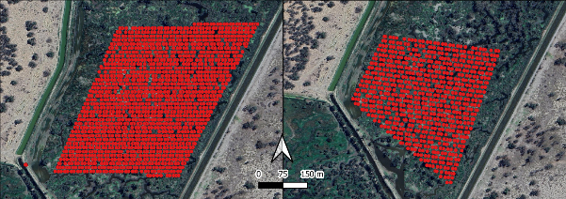
Image: Drone transects flown over ibis breeding site on a) 11 November 2022 and b) 15 December 2022 (reproduced from Francis et al. 2023).
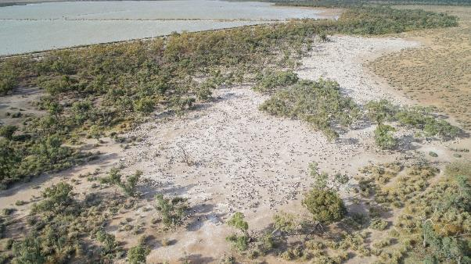
Photo: Drone survey image of pelicans nesting in the Gayini wetlands in March 2022-23 (Credit: M. Carnegie, 20 March 2023).

Wetland field day at Hartwood
A successful wetland field day event was held at Hartwood Station on the Billabong Creek on Friday 8 March. The event was a collaboration between CSU, Commonwealth Environmental Water Holder (CEWH), Yanco Creek and Tributaries Advisory Council Inc. (YACTAC), and Local Land Services Refreshing Rivers Program.
The opening started with Nioka Dupond from Murrumbidgee Landcare Inc. who gave a heartfelt Acknowledgement of Country; Trevor Clark spoke on behalf of the landholder and YACTAC on the history of the property and creek system; and Michele Groat, Murrumbidgee Local Engagement Officer (CEWH), spoke about Commonwealth water for the environment in the Yanco Creek system.
After a BBQ dinner put on by Jerilderie Fishing Club, Prof. Skye Wassens (CSU) discussed wetland and riparian vegetation and habitats; Andrea Mitchell discussed the Refreshing Rivers Program; Dr Anna Turner gave a brief run down on frog species and their calls; and Emmalie Sanders chatted about Rakali in the Creek. We then went for a walk along the creek to see what creatures are active at that time of day.
It was a great turnout by locals and those who travelled from further afield and many valuable discussions were had.
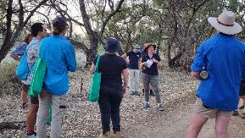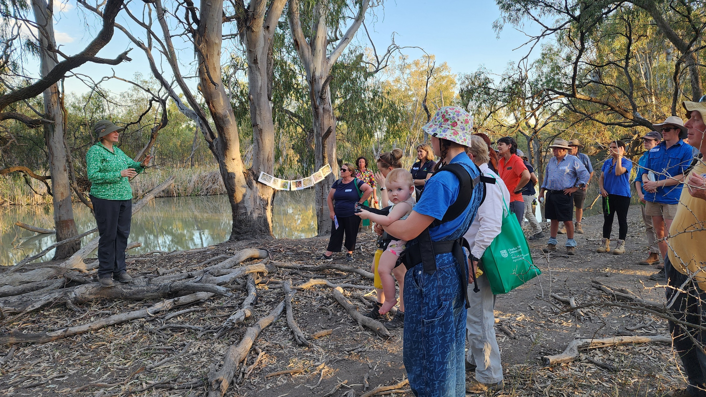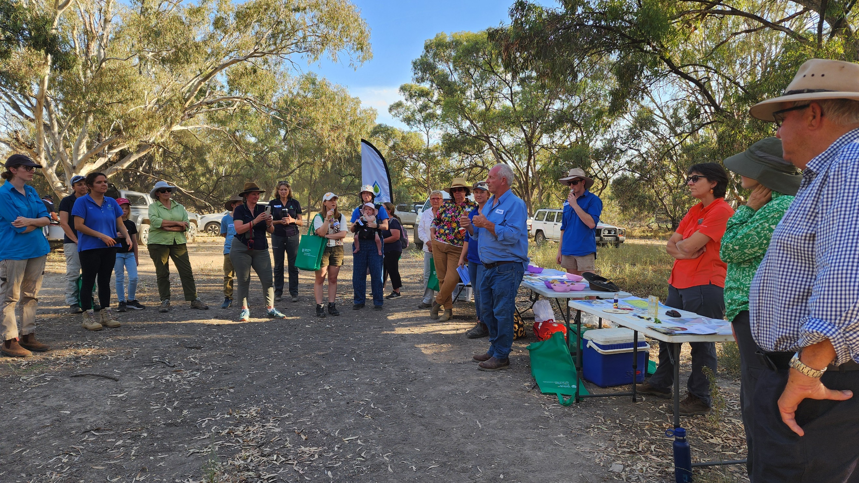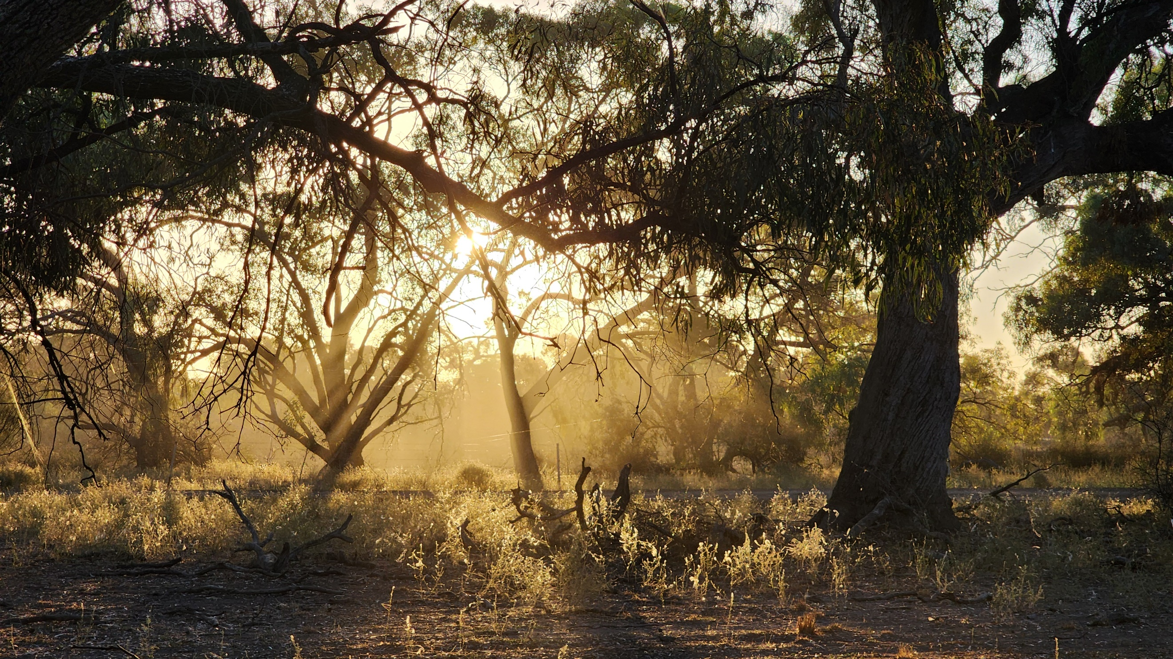
All photos: Snapshots of the afternoon at Hartwood on the Billabong Creek. Photo credit: Emmalie Sanders.
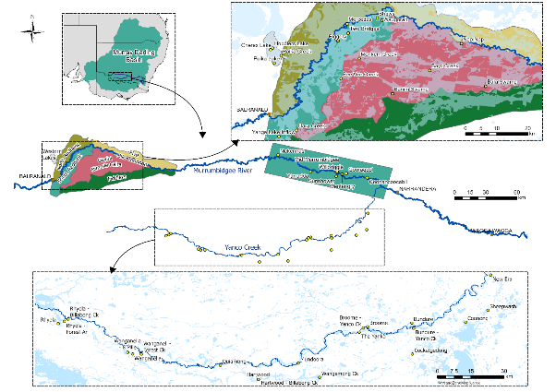
Map showing monitored wetlands within the Murrumbidgee zones: Lower Murrumbidgee, mid-Murrumbidgee and Yanco Creek Systems.
Authors: Anna Turner, Sarah Talbot, Emmalie Sanders, Christopher Sundblom and Professor Skye Wassens.
The next issue of The Bidgee Bulletin is out in Winter 2024.
We're on social media too!
Stay up to date with our adventures on Instagram and X:

@BidgeeMER
The Murrumbidgee MER team would like to acknowledge the consortium partners and local landholders with whom we work.
We respectfully acknowledge the Wiradjuri, Nari Nari, Wamba Wamba, Bpangerang, Barapa Barapa and Muthi Muthi peoples, traditional owners of the lands on which this publication is focused
