Winter 2024 Issue 20

The Bidgee Bulletin

Welcome to Issue 20 of The Bidgee Bulletin. In this issue we update you on the recent field work conducted in the mid and lower Murrumbidgee wetlands during March 2024.
You will read about the bittern acoustic monitoring project using long term call recorder data from the Murrumbidgee wetlands. The project was run as a collaboration between Charles Sturt University and Biodiversity, Conservation and Science (NSW Department of Climate Change, Energy, the Environment and Water).
This edition we feature a snapshot of the beautiful water-year calendar with artworks by Wiradjuri artist Ashleigh Pengelly.
The Bidgee Bulletin is a quarterly newsletter designed to provide updates on our progress as we monitor the ecological outcomes of Commonwealth environmental water flows in the Murrumbidgee Selected Area. The 2023-2024 program builds on the previous nine years of wetland monitoring (LTIM 2014-2019 and MER 2019-2023).

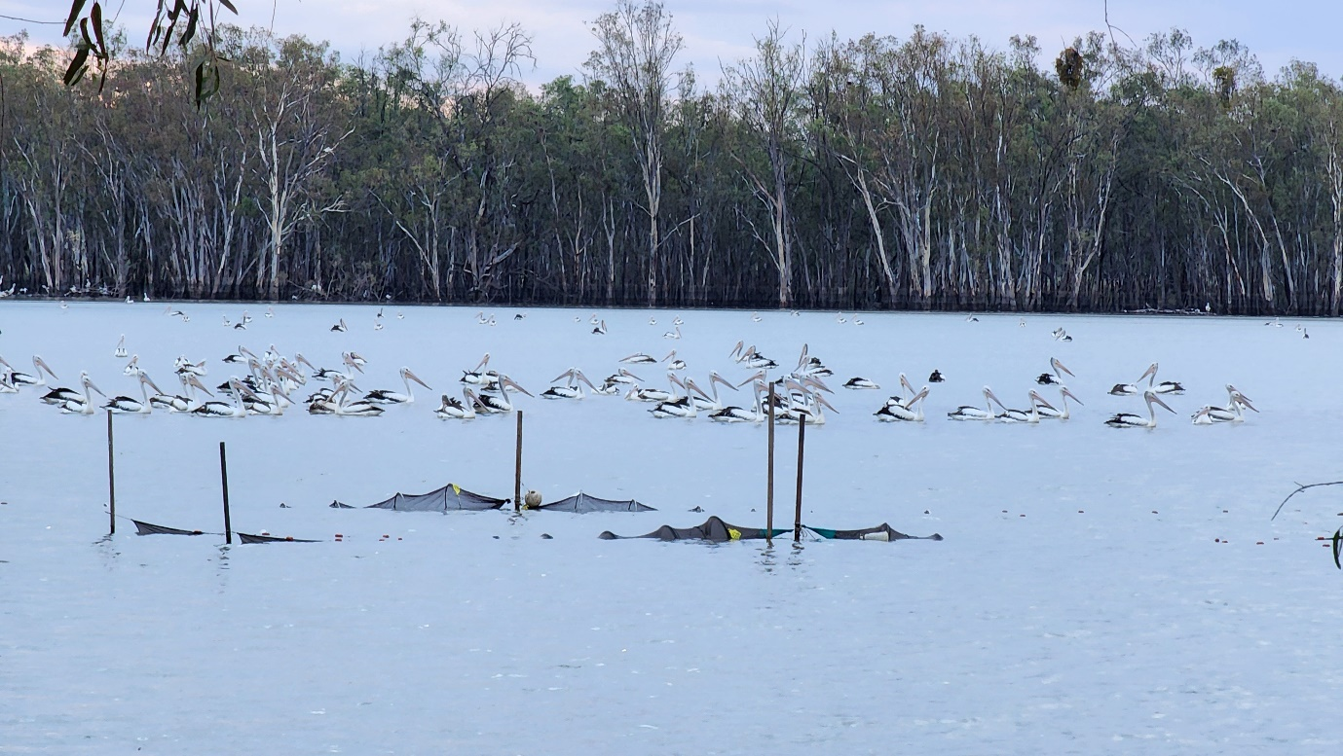
Photo: Pelicans at Waugorah Lake during fyke net surveys for fish, March 2024. Credit: Emmalie Sanders

1. Update from the field

Core wetland sites had started to dry in the lead up to the March surveys. Supplementary sites were surveyed where necessary.

Highlights:

Lowbidgee floodplain
Sites surveyed (18th-22nd March) included Yanga Lake inflow, Waugorah Lagoon and Waugorah Lake, Kieeta Creek, Emu Lake, Fairfax Swamp, Bala Swamp and Bayil Creek. Southern bell frogs were detected at all sites except Kieeta Creek and Emu Lake. Highlights for the week included two musk ducks seen at Fairfax Swamp and the incidental sighting of an adult Australasian bittern on Warwaegae Road (Gayini Nimmie-Caira). Bony bream were detected at all sites except Bala swamp, Australian smelt were detected at Fairfax swamp only and carp gudegon were detected at all sites except Bala Swamp and Bayil Creek. One broad-shelled turtle was detected at Waugorah Lake. Eastern long-necked turtles were more common with nine detected throughout the week.

mid-Murrumbidgee
Yarradda, Mantangery, Gooragool West and Coonancoocabil were surveyed from 26th-28th March, however, water levels and quality were too low to set fyke nets at Gooragool West and Coonancoocabil, so only frog and bird surveys were conducted. The highlight included all three turtle species being detected at Mantangery including seven eastern long-neck turtles, one broad-shelled turtle and three Murray River short-necked turtles.

Vegetation surveys
Surveys were conducted for wetland vegetation in the lower and mid-Murrumbidgee from 13th-15th March. These were the last surveys for the season. Gooragool and Sunshower lagoons were completely dry by March. Native species richness was found to be highest at Gooragool and Nap Nap swamps.
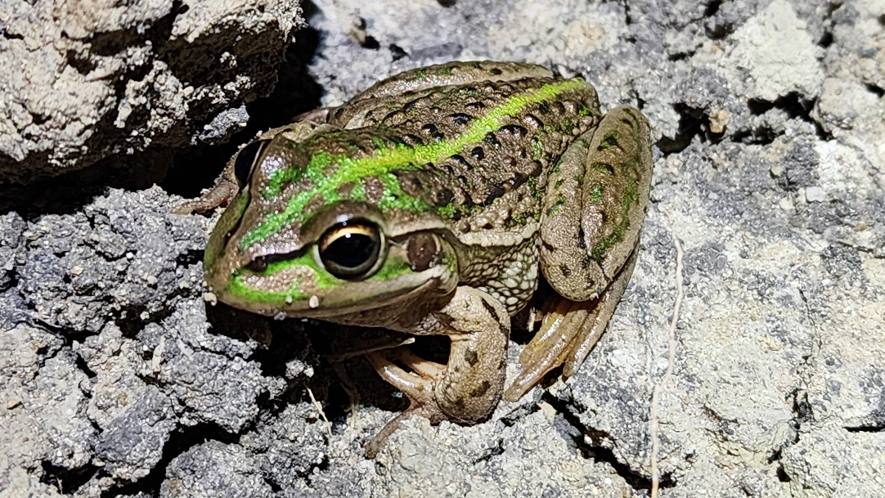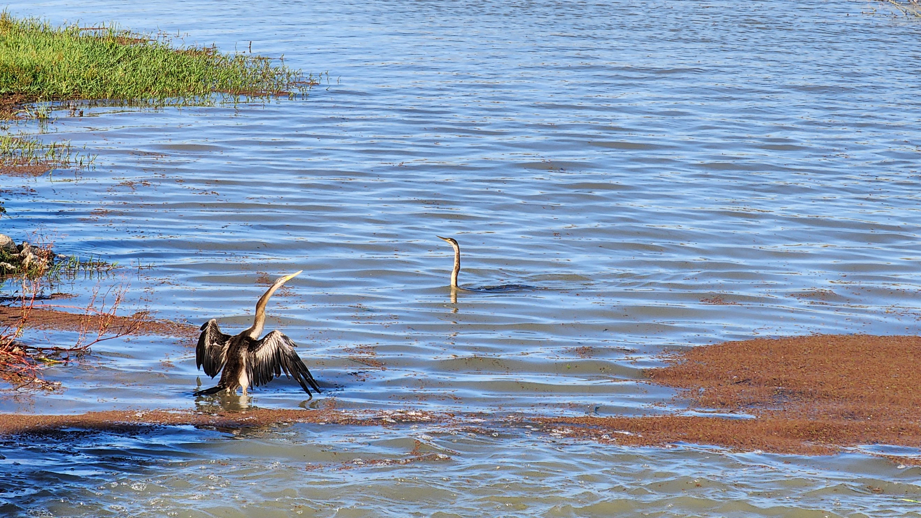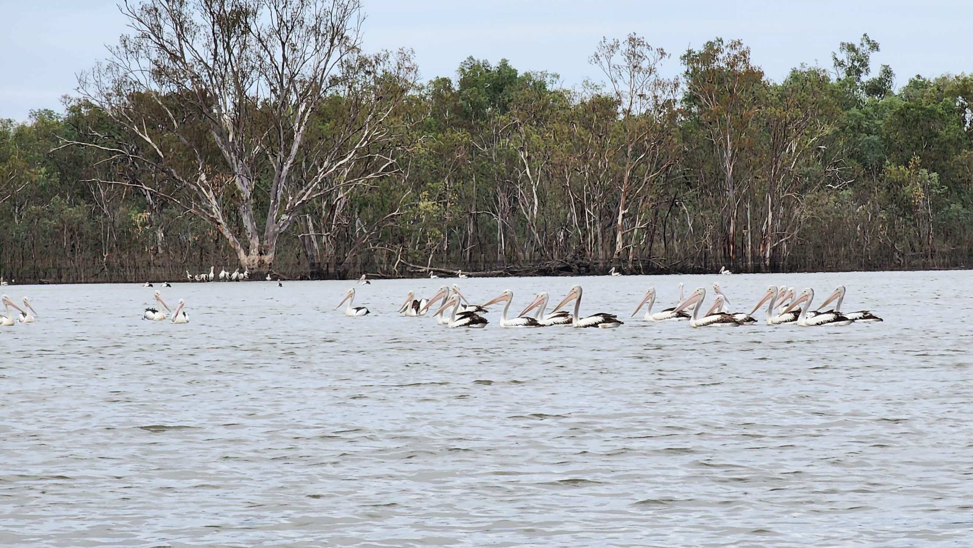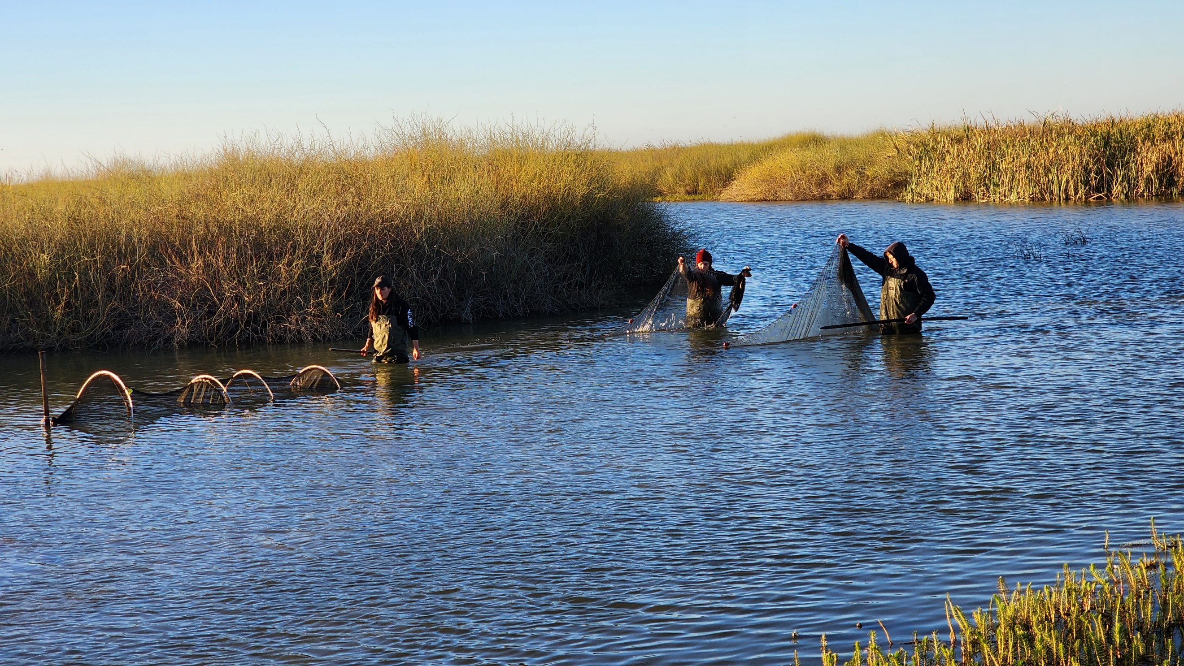
Top to bottom (all photos credit: Emmalie Sanders)
1) Bell frog at Fairfax Swamp.
2) Darters at Bala Swamp.
3) Pelicans at Waugorah Lake.
4) Team setting fyke nets at Fairfax Swamp.

Investigating the water requirements of the endangered Australasian bittern
Authors: Skye Wassens¹, Elizabeth Znidersic¹, Sarah Talbot¹, Andrew Hall¹, Jennifer Spencer², Helen P. Waudby²
¹ Charles Sturt University
² Biodiversity, Conservation and Science, NSW Department of Climate Change, Energy, the Environment and Water
Detecting Australasian bitterns can be a challenge. They are listed as Endangered in Australia with only 1300 estimated left in the wild. They are elusive and well-camouflaged, nest amongst dense wetland vegetation, and male bitterns call at night for part of the year (Fig 1). CSU researchers and NSW DCCEEW scientists have collaborated in a project funded by the Commonwealth Environmental Water Holder (CEWH) to investigate the relationship between the timing and duration of water for the environment deliveries and bittern calling activity.
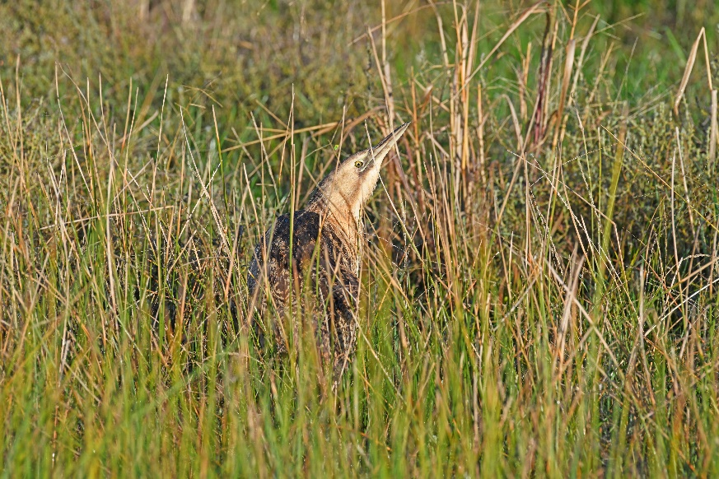
Figure 1. Australasian bittern amongst wetland vegetation. Photo credit: Mal Carnegie, Lake Cowal Foundation.
Audio recorders have been deployed by CSU at twelve key wetlands in the Lower Murrumbidgee wetlands since 2016. Data collected from five of these call recorders were screened for bittern calling activity. Over 7000 days of usable audio data was collected from the five sites. A software package was used to detect the bittern call and show it visually on a spectrogram (see Fig. 2).
Flow conditions varied considerably over the six watering years during which this data was gathered. Commonwealth and NSW environmental watering actions were delivered during this time depending on inundation requirements in key wetlands.

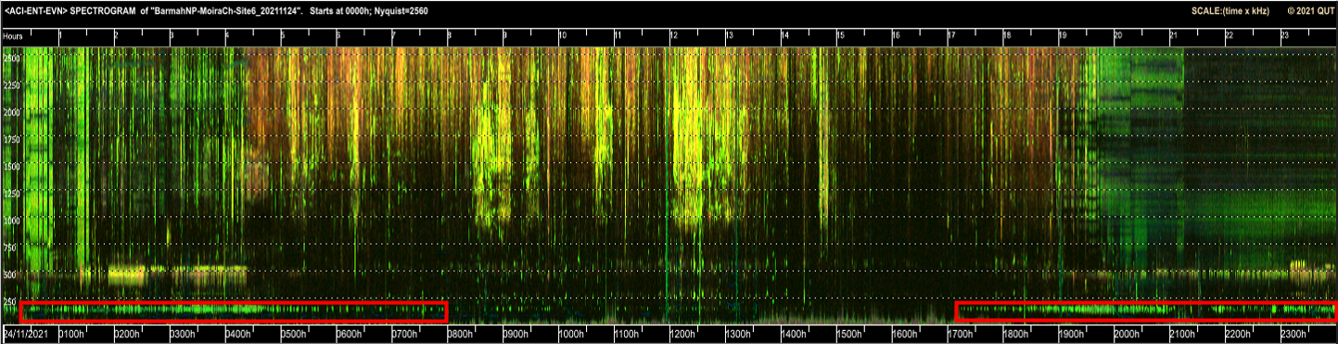
Figure 2. Long-duration false-colour spectrogram showing lots of Australasian Bittern calls in the red rectangles.
Australasian bitterns were detected from audio recordings at five wetlands: Nap Nap, Bala swamp and Bayil creek in Gayini Nimmie-Caira and Two Bridges and Mercedes swamp in Yanga National Park. Long periods of calling were likely to be associated with breeding events at Bala, Bayil and Two Bridges with shorter periods detected at Nap Nap and Mercedes. Unregulated floodplain inundation in 2021-22 at Two Bridges resulted in the longest calling period, which spanned 101 days.
Analysis of the call frequency with wetland depths found that calling increased with increasing depth. The plot below shows when calling occurs (black vertical lines) in relation to water depth (black horizontal line) (Figure 3.).
Bittern calling was associated with larger watering actions of longer durations. This relationship was strongest at Gayini Nimmie-Caira where flows associated with bittern calling were more than twice the size of flow events that were not associated with calling.

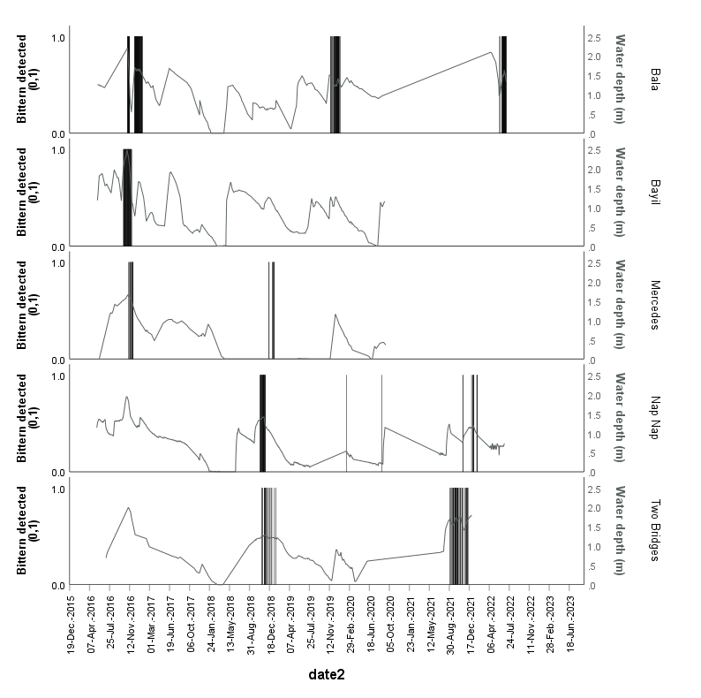
Figure 3. Call detections against water depth at five wetlands where Australasian bitterns were detected between 2016 and 2022.
Another key feature of the five wetlands in which calling activity was detected, included a high cover of lignum or tall spike rush, which provides suitable nesting habitat in the Lowbidgee Floodplain.
The delivery of environmental water is critical to ensure provision of breeding, foraging and refuge habitats for Australasian bitterns. In wetlands where bittern breeding is likely, water levels need to be maintained for at least 6 months while nesting occurs. Wetlands should be filled in August or September and relatively stable water levels held from October to February. Where possible, it is important to inundate shallow wetland habitats adjacent to priority breeding sites to maintain adequate foraging. It is also important that sudden rises or falls in water levels do not occur during the peak nesting period to protect eggs and immobile young chicks from drowning or predation from ground predators.
This project demonstrates the importance of continuous monitoring of Australasian bittern calling activity in response to environmental water delivery. Early identification of potential breeding events using acoustic monitoring, including potential deployment of telemetered units with real time detection capability, coupled with targeted on-ground monitoring will enable responsive watering strategies to maximise the potential for recruitment success.

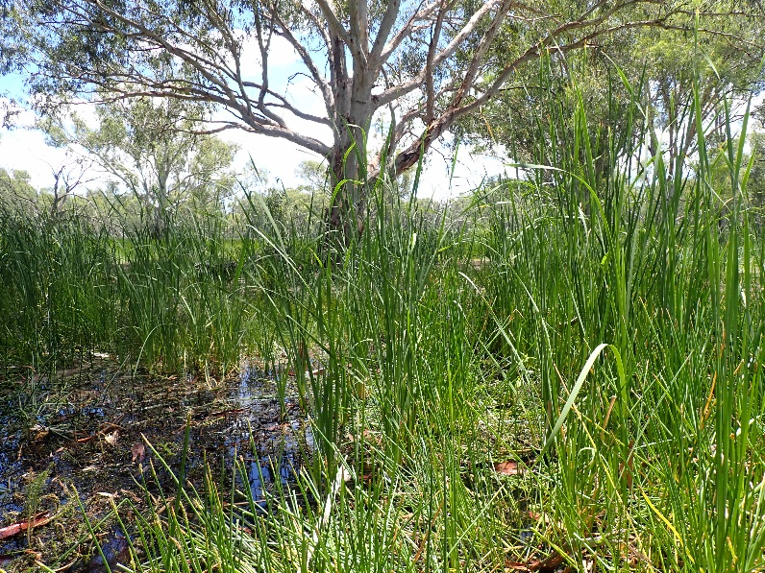
Figure 4. Two Bridges swamp, Yanga National Park, Lower Murrumbidgee, January 2021. A bittern monitoring site. Photo credit: Skye Wassens.
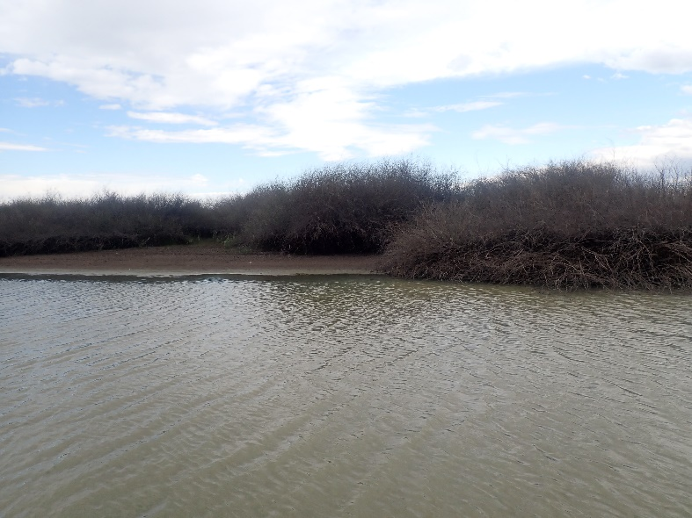
Figure 5. Bala Swamp, lignum dominated monitoring site in Gayini Nimmie-Caira.

2024-2025 Murrumbidgee Wetland Monitoring Calendar
Each year the Murrumbidgee MER team produce a water year calendar based on favourite photos from the field during the year. Last year for the 2023-24 calendar we collaborated with Wiradjuri artist, Ashleigh Pengelly, who produced beautiful artworks alongside the teams' photos.
This year we have engaged with Ashleigh again to produce a new series of works for the 2024-25 water year calendar and the results are just stunning.
Ashleigh has captured the colours and themes of each photo with her creative digital art. Each month is a new surprise with photos ranging from aerial drone shots of nesting waterbirds to close-ups of other creatures we find around the wetlands, such as spiders, frogs and reptiles.
Each image is accompanied by a short block of text to give context and information behind the image and artwork.
We look forward to sharing these calendars amongst community and stakeholders over the coming months for you to enjoy throughout the year.

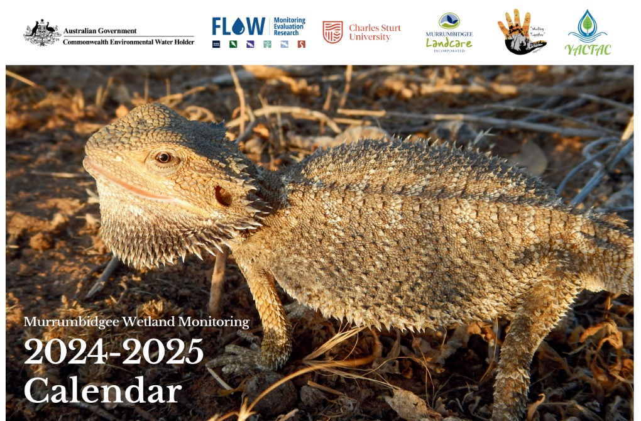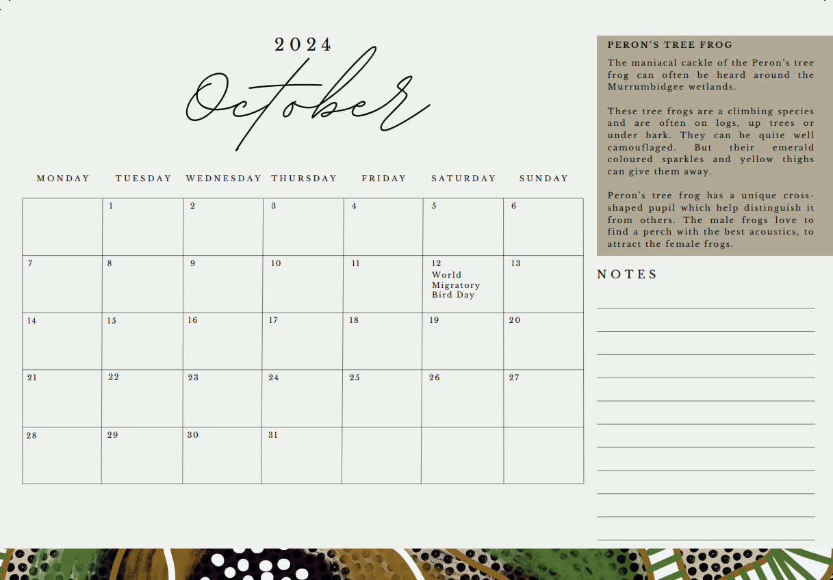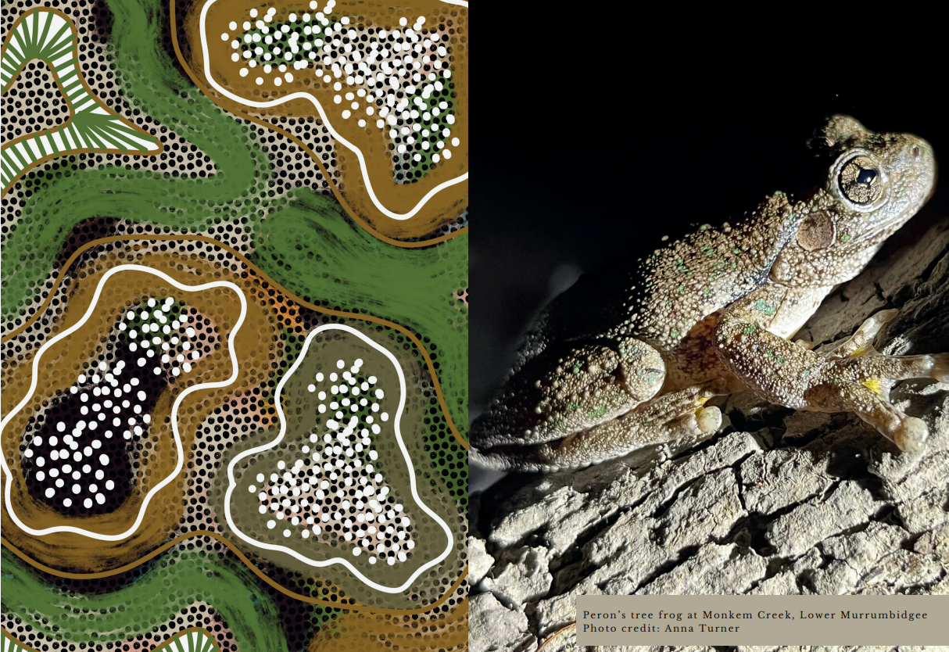
Snapshots of the artworks created by Ashleigh Pengelly for the annual water year calendar.
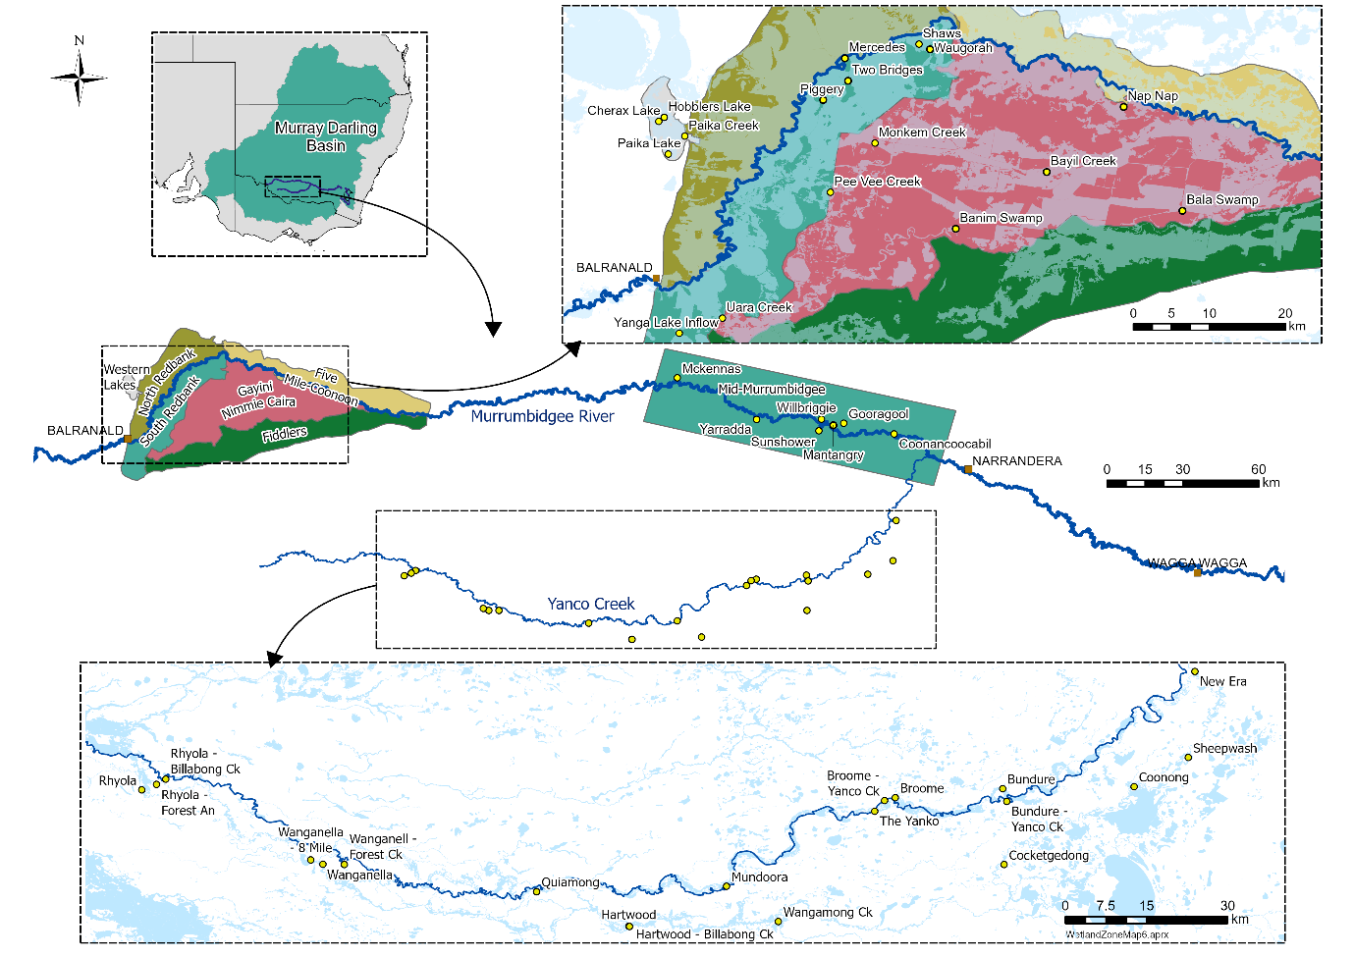
Map showing monitored wetlands within the Murrumbidgee zones: Lower Murrumbidgee, mid-Murrumbidgee and Yanco Creek Systems.
Authors: Anna Turner, Sarah Talbot, Emmalie Sanders, Christopher Sundblom and Professor Skye Wassens.
Keep an eye out for our new MER2.0 snapshot out in Spring 2024.
We're on social media too!
Stay up to date with our adventures on Instagram and X:

@BidgeeMER
The Murrumbidgee MER team would like to acknowledge the consortium partners and local landholders with whom we work.
We respectfully acknowledge the Wiradjuri, Nari Nari, Wamba Wamba, Bpangerang, Barapa Barapa and Muthi Muthi peoples, traditional owners of the lands on which this publication is focused.
