Committee on Aboriginal and Torres Strait Islander Water Interests

Communique #8, November 2024

Meeting 31, Canberra, 27-29 November 2024

The Committee on Aboriginal and Torres Strait Islander Water Interests (the Committee) met on the land of the Ngunnawal and Ngambri Peoples in Canberra on 27-29 November 2024. The meeting was jointly hosted by the Australian Government Department of Climate Change, Energy, the Environment and Water (the department) and the Australian Capital Territory’s Environment, Planning and Sustainable Development Directorate.

The Committee visited Cotter Reserve and received a Welcome to Country by Ngunnawal Elder Uncle Fred Monaghan. During the field trip, the Committee had the opportunity to hear from Ngunnawal Traditional Owners about their key water priorities and concerns. The Committee thanked the ACT Government and Ngunnawal representatives for their time, insights and for sharing stories, which helped CAWI to build their understanding of the priorities and sensitivities on water in the Canberra region.

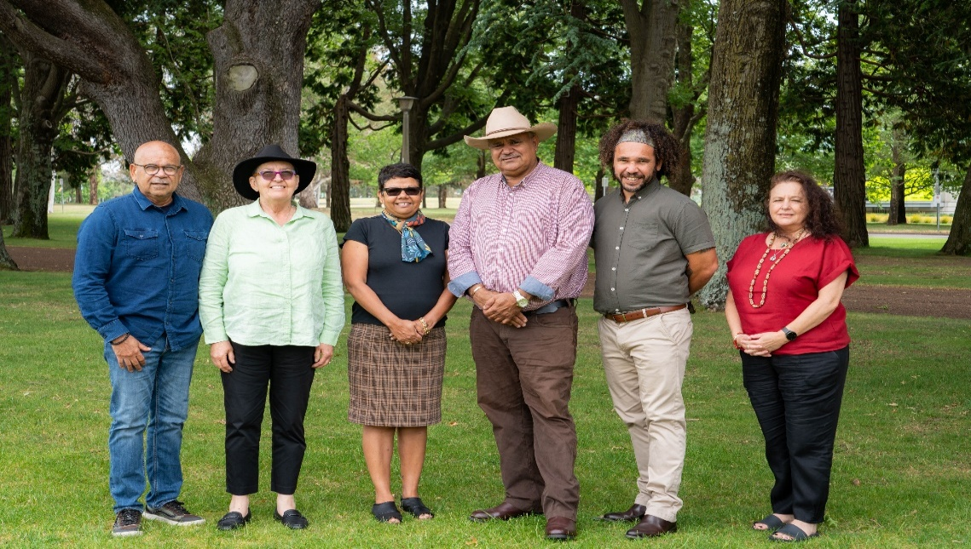
Unfortunately, Ngambri Peoples were unavailable to meet with the Committee.
From left: John Locke, Virginia Marshall, Kay Blades, Tony Jack, Nathan Brennan, Sarah Wilcox.

The Committee welcomed three new appointees, Mr Nathan Brennan from New South Wales, Ms Sarah Wilcox from Tasmania, and Mr Tony Jack from the Northern Territory. The Committee acknowledged the wealth of skills and expertise of new members. This brings the Committee’s membership to a total of 6 people. The Committee agreed for the department to undertake further expressions of interests early in the New Year, for the remaining 3 vacant positions in South Australia, Victoria and Western Australia to address the geographic gap within the Committee membership.

As the last CAWI meeting for 2024, the Committee highlighted its key achievements over the year, including progress on the National Water Agreement (NWA) and the Inland Waters Target. They discussed their strategic priorities for 2025, developed a forward workplan and agreed a schedule of meetings and locations for the year. The Committee also met with state and territory government representatives to receive updates and discuss planned or key water reforms underway, including planned processes for the development of jurisdictional Water Action Plans under the NWA. The Committee committed to continue their collaboration and partnership with state and territory governments in 2025 and provide support, as required, as they begin implementation of the new NWA.

The department updated the Committee on the Australian Government’s Aboriginal and Torres Strait Islander Water initiatives, including the Murray—Darling Basin (Basin) Aboriginal Water Entitlements Program, national and Basin enduring water holding arrangements, the Cultural Flows Planning for Cultural Economies Program, and the development of the Inland Waters Target.

The Committee met with Ms Lyn O’Connell, Chair of the National Water Committee and Mr Matthew Dadswell, Division Head of the Water Policy Division, to discuss the progress of the NWA and the importance of building relationships with key stakeholders and jurisdictions to progress the implementation of the NWA and also welcomed a presentation from Ms Melina Saunders, Branch Head, First Nations Branch, DCCEEW on frameworks being developed to strengthen partnerships with Aboriginal and Torres Strait Islander Peoples.
The Committee also met with states and territories to receive jurisdictional updates on their projects underway and respective water reforms initiatives.

Next meeting
The Committee’s next meeting will be in Adelaide, South Australia, 3-5 February 2025.
Contact: CAWI@dcceew.gov.au

