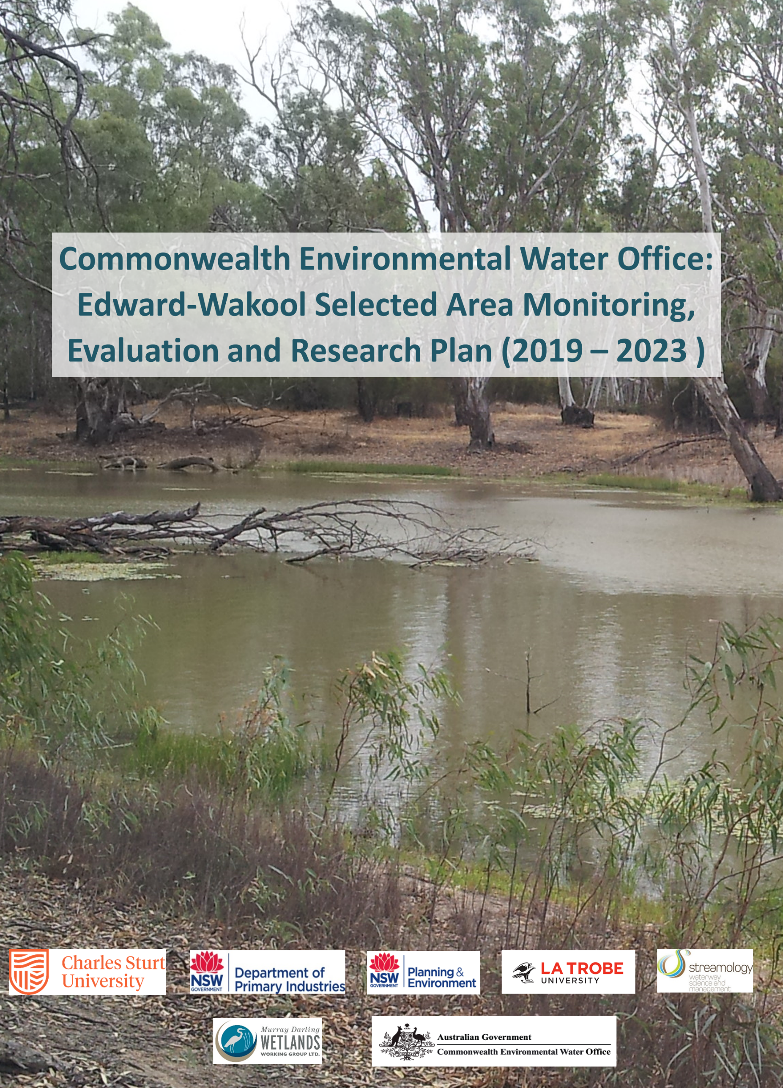

Prepared by: Watts, R.J.ª, McCasker, N.ª, Howitt, J.ª, Liu, X. ª, Trethewie, J.ª , Allan, C. ª, Thiem, J.^{b}, Duncan, M.^{b}, Healy, S.^{c, f}, Bond, N.^{d}, Van Dyke, J. ^{d}, Siebers, A. ^{d}, Vietz, G.^{e}, Donges, M. ^{e}

^{a.}Charles Sturt University  PO Box789, Albury, NSW 2640 | 
^{b.}NSW Department of Primary Industries  Narrandera Fisheries Centre,  PO Box 182, Narrandera NSW 2700 | 
^{c.} NSW Department of Planning and Environment  Level 1, 512 Dean St, Albury, NSW, 2640 | 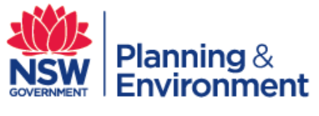
^{d.} La Trobe University | 
^{e.} Streamology  Waterway science and management | 
^{f.} Murray-Darling Wetlands Working Group  512 Dean Street, Albury, NSW 2640 | 

This monitoring project was commissioned and funded by Commonwealth Environmental Water Office with additional in-kind support from Charles Sturt University, NSW DPI Fisheries, NSW Department of Planning and Environment and La Trobe University.
Copyright
© Copyright Commonwealth of Australia, 2023.

‘Edward-Wakool Monitoring, Evaluation and Research Plan (2019-2023) is licensed by the Commonwealth of Australia for use under a Creative Commons By Attribution 3.0 Australia licence with the exception of the Coat of Arms of the Commonwealth of Australia, the logo of the agency responsible for publishing the report, content supplied by third parties, and any images depicting people. For licence conditions see: http://creativecommons.org/licenses/by/3.0/au/
The Commonwealth of Australia has made all reasonable efforts to identify content supplied by third parties.
Disclaimer
The views and opinions expressed in this publication are those of the authors and do not necessarily reflect those of the Australian Government or the Minister for the Environment.
While reasonable efforts have been made to ensure that the contents of this publication are factually correct, the Commonwealth does not accept responsibility for the accuracy or completeness of the contents, and shall not be liable for any loss or damage that may be occasioned directly or indirectly through the use of, or reliance on, the contents of this publication.

Notes regarding the 2023 Revision to this Flow-MER Plan
The Flow-MER Program has been extended to December 2023. Read more about the Monitoring Evaluation and Research Program (Flow-MER) .
The Edward-Wakool Monitoring Evaluation and Research (Flow-MER) Plan has been extended for one year to 2022–23, with monitoring ending on 30 June 2023 and reporting ending December 2023. All aspects of the Plan remain current with time specific sections related to what was originally planned in 2019.
In addition to numerous minor changes, this revised plan includes the following major changes:
- Updated table of monitoring sites (Tables 1 and 10)
- Updated section 6.9 and Table 23, outlining the schedule for monitoring, evaluation and research activities (2021-2023)
- Work orders for additional monitoring, research, and engagement and communications projects (see Appendices)
Up to date information on project outcomes is in the most recent Edward-Wakool Flow-MER Annual Technical Report and Summary Report. Annual Reports also report on the implementation of contingency funds for additional monitoring, research, and engagement and communications activities discussed in the Flow-MER Plan.
Progress on all elements of the Edward-Wakool Flow-MER program is also reported to CEWO via Edward/Kolety-Wakool Flow-MER Quarterly Outcomes Newsletters.

Contents
1. Introduction 5
1.1 Background 5
1.2 Monitoring, Evaluation and Research approach for the Edward-Wakool Selected Area 5
2. Edward-Wakool Selected Area description 8
3. Commonwealth environmental watering 14
3.1 Commonwealth environmental watering actions 2009-2022 14
3.2 Expected outcomes relevant to the Mid-Murray Region 15
3.3 Practicalities of environmental watering in the Edward-Wakool system 17
4. Monitoring and research priorities 19
4.1 Principles to underpin the development of the Flow-MER Plan 19
4.2 Process for prioritisation of hydrological zones 20
4.3 Priorities identified by stakeholders 21
5. Indicators for Monitoring and Evaluation 22
5.1 Hydrology (Category 1) 24
5.2 Carbon and water quality (Category 3) 28
5.3 Stream metabolism (Category 1) 35
5.4 Riverbank and aquatic vegetation (Category 3) 41
5.5 Fish movement (Category 2) 45
5.6 Fish Reproduction (Larvae) (Category 1) 55
5.7 Fish Reproduction (larvae) (Category 3) 59
5.8 Fish recruitment (Category 3) 66
5.9 Fish River (Category 1) 70
5.10 Fish River (Category 3) 80
6. Contingency research, monitoring and engagement (2019-2022) 87
6.1 Two-dimensional hydraulic modelling 89
6.2 Physical habitat research 92
6.3 Riverbank and aquatic vegetation 99
6.4 Primary productivity and ecosystem respiration 100
6.5 Turtle research 101
6.6 Fish spawning in the Edward River 105
6.7 Biodiversity research (Environmental DNA) 107
6.8 Social science research 111
6.9 Schedule for monitoring, evaluation and research activities (2021-2023) 114
7. Engagement and communication 116
8. Reporting 119
9. Project management 121
9.1 Project governance 121
9.2 Risk assessment 122
9.3 Key personnel 122
9.4 Quality assurance 124
9.5 Health, Safety and Environment Plan 124
9.6 Equipment 126
10. Data management 128
11. References 129
12. Budget 137
13. Appendices 138

1. Introduction

1.1 Background
The Commonwealth Environmental Water Holder (CEWH) is responsible under the Water Act 2007 (Cth) for managing Commonwealth environmental water holdings. The holdings must be managed to protect or restore the environmental assets of the Murray-Darling Basin, and other areas where the Commonwealth holds water, so as to give effect to relevant international agreements. The Basin Plan (2012) further requires that the holdings must be managed in a way that is consistent with the Basin Plan’s Environmental Watering Plan. The Water Act 2007 (Cth) and the Basin Plan also impose obligations to report on the contribution of Commonwealth environmental water to the environmental objectives of the Basin Plan. Monitoring, evaluation and research are critical for supporting effective and efficient use of Commonwealth environmental water. Monitoring, evaluation and research will also provide important information to support the CEWH meet their reporting obligations.
In June 2014, the CEWO commenced the Long Term Intervention Monitoring Project (LTIM Project) which facilitated the monitoring and evaluation of the contribution of Commonwealth environmental water delivery in the Murray-Darling Basin over five years from July 2014 to June 2019. Over the period from 2014 to 2019 the CEWO also funded the Murray-Darling Basin Environmental Water Knowledge and Research Project (EWKR Project) that aimed to improve the science available to support environmental water management in the Murray-Darling Basin. The EWKR project implemented research aimed to better understand the links between ecological responses to environmental flows and changes in condition, and the impact of threats such as pests, grazing or poor water quality on ecological improvements through environmental flows. The CEWO Flow-MER Program (2019 to 2023) is an extension of the LTIM and EWKR projects, with monitoring, evaluation and research activities undertaken within a single integrated program.

1.2 Monitoring, Evaluation and Research approach for the Edward-Wakool Selected Area
This Flow-MER Plan describes the monitoring, evaluation and research activities that will be undertaken as part of the CEWO Flow-MER Program from July 2019 to December 2023. The core monitoring for this project will be undertaken as a collaboration between Charles Sturt University, NSW DPI (Fisheries), NSW Department of Planning and Environment, La Trobe University, and Murray-Darling Wetlands Working Group. The contingency projects described in the plan include additional monitoring, evaluation and research projects that complement the core monitoring. The contingency projects described in this plan were undertaken by the organisations listed here as well as Streamology and Yarkuwa Indigenous Knowledge Centre Aboriginal Corporation.
The overarching principle that underpins this Flow-MER Plan for the Edward-Wakool Selected Area is that we are taking an ecosystem approach to evaluate the responses to Commonwealth environmental watering. A set of questions and indicators have been selected that each have clear linkages to other components of the Flow-MER project (see Figure 1). The plan has a strong focus on fish (including movement, reproduction, recruitment and adult populations) and water quality. The Edward-Wakool system is recognised as a priority area for fish diversity in the Murray-Darling Basin, including threatened and endangered fish, and it is part of the ‘aquatic ecological community in the natural drainage system of the lower Murray River catchment’ in New South Wales (NSW Fisheries Management Act 1994). Outcomes for fish and water quality have been the main focus of environmental watering actions in the Edward-Wakool system since 2010. Some of the other indicators (e.g., stream metabolism and aquatic vegetation) strongly influence the health of the ecosystem, and thus a key goal of this Flow-MER Plan is to improve our understanding and interpretation of these interdependencies.
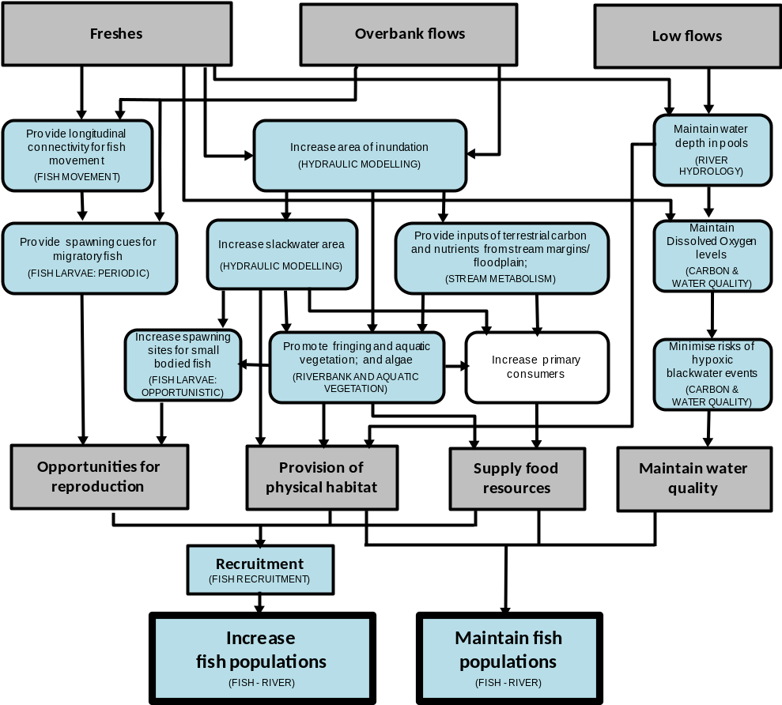
Figure 1 Conceptual diagram illustrating three main flow types (low flows, freshes, overbank flows) and their influence on ecosystem components and processes that, in turn, influence fish population dynamics. Indicators included in the Edward-Wakool Flow-MER Plan are shown in brackets in boxes shaded blue.
Ecosystem responses to Commonwealth environmental water will be evaluated in two ways:
- Indicators that respond quickly to flow (e.g., hydrology, water quality and carbon, stream metabolism) will be evaluated for their responses to specific watering actions. These indicators will be evaluated with respect to the discharge data with and without the environmental water.
- Indicators that respond over longer time frames (e.g., riverbank and aquatic vegetation, fish recruitment, fish populations) will be evaluated for their response to the longer-term environmental watering regimes. This will be undertaken by comparing responses over multiple years in reaches that have received environmental water (e.g., LTIM Project zones 1, 3 and 4) compared to zones (e.g., LTIM Project zone 2) that have received none or minimal environmental water.
This Edward-Wakool Flow-MER Plan (2019 to 2023) is an extension of the monitoring and evaluation that was undertaken in the Edward-Wakool system for the Long-Term Intervention Monitoring (LTIM) project (2014-2019). The LTIM project developed conceptual models and generic cause and effect diagrams (MDFRC 2013) to describe the relationship between flow and ecological responses in freshwater systems. These were used to describe the potential role of Commonwealth environmental water in achieving the environmental objectives. The LTIM project also developed standard methods for each of the key indicators (Hale et al. 2014) that will continue to be used as part of the Flow-MER project, noting that a few minor changes to these methods have been during the LTIM project.
The Flow-MER Plan for the Edward-Wakool Selected Area includes this introduction followed by a description of the Edward-Wakool Selected Area (section 2), Commonwealth environmental water use, objectives and watering actions in this system (section 3), and an overview of the monitoring and research priorities and process for prioritisation (section 4). Details of the monitoring and evaluation for each indicator is presented in section 5 and research projects descriptions in section 6. A summary of the core monitoring, evaluation and research activities is outlined in section 7. Sections 8 and 9 outline the engagement, communications and reporting for the project. Sections 10 and 11 outline the project management and data management. Descriptions of contingency projects are included as Appendices.

Edward-Wakool Selected Area description
The Edward-Wakool system is a large anabranch system of the Murray River in the southern MDB, Australia. The system begins in the Millewa Forest and travels north and then northwest before discharging back into the Murray River (Figure 2). It is a complex network of interconnected streams, ephemeral creeks, flood-runners and wetlands including the Edward River, Wakool River, Yallakool Creek, Colligen-Niemur Creek and Merran Creek.
Under regulated conditions flows in the Edward River and tributaries remain within the channel, whereas during high flows there is connectivity between the river channels, floodplains and several large forests including the Barmah-Millewa Forest, Koondrook-Perricoota Forest and Werai Forest (Figure 2). These three forests make up the NSW Central Murray Forests Ramsar site (NSW Office of Environment and Heritage 2018), being one of the matters of national environmental significance to which the EPBC Act applies. Threatened species of the site include the Trout Cod, Murray Hardyhead, Murray Cod, Australian Bittern, Australian Painted Snipe, Superb Parrot, and Swamp Wallaby Grass (Department of Environment and Energy 2019).
The Edward-Wakool Selected Area can be broadly divided into three aquatic ecosystem types: 1) The main semi-permanent flowing rivers including Yallakool and Colligen creeks and the Wakool, Niemur and Edward rivers, 2) The floodplain forests and woodlands including the Niemur and Werai Forests, and 3) Several small intermittent and ephemeral creeks of ecological significance including Tuppal, Jimaringle, Cockran and Gwynne’s Creeks.
Edward River, Colligen- Niemur, Yallakool Creek and Wakool River
- These rivers and creeks support high regional biodiversity values and have significant value as drought refugia for native fish and other biota. The dominant vegetation is river red gum (Eucalyptus camaldulensis) with areas providing habitat for a number of threatened species.
Floodplain – Werai and Niemur Forest
- Werai Forest is of special significance to the Aboriginal community. The Werai Forest is a culturally significant area of land identified as a potential future Indigenous Protected Area, the first in the Murray region of NSW. The higher floodplain areas are dominated by river red gum with lower lying areas typically dominated by giant rush. The low lying areas, floodrunners and backwaters in Werai Forest may be important habitat for larval and juvenile fish and is a potential source of carbon to feed the lower Edward River and Niemur River systems. The Werai Forest supports significant breeding colonies of several species of cormorants, whilst the Niemur Forest supports egrets and nankeen knight heron breeding colonies. Both forests support a number of listed species and migratory species. Werai Forest is part of the Ramsar listed NSW Central Murray State Forests (NSW OEH 2018) and Niemur Forest is located in a National Park (CEWO 2012c).
Ephemeral and intermittent creeks - Tuppal, Jimaringle, Cockran and Gwynnes
- Tuppal Creek is an intermittent flood runner connecting the Murray River to the Edward River and has a largely continuous riparian corridor which provides habitat connectivity for over 120 terrestrial native species and supports a number of State listed threatened and vulnerable species (Brownbill and Warne 2010; CEWO 2012c). Jimaringle, Cockran and Gwynnes Creeks are all ephemeral creeks and considered a biodiversity hotspot of significant regional value.
The Edward-Wakool system is considered to be important for its high native species richness and diversity including threatened and endangered fish, frogs, mammals, and riparian plants. It is listed as an endangered ecosystem, as part of the ‘aquatic ecological community in the natural drainage system of the lower Murray River catchment’ in New South Wales (NSW Fisheries Management Act 1994). This system has abundant areas of fish habitat, and historically had diverse fish communities which supported both commercial and recreational fisheries.
The area supports a productive agricultural community, has a rich and diverse Indigenous history, and supports both active and passive recreational uses such as fishing, birdwatching and bush-walking. Many Aboriginal nations maintain strong connections to the country (including the Yorta Yorta, Wiradjuri, Barapa Barapa, Wemba Wemba and Wadi Wadi), with the Werai Forest in the process of conversion to an Indigenous Protected Area.
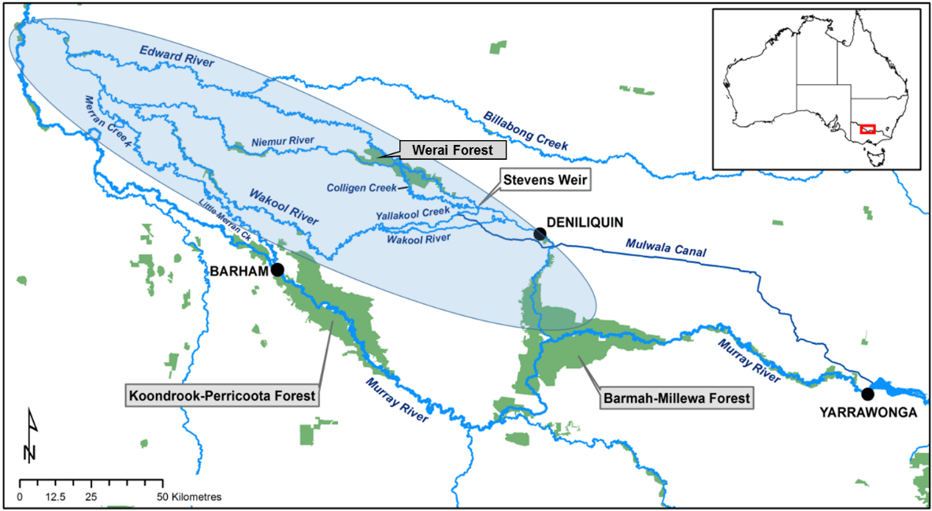
Figure 2 Map showing the location of the Edward-Wakool system in the mid-Murray River.
The Edward-Wakool system also plays an important ecological role in connecting upstream and downstream ecosystems in the mid-Murray River. The multiple streams and creeks in this system provide important refuge and nursery areas for fish and other aquatic organisms, and adult fish regularly move between this system and other parts of the Murray River. As some of the rivers in the Edward-Wakool system have low discharge (compared to the Murray River) there is a risk of poor water quality developing in this system, particularly during warm periods or from floodplain return flows. Maintaining good water quality in the Edward-Wakool system is crucial for both the river ecosystem, the communities and landholders that rely on the water from this system, and downstream communities along the Murray River that are influenced by the water quality in this system.
Like many rivers of the MDB, the flow regimes of rivers in the Edward-Wakool system have been significantly altered by river regulation (Green 2001; Hale and SKM 2011). Natural flows in this system are strongly seasonal, with high flows typically occurring from July to November. Analysis of long-term modelled flow data show that flow regulation has resulted in a marked reduction in winter high flows, including extreme high flow events and average daily flows during the winter period (Watts et al. 2015). There is also an elevated frequency of low to median flows and reduced frequency of moderate high flows. These flow changes reflect the typical effects of flow-regime reversal observed in systems used to deliver dry-season irrigation flows (Maheshwari et al. 1995).
The Edward-Wakool system has experienced a wide range of flow conditions over the past 15 years, and these antecedent conditions will influence the way in which the ecosystem responds to Commonwealth environmental watering. From 1998 to 2010 south-eastern Australia experienced a prolonged drought (referred to as the Millennium drought) and flows in the MDB were at record low levels (van Dijk 2013; Chiew et al. 2014). During this period the regulators controlling flows from the Edward River into tributary rivers such as Yallakool Creek and the Wakool River were closed for periods of time. Between February 2006 and September 2010 there were periods of minimal or no flow in the Wakool River and localised fish deaths were recorded on a number of occasions including in 2006 and 2009. At the break of the drought after many years without overbank flows, a sequence of unregulated flow events between September 2010 and April 2011 triggered a widespread hypoxic (low oxygen) blackwater event in the mid-Murray (MDBA 2011; Whitworth et al. 2012). In late 2016 there was a widespread flood in the southern-MDB associated with record-breaking rainfall in the catchment. Some areas of the floodplain were inundated that had not been flooded for more than 20 years. In the Murray catchment, Murray River flows at Yarrawonga in October were the highest since 1993 (MDBA River Murray Weekly Report, 7th Dec 2017). The unregulated flows from the Murray River inundated the floodplain including Barmah Forest and Koondrook–Perricoota Forests and agricultural land, resulting in a very large flood event in the Edward-Wakool system (BOM 2017). In association with the floods there was a hypoxic blackwater event that extended throughout the Murray River system, including the Edward-Wakool system.
At the commencement of the LTIM program daily discharge data from 14 hydrological stations in the Edward-Wakool system were analysed along with information on geomorphology and location of major distributaries to classify the system into distinct hydrological zones (Watts et al. 2014). Fifteen distinct zones were identified (Figure 3, Table 1). Transitions between these zones occur where there are major inflows or outflows to a river or at locations where there are significant changes in geomorphology. The zones range from ephemeral watercourses (e.g., Jimaringle, Cockran and Gwynne’s Creeks), to smaller creeks and rivers (Wakool River, Yallakool Creek, Colligen-Niemur system, and Merran Creek) to the larger Edward River system.

.
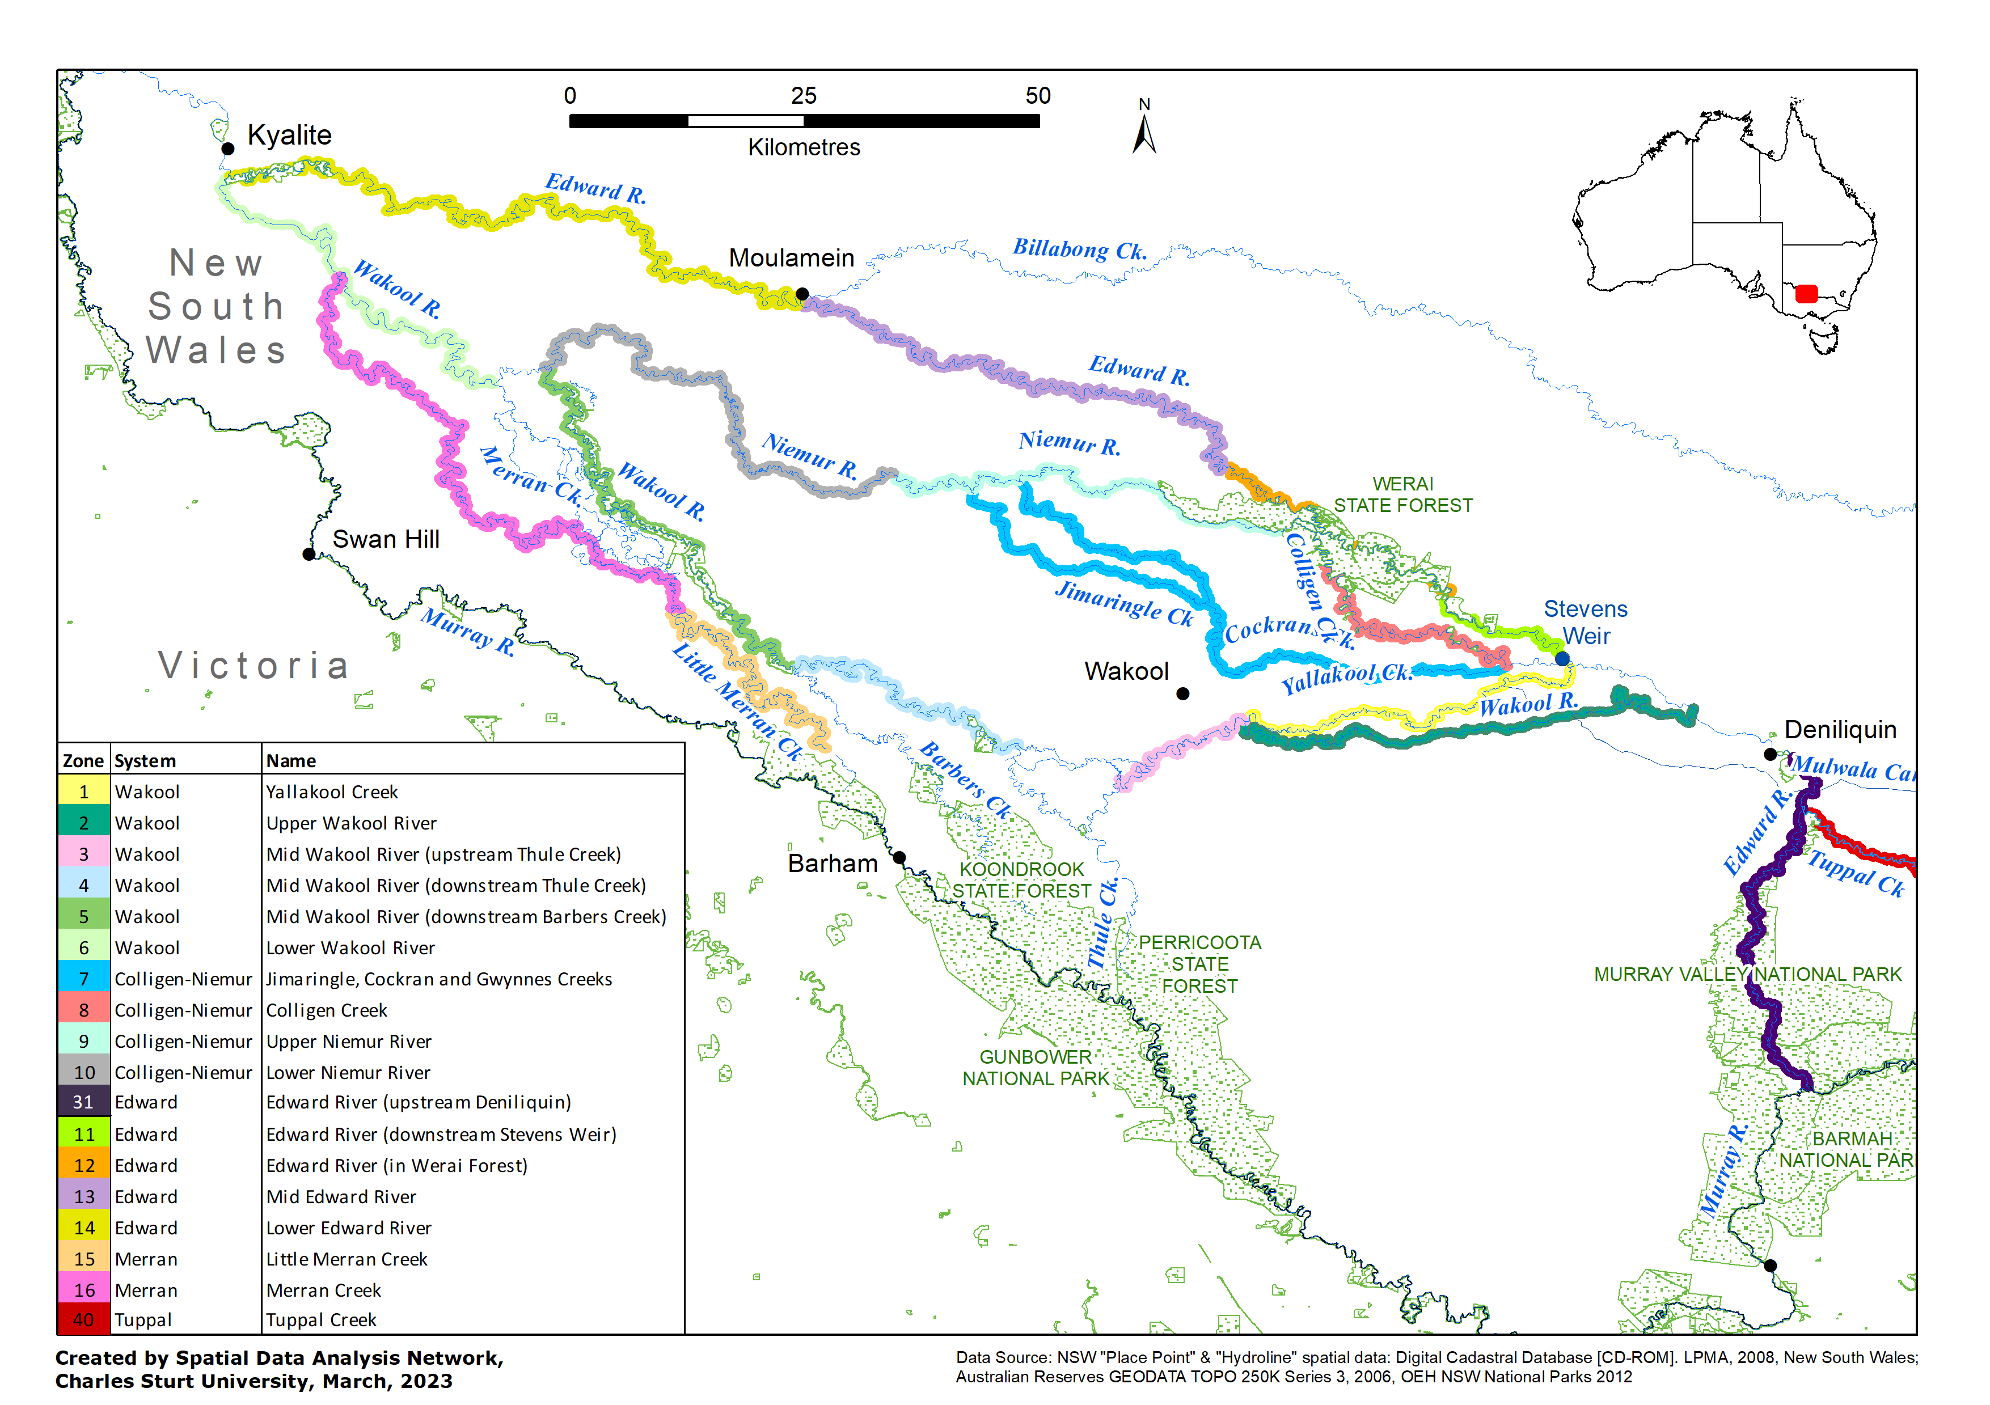
Figure 3. Map showing the 17 hydrological zones within the Edward-Wakool system. Flow-MER core monitoring sites take place in these zones and are listed in Table 1.
Table 1 List of site names for the CEWO Flow-MER Project in the Edward-Wakool Selected Area. Sites are ordered upstream to downstream.
Hydrological Zone | Zone  No. | Site Name
Yallakool Creek | 01 | Back Creek
Yallakool Creek | 01 | Hopwood
Yallakool Creek | 01 | Cumnock
Yallakool Creek | 01 | Cumnock Park
Yallakool Creek | 01 | Mascott
Yallakool Creek | 01 | Windra Vale1
Yallakool Creek | 01 | Windra Vale2
Upper Wakool River | 02 | Brassi Bridge
Upper Wakool River | 02 | Fallonville
Upper Wakool River | 02 | Yaloke
Upper Wakool River | 02 | Carmathon Reserve
Upper Wakool River | 02 | Emu Park
Upper Wakool River | 02 | Homeleigh
Upper Wakool River | 02 | Widgee1
Upper Wakool River | 02 | Widgee2
Mid Wakool River (upstream Thule Creek) | 03 | Talkook
Mid Wakool River (upstream Thule Creek) | 03 | Tralee1
Mid Wakool River (upstream Thule Creek) | 03 | Tralee2
Mid Wakool River (upstream Thule Creek) | 03 | Rail Bridge
Mid Wakool River (upstream Thule Creek) | 03 | Cummins
Mid Wakool River (upstream Thule Creek) | 03 | Ramley1
Mid Wakool River (upstream Thule Creek) | 03 | Ramley2
Mid Wakool River (upstream Thule Creek) | 03 | Yancoola
Mid Wakool River (upstream Thule Creek) | 03 | Llanos Park1
Mid Wakool River (upstream Thule Creek) | 03 | Llanos Park2
Mid Wakool River (downstream Thule Creek) | 04 | Moulamein Road Bridge
Mid Wakool River (downstream Thule Creek) | 04 | Possum Reserve
Mid Wakool River (downstream Thule Creek) | 04 | Whymoul NPk
Mid Wakool River (downstream Thule Creek) | 04 | Yarranvale
Mid Wakool River (downstream Thule Creek) | 04 | Noorong1
Mid Wakool River (downstream Thule Creek) | 04 | Noorong2
Mid Wakool River (downstream Barbers Creek) | 05 | La Rosa
Mid Wakool River (downstream Barbers Creek) | 05 | Gee Gee
Mid Wakool River (downstream Barbers Creek) | 05 | Glenbar
Lower Wakool River | 06 | StoneyCrossing2
Colligen Creek | 08 | Calimo
Colligen Creek | 08 | Werai Station
Colligen Creek | 08 | Old Morago Road
Colligen Creek | 08 | Bowen Park
Colligen Creek | 08 | Calimo Station
Upper Niemur River | 09 | Burswood Park
Upper Niemur River | 09 | Ventura
Lower Niemur River | 10 | Niemur Valley
Lower Niemur River | 10 | Mallan School
Tumudgery Creek |  | Elimdale
Edward River (downstream Stephens Weir) | 11 | Eastman Bridge
Mid Edward River | 13 | Balpool Road
Mid Edward River | 13 | Moulamein1
Lower Edward River | 14 | Moulamein2
Lower Edward River | 14 | Kyalite State Forest
Little Merran Creek | 15 | Merran Downs
Merran Creek | 16 | Erinundra
Merran Creek | 16 | Merran Creek Bridge
Tuppal Creek | 40 | Aratula Road
Edward River, Stevens weir | 20 | Weir1
Edward River, Stevens weir | 20 | Weir2
Mulwala canal | 21 | Canal1
Mulwala canal | 21 | Canal2

Commonwealth environmental watering

3.1 Commonwealth environmental watering actions 2009-2022
Commonwealth environmental watering actions have occurred in the Edward-Wakool system since 2009 (Table 2). Between July 2009 and June 2019 Commonwealth environmental watering actions delivered base flows and freshes, contributed to the recession of flow events, delivered water from irrigation canal escapes to create local refuges during hypoxic blackwater events, and contributed to flows in ephemeral watercourses (Table 2). Many of the watering actions in ephemeral creeks were undertaken jointly with NSW environmental water. One Commonwealth watering action in 2009-10 for Werai State Forest (DEE 2017) was undertaken to deliver environmental water to Edward-Wakool forests (Table 2). In the winter of 2017, an environmental watering action was undertaken to maintain winter base flows during the period when the regulators to some of the smaller streams are usually shutdown in winter (Table 2). To date it has not been possible to deliver large within channel freshes (> half bankful) or overbank flows due to the current operational constraints of 600 ML/d at confluence of the Wakool River and Yallakool Creek. However, in spring 2018 a flow trial was undertaken to deliver 800 ML/d at the confluence of Wakool River and Yallakool Creek.
Table 2 Summary of Commonwealth environmental watering actions and unregulated overbank flows in the Edward-Wakool system from July 2010 to June 2019. More detailed information about environmental watering in the mid-Murray catchment is available from the CEWO website (Department of the Environment and Energy 2017)
 | In-channel environmental  watering actions |  |  |  |  |  | Environmental watering actions using irrigation infrastructure |  |  |  | Unregulated overbank flows
Water Year | Base flows and small freshes | Contribute to flow recession | Maintain winter base flows | Larger within channel freshes¹ |  | Flows from canal escapes during hypoxic events |  | Flows in ephemeral streams² | Watering forests |  | Flooding forests and/or floodplains
2009-10 |  |  |  |  |  |  |  |  | ü
2010-11 |  |  |  |  |  |  | ü | ü |  |  |  | ü
2011-12 | ü |  |  |  |  |  |  | ü
2012-13 | ü |  |  |  |  |  | ü | ü
2013-14 | ü | ü |  |  |  |  |  | ü
2014-15 | ü | ü |  |  |  |  |  | ü
2015-16 | ü | ü |  |  |  |  |  | ü
2016-17 | ü | ü |  |  |  |  | ü | ü |  |  |  | ü
2017-18 | ü | ü | ü |  |  |  |  | ü
2018-19 | ü | ü |  |  |  |  |  | ü
2019-20 | ü | ü | ü |  |  |  |  | ü
2020-21 | ü | ü |  |  |  |  | ü | ü
¹ Delivery of larger within channel freshes to the Wakool River and Yallakool Creek is not possible under current operational constraints (e.g. constrained to 600 ML/d at the confluence of the Wakool River and Yallakool Creek). Some of the watering actions in ephemeral creeks done jointly with NSW Department of Planning and Environment.
Environmental water in the Edward-Wakool system may be delivered to contribute to the slower recession of freshes, delivered during low flow periods to provide refuge habitat, or delivered to manage water quality issues, such as hypoxic events (Gawne et al. 2013; Watts et al. 2017a). A detailed description of the CEWO’s water holdings for the Murray catchment is available on the CEWO website at https://www.dcceew.gov.au/water/cewo/about/water-holdings#murray
In addition to watering actions specifically targeted for the Edward-Wakool system, water from upstream Commonwealth environmental watering actions and actions that are targeted for downstream watering actions transit through the Edward-Wakool system in some years. For example, in 2015-16 environmental water returning from Barmah-Millewa Forest influenced the hydrograph in the Edward-Wakool system (Watts et al. 2016). In some years operational flows limit the ability to deliver the planned use of Commonwealth environmental water in the Edward Wakool system. For example, in 2018-19 the planned environmental watering actions were suspended to enable operational flows to be delivered, reflecting CEWO’s good neighbour policy related to channel sharing.

3.2 Expected outcomes relevant to the Mid-Murray Region
Expected outcomes from the Basin-wide Environmental Watering Strategy (MDBA 2014) that are relevant to the Mid Murray Region are listed below and in Tables 3 and 4.
River flows and connectivity
- Base flows are at least 60 per cent of the natural level
- Contributing to a 30 per cent overall increase in flows in the River Murray
- A 30–60 per cent increase in the frequency of freshes, bankfull and lowland floodplain flows
Vegetation
- Maintain the current extent of water-dependent vegetation near river channels and on low-lying areas of the floodplain
- Improve condition of black box, river red gum and lignum shrublands
- Improve recruitment of trees within black box and river red gum communities
- Increased periods of growth for non-woody vegetation communities that closely fringe or occur within the river and creek channels, and those that form extensive stands within wetlands and low-lying floodplains including Moira grasslands in Barmah–Millewa Forest
Fish
- No loss of native species
- Improved population structure of key species through regular recruitment, including:
  - Short-lived species with distribution and abundance at pre-2007 levels. Breeding success every 1–2 years
  - Moderate to long-lived with a spread of age classes and annual recruitment in at least 80% of years
- Increased movements of key species
- Expanded distribution of key species and populations

Annual priority watering actions are identified each year by CEWO via the CEWO annual Water Management Plans (Commonwealth Environmental Water Office Publications and Resources).
Table 3 Important Basin environmental assets for native fish in the Mid Murray (from MDBA 2014)
Environmental asset | Key movement corridors | High Biodiversity | Site of other Significance | Key site of hydrodynamic diversity | Threatened species | Dry period / drought refuge | In-scope for Cwealth water
Koondrook–Perricoota | * | * | * | * | * |  | Yes
Gunbower | * | * | * | * | * |  | Yes
Barmah–Millewa | * | * | * | * | * | * | Yes
Edward–Wakool system | * |  | * | * | * | * | Yes
Werai Forest |  |  | * | * |  |  | Yes
Billabong–Yanco–Columbo Creeks |  | * | * | * | * | * | Yes
Lake Mulwala | * |  | * | * | * | * | Yes

Table 4 Key species for the Mid Murray (Source: MDBA 2014)
Species | Specific outcomes | In-scope for C’th water ?
Flathead galaxias  (Galaxias rostratus) | Expand the core range in the wetlands of the River Murray | Yes
Freshwater catfish (Tandanus tandanus) | Expand the core range in Columbo-Billabong Creek and Wakool system | Yes
Golden perch  (Macquaria ambigua) | A 10–15% increase of mature fish (of legal take size) in key populations | Yes
Murray cod  (Maccullochella peelii peelii) | A 10–15% increase of mature fish (of legal take size) in key populations | Yes
Murray hardyhead (Craterocephalus fluviatilis) | Expand the range of at least two current populations. Establish 3–4 additional populations, with at least one in the Mid Murray conservation unit. | Yes
Olive perchlet  (Ambassis agassizii) | Olive perchlet are considered extinct in the southern Basin. Reintroduction using northern populations is the main option for recovery. Candidate sites may result from improved flow that reinstates suitable habitat in the River Murray. | Restoration of flow to Murray R could support future reintroduction of the species
River blackfish  (Gadopsis marmoratus) | Expand the range of current populations from the Mulwala canal | Yes
Silver perch  (Bidyanus bidyanus) | Expand the core range within the River Murray (Yarrawonga–Euston) | Yes
Southern purple-spotted gudgeon  (Mogurnda adspersa) |  | Yes
Southern pygmy perch (Nannoperca australis) | Expand the range of current populations at Barmah-Millewa and other Mid Murray wetlands | Yes
Trout cod  (Maccullochella macquariensis) | Expand the range of trout cod up the Murray upstream of Lake Mulwala and into the Kiewa River. For the connected population of the Murrumbidgee–Murray–Edward: continue downstream expansion. | Yes
Two-spined blackfish (Gadopsis bispinosus) | Establish additional populations (no specific locations identified) | Yes

Waterbirds
The expected outcomes for waterbirds are increased abundance and the maintenance of current species diversity. The MDBA (2014) Basin-Wide Environmental Watering Strategy identifies Gunbower-Koondrook-Perricoota as an important asset for colonial waterbird breeding. The environmental watering strategy states that from 2014, the expected outcomes are:
- That the number and type of waterbird species present will not fall below current observations
- A significant improvement in waterbird populations in the order of 20 to 25% over the baseline scenario, with increases in all waterbird functional groups
- Breeding events of colonial nesting waterbirds to increase by up to 50% compared to the baseline scenario
- Breeding abundance (nests and broods) for all other functional groups to increase by 30–40% compared to the baseline scenario, especially in locations where the Basin Plan improves over-bank flows.

Water Quality targets
The water quality targets of the Basin Plan (2012) are outlined in Chapter 9, Part 4, sub-section 9.14(5) of the Basin Plan. The targets for recreational water quality in Section 9.18 of the Basin Plan contains Guidelines for Managing Risks in Recreational Water. The target for dissolved oxygen in the Plan is to maintain dissolved oxygen at a value of at least 50% saturation and suggests this be determined at 25°C and 1 atmosphere of pressure (sea level). This equates to a dissolved oxygen concentration of approximately 4 mg/L. The CEWO has used a trigger of 4.0 mg/L for the potential provision of refuge flows into catchments like the Edward-Wakool River system. The Guidelines for Managing Risks in Recreational Water also guide the green, amber and red alert levels issued by relevant state management agencies (e.g. in NSW – the Regional Algal Coordinating Committees) who are responsible for the catchment scale management of algal blooms. The CEWO has access to the alert advice issued by these state agencies and can adjust the use of Commonwealth environmental water accordingly.

3.3 Practicalities of environmental watering in the Edward-Wakool system
The main source of Commonwealth environmental water for the Edward-Wakool system is from the Murray River through the Edward River and Gulpa Creek. During high flow events in the Murray River, water can also flow from the Murray River through Koondrook-Perricoota Forest and into the Wakool River via Thule and Barber Creeks. The main flow regulating structure within the Edward-Wakool system is Stevens Weir, located on the Edward River downstream of Colligen Creek (Figure 3). This structure creates a weir pool that allows Commonwealth environmental water to be delivered to Colligen Creek-Niemur River system, Yallakool Creek, the Wakool River, the Edward River and Werai Forest.
Water diverted into the Mulwala Canal from Lake Mulwala can also be delivered into the Edward-Wakool system through numerous ‘escapes’ or outfalls managed by the irrigator-owned company Murray Irrigation Limited (MIL). These escapes can be used to deliver flows to the river system. During a hypoxic blackwater event in 2010, environmental water was released from Mulwala Canal escapes to lessen the impact of hypoxia and create localised refugia with higher DO and lower DOC (Watts et al. 2017a). The Wakool escape was also used to deliver environmental water as refuge flows in response to the 2016 hypoxic blackwater event (Watts et al. 2017c) and in the 800 ML/d flow trial in spring 2018 to avoid third party impacts that would have occurred due to a lack of demand in the canal network and corresponding management of the weir pool.
The ability to deliver environmental water to the Edward-Wakool system depends on water availability and circumstances in the river at any given time. Environmental water delivery in this system involves various considerations as outlined by Gawne et al. (2013), including:
- the capacity of the off takes / regulators and irrigation escapes
- channel constraints (e.g., to avoid third party impacts)
- the availability of third party infrastructure to assist in delivering water into the system
- existing flows and other demands on the system.
Delivery of instream flows to the Edward River, Wakool River, Yallakool Creek, Colligen Creek, Niemur River and Merran River system are managed within regular operating ranges as advised by river operators to avoid third party impacts, such as inundation of low lying private bridges. For example, in the Wakool-Yallakool system the operational constraint is 600 ML d⁻¹ at the confluence of the Wakool River and Yallakool Creek. Thus, the types of flow components that can be achieved under current operating ranges are in-channel baseflows and freshes (Gawne et al. 2013). Environmental watering may also be constrained due to the limitations on how much water can be delivered under regulated conditions. At times of high irrigation demand channel capacity will be shared with other water users. The Edward-Wakool system plays a key role in the operations and ecosystem function of the Murray River and the southern MDB. Some of the water released from Hume Dam is diverted from the Murray River through the Edward-Wakool system to avoid breaching operational constraints in the mid-Murray River. Given the prolonged below average inflows to the River Murray System over the past 2 years, there is a high likelihood that there will be a need for system transfers to recommence in 2019 and this may limit the options for the delivery of environmental water in this system (as per 2018-19). Similarly, if the system is receiving higher unregulated flows, there may not be enough capacity to deliver environmental water (Gawne et al. 2013).

Monitoring and research priorities

4.1 Principles to underpin the development of the Flow-MER Plan
The following principles were used to guide the development of the Edward-Wakool Flow-MER Plan:

- The project team will be inclusive, consultative and respectful during the development of the MER Plan for the Edward-Wakool system. We recognise that local community members have important knowledge that can make a significant contribution to the development of the Flow-MER Plan. As such we will consult with the following stakeholders:
  - Commonwealth Environmental Water Office
  - Local stakeholders in the Edward-Wakool area, including the Edward-Wakool Environmental Water Reference Group, Murray Local Land Services, Wakool River Association, Edward-Wakool Angling Association, Yarkuwa Indigenous Knowledge Centre Aboriginal Corporation, Werai Land and Water Aboriginal Corporation, Murray Irrigation Limited, Ricegrowers’ Association of Australia Inc., Western Murray Land Improvement Group, and landholders and individual community members
  - NSW Department of Planning and Environment
  - NSW Department of Primary Industries (Fisheries)
  - WaterNSW
  - CEWO Flow-MER project Basin Evaluation Team
  - CEWO Flow-MER project Selected Area teams
- Meetings with stakeholders will be organised to ensure as wide participation in the planning process as possible
- Where possible, the Flow-MER Plan will maintain monitoring and evaluation methods from the LTIM project to ensure continuity of data over time.
- The Flow-MER Plan will include outputs and engagement activities that will enable the findings to be shared regularly and with a range of audiences, including managers and community.
- The Flow-MER Plan will focus on reaches in the Edward-Wakool Selected Area where we can best assess responses to Commonwealth environmental watering.
- The Flow-MER Plan will include a suite of indicators that will enable linkages between different indicators to be explored to ensure clear interpretation of the findings
- The approach to evaluation developed for the Edward-Wakool Flow-MER Plan will be consistent with the Flow-MER Basin Evaluation Plan. We will collaborate with other Selected Area teams and the Basin Evaluation team to align methods, and coordinate evaluation and research to enable selected area results to be incorporated in the basin evaluation and findings to be extrapolated to other areas of the basin.
- Where possible we will aim to value-add to any proposed monitoring, evaluation and research activities. For example, we will seek opportunities to undertake complementary research in the Selected Area. Honours or PhD students enrolled at Charles Sturt University, or La Trobe will be supported to undertake projects that complement the contracted monitoring and research.

4.2 Process for prioritisation of hydrological zones
Due to funding constraints it is not possible to undertake monitoring and evaluation in all seventeen of the hydrological zones identified in the Edward-Wakool system (Figure 3). The following factors were considered when prioritising the zones to include in the Flow-MER Plan:
- Likelihood of hydrological zones receiving Commonwealth environmental water or serving as a comparison zone (i.e., not receive Commonwealth environmental water)
- Location of hydrological gauging stations
- Availability of historical monitoring data in each zone and existing arrangements for access, including maintaining continuity of monitoring established during the LTIM project
- Ease of access for undertaking fieldwork under a range of weather conditions
- Need for a number of zones that experience a range of flows to facilitate predictive ecosystem response modelling and Selected Area gradient analysis
- Capacity to inform on specific objectives aligned with values and needs of local community, including Aboriginal people
Taking all of these factors into account, the proposed Flow-MER project in the Edward-Wakool system will include monitoring in the following hydrological zones:
- Monitoring sites established during the LTIM project that focus on the upper and mid reaches of the Wakool-Yallakool system (zones 1, 2, 3 and 4) will be maintained for the Flow-MER project. During the LTIM project these four hydrological zones have been referred to as the Focal Area.
- Twenty sites that were established for fish community surveys in 2010 and were monitored in year one (2015) and year five (2019) of the LTIM project will be maintained and will be surveyed for fish community indices in year three of Flow-MER (2022).
- Additional sites will be added to the existing network of water quality monitoring sites established during LTIM project. For the Flow-MER project there will be a total of 17 water quality monitoring sites throughout the whole system, including ongoing sites in Yallakool Creek, Wakool River zones 2 to 4, and source water sites in the Mulwala Canal and the Edward River at Stephens Weir. New sites expand the water quality monitoring to further downstream in the Wakool River as well as in Tuppal Creek, the Edward River and the Colligen-Niemur system to enable an evaluation of environmental water across the broader system.
- Additional monitoring sites will be established in the Edward River downstream of Stevens Weir to inform the adaptive management of environmental water in the Edward River. This river system was not monitored as part of LTIM.
Hydrological zones not included in the Flow-MER Plan
The Milewa Forest and Koondrook-Perricoota Forest are not included in the Flow-MER Plan because they are currently monitored by other programs such as the MDBA Living Murray Program. The ephemeral creeks in zone 15, Jimaringle, Cockran and Gwynnes Creek, have not been included in the Flow-MER Plan to avoid duplication of monitoring, as environmental watering actions in these ephemeral creeks have previously been monitored by the NSW Department of Planning and Environment (DPE - formerly the Office of Environment and Heritage (OEH)). We will seek to integrate outcomes of environmental watering in these systems in a qualitative evaluation of the outcomes of Commonwealth environmental water in the Edward-Wakool system.

4.3 Priorities identified by stakeholders
During the development of the Edward-Wakool Flow-MER Plan the following activities were undertaken to seek a wide range of stakeholder input to the plan:
- In January 2019 the Edward-Wakool Flow-MER team meeting met to review the LTIM project, identify knowledge gaps and discuss and scope potential complementary research projects
- A presentation on the Flow-MER project was given to the Edward-Wakool Environmental Water Reference Group meeting on 26 March 2019 in Deniliquin. At that meeting feedback from stakeholders was sought on the LTIM monitoring and evaluation and attendees were invited to contribute ideas for the Flow-MER Plan. In particular, we sought ideas for engagement, communications and citizen science.
- Members of the Edward-Wakool Flow-MER team attended an inception workshop organised by Basin Flow-MER team. This workshop included several sessions on basin themes (fish, vegetation and stream metabolism, hydrology, biodiversity) in which the standard methods were reviewed.
- Several Selected Area team meetings were held both face-to-face and by teleconference to progress ideas for the plan
- CEWO staff were regularly updated and were given opportunities to provide input to the plan as it was being developed
- A second planning workshop for local stakeholders was held on 6th May in Deniliquin to provide stakeholders with an update on the plan and seek further input to the engagement and communications strategy. Stakeholders from the Edward-Wakool Environmental Water Reference Group, Wakool River Association, Murray Local Land services, Edward-Wakool Angling Association, Yarkuwa Indigenous Knowledge Centre Aboriginal Corporation, Ricegrowers’ Association of Australia Inc., landholders and other community members were invited to this meeting. Staff from the Commonwealth Environmental Water Office, NSW Office of Environment and Heritage and the Murray-Darling Basin Authority also attended this meeting and contributed to the discussion.
- A meeting was held at the Yarkuwa Indigenous Knowledge Centre to develop opportunities for indigenous involvement in the monitoring, evaluation and research.
Through these meetings, themes identified as being of high priority by stakeholders included:
- Understanding the links between environmental watering and fish spawning, recruitment and survival
- The role of environmental water in maintaining water quality
- Understanding responses to environmental water during winter flows and refuge flows
- Increasing knowledge of flows downstream of Stevens Weir and in relation to Werai Forest
- The engagement of local community, including involvement in monitoring where possible
- Good communication of outcomes of the Project, with outputs targeted to local audiences.
Aspects of the Flow-MER Plan identified as being of lower priority by stakeholders was:
- Undertaking continued studies of fine scale fish movements. Stakeholders were very interested in gaining a better understanding of fish movement into and out of the Edward-Wakool system and understanding the role of the system in the southern connected Basin. However, this was regarded to be at a larger landscape scale than the Edward-Wakool Flow-MER project, and would be better funded by another program

Indicators for Monitoring and Evaluation

Section five of this Flow-MER Plan outlines the methods for each of the indicators for monitoring and evaluation of Commonwealth environmental water in the Edward-Wakool system. The detailed methods for each indicator are presented in sections 5.1 to 5.10.
Table 6 provides a summary of the monitoring and evaluation activities for this Flow-MER Plan and provides a summary of the changes or additions relative to the Edward-Wakool LTIM project (2014-2019). One of the main changes is that carbon and water quality monitoring has been extended so that evaluation can be undertaken across the entire Edward-Wakool system (Table 6). A summary of the long-term and short-term evaluation questions is provided in Table 7. Category 1 monitoring and evaluation questions follow those outlined in the CEWO LTIM Standard methods (Hale et al. 2014).
Table 6 Summary of monitoring and evaluation to be undertaken in the Edward-Wakool system for the CEWO Monitoring, Evaluation and Research (Flow-MER) Project from 2019 to 2023. Changes and additions relative to the Edward-Wakool LTIM project (2014-2019) are described. Zones and sites are described in section 2. Category 1 and 2 indicators are monitored using standard operating protocols to inform Basin-scale evaluation and may be used to answer Selected Area questions. Category 3 indicators are those monitored to answer Selected Area questions.
Theme | Cat | Zones | Changes or additions compared to the LTIM project (2014-19)
Monitoring and Evaluation
River hydrology | 1 | system | No changes to monitoring or evaluation from LTIM project
Hydraulic modelling |  |  | Hydraulic modelling was undertaken in zones 1,2,3,4 and 8 as part of the LTIM project. These models will continue to be used as part of Flow-MER evaluations but no new hydraulic modelling will be undertaken in these zones. Reaches in zones 11 and 12 will modelled as part of the integrated Edward River research project (see section 6)
Carbon and water quality | 3 | system | No changes in methods from LTIM. New sites have been added for the Flow-MER project so that the evaluation of this indicator will be undertaken across the whole Edward-Wakool system.
Stream metabolism | 1 | 1,2,3,4,8 | No changes in methods from LTIM. Additional dissolved oxygen logger site established in Colligen Creek
Riverbank and aquatic vegetation | 3 | 1,2,3,4,8 | No changes in methods from LTIM. Four reaches added in Colligen Creek for the Flow-MER project were previously monitored 2014-2019 through a project funded by Murray Local Land Services
Fish movement | 2 | system | Golden perch movement will be monitored from June-Sept 2019 to evaluate the 2019 winter environmental watering action. No fish movement will be monitored as part of the Flow-MER project after September 2019.
Fish reproduction | 1 | 3 | No changes to monitoring or evaluation from LTIM project
Fish reproduction | 3 | 1,2,3,4, | No changes in methods from LTIM. Research on fish spawning will be undertaken in the Edward River as part of the integrated research project (see section 6)
Fish recruitment | 3 | 1,2,3,4 | Minor changes to monitoring methods from LTIM project. No changes to monitoring sites
Fish river (Cat 1) | 1 | 3 | No changes to monitoring or evaluation from LTIM project
Fish community survey | 3 | system | No changes from LTIM project. This monitoring and evaluation will be undertaken in 2022 only (year 3 of the Flow-MER project)

Table 7 Summary of the long-term and short-term evaluation questions for the Edward-Wakool Flow-MER project
Indicator | Evaluation questions
Hydrology | Short and long-term questions  - What was the effect of CEW (Commonwealth environmental water) on the hydrology of the rivers in the Edward-Wakool system?  - What did CEW contribute to longitudinal connectivity?
Carbon and water quality | Short and long-term questions  - What did CEW contribute to modification of the type and amount of dissolved organic matter through reconnection with previously dry or disconnected in-channel habitat?  - What did CEW contribute to dissolved oxygen concentrations?  - What did CEW contribute to nutrient concentrations?  Question for contingency monitoring  - What did CEW contribute to reducing the impact of hypoxic blackwater or other adverse water quality events in the system?
Stream metabolism (Cat 1) | Short and long-term questions  - What was the effect of CEW on rates of GPP, ER and NPP  - What did CEW contribute to total GPP, ER and NPP?  - Which aspect of CEW delivery contributed most to productivity outcomes?
Riverbank and aquatic vegetation | Long-term questions  - What has CEW contributed to the recovery (measured through species richness, plant cover and recruitment) of riverbank and aquatic vegetation that have been impacted by operational flows and drought and how do those responses vary over time?  - How do vegetation responses to CEW delivery vary among hydrological zones?  Short-term questions  - What did CEW contribute to the percent cover of riverbank and aquatic vegetation?  - What did CEW contribute to the diversity of riverbank and aquatic vegetation taxa?
Fish movement | Short term questions  - Does CEW facilitate longitudinal connectivity for periodic species during winter?
Fish reproduction (Cat 1) | Long term questions  - What did CEW contribute to native fish populations?  - What did CEW contribute to native fish species diversity?  Short term questions  - What did CEW contribute to native fish reproduction?  - What did CEW contribute to native fish survival
Fish reproduction | Short and Long-term questions  - What did CEW contribute to the spawning of 'Opportunistic' (e.g. small bodied fish) species?  - What did CEW contribute to spawning in ‘flow-dependent’ spawning species (e.g. golden and silver perch)?
Fish recruitment | Short and Long-term questions  - What did CEW contribute to native fish recruitment to the first year of life?  - What did CEW contribute to native fish growth rate during the first year of life?
Fish river  (Cat 1) | Long term questions  - What did CEW contribute to native fish populations?  Short term questions  - What did CEW contribute to native fish reproduction?  - What did CEW contribute to native fish survival?
Fish community | Long-term question  - How does the fish community in the Edward-Wakool system vary over 3-5 years, and does this link with sequential flow characteristics?

5.1 Hydrology (Category 1)
5.1.1 Monitoring
Overview and context
Monitoring of river hydrology will be used to describe the flow regime of rivers in the Edward-Wakool system and evaluate the contribution of Commonwealth environmental water to the flows in this system. Hydrological data will be used to underpin the evaluation of water quality, stream metabolism, aquatic and riverbank vegetation, and native fish in this system.
Hydrological data will be obtained from:
- Downloading data from WaterNSW automated hydrological gauges
- Obtaining discharge data for irrigation escapes from Murray irrigation Limited
- Field readings of gauge boards
The key elements of river hydrology used for the Selected Area monitoring and evaluation are shown in Figure 4.
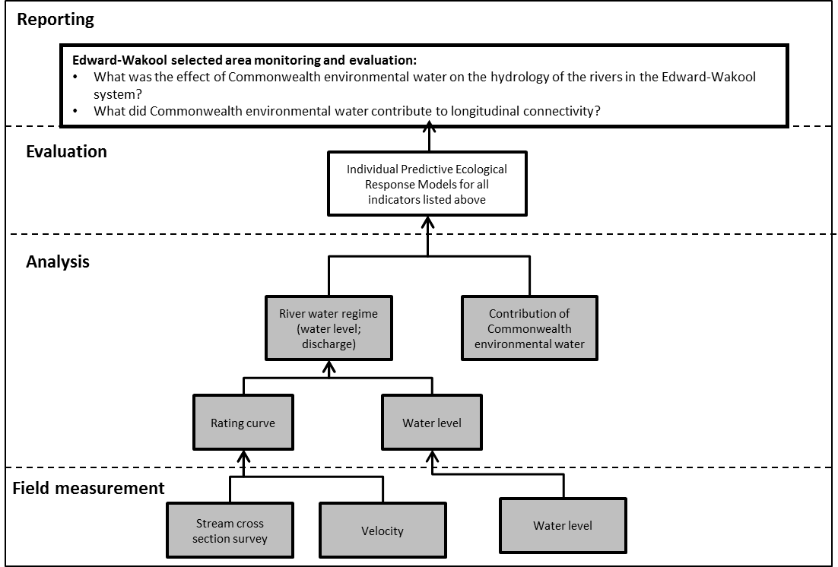
Figure 4 Schematic of key elements of River Hydrology used for the Selected Area monitoring and evaluation. Components covered by this protocol are highlighted in grey.

Indicators
- Daily discharge (ML/d)
- Minimum, maximum, mean, median and coefficient of variation (SD/mean) of the daily discharge
Location for monitoring
Hydrological data is available at sites listed in table 8 from ten established automated hydrological gauges in this system. For a small number of study reaches where there is no automated gauge, the daily discharge will be determined by numerical estimation from the nearest upstream gauge, taking into account losses.
An array of gauge boards have been installed throughout the river system and data from these will complement the existing network of automated gauges.
Table 8 Details of Water NSW hydrometric gauges used to obtain discharge data. Zone codes are as described in Figure 3 and Table 2.
River | Hydrological zone | Gauge number | Name of gauge
Yallakool Creek | 1 | 409020 | Yallakool Creek @ Offtake
Wakool River | 2 | 409019 | Wakool River Offtake regulator
Wakool River | 4 | 409045 | Wakool @ Wakool-Barham Road
Wakool River | 5 | 409062 | Wakool River Gee Gee Bridge 2
Wakool River | 6 | 409013 | Wakool @ Stoney Crossing
Colligen Creek | 8 | 409024 | Colligen Creek B/L regulator
Niemur River | 9 | 409048 | Niemur R Barham-Moulamein Road
Niemur River | 9 | 409086 | Niemur @Mallan School
Edward River | 11 | 409023 | Edward R D/S Stevens
Edward River | 14 | 409014 | Edward R @ Moulamein

Timing and frequency
Water NSW automated gauging stations record discharge continuously.
Field readings of gauge boards in hydrological zones 1 to 4 will be undertaken fortnightly between September and March and monthly between April and August. Staff gauges elsewhere in the system will be monitored monthly.
Responsibilities
- CSU staff will download discharge data from water NSW website and obtain discharge data from Murray Irrigation Limited.
- Field readings of gauge boards will be undertaken by CSU, DPI and DPE staff.
- Data analysis and reporting will be undertaken by Robyn Watts (CSU)
Methods
Daily discharge data for automated hydrometric gauges will be obtained from the New South Wales Office of Water website (https://realtimedata.waternsw.com.au/water.stm). Daily discharge data for non-automated sites, such as the Wakool escape from Mulwala Canal, and daily usage of Commonwealth environmental water will be obtained from WaterNSW and the Commonwealth Environmental Water Office staff.
Some of the study reaches do not have hydrometric gauging stations. The daily discharge data for sites in the Wakool River zone 2 will be estimated by adding the discharge from gauge 409019 Wakool River offtake regulator to the discharge data from the Wakool escape from Mulwala canal. The daily discharge data for Wakool River zone 3 will be estimated by adding daily discharge data from Yallakool Creek offtake (gauge 409020), the Wakool offtake regulator (gauge 409019) and the Wakool Escape from Mulwala Canal with an adjustment during regulated flows to account for travel time (4 days) and estimated 20% losses (V. Kelly, WaterNSW pers. comm.) between the offtakes and the confluence of Yallakool Creek and the Wakool River.
Health and Safety
The Edward-Wakool Selected Area Health and Safety Plan (HSP) includes an assessment of all identified potential risks and a plan on how these risks will be managed.

5.1.2 Evaluation

River hydrology monitoring will address the Selected Area evaluation questions in table 9.
Table 9 River Hydrology evaluation questions
Evaluation questions
Short and Long-term questions
- What was the effect of Commonwealth environmental water on the hydrology of the rivers in the Edward-Wakool system?
- What did Commonwealth environmental water contribute to longitudinal connectivity?

In addition to the questions listed above, this protocol is important for informing the Selected Area evaluation for the following indicators: Carbon and Water Quality, Metabolism, Fish (Larvae), Fish recruitment, and Fish (River).

Data analysis and reporting
The following river water regime parameters will be reported:
- Daily mean river ‘stage’ water height (cm)
- Daily mean river discharge (ML/day)
Daily discharge data will be used to produce hydrographs showing the overall daily discharge and the proportion of that flow that is Commonwealth environmental water for reaches where usage of Commonwealth environmental water is available.
The minimum, maximum, mean, median and coefficient of variation (SD/mean) of the daily discharge will be calculated with and without Commonwealth environmental water.
All data provided for this indicator will conform to the data structure defined in the LTIM Project Data Standard (Brooks and Wealands 2014). The data standard provides a means of collating consistent data that can be managed within the LTIM Project Monitoring Data Management System (MDMS).
5.1.3 Research
No new research on hydrological indicators will be undertaken as part of the Flow-MER project.

5.2 Carbon and water quality (Category 3)
5.2.1 Monitoring
Overview and context
Dissolved organic carbon characterisation by ultra-violet/visible spectroscopy and fluorescence excitation-emission spectroscopy is a category 3 indicator for the Edward-Wakool River System, to be interpreted in conjunction with other water quality parameters, collected as described in the stream metabolism protocol (section 5.3). These methods have been applied to studies in this system since 2010 and have proved to be valuable tools for tracking the progress of hypoxic blackwater events and as rapid-response indicators for evaluating the releases of Commonwealth environmental water from the Mulwala Canal to mitigate the effects of hypoxic blackwater in the river system (Watts et al 2013, Watts et al 2017). During the 2012-13 sampling season the fluorescence technique also proved invaluable as a marker of connectivity and assisted with interpretation of a number of other key response variables as a result. During the 2016 algal bloom event these indicators were also valuable for identifying a substantial shift in the composition of the DOC in the system during the bloom (Watts et al 2016). This indicator is complementary to DOC, nutrient and DO indicators used as part of the metabolism analysis.
The Edward-Wakool River system has a history of hypoxic blackwater events (Baldwin et al. 2001; Howitt et al. 2007; Hladyz et al. 2011; Whitworth et al. 2012). In recent years the area has been impacted by blackwater generated upstream, (especially from the Barmah Forest) (Howitt et al. 2007; Watts et al. 2013), but has also seen blackwater generated within the system during re-wetting of non-flowing rivers (Hladyz et al. 2011) and a broader flooding event bringing organic matter from both upstream and within the system (Watts et al 2017). Understanding the processes controlling hypoxic blackwater events and alternatively, flow conditions that result in the input of valuable organic matter resources to the river channel without creating hypoxic conditions is essential for the long-term management of this system. In addition, it is important to fully understand the role of Commonwealth environmental water in the provision of temporary refuges within the river channel during severe hypoxic blackwater events.
As noted in the Cause and Effect diagrams (CED) from the LTIM Project standard methods manual for decomposition, dissolved oxygen and dissolved organic carbon (Figs. 21, 35, and 37, Hale et al. 2014) all of these parameters/processes are inter-related and have a flow dependence. A modified CED highlighting the linkages between key parameters involved in the development of hypoxic blackwater is given below (Figure 5).
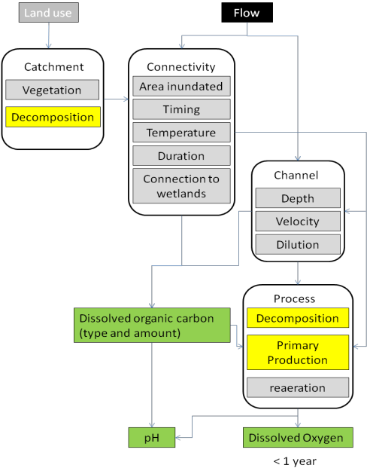
Figure 5 Modified Cause and Effect Diagram illustrating the effect of flow on key parameters associated with hypoxic blackwater events.
The process for evaluating the evaluation questions is illustrated in Figure 6, with components covered by the protocol highlighted in grey. Components highlighted in blue are also required for the predictive ecological response model.
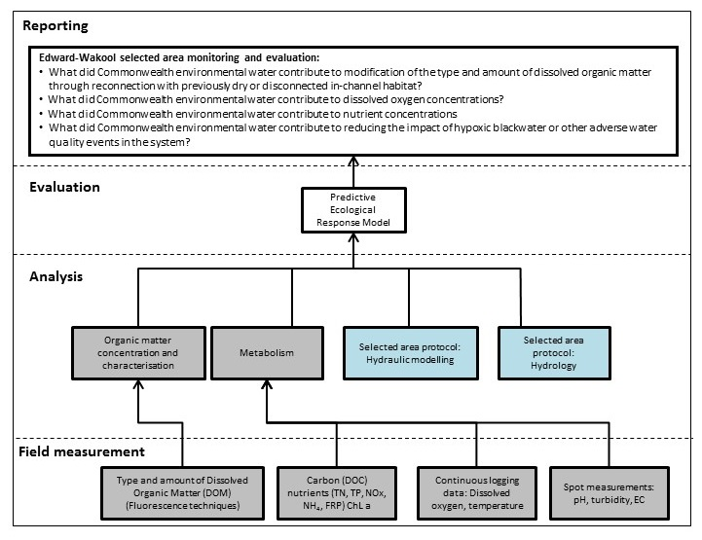
Figure 6 Schematic of key elements in Selected Area Monitoring and Evaluation – Water Quality. Components covered by this protocol are highlighted in grey. Components highlighted in blue are also required for the predictive ecological response model.
Indicators
DOC, nutrients (TN, TP, FRP/NOx), dissolved oxygen, pH, temperature. These parameters will be collected as described for the Stream Metabolism indicator (Section 5.3), including at core monitoring sites for water quality that are not included in the metabolism study sites.
UV-vis and fluorescence organic matter profiles
Carbon fluorescence techniques can be used as rapid-response indicators of the progress of a blackwater event through the tracking of complex organic matter and serve as a sensitive marker of connectivity with previously dry habitat (Watts et al. 2013) During the natural flooding event in 2012 these techniques provided the only strong indicators that the blackwater event in the Edward Wakool system had originated upstream of the study sites and had not developed within the study rivers themselves. They also provided a rapid indication that the environmental water releases from the Mulwala canal would be less effective than during the previous event (but still useful) due to floodwater impacts on the DOC concentrations in the canal(Watts et al. 2013).
The combination of fluorescence spectroscopy as an indicator of floodplain connectivity and the use of inundation models is valuable for the interpretation of other ecological indicators measured to assess the impacts of environmental water uses.
Critical covariates
Area of inundation
Locations for monitoring
This work has two components- an annual core monitoring component at standard sites and an expanded contingency component with more frequent sampling and a broader range of sites which will come into effect if hypoxic blackwater or other poor water quality occurs in the system.
The core carbon fluorescence and water quality data will be collected at sites listed in Table 10 and includes ongoing monitoring at established sites in Yallakool Creek, Wakool River (zones 2 to 4), and source water for these sites from the Mulwala Canal and the Edward River at Stephens Weir (Nutrients not sampled at source sites). New sites expand the water quality monitoring further downstream in the Wakool River and to Tuppal Creek, the Edward Riverl, and the Colligen-Niemur River system to better capture the impact of environmental water in the broader system. Sites 5 and 6 (Edward River) together with 8, 9 and 10 (Colligen-Niemur) (Table 10) may be used in combination to assess carbon and nutrient exchange between the river systems and the Werai Forest should an appropriate overbank flow occur.
Should the contingency component be triggered due to blackwater or other adverse water quality in the system, additional downstream sites will be selected to monitor the progress and severity of the blackwater in the broader system. The sites will be determined on an event basis in collaboration with the CEWO but may include sites with existing dissolved oxygen loggers as marked in figure 7.
Table 10 Sites for Water Quality and Organic carbon core monitoring.
River Section | Site name | Lat/long
Wakool – Yallakool System
Edward/Kolety River, Stevens Weir | Weir | -35.4486, 144.7865
Mulwala Canal | Canal | -35.5060, 144.7870
Yallakool Creek | Zone 1 (@WindraVale2) | -35.5060, 144.7528
Upper Wakool River | Zone 2 (@ Widgee1) | -35.5228, 144.5192
Mid. Wakool River us Thule | Zone 3 (@ Llanos Park2) | -35.5641, 144.3449
Mid. Wakool River ds Thule | Zone 4 upstream (@Moulamien Road Bridge) | -35.5128, 144.2098
 | Zone 4 downstream (@ Noorong 2) | -35.4414, 144.0364
Mid. Wakool River ds Barbers | Zone 5 (@ Gee Gee Bridge) | -35.3293, 143.9275
Lower Wakool River | Zone 6 (@ Stoney Crossing) | -35.0497,143.5803
Edward/Kolety River
Upper Edward River | Four post | -35.6016, 144.9932
Edward River, Stevens Weir | Weir | -35.4486, 144.7865
Edward River, ds Stevens Weir | Eastman bridge | -35.3802, 144.6542
Mid. Edward River | Balpool road | -35.1916, 144.3762
Lower Edward River | Moulamein | -35.0970, 144.0318
Lower Edward River | Liewah | -34.9894, 143.6228
Colligen-Niemur System
Edward/Kolety River, Stevens Weir | Weir | -35.4486, 144.7865
Colligen Creek | Old morago road | -35.4150, 144.6308
Upper Niemur River | Moulamein road bridge | -35.2742, 144.1630
Lower Niemur River | Mallan School | -35.1352, 143.8000
Tuppal Creek
Tuppal Creek | Aratula road | -35.6281, 145.0545
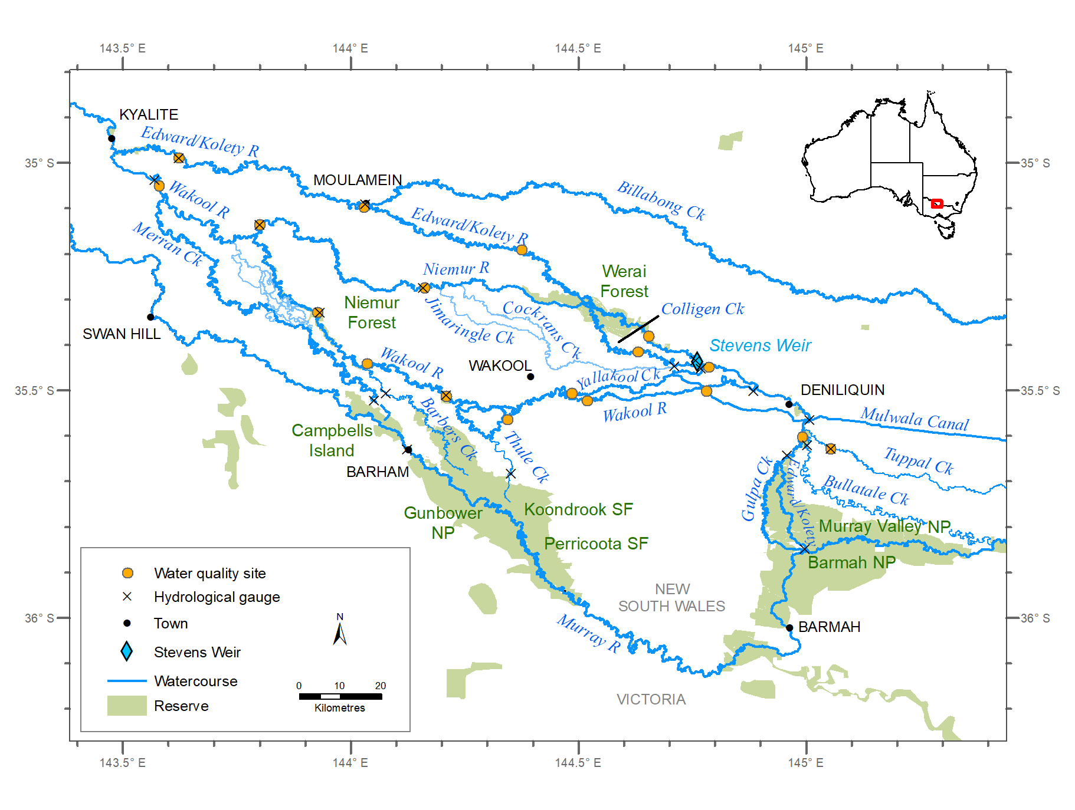
Figure 7 Map of the water quality and carbon core monitoring sites (orange dots) in the Edward/Kolety-Wakool Selected Area, and nearby hydrological gauges (crosses).

Timing and frequency
Core monitoring
The focus of the annual monitoring is the assessment of organic matter inputs and water quality changes during in-stream flows. Sampling will consist of water samples collected from each site in table 10 on a monthly basis throughout the year (expanded from 8 months monitoring during LTIM program to include monitoring of winter flows during the Flow-MER program). Where possible, sites will be aligned with dissolved oxygen loggers established for the assessment of metabolism.
Targeted monitoring
Large flow events, water quality crises and releases of environmental water for hypoxic blackwater mitigation require more intensive sampling than the core monthly monitoring. The sampling design for contingency monitoring will be developed depending on the event.
Responsibilities
- Field work: Dr Xiaoying Liu (CSU) will lead the field program with assistance from Robyn Watts (CSU), John Trethewie (CSU), Chris Davey (CSU) and casual staff (CSU)
- Laboratory analysis for organic matter characterisation will be undertaken by Dr Xiaoying Liu (CSU). Nutrient and DOC analysis will be undertaken by CSIRO NATA certified lab.
- Data management: Xiaoying Liu (CSU), Dr Nicole McCasker (CSU), Prof Nick Bond (La Trobe)
- Data analysis and reporting: Dr Xiaoying Liu (CSU)
Field Methods
Water samples for organic matter characterisation (approx 30 mL) will be filtered in the field using 0.2 μm syringe filters. Samples will be stored on ice, in the dark (not frozen) and brought to the CSU laboratories in Wagga Wagga at the end of each field trip. Spot water quality, nutrients, DOC and Chlorophyll-a will be collected and analysed as described in section 5.3 (stream metabolism).
Laboratory methods
Water samples will be analysed by UV-Vis and fluorescence spectroscopy within 1 day of receipt by the laboratory (48 hours may be necessary during a blackwater event due to the larger number of samples). Absorbance scans will be collected using a Varian Cary 4000 instrument across a wavelength range of 550 nm to 200 nm (green through to ultraviolet) with a 1 nm step size. Fluorescence scans will be collected using a Varian Eclipse spectrofluorometer scanning both emission and excitation wavelengths to give an excitation-emission matrix.
Health and Safety
The Edward-Wakool Selected Area Health and Safety Plan (HSP) includes an assessment of all identified potential risks and a plan on how these risks will be managed.
5.2.2 Evaluation
This component of the monitoring is composed of two parts: annual core sampling and targetted studies of adverse water quality events. The monitoring consistes of a combination of the water quality sampling described in the Cat 1 Stream Metabolism Methodology (See Section 5.3) expanded to a greater range of sites, and Cat 3 methods for organic matter characterisation. This monitoring protocol addresses the Selected Area evaluation questions listed in Table 11.
Table 11 Carbon and water quality evaluation questions
Evaluation questions
Selected Area questions for core monitoring
Short and Long-term questions
- What did Commonwealth environmental water contribute to modification of the type and amount of dissolved organic matter through reconnection with previously dry or disconnected in-channel habitat?
- What did Commonwealth environmental water contribute to dissolved oxygen concentrations?
- What did Commonwealth environmental water contribute to nutrient concentrations?
Selected Area questions for targeted contingency monitoring
- What did Commonwealth environmental water contribute to reducing the impact of hypoxic blackwater or other adverse water quality events in the system?

Data analysis and reporting
Spectroscopic analyses will be plotted using Sigma Plot or R for comparison between sampling sites and sampling dates. UV-Vis scans will be plotted as line graphs and fluorescence results will be corrected for sample absorption and plotted as contour plots (Howitt et al. 2008). Spectroscopic analyses will be reported annually for the core monitoring component. Spectroscopic analyses during targeted contingency water quality monitoring can serve as rapid-response indicators with the UV-Vis results available on the day of analysis (same day as receipt if urgent) and the fluorescence results available within 2-3 days (due to the greater data processing requirements). Combined with spot water quality measurements, this data will provide a critical guide to the progress of a blackwater event and the impact of any releases from channel escapes.
5.2.3 Research
New research on carbon and water quality indicators will be undertaken as part of the integrated research project on the Edward River (see section 6).

5.3 Stream metabolism (Category 1)
5.3.1 Monitoring
Overview and context
The key objective of the stream metabolism monitoring program is to enable determination of the effects of environmental watering actions on the rates of Gross Primary Production (GPP) and Ecosystem Respiration (ER) within the Edward-Wakool system. These processes support and sustain aquatic food webs, and hence are directly related to ecosystem health and viable fish populations. Important drivers for these processes, notably nutrient and organic carbon concentrations and light are collected concurrently to allow flow effects to be distinguished from nutrient variations and daily weather fluctuations.
Flow variability is a key factor influencing rates of GPP and ER in river systems. For example, flow pulses that inundate benches and areas of low lying floodplain increase terrestrial carbon inputs, as well as increasing the area of shallow water where benthic and planktonic algae can grow. In turn this primary production help provide food and fuels food webs. These links have been clearly identified as important processes supporting native fish and waterbird outcomes under the Basin Plan.
The aim of the stream metabolism component of the LTIM monitoring, is thus to assess how delivery of Commonwealth Environmental Water contributes to rates of primary productivity, and overall ecosystem production and respiration in the Edward Wakool River System. This component of work forms an important contribution to predicting broader ecosystem outcomes (Figure 8).
Indicators
- Rates of Gross Primary Productivity (GPP), Ecosystem Respiration (ER) and Net Primary Productivity (NPP) reported in mg Carbon / Litre / day.
- Total GPP, ER, and NPP, taking into account not just rates but also the total daily flow
- Estimated contribution of Commonwealth environmental water to total GPP, ER and NPP, based on counterfactual modelling.
Location for monitoring
Measurements of dissolved oxygen concentrations to support stream metabolism modelling will be undertaken in four hydrological zones in the Edward-Wakool system: zone 1 (Yallakool Creek), zone 2 (Upper Wakool River), zone 3 (Mid Wakool River, upstream Thule Creek), zone 4 (Mid Wakool River, downstream Thule Creek) and zone 8 (Colligen Creek). Each logger integrates between 2 and 10 km of stream reach depending on water velocity and re-aeration rate. One logger will be deployed at the bottom end of each zone. In addition, one logger will be deployed in zone 11 in the Edward River downstream of Stevens Weir and one in zone 12 in the Edward River downstream of Werai Forest as part of the integrated Edward River research project (see section 6).

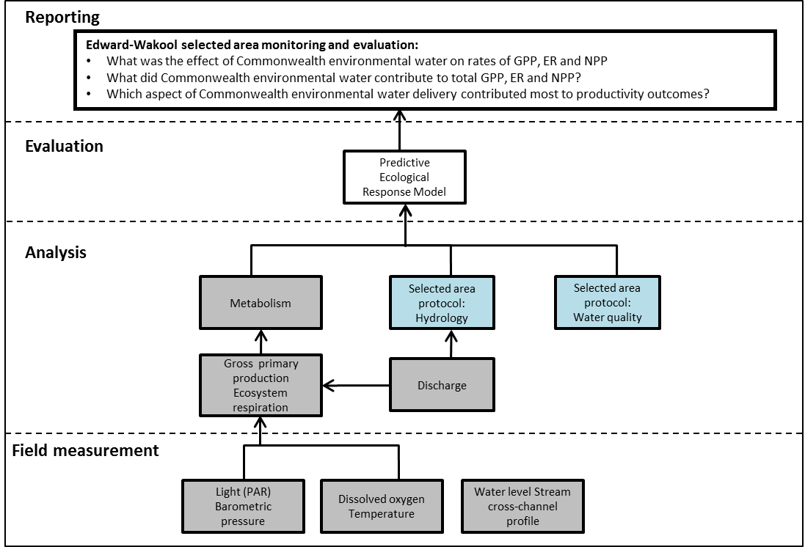 Figure 8 Schematic of key elements in Selected Area Monitoring and Evaluation – Stream metabolism. Components covered by this protocol are highlighted in grey. Components highlighted in blue are also required for the predictive ecological response model.
Timing and frequency
Stream metabolism will be calculated for each site, thus providing daily estimates of the metabolic parameters. Monitoring will be continuous all year round to capture the diversity of timing in unregulated flows and Commonwealth environmental water as well as seasonal responses.
Measurement of dissolved oxygen, temperature, surface light (PAR) and barometric pressure will be recorded every 10 minutes. The need for a strict maintenance, calibration check and possible recalibration means that one day’s data is lost per month as the probe is removed from the stream for these activities. Water samples for nutrient analysis (FRP, NOx, ammonia, chlorophyll-a, TP, TN and DOC) will be collected once per month.
Responsibilities
- Collaboration: This is a collaboration involving Charles Sturt University and La Trobe University
- Field sampling: Field Technicians from CSU
- Data management and preparation: Nicole McCasker and Dr Xiaoying Liu (CSU)
- Data analysis and reporting: Nick Bond and Andre Siebers (LTU)
Methods
Stream metabolism measures for temperature, dissolved oxygen, light (PAR) and barometric pressure will be logged at ten-minute intervals.

Equipment
- Dissolved oxygen and temperature sensors with an integrated logger (e.g. ZebraTech DOpto) using optical (fluorescence) DO measurement.
- PAR sensor and logger (e.g., DataFlow Odyssey). The sensor will be calibrated against a laboratory-based sensor reading in μEs/m²/s across the full range of PAR expected throughout a bright summer’s day.
- Barometric pressure sensor and logger (weather station).
- Tool kit and spare parts for the multi-parameter probe; including spare batteries
- Metal star pickets and star picket driver or mallet
- Anodized chain with padlock, plus cable ties to attach probe to a star picket or permanent structure
- GPS
- Probe calibration log
- Field sheets
- Laptop and data cables for connecting to probes / logger
- Air bubbler with battery (e.g. one suitable for a large fish tank) and a large bucket (e.g. 20 L), for probe calibration.

Protocol
- Prior to deployment in the field, the probe(s) will be calibrated, using a two point (100% & 0% DO saturation) according to manufacturer’s instructions and results of calibration entered into a calibration log.
- Before leaving the office / laboratory the following will be checked for all electronic equipment (probes, loggers, GPS):
- Batteries are charged and properly inserted
- Previous data downloaded and memory cleared
- Check cable and cable connections
- Check for any obvious/minor faults on sensors including growth or dirt on the probes or tubing
- Check contents and condition of probe toolkit
- All equipment listed above is present and in functional order
- A suitable location, above the area likely to be inundated and in a clear open (unshaded) area will be identified. This could be a nearby paddock. Note that on private property locations a fence post near gate access may be suitable.
- Secure PAR logger to existing structure or if necessary, a newly placed star picket.
- Set loggers to read at 10 minute intervals.
- The following information will be recorded on field sheets:
- River name and ANAE Streamid
- Date and time
- GPS coordinates (latitude and longitude; GDA94)
- Name(s) of survey team
- Record site characteristics:
- Substrate type
- Width of channel
- Presence of any geomorphic features
- Percent canopy cover
- Land use immediate adjacent to site
- Collect water quality samples and spot measures as described above.
- Calibrate dissolved oxygen sensor on site:
  - Calibrate according to manufacturer’s instructions for both oxygen free water (e.g. 1% sodium sulfite Na₂SO₃ solution) and 100% saturation (air saturated water). The easiest way to obtain a reliable on-site calibration of 100% saturation is to place the probe in a bucket of stream water which itself is sitting in the stream to ensure thermal control. Air is bubbled through the water in the bucket for at least 45-60 minutes. This should result in a stable reading from the probe. It is important that the probe is not in the direct line of air bubbles.
- Set the dissolved oxygen, temperature, PAR and barometric pressure loggers to record at ten minute intervals. Synchronise loggers so as to obtain corresponding readings.
- Select appropriate place for deployment of sensors and loggers noting:
- Dissolved oxygen and temperature sensors must be placed in open water, mid stream and at a depth that will not expose sensors for entire deployment period. Sensors should not be placed in eddies, stratified zones, backwaters or where flow is influenced by structures.
- Sensors can be deployed on suitable existing structures or on star pickets securing embedded mid-stream.
- Deploy loggers.
- Leave loggers deployed for between four and six weeks. Experience over the LTIM program in these streams indicated that more frequent cleaning was required, hence loggers will be maintained every 2 weeks during the warmer months when necessary.
- Perform servicing, cleaning and calibration of loggers at each repeat visit.
- Repeat water quality samples and spot measures at each repeat visit.
- Repeat 100% saturation value check (water saturated air) and note the value of any drift.
- Record any relevant information, such as changes in site characteristics since deployment.
- Upload data onto laptop following manufacturer’s instructions.
- Calibrate all sensors and loggers and perform routine maintenance / cleaning as necessary.
Health and Safety
The Edward-Wakool Selected Area Health and Safety Plan (HSP) includes an assessment of all identified potential risks and a plan on how these risks will be managed.

5.3.2 Evaluation
Metabolism monitoring will address the Selected Area evaluation questions in table 12.
Table 12 Stream metabolism evaluation questions
Evaluation questions
Short and Long-term questions
- What was the effect of Commonwealth environmental water on rates of GPP, ER and NPP
- What did Commonwealth environmental water contribute to total GPP, ER and NPP?
- Which aspect of Commonwealth environmental water delivery contributed most to productivity outcomes?

Data analysis and reporting
This method adopts the approach of determining GPP, ER and reaeration rate (K_{O2}) from the diel dissolved oxygen curves using the daytime regression model reviewed by Kosinski (1984). A program to evaluate these parameters for the diel dissolved oxygen curve, ‘BASE’, has been developed by Mike Grace, Darren Giling and Ralph MacNally at Monash University.
The model requires data for dissolved oxygen in mg O₂/L, temperature, PAR and barometric pressure (in atmospheres) at 10 minute intervals. The salinity also needs to be entered. This will be approximated as 0 unless the electrical conductivity increases above 500 μS/cm, in which case salinity = 6 x 10⁻⁴ x EC (Based on conversion factor of 1 µS/cm = 0.6 mg/L TDS). The ‘BASE’ program provides estimates of GPP and ER in mg O₂ /L/Day with uncertainties for each and goodness of fit parameters.
The current version of BASE (BASEmetab; https://github.com/dgiling/BASEmetab) includes a number of changes made following Song et al. (2016). Results published by Song et al. (2016) showed that BASE underestimated metabolic rates in some cases due to two differences in the model formulation compared to other aquatic metabolic models (e.g. Hall and Tank 2005; Hanson et al. 2008; Holtgrieve et al. 2010; Van de Bogert et al. 2007):
- BASE used a ‘stepwise’ approach to model changes in DO concentration (Δ[DO]) between successive measurements rather than DO concentration ([DO]) directly.
- BASE also used the measured DO concentration ([DO]measured) to estimate oxygen deficiency for reaeration rates instead of the modelled DO concentration ([DO]measured).
Given the findings of Song et al. (2016), these inconsistencies in the BASE model were rectified:
BASE: Δ[𝐷𝑂]𝑡Δ𝑡⁄=𝐴𝐼𝑡𝑝−𝑅(𝜃(𝑇𝑡−𝑇̅))+𝐾𝐷𝑂.(1.0241(𝑇𝑡−𝑇̅)).([𝐷𝑂]𝑠𝑎𝑡,𝑡− [𝐷𝑂]𝑚𝑒𝑎𝑠,𝑡)
BASEv2: [𝐷𝑂]𝑡+1=[𝐷𝑂]𝑡+𝐴𝐼𝑡𝑝−𝑅(𝜃(𝑇𝑡−𝑇̅))+𝐾𝐷𝑂.(1.0241(𝑇𝑡−𝑇̅)).([𝐷𝑂]𝑠𝑎𝑡,𝑡− [𝐷𝑂]𝑚𝑜𝑑𝑒𝑙𝑙𝑒𝑑,𝑡)
Here, t indicates the timestep, A is a constant, p is an exponent describing incident light use, ϴ describes temperature dependence of respiration, T is water temperature and sat, meas and mod indicate [DO] at saturation, observed concentration and modelled concentration. The updated model of BASEv2 improved fit (visual and R2) of modelled DO to observed values and reduced uncertainty in parameter estimates of the validation dataset of Grace et al. (2015). There was greater agreement between the estimates from BASEv2, BaMM (Holtgrieve et al. 2010) and the ‘accurate’ method of Song et al. (2016), for a wide range of stream characteristics and range of metabolic rates.
As part of the update of the BASE model, there was also a change in software for the MCMC (Markov Chain Monte Carlo) algorithm from OpenBUGS (Lunn et al. 2000) to JAGS (Plummer 2003) for platform-independence and to allow for parallel core processing of the three chains, greatly increasing computational speed.
Subsequent data analysis will involve using the daily estimates for the two metabolic parameters with the collected explanatory variables (nutrients, DOC, chlorophyll-a, light) as well as daily discharge and season to determine the influence of flow on rates of GPP, ER and NPP, and also total GPP, ER, and NPP. By undertaking counterfactual modelling estimates of the contribution of Commonwealth environmental water to GPP, ER and NPP will be determined and reported.
5.3.3 Research
New research on stream metabolism and productivity is planned for the Flow-MER program as part of the integrated research project on the Edward River (see section 6).

5.4 Riverbank and aquatic vegetation (Category 3)
5.4.1 Monitoring
Overview and context
Riverbank vegetation and aquatic vegetation play an important role in the functioning of aquatic ecosystems, supporting riverine productivity and food webs and providing habitat for fish, invertebrates, frogs and birds (Roberts and Marston 2011). The cover and composition of aquatic vegetation can determine the availability of oviposition sites for macro invertebrates and calling and spawning locations for frogs (Wassens et al. 2010) and support wetland food webs and zooplankton communities (Warfe and Barmuta 2006). Furthermore, the response of aquatic and riverbank vegetation following a flow event can assist understanding the response of other biological indicators.
Riverbank plant survival and growth is affected by the frequency and duration of inundation (Toner and Keddy 1997; Johansson and Nilsson 2002; Lowe et al. 2010). Frequent inundation can delay reproduction (Blom and Voesenek 1996), whilst long duration of inundation can reduce growth or survival (Blom et al. 1994; Johansson and Nilsson 2002; Lowe et al. 2010). Favourable soil moisture and nutrient conditions created by a receding flood can encourage rapid recovery and root and shoot development and many plants, including emergent macrophytes and riparian understorey herbs, often germinate on flood recession (Nicol 2004; Roberts and Marston 2011). Differences in seasonal patterns of inundation within a single year can result in different survival, growth and reproduction responses of riverbank and aquatic plant species (Lowe 2002).
The process for evaluating the questions is illustrated in Figure 9, with components covered by the protocol highlighted in grey. Components highlighted in blue are also required for the predictive ecological response model.
Indicators
- Percent cover of aquatic vegetation
- Percent cover and maximum height of riverbank vegetation
- Diversity of aquatic vegetation
- Diversity of riverbank vegetation
Locations for monitoring
Monitoring sites established as part of the LTIM program will continue to be surveyed as part of the Flow-MER program. Monitoring will occur in zone 1 (Yallakool Creek), zone 2 (upper Wakool River), zone 3 (mid Wakool River, upstream Thule Creek), zone 4 (mid Wakool River, downstream Thule Creek), and zone 8 (Colligen Creek). Four sample sites will be monitored in each zone.
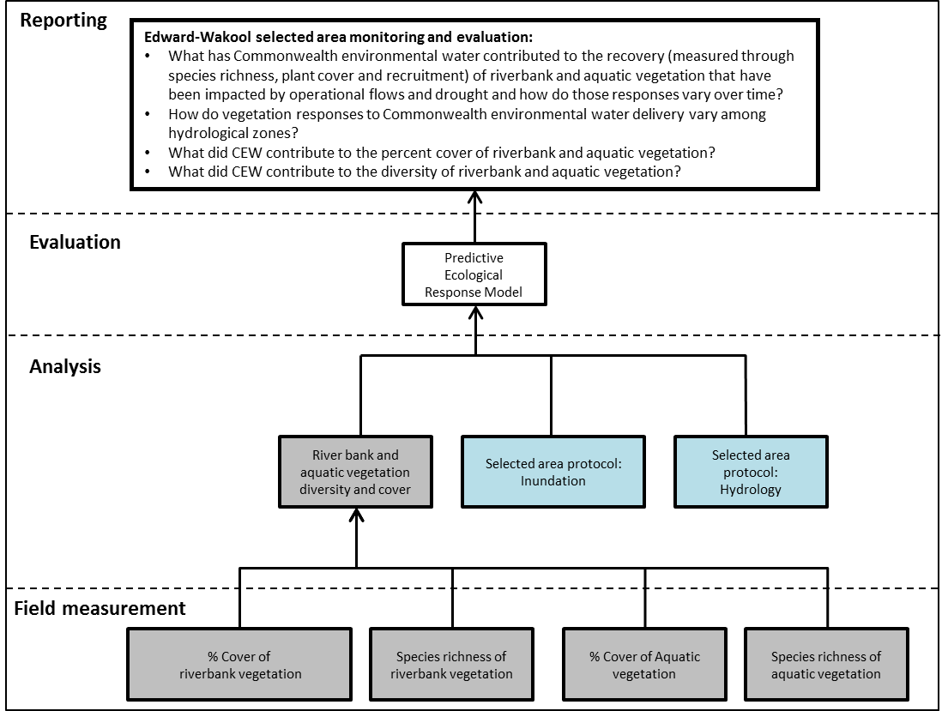
Figure 9. Schematic of key elements in Selected Area Monitoring and Evaluation – Riverbank and aquatic vegetation. Components covered by this protocol are highlighted in grey. Components highlighted in blue are also required for the predictive ecological response model.

Timing and frequency
Monitoring of riverbank and aquatic vegetation in zones 1 to 4 and Colligen Creek will be undertaken monthly.
Responsibilities and collaboration
- Collaboration: This is a collaboration involving Charles Sturt University and Murray-Darling Wetlands Working Group.
- Field sampling: Sascha Healy (MDWWG), Robyn Watts (CSU), casual staff (CSU).
- Data entry and management: Xiaoying Liu (CSU), Nicole McCasker (CSU)
- Data analysis and reporting: Robyn Watts (CSU), Sascha Healy (MDWWG)

Methods
Monitoring will be undertaken once per month at each site. In 2014 six permanent 20 m long transects were established parallel with the river channel. Star pickets were installed at each end of the permanent transect. The lowest transect on the riverbank was labelled as transect 0 and the other five transects labelled consecutively up to transect 5 highest on the river bank. The transects were surveyed so they were 25 cm apart in vertical height, with the five transects thus covering 1.25 m of vertical height of the bank. Transects zero and one were in the water at base operational flows, and the other four transects further up the riverbank have the potential to be inundated during Commonwealth environmental watering or during unregulated flows.
Vegetation will be assessed using the line point intercept method along transects. At each of the transects on each sampling date a 20 m tape measure will be laid out running horizontally along the riverbank between two star pickets installed at a known height of riverbank. The taxa at each 50 cm point quadrat along the 20 m transect (40 points on each transect) will be recorded. Plants will be identified to species level where possible, but if the plants are very small and without seeds or flowers to enable correct identification they will be identified to genus. If no vegetation is present at a point, then that point will be recorded as bare ground, leaf litter or log/tree trunk. For transects in the water the tape measure will be laid at the water’s edge and a flexible fibreglass pole held from the tape out to the water surface to locate the point on the transect for recording data. Photopoints were established at each site in 2014 as part of the LTIM program. Photos will be taken at these sites on each sample event.
Health and Safety
The Edward-Wakool Selected Area Health and Safety Plan (HSP) includes an assessment of all identified potential risks and a plan on how these risks will be managed.
5.4.2 Evaluation
Riverbank vegetation and aquatic vegetation monitoring will address the Selected Area evaluation questions in table 13.
Table13. Riverbank and aquatic vegetation evaluation questions
Evaluation questions
Long-term questions
- What has Commonwealth environmental water contributed to the recovery (measured through species richness, plant cover and recruitment) of riverbank and aquatic vegetation that have been impacted by operational flows and drought and how do those responses vary over time?
- How do vegetation responses to Commonwealth environmental water delivery vary among hydrological zones?
Short-term questions
- What did Commonwealth environmental water contribute to the percent cover of riverbank and aquatic vegetation?
- What did Commonwealth environmental water contribute to the diversity of riverbank and aquatic vegetation taxa?

Data analysis and reporting
Each taxa will be classified into three broad functional categories using a range of sources including Brock and Casanova (1997), Casanova (2011) and Roberts and Marston (2011). Although there are some limitations of using water plant functional groups to classify taxa, the approach of using three functional categories is sound for common taxa that can be reliably distinguished and can be related to hydrological information on wetting and drying regimes.
The three functional categories are:
- Submerged taxa, being those that have special adaptations for living submerged in water. These plants grow to, but do not emerge from, the surface of the water.
- Amphibious taxa, including those that tolerate wetting and drying, and those that respond to water level fluctuations, and
- Terrestrial taxa, being those that typically occur in damp or dry habitats.
Total species richness will be calculated for each site in each zone for each month. The percent cover will be calculated for each transect for each sample date. To compare cover of vegetation across the years of the LTIM program and CEWO Flow-MER program, the month when the maximum cover occurred will be identified for each taxa.
To test if the percent cover of vegetation is significantly different among the hydrological zones across years, the total percent cover of all taxa will be transformed and analysed using a one way ANOVA with zone as the treatment factor. Analysis of the percent cover for the eight most common taxa will be analysed individually using Kruskal-Wakllis nonparametric test because the data are usually not normally distributed. Statistical analyses will be undertaken using the freeware R and the R package MASS (R Development Core Team 2013) and IBM SPSS Statistics v20. When significant differences are indicated, post hoc pairwise comparisons will be undertaken to determine differences between hydrological zones.
5.4.3 Research
Research on riverbank and aquatic vegetation will be undertaken as part of the integrated research project on the Edward River and Werai Forest (see section 6).
5.4.4 Links to other monitoring and research themes
The riverbank and aquatic vegetation theme links with the hydrology (section 5.1), larval fish (section 5.6, 5.7) and fish recruitment (section 5.8) themes and with several aspects of the integrated research project (e.g., hydraulic modelling and turtle research, section 6).

5.5 Fish movement (Category 2)
5.5.1 Monitoring
Overview and context
Freshwater fish make reproduction, dispersal and feeding movements in response to biotic and abiotic stimuli (Lucas et al. 2001) (Figure 10). The delivery of Commonwealth environmental water will affect the scale of fish responses to these stimuli, as the frequency, timing and magnitude of fish movements are strongly related to flow (Taylor and Cooke 2012). It is important that any fish movements are able to be quantified and related back to discharge (whether it is delivered by the Commonwealth or otherwise), to enable adaptive management of future flow events. For example, elevated flows increase longitudinal and lateral habitat connections, enabling fish to seek refuge to avoid disturbances such as hypoxic blackwater events or to recolonise following disturbances. Commonwealth environmental water objectives have, in the past, had ecological objectives which required monitoring of fish movements to determine outcomes. For instance, if fish reproduction (and thus changes in landscape fish diversity) is an objective, then tracking the movements of fish to breeding locations, or documenting behaviour consistent with reproduction, provides direct evidence that the delivery was successful. In addition, movement data can demonstrate whether fish survived during poor water quality events, or whether fish successfully moved into refuge habitat during periods of low flow. The strategic placement of acoustic receivers in the Edward-Wakool Selected Area will provide information on the timing, frequency and magnitude of movements related to Commonwealth environmental watering events. Importantly, data is logged on average every 90 seconds. With this level of precision, movement events can be linked to particular aspects of the hydrograph. Such information is important to determine whether the fish movement aspects of Commonwealth environmental water delivery are successfully achieved.
Given the climatic variability in Australia and the associated unpredictable hydrology, numerous species rely on in-channel flows, rather than off-channel connections, to complete their life cycle (Humphries et al. 1999). For example, golden perch reproduction can occur from early November to March (Roberts et al. 2008; King et al. 2009). In-channel reproduction has occurred in non-flood years for golden and silver perch, and rapid responses of reproduction to rising water levels and temperatures have been documented, often in conjunction with long-distance migrations (Reynolds 1983, Mallen-Cooper and Stuart 2003, O’Connor et al. 2005). This suggests that both species are in a state of ‘reproductive readiness’ over a specified season and are awaiting suitable environmental conditions to spawn. If these conditions are not achieved minimal reproduction may occur or the species will simply resorb gonads.

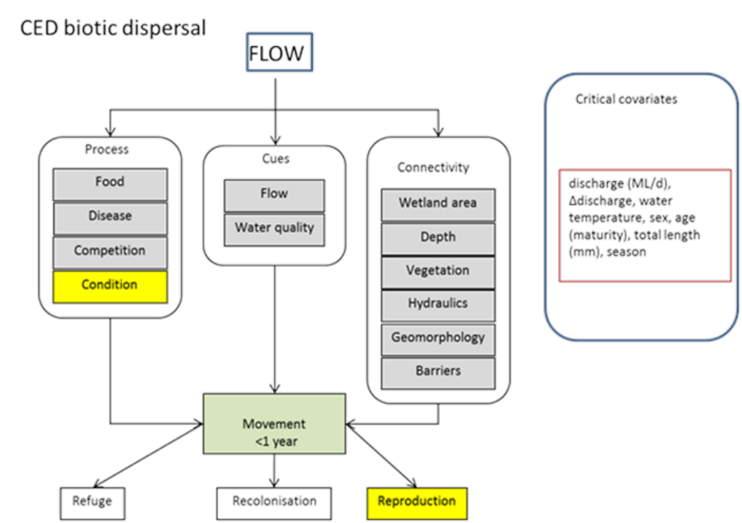
Figure 10. Modified biotic dispersal cause and effect diagram reflecting the biotic and abiotic influences on fish movement. Yellow boxes indicate other cause and effect diagrams. The critical reason biotic dispersal is important for fish is that it may be reproduction related in response to flow. (Modified from MDFRC 2013).
Telemetry is a useful method for obtaining detailed movement information on fish, as it enables quantification of the magnitude, timing and frequency of individual responses to abiotic stimuli such as flows (Taylor and Cooke 2012). In Australia, telemetry has been used to identify the reproduction related movements of golden perch in response to flow events (O’Connor et al. 2005). Leigh and Zampatti (2013) used telemetry to quantify the lateral movements of Murray cod during high discharge events. Using telemetry, Simpson and Mapleston (2002) identified a positive correlation between the distance moved by Mary River cod and discharge. Telemetry can also be used to quantify large scale dispersal, including movements to and from refuge habitats, and serves as a useful additional line of evidence to infer successful reproduction (e.g. Thiem et al. 2013, Walsh et al. 2013).
Acoustic tracking is a useful telemetry method for obtaining information on fish movements. The process involves implanting a transmitter into a fish, which is then detected by a series of stationary readers installed in a target stream. Acoustic monitoring can provide high resolution spatial information on fish location, and data can be graphically presented to identify specific movement patterns (Barnett et al. 2010). In the case of environmental water delivery, the strategic placement of acoustic receivers will provide information on timing of movements, distances travelled, residency, correlation of movements with flow delivery and evidence of reproduction behaviour. Such information is important to determine the delivery success of a particular Commonwealth environmental water volume, to provide additional evidence to support existing monitoring activities such as larval fish monitoring, and to inform the planning of future events.
These standard methods describe monitoring required for the Basin-scale evaluation and Selected Area evaluation of the response of river fish to Commonwealth environmental water. The methods describe the sampling design and protocol for large-bodied fishes in river channels for the LTIM Project.
This protocol describes equipment specifications and implantation procedures to measure dispersal rates and directions of target periodic life-history fishes
The process for evaluating Basin-scale questions is illustrated in Figure 11, with components covered by this protocol highlighted in grey.
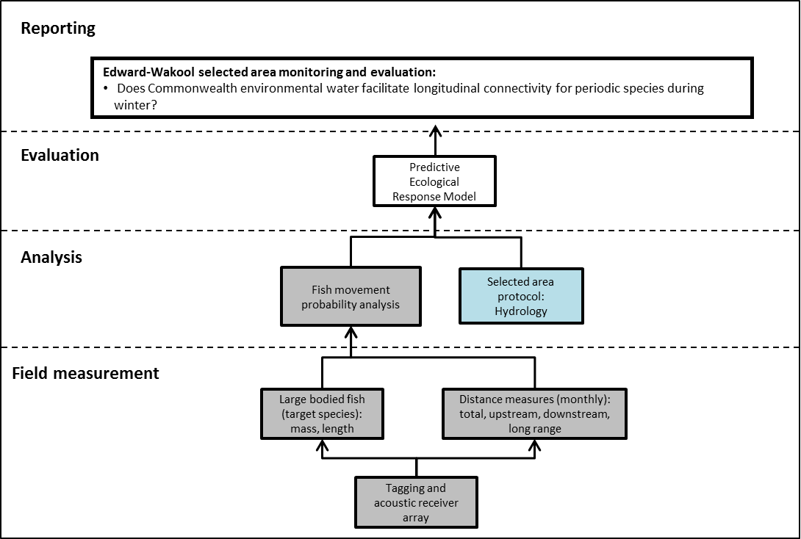
Figure 11 Schematic of key elements in LTIM Project Standard Protocol: Fish (Movement). Components covered by this protocol are highlighted in grey. Components highlighted in blue are also required for the predictive ecological response model

Establishing sites
Protocol
LTIM Project for Basin-scale evaluation adopted a hierarchical approach to sample design. The spatial hierarchy for fish (movement) monitoring is as follows:
- Selected Area
  - Zone
    - Site
Zone placement within Selected Areas
A ‘zone’ is a subset of a Selected Area that represents a spatially, geomorphological and/or hydrological distinct unit at a broad landscape scale. For example, separate river systems, sub-catchments or large groups of wetlands.
For Basin-scale evaluation, we selected four zones for monitoring of fish movement in river channels based on the following recommendations of Hale et al. (2014):
- Different zones within Selected Areas represent spatially-, geomorphologically- and/or hydrologically distinct units;
- Zones must be likely to receive Commonwealth environmental water at least once in the next five years;
- Zones must have an expected outcome related to the indicator in question (in this instance fish movement);
- The zones selected for monitoring fish movement responses to flows are to be the same as selected for monitoring fish population and community structure for Basin-scale modelling data (see LTIM Project Standard Protocol: Fish (River)). In this way we may achieve synergies amongst different forms of fish data collected.

Receiver design / placement within zones
The array and design of the telemetry study in the Edward-Wakool Selected Area (Figure 12) was established with respect to the following general requirements outlined in Hale et al. (2014):
- Receivers will span the length of channel defined by the ten sites established as part of the population/community monitoring; these are placed within Zone 3 (see LTIM Project Standard Protocol: Fish (River));
- Consistent spacing of acoustic receivers will occur within monitoring zones.
- Additional receivers will be deployed at major waterway junctions to determine the direction of movement into and out of these waterways.
- GPS coordinates of receiver locations will be recorded to facilitate calculation of distances moved by individual fish.

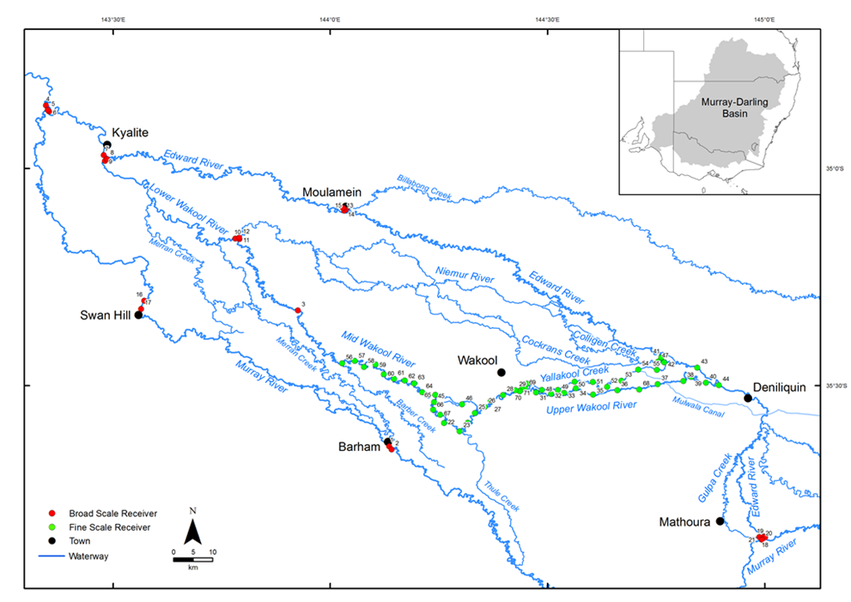
Figure 12 Locations of acoustic receivers in the Edward-Wakool system.

Indicators
Fish movement metrics and location data will be calculated including: linear range (the maximum upstream minus the maximum downstream location), mobility (the sum of all distances moved) and residency (the proportion of the tagged sample within any given location). These metrics will be relation to season and discharge for periodic species and will be queried on time-scales of days to months depending upon the question of interest.

Location for monitoring
Fish (movement) Cat 2 will be monitored in zones 1 (Yallakool Creek), 2 (Upper Wakool River), 3 (mid Wakool River, upstream of Thule Creek) and 4 (mid Wakool River, downstream of Thule Creek). Additional acoustic receivers will be placed at major junctions within the broader Edward-Wakool river system to quantify emigration and routes of travel.
Knowledge of the dispersal paths in the system will enhance management of future Commonwealth environmental watering actions targeting native fish colonisation and dispersal. The scale of movement exhibited by fish will likely vary depending upon the magnitude of Commonwealth environmental water that is delivered, and will be of the greatest magnitude during high flow events. Dispersal of tagged fish from the study area into the catchment will provide insight into resilience, emigration, immigration and blackwater related movements, informing Selected Area reporting. Movements by fish throughout the Selected Area result in increased population resilience, through dispersal into new habitats, by enabling greater access to breeding habitat, through colonisation of new or previously impacted habitat (e.g. drought or hypoxic blackwater affected areas) and avoidance of poor quality habitat (e.g. water quality). Large bodied fish communities in the mid and lower Wakool river system were significantly impacted by drought (2000 – 2010) and large scale fish kills caused by hypoxic blackwater following system wide flooding in 2010. The monitoring of flow related fish movement into and out of these zones from less affected ‘refuge’ areas will assist in interpretation of the role of Commonwealth environmental water in facilitating system-wide recovery. The data collected from the fish movement component will also be used to compliment fish community monitoring that will occur annually in these zones.
Timing and frequency
Monitoring of fish movement studies will not continue as part of the Edward-Wakool Flow-MER Plan after 2019, although the data generated through LTIM in this region will be integrated into the Basin scale Flow-MER research project.
Submerged Vemco autonomous receivers will record the time, date and identity of acoustic tagged fish swimming within detection range of the receiver units (~ 500 m). Logged receiver data will be downloaded quarterly, although there is potential to incorporate strategic downloads to inform adaptive management. Individually coded acoustic transmitters will be inserted into the peritoneal cavity of each fish and tags will have a programming-dependent battery life of up to 900 days depending upon fish size.
Responsibilities
Fisheries NSW project staff based at Narrandera Fisheries Centre will perform receiver deployment, acoustic tagging, receiver downloads, data management, analysis and reporting. Fisheries NSW staff involved in the project (Thiem, Wooden and Smith have extensive experience with all aspects of telemetry – including tagging, data management, analysis and reporting).
Methods
This fish movement indicator will build upon 4 years of monitoring fish movement under LTIM. This methodology is according to Hale et al. (2014), and includes adjustments (where relevant) to incorporate Edward-Wakool selected area methods and evaluation questions, with inclusions of Health and Safety Plan, Location for monitoring, and Responsibilities.
Representative species from life-history guilds
Overview
Fishes belonging to different life history guilds may respond in different ways to managed and natural flows. Periodic species including golden and silver perch are considered to be flow dependent spawners and are expected to provide detectable responses to Commonwealth environmental water.

Protocol
The monitoring of fish movement in the Edward-Wakool Selected Area will be undertaken with respect to the guidelines from Hale et al. (2014).

Target species for the Edward-Wakool Selected Area
Tagging of golden perch (n=79) and silver perch (n=43) was undertaken in LTIM (2014-19). From December 2018 until May 2019 n=14/27 golden perch and n=8/32 silver perch tagged in 2017 were detected on acoustic receivers in the Edward-Wakool. Eighteen of the golden perch tagged in 2017 will have active transmitters during the winter 2019 watering action and are available to be detected (i.e. battery life extends past this point). No silver perch tagged in 2017 will have active transmitters during the 2019 winter watering action. Subsequently, the movement responses of golden perch already fitted with active acoustic transmitters will be monitored from May 2019-September 2019 in response to a winter watering event.
Sampling protocol
Equipment
- For reliability as well as consistency with current projects (Murrumbidgee, Gwydir and Goulburn) we will use Vemco (http://vemco.com/) VR2W acoustic monitoring receivers operating on 69 kHz; VR2Ws are a submerged, single channel, omni-directional receiver that record time, date and identity of fish fitted with acoustic transmitters. VR2W receivers are powered by a single “D” sized 3.6 Volt lithium battery, with a projected battery life of 15 months. Range testing of receivers in other Australian installations indicated 100% detection efficiency to 300 m which declines to 60% at 400 m. Receiver locations will be placed where channel widths are less than reliable detection ranges (< 600 m) and possess clear open substrate to eliminate detection shadows.
- Vemco tags will be used. Other ‘compatible’ tags are available on the market but cannot guarantee unique tag numbers. Duplicate tag numbers will be avoided;
- Tag size may vary with target species body size within the Edward-Wakool Selected Area. We will ensure that tag burden does not exceed 2% of the body weight of fish. Tag battery life will be maximised while considering transmission delays to reduce code collision, taking into account the following points raised by Hale et al. (2014):
- Tag size is governed by battery size; larger tags = larger battery = longer tag life;
- Tags with a 3 year life can be purchased but only implanted into large fish;
- Tags transmit on a random delay. The delay is determined at the time of purchase and influences two things:
  - The chances of code collision. More tags in a location at any given time requires a longer transmission delay to reduce the risk of tags transmitting at the same time and collision of transmission codes (i.e. 2 tags transmitting at the same time in the same location will usually result in no detections)
  - Tag life. Longer delays = longer tag life. BUT increase the chance a fish can swim past a receiver and not be detected as receivers are passive and only detect tags when tags transmit.
- Previous Edward-Wakool projects used Vemco model V9 tags (http://vemco.com/products/v7-to-v16-69khz/) on an average 90 second delay (i.e. transmission occurs randomly between 50 and 130 seconds) for small fish (tag weight 3.6 g, battery life ~225 days) and V13 tags on an average 90 second delay for larger fish (tag weight 11g, battery life ~885 days). It is expected that these tags will continue to be used
Implantation
- Telemetry tagging will be conducted between March and August to avoid high water temperatures and reproductive events. Fish with advanced gonad development have little room in the coelomic cavity to accommodate a tag.
- Fish will be immediately tagged on-site following recovery from capture.
- All telemetry tags will be surgically implanted into the coelomic cavity whilst fish are under anaesthesia. Dose rates of anaesthesia will comply with animal ethics approval.
- Anaesthesia will be achieved through submersion of fish in an induction bath of either benzocaine or Aqui-S (http://www.aqui-s.com/).
- Stage 4 anaesthesia, characterised by total loss of equilibrium and no reaction to handling, is typically the stage required for surgical procedures on fish (Summerfelt & Smith 1990).
- Relevant total length (TL: mm) and fork length (FL: mm) as well as mass (g) will be recorded
- Fish exhibiting visible signs of disease, injuries and deformities will be excluded from tagging.
- Surgery will take place in a V-shaped cradle and fish are to have water continually pumped over the gills (containing a reduced concentration of anaesthetic where necessary).
- Mid-ventral incisions of 20–30 mm will be made through the body wall of the fish posterior to the pelvic girdle and anterior of the anal vent.
- Every possible effort will be made to determine the sex of fish by examining the gonads through the incision prior to transmitter insertion or by collecting a fin clip to retrospectively assign sex. It will be important for later interpretation of data and identifying possible reproductive behaviour during flow events.
- Incisions will be closed using 2–3 interrupted monofilament absorbable sutures (Ethicon PDS II sutures: http://www.ecatalog.ethicon.com/sutures-absorbable/view/pds-ii-suture) using multiple surgeons knots.
- A single surgeon will be used for all tag implantation where possible, or record kept if multiple surgeons are used.
- All tagged fish will be fitted with external, individually numbered dart tags in the dorsal musculature to aid angler identification and facilitate tag returns which is important to understand the fate of the fish if it is not detected in the future.
Post-surgery fish will be recovered on-site and released within 24 hours of capture/surgery at the point of capture.
Quality Assurance/Quality Control
Quality control and quality assurance protocols are documented in the Quality Plan developed as part of the Monitoring and Evaluation Plan for the Edward-Wakool Selected Area. QA/QC activities specific to this protocol include:
- Electrofishers will be experienced operators of units. They will be supervised by Senior Operators on-site, and have obtained their electrofishing certificates through a reputable course.
- Monitoring and Evaluation Providers will have relevant boat licenses.
- Monitoring and Evaluation Providers will have specific fisheries and ethics permits with them while sampling.
- Monitoring and Evaluation Providers will have appropriate experience in the surgical implantation of telemetry tags.
Health and Safety
The Edward-Wakool Selected Area Health and Safety Plan (HSP) includes an assessment of all identified potential risks and a plan on how these risks will be managed.

5.5.2 Evaluation
Fish movement monitoring will address the Selected Area evaluation question in table 14.
Table 14 Fish movement evaluation questions
Evaluation question
Short term questions
- Does Commonwealth environmental water facilitate longitudinal connectivity for periodic species during winter?

Selected area hypothesis:
H₁ Delivery maintains ecological connectivity for periodic species during winter watering.
Data analysis and reporting
Receiver download schedule
- Acoustic receivers will be downloaded quarterly to reduce the possible risk of lost/stolen receivers
- Data will be filtered to remove single detections (Clements et al. 2005), false detections and orphan tags.
- Data files will be stored and managed appropriately.
Data outputs
Downloaded acoustic receiver data will be uploaded into a custom built SQL database. This database will comprise a distance matrix of receiver locations that account for river sinuosity so that movement paths of individual fish can be recreated and distances moved quantified. Single detections will be removed and false detections and orphan tags filtered by the database prior to any analysis.
An interactive fish movement visualisation will be provided to CEWO to be linked to their website that will include all detection data for the life of LTIM/ Flow-MER in a format mutually agreed upon between DPI and CEWO.
Data management
All data provided for this indicator will conform to the data structure defined in the LTIM Project Data Standard (Brooks and Wealands 2014). The data standard provides a means of collating consistent data that can be managed within the LTIM Project Monitoring Data Management System (MDMS).
The spatial unit for which data is reported for this indicator is known as an ‘assessment unit’. The assessment unit for this indicator is the site (river section).
Each row of data provided for this indicator will identify the assessment unit, the temporal extent of the data and a number of additional variables (as guided by this standard method). The exact data structure for this indicator is maintained and communicated in the LTIM Project Data Standard and will be enforced by the MDMS when data is submitted.
5.5.3 Research
No new research on fish movement indicators will be undertaken as part of the Flow-MER project.

5.6 Fish Reproduction (Larvae) (Category 1)
5.6.1 Monitoring
Overview and context
This methodology follows the methods developed for the Long-Term Intervention Monitoring Program (2014-2019), as set out in Hale et al. (2014) with inclusions of location for monitoring, responsibilities and Health and Safety Plan subsections. Fish (Larvae) – Cat 1 methods will be used by the Basin-team to address Basin-scale evaluation questions. Some of the Cat 1 data will also be used to address Selected Area questions along with data collected through the Fish Reproduction – Cat 3 methods (section 5.7).
The process for which the Basin-matter team will evaluate Basin-scale evaluation questions for Fish (larvae) is illustrated in Figure 13, with components covered by this protocol highlighted in blue. Note that the boxes marked in red for otolith examination and daily age and growth will not be monitored for Basin-Scale evaluation in the Edward-Wakool Selected Area.
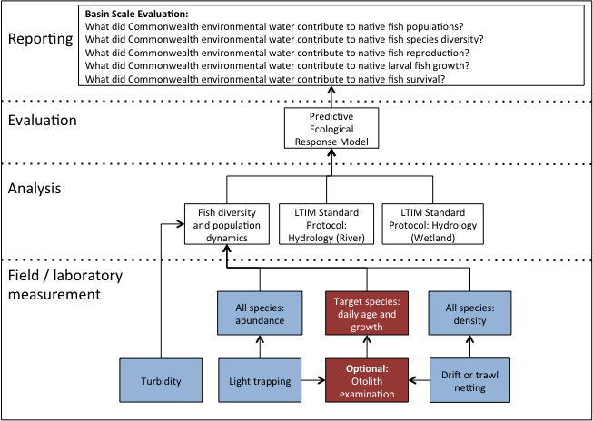
Figure 13 Schematic of key elements in Flow-MER Project Standard Protocol: Fish (larvae) – Cat 1. Boxes marked in red for otolith examination and daily age and growth are optional (category 2) and will not be monitored in the Edward-Wakool Selected Area.

Indicators
This protocol describes sampling over five years, each year to measure:
- Catch-Per-Unit-Effort (CPUE) of each larval fish species in rivers using fixed position drift nets
- And the in situ measurement of turbidity.
Note: In 2016 an amendment to the Cat 1 larval fish survey methods was agreed upon by the CEWO, Basin-matter fish leads and the Edward Wakool selected area team, which saw the replacement of light trap sampling with the addition of two extra drift net sampling trips (from 5 survey trips to 7) (See Watts et 2018 for details on LTIM Plan addendum).
Location for monitoring
Larval fish monitoring for Basin-scale analysis will take place in Zone 3 (Mid Wakool River, upstream of Thule Creek). Three of the ten sampling sites specified for the monitoring of adult fish in Zone 3 will be used, Cummins Llanos Park1 and Llanos Park2 The rationale underlying this is to seek as much synergy as possible among the three different monitoring components for fishes.
Timing and frequency
Larval sampling will occur fortnightly, with 7 trips in total taking place between September and December every year, inclusive.
Responsibilities and Collaboration
- Collaboration: This is a collaboration involving Charles Sturt University and NSW DPI Fisheries. Cat 1 fish larvae will be evaluated by the Basin-scale Flow-MER team led by CSIRO.
- Field sampling: Field Technicians from CSU and NSW DPI Fisheries
- Larval identification and sample processing: Nicole McCasker and John Trethewie (CSU)
- Data analysis and reporting: Nicole McCasker (CSU)
Methods
The standard methods outlined here describe the monitoring required for the Basin-scale evaluation of fish spawning in response to Commonwealth environmental water for the Flow-MER Project.
Larval density will be measured using stationary drift nets for higher current areas. Three drift nets per site (total of nine per zone, per sampling event) will be positioned in water with a moderate velocity, preferably where the discharge is concentrated through a narrow section of the river (a funnel effect). Ideally, drift nets will not be closer than 100 m to each other.
At each site on each sampling event, turbidity will be measured in situ via an appropriately calibrated meter and recorded.
Drift nets will be constructed from 500 μm mesh, have an opening diameter of 50 cm, tapering over 1.5 m to an opening of 9 cm, to which a reducing bottle is fitted. Positioning of drift nets is explained earlier. Volume through the net will be estimated so that larval abundances in drift nets can be expressed as a density: number of individuals per m³. Volume sampled by the net is estimated as $πr^{2}∙v ∙t$, where r is radius in metres, v is mean velocity in m s⁻¹, and t is time set in seconds.
Entire samples will be preserved individually in 90% ethanol and returned to the laboratory for larval identification and enumeration.
Health and Safety
The Edward-Wakool Selected Area Health and Safety Plan (HSP) includes an assessment of all identified potential risks and a plan on how these risks will be managed.
5.6.2 Evaluation
Evaluation of Cat 1 fish larvae data will be undertaken by Basin-scale evaluation team led by CSIRO. Fish larvae (Cat 1) monitoring will address the Basin-scale evaluation questions in table 15.
Table 15 Fish larvae (Cat 1) Basin-scale evaluation questions
Evaluation questions
Long term questions
- What did Commonwealth environmental water contribute to native fish populations?
- What did Commonwealth environmental water contribute to native fish species diversity?
Short term questions
- What did Commonwealth environmental water contribute to native fish reproduction?
- What did Commonwealth environmental water contribute to native fish survival?

Data analysis and reporting
All data provided for this indicator will conform to the data structure defined in the LTIM Project Data Standard (Brooks and Wealands 2014). The data standard provides a means of collating consistent data that can be managed within the LTIM & Flow-MER Project Monitoring Data Management System (MDMS).
The spatial unit for which data is reported for this indicator is known as an ‘assessment unit’. The assessment unit for this indicator is: the site (river section or wetland). Each row of data provided for this indicator will identify the assessment unit, the temporal extent of the data and a number of additional variables (as guided by this standard method). The exact data structure for this indicator is maintained and communicated in the LTIM & Flow-MER Project Data Standard and will be enforced by the MDMS when data is submitted.
Turbidity measures will be recorded as mean turbidity per site per sampling event and matched to Light trap abundance data.
Drift net abundances will be expressed as densities; number of individuals per cubic metre of water filtered.
CPUE data at the level of the site (species by site abundance matrices) will be recorded.
Abundance data will be reported for each species as the mean CPUE for the site.
Quality Assurance/Quality Control
Quality control and quality assurance protocols are documented in the Quality Plan developed as part of the Monitoring and Evaluation Plan for all Selected Areas. QA/QC activities specific to this protocol include that the specific fisheries, national park and ethics permits are carried with the monitoring team while sampling.
5.6.3 Research
No additional research on fish larvae (Cat 1) will be undertaken as part of the Flow-MER project.

5.7 Fish Reproduction (larvae) (Category 3)
5.7.1 Monitoring
Overview and context
The delivery of environmental water is seen as a key way of enhancing the spawning and recruitment of native fish species (Murray-Darling Basin Commission 2004). The environmental and hydraulic conditions under which the spawning and recruitment of Murray-Darling fish takes varies across species (Humphries et al. 1999). These methods describe the monitoring approach for the Selected Area evaluation of fish breeding in response to Commonwealth environmental water, focussing on two broad groups of fish; small-boded ‘opportunistic’ fish, and large-bodied ‘perodic’ flow-dependent species (Humphries et al. 1999).
For small-bodied ‘opportunistic’ fish, the prevalence of slackwater environments characterized by low flows, warm temperatures, high food resources and microhabitat such as aquatic vegetation are considered key environmental factors amenable for spawning and recruitment (Humphries et al. 2006) (see Figure14). Monitoring the larval abundance and diversity of ‘opportunistic’ fish species will be undertaken across a gradient of rivers with differing hydrological variability, in order to assess the effect of CEWO delivered water on fish spawning. We hypothesize that environmental water delivery that seeks to increase the inundation of slackwater areas will increase the spawning and recruitment of native small bodied, opportunistic fish species.
For large-bodied ‘periodic’ flow-dependent species, high spring flows are considered to be key spawning cue (Figure 14). Monitoring of the eggs and larvae of silver and golden perch will be undertaken to detect the occurrence and magnitude of spawning in response to commonwealth environmental water. By monitoring the presence/absence and abundance of silver and golden perch eggs and larvae under a range of different hydraulic conditions, across rivers and across seasons, we aim to develop a predictive model that will look at what environmental factors trigger spawning in golden and silver perch in the Edward-Wakool Selected Area. These models will help to provide predictive capabilities for spawning success for these species under different environmental watering actions.
The process for evaluating Fish (Larvae) Selected Area questions is illustrated in Figure 14, with components covered by the protocol highlighted in grey. Components highlighted in blue are also required for the predictive ecological response model.
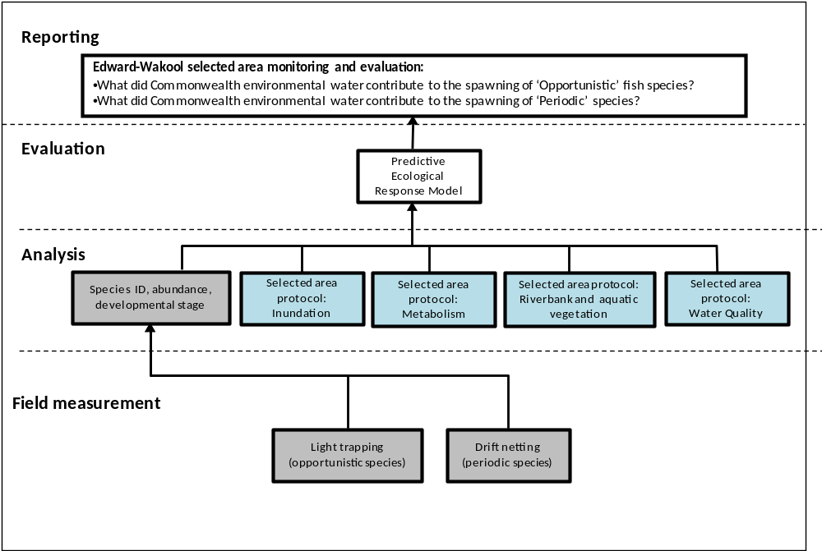
Figure 14. Schematic of key elements in Selected Area Monitoring and Evaluation - Fish larvae (Cat 3). Components covered by this protocol are highlighted in grey. Components highlighted in blue are also required for the predictive ecological response model.

Indicators
- Abundance of small bodied ‘opportunistic’ larval fish
- Abundance of eggs and larvae of large bodied ‘periodic’ flow dependent fish

Location for monitoring
Opportunistic fish species
Sampling for the fish larvae of opportunistic fish species will take place at 5 sites in 4 hydrological zones: zone 1 (Yallakool Creek), zone 2 (upper Wakool River), zone 3 (Mid Wakool River, upstream of Thule Creek), and zone 4 (Mid Wakool River, downstream of Thule Creek). Note: Only 2 sites in zone 3 will need to be sampled as per the Fish (Larvae) standard methods (Cat 3). This is because a subset of the data collected from the three sites used in Fish (Larvae) Basin-level-evaluation will be used to make up the full complement of data required from Zone 3.

Periodic fish species
Drift nets will be set at 1 site in each of the following hydrological zones: zone 1 (Yallakool Creek), zone 2 (upper Wakool River) and zone 4 (mid Wakool River, downstream of Thule Creek). Data collected for Fish (Larvae) Basin Level evaluation (drift nets) from Zone 3 will be also used for Selected Area evaluation.

In addition to the drift net sampling taking place in zone 1 – 4 as described above, additional drift netting will take place in the Edward River downstream of Steven’s Weir, near Deniliquin, as part of the integrated research project in the Edward River (see section 6). The location of these sites will be determined following consultation with CEWO and other stakeholders at the same time as reaches are selected for hydraulic modelling and vegetation (see section 6).

Timing and frequency
Opportunistic fish species
Light trap sampling for larvae of Opportunistic fish species will occur fortnightly, from September to February inclusive in zone 1, zone 2, zone 3 and zone 4. Each zone will be sampled for 1 night on each sampling event. This type of sampling will also capture other species, including more ‘Equilibrium’ fish species (e.g Murray Cod, sensu Humphries et al. 1999), that spawn every year independently of flow conditions.
Periodic fish species
To compliment the sampling of Periodic larval fish species for the Basin-Scale evaluation, drift net sampling for the Edward-Wakool Selected Area evaluation will also be undertaken on a fortnightly basis, between September and December of each year in zones 1, zone 2, zone 3 and zone 4
Responsibilities and collaboration
- Collaboration: This is a collaboration involving Charles Sturt University and NSW DPI Fisheries
- Field sampling: Field Technicians from CSU and NSW Fisheries will undertake the monitoring in the Wakool River and Yallakool Creek.
- Larval identification and sample processing: Nicole McCasker and John Trethewie (CSU)
- Data analysis: Nicole McCasker (CSU)
- Report writing: Nicole McCasker (CSU)

Field methods
Opportunistic fish species
In alignment with the gear used in Fish (Larvae) standard methods (Cat 1) for light trapping (Hale et al. 2014), modified quatrefoil light traps with 5 mm entrances and 3mm knot-to-know mesh will be used to sample fish larvae (as described in Humphries et al. 2002). Light traps will be deployed fortnightly at five sites in zones 1, 2, 3 and 4. Three light traps will be randomly allocated within each site, whereby 3 random GPS waypoints are used to locate the closest slackwater to each waypoint for the positioning of light traps. If no slackwater is available within 20 m either side of the waypoint, another random waypoint will be selected.
Light traps will be deployed late afternoon, and retrieved the following morning. Set and retrieval times will be recorded, so that relative abundance can be expressed as catch-per-unit-effort (CPUE). Each light trap will be baited with a yellow Cyalume 12 h light stick.
Upon retrieval, light traps will be rinsed down and entire samples will be preserved individually in 90% ethanol, and returned to the laboratory for processing.
Periodic fish species
In alignment with the gear used in Fish (Larvae) standard methods for Basin-Scale evaluation, drift nets constructed of 500 µm mesh, with an opening of 50 cm and tapering over 1.5 m to an opening of 9 cm will be used to collect eggs/larvae of golden and silver perch. On each sampling trip, three, fixed station drift nets will be deployed at 1 site within each zone (zone 1, 2 and 4). Because the Edward River is much larger compared to the Wakool and Yallakool Rivers, a greater effort of drift net sampling will take place, with three drift nets to be deployed at 4 sites.
Drift nets will be positioned in the water with a moderate velocity, at locations within each zone where the discharge is concentrated through a narrow section of the river (a funnel effect). Each drift net will be fitted with an Oceanic Flow Meter to estimate the volume of water that has passed through the drift net during its deployment. Volume through the net will be estimated so that larval abundances in drift nets can be expressed as a density: number of individuals per m³. Volume sampled by the net is estimated as $πr^{2}∙v ∙t$, where r is radius in metres, v is mean velocity in m s⁻¹, and t is time set in seconds.
Drift nets will be deployed late afternoon and retrieved the following morning. Set and retrieval times will be recorded, so that relative abundance can be expressed as catch-per-unit- effort (CPUE). Upon retrieval, drift nets will be rinsed down and entire samples will be preserved individually in 70% ethanol and returned to the laboratory for processing.
Laboratory methods
All eggs/larvae collected in the light trap and drift net samples will be identified to species, and enumerated. The developmental stage of each individual will also be recorded according to classifications of Serafini and Humphries (2004). Here, ontogeny is classified into seven key developmental stages: egg, yolksac protolarvae, protolarvae, flexion, post-flexion, metalarvae and juvenile/adult.

Health and Safety
The Edward-Wakool Selected Area Health and Safety Plan (HSP) includes an assessment of all identified potential risks and a plan on how these risks will be managed.
5.7.2 Evaluation
Fish larvae (Cat 3) monitoring will address the Selected Area evaluation questions in table 16.
Table 16 Fish larvae (Cat 3) evaluation questions
Evaluation questions
Short and Long-term questions
- What did Commonwealth environmental water contribute to the spawning of 'Opportunistic' (e.g. small bodied fish) species?
- What did Commonwealth environmental water contribute to spawning in ‘flow-dependent’ spawning species (e.g. golden and silver perch)?

Selected Area question hypotheses
H₁ Spawning of opportunistic fish species, as measured by abundance of larvae, will increase either during or immediately following environmental water delivery, compared to nearby rivers not receiving environmental water (<1 year reporting).
H₂ Successful spawning of flow-dependent spawners such as golden and silver perch will occur either during or immediately following the delivery of CEWO environmental water that is delivered as high spring flows, compared to nearby rivers not receiving environmental water (<1 year reporting).
H₃ Total production of fish larvae during spawning season will be significantly greater in the rivers that received environmental freshes compared to those that did not (1-5 years reporting).
H₄ The magnitude of spawning in opportunistic fish species will be significantly influenced by key hydrological and physical chemical parameters including the amount and duration of slackwater habitat, water depth, instream aquatic vegetation (1-5 years reporting).
H₅ The successful spawning of flow-dependent spawners will be significantly influenced by key hydrological and physical chemical parameters including magnitude of discharge change, rate of discharge change, extent and duration of overbank flow, and temperature (1-5 years reporting).
Critical covariates
- For opportunistic fish species: temperature, area of slackwater inundated, velocity, depth and discharge, and whether the zone received environmental water
- For periodic fish species: temperature, rate and magnitude of discharge change, extent of overbank flow and duration, whether the zone received environmental water.
Data analysis and reporting
Spawning in opportunistic fish species
Light trap abundance will be expressed abundance of larvae collected at the site level. To do this, data from the three light traps per site will be pooled.
For event-based analysis, data will be analysed with a BACI style approach comparing larval abundance in zones that received environmental water to zones that did not receive environmental water; before, during and after environmental water releases.
For short (<1 year analysis), data will be analysed using a traditional ANOVA approach, to answer the question: Was the magnitude of fish spawning over the spawning season greater in hydrological zones that received environmental water compared to those that did not. Here the total number of larvae collected in light traps across the entire season will be used as the dependent variable, and hydrological zone used as the treatment factor.
For longer term (1-5 year analysis) trends: a hierarchical model (continuous modelling) will be used to look at what environmental factors drive spawning magnitude in the Edward-Wakool area. Independent variables that will be assessed in this model include a mix of continuous variables including temperature, season, and hydrological variables such area of slackwater within sites, velocity, depth and discharge, and categorical variables such as (e.g. hydrological zone, and whether zone received environmental water). This model will be important for understanding the mechanisms behind observed trends in spawning magnitude of small bodied fish, and thus help to provide predictive capabilities under different environmental watering actions.
The magnitude of spawning in fish is an important variable influencing the amount of recruitment taking place in native fish populations. Therefore, the data gathered in this cat 3 component will be important data that is used in a larger fish recruitment model (see Cat 3: Fish recruitment, section 5.9).
Spawning in periodic fish species
Eggs and larvae collected from drift nets will be expressed as ‘catch-per-unit-effort’ (CPUE), where the units are density of eggs/larvae (number of individuals collected per drift net per volume of water passed through the net). Density data will be analysed at the site level, meaning that data from the three drift nets per site will be pooled.
For short (1 year) analysis, data will be analysed using a more traditional ANOVA approach, to answer the question: Was the spawning magnitude of golden and silver perch over the entire spawning season greater in hydrological zones receiving environmental water compared to those that did not. Here the total density of eggs/larvae collected in drift nets across the entire season is used as the dependent variable, and hydrological zone used as the treatment factor.
For longer term (1-5 year) analysis trends, a hierarchical model (continuous modelling) will be used to look at what environmental factors influence the successful spawning of golden and silver perch spawning in the Edward-Wakool area. Independent variables that will be assessed in this model include a mix of continuous variables including temperature, season, and hydrological variables such as rate of discharge change, magnitude of discharge change, extent of overbank flow and duration, as well as categorical variables such as hydrological zone, and whether the zone received environmental water. These models will be important for understanding the mechanisms behind both the success and magnitude of spawning in flow-dependent spawners like golden and silver perch, and help to provide predictive capabilities of spawning for these species under different environmental watering actions in the Edward-Wakool Selected Area.
The magnitude of spawning in fish is an important variable influencing the amount of recruitment taking place in native fish populations. Therefore, the data gathered in this cat 3 component will be important data that is used in a larger fish recruitment model for golden and silver perch (see Cat 3: YOY Fish recruitment methods, section 5.9).
5.7.3 Research
New research on fish reproduction will be undertaken as part of the integrated research project in the Edward River (see section 6).

5.8 Fish recruitment (Category 3)
5.8.1 Monitoring
Overview and context
The early stage of the life of a fish is when the highest mortality occurs. Recruitment, or survival of eggs/larvae to young-of-year life-history stage, is a fundamental process required to sustain fish populations. Previous data from the Edward-Wakool system (Watts et al. 2012; 2013) demonstrate that recruit stages of large-bodied fish will not be sampled effectively under proposed Cat 1 boat electrofishing and larval fish sampling methodologies. The proposed monitoring aims to develop an annual index of recruitment for young-of-year (YOY) juveniles and age-class 1 (1+) fish, specifically targeting Murray cod, golden perch and silver perch. Daily and annual age-length curves developed from recruit stage fish will fill gaps contributing to Cat 1 otolith age requirements.
This component aims to develop a recruitment index for young-of-year (YOY) and age-class 1 (1+) fish across a range of species and will develop age-length growth models for target species including Murray cod, golden perch and silver perch. The age-length data will contribute to Cat 1 age and growth requirements by providing aged samples of fish less than 2 years old and will provide an annual index of fish recruitment for large bodied species that will not otherwise be available as part of the proposed standard methodology.
A gap in the current proposed Cat 1 methodology is a targeted monitoring programme to understand changes in fish recruitment in response to Commonwealth Environmental Watering actions. The standard methodology for sampling larvae, an indicator of adult reproduction, does not target or effectively sample young-of-year fish of large-bodied species including Murray cod, golden perch and silver perch. Furthermore, annual Category 1 Fish River monitoring is targeted only in zone 3 of the Edward-Wakool system. This Category 3 method addresses the spatial limitations of the Category 1 approach, and specifically addresses questions regarding fish recruitment.
The process for evaluating YOY Fish Recruitment questions is illustrated in Figure 15, with components covered by the protocol highlighted in grey. Components highlighted in blue are required for the predictive ecological response model.

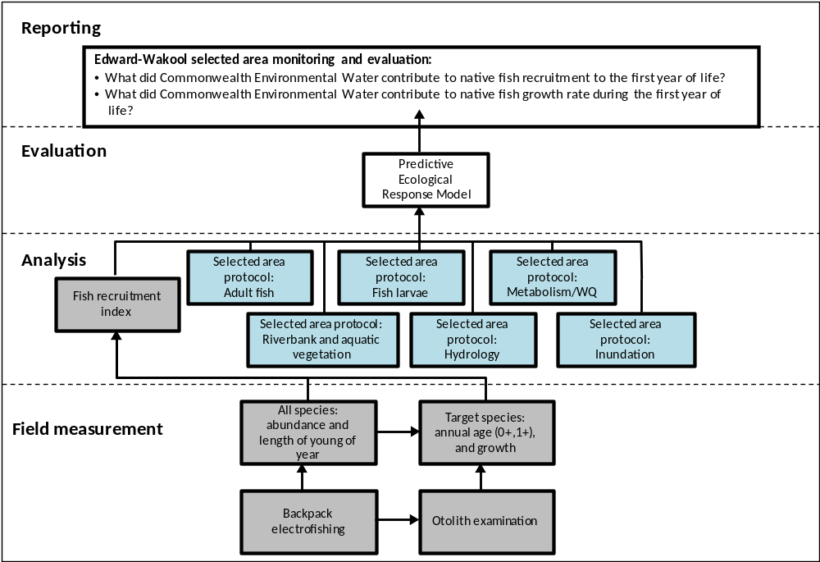
Figure 15 Schematic of key elements in Selected Area Monitoring and Evaluation – Fish recruitment. Components covered by this protocol are highlighted in grey. Components highlighted in blue are required for the predictive ecological response model.

Indicators
Two annual recruitment indices and one index of annual recruit growth will be developed for Murray cod, golden perch and silver perch in each zone:
- Recruitment index 1: Annual relative abundance of YOY juveniles:
- Recruitment index 2: Annual relative abundance of 1+ fish
- Recruit growth: Annual variation in length of recruits (YOY and 1+)

Critical covariates
Species, area of inundation, year, zone, temperature, adult CPUE, ecosystem metabolism, invertebrate biomass and annual flow parameters.
Location for monitoring
Monitoring of YOY fish recruitment will be undertaken in zone 1 (Yallakool Creek), zone 2 (upper Wakool River), zone 3 (mid Wakool River upstream Thule Creek) and zone 4 (mid Wakool River downstream Thule Creek.) with four sites per zone.

Timing and frequency
Targeted sampling for recruits will occur between January and April at which point fish hatched in October-December that year (YOY) and the previous year (1+) will be targeted.
Responsibilities
- Collaboration: This is a collaboration involving Charles Sturt University and NSW DPI Fisheries.
- Planning and organizing field trips, maintaining equipment, conducting fish sampling using boat electrofishing, backpack electrofishing fishing, setlines and standardised angling: John Trethewie (CSU) and Field Technicians (NSW DPI)
- Extracting and mounting otoliths: Fish Aging Services, Queenscliff
- Lab processing of otoliths: Fish Aging Services, Queenscliff
- Otolith age estimates, analysis and reporting: John Trethewie (CSU)
Field methods
Four sites will be sampled in each zone between January and April. Sites will be sampled in random order among zones. Sampling will be targeted in and around coarse woody debris, overhanging vegetation and other physical structure that may provide cover for young fish.
Each sampling occasion and site will consist of boat or backpack electrofishing depending on depth, ten setlines with two baited hooks per line and standardised angling to sample young individuals of large-bodied species.
Juveniles of all species will be identified enumerated and measured in the field. Otoliths from estimated young-of-year, 1+ and 2+ fish of each species including Murray cod, golden perch and silver perch will be retained for annual aging.
Laboratory methods
Annual aged otoliths will be extracted and embedded in a polyester resin, sectioned to approximately 100 µm thick, mounted on a microscope slide and polished with lapidary film. Each sample will be aged once by an internal reader (John Trethewie) and twice by the Fish Ageing Services. Digitized photographs of each otolith and each annulus reading will be recorded. The final age estimate will be determined by using the matching readings and samples with low reading precision will be discarded (Campana 2001).
Health and Safety
The Edward-Wakool Selected Area Health and Safety Plan (HSP) includes an assessment of all identified potential risks and a plan on how these risks will be managed.

5.8.2 Evaluation
Fish recruitment monitoring will address the Selected Area evaluation questions in table 17.
Table 17 Fish recruitment evaluation questions
Evaluation questions
Short and Long-term questions
- What did Commonwealth environmental water contribute to native fish recruitment to the first year of life?
- What did Commonwealth environmental water contribute to native fish growth rate during the first year of life?
Selected Area Hypotheses
We will test two hypotheses:
- H₁: Annual recruitment of YOY and 1+ Murray cod, golden perch and silver perch will be highest in years with increasing area and duration of inundation.
- H₂: Growth rate of YOY and 1+ Murray cod, golden perch and silver perch will highest in years with increasing area and duration of inundation.
Data analysis and reporting
Recruitment indices of YOY and 1+ juvenile Murray cod, golden perch and silver perch will be calculated from catch per unit effort of samples collected from boat and backpack electrofishing, setlines and standardised angling.
Raw catch per unit effort for recruitment indices will be examined using a Generalized Linear Mixed Effects Model (GLMM) incorporating temporal, spatial and abiotic factors including flow related parameters and inundation area model estimates for each zone and year over the five year project duration. Factors influencing variation in recruit length after removing the effects of age will also be examined using a GLMM incorporating the same factors.
Estimates of recruit age will be derived from age-length models in individuals where otoliths were not extracted. The trajectory of change (positive, neutral, negative) in recruit growth will be estimated from GLMMs to evaluate effect of Commonwealth environmental water.
Reporting will include the three annual indicators (two annual recruitment indices and one index of annual recruit growth) for Murray cod, golden perch and silver perch within each zone.
- Recruitment index 1: Annual relative abundance of YOY juveniles
- Recruitment index 2: Annual relative abundance of 1+ fish
- Recruit growth: Annual variation in length of recruits (YOY and 1+)
Discussion will focus on whether annual recruitment and growth indices were affected by changes in flow conditions and to what extent Commonwealth environmental water contributed these changes.
5.8.3 Research
No additional research on fish recruitment will be undertaken as part of the Flow-MER project.

5.9 Fish River (Category 1)
5.9.1 Monitoring
Overview and context
These standard methods describe monitoring required for the Basin-scale evaluation of the response of river fish to Commonwealth environmental water. The methods describe the sampling design and protocol for small- and large-bodied fishes in river channels for the LTIM Project. The process for evaluating these questions is illustrated in Figure 16, with components covered by this protocol highlighted in blue.
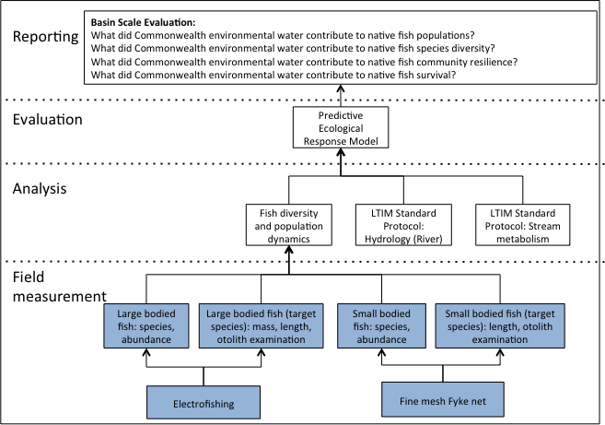
Figure 16 Schematic of key elements in LTIM Project Standard Protocol: Fish (River) – Cat 1. Components covered by the Fish (river) Cat 1 methods are highlighted in blue.

Indicators
This protocol describes sampling once each year during autumn to measure:
- Catch-Per-Unit-Effort (CPUE) of each fish species for:
  - Electrofishing
  - Small-meshed fyke nets
- Population structure data for target species:
  - Length
  - Weight
  - Approximate age structure (from otolith examination)
Location for monitoring
Monitoring for Fish (River – Cat 1) will take place in Zone 3 (Mid Wakool River, upstream of Thule Creek).
Timing and frequency
The channel sites of each Selected Area will be sampled once each autumn (March-May inclusive).
Responsibilities
- Collaboration: This is a collaboration involving NSW DPI Fisheries and Charles Sturt University.
- Field sampling: NSW DPI Fisheries staff and CSU Technical Officer
- Data entry and management, Data analysis and reporting: Led by Dr Jason Thiem (NSW Fisheries) Fisheries NSW project staff based at Narrandera Fisheries Centre will coordinate and schedule the sampling, data management, analysis and reporting for this component; with assistance from other team members as required.
Methods
The following sections outline the methodology for fish (river) Cat 1 according to Hale et al. (2014) and also fish (river) Cat 3, with inclusions of Location for monitoring, Responsibilities and Health and Safety Plan subsections. The fish (river) – Cat 1 methodology will be used for Basin-scale evaluations, however part of the data obtained will also be used to address Selected Area questions as part of the Fish (River) – Cat 3 methodology.
Protocol for establishing sites
LTIM Project for Basin-scale evaluation adopted a hierarchical approach to sample design (Figure 17). The spatial hierarchy for fish (river) monitoring is as follows:
- Selected Area
  - Zone
    - Site
Zone placement within Selected Areas
A ‘zone’ is a subset of a Selected Area that represents a spatially, geomorphological and/or hydrological distinct unit at a broad landscape scale. For example, separate river systems, sub-catchments or large groups of wetlands.
For Basin-scale evaluation, Zone 3 will be used. Following the recommendations of Hale et al. (2014):
- Different zones within Selected Areas represent spatially-, geomorphologically- and/or hydrologically-distinct units;
- Zones must be likely to receive Commonwealth environmental water at least once in the next five years;
- Zones must have an expected outcome related to the indicator in question
For Basin-scale analysis one zone (Zone 3) will be monitored within the Edward-Wakool Selected Area. The zone selected for Basin-scale data will have the following characteristics:
- The zone will be situated on a single river channel within a Selected Area, and the zone should contain channel habitat that is generally representative of the Selected Area as a whole;
- Within the channel of this zone there will ideally be a flow gauging station measuring height and discharge (otherwise a manual gauging station must be established (see LTIM Project Standard Protocol: Hydrology (River);
- The zone will contain relatively high abundances of the target species to maximise potential to obtain powerful age- or stage-structure data.
- This zone will be among the zones of an Selected Area most likely to receive Commonwealth environmental water, towards some significant change in river hydrology during that Commonwealth environmental water delivery event;
- The zone will contain channel habitat that can be readily accessed—either by boat or car—for sampling using the full suite of active and passive gears detailed below;
Site placement within zones
A ‘site’ is defined as follows:
- An 800 m reach of channel within a zone
- Site location for channel sampling will be fixed throughout the project.
- Each site will be accessible and be representative of the zone.
- Ideally, each site will coincide with a pre-existing discharge and river height gauging station. In the event a site does not contain a gauging station, new gauging stations (and associated rating curves etc.) may have to be established.
- Each site will not be within 1 km of a significant tributary and/or distributary.
The below specifications for site number and distribution will be applied:
- Ten channel sites will be located within the zone targeted for Basin-scale monitoring/analysis.
- All ten sites for Basin-scale data will be located on a single channel.
- These sites will be distributed randomly throughout the zone selected for Basin-scale data collection, such that the samples collected are representative of that zone. However, they will not be spread over a distance farther than 100 km.
Sample placement within sites
A sampling grid will be established within each site to ensure individual samples can be randomly sampled from that site, and are therefore representative of that site as a whole. Sampling will be random with respect to the environment to avoid temporal and spatial biases.
Hale et al. (2014) propose that a totally random sampling design is most appropriate for detecting flow-induced temporal trends within zones and Selected Areas, and spatiotemporal trends among zones and Selected Areas. Each 800 m site is subdivided by fixed transects spaced 50 m apart. Points of intersection between transects and the river bank define the sampling grid (Figure 17).
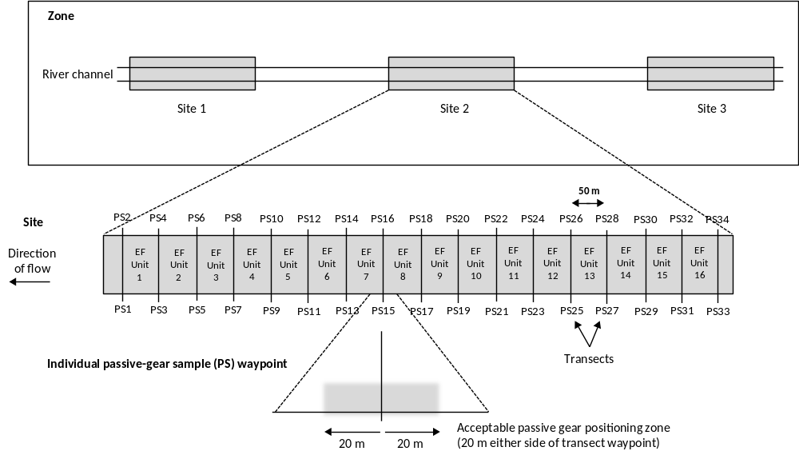
Figure 17 Diagram of hierarchical sample design illustrating zones, sites and sample locations.

The sample design defines two key sampling locations: electrofishing (EF) units (16 in total), and passive-gear sample (PS) waypoints (34 in total). Use of these EF units and PS waypoints will be explained below.
To establish the PS grid, each PS waypoint will be saved in a GPS, so that the GPS can be used to locate each PS waypoint over the monitoring period. That is, it is not necessary to establish visible transects and physically label each PS waypoint (e.g. a stake, floats or flagging tape).
Representative species from life-history guilds
Fishes belonging to different life history guilds may respond in different ways to managed and natural flows. Towards a more complete knowledge of fish population response to flows, monitoring will target representatives of the three primary life history guilds: equilibrium, periodic and opportunistic. Additional data will be collected from these target species.
Protocol
The following protocol from Hale et al. (2014) will be followed:
- Within the Selected Area we will identify six target species, two from each guild. Within each guild, one of the two species will be fixed, and common to all Selected Areas (as much as practicable), while the identity of the other species will be flexible across Selected Areas.
- The equilibrium life history species targeted for detailed data collection will be Murray cod.
- Across all Selected Areas the periodic life-history species targeted will be golden perch. Across all Selected Areas the opportunistic life-history species targeted will be carp gudgeon, Hypseleotris spp.
Sampling protocol
Equipment
- Backpack or boat electrofisher, including nets, storage and processing equipment;
- Ethics and fisheries permits from relevant institutions;
- GPS;
- GPS coordinates of site structure (PS waypoints and EF units)
- PS waypoints determined using random number generator (sample locations within sites);
- 12 fine-mesh fyke nets (10 for use; 2 spare) per site;
- Anchoring devices for fyke nets (stakes, chains, etc.);
- Large (1000 mm) and small (300 mm) measuring boards;
- Scales, either quality hanging scales with bag or bench scales with bucket/tray for fish;
- Data sheets

Large-bodied species
Sampling
Large-bodied species will be sampled using either boat or backpack electrofishing, depending on the river height.
Sustainable Rivers Audit (SRA) electrofishing protocol will be a subset of what is described here, so that data collected as part of the CEWO Flow-MER Project can be compared and contrasted with SRA large-bodied fish data. We will not collect small-bodied species for processing using electrofishing, but collect all stages (including juveniles) of large-bodied species for processing.
Herein, ‘small-bodied’ species are those belonging to the following families:
- Galaxiidae;
- Retropinnidae;
- Atherinidae;
- Melanotaeniidae;
- Ambassidae;
- Nannopercidae;
- Eleotridae;
- Gobiidae;
- Poecilidae;
All other fish families of the Basin are considered ‘large-bodied’.
The following methods are suggested by Hale et al. (2014) and will be followed, with some adjustments to standard protocol (as described in a section below).
- The entire 800 m site will be electrofished. Within each electrofishing unit of a site (EF unit; Figure 17) two ‘shots’ of 90 s ‘on-time’ should be carried out. This results in a total of 2880 s (48 min on-time) for each site. No more than 180 s of shocking will be allocated to each EF unit, such that electrofishing effort is spread out across the entire site, thus giving a more random sample with respect to the (site’s) environment. Note that, within EF units the location of shots is left to the discretion of the service provider.
- If boat electrofishing alone results in a sample biased towards larger and/or older individuals, then effort may be split in half, across both boat and backpack methods. For example, 50% of the EF units might be shallow enough to be intensively fished (still 180 s) with backpack electrofishing, thus enabling fishers to target the shallower (< 40 cm deep), more structurally complex habitats where 0+ and 1+ individuals might reside. Alternatively a certain proportion of the 16 (EF units) x 2 (90 s shots per EF unit) = 32 shots may be allocated to backpack electrofishing the shallow margins.
- It is difficult to standardise electrofishing across areas towards meeting the objective of a robust sample that is representative of the population present. Once a certain ‘balance’ or partitioning of boat and backpack electrofishing is devised—within the constraints of the general ‘shot structure’ laid out above—the design will be maintained over the entire five years.
Processing - electrofishing
For every individual belonging to a target large-bodied species, the following will be obtained or implemented:
- Identified to species;
- Total (TL; round or square caudal fin species) OR fork (FL; fork-tailed species) lengths, in millimetres (mm);
- Mass in grams (g) (use scales that have been recently calibrated);
If > 20 individuals are obtained within a 90 s shot, the above information will be recorded on a random sub-sample of 20 individuals only. The random sub-sample will be the first 20 individuals sampled during a 90 s shot. That is, if 20 individuals from a target species are obtained in less than 90 s, sampling will cease until the above statistics are obtained, or we will separate the first 20 individuals from those caught subsequently during that 90 s shot.
Non-target species will be identified and enumerated; lengths and masses of these non-target species will not be measured. All individuals (including alien species) will be returned to the water.

Small-bodied species
Sampling
Small-bodied species will be sampled using a passive technique only; fine-mesh fyke nets. The fine-mesh fyke nets (2 mm mesh) should be double wing (each wing: 2.5 m × 1.2 m), with a first supporting hoop covered by a plastic grid (5 cm x 5 cm) to keep large aquatic vertebrates out of the trap.
A random number generator will be used to randomly select a subset of 10 PS waypoints from the total of 34. A waypoint encompasses a total of 40 m of bank (20 m either side of specific waypoint), so we will endeavour to find the point on the bank as close to the exact waypoint as possible. The purpose of this system is to ensure sampling is random with respect to the environment. If it is impossible (in the strict sense, not just inconvenient) to set a fyke net at a certain waypoint (current is too fast; bank is far too steep; water too deep; too many emergent macrophytes to be an effective fish sample), then an adjacent, unoccupied waypoint will be used.
Fine-mesh fyke nets will be set in the afternoon and retrieved the following morning. Set and retrieval times will be recorded for each individual net/trap, so that abundances can be expressed as rates.
Past monitoring programs have not used fine-mesh fyke nets in the channel. In many cases, however, fine-mesh fyke nets can be set in certain locations within river channels. Fine-mesh fyke nets sample a much broader subset of the overall fish community than minnow traps, and are effective for estimating relative abundances of active, pelagic species such as smelt and hardyhead. Furthermore, use of fyke nets in the river channel and in wetlands may allow comparisons of community and population structure among these two major habitat types.
Fine-mesh fyke nets will be set with the cod end facing the current, so that water velocity is deflected around the net and wings (Figure 18). For the net to be effective both wings and the cod end need to be anchored to the bottom very well using steel stakes. So that sampling effort is held constant across nets, the wings will have an aperture of 1 m.
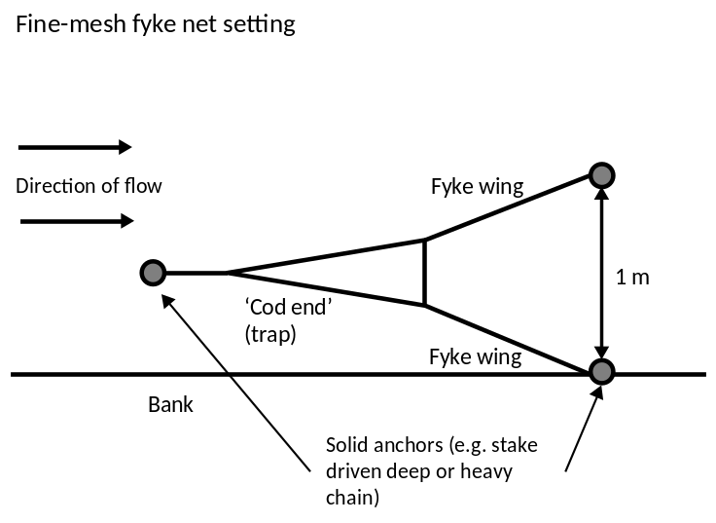
Figure 18 Diagram indicating the positioning of fine-mesh fyke nets in river channels, relative to the bank and direction of water flow. Cod-end should face upstream so as to not collect debris and act as a water velocity ‘parachute’.
Processing
The following measurements will be made for non-target, small-bodied species:
- Identify (to species) and enumerate all individuals. Random sub-samples will be used if nets capture too many fish for complete processing, as long as proportion of total sample sub-sample represents is recorded;
Further measurements are required for those small-bodied species targeted as part of the opportunistic guild:
- Obtain total (TL; round or square caudal fin species) OR fork (FL; fork-tailed species) lengths, in millimetres (mm), of up to the first 10 individuals from both target species, from each net. We will ensure the first ten are randomly selected from the overall sample. This may be achieved, for example, by using an aquarium net to ‘blindly’ sub-sample from a bucket until 10 individuals have been measured.
Adjustments to standard protocol
Annual sampling for Basin-scale analysis within zone 3 will follow the standard methods for riverine fish as specified by Hale et al. (2014). However, in order to improve comparability with historical data (SRA, NSW DPI) and increase sampling effectiveness for target species the following additional protocols and augmentations at each site have been proposed;
1. The amount of sampling effort per 90 second electrofishing ‘shot’ is to be partitioned between littoral/structural and open water habitats at a ratio of 5:1 in order to maintain comparability with CPUE data generated using the standard SRA protocol. This means that within any single electrofishing operation, 75 seconds should be used to sample littoral/structural habitats and 15 seconds of sampling should be undertaken in open-water habitats < 4 m deep.
2. Length data from all species is recorded for all operations of every gear type (with sub-sampling of 20 individuals per shot/net/trap) to allow generation of SRA metrics. This includes alien and both large and small bodied species.
3. The individual weight of the first 50 individuals measured for length of each non-target species will also be recorded.
4. Ten unbaited bait traps will be set for the duration of the electrofishing operations (minimum of 1.5 hours) to maintain consistency with SRA protocol.
Health and Safety
The Edward-Wakool Selected Area Health and Safety Plan (HSP) includes an assessment of all identified potential risks and a plan on how these risks will be managed.

5.9.2 Evaluation
Fish River monitoring will address the Basin scale and Selected Area evaluation questions in table 18.
Table 18 Fish river evaluation questions that are relevant to the Edward-Wakool Selected Area
Evaluation questions
Basin scale evaluation questions
Long term questions
- What did Commonwealth environmental water contribute to native fish populations?
Short term questions
- What did Commonwealth environmental water contribute to native fish reproduction?
- What did Commonwealth environmental water contribute to native fish survival?

Selected Area Hypothesis
H₁ The Edward-Wakool fish community responds to large-scale hydrological changes (floods and drought), and Commonwealth environmental water can contribute to the protection, maintenance and enhancement of the native fish community through strategic water delivery.

Data analysis and reporting
Relative abundance estimation
Abundances will be recorded as ‘catch-per-unit-effort’ (CPUE). Data will be structured in spreadsheets by individual ‘samples’, which are individual net hauls, or abundances within discrete electrofishing shots. Units will depend on sampling method—electrofishing versus trapping. Electrofishing CPUE will have units number of individuals per unit on-time for each shot. Passive trap CPUE units will be number of individuals per net per hour.
Population structure data for target species
Additional data will be collected for target species:
- Total length or fork length (mm), depending on species.
- Mass (gm).
Community data
The Basin Team (CSIRO) will also be conducting Basin-scale analyses of community response to Commonwealth environmental water. For these analyses they require CPUE data at the level of the site (species by site matrices) corresponding to each sampling method.

management
All data provided for this indicator will conform to the data structure defined in the LTIM Project Data Standard (Brooks and Wealands 2014). The data standard provides a means of collating consistent data that can be managed within the LTIM Project Monitoring Data Management System (MDMS).
The spatial unit for which data is reported for this indicator is known as an ‘assessment unit’. The assessment unit for this indicator is: the site (river section).
Each row of data provided for this indicator will identify the assessment unit, the temporal extent of the data and a number of additional variables (as guided by this standard method). The exact data structure for this indicator is maintained and communicated in the LTIM Project Data Standard and will be enforced by the MDMS when data is submitted.
Quality Assurance/Quality Control
Quality control and quality assurance protocols are documented in the Quality Plan developed as part of the Monitoring and Evaluation Plan for all Selected Areas. QA/QC activities specific to this protocol include:
- Electrofishers will be experienced operators of units. They will be supervised by Senior Operators on-site, and have obtained their electrofishing certificates through a reputable course.
- Monitoring and Evaluation Providers will have relevant boat licenses.
- Monitoring and Evaluation Providers will have specific fisheries and ethics permits with them while sampling.
- Fyke nets will be checked for holes in either wing- or cod-ends prior to every field trip. Any net with a hole will be repaired or replaced.
5.9.3 Research
No new research on Fish River (Cat 1) indicator will be undertaken as part of the Flow-MER program.

5.10 Fish River (Category 3)
5.10.1 Monitoring
Overview and context
Detecting valley-scale native fish changes in response to hydrological regimes
River regulation reduces habitat complexity, alters the timing and magnitude of flows necessary for critical life stages for fish, reduces in- and off-channel connectivity and promotes invasion of generalist alien species (Bunn and Arthington 2002). The use of Commonwealth environmental water to restore more natural flow characteristics can benefit native fish by increasing reproduction opportunities, stimulating in-stream migration to trigger a reproduction response or improving food availability which can translate to improved condition and larval survival (Humphries et al. 1999, Humphries et al. 2002, King et al. 2003). Further, many native fish species have been known to opportunistically use wetlands and floodplains for nursery habitat and to benefit from increased food availability (Lyon et al. 2010), and the delivery of Commonwealth environmental water can promote connectivity with these off-channel habitats.

The Edward-Wakool Selected Area presents an opportunity to understand flow-related outcomes because delivery options are flexible and controlled. We have designed a monitoring program that will enable 1) in-channel long-term broad scale trends in fish community composition in relation to sequential hydrological events and the long-term hydrological regime. A broad scale fish community monitoring program will be undertaken in years 3 that will report on changes in native and alien species abundance and biomass using Sustainable Rivers Audit health indices. The design will be strengthened by having access to long term data collected (at some sites up to 20 years of data) and will extend the existing datasets at each of these sites.
Background
Dryland rivers in Australia are characterised by unique ecological communities that have adapted to extreme hydrological regimes, such as extensive flooding interrupted by long periods of low flow and drought (Humphries et al. 1999, Thoms and Sheldon 2000). Following European settlement, the majority of fish communities within these systems have undergone severe declines, and the alteration of natural flow regimes has contributed significantly. Flow regulation reduces habitat complexity, alters the timing and magnitude of flows necessary for critical life stages for fish, reduces in- and off-channel connectivity and promotes invasion of generalist alien species (Bunn and Arthington 2002). The use of Commonwealth environmental water to restore more natural flow characteristics can benefit native fish by increasing reproduction opportunities, by stimulating in-stream migration to trigger a reproduction response (Humphries et al. 1999, Humphries et al. 2002, King et al. 2003) or improving food availability which can translate to improved condition and larval survival. Further, many native fish species have been known to opportunistically use wetlands and floodplains for nursery habitat and to benefit from increased food availability (Lyon et al. 2010), and the delivery of Commonwealth environmental water can promote connectivity with these off-channel habitats.
Environmental water delivery has previously provided detectable short-term changes in fish communities in the Edward-Wakool system. For example, Gilligan et al. (2009) examined changes to the fish community before, during and after a 30 GL environmental flow. The objective of the flow was to sustain existing populations by improving water quality in deteriorating conditions during an extreme drought. Reproduction was triggered in Murray-Darling rainbowfish (Melanotaenia fluviatilis) and un-specked hardyhead (Craterocephalus stercusmuscarum fulvus), although there was no change detected in the abundances of Murray cod or silver perch (Bidyanus bidyanus) (Gilligan et al. 2009). Following the environmental water release, the abundance of golden perch and carp gudgeon (Hypseleotris spp) was found to decline (Gilligan et al. 2009). These outcomes were all based on a short-term before and after comparison. Whether these benefits contributed to overall long term changes was not determined.
It is likely that short term changes in fish community redistribution during environmental water delivery are driven by movement, localised changes in hydraulic and structural habitat availability and food resources. However, changes in fish community composition at the reach and valley scale are also likely to occur in response to environmental water delivery as indicated in the landscape fish diversity CED (MDFRC 2013). These landscape-scale changes are manifested by increasing biomass across the system, overall improvements to fish condition, the presence of recruitment, positive changes in native fish abundance and increased species richness. For example, landscape fish diversity over longer time scales (>10 years) is influenced by available habitat, connectivity and disturbance, which are mainly influenced by the interactions between flow and geomorphology. Providing greater access to habitat through connectivity is achievable using environmental water and will lead to a detectable change, at the valley scale, over the medium-long term. These are expected and measurable changes. The ability to detect change is often influenced by the overall objective of water delivery. Changes in landscape-scale fish condition are generally only applicable if environmental water delivery occurs to drive these impacts, and that only occurs when water holdings are high.
During periods when holdings are low, Commonwealth environmental water can be used to prevent deterioration of fish condition, to encourage dispersal to refuge sites and to sustain populations already present within refuge areas. For instance, a previous Commonwealth environmental water allocation in the Edward-Wakool River system successfully prevented a hypoxic blackwater event and protected many fish when water was released from irrigation escapes into the upper Wakool River and Yallakool Creek. Many fish survived in the area where water delivery took place, whilst many thousands of fish perished elsewhere.
The delivery of Commonwealth environmental water can also influence native fish reproduction directly by providing cues that stimulate reproductive behaviour or provide access to suitable available habitat. Likewise, the delivery of Commonwealth environmental water to drive fish recruitment outcomes can therefore be influenced indirectly by:
- The provision of food,
- Increasing available habitat,
- Promoting suitable water quality,
- Facilitating connectivity and dispersal

We have designed a monitoring protocol capable of detecting the changes likely to occur to the fish community structure in the Selected Area. The design enables the evaluation of fish community changes over:
- Medium term (1-5 years; recruitment and young of year abundance, fish condition, redistribution); and
- Long-term (5+ years; species richness, abundance and biomass).
The design will also enable comparison of the community structure with long term trends by including existing long term sites.

Basin plan objective and outcome
- Biodiversity (Fish species diversity)
- Resilience (Individual survival and condition)

The process for evaluating these questions is illustrated in Figure 19, with components covered by the protocol highlighted in grey. A modified CED is presented in Figure 20 and 21.
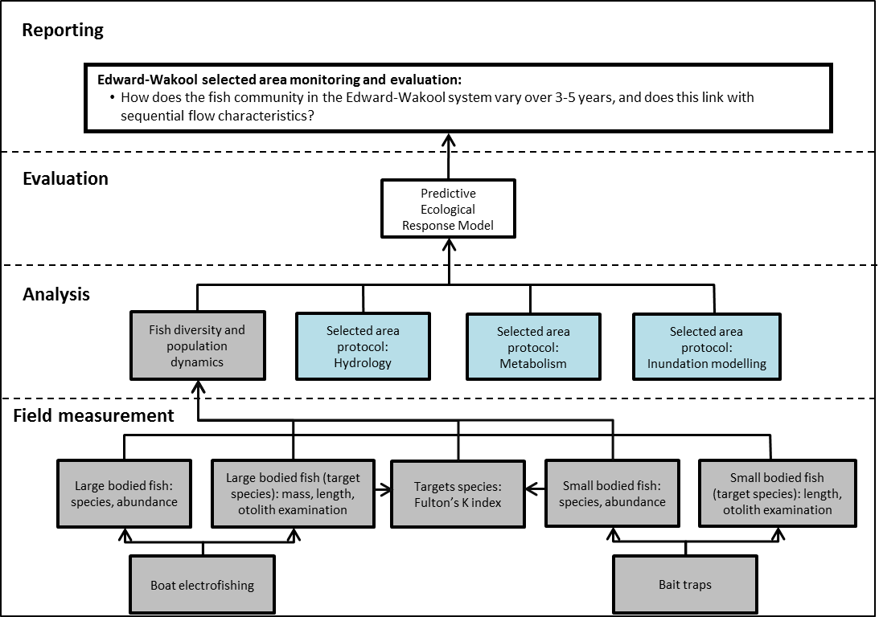
Figure 19. Schematic of key elements in Selected Area Monitoring and Evaluation – Fish (river) – Cat 3. Components covered by this protocol are highlighted in grey. Components highlighted in blue are also required for the predictive ecological response model.
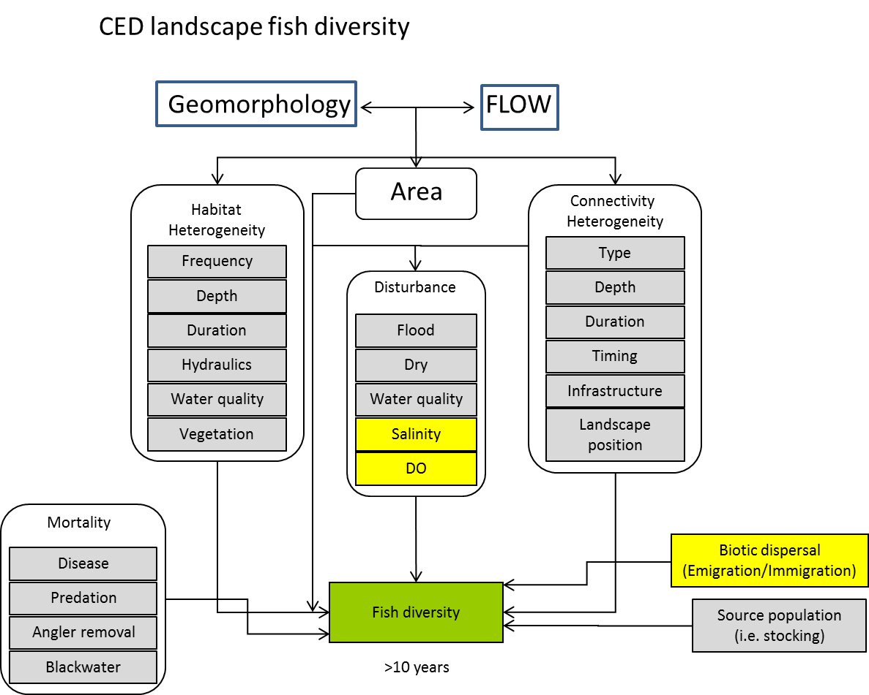
Figure 20. Modified landscape fish diversity cause and effect diagram. Yellow boxes indicate other CED’s.
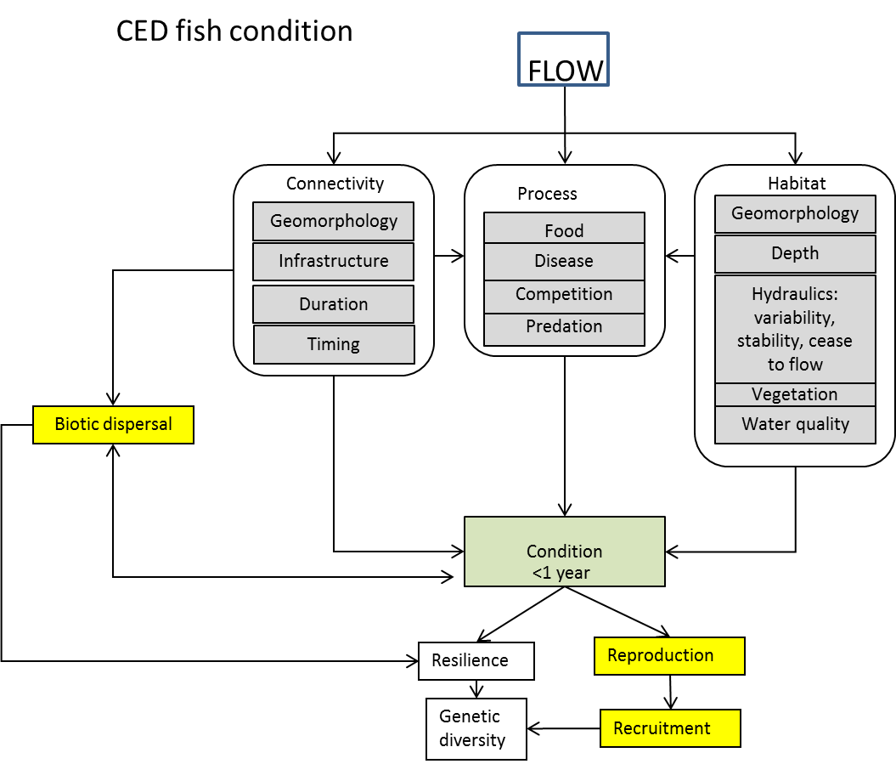
Figure 21. Modified Fish condition cause and effect diagram depicting the influences of flow. Yellow boxes indicate other CED’s.
Indicators
- CPUE of fish, length of fish, weight of fish, spatial distribution
- Covariates: Hydrology: (discharge, Δdischarge, height/level, wetted area, connectivity); water quality: temp, DO
Locations for monitoring
Sampling of an additional 20 sites distributed throughout the Edward-Wakool system will occur in year 3 (2022) of the Flow-MER project. These will all be in-channel sites, and will be located outside the Focal Area. Use of data from these additional sites coupled with data collected from a subsample of sites in the Fish (River) Cat 1 will enable long-term change trajectories of the native fish population to be determined using SRA health indices.
Timing and frequency
Cat 3 Fish River monitoring will be undertaken in 2022 (year 3 of Flow-MER program) between March and May following flow recession.
Responsibilities
- Collaboration: This is a collaboration involving NSW DPI Fisheries and Charles Sturt University.
- Field sampling: NSW DPI Fisheries staff and CSU Technical Officer
- Data entry and management, Data analysis and reporting: Led by Dr Jason Thiem, Fisheries NSW project staff based at Narrandera Fisheries Centre will coordinate and schedule the sampling, data management, analysis and reporting for this component; with assistance from other team members as required.
Methods
Existing long term fish community data exists at numerous sites within the Edward-Wakool Selected Area and was collected as part of other projects including short-term intervention monitoring, Edward-Wakool Fish and Flows, SRA, and NSW rivers survey. Where possible, sites with long term data sets will be retained.
Sampling will be conducted in year three of the Flow-MER program from March-May. In the interests of cost-efficiency and comparability with data generated by previous projects within the study area, the area scale assessment of the status of fish populations and assemblages will be conducted using Sustainable Rivers Audit (SRA) protocol (Davies et al. 2010). Fish will be sampled using a combination of boat or backpack electrofishing (12 x 90 second shots) and unbaited bait traps (n = 10). Additional augmentations to the standard SRA protocol will be:

- The LTIM Project subsampling procedure of measuring the first 20 individuals per shot/net/trap will be utilised in place of the SRA’s subsampling procedure.
- The individual weight of the first 50 individuals measured for length of each species will be recorded.

Important points of difference to LTIM Project Fish (river) Cat 1 sampling methods are that:
- Small-meshed fyke nets will not be used
- Only 18 to 20 minutes of electrofishing sampling effort will be used per site (depending on electrofishing equipment used).
- No otolith samples will be retained.
All fish community data will be entered onto the Fisheries NSW database.
Health and Safety
The Edward-Wakool Selected Area Health and Safety Plan (HSP) includes an assessment of all identified potential risks and a plan on how these risks will be managed.
5.10.2 Evaluation
Fish River (Cat 3) monitoring will address the Selected Area evaluation question in table 19.
Table 19 Fish River (Cat 3) evaluation questions
Evaluation questions
Long-term question
- How does the fish community in the Edward-Wakool system vary over 3-5 years, and does this link with sequential flow characteristics?

Data analysis and reporting
Raw catch and effort data for each sampling operation (electrofishing shot or net/trap set) will be recorded. Processed data for fish abundances will be reported as standardised catch-per-unit-effort (CPUE) per site.
Recruitment: Fish length structure will be evaluated for each species (where sample sizes permit) using Kolmogorov-Smirnov tests to examine changes in length distribution. Increased recruitment would be expected in years where the hydrological regime facilitated successful reproduction and provided suitable conditions conducive to growth and survival of larvae.
Native fish diversity and abundance, native fish biomass, recovery of the fish community: Fish community data will be summarised to compare results to four main SRA Indicators (see Robinson (2012)). The SRA derived Indicators will be; 1) Expectedness (provides a comparison of existing catch composition with historical fish distributions), 2) Nativeness (combination of abundance and biomass describing the proportion of the community comprised of native fish), 3) Recruitment (provides a proportion of the entire native fish population that is recruiting within a zone) and 4) Native and alien Biomass. Recruitment will be further divided; recruiting taxa (proportion of native species present recruiting), and recruiting sites (proportion of sites where recruitment occurs). These indicators produce a score that is related to Reference conditions, and receive a condition rating (Extremely Poor (0-20), Very Poor (21-40), poor (41-60), Moderate (61-80), Good (81-100). Changes to SRA condition ratings will be examined in 2014, 2019 and 2022, with an overall expectation that condition ratings will improve over time as a result of Commonwealth environmental water. In addition, fish community structure (species specific abundance and biomass at each site) will be analysed using permutational multivariate analysis of variance (PERMANOVA), with year as a fixed factor.
5.10.3 Research
No new research on Fish River (Cat 3) indicators will be undertaken as part of the Flow-MER Program.
5.10.4 Links to other monitoring themes and research
The fish river (Cat 3) indicator links with the hydrology (section 5.1), larval fish (section 5.7), fish recruitment (section 5.8) and eDNA research (section 6).

Contingency research, monitoring and engagement (2019-2022)
This section outlines the contingency research, monitoring and engagement activities undertaken from 2019 to 2021 that were included in the initial 2019 Edward-Wakool Flow-MER Plan. These activities were undertaken as an integrated research project, with components described here in sections 6.1 to 6.8. The details of contingency activities that were developed after the 2019 Flow-MER Plan was published are included in work orders presented in Appendices 3 to 10.
Integrated research project
An integrated research project that will specifically target gaps in knowledge that are necessary to improve the delivery, monitoring and evaluation of environmental water in the Edward-Wakool system. It will improve our understanding of the processes that drive physical and ecological responses to flow, and will inform adaptive management by providing recommendations for how Commonwealth environmental water can best be managed to achieve desired responses in the Edward-Wakool Selected Area.
An integrated research project undertaken from 2019 to 2021 will focus on the Edward River. This part of the Edward-Wakool River system was not monitored as part of the LTIM project, so there is a considerable knowledge gap that needs to be addressed to inform the future delivery of Commonwealth environmental water to the Edward River and the management of environmental water in relation to the Werai Forest, which is part of the NSW Central Murray Forests Ramsar site (NSW Office of Environment and Heritage 2018).
This integrated research project includes physical, ecological, and social research (Table 20) that will examine how managed flows in the Edward River, and the operation of Stevens Weir, influence physical aspects (e.g., lateral connectivity and physical form) and ecological processes, such as river productivity, wetland plant emergence and survival, turtle movement and condition, and fish spawning. In addition, an e-DNA approach will be used to determine the presence and spatial distribution of threatened, uncommon and iconic species of crustacean, frog, turtles, fish and aquatic mammals in the Edward-Wakool system that have not been the target of the LTIM and Flow-MER monitoring and evaluation. Integrated with these biophysical research themes, social research will be undertaken to examine stakeholder attitudes to, and acceptance of, the concept and use of Commonwealth environmental water. This will help identify what institutional, social and/or cultural interventions could improve the acceptance and impact of environmental water in the Edward-Wakool system.
An innovative aspect of this research project is that several stakeholder groups will participate in the research. Members of the Edward-Wakool Angler Association will participate in research on fish spawning. River Rangers from Yarkuwa Indigenous Knowledge Centre will collaborate on the riverbank and aquatic vegetation research in and near Werai Forest, which is in the process of being transferred to the Werai Land and Water Aboriginal Corporation as an Indigenous Protected Area. River Rangers will also participate in the research on turtle distribution and movement.
The integration of physical, ecological and social research within a research project is extremely rare, and the engagement and participation of community groups in this type of project is very uncommon. Thus, this project provides an opportunity to explore interrelationships and responses to flow, as well as examine other influences on the system. The results of this integrated research will inform the future adaptive management of environmental water and the approach to future monitoring in the Edward-Wakool system. The integrated nature of the research will also have broader relevance and will inform the adaptive management of environmental water in other areas of the Murray-Darling Basin.
Table 20 Summary of components that are part of the integrated research project to be undertaken in the Edward-Wakool system for the CEWO Monitoring, Evaluation and Research (Flow-MER) Project from 2019 to 2021. For information on hydrological zones see Figure 3 and Table 1 in section 2 of this Flow-MER Plan.
Theme | Zone |  | Overview
Hydraulic modelling | 11,12 | Hydraulic models will be developed for reaches in zones 11 and 12. This will be undertaken using a similar approach to the hydraulic models developed for Yallakool Creek, Wakool River and Colligen Creek as part of the LTIM project
Physical habitat | 4, 8,11,12 | Physical habitat evaluation will be undertaken in 2019-20 using an Unmanned Aerial Vehicle to assess riverbank condition and link with the evaluation of vegetation cover in response to flow
Riverbank and aquatic vegetation | 11,12 | Research on vegetation will be undertaken on riverbanks and in low lying parts of Werai Forest in collaboration with Yarkuwa Indigenous Knowledge Centre
Stream metabolism | 11,12 | The effect of flows and lateral connectivity on river productivity will be assessed comparing sites upstream and downstream of Werai Forest in the Edward River
Turtles | 11,12 | Research on turtle populations in the Edward River and adjacent wetlands is planned for 2019-21 to assess how connectivity of wetlands, affects turtle distribution, movement, and body condition.
Fish reproduction | 11 | Research on perch spawning will be undertaken in the Edward River downstream of Stevens Weir in 2019-20 in collaboration with the Edward-Wakool Angler Association
Biodiversity (e-DNA) | system | A biodiversity assessment will be undertaken 2019-20 to assess the presence of a range of rare and threatened taxa, including fish, frogs, mammals and crayfish.
Social science | system | Social science research is planned for 2020-21 to examine stakeholder attitudes to, and acceptance of, the concept and use of Commonwealth environmental water. This follows on from a project undertaken to assessment stakeholder responses to flow trials in the Edward-Wakool system in 2017 and 2018.

Some of the components of this research program will initially be undertaken for a period of 1 year (2019-20) under current budget allocations. This will limit the number of flow conditions that can be assessed. The opportunities for continuing this research beyond the first year will be assessed following the evaluation of the first year of results.

6.1 Two-dimensional hydraulic modelling
6.1.1 Background
Understanding the extent of riverbank inundation under different discharge scenarios is essential to describe changes in wetted benthic surface area, shallow water habitat and water velocity during environmental watering actions. Hydraulic modelling can also assist the interpretation of other indicators.
The use of digital elevation models to create a floodplain surface that can be inundated under different discharge scenarios may not give the best representation of floodplain inundation, because even small impediments on a predominantly flat floodplain can affect the models. However, in the Edward-Wakool system where much of the environmental watering is contained within the channel, the use of digital elevation models to create flow path assessments below bankfull is an appropriate approach to compare the extent of riverbank inundation and the area of slow flowing slackwater under different discharge scenarios. The inundation models can also serve as a tool to help predict the likely outcome of different flow management options on patterns of riverbank inundation.
The key objective of the hydraulic modelling is to estimate the extent of in-channel inundation and the area of different categories of velocities and depths that are created during flow events of different magnitude from base flows up to bankful flows. Inundation of riverbanks is important for river productivity. The creation of low flow shallow areas is important for the survival and growth of some riverbank plants and the survival of organisms such as larval fish. Similarly, the creation of higher velocity zones is important for spawning of some fish species.
The 2-D hydraulic modelling undertaken here will contribute to the Edward River integrated research project by informing the extent of inundation of low lying geomorphological features (e.g. benches, flood runners) and wetlands along the Edward River. It will also assist the communication of likely outcomes of planned watering events with stakeholders.
6.1.2 Research Question
- What is the relationship between flows and lateral connectivity, as measured by the in-channel wetted benthic area?
- What is the relationship between flows and the area of slackwater and slow flowing water?
- How does the management of Stevens Weir influence connectivity of wetlands and low lying features upstream and downstream of the weir?
6.1.3 Responsibilities and Collaboration
- Inundation modelling will be undertaken by a consultant in collaboration with the Project Manager. The Consultant will provide GIS layers and files to the Project team
- The mapping of inundated benthic area and velocity zones will be undertaken by the Charles Sturt University Spatial Analysis Unit (SPAN)
- Data analysis and reporting will be undertaken by Robyn Watts (CSU) and Nick Bond (La Trobe)
6.1.4 Research Proposal
2D hydraulic models will be created for study reaches in the Edward River both upstream and downstream of Stevens Weir, to complement the monitoring and research in that system. The location of reaches in the Edward River will be determined following consultation with CEWO and other stakeholders.
Each reach will be represented within the hydraulic model using a digital elevation model (DEM) supplied by the Murray LLS. It is fortunate that LIDAR was flown in the Edward-Wakool system during the drought when the majority of the river channels in this system were dry, so the DEMs are appropriate for modelling inundation within the river channel. Six discharge scenarios will be modelled for each zone or reach ranging from low flow to estimated bank-full flows including discharges at which Commonwealth environmental water is to be delivered.
Each scenario will be modelled assuming an initial dry starting condition with no residual water in the system. All scenarios will be run until stable state flow is achieved whereby the instantaneous flow rate at the downstream boundary condition stabilised and matched the upstream inflow value. Discharge scenarios will be modelled using the 2D grid implementation of Eonfusion Flood (Myriax Software) with model outputs post-processed using the GIS functionality of Eonfusion (Myriax Software).
Upon reaching stable state flow, an extent output from the model will be captured representing the spatial coverage of the water surface. Within each cell of the extent the water depth and surface elevation will be captured allowing a 3D surface of the stream bed underlying the water surface to be constructed. The wetted benthic surface area covered by the water surface will then be calculated using the derived 3D surface. Post-processing, including surface area calculations, will be undertaken achieved using Eonfusion (Myriax Software), Quantum GIS and made distributable using Google Earth.
Post processing of model outputs will be undertaken to quantify the spatial configuration into three velocity categories: Group 1: 0 – 0.02 m.sec⁻¹ (still water/slackwater), Group 2: 0.02 – 0.3 m.sec⁻¹ (slow water); Group 3: >0.3 m.sec⁻¹ (fast water). Post-processing, including surface area and depth calculations, will be achieved using Eonfusion Quantum GIS, Excel and made distributable using Google Earth. The results will be ground truthed by comparison with depth logger data at each site and through engagement with local landholders, especially for modelling of large flow events.
Several data sets will be constructed to quantify and represent the spatial distribution of each velocity zone including:
- Water velocity frames exported as a multiband raster in GeoTiff format suitable for viewing in ArcGIS or a similar GIS platform (GDA_MGA_1994_Zone_55),
- Water surface extent for each velocity zone for each scenario exported as bounding contours and polygons suitable for viewing in ArcGIS or a similar GIS platform (GDA_MGA_1994_Zone_55),
- Water surface extent for each velocity zone exported in a KMZ vector format which can be loaded directly into Google Earth for viewing against satellite imagery (WGS84).
- 3D surface area calculations for each velocity zone provided in spread sheet (.xlsx)
Data will be mapped for visual representation, and outputs will be analysed for comparison among discharge scenarios. 2D hydraulic models will be used to estimate a) the extent of lateral connectivity (as measured by benthic wetted area) under different flows, b) Area of water in different categories of velocities under different discharge scenarios, c) Area of water in different categories of depth under different discharge scenarios.
6.1.5 Timing and frequency
The modelling will be undertaken in the first year of the project. We have also budgeted for additional flow scenarios to be undertaken in the final year of the Flow-MER project year, to facilitate assessment of additional discharge scenarios that may be required to reflect delivery conditions of Commonwealth environmental water. Data analysis and reporting of the initial modelling will be included in the 2020 annual report.
6.1.6 Links to other monitoring and research themes
This research links with other components of the integrated research project.

6.2 Physical habitat research
6.2.1 Background
Bank condition is explicitly linked to Commonwealth Environmental Water (CEW) and other variable flows. The risk to biota from changes in bank morphology and sediment liberated from erosion make bank condition an important, and explanatory, variable for assessing the value of these water delivery patterns for achieving ecosystem objectives.
River banks influence the velocity of flow, depth of water, and provide the sediment conditions for biota including flora and fauna. River bank condition can alter conditions for biota, and this is often related to the extent of bank activity and river flow. For example, appropriate levels of erosion provide niches for vegetation establishment, yet, excessive erosion can lead to sediment smothering of bed habitat (as well as concerns for riparian infrastructure such as bridges and property).
Riverbank vegetation richness and diversity are also impacted by flows, including due to flow characteristics such as prolonged inundation, high velocities, and smothering (see section 5.4). These vegetation changes can be independent of bank condition, or extricable linked. There are considerable advantages to monitoring bank condition in concert with riverbank vegetation condition.
Quantifying the relationship between CEW and bank condition can assist with understanding flows that enhance the ecological objectives sought (i.e. bank vegetation establishment) and reduce any potential unintended consequences. The Cause and Effect Diagrams (CEDs) developed as part of the original LTIM illustrate some of the linkages between bank condition and a range of ecological and ecosystem values, Figure 22.
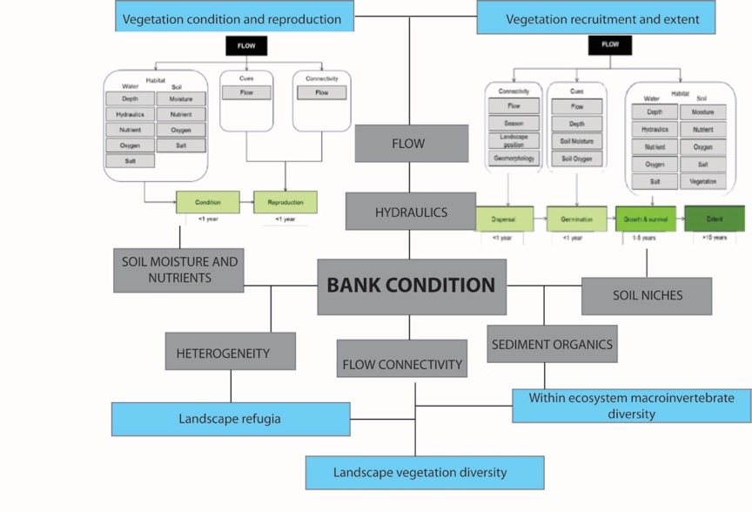
Figure 22 Contribution of bank condition monitoring to example CEDs developed for the CEW monitoring program.
Streamology has been undertaking physical habitat monitoring, including hydraulic habitat (hydraulic modelling) and bank condition monitoring (including erosion pins) for more than five years. Unmanned Aerial Vehicle (UAV) technology and photogrammetry methods have been used to generate spatial and temporal data investigating the impacts of environmental flows. UAVs were used to capture high resolution aerial imagery to process with photogrammetry methods to produce;
1) Detailed digital elevation models (DEMs), DEMs of Difference (DoDs) and quantifying bank condition changes.
2) Classified riparian vegetation maps displaying spatial and temporal differences associated with flow events, quantification of the percentage loss of riparian vegetation, and locating areas of most/least impact.
This approach has been successfully applied in the Goulburn River system. Similar techniques will be undertaken the Edward-Wakool Flow-MER project to gain accurate insights into the impacts of flow operations on riverbank habitat and riverbank condition. The Edward-Wakool system is a much smaller system than the Goulburn River. One of the aims of this research is to test this method during the ‘low flow delivery’ periods of the Edward Wakool.
6.2.2 Research Questions
The broad research questions are:
- What are the characteristics of the flow regime and river operations that drive erosion and deposition?
- What are the characteristics of flow regime and river operations that affect riverbank vegetation and aquatic vegetation cover?
Questions related to Commonwealth environmental watering actions in the Edward-Wakool system are:
- How does Commonwealth environmental watering in the Edward-Wakool system contribute to sustaining bank condition?
- How does the timing and delivery of Commonwealth environmental watering actions affect bank condition of rivers in the Edward-Wakool system?
- How do vegetation responses to Commonwealth environmental watering actions vary between sites with different channel features and different bank conditions?
- Is the use of Commonwealth environmental water adversely impacting the banks of the creeks and rivers?
The main outcomes of the riverbank vegetation and riverbank condition protocol using drones is:
  - determining links between flow operations and bank erosion or deposition;
  - determining links between flow operations and vegetation changes;
  - identifying how bank erosion/deposition and/or vegetation changes might be linked;
  - explaining how bank erosion/deposition and/or vegetation changes might explain other ecological responses (e.g., for fish or macroinvertebrates); and
  - better informing management of the pattern and timing of delivery of environmental flows to reduce bank instability, maintain/improve vegetation, and achieve ecological objectives.
6.2.3 Responsibilities and Collaboration
- Collaboration: This is a collaborative project involving Streamology and Charles Sturt University
- Field monitoring: UAV data collection will be undertaken by Streamology, vegetation ground truthing will be undertaken by Sascha Healy (MDWWG), and Robyn Watts (CSU)
- Data management: Desktop processing of UAV data to generate DEMs of difference and classified vegetation maps (Streamology)
- Data analysis and reporting: Geoff Vietz and Neil Sutton (Streamology)
6.2.4 Research Proposal
Background
During 2018-2019, Streamology employed a new technique to improve the monitoring of bank condition and riparian vegetation for investigating the impacts of environmental flows. The previous best practice methodology involved the use of erosion pins to measure and assess geomorphic condition and vegetation transect surveying to assess changes in riparian vegetation. The erosion pin approaches were able to gather insights for environmental flow management but were not spatially encompassing, not well suited to assessing some of the specific mechanisms associated with environmental flows (i.e., bank notching) and were time consuming. Compared to vegetation transects (one line of vegetation) the broad-scale assessment of vegetation has considerable advantages for assessing variability in vegetation changes and proportional change. The use of UAVs for riverbank vegetation and riverbank condition can be at the expense of detail, but is focused on providing a robust, repeatable measure of changes resulting from flowing conditions that can be used to monitor and inform flow operations.
Site selection
Sites have not yet been finalised for this project, but will be based on the following criteria:
- Sites must be directly influenced by environmental flow deliveries.
- Site characteristics of interest should be considered those sensitive to flow changes
- Sites should be preferably in close proximity to gauging stations.
- Sites must have appropriate access, but limited public access.
- If possible, sites will be preferentially considered if they have a history of ongoing geomorphic or vegetative surveying, as this will provide greater context for the changes occurring as a result of environmental flows.
- Sites must have sufficient vegetation to monitor, but must not have significant overhanging tree canopies which interfere with UAV image capture.

Timing of field visits
The timing of field visits will be coordinated to coincide with periods of low mean daily discharge, to gain as much insight possible into the condition of submerged banks associated with heightened environmental flows. As an example from the Goulburn River, Figure 23 illustrates the timing of past site visits measuring bank. Site visits were coordinated with low flow deliveries.
UAV bank and vegetation assessments will be undertaken four times during the first year of the Flow-MER to enable capture a minimum of change in two flow periods. Timing of UAV image collection will be scheduled to coordinate with low flow deliveries, so as to gain as much insight into the condition of the otherwise submerged banks.
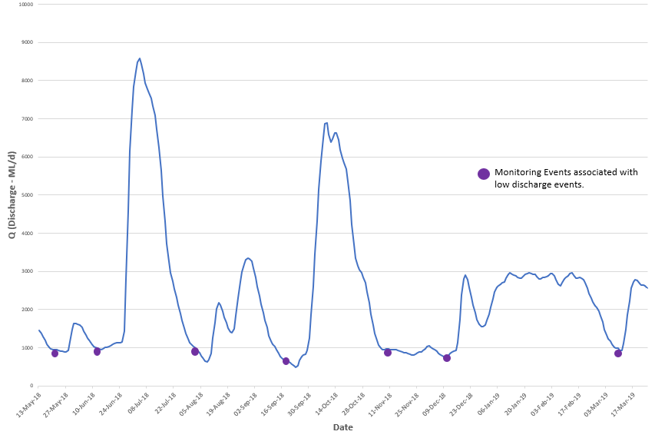
Figure 23 Hydrograph illustrating flow and the timing of past monitoring project at McCoy's Bridge (Goulburn River) between 2018 and 2019.

Field monitoring protocol
The following section details an abridged summary of the suggested field monitoring protocol as developed by Streamology.
- Ground control points (GCPS) are distributed
GCPs used in for this project will be bright objects such as orange traffic cones and bright yellow disks with large black ‘x’s in the centre. Approximately 10 GCPs will be distributed along riverbanks, with an even spread present on both banks. The GCPs will be placed in areas not constrained by canopy cover or hidden obstructions so they can be clearly identified and marked in both nadir and oblique imagery.

- UAV data collection
A DJI Phantom 4 with real-time kinetic (RTK) capability will be deployed to capture survey quality imagery. This is paired with a RTK base station providing real time corrections to the UAV. The DJI Phantom 4 is a sub-2kg class drone, and can be flown without a commercial license, in accordance with CASA restrictions. The Streamology team will notify CASA approximately 5 days before each flight.
A combination of nadir, oblique and terrestrial imagery will be captured using the DJI Phantom 4 (Figure 24). Nadir imagery will be collected using an ‘aerial grid flight’ and will be flown at an altitude of 60m above water level. The oblique imagery will be collected in a ‘freestyle’ flight, obtained at a lesser altitude (approx. 5-25m above water level).
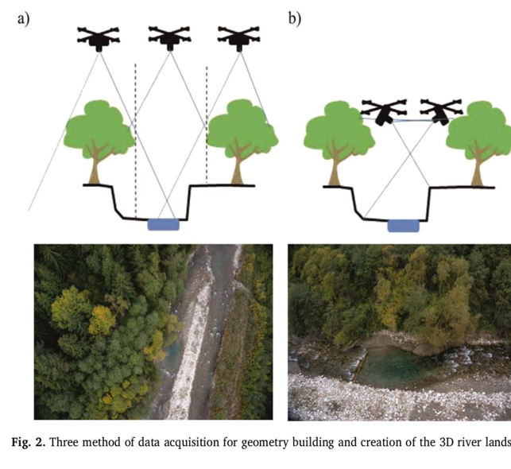
Figure 24 Imagery is captured through a combination of elevations and angles to create a detailed 3D model. Three methods include (a) nadir, (b) oblique, or (c) terrestrial or boat captured imagery (not shown)

- Ecological Input
Ecologists will be approached to provide expert opinion to assist Streamology by ‘ground truthing’ the data obtained by the UAV with observations made in the field. The input by these ecologists will involve species identification and map annotation, to provide ‘ground truthed’ training data for the subsequent classification of riparian vegetation.

Desktop monitoring protocol
The following section details an abridged summary of the proposed desktop monitoring protocol developed by Streamology.

- Generation of Densified Point Cloud
A densified point cloud is a series of 3D points which are used to generate a reconstructed model of a scene captured using UAV. The position of colour information will be stored as X, Y and Z coordinates, and these coordinates will be depicted in 3D space to generate an interactive and explorable model of the scene (riverbank). The nadir and oblique imagery collected by UAV will be input into a photogrammetry software (Pix4D Mapper). Each site visit will be separated into a new project file, and the GCPs will be used to resolve spatial differences between the nadir and oblique imagery, tying both sets of imagery into one geo-rectified densified point cloud. The densified point clouds will be necessary to generate a digital elevation model of difference.

- Generation of Orthomosaic
An orthomosaic is a 2D map, stitched together by correcting camera perspective from nadir imagery to display a map of uniform scale. Only nadir imagery will be used to generate the orthomosaics for each site visit. The orthomosaics will be necessary to perform the supervised image classification.

- Generation of digital elevation model of difference (DoD)
Densified point clouds will be exported into a spatial mapping program, to generate digital elevation models of difference which consider the minimum elevation points located for each coordinate. This will provide a more realistic picture of surface elevation changes as a result of environmental flows, with negative elevation changes represent erosion, and increased elevation indicates deposition has occurred. This will be represented spatially, with a large map per site, illustrating bank condition change, and will be accompanied by a series of smaller maps illustrating change at key areas, at high magnification and in high resolution.
- Generation of classified maps illustrating vegetation change
Orthomosaics will be imported into an image classification software to perform a supervised image classification to distinguish between vegetation classes (i.e. bare ground, woody debris, shrubs, high vegetation etc.). The classified images are then compared over consecutive site visits and are incorporated into a final interactive map which displays the spatial and temporal changes in riparian vegetation as a result of an environmental watering action (Figure 25). This data can also be displayed in a tabulated form, indicating the percentage change of different vegetation classes.
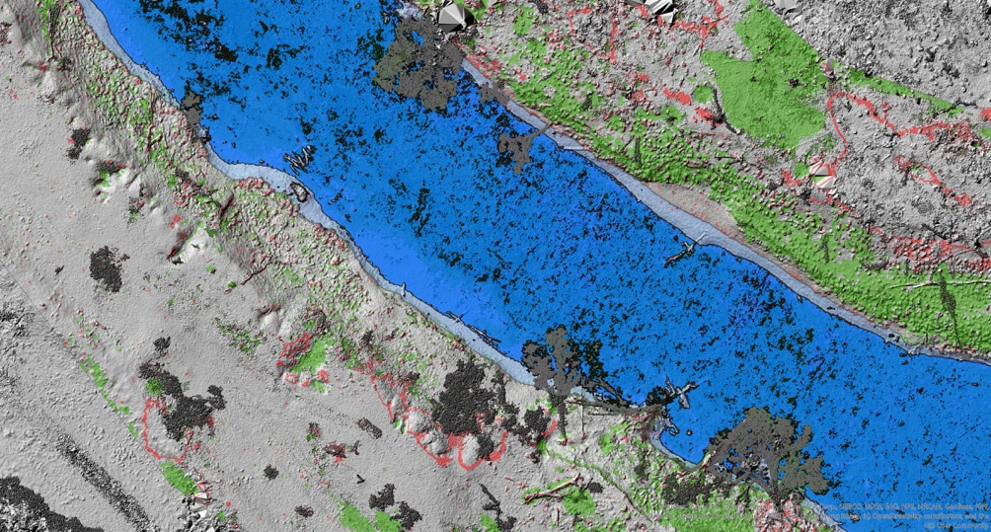
Figure 25 DOD layer overlaid upon a hillshade model produced from the UAV. Blue layer is current water level, light blue is maximum extent of IVT Flows with green represented deposition and vegetation increase and red representing erosion or vegetation mass lost.

Interpretation and outputs
Final interpretations will be performed by Streamology linking the results of riverbank vegetation changes and riverbank physical form changes (Figure 26) to hydrologic data. This will be placed in the context of ecological and ecosystem considerations to explain the influence of environmental flows on both bank condition and riparian vegetation. The data and outputs will be of great value providing insightful data for other MER activities. These results will be used to synthesise recommendations for the Commonwealth Environmental Water Holder and will greatly contribute to the growing understanding of environmental flow impact assessments in these systems.
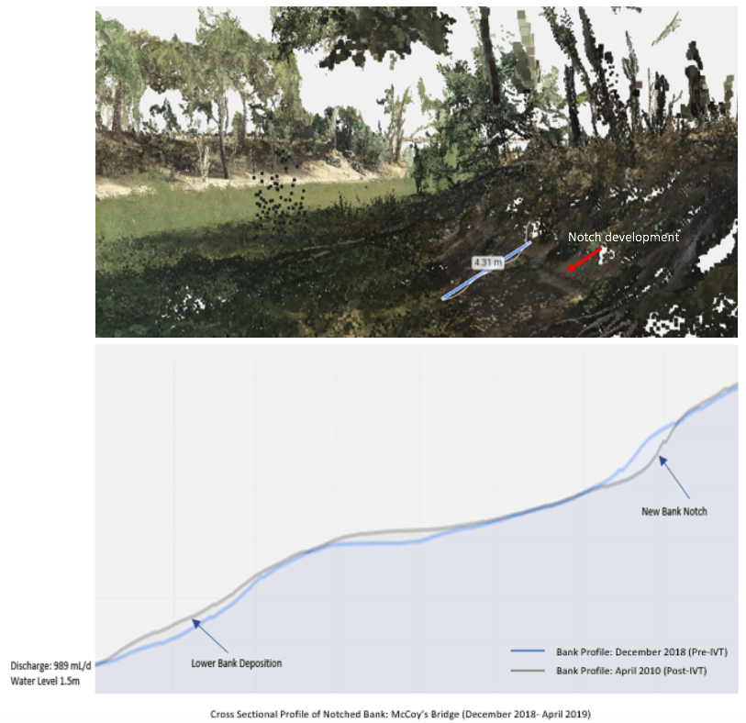
Figure 26 Example of outputs from digital models (above) and the extraction of changes in bank profiles between flows (below). Example from McCoy’s Bridge on the Goulburn River from December 2018 to April 2019. Note that high flows (at notch level) often create mid-bank notching and deposit material on the lower bank.

6.2.5 Links to other monitoring and research themes
This research links with the hydrology, hydraulic modelling, primary productivity, riverbank and aquatic vegetation, and social science components of the integrated research project.

6.3 Riverbank and aquatic vegetation
6.3.1 Background
As described in section 5.4, riverbank and aquatic plant survival and growth is affected by the frequency and duration of inundation, influencing germination, root and shoot development, growth, survival and reproduction. Riverbank vegetation and aquatic vegetation play an important role in the functioning of aquatic ecosystems, supporting riverine productivity and food webs and providing habitat for fish, invertebrates, frogs and birds. Riverbank and aquatic vegetation are also important natural resources to the Indigenous people of the Riverine Plains. The Wamba Wamba, Wiradjuri, Yorta Yorta, Perrapa Perrapa, Nari Nari, Muthi Muthi and Wadi Wadi people use natural resources for food, herbs and medicines, shelter, tool and implement making and trading (Yarkuwa Indigenous Knowledge Centre, n.d.).
The Edward-Wakool Flow-MER team are working in partnership with the Yarkuwa Indigenous Knowledge Centre to assess riverbank and aquatic vegetation responses to flow regimes on the riverbanks of the Edward River and in the low lying parts of Werai Forest as part of the integrated research project in the Edward River.
6.3.2 Research Question
The specific research questions are in the process of being developed for this project. The questions and location of the study sites for the research will be informed by the results of the hydraulic modelling (section 6.1) that will identify low lying areas inundated by managed flows in the Edward River. The research will also be informed by preliminary on-ground assessment of low lying areas in Werai Forest and through collaborative discussion and consultation with CEWO and other stakeholders.
The reporting on this research will include an evaluation of the research findings from both a scientific and an Indigenous cultural perspective.
6.3.3 Responsibilities and Collaboration
- This is a collaborative project between Charles Sturt University, the Yarkuwa Indigenous Knowledge Centre and the Murray-Darling Wetlands Working Group
- Vegetation modelling will be undertaken through a collaboration of CSU staff, NSW DPE staff and staff from the Yarkuwa Indigenous Knowledge Centre. Indigenous people from Deniliquin and surrounds will be employed as CSU casual staff to participate in the monitoring (see section 8).
- Data analysis and reporting will be undertaken by Robyn Watts (CSU), Yarkuwa Indigenous Knowledge Centre, and Nicole McCasker (CSU).
6.3.4 Links to other monitoring and research themes
This research links with other components of the integrated research project including the hydrology and hydraulic modelling, physical habitat, turtle, biodiversity, and social science research.

6.4 Primary productivity and ecosystem respiration
6.4.1 Background
Stream metabolism has been a core component of the LTIM project in the Edward-Wakool system (2014-2019) and will continue to be monitored as part of the Flow-MER program (section 5.3). Stream metabolism monitoring is undertaken to estimate Gross Primary Production (GPP) and Ecosystem Respiration (ER) under different flow conditions. These processes support and sustain aquatic food webs and are directly related to ecosystem health. Flow variability is a key factor influencing rates of GPP and ER in river systems. The aim of the stream metabolism component of the LTIM monitoring is to assess how delivery of Commonwealth Environmental Water contributes to rates of primary productivity, and overall ecosystem production and respiration in the Edward Wakool River System.
As described in section 5.3, flow pulses that inundate benches and areas of low lying floodplain increase terrestrial carbon inputs, as well as increasing the area of shallow water where benthic and planktonic algae can grow. In turn this primary production help provide food for food webs.
The stream metabolism monitoring in the Edward-Wakool system for the LTIM and Flow-MER projects has been undertaken at sites on Yallakool Creek and the upper and mid-Wakool River. However, the constraints on flows in Yallakool Creek and the Wakool River (section 3.4) limits the extent to which benches and low lying floodplain can be inundated in these reaches. There are more opportunities to evaluate the influence of lateral connectivity in the Edward River, due to the occurrence of wetlands and low lying features in Werai Forest along this reach. Thus, this component of the integrated research in the Edward River will focus on understanding the influence of lateral connectivity of low lying areas in Werai Forest influence Gross Primary Production and Ecosystem Respiration.
6.4.2 Research Question
- Which aspects of the flow regime downstream of Stevens Weir contribute most to GPP, ER and NPP outcomes?
6.4.3 Responsibilities and Collaboration
- This is a collaboration between Charles Sturt University and La Trobe University
- Field sampling: CSU Staff
- Data management and preparation: Nicole McCasker
- Data analysis and reporting : Nick Bond and Andre Siebers (LTU)
6.4.4 Research Proposal
The research will be undertaken using the same methods as described in section 5.3. However, for this study one logger will be installed upstream of Werai Forest and one logger downstream of the forest to specifically evaluate the contribution of Werai Forest to river productivity under different flows. The results of the 2D hydraulics models (section 6.1) determining the relationship between flows and lateral connectivity (as measured by the in-channel wetted benthic area) will be used to examine the relationship between inundation and rates of ecosystem production and respiration in the Edward River System.

6.5 Turtle research
6.5.1 Background
About half of all Australian turtles, and 60% of all turtles worldwide, are currently listed as vulnerable, threatened, or endangered (Van Dyke et al. 2018). Within the Murray River catchment, 2 of the 3 endemic turtle species have declined by more than 70% since the 1970s: the common long-necked turtle, Chelodina longicollis and the Murray River Turtle, Emydura macquarii (Chessman 2011). The third species, C. expansa, has not apparently declined, but is listed as Endangered in Victoria because of its historically low abundance (Chessman 2011). Similar trends are currently being found throughout the Murray catchment (Van Dyke et al. 2019). In southern Australia, turtle declines are usually blamed on high rates of nest destruction by foxes (Spencer and Thompson 2005), which exceeds 95% throughout the catchment and has been predicted to cause demographic collapse in many populations (Thompson 1983; Thompson 1993). Other factors, including drought and road mortality, have also recently been blamed (Santori et al. 2018). These factors are typically thought of as “death from a thousand cuts”, and are likely to drive slow declines in turtle populations (Van Dyke et al. 2019).
Disruption of natural flow regimes has potential to impact turtles much more rapidly, especially at sites that are forced to dry during the winter due to current operational flow regimes. As aquatic ectotherms (ie, cold-blooded), freshwater turtles substantially reduce their activity rates during the cold of winter. If they overwinter at a site that dries completely, they are likely to be exposed to both the elements and predators (including invasive foxes). Because of their ectothermic physiology, they will not be able to escape either the cold or the predators. Thus, turtle populations in sites that dry over winter are at risk of total extirpation in a single year. In comparison, environmental water flows that help maintain wetlands over winter are likely to protect turtles from this potentially major source of mortality.
Almost all of the rivers in the Murray River catchment are now heavily regulated to provide water for irrigation and humans. The Edward-Wakool River system is an example. Long-term modelling indicates that the Edward-Wakool experienced high flows from July-November in most years, and reduced flows in the summer (Watts et al. 2015). It now experiences much-reduced flows in July-November, and some sites dry completely (Watts et al. 2015). Environmental flows that protect sites from winter drying are likely to be highly beneficial to turtles in this system. The current altered flow regime thus makes the Edward-Wakool an excellent model system for testing the impacts of altered flow regimes, and environmental flows on freshwater turtles.
Losses of turtles has cultural ramifications. Turtles are culturally important to many Indigenous Australians, and in the Deniliquin area are important to both the Barapa Barapa and Wemba Wemba Peoples as well as the nearby Yorta Yorta People (Deniliquin Local Aboriginal Land Council, 2016). Turtles are traditional food species for some Indigenous People. The broad-shelled turtle (Chelodina expansa), or “Bayadherra” is a totemic species for the Yorta Yorta People and is important as a protector, provider, and guide associated with creation stories (Moama Local Aboriginal Land Council, 2016). Turtle surveys by the Yorta Yorta People have contributed to our knowledge of their decline (Moama Local Aboriginal Land Council, 2016).
6.5.2 Research Question
- How does connectivity of wetlands, driven by environmental water, affect turtle distribution, movement, and body condition?
6.5.3 Responsibilities and Collaboration
- Collaboration: This is a collaborative project involving La Trobe University, Charles Sturt University, NSW DPI Fisheries and the Yarkuwa Indigenous Knowledge Centre.
- Field monitoring: James Van Dyke (LTU), Robyn Watts (CSU), casual staff (CSU). Indigenous people from Deniliquin and surrounds will be employed as CSU casual staff to participate in this research (see section 8).
- Data management: James Van Dyke (LTU), Robyn Watts (CSU)
- Data analysis and reporting: James Van Dyke (LTU), Robyn Watts (CSU)
6.5.4 Research Proposal
The research question will be addressed by identifying at least 2 replicates of each of three wetland types (these sites have not yet been identified on-ground):
    - Permanent: Wetlands that remain permanently connected to the Edward River through winter
    - Disconnected: Wetlands that are disconnected from the Edward River for long periods during winter, but re-connect during environmental and/or operation flows
    - Sporadic: Wetlands that disconnect from the Edward River temporarily , but are re-connected sporadically even without environmental flows
At each site (6 total), we will determine turtle distributions through up to four trapping sessions, in October 2019, December 2019, February 2020, and April 2020. In each trapping session, we will set turtle traps both within the wetland and in the adjacent Edward River (5 traps each). Trap arrays will include cathedral traps, fyke nets, and commercially available crab pots, all baited with offal. We will trap each site for up to four days. Every turtle captured will be identified to species and sex, measured, weighed, uniquely marked via shell notching, and released. This design will allow us to determine how turtle distributions differ in each wetland, and the associated river, at multiple time-points through the year. Thus, we will be able to compare which species occurs in each wetland type at each time point. Common long-necked turtles, Chelodina longicollis, are most likely to remain even in disconnected wetlands throughout the year, because they prefer wetlands that dry occasionally. In comparison, short-necked (Emydura macquarii) and broad-shelled turtles (C. expansa) prefer permanent water, so are more likely to remain in permanent and/or sporadic wetlands, and may avoid disconnected wetlands. However, as disconnected wetlands are re-flooded by environmental flows or operational flows, both species may arrive later in the year. Alternatively, if turtles do not survive the winter in disconnected wetlands, then we may expect to not catch any turtles early in the season, and individuals may move into wetlands later after re-flooding. In comparison, all three species should remain in permanent, and possibly sporadic, wetlands throughout the year. Population sizes will be determined via mark-recapture and catch-per-unit-effort. Presence/absence of a given species will be compared using logistic regression, and turtle demographics will be compared with general linear models.
Turtle movements into and out of each wetland type will be evaluated through a study of E. macquarii. Emydura macquarii do not usually move overland between wetlands, and so are most likely to enter disconnected wetlands following re-flooding via swimming. In the October 2019 trapping session, we will attach acoustic transmitters to the shells of 3-5 turtles per site (18-30 total), spread across the wetland (if turtles are present) and the adjacent river. Two acoustic receiver stations will be established in each wetland: one at the connection to the river, and one in the deepest section of the wetland. A third acoustic station will be established in the adjacent river close to its connection to the wetland. We will use this array to record movement of turtles from inside the wetland out to the river, or from the river into the wetland. We will monitor turtle movements for 12 months, from October, 2019, to October, 2020.
In combination with our ongoing trapping, the movement data will allow us to determine 1) whether and how turtles access disconnected wetlands in comparison to permanent and sporadic wetlands, and 2) how environmental flows facilitate turtle access into disconnected (and possibly sporadic) wetlands in comparison to permanent wetlands. In winter, 2020, the data will also allow us to determine whether turtles leave disconnected wetlands before they become disconnected, or whether turtles are likely to be at risk of mortality due to winter drying. Turtle movements will be compared across wetland types using generalized linear mixed models, and GIS analysis.
We will compare turtle body condition among wetland types using weight and length data collected in our trapping surveys. We will compare Scaled Mass Indices (Peig and Green 2009) of male and female turtles of each species across each wetland type, and each trapping time point. This comparison will show us how wetland type influences changes in body condition over the course of the year. We will combine this analysis with data on the aquatic vegetation at each site (from Riverbank and Aquatic Vegetation Research Theme) to make predictions about water flows not only allow turtles to access wetlands, but also may influence wetland habitat suitability by driving growth and diversity of vegetation. Turtle foraging ecology is heavily impacted by aquatic vegetation, to the point that low vegetation abundance is associated with high rates of empty stomachs in E. macquarii, which is omnivorous and eats large amounts of filamentous green algae (Petrov et al. 2018). Thus, sites with low vegetation abundance/diversity may have low turtle body condition, even if environmental flows make them available to turtles. Body condition (calculated via Scaled Mass Index) will be compared across wetland type using general linear models. Associations between body condition and vegetation will be compared using multivariate statistical models including principal component analysis and analysis of similarity (Petrov et al. 2018).
6.5.5 Timing and frequency
Turtle population surveys will occur approximately bimonthly from October 2019 to April 2020. We will attach acoustic tags on turtles in October-December 2019 and will monitor turtle movements continuously for one year, until December 2020 at the latest. Data analysis and report writing will occur from January 2021, with report submission for the 2020-21 Edward-Wakool Flow-MER annual report in 2021.
The reporting on this research include an evaluation of the research findings from both a scientific and an Indigenous cultural perspective.
6.5.6 Links to other monitoring and research themes
This research links with other components of the integrated research project including the hydrology and hydraulic modelling, physical habitat, riverbank and aquatic vegetation, eDNA biodiversity research and social science research.

6.6 Fish spawning in the Edward River
6.6.1 Background
Fish reproduction has been a core component of the LTIM project in the Edward-Wakool system (2014-2019) and will continue to be monitored as part of the Flow-MER program (section 5.6, 5.7). Throughout the LTIM project (2014-2019) there has been limited evidence of perch spawning occurring in the Wakool River and Yallakool Creek. A very small number of silver perch eggs were collected in Yallakool Creek in late spring/early summer 2017 (Watts et al. 2018) and again at several sites in Yallakool Creek and the Wakool River in late spring early summer 2018. There has been the question of whether flow-dependent spawning species (e.g. golden and silver perch) may be spawning in other parts of the Edward-Wakool system, such as the Edward River, where there are possibly higher velocities and also connected wetlands that can serve as nursery areas. Local fishers have observed fish, including golden perch, congregating downstream of Stevens Weir during late spring, that suggests the Edward River may be a spawning area for this species.
This component of the integrated research in the Edward River will focus on understanding the influence of flow regime on spawning of flow dependent species.
6.6.2 Research Question
Which aspects of the flow regime in the Edward River and operation of Stevens Weir contribute to spawning in ‘flow-dependent’ spawning species (e.g. golden and silver perch)?

6.6.3 Responsibilities and Collaboration
- Collaboration: This is a collaboration involving Charles Sturt University, NSW DPI Fisheries and the Edward-Wakool Angling Association.
- Field sampling: The field sampling will be led by CSU staff and undertaken by members of the Edward-Wakool Angling Association, who will be employed as casual CSU staff and undergo training as part of this project
- Larval identification and sample processing: Nicole McCasker and John Trethewie(CSU)
- Data analysis: Nicole McCasker (CSU)
- Report writing: Nicole McCasker (CSU) in collaboration with Edward-Wakool Angling Association

6.6.4 Research Proposal
The research will be undertaken using the same drift net methods as described in section 5.7. For this Edward River research project, sets of drift nets will be set weekly from September to December in 2019 at four sites downstream from Stevens Weir.
The Edward River drift net monitoring will be undertaken by CSU staff and members of the Edward-Wakool Angling Association, who will be employed as casual CSU staff and will undertake training and comply with CSU WHS and other policies when undertaking the field work. Hydrology and 2D hydraulic modelling results (section 6.1) will be used to analyse the flow velocities in relation to observations of spawning.
The drift net design will also catch larvae of other species of interest in the Edward River, including Murray crayfish. Other taxa collected during this work will be included in the reporting.
The reporting on this research will include an evaluation of the research findings from both a scientific and a community engagement perspective. In collaboration with the social science research (see section 6.8), we will report on the learnings and perspectives of the community members involved in the research.

6.6.5 Links to other monitoring and research themes
This research links with other components of the integrated research project including the hydrology and hydraulic modelling, physical habitat, eDNA biodiversity research and social science research.

6.7 Biodiversity research (Environmental DNA)
6.7.1 Background
Monitoring aquatic species such as fish using traditional methods can ineffectively sample rare or cryptic species. It is critical that the distribution of these species be accurately understood given that their continued survival will depend on appropriate water management. Environmental DNA (eDNA) provides an indirect approach to detecting the presence or absence of a species. eDNA includes any DNA found in a wide range of substrates, including water, soil, ice or air. In the aquatic environment, eDNA is continuously shed by organisms when they defecate and shed cells, including gametes. This eDNA can be captured by filtering the water, extracting the eDNA and using targeted PCR to identify if the species is present or absent.
eDNA has some benefits over traditional techniques given that it does not require the species to be physically sampled, it is less labour intensive, economical and it can potentially detect species that are not targeted or not efficiently sampled as part of the Cat 1 and 3 components due to their low abundance and/or cryptic nature. The added benefit of collecting eDNA is that the extracted DNA sample contains a snap shot of the species present at that location and time. Therefore, these samples can be stored and used to identify other species of interest at a later date, which can allow for range expansions/contractions to be tracked.
The current project is focusing on identifying individual species (species-specific analysis) rather than whole communities of organisms (metabarcoding). While metabarcoding is valuable for identifying whole communities (such as fish), species in low abundance can be overlooked due to the low concentration of their eDNA in the water. For the purpose of this study, species-specific analysis will give the most accurate information of the presence/absence of species in low abundance. However, the eDNA samples collected for species-specific analysis can be stored for metabarcoding analysis should it be required in the future. For example, an evaluation of the performance of metabarcoding compared to traditional techniques in estimating species richness could be made at a later date. In addition, temporal changes in the whole aquatic community could be assessed and related to environmental conditions to determine what factors are driving fish community composition changes.

6.7.2 Research Question
- What is the presence and spatial distribution of threatened, uncommon and iconic species of crustacean, frog, turtles, fish and aquatic mammals in the Edward-Wakool system?
This question is a priority given the presence of any of the species listed under the research proposal may result in changes to the way environmental water is managed. For example, if southern pygmy perch (a wetland specialist) were detected, environmental watering actions could be planned to allow for regular watering of wetland habitat to ensure the species is able to spawn and recruit at during its short lifespan (3 to 5 years).

The main outcomes from the development and use of the e-DNA protocol/method are:
- provide additional data on the presence of cryptic fish species and other aquatic species that are not likely to be captured using the current LTIM/ Flow-MER methods
- make an assessment of the ability for e-DNA methods to contribute to answering the relevant fish evaluation questions in the Edward-Wakool Flow-MER Plan
- make suggestions on the design of future monitoring and evaluation activities in the Edward-Wakool River system (provided as input into the review of LTIM to be undertaken by the CEWO)
- enable linkages with findings of other e-DNA related projects, including the Lachlan LTIM e-DNA project being undertaken during 2018-19.

6.7.3 Responsibilities and Collaboration
- Collaboration: This is a collaborative project involving NSW DPI Fisheries and Charles Sturt University.
- Field monitoring: Xiaoying Liu (CSU) and casual staff (CSU)
- Laboratory analysis: Meaghan Duncan (NSW DPI)
- Data management: Meaghan Duncan (NSW DPI), Fisheries Technician (NSW DPI)
- Data analysis and reporting: Meaghan Duncan (NSW DPI), Fisheries Technician (NSW DPI)
6.7.4 Research Proposal
Water sampling will be carried out during the spring months (September to November 2019) given this is when most species in the Edward-Wakool system are becoming more active and thus the concentration of eDNA is likely to be higher in the water (de Souza, Godwin, Renshaw, & Larson, 2016; Hinlo, Gleeson, Lintermans, & Furlan, 2017). A total of ten sites will be selected from existing sampling locations used for Cat 1 and Cat 3 fish river methods (section 5.9 and 5.10), and will include at least two sites in the Edward River (Sites 5 and 6, Table 10, section 5.2) to ensure integration with other components of the Edward River integrated research project.
eDNA will be filtered from 8 replicate sites per sampling location using the ANDe Sampling Backpack System (Smith Root). A new filter housing (5 µM filter size) will be used at each replicate site and a maximum of 10 L of water will be filtered. The final volume of water filtered will depend on the particulate load at the time of sampling. At each sampling location an equipment control will be taken by filtering 2 L of UV sterilised water. This will be treated as an additional replicate that is processed in the laboratory in exactly the same way as the other replicates in order to check for contamination of equipment. Following collection of the equipment control, 8 replicate sites will be sampled covering a distance of approximately 150 to 200 m. Sampling will be conducted along the left bank, right bank and mid-river targeting areas where eDNA is likely to accumulate such as eddies (area of a circular current), areas of low flow and shaded areas (as UV light breaks down eDNA). To avoid sediment disturbance that could release older eDNA trapped in the sediment, mid-river samples will be taken after the left and right bank samples using a boat if necessary. Once the water is filtered, the filter housing will be removed and the filter paper stored in a 1.5 mL tube containing 100% ethanol for later eDNA extraction. Following completion of a day of sampling, a 1% bleach solution will be run through the ANDe System to decontaminate it, followed by thoroughly flushing with freshwater.
Species-specific eDNA primers will be designed for a maximum of 13 species (to be selected from Table 21) for a fragment of 12S rRNA or other appropriate sequence depending on what is available on NCBI’s GenBank. Sequences from all Murray-Darling Basin fish (including introduced species) will be imported into BioEdit where they will be aligned and primers will be designed to ensure they have the maximum number of mismatches to non-target species. The selected primer pair for each species will be tested on closely related species that occur anywhere in Australia by performing real-time PCR (qPCR) to identify any amplification of non-target species.
Table 21 Potential species that could be detected for biodiversity assessment using eDNA.
Common name | Taxonomic name
Crayfish | Euastacus armatus
River blackfish | Gadopsis marmoratus
Southern pygmy perch | Nannoperca australis
Flat-headed galaxias | Galaxias rostratus
Mountain galaxias | Galaxias olidus
Silver perch | Bidyanus bidyanus
Trout cod | Maccullochella macquariensis
Freshwater catfish | Tandanus tandanus
Southern bell frog | Litoria raniformis
Platypus | Ornithorhynchus anatinus
Eastern long-necked turtle | Chelodina longicollis
Broad shelled river turtle | Chelodina expansa
Short necked turtle | Emydura Macquarii
Billabong mussel | Velesunio ambiguous
River mussel | Alathyria jacksoni
Water rat | Hydromys chrysogaster

Following sample collection the filter papers will be transported to the Narrandera Fisheries Centre for processing in a purpose-built eDNA facility. This facility is equipped with its own heating and cooling system (to avoid transfer of eDNA from other laboratories) has a room dedicated to eDNA extraction, qPCR plate preparation (DNA-free room) and a room to add eDNA to the qPCR plate. Each room has overnight UV irradiation to decontaminate surfaces of DNA prior to starting the day’s work. In addition, each room is fitted with a UV hood where laboratory work can be carried out to minimise contamination. eDNA will be extracted using a DNeasy PowerWater Kit (Qiagen). qPCR composition and conditions have yet to be optimised but will contain a mixture of TaqMan Environmental MasterMix (ThermoFisher), target primers and an internal positive control (IPC) (Furlan and Gleeson 2017) that detects any species of fish present in the Murray-Darling Basin. The IPC ensures that a negative detection of the target species is not due to the failure of the qPCR. Two species will be multiplexed in each qPCR to cut down on the number of PCRs that need to be run. A positive detection will be confirmed if the amplification of the eDNA from the target species is above the threshold set in the qPCR, and if the IPC is also positive. Negative detection will be confirmed if the amplification of the target species fails to cross the threshold combined with the successful detection of the IPC.

6.7.5 Timing and frequency
The eDNA sampling will be carried out in the spring/early summer of 2019-20. The laboratory work and data analysis will be carried out over the next 3-6 months and the findings will be reported in the Edward-Wakool Flow-MER annual report in 2019-20.
6.7.6 Links to other monitoring and research themes
This research links with other monitoring in the Edward-Wakool Flow-MER Project; hydrology (section 5.1), carbon and water quality (section 5.2), fish reproduction Cat 3 (section 5.7) and fish river (section 5.10) themes.
This research is one component of the Edward River Integrated research project and links with the turtle research and fish spawning research.
This research also links with eDNA work in the Lachlan selected area. After finalising the Edward-Wakool research, we will collaborate with the Lachlan River Selected Area lead (Fiona Dyer) to develop broad recommendations/guidelines describing species-specific eDNA methodology to collect baseline species distribution data. This will include a discussion of the importance of managing contamination risks, the importance of positive controls and of adequate replication (number of water samples collected at each site and number of PCR replicates) to ensure accuracy of results.

6.8 Social science research
6.8.1 Background
There is global recognition that governing water is ‘wicked’ as it encompasses social and biophysical complexities and uncertainties (Freeman, 2000). The rapidly altering biogeochemical and hydrological cycles of the Anthropocene (Waters et al., 2016) increase the imperative to work with, rather than deny, the complexities of social ecological systems (Ison, Alexandra, & Wallis, 2018). Robust biophysical knowledge is necessary, but not sufficient if water is to be managed well in the future; social and institutional arrangements that facilitate new ways of understanding and operating are also required (Foster, Ison, Blackmore, & Collins, 2019; Pahl-Wostl et al., 2013). Understanding how learning and knowledge interact with individual and community values and norms can shape the use of research outputs such that actions transform at socially and ecologically meaningful scales (Steyaert & Jiggins, 2007).
This proposed social research builds on recent (Allan & Watts, 2017; Webb, Watts, Allan, & Conallin, 2018) and current social research in the Edward-Wakool River System that highlights a variety of understandings of river water, environmental water and adaptive management. This work is also highlighting a range of expectations about what the monitoring is for, what can be known and what can be achieved, as well as a range of understandings of the institutional arrangements around water management.
6.8.2 Research Question
1. How are knowledge, information and learning (i.e. acting, adapting and accepting) understood and experienced by stakeholders in the Edward-Wakool River System?
2. What are the current Edward-Wakool River system stakeholder attitudes to, and acceptance of, the concept and use of Commonwealth environmental water?
3. What institutional, social and/or cultural interventions could improve the acceptance and impact of Commonwealth environmental water for this and other sites?

6.8.3 Responsibilities and Collaboration
- Collaboration: Participatory data creation will ensure that stakeholders are, to varying extents, collaborators in the research, rather than simply sources of data.
- Data collection: Catherine Allan (CSU), casual staff (CSU)
- Data management: Catherine Allan (CSU).
- Data analysis and reporting: Catherine Allan, Robyn Watts (CSU)
6.8.4 Research Proposal
A definition of ‘knowledge’ can include aspects of knowing (truth and truths) information (sources, trust), wisdom and learning (acting, adapting, accepting) and learning (acting, adapting, accepting). This research will explore the interaction of these aspects of knowledge with relation to the values, attitudes and social norms of the broad ‘stakeholder’ community of the Edward-Wakool River System.
The research will build on a current social research project being undertaken in the Edward-Wakool Selected Area by Charles Sturt University. The findings of that research suggest that while stakeholders expect that environmental water should be managed such that it leads to obvious beneficial outcomes, there is much divergence of understanding of the concepts of ‘environmental water’, ‘managed’ ‘outcomes’ and even ‘benefit’. Developing a clear understanding of the expectations of, and attitudes towards, environmental water and its management will inform both operational practice and the outreach and engagement around that practice.
Because knowledge and acceptance and values are complex features of society mediated through language and norms it is not effective or accurate to ask simple questions about acceptance or otherwise of environmental water. This project will take a two stage approach that first develops an appropriate tool for seeking wide community opinion, before administering that tool and analysing the results. A mixed method approach will combine participatory research design sessions (Mackay, Allan, Colliver, & Howard, 2014), supported by individual interviews (Denzin & Lincoln, 2003; Wengraf, 2001) if required, and a broad survey instrument, possibly a web based questionnaire. The latter is subject to the outcomes of the participatory design phase, and it is possible that an alternative to a web based questionnaire will be proposed and designed. This lack of certainty is a strength of this phased, participatory research design.
The ‘stakeholder community’ for this project is necessarily a broad term, and research participant recruitment will be from communities of use, place and interest. It is anticipated that the research will involve 15-30 participants in the qualitative phase, and up to 600 participants for the quantitative survey phase.
The apparent conflict of interest, with staff from the funding body necessarily being part of the recruitment pool, will be managed by full transparency, and by careful data management. The research proposal will be reviewed by the Charles Sturt University Human Research Ethics Committee, who will give approval once they are satisfied that it meets the guidelines of the National Statement on Ethical Conduct in Human Research.
The proposed research steps and timeline (Table 22) will include:
- Community sampling design
- Gaining approval from the Charles Sturt Human Research Ethics Committee
- Recruitment for qualitative phase
- Individual interviews and participatory design workshops
- Design of broad survey instrument (questionnaire or other approach as agreed through the qualitative phase)
- Design of recruitment sampling strategy for second phase
- Administration of broad survey instrument.
- Data collation and analysis, including analysis with the participants of the qualitative phase
- Recommendations for framing of monitoring and other information about environmental water in the Edward-Wakool.

Table 22. Timeline for social science research
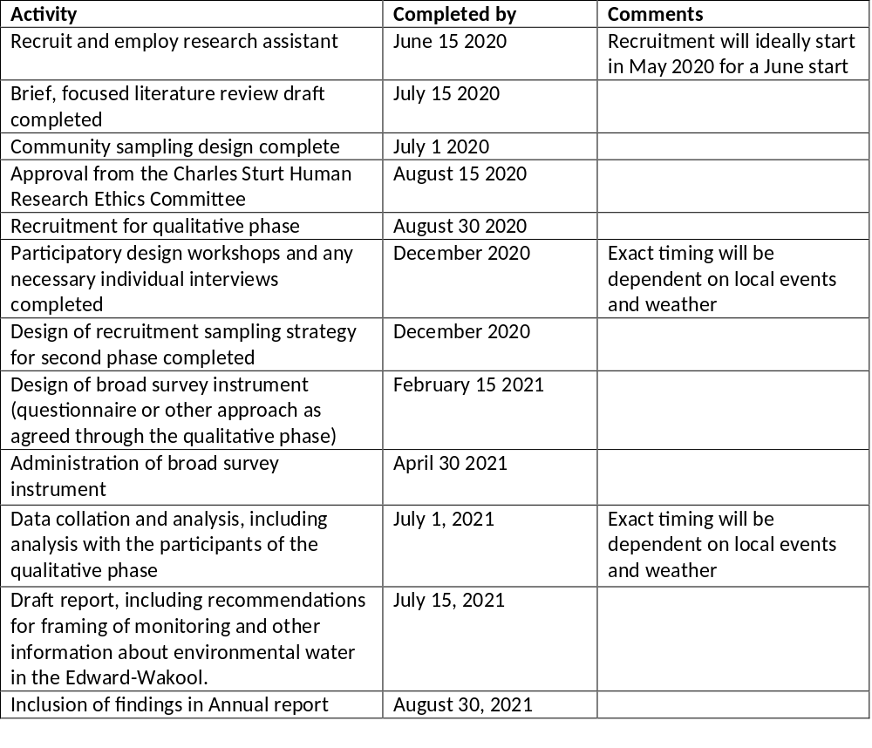
6.8.5 Links to other monitoring and research themes
This research links with all of the monitoring and research themes as it informs the framing of the use of the monitoring and evaluation, and is a bridge to the communication and engagement activities of the project.
A research project currently being undertaken by Charles Sturt University is narrowly focused on two environmental watering trials, with fewer than 15 key stakeholders interviewed. While the research questions proposed in the Flow-MER Plan are informed by the insights from the current research, the approach proposed in the Flow-MER Plan is more participatory in its design and wider reaching in its execution. Whatever method is selected through the participatory design, it will be recruiting from a large population of stakeholders. Some people who were interviewed as part of the current research project may be invited to be part of the Flow-MER project, but they will be invited to be part of developing a process for capturing a much wider view of Commonwealth and other environmental water.

6.9 Schedule for monitoring, evaluation and research activities (2021-2023)
This section describes the schedule for core monitoring and contingency monitoring, research and engagement undertaken in the Edward-Wakool Selected Area. The location of zones and indicators in the Edward-Wakool Selected Area was described in Section 4. The timing of reporting is summarised in Section 9. Details on the monitoring and research activities were described in Section 5 and 6.
The monitoring schedule was developed to ensure it is in line with the expected environmental watering in this system (Section 3). As watering actions are likely to occur throughout the year, including winter watering actions, many of the indicators will be monitored continuously throughout the year. In addition, there was additional monitoring, research and engagement activities undertaken as part of the program.
The Edward-Wakool Project Team designed the field monitoring schedule to utilise staff time efficiently and to ensure value for money. Field costs were kept to a minimum by incorporating several indicators into the same field trip where possible. At the same time, the schedule allows for field work to be completed on a Monday to Friday basis to ensure staff are able to spend weekends at home and thus be rested for subsequent field trips and laboratory work.
Table 23 provides a summary of the schedule for the core field and reporting activities for this Flow-MER Plan 2019-2023 and for the contingency monitoring, research and engagement projects. Some activities will vary from year to year. Examples of variation in activities between years include:
- In 2019-20 fish movement will be monitored only from June-September, and this activity will not be undertaken in subsequent years.
- Physical habitat research is currently scheduled to be undertaken only in 2019-20.
- The turtle research will be undertaken from 2019-21. Depending on the outcome of that research we may seek funding for follow up research or monitoring.
- The eDNA biodiversity research is currently scheduled to be undertaken only in 2019-20.
- The social science research is currently scheduled to be undertaken only in 2020-21.
- The hydraulic modelling for the integrated research project will be largely undertaken in 2019-20, with some budget allocated for additional scenarios to be modelled in 2021-22.
- Contingency project ‘Water quality and primary productivity monitoring’ (work order 2) was undertaken in 2020. This work order is in Appendix 3.
- Contingency project ‘Characterising the hydrology of the Werai Forest region’ (Work Order 3) was undertaken in 2021-2022. This work order is in Appendix 4.
- Contingency project ‘Assessment of Groundcover vegetation Condition in the Werai Forest’ (Work Order 4) was undertaken in 2021-2022. This work order is in Appendix 5.
- Contingency project ‘Comparison of aquatic productivity rates between river channels and recently inundated sites in the Werai forest’ (Work Order 5) was undertaken in 2021-2022. This work order is in Appendix 6.
- Contingency project ‘Ephemeral Creek habitat use by fish and other vertebrates’ (Work Order 6) was undertaken in 2022-2023. This work order is in Appendix 7.
- Contingency project ‘Online interactive map and data visualisation tool’ (Work Order 7) was undertaken in 2022-2023. This work order is in Appendix 8.
- Contingency project ‘Freshwater mussels’ (Work Order 8) was undertaken in 2022-2023. This work order is in Appendix 9.
- Contingency project ‘Evaluating outcomes of environmental water delivery from MIL escapes 2022-23’ (Work Order 9) was undertaken in 2022-2023. This work order is in Appendix 10.
- No field monitoring will be undertaken after June 2023, as this will be the period in which the final evaluation report is prepared.
Table 23 Summary and schedule of monitoring and research undertaken in the Edward-Wakool system for the CEWO Monitoring, Evaluation and Research project from 2019 to 2023.
Theme | Cat | Zones | Schedule of activities
Theme | Cat | Zones | Jul |  | Aug | Sep | Oct | Nov | Dec |  | Jan | Feb |  | Mar |  |  | Apr | May |  | Jun
Monitoring and evaluation
River hydrology | 1 | system | Continuous data from gauging stations
Carbon and water quality | 3 | system | Monthly
Stream metabolism | 1 | 1,2,3,4,8,11,12 | Continuous data from DO loggers
Riverbank and aquatic veg | 3 | 1,2,3,4,8,11,12 | Monthly
Fish movement | 2 | system | 2019 only
Fish reproduction (larvae) | 1 | 3 |  |  |  | Fortnightly
Fish reproduction (larvae) | 3 | 1,2,3,4,11 |  |  |  | Fortnightly
Fish recruitment | 3 | 1,2,3,4
Fish community (Cat 1) | 1 | 3
Fish community survey* | 3 | system |  |  |  |  |  |  |  |  |  |  |  |  |  |  |  | *
Contingency monitoring, research and engagement projects
Hydraulic modelling | NA | 11,12 | Modelling to be undertaken in 2019-20
Physical habitat | NA | 4, 8,11,12 |  | 2019-20
Riverbank and aquatic veg | NA | 11,12 | Timing to be confirmed
Primary productivity | NA |  | 2019-22
Turtles | NA | 11 | 2019-21
Fish spawning | NA |  |  |  |  | 2019
Biodiversity (e-DNA) | NA | system |  |  |  | 2019-20
Social science | NA | system | 2020-21
Contingency water quality | NA | 1, 2 | 2021-22
Hydrological modelling of Werai Forest | NA | Werai Forest | 2021-22
Groundcover vegetation Condition in Werai Forest | NA | Werai Forest | 2021-22
Aquatic productivity in Werai Forest | NA | Werai Forest | 2021-22
Ephemeral Creeks | NA | Ephemeral creeks | 2022-23
Online interactive map and data visualisation tool’ | NA | System | 2022-23
Freshwater Mussels | NA | Wakool-Yallakool | 2022-23
Evaluating outcomes of environmental water delivery from MIL escapes | NA | Edward/Kolety River, Niemur River | 2022-23
* Fish community survey (Cat 3) will be undertaken in 2022 only

Engagement and communication

Introduction
The Engagement and Communication approach for the Edward-Wakool Flow-MER project will build on the communications and stakeholder engagement undertaken as part of the LTIM project in the Edward-Wakool system. To develop this plan we participated in two meetings with the Edward-Wakool Environmental Water Reference Group, a meeting with staff of the Yarkuwa Indigenous Knowledge Centre, and several follow up phone meetings and emails with representatives of community groups. The aim of these meetings were to review the communications activities undertaken during the LTIM project, develop activities that involve and engage local stakeholders in the monitoring, and develop a communications and engagement plan that delivers communication and engagement activities associated with CEWO environmental water in the Edward-Wakool system in a format that is meaningful to a diversity of stakeholders.
The key lessons from the review of past engagement and communication were:
- A broad range of activities and outputs is required to target different audiences
- The detailed scientific reports were not a good communication tool for local communities
- Communication through social media (e.g. twitter, Youtube) reached only some members of the local community
- Activities that involved hands-on opportunities, such as the information booth with microscopes at the Deniliquin Fishing Classic, were well received by the community and reached a wide range of the community from children through to adults
- Communication products that focussed on individual stories were well received by the local community. For example, articles in local newspapers on the first observation of catfish larvae in the system and the increased distribution of river blackfish.
- There is a strong interest of indigenous people to be more engaged in the Flow-MER project
Objectives and intended outcomes of communications and engagement activities
- Help to communicate the role and benefits of environmental water to key stakeholders and the broader community, including:
  - Local Edward-Wakool community
  - The Commonwealth Environmental Water Holder and CEWO
  - Other government agencies and policy makers
  - The broader Australian and international community
  - The science community
- Produce user friendly products for target audiences that make monitoring and research observations and outcomes accessible and useful to a wide range of stakeholders.
- Develop means by which a wide range of local stakeholders can be involved and engaged in the project
- Ensure there is meaningful aboriginal engagement in the project and in environmental water management
- Work with the Flow-MER team (Basin-scale, Selected Area and CEWO) to integrate communication outputs and outcomes of environmental watering actions and promote knowledge exchange and collaboration opportunities
Key stakeholder groups
Communications and engagement will target the following stakeholders:
- Commonwealth Environmental Water Office
- Local stakeholders in the Edward-Wakool area including: the Edward-Wakool Environmental Water Reference Group, Murray Local Land Services, Wakool River Association, Edward-Wakool Angling Association, Yarkuwa Indigenous Knowledge Centre Aboriginal Corporation, Deniliquin Local Aboriginal Land Council, Werai Land and Water Aboriginal Corporation, Murray Irrigation Limited, Ricegrowers’ Association of Australia Inc., landholders and the broader community
- Relevant government agencies including: NSW Department of Planning and Environment, NSW Department of Primary Industries (Fisheries), WaterNSW, DPI Water, Murray-Darling Basin Authority
- Basin Flow-MER Team and other Selected Area Flow-MER Teams
- Broader Australian and International community
- Science community
Communication and engagement activities for Flow-MER project
Presentations/workshops to targeted groups:
- Edward-Wakool Environmental Water Reference Group meetings (2 per year)
- Annual Flow-MER project Forum
- Presentation to other relevant local groups, such as the Murray-Lower Darling Environmental Water Advisory Group Wakool River Association, Edward-Wakool Angler Association
- Presentations at scientific conferences
- School workshops

Activities that bring stakeholders, community, scientists together to foster relationships and engagement of local knowledge and expertise:
- Members of the Edward-Wakool Angling Association will be engaged to participate in the Edward River larval fish surveys (see section 6.6)
- Staff of the Yarkuwa Indigenous Knowledge Centre plus other local Aboriginal people will participate in riverbank and aquatic vegetation research in Werai Forest (see section 6.3)
- The Western Murray Land Improvement Group (Landcare) will coordinate four workshops (Barham, Moulamein, Kyalite and Wakool) to engage local community members in workshops focussing on water quality monitoring with opportunities to more broadly discuss outcomes of LTIM and the Flow-MER project
- Local First Nations people will participate in the turtle research component of the integrated research project (see section 6.5)

Written outputs
- Information sheets will be distributed at meetings and field days and posted to the website
- Media releases will be produced on interesting monitoring results that make good stories of interest to the local and broader community
- Annual Selected Area Evaluation report
- Quarterly progress report
- Quarterly Outcomes Newsletter
- Reporting on the integrated research project will include outputs from a community engagement perspective, including an Indigenous cultural perspective. These outputs, written in collaboration with members of the community groups, will share the learnings and perspectives of the community members involved in the research.

Individual communication with landholders on whose properties we have established monitoring sites and with community groups participating in research
- Regular email/text/ring to inform of our monitoring schedule
- Face to face catch-up with landholders and community groups while we are in the field

Participation in committees
- Edward-Wakool Environmental Water Reference Group Committee (EWEWRG) (meet 2 times each year)
- Edward-Wakool Operations Advisory Group (regular teleconferences)
- Murray and Districts Dissolved Oxygen Group (Active during poor water quality events)

Engagement with scientific community
- papers, conference presentations, collaboration on complementary projects
- supervision of research students

Online – general access
- An Edward-Wakool Environmental Water webpage will continue to be hosted by CSU. All annual reports, progress reports, info sheets, media releases are posted to this site. It serves as a single location where recent and past outputs can be accessed
- The Edward-Wakool team will contribute to Flow-MER team products and engage with Flow-MER team by providing input to the new website, calendar of events, and contributing a minimum of two stories per year. Many of the written materials will be directly transferable to the Flow-MER team requirements.

Reporting
A summary of the reporting for the Edward-Wakool Flow-MER project is outlined in table 24 and this is summarised as a timeline in table 25.
Table 24 Summary of the annual reporting requirements for the Edward-Wakool CEWO Monitoring, Evaluation and Research project from 2019 to 2023.
Item | Reporting activity | Activity | Date
1. | Selected Area Working Group | CSU will initiate, organise, facilitate and provide secretariat duties for Selected Area Working Group meetings consisting of CSU representatives and any subcontractors involved in the development of the Edward-Wakool Flow-MER Project. | At least two Selected Area Working Group meetings held annually
2. | Thematic Working Groups | Team members will attend at least two thematic working group meetings organised by the Basin Matter Leads for each of the following themes: fish, vegetation and stream metabolism. | Meeting dates organised by the Basin Matter Leads.
3. | Steering Committee participation | Edward-Wakool team members will attend at least two Steering Committee meetings (teleconferences) organised by the CEWO annually. | Meeting dates organised by CEWO
4. | Annual Forum | At least 4 members of the Edward-Wakool team will attend the Annual Forum each July quarter | In the July quarter
5. | Progress Reports | Progress reports will be submitted in accordance with a standard format and template. The reports will outline progress against Flow-MER Plan requirements including core monitoring and research activities. It will identify issues that have affected the delivery of services and measures taken to address this. It will include a summary of external communications. | Last Business Day of September, December,  March and June
6. | Quarterly Outcomes Newsletter | Newsletters will be written in plain English for a public audience and will communicate Flow-MER activities, preliminary observations and findings relevant to environmental watering, and case studies about environments and people. It will contain opportunistic photos of outcomes from environmental watering and other visual aids relevant to demonstrating outcomes to the public. It will also include a description of the monitoring and research activities undertaken in this quarter. | Due on last Business Day of September, December, March and June
7. | Annual Selected Area Evaluation Report | The annual Selected Area Evaluation report will be submitted each year, in accordance with the requirements set out in the contract. This will include information in Monitoring, Evaluation and Research, and will include recommendations that will inform adaptive management of Commonwealth environmental water. | Draft due 30 September and of final due 30 November

Table 25 Timeline of the annual reporting undertaken in the Edward-Wakool system for the CEWO Monitoring, Evaluation and Research project from 2019 to 2023.
# | Activity | Schedule of activities
# | Activity | July to Sep |  |  | Oct to Dec |  |  | Jan to March |  |  | April to June
1 | Selected Area Working Group | At least 2 per year organized by the Project Leader
2 | Thematic working Groups | 2 per year organized by Basin team
3 | CEWO Flow-MER Steering Committee | 2 per year organized by CEWO
4 | Annual Flow-MER Forum
5 | Progress Reports
6 | Quarterly Outcomes newsletters
7 | Annual report
7 | Final Annual Selected Area Evaluation report
8 | Data uploaded to MDMS

Project management

9.1 Project governance
The project will operate under the following governance structure:
- Corporate Client – The government body that is funding the project – in this case, the Australian Government through the Department of Environment and Energy. The corporate client is the champion of the project with final authority; promotes the benefits of the project to the community and may be viewed as the ’public face’ of the project (involvement in most high-profile media activity); lends support by advocacy at senior level and ensure that necessary resources are available for the project.
- Project Leader – Professor Robyn Watts is the Project Leader. She will be the key person around which the project evolves and who will follow the strategic direction set by the funding body and consult with the theme leaders and project team.
The Project Leader is responsible for all the operational aspects of the project. The Project Leader is responsible for organizing the project into one or more sub-projects, managing the day-to-day aspects of the project, maintain the project schedule, resolving planning and implementation issues and monitoring progress towards budget. The Project Leader will: manage and monitor the project activities through detailed plan and schedules; report to the Corporate Clients at regular intervals; and manage (client/partners/stakeholder) expectations through formal specification and agreement of goals, objectives, scope, outputs, resources required, budget, schedule, project structure, role and responsibilities.
- Assistant Project Leader - Dr Nicole McCasker is the Assistant Project Leader. The Assistant Project Leader will support the Project Leader and represent the team in the absence of the Project Leader. The Assistant Project Leader will assume the role of Project Leader as required to ensure continuity in project delivery.
- Theme Leaders – The theme leaders coordinate specific elements of the project. Theme Leaders will work closely with the Project Leader and Assistant Project Leader to deliver on project outcomes. The Theme Leaders are Prof Robyn Watts (hydrology), Dr Xiaoying Liu (water quality and carbon), Prof Nick Bond (stream metabolism), Prof Robyn Watts (riverbank and aquatic vegetation), Dr Jason Thiem (fish movement and fish adult populations), Dr Nicole McCasker (fish spawning), Mr John Trethewie (fish recruitment), and Prof Nick Bond (data analysis and modelling).
The Theme Leaders will be coordinated by the Project Leader and are responsible for completing tasks and activities required for delivering project outputs.
- Research Project Leaders – The research project leaders coordinate specific elements of the project. Theme Leaders will work closely with the Project Leader and Assistant Project Leader to deliver on project outcomes. The Theme Leaders are Dr Geoff Vietz (physical habitat research), Dr James Van Dyke (turtle research), Dr Meaghan Duncan (eDNA biodiversity research), and A/Prof Catherine Allan (social science research). The research project leaders will be coordinated by the Project Leader and are responsible for completing tasks and activities required for delivering project outputs.
- Team members – All team members have specific roles and will contribute to the success of the project. Team members undertake fieldwork, laboratory work, data management and analysis, evaluation, reporting and project administration. All team members will contribute to reporting, stakeholder engagement and participate in team meetings when required. The composition of the team may change as the project moves through its various phases, as the assessment and selection of people with the requisite skills required for each phase of the project is critical to its overall success.
- Selected Area Reference Group – This group will consist of all Team members including any subcontractors involved in the Edward-Wakool Flow-MER Project. This group is an internal governance group for the Flow-MER project and is chaired by the Project Leader. This group will ensure that the Edward-Wakool Flow-MER team regularly catches up with each other to plan monitoring evaluation and research and prepare reports and other outputs.

9.2 Risk assessment
The Flow-MER project will adhere to the Risk Management Plan for the Edward-Wakool Selected Area (Watts et al. 2014b) that was prepared in accordance with:
- CSU Risk Management framework
- CSU Risk Management Policy
- CSU guidelines on How to complete a CSU Risk Assessment
- Australian Standard AS/NZS 4360:2004 Risk Management and revised AS/NZs ISO 31000:2009 Risk Management – Principles and Guidelines.

The Project Risk Management Plan follows the CSU Risk Management framework, including policies, guidelines and procedures, identifies major risks that are considered to have potential adverse effects or provide potential opportunities to meet the project objectives, risks to the environment and individuals and records the outcomes of the risk management process undertaken with the use of the Project Risk Register.

9.3 Key personnel
This section outlines the personnel who will perform the services for this tender, including the skills, experience and qualifications of those personnel. A summary of the project team members is provided in Table 26.

Table 26 List of personnel who will perform the services for this tender, including a summary of their roles.
Name | Organisation | Roles
Prof Robyn Watts | CSU | Project Leader. Project planning, manage CSU staff, coordinate reporting, represent team on stakeholder reference group and environmental water groups, and liaise with CEWO. Lead hydrology theme and riverbank and aquatic vegetation theme. Contribute to field work, data analysis and reporting for hydrology and riverbank vegetation themes
Dr Nicole McCasker | CSU | Assistant Project Leader. Lead fish spawning theme - undertake field work, laboratory processing of fish larval samples, analysis and reporting of fish larval data. Lead Data Management and assist with analysis of data and modelling. Processing data from DO loggers for stream metabolism analysis. Assist coordination of CSU staff.
Dr Xiaoying Liu | CSU | Leader of carbon and water quality theme. Undertake processing of carbon fluorescence samples, chlorophyll-a samples, vegetation monitoring and data entry. Analysis and reporting of carbon and water quality data. Contribute to project planning and reporting. Contribute to project planning and reporting.
Mr John Trethewie | CSU | Leader of fish recruitment theme. Undertake fieldwork, manage field equipment, laboratory processing of fish larval samples. Undertake laboratory work, data analysis & reporting for fish recruitment theme. Contribute to project planning and reporting.
Casual assistants | CSU | Assistance with field work or laboratory work
A/Prof Catherine Allan | CSU | Develop and undertake social research. Contribute to project planning and reporting.
Dr James Van Dyke | CSU | Develop and undertake turtle research. Contribute to project planning and reporting.
Dr Jason Thiem | DPI NSW | Leader of fish movement and fish population theme. Analysis and reporting activities for fish movement and fish population indicators. Supervision of DPI, budgeting and project management. Contribute to project planning and reporting.
Dr Meaghan Duncan | DPI NSW | Develop and undertake e-DNA biodiversity research. Contribute to project planning and reporting.
Casual assistants | DPI NSW | Assist with fieldwork in stage 2
Prof Nick Bond | La Trobe | Leader of stream metabolism theme. Contribute to project planning and reporting. Contribute to statistical analysis and ecosystem modelling. Contribute to hydrology analysis.
Dr Andre Siebers | La Trobe | Undertake stream metabolism analysis. Undertake contingency research project on productivity in Werai Forest
Ms Sascha Healey | Murray-Darling Wetlands Working Group | Contribute to fieldwork for vegetation assessment, assist with data analysis and reporting of river bank vegetation indicators. Contribute to project planning and reporting.
Dr Geoff Vietz | Streamology | Develop and undertake physical habitat research or monitoring. Contribute to project planning and reporting.
Mr Mick Donges and Neil Sutton | Streamology | Undertake physical habitat research. Contribute to project planning and reporting.
CSU staff | CSU | Administration, budgets and contract management
CSU staff | CSU | Administrative support for travel, meetings and purchases

The NATA-certified laboratory within the CSIRO Laboratory based at the Charles Sturt University Albury campus will undertake the nutrient and organic carbon analyses for the water quality monitoring component of the project.

9.4 Quality assurance
The Quality Management Plan for the Edward-Wakool Selected Area (Watts et al. 2014a) documents quality control and quality assurance procedures for all activities undertaken for the Edward-Wakool system under this Flow-MER Plan. The plan is in accordance with relevant standards such as AS/NZ ISO 10005:2006 Quality management systems – Guidelines for quality plans as well as ANZECC and ARMCANZ (2000) Australian Guidelines for Water Quality Monitoring and Reporting.
The Quality Assurance Plan features the three following components:
- Quality assurance – to ensure quality management processes;
- Quality control - to establish standards for acceptance of outputs, monitoring against the criteria to determine if quality has been achieved
- Quality improvement - review points to assess and improve quality where possible.

9.5 Health, Safety and Environment Plan
The Workplace Health, Safety and Environment Plan (HSEP) for the Edward-Wakool Selected Area (Watts et al. 2014c) has been developed in line with the current Flow-MER Plan, and will be revised when indicators to be monitored in the Edward-Wakool Selected Area have been finalised. The HSEP is in line with Charles Sturt University policy and existing frameworks, including Work Health and Safety (WHS) Act 2011, Occupational Health and Safety Regulation, 2001 (NSW), Occupational Health and Safety Act, 1989 (ACT) and Occupational Health and Safety Regulations, 1991 (ACT). The plan describes the procedures and requirements for minimizing the risk of injury to persons and harm to the environment in relation to the LTIM Project.
Work Health and Safety (WHS) at CSU supports the identification, development and implementation of strategically based health and safety programs. These programs aim to ensure compliance with relevant health and safety legislation, as well as to assist managers and employees to maintain a workplace that is free from risk to health, safety and welfare and promotes staff health and wellbeing. These programs focus responsibilities and resources in the areas of accident and injury prevention, hazard removal and control, health and welfare preservation, the development of safe and healthy work practices, the promotion of health and safety awareness, the provision of training in safe and healthy work practices, the compliance with health and safety legislation and regulations, the rehabilitation of injured employees and consultative mechanisms.
All staff and students have a general responsibility in terms of the WHS Act (2011) to ensure a safe and healthy work environment. The broad parameters of these specific responsibilities are set out in the policy document Occupational Health, Safety and Welfare Objectives and Responsibilities.
To monitor and assist with the implementation of this policy, Occupational Health and Safety Committees have been established at each Campus pursuant to the provisions of the WHS Act 2011. Each Committee reports to the Executive Director, Division of Human Resources. The Presiding Officers of each OH&S Committee represent these committees on the University-wide Environment and Safety Management Committee established to coordinate occupational health and safety matters across the University.
Where Charles Sturt University has a presence at sites other than a designated campus, it is the responsibility of the management of that site, or the coordinating senior officer of the University in regard to joint ventures, to ensure the operations at that site are compliant with applicable health and safety legislation.
The CSU Safety Management System and framework is centered on a number of policies, procedures and induction/training modules, including:
- Driving hours policy and Guidelines
- First aid policy
- Occupational Health & Safety Consultation Statement
- Occupational Health, Safety and Welfare Objectives and Responsibilities
- Occupational Health and Safety Policy
- Occupational Health, Safety and Welfare Objectives and Responsibilities
- Safety Management Plan Policy
- Accidents and incidents reporting
- CSU Risk Management Policy and Risk Register
- OH&S Induction and ELMO OHS Online Training

Charles Sturt University also has specific policies and procedures relating to the management of OH&S related risks including:
- New staff safety induction processes (ELMO)
- Ergonomics
- Manual Handling
- Electrical Safety
- Thermal comfort
- Accidents and incidents reporting
All persons in charge of workplaces at CSU coordinate the production of an annual Safety Management Plan by the commencement of May each year. This Plan details all planned WHS activities and targets for the current financial period. Longer term planning can also be incorporated where management of safety, needs to be staged over a number of years.
The HSEP includes information relating to the provision of safety information, the need for instruction, and the need for generic, specialist or on-the-job safety training in the coming year. The Plan includes objectives and targets to minimise risks resulting from hazards identified through observation, inspections, hazard reports, incident investigations and where changes occur to facilities or processes or through identified non-compliance with legislation, policies or standards. The planning and programming of risk assessments and risk control measures, including the production of administrative controls such as operating procedures are also included in the Plan when required. Emergency and contingency planning may also need development or improvement within the Plan.
Safety Management Plans form an essential part of the safety system at each workplace and active records of these plans are kept for the current plan and the previous four plans. Archived records to cover a span not exceeding 5 years are also kept.
The CSU team operates under the auspice of the Faculty of Science and will follow a number of faculty specific WHS policies and procedures through the delivery of this project. These include:
- Faculty of Science Risk Assessment Procedure , outlining the formal risk assessment process used by the Faculty of Science to ensure all activities conducted in on campus and off campus localities used for work, research or study implement controls to mitigate and/or reduce the risks of incidents, injury or damage
- Laboratory safety and standard operating procedures.
- Field work procedures, including the completion of project safety risk assessments to be completed and approved prior to any project field work being undertaken; in particular the project safety risk assessment covers potential hazards relating to field sites and their access as well as well as field activities (e.g. night trawls) and the controls in place to minimize risks
- Emergency response; the field work procedure includes a subset relating to the procedure that is to be followed in case of an emergency and will be detailed in the final HSEP; whilst working in the laboratory, staff are to follow existing building emergency procedures (these are detailed as part of new staff induction processes)
- More specific Job Safety and Environment Assessment (JSEA) for all laboratory and field activities if not covered under existing Faculty of Science procedures; specific standard operating procedures are developed for the project and will include a safety aspect component
- First aid training; the final HSEP will include a list of first aid training requirements, in particular for field work, as well as a record of staff first aid qualification; training records will be reviewed and updates on a quarterly basis as a minimum
- Incident reporting; the project team will follow CSU Incident Reporting and Management procedures which will be detailed in the final HSEP
All organisations sub-contracted by CSU will operate under CSU HSEP, with the exception of Fisheries NSW, which has developed a separate HSEP. Fisheries NSW will submit their HSEP to the project manager for review. As a requirement of CSU sub-contracting procedures Fisheries NSW HSEP is to be approved by the CSU project manager prior to NSW DPI commencing work on the project.

9.6 Equipment
The Edward-Wakool Team have established capital capacity that support the efficient delivery of monitoring, evaluation and research in the Edward-Wakool Selected Area. The project team has fully established capital capacity, including field equipment and access to fully equipped research laboratories. The project team also have access to a wide range of scientific analytical facilities and field sampling equipment at CSU, DPI Fisheries Narrandera, La Trobe University and NSW Department of Planning and Environment.
Existing capital assets that assist with communication among the team and with other stakeholders include videoconference facilities, high-end IT equipment and networks. The CSU cloudstor and data storage is used as a repository for active datafiles and facilitates the sharing of data among the project team. CSU has a Spatial Analysis Unit which has assisted with inundation mapping and other mapping for the project.
Charles Sturt University has all field equipment required to undertake the two year Flow-MER project in the Edward-Wakool river system. Key equipment includes logging equipment to continuously monitor water quality, water depth and light conditions at selected river reaches. In addition, CSU has field vehicles, small boats, drift nets (equipped with flow meters), and fish light traps that can be dedicated to this project. The CSU Albury-Wodonga campus has a fully equipped laboratory with microscopes for larval fish identification and equipment for processing of phytoplankton biomass.
Fisheries NSW have a fleet of five electrofishing boats which have been purchased and are available for use by the project on an operating cost recovery basis. Fisheries NSW have also previously deployed an acoustic array and have implanted tags into Murray cod, golden perch and silver perch in the Edward-Wakool river system to monitor and track long distance migrations in response to flow delivery. This infrastructure could also be accessed by the project on an operating cost recovery basis. DPI also has access to larval nets, flow meters, laboratory facilities, punts and light traps which can be brought to the project provided any routine maintenance is covered.
For assessment of water quality and stream metabolism this includes water quality loggers, and access to laboratory instrumentation at Charles Sturt University including a Varian Cary 4000 UV-visible spectrophotometer and a Varian Cary Eclipse fluorescence spectrophotometer. The NATA-certified laboratory within the CSIRO Laboratory based at the Charles Sturt University Albury campus will undertake the nutrient and organic carbon analyses for the water quality monitoring component of the project.
As the project team has a long history of working in the Edward-Wakool river system we have access to a wide range of complementary data sets and intellectual property that will support the efficient delivery of monitoring and evaluation in the Selected Area.

Data management
All data collected as part of this project will conform to the data structure defined in the LTIM Project Data Standard (Brooks and Wealands 2014). The data standard provides a means of collating consistent data that can be managed within the LTIM Project Monitoring Data Management System (MDMS).
Data Management protocols will be followed as outlined in the Edward-Wakool Quality Management Plan (Watts et al. 2014a) and will be subject to annual audit. This includes document Management, record keeping, data storage and management.
CSU has a well-established document management system ‘Total Records and Information Management’ (TRIM). TRIM is an Electronic Document and Records Management System software solution for managing records of all formats. All controlled copies of accepted documents and reports are to be recorded in TRIM. In addition such documents and reports will also be recorded in Research Master. Financial data is recorded on Banner Finance, which in turn feeds financial information into Research Master. Data stored on Banner Finance is used to generate the relevant financial reports and acquittal for both internal and external purposed.
The Edward-Wakool Project Team anticipates that the MDMS may not provide all the needs of selected area. In addition, we will use an online cloudstor data storage system for data storage in addition to the MDMS. The CSU cloudstor and data storage will be used as a repository for active and archived datafiles and facilitates the sharing of data among the project team.
The Edward-Wakool Project team will store and manage access to primary data for the duration of the Flow-MER Project. The Project Leader and Assistant Project Leader will be responsible for ensuring the team members all comply with the management and storage of all primary data. All field and laboratory primary data sheets will be scanned and stored within the CSU data management system as image files using tagged image file format at a minimum 300 dpi resolution. This will include trip reports, audit reports and any other relevant data or documents.
All derived data that supports shared evaluation will adhere to LTIM Project data standards and be traceable to primary data sets held on the Interact site. The Edward-Wakool team will submit data that supports shared evaluation into the Project Monitoring Data Management System according to protocols established by CEWO.

References

Agostinho, A.A., Gomes, L.C., & Pelicice, F.M. (2007) Ecology and management of fish resources in reservoirs in Brazil. Eduem.
Allan, C. and Watts, R.J. (2017) Revealing Adaptive Management of Environmental Flows. Environmental Management. doi:10.1007/s00267-017-0931-3
ARMCANZ (2000) National Water Quality Management Strategy: Australian and New Zealand guidelines for fresh and marine water quality. Australian and New Zealand Environment and Conservation Council & Agriculture and Resource Management Council of Australia and New Zealand, Canberra.
Baldwin, D., Howitt, J., & Edwards, M. (2001) Blackwater Event. Austasia Aquaculture, 15, 21.
Barnett, A., Abrantes, K.G., Stevens, J.D., Bruce, B.D., & Semmens, J.M. (2010) Fine-scale Movements of the Broadnose Sevengill Shark and Its Main Prey, the Gummy Shark. PLoS ONE, 5(12), e15464. doi:10.1371/journal.pone.0015464
Baumgartner, L.J., Conallin, J., Wooden, I., Campbell, B., Gee, R., Robinson, W.A., & Mallen‐Cooper, M. (2013) Using flow guilds of freshwater fish in an adaptive management framework to simplify environmental flow delivery for semi‐arid riverine systems. Fish and Fisheries.
Blom, C.W.P.M., Voesenek, L.A.C.J., Banga, M., Engelaar, W.M.H.G., Rijnders, J.H.G.M., Vandesteeg, H.M., & Visser, E.J.W. (1994) Physiological ecology of riverside species - adaptive responses of plants to submergence. Annals of Botany, 74(3), 253-263.
Blom, C.W.P.M. and Voesenek, L.A.C.J. (1996) Flooding - the survival strategies of plants. Trends in Ecology & Evolution, 11(7), 290-295.
Brock, M.A. and Casanova, M.T. (1997) Plant life at the edges of wetlands: ecological responses to wetting and drying patterns. In: Frontiers in Ecology; Building the Links (Eds N. Klomp & I. Lunt), pp. 181-192. Elsevier Science, Oxford.
Brooks, S. and Wealands, S. (2014) Commonwealth Environmental Water Office Long Term Intervention Monitoring Project: Data Standard. Report prepared for the Commonwealth Environmental Water Office by The Murray-Darling Freshwater Research Centre, MDFRC Publication 29.3/2013 Revised Jan 2014.
Bunn, S.E. and Arthington, A.H. (2002) Basic principles and ecological consequences of altered flow regimes for aquatic biodiversity. Environmental management, 30(4), 492-507.
Bureau of Meteorology (2017) Special Climate Statement 58- record September rains continue wet period in much of Australia, Bureau of Meteorology, No 58. http://www.bom.gov.au/climate/current/statements/scs58.pdf
Campana, S.E. (2001) Accuracy, precision and quality control in age determination, including a review of the use and abuse of age validation methods. Fish Biol, 59(2), 197-242.
Campbell, H.A., Watts, M.E., Dwyer, R.G., & Franklin, C.E. (2012) V-Track: software for analysing and visualising animal movement from acoustic telemetry detections. Marine and Freshwater Research, 63(9), 815-820.
Casanova, M.T. (2011) Using water plant functional groups to investigate environmental water brequirements. Freshwater Biology, 56, 2637-2652.
Chessman, B.C. (2011) Declines of freshwater turtles associated with climatic drying in Australia’s Murray-Darling Basin. Wildlife Research, 38, 664-671.
Chiew, F.H.S., Potter, N.J., Vaze, J. Petheram, C., Zhang, L., Teng, J., & Post, D.A. (2014) Observed hydrologic non-stationarity in far south-eastern Australia: implications for modelling and prediction. Stochastic Environmental Research Risk Assessment, 28, 3-15.
Clements, S., Jepsen, D., Karnowski, M., & Schreck, C.B. (2005) Optimization of an acoustic telemetry array for detecting transmitter-implanted fish. North American Journal of Fisheries Management, 25(2), 429-436.
Commonwealth Environmental Water Office (2019) Commonwealth environmental water holdings in the Murray catchment https://www.dcceew.gov.au/water/cewo/about/water-holdings
David, B.O. and Closs, G.P. (2002) Behavior of a stream-dwelling fish before, during, and after high-discharge events. Transactions of the American Fisheries Society, 131(4), 762-771.
Davies, P.E., Harris, J.H., Hillman, T.J., & Walker, K.F. (2010) The sustainable rivers audit: assessing river ecosystem health in the Murray–Darling Basin, Australia. Marine and Freshwater Research, 61(7), 764-777.
Deniliquin Local Aboriginal Land Council. (2016). Turtle Project. Government Report.
Denzin, N.K. and Lincoln, Y.S. (2003) Collecting and interpreting qualitative materials. Thousand Oaks: Sage Publications.
Department of the Environment and Energy (2017 online) Wateruse in catchments – Mid Murray. URL https://www.dcceew.gov.au/water/cewo/catchment/mid-murray/history#werai
Department of Environment and Energy (2019). NSW Central Murray Forests http://www.environment.gov.au/cgi-bin/wetlands/ramsardetails.pl?refcode=64
de Souza, L.S., Godwin, J.C., Renshaw, M.A., & Larson, E. (2016) Environmental DNA (eDNA) Detection Probability Is Influenced by Seasonal Activity of Organisms. PLoS ONE, 11(10), e0165273. doi:10.1371/journal.pone.0165273
Foster, N., Ison, R., Blackmore, C., & Collins, K. (2019) Revisiting deliberative policy analysis through systemic co-inquiry: some experiences from the implementation of the Water Framework Directive in England. Policy Studies, 1-24. doi:10.1080/01442872.2019.1618816
Freeman, D.M. (2000) Wicked Water Problems: Sociology and Local Water Organizations in Addressing Water Resources Policy. Journal of the American Water Resources Association, 36(3), 483-491.
Furlan, E.M. and Gleeson, D. (2017) Improving reliability in environmental DNA detection surveys through enhanced quality control. Marine and Freshwater Research, 68(2) 388-395
Gawne, B., Brooks, S., Butcher, R., Cottingham, P., Everingham, P., Hale, J., Nielson, D., Stewardson, M., & Stoffels, R. (2013) Long Term Intervention Monitoring Logic and Rationale Document Final Report prepared for the Commonwealth Environmental Water Office by The Murray-Darling Freshwater Research Centre, MDFRC Publication 01/2013, May, 109pp.
Gilligan, D.M., Vey, A., & Asmus, M. (2009) Identifying drought refuges in the Wakool system and assessing status of fish populations and water quality before, during and after the provision of environmental, stock and domestic flows. 58 pp.
Green, D. (2001) The Edward-Wakool System: River Regulation and Environmental Flows. Department of Land and Water Conservation. Unpublished Report.
Hale, J. and SKM. (2011) Environmental Water Delivery: Edward-Wakool. Prepared for Commonwealth Environmental Water, Department of Sustainability, Environment, Water, Population and Communities.
Hale, J., Stoffels, R., Butcher, R., Shackleton, M., Brooks, S., & Gawne, B. (2014) Commonwealth Environmental Water Office Long Term Intervention Monitoring Project – Standard Methods. Final Report prepared for the Commonwealth Environmental Water Office by The Murray-Darling Freshwater Research Centre, MDFRC Publication 29.2/2014, January, 182 pp.
Hinlo, R., Gleeson, D., Lintermans, M., & Furlan, E. (2017) Methods to maximise recovery of environmental DNA from water samples. PLoS ONE, 12(6), e0179251. doi:10.1371/journal.pone.0179251
Hladyz, S., Watkins, S.C., Whitworth, K.L., & Baldwin, D.S. (2011) Flows and hypoxic blackwater events in managed ephemeral river channels. Journal of Hydrology, 401(1-2), 117-125.
Howitt, J.A., Baldwin, D.S., Rees, G.N., and Williams, J.L. (2007) Modelling blackwater: predicting water quality during flooding of lowland river forests. Ecological Modelling, 203(3-4), 229-242.
Howitt, J.A., Baldwin, D.S., Rees, G.N., & Hart, B.T. (2008) Photodegradation, interaction with iron oxides and bioavailability of dissolved organic matter from forested floodplain sources. Marine and Freshwater Research, 59(9), 780-791.
Humphries, P., King, A.J., & Koehn, J.D. (1999) Fish, flows and flood plains: links between freshwater fishes and their environment in the Murray-Darling River system, Australia. Environmental Biology of Fishes, 56, 129-151.
Humphries, P. and Lake, P.S. (2000) Fish larvae and the management of regulated rivers. Regulated Rivers: Research & Management, 16(5), 421-432.
Humphries, P., Serafini, L.G., & King, A.J. (2002) River regulation and fish larvae: variation through space and time. Freshwater Biology, 47(7), 1307-1331.
Humphries, P., Cook, R.A., Richardson, A.J., & Serafini, L.G. (2006) Creating a disturbance: manipulating slackwaters in a lowland river. River Research Applications, 22, 525-542.
Ison, R.L., Alexandra, J., & Wallis, P.J. (2018) Governing in the Anthropocene: are there cyber-systemic antidotes to the malaise of modern governance? Sustainability Science. doi:10.1007/s11625-018-0570-5
Johansson, M.E. and Nilsson, C. (2002) Responses of Riparian Plants to Flooding in Free-Flowing and Regulated Boreal Rivers: an Experimental Study. Journal of Applied Ecology, 39, 971-986.
King, A.J., Humphries, P., & Lake, P.S. (2003) Fish recruitment on floodplains: the roles of patterns of flooding and life history characteristics. Canadian Journal of Fisheries and Aquatic Sciences, 60(7), 773-786.
King, A.J., Ward, K.A., O'Connor, P., Green, D., Tonkin, Z., & Mahoney, J. (2009) Adaptive management of an environmental watering event to enhance native fish spawning and recruitment. Freshwater Biology, 55, 17-31
Leigh, S.J. and Zampatti, B.P. (2013) Movement and mortality of Murray cod, Maccullochella peelii, during overbank flows in the lower River Murray, Australia. Australian Journal of Zoology, 61(2), 160-169.
Lowe, B.J. (2002) Impacts of altered flow regime on riverbank vegetation in a lowland floodplain river. Unpublished PhD thesis, Charles Sturt University.
Lowe, B.J., Watts, R.J., Roberts J., & Robertson, A. (2010) The effect of experimental inundation and sediment deposition on the survival and growth of two herbaceous riverbank plant species. Plant Ecology, 209(1), 57-69.
Lucas, M.C., Baras, E., Thom, T.J., Duncan, A., & Slavík, O. (2001) Migration of freshwater fishes.
Lyon, J., Stuart, I., Ramsey, D., & O'Mahony, J. (2010) The effect of water level on lateral movements of fish between river and off-channel habitats and implications for management. Marine and Freshwater Research, 61(3), 271-278.
Mackay, M., Allan, C., Colliver, R., & Howard, J. (2014) Systems Approaches Enable Improved Collaboration in Two Regional Australian Natural Resource Governance Situations. International Journal of Systems and Society, 1(2), 1-21. doi:10.4018/ijss.2014070101
Maheshwari, B.L., Walker, K.F., & McMahon, T.A. (1995) Effects of regulation on the flow regime of the river Murray, Australia. Regulated Rivers Research and Management, 10, 15-38.
Mallen‐Cooper, M. and Stuart, I.G. (2003) Age, growth and non‐flood recruitment of two potamodromous fishes in a large semi‐arid/temperate river system. River Research and Applications, 19(7), 697-719.
MDFRC (2013) Long-term Intervention Monitoring – Generic Cause and Effect Diagrams. Final report prepared for the Commonwealth Environmental Water Office by the Murray-Darling Freshwater Research centre, MDFRC Publication 01/2013, May, 163pp.
Moama Local Aboriginal Land Council. (2016). Koondrook-Perricoota Cultural Knowledge Project Turtle Monitoring Report: An Indigenous Partnerships Project Under The Living Murray Initiative. Government Report.
Murray Darling Basin Authority (2011) Murray-Darling Basin Authority Annual Report 2010-11. MDBA publication No. 218/11. MDBA, Canberra.
Murray Darling Basin Authority (2014) Basin-wide environmental watering strategy. Murray-Darling Basin Authority.
Murray-Darling Basin Commission (2004) Native fish strategy for the Murray-Darling Basin 2003-2013. Murray-Darling Basin Commission Publication No. 25/04.MDBC, Canberra, Australia.
NSW Office of Environment and Heritage (2018). NSW Central Murray Forests. https://www.environment.nsw.gov.au/topics/water/wetlands/internationally-significant-wetlands/nsw-central-murray-forests
Nicol, J. (2004) Vegetation Dynamics of the Menindee Lakes with Reference to the Seed Bank. PhD Thesis. The University of Adelaide, Adelaide, SA.
O'Connell, M., Baldwin, D.S., Robertson, A.I., & Rees, G. (2000) Release and bioavailability of dissolved organic matter from floodplain litter: influence of origin and oxygen levels. Freshwater Biology, 45, 333-342
O'Connor, J.P., O'Mahony, D.J., & O'Mahony, J.M. (2005) Movements of Macquaria ambigua, in the Murray River, south‐eastern Australia. Journal of Fish Biology, 66(2), 392-403.
Pahl-Wostl, C., Vörösmarty, C., Bhaduri, A., Bogardi, J., Rockström, J., & Alcamo, J. (2013) Towards a sustainable water future: shaping the next decade of global water research. Current Opinion in Environmental Sustainability. doi:10.1016/j.cosust.2013.10.012
Peig, J. and Green, A.J. (2009) New perspectives for estimating body condition from mass/length data: the scaled mass index as an alternative method. Oikos, 118, 1883-1891.
Petrov, K., Lewis, J., Malkiewicz, N., Van Dyke, J.U., & Spencer, R.J. (2018) Food abundance and diet variation in freshwater turtles from the mid-Murray River, Australia. Australian Journal of Zoology, 66, 67-76.
R Development Core Team (2013) R: A Language and Environment for Statistical Computing. R Foundation for Statistical Computing, Vienna, Austria.
Reynolds, L.F. (1983) Migration patterns of five fish species in the Murray-Darling River system. Marine and Freshwater Research, 34(6), 857-871.
Roberts, D.T., Duivenvoorden. L.J., & Stuart, I.G. (2008) Factors influencing recruitment patterns of Golden Perch (Macquaria ambigua oriens) within a hydrologically variable and regulated Australian tropical river system. Ecology of Freshwater Fish, 17, 577-589
Roberts, J. and Marston, F. (2011) Water regime for wetland and floodplain plants: A source book for the Murray-Darling Basin. National Water Commission, Canberra.
Robinson, W.A. (2012) Calculating statistics, metrics, sub-indicators and the SRA Fish theme index: A Sustainable Rivers Audit Technical report. Consultancy report to the Murray-Darling Basin Authority.
Santori, C., Spencer, R.J., Van Dyke, J.U., & Thompson, M.B. (2018) Road mortality of the eastern long-necked turtle (Chelodina longicollis) along the Murray River, Australia: an assessment using citizen science. Australian Journal of Zoology, 66, 41-49.
Secor, D.H., Dean, J.M., & Laban, E.H. (1992) Otolith removal and preparation for microstructural examination. In Otolith Microstructure Examination and Analysis. Edited by D.K. Stevensen and S.E. Campana. Canadian Special Publication in Fisheries and Aquatic Science. 117. pp. 19-57.
Serafini, L.G. and Humphries, P. (2004) A preliminary guide to the identification of the larvae of species of freshwater fish from the Murray-Darling Basin. CRC for Freshwater Ecology, February 2004.
Simpson, R.R. and Mapleston, A.J. (2002) Movements and habitat use by the endangered Australian freshwater Mary River cod, Maccullochella peelii mariensis. Environmental Biology of Fishes, 65(4), 401-410.
Spencer, R.J. and Thompson, M.B. (2005) Experimental analysis of the impact of foxes on freshwater turtle populations. Conservation Biology, 19, 845-854.
Steyaert, P. and Jiggins, J. (2007) Governance of complex environmental situations through social learning: a synthesis of SLIM's lessons for research, policy and practice. Environmental Science & Policy, 10(6), 575-586. doi:10.1016/j.envsci.2007.01.011
Summerfelt, R.C. and Smith, L.S. (1990) Anesthesia, surgery and related techniques. Pages 213-272 In C. B. Schreck and P. B. Moyle, (eds.) Methods for ﬁsh biology. American Fisheries Society, Bethesda, Maryland.
Taylor, M.K. and Cooke, S.J. (2012) Meta-analyses of the effects of river flow on fish movement and activity. Environmental Reviews, 20(4), 211-219.
Thiem, J.D., Hatin, D., Dumont, P., Van Der Kraak, G., & Cooke, S.J. (2013) Biology of lake sturgeon (Acipenser fulvescens) spawning below a dam on the Richelieu River, Quebec: behaviour, egg deposition, and endocrinology. Canadian Journal of Zoology, 91(3), 175-186.
Thompson, M.B. (1983) Populations of the Murray River Tortoise, Emydura (Chelodina): the effect of egg predation by the Red Fox, Vulpes vulpes. Australian Wildlife Research, 10, 363-371.
Thompson, M.B. (1993) Hypothetical considerations of the biomass of chelid tortoises in the River Murray and the possible influences of predation by introduced fox., Pages 219-224 in D. Lunney, and D. Ayes, eds. Herpetology in Australia. Sydney, NSW, Australia, Surrey Beatty and Sons.
Thoms, M.C. and Sheldon, F. (2000) Lowland rivers: an Australian introduction. Regulated Rivers: Research & Management, 16(5), 375-383.
Toner, M. and Keddy, P. (1997) River hydrology and riparian wetlands - a predictive model for ecological assembly. Ecological Applications, 7(1), 236-246.
van Dijk, A.I.J.M., Beck, H.E., Crosbie, R.S., de Jeu, R.A.M., Liu, Y.Y., Podger, G.M., Timbal, B., & Viney, N.R. (2013) The Millennium Drought in southeast Australia (2001-2009): natural and human causes and implications for water resources, ecosystems, economy, and society. Water Resources Research, 49, doi:10.1002/wrcr.20123.
Van Dyke, J.U., Ferronato, B., & Spencer, R.J. (2018) Current conservation status of Australian freshwater turtles. Australian Journal of Zoology, 66, 1-3.
Van Dyke, J.U., Spencer, R.J., Thompson, M.B., Chessman, B., Howard, K., & Georges, A. (2019) Conservation implications of turtle declines in Australia’s Murray River system. Scientific Reports, 9, 1-12.
Walsh, C.T., Reinfelds, I.V., Ives, M.C., Gray, C.A., West, R.J., & van der Meulen, D.E. (2013) Environmental influences on the spatial ecology and spawning behaviour of an estuarine-resident fish, Macquaria colonorum. Estuarine, Coastal and Shelf Science, 118, 60-71.
Warfe, D. and Barmuta, L. (2006) Habitat structural complexity mediates food web dynamics in a freshwater macrophyte community. Oecologia, 150(1), 141-154.
Wassens, S., Hall, A., Osborne, W., & Watts, R.J. (2010) Habitat characteristics predict occupancy patterns of the endangered amphibian Litoria raniformis in flow-regulated flood plain wetlands. Austral Ecology, 35(8), 944-955.
Waters, C.N., Zalasiewicz, J., Summerhayes, C., Barnosky, A.D., Poirier, C., Gałuszka, A., & Wolfe, A.P. (2016) The Anthropocene is functionally and stratigraphically distinct from the Holocene. Science (New York, N.Y.), 351(6269). doi:10.1126/science.aad2622
Watts, R., Kopf, R.K., Hladyz, S., Grace, M., Thompson, R., McCasker, N., Wassens, S., Howitt, J.A., Burns, A., & Conallin, J. (2013) Monitoring of ecosystem responses to the delivery of environmental water in the Edwards-Wakool river system, 2011-2012. Report 2. . Institute for Land, Water and Society.
Watts, R.J., McCasker, N., Baumgartner, L., Bond, N., Bowen, P., Conallin, A., Grace, M., Healy, S., Howitt, J.A., Kopf, R.K., Scott, N., Thiem, J., & Wooden, I. (2014a) Monitoring and Evaluation Plan for the Edward-Wakool Selected Area. Insititute for Land, Water and Society, Charles Sturt University. Prepared for Commonwealth Environmental Water Office.
Watts, R.J., McCasker, N., Thiem, J., Howitt, J.A., Grace, M., Healy, S., Kopf, R.K., Dyer, J.G., Conallin, A., Wooden, I., Baumgartner, L., & Bowen, P. (2014b) Monitoring the ecosystem responses to Commonwealth environmental water delivered to the Edward-Wakool river system, 2013-14. Institute for Land, Water and Society, Charles Sturt
Watts, R.J., Scott, N., Bowen, P., Conallin, A., Grace, M., Healy, S., Abell, J., & Thiem, J. (2014c) Workplace Health and Safety and Environment Plan for the Edward-Wakool Selected Area. Commonwealth of Australia.
Watts, R., McCasker, N., Thiem, J., Howitt, J., Grace, M., Kopf, R., & Healy, S. (2015) Commonwealth Environmental Water Office Long Term Intervention Monitoring project: Edward-Wakool Selected Area Synthesis Report 2014-15. Canberra, ACT, Australia, Institute for Land, Water and Society, Charles Sturt University.
Watts, R.J., McCasker, N., Howitt, J.A., Thiem, J., Grace, M., Kopf, R.K., Healy, S., & Bond, N. (2016) ‘Commonwealth Environmental Water Office Long Term Intervention Monitoring Project: Edward-Wakool River System Selected Area Evaluation Report, 2015-16’. Report prepared for Commonwealth Environmental Water Office. Commonwealth of Australia.
Watts, R.J., Kopf, R.K., McCasker, N., Howitt, J.A., Conallin, J., Wooden, I., & Baumgartner, L. (2017a) Adaptive management of environmental flows: Using irrigation infrastructure to deliver environmental benefits during a large hypoxic blackwater event in the southern Murray-Darling Basin. Environmental Management. DOI 10.1007/s00267-017-0941-1.
Watts, R.J., McCasker, N., Howitt, J.A., Thiem, J., Grace, M., Kopf, R.K., Healy, S., & Bond, N. (2017b) ‘Commonwealth Environmental Water Office Long Term Intervention Monitoring Project: Edward-Wakool River System Selected Area Evaluation Report, 2016-17’. Report prepared for Commonwealth Environmental Water Office. Commonwealth of Australia
Watts, R.J., Wolfenden, B., Howitt, J.A., Jenkins, K., & McCasker, N. (2017c) Contribution of Koondrook-Perricoota floodplain runoff to the productivity of the Wakool River – Draft report. Report prepared for Forestry Corporation of New South Wales.
Watts, R.J., McCasker, N., Howitt, J., Trethewie, J., Thiem, J., & Grace, M. (2018) Addendum: Monitorig and Evaluation Plan for the Edward-Wakool Selected Area, Commonwealth of Australia 2014’. Report trepared for the Commonwealth Environmental Water Holder. Charles Sturt University, May 2018.
Webb, J.A., Watts, R.J., Allan, C., & Conallin, J.C. (2018) Adaptive Management of Environmental Flows. Environmental Management. Retrieved from https://www.ncbi.nlm.nih.gov/pubmed/29362893. doi:10.1007/s00267-017-0981-6
Wengraf, T. (2001) Qualitative research interviewing. London: Sage Publications.
Whitworth, K.L., Baldwin, D.S., & Kerr, J.L. (2012) Drought, floods and water quality: drivers of a severe hypoxic blackwater event in a major river system (the southern Murray-Darling Basin, Australia). Journal of Hydrology, 450-451(0), 190-198.
Yarkuwa Indigenous Knowledge Centre (no date). Sustainable Indigenous use of the natural resources. Information sheet published by Yarkuwa Indigenous Knowledge Centre.

Budget
The budget has been removed for Commercial in Confidence reasons.

Appendices

Edward-Wakool MER Plan Appendix 1.

Workplace Health & Safety Plan

This document is a stand-alone publication that is available on request from the CEWO.

Edward-Wakool MER Plan Appendix 2.

Progress Report Template

This document is a stand-alone publication that is available on request from the CEWO.

Edward-Wakool MER Plan Appendix 3.

Schedule 6 –Work Order 1

Order
The parties have agreed in accordance with clause 7 of the Agreement that the Provider will provide the Additional Project Services specified in this Work Order.

Item | Description | Clause | Details
 | Agreement description | N/A | Agreement for Additional Project Services in respect of Edward-Wakool Selected Area: Additional research projects (Work Order number 1) dated 16 July 2019.
 | Names of Parties to the Agreement | N/A | The Commonwealth of Australia as represented by the Department of the Environment and Energy  ABN 34 190 894 983  Charles Sturt University  ABN: 83 878 708 551
 | Additional Project Start Date | 1.1 | 16 July 2019
 | Additional Project Timeframe | 1.1 | From the Additional Project Services Start Date until  31/12/2022
 | Category of Services | 7 | Research
 | Additional Project Services | 7 | See Attachment A that includes details of services, deliverables and milestones.  Service levels are as per the signed agreement and/or as outlined in the ‘Quality Assurance’ section of the Monitoring, Evaluation and Research Plan (2019-2022).
 | Subcontractors | 6.5 | Edward River - Primary productivity and ecosystem respiration research  La Trobe University,  ABN 64 804 735 113  Edward River - Vegetation research  NSW Office of Environment and Heritage  ABN 30 841 387 271  Edward River – Turtle research  La Trobe University  ABN 64 804 735 113  Physical habitat research  Streamology  ABN 34 336 739 166  eDNA biodiversity research  NSW DPI Fisheries  ABN 72 189 919 072
 | Progress meetings and reports | 11 | Details of reporting requirements, progress meetings and reports are outlined in Attachment A.
 | Performance Criteria | 12 | Must be in accordance with the Work Order and/or the Monitoring, Evaluation and Research Plan (2019-2022).  Must be completed to a professional standard.  Must be undertaken in accordance with the dates and timeframes specified the Work Order.  Must demonstrate how the research undertaken has improved understanding of the processes that drive ecological responses to flow and / or other drivers in the Edward-Wakool Selected Area;  Must provide recommendations for how Commonwealth environmental water can best be managed to influence these processes and encourage desired responses in the Edward-Wakool Selected Area i.e. to directly inform adaptive management.  Must address relevant feedback previously provided by the Department.
 | Project Officers | 1.1 | Department  Name: Damian McRae  Position: Assistant Director for Edward-Wakool Water Delivery, Central Basin Section  Phone: 02 6274 2524  Email: damian.mcrae@dcceew.gov.au  Provider  Name: Professor Robyn Watts  Position: Professor, School of Environmental Sciences  Phone: 02 6027 1979  Email: rwatts@csu.edu.au
 | Specified Personnel | 1.1 and 13 | Edward River - Primary productivity and ecosystem respiration research  Prof Nick Bond (La Trobe)  Dr Nicole McCasker (CSU)  Dr Paul McInerney (La Trobe)  Dr Xiaoying Liu ( CSU )  Edward River - Vegetation research  Prof Robyn Watts  Ms Sascha Healy (NSW OEH)  Dr Xiaoying Liu (CSU)  Dr Nicole McCasker (CSU)  Casual staff (CSU)  Edward River – fish larvae research  Prof Robyn Watts (CSU)  Mr John Trethewie (CSU)  Dr Nicole McCasker (CSU)  Casual staff (CSU)  Edward River – Turtle research  Dr James Van Dyke (La Trobe)  Prof Robyn Watts (CSU)  Mr John Trethewie (CSU)  Casual staff (CSU)  Hydraulic modelling research  Prof Robyn Watts  Casual staff (CSU)  Dr Hugh Pederson (consultant)  Physical habitat research  Dr Geoff Vietz (Streamology)  Mr Mick Donges (Streamology)  eDNA biodiversity research  Dr Meaghan Duncan (NSW DPI Fisheries)  Casual staff (NSW DPI Fisheries)  Dr Xiaoying Liu (CSU)  Casual staff (CSU)  Social science research  A/Prof Catherine Allan (CSU)  Casual staff (CSU)
 | Department Material | 1.1 | Not applicable
 | Pre-existing Material of the Provider | 1.1 | Not applicable
 | Payment Schedule | 7 and 16 | All costings have been removed from this version.
 | Expenses | 16 | No change
 | Other | N/A | No change

ATTACHMENT A

Item 6. Additional project Services for Work Order number 1
- Details of services
Details of services for these additional project services are outlined in Watts et al (2019) Edward-Wakool Monitoring, Evaluation and Research (MER) Plan (2019-2022).
Research project | Section of MER Plan | Dates of services
Edward River 2D hydraulic modelling research | Section 6.1 | July 2019 - Dec 2022
Physical habitat research | Section 6.2 | July 2019 – Dec 2020
Edward River riverbank and aquatic vegetation research | Section 6.3 | July 2019 - Dec 2022
Edward River primary productivity and ecosystem respiration research | Section 6.4 | July 2019 - Dec 2022
Edward River turtle research | Section 6.5 | July 2019 – Dec 2021
Edward River fish spawning research | Section 6.6 | July 2019 – Dec 2020
eDNA biodiversity research | Section 6.7 | July 2019 – Dec 2020
Social science research | Section 6.8 | June 2020 – Dec 2021

- Deliverables and milestone due dates
2019-2020
Item | Service/deliverable | Milestone due date | Payment
1 July to 30 Sept 2019
1 | Undertake research in accordance with the MER Plan | 30 Sept 2019 | 25% of specified additional services annual total
1 | Include update in Progress Report to Department on:  - Edward River 2D hydraulic modelling research  - Physical habitat research  - Edward River riverbank and aquatic vegetation research  - Edward River primary productivity and ecosystem respiration research  - Edward River turtle research  - Edward River fish spawning research  - eDNA biodiversity research | 30 Sept 2019
1 Oct to 30 Dec 2019
2 | Undertake research in accordance with the MER Plan | 30 Dec 2019 | 25% of specified additional services annual total
2 | Include update in Progress Report to Department on:  - Edward River 2D hydraulic modelling research  - Physical habitat research  - Edward River riverbank and aquatic vegetation research  - Edward River primary productivity and ecosystem respiration research  - Edward River turtle research  - Edward River fish spawning research  - eDNA biodiversity research | 30 Dec 2019
1 January – 30 March 2020
3 | Undertake research in accordance with the MER Plan | 30 March 2020 | 25% of specified additional services annual total
3 | Include update in Progress Report to Department on:  - Edward River 2D hydraulic modelling research  - Physical habitat research  - Edward River riverbank and aquatic vegetation research  - Edward River primary productivity and ecosystem respiration research  - Edward River turtle research  - Edward River fish spawning research  - eDNA biodiversity research | 30 March 2020
1 April – 30 June 2020
4 | Undertake research in accordance with the MER Plan | 30 June 2020 | 25% of specified additional services annual total
4 | Include update in Progress Report to Department on:  - Edward River 2D hydraulic modelling research  - Physical habitat research  - Edward River riverbank and aquatic vegetation research  - Edward River primary productivity and ecosystem respiration research  - Edward River turtle research  - Edward River fish spawning research  - eDNA biodiversity research | 30 June 2020

2020-2021
Item | Service/deliverable | Milestone due date | Payment
1 July to 30 Sept 2020
5 | Undertake research in accordance with the MER Plan | 30 Sept 2020 | 15% of specified additional services annual total
5 | Submit Draft Annual Selected Area Report to the Department including reporting on the following research:  - Edward River 2D hydraulic modelling research  - Physical habitat research  - Edward River primary productivity and ecosystem respiration research  - Edward River fish spawning research  - eDNA biodiversity research | 30 Sept 2020 | 15% of specified additional services annual total
5 | Include update in Progress Report to Department on:  - Edward River 2D hydraulic modelling research  - Physical habitat research  - Edward River riverbank and aquatic vegetation research  - Edward River primary productivity and ecosystem respiration research  - Edward River turtle research  - Edward River fish spawning research  - eDNA biodiversity research | 30 Sept 2020 | 15% of specified additional services annual total
1 Oct to 30 Dec 2020
6 | Undertake research in accordance with the MER Plan | 30 Dec 2020 | 55% of specified additional services annual total
6 | Submit Final Annual Selected Area Evaluation Report to the Department | 30 Dec 2020 | 55% of specified additional services annual total
6 | Include update in Progress Report to Department on:  - Edward River riverbank and aquatic vegetation research  - Edward River primary productivity and ecosystem respiration research  - Edward River turtle research  - Social science research | 30 Dec 2020 | 55% of specified additional services annual total
6 | All data from previous water year uploaded to MDMS and accepted by Data Manager as finalised | 30 Dec 2020 | 55% of specified additional services annual total
1 January – 30 March 2021
7 | Undertake research in accordance with the MER Plan | 30 March 2021 | 15% of specified additional services annual total
7 | Include update in Progress Report to Department on:  - Edward River riverbank and aquatic vegetation research  - Edward River primary productivity and ecosystem respiration research  - Edward River turtle research  - Social science research | 30 March 2021 | 15% of specified additional services annual total
1 April – 30 June 2021
8 | Undertake research in accordance with the MER Plan | 30 June 2021 | 15% of specified additional services annual total
8 | Include update in Progress Report to Department on:  - Edward River riverbank and aquatic vegetation research  - Edward River primary productivity and ecosystem respiration research  - Edward River turtle research  - Social science research | 30 June 2021 | 15% of specified additional services annual total

2021-2022
Item | Service/deliverable | Milestone due date |  | Payment
1 July to 30 Sept 2021
9 | Undertake research in accordance with the MER Plan | 30 Sept 2021 | 15% of specified additional services annual total
9 | Submit Draft Annual Selected Area Report to the Department including reporting on the following research:  - Edward River riverbank and aquatic vegetation research  - Edward River primary productivity and ecosystem respiration research  - Edward River turtle research  - Social science research | 30 Sept 2021
9 | Include update in Progress Report to Department on:  - Edward River riverbank and aquatic vegetation research  - Edward River primary productivity and ecosystem respiration research  - Edward River turtle research  - Social science research | 30 Sept 2021
1 Oct to 30 Dec 2021
10 | Undertake research in accordance with the MER Plan | 30 Dec 2021 | 55% of specified additional services annual total
10 | Submit Final Annual Selected Area Evaluation Report to the Department | 30 Dec 2021
10 | Include update in Progress Report to Department on:  - Edward River riverbank and aquatic vegetation research  - Edward River primary productivity and ecosystem respiration research | 30 Dec 2021
10 | All data from previous water year uploaded to MDMS and accepted by Data Manager as finalised | 30 Dec 2021
1 January – 30 March 2022
11 | Undertake research in accordance with the MER Plan | 30 March 2022 | 15% of specified additional services annual total
11 | Include update in Progress Report to Department on:  - Edward River riverbank and aquatic vegetation research  - Edward River primary productivity and ecosystem respiration research | 30 March 2022
1 April – 30 June 2022
12 | Undertake research in accordance with the MER Plan | 30 June 2022 | 15% of specified additional services annual total
12 | Include update in Progress Report to Department on:  - Edward River riverbank and aquatic vegetation research  - Edward River primary productivity and ecosystem respiration research | 30 June 2022

2022-2023
Item | Service/deliverable | Milestone due date | Payment
1 July to 30 Sept 2022
13 | Undertake research in accordance with the MER Plan | 30 Sept 2022 | 35% of specified additional services annual total
13 | Submit Draft Annual Selected Area Report to the Department including reporting on the following research:  - Edward River riverbank and aquatic vegetation research  - Edward River primary productivity and ecosystem respiration research | 30 Sept 2022 | 35% of specified additional services annual total
13 | Include update in Progress Report to Department on:  - Edward River riverbank and aquatic vegetation research  - Edward River primary productivity and ecosystem respiration research | 30 Sept 2022 | 35% of specified additional services annual total
1 Oct to 30 Dec 2022
14 | Undertake research in accordance with the MER Plan | 30 Dec 2022 | 65% of specified additional services annual total
14 | Submit Final Annual Selected Area Evaluation Report to the Department | 30 Dec 2022 | 65% of specified additional services annual total
14 | All data from previous water year uploaded to MDMS and accepted by Data Manager as finalised | 30 Dec 2022 | 65% of specified additional services annual total

Item 8. Reporting requirements
Progress meetings and reports will be as outlined in the Edward-Wakool MER Plan and the deliverables table under item 2.

Item 14. Payment schedule for Work Order number 1
All costings have been removed from this version

Edward-Wakool MER Plan Appendix 4.

Schedule 6 –Work Order 2

Order
The parties have agreed in accordance with clause 7 of the Agreement that the Provider will provide the Additional Project Services specified in this Work Order.

Note: All costings have been removed from this version.
Item | Description | Clause | Details
 | Agreement description | N/A | Agreement for Additional Project Services in respect of Edward/Kolety-Wakool Selected Area: Contingency water quality and primary productivity monitoring (Work Order number 2) dated 30 January 2020.
 | Names of Parties to the Agreement | N/A | The Commonwealth of Australia as represented by the Department of the Environment and Energy  ABN 34 190 894 983  Charles Sturt University  ABN: 83 878 708 551
 | Additional Project Start Date | 1.1 | 30 January 2020
 | Additional Project Timeframe | 1.1 | From the Additional Project Services Start Date 30 January 2020 until 30 December 2020
 | Category of Services | 7 | Contingency
 | Additional Project Services | 7 | See Attachment B that includes details of services, deliverables and milestones.  Service levels are as per the signed agreement and/or as outlined in the ‘Quality Assurance’ section of the Monitoring, Evaluation and Research Plan (2019-2022).
 | Subcontractors | 6.5 | Edward/Kolety-Wakool River - contingency water quality and primary productivity monitoring  La Trobe University,  ABN 64 804 735 113
 | Progress meetings and reports | 11 | Details of reporting requirements, progress meetings and reports are outlined in Attachment A.
 | Performance Criteria | 12 | Must be in accordance with the Work Order and/or the Monitoring, Evaluation and Research Plan (2019-2022).  Must be completed to a professional standard.  Must be undertaken in accordance with the dates and timeframes specified the Work Order.  Must provide recommendations for how Commonwealth environmental water can best be managed to influence these processes and encourage desired responses in the Edward-Wakool Selected Area i.e. to directly inform adaptive management.  Must address relevant feedback previously provided by the Department.
 | Project Officers | 1.1 | Department  Name: Damian McRae  Position: Assistant Director for Edward-Wakool Water Delivery, Central Basin Section  Phone: 02 6274 2524  Email: damian.mcrae@dcceew.gov.au  Provider  Name: Professor Robyn Watts  Position: Professor, School of Environmental Sciences  Email: rwatts@csu.edu.au
 | Specified Personnel | 1.1 and 13 | Edward/Kolety-Wakool River - contingency water quality and primary productivity monitoring  Prof Robyn Watts (CSU)  Dr Xiaoying Liu (CSU)  Dr Julia Howitt (CSU)  Dr Nicole McCasker (CSU)  Prof Nick Bond (La Trobe)
 | Department Material | 1.1 | Not applicable
 | Pre-existing Material of the Provider | 1.1 | Not applicable
 | Payment Schedule | 7 and 16 | All costings have been removed from this version.
 | Expenses | 16 | No change
 | Other | N/A | No change

ATTACHMENT A

Item 6. Additional Project Services for Work Order number 2
- Details of services
Details of services for these additional project services are outlined in Watts et al (2019) Edward-Wakool Monitoring, Evaluation and Research (MER) Plan (2019-2022) and contingency water quality and primary productivity monitoring plan (attachment B).
Services | Section of MER Plan | Dates of services
Edward/Kolety-Wakool River - contingency water quality and primary productivity monitoring | Section 5.2 | 30 Jan 2020 – 30 Dec 2020

- Deliverables and milestone due dates
2019-2020
Item | Service/deliverable | Milestone due date | Payment
30 January – 30 March 2020
3 | Undertake monitoring in accordance with the MER Plan and contingency monitoring plan (attachment B) | 30 March 2020 | 25% of specified contingency services
3 | Include update in Progress Report to Department on:  Contingency water quality and primary productivity monitoring | 30 March 2020 | 25% of specified contingency services
1 April – 30 June 2020
4 | Undertake monitoring in accordance with the MER Plan and contingency monitoring plan (attachment B) | 30 June 2020 | 25% of specified contingency services
4 | Include update in Progress Report to Department on:  Contingency water quality and primary productivity monitoring | 30 June 2020 | 25% of specified contingency services
1 July to 30 Sept 2020
5 | Undertake monitoring in accordance with the MER Plan and contingency monitoring plan (attachment B) | 30 Sept 2020 | 25% of specified contingency services
5 | Submit Draft Annual Selected Area Report to the Department including reporting on the following research:  Contingency water quality and primary productivity monitoring | 30 Sept 2020 | 25% of specified contingency services
5 | Include update in Progress Report to Department on:  Contingency water quality and primary productivity monitoring | 30 Sept 2020 | 25% of specified contingency services
1 Oct to 30 Dec 2020
 | Submit Final Annual Selected Area Evaluation Report to the Department | 30 Dec 2020 | 25% of specified contingency services
 | All data from previous water year uploaded to MDMS and accepted by Data Manager as finalised | 30 Dec 2020

Item 8. Reporting requirements
Progress meetings and reports will be as outlined in the Edward-Wakool MER Plan and the deliverables table under item 2.

Item 14. Payment schedule for Work Order number 2
All costings have been removed from this version.

ATTACHMENT B
Edward/Kolety-Wakool River: Contingency water quality and primary productivity monitoring plan (Work Order number 2)

Background
In the week of 20-24 January 2020 the MER team observed black coloured water at all sites in Yallakool Creek and the Upper Wakool River. Dissolved oxygen (DO) concentrations were also observed to have dropped compared to the previous fortnight (Table 1). There was also observations of increasing algae in the system.
Table 1. Spot dissolved oxygen recorded at sites in the Upper Wakool River, 9/01/2020 and 24/01/2020.
 |  | 9/01/2020 |  | 24/01/2020
Zone | Site | DO (mg/L) | DO (%) | DO (mg/L) | DO (%)
2 | 1 | 7.89 | 94.9 | 6.6 | 77.1
2 | 2 | 7.4 | 89.8 | 5.34 | 62.7
2 | 3 | 7.15 | 85.9 | 4.86 | 54.5
2 | 4 | 4.61 | 54.7 | 4.5 | 51.7
2 | 5 | 6.43 | 76.6 | 6.65 | 76.6

At a teleconference on Monday 27th January 2020 with representatives of NSW Department of Planning, Industry and Environment (DPIE), Commonwealth Environmental Water Office (CEWO), NSW Water and the Edward/Kolety-Wakool MER monitoring team there were concerns raised about the potential for the DO to decrease further over the following week. The weather forecast for the week 29th January for Deniliquin was Wed 37°C, Thu 42°C, Fri 45°C, Sat 42°C, Sun 28°C, Mon 26°C, Tue 28°C with weather staying high 20’s low 30’s in the 14 day forecast from then on. In addition, WaterNSW had planned to reduce the discharge in the Yallakool due to low operational demand of 190ML/day (currently at 250ML/day), Wakool to stay around 40ML/day.
Actions following the teleconference included:
- DPIE to place orders to maintain Yallakool Creek at current flow rate (approx. 250 ML/d) and increase flow rate in Wakool to 60ML/day until at least Monday 3rd February through the forecast heatwave conditions
- DPIE to contact Murray Irrigation Limited to discuss about Wakool escape availability and readiness. DPIE Officers discussed ordering 10ML/day from the Wakool escape for the 3 days (6-9th Jan 2020) to create a small refuge during the three forecast days of hot weather.
- CEWO Local Engagement Officer to contact landholder and discuss removal of Widgee weir to enable fish to move downstream into the refuge pool in Wakool River
- CEWO to organise contract with CSU for additional contingency water quality monitoring. The Edward/Kolety-Wakool MER monitoring team will install three additional loggers to record changes in DO concentrations over the forecast hot weather.

Monitoring
Additional water quality monitoring will be undertaken following the field and laboratory methods outlined in section 5.2.1 of the Edward/Kolety-Wakool Selected Area Monitoring, Evaluation and Research Plan (2019-2022) described in Watts et al (2019). The MER Plan states “Should the contingency component be triggered due to blackwater or other adverse water quality in the system, additional sites will be selected to monitor the progress and severity of the blackwater in the broader system. The sites will be determined on an event basis in collaboration with the CEWO”.
Ten sites will be monitored on a weekly basis over 5 weeks, commencing 30th January and completing on 28th February 2020:
- Water source: Upper Wakool River. An additional DO logger will be installed at either at Bolton Road bridge or Calimo Rd bridge (Fallonville)
- Water source: Mulwala canal crossing at Wakool Rd
- Yallakool Creek: Z1S1 (additional DO logger)
- Yallakool creek: Z1S5 (existing MER DO logger)
- Upper Wakool River: Z2S1 (additional DO logger)
- Upper Wakool River: Z2S4 (existing MER DO logger)
- Wakool River: Z3S1 (no logger)
- Wakool River: Z3S5 (existing MER DO logger)
- Niemur River: Barham-Moulamein Rd (WaterNSW hydrological station)
- Niemur River: Mallan School (WaterNSW hydrological station)
Each week at each site spot water quality will be measured (temperature, pH, dissolved oxygen, turbidity, and electrical conductivity) and water samples will be collected at each site for analysis of the following parameters following the methods outlined in section 5.2.1 of the Edward/Kolety-Wakool Selected Area MER Plan:
- Total nitrogen (TN)
- Total phosphorous (TP)
- Dissolved organic carbon (DOC)
- Nitrogen oxides (NO_{X}) and ammonia
- Filterable reactive phosphorous (FRP)
- Chlorophyll-a
The aim of the stream metabolism component is to assess the effect of environmental water on rates of primary productivity and overall ecosystem production and respiration in Yallakool Creek, the upper Wakool River and the Niemur River over the period of this project.
Evaluation
The Selected Area questions for contingency monitoring is:
- What did Commonwealth environmental water contribute to reducing the impact of hypoxic blackwater or other adverse water quality events in the system? (Section 5.2.2 Edward-Wakool MER Plan)
- What was the effect of Commonwealth environmental water on rates of GPP, ER and NPP? What did Commonwealth environmental water contribute to total GPP, ER and NPP? (Section 5.3.2 Edward-Wakool MER Plan).
Reporting
The results of this contingency water quality and primary productivity monitoring will be included in the Edward/Kolety-Wakool annual Selected Area Report (draft due 30 September 2020, final report due 30 Dec 2020).

Edward-Wakool MER Plan Appendix 5.

Schedule 6 –Work Order 3

Order
The parties have agreed in accordance with clause 7 of the Agreement that the Provider will provide the Additional Project Services specified in this Work Order.

Note: All costings have been removed from this version.
Item | Description | Clause | Details
 | Agreement description | N/A | Agreement for Additional Project Services in respect of Edward/Kolety-Wakool Selected Area: Contingency Characterising the hydrology of the Werai Forest region (Work Order number 3) dated June 2021.
 | Names of Parties to the Agreement | N/A | The Commonwealth of Australia as represented by the Department of the Environment and Energy  ABN 34 190 894 983  Charles Sturt University  ABN: 83 878 708 551
 | Additional Project Start Date | 1.1 | 1 April 2021
 | Additional Project Timeframe | 1.1 | To be completed 30 March 2022
 | Category of Services | 7 | Contingency
 | Additional Project Services | 7 | See Attachment B that includes details of services, deliverables and milestones.  Service levels are as per the signed agreement and/or as outlined in the ‘Quality Assurance’ section of the Monitoring, Evaluation and Research Plan (2019-2022).
 | Subcontractors | 6.5 | 2rog consulting
 | Progress meetings and reports | 11 | Details of reporting requirements, progress meetings and reports are outlined in Attachment A.
 | Performance Criteria | 12 | Must be in accordance with the Work Order and/or the Monitoring, Evaluation and Research Plan (2019-2022).  Must be completed to a professional standard.  Must be undertaken in accordance with the dates and timeframes specified the Work Order.  Must provide recommendations for how Commonwealth environmental water can best be managed to influence these processes and encourage desired responses in the Edward-Wakool Selected Area i.e. to directly inform adaptive management.  Must address relevant feedback previously provided by the Department.
 | Project Officers | 1.1 | Department  Name: Damian McRae  Position: Assistant Director for Edward-Wakool Water Delivery, Central Basin Section  Phone: 02 6274 2524  Email: damian.mcrae@dcceew.gov.au  Provider  Name: Professor Robyn Watts  Position: Professor, School of Environmental Sciences  Email: rwatts@csu.edu.au
 | Specified Personnel | 1.1 and 13 | Edward/Kolety-Wakool River - contingency monitoring  Prof Robyn Watts (CSU)  Dr Paul Frazier – Director, 2Rog Consulting
 | Department Material | 1.1 | Not applicable
 | Pre-existing Material of the Provider | 1.1 | Not applicable
 | Payment Schedule | 7 and 16 | All costings have been removed from this version.
 | Expenses | 16 | No change
 | Other | N/A | No change

ATTACHMENT A

Item 6. Additional Project Services for Work Order number 3
- Details of services
Details of services for these additional project services are outlined in Watts et al (2019) Edward-Wakool Monitoring, Evaluation and Research (MER) Plan (2019-2022) and contingency monitoring plan (Attachment B).
Should the planned activities not be able to be progressed under this Work Order, any unspent funds will be redirected to other priority activities as identified in the MER Plan and/or as agreed to by the CEWO. This process may involve either a variation to this Work Order (for similar activities) or a separate Work Order (for different activities).
Services | Section of MER Plan | Dates of services
Edward/Kolety-Wakool River - contingency monitoring | Section 5.1 | 1 April 2021 – 30 March 2022

- Deliverables and milestone due dates
2021-2022
Item | Service/deliverable |  |  | Milestone due date | Payment
1 April – 30 June 2021
1 | - Undertake research according to project plan  - Preliminary draft hydrological characterisation report.  - Include update on Hydrology of Werai Forest in June 2021 Edward/Kolety-Wakool Progress Report and quarterly newsletter to Department |  |  | 30 June 2021 | 25% of specified contingency services
1 July to 30 Sept 2021
2 |  | - Undertake research according to project plan  - Include update on Hydrology of Werai Forest in Sept 2021 Edward/Kolety-Wakool Progress Report to Department | 30 Sep 2021 |  |  | 25% of specified contingency services
1 Oct to 30 Dec 2021
3 | - Undertake research according to project plan  - Include update on Hydrology of Werai Forest in December 2021 Edward/Kolety-Wakool Progress Report to Department |  |  | 30 Dec 2021 | 25% of specified contingency services
1 Jan to 31 March 2022
4 | - Undertake research according to project plan  - Submit draft report on Hydrology of Werai Forest to Department. The revised report will be included as a section in 2021-22 Edward/Kolety-Wakool MER Annual report  - Include update in March 2022 Edward/Kolety-Wakool Progress Report and quarterly newsletter to Department |  |  | 30 March 2022 | 25% of specified contingency services
Item 8. Reporting requirements
Progress meetings and reports will be as outlined in the deliverables table.

Item 14. Payment schedule for Work Order number 3
All costings have been removed from this version.

ATTACHMENT B
Edward/Kolety-Wakool River: Characterising the hydrology of the Werai Forest region (Work Order number 3)

Background
The Werai Forest is a component of the Central Murray Forests Ramsar site. It is located along a section of the Edward/Kolety River - a large anabranch of the Murray River in the southern Murray-Darling Basin. Werai Forest is dominated by flood-dependent River Red Gum forest. The Wamba Wamba or Wemba Wemba, and Perrepa Perrepa or Barapa Barapa are the traditional owners of the Edward/Kolety-Wakool River system. The Werai Forest is in the process of being transferred from management by the National Parks and Wildlife Service (NPWS) to be returned to local Traditional Owners and established as an Indigenous Protected Area (IPA) to be cared for by Traditional Owners.
The altered hydrology of the Edward/Kolety River system is placing the forest at threat and it could cease to exist as a large complex ecosystem. Understanding the relationship between river flows and inundation in the forest and surrounding system will help to better target the delivery of water for the environment to help protect the forest ecosystem.
This study will characterise the relationship between river flows, releases from Stevens Weir and inundation in the Werai Forest. The study will inform future environmental watering actions and management of the Werai Forest.

Method
The study will involve three components:
- Hydrological characterisation of the Werai system
- Linking key flow events to inundation patterns determined from Sentinel 2 image analysis
- Presenting the project outcomes via a project report and stakeholder presentations

- Hydrological characterisation
The relationship between channels, wetlands and flows will be characterised through assessment of relationships between gauged flow records, regulated releases, other releases and wetland inundation records. Discharge relationships at key stages will be established by examining historical flow events linking stages at various gauges throughout the hydrological system.
The gauge downstream of Stevens Weir (409023) has been identified as the central gauge to link upstream and downstream gauges, regulators and wetlands (Figure 1). The link with flows measured at the upstream Tocumwal gauge (409202a) will also be assessed to determine the predictability of the link with downstream flows.
A field survey of key components of the Werai hydrological system will be undertaken to help describe each element of the system.
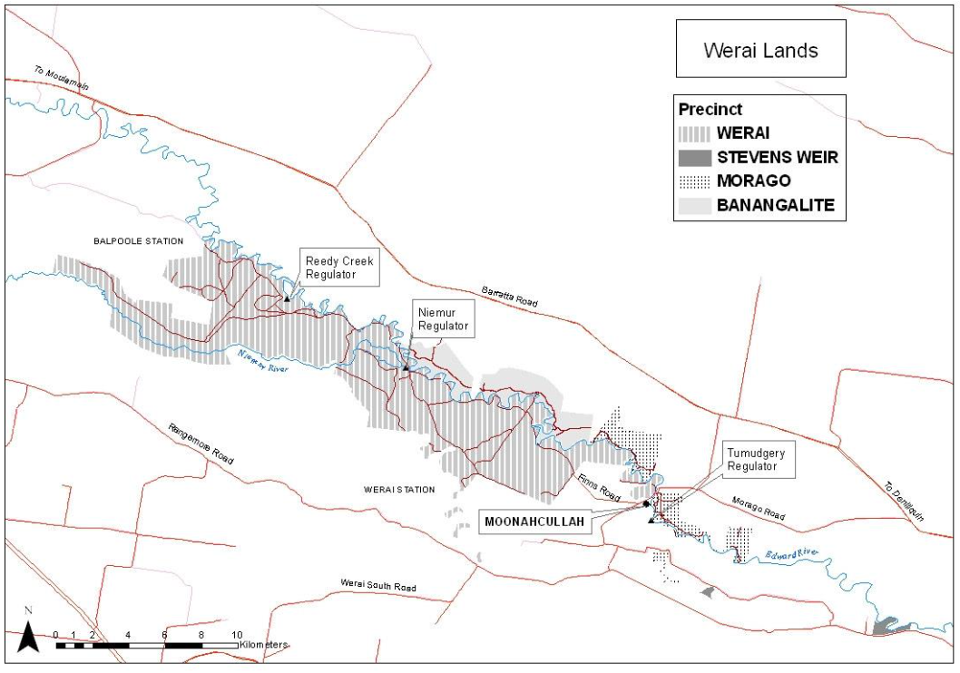
Figure 1 Hydrological network of the Werai system (from Werai Water Management Plan 2018).

Inundation patterns
Following hydrological characterisation of the system a number of target hydrological events will be chosen to assess inundation patterns using Sentinel 2 images. Sentinel 2 image analysis is currently being used by the MDBA and the Gwydir and Warrego-Darling MER Selected Areas to map wetland inundation sequences and this project will use the same approach.
The Sentinel-2 series provides:
- 10 m pixel size for visible and near-infrared bands
- 20 m pixel size for shortwave infrared bands
- twice weekly (approximate) image captures

There are a number of commonly used indices that are able to be used to map water extent with a high degree of accuracy. These include:
- Normalised Difference Water index
  - NDWI = (Green – NIR)/(Green + NIR)
- Modified Normalised Difference Water index
  - MNDWI = (Green − SWIR)/(Green + SWIR)

We will trial a combination of these equations to optimise the imagery spatial and spectral properties to map water extent. All images associated with the target inundation events will be downloaded and the pattern of inundation mapped for each event. A descriptive model linking inundation to flow will be created for each mapped event. The descriptive model will determine the inundation sequence, inundation patterns and the maximum inundated area for each event. We will also examine flows leaving the forest area. Visual representations of the sequence of inundation with each event will also be produced to help determine typical inundation pathways and communicate the project outputs.

Vegetation responses
A trial project linking vegetation response to inundation will be undertaken. The approach developed by Thomas et al. (2015) will be explored to examine the response of wetland vegetation to inundation events and help to better quantify inundation extents and patterns.
Thomas, R. Kingsford, R. Lu, Y. Cox, S. Sims, N. d, Hunter, S. (2015) Mapping inundation in the heterogeneous floodplain wetlands of the Macquarie Marshes, using Landsat Thematic Mapper, Journal of Hydrology 524 194–213.

Reporting and presentations
Reports on the progress of this research will be included as part of the Edward/Kolety-Wakool MER newsletters (June 2021 and March 2022 issues).
A final report detailing the methods, outcomes and descriptive system model will be submitted to the Department by 31st March 2022. The revised report will be included as a section of the 2021-22 Edward/Kolety-Wakool MER Annual report.
A presentation of findings to CEWO, relevant agencies and key stakeholders will be given at the March 2022 Edward/Kolety-Wakool Environmental Water Reference Group meeting.

Project staging and outputs
To optimise the chances of project success this project will be undertaken in two stages.
Stage 1 output - completed by June 30 2021
The initial stage will examine key hydrological relationships and test the efficacy of using Sentinel remotely sensed data to map inundation within the Werai Forest environment. A progress report will be completed following this initial stage.
Stage 2 – outputs - completed by March 31 2022.
Should Stage 1 prove to be successful, the initial hydrological characterisation will be enhanced by including additional flow events and Sentinel image sets. If environmental watering actions to Werai Forest occur in 2021 the flow action(s) will be incorporated into the project.

The final report will include the following:
- Figures and/or tables showing the relationship between hydrological gauges
- Set of maps showing inundation under different historical flow sequences, including any 2021 environmental watering actions. These inundation maps will be overlain with information on forestry compartments to reference different zones within Werai Forest.
- Table of inundated area under different flow events
Presentation of the hydrological character model to stakeholders and community will be undertaken following the completion of the second project stage. Any GIS data created will be provided to the Department in appropriate formats.
Benefits to management of commonwealth environmental water
The relationship between hydrological gauges and the area of forest inundated under different flow events will be critical information that can be used by CEWO staff to inform the management of the Commonwealth environmental water holdings. This information can be used to predict and compare the area inundated under different options considered for environmental watering.
The inundation maps will be included as a part of the reporting of outcomes of the environmental watering action(s) in 2021, to be reported in the 2021-22 Edward/Kolety-Wakool MER annual report.
The inundation maps will be a resource for CEWO, Werai Corporation and other organisations to use as part of ongoing management of Werai Forest. These inundation maps will be overlain with information on forestry compartments to reference different zones within Werai Forest and will enable users to link the inundation with other GIS layers on natural resources or heritage sites.

Edward-Wakool MER Plan Appendix 6.

Schedule 6 –Work Order 4

Order
The parties have agreed in accordance with clause 7 of the Agreement that the Provider will provide the Additional Project Services specified in this Work Order.

Note: All costings have been removed from this version.
Item | Description | Clause | Details
 | Agreement description | N/A | Agreement for Additional Project Services in respect of Edward/Kolety-Wakool Selected Area: Assessment of Groundcover vegetation Condition in the Werai Forest (Work Order 4) dated 17 September 2021.
 | Names of Parties to the Agreement | N/A | The Commonwealth of Australia as represented by the Department of the Agriculture Water and Environment  ABN 34 190 894 983  Charles Sturt University  ABN: 83 878 708 551
 | Additional Project Start Date | 1.1 | 11 October 2021
 | Additional Project Timeframe | 1.1 | To be completed 30 September 2022
 | Category of Services | 7 | Contingency
 | Additional Project Services | 7 | See Attachment B that includes details of services, deliverables and milestones.  Service levels are as per the signed agreement and/or as outlined in the ‘Quality Assurance’ section of the Monitoring, Evaluation and Research Plan (2019-2022).
 | Subcontractors | 6.5 | Streamology Pty Ltd
 | Progress meetings and reports | 11 | Details of reporting requirements, progress meetings and reports are outlined in Attachment A.
 | Performance Criteria | 12 | Must be in accordance with the Work Order and/or the Monitoring, Evaluation and Research Plan (2019-2022).  Must be completed to a professional standard.  Must be undertaken in accordance with the dates and timeframes specified the Work Order.  Must provide recommendations for how Commonwealth environmental water can best be managed to influence these processes and encourage desired responses in the Edward/Kolety-Wakool Selected Area i.e. to directly inform adaptive management.  Must address relevant feedback previously provided by the Department.
 | Project Officers | 1.1 | Department  Name: Ebony Mullins  Position: Assistant Director for Edward-Wakool Water Delivery, Central Basin Section  Phone: 02 6274 2497  Email: damian.mcrae@dcceew.gov.au  Provider  Name: Professor Robyn Watts  Position: Professor, Institute for Land, Water and Society  Email: rwatts@csu.edu.au
 | Specified Personnel | 1.1 and 13 | Edward/Kolety-Wakool River - contingency monitoring  Prof Robyn Watts (CSU)  Dr Christine Lauchlan Arrowsmith (Streamology Pty Ltd)  Neil Sutton (Streamology Pty Ltd)  Vincent Chea (Streamology Pty Ltd)  Thom Gower (Streamology Pty Ltd)  Sam Davidson (Streamology Pty Ltd)  Mitchell Baum (Streamology Pty Ltd)
 | Department Material | 1.1 | Not applicable
 | Pre-existing Material of the Provider | 1.1 | Not applicable
 | Payment Schedule | 7 and 16 | All costings have been removed from this version.
 | Expenses | 16 | No change
 | Other | N/A | No change

ATTACHMENT A

Item 6. Additional Project Services for Work Order number 4
- Details of services
Details of services for these additional project services are outlined in the contingency monitoring plan (attachment B).
Services | Section of MER Plan | Dates of services
Edward/Kolety-Wakool River – groundcover vegetation research |  | 11 October 2021 – 30 September 2022

- Deliverables and milestone due dates
2021-2022
Item | Service/deliverable |  |  | Milestone due date | Payment
1 October 2021 to 31 January 2022
1 |  | - Undertake research according to project plan  - Include update on “Assessment of vegetation condition in the Werai forest” in December 2021 Progress Report and Newsletter | 31 Jan 2022 |  |  | 40% of specified contingency services
1 February 2022 to 31 May 2022
2 | - Undertake research according to project plan  - Include update on “Assessment of vegetation conditions in the Werai forest” in March 2022 Progress Report |  |  | 31 May 2022 | 30% of specified contingency services
1 June 2022 to 30 September 2022
3 | - Undertake research according to project plan  - Submit draft report on “Assessment of vegetation condition in the Werai forest” to Department. The revised report will be included as a section in 2021-22 Edward/Kolety-Wakool MER Annual report |  |  | 30 Sept 2022 | 30% of specified contingency services

Item 8. Reporting requirements
Progress meetings and reports will be as outlined in the deliverables table.

Item 14. Payment schedule for Work Order number 4
All costings have been removed from this version.
ATTACHMENT B
Effectiveness of using drones to assess groundcover vegetation condition in the Werai forest (Work Order number 4)

Background
In 2019-20 CEWO engaged CSU and Streamology to monitor river bank and vegetation condition in response to flow events during the Edward-Wakool MER (Watts et al. 2020). This new proposal is to build on the previous research to evaluate the potential for using drone data to assess groundcover vegetation condition and responses to environmental watering actions in the Werai Forest across the 2021-22 water year.
This proposal summarises the research questions, methodology, deliverables and budget necessary conduct this research. The research will enable the CEWO to gain a greater understanding of how emerging technologies like drone monitoring could be employed to improve understanding of how Commonwealth environmental watering actions and other flows impact groundcover vegetation condition.
Drone monitoring data includes colour imagery (red, green, and blue spectral bands), multispectral imagery (red, green, blue, near infrared, and red-edge bands), and three-dimensional elevation data (point clouds, digital surface models). Critically for investigating vegetation condition, visible and non-visible imagery bands can be combined to create a wide range of vegetation indices that can reveal insights on vegetation cover, type, and condition that are not possible from standard colour imagery.
However, the majority of the studies of this type focusses on monocultures like forestry or horticulture, and research using the techniques in natural settings is much more limited, especially in the Australian landscape. This project will advance our understanding of how effective drone-based monitoring is for assessing ground vegetation condition in the Werai Forest. The project will help will inform future Commonwealth environmental watering actions and assist the management of Werai Forest Indigenous Protected Area by Traditional Owners.

Research questions
The overarching question for this study is:
Can we assess groundcover vegetation response to watering conditions using drone technology?
This can be broken down into 5 core research questions that this study will address:
- Using drone-derived data captured from above a eucalyptus forest, how accurately can it separate ground vegetation from canopy cover?

- How effective, compared to ground-truthed field observations, is drone-derived data for measuring ground vegetation coverage versus bare earth?

- How effective, compared to ground-truthed field observations, is drone-derived data for differentiating between dead vegetation and living (but potentially dry) vegetation?

- How effective, compared to ground-truthed field observations, is drone-derived data for differentiating between different plant growth stages of ground cover vegetation?

- How effective, compared to ground-truthed field observations, is drone-derived data for differentiating between different ground cover vegetation types?

Two additional research questions will be considered (although they may not be able to be answered fully within the limited scope of the study):

- How effective, compared to ground-truthed field observations, is drone-derived data for determining ground cover vegetation health/condition?

- How effective, compared to ground-truthed field observations, is drone-derived data for detecting changes in ground cover vegetation health/condition in response to different inundation regimes?

The methods that will be employed to answer the above questions are summarised below.

Methods
This study will employ repeat visits to up to three sites in the Werai Forest to capture drone data that will be used to evaluate the above research questions. A high-precision RTK-GPS equipped drone will capture traditional and multispectral imagery which can be transformed into a variety of georeferenced products including orthomosaics, point clouds, digital surface models (DSMs), and digital terrain models (DTMs). By capturing matching datasets at multiple times during the watering season, and at multiple locations of interest, combined with simultaneous ground-truthed observations, we will be able to determine the efficacy of this remote sensing approach for monitoring forest ground cover vegetation.
Study site selection
The study design is to monitor the groundcover vegetation condition at up to three sites in the Werai Forest. The sites will be selected in collaboration with CSU staff familiar with the conditions in the forest. Key considerations for site selection include:
- Access. Sites where safe 4WD access is mostly likely to remain possible throughout the season.
- Density of canopy. Areas of forest with relatively sparse canopy cover to allow maximum ground cover visibility from the air.
- Vegetation types. Site containing a range of ground vegetation types.
- Inundation regime. Locations that experience different inundation regimes.

Initial discussions with CSU staff indicate that several locations along the south side of the Edward/Kolety River (e.g. between markers 2 and 4 in Figure 1) would be suitable. Aerial imagery indicates that this area also consists of relatively sparse canopy cover. Locations along Tumudgery Creek (13/14 and 17-19 in Figure 1) may also be suitable. The precise location and size of the three drone survey areas will be decided in the field based on discussions with ground staff, considering the factors listed above. However, three sites covering up to 10 hectares each should provide ample data to evaluate the research questions.

Once identified, site setup would include installation of a survey benchmark and ground control points (GCPs) that will allow to precise alignment of repeat surveys. Key vegetation areas of interest (with high visibility from above) will also be marked so they are visible in the drone imagery.
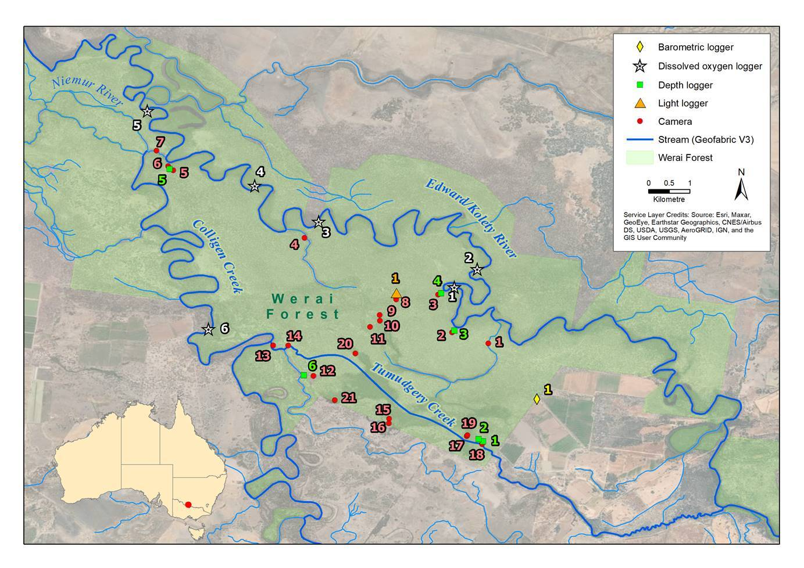

Figure 1. Map of the Werai Forrest including existing monitoring sites.

Survey timing

There will be a total of 4 field visits (timing to be confirmed based on weather, watering actions and COVID-19 restrictions). An approximate schedule could include visits in November 2021, and January, March and May 2022.

Drone surveys
A Phantom 4 RTK drone (with base station) will be used to capture high-resolution colour imagery and during each visit. We will also use a multispectral camera during the flights to capture multispectral imagery in five separate bands (blue, green, red, red-edge, near-infrared). The drone’s built-in irradiance sensor will capture data on lighting conditions that allow for radiometric calibration of all captured images. The RTK-GPS equipped drone will allow for precisely matching grid-like flight paths for repeat surveys above the canopy (e.g. 60-80 m above ground level).

Ground truthing
Drone surveys will be conducted simultaneously with on-ground vegetation surveys undertaken by CSU field staff in collaboration with Murray-Darling Wetlands Working Group and Indigenous Rangers from Yarkuwa Indigenous Knowledge Centre. These surveys will be undertaken at selected locations within each survey area, to provide a validation dataset with which drone outputs can be compared. Field assessments will involve classifying ground cover into categories that help with answering the research questions. For example, the percent cover of the following categories will be assessed:
- Bare earth
- Dead vegetation
- Leaf litter
- Vegetation type
The growth stage, height and health/condition of the vegetation will also be recorded.
To make comparisons with the drone results feasible, the emphasis will be on ground assessments of areas with relatively uniform ground cover. For example, one survey site could contain 12 marked plots, each several square metres in area, representing a range of cover types (those listed above) and include:
- Plots dominated by a single cover type (to the extent possible).
- Plots containing a mixture of cover types.
- Plots that have been manually cleared of leaf litter to create uniform plots of bare earth.

Post-flight photogrammetric image processing
Data from the drone surveys will be processed using photogrammetry software (Pix4D Mapper) to transform the imagery into the following georeferenced outputs:
- Orthomosaic maps (in traditional colour and all multispectral bands)
- 3D point clouds (also incorporating colour and multispectral bands)
- Digital surface models (DTMs) and terrain models (DTMs) of elevation
These outputs (in different combinations) will provide the basis for answering the research questions.

Evaluation of research questions
Core research questions:
- Using drone-derived data captured from above a eucalyptus forest, how accurately can it separate ground vegetation from canopy cover?

The study will determine how effective automated techniques are for isolating ground cover from canopy cover in drone-derived aerial data. Techniques will include, but are not limited to:
- Classification of ground cover and canopy using multispectral orthomosaics and vegetation indices (e.g. Normalised Difference Vegetation Index - NDVI).
- Elevation-based filtering using 3D point clouds (e.g. removing all data >2 m above ground level).

Results of the classification and filtering will be validated using standard colour orthomosaic imagery.

- How effective, compared to ground-truthed field observations, is drone-derived data for measuring ground vegetation coverage versus bare earth?

Techniques for assessing bare earth versus vegetation ground cover include but are not limited to:
- Classification of multispectral orthomosaics using vegetation indices (e.g. NDVI index values range from -1 to 1 and typical bare soil typically falls within the 0.1-0.2 range).
- Filtering of vegetation from 3D point cloud based on surface roughness (vegetation produces rougher point clouds than bare ground).

Results will be validated using ground-truthing results and visual interpretation of standard colour orthomosaic images.

- How effective, compared to ground-truthed field observations, is drone-derived data for differentiating between dead vegetation and living (but potentially dry) vegetation?

- Classification of multispectral orthomosaics using vegetation indices (e.g. weighted difference vegetation index (WDVI).
- 3D point cloud classification using vegetation indices (e.g. WDVI), where results under canopy are desired (not normally visible in an orthomosaic).
Results will be validated using ground-truthing results.

- How effective, compared to ground-truthed field observations, is drone-derived data for differentiating between different plant growth stages for ground cover vegetation?

Plant grow stages will be investigated using a variety of vegetation indices in orthomosaics. Different indices are likely to yield better results for different grow stages and circumstances. In addition to NDVI, some examples include:
- SAVI (Soil-Adjusted Vegetation Index) – for sparse vegetation cover
- EVI (Enhanced Vegetation Index) – for dense vegetation cover
- PSRI (Plant Senescence Reflectance Index) – for later growth stages
Results will be validated using ground-truthing results.

- How effective, compared to ground-truthed field observations, is drone-derived data for differentiating between different ground cover vegetation types?

- Differentiating between vegetation classes (e.g. taxonomic, structural, or functional groups) using remotely sensed data will be a challenging task. Success is most likely for areas with lower complexity (e.g. phragmites dominated areas).
- It will require exploration of a range of vegetation indices to determine how well they function in the specific setting that is the Werai Forest.
- 3D point cloud data is likely to be valuable, especially when classifying vegetation types with distinctly different structural forms (e.g. phragmites vs old man weed groundcover).
Results will be validated using ground-truthing results.

Additional research questions for consideration:
The additional research questions will be considered (building on the knowledge gained from assessing the core questions above), although given a lower priority, depending on availability of resources.
- How effective, compared to ground-truthed field observations, is drone-derived data for determining ground cover vegetation health/condition?
- Multispectral data cannot tell us directly about plant health, but instead provides proxy information, including chlorophyll content.
- Relating the proxy measures to actual plant health is the major challenge, and will rely heavily on the expert input from ground truthing teams.

- How effective, compared to ground-truthed field observations, is drone-derived data for detecting changes in ground cover vegetation health/condition in response to different inundation regimes?
- Will draw on existing inundation modelling being conducted as a part of the broader Werai Forest research.
- Results from the multispectral imagery analysis (e.g. relating to question 6) will be compared with previous inundation condition for each visit at the same location
- Drone-derived elevation data will allow for comparison of differing vegetation response caused by terrain differences (e.g. high vs low ground).

Deliverables
Streamology aims to complete this project as described above, however, accurate drone surveying is dependent on suitable flow and weather conditions, with this in mind dates are subject to change.
The following deliverables will be provided as a result as a result of the study:
- Field updates will be provided after each visit detailing the initial findings based on surveying experience in Werai Forest.
- Progress reports to align with the Edward/Kolety-Wakool MER reporting timelines. The field updates will be used as the basis for stories in two Edward/Kolety-Wakool quarterly newsletters (two of either December 2021, March 2022, June 2022 or September 2022, depending on timing of field work).
- Draft reporting outputs submitted by 31 July 2022 with the intention being for some or all of the content to be included as a section of the 2021-22 Edward/Kolety-Wakool MER Annual Report. Reporting outputs will be in the form of a technical report that includes:
  - Maps and figures visualising vegetation change over time in response to watering actions, and location differences.
  - Answers to the five core research questions, plus high-level discussion regarding the two additional secondary research questions.
  - Recommendations on next steps to advance the knowledge generated through the study.
- Communications and engagement: A presentation of findings of this project to CEWO, relevant agencies and key stakeholders including Traditional Owners will be given at one of the Edward/Kolety-Wakool Environmental Water Reference Group meetings. Indigenous Rangers will be embedded in the project team and have opportunities to share their knowledge and gain experience in fieldwork, GIS and other skills. A community field day in Werai Forest will be coordinated by CSU as part of the broader Edward/Kolety-Wakool MER project (not a deliverable of this work order).
Project Management
This research will be subcontracted by Charles Sturt University to Streamology Pty Ltd. Streamology will undertake project management of these works using their proprietary project management system. This will involve regular project communications to update CEWO/CSU as to the progress of works and to identify risks to the project's scope, timeline and budget proactively.
Upon acceptance of this proposal, Streamology will engage with CEWO/CSU in a kick-off meeting to identify the key concerns from client with respect to the undertaking of these works. At this meeting, a firm timeline and communication plan will be established with CSU to form the basis of the project's management and execution. Any additional documentation or data required to complete the project will be identified and a plan for obtaining the data or working around data that cannot be obtained agreed upon.

Edward-Wakool MER Plan Appendix 7.

Schedule 6 –Work Order 5

Order
The parties have agreed in accordance with clause 7 of the Agreement that the Provider will provide the Additional Project Services specified in this Work Order.

Note: All costings have been removed from this version.

Item | Description | Clause | Details
 | Agreement description | N/A | Agreement for Additional Project Services in respect of Edward/Kolety-Wakool Selected Area: Comparison of aquatic productivity rates between river channels and recently inundated sites in the Werai forest (Work Order 5) dated 14 February 2022.
 | Names of Parties to the Agreement | N/A | The Commonwealth of Australia as represented by the Department of the Agriculture Water and Environment  ABN 34 190 894 983  Charles Sturt University  ABN: 83 878 708 551
 | Additional Project Start Date | 1.1 | 28 February 2022
 | Additional Project Timeframe | 1.1 | To be completed 30 September 2022
 | Category of Services | 7 | Contingency
 | Additional Project Services | 7 | See Attachment B that includes details of services, deliverables and milestones.  Service levels are as per the signed agreement and/or as outlined in the ‘Quality Assurance’ section of the Monitoring, Evaluation and Research Plan (2019-2022).
 | Subcontractors | 6.5 | La Trobe University
 | Progress meetings and reports | 11 | Details of reporting requirements, progress meetings and reports are outlined in Attachment A.
 | Performance Criteria | 12 | Must be in accordance with the Work Order and/or the Monitoring, Evaluation and Research Plan (2019-2022).  Must be completed to a professional standard.  Must be undertaken in accordance with the dates and timeframes specified the Work Order.  Must provide recommendations for how Commonwealth environmental water can best be managed to influence these processes and encourage desired responses in the Edward/Kolety-Wakool Selected Area i.e. to directly inform adaptive management.  Must address relevant feedback previously provided by the Department.
 | Project Officers | 1.1 | Department  Name: Ebony Mullins  Position: Assistant Director for Edward-Wakool Water Delivery, Central Basin Section  Phone: 02 6274 2497  Email: damian.mcrae@dcceew.gov.au  Provider  Name: Professor Robyn Watts  Position: Professor of Environmental Sciences, Charles Sturt University  Email: rwatts@csu.edu.au
 | Specified Personnel | 1.1 and 13 | Edward/Kolety-Wakool River - contingency monitoring  Prof Robyn Watts (CSU)  Prof Nick Bond (La Trobe University)  Dr Andre Siebers (La Trobe University)  Dr Xiaoying Liu (CSU)  Dr Nicole McCasker (CSU)  Mr John Trethewie (CSU)
 | Department Material | 1.1 | Not applicable
 | Pre-existing Material of the Provider | 1.1 | Not applicable
 | Payment Schedule | 7 and 16 | All costings have been removed from this version.
 | Expenses | 16 | No change
 | Other | N/A | No change

ATTACHMENT A

Item 6. Additional Project Services for Work Order number 5
- Details of services
Details of services for these additional project services are outlined in the contingency monitoring plan (attachment B).
Services | Section of MER Plan | Dates of services
Edward/Kolety-Wakool River – Aquatic productivity Werai Forest |  | 28 February 2022 – 30 September 2022

- Deliverables and milestone due dates
Item | Service/deliverable | Milestone due date | Payment
28 February 2022 to 31 May 2022
1 | - Undertake research according to project plan  - Include update on “Comparison of aquatic productivity rates between river channels and recently inundated sites in the Werai forest” in March 2022 Progress Report and Newsletter | 31 May 2022 | 50% of specified contingency services
1 June 2022 to 30 September 2022
2 | - Undertake research according to project plan  - Include update on “Comparison of aquatic productivity rates between river channels and recently inundated sites in the Werai forest” in June 2022 Progress Report, and story for either June or Sept 2022 Newsletter  - Submit draft report on “Comparison of aquatic productivity rates between river channels and recently inundated sites in the Werai forest” to Department. The revised report will be included as a chapter in 2021-22 Edward/Kolety-Wakool MER Annual report | 30 Sept 2022 | 50% of specified contingency services
Item 8. Reporting requirements
Progress meetings and reports will be as outlined in the deliverables table.

Item 14. Payment schedule for Work Order number 5
All costings have been removed from this version.

ATTACHMENT B
Comparison of aquatic productivity rates between river channels and recently inundated sites in the Werai Forest (Work Order number 5)

Background
In 2019-20 CEWO engaged CSU and La Trobe to investigate how the flow regime downstream of Stevens Weir affects ecosystem metabolism (primary productivity and ecosystem respiration) along the Edward-Kolety River (Watts et al. 2020). This new proposal builds on the previous research by evaluating potential benefits of lateral hydrological connectivity within the Werai Forest to the productivity of the Edward/Kolety River system across the 2021-22 water year.
This proposal summarises the research questions, methodology, deliverables and budget necessary to conduct this research. The research will enable the CEWO to gain a greater understanding of the potential increases in whole-system productivity that occur with connection to inundated, low-lying floodplains and intermittent anabranches. This work can thus be used to inform future sampling techniques for stream metabolism monitoring and research across the Flow-MER program.
Stream metabolism measures the processes of Gross Primary Production (GPP) and Ecosystem Respiration (ER) that support and sustain aquatic food webs and are directly related to ecosystem health. Stream metabolism has historically been monitored by continuous measurement of dissolved oxygen within river channels. Yet inundation of low-lying benches, anabranches, and floodplains surrounding river channels can result in large pulses of terrestrial organic matter and nutrients into the aquatic environment, which then support relatively high rates of both GPP and ER. A central tenet of large river ecology is that high-flow events which inundate off-channel areas therefore support a disproportionately large proportion of whole-system production at an annual scale. However, pulses of GPP and ER related to high-flow events may be concentrated within inundated off-channel habitats and thus not picked up by conventional measurements of river channel stream metabolism. Direct measurements of off-channel metabolism in the Murray-Darling Basin are rare, and the potential magnitude of differences in aquatic productivity between river channel and inundated off-channel habitats is largely unknown.
This project will therefore advance our understanding of how inundation of the Werai Forest might increase production within the Edward/Kolety system. This project is one component of the integrated Werai Forest research project that will help will inform future Commonwealth environmental watering actions and assist Traditional Owners manage the Werai Forest Indigenous Protected Area (see story published in the Edward/Kolety-Wakool Flow-MER Newsletter #9 September 2021).
Research questions
The overarching question for this study is:
What is the effect of inundation of the Werai Forest on aquatic productivity in the Edward/Kolety system?
There are three research questions that this study will address:
- How do aquatic productivity rates compare between river and off-channel habitats during high-flow events?
- Does the majority of aquatic production occur in the water column or on inundated substrates (e.g., soils, aquatic plants) in off-channel habitats?
- Can we identify changes in GPP and ER within the Edward/Kolety River or Colligen Creek when the Werai Forest is inundated?
Methods
A key challenge in measuring the contribution of inundated floodplains to river productivity is (i) the high spatial and temporal variability in floodplain productivity when compared with river channels and (ii) measurement errors associated with monitoring dissolved oxygen in shallow, low-flowing habitats. In particular, floodplain productivity is likely to be higher in algae and biofilms attached to ground-cover vegetation on floodplains and in intermittent anabranches than in the broader water column where dissolved oxygen is conventionally monitored. Further, return flows from off-channel inundation can sometimes only induce a metabolic response in river channels for a short distance downstream of confluences, and may vary in effect with the ratio of channel to floodplain flows (i.e., be greatest when the proportional contribution of return flows to channel flows is greatest). Capturing the potential productivity benefits of overbank flow events to river systems therefore requires both (i) direct measurement of potential off-channel “hotspots” of productivity and (ii) targeted monitoring of stream metabolism at potential return flow confluences.
This project will: (i) use a network of dissolved oxygen loggers to provide finer spatial-resolution data on stream metabolism along the Edward/Kolety River and Colligen Creek, particularly with respect to return flow points from Werai Forest; (ii) conduct field samplings to directly measure the productivity of ecosystem components (plankton, epiphyton) assumed to contribute most to whole-system metabolism, including additional chemical indicators of productivity; and (iii) determine whether empirical relationships can be derived between stream metabolism estimates from dissolved oxygen loggers and field productivity measurements and/or chemical indicators.

Study site selection
The study design is to:
- Expand the current network of dissolved oxygen loggers to include sites upstream and downstream of potential confluences between Tumudgery Creek overflows (i.e., return flows from Werai Forest) and the Edward-Kolety River and Colligen Creek, and;
- Conduct field samplings to determine areal/volumetric rates of aquatic productivity within the Edward/Kolety River and Colligen Creek channels, and inundated areas of the Werai Forest, across three time periods: (i) pre-high flows (base flows), (ii) during a high-flow event, and (iii) in the drawdown stages of an high-flow event (i.e., while off-channel areas within the Werai Forest are still inundated but discharge is declining).
Sites for field sampling will be selected in collaboration with CSU staff and Traditional Owners familiar with the conditions in the forest. Key considerations for site selection include:
- Access. Sites where safe access is possible given current flow and weather conditions.
- Potential to contribute to river channels. Inundated off-channel areas within the Werai Forest where water flows may ultimately deliver nutrients and organic matter away into river channels.
- Substrate availability. Areas where substrates for algal growth (shallow sediments, aquatic or emergent plants) are available.
CSU staff have installed dissolved oxygen loggers upstream and downstream of the most likely return flow points of water from Tumudgery Creek and inundated off-channel areas within the Werai Forest into the Edward/Kolety River and Colligen Creek (white stars in Figure 1). These locations complement existing Flow-MER loggers installed upstream of Werai Forest along the Edward/Kolety River and Colligen Creek and have greater potential for registering metabolic responses to inundation water returning to either system than another logger currently installed approximately 19 km further downstream along the Edward/Kolety River (Watts et al. 2020). Field experiments to measure volumetric rates of productivity will be conducted at/near three of these sites during base-flow periods (i.e., prior to any potential high-flow events) to provide a baseline for in-channel rates during normal flow conditions.

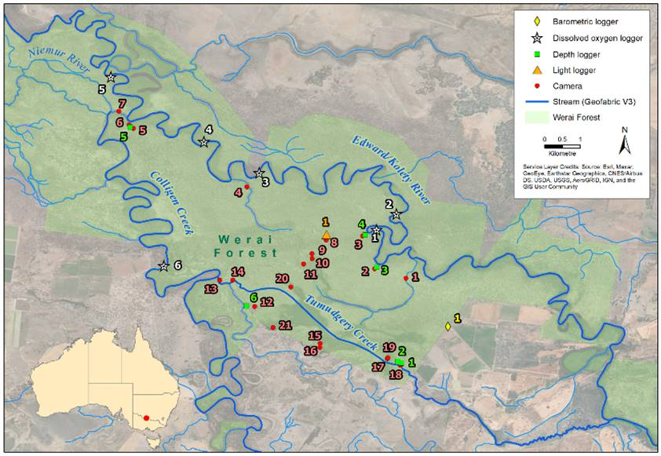
Figure 1. Map of the Werai Forest with dissolved oxygen monitoring sites (white stars) shown in relation to other field monitoring equipment.

Under high-flow conditions, field experiments to measure areal and volumetric rates of productivity will be conducted at three Edward/Kolety River and Colligen Creek sites where dissolved oxygen loggers are installed (if accessible), and at approximately five off-channel inundated floodplain or anabranch sites within Werai Forest. The same sites will be revisited in the drawdown stages of a high-flow event (approx. 10-20 days following peak flows) to measure areal and volumetric rates of productivity at the time when return flows from the Werai Forest are likely at their highest proportional to river flow.

Survey timing
There will be a total of three field visits (timing to be confirmed based on weather, watering actions and COVID-19 restrictions). The first, base flow sampling is likely to be conducted in late 2021. The subsequent samplings will be reliant on the occurrence of high flows downstream of Stevens Weir.

Areal and volumetric productivity
Productivity experiments will consist of light/dark chambers filled with (i) open surface water and (ii) epipelic/epiphytic algae (with attached sediment/macrophytes) to give an indication of planktonic and benthic contributions to whole system productivity, respectively. Chambers will be placed in-situ at each site for 4 hours with dissolved oxygen measured at the beginning and end of the experiment. Half of the chambers will be made of Perspex which allows light penetration (for measurement of primary productivity) and half of the chambers will be opaque (for measurement of respiration). Phytoplankton productivity will be determined from depth-integrated measurements (i.e., samples at different depths within the water column). Epiphytic productivity will be determined at the depth at which macrophyte/algal samples are located. Water temperature and light intensity will be measured at the start and end of each experiment to allow for potential variations across sites and sampling times.
Water chemistry and laboratory analyses
Samples for analysis of water chemistry (dissolved organic matter) will be collected at the start and end of each field experiment. Water samples will be analysed for dissolved organic carbon (DOC) as well as chlorophyll a (chl a) concentrations. Three-dimensional fluorescence excitation emission matrices (EEMs) will also be used to characterise the composition and potential origin of dissolved organic matter (DOM). DOM-EEMs will be analysed by parallel factor analysis (PARAFAC), a multivariate decomposition of the fluorescence signal into individually-identifiable components.
Stream metabolism
Stream metabolism will be estimated in the Edward/Kolety River and Colligen Creek through continuous dissolved oxygen concentration measurements in accordance with the LTIM Standard Operating Procedure (Hale et al., 2014) and analysed with the BASEv2 model (updated from Grace et al., 2015 according to Song et al., 2016), consistent with the Flow-MER monitoring program (Watts et al., 2020).
These outputs (in different combinations) will provide the basis for answering the research questions.
Evaluation of research questions
1. How do aquatic productivity rates compare between river and off-channel habitats during high-flow events?
This study will provide directly comparable measurements of aquatic productivity rates in both river channel and inundated off-channel habitats, allowing for estimation of the magnitude of different in productivity between these habitats. Techniques will include, but are not limited to:
- Statistical comparison of measured primary productivity and respiration rates across habitats, at different times during the high-flow event.
2. Does the majority of aquatic production occur in the water column or on inundated substrates (e.g., soils, aquatic plants) in off-channel habitats?
Comparison of aquatic productivity associated with the planktonic and benthic compartments of inundated off-channel ecosystems will allow us to identify broadly applicable rates for scaling of floodplain area to overall system production, given estimates of area inundated and substrate availability. Techniques will include, but are not limited to:
- Statistical comparison of measured primary productivity and respiration rates across planktonic and benthic compartments in off-channel habitats.
- Broad estimation of overall aquatic production associated with different substrate types, scaled from field mapping of off-channel habitats.
- Scaling of areal and volumetric productivity rates by estimates of off-channel wetted area extent to predict potential overall production associated with inundation of the Werai Forest.

3. Can we identify changes in GPP and ER within the Edward/Kolety River or Colligen Creek when the Werai Forest is inundated?
Analysis of the dissolved oxygen logger data upstream and downstream of potential return flow points from the Werai Forest will allow us to potentially identify any short-term or spatially restricted pulses in GPP and ER that occur in the larger rivers during high-flow events. In addition, correlations between potential chemical indicators of productivity and measured rates will allow us to identify whether these techniques can be used as broader or longer-term indicators of aquatic productivity within the Edward/Kolety-Wakool system. Techniques will include, but are not limited to:
- Statistical comparison of stream metabolism (GPP and ER) across sites within the Edward/Kolety River or Colligen Creek (upstream/downstream of potential return flow points) and across times (before, during, and in the draw-down stages of the high-flow event).
- Determination of whether correlations can be made between stream metabolism (GPP and ER) time series and measured river channel productivity rates before and after the high-flow event.
- Comparison of potential chemical indicators of productivity (DOC, chlorophyll a and DOM) with rates of aquatic productivity, and their change in relation to stream metabolism (GPP and ER) in the Edward/Kolety River and Colligen Creek.
Deliverables
The project team intends complete this project as described above. However, accurate field surveys will be dependent on suitable flow conditions, weather, and site access, and with this in mind dates are subject to change.
The following deliverables will be provided as a result of the study:
- Informal email or verbal updates
- Progress reports will be provided to CSU to align with the Edward/Kolety-Wakool MER reporting timelines (March 2022, June 2022, Sept 2022). Stories will be provided for two Edward/Kolety-Wakool quarterly newsletters (March 2022, June 2022 or September 2022, depending on timing of field work and preliminary outcomes).
- Final report: Draft reporting outputs will be completed by 31 July 2022 and this will be included as a section of the 2021-22 Edward/Kolety-Wakool MER Annual Report (due September 30 2022). Reporting outputs will be in the form of a technical report that includes:
- Figures visualising change in aquatic productivity over time (before, during, and in the draw-down stages of the high-flow event) and space (between river channel and off-channel habitats, and along different sites in river channels) in response to the high-flow event.
- Discussion of the three research questions
- Recommendations on next steps to advance the knowledge generated through the study
- Recommendations for management of environmental water, where appropriate

- A presentation of findings to CEWO, relevant agencies and key stakeholders will be given at one of the Edward/Kolety-Wakool Environmental Water Reference Group meetings.
- Engagement: Indigenous Rangers will have the opportunity to work alongside the project team and share their knowledge and gain experience in fieldwork, GIS and other skills. The extent to which the Indigenous Rangers can contribute to the project will depend on other commitments that have on the dates when field work is undertaken.
In addition to these deliverables, a community field day in Werai Forest will be coordinated by CSU as part of the broader Edward/Kolety-Wakool MER project (this deliverable is part of the integrated Werai Forest project and the field day will be funded as part of Work Order 6, not Work Order 5). Outcomes of workorder #5 will be included in the discussions at the field day.

Project Management
The project will be undertaken as a collaboration between Charles Sturt University and La Trobe University with engagement with Traditional Owners. Upon acceptance of this proposal, we will hold an inception meeting with all relevant parties including CEWO. At this meeting a timeline and communication plan will be established, and any additional documentation or data required to complete the project will be identified.

Edward-Wakool MER Plan Appendix 8.

Schedule 6 –Work Order 6

Order
The parties have agreed in accordance with clause 7 of the Agreement that the Provider will provide the Additional Project Services specified in this Work Order.

Note: All costings have been removed from this version.
Item | Description | Clause | Details
 | Agreement description | N/A | Agreement for Additional Project Services in respect of Edward/Kolety-Wakool Selected Area: Ephemeral Creek habitat use by fish and other vertebrates (Work Order 6) dated 4 September 2022
 | Names of Parties to the Agreement | N/A | The Commonwealth of Australia as represented by the Department of Climate Change, Energy, the Environment and Water  ABN 63 573 932 849  Charles Sturt University  ABN: 83 878 708 551
 | Additional Project Start Date | 1.1 | 4 September 2022
 | Additional Project Timeframe | 1.1 | To be completed 31 December 2023
 | Category of Services | 7 | Contingency
 | Additional Project Services | 7 | See Attachment B that includes details of services, deliverables and milestones.
 | Subcontractors | 6.5 | NSW DPI Fisheries  NSW Department of Planning and Environment  Yarkuwa Indigenous Knowledge Centre
 | Progress meetings and reports | 11 | Details of reporting requirements, progress meetings and reports are outlined in Attachment A.
 | Performance Criteria | 12 | Must be in accordance with the Work Order and/or the Monitoring, Evaluation and Research Plan (2019-2022).  Must be completed to a professional standard.  Must be undertaken in accordance with the dates and timeframes specified the Work Order.  Must provide recommendations for how Commonwealth environmental water can best be managed to influence these processes and encourage desired responses in the Edward/Kolety-Wakool Selected Area i.e. to directly inform adaptive management.  Must address relevant feedback previously provided by the Department.
 | Project Officers | 1.1 | Department  Name: Katherine Reid  Position: Edward-Wakool System Water Delivery Officer, Central Basin Delivery Section  Phone: 02 6274 2868  Email: damian.mcrae@dcceew.gov.au  Provider  Name: Professor Robyn Watts  Position: Professor of Environmental Sciences, Charles Sturt University  Email: rwatts@csu.edu.au
 | Specified Personnel | 1.1 and 13 | Edward/Kolety-Wakool River - contingency monitoring  Prof Robyn Watts (CSU)  Mr John Trethewie (CSU)  Dr Meaghan Duncan (NSW DPI)  Kolety-Werkul Rangers (Yarkuwa Indigenous Knowledge Centre)  Dr Dale Campbell (NSW DPE)
 | Department Material | 1.1 | Not applicable
 | Pre-existing Material of the Provider | 1.1 | Not applicable
 | Payment Schedule | 7 and 16 | All costings have been removed from this version.
 | Expenses | 16 | No change
 | Other | N/A | No change

ATTACHMENT A

Item 6. Additional Project Services for Work Order number 6
- Details of services
Details of services for these additional project services are outlined in the contingency monitoring plan (attachment B).
Services | Section of MER Plan | Dates of services
Edward/Kolety-Wakool River – Ephemeral Creek habitat use by fish and other vertebrates | Contingency | 1 September 2022 – 30 December 2023

- Deliverables and milestone due dates
Item | Service/deliverable | Milestone due date | Payment
1 September 2022 to 31 Dec 2022
1 | - Undertake research according to project plan  - Include update on “Ephemeral Creek habitat use by fish and other vertebrates” in Dec 2022 Progress Report and a story for Dec 2022 Newsletter. | 31 Dec 2022 | 25% of specified contingency services
1 Jan 2023 to 30 June 2023
2 | - Undertake research according to project plan  - Include update on “Ephemeral Creek habitat use by fish and other vertebrates” in Mar 2023 Progress Report  - Include update on “Ephemeral Creek habitat use by fish and other vertebrates” in June 2023 Progress Report, story for June 2023 Newsletter | 30 Jun 2023 | 25% of specified contingency services
1 July 2023 to 30 September 2023
3 | - Undertake research according to project plan  - Include update on “Ephemeral Creek habitat use by fish and other vertebrates” in September 2023 Progress Report | 30 Sep 2023 | 25% of specified contingency services
1 October 2023 to 31 December 2023
4 | - Undertake research according to project plan  - Submit draft report ““Ephemeral Creek habitat use by fish and other vertebrates” by 30 Nov 2023  - Submit final report ““Ephemeral Creek habitat use by fish and other vertebrates” by 31 Dec 2023  - Include update on “Ephemeral Creek habitat use by fish and other vertebrates” in Dec 2023 Progress Report and story for Dec 2023 Newsletter. | 31 Dec 2023 | 25% of specified contingency services

Item 8. Reporting requirements
Progress meetings and reports will be as outlined in the deliverables table in item 6.

Item 14. Payment schedule for Work Order number 6
All costings have been removed from this version.

ATTACHMENT B
Ephemeral Creek habitat use by fish and other vertebrates (Work Order number 6)

Background
Ephemeral creeks provide a vital source of water in otherwise dry landscapes. Ephemeral creeks provide important ecological and hydrological functions by moving water and nutrients through the ecosystem and importantly increase connectivity and create additional habitats for aquatic organisms.
There are a large number of ephemeral creeks in the Edward/Kolety-Wakool system, including Cockrans/Jimaringle Creek, Tuppal Creek, Thule Creek, Murrain-Yarrien Creek, Yarrien Creek, Whymoul Creek, and Buccaneit-Cunninyeuk Creek. These Creeks have important ecosystem functions, enabling connectivity between the larger rivers and tributaries within the system.
Environmental water has been delivered to many of these ephemeral creeks in the Edward/Kolety-Wakool system in recent years, however targeted monitoring of outcomes of these watering actions not been undertaken, and as such little is known about the utilisation of these habitats by fish and other vertebrates. Landholders have observed that large-bodied fish, such as Murray cod, can move into these creeks when connected with larger tributaries, but no formal study has collected as baseline data in this system. At the beginning of the 2022-23 water year the refuge pools in the ephemeral creeks were disconnected from the main tributaries. There are plans to deliver environmental water to several ephemeral creeks in the 2022-23 watering year. Assessing outcomes of environmental water delivery is important to refine future watering actions to maximise the positive outcomes for the aquatic community. This requires monitoring methods that can reliably detect a species when it is present.
In this study monitoring of the vertebrates in a selection of the ephemeral creeks in the Edward/Kolety-Wakool system will be undertaken using a range of traditional fish survey methods as well as eDNA metabarcoding.
The traditional fish survey methods that will be deployed include backpack electrofishing, large mesh double wing fyke nets set overnight, small mesh double wing fyke nets set overnight, bait traps set overnight, and drift nets. These are standard methods that are proven to catch a wide range of fish of different life stages.
Monitoring will also be undertaken using eDNA metabarcoding, a method that is routinely being applied to characterise aquatic biodiversity in a range of environments. Environmental DNA metabarcoding differs from a species-specific eDNA approach in that it is able to characterise biodiversity of a whole community from a water sample. Metabarcoding relies on accurate databases of sequences to be able to identify each species in a sample. These databases are generally good for fish and vertebrate species in the Murray-Darling Basin, though there are likely to be some sequences that can only be allocated to family or genus. Very rare species may not be detected due to their signal being swamped by more common species. Despite this, eDNA metabarcoding is a very effective method for characterising the biodiversity in freshwater environments and often outperforms traditional techniques.

Aims
- To monitor and evaluate the fish assemblages in ephemeral creeks in the Edward/Kolety-Wakool River system prior to and after environmental watering actions using traditional fish survey methods and eDNA metabarcoding, and to survey the movement of fish into these creeks during the delivery of environmental water from irrigation canals and during connection with permanent waterbodies.
- To compare the results from traditional fish survey methods to eDNA sampling to evaluate the efficacy of each method.
Study sites
Study sites were selected in collaboration with water managers, following discussions about which ephemeral creeks were expected to be receive environmental water in 2022-23 water year, and which systems have retained water in pools over winter. Five ephemeral creeks within the Edward/Kolety-Wakool River system that will receive targeted environmental water from September 2022 onwards will be monitored:
- Jimeringal-Cockrans Creek
- Murrian-Yarrien Creek
- Thule Creek
- Tuppal Creek
- Yarrien Creek

Methods
Field surveys will be undertaken on four occasions. All species captured will be identified, measured and released at the site of capture.
Pre-watering (Refuge Pools) – to determine what vertebrate species remain in refuge pools since previous environmental watering action
- 8 x 150 seconds backpack electrofishing at each site (1200 seconds in total).
- 2 x large mesh double wing fyke nets set overnight.
- 2 x small mesh double wing fyke nets set overnight.
- 10 x bait traps set overnight.
- eDNA sampling
Commencement of environmental watering – to determine what fish species move into the ephemeral creeks from irrigation canal water sources
- 8 x 150 seconds backpack electrofishing at each site (1200 seconds in total).
- 2 x large mesh double wing fyke nets set overnight.
- 2 x small mesh double wing fyke nets set overnight.
- 10 x bait traps set overnight.
Commencement of downstream connection – to determine what fish species move into the ephemeral creeks when connected with main tributaries
- 8 x 150 seconds backpack electrofishing at each site (1200 seconds in total).
- 2 x large mesh double wing fyke nets set overnight.
- 2 x small mesh double wing fyke nets set overnight.
- 10 x bait traps set overnight.
Cessation of watering (Refuge Pools) - to determine what vertebrate species remain in refuge pools after disconnection
- 2 x large mesh double wing fyke nets set overnight.
- 2 x small mesh double wing fyke nets set overnight.
- 10 x bait traps set overnight.
- eDNA sampling
Targeted cod spawning – to determine if Murray cod spawn within the ephemeral creeks
- One week of intensive drift netting during the first week in November
e-DNA analysis
At each site four water samples will be filtered until the filter is clogged (i.e., we will filter as much water as possible) using a Smith Root eDNA sampling backpack and self-preserving filters. Samples will be collected while walking slowly along the edge of each creek and a range of habitats will be targetted. Samples will be collected at least 15 to 20 m apart. Sampling will be conducted along the left bank, right bank and mid-creek targeting areas where eDNA is likely to accumulate. To avoid sediment disturbance that could release older eDNA trapped in the sediment, the mid-creek samples will be taken after the left and right bank samples are collected. At each sampling location an equipment control will be taken by filtering 2 L of UV sterilised water. This will be treated as an additional replicate that is processed in the laboratory in the same way as the other replicates in order to check for contamination of equipment.
Once the water is filtered, filter housings will be stored at ambient temperature until the end of the day when they will be refrigerated. Following completion of a day of sampling, a 1% bleach solution will be run through the eDNA backpack system to decontaminate it, followed by flushing with freshwater prior to storage.
Filters will be sent to a metabarcoding service provider for eDNA extraction and metabarcoding to identify indicating the species that were detected.
Project outputs
This work will provide water managers and the community with an improved understanding of the diversity of fish and other vertebrates that use refuge pools in ephemeral creeks, the impact of environmental watering actions on movement of fish and other vertebrates into these ephemeral creeks, and which taxa remain in refuge pools when disconnected from main tributaries. This will help guide future adaptive management of environmental watering in ephemeral creeks.
Communications and reporting:
- Informal/verbal updates to CEWO and partners as the project progresses
- Updates in Edward/Kolety-Wakool quarterly progress reports
- Stories included in two of the 2022-23 Edward/Kolety-Wakool quarterly newsletters
- Final report
Engagement:
- First Nations Engagement: The Kolety-Werkul Rangers will be involved in the field component of the project and share their knowledge and gain experience in monitoring of fish and data recording.
- Community engagement: Landholders whose properties the monitoring is undertake on will be kept informed about the project. A presentation of findings to CEWO, relevant agencies and key stakeholders will be given at a Edward/Kolety-Wakool Environmental Water Reference Group meeting.
Additional expected communication outputs (not deliverables of work order 6):
- A list of taxa and photos of the fish species identified in these ephemeral creeks will be included in the first stage of the interactive flow map (to be described in workorder 7). Clickable icons will allow the viewer to look at the locations where fish surveys were conducted, and a pop-up box of the fish that have been identified at that site will come up, including the common name, species name, photo of fish and date of survey.
- A journal article is planned to be written after the completion of this project

Project management, responsibilities and collaboration
The project will be undertaken as a collaboration between Charles Sturt University, NSW DPI Fisheries, NSW DPE, and Yarkuwa Indigenous Knowledge Centre (Kolety Werkul Rangers).
Project management and oversight
General project management and report review will be undertaken by Prof Robyn Watts, leader of the Edward/Kolety-Wakool Flow-MER project.
Field surveys
- Leader: John Trethewie, Charles Sturt University
- Field monitoring: Charles Sturt University, NSW DPE staff, Kolety-Werkul Rangers (Yarkuwa Indigenous Knowledge Centre)
- Data management, data analysis and reporting: John Trethewie, Charles Sturt University
e-DNA analysis
- Leader: Meaghan Duncan, NSW DPI Fisheries
- Collection of eDNA samples: DPI staff and Charles Sturt University staff
- eDNA metabarcoding: Outsource to an external provider such as EnviroDNA or EcoDNA
- Data management, data analysis and reporting: Meaghan Duncan, NSW DPI Fisheries

Edward-Wakool MER Plan Appendix 9.

Schedule 6 –Work Order 7

Order
The parties have agreed in accordance with clause 7 of the Agreement that the Provider will provide the Additional Project Services specified in this Work Order.

Note: All costings have been removed from this version.
Item | Description | Clause | Details
 | Agreement description | N/A | Agreement for Additional Project Services in respect of Edward/Kolety-Wakool River river system: Online interactive map and data visualisation tool (Work Order 7) dated 23 September 2022
 | Names of Parties to the Agreement | N/A | The Commonwealth of Australia as represented by the Department of Climate Change, Energy, the Environment and Water  ABN 63 573 932 849  Charles Sturt University  ABN: 83 878 708 551
 | Additional Project Start Date | 1.1 | 1 October 2022
 | Additional Project Timeframe | 1.1 | To be completed 30 June 2023
 | Category of Services | 7 | Contingency (Communication and Engagement)
 | Additional Project Services | 7 | See Attachment B that includes details of services, deliverables and milestones.
 | Subcontractors | 6.5 | DiscoverEI
 | Progress meetings and reports | 11 | Details of reporting requirements, progress meetings and reports are outlined in Attachment A.
 | Performance Criteria | 12 | Must be completed to a professional standard.  Must be undertaken in accordance with the dates and timeframes specified the Work Order.  Must address relevant feedback previously provided by the Department.
 | Project Officers | 1.1 | Department  Name: Katherine Reid  Position: Edward-Wakool System Water Delivery Officer, Central Basin Delivery Section  Phone: 02 6274 2868  Email: damian.mcrae@dcceew.gov.au  Provider  Name: Professor Robyn Watts  Position: Professor of Environmental Sciences, Charles Sturt University  Email: rwatts@csu.edu.au
 | Specified Personnel | 1.1 and 13 | Prof Robyn Watts (CSU)  Dr Nicole McCasker (CSU)  Christian Borovac (Discover EI)  Daniel Marsh-Patrick (DiscoverEI)
 | Department Material | 1.1 | Not applicable
 | Pre-existing Material of the Provider | 1.1 | Not applicable
 | Payment Schedule | 7 and 16 | All costings have been removed from this version.
 | Expenses | 16 | No change
 | Other | N/A | No change

ATTACHMENT A

Item 6. Additional Project Services for Work Order number 7
- Details of services
Details of services for these additional project services are outlined in the contingency monitoring plan (attachment B).
Services | Section of MER Plan | Dates of services
Edward/Kolety-Wakool Selected Area: Online interactive map and data visualisation tool | Contingency (Communication and Engagement) | 1 October 2022 to 30 June 2023

- Deliverables and milestone due dates
Item | Service/deliverable | Milestone due date | Payment
1 October – 31 December 2022
1 | - Inception meeting, review of datasets and webpage options  - Design draft graphic map  - Build framework for hosting datasets and website  - Compile relevant data sets from LTIM & Flow-MER  - Workshop with project team, CEWO and relevant stakeholders to present draft map and receive feedback  - Update in December 2022 Edward/Kolety-Wakool Flow-MER progress report | 31 Dec 2022 | 30% of specified comms and engagement services
1 Jan – 30 June 2023
2 | - Design of draft online visualisation tool  - Presentation of draft tool to CEWO and relevant stakeholders to review and provide feedback  - Feedback compiled from user testing  - Update in March 2023 Edward/Kolety-Wakool Flow-MER progress report  - Revise draft and complete online interactive map and data visualisation tool  - Presentation of the final online interactive map and data visualisation tool to CEWO and relevant stakeholders.  - Final interactive map goes live  - Communications to advertise the website and tool  - Update in June 2023 progress report. Story with link to webpage in Edward/Kolety-Wakool Flow-MER June 2023 Newsletter | 30 June 2023 | 70% of specified comms and engagement services

Item 8. Reporting requirements
Progress meetings and reports will be as outlined in the deliverables table in item 6.

Item 14. Payment schedule for Work Order number 7
All costings have been removed from this version.

ATTACHMENT B
Edward/Kolety-Wakool river system: Online interactive map and data visualisation tool (Work Order number 7)
Background
A recent survey conducted by Catherine Allen and Wendy Minato (CSU) looked at the knowledge, values and opinions on environmental water to people living in, or connected to, the Edward/Kolety-Wakool River System. Several key themes emerged from survey: that 100% of respondents all believed that healthy rivers are needed for healthy societies, and that environmental water could, to varying degrees, have a role in achieving river health.
The study also showed there are some key opportunities for improving the way that environmental water information and data can be made more accessible to the local community. Respondents also felt that information about river health and water quality needed to be made more available in locally relevant and accessible ways.
The aim of this communications and engagement activity is to develop a web-based interactive map and data visualisation tool for the Edward/Kolety-Wakool river system. The interactive map will be highly visual, engaging, simple to use and allow users (e.g. community members, irrigators, landholders, land and water managers) to click on areas or sites of interest on the map, and find out more information about i) the hydrology at that site, ii) the contribution of environmental water to the hydrology of the site (when available), iii) key results and findings from the long-term fish monitoring studies (from 2014-present), and iv) photos of sites or other information of interest.
Aims
- To create a web-based interactive map and data visualisation tool for the Edward/Kolety-Wakool river system that is easy for users to access, is visually engaging, simple to interact with, and provide users with information on environmental water and operational water delivery throughout the system.
- Ensure the web-based interactive map and data visualisation tool provides locations of interest that users can click on to see photos and find out more about key monitoring data (e.g. fish species found in these sites, fish species known to spawn at these sites, population trends over time etc).
- Ensure that the map and data framework behind the web-tool can be added to over future years of the Flow-MER program. For example, for the proposed stage 2 of this project in 2023-24 we could add additional detailed maps (e.g. Werai Forest), and include additional information on monitored parameters to sites of interest (e.g. water quality, vegetation, flow time series with satellite imagery of flood inundation, on-ground time-lapse photos etc).

Project outputs
The communications and engagement output for this project will be a web-based interactive flow map that has the following layers:
- Graphic map representation of the Edward/Kolety-Wakool River system showing the rivers, creeks, and floodplain forests that make up the system.
- Clickable icons that depict key flow gauges in the system. Once clicked on, a pop-up box would then show daily time series of i) total discharge, ii) contribution of e-water (where available), iii) temperature (where available) and iv) dissolved oxygen data (where available).
- Clickable icons that allow users to view monitoring outputs for the locations where fish surveys are conducted. Once a fish icon clicked on, a pop-up box of the fish taxa that occur at that site would appear, including the common name, species name, photos and dates of survey. Information on spawning and movement may also added for some sites. Sites included on the interactive map would include those monitored as part of LTIM/Flow-MER core monitoring, as well as sites monitored as part of the 2022-23 ephemeral creek monitoring (Work order 6).
- Clickable icons for a range of sites around the system that pop-up photos of river sites

Communications and reporting
- Informal/verbal updates to CEWO as the project progresses
- Updates in Edward/Kolety-Wakool quarterly progress reports
- Story included in one of the 2022-23 Edward/Kolety-Wakool quarterly newsletters
- Final interactive flow map and data visualisation tool to go live on-line
- Other communications and advertising of the website when it goes live – e.g., social media and story in local newspapers
Engagement
- Presentation of the draft base map, and later the draft interactive flow map and data visualisation tool to CEWO, relevant agencies and community representatives at a Edward/Kolety-Wakool Environmental Water Reference Group meeting. This will allow for feedback and refinement of the interactive flow map and tool to ensure useability
- Presentation of the final online interactive map and data visualisation tool to CEWO and relevant stakeholders.
Project management, responsibilities and collaboration
The project will be undertaken as a collaboration between Charles Sturt University and DiscoverEI (Discover Environmental Intelligence).
Project management and oversight
General project management and oversight will be undertaken by Prof Robyn Watts, Leader of the Edward/Kolety-Wakool Flow-MER project.
LTIM and Flow-MER Data preparation
Project leader and data management: Nicole McCasker, Charles Sturt University
Base map design and Interactive flow map construction
Leader: Christian Borovac, Discover EI
Base map design: Rinat Murtazin, Discover EI
Data analyst and Interactive flow map construction: Daniel Marsh-Patrick, Discover Ei

Edward-Wakool MER Plan Appendix 10.

Schedule 6 –Work Order 8

Order
The parties have agreed in accordance with clause 7 of the Agreement that the Provider will provide the Additional Project Services specified in this Work Order.

Note: All costings have been removed from this version.
Item | Description | Clause | Details
 | Agreement description | N/A | Agreement for Additional Project Services in respect of Edward/Kolety-Wakool River System: Freshwater mussels (Work Order 8) dated 1 October 2022
 | Names of Parties to the Agreement | N/A | The Commonwealth of Australia as represented by the Department of Climate Change, Energy, the Environment and Water  ABN 63 573 932 849  Charles Sturt University  ABN: 83 878 708 551
 | Additional Project Start Date | 1.1 | 1 January 2023
 | Additional Project Timeframe | 1.1 | To be completed 30 December 2023
 | Category of Services | 7 | Contingency Funding - Research
 | Additional Project Services | 7 | See Attachment B that includes details of services, deliverables and milestones.
 | Subcontractors | 6.5 | Austral Research and Consulting  Yarkuwa Indigenous Knowledge Centre
 | Progress meetings and reports | 11 | Details of reporting requirements, progress meetings and reports are outlined in Attachment A.
 | Performance Criteria | 12 | Must be completed to a professional standard.  Must be undertaken in accordance with the dates and timeframes specified the Work Order.  Must address relevant feedback previously provided by the Department.
 | Project Officers | 1.1 | Department  Name: Katherine Reid  Position: Edward-Wakool System Water Delivery Officer, Central Basin Delivery Section  Phone: 02 6274 2868  Email: damian.mcrae@dcceew.gov.au  Provider  Name: Professor Robyn Watts  Position: Professor of Environmental Sciences, Charles Sturt University  Email: rwatts@csu.edu.au
 | Specified Personnel | 1.1 and 13 | Dr Nicole McCasker (CSU)  Prof Robyn Watts (CSU)  Paul Humphries (CSU)  Dion Iervasi (Austral Research and Consulting)  Kolety Werkul Rangers
 | Department Material | 1.1 | Not applicable
 | Pre-existing Material of the Provider | 1.1 | Not applicable
 | Payment Schedule | 7 and 16 | All costings have been removed from this version.
 | Expenses | 16 | No change
 | Other | N/A | No change

ATTACHMENT A

Item 6. Additional Project Services for Work Order number 8
- Details of services
Details of services for these additional project services are outlined in the contingency monitoring plan (attachment B).
Services | Section of MER Plan | Dates of services
How does the distribution and abundance of freshwater mussels differ in rivers with contrasting flow histories? | Contingency Funding - research | 1 January 2023 – 30 December 2023

- Deliverables and milestone due dates
Item | Service/deliverable | Milestone due date | Payment
1 January – 30 June 2023
1 | - Undertake research according to project plan  - Include update on project in March 2023 and June Edward/Kolety-Wakool Progress Report  - Story on project progress included in either March 2023 or June 2023 Edward/Kolety-Wakool newsletter  - Submit photos and/or videos of field research to CEWO comms team for social media | 30 June 2023 | 50% of specified contingency services
1 July– 30 December 2023
2 | - Complete research according to project plan  - Submit draft report “How does the distribution and abundance of freshwater mussels differ in rivers with contrasting flow histories?” by 1 Sep 2023  - Story submitted to local newspapers by November 2023  - Submit revised final report ““How does the distribution and abundance of freshwater mussels differ in rivers with contrasting flow histories?” by 1 December 2023  - Story in the December 2023 Edward/Kolety-Wakool Newsletter | 30 December 2023 | 50% of specified contingency services

Item 8. Reporting requirements
Progress meetings and reports will be as outlined in the deliverables table in item 6.

Item 14. Payment schedule for Work Order number 8
All costings have been removed from this version.

ATTACHMENT B
How does the distribution and abundance of freshwater mussels differ in rivers with contrasting flow histories? (Work Order number 8)

Background
Freshwater mussels are of significant cultural and functional importance to the rivers and wetlands they inhabit. In the Murray-Darling Basin, freshwater mussels were once widespread and abundant, however river regulation is thought to have had a significant impact on their populations. Often overlooked and underappreciated, there is a lack of basic knowledge on their distribution, life cycle, habitat and flow requirements. This issue is compounded by the difficulty in sampling adult mussels in deep, turbid, lowland river and wetlands.
Recent work by McCasker et al. (in prep) in the Edward/Kolety-Wakool River System has found the parasitic stage of mussels (glochidia, Figure 1c) to use larval and early juvenile fish as hosts (Figure 1b). Spatial differences in the abundance of glochidia on larval fish were apparent across sites, and may indicate spatial differences in the distribution and abundance of adult mussels. If this can be validated, sampling for glochidia may be a cost-effective way of determining the location and biomass of adult populations, as well as informing on spawning dynamics of local populations.
The aim of the research proposed here is to validate methods that could be used to assess the distribution and abundance of adult mussel populations in the Edward/Kolety River System. Comparisons of adult populations and their spawning dynamics in Yallakool Creek and the upper Wakool River will also address important knowledge gaps that can inform future flow delivery recommendations. This research will value add to the ongoing Flow-MER larval fish sampling in the upper Wakool River and Yallakool Creek in 2022-23. We aim to conduct this mussel research in two stages, the first stage to be undertaken in 2022-23:
Stage 1 - Adult mussel population surveys in 2022-23. The aims and methods for 2022-23 research are provided in this work order.
Stage 2 - linking adult population estimate to mussel glochidia and spawning dynamics in 2023-24.

Aims & Research Questions
Stage 1 (2022-23): Adult mussel surveys
- How does the distribution and abundance of freshwater mussels differ in rivers with contrasting flow histories: a case study of Yallakool Creek and the upper Wakool River.
- Can side-scan sonar technology detect adult mussel beds in otherwise difficult to sample aquatic habitats?
Methods
Adult mussel surveys
- Adult mussel surveys will be conducted in Yallakool Creek and the upper Wakool River, at the five larval fish monitoring sites that are used in each of these river systems for Flow-MER Selected Area (Cat 3) fish spawning analysis. The rationale for using these pre-existing larval fish sites is that should stage 2 be funded in 2023-24, we can link adult mussel densities to abundance patterns of glochidia found on larval fish samples.
- Abundance and distribution of mussels will be surveyed using two approaches:
  - During the 2022-23 winter draw-down period when Yallakool Creek and the upper Wakool are near dry or experiencing very low flow, adult mussel distribution and abundance will be mapped for approximately 2 km at each of five larval fish monitoring sites in each of the rivers used for Flow-MER Selected Area (Cat 3) Analysis. This will be undertaken by walking the river banks and mapping and recording exposed adult mussels beds. Mussels will be identified to species, and a sample of 100 individuals will be measured at each site and used to construct size-frequency distributions of mussel populations.
  - In spring/summer of 2022/23 when flows are sufficient for boating, we will map the same 2 km reaches using boat-mounted side scan sonar and evaluate if this technology can detect mussels, and compare the distribution and population size estimates across both methods (ground-truth surveys vs side-scan sonar).

Project outputs
This work will provide water managers and the community with an improved understanding of the presence of freshwater mussels in the Edward/Kolety Wakool River System. The comparison of mussel populations from two rivers that have contrasting flow histories (Yallakool Creek and the upper Wakool River) will provide some preliminary insight in the role that flow may have on shaping mussel populations. This will help guide future adaptive management of environmental watering in the Edward/Kolety River System.
Communications and reporting
- Informal/verbal updates to CEWO and partners as the project progresses
- Updates in the Edward/Kolety quarterly newsletters
- Drone footage and photos of the side-scan and mapping surveys to CEWO comms team for social media
- Story submitted to local newspapers by November 2023
Engagement
- First Nations Engagement: The Kolety Werkul Rangers will be involved in the field component of the project. Two-way knowledge exchange of freshwater mussels between Rangers and other Project Collaborators will be fostered, and the contribution of the Rangers to this project will be acknowledged through co-authorship of the report.
- Community communications and engagement: Landholders whose properties the surveys will take place on will be kept informed about the project. A presentation of findings to CEWO, relevant agencies and key stakeholders will be given at an Edward/Kolety-Wakool Environmental Water Reference Group meeting.
Additional expected communication outputs (not deliverables of work order 8).
- This work will provide base line estimates of the adult mussel population in Yallakool Creek and the upper Wakool River. In future research (potentially in 2023-24), the spawning dynamics of the mussel populations can be investigated and linked to these adult population estimates. This would be done by value adding onto Flow-MER Cat 3 routine larval sampling by inspecting larval and juvenile fish catch for glochidia.
- A journal article is planned to be written after the completion of this project.
Project management, responsibilities and collaboration
The project will be undertaken as a collaboration between Charles Sturt University, Austral Consulting and Research, and Yarkuwa Indigenous Knowledge Centre (Kolety Werkul Rangers).

Project management and oversight
- General project management and oversight will be undertaken by Prof Robyn Watts, Leader of the Edward/Kolety-Wakool Flow-MER project.
- The research will be led by Dr Nicole McCasker
- Leader of Visual mapping surveys: Nicole McCasker, Charles Sturt University
- Leader of Side-Scan Sonar Surveys: Dion Ievasi, Austral Research and Consulting
- Field Surveys: Charles Sturt University, Austral Research and Consulting, Koltey-Werkul Rangers (Yarkuwa Indigenous Knowledge Centre)
- Drone imagery of SSS surveys and visual surveys: Kolety-Werkul Rangers
- Data management, data analysis and reporting: Led by Nicole McCasker, Charles Sturt University, with other collaborators co-authoring the final report

Edward-Wakool MER Plan Appendix 11

Schedule 6 –Work Order 9

Order
The parties have agreed in accordance with clause 7 of the Agreement that the Provider will provide the Additional Project Services specified in this Work Order.

Note: All costings have been removed from this version.
Item | Description | Clause | Details
 | Agreement description | N/A | Agreement for Additional Project Services in respect of Edward/Kolety-Wakool Selected Area: Evaluating outcomes of environmental water delivery from MIL irrigation escapes 2022-23 (Work Order 9) dated 21 November 2022
 | Names of Parties to the Agreement | N/A | The Commonwealth of Australia as represented by the Department of Climate Change, Energy, the Environment and Water  ABN 63 573 932 849  Charles Sturt University  ABN: 83 878 708 551
 | Additional Project Start Date | 1.1 | 21 November 2022
 | Additional Project Timeframe | 1.1 | To be completed 31 December 2023
 | Category of Services | 7 | Contingency
 | Additional Project Services | 7 | See Attachment B that includes details of services, deliverables and milestones.
 | Subcontractors | 6.5 | La Trobe University  Edward-Wakool Angling Association
 | Progress meetings and reports | 11 | Details of reporting requirements, progress meetings and reports are outlined in Attachment A.
 | Performance Criteria | 12 | Must be in accordance with the Work Order and/or the Monitoring, Evaluation and Research Plan (2019-2022).  Must be completed to a professional standard.  Must be undertaken in accordance with the dates and timeframes specified the Work Order.  Must provide recommendations for how Commonwealth environmental water can best be managed to influence these processes and encourage desired responses in the Edward/Kolety-Wakool Selected Area i.e. to directly inform adaptive management.  Must address relevant feedback previously provided by the Department.
 | Project Officers | 1.1 | Department  Name: Katherine Reid  Position: Edward-Wakool System Water Delivery Officer, Central Basin Delivery Section  Phone: 02 6274 2868  Email: damian.mcrae@dcceew.gov.au  Provider  Name: Professor Robyn Watts  Position: Professor of Environmental Sciences, Charles Sturt University  Email: rwatts@csu.edu.au
 | Specified Personnel | 1.1 and 13 | Prof Robyn Watts (CSU)  Dr Xiaoying Liu (CSU)  Dr Nicole McCasker (CSU)  Mr John Trethewie (CSU)  Mr Chris Davey (CSU)  Ms Deanna Duffy (CSU)  A/Prof Alison King (La Trobe University)  Mr Sam Lewis (La Trobe University)  Members of Edward/Wakool Angling Association
 | Department Material | 1.1 | Not applicable
 | Pre-existing Material of the Provider | 1.1 | Not applicable
 | Payment Schedule | 7 and 16 | All costings have been removed from this version.
 | Expenses | 16 | No change
 | Other | N/A | No change
ATTACHMENT A

Item 6. Additional Project Services for Work Order number 9
- Details of services
Details of services for these additional project services are outlined in the contingency monitoring plan (attachment B).
Services | Section of MER Plan | Dates of services
Edward/Kolety-Wakool River – Evaluating outcomes of environmental water delivery from MIL irrigation escapes 2022-23 | Contingency | 21 November 2022 - 30 December 2023

- Deliverables and milestone due dates
Item | Service/deliverable | Milestone due date | Payment
21 November 2022 to 31 March 2023
1 | - Undertake research according to project plan  - Regular informal updates to CEWO following field observations and from preliminary data analysis  - Include an update in Edward/Kolety-Wakool December 2022 Progress Report and a story for December 2022 Newsletter.  - Include update in in Edward/Kolety-Wakool March 2023 Progress Report and a story for March 2023 Newsletter. | 31 March 2023 | 25% of specified contingency services
1 April 2023 to 30 June 2023
2 | - Undertake research according to project plan  - Include update in June 2023 in Edward/Kolety-Wakool Progress Report | 30 Jun 2023 | 25% of specified contingency services
1 July 2023 to 30 September 2023
3 | - Undertake research according to project plan  - Include update in September 2023 in Edward/Kolety-Wakool Progress Report  - Submit draft report “Evaluating outcomes of environmental water delivery from MIL irrigation escapes 2022-23” by 30 September 2023 | 30 Sep 2023 | 25% of specified contingency services
1 October 2023 to 31 December 2023
4 | - Submit final report “Evaluating outcomes of environmental water delivery from MIL irrigation escapes 2022-23” by 31 December 2023 | 31 Dec 2023 | 25% of specified contingency services

Item 8. Reporting requirements
Progress meetings and reports will be as outlined in the deliverables table in item 6.

Item 14. Payment schedule for Work Order number 9
Note: All costings have been removed from this version.

ATTACHMENT B
Evaluating outcomes of environmental water delivery from MIL irrigation escapes 2022-23 (Work Order number 9)

Background
Since 2010 there have been several large unregulated flow events in the Murray River that have resulted in inundation of large areas of floodplain. Carbon and nutrient release following the inundation of agricultural and forested floodplain, sediment and vegetation has been observed to result in hypoxic blackwater under field conditions (e.g., Whitworth et al. 2012; Watts et al, 2016) and in laboratory experiments (e.g., Liu et al. 2019). Fish deaths are often associated with the hypoxic blackwater conditions, with low oxygen concentrations resulting in stress or death of fish (e.g., Small et al. 2014) and hypoxia can also interrupt flood-response movements of native fish (Thiem et al. 2020).
In the Edward/Kolety-Wakool system large unregulated flow events have occurred in 2010/11, 2012, 2016 and currently in 2022-23. On each of these occasions hypoxic blackwater has developed and Commonwealth environmental watering actions from irrigation canal escapes have been undertaken to create small refuges of higher dissolved oxygen for fish and other aquatic biota (e.g., Watts et al 2017a, 2017b).
The delivery of environmental water from the Wakool Escape into the Wakool River in 2010/11 resulted in several positive outcomes documented by Watts et al. (2017a); mean dissolved oxygen (DO) increased by 1–2 mg L⁻¹ for at least 40 km downstream of the escape, and there were fewer days when DO was below the sub-lethal threshold of 4 mg L⁻¹ and the lethal threshold of 2 mg L⁻¹ at which fish are known to become stressed or die, respectively. Furthermore, there were no fish deaths in reaches nearby to the Wakool and Edward escapes where environmental water was delivered, whereas fish deaths were reported elsewhere throughout the system (Watts et al. 2017a).
In 2022-23 unregulated flooding is currently occurring throughout the Murray River catchment following record-breaking rainfall in parts of the catchment. By late October/early November 2022 hypoxic blackwater conditions have been observed and are likely to continue for some time as temperatures increase in summer. Commonwealth environmental water is currently being delivered from several Murray Irrigation Limited (MIL) irrigation escapes throughout the Edward/Kolety-Wakool system to create small refuges that have higher dissolved oxygen concentrations, and these environmental watering actions are likely to continue for many weeks through summer.
Assessing the outcomes of these environmental watering actions is important for the real-time management of the watering actions as well as to inform future watering actions. This requires monitoring methods that can determine the outcomes of the creation of small refuges. This study will evaluate the outcomes of environmental watering actions from two of the larger irrigation escapes; Edward Escape from Mulwala Canal, and Niemur Escape from Northern Branch Canal.

Aims
This work order will address the following four questions:
- What is the effect of environmental water delivery from escapes on the water quality? Is there an observable change in dissolved oxygen concentration (DO), dissolved organic carbon and nutrients downstream of the irrigation escape? At sites downstream of the escapes, is there an observable reduction in the duration of time that DO is below critical thresholds?
- How far downstream of the escape is the refuge created under different flows?
- Can we assess water quality responses to delivery of environmental watering from escapes using satellite imagery? How effective is satellite data for measuring water quality responses to environmental watering compared to field observations?
- Are fish using the refuges created by the delivery of water from the irrigation escapes?

Study sites
Study sites were selected in collaboration with water managers, taking into consideration which MIL irrigation escapes were expected to be used to deliver environmental water in 2022-23 water year, and which of those escapes could be monitored with the proposed methods. Two of the MIL irrigation escapes were selected for this study:
- Edward escape from Mulwala Canal
- Niemur Escape from Northern Branch Canal
Methods
Ecosystem responses to the delivery of environmental water from MIL irrigation escapes will be evaluated using a multiple lines of evidence approach. Results from four approaches will be integrated into a single report.
- What is the effect of environmental water delivery from escapes on the water quality?
Field monitoring of water chemistry will be undertaken following the field and laboratory methods outlined in section 5.2.1 of the Edward/Kolety-Wakool Selected Area Monitoring, Evaluation and Research Plan (2019-2022) described in Watts et al (2019).
Monitoring of water quality will be undertaken at field sites upstream and downstream of the Edward irrigation escape from Mulwala Canal (Figure 1) (total 5 sites). Monitoring will be undertaken at total of seven sites associated with the Niemur Escape from the Northern Branch Canal (Figure 2).
Each fortnight (between 21 Nov 2022 and 21 Feb 2023, total of 8 trips) at each site spot water quality will be measured (temperature, pH, dissolved oxygen, turbidity, and electrical conductivity). Three replicate water samples will be collected at each site for analysis of the following parameters. Analysis will be undertaken following the methods outlined in section 5.2.1 of the Edward/Kolety-Wakool Selected Area MER Plan:
- Total nitrogen (TN)
- Total phosphorous (TP)
- Dissolved organic carbon (DOC)
- Chlorophyll-a
- Nitrogen oxides (NO_{X}) and ammonia
- Filterable reactive phosphorous (FRP)
Including nitrogen oxides, ammonia and FRP in the study is important to inform management of the potential risk of algal bloom following the blackwater event. Determination of FRP and NOx/NH4+ present in water can be used to assess the potential impacts of algae in the water. FRP and NOx/NH4+ are readily available forms to aquatic organisms. They are preferred phosphorus-containing and nitrogen-containing nutrients for plant growth (including algae). High levels of FRP are associated with outbreaks of potentially toxic blue-green algae and blocking light for other aquatic plants. Together with phosphorus, excessive amounts of nitrate/nitrite/ammonia can accelerate eutrophication causing dramatic increased in aquatic plant growth and changes in the types of plants and animals that live in the water system.
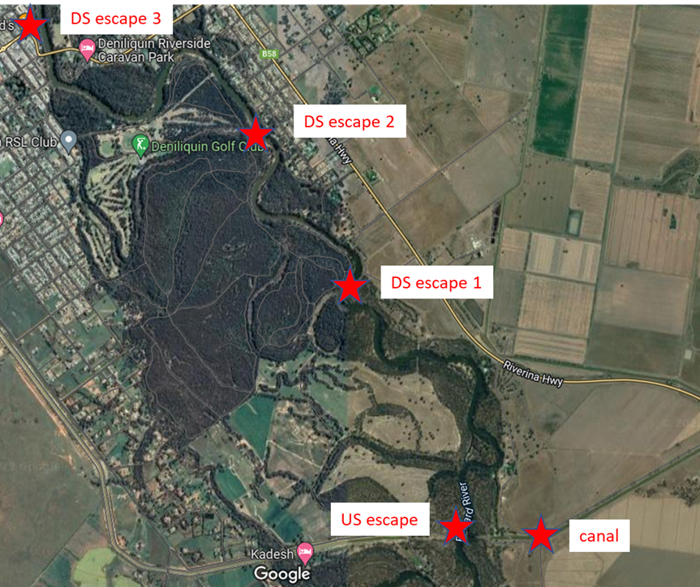
Figure 1. Location of water quality monitoring sites in the Edward/Kolety River upstream and downstream of the Edward irrigation escape from Mulwala Canal, and in the Mulwala Canal (source of environmental water).

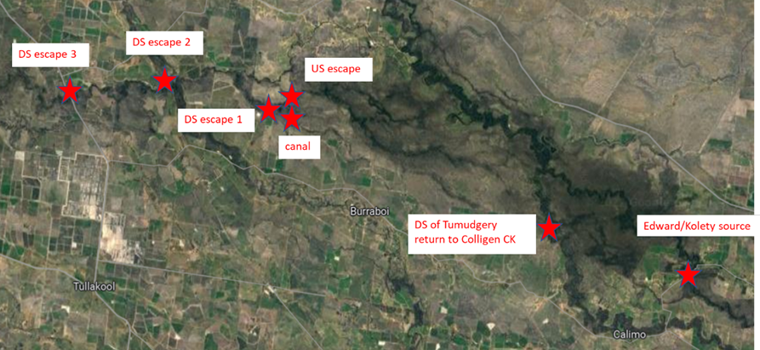
Figure 2. Location of water quality monitoring sites in the Niemur River upstream and downstream of the Niemur irrigation escape from the Northern Branch Canal (source environmental water), in the Northern Branch Canal itself, and in Colligen Creek an Edward/Kolety River (sources of environmental water to the Niemur River).
- How far downstream of the escape is the refuge created under different flows?

Longitudinal transects to measure spot water quality in the river channel will be undertaken in the Edward River commencing a short distance upstream of the Edward Escape, and extending downstream of irrigation escape, possibly up to 2km.
Similarly, longitudinal transects to measure spot water quality in the river channel will be undertaken in the Niemur River commencing a short distance upstream of the Niemur Escape, and extending downstream of irrigation escape, possibly up to 2km.
Transects will be undertaken once per fortnight (total of 8 trips x 2 escapes) using a handheld water quality meter. Monitoring will be undertaken on days that are free of cloud, and location of sites will be recorded using GPS so that the ground collected data can be integrated with data analysis of the satellite imagery (see question 3).

- Can we assess water quality responses to delivery of environmental watering from escapes using satellite imagery? How effective is satellite data for measuring water quality responses to environmental watering compared to field observations?
Satellite imagery is commonly used to monitor turbidity for open water bodies over large areas. However, satellite imagery has not previously been used to evaluate the effectiveness of the delivery of environmental water in river channels. The challenge of using satellite imagery in this application is that many of the rivers and creeks are narrow and have overhanging trees. This requires the imagery to have small cell sizes to ensure that data on changes in water quality conditions can be collected along the river channel.
Planet Lab satellite imagery is highly suited to this application because the cell size is 3 x 3 m, images are collected daily, and the sensor results in an eight-band multispectral image that can be used to calculate a number of different indices. Planetlab imagery has advantages over Sentinel (10 x 10 m cell size, images collected every 5 days) and Landsat (30 x 30m cell size, images collected every 8 days).
Planet imagery will be sourced by CSU’s Spatial Data Analysis Network for cloud free days in the study period from October 2022 through to the end of February 2023, ideally at least one image per week for each study area. Each image will be analysed to calculate a turbidity index in each 3 x 3 m cell in the river upstream of the escape, in the canal, and in the river downstream of the irrigation escape. Examples of Planet imagery are shown in Figures 3 and 4. In Figure 4 it is possible to see the small plume of turbid water entering the Edward River from the Edward Escape. Using eight-band multispectral imagery it will be possible to detect differences downstream that are not as clearly evident, by applying a Normalised Difference Turbidity Index, with turbidity derived from the red and green bands (RED-GREEN/RED+GREEN).
The results from the satellite imagery will be compared with the ground truth data collected for questions 1 and 2 described previously.
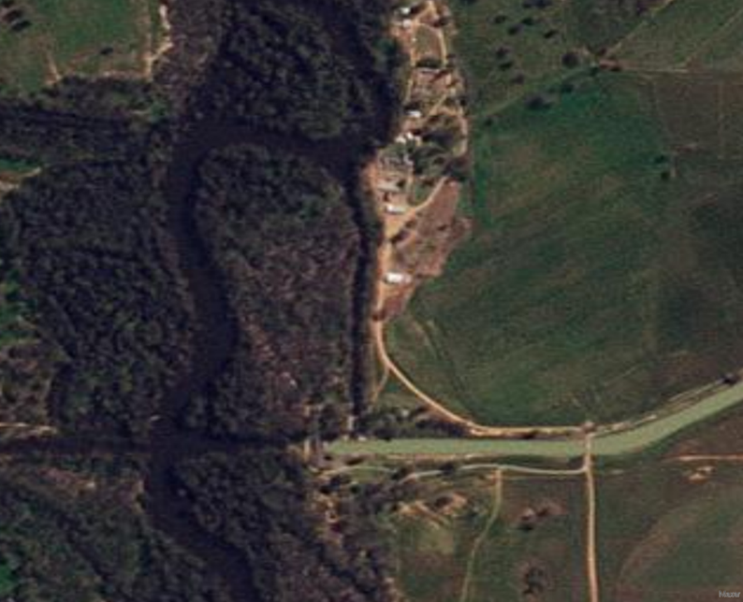
Figure 3. Planetlab imagery of the Edward/Kolety River and Edward Escape on 1 Oct 2022. Discharge at Deniliquin 31,074 ML/d, Temperature 15.82 °C, and dissolved oxygen 5.844 mg/L.
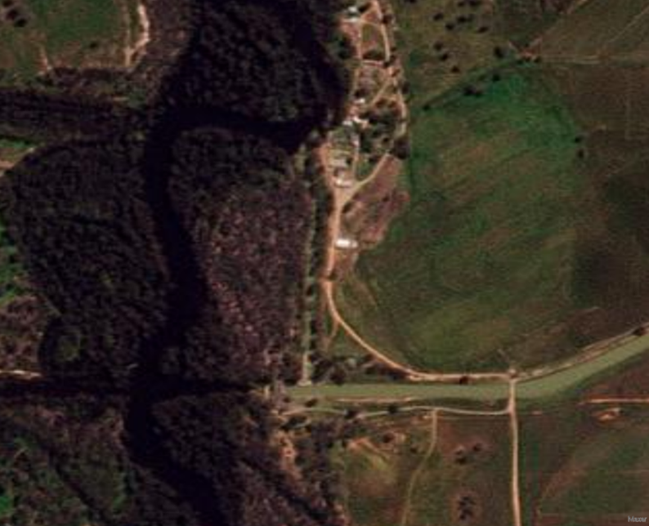
Figure 4. Planetlab imagery of the Edward/Kolety River and Edward Escape on 9 Oct 2022. Discharge at Deniliquin 34,995 ML/d, Temperature 16.15 °C, and dissolved oxygen 4.876 mg/L. Environmental water from Edward Escape was 511 ML/d.
- Are fish using the refuges created by the delivery of water from the irrigation escapes?
Boat mounted sonar will be undertaken to detect the presence and location of fish in the Edward/Kolety River in the vicinity of the Edward Escape. Sonar technology allows ‘vision’ into the water column using sound ultrasonic beams. This will be used to detect if fish are present, and also describe their vertical and horizontal position in the water column and behaviour. The method may also be able to determine what species are present, and what size they are, depending on image quality.
Sonar transect surveys of fish populations near the Edward Escape will be undertaken on two occasions, ideally under contrasting flow conditions, once during high flows soon after recession of the flow peak, and once under lower flow conditions after delivery of environmental water from the Edward Escape has increased relative to river flows. Vertical sonar video imagery will be captured at designated points at set transects upstream and downstream of the escape, in areas receiving and not receiving environmental water. Sonar survey points will also be linked to dissolved oxygen conditions occurring (Q1-3), enabling direct comparison of fish presence and behaviour to DO conditions.
The collection of data linking fish presence and behaviour during hypoxic conditions will also provide important information to MD WERP 9.2 project (Forecasting risks to fish and their available habitat from low flows and hypoxia).

Project outputs
This work will provide water managers and the community with an improved understanding of water quality outcomes and fish responses to the delivery of Commonwealth environmental water from two irrigation escapes during the 2022-23 hypoxic blackwater event. The results will be used to guide real time management of Commonwealth environmental watering during the hypoxic blackwater event and will also contribute to future adaptive management of environmental watering.
Communications and reporting:
- Informal/verbal updates to CEWO as the project progresses
- Informal updates of preliminary findings will be presented to Edward/Kolety-Wakool Operational Advisory Group, Southern Blackwater Response Group, and Edward/Kolety-Wakool Environmental Water Reference Group
- Contribution to CEWO communications during the environmental watering actions
- Updates in Edward/Kolety-Wakool quarterly progress reports
- Stories included in two of the 2022-23 Edward/Kolety-Wakool quarterly newsletters
- Presentation of findings to CEWO, relevant agencies and key stakeholders at an Edward/Kolety-Wakool Environmental Water Reference Group meeting.
- Final report, integrating results from the four components of the study
Engagement:
- Edward/Wakool Angling Association members will collaborate to undertake the longitudinal surveys of water quality upstream and downstream of escapes
- Landholders whose properties will be accessed to undertake the project will be kept informed throughout the project.
Additional expected communication outputs (not a deliverable of Work Order 9):
- A collaborative journal article that integrates the four components of this study is planned to be written after the completion of this project. The writing of this paper will be funded through in-kind contribution from Charles Sturt University, La Trobe University, and EWAA members.

Project management, responsibilities and collaboration
The project will be undertaken as a collaboration between Charles Sturt University, La Trobe University, and the Edward/Wakool Angling Association

Project management and oversight
General project management and report review will be undertaken by Prof Robyn Watts, leader of the Edward/Kolety-Wakool Flow-MER project.
Water chemistry
- Leader: Xiaoying Liu, CSU
- Field monitoring: Dr Xiaoying Liu and CSU staff
- Data visualisation and data management: Dr Nicole McCasker, CSU
- Data analysis and reporting: Dr Xiaoying Liu, CSU

Longitudinal transects of spot water quality
- Leader: Mr John Trethewie CSU
- Field monitoring: Mr John Trethewie (CSU) and members of Edward/Wakool Angling Association
- Data visualisation: Ms Deanna Duffy, Spatial Analysis Unit, CSU
- Data analysis and reporting: Mr John Trethewie, EWAA and Prof Robyn Watts, CSU

Satellite imagery analysis
- Leader: Prof Robyn Watts, CSU
- Data visualisation and data analysis: Ms Deanna Duffy, Spatial Analysis Unit, CSU
- Reporting: Prof Robyn Watts, CSU

Fish surveys
- Leader: A/Prof Alison King, La Trobe University
- Field monitoring: Mr Sam Lewis (La Trobe) and CSU staff
- Data analysis and reporting: Mr Sam Lewis (La Trobe) and A/Prof Alison King

References
Liu X, Watts R, Howitt J and McCasker N (2019) Carbon and nutrient release from experimental inundation of agricultural and forested floodplain sediment and vegetation: Influence of floodplain land use on the development of hypoxic blackwater during floods. Marine and Freshwater Research, 71(2), 213-228.
Small, K., Kopf, R.K., Watts, R.J., Howitt, J. (2014). Hypoxia, blackwater and fish kills: experimental lethal oxygen thresholds in juvenile predatory lowland river fishes. PLOS ONE 9(4), e94524
Thiem J. D., Wooden I. J., Baumgartner L. J., Butler G. L., Taylor M. D., and Watts R. J. (2020). Hypoxic conditions interrupt flood-response movements of three lowland river fish species: implications for flow restoration in modified landscapes. Ecohydrology 13:e2197.
Watts R, Kopf K, McCasker N, Howitt J, Conallin J, Wooden I, Baumgartner I (2017a) Adaptive Management of Environmental Flows: Using Irrigation Infrastructure to Deliver Environmental Benefits During a Large Hypoxic Blackwater Event in the Southern Murray-Darling Basin, Australia. Environmental Management 61, 1-12.
Watts, R.J., McCasker, N., Howitt, J.A., Thiem, J., Grace, M., Kopf, R.K., Healy, S., Bond, N. (2017b). ‘Commonwealth Environmental Water Office Long Term Intervention Monitoring Project: Edward-Wakool River System Selected Area Evaluation Report, 2016-17’. Report prepared for Commonwealth Environmental Water Office. Commonwealth of Australia.
Watts R., McCasker, N, Howitt, J, Liu X, Trethewie J, Allan C, Thiem J, Duncan M, Healy S, Bond N, Van Dyke J, Vietz G, Donges M. (2019) Commonwealth Environmental Water Office: Edward/Kolety-Wakool Selected Area Monitoring, Evaluation and Research Plan 2019-22. Report to the Commonwealth Environmental Water Office.
Whitworth, K. L., Baldwin, D. S. and Kerr, J. L. (2012). Drought, floods and water quality: drivers of a severe hypoxic blackwater event in a major river system (the southern Murray–Darling Basin, Australia). Journal of Hydrology, 450-451, 190-198.
Whitworth, K. L., Baldwin, D. S. and Kerr, J. L. (2014). The effect of temperature on leaching and subsequent decomposition of dissolved carbon from inundated floodplain litter: implications for the generation of hypoxic blackwater in lowland floodplain rivers. Chemistry and Ecology, 30,

