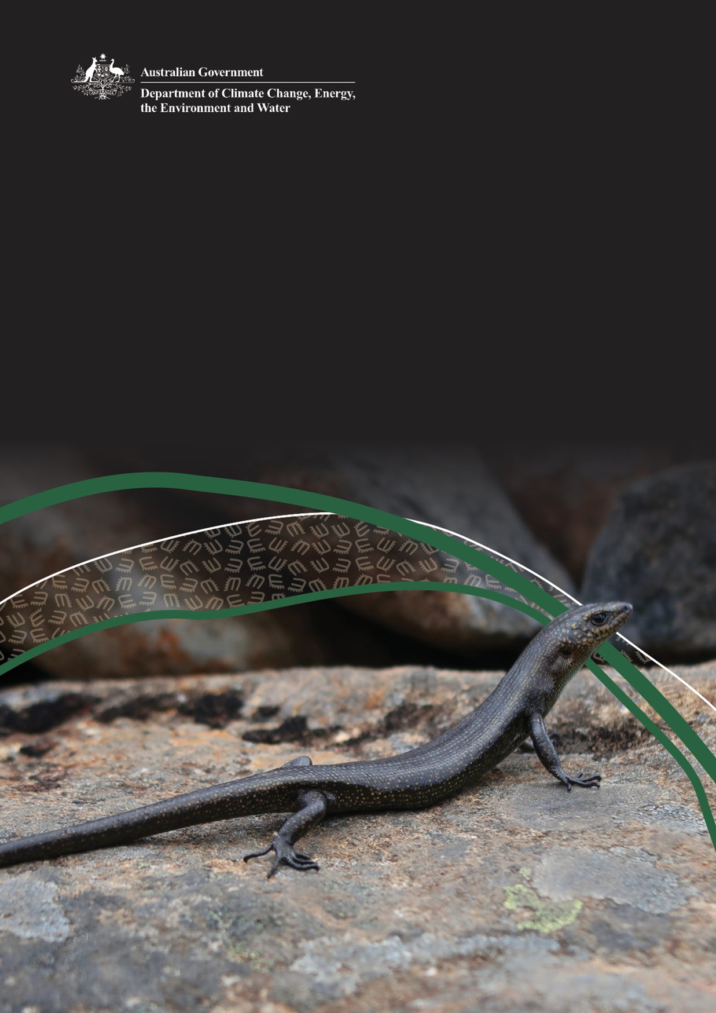

Environment Information Australia Species Distribution Models: User Guide

© Commonwealth of Australia 2026
Ownership of intellectual property rights
Unless otherwise noted, copyright (and any other intellectual property rights) in this publication is owned by the Commonwealth of Australia (referred to as the Commonwealth).
Creative Commons licence
All material in this publication is licensed under a Creative Commons Attribution 4.0 International Licence except content supplied by third parties, logos and the Commonwealth Coat of Arms.
Inquiries about the licence and any use of this document should be submitted via our online contact form.

Cataloguing data
This publication (and any material sourced from it) should be attributed as: DCCEEW 2026, Environment Information Australia’s Species Distribution Models: User Guide, Department of Climate Change, Energy, the Environment and Water, Canberra, June. CC BY 4.0.
This publication is available at dcceew.gov.au/environment/environment-information-australia/geospatial-data-services/data-snes.
Department of Climate Change, Energy, the Environment and Water
GPO Box 3090 Canberra ACT 2601
Telephone 1800 920 528
Web dcceew.gov.au
Disclaimer
The Australian Government acting through the Department of Climate Change, Energy, the Environment and Water has exercised due care and skill in preparing and compiling the information and data in this publication. Notwithstanding, the Department of Climate Change, Energy, the Environment and Water, its employees and advisers disclaim all liability, including liability for negligence and for any loss, damage, injury, expense or cost incurred by any person as a result of accessing, using or relying on any of the information or data in this publication to the maximum extent permitted by law.
AI assisted content drafting was utilised in generating this document. AI was utilised in accordance with the department’s guidance on AI use and in line with the department’s public AI transparency statement.
Acknowledgements
We thank the states and territories for their continued collaboration in improving the distribution models for Australia’s threatened species.
Acknowledgement of Country
We acknowledge the Traditional Owners of Country throughout Australia and recognise their continuing connection to land, waters and culture. We pay our respects to their Elders past and present.

Front cover: Alpine cool-skink (Carinascincus greeni), Tasmania © Michael Horton

EIA Species Distribution Models: User Guide
This guide has been developed by Environment Information Australia (EIA). It explains what EIA’s species distribution models show, how they are developed, and their appropriate use in environmental decision-making.

Overview
Australia is home to an estimated 600,000 species of plants and animals. For many species, we do not have comprehensive data on where they occur. That’s why we use species distribution modelling to predict their distribution.
EIA develops species distribution models for species listed under the Environment Protection and Biodiversity Conservation Act 1999 (EPBC Act). These models support decisions to protect, conserve and manage Australia’s biodiversity. The model outputs are published in the Species of National Environmental Significance dataset.

Who should use these data?
These models are intended for regulators, planners, researchers and consultants. They support regional to national scale environmental assessment and conservation planning.

What are SDMs and why use them?
Species distribution models (SDMs) use species occurrence records and environmental data such as vegetation, climate and soil to predict where a species or its habitat is present.
Species occurrence data record the presence of an organism. Observations are commonly based on sightings but can also be obtained from photographs, sound, scats, fossils, DNA or other evidence of presence. Specimen data collected by a museum or herbarium can also provide a record. Recording the absence of a species can also be valuable for modelling. However, consistent absence data is not widely available for most species.
Occurrence records alone do not provide a complete picture of a species’ distribution. Observations are unevenly distributed across Australia. They are often biased towards particular species and accessible areas.
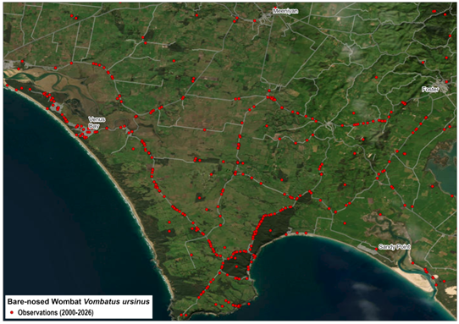
Figure 1 Species occurrence data are often biased towards accessible areas such as along roadsides.
Modelling can use species occurrence data, ecological knowledge and environmental data to predict similar habitat. This fills data gaps and accounts for survey bias.

FAQ: Why are EIA’s models different to state and territory distributions?
Each jurisdiction develops species distribution models for different purposes. They use data, methods and scales that reflect their responsibilities. EIA’s models are developed to support decision-making under the EPBC Act. They identify the location of protected matters at regional to national scales.
Commonwealth and state or territory models can be produced at different times. This means they may incorporate different survey effort, occurrence records, taxonomic updates or habitat information.
EIA’s models are typically broader in extent than state and territory distributions. This reflects a precautionary, nationally consistent approach aligned with EPBC Act decision-making.

EIA’s modelling approach
We develop SDMs by acquiring species occurrence (point) data and validating these against data quality criteria. Drawing on expert advice to assess species traits and habitat requirements, we use relevant environmental data (such as vegetation, elevation, climate and soil) to model species distributions.
EIA uses both statistical and thematic modelling approaches. We select the method that best suits data availability, species ecology and expert understanding of species–environment relationships. Both approaches classify the landscape into presence categories that reflect how well an area aligns with known habitat or environmental suitability.
Where possible, we develop species distribution models in collaboration with species experts and state and territory agencies. A cross-jurisdictional SDM Working Group has been established. This further strengthens collaboration on data sharing and modelling approaches.

Species occurrence records
We source species occurrence records from a range of repositories and data custodians, including:
- state and territory herbarium and museum collections
- researchers
- environmental non-governmental organisations
- national aggregators such as the Atlas of Living Australia.

Data quality
Before modelling, we validate species occurrence records against criteria to ensure suitability for modelling. Criteria include:
- Currency – most models use data from the last 20 years to inform the distribution. Historic records are used depending on data availability, species ecology and the degree of land use change in the species range.
- Spatial precision – only records with spatial precision better than 1 km are used for modelling.
- Spatial accuracy – records are excluded where the location description in the record does not match the coordinates e.g. a species record for a terrestrial animal that is in the ocean, or other obvious errors.
- Ecological plausibility – records are assessed against known species ecology, biogeographic range and habitat requirements.

Statistical models
We use statistical models where sufficient high-quality occurrence data are available to support robust, data-driven predictions. Relationships between species occurrence records and environmental data such as climate, vegetation, terrain, soils or hydrology are used to predict where suitable habitat occurs.

Thematic modelling
Thematic modelling uses expert knowledge of a species’ ecological requirements to identify and combine spatial datasets, such as vegetation type, substrate or climate. It is the primary approach when a species has well characterised habitat associations that can be directly mapped. It is also used when occurrence data are too limited for statistical modelling.

Hybrid models
Combining statistical and thematic approaches can produce strong results and can be used where it improves the model’s ecological defensibility. The statistical model can provide the broader geographic range in which habitat for the species may be present. This is further refined by thematic modelling to identify key environmental requirements.

Evaluating models
Evaluation ensures that outputs are scientifically defensible and aligned with expert knowledge. We use several methods, including quantitative statistical metrics, ecological assessments and expert review. This ensures that models align with known ranges and ecological constraints.
For more detailed information on modelling methods, refer to the Technical Guide, available at https://www.dcceew.gov.au/environment/environment-information-australia/geospatial-data-services/data-snes

FAQ: Can I use these models to assess a specific site?
EIA’s SDMs support regional to national scale analysis. They do not replace site-specific ecological surveys or local habitat assessments.

Using the SDMs
The primary purpose of EIA’s models is to support decisions under the EPBC Act. The data can also inform a range of other environmental management decisions such as prioritising areas for protection, conservation or restoration.
EIA’s species distribution models are designed for regional to national scale analysis and decision support, rather than fine-scale site assessment. They should be complemented by local surveys and expert assessment for site-specific decisions.
The model outputs are provided at a nominal 100-metre grid resolution. This does not mean that SDMs are reliable at an individual property, paddock or development footprint scale. For sensitive species, modelled outputs are spatially generalised in line with state and territory sensitive species occurrence data requirements. This manages risks associated with disclosure.
The SDMs indicate potential habitat, not confirmed presence or absence at a specific location. Local habitat condition, recent disturbance and fine-scale features (such as tree hollows) are critical for site-level decision-making. These factors are not fully captured in the models.
The SDMs reflect the best available information at the time of modelling and are updated periodically, rather than continuously. They represent the current predicted distributions. They do not readily support reporting changes in species distributions over time.
To support different decision‑making needs, EIA classifies model outputs into 2 categories.
Presence category | Description | Best used for
Likely to occur | Areas with environmental conditions highly consistent with habitat where the species has been observed. | - identifying matters protected under the EPBC Act  - regional to national scale analysis  - conservation planning and prioritisation  - spatial overlay analysis and summary statistics
May occur | Broader areas identified as having environmental conditions that could support the species. | - identifying matters protected under the EPBC Act  - early-stage environmental assessment and screening  - supporting decisions under the EPBC Act

In developing the models, we apply a precautionary principle to the ‘may occur’ category. This minimises the risk of excluding areas of potential habitat. This is critical for EPBC Act decision‑making.

Important considerations for decision-making
- Models predict potential habitat, not confirmed presence. SDMs do not confirm that a species is present at a particular site. They also do not mean that species are absent outside the modelled extent. A species may be absent from modelled habitat due to historical clearing, barriers to dispersal, or other factors not captured in environmental data.
- Models should be used alongside occurrence records. Site‑specific decisions should be informed by targeted surveys, occurrence records and expert ecological advice. Use these alongside the SDMs.
- Current land condition and local variation may differ from modelled habitat. Models represent potential habitat based on broad-scale environmental conditions. Vegetation clearing, degradation, land-use change, recent disturbance, and fine-scale features required by some species are not fully captured by national-scale models. These may reduce actual habitat availability below the modelled extent.

Metadata
Metadata helps users understand model confidence, data sources and appropriate use. We publish species-level metadata describing modelling inputs and methods with the dataset. Metadata will be expanded over time as models are reviewed and updated.

Uncertainty in SDMs
There is inherent uncertainty in models. Causes of uncertainty include:
- too few species observations (resulting in overly general predictions)
- sample bias reflecting survey effort rather than true distribution
- incomplete knowledge of the environmental factors that influence the distribution of a species
- errors and uncertainties in the environmental data layers used by the models, for example outdated or inconsistent vegetation mapping.
We have designed the categories, metadata and guidance in this document to help users account for model uncertainty in decisions.

Unsuitable habitat
EIA’s SDMs do not exclude every area of unsuitable habitat. Reasons that cleared or built-up land may appear in a distribution model include:
- environmental datasets such as climate, elevation and soils remain unchanged when land use changes, so environmental conditions still match habitat requirements for a species
- currency of data, for example, vegetation mapping may not reflect recent clearing
- scale of input data
- ability of the modelled species to inhabit fragmented or disturbed landscapes.
Distributions may therefore include areas where an EPBC Act listed species is not present.
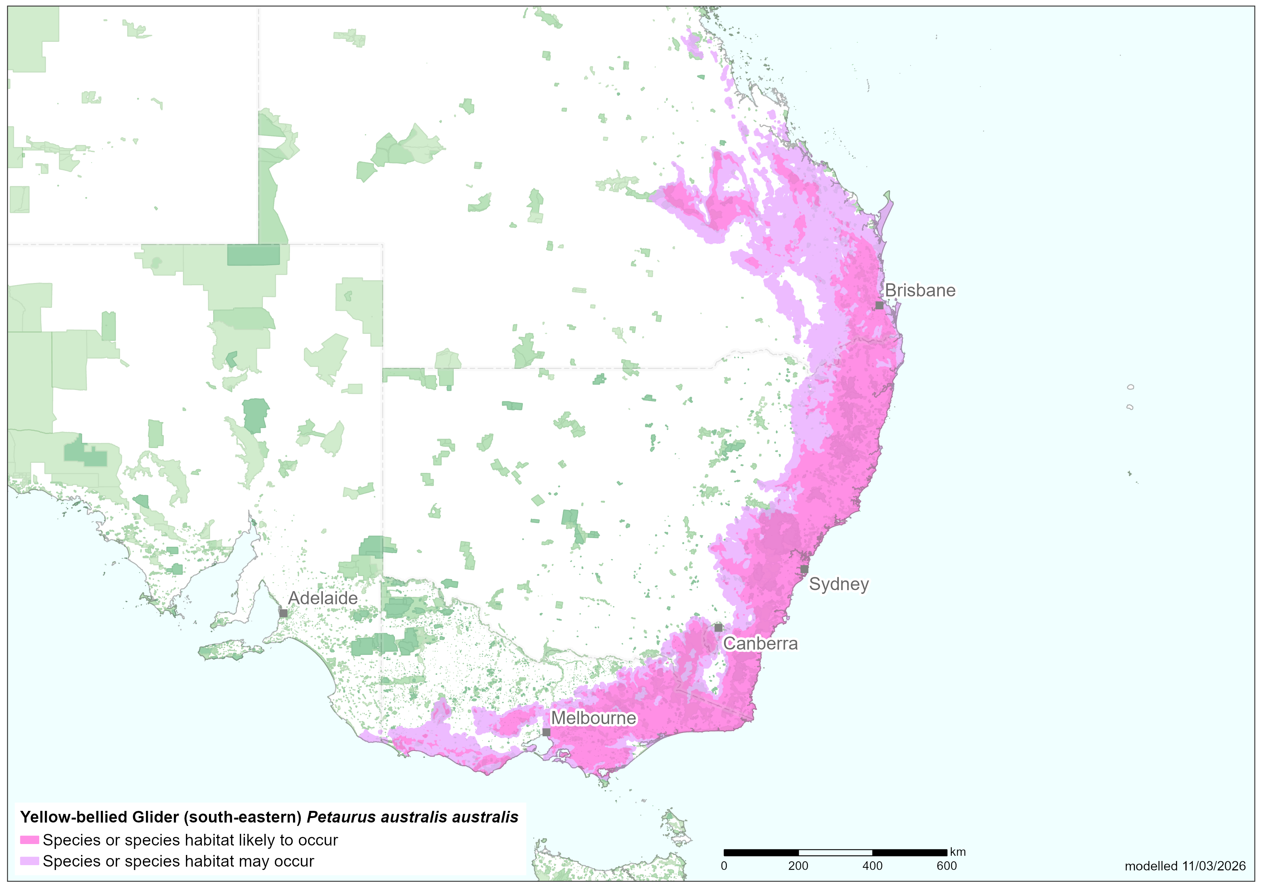
Figure 2 Species distribution model of the yellow-bellied glider (south-eastern) (Petaurus australis australis)

Update and maintenance
The Species of National Environmental Significance dataset is regularly updated when:
- new species are listed under the EPBC Act
- a species listing status changes
- new data on presence or absence is available.

FAQ: I have updated survey data. Can you update the model?
New data is always welcome and helps inform our ongoing review of EIA’s species distribution models. We periodically review and update SDMs where new information is likely to materially improve model performance or interpretation at a regional to national scale.
We prioritise all updates as part of our review and maintenance processes.

FAQ: Can I access the species occurrence data?
Much of the species occurrence data used to develop our models are provided under data licence agreements that do not permit on-sharing to third parties. You can access the publicly available species occurrence data for threatened and other species through the Atlas of Living Australia.

Where to find the data
You can download the Species of National Environmental Significance dataset from Find Environmental Data.
The data are also accessible via the Protected Matters Search Tool.
Further information on species listed under the EPBC Act is available at the Species Profile and Threats Database.

Contact us
For enquiries, feedback or to share additional information, please contact us at geospatial@dcceew.gov.au.

