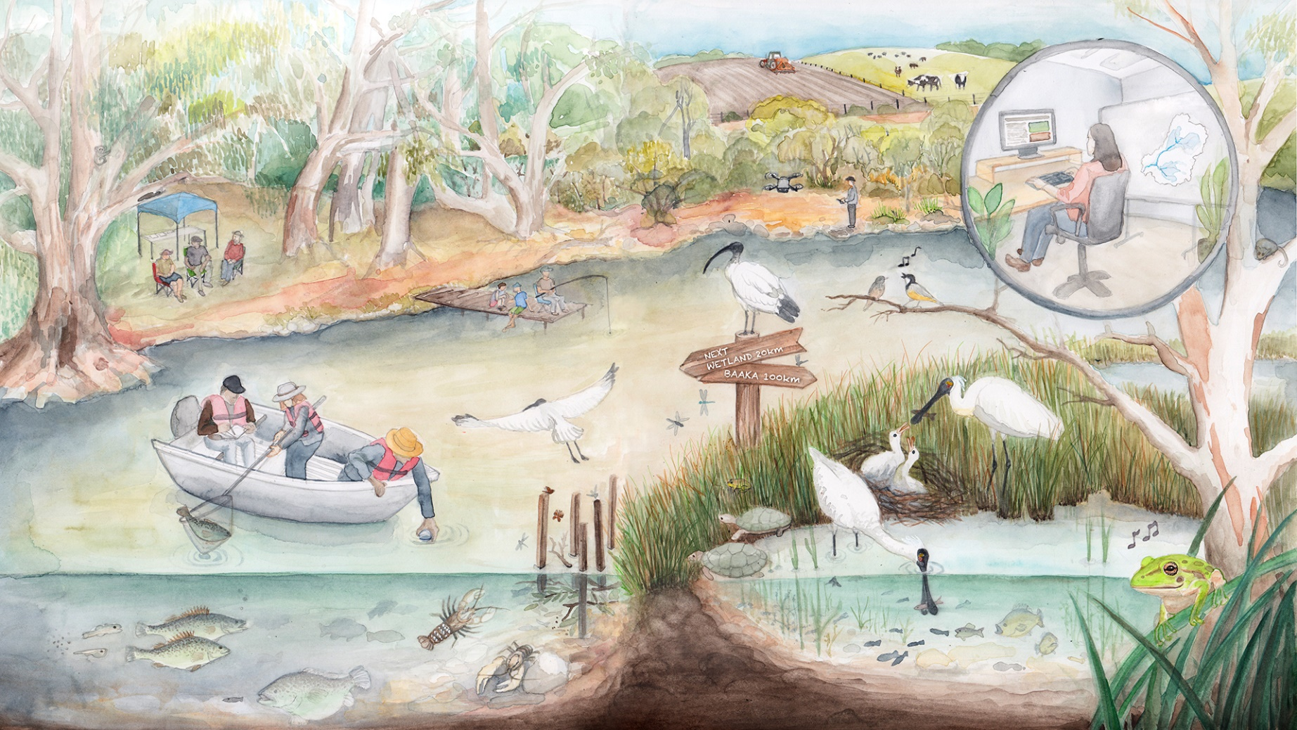
Commonwealth environmental water sustaining Murray–Darling Basin ecosystems: 10-year (2014–24) retrospective
  - Commonwealth Environmental Water Holder’s Science Program:
Flow Monitoring, Evaluation and Research Program (Flow-MER)
Basin-scale Synthesis

June 2025
Acknowledgement of Country
The Flow-MER team acknowledges the Traditional Owners of the lands and waters of Australia, and in particular the Traditional Owners of the lands and waters of the Murray–Darling Basin. The river and its tributaries are known by many names including; Millewa (Ngarrindjeri name for the main Murray channel in South Australia), Baarka (Barkindji; Darling River, inland New South Wales (NSW)), Warring (Taungurung; Goulburn River, Victoria), Kolety (Wamba Wamba; Edwards River, inland NSW), Kalari (Wiradjuri; Lachlan River, inland NSW), Murrumbidjeri (Wiradjuri; Murrumbidgee River, inland NSW) and Guwayda (Kamilaroi; Gwydir River, northern NSW), amongst others. While the European names will be used here, the authors recognise the important associations and history of the Indigenous names for rivers and streams in the Murray–Darling Basin. We express our respect for Elders, past present and emerging amongst the Nations of the Murray–Darling Basin.
Citation
Flett D, Cuddy SM, Brooks S, Dyer F, Egger F, Giling D, Hladyz S, Mathwin R, McInerney P, Nolan, M, Sengupta A, Tonkin Z, Wassens S, Weber T (2025) Commonwealth environmental water sustaining Murray–Darling Basin ecosystems: 10-year (2014–24) retrospective. Commonwealth Environmental Water Holder (CEWH), Department of Climate Change, Energy, the Environment and Water, Australia.
[Citation is in alphabetical order after the first 2 authors]. Copilot was used to assist with drafting of the content.
Acknowledgement of contributors
We take this opportunity to thank all contributors to Flow-MER. Their data collection, analyses and reporting have provided the foundations for this synthesis report. We would like to thank Jane Thomas of CSIRO whose input in terms of editing and formatting greatly improved the quality and readability of the report as well as Jill Sharkey for formatting assistance. A final thanks to the Selected Area teams, members of the Flow-MER2.0 Independent Advisory Group and Officers of the Commonwealth Environmental Water Holder for their reviews.
Basin-scale Flow-MER partnership
Basin-scale evaluation in Flow-MER was led by CSIRO in partnership with the University of Canberra. Collaborators on the 2023–24 evaluation included Alluvium, Arthur Rylah Institute, Charles Sturt University, South Australian Research & Development Institute, NSW Department of Primary Industries, Australian River Restoration Centre and Brooks Ecology & Technology.
2025 is the final year of this phase of Flow-MER (2019 –2025) which was the successor of the Long Term Intervention Monitoring Program (LTIM). The next 5-year phase commenced on 1 July 2025 and is led by CSIRO in partnership with the One Basin Cooperative Research Centre. Information on the new phase of Flow-MER can be found at the CEWH's science programs website
Copyright
 © Commonwealth of Australia 2025
With the exception of the Commonwealth Coat of Arms, partner logos and where otherwise noted, all material in this publication is provided under a Creative Commons Attribution 4.0 International Licence https://creativecommons.org/licenses/by/4.0/. The Flow-MER Program requests attribution as ‘© Commonwealth of Australia (Flow-MER Program).’
Document history
Date | Document stage
16 May 2025 | Preparation of first draft following submission of draft evaluation reports to the CEWH
12 June 2025 | Draft report delivered to CEWH for review
8–21 July 2025 | Response to review period
20 August 2025 | Final version of report (this report) delivered to CEWH
 | Approved final report for publication
Cover
Artist: Nina Rupena. http://www.ninarupena.studio/
Important disclaimer
The information contained in this publication comprises general statements based on scientific research. The reader is advised and needs to be aware that such information may be incomplete or unable to be used in any specific situation. No reliance or actions must therefore be made on that information without seeking prior expert professional, scientific and technical advice. To the extent permitted by law, the Flow-MER Program (including its partners and collaborators) excludes all liability to any person for any consequences, including but not limited to all losses, damages, costs, expenses and any other compensation, arising directly or indirectly from using this publication (in part or in whole) and any information or material contained in it.
The Flow-MER is committed to providing web accessible content wherever possible. If you are having difficulties with accessing this document, please contact ewater@dcceew.gov.au.

Executive summary: Ten years of sustaining and revitalising water-dependent ecosystems of the Basin
The delivery of Commonwealth environmental water has sustained life in the Basin’s floodplain–wetland ecosystems and contributed to rebuilding the Basin’s rich biodiversity. Over the past decade (2014–24), the Commonwealth Environmental Water Holder (CEWH) has delivered water to protect and restore hydrological regimes and connectivity within and between water-dependent ecosystems of the Basin. Delivery has been informed by annual planning and, where and when possible, in partnership with other environmental water holders. This executive summary synthesises the key outcomes, trends, and strategic lessons learned from 10 years of dedicated stewardship, with a focus on vegetation, fish, waterbirds, and other fauna. A second part synthesises the key outcomes for 2023–24, the final evaluation year of this phase of the Flow-MER program.

Basin-scale evaluation – a decade of environmental outcomes from the delivery of Commonwealth environmental water
Every year since 1 July 2014, Basin-scale teams have evaluated environmental outcomes for 6 Basin themes – hydrology, vegetation, fish, food webs and water quality, and ecosystem and species biodiversity (Figure 1) – using data provided by the CEWH’s Science Program and monitoring data from the 7 Selected Areas established by the CEWH to monitor environmental outcomes (Figure 1). Detailed findings and supporting evidence are presented in 6 thematic evaluation reports and 7 Selected Area reports (Basin-scale thematic evaluations and Area-scale evaluations are reported separately).
Figure 1 The 6 Flow-MER evaluation themes; and map showing the location and extent of the 7 Selected Areas established for long-term monitoring of the impacts of environmental watering under the Long Term Intervention Monitoring Project and Flow-MER (10 years, 2014–15 to 2023–24)
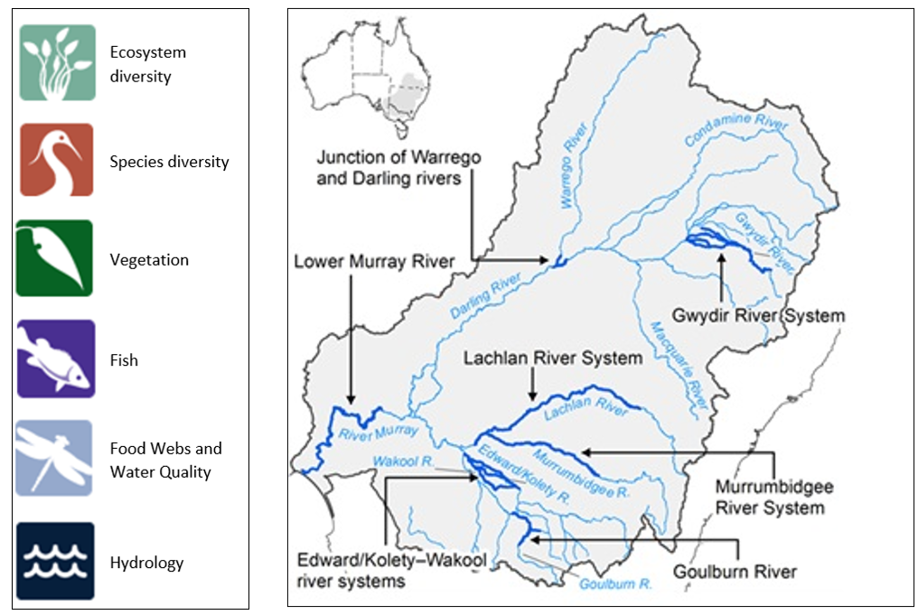
Vegetation: Sustaining diversity and cultural heritage
A decade of environmental water delivery has underpinned the health, resilience, and diversity of floodplain and wetland vegetation communities across the Basin. By maintaining appropriate inundation regimes, environmental water has supported a mosaic of habitats essential for a wide range of plant species, including submerged and amphibious varieties.
- Inundation regimes: Commonwealth environmental water has preserved natural wetting and drying cycles and flow of inundation across key floodplain–wetland sites. By mimicking natural cycles, these actions have sustained species diversity and community composition at the Basin scale.
- Enhanced vegetation cover: Strategic reductions in the duration of dry phases in floodplain–wetland complexes have fostered greater vegetation cover and diversity, promoting ecological resilience. This has benefited not only widespread plant communities but also specialised submerged and amphibious species that are integral to ecosystem function.
- Supporting culturally significant species: Some of the plant species shown to be supported by Commonwealth environmental water are known to be important for cultural practices, paving the way for working with Aboriginal people to support species of cultural importance.

Key lessons and strategic directions
- Collaboration with Aboriginal communities is vital for integrating traditional knowledge and identifying culturally important plant species that benefit from environmental water.
- Adaptive management—responding to annual and decadal shifts in climate and hydrology—remains essential for maintaining vegetation health in the face of future uncertainty.
Fish: Strengthening populations under changing climates
Native fish populations have responded positively to environmental water management, particularly through the mitigation of low flow periods and the strategic augmentation of daily flows. These interventions have been pivotal during climate transitions, including recovery from drier periods.
- Mitigating low flows: Commonwealth environmental water has reduced the frequency and duration of low flow days, supporting fish survival, growth, and recruitment even during adverse conditions.
- Responding to natural events: In wetter and flood years, Commonwealth environmental water deliveries have built on natural inundation, providing dilution flows that reduce hypoxic events and fish deaths, and facilitating the dispersal of migratory species. Post-flood, adaptive hydrograph management has maximised spawning and recruitment opportunities.
- Enhancing resilience: These strategies have fostered fish populations that are better able to withstand climatic variability, supporting long-term recovery and sustainability.

Key lessons and strategic directions
- Flexibility in environmental water management is crucial during climatic transitions, allowing for both the mitigation of stress in dry years and the optimisation of conditions that support recovery through dispersal and recruitment opportunities during wet cycles.
- Long-term monitoring and expansion of spatial coverage are needed to track population trends and inform future adaptive management, ensuring continued benefits for native fish.
Waterbirds and Other Fauna: Targeted support for iconic and threatened species
The delivery of Commonwealth environmental water has benefited waterbirds and a diverse array of other fauna, by targeting critical habitats and addressing the needs of conservation-significant species. By maintaining and restoring critical habitats, environmental water delivery has supported waterbird populations and threatened species, ensuring the Basin maintains refugia for a wide spectrum of fauna.
- Identification of water needs: Commonwealth environmental water has been delivered to support the needs of listed threatened and migratory species.
- Improved water delivery for waterbirds: Many waterbirds are highly mobile, and their survival—especially in early life stages—depends on the availability of foraging habitats. Better coordination of water delivery across Basin valleys has supported habitat for waterbird breeding and foraging, particularly in dry years when refuges are critical and for large-scale breeding events in wetter times.
- Water for conservation-significant fauna: Enhanced monitoring of species such as the southern bell frog, platypus, large-footed myotis (southern myotis), and grey snake in frequently watered habitats has supported regional water delivery and adaptive management responses.

Key lessons and strategic directions
- Continued investment in mapping and monitoring habitat use by waterbirds and other fauna is required to close knowledge gaps and refine water delivery strategies.
- Proactive management can secure refuge habitats during drought, sustaining populations through adverse conditions and supporting post-drought recovery.
Biodiversity: Protecting and restoring water-dependent ecosystems and species
A key insight from a decade of Commonwealth environmental water delivery is its remarkable reach: 18,310 GL of water supported a vast array of habitats—from lakes and wetlands to floodplains, rivers, and estuaries. This strategic and adaptive allocation ensured that representative ecosystem types are being sustained, reflecting the program’s alignment with the diverse and specific needs of the Basin’s aquatic environments.
- Supporting diverse ecosystems: The ecosystems watered represent 88% of the diversity of aquatic ecosystem types found in the Basin, according to the Australian National Aquatic Ecosystem (ANAE) classification.
- Meeting environmental watering requirements: The frequency of Commonwealth environmental water delivery over the past 10 years broadly matches the expected requirements of ecosystem types:
- More frequent support for permanent rivers, lakes, meadows, and permanent tall marshes
- Less frequent inundation for temporary channels, intermittent swamps, and floodplains.

Support for native plant species and habitat diversity
Commonwealth environmental water has supported submerged, amphibious and damp-loving plant species, native fish, waterbirds and a range of other fauna, including species of conservation significance.
- More than 800 plant taxa (804) recorded since 2014, including 527 native groundcover species and 101 listed as rare or threatened.
- 10% (81 plant species) only found at locations with increased wetness from environmental water, showing the importance of environmental flows for submerged, amphibious, and damp-loving species.

Enhancement of fauna diversity
- 26 listed water-dependent fish, crayfish, mammals, frogs and reptiles were reported from habitats that received Commonwealth environmental water on at least one occasion over the 10-year period.
- Environmental water contributed to the presence of southern bell frogs (Vulnerable, EPBC Act) and supported habitats for Macquarie turtles and other significant fauna.

Support for waterbirds and breeding events
- Since 2014, 97 waterbird and raptor species recorded, including 59 threatened or migratory species.
- Extensive breeding events in 2022 and 2023, with Commonwealth environmental water extending inundation duration to aid breeding of species such as Australian ibis, pelicans, spoonbills, cormorants, herons, egrets, and the endangered Australasian bittern at 110 sites.

Sustaining vegetation community diversity
- Environmental water maintained characteristic wetland and floodplain plant communities, preventing reductions in species richness and resilience.
- Locations receiving water displayed greater diversity and cover, particularly of submerged and amphibious species, compared to drier sites.

Improvement of native fish populations
- Environmental water increased fish spawning, recruitment, body condition, and movement for key species, notably Murray cod and golden perch.
- No loss of native species detected during the monitoring period, with 15 native fish species including 6 key freshwater species regularly observed.
- Delivery of environmental water aided golden perch spawning migrations by providing connected flows across regions and at critical times.

Support for Ramsar wetlands
- All 11 Ramsar wetlands capable of receiving Commonwealth environmental water have done so since 2014, with 8 receiving water in 2023–24, supporting 172,667 ha of 50 aquatic ecosystem types (ANAE).
- Environmental water was crucial for waterbird breeding at sites like the Gwydir Wetlands, Narran Lakes and Macquarie Marshes and contributed to the first simultaneous breeding event in 24 years across these Ramsar sites in 2021–22, with consecutive breeding events in 2022–23.
Hydrology: Restoring natural flow regimes
Commonwealth environmental water has played a critical role in restoring natural flow regimes and supporting river and floodplain ecosystems, particularly during dry periods.
- Over the past decade, 28,549 km (54% of managed floodplain river length) received support from Commonwealth environmental water.
- During drought years, up to 97% of flows in the Darling River (measured at Bourke) were attributed to Commonwealth environmental water.
- Commonwealth environmental water delivery was essential in meeting Basin targets, achieving a 10% overall increase in flows in the Barwon Darling in 6 out of 10 years and a 30% increase in the Murray River during significant dry periods.
- In drier years, Commonwealth environmental water provided up to 100% of flows at the barrages for the Coorong, Lower Lakes, and Murray Mouth, though barrage flow targets were often unmet in most years except during wetter periods.
Food webs: Sustaining ecosystem function and productivity
Commonwealth environmental water plays a role in supporting ecosystem functions in Basin river systems, especially during dry periods, influencing metabolic balance and carbon cycling in river ecosystems.
- The way the Lower Murray River produces and uses energy changed depending on how much water was flowing. Big floods in 2022 made the river use more energy than it produced, but when water levels dropped again in 2023–24, the river started making more of its own energy.
- Primary production rates were mainly determined by seasonal and site-specific drivers, such as light, temperature, nutrients, and turbidity, independent of environmental water actions.
Water quality: meeting targets for salt export, salinity and dissolved oxygen
Commonwealth environmental water has played an important role in managing dissolved oxygen levels and salinity regimes in the Murray–Darling Basin, particularly during dry years.
- In low-flow years, Commonwealth environmental water sustained salt export, reduced salt import to the Coorong, and maintained dissolved oxygen concentrations above target thresholds by improving water mixing and flow velocity.
- Since 2014, environmental water delivery enabled an additional 4.4 million tonnes of salt to be exported and reduced salt import by over 28 million tonnes.
- Salinity levels were kept below 800 µS/cm at Morgan and within potable water standards for the Murray River, resulting in water that was approximately 10% less saline due to environmental flows.

Overarching trends and lessons learned
A decade of Commonwealth environmental water delivery has shown:
- Adaptive management is essential: The ability to respond flexibly to climatic variability, water management priorities and emerging knowledge underpins the success of water delivery strategies.
- Integration of science and Indigenous knowledge: Combining scientific monitoring with Indigenous knowledge systems enriches understanding, paving the way for more holistic water management.
- Targeted watering of key sites: Prioritising floodplain–wetland locations, important for sustaining biodiversity, maximises the ecological return of environmental water investments.
- Leveraging natural events: Responding to wet and dry cycles amplifies positive outcomes for fish, birds, and vegetation, while strategic interventions during dry periods maintain critical refuges.
- Closing knowledge gaps: Identifying ‘blind spots’ in ecological monitoring and investing in research enhance our ability to address unmet needs of threatened species and habitats.

Water years 2014–24: 10-year statistics
The first 2 years (2014–15 and 2015–16) saw particularly dry conditions in the southern Basin. In 2016–17, there were wetter conditions in the southern Basin and along the headwaters of the New South Wales tributaries in the northern Basin. Conditions returned to dry over the period 2017–20 across the whole Basin. In 2020–23, conditions were wetter – average, above average and very much above average conditions were experienced across the Basin. In 2023–24, large areas of the Basin returned to more average rainfall conditions. However, some central areas of the Basin experienced above average to very much above average rainfalls, while other parts of the southern Basin became increasingly dry – conditions in both the headwaters and the South Australian sections of the River Murray changed from very much above average rainfall in 2022–23 to very much below average rainfall in 2023–24.
Flows over the 10 years were close to or above the longer-term (24-year) average in the northern Basin and southern Basin, mostly due to 3 very wet years.

Commonwealth environmental water delivery
- Over the 10-year period, 18,310 GL of Commonwealth environmental water were delivered to 56 ecosystem types representing 124,091 ha of lakes, 130,574 ha of wetlands, 191,599 ha of floodplain, 28,549 km of waterways and 23,768 ha of estuarine ecosystems. Delivery was via 1,194 independent watering events.
- Instream actions (base flow, freshes, and bankfull) delivered larger water volumes than wetland actions.
- By number, wetland actions were typically predominant, making up 46% of actions over the years.
- Exceptions were in water years 2016–17 and 2023–24, when most actions comprised freshes and base flows, respectively.
- The 2023–24 water year saw the highest allocation in volumes of Commonwealth environmental water delivered compared to earlier years.
- All 11 of the 16 Ramsar Sites in the Basin able to receive Commonwealth environmental water were inundated in some years during the 10-year period.

Observations
- 804 groundcover plant taxa were recorded at monitored floodplain, wetland and riverine locations since 2014, including 527 native and 221 exotic species. 77 of these taxa are known to be used by Aboriginal people, including 33 that require flooding to occur.
- 101 groundcover plant species that are listed as threatened were recorded at monitoring locations.
- 15 native fish species and 5 exotic fish species were detected during the 10-year monitoring program by instream river sampling of adult fish communities.
- Since 2014, 97 waterbird and raptor species have been reported – 59 of these are of conservation significance.

Environmental outcomes
- Since 2014, Commonwealth environmental water resulted in the export of more than 4.3 million tonnes of salt (around 22% of the Basin Plan target) through the barrages and reduced import of salt through the Murray Mouth by almost 29 million tonnes.
- Commonwealth environmental water was used to decrease the likelihood of, and support recovery from, widespread hypoxic events across the Basin. For example, anoxic events in 2016 and the subsequent delivery of ameliorating flows that included Commonwealth environmental water demonstrated the utility of targeted watering actions that are designed to improve water quality.
- Without Commonwealth environmental water, 40% of floodplain–wetland monitoring locations would have experienced drier water regimes, resulting in less diversity and less cover of submerged, amphibious and damp-loving plant species. Commonwealth environmental water is preventing a permanent transition to vegetation community assemblages typical of drier conditions.
- Commonwealth environmental water contributed to increased fish spawning, recruitment, occurrence, population growth rates, body condition and improved community composition in some monitoring locations and for several species.
- Commonwealth environmental water delivery influenced fish movement. For example, the probability of golden perch movement in the southern Basin was found to be higher in years with delivery of environmental water (as predicted using a Basin scale fish movement model).
- Positive fish responses to the delivery of Commonwealth environmental water were primarily due to watering actions reducing the number of low flow days, increasing average daily flows and altering flow variability.
- Commonwealth environmental water had a significant influence on restoring the presence of southern bell frogs (listed as Vulnerable under the EPBC Act). Increasing the frequency of inundation of Commonwealth environmental water was shown to contribute to the persistence of sensitive frog species including the southern bell frog which has low survival during dry periods.

Summary metrics 2014–24
Hydrology
Mean annual surface water runoff (GL) (10-year average) | 36,504
Total Commonwealth environmental watering actions | 1,194
Total Commonwealth environmental water delivered (GL) | 18,310
Commonwealth environmental water delivered in northern Basin (GL) | 1,953
Commonwealth environmental water delivered in southern Basin (GL) | 16,356
Number of valleys that received Commonwealth environmental water | 20
Commonwealth environmental water barrage releases (GL) | 7,184
Ecosystem Diversity
Ecosystem types supported (Australian National Aquatic Ecosystems) | 56
Maximum extent of length of waterways supported (km) | 28,549
Lakes and wetlands inundated (ha) | 254,665
Inundated floodplain (ha) | 191,599
Inundated estuarine ecosystems (ha) | 23,768
Species Diversity
Total Commonwealth environmental water delivered to support species diversity objectives (GL) | 11,021
Number of Commonwealth environmental watering actions | 740
Waterbird species supported | 97
Number of waterbird species of conservation significance supported | 59
Vegetation
Total Commonwealth environmental water delivered to support vegetation objectives (GL) | 13,011
Number of Commonwealth environmental watering actions | 818
Number of taxa recorded at monitoring locations (Selected Areas) | 804
Number of culturally significant plant taxa recorded | 77
Number of rare or threatened species recorded | 101
Fish
Total Commonwealth environmental water delivered to support fish objectives (GL) | 15,607
Number of Commonwealth environmental watering actions | 701
Number of native fish species detected from instream sampling in Selected Areas | 15
Food webs and water quality
Total Commonwealth environmental water delivered to support food web and/or water quality objectives (GL) | 14,310
Number of Commonwealth environmental watering actions | 511
Additional export of salt over barrages due to Commonwealth environmental water (tonnes) | 4,374,174
Reduction of salt import at the Murray Mouth due to Commonwealth environmental water (tonnes) | 28,932,488

Water year 2023–24: statistics
Annual rainfall in 2023–24 was close to the long-term average in Basin valleys. Rainfall varied significantly between and within valleys, wetter in the central Basin and very dry in headwaters and the lower Murray. Following very wet conditions in 2021–22 and 2022–23, a return to average rainfall conditions in 2023–24 saw Basin storages start at 94% of total capacity of 22,258 GL in July 2023 and decrease to 77% through the water year. Total surface water runoff in the Basin in 2023–24 was 22,509 GL, much less than the 10-year average of around 36,500 GL and the 24-year (from 2000) average of around 31,700 GL.

Commonwealth environmental water delivery
- In 2023–24, 114 watering actions delivered 2,870 GL of Commonwealth environmental water to rivers, wetlands and floodplains across all 19 Basin valleys where the CEWH holds entitlements.
- Of 66 ANAE types found in the Basin, the Commonwealth can deliver environmental water to 64 representative types. In 2023–24, Commonwealth environmental water was delivered to 52 types (or 81% of those able to receive it).
- 2,615 GL (91% by volume, of total 2023–24 delivery) of Commonwealth environmental water were delivered in the southern Basin. The northern Basin received 255 GL – 71 GL of this (28% of northern Basin total or 2.5% of Basin total) was delivered in the Condamine Balonne to support the Narran Lakes.
- Most Commonwealth environmental water was delivered as base flow actions in the southern Basin. Actions in the northern Basin were predominantly for fresh and overbank flows except for a base flow action in the Warrego and Barwon Darling. Base flow actions aimed to improve flow regime.
- Commonwealth environmental water supported 23,768 ha of estuary, 200,890 ha of lakes and wetlands, and 47,770 ha of floodplain area and connected 21,075 km of waterways.
- 1,835 GL of Commonwealth environmental water were delivered to 8 Ramsar Sites in 2023–24.

Observations
- 54 groundcover plants known to be used by Aboriginal people were recorded, including 12 only seen at locations that experienced a wetter inundation regime because of environmental water.
- 14 native fish species were detected in 2023–24 at Flow-MER monitoring locations, compared with 15 native fish species detected over the monitoring period (2014–24).
- 68 species of waterbirds, including 39 species of conservation significance, were reported from the Warrego, Darling, Murrumbidgee, Macquarie, Central Murray, Lachlan and Condamine valleys, and aggregate-nesting species were recorded breeding in wetlands in these valleys.
- 11 frog species, including the southern bell frog (a species of conservation significance), were reported from Flow-MER monitoring in the Murrumbidgee valley and the junction of the Warrego and Darling rivers.

Environmental outcomes
- Basin Plan target flow volumes were achieved for the Coorong, Lower Lakes and Murray Mouth in 2023–24. Water level thresholds in the Lower Lakes were maintained (Basin Plan objective 8.06).
- Commonwealth environmental water contributed to the Basin Plan salt-export objective of 2 million tonnes per year by exporting 221,272 tonnes of salt (17.8% of the total salt export to the ocean in 2023–24).
- Commonwealth environmental water provided the wetter hydrological regimes that supported important water-dependent plant communities. There was a greater proportion and cover of submerged and amphibious plants observed at sites that had wetter inundation regimes maintained using environmental water.
- It is very likely that in the absence of environmental water, there would have been a near absence of submerged species and considerably less diversity and cover of amphibious and damp-loving species at 40% of monitored sample points.
- Golden perch spawning occurred in the Goulburn River and in the Lower Murray River. Spawning in the Goulburn River coincided with a large natural overbank flow and a Commonwealth environmental water delivery of a fresh.
- Silver perch spawned in the Lower Murray and in the Murrumbidgee, and there was evidence of Murray cod recruitment in the Lower Murray River. In the Lower Murray, golden and silver perch spawning coincided with flows supported by Commonwealth environmental water.

Summary metrics 2023–24
Hydrology
Total surface water runoff in the Basin (GL) | 22,509
Total Commonwealth environmental watering actions | 114
Total Commonwealth environmental water delivered (GL) | 2,870
Commonwealth environmental water delivered in northern Basin (GL) | 255
Commonwealth environmental water delivered in southern Basin (GL) | 2,615
Number of valleys that received Commonwealth environmental water | 20
Commonwealth environmental water contribution to barrage releases (GL) | 1,146
Ecosystem Diversity
Australian National Aquatic Ecosystem types supported by Commonwealth environmental water | 52
Length of waterways supported by Commonwealth environmental water (km) | 21,075
Lakes and wetlands inundated (ha) | 200,890
Inundated floodplain (ha) | 47,770
Inundated estuarine ecosystems (ha) | 23,768
Species Diversity
Total volume of Commonwealth environmental water delivered targeting species diversity outcomes (GL) | 2,324
Number of Commonwealth environmental watering actions | 75
Waterbird species supported | 68
Waterbird species supported that are of conservation significance | 39
Vegetation
Total Commonwealth environmental water delivered (GL) | 2,421
Number of Commonwealth environmental watering actions | 72
Number of taxa recorded at monitoring locations (Selected Areas) | 360
Number of culturally significant plant taxa recorded | 54
Number of threatened species recorded | 46
Fish
Total Commonwealth environmental water delivered (GL) | 2,708
Number of Commonwealth environmental watering actions | 99
Number of native fish species detected from instream sampling in Selected Areas | 14
Food webs and water quality
Total Commonwealth environmental water delivered (GL) | 2,160
Number of Commonwealth environmental watering actions | 38
Additional export of salt over barrages due to Commonwealth environmental water (tonnes) | 221,272
Reduction of salt import at the Murray Mouth due to Commonwealth environmental water (tonnes) | 2,854,965

Contents
Executive summary: Ten years of sustaining and revitalising water-dependent ecosystems of the Basin iii
Basin-scale evaluation – a decade of environmental outcomes from the delivery of Commonwealth environmental water iii
Overarching trends and lessons learned vii
Water years 2014–24: 10-year statistics viii
Commonwealth environmental water delivery viii
Observations viii
Environmental outcomes ix
Summary metrics 2014–24 x
Water year 2023–24: statistics xi
Commonwealth environmental water delivery xi
Observations xi
Environmental outcomes xii
Summary metrics 2023–24 xiii
Abbreviations and terms xvii
1 Introduction 1
1.1 Basin-scale evaluation 1
1.2 Evaluation questions 2
1.3 About this report 2
2 Hydrology and connectivity 4
2.1 Rainfall 5
2.2 Total runoff in the Basin 6
2.3 Delivery of Commonwealth environmental water 10
2.4 Restoring flows 15
2.5 Lateral connectivity 21
2.6 Basin ecosystems 23
2.7 Ramsar wetlands 25
3 Outcomes 2023–24 29
3.1 Biodiversity outcomes 2023–24 31
3.2 Ecosystem function outcomes 2023–24 37
3.3 Water quality outcomes 2023–24 40
4 Outcomes 2014–24 41
4.1 Biodiversity outcomes 2014–24 43
4.2 Ecosystem function outcomes 2014–24 52
4.3 Water quality outcomes 2014–24 53
4.4 Resilience outcomes 2014–24 54
5 Informing adaptive management 56
Appendix A Commonwealth environmental watering actions 58
Appendix B Detailed outcomes table 61

Figures
Figure 1 The 6 Flow-MER evaluation themes; and map showing the location and extent of the 7 Selected Areas established for long-term monitoring of the impacts of environmental watering under the Long Term Intervention Monitoring Project and Flow-MER (10 years, 2014–15 to 2023–24) iii
Figure 2.1 Maps of annual rainfall conditions across the Basin, per year 2014–24 6
Figure 2.2 Maps of annual surface water runoff in the Basin by river valley, per year 2014–24 7
Figure 2.3 Annual total runoff in the Basin, per year 2000–24 8
Figure 2.4 Gauge plot showing 2023–24 seasonal flows in Selected Areas, compared to previous years 2014–23 9
Figure 2.5 An illustrative river cross-section showing 4 river flow components (base flow, fresh, bankfull and overbank) and wetland inundation referenced in this evaluation 10
Figure 2.6 Volume of water and number of watering actions delivered (left) and the watercourses and area inundated or connected (right) by Commonwealth environmental water, 2023–24 11
Figure 2.7 Commonwealth environmental water portfolio showing volume of watering actions by flow component and year, 2014–24 13
Figure 2.8 Commonwealth environmental water portfolio showing the number of watering actions and the proportioning of flow components each year, by flow component and year, 2014–24 13
Figure 2.9 Number of Commonwealth environmental watering actions targeted to specific outcomes, 2014–24 14
Figure 2.10 Map showing length of waterways connected and wetland inundation, 2023–24 18
Figure 2.11 Map of annual frequency (from 1 in 10 years to 10 in 10 years) of Commonwealth environmental water in rivers in the Murray–Darling Basin, 2014–24 19
Figure 2.12 Percentage increases in annual flow volumes in the Darling River at Bourke (top) and the Murray River at the South Australian border (bottom) that are directly attributable to Commonwealth environmental water, 2014–24 20
Figure 2.13 Area of lakes and wetlands and floodplain and length of waterways receiving Commonwealth environmental water in Basin valleys, 2023–24 22
Figure 2.14 Map showing the location and names of Ramsar Sites in the Murray–Darling Basin 27
Figure 3.1 Longer-term 2014–23 metabolic fingerprints overlaid with the 2023–24 metabolic fingerprint for the 7 Selected Areas 39
Figure 4.1 Number and volume of Commonwealth environmental watering actions with objectives for fish, vegetation, species diversity and water quality, 2014–24 43
Figure 4.2 Percentage of plant species cover recorded across all Selected Areas in each growth-form group for each water year and across all years, 2014–24 46
Figure 4.3 Average percentage cover of plant functional groups across Selected Areas for each water year and across all years, 2014–24 47
Figure 4.4 Modelled additional salt export and reduced salt import due to Commonwealth environmental water, 2014–24 54

Figure A.1 Commonwealth environmental water portfolio showing volume (left) and number (right) of watering actions, by valley and year, 2014–24 60

Tables
Table 2.1 River flows and connectivity expected environmental outcomes as set out in the Strategy 15
Table 2.2 Contribution of Commonwealth environmental water to barrage releases (South Australia barrage dashboard accounting data) 21
Table 2.3 Areas of Ramsar Sites supported by Commonwealth environmental water, 2014–24 28

Table A.1 Commonwealth environmental watering actions in the northern Basin by valley and hydrological flow component, 2023–24 58
Table A.2 Commonwealth environmental watering actions in the southern Basin by valley and hydrological flow component, 2023–24 59
Table A.3 Commonwealth environmental watering actions in the northern Basin and southern Basin by valley and hydrological flow component, 2023–24 59
Table B.1 Commonwealth Environmental Outcomes framework against Basin Plan biodiversity objectives (Basin Plan S8.05) 61
Table B.2 Commonwealth Environmental Outcomes framework against Basin Plan ecosystem function objectives (Basin Plan S8.06) 63
Table B.3 Commonwealth Environmental Outcomes framework against Basin Plan water quality objectives (Basin Plan S9.08; 9.09; 9.14) 64
Table B.4 Commonwealth Environmental Outcomes framework against Basin Plan resilience objectives (Basin Plan S8.07) 65

Abbreviations and terms
Term | Description
2014–24 | Water years 1 July 2014 to 30 June 2023
2023–24 | Water year 1 July 2022 to 30 June 2023
aggregate nesting | the behaviour where multiple birds of the same species nest in close proximity to breed and raise their young
ANAE | Australian National Aquatic Ecosystems, a classification framework which allows groupings of similar ecosystems into a series of classes
autotrophic | describing a system that produces more carbon than it consumes
base flow | flow in a system that is not impacted by runoff, or flow sustained by seeping groundwater
bankfull flow | a larger flow event that fills the river channel
the Basin | shortened form for the Murray–Darling Basin
the Basin Plan | shortened form for the (Murray–Darling) Basin Plan 2012
CAMBA | China–Australia Migratory Bird Agreement
CEW | Commonwealth environmental water
CEWH | Commonwealth Environmental Water Holder
CSIRO | Commonwealth Scientific and Industrial Research Organisation
DCCEEW | Australian Department of Climate Change, Energy, the Environment and Water
ecological community | living organisms described by number of species (diversity), number of individuals (abundance), physical arrangement of species (structure) and distribution of individuals across species (composition)
ecological condition | condition is an assessment of the presence of ecological communities and processes that would represent the undisturbed state of an ecosystem
ecosystem diversity | the number of aquatic ecosystem types that are affected by Commonwealth environmental water
ecosystem functions | the movement of energy and transformation of materials in an ecosystem (e.g. denitrification, respiration)
ecosystem energetics | the movement of energy in an ecosystem, including photosynthesis, decomposition and respiration
ER | ecosystem respiration
EPBC Act | Australian Environment Protection and Biodiversity Conservation Act 1999
Flow-MER | CEWH’s Flow Monitoring, Evaluation and Research program (2019–24)
food webs | the movement of energy between organisms in an ecosystem, usually as feeding links
fresh flow | (in-stream) small-to-medium flow events, usually of short duration, that inundate benches and stay in the river channel
the Framework | the Environmental water outcomes framework
GPP | gross primary production
heterotrophic | describing a system that consumes more carbon than it produces
hydrology | river flow (with and without Commonwealth environmental water)
hypoxic | describing water that has a low oxygen concentration
JAMBA | Japan–Australia Migratory Bird Agreement
lateral connectivity | the movement of water between the channel and floodplain, including inundation of floodplain wetlands through overbank flows
longitudinal connectivity | the continuous pathways along the length of a river, allowing the movement of water, organisms, energy and matter from upstream to downstream
managed floodplain | the area of the Basin where watering with Commonwealth environmental water is possible
NSW DCCEEW | New South Wales Department of Climate Change, Energy, the Environment and Water
overbank flow | a substantial flow event that spills onto the floodplain
palustrine wetlands | shallow wetlands with a predominance of emergent vegetation (reeds, sedges, shrubs, trees)
photic zone | the uppermost layer of a body of water that receives sunlight, allowing phytoplankton to photosynthesise
recruitment | describes the movement of an individual from one life-history stage to another (e.g. from larvae to juvenile or from sub-adult to adult)
refugia | areas of habitat where a species or group of species can be sheltered from the effects of stressful conditions. These refugia may be short term or may have persisted for millennia
remote sensing | the process of collecting data at a distance via satellite or aerial imagery from drones or other aircraft
resilience | an ecosystem’s capacity to tolerate disturbance (resistance) and restore itself (recovery)
ROKAMBA | Republic of Korea–Australia Migratory Bird Agreement
scaling | in an ecological context, scaling represents the ability to predict future ecological response (temporal scaling) at unmonitored locations (extrapolating) or over larger areas than sampled (scaling up)
species diversity | the number and relative abundance of species in a location. Sometimes referred to as biodiversity
the Strategy | shortened form for the Basin-wide environmental watering strategy (MDBA 2019)
stream metabolism | the movement of energy into (via photosynthesis), through (by feeding links) and out of (via respiration) a food web
trophic level | the position an organism occupies in a food web, indicating its level in the food chain, from primary producers to apex predators
vegetation diversity | the number and relative abundance of plant species found in a particular location
water quality | the concentrations of biologically important materials in natural waters (e.g. dissolved oxygen, pH, nitrate, phosphorus, salts)

Introduction
Australia’s rivers, floodplains and wetlands are unique and diverse ecosystems that support a range of plant and animal communities and ecological and biogeochemical processes. Rivers, floodplains and wetlands provide food and habitat for a wide variety of species, often within landscapes that are otherwise dry. Floodplains and wetlands also provide organic matter to rivers, contributing important resources that underpin ecosystem functions, such as the processing of carbon and other nutrients. These functions in turn support the plants and animals that constitute river, floodplain and wetland ecosystems.
River, floodplain and wetland ecosystems are sensitive to changes in flows and watering regimes, and the composition and structure of plant and animal communities is strongly influenced by both short-term and long-term flow conditions. Commonwealth environmental water is delivered to rivers and wetlands across the Murray–Darling Basin (the Basin) to supplement flows and support water-dependent ecosystems to achieve a range of specified environmental outcomes.

Basin-scale evaluation
Flow-MER monitors and evaluates outcomes from the delivery of Commonwealth environmental water according to the CEWH’s Monitoring, evaluation, reporting and innovation strategy (MERI). The Basin-scale evaluation is undertaken across 6 Basin Themes (Figure 1) based on ecological indicators developed for the Long Term Intervention Monitoring Project and described in the Environmental water outcomes framework (the Framework). While there is line of sight to the Basin-wide environmental watering strategy (the Strategy), links between objectives in the Strategy and Flow-MER evaluation questions, while implicit, are not well defined, as the MERI and the Framework were developed prior to the Strategy. Data obtained from evaluation of environmental water outcomes from within 7 Selected Areas is used in this evaluation and is supplemented by other publicly available data.
The Basin-scale evaluation addresses how Commonwealth environmental water contributed to, supported or influenced environmental water outcomes. The way in which this is assessed varies between the 6 Basin Themes, depending on the data collected at monitoring locations in the 7 Selected Areas:
- monitoring of ecological response in locations that received Commonwealth environmental water (potentially in conjunction with other sources of environmental water or non-environmental water)
- modelling to compare outcomes with and without Commonwealth environmental water
- use of flow and water-quality metrics to infer unmonitored outcomes (within and outside of the 7 Selected Areas)
- summaries of findings across Selected Areas and across years.
The Basin-scale evaluation reports on the outcomes of delivery of Commonwealth environmental water for 2023–24, and cumulative since monitoring began in 2014–15, against environmental water outcomes from the Framework using evaluation questions described in the Basin-scale Evaluation and Research Plan. The evaluation is reported at the Basin scale using information derived at the Area scale.
The findings of the Basin-scale evaluation are summarised in this synthesis and complement findings from targeted intervention monitoring (for specific watering events) and evaluations undertaken for each of the 7 Selected Areas (reported separately). Where information is available, the evaluation reports achievement of expected environmental outcomes from the Strategy. Evaluation of environmental water outcomes from delivery of Commonwealth environmental water is presented in 6 separate thematic evaluation reports.

Evaluation questions
The contribution of Commonwealth environmental water to Basin Plan objectives
Biodiversity – to protect and restore water-dependent ecosystems (Basin Plan section 8.05)
What did Commonwealth environmental water contribute to ecosystem diversity?
What did Commonwealth environmental water contribute to species diversity?
What did Commonwealth environmental water contribute to vegetation community diversity?
What did Commonwealth environmental water contribute to sustaining native fish populations?
What did Commonwealth environmental water contribute to Ramsar wetlands in the Basin?
Ecosystem function – to protect and restore the ecosystem functions of water-dependent ecosystems (Basin Plan section 8.06)
What did Commonwealth environmental water contribute to the restoration of flow regime?
What did Commonwealth environmental water contribute to patterns and rates of ecosystem respiration and primary productivity?
Resilience – to ensure water-dependent ecosystems are resilient to climate change and other risks and threats (Basin Plan section 8.07)
Addressed through considering refugia.
Water quality – to maintain water quality and meet targets for salt export, salinity and dissolved oxygen (Basin Plan sections 9.08, 9.09, 9.14)
What did Commonwealth environmental water contribute to dissolved oxygen levels and salinity regimes?

About this report
Flow-MER provides the CEWH with evidence of how Commonwealth environmental water is helping maintain, protect and restore ecosystems and native species across the Basin. This work supports environmental water managers to demonstrate outcomes, inform adaptive management, and fulfil reporting requirements associated with managing Commonwealth environmental water.
This report summarises environmental outcomes from the delivery of Commonwealth environmental water for the most recent water year (2023–24) and cumulative outcomes for the 10 water years since 1 July 2014. Its preparation was led by Dianne Flett and Susan Cuddy, CSIRO, and input was received from all other members of the Basin-scale Flow-MER evaluation team. It summarises and synthesises information from the most recent Basin-scale evaluation reports in a format that is suitable for Government briefings and other uses as required by the CEWH. As a synthesis of the evaluation reports, it does not include references. These are provided in the primary reports which are listed below:
- Basin-scale evaluation of 2023–24 Commonwealth environmental water: Hydrology
- led by Ashmita Sengupta (CSIRO) with Felix Egger and Tony Weber (Alluvium)
- Basin-scale evaluation of 2023–24 Commonwealth environmental water: Ecosystem Diversity
- led by Shane Brooks (Brooks Ecology & Technology)
- Basin-scale evaluation of 2023–24 Commonwealth environmental water: Fish
- led by Sally Hladyz (Arthur Rylah Institute [ARI], Victorian Department of Energy, Environment and Climate Action [DEECA]), with Zeb Tonkin, Jian Yen, Ben Fanson, Wayne Koster, Jarod Lyon (ARI, DEECA), Chris Bice, George Giatas, Qifeng Ye (South Australian Research and Development Institute), Lee Baumgartner, Nicole McCasker, Ivor Stuart (Charles Sturt University [CSU]), Gavin Butler, Jason Thiem, Jerom Stocks (NSW Department of Primary Industries), Ben Broadhurst (University of Canberra [UC]), Brenton Zampatti (CSIRO)
- Basin-scale evaluation of 2023–24 Commonwealth environmental water: Vegetation
- led by Fiona Dyer (University of Canberra) with Will Higgisson, Alica Tschierschke, Margarita Medina (UC) and Tanya Doody (CSIRO)
- Basin-scale evaluation of 2023–24 Commonwealth environmental water: Species Diversity
- led by Skye Wassens, Rupert Mathwin and Andrew Hall (CSU)
- Basin-scale evaluation of 2023–24 Commonwealth environmental water: Food Webs and Water Quality
- led by Paul McInerney with Simon Linke and Darren Giling (CSIRO)
- Basin-scale evaluation of 2023–24 Commonwealth environmental water: Report summary dashboards
- led by Martin Nolan (CSIRO) with input from Basin Theme evaluation leads.
This report, together with the 6 contributing Basin-scale evaluation reports, is available from the Australian Department of Climate Change, Energy, the Environment and Water’s (DCCEEW) Flow-MER Basin-scale Project publications webpage.
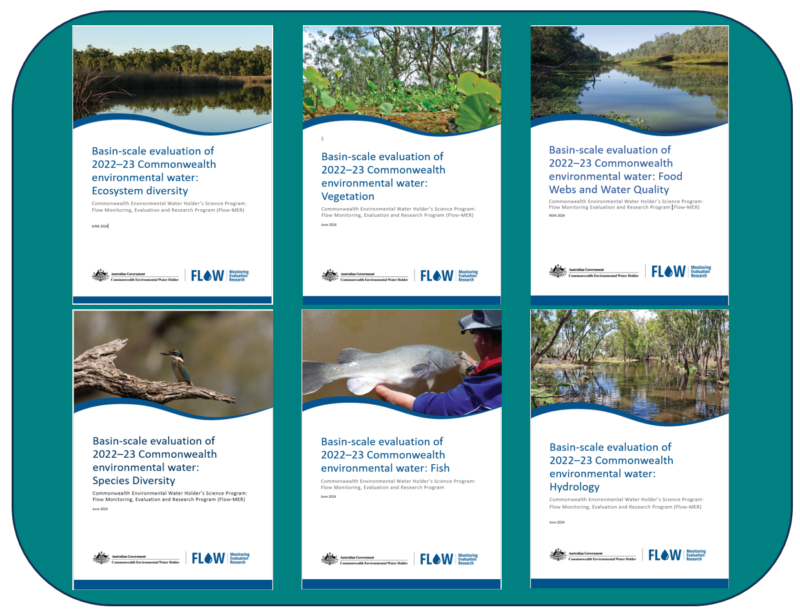

Hydrology and connectivity
This chapter describes the hydrological conditions (rainfall, surface water runoff) in the Basin that affect the planning of Commonwealth environmental water delivery – volumes, locations, and how Commonwealth environmental water has contributed to restoring the hydrological regime.
2023–24 At a glance
- Following 2 wetter years, rainfall in 2023–24 was similar to the long-term average in most valleys in the Basin, returning to conditions comparable to 2020–21.
- Rainfall varied significantly between and within valleys. Compared to the long-term average, conditions were wetter in central New South Wales, Queensland and Victoria and very dry in headwaters and the lower Murray.
- Surface water runoff in the Basin was significantly less than the previous year, dropping from 67,760 GL in 2022–23 to 22,509 GL in 2023–24, most likely because of drier conditions in headwaters feeding Basin storages. Whole-of-Basin storages were at 94% (of 22,258 GL of total storage) in July 2023, dropping over the year to a winter low of 77% by June 2024.
- 2,870 GL of Commonwealth environmental water was delivered in 2023–24, the largest volume over the 10 years since 2014, in part due to storages being relatively full following a very wet year in 2022–23. This equates to 12.9% of Basin storage volume or 12.8% of total surface water runoff.
- Commonwealth environmental water was mostly delivered in spring and summer in 114 watering actions. In some cases, Commonwealth environmental water contributed to flows for extended periods of time. As the southern Basin was wetter during the winter, some planned watering actions could not be delivered.
- Most Commonwealth environmental water was delivered as base flow actions in the southern Basin. Actions in the northern Basin were predominantly for fresh and overbank flows except for a base flow action in the Warrego and Barwon Darling. Base flow actions aimed to improve flow regime.
- Commonwealth environmental water delivered freshes (higher instream flows) and contributed to increased duration of freshes in most valleys. While freshes were not delivered in the Barwon Darling, flows were higher in late summer due to contributions from upstream valleys.
- 2,615 GL (91% by volume of total 2023–24 delivery) of Commonwealth environmental water were delivered in the southern Basin. The northern Basin received 255 GL – 71 GL of this (28% of northern Basin total or 2.5% of Basin total) were delivered in the Condamine Balonne to support the Narran Lakes.
- Commonwealth environmental water inundated 23,768 ha of estuary, 200,890 ha of lakes and wetlands, and 47,770 ha of floodplain area and connected 21,075 km of waterways.
- 1,835 GL of Commonwealth environmental water were delivered to 8 Ramsar Sites in 2023–24.
- Basin Plan target flow volumes were achieved for the Coorong, Lower Lakes and Murray Mouth in 2023–24. Water level thresholds in the Lower Lakes were maintained (Basin Plan objective 8.06).
2014–24 At a glance
- Mean annual system flows over the last 10 years have been close to or above the longer-term (24-year) average in the northern Basin and southern Basin, mostly due to 3 of the 5 wettest years occurring in the last 10 years.
- Over the 10 years of the Commonwealth monitoring program, 18,310 GL of water were delivered through a total of 1,194 independent Commonwealth environmental watering actions.
- Over the last 10 years, Commonwealth environmental water contributed flows to a maximum extent of 28,549 km of waterways. Recent wetter years have generally shown higher connectivity, and Commonwealth environmental water (in conjunction with other flows) led to greater achievement of environmental outcomes. The total length of waterways connected over the 10-year period was highest in the Murrumbidgee and the Central Murray systems. Even in wetter years (2021–23), Commonwealth environmental water extended the duration of flows in some periods.
- Commonwealth environmental water was often delivered in partnership with state and other environmental water holders. Of the 1,194 watering actions, about 50% were in collaboration with partners, and Commonwealth environmental water contributed about 50% in volume.
- Cumulatively over the last 10-years, 446,264 ha of wetlands, lakes and floodplains (including the Coorong, Lower Lakes and Murray Mouth) received Commonwealth environmental water.
- Between 2014 and 2023, all 11 of the Ramsar wetlands in the Basin that can receive Commonwealth environmental water (11 of 16 in total) were inundated at least once.
- Over the 10-year period, 18,310 GL of Commonwealth environmental water were delivered to 56 ecosystem types (88% of Australian National Aquatic Ecosystems [ANAE] types on the managed floodplain, the area of the Basin where watering with Commonwealth environmental water is possible) on at least one occasion, supporting 124,091 ha of lakes, 130,574 ha of wetlands, 191,599 ha of floodplain, 28,549 km of waterways and 23,768 ha of estuarine ecosystems.

Rainfall
While rainfall across Australia was above the long-term average in 2023–24, the average rainfall of 479.9 mm for the Basin was below the long-term average (−3%). There was high variability within and between valleys. Southern and northern areas of the Basin received average rainfall, large parts of central New South Wales and central Victoria were above average, and South Australia, the upper Murray and highland areas of north-eastern New South Wales experienced below average rainfall (Figure 2.1).
Temporal variations were also observed over the water year. Many of the southern Basin valleys received very much above average rainfall in the winter months. These variations affected the delivery of Commonwealth environmental water – some scheduled actions were not delivered due to high natural flows, and many base flow events were delivered in the southern Basin in the summer months.
During the 10-year period (2014–24) of Basin-scale monitoring and evaluation, the first 2 years were dry, particularly in the southern Basin, where rainfall was the lowest on record (Figure 2.1). In 2016–17, conditions were wetter in the southern Basin and the headwaters of some northern Basin tributaries. Conditions returned to dry across the whole Basin over the period 2017–20.
In 2020–21, the Basin returned to wetter conditions, and average, above average or very much above average rainfall was experienced across the Basin. Those conditions persisted through to 2022–23, although it should be noted that some valleys saw a dry start in the early months of 2023, especially in the southern Basin. In 2023–24, the Basin returned to more ‘average’ conditions, similar to 2020–21.
Figure 2.1 Maps of annual rainfall conditions across the Basin, per year 2014–24
Maps include valley boundaries. Maps are coloured by the 7 condition categories which are deciles rankings from lowest to highest on record, and are those used by the Bureau of Meteorology. Data source: Bureau of Meteorology.
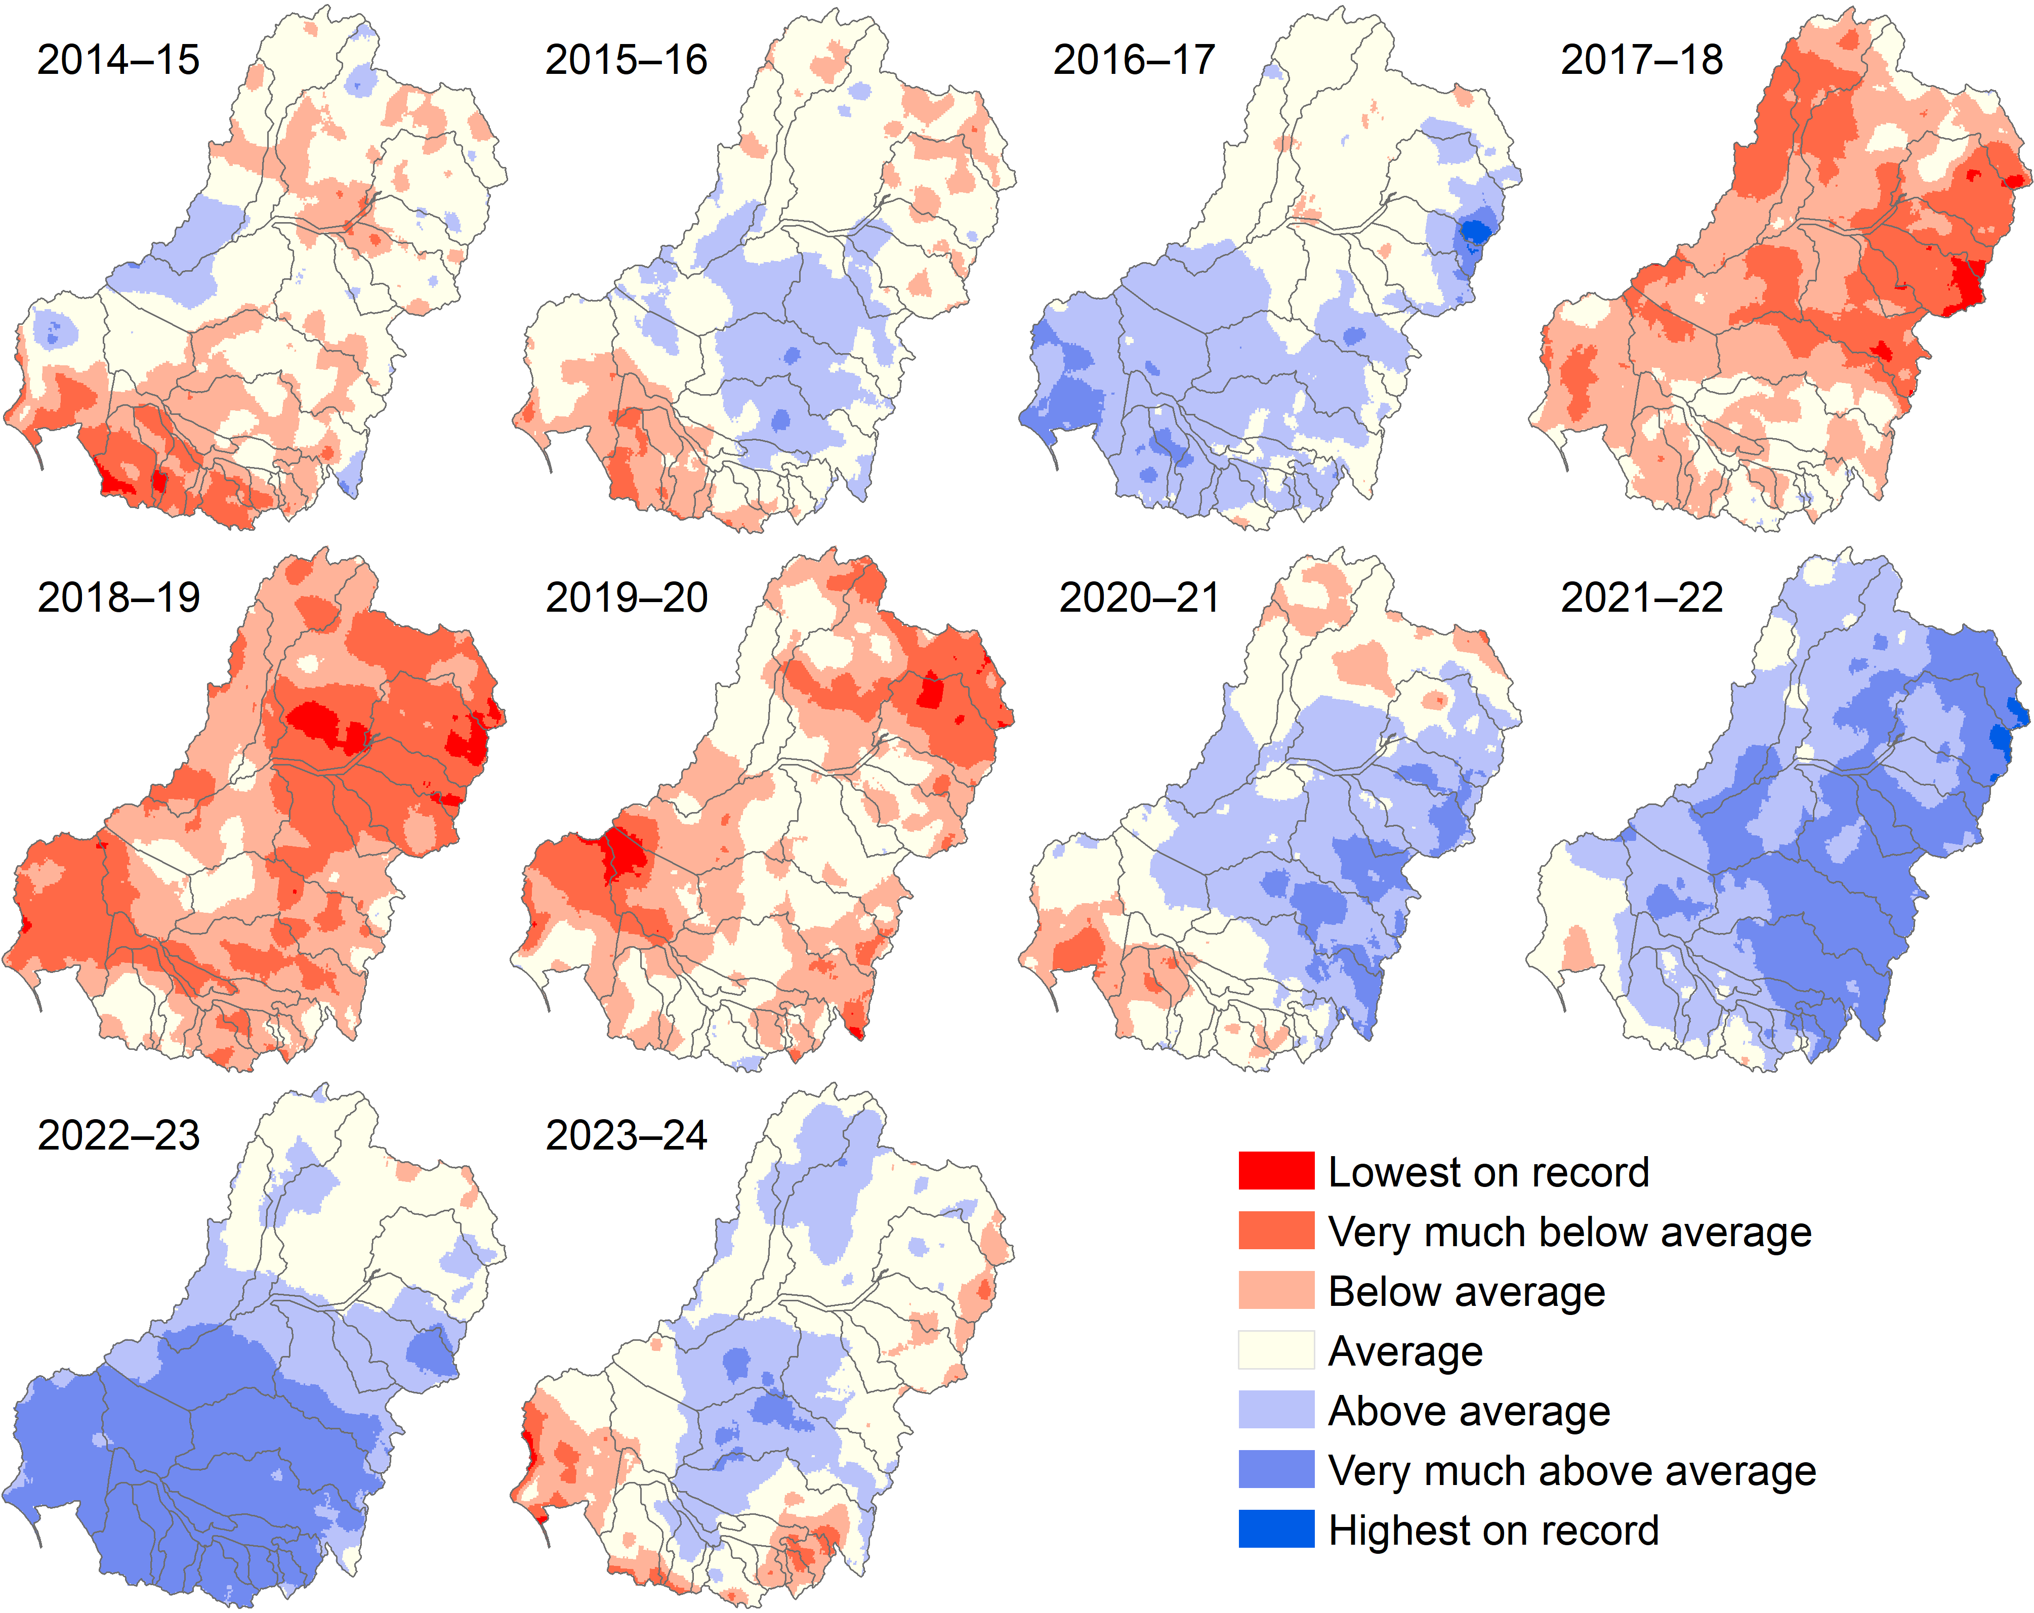

Total runoff in the Basin
The last 20 years were a dry period for the Basin. There were persistent low inflows during the Millennium Drought and only brief respites in 2010–11, 2011–12 and 2016–17, before returning to dry conditions. Over recent years, total runoff has been above the average for this century, and most valleys experienced much wetter conditions (Figure 2.2).
Total surface water runoff in the Basin in 2023–24 was 22,509 GL, much less than the 10-year average of ~36,500 GL and 24-year average of ~31,700 GL (Figure 2.3). Following a wet 2022–23 with little soil moisture capacity available, lower rainfall conditions in 2023–24 resulted in only slightly less than average surface flows across the Basin. Storages were at a 94% in July 2023, peaked at 95% during spring (21,077 GL out of 22,258 GL of total storage), then dropped over the remainder of the water year to 77% by June 2024.
Variability in rainfall within and between valleys, as well as during the water year, resulted in significant seasonal variability in flow at monitoring areas (Selected Areas, shown in Figure 1) (Figure 2.4). River flows across most Basin river systems were higher in winter of 2024, resulting in overbank flooding and floodplain inundation in some areas and then much lower through summer and autumn, impacting base flows.
Figure 2.2 Maps of annual surface water runoff in the Basin by river valley, per year 2014–24
Data is modelled annual surface water volumes in the Basin, generated from rainfall-runoff modelling. The colours indicate total volume of runoff predicted for each year – lighter colours indicate lower runoff volumes. Data source: CSIRO.
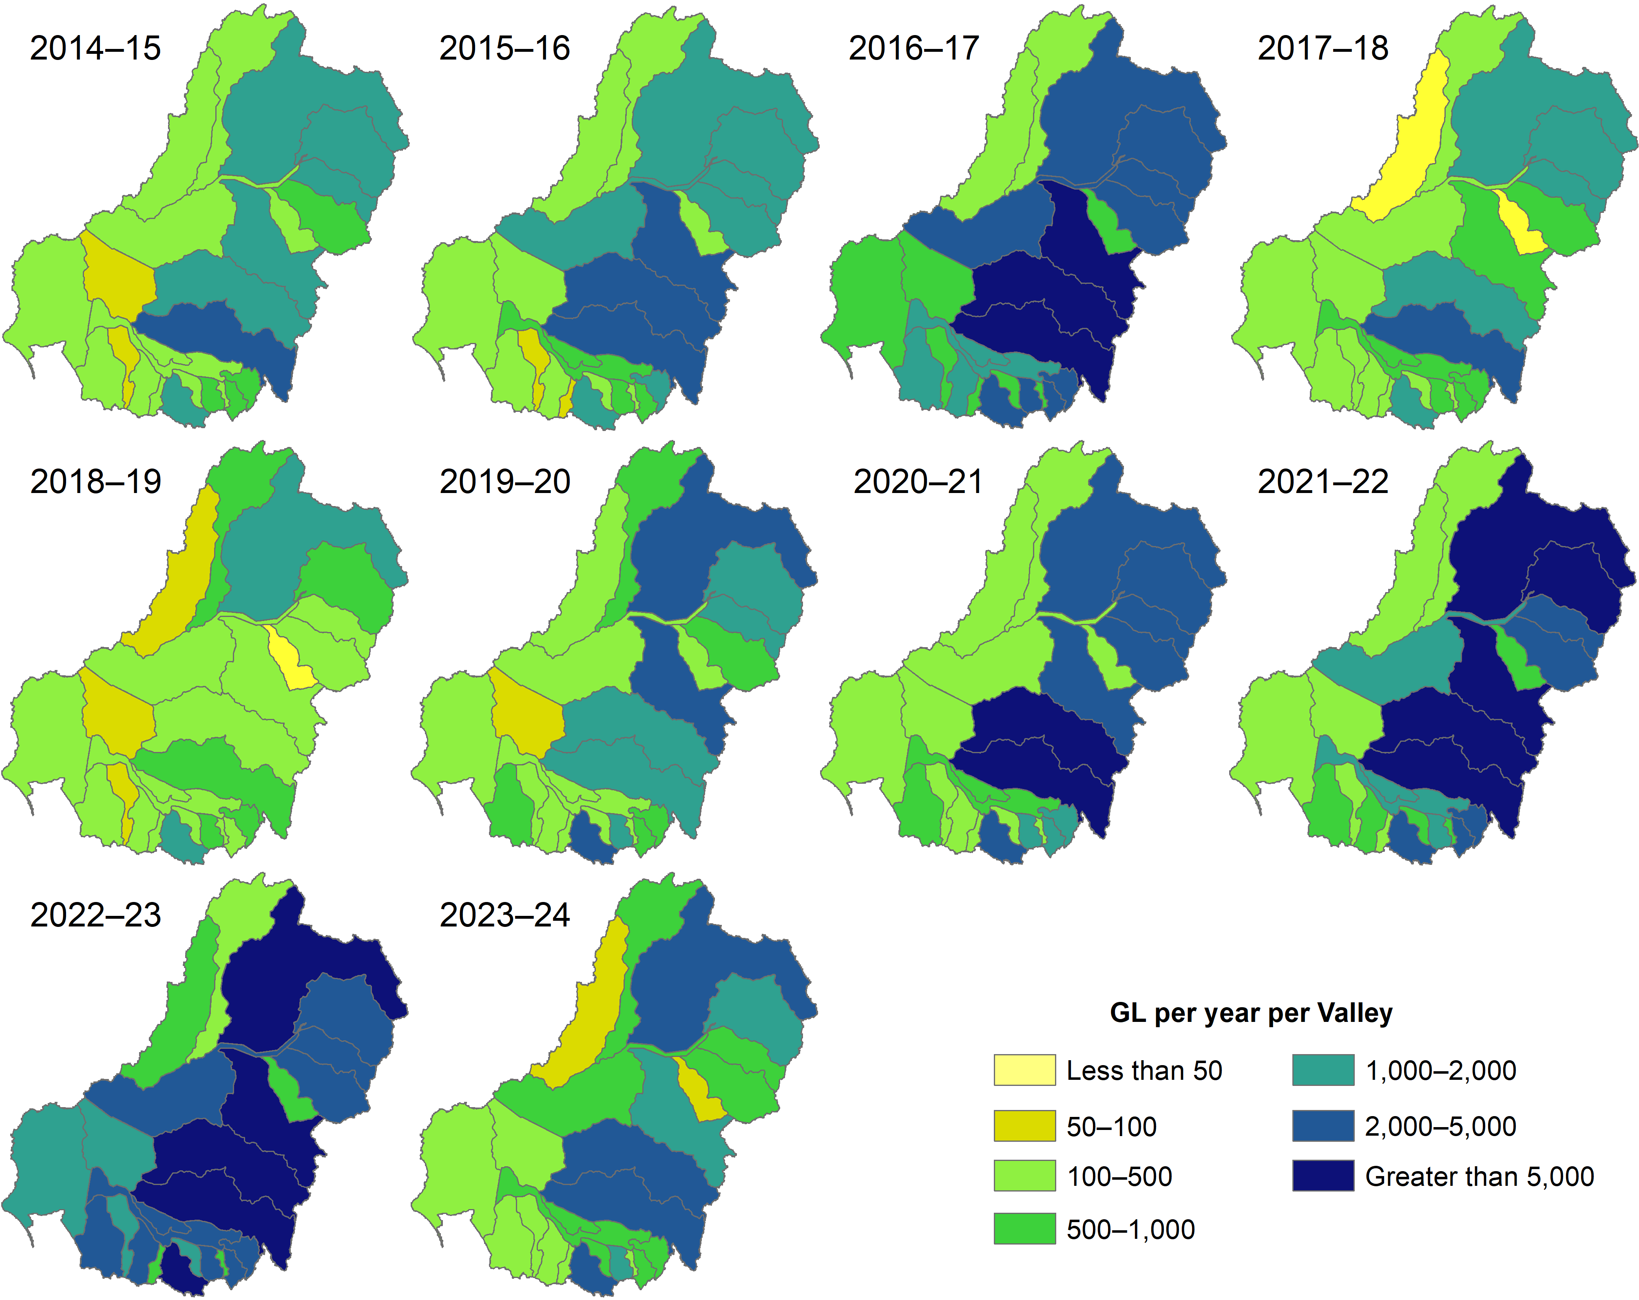
Figure 2.3 Annual total runoff in the Basin, per year 2000–24
Top chart shows total runoff in the Basin, middle chart shows southern Basin total runoff, bottom chart shows northern Basin total runoff. All charts include 24-year 2000–24) and 10-year (2014 –24) averages. Data source: CSIRO.
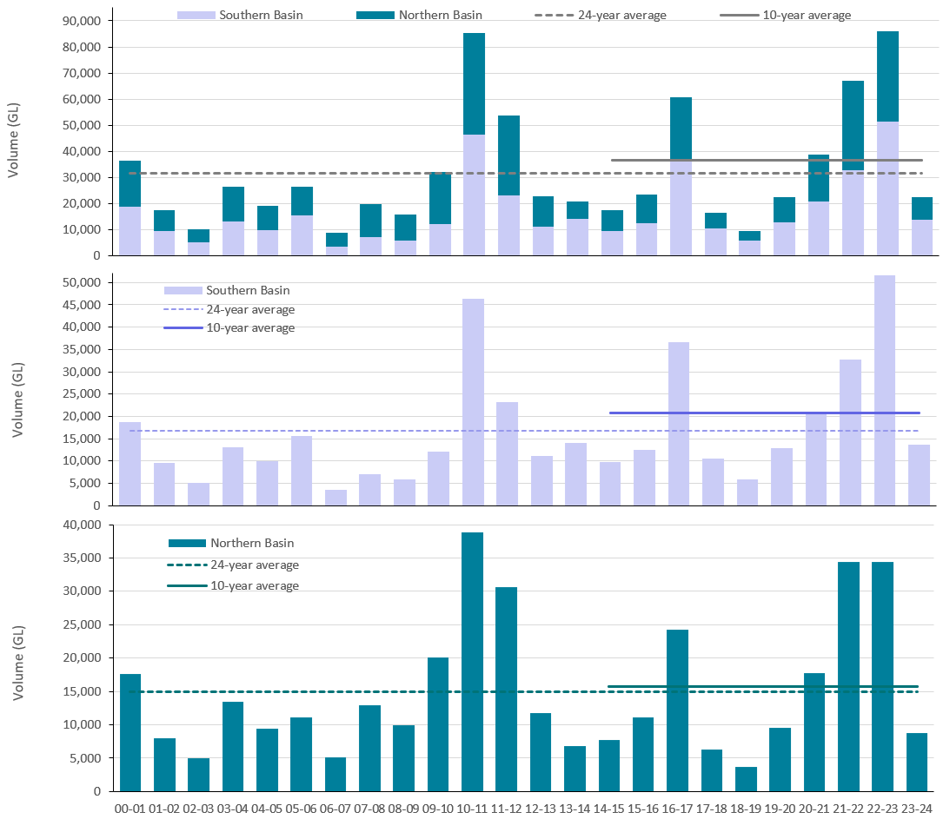
Figure 2.4 Gauge plot showing 2023–24 seasonal flows in Selected Areas, compared to previous years 2014–23
For each Selected Area, the mean flow for each season was calculated. This was then expressed as a percentage of the maximum mean flow recorded for that season between 2014 and 2024. Therefore, 100% indicates that 2023–24 recorded the maximum flow mean since 2014 for that season. Data is not available for the Junction of Warrego and Darling rivers Selected Area.
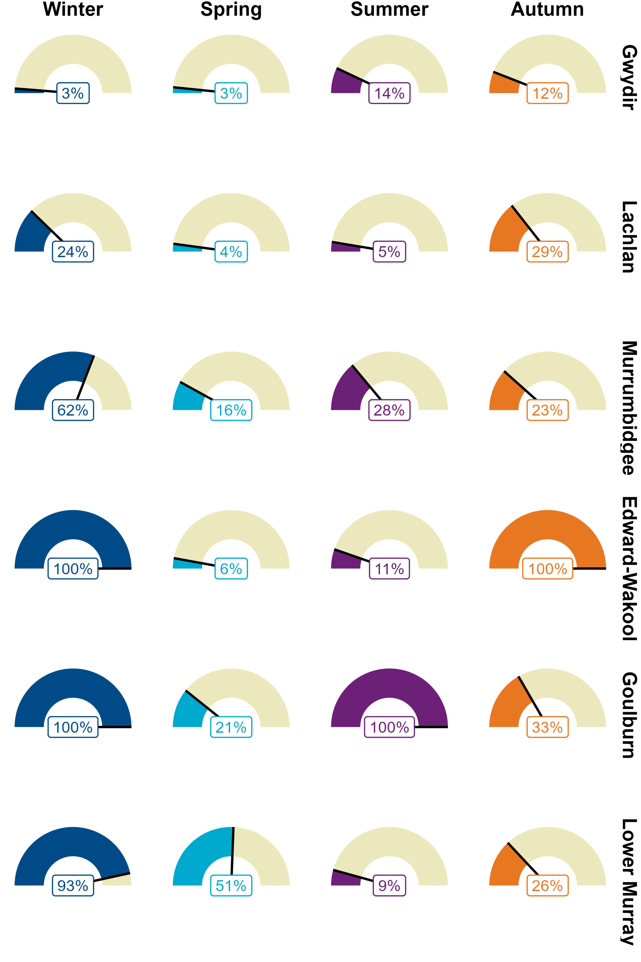

Delivery of Commonwealth environmental water
Water for the environment is strategically used by the CEWH to protect and restore hydrological regimes and connectivity within and between water-dependent ecosystems (Basin Plan S8.06). This involves connecting river reaches during dry times and connecting the river to the floodplain during wetter periods, as well as connecting and maintaining instream habitat and providing cues for breeding and movement. The evaluation considered the impact of Commonwealth environmental water on 5 ecologically important flow components (depicted in Figure 2.5):
- Base flows (low flows) maintain longitudinal connectivity in river systems so that they do not become dry or isolated pools.
- Freshes are small, instream events that replenish pools and are important for managing water quality (e.g. algal blooms), allowing fish to move between refugia and supporting the quality, persistence and resilience of instream refuge pools. Freshes are commonly used to inundate benches or lower levels of the channel environment, pulsing nutrients and carbon into the system and creating habitat for fish, bugs and plants.
- Lateral connectivity refers to the movement of water between the channel and floodplain, including inundation of floodplain wetlands through overbank flows.
- Upstream–downstream (longitudinal) connectivity.
Figure 2.5 An illustrative river cross-section showing 4 river flow components (base flow, fresh, bankfull and overbank) and wetland inundation referenced in this evaluation
Source: Figure 10, the Strategy 2019.

Water year 2023–24
In 2023–24, 2,870 GL of Commonwealth environmental water were delivered through 114 watering actions for rivers, wetlands and floodplains in the 19 valleys where CEWH holds water entitlements (Figure 2.6 and refer to Table A.1, Table A.2 and Table A.3). This equates to 12.9% of Basin storage volume or 12.8% the total volume of Basin runoff in 2023–24. This is the largest volume of Commonwealth environmental water delivered over the 10 years since 2014, in part due to storages being relatively full following a very wet year in 2022–23.
Larger environmental water entitlements are held and delivered in the southern Basin compared to the northern Basin and are accompanied by a wider range of options for active water management. For the water year 2023–24, 2,615 GL (91% by volume of total 2023–24 delivery) and 74% (or 84) actions were delivered in the southern Basin. The northern Basin received 255 GL – 71 GL of this (28% of northern Basin total or 2.5% of Basin total) was delivered in the Condamine Balonne to support the Narran Lakes.
In 2023–24, 88 watering actions (77% by volume) were delivered to support instream flows across all 19 of the Basin valleys where Commonwealth environmental water is delivered (refer to Table A.1, Table A.2 and Table A.3). Commonwealth environmental water connected 21,075 km of waterways, including channels on the managed floodplain.
Wetlands in the Gwydir, Macquarie, Edward/Kolety–Wakool, Lachlan, Lower Murray and Murrumbidgee benefited from delivery of Commonwealth environmental water in 2023–24, including internationally significant Ramsar Sites. 23 actions were delivered to support floodplains (overbank) or wetlands, inundating 23,768 ha of estuary, 200,890 ha of lakes and wetlands and 47,770 ha of floodplain area.
The timing and duration of high flow events, as well as the maintenance of baseflow, are important for Basin ecosystems and delivery of Commonwealth environmental water. In 2023–24, Commonwealth environmental water was used to maintain baseflows as well as extend the duration of natural freshes to water wetlands, improve water quality by maintaining dissolved oxygen levels above critical thresholds, maintain high flow rates during spring and summer, and reduce rapid recessions. The use of Commonwealth environmental water deliveries to maintain water quality and dissolved oxygen levels likely lessened the impact of hypoxic water conditions and associated fish deaths.
Figure 2.6 Volume of water and number of watering actions delivered (left) and the watercourses and area inundated or connected (right) by Commonwealth environmental water, 2023–24
In these 2 maps, those valleys shaded grey are the 5 valleys where the Commonwealth Environmental Water Holder does not hold water entitlements. CEW = Commonwealth environmental water. Volumes are in megalitres and number of watering actions are in brackets.
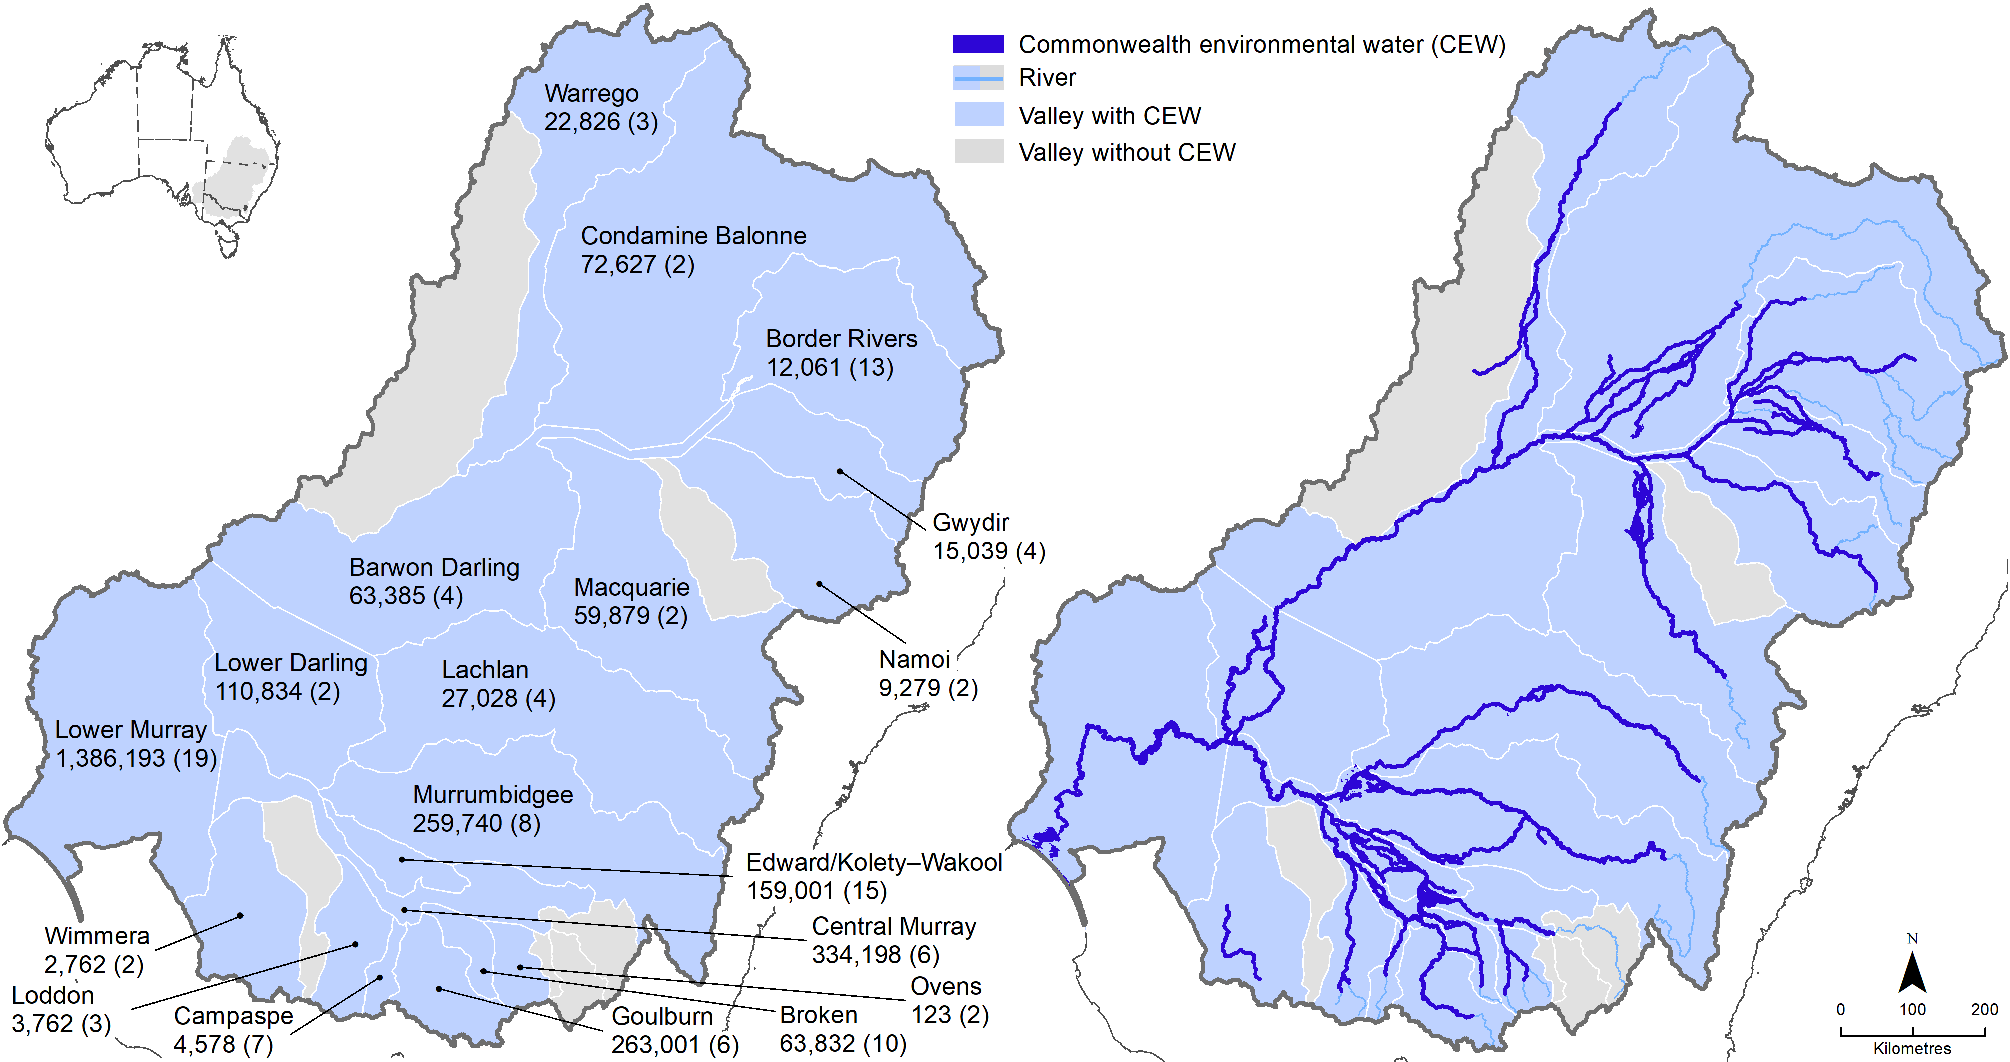

Water years 2014–24
All 19 valleys where the Commonwealth holds water entitlements (Figure 2.6) received Commonwealth environmental water at some time between 2014 and 2024 (Figure A.1). Over the 10 years from 2014–24, 18,310 GL of Commonwealth environmental water were delivered in 1,194 independent watering actions.
The 12 southern Basin valleys received most of the water by volume as well as by the number of actions. Among the southern Basin valleys, the Lower Murray Valley received the largest deliveries (7,339 GL through 421 watering actions), supporting end-of-system flows to the Coorong, Lower Lakes and Murray Mouth and creeks and wetlands. The Murrumbidgee, Central Murray and Goulburn river systems also received a large portion of the environmental water portfolio. Of the 7 northern Basin valleys, the Condamine Balonne received the highest volume of Commonwealth environmental water (797 GL through 20 actions) primarily to support the Narran Lakes.
Most Commonwealth environmental water was delivered for instream flows – 643 actions (54% of total number of actions) totaling 15,532 GL, representing 85% of the total volume over the 10 years – although some of these actions also having an overbank component. In comparison, 551 actions (46% of actions over the 10 years) totalling 2,778 GL, representing 15% of total volume over 10 years. Base flows and freshes were delivered in all years (Figure 2.7, Figure 2.8).
Over the 10 years, Commonwealth environmental water were delivered to inundate wetlands and floodplains in 11 of the 19 Basin valleys where the Commonwealth holds water entitlements, with at least some overbank flows being delivered each year (Figure 2.7, Figure 2.8). In the other 8 valleys – the Barwon Darling, Broken, Campaspe, Goulburn, Loddon, Namoi, Ovens and Wimmera rivers – flows are managed with little overbank inundation, but instream base flows and freshes were delivered most.
Across the 10 years 2014–24, Commonwealth environmental water was generally delivered with a similar seasonal pattern. In the southern Basin, most deliveries were released in spring and summer pulses, even in the drier years (water years 2017–20). In the northern Basin, releases were spread across the year.
Delivery of Commonwealth environmental water over the 10-year period typically targeted Basin Plan environmental outcomes for vegetation, fish and waterbirds (Figure 2.9). Commonwealth environmental water also supported longitudinal river connectivity for instream ecosystem processes and water quality objectives, including mitigation of hypoxic conditions and algal blooms.
Figure 2.7 Commonwealth environmental water portfolio showing volume of watering actions by flow component and year, 2014–24
Volumes per component are displayed above each bar. Annual volumes are displayed inside boxes at the bottom of the figure.
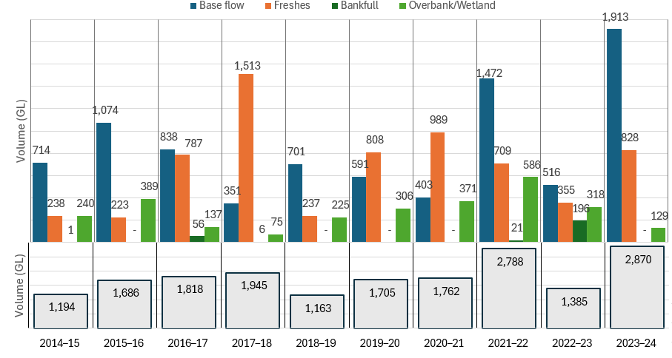
Figure 2.8 Commonwealth environmental water portfolio showing the number of watering actions and the proportioning of flow components each year, by flow component and year, 2014–24
The number of watering actions is displayed inside each component of the stacked horizontal bar.
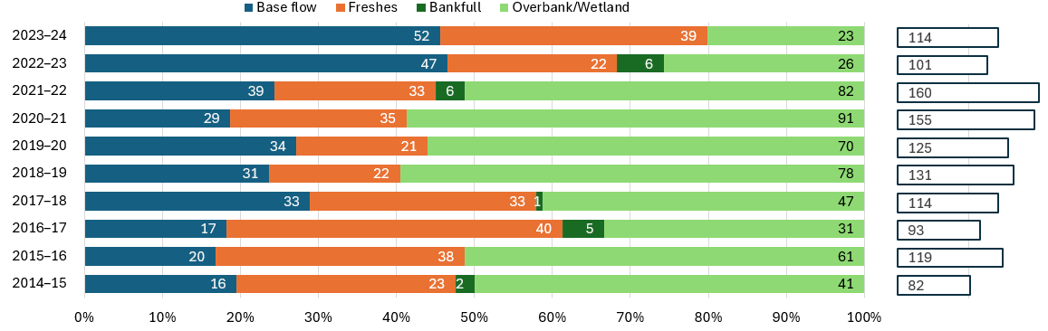
Figure 2.9 Number of Commonwealth environmental watering actions targeted to specific outcomes, 2014–24
Actions include multiple objectives. Note that very few watering actions explicitly target resilience or connectivity.
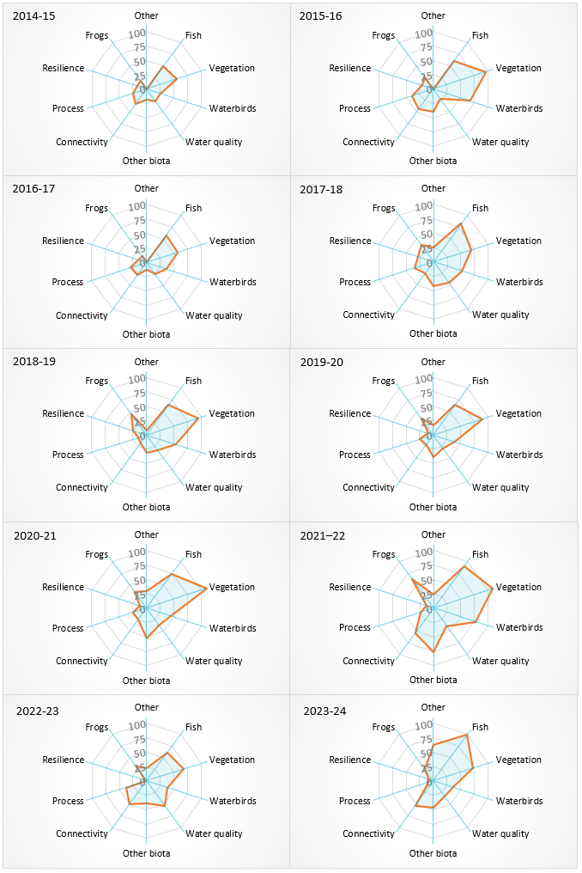

Restoring flows
This section presents findings from the Hydrology evaluation for the 2023–24 water year, compared with the prior 9 years of monitoring, presented in the ‘Basin-scale evaluation of 2023–24 Commonwealth environmental water: Hydrology’ report (will be available from DCCEEW’s Flow-MER Basin-scale Project publications webpage).
What did Commonwealth environmental water contribute to restoration of the hydrological regime?
In 2023–24, Commonwealth environmental water:
improved flow regime in strategic locations through provision of baseflows
improved lateral and longitudinal connectivity in most valleys by extending extent and duration of natural flooding.
The Basin Plan (Section 8.06 Protection and restoration of ecosystem functions of water-dependent ecosystems) requires the protection and restoration of hydrological connectivity within and between water-dependent ecosystems, including:
- longitudinally along watercourses
- laterally between watercourses and their floodplains (and associated wetlands)
- vertically between the surface and subsurface.
The Strategy sets expected environmental outcomes for river flows and connectivity (Table 2.1). This evaluation considers the impact of delivery of Commonwealth environmental water on restoration of flows, including low flows (base flows), flow increases in the river channel (freshes and bankfull), floodplain inundation (overbank), and longitudinal and lateral (wetland) connectivity.
Table 2.1 River flows and connectivity expected environmental outcomes as set out in the Strategy
Outcome | Quantified expected environmental outcome
Maintained base flows | At least 60% of natural levels
Improved overall flow | 10% more into the Barwon Darling, 30% more into the River Murray, 30% to 40% more to the Murray Mouth; open to the sea 90% of time; barrage flows > 2,000 GL/year
Maintained connectivity in areas where it is relatively unaffected | Between rivers and floodplains in the Paroo, Moonie, Nebine, Warrego and Ovens
Improved connectivity with bankfull or low floodplain flows | By 30% to 60% in the Murray, Murrumbidgee, Goulburn and Condamine Balonne  By 10% to 20% in remaining catchments
Maintain Lower Lakes above sea level | Maintain the water level in Lake Alexandrina above 0.4 m Australian Height Datum

Base flows
The Strategy sets environmental outcomes for base flows (Table 2.1). In 2023–24, at least 60% of natural base flow levels was achieved in all valleys except for the Wimmera and Broken. Delivery of base flows led to flow regime improvement in many valleys and contributed to improved flow regimes in some valleys. Since 2014, the Strategy outcome was met in all valleys in at least some years, ranging from all 10 years for the Central Murray to twice in the Barwon Darling, Edward/Kolety–Wakool and Lower Darling/Baaka.
In 2023–24, Commonwealth environmental water was mostly delivered as base flows. Over the 10-year period of the program, the most Commonwealth environmental water was delivered in 2023–24 and most of that was delivered as base flow watering actions (67% by volume). Overall, targeted base flow releases led to flow regime improvement and, in some cases, provided progress towards the pre-development flow regime.
Of the 114 watering actions delivered in 2023–24, 34 were dedicated to supporting base flows and 18 were delivered for base flows as part of multi-component flow events. Where base flow actions were delivered, they improved the flow regime by progressing the hydrograph closer to ‘natural’ (modelled pre-development) flows.
Rivers in the northern Basin are naturally intermittent, becoming disconnected waterholes in drier periods. In the northern Basin, high-volume (63.4 GL) delivery was used to maintain base flows in the Barwon-Darling. In 2023–24, Commonwealth environmental water contributed to improving base flows in the Barwon, Gwydir, Macquarie, Namoi and Peel rivers, although most northern river systems met base flow requirements without additional water. Over the 10 years since 2014, Commonwealth environmental water contributed to improving base flows (of up to 20%) in some years in the Namoi and Macquarie valleys and < 5% in other northern Basin valleys.
In 2023–24, most Commonwealth environmental water was delivered in the southern Basin, where river systems are more naturally connected. Commonwealth environmental water contributed to maintaining base flows in the southern Basin in autumn, which also improved the base flow in the Murray River in autumn and winter. An autumn fresh action in the Lachlan also served to maintain base flows.
Over the 10 years since 2014, Commonwealth environmental water contributed to improving base flows (of between 5% and 10%) in the Goulburn, Lower Murray, Campaspe, Edward/Kolety–Wakool, Murrumbidgee and Lachlan. In other southern valleys, improvements to base flow were less than 5%. In most systems in the southern Basin during the drier years (2017–20), Commonwealth environmental water supported base flows, especially in the Goulburn, Central Murray and Lower Murray.

Freshes
All Basin valleys, except the Lower Darling/Baaka, received Commonwealth environmental water for freshes in 2023–24. Compared to the previous year, the climate was drier with lower likelihood for natural freshes. Delivery of Commonwealth environmental water increased the frequency of freshes in multiple valleys and added to duration of freshes to support the inundation of wetlands in the Basin. 33 watering actions were delivered for freshes, and another 3 actions were delivered for freshes as well as supporting base flows.
In 2023–24, Commonwealth environmental water was delivered as freshes in spring and summer to support inundation of Basin wetlands – Narran Lakes, Macquarie Marshes, Barmah–Millewa Forest, Lower Murrumbidgee wetlands – and in the autumn in the Lachlan and Goulburn. Many fresh actions, specifically targeted at wetland inundation, were delivered to extend the duration of flow and thus prolong the time the wetlands were inundated, rather than delivering freshes as singular events.
In the northern Basin, Commonwealth environmental water extended the duration of fresh flows in the Condamine Balonne, Barwon Darling, Macquarie and Warrego. In the southern Basin, Commonwealth environmental water contributed to increased frequency and duration of freshes in the Goulburn (5 instances) as well as the Lachlan, Loddon, Central Murray and Murrumbidgee valleys. In the Edward/Kolety–Wakool, Commonwealth environmental water extended the duration of naturally occurring freshes.
Over the 10 years since 2014, Commonwealth environmental water consistently contributed to freshes, most notably in the Goulburn, Campaspe and Lower Murray valleys. In some drier years, Commonwealth environmental water resulted in the delivery of a fresh in the Goulburn, Campaspe, Lachlan, Lower Darling/Baaka and Condamine Balonne rivers, where otherwise a fresh would not have occurred.

Connectivity along rivers
Commonwealth environmental water has improved the overall connectivity in the Basin (Figure 2.10). In 2023–24, Commonwealth environmental water supported longitudinal connectivity through 21,075 km of Basin waterways along 40% of the river length on the managed floodplain. Over the last 10 years, Commonwealth environmental water delivered flows to a maximum length in any one year of 22,164 km.
In the northern Basin in 2023–24, the Barwon Darling, Condamine Balonne, Border Rivers, Macquarie and Warrego river systems experienced improved longitudinal connectivity due to Commonwealth environmental water. In southern Basin valleys, the Central Murray, Edward/Kolety–Wakool, Lachlan, Lower Darling, Lower Murray and Murrumbidgee valleys saw an increase in instream connectivity.
Over the last 10 years, Commonwealth environmental water contributed flows to a maximum length in any one year of 22,164 km (in 2021–22). Recent wetter years have generally shown higher connectivity, and Commonwealth environmental water (in conjunction with other flows) led to greater achievement of environmental outcomes. The total length of waterways connected over the 10-year period was highest in the Murrumbidgee followed by the Barwon Darling.
Figure 2.10 Map showing length of waterways connected and wetland inundation, 2023–24
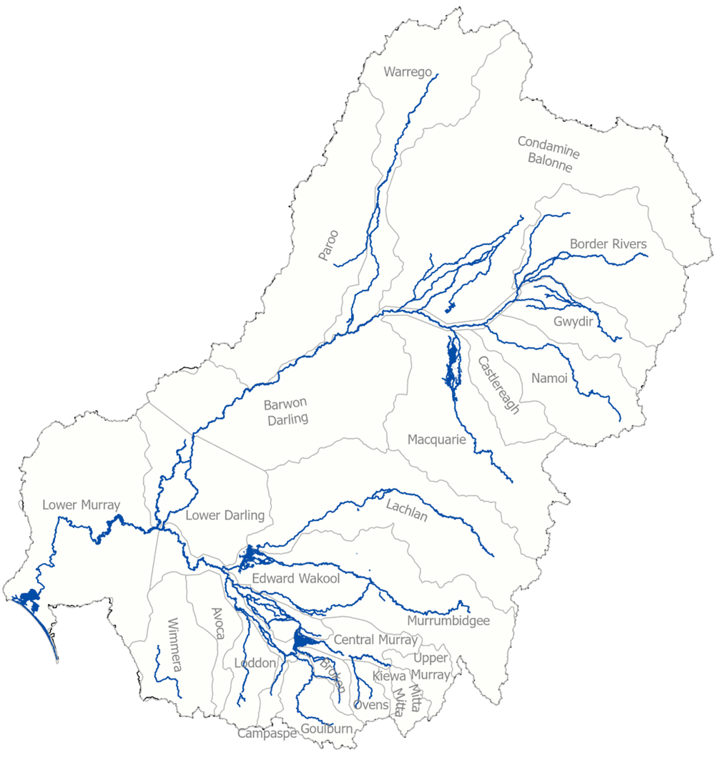
Over the 10-year period, 54% of all the river length on the managed floodplain (representing 28,549 km of river) was supported by Commonwealth environmental water (Figure 2.11). 33% (or 9,419 km) was watered in every year along permanent lowland sections of the Barwon, Macquarie, Gwydir, Lachlan, Murrumbidgee, Edward/Kolety–Wakool, Murray, Ovens, Broken, Goulburn and Loddon rivers. Permanent reaches in the lowland sections of the Bokhara, Culgoa, Darling and Campaspe rivers, and the smaller upland, transitional Severn River, received Commonwealth environmental water in 9 of the 10 years. Some temporary rivers also received water in 7–8 of the years: Gunbower Creek, Tuppal Creek, Moonie River and the lower end of the Warrego River (Figure 2.11).
Figure 2.11 Map of annual frequency (from 1 in 10 years to 10 in 10 years) of Commonwealth environmental water in rivers in the Murray–Darling Basin, 2014–24
CEW = Commonwealth environmental water.
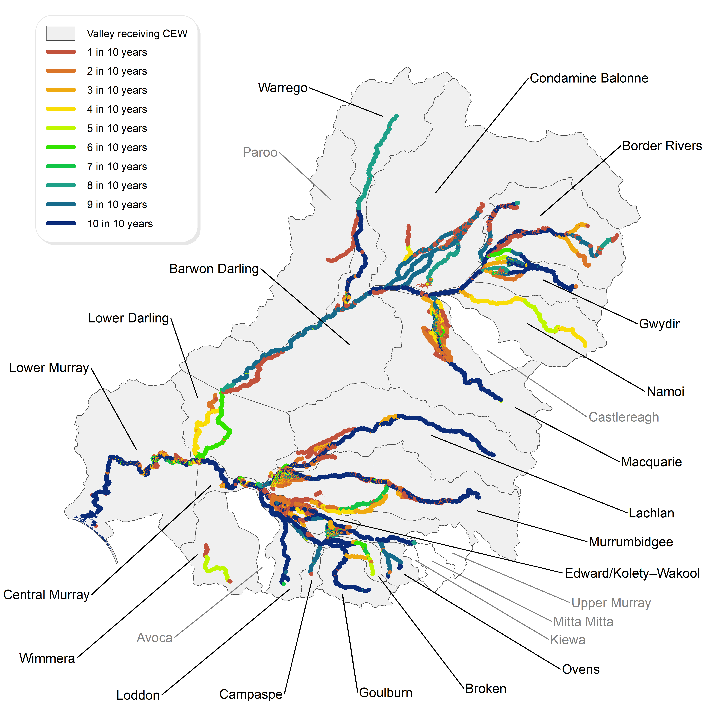
The Strategy sets expected outcomes for connectivity as increased flows into the Murray and Barwon Darling rivers (Table 2.1). Due to high base flows, longitudinal connectivity outcomes were achieved for all valleys except for the Wimmera and Broken river systems. In 2023–24, Commonwealth environmental water contributed to a 14% increase in flows to the Barwon Darling River and 16% increase in the Murray River.
Natural base flows were high in 2023–24 and persisted for longer compared to the ‘natural’ (modelled pre-development scenario) flow regime. Strategy outcomes were met in all valleys except for the Wimmera and Broken river systems, although Commonwealth environmental water was only a partial contributor. Commonwealth environmental water plays a more significant role during drier periods (shown in
Figure 2.12); for example, contributing over 97% of total flow in the Darling River at Bourke in 2017–18. In 2023–24, Commonwealth environmental water supported a 14% increase in annual flows to the Barwon Darling in the northern Basin and a 16% increase in flows in the Murray River in the southern Basin.
Figure 2.12 Percentage increases in annual flow volumes in the Darling River at Bourke (top) and the Murray River at the South Australian border (bottom) that are directly attributable to Commonwealth environmental water, 2014–24
For the northern Basin valleys, up to water year 2021–22, Louth was used as the point of evaluation. CEW = Commonwealth environmental water.
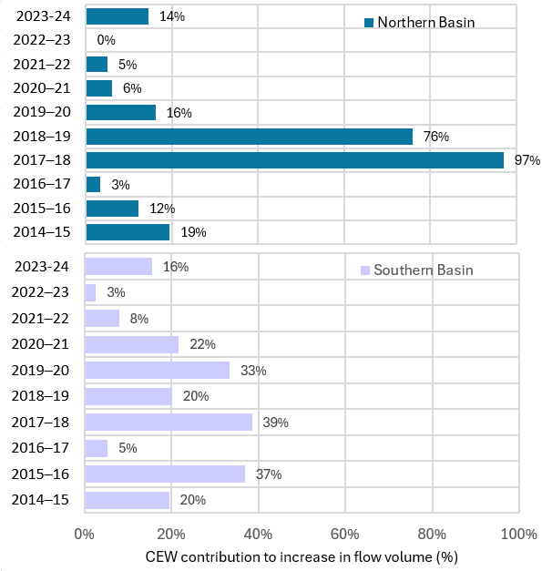

End-of-Basin flows
The Strategy defines expected environmental outcomes for flow volume and depth for the Coorong, Lower Lakes and Murray Mouth (Table 2.1). In 2023–24, due to high natural flows, barrage releases were above the 2,000 GL/year target without Commonwealth environmental water. Similarly, water levels in Lake Alexandrina did not fall below the 0.4 m Australian Height Datum target, primarily due to high natural flows.
Lower reaches of river valleys are particularly vulnerable to water withdrawals from upstream, and there is a risk of flows declining to severely low levels during dry periods. For example, the Coorong, Lower Lakes and Murray Mouth depends on freshwater flows that deliver longitudinal hydrological connectivity from upstream.
The Strategy target for flows to the Murray Mouth is an increase of 30–40%. In 2023–24, a 21% increase due to Commonwealth environmental water (at Wellington) was realised. While this is a high contribution, the Strategy target was technically not met.
Commonwealth environmental water contributed 1,146 GL to barrage releases over the year (Table 2.2), helping to meet the flow target of above 2,000 GL/year at the barrages. In drier years, Commonwealth environmental water contributes up to 100% of flows at the barrages. In most years, barrage flow requirements are not met, even with Commonwealth environmental water.
A further Strategy expected environmental outcome is minimum flows at the barrages over 2 years should be no less than 600 GL/year. This was also achieved in 2023–24 with the contribution of Commonwealth environmental water. In 2023–24, water levels in the Lower Lakes were maintained higher than 0.4 m Australian Height Datum for the entire year. By way of comparison, this target water level would not have been maintained in Lake Alexandrina in 2015, 2016, 2018, 2019 and 2020 without the contribution of Commonwealth environmental water.
Table 2.2 Contribution of Commonwealth environmental water to barrage releases
CEW = Commonwealth environmental water. Sourced from Table 2, Ye et al. (2025)
 | 2014–15 | 2015–16 | 2016–17 | 2017–18 | 2018–19 | 2019–20 | 2020–21 | 2021–22 | 2022–23 | 2023–24
CEW contribution (GL) | 454 | 561 | 802 | 757 | 377 | 685 | 808 | 841 | 753 | 1,146
CEW contribution (% of barrage releases) | 46% | 100% | 12% | 89% | 100% | 100% | 65% | 14% | 3.5% | 19%
Barrage release (GL) | 987 | 561 | 6,484 | 854 | 377 | 685 | 1,247 | 6,161 | 21,597 | 5,185

Lateral connectivity
The Strategy sets environmental objectives for lateral connectivity, as an increase in the frequency of freshes, bankfull and overbank flow (Table 2.1).
In 2023–24, Commonwealth environmental water inundated wetlands and floodplains in 8 of the 19 valleys of the Basin where the Commonwealth holds entitlements. Commonwealth environmental water was mostly used to extend the duration of widespread natural flooding and provide cues to support waterbird breeding rookeries (Condamine Balonne, Lachlan, Gwydir, Macquarie and Murrumbidgee valleys), and fish movement and breeding (Central Murray, Murrumbidgee).
This is the first year since monitoring began that Commonwealth environmental water inundated areas in the Paroo valley. These flows originated in the Warrego River, where licence rules were triggered to retain high flows in the Warrego River that spilled westward into the adjoining Cuttaburra distributary and to the nationally significant Cuttaburra and Yantabulla wetlands in the Paroo valley.
The Strategy includes expected outcomes related to freshes as an indicator of lateral connectivity. Strategy expected outcomes for improved connectivity with floodplains (lateral connectivity) are a 30% to 60% increase in frequency of freshes, bankfull and overbank flows in the Murray, Murrumbidgee, Goulburn and Condamine Balonne and 10% to 20% in remaining catchments. In 2023–24, climate conditions resulted in the natural occurrence of freshes, and Commonwealth environmental water was generally used to extend duration rather than increase frequency.
Lateral-connectivity expected outcomes were met in the Mid-Murray (Edward/Kolety–Wakool) and the Lachlan. These targets were almost met in the Barwon Darling (8% increase in fresh frequency, where 10% was the target). The flow-increase target in the northern Basin was met, 15% flow increase at Bourke, where 10% is the target. However, the flow-frequency targets were not met in the southern Basin and the Murray Mouth by Commonwealth environmental water alone. End-of-basin connectivity targets were all met.
Over the 10 years, Strategy expected outcomes for lateral connectivity were met in some years across most valleys, although context is very important. Given the latter years have had very wet periods, this means that while some indicators were not technically met, freshes occurred over extended periods, and the need for Commonwealth environmental water to support achievement of improved lateral connectivity was not required. Even so, Commonwealth environmental water improved characteristics of lateral connectivity, especially duration of inundation for important Basin wetland systems (e.g. Macquarie Marshes).
In 2023–24, delivery of Commonwealth environmental water contributed to lateral connectivity by prolonging duration of overbank flows and targeting delivery of water to important wetlands in the Basin.
Climate conditions in 2023–24 resulted in higher base flows across the Basin, providing opportunities for extending the area and duration of inundation of floodplains and wetlands (Figure 2.13).
Similar to 2022–23, the largest areas of inundated wetlands and floodplain were from Commonwealth environmental water that was delivered to extend the duration of widespread natural flooding and provide cues to support waterbird breeding rookeries in the Condamine Balonne, Lachlan, Gwydir, Macquarie and Murrumbidgee valleys and fish movement and breeding in the Central Murray and Murrumbidgee.
In 2023–24, Commonwealth environmental water was delivered to floodplains and wetlands in 8 of the 25 valleys of the Basin. 2023–24 is the first year since monitoring began in 2014 that Commonwealth environmental watering triggered licence rules to retain high flows in the Warrego. These flows contributed to inundation of the Cuttaburra distributary and the nationally significant Cuttaburra and Yantabulla wetlands.
Figure 2.13 Area of lakes and wetlands and floodplain and length of waterways receiving Commonwealth environmental water in Basin valleys, 2023–24
Lower Murray does not include the Lower Lakes. Area in hectares is shown on the left y-axis, and length in kilometres is shown on the right y-axis.
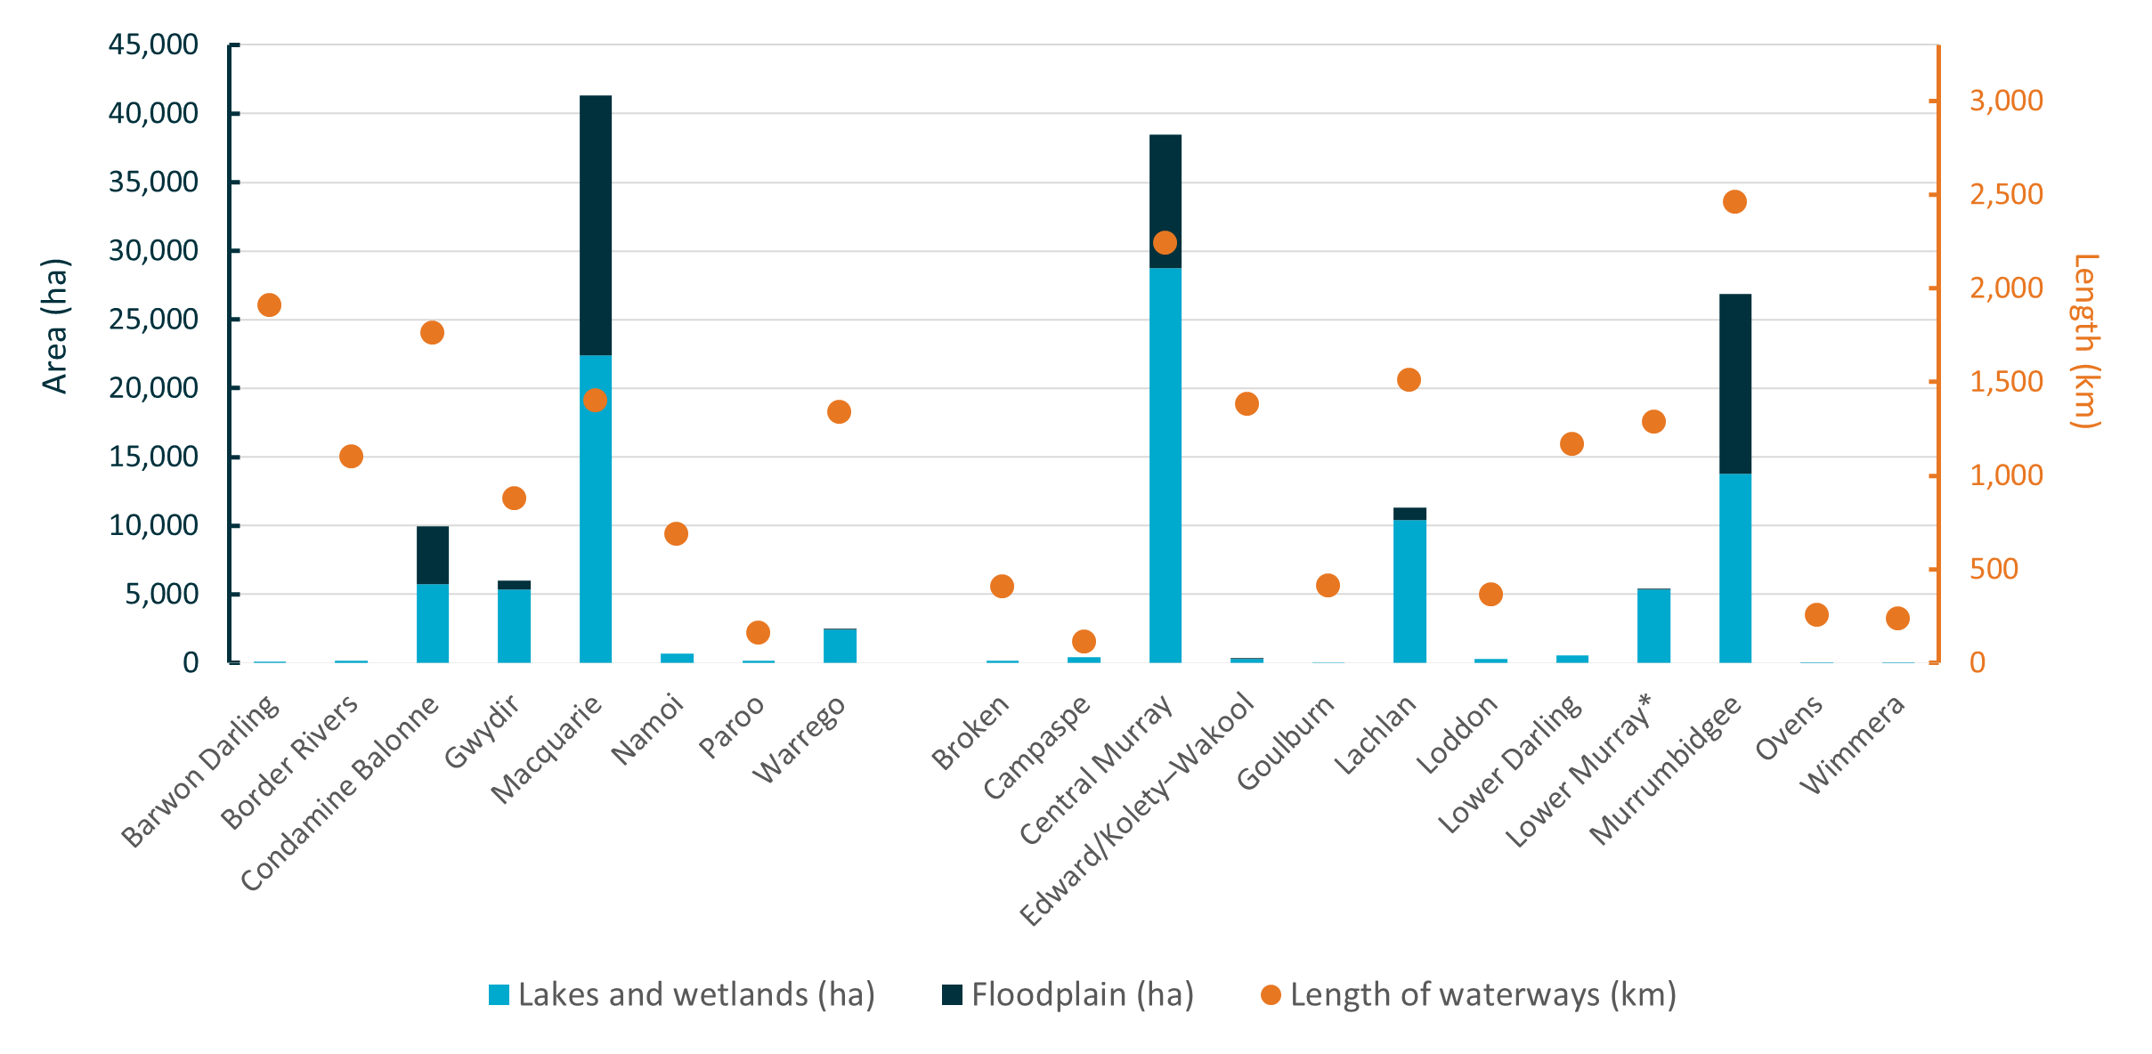
Over the 10 years since 2014, some floodplains in the Gwydir, Macquarie, Murrumbidgee, Lachlan, Central and Lower Murray valleys were inundated nearly every year (7 or more of the 10 years). The Macquarie Valley received Commonwealth environmental water in 8 of the 10 years, targeting the restoration and protection of wetlands within the Macquarie Marshes. The Murrumbidgee received Commonwealth environmental water in all 10 years and the largest 1-in-10-year inundation magnitude of 57,497 ha.

Basin ecosystems
This section presents findings from the Ecosystem Diversity evaluation for the 2023–24 water year, compared with the prior 9 years of monitoring, presented in full in the ‘Basin-scale evaluation of 2022–23 Commonwealth environmental water: Ecosystem Diversity’ report (available from DCCEEW’s Flow-MER Basin-scale Project publications webpage).
What did Commonwealth environmental water contribute to ecosystem diversity?
Commonwealth environmental water contributed to Basin Plan objective at paragraph 8.05(2)a to protect and restore a subset of all water-dependent ecosystems of the Murray–Darling Basin:
Of the Basin ecosystem types, 97% occur on the managed floodplain. In 2023–24, 52 ANAE ecosystem types – representing 81% of the ecosystem diversity on the managed floodplain – received Commonwealth environmental water.
The 10-year watering history (2014–24) included a similar diversity of ecosystem types through the years but a wide difference in the total areal extent.
Using the ANAE classification system, 66 aquatic ecosystem types have been identified and mapped in the Basin. 64 ecosystem types (97%) are represented on the managed floodplain, and the relative abundance (by area) of ecosystem types is similar when comparing the managed floodplain to the whole Basin.
Commonwealth environmental water supported 23,768 ha of estuary, 200,890 ha of lakes and wetlands, and 47,770 ha of floodplain area in 2023–24. Additionally, 21,075 km of waterways carried Commonwealth environmental water in 2023–24.
In 2023–24, Commonwealth environmental water supported 34,693 ha of temporary river red gum swamps, which is 60% of all temporary river red gum swamp on the managed floodplain. Much of the temporary river red gum swamp was watered through actions to flood Barmah Forest, Macquarie Marshes and Lowbidgee Redbank system. Many smaller swamps connected to river channels along the Edward/Kolety–Wakool rivers, Murray, Namoi, Loddon, Campaspe, Broken and Goulburn rivers benefitted from freshes in these systems. This is a similar pattern to that seen in previous years whenever the large expanse of the Barmah–Millewa Forest complex receives Commonwealth environmental water.
Commonwealth environmental water supported a significant area (30,835 ha) of meadows and marshes, consisting of permanent and temporary tall emergent marshes, temporary sedge/grass/forb marsh, permanent grass marsh and freshwater meadow. This includes sedge marshes (8,674 ha), tall marsh reed beds (5,134 ha) and freshwater meadows (2,092 ha) in the Macquarie Marshes and grassy freshwater meadows and tall marsh of the Gwydir Valley floodplains (5,250 ha). The water delivered in 2023–24 was similar to the preceding year, consolidating the recovery of bird breeding areas in Narran Lakes, Gwydir wetlands and Macquarie Marshes from the impacts of the acute ‘Tinderbox Drought’ 2018–2020.
In 2023–24, Commonwealth environmental water inundated 47,696 ha of floodplain ecosystems upstream of the Coorong, Lower Lakes and Murray Mouth (3% of the managed floodplain). The largest contributors to this total were 14,649 ha of river red gum floodplain in the Macquarie Valley (combining river red gum forest and woodland), 9,617 ha of river red gum floodplain in the Central Murray, 5,939 ha of river red gum and 5,880 ha of black box floodplain in the Murrumbidgee Valley, and 3,542 ha of lignum (Duma florulenta) floodplain in the Condamine Balonne.
The ecosystem pattern of delivery of Commonwealth environmental water to rivers was similar to previous years – the majority (97%) of watered channels were lowland rivers (15,227 km of permanent lowland stream and 5,285 km of temporary lowland stream). In total, 40% of river length on the managed floodplain, representing 5 of the 8 ANAE river types, received Commonwealth environmental water during 2023–24. Commonwealth environmental water delivered to the Macquarie, Namoi, Gwydir and Barwon Darling valleys supported the full length of the Darling/Baaka to its confluence with the Murray River.
In summary, in 2023–24, Commonwealth environmental water supported:
- 52 ANAE ecosystem types, representing 79% of types in the Basin and 81% of types on the managed floodplain
- 21,075 km of permanent and temporary lowland rivers, representing 40% of river length on the managed floodplain
- 200,890 ha of lakes and wetlands of 27 different types, representing 75% of lake and wetland diversity and 27% of the total area of lakes and wetlands on the managed floodplain
- 47,770 ha of floodplain, representing 11 different floodplain vegetation communities and 3% of the managed floodplain in the Basin
- 23,768 ha of estuary habitat in the Coorong and Murray Mouth, representing 100% of the estuary on the managed floodplain.
Over the 10-year monitoring period, 446,264 ha (including the Coorong, Lower Lakes and Murray Mouth) of wetlands, lakes and floodplains received Commonwealth environmental water. This includes 124,091 ha of lakes, including the Lower Lakes, 130,574 ha of wetlands and 191,599 ha of floodplains.
The frequency of delivery of Commonwealth environmental water across the Basin over the 10 years broadly aligned with the expected requirements of ecosystem types – more frequent support of permanent rivers, lakes, meadows and permanent tall marsh and less frequent inundation of temporary channels, swamps and floodplains. Watering is responsive to climatic conditions and is sufficiently flexible to deliver water in accordance with Strategy priorities. Ecosystem types in areas able to receive environmental water are broadly representative of ecosystem types elsewhere in the Basin.
In summary, over the 10-year period 2014–24, Commonwealth environmental water has supported:
- 56 ecosystem types, representing 85% of the ANAE ecosystem types in the Basin and 88% of the ANAE types currently mapped on the managed floodplain
- 124,091 ha of lakes, representing 41% of lake area on the managed floodplain, including lakes Alexandrina and Albert
- 130,574 ha of 24 types of palustrine wetland, representing 26% of the wetland area on the managed floodplain
- 191,599 ha of 12 types of floodplain, representing 12% of floodplain ecosystem area on the managed floodplain
- 28,549 km of 7 types of waterway, representing 54% of the river length on the managed floodplain
- 23,768 ha of 9 types of estuarine ecosystem, representing 100% of the estuary on the managed floodplain.
Temporary sedge/grass/forb marsh is the most extensive wetland ecosystem type on the managed floodplain (130,904 ha), and 12% (16,193 ha) was watered at least once over the 10-year period 2014–24. Many of these areas were watered multiple times. The Gwydir Wetlands and Macquarie Marshes received regular delivery of Commonwealth environmental water to inundate permanent and temporary tall emergent marsh, freshwater meadow, permanent wetland, permanent forb marsh and permanent sedge/grass/forb marsh.
Temporary river red gum swamp is the ecosystem with the largest area supported by Commonwealth environmental water (38,717 ha). Most (61%) of this area has received Commonwealth environmental water in 8 of the 10 years since 2014–15, corresponding to water deliveries to Barmah–Millewa Forest. Temporary river red gum swamp is commonly supported by environmental water due to its proximity and connectedness to lowland river channels. Fringing river red gums and swamps connected to waterways receive water during channel freshes or weir-pool raising actions, in addition to actions that specifically target overbank flooding.

Ramsar wetlands
What did Commonwealth environmental water contribute to Ramsar wetlands in the Basin?
Basin Plan objective at paragraph 8.05(2)(a) is to protect and restore a subset of all water-dependent ecosystems of the Murray–Darling Basin, including by ensuring that declared Ramsar wetlands that depend on Basin water resources maintain their ecological character. In support of this objective, Commonwealth environmental water was delivered to 8 Ramsar Sites in 2023–24, supporting approximately 172,667 ha of 50 ecosystem types within the Ramsar estate (including lakes Alexandrina and Albert and the Coorong).
11 of the 16 Ramsar wetlands in the Basin (Figure 2.14) are actively supported by Commonwealth environmental water. The remaining 5 Ramsar Sites cannot receive environmental water due to their locations in the river system.
In 2023–24, 1,835 GL of Commonwealth environmental water (~1,984 GL across all water holders) was delivered to 8 Ramsar Sites in the Basin. In many instances, water delivered to floodplains is returned to the river and subsequently inundates Ramsar Sites downstream. For example, water in the Barmah Forest Ramsar Site flows back into the Murray and may inundate the Gunbower Forest, Hattah–Kulkyne Lakes and Riverland Ramsar Sites further downstream. In 2023–24, Commonwealth environmental water supported vegetation listed as a critical component of the Ramsar Sites. For example:
- 23,495 ha (100%) of river red gum swamp in the Barmah Forest Ramsar Site
- 8,895 ha of river red gum floodplain and another 658 ha of river red gum swamps in the NSW Central Murray State Forests Ramsar Site
- extensive inundation (2,676 ha, 98%) of the tall marsh of the Macquarie Marshes Ramsar Site
- inundation of 2,660 ha of lignum in the Narran Lakes Ramsar Site.
Over the 10 years since 2014, Commonwealth environmental water has supported all 11 Ramsar Sites (often in combination with other environmental water [Table 2.3]). Some highlights include:
- The Narran Lake Nature Reserve Ramsar Site received Commonwealth environmental water to inundate lignum swamps and floodplains in 6 of the 10 years
- Commonwealth environmental water contributed to inundation of the Macquarie Marshes Ramsar Site in 9 of the 10 years
- Barmah Forest Ramsar Site received Commonwealth environmental water in 8 of the 10 years, and other sources of water inundated the site in the other 2 years.
Figure 2.14 Map showing the location and names of Ramsar Sites in the Murray–Darling Basin
Those that received Commonwealth environmental water between 2014 and 2024 are highlighted in blue.
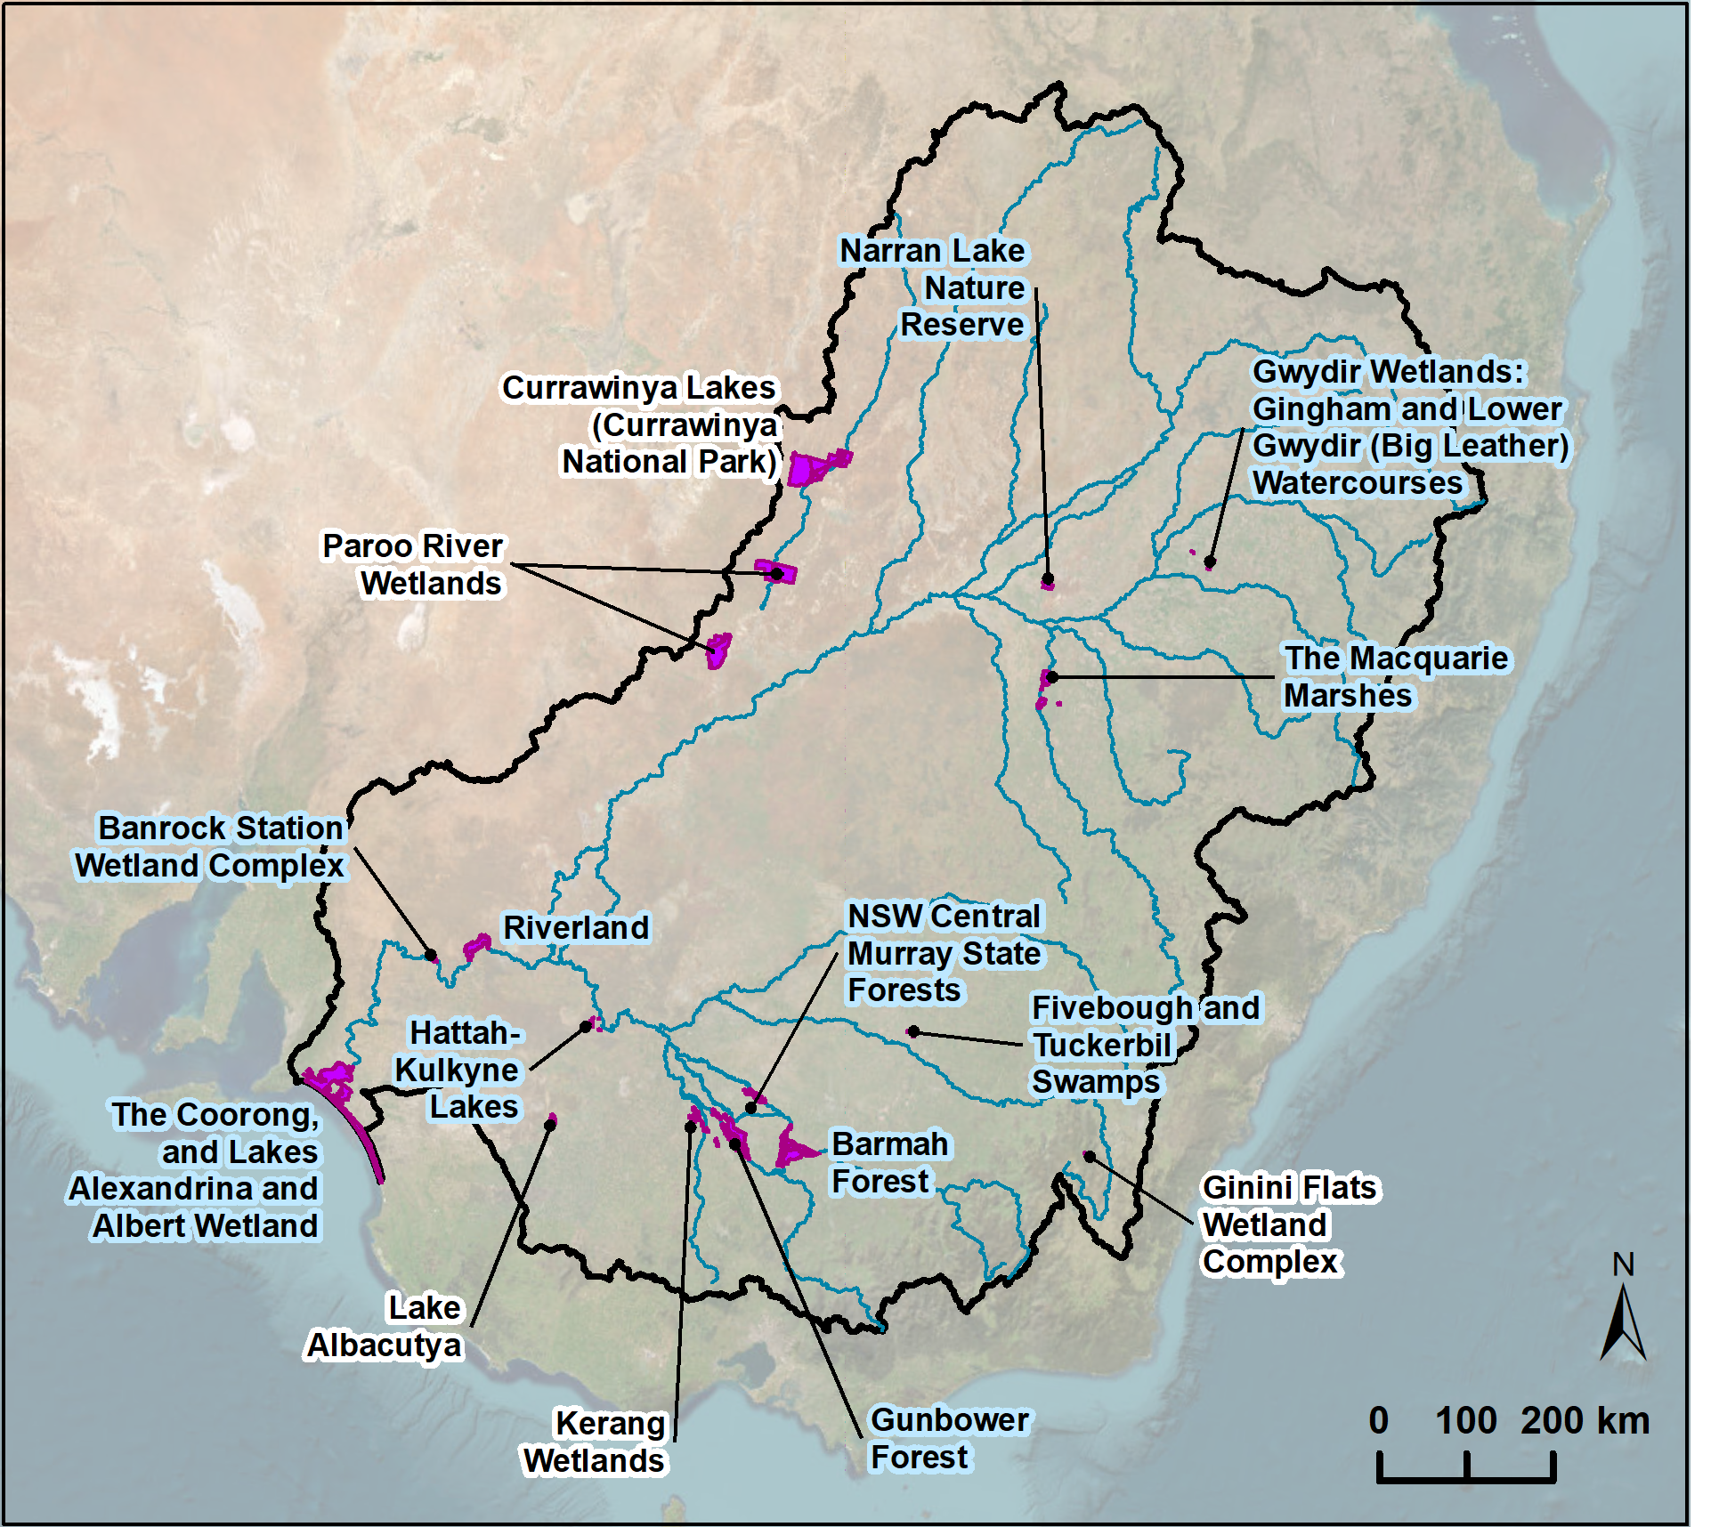

Table 2.3 Areas of Ramsar Sites supported by Commonwealth environmental water, 2014–24
Most water delivery to Ramsar Sites was in conjunction with other water, and the areal contribution of Commonwealth environmental water cannot be apportioned. Areas are in hectares.
ª Gingham and Lower Gwydir (Big Leather) Watercourses
^{b} For this table, NSW Central Murray Forests includes Koondrook and Werai Forests – Millewa Forest is included with Barmah Forest
^{c} No inundation mapped; however, Commonwealth environmental water supported 52 km of Gunbower Creek base flows within the Gunbower Forest Ramsar Site.
Ramsar Site | 2014–15 | 2015–16 | 2016–17 | 2017–18 | 2018–19 | 2019–20 | 2020–21 | 2021–22 | 2022–23 | 2023–24
Gwydir Wetlandsª | 648 | 565 | 649 | 618 | 736 | 0 | 588 | 519 | 701 | 591
Narran Lake Nature Reserve | 0 | 0 | 838 | 0 | 0 | 4,380 | 1,697 | 2,376 | 2,322 | 3,779
Macquarie Marshes | 5,471 | 6,118 | 8,364 | 8,632 | 6,848 | 0 | 7,143 | 11,396 | 10,232 | 10,290
Banrock Station Wetland Complex | 11 | 495 | 0 | 301 | 91 | 59 | 37 | 243 | 0 | 0
Barmah Forest^{b} | 0 | 24,647 | 0 | 24,969 | 24,747 | 24,116 | 24,614 | 25,923 | 25,526 | 25,632
Gunbower Forest^{c} | 0 | – | – | – | – | – | – | – | 419 | 419
The Coorong, and Lakes Alexandrina and Albert Wetland | 116,843 | 116,843 | 116,843 | 116,848 | 116,848 | 117,022 | 117,022 | 116,848 | 116,871 | 128,062
Fivebough and Tuckerbil Swamps | 0 | 0 | 0 | 272 | 599 | 272 | 599 | 0 | 0 | 0
Hattah–Kulkyne Lakes | 965 | 954 | 0 | 842 | 0 | 125 | 0 | 0 | 0 | 0
NSW Central Murray Forests^{b} | 0 | 6,091 | 0 | 5,875 | 7,165 | 3,794 | 5,410 | 16,520 | 6,252 | 12,380
Riverland | 504 | 3,574 | 321 | 4,277 | 3,298 | 2,775 | 3,904 | 1,452 | 55 | 2,457

Outcomes 2023–24
At a glance
Vegetation
- Environmental water was important for maintaining distinct groups of damp-loving plant species in the Basin in 2023–24.
- 72 water actions – totalling 2,421 GL of Commonwealth environmental water – targeted outcomes for vegetation.
- 360 plant species were recorded in 2023–24, 70% of which were native. 15 previously unrecorded taxa (including 2 introduced plants) were observed at Flow-MER monitoring locations.
- The extended wet conditions appear to favour native species – the highest proportion of taxa and the greatest cover of native species observed between 2014 and 2023 were recorded over the past 3 years (2021–22 to 2023–24).
- 54 taxa used by Aboriginal people were recorded, including 12 recorded only at locations that experienced a wetter inundation regime because of environmental water.
- There was a greater proportion and cover of submerged and amphibious plants observed at sites that had wetter inundation regimes maintained using environmental water.
Native fish
- 99 water actions – totalling 2,708 GL of Commonwealth environmental water – targeted outcomes for native fish to improve habitat, enhance connectivity or provide cues for movement, and, to a lesser extent, for targeted species outcomes.
- Commonwealth environmental water was used to water wetlands, lakes and ephemeral creeks, maintain high instream flow rates during spring and summer, reduce rapid recessions, protect stable flows, and provide variable base flows and winter/spring freshes and autumn freshes.
- 14 native fish species were detected in 2023–24 at monitoring locations, compared with 15 native fish species detected over the monitoring period (2014–24).
- Golden perch (Macquaria ambigua) spawned in the Goulburn River and Lower Murray River. Spawning in the Goulburn River coincided with a large natural overbank flow and a Commonwealth environmental water delivery of a fresh.
- Silver perch (Bidyanus bidyanus) spawned in the Lower Murray River and Murrumbidgee River System. In the Lower Murray River, spawning of golden and silver perch coincided with large instream flow pulses that included contributions of Commonwealth environmental water.
- There was evidence of Murray cod (Maccullochella peelii) recruitment in the Lower Murray River. In other areas recruitment was poor, possible reasons include unfavourable flow conditions during nesting and early life stages, insufficient prey availability in summer, and populations still recovering from the flooding impacts from the previous year.
- Although small-bodied native species are generally less dependent on flows for spawning and recruitment compared to some large-bodied species, there is evidence that the flow regime in some riverine monitoring locations favoured recruitment for some small-bodied native fish species.
- Recruitment of Australian smelt (Retropinna semoni) was positively associated with Commonwealth environmental water in the Goulburn River, Lachlan River System and Lower Murray River.
- Murray–Darling rainbowfish (Melanotaenia fluviatilis) had lower abundance (representative of recruitment) than in previous years at some riverine monitoring locations likely due to high or variable flows negatively impacting the populations, as this species prefers low-to-moderate flows for spawning and recruitment.
- Some exotic species (common carp [Cyprinus carpio], goldfish [Carassius auratus]) declined in abundance following widespread wet conditions over recent years.
Waterbirds
- 36 water actions – totalling 2,011 GL of Commonwealth environmental water – targeted waterbird outcomes, the highest amount delivered for waterbirds in the period since 2014.
- Combined Flow-MER and complementary NSW Department of Climate Change, Energy, the Environment and Water (NSW DCCEEW) data were available for the Border Rivers, Gwydir River, Junction of Warrego and Darling rivers, Murrumbidgee River System, Macquarie Marshes, Central Murray, Lachlan and Condamine (Narran Lakes) surface-water regions.
- 103,329 individuals representing 84 species were reported.
- 11 conservation-significant species were identified from the combined Flow-MER and NSW DCCEEW monitoring in 2023–24, including 3 species listed under the Australian Environment Protection and Biodiversity Conservation Act 1999 (EPBC Act) – Australasian bittern (Botaurus poiciloptilus), sharp-tailed sandpiper (Calidris acuminata) and Latham’s snipe (Gallinago hardwickii). Other species of significance included the threatened black-necked stork (Ephippiorhynchus asiaticus), blue-billed duck (Oxyura australis), freckled duck (Stictonetta naevosa) and marsh sandpiper (Tringa stagnatilis).
- Commonwealth environmental water was delivered to Lake Brewster to support Australian pelican breeding. A total of 22,919 pelican nests were counted at Lake Brewster with a potential estimate of 22,919 chicks produced.
Other environmental outcomes
- Commonwealth environmental water was delivered to support the life cycles of nationally and state-listed threatened species. There were 21 individual Commonwealth environmental watering actions with at least one watering objective related to listed plant and animal species, for a combined volume of ~111 GL.
- There were 25 individual Commonwealth environmental watering actions with at least one watering objective related to frog outcomes, for a combined volume of 95 GL.
- 11 frog species were detected from combined Flow-MER and complementary NSW DCCEEW monitoring. Southern bell frog (Litoria raniformis) adults and tadpoles were identified in locations receiving Commonwealth environmental water in the lower Murrumbidgee.
- Commonwealth environmental water contributed to the Basin Plan salt-export objective of 2 million tonnes per year by exporting 221,272 tonnes of salt (17.8% of the total salt export to the ocean in 2023–24).

Biodiversity outcomes 2023–24
Environmental watering can play a crucial role in maintaining species and community diversity across the Basin. Many water-dependent species and ecosystems found in the Basin are adapted to and require specific cycles of high flow and periods of drying. Important reproduction and movement cues are often tightly linked to the water regime. This section describes the importance of Commonwealth environmental water for maintaining Basin ecosystems and the biodiversity that depends on them.
During 2023–24, 2,870 GL of Commonwealth environmental water targeted multiple outcomes, including 2,324 GL for outcomes relating broadly to biodiversity (waterbirds and other fauna), 2,421 GL for vegetation outcomes and 2,708 GL for fish outcomes (noting that individual watering actions may include outcomes for any or all of biodiversity, fish and vegetation).

Vegetation
This section presents findings from the Vegetation evaluation for the 2023–24 water year, presented in full in the ‘Basin-scale evaluation of 2023–24 Commonwealth environmental water: Vegetation’ report (accompanying this document and will be available from DCCEEW’s Flow-MER Basin-scale Project publications webpage).
What did Commonwealth environmental water contribute to plant species diversity?
What did Commonwealth environmental water contribute to vegetation community diversity?
Changes in flow regimes are likely to significantly impact vegetation diversity across multiple scales, from local presence and abundance of plant species to landscape-scale vegetation community composition and structure. This evaluation reports on the contribution of Commonwealth environmental water to the diversity and condition of non-woody vegetation, including aquatic macrophytes, herbs, sedges and rushes.
Evaluation of vegetation community diversity considers the composition and structure of vegetation assemblages occurring in riverine and floodplain–wetland habitats, including water plant functional groups (submerged, amphibious, damp, woody flood-dependent, terrestrial), species growth forms (forbs, grasses, ferns), native and exotic species, threatened species, and species known to be used by Aboriginal people.
Noticeable differences were observed in the 2023–24 vegetation assemblages associated with sites that have a wetter inundation regime supported by environmental water, when compared with those that have a drier inundation regime. There was a greater proportion and cover of submerged and amphibious plants observed at sites that had wetter inundation regimes maintained using environmental water. It is very likely that in the absence of environmental water, there would have been a near-absence of submerged species and considerably less diversity and cover of amphibious and damp-loving species at 38% of monitoring locations.

Observations for groundcover vegetation in 2023–24
- 360 plant taxa were observed in 2023–24 across floodplain, wetland and riverine monitoring locations.
- Most were native plant species (70% of taxa) and most of the plant cover (87%) was native.
- 15 previously unrecorded plant species were observed, including 4 species associated with wetter habitats.
- Commonwealth environmental water support for threatened species:
- 46 listed species were recorded at monitored locations in 2023–24 (but not all are listed in the state in which they were recorded).
- Commonwealth environmental water support for plants with traditional Aboriginal uses:
- 54 taxa used by Aboriginal people were recorded in 2023–24.
- These plants are used for food (21 taxa), fibre and shelter (2 taxa), medicine (5 taxa), fishing and hunting (1 taxon) or ceremonial (1 taxon). 22 taxa are known to have multiple uses.
- 27 plant taxa used by Aboriginal people require support by flooding, including 6 amphibious, 3 submerged, 9 damp-loving and 9 woody flood-dependent taxa.

Outcomes for groundcover vegetation in 2023–24
- Commonwealth environmental water support for vegetation communities. 2,421 GL of Commonwealth environmental water were delivered for vegetation outcomes through 72 watering actions during 2023–24. These actions helped sustain vegetation communities that include submerged and amphibious species and contributed to maintaining a diversity of riverine and floodplain–wetland ecosystem types in the Basin.
- Strategy annual watering priorities for vegetation, 2023–24. Vegetated ecosystems were supported in agreement with the Strategy’s Basin-wide annual watering priorities for 2023–24:
- Non-woody vegetation priorities to provide opportunities for growth were met. Commonwealth environmental water was delivered to 30,835 ha of meadow and marsh upstream of the Lower Lakes and another 9,803 ha of marsh around the Lower Lakes. 12 ha of sedge/forb/grassland riparian zone or floodplain and 21,075 km of river channel were inundated, supporting non-woody riverbank vegetation.
- A rolling priority to maintain the extent, improve the condition, and promote recruitment of forests and woodlands was met. Commonwealth environmental water was delivered to 38,658 ha of woody wetlands (swamps) and 47,684 ha of woody floodplain vegetation.
- A rolling priority to maintain the extent and improve the condition of lignum shrublands and an annual priority to support continued recovery of lignum shrublands at Narran Lakes and other sites in the northern Basin were met. 4,895 ha of lignum floodplain were inundated, and another 215 ha of temporary lignum swamp received Commonwealth environmental water.
- An annual priority to provide flows to support core wetland vegetation at key sites in the Macquarie Marshes was met by watering 25,415 ha of wetlands and 18,927 ha of floodplains in the Macquarie Valley, including 10,290 ha (56%) of the Macquarie Marshes Ramsar Site.
- A rolling priority was to expand the extent and improve the condition of Moira grass in Barmah–Millewa Forest, and 99 ha of freshwater meadow was inundated in 2023–24. However, Moira grass was not monitored.
- An annual priority to support inundation of the Warrego floodplain was met – 65 ha of floodplain and 2,435 ha wetlands were inundated by Commonwealth environmental water in the Warrego Valley.
- Commonwealth environmental water support for groundcover plants
- Environmental water has contributed to maintaining the cover (amount) of water plants. There was a greater proportion and cover of submerged and amphibious plants observed at sites that had wetter inundation regimes that were maintained using environmental water.
- There was a greater proportion and cover of submerged and amphibious plants observed at sites that had wetter inundation regimes maintained using environmental water.
- It is very likely that in the absence of environmental water, there would have been a near-absence of submerged species and considerably less diversity and cover of amphibious and damp-loving species at 38% of monitoring locations.

Native fish
This section presents findings from the Fish evaluation for the 2023–24 water year, presented in full in the ‘Basin-scale evaluation of 2023–24 Commonwealth environmental water: Fish’ report (accompanying this document and will be available from DCCEEW’s Flow-MER Basin-scale Project publications webpage).
What did Commonwealth environmental water contribute to sustaining native fish?
Many of the critical life-history processes for fish (pre-spawning condition and maturation, spawning cues and movements, larval and juvenile dispersal, growth and survival) are linked either directly or indirectly to the flow regime. In the Basin, the delivery of environmental water is a key approach to supporting critical life-history processes and sustaining and restoring native fish populations. This evaluation reports on the contribution of Commonwealth environmental water to sustaining native fish.
- In 2023–24, the Basin experienced a return to more average climate conditions across the Basin following 2 wetter years (2021–23). Commonwealth environmental water was used to water wetlands, lakes and ephemeral creeks, reduce rapid recessions, protect stable flows during key periods, and provide variable base flows and winter/spring freshes and autumn freshes.

Observations for native fish in 2023–24
- Commonwealth environmental water providing flows and habitat for native fish
- Through 99 watering actions, 2,708 GL of Commonwealth environmental water were delivered with expected outcomes for fish, primarily to improve habitat, enhance connectivity or provide cues to support fish movement, and for various targeted species outcomes (e.g. survival of Murray hardyhead [Craterocephalus fluviatilis] and support of breeding and recruitment of freshwater catfish [Tandanus tandanus] and migration flow cues for lamprey [Mordacia mordax] and congolli [Pseudaphritis urvillii]).
- Strategy annual watering priorities for fish in 2023–24
- No loss of native species was evident in monitoring locations, and 14 native fish species were detected in 2023–24 at monitored sites.
- Evidence of Murray cod recruitment was minimal in most monitoring locations except in the Lower Murray, possibly due to high or variable flows (displacing/desiccating eggs or larvae), or insufficient prey availability, or past hypoxic conditions causing fish emigration or fish deaths.

Outcomes for native fish in 2023–24
- Commonwealth environmental water benefited recruitment of Australian smelt in the Goulburn River, Lachlan River System and Lower Murray River (with positive associations between Commonwealth environmental water and recruitment). High unregulated instream flows likely facilitated hydrological connectivity and increased habitat and food resources.
- Abundance and recruitment of the Murray–Darling rainbowfish was again lower than previous years in some monitoring locations (no positive associations between Commonwealth environmental water and recruitment were found). High or variable natural flows may have impacted populations of this species, as it prefers low-to-moderate stable flows during its extended spawning and recruitment period.
- Murray cod populations
- There was evidence of recruitment of Murray cod in the Lower Murray River.
- Recruitment was either very low or absent in other Selected Areas (no positive associations between Commonwealth environmental water and recruitment were found). Possible reasons include unfavourable flow or hydraulic conditions during the spawning and early life stage period (eggs and larvae), insufficient prey availability in summer leading to poor recruitment, or populations still recovering from disturbances the previous year, when widespread flooding and high flows reduced water quality (hypoxic conditions) which may have caused fish emigration or fish deaths.
- Golden and silver perch populations
- Golden perch spawned in the Goulburn River, coinciding with a large overbank flow and a Commonwealth environmental water delivery of a fresh.
- Golden perch and silver perch spawned in the Lower Murray River and there were low levels of recruitment of golden perch, coinciding with high instream flows supported by Commonwealth environmental water.
- Drifting silver perch eggs were detected in the Murrumbidgee River System.
- There was little evidence of recruitment in other monitoring locations. High instream flows may have reduced detectability of larvae, eggs and new recruits. Future monitoring of juvenile fish and year-class assessments will provide a more accurate reflection of recruitment for the 2023–24 flow year.
- Some exotic species (common carp, goldfish [Carassius auratus]) declined in abundance this year after the initial boom response to widespread flooding in 2022–23 and high flows in Selected Areas.

Waterbirds
This section presents findings from the Species Diversity evaluation for the 2023–24 water year, presented in full in the ‘Basin-scale evaluation of 2023–24 Commonwealth environmental water: Species Diversity’ report (accompanying this document and will be available from DCCEEW’s Flow-MER Basin-scale Project publications webpage).
What did Commonwealth environmental water contribute to species diversity?
- What was the contribution of Commonwealth environmental water to the diversity and abundance of waterbirds?
- What was the contribution of Commonwealth environmental water to threatened species and ecological communities?
- What was the contribution of Commonwealth environmental water to migratory species listed under international agreements – Bonn Convention, China–Australia Migratory Bird Agreement (CAMBA), Japan–Australia Migratory Bird Agreement (JAMBA) or Republic of Korea–Australia Migratory Bird Agreement (ROKAMBA)?
There are more than 100 waterbird species known to occur in the Basin. This includes 16 species listed under the EPBC Act and 25 species listed under international migratory waterbird treaties (Bonn Convention, CAMBA, JAMBA or ROKAMBA). There is growing evidence of the importance of environmental water to maintain waterbird populations in Australia.⁷ Evaluation of outcomes for waterbirds (as well as frogs, turtles and other water-dependent aquatic reptiles, mammals and birds; Section 3.1.4) considers outcomes for listed threatened species as defined under the EPBC Act and relevant state legislation.
In 2023–24, 36 watering actions delivered 2,011 GL of Commonwealth environmental water with objectives related to waterbirds. The largest volumes were delivered in the Lower Murray (1,386 GL), Central Murray (308 GL), Lower Darling/Baaka (111 GL), Condamine Balonne (71 GL), Macquarie (60 GL) and Murrumbidgee (53 GL). Smaller volumes of under 10 GL were delivered to 5 other valleys.
In 2023–24, there was a return to more average conditions across the Basin. Commonwealth environmental water was delivered to sustain waterbird breeding events (for example, Australian pelicans) in the Condamine Balonne (71 GL), Warrego (8 GL), Lachlan (4 GL) and Wimmera (3 GL). Extensive group-nesting waterbird rookeries were observed in the Lower Murray, Condamine Balonne, Murrumbidgee, Macquarie, Lachlan and Wimmera valleys, in conjunction with the delivery of Commonwealth environmental water.
During 2023–24, 68,718 individuals were reported in Flow-MER and NSW DCCEEW data (noting these data reflect survey effort), representing 8 waterbird functional groups and 2 water-associated groups (reed-inhabiting passerines and raptors) and 68 species. Grey teal (Anas gracilis) was the most-recorded species, followed by Australian pelican (Pelecanus conspicillatus), Eurasian coot (Fulica atra), Pacific black duck (Anas superciliosa) and Australian wood duck (Chenonetta jubata).

Observations for waterbirds in 2023–24
- Commonwealth environmental water support for waterbirds
- 2,011 GL of Commonwealth environmental water were delivered to support waterbirds through 36 independent watering actions.
- 68 waterbird species were reported from 8 functional groups and 2 water-associated groups (reed-inhabiting passerines and raptors) from monitoring locations.
- Commonwealth environmental water support for threatened or listed waterbirds
- 18 conservation-significant species were identified from the combined Flow-MER and NSW DCCEEW monitoring in 2023–24 that coincided with Commonwealth environmental water, including 3 species listed under the EPBC Act – Australasian bittern, sharp-tailed sandpiper and Latham’s snipe.
- Other species of significance included the threatened black-necked stork, blue-billed duck, freckled duck and marsh sandpiper.

Outcomes for waterbirds in 2023–24
- Modelling demonstrates that Commonwealth environmental water contributed to the habitat preferences for Australian painted snipe (Rostratula australis), common greenshank (Tringa nebularia), sharp-tailed sandpiper and Latham’s snipe in 2023–24.

Other fauna – turtles, snakes and frogs
This section presents findings from the Species Diversity evaluation for the 2023–24 water year, presented in full in the ‘Basin-scale evaluation of 2023–24 Commonwealth environmental water: Species Diversity’ report (accompanying this document and will be available from DCCEEW’s Flow-MER Basin-scale Project publications webpage).
What did Commonwealth environmental water contribute to species diversity?
- What was the contribution of Commonwealth environmental water to the diversity and abundance of frogs, turtles and other water-dependent vertebrates?
- What was the contribution of Commonwealth environmental water to threatened species and ecological communities?
In 2023–24, there were 25 individual watering actions – a combined volume of about 95 GL of Commonwealth environmental water – with at least one watering objective related to outcomes for frogs. 11 species were detected – the most abundant and widespread being the spotted marsh frog (Limnodynastes tasmaniensis), barking marsh frog (Limnodynastes fletcheri) and Peron’s tree frog (Litoria peronii), which were detected in both the Junction of the Warrego and Darling rivers in the northern Basin and the Murrumbidgee in the southern Basin. As in previous years, the diversity of frog species is higher in the northern Basin due to the presence of rain-responding species.

Observations for frogs and other biota in 2023–24
- Commonwealth environmental water support for frogs and other biota
- 25 watering actions delivered 95 GL of Commonwealth environmental water with objectives related to frogs, and 46 watering actions delivered 315 GL with objectives related to ‘other biota’.
- In 2023–24, 11 species of frog were detected at monitored locations.
- Southern bell frog (listed as Vulnerable under the EPBC Act) adults and tadpoles were identified at multiple sites receiving Commonwealth environmental water across the lower Murrumbidgee.
- Commonwealth environmental water support for threatened species
- 21 watering actions delivered 111 GL with at least one watering objective related to listed species.
- Southern bell frog (listed as Vulnerable under the EPBC Act) adults and tadpoles were identified in the lower Murrumbidgee, and adults were detected in the lower Lachlan.
- Commonwealth environmental water supported habitat for nationally and state-listed threatened species, including the grey snake (Hemiaspis damelii), regent parrot (Polytelis anthopeplus), platypus (Ornithorhynchus anatinus), large-footed myotis (Myotis macropus, also known as the southern myotis) and southern bell frog.
Highlight: Supporting the recovery of the threatened southern bell frog
Commonwealth environmental water significantly benefitted southern bell frogs, listed as Vulnerable under the EPBC Act. Since Commonwealth environmental water delivery began in 2014, 161 known locations of southern bell frogs received Commonwealth environmental water at least once.
The southern bell frog is a large, wetland-dependent frog found in floodplain wetlands in the Murrumbidgee River System, Lachlan River System, Central Murray and Lower Murray. This sensitive species needs its critical refuge habitats maintained by water during dry periods. Flow-MER research has shown that even a 2-year dry spell can make a wetland uninhabitable for this frog. Targeted watering objectives for this species include supporting its habitat, breeding and recruitment. The delivery of Commonwealth environmental water since 2014 has increased the number of sites occupied by the frog. Many of these are sites the frog had previously disappeared from – meaning that the southern bell frog is moving back into areas where it once lived and being supported in areas where it continues to live, thanks to the delivery of environmental water by the Commonwealth and other environmental water managers.
In the Murrumbidgee, southern bell frogs have been monitored since 2000. Over the past 6 years, the frogs have moved back into wetlands through the North Redbank and Western Lakes areas where they had not been seen for more than 10 years. And southern bell frogs successfully produced their next generation in the Murrumbidgee, Central Murray and Lower Murray valleys after inundation supported by Commonwealth environmental water.

Ecosystem function outcomes 2023–24
This section presents findings from the Foodwebs and Water Quality evaluation for the 2023–24 water year, presented in full in the ‘Basin-scale evaluation of 2023–24 Commonwealth environmental water: Foodwebs and Water Quality’ report (accompanying this document and will be available from DCCEEW’s Flow-MER Basin-scale Project publications webpage).
What did Commonwealth environmental water contribute to protecting and restoring energy, carbon and nutrient dynamics, primary production and respiration?
Native fish, vegetation and waterbirds rely on a range of ecosystem functions to support healthy populations. Food webs illustrate how much energy (carbon) is moving between organisms or groups and show the role of individual animal species or connections in sustaining life across an ecosystem. Without energy, organisms have no capacity for growth and reproduction. Understanding the relationships between the provision of energy for food webs and flow is critical for environmental water management.
Aquatic food webs are underpinned by 2 fundamental biological processes: gross primary production (GPP) and ecosystem respiration (ER). Collectively termed ‘stream metabolism’ in rivers, GPP describes the rate of new organic matter generation via photosynthesis, and ER describes the rate at which organic matter is recycled. Net ecosystem production – the difference between GPP and ER – determines whether carbon accumulates (autotrophic) or is depleted (heterotrophic) within an ecosystem.
Commonwealth environmental water can support higher ER rates and heterotrophic production if flows lead to increases in terrestrial carbon subsidies to the river channel (e.g. litter). The amount of litter incorporated into the river channel is governed primarily by flow type (e.g. bankfull and overbank flows may mobilise large quantities of litter, while freshes may be limited to small quantities of litter from instream features) and antecedent patterns (e.g. climate, time since last flow, magnitude of last flow).
Increasing flow reduces the volumetric rate of primary production but increases cross-sectional channel GPP, particularly in reaches where the channel broadens, by increasing the cross-sectional area of the photic zone. Although rates of GPP and ER are not direct estimates of secondary production by higher trophic levels, ecological theory and existing empirical evidence suggest that this increased ecosystem metabolism is correlated with higher consumer productivity.
A metabolic fingerprinting approach was used to visualise and diagnose change in stream metabolism (Figure 3.1). This approach shows whether metabolic responses to flow conditions are within the typical metabolic regime of a location or if they represent atypical conditions at that location. Atypical metabolic conditions may indicate a desirable state (such as high GPP and ER) or an undesirable state (such as algal blooms and hypoxic conditions). Fingerprints above the diagonal dotted line in Figure 3.1 represent locations that are heterotrophic (consuming more carbon than they are producing) while those below the line are autotrophic (deriving energy and nutrients from within the river channel). Microbial processing rates are highly sensitive to temperature, so the highest rates of GPP and ER are recorded in summer.
In 2023–24, 38 Commonwealth environmental water actions – totalling 2,160 GL – targeted ecological outcomes for water quality, food webs, stream metabolism, productivity and river function. 33 watering actions targeted water quality, of which 5 also targeted ecosystem processes / food webs.

Observations for stream metabolism in 2023–24
- Food webs, stream metabolism, gross primary productivity and ecosystem respiration
- 6 of the 7 monitoring areas were net consumers of carbon (ratio of GPP to ER < 1). This highlights the importance of terrestrial organic carbon in the Basin as a major energy source in these systems made available through channel and floodplain connectivity.
- Season was the primary driver of rates of stream metabolism – the highest daily rates of GPP and ER were consistently recorded in summer.
- There were significant relationships between stream metabolism and flow. Higher flows generally decreased instream volumetric rates of GPP and ER, likely due to disturbance and dilution effects. However, responses were variable among sites, emphasising a high level of context dependency, likely related to channel morphology and other site-specific characteristics.
- Overall, Commonwealth environmental water reduced annual GPP by a mean of 5.3% (range 0.3% to 17.5% among site and years). On individual days with Commonwealth environmental water contribution, daily GPP was 15% lower on average compared to the counterfactual scenario.
- Within Selected Areas, changes to rates of GPP and ER in response to flow were generally small and comparable to previous years.
- The 2014–23 metabolic fingerprints for monitored Areas are overlaid with the 2023–24 metabolic data (Figure 3.1). Shaded areas above the line indicate heterotrophic systems that are consuming more carbon than they are producing. This information provides context for understanding stream metabolism for the 2023–24 year and does not demonstrate impacts of environmental water delivery.
- In 2023–24, all Selected Areas were net heterotrophic, except for the Lower Murray River, which was strongly autotrophic.
- The Lower Murray River is typically net autotrophic, likely a product of the lentic character of sites within this Selected Area that support phytoplankton. Results for the remaining Selected Areas highlight the importance of terrestrial organic carbon from channel and floodplain connectivity as a major energy source in rivers.
- The Murrumbidgee River System was notable for its narrow range of metabolic throughput, shown by the metabolic fingerprint being constrained in a small region close to the diagonal 1:1 because of highly uniform and stable rates of both ER and GPP. In contrast, all other Selected Areas were stretched across a wide range along the 1:1 line, reflecting more variable metabolic rates.
- In 2023–24, the Lachlan River system was dominated by relatively high metabolic throughput – the 10% kernel-density area resided relatively high up the 1:1 line.
Figure 33.1 Longer-term 2014–23 metabolic fingerprints overlaid with the 2023–24 metabolic fingerprint for the 7 Selected Areas
Note log scale on x-axis and y-axis. Longer-term metabolic fingerprints are shown as contour lines, and the most recent metabolic fingerprints are shown as dots.
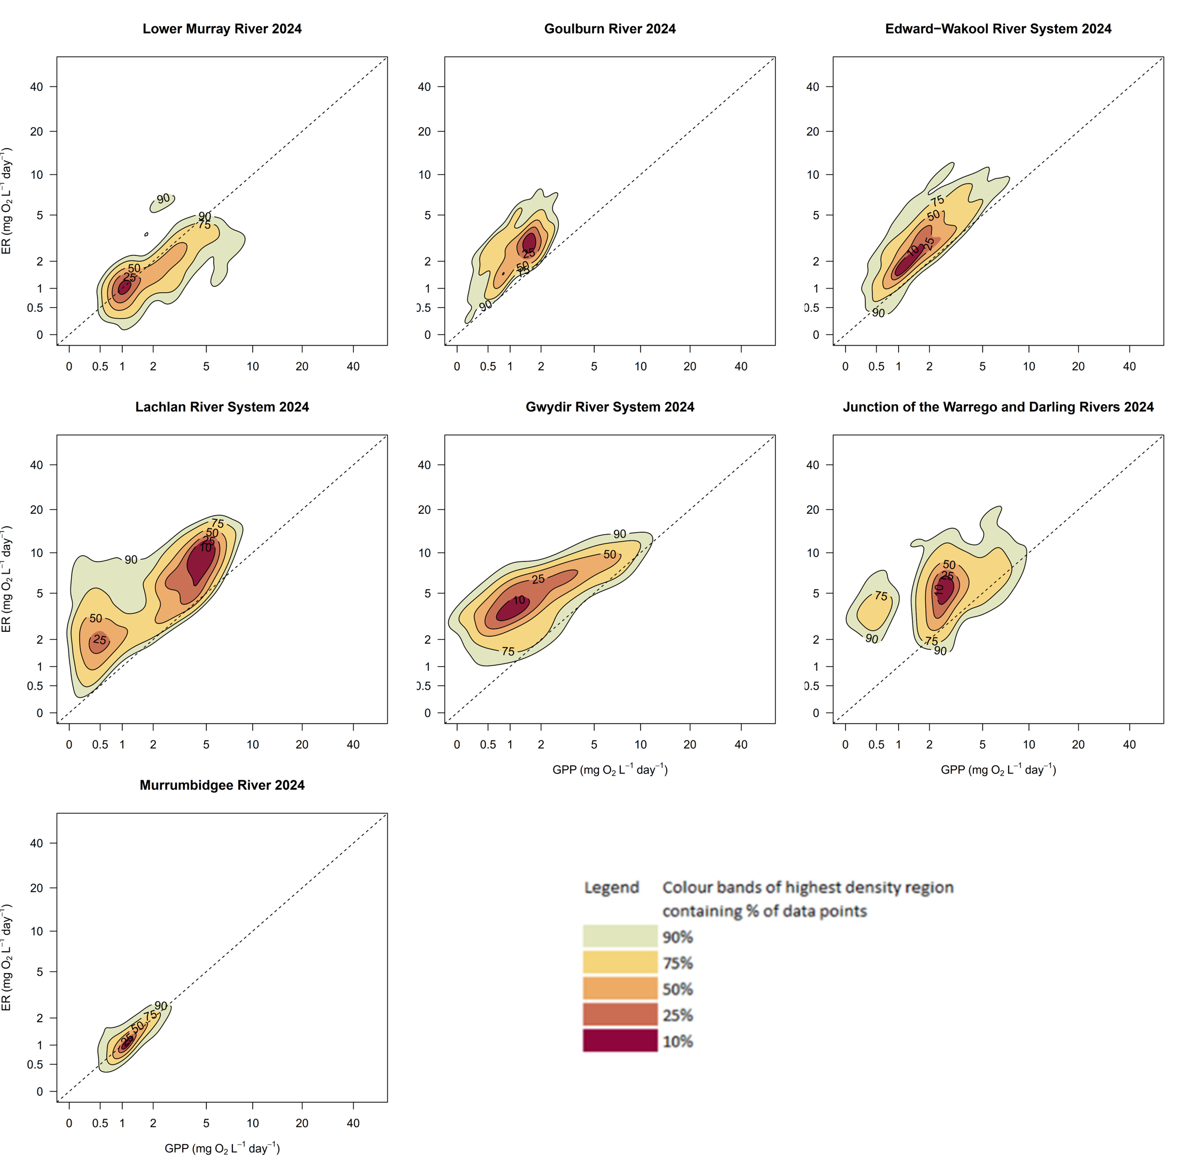

Water quality outcomes 2023–24
This section presents findings from the Foodwebs and Water Quality evaluation for the 2023–24 water year, presented in full in the ‘Basin-scale evaluation of 2023–24 Commonwealth environmental water: Foodwebs and Water Quality’ report (accompanying this document and will be available from DCCEEW’s Flow-MER Basin-scale Project publications webpage).
What was the contribution of Commonwealth environmental water to maintaining water quality and meeting targets for dissolved oxygen, salinity and salt export?
Water quality describes the chemical, physical and biological characteristics of water and its suitability for environmental uses. Water quality is a key indicator of aquatic ecosystem health, and flow plays an important role in the maintenance of water quality in rivers. Water quality objectives and associated watering actions aim to prevent or reduce the impact of poor water quality (low dissolved oxygen, high salinity, algal blooms) on ecosystems, plants and animals. Maintenance of water quality is critical to the completion of life cycles for native fish, vegetation and waterbirds.

Concentration of dissolved oxygen
The Basin Plan target for dissolved oxygen is to maintain a value of at least 50% saturation, which equates to a dissolved oxygen concentration of approximately 4–5 mg/L.
- In past years, delivery of Commonwealth environmental water has decreased the likelihood of low dissolved oxygen in the Lower Murray by increasing water mixing and oxygen exchange at the surface and elevating flow velocity above 0.18 m/s. Once flow velocity is greater than 0.4 m/s, there is no additional benefit for gas exchange. During 2023–24, naturally high flows maintained flow velocity above 0.4 m/s in the Lower Murray River, so the addition of Commonwealth environmental water did not influence gas exchange and saturation levels.
- Environmental watering actions in the Edward/Kolety–Wakool river systems and Murrumbidgee River System helped to maintain dissolved oxygen concentrations and prevent the development of hypoxic conditions.

Salt export and salinity
The Basin Plan salt-export objective (section 9.09) aims to ensure adequate removal of salt from the Murray River system into the Southern Ocean.
- 221,272 tonnes of salt were exported due to Commonwealth environmental water.
- Commonwealth environmental water was responsible for the export of approximately 18% of the salt exported from the Basin through the barrages in 2023–24, equating to 11% of the Basin target.
- Commonwealth environmental water was responsible for the reduction of salt import into the Coorong estuary in 2023–24 by an estimated 2,854,965 tonnes.
- Commonwealth environmental water contributed to low river salinity in South Australia by diluting salt in the Lower Murray River channel. Commonwealth environmental water is important for maintaining salt export from the Basin and limiting net salt import to the Coorong.

Outcomes 2014–24
At a glance
Vegetation
- Over the 10 years since 2014, 818 watering actions– totalling 13,011 GL of Commonwealth environmental water – targeted outcomes for vegetation.
- Commonwealth environmental water has contributed to distinct hydrological regimes across the Basin, which likely contributed to the observed diversity in functional and structural assemblages of vegetation.
- Notably, Commonwealth environmental water has supported ecosystem types with distinct vegetation communities such as freshwater meadows and permanent tall marsh. These habitats were watered more frequently than most treed swamps, and palustrine wetlands were watered more frequently than floodplains. Without environmental water and in the absence of overbank flooding, these ecosystems would transition to vegetation communities typical of drier conditions.
- Without Commonwealth environmental water, 40% of floodplain–wetland monitoring locations would have experienced drier water regimes, resulting in less diversity and less cover of submerged, amphibious and damp-loving plant species. By maintaining these species assemblages, Commonwealth environmental water is preventing a permanent transition in vegetation community assemblages and a loss of resilience of water-dependent plant communities.
- 804 taxa were recorded at monitored floodplain, wetland and riverine locations since 2014, including 527 native and 221 exotic species.
- Almost 10% (77) of the plant taxa observed at monitoring locations are known to be used by Aboriginal people for uses including food, fibre, shelter, medicine, messages and boundaries, dreaming/storytelling or ceremonial, and basket weaving.
- 33 of the plants used by Aboriginal people require flooding to occur, including 8 amphibious taxa, 3 submerged taxa, 13 damp-loving taxa and 9 woody flood-dependent taxa.
- 101 groundcover plant species that are listed as threatened were recorded at monitoring locations (but not all are listed in the state in which they were recorded).
Native fish
- 701 watering actions since 2014 – totalling 15,607 GL of Commonwealth environmental water – targeted outcomes for native fish.
- 15 native species and 5 exotic species were detected during the 10-year monitoring program by in-channel river sampling of adult fish communities in monitored areas. The number of native species detected did not vary greatly among years.
- Counterfactual modelling showed that Commonwealth environmental water contributed to increased fish spawning, recruitment, frequency of occurrence, population growth rates, body condition, movement (for golden perch using a basin scale movement model) and improved community composition in some monitoring locations and for several species. Positive fish responses to Commonwealth environmental water delivery were primarily driven by reductions in the number of low flow days and, to a lesser extent, increased average daily flows and changes in flow variability.
- Positive fish responses to Commonwealth environmental water delivery were most pronounced in the Goulburn River and Lower Murray River and to a lesser extent in the Edward/Kolety–Wakool river systems, Murrumbidgee River System and Lachlan River System. In the Gwydir River System, there were very few positive fish responses to Commonwealth environmental water delivery.
Waterbirds
- 470 watering actions since 2014 – totalling 9,299 GL of Commonwealth environmental water – targeted outcomes for waterbirds.
- Since 2014, 97 waterbird species were recorded on the managed floodplain (for a subset of Basin valleys).
- Commonwealth environmental water has supported habitats of a wide range of waterbird species, including straw-necked ibis, white ibis, glossy ibis, royal spoonbills, yellow spoonbills, cormorants, darters, grebes and several species of duck.
- 2,201 GL of Commonwealth environmental water were delivered to benefit listed threatened or migratory species, either alone or in combination with watering objectives.
- Since 2014, 59 listed threatened or migratory waterbird species were identified from the managed floodplain.
- Commonwealth environmental water had a significant influence on the presence of the federally listed Australasian bittern.
Other outcomes
- Since 2014, 1,991 GL of Commonwealth environmental water has been delivered through 324 watering actions with specific objectives for frogs.
- 20 species of frog have been reported from wetlands inundated with Commonwealth environmental water in the Murrumbidgee River System, Junction of Warrego and Darling rivers, Macquarie Marshes, Lachlan River System and Gwydir River System.
- Commonwealth environmental water had a significant influence on the presence of the federally listed southern bell frog.
- 26 listed water-dependent fish, crayfish, mammals, frogs and reptiles were reported from habitats that received Commonwealth environmental water on at least one occasion over the 10-year period.
- Commonwealth environmental water has supported broad-shelled turtles (Chelodina expansa; threatened in South Australia) and created nursery habitats that supported hatchling Macquarie turtles (Emydura macquarii), long-necked turtles (Chelodina longicollis) and broad-shelled turtles.
- Since 2014, Commonwealth environmental water has been responsible for the export of more than 4.3 million tonnes of salt through the barrages (around 22% of the Basin Plan target) and has reduced import of salt through the Murray Mouth by almost 29 million tonnes.
- Commonwealth environmental water has helped to decrease the likelihood of widespread hypoxic events across the Basin. In wet years, environmental water was used to pre-flush systems and maintain dissolved oxygen concentrations. In dry years, environmental water was used to increase flow volumes and increase water mixing.

Biodiversity outcomes 2014–24
This evaluation reports on outcomes from Commonwealth environmental water for 2014–24 and assesses the contribution of Commonwealth environmental water to Basin Plan objectives.
From 2014 to 2024, 18,310 GL of Commonwealth environmental water were delivered in the Basin through 1,194 watering actions (Figure 4.1). Many watering actions target more than one outcome. Of those watering actions with objectives relating to biodiversity, 701 actions totalling 15,607 GL targeted fish, 818 actions totalling 13,011 GL targeted vegetation, and 740 actions totalling 11,021 GL targeted waterbirds, frogs, turtles, platypus and rakali (Hydromys chrysogaster).
Figure 4.1 Number and volume of Commonwealth environmental watering actions with objectives for fish, vegetation, species diversity and water quality, 2014–24
Volumes are rounded to the nearest gigalitre. Many actions contribute to multiple objectives. Asterisk (*) combines actions for waterbirds, frogs and other biota; Hash (#) combines water quality and ecosystem processes.
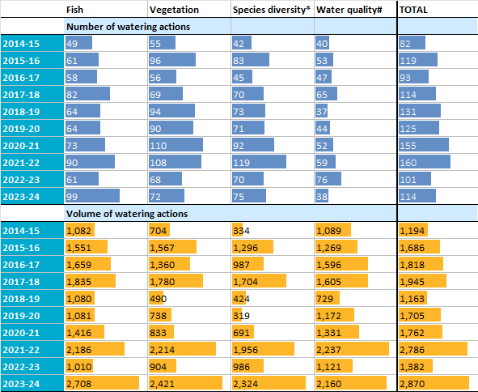

Vegetation
This section presents findings from the Vegetation evaluation for the 10 years from 2014–24, presented in full in the ‘Basin-scale evaluation of 2023–24 Commonwealth environmental water: Vegetation’ report (accompanying this document and will be available from DCCEEW’s Flow-MER Basin-scale Project publications webpage).
Environmental water is preventing the loss of characteristic wetland and floodplain plants by maintaining wetter hydrological regimes across the managed portion of the Murray–Darling Basin. In the absence of Commonwealth environmental water, important assemblages of species would have been markedly reduced in extent during dry periods. There would be a reduction in vegetation community richness and a high risk of permanent transitions to altered vegetation community assemblages and loss of resilience of water-dependent plant communities. The evaluation also demonstrates the importance of reducing the duration of the dry phase for supporting a greater cover of vegetation, particularly the cover of submerged and amphibious species.
Between 2014 and 2024, 818 watering actions – totalling 13,011 GL of Commonwealth environmental water – targeted expected outcomes for vegetation. Environmental water has resulted in 4 distinct inundation regimes for 73 monitored floodplain and wetland locations across the Basin. The wetter of these inundation regimes are almost entirely the result of the delivery of environmental water. Each inundation regime is associated with distinct functional and structural assemblages of plants. and modelling shows that, over the past 10 years, environmental water has maintained important assemblages of species and diverse vegetation communities.
Environmental water has likely contributed to a greater number of plant species and increased vegetation community diversity in unmonitored areas that receive environmental water. Over the past 10 years, watering frequencies broadly aligned with the expected needs of vegetation groups. Permanent lowland rivers, temporary tall emergent marsh and permanent tall emergent marsh were watered more frequently than most treed swamps, and palustrine wetlands were watered more frequently than floodplains (Brooks 2025). Without environmental water, and in the absence of other overbank flooding because of water-resource management activities, these ecosystem types will shift to different assemblages of vegetation and transition to the ecosystem types that are more common to drier hydrological regimes.
Basin Plan objective at paragraph 8.04(a): to protect and restore water-dependent ecosystems of the Murray–Darling Basin.
- Environmental watering has contributed to a greater diversity and cover of submerged, amphibious and damp-loving species. Without Commonwealth environmental water, many locations across the Basin would have experienced drier water regimes. This likely would have resulted in the near-absence of submerged species and substantially less diversity and cover of amphibious and damp-loving species at these locations.
- Environmental water has contributed to a greater number of plant species and increased vegetation community diversity. Over the past 10 years, watering frequencies broadly align with expected needs of vegetation groups. Permanent lowland rivers, freshwater meadows and permanent tall marsh were watered more frequently than most treed swamps, and palustrine wetlands were watered more frequently than floodplains. Without environmental water and in the absence of other overbank flooding, these ecosystem types would be expected to transition to ecosystem types more typical of drier hydrological regimes.
- By maintaining distinct inundation regimes and corresponding vegetation communities, environmental water has contributed to the longer-term resilience of water-dependent plant communities across the Basin. By maintaining submerged, amphibious and damp-loving species, environmental water is preventing a permanent transition to altered vegetation community assemblages and a loss of resilience of water-dependent plant communities.
- The evaluation shows that reducing the average duration of the dry phase in important in supporting a greater cover of vegetation and, particularly, the cover of submerged and amphibious species.

Observations since 2014
- 804 taxa were recorded at monitored floodplain, wetland and riverine locations since 2014. This includes 527 native and 221 exotic species, 70% of species and 86% of total cover were native plants.
- Almost 10% of the plant taxa observed at monitoring locations—representing a total of 77 species recorded since 2014—are known to be used by Aboriginal people for a variety of traditional purposes, including food, fibre, shelter, medicine, hunting or fishing, messages and boundaries, dreaming or storytelling, ceremonial uses, and basket weaving.
- 7 of the groundcover plant species recorded are listed as threatened, either nationally (under the EPBC Act) or within the state where they were detected. 4 of these are considered flow dependent.

Outcomes for groundcover vegetation since 2014
- Commonwealth environmental water is supporting groundcover plants.
- Environmental water is preventing the loss of characteristic wetland and floodplain plants by maintaining wetter hydrological regimes, helping to maintain biodiversity across the Basin.
- Without Commonwealth environmental water, 40% of monitoring locations would have experienced a drier inundation regime. This is likely to have resulted in less diversity and cover of submerged, amphibious and damp-loving species.
- This highlights the significant role of environmental water in supporting a substantial number of native plant species across the Basin over the past 10 years.
- Commonwealth environmental water is supporting plants with traditional Aboriginal uses.
- While Commonwealth environmental water has not deliberately targeted plant species of traditional uses, watering to support groundcover vegetation has supported a range of such species.
- 33 of the plants used by Aboriginal people require flooding to occur, including 8 amphibious taxa, 3 submerged taxa, 13 damp-loving taxa and 9 woody flood-dependent taxa. For example, the 3 submerged taxa (2 species of cumbungi [Typha domingensis and Typha orientalis] and the common reed [Phragmites australis]) are culturally important species to Aboriginal people; cumbungi requires near-permanent water while the common reed requires flooding every few years.
HIGHLIGHT: Water-dependent plant communities
Vegetation species and community responses to environmental water are described using structural and functional attributes, such as:
- functional groups – submerged, amphibious, damp-loving, woody flood-dependent, terrestrial
- species growth forms – forbs, grasses, ferns
- native and exotic species and threatened species
- species that are known to be used by Aboriginal people.
Since 2014, the greatest proportional cover of native plants was recorded over the last 3 years (87% to 96%), as well as the greatest proportion of native species (74% and 73% for 2021–22 and 2022–23, respectively). It is likely that above-average rainfall conditions combined with environmental watering contributed to these increases.
Forbs had the greatest average cover in most years (8% to 15%), followed by sedges and rushes (7% to 16%) and grasses (5% to 14%). Wetter conditions in recent years saw an increase in cover of ferns and fern allies, and sedges and rushes (Figure 4.2), greatest at sites that had wetter inundation regimes due to Commonwealth environmental water. Azolla and Marsilea species increased cover of ferns and fern allies, and Typha, Eleocharis and Cyperus species increased cover of sedges and rushes.
Figure 4.2 Percentage of plant species cover recorded across all Selected Areas in each growth-form group for each water year and across all years, 2014–24
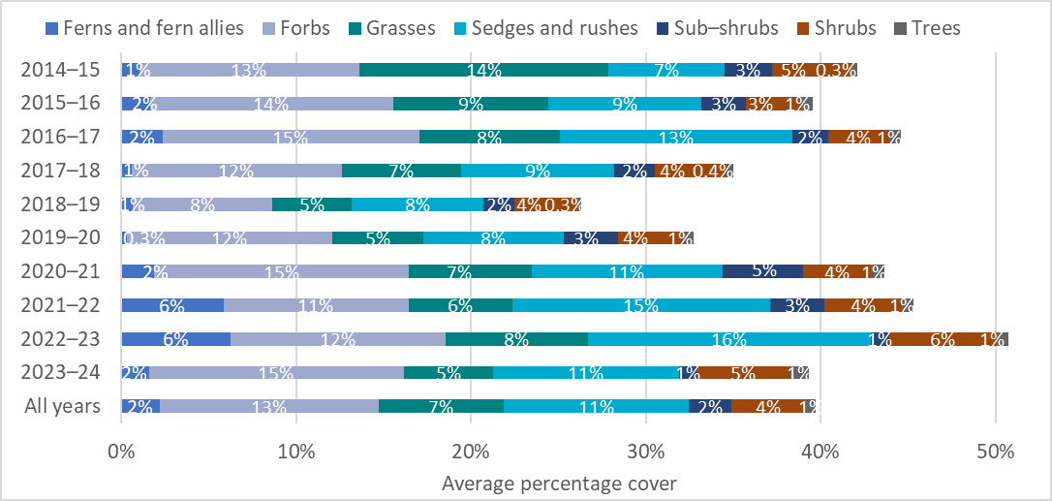
Amphibious taxa had the greatest average cover (Figure 4.3) in all years except for 2019–20, when terrestrial taxa dominated following widespread dry conditions. Damp-loving taxa were the next-most dominant (7 of the 10 years). Submerged taxa increased in the last 2 years due to wetter conditions.
Figure 4.3 Average percentage cover of plant functional groups across Selected Areas for each water year and across all years, 2014–24
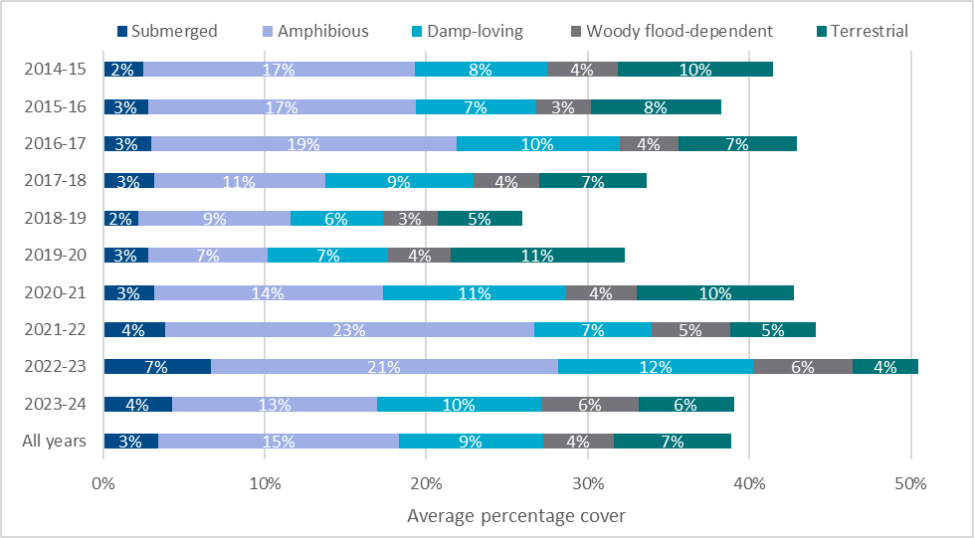

Native fish
This section presents findings from the Fish evaluation for the 10 years from 2014–24, presented in full in the ‘Basin-scale evaluation of 2023–24 Commonwealth environmental water: Fish’ report (accompanying this document and will be available from DCCEEW’s Flow-MER Basin-scale Project publications webpage).
Between 2014 and 2023, 701 watering actions – totalling 15,607 GL of Commonwealth environmental water – targeted expected outcomes for fish. Commonwealth environmental water provided a range of benefits to native fish populations and supported critical life-history processes, such as recruitment, body condition and population growth.

Observations since 2014
- 15,607 GL of Commonwealth environmental water were delivered in 701 independent watering actions for outcomes targeting native fish since 2014.
- 15 native species and 5 exotic species were detected during the 10 years of instream river sampling of adult fish communities in monitoring areas. This includes 6 key freshwater species as identified by the Strategy. The number of native species detected did not vary greatly among years. Golden perch, Murray cod and carp gudgeon (Hypseleotris spp.) were detected in all years in all monitored areas, while silver perch, flathead gudgeon (Philypnodon grandiceps) and unspecked hardyhead (Craterocephalus stercusmuscarum fulvus) had patchier spatial and temporal distributions.
- Counterfactual modelling showed that Commonwealth environmental water contributed to increased fish spawning, recruitment, frequency of occurrence, population growth rates, body condition and improved community composition in some monitoring locations and for several species.
- Positive fish responses to Commonwealth environmental water delivery were primarily driven by reductions in the number of low flow days and, to a lesser extent, increased average daily flows and changes in flow variability.
- Positive fish responses to Commonwealth environmental water delivery were most pronounced in the Goulburn River and Lower Murray River and to a lesser extent in the Edward/Kolety–Wakool river systems, Murrumbidgee River System and Lachlan River System. In the Gwydir River System, there were very few positive fish responses to Commonwealth environmental water delivery.
Basin Plan objective at paragraph 8.04(a): to protect and restore water-dependent ecosystems of the Murray–Darling Basin; and improvements in recruitment and populations of native fish. The Strategy lists 5 expected outcomes for fish to be achieved by 2024, of which 2 are addressed in this evaluation.
- No loss of native species currently present within the Basin
- Most native fish species were detected consistently over the monitoring period (2014–24). Cumulatively, 15 native fish species, including 6 key freshwater species as identified by the Strategy, were detected during the monitoring program.
- Improved population structure of key fish species through regular recruitment
- Murray cod spawned and recruited to young-of-year in some years. The 2016–17 Murray River hypoxic event and associated major fish death events, or possible fish emigration out of the area, resulted in marked reductions in recruits and adults in several monitoring locations in the southern Basin. Murray cod populations were steadily recovering from these fish death events however in more recent years (2022–23, 2023–24), Murray cod recruitment has been poor in most monitoring locations (except the Lower Murry River). Localised fish deaths were reported in some monitoring locations, but there was no evidence of further large-scale fish deaths. However, there were large-scale fish death events in 2022–23 recorded at other locations in the Basin.
- From 2014–24, golden perch spawned in the Goulburn River, Lachlan River System, Lower Murray River and Murrumbidgee River System, although only low numbers of recruits were detected in most monitoring locations. However, low levels of recruitment are often not detected until cohorts reach larger sizes and are more readily sampled. More recently, there was successful recruitment in the Lower Murray in the past 3 years but limited evidence at other monitoring locations. Population size structure in most monitoring locations in most years indicates the population is dominated by adult fish – few juveniles were observed. This most likely reflects the spatially and temporally episodic nature of major recruitment events for the species (and the flows that drive them) and the spatial scale over which populations operate.

Outcomes for native fish since 2014
Commonwealth environmental water contributed to increased fish spawning, recruitment, population growth, frequency of occurrence and body condition, movement (for golden perch) and improved community composition in some monitored areas for several native species. These fish responses were driven by reductions in the number of low flow days and, to a lesser extent, increased average daily flows and changes in flow variability (both increases and decreases in flow variability, depending on location).
- Spawning of golden perch (i.e. presence of larval fish and eggs) increased because of Commonwealth environmental water delivery in some years in all areas monitored for this indicator. The probability of regional scale golden perch movement in the southern Basin was also higher in years subject to environmental water delivery compared to years of regulated low discharge rates (as predicted using a basin scale movement model developed as a research activity).
- Recruitment of Australian smelt increased because of Commonwealth environmental water (fewer low flow days and changes in flow variability) in some years in several monitoring locations. Murray cod recruitment had variable responses to Commonwealth environmental water delivery in some years in the Edward/Kolety–Wakool river systems and Gwydir River System. In other monitoring locations, there was either negative responses in some years (Lachlan River System, Murrumbidgee River System) or no effects (Goulburn River, Lower Murray River). There were a few positive effects of Commonwealth environmental water on recruitment of carp gudgeon and Murray–Darling rainbowfish in some monitoring locations.
- Commonwealth environmental water delivery (fewer low flow days) contributed to increased probability of detection of Australian smelt at more sites in most years within monitored areas. The growth rate for the adult Murray cod population increased with the delivery of Commonwealth environmental water (fewer low flow days and changes in flow variability) in some years in monitored areas. The population growth rate for golden perch increased with delivery of Commonwealth environmental water in most years in the Goulburn River, Lachlan River System, Lower Murray River and Murrumbidgee River System (fewer low flow days).
- Individual body condition for Murray cod and golden perch increased due to Commonwealth environmental water (fewer low flow days and increased average daily flows) in some years in monitored areas. Strong responses for Murray cod were found in the Goulburn River and Lower Murray River. Bony herring body condition increased with delivery of Commonwealth environmental water (changes in flow variability) in some years in monitored areas.
- The predicted contribution of Commonwealth environmental water to Murray cod and Murray–Darling rainbowfish recruitment at unmonitored locations was greatest in the southern Basin, although there is higher uncertainty in the predicted effects of Commonwealth environmental water in the northern Basin, which is limited to a single monitoring location (Gwydir River System). Currently, predictions at unmonitored locations are with low confidence without local data in these unmonitored locations to test with model predictions.
HIGHLIGHT: Enhancing spawning, recruitment and movement of golden perch
Environmental water delivered benefits for golden perch across the Murray–Darling Basin
Golden perch are found throughout the Murray–Darling Basin. They are a popular angling fish and are culturally important to First Nations people. Flow-MER research and evaluation showed that Commonwealth environmental water supported critical life-history processes of golden perch, including spawning, body condition and population growth.
Data from tagged golden perch shows that the greater the flow, the more likely golden perch are to move throughout a river system. Understanding relationships between flows and fish movements, at varying spatial scales, informs the delivery of Commonwealth environmental water to best benefit fish populations.
Between 2014 and 2024, spawning of golden perch increased with delivery of Commonwealth environmental water. Golden perch need hundreds of kilometres of connected flowing water for spawning migrations, and spawning often coincides with increased flow during spring and summer. Environmental water helped maintain their habitat by providing connected flow events across regions and at critical times.
Modelling showed that numbers of golden perch across the Basin went up when Commonwealth environmental water was delivered, strengthening populations against future environmental change. The Basin-wide model was developed by integrating knowledge of life-history processes (such as spawning and movement) with information on the connectivity and spatial scale of golden perch populations.
The model also showed that bigger river discharges, such as those boosted by Commonwealth environmental water (and seen in the very wet 2022–23 water year), enhance fish spawning, recruitment and movement – ultimately supporting the populations and recovery of golden perch and other native fish.

Waterbirds
This section presents findings from the Species Diversity evaluation for the 10 years from 2014–24, presented in full in the ‘Basin-scale evaluation of 2023–24 Commonwealth environmental water: Species Diversity’ report (accompanying this document and will be available from DCCEEW’s Flow-MER Basin-scale Project publications webpage).
Waterbirds are a key priority for environmental watering in floodplain and wetland habitats. Critical waterbird habitats and multiple populations of listed waterbird species are associated with locations periodically inundated by environmental water. There is also potential for other, complementary adaptive-management actions to support the effectiveness of environmental water and, ultimately, waterbird recruitment. Environmental water, vegetation management and management of pressures and threats, such as predation, disease and toxins, all interact with habitat availability and quality to affect waterbird movements, condition, growth, survival and mortality, as well as breeding initiation and frequency.

Observations since 2014
- 9,299 GL of Commonwealth environmental water has been delivered for outcomes for waterbirds.
- Commonwealth environmental water has supported habitats of a wide range of waterbird species, including straw-necked ibis, white ibis, glossy ibis, royal spoonbills, yellow spoonbills, cormorants, darters, grebes and several species of duck.
- 97 waterbird and raptor species were recorded from the Long Term Intervention Monitoring Project and Flow-MER monitoring sites in the Junction of the Warrego and Darling rivers, Gwydir River System and Murrumbidgee River system from 2014 to 2024.
- 1,877 GL of Commonwealth environmental water were delivered to benefit listed threatened or migratory species, either alone or in combination with watering objectives.
- Since 2014, 59 listed threatened or migratory waterbird and raptor species were reported. Of these, 57 were reported from habitats that received Commonwealth environmental water.
HIGHLIGHT: Supporting threatened species (waterbirds)
Australasian bittern
The Australasian bittern is a threatened species with scattered distribution through eastern Australia. The Basin contains core habitat for this species. It is federally listed as Endangered under the EPBC Act and is also listed in Victoria, South Australia and New South Wales. It is a large, nocturnal wading bird that requires wetland and floodplain habitats with areas of tall emergent vegetation. Since delivery began in 2014, 110 known locations of Australasian bittern received Commonwealth environmental water at least once.
Glossy ibis
The glossy ibis (Plegadis falcinellus) is a wading waterbird. It is a listed migratory species under the Bonn Convention and is listed in South Australia. It is highly nomadic and has a wide distribution across eastern and northern Australia. Since delivery began in 2014, 183 known locations of glossy ibis received Commonwealth environmental water at least once.
Australasian shoveler
The Australasian shoveler (Spatula rhynchotis) is a species of dabbling duck and is listed in Victoria and South Australia. This species is highly mobile and has a wide distribution that extends throughout eastern and south-western Australia. Since delivery began in 2014, 233 known locations of Australasian shoveler received Commonwealth environmental water at least once.

Other fauna – turtles, snakes and frogs
This section presents findings from the Species Diversity evaluation for the 10 years from 2014–24, presented in full in the ‘Basin-scale evaluation of 2023–24 Commonwealth environmental water: Species Diversity’ report (accompanying this document and will be available from DCCEEW’s Flow-MER Basin-scale Project publications webpage).
Since 2014, 740 watering actions with objectives for species diversity outcomes delivered ~11,021 GL of Commonwealth environmental water. 4,308 GL of Commonwealth environmental water were delivered to support other biota, including mammals (platypus and rakali), woodland birds (regent parrot) and reptiles (turtles and snakes), and 1,991 GL of Commonwealth environmental water were delivered with specific objectives for frogs.
Watering objectives for frogs typically focus on general habitat maintenance (habitat). More targeted objectives exist for frog breeding (breeding), maintaining critical refuge habitat for frogs (refuge), and providing opportunities for breeding and recruitment of the southern bell frog.
Frogs generally have low mobility, and occurrence at environmental watering sites is highly dependent on the longer-term water regime, including the frequency of inundation and length of dry periods which influences survival over time. Each year, specific characteristics of the flow regime, such as the timing of inundation, may influence breeding responses of resident populations.

Observations since 2014
- 20 species of frog have been reported from wetlands inundated with Commonwealth environmental water in the Murrumbidgee River System, Junction of Warrego and Darling rivers, Macquarie Marshes, Lachlan River System and Gwydir River System. Frog species richness in the Murrumbidgee has been stable across years.
- Commonwealth environmental water was the primary source of inundation and played a significant role in shaping the hydrological regime at 11 of the 12 frog survey sites in the Murrumbidgee.
- 26 listed water-dependent fish, crayfish, mammals, frogs and reptiles were reported from habitats that received Commonwealth environmental water on at least one occasion over the 10-year period.
- Commonwealth environmental water supported broad-shelled turtles (threatened in South Australia) and created nursery habitats that supported hatchling Macquarie turtles, long-necked turtles and broad-shelled turtles.
- Commonwealth environmental water supported habitats and populations of threatened species, including one frog (southern bell frog), one turtle (broad-shelled turtle) and one snake (grey snake).
- Commonwealth environmental water had a significant influence on the presence of southern bell frogs (listed as Vulnerable under the EPBC Act).

Ecosystem function outcomes 2014–24
This section presents findings from the Foodwebs and Water Quality evaluation for the 10 years from 2014–24, presented in full in the ‘Basin-scale evaluation of 2023–24 Commonwealth environmental water: Foodwebs and Water Quality’ report (accompanying this document and will be available from DCCEEW’s Flow-MER Basin-scale Project publications webpage).
From 2014–24, 511 watering actions – totalling 14,310 GL of Commonwealth environmental water – were delivered for outcomes linked to water quality, food webs, stream metabolism, productivity and river function.
Channel and floodplain morphology (both at a site and immediately upstream) should be a strong driver of context-dependent metabolic responses to flow. For example, in shallow river channels with low banks, a small increase in flow volume may lead to relatively large increases in inundated surface area. Such increases to wetted area are likely to increase metabolic throughput by creating proportionally larger surface-area-to-volume ratios, leading to a larger photic zone and potential increases in rates of GPP (noting lag times for autotrophic communities to colonise). In such circumstances, there is also a greater likelihood of incorporating more terrestrial organic carbon from litter, also driving up rates of ER. In contrast, even moderate increases in flow volume that occur in river reaches that are deeply incised are likely to lead to only small increases in wetted surface area. Here, metabolic throughput would likely decrease, since any increases in surface area are likely to be exceeded by dilution and disturbance influences.

Observations for stream metabolism 2014–24
- Rates of GPP and ER across all Selected Areas in the 2023–24 water year were broadly similar and comparable with the previous 9-year record. Over the 10 years, riverine ecosystems of the Goulburn River, Edward/Kolety–Wakool river systems, Lachlan River System, Gwydir River System and Junction of Warrego and Darling rivers were predominantly heterotrophic and consuming more carbon than they were producing.
- The Murrumbidgee River System regularly alternated between heterotrophy and autotrophy over the 10 years, depending on conditions (such as season).
- The Lower Murray River was mostly a net producer of carbon (autotrophic) up to 2021–22, driven by phytoplankton and relatively low turbidity in the slow-flowing channels. However, high flows in 2022 shifted the Lower Murray River into heterotrophy, reflecting a return to a flowing system more closely resembling metabolic patterns at other Selected Areas. In 2023–24, the Lower Murray River returned to autotrophy, reflecting reduced flows from the previous year.
- Independent of Commonwealth environmental watering actions, rates of GPP are most strongly influenced by seasonal changes (e.g. light, temperature) and site-specific drivers, such as bioavailable nutrient concentrations and reduced light availability due to turbidity.

Water quality outcomes 2014–24
This section presents findings from the Foodwebs and Water Quality evaluation for the 10 years from 2014–24, presented in full in the ‘Basin-scale evaluation of 2023–24 Commonwealth environmental water: Foodwebs and Water Quality’ report (accompanying this document and will be available from DCCEEW’s Flow-MER Basin-scale Project publications webpage).
The Basin Plan target for dissolved oxygen is to maintain a value of at least 50% saturation, which equates to a dissolved oxygen concentration of approximately 4–5 mg/L. When the addition of Commonwealth environmental water increases mean water velocities above ~0.18 m/s in the Lower Murray River, it can help increase dissolved oxygen concentrations. Under these circumstances, Commonwealth environmental water decreases the likelihood of low dissolved oxygen by increasing water mixing and oxygen exchange at the surface. Commonwealth environmental water is most important for decreasing the likelihood of low dissolved oxygen during years with low base flows.

Observations for water quality 2014–24
In 2014–24, Commonwealth environmental water decreased the likelihood of low dissolved oxygen in the Lower Murray River by contributing to maintaining flow velocities above the 0.18 m/s threshold. In 2023–24, natural flows were above 0.4 m/s, and oxygen exchange was naturally higher. Environmental water did not contribute to gas exchange under these conditions.
The Basin Plan salt-export objective (section 9.09) aims to ensure adequate removal of salt from the Murray River system into the Southern Ocean. It has been set at 2 million tonnes per year.
In low flow years, Commonwealth environmental water has become increasingly important for sustaining salt export from the Basin and limiting salt import to the Coorong. Since 2014–15, Commonwealth environmental water has been responsible for an additional 4.4 million tonnes of salt exported through the barrages (Figure 4.4). While Commonwealth environmental water has played a key role in salt export from the Basin, salt export remains below the Basin Plan target – the greatest export of 1.07 million tonnes occurred in 2020–21. Commonwealth environmental water contributed to maintenance of river salinity (electrical conductivity) below 800 µS/cm at Morgan over the 2014–24 period. Salinity was maintained within the range required for potable water in the Murray River in 2014–24, and water was about 10% fresher due to environmental flows.
Basin plan objectives for water quality
- Section 9.08. There is strong evidence that Commonwealth environmental water played an important role in maintaining water quality during 2014–24. For example, Commonwealth and other environmental water was used in 2016 to ameliorate anoxic conditions and improve water quality.
- Section 9.09. Since 2014, Commonwealth environmental water exported over 4 million tonnes of salt through the barrages (~22% of the Basin Plan target) and reduced salt import by over 28 million tonnes.
- Paragraph 9.14(5)(a). Where Commonwealth environmental water increased mean water velocities above ~0.18 m/s in the Lower Murray River, it contributed to lower dissolved oxygen concentrations.
- Paragraph 9.14(5)(c). During 2014–24, Commonwealth environmental water contributed to maintaining river salinity below the 800 µS/cm target at Morgan and maintaining salinity within the range for potable water in the Murray River, averaging around 10% fresher due to environmental flows.
Figure 4.4 Modelled additional salt export and reduced salt import due to Commonwealth environmental water, 2014–24
Measures are in thousands of tonnes and represent the salt export through the barrages to the Coorong estuary and reduction in import of salt through the Murray Mouth into the Coorong from the Southern Ocean that is attributable to Commonwealth environmental water (CEW). Source: Ye et al. 2025.
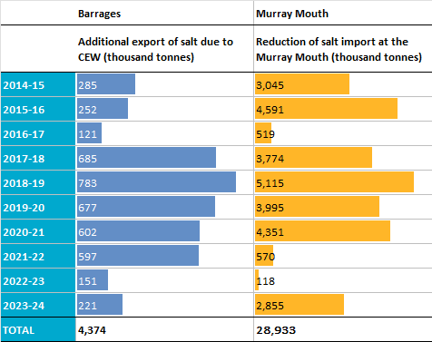

Resilience outcomes 2014–24
What does the evaluation show in relation to resilience to climate change and other risks and threats?
- Maintaining refugia is a key component of managing for resilience at landscape levels.
- An objective of the Basin Plan is to protect refugia to support the long-term survival and resilience of water-dependent populations of native flora and fauna, including during drought, to allow for subsequent re-colonisation beyond the refugia.
- Refuge connecting or maintenance flows are delivered instream as freshes and base flows or to critical wetland habitats as overbank flows (including targeted delivery of water via pumping and regulator diversions). The maintenance of refugial habitat for the southern bell frog and associated wetland species is a key objective for Commonwealth environmental water in the Murrumbidgee River System, particularly during dry years. These actions support the survival of frogs, native fish and turtles and provide foraging opportunities for waterbirds during dry periods.
- Providing water to support breeding events in wetter years is critical in enhancing population size and increasing likelihood of persistence over dry periods.
- Watering events were used across the Basin to support frog, fish and waterbird breeding events to enhance population numbers and increase resilience to prolonged dry periods.
- Providing water is critical to providing plant communities with sufficient resilience to persist over dry periods.
- There were regular actions in the Gwydir Wetlands and Macquarie Marshes that inundated permanent and temporary tall emergent marsh, freshwater meadow, permanent wetlands, permanent forb marsh and permanent grass marshes.
- Watering targeted vulnerable species including lignum (during water delivery to Narran Lakes) and river cooba (Acacia stenophylla; associated with floodplain watering of the Gwydir Wetlands).
- Monitoring data illustrate the importance of reducing the average duration of the dry phase for supporting a greater cover of vegetation, particularly the cover of submerged and amphibious species in floodplain and wetland environments.
- Providing water to support breeding events in wetter years is critical for species’ resilience to stressors such as invasive species.
- Watering events were used across the Basin to support frog, fish and waterbird breeding events to support population numbers and enhance resilience to the effects of invasive species, such as redfin perch (Perca fluviatilis), common carp and fox (Vulpes vulpes).
- Providing water to support the condition of native vegetation increases native species’ resilience to long dry periods.
- Watering events were used across the Basin to support the condition of vegetation communities that require regular inundation, enhancing their ability to cope with unfavourable conditions.
- Protecting species from the effects of major disturbances such as hypoxic events.
- Watering events were used to reduce the impacts of hypoxic conditions and increase the ability of fish species to recover in the Edward/Kolety–Wakool river systems in 2016–18.

Informing adaptive management
At the Basin scale, Commonwealth environmental water is contributing to the achievement of Basin Plan objectives for biodiversity (including threatened species and communities), ecosystem function and water quality. Managing and improving existing ecological condition improves ecological resilience to future change and risk, including climate change.
Our assessment is based on current data, knowledge and tools for evaluating the contribution of Commonwealth environmental water and acknowledges existing limitations in the attribution of outcomes based on temporal and spatial variability in response. In 2023–24, delineation of the managed floodplain was expanded using 10 years of evidence from the Long Term Intervention Monitoring Project (2014–19) and Flow-MER inundation mapping. This has added 359,091 ha to the known area of aquatic ecosystems that can be managed with environmental water in the Basin.
At the Basin scale, the 10-year evaluation of watering frequencies suggests the CEWH’s current water allocation and delivery is qualitatively fit for purpose. 10 years of continued evaluation of Basin biodiversity has improved understanding of:
- the spatial patterning of watering actions in the landscape
- the distribution of water-dependent ecosystems in the Basin
- the distribution of Commonwealth environmental water to the different ecosystem types (e.g. with a greater proportion supporting temporary river red gum swamps and marsh ecosystems)
- watering frequencies at the scales of ecosystems, wetland complexes and valleys.
Environmental water is very important for decreasing the likelihood of low dissolved oxygen by increasing water mixing and oxygen exchange at the surface, particularly in the Lower Murray, where the river is dominated by slow-flowing locks and weirs. Commonwealth environmental water can contribute to maintaining dissolved oxygen levels above desired thresholds during hypoxic events, when flows can dilute anoxic water and increase oxygen exchange at the surface. Commonwealth environmental water can also maintain base flows to support aquatic ecosystems during low flow periods.
Commonwealth environmental water is critical for maintaining salinity regimes within a desired range. Commonwealth environmental water has been used to successfully:
- maintain river salinity (electrical conductivity) below 800 µS/cm at Morgan (a river management target of the Murray–Darling Basin Authority and SA Water)
- maintain salt export from the Coorong in low flow years
- contribute to the Basin Plan’s target of exporting 2 million tonnes of salt from the Murray River System into the Southern Ocean each water accounting period; however, salt export remains below the Basin Plan target.
Recommendations for vegetation
- Continue to deliver environmental water to maintain inundation regimes at floodplain–wetland locations that are central to supporting vegetation species and community diversity at the Basin scale.
- Where appropriate, consider using environmental water to reduce the average dry phase experienced by floodplain–wetland locations to support a greater cover of vegetation, including submerged and amphibious vegetation. Consider opportunities to use environmental water to further support plant species known to be used by Aboriginal people and engage Aboriginal communities across the Basin to identify culturally important plant species that can be supported with environmental water.
Recommendations for fish
- Commonwealth environmental water should continue to be managed to mitigate the number of low flow days and increase average daily flows to support fish populations. This is important during transitions out of La Niña climate patterns and into normal or, at the extreme end, El Niño climate periods.
- In wet and flood years, there is an opportunity to use Commonwealth environmental water delivery to build on these natural events to support the recovery of fish populations (e.g. dilution flows to reduce hypoxic events and fish deaths, flows to help disperse migratory species) or maximise benefits from the post-flood period (e.g. filling gaps in the hydrograph to optimise spawning and recruitment in the season following floods).
Recommendations for waterbirds and other fauna
- Explicit identification is needed within each valley of the occurrence and water needs of listed threatened and migratory species that occur within the managed floodplain. A more detailed assessment of the distribution of key species and current water management practices in each valley is critical to identify ‘blind spots’ where the water requirements of these species are not being met.
- Increased surveillance is needed of conservation-significant species that are known to occur in habitats frequently targeted with Commonwealth environmental water delivery, including platypus, large-footed myotis (also referred to as southern myotis) and grey snake.
- While many waterbirds are highly mobile, improvements in waterbird health and survival, particularly in the first year of life, can be made by ensuring foraging habitats are maintained year-round within key valleys. In addition, there is a need for better coordination between valleys to set and meet targets for waterbird habitats at the Basin scale, particularly in dry years when refuge habitats are critical.

Commonwealth environmental watering actions
Table A.1 Commonwealth environmental watering actions in the northern Basin by valley and hydrological flow component, 2023–24
The flow-component terms (base flow, fresh, bankfull, overbank, wetland) are those used by the Commonwealth Environmental Water Holder when describing the watering actions. Cell values are number of actions, and values in parentheses are volumes in megalitres. Dash (–) indicates that the watering action did not include that flow component.
Valley | Base flow | Base flow, fresh | Base flow, fresh, bankfull | Fresh | Fresh, base flow | Fresh, overbank | Fresh, wetland | Overbank | Wetland, fresh | Wetland | Total actions (volume, ML)
Barwon Darling | – | 4 (63,385) | – | – | – | – | – | – | – | – | 4 (63,385)
Border Rivers | – | 3 (1,437) | 1 (5,671) | 9 (4,953) | – | – | – | – | – | – | 13 (12,061)
Condamine Balonne | – | – | – | 1 (1,328) | – | 1 (71,299) | – | – | – | – | 2 (72,627)
Gwydir | – | – | – | 2 (4,500) | – | – | – | – | – | 2 (10,539) | 4 (15,039)
Macquarie | – | – | – | 1 (3,833) | – | – | – | – | 1 (56,046) | – | 2 (59,879)
Namoi | 1 (900) | – | – | 1 (8,379) | – | – | – | – | – | – | 2 (9,279)
Warrego | – | – | 2 (14,456) | – | – | – | – | 1 (8,370) | – | – | 3 (22,826)
Total | 1 (900) | 7 (64,822) | 3 (20,127) | 14 (22,993) | – | 1 (71,299) | – | 1 (8,370) | 1 (56,046) | 2 (10,539) | 30 (255,096)
Table A.2 Commonwealth environmental watering actions in the southern Basin by valley and hydrological flow component, 2023–24
The flow-component terms (base flow, fresh, bankfull, overbank, wetland) are those used by the Commonwealth Environmental Water Holder when describing the watering actions. Cell values are number of actions, and values in parentheses are volumes in megalitres. Dash (–) indicates that the watering action did not include that flow component.
Valley | Base flow | Base flow, fresh | Base flow, fresh, bankfull | Fresh | Fresh, base flow | Fresh, overbank | Fresh, wetland | Overbank | Wetland, fresh | Wetland | Total actions (volume, ML)
Broken | 8 (57,044) | – | – | 2 (6,788) | – | – | – | – | – | – | 10 (63,832)
Campaspe | 4 (2,210) | – | – | 3 (2,368) | – | – | – | – | – | – | 7 (4,578)
Central Murray | 3 (23,437) | – | – | 3 (310,761) | – | – | – | – | – | – | 6 (334,198)
Edward/Kolety–Wakool | 6 (12,798) | 4 (85,479) | – | – | 2 (59,881) | – | – | – | – | 3 (843) | 15 (159,001)
Goulburn | 3 (146,441) | – | – | 3 (116,560) | – | – | – | – | – | – | 6 (263,001)
Lachlan | 1 (1,213) | – | – | 1 (110) | – | – | 1 (22,059) | – | – | 1 (3,646) | 4 (27,028)
Loddon | 2 (732) | – | – | 1 (3,030) | – | – | – | – | – | – | 3 (3,762)
Lower Darling | 2 (110,834) | – | – | – | – | – | – | – | – | – | 2 (110,834)
Lower Murray | 2 (769,382) | 3 (614,959) | – | 4 (0)* | – | – | – | – | – | 10 (1,852) | 19 (1,386,193)
Murrumbidgee | – | – | – | 1 (3,759) | 1 (203,235) | – | 1 (4,646) | – | – | 5 (48,100) | 8 (259,740)
Ovens | 1 (50) | – | – | 1 (73) | – | – | – | – | – | – | 2 (123)
Wimmera | 1 (1,291) | 1 (1,471) | – | – | – | – | – | – | – | – | 2 (2,762)
Total | 33 (1,125,432) | 8 (701,909) | – | 19 (443,449) | 3 (263,116) | – | 2 (26,705) | – | – | 19 (54,441) | 84 (2,615,052)
Table A.3 Commonwealth environmental watering actions in the northern Basin and southern Basin by valley and hydrological flow component, 2023–24
The flow-component terms (base flow, fresh, bankfull, overbank, wetland) are those used by the Commonwealth Environmental Water Holder when describing the watering actions. Cell values are number of actions, and values in parentheses are volumes in megalitres. Dash (–) indicates that the watering action did not include that flow component.
Sub-Basin | Base flow | Base flow, fresh | Base flow, fresh, bankfull | Fresh | Fresh, base flow | Fresh, overbank | Fresh, wetland | Overbank | Wetland, fresh | Wetland | Total actions (volume, ML)
Northern Basin | 1 (900) | 7 (64,822) | 3 (20,127) | 14 (22,993) | – | 1 (71,299) | – | 1 (8,370) | 1 (56,046) | 2 (10,539) | 30 (255,096)
Southern Basin | 33 (1,125,432) | 8 (701,909) | – | 19 (443,449) | 3 (263,116) | – | 2 (26,705) | – | – | 19 (54,441) | 84 (2,615,052)
Total | 34 (1,126,332) | 15 (766,730) | 3 (20,127) | 33 (466,441) | 3 (263,116) | 1 (71,299) | 2 (26,705) | 1 (8,370) | 1 (56,046) | 21 (64,981) | 114 (2,870,148)

Figure A.1 Commonwealth environmental water portfolio showing volume (left) and number (right) of watering actions, by valley and year, 2014–24
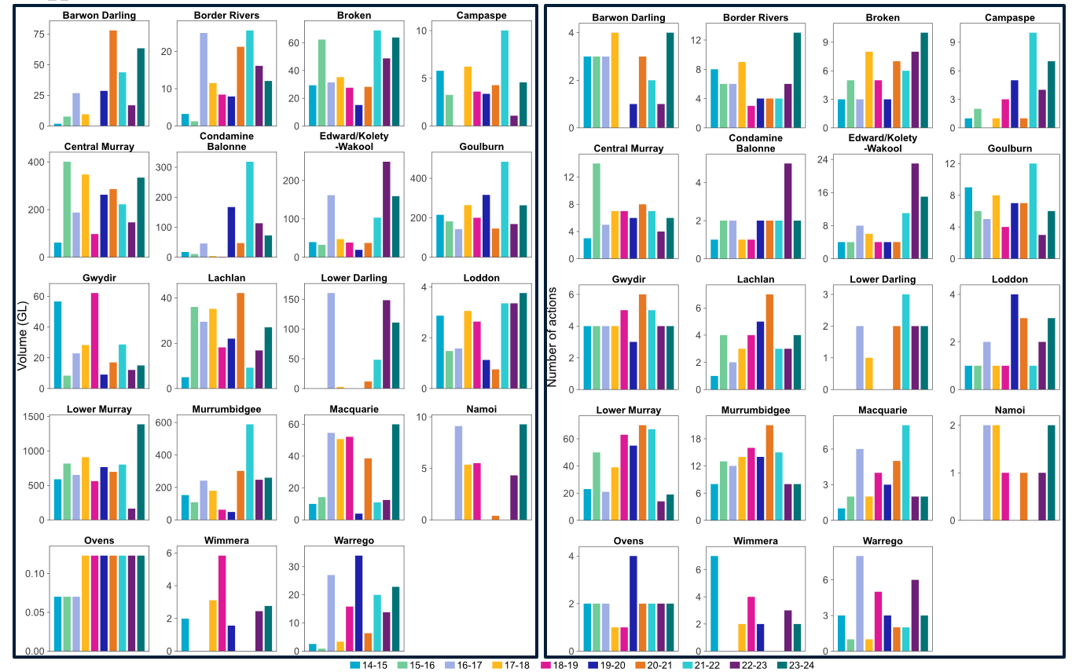

Detailed outcomes table
Table B.1 Commonwealth Environmental Outcomes framework against Basin Plan biodiversity objectives (Basin Plan S8.05)
Flow-MER monitors and evaluates outcomes from the delivery of Commonwealth environmental water according to the CEWH’s Monitoring, evaluation, reporting and innovation strategy (MERI) using one-year and five-year outcomes (extended to 10 years and referred to here as long-term) described in the Environmental water outcomes framework (the Framework).
Basin outcomes | One-year expected outcomes | Long-term expected outcomes | Outcomes 2023–24 | Outcomes 2014–24
Ecosystem diversity | None identified | None identified | 200,890 ha of mapped lakes and wetland supported  21,075 km of rivers supported  47,770 ha of floodplain inundated  23,768 ha of estuary supported with fresh water  52 Basin Australian National Aquatic Ecosystem types supported | 254,665 ha of lakes, and wetlands supported  191,599 ha of floodplain supported  28,549 km of waterways supported  23,768 ha of estuary supported  56 Basin Australian National Aquatic Ecosystem types supported
Ecosystem diversity: Ramsar wetlands | None identified | None identified | Commonwealth environmental water delivered to 8 Ramsar Sites, supporting vegetation listed as a critical component of the Ramsar Sites | Commonwealth environmental water was delivered to support environmental outcomes in 11 Ramsar Sites in the Basin, noting that Commonwealth environmental water is often delivered in partnership with water held by the Murray–Darling Basin Authority (e.g. The Living Murray Program) as well as water from state jurisdictions
Species diversity: Vegetation | Plant species diversity | Plant species diversity | 360 plant taxa were recorded across all floodplain, wetland and riverine monitoring locations, including 54 taxa known to be used by Aboriginal people | The delivery of Commonwealth environmental water played a role in maintaining a substantial number of native plant species across the Basin. Of the 804 taxa recorded across all sample points since 2014, 10% (81) are native species that have only occurred at floodplain–wetland sample points that experience a wetter inundation regime because of environmental water
Species diversity: Vegetation | Vegetation community diversity | Vegetation community diversity | Noticeable differences were observed in the vegetation assemblages associated with sites that have a wetter inundation regime supported by environmental water, compared with those that have a drier inundation regime. A greater proportion and cover of submerged and amphibious plants observed at sites that had wetter inundation regimes maintained using environmental water | There was a greater diversity and cover of submerged, amphibious and damp-loving species at sample points that have received wetter regimes supported by environmental watering events, than at sample points not receiving environmental water
Species diversity: Fish | None identified | No loss of native species currently present within the Basin | The Basin-scale evaluation was not designed to detect loss of native species within the Basin | There is no evident loss of species in the Selected Areas; however, the contribution of Commonwealth environmental water to this Strategy outcome is unknown
Species diversity: Fish | None identified | Improved population structure of key fish species through regular recruitment | There was evidence of golden perch spawning along with detection of young-of-year recruits indicating low levels of recruitment in the Lower Murray River and limited evidence in other Selected Areas. Murray cod recruitment has been absent or minimal, based on young-of-year abundances, in the Edward/Kolety–Wakool river systems, Goulburn River, Gywdir River System, Lachlan River System and Murrumbidgee River System. There was evidence of minor recruitment occurring in the Lower Murray River | Across the Basin, there is evidence of recruitment of golden perch; however, the contribution of Commonwealth environmental water to this outcome at the wider Basin scale is unknown due to the limited availability of golden perch recruitment data and long-term counterfactual flow data. There is evidence of recruitment of Murray cod in the Selected Areas; however, in recent years recruitment has been absent or minimal in several Selected Areas
Species diversity: Fish | None identified | Improved community structure of key native fish species | Setting community metrics for assessing Commonwealth water for the environment is challenging, since the Strategy outcome does not provide any guidance as to what is considered an improvement | Counterfactual modelling showed that in the Goulburn, the Lower Murray River and Murrumbidgee River System (all associations with medium confidence) there were positive effects on the community metric (the proportion of catch that was native) in association with Commonwealth environmental water in multiple years. There were more variable responses in the other Selected Areas
Species diversity: Waterbirds | None identified | Waterbird diversity | 68 waterbird species reported from annual waterbird counts | Over the past 10 years, 224,921 individuals from 97 waterbird species were detected at Junction of Warrego and Darling rivers, Gwydir and Murrumbidgee monitoring sites
Species diversity: Frogs | None identified | None identified | 11 species were detected. The most widespread species were spotted marsh frog, barking marsh frog and Peron’s tree frogs. In the Murrumbidgee, only one of the monitored wetlands received environmental water – Bala (Eulimbah), which is a large lignum wetland. This action was successful in triggering breeding, as evidenced by the detection of calling, tadpoles and recently metamorphosed frogs between September 2023 and March 2024 | The hydrological regime of floodplain wetlands surveyed for frogs is strongly influenced by Commonwealth environmental water. All survey sites were influenced by Commonwealth environmental water on at least one occasion, and most sites were influenced by Commonwealth environmental water in more than 5 years. At the site scale, Commonwealth environmental water has had a profound impact on species occurrence (number of species) in most years by increasing inundation frequency of wetland inundation
Species diversity: Turtles | None identified | None identified | Abundance not reported | Abundance not reported
Species diversity: Threatened and migratory species | None identified | None identified | 18 conservation-significant waterbird species were identified from the Flow-MER and NSW Department of Climate Change, Energy, the Environment and Water monitoring in 2023–24, including 3 species listed under the Australian Environment Protection and Biodiversity Conservation Act 1999 – Australasian bittern, sharp-tailed sandpiper and Latham’s snipe. Other species of significance included the listed threatened species black-necked stork, blue-billed duck, freckled duck and marsh sandpiper. | 59 listed threatened or migratory waterbird and raptor species were reported from habitats that received Commonwealth environmental water on at least one occasion
Table B.2 Commonwealth Environmental Outcomes framework against Basin Plan ecosystem function objectives (Basin Plan S8.06)
Basin outcomes | One-year expected outcomes | Long-term expected outcomes | Outcomes 2023–24 | Outcomes 2014–24
Connectivity | Longitudinal connectivity | Longitudinal connectivity | 21,075 km of waterways supported | 28,549 km of waterways supported
Connectivity | Lateral connectivity | Lateral connectivity | 272,428 ha of lakes, wetlands, floodplain and estuary supported | 470,032 ha of lakes, wetlands, floodplain and estuary supported
Connectivity | End-of-system flows | End-of-system flows | Commonwealth environmental water contributed 1,146 GL to barrage releases over the year | Commonwealth environmental water had an important role to play in meeting long-term objectives to protect and restore connectivity within and between water-dependent ecosystems, particularly in the Lower Murray River Selected Area
Process | Primary productivity (of aquatic ecosystems) | Primary productivity (of aquatic ecosystems) | Commonwealth environmental water had a positive influence on primary production and respiration | Evidence from all Selected Areas that Commonwealth environmental water had a positive influence on primary production and respiration
Process | Nutrient and carbon cycling | Nutrient and carbon cycling | Commonwealth environmental water had a positive influence on protecting and restoring energy, carbon and nutrient dynamics | Commonwealth environmental water had a positive influence on protecting and restoring energy, carbon and nutrient dynamics
Table B.3 Commonwealth Environmental Outcomes framework against Basin Plan water quality objectives (Basin Plan S9.08; 9.09; 9.14)
Basin outcomes | One-year expected outcomes | Long-term expected outcomes | Outcomes 2023–24 | Outcomes 2014–24
Chemical | Salinity | Salinity | 221,272 tonnes of salt exported through barrages estimated as being attributable to Commonwealth environmental water  Commonwealth environmental water contributed to maintenance of salinity below 800 EC (µS/cm) at Morgan (Ye et al. 2025) | Commonwealth environmental water accounted for 80% to 100% of annual environmental flow releases through the barrages (the only mechanism for salt export from the Basin) during the dry years (between 2014–15 and 2020–21, except for 2016–17). Since 2014–15, Commonwealth environmental water has been responsible for over 4 million tonnes of additional salt exported through the barrages and has reduced salt import by more than 28 million tonnes (Ye et al. 2025)
Chemical | Dissolved oxygen | Dissolved oxygen | There were clear benefits of environmental flow provision in March 2023 in terms of increasing dissolved oxygen concentrations and reducing the potential for blackwater events (e.g. Higgisson et al. 2024). | Commonwealth environmental water can help reduce the likelihood of low dissolved oxygen concentrations in the Lower Murray River if the contribution increases water velocities above a level of ~0.18 m/s, below which surface oxygen exchange is poor (Ye et al. 2025). Reducing the likelihood of low dissolved oxygen concentrations can be achieved by increasing water mixing in otherwise low flow (Ye et al. 2025)
Table B.4 Commonwealth Environmental Outcomes framework against Basin Plan resilience objectives (Basin Plan S8.07)
Basin outcomes | One-year expected outcomes | Long-term expected outcomes | Outcomes 2023–24 | Outcomes 2014–24
Ecosystem resilience | Individual refuges | Individual refuges | 9 watering events (214 GL) were used with the objective of supporting refugia | 189 watering events (3,082 GL) were used with the objective of supporting refugia
Ecosystem resilience | Landscape refuges | Landscape refuges | Vegetated ecosystems were supported in agreement with the Strategy’s Basin-wide annual watering priorities for 2023–24 | Watering events were used across the Basin to support a wide range of vegetation communities. Commonwealth environmental water supported 130,574 ha of palustrine wetlands and 191,599 ha of floodplains
Ecosystem resilience | Ecosystem recovery | Ecosystem recovery | A rolling priority to maintain the extent and improve the condition of lignum shrublands and an annual priority to support continued recovery of lignum shrublands at Narran Lakes and other key sites in the northern Basin were met. 4,895 ha of lignum floodplain were inundated, and another 215 ha of temporary lignum swamp received Commonwealth environmental water | Watering events were used for flow management to support the recovery of instream aquatic vegetation and large-bodied native fish in the Edward/Kolety–Wakool system following the 2016 hypoxic blackwater event (Watts et al. 2022)

https://flow-mer.org.au
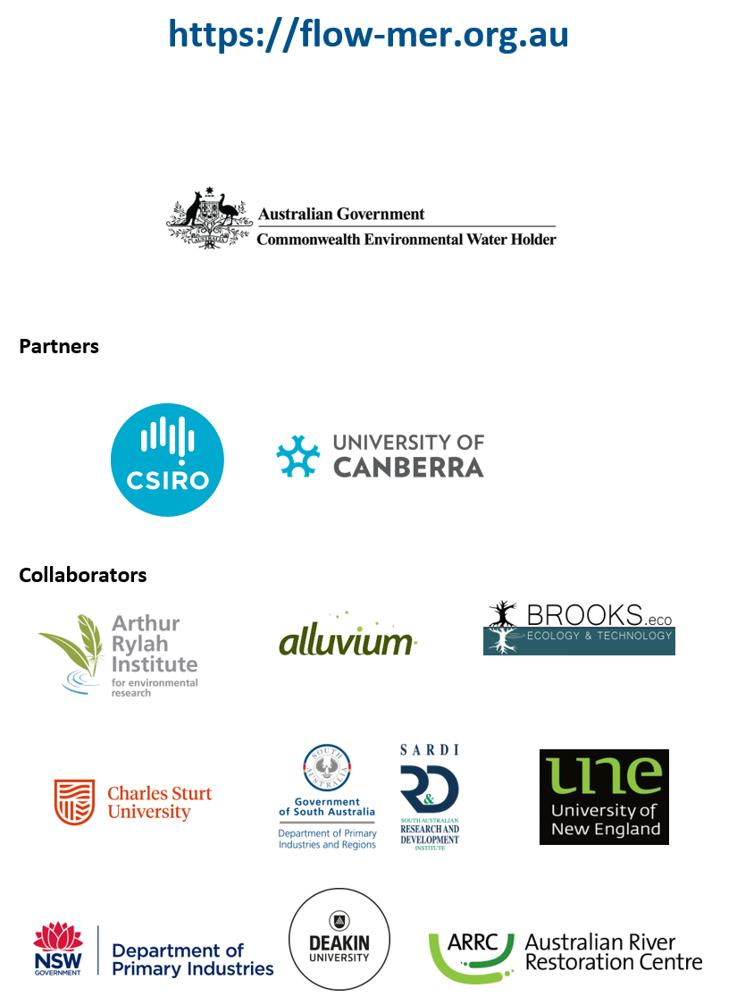

Reports available from the Australian Department of Climate Change, Energy, the Environment and Water’s Flow-MER Basin-scale Project publications webpage.
Total runoff is calculated as total precipitation less losses from evapotranspiration. It includes water flowing over the land surface and through channels to reach a stream but also water that infiltrates the soil surface and travels by means of gravity toward a stream channel.
This report uses the Bureau of Meteorology’s Geofabric v3 river line mapping to categorise river ecosystems. The ANAE includes 4 additional river types to cater for gaps in the polygon mapping for rivers that are not used in the 2023–24 evaluation but have contributed to totals in previous years.
Total figures for the Basin, including the Coorong, Lower Lakes and Murray Mouth, except where stated otherwise.
These 12 floodplain types comprise 11 floodplain types upstream of the Coorong, Lower Lakes and Murray Mouth and one additional type (paperbark-dominated floodplain) adjacent to the Coorong.
Convention on Wetlands of International Importance (the Ramsar Convention 1971).
Waterbirds of the Murray–Darling Basin, 2017 Basin Plan Evaluation, Murray–Darling Basin Authority. Canberra ACT.
Office of the NSW Chief Scientist and Engineer (2023) Independent review into the 2023 fish deaths in the Darling–Baaka River at Menindee.
Ye Q, Giatas G, Bice C, Brookes J, Frahn, K, Furst D, Gibbs M, Nicol J, Oliver R, Zampatti B, Bucater L, Deane D, Hipsey M, Huang P, Lorenz Z, Mills J, Shiel R, Zhai S (2025) Commonwealth Environmental Water Office Monitoring, Evaluation and Research Program: Lower Murray 2023–24 technical report. Draft report prepared for the CEWO by the South Australian Research and Development Institute, Aquatic Sciences.
Higgisson W, Broadhurst B, Tschierschke A, Stocks J, van der Meulen D, Kerezsy A, Lenehan J, Thompson R, Dyer F (2024) Commonwealth Environmental Water Holder Monitoring, Evaluation and Research Program: Lachlan River system Selected Area 2023–24 Monitoring, Evaluation and Research Program Summary Report. Commonwealth of Australia.
Watts RJ, Bond N, Healy S, Liu X, McCasker N, Michie L, Siebers A, Thiem J, and Trethewie J (2022) Commonwealth Environmental Water Office Monitoring, Evaluation and Research Project: Edward/Kolety-Wakool Flow Selected Area Technical Report 2021-22. Report prepared for the CEWO. Commonwealth of Australia.

