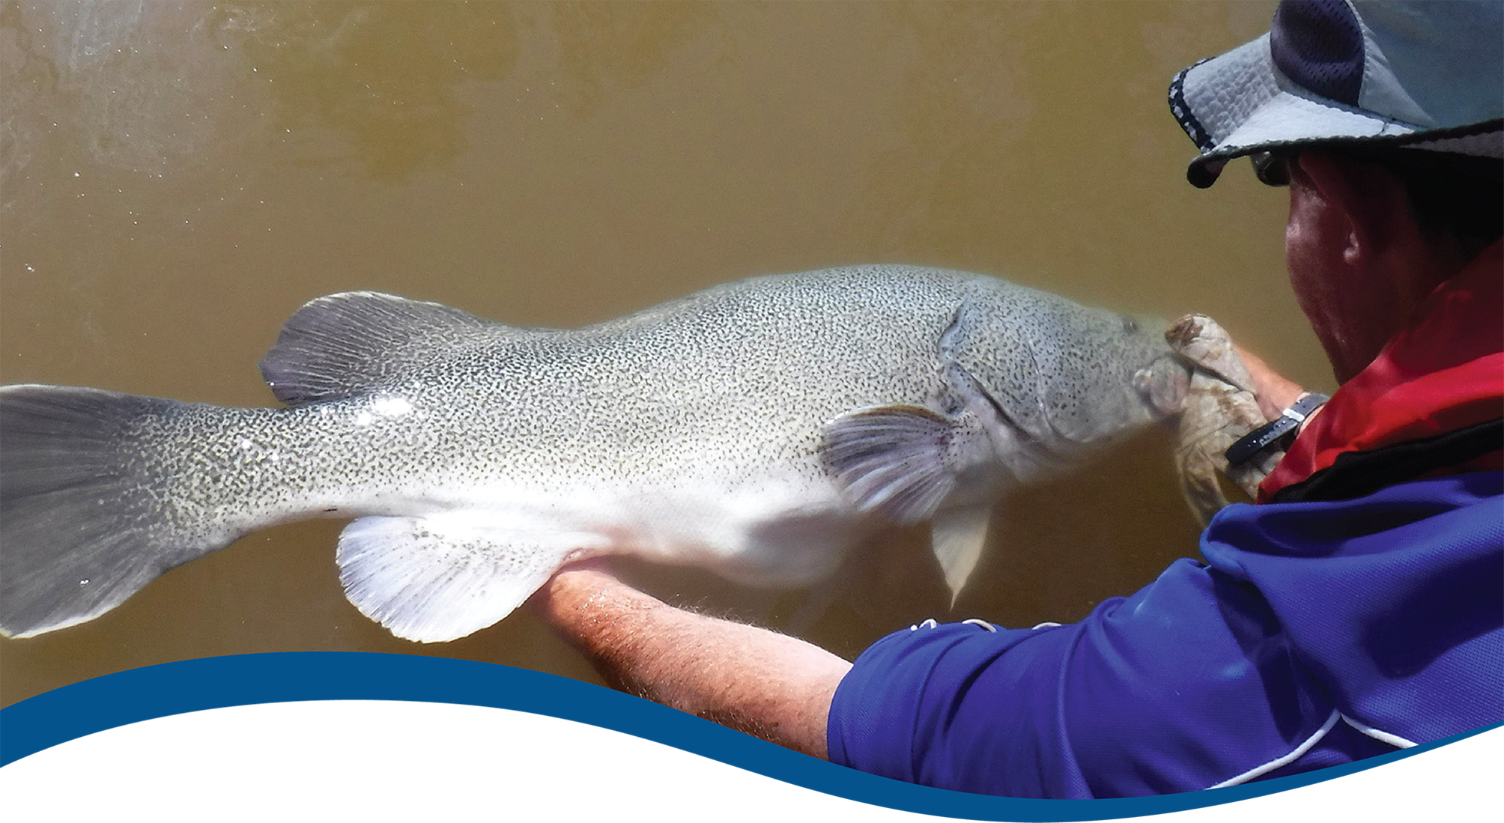
Basin-scale evaluation of 2023–24 Commonwealth environmental water: Fish
  - Commonwealth Environmental Water Holder’s Science Program:
Flow Monitoring, Evaluation and Research Program (Flow-MER)
June 2025

Acknowledgements
The project team and the Commonwealth Environmental Water Holder (CEWH) respectfully acknowledge the Traditional Owners of the land on which this work is conducted, their Elders past and present, their Nations of the Murray–Darling Basin, and their cultural, social, environmental, spiritual and economic connection to their lands and waters.
We thank fish team members of the Selected Area monitoring and evaluation providers who undertook all fieldwork and data collation, data entry and management, technical input and Selected Area annual reports. These fish experts include John Trethewie (Charles Sturt University), Dylan Van Der Meulen and Chris Bowen (NSW Department of Primary Industries and Regional Development). We thank Martin Nolan for construction of the fish sampling sites map and the Commonwealth environmental water actions and volumes visualisation and associated tables. Sincere thanks to Shane Brooks and Julia Mynott for data management and quality assurance checks. We thank the Flow-MER Hydrology team for processing and verifying the hydrology data for use in the Basin-scale evaluation.
The Fish team would also like to acknowledge Dianne Flett, Susan Cuddy, Martin Nolan and Jane Thomas of CSIRO and Jill Sharkey of DocumentMagic for reviewing, proofreading, formatting and copy-editing the report.
With thanks to staff of the CEWH and members of the Flow-MER2.0 Independent Advisory Group for providing independent review; and especially to Prof Peter Davies for his reviews of this report throughout the life of Flow-MER.
Citation
Hladyz S, Baumgartner L, Bice C, Broadhurst, B, Butler G, Fanson B, Giatas G, Koster W, Lyon J, McCasker N, Stocks, J, Stuart I, Thiem J, Tonkin Z, Ye Q, Yen J and Zampatti B (2025) Basin-scale evaluation of 2023–24 Commonwealth environmental water: Fish. Flow-MER Program. Commonwealth Environmental Water Holder, Department of Climate Change, Energy, the Environment and Water, Australia. 146pp.
Copyright
 © Commonwealth of Australia 2025
With the exception of the Commonwealth Coat of Arms, partner logos and where otherwise noted, all material in this publication is provided under a Creative Commons Attribution 4.0 International Licence https://creativecommons.org/licenses/by/4.0/. Flow-MER requests attribution as ‘© Commonwealth of Australia (Flow-MER, https://flow-mer.org.au)’.
Cover photograph
Releasing a Murray cod
Photo credit: Arthur Rylah Institute
Document log
Date
28/5/2025 | Draft delivered to CSIRO for editing and internal review
2 June 2025 | Draft delivered to CEWH and external reviewer
30 June 2025 to 4 July 2025 | Review comments received and authors responded
8 July 2025 | Draft final delivered to CEWH

Important disclaimer
The information contained in this publication comprises general statements based on scientific research. The reader is advised and needs to be aware that such information may be incomplete or unable to be used in any specific situation. No reliance or actions must therefore be made on that information without seeking prior expert professional, scientific and technical advice. To the extent permitted by law, Flow-MER (including its partners and collaborators) excludes all liability to any person for any consequences, including but not limited to all losses, damages, costs, expenses and any other compensation, arising directly or indirectly from using this publication (in part or in whole) and any information or material contained in it.
Flow-MER is committed to providing web-accessible content wherever possible. If you are having difficulties with accessing this document, please contact ewater@dcceew.gov.au.

Executive summary
Strategic management of Commonwealth environmental water by the Commonwealth Environmental Water Holder (CEWH) is key to achieving the environmental objectives in the Commonwealth’s (Murray–Darling) Basin Plan 2012 (the Basin Plan). Longer-term targets identified in the Basin Plan to measure progress towards the overall environmental objectives for water-dependent ecosystems include improvements in recruitment and populations of native fish. The CEWH’s Science Program invests in Flow Monitoring, Evaluation and Research Program (Flow-MER) to demonstrate Basin-scale outcomes of Commonwealth environmental water, support adaptive management, and fulfil CEWH legislative requirements under the Basin Plan.
The Basin-scale Fish evaluation describes outcomes for fish across the Murray–Darling Basin (the Basin) from the use of Commonwealth environmental water for the water year 2023–24 as well as cumulative outcomes since monitoring began in 2014–15. This information is used to answer the following evaluation question:
What did Commonwealth environmental water contribute to sustaining native fish at the Basin scale?

Water year 2023–24
- In 2023–24, the Basin experienced a return to average, drier conditions compared to the previous wet year. Wet conditions were still evident in some places but tended to contract towards central areas. During winter, Selected Areas in the southern Basin experienced high in-stream winter flows, while conditions were drier in the northern Basin.
- Across the Basin, Commonwealth environmental water was used to water wetlands, lakes and ephemeral creeks, and to maintain high in-stream flow rates during spring and summer, reduce rapid recession, protect stable flows, and provide variable baseflows and freshes.
- The main functional flow objectives for enhancing native fish populations with Commonwealth environmental water delivery across the Basin in 2023–24 were to improve habitat, enhance connectivity or provide cues for movement, and, to a lesser extent, support various targeted species outcomes (e.g. survival of Murray hardyhead and support of breeding and recruitment of freshwater catfish and migration flow cues for lamprey and congolli).
- Observations of fish responses in 2023–24 are based on qualitative interpretations of the authors’ readings of key findings from the Selected Area annual reports and from our own quantitative analyses of 2023–24 data using a counterfactual modelling approach.
- Golden perch spawned in the Goulburn River and in the Lower Murray River. Silver perch spawned in the Lower Murray River and in the Murrumbidgee River System. Spawning in the Goulburn River coincided with a large natural overbank flow and a Commonwealth environmental water delivery of a fresh. In the Lower Murray River, golden and silver perch spawning coincided with large in-stream flow pulses which included contributions of Commonwealth environmental water. Our quantitative analysis found no strong evidence of positive associations in perch spawning responses with Commonwealth environmental water at these Selected Areas. There were low levels of recruitment of golden perch in the Lower Murray River and limited evidence of recruitment in the other Selected Areas. It is possible that high in-stream flows may have reduced the detectability of larvae, eggs and new recruits in some Selected Areas. Future monitoring of juvenile fish and year-class assessments (such as that conducted in the River Murray Channel Monitoring Program) will provide complementary information on recruitment during the 2023–24 period.
- There were low levels of recruitment of Murray cod in the Lower Murray River, and recruitment was limited (zero or very low abundances of young-of-year detected) in other Selected Areas. Likely reasons for poor recruitment in some Selected Areas include unfavourable flow conditions during nesting and early life stages, insufficient prey availability in summer, and populations still recovering from the previous year’s impacts (e.g. hypoxic conditions leading to fish emigration or mortality) due to flooding disturbance. This year’s quantitative analyses found no strong evidence of positive associations between Commonwealth environmental water and Murray cod recruitment.
- Although small-bodied native species are generally less dependent on flows for spawning and recruitment compared to some large-bodied species, there is evidence that the flow regime in some Selected Areas (e.g. Goulburn River, Lachlan River System and Lower Murray River) during 2023–24 favoured recruitment for some small-bodied native fish species, likely through the provision of increased hydrological connectivity, habitat and food resources. Our quantitative analysis found positive associations between Commonwealth environmental water and Australian smelt recruitment in the Goulburn River, Lachlan River System and Lower Murray River. In contrast, the small-bodied Murray–Darling rainbowfish was lower in abundance and there was little evidence of recruitment for the past several years in some Selected Areas. High flows may have negatively impacted populations of this species, as it prefers low-to-moderate stable flows during its extended spawning and recruitment period (late spring to early autumn). Our quantitative analyses found no positive associations between Commonwealth environmental water and Murray–Darling rainbowfish recruitment.
- Exotic species (common carp and goldfish) declined markedly in abundance this year after the initial boom response to the 2022–23 wet conditions when widespread flooding and high flows were experienced across Selected Areas. Our quantitative analyses of exotic species responses showed positive associations between Commonwealth environmental water and common carp recruitment and negative associations with eastern gambusia in several Selected Areas.

Water years 2014–24
- Fifteen native and 5 exotic species were detected during the 10 years of in-stream river sampling of fish communities in the Selected Areas, using standardised methods of boat electrofishing and fyke nets. This includes 6 key freshwater species as identified by the Murray–Darling Basin Authority Basin-wide environmental watering strategy (the Strategy) (MDBA 2019). The number of native species detected was similar among years. Golden perch, Murray cod and carp gudgeon were detected in all years across all Selected Areas, while the detection of silver perch, flathead gudgeon and freshwater catfish were far patchier through both space and time.
- Counterfactual modelling showed that Commonwealth environmental water contributed to increased fish spawning, recruitment, population growth, frequency of occurrence and body condition, and improved community composition in some Selected Areas for several native species, including golden perch, Murray cod and bony herring. The responses of these species to Commonwealth environmental water were driven by reductions in the number of low flow days and, to a lesser extent, increased average daily flows and changes in flow variability (both increases and decreases in flow variability depending on Selected Area).

- Specific findings from counterfactual modelling were:
  - The likelihood of spawning of golden perch (i.e. presence of larval fish and eggs) increased as a result of Commonwealth environmental water delivery in some years across all Selected Areas monitored for this indicator (though responses for the Edward/Kolety–Wakool river systems and Lachlan River System were associated with low confidence). This response was driven primarily by a response to the number of days of increased flow in the 7 days prior to sampling (positive and negative effects depending on the Selected Area and year) and, to a lesser extent, to median standardised flows in the 30 days prior to sampling.
  - Recruitment of Australian smelt increased as a result of Commonwealth environmental water delivery (fewer low flow days and changes in flow variability) in some years in several Selected Areas. Murray cod recruitment had variable responses (recruitment increased and decreased) to Commonwealth environmental water delivery in some years in the Edward/Kolety–Wakool river systems and Gwydir River System. In other Selected Areas, there was either negative responses in some years (Lachlan River System, Murrumbidgee River System) or no effects (Goulburn River, Lower Murray River). There were a few positive effects of Commonwealth environmental water on recruitment of carp gudgeon and Murray–Darling rainbowfish but no effects for bony herring in all Selected Areas.
  - There was evidence that Commonwealth environmental water delivery (fewer low flow days) contributed to increased probability of detection of Australian smelt at more sites within Selected Areas in most years. More variable responses (detection at more and less sites) to Commonwealth environmental water delivery were evident for bony herring, golden perch, Murray cod and Murray–Darling rainbowfish.
  - Adult population growth rate increased with Commonwealth environmental water delivery for golden perch in most years in the Goulburn River, Lachlan River System, Lower Murray River and Murrumbidgee River System (due to Commonwealth environmental water reducing the number of low flow days). Murray cod population growth rates had variable responses to Commonwealth environmental water delivery (population growth rates increased and decreased).
  - Individual body condition for Murray cod and golden perch increased with Commonwealth environmental water delivery (due to Commonwealth environmental water reducing the number of low flow days and increasing average daily flows) in some years across all Selected Areas. Strong positive responses were evident in the Goulburn River and Lower Murray River. Bony herring body condition increased with delivery of Commonwealth environmental water (changes in flow variability) in some years across all Selected Areas (where this variable was measured).
  - The contribution of Commonwealth environmental water to the recruitment of Murray cod and Murray–Darling rainbowfish was predicted to be greatest in the southern Basin. There is high uncertainty in the predicted effects of Commonwealth environmental water in the northern Basin, which is limited to a single Selected Area (Gwydir River System). This Selected Area is subject to a variety of stressors (e.g. cold-water pollution, hydrological fragmentation, ecological connectivity) that likely override the effects of Commonwealth environmental water. Therefore, more representative northern Basin monitoring sites are needed to reduce uncertainty around predicted effects. Furthermore, the current model predictions are associated with low confidence as they attempt to extrapolate beyond Selected Areas data and have not been independently validated.
- The analyses presented here are based on 10 years of condition monitoring data (i.e. fixed timing and methods), limited spatial coverage of waterways across the Basin, and low abundances of many native fish species. Our evaluation of the responses of fish population indices to Commonwealth environmental water depends directly on the analysis of fish–flow associations. These associations are limited not just by the spatial constraints of the monitoring data but also by the temporal window and flow events that occur during such time (e.g. high flow years are often extreme and coupled with hypoxia-induced native fish deaths or emigration and booms of exotic species recruitment). Capturing more ‘intermediate’ type flow years in our monitoring data and integrating additional data sources in future iterations of the Flow-MER program will help with this constraint. Continual advancement in analytical methods and refinement of hydrology metrics, as well as collection of additional monitoring data from sentinel sites and other reaches during future iterations of the Flow-MER program, will help to reduce uncertainty.

Key contributions to Basin Plan objectives
- Commonwealth environmental water has a critical role to play in meeting the long-term objectives to protect and restore that biodiversity that depends on Basin water resources (Basin Plan 8.05(3)(a)(b)). Longer-term targets identified in the Basin Plan to measure progress towards the overall environmental objectives for water-dependent ecosystems include improvements in recruitment and populations of native fish (outlined in Schedule 7; Basin Plan Schedule 12, item 7). The Strategy underpins and adds specificity to the biodiversity outcomes of the Basin Plan and lists 5 expected outcomes for fish. Flow-MER evaluated the diversity of native species in the Selected Areas and the status of 2 key species identified by the Strategy: golden perch and Murray cod. We address 2 of the Strategy’s expected outcomes in this evaluation at the Selected Area scale below, as the other 3 expected outcomes are out of scope with the current monitoring design (i.e. movement of key fish species, expanded distributions, improved community structure):
  - ‘no loss of native species currently present within the Basin’ (p 49 in MDBA 2019) – No loss of native species was evident in the Selected Areas, and most native fish species were detected consistently over the monitoring period (2014–24). The contribution of Commonwealth environmental water to this outcome at the wider Basin scale is unknown due to the limited spatial extent of Selected Areas. In 2023–24, there were 14 species detected across all the Selected Areas.
  - ‘improved population structure of key fish species through regular recruitment’ (p 49 in MDBA 2019) – Murray cod spawning and recruitment to young-of-year (i.e. presence of fish between < 130 mm and < 222 mm long, depending on Selected Area) occurred most years in the Selected Areas. Our analyses indicated that Commonwealth environmental water delivery contributed to recruitment at some Selected Areas in some years. The 2016–17 Murray River hypoxic event and associated major fish-death events, or possible fish emigration out of the area, resulted in marked reductions in recruits and adults in several Selected Areas. Since this event, Murray cod populations have shown a steady recovery at several Selected Areas, and counterfactual modelling shows that Commonwealth environmental water has contributed to population growth in some years in some Selected Areas. However, in more recent years (2022–23, 2023–24), Murray cod recruitment has been low (defined as absent or very low abundances of young-of-year), as reported from the annual Selected Area reports (except for in the Lower Murray River). Potential reasons for poor recruitment in 2022–23 and 2023–24 in some Selected Areas include highly variable water levels coinciding with nesting and early life stages (eggs and larvae), insufficient prey availability in summer, and populations (specifically the number of mature fish in Selected Areas) still recovering following earlier disturbances where widespread flooding and high flows reduced water quality (hypoxic conditions), which may have caused fish mortality or emigration out of sampling areas.
- Eggs and or larvae of golden perch (indicator of successful spawning) was detected in 2023–24 in some Selected Areas (e.g. Goulburn River, Lower Murray River). Population size structure indicates the dominance of adult fish – few juveniles were observed in most Selected Areas (excluding Lower Murray River and Warrego River) in most years. From 2014–15 to 2023–24, golden perch spawning was detected in the Goulburn River, Lachlan River System, Lower Murray River and Murrumbidgee River System; however, only low numbers of recruits (i.e. presence of fish < 75 mm long, or < 85–135 mm long in the Lower Murray River) were detected in most Selected Areas (except in the Lower Murray River and Warrego River in some years). The contribution of Commonwealth environment water to golden perch recruitment is unknown due to the limited availability of golden perch recruitment data and long-term counterfactual flow data. In 2023–24, a low number of golden perch recruits were detected in the Lower Murray River, and there was limited evidence of recruitment in other Selected Areas. The population structure bias toward adult fish at Selected Areas likely reflects the spatially and temporally episodic nature of major recruitment events for the species (and the flows that drive them) and the spatial scale at which populations operate.

Informing adaptive management
The Flow-MER Basin-scale evaluation of fish outcomes highlighted several adaptive management opportunities:
- Commonwealth environmental water should continue to be managed to mitigate the number of low flow days and increase average daily flows to support fish populations. This will become increasingly important during the transition out of the wet La Niña climate pattern and into normal or, at the extreme end, El Niño climate periods. Commonwealth environmental water provided a range of benefits to native fish populations and supported critical life-history processes, such as recruitment, body condition and population growth. In the absence of Commonwealth environmental water, there would likely be further declines in fish populations or loss of species in some Selected Areas.
- Modelling successfully predicted Murray cod and Murray–Darling rainbowfish recruitment at unmonitored sites, and we were able to assess the effects of Commonwealth environmental water on these 2 species. Population models developed from the Flow-MER Basin-scale research project were able to test various flow scenarios and identify those with the greatest benefit for populations of Murray cod and golden perch. This provides strong evidence to the CEWH that the findings at Selected Areas will be transferable to inform planning for watering actions at sites across the Basin.
- Native fish face multiple compounding threats, many of which are not related to flow. Integrating Flow-MER into the broader Basin recovery framework – such as objectives from threatened species recovery plans, complementary measures (e.g. fish passage, exotic species control) and action plans, the Native Fish Recovery Strategy, the Basin Plan and the Strategy – will bring together currently disparate efforts to support fish recovery.

Overview of Flow-MER and this 2023–24 evaluation
The Commonwealth Environmental Water Holder’s (CEWH) Science Program invests in monitoring, evaluation and research activities through its Flow Monitoring, Evaluation and Research Program (Flow-MER). The Flow-MER Basin-scale evaluation assesses the contributions of Commonwealth environmental water (CEW) to meeting the environmental objectives stated in chapters 8 and 9 of the (Murray–Darling) Basin Plan 2012 and in the Basin-wide environmental watering strategy. Six Basin Themes (Figure 1) are evaluated using data from 7 Flow-MER Selected Areas (left-side map, Figure 2) and the 19 valleys (right-side map, Figure 2) where the CEWH holds water entitlements in the Murray–Darling Basin. The evaluation builds on work undertaken by its predecessors. Research informs the evaluation and the CEWH’s Science Program.
Figure 1 Schematic of the components of the Basin-scale evaluation
The evaluations are informed by Basin-scale research projects, stakeholder engagement and Selected Areas monitoring data.
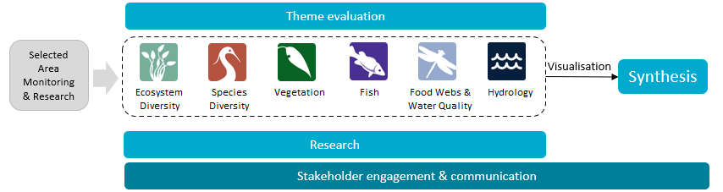
Figure 2 The 7 Selected Areas (left map) and 25 valleys (right map) established for long-term monitoring of the impacts of environmental watering under the Long Term Intervention Monitoring and Flow-MER (2014–15 to present)
In the valleys map, shaded grey shows the 19 valleys where the Commonwealth holds water entitlements and which are in scope for evaluation; white identifies those valleys which are not in scope for evaluation.
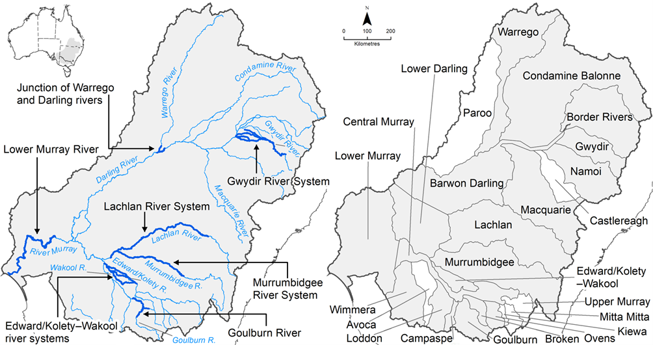

Evaluating the contribution of Commonwealth environmental water to observed environmental outcomes
To undertake the Basin-scale evaluation, the Basin-scale evaluation team uses water delivery and outcomes data provided by the CEWH’s Science Program, along with monitoring data provided by the 7 Selected Areas. Other publicly available data may be used where the relevant data are not collected by the Selected Areas.
Evaluation of the contribution of CEW to observed environmental outcomes for the 6 Basin Themes depends on the data available.
When delivered with other water, ecological outcomes cannot be apportioned with current methods, and CEW is reported as contributing to, or supporting, the environmental outcomes of the watering action.
The multi-year Hydrology (instream), Fish and Vegetation Basin Themes have sufficient data to model and compare environmental outcomes, both with and without CEW (counterfactual modelling).
Ecosystem Diversity, Species Diversity and Vegetation Basin Themes identify environmental responses in locations that received CEW (often in conjunction with other sources of environmental or non-environmental water) and, where feasible, compare with areas that did not receive CEW.
Hydrology (inundation) and Food Webs and Water Quality Basin Themes use flow and water quality metrics to infer likely outcomes.
Fish (annual), Vegetation (annual), and Food Webs and Water Quality Basin Themes synthesise findings across Selected Areas.

Partnering on watering actions
Commonwealth environmental water is often delivered in conjunction with other environmental water holdings and non-environmental water releases (such as for irrigation or during high-flow events).
Commonwealth environmental watering actions for the most recent evaluation year (2023–24) and cumulative over the 10 evaluation years (2014–15 to 2023–24) are provided in Table 1.
Table 1 Summary statistics for most recent evaluation year and multi-year evaluation period
Dash (–) indicates statistic not available
 | 2023–24 | 2014–24
Volume of CEW actions (GL) | 2,870 | 18,310
Number of CEW actions | 114 | 1,194
% CEW volume of total EW volume | ~70% | –
% of CEW actions with partners or with other flows | ~50% | –
CEW % of total volume of partnered watering actions | ~50% | –
CEW % of total Basin surface water runoff | ~13% | –

Evaluation reporting
Each Theme prepares a technical evaluation report for each water year, from which key outcomes and lessons for adaptive management are brought together, with research highlights, into an annual Synthesis report. To provide consistency over the life of Flow-MER and its predecessors, some content in these annual reports may be reused from previous years. In these cases, all efforts have been made to cite the relevant Long Term Intervention Monitoring Project, Environmental Water Knowledge and Research Project or Flow-MER publication. All reports published by the CEWH are available from the CEWH's publications and resources webpage.

Basin-scale Flow-MER partnership
Basin-scale evaluation in Flow-MER is led by CSIRO in partnership with the University of Canberra. Collaborators on the 2023–24 evaluation include Alluvium, Arthur Rylah Institute, Charles Sturt University, South Australian Research & Development Institute, NSW Department of Primary Industries and Regional Development, the Australian River Restoration Centre and Brooks Ecology & Technology.
2025 is the final year of this 5-year phase of Flow-MER. This is the final evaluation under this phase. The next 5-year phase commenced on 1 July 2024 and is led by CSIRO in partnership with the One Basin Cooperative Research Centre. Information on the new phase of Flow-MER can be found at the CEWH's science programs website.

Contents
Executive summary iii
Water year 2023–24 iii
Water years 2014–24 iv
Key contributions to Basin Plan objectives vi
Informing adaptive management vii
Overview of Flow-MER and this 2023–24 evaluation viii
Evaluating the contribution of Commonwealth environmental water to observed environmental outcomes ix
Partnering on watering actions ix
Evaluation reporting ix
Basin-scale Flow-MER partnership ix
1 Introduction 1
1.1 Background 1
1.2 Evaluation objectives 2
1.3 Evaluation coverage 4
1.4 About this report 6
2 Overview of approach and methods 7
2.1 Conceptual model 8
2.2 Evaluation method 9
3 Data 11
3.1 Rainfall 11
3.2 Hydrology 12
4 Basin-scale evaluation 2023–24 15
4.1 Key findings 15
4.2 Commonwealth environmental watering actions for fish 16
4.3 Contribution of Commonwealth environmental water to sustaining native fish 18
5 Basin-scale evaluation 2014–24 21
5.1 Key findings 21
5.2 Contribution of Commonwealth environmental water to sustaining native fish 21
6 Contribution to Basin Plan objectives 51
6.1 Strategy outcome: No loss of native species currently present within the Basin 52
6.2 Strategy outcome: Improved population structure of key fish species through regular recruitment 52
6.3 Strategy outcome: Increased movement of key fish species 54
6.4 Strategy outcome: Expanded distribution of key fish species and populations in the northern and southern Basin 55
6.5 Strategy outcome: Improved community structure of key native fish species 55
7 Informing adaptive management 57
7.1 Informing the planning and management of environmental water for fish 57
7.2 Improving our approach to Basin-scale evaluation 58
8 Discussion 62
Appendix A Flow details and metrics 70
Appendix B Reported fish-death events or hypoxic events in the Selected Areas 74
Appendix C Summary of 2023–24 Commonwealth environmental watering actions for fish within Selected Areas 75
Appendix D Monitoring Data Management System data used for evaluation 86
Appendix E Catch per unit effort of adult fish species across Selected Areas 87
Appendix F Catch per unit effort of larval fish species across Selected Areas 93
Appendix G Recruitment 96
Appendix H Statistical analyses 107
Abbreviations and terms 120
References 121

Figures
Figure 1 Schematic of the components of the Basin-scale evaluation viii
Figure 2 The 7 Selected Areas (left map) and 25 valleys (right map) established for long-term monitoring of the impacts of environmental watering under the Long Term Intervention Monitoring and Flow-MER (2014–15 to present) viii
Figure 1.1 Map of the Murray–Darling Basin showing the 2023–24 sampling sites within the 6 Selected Areas, focusing on fish responses to flows and extent of Commonwealth environmental water deliveries to Selected Areas in 2023–24 5
Figure 2.1 Schematic of the evaluation approach 8
Figure 3.1 Maps of annual rainfall conditions, 2014–24 12
Figure 3.2 Average flow metrics (standardised daily flows, number of days of low flow, coefficient of variability in daily flows and standardised maximum antecedent flow), by Selected Area, 2014–24 13
Figure 3.3 Gauge plot showing flows for 2023–24 compared to previous flow years 14
Figure 4.1 Total volume and number of Commonwealth environmental watering actions with expected outcomes for fish, 2014–24 17
Figure 4.2 Number of Commonwealth environmental watering actions with expected outcomes for fish and flow components, 2023–24 17
Figure 5.1 Map of the Murray–Darling Basin showing the magnitude of Commonwealth environmental water effects on flow metrics (small panels) and the predicted positive fish responses from Commonwealth environmental watering based on counterfactual modelling (larger panels) for each Selected Area, over the period 2014–24 25
Figure 5.2 Predicted effect of Commonwealth environmental water on spawning likelihood for silver perch and golden perch, by Selected Area, over the period 2014–24. 27
Figure 5.3 Contribution of each flow variable (median standardised flows in 30 days, change in daily flow in 7 days, number of days of increasing flow in 7 days) to the predicted Commonwealth environmental water effect on spawning likelihood of golden perch and silver perch, over the period 2014–24 28
Figure 5.4 Predicted effect of Commonwealth environmental water on recruitment rates for each focal fish species, excluding Australian smelt, by Selected Area, over the period 2014–24 30
Figure 5.5 Predicted effect of Commonwealth environmental water on recruitment rates for each focal fish species, including Australian smelt, by Selected Area, over the period 2014–24. 31
Figure 5.6 Contribution of each flow variable (coefficient of variability in daily flows, number of days of low flow, standardised maximum antecedent flow and standardised daily flows) to the predicted Commonwealth environmental water effect on recruitment for each focal fish species, by year and Selected Area, over the period 2014–24 32
Figure 5.7 (A) Recruitment strength estimates for golden perch in Lower Murray River; (B) daily flow for Lower Murray River; and (C) relating recruitment strengths to flow conditions 34
Figure 5.8 Predicted effect of Commonwealth environmental water on frequency of occurrence across sampling sites within Selected Areas for each focal fish species, by Selected Area, over the period 2014–24 37
Figure 5.9 Contribution of each flow variable (coefficient of variability in daily flows, number of days of low flow, standardised maximum antecedent flow and standardised daily flows) to the predicted Commonwealth environmental water effect on frequency of occurrence for each focal fish species, by year and Selected Area, over the period 2014–24 38
Figure 5.10 Predicted effect of Commonwealth environmental water on population growth rate for each focal fish species, by Selected Area, over the period 2014–24 40
Figure 5.11 Contribution of each flow variable (coefficient of variability in daily flows, number of days of low flow, standardised maximum antecedent flow and standardised daily flows) to the predicted Commonwealth environmental water effect on population growth rates for each focal fish species, by year and Selected Area, over the period 2014–24 41
Figure 5.12 Predicted effect of Commonwealth environmental water on body condition for each focal fish species, by Selected Area, over the period 2014–24 43
Figure 5.13 Contribution of each flow variable (coefficient of variability in daily flows, number of days of low flow, standardised maximum antecedent flow and standardised daily flows) to the predicted Commonwealth environmental water effect on body condition for each focal fish species, by year and Selected Area, over the period 2014–24 44
Figure 5.14 Predicted effect of Commonwealth environmental water on the community compositional metric (as percentage change of the proportion of catch that was native), by year and Selected Area, over the period 2014–24 46
Figure 5.15 Contribution of each flow variable (coefficient of variability in daily flows, number of days of low flow, standardised maximum antecedent flow and standardised daily flows) to the predicted Commonwealth environmental water effect on the community compositional metric (the proportion of catch that was native), by year and Selected Area, over the period 2014–24 47
Figure 5.16 Map of the Murray–Darling Basin showing the predicted Commonwealth environmental water contribution to recruitment rates for Murray cod across the Basin 49
Figure 5.17 Map of the Murray–Darling Basin showing the predicted Commonwealth environmental water contribution to recruitment rates for Murray–Darling rainbowfish across the Basin 50

Figure A.1 Average flow (ML/day on log scale) for key gauged sites in each Selected Area over the period 2014–24, showing observed flow with Commonwealth environmental water and modelled flow without Commonwealth environmental water 73
Figure C.1 Volume of Commonwealth environmental watering actions with expected outcomes for fish and flow components, 2023–24 85
Figure E.1 Abundance (catch per hour of electrofishing) of 7 large-bodied native fish species in each Selected Area for each year, 2014–24 90
Figure E.2 Abundance (catch per number of nets deployed) of 6 small-bodied native fish species in each Selected Area for each year, 2014–24 91
Figure E.3 Abundance (catch per hour of electrofishing or number of nets deployed) of 5 exotic fish species in each Selected Area for each year, 2014–24 92
Figure F.1 Larval abundance of large-bodied native fish species in each Selected Area over the period 2014–24 94
Figure F.2 Larval abundance of small-bodied native fish species in each Selected Area over the period 2014–24 95
Figure G.1 Length–frequency histogram of golden perch, by Selected Area and water year, over the period 2014–24 98
Figure G.2 Length–frequency histogram of Murray cod, by Selected Area and water year, over the period 2014–24 99
Figure G.3 Length–frequency histogram of bony herring, by Selected Area and water year, over the period 2014–24 100
Figure G.4 Length–frequency histogram of common carp (exotic species), by Selected Area and water year, over the period 2014–24 101
Figure G.5 Length–frequency histogram of Australian smelt, by Selected Area and water year, over the period 2014–24 103
Figure G.6 Length–frequency histogram of carp gudgeon, by Selected Area and water year, over the period 2014–24 104
Figure G.7 Length–frequency histogram of Murray–Darling rainbowfish, by Selected Area and water year, over the period 2014–24 105
Figure G.8 Length–frequency histogram of eastern gambusia (exotic species), by Selected Areas and water year, over the period 2014–24 106
Figure H.1 Estimated effect (as percentage change) of each flow variable on spawning rates for each species 116
Figure H.2 Estimated effect (as percentage change) of each flow variable on recruitment rates for each species 116
Figure H.3 Estimated effect (as percentage change) of each flow variable on frequency of occurrence for each species 117
Figure H.4 Estimated effect (as percentage change) of each flow variable on population growth rate for each species 117
Figure H.5 Estimated effect (as percentage change) of each flow variable on body condition for each species 118
Figure H.6 Estimated effect (as percentage change) of each flow variable on community metric 119

Tables
Table 1 Summary statistics for most recent evaluation year and multi-year evaluation period ix
Table 1.1 Commonwealth environmental watering actions with fish objectives in 2023–24, by valley 6
Table 2.1 Fish species collected in Flow-MER adult fish population surveys across all Selected Areas between 2014 and 2024 and key freshwater species as identified by the Basin-wide environmental watering strategy 10
Table 3.1 Observed average daily flows and low flow thresholds for each Selected Area over the survey period, 2014–24 13
Table 5.1 Positive contributions of Commonwealth environmental water to native fish populations detected in Selected Areas, 2014–24 23
Table 5.2 Number of adult native species recorded in each Selected Area for each year, 2014–24, from Category 1 fish sampling 35

Table A.1 Streamflow gauges for each Selected Area 70
Table A.2 Description of annual flow metrics and other descriptive metrics used in analyses 70
Table A.3 Description of event-based flow metrics and other descriptive metrics for use in larval analyses 72
Table B.1 Reported fish-death events or hypoxic events in the Selected Areas 74
Table C.1 Commonwealth environmental watering actions in 2023–24 with expected outcomes for fish, by valley and total volume 75
Table C.2 Summary of results from monitored watering actions with expected outcomes for fish in 2023–24 at Selected Areas 80
Table D.1 Summary of data from the Monitoring Data Management System used for evaluation analyses 86
Table E.1 Adult native fish species detected in Selected Areas over the period 2014–24 89
Table G.1 Length thresholds used for assigning new recruits for large-bodied fish species for Selected Areas 97
Table H.1 Terms and variables used in the model structure 107
Table H.2 Summary of statistical analyses: model type, relevant species and response variables, grouped by objective 108
Table H.3 Estimate of the Commonwealth environmental water effect on population processes for each focal speciesSho 109

Introduction
This chapter summarises the purpose of the evaluation, the locations within the Murray–Darling Basin (the Basin) where native fish have been evaluated, and the structure of this report.

Background
Native fish in the Basin contribute significantly to ecological, social, cultural and economic values (MDBA 2019). However, native fish populations have declined substantially in the last 100 years (Lintermans 2007) due to multiple causes, including altered flow regimes, barriers to fish movement, the introduction of exotic species and overfishing (Koehn et al. 2020). One of the major threats to native fish populations is alteration to natural hydrology (i.e. flow volume, distribution changes, seasonality) and hydraulic regimes (i.e. water velocity, depth, turbulence). Together, these are known as the ‘flow regime’ (Mallen-Cooper and Zampatti 2018; Thompson et al. 2018). The Basin is recognised as one of the world’s most regulated river basins (Nilsson et al. 2005), and alterations to the Basin’s natural flow regimes have resulted in major changes to riverine ecosystems, including changes to the magnitude, timing, frequency and duration of flow events such as floods, and major changes to hydraulics, often causing loss of lotic (flowing) habitats (Bunn and Arthington 2002; Poff et al. 1997).
Many of the critical life-history processes for fish (e.g. pre-spawning condition and maturation, spawning cues and movements, larval and juvenile dispersal, growth and survival) are linked either directly or indirectly to the flow regime (Koehn et al. 2020; Mallen-Cooper and Zampatti 2018; Stoffels et al. 2016; Tonkin et al. 2019; Tonkin et al. 2021). In the Basin, the delivery of environmental water is a key approach to supporting critical life-history processes and sustaining and restoring native fish populations (MDBA 2019; Stuart et al. 2019; Tonkin et al. 2020). Evaluating these life-history processes can help us understand the contributions of environmental flows for native fish to achieving the biodiversity outcomes sought by the Commonwealth’s (Murray–Darling) Basin Plan 2012 (the Basin Plan) and Basin-wide environmental watering strategy (the Strategy; MDBA 2019).
Flow-MER is the Commonwealth Environmental Water Holder’s (CEWH) Monitoring, Evaluation and Research Program. Its objective is to monitor and evaluate ecological responses to the delivery of Commonwealth environmental water (CEW) in the Basin. From 2014–15 to 2023–24 (abbreviated here to 2014–24), the CEWH delivered 18,310 GL of CEW to rivers, wetlands and floodplains of the Basin for a broad range of outcomes in line with the 10-year monitoring program (Sengupta et al. 2025). In 2023–24, 2,870 GL of CEW was delivered through 114 independent watering actions (Sengupta et al. 2025). Of this, 99 watering actions, comprising 2,708 GL, had expected outcomes associated with fish.
This report presents an evaluation of fish outcomes from the use of CEW over the short term (2023–24) and longer term (2014–24). There are 7 Selected Areas studied in Flow-MER, of which 6 have a fish monitoring focus using standardised methods. It is important to note that our evaluation does not examine the specific 99 watering actions that had expected outcomes associated with fish but encompasses a much broader view of all possible contributions of CEW to fish populations. For example, if CEW is delivered to benefit a wetland complex, this water delivery will also achieve outcomes (positive or negative) en route via the flow pathway by which it is delivered, even if there are no specified expected outcomes associated with fish within those reaches. Our evaluation captures this.

Evaluation objectives
The overarching Flow-MER evaluation question for fish was:
What did Commonwealth environmental water contribute to sustaining native fish at the Basin scale?
This report presents an evaluation of fish outcomes from the use of CEW over the 2023–24 water year and the 2014–24 water years collectively. The 2023–24 Basin-scale evaluation comprises:
- a summary of Commonwealth environmental watering actions with expected fish outcomes across all regions/assets
- a synthesis of 2023–24 Selected Area findings from Selected Area annual reports, examining trends to support Basin-scale understanding of the influence of Commonwealth environmental watering actions across the Selected Areas.
The 2014–24 Basin-scale evaluation consists of quantitative analysis of the fish monitoring data collected between 2014–15 and 2023–24 to determine the contribution of CEW to sustaining fish populations.
In this evaluation, Commonwealth environmental water contribution is defined as any positive effect on fish responses and includes the degree of confidence around that effect. Commonwealth environmental water is defined separately from other contributors of environmental water and non-environmental water.
In terms of spatial scale, ‘Basin scale’ is defined as an ecological response across multiple river catchments and does not necessarily imply analysis of flow responses at the spatial extent of the entire Basin (Stoffels et al. 2016). In the evaluation, Basin scale is defined as the analysis of monitoring data from the 6 Selected Areas where fish outcomes are being assessed.
The approach to the 2014–24 evaluation follows the strategy developed using the foundation report (Stoffels et al. 2016) and updates (Barbour et al. 2021; Cuddy et al. 2022; King 2019; Stuart et al. 2020) and as applied in the previous annual Basin-scale evaluation reports (Hladyz et al. 2021, 2022, 2023, 2024; King et al 2020). Refinements to better reflect objectives are summarised below.
A series of metrics used to represent (i) key aspects of the flow regime that influence fish and (ii) fish population processes – such as spawning occurrence, recruit abundance and individual body condition – were reviewed for the evaluation to identify the most ecologically sensitive and meaningful flow–ecology relationships (see hypotheses in Table A.2 and Table A.3). These were informed by watering plans and objectives (e.g. VEWH 2020) and by similar evaluations such as the Victorian Environmental Flows Monitoring and Assessment Program (VEFMAP) and contemporary research (Koster et al. 2021; Stoffels et al. 2020; Stuart et al. 2019; Tonkin et al. 2020; Tonkin et al. 2019; Tonkin et al. 2021; VEWH 2020). These flow and fish metrics were used to measure how CEW contributed to sustaining native fish populations.
Answering the evaluation question comprehensively requires isolating the contribution of CEW from other aspects of the hydrological regime. For the 2014–24 evaluation, we used quantitative models in a stepped approach to determine the contribution of CEW to fish populations. First, quantitative models were developed using the observed fish responses to key attributes of the flow regime (that are also influenced by CEW), based on the data collected from the 10 years of monitoring in the 6 Selected Areas. This approach used data on local flows in the river system and environmental conditions that fish populations encounter across Selected Areas (e.g. relating fish populations to observed flow conditions – this includes flow data recorded from gauges that encompass all environmental and non-environmental water). Second, predictive models informed by the observed fish responses were developed to separate the effects of CEW from the effects of background hydrological variability using flow scenarios with and without CEW (the ‘counterfactual’ scenario). This approach provides information on how fish population dynamics would have differed had CEW not been delivered into a river system.
Answering the key evaluation question also requires information on what CEW achieved at the wider Basin scale (i.e. spatial extent of the Basin). This means that findings from the Selected Areas must be extrapolated to predict fish responses in unmonitored areas and to hypothesised flow scenarios (King 2019; King et al. 2020), both of which have presented a challenge over the duration of Flow-MER and its predecessor, the Long Term Intervention Monitoring Project (LTIM).
While predictive Basin-scale fish population models are needed in the future, developing these for the current evaluation has not been possible in the early stages of the program for several reasons related to both technical and conceptual limitations. These include the small number of replicate flow years (10), non-random selection of the location of the Selected Areas, limited coverage of the northern Basin (represented by only the Gwydir River System), low abundances of many native fish species, and other confounding modifiers of population dynamics (e.g. fish stocking, recreational fishing, fish-death events). These limitations make it difficult to estimate responses to CEW under higher flows (e.g. large fresh events and overbank flows) (King 2019; King et al. 2020), resulting in high uncertainty in any extrapolations beyond the Selected Areas.
Nevertheless, the use of predictive models can speed up the learning process – monitoring data can take many years to collect and evaluate, while predictive modelling can be essentially a desktop-based activity with lower cost and time investment (Moxham et al. 2020). Predictive models can also be validated and model predictions improved as new monitoring data are collected. As Flow-MER datasets continue to accrue, we are starting to develop preliminary Basin-scale predictive models. We present a case study on Murray cod (Maccullochella peelii) and Murray–Darling rainbowfish (Melanotaenia fluviatilis) recruitment to demonstrate how the contribution of CEW could be predicted at unmonitored gauges across the Basin, once sufficient fish and flow data are available. However, note that the current model predictions are associated with low confidence due to being extrapolated beyond Selected Areas without independent validation.
The evaluation contribution to Basin Plan objectives and the Strategy (MDBA 2019) outcomes are discussed in Chapter 6, and the lessons learned for adaptive management are discussed in Chapter 7. This Basin-scale evaluation for the 2023–24 water year, and 2014–24 water years collectively, aimed to:
- determine the influence of flow on measures (spawning occurrence, recruitment, frequency of occurrence, population growth rate, fish condition) that inform whether fish populations and community diversity are being sustained in 6 Selected Areas
- determine the contribution of CEW to the observed fish responses and answer the following questions. Did CEW contribute to:
  - increased likelihood of spawning?
  - increased recruitment?
  - increased frequency of occurrence within Selected Areas?
  - increased population growth rates?
  - increased individual body condition?
  - increased proportion of catch that was native (community response)?
- Predict the potential contribution of CEW to Murray cod and Murray–Darling rainbowfish recruitment to demonstrate how the contribution of CEW could be predicted at unmonitored gauges across the Basin.

Evaluation coverage
The Basin-scale evaluation uses data collected from the 6 Selected Areas – the Edward/Kolety–Wakool river systems, Goulburn River, Gwydir River System, Lachlan River System, Lower Murray River and Murrumbidgee River System (Figure 1.1) – where fish are a target indicator. The seventh Selected Area – the Junction of Warrego and Darling rivers – does not have a designated targeted indicator for fish and historically has not been included in Basin-scale fish analyses. Preliminary investigations were made into the feasibility of incorporating fish data from this Selected Area into the longer-term evaluation (and quantitative analysis) but, due to differences in field-collection methods and data inconsistencies, this was not possible for the current report. General fish outcomes are still reported for this Selected Area in the 2023–24 evaluation based on findings from the 2023–24 Selected Area annual report (Mika et al. 2024a).
The Flow-MER Research theme project (F1: Fish population models) provides further insight into regional and Basin-scale fish responses to flows using population modelling.
Reference to findings from the research reports are included to provide context for the evaluation. The modelling underpinning these research initiatives aims to contextualise and investigate the transferability of flow metrics and models of environmental flow benefits for native fish populations across the Basin (Thiem et al. 2022b; Todd et al. 2023).
There were 99 Commonwealth environmental watering actions with fish objectives delivered across the Basin in 2023–24. The total amount of water delivered for fish objectives was 2,708,371 ML, delivered across 17 valleys (Table 1.1). Of this total, 45 watering actions totalling 2,022,718 ML of CEW was delivered to the 6 valleys in which the Selected Areas are located and where the fish monitoring occurs.
Figure 1.1 Map of the Murray–Darling Basin showing the 2023–24 sampling sites within the 6 Selected Areas, focusing on fish responses to flows and extent of Commonwealth environmental water deliveries to Selected Areas in 2023–24
Commonwealth environmental water (CEW) delivered instream is delineated by dark blue lines, and CEW delivered to wetlands is delineated by green shapes.
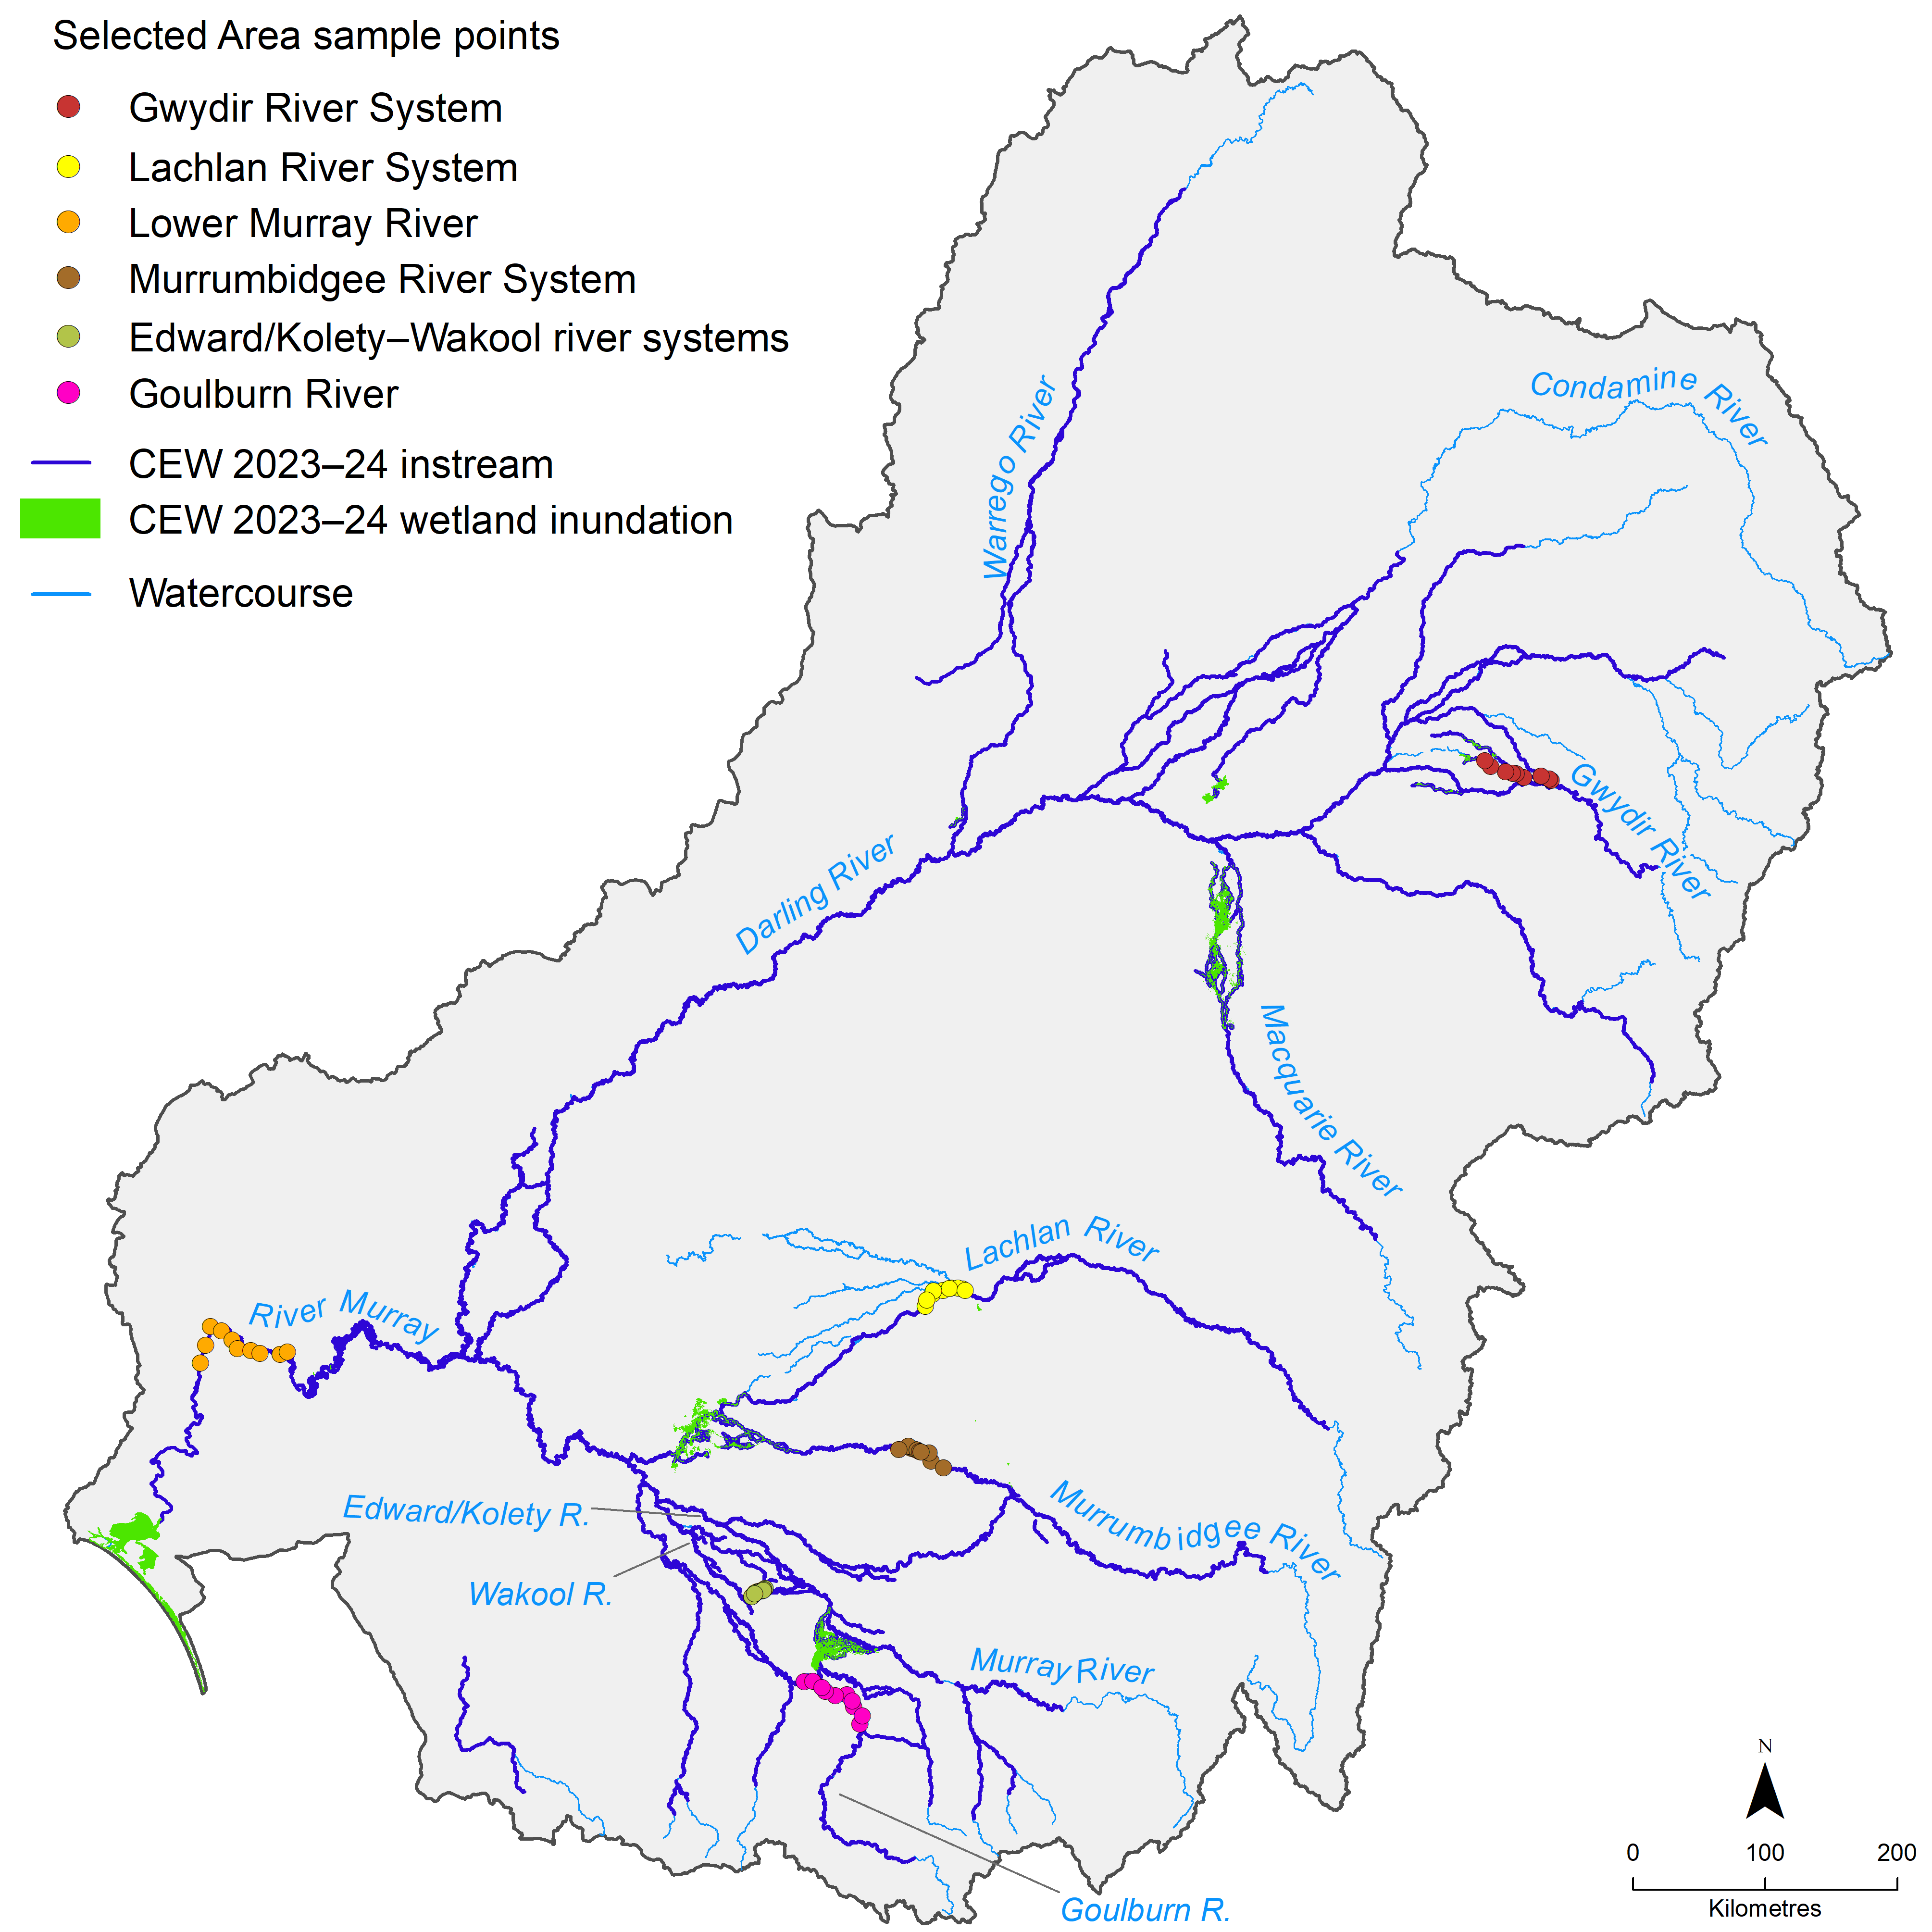
Table 1.1 Commonwealth environmental watering actions with fish objectives in 2023–24, by valley
Asterisk (*) indicates the valley contains a Selected Area; dash (–) indicates a valley that did not have objectives for fish in 2023–24.
Valley | Volume (ML) | Number of actions
Barwon Darling | 63,385 | 4
Border Rivers | 12,061 | 13
Broken | 62,918 | 9
Campaspe | 4,578 | 7
Central Murray | 334,198 | 6
Condamine Balonne | – | –
Edward/Kolety–Wakool* | 158,419 | 14
Goulburn* | 209,621 | 4
Gwydir* | 9,500 | 3
Lachlan* | 1,323 | 2
Lower Darling | 110,834 | 2
Loddon | 3,762 | 3
Lower Murray* | 1,386,114 | 15
Murrumbidgee* | 257,740 | 7
Macquarie | 59,879 | 2
Namoi | 9,279 | 2
Ovens | 123 | 2
Wimmera | 2,762 | 2
Warrego* | 21,876 | 2
Total | 2,708,371 | 99

About this report
The evaluation has been led by the Arthur Rylah Institute in partnership with the broader Basin-scale Fish theme team and Selected Area fish theme leads. This report builds on previous Flow-MER Basin-scale evaluation reports (Hladyz et al. 2021, 2022, 2023, 2024) and reporting undertaken as part of LTIM. The adopted approach and methods are fully described in the companion Methods report (O’Sullivan and Cuddy 2025) and are consistent with methods set out in LTIM and Flow-MER foundation reports (Stoffels et al. 2016) and updates (Barbour et al. 2021; King 2019; Stuart et al. 2020; Cuddy et al. 2022).
Data and analyses that support the evaluation are available in appendices to this report, and some datasets may become available from data.gov.au post publication of this report.

Overview of approach and methods
This chapter provides a high-level overview of the evaluation approach for both the short-term (2023–24) and long-term evaluation (2014–24). Full details are available in the companion methods report (O’Sullivan and Cuddy 2025).
We used a counterfactual modelling approach to determine the contribution of CEW to fish populations for the Basin-scale evaluation. The steps of this approach are outlined below and in Figure 2.1.
- Fish responses are measured in a river system (e.g. fish abundance).
- Flows are measured in a river system (observed flows).
- Using this information, we are able to look at the relationship between flows and fish responses (observed flows).
- We then combine this relationship with a modelled flow scenario without CEW (counterfactual scenario).
- This allows the prediction of fish response without CEW, and the difference between the 2 scenarios (observed flows and counterfactual) allows us to estimate the effect of CEW on fish responses.
Figure 2.1 Schematic of the evaluation approach
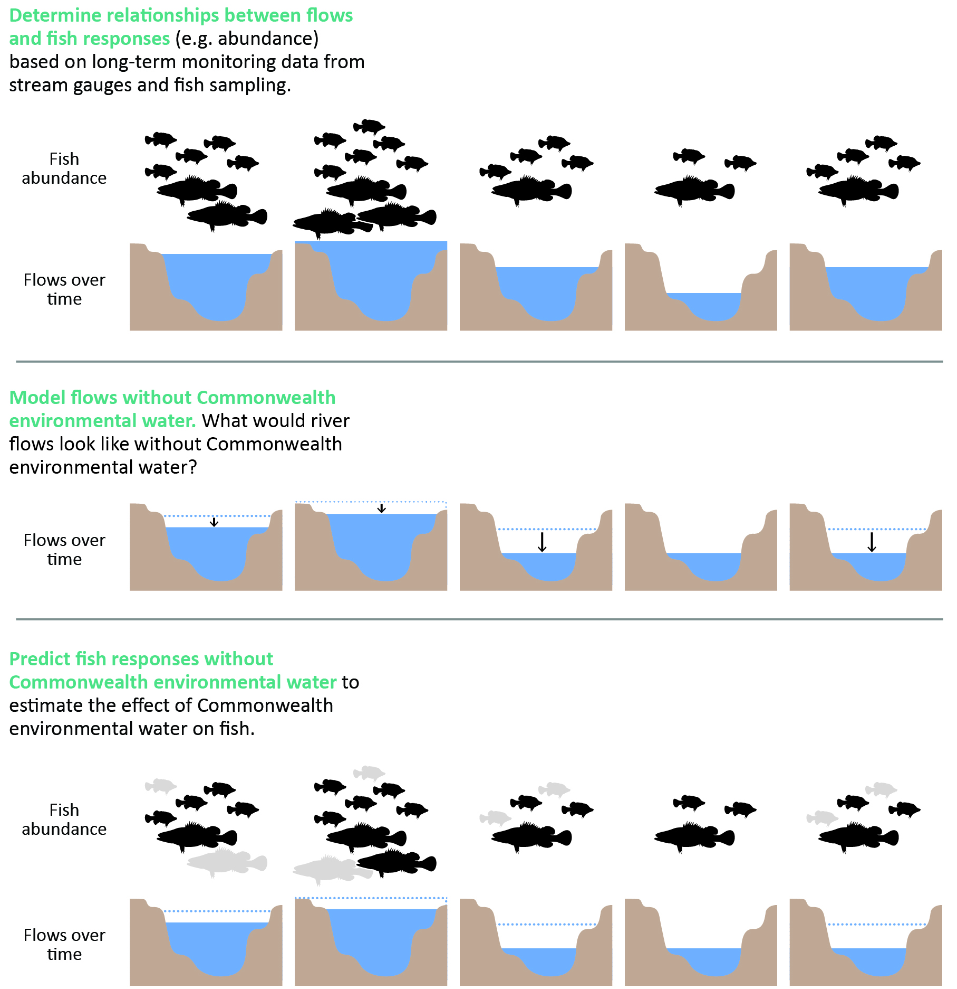

Conceptual model
We used a counterfactual modelling approach to determine the contribution of CEW to fish populations for the Basin-scale evaluation 2014–24 (Figure 2.1). In this approach, quantitative models were used to estimate fish responses to a range of flow predictors that conceptually influence the processes that underpin the dynamics of fish populations (and are also targeted by environmental flows) from the 10 years of monitoring data in the 6 Selected Areas. These quantitative models then were used to predict fish responses under a hydrological scenario without CEW (the counterfactual scenario). This approach separates the effects of CEW from the effects of background hydrological variability and provides an estimate of possible fish population outcomes had CEW not been delivered into a river system.
Observed and counterfactual flow data are useful in environmental flows research and ecosystem management, where observed comparisons with and without an intervention are not always possible (King et al. 2020; Stewardson and Skinner 2018). The use of counterfactual scenarios in impact evaluations can be used to assess the effectiveness of interventions in ecosystem management (Pearl 2000). They can be considered as a reference scenario that describes the possible alternative pathway in an ecosystem that occurs without the intervention implemented (Bull et al. 2021). Caution must be applied when interpreting predicted responses to counterfactual flow because these predictions are susceptible to uncertainty in the counterfactual flow data and (in some cases) errors occur due to extrapolation of fitted models beyond the range of the observed flow data. In addition, it can be difficult to link counterfactual flow sequences to other flow-dependent processes, such as hypoxic events, due to the complexity of causal and contextual factors.

Evaluation method
The aim of this evaluation was to present and analyse fish data collected in 6 Selected Areas in the first 10 years of monitoring. This will extend the learnings from the previous Flow-MER Basin-scale evaluation reports (Hladyz et al. 2021, 2022, 2023, 2024) for the purpose of the primary objective – specifically, to determine the contribution of CEW (and, more broadly, flows and flow regimes) to fish populations in Selected Areas.
A secondary objective was to incorporate a renewed focus on high-level predictive models to investigate fish responses at the wider Basin scale, focusing on how the contribution of CEW could be predicted at unmonitored gauges across the Basin, to provide new insights into recruitment of Murray cod and Murray–Darling rainbowfish. Full details of the evaluation approach and methods can be found in O’Sullivan and Cuddy (2024), and, for further details on analyses, in the technical supplement (Fanson 2025).

Basin-scale evaluation 2023–24
This evaluation consists of:
- a summary of Commonwealth environmental watering actions for expected fish outcomes across all regions and assets for the water year 2023–24
- a synthesis of 2023–24 findings from Selected Area annual reports to report on trends of key population parameters and processes and their links with environmental variables, particularly attributes of streamflow.

Basin-scale evaluation 2014–24
The 2014–24 evaluation consists of a quantitative analysis of fish monitoring data collected annually from 2014–15 to 2023–24. Information on data and metrics and data analysis are described in Chapter 2. The key findings and patterns are described in Chapter 5. It was not feasible to discuss each result, given the variability and context dependence of all the results.
Information on all fish species captured in Flow-MER is provided in this report, and the key freshwater fish species identified by the Strategy are provided in Table 2.1. More detailed analysis is provided for 8 focal fish species identified by Flow-MER – Australian smelt (Retropinna semoni), bony herring (Nematalosa erebi), carp gudgeon (Hypseleotris spp.), common carp (exotic) (Cyprinus carpio), eastern gambusia (exotic) (Gambusia holbrooki), golden perch (Macquaria ambigua), Murray cod and Murray–Darling rainbowfish. Silver perch (Bidyanus bidyanus) was included in the spawning analyses as it is a flow-cued spawner, is prioritised as a key freshwater species in the Strategy, and is listed as threatened under the Australian Environment Protection and Biodiversity Conservation Act 1999 (EPBC Act).
Table 2.1 Fish species collected in Flow-MER adult fish population surveys across all Selected Areas between 2014 and 2024 and key freshwater species as identified by the Basin-wide environmental watering strategy
Asterisk (*) denotes focal fish species as identified by Flow-MER in the Selected Areas. Dagger (†) denotes key freshwater species as identified by the Basin-wide environmental watering strategy (MDBA 2019), excluding estuarine species. Caret (^) denotes exotic species. Double dagger (‡) denotes key freshwater fish species identified by the Strategy that have not yet been detected in Flow-MER adult fish population surveys. Hyrtl’s tandan has been detected in the Junction of Warrego and Darling rivers, but this Selected Area is not included in the evaluation.
Common name
Australian smelt*
Bony herring*
Carp gudgeon*
Common carp*^
Dwarf flathead gudgeon
Eastern gambusia*^
Flathead galaxias†‡
Flathead gudgeon
Freshwater catfish†
Golden perch*†
Goldfish^
Hyrtl’s tandan†‡
Macquarie perch†‡
Murray cod*†
Murray hardyhead†‡
Murray–Darling rainbowfish*
Northern river blackfish†‡
Obscure galaxias
Olive perchlet†
Oriental weatherloach^
Redfin perch^
Rendahl’s tandan†‡
River blackfish†
Silver perch†
Southern purple-spotted gudgeon†‡
Southern pygmy perch†‡
Spangled perch
Trout cod†
Two-spined blackfish†‡
Unspecked hardyhead
Yarra pygmy perch†‡

Data
The evaluation uses Selected Area fish data, collected as part of LTIM (between 2014–15 and 2018–19) and Flow-MER (between 2019–20 and 2023–24) in 6 Selected Areas, and the hydrological data provided by the Basin-scale Hydrology Theme to assess fish responses to flow. The 2023–24 CEWH watering actions summary table was used to prepare summaries of outcomes against watering objectives targeting fish. The evaluation also uses a range of published reports and references to contemporary research to provide context for Selected Area monitoring.

Rainfall
Figure 3.1 depicts the Basin annual rainfall condition for each water year from 2014–15 to 2023–24. The first 2 years (2014–15 and 2015–16) saw particularly dry conditions in the southern Basin. In 2016–17, there were wetter conditions in the southern Basin and along the headwaters of the New South Wales tributaries in the northern Basin. Conditions returned to dry over the period 2017–20 across the whole Basin. In 2020–23, conditions were wetter – average, above average and very much above average conditions were experienced across the Basin. In 2023–24, large areas of the Basin returned to more average rainfall conditions. However, some central areas of the Basin experienced above average to very much above average rainfalls, while other parts of the southern Basin became increasingly dry – conditions in both the headwaters and the South Australian sections of the River Murray changed from very much above average rainfall in 2022–23 to very much below average rainfall in 2023–24.
Figure 3.1 Maps of annual rainfall conditions, 2014–24
Data sourced from the Bureau of Meteorology. The decile rankings (lowest on record to highest on record) are those used by the Bureau. For information on how the deciles are derived, see the Bureau’s Deciles webpage.
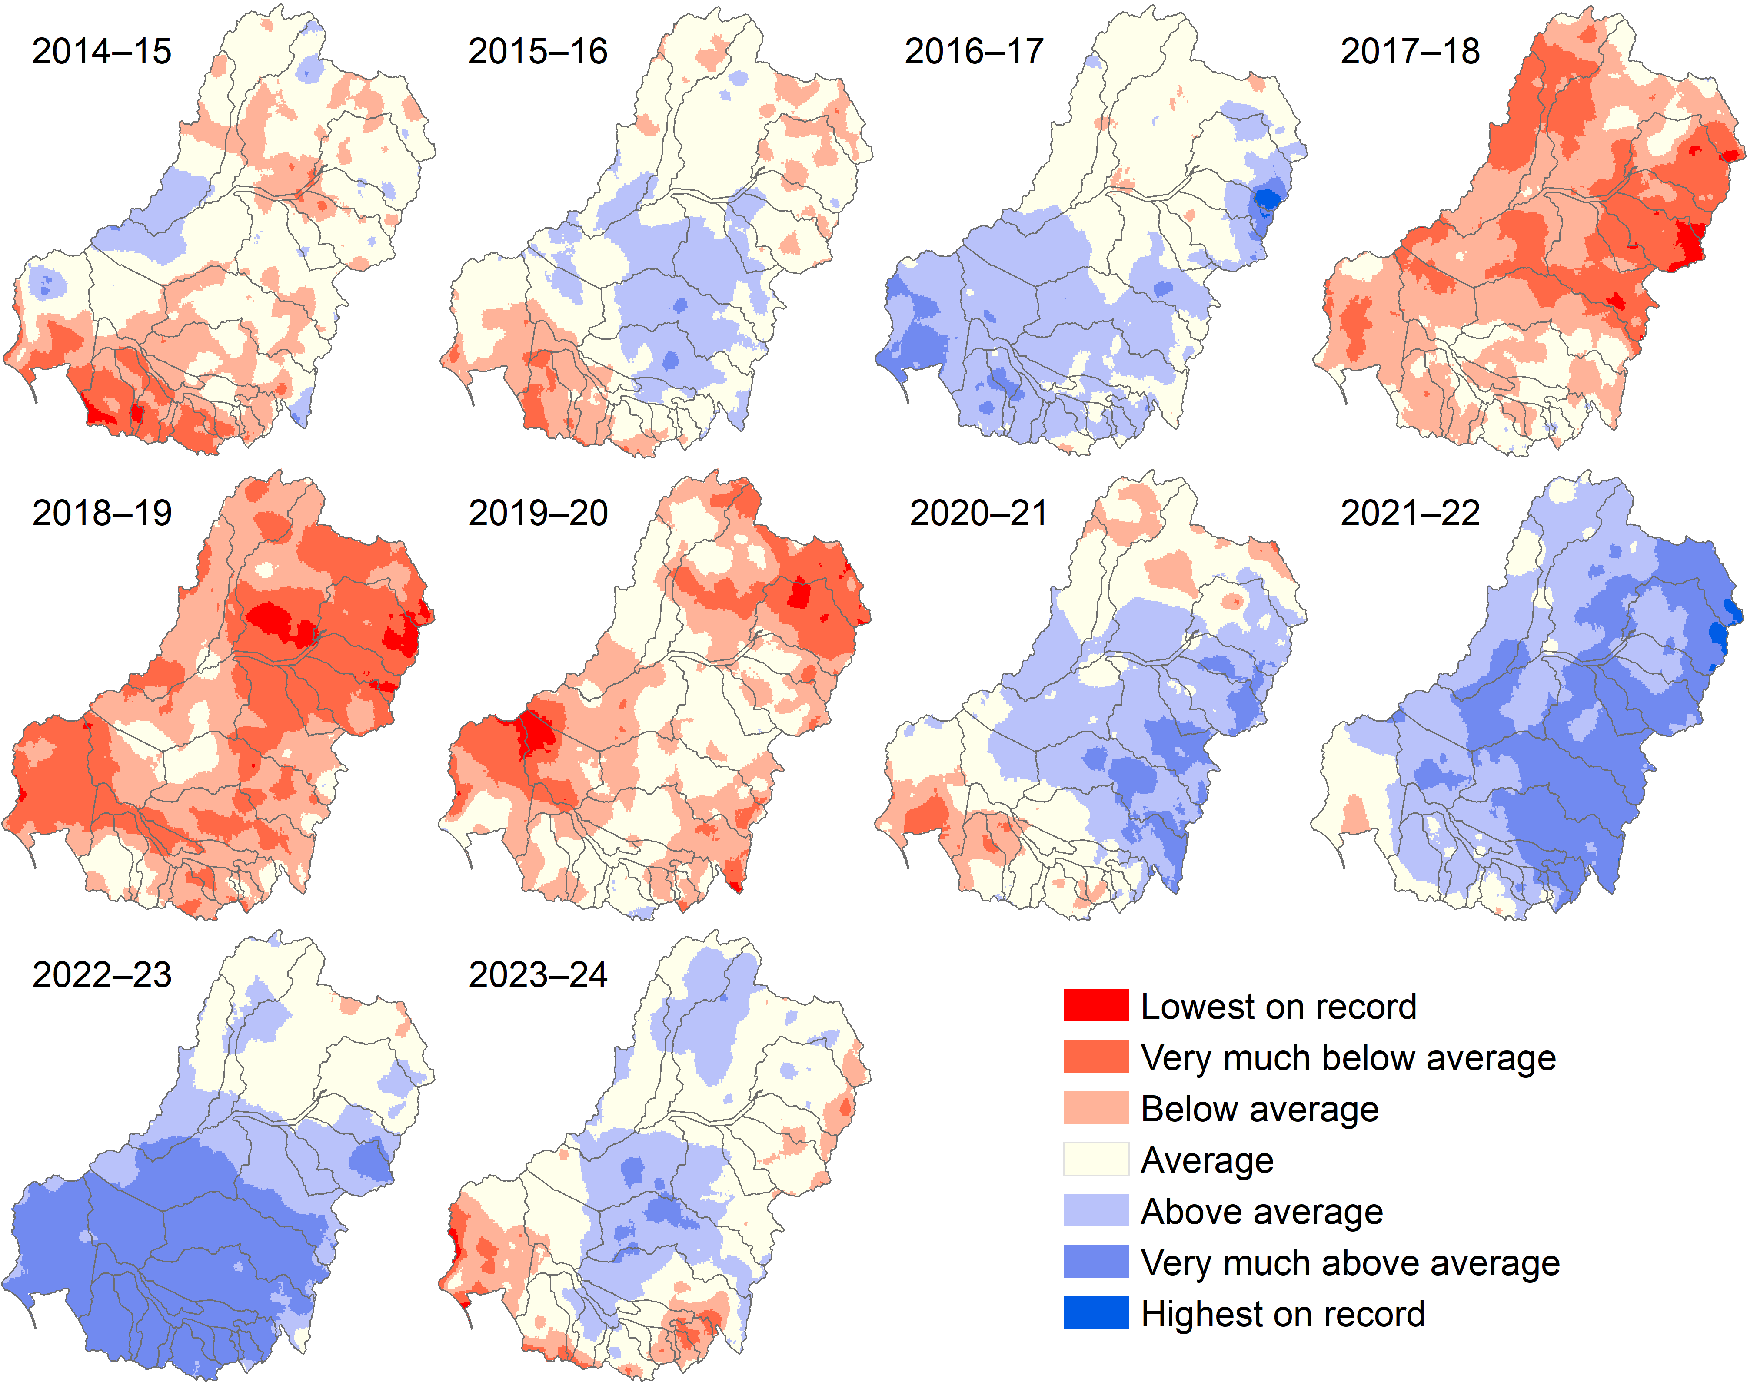

Hydrology
Volumes and timings of flow events varied across the Selected Areas. Flow conditions in Selected Areas were highly regulated. Low flows occurred in 6 of the 10 years, unregulated high flows (and flooding in some areas) in 2016–17, unregulated elevated flows in spring–summer in 2021–22, unregulated high flows and overbank flooding (extensive floodplain inundation in some areas ) in 2022–23, and unregulated high in-stream flows in winter in 2023–24 (in some areas) (Figure A.1). Observed average daily flows and low flow thresholds for each Selected Area over the survey period are shown in Table 3.1. Commonwealth environmental water increased average daily flows in the Selected Areas to varying degrees (Figure 3.2). Without CEW, average daily flows for the water year would have been below the average daily flows calculated over the 10-year survey period for the Lower Murray River, Edward/Kolety–Wakool river systems, Lachlan River System and Goulburn River (Figure 3.2).
For example, without CEW, average daily flows in reaches of the Lower Murray River and Edward/Kolety–Wakool river systems would have decreased by 38% and 21%, respectively. In additions, the delivery of CEW decreased the number of low flows days in the Selected Areas. This was most evident in the Lower Murray River, Goulburn River and Edward/Kolety–Wakool river systems (Figure 3.2). Commonwealth environmental water reduced flow variability in most Selected Areas (Figure 3.2). Maximum antecedent flows did not differ markedly with CEW in Selected Areas (Figure 3.2). This was likely because there were only 3 high flow years that predominantly were due to unregulated natural flows rather than CEW. In 2023–24, the winter flow pulse resulted in some southern Selected Areas having their highest winter mean flow, but northern Selected areas remained drier (Figure 3.3).
Table 3.1 Observed average daily flows and low flow thresholds for each Selected Area over the survey period, 2014–24
Low flow thresholds are calculated as below the 10th percentile of available flow data. Junction of Warrego and Darling rivers is not included in the evaluation. The flow gauge for the Edward/Kolety–Wakool river systems was located on the Wakool River (flow gauge 409045).
Selected Area | Average daily flows (ML/day) | Low flow thresholds (ML/day)
Edward/Kolety–Wakool river systems | 402 | 137
Goulburn River | 1,660 | 889
Gwydir River System | 242 | 36
Lachlan River System | 1,655 | 346
Lower Murray River | 12,033 | 5,534
Murrumbidgee River System | 4,173 | 1,539
Figure 3.2 Average flow metrics (standardised daily flows, number of days of low flow, coefficient of variability in daily flows and standardised maximum antecedent flow), by Selected Area, 2014–24
x-axis is Selected Areas; y-axis is metric value. ‘Observed’ (light blue bar) refers to flow metrics calculated using hydrological data collated from gauged sites across the Basin. Junction of Warrego and Darling rivers is not included in the evaluation. ‘Without CEW’ (Commonwealth environmental water; dark blue bar) refers to the modelled flow data without CEW. Height of each bar is the average, and the whisker boundaries show 10th and 90th percentiles. Average daily flows and maximum antecedent flows are unitless ratios calculated by dividing raw values by the median daily flow from 2014 to 2024. Standardising these metrics enabled broad comparisons among Selected Areas that have different hydrological conditions. The number of days of low flow is recorded in units of days, and flow variability is a unitless coefficient of variability.
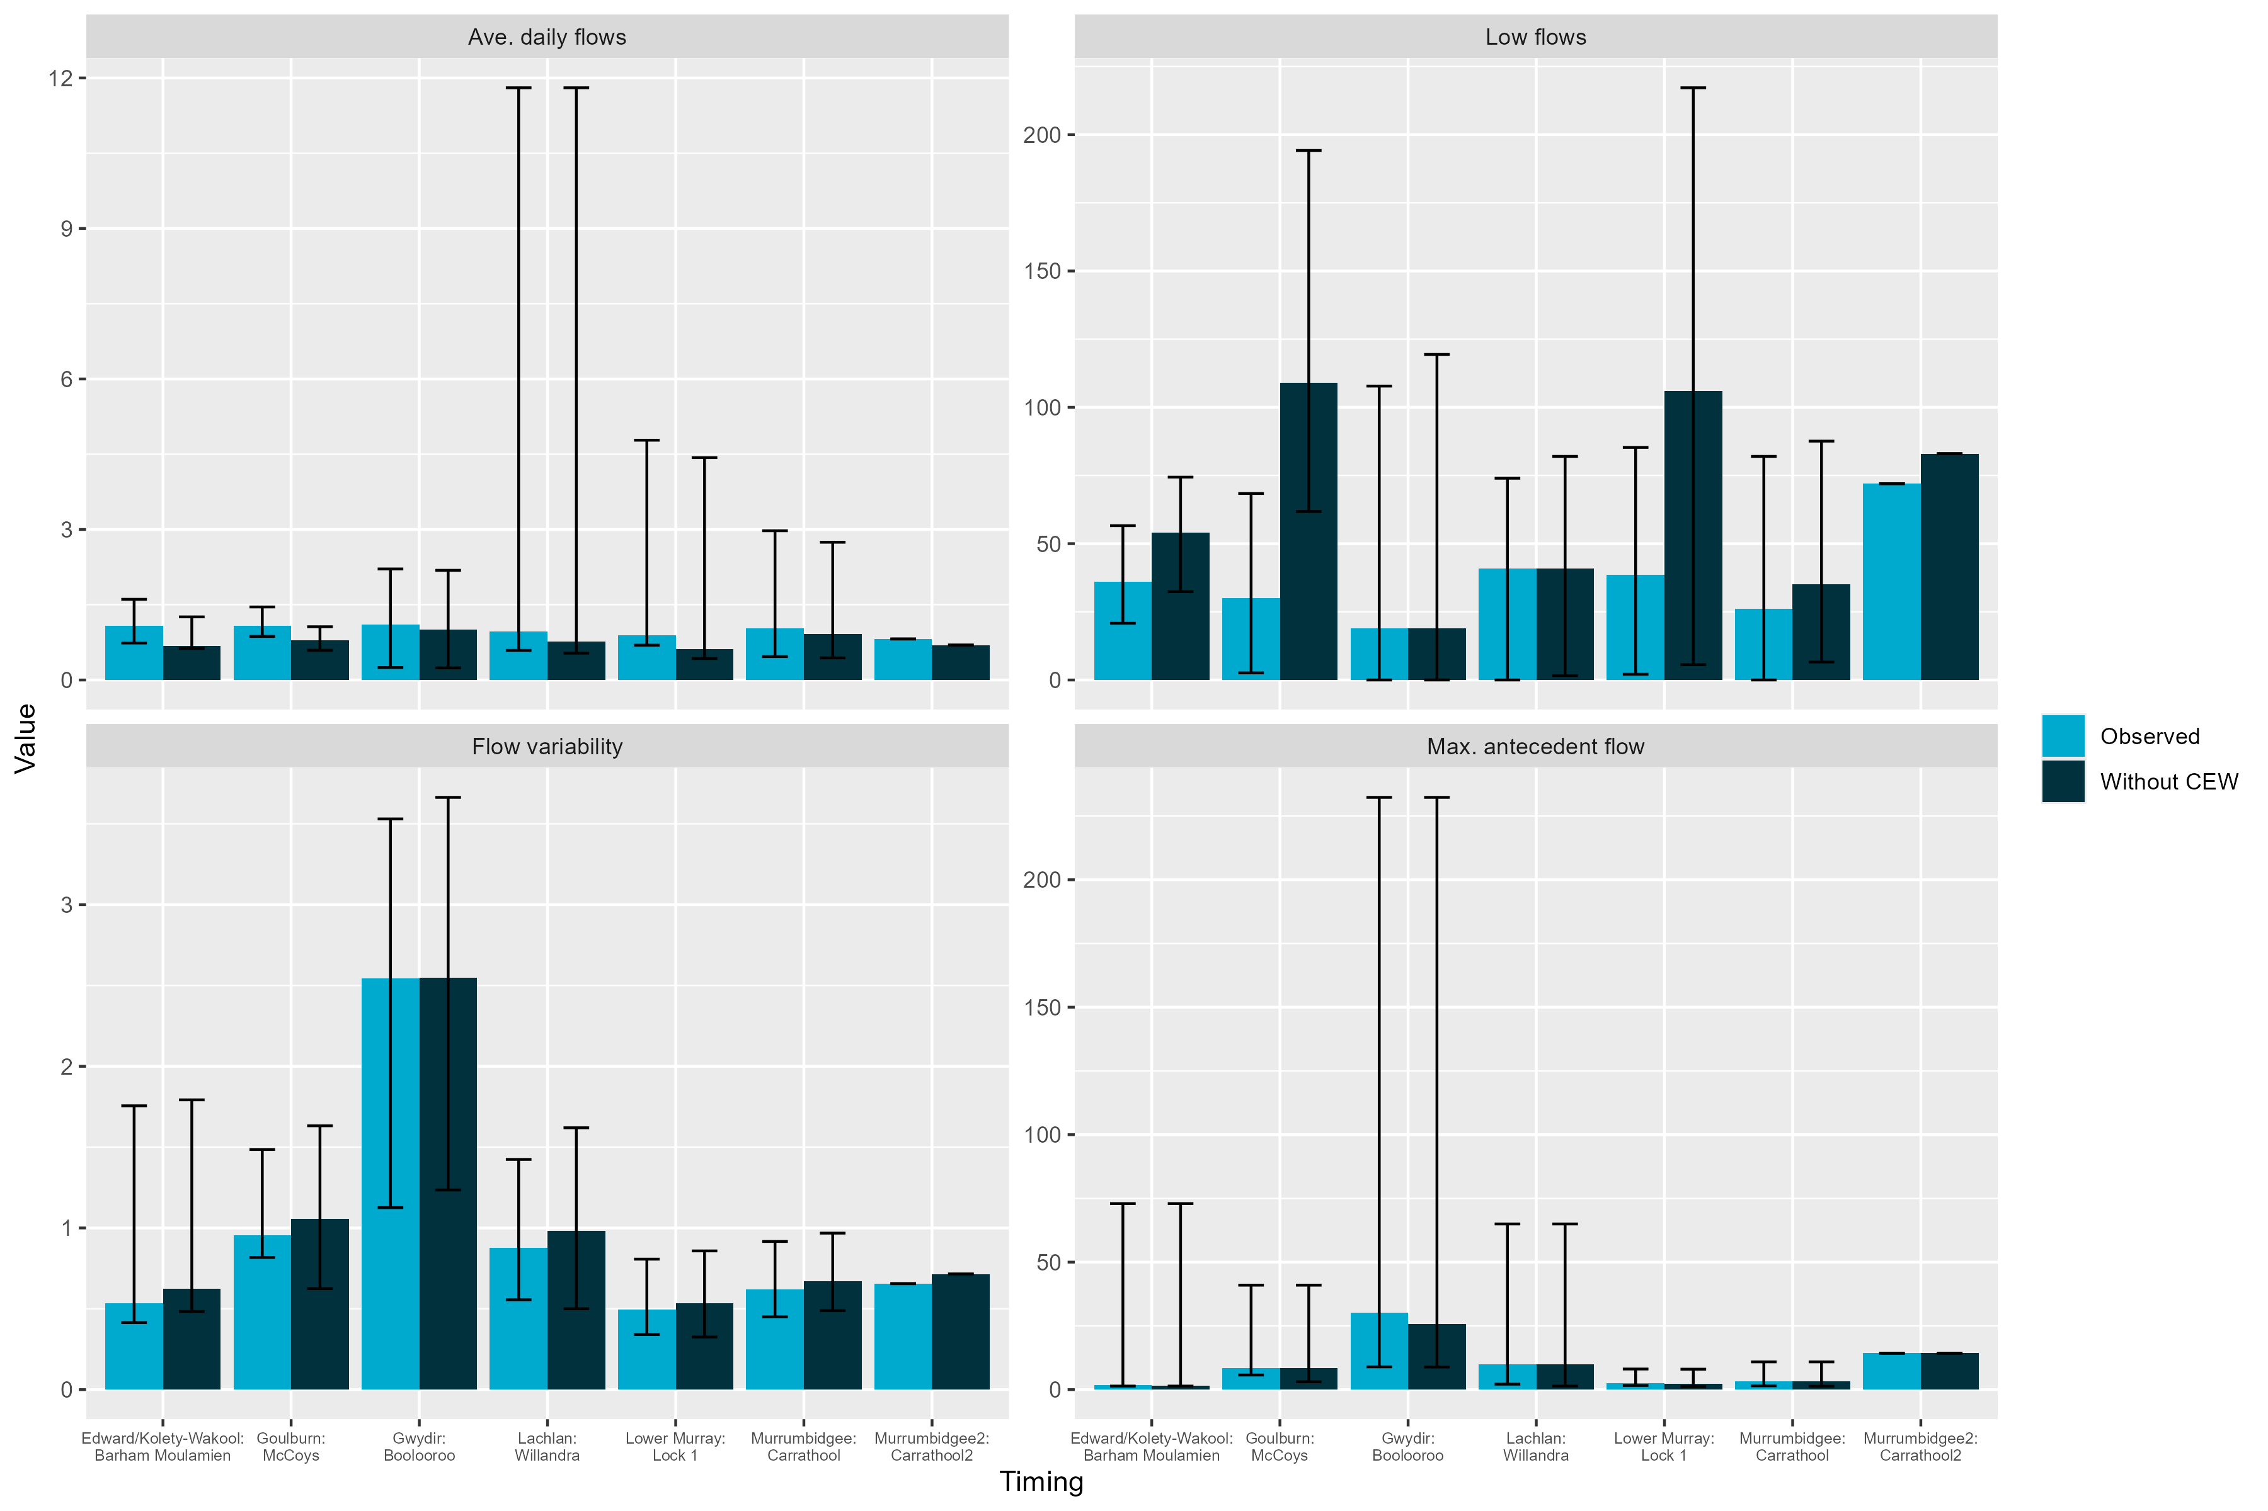
Figure 3.3 Gauge plot showing flows for 2023–24 compared to previous flow years
For each Selected Area, the mean flow for each season is calculated, then the percentage of the maximum flow mean (within 2014 to 2024). Therefore, 100% indicates this year is the maximum (mean) flow recorded during the 10 year monitoring period for that season.
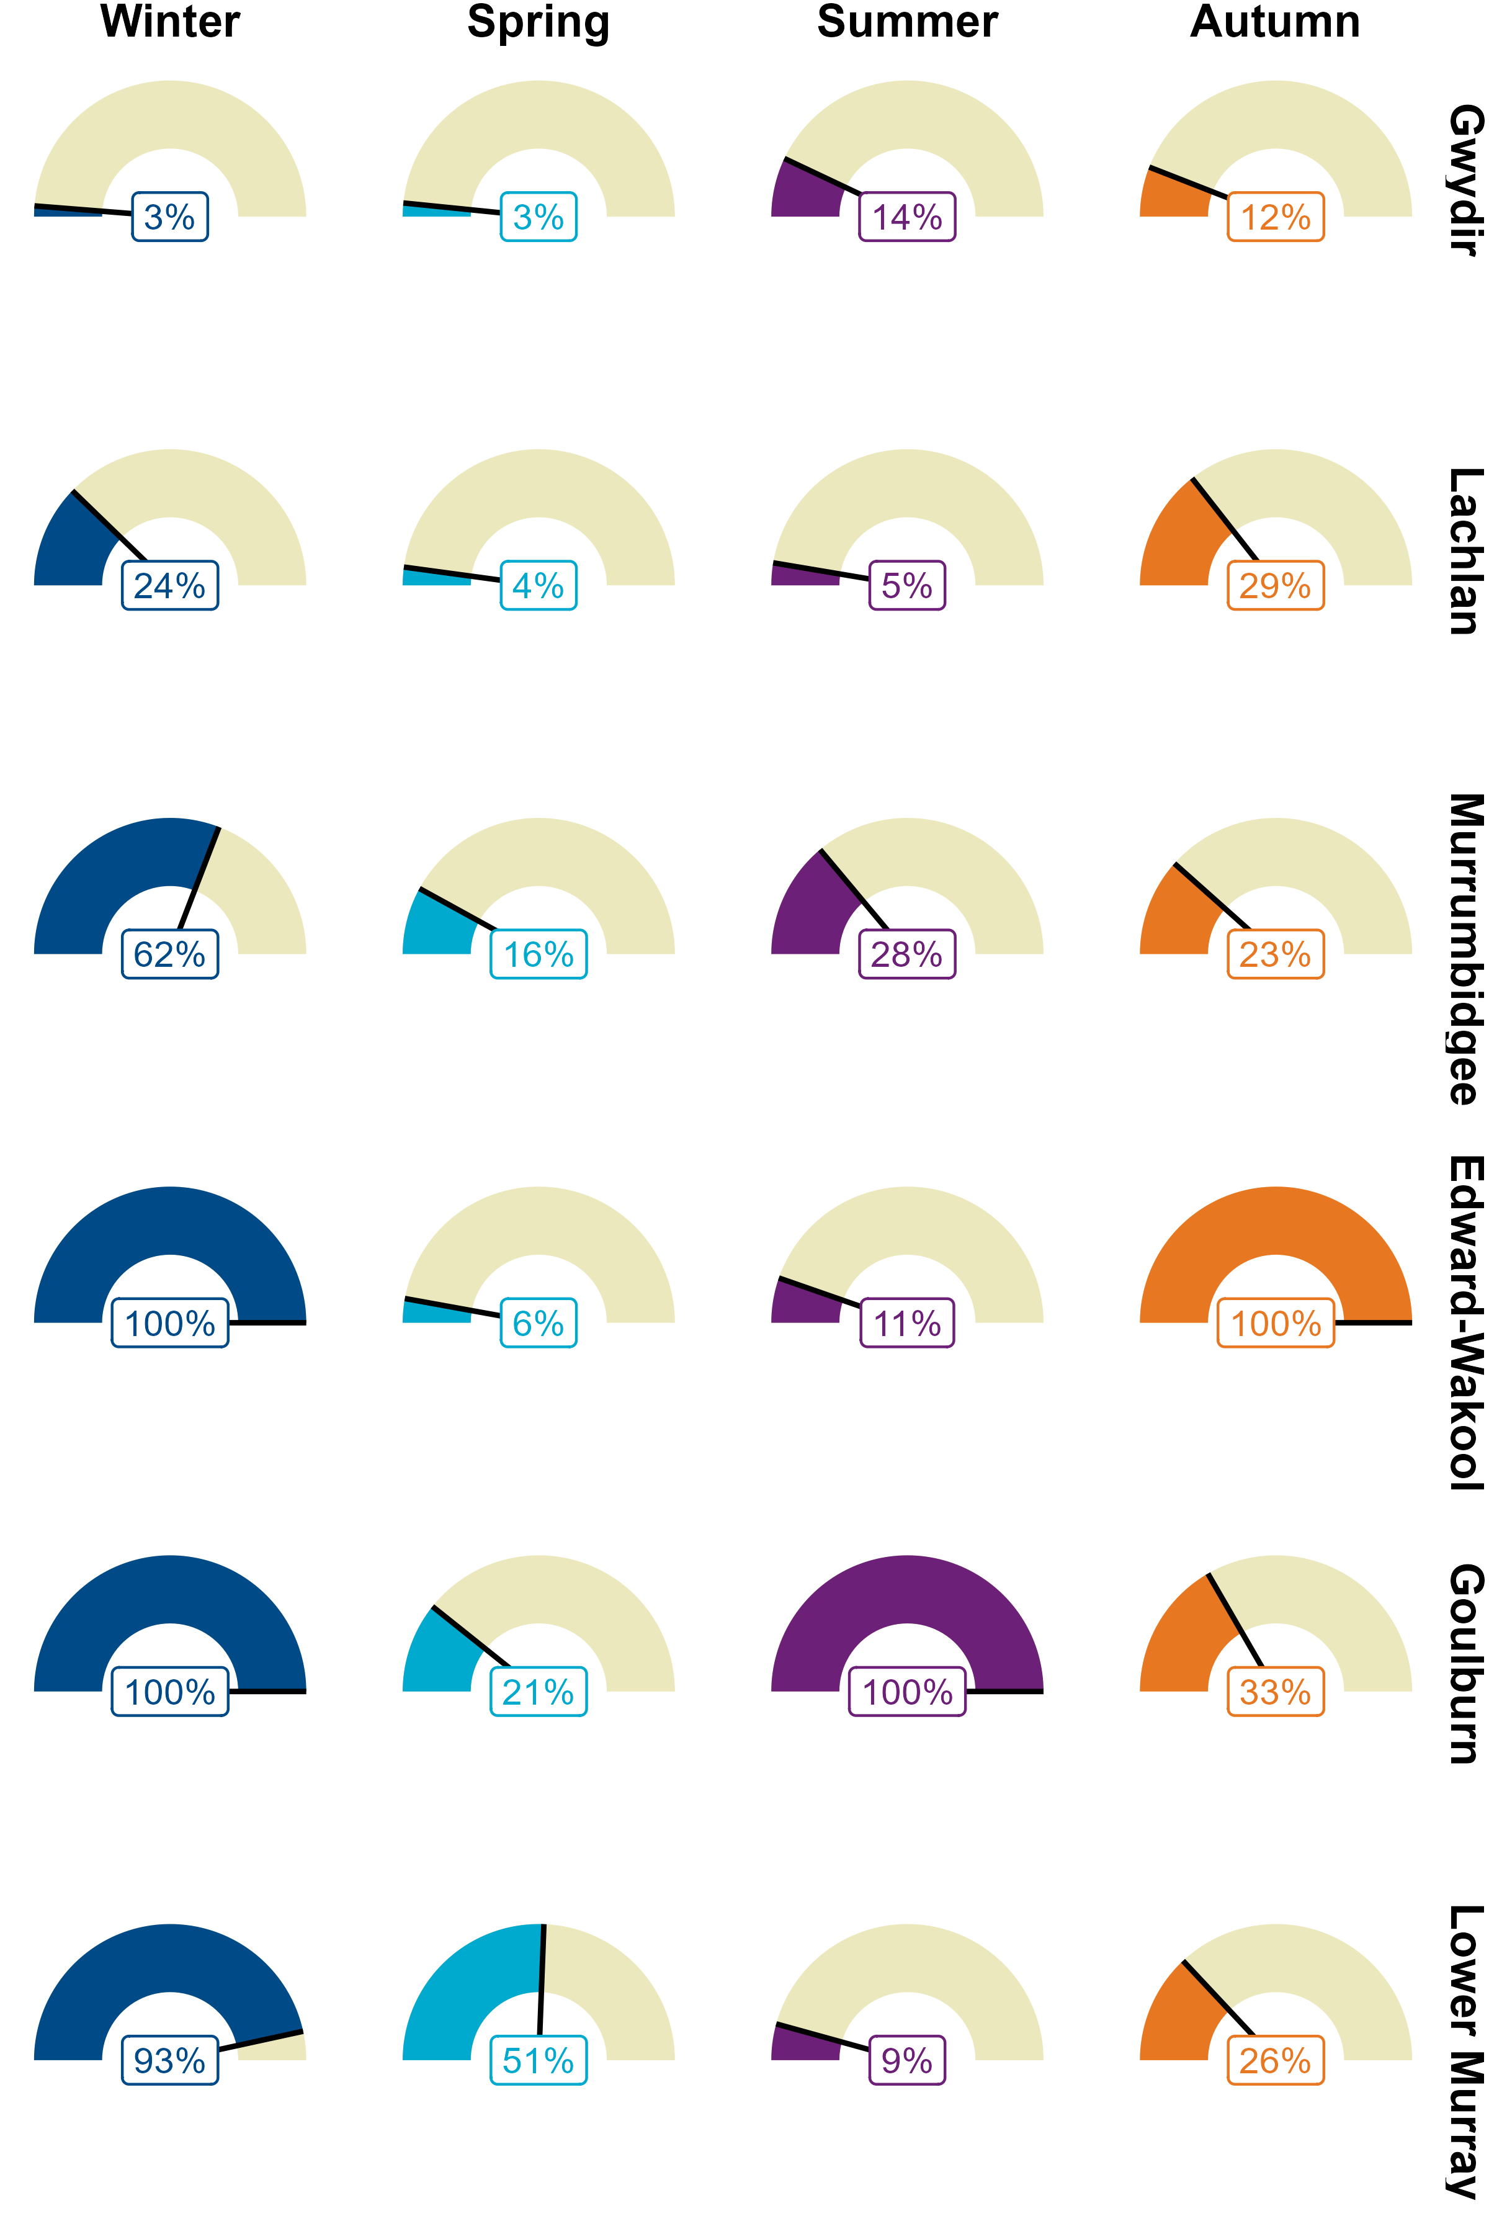

Basin-scale evaluation 2023–24
This chapter consists of (i) a summary of Commonwealth environmental watering actions with expected fish outcomes across all regions and assets and (ii) a synthesis of 2023–24 findings from Selected Area annual reports to report on trends of key population parameters and processes and their links with environmental variables, particularly attributes of streamflow.

Key findings
Key findings reflect a return to average and drier conditions across the Basin in 2023–24 compared to the previous water year. Wet conditions were still evident but contracted to the central areas – rainfall was classified as above average or very much above average in those areas. As a result, Selected Areas, particularly in the southern Basin, experienced unregulated high in-stream flows in the winter. Conditions were drier in the northern Basin.
In 2023–24, 99 watering actions that targeted expected outcomes for fish were delivered across the Basin. These actions comprised 2,708 GL of CEW. The main functional flow objectives for enhancing native fish populations were to improve habitat, enhance connectivity or provide cues for movement, and, to a lesser extent, for various targeted species outcomes.
Commonwealth environmental water was used to water wetlands, lakes and ephemeral creeks, maintain high in-stream flow rates during spring and summer, reduce rapid recession, protect stable flows, and provide variable baseflows and freshes.
Golden perch spawned in the Goulburn River, coinciding with a large overbank flow and a Commonwealth environmental water delivery of a fresh; however, quantitative analysis did not show any positive association in spawning responses with Commonwealth environmental water. Golden perch and silver perch spawned in the Lower Murray River, coinciding with high in-stream flows (including Commonwealth environmental water). Drifting silver perch eggs were detected in the Murrumbidgee River System. Quantitative analysis did not show any positive associations in spawning responses with Commonwealth environmental water in either of these Selected Areas in 2023–24. There were low levels of recruitment of golden perch in the Lower Murray River and little evidence of recruitment in other Selected Areas. In some Selected Areas, high in-stream flows may have reduced detectability of larvae, eggs and new recruits. Quantitative analysis of the contributions of Commonwealth environmental water to golden perch recruitment strength was not possible due to data constraints (e.g. limited availability of recruitment data and long-term counterfactual flow data).
There were low levels of recruitment of Murray cod in the Lower Murray River, and recruitment was either very low or absent in other Selected Areas. Possible reasons for poor recruitment include unfavourable flow conditions during nesting and early life stages, insufficient prey availability in summer, and populations still recovering from the previous year’s flooding disturbance impacts (e.g. hypoxic conditions leading to fish emigration or mortality). Quantitative analyses found no positive associations between Commonwealth environmental water and recruitment of Murray cod.
Australian smelt may have benefited from the hydrological conditions. High unregulated in-stream flows likely facilitated hydrological connectivity and increased habitat and food resources. Quantitative analyses found positive associations between Commonwealth environmental water and recruitment of Australian smelt in the Goulburn River, Lachlan River System and Lower Murray River. Murray–Darling rainbowfish were in lower abundance (representative of poor recruitment) for the last several years in some Selected Areas, likely due to high flows negatively impacting on the populations. Quantitative analysis did not find any positive associations with Commonwealth environmental water and this species.
Some exotic species (common carp, goldfish [Carassius auratus]) declined markedly in abundance this year after the initial boom response to the 2022–23 widespread flooding and high flows in Selected Areas. Quantitative analyses of exotic species identified positive associations between Commonwealth environmental water and recruitment of common carp in several Selected Areas and negative associations with eastern gambusia.

Commonwealth environmental watering actions for fish
During 2023–24, 99 Commonwealth environmental watering actions targeting expected outcomes for fish were delivered throughout the Basin. These watering actions accounted for approximately 2,708 GL of CEW delivered in that year. Many watering actions also included other sources of environmental water in addition to CEW. In 2023–24, CEW volume contributions and number of watering actions for fish were the highest since the monitoring program began (Figure 4.1). In terms of the number of watering actions delivered for 2023–24, the main functional flow objectives for enhancing native fish populations were to improve habitat, enhance connectivity or provide cues for movement (Figure 4.2), and, to a lesser extent, support various targeted species outcomes (e.g. survival of Murray hardyhead [Craterocephalus fluviatilis] and support of breeding and recruitment of freshwater catfish [Tandanus tandanus] and migration flow cues for pouched lamprey [Geotria australis] and short-headed lamprey [Mordacia mordax] and congolli [Pseudaphritis urvillii]). In terms of the volume of watering actions delivered, the main functional flow objectives for native fish populations were to enhance connectivity or provide cues for movement, spawning, or to improve various other species outcomes (Figure C.1).
It is also important to note that many of these expected outcomes for fish are intrinsically linked. For example, freshes can provide cues for movement as well as spawning, while improved habitat can enhance fish survival which can subsequently benefit species or spawning outcomes. Commonwealth environmental water delivery can have broader benefits for fish populations than just the defined 99 unique actions associated with fish. For example, the delivery of CEW down a river reach to inundate a targeted wetland complex can still provide outcomes for fish in river reaches (positive or negative) via the flow pathway of delivery, even if there are no CEW expected outcomes associated with fish in those river reaches. Our quantitative analysis approach for the Basin-scale evaluation takes this potential additional integrated benefit for fish into account when estimating the contribution of CEW delivery.
Figure 4.1 Total volume and number of Commonwealth environmental watering actions with expected outcomes for fish, 2014–24
Blue bars represent volume of Commonwealth environmental water (CEW) delivered for fish outcomes, and orange circles represent number of CEW watering actions for fish outcomes.
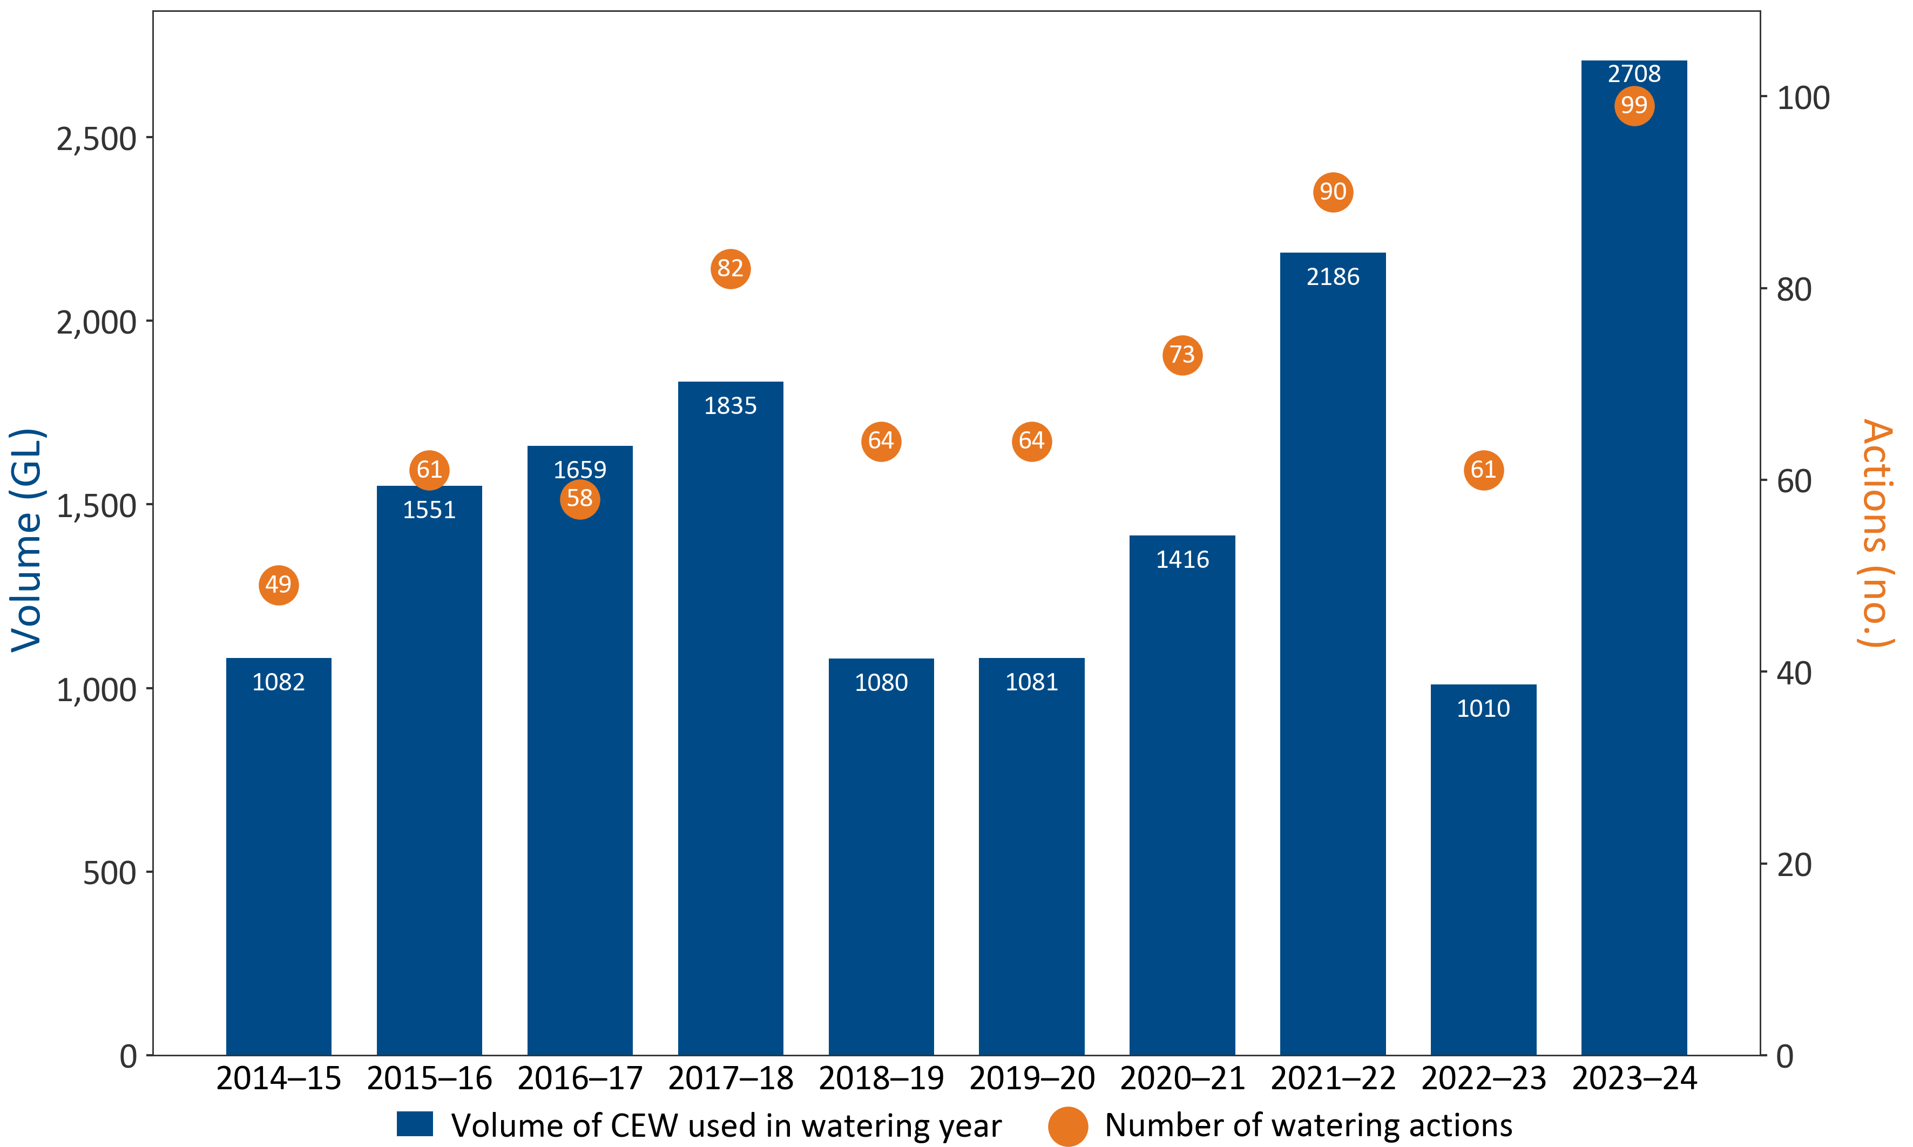
Figure 4.2 Number of Commonwealth environmental watering actions with expected outcomes for fish and flow components, 2023–24
The highest target flow component for each watering action in riverine systems was used. On the x-axis, the expected outcome population structure is abbreviated to ‘Pop. Structure’. Volumes of Commonwealth environmental watering actions with expected outcomes for fish and flow components in 2023–24 are shown in Figure C.1. CEW = Commonwealth environmental water.
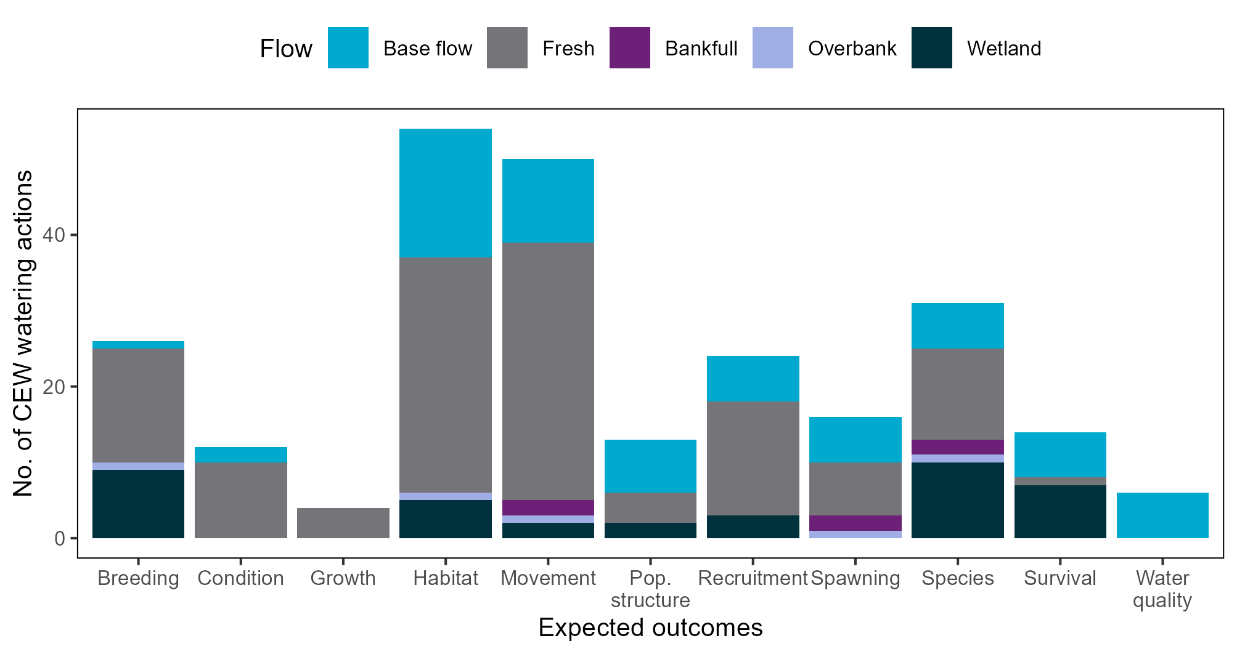
In terms of the flow components and expected outcomes for fish, most CEW was delivered to riverine channels: 2,655 GL (by riverine channel or wetland categories, 83% by number of watering actions out of total actions delivered, 96% by volume of total volume delivered; Table C.1). Base flows were delivered in many rivers (by flow categories; 32% by actions out of total actions delivered, 40% by volume of total volume delivered), including the Broken River, Campaspe River System, Gunbower Creek, Loddon River System and Peel River, to improve habitat and provide cues for movement and, to a lesser extent, to improve population structure (Figure 4.2, Figure C.1).
Freshes were delivered in many rivers (by flow categories; 48% by actions out of total actions delivered, 55% by volume of total volume delivered), including the Barwon Darling, River Murray Channel Creeks, Gwydir River System and Lower Namoi River. These were usually delivered to provide cues for movement, improve habitat, and, to a lesser extent, improve recruitment and breeding outcomes. Commonwealth environmental water contributed to 2 bankfull flows (by flow categories; 2% by action of total actions delivered, 0.7% by volume of total volume delivered) in the Lower Moonie River and Lower Warrego River to provide cues for movement and increase spawning outcomes for golden perch and other large-bodied species. One overbank flow (by flow categories; 1% by action of total actions delivered, 0.3% by volume of total volume delivered) was delivered to the Warrego Toorale Western Floodplain via intersecting streams (e.g. Darling River) to improve habitat and water quality and provide cues for movement, spawning and breeding (for golden perch and other large-bodied fish species) (Figure 4.2, Figure C.1).
Of CEW deliveries, 122 GL enabled wetland inundation, which was achieved by artificial pumping and natural connections (by riverine or wetland categories; 17% by actions out of total actions delivered, 4% by volume of total volume delivered; Table C.1). These flows to wetlands were delivered for a variety of fish outcomes, including to support breeding and enhance survival and for various targeted species outcomes (Figure 4.2, Figure C.1). Flows were delivered to Lower Murray wetlands to support and provide breeding opportunities for the nationally Endangered Murray hardyhead (EPBC Act) and to support small-bodied fish conservation actions including reintroduction and surrogacy for the threatened Murray hardyhead, southern purple-spotted gudgeon (Mogurnda adspersa), southern pygmy perch (Nannoperca australis) and Yarra pygmy perch (Nannoperca obscura) (EPBC Act, South Australian Fisheries Management Act 2007). Murrumbidgee wetlands were watered to support habitat for the NSW Endangered southern pygmy perch (New South Wales Fisheries Management Act 1994). Commonwealth environmental watering actions in many wetlands across the Basin will likely concurrently benefit condition or recruitment outcomes for fish populations within main riverine channels where connectivity between these habitats provide prey or recruits (Lyon et al. 2010).

Contribution of Commonwealth environmental water to sustaining native fish
Of the 99 Commonwealth environmental watering actions in the Basin with expected outcomes for fish in 2023–24, 14 were monitored as part of the Flow-MER Program within the Selected Areas. Note that CEW deliveries can still benefit fish in some cases, even if there are no defined CEW targeted expected outcomes associated with fish for the watering action. A summary of results from the 14 monitored watering actions with expected and observed outcomes for fish is provided in Table C.2. A synthesis of findings from the 2023–24 Selected Area reports enabled reporting of trends of key population parameters and processes across the Selected Areas and was used to answer the evaluation question:
What did Commonwealth environmental water contribute to sustaining native fish at the Basin scale?
Key highlights within the Selected Area monitoring programs are reported in Appendix C. The extent of the CEW deliveries in the Selected Areas is also highlighted in Figure 1.1. Below, we summarise key findings relevant to the evaluation question in relation to the Basin-scale evaluation for 2023–24.
Observations of fish responses are based on qualitative interpretations of the authors’ readings of key findings from the Selected Area annual reports and from our own quantitative analyses of 2023–24 data.

Spawning and recruitment
In 2023–24, Selected Areas, particularly in the southern Basin, experienced unregulated high in-stream flows in winter (Figure 3.3; Figure A.1). Commonwealth environmental water was used in some Selected Areas to water wetlands, lakes and ephemeral creeks (Liu et al. 2024; Mika et al. 2024b; Wassens et al. 2024), maintain high in-stream flow rates during spring and summer, reduce rapid recessions, (Ye et al. 2025), protect stable flows (Higgisson et al. 2024), and provide variable baseflows and winter/spring freshes (Higgisson et al. 2024; Mika et al. 2024b; Wassens et al. 2024) and autumn freshes (Higgisson et al. 2024; Liu et al. 2024; Treadwell et al. 2024).
Golden perch and silver perch are flow-cued spawners. Golden perch spawned in the Goulburn River (during a large overbank flow in late October and delivery of a CEW fresh in late November) and Lower Murray River (Treadwell et al. 2024; Ye et al. 2025). Silver perch spawned in the Lower Murray River, and eggs were detected in the Murrumbidgee River (Ye et al. 2025; Wassens et al. 2024). There was no evidence of golden perch or silver perch spawning in the Edward/Kolety–Wakool river systems nor of golden perch spawning in the Murrumbidgee River System (Liu et al. 2024; Wassens et al. 2024). Only one golden perch larva was detected in the Lachlan River System (Higgisson et al. 2024). Our quantitative analysis of 2023–24 data showed no positive associations with spawning and CEW for either species at most Selected Areas (see Section 5.2.3).
Minor recruitment was evident in the Lower Murray, where golden perch young-of-year and 2 silver perch recruits were detected (Ye et al. 2025). Silver perch recruitment was detected at one survey site in the Murrumbidgee River System (Wassens et al. 2024). Limited recruitment of golden perch was detected in the Upper Warrego–Warriku River (Mika et al. 2024a), and only one young-of-year golden perch was detected in the Goulburn River (Treadwell et al. 2024). High in-stream flows may have reduced detectability of larvae, eggs and new recruits in some Selected Areas. Ongoing monitoring of juvenile fish and year-class assessments, such as those in the River Murray Monitoring Program, will yield vital data on recruitment during the 2023–24 period. Golden perch population size structure in the Selected Areas (excluding Lower Murray River and Junction of Warrego and Darling rivers) indicates the golden perch population is dominated by adult fish – few juveniles were observed at monitored sites (Figure G.1). A quantitative analysis on the contribution of CEW to golden perch recruitment strength at Selected Areas is not possible due to data constraints, such as the limited availability of recruitment data and long-term counterfactual flow data (see Section 8.1.2).
Murray cod recruitment in Selected Areas can be from in-situ spawning and recruitment, movement from elsewhere, or survival of stocked fish (or a combination of these processes). Despite uncertainty around the origin of recruits, increased recruitment still indicates a positive outcome, as new recruits survived their early life stages in river systems. In 2023–24, minor recruitment occurred in the Lower Murray River, possibly due to high in-stream spring–summer flows, which CEW contributed to, providing habitat and connectivity (Ye et al. 2025). Our quantitative analysis of 2023–24 data found no positive associations between CEW and recruitment of Murray cod in the Lower Murray (see Section 5.2.4). Recruitment was either very low or absent at other Selected Areas, possibly due to unfavourable flow or hydraulic conditions during the spawning and early life stage period (eggs and larvae) (Higgisson et al. 2024), insufficient prey availability in summer leading to poor recruitment (Liu et al. 2024), or populations still recovering from disturbances the previous year, when widespread flooding and high flows reduced water quality (hypoxic conditions) which may have caused fish emigration or fish deaths (noting that mass fish-death events were not evident in 2022–23 at Selected Areas) (Treadwell et al. 2024) (see Section 5.2.4).
Small-bodied native fish of the Basin are generally less dependent on specific flow cues and conditions in-stream to spawn and recruit (Humphries et al. 1999); however, some species can recruit in wetlands after watering. High unregulated in-stream flows likely facilitated hydrological connectivity and increased habitat and food resources for small-bodied native fish. Our quantitative analysis of 2023–24 data found positive associations between CEW and recruitment of Australian smelt in the Goulburn River, Lachlan River System and Lower Murray River (see Section 5.2.4).
Murray–Darling rainbowfish and unspecked hardyhead (Craterocephalus fulvus), 2 small-bodied native species, had lower abundance and recruitment for the last couple of years (2022–23, 2023–24) in the Edward/Kolety–Wakool river systems, Lower Murray River and Murrumbidgee River System (Liu et al. 2024; Wassens et al. 2024; Ye et al. 2025). Potential reasons include that high or variable flows during the summer breeding period negatively impacted populations of the species. These species prefer low-to-moderate stable flows during the breeding period, likely due to stable hydraulic conditions, higher temperatures and concentrations of prey resources (Bice et al. 2014; Wassens et al. 2024; Ye et al. 2025). In contrast, in the Goulburn River, Murray–Darling rainbowfish had markedly increased abundance and recruitment in 2023–24, a year which had much lower and more stable summer flow conditions than previous years (Treadwell et al. 2024).
Some exotic species (common carp, goldfish) declined markedly in abundance this year after the initial boom response to the 2022–23 widespread flooding and high flows in Selected Areas. These patterns were most evident in the Edward/Kolety–Wakool river systems, Goulburn River, Lachlan River System and Lower Murray River (Higgisson et al. 2024; Liu et al. 2024; Treadwell et al. 2024; Ye et al. 2025). However, there is low confidence in abundance estimates for some species (e.g. common carp) in the Lower Murray River due to sampling being postponed to winter 2024. Our quantitative analysis of 2023–24 data of exotic species found positive associations between CEW and recruitment of common carp in the Edward/Kolety–Wakool river systems, Gwydir River System, Lower Murray River and Murrumbidgee River Systems (see Section 5.2.4).

Basin-scale evaluation 2014–24
This chapter describes the status and patterns of various fish variables recorded across all monitoring locations between 2014–15 and 2023–24 and provides the cumulative evaluation of the responses of fish to CEW.

Key findings
Fifteen native and 5 exotic species were detected during the 10-year monitoring program that conducted in-stream river sampling of adult fish communities in the Selected Areas. The number of native species detected did not vary greatly among years.
Counterfactual modelling showed that Commonwealth environmental water contributed to varying degrees to increased fish spawning, recruitment, frequency of occurrence, population growth rates, body condition and improved community composition in some Selected Areas and for several species.
Positive fish responses to Commonwealth environmental water delivery were primarily driven by reductions in the number of low flow days and, to a lesser extent, increased average daily flows and changes in flow variability.
Positive fish responses to Commonwealth environmental water delivery were most pronounced in the Goulburn River and Lower Murray River and, to a lesser extent, in the Edward/Kolety–Wakool river systems, Murrumbidgee River System and Lachlan River System. In the Gwydir River System, there were very few positive fish responses to Commonwealth environmental water delivery.
Scaling from the Selected Area scale to Basin scale presents many challenges. We suggest predictive modelling at unmonitored sites as one way forward and present a case study on Murray cod and Murray–Darling rainbowfish recruitment to demonstrate how the contribution of environmental water could be predicted at unmonitored gauges across the Basin, once sufficient fish and flow data are available (which could involve a combination of existing data sets and new additional data collected in the future). The contribution of Commonwealth environmental water to Murray cod and Murray–Darling rainbowfish recruitment was predicted to be greatest in the southern Basin; however, only limited predictions could be made in the northern Basin as there is only a single Selected Area site (Gwydir River System) representing the northern Basin.

Contribution of Commonwealth environmental water to sustaining native fish
The key Flow-MER evaluation question for fish was:
What did Commonwealth environmental water contribute to sustaining native fish at the Basin scale?
Major results are summarised here (for positive responses to CEW delivery, see Table 5.1, Figure 5.1; for all responses to CEW delivery, including negative responses, see Appendix H, Table H.3) and described in detail in sections 5.2.3–5.2.9. Our findings indicate that CEW provided a range of important benefits to native fish populations and supported critical life-history processes (Table 5.1, Figure 5.1). Over the entire monitoring period, CEW contributed to increased fish spawning, recruitment, frequency of occurrence, population growth rates and body condition for several species and improved community composition in several Selected Areas; however, responses differed among Selected Areas and species (Table 5.1, Figure 5.1). Averaged over all survey years, the likelihood of spawning for golden perch in the Lower Murray River increased as a result of CEW delivery (Table 5.1, Figure 5.1). Commonwealth environmental water contributed to increased recruitment for Australian smelt and Murray–Darling rainbowfish in several Selected Areas (Table 5.1, Figure 5.1). The frequency of occurrence within Selected Areas and population growth rates for several species increased with CEW delivery in several Selected Areas (Table 5.1, Figure 5.1). The provision of CEW contributed to increased individual body condition of Murray cod, golden perch and bony herring in some Selected Areas (Table 5.1, Figure 5.1). Commonwealth environmental water contributed to improved community composition (increased proportion of catch that is native) in the Edward/Kolety–Wakool river systems, Goulburn River, Lachlan River System, Lower Murray River and Murrumbidgee River System (Table 5.1, Figure 5.1).
While some Selected Areas exhibited positive responses to CEW delivery and metrics as described above, there were negative responses for some Selected Areas and other species (Appendix H, Table H.3). Averaged over all survey years, there were negative responses in the Gwydir River System to CEW delivery for population growth rates, frequency of occurrence and recruitment of Murray cod, golden perch (population growth rates only), Murray–Darling rainbowfish and bony herring (excluding recruitment) (Appendix H, Table H.3). In the Lachlan River System, there were negative responses to CEW for recruitment of Murray cod (Appendix H, Table H.3). The frequency of occurrence and recruitment of eastern gambusia and population growth rates of common carp decreased in response to CEW delivery in several Selected Areas (Appendix H, Table H.3). Common carp and eastern gambusia are both exotic species, and negative responses to CEW delivery is not a negative outcome. Potential reasons for these negative responses to CEW are provided in the discussion (Chapter 8).

Table 5.1 Positive contributions of Commonwealth environmental water to native fish populations detected in Selected Areas, 2014–24
Note that this table describes the statistical strength of the association, not the magnitude of the response (e.g. there can be an association with high confidence for a low-magnitude effect). Junction of Warrego and Darling rivers Selected Area is not included in the evaluation. For all fish responses to delivery of Commonwealth environmental water (CEW), including negative responses, see Table H.3. Level of confidence in evidence is the posterior probability that the response is greater with than without CEW. Response categories are associated with levels of confidence. Dark green denotes association with high confidence, medium green denotes associations with medium confidence, light green denotes associations with low confidence, and white denotes no evidence of a positive association (Fanson 2025). Detailed results can be found in sections 5.2.3, 5.2.4, 5.2.6, 5.2.7, 5.2.8 and 5.2.9.
Selected Area | Did CEW contribute to increased likelihood of spawning? | Did CEW contribute to increased recruitment? | Did CEW contribute to increased frequency of occurrence within Selected Areas? | Did CEW contribute to increased population growth rates? | Did CEW contribute to increased individual body condition? | Did CEW contribute to increased proportion of catch that was native (community responses)?
Edward/ Kolety–Wakool river systems | No confidence | High confidence for Australian smelt. Murray–Darling rainbowfish  Low confidence for bony herring | High confidence for Australian smelt | Medium confidence for Murray cod | High confidence for bony herring | Low confidence for community response
Goulburn River | No confidence | High confidence for Australian smelt  Low confidence for Murray–Darling rainbowfish | High confidence for Australian smelt  Medium confidence for bony herring | High confidence for golden perch  Low confidence for Murray cod | High confidence for golden perch, Murray cod | High confidence for community response
Gwydir River System | Not measured in this Selected Area | Low confidence for Australian smelt, bony herring | Medium confidence for carp gudgeon  Low confidence for Australian smelt | No confidence | Medium confidence for bony herring  Low confidence for golden perch, Murray cod | No confidence
Lachlan River System | No confidence | High confidence for Australian smelt | High confidence for Australian smelt  Medium confidence for bony herring | High confidence for golden perch  Low confidence for Murray cod, bony herring | Low confidence for bony herring | Low confidence for community response
Lower Murray River | Low confidence for golden perch | High confidence for Australian smelt  Medium confidence for Murray–Darling rainbowfish | High confidence for Australian smelt  Low confidence for bony herring | High confidence for golden perch  Low confidence for Murray cod | Low confidence for golden perch, Murray cod | High confidence for community response
Murrumbidgee River System | No confidence | High confidence for Australian smelt, Murray–Darling rainbowfish  Low confidence for bony herring | High confidence for Australian smelt  Low confidence for Murray cod | High confidence for golden perch, Murray cod | Low confidence for bony herring | High confidence for community response

Relative change in flow metrics
Evaluation results are presented visually in Figure 5.1. The flow (small) panels display the contribution of CEW to key flow metrics in each Selected Area (x-axis: name of flow metric [for definition of metrics refer to Appendix H, Table H.1]; y-axis: timing of metric). The flow colour legend shows the direction and relative contribution of CEW to each flow metric. Darker blue colours indicate larger positive contributions, white indicates no contribution, and red colours indicate negative contributions (e.g. CEW decreases flow variability in the Edward/Kolety–Wakool river systems). Positive contributions were defined in relation to a variable’s expected effects on fish, so that darker blue colours indicate fewer low flow days. Note there were no spring flow metrics calculated for the Gwydir River System (spring flows are associated with fish spawning response), as annual larval fish surveys were not conducted in this Selected Area. For this results chapter, we use the terms ‘strong’ and ‘weak’ evidence, which describe the magnitude and uncertainty in estimated flow associations.
Commonwealth environmental water decreased the number of low flow days and increased average daily flows to varying degrees in the Selected Areas. These patterns were most evident in the Goulburn River and Lower Murray River.

Strength of support by life stage
The response (larger) panels in Figure 5.1 show the degree of confidence that CEW had a positive effect on each fish response variable (y-axis: name of response variable [for definition of responses, refer to Appendix H, Table H.1]) for each species (x-axis: ‘community’ stands for community metric analysis). The flow panels (small) described in Section 5.2.1 indicate the most influential flow metrics affecting fish responses. The confidence colour legend comprises white (no confidence; no evidence that CEW had a positive effect, probability ≤ 0.80), lightest green denotes low confidence (probability of a positive effect between > 0.80 and 0.90), medium green denotes medium confidence (probability between > 0.90 and 0.95), and dark green denotes high confidence that CEW had a positive effect (probability > 0.95). Confidence ratings describe the statistical strength of the association, not the magnitude of the response, and reflect uncertainty in fish responses to flows. Grey squares indicate no data for that cell (e.g. insufficient data collected for defensible analysis). For all fish species responses to delivery of CEW, including negative responses, see Appendix H, Table H.3.
When interpreting Figure 5.1, note that:
- Gwydir River System does not have larval flow (spring) metrics, as larval fish surveys were not conducted on an annual basis
- Junction of Warrego and Darling rivers Selected Area is not included in the evaluation
- Responses and degree of confidence have been averaged over all survey years for each Selected Area (and therefore positive responses to delivery of CEW for individual years are not captured here but are described in sections 5.2.3–5.2.9).

Figure 5.1 Map of the Murray–Darling Basin showing the magnitude of Commonwealth environmental water effects on flow metrics (small panels) and the predicted positive fish responses from Commonwealth environmental watering based on counterfactual modelling (larger panels) for each Selected Area, over the period 2014–24
For explanations, see Section 5.2.1 for flow (small) panels and Section 5.2.2 for response (larger) panels. For definition of flow metrics and fish responses, refer to Appendix H, Table H.1. This figure has been optimised to A3 size.
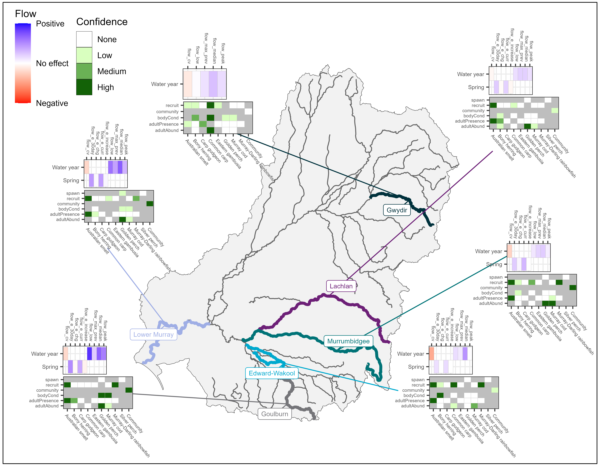

Contribution to flow-cued fish spawning
The most influential flow variables that contributed to increased golden perch spawning were the number of days of increasing flow in the 7 days prior to sampling and the variable day of year (with strong evidence) (Appendix H, Figure H.1). Silver perch spawning increased in response to the day of year (with strong evidence) and, like golden perch (with weaker evidence), change in daily flow in the 7 days prior to sampling (high uncertainty, 95% credible interval overlapping zero) (Appendix H, Figure H.1).
In this section, we have presented results relating to the occurrence of spawning (a binary variable). A qualitative interpretation of larval-abundance data (a count variable) for large-bodied and small-bodied fish species across the Selected Areas (as not all fish species had sufficient data for analysis) is described in Appendix F. It must be noted that golden perch spawning has not been recorded in the Edward/Kolety–Wakool river systems, and the estimated effects of CEW for golden perch is based on average flow responses across all Selected Areas, coupled with counterfactual scenarios for each area. Consequently, the estimated effects of CEW in this case are associated with low confidence.
Commonwealth environmental water contributed to an increased likelihood of spawning of golden perch in 1–3 out of 10 years in all Selected Areas. (Figure 5.2). Golden perch spawned less frequently than with CEW in some Selected Areas (1 out of 10 years in the Edward/Kolety–Wakool river systems,¹⁰ Goulburn River,10 Lachlan River System,10 Murrumbidgee River System,10 and 2 out of 10 years in the Lower Murray River10) (Figure 5.2). These spawning responses were driven primarily by CEW contributions to the number of days of increasing flow in the 7 days prior to sampling (positive and negative responses) and, to a lesser extent, by median standardised flows in the 30 days prior to sampling (positive responses) (Figure 5.3). There were no positive associations between CEW delivery and silver perch spawning at the Selected Areas across the monitoring period (Figure 5.2).

Figure 5.2 Predicted effect of Commonwealth environmental water on spawning likelihood for silver perch and golden perch, by Selected Area, over the period 2014–24.
Each density plot shows the distribution of effect sizes, which are the percentage change in odds (the probability of a spawning event divided by the probability of no spawning event). Vertical dashed line shows no effect (0%); distribution to the left of this line indicates a negative effect and right a positive effect. Red and blue numbers indicate the number of years in which there was a significant negative and positive effect, respectively. Dot indicates the current year estimate, and colour indicates if the contribution was significant (green = positive; red = negative) or not (grey). Note that golden perch spawning was not recorded in the Edward/Kolety–Wakool river systems and was recorded only twice in the Lachlan River System during the survey period. Silver perch spawning was also not recorded in the Lachlan River System during the survey period. The estimated effects of Commonwealth environmental water (CEW) in these 2 systems for these species are based on average flow responses across all Selected Areas, coupled with counterfactual scenarios for each area. Consequently, the estimated effects of CEW in these cases are associated with low confidence (Figure 5.1). No larval monitoring occurred in the Gwydir River System or Junction of Warrego and Darling rivers; hence, they are not included in the evaluation.
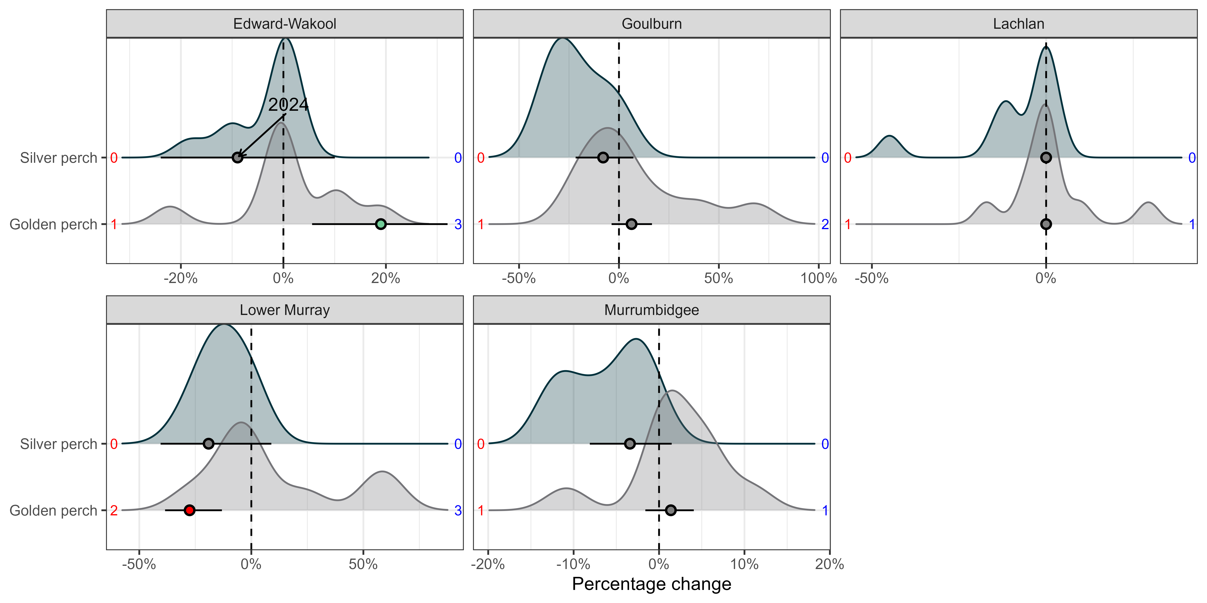

Figure 5.3 Contribution of each flow variable (median standardised flows in 30 days, change in daily flow in 7 days, number of days of increasing flow in 7 days) to the predicted Commonwealth environmental water effect on spawning likelihood of golden perch and silver perch, over the period 2014–24
Contributions are the modelled effects of each flow variable multiplied by the change in that flow variable due to Commonwealth environmental water (CEW). They combine the magnitude of a variable’s impact with the magnitude of change in that variable due to CEW. Contributions are calculated on the model-link scale (the scale on which effects are estimated), rather than the observation scale (the scale on which the data are observed), to preserve their sign (negative or positive). Negative effects of CEW are shown as columns below 0 and positive effects of CEW are columns above 0. Flow_e_30day = median standardised flows in 30 days, flow_e_chg = change in daily flow in 7 days, flow_e_increase = number of days increasing flow in 7 days. Years on the x-axis represent the previous water year, i.e. 2015 = 2014–15.
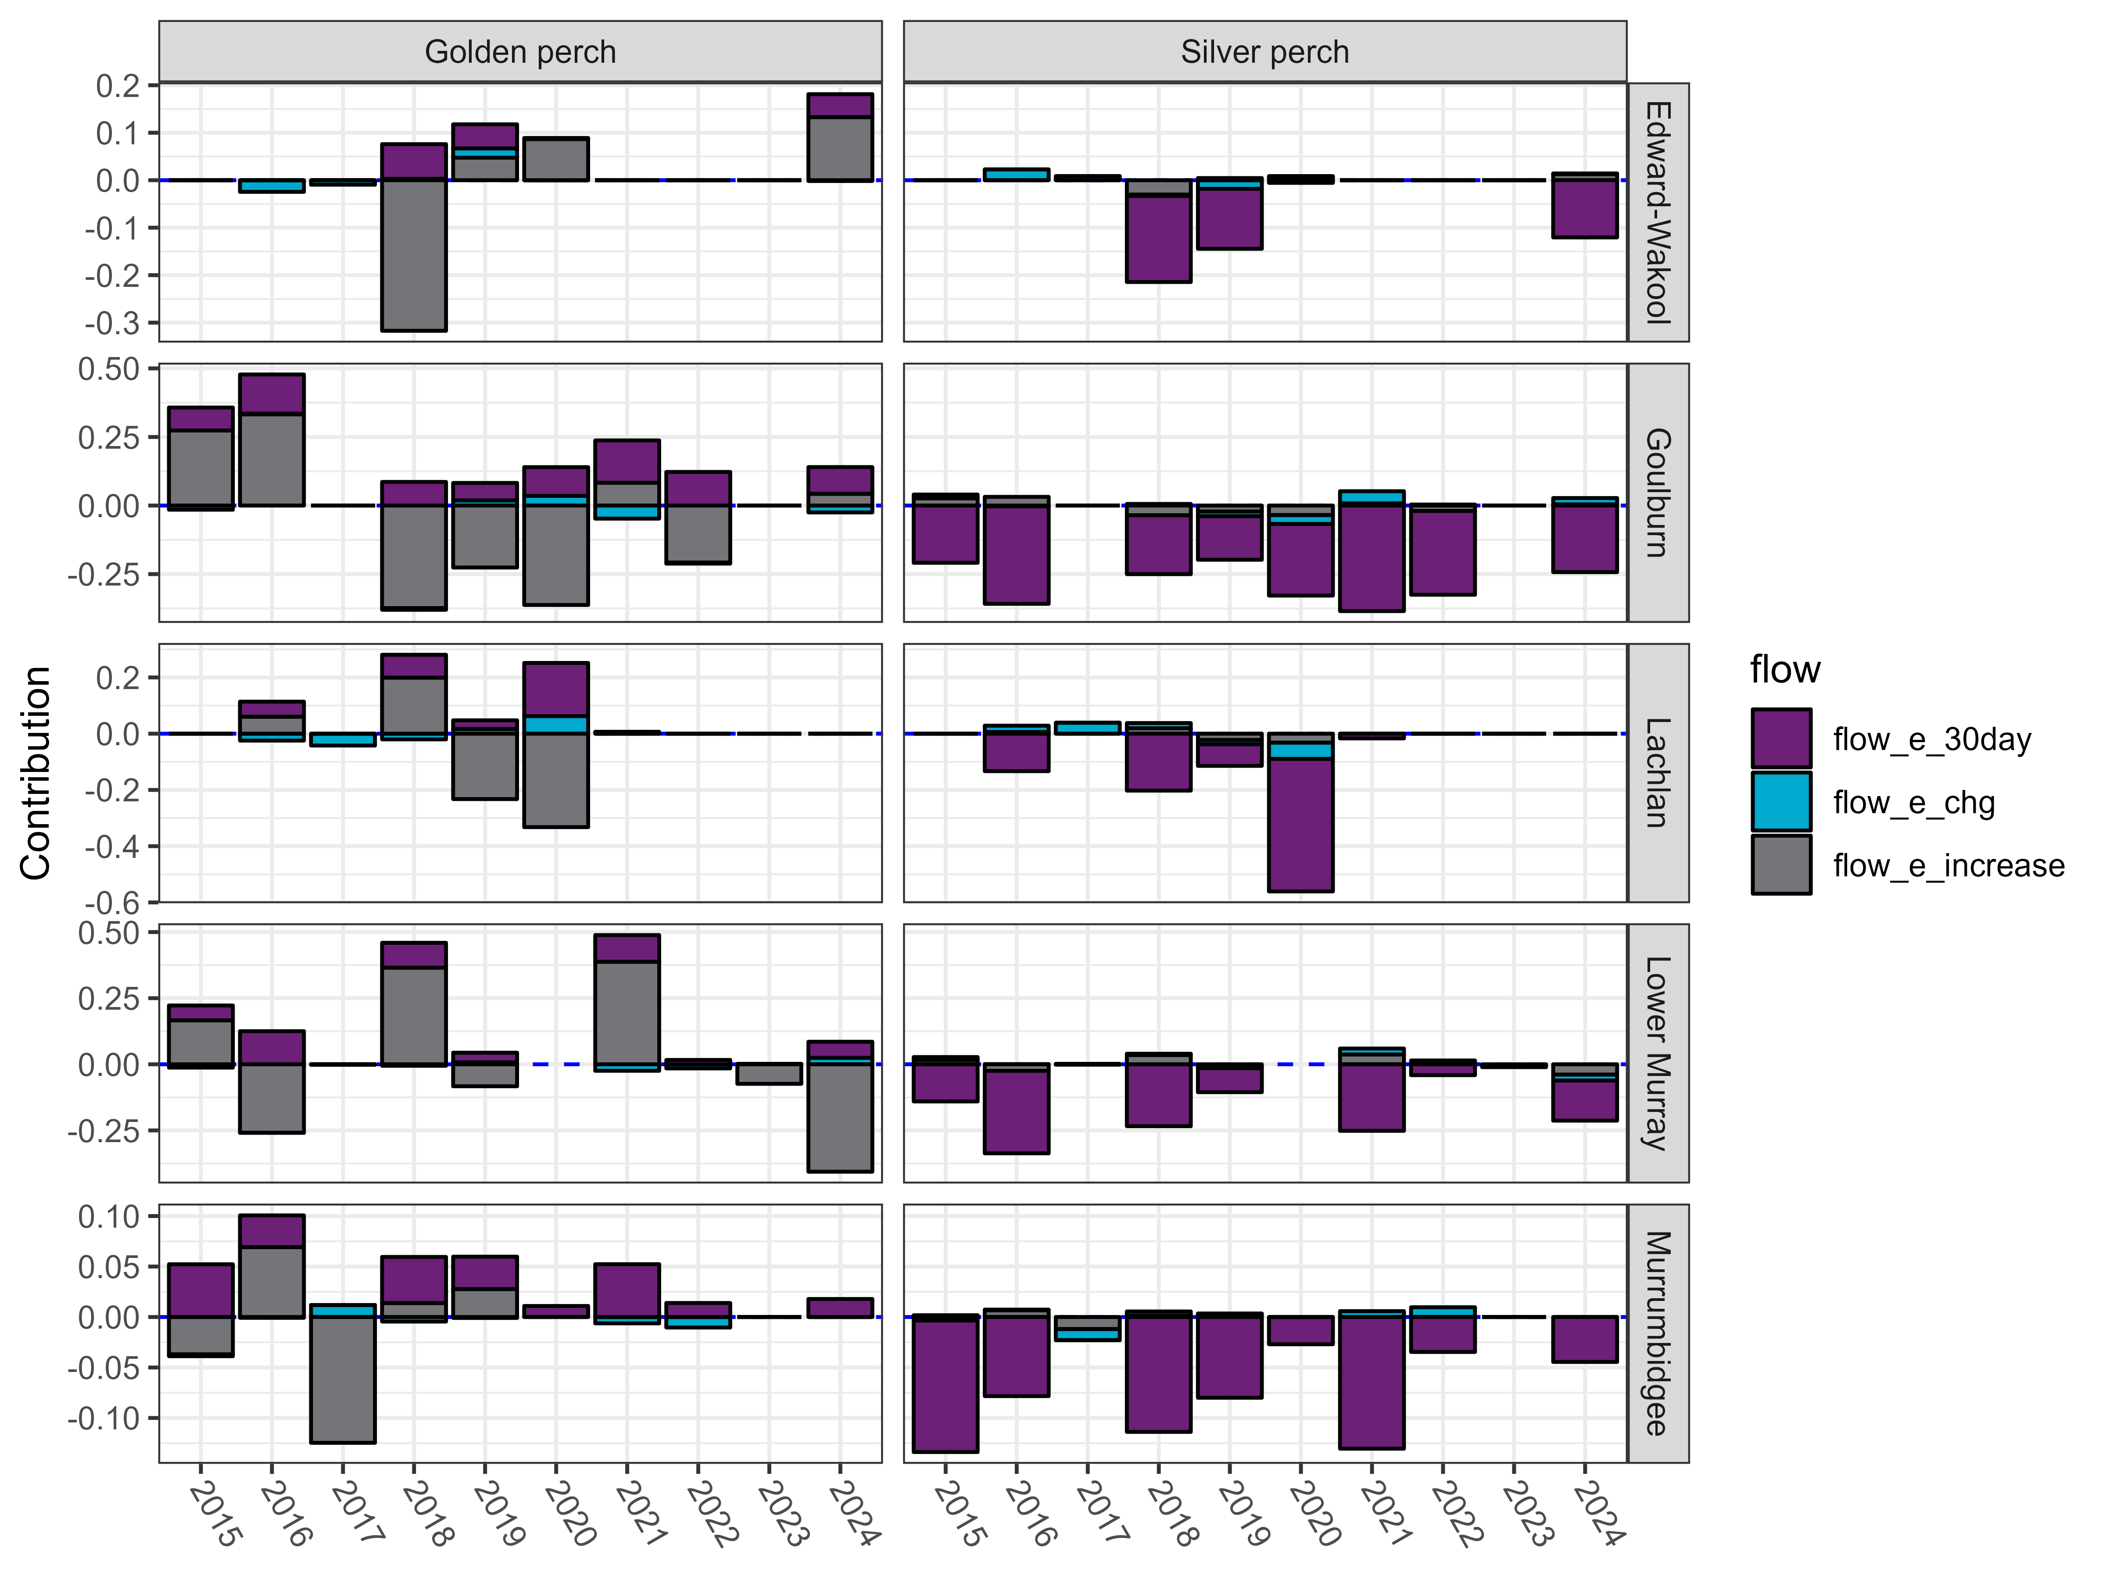

Contribution to young-of-year recruitment of focal species
Increases in the number of low flow days had a negative effect on recruitment for Australian smelt (strong evidence), Murray cod and Murray–Darling rainbowfish (both weak evidence) (Appendix H, Figure H.2). Note that a negative response to increases in the number of low flow days means that a reduction in the number of low flow days (a common outcome of environmental water deliveries) has a positive effect on fish recruitment. Recruitment of Murray cod decreased with increased average daily flows and flow variability (with strong evidence) and increased maximum antecedent flows (with weaker evidence) (Appendix H, Figure H.2). Recruitment of Murray–Darling rainbowfish decreased with increased average daily flows (Appendix H, Figure H.2). Recruitment of common carp increased with increased average daily flows and decreased with maximum antecedent flows (with strong evidence) (Appendix H, Figure H.2). Recruitment of carp gudgeon decreased with flow variability (with strong evidence) (Appendix H, Figure H.2). Recruitment of eastern gambusia increased with increases in the number of low flow days (with strong evidence) (Appendix H, Figure H.2). Recruitment of bony herring was not associated strongly with any of the included flow metrics (Appendix H, Figure H.2). Appendix G provides a qualitative interpretation of length–frequency data for focal species to help inform recruitment patterns. It must be noted that Murray–Darling rainbowfish has not been recorded in the Lachlan River System, and the estimated effects of CEW for Murray–Darling rainbowfish is based on average flow responses across all Selected Areas, coupled with counterfactual scenarios for each area. Consequently, the estimated effects of CEW in this case are associated with low confidence.
Recruitment of Murray cod had variable responses to CEW in the Edward/Kolety–Wakool river systems and Gwydir River System (positive in 1 out of 10 years; negative in 3–5 out of 10 years)11 (Figure 5.4). In the Lachlan River System11 and Murrumbidgee River System,11 there were only negative responses in 1–3 out of 10 years on recruitment with CEW (Figure 5.4). In the Goulburn River and Lower Murray River, there were no negative or positive recruitment responses to CEW (Figure 5.4). Commonwealth environmental water contributed to increased recruitment of Australian smelt in 1–10 out of 10 years in all Selected Areas11 and decreased recruitment in 1–3 out of 10 years in several Selected Areas (Figure 5.5). Commonwealth environmental water delivery contributed to recruitment of carp gudgeon or Murray–Darling rainbowfish in some years in the Edward/Kolety–Wakool river systems,11 Gwydir River System11 and Murrumbidgee River System (1 out of 10 years)11 (Figure 5.4).
There was no evidence of any positive or negative effects of CEW on recruitment of bony herring in any Selected Area (Figure 5.4).
Responses to CEW for native species were driven primarily by contributions to reducing the number of low flow days (positive responses) and, to a lesser extent, influences on flow variability (positive and negative responses) and increased average daily flows (negative responses for Australian smelt, Murray cod and Murray–Darling rainbowfish) (Figure 5.6).
Recruitment of common carp increased with the delivery of CEW in the Edward/Kolety–Wakool river systems (5 out of 10 years),11 Gwydir River System (5 out of 10 years),11 Lachlan River System (4 out of 10 years),11 Lower Murray River (2 out of 10 years) and in the Murrumbidgee River System (2 out of 10 years)11 (Figure 5.4). Recruitment of eastern gambusia decreased with CEW in the Edward/Kolety–Wakool river systems (3 out of 10 years),11 Goulburn River (1 out of 10 years),11 Lachlan River System (4 out of 10 years)11, Lower Murray River (9 out of 10 years)11 and Murrumbidgee River System (6 out of 10 years)11 (Figure 5.4). These recruitment responses were driven primarily by CEW contributions to increased average daily flows (positive responses) and reducing the number of low flow days (negative responses) (Figure 5.6).
For the current water year, recruitment of Australian smelt increased with CEW in the Goulburn River, Lachlan River System and Lower Murray River and for common carp in the Edward/Kolety–Wakool river systems, Gwydir River System, Lower Murray River and Murrumbidgee River System (Figure 5.4, Figure 5.5).

Figure 5.4 Predicted effect of Commonwealth environmental water on recruitment rates for each focal fish species, excluding Australian smelt, by Selected Area, over the period 2014–24
Each density plot shows the distribution of effect sizes, which have been scaled to percentage rather than absolute change with Commonwealth environmental water (CEW), because these values are more easily compared among species that differ in abundance. Vertical dashed line shows no effect (0%); distribution to the left of this line indicates a negative effect and right a positive effect. Red and blue numbers indicate the number of years in which there was a significant negative and positive effect, respectively. Dot indicates the current year estimate, and colour indicates if the contribution was significant (green = positive; red = negative) or not (grey). Note that Murray–Darling rainbowfish was not recorded in the Lachlan River System during the survey period. The estimated effects of CEW in this system for Murray–Darling rainbowfish are based on average flow responses across all Selected Areas, coupled with counterfactual scenarios for each area. Consequently, the estimated effects of CEW in this case are associated with low confidence (Figure 5.1). Junction of Warrego and Darling rivers is not included in the evaluation. Golden perch recruits are not included here but were analysed using age information from otoliths to estimate year-class strength (a more accurate estimate of recruitment).
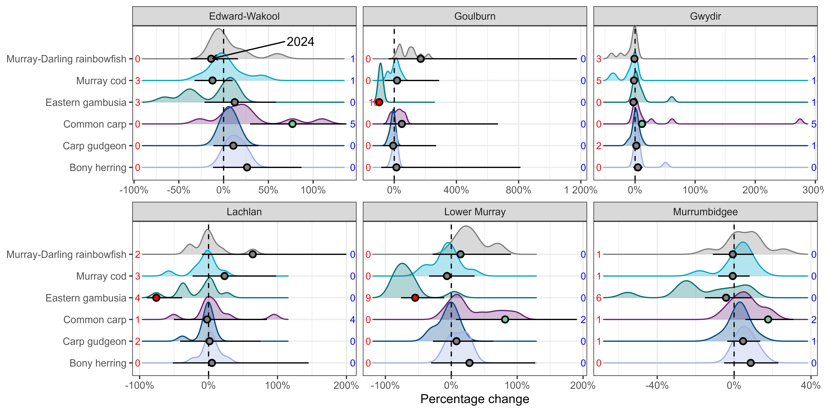
Figure 5.5 Predicted effect of Commonwealth environmental water on recruitment rates for each focal fish species, including Australian smelt, by Selected Area, over the period 2014–24.
Each density plot shows the distribution of effect sizes, which have been scaled to percentage rather than absolute change with Commonwealth environmental water (CEW), because these values are more easily compared among species that differ in abundance. Vertical dashed line shows no effect (0%); distribution to the left of this line indicates a negative effect and right a positive effect. Red and blue numbers indicate the number of years in which there was a significant negative and positive effect, respectively. Dot indicates the current year estimate, and colour indicates if the contribution was significant (green = positive; red = negative) or not (grey). Note that Murray–Darling rainbowfish was not recorded in the Lachlan River System during the survey period. The estimated effects of CEW in this system for Murray–Darling rainbowfish are based on average flow responses across all Selected Areas, coupled with counterfactual scenarios for each area. Consequently, the estimated effects of CEW in this case are associated with low confidence (Figure 5.1). Junction of Warrego and Darling rivers is not included in the evaluation. Golden perch recruits are not included here but were analysed using age information from otoliths to estimate year-class strength (a more accurate estimate of recruitment). See figure above for nuances of other species.
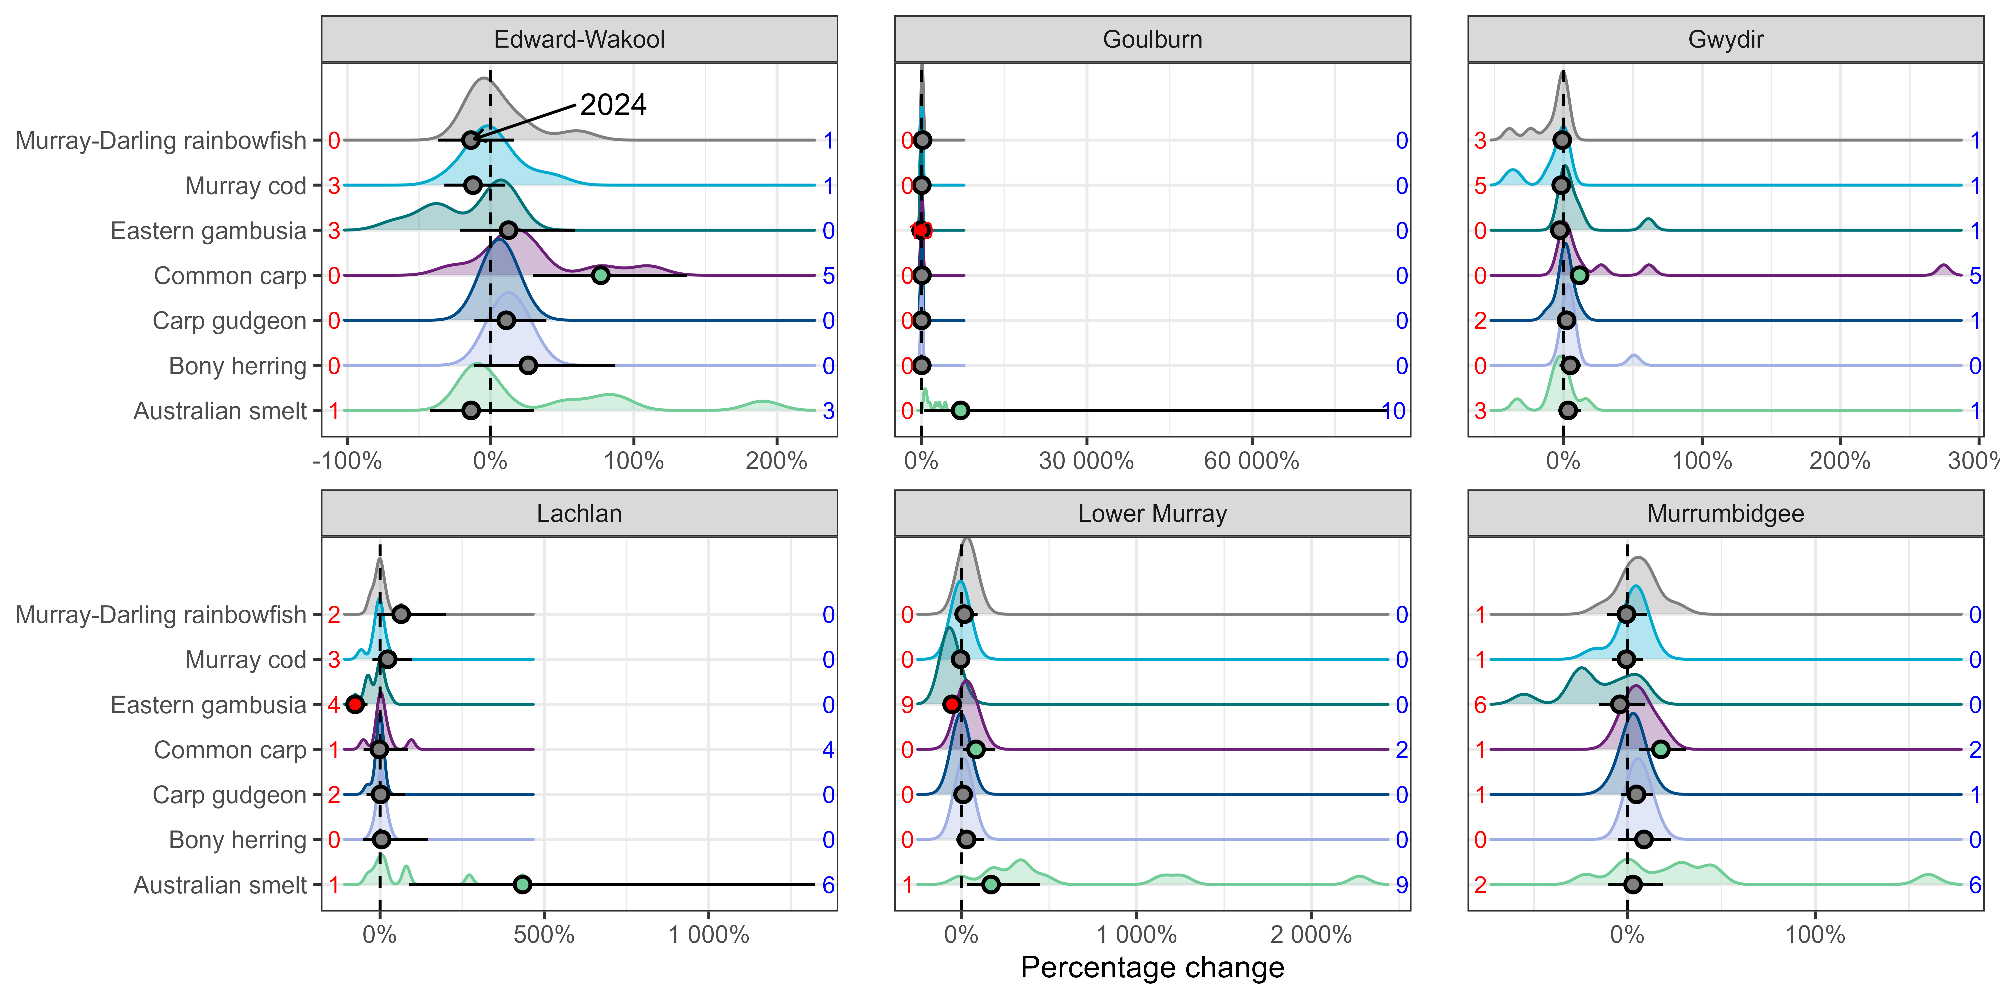

Figure 5.6 Contribution of each flow variable (coefficient of variability in daily flows, number of days of low flow, standardised maximum antecedent flow and standardised daily flows) to the predicted Commonwealth environmental water effect on recruitment for each focal fish species, by year and Selected Area, over the period 2014–24
Contributions are the modelled effects of each flow variable multiplied by the change in that flow variable due to Commonwealth environmental water (CEW). They combine the magnitude of a variable’s impact with the magnitude of change in that variable due to CEW. Contributions are calculated on the model-link scale (the scale on which effects are estimated), rather than the observation scale (the scale on which the data are observed), to preserve their sign (negative or positive). Negative effects are shown as columns below 0 and positive effects are columns above 0. Golden perch recruits are not included here but were analysed using age information from otoliths to estimate year-class strength (a more accurate estimate of young-of-year recruitment). Flow_cv = coefficient of variability in daily flows, flow_low = number of days of low flow, flow_max_prev = standardised maximum antecedent flow, flow_median = standardised daily flows. Years on the x-axis represent the previous water year, i.e. 2015 = 2014–15.

Hydrological influences on young-of-year recruitment based on age data
Estimates of age-class strength using otoliths for determining age provide detailed insight into recruitment patterns, drawing on age information to estimate recruitment in years prior to the survey period. This is demonstrated with an analysis of golden perch, which revealed strong recruitment events in several years (1996, 2000, 2009, 2010, noting that birth year refers to the spring of that year i.e. 1996 = 1996–97) (Figure 5.7A). Moreover, we found positive responses for golden perch recruitment to increased average daily flows and negative responses to increases in the number of low flow days (Figure 5.7). Although high recruitment was evident in 2009–10, it did not correspond with high overbank flows and floods in the Lower Murray River and was likely driven by immigration of fish born in association with high flows in the Darling River at this time (Zampatti et al. 2021).
This approach and these data could not be used to demonstrate the specific effects of CEW, because the available counterfactual scenarios did not overlap sufficiently with the window of birth years identified in this study (which span from 1996 if including the earliest recorded recruitment event). Commonwealth environmental water is only a relatively recent component of underlying hydrological conditions in most Selected Areas (e.g. environmental flows have only been delivered in the Lower Murray River for the past 13 years and only substantially in the past 10 years).

Contribution to adult fish diversity
Fifteen native and 5 exotic species were detected during the 10-year monitoring program (2014–24) by in-stream river sampling of adult fish communities in the Selected Areas, which used standardised methods of boat electrofishing and fyke nets. The number of native species detected did not vary greatly among years within Selected Areas.
This section describes a qualitative investigation of fish diversity (20 fish species). Information on the abundance of 7 large-bodied and 6 small-bodied native fish species, as well as 5 exotic species, from combinations of Selected Areas (since not all fish species had sufficient data for analysis) is provided in Appendix E. Two species were not included in abundance information as were rarely detected in the monitoring program these include river blackfish (Gadopsis marmoratus) and obscure galaxias (Galaxias oliros).
In total, 15 native fish species and 5 exotic species were recorded across all Selected Areas and all years (2014–24). This included 6 key freshwater species as identified by the Strategy – freshwater catfish, golden perch, Murray cod, river blackfish, silver perch and trout cod (Maccullochella macquariensis) (Table 2.1). The number of native species detected varied among Selected Areas and years (Table 5.2). In 2023–24, 14 native fish species were detected across the Selected Areas. The number of native species detected increased in 2023–24 in the Lower Murray River and decreased in the Edward/Kolety–Wakool river systems, Goulburn River and Murrumbidgee River System. The number of native species remained the same in the Gwydir River System and Lachlan River System (Table 5.2). The highest number of native species occurred in the Lower Murray River, where 11 native species were detected in 6 of the 10 years of monitoring (Table 5.2). The lowest number of native species was found in the Lachlan River System, where 6–8 species were detected during the monitoring period (Table 5.2).
The same core set of native fish species dominated the species list each year for each Selected Area (Table E.1). Golden perch, Murray cod and carp gudgeon were detected in all years in all Selected Areas. Fortunately, species that were found only occasionally (or rarely) in each Selected Area were not lost entirely, as most species were detected again in 2023–24. Species that were not detected in 2023–24 include obscure galaxias in the Goulburn River (last detected in 2022), silver perch in the Lachlan River System (last detected in 2021), and flathead gudgeon (Philypnodon grandiceps) in Edward/Kolety–Wakool river systems (last detected in 2022). Flathead gudgeon was generally detected less frequently in most Selected Areas.

Figure 5.7 (A) Recruitment strength estimates for golden perch in Lower Murray River; (B) daily flow for Lower Murray River; and (C) relating recruitment strengths to flow conditions
Recruitment strengths are the random-effect estimates for each water year from the model, which reflect the deviation from the level of recruitment expected on average and thus identify years of stronger-than-expected recruitment. Years are shown for the strong recruitment years. Birth year refers to the spring of that year i.e. 1996 = 1996–97. In C), blue lines show a naive regression line for exploratory purposes. Dots indicate the year estimate, and colour indicates if significant (green = 95%CI does not overlap with 0 and is significantly higher or lower from average) or not (grey =95%CI overlap with 0 and is not significant from average). Error bars are 95% credible intervals.
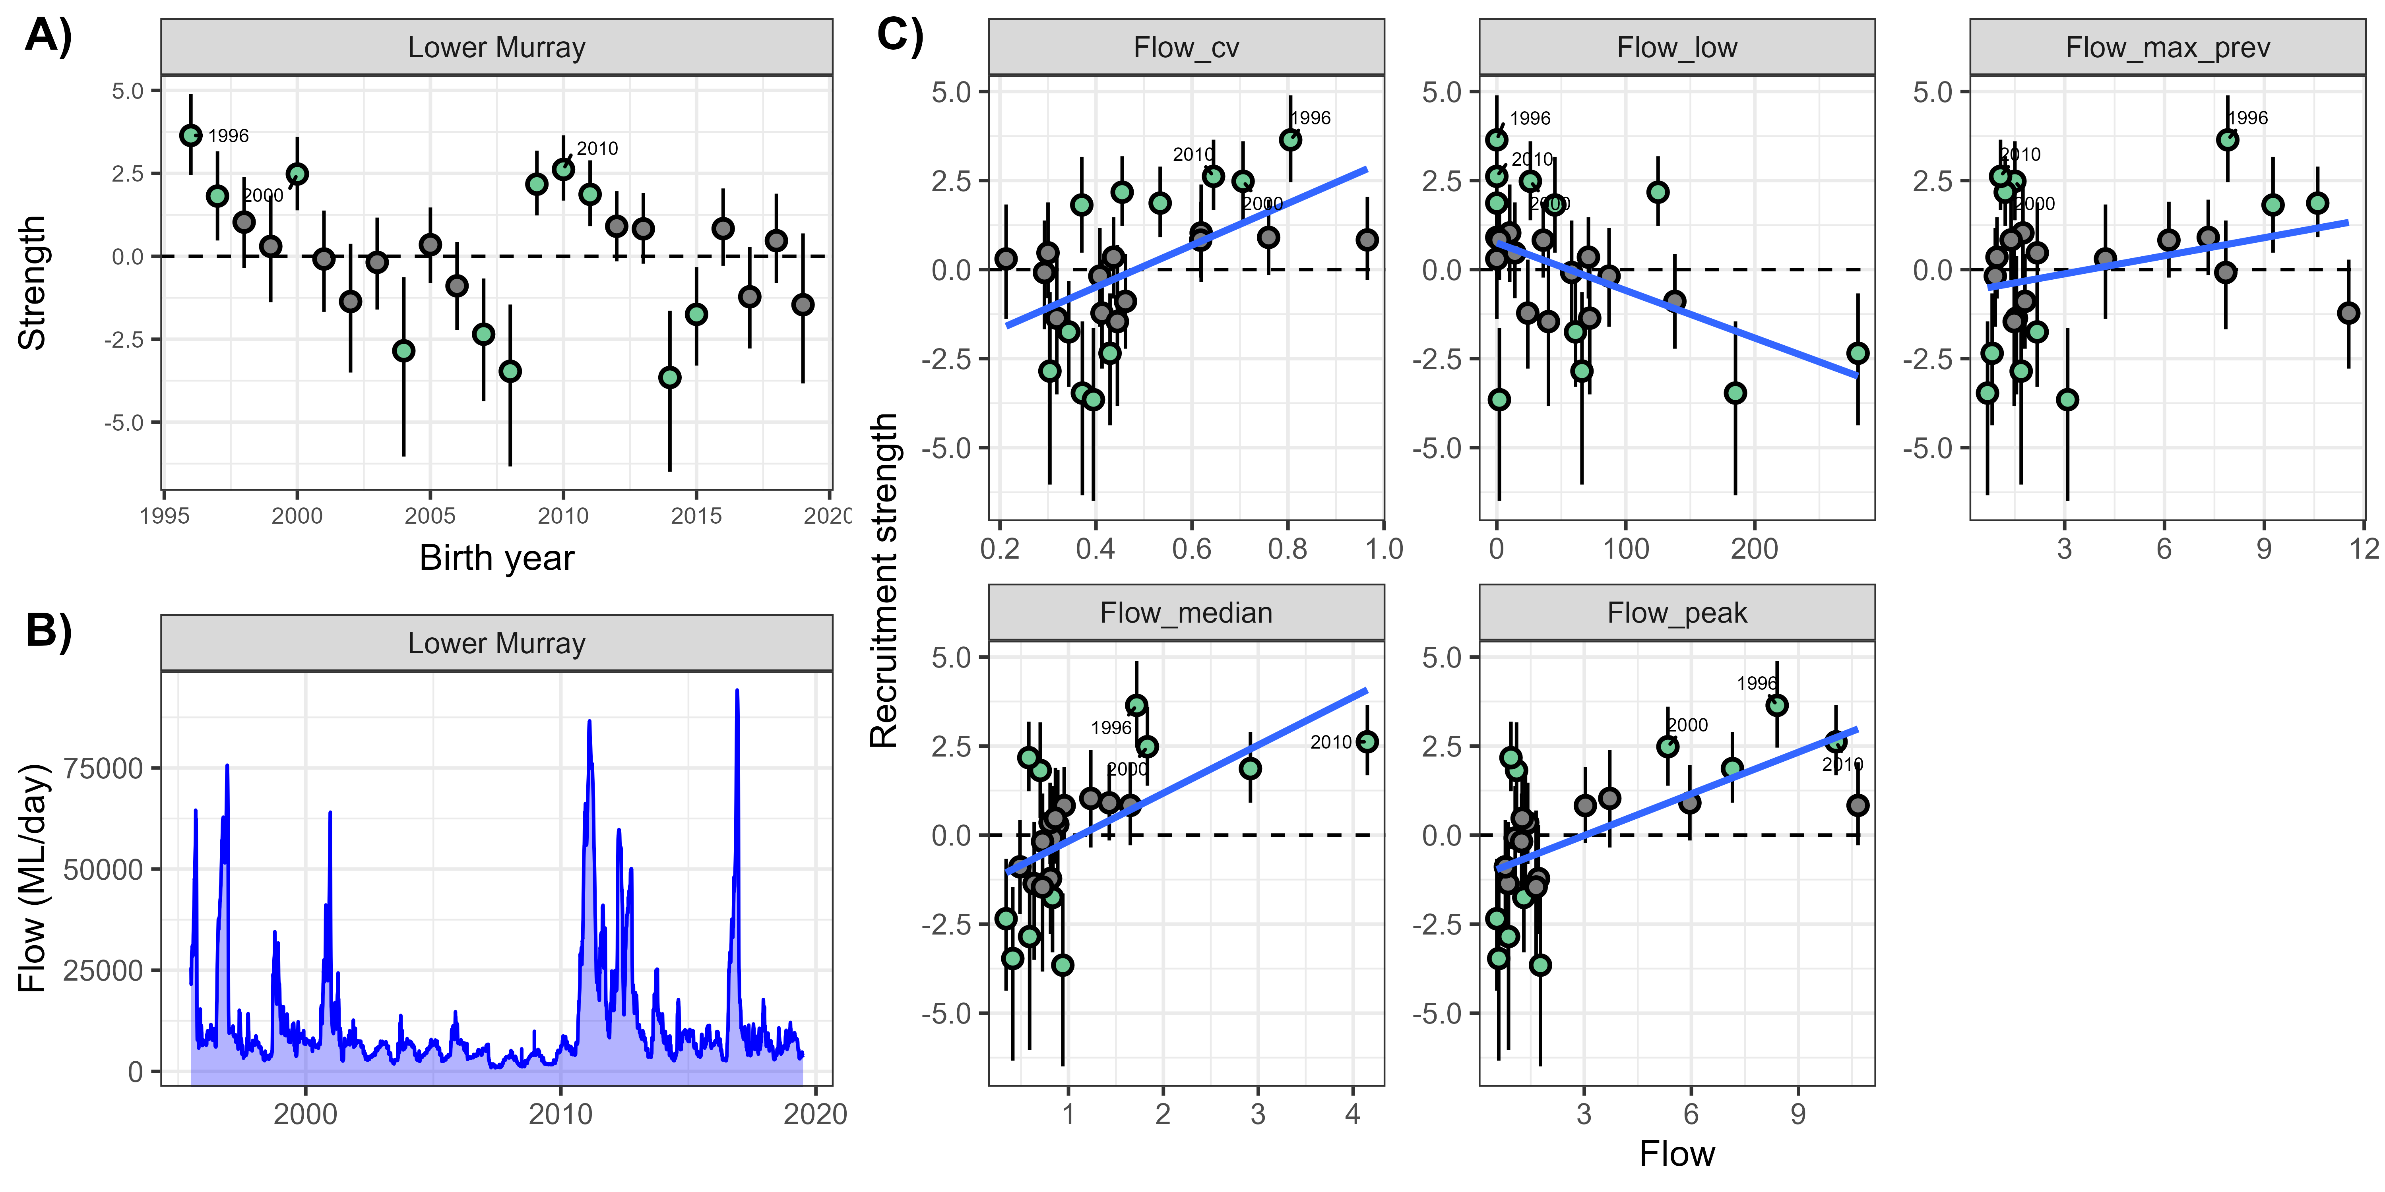

Table 5.2 Number of adult native species recorded in each Selected Area for each year, 2014–24, from Category 1 fish sampling
Note that no sampling occurred in the Gwydir River System in 2020–21, and Junction of Warrego and Darling rivers is not included in the evaluation. Category 1 fish sampling comprises standardised methods implemented across all 6 Selected Areas and has a focus on monitoring annual fish condition. These methods include boat and backpack electrofishing and the use of fine-mesh fyke nets to survey adult fish communities.
Selected Area | 2014–15 | 2015–16 | 2016–17 | 2017–18 | 2018–19 | 2019–20 | 2020–21 | 2021–22 | 2022–23 | 2023–24
Edward/Kolety–Wakool river systems | 8 | 9 | 8 | 8 | 8 | 8 | 9 | 9 | 9 | 8
Goulburn River | 7 | 9 | 8 | 7 | 7 | 7 | 9 | 10 | 9 | 8
Gwydir River System | 8 | 9 | 9 | 9 | 9 | 9 | – | 9 | 9 | 9
Lachlan River System | 6 | 7 | 7 | 6 | 6 | 7 | 8 | 7 | 7 | 7
Lower Murray River | 11 | 11 | 8 | 10 | 11 | 11 | 11 | 10 | 9 | 11
Murrumbidgee River System | 8 | 7 | 9 | 8 | 8 | 7 | 9 | 9 | 9 | 8

Contribution to focal species frequency of occurrence within Selected Areas
The key flow variables that contributed to reduced detections of native fish at sites within Selected Areas were increased average daily flows and increases in the number of low flow days (Appendix H, Figure H.3). Negative responses to increased average daily flows were evident for bony herring (strong evidence). Evidence was weaker for golden perch, Murray cod and Murray–Darling rainbowfish (Appendix H, Figure H.3). Negative responses to increases in the number of low flow days were evident for Australian smelt (strong evidence). Evidence was weaker for bony herring and Murray cod, while carp gudgeon and eastern gambusia detection at sites had a positive response (with weak evidence) (Appendix H, Figure H.3). Note that a negative response to increases in the number of low flow days means that environmental water is often positive in its impacts because it reduces the number of low flow days. Detection at sites within Selected Areas for Murray cod and Murray–Darling rainbowfish decreased with increased flow variability (with strong evidence). Evidence was weaker for golden perch and carp gudgeon (Appendix H, Figure H.3). Detection of Murray–Darling rainbowfish at sites within Selected Areas decreased with increased maximum antecedent flows (with strong evidence). Evidence was weaker for Australian smelt and carp gudgeon (Appendix H, Figure H.3). It must be noted that Murray–Darling rainbowfish has not been recorded in the Lachlan River System, and the estimated effects of CEW for Murray–Darling rainbowfish is based on average flow responses across all Selected Areas coupled with counterfactual scenarios for each area. Consequently, the estimated effects of CEW in this case are associated with low confidence.

Commonwealth environmental water contributed to detections of Australian smelt at more sites within the Edward/Kolety–Wakool river systems (5 out of 10 years), Goulburn River (10 out of 10 years),12 Lachlan River System (5 out of 10 years),12 Lower Murray River (9 out of 10 years)12 and Murrumbidgee River System (7 out of 10 years)12 (Figure 5.8).
More variable responses to CEW were evident for bony herring, golden perch, Murray cod and Murray–Darling rainbowfish (Figure 5.8). Commonwealth environmental water contributed to detections of bony herring at more sites in 2 out of 10 years within the Goulburn River12 and Lower Murray River (negative in 1 out of 10 years)12 and in 1 out of 10 years within the Edward/Kolety–Wakool river systems (negative in 3 out of 10 years)12 (Figure 5.8). Bony herring was detected at fewer sites with CEW in 1–4 out of 10 years within the Gwydir River System12 and Lachlan River System12 (Figure 5.8). Golden perch were detected at more sites with CEW in 1 out of 10 years within the Murrumbidgee River System12 and at less sites in 1 out of 10 years within the Gwydir River System12 (Figure 5.8).
Murray cod were detected at more sites with CEW in 1 out of 10 years within the Edward/Kolety–Wakool river systems,12 Gwydir River System (negative in 2 out of 10 years)12 and Murrumbidgee River System (negative in 1 out of 10 years)12 (Figure 5.8). In the Lachlan River System,12 Murray cod were detected at fewer sites with CEW in 2 out of 10 years (Figure 5.8). Murray–Darling rainbowfish were detected at more sites with CEW in 1 out of 10 years within the Gwydir River System (negative in 2 out of 10 years)12. Within the Lachlan River System12 and the Murrumbidgee River System,12 Murray–Darling rainbowfish were detected at fewer sites with CEW in 1–3 out of 10 years (Figure 5.8).
Responses to CEW were driven primarily by contributions to reducing the number of low flow days (positive responses) and, to a lesser extent, influences on flow variability (positive and negative responses) and increased average daily flows (negative responses) (Figure 5.9).
There were no positive responses with CEW for detection of carp gudgeon at sites in any of the Selected Areas (Figure 5.8).
Eastern gambusia were detected at fewer sites with CEW in most Selected Areas (1–10 out of 10 years)12 (Figure 5.8). These responses were driven primarily by CEW contributing to a reduced number of low flow days (negative response) (Figure 5.9).
For the current water year, CEW contributed to detections of Australian smelt at more sites in the Goulburn River, Gwydir River System, Lachlan River System, Lower Murray River and Murrumbidgee River System (Figure 5.8).

Figure 5.8 Predicted effect of Commonwealth environmental water on frequency of occurrence across sampling sites within Selected Areas for each focal fish species, by Selected Area, over the period 2014–24
Each density plot shows the distribution of effect sizes, which have been scaled to percentage rather than absolute change with Commonwealth environmental water (CEW), because these values are more easily compared among species that differ in site occupancy rates. Vertical dashed line shows no effect (0%); distribution to the left of this line indicates a negative effect and right a positive effect. Red and blue numbers indicate the number of years in which there was a significant negative and positive effect, respectively. Dot indicates the current year estimate, and colour indicates if contribution was significant (green = positive; red = negative) or not (grey). Note that Murray–Darling rainbowfish was not recorded in the Lachlan River System during the survey period. The estimated effects of CEW in this system for Murray–Darling rainbowfish are based on average flow responses across all Selected Areas, coupled with counterfactual scenarios for each area. Consequently, the estimated effects of CEW in this case are associated with low confidence (Figure 5.1). Junction of Warrego and Darling rivers is not included in the evaluation. As common carp was present at every site within Selected Areas, it was excluded from this analysis.
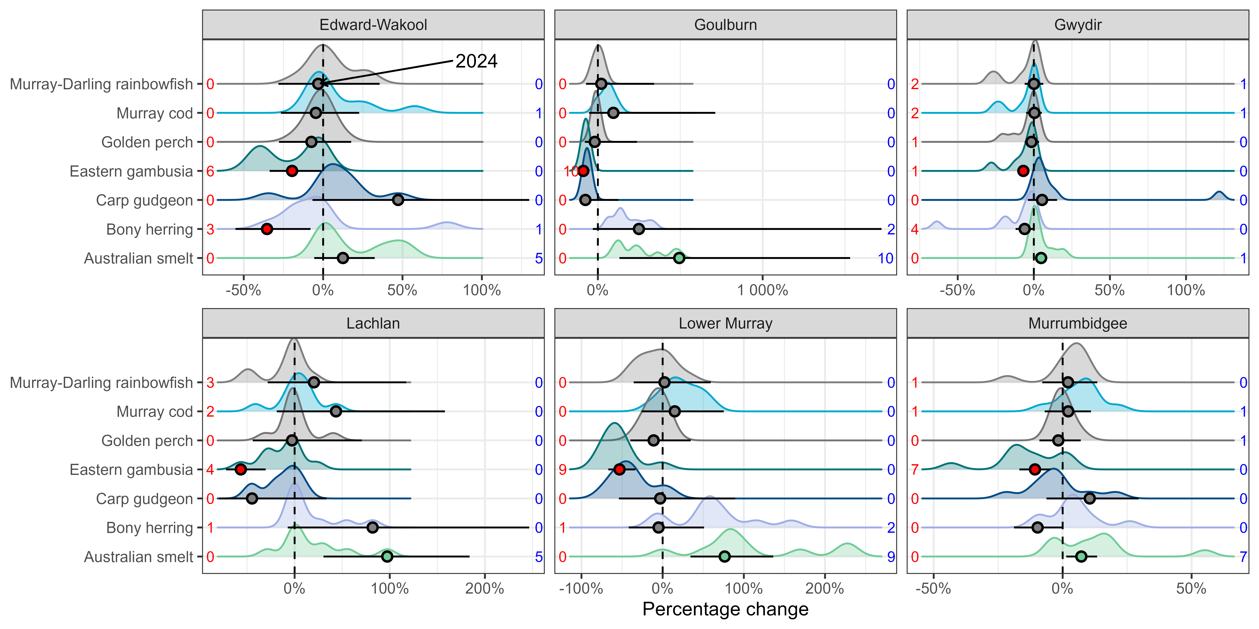
Figure 5.9 Contribution of each flow variable (coefficient of variability in daily flows, number of days of low flow, standardised maximum antecedent flow and standardised daily flows) to the predicted Commonwealth environmental water effect on frequency of occurrence for each focal fish species, by year and Selected Area, over the period 2014–24
Contributions are the modelled effects of each flow variable multiplied by the change in that flow variable due to Commonwealth environmental water (CEW) and combine the magnitude of a variable’s impact with the magnitude of change in that variable due to CEW. Contributions are calculated on the model-link scale (the scale on which effects are estimated), rather than the observation scale (the scale on which the data are observed), to preserve their sign (negative or positive). Negative effects are shown as columns below 0 and positive effects are columns above 0. As common carp was present at every site within Selected Areas, it was excluded from this analysis. Flow_cv = coefficient of variability in daily flows, flow_low = number of days of low flow, flow_max_prev = standardised maximum antecedent flow, flow_median = standardised daily flows. Years on the x-axis represent the previous water year, i.e. 2015 = 2014–15.
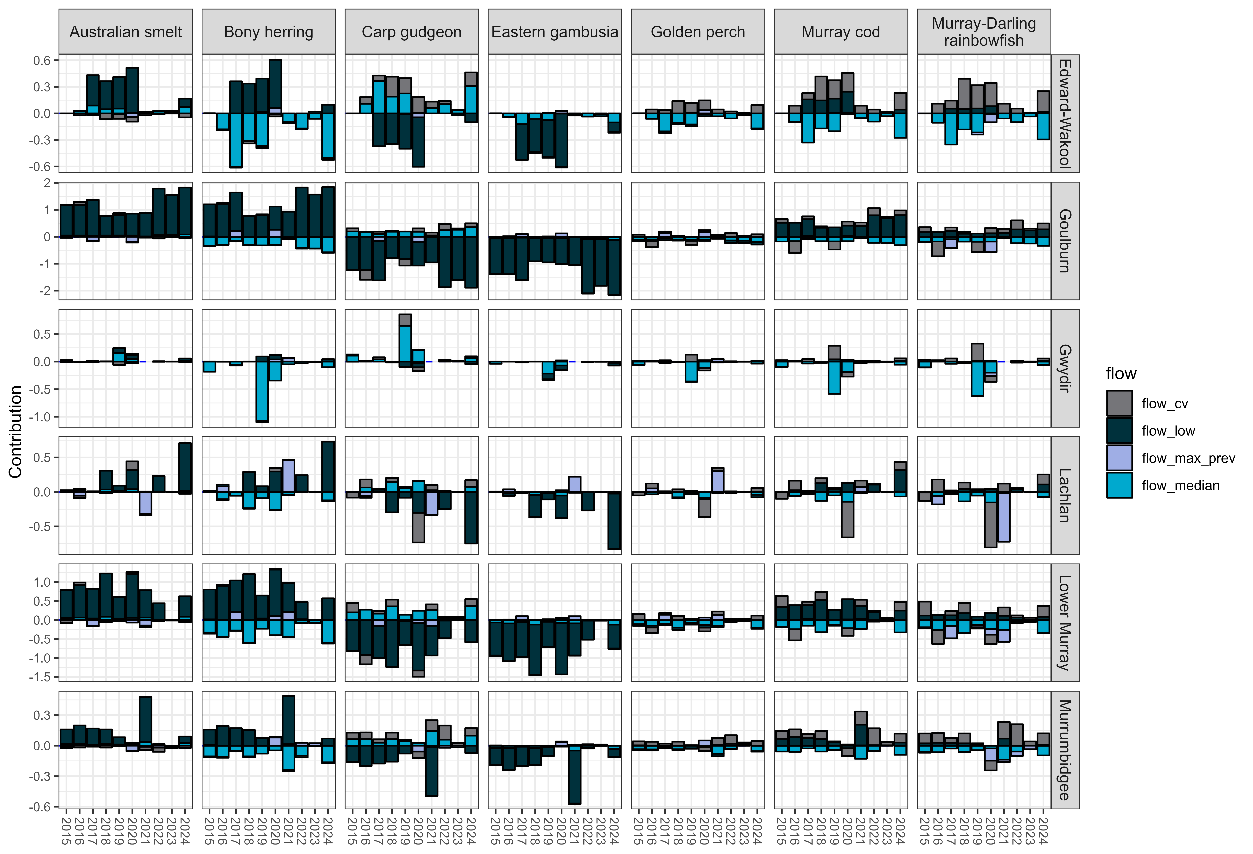.

Contribution to population growth rates of focal species
Native fish population growth rates decreased in response to increasing numbers of low flow days and increased average daily flows (with strong evidence); however, negative responses were detected for golden perch, Murray cod (with weaker evidence for increasing numbers of low flow days) and (with weaker evidence) bony herring (Appendix H, Figure H.4). In contrast (and with weaker evidence), population growth rates of common carp increased with increased average daily flows and increased number of low flow days (Appendix H, Figure H.4). Increasing flow variability was associated with decreased population growth rates of Murray cod (with strong evidence) and common carp (with weaker evidence) but was associated with increased population growth rates of golden perch (with weaker evidence) (Appendix H, Figure H.4). Population growth rates of Murray cod, bony herring (both with strong evidence) and golden perch (with weaker evidence) increased with increasing maximum antecedent flows, while population growth rates of common carp decreased (with strong evidence) (Appendix H, Figure H.4). Population growth rates of Murray cod and golden perch decreased (with strong evidence) in response to the time since most-recent fish-death event, while population growth rates of common carp increased (weaker evidence; high uncertainty, 95% credible intervals overlapping zero) (Appendix H, Figure H.4).
Murray cod population growth rates showed variable responses to CEW delivery (Figure 5.10). Commonwealth environmental water contributed to increased Murray cod population growth rates in 1–6 years out of 9 years at all Selected Areas (Figure 5.10). However, in some Selected Areas, there was negative responses to CEW, including in the Edward/Kolety–Wakool river systems (2 out of 9 years),13 Gwydir River System (3 out of 9 years),13 Lachlan River System (2 out of 9 years)13 and Murrumbidgee River System (1 out of 9 years)13 (Figure 5.10).
Population growth rates of golden perch increased with delivery of CEW in the Goulburn River (9 out of 9 years). Responses were more variable in other Selected Areas, including the Lower Murray River (positive in 7 out of 9 years, negative in 1 out of 9 years),13 Murrumbidgee River System (positive in 5 out of 9 years, negative in 1 out of 9 years),13 Lachlan River System (positive in 4 out of 9 years, negative in 1 out of 9 years)13 and Edward/Kolety–Wakool river systems (positive in 1 out of 9 years, negative in 4 out of 9 years)13 (Figure 5.10). In the Gwydir River System,13 responses to CEW were negative in 4 out of 9 years (Figure 5.10).
Commonwealth environmental water contributed to increased population growth rates of bony herring in the Lachlan River System13 (1 out of 9 years) (Figure 5.10).
Population growth rates of common carp showed variable responses to CEW delivery (Figure 5.10). Growth rates decreased with delivery of CEW in the Goulburn River (4 out of 9 years)13 and Lower Murray River (positive in 1 out of 9 years, negative in 6 out of 9 years)13 (Figure 5.10). Increased population growth rates occurred with CEW delivery in the Gwydir River System (positive in 6 out of 9 years, negative in 1 out of 9 years)13 and the Edward/Kolety–Wakool river systems (positive in 4 out of 9 years)13 (Figure 5.10).
Species’ responses to CEW were driven primarily by contributions to reducing the number of low flow days (positive responses for native species and negative for common carp) and, to a lesser extent, increased average daily flows (negative responses for native species and positive for common carp) (Figure 5.11).
For the current water year, CEW contributed to increased population growth rates for golden perch in the Goulburn River and Lachlan River System, for Murray cod in the Lachlan River System and for common carp in the Edward/Kolety–Wakool river systems, Gwydir River System and Murrumbidgee River System (Figure 5.10).

Figure 5.10 Predicted effect of Commonwealth environmental water on population growth rate for each focal fish species, by Selected Area, over the period 2014–24
Model estimates growth rates between years. Each density plot shows the distribution of effect sizes, which have been scaled to percentage change in abundance relative to previous year. Vertical dashed line shows no effect (0%); distribution to the left of this line indicates a negative effect and right a positive effect. Red and blue numbers indicate the number of years in which there was a significant negative and positive effect, respectively. Dot indicates the current year estimate, and colour indicates if the contribution was significant (green = positive; red = negative) or not (grey). Note that Junction of Warrego and Darling rivers is not included in the evaluation. Only large-bodied fish were included for analysis, as small-bodied fish were likely young-of-year and hence analysed in the recruitment analysis.
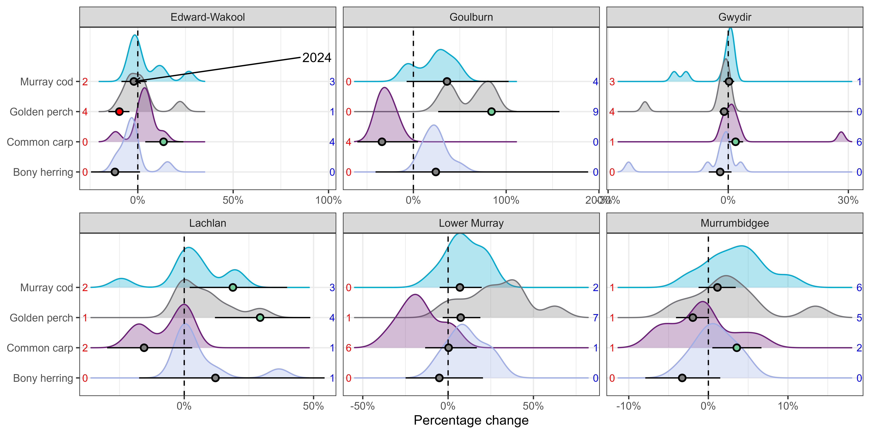
Figure 5.11 Contribution of each flow variable (coefficient of variability in daily flows, number of days of low flow, standardised maximum antecedent flow and standardised daily flows) to the predicted Commonwealth environmental water effect on population growth rates for each focal fish species, by year and Selected Area, over the period 2014–24
Contributions are the modelled effects of each flow variable multiplied by the change in that flow variable due to Commonwealth environmental water (CEW). They combine the magnitude of a variable’s impact with the magnitude of change in that variable due to CEW. Contributions are calculated on the model-link scale (the scale on which effects are estimated), rather than the observation scale (the scale on which the data are observed), to preserve their sign (negative or positive). Negative effects are shown as columns below 0 and positive effects are columns above 0. Only large-bodied fish were included for analysis, as small-bodied fish were likely young-of-year and hence analysed in the recruitment analysis. Flow_cv = coefficient of variability in daily flows, flow_low = number of days of low flow, flow_max_prev = standardised maximum antecedent flow, flow_median = standardised daily flows. Years on the x-axis represent the previous water year, i.e. 2015 = 2014–15.
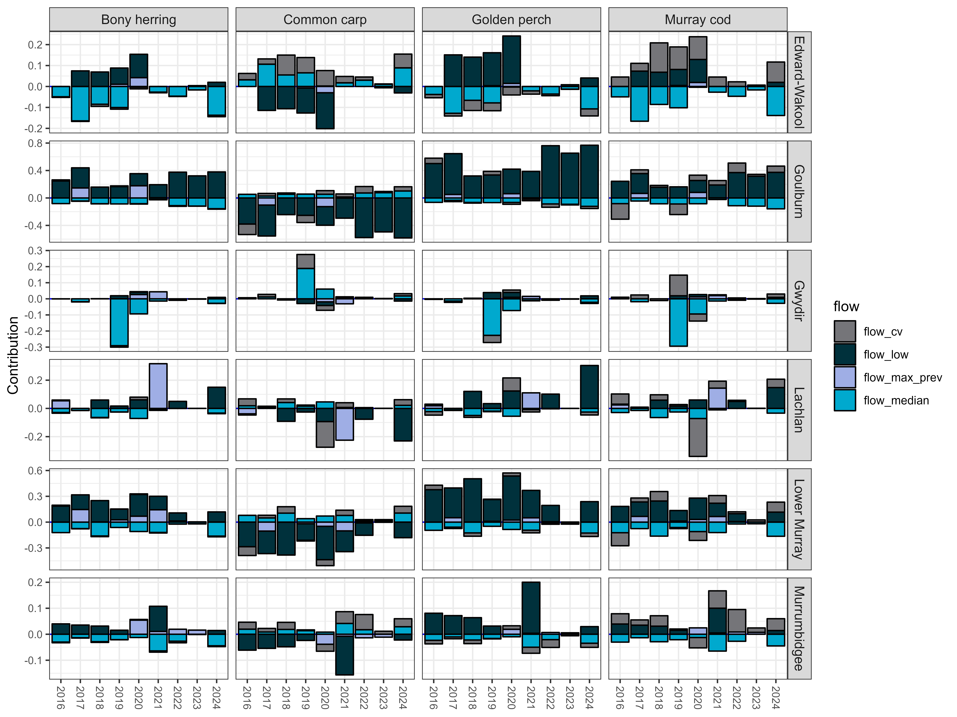

Contribution to adult fish body condition
Body condition increased with increased average daily flows. Positive responses were detected – there was strong evidence for Murray cod, golden perch and common carp and weaker evidence for bony herring (Appendix H, Figure H.5). There was weaker evidence that body condition decreased with increases in the number of low flow days – negative responses were detected for Murray cod and golden perch (Appendix H, Figure H.5). Body condition of Murray cod also increased with increasing maximum antecedent flows and flow variability (with strong evidence) (Appendix H, Figure H.5). Body condition for bony herring decreased with increases in flow variability (with strong evidence), while body condition for golden perch increased (with weaker evidence) (Appendix H, Figure H.5).
Body condition for Murray cod predominantly increased with the delivery of CEW in all Selected Areas: Edward/Kolety–Wakool river systems (positive in 2 out of 10 years, negative in 2 out of 10 years),14 Goulburn River (8 out of 10 years), Gwydir River System (4 out of 9 years),14 Lachlan River System (positive in 4 out of 10 years, negative in 1 out of 10 years),14 Lower Murray River (6 out of 10 years, negative in 1 out of 10 years)14 and Murrumbidgee River System (positive in 3 out of 10 years; negative in 1 out of 10 years)14 (Figure 5.12).
Body condition for golden perch increased with the delivery of CEW in all Selected Areas: Edward/Kolety–Wakool river systems (positive in 2 out of 10 years),14 Goulburn River (9 out of 10 years),14 Gwydir River System (2 out of 9 years),14 Lachlan River System (3 out of 10 years),14 Lower Murray River (6 out of 10 years)14 and Murrumbidgee River System (4 out of 10 years)14 (Figure 5.12).
Murray cod and golden perch responses to CEW were driven primarily by contributions to reducing the number of low flow days (positive response), increased average daily flows (positive response), and influencing flow variability (negative response) (Figure 5.13).
Body condition for bony herring predominantly increased with the delivery of CEW in the majority of Selected Areas: Edward/Kolety–Wakool river systems (9 out of 10 years),14 Gwydir River System (positive in 6 out of 9 years, negative in 1 out of 9 years),14 Lachlan River System (positive in 6 out of 10 years, negative in 2 out of 10 years),14 Lower Murray River (positive in 4 out of 10 years, negative in 1 out of 10 years)14 and Murrumbidgee River System (positive in 9 out of 10 years; negative in 1 out of 10 years)14 (Figure 5.12). Responses to CEW were driven primarily by contributions to flow variability (positive and negative responses), increased average daily flows (positive responses), and maximum antecedent flows (negative responses) (Figure 5.13).
Body condition for common carp increased with the delivery of CEW in some years at most Selected Areas (positive in 2–5 out of 10 years)14 (Figure 5.12). Responses to CEW were driven primarily by contributions to increased average daily flows (positive response) and reducing the number of low flow days (positive response) (Figure 5.13).
For the current water year, CEW contributed to increased body condition for golden perch in the Edward/Kolety–Wakool river systems, Goulburn River and Lower Murray River, for Murray cod in the Goulburn river and Lower Murray River, for bony herring in the Edward/Kolety–Wakool river systems, Gwydir River System, Lachlan River System, Lower Murray River and Murrumbidgee River System, and for common carp in Edward/Kolety–Wakool river systems (Figure 5.13).

Figure 5.12 Predicted effect of Commonwealth environmental water on body condition for each focal fish species, by Selected Area, over the period 2014–24
Each density plot shows the distribution of effect sizes, which have been scaled to percentage of average Fulton’s K for each species. Vertical dashed line shows no effect (0%); distribution to the left of this line indicates a negative effect and right a positive effect. Red and blue numbers indicate the number of years in which there was a significant negative and positive effect, respectively. Dot indicates the current year estimate, and colour indicates if the contribution was significant (green = positive; red = negative) or not (grey). Note that weights of common carp were recorded only once in the Lower Murray River during the survey period, which was not adequate for analysis. In the Goulburn River, common carp weights were not recorded at all during the survey period, and bony herring was detected only 5 in 10 years, which was not adequate for analysis. Junction of Warrego and Darling rivers is not included in the evaluation. Only fish species with sufficient numbers across most Selected Areas were analysed to ensure a robust analysis.
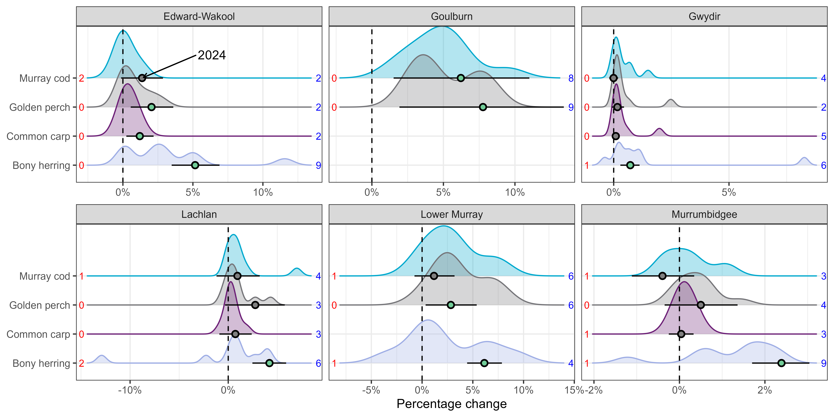
Figure 5.13 Contribution of each flow variable (coefficient of variability in daily flows, number of days of low flow, standardised maximum antecedent flow and standardised daily flows) to the predicted Commonwealth environmental water effect on body condition for each focal fish species, by year and Selected Area, over the period 2014–24
Contributions are the modelled effects of each flow variable multiplied by the change in that flow variable due to Commonwealth environmental water (CEW). They combine the magnitude of a variable’s impact with the magnitude of change in that variable due to CEW. Contributions are calculated on the observation scale (the scale on which data are observed), because this scale retains positive and negative values. Negative effects are shown as columns below 0 and positive effects are columns above 0. Note that weights of common carp were recorded only once in the Lower Murray River during the survey period. In the Goulburn River, common carp weights were not recorded at all during the survey period, and bony herring was only detected in 5 in 10 years. The Junction of Warrego and Darling rivers is not included in the evaluation. Only fish species with sufficient numbers across most Selected Areas were analysed to ensure a robust analysis. Flow_cv = coefficient of variability in daily flows, flow_low = number of days of low flow, flow_max_prev = standardised maximum antecedent flow, flow_median = standardised daily flows. Years on the x-axis represent the previous water year, i.e. 2015 = 2014–15.
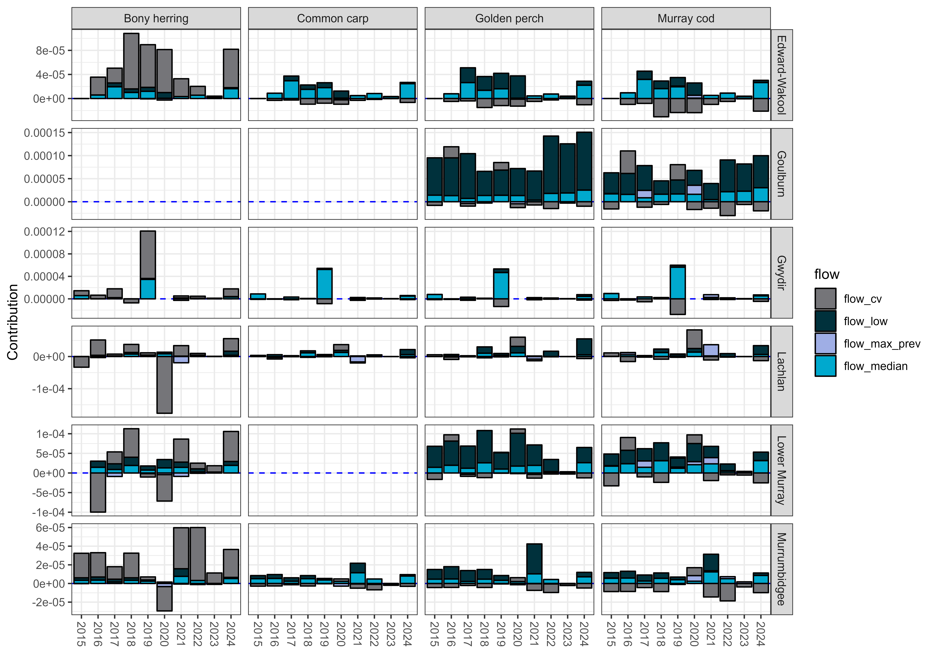

Contribution to community compositional responses
There was strong evidence that the proportion of catch that was native decreased with increases in the number of low flow days. Evidence was weaker that the proportion of catch that was native decreased with increased average daily flows, flow variability and maximum antecedent flows (Appendix H, Figure H.6).
There was medium confidence that the proportion of catch that was native increased with delivery of CEW in 8 out of 10 years in the Goulburn River, 7 out of 10 years in the Lower Murray River15 and 5 out of 10 years in the Murrumbidgee River System (negative in 1 out of 10 years)15 (Figure 5.14). The proportion of catch that was native had variable responses to delivery of CEW in the Edward/Kolety–Wakool river systems and Lachlan River System (positive in 3 out of 10 years, negative in 2 out of 10 years) (Figure 5.14). There was no evidence of any positive responses in the Gwydir River System (negative in 4 out of 10 years)15 (Figure 5.14). Responses to CEW were driven primarily by contributions to reducing the number of low flow days (positive responses) and increased average daily flows (negative responses) (Figure 5.15).

Figure 5.14 Predicted effect of Commonwealth environmental water on the community compositional metric (as percentage change of the proportion of catch that was native), by year and Selected Area, over the period 2014–24
Error bars are 95% credible intervals (CIs). Asterisks (*) indicate 95% CIs do not overlap with 0 (if * is above error bar, then the effect is positive; below error bar, effect is negative). Note that Junction of Warrego and Darling rivers is not included in the evaluation.
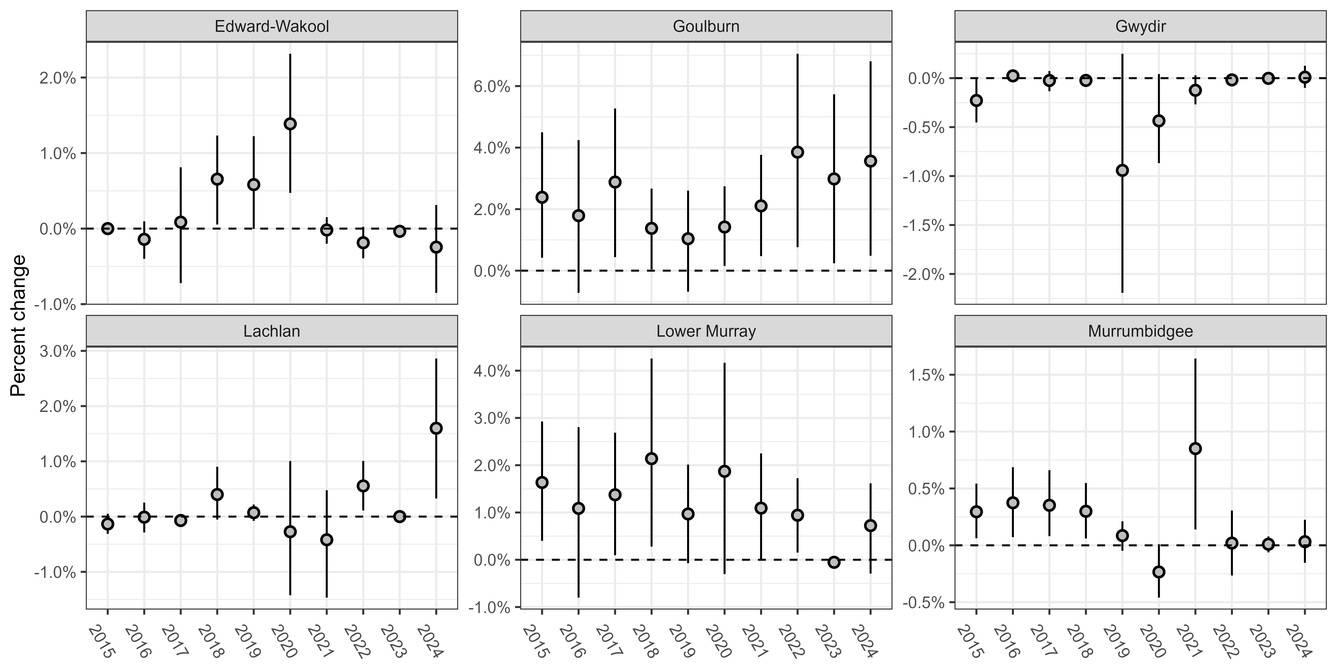
Figure 5.15 Contribution of each flow variable (coefficient of variability in daily flows, number of days of low flow, standardised maximum antecedent flow and standardised daily flows) to the predicted Commonwealth environmental water effect on the community compositional metric (the proportion of catch that was native), by year and Selected Area, over the period 2014–24
Contributions are the modelled effects of each flow variable multiplied by the change in that flow variable due to Commonwealth environmental water (CEW). They combine the magnitude of a variable’s impact with the magnitude of change in that variable due to CEW. Contributions are calculated on the observation scale (the scale on which data are observed), because this scale retains positive and negative values. Negative effects are shown as bars below 0 and positive effects are bars above 0. Flow_cv = coefficient of variability in daily flows, flow_low = number of days of low flow, flow_max_prev = standardised maximum antecedent flow, flow_median = standardised daily flows. Years on the x-axis represent the previous water year, i.e. 2015 = 2014–15.

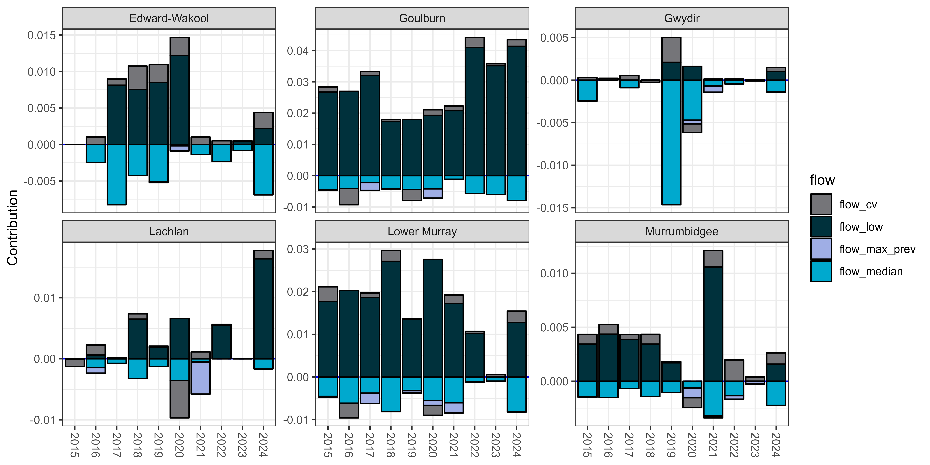

Predicting contribution to Murray cod and Murray–Darling rainbowfish recruitment at unmonitored areas across the Basin
Predicting the contribution of CEW to recruitment of Murray cod and Murray–Darling rainbowfish at unmonitored areas is a recent element added to the Flow-MER analyses and highlights the growing predictive capacity for the Basin-scale Fish Theme. The predictions are, however, associated with low confidence due to being extrapolated beyond Selected Area monitored sites without the opportunity for validation. At some Selected Areas in some years, there was high confidence of a positive effect of CEW on recruitment of Murray cod and Murray–Darling rainbowfish (for Murray cod and Murray–Darling rainbowfish recruitment responses observed in the Selected Areas, see Section 5.2.4).
Model predictions were very similar between the 2 fish species (Figure 5.16 and Figure 5.17, respectively). The contribution of CEW to recruitment of Murray cod and Murray–Darling rainbowfish was predicted to be greatest in the southern Basin, including in the Broken River, Goulburn River, Loddon River, Lower Murray River and Campaspe River (Figure 5.16, Figure 5.17). These predicted effects in the southern Basin were associated with greater contributions of CEW to mitigating low flows in this region (lower right panel in Figure 5.16 and Figure 5.17). Commonwealth environmental water contributed substantially to increased average daily flows in the northern Basin, and these flows are predicted to increase recruitment in this region but to a lesser extent than in the southern Basin. Increases in average daily flows were most evident in the Namoi River, Moonie River and Severn River (upper right panel in Figure 5.16 and Figure 5.17).

Figure 5.16 Map of the Murray–Darling Basin showing the predicted Commonwealth environmental water contribution to recruitment rates for Murray cod across the Basin
The Commonwealth environmental water (CEW) effect map (left) shows the relative effect size of CEW delivery on Murray cod recruitment for each flow gauge. Larger circles and lighter blues indicate larger effects. Smaller maps (right) show differences between actual flows and modelled flows without CEW for average daily flows (flow median) and low flow days (flow low) – 2 key flow metrics for Murray cod. For average daily flows, larger circles/lighter blues indicate increased flows due to CEW. For low flow days, larger circles and lighter blues indicate the number of low flow days that decreased with CEW (i.e. declining low flow days indicate fewer number of low flow days and, in theory, better flow environment). A subset of flow gauges was used across the Basin (n = 97) for predictions, and several gauges were filtered out of the prediction process due to incomplete flow data. Green line denotes Gwydir River System, aqua line denotes Lachlan River System, pink line denotes Murrumbidgee River System, orange line denotes Edward/Kolety–Wakool river systems, yellow line denotes Goulburn River, and light blue line denotes Lower Murray River.
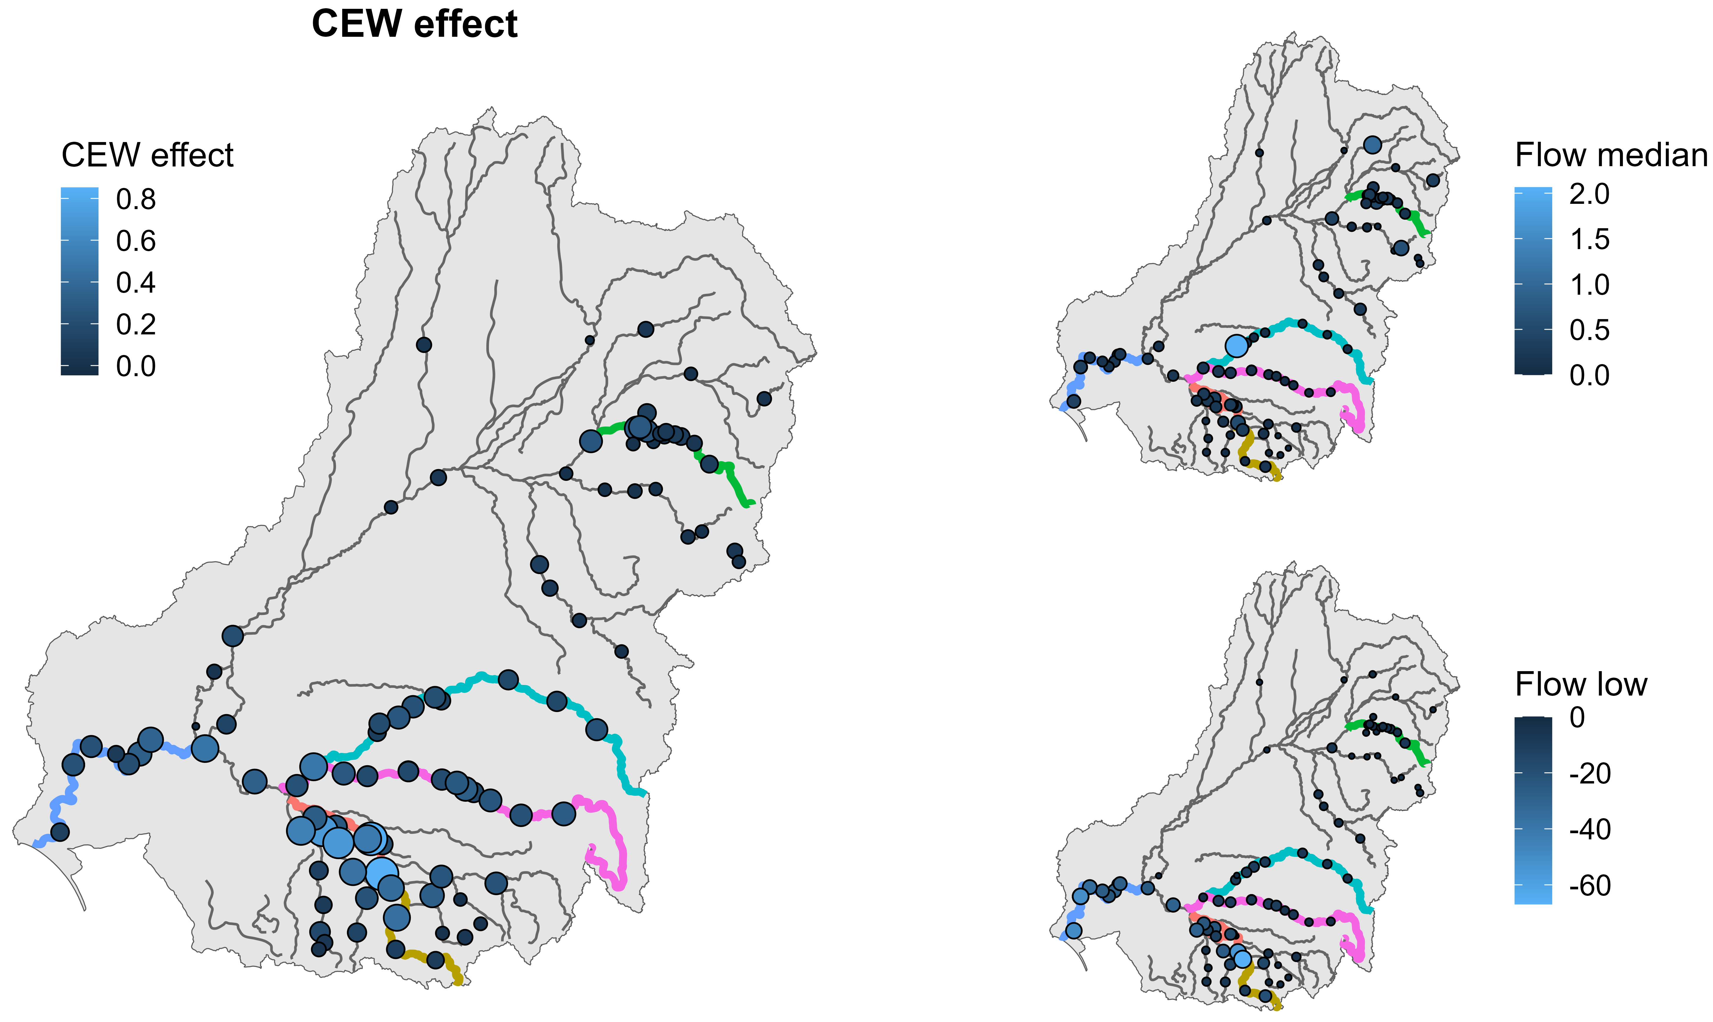
Figure 5.17 Map of the Murray–Darling Basin showing the predicted Commonwealth environmental water contribution to recruitment rates for Murray–Darling rainbowfish across the Basin
The Commonwealth environmental water (CEW) effect map (left) shows the relative effect size of CEW delivery on Murray–Darling rainbowfish recruitment for each flow gauge. Larger circles and lighter blues indicate larger effects. Smaller maps (right) show differences between actual flows and modelled flows without CEW for average daily flows (flow median) and low flow days (flow low) – 2 key flow metrics for Murray–Darling rainbowfish. For average daily flows, larger circles and lighter blues indicate increased flows due to CEW. For low flow days, larger circles and lighter blues indicate the number of low flow days that decreased with CEW (i.e. declining low flow days indicate fewer number of low flow days and, in theory, better flow environment). A subset of flow gauges was used across the Basin (n = 99) for predictions, and several gauges were filtered out of the prediction process due to incomplete flow data. Green line denotes Gwydir River System, aqua line denotes Lachlan River System, pink line denotes Murrumbidgee River System, orange line denotes Edward/Kolety–Wakool river systems, yellow line denotes Goulburn River, and light blue line denotes Lower Murray River.
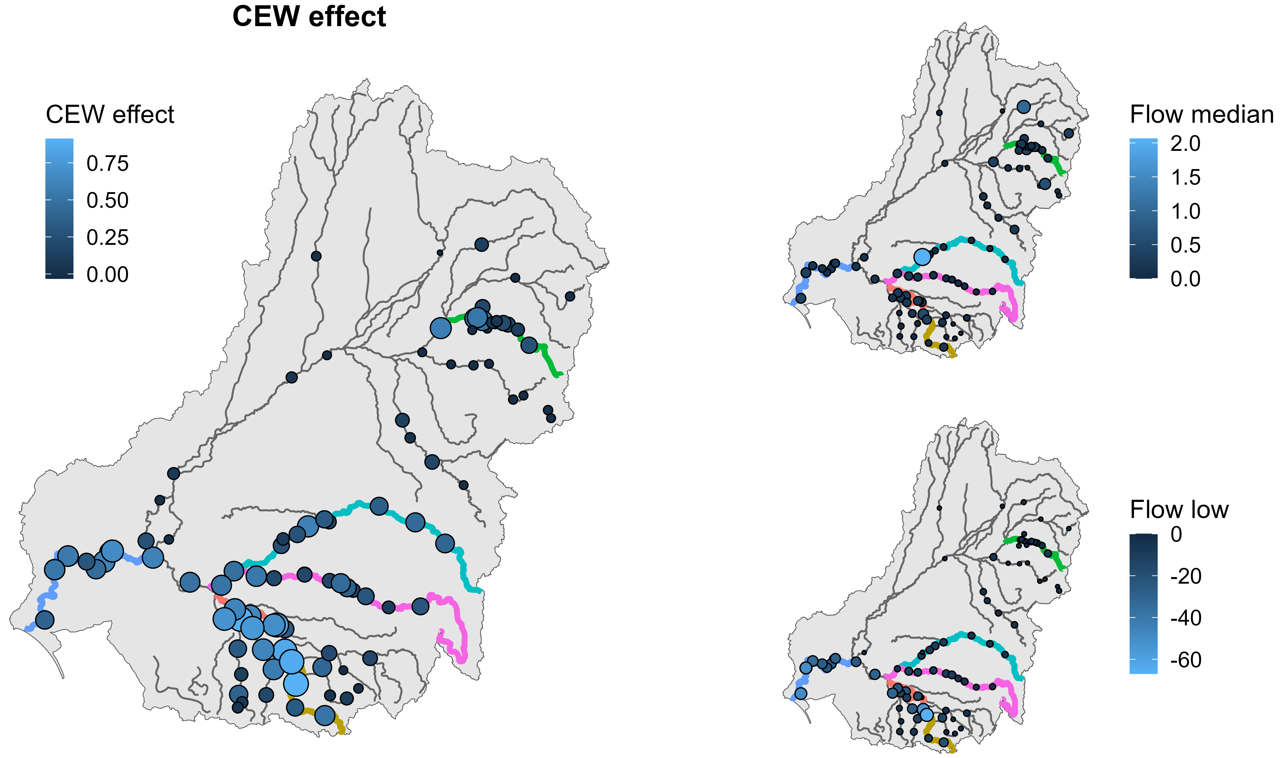

Contribution to Basin Plan objectives
The Basin Plan sets high-level objectives to protect and restore water-dependent ecosystems of the Basin to ensure that they are resilient to climate change and other risks and threats (Basin Plan section 8.04). This chapter describes the contributions of this year’s environmental water deliveries to realising these objectives.
Commonwealth environmental water plays a critical role in meeting long-term Basin Plan objectives under paragraphs 8.05(3)(a)(b) to protect and restore biodiversity that is dependent on Basin water resources. Longer-term targets identified in the Basin Plan to measure progress towards the overall environmental objectives for water-dependent ecosystems include improvements in recruitment and populations of native fish (outlined in Schedule 7; Basin Plan Schedule 12, item 7). The evaluation developed under LTIM and Flow-MER is focused on evaluating the outcomes of using CEW to sustain native fish at the Basin scale and uses the general objectives of the Basin Plan to develop a suite of expected outcomes for fish (see Gawne et al. 2013), as the Basin Plan did not contain quantifiable fish objectives. A stronger link, including developing specific, quantifiable objectives and targets in the Basin Plan, would be useful in closing this gap. The Strategy (MDBA 2019) elaborates some of these key biodiversity outcomes of the Basin Plan in more detail. The Strategy is designed to add detail and quantified outcomes to the Basin Plan objectives with a focus on using CEW to help achieve these outcomes. It is an evolving document, and progressive quantification and refinement of the outcomes clarify the ‘measures of success’ and support effective monitoring. The Strategy lists 5 expected outcomes for fish to be achieved, as summarised in sections 6.1–6.5. Currently, there is a 2025 draft version of the Strategy which is yet to be finalised; however, expected outcomes for all native fish are the same at this stage.
Here, we consider the evidence from Flow-MER as it pertains to achieving the general targets of the Basin Plan (i.e. improvements in recruitment and populations of native fish) and outcomes in the Strategy. This information can help inform CEWH, who is required to report ‘every 5 years on the achievements of environmental outcomes at a Basin scale, by reference to the targets to measure progress towards the environmental objectives outlined in Schedule 7 (Basin Plan Schedule 12, item 7)’. The Schedule 7 targets relevant to fish include improvements in: ‘f) recruitment and populations of native water-dependent species, including vegetation, birds, fish and macroinvertebrates’. Note the limitations of Flow-MER, which encompasses only 6 Selected Areas and has a focus on the contribution of CEW to fish responses. A more robust assessment against Strategy outcomes could be achieved using a combination of Flow-MER and other fish monitoring programs (e.g. The Living Murray, Murray–Darling Basin Fish Strategy). Sections 6.1–6.5 evaluate the Flow-MER evidence against the 5 Strategy expected outcomes for fish.

Strategy outcome: No loss of native species currently present within the Basin
There is no loss of native species evident in the Selected Areas; however, the contribution of Commonwealth environmental water to this outcome at the wider Basin scale is unknown due to the limited spatial extent of Selected Areas.
The Basin-scale evaluation in Flow-MER was not designed to detect loss of native species within the Basin but it can assess if species are lost over the long term within Selected Areas. To address this outcome at the Basin scale, increasing the number of sites monitored and/or incorporating other datasets that monitor threatened species (as these species will strongly influence the metric) is needed. In LTIM and Flow-MER, within the Selected Areas, the number of adult native fish species detected fluctuated over the monitoring period (i.e. 2014–15 to 2023–24); however, these changes were relatively minor (Table E.1). Cumulatively, 15 native fish species, including 6 key freshwater species as identified by the Strategy, were detected during the monitoring program in the Selected Areas. In 2023–24, 14 native species were detected. Persistence of fish species was likely related to post-drought widespread rainfall and associated natural flows as well as supporting environmental flows.

Strategy outcome: Improved population structure of key fish species through regular recruitment
For improved population structure, the Strategy identifies that desired annual recruitment events for key species with moderate to long lifespans, including golden perch and Murray cod, should occur in at least 8 out of 10 years at 80% of key sites, and 4 of those should be strong recruitment events (MDBA 2019).

Golden perch spawning and recruitment
Across the Basin, there is evidence of recruitment of golden perch; however, the contribution of Commonwealth environmental water to this outcome at the wider Basin scale is unknown due to the limited availability of both golden perch recruitment data and long-term counterfactual flow data.
From analysis of Flow-MER data, there was evidence of golden perch spawning in the Goulburn River, Lachlan River System, Lower Murray River and Murrumbidgee River System; however, successful recruitment (measured by the presence of young-of-the year) was minimal in most Selected Areas in most years – only a few young-of-year recruits were detected. Strong recruitment, as indicated by high abundance of age 1+-year-olds in the following year, was detected in the Lower Murray River (and lower Darling River) in 2021–22 during high in-stream flows (e.g. Rees et al. 2022; Stuart et al. 2023; Ye et al. 2025). Population dynamics in the Lower Murray River are dependent on local spawning and the physical and hydrological connectivity between the Murray and Darling rivers. High in-stream–overbank flows contribute to downstream dispersal of larvae, young of year and juveniles into the Lower Murray River (Zampatti and Leigh 2013a; Zampatti et al. 2021; Ye et al. 2025). Lower levels of recruitment resulted from spawning during overbank (2016–17, 2022–23) flows and in-stream spring–summer flows (2017–19, 2020–21); however, cohorts were often not evident until individuals were larger and more readily sampled (Ye et al. 2025). Indeed, low levels of recruitment, not detected until cohorts reached larger sizes, is also evident in other reaches, including the lower Goulburn River. Contemporary collections of otolith samples representative of the age structure across the Basin, thereby repeating collections of golden perch in 2018 (noting the Lower Murray has annual otolith collections from the period 2015–24), will alleviate uncertainty of detecting cohorts and their natal origin and will provide further insight into recruitment and movement dynamics in response to flows.
In 2023–24, there was evidence of spawning and detection of young-of-year recruits, indicating low levels of recruitment in the Lower Murray River coinciding with high in-stream flows (Ye et al. 2025). Evidence of spawning and successful recruitment of golden perch in other Selected Areas was limited – there was minimal evidence of recruitment in the Edward/Kolety–Wakool river systems, Goulburn River (despite detection of spawning), Gwydir River System, Lachlan River System and Murrumbidgee River System. Spawning and recruitment responses at these Selected Areas may have been missed due to high flows which may have reduced the detectability of larvae, eggs and new recruits. Future monitoring of juvenile fish and year-class assessments (such as conducted in the River Murray Monitoring and Lower Darling/Baaka programs Stuart et al. 2024a) will provide a more accurate reflection of recruitment for the 2023–24 flow year.
Recruitment patterns for golden perch are spatially patchy and often associated with major flows and flood events in the Darling, Lower Murray and mid-Murray systems (Cruz et al. 2020; Shams et al. 2020; Stuart and Sharpe 2020). However, golden perch can also recruit with in-stream flow events, particularly spring–summer pulses (Thiem et al. 2022a; Zampatti and Leigh 2013b; Zampatti et al. 2021). While these fish have reasonably flexible spawning and recruitment strategies, they appear to rarely recruit in most southern Basin tributaries, including the Loddon, Goulburn, Wakool, Gunbower and Campaspe, and in the Murray River upstream of Torrumbarry Weir. Populations in these tributaries appear to be maintained by emigration (from the Darling, Lower Murray and possibly mid-Murray) or stocking (Lyon et al. 2021; Zampatti et al. 2021).
In the Murrumbidgee River, there are some recent data supporting isolated recruitment associated with inundation of lower system lakes (e.g. Lake Yanga). Hence, the lessons learned from zones that experience more regular recruitment (e.g. mid Murray, lower Murray, Barwon Darling and the less regulated northern tributaries) could be synthesised to help guide management and flow planning (Stuart and Sharpe 2020; Thiem et al. 2023).
It is also likely that spawning in some Selected Areas (e.g. lower Goulburn River) results in downstream drift of eggs and larvae into unmonitored areas of the mid–Murray River below Torrumbarry Weir (Koster et al. 2017). This reach of the Murray River also hosts in-situ spawning during in-stream flows (e.g. Rees et al. 2022) and has been recently identified as a priority for future monitoring. Specifically, in the wake of successive wet years, the collection of a contemporary sample of otoliths from across the Basin (repeating the approach from Zampatti et al. 2019) in coming monitoring years will improve the program’s ability to detect recruitment and their sources and identify the role of flows in governing for evaluation against Basin Plan objectives. Other priorities for better understanding of the population dynamics of golden perch include the potential integration of additional Selected Area and southern Murray sites, synthesis of data and conceptual models, and utilisation of Basin-wide metapopulation models developed for golden perch from Flow-MER research, to test a range of watering scenarios to maximise predicted recovery of fish populations (Todd et al. 2023).

Murray cod spawning and recruitment
There is evidence of recruitment of Murray cod in some Selected Areas; however, in recent years recruitment has been absent or minimal in several Selected Areas. Counterfactual modelling indicated that recruitment of Murray cod had variable responses to Commonwealth environmental water in the Edward/Kolety–Wakool river systems, Gwydir River System and Murrumbidgee River System (an association with high confidence).
There was evidence of Murray cod spawning in all Selected Areas and of recruitment in most Selected Areas most years over the 10-year period. The 2016–17 (Murray River) hypoxic event and associated fish deaths, or fish migration away from the area, had an adverse impact on Murray cod populations across some parts of the Basin. Reductions in recruits and adult abundances were evident in the Edward/Kolety–Wakool river systems, Lachlan River System, Murrumbidgee River System and, to a lesser extent, the lower Goulburn River (Thiem et al. 2017). After this event, populations started to show a steady recovery at several Selected Areas (Figure E.1).
In recent years (2022–23, 2023–24), recruitment of Murray cod was absent or minimal, based on young-of-year abundances in the Edward/Kolety–Wakool river systems, Goulburn River, Gwydir River System, Lachlan River System and Murrumbidgee River System (Higgisson et al. 2024; Liu et al. 2024; Mika et al. 2024b; Treadwell et al. 2024; Wassens et al. 2024). Further to these Flow-MER results, poor recruitment of Murray cod was also documented across many other waterways of the southern Basin in 2022–23 (Stoios et al. 2023). Possible reasons may be that, in some Selected Areas, falling water levels coincided with nesting behaviours and spawning windows which may have led to low larval abundance and poor recruitment (Higgisson et al. 2024), there may have been insufficient prey availability in summer leading to poor recruitment (Liu et al. 2024), or populations may be still be recovering from the previous year’s disturbances, when widespread flooding and high flows reduced water quality (causing hypoxic conditions). This may have caused fish emigration or fish deaths, noting that mass fish-death events were not evident in 2022–23 at Selected Areas (Treadwell et al. 2024). There were, however, large-scale deaths of Murray cod at unmonitored sites, such as the lower Darling River in 2018-19 and 2022–23 (OCSE 2023; Sheldon et al. 2022; Stocks et al. 2022).
Evidence of minor recruitment was detected in the Lower Murray River in 2023–24. Potential drivers were identified as high in-stream spring–summer flows, which CEW contributed to, providing increases in productivity and food resources and improving habitat (Ye et al. 2025).
Recent broad-scale analyses are identifying key hydrological (e.g. elevated flows with minimal extreme variability during core spawning period, low stable base flows with suitable water quality during summer) and hydraulic (e.g. average cross-sectional velocities > 0.3 m/s; (Gibbs et al. 2023)) components of the flow regime that contribute to Murray cod ecology and population structure (Stuart et al. 2019; Stuart and Sharpe 2022; Tonkin et al. 2020). Further insights into Murray cod populations and environmental water delivery may be gained with the use of population models that have been developed by Flow-MER research (project F1: Fish population models). These can test a range of watering scenarios (e.g. with and without CEW counterfactuals, hydrograph simulations) on the recruitment of Murray cod in Selected Areas (Todd et al. 2023).

Strategy outcome: Increased movement of key fish species
The Basin-scale evaluation was not designed to assess increased movement of fish species. The Flow-MER fish movement research project found that the magnitude of river discharge positively influenced regional and inter-regional movements of Murray cod and golden perch. These findings could help guide future management of environmental water to improve movement of these species.
The Basin-scale evaluation was not originally designed to assess increased movement of fish species. However, other metrics, including spawning and frequency of occurrence, have strong links to movement (e.g. Koster et al. 2017). We could, therefore, infer that any positive association between CEW delivery and these metrics could also translate to movement outcomes. Valuable insights have been provided by Flow-MER research – a major project on fish movement was completed, which investigated regional and Basin-scale fish response to flows (F2: Fish movement, Thiem et al. 2022b). A key finding was that the magnitude of river discharge had a positive influence on regional and inter-regional movements of Murray cod and golden perch. Further details on the research can be found in Thiem et al. (2022b). More recently, the influence of flows on downstream dispersal of early life stages of golden perch has highlighted the potentially large (hundreds to thousands of kilometres) spatial scale over which flows should be considered (Thiem et al. 2023). Future planning of the Basin-scale evaluation will consider the inclusion of movement indicators. The primary challenge will be defining what is meaningful movement in response to CEW delivery.

Strategy outcome: Expanded distribution of key fish species and populations in the northern and southern Basin
The Basin-scale evaluation was not designed to assess the distribution of fish species. The Flow-MER fish data could be used in conjunction with other Commonwealth and state agency monitoring programs to help inform the evaluation against this objective. The contribution of Commonwealth environmental water to this outcome at the wider Basin scale is unknown due to the limited availability of both adequate species data and counterfactual flow data.
The monitoring program was not originally designed to assess this objective. Standardised fish monitoring only occurs in 6 Selected Areas across the Basin and is considered out of scope for the Basin-scale evaluation.
The LTIM and Flow-MER fish data could be used in conjunction with other Commonwealth and state agency monitoring programs (e.g. The Living Murray, VEFMAP, New South Wales Basin Plan Environmental Outcomes Monitoring, Murray–Darling Basin Fish Survey) to help inform the evaluation against this objective. Coverage of the basin will increase with additional areas being monitored in the future for the Basin-Scale evaluation. The development of predictive models to extrapolate beyond Selected Areas would provide some insight into distributional changes in response to CEW. In 2023–24, we predicted CEW effects on the recruitment of Murray cod and Murray–Darling rainbowfish at unmonitored areas across the Basin (see Section 5.2.10). Extending and validating this approach for other fish response variables (e.g. adult abundance) would provide insights into changes in distributions of fish species across the entire Basin.

Strategy outcome: Improved community structure of key native fish species
Counterfactual modelling showed that there were positive effects on the community metric (the proportion of catch that was native) in the Goulburn, Lower Murray River and Murrumbidgee River System (all associations with medium confidence) in association with Commonwealth environmental water in multiple years. There were more variable responses in the other Selected Areas.
Setting community metrics for assessing CEW is challenging, as the Strategy outcome does not provide any guidance as to what is considered an improvement. In this evaluation, we used the proportion of catch that was native as a community metric to assess community compositional responses. Counterfactual modelling indicated CEW showed medium confidence of positive effects with the community metric in some Selected Areas. This community compositional metric is sensitive to exotic species, such as common carp, which can respond with increased recruitment during floods and hypoxic events. At the same time, hypoxic events often negatively impact native species (King et al. 2012; Thiem et al. 2017). Future avenues to explore include investigating alternative community metrics or using a reference community to demonstrate the trajectory of improvement; however, defining reference communities introduces a range of conceptual and practical challenges. Alternatively, monitoring community responses in a wider variety of aquatic habitats (including floodplains and wetlands) may help to demonstrate positive responses to floodplain watering and the river as a fish-receiving habitat, as for the Gunbower system (Stuart et al. 2024b).

Informing adaptive management
Each annual evaluation contributes to our understanding of how the ecosystems of the Basin respond to delivery of CEW in the short term and long term. This chapter provides our reflections on how this increased understanding can inform the next cycle of environmental water planning and its delivery and improve our approach to Basin-scale evaluation.
Adaptive management [includes]: (a) setting clear objectives, (b) linking knowledge (including local knowledge), management evaluation and feedback over a period of time, (c) identifying and testing uncertainties, (d) using management as a tool to learn about the relevant system and change its management, (e) improving knowledge, (f) having regard to the social, economic and technical aspects of management. Basin Plan subsection 1.07(1)

Informing the planning and management of environmental water for fish

Commonwealth environmental water should continue to be managed to mitigate the number of low flow days and increase average daily flows to support fish populations
Commonwealth environmental water contributions to reducing the number of low flow days and, to a lesser extent, increased average daily flows in Selected Areas, provided a range of benefits to native fish populations and supported critical life-history processes, such as recruitment, body condition and population growth. Over-wintering flows are also important to prevent cease-to-flow conditions and major habitat constriction, which is important in some southern Basin systems to improve fish recruitment. The provision of CEW (particularly in drier years) to maintain water quality and critical habitat for fish survival will be crucial as the Basin enters the next arc of low flows and reduced water availability, which will be further exacerbated by climate change (Colloff and Pittock 2022).

Counterfactual modelling with observed, and counterfactual flow is a useful approach to assess the effectiveness of Commonwealth environmental water delivery on fish populations
The counterfactual approach is a reliable way of overcoming some of the common challenges of monitoring environmental flows (e.g. lack of control sites, distinguishing the effects of environmental flows from the background hydrological regime) and can be used to assess the effectiveness of interventions in environmental water management. Uncertainty in predictions should reduce as the new monitoring program improves the spatial and temporal coverage of data collection (and fish–flow relationships improve) and generates additional or more ecologically relevant counterfactual flow scenarios. Predictive models provide a useful tool to inform environmental flow management.
Scaling from the Selected Area scale to Basin scale presents many challenges, especially in the northern Basin and in relation to cryptic fish species. We suggest that the predictive modelling approach demonstrated here for recruitment of Murray cod and Murray–Darling rainbowfish at unmonitored sites could be extended to other sites and other fish species, particularly as fish–flow relationships improve via a more expansive spatial and temporal data set. This modelling provides an opportunity to assess the effects of CEW on these 2 species across a larger set of sites than represented in the Selected Areas. In addition, population models developed from Flow-MER research are able to predict the outcomes of various flow regimes at Basin scale (including movement of golden perch among sites) (Todd et al. 2023). This form of predictive-scenario testing and modelling can inform hydrograph design and adaptive implementation of flows (i.e. an active, forward-looking approach) rather than simply assessing actual flows (i.e. a passive, hindcasting approach) and trying to retrofit patterns and infer causality.
Importantly, monitoring and assessing observed fish responses to flows remains important, as this fundamental ecological knowledge forms the basis of the predictive models described above and supports reporting on the actual outcomes of past management. An example of fundamental ecological knowledge from our work is the finding that the directions of some fish responses to CEW varied idiosyncratically among rivers, which has implications for how water managers apply learnings from one Selected Area to another. For the CEWH, a predictive-modelling approach represents a powerful way to design local, regional and inter-valley flow regimes and predict likely fish responses to proposed future flow regimes at multiple scales (sites, rivers, Basin). In addition, complementary measures (e.g. fishways, thermal pollution mitigation, carp control) can also be included in the modelling for more integrated management outcomes.

Evaluation of Commonwealth environmental water requires better alignment of recovery frameworks and clearer objectives
Native fish face multiple threats, many of which are not related to flow. Therefore, it is strongly recommended to integrate Flow-MER into the broader recovery framework for the Basin, such as objectives from threatened species recovery plans, the Native Fish Recovery Strategy, the Basin Plan and the Strategy. However, this is challenging, as the high-level objectives in the Basin Plan for fish (which are to protect and restore biodiversity that is dependent on water resources in the Basin) do not align closely with the more specific objectives of the Strategy and Flow-MER. Objectives of the Strategy are sometimes unquantifiable (e.g. ‘improved’ community structure of key native fish species) and have a focus on key species (often threatened species) that are rarely detected in Flow-MER Area-scale monitoring. Furthermore, the Strategy objectives have a Basin-wide focus, while Flow-MER has only 7 Selected Areas in the Basin (of which 6 are used for evaluation of fish populations). In future iterations of the Basin Plan, the Strategy and Flow-MER, it is recommended that there is better alignment among the frameworks, including clear, quantifiable objectives that can be better addressed by the Flow-MER evaluation. This will require knowledge exchange between Flow-MER and the Murray–Darling Basin Authority (the Strategy) teams.

Improving our approach to Basin-scale evaluation

Improvements to the broad objectives of the Flow-MER program should be considered
The broad objective of the Flow-MER Basin-scale Fish Theme is to demonstrate the benefits of CEW to native fish populations. Demonstrating this can be challenging in contexts where Selected Area monitoring is not based on flow events. There is a relatively short time series of hydrological and annual measures of fish population demography, particularly where (in most cases) CEW is a small component of the entire flow regime (which is especially evident in wet years). Improvements could include encompassing all components of environmental water, rather than just CEW contributions, to ensure a more representative assessment of the value of environmental water to fish populations (e.g. CEW plus The Living Murray). We recommend continued investment in research and evaluation that targets both functional questions related to process and specific flow events as well as longer-term monitoring and research that tracks fundamental outcomes related to the whole flow regime and population dynamics.

Realistic expected outcomes for the hydrological regime, fish species and Selected Areas need to be incorporated into the Flow-MER monitoring program
The monitoring program would benefit from clear and realistic expectations for anticipated ecological responses (i.e. during a drought or a wet year), especially if the objective is to disentangle environmental water from the wider flow regime. For example, in a drought year, CEW will likely be used to support fish survival (e.g. refugia habitats, flow connectivity), while in a wet year, water could be used to increase the likelihood of optimal fish outcomes (e.g. spawning and recruitment) by filling gaps in the hydrograph and extending the duration of flows or maintaining high in-stream flow rates. In more degraded rivers (e.g. the Gwydir River), limited fish responses to environmental water alone may be expected because of the low population base and an overwhelming influence of other factors, such as cold-water pollution and restricted fish passage. Other scenarios where limited fish responses to CEW delivery may be expected include when a fish species is in a recovery phase (Theim et al. 2017). These refined expectations could then be used to inform the improvement of the Strategy’s desired outcomes and contextualise other prevailing threats to responses to environmental water (e.g. low standing adult stock, barriers to migration, high exotic fish abundance/biomass). Expected outcomes from CEW could be further contextualised by reporting on absolute ecological condition alongside the benefits of CEW.

Improvements to the sampling design are needed to better support the evaluation
The Selected Area sites represent a valuable source of data and are representative of specific river reaches and management opportunities. We recommend modifying this approach to gain more spatial coverage and representativeness to improve the description of flow–ecology relationships, particularly for species with few data (e.g. silver perch in the mid-Murray River).
The spatial scale of water delivery needs to match the life history of fish, and monitoring increasingly reveals the large spatial scale over which some processes (e.g. movement) can operate. For some species, such as silver perch and golden perch, hundreds of kilometres of continuous lotic habitat, which may require inter-regional connected flow events, are needed for fish to complete life-history processes (Koster et al. 2021; Stuart and Sharpe 2020; Zampatti et al. 2022; Zampatti et al. 2019). For other species, such as Murray cod, relatively small spatial scales are required (tens of kilometres; Stuart and Sharpe 2022). For this reason, the CEWH’s shift to landscape-scale planning and delivery of environmental water is warranted if the objective is to achieve outcomes for those wide-ranging species. It can be further supported by expanding the spatial scope of Selected Area monitoring and using predictive models (e.g. population models) to examine likely regional or Basin-scale outcomes for target fish species.
Greater incorporation of northern Basin river systems into Basin-scale analyses would be useful. Currently, there is only one Selected Area – Gwydir River System – represented in the northern Basin. The climate, hydrological regimes and threats in the northern Basin are different to those in the southern Basin, and a truly Basin-scale evaluation requires broadened monitoring and evaluation in the northern Basin. The value of semi-unregulated systems, such as the Junction of Warrego and Darling rivers site, is that their ecology is relatively intact (i.e. regular golden perch recruitment). Therefore, these systems provide an important opportunity to rapidly identify flow components that support major ecological processes that have been suppressed in regulated systems (Zampatti et al. 2021). The Ovens River is an example of an unregulated river in the southern Basin whose addition into future monitoring would also be informative. A mid-Murray Selected Area site (i.e. within the Swan Hill to Hattah reach) is a high priority, and this may now be filled by the Murray River Channel Monitoring program (Rees et al. 2022).

Improvements to analysis are needed to better support the evaluation
The predictive modelling approach could be improved by considering river-specific or region-specific relationships between flow and fish responses and by moving away from a ‘one rule fits all’ approach to designing flow metrics, which is currently applied to all Basin flow gauges and species (e.g. the current flow metrics assume that spring flows underpin recruitment). A more flexible, location-specific approach to the analysis would be supported by grouping similar waterways using current mechanistic understandings of how different flow attributes influence various life stages to inform an analysis and predictive modelling approach targeted to particular rivers, regions or species.
Analyses should be refined to incorporate development of additional flow scenarios (e.g. examining potential impacts of delivering overbank flows and floods as well as designed hydrographs with environmental water targeting specific flow components) and, potentially, future flow predictions (e.g. under scenarios of climate change). Overall, the development of improved flow metrics is a very high priority for future planning of the Basin-Scale evaluation, alongside transitioning to a wider range of flow scenarios.
There are potential synergies with other federal and state-based monitoring programs, such as VEFMAP (Tonkin et al. 2020), that also incorporate long-term data series based on both annual sampling of sites and monitoring based on flow events. The Living Murray and The Basin Plan Environmental Outcomes Monitoring programs could also be considered. In future, combining data from new sites or other monitoring programs with the predictive models outlined above would assist in validating our findings and approach (i.e. are trends observed in Selected Areas representative of the broader Basin?). Drawing from a broader suite of data would also help to identify the range of variability in flow–ecology relationships, which would inform river-specific or region-specific environmental flow planning. Capturing the full range of flow–ecology links is especially important when designing multi-year flow regimes, rather than seasonal flow components, and when identifying linkages and opportunities among regions. The knowledge accrued across these programs would inform the development of predictive models of population dynamics, such as those developed in the Flow-MER research project F1: Fish population models.
Better alignment of flow metrics with response variables would provide greater clarity around the mechanisms underpinning species responses to CEW. The development of generalisable flow metrics linked to specific sampling events would potentially strengthen observed links with fish responses. This is particularly important for event-based analyses (e.g. spawning) for which the current metrics (and associated counterfactuals) provide only a snapshot of the CEW impacts prior to sampling of these events. This would be supported by event-based monitoring and the availability of better-resolved hydrodynamic information (e.g. river hydraulics in specific Selected Areas or river gauges). A recent analysis comparing hydraulic metrics with discharge-based metrics as predictors of fish response using hydraulic model outputs from 2 Selected Areas (Goulburn River, Lower Murray River) and the Campaspe River identified the potential for hydraulic metrics to contain unique information beyond that captured by discharge metrics (Fanson et al. 2025). Findings showed near-linear associations, indicating high redundancy between the discharge and selected hydraulic metrics (Fanson et al. 2025). Further research in this area would help to assess whether these findings apply across a broader range of environmental contexts and to more thoroughly test whether hydraulic metrics are transferable among systems with different channel morphology and flow characteristics (Fanson et al. 2025).
For golden perch, an extension of the catch-curve approach (e.g. fish age derived from otolith data used to generate year-class abundance) would consider direct integration of monitoring data with dynamic population models (e.g. an integrated population model). The Selected Area statistical models, such as those used to examine flow–recruitment relationships, are continuing to improve the evaluation (highlighting the idiosyncratic nature of these relationships in Selected Areas), and these findings could be used to refine population model parameters for each Selected Area. This approach would support the development of predictive models that explicitly incorporate demographic and life-history processes, allowing greater interrogation and validation of the links between CEW and population responses.
Note that many of the recommendations made here are already being incorporated into the future planning of the Basin-scale fish evaluation.

Discussion
Counterfactual modelling in the Selected Areas showed that CEW provided a range of benefits to native fish populations and supported critical life-history processes, such as recruitment, body condition and population growth, over the 10-year monitoring period. Positive responses to the delivery of CEW were most pronounced in the Goulburn River, Lower Murray River and, to a lesser extent, Edward/Kolety–Wakool river systems, Murrumbidgee River System and Lachlan River System. There were very few positive responses to CEW delivery in the Gwydir River System, and the underlying reasons are discussed below.
Commonwealth environmental water reduced the number of low flow days and, to a lesser extent, increased average daily flows in the Goulburn River and Lower Murray River. Management of flows for fish in these systems is supported by a long research history. This knowledge has provided a sound foundation for the management of flows to benefit native fish in these rivers (e.g. Treadwell et al. 2024; Ye et al. 2025). In particular, restoring specific flow components (such as winter flows to aid recruitment, summer flows to enhance water quality, and spring flows to enhance lotic habitats, breeding success and recruitment) has significant benefits, particularly for Murray cod, highlighting the need to examine the characteristics of river-specific hydrographs relative to natural flow regimes when planning and managing flows (Yarnell et al. 2015).
Commonwealth environmental water had less influence on reducing the number of low flow days and increasing average daily flows in other Selected Areas – fewer positive fish responses were detected in these systems. For example, the Gwydir River System had few positive responses to CEW delivery. The minimal fish responses of large-bodied species to CEW delivery (Figure 5.1) might arise because fish communities in this system are largely maintained by artificial stocking and are subjected to several stressors such as impacts of cold-water pollution from Copeton Dam, the presence of competing exotic species, and barriers to fish movement with weirs and regulators. In the Gwydir River System, the abundance of most native species has declined and recruitment levels have been low despite favourable conditions in the last 2 years (Mika et al. 2024b). This system has been described to be in a highly stressed state with intervention needed to recover native fish populations (e.g. translocations of adults, stocking of all large-bodied and small-bodied species) (Mika et al. 2024b). Commonwealth environmental water is still crucial in providing suitable flow conditions in this system to conserve fish populations, particularly in drier years (further exacerbated by climate change), by reducing the risk of large-scale drying-down of riverine corridors, alleviating poor water quality, and reducing risk of hypoxic events and associated fish deaths (Mika et al. 2024b). As noted above, the counterfactual modelling approach used here accounts for CEW contributions to only discharge and may underestimate contributions to maintaining water quality and lotic habitat that underpin fish populations.
Our work also highlights that the direction of some fish responses to CEW varied idiosyncratically between rivers (e.g. native fish responses in the Goulburn River and Lower Murray River compared with the Gwydir River System). Indeed, this was recently demonstrated for Murray cod in the southern Basin, where the magnitude and, in some cases, direction of responses to specific attributes of the flow regime differed among waterways (Tonkin et al. 2021). For example, summer or winter low flows are unlikely to influence water quality or habitat availability in Selected Areas such as the Lower Murray River (perennial), compared with more flow-stressed rivers or Selected Areas in the northern Basin (where habitat availability or water quality can be significantly reduced due to large-scale drying-down of riverine corridors during droughts or ‘bust’ hydrological cycles). This has implications for how water managers apply learnings from one Selected Area to another and for our Basin-scale evaluation, where one set of flow associations is assumed to apply across all Basin flow gauges (see Section 8.1.7). As such, as our mechanistic understanding of how different flow attributes influence different life stages increases, future assessments of regional or even waterway-specific flow associations will greatly benefit the Basin-scale evaluation.
Commonwealth environmental water was also predicted to have negative associations for some metrics and species. It was negatively associated with recruitment, population growth rates and frequency of occurrence of Murray cod, golden perch, Murray–Darling rainbowfish and bony herring in the most ecologically stressed Gwydir River System. Commonwealth environmental water was negatively associated with recruitment of Murray cod in the Lachlan River System. Commonwealth environmental water had negative associations with some exotic species that could be considered beneficial to the native fish community; that is, CEW decreased the frequency of occurrence of eastern gambusia and population growth rates of common carp within several Selected Areas. Low confidence associations or negative associations of fish responses to CEW may be due to limitations of the modelling method and data, reinforced by the absence of counterfactual scenarios for predictor variables other than discharge, limited sample sizes for some species, and the relatively low sample size of monitoring data (10 years).

Spawning
Golden and silver perch spawning is usually an annual event in free-flowing rivers based on suitable flows and hydraulics in locations in the Upper and Mid- Murray. It is not regular event in other river reaches such as the Lower Murray and Goulburn due to locks and weir pools and river regulation altering river hydraulics and flows. Environmental flows are used in these reaches to restore river functions and hydraulic attributes. Spawning of golden perch increased with delivery of CEW in some years. It was likely driven by increases in the number of days of increasing flow in the 7 days prior to sampling and, to a lesser extent, by median standardised flows in the 30 days prior to sampling. Spawning of golden perch and silver perch is often associated with increases in flow during spring fresh events and, for golden perch, during large flow events and overbank flows (Koster et al. 2017; Stuart and Sharpe 2020; Zampatti and Leigh 2013a). Major spawning of golden perch and silver perch has not been detected in some of the Selected Areas since monitoring began, which may indicate that some Selected Areas are not key locations for spawning for these species, despite what appears to be suitable flow conditions in some years (e.g. 2022–23) (Higgisson et al. 2024; Liu et al. 2024). Alternatively, other factors (e.g. barriers to movement) may be inhibiting spawning at these areas and need to be investigated.
The analysis of silver perch spawning was complicated by the sparsity of data across most Selected Areas, and it was therefore difficult to detect any responses to CEW delivery. A primary challenge is that there are no Selected Areas (with the exception of the Goulburn River and possibly the Lower Murray) encompassing the main spawning (and recruitment) reach for silver perch, which occurs in the lotic mid–Murray River between Yarrawonga and Euston weirs (Mallen-Cooper and Stuart 2003; Tonkin et al. 2019). Fortunately, a monitoring program (spawning and recruitment) has begun in this reach, the results of which will provide important information over the coming years (Rees et al. 2022). Continuation of the spawning sampling in the few areas where silver perch spawning is detected (i.e. the Lower Murray and especially the Goulburn River) is also critical to developing an understanding of any benefits of CEW delivery. It is important to note that spawn dates are not considered in these analyses (due to the requirement of consistency across Selected Areas); therefore, it is important to keep in mind that the confidence and correlations with the spawning metrics may change if the exact time of spawning is taken into account, rather than the timing of occurrence of larvae (which may be 5–20 days old in some cases).

Recruitment
There was increased recruitment of Australian smelt with CEW delivery in several Selected Areas. This species is classified as opportunistic, being small-bodied and having a short life span, prolonged spawning seasons and frequent reproduction (Baumgartner et al. 2014; King et al. 2020). Due to protracted spawning, flows delivered from spring to autumn that meet their life history requirement will possibly benefit this species, reinforcing the effect and detectability of a positive outcome.
Recruitment of Murray cod had variable responses to delivery of CEW in several Selected Areas. There was evidence that recruitment increased with CEW delivery in some years in the Edward/Kolety–Wakool river systems and Gwydir River System. Recruitment of Murray cod is influenced by a series of flow attributes that affect each of the key life stages during the recruitment process, including adult condition and migration, spawning, and juvenile survival in summer and winter (Stuart and Sharpe 2022; Tonkin et al. 2021). The responses to CEW potentially reflect these quite specific ecohydraulic conditions required for recruitment that are linked to local elements of the hydrograph, rather than just spring flow pulses per se (Stuart and Sharpe 2022; Tonkin et al. 2021).
Recruitment responses for Murray cod differed markedly from the previous year’s analysis – there were fewer positive associations with CEW. This may be due to aligning the water year used in analysis to that (i.e. July to June) used by other Basin-scale evaluation themes (see Fanson 2025). This change may have affected the low flow metric, as low flows occur during July in some systems (e.g. Edward/Kolety–Wakool river systems) and were not previously included in recruitment models (but were included in model predictions). Shifting to a July-to-June water year, these low flow events are included in the model but now precede recruitment. From a biological perspective, this means these July low flow events are affecting fish condition, which affects spawning rate and then recruitment measures in autumn. Recruitment models are also influenced by high overdispersion (variance greater than the mean), which means recruitment is highly variable among years.
Further insights into Murray cod recruitment can be provided by the Murray cod stochastic population models (Flow-MER research project F1: Fish population models), which predicted increased recruitment in response to CEW in most Selected Areas (Todd et al. 2023). These population models developed for the Selected Areas could be used to forecast outcomes of a range of management scenarios (including with and without CEW) to support future water planning for the environment (Todd et al. 2023).
It is important to note that recruitment of Murray cod (and other species such as golden perch) in Selected Areas can be from one or a combination of in-situ spawning success, movement into the Selected Area, and survival of stocked fish. Despite this uncertainty around origins, increased recruitment can be considered a positive response in river systems. Other projects within Selected Areas have investigated the origin of recruits using tools such as otolith-based age data and otolith chemistry analyses (e.g. Ye et al. 2025).
Enhanced recruitment of exotic common carp occurred with the delivery of CEW in the Edward/Kolety–Wakool river systems, Gwydir River System, Lachlan River System, Lower Murray and Murrumbidgee River System. Responses of common carp to CEW were primarily driven by positive associations between increased average daily flows and recruitment. Previous studies have shown that environmental water deliveries in regulated rivers can promote spawning and recruitment of common carp (Conallin et al. 2012). Despite such positive associations between environmental water delivery and carp recruitment, recent population modelling work has shown that large natural floods and prolonged droughts accounted for the greatest amplitude of projected carp population increases and declines, respectively. In-stream flow pulses and small floods, which are a primary focus of environmental flows, had little influence on long-term trajectories of carp populations (Todd et al. 2024). These insights are important because the spread of carp has fundamentally altered the Basin’s aquatic environments. Recent work has mapped devastating decreases in macrophytes (median of −36%) and macroinvertebrates (−31%) and increases in turbidity (+63%; Fanson et al. 2024). Furthermore, where there are clear benefits for native fish, perverse outcomes for exotic fish may still be acceptable (e.g. enhanced recruitment of exotics).
There was no evidence of any responses for recruitment of bony herring with delivery of CEW. One potential explanation is that spawning and recruitment of bony herring can occur with and without large flows and flooding (Balcombe et al. 2006); therefore, our flow metrics may not be sensitive enough to ascertain this species’ response. There were very few positive associations between recruitment of the exotic eastern gambusia and native carp gudgeon and CEW. This may be because these species recruit primarily in wetlands and slackwater areas within the river channel and generally do not recruit in high flows (Bice et al. 2014; Ho et al. 2013).
Flow-MER is improving our understanding of CEW contributions to fish recruitment through the collection of otolith-based age data. For golden perch, high recruitment years corresponded with overbank flows and floods in the Lower Murray River and Darling catchments, and low recruitment years corresponded with the cumulative effects of the Millennium Drought (Ye et al. 2020). High recruitment was evident in 2009–10; however, it did not correspond with high overbank flows and floods in the Lower Murray River. This high recruitment year in the Lower Murray River was likely driven by immigration of fish that were actually born in association with a high flow in the Darling in 2009–10, while commensurate flow in the Lower Murray was low (Zampatti et al. 2021). In Flow-MER, we cannot yet relate annual flow metrics to recruitment strength for 3 reasons. First, observed and counterfactual flow sequences are not available prior to 2014. Second, catch-curve regressions work best above a threshold age when mortality and detection rates become constant, a situation that occurred only for golden perch in the current Flow-MER fish monitoring dataset. Third, sample sizes were low for fish spawned before 2014; that is, otolith samples predominantly represented younger fish spawned after 2014 and before 2024, when the last sample of fish was taken. There is a need for continuation of otolith-based age data collection for fish, particularly to determine the influence of recent wet years on recruitment dynamics and age structure, and the influence of flow (and subsequent environmental water deliveries) on these ecological processes.
These issues highlight the importance of relating recruitment strength and cohort provenance to annual flow metrics. If observed and counterfactual flows are available for preceding years (e.g. 1970–2021), the catch-curve models could explicitly link year-class strength to CEW contributions. Noting that CEW is a relatively recent contributor to flows in Selected Areas (e.g. from 2012 in some Selected Areas), we could potentially use a broader definition of the counterfactual to assess this. For example, prior to the delivery of CEW to a Selected Area, a counterfactual flow scenario might be created to represent hypothetical flows with CEW, to be contrasted with the observed flows that do not include environmental water. This would allow us to make the same comparison but based on 40–50 years of flow and recruitment (for long-lived species such as golden perch and Murray cod). Water managers are increasingly aware that successful major recruitment events for golden perch are associated with broad-scale (hundreds to thousands of kilometres) connected flows that create lotic conditions for spawning while also enabling larval drift and recruitment processes to occur (Stuart and Sharpe 2020; Zampatti et al. 2022). While this could include the integration of a diversity of spatially discrete recruitment sources and connections to floodplain nursery habitats (Stuart et al. 2021a), the recent broad-scale high flows and flooding across many areas of the Basin do not appear to have yielded such outcomes. Thus, it is apparent that there are still major knowledge gaps around the spatial temporal drivers of golden perch recruitment.
The recently developed golden perch stochastic population model (project F1: Fish population models), which tracks population dynamics and movements among 14 populations across the Basin, can provide further insight into population-recovery processes and testing of water-delivery scenarios (Todd et al. 2023). Model predictions suggested broadly stable population dynamics and large recruitment events due to floods and intermediate recruitment levels in intervening years (Todd et al. 2023). Model predictions suggested that populations in the northern Basin were source populations (i.e. recruitment was high enough for self-sustaining populations) and that southern Basin populations, other than the Lower Murray, Lower Darling and mid-Murray, were considered sink populations (i.e. recruitment was not high enough to sustain populations). This included areas such as the upper mid-Murray (above Torrumbarry Weir), upper Murray, Edward/Kolety–Wakool river systems and Murrumbidgee River System (Todd et al. 2023). Importantly, model predictions were in agreement with recent data and knowledge of population processes in the Basin (Zampatti et al. 2021).

Frequency of occurrence within Selected Areas
Delivery of CEW contributed to Australian smelt being detected at more sites within most Selected Areas. Murray cod and bony herring were detected at more sites with delivery of CEW within some Selected Areas. The provision of CEW can support hydrological connectivity (Sengupta et al. 2025), thereby increasing available habitat and food resources, and providing cues and more suitable conditions to facilitate fish movement and colonisation (Koster et al. 2021; Tonkin et al. 2019). Our findings are limited by the unmeasured interactions between covariate factors, such as fish deaths due to hypoxic events, high flows, and variation in species detectability (e.g. Lyon et al. 2014). Furthermore, other factors not directly affected by CEW, such as loss of habitat at key sites, may cause fish to disperse and occupy new sites.

Population growth rates
Population growth rates of Murray cod show variable responses to CEW delivery; however, there were evidence of increased growth rates in all Selected Areas in some years, through CEW contributions to reducing the number of low flow days. In contrast, population growth rates of common carp decreased with delivery of CEW in the Goulburn River and Lower Murray River and, in contrast, increased in the Gwydir River System and Edward/Kolety–Wakool river systems. These responses were primarily driven by negative responses to increases in the number of low flow days. These findings indicate that CEW can support adult native fish populations in Selected Areas and, at the same time, potentially be detrimental to exotic adult fish populations in some Selected Areas (although the exact mechanism of this process is unknown and needs further investigation).
Population growth rates also responded to the time since the most recent fish-death event in each Selected Areas. Decreased abundances due to hypoxic events and associated fish deaths or emigration were evident in the data for Murray cod across most Selected Areas. These results support findings from the Murray cod stochastic population models (project F1: Fish population models), which revealed that population trajectories of Murray cod were predicted to be highly sensitive to hypoxic events, causing a significant drop in modelled adult populations in Selected Areas (Todd et al. 2023). Decreased abundances due to hypoxic events and associated fish deaths were also evident for golden perch in the Edward/Kolety–Wakool river systems and Lachlan River System. Fish communities can be heavily impacted by past hypoxic events, either through mortality (Baldwin and Whitworth 2009; King et al. 2012; Sheldon et al. 2022; Thiem et al. 2017) or emigration out of a reach (Tonkin et al. 2022). Therefore, prevention is a priority, and delivery of CEW in 2023–24 was used to ameliorate poor water quality to help prevent the likelihood of hypoxic events and associated fish deaths in several rivers across the Basin (see Section 4.2).
Population growth rates of bony herring did not show any significant responses to the time since the most recent fish-death event. Further insights into population dynamics of bony herring may be gained with the recent bony herring model developed through Flow-MER research (F1: Fish population models). The bony herring model can be used to test the impacts of fish deaths and flows on species recovery, but there is still a lot of uncertainty in model parameters (e.g. the movement rules in the metapopulation model construct are based on golden perch) (Todd et al. 2023). Movement rates are largely unknown for this species, and future research should investigate movement patterns to improve model predictions and enhance knowledge of population recovery processes in the Basin (Todd et al. 2023).
Common carp population growth rates did not decrease in response to the time since the most recent fish-death event in any of the Selected Areas, but this is not unexpected. Firstly, the fish-death event in 2016–17 in Selected Areas had little impact on common carp due to their tolerance of hypoxic conditions (King et al. 2012; Koehn et al. 2000), and the high in-stream flows that produced these conditions also favoured their preferred breeding habitat (Stuart and Jones 2006). Secondly, the fish-death event in 2016–17 in Selected Areas was largely related to Murray cod, a species that predates on and, as larvae, competes with common carp. As such, common carp exhibited high recruitment after the hypoxic post-flooding event in 2016–17 and with unregulated high flows and overbank flooding in 2022–23. However, it was noted that, beyond Selected Areas, large numbers of common carp and native species died in the Lower Darling River (and mid-upper Darling) in a series of major fish-death events in 2022–23 (OCSE 2023; Stocks et al. 2022).

Body condition
Murray cod, golden perch, bony herring and, to a lesser extent, common carp had increased individual body condition with delivery of CEW. These responses were driven by the reduction in the number of low flow days and increased average daily flows (and, for bony herring, increased flow variability). Maximum flows in the previous year (2022–23) also contributed (to a lesser extent) to increased body condition of Murray cod. Large flows in previous years can stimulate productivity and improve food availability and fish condition (e.g. Balcombe et al. 2012). Hence, flow increases can promote fish body condition (Mallett et al. 2025) through increased productivity, availability of food resources and habitat, and connectivity (Tonkin et al. 2017). These increases in body condition may translate into increased spawning and recruitment in subsequent years, highlighting the potential for lagged effects of CEW on fish population outcomes. We also note that many metrics of fish body condition can be unreliable in instances where fish lengths vary greatly and where fish do not show isometric growth (Ogle 2016).

Community metrics
The community metric (the proportion of catch that was native) increased with delivery of CEW in the Goulburn River, Lower Murray River and Murrumbidgee River System (with medium confidence for this effect). This pattern was likely driven by negative responses to the number of low flow days, which were mitigated by CEW. Responses to CEW were more variable in the Edward/Kolety–Wakool river systems and Lachlan River System – there were both positive and negative responses in some years in the proportion of catch that was native for both systems. There was no evidence for any positive associations in the Gwydir River System. Note that this metric is influenced by exotic species such as common carp (not just increasing native species), which, as discussed in Section 8.1.4, can respond with increased recruitment during floods and hypoxic events. At the same time, these hypoxic events often negatively impact native species (King et al. 2012; Thiem et al. 2017).
The Strategy outcome for community responses (improved community structure of key native fish species) does not define ‘improvement’. Future versions of this metric could include investigating alternative metrics that use a reference community to demonstrate the trajectory of improvement’ however, defining these reference communities also introduces conceptual and practical challenges.

Prediction of contribution of Commonwealth environmental water to Murray cod and Murray–Darling rainbowfish recruitment at unmonitored areas
The CEWH requires information on the effects of CEW in the Basin outside of Selected Areas. Extrapolating fish responses from Selected Areas to unmonitored areas and hypothesised flow scenarios presents a key challenge for Flow-MER. In the current evaluation, we predicted the potential contribution of CEW to Murray cod and Murray–Darling rainbowfish recruitment at unmonitored areas across the Basin. Model predictions were very similar for these 2 fish species. Counterfactual modelling predicted that the largest responses to CEW on recruitment would occur in the southern Basin, including the Broken, Goulburn, Loddon, Lower Murray River and Campaspe rivers, where CEW substantially reduced the number of low flow days. Similar findings using both population models and empirical monitoring data were found for the Campaspe in the VEFMAP for Murray cod and Murray–Darling rainbowfish (Tonkin et al. 2020).
The predicted responses to CEW in the southern Basin could inform the monitoring and management of Murray cod and Murray–Darling rainbowfish in the southern Basin. In the northern Basin, Flow-MER data are more limited due to a single Selected Area site (Gwydir River System) that is subject to cold-water pollution and severe fragmentation by many weirs, which likely overrides the responses to CEW delivery (Koehn et al. 2023; Todd et al. 2023). Further insights into these predicted relationships at unmonitored areas, including a better understanding of idiosyncratic dependencies with flow, will require monitoring (more representative sites in the northern Basin as a priority) or at least single surveys to validate model predictions. Future development of predictive models in Flow-MER is needed to quantify responses to delivery of CEW and inform water management at all gauged locations across the Basin.

Limitations/caveats on interpreting responses
There are several limitations of the Basin-scale evaluation. Key among these is the considerable uncertainty introduced by a limited spatial coverage of waterways across the Basin and the low abundances of several native fish species. The Basin-scale fish evaluation is expanding the spatial extent of the monitoring program – there will be 10 areas (up from 7) encompassing more representative sites from the northern Basin and more key native species (e.g. freshwater catfish, trout cod).
Our evaluation of the responses of fish population indices to CEW hinges directly on the analysis of fish–flow associations. These associations are limited not just by the spatial constraints of the monitoring data but also by the temporal window and flow events that occur during such times. For example, for many of the monitored sites, elevated flow years were often extreme and coupled with hypoxia-induced native fish deaths or emigration, along with large exotic species recruitment events. In the wake of such high flow years, our fish–flow association analyses now show negative associations between fish indices and some stream flow discharge metrics, yet CEW rarely (if ever) occurs at such magnitudes to result in such negative outcomes. Capturing more ‘intermediate’ type flow years in our monitoring data and integrating additional data sources in future iterations of the Flow-MER program will help with this constraint.
The evaluation of CEW is also constrained by having counterfactual scenarios only for discharge. It has been proposed that a shift to ecohydraulic metrics in some Selected Areas (e.g. water velocity, depth) (e.g. Stuart and Sharpe 2022) may support the development of metrics that are more sensitive, which would more comprehensively quantify the contributions of CEW to fish population processes (Mallen-Cooper and Zampatti 2018). A recent analysis comparing ecohydraulic metrics with discharge-based metrics as predictors of fish response using hydraulic model outputs from 2 Selected Areas (Goulburn River, Lower Murray River) and the Campaspe River identified the potential for hydraulic metrics to contain unique information beyond that captured by discharge metrics (Fanson et al. 2025). However, there was limited evidence that this unique information carried through to metrics averaged over 2 key fish life-history stages (spawning and early life survival of Murray cod, golden perch and Murray–Darling rainbowfish) – near-linear associations indicated high redundancy between the discharge and hydraulic metrics (Fanson et al. 2025). It was recommended to expand this preliminary analysis to consider more sites, particularly those with different river characteristics (e.g. the northern Basin), or to target sites where slackwater is predicted to have a strong influence on fish populations (Fanson et al. 2025). This research would help assess whether the findings apply across a broader range of environmental contexts and more thoroughly test whether hydraulic metrics are transferable among systems with different channel morphology and flow characteristics (Fanson et al. 2025).
The present evaluation has primarily focused on the contribution of CEW to native fish populations through the amelioration of altered flow regimes. It is important to acknowledge the multiple causes of fish declines in the Basin, including barriers to fish movement, the introduction of exotic species, habitat loss and cold-water pollution. Alongside the provision of environmental water, remediation of these threats is necessary for substantive native fish recovery in the Basin (Baumgartner et al. 2020; Koehn et al. 2020).

Conclusions
The monitoring of fish populations in LTIM and Flow-MER, and the use of counterfactual modelling, enabled separation of the effects of CEW from the effects of background hydrological variability. Comparisons between observed fish outcomes and those modelled without contributions from CEW showed that CEW provided a significant range of benefits to native fish populations and supported critical life-history processes over a 10-year period. These responses were primarily driven by a reduction in the number of low flow days due to CEW and, to a lesser extent, increased average daily flows and influence on flow variability in Selected Areas. Hence, it appears that environmental water can play a critical role in supporting native fish populations. The present evaluation makes an important contribution to better inform the CEWH and provides evidence to inform our understanding of how water for the environment is helping maintain, protect and restore native fish populations in Selected Areas.

Flow details and metrics
Table A.1 Streamflow gauges for each Selected Area
Gauge names in bold are gauges currently used in all analyses. Note that Junction of Warrego and Darling rivers is not included in the evaluation.
Selected Area | Gauge name | Gauge number
Edward/Kolety–Wakool river systems | Barham-Moulamien | 409045
Edward/Kolety–Wakool river systems | Wakool Offtake | 409019
Edward/Kolety–Wakool river systems | Yallakool Offtake | 409020
Goulburn River | McCoys Bridge | 405232
Gwydir River System | Boolooroo | 418036
Gwydir River System | Gingham Diversion | 418065
Gwydir River System | Tyreel | 418063
Lachlan River System | Willandra | 412038
Lachlan River System | Hillston | 412039
Lower Murray River | Lock 1 | 4260903
Lower Murray River | Lock 3 | 4260517
Murrumbidgee River System | Carrathool | 410078
Murrumbidgee River System | Darlington | 410021
Table A.2 Description of annual flow metrics and other descriptive metrics used in analyses
Timing refers to specific periods within which metrics are calculated and are specific to each response variable.
Hypothesis | Metric | Description and calculation | Timing
Increased flow boosts productivity, leading to improved condition and survival outcomes for fish, and may support fish movements and reproduction by improving connectivity and providing critical movement and spawning cues.  Increased flow may improve water quality in refuge pools during low flow periods. If timed inappropriately or too frequently, large increases in flow may reduce egg and larval survival of some species due to sudden changes in hydraulics, depth or water temperature. | Standardised daily flow for relevant timing | Average daily flow for a relevant timing period divided by the median daily flow over the entire sampling period. Referred to as flow_median in the analysis. | - Adult abundance: water years: September to August  - Recruitment: September to March  - Larval data: September to December  Others: default to water year
Consistent base flows support survival and condition of fish, and support fish movements, by increasing connectivity among reaches and rivers. Low flows (below base flows) reduce habitat and food resources, which may increase mortality of all life stages, particularly larvae and fingerlings. | Number of days of low flow | Number of days with flows below 10th percentile over the entire sampling period. Referred to as flow_low in the analysis. | Water years
Large flows in previous years stimulate productivity, improving food availability and fish condition, which can have positive effects on reproduction in later years.  Very large flows may provide lateral connectivity, which increases productivity and connectivity to wetlands and floodplains that provide refuges and feeding opportunities. | Standardised maximum antecedent flow | Maximum daily flow divided by the median daily flow over the entire sampling period. Referred to as flow_max_prev in the analysis. | Water years
Rapid changes in flow during core spawning periods increase mortality of eggs and larvae, but enhance productivity and improve condition and growth of older cohorts. | Coefficient of variability in daily flow for relevant timing | Coefficient of variability in daily flow in a given time period. Referred to as flow_cv in the analysis. | - Adult abundance: water years  - Recruitment: September to March  - Larval data: September to November  Others: default to water year
Flow at the time of sampling influences detectability of fishes in electrofishing surveys. | Flow on day of sampling | Daily flow on the day of sampling. Referred to as flow_daily in the analysis. | Daily
High flow events trigger recruitment events, but also lead to flooding conditions that may lead to improved productivity but also hypoxic events. | Peak standardised flow (95th percentile) | The 95th percentile of standardised flow. Referred to as flow_peak in the analysis. Note: only used with catch curve analysis as often tightly correlated with flow_median. | Water years
More recent fish-death events negatively impact fish population recovery through losses of reproductive adults and reductions in body condition. | Time since most recent fish-death event (substantial fish deaths) | Number of years since most recent fish-death event in that system. Referred to as do_last_year in the analysis. | Water years
Larger adult population size benefits native fish recovery through increased numbers of potentially spawning fish. | Adult population abundance in previous year | Abundance of adult population in year prior to sampling. Referred to as ad_cpue in the analysis. | Water years

Table A.3 Description of event-based flow metrics and other descriptive metrics for use in larval analyses
Hypothesis | Metric | Metric captures | Description and calculation
Short-term increases in flow and subsequent changes in hydraulics (velocity or depth) may provide spawning cues to some fish species, potentially signalling increased productivity and improved spawning conditions. | Change in daily flow in 7 days prior to capture | Change in daily flow | Maximum minus minimum flow in the week (7 days) prior to capture, divided by median daily flow in the water year. Referred to as flow_e_chg in the analysis.
Sustained increases in flow may provide spawning cues and increase the availability of spawning and larval habitat. | Number of days of increasing flow in 7 days prior to capture | High flow duration | Number of days in which daily flow increased relative to the previous day in the week (7 days) prior to capture. Referred to as flow_e_increase in the analysis.
Higher flow during spawning period can trigger spawning and may improve fish condition and increase the availability of spawning and larval habitat. | Median standardised flow in the last 30 days | Proportional flow magnitude | Average daily flow in 30 days prior to capture divided by median flow over the spawning period (September–November) in the water year. Referred to as flow_e_30day in the analysis
Temperature provides an important spawning cue in some fish species, linked to one or a combination of increasing temperature and day length. | Daily water temperature |  | Water temperature on day of capture.
Daylight provides an important spawning cue in some fish species, linked to one or a combination of increasing temperature and day length. | Day of year |  | Day of year of capture. Referred to as wday in the analysis.

Figure A.1 Average flow (ML/day on log scale) for key gauged sites in each Selected Area over the period 2014–24, showing observed flow with Commonwealth environmental water and modelled flow without Commonwealth environmental water
Note that Junction of Warrego and Darling rivers is not included in the evaluation. CEW = Commonwealth environmental water.
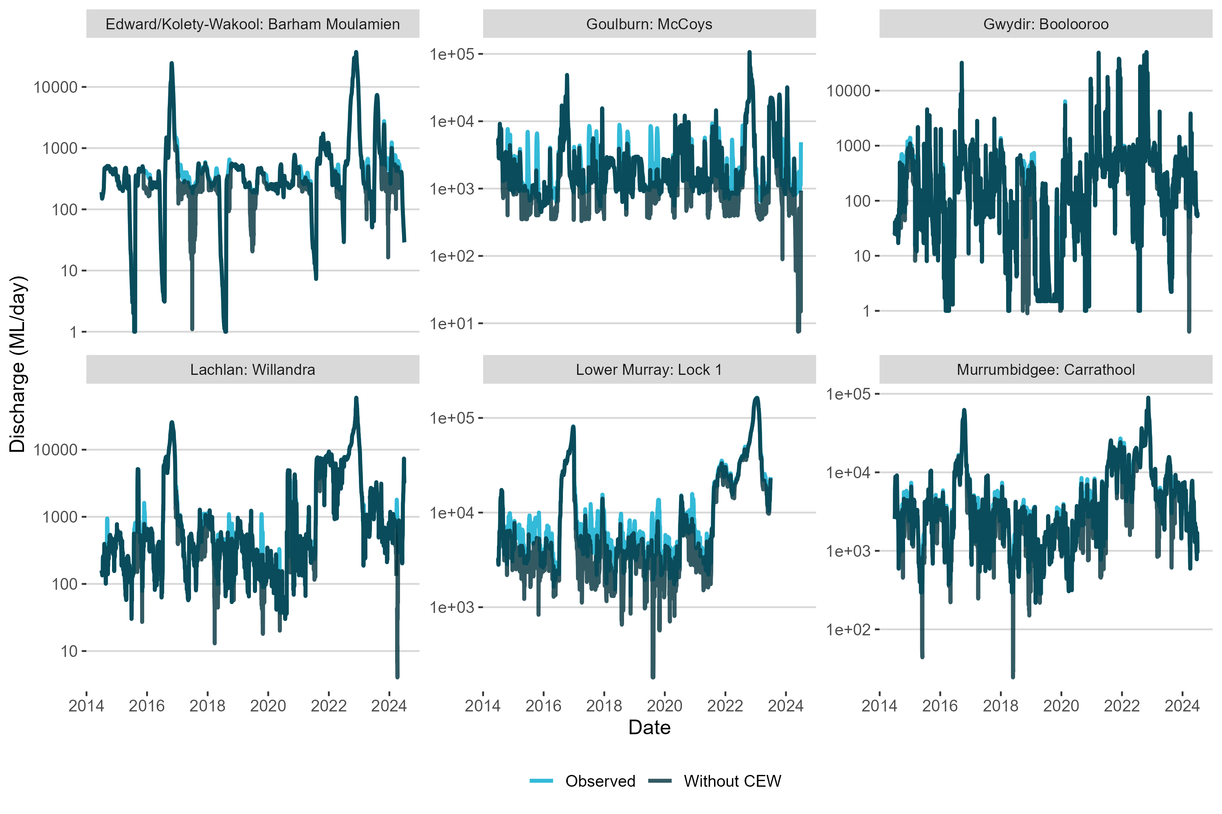

Reported fish-death events or hypoxic events in the Selected Areas
Table B.1 Reported fish-death events or hypoxic events in the Selected Areas
The NSW fish death database was last checked 2 May 2025.
Selected Area | Date | Reference
Edward/Kolety–Wakool river systems | 29 Nov 2010  Oct 2016  6 Nov 2016 | NSW fish death database  (Watts et al. 2017)  NSW fish death database
Goulburn River | Dec 2010  Dec 2016–Jan 2017 | (Koster et al. 2012)  (Webb et al. 2017)
Gwydir River System  Gwydir Valley (Tareelaroi Weir pool)  Mehi River (Moree)  Mehi River (Moree) | 6 Nov 2009  19 Dec 2020  5 Feb 2020  6 Nov 2019 | NSW fish death database  NSW fish death database  NSW fish death database  NSW fish death database
Lachlan River System  Forbes | 5 July 2006  3 Oct 2015  8 Nov 2016  6 Mar 2020 | NSW fish death database  NSW fish death database  NSW fish death database  NSW fish death database
Lower Murray River | Oct–Nov 2008  Nov–Dec 2016 | South Australia fish death database  (Ye et al. 2018)
Murrumbidgee River System | 31 Jan 2011  Sept–Dec 2016  10 Jul 2023 | (Wassens et al. 2018)  NSW fish death database
Junction of Warrego and Darling rivers  Darling/Baaka River near Bourke  Lower Darling/Baaka River at Menindee  Lower Darling/Baaka and Menindee 32 weir pool  Darling/Baaka River at Menindee Town weir pool  Darling/Baaka River near Pamamaroo outlet | 6 Jan 2011  24 Dec 2021  Mar 2023  12 Nov 2023  10 Feb 2024  15 Oct 2023  3 Nov 2023  25 Jul 2023 | NSW fish death database  NSW fish death database  OCSE 2023  NSW fish death database  NSW fish death database  NSW fish death database  NSW fish death database  NSW fish death database

Summary of 2023–24 Commonwealth environmental watering actions for fish within Selected Areas
A summary of 2023–24 Commonwealth environmental watering actions with expected outcomes for fish, reported by ecosystem type and valley, is provided in Table C.1. Key findings from the Selected Area monitoring of Commonwealth environmental watering events are summarised in Table C.2. More detail can be found in the Selected Area reports cited in that table. General highlights from the monitoring in 2023–24 are listed for each Selected Area (Section C.1 to Section C.7).
Table C.1 Commonwealth environmental watering actions in 2023–24 with expected outcomes for fish, by valley and total volume
The table only includes valleys that had targeted fish outcomes for delivery of Commonwealth environmental water. Asterisks (*) denote Commonwealth environmental watering actions that included both riverine and wetland/floodplain ecosystems; volumes for these actions were included in both riverine and wetland/floodplain categories.
Valley | Riverine (ML) | Wetland/floodplain (ML) | Riverine and wetland/ floodplain (ML)
Barwon Darling | 63,385 | – | –
Border Rivers | 12,061 | – | –
Broken | 62,918 | – | –
Campaspe | 4,578 | – | –
Central Murray | 334,198 | – | –
Condamine Balonne | – | – | –
Edward/Kolety–Wakool | 158,158 | 262 | –
Goulburn | 209,621 | – | –
Gwydir | 4,500 | 5,000 | –
Lachlan | 1,323 | – | –
Lower Darling | 110,834 | – | –
Loddon | 3,762 | – | –
Lower Murray | 1,384,341 | 1,774 | –
Murrumbidgee | 211,640* | 50,746* | 4,646
Macquarie | 59,879* | 56,046* | 56,046
Namoi | 9,279 | – | –
Ovens | 123 | – | –
Wimmera | 2,762 | – | –
Warrego | 21,876* | 8,370* | 8,370
- Edward/Kolety–Wakool river systems
Summary of main findings are taken from the Selected Area report (Liu et al. 2024):
- Spawning of native species Murray cod, bony herring, Australian smelt, carp gudgeon, flathead gudgeon and river blackfish was detected. There was no evidence of golden or silver perch spawning.
- There was no Murray cod young-of-year recruits detected despite evidence of widespread spawning This failure to recruit this year may be due to insufficient prey availability in the summer. Furthermore, the absence of Murry cod 1+ recruits confirmed the species also failed to recruit in the previous year 2022–23 most likely due to high flows during the nesting period. No silver perch or golden perch young-of-year recruits were detected.
- An adult river blackfish was detected in the mid-Wakool River in adult fish population surveys which is the second consecutive year of detection for this species.
- Adult Murray cod relative abundances have shown a continual decline since 2020–21 sampling. Silver perch relative abundances remain low but stable throughout the years. Golden perch abundances were similar to previous years dominated by mature fish (>300 mm in length).
- River blackfish was detected in the mid-Wakool River for the first time in adult fish population surveys. Adult Murray–Darling rainbowfish relative abundances have remained low which has been the case since 2021–22. Unspecked hardyhead were not detected in the 2024 surveys, despite being present in surveys in all previous years
- Adult common carp populations and other exotic species declined markedly in abundance and biomass this year after the initial boom response to the 2022–23 flooding in the system.
- Fish surveys shown that the fish community has declined in health since the 2022–23 floods.
- (Lower) Goulburn River
Summary of main findings are taken from the Selected Area reports (Treadwell et al. 2024):
- Golden perch spawning coincided with a large overbank flow in October 2023 and during an environmental flow fresh in November 2023. Spawning of other native fish detected included Murray cod, cod (Maccullochella spp.), Australian smelt, gudgeon (Philypnodon grandiceps or Hypseleotris spp.), carp gudgeon and trout cod. Murray cod larva was the most abundant species (n= 1522) detected which was markedly higher than last year where only 1 Murray cod larva was detected.
- One young-of-year golden perch was recorded (though are rarely collected in the reach, as most likely early life stages drift into the Murray River), and the population consisted of larger sized, possibly older, fish, similar to previous years. No young-of-year silver perch were detected with only one adult collected. Only 2 young-of-year Murray cod were detected, which is similar to the previous year (2022–23 n = 3). However, these low numbers contrast prior to 2022–23, when young-of-year comprised larger proportions of the catch.
- Relative abundances of adult Murray cod which decreased markedly in 2022–23 were again low in numbers. This may be due to Murray cod populations needing several years or longer to recover from the previous year disturbance (Theim et al. 2017). Last year, widespread flooding and reductions in water quality (low dissolved oxygen), and possible reductions due to fish deaths (though very few dead fish were detected in the Goulburn during and after floods) and/or fish migration from impacted reaches, potentially reduced numbers at monitored sites. In contrast, relative abundances of adult carp gudgeons and Murray–Darling rainbowfish increased markedly compared to the previous year, likely due to these short-lived species maturing quickly and producing large numbers of offspring with favourable environmental conditions (Humphries et al. 1999).
- Adult bony herring which has been detected only occasionally throughout the surveys was again detected for the second consecutive year in similar numbers to last year. The nationally threatened trout cod was collected again in electrofishing surveys for the fifth consecutive year (2019–20, 2020–21, 2021–22, 2022–23, 2023–24). Trout cod are known from other sites in the Goulburn River.
- Relative abundances of adult common carp and goldfish markedly decreased from the previous year.
- Gwydir River System
Summary of main findings are taken from the Selected Area report (Mika et al. 2024b):
- Rainfall was at, or above, average during November 2023, April and May 2024, other months it was below average and after significant flooding in 2021–22 and 2022–23, inundation in the Gwydir catchment was greatly reduced in 2023–24. Delivery of CEW improved connectivity and water quality.
- Murray cod spawning was detected with low numbers of larval fish captured in the Gwydir and Mehi channels.
- Decreases in relative abundance from the previous year were evident for carp gudgeon and spangled perch (Leiopotherapon unicolor) (lowest recorded since monitoring began) and small increases for Australian smelt. Murray cod and bony herring were detected in similar abundances to the previous year. Species traditionally known to occur in the system, including olive perchlet (Ambassis agassizii), silver perch, southern purple-spotted gudgeon and Darling River hardyhead (Craterocephalus amniculus), were not detected in the monitoring program.
- Monitoring detected the same suite of species compared with previous years, though total number and native individual species numbers declined in 2023–24 (e.g. 2023–24 n: 415; compared with 2022–23 n: 691). The native fish community appears to remain depauperate and in poor condition with low recruitment in the Gwydir River System, despite the wetter conditions over the last several years. Other measures (e.g. stocking) complementary to the delivery of environmental water are likely needed to improve fish populations.
- Lachlan River System
Summary of main findings are taken from the Selected Area report (Higgisson et al. 2024):
- Spawning of Murray cod, flathead gudgeon, Australian smelt and carp gudgeon was detected in the lower Lachlan River System. A single larval golden perch was detected which is only the third time since the monitoring program began that larvae of this species has been recorded. No golden perch recruitment was detected.
- Murray cod had very low larval abundances again this year similar to the past 3 spawning seasons. This may be due to falling water levels that occurred in late September to early October coinciding with Murray cod nesting behaviour and spawning windows leading to low larval abundances. A low number of young-of year were detected for the first time since 2020–21, though overall poor recruitment has been evident in the past few years.
- Adult Murray cod had similar relative abundances this year, compared with the previous year, though abundances were still markedly lower than in 2020–21. Golden perch abundances decreased compared with the previous year, and abundances remained low compared to surveys before 2021–22. Bony herring increased in relative abundance from last year, but still markedly lower compared with pre-2019–20. No silver perch was detected. One adult freshwater catfish was detected, this species hadn’t been detected in the surveys since 2014–15.
- Seven native species were detected in the lower Lachlan River System, which is similar to last year.
- Lower Murray River
Summary of main findings are taken from the Selected Area report (Ye et al. 2025):
- Spawning of golden and silver perch was detected in Selected Area sites coincident with high in-stream flows in the Lower Murray River. Low numbers of golden and silver perch larvae were detected and otolith chemistry analysis (⁸⁷Sr/⁸⁶Sr otolith core analysis) of golden perch revealed the majority were indicative of an origin in the Lower Murray River and to a lesser extent the mid-Murray River. For silver perch larvae the natal origin was mostly the mid-Murray and to a lesser extent the Lower Murray River.
- Low levels of recruitment were evident for golden perch with high in-stream flows which CEW contributed to and assisted with enhancing spring-summer flow pulses and maintaining elevated flows during peak spawning timing windows.
- Adult golden perch relative abundances declined from the previous year. These reduced abundances may be a result of upstream emigration or movement of adults and or delayed sampling in 2023–24. Adult silver perch relative abundance was relatively low similar to most years (with the exception of 2021–22, where abundances were highest since monitoring began).
- Spawning of Murray cod was detected; and there was minor recruitment of Murray cod with high in-stream spring–summer flows (which CEW contributed to). Adult relative abundances have declined the previous 2 years, and may be due to reduced electrofishing efficiency because of higher flows during sampling resulting in lower catch rates in 2022–23 and delayed sampling in 2023–24.
- The fish assemblage characterised the floodplain and flowing riverine environment, i.e. low abundances of small-bodied fish. Delayed sampling in 2023–24 limited the interpretations of the large-bodied fish community such as bony herring and common carp which changes in fish behaviour associated with colder water temperatures.
- Murrumbidgee River System
Summary of main findings are taken from the Selected Area report (Wassens et al. 2024):
- Wetland fish communities were lower in abundance this year compared to the previous year (experienced wetter conditions) which is expected with the majority of wetlands in a drying phase. Wetland communities continued to be depauperate and dominated by generalist species including Australian smelt, carp gudgeon and bony herring. However, higher species richness was evident at the more persistent and regularly watered sites, including Bayil Creek, Wagourah and Yarradda Lagoon.
- The young-of-year of small-bodied native and exotic fish species were found at most wetlands.
- Native species detected spawning in-stream included Murray cod, bony herring, silver perch (drifting eggs detected), Australian smelt, flathead gudgeon and unspecked hardyhead. There was no evidence of golden perch spawning in-stream.
- Adult relative abundances of Murray cod, golden perch and bony herring increased compared to the previous year, and the highest abundances of golden perch were observed since monitoring began. The relative abundances of all 5 small-bodied native fishs decreased from the previous year (Australian smelt, carp gudgeon, flatheaded gudgeon, Murray–Darling rainbowfish and unspecked hardyhead). Murray–Darling rainbowfish declines is a trend that has continued over the past 2 years though recruitment did occur this year. For large-bodied species recruitment was detected for silver perch at one survey site and all sites for bony herring but no recruitment was detected for Murray cod or golden perch.
- Junction of Warrego and Darling rivers
Summary of main findings are taken from the Selected Area report (Mika et al. 2024a):
- The fish community was dominated by common carp, and native species were in low abundances. The most abundant native species included Australian smelt, carp gudgeon, spangled perch and bony herring at Flow-MER monitoring sites. Condition metrics were the lowest recorded in the ten years of monitoring.
- For the current year, no golden perch were collected in the Darling/Baaka and there was evidence of limited recruitment in the Upper Warrego–Warriku. The Lower Warrego–Warriku population was dominated by more mature individuals. This contrasts with previous years (prior to 2022) where the Lower Warrego–Warriku population was dominated by young-of-year. Recent recruitment was evident for bony herring in the Upper Warrego–Warriku and to a more limited extent in the Lower Warrego–Warriku and Darling/Baaka.
- No Murray cod, silver perch or freshwater catfish were detected at the Flow-MER monitoring sites, which suggests the species are extirpated at these sampling sites or only present in very low numbers.
- Species once common to the area, such as freshwater catfish, Murray cod, olive perchlet, southern purple-spotted gudgeon and Darling river hardyhead, were rarely detected or were not detected at all and are now likely below self-sustaining levels. Recovery for all these species may need more than just flow management, and other strategies will be required to improve these species’ populations in the Warrego–Warriku and Darling/Baaka rivers (e.g. stocking, translocations, habitat improvement).

Table C.2 Summary of results from monitored watering actions with expected outcomes for fish in 2023–24 at Selected Areas
Note that many of these actions involved multiple water sources (not only Commonwealth environmental water [CEW]). Additional information on the portfolio of environmental water can be found in Sengupta et al. (2025). This table does not include monitoring of fish in Selected Areas that was not directly linked to a CEW watering action. * As reported by the Commonwealth Environmental Water Holder. † This watering action represents 8 combined watering actions for this system from all fresh and base flow components.
Surface water region/asset | CEW volume (ML) | Start–end dates* | Flow component | Expected ecological outcomes* | Observed ecological outcome | Influences | Reference
Edward/Kolety–Wakool river systems:  Wakool, Yallakool and Colligen-Niemur | 29,135  30,746  25,950 | 17/12/2023–  6/05/2024  17/12/2023–  05/12/2024  30/04/2024–  25/05/2024 | Fresh, base flow | Improve dispersal/condition for all species including fish.  Improve native fish population structure for moderate to long-lived riverine specialist native fish species | Fish movement not monitored. Though there was evidence of continued range expansion of river blackfish in 2023–24 in the Edward/Kolety–Wakool river systems. In general, the health of the fish community has declined since 2022–23 floods.  No evidence of silver perch, golden perch or Murray cod recruitment in 2023–24. | Widespread flooding and associated hypoxic conditions in some areas in 2022–23 | Liu et al. (2024)
Goulburn River: Lower Goulburn River | 73,867  33,853 | 04/09/23–6/10/24  17/11/23–28/11/23 | Fresh | Provide cues for spawning and migration for flood specialist native fish  Stimulate fish spawning and movement; increase habitat and feeding opportunities for macroinvertebrates and aquatic animals. Provide cues for golden perch spawning in November. | Golden perch spawning was detected and coincided with a large overbank flow in late October and an environmental flow fresh in late November. No silver perch spawning was detected. | Unregulated high flows with overbank flooding and associated hypoxic conditions in some areas in 2022–23 | Treadwell et al. (2024)
 | 55,235 | 31/10/23–  27/06/24 | Base flow | Support native fish by providing suitable habitat and food resources during the year for supporting recruitment success | Low recruitment was evident for some long-lived species. Only one young-of-year golden perch and 2 Murray cod young-of-year were detected. | As above | As above
Gwydir River System: Gwydir River | 2,500 | 20/09/23–27/09/23 | Fresh | Support breeding and recruitment of native fish (in-stream specialists and generalists). Support native fish condition and movement (in-stream specialists and generalists). | Murray cod spawning was detected in the Gwydir River. Fish community has low recruitment despite wetter conditions over the last several years, other measures (e.g. stocking) complementary to the delivery of environmental water are likely needed to improve fish populations. | Unregulated elevated flows and flooding in 2022–23 | Mika et al. (2024b)
Lachlan River System:  Lachlan River downstream of Jemalong Weir | 12,013 | 01/09/23–15/12/23 | Base flow | Provide a sequence of flow events designed to enhance instream productivity; cue spawning; and aid the dispersal of Murray cod throughout the mid and lower Lachlan. Support native fish populations. Improve native fish population structure for moderate to long-lived flow pulse specialist species. | No monitoring of Murray cod spawning or recruitment was undertaken in the target reach of the watering action in the Lachlan. In the lower Lachlan River System low levels of recruitment for Murray cod were detected. Seven native species were detected. | Murray cod recruitment may have been comprised by flow rates that fell below 1, 000 ML/day for 5 of 6 day target and the lower Lachlan in Feb 2024 experienced an hypoxic event (dissolved oxygen was near 0 mg/L for a 10-day period) which could cause hypoxia related fish deaths or emigration | Higgisson et al. (2024)
Lower Murray River:  Channel of Lower Murray River, Lower Lakes and Coorong | 1,003,487† | 01/07/22–30/06/23 | Base flow, fresh | Maintain current species diversity, extend distributions and improve breeding success and numbers of short, moderate and long-lived native fish species by:  - Providing opportunities for spawning during spring and recruitment (subject to appropriate seasonal conditions).  - Providing in-stream habitat for fish and thereby supporting recruitment of fish, particularly by increasing the availability of food resources and habitat through water level variability and improved hydraulics.  - Where feasible, increasing the presence of lotic conditions along the Murray River and, where feasible, increased lateral connectivity with anabranches and low elevation floodplain wetlands.  - Maintaining sufficient flows through the barrage fishways at all times, and additional barrage openings whenever possible, to maintain connectivity between the Murray River channel, Lower Lakes and Coorong.  - Providing attractant and connecting flows to support movement of diadromous fish species, subject to appropriate seasonal conditions.  - Contributing to the maintenance of critical habitat, water quality, water level and the provision, where possible, of localised refuge sites as required, in both the Lower Lakes and Coorong. | Spawning of golden and silver perch and low levels of recruitment of golden perch were coincident with high in-stream flow pulses that included CEW. Spawning of Murray cod was detected and there was minor recruitment of Murray cod. | Unregulated overbank flows in 2022–23 and high in-stream flows in 2023–24 | Ye et al. (2025)
Murrumbidgee River System: Lowbidgee low dissolved oxygen (DO) refuge flows and native fish passage flows | 203,235 | 02/09/23–25/09/24 | Fresh, Base flow | Maintain native fish populations by providing limited variation in river height (<10% daily discharge variation) to support breeding and cod nesting; provide opportunities for lateral and longitudinal movement and dispersal through temporary floodplain-river connection and removal of lower Murrumbidgee weirs. | This flow targeted the Murrumbidgee downstream of Maude but may have had some influence on the hydrology of the monitored reach in the mid-Murrumbidgee. Murray cod spawning was detected with highest catches of larvae since 2018. This is likely attributed to spring environmental water delivery (which CEW contributed to). However, this did not result in successful recruitment with no young-of-year detected at the monitored sites. | Above-average rainfall led to high flows and extensive flooding of wetland complexes in 2022–23. Return to more average conditions in 2023–24 | Wassens et al. (2024)
Murrumbidgee:  Gayini Nimmie – Caira wetlands | 32,627 | 13/09/24–/03/24 | Wetland | Maintain native fish populations by protecting and improving the condition of fish habitat and providing opportunities for movement. | There was limited CEW delivery to the 12 monitored sites with Bala swamp the only wetland to receive CEW. Fish movement was not monitored. The fish community in Bala swamp after CEW delivery was similar to sites which did not receive CEW in 2023–24 showing no marked changes. However, there was some evidence that carp gudgeon complex increased in Bala swamp compared to similar sites that did not receive CEW. that | As above | As above
Murrumbidgee River System: Yanco Creek system fresh and wetland connection | 3,759  4,646 | 03/09/23–06/12/23  06/02/24–20/02/24 | Fresh  Fresh, wetland | Maintain native fish populations by providing limited variation in river height to support breeding and cod nesting; support native fish movement and dispersal.  Provide habitat; recruitment and movement opportunities for water dependent species; including waterbirds; native fish; turtles; frogs and bats. This includes for threatened species; southern bell frogs; Southern Myotis (fisher bat); Murray cod; trout cod; freshwater catfish and silver perch known to occur in the system. | Fish surveys took place in the Yanco-Billabong in April 2024. Eight species were recorded in the Yanco Creek system including golden and silver perch, Murray cod and freshwater catfish. | As above | As above
Junction of Warrego and Darling rivers:  Lower Warrego River and fringing wetlands | 13,506 | 15/01/24–  26/04/24 | Base flow, fresh, bankfull | Enhance fish migration and spawning opportunities especially large-bodied species including golden perch. | Fish surveys in the Warrego–Warriku River were dominated by common carp and contained low abundances of native species. Murray cod, freshwater catfish and silver perch are in very low numbers that surveys no longer regularly detect individuals. Golden perch populations were dominated by more mature individuals which is in contrast to previous years when young-of-year dominated the catch. | Start of water year was characterised by low rainfall with above average rainfall Nov–Jan 2023. No flow was recorded in the Warrego–Warriku River from mid July until late December with a sustained flow commencing in mid January 2024 until end of water year. | Mika et al. (2024a)

Figure C.1 Volume of Commonwealth environmental watering actions with expected outcomes for fish and flow components, 2023–24
In this figure, the highest target flow component for each watering action in riverine systems was used.
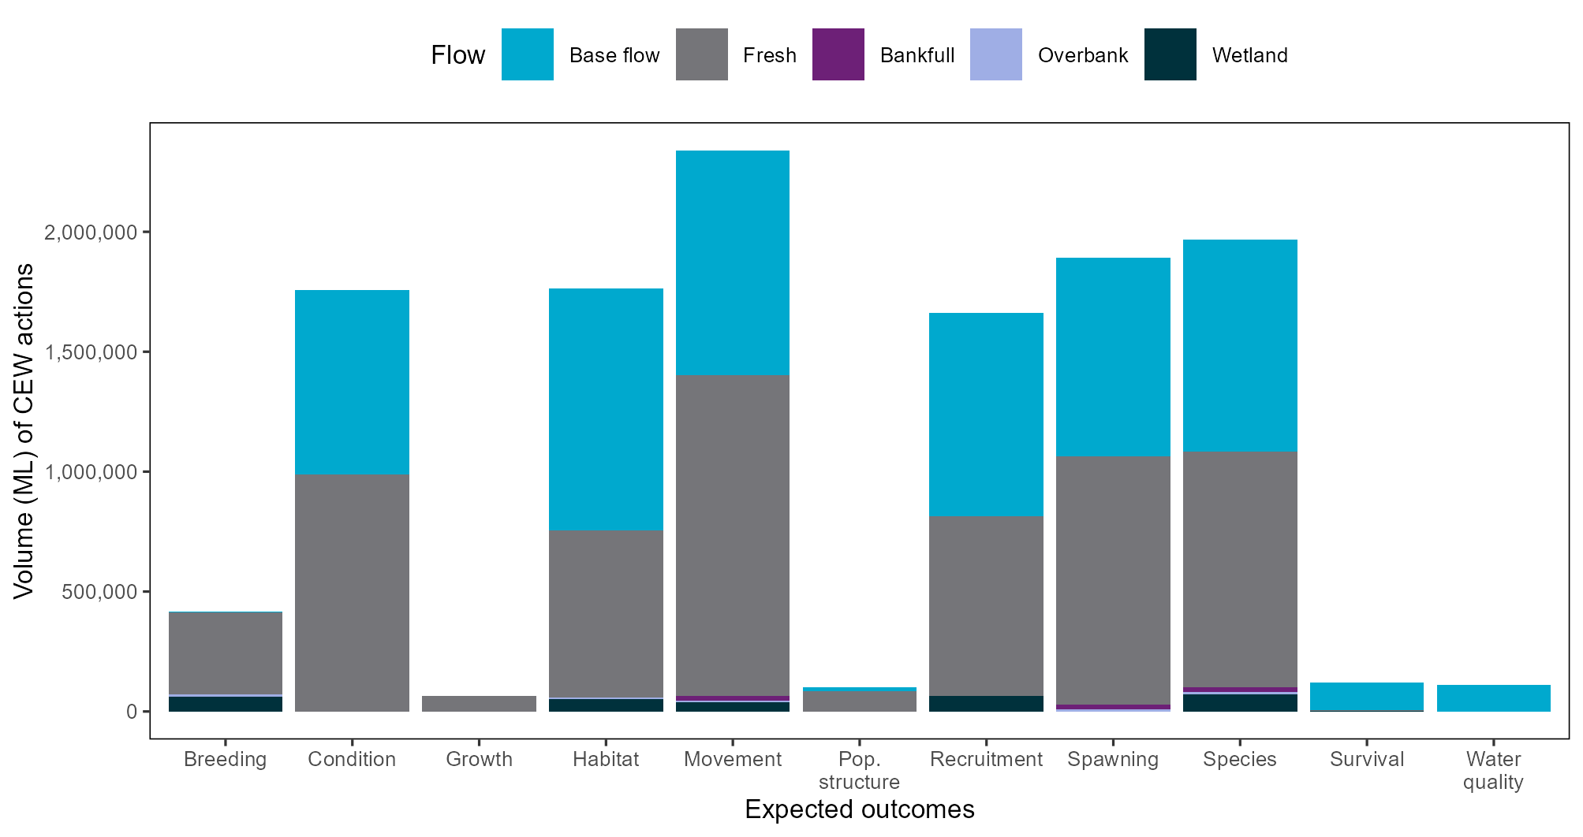

Monitoring Data Management System data used for evaluation
Table D.1 Summary of data from the Monitoring Data Management System used for evaluation analyses
CPUE = catch per unit effort
Response variable | Species | Data used | Field collection methods | Standardised
Spawning occurrence (presence of larval fish and eggs) | Golden perch  Silver perch | Category 1 + Category 3 | Bongo tow nets used in the Lower Murray for large-bodied species. Drift nets used in the other Selected Areas for large-bodied species | Binary data
Recruit abundance (length threshold) | Australian smelt  Carp gudgeon  Common carp  Eastern gambusia  Murray cod  Murray–Darling rainbowfish | Category 1 + Category 3 for Lower Murray and Gwydir | Boat and backpack electrofishing, fine-mesh fyke nets | Raw counts of recruits
Fish age (otolith data) | Golden perch | Category 1 + Category 3 for Lower Murray | Boat and backpack electrofishing, fine-mesh fyke nets | Raw age of fish
Adult frequency of occurrence | Australian smelt  Bony herring  Carp gudgeon  Eastern gambusia  Golden perch  Murray cod  Murray–Darling rainbowfish | Category 1 + Category 3 for Lower Murray and Gwydir | Boat and backpack electrofishing, fine-mesh fyke nets | Proportion of sites within each Selected Area at which a species is detected
Adult abundance (catch per unit effort; CPUE) | Bony herring  Common carp  Golden perch  Murray cod | Category 1 | Boat and backpack electrofishing for large-bodied species, fine-mesh fyke nets for small-bodied species | CPUE
Fulton’s K condition factor (length and weight data) | Bony herring  Common carp  Golden perch  Murray cod | Category 1 + Category 3 for Lower Murray and Gwydir | Boat and backpack electrofishing, fine-mesh fyke nets | Fulton’s K condition factor
Proportion of catch belonging to a native species (community metric) | All recorded species | Category 1 + Category 3 for Lower Murray and Gwydir | Boat and backpack electrofishing, fine-mesh fyke nets | Proportion of catch belonging to a native species

Catch per unit effort of adult fish species across Selected Areas
A qualitative investigation of fish abundance of large-bodied and small-bodied fish species across Selected Areas (as not all fish species had sufficient data for analysis) is described:
- Native large-bodied fish species detected in all Selected Areas included bony herring, golden perch, and Murray cod (Figure E.1), along with the exotic common carp and goldfish (Figure E.3). Other large-bodied native fish species detected in most years at some, but not all, Selected Areas included freshwater catfish and silver perch. The nationally threatened species trout cod was only found in the Goulburn River.
- The relative abundance (as indicated by the catch per unit effort, or CPUE) of large-bodied native species varied among Selected Areas and years (Figure E.1). There were marked declines in Murray cod abundances in the Edward/Kolety–Wakool river systems, Goulburn River, Lachlan River System and Murrumbidgee River System following the 2016–17 post-flood hypoxic event. Following this event adult abundances increased in some Selected Areas, including the Edward/Kolety–Wakool river systems, Goulburn River and Lachlan River System, indicating that some populations were recovering. However, in more recent years in the Edward/Kolety–Wakool river systems and Lachlan River System adult abundance have shown a marked decline since 2020–21 and in the Goulburn River and Lower Murray River since 2021–22. These observed declines may due to a number of factors such as fish emigration from monitored sites, high flows and overbank flooding in the previous year impacting recruitment (e.g. poor water quality and fish deaths, disrupting nesting) or reducing electrofishing efficiency which results in lower catch rates, and lag effects in recovery.
- Native small-bodied species detected across all Selected Areas included Australian smelt, carp gudgeon and unspecked hardyhead, as well as the exotic eastern gambusia (Figure E.2). The only small-bodied species detected in all years and Selected Areas was carp gudgeon. Other native small-bodied fish species detected in most years, but not in all Selected Areas, included Murray–Darling rainbowfish. Two small-bodied native fish species only detected in one Selected Area each were the dwarf flathead gudgeon (Philypnodon macrostomus) (Lower Murray River) and obscure galaxias (Goulburn River).
- The CPUE of small-bodied native species differed among Selected Areas and years. Several small-bodied species declined in abundance in the Lower Murray River following the 2016–17 post-flood hypoxic event (declines may be attributed to reduced habitat availability or hypoxic effects), in 2021–22 and 2023–24 due to high in-stream flows, and in 2022–23 due to high flows and overbank flooding likely reducing habitat availability (Figure E.2).
- The CPUE of exotic species differed among Selected Areas and years (Figure E.3). The 2016–17 post-flood hypoxic event may have provided favourable conditions, and appeared to benefit exotic species such as common carp – abundances reached their peak 6–12 months following this event (which occurred in summer, followed by autumn adult sampling) and again in 2021–22 and 2022–23.The high unregulated flows and overbank flooding appeared to benefit common carp and goldfish in many Selected Areas (with the highest abundances detected in 2022–23 since monitoring began in some Selected Areas). In 2023–24 common carp abundances (in particular young-of-year) markedly declined in abundance from the previous year as conditions returned to more regulated in-stream flows at most Selected Areas. Eastern gambusia abundances also increased in the Lachlan River System and the Goulburn River following the 2016–17 hypoxic event, though no real patterns were evident in recent years. Redfin perch (Perca fluviatilis) displayed no clear patterns of abundance during the monitoring program (though in the Lower Murray River in 2022–23 the highest abundances since monitoring began were detected) and were absent from the Edward/Kolety–Wakool river systems and Gwydir River System. Oriental weatherloach (Misgurnus anguillicaudatus) was detected in the Goulburn River in 2018–19, 2019–20, 2021–22, 2022–23 and 2023–24 and in the Edward/Kolety–Wakool river systems in 2021–22, 2022–23 and 2023–24.

Table E.1 Adult native fish species detected in Selected Areas over the period 2014–24
Adult species detected is based on electrofishing and fine-mesh fyke-net collection methods using standard Category 1 sampling methods. ü denotes species detected all survey years, ü^{number/year} number denotes how many years species detected over 10-year survey period, and year denotes last year species was detected in surveys; û denotes species not detected over 10-year survey period. No monitoring occurred in the Gwydir River System in 2021; therefore, there is only 9-year survey period for this Selected Area. Alpha (α) denotes focal fish species as identified by Flow-MER; asterisk (*) denotes key freshwater species as identified by the Strategy, excluding estuarine species (MDBA 2019).
Common name | Edward/Kolety–Wakool river systems | Goulburn River | Gwydir River System | Lachlan River System | Lower Murray River | Murrumbidgee River System
Australian smelt^{α} | ü | ü | ü^{9/2024} | ü | ü^{8/2024} | ü
Bony herring^{α} | ü | ü^{5/2024} | ü | ü | ü | ü
Carp gudgeon^{α} | ü | ü | ü | ü | ü | ü
Dwarf flathead gudgeon | û | û | û | û | ü^{7/2024} | û
Flathead gudgeon | ü^{3/2022} | ü^{6/2023} | û | ü^{7/2023} | ü | ü^{6/2024}
Freshwater catfish* | û | û | ü^{8/2023} | ü^{1/2024} | ü^{9/2024} | û
Golden perch^{α}* | ü | ü | ü | ü | ü | ü
Murray cod ^{α}* | ü | ü | ü | ü | ü | ü
Murray–Darling rainbowfish^{α} | ü | ü | ü | û | ü | ü
Obscure galaxias | û | ü^{1/2022} | û | û | û | û
River blackfish | ü^{2/2024} | û | û | û | û | û
Silver perch* | ü | ü | û | ü^{1/2021} | ü^{9/2024} | ü^{9/2024}
Spangled perch | û | û | ü | û | û | û
Trout cod* | û | ü^{7/2024} | û | û | û | û
Unspecked hardyhead | ü | ü^{2/2022} | ü | ü^{9/2024} | ü | ü^{7/2023}

Figure E.1 Abundance (catch per hour of electrofishing) of 7 large-bodied native fish species in each Selected Area for each year, 2014–24
Height of each bar is the average, and the whiskers show the ± 1 standard error. Y-axis scales differ among species. Fish were collected using boat and backpack electrofishing. No monitoring occurred in the Gwydir River System in 2020–21.
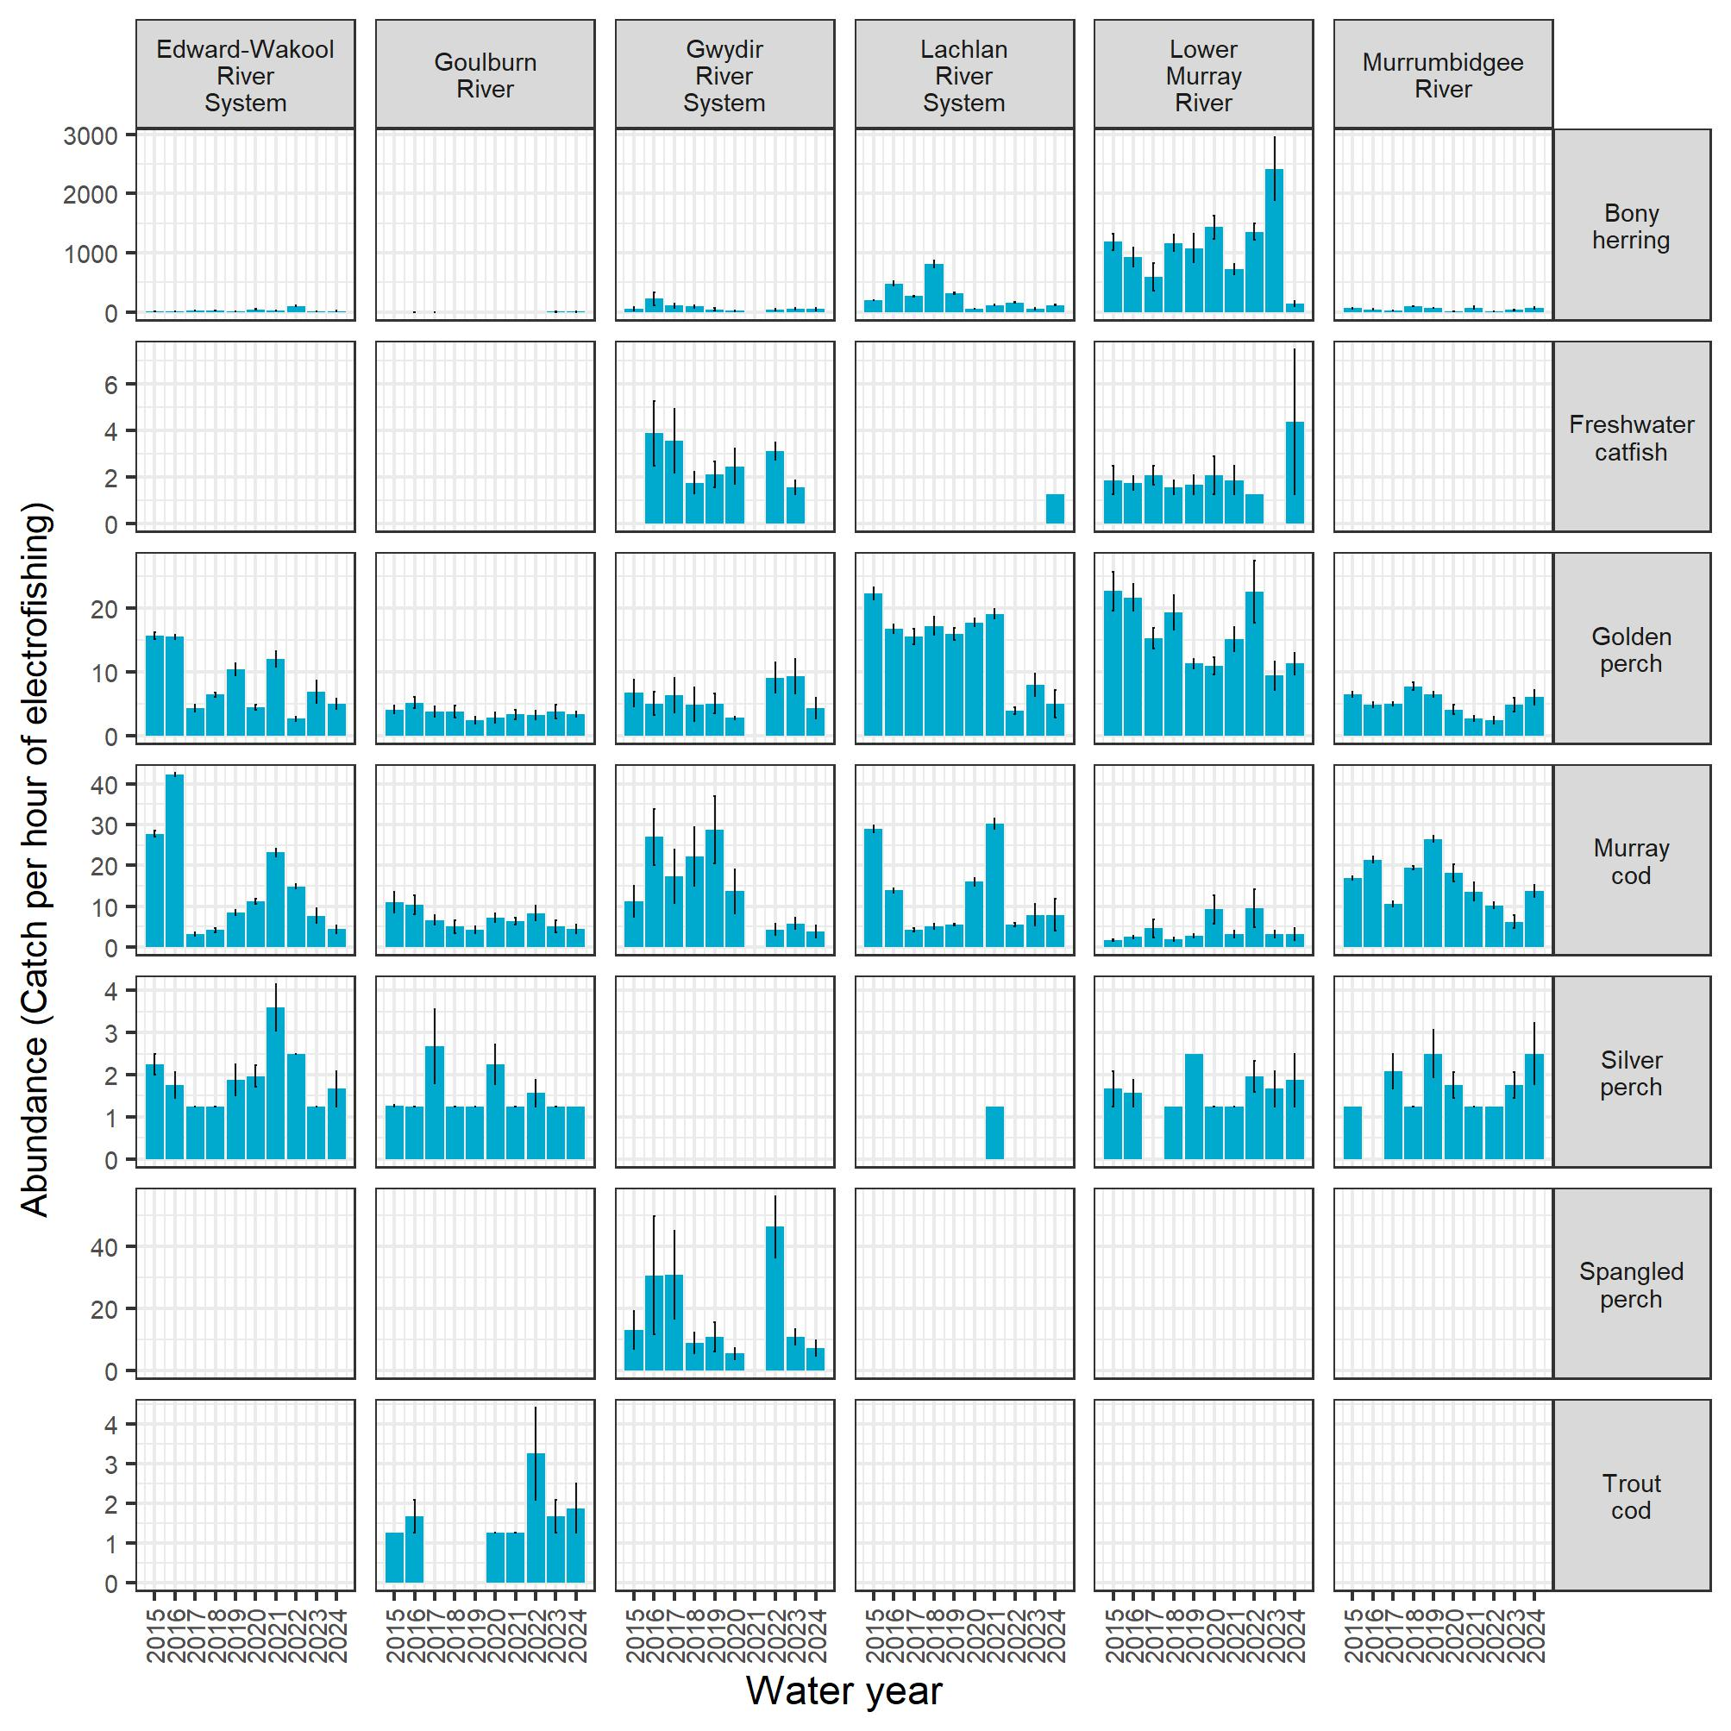
Figure E.2 Abundance (catch per number of nets deployed) of 6 small-bodied native fish species in each Selected Area for each year, 2014–24
Height of each bar is the average, and the whiskers show the ± 1 standard error. Y-axis scales differ among species. Small-bodied fish were collected using fine-mesh fyke nets. No monitoring occurred in the Gwydir River System in 2020–21.
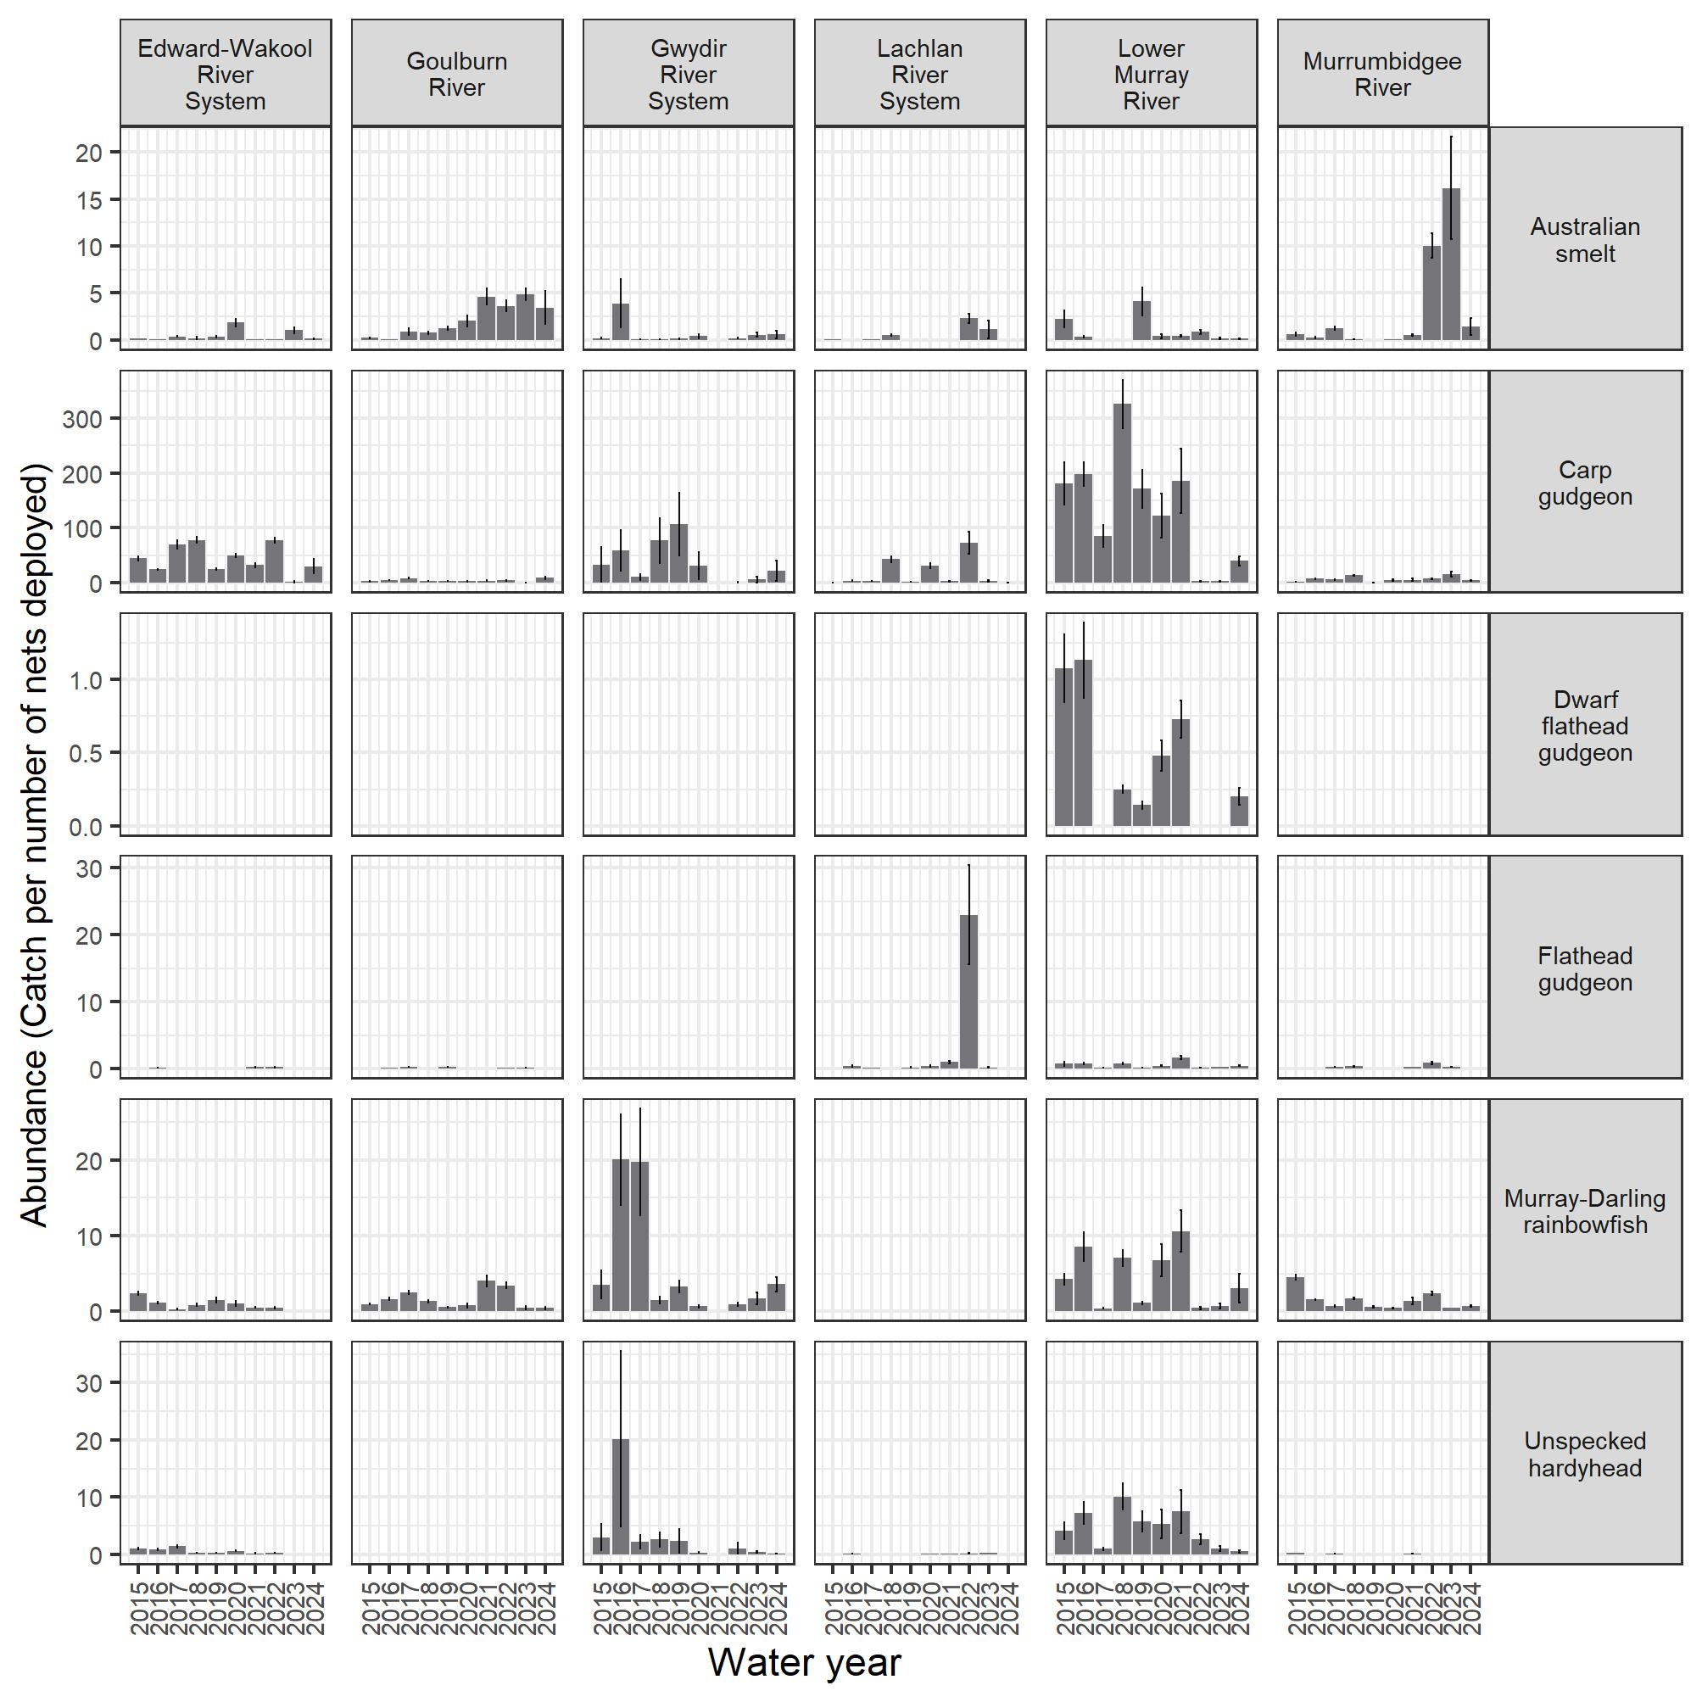
Figure E.3 Abundance (catch per hour of electrofishing or number of nets deployed) of 5 exotic fish species in each Selected Area for each year, 2014–24
Height of each bar is the average, and the whiskers show the ± 1 standard error. Y-axis scales differ among species. Eastern gambusia were collected using fine-mesh fyke nets, and abundance was calculated as catch per number of nets deployed. Common carp, goldfish, oriental weatherloach and redfin perch were collected using boat and backpack electrofishing, and abundance was calculated as catch per hour of electrofishing. No monitoring occurred in the Gwydir River System in 2020–21.
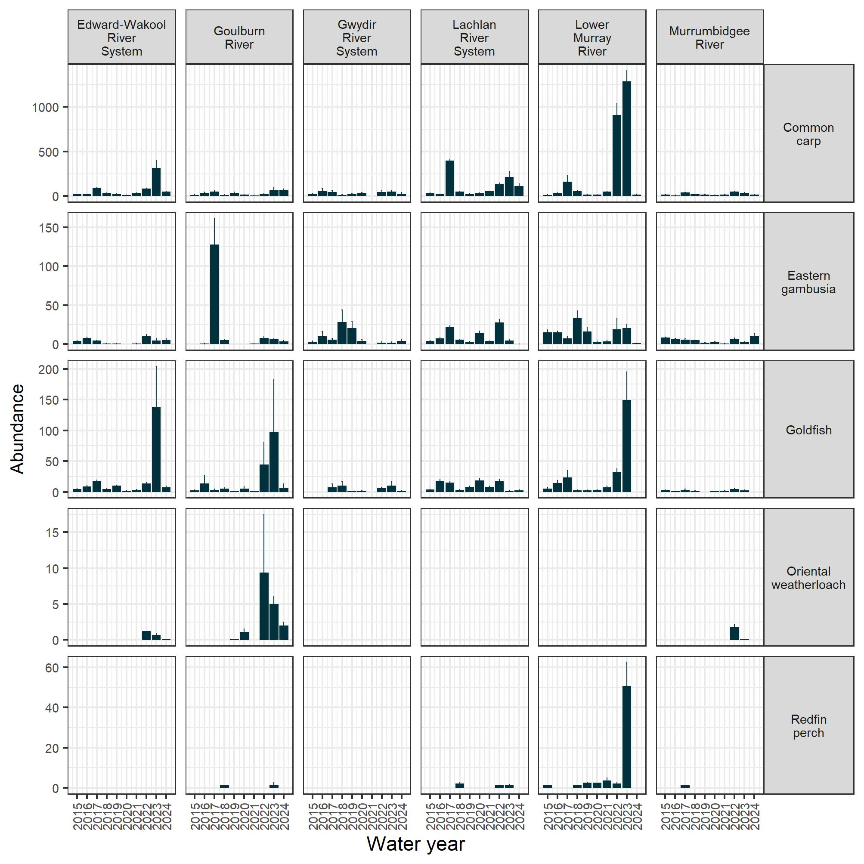

Catch per unit effort of larval fish species across Selected Areas
A qualitative interpretation of larval data for large-bodied and small-bodied fish species across Selected Areas (as not all fish species had sufficient data for analysis) is described:
Fish larval abundances differed among species, Selected Areas and years, and were highly variable (Figure F.1, Figure F.2). For large-bodied species, golden perch larvae were regularly detected in the Goulburn River, Lower Murray River and Murrumbidgee River System. Golden perch larvae were detected in the Lachlan River System only twice in the larval surveys, whereas golden perch larvae and eggs were not detected in the Edward/Kolety–Wakool river systems. Silver perch larvae were detected in the Goulburn River though not in recent years and on a few occasions in the Lower Murray River and in the Edward/Kolety–Wakool river systems as eggs (detected in drift nets, data not shown here) and larvae (detected in light traps, data not shown here (McCasker et al. 2023). Murray cod larvae and the exotic common carp larvae were detected most years in all Selected Areas. Bony herring larvae were detected in the Lower Murray River and Murrumbidgee River System. Freshwater catfish larvae were commonly detected in the Lower Murray River and, on rarer occasions, in the Edward/Kolety–Wakool river systems and the Lachlan River System.
For small-bodied species, Australian smelt, carp gudgeon and flathead gudgeon larvae were detected most years in the Selected Areas. The exotic species eastern gambusia was detected commonly in the Lachlan River System and less frequently in the Edward/Kolety–Wakool river systems and Murrumbidgee River System. Murray–Darling rainbowfish and unspecked hardyhead larvae were detected in the Edward/Kolety–Wakool river systems regularly and less frequently in the Murrumbidgee River System.
Figure F.1 Larval abundance of large-bodied native fish species in each Selected Area over the period 2014–24
Height of each bar is the average, and the whiskers show the ± 1 standard error. Y-axis scales differ among species. Bongo tow nets used for Lower Murray River Selected Area. Larval abundance is log₁₀ of the number (no.s) of larval fish captured per drift net/1,000 m³ + 1.
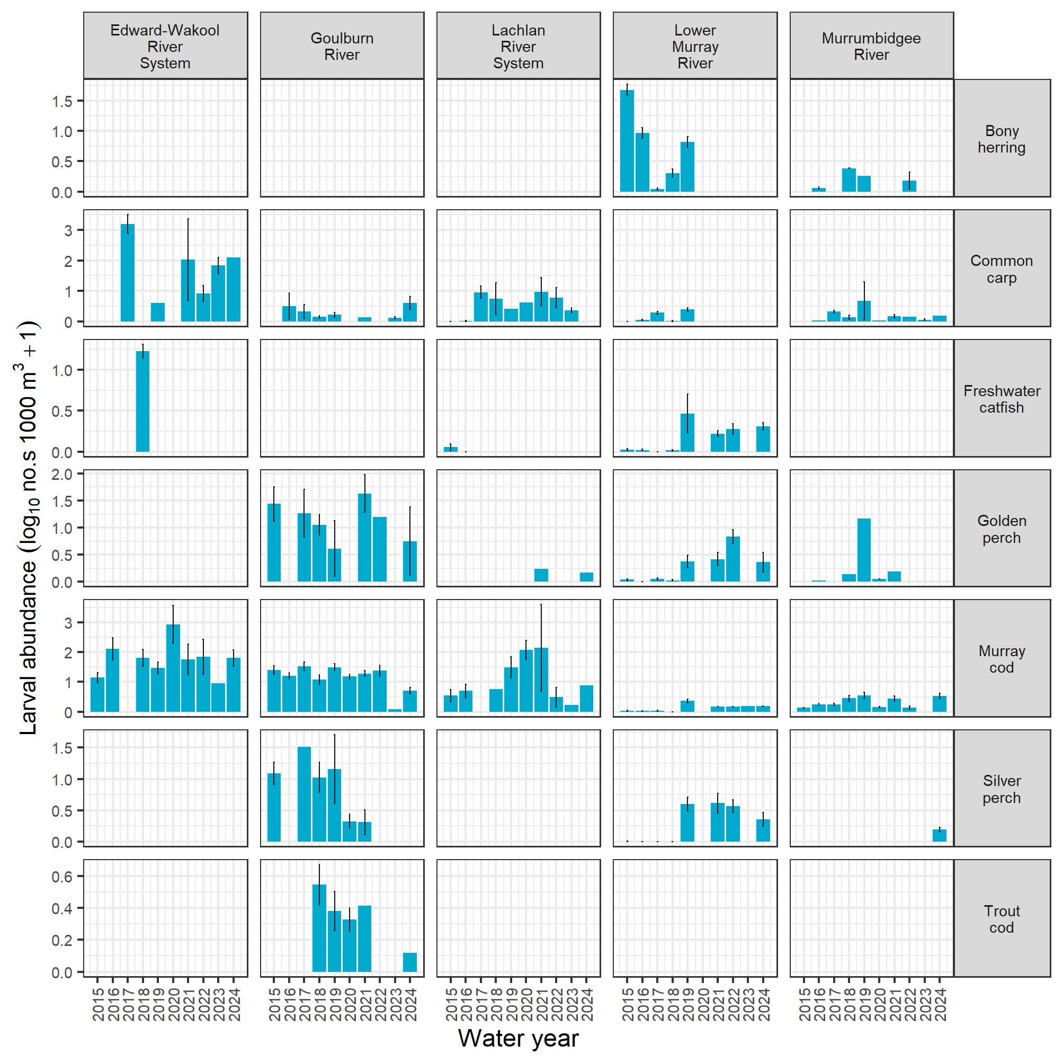
Figure F.2 Larval abundance of small-bodied native fish species in each Selected Area over the period 2014–24
Height of each bar is the average, and the whiskers show the ± 1 standard error. Y-axis scales differ among species. Larval abundance is log₁₀ of the number (no.s) of larval fish captured per light trap/24-hour period + 1.
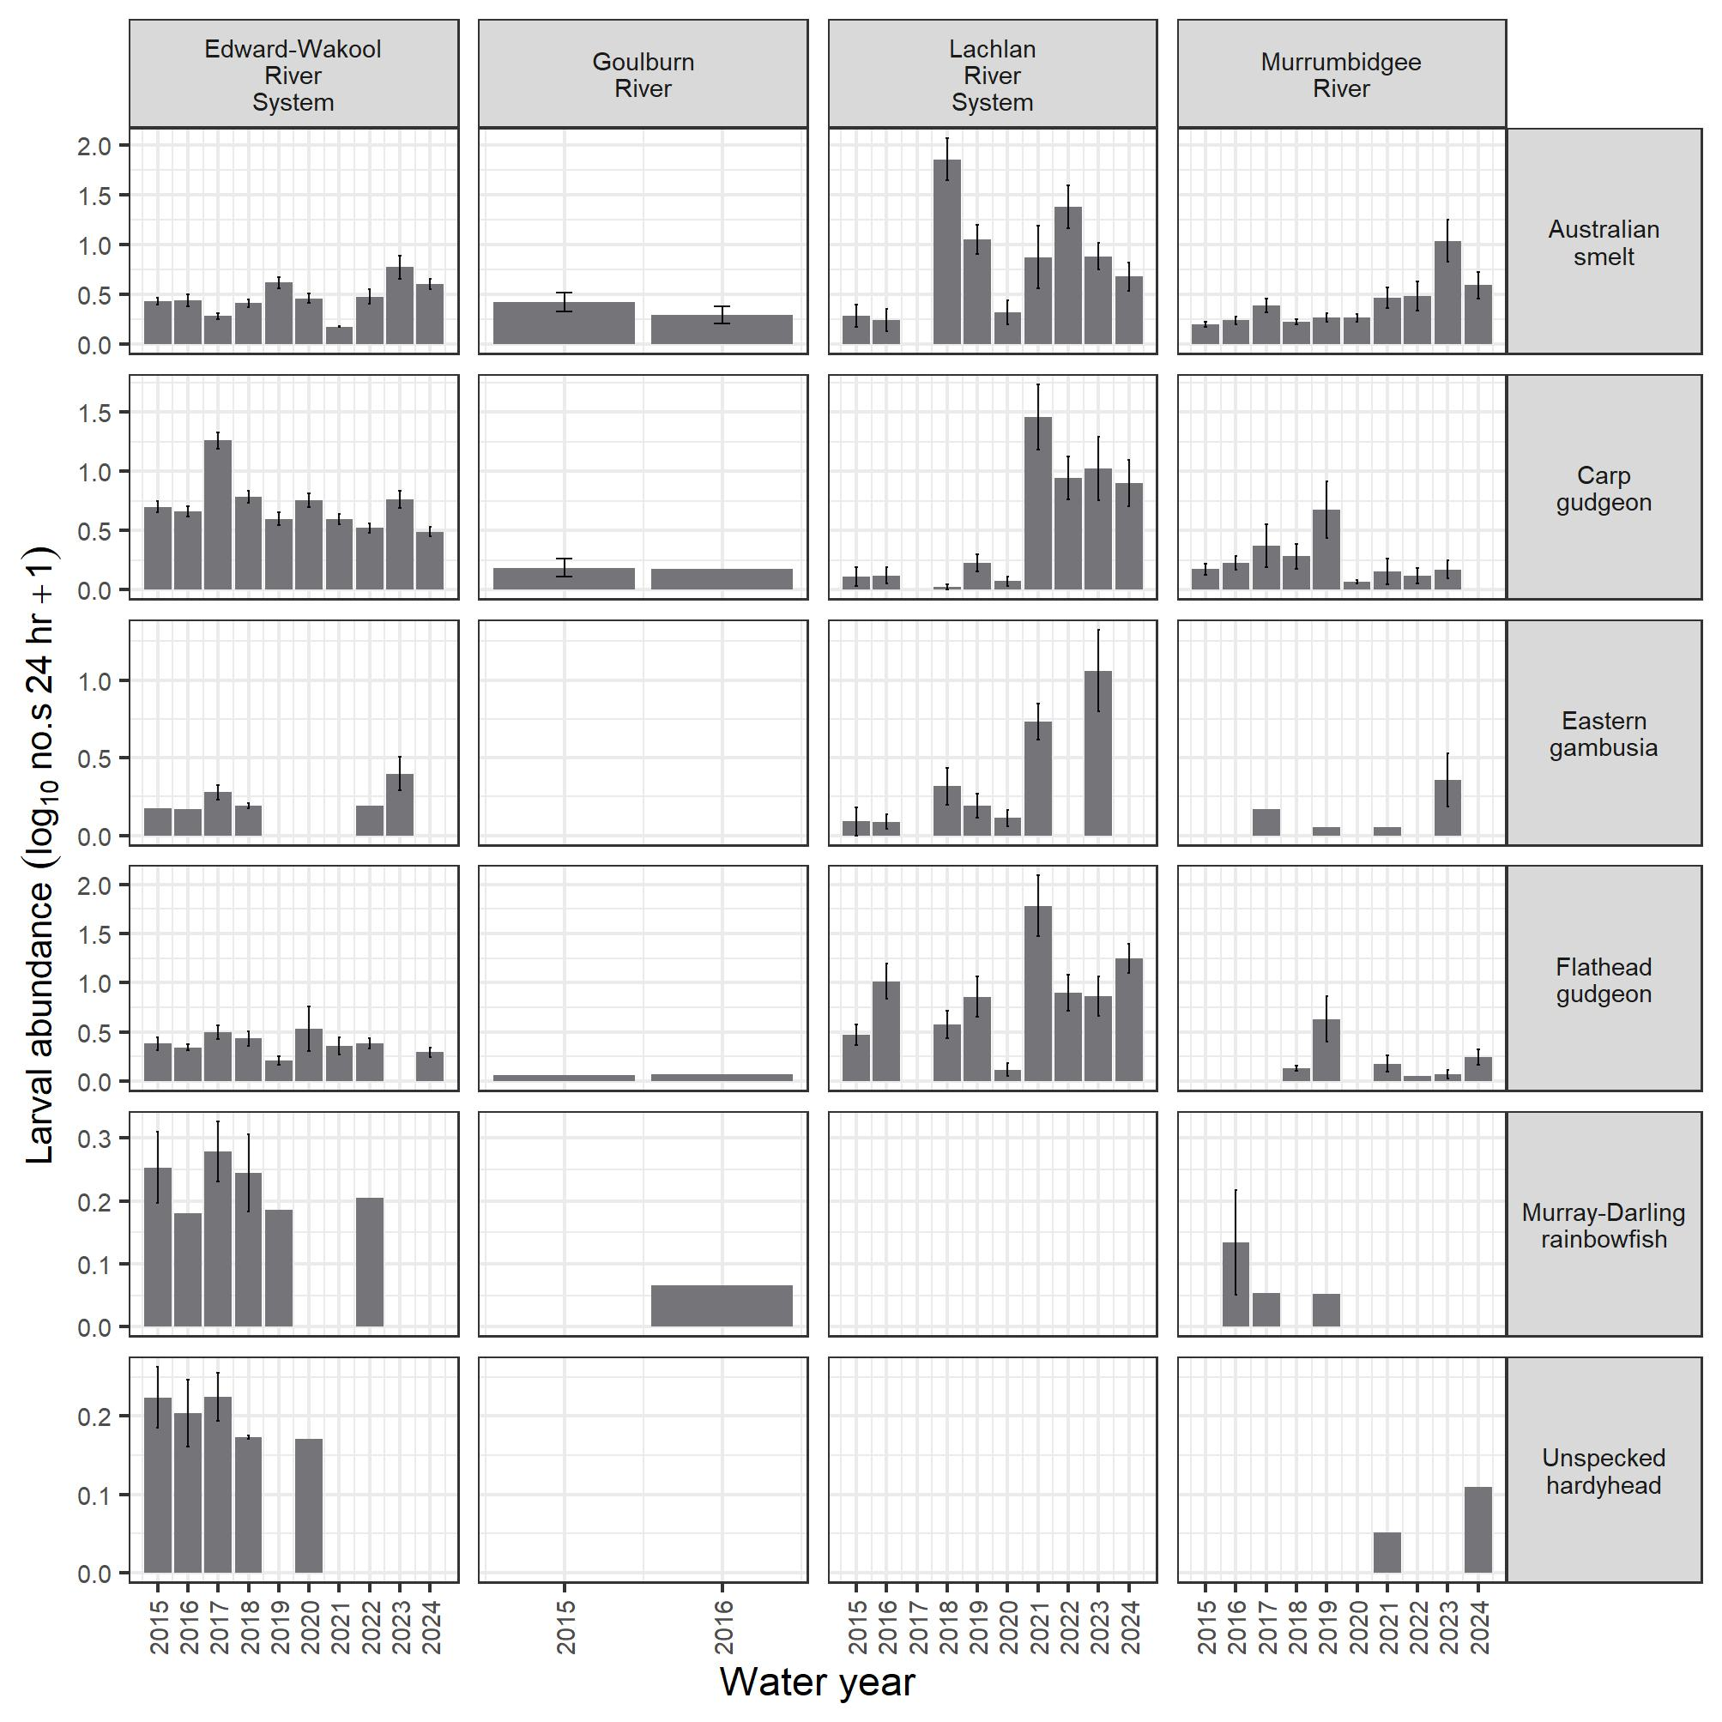

Recruitment
This appendix contains length–frequency histograms for the 8 Flow-MER focal species.
- Large-bodied fish species
Large-bodied fish species were considered recruits when their length was below the minimum size of a one-year-old (Table G.1). Length thresholds were taken from the published literature or supplied by Selected Area leads.
Golden perch population structure in most Selected Areas was dominated by adults. There were fewer juvenile fish (< 250 mm total length) (Figure G.1). Golden perch recruits were not detected in fish length data in most Selected Areas and years. The exception to this was at the Junction of Warrego and Darling rivers, where high numbers of young-of-year recruits were commonly found in most years, though were not detected in 2022–23 and limited recruitment was found in the Upper Warrego in 2023–24 (Mika et al. 2024a). Several young-of-year recruits were captured in the Goulburn River during the water years of 2015–16, 2019–20, 2020–21, 2023–24 (one young-of-year detected), and in 2020–21 in the Lachlan River System and subadults detected in the Edward/Kolety–Wakool river systems. A single individual was detected in 2022–23 in the Gwydir River System (Mika et al. 2023). As fish stocking is known to occur in all these Selected Areas, there is uncertainty as to whether these recruits were stocked fish, a result of local flow management, or had immigrated from outside the Selected Areas. Recruits were captured in the Lower Murray River in 2022–23 and 2023–24 (Ye et al. 2025).
Murray cod population structure comprised a wide range of adult length classes and juvenile fish in most Selected Areas in most years, and recruits were present in most years in most Selected Areas (Figure G.2). In contrast, at the Junction of Warrego and Darling rivers, there was no recruitment detected since the monitoring program began (Mika et al. 2024a). Fish stocking is also known to occur in the Selected Areas. There were pronounced reductions in the number of recruits and the range of adult length classes in the Edward/Kolety–Wakool river systems, Lachlan River System, Murrumbidgee River System and, to a lesser extent, in the Goulburn River, since the 2016–17 hypoxic event. Murray cod populations displayed evidence of a gradual recovery following the 2016–17 (Murray River) hypoxic event in recent years. In 2022–23 recruitment was low or absent in many Selected Areas, likely due to the high flow conditions during Murray cod nesting periods which are not ideal for recruitment (Edward/Kolety–Wakool river systems, Goulburn River, Gwydir River System, Lachlan River System, Murrumbidgee River System). Again, in 2023–24 recruitment was absent or low in many Selected Areas (except in the Lower Murray minor recruitment was evident) with drier conditions than the previous year likely reasons could be insufficient prey availability, flows occurring during nesting periods and population recovery from poor water quality and flooding from the previous year.
Bony herring population structure differed markedly among the Selected Areas (Figure G.3). Adult population abundances were generally higher in the Lachlan River System than in other Selected Areas. Bony herring adults were present, and recruitment occurred in most years in the Lachlan River System, Gwydir River System, Lower Murray River and Murrumbidgee River System. At the Junction of Warrego and Darling rivers, adults were detected and there was evidence of recruitment in 2020–21, 2021–22, 2022–23 and 2023–24 (Mika et al. 2024a). Populations were generally less abundant in the Edward/Kolety–Wakool river systems, though in 2021–22, populations increased markedly and there was evidence of recruitment in 2019–20 and 2021–22 and 2023–24 . Bony herring was detected only rarely in the Goulburn River and in 2023–24 a low number of adults were detected. This is most likely due to unsuitable thermal conditions in southern tributaries (<10˚C winter water temperatures) (Lintermans 2007).
Common carp (exotic species) population structure varied spatially and temporally (Figure G.4). Recruitment occurred in most Selected Areas and years, and there were especially high levels of recruitment following the 2016–17 Murray River post-flood hypoxic event. This pattern was most evident in the Edward/Kolety–Wakool river systems, Lachlan River System and Lower Murray River. Common carp can recruit during hypoxic events, and are tolerant of environmental stressors such as low oxygen levels (King et al. 2012; Koehn et al. 2000). High levels of recruitment in recent years (2021–22, 2022–23) are evident in the Selected Areas with unregulated high flows and overbank flooding making ideal conditions for common carp spawning and recruitment (Stuart et al. 2021b). In 2023–24 recruitment was generally lower at most Selected areas than the previous year likely due to drier conditions with a return to more average rainfall conditions across the basin in most areas.
Table G.1 Length thresholds used for assigning new recruits for large-bodied fish species for Selected Areas
Values indicate length at one year of age for longer-lived fish species, or the age at sexual maturity for fish species reaching sexual maturity within one year. Dash (–) indicates no data available.
Species | Estimated length at one year old or at sexual maturity (fork/total length) (mm) | Reference | Selected Area specific threshold (mm):  Goulburn River | Selected Area specific threshold (mm): Lower Murray River 2022–23 | Selected Area specific threshold (mm): Lower Murray River  2014–15 to 2021–22, 2023–24
Golden perch | 75 | Mallen-Cooper (1996) | – | 135 | 85
Murray cod | 222 | Gavin Butler, unpublished data | 130 | 170 | 155
Bony herring | 67 | Cadwallader (1977) | – | 150 | 120
Common carp | 155 | Vilizzi and Walker (1999) | – | – | –
Figure G.1 Length–frequency histogram of golden perch, by Selected Area and water year, over the period 2014–24
Years (row labels): 2015 refers to water year 2014–15, 2016 refers to 2015–16, and so forth. In 2020–21, only 3 of the 6 Gwydir River sites were sampled. No length data were recorded at Junction of Warrego and Darling rivers in 2014–15 to 2017–18 nor in 2019–20. In 2023–24, no data were recorded in the Monitoring Data Management System at Junction of Warrego and Darling rivers; therefore, data cannot be displayed here.
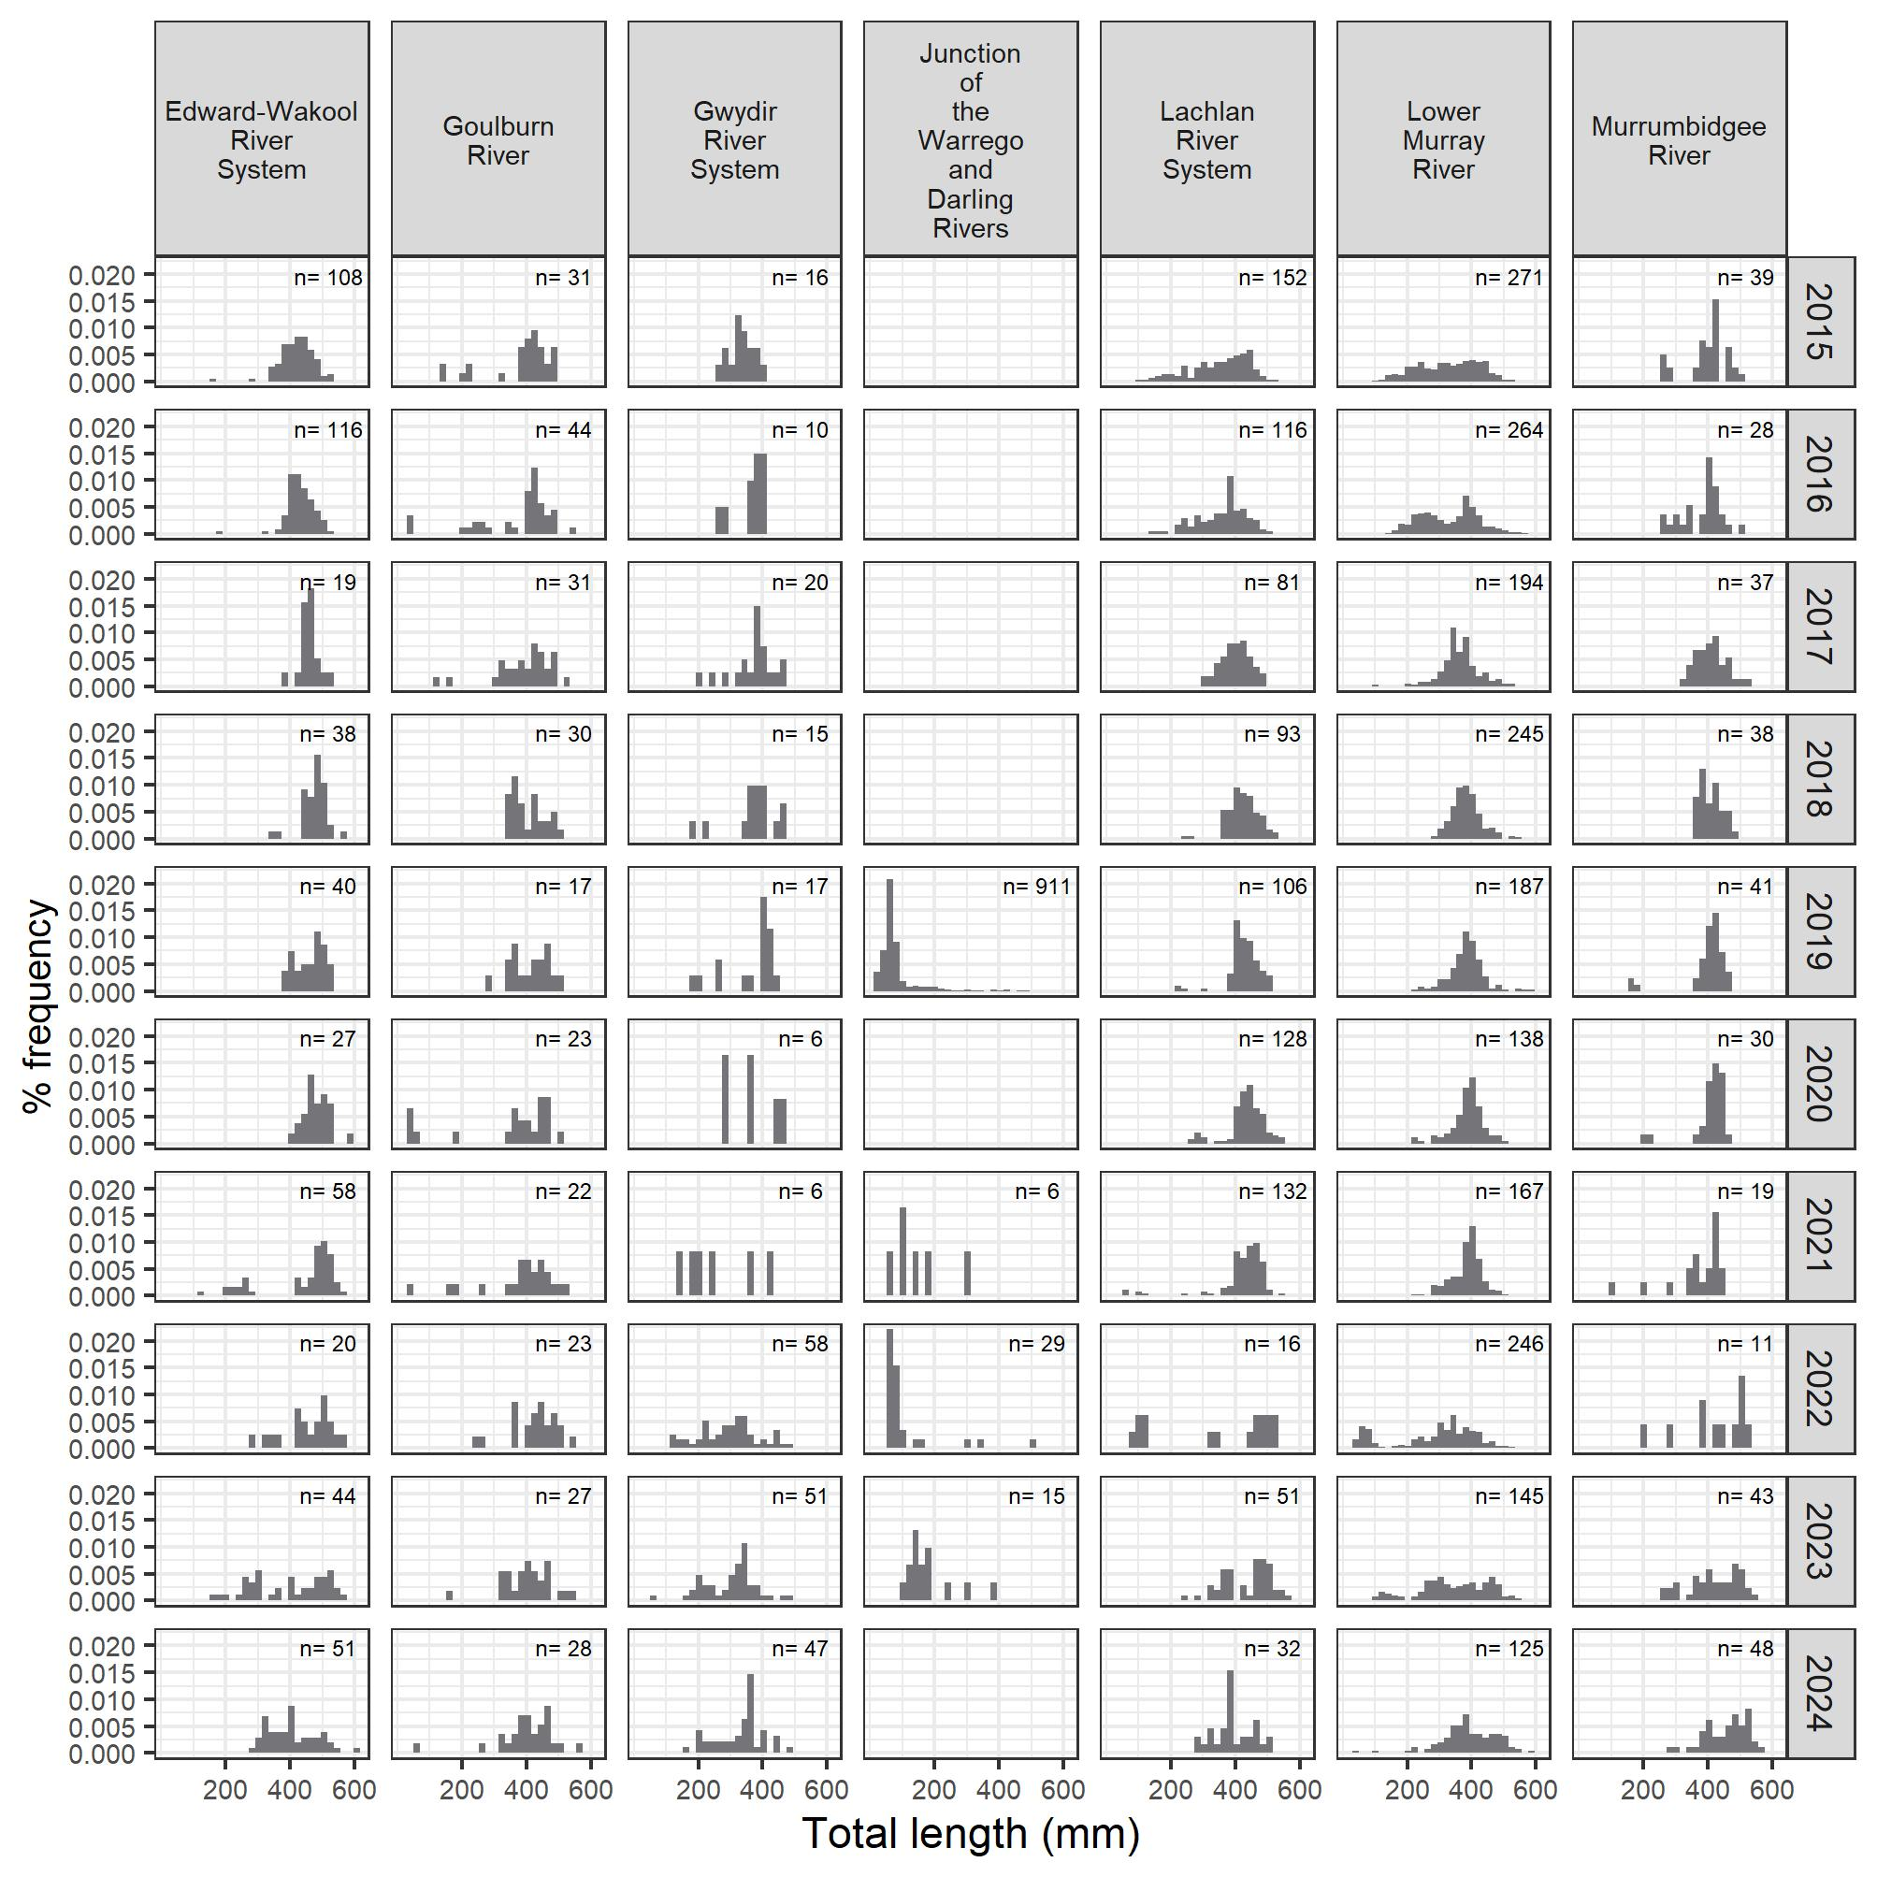
Figure G.2 Length–frequency histogram of Murray cod, by Selected Area and water year, over the period 2014–24
Years (row labels): 2015 refers to water year 2014–15, 2016 refers to 2015–16, and so forth. In 2020–21, only 3 of the 6 Gwydir River sites were sampled. No length data were recorded at Junction of Warrego and Darling rivers except for 2018–19 when Murray cod was detected. Murray cod have not been detected in that Selected Area in 2020–21, 2021–22, 2022–23. In 2023–24, no data were recorded in the Monitoring Data Management System at Junction of Warrego and Darling rivers; therefore, data cannot be displayed here.
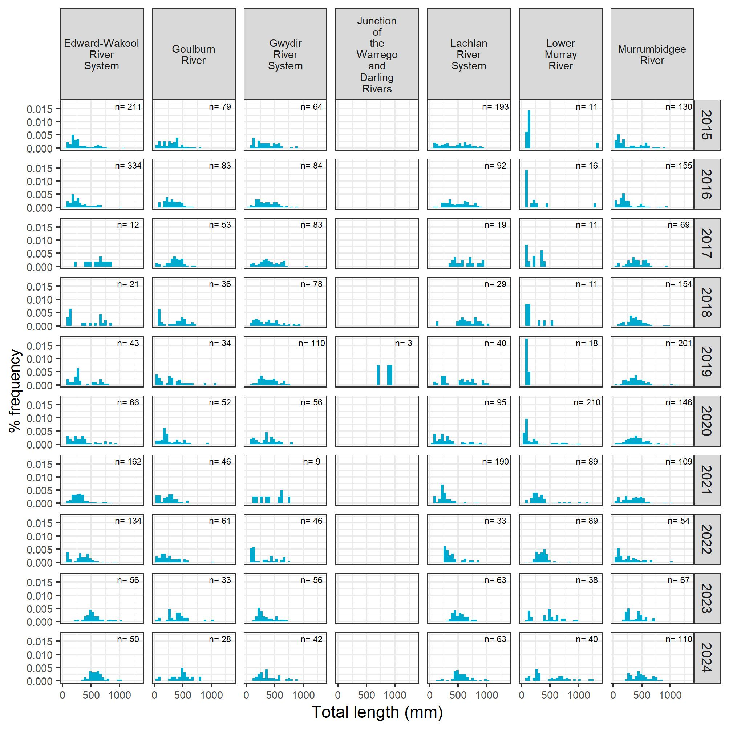
Figure G.3 Length–frequency histogram of bony herring, by Selected Area and water year, over the period 2014–24
Years (row labels): 2015 refers to water year 2014–15, 2016 refers to 2015–16, and so forth. In 2020–21, only 3 of the 6 Gwydir River sites were sampled. No length data were recorded at Junction of Warrego and Darling rivers in 2014–15 to 2017–18 nor in 2019–20, nor the Lower Murray River in 2014–15. Bony herring was absent in the Goulburn River in 2014–15, 2018–19, 2019–20 and 2020–21. In 2023–24, no data were recorded in the Monitoring Data Management System at Junction of Warrego and Darling rivers; therefore, data cannot be displayed here.
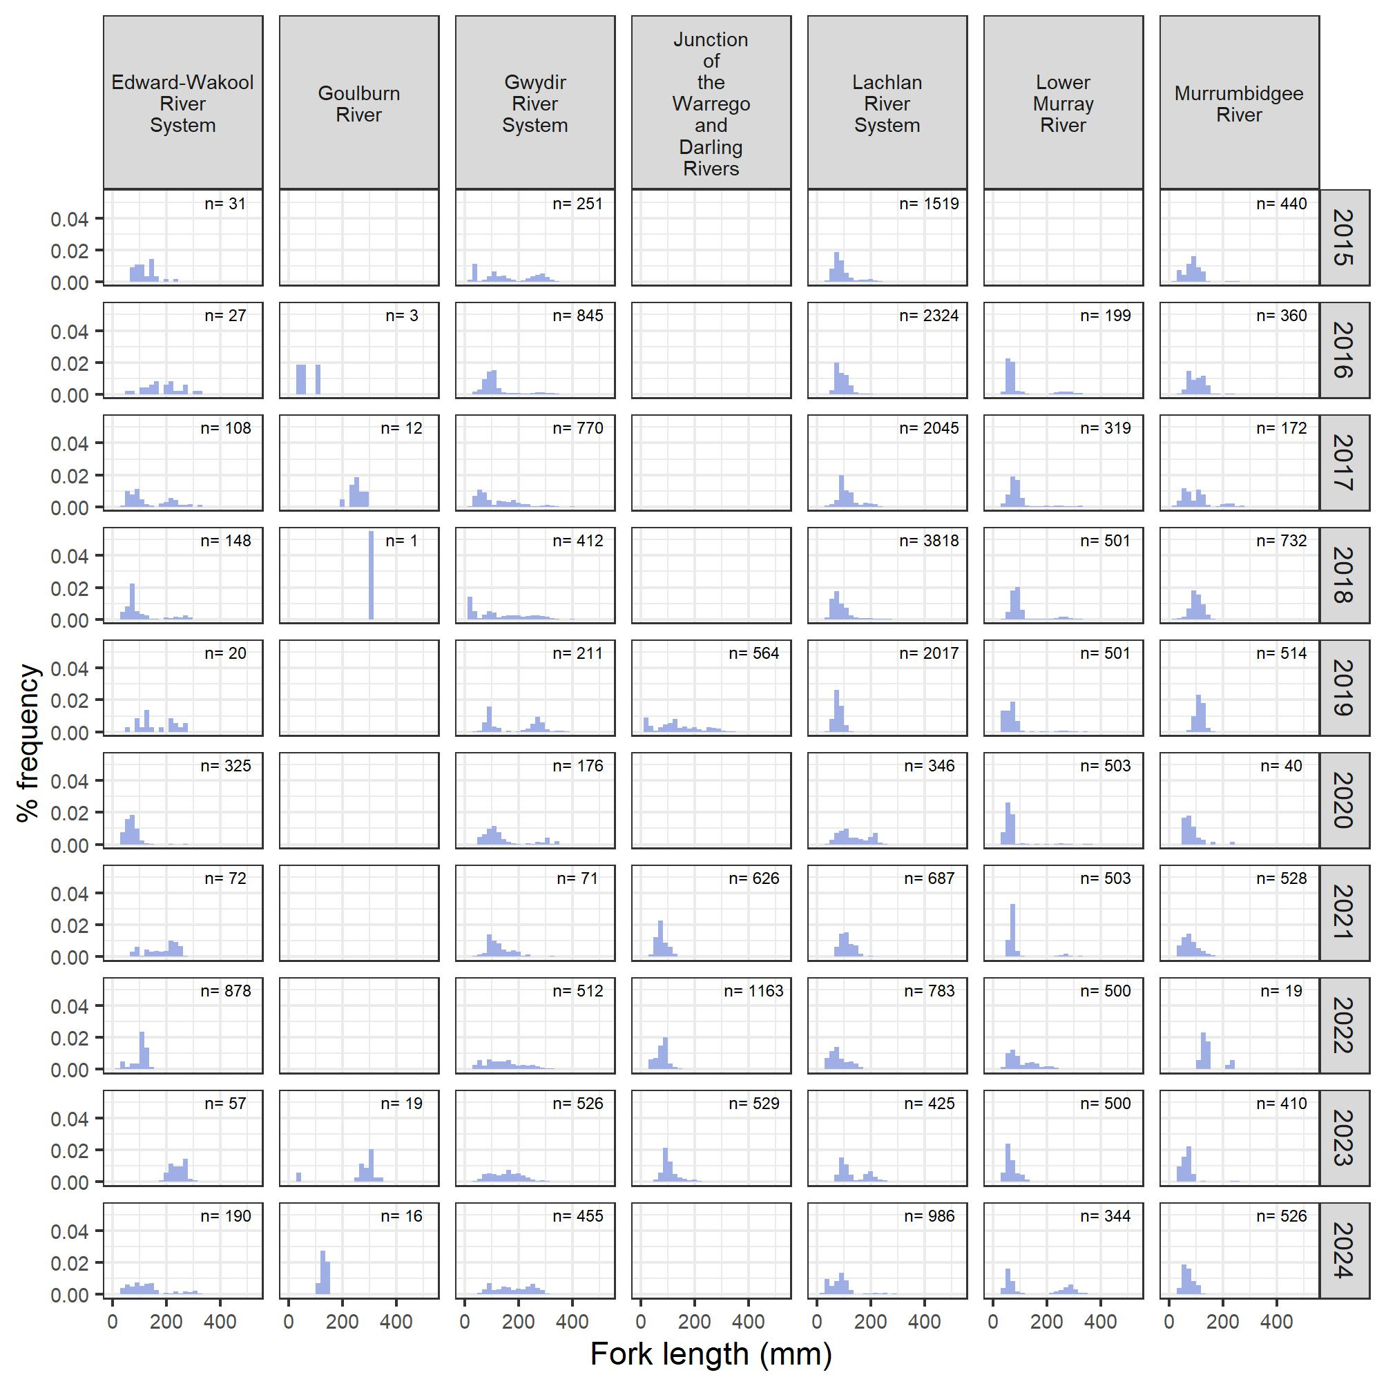
Figure G.4 Length–frequency histogram of common carp (exotic species), by Selected Area and water year, over the period 2014–24
Years (row labels): 2015 refers to water year 2014–15, 2016 refers to 2015–16, and so forth. In 2020–21, only 3 of the 6 Gwydir River sites were sampled. No length data were recorded at Junction of Warrego and Darling rivers in 2014–15 to 2017–18 nor in 2019–20, and lengths of common carp were not measured in the Goulburn River from 2014–15 to 2018–19. In 2023–24, no data were recorded in the Monitoring Data Management System at Junction of Warrego and Darling rivers; therefore, data cannot be displayed here.
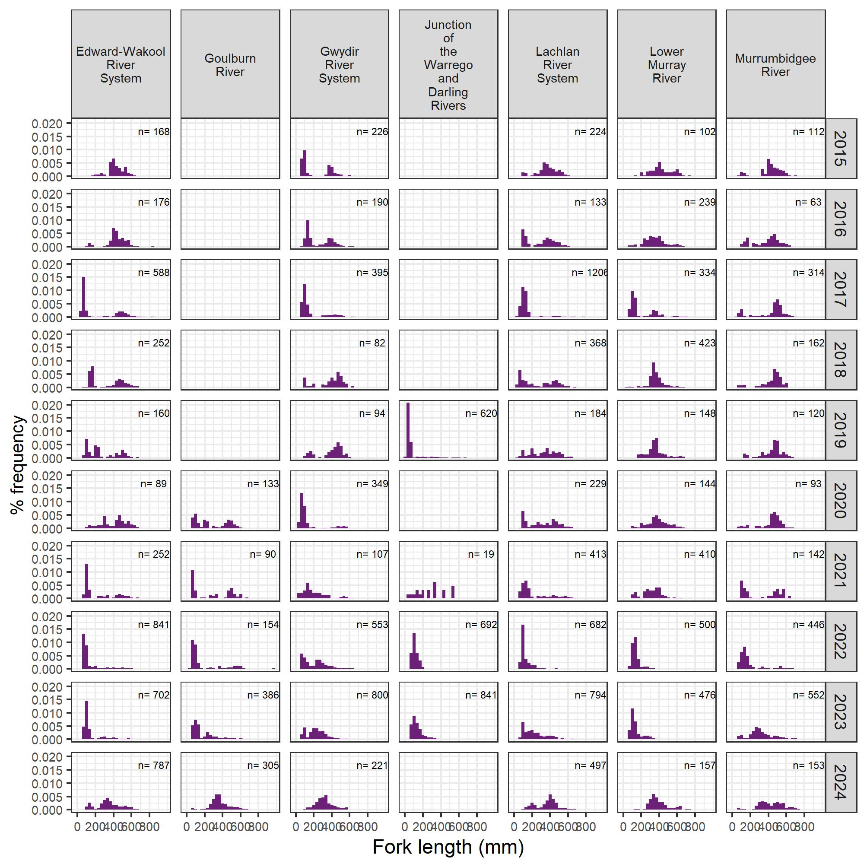
- Small-bodied fish species
Length thresholds can be problematic for small-bodied fish species as they can reach maturity quickly and produce multiple generations in less than one year (e.g. eastern gambusia). Flow-MER sampling occurs largely at the end of the breeding period for all the focal small-bodied species (especially Australian smelt, eastern gambusia and carp gudgeon, which have a protracted spawning period) and the majority of the sample would be young-of-year. Therefore, detection/abundance of small-bodied species was used as a whole for small-bodied species recruitment. This follows the same logic and methodology applied in The Living Murray fish monitoring at Barmah–Millewa Forest Icon Site for small-bodied species recruitment (Raymond et al. 2021).
Australian smelt populations were variable among Selected Areas and water years. There was consistent detection/recruitment in the Murrumbidgee River System and relatively stable population structure in the Edward/Kolety–Wakool river systems and Gwydir River System (Figure G.5).
Carp gudgeon population structure was skewed to smaller size classes (Figure G.6). There was consistent detection/evidence of recruitment regularly in most Selected Areas and water years, except at the Junction of Warrego and Darling rivers where no individuals were detected in 2022–23. In 2023–24 individuals were collected in the Darling surveys but not in the lower Warrego surveys (Mika et al. 2024a).
Murray–Darling rainbowfish populations were present in all Selected Areas spanning the species’ size range (Figure G.7). Detection/recruitment was evident in all Selected Areas and water years.
Eastern gambusia (exotic species) populations spanned the species’ full-size range and detection/evidence of recruitment was seen in most Selected Areas (Figure G.8).
Figure G.5 Length–frequency histogram of Australian smelt, by Selected Area and water year, over the period 2014–24
Years (row labels): 2015 refers to water year 2014–15, 2016 refers to 2015–16, and so forth. In 2020–21, only 3 of the 6 Gwydir River sites were sampled. Lengths were not measured for the Lower Murray River in all years (hence, not included), nor the Goulburn River in 2017–18 and 2018–19. No length data were recorded at Junction of Warrego and Darling rivers in 2014–15 to 2017–18 nor in 2019–20, and no Australian smelt were captured in that Selected Area in 2020–21, 2021–22 and 2022–23. In 2023–24, no data were recorded in the Monitoring Data Management System at Junction of Warrego and Darling rivers; therefore, data cannot be displayed here.
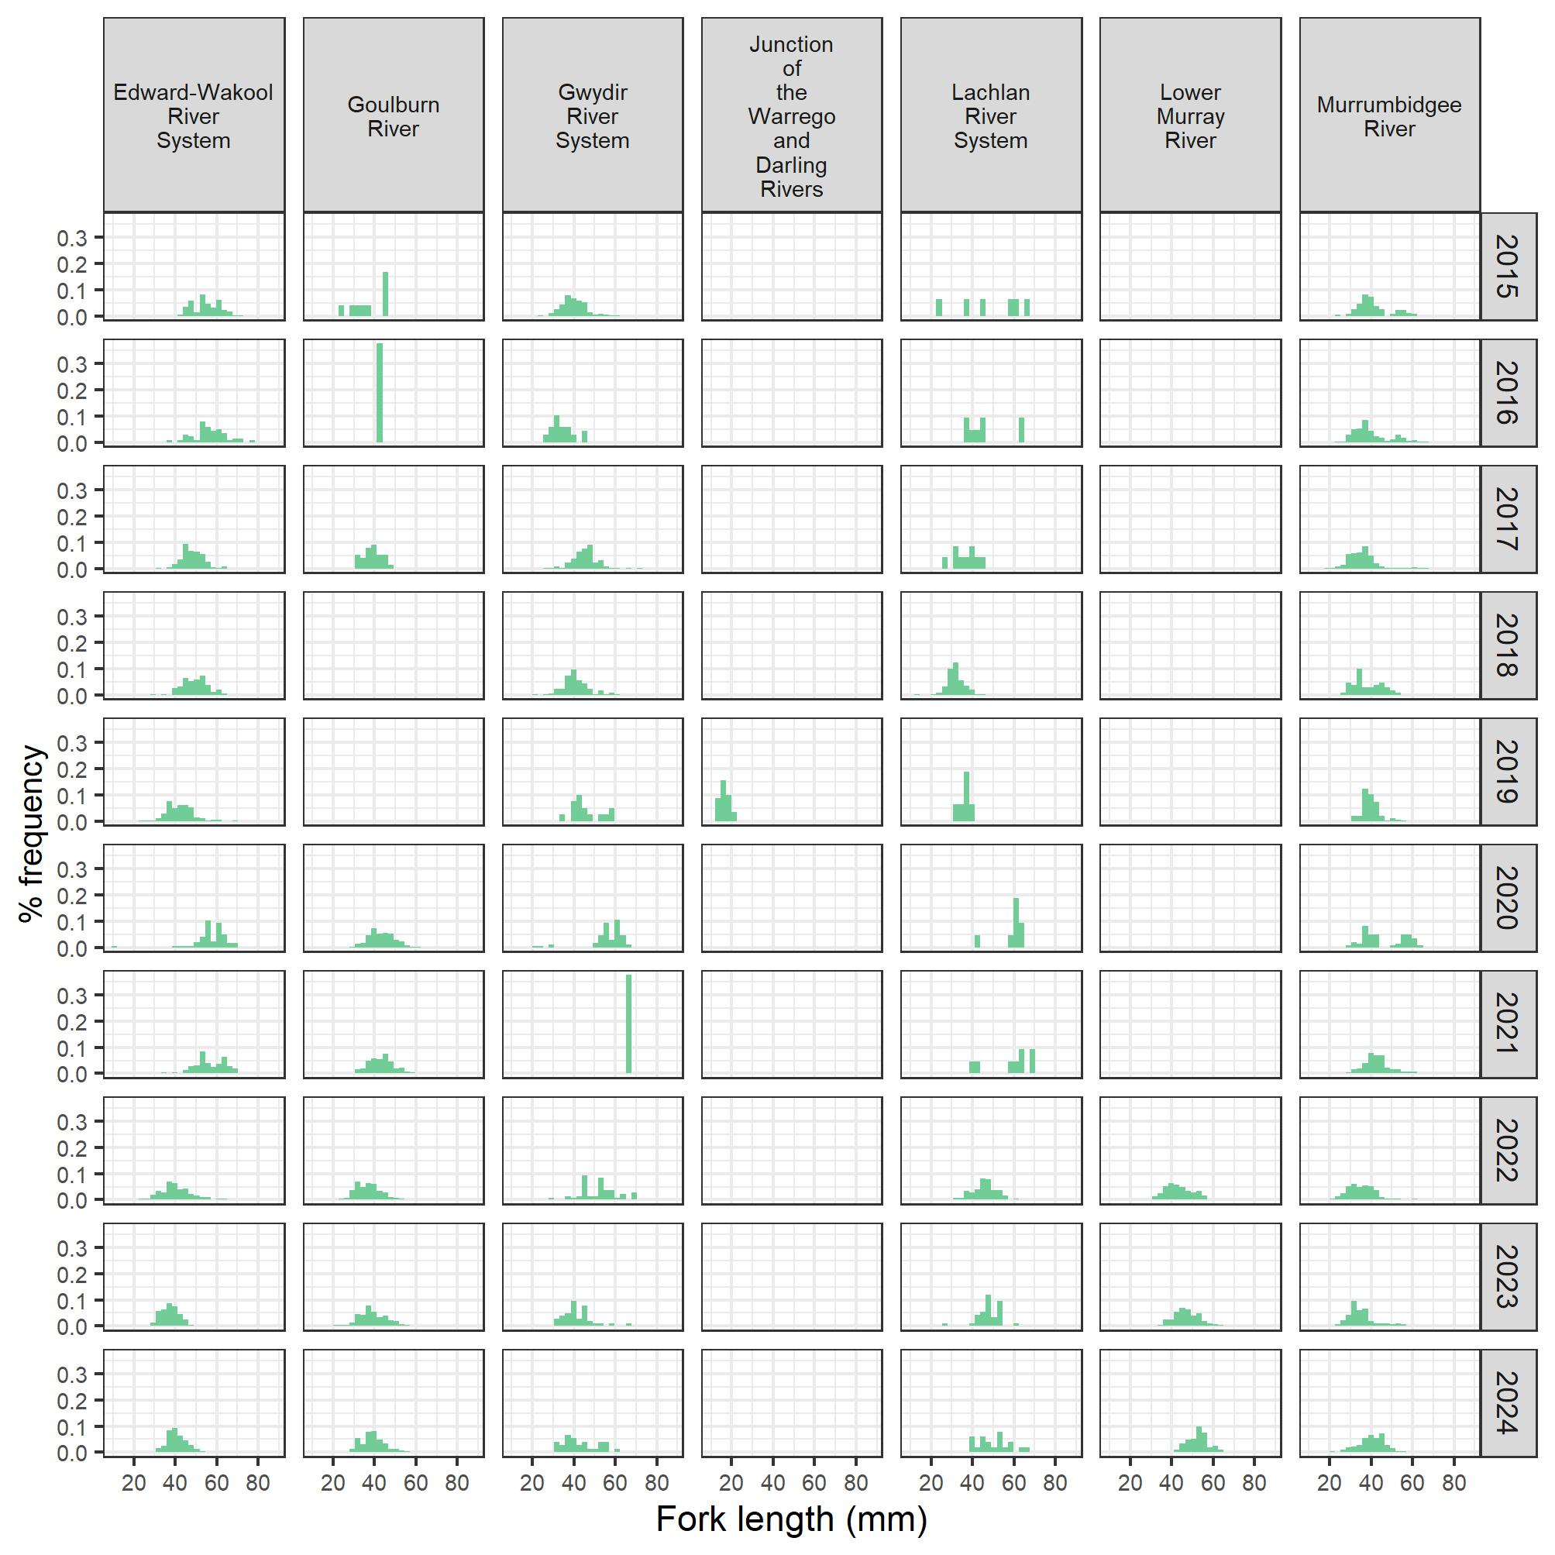
Figure G.6 Length–frequency histogram of carp gudgeon, by Selected Area and water year, over the period 2014–24
Years (row labels): 2015 refers to water year 2014–15, 2016 refers to 2015–16, and so forth. In 2020–21, only 3 of the 6 Gwydir River sites were sampled. No length data were recorded at Junction of Warrego and Darling rivers in 2014–15 to 2017–18 nor in 2019–20, and carp gudgeon were not detected in this Selected Area in 2022–23. No length data were recorded at the Goulburn River in 2017–18 and 2018–19. In 2023–24, no data wererecorded in the Monitoring Data Management System at Junction of Warrego and Darling rivers; therefore, data cannot be displayed here.
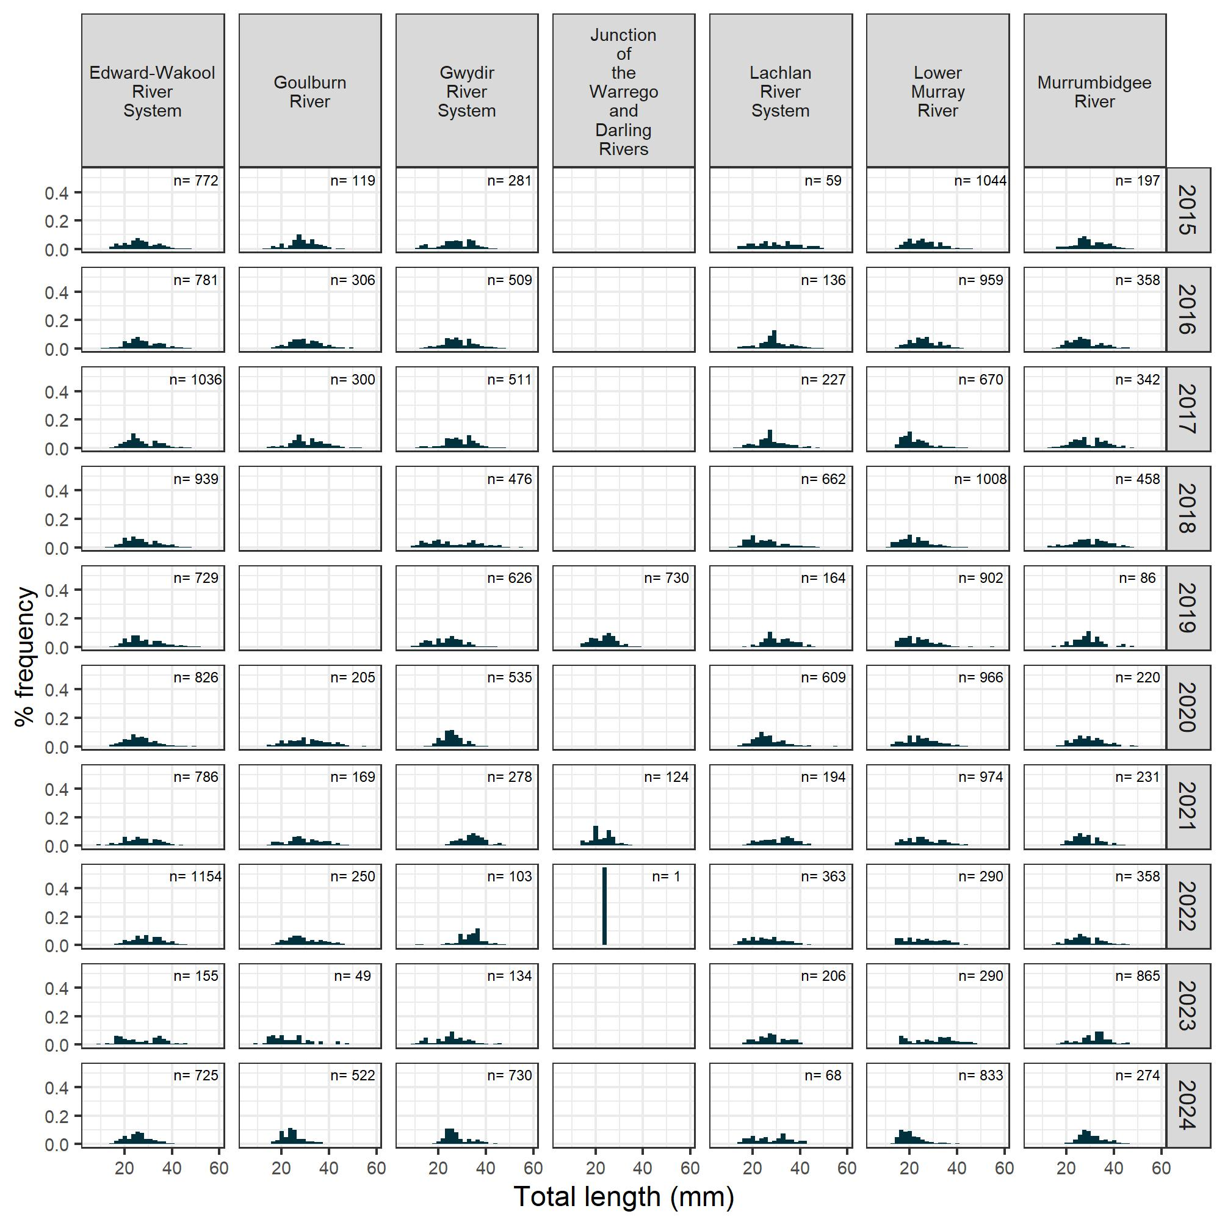
Figure G.7 Length–frequency histogram of Murray–Darling rainbowfish, by Selected Area and water year, over the period 2014–24
Years (row labels): 2015 refers to water year 2014–15, 2016 refers to 2015–16, and so forth. In 2020–21, only 3 of the 6 Gwydir River sites were sampled. No length data were recorded at Junction of Warrego and Darling rivers in 2014–15 to-2017–18 nor in 2019–2020, nor the Goulburn River in 2017–18 and 2018–19. Rainbowfish were not detected at Junction of Warrego and Darling rivers in 2018–19 nor 2020–21 (electrofishing and fine-mesh fykes). In 2023–24, no data were recorded in the Monitoring Data Management System at Junction of Warrego and Darling rivers; therefore, data cannot be displayed here.
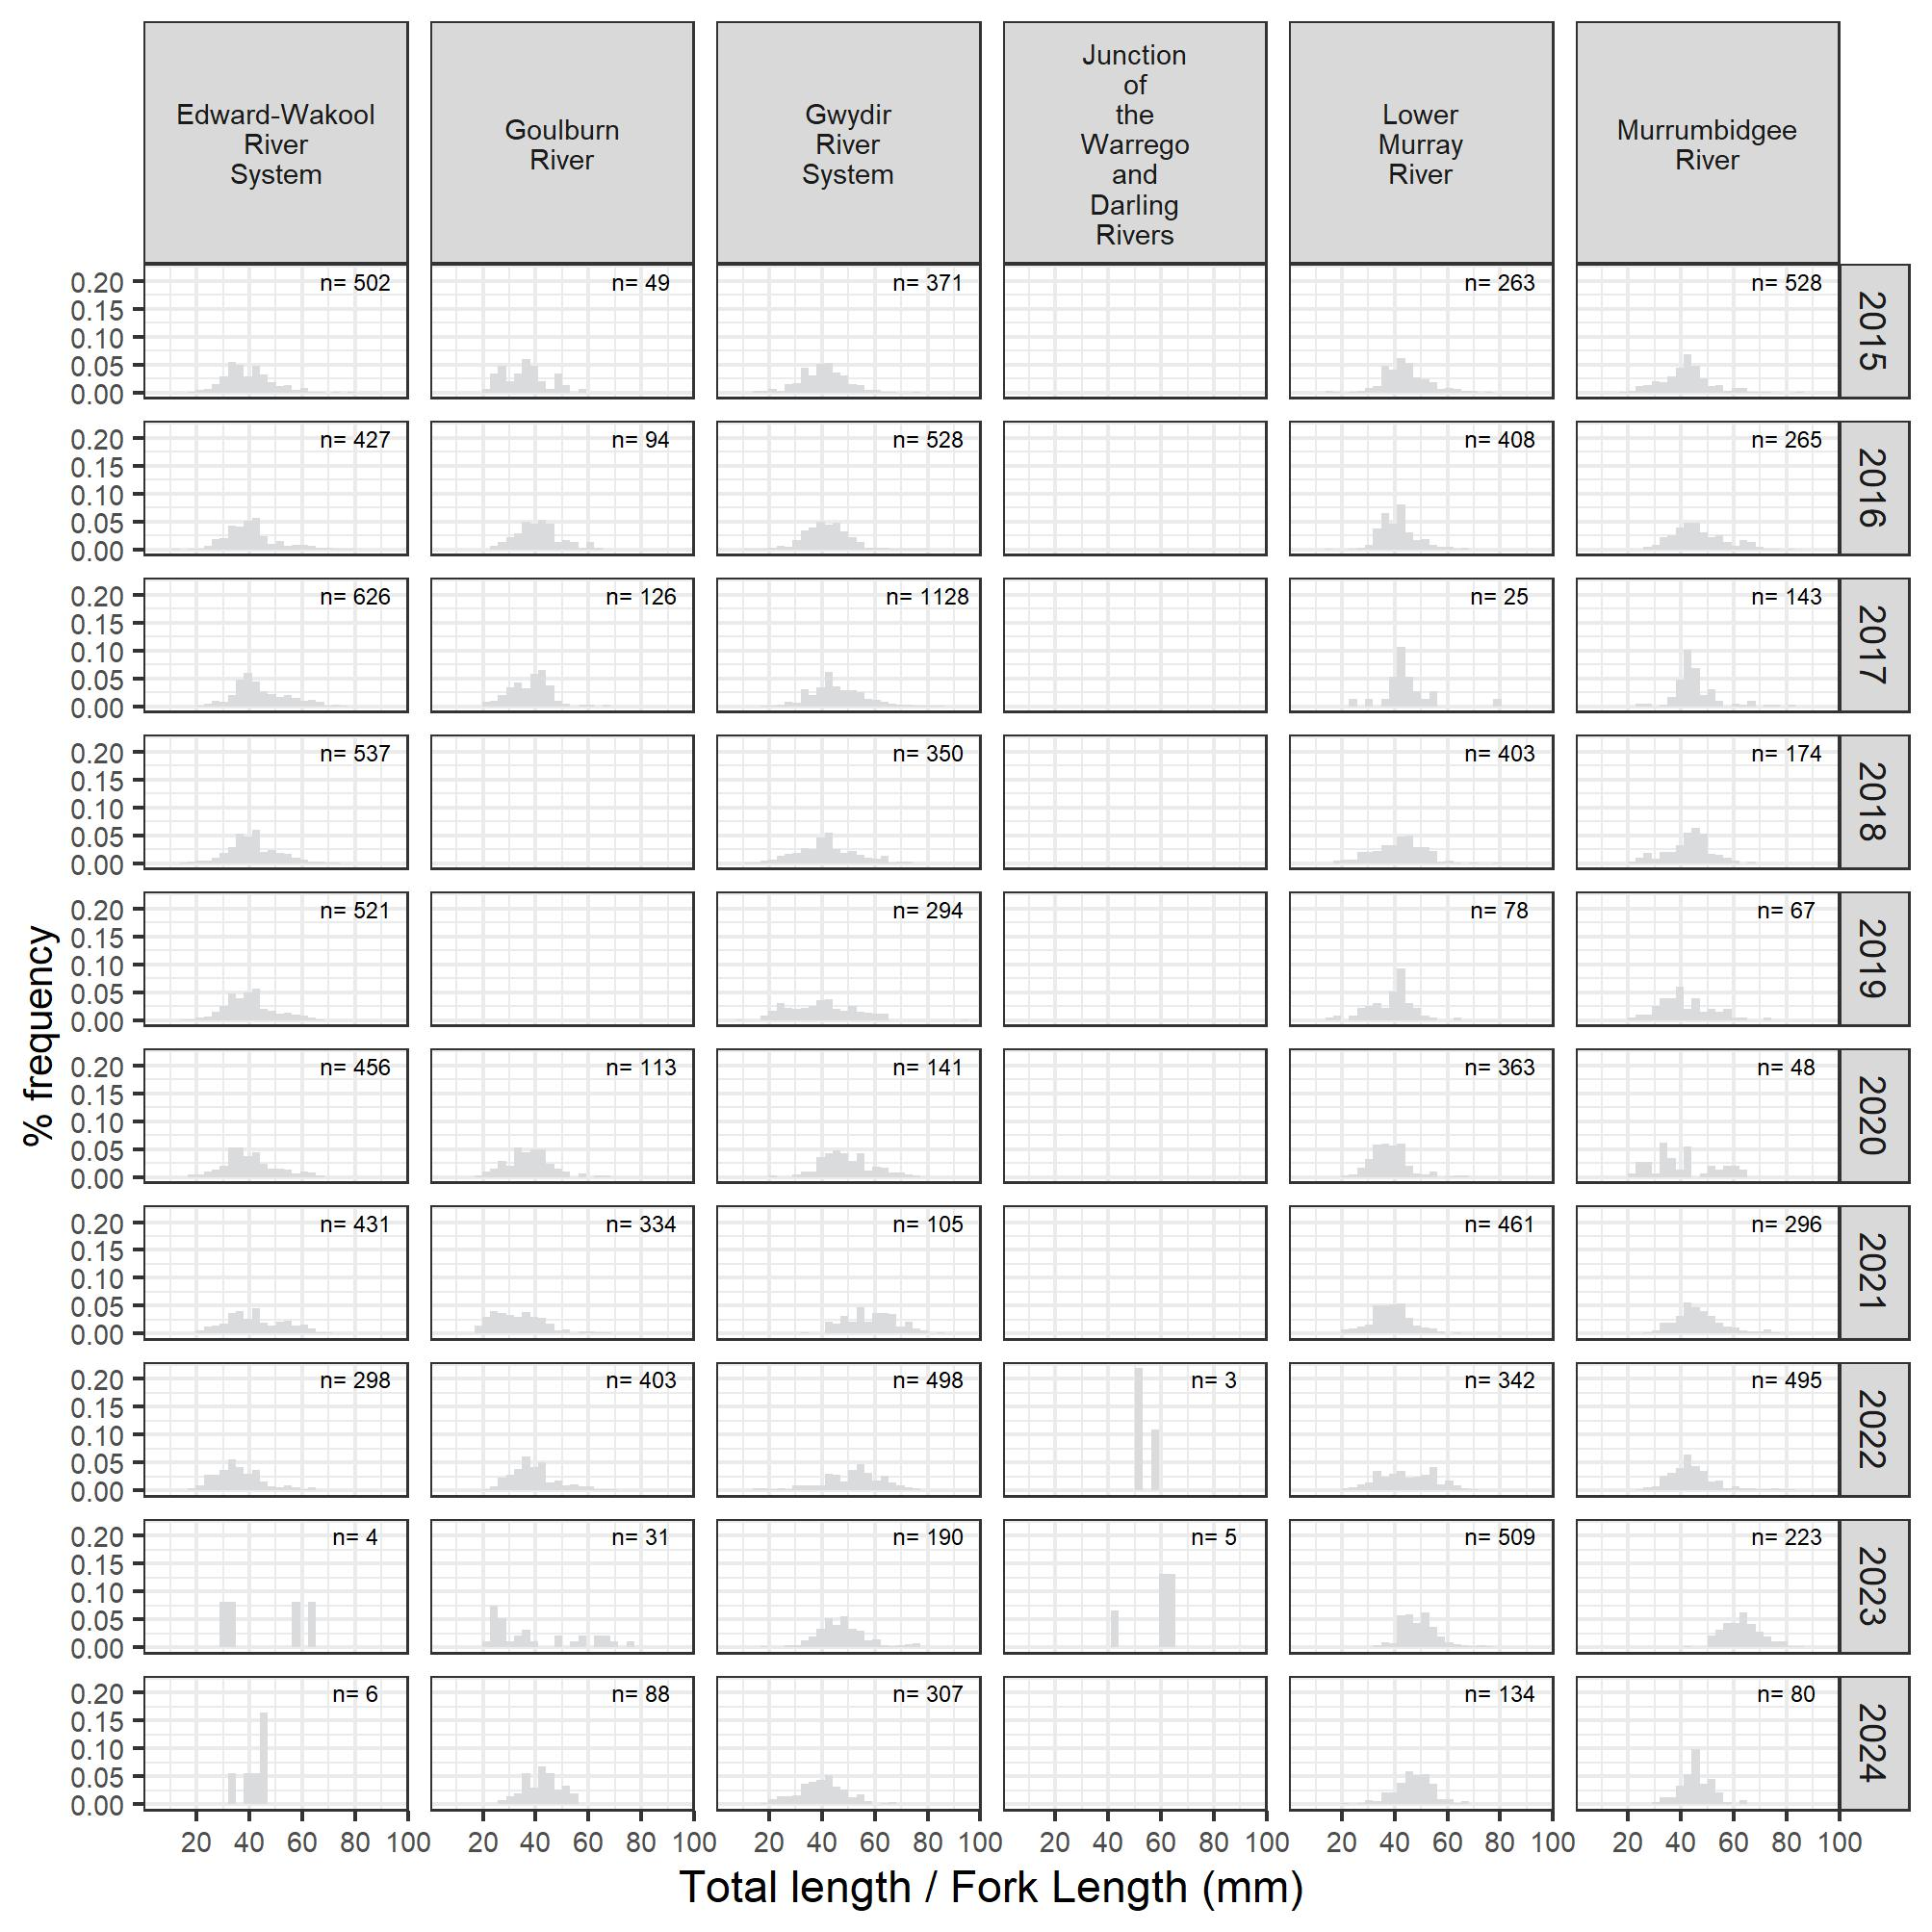
Figure G.8 Length–frequency histogram of eastern gambusia (exotic species), by Selected Areas and water year, over the period 2014–24
Years (row labels): 2015 refers to water year 2014–15, 2016 refers to 2015–16, and so forth. In 2020–21, only 3 of the 6 Gwydir River sites were sampled. Lengths were not measured in the Lower Murray River in all years (hence, not included) nor Goulburn River in 2014–15, 2017–18 and 2018–19, and no length data were recorded at Junction of Warrego and Darling Rivers in 2014–15 to-2017–18 nor in 2019–20. In 2019–20, eastern gambusia was not detected in the Edward/Kolety–Wakool river systems and in the Goulburn River. In 2023–24, no data were recorded in the Monitoring Data Management System at Junction of Warrego and Darling rivers; therefore, data cannot be displayed here.
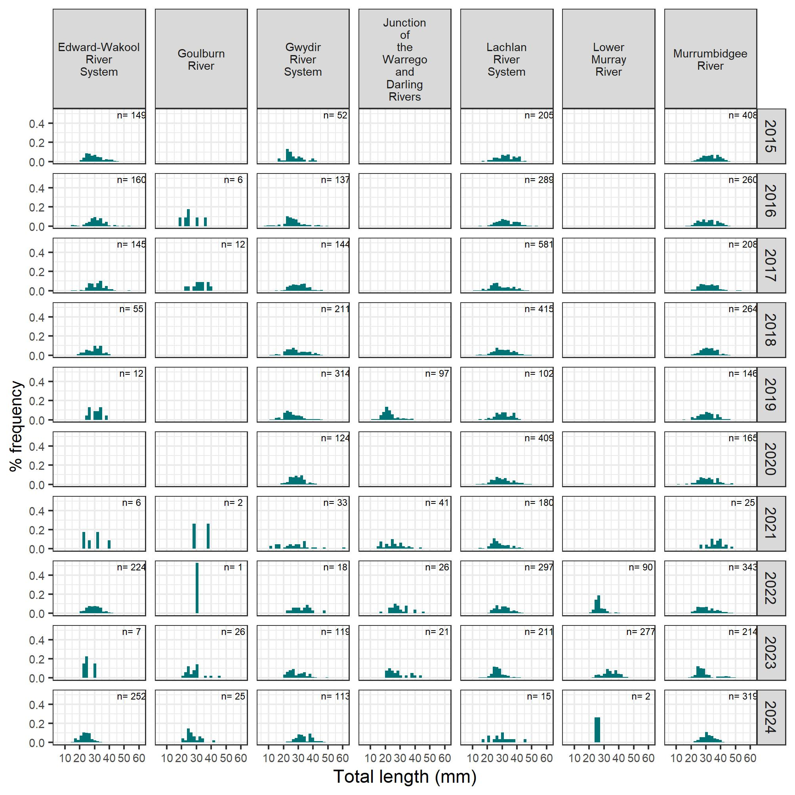

Statistical analyses
This appendix gives a brief overview of model structure and description. Each species was modelled separately for each response variable of interest. The model structure was broken into 3 components: response variable, flow covariates (annual or event metrics), and spatial/temporal effects that were either fixed or random. Model structure was represented by the combination of the model equation and the link function and model family listed in the right-hand column of Table H.2. Model equations are in simplified R notation, where the notation (1|x) denotes a random intercept for each level of the variable x. Predictor variables are defined in Table H.2. Terms defined in the model structures are included in Table H.1.
Table H.1 Terms and variables used in the model structure
Term/variable | Used for
Flow covariates
flow_median | Standardised daily flow for relevant timing
flow_cv | Coefficient of variability in daily flow for relevant timing
flow_low | Number of days of low flow (below 10th percentile of available data)
flow_max_prev | Standardised maximum antecedent flow
flow_peak | Peak standardised flow (95th percentile)
Flow event-based covariates
flow_e_chg | Change in daily flow in 7 days prior to capture
flow_e_increase | Number of days of increasing flow in 7 days prior to capture
flow_e_curr | Median standardised flow in the last 7 days
flow_e_30day | Median standardised flow in the last 30 days
Response variables
spawned | Spawning occurrence (labelled spawn in Figure 5-1)
count | Recruit abundance (labelled recruit in Figure 5-1)
n_fish | Number of fish caught at each age
presence | Presence of that species at that site (for that water year) (labelled adultPresence in Figure 5-1)
r | Adult abundance (catch per unit effort) (labelled adultAbund in Figure 5-1)
fulton_index | Fulton’s K body condition factor (labelled bodyCond in Figure 5-1)
prop | Proportion of the fish species per program per water year per sample point that was native (labelled community in Figure 5-1)
Other variables
ad_cpue | Current water year’s adult abundance (catch per unit effort)
age | Fish age
birthyear | Birth year of an individual fish
do_last_year | Indicator variable denoting time since most recent fish-death event or hypoxic event at a sample point
tot_effort | Sampling effort, either electrofishing time or volume filtered through fyke nets
program | Selected Area site
samplepoint | Site within Selected Area
wateryear | Water year in which a survey occurred
wday | Day of year
Table H.2 Summary of statistical analyses: model type, relevant species and response variables, grouped by objective
Objective | Response variable | Species | Model structure | Model description
Determine influence of flow events and flow regimes across all Selected Areas on spawning success of native, flow-cued species | Spawning occurrence | Golden perch  Silver perch | spawned~flow_e_chg + flow_e_increase + flow_e_30day + selected_area + wday + tot_effort + ad_cpue + (1 | selected_area:wateryear) + (1 | samplepoint) | Binomial linear model with logit link
Determine influence of flow events and flow regimes across all Selected Areas on recruitment strength of all native fish species | Recruit abundance (length threshold) | Australian smelt  Carp gudgeon  Common carp  Eastern gambusia  Murray cod  Murray–Darling rainbowfish | count~flow_median + flow_cv + flow_low + flow_max_prev + selected_area + tot_effort + ad_cpue + (1 | selected_area:wateryear) + (1 | samplepoint) | Negative binomial linear model with log link
 | Recruit abundance (fish age otolith data) | Golden perch | n_fish~age + (1 | birthyear) | Catch curve regression; negative binomial linear model with log link
Determine influence of flow events and flow regimes across all Selected Areas on frequency of occurrence of abundant species | Adult frequency of occurrence (proportion of sites where species are detected within Selected Areas) | Australian smelt  Bony herring  Carp gudgeon  Eastern gambusia  Golden perch  Murray cod  Murray–Darling rainbowfish | presence~flow_median + flow_cv + flow_low + flow_max_prev + selected_area + (1 | wateryear) + (1 | samplepoint) | Binomial linear model with logit link
Determine influence of flow events and flow regimes across all Selected Areas on population composition (structure and condition) of abundant native species | Adult abundance (CPUE) (population growth rate) | Bony herring  Common carp  Golden perch  Murray cod | r~flow_median + flow_cv + flow_low + flow_max_prev + selected_area + do_last_year + (1 | wateryear) + (1 | samplepoint) | Autoregressive Gaussian linear model with log link
 | Fulton’s K condition factor (length and weight data) | Bony herring  Common carp  Murray cod  Golden perch | fulton_index~flow_median + flow_cv + flow_low + flow_max_prev + selected_area + (1 | wateryear) + (1 | wateryear:selected_area) + (1 | samplepoint) | Linear mixed model with identity link (non-Bayesian)
Determine influence of flow events and flow regimes across all Selected Areas on community responses | Proportion of catch belonging to a native species (community metric) | All recorded species | prop~flow_median + flow_cv + flow_low + flow_max_prev + selected_area + (1 | wateryear) + (1 | samplepoint) | Gaussian linear model with identity link

Table H.3 Estimate of the Commonwealth environmental water effect on population processes for each focal speciesSho
The Commonwealth environmental water (CEW) effect is the difference in each response between the observed data (with CEW) and a counterfactual scenario (without CEW), averaged over all survey years. Positive values reflect increases in a response due to CEW. Lower and upper bounds are 10th and 90th percentiles, respectively, over all survey years. Confidence is the posterior probability that the response is greater with CEW than without CEW, and confidence categories assigning these values to broad classes are described in Fanson (2025). Selected Areas (abbreviated in the table) are Edward/Kolety–Wakool river systems, Goulburn River, Gwydir River System, Lachlan River System, Lower Murray River and Murrumbidgee River System, respectively. The Junction of Warrego and Darling rivers Selected Area is not included as it does not have a designated targeted indicator for fish and historically is not included in Basin-scale fish analyses.
Selected Area | Response |  | CEW effect | CEW effect lower | CEW effect upper | Confidence category
Australian smelt
Edward/Kolety–Wakool | Recruit abundance |  | 0.22 | -2.4e-02 | 0.45 | medium positive
Edward/Kolety–Wakool | Adult frequency of occurrence |  | 0.16 | 0.07 | 0.25 | high positive
Goulburn | Recruit abundance |  | 2.97 | 1.19 | 4.61 | high positive
Goulburn | Adult frequency of occurrence |  | 1.17 | 0.50 | 1.85 | high positive
Gwydir | Recruit abundance |  | -5.0e-02 | -1.9e-01 | 0.09 | no association
Gwydir | Adult frequency of occurrence |  | 0.04 | -2.9e-02 | 0.10 | low positive
Lachlan | Recruit abundance |  | 0.37 | 0.16 | 0.60 | high positive
Lachlan | Adult frequency of occurrence |  | 0.14 | 0.05 | 0.22 | high positive
Lower Murray | Recruit abundance |  | 1.64 | 0.69 | 2.59 | high positive
Lower Murray | Adult frequency of occurrence |  | 0.69 | 0.31 | 1.05 | high positive
Murrumbidgee | Recruit abundance |  | 0.21 | 0.06 | 0.37 | high positive
Murrumbidgee | Adult frequency of occurrence |  | 0.11 | 0.05 | 0.17 | high positive
Bony herring
Edward/Kolety–Wakool | Recruit abundance |  | 0.12 | -9.1e-02 | 0.32 | low positive
Edward/Kolety–Wakool | Adult abundance |  | -2.9e-02 | -1.2e-01 | 0.05 | no association
Edward/Kolety–Wakool | Fulton’s K condition |  | 5.0e-05 | -2.6e-08 | 1.9e-04 | medium positive
Edward/Kolety–Wakool | Adult frequency of occurrence |  | -5.7e-02 | -2.1e-01 | 0.09 | no association
Goulburn | Recruit abundance |  | 0.04 | -1.3e+00 | 1.44 | no association
Goulburn | Adult abundance |  | 0.21 | -3.6e-01 | 0.73 | no association
Goulburn | Adult frequency of occurrence |  | 0.96 | -1.9e-01 | 2.07 | medium positive
Gwydir | Recruit abundance |  | 0.07 | -4.6e-02 | 0.19 | low positive
Gwydir | Adult abundance |  | -4.0e-02 | -8.7e-02 | 0.01 | medium negative
Gwydir | Fulton’s K condition |  | 1.7e-05 | -6.9e-06 | 1.2e-04 | low positive
Gwydir | Adult frequency of occurrence |  | -1.5e-01 | -2.8e-01 | -1.1e-02 | high negative
Lachlan | Recruit abundance |  | 0.03 | -1.5e-01 | 0.19 | no association
Lachlan | Adult abundance |  | 0.05 | -2.2e-02 | 0.12 | low positive
Lachlan | Fulton’s K condition |  | 8.2e-06 | -2.0e-04 | 8.5e-05 | low positive
Lachlan | Adult frequency of occurrence |  | 0.13 | -1.0e-02 | 0.26 | medium positive
Lower Murray | Recruit abundance |  | 0.10 | -6.5e-01 | 0.88 | no association
Lower Murray | Adult abundance |  | 0.10 | -1.9e-01 | 0.41 | no association
Lower Murray | Fulton’s K condition |  | 4.1e-05 | -6.5e-05 | 1.6e-04 | no association
Lower Murray | Adult frequency of occurrence |  | 0.44 | -1.8e-01 | 1.04 | low positive
Murrumbidgee | Recruit abundance |  | 0.06 | -7.9e-02 | 0.18 | no association
Murrumbidgee | Adult abundance |  | 8.1e-03 | -3.9e-02 | 0.05 | no association
Murrumbidgee | Fulton’s K condition |  | 2.8e-05 | -3.0e-05 | 6.2e-05 | low positive
Murrumbidgee | Adult frequency of occurrence |  | 0.04 | -5.0e-02 | 0.13 | no association
Carp gudgeon
Edward/Kolety–Wakool | Recruit abundance |  | 0.06 | -8.1e-02 | 0.20 | no association
Edward/Kolety–Wakool | Adult frequency of occurrence |  | 0.06 | -1.9e-01 | 0.32 | no association
Goulburn | Recruit abundance |  | -1.3e-01 | -1.0e+00 | 0.84 | no association
Goulburn | Adult frequency of occurrence |  | -1.1e+00 | -2.8e+00 | 0.52 | low negative
Gwydir | Recruit abundance |  | 7.2e-03 | -6.6e-02 | 0.09 | no association
Gwydir | Adult frequency of occurrence |  | 0.13 | -1.9e-02 | 0.28 | medium positive
Lachlan | Recruit abundance |  | -5.0e-02 | -1.6e-01 | 0.06 | no association
Lachlan | Adult frequency of occurrence |  | -1.7e-01 | -4.0e-01 | 0.02 | medium negative
Lower Murray | Recruit abundance |  | -6.8e-02 | -5.7e-01 | 0.47 | no association
Lower Murray | Adult frequency of occurrence |  | -5.5e-01 | -1.5e+00 | 0.33 | low negative
Murrumbidgee | Recruit abundance |  | 0.03 | -6.3e-02 | 0.12 | no association
Murrumbidgee | Adult frequency of occurrence |  | -3.0e-02 | -1.8e-01 | 0.13 | no association
Common carp
Edward/Kolety–Wakool | Recruit abundance |  | 0.20 | 0.04 | 0.38 | high positive
Edward/Kolety–Wakool | Adult abundance |  | 0.03 | -2.7e-02 | 0.08 | no association
Edward/Kolety–Wakool | Fulton’s K condition |  | 7.6e-06 | -5.8e-06 | 3.3e-05 | no association
Goulburn | Recruit abundance |  | 0.16 | -9.2e-01 | 1.27 | no association
Goulburn | Adult abundance |  | -3.5e-01 | -6.8e-01 | -1.0e-02 | high negative
Gwydir | Recruit abundance |  | 0.22 | 0.12 | 0.31 | high positive
Gwydir | Adult abundance |  | 0.03 | 4.7e-04 | 0.06 | high positive
Gwydir | Fulton’s K condition |  | 4.9e-06 | -1.1e-07 | 2.3e-05 | medium positive
Lachlan | Recruit abundance |  | 0.04 | -1.0e-01 | 0.18 | no association
Lachlan | Adult abundance |  | -7.2e-02 | -1.2e-01 | -2.7e-02 | high negative
Lachlan | Fulton’s K condition |  | 6.8e-06 | -1.8e-05 | 3.7e-05 | no association
Lower Murray | Recruit abundance |  | 0.25 | -3.7e-01 | 0.85 | no association
Lower Murray | Adult abundance |  | -1.9e-01 | -3.7e-01 | -2.3e-03 | high negative
Murrumbidgee | Recruit abundance |  | 0.06 | -5.4e-02 | 0.16 | low positive
Murrumbidgee | Adult abundance |  | -9.6e-03 | -3.9e-02 | 0.02 | no association
Murrumbidgee | Fulton’s K condition |  | 4.6e-06 | -4.2e-06 | 1.7e-05 | no association
Eastern gambusia
Edward/Kolety–Wakool | Recruit abundance |  | -2.1e-01 | -4.3e-01 | 0.02 | medium negative
Edward/Kolety–Wakool | Adult frequency of occurrence |  | -2.4e-01 | -3.5e-01 | -1.2e-01 | high negative
Goulburn | Recruit abundance |  | -2.3e+00 | -3.9e+00 | -8.5e-01 | high negative
Goulburn | Adult frequency of occurrence |  | -1.4e+00 | -2.2e+00 | -6.1e-01 | high negative
Gwydir | Recruit abundance |  | 0.08 | -4.3e-02 | 0.19 | low positive
Gwydir | Adult frequency of occurrence |  | -6.6e-02 | -1.4e-01 | 0.01 | medium negative
Lachlan | Recruit abundance |  | -2.6e-01 | -4.3e-01 | -6.5e-02 | high negative
Lachlan | Adult frequency of occurrence |  | -1.8e-01 | -2.7e-01 | -8.3e-02 | high negative
Lower Murray | Recruit abundance |  | -1.3e+00 | -2.1e+00 | -4.2e-01 | high negative
Lower Murray | Adult frequency of occurrence |  | -8.6e-01 | -1.3e+00 | -4.3e-01 | high negative
Murrumbidgee | Recruit abundance |  | -1.9e-01 | -3.4e-01 | -5.0e-02 | high negative
Murrumbidgee | Adult frequency of occurrence |  | -1.6e-01 | -2.2e-01 | -8.0e-02 | high negative
Golden perch
Edward/Kolety–Wakool | Spawning occurrence |  | 8.8e-03 | -2.1e-02 | 0.04 | no association
Edward/Kolety–Wakool | Adult abundance |  | 4.6e-03 | -3.2e-02 | 0.04 | no association
Edward/Kolety–Wakool | Fulton’s K condition |  | 1.3e-05 | -6.2e-06 | 5.8e-05 | no association
Edward/Kolety–Wakool | Adult frequency of occurrence |  | -2.2e-02 | -1.5e-01 | 0.12 | no association
Goulburn | Spawning occurrence |  | 0.05 | -1.4e-01 | 0.23 | no association
Goulburn | Adult abundance |  | 0.46 | 0.20 | 0.69 | high positive
Goulburn | Fulton’s K condition |  | 7.9e-05 | 1.1e-05 | 1.9e-04 | high positive
Goulburn | Adult frequency of occurrence |  | -1.4e-01 | -1.0e+00 | 0.80 | no association
Gwydir | Adult abundance |  | -3.3e-02 | -5.2e-02 | -1.2e-02 | high negative
Gwydir | Fulton’s K condition |  | 4.3e-06 | -1.1e-06 | 1.9e-05 | low positive
Gwydir | Adult frequency of occurrence |  | -4.1e-02 | -1.2e-01 | 0.04 | no association
Lachlan | Spawning occurrence |  | 7.0e-03 | -6.4e-02 | 0.08 | no association
Lachlan | Adult abundance |  | 0.07 | 0.04 | 0.10 | high positive
Lachlan | Fulton’s K condition |  | 1.4e-05 | -1.3e-05 | 7.3e-05 | no association
Lachlan | Adult frequency of occurrence |  | -1.5e-02 | -1.2e-01 | 0.10 | no association
Lower Murray | Spawning occurrence |  | 0.06 | -4.0e-02 | 0.18 | low positive
Lower Murray | Adult abundance |  | 0.24 | 0.10 | 0.37 | high positive
Lower Murray | Fulton’s K condition |  | 5.1e-05 | -1.8e-06 | 1.4e-04 | medium positive
Lower Murray | Adult frequency of occurrence |  | -1.0e-01 | -6.1e-01 | 0.42 | no association
Murrumbidgee | Spawning occurrence |  | 0.02 | -2.9e-02 | 0.07 | no association
Murrumbidgee | Adult abundance |  | 0.02 | 3.7e-03 | 0.05 | high positive
Murrumbidgee | Fulton’s K condition |  | 7.7e-06 | -5.4e-06 | 2.9e-05 | no association
Murrumbidgee | Adult frequency of occurrence |  | -2.2e-04 | -9.1e-02 | 0.08 | no association
Murray cod
Edward/Kolety–Wakool | Recruit abundance |  | 5.8e-03 | -1.2e-01 | 0.13 | no association
Edward/Kolety–Wakool | Adult abundance |  | 0.04 | -2.9e-03 | 0.08 | medium positive
Edward/Kolety–Wakool | Fulton’s K condition |  | 2.7e-06 | -1.5e-05 | 2.6e-05 | no association
Edward/Kolety–Wakool | Adult frequency of occurrence |  | 0.07 | -6.8e-02 | 0.22 | no association
Goulburn | Recruit abundance |  | 0.01 | -7.9e-01 | 0.82 | no association
Goulburn | Adult abundance |  | 0.19 | -8.6e-02 | 0.45 | low positive
Goulburn | Fulton’s K condition |  | 5.9e-05 | 3.9e-06 | 1.3e-04 | high positive
Goulburn | Adult frequency of occurrence |  | 0.43 | -5.8e-01 | 1.39 | no association
Gwydir | Recruit abundance |  | -1.1e-01 | -1.9e-01 | -3.6e-02 | high negative
Gwydir | Adult abundance |  | -2.5e-02 | -4.9e-02 | -4.2e-03 | high negative
Gwydir | Fulton’s K condition |  | 3.1e-06 | -2.3e-06 | 1.4e-05 | no association
Gwydir | Adult frequency of occurrence |  | -5.8e-02 | -1.4e-01 | 0.03 | low negative
Lachlan | Recruit abundance |  | -1.0e-01 | -2.0e-01 | 4.9e-03 | high negative
Lachlan | Adult abundance |  | 0.02 | -1.1e-02 | 0.06 | low positive
Lachlan | Fulton’s K condition |  | 1.4e-05 | -5.7e-06 | 8.5e-05 | no association
Lachlan | Adult frequency of occurrence |  | 0.02 | -1.1e-01 | 0.12 | no association
Lower Murray | Recruit abundance |  | -9.9e-02 | -5.3e-01 | 0.36 | no association
Lower Murray | Adult abundance |  | 0.09 | -7.1e-02 | 0.22 | low positive
Lower Murray | Fulton’s K condition |  | 3.6e-05 | -5.8e-06 | 1.1e-04 | low positive
Lower Murray | Adult frequency of occurrence |  | 0.20 | -3.5e-01 | 0.73 | no association
Murrumbidgee | Recruit abundance |  | 0.02 | -6.0e-02 | 0.09 | no association
Murrumbidgee | Adult abundance |  | 0.03 | 9.3e-03 | 0.06 | high positive
Murrumbidgee | Fulton’s K condition |  | 3.2e-06 | -1.0e-05 | 2.0e-05 | no association
Murrumbidgee | Adult frequency of occurrence |  | 0.07 | -2.7e-02 | 0.16 | low positive
Murray–Darling rainbowfish
Edward/Kolety–Wakool | Recruit abundance |  | 0.04 | -1.2e-01 | 0.22 | no association
Edward/Kolety–Wakool | Adult frequency of occurrence |  | 0.04 | -1.2e-01 | 0.19 | no association
Goulburn | Recruit abundance |  | 0.62 | -3.9e-01 | 1.64 | low positive
Goulburn | Adult frequency of occurrence |  | -2.5e-02 | -9.0e-01 | 0.97 | no association
Gwydir | Recruit abundance |  | -1.0e-01 | -2.1e-01 | 5.4e-04 | medium negative
Gwydir | Adult frequency of occurrence |  | -7.0e-02 | -1.8e-01 | 0.05 | low negative
Lachlan | Recruit abundance |  | -2.3e-03 | -1.3e-01 | 0.12 | no association
Lachlan | Adult frequency of occurrence |  | -1.3e-01 | -2.4e-01 | -1.9e-02 | high negative
Lower Murray | Recruit abundance |  | 0.26 | -3.2e-01 | 0.83 | no association
Lower Murray | Adult frequency of occurrence |  | -1.1e-01 | -6.3e-01 | 0.41 | no association
Murrumbidgee | Recruit abundance |  | 0.05 | -5.2e-02 | 0.15 | no association
Murrumbidgee | Adult frequency of occurrence |  | 0.02 | -7.6e-02 | 0.10 | no association
Silver perch
Edward/Kolety–Wakool | Spawning occurrence |  | -3.9e-02 | -9.2e-02 | 0.02 | low negative
Goulburn | Spawning occurrence |  | -2.5e-01 | -5.8e-01 | 0.11 | low negative
Lachlan | Spawning occurrence |  | -1.0e-01 | -2.3e-01 | 0.04 | low negative
Lower Murray | Spawning occurrence |  | -1.4e-01 | -3.4e-01 | 0.06 | low negative
Murrumbidgee | Spawning occurrence |  | -6.6e-02 | -1.6e-01 | 0.03 | low negative
Community compositional metric
Edward/Kolety–Wakool |  |  | 2.1e-03 | -8.4e-04 | 5.1e-03 | low positive
Goulburn |  |  | 0.02 | 1.7e-03 | 0.04 | high positive
Gwydir |  |  | -1.8e-03 | -3.9e-03 | 3.5e-04 | medium negative
Lachlan |  |  | 1.6e-03 | -1.2e-03 | 4.3e-03 | low positive
Lower Murray |  |  | 0.01 | -6.2e-04 | 0.02 | medium positive
Murrumbidgee |  |  | 2.1e-03 | 2.6e-04 | 4.0e-03 | high positive

Figure H.1 Estimated effect (as percentage change) of each flow variable on spawning rates for each species
Values represent the expected change in spawning rates per each 1 standard deviation increase in a flow variable. Error bars are 95% credible intervals (CIs). Vertical dashed line denotes the line of no effect = 0. Coloured dots indicate 95% Cls that do not overlap 0. Flow_e_30day = median standardised flow in the last 30 days, Flow_e_chg = change in daily flow in 7 days prior to capture, Flow_e_increase = number of days of increasing flow in 7 days prior to capture, Day = day of year.
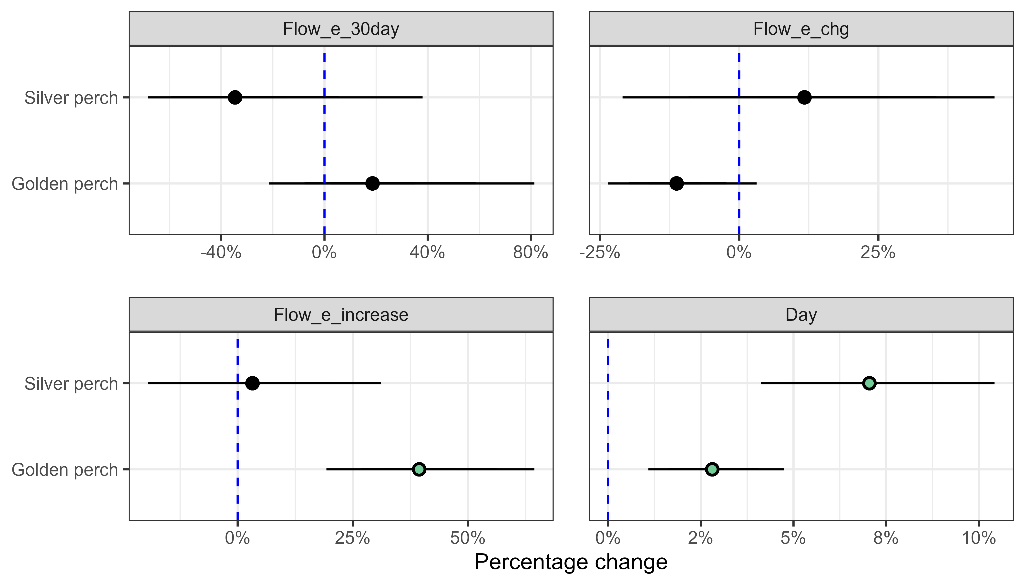
Figure H.2 Estimated effect (as percentage change) of each flow variable on recruitment rates for each species
Values represent the expected change in recruitment rates per each 1 standard deviation increase in a flow variable. Error bars are 95% credible intervals (CIs). Vertical dashed line denotes the line of no effect = 0. Coloured dots indicate 95% Cls that do not overlap 0. Flow_median = standardised daily flow for relevant timing, Flow_cv = coefficient of variability in daily flow for relevant timing, Flow_low = number of days of low flow (below 10th percentile of available data), Flow_max_prev = standardised maximum antecedent flow.
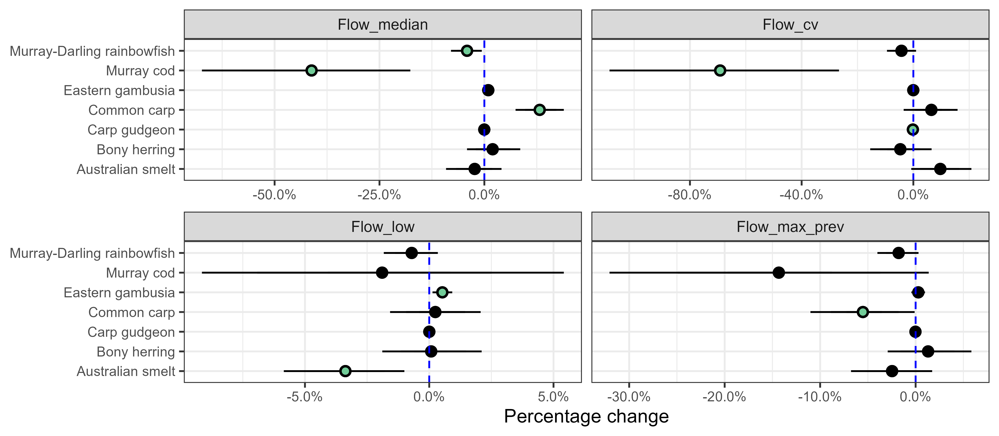
Figure H.3 Estimated effect (as percentage change) of each flow variable on frequency of occurrence for each species
Values represent the expected change in species frequency of occurrence (proportion of sites occupied within a Selected Area) per each 1 standard deviation increase in a flow variable. Error bars are 95% credible intervals (CIs). Vertical dashed line denotes the line of no effect = 0. Coloured dots indicate 95% Cls that do not overlap 0. See Fanson (2024) for key to metrics. Flow_median = standardised daily flow for relevant timing, Flow_cv = coefficient of variability in daily flow for relevant timing, Flow_low = number of days of low flow (below 10th percentile of available data), Flow_max_prev = standardised maximum antecedent flow.
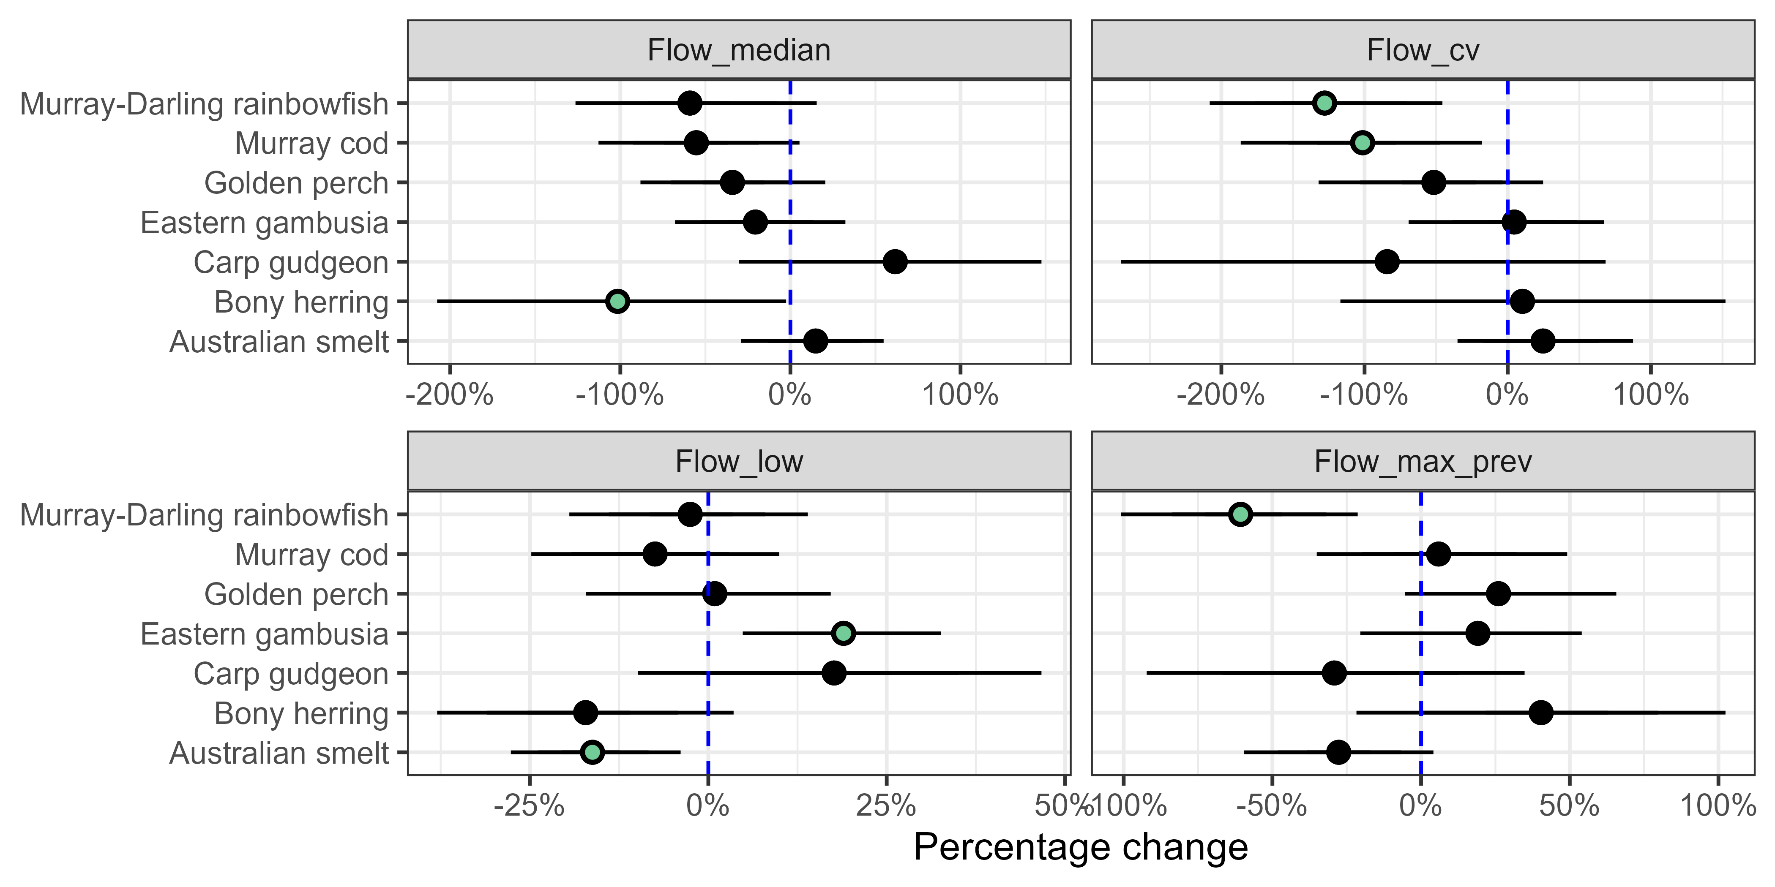
Figure H.4 Estimated effect (as percentage change) of each flow variable on population growth rate for each species
Values represent the expected change in population growth rate per each 1 standard deviation increase in a flow variable. Error bars are 95% credible intervals (CIs). Vertical dashed line denotes the line of no effect = 0. Coloured dots indicate 95% Cls that do not overlap 0. See Fanson (2024) for key to metrics. Flow median = standardised daily flow for relevant timing, Flow_cv = coefficient of variability in daily flow for relevant timing, Flow_low = number of days of low flow (below 10th percentile of available data), Flow_max_prev = standardised maximum antecedent flow.
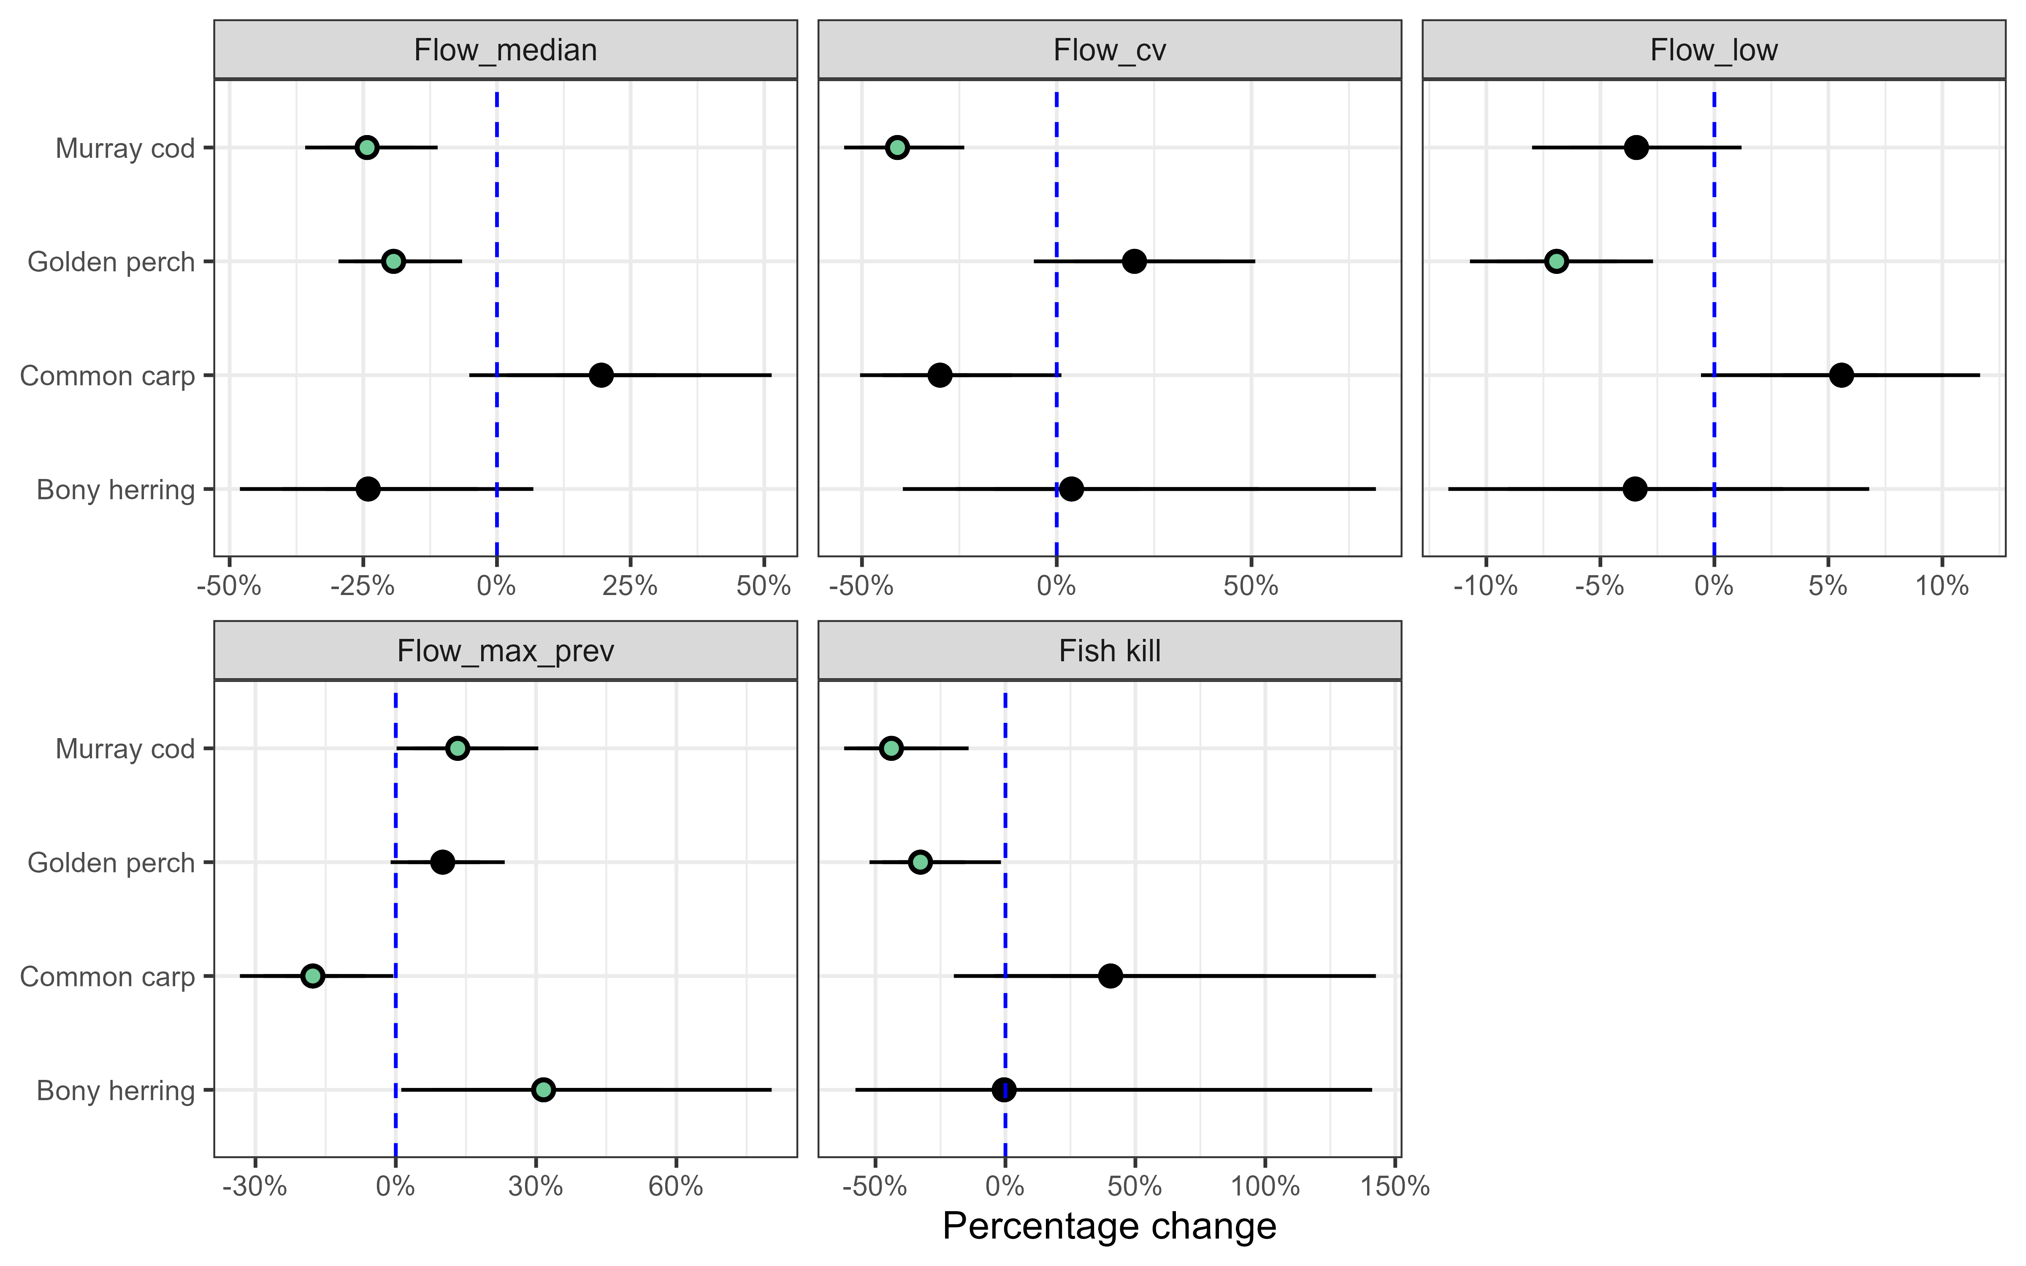
Figure H.5 Estimated effect (as percentage change) of each flow variable on body condition for each species
Values represent the expected change in fish body condition per each 1 standard deviation increase in a flow variable. Error bars are 95% confidence intervals (CIs). Vertical dashed line denotes the line of no effect = 0. Coloured dots indicate significant effects at p < 0.05 threshold. See Fanson (2024) for key to metrics. Flow_median = standardised daily flow for relevant timing, Flow_cv = coefficient of variability in daily flow for relevant timing, Flow_low = number of days of low flow (below 10th percentile of available data), Flow_max_prev = standardised maximum antecedent flow.
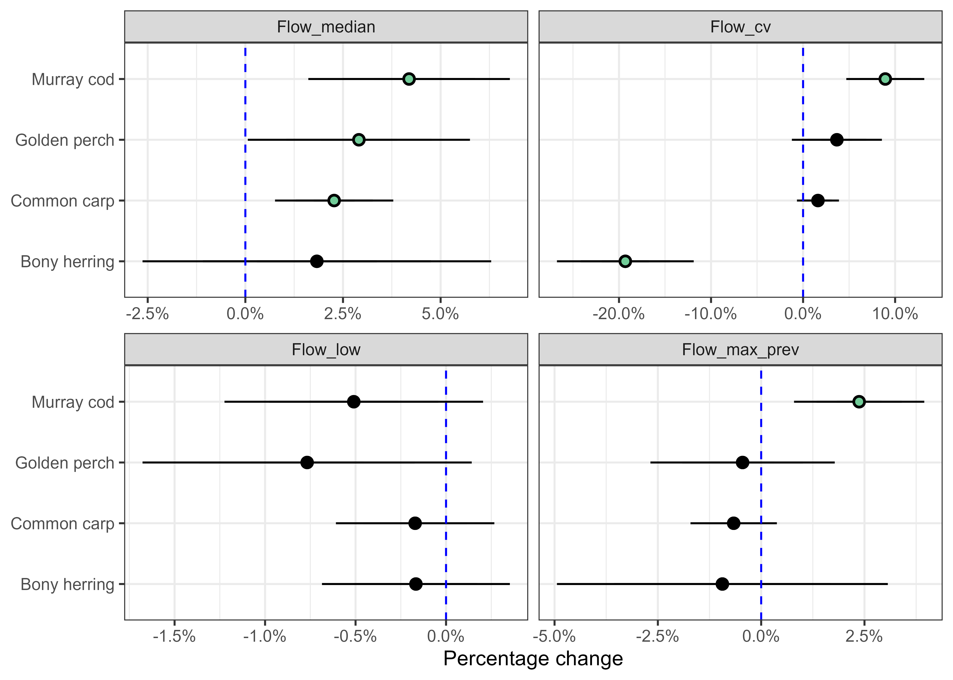
Figure H.6 Estimated effect (as percentage change) of each flow variable on community metric
Values represent the expected change in the proportion of catch that is native per each 1 standard deviation increase in a flow variable. Error bars are 95% credible intervals (CIs). Vertical dashed line denotes the line of no effect = 0. Coloured dots indicate 95% Cls that do not overlap 0. See Fanson (2024) for key to metrics. Flow_median = standardised daily flow for relevant timing, Flow_cv = coefficient of variability in daily flow for relevant timing, Flow_low = number of days of low flow (below 10th percentile of available data), Flow_max_prev = standardised maximum antecedent flow.
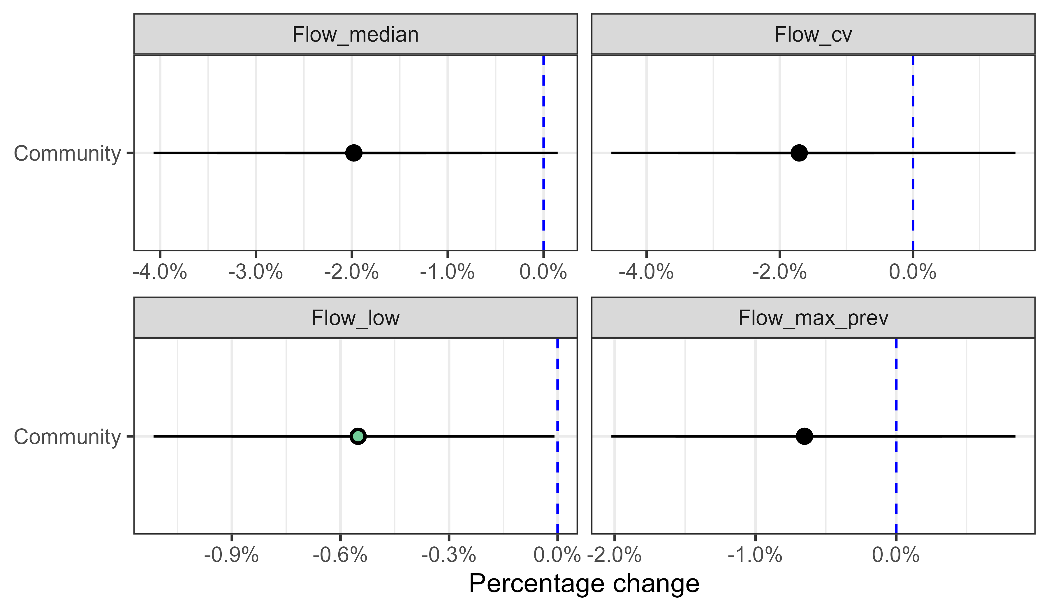

Abbreviations and terms
Term | Description
2023–24 | water year, 1 July 2023 to 30 June 2024
2014–24 | water years, 1 July 2014 to 30 June 2024
the Basin | shortened term for the Murray–Darling Basin
the Basin Plan | shortened form for the (Murray–Darling) Basin Plan 2012
CEW | Commonwealth environmental water
CEWH | Commonwealth Environmental Water Holder
CI | credible interval (but confidence interval in reference to body condition)
cohort | birth year of an individual fish
condition | Fulton’s body condition factor: a metric calculated from individual fish length–weight ratio to indicate the health of a fish
counterfactual | In the counterfactual approach, Commonwealth environmental water is removed from the observed streamflow time series, creating a hypothetical (counterfactual) daily streamflow time series with no Commonwealth environmental water. This approach is used to infer the effects of Commonwealth environmental water, as an experimental design with controls and/or before–after comparisons is not possible.
CPUE | catch per unit effort
EPBC Act | Australian Environment Protection and Biodiversity Conservation Act 1999
Flow-MER | the CEWH’s Monitoring, Evaluation and Research Program (2019–20 to 2023–24)
Fulton’s K | a commonly used metric of fish body condition (see ‘condition’)
hypoxia | low oxygen in the water coincides with hypoxic events and can lead to fish deaths
lotic | rapidly moving fresh water
LTIM | Long Term Intervention Monitoring Project (2014–15 to 2018–19)
otolith | inner ear bone used to determine the age of fish
SE | standard error (e.g. ± 1 SE)
the Strategy | shortened term for the Basin-wide environmental watering strategy (MDBA 2019)
VEFMAP | Victorian Environmental Flows Monitoring and Assessment Program

References
Balcombe SR, Arthington AH, Foster ND, Thoms MC, Wilson GG and Bunn SE (2006) Fish assemblages of an Australian dryland river: abundance, assemblage structure and recruitment patterns in the Warrego River, Murray Darling Basin. Marine and Freshwater Research 57(6), 619-633. Doi: https://doi.org/10.1071/MF06025.
Balcombe SR, Lobegeiger JS, Marshall SM, Marshall JC, Ly D and Jones DN (2012) Fish body condition and recruitment success reflect antecedent flows in an Australian dryland river. Fisheries Science 78(4), 841-847. Doi: 10.1007/s12562-012-0519-z.
Baldwin DS and Whitworth K (2009) Current conditions in the Wakool River System and the potential for a blackwater event resulting in fish deaths. MDFRC Technical Report, Wodonga, Victoria, http://hdl.handle.net/1959.9/540042.
Barbour E, Brooks S, Campbell C, Dyer F, Guarino F, Hladyz S, McInerney P, Rees G, Stuart I, Wassens S and Yen J (2021) Foundation Report Update 2021. Flow-MER Program. Commonwealth Environmental Water Office (CEWO): Monitoring, Evaluation and Research Program. Department of Agriculture, Water and the Environment, Australia., https://www.awe.gov.au/water/cewo/publications/foundation-report-update-2021.
Baumgartner LJ, Conallin J, Wooden I, Campbell B, Gee R, Robinson WA and Mallen-Cooper M (2014) Using flow guilds of freshwater fish in an adaptive management framework to simplify environmental flow delivery for semi-arid riverine systems. Fish and Fisheries 15(3), 410-427. Doi: https://doi.org/10.1111/faf.12023.
Baumgartner LJ, Gell P, Thiem JD, Finlayson CM and Ning N (2020) Ten complementary measures to assist with environmental watering programs in the Murray–Darling river system, Australia. River Research and Applications 36, 645–655. Doi: doi:10.1002/RRA.
Bice CM, Gehrig SL, Zampatti BP, Nicol JM, Wilson P, Leigh SL and Marsland K (2014) Flow-induced alterations to fish assemblages, habitat and fish–habitat associations in a regulated lowland river. Hydrobiologia 722(1), 205-222. Doi: 10.1007/s10750-013-1701-8.
Bull JW, Strange N, Smith RJ and Gordon A (2021) Reconciling multiple counterfactuals when evaluating biodiversity conservation impact in social-ecological systems. Conservation Biology 35(2), 510-521. Doi: https://doi.org/10.1111/cobi.13570.
Bunn SE and Arthington AH (2002) Basic principles and ecological consequences of altered flow regimes for aquatic biodiversity. Environmental management 30(4), 492-507. Doi: 10.1007/s00267-002-2737-0.
Cadwallader P (1977) J.O. Langtry’s 1949-50 Murray River Investigations. Fisheries and Wildlife Paper No.13. Fisheries and Wildlife Division, Victoria.
Colloff MJ and Pittock J (2022) Mind the Gap! Reconciling Environmental Water Requirements with Scarcity in the Murray-Darling Basin, Australia. Water 14(2), 208.
Conallin AJ, Smith BB, Thwaites LA, Walker KF and Gillanders BM (2012) Environmental Water Allocations in regulated lowland rivers may encourage offstream movements and spawning by common carp, Cyprinus carpio: implications for wetland rehabilitation. Marine and Freshwater Research 63(10), 865-877.
Cruz DO, Kingsford RT, Suthers IM, Rayner TS, Smith JA and Arthington AH (2020) Connectivity but not recruitment: Response of the fish community to a large-scale flood on a heavily regulated floodplain. Ecohydrology 13(3), e2194. Doi: https://doi.org/10.1002/eco.2194.
Cuddy SM, Hladyz S and Yen J (2022) Foundation Report Update 2022. Flow-MER Program. Commonwealth Environmental Water Office (CEWO): Monitoring, Evaluation and Research Program. Department of Agriculture, Water and the Environment, Australia.
Fanson B (2025) Technical supplement to Basin-scale evaluation of 2023–24 Commonwealth environmental water: Fish. Flow-MER Program. Commonwealth Environmental Water Holder, Department of Climate Change, Energy, the Environment and Water, Australia.
Fanson B, Hladyz S, Tonkin Z, Arrowsmith C, Bice C, Giatis G, Gibbs M, Koster W, Ye Q, Zampatti B and Yen JDL (2025) Can hydraulic information improve Basin-scale evaluation of fish outcomes? Arthur Rylah Institute for Environmental Research Published Report for the Commonwealth Environmental Water Holder. Department of Energy, Environment and Climate Action, Heidelberg, Victoria
Fanson B, Hale R, Thiem J, Lyon J, Koehn J, Bennett A and Stuart I (2024) Assessing impacts of a notorious invader (common carp Cyprinus carpio) on Australia's aquatic ecosystems: Coupling abundance-impact relationships with a spatial biomass model. Biological Conservation 290, 110420, doi.org/10.1016/j.biocon.2023.110420.
Gawne B, Brookes S, Butcher R, Cottingham P, Everingham P, Hale J, Nielson D, Stewardson M and Stoffels R (2013) Long Term Intervention Monitoring Project Logic and Rational Document. Final Report prepared for the Commonwealth Environmental Water Office by the Murray–Darling Freshwater Research Centre. MDFRC Publication 01/2013, 109pp.
Gibbs M, Bice C, Furst DJ, Gao L, Joehnk K, McCullough D, Montazeri M, Nicol J, Smart J, Wallace T, Zampatti B and Brookes J (2023) Using hydraulics to evaluate ecological benefits, risks, and trade‐offs from engineered flooding. Hydrological Processes 37. Doi: 10.1002/hyp.15024.
Higgisson W, Dyer F, Broadhurst B, Tschierschke A, Lenehan J, Kerezsy A, Giling D, Stocks J, van der Meulen D and Thompson R (2024) Commonwealth Environmental Water Holder Monitoring, Evaluation and Research Project: Lachlan River system Selected Area 2022-23 Monitoring and Evaluation Summary Report. A report prepared for the Commonwealth Environmental Water Holder.
Hladyz S, Baumgartner L, Bice C, Broadhurst B, Butler G, Fanson B, Giatas G, Koster W, Lyon J, McCasker N, Stocks J, Stuart I, Thiem J, Tonkin Z, Ye Q, Yen J and Zampatti B (2024) Basin-scale evaluation of 2022–23 Commonwealth environmental water: Fish. Flow-MER Program. Commonwealth Environmental Water Holder, Department of Climate Change, Energy, the Environment and Water, Australia.
Hladyz S, Baumgartner L, Bice C, Butler G, Fanson B, Giatas G, Koster W, Lyon J, McCasker N, Stuart I, Thiem J, Tonkin Z, Ye Q, Yen J and Zampatti B (2023) Basin-scale evaluation of 2021-22 Commonwealth environmental water: Fish. Flow-MER Program., Commonwealth Environmental Water Holder, Department of Climate Change, Energy, the Environment and Water, Australia. 154pp.
Hladyz S, Baumgartner L, Bice C, Butler G, Fanson B, Giatas G, Koster W, Lyon J, Stuart I, Thiem J, Tonkin Z, Ye Q, Yen J and Zampatti B (2021) Basin-scale evaluation of 2019-20 Commonwealth environmental water: Fish. Flow-MER Program. Commonwealth Environmental Water Office (CEWO): Monitoring, Evaluation and Research Program, Department of Agriculture, Water and the Environment, Australia. 106pp.
Hladyz S, Baumgartner L, Bice C, Butler G, Fanson B, Giatas G, Koster W, Lyon J, Stuart I, Thiem J, Tonkin Z, Ye Q, Yen J and Zampatti B (2022) Basin-scale evaluation of 2020-21 Commonwealth environmental water: Fish. Flow-MER Program. Commonwealth Environmental Water Office (CEWO): Monitoring, Evaluation and Research Program, Department of Agriculture, Water and the Environment, Australia. 122pp.
Ho SS, Bond NR and Thompson RM (2013) Does seasonal flooding give a native species an edge over a global invader? Freshwater Biology 58(1), 159-170. Doi: https://doi.org/10.1111/fwb.12047.
Humphries P, King AJ and Koehn JD (1999) Fish, Flows and Flood Plains: Links between Freshwater Fishes and their Environment in the Murray-Darling River System, Australia. Environmental Biology of Fishes 56(1), 129-151. Doi: 10.1023/A:1007536009916.
King AJ (2019) Long Term Intervention Monitoring Basin Matter - Fish foundation report. Final Report prepared for the Commonwealth Environmental Water Office by The Centre for Freshwater Ecosystems.
King AJ, McPhan L, Bond N and Thurgate N (2020) Murray–Darling Basin Long Term Intervention Monitoring Project — 2018–19 Basin-scale evaluation of Commonwealth environmental water – Fish Report. Report prepared for the Department of Agriculture, Water and the Environment, Commonwealth Environmental Water Office by La Trobe University, Centre for Freshwater Ecosystems.
King AJ, Tonkin Z and Lieshcke J (2012) Short-term effects of a prolonged blackwater event on aquatic fauna in the Murray River, Australia: considerations for future events. Marine and Freshwater Research 63(7), 576-586. Doi: https://doi.org/10.1071/MF11275.
Koehn J, Brumley A and Gehrke P (2000) Managing the Impacts of Carp. Bureau of Rural Sciences. Department of Agriculture, Fisheries and Forestry - Australia, Canberra.
Koehn JD, Raymond SM, Stuart I, Todd CR, Balcombe SR, Zampatti BP, Bamford H, Ingram BA, Bice CM, Burndred K, Butler G, Baumgartner L, Clunie P, Ellis I, Forbes JP, Hutchison M, Koster WM, Lintermans M, Lyon JP, Mallen-Cooper M, McLellan M, Pearce L, Ryall J, Sharpe C, Stoessel DJ, Thiem JD, Tonkin Z, Townsend A and Ye Q (2020) A compendium of ecological knowledge for restoration of freshwater fishes in Australia’s Murray–Darling Basin. Marine and Freshwater Research 71(11), 1391-1463. Doi: https://doi.org/10.1071/MF20127.
Koehn JD, Todd CR and Wootton H (2023) Cold-water pollution impacts on two ‘warm-water’ riverine fish: interactions of dam size and life-history requirements. Marine and Freshwater Research 74(13), 1154-1170. Doi: https://doi.org/10.1071/MF23023.
Koster W, Crook D, Dawson D and Moloney P (2012) Status of fish populations in the lower Goulburn River (2003 - 2012). Arthur Rylah Institute for Environmental Research Client Report, Department of Sustainability and Environment, Heidelberg, Victoria.
Koster WM, Dawson DR, Liu C, Moloney PD, Crook DA and Thomson JR (2017) Influence of streamflow on spawning-related movements of golden perch Macquaria ambigua in south-eastern Australia. Journal of Fish Biology 90(1), 93-108. Doi: https://doi.org/10.1111/jfb.13160.
Koster WM, Stuart I, Tonkin Z, Dawson D and Fanson B (2021) Environmental influences on migration patterns and pathways of a threatened potamodromous fish in a regulated lowland river network. Ecohydrology 14(2), e2260. Doi: 10.1002/eco.2260.
Lintermans M (2007) Fishes of the Murray-Darling Basin. An Introductory Guide. Murray-Darling Basin Commission, Canberra, ACT, Australia.
Liu X, Arrowsmith C, Bond N, Elgindy P, Healy S, Lewis S, McCasker N, Stoios R, Trethewie J, van der Meulen D and Watts R (2024) Commonwealth Environmental Water Holder Monitoring, Evaluation and Research Project: Edward/Kolety-Wakool River System Selected Area Technical Report, 2023–24. Report prepared for Commonwealth Environmental Water Holder. Commonwealth of Australia.
Lyon J, Stuart I, Ramsey D and O'Mahony J (2010) The effect of water level on lateral movements of fish between river and off-channel habitats and implications for management. Marine and Freshwater Research 61(3), 271-278. Doi: https://doi.org/10.1071/MF08246.
Lyon JP, Bird T, Nicol S, Kearns J, O’Mahony J, Todd CR, Cowx IG and Bradshaw CJA (2014) Efficiency of electrofishing in turbid lowland rivers: implications for measuring temporal change in fish populations. Canadian Journal of Fisheries and Aquatic Sciences 71(6), 878-886. Doi: 10.1139/cjfas-2013-0287.
Lyon JP, Bird T, Tonkin Z, Raymond S, Sharley J and Hale R (2021) Does life history mediate discharge as a driver of multi-decadal changes in populations of freshwater fish? Ecological applications 31(8), e02430. Doi: 10.1002/eap.2430.
Mallen-Cooper M (1996) Fishways and freshwater fish migration in south-eastern Australia. University of Technology, Sydney. 429pp.
Mallen-Cooper M and Stuart IG (2003) Age, growth and non-flood recruitment of two potamodromous fishes in a large semi-arid/temperate river system. River Research and Applications 19(7), 697-719. Doi: https://doi.org/10.1002/rra.714.
Mallen-Cooper M and Zampatti BP (2018) History, hydrology and hydraulics: Rethinking the ecological management of large rivers. Ecohydrology 11(5), e1965. Doi: https://doi.org/10.1002/eco.1965.
Mallett MC, Thiem JD, Butler GL, Carpenter-Bundhoo L and Kennard MJ (2025) Freshwater fish condition responses to hydrological disturbance are species- and scale dependent. Journal of Fish Biology, 1-18. Doi: https://doi.org/10.1111/jfb.70033.
MDBA (2019) Basin-wide environmental watering strategy. Murray-Darling Basin Authority, Canberra.
Mika S, Frazier P, Southwell M, Growns I, Bower D, Butler G, Cameron L, McKay D, McIntosh L, Shakya M, Frost L, Reid J, Oxley J, Kermode T and Shrubb J (2024a) Commonwealth Environmental Water Holder Monitoring, Evaluation and Research Program: Junction of the Warriku (Warrego) and Baaka (Darling) Rivers Selected Area Monitoring, Evaluation and Research Annual Summary Report (2023-2024) Report prepared for Commonwealth Environmental Water Holder. Commonwealth of Australia 2024.
Mika S, Frazier P, Southwell M, Growns I, Bower D, Butler G, Cameron L, McKay D, Oxley J, Kermode T, McIntosh L, Frost L, Shakya M, Reid J and Shrubb J (2023) Commonwealth Environmental Water Holder Monitoring, Evaluation and Research Program: Gwydir River Selected Area 2022-23 Annual Summary Report. A report prepared for the Commonwealth Environmental Water Holder.
Mika S, Frazier P, Southwell M, Growns I, Butler G, Cameron L, McKay D, Oxley J, Kermode T, McIntosh L, Frost L, Shakya M, Reid J and Shrubb J (2024b) Commonwealth Environmental Water Holder Monitoring, Evaluation and Research Program: Gwydir River Selected Area 2023–24 Annual Summary Report. Report prepared for Commonwealth Environmental Water Holder. Commonwealth of Australia.
Moxham C, Gwinn DC and Kenny S (2020) The Living Murray Hattah Lakes Intervention Monitoring Understorey Vegetation Monitoring Program: Annual Report. Unpublished Report for the Mallee Catchment Management Authority. Arthur Rylah Institute for Environmental Research, Department of Environment, Land, Water and Planning, Heidelberg, Victoria.
Nilsson C, Reidy CA, Dynesius M and Revenga C (2005) Fragmentation and flow regulation of the world's large river systems. Science 308(5720), 405-408. Doi: 10.1126/science.1107887.
OCSE (2023) Independent review into the 2023 fish deaths in the Darling-Baaka River at Menindee. Published by the Office of the NSW Chief Scientist & Engineer, September 2023.
Ogle DH (2016) Introductory Fisheries Analyses with R. Chapman and Hall/CRC, Florida, USA.
Pearl J (2000) Causality : models, reasoning, and inference. Cambridge : Cambridge University Press.
Poff NL, Allan JD, Bain MB, Karr JR, Prestegaard KL, Richter BD, Sparks RE and Stromberg JC (1997) The Natural Flow Regime. BioScience 47(11), 769-784. Doi: 10.2307/1313099.
Raymond S, Duncan M, Tonkin Z and Robinson W (2021) Barmah-Millewa Fish Condition Monitoring (2007-2021). Arthur Rylah Institute for Environmental Research Unpublished Client Report for the Murray-Darling Basin Authority. Department of Environment, Land, Water and Planning, Heidelberg, Victoria.
Rees GN, Zampatti B, McInerney P, Biswas TK, Bice C and Tonkin Z (2022) River Murray Channel Monitoring 2021-2022: a technical report to the Commonwealth Environmental Water Office and The Living Murray joint venture. . CSIRO Land & Water, Canberra, Australia.
Sengupta A, Egger F and Weber T (2025) Basin-scale evaluation of 2023–24 Commonwealth environmental water: Hydrology. Flow-MER Program. Commonwealth Environmental Water Holder, Department of Climate Change, Energy, the Environment and Water, Australia. 74pp.
Shams F, Dyer F, Thompson R, Duncan RP, Thiem JD, Enge TG and Ezaz T (2020) Multiple Lines of Evidence Indicate Limited Natural Recruitment of Golden Perch (Macquaria ambigua) in the Highly Regulated Lachlan River. Water 12(6), 1636.
Sheldon F, Barma D, Baumgartner LJ, Bond N, Mitrovic SM and Vertessy R (2022) Assessment of the causes and solutions to the significant 2018–19 fish deaths in the Lower Darling River, New South Wales, Australia. Marine and Freshwater Research 73(2), 147-158. Doi: https://doi.org/10.1071/MF21038.
Stewardson MJ and Skinner D (2018) Evaluating Use of Environmental Flows to Aerate Streams by Modelling the Counterfactual Case. Environ Manage 61(3), 390-397. Doi: 10.1007/s00267-017-0955-8.
Stocks JR, Ellis IM, van der Meulen DE, Doyle JI and Cheshire KJM (2022) Kills in the Darling: assessing the impact of the 2018–20 mass fish kills on the fish communities of the Lower Darling–Baaka River, a large lowland river of south-eastern Australia. Marine and Freshwater Research 73, 159-177.
Stoffels R, Bond N, Pollino C, Broadhurst B, Butler G, Kopf RK, Koster W, McCasker N, Thiem J, Zampatti B and Ye Q (2016) Long Term Intervention Monitoring Basin Matter - Fish foundation report. Final Report prepared for the Commonwealth Environmental Water Office by The Murray-Darling Freshwater Research Centre.
Stoffels RJ, Weatherman KE, Bond NR, Morrongiello JR, Thiem JD, Butler G, Koster W, Kopf RK, McCasker N, Ye Q, Zampatti B and Broadhurst B (2020) Stage-dependent effects of river flow and temperature regimes on the growth dynamics of an apex predator. Global Change Biology 26(12), 6880-6894. Doi: https://doi.org/10.1111/gcb.15363.
Stoios R, Tonkin Z, Yen J, Kitchingman A and Lyon J (2023) Floodwater short-term impacts and potential recovery paths of freshwater fish populations. Unpublished report for the Department of Energy, Environment and Climate Action - Water and Catchments Division. Arthur Rylah Institute for Environmental Research, Department of Energy, Environment and Climate Action. .
Stuart I, Bice C, Baumgartner L, Butler G, Hladyz S, Koster W, Lyon J, Thiem J, Todd C, Tonkin Z, Ye Q, Yen J and Zampatti B (2020) Foundation Report Update 2020: Fish. Flow-MER Program. Commonwealth Environmental Water Office (CEWO): Monitoring, Evaluation and Research Program. Department of Agriculture, Water and the Environment, Australia., https://www.awe.gov.au/water/cewo/publications/foundation-report-update-2020.
Stuart I, D’Santos P, Rourke M, Ellis I, Harrisson K, Michie L, Dyer J, Sharpe C and Thiem JD (2023) Monitoring native fish response to environmental water delivery in the lower Darling River 2021-2022: Technical Report. Department of Planning & Environment, New South Wales, Australia.
Stuart I, D’Santos P, Rourke M, Ellis I, Harrisson K, Michie L, Sharpe C and Thiem J (2021a) Monitoring native fish response to environmental water delivery in the lower Darling River 2020-2021. State of New South Wales and Department of Planning, Industry and Environment, New South Wales, Australia.
Stuart I, Fanson B, D’Santos P, Sharpe C, Ellis I, Dyer J, Vu A, Doyle K, Conallin A, Michie L and Thiem J (2024a) Monitoring native fish response to environmental water delivery in the lower Darling-Baaka River 2022–24., State of New South Wales and Department of Climate Change, Energy, the Environment and Water, New South Wales, Australia.
Stuart I, Sharpe C, Stanislawski K, Parker A and Mallen-Cooper M (2019) From an irrigation system to an ecological asset: adding environmental flows establishes recovery of a threatened fish species. Marine and Freshwater Research 70(9), 1295-1306. Doi: https://doi.org/10.1071/MF19197.
Stuart IG, Fanson BG, Lyon JP, Stocks J, Brooks S, Norris A, Thwaites L, Beitzel M, Hutchison M, Ye Q, Koehn JD and Bennett AF (2021b) Continental threat: How many common carp (Cyprinus carpio) are there in Australia? Biological Conservation 254, 108942. Doi: https://doi.org/10.1016/j.biocon.2020.108942.
Stuart IG and Jones M (2006) Large, regulated forest floodplain is an ideal recruitment zone for non-native common carp (Cyprinus carpio L.). Marine and Freshwater Research 57, 333-347.
Stuart IG and Sharpe CP (2020) Riverine spawning, long distance larval drift, and floodplain recruitment of a pelagophilic fish: A case study of golden perch (Macquaria ambigua) in the arid Darling River, Australia. Aquatic Conservation: Marine and Freshwater Ecosystems 30(4), 675-690. Doi: https://doi.org/10.1002/aqc.3311.
Stuart IG and Sharpe CP (2022) Ecohydraulic model for designing environmental flows supports recovery of imperilled Murray cod (Maccullochella peelii) in the Lower Darling–Baaka River following catastrophic fish kills. Marine and Freshwater Research 73(2), 247-258.
Stuart IG, Sharpe CP, O'Connor J, Lieschke J, Hale R and Fanson B (2024b) Escaping the dry: Native and non-native fish outmigration from a receding floodplain following managed inundation. Freshwater Biology 69(2), 240-253. Doi: https://doi.org/10.1111/fwb.14207.
Thiem JD, Baumgartner LJ, Fanson B, Sadekov A, Tonkin Z and Zampatti BP (2022a) Contrasting natal origin and movement history informs recovery pathways for three lowland river species following a mass fish kill. Marine and Freshwater Research 73, 237-246.
Thiem JD, Michie LE, Butler GL, Ebner BC, Sharpe CP, Stuart I and Townsend A (2023) A protected flow breaks the drought for golden perch (Macquaria ambigua) spawning along an extensive semi-arid river system. Ecohydrology 16(7), e2576. Doi: https://doi.org/10.1002/eco.2576.
Thiem JD, Wooden IJ, Baumgartner LJ, Butler GL, Forbes JP and Conallin J (2017) Recovery from a fish kill in a semi-arid Australian river: Can stocking augment natural recruitment processes? Austral Ecology 42(2), 218-226. Doi: https://doi.org/10.1111/aec.12424.
Thiem JD, Zampatti BP, Fanson BG, Stuart I, Baumgartner L, Bice C, Butler GL, Carpenter-Bundhoo L, Crook D, Harding D, Hodges K, Koster W, Lyon J, Tonkin Z, Wooden I and Woods R (2022b) Regional and inter-regional fish movement responses to river discharge: Final report. Flow-MER Program. Commonwealth Environmental Water Office (CEWO): Monitoring, Evaluation and Research Program, Department of Agriculture, Water and the Environment, Australia.
Thompson RM, King AJ, Kingsford RM, Mac Nally R and Poff NL (2018) Legacies, lags and long-term trends: Effective flow restoration in a changed and changing world. Freshwater Biology 63(8), 986-995. Doi: https://doi.org/10.1111/fwb.13029.
Todd CR, Koehn JD, Stuart IG, Wootton HF, Zampatti BP, Thwaites L, Conallin A, Ye Q, Stamation K and Bice C (2024) Modelling the response of common carp (Cyprinus carpio) to natural and managed flows using a stochastic population model. Biological Invasions 26(5), 1437-1456. Doi: 10.1007/s10530-024-03247-z.
Todd CR, Wootton HF, Stuart IG, Koehn JD, Tonkin Z, Thiem JD, Baumgartner L, Bice C, Butler GL, Koster W, Sharpe C, Ye Q and Zampatti B (2023) Fish population models to inform Commonwealth water for the environment. Flow-MER Program. Commonwealth Environmental Water Office (CEWO): Monitoring, Evaluation and Research Program, Department of Agriculture, Water and the Environment, Australia.
Tonkin Z, Jones C, Clunie P, Vivian L, Amtstaetter F, Jones M, Koster W, Mole B, O’Connor J, Brooks J, Caffrey L and Lyon J (2020) Victorian Environmental Flows Monitoring and Assessment Program. Stage 6 Synthesis Report 2016-2020. Department of Environment, Land, Water and Planning, Heidelberg, Victoria.
Tonkin Z, Kitchingman A, Lyon J, Kearns J, Hackett G, O’Mahony J, Moloney PD, Krusic-Golub K and Bird T (2017) Flow magnitude and variability influence growth of two freshwater fish species in a large regulated floodplain river. Hydrobiologia 797(1), 289-301. Doi: 10.1007/s10750-017-3192-5.
Tonkin Z, Moloney P, Lyon J, Kitchingman A, O'Mahony J, Raymond S, Hackett G, Saddlier S, Greenfield A, Wood D and Hale R (2022) Movement behavior of a threatened native fish informs flow management in a modified floodplain river system. Ecosphere 13(1), e3916. Doi: https://doi.org/10.1002/ecs2.3916.
Tonkin Z, Stuart I, Kitchingman A, Thiem JD, Zampatti B, Hackett G, Koster W, Koehn J, Morrongiello J, Mallen-Cooper M and Lyon J (2019) Hydrology and water temperature influence recruitment dynamics of the threatened silver perch <i>Bidyanus bidyanus</i> in a regulated lowland river. Marine and Freshwater Research 70(9), 1333-1344. Doi: https://doi.org/10.1071/MF18299.
Tonkin Z, Yen J, Lyon J, Kitchingman A, Koehn JD, Koster WM, Lieschke J, Raymond S, Sharley J, Stuart I and Todd C (2021) Linking flow attributes to recruitment to inform water management for an Australian freshwater fish with an equilibrium life-history strategy. Science of The Total Environment 752, 141863. Doi: https://doi.org/10.1016/j.scitotenv.2020.141863.
Treadwell S, Bovill W, Webb A, Baker B, Casanelia S, Gower T, Grace M, Greet J, Kellar C, Koster W, Lovell D, Morris K, Pettigrove V, Sutton F, Wilkins T and Vietz G (2024) Commonwealth Environmental Water Holder Monitoring, Evaluation and Research Project: Goulburn River Selected Area Scientific Report 2023–2024. A report prepared for the Commonwealth Environmental Water Holder. Commonwealth of Australia.
Vertessy R, Barma D, Baumgartner L, Mitrovic S, Sheldon F and Bond N (2019) Independent assessment of the 2018-19 fish deaths in the Lower Darling: Final report. Australian Government, https://www.mdba.gov.au/sites/default/files/pubs/Final-Report-Independent-Panel-fish-deaths-lower%20Darling_4.pdf.
VEWH (2020) Seasonal Watering Plan 2020-21. Victorian Environmental Water Holder.
Vilizzi L and Walker K (1999) Age and growth of common carp, Cyprinus carpio, in the River Murray, Australia: validation, consistency of age interpretation and growth models. Environmental Biology of Fishes 54, 77-106.
Wassens S, Spencer J, Heath J, Kobayashi T, Stocks J, Mathwin R, Talbot S, Bino G, Cain V, Francis R, Gopalakrishnan T, Grimmett L, Prasad K and Hall A (2024) Commonwealth Environmental Water Holder Monitoring, Evaluation and Research Program Murrumbidgee River System Technical Report, 2014–24 Report prepared for the Commonwealth Environmental Water Holder. Commonwealth of Australia.
Wassens S, Spencer J, Wolfenden B, Thiem J, Thomas R, Jenkins K, Brandis K, Lenon E, Hall A, Ocock J, Kobayashi T, Bino G, Heath J and Callaghan D (2018) Commonwealth Environmental Water Office Long-Term Intervention Monitoring project Murrumbidgee River System Selected Area evaluation report, 2014-17. Report prepared for Commonwealth Environmental Water Office. Commonwealth of Australia.
Watts RJ, McCasker N, Howitt JA, Thiem J, Grace M, Kopf RK, Healy S and Bond N (2017) Commonwealth Environmental Water Office Long Term Intervention Monitoring Project: Edward-Wakool River System Selected Area Evaluation Report, 2016-17. Report prepared for Commonwealth Environmental Water Office. Commonwealth of Australia.
Webb A, King E, Treadwell S, Lintern A, Baker B, Casanelia S, Grace M, Koster W, Lovell D, Morris K, Pettigrove V, Townsend K and Vietz G (2017) Commonwealth Environmental Water Office Long-Term Intervention Monitoring Project – Goulburn River Selected Area evaluation report 2016–17 Report prepared for the Commonwealth Environmental Water Office.
Yarnell SM, Petts GE, Schmidt JC, Whipple AA, Beller EE, Dahm CN, Goodwin P and Viers JH (2015) Functional Flows in Modified Riverscapes: Hydrographs, Habitats and Opportunities. BioScience 65(10), 963-972. Doi: 10.1093/biosci/biv102.
Ye Q, Giatas G, Aldridge K, Busch B, Brookes J, Gibbs M, Hipsey M, Lorenz Z, Maas R, Oliver R, Shiel R, Woodhead J and Zampatti B (2018) Long-term intervention monitoring of the ecological responses to Commonwealth environmental water delivered to the Lower Murray River Selected Area in 2016/2017. Report prepared for the Commonwealth Environment Water Office. Commonwealth of Australia.
Ye Q, Giatas G, Bice C, Brookes J, Furst D, Gibbs M, Nicol J, Oliver R, Zampatti B, Bucater L, Deane D, Frahn K, Hipsey M, Huang P, Lorenz Z, Mills J, Shiel R and Zhai S (2025) Commonwealth Environmental Water Holder Monitoring, Evaluation and Research Project: Lower Murray 2019–2024 Technical Report. Report prepared for the Commonwealth Environmental Water Holder by the South Australian Research and Development Institute, Aquatic Sciences.
Ye Q, Giatas G, Brookes J, Furst D, Gibbs M, Oliver R, Shiel R, Zampatti B, Aldridge K, Bucater L, Busch B, Hipsey M, Lorenz Z, Maas R and Woodhead J (2020) Commonwealth Environmental Water Office Long-Term Intervention Monitoring Project 2014-2019: Lower Murray River Technical Report. A report prepared for the Commonwealth Environmental Water Office by the South Australian Research and Development Institute, Aquatic Sciences.
Zampatti B and Leigh S (2013a) Effects of flooding on recruitment and abundance of Golden Perch (Macquaria ambigua ambigua) in the lower River Murray. Ecological Management & Restoration 14(2), 135-143. Doi: https://doi.org/10.1111/emr.12050.
Zampatti BP, Fanson BG, Baumgartner LJ, Butler GL, Brooks SG, Crook DA, Doyle K, King AJ, Koster WM, Maas R, Sadekov A, Scott P, Strawbridge A, Thiem JD, Tonkin Z, Wilson PJ, Woodhead J and Woods R (2022) Population demographics of golden perch Macquaria ambigua in the Darling River prior to a major fish kill: a guide for rehabilitation. Marine and Freshwater Research 73(2), 223-236. Doi: https://doi.org/10.1071/MF21033.
Zampatti BP, Fanson BG, Strawbridge A, Tonkin Z, Thiem J, Butler GL, Balcombe S, Koster W, King A, Crook D, Woods R, Brooks S, Lyon J, Baumgartner LJ and Doyle K (2019) Basin-scale population dynamics of golden perch and Murray cod: relating flow to provenance, movement and recruitment in the Murray–Darling Basin. In: Price AE, Balcombe SR, Humphries P, King AJ and Zampatti BP (eds), Murray-Darling Basin Environmental Water Knowledge and Research Project - Fish Theme Research Report. Report prepared for the Department of the Environment and Energy, Commonwealth Environmental Water Office by La Trobe University, Centre for Freshwater, Wodonga, Victoria.
Zampatti BP and Leigh SJ (2013b) Within-channel flows promote spawning and recruitment of golden perch, Macquaria ambigua ambigua – implications for environmental flow management in the River Murray, Australia. Marine and Freshwater Research 64(7), 618-630. Doi: https://doi.org/10.1071/MF12321.
Zampatti BP, Leigh SJ, Wilson PJ, Crook DA, Gillanders BM, Maas R, Macdonald JI and Woodhead J (2021) Otolith chemistry delineates the influence of natal origin, dispersal and flow on the population dynamics of golden perch (Macquaria ambigua) in a regulated river. Marine and Freshwater Research 72. Doi: 10.1071/MF20280.

https://flow-mer.org.au
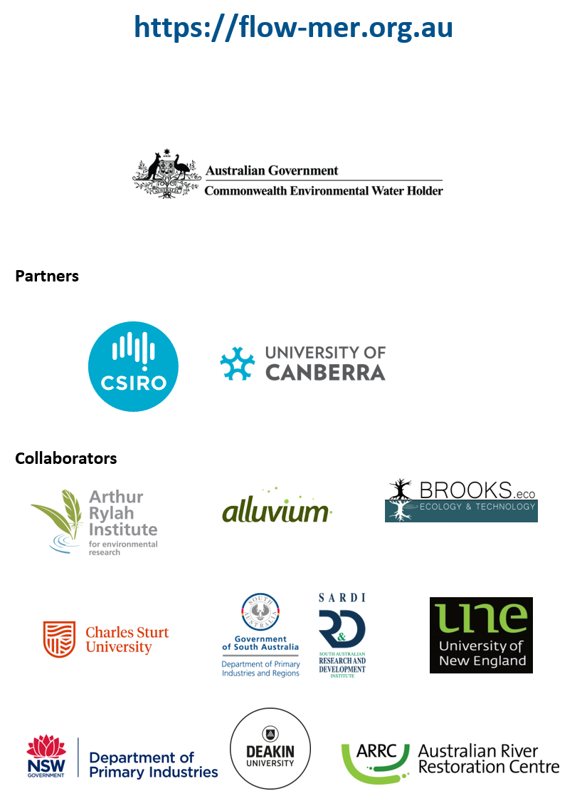

At the time of writing, the 2025 edition of the Strategy was not available. 2023–24 evaluations reference the 2019 edition (MDBA 2019).
The Long Term Intervention Monitoring and Environmental Water Knowledge and Research projects (2014–2019)
In the counterfactual approach, CEW is removed from the observed streamflow time series, creating a hypothetical (counterfactual) daily streamflow time series with no CEW. This approach is used to infer the effects of CEW, as an experimental design with controls and/or before–after comparisons is not possible.
In these evaluations, it is not possible to attribute the Commonwealth’s contribution separately to other environmental water under the current methods.
At the time of writing, the 2025 edition of the Strategy was not available. 2023–24 evaluations reference the 2019 edition (MDBA 2019).
At the time of writing, the 2025 edition of the Strategy was not available. 2023–24 evaluations reference the 2019 edition (MDBA 2019).
At the time of writing, the 2025 edition of the Strategy was not available. 2023–24 evaluations reference the 2019 edition (MDBA 2019).
This volume of 2,708 GL is calculated from the overall total of 99 individual watering actions with expected outcomes for fish. This overall total does not include double counting of individual watering actions that included both wetland and riverine flow components – see footnote 9.
Three watering actions included both wetland–floodplain and riverine flow components. In these instances, volumes were counted for both flow component categories, ‘riverine’ and ‘wetland’– see Table 1.1 for more details. Double counting of watering actions for wetland–floodplain and riverine flow categories increased the overall watering actions volume to 2,777 GL, which is different to the overall total calculated for footnote 4.
An association with high confidence (spawning)
An association with high confidence (recruitment)
An association with high confidence (frequency of occurrence)
An association with high confidence (population growth rates)
An association with high confidence (body condition)
An association with medium confidence (community response)
At the time of writing, the 2025 edition of the Strategy was not available. 2023–24 evaluations reference the 2019 edition (MDBA 2019).

