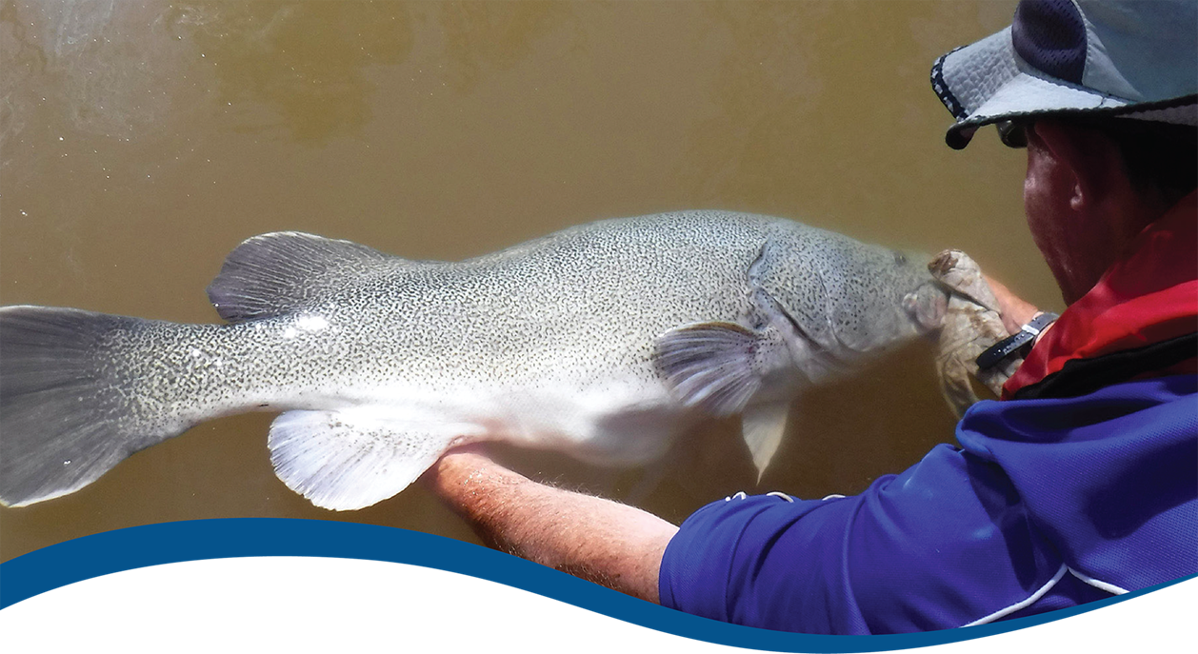
Can hydraulic information improve Basin-scale evaluation of fish outcomes?
  - Supplement to Basin-scale evaluation of 2023–24 environmental outcomes of Commonwealth environmental water: Fish (Hladyz et al. 2025)
  - Commonwealth Environmental Water Holder’s Science Program:
Flow Monitoring, Evaluation and Research Program (Flow-MER)
August 2025
Acknowledgements
The project team and the Commonwealth Environmental Water Holder (CEWH) respectfully acknowledge the Traditional Owners of the land on which this work is conducted, their Elders past and present, their Nations of the Murray–Darling Basin, and their cultural, social, environmental, spiritual and economic connection to their lands and waters.
This investigation was undertaken by staff of the Arthur Rylah Institute for Environmental Research in the final year of the 2019–25 phase of the Basin-scale Flow-MER program, and we thank Susan Cuddy, Project Lead, for facilitating this funding. We thank Jason Thiem and Ashmita Sengupta for input into project development. Annique Harris provided feedback on a draft report and Susan Cuddy and Luke McPhan, CSIRO, provided valuable review comments. CSIRO reformatted the report to meet departmental branding and accessibility requirements.
Arthur Rylah Institute for Environmental Research
Department of Energy, Environment and Climate Action
PO Box 137, Heidelberg, Victoria 3084
Phone (03) 9450 8600
Website: www.ari.vic.gov.au
Citation
Fanson B, Hladyz S, Tonkin Z, Lauchlan Arrowsmith C, Bice C, Giatas G, Gibbs M, Koster W, Ye Q, Zampatti B and Yen JDL (2025). Can hydraulic information improve Basin-scale evaluation of fish outcomes? Flow-MER Program. Commonwealth Environmental Water Holder, Department of Climate Change, Energy, the Environment and Water, Australia. 30pp.
Copyright
 © Commonwealth of Australia 2025
With the exception of the Commonwealth Coat of Arms, partner logos and where otherwise noted, all material in this publication is provided under a Creative Commons Attribution 4.0 International Licence https://creativecommons.org/licenses/by/4.0/. Flow-MER requests attribution as ‘© Commonwealth of Australia (Flow-MER, https://flow-mer.org.au)’.
Important disclaimer
The information contained in this publication comprises general statements based on scientific research. The reader is advised and needs to be aware that such information may be incomplete or unable to be used in any specific situation. No reliance or actions must therefore be made on that information without seeking prior expert professional, scientific and technical advice. To the extent permitted by law, Flow-MER (including its partners and collaborators) excludes all liability to any person for any consequences, including but not limited to all losses, damages, costs, expenses and any other compensation, arising directly or indirectly from using this publication (in part or in whole) and any information or material contained in it.
Flow-MER is committed to providing web-accessible content wherever possible. If you are having difficulties with accessing this document, please contact ewater@dcceew.gov.au.

Executive summary
The Flow-MER program was established to Monitor, Evaluate, and Research the ecological outcomes of environmental water use in the Murray–Darling Basin. Since 2020, annual assessments have been undertaken to estimate the potential contribution of Commonwealth environmental water (CEW) to supporting native fish populations. Flow-ecology relationships are central to these assessments. To date, flow-ecology relationships have focused exclusively on river discharge, which is a commonly used flow descriptor. However, recent studies have highlighted potential advantages of alternative hydraulic measures, such as water velocity, depth, wetted area, and their spatial heterogeneity across a channel. These studies suggest that a shift in focus from bulk discharge to local hydraulics may lead to more robust and transferable flow-ecology relationships.

Aims of this investigation
Here, we evaluate the potential for hydraulic metrics of flow to contribute to the Flow-MER Basin-Scale Fish Evaluation and to the wider study of flow-ecology relationships. This study presents a preliminary assessment of the potential for flow hydraulics to be incorporated into the Flow-MER Basin-Scale Fish Evaluation. This assessment focused on 3 key questions:
At what spatial and temporal scales do flow hydraulic data exist?
Do metrics of flow hydraulics provide unique information beyond that captured in river discharge?
Are metrics of flow hydraulics associated more closely with fish population outcomes than river discharge?
Our assessment focused on 3 tasks:
- Engaging with members of the Flow-MER Fish and Hydrology themes to assess the availability of two-dimensional hydraulic models at Flow-MER Selected Areas and elsewhere in the Basin.
- Comparing hydraulic and hydrological metrics of flow to identify whether hydraulic metrics contain unique information not captured in hydrological metrics.
- Developing statistical models of fish recruitment (following the methods used in the Flow-MER Basin-Scale Fish Evaluation) to determine whether hydraulic metrics improve model fit or provide new information relative to equivalent models with hydrological metrics.

Results
Two-dimensional hydraulic models were available for 3 of the 7 Selected Areas of Flow-MER, with relevant outputs restricted to 2 Selected Areas (Lower Murray, Goulburn). Additional models were available for 3 sites in the Campaspe River in northern Victoria. We found that metrics based on outputs of the hydraulic models contained unique information beyond that captured by river discharge when considered at fine temporal resolutions (e.g. daily) and over a wide range of discharge levels. However, flow hydraulic metrics averaged over time periods relevant to fish populations (e.g. seasonal averages during spawning/early life stages) were closely (and often linearly) associated with discharge metrics.
Of the 2 metrics considered in this study, the slackwater metric appeared to contain more unique information on averaged site-level flow conditions.
There was no strong evidence that models of fish recruitment based on hydraulic metrics outperformed equivalent models based on hydrological metrics, although there was weak evidence of sign differences in parameter estimates (i.e. a switch from a negative to a positive effect or vice versa) based on site-level hydraulic versus hydrological metrics.

Conclusions and implications
Although our analysis identified the potential for hydraulic metrics to contain unique information beyond that captured by discharge metrics, we did not find convincing evidence that this unique information carried through to metrics averaged over 2 key fish life history stages (spawning and early life survival). Rather, within a site, hydraulic and hydrological metrics of spawning conditions had near-linear associations, indicating high levels of redundancy between the two. Weak evidence of differences between a hydraulic slackwater metric and its hydrological equivalent suggests that the slackwater metric used here may capture different hydraulic conditions at sites with similar discharge, which supports further assessments of similar, habitat-focused hydraulic metrics to explain among-site variation in fish responses to flows. These differences did not strongly influence models of fish recruitment based on hydraulic versus hydrological metrics, which suggests there is limited near-term benefit in incorporating hydraulic metrics in evaluations of fish population outcomes at the site scale.
Based on our main findings, we make the following recommendations:
We do not recommend the Flow-MER Basin-Scale Fish Evaluation pursue the use of hydraulic metrics for 3 reasons. First, appropriate hydraulic models are not readily available for most fish sampling sites, and their development would require significant investment. Second, the evaluation of Basin-scale fish population outcomes is conducted at coarse spatial and temporal resolutions (river reaches, annually), and hydraulic metrics provide less unique information at these resolutions. Last, there was limited evidence that hydraulic metrics improved the explanatory or predictive capacity of models of fish recruitment.
We recommend additional research that expands this preliminary analysis to consider more sites, particularly those with different river characteristics (e.g. the northern Basin) or targeting sites where slackwater is predicted to have a strong influence on fish populations. This expansion would assess whether our findings apply across a broader range of environmental contexts and more thoroughly test whether hydraulic metrics are transferable among systems with different channel morphology and flow characteristics.

Contents
Executive summary iii
Aims of this investigation iii
Results iii
Conclusions and implications iv
1 Introduction 1
1.1 Approach of this report 2
2 Methods 3
2.1 Acquisition of hydraulic data 3
2.2 Data analysis 5
3 Results 8
3.1 At what spatial and temporal scales do flow hydraulic data exist? 8
3.2 Do metrics of flow hydraulics provide unique information beyond that captured in river discharge? 8
3.3 Are metrics of flow hydraulics associated more closely with fish population outcomes than river discharge? 11
4 Discussion 13
4.1 Current availability of hydraulic models is limited 13
4.2 Hydraulic metrics may provide limited unique information beyond discharge metrics 14
4.3 Hydraulics and discharge supported similar ecological models 15
4.4 Recommendations 15
References 17
Appendix A Supplementary information 20

Figures
Figure 1 Map of the focal rivers for which hydraulic data were available for the study 3
Figure 2 Relationships between hydraulic and hydrological metrics for the Lower Murray Selected Area 9
Figure 3 Relationships between hydraulic and hydrological (log-transformed daily discharge) metrics for spawning area and slackwater area in the Goulburn River and Campaspe River sites 10
Figure 4 Relationships between hydraulic and hydrological (log-scaled daily discharge) water-year metrics for all years included in analyses of fish recruitment within the Lower Murray Selected Area 11
Figure 5 Comparison of parameters from models fitted with hydraulic versus hydrological predictor variables for 2 fish species in the Lower Murray River and 3 fish species in the Campaspe and Goulburn rivers 12

Figure A.1 Sampling design by program 20
Figure A.2 Catch of young-of-year (YoY) golden perch and Murray cod plotted against hydraulic and hydrological metrics for the Lower Murray River Selected Area 21
Figure A.3 Catch of young-of-year (YoY) fish plotted against hydraulic and hydrological metrics for sites in the Goulburn and Campaspe rivers 22

Tables
Table 1 Hydraulic and flow variables used in this study 4
Table 2 Summary of survey data available on young-of-year recruits in each system 6
Table 3 Key findings for each research question 16

Introduction
The Flow-MER program was established to Monitor, Evaluate, and Research the ecological outcomes of environmental water use in the Murray–Darling Basin. Since 2020, annual assessments have been undertaken to estimate the potential contribution of Commonwealth environmental water (CEW) across 6 Basin themes (hydrology, ecosystem and species diversity, food webs and water quality, vegetation, fish). In the fish theme, flow-ecology relationships have been developed and used to assess the contributions of CEW to fish population outcomes. These flow-ecology relationships are based on metrics of river discharge, a commonly used flow descriptor in the literature (e.g. Poff and Zimmerman 2010). In recent years, several studies have highlighted the potential advantages of a hydraulic approach to studies of flow-ecology relationships (e.g. Gibbs et al. 2023, Webb et al. 2022). Here, we evaluate the potential for hydraulic metrics of flow to contribute to the Flow-MER fish theme evaluation and to the wider study of flow-ecology relationships.
River flow regimes play a critical role in the ecology of freshwater ecosystems. The timing, magnitude, and variability of flow pulses cue important life-history events for many fish species. Spring floods can trigger spawning migrations and provide access to floodplain habitats that serve as productive nursery areas for early life stages (King et al. 2009; Zampatti and Leigh 2013). Spring floods can also reduce water quality, degrade spawning and nursery habitat, and increase predation risk (Koehn et al. 2020). Meanwhile, summer base flows can create habitat conditions required for feeding, growth, and survival of juvenile and adult fishes (i.e. the low-flow recruitment hypothesis; Humphries et al. 1999). Conversely, low flow periods or droughts can severely restrict available habitat, expose fishes to increased predation, inhibit movements, and reduce overall productivity (Bond et al. 2008; Koehn et al. 2020; Lake 2011). Beyond local hydrological impacts, flow pulses also connect the riverine landscape by transporting organisms, nutrients, and energy between upstream and downstream reaches and facilitating lateral connectivity with floodplain and littoral habitats (Doretto et al. 2020, Tockner et al. 2000, Vannote et al. 1980).
Although river discharge is a useful proxy for flow conditions (and the basis of hydrological metrics), characterising flow solely through a bulk-discharge lens may be inadequate to capture the nuance of fish habitat quality and availability (Gibbs et al. 2023). Characteristics such as water velocity, depth, wetted area, and their spatial heterogeneity across the channel are broader measures that describe the physical characteristics of flow (and the basis of hydraulic-derived metrics) and create the physical template that shapes fish breeding, foraging, and refuge habitats (Wheaton et al. 2018, Yao 2021). The same discharge can produce vastly different hydraulic properties depending on channel geomorphology (Turner and Stewardson 2014, Yao 2021). For instance, a higher discharge confined within a narrow channel may create high velocities unfavourable to many species, whereas that same discharge spreading laterally over a wide, vegetated floodplain could inundate productive off-channel habitats. Shifting focus from bulk discharge to local hydraulics may enable more robust and transferable models of fish responses to flow variability, leading to more effective conservation and management of riverine ecosystems.
Advances in 2-dimensional and 3-dimensional hydraulic modelling have created opportunities for a more mechanistic understanding of how flow influences fish habitat and, consequently, fish populations (Wheaton et al. 2018, Yao 2021). These models now allow for detailed characterisation of hydraulic conditions across entire river reaches, leading to increasing calls for hydraulic metrics to be included in the evaluation of fish responses to flow regimes (Bice et al. 2017; Webb et al. 2022). Vietz et al. (2013) provide an early example of this work, examining the link between slackwater availability (a key habitat component for recruitment of small-bodied fish) and flows in the Broken River. More recently, Ye et al. (2023) assessed how managed flows can be used to maximise spawning and recruitment habitat for Murray cod (see also Gibbs et al. 2023).

Approach of this report
This study presents a preliminary assessment of the potential for flow hydraulics to be incorporated in the Flow-MER Basin-Scale Fish Evaluation. This assessment focused on 3 key questions:
- At what spatial and temporal scales do flow hydraulic data exist?
- Do metrics of flow hydraulics provide unique information beyond that captured in river discharge?
- Are metrics of flow hydraulics associated more closely with fish population outcomes than river discharge?
Questions 1 and 2 were assessed using hydraulic models provided by Flow-MER Selected Area teams and discharge data provided by the Flow-MER Hydrology Theme. For Question 3, we used fish data from the Flow-MER Basin-Scale Evaluation and complementary data from Victorian fish monitoring programs. We focused specifically on fish recruitment to young-of-year (age < 1 year old) given a growing literature on the influence of flow hydraulics on early life stages in fish (Webb et al. 2022).
We focused on 3 fish species with different life-history characteristics: Murray cod (Maccullochella peelii), golden perch (Macquaria ambigua), and Murray-Darling rainbowfish (Melanotaenia fluviatilis).
- Murray cod is a large-bodied, equilibrium species typically associated with meso-scale (10s of km) lotic reaches where large woody debris occurs (Koehn and Nicol 2014).
- Golden perch is a large-bodied, periodic species and is considered a flow-cued pelagic spawner that responds to elevated flow volumes during spring-summer with passive egg and larval drift and adult migrations over macro-scales (100s to 1000s of km) (Bice et al. 2017; Koster et al. 2017; Zampatti and Leigh 2013).
- Murray-Darling rainbowfish is a small-bodied, opportunistic species that generally prefers slow-flowing rivers and wetlands and prefers low-to-moderate stable flows (Lintermans 2023). This species has a short life span, prolonged spawning seasons and frequent (and protracted) reproduction (Baumgartner et al. 2014; King et al. 2020).

Methods

Acquisition of hydraulic data
We contacted members of the Flow-MER Hydrology and Fish themes to assess the availability of hydraulic data for each Selected Area. Teams identified existing two-dimensional (2D) hydraulic models for the Lower Murray, Goulburn, and Edward-Wakool Selected Areas as well as the Campaspe River in northern Victoria. The Lower Murray model was developed by the South Australian Department for Environment and Water, while models for the Goulburn and Campaspe rivers were developed under the Victorian Environmental Flows Monitoring and Assessment Program (VEFMAP). The model for the Edward-Wakool Selected Area did not include outputs suitable for this project and was excluded from our analysis. Therefore, our analysis included hydraulic data for 2 Flow-MER Selected Areas (Lower Murray River, Goulburn River) and the Campaspe River, which flows north into the Murray River at the Victorian-New South Wales border (Figure 1).
Figure 1 Map of the focal rivers for which hydraulic data were available for the study
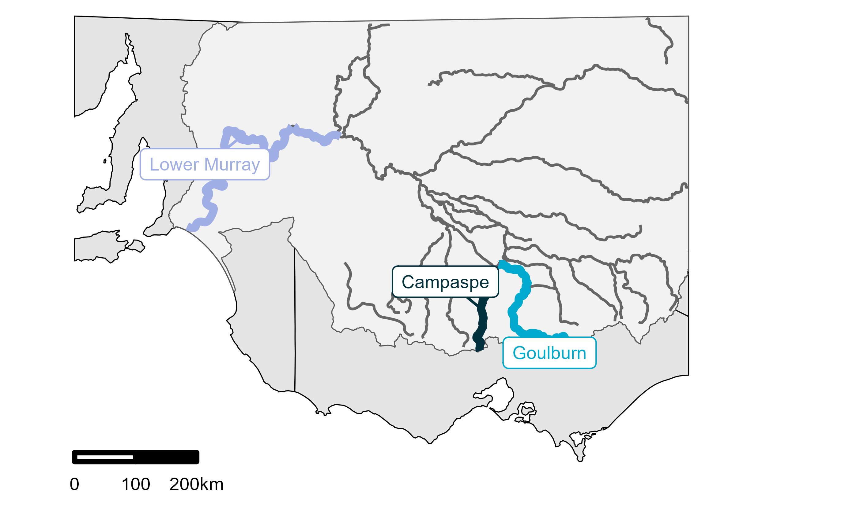

Goulburn and Campaspe rivers
Hydraulic data for the Goulburn and Campaspe were derived from a 2D hydraulic model (described in Webb et al. 2022). Models were developed for3 sites in each river, with a site comprising 0.5–1 km of river channel. Goulburn River sites were near Darcy’s Track, Loch Garry, and McCoys Bridge, while Campaspe River sites were near English Bridge, Spencer Road, and Strathallan Road. For each site, a calibrated HEC-RAS hydraulic model was developed. HEC-RAS models are 2D models that estimate the spatial distribution of water velocity and depth (cf. cross-section averages commonly derived from 1D models). Models were built using aerial LiDAR layers and boat-mounted sonographic surveys, combined with River 2D software (www.river2d.ca).
We extracted 2 outputs from the 2D hydraulic models: slackwater habitat area and lotic habitat area (see Table 1 for definitions):
- Slackwater is critical habitat for spawning and early life stages of many fish species, particularly small-bodied fish species such as Murray-Darling rainbowfish.
- Lotic conditions provide critical spawning habitat for many large-bodied species such as Murray cod and golden perch.
The 2D hydraulic models provided look-up tables to estimate the area of slackwater and lotic spawning habitat for a pre-specified set of discharge levels (spanning the range of discharge levels observed in each reach). We linearly interpolated the values in the look-up tables and used discharge sequences for each reach to estimate the (daily) habitat areas at each site. We note that different geomorphic structures and hydraulic models at each site means that the same discharge sequence leads to different hydraulic conditions at each site.

Lower Murray River
Hydraulic data for the Lower Murray were derived from a 2D hydraulic model used by the Flow-MER Hydrology Theme (Gibbs et al. 2023, Ye et al. 2023). This model was based on a steady-state approach. Specifically, a steady-state solution was calculated at a range of discharge levels (2,000–100,000 ML/d) for each weir pool and the main channel between Lock 1 and Wellington in the Lower Murray Selected Area. For each steady-state solution, several hydraulic metrics were calculated, including the 10th, 50th, and 90th percentile velocities within the weir pool, the proportion of the weir pool with water velocity exceeding 0.2 and 0.3 m/s, and water levels at multiple locations along the weir pool. Water velocity exceeding 0.2 m/s is associated with transport of phytoplankton, zooplankton, and fish larvae (Gibbs et al. 2023), as well as gas exchange at the water surface (Ye et al. 2021). Water velocity exceeding 0.3 m/s is commonly considered to represent lotic habitat conditions for riverine species (Ye et al. 2023). To enable comparisons among different flow scenarios, all velocity calculations were based on a standardised area in each weir pool, defined as the inundated area at 5,000 ML/d and normal pool-level conditions. This approach avoided very low estimated proportions of lotic habitat under higher discharge when a large area of slow-flowing backwaters is inundated.
We focused on the 2 water velocity metrics in our analysis, and restricted our analysis to the proportion of the Selected Area with water velocity exceeding 0.2 m/s. We note that this value was highly correlated (r = 0.95) with the proportion of the Selected Area with water velocity exceeding 0.3 m/s, so is consistent with the lotic habitat area threshold used for Victorian sites.
Table 1 Hydraulic and flow variables used in this study
Region | Variable | Description
Victoria | Slackwater habitat area | The area (m²) of slackwater habitat per 100 m of reach. Slackwater was defined as areas with water velocity < 0.01 m/s and water depth < 0.5 m. Estimates were derived from outputs of the 2D hydraulic model, combined with discharge recorded at the nearest gauge for the relevant period.
 | Proportional lotic habitat area: site level | The proportion of total area at a site with lotic habitat (ratio of lotic area to total area). Lotic habitat was defined as areas with water velocity > 0.3 m/s and water depth > 0.4 m. Estimates were derived from outputs of the 2D hydraulic model, combined with discharge recorded at the nearest gauge for the relevant period.
Lower Murray | Proportional lotic habitat area: reach level | The linear distance (km) of the Lower Murray Selected Area with average cross-sectional water velocity > 0.2 m/s. This metric was highly correlated with equivalent values calculated at 0.3 m/s, so is closely aligned with that used for the lotic habitat in the 2 Victorian rivers. Estimates were provided by the Flow-MER Hydrology Theme.

Data analysis

Flow metrics
Hydraulic and hydrological data were measured (or calculated) at a daily temporal resolution. For models of fish recruitment, these data were summarised at an annual (water year) resolution. We identified 2 key ecological processes affecting recruitment rates as detected in Autumn fish surveys:
- spawning conditions for large-bodied species from Sep–Dec, and
- survival of early life stages during the drier summer (Dec–Feb) period.
Spawning metrics (relevant to large-bodied fish species) were based on discharge (hydrological metric) and the proportion of lotic habitat area (hydraulic metric), averaged over the Sep–Dec period. Summer survival metrics were based on discharge (hydrological metric) and the extent of slackwater habitat (hydraulic metric), averaged over the Dec–Feb period. Estimates of slackwater habitat were not available for the Lower Murray Selected Area, so this dataset was excluded from the analysis of slackwater habitat.

Fish recruitment data
The abundance of Murray cod and golden perch young-of-year recruits was defined using length thresholds. The abundance of Murray-Darling rainbowfish recruits was defined as all captured individuals due to their small body sizes and relatively short lifespan (applicable to the Campaspe and Goulburn rivers only).
- For the Campaspe and Goulburn rivers, Murray cod young-of-year were defined as all individuals < 125 mm in total length, and golden perch young-of-year were defined as all individuals < 100 mm in total length.
- For the Lower Murray Selected Area, Murray cod young-of-year were defined as all individuals < 155 mm in total length, and golden perch young-of-year were defined as all individuals < 85 mm in total length.
Length thresholds were derived from the Flow-MER Basin-Scale Fish Evaluation (Hladyz et al. 2024).
Data from fish surveys in the Goulburn River and Lower Murray Selected Area were provided by the members of the Flow-MER Fish Theme. Surveys in the Goulburn River were supplemented by data from Victorian survey programs at the target sites. Data from fish surveys in the Campaspe River were provided by the Arthur Rylah Institute, with data collection funded primarily by VEFMAP. Details of surveys are in Table 2 and in Figure A.1 in Appendix A.
Fish surveys were assigned to water years (Jul–Jun), but with late surveys in July or August assigned to the previous water year. Fish surveys are planned for autumn or early winter, and late surveys are considered more representative of the recruitment in the preceding water year (2–3 months prior) than the following water year (for which most surveys occur 8–10 months later).
Table 2 Summary of survey data available on young-of-year recruits in each system
Murray-Darling rainbowfish were present in the Lower Murray River but were not recorded in electrofishing surveys.
System | Number of years | Number of sites | Number of recruits detected (Murray cod) | Number of recruits detected (Golden perch) | Number of recruits detected (Murray-Darling rainbowfish)
Campaspe River | 16 | 5 | 43 | 8 | 945
Goulburn River | 15 | 4 | 38 | 0 | 800
Lower Murray Selected Area | 9 | 10 | 116 | 48 | N/A

Relating hydraulic and hydrological metrics
We aimed to assess whether metrics based on flow hydraulics provided unique information beyond that contained in metrics of discharge. To examine this question, we characterised the relationship between hydraulic metrics and discharge at daily and water-year temporal resolutions. We considered the 2 different hydraulic models (Lower Murray and Goulburn/Campaspe) separately due to differences in their implementations and spatial resolutions (reach vs site). These differences prevent an evaluation of the ability of hydraulic metrics to explain fish recruitment across very different river morphologies and should be the focus of future work if consistent hydraulic metrics become available.
We plotted daily estimates of each hydraulic metric against daily discharge, at reach level for the Lower Murray Selected Area and at site level for the Goulburn and Campaspe Rivers. We also plotted the calculated water-year metrics (see Section 2.2.1 above) against equivalent discharge metrics. The relationship between hydraulic and hydrological water-year metrics was described using Pearson’s correlation coefficient (r). Correlations were calculated against log-transformed discharge given the right-skewed nature of discharge data (outliers of large magnitude, e.g. flood events). For the Goulburn and Campaspe rivers, we considered comparisons within sites but also among sites to capture different associations in each site (despite the underlying hydrological data being identical in all sites in a reach).

Model comparisons
Our final goal was to examine whether hydraulic and hydrological metrics supported different inferences regarding the influence of flow on recruitment rates. We used Bayesian hierarchical models to relate fish recruitment estimates to flow metrics (hydraulic and hydrological). We fitted a separate model for each pair of hydraulic and hydrological metrics, and compared parameter estimates for each pair of models. We also calculated model fit (based on Pearson’s r and the Spearman rank-correlation coefficient) to assess differences in model fit based on hydraulic vs hydrological metrics.
We fitted models separately for each species and for the Lower Murray and the Goulburn/Campaspe systems. For the Lower Murray, the models had the following general structure (in R formula notation):
Young-of-year catch ~ lotic flow + (1 | site) + (1 | water year) + Offset(effort)
Here, lotic flow refers to the hydraulic lotic habitat metric (for the hydraulic model) and the average discharge during the spawning period (for the hydrological model). We assumed that catch of young-of-year fish followed a Negative Binomial distribution.
We combined data from the Goulburn and Campaspe rivers to fit models with the following general structure:
Young of year ~ (lotic flow + summer flow) × waterbody + (1 | site) + (1 | water year) + Offset(effort)
Here, lotic flow refers to the site-level hydraulic habitat metric or the site-level average discharge during the spawning period, summer flow refers to the site-level slackwater metric or the site-level average discharge during summer, and waterbody is the river (Goulburn or Campaspe). We assumed that catch of young-of-year Murray cod and Murray-Darling rainbowfish followed a Negative Binomial distribution. We modelled catch of young-of-year golden perch as a binary (detected/not detected) variable following a Bernoulli distribution due to low absolute catches of golden perch in the Goulburn and Campaspe rivers.
All models were fitted using the brms package (Bürkner 2017, 2018) in R (R Core Team 2024). Weakly informative default priors were used (Normal distributions for fixed effects, half-Normal distributions for random effects, and Student-t distributions for hyper-priors on random effect standard deviations). All inferences were based on 4 chains of 4,000 iterations each, discarding the first 2,000 iterations after tuning the sampler. Model convergence was verified using Gelman-Rubin statistics (R̂) (Gelman and Rubin 1992). All R̂ values were less than 1.05 for the results presented below.

Results

At what spatial and temporal scales do flow hydraulic data exist?
Within the Flow-MER program and the wider network of the Flow-MER Fish and Hydrology themes, two-dimensional (2D) hydraulic models were identified for the entire Lower Murray Selected Area and at selected sites in the Goulburn and Edward-Wakool Selected Areas. In addition, a 2D hydraulic model exists for 3 sites in the Campaspe River in northern Victoria.
The reach-level Lower Murray model provided estimates of several hydraulic metrics, particularly the proportion of the channel exceeding specific water-velocity thresholds. All calculations were conducted within the Flow-MER Hydrology theme and outputs were provided as daily average values. The site-level Goulburn River and Campaspe River models provided estimates of the proportion of a site exceeding specific water-velocity thresholds, as well as estimates of the amount of slackwater habitat at each site. Outputs from these models were provided as a function of discharge, so could be calculated from a discharge time series. The Edward-Wakool model did not include outputs compatible with our flow-ecology hypotheses and was excluded from our analysis.

Do metrics of flow hydraulics provide unique information beyond that captured in river discharge?
Daily values of lotic habitat and discharge in the Lower Murray had a clear, sigmoidal relationship when plotted on a log-scale (solid lines in Figure 2). This relationship was near-linear when looking at the summarised water-year metrics (averages over the spawning period) (r = 0.96, Figure 2 and middle panel of Figure 4). Deviations from this linear association occur at very low (< 3,000 ML/d) or very high (> 30,000 ML/d) discharge levels (Figure 2, Figure 4).
Daily values of lotic habitat and discharge in the Goulburn and Campaspe rivers also had sigmoidal associations when plotted on a log-scale (Figure 3). Summarised water-year metrics had a near-linear association, with high Pearson correlations at all sites in both river systems (points in Figure 3 and right-hand panel of Figure 4). Site-level means differed slightly among sites but associations had similar, positive slopes in all sites (Figure 4). Daily values of slackwater habitat and discharge in the Goulburn and Campaspe rivers had clear, non-linear associations (Figure 3). Site-level means and slopes differed among sites, although slopes were negative in all but one site (Strathallan Rd; left-hand panel in Figure 4). Figure 4 demonstrates the point that, for different rivers and different sites within a river, the same discharge can result in very different slackwater and lotic habitats.
Figure 2 Relationships between hydraulic and hydrological metrics for the Lower Murray Selected Area
Two line plots showing the modelled relationship (spline r2 > 0.99) between flow (discharge) and linear distance for all daily data from 2014–15 to 2022–23. Plot A shows the discharge values on a raw scale and Plot B shows the same data on a log10 scale. Discharge is on the x-axis and linear distance (km) with average cross-sectional water velocity >0.2 m/s on the y-axis. Points on the lines (i.e. the small coloured circles where the colour shows the year as per the legend) show the summarised water-year metrics used in the analysis (2014–23). r is the Pearson correlation for points.
Plot A shows that the hydraulic metric increases rapidly at low values of discharge but plateaus when discharge exceeds 25,000 ML/day. Plot B shows this same relationship, but on a log10 scale of discharge, which emphasises the log-sigmoidal nature of the relationship between discharge and hydraulics.
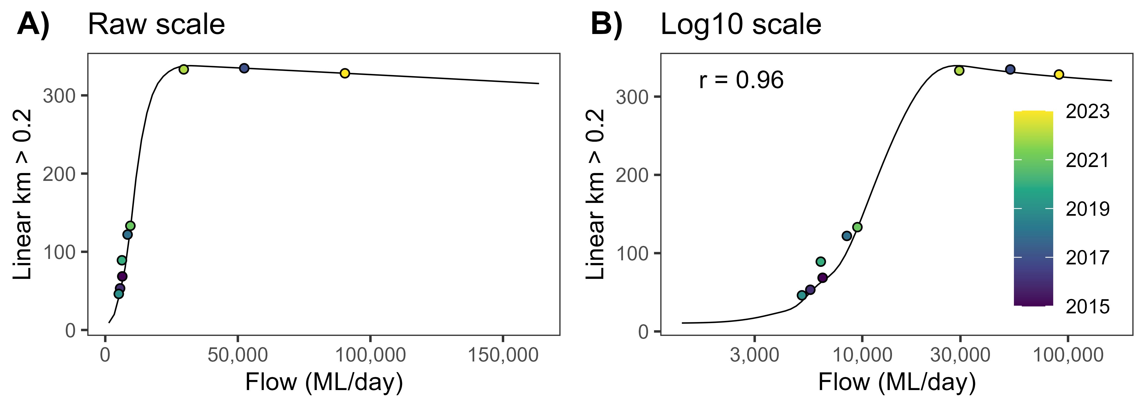
Figure 3 Relationships between hydraulic and hydrological (log-transformed daily discharge) metrics for spawning area and slackwater area in the Goulburn River and Campaspe River sites
Twelve line plots displaying modelled relationships (non-linear r2=1.0) between flow (discharge) and spawning area (plots 1 to 6) and slackwater area (plots 7 to 12) for all daily data between 2000 and 2023. Symbols show the summarised data (mean) used as predictors in the analysis. The smaller grey dots show those data not included in the analysis (prior to 2014). The diamonds show the data used in the analysis. r is the Pearson correlation between discharge and hydraulic water-year averages (i.e. the linear correlation for the points).
Plots 1 to 6 show that the proportion of spawning area has a positive sigmoidal relationship with log-transformed discharge. Plots 7 to 12 show mixed, but often negative or unimodal, relationships between slackwater area and log-transformed discharge.
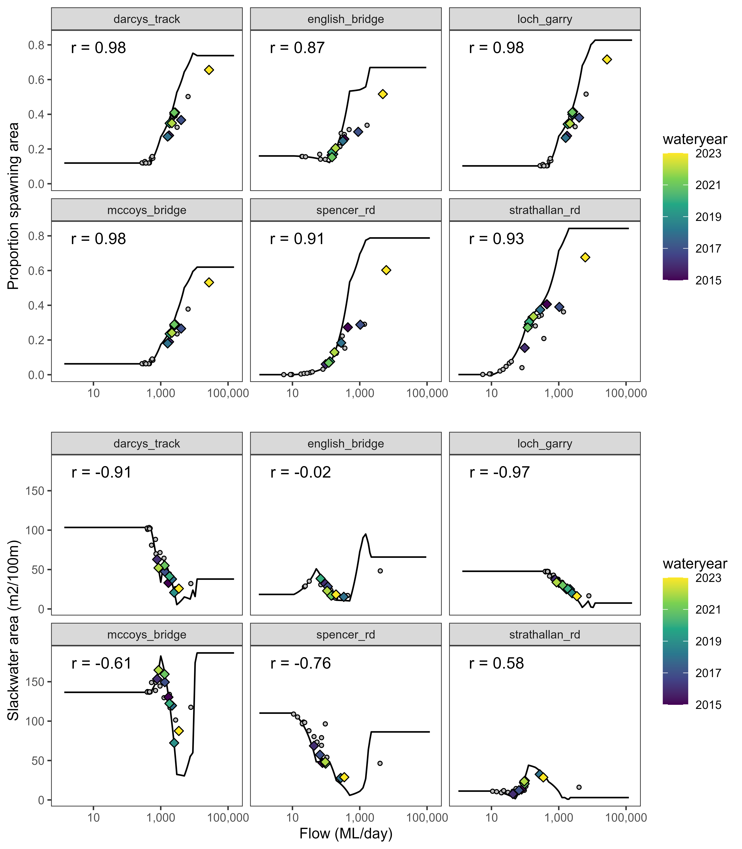
Figure 4 Relationships between hydraulic and hydrological (log-scaled daily discharge) water-year metrics for all years included in analyses of fish recruitment within the Lower Murray Selected Area
Three plots displaying relationships between 3 hydraulic metrics and discharge for the Campaspe, Goulburn and Murray rivers in the Lower Murray Selected Area. Discharge (flow in ML/day) is on the x-axis and hydraulic metric on the y-axis. Plot A (left-most plot) shows slackwater habitat, Plot B (middle plot) shows proportion of Lower Murray Selected Area with water velocity exceeding 0.2 m/s, and Plot C (right-most plot) shows proportion of lotic habitat. The plot lines are linear regression associations fitted separately for each site (note: the Lower Murray reach is treated as a single site). The 3 plots show site-level means and slopes differed among sites, although slopes were negative in all but one site.
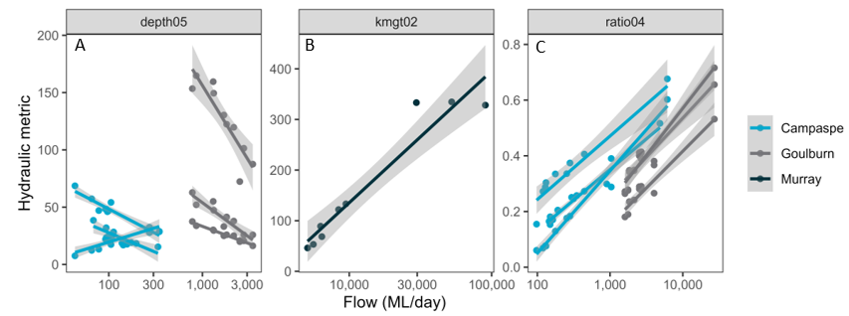

Are metrics of flow hydraulics associated more closely with fish population outcomes than river discharge?
Estimates of model fits (based on Pearson’s r) were nearly identical in all systems (see r-value comparisons in Figure 5). Parameter estimates for hydraulic lotic metrics (ratio04 and kmgt02) were similar to those for spawning discharge, particularly in the Lower Murray system (compare grey and blue points in Figure 5). For these lotic metrics, there was weak evidence of sign differences in parameter estimates for golden perch in the Goulburn and Campaspe rivers and for Murray-Darling rainbowfish in the Goulburn River, noting high uncertainty in estimates for these parameters (Figure 5). There was weak evidence (wide and overlapping credible intervals) that parameter estimates for the slackwater metric (depth05) differed from those for average discharge over the same period, with the median estimate having a different sign in several cases (Figure 5). Credible intervals were wider for discharge metrics than hydraulic metrics in the Goulburn and Campaspe rivers, particularly for golden perch in the Goulburn River (where recruits were not detected), indicating that estimated associations with discharge metrics were more uncertain than those with hydraulic metrics (Figure 5).
Raw data and associations are shown in Figure A.2 and Figure A.3 in Appendix A.
Figure 5 Comparison of parameters from models fitted with hydraulic versus hydrological predictor variables for 2 fish species in the Lower Murray River and 3 fish species in the Campaspe and Goulburn rivers
Eight plots comparing parameters from models fitted with hydraulic vs. hydrological predictor variables for 2 fish species in the Lower Murray River. River is on x-axis and effect size is on y-axis. Points are estimated means and error bars are 95% credible intervals. r values are Spearman rank correlation coefficients between fitted and observed values for a discharge-based model relative to a hydraulics-based model. LOO values are the difference in approximate leave-one-out cross-validation statistics between a discharge-based and hydraulics-based model (values are loo(hydraulic) minus loo(hydrology), with standard deviations in brackets). A single r and LOO value is shown for depth05 and ratio04 because both metrics were included in a single model. Metric definitions: depth05 – slackwater habitat; kmgt02 – proportion of Lower Murray Selected Area with water velocity exceeding 0.2 m/s; ratio04 – proportion of lotic habitat.
Estimates of model fits were similar in all systems. Parameter estimates for hydraulic metrics (proportion of lotic habitat (metric ratio04), proportion of area with water velocity >0.2 m/s (metric: kmgt02) were similar to those for spawning (metric: depth05) discharge particularly in the Lower Murray. There was weak evidence that the proportion of lotic habitat metric and slackwater metric differed from those for discharge with sign differences in parameter estimates in several cases.
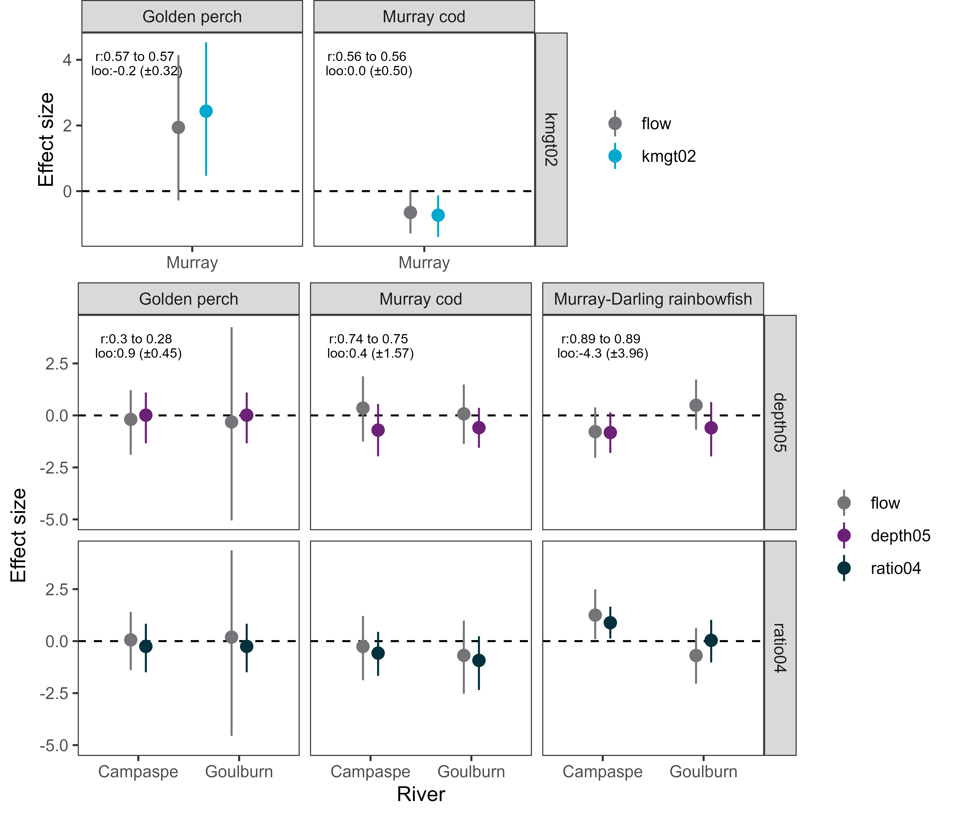

Discussion
We assessed the potential to incorporate hydraulic information in the Flow-MER Basin-Scale Fish Evaluation. We considered:
- The availability of hydraulic models
- The potential for metrics based on hydraulic model outputs to provide unique information relative to the more commonly used stream discharge
- The potential for hydraulic metrics to improve model fit (relative to discharge metrics) for models of fish recruitment to young-of-year.
Two-dimensional (2D) hydraulic models were available for 3 of the Flow-MER Selected Areas, with appropriate model outputs available for 2 of these 3 areas (Lower Murray, Goulburn). A 2D hydraulic model was also available for the Campaspe River in northern Victoria.
Comparisons of daily flow data revealed potential unique information in hydraulic metrics compared to discharge metrics. However, these differences were less apparent when metrics were averaged over key periods of the water year (the spawning period for large-bodied fish and early life stage period from spring to summer), with near-linear associations between hydraulic and hydrological metrics. These near-linear associations were relatively consistent among sites for lotic habitat metrics but differed in intercept and slope for the slackwater metric, indicating the potential for unique information in slackwater metrics. There were clear differences between hydraulic metrics for a given discharge across sites and rivers in the Campaspe and Goulburn rivers. Models of fish recruitment based on hydraulic metrics had similar explanatory power as those based on discharge, with nearly identical parameter estimates for hydraulic lotic habitat metrics and discharge metrics. Credible intervals were wider for discharge metrics than hydraulic metrics suggesting that the hydraulic metrics reduced parametric uncertainty. By contrast, associations of fish recruitment with the hydraulic slackwater metric had a different sign than associations with discharge metrics in several cases. Additionally, associations of fish recruitment with site-based hydraulic metrics tended to have narrower credible intervals than those with discharge metrics.

Current availability of hydraulic models is limited
The availability of appropriate hydraulic models is a critical first step towards incorporating hydraulic metrics in the Flow-MER Basin-Scale Fish Evaluation. Through discussions with members of the Flow-MER Fish and Hydrology themes, we determined that 2D hydraulic models provided sufficient hydrological detail and were available for 3 of the Selected Areas. Although we only included 2 of these in this analysis, it should be feasible for the model developers (Streamology) to generate hydraulic outputs for the third Selected Area (Edward-Wakool) given a 2D hydraulic model exists. However, significant investment would be needed to develop (or obtain) hydraulic models for all Selected Areas and, ideally, for a wider set of areas across the Basin.
The hydraulic information used in our analysis was provided at different spatial resolutions and extents. The hydraulic model for the Lower Murray covers much of the Lower Murray Selected Area but provided an averaged output across all fish sampling locations. By contrast, hydraulic models for the Goulburn and Campaspe rivers were available only at 3 sites in each river but provided detailed insight into the local hydraulic conditions experienced by fish at each site. Differences among sites in the hydraulic metrics (and their associations with discharge metrics and fish recruitment) indicate that site-level differences may be important when incorporating hydraulics into ecological models.
Two challenges emerge from these findings.
First, determining the appropriate spatial resolution and extent of hydraulic models (when used as inputs into models of fish responses) is likely to introduce a trade-off between feasibility and information content. More detailed models are more likely to capture the local conditions that determine fish responses to flows, but at the cost of requiring 10s or 100s of unique 2D hydraulic models to cover all fish sampling sites in the current Flow-MER Selected Areas (which represent a small portion of the Basin’s rivers).
Second, hydraulic models are complex and computationally demanding, and it can be challenging to update models frequently to incorporate new flow scenarios or contexts. The site-level models used here were characterised by look-up tables of averaged hydraulic conditions at each site under different discharge levels, which allowed rapid calculations of hydraulic metrics. Although this approach is efficient, it may be sacrificing accuracy for convenience. Further input from the Flow-MER Hydrology Theme would be important to clarify the limitations of 2D hydraulic models and determine the appropriate balance between simplified heuristics and computationally demanding model runs.

Hydraulic metrics may provide limited unique information beyond discharge metrics
Non-linear and spatially variable associations between discharge and hydraulic metrics highlighted the potential for some unique information in the hydraulic metrics considered here. However, focusing on averaged values over critical periods for fish populations revealed near-linear associations between hydraulic metrics and discharge in most cases. This was particularly pronounced for the large-bodied fish spawning metric (the proportion of a site/reach with water velocities above a specified threshold), indicating that discharge metrics may be sufficient to characterise flow impacts on fish spawning at the site scale. This finding partly reflects that major changes in hydraulics often occur at the extremes of discharge, such as when high flows inundate shallow, slow-flowing areas (e.g. backwaters). Consideration of alternative metrics of hydraulic conditions during the fish spawning period, or changes in the spatial resolution of metrics may identify more situations in which hydraulic metrics provide unique information on flow conditions.
The hydraulic slackwater metric was less closely associated with discharge, although averaged slackwater values over the summer period still had mostly linear associations with discharge averaged over the same period. Perhaps most important was the different slope of the slackwater-discharge relationship at the Strathallan Rd site compared to all other sites. Unlike other sites, slackwater area appeared to increase with increasing discharge at the Strathallan Rd site, before decreasing at higher discharge rates (which do not typically occur during the critical summer period for early fish life stages). This finding suggests that the slackwater metric used here may capture different hydraulic conditions at sites with similar discharge, which supports further assessments of similar, habitat-focused hydraulic metrics to explain among-site variation in fish responses to flows.
This component of our analysis highlights 3 points relating to the use of hydraulic versus hydrological metrics. First, there is limited potential for the hydraulic metrics used here to contain unique information beyond that captured in discharge metrics. Second, the amount of new information likely depends on how the hydraulic metrics are derived and summarised, both spatially and temporally. Based on our assessment, we suspect that averaging over larger spatial areas or longer temporal extents will reduce the amount of unique information in hydraulic metrics (i.e. hydrology and hydraulics are more aligned at coarser resolutions). Third, it is unclear whether hydraulic metrics have consistent associations with ecological responses across river systems (a common motivation for the use of hydraulic metrics in flow-ecology studies). Substantial additional work would be required to determine whether these (or alternative) metrics can sufficiently characterise flow-ecology links elsewhere in the Murray–Darling Basin. These 3 points suggest that hydraulic metrics have some, but limited potential to improve flow-ecology studies in the short to medium term, and primarily at finer spatial resolutions. However, we acknowledge that our study was based on a small set of sites and only two metrics, so that additional work is necessary to determine the generality of these points.

Hydraulics and discharge supported similar ecological models
We did not find substantial differences between hydraulic and hydrological metrics in their capacity to explain variation in fish recruitment. In the Lower Murray, all comparison measures (parameter estimates, correlations, LOO statistics) indicated that hydraulic and hydrological metrics provided near-identical information on fish response to flow conditions. Similarly, in the Goulburn and Campaspe rivers, we found limited evidence that hydraulic models provided new or different information than those based on hydrological metrics. For these site-level models, the only clear association with any flow metric was for Murray-Darling rainbowfish and the lotic habitat metrics, for which both hydraulic and hydrological parameters were closely aligned. Our findings are in line with recent work in the Goulburn River by Webb et al. (2022), who found that mean velocity (at site level) was closely correlated with mean discharge and that associations with golden perch spawning were closely aligned between hydraulic and hydrological metrics. More nuanced implementations of hydraulic metrics may reveal larger differences between hydraulics and hydrology, including careful consideration of the spatial and temporal scales over which hydraulic metrics are averaged. In addition, consideration of other factors (productivity, channel morphology, water quality, detectability of fish recruits) and how these interact with fish and flows may clarify the influence of hydraulics on fish population processes.
Examples of sign differences in parameter estimates indicate that hydraulic metrics may provide new insights into fish recruitment, noting that these sign differences were associated with high uncertainty (wide credible intervals). Although high uncertainty and small effect size limits inferences from our analysis, this suggests that assessments at more sites may reveal more substantial differences. In particular, including sites where slackwater is predicted to have a strong influence on fish populations may be informative. This is because data from these sites would be expected to increase the precision of parameter estimates, thus increasing the likelihood of identifying true differences between hydraulic and hydrological metrics. Consideration of more sites may also address the higher uncertainty in parameter estimates for discharge relative to those for hydraulic metrics (in the site-level analysis). The cause of this uncertainty is unclear but may reflect different distributions of hydraulic versus hydrological metrics (e.g. one may have higher statistical leverage) or the potential for hydraulic metrics to have more consistent (but not more predictive) associations with fish recruitment.

Recommendations
We summarise our key findings in Table 3. Based on these findings, we make the following recommendations:
- We do not recommend the Flow-MER Basin-Scale Fish Evaluation pursue the use of hydraulic metrics for3 reasons. First, appropriate hydraulic models are not readily available for most fish sampling sites, and their development would require significant investment. Second, the evaluation of Basin-scale fish population outcomes is conducted at coarse spatial and temporal resolutions (river reaches, annually), and hydraulic metrics provide less unique information at these resolutions. Last, there was limited evidence that hydraulic metrics improved the explanatory or predictive capacity of models of fish recruitment at coarse resolutions.
- We recommend additional research that expands this preliminary analysis to consider more sites, particularly those with different river characteristics (e.g. the northern Basin) or targeting sites where slackwater is predicted to have a strong influence on fish populations. Other avenues of research include relating hydraulic metrics to more proximate, velocity-driven fish responses (e.g. golden perch spawning) across scales and further exploring fish-hydraulics relationships at finer spatial and temporal scales. This expansion would assess whether our findings apply across a broader range of environmental contexts and more thoroughly test whether fish responses to hydraulic metrics are similar across systems with different channel morphology and flow characteristics.
Table 3 Key findings for each research question
Question | Outcome
At what spatial and temporal scales do flow hydraulic data exist? | 2D hydraulic models were available for 3 of 7 Selected Areas, with relevant outputs restricted to two Selected Areas (Lower Murray, Goulburn).
Do metrics of flow hydraulics provide unique information beyond that captured in river discharge? | Flow hydraulic metrics contain unique information beyond river discharge when considered at fine temporal resolutions (e.g. daily) and over a wide range of discharge levels.  Flow hydraulic metrics averaged over time periods relevant to fish populations (e.g. seasonal averages) were closely (and often linearly) associated with discharge metrics. Of the 2 metrics considered in this study, the slackwater metric appeared to contain more unique information on averaged site-level flow conditions.
Are metrics of flow hydraulics associated more closely with fish population outcomes than river discharge? | There was no strong evidence that models of fish recruitment based on hydraulic metrics outperformed equivalent models based on hydrological metrics at coarse resolutions.

References
Baumgartner LJ, Conallin J, Wooden I, Campbell B, Gee R, Robinson WA and Mallen-Cooper M (2014) Using flow guilds of freshwater fish in an adaptive management framework to simplify environmental flow delivery for semi-arid riverine systems. Fish and Fisheries 15, 410–427, DOI: 10.1111/faf.12023.
Bice CM, Gibbs MS, Kilsby NN, Mallen-Cooper M and Zampatti BP (2017) Putting the “river” back into the Lower River Murray: quantifying the hydraulic impact of river regulation to guide ecological restoration. Transactions of the Royal Society of South Australia 141, 108–131. DOI: 10.1080/03721426.2017.1374909.
Bond NR, Lake PS and Arthington AH (2008) The impacts of drought on freshwater ecosystems: an Australian perspective. Hydrobiologia 600, 3–16. DOI: 10.1007/s10750-008-9326-z.
Bürkner P-C (2017) brms: An R Package for Bayesian Multilevel Models Using Stan. Journal of Statistical Software 80, 1–28. DOI:10.18637/jss.v080.i01.
Bürkner P-C (2018) Advanced Bayesian multilevel modeling with the R Package brms. The R Journal 10, 395–411. DOI:10.32614/RJ-2018-017.
Doretto A, Piano E and Larson CE (2020) The River Continuum Concept: lessons from the past and perspectives for the future. Canadian Journal of Fisheries and Aquatic Sciences 77, 1853–1864. DOI: 10.1139/cjfas-2020-0039.
Gelman A and Rubin DB (1992) Inference from iterative simulation using multiple sequences. Statistical Science 7, 457–472. DOI: 10.1214/ss/1177011136.
Gibbs M, Bice C, Furst D, Gao L, Joehnk K, McCullough D, et al. (2023) Using hydraulics to evaluate ecological benefits, risks, and trade-offs from engineered flooding. Hydrological Processes 37, e15024. 10.1002/hyp.15024.
Hladyz S, Baumgartner L, Bice C, Broadhurst B, Butler G, Fanson B, et al. (2024) Basin-scale evaluation of 2022–23 Commonwealth environmental water: Fish. Flow-MER Program. Commonwealth Environmental Water Holder, Department of Climate Change, Energy, the Environment and Water, Australia. URL: https://www.dcceew.gov.au/sites/default/files/documents/flow-mer_22-23fishevaluationreport_draftfinal_a.pdf (last accessed 14 March 2025).
Hladyz S, Baumgartner L, Bice C, Broadhurst B, Butler G, Fanson B, et al. (2025) Basin-scale evaluation of 2023–24 Commonwealth environmental water: Fish. Flow-MER Program. Commonwealth Environmental Water Holder, Department of Climate Change, Energy, the Environment and Water, Australia.146pp.
Humphries P, King AJ and Koehn JD (1999) Fish, flows and flood plains: links between freshwater fishes and their environment in the Murray-Darling river system Australia. Environmental Biology of Fishes 56, 129-151. DOI: 10.1023/A:1007536009916.
King AJ, Tonkin Z and Mahoney J (2009) Environmental flow enhances native fish spawning and recruitment in the Murray River, Australia. River Research and Applications 25, 1205–1218. DOI: 10.1002/rra.1209.
King AJ, McPhan L, Bond N and Thurgate N (2020) Murray–Darling Basin Long Term Intervention Monitoring Project: 2018–19 Basin-scale evaluation of Commonwealth environmental water – Fish. Report prepared for the Department of Agriculture, Water and the Environment, Commonwealth Environmental Water Office by La Trobe University, Centre for Freshwater Ecosystems. URL: https://www.dcceew.gov.au/sites/default/files/documents/2018-19-basin-evaluation-fish.pdf (last accessed 14 March 2025).
Koehn JD and Nicol SJ (2014) Comparative habitat use by large riverine fishes. Marine and Freshwater Research 65, 164–174. DOI:10.1071/MF13011.
Koehn JD, Raymond SM, Stuart I, Todd CR, Balcombe SR, Zampatti BP, et al. (2020) A compendium of ecological knowledge for restoration of freshwater fishes in Australia’s Murray–Darling Basin. Marine and Freshwater Research 71, 1391–1463. DOI: 10.1071/MF20127.
Koster WM, Dawson DR, Liu C, Moloney PD, Crook DA and Thomson JR (2017) Influence of streamflow on spawning-related movements of golden perch Macquaria ambigua in south-eastern Australia. Journal of Fish Biology 90, 93–108. DOI: 10.1111/jfb.13160.
Lake PS (2011) Drought and Fish of Standing and Flowing Waters. In Drought and Aquatic Ecosystems: Effects and Responses, P.S. Lake (Ed.). DOI: 10.1002/9781444341812.ch9.
Lintermans M (2023) Fishes of the Murray–Darling Basin (Second Edition). Australian River Restoration Centre, Canberra.
Poff NL and Zimmerman JK (2010) Ecological responses to altered flow regimes: A literature review to inform the science and management of environmental flows. Freshwater Biology 55, 194–205. DOI: 10.1111/j.1365-2427.2009.02272.x.
R Core Team (2024) R: A Language and Environment for Statistical Computing. R Foundation for Statistical Computing, Vienna, Austria. URL: https://www.R-project.org/ (last accessed 14 March 2025).
Tockner K, Malard F and Ward JV (2000) An extension of the flood pulse concept. Hydrological Processes 14, 2861–2883. DOI: 10.1002/1099-1085(200011/12)14:16/17<2861: AID-HYP124>3.0.CO;2-F.
Turner M and Stewardson M (2014) Hydrologic indicators of hydraulic conditions that drive flow–biota relationships. Hydrological Sciences Journal 59, 659–672. DOI: 10.1080/02626667.2014.896997.
Vannote RL, Wayne Minshall G, Cummins KW, Sedell JR and Cushing CE (1980) The river continuum concept. Canadian Journal of Fisheries and Aquatic Sciences 37, 130–137. DOI: 10.1139/f80-017.
Vietz GJ, Sammonds MJ and Stewardson MJ (2013) Impacts of flow regulation on slackwaters in river channels. Water Resources Research 49, 1797–1811. DOI: 10.1002/wrcr.20094.
Wheaton JM, Bouwes N, Mchugh P, Saunders C, Bangen S, Bailey P, et al. (2018) Upscaling site-scale ecohydraulic models to inform salmonid population level life cycle modeling and restoration actions: Lessons from the Columbia River Basin. Earth Surface Processes and Landforms 43, 21–44. DOI: 10.1002/esp.4137.
Webb JA, Guo D, Koster WM, Lauchlan-Arrowsmith C and Vietz GJ (2022) Can hydraulic measures of river conditions improve our ability to predict ecological responses to changing flows? Flow velocity and spawning of an iconic native Australian fish. Frontiers in Environmental Science 10, 882495. DOI: 10.3389/fenvs.2022.882495.
Yao W (2021) Ecohydraulic tools for aquatic fauna habitat and population status assessment, analysis and monitoring aimed at promoting integrated river management. Ecological Modelling 456, 109682. DOI: 10.1016/j.ecolmodel.2021.109682.
Ye Q, Giatas G, Bice C, Brookes J, Furst D, Gibbs M, et al. (2021) Commonwealth Environmental Water Office Monitoring, Evaluation and Research Project: Lower Murray 2019-20 Technical Report. A report prepared for the Commonwealth Environmental Water Office by the South Australian Research and Development Institute, Aquatic Sciences. https://www.dcceew.gov.au/sites/default/files/documents/mer-lower-murray-2019-20-technical-report.pdf (last accessed 28 April 2025)
Ye Q, Giatas G, Bice C, Brookes J, Furst D, Gibbs M, et al. (2023) Commonwealth Environmental Water Office Monitoring, Evaluation and Research Project: Lower Murray 2021-22 Technical Report. A report prepared for the Commonwealth Environmental Water Office by the South Australian Research and Development Institute, Aquatic Sciences. URL: https://www.dcceew.gov.au/sites/default/files/documents/2021-22-lower-mer-annual-techincal-report.pdf (last accessed 21 February 2025)
Zampatti B and Leigh S (2013) Effects of flooding on recruitment and abundance of Golden Perch (Macquaria ambigua ambigua) in the lower River Murray. Ecological Management and Restoration 14, 135–143. DOI: 10.1111/emr.12050.

Supplementary information
Figure A.1 Sampling design by program
Three plots each one representing a river with water year on x-axis and individual study sites on y-axis. Coloured cells indicate the water years in which fish surveys were undertaken. Water years are defined by the calendar year for their second half (e.g. 2020 is the 2019–20 survey year). The top plot is for 5 sites in the Campaspe River, the middle plot for 3 sites in the Goulburn River and the bottom plot for 10 sites in the Murray.
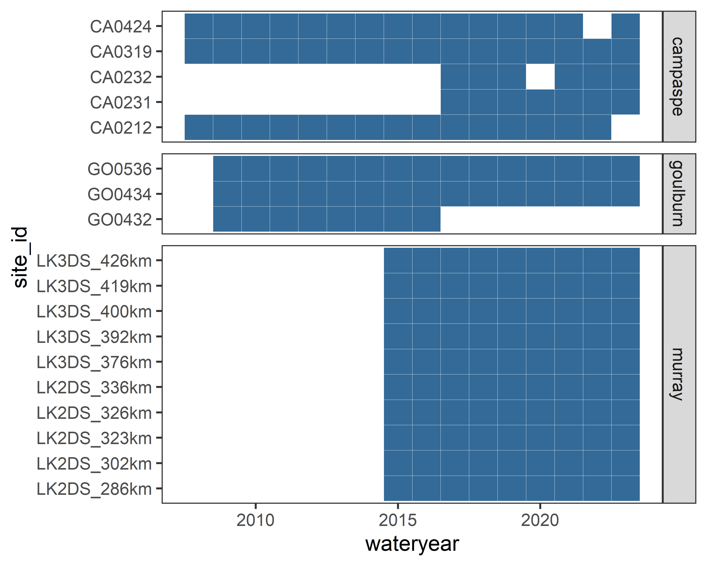
Figure A.2 Catch of young-of-year (YoY) golden perch and Murray cod plotted against hydraulic and hydrological metrics for the Lower Murray River Selected Area
Four plots comparing golden perch (top row) and Murray cod (bottom row) associations with average daily discharge during the spawning period (metric: flow_ml, left-most plots) and with the proportion of the Lower Murray Selected Area with water velocity exceeding 0.2 m/s (metric: kmgt02, right most plots). Points are site-level catch in each water year. Plot lines are linear regression fits (one per site) included for exploratory purposes. Both axes are log-scaled, and young-of-year catch has had a value of 1 added to enable a log-transformation of data with many zeros.
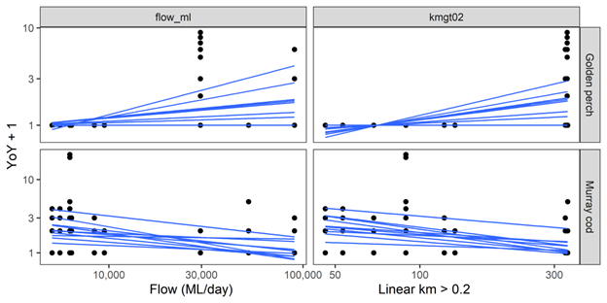
Figure A.3 Catch of young-of-year (YoY) fish plotted against hydraulic and hydrological metrics for sites in the Goulburn and Campaspe rivers
Two sets of 12 plots (grids of 4 metrics x 3 fish species). The first set is for the Goulburn River and the second set for the Campaspe River. In each set, the 4 metrics are (from the left) slackwater habitat (metric: depth05), average daily discharge during the summer period (metric: flow_depth05), average daily discharge during the spawning period (metric: flow_ratio04) and proportion of lotic habitat (metric: ratio04). In each set, the 3 fish species are golden perch (top row), Murray-Darling rainbow fish (middle row) and Murray cod (bottom row).Points are site-level catch in each water year. Lines are linear regression fits (one per site) included for exploratory purposes. Both axes are log-scaled, and young-of-year catch has had a value of 1 added to enable a log-transformation of data with many zeros..
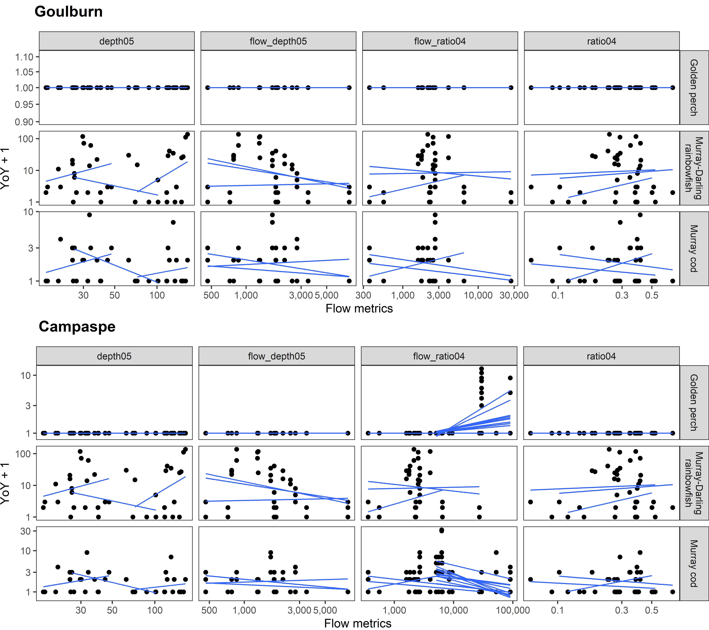

https://flow-mer.org.au
