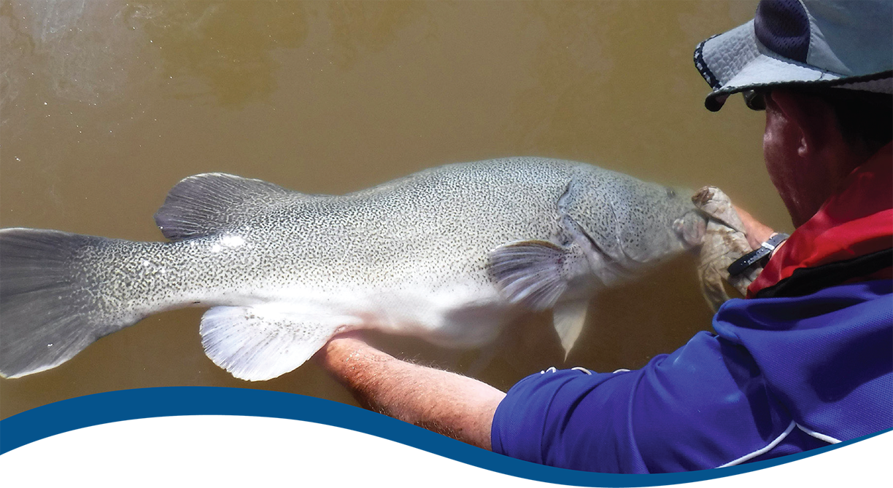

Technical supplement to Basin-scale evaluation of 2023–24 Commonwealth environmental water: Fish
  - Commonwealth Environmental Water Holder’s Science Program:
Flow Monitoring, Evaluation and Research Program (Flow-MER)

June 2025

Acknowledgement of Country
The project team and the Commonwealth Environmental Water Holder (CEWH) respectfully acknowledge the Traditional Owners of the land on which this work is conducted, their Elders past and present, their Nations of the Murray–Darling Basin, and their cultural, social, environmental, spiritual and economic connection to their lands and waters.
Acknowledgements of collaborators and contributors
We take this opportunity to thank the contributors and the many individuals and agencies who provided data to support this evaluation.
We would like to thank the CSIRO team for their efforts in report layout, editing, reviewing and formatting. Special mention to Susan Cuddy and Jane Thomas whose input, together with formatting specialist, Jill Sharkey, greatly improved the readability of the report.
Citation
Fanson B (2025) Technical supplement to Basin-scale evaluation of 2023–24 Commonwealth environmental water: Fish. Flow-MER Program. Commonwealth Environmental Water Holder (CEWH): Monitoring, Evaluation and Research Program, Department of Climate Change, Energy, Environment and Water, Canberra, Australia. 74pp
Copyright
 © Commonwealth of Australia 2025
With the exception of the Commonwealth Coat of Arms, partner logos and where otherwise noted, all material in this publication is provided under a Creative Commons Attribution 4.0 International Licence https://creativecommons.org/licenses/by/4.0/. The terms of this licence allow content to be shared and/or adapted, with appropriate attribution.
The Flow-MER Program requests attribution as ‘© Commonwealth of Australia (Flow-MER Program, https://flow-mer.org.au)’.
Document history
Date | Version
30/4/2025 | Draft delivered to CSIRO for editing and quality check
12/5/2025 | Formatting, internal review and response to review period
12/5/2025 | Updated with revised results (received 5/5/2025)
30/6/2025 | Draft final delivered to CEWH

Cover photograph
Image: Releasing a Murray cod
Photo credit: Arthur Rylah Institute
Important disclaimer
The information contained in this publication comprises general statements based on scientific research. The reader is advised and needs to be aware that such information may be incomplete or unable to be used in any specific situation. No reliance or actions must therefore be made on that information without seeking prior expert professional, scientific and technical advice. To the extent permitted by law, the Flow-MER Program (including its partners and collaborators) excludes all liability to any person for any consequences, including but not limited to all losses, damages, costs, expenses and any other compensation, arising directly or indirectly from using this publication (in part or in whole) and any information or material contained in it.
The Flow-MER is committed to providing web accessible content wherever possible. If you are having difficulties with accessing this document please contact CEWOmonitoring@environment.gov.au.

Contents
1 Summary 1
1.1 Graphical summary of analyses 1
1.2 Sensitivity of 2023–24 data 3
1.3 CEW contributions in 2023–24 4
1.4 Flow conditions for 2023–24 4
1.5 Revisions from 2023–24 report 6
2 Considerations: Analyses and population processes 7
3 Fish analyses 9
3.1 Overview 9
3.2 Overview of flow metrics and analyses 11
3.3 Analysis: Spawning presence 16
3.4 Analysis: Recruit analysis (young-of-year) using abundance data 19
3.5 Analysis: Catch curve analysis 25
3.6 Analysis: Adult abundance 28
3.7 Analysis: Adult body condition 33
3.8 Analysis: Adult presence/distribution 38
3.9 Analysis: Community metric 42
3.10 Analysis: Predicting Commonwealth environmental water contribution on Murray cod recruitment at unmonitored areas across the Murray–Darling Basin 47
4 References 50
Appendix A Table of Commonwealth environmental water contribution from each analysis 51
A.1 Contribution: Spawning 51
A.2 Contribution: Recruitment (young-of-year) using abundance data 51
A.3 Contribution: Adult abundance 53
A.4 Contribution: Body condition 54
A.5 Contribution: Adult presence/distribution 55
A.6 Contribution: Community metric 56
A.7 Contribution: Recruitment at Basin-level 56
Appendix B Table of Commonwealth environmental water effects 57
B.1 Summary table across all analyses 57
Appendix C Statistical tables for all analyses 62
C.1 Analysis: Spawning 62
C.2 Analysis: Recruits analysis (young-of-year) using abundance data 62
C.3 Analysis: Adult abundance 63
C.4 Analysis: Adult body condition 64
C.5 Analysis: Adult presence/distribution 64
C.6 Analysis: Community metric 65

Figures
Figure 1.1 Magnitude of Commonwealth environmental water effects on flow metrics (small panels) and the predicted fish response effects based on counterfactual effects (larger panels) for each Selected Area 2
Figure 1.2 Sensitivity of model coefficients with the addition of 2023–24 data 3
Figure 1.3 CEW contribution to flow components in Selected Areas, 2023–24 4
Figure 1.4 Gauge plots of seasonal flows in Selected Areas in 2023–24 as percentage of maximum (mean-) flow across all years (2014-24) 5
Figure 2.1 Coarse schematic of the key analyses overlaid onto the population processes 7
Figure 3.1 Flow profiles for each Selected Area on raw scale 13
Figure 3.2 Flow profiles for each Selected Area on log-scale 14
Figure 3.3 Temporal profiles for each annual flow metric by Selected Area 15
Figure 3.4 Temporal profiles for each event flow metric by Selected Area 15
Figure 3.5 Line plot showing change in golden perch and silver perch spawning rates over time across five Selected Areas and species 17
Figure 3.6 Effect of each flow metric on silver perch and golden perch spawning rates 18
Figure 3.7 Distribution of predicted effect of CEW on silver perch and golden perch spawning rates, by Selected Area 18
Figure 3.8 Contribution of each flow metric on the predicted CEW effect on spawning rates of silver perch and golden perch by Selected Area, 2014–24 19
Figure 3.9 Violin plot showing change in recruit abundance (cpue) over time for 7 species, by Selected Areas, 2014-24 21
Figure 3.10 Effect of each flow metric on recruitment rates for each species 22
Figure 3.11 Distribution of predicted effect of CEW on recruitment rates for each species (without Australian smelt), by Selected Area 22
Figure 3.12 Distribution of predicted effect of CEW on recruitment rates for each species (without Australian smelt), by Selected Area 23
Figure 3.13 Predicted effect of CEW on recruitment rates for each species (no smelt), by Selected Area 23
Figure 3.14 Predicted effect of CEW on recruitment rates for each species, by Selected Area 24
Figure 3.15 Contribution of each flow metric on the predicted CEW effect on recruitment rates of 7 fish species, by Selected Area 25
Figure 3.16 Histogram showing age classes by birthyear (1996 to 2019) for golden perch for Lower Murray 27
Figure 3.17 A) Recruitment strength estimates for golden perch; B) daily flow for Lower Murray; and C) relating recruitment strengths to flow conditions 28
Figure 3.18 Boxplot showing CPUEs over time across all Selected Areas and species 29
Figure 3.19 Effect of each flow metric on adult abundance for bony herring, common carp, golden perch and Murray cod 31
Figure 3.20 Distribution of predicted effect of CEW on adult abundance for bony herring, common carp, golden perch and Murray cod, by Selected Area 31
Figure 3.21 Predicted effect of CEW on adult abundance for bony herring, common carp, golden perch and Murray cod, by Selected Area 32
Figure 3.22 Contribution of each flow metric on the predicted CEW effect on adult abundance of 4 fish species, by Selected Area, 2015–23 32
Figure 3.23 Exploratory graph looking for potential outliers in length:weight for bony herring, common carp, golden perch and Murray cod 34
Figure 3.24 Boxplot showing change in Fulton Index time for bony herring, common carp, golden perch and Murray cod, by Selected Areas, 2014-24 35
Figure 3.25 Effect of each flow metric on body condition for 4 fish species 36
Figure 3.26 Distribution of predicted effect of CEW on body condition for each species, by Selected Area 37
Figure 3.27 Predicted effect of CEW on body condition for each species, by Selected Area 37
Figure 3.28 Contribution of each flow metric on the predicted CEW effect for body condition of 4 fish species, by Selected Area 38
Figure 3.29 Temporal plot showing proportion of sites with that species present, 2014–24 39
Figure 3.30 Effect of each flow metric on adult presence of 7 fish species 40
Figure 3.31 Distribution of predicted effect of CEW on adult presence for each species, by Selected Area 41
Figure 3.32 Predicted effect of CEW on adult presence for each species, by Selected Area 41
Figure 3.33 Contribution of each flow metric on the predicted CEW effect on adult presence by Selected Area, 2014–24 42
Figure 3.34 (A) Boxplot showing change in community index over 2014–24 for species, by Selected Area and (B) presence of each species over 2014–24 44
Figure 3.35 Effect of each flow metric on community metric for each species 45
Figure 3.36 Predicted effect of CEW on community metric, by Selected Area, 2014–24 45
Figure 3.37 Predicted effect of CEW on community metric, by Selected Area 46
Figure 3.38 Contribution of each flow metric on the predicted CEW effect for community metric by Selected Area, 2014–24 46
Figure 3.39 Maps of predicted CEW effects on recruitment rates for Murray cod across the Basin 48
Figure 3.40 Map showing predicted CEW effects on recruitment rates for Murray-Darling rainbowfish across the Basin 49

Tables
Table 1.1 List of revisions from previous report 6
Table 3.1 Summary of statistical formulas used for each analysis 10
Table 3.2 Terms and variables used in the model structure 10
Table 3.3 Summary of flow metrics used in these analyses 12
Table 3.4 Summary of sample sizes for silver perch and golden perch spawning dataset for 5 Selected Areas and the percentage of samples that had zero eggs (all years and for just the current year) 16
Table 3.5 Summary of sample sizes for recruitment dataset for 7 species across Selected Areas 20
Table 3.6 Length thresholds used for assigning new recruits for large-bodied fish species for Selected Areas 20
Table 3.7 Summary of sample sizes for catch curve dataset (Murray cod, golden perch, bony herring) in Selected Areas 26
Table 3.8 Summary of sample sizes for adult dataset and the percentage of samples that had zero catch for bony herring, common carp, Murray cod and golden perch across Selected Areas 29
Table 3.9 Summary of sample sizes for body condition dataset and for which species were analysed (yes/no), 2014–24 33
Table 3.10 Summary of sample sizes for community analysis showing number of introduced and native species at the 6 Selected Areas, 2014–24 43
Table 3.11 Fish species collected in Flow-MER adult fish population surveys using Category 1 methods across all Selected Areas, 2014–24 43

Table A.1 Estimate of the effect of Commonwealth environmental water on spawning rates of golden perch and silver perch, by Selected Area 51
Table A.2 Estimate of the effect of Commonwealth environmental water on recruitment rates, by Selected Area 51
Table A.3 Estimate of the effect of Commonwealth environmental water on adult abundance, by Selected Area 53
Table A.4 Estimate of the effect of Commonwealth environmental water on body condition, by Selected Area 54
Table A.5 Estimate of the effect of Commonwealth environmental water on species presence, by Selected Area 55
Table A.6 Estimate of the effect of Commonwealth environmental water on community metric, by Selected Area 56
Table B.1 Confidence categories for statistical analyses 57
Table B.2 Estimate of the effect of Commonwealth environmental water on population processes for each focal species 57
Table C.1 Estimate of the effect of each flow variable on recruitment rates of golden perch and silver perch, by Selected Area 62
Table C.2 Estimate of the effect of each flow variable on recruitment rates, by Selected Area 62
Table C.3 Estimate of the effect of each flow variable on adult abundance, by Selected Area 63
Table C.4 Estimate of the effect of Commonwealth environmental water on body condition, by Selected Area 64
Table C.5 Estimate of the effect of Commonwealth environmental water on body condition, by Selected Area 64
Table C.6 Estimate of the effect of Commonwealth environmental water on community metric 65

Summary

Graphical summary of analyses
The effects of Commonwealth environmental water (CEW) on fish are presented graphically in Figure 1.1 for each Selected Area. The degree of confidence in our results was quantified by the probability that CEW had a positive effect on a given fish response. These probabilities (Bayesian posterior probabilities) range from 0 to 1 and were assigned to categories based on whether the estimated effects were strong (>95 % probability), moderate (90-95 %), weak (80-90 %) or not supported (<80 %).
The flow panels (small panels) in Figure 1.1 (red-blue shading) display the contribution of Commonwealth environmental water to key flow metrics in each Selected Area (x-axis: name of flow metric, for definition of metrics refer to Table 1.1; y-axis: timing of metric). The flow colour legend shows the direction and relative effect of Commonwealth environmental water on each flow metric, with darker blue colours indicating larger positive effects, white indicating no effect, and red colours indicating negative effects (e.g. Commonwealth environmental water decreases flow variability in the Lower Murray River).
Commonwealth environmental water decreased the number of low flows days and increased average daily flows (to a lesser extent) at varying degrees at the Selected Areas. These patterns were most evident in the Goulburn and Lower Murray rivers. The response panels (larger panels) in Figure 1.1 show the degree of confidence that Commonwealth environmental water had a positive effect on each response variable (y-axis) for each species (x-axis; community = community analysis). The confidence colour legend ranges from white (no confidence; no evidence that Commonwealth environmental water had a positive effect) to dark green (high confidence; strong evidence that Commonwealth environmental water had a positive effect). Grey squares indicate no data for that cell (e.g. insufficient data collected to analyse). Note – the Gwydir River System did not have any larval fish surveys so it does not have larval flow metrics. Fish responses to Commonwealth environmental water differed among species, years, hydrological components, and Selected Areas. The Junction of Warrego and Darling rivers Selected Area is not included in this evaluation as it does not have a designated targeted indicator for fish and historically is not included in Basin-scale fish analyses. Fish responses to Commonwealth environmental water differed among species, years, hydrological components, and Selected Areas.

Figure 1.1 Magnitude of Commonwealth environmental water effects on flow metrics (small panels) and the predicted fish response effects based on counterfactual effects (larger panels) for each Selected Area
An A3 size version of this figure is provided in the main Fish evaluation report (Hladyz et al. 2025).
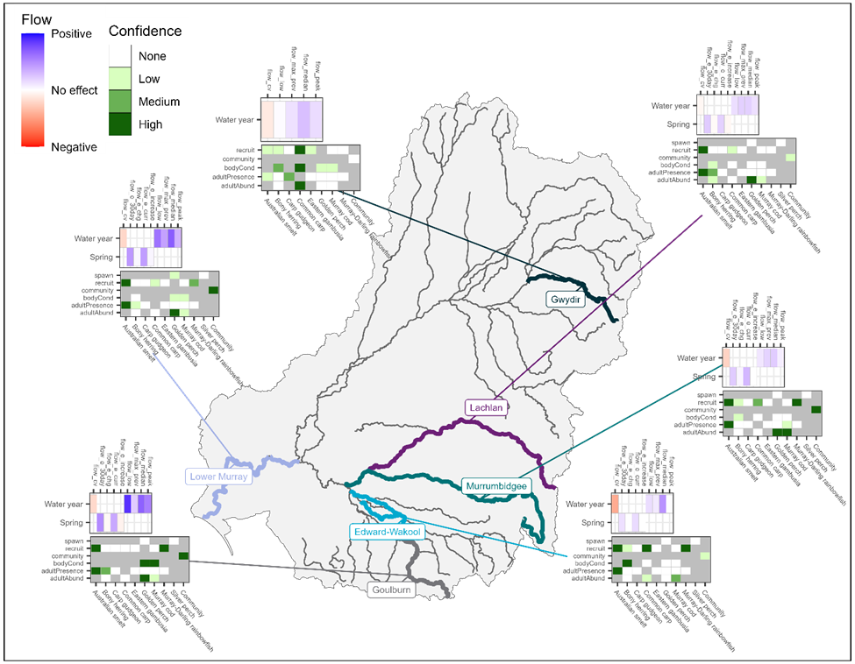

Sensitivity of 2023–24 data
To provide an index of how influential this year’s data were on the models, I assess how the model estimates changed from the previous report (e.g. parameter sensitivity; Figure 1.2). This metric can be interpreted similar to t-statistics and hence values |t|>2 indicate increasing strong evidence for a statistical change in the slope.
Overall, 2 values exceeded the |t|>2 threshold. These values were from the body condition analysis for bony herring. For the 2023–24 models, the largest difference was 2.25 which was for bony herring in the bodyCond model (Figure 1.2). Compared to the previous report, the slope for flow_cv decreased. Both flow_cv and flow_median decreased with both slopes being negatively related to body condition.
Figure 1.2 Sensitivity of model coefficients with the addition of 2023–24 data
Colour of tiles show the standardised differences (sensitivity) with black indicating no difference to yellow indicating statistical differences. A) shows differences based on annual flow metrics by species; B) shows event-based flow metrics; and C) shows community model based on annual flow metrics.
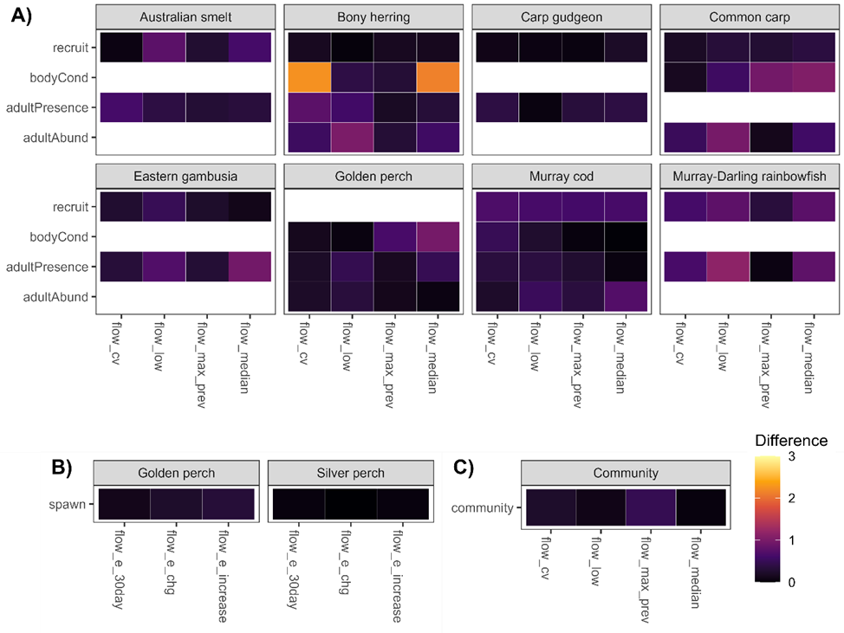

CEW contributions in 2023–24
Here, I report on the CEW contribution for 2023–24 relative to other years to assess if CEW contributions were lower, similar, or higher than previous years. As an assessment metric, I calculated the percentage of times this year’s CEW contribution exceeded previous years. Patterns are summarised in Figure 1.3.
Figure 1.3 CEW contribution to flow components in Selected Areas, 2023–24
Purple/blue squares indicate that the CEW contribution was higher than at least 50% of all years. For flow_low, the square represents the total number of reduced flow days and bluer indicates more flow days reduced. Note: CEW contributions cause increase or decrease flow_cv as contributions can reduce or increase variation.
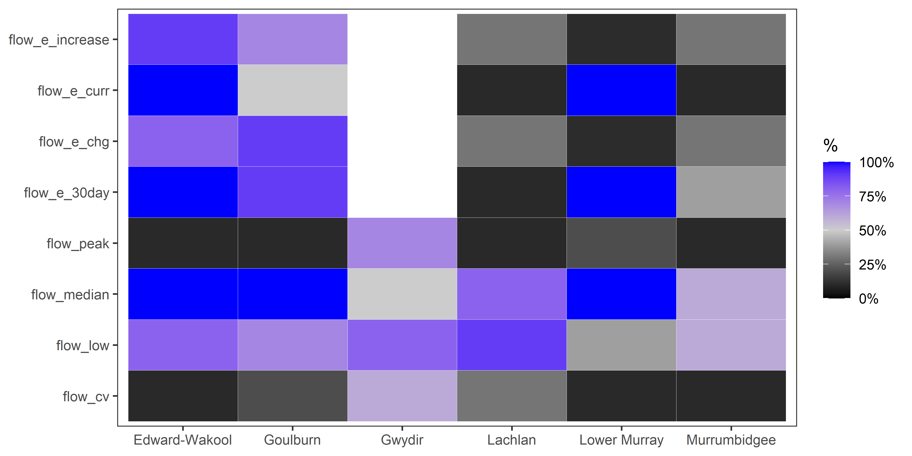

Flow conditions for 2023–24
To set the hydrological context for this year’s flow conditions, I compared this year’s seasonal flows to all years (2014–24; Figure 1.4). These gauge plots show how the mean flow during each season in 2023–24 compared across all years. 100% would mean that 2023–24 had the highest mean flow for that season across the 10 years. From the gauge plots, a winter flow pulse resulted in having the highest (or second highest) winter mean flow for southern Selected Areas, while the northern Selected Areas remained dry.
Figure 1.4 Gauge plots of seasonal flows in Selected Areas in 2023–24 as percentage of maximum (mean-) flow across all years (2014-24)
Season is defined as follows (to match water year): Winter = July/August, Spring=September-November, Summer=December-February, Autumn=March-June.
For each Selected Area, the mean flow for each season is calculated and then the percentage of the maximum (mean-)flow from all years (2014-24). Therefore, 50% indicates this year is 50% of the maximum (mean-)flow recorded during the study for that season.
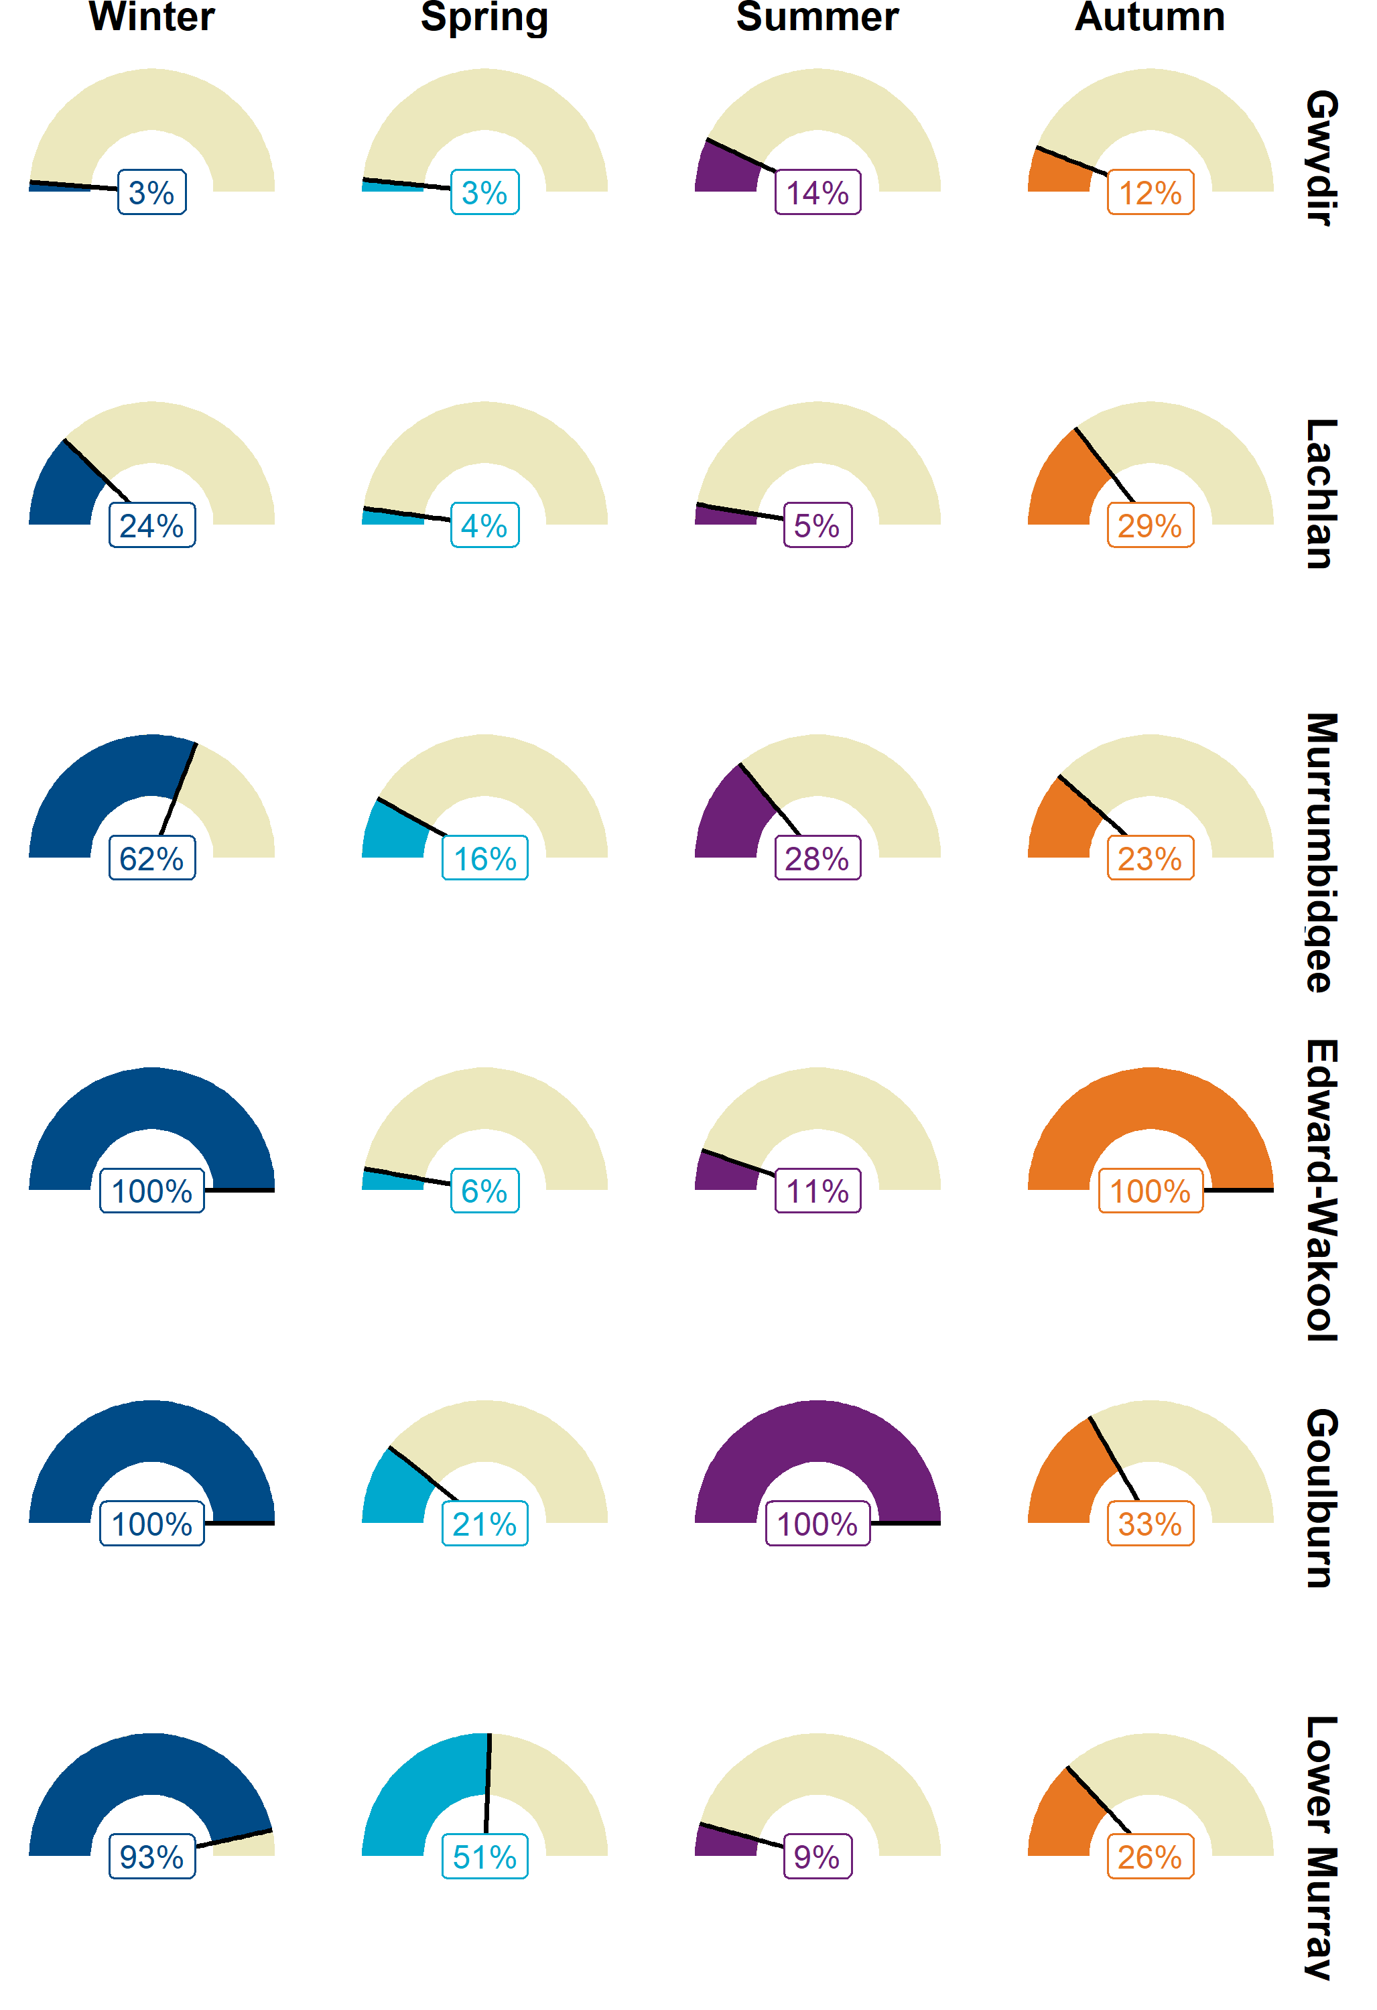

Revisions from 2023–24 report
Table 1.1 contains the revisions in the 2023–24 report from the previous year (Fanson 2024).
Table 1.1 List of revisions from previous report
Section refers to the section(s) that the revision applies to.
Revision ID | Section | Description | Rationale
1 | 1a_importData.R; importing workflow | As datafiles are now csv (rather than xlsx as in previous years), I adopted the code to import csv and added minor coding changes due to minor structure differences | I had to adjust my workflow to the new datafile dissemination workflow
2 | funcMain.R; affects everything | Changed the water year to from July1 to Jun30 (previously Sep1 - Agu31). As adult surveys continued into July/August, I treated these surveys as being the end of Jun30 for flow metrics | This is to match broader themes and reporting guidelines
3 | tech report | Updated gauge plot changing season definitions to fit CEWH water year definition. Order of columns changed to match new seasons chronological order | Now July-August is winter and June is added to Autumn. This prevents 2 different year winter being joined together
4 | analysis | Reverted length thresholds to define recruitment back to pre-2022 levels in Lower Murray | 2022–23 length thresholds were changed for flood year growth rates and 2023–24 was not considered a flood year in Lower Murray
5 | 1a_importData.R | Revised code such that fish lengths between fishLengthWeight and fishAge datasets do not have to be equal for merge | Due to discrepancy in fish lengths between data files, this was originally coded to add in those missing fish from age to length. This led to some duplication of fish (which was corrected)
6 | 1a_importData.R | Clean up of code to remove some inefficiencies due to historical contingencies with changes over time. Additional checks added, as well as made it clearer the hierarchy of assumptions in data cleaninesss (e.g. lengths in fishLengthWeight are the correct ones) | Over time, it is prudent to update code, removing accumulated revisions

Considerations: Analyses and population processes
The central paradigm to this project is that flow affects population processes. The experimental/analysis design attempts to dissect out each component, though analyses vary in the number of processes included (Figure 2.1).
Figure 2.1 Coarse schematic of the key analyses overlaid onto the population processes
Dashed polygons show the main processes involved in that analysis. S_{x} = survival rate; N_{x} = age class population size; R_{spawn} = spawning rate; Prob(spawn) - probability of spawning; YoY - young of year; juv - juvenile. Note - Dashed line between juvenile age classes reflect variable juvenile duration for species.
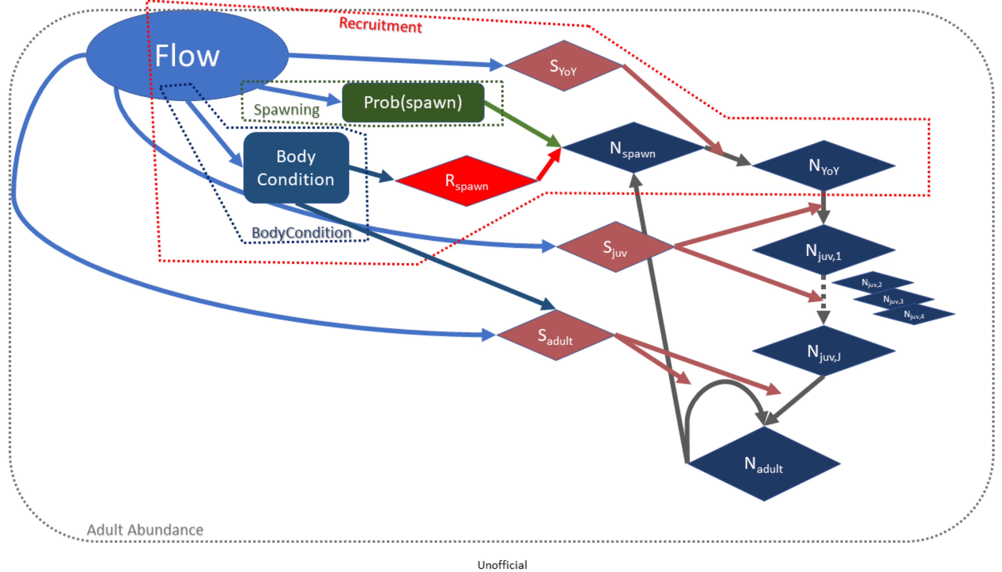
The spawning rate analysis is the most straightforward analysis though complicated by the episodic nature of spawning (and difficulty in sampling). The count data were highly variable (lots of zeros with wide range of catches) and the flow metrics could not quite fully account for that variation, resulting in poor fit with negative binomial (as well as zero-inflated negative binomial models or ZINB). Adopting a binary approach allowed for a defensible model/representation.
The next level up analysis is the recruitment analysis. This analysis combines spawning analysis, adult population level, and first year survival (and potentially a bit of body condition). In the recruitment analysis, I try to control for adult population size by including previous year CPUE (catch-per-unit-effort) as a predictor. A complication here is that for say, common carp, juveniles add uncertainty in estimating the true number of females, weakening the relationship.
Adult abundance analysis includes basically all the processes, just with varying time lags depending on age classes included in the survey sample. For instance, total catch included young-of-year for common carp, whereas golden perch did not have young-of-year. An obvious result here is that teasing out flow effects on certain processes becomes more difficult. Negative effects on adult survival may be offset by juvenile-to-adult recruits. Sampling artifacts such as varying detection levels with younger age class also complicate the picture.
As an increasing number of population processes become involved, predicting effects of CEW becomes more difficult. For instance, how does a 100-fold in spawning rate affect adult population once that year-class reaches adult maturity? Density-dependent processes are the norm rather than the exception in ecological systems. I would expect monotonic positive relationships (higher spawning rates = improved population growth rate), just the shape of that relationship is rather complex (e.g. sigmoidal shaped curve).

Fish analyses

Overview

Background
All analyses in this report were performed using R version 4.2.2 (R Core Team 2022) using rstanarm package (Goodrich et al. 2020), except for the body condition data which was analysed using lme4 package (Bates et al. 2015) due to prohibitively long computation times. I used a Bayesian linear model approach to better deal with estimation issues with some generalised model due to limited data (e.g. zero spawning in some Selected Areas monitoring datasets). Specific details about each analysis are outlined in the sections below, but the models had similar basic structures and these shared similarities are outlined directly below.
First, each species was modeled separately for each response variable of interest. The model structure was broken into 3 components:
- response variable (possibly transformed; described in each section below)
- flow covariates (annual or event metrics; see section 3.2)
- spatial/temporal effects that were either fixed or random.
For the spatial/temporal effects, I adopted the following logic. I treated Selected Area (e.g. Lower Murray, Goulburn) as a fixed effect as it appears the experimental design is not random (the Selected Areas were selected nonrandomly) and hence extrapolation is likely tenuous. Within each Selected Area, I assumed site (aka samplepoint) as being roughly randomly selected and hence treated site as random effect. For simplicity, I assume that constant site variation across Selected Areas. As for the temporal component, I assumed that water year was nested in Selected Area (i.e. assumed independence across Selected Areas conditioned on the flow metrics), except for community analysis in which the data are summarised at the Selected Area-by-water year level and hence I only included a water year random effect. Again, I assume constant variability across Selected Areas. Finally, for the body condition analysis, there is a site-by-year random effect.
After fitting the model, validity of model assumptions was assessed through graphical analysis using posterior predictive checks ( pp_check() ) and Pearson residuals testing main assumptions: normality (where appropriate), heteroscedasticity, nonlinearities (residuals vs. each predictor), and looking for potential outliers (high leverage points). Variable transformations (noted in each analysis section) were used to correct if appropriate or a different statistical distribution if possible. Any model issues are discussed in the analysis document.
To model the counterfactual scenario, I used the final model to predict change in mean response using the provided counterfactual flows. For the annual flow models, I estimated the difference between predicted flows with and without CEW using posterior_linpred(), conditioning on the random effects (Goodrich et al. 2020). For analysis in which samplepoint was included, I took the mean flow conditions for that water year and used those conditions to predict the effect. For body condition, a conceptual similar approach was used except using parametric bootstrapping of the model.
For event-based models, it is less clear on how to approach the counterfactual scenario. For instance, with spawning, the sampling only records a fraction of the CEW events that did occur and I may have missed the largest CEW effects. For this report, I took the maximum CEW scenario for each water year in each Selected Area. I did this by getting the difference between with and without CEW for each flow metric and then ranked for flow metric the magnitude of the difference. Then I summed the ranks and chose the sampling conditions that had the highest rank. Thus, I weighed each flow metric equally, even if the best model suggests unequal effects (this could be improved in the future). Similar approach was used for body condition, except I used parametric bootstrapping rather than the posterior distributions.
Finally, I present model results with 95% credible intervals (95%CI) [or 95% confidence intervals for body condition].
Table 3.1 Summary of statistical formulas used for each analysis
Rationale for approach is explained in each section below.
Analysis | Species | Equation | Link function | Family
spawn | Golden perch  Silver perch | spawned~flow_e_chg + flow_e_increase + flow_e_30day + selected_area + wday + tot_effort + ad_cpue + (1 | selected_area:wateryear) + (1 | samplepoint) | logit | binomial
recruit | Murray cod  Common carp  Australian smelt  Carp gudgeon  Bony herring  Eastern gambusia  Murray-Darling rainbowfish | count~flow_median + flow_cv + flow_low + flow_max_prev + selected_area + tot_effort + ad_cpue + (1 | selected_area:wateryear) + (1 | samplepoint) | log | negative binomial
catchCurveAge | Golden perch | n_fish~age + (1 | birthyear) | log | negative binomial
adultAbund | Golden perch  Murray cod  Bony herring  Common carp | r~flow_median + flow_cv + flow_low + flow_max_prev + selected_area + do_last_year + (1 | wateryear) + (1 | samplepoint) | log | gaussian
bodyCond | Golden perch  Murray cod  Bony herring  Common carp | fulton_index~flow_median + flow_cv + flow_low + flow_max_prev + selected_area + (1 | wateryear) + (1 | wateryear:selected_area) + (1 | samplepoint) | identity | gaussian
adultPresence | Golden perch  Murray cod  Carp gudgeon  Bony herring  Common carp  Eastern gambusia  Australian smelt  Murray-Darling rainbowfish | presence~flow_median + flow_cv + flow_low + flow_max_prev + selected_area + (1 | wateryear) + (1 | samplepoint) | logit | binomial
community | Community | prop~flow_median + flow_cv + flow_low + flow_max_prev + selected_area + (1 | wateryear) + (1 | samplepoint) | identity | gaussian
Table 3.2 Terms and variables used in the model structure
Term/variable | Used for
Flow covariates
flow_median | Standardised daily flow for relevant timing
flow_cv | Coefficient of variability in daily flow for relevant timing
flow_low | Number of days of low flow (below 10th percentile of available data)
flow_max_prev | Standardised maximum antecedent flow
flow_peak | Peak standardised flow (95th percentile)
Flow event-based covariates
flow_e_chg | Change in daily flow in 7 days prior to capture
flow_e_increase | Number of days of increasing flow in 7 days prior to capture
flow_e_curr | Median standardised flow in the last 7 days
flow_e_30day | Median standardised flow in the last 30 days
Response variables
spawned | Spawning occurrence
count | Recruit abundance
n_fish | Number of fish caught at each age
presence | Presence of that species at that site (for that wateryear)
r | Adult abundance catch-per-unit-effort
fulton_index | Fulton’s K body condition factor
prop | Proportion of the fish species per selected_area:wateryear:sampelpoint that were native
Other variables
ad_cpue | current water year’s adult abundance catch-per-unit-effort
age | fish age
birthyear | the birth year of an individual fish
do_last_year | indicator variable denoting time since most-recent fish death event or blackwater event at a sample point
tot_effort | sampling effort (log-transformed), either electrofishing time or volume filtered through fyke nets
selected_area | Selected Area site
samplepoint | site within Selected Area
wateryear | the water year in which a survey occurred
wday | Day of year

Overview of flow metrics and analyses

Description of flow metrics
Flow metrics remained the same as previous years and I used the same ‘recruitment’ temporal window introduced in the 2021–22 report (September-March; Hladyz et al. (2023)).
A brief summary of the variables is given in Table 3.3. Daily flow profiles without and with CEW events are shown in Figure 3.1/Figure 3.2. Temporal patterns in annual metrics and event metrics are shown in Figure 3.3 and Figure 3.5, respectively. Water year is defined as maximum year between July01 to June30 e.g. Water year 2016 is 2015 July 1st to 2016 June 30th.
To ameliorate leverage effects and improve spacing of flow data, I log-transformed the following flow metrics: flow_median, flow_max_prev, flow_e_curr, flow_e_30day, flow_cv. The following flow metrics were square-root transformed: flow_low.
Table 3.3 Summary of flow metrics used in these analyses
Note: flow_peak correlated strongly with flow_median and was only included in the catch curve analysis in which there was a longer temporal dataset (see catch curve section below).
Short name | Metric | Description
Flow annual covariates
flow_median | Standardised daily discharge for relevant timing | Increased discharge boosts productivity, leading to improved condition and survival outcomes for fish, and may support fish movements and reproduction by improving connectivity and providing critical movement and spawning cues. Increased discharge may improve water quality in refuge pools during low-flow periods. If timed inappropriately or too frequent, large increases in discharge may reduce egg and larval survival of some species due to sudden changes in hydraulics, depth, or water temperature.
flow_low | Number of days of low discharge (below 10th percentile of available data) | Consistent base flows support survival and condition of fish and support fish movements by increasing connectivity among reaches and rivers. Low flows (below base flows) reduce habitat and food resources, which may increase mortality of all life stages, particularly larvae and fingerlings.
flow_max_prev | Standardised maximum antecedent discharge | Large flows in previous years stimulate productivity, improving food availability and fish condition, which can have positive effects on reproduction in later years. Very large flows may provide lateral connectivity, which increases productivity and connectivity to wetlands and floodplains that provide refuges and feeding opportunities.
flow_cv | Coefficient of variability in daily discharge for relevant timing | Rapid changes in discharge during core spawning period may increase mortality of eggs and larvae but may enhance productivity and improve condition and growth of older cohorts.
flow_daily | Discharge on day of sampling | Discharge at the time of sampling influences detectability of fishes in electrofishing surveys.
flow_peak | Peak standardised discharge (95th percentile) | High flow events are trigger recruitment events but also lead to flooding conditions that may lead to improved productivity but also blackwater events. Note - only used with catch curve analysis as often tightly correlated with flow_median.
Flow event-based covariates
flow_e_chg | Change in daily discharge in 7 days prior to capture | Short-term increases in discharge and subsequent changes in hydraulics (velocity or depth) may provide spawning cues to some fish species, potentially signalling increased productivity and improved spawning conditions.
flow_e_increase | Number of days of increasing discharge in 7 days prior to capture | Sustained increases in discharge may provide spawning cues and increase the availability of spawning and larval habitat.
flow_e_30day | Median standardised flow discharge in the last 30 days | Higher flow discharge can trigger spawning as higher flow may provide better spawning habitat.

Daily flow profiles across each Selected Area
Figure 3.1 Flow profiles for each Selected Area on raw scale
Grey area shows flow when no CEW is present. Blue area shows added CEW volume. Green and red rugs show timing of larval and adult surveys, respectively. Vertical dotted lines are temporal boundaries for each water year.
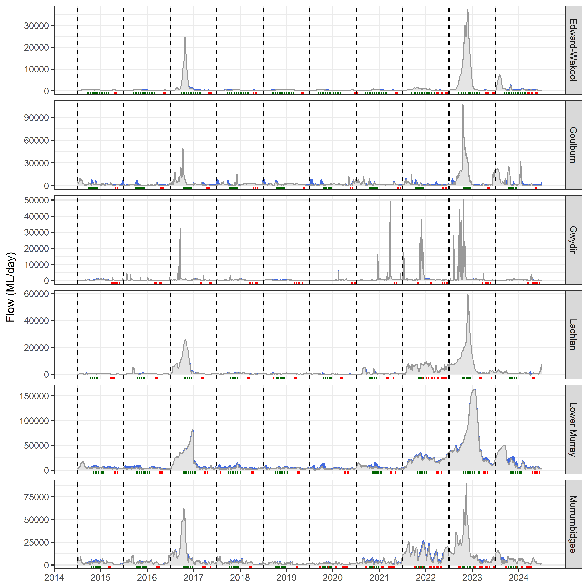
Figure 3.2 Flow profiles for each Selected Area on log-scale
Grey area shows flow when no CEW is present. Blue area shows added CEW volume. Green and red rugs show timing of larval and adult surveys, respectively. Vertical dotted lines are temporal boundaries for each water year. Note that y-axis is logged scaled to emphasis a proportional perspective.
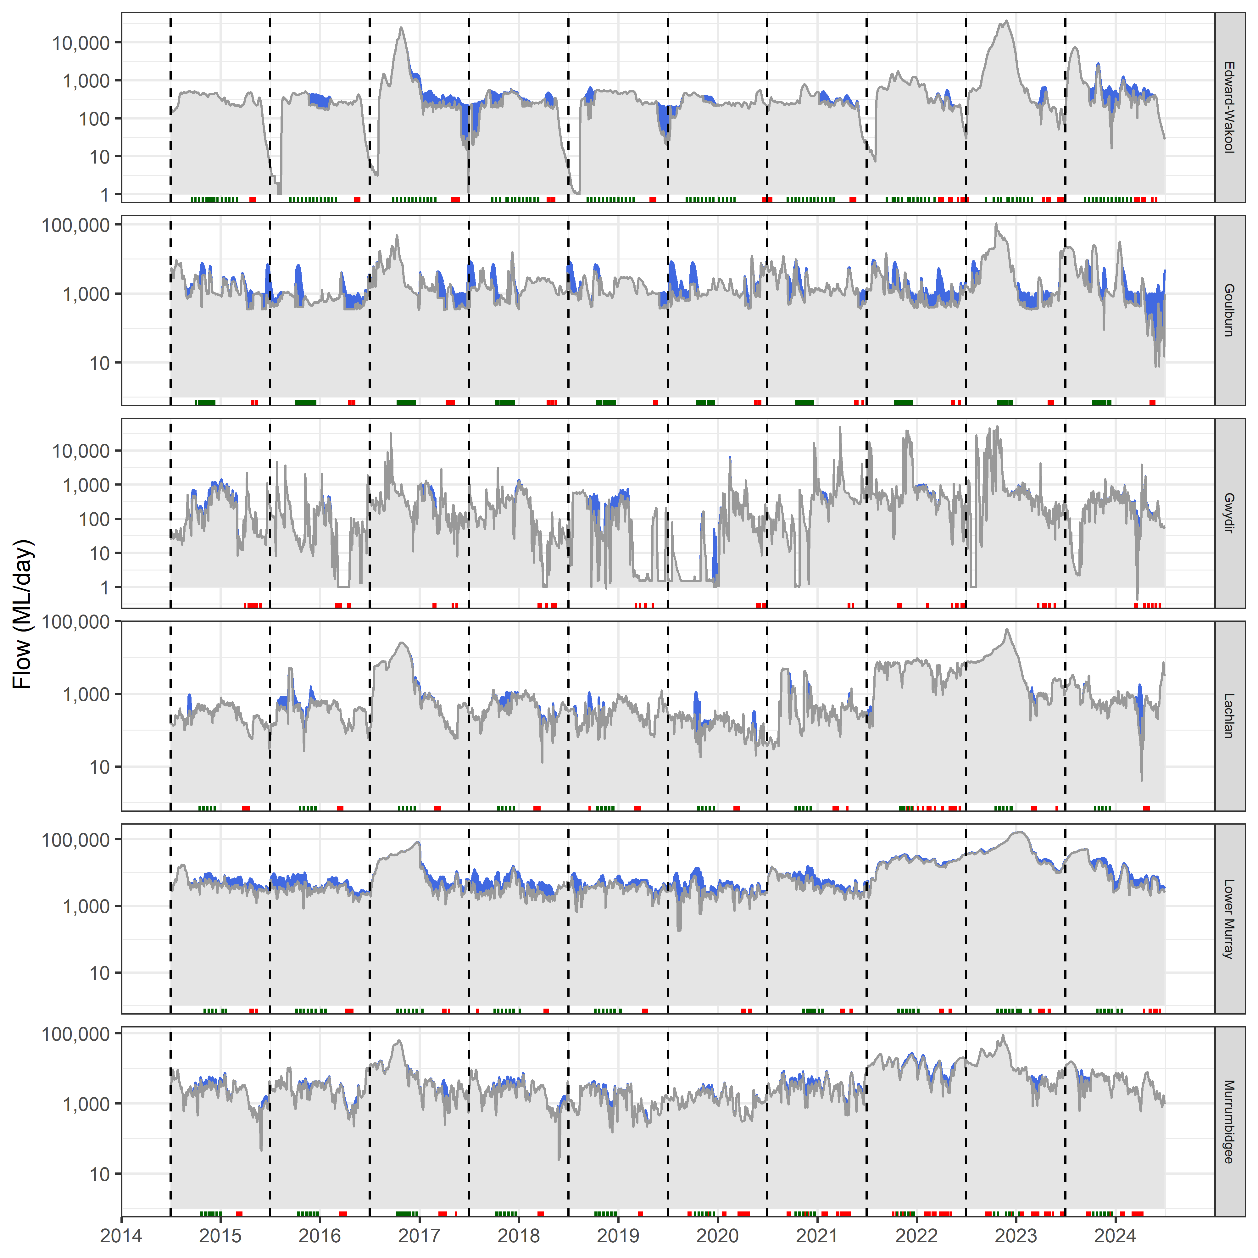

Temporal pattern in annual flow metrics
Figure 3.3 Temporal profiles for each annual flow metric by Selected Area
Each point is the mean of all the surveys that water year. Note that flow conditions are based on hydrological conditions up to that event (and hence not the entire water year if the survey date preceded end of water year).
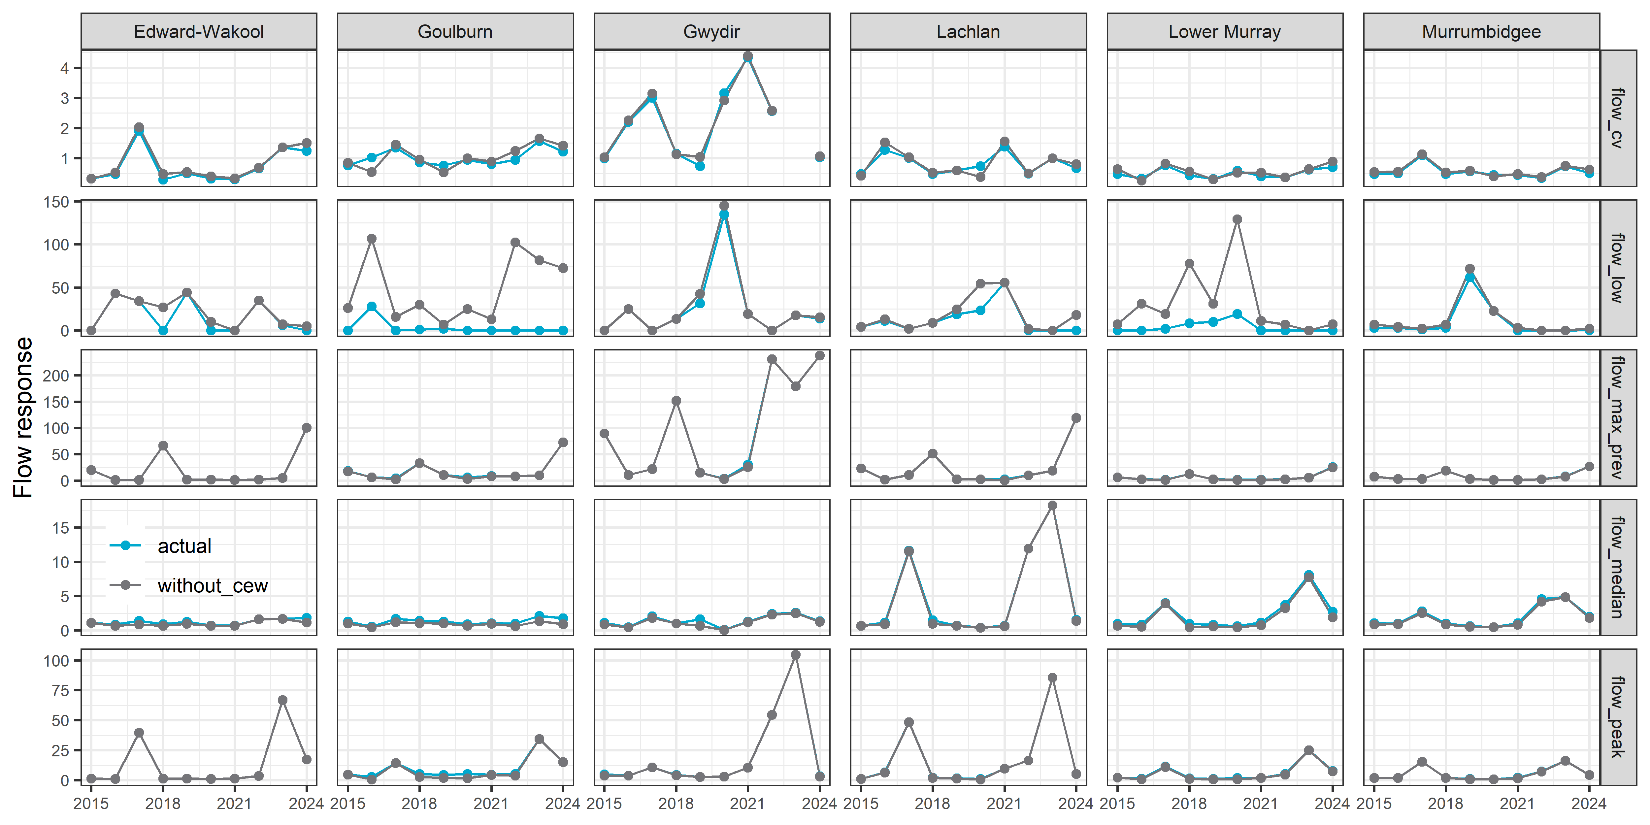

Temporal pattern in event flow metrics
Figure 3.4 Temporal profiles for each event flow metric by Selected Area
Each point is the mean of all the sampling surveys for that water year. The Gwydir River System was not included as event flow metrics were only calculated for the spawning analysis and spawning was not monitored at this Selected Area.
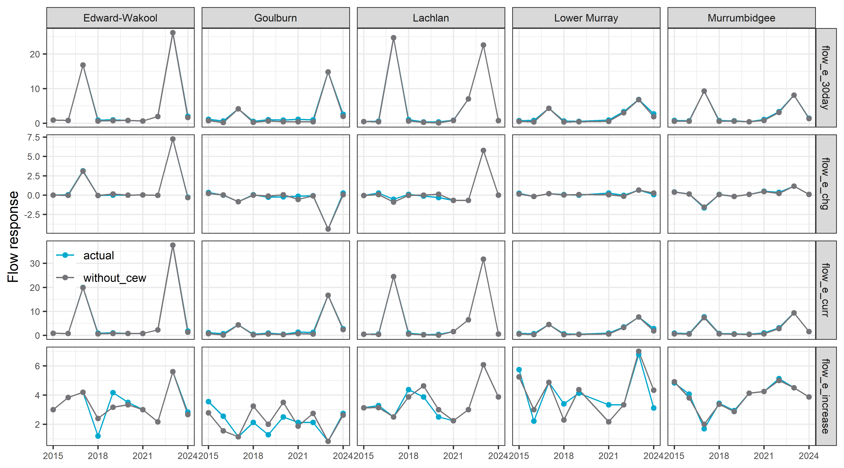

Analysis: Spawning presence

Logic and data trimming

Logic
For flow-cued spawners (golden perch and silver perch), flow conditions affect the spawning triggers and survival of recruits. Triggers likely include rapid changes in flow conditions as well as baseline flow levels.

Data trimming
Total sample sizes are shown in Table 3.4. Surveys not conducted during the spring period were not included. Due to the larger number of zeros and the wide range of count data when eggs/larva present, I chose to just analyse the data as presence/absence of spawning. So, I converted count to a binary response variable.
Table 3.4 Summary of sample sizes for silver perch and golden perch spawning dataset for 5 Selected Areas and the percentage of samples that had zero eggs (all years and for just the current year)
Species | Selected Areas | Sites | # of Years | Percent Zero  (all years) | Percent Zero  (2024)
Golden perch | Edward-Wakool | 9 | 10 | 100.0% | 100.0%
Golden perch | Goulburn | 7 | 10 | 89.4% | 90.3%
Golden perch | Lachlan | 6 | 10 | 98.4% | 91.7%
Golden perch | Lower Murray | 7 | 9 | 86.0% | 66.7%
Golden perch | Murrumbidgee | 6 | 10 | 82.4% | 100.0%
Silver perch | Edward-Wakool | 9 | 10 | 99.5% | 100.0%
Silver perch | Goulburn | 7 | 10 | 96.8% | 100.0%
Silver perch | Lachlan | 6 | 10 | 100.0% | 100.0%
Silver perch | Lower Murray | 7 | 9 | 95.3% | 88.9%
Silver perch | Murrumbidgee | 6 | 10 | 85.9% | 91.7%

Key exploratory graph(s)
To explore patterns in the data, I looked at temporal patterns in the proportion of sites that recorded spawning each water year (Figure 3.5).
Figure 3.5 Line plot showing change in golden perch and silver perch spawning rates over time across five Selected Areas and species
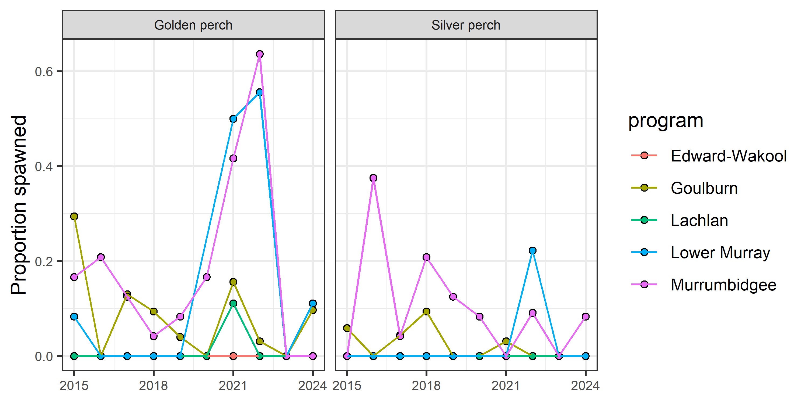

Data analysis
To test for the effects of flow metrics on spawning, I modeled the probability that a spawning event is detected based on flow conditions. Previous water year’s adult CPUE (ad_cpue) was calculated as average CPUE for the Selected Area. I imputed adult CPUE for 2014 as the average of other years.
Using the above approach, I ran a bGLMM (Bayesian General Linear Mixed Model) with a binomial distribution (in a Bayesian framework). As the metrics were the same within a Selected Area, I summed together all sampling events within a Selected Area and used total number of spawning events detected as the response variable. I included the selected annual flow metrics, total volumetric effort (log-scaled), previous water year’s adult CPUE (log-transformed), and Selected Area as fixed effects. Selected Area-by-water year was included as a random effect, which helps account for potential overdispersion in the data.

Key results
Spawning was detected in 3 Selected Areas: Lachlan, Lower Murray, Goulburn.
Spawning probabilities increased later in the spawning season for both species, golden perch and silver perch.
Golden perch had a higher probability of spawning due to the number of consecutive days of increasing flow (flow_e_increase)
Figure 3.6 Effect of each flow metric on silver perch and golden perch spawning rates
Error bars are 95%CrI (95% Credible Intervals). Coloured dots indicate significant effects at p<0.05 threshold.
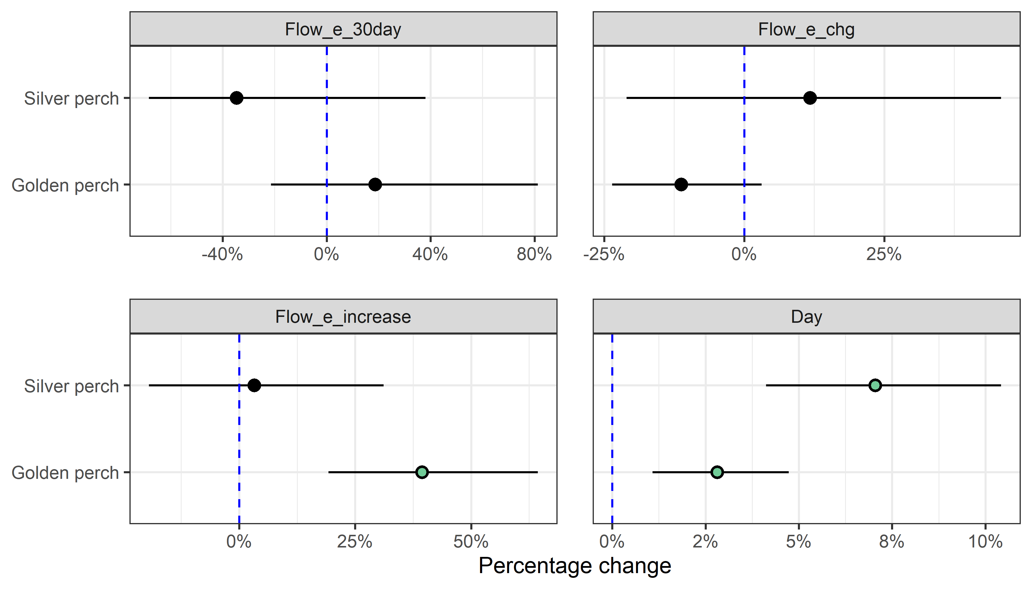

Counterfactual predictions
Figure 3.7 Distribution of predicted effect of CEW on silver perch and golden perch spawning rates, by Selected Area
Each density plot shows distribution of effect sizes (scaled to percentage change) across all years covered in this report. Vertical dash line shows no effect (0%); left of line indicates negative effect and right a positive effect. Red and blue numbers indicate number of years in which there was a significant negative and positive, respectively. Point indicates current year estimate with colour indicating if contribution was significant (green=positive; red=negative) or not (grey).
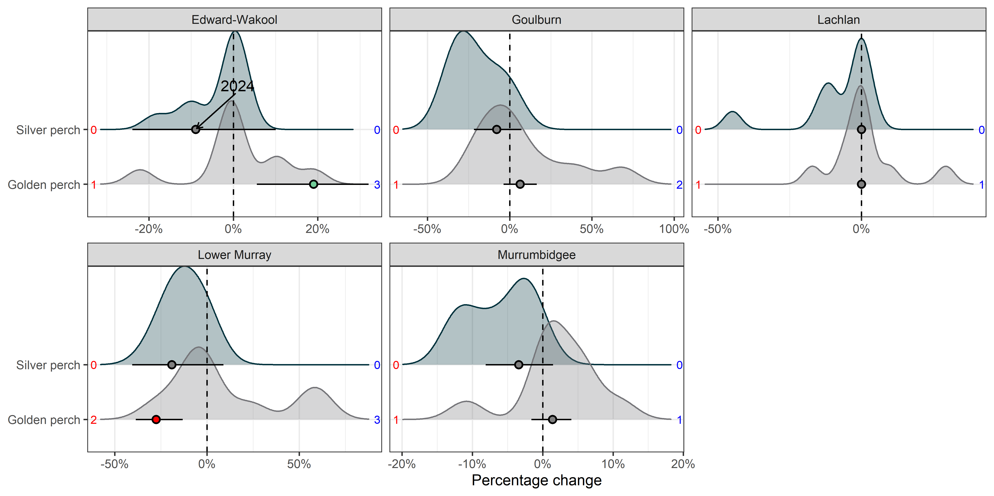
Figure 3.8 Contribution of each flow metric on the predicted CEW effect on spawning rates of silver perch and golden perch by Selected Area, 2014–24
Negative effects are shown as bars below 0 and positive effects above. Effect sizes are on link scale.
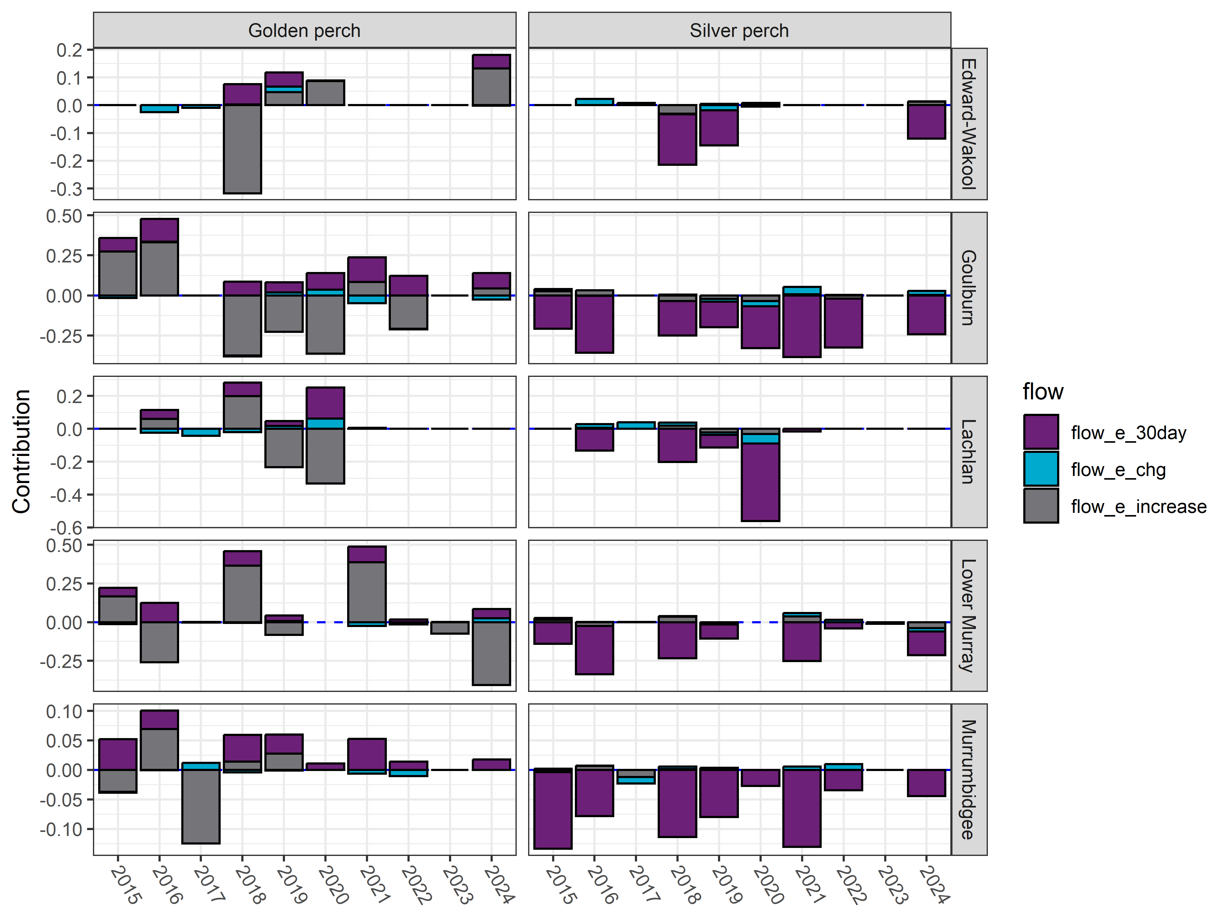

Analysis: Recruit analysis (young-of-year) using abundance data

Logic and data trimming

Logic
Recruits numbers reflect multiple population processes: reproductive output and larval survival. The annual flow metrics were included as predictors affecting these processes.

Data trimming
Species retained for analyses were the MER focal species (Table 3.5). However, only 4 golden perch recruits were caught (and measured) so were dropped for this analysis. For large-bodied species, only electrofishing data were kept and for small-bodied species, only fine fyke data were kept. Length thresholds for large-bodied species were used to determine young-of year recruits (Table 3.6). Length thresholds can be problematic for small-bodied fish species as they can reach maturity quickly and produce multiple generations in less than 1 year (e.g. eastern gambusia). Flow-MER sampling occurs largely at the end of the breeding period for all the focal small-bodied species (esp. for Australian smelt, eastern gambusia, carp gudgeon that have a protracted spawning period) and the majority of the sample would be young-of-year. Therefore, detection/abundance of small-bodied species was used as a whole for small-bodied species recruitment which follows the same logic and methodology applied in The Living Murray fish monitoring at Barmah-Millewa Forest Icon site for small-bodied species recruitment (Raymond et al. 2021).
Table 3.5 Summary of sample sizes for recruitment dataset for 7 species across Selected Areas
‘Percent zero’ is the percentage of sampling events with zero recruits caught (all years and just for current year).
Species | Method | Fish caught | # Selected Areas | Sites | Years | Percent zero  (all years) | Percent zero  (2024)
Carp gudgeon | finefyke | 336,231 | 6 | 107 | 10 | 4.8% | 2.0%
Eastern gambusia | finefyke | 69,375 | 6 | 107 | 10 | 30.6% | 47.0%
Murray-Darling rainbowfish | finefyke | 11,474 | 6 | 107 | 10 | 54.1% | 76.0%
Bony herring | ef | 8,901 | 6 | 93 | 10 | 54.3% | 60.2%
Australian smelt | finefyke | 8,653 | 6 | 107 | 10 | 60.2% | 63.0%
Common carp | ef | 6,778 | 6 | 93 | 10 | 40.6% | 63.6%
Murray cod | ef | 1,377 | 6 | 93 | 10 | 52.5% | 88.6%

Table 3.6 Length thresholds used for assigning new recruits for large-bodied fish species for Selected Areas
Values indicate length at one year of age for longer-lived fish species, or the age at sexual maturity for fish species reaching sexual maturity within one year. Dash (–) indicates no record
Species | Year | Edward-Wakool | Goulburn | Gwydir | Lachlan | Lower Murray | Murrumbidgee
Australian smelt | 2014-24 | 40 | 40 | 40 | 40 | 40 | 40
Bony herring | 2014-22, 2024 | – | – | – | – | 120 | –
Bony herring | 2014-24 | 65 | 65 | 67 | 67 | – | 67
Bony herring | 2023 | – | – | – | – | 150 | –
Carp gudgeon | 2014-24 | 35 | 35 | 35 | 35 | 35 | 35
Common carp | 2014-24 | 150 | 150 | 155 | 155 | 155 | 155
Eastern gambusia | 2014-24 | 20 | 20 | 20 | 20 | 20 | 20
Golden perch | 2014-22, 2024 | – | – | – | – | 85 | –
Golden perch | 2014-24 | 75 | 75 | 75 | 75 | – | 75
Golden perch | 2023 | – | – | – | – | 135 | –
Murray cod | 2014-22, 2024 | – | – | – | – | 155 | –
Murray cod | 2014-24 | 220 | 220 | 222 | 222 | – | 222
Murray cod | 2023 | – | – | – | – | 170 | –
Murray-Darling rainbowfish | 2014-24 | 45 | 45 | 45 | 45 | 45 | 45

Key exploratory graph(s)
Violin plot and mean recruit abundance (CPUE) over time for 6 Selected Areas and 7 species is shown in Figure 3.9.
Figure 3.9 Violin plot showing change in recruit abundance (cpue) over time for 7 species, by Selected Areas, 2014-24
Species are Australian smelt, bony herring, carp gudgeon, common carp, eastern gambusia, Murray-Darling rainbowfish, Murray cod.
Mean CPUE shown as dots with the blue dot indicating 2024’s data.
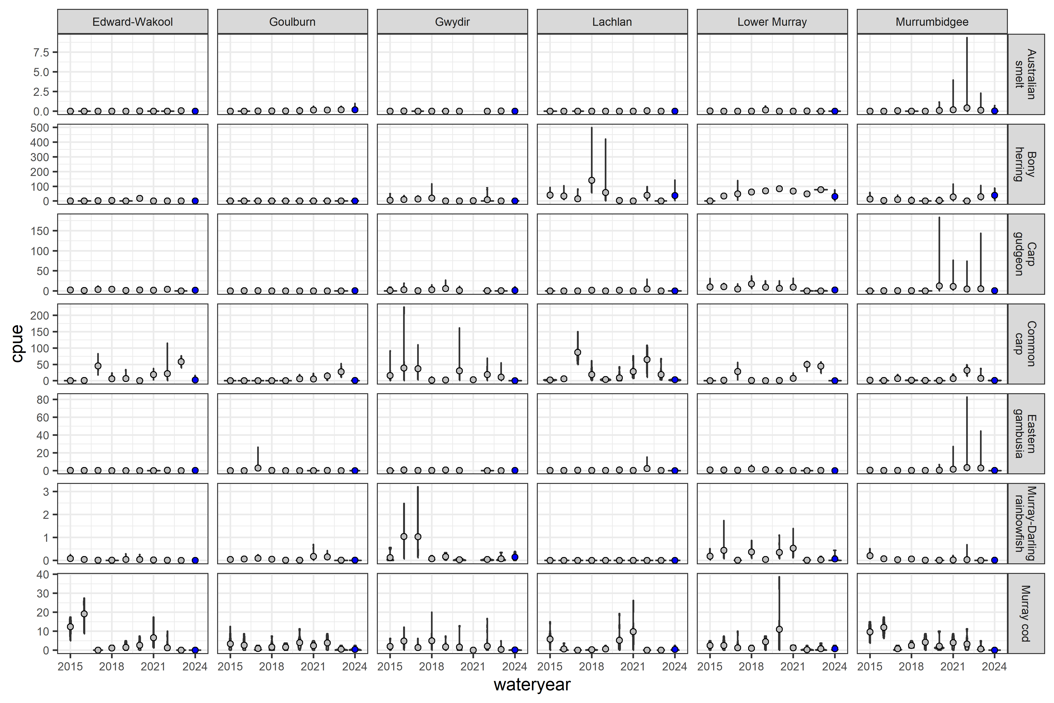

Data analysis
I ran a GLMM (generalised linear mixed model) with a negative binomial distribution (in a Bayesian framework). Count was the response variable. Fixed effects include annual flow metrics, total effort, Selected Area, and previous adult cpue (log-transformed). Random effects include Selected Area:water year and samplepoint.

Key results
Recruitment was generally low for 2023–24.
Murray cod had increased recruitment rates with decreased flow_median and decreased flow variable (flow_cv) recruitment.
Common carp had increased recruitment rates with increasing flow_median.
Australia smelt had higher recruitment with fewer low flow days.

Flow coefficients
Estimates of flow coefficients for each species are shown in Figure 3.10.
Figure 3.10 Effect of each flow metric on recruitment rates for each species
Species are Australian smelt, bony herring, carp gudgeon, common carp, eastern gambusia, Murray-Darling rainbowfish, Murray cod.
Flow metrics are flow_median, flow_cv, flow_low, flow_max_prev.
Error bars are 95%CrI. Coloured dots indicate significant effects at p<0.05 threshold.
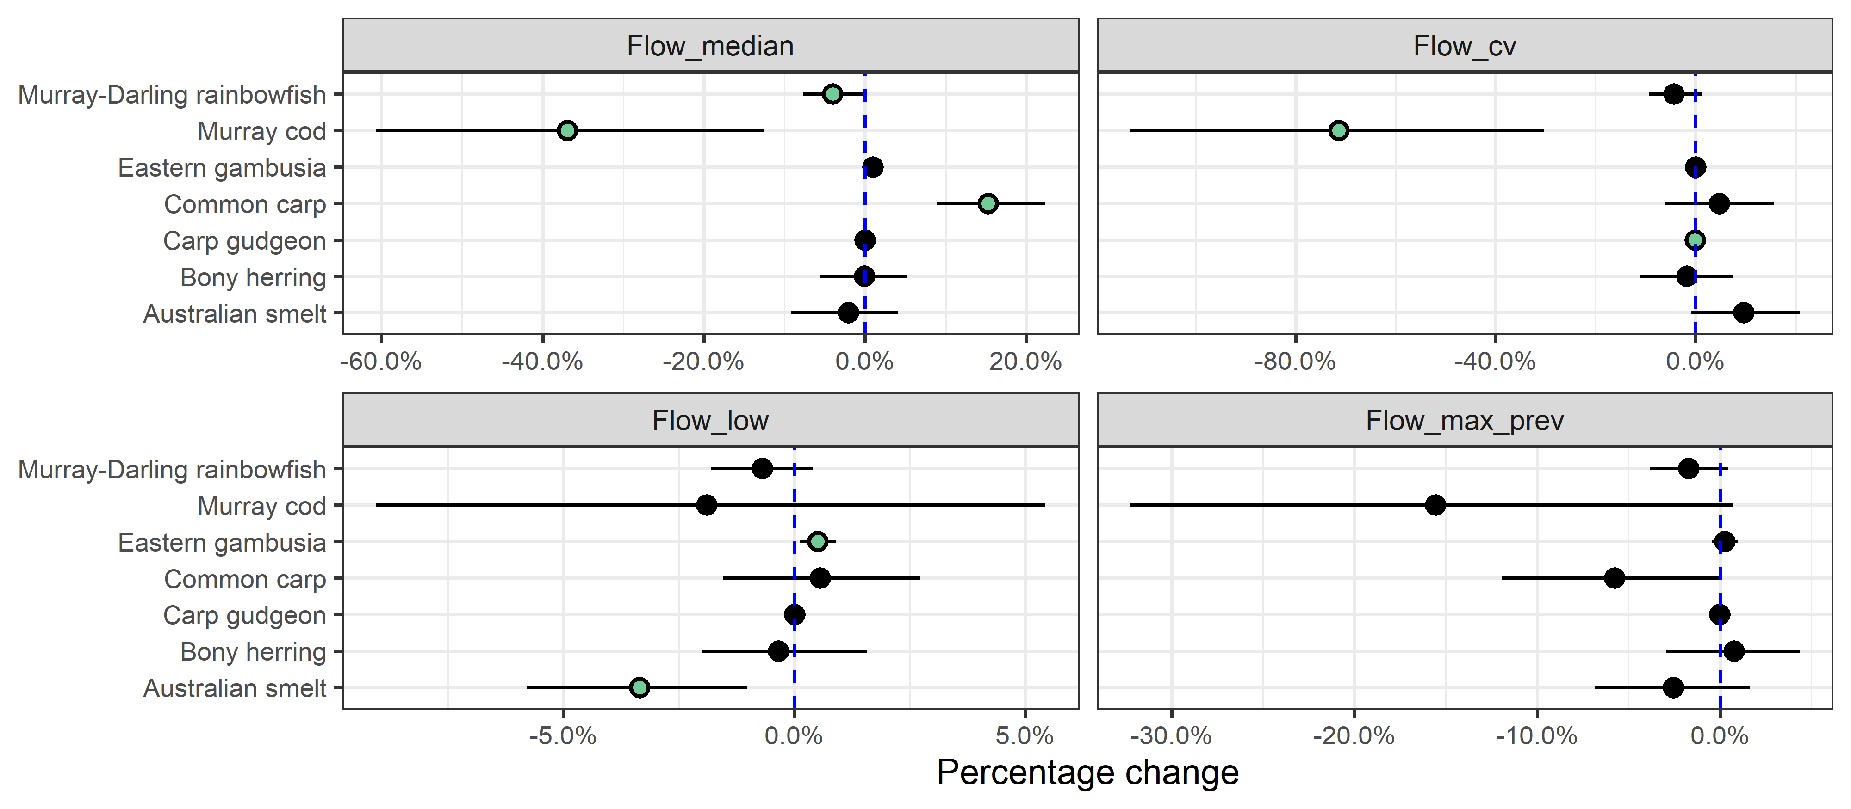

Counterfactual predictions
The predicted effect and marginal effect of CEW on recruitment is shown (Figure 3.11, Figure 3.12, Figure 3.13, Figure 3.14). Australian smelt are split from the other fish species for better visual clarity (Figure 3.11; Figure 3.13). The positive changes show CEW increased recruitment.
Figure 3.11 Distribution of predicted effect of CEW on recruitment rates for each species (without Australian smelt), by Selected Area
Fish are bony herring, carp gudgeon, common carp, eastern gambusia, Murray cod, Murray-Darling rainbowfish.
Australian smelt dropped due to large error bars distorting scale.
Each density plot shows distribution of effect sizes (scaled to percentage change). Vertical dash line shows no effect (0%); left of line indicates negative effect and right a positive effect. Red and blue numbers indicate number of years in which there was a significant negative and positive, respectively. Point indicates current year estimate with color indicating if contribution was significant (green=positive; red=negative) or not (grey).
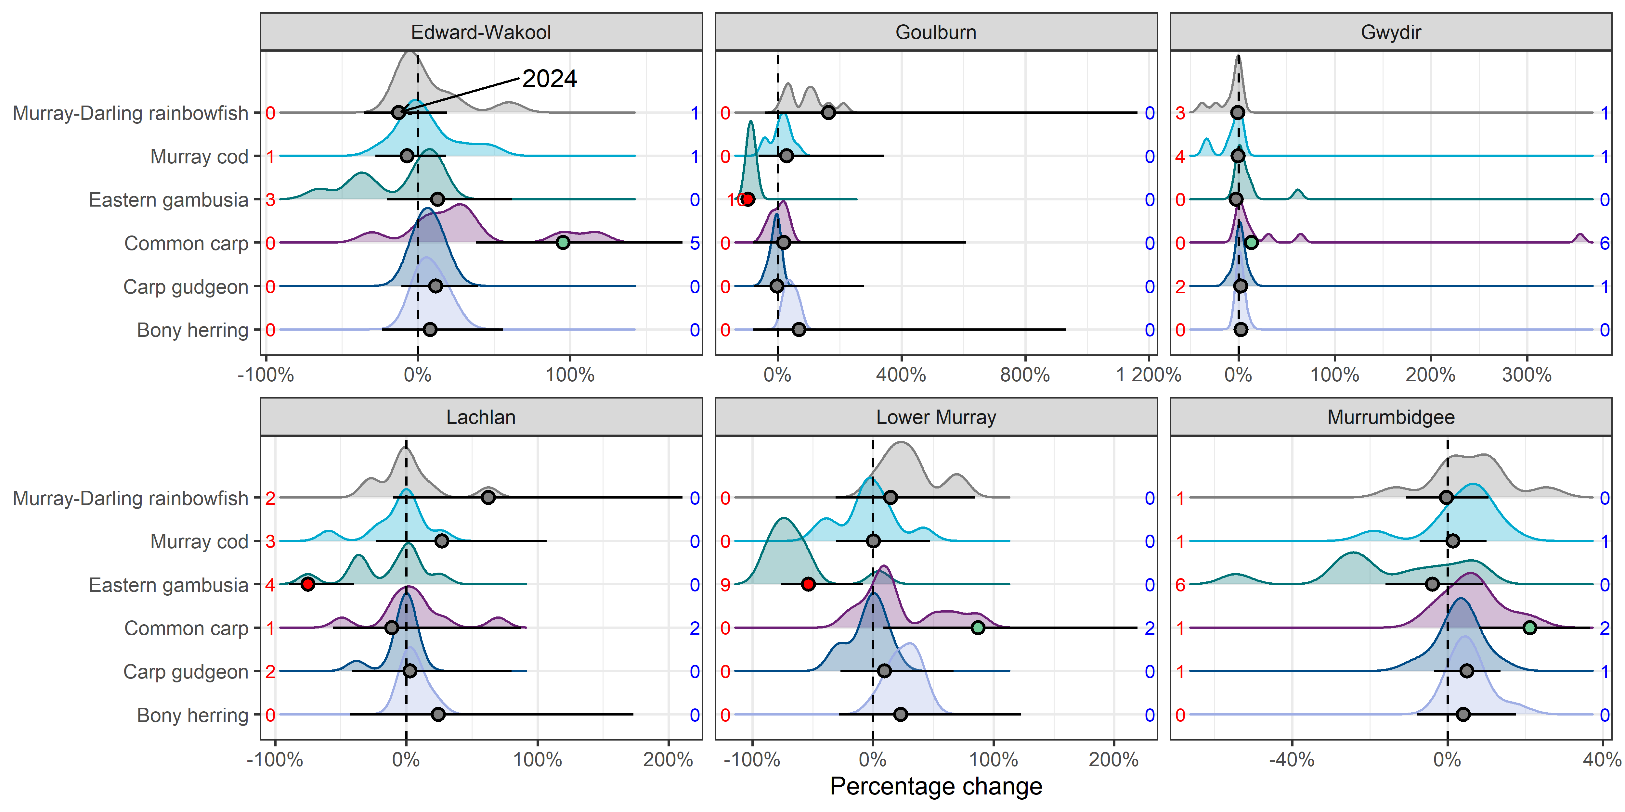
Figure 3.12 Distribution of predicted effect of CEW on recruitment rates for each species (without Australian smelt), by Selected Area
Fish species are bony herring, carp gudgeon, common carp, eastern gambusia, Murray cod and Murray-Darling rainbowfish.
Each density plots shows distribution of effect sizes (scaled to percentage change). Vertical dash line shows no effect (0%); left of line indicates negative effect and right a positive effect. Red and blue numbers indicate number of years in which there was a significant negative and positive, respectively. Point indicates current year estimate with colour indicating if contribution was significant (green=positive; red=negative) or not (grey).
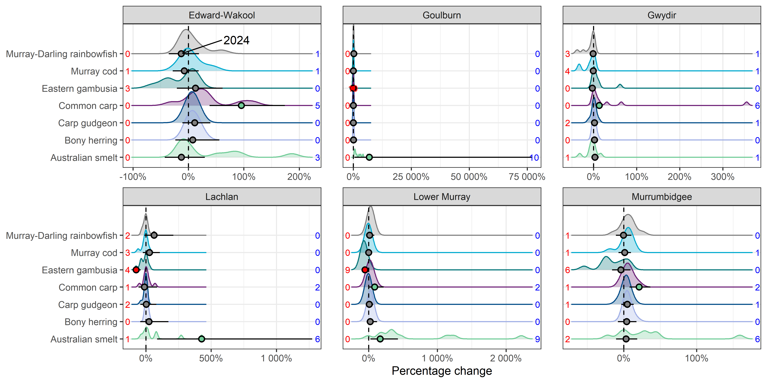
Figure 3.13 Predicted effect of CEW on recruitment rates for each species (no smelt), by Selected Area
Fish species are bony herring, carp gudgeon, common carp, eastern gambusia, Murray cod and Murray-Darling rainbowfish.
Effect sizes have been scaled to percentage change with CEW. Error bars are 95%CrI. * - indicates 95%CrI do not overlap with 0 (* above and below error bars indicate positive and negative effects, respectively).
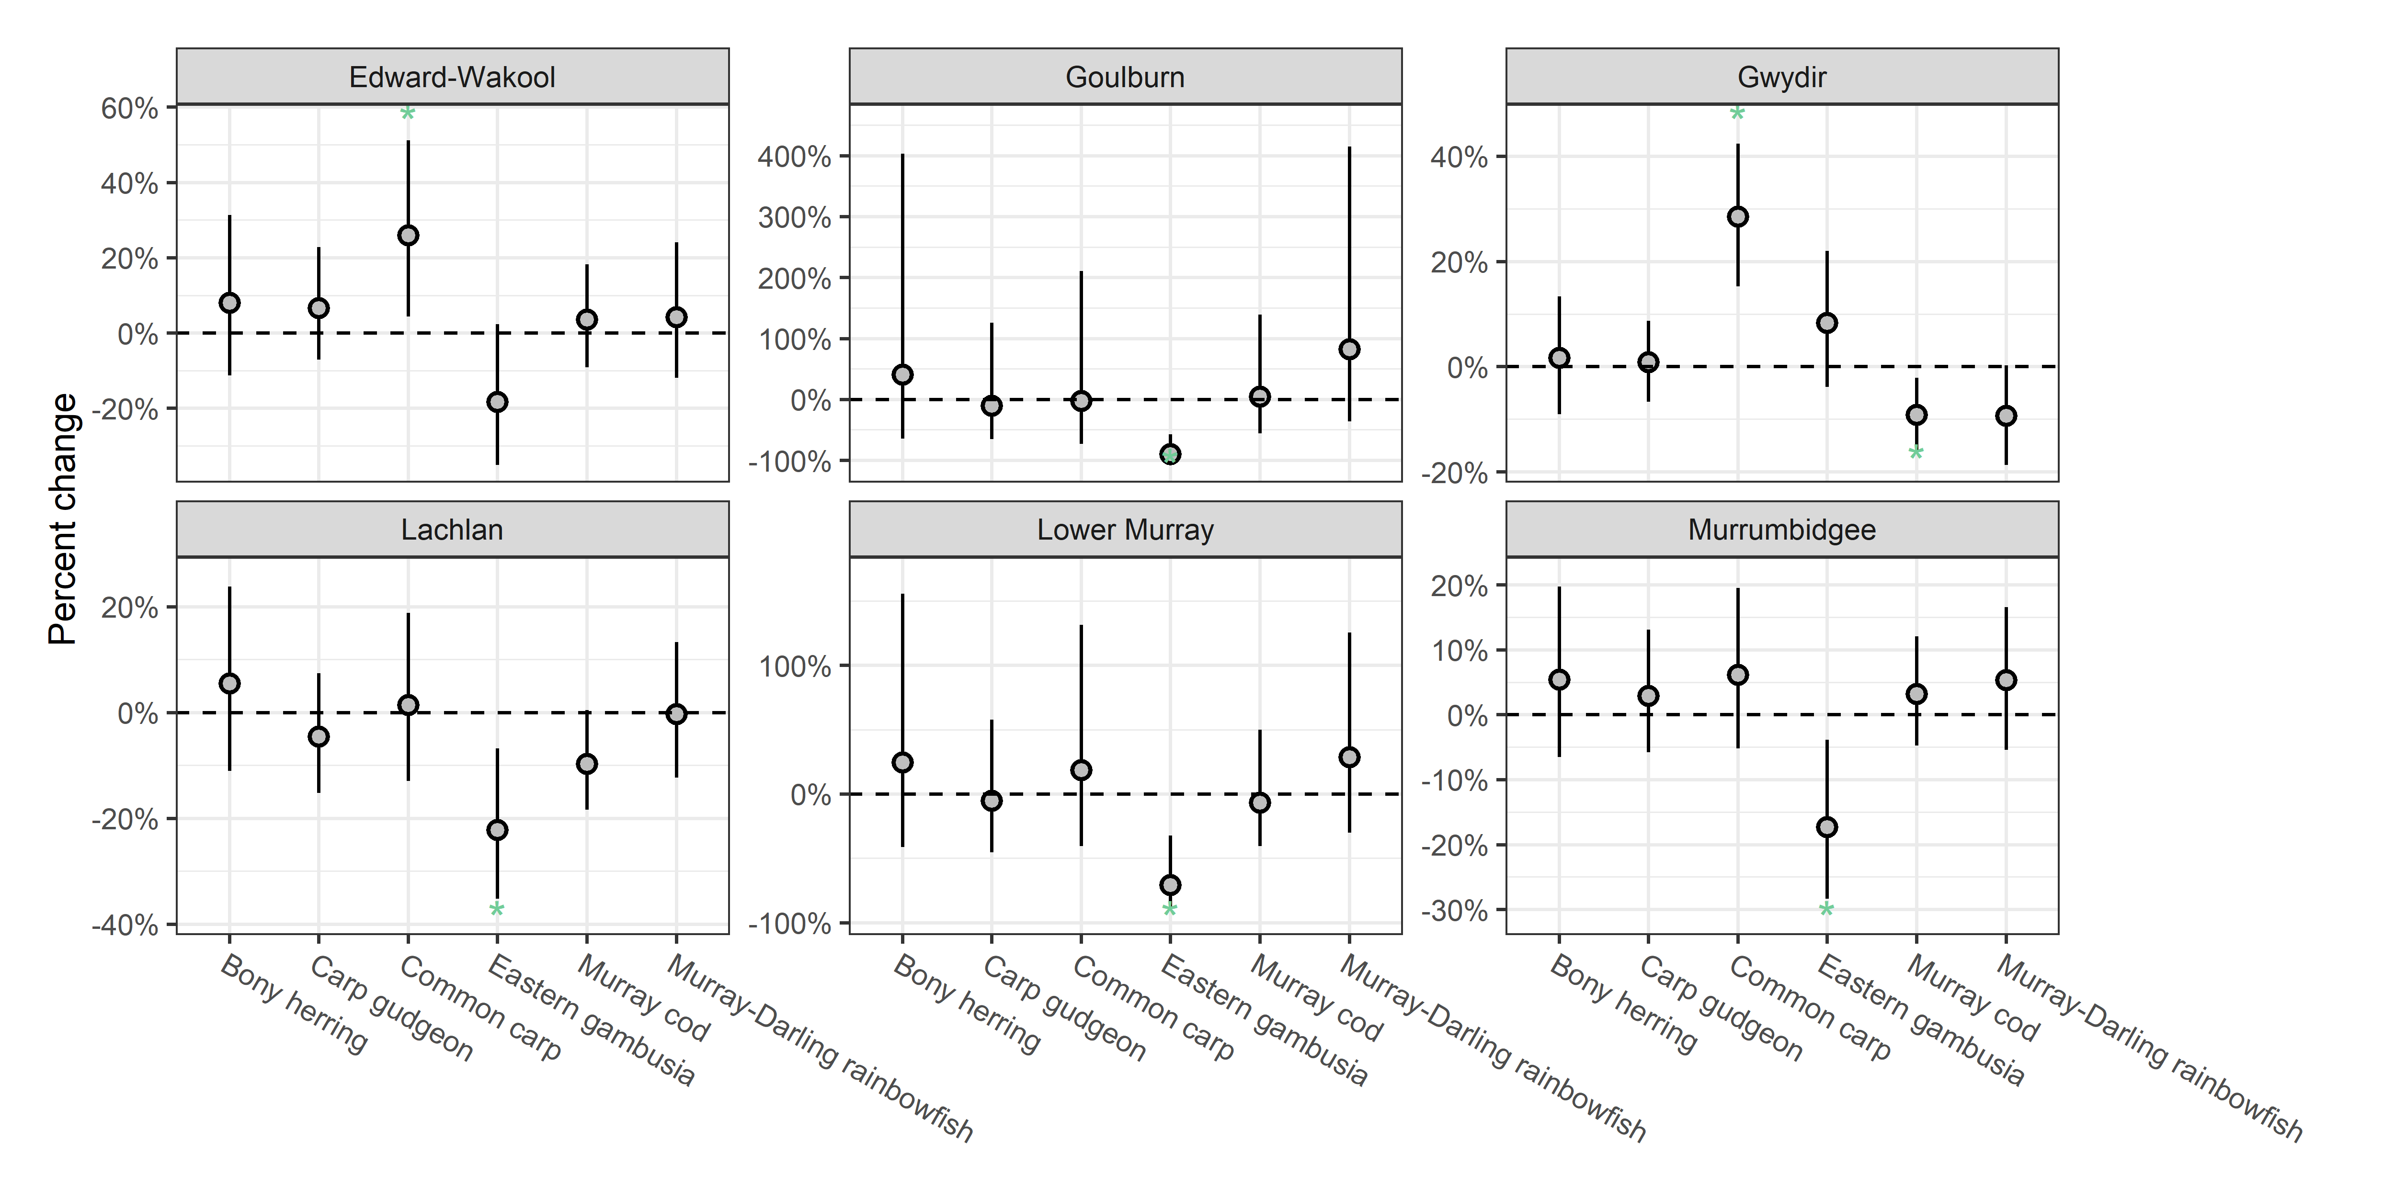
Figure 3.14 Predicted effect of CEW on recruitment rates for each species, by Selected Area
Fish species are bony herring, carp gudgeon, common carp, eastern gambusia, Murray cod and Murray-Darling rainbowfish.
Flow metrics are flow_cv, flow_low, flow_max_prev, flow_median.
Effect sizes have been scaled to percentage change with CEW. Error bars are 95%CrI. * - indicates 95%CrI do not overlap with 0 (* above and below error bars indicate positive and negative effects, respectively).
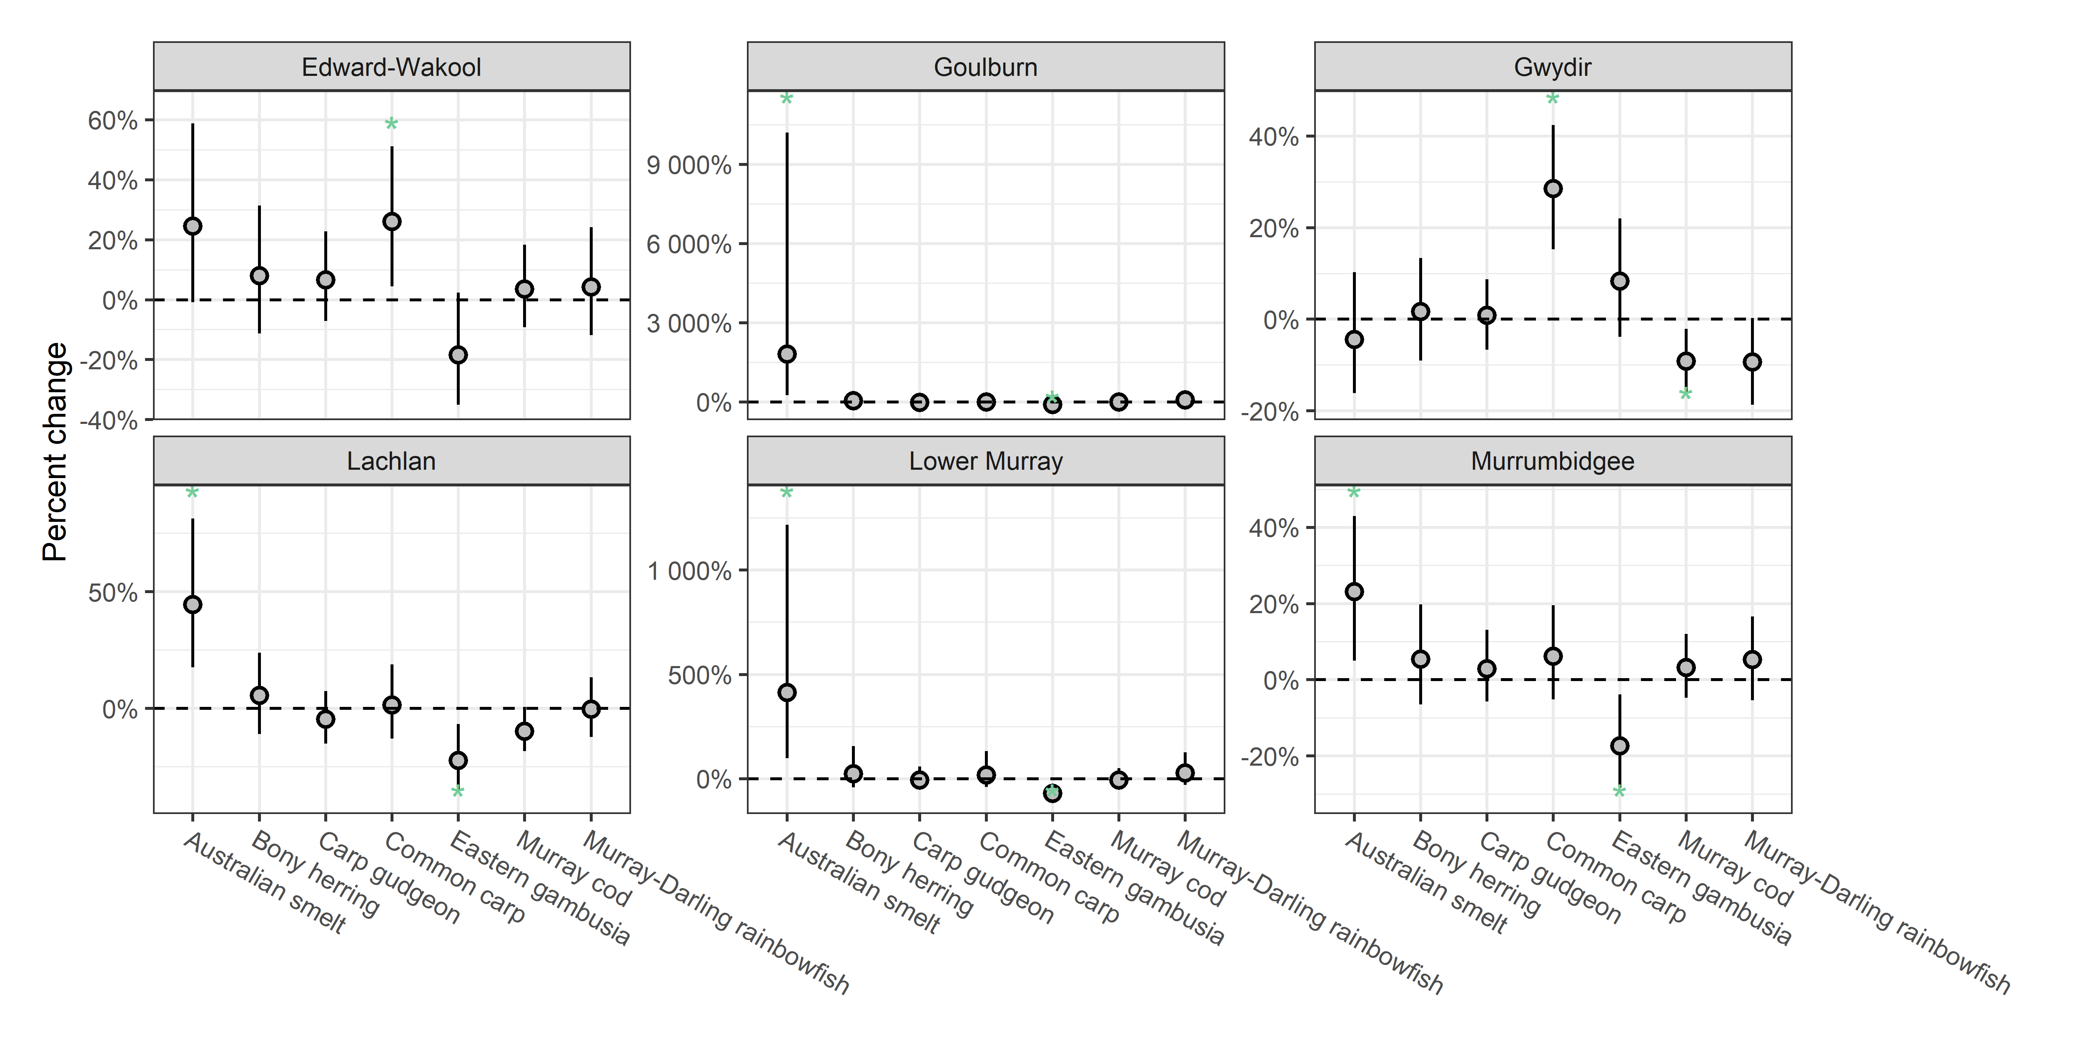
Figure 3.15 Contribution of each flow metric on the predicted CEW effect on recruitment rates of 7 fish species, by Selected Area
Negative effects are shown as bars below 0 and positive effects above. Effect sizes are on link scale.
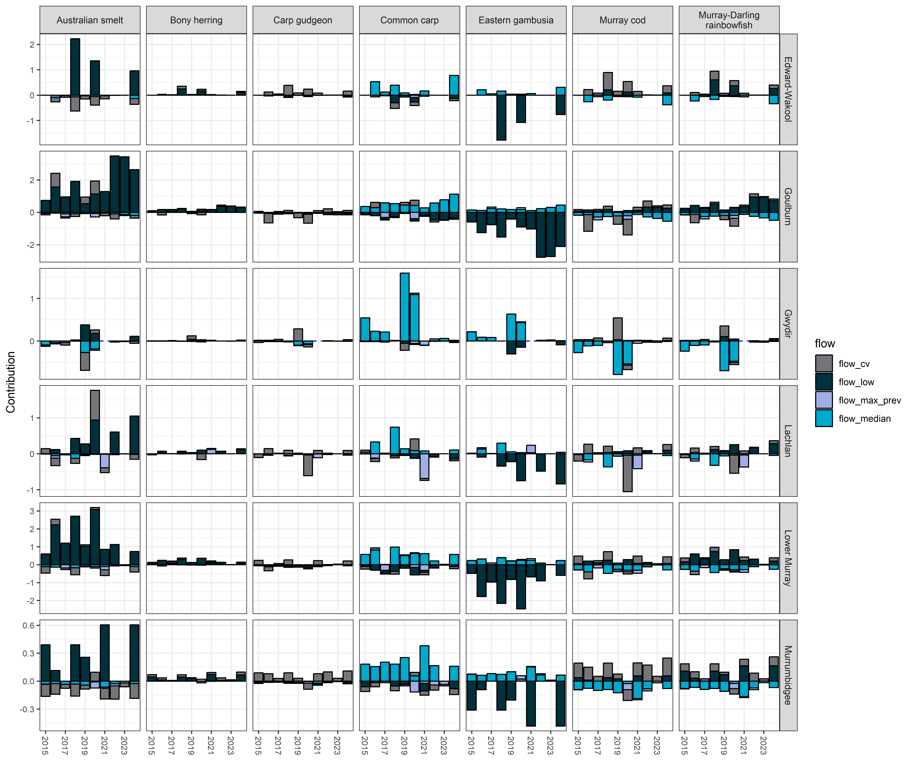

Analysis: Catch curve analysis

Logic and data trimming

Logic
Flow-MER has the potential to improve our understanding of CEW effects on recruitment through the collection of otolith-based age data. These data enable the calculation of recruitment strength using catch-curve regression analyses. Estimated recruitment strength can be linked to observed flow metrics (see Tonkin et al. 2021), which can inform scenarios-based modelling of population outcomes with and without CEW, further clarifying the influence of water management on recruitment outcomes. For Flow-MER, relating annual flow metrics with recruitment strength is not yet achievable for 3 reasons. First, observed and counterfactual discharge sequences are not available prior to 2014. Second, catch curve regressions work best above a threshold age when mortality and detection rates become constant, a situation that occurred only for golden perch in the current Flow-MER fish monitoring data set. Third, sample sizes were low for fish spawned before 2014, that is, otolith samples predominantly represented younger fish spawned after 2014.

Data trimming
The catch curve analysis required extensive data filtering in order to provide a usable dataset (Table 3.7). For Murray cod, over 80% were less than 3-year-old and confounding detection and variable survival rates (e.g. survival rates are likely very variable the first few years). Therefore, no analysis was conducted for Murray cod or bony herring, over 90% were less than 3 year old. As catch curves are questionable for young ages (e.g. variable mortality rates, detection issues) I did not run a catch curve regression and rather rely on the recruit abundance analysis which has less assumptions. For golden perch, there were sufficient data for the Lower Murray Selected Area. Murrumbidgee had reasonable sample sizes but multiple catch across years from the same birth year were very rare and when present, they often had increasing counts with the older ages (rather than decreasing counts due to mortality) suggested potential detection complications (e.g. more effort or better detection). Therefore, I provide an analysis of just the Lower Murray Selected Area in which I identity higher and lower recruitment years.
Table 3.7 Summary of sample sizes for catch curve dataset (Murray cod, golden perch, bony herring) in Selected Areas
Table shows number of fish aged each year (2015-19 grouped to reduce table size) and the total number of fish (# fish). Percent <3yr indicates percentage of fish less than 3 years old. Finally, born in 2014–24 indicated the number of fish within the CEW flow data range. Dash (–) in a cell indicates no record.
Species | Selected Area | 2014-19 | 2020 | 2021 | 2022 | 2023 | 2024 | # Fish | Percent <3yr | Born in 2014–24
Murray cod | Edward-Wakool | 49 | – | – | – | – | – | 49 | 98% | 6
Murray cod | Lachlan | 54 | – | – | – | – | – | 54 | 31% | 7
Murray cod | Lower Murray | 56 | 130 | 17 | 2 | 11 | 5 | 221 | 100% | 221
Murray cod | Murrumbidgee | 47 | – | – | – | – | – | 47 | 47% | 5
Golden perch | Edward-Wakool | 26 | – | – | – | – | – | 26 | 0% | 0
Golden perch | Goulburn | 26 | – | – | – | – | – | 26 | 12% | 0
Golden perch | Gwydir | 66 | – | – | – | – | – | 66 | 17% | 22
Golden perch | Lachlan | 61 | – | – | – | – | – | 61 | 36% | 3
Golden perch | Lower Murray | 594 | 121 | 91 | 106 | 93 | 67 | 1072 | 12% | 210
Golden perch | Murrumbidgee | 86 | – | – | – | – | – | 86 | 2% | 7
Bony herring | Edward-Wakool | 46 | – | – | – | – | – | 46 | 80% | 11
Bony herring | Gwydir | 316 | 93 | 41 | 121 | 96 | 75 | 742 | 77% | 655
Bony herring | Lachlan | 472 | 98 | 100 | 33 | 95 | 106 | 904 | 99% | 861
Bony herring | Lower Murray | 479 | 100 | 120 | 111 | 120 | 100 | 1030 | 92% | 1002
Bony herring | Murrumbidgee | 475 | 100 | 100 | 37 | 87 | 98 | 897 | 100% | 867

Key exploratory graph(s)
Change in golden perch recruit abundance over time in the Lower Murray is shown in Figure 3.16.
Figure 3.16 Histogram showing age classes by birthyear (1996 to 2019) for golden perch for Lower Murray
Broken vertical line shows 5-year cutoff.
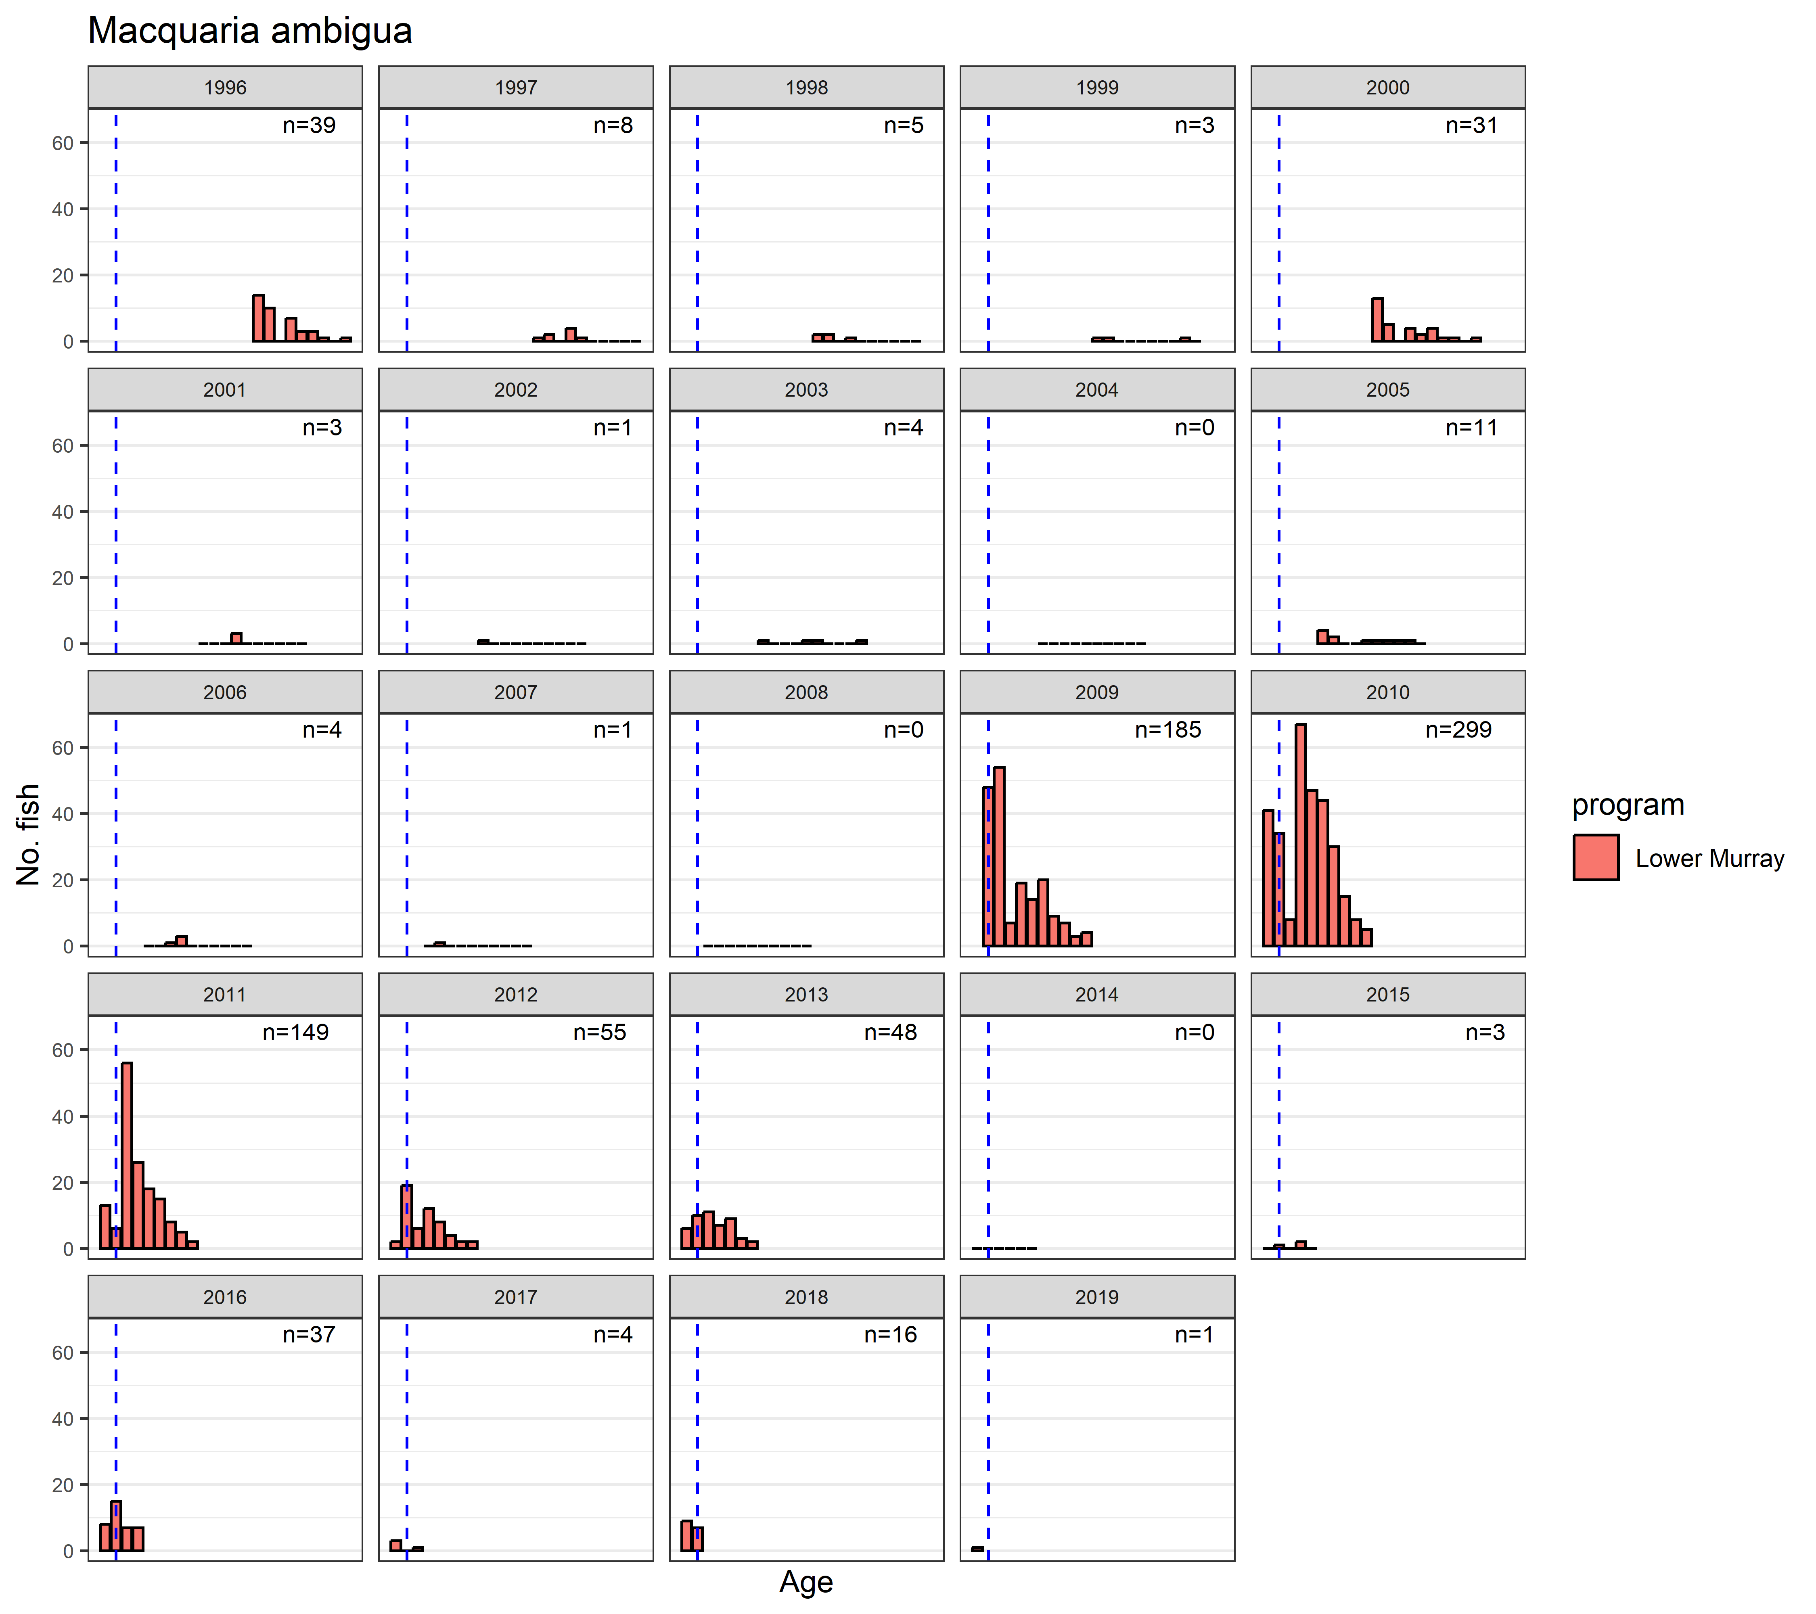

Data analysis
I first calculated birth-year as follows: water year of sampledate - age - 1. for example, a fish caught on 2000MAY03 and aged at 0 (YOY) would be birth-year = 2000 - 0 - 1 = 1999. For the analysis, I ran a catch curve regression on the golden perch data. The dataset was expanded to include all possible ages for sampling, up to the max age caught for golden perch. The response variable was number of fish caught at each age and was assumed to follow a negative binomial distribution. The fixed effects were age and Selected Area. Birth-year was included as a random effect. I extracted the estimate for each birth year to provide an indication of recruitment strength. Standard errors were obtained by sampling the posterior distribution.
As an exploratory process, I combine the recruitment strength (year) with historical flow data extracted from NSW constraint project for Lock 9. Annual flow metrics for birth-year were linked to recruitment strength years and then graphically explored.

Key results
Patterns were very similar to those in last year’s report, except for a drop in 2001 recruit from the previous year.

Recruitment strength
Model results only delineated varying recruitment strengths in only golden perch Figure 3.17, mainly in the Lower Murray where I had substantial data and hence higher statistical power.
Figure 3.17 A) Recruitment strength estimates for golden perch; B) daily flow for Lower Murray; and C) relating recruitment strengths to flow conditions
Flow metrics are flow_cv, flow_low, flow_max_prev, flow_median, flow_peak.
Recruitment strengths are the random effect estimates for each water year from the model. Years are shown for the strong recruitment years. In C) blue lines show a naive regression line for exploratory purposes. Error bars are 95%CrI.
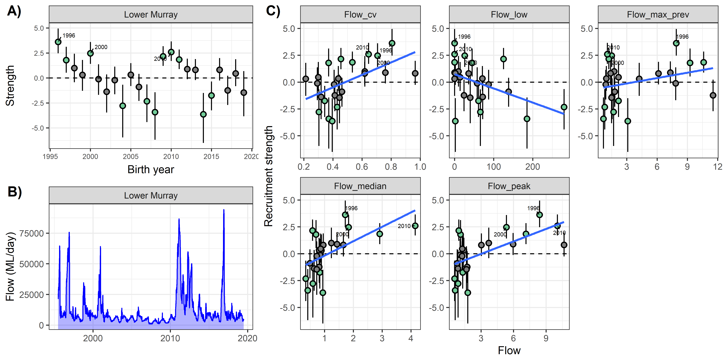

Analysis: Adult abundance

Logic and data trimming

Logic
Flow metrics may affect adult survival across the years.

Data trimming
Only large-bodied fish were kept as small-bodied were likely young-of-year recruits and hence analysed in the recruit analysis (Table 3.8). If there were multiple surveys per water year per sample point, I selected the latest date. This ensured a single sampling point at the latest part of the year (incorporates more of the water year flow conditions). I dropped any surveys from September to December to make comparisons more comparable.
Table 3.8 Summary of sample sizes for adult dataset and the percentage of samples that had zero catch for bony herring, common carp, Murray cod and golden perch across Selected Areas
Species | Fish | # Selected Areas | Sites | # of Years | Percent Zero  (all years) | Percent Zero  (2024)
Bony herring | 116,297 | 6 | 62 | 10 | 21.7% | 13.8%
Common carp | 47,271 | 6 | 62 | 10 | 0.0% | 0.0%
Murray cod | 4,302 | 6 | 62 | 10 | 13.9% | 17.2%
Golden perch | 3,397 | 6 | 62 | 10 | 15.6% | 10.3%

Key exploratory graph(s)
Change in fish CPUE over time across all Selected Areas and fish death events are shown in Figure 3.18.
Figure 3.18 Boxplot showing CPUEs over time across all Selected Areas and species
Fish species are bony herring, common carp, golden perch and Murray cod. Fish deaths (DO events) are highlighted as red.
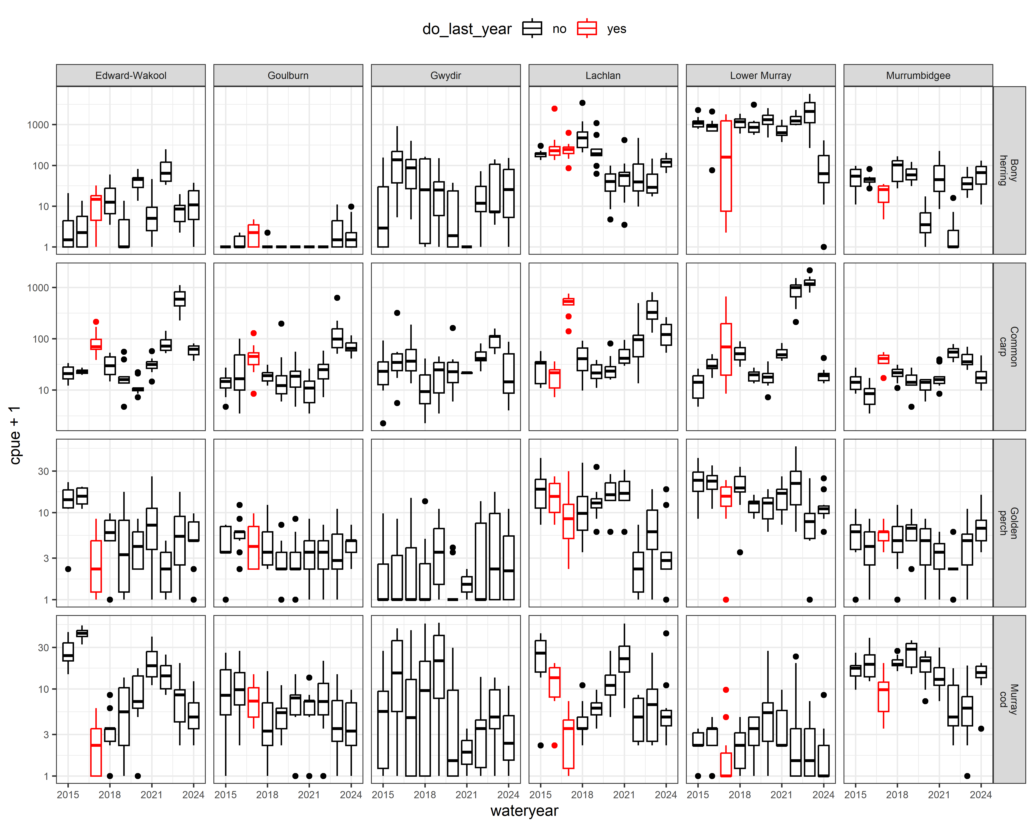

Data analysis
For the analysis, the main hypotheses are focused on the effect of flow on growth rate between years. Consequently, I modeled log growth rate as the following:
$$R=log\left(\frac{CPUE_{t}+1}{CPUE_{t-1}+1}\right)$$
I ran a linear mixed model (LMM) in a Bayesian framework with growth rate as the response variable. As fixed factors, I included annual flow metrics, Selected Area and if last year was a fish kill event. Selected Area:wateryear and samplepoint were included as random effects.

Key results
For Murray cod, similar patterns with catch rates increasing with decreasing flow_median and flow_cv; higher flow_max_prev increased catch rates.
For bony herring catch rates, higher flow_max_prev increased catch rates.
For golden perch, similar patterns with catch rates increasing with decreasing flow_median and flow_low .
Common carp catch rates increased with higher flow_median and higher flow_low.

Flow coefficients
Estimates of flow coefficients for each species are shown in Figure 3.19.

Non-flow coefficients

Common carp
Common carp did not show any fish death event effect but this may have been hidden by large number of recruits appearing in the CPUE (up to 75% being young-of-year). Therefore, this analysis is driven more by the recruit dynamics than adult population trends.

Bony herring
Fish death pattern did not come out as significant.

Murray cod and golden perch
Fish death events were obvious in the data for Murray cod across most systems and for golden perch in the Edward/Kolety–Wakool and Lachlan. These fish death events will have strong residual effects potentially complicating flow relationships. For instance, in the Edward/Kolety–Wakool, Murray cod continue to recover since 2016/2017, almost approaching pre-fish death levels. A similar pattern is found in the Lachlan. Such recovery may have less to do with flow conditions and more with density-dependent population processes. The population models in the Research theme may provide more insights about this hypothesis (Todd et al. 2022).
Figure 3.19 Effect of each flow metric on adult abundance for bony herring, common carp, golden perch and Murray cod
Flow metrics are flow_median, flow_cv, flow_low, flow_max_prev, plus fish deaths.
Error bars are 95%CrI. Coloured dots indicate significant effects at p<0.05 threshold.
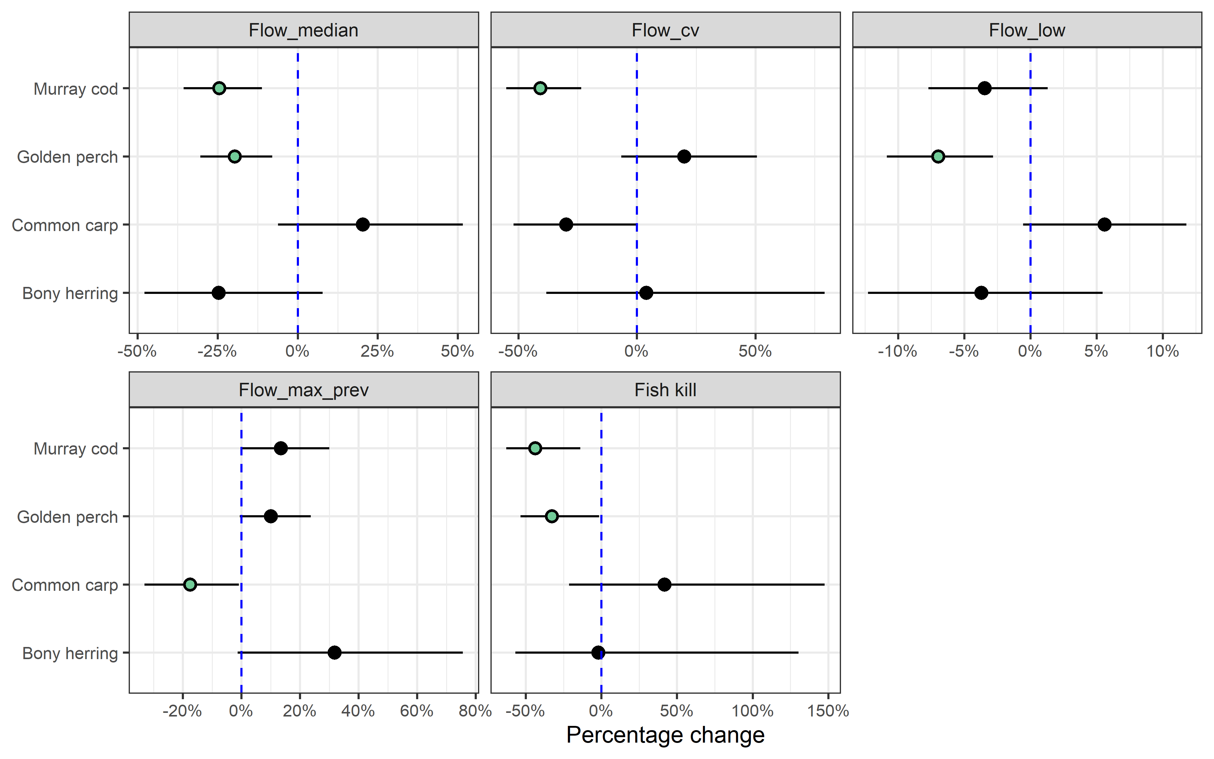
Figure 3.20 Distribution of predicted effect of CEW on adult abundance for bony herring, common carp, golden perch and Murray cod, by Selected Area
Each density plots shows distribution of effect sizes (scaled to percentage change) across all years covered in this report. Vertical dash line shows no effect (0%); left of line indicates negative effect and right a positive effect. Red and blue numbers indicate number of years in which there was a significant negative and positive, respectively. Point indicates current year estimate with colour indicating if contribution was significant (green=positive; red=negative) or not (grey).
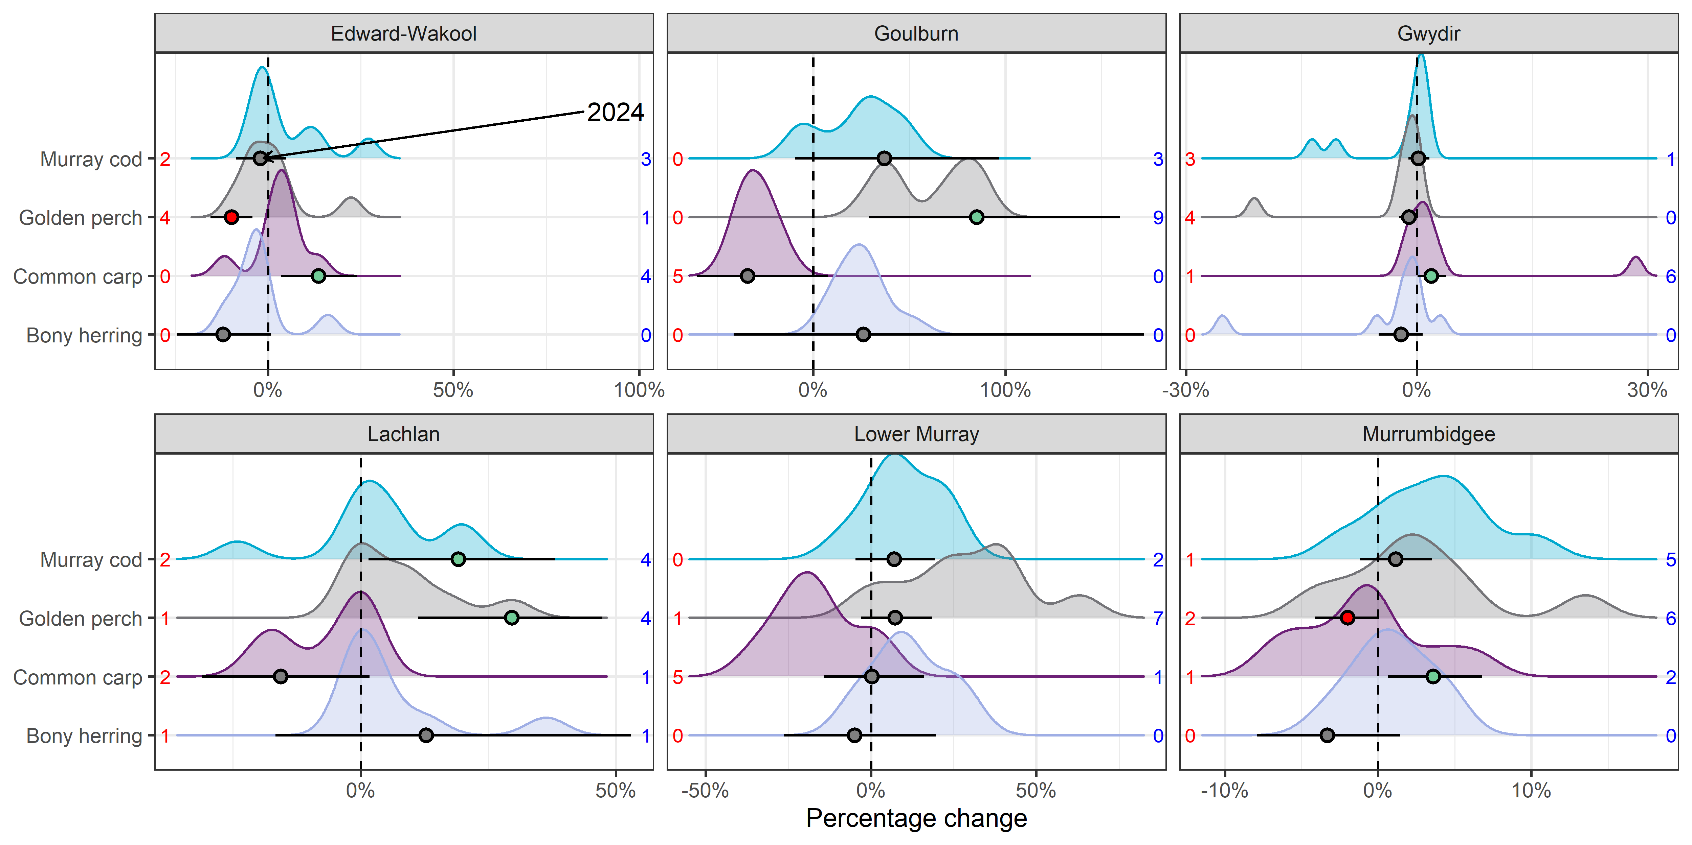
Figure 3.21 Predicted effect of CEW on adult abundance for bony herring, common carp, golden perch and Murray cod, by Selected Area
Effect sizes have been scaled to percentage of mean Fulton Index for each species. Error bars are 95%CrI. * - indicates 95%CrI do not overlap with 0 (* above and below error bars indicate positive and negative effects, respectively).
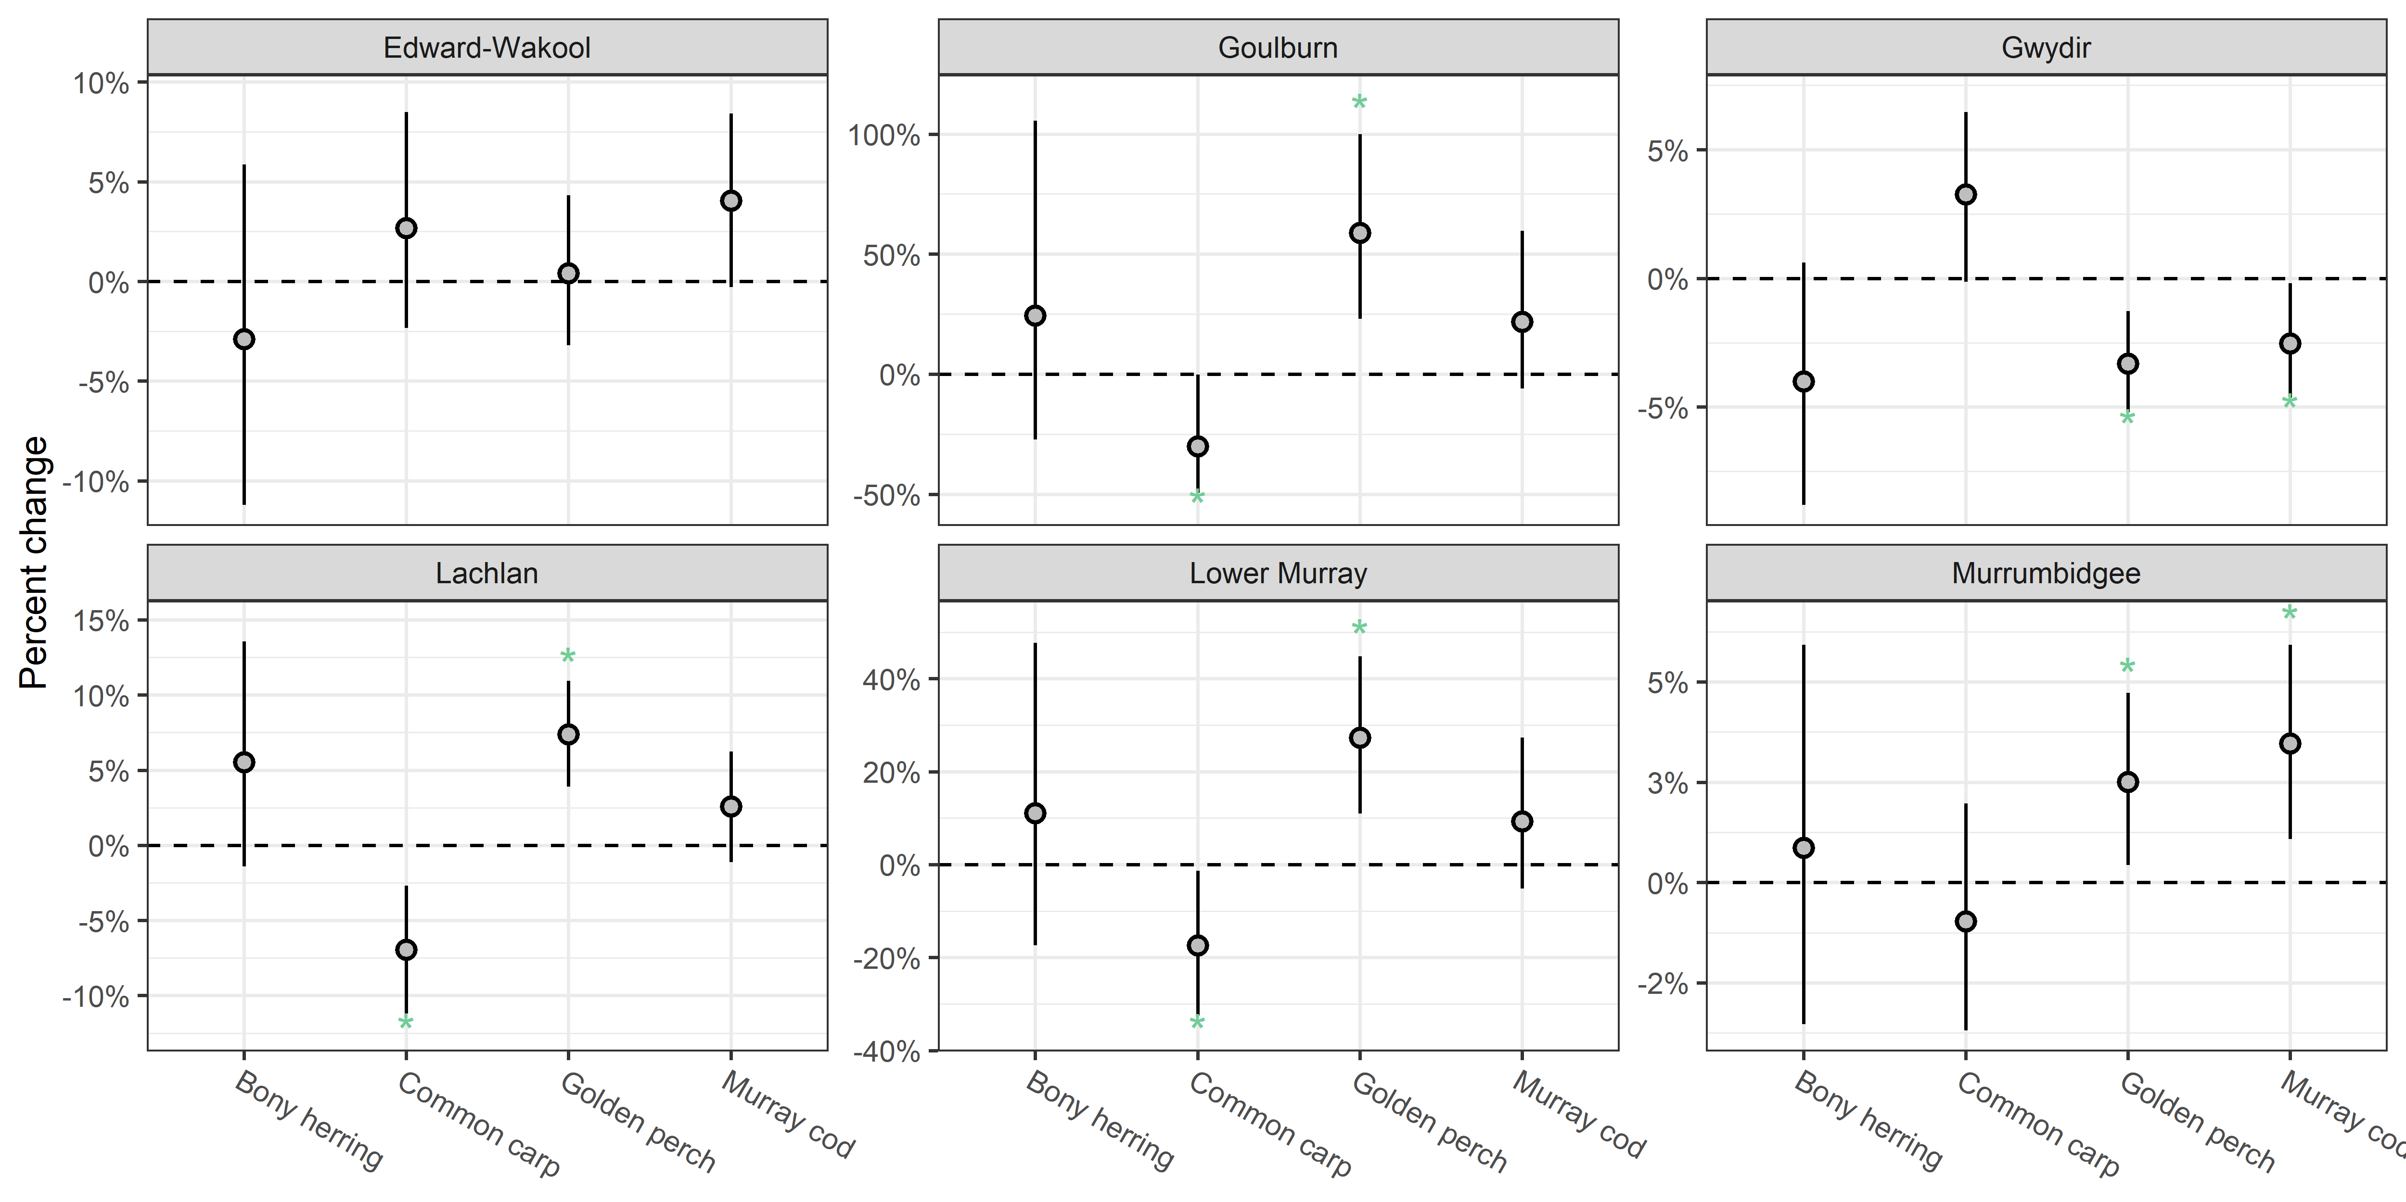
Figure 3.22 Contribution of each flow metric on the predicted CEW effect on adult abundance of 4 fish species, by Selected Area, 2015–23
Fish species are bony herring, common carp, golden perch, Murray cod. Flow metrics are flow_cv, flow_low, flow_max_prev, flow_median. Negative effects are shown as bars below 0 and positive effects above. Effect sizes are on link scale.
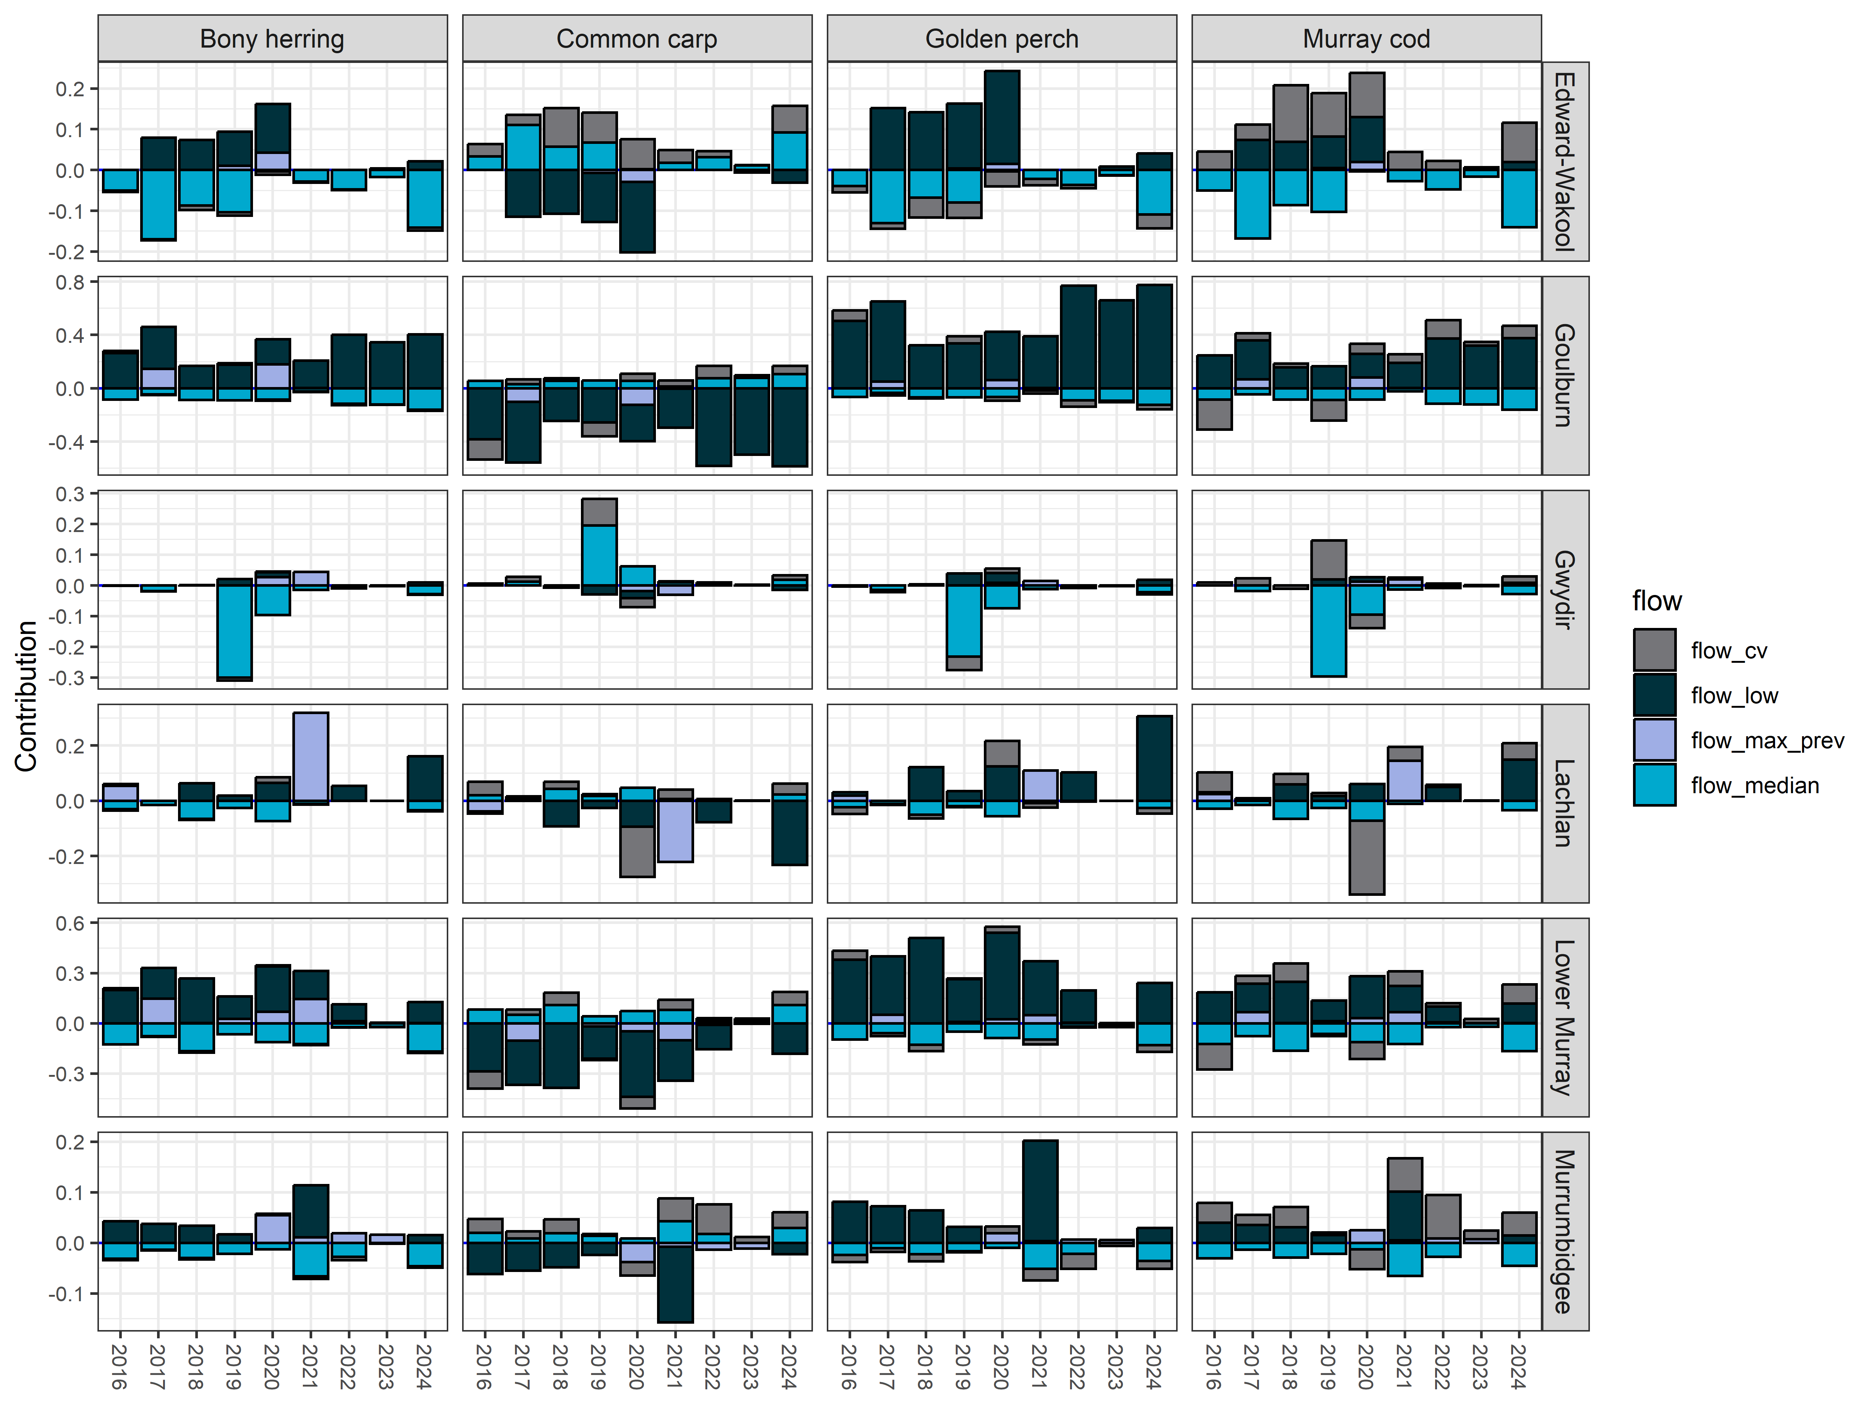

Analysis: Adult body condition

Logic and data trimming

Logic
Flow conditions affect river productivity and hence have knock-on effects for fish condition. I assumed that sampled body condition represents roughly the last 6–12 months of river conditions (beginning of wateryear to sample date).
To test for the effects of flow metrics on body condition, I modeled the Fulton Index (proxy for body condition; Froese (2006)) in relation to the kept annual flow metrics.
$$\text{Fulton Index}=100*\frac{weight}{length^{3}}$$
I used a linear mixed model (LMM) with an untransformed Fulton Index. I included the annual flow metrics and Selected Area as the fixed factor. Selected Area:wateryear, samplepoint, and samplepoint:year were included as random effects. Due to computation slowness using a Bayesian approach with such large sample size, I used lmer() from the lme4 package (Bates et al. 2015).

Data trimming
Only fish that could be linked to a survey in catch dataset were included. Only fish with sufficient numbers across most Selected Areas were analysed (Table 3.9). Next, I explored the relationship between length and weight to assess any outliers in the data. As there were obvious outliers, I used the 4 times the standardised residuals method to identity those outliers. Therefore, I ran a linear regression for each species (log(weight) ~ log(length)) and identified outliers (Figure 3.23). The method worked well, though could be improved for bony herring. Bony herring had decreasing variance on log-scale, which likely reflects measurement error becoming proportionally larger at small sizes. For now (time-limitations), I kept the outlier criteria the same, but model improvements could be had with future refinements to bony herring such as using weighted regression approaches.
Table 3.9 Summary of sample sizes for body condition dataset and for which species were analysed (yes/no), 2014–24
Species | Analysed? | Fish  (total) | Fish  (current) | # Selected Area | Sites | # of Years
Bony herring | Yes | 26,755 | 2,434 | 6 | 83 | 10
Common carp | Yes | 10,736 | 1,549 | 5 | 73 | 10
Murray cod | Yes | 4,266 | 272 | 6 | 79 | 10
Golden perch | Yes | 3,976 | 309 | 6 | 75 | 10
Carp gudgeon | No | 941 | 730 | 2 | 19 | 4
Spangled perch | No | 851 | 40 | 1 | 19 | 9
Goldfish | No | 807 | 99 | 6 | 64 | 10
Murray-Darling rainbowfish | No | 483 | 296 | 3 | 10 | 7
Eastern gambusia | No | 193 | 113 | 1 | 8 | 2
Silver perch | No | 191 | 17 | 5 | 42 | 10
Freshwater catfish | No | 101 | 17 | 3 | 19 | 10
Australian smelt | No | 53 | 14 | 1 | 8 | 2
Trout cod | No | 29 | 3 | 1 | 5 | 7
Redfin perch | No | 29 | 0 | 4 | 9 | 3
Unspecked hardyhead | No | 16 | 2 | 1 | 5 | 2
Oriental weatherloach | No | 10 | 0 | 2 | 5 | 2
 | No | 1 | 1 | 1 | 1 | 1

Key exploratory graph(s)
I explored the relationship between length and weight to assess any outliers in the data and these are shown in Figure 3.23. The change in Fulton Index over time across all Selected Areas and species is shown in Figure 3.24.
Figure 3.23 Exploratory graph looking for potential outliers in length:weight for bony herring, common carp, golden perch and Murray cod
Red dots show outliers using four times the standardised residuals method. Grey circles show non-outlier data.
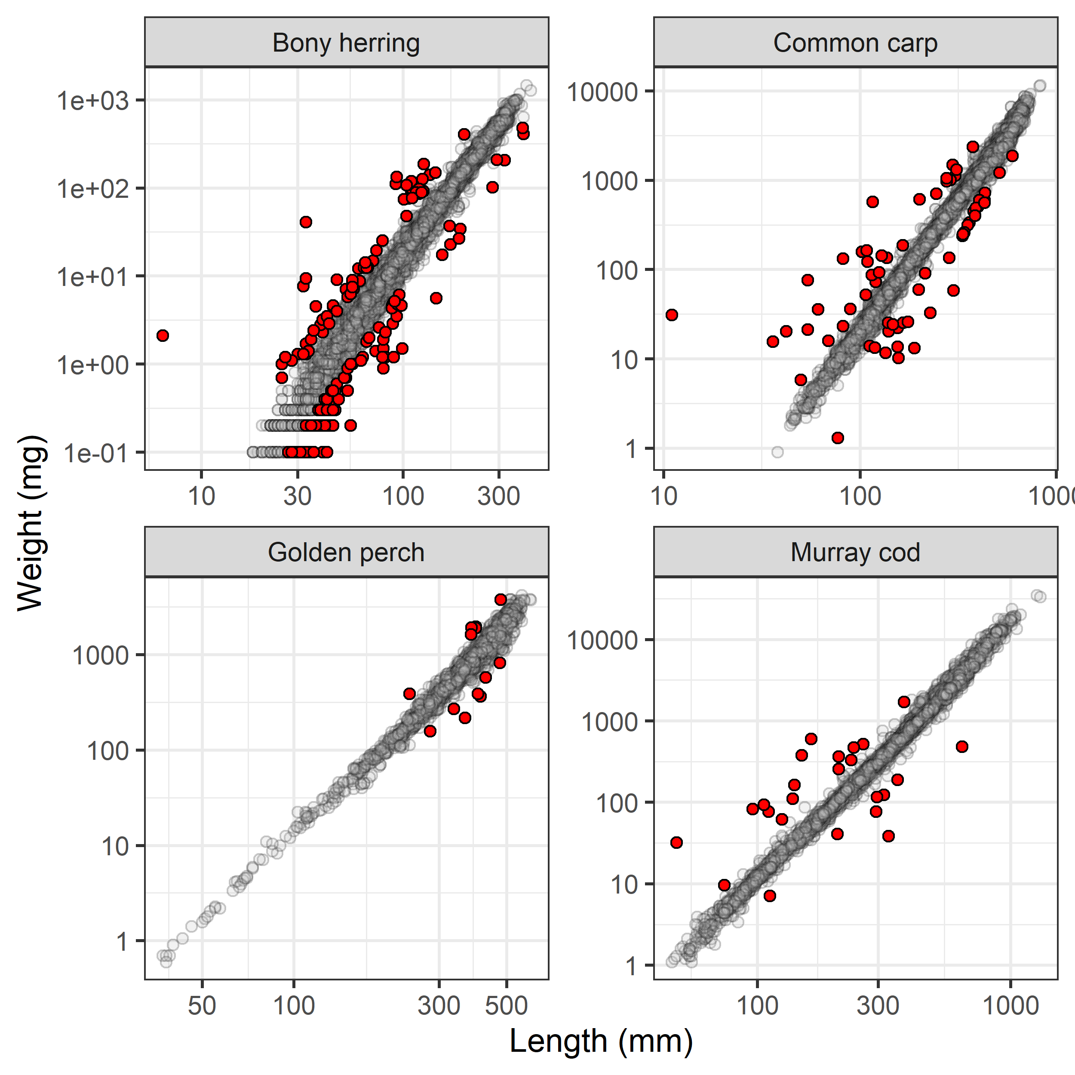
Figure 3.24 Boxplot showing change in Fulton Index time for bony herring, common carp, golden perch and Murray cod, by Selected Areas, 2014-24
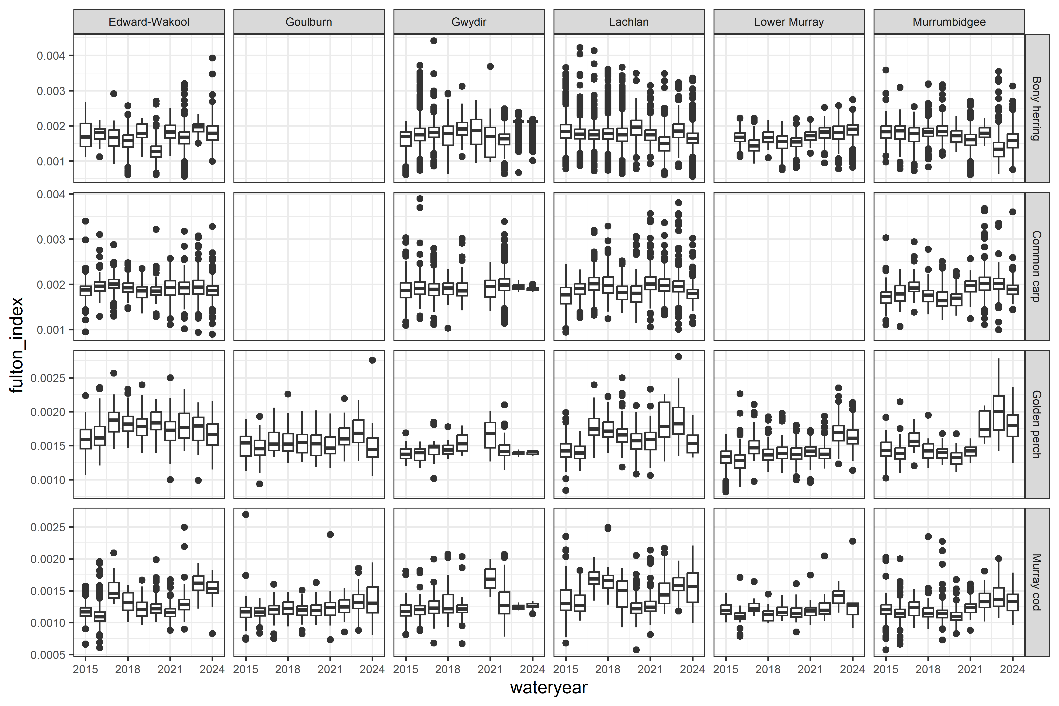

Data analysis
As noted above, I removed outliers from the analysis using four times the standardised residual method. With the remaining data, I undertook the following approach. To test for the effects of flow metrics on body condition, I modeled the Fulton Index (proxy for body condition) in relation to the annual flow metrics. I used a linear mixed model (LMM) with an untransformed Fulton Index. I included the annual flow metrics and Selected Area as the fixed factor. Selected Area:water year, samplepoint, and samplepoint:year were included as random effects. Due to computation slowness using a Bayesian approach, I used lmer() from the lme4 package (Bates et al. 2015).

Key results
Murray cod condition increased with higher flow_median, flow_cv, and flow_max_prev matching last year’s findings
Bony herring had substantial changes from last year’s report in the coefficients: decreasing flow_cv was estimated to increase body condition substantially more than last years. Plus, flow_median was positively weakly associated with body condition, rather than negatively associated in last year’s analysis.
Common carp condition increased with higher flow_median
Golden perch condition potentially increased with flow_median

Flow coefficients
Estimates of flow coefficients for each species are shown in Figure 3.25.
Figure 3.25 Effect of each flow metric on body condition for 4 fish species
Fish species are bony herring, common carp, golden perch and Murray cod.
Flow metrics are flow_median, flow_cv, flow_low, flow_max_prev.
Error bars are 95%CrI. Coloured dots indicate significant effects at p<0.05 threshold.
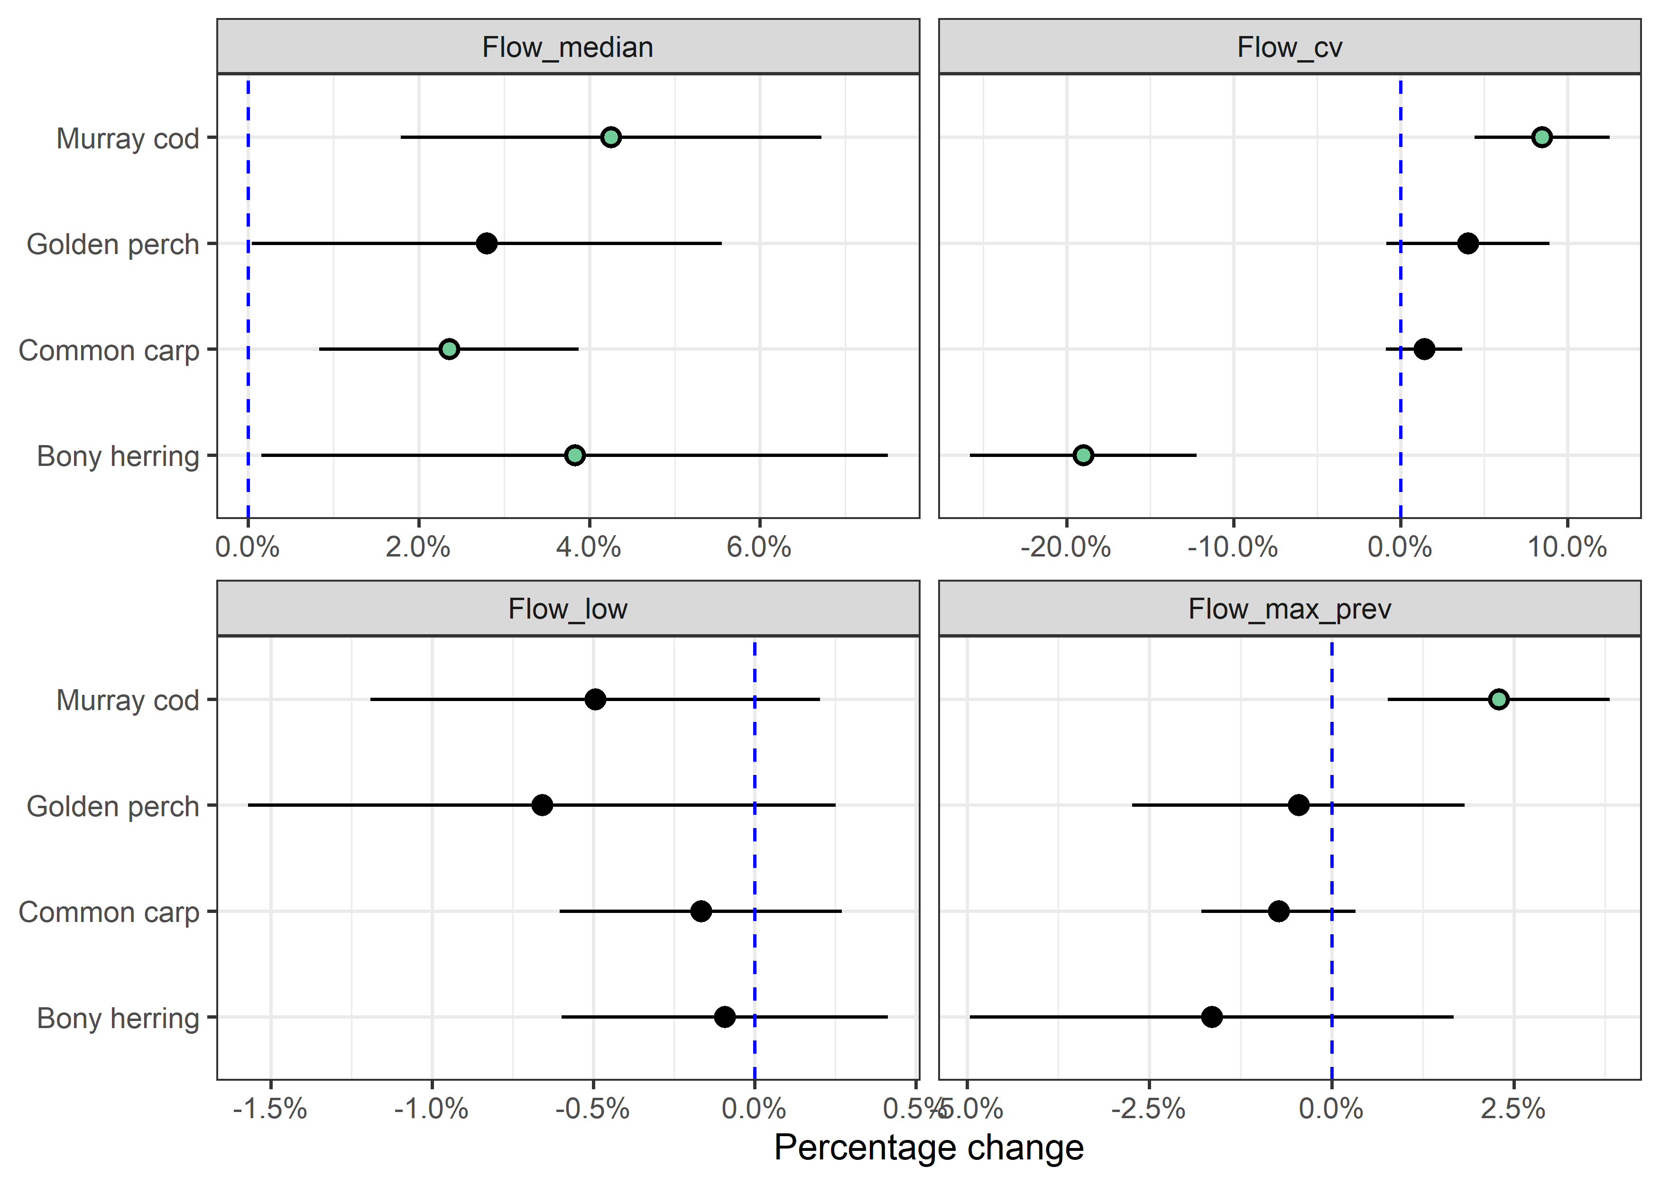

Counterfactual predictions
The predicted effect and marginal effect of CEW on species body condition are shown. The positive changes show CEW increased body condition (Figure 3.26; Figure 3.27).
Figure 3.26 Distribution of predicted effect of CEW on body condition for each species, by Selected Area
Each density plots shows distribution of effect sizes (scaled to percentage change) across all years covered in this report. Vertical dash line shows no effect (0%); left of line indicates negative effect and right a positive effect. Red and blue numbers indicate number of years in which there was a significant negative and positive, respectively. Point indicates current year estimate with colour indicating if contribution was significant (green=positive; red=negative) or not (grey).
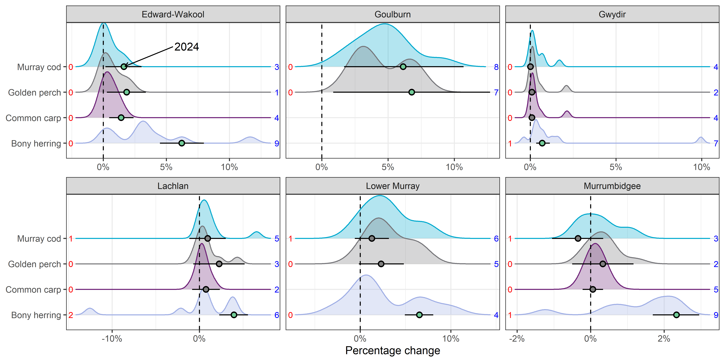
Figure 3.27 Predicted effect of CEW on body condition for each species, by Selected Area
Effect sizes have been scaled to percentage of mean Fulton Index for each species. Error bars are 95%CrI. * - indicates 95%CrI do not overlap with 0 (* above and below error bars indicate positive and negative effects, respectively).
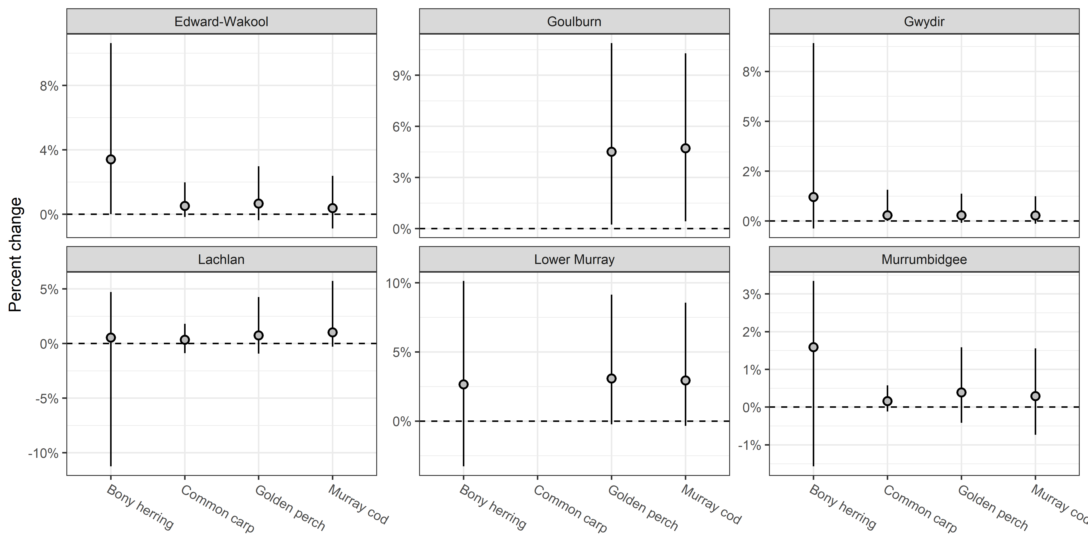
Figure 3.28 Contribution of each flow metric on the predicted CEW effect for body condition of 4 fish species, by Selected Area
Fish species are bony herring, common carp, golden perch and Murray cod. Flow metrics are flow_cv, flow_low, flow_max_prev, flow_median. Negative effects are shown as bars below 0 and positive effects above. Effect sizes are on raw scale.
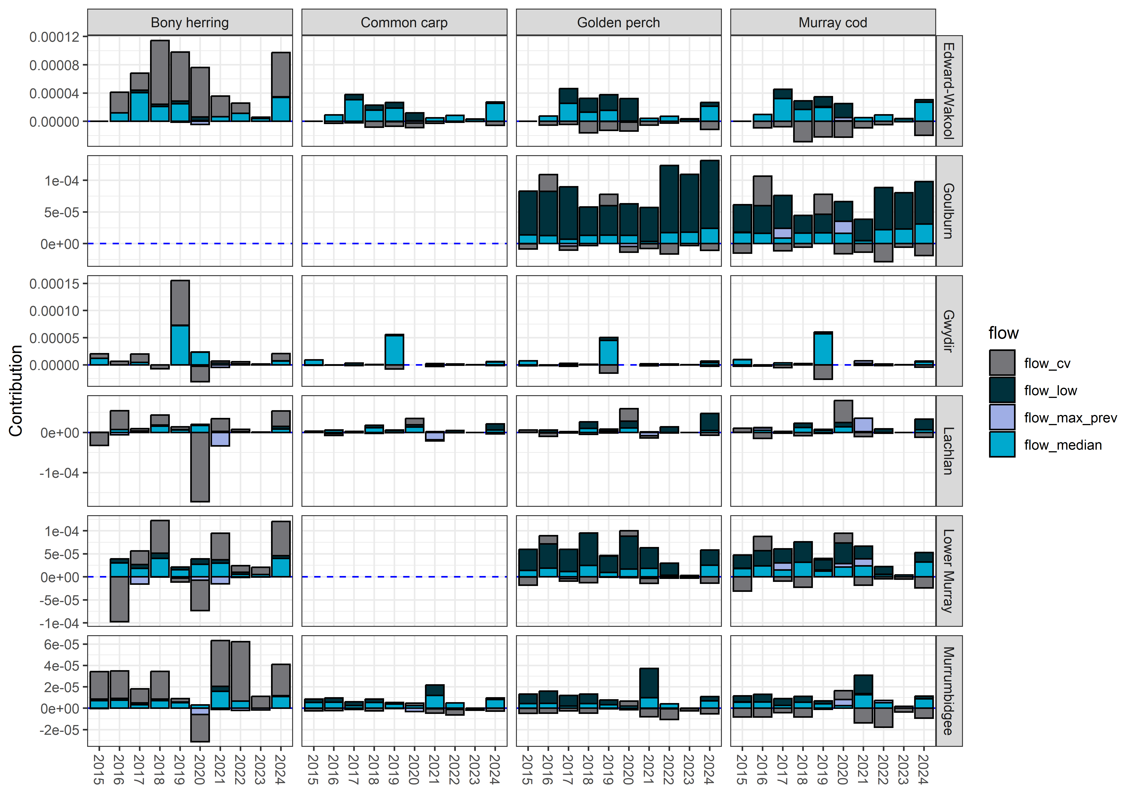

Analysis: Adult presence/distribution

Logic and data trimming

Logic
Flows support hydrological connectivity, thereby increasing available habitat and food resources and providing more suitable conditions for fish movement and colonisation.

Data trimming
If there were multiple surveys per water year per site, I selected the latest date. This ensured a single sampling point and was comparable with other years. As common carp was present at every site every year, it was dropped from the analysis.

Key exploratory graph(s)
Proportion of sites that species were present over years and across Selected Areas is shown in Figure 3.29.
Figure 3.29 Temporal plot showing proportion of sites with that species present, 2014–24
Fish species are Australian smelt, bony herring, carp gudgeon, common carp, eastern gambusia, golden perch, Murray cod, Murray-Darling rainbowfish.
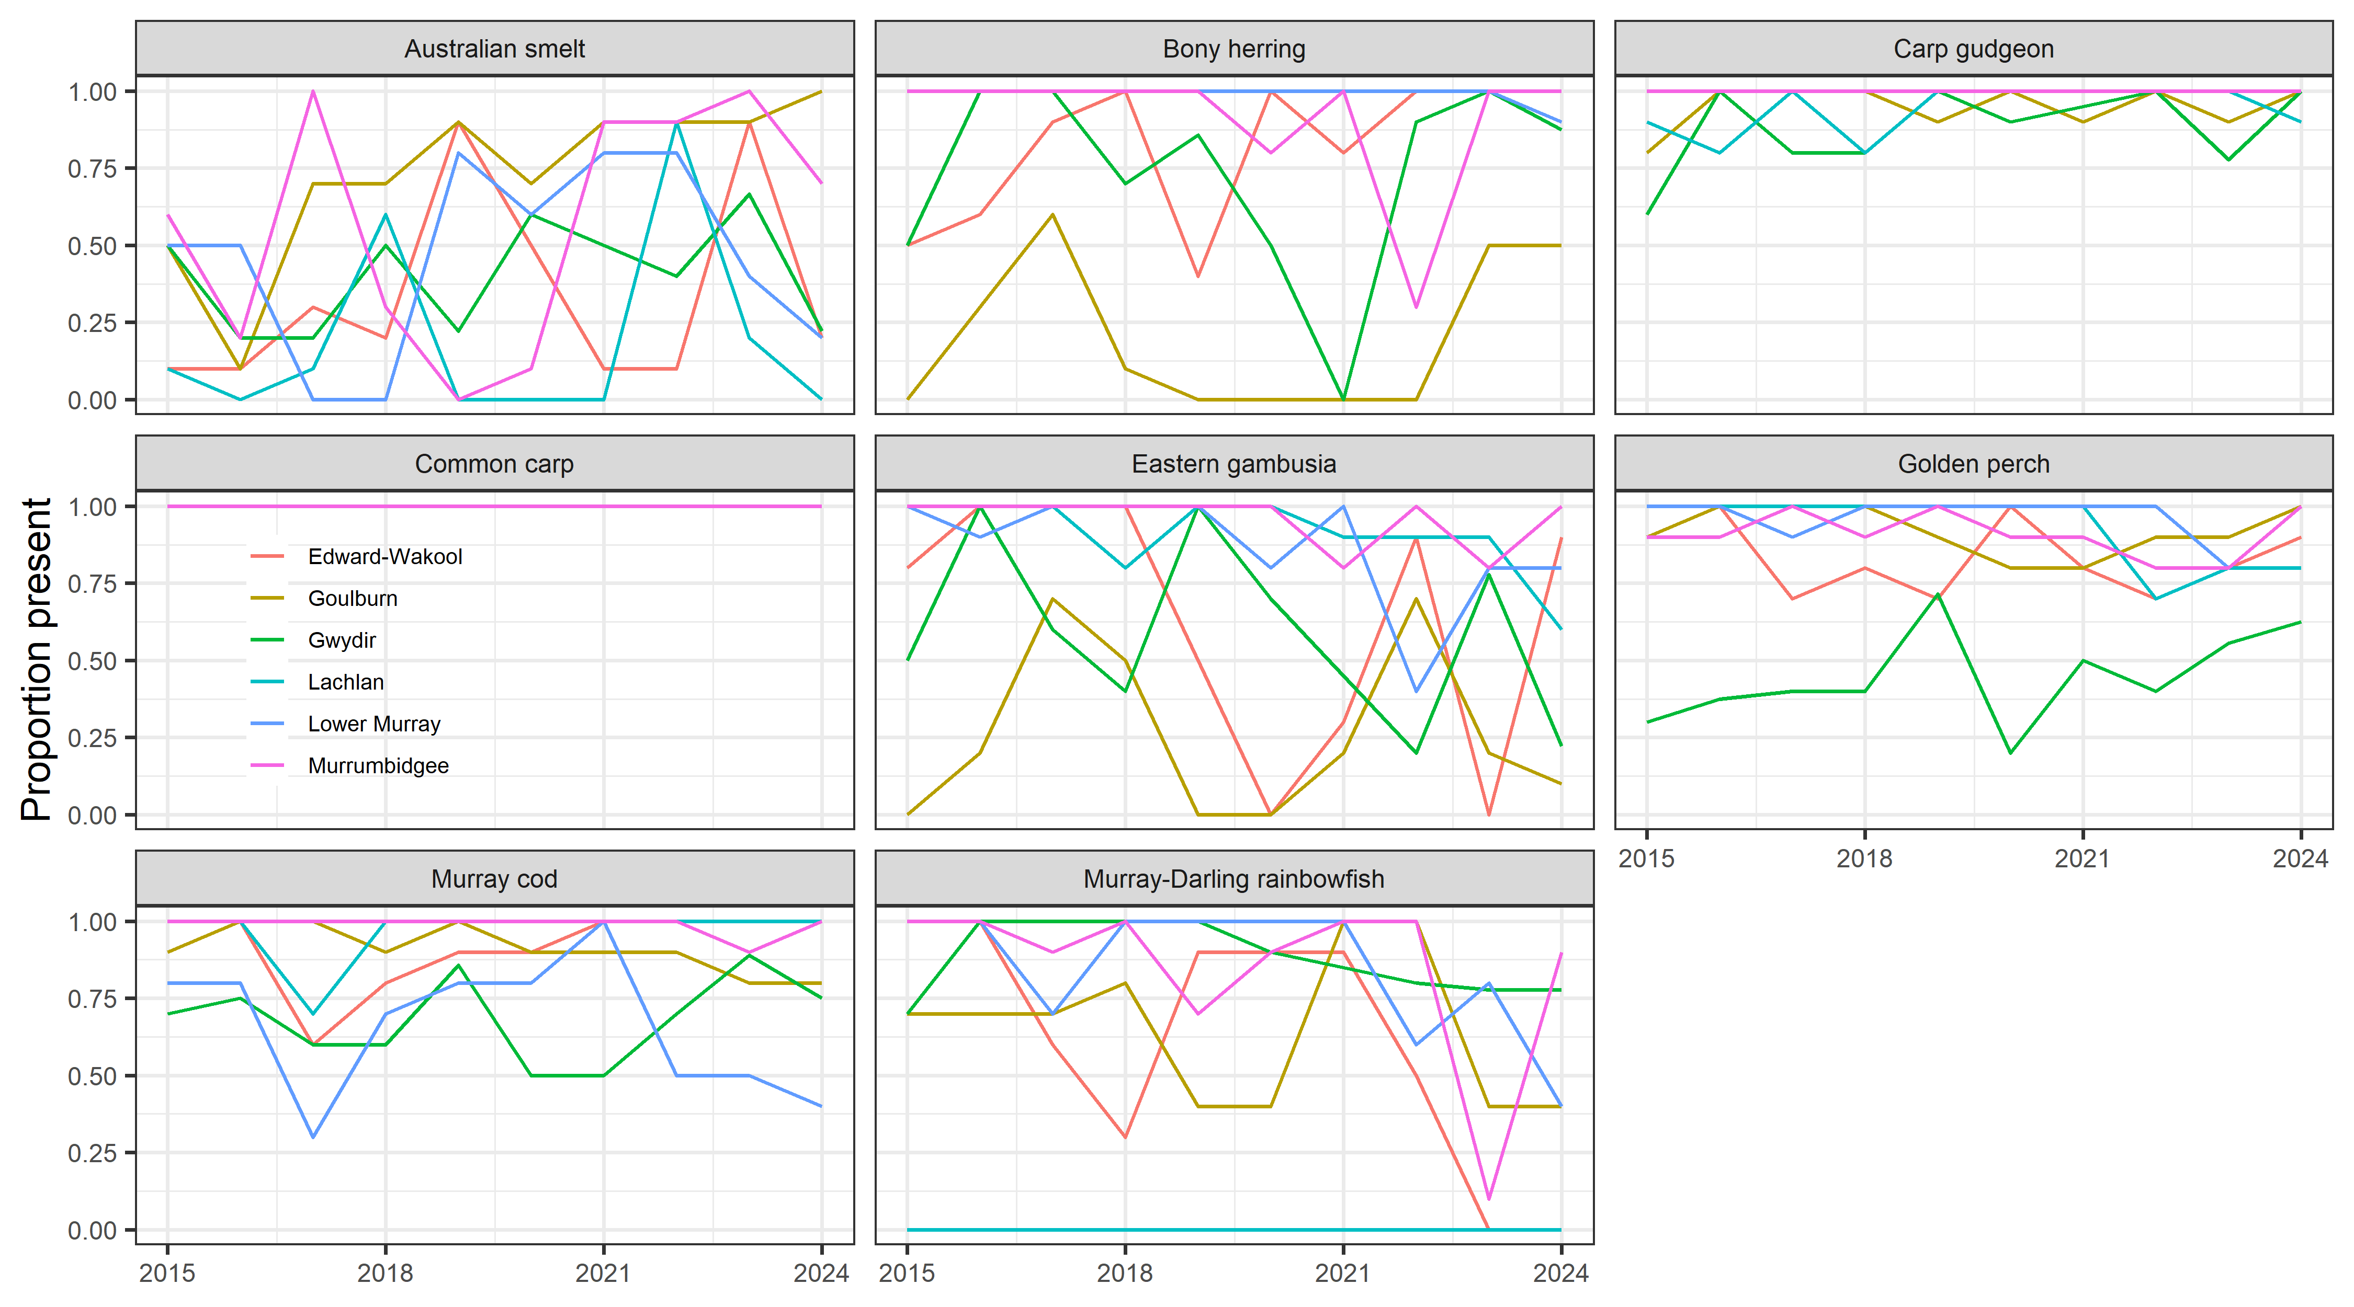

Data analysis
Using the above approach, I ran a GLMM (generalised linear mixed model) with a Bernoulli distribution (in a Bayesian framework). The response variable was the presence of that species at that site (for that water year). I included the annual flow metrics and Selected Area as the fixed factor. Selected Area:water year and samplepoint were included as random effects. However, Selected Area:water year caused convergence issues so it was reduced to water year only for the analysis.

Key results
Decreasing flow_median increased Bony herring presence.
Decreasing flow_cv increased Murray-Darling rainbowfish and Murray Cod.
Decreasing flow_low increased presence of Australian smelt and decreased Eastern gambusia.

Flow coefficients
Figure 3.30 Effect of each flow metric on adult presence of 7 fish species
Species are Australian smelt, bony herring, carp gudgeon, eastern gambusia, golden perch, Murray cod and Murray-Darling rainbowfish.
Flow metrics are flow_median, flow_cv, flow_low, flow_max_prev. Error bars are 95%CrI. Coloured dots indicate significant effects at p<0.05 threshold.
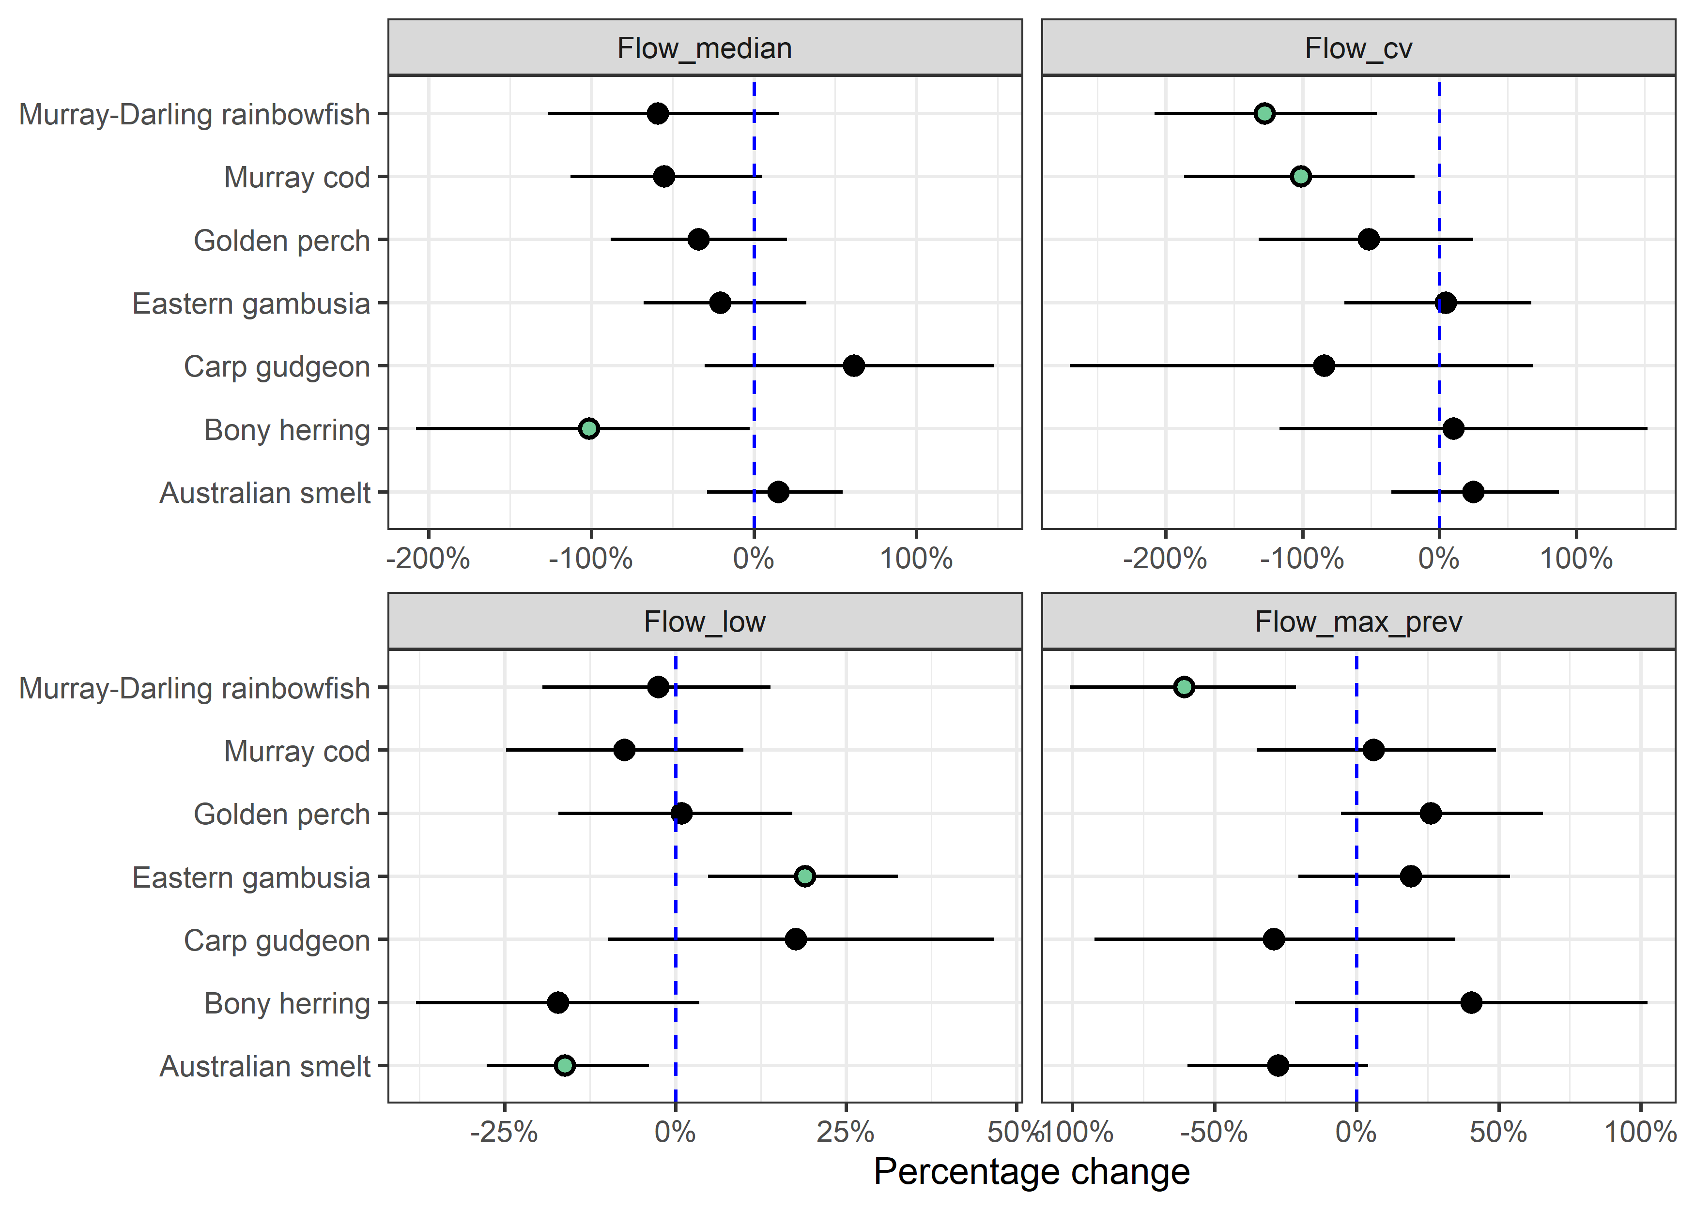

Counterfactual predictions
Figure 3.31 Distribution of predicted effect of CEW on adult presence for each species, by Selected Area
Species are Australian smelt, bony herring, carp gudgeon, eastern gambusia, golden perch, Murray cod and Murray-Darling rainbowfish.
Each density plot shows distribution of effect sizes (scaled to percentage change) across all years covered in this report. Vertical dash line shows no effect (0%); left of line indicates negative effect and right a positive effect. Red and blue numbers indicate number of years in which there was a significant negative and positive, respectively. Point indicates current year estimate with colour indicating if contribution was significant (green=positive; red=negative) or not (grey).
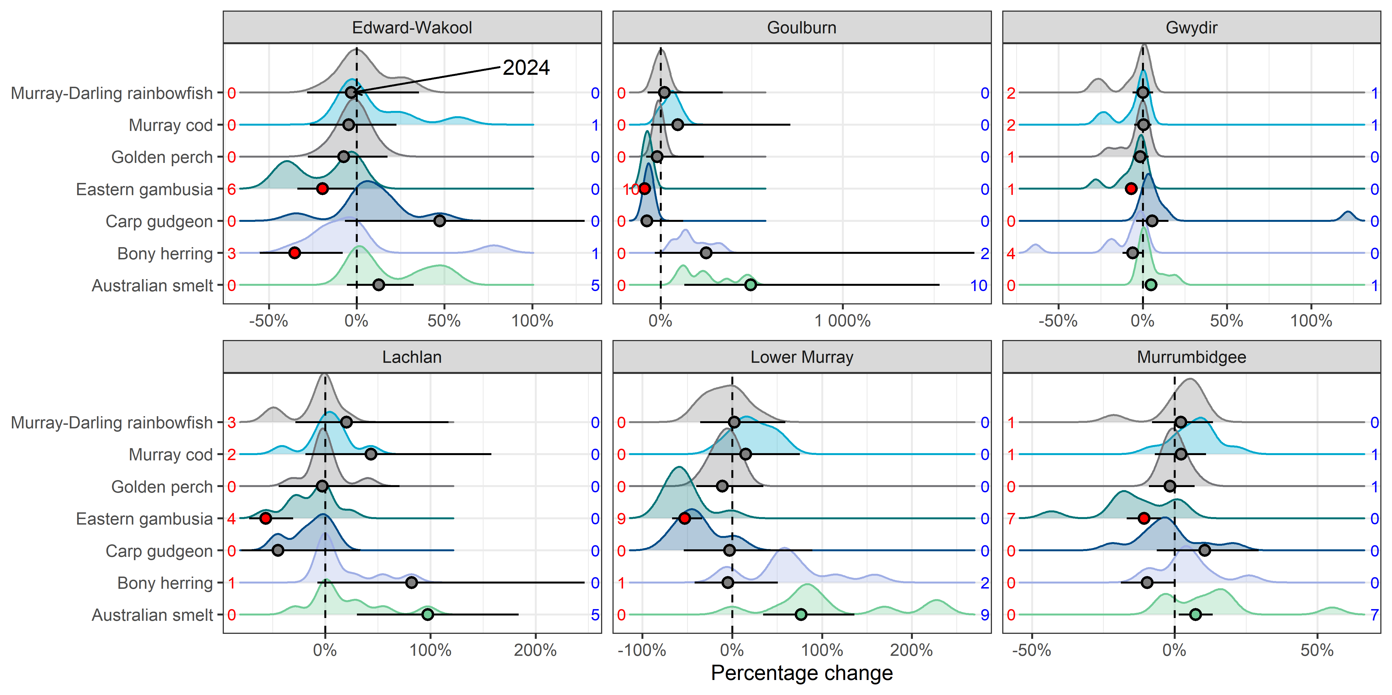
Figure 3.32 Predicted effect of CEW on adult presence for each species, by Selected Area
Species are Australian smelt, bony herring, carp gudgeon, eastern gambusia, golden perch, Murray cod and Murray-Darling rainbowfish.
Effect sizes have been scaled to percentage of mean Fulton Index for each species. Error bars are 95%CrI. * - indicates 95%CrI do not overlap with 0 (* above and below error bars indicate positive and negative effects, respectively).
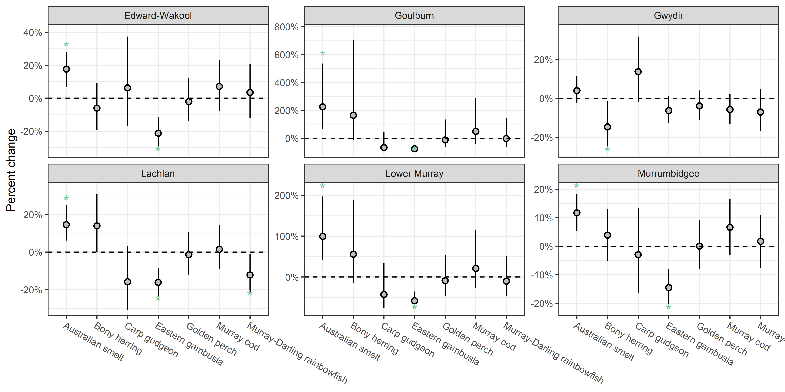
Figure 3.33 Contribution of each flow metric on the predicted CEW effect on adult presence by Selected Area, 2014–24
Species are Australian smelt, bony herring, carp gudgeon, eastern gambusia, golden perch, Murray cod and Murray-Darling rainbowfish.
Flow metrics are flow_cv, flow_low, flow_max_prev, flow_median.
Negative effects are shown as bars below 0 and positive effects above. Effect sizes are on link scale.
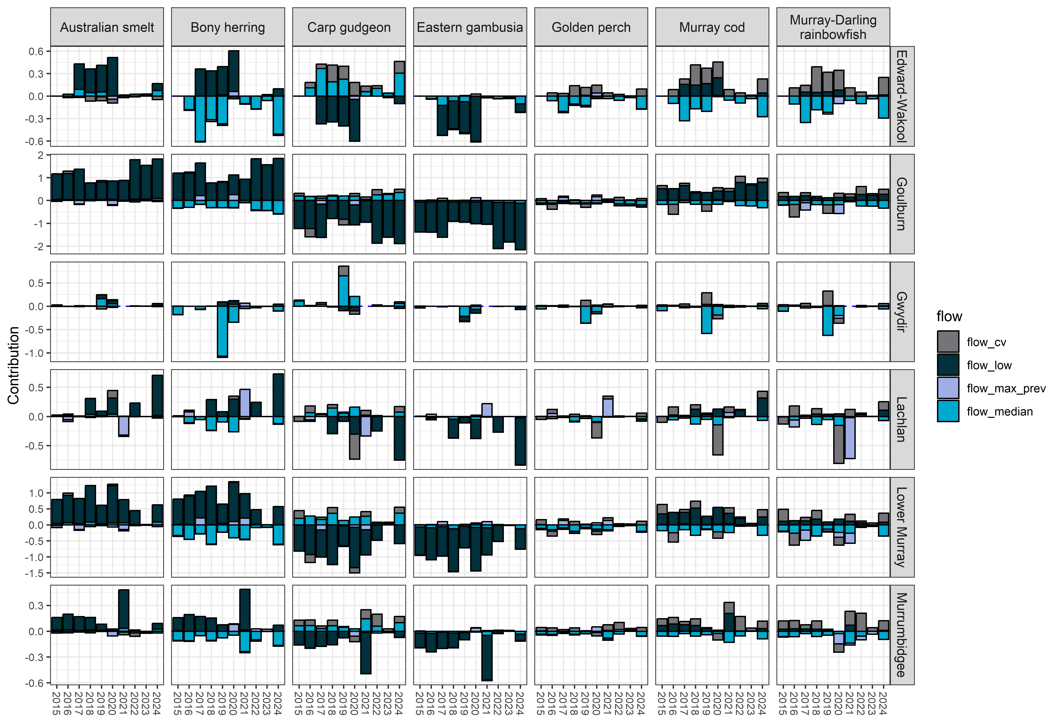

Analysis: Community metric

Logic and data trimming

Logic
Flows support hydrological connectivity, thereby increasing available habitat and food resources and providing more suitable conditions for native fish movement and colonisation.

Data trimming
I dropped any sites that had no catch data. I calculated the proportion of the fish species per Selected Area:wateryear:sampelpoint that were native (Table 3.10).
Table 3.10 Summary of sample sizes for community analysis showing number of introduced and native species at the 6 Selected Areas, 2014–24
Selected Area | Introduced | Native | Sites | # of Years
Edward-Wakool | 4 | 9 | 10 | 10
Goulburn | 5 | 10 | 11 | 10
Gwydir | 3 | 9 | 10 | 10
Lachlan | 4 | 9 | 11 | 10
Lower Murray | 4 | 11 | 10 | 10
Murrumbidgee | 4 | 9 | 10 | 10

Key exploratory graph(s)
The change in community index over time across all Selected Areas and species is shown in Figure 3.34 and species scientific names with common names is shown in Table 3.11.
Table 3.11 Fish species collected in Flow-MER adult fish population surveys using Category 1 methods across all Selected Areas, 2014–24
Common name | Species name | Introduced/Native
Australian smelt | Retropinna semoni | Native
Bony herring | Nematalosa erebi | Native
Carp gudgeon | Hypseleotris spp | Native
Common carp | Cyprinus carpio | Introduced
Dwarf flathead gudgeon | Philypnodon macrostomus | Native
Eastern gambusia | Gambusia holbrooki | Introduced
Flathead gudgeon | Philypnodon grandiceps | Native
Freshwater catfish | Tandanus tandanus | Native
Golden perch | Macquaria ambigua | Native
Goldfish | Carassius auratus | Introduced
Murray cod | Maccullochella peelii | Native
Murray-Darling rainbowfish | Melanotaenia fluviatilis | Native
Oriental weatherloach | Misgurnus anguillicaudatus | Introduced
Redfin perch | Perca fluviatilis | Introduced
Silver perch | Bidyanus bidyanus | Native
Spangled perch | Leiopotherapon unicolor | Native
Trout cod | Maccullochella macquariensis | Native
Unspecked hardyhead | Craterocephalus stercusmuscarum fulvus | Native
Obscure galaxias | Galaxias oliros | Native
Community | community | Native
Figure 3.34 (A) Boxplot showing change in community index over 2014–24 for species, by Selected Area and (B) presence of each species over 2014–24
A) is an aggregated metric over all species and is the proportion of catch that is native. Species are common carp, eastern gambusia, goldfish, oriental weatherloach, redfin perch, Australian smelt, bony herring, carp gudgeon, dwarf flathead gudgeon, flathead gudgeon, freshwater catfish, golden perch, Murray cod, Murray-Darling rainbowfish, silver perch, spangled perch, trout cod, unspecked hardyhead, obscure galaxias. Pink indicates introduced species. Green indicates Native species.
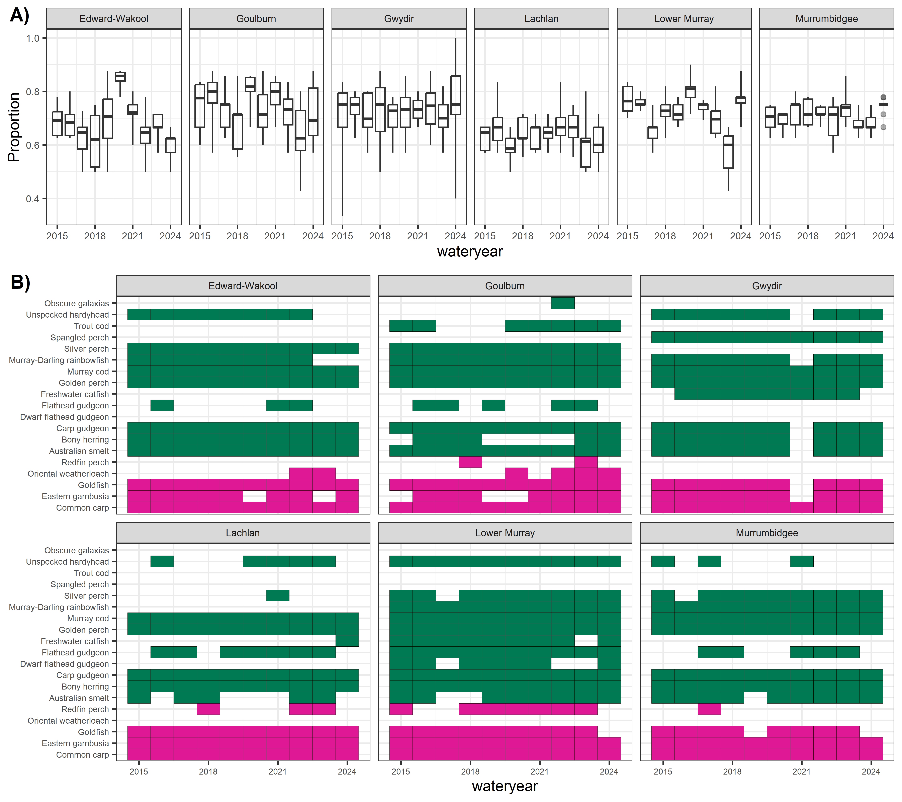

Data analysis
Using the above approach, I ran a bGLMM (Bayesian generalised linear mixed model) with a Gaussian distribution. I included the annual flow metrics and Selected Area as fixed effects. Wateryear was included as a random effect to account for the correlational structure.

Key results
The proportion of catch that was native decreased with increases in the number of low flow days with strong evidence.
There was weaker evidence that the proportion of catch that was native decreased with increased average daily flows, flow variability and maximum antecedent flows.

Flow coefficients
Estimates of flow coefficients for the community metric is shown in Figure 3.35.
Figure 3.35 Effect of each flow metric on community metric for each species
Flow metrics are flow_median, flow_cv, flow_low, flow_max_prev.
Error bars are 95%CrI. Coloured dots indicate significant effects at p<0.05 threshold.
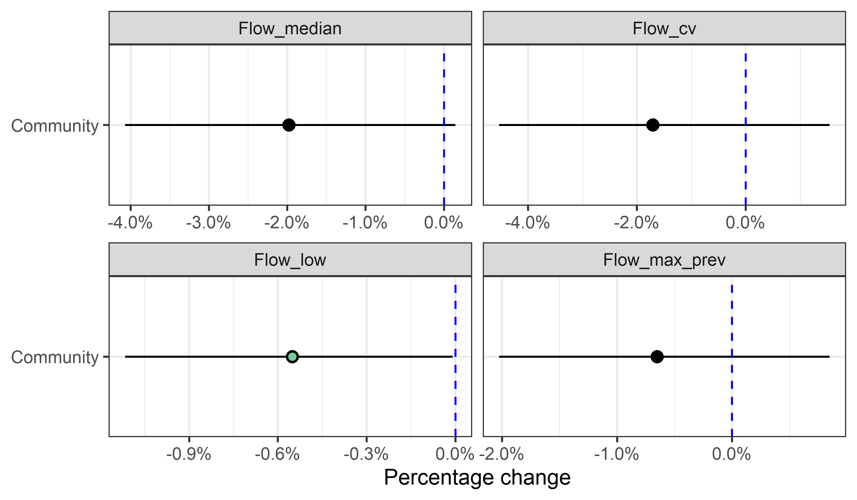

Counterfactual predictions
Figure 3.36 Predicted effect of CEW on community metric, by Selected Area, 2014–24
Error bars are 95%CrI. Green dots indicate 95%CrI do not overlap with 0.
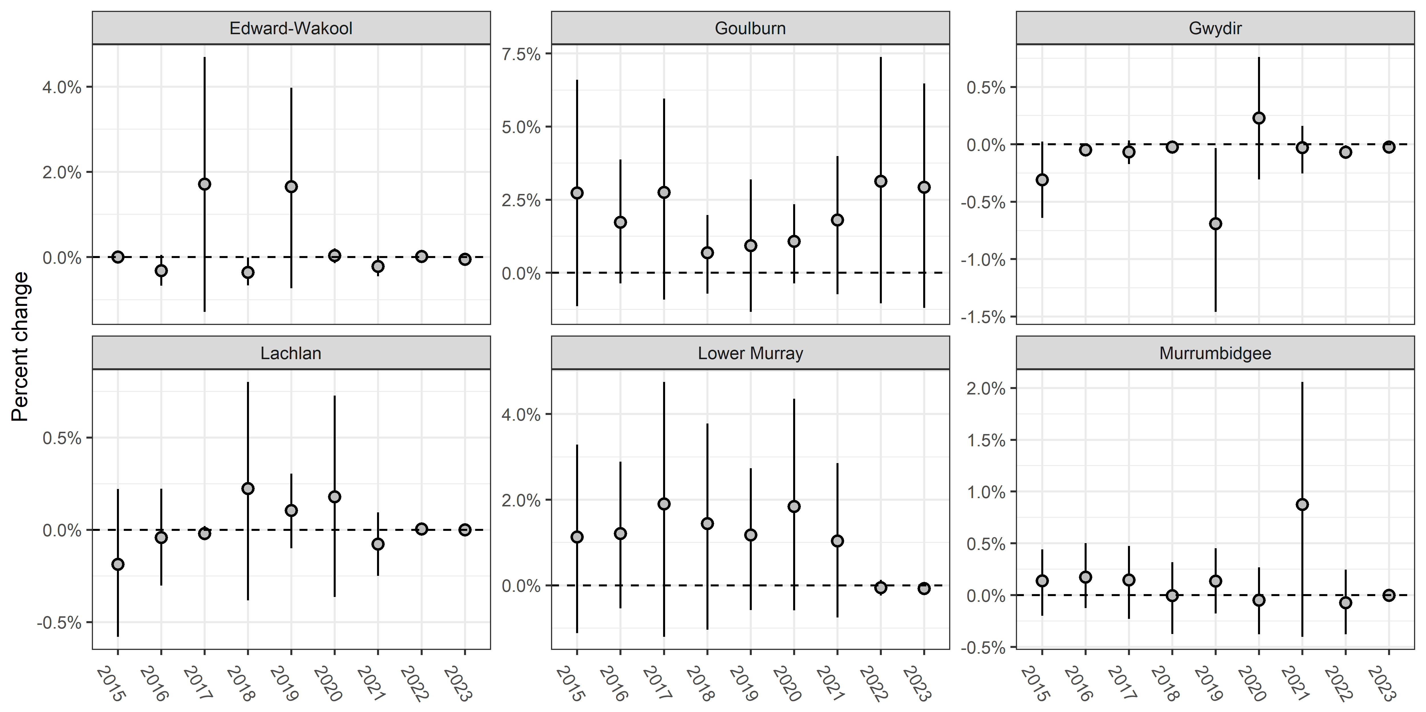
Figure 3.37 Predicted effect of CEW on community metric, by Selected Area
Error bars are 95%CrI. * - indicates 95%CrI do not overlap with 0 (* above and below error bars indicate positive and negative effects, respectively).
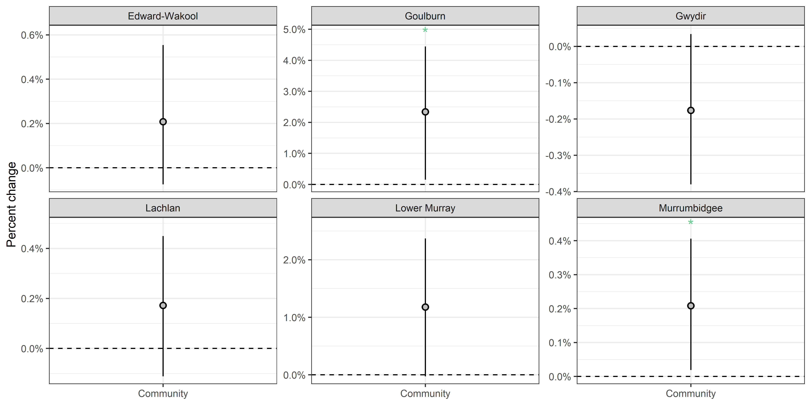
Figure 3.38 Contribution of each flow metric on the predicted CEW effect for community metric by Selected Area, 2014–24
Flow metrics are flow_median, flow_max_prev, flow_low and flow_cv.
Negative effects are shown as bars below 0 and positive effects above. Effect sizes are on raw scale.
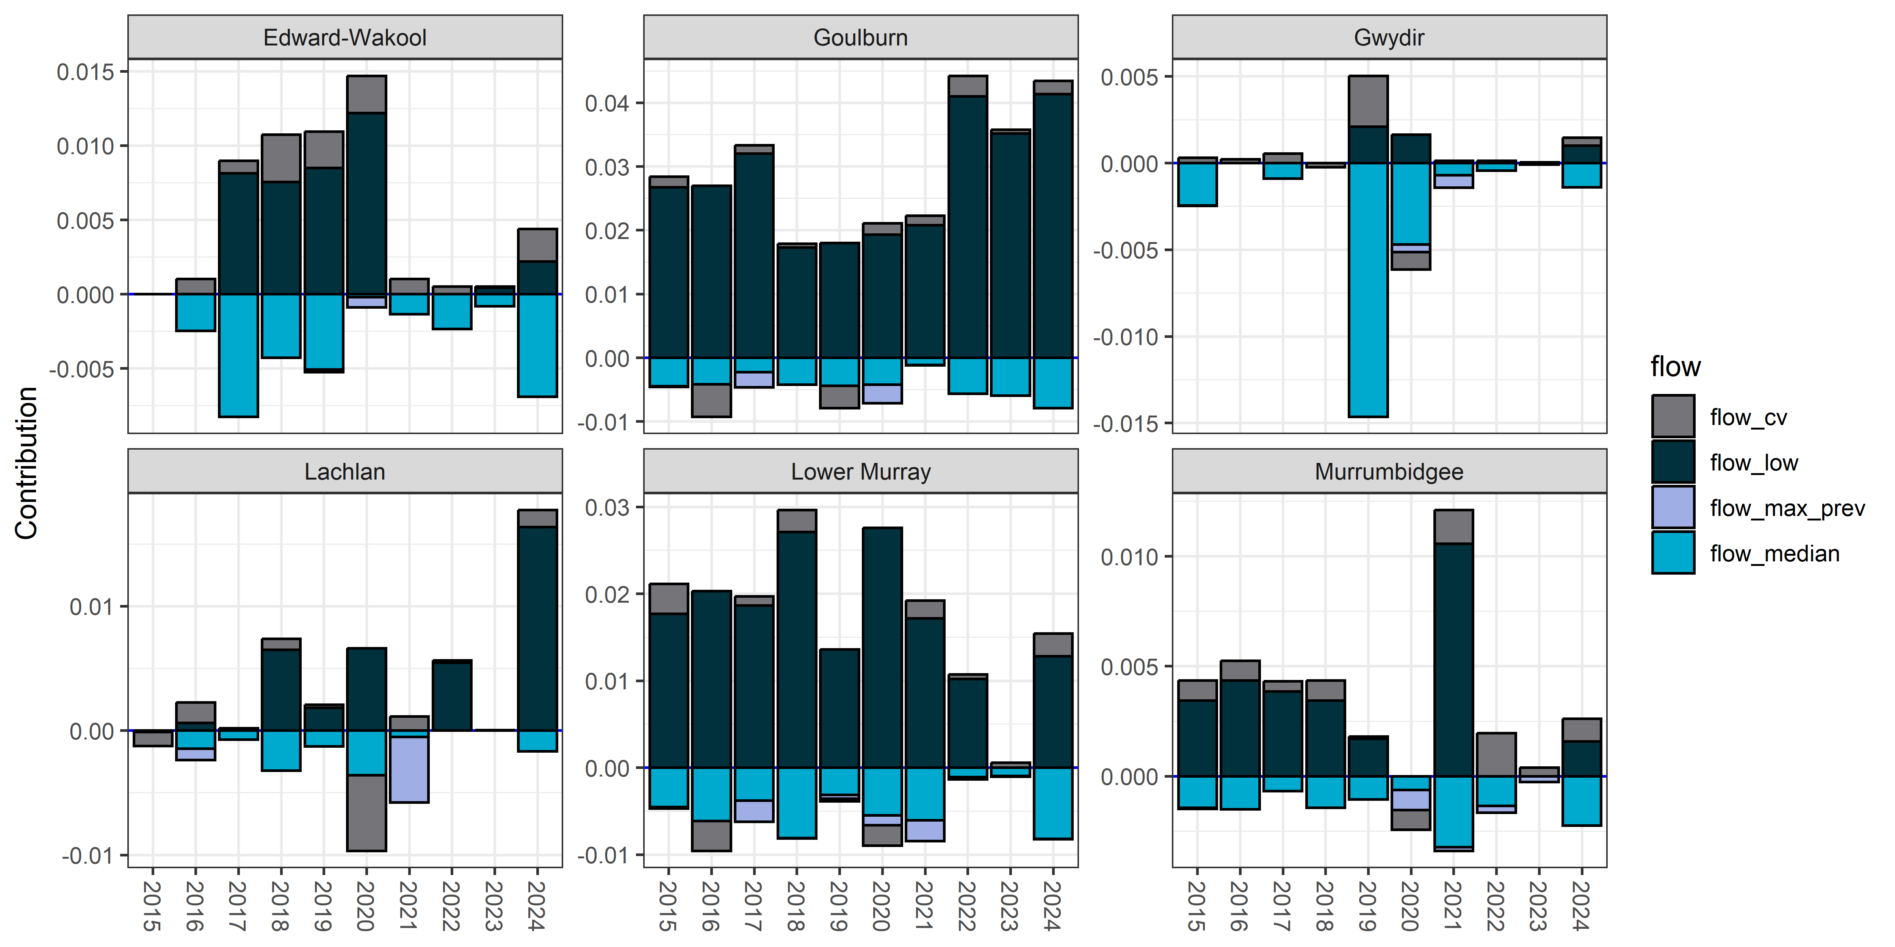

Analysis: Predicting Commonwealth environmental water contribution on Murray cod recruitment at unmonitored areas across the Murray–Darling Basin

Logic and data trimming

Logic
Recruit numbers reflect multiple population processes: reproductive output and larval survival. The annual flow metrics were included as predictors affecting these processes.

Data trimming
See Section 0
Analysis: Recruit analysis (young-of-year) using abundance data. Additionally, we dropped any flow sites in which there was less than 2 years of flow data as well as flows that were negative or without-.

Data analysis
As part of the results, I predicted CEW effects across the Basin using predicted flow relationships. Using the full flow dataset, I applied the flow metric algorithms to every gauge. For any flow gauges missing without_cew data, I assumed no CEW. Next, I used the Murray cod recruitment model and predicted the difference between actual and without_cew scenarios (positive differences indicate improved recruitment). To visualise these effects, I mapped the maximum difference across all years for each gauge and mapped these differences on the Basin’s river system. Predicted effects of CEW on Murray cod recruitment at all gauges, with lower and upper bounds, are listed in Error! Reference source not found..

Predicting effect across the Basin for Murray cod
Figure 3.39 Maps of predicted CEW effects on recruitment rates for Murray cod across the Basin
CEW effect map shows the relative effect size for each flow gauge with larger circles and lighter blues indicating larger effects. Smaller maps on right show differences between actual flows and modelled without CEW for flow_median and flow_low (two key flow metrics for Murray cod). For flow median, larger circles/lighter blues indicate increased flow_median due to CEW. For flow_low, larger circles/lighter blues indicate number of low flow days (flow_day) decreased with the CEW flows (i.e. declining flow_low indicates less low flow days and in theory better flow environment).
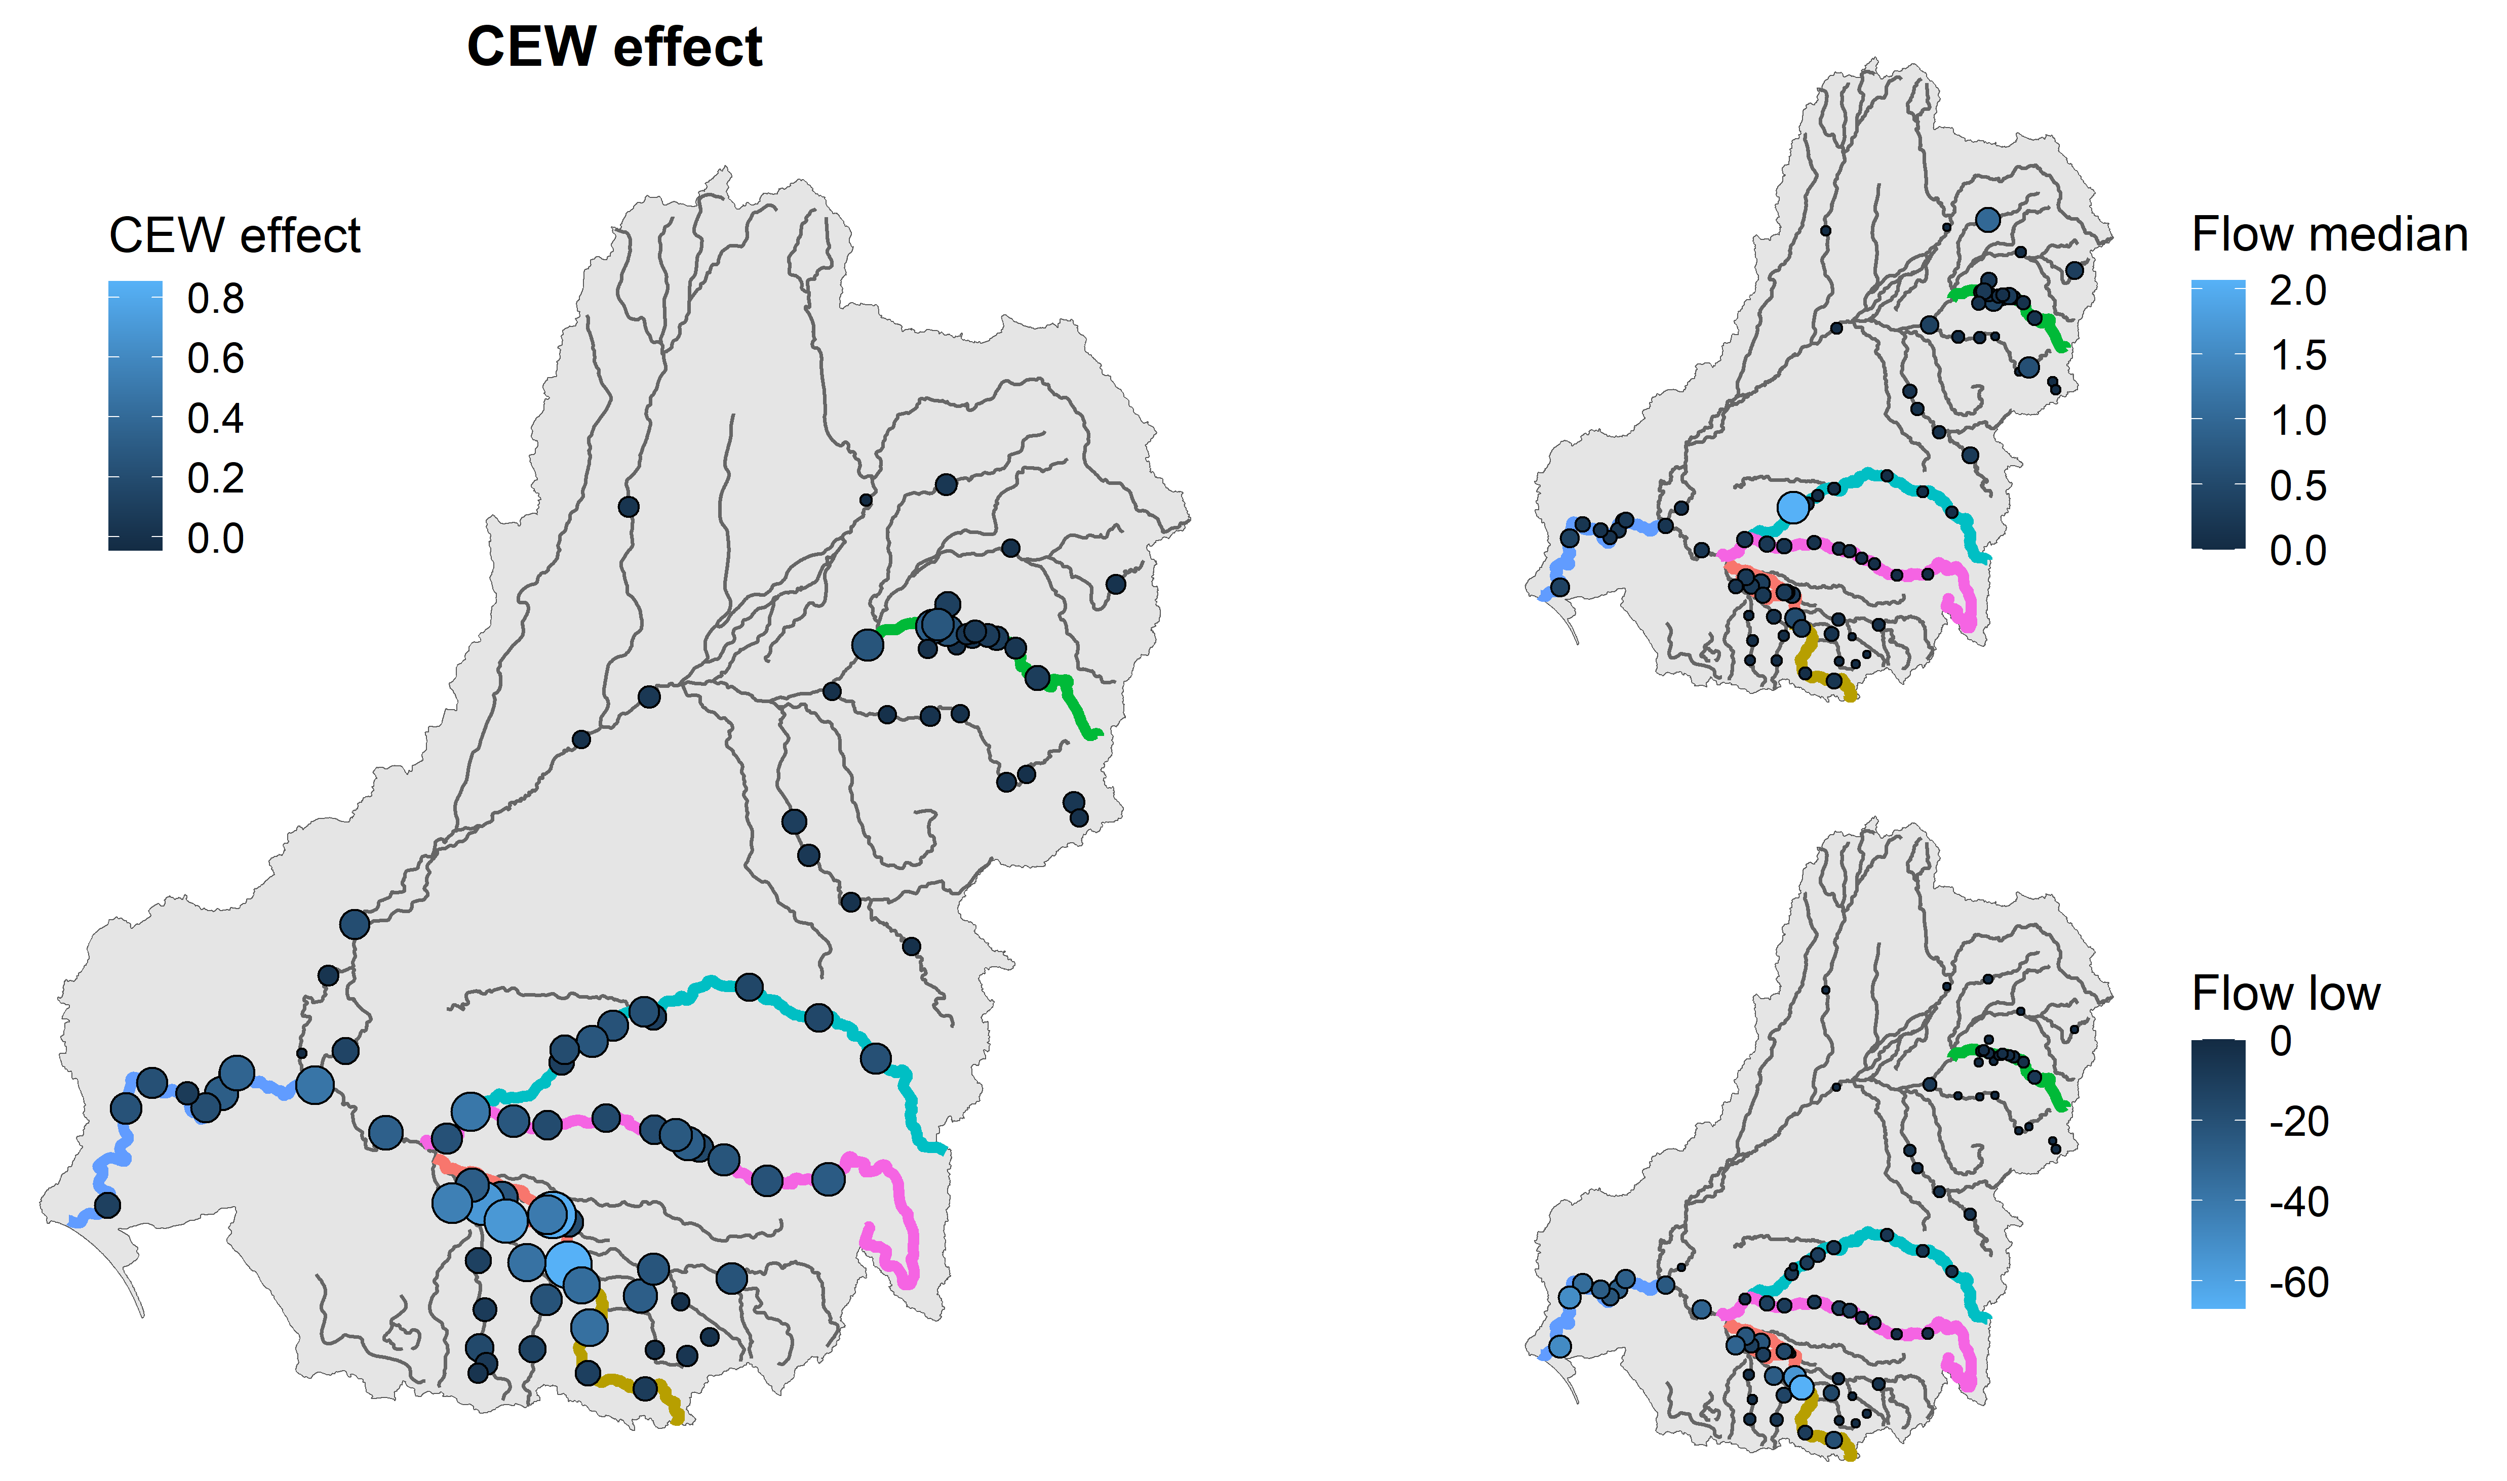

Predicting effect across the Basin for Murray-Darling rainbowfish
Figure 3.40 Map showing predicted CEW effects on recruitment rates for Murray-Darling rainbowfish across the Basin
CEW effect map shows the relative effect size for each flow gauge with larger circles and lighter blues indicating larger effects. Smaller maps on right show differences between actual flows and modelled without CEW for flow_median and flow_low (two key flow metrics for Murray cod). For flow median, larger circles/lighter blues indicate increased flow_median due to CEW. For flow_low, larger circles/lighter blues indicate number of low flow days (flow_day) decreased with the CEW flows (i.e. declining flow_low indicates less low flow days and in theory better flow environment).
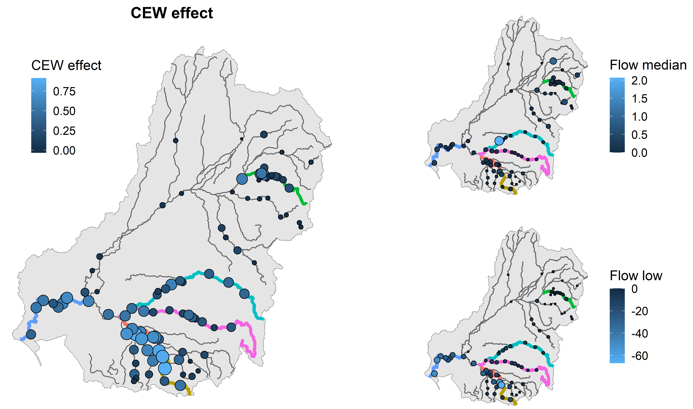

References
Bates D, Mächler M, Bolker B, Walker S (2015) Fitting linear mixed-effects models using lme4. Journal of Statistical Software, 67(1), 1–48. https://doi.org/10.18637/jss.v067.i01
Froese R (2006) Cube law, condition factor and weight–length relationships: History, meta-analysis and recommendations. Journal of Applied Ichthyology, 22(4), 241–253.
Goodrich B, Gabry J, Ali I, Brilleman S (2020) Rstanarm: Bayesian applied regression modeling via Stan. Retrieved from https://mc-stan.org/rstanarm
Hladyz S, Baumgartner L, Bice CM, Butler GL, Fanson BG, Giatas G, Koster W, Lyon J, McCasker N, Stuart I, others (2023) Basin-scale evaluation of 2021–22 Commonwealth environmental water: Fish: Commonwealth Environmental Water Holder’s science program: Flow monitoring, evaluation and research program.
Hladyz S, Baumgartner LJ, Bice CM, Butler GL, Fanson BG, Giatas G, Koster WM, Lyon JP, Stuart IG, Thiem JD, Tonkin Z, Ye Q, Yen JDL, Zampatti BP (2025) Basin-scale evaluation of 2023–24 Commonwealth environmental water: Fish. Flow-MER Program. Commonwealth Environmental Water Holder (CEWH): Monitoring, Evaluation and Research Program, Department of Climate Change, Energy, the Environment and Water, Australia.
R Core Team (2022) ‘R: A language and environment for statistical computing’. (R Foundation for Statistical Computing: Vienna, Austria) Available at: https://www.R-project.org/
Raymond SM, Duncan M, Tonkin Z, Robinson W (2021) Barmah-Millewa fish condition monitoring (2007 –2021). Arthur Rylah Institute for Environmental Research unpublished client report for the Murray-Darling Basin Authority. Department of Environment, Land, Water and Planning, Heidelberg, Victoria.
Todd CR, Wootton HF, Koehn JD, Stuart IG, Thiem JD, Baumgartner LJ, Bice CM, Butler GL, Koster WM, Sharpe CP, Tonkin Z, Ye Q, Zampatti BP (2022) Fish population models to inform Commonwealth environmental watering. Arthur Rylah Institute for Environmental Research client report, Victoria.
Tonkin Z, Yen J, Lyon J, Kitchingman A, Koehn JD, Koster WM, Lieschke J, Raymond S, Sharley J, Stuart I, others (2021) Linking flow attributes to recruitment to inform water management for an australian freshwater fish with an equilibrium life-history strategy. Science of the Total Environment 752, 141863.

Table of Commonwealth environmental water contribution from each analysis
- Contribution: Spawning
Table A.1 Estimate of the effect of Commonwealth environmental water on spawning rates of golden perch and silver perch, by Selected Area
Estimates and 90%, 80%, and 60% credible intervals are shown.
Species/Selected Area | estimate | lower_90 | upper_90 | lower_80 | upper_80 | lower_60 | upper_60
Golden perch
Edward-Wakool | 0.009 | -0.023 | 0.039 | -0.015 | 0.032 | -0.008 | 0.023
Goulburn | 0.047 | -0.146 | 0.239 | -0.103 | 0.194 | -0.051 | 0.137
Lachlan | 0.007 | -0.073 | 0.079 | -0.055 | 0.062 | -0.033 | 0.042
Lower Murray | 0.063 | -0.057 | 0.171 | -0.014 | 0.163 | 0.007 | 0.120
Murrumbidgee | 0.019 | -0.033 | 0.071 | -0.021 | 0.059 | -0.006 | 0.045
Silver perch
Edward-Wakool | -0.038 | -0.093 | 0.016 | -0.081 | 0.004 | -0.066 | -0.010
Goulburn | -0.241 | -0.599 | 0.080 | -0.507 | 0.020 | -0.418 | -0.075
Lachlan | -0.098 | -0.233 | 0.038 | -0.200 | 0.010 | -0.165 | -0.027
Lower Murray | -0.137 | -0.326 | 0.076 | -0.284 | 0.028 | -0.236 | -0.031
Murrumbidgee | -0.064 | -0.153 | 0.030 | -0.134 | 0.008 | -0.114 | -0.021
- Contribution: Recruitment (young-of-year) using abundance data
Table A.2 Estimate of the effect of Commonwealth environmental water on recruitment rates, by Selected Area
Estimates and 90%, 80%, and 60% credible intervals are shown
Species/Selected Area | estimate | lower_90 | upper_90 | lower_80 | upper_80 | lower_60 | upper_60
Australian smelt
Edward-Wakool | 0.22 | -0.01 | 0.46 | 0.03 | 0.39 | 0.09 | 0.33
Goulburn | 2.95 | 1.25 | 4.63 | 1.53 | 4.17 | 2.06 | 3.77
Gwydir | -0.05 | -0.18 | 0.10 | -0.15 | 0.06 | -0.11 | 0.03
Lachlan | 0.37 | 0.16 | 0.60 | 0.19 | 0.52 | 0.23 | 0.45
Lower Murray | 1.63 | 0.68 | 2.58 | 0.86 | 2.32 | 1.13 | 2.08
Murrumbidgee | 0.21 | 0.05 | 0.36 | 0.08 | 0.32 | 0.13 | 0.29
Bony herring
Edward-Wakool | 0.08 | -0.12 | 0.27 | -0.08 | 0.22 | -0.04 | 0.16
Goulburn | 0.34 | -1.04 | 1.62 | -0.63 | 1.41 | -0.29 | 1.04
Gwydir | 0.02 | -0.10 | 0.13 | -0.06 | 0.11 | -0.04 | 0.07
Lachlan | 0.05 | -0.12 | 0.21 | -0.08 | 0.18 | -0.02 | 0.14
Lower Murray | 0.22 | -0.53 | 0.94 | -0.32 | 0.81 | -0.10 | 0.64
Murrumbidgee | 0.05 | -0.07 | 0.18 | -0.04 | 0.15 | -0.01 | 0.12
Carp gudgeon
Edward-Wakool | 0.06 | -0.07 | 0.20 | -0.04 | 0.18 | -0.01 | 0.13
Goulburn | -0.11 | -1.06 | 0.81 | -0.81 | 0.66 | -0.60 | 0.35
Gwydir | 0.01 | -0.07 | 0.08 | -0.05 | 0.07 | -0.03 | 0.04
Lachlan | -0.05 | -0.17 | 0.07 | -0.14 | 0.04 | -0.11 | 0.01
Lower Murray | -0.06 | -0.61 | 0.46 | -0.45 | 0.38 | -0.35 | 0.19
Murrumbidgee | 0.03 | -0.06 | 0.12 | -0.05 | 0.10 | -0.02 | 0.07
Common carp
Edward-Wakool | 0.23 | 0.04 | 0.41 | 0.09 | 0.38 | 0.14 | 0.33
Goulburn | -0.02 | -1.32 | 1.13 | -0.97 | 0.94 | -0.62 | 0.65
Gwydir | 0.25 | 0.14 | 0.35 | 0.17 | 0.33 | 0.19 | 0.30
Lachlan | 0.01 | -0.14 | 0.17 | -0.10 | 0.14 | -0.07 | 0.09
Lower Murray | 0.17 | -0.52 | 0.84 | -0.33 | 0.73 | -0.19 | 0.50
Murrumbidgee | 0.06 | -0.05 | 0.18 | -0.03 | 0.15 | -0.00 | 0.12
Eastern gambusia
Edward-Wakool | -0.20 | -0.43 | 0.02 | -0.38 | -0.03 | -0.30 | -0.08
Goulburn | -2.27 | -3.82 | -0.85 | -3.32 | -1.01 | -2.98 | -1.47
Gwydir | 0.08 | -0.04 | 0.20 | -0.01 | 0.17 | 0.01 | 0.13
Lachlan | -0.25 | -0.43 | -0.07 | -0.39 | -0.11 | -0.34 | -0.15
Lower Murray | -1.23 | -2.06 | -0.39 | -1.86 | -0.57 | -1.62 | -0.77
Murrumbidgee | -0.19 | -0.33 | -0.04 | -0.30 | -0.08 | -0.27 | -0.12
Murray cod
Edward-Wakool | 0.04 | -0.10 | 0.17 | -0.07 | 0.14 | -0.04 | 0.09
Goulburn | 0.05 | -0.82 | 0.87 | -0.61 | 0.69 | -0.38 | 0.47
Gwydir | -0.10 | -0.18 | -0.02 | -0.15 | -0.03 | -0.14 | -0.06
Lachlan | -0.10 | -0.20 | 0.00 | -0.18 | -0.02 | -0.15 | -0.05
Lower Murray | -0.07 | -0.52 | 0.41 | -0.44 | 0.28 | -0.30 | 0.17
Murrumbidgee | 0.03 | -0.05 | 0.11 | -0.03 | 0.09 | -0.01 | 0.08
Murray-Darling rainbowfish
Edward-Wakool | 0.04 | -0.13 | 0.22 | -0.09 | 0.18 | -0.04 | 0.14
Goulburn | 0.60 | -0.45 | 1.64 | -0.18 | 1.42 | 0.08 | 1.13
Gwydir | -0.10 | -0.21 | 0.00 | -0.18 | -0.02 | -0.15 | -0.04
Lachlan | -0.00 | -0.13 | 0.12 | -0.10 | 0.10 | -0.06 | 0.06
Lower Murray | 0.25 | -0.36 | 0.81 | -0.18 | 0.72 | -0.04 | 0.55
Murrumbidgee | 0.05 | -0.06 | 0.15 | -0.02 | 0.14 | 0.00 | 0.10
- Contribution: Adult abundance
Table A.3 Estimate of the effect of Commonwealth environmental water on adult abundance, by Selected Area
Estimates and 90%, 80%, and 60% credible intervals are shown
Species/Selected Area | estimate | lower_90 | upper_90 | lower_80 | upper_80 | lower_60 | upper_60
Bony herring
Edward-Wakool | -0.03 | -0.12 | 0.06 | -0.10 | 0.04 | -0.07 | 0.02
Goulburn | 0.22 | -0.32 | 0.72 | -0.19 | 0.63 | -0.06 | 0.49
Gwydir | -0.04 | -0.09 | 0.01 | -0.08 | -0.00 | -0.06 | -0.01
Lachlan | 0.05 | -0.01 | 0.13 | -0.00 | 0.11 | 0.02 | 0.09
Lower Murray | 0.11 | -0.19 | 0.39 | -0.12 | 0.34 | -0.02 | 0.28
Murrumbidgee | 0.01 | -0.04 | 0.06 | -0.03 | 0.05 | -0.02 | 0.03
Common carp
Edward-Wakool | 0.03 | -0.02 | 0.08 | -0.02 | 0.06 | 0.00 | 0.06
Goulburn | -0.36 | -0.68 | -0.00 | -0.61 | -0.08 | -0.53 | -0.18
Gwydir | 0.03 | -0.00 | 0.06 | 0.01 | 0.06 | 0.02 | 0.05
Lachlan | -0.07 | -0.12 | -0.03 | -0.11 | -0.03 | -0.09 | -0.05
Lower Murray | -0.19 | -0.39 | -0.01 | -0.32 | -0.02 | -0.30 | -0.10
Murrumbidgee | -0.01 | -0.04 | 0.02 | -0.03 | 0.01 | -0.02 | 0.01
Golden perch
Edward-Wakool | 0.00 | -0.03 | 0.04 | -0.02 | 0.04 | -0.02 | 0.02
Goulburn | 0.46 | 0.21 | 0.69 | 0.27 | 0.64 | 0.34 | 0.59
Gwydir | -0.03 | -0.05 | -0.01 | -0.05 | -0.02 | -0.04 | -0.02
Lachlan | 0.07 | 0.04 | 0.10 | 0.05 | 0.10 | 0.06 | 0.09
Lower Murray | 0.24 | 0.10 | 0.37 | 0.14 | 0.35 | 0.18 | 0.31
Murrumbidgee | 0.02 | 0.00 | 0.05 | 0.01 | 0.04 | 0.01 | 0.03
Murray cod
Edward-Wakool | 0.04 | -0.00 | 0.08 | 0.01 | 0.07 | 0.02 | 0.06
Goulburn | 0.20 | -0.06 | 0.47 | 0.01 | 0.43 | 0.07 | 0.33
Gwydir | -0.03 | -0.05 | -0.00 | -0.04 | -0.01 | -0.04 | -0.02
Lachlan | 0.03 | -0.01 | 0.06 | -0.00 | 0.05 | 0.01 | 0.05
Lower Murray | 0.09 | -0.05 | 0.24 | -0.03 | 0.20 | 0.01 | 0.16
Murrumbidgee | 0.03 | 0.01 | 0.06 | 0.02 | 0.05 | 0.02 | 0.04

- Contribution: Body condition
Table A.4 Estimate of the effect of Commonwealth environmental water on body condition, by Selected Area
Estimates and 90%, 80%, and 60% credible intervals are shown.
Species/Selected Area | estimate | lower_90 | upper_90 | lower_80 | upper_80 | lower_60 | upper_60
Bony herring
Edward-Wakool | 0.000055 | -0.000000 | 0.000171 | 0.000002 | 0.000117 | 0.000004 | 0.000094
Gwydir | 0.000022 | -0.000007 | 0.000164 | -0.000002 | 0.000033 | 0.000004 | 0.000021
Lachlan | 0.000010 | -0.000199 | 0.000083 | -0.000041 | 0.000076 | 0.000001 | 0.000064
Lower Murray | 0.000044 | -0.000055 | 0.000169 | -0.000028 | 0.000138 | -0.000004 | 0.000112
Murrumbidgee | 0.000030 | -0.000030 | 0.000063 | -0.000018 | 0.000059 | 0.000011 | 0.000053
Common carp
Edward-Wakool | 0.000010 | -0.000003 | 0.000038 | -0.000001 | 0.000031 | -0.000000 | 0.000022
Gwydir | 0.000006 | 0.000000 | 0.000031 | 0.000000 | 0.000013 | 0.000001 | 0.000006
Lachlan | 0.000007 | -0.000018 | 0.000035 | -0.000006 | 0.000026 | -0.000001 | 0.000016
Murrumbidgee | 0.000005 | -0.000004 | 0.000018 | -0.000002 | 0.000014 | -0.000001 | 0.000010
Golden perch
Edward-Wakool | 0.000011 | -0.000006 | 0.000051 | -0.000004 | 0.000040 | -0.000001 | 0.000026
Goulburn | 0.000070 | 0.000004 | 0.000169 | 0.000016 | 0.000142 | 0.000030 | 0.000108
Gwydir | 0.000004 | -0.000001 | 0.000020 | -0.000001 | 0.000009 | 0.000000 | 0.000004
Lachlan | 0.000012 | -0.000015 | 0.000068 | -0.000006 | 0.000041 | -0.000001 | 0.000020
Lower Murray | 0.000043 | -0.000003 | 0.000129 | -0.000001 | 0.000106 | 0.000007 | 0.000074
Murrumbidgee | 0.000006 | -0.000007 | 0.000025 | -0.000004 | 0.000019 | -0.000002 | 0.000013
Murray cod
Edward-Wakool | 0.000005 | -0.000011 | 0.000030 | -0.000007 | 0.000024 | -0.000004 | 0.000015
Goulburn | 0.000058 | 0.000005 | 0.000126 | 0.000015 | 0.000108 | 0.000027 | 0.000085
Gwydir | 0.000004 | -0.000002 | 0.000016 | -0.000001 | 0.000010 | 0.000000 | 0.000005
Lachlan | 0.000014 | -0.000004 | 0.000079 | -0.000002 | 0.000035 | -0.000001 | 0.000020
Lower Murray | 0.000035 | -0.000004 | 0.000102 | -0.000002 | 0.000087 | 0.000004 | 0.000062
Murrumbidgee | 0.000004 | -0.000009 | 0.000019 | -0.000006 | 0.000016 | -0.000003 | 0.000011

- Contribution: Adult presence/distribution
Table A.5 Estimate of the effect of Commonwealth environmental water on species presence, by Selected Area
Estimates and 90%, 80%, and 60% credible intervals are shown
Species/Selected Area | estimate | lower_90 | upper_90 | lower_80 | upper_80 | lower_60 | upper_60
Australian smelt
Edward-Wakool | 0.16 | 0.07 | 0.25 | 0.09 | 0.23 | 0.12 | 0.22
Goulburn | 1.18 | 0.52 | 1.85 | 0.67 | 1.69 | 0.83 | 1.50
Gwydir | 0.04 | -0.02 | 0.11 | -0.01 | 0.09 | 0.01 | 0.08
Lachlan | 0.14 | 0.06 | 0.22 | 0.07 | 0.20 | 0.09 | 0.17
Lower Murray | 0.69 | 0.35 | 1.09 | 0.40 | 0.96 | 0.51 | 0.88
Murrumbidgee | 0.11 | 0.05 | 0.17 | 0.07 | 0.16 | 0.08 | 0.14
Bony herring
Edward-Wakool | -0.06 | -0.22 | 0.09 | -0.17 | 0.07 | -0.15 | 0.00
Goulburn | 0.97 | -0.17 | 2.08 | 0.09 | 1.86 | 0.38 | 1.54
Gwydir | -0.16 | -0.29 | -0.02 | -0.26 | -0.04 | -0.21 | -0.08
Lachlan | 0.13 | -0.00 | 0.27 | 0.03 | 0.25 | 0.06 | 0.20
Lower Murray | 0.44 | -0.17 | 1.06 | 0.02 | 1.00 | 0.09 | 0.72
Murrumbidgee | 0.04 | -0.05 | 0.12 | -0.04 | 0.10 | -0.00 | 0.09
Carp gudgeon
Edward-Wakool | 0.06 | -0.19 | 0.32 | -0.13 | 0.26 | -0.08 | 0.17
Goulburn | -1.11 | -2.76 | 0.39 | -2.32 | 0.07 | -1.90 | -0.35
Gwydir | 0.13 | -0.02 | 0.28 | 0.01 | 0.24 | 0.04 | 0.19
Lachlan | -0.17 | -0.37 | 0.03 | -0.32 | -0.01 | -0.26 | -0.06
Lower Murray | -0.55 | -1.44 | 0.30 | -1.22 | 0.12 | -0.96 | -0.09
Murrumbidgee | -0.03 | -0.18 | 0.13 | -0.16 | 0.08 | -0.11 | 0.05
Eastern gambusia
Edward-Wakool | -0.24 | -0.35 | -0.12 | -0.33 | -0.15 | -0.29 | -0.18
Goulburn | -1.41 | -2.20 | -0.67 | -2.06 | -0.87 | -1.73 | -0.93
Gwydir | -0.07 | -0.14 | 0.01 | -0.12 | -0.00 | -0.11 | -0.03
Lachlan | -0.18 | -0.27 | -0.09 | -0.25 | -0.10 | -0.22 | -0.12
Lower Murray | -0.86 | -1.30 | -0.44 | -1.18 | -0.52 | -1.03 | -0.59
Murrumbidgee | -0.16 | -0.23 | -0.08 | -0.21 | -0.10 | -0.19 | -0.12
Golden perch
Edward-Wakool | -0.02 | -0.15 | 0.11 | -0.13 | 0.08 | -0.09 | 0.04
Goulburn | -0.13 | -1.05 | 0.85 | -0.90 | 0.55 | -0.61 | 0.31
Gwydir | -0.04 | -0.12 | 0.04 | -0.10 | 0.02 | -0.08 | -0.00
Lachlan | -0.01 | -0.13 | 0.10 | -0.11 | 0.07 | -0.07 | 0.04
Lower Murray | -0.09 | -0.61 | 0.43 | -0.51 | 0.30 | -0.35 | 0.16
Murrumbidgee | 0.00 | -0.08 | 0.09 | -0.07 | 0.07 | -0.05 | 0.04
Murray cod
Edward-Wakool | 0.07 | -0.08 | 0.21 | -0.04 | 0.19 | -0.01 | 0.14
Goulburn | 0.40 | -0.57 | 1.36 | -0.36 | 1.13 | -0.05 | 0.91
Gwydir | -0.06 | -0.14 | 0.02 | -0.12 | 0.01 | -0.09 | -0.01
Lachlan | 0.01 | -0.10 | 0.13 | -0.07 | 0.10 | -0.05 | 0.06
Lower Murray | 0.19 | -0.31 | 0.77 | -0.22 | 0.61 | -0.06 | 0.49
Murrumbidgee | 0.06 | -0.03 | 0.15 | 0.00 | 0.15 | 0.02 | 0.11
Murray-Darling rainbowfish
Edward-Wakool | 0.03 | -0.13 | 0.19 | -0.09 | 0.15 | -0.05 | 0.11
Goulburn | -0.02 | -0.95 | 0.90 | -0.82 | 0.63 | -0.48 | 0.47
Gwydir | -0.07 | -0.18 | 0.05 | -0.16 | 0.02 | -0.14 | -0.02
Lachlan | -0.13 | -0.24 | -0.01 | -0.22 | -0.04 | -0.19 | -0.08
Lower Murray | -0.11 | -0.62 | 0.41 | -0.49 | 0.32 | -0.35 | 0.18
Murrumbidgee | 0.02 | -0.08 | 0.10 | -0.05 | 0.09 | -0.04 | 0.06

- Contribution: Community metric
Table A.6 Estimate of the effect of Commonwealth environmental water on community metric, by Selected Area
Estimates and 90%, 80%, and 60% credible intervals are shown
Species/Selected Area | estimate | lower_90 | upper_90 | lower_80 | upper_80 | lower_60 | upper_60
Community
Edward-Wakool | 0.00 | -0.00 | 0.01 | -0.00 | 0.00 | 0.00 | 0.00
Goulburn | 0.02 | 0.00 | 0.04 | 0.01 | 0.04 | 0.01 | 0.03
Gwydir | -0.00 | -0.00 | 0.00 | -0.00 | -0.00 | -0.00 | -0.00
Lachlan | 0.00 | -0.00 | 0.00 | -0.00 | 0.00 | 0.00 | 0.00
Lower Murray | 0.01 | -0.00 | 0.02 | 0.00 | 0.02 | 0.01 | 0.02
Murrumbidgee | 0.00 | 0.00 | 0.00 | 0.00 | 0.00 | 0.00 | 0.00
- Contribution: Recruitment at Basin-level
The table showing Basin-wise CEW effects with 60%, 80%, and 90% credible intervals for recruitment rates analysis is available on request to the author.

Table of Commonwealth environmental water effects
- Summary table across all analyses
Table B.1 Confidence categories for statistical analyses
Confidence is the posterior probability that the value of a fish response is increased by the delivery of Commonwealth environmental water.
Value | Category | Description
0.00–0.05 | strong negative | Greater than 95% probability that response was lower with Commonwealth environmental water than under a counterfactual scenario without Commonwealth environmental water
>0.05–0.10 | moderate negative | 90–95% probability that response was lower with Commonwealth environmental water than under a counterfactual scenario without Commonwealth environmental water
>0.10–0.20 | weak negative | 80–90% probability that response was lower with Commonwealth environmental water than under a counterfactual scenario without Commonwealth environmental water
>0.20–0.80 | no association | Less than 80% probability that response was lower or higher with Commonwealth environmental water than under a counterfactual scenario without Commonwealth environmental water
>0.80–0.90 | weak positive | 80–90% probability that response was higher with Commonwealth environmental water than under a counterfactual scenario without Commonwealth environmental water
>0.90–0.95 | moderate positive | 90–95% probability that response was higher with Commonwealth environmental water than under a counterfactual scenario without Commonwealth environmental water
>0.95–1.00 | strong positive | Greater than 95% probability that response was higher with Commonwealth environmental water than under a counterfactual scenario without Commonwealth environmental water
Table B.2 Estimate of the effect of Commonwealth environmental water on population processes for each focal species
The CEW effect is the difference in each response between the observed data (with CEW) and a counterfactual scenario (without CEW), averaged over all survey years. Positive values reflect increases in a response due to CEW. Lower and upper bounds are 10th and 90th percentiles over all survey years. Confidence is the posterior probability that the response is greater with than without CEW, with confidence categories assigning these values to broad classes as described in Table B.1. Selected Areas (abbreviated in the table) are Edward/Kolety–Wakool river systems, Goulburn River, Gwydir River System, Lachlan River System, Lower Murray River and Murrumbidgee River System, respectively. The Junction of Warrego and Darling rivers Selected Area is not included as it does not have a designated targeted indicator for fish and historically is not included in Basin-scale fish analyses.
Selected Area | Response | Commonwealth environmental water |  |  | Category
Selected Area | Response | Effect | Lower | Upper | Category
Australian smelt
Edward-Wakool | Recruit abundance | 0.22 | -9.4e-03 | 0.46 | moderate positive
Edward-Wakool | Adult distribution | 0.16 | 0.07 | 0.25 | strong positive
Goulburn | Recruit abundance | 2.95 | 1.25 | 4.63 | strong positive
Goulburn | Adult distribution | 1.18 | 0.52 | 1.85 | strong positive
Gwydir | Recruit abundance | -4.5e-02 | -1.8e-01 | 0.10 | no association
Gwydir | Adult distribution | 0.04 | -2.2e-02 | 0.11 | weak positive
Lachlan | Recruit abundance | 0.37 | 0.16 | 0.60 | strong positive
Lachlan | Adult distribution | 0.14 | 0.06 | 0.22 | strong positive
Lower Murray | Recruit abundance | 1.63 | 0.68 | 2.58 | strong positive
Lower Murray | Adult distribution | 0.69 | 0.35 | 1.09 | strong positive
Murrumbidgee | Recruit abundance | 0.21 | 0.05 | 0.36 | strong positive
Murrumbidgee | Adult distribution | 0.11 | 0.05 | 0.17 | strong positive
Bony herring
Edward-Wakool | Recruit abundance | 0.08 | -1.2e-01 | 0.27 | no association
Edward-Wakool | Adult abundance | -2.9e-02 | -1.2e-01 | 0.06 | no association
Edward-Wakool | Fulton’s K condition | 5.5e-05 | -1.2e-08 | 1.7e-04 | strong positive
Edward-Wakool | Adult distribution | -6.2e-02 | -2.2e-01 | 0.09 | no association
Goulburn | Recruit abundance | 0.34 | -1.0e+00 | 1.62 | no association
Goulburn | Adult abundance | 0.22 | -3.2e-01 | 0.72 | no association
Goulburn | Adult distribution | 0.97 | -1.7e-01 | 2.08 | moderate positive
Gwydir | Recruit abundance | 0.02 | -9.5e-02 | 0.13 | no association
Gwydir | Adult abundance | -4.1e-02 | -9.2e-02 | 6.1e-03 | moderate negative
Gwydir | Fulton’s K condition | 2.2e-05 | -7.0e-06 | 1.6e-04 | moderate positive
Gwydir | Adult distribution | -1.6e-01 | -2.9e-01 | -1.6e-02 | strong negative
Lachlan | Recruit abundance | 0.05 | -1.2e-01 | 0.21 | no association
Lachlan | Adult abundance | 0.05 | -1.4e-02 | 0.13 | moderate positive
Lachlan | Fulton’s K condition | 9.7e-06 | -2.0e-04 | 8.3e-05 | weak positive
Lachlan | Adult distribution | 0.13 | -2.7e-03 | 0.27 | moderate positive
Lower Murray | Recruit abundance | 0.22 | -5.3e-01 | 0.94 | no association
Lower Murray | Adult abundance | 0.11 | -1.9e-01 | 0.39 | no association
Lower Murray | Fulton’s K condition | 4.4e-05 | -5.5e-05 | 1.7e-04 | no association
Lower Murray | Adult distribution | 0.44 | -1.7e-01 | 1.06 | weak positive
Murrumbidgee | Recruit abundance | 0.05 | -6.7e-02 | 0.18 | no association
Murrumbidgee | Adult abundance | 8.7e-03 | -3.6e-02 | 0.06 | no association
Murrumbidgee | Fulton’s K condition | 3.0e-05 | -3.0e-05 | 6.3e-05 | weak positive
Murrumbidgee | Adult distribution | 0.04 | -5.3e-02 | 0.12 | no association
Carp gudgeon
Edward-Wakool | Recruit abundance | 0.06 | -7.4e-02 | 0.20 | no association
Edward-Wakool | Adult distribution | 0.06 | -1.9e-01 | 0.32 | no association
Goulburn | Recruit abundance | -1.1e-01 | -1.1e+00 | 0.81 | no association
Goulburn | Adult distribution | -1.1e+00 | -2.8e+00 | 0.39 | weak negative
Gwydir | Recruit abundance | 8.6e-03 | -6.9e-02 | 0.08 | no association
Gwydir | Adult distribution | 0.13 | -1.9e-02 | 0.28 | moderate positive
Lachlan | Recruit abundance | -4.7e-02 | -1.7e-01 | 0.07 | no association
Lachlan | Adult distribution | -1.7e-01 | -3.7e-01 | 0.03 | moderate negative
Lower Murray | Recruit abundance | -5.5e-02 | -6.1e-01 | 0.46 | no association
Lower Murray | Adult distribution | -5.5e-01 | -1.4e+00 | 0.30 | weak negative
Murrumbidgee | Recruit abundance | 0.03 | -6.0e-02 | 0.12 | no association
Murrumbidgee | Adult distribution | -3.1e-02 | -1.8e-01 | 0.13 | no association
Common carp
Edward-Wakool | Recruit abundance | 0.23 | 0.04 | 0.41 | strong positive
Edward-Wakool | Adult abundance | 0.03 | -2.4e-02 | 0.08 | no association
Edward-Wakool | Fulton’s K condition | 9.9e-06 | -3.2e-06 | 3.8e-05 | no association
Goulburn | Recruit abundance | -2.1e-02 | -1.3e+00 | 1.13 | no association
Goulburn | Adult abundance | -3.6e-01 | -6.8e-01 | -3.1e-03 | strong negative
Gwydir | Recruit abundance | 0.25 | 0.14 | 0.35 | strong positive
Gwydir | Adult abundance | 0.03 | -1.3e-03 | 0.06 | strong positive
Gwydir | Fulton’s K condition | 5.8e-06 | 6.8e-08 | 3.1e-05 | strong positive
Lachlan | Recruit abundance | 0.01 | -1.4e-01 | 0.17 | no association
Lachlan | Adult abundance | -7.2e-02 | -1.2e-01 | -2.7e-02 | strong negative
Lachlan | Fulton’s K condition | 6.7e-06 | -1.8e-05 | 3.5e-05 | no association
Lower Murray | Recruit abundance | 0.17 | -5.2e-01 | 0.84 | no association
Lower Murray | Adult abundance | -1.9e-01 | -3.9e-01 | -1.4e-02 | strong negative
Murrumbidgee | Recruit abundance | 0.06 | -5.3e-02 | 0.18 | no association
Murrumbidgee | Adult abundance | -9.7e-03 | -3.8e-02 | 0.02 | no association
Murrumbidgee | Fulton’s K condition | 5.0e-06 | -3.6e-06 | 1.8e-05 | no association
Eastern gambusia
Edward-Wakool | Recruit abundance | -2.0e-01 | -4.3e-01 | 0.02 | moderate negative
Edward-Wakool | Adult distribution | -2.4e-01 | -3.5e-01 | -1.2e-01 | strong negative
Goulburn | Recruit abundance | -2.3e+00 | -3.8e+00 | -8.5e-01 | strong negative
Goulburn | Adult distribution | -1.4e+00 | -2.2e+00 | -6.7e-01 | strong negative
Gwydir | Recruit abundance | 0.08 | -4.0e-02 | 0.20 | weak positive
Gwydir | Adult distribution | -6.5e-02 | -1.4e-01 | 0.01 | moderate negative
Lachlan | Recruit abundance | -2.5e-01 | -4.3e-01 | -7.0e-02 | strong negative
Lachlan | Adult distribution | -1.8e-01 | -2.7e-01 | -8.8e-02 | strong negative
Lower Murray | Recruit abundance | -1.2e+00 | -2.1e+00 | -3.9e-01 | strong negative
Lower Murray | Adult distribution | -8.6e-01 | -1.3e+00 | -4.4e-01 | strong negative
Murrumbidgee | Recruit abundance | -1.9e-01 | -3.3e-01 | -4.0e-02 | strong negative
Murrumbidgee | Adult distribution | -1.6e-01 | -2.3e-01 | -8.2e-02 | strong negative
Golden perch
Edward-Wakool | Spawning occurrence | 8.6e-03 | -2.3e-02 | 0.04 | no association
Edward-Wakool | Adult abundance | 4.1e-03 | -3.3e-02 | 0.04 | no association
Edward-Wakool | Fulton’s K condition | 1.1e-05 | -6.4e-06 | 5.1e-05 | no association
Edward-Wakool | Adult distribution | -2.1e-02 | -1.5e-01 | 0.11 | no association
Goulburn | Spawning occurrence | 0.05 | -1.5e-01 | 0.24 | no association
Goulburn | Adult abundance | 0.46 | 0.21 | 0.69 | strong positive
Goulburn | Fulton’s K condition | 7.0e-05 | 3.6e-06 | 1.7e-04 | strong positive
Goulburn | Adult distribution | -1.3e-01 | -1.0e+00 | 0.85 | no association
Gwydir | Adult abundance | -3.4e-02 | -5.3e-02 | -1.3e-02 | strong negative
Gwydir | Fulton’s K condition | 4.1e-06 | -1.4e-06 | 2.0e-05 | weak positive
Gwydir | Adult distribution | -4.0e-02 | -1.2e-01 | 0.04 | no association
Lachlan | Spawning occurrence | 6.6e-03 | -7.3e-02 | 0.08 | no association
Lachlan | Adult abundance | 0.07 | 0.04 | 0.10 | strong positive
Lachlan | Fulton’s K condition | 1.2e-05 | -1.5e-05 | 6.8e-05 | no association
Lachlan | Adult distribution | -1.4e-02 | -1.3e-01 | 0.10 | no association
Lower Murray | Spawning occurrence | 0.06 | -5.7e-02 | 0.17 | weak positive
Lower Murray | Adult abundance | 0.24 | 0.10 | 0.37 | strong positive
Lower Murray | Fulton’s K condition | 4.3e-05 | -3.3e-06 | 1.3e-04 | weak positive
Lower Murray | Adult distribution | -9.4e-02 | -6.1e-01 | 0.43 | no association
Murrumbidgee | Spawning occurrence | 0.02 | -3.3e-02 | 0.07 | no association
Murrumbidgee | Adult abundance | 0.02 | 4.4e-03 | 0.05 | strong positive
Murrumbidgee | Fulton’s K condition | 6.1e-06 | -6.6e-06 | 2.5e-05 | no association
Murrumbidgee | Adult distribution | 2.4e-04 | -8.5e-02 | 0.09 | no association
Murray cod
Edward-Wakool | Recruit abundance | 0.04 | -9.6e-02 | 0.17 | no association
Edward-Wakool | Adult abundance | 0.04 | -3.0e-03 | 0.08 | moderate positive
Edward-Wakool | Fulton’s K condition | 4.8e-06 | -1.1e-05 | 3.0e-05 | no association
Edward-Wakool | Adult distribution | 0.07 | -8.0e-02 | 0.21 | no association
Goulburn | Recruit abundance | 0.05 | -8.2e-01 | 0.87 | no association
Goulburn | Adult abundance | 0.20 | -6.3e-02 | 0.47 | weak positive
Goulburn | Fulton’s K condition | 5.8e-05 | 5.2e-06 | 1.3e-04 | strong positive
Goulburn | Adult distribution | 0.40 | -5.7e-01 | 1.36 | no association
Gwydir | Recruit abundance | -9.6e-02 | -1.8e-01 | -2.2e-02 | strong negative
Gwydir | Adult abundance | -2.6e-02 | -4.7e-02 | -2.0e-03 | strong negative
Gwydir | Fulton’s K condition | 3.7e-06 | -1.9e-06 | 1.6e-05 | weak positive
Gwydir | Adult distribution | -5.9e-02 | -1.4e-01 | 0.02 | weak negative
Lachlan | Recruit abundance | -1.0e-01 | -2.0e-01 | 4.6e-03 | moderate negative
Lachlan | Adult abundance | 0.03 | -1.1e-02 | 0.06 | weak positive
Lachlan | Fulton’s K condition | 1.4e-05 | -4.1e-06 | 7.9e-05 | no association
Lachlan | Adult distribution | 0.01 | -9.6e-02 | 0.13 | no association
Lower Murray | Recruit abundance | -6.8e-02 | -5.2e-01 | 0.41 | no association
Lower Murray | Adult abundance | 0.09 | -5.3e-02 | 0.24 | weak positive
Lower Murray | Fulton’s K condition | 3.5e-05 | -4.2e-06 | 1.0e-04 | weak positive
Lower Murray | Adult distribution | 0.19 | -3.1e-01 | 0.77 | no association
Murrumbidgee | Recruit abundance | 0.03 | -4.9e-02 | 0.11 | no association
Murrumbidgee | Adult abundance | 0.03 | 0.01 | 0.06 | strong positive
Murrumbidgee | Fulton’s K condition | 3.5e-06 | -8.9e-06 | 1.9e-05 | no association
Murrumbidgee | Adult distribution | 0.06 | -3.1e-02 | 0.15 | weak positive
Murray-Darling rainbowfish
Edward-Wakool | Recruit abundance | 0.04 | -1.3e-01 | 0.22 | no association
Edward-Wakool | Adult distribution | 0.03 | -1.3e-01 | 0.19 | no association
Goulburn | Recruit abundance | 0.60 | -4.5e-01 | 1.64 | weak positive
Goulburn | Adult distribution | -2.1e-02 | -9.5e-01 | 0.90 | no association
Gwydir | Recruit abundance | -9.8e-02 | -2.1e-01 | 2.6e-03 | moderate negative
Gwydir | Adult distribution | -7.3e-02 | -1.8e-01 | 0.05 | weak negative
Lachlan | Recruit abundance | -3.1e-03 | -1.3e-01 | 0.12 | no association
Lachlan | Adult distribution | -1.3e-01 | -2.4e-01 | -1.0e-02 | strong negative
Lower Murray | Recruit abundance | 0.25 | -3.6e-01 | 0.81 | no association
Lower Murray | Adult distribution | -1.1e-01 | -6.2e-01 | 0.41 | no association
Murrumbidgee | Recruit abundance | 0.05 | -5.6e-02 | 0.15 | weak positive
Murrumbidgee | Adult distribution | 0.02 | -8.0e-02 | 0.10 | no association
Silver perch
Edward-Wakool | Spawning occurrence | -3.8e-02 | -9.3e-02 | 0.02 | weak negative
Goulburn | Spawning occurrence | -2.4e-01 | -6.0e-01 | 0.08 | weak negative
Lachlan | Spawning occurrence | -9.8e-02 | -2.3e-01 | 0.04 | weak negative
Lower Murray | Spawning occurrence | -1.4e-01 | -3.3e-01 | 0.08 | weak negative
Murrumbidgee | Spawning occurrence | -6.4e-02 | -1.5e-01 | 0.03 | weak negative
Community compositional metric
Edward-Wakool |  | 2.1e-03 | -7.5e-04 | 5.5e-03 | weak positive
Goulburn |  | 0.02 | 1.5e-03 | 0.04 | strong positive
Gwydir |  | -1.8e-03 | -3.8e-03 | 3.4e-04 | moderate negative
Lachlan |  | 1.7e-03 | -1.1e-03 | 4.5e-03 | weak positive
Lower Murray |  | 0.01 | -2.8e-04 | 0.02 | strong positive
Murrumbidgee |  | 2.1e-03 | 1.9e-04 | 4.1e-03 | strong positive

Statistical tables for all analyses
- Analysis: Spawning
Table C.1 Estimate of the effect of each flow variable on recruitment rates of golden perch and silver perch, by Selected Area
Estimates and 90%, 80%, and 60% credible intervals are shown.
Species/Term | Estimate | Lower_0.95 | Upper_0.95 | Lower_0.8 | Upper_0.8 | Lower_0.5 | Upper_0.5
Golden perch
flow_e_chg | -0.12 | -0.27 | 0.03 | -0.22 | -0.02 | -0.18 | -0.07
flow_e_increase | 0.33 | 0.18 | 0.50 | 0.24 | 0.45 | 0.28 | 0.38
flow_e_30day | 0.17 | -0.24 | 0.59 | -0.08 | 0.46 | 0.02 | 0.30
Silver perch
flow_e_chg | 0.11 | -0.24 | 0.38 | -0.10 | 0.30 | 0.03 | 0.24
flow_e_increase | 0.03 | -0.22 | 0.27 | -0.13 | 0.18 | -0.06 | 0.10
flow_e_30day | -0.43 | -1.15 | 0.32 | -0.91 | 0.06 | -0.66 | -0.16
- Analysis: Recruits analysis (young-of-year) using abundance data
Table C.2 Estimate of the effect of each flow variable on recruitment rates, by Selected Area
Estimates and 90%, 80%, and 60% credible intervals are shown
Species/Term | Estimate | Lower_0.95 | Upper_0.95 | Lower_0.8 | Upper_0.8 | Lower_0.5 | Upper_0.5
Australian smelt
flow_median | -0.27 | -1.17 | 0.52 | -0.82 | 0.26 | -0.53 | 0.04
flow_cv | 1.23 | -0.11 | 2.65 | 0.30 | 2.09 | 0.73 | 1.68
flow_low | -0.43 | -0.74 | -0.13 | -0.62 | -0.23 | -0.52 | -0.31
flow_max_prev | -0.33 | -0.87 | 0.21 | -0.68 | 0.03 | -0.53 | -0.17
Bony herring
flow_median | -0.01 | -0.76 | 0.70 | -0.50 | 0.46 | -0.25 | 0.24
flow_cv | -0.24 | -1.51 | 1.03 | -1.10 | 0.54 | -0.64 | 0.21
flow_low | -0.05 | -0.27 | 0.21 | -0.20 | 0.11 | -0.14 | 0.02
flow_max_prev | 0.11 | -0.40 | 0.59 | -0.22 | 0.41 | -0.06 | 0.28
Carp gudgeon
flow_median | -0.09 | -0.54 | 0.37 | -0.39 | 0.20 | -0.27 | 0.05
flow_cv | -0.85 | -1.57 | -0.06 | -1.34 | -0.35 | -1.07 | -0.55
flow_low | 0.01 | -0.15 | 0.18 | -0.09 | 0.12 | -0.04 | 0.07
flow_max_prev | -0.09 | -0.40 | 0.23 | -0.29 | 0.12 | -0.20 | 0.01
Common carp
flow_median | 1.57 | 0.92 | 2.31 | 1.11 | 2.01 | 1.33 | 1.81
flow_cv | 0.48 | -0.64 | 1.62 | -0.27 | 1.18 | 0.12 | 0.86
flow_low | 0.06 | -0.16 | 0.28 | -0.09 | 0.20 | -0.01 | 0.14
flow_max_prev | -0.60 | -1.23 | 0.00 | -0.99 | -0.20 | -0.79 | -0.39
Eastern gambusia
flow_median | 0.63 | -0.03 | 1.41 | 0.16 | 1.08 | 0.37 | 0.86
flow_cv | -0.00 | -1.14 | 1.27 | -0.75 | 0.85 | -0.39 | 0.43
flow_low | 0.34 | 0.08 | 0.61 | 0.17 | 0.51 | 0.25 | 0.43
flow_max_prev | 0.18 | -0.30 | 0.66 | -0.14 | 0.48 | -0.00 | 0.32
Murray cod
flow_median | -0.77 | -1.27 | -0.26 | -1.11 | -0.44 | -0.94 | -0.60
flow_cv | -1.50 | -2.37 | -0.64 | -2.04 | -0.93 | -1.81 | -1.24
flow_low | -0.04 | -0.19 | 0.11 | -0.14 | 0.06 | -0.10 | 0.00
flow_max_prev | -0.33 | -0.68 | 0.01 | -0.56 | -0.11 | -0.44 | -0.20
Murray-Darling rainbowfish
flow_median | -0.69 | -1.30 | -0.04 | -1.11 | -0.30 | -0.88 | -0.46
flow_cv | -0.74 | -1.58 | 0.20 | -1.34 | -0.18 | -1.06 | -0.46
flow_low | -0.12 | -0.30 | 0.07 | -0.24 | -0.01 | -0.19 | -0.06
flow_max_prev | -0.29 | -0.65 | 0.08 | -0.53 | -0.06 | -0.40 | -0.16
- Analysis: Adult abundance
Table C.3 Estimate of the effect of each flow variable on adult abundance, by Selected Area
Estimates and 95%, 80%, and 60% credible intervals are shown
Species/Term | Estimate | Lower_0.95 | Upper_0.95 | Lower_0.8 | Upper_0.8 | Lower_0.5 | Upper_0.5
Bony herring
flow_median | -0.28 | -0.65 | 0.08 | -0.51 | -0.05 | -0.40 | -0.14
flow_cv | 0.04 | -0.48 | 0.58 | -0.32 | 0.38 | -0.16 | 0.21
flow_low | -0.04 | -0.13 | 0.05 | -0.10 | 0.02 | -0.08 | -0.01
flow_max_prev | 0.28 | -0.01 | 0.56 | 0.08 | 0.46 | 0.17 | 0.36
Common carp
flow_median | 0.18 | -0.06 | 0.42 | 0.02 | 0.34 | 0.12 | 0.28
flow_cv | -0.36 | -0.74 | 0.00 | -0.58 | -0.10 | -0.48 | -0.23
flow_low | 0.05 | -0.01 | 0.11 | 0.02 | 0.09 | 0.03 | 0.08
flow_max_prev | -0.19 | -0.40 | -0.01 | -0.33 | -0.06 | -0.26 | -0.12
Golden perch
flow_median | -0.22 | -0.36 | -0.08 | -0.31 | -0.13 | -0.27 | -0.17
flow_cv | 0.18 | -0.07 | 0.41 | 0.04 | 0.34 | 0.09 | 0.25
flow_low | -0.07 | -0.11 | -0.03 | -0.10 | -0.04 | -0.09 | -0.06
flow_max_prev | 0.10 | -0.01 | 0.21 | 0.03 | 0.17 | 0.06 | 0.13
Murray cod
flow_median | -0.28 | -0.44 | -0.12 | -0.39 | -0.18 | -0.34 | -0.24
flow_cv | -0.52 | -0.80 | -0.27 | -0.69 | -0.34 | -0.61 | -0.42
flow_low | -0.04 | -0.08 | 0.01 | -0.07 | -0.00 | -0.05 | -0.02
flow_max_prev | 0.13 | -0.00 | 0.26 | 0.04 | 0.21 | 0.08 | 0.17
- Analysis: Adult body condition
Table C.4 Estimate of the effect of Commonwealth environmental water on body condition, by Selected Area
Estimates and 95%, 80%, and 60% credible intervals are shown.
Species/Term | Estimate | Lower_0.95 | Upper_0.95 | Lower_0.8 | Upper_0.8 | Lower_0.5 | Upper_0.5
Bony herring
flow_median | 0.00 | 0.00 | 0.00 | 0.00 | 0.00 | 0.00 | 0.00
flow_cv | -0.00 | -0.00 | -0.00 | -0.00 | -0.00 | -0.00 | -0.00
flow_low | -0.00 | -0.00 | 0.00 | -0.00 | 0.00 | -0.00 | 0.00
flow_max_prev | -0.00 | -0.00 | 0.00 | -0.00 | 0.00 | -0.00 | -0.00
Common carp
flow_median | 0.00 | 0.00 | 0.00 | 0.00 | 0.00 | 0.00 | 0.00
flow_cv | 0.00 | -0.00 | 0.00 | -0.00 | 0.00 | 0.00 | 0.00
flow_low | -0.00 | -0.00 | 0.00 | -0.00 | 0.00 | -0.00 | -0.00
flow_max_prev | -0.00 | -0.00 | 0.00 | -0.00 | -0.00 | -0.00 | -0.00
Golden perch
flow_median | 0.00 | 0.00 | 0.00 | 0.00 | 0.00 | 0.00 | 0.00
flow_cv | 0.00 | -0.00 | 0.00 | 0.00 | 0.00 | 0.00 | 0.00
flow_low | -0.00 | -0.00 | 0.00 | -0.00 | -0.00 | -0.00 | -0.00
flow_max_prev | -0.00 | -0.00 | 0.00 | -0.00 | 0.00 | -0.00 | 0.00
Murray cod
flow_median | 0.00 | 0.00 | 0.00 | 0.00 | 0.00 | 0.00 | 0.00
flow_cv | 0.00 | 0.00 | 0.00 | 0.00 | 0.00 | 0.00 | 0.00
flow_low | -0.00 | -0.00 | 0.00 | -0.00 | -0.00 | -0.00 | -0.00
flow_max_prev | 0.00 | 0.00 | 0.00 | 0.00 | 0.00 | 0.00 | 0.00
- Analysis: Adult presence/distribution
Table C.5 Estimate of the effect of Commonwealth environmental water on body condition, by Selected Area
Estimates and 95%, 80%, and 60% credible intervals are shown
Species/Term | Estimate | Lower_0.95 | Upper_0.95 | Lower_0.8 | Upper_0.8 | Lower_0.5 | Upper_0.5
Australian smelt
flow_median | 0.15 | -0.29 | 0.55 | -0.13 | 0.42 | -0.00 | 0.29
flow_cv | 0.25 | -0.35 | 0.88 | -0.17 | 0.64 | 0.00 | 0.43
flow_low | -0.16 | -0.28 | -0.04 | -0.24 | -0.08 | -0.21 | -0.12
flow_max_prev | -0.28 | -0.59 | 0.04 | -0.48 | -0.07 | -0.38 | -0.17
Bony herring
flow_median | -1.02 | -2.08 | -0.03 | -1.66 | -0.34 | -1.34 | -0.65
flow_cv | 0.10 | -1.17 | 1.52 | -0.76 | 0.97 | -0.45 | 0.46
flow_low | -0.17 | -0.38 | 0.04 | -0.31 | -0.04 | -0.25 | -0.11
flow_max_prev | 0.40 | -0.22 | 1.02 | 0.00 | 0.80 | 0.22 | 0.63
Carp gudgeon
flow_median | 0.62 | -0.30 | 1.48 | 0.00 | 1.16 | 0.29 | 0.89
flow_cv | -0.84 | -2.70 | 0.68 | -1.90 | 0.24 | -1.39 | -0.29
flow_low | 0.18 | -0.10 | 0.47 | -0.01 | 0.35 | 0.07 | 0.26
flow_max_prev | -0.29 | -0.92 | 0.35 | -0.67 | 0.13 | -0.47 | -0.08
Eastern gambusia
flow_median | -0.21 | -0.68 | 0.32 | -0.52 | 0.14 | -0.37 | -0.02
flow_cv | 0.05 | -0.69 | 0.67 | -0.39 | 0.49 | -0.13 | 0.34
flow_low | 0.19 | 0.05 | 0.33 | 0.10 | 0.27 | 0.14 | 0.23
flow_max_prev | 0.19 | -0.20 | 0.54 | -0.04 | 0.44 | 0.08 | 0.32
Golden perch
flow_median | -0.34 | -0.88 | 0.21 | -0.70 | -0.01 | -0.51 | -0.15
flow_cv | -0.52 | -1.32 | 0.25 | -1.03 | -0.04 | -0.74 | -0.22
flow_low | 0.01 | -0.17 | 0.17 | -0.10 | 0.12 | -0.05 | 0.06
flow_max_prev | 0.26 | -0.05 | 0.66 | 0.01 | 0.46 | 0.15 | 0.39
Murray cod
flow_median | -0.55 | -1.13 | 0.05 | -0.92 | -0.19 | -0.74 | -0.37
flow_cv | -1.01 | -1.86 | -0.18 | -1.53 | -0.47 | -1.33 | -0.78
flow_low | -0.07 | -0.25 | 0.10 | -0.19 | 0.03 | -0.13 | -0.01
flow_max_prev | 0.06 | -0.35 | 0.49 | -0.20 | 0.32 | -0.09 | 0.17
Murray-Darling rainbowfish
flow_median | -0.59 | -1.26 | 0.15 | -1.00 | -0.08 | -0.83 | -0.36
flow_cv | -1.28 | -2.08 | -0.46 | -1.77 | -0.70 | -1.57 | -1.02
flow_low | -0.03 | -0.19 | 0.14 | -0.14 | 0.08 | -0.08 | 0.03
flow_max_prev | -0.61 | -1.01 | -0.21 | -0.84 | -0.32 | -0.73 | -0.47
- Analysis: Community metric
Table C.6 Estimate of the effect of Commonwealth environmental water on community metric
Estimates and 95%, 80%, and 60% credible intervals are shown
Species/Term | Estimate | Lower_0.95 | Upper_0.95 | Lower_0.8 | Upper_0.8 | Lower_0.5 | Upper_0.5
Community
flow_median | -0.01 | -0.03 | 0.00 | -0.02 | -0.00 | -0.02 | -0.01
flow_cv | -0.01 | -0.03 | 0.01 | -0.02 | 0.00 | -0.02 | -0.00
flow_low | -0.00 | -0.01 | -0.00 | -0.01 | -0.00 | -0.01 | -0.00
flow_max_prev | -0.00 | -0.01 | 0.01 | -0.01 | 0.00 | -0.01 | -0.00

https://flow-mer.org.au
