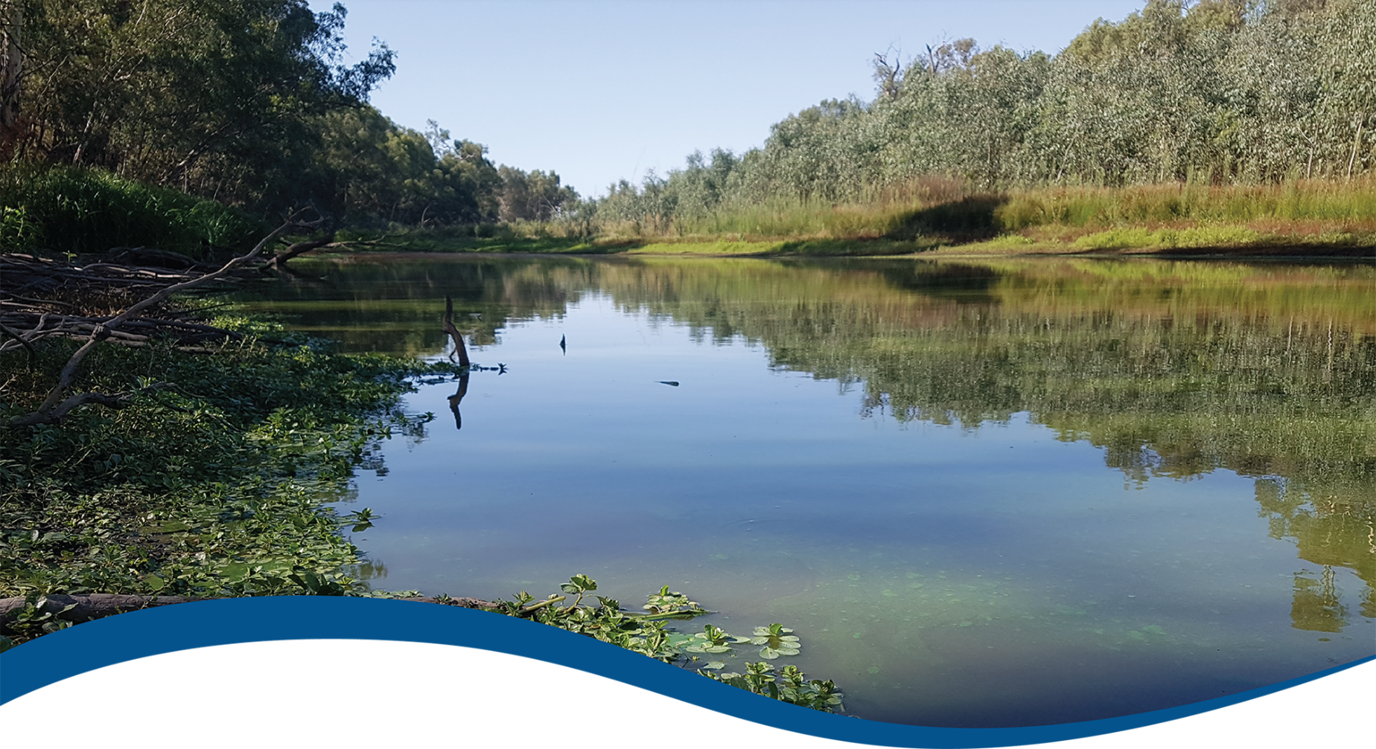
Basin-scale evaluation of 2023–24 Commonwealth environmental water: Food Webs and Water Quality
  - Commonwealth Environmental Water Holder’s Science Program:
Flow Monitoring Evaluation and Research Program (Flow-MER)
JUNE 2025
Acknowledgement of Country
The project team and the Commonwealth Environmental Water Holder (CEWH) respectfully acknowledge the Traditional Owners of the land on which this work is conducted, their Elders past and present, their Nations of the Murray–Darling Basin, and their cultural, social, environmental, spiritual and economic connection to their lands and waters.
Acknowledgement of collaborators and contributors
A big thank you for contributions from Selected Area Theme Leaders and team members: Mike Grace, Simon Treadwell, Yoshi Kobayashi, Xiaoying Liu, Nicole McCasker, Rod Oliver, Alica Tschierschke, Andre Siebers, Nick Bond, Mark Southwell and Sarah Mika.
We would like to thank the CSIRO team members for their efforts in report layout, editing, reviewing and formatting. Special mention to Jane Thomas, Dianne Flett, Martin Nolan and Susan Cuddy whose input, together with formatting specialist Jill Sharkey, greatly improved the readability of the report. CSIRO’s Martin Nolan assisted with figures and GIS layers.
We would also like to thank Luke McPhan for his peer review of the new counterfactual modelling, and write-up in Chapter 5 of this report and companion Methods report (O’Sullivan and Cuddy 2025); and the staff of the CEWH and the CEWH’s Independent Advisory Group for providing independent expert review. We acknowledge the independent expert reviews provided by Professor Peter Davies over several years and the contribution his reviews have made to improving this evaluation and reporting.
Citation
McInerney P, Linke S and Giling D (2025) Basin-scale evaluation of 2023–24 Commonwealth environmental water: Food Webs and Water Quality. Flow-MER Program. Commonwealth Environmental Water Holder, Department of Climate Change, Energy, the Environment and Water, Australia. 78pp.
Copyright
 © Commonwealth of Australia 2025
With the exception of the Commonwealth Coat of Arms, partner logos and where otherwise noted, all material in this publication is provided under a Creative Commons Attribution 4.0 International Licence https://creativecommons.org/licenses/by/4.0/. Flow-MER requests attribution as ‘© Commonwealth of Australia (Flow-MER Program, https://flow-mer.org.au)’.
Cover photograph
Gulpa Creek, New South Wales
Photo credit: Paul McInerney
Document history
Date | Version
24 March 2025 | Draft delivered to CSIRO for editing and quality checking
26 March 2025 | V1.0 – reporting team editing and review
30 April 2025 | V2.0 – draft delivered to CEWH for review
20–24 June 2025 | Review comments received from CEWH and response to review comments undertaken
30 June 2025 | V3.0 Final delivered to CEWH

Important disclaimer
The information contained in this publication comprises general statements based on scientific research. The reader is advised and needs to be aware that such information may be incomplete or unable to be used in any specific situation. No reliance or actions must therefore be made on that information without seeking prior expert professional, scientific and technical advice. To the extent permitted by law, Flow-MER (including its partners and collaborators) excludes all liability to any person for any consequences, including but not limited to all losses, damages, costs, expenses and any other compensation, arising directly or indirectly from using this publication (in part or in whole) and any information or material contained in it.
Flow-MER is committed to providing web-accessible content wherever possible. If you are having difficulties with accessing this document, please contact ewater@dcceew.gov.au.

Executive summary
Strategic management of Commonwealth environmental water by the Commonwealth Environmental Water Holder (CEWH) is key to achieving the environmental objectives in the Commonwealth’s (Murray–Darling) Basin Plan 2012 (the Basin Plan). The CEWH’s Science Program invests in Flow Monitoring, Evaluation and Research (Flow-MER) to demonstrate Basin-scale outcomes of Commonwealth environmental water, support adaptive management, and fulfil the CEWH’s legislative requirements under the Basin Plan.
A key objective of the Basin Plan is the ‘protection and restoration of ecosystem functions of water-dependent ecosystems’ (Basin Plan section 8.06). This includes ‘food webs that sustain water-dependent ecosystems, including by protecting energy, carbon and nutrient dynamics, primary production and respiration’ (Basin Plan subsection 8.06(7)). Furthermore, Basin Plan section 5.04 establishes objectives for maintaining adequate water quality, which underpins productive and diverse food webs. These objectives are highlighted for future consideration within the Basin-wide environmental watering strategy (the Strategy) and will be further explored for inclusion in the next Strategy under Ecosystem Functions as a subtheme of the Flows and Connectivity Theme.
The Basin-scale Food Webs and Water Quality Theme investigates how environmental water impacts water quality and stream metabolism in the Murray–Darling Basin (the Basin). The Basin Plan seeks to protect and restore biodiversity in the Basin’s aquatic ecosystems. Energy flow in food webs is one of several critical ecosystem functions that are central to sustaining biodiversity, along with hydrological connectivity and nutrient cycling. Improved understanding of the influence of flow on the production and breakdown of organic matter in food webs will complement our understanding of the influence of flow on habitat and connectivity. In combination, this knowledge will enable better management of environmental flows within the Basin. The evaluation is structured around answering 4 Basin-scale questions:
What did Commonwealth environmental water contribute to patterns and rates of ecosystem respiration?
What did Commonwealth environmental water contribute to patterns and rates of primary productivity?
What did Commonwealth environmental water contribute to dissolved oxygen levels?
What did Commonwealth environmental water contribute to salinity regimes?
Stream metabolism is used to address the first 3 evaluation questions. We report on stream metabolism from the 7 Selected Areas for the 2023–24 water year (1 July 2023 to 30 June 2024) and place this in the context of longer term (2014–24) patterns.
In this evaluation, we extend our ‘metabolic fingerprint’ approach to interrogate dominant metabolic responses to flows that are common to all Selected Areas. The approach improves the correlation of metabolic responses to flow and provides a visual assessment of whether responses are within the ‘typical’ metabolic regime of a Selected Area. The metabolic fingerprints developed for this evaluation are based on 24,621 daily records of gross primary production (GPP) and ecosystem respiration (ER) from 2014–24. This is one of the largest riverine metabolic datasets in the world. We also performed counterfactual modelling to estimate the contribution of Commonwealth environmental water to riverine GPP across the entire 2014–24 monitoring period.
The export of salt through the Lower Murray River Selected Area and in-situ measurements of electrical conductivity at the other Selected Areas are used to evaluate salinity.

2023–24 key metrics and messages
Of the 114 Commonwealth environmental watering actions in 2023–24, 38 (2,160 GL) had expected outcomes linked to water quality and ecosystem process or food webs. Of the 38 watering actions linked to water quality, 21 (1,955 GL) occurred within 6 of the 7 Selected Areas. Of the 10 watering actions linked to ecosystem process or food webs, 6 (1,492 GL) occurred within 2 of the 7 Selected Areas.

Food webs, stream metabolism, gross primary production and ecosystem respiration
- 6 out of 7 Selected Areas were net consumers of carbon (ratio of GPP to ER was less than 1). This highlights the importance of terrestrial organic carbon from channel and floodplain connectivity as a major energy source in these systems.
- Season was the primary driver of rates of stream metabolism – the highest daily rates of GPP and ER were consistently recorded in summer.
- There were significant relationships between stream metabolism and flow. Higher flows generally decreased in-channel volumetric rates of GPP and ER, likely due to disturbance and dilution effects. However, responses were variable among sites, emphasising a high level of context dependency, likely related to channel morphology and other site-specific characteristics.
- Within Selected Areas, changes to rates of GPP and ER in response to flow were generally small and comparable to previous years.

Dissolved oxygen
- Environmental watering actions in the Edward/Kolety–Wakool river systems maintained dissolved oxygen concentrations during warm periods, potentially preventing the development of hypoxic blackwater events.

Salinity
- Commonwealth environmental water was responsible for the export of 221,272 tonnes of salt (17.8% of total salt exported) through the barrages.

2014–24 key metrics and messages

Food webs, stream metabolism, gross primary production and ecosystem respiration
- Rates of GPP and ER across all Selected Areas in the 2023–24 water year were broadly similar and comparable to the previous 9-year record. Over the 10 years, riverine ecosystems of the Goulburn River, Edward/Kolety–Wakool river systems, Lachlan River System, Gwydir River System and Junction of Warrego and Darling rivers were predominantly heterotrophic, consuming more carbon than they were producing.
- The Murrumbidgee River System regularly alternated between heterotrophy and autotrophy over the 10 years, depending on conditions (such as season).
- The Lower Murray River was mostly a net producer of carbon (autotrophic) up to 2021–22, driven by phytoplankton and relatively low turbidity in the slow-flowing channels. However, high flows in 2022–23 shifted the Lower Murray River into heterotrophy, reflecting a return to a flowing system more closely resembling metabolic patterns at other Selected Areas. For the 2023–24 water year, the Lower Murray River returned to autotrophy, reflecting reduced flows from the previous year.
- GPP was sensitive to Commonwealth environmental water. Counterfactual modelling revealed that Commonwealth environmental water most often was associated with a modest reduction in riverine GPP. This is generally a positive outcome for river condition as it potentially limits the proliferation of algae during warm and low flow periods.
- Overall, Commonwealth environmental water was estimated to have reduced annual GPP by a mean of 5.3% (range 0.3% to 17.5% among site and years). On individual days with Commonwealth environmental water contribution, daily GPP was a mean of 15% lower than the counterfactual scenario (range 6.5% to 43% among sites and years).
- Commonwealth environmental water bolstered riverine GPP in rare instances where the water contributed to very high discharges (e.g. when extending a flood recession), supporting the boom–bust nature of the lowland river–floodplain systems.
- Independent of Commonwealth environmental watering actions, rates of GPP are most strongly influenced by seasonal changes (i.e. light, temperature) and site-specific drivers (e.g. bioavailable nutrient concentrations, reduced light availability due to turbidity).

Dissolved oxygen
- In 2014–24, Commonwealth environmental water decreased the likelihood of low dissolved oxygen in the Lower Murray River by maintaining flow velocities above 0.18 m/s. Flow velocities above this threshold increase water mixing and oxygen exchange at the surface. Below this velocity, surface oxygen exchange is poor.

Key contributions to Basin Plan objectives

Water year 2023–24
- Paragraphs 8.06(3)(c),(d) and section 9.09: Commonwealth environmental water was responsible for the export of 221,272 tonnes of salt (17.8% of total salt exported and around 11% of the Basin target) through the barrages.
- Subsection 8.06(7): Data from the 7 Selected Areas provided evidence that Commonwealth environmental water contributed to protecting and restoring energy, carbon and nutrient dynamics, primary production and respiration – reducing the risk of blackwater events and algal blooms.
- Section 9.08: Environmental watering actions in 2023–24 provided benefits in terms of increasing oxygen concentrations and reducing the potential for blackwater events

Water years 2014–24
- Paragraphs 8.06(3)(c),(d): Commonwealth environmental water played an important role in meeting long-term objectives to protect and restore connectivity within and between water-dependent ecosystems. Commonwealth environmental water can support heterotrophic production if it contributes to connectivity between river channels and floodplains by increasing the supply of allochthonous organic carbon to food webs.
- Subsection 8.06(7): There is evidence from all Selected Areas that Commonwealth environmental water has had a positive influence on protecting and restoring energy, carbon and nutrient dynamics, primary production and respiration over the 10 years. For example, even when changes in rates of GPP and ER were small, the increase in water volume provided by Commonwealth environmental water increased total production and consumption of carbon in riverine food webs.
- Section 9.08: Trends in water quality and relationships with environmental flow delivery are difficult to assess across the Basin due to the high level of spatial and temporal baseline variation and inadequate data to capture that variability. However, there is strong evidence that Commonwealth environmental water played an important role in maintaining water quality over the 10 years. For example, anoxic events in 2016 and the subsequent delivery of ameliorating flows that included Commonwealth environmental water demonstrated the utility of targeted watering actions that are designed to improve water quality (e.g. evidenced by counterfactual observations). Commonwealth environmental water also contributed to the objective of meeting salt export targets (see section 9.09 and paragraph 9.14(5)(c)).
- Section 9.09: Over the 10 years, Commonwealth environmental water was responsible for exporting over 4 million tonnes of salt exported through the barrages (around 22% of the Basin Plan target) and reducing salt import by more than 28 million tonnes.
- Paragraph 9.14(5)(a): When the addition of Commonwealth environmental water increased mean water velocities above ~0.18 m/s in the Lower Murray River, it helped reduce the likelihood of low dissolved oxygen concentrations by increasing gas exchange at the water surface.
- Paragraph 9.14(5)(c): Commonwealth environmental water contributed to maintenance of river salinity below 800 µS/cm (electrical conductivity) at Morgan over the 10 years. Salinity was maintained within the range required for potable water in the Murray River over this period – water was about 10% fresher due to environmental flows.

Informing adaptive management
- Despite high site-specific context dependency, we identify a general response at the vast majority of locations: increased flow decreases volumetric rates of overall metabolic activity, or ‘metabolic throughput’, via disturbance and dilution. Flow disturbance can therefore be used to ‘reset’ aquatic ecosystems by moving sediments and scouring periphyton. The trajectory of recovery is likely to vary by site and by valley, governed by localised drivers such as size of the flow, substrate type, channel morphology and structural complexity. The rate of recovery is indicative of ecosystem resilience.
- Commonwealth environmental water can support higher ecosystem respiration rates and heterotrophic production if flows lead to increases in terrestrial carbon subsidies to the river channel (e.g. litter). The amount of litter incorporated into the river channel is governed primarily by:
  - flow type, for example bankfull and overbank flows may increase lateral connectivity and mobilise large quantities of litter, while freshes may be limited to incorporating small quantities of litter from in-channel features only; and
  - antecedent patterns, for example climate, time since last flow, magnitude of last flow).
- Increasing flow reduces the volumetric rate of primary production but increases cross-sectional channel GPP, particularly in reaches where the channel broadens, by increasing the cross-sectional area of the photic zone (i.e. the area with enough light for photosynthesis). Although rates of GPP and ER are not direct estimates of secondary production by higher trophic levels, ecological theory and existing empirical evidence suggest that this increased ecosystem metabolism will be correlated with higher consumer productivity.
- There is scope to focus future Basin-scale reporting for food webs and water quality on improving our understanding of how the food supply for food webs is influenced by Commonwealth environmental water (e.g. recovery of metabolic activity following flow disturbance, influence of disturbance on food webs).

Recommendations
- To improve the utility of metabolic data collected, we recommend a formally designed and coordinated sampling approach between and beyond Selected Areas for future iterations of Flow-MER. Lack of a complete metabolic time series (e.g. no winter data) at most Selected Areas makes removal of ‘season’ as a factor to better understand the influence of flow problematic. We recommend collection of metabolic data year-round using the same sampling approach at all Selected Areas. This will improve our capacity to predict flow-metabolism responses in unmonitored areas.
- We recommend estimation of average depth at all Selected Areas, which will enable conversion of volumetric metabolic rates to areal rates, in line with international literature.

Overview of Flow-MER and this 2023–24 evaluation
The Commonwealth Environmental Water Holder’s (CEWH) Science Program invests in monitoring, evaluation and research activities through its Flow Monitoring, Evaluation and Research (Flow-MER) Program. The Flow-MER Basin-scale evaluation assesses the contributions of Commonwealth environmental water (CEW) to meeting the environmental objectives stated in chapters 8 and 9 of the (Murray–Darling) Basin Plan 2012 and in the Basin-wide environmental watering strategy. Six Basin Themes (Figure 1) are evaluated using data from 7 Flow-MER Selected Areas (left-side map, Figure 2) and the 19 valleys (right-side map, Figure 2) where the CEWH holds water entitlements in the Murray–Darling Basin. The evaluation builds on work undertaken by its predecessors. Research informs the evaluation and the CEWH’s Science Program.
Figure 1 Schematic of the components of the Basin-scale evaluation
The evaluations are informed by Basin-scale research projects, stakeholder engagement and Selected Area monitoring data.
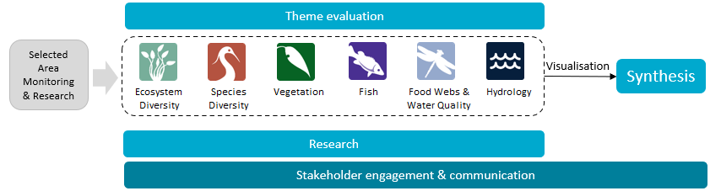
Figure 2 The 7 Selected Areas (left map) and 25 valleys (right map) established for long-term monitoring of the impacts of environmental watering under the Long Term Intervention Monitoring Project and Flow-MER (2014–15 to present)
In the valleys map, grey shading indicates the 19 valleys where the Commonwealth holds water entitlements and which are in scope for evaluation; white identifies those valleys which are not in scope.
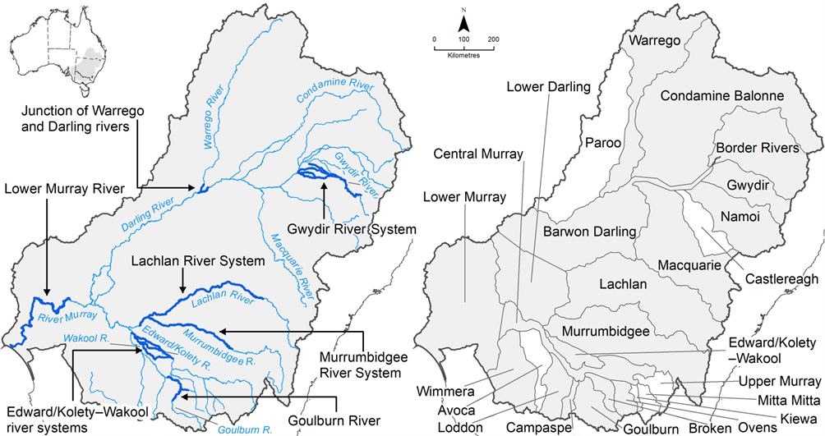

Evaluating the contribution of Commonwealth environmental water to observed environmental outcomes
To undertake the Basin-scale evaluation, the Basin-scale evaluation team uses water delivery and outcomes data provided by the CEWH’s Science Program, along with monitoring data provided by the 7 Selected Areas. Other publicly available data may be used where relevant data are not collected by the Selected Areas.
Evaluation of the contribution of CEW to observed environmental outcomes for the 6 Basin Themes depends on the data available.
When delivered with other water, ecological outcomes cannot be apportioned with current methods and CEW is reported as contributing to, or supporting, the environmental outcomes of the watering action.
The multi-year Hydrology (instream), Fish and Vegetation Basin Themes have sufficient data to model and compare environmental outcomes both with and without CEW (counterfactual modelling).
Ecosystem Diversity, Species Diversity and Vegetation Basin Themes identify environmental responses in locations that received CEW (often in conjunction with other sources of environmental or non-environmental water) and, where feasible, compare them with areas that did not receive CEW.
Hydrology (inundation) and Food Webs and Water Quality Basin Themes use flow and water quality metrics to infer likely outcomes.
Fish (annual), Vegetation (annual) and Food Webs and Water Quality Basin Themes synthesise findings across Selected Areas.

Partnering on watering actions
Commonwealth environmental water is often delivered in conjunction with other environmental water holdings and non-environmental water releases (such as for irrigation or during high flow events).
Commonwealth environmental watering actions for the most recent evaluation year (2023–24) and cumulative over the 10 evaluation years (2014–15 to 2023–24) are provided in Table 1.1.
Table 1.1 Summary statistics for most recent evaluation year and multi-year evaluation period
Dash (–) indicates statistic not available.
 | 2023–24 | 2014–24
Volume of CEW actions (GL) | 2,870 | 18,310
Number of CEW actions | 114 | 1,194
% CEW volume of total EW volume | ~70% | –
% CEW actions with partner or with other flows | ~50% | –
CEW % of total volume of partnered watering actions | ~50% | –
CEW % of total Basin surface water runoff | ~13% | –

Evaluation reporting
Each Basin Theme prepares a technical evaluation report for each water year from which key outcomes and lessons for adaptive management are brought together, with research highlights, into an annual synthesis report. To provide consistency over the life of Flow-MER and its predecessors, some content in these annual reports may be reused from previous years. In these cases, all efforts have been made to cite the relevant Long Term Intervention Monitoring Project, Environmental Water Knowledge and Research Project, or Flow-MER publication. All reports published by the CEWH are available from the CEWH's publications and resources webpage.

Basin-scale Flow-MER partnership
Basin-scale evaluation in Flow-MER is led by CSIRO in partnership with the University of Canberra. Collaborators on the 2023–24 evaluation include Alluvium, Arthur Rylah Institute, Charles Sturt University, South Australian Research & Development Institute, NSW Department of Primary Industries, the Australian River Restoration Centre and Brooks Ecology & Technology.
2025 is the final year of this 5-year phase of Flow-MER. This is the final evaluation under this phase. The next 5-year phase commenced on 1 July 2025 and is led by CSIRO in partnership with the One Basin Cooperative Research Centre. Information on the new phase of Flow-MER can be found at the CEWH's science programs website.

Contents
Executive summary iii
2023–24 key metrics and messages iv
2014–24 key metrics and messages v
Key contributions to Basin Plan objectives v
Informing adaptive management vi
Overview of Flow-MER and this 2023–24 evaluation viii
Evaluating the contribution of Commonwealth environmental water to observed environmental outcomes ix
Partnering on watering actions ix
Evaluation reporting ix
Basin-scale Flow-MER partnership ix
Contents xi
1 Introduction 1
1.1 Evaluation objectives 1
1.2 Evaluation coverage 2
1.3 About this report 2
2 Overview of evaluation approach 3
2.1 Conceptual model 3
2.2 Metabolic fingerprints 4
3 Basin-scale evaluation 2023–24 6
3.1 Key findings 6
3.2 Rainfall 6
3.3 Environmental water delivery 2023–24 7
3.4 Outcomes 8
4 Basin-scale evaluation 2014–24 15
4.1 Key findings 15
4.2 Rainfall 15
4.3 Environmental water delivery 2014–24 16
4.4 Outcomes 17
5 Contribution of Commonwealth environmental water to river gross primary production 2014–24 – counterfactual analyses 26
5.1 Key findings 26
5.2 Overview of approach 26
5.3 Outcomes 27
5.4 Implications 31
6 Contribution to Basin Plan objectives 32
7 Informing adaptive management for food webs and water quality outcomes 35
7.1 Informing the planning and management of environmental water for food webs and water quality 35
7.2 Improving our approach to Basin-scale evaluation 37
Appendix A Stream metabolic responses to flow at sites in 7 Selected Areas 39
A.1 Junction of Warrego and Darling rivers stream metabolism – flow relationship plots 39
A.2 Edward/Kolety–Wakool river systems stream metabolism – flow relationship plots 40
A.3 Goulburn River stream metabolism – flow relationship plots 44
A.4 Lachlan River System stream metabolism – flow relationship plots 48
A.5 Lower Murray River stream metabolism – flow relationship plots 54
A.6 Murrumbidgee River System stream metabolism – flow relationship plots 55
A.7 Gwydir River System stream metabolism – flow relationship plots 57
Abbreviations and terms 60
References 61

Figures
Figure 1 Schematic of the components of the Basin-scale evaluation viii
Figure 2 The 7 Selected Areas (left map) and 25 valleys (right map) established for long-term monitoring of the impacts of environmental watering under the Long Term Intervention Monitoring Project and Flow-MER (2014–15 to present) viii
Figure 1.1 Schematic of key elements of stream metabolism and water quality indicators 1
Figure .1 Conceptual model of the approach within the Flow-MER Basin-scale Food Webs and Water Quality Theme evaluation to measuring metabolic responses to Commonwealth environmental water 5
Figure .1 Variation in metabolic fingerprints across the 7 Selected Areas, 2023–24 10
Figure .1 Maps of annual rainfall conditions, 2014–24 16
Figure .2 Number of Commonwealth environmental watering actions and corresponding total volume linked to objectives for water quality and ecosystem processes or food webs for each water year, 2014–24 17
Figure .3 Longer-term 2014–23 metabolic fingerprints (contour lines) overlaid with the 2023–24 metabolic fingerprint (dots) for Selected Areas 19
Figure .4 Relationship between stream metabolism and flow at Loch Garry gauge, Goulburn River 23
Figure .5 Relationship between stream metabolism and flow at McCoys Bridge, Goulburn River 24
Figure .1 Plot of generalised additive model (GAM) results 28
Figure .2 Effect of Commonwealth environmental water contribution to flow on the predicted change in annual gross primary production compared to the counterfactual scenario 29
Figure .3 Counterfactual gross primary production (GPP) predictions for one site in the Lower Murray River Selected Area over 2 years 29
Figure .4 Counterfactual gross primary production (GPP) predictions for Hopwood in the Edward/Kolety–Wakool river systems Selected Area in 2016–17 30
Figure .5 Counterfactual gross primary production (GPP) predictions for Lane’s Bridge in the Lachlan River System Selected Area 30

Figure A.1 Junction of Warrego and Darling rivers stream metabolism – flow relationship plots: WD_AKUNA 39
Figure A.2 Junction of Warrego and Darling rivers stream metabolism – flow relationship plots: WD_YANDA 40
Figure A.3 Edward/Kolety–Wakool river systems stream metabolism – flow relationship plots: Hopwood 40
Figure A.4 Edward/Kolety–Wakool river systems stream metabolism – flow relationship plots: Llanos Park 2 41
Figure A.5 Edward/Kolety–Wakool river systems stream metabolism – flow relationship plots: Moulamein Road Bridge 41
Figure A.6 Edward/Kolety–Wakool river systems stream metabolism – flow relationship plots: Noorong 2 42
Figure A.7 Edward/Kolety–Wakool river systems stream metabolism – flow relationship plots: Old Morago Road 42
Figure A.8 Edward/Kolety–Wakool river systems stream metabolism – flow relationship plots: Widgee 1 43
Figure A.9 Edward/Kolety–Wakool river systems stream metabolism – flow relationship plots: Windra Vale 2 43
Figure A.10 Edward/Kolety–Wakool river systems stream metabolism – flow relationship plots: Cummins 44
Figure A.11 Goulburn River stream metabolism – flow relationship plots: Arcadia Down 44
Figure A.12 Goulburn River stream metabolism – flow relationship plots: Darcy’s Track 45
Figure A.13 Goulburn River stream metabolism – flow relationship plots: Day Road 45
Figure A.14 Goulburn River stream metabolism – flow relationship plots: Loch Garry Gauge 46
Figure A.15 Goulburn River stream metabolism – flow relationship plots: McCoys Bridge 46
Figure A.16 Goulburn River stream metabolism – flow relationship plots: Moss Road 47
Figure A.17 Goulburn River stream metabolism – flow relationship plots: Murchison 47
Figure A.18 Goulburn River stream metabolism – flow relationship plots: Shepparton 48
Figure A.19 Lachlan River System stream metabolism – flow relationship plot: CC 48
Figure A.20 Lachlan River System stream metabolism – flow relationship plots: EU 49
Figure A.21 Lachlan River System stream metabolism – flow relationship plots: KP 49
Figure A.22 Lachlan River System stream metabolism – flow relationship plots: LB (Lanes Bridge) 50
Figure A.23 Lachlan River System stream metabolism – flow relationship plots: MG 50
Figure A.24 Lachlan River System stream metabolism – flow relationship plots: TH 51
Figure A.25 Lachlan River System stream metabolism – flow relationship plots: WAL 51
Figure A.26 Lachlan River System stream metabolism – flow relationship plots: WB 52
Figure A.27 Lachlan River System stream metabolism – flow relationship plots: BOO 52
Figure A.28 Lachlan River System stream metabolism – flow relationship plots: CON 53
Figure A.29 Lachlan River System stream metabolism – flow relationship plots: HUN 53
Figure A.30 Lower Murray River stream metabolism – flow relationship plots: LK1DS_265km (Lock 1) 54
Figure A.31 Lower Murray River stream metabolism – flow relationship plots: LK4DS_501km (Lock 4) 54
Figure A.32 Lower Murray River stream metabolism – flow relationship plots: LK6DS_616km (Lock 6) 55
Figure A.33 Murrumbidgee River System stream metabolism – flow relationship plots: 1 km upstream Wynburn Escape 55
Figure A.34 Murrumbidgee River System stream metabolism – flow relationship plots: 3 km downstream Wynburn Escape 56
Figure A.35 Murrumbidgee River System stream metabolism – flow relationship plots: McKennas 56
Figure A.36 Murrumbidgee River System stream metabolism – flow relationship plots: Narrandera 57
Figure A.37 Gwydir River System stream metabolism – flow relationship plots: GWY_418001 57
Figure A.38 Gwydir River System stream metabolism – flow relationship plots: GWY_418053 58
Figure A.39 Gwydir River System stream metabolism – flow relationship plots: GWY 418077 58
Figure A.40 Gwydir River System stream metabolism – flow relationship plots: GWY_418078 59
Figure A.41 Gwydir River System stream metabolism – flow relationship plots: GWY_ME1 59

Tables
Table 1.1 Summary statistics for most recent evaluation year and multi-year evaluation period ix
Table 1.2 Sources of data used for analyses in this report 2
Table 3.1 Annual rainfall conditions by valley, 2023–24 6
Table 3.2 Commonwealth environmental watering actions with objectives linked to water quality and ecosystem process or food webs, by valley, 2023–24 7
Table 3.3 Stream metabolism evaluation questions and responses relating to 2023–24 Commonwealth environmental water, extracted from 2023–24 Selected Area reports 11
Table 4.1 Modelled metabolic response to flow at 41 sites in 5 of the 7 Selected Areas 20
Table 4.2 Ten-year record of modelled additional salt export (tonnes) due to Commonwealth environmental water (CEW) through the barrages to the Coorong estuary and reduction in import of salt through the Murray Mouth into the Coorong from the Southern Ocean attributable to CEW 25
Table 5.1 Results of best supported GAM model 27
Table 6.1 Commonwealth Environmental Outcomes Framework for food webs and water quality, and key findings for 2023–24 and 2014–24 32

Introduction
This chapter summarises the purpose of the Basin-scale evaluation, its objectives and coverage, and the structure of this report.

Evaluation objectives
The Basin-scale Food Webs and Water Quality Theme evaluates the contribution of Commonwealth environmental water (CEW) to stream metabolism in the Murray–Darling Basin (the Basin). This report describes the most recent (one-year) and longer term (10-year) evaluations, addressing 4 Basin-scale evaluation questions (see Figure 1.1):
What did Commonwealth environmental water contribute to patterns and rates of ecosystem respiration?
What did Commonwealth environmental water contribute to patterns and rates of primary productivity?
What did Commonwealth environmental water contribute to dissolved oxygen levels?
What did Commonwealth environmental water contribute to salinity regimes?
Figure 1.1 Schematic of key elements of stream metabolism and water quality indicators
LTIM = Long Term Intervention Monitoring Project; PAR = photosynthetically active radiation. Source: adapted from Hale et al. (2014).
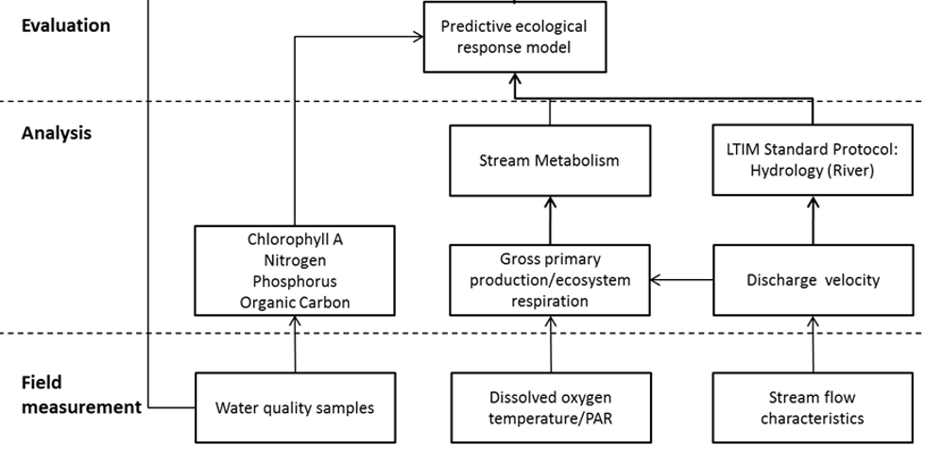
The Commonwealth’s (Murray–Darling) Basin Plan 2012 (the Basin Plan) lists food webs and water quality objectives in sections 8 and 9. Many of these are qualitative – that is, they refer to expected outcomes such as improved hydrological connectivity, more frequent opening of the Murray Mouth, improved water quality, and restoration of ecological community structures and food webs – rather than measurable targets.
Three measurable targets relevant to the Basin-scale Food Webs and Water Quality Theme are:
- maintenance of (instream) dissolved oxygen (DO) of at least 50% saturation
- an average of 2 million tonnes of salt discharged into the Southern Ocean each water year
- salinity levels at reporting sites not to exceed set targets 95% of the time (e.g. target of 830 µS/cm at Murray Bridge).
Basin Plan objectives are fully listed in Table 6.1.

Evaluation coverage
This report uses the Stream Metabolism Category 1 — gross primary production (GPP), ecosystem respiration (ER) and dissolved oxygen (DO) – data collected by the Flow-MER Selected Area teams and stored in the CEWH’s Monitoring Data Management System (MDMS); and hydrological data provided by the Basin-scale Hydrology Theme to assess riverine metabolic responses to flow (Table 1.1).
For the 2023–24 evaluation, Stream Metabolism Category 1 data were collected from 26 sites from all 7 Selected Areas: Lower Murray River, 3 sites; Goulburn River, 4 sites; Edward/Kolety–Wakool river systems, 7 sites; Lachlan River System, 5 sites; Gwydir River System, 3 sites; Junction of Warrego and Darling rivers, 3 sites and Murrumbidgee River System, 1 site.
Table 1.1 Sources of data used for analyses in this report
Note: Dissolved oxygen (DO) data are logged at the Selected Areas. The Selected Areas then run these data through the Bayesian single-station estimation model to estimate gross primary production (GPP) and ecosystem respiration (ER). The raw DO data are uploaded to the CEWH’s Monitoring Data Monitoring System. DO is reported when or if it reaches critically low values at the Selected Area.
Selected Area | Parameter | Source
Lower Murray River | Daily estimates of GPP and ER | Local Selected Area team
Goulburn River | Daily estimates of GPP and ER | Local Selected Area team
Edward/Kolety–Wakool river systems | Daily estimates of GPP and ER | Local Selected Area team
Lachlan River System | Daily estimates of GPP and ER | Local Selected Area team
Murrumbidgee River System | Daily estimates of GPP and ER | Local Selected Area team
Gwydir River System | Daily estimates of GPP and ER | Local Selected Area team
Junction of Warrego and Darling rivers | Daily estimates of GPP and ER | Local Selected Area team
Basin | Hydrological data | Hydrology Theme team
Basin | Rainfall data | Hydrology Theme team
Basin | Commonwealth environmental watering actions | CEWH Science section (CEWH 2024)

About this report
The Basin-scale Food Webs and Water Quality Theme has been led by CSIRO in partnership with the University of Canberra. This report builds on previous reports (Grace 2019, 2020; McInerney et al. 2021, 2022, 2023) and reporting undertaken as part of the Long Term Intervention Monitoring Project (2014–19) and Flow-MER (2019–24). The approach and methods are fully described in companion methods report (O’Sullivan and Cuddy 2025).

Overview of evaluation approach
This chapter provides an overview of the approach adopted for the evaluation and its conceptual framing. Methods are fully described in companion methods report (O’Sullivan and Cuddy 2025).
Stream metabolism comprises 2 key ecological processes – gross primary productivity (GPP) and ecosystem respiration (ER) – which generate and recycle organic matter, respectively. Stream metabolism measurements estimate the instream rates of GPP and ER by measuring changes in DO. Net ecosystem production (NEP) – the difference between GPP and ER – determines whether carbon accumulates or is depleted within an ecosystem (Bernhardt et al. 2018). Volumetric GPP and ER rates represent the amount of carbon being fixed or respired per litre of water, respectively, which is important for understanding food web processes and assessing potential water quality risks, such as algal blooms or hypoxia. Since GPP represents the fixing of carbon into organic matter and ER is the breakdown of this matter and remineralisation of the organic carbon, high rates of both GPP and ER (i.e. with a GPP:ER close to 1) indicate rapid cycling or ‘metabolic throughput’ of carbon by aquatic organisms. In contrast, low but balanced GPP and ER indicates slow cycling and low throughput.
We do not expect metabolic responses to flow to be sensitive to the purpose of the flow (e.g. environment, irrigation supply) but rather to the duration, timing and magnitude or spatial extent of watering events. Therefore, to understand the general flow–ecology relationships, we focus most of our analyses on metabolic responses to the full hydrological dataset (i.e. total flow, not just Commonwealth environmental water (CEW). However, we also present a model that uses these flow–ecology relationships to estimate the contribution of CEW to GPP by estimating a counterfactual scenario.
Continuous water quality monitoring integrated into Flow-MER is restricted to temperature and DO, which are collected to calculate rates of stream metabolism. Other water quality parameters (e.g. pH, turbidity, electrical conductivity), and water column nutrients (e.g. total and filterable nitrogen and phosphorus) are typically measured during visits to sites. Hence, data often comprise single measurements made at intervals of a month or more. Spot measurements of water quality and nutrients provide useful information about riverine conditions at a single point in time, but values can vary widely between collection of samples and such measurements are not necessarily representative of conditions for the entire continuous logging period. Thus, we do not report these values when interpreting Basin-scale stream metabolism calculated from logged DO data. This Basin Theme aims to understand and predict how flow influences water quality (nutrients, temperature, light, salinity) which, in turn, can regulate rates of stream metabolism and productivity (energy availability).

Conceptual model
Conceptually, our approach builds on work carried out in the preceding Environmental Water Knowledge and Research and Long Term Intervention Monitoring projects. The Environmental Water Knowledge and Research Project Food Web Theme explored the conceptual link between the Waterbird, Fish and Vegetation themes, linking the production of resources to provision of food for consumers in response to environmental flows. We have extended that framework to incorporate productivity responses of ecosystems to different flow components (Figure 2.1). Rates of GPP and ER can control and impose restrictions on energy supply and energy dispersal through food webs (Rüegg et al. 2021). The balance of these 2 fluxes, measured as NEP, determines whether carbon accumulates or decreases in an ecosystem.
A significant challenge when interpreting responses of stream metabolism to environmental water is determining what levels of productivity are ‘desirable’ and ‘undesirable’. For example, a large overbank flow event has the potential to liberate substantial quantities of organic carbon from floodplains, which can generate significant increases in heterotrophic in-channel productivity (measured as ER). However, such large productivity responses may be undesirable if they occur in concert with small GPP responses, potentially leading to blackwater events, where more oxygen is consumed from the water column than is produced, ultimately leading to hypoxia (acute lack of oxygen) for aquatic animals (large brown arrow in top ‘fingerprint’ plot in Figure 2.1). Equally, at the other extreme, a cease-to-flow or base flow event (depicted by the darker green arrow in top fingerprint plot in Figure 2.1) coupled with high sunlight and high nutrient concentrations has the potential to generate high rates of GPP during daylight hours and similarly high rates of ER overnight. However, if this occurs as a blue-green algal bloom, it is also an undesirable productivity response that may be harmful to aquatic animal and human health.
Conceptually, we are addressing whether metabolism at a particular place and time is inside the bounds of expected productivity conditions, by generating metabolic fingerprints for each Selected Area.

Metabolic fingerprints
Metabolic fingerprints are a visualisation tool for contrasting annual patterns of metabolism across rivers or across years for the same river (Bernhardt et al. 2018). The metabolic fingerprint depicts the dominant metabolic regime at a site, presented as a kernel-density plot of all daily estimates of GPP and ER rates (Figure 2.1). Importantly, a metabolic fingerprint displays the dispersion of both GPP and ER in a single plot, allowing an integrated examination of organic carbon generation and consumption. This plotting approach can be used to assess the degree to which a site satisfies certain metabolic conditions (e.g. target ranges or states) and can be linked to evaluation against expected outcomes – for example, under a future metabolism component in the Basin-wide environmental watering strategy (the Strategy) (MDBA 2019). The approach can also be extended beyond plotting and used to establish statistical patterns in metabolic responses to flow (see Section 4.4.2).

Figure 2.1 Conceptual model of the approach within the Flow-MER Basin-scale Food Webs and Water Quality Theme evaluation to measuring metabolic responses to Commonwealth environmental water
We use a metabolic fingerprinting approach (Bernhardt et al. 2018), an emerging tool for visualising and diagnosing change in stream metabolism across time or space and in response to hypothesised drivers. The method enables us to identify whether metabolic responses to a flow condition are within the typical metabolic regime of a site or represent atypical conditions at that site. Atypical metabolic conditions may indicate a desirable state (e.g. high gross primary production [GPP] and ecosystem respiration [ER], high system throughput) or an undesirable state (e.g. algal blooms, hypoxic blackwater), providing an indication of how different flow types can provide carbon and nutrients for food webs. The approach can be scaled spatially (e.g. valley responses, northern or southern Basin) and temporally (e.g. fingerprints overlaid through time with multiple flows) to improve our understanding of the relationships between environmental water and productivity. OM = organic matter.
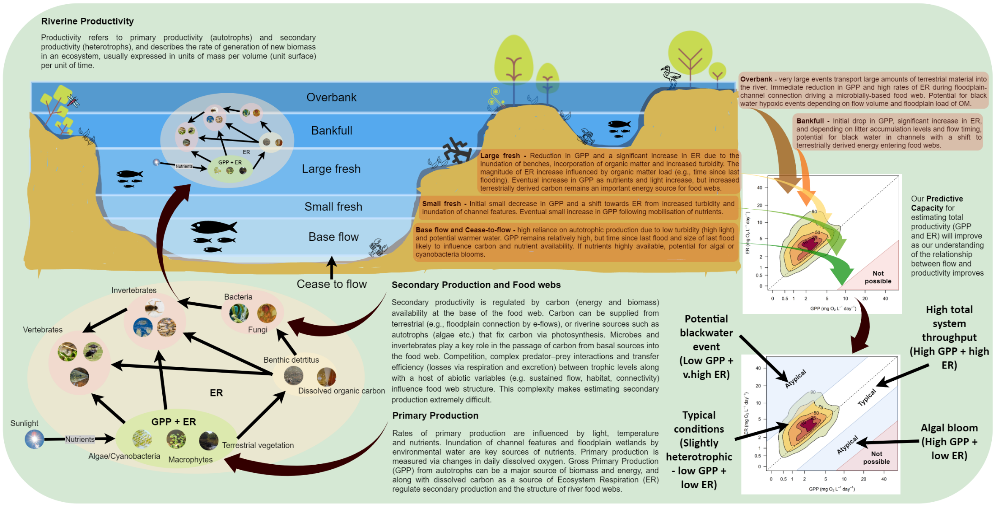

Basin-scale evaluation 2023–24
This chapter describes water quality and metabolic parameters recorded across all monitoring locations in water year 2023–24, analyses metabolic responses to flow, and relates outcomes to the Basin-scale evaluation questions.
Due to the relatively small contribution of CEW to total flow volumes, outcomes are reported for the full 2023–24 hydrological dataset, i.e. not specific to Commonwealth environmental watering actions.

Key findings
In 2023–24, 6 of the 7 monitored Selected Areas were net heterotrophic (ecosystems were respiring more carbon than they were fixing via GPP).
The results highlight the importance of terrestrial organic carbon from channel and floodplain connectivity as a major energy source in these ecosystems.
In 2023–24, the Lower Murray River was strongly autotrophic, reflecting a shift to more lentic conditions at these sites than the lotic conditions seen in 2022–23.
The Murrumbidgee River System had a comparatively smaller range of metabolic throughput than all other Selected Areas, signifying low and uniform rates of both ER and GPP.
Commonwealth environmental water contributed to the export of 221,272 tonnes of salt (17.8% of total salt exported) through the barrages, and decreased salt import at the Murray Mouth by approximately 2,854,965 tonnes.

Rainfall
Wet conditions contracted to the central areas of the Basin in 2023–24. Parts of the southern Basin became increasingly dry, including both the headwaters and the South Australian sections of the River Murray changing from conditions that were very much above average rainfall in 2022–23 to very much below average rainfall in 2023–24. Conditions across the Basin valleys are listed in Table 3.1 and visualised in Figure 4.1.
Table 3.1 Annual rainfall conditions by valley, 2023–24
Includes the 19 valleys in scope for the Flow-MER evaluation. Condition extracted from Figure 4.1.
Valley | Rainfall condition
Northern Basin
Barwon Darling | Average to above average
Border Rivers | Mainly average with some areas below average and some above average
Condamine Balonne | Average to above average, some areas in the east below average
Gwydir | Mainly average with some areas in the east below average
Macquarie | Average to above average
Namoi | Average to above average
Warrego | Average to above average
Southern Basin
Broken | Average
Campaspe | Average
Central Murray | Below average to average
Edward/Kolety–Wakool | Average to above average
Goulburn | Below average to above average
Lachlan | Average to very much above average
Loddon | Very much below average to above average
Lower Darling/Baaka | Below average to above average
Lower Murray | Very much below average to average
Murrumbidgee | Below average to above average
Ovens | Average
Wimmera | Very much below average to average

Environmental water delivery 2023–24
Of the 114 Commonwealth environmental watering actions in 2023–24, 38 (2,160 GL) had expected outcomes linked to water quality and/or ecosystem process or food webs, and 21 (1,955 GL) of these actions occurred within 6 of the 7 Selected Areas. These are listed in Table 3.2. Of the 33 watering actions linked to water quality, 19 (1,848 GL) occurred within 6 of the 7 Selected Areas. Of the 10 watering actions linked to ecosystem process or food webs, 6 (1,492 GL) occurred within 2 of the 7 Selected Areas
Table 3.2 Commonwealth environmental watering actions with objectives linked to water quality and ecosystem process or food webs, by valley, 2023–24
* contains a Selected Area, Dash (–) indicates no watering actions in that Valley for this Theme.
Valley | Volume (ML) | Number of actions
Northern Basin
Barwon Darling | – | –
Border Rivers | – | –
Condamine Balonne | – | –
Gwydir* | 2,000 | 1
Macquarie | 56,046 | 1
Namoi | 9,279 | 2
Warrego* | – | –
Southern Basin
Broken | 1,637 | 5
Campaspe | 1,114 | 1
Central Murray | 19,497 | 1
Edward/Kolety–Wakool* | 148,504 | 9
Goulburn* | 216,335 | 5
Lachlan* | 1,213 | 1
Loddon | 3,762 | 3
Lower Darling/Baaka | 110,834 | 2
Lower Murray* | 1,384,021 | 4
Murrumbidgee* | 203,235 | 1
Ovens | – | –
Wimmera | 2,762 | 2
Total | 2,160,239 | 38

Outcomes

Metabolic responses to flows at Selected Areas
Rates of data that met output acceptance criteria from the Bayesian single-station estimation routine remained very low in some Selected Areas. Within the metabolic rate data, 3,027 records (daily GPP and ER measured as mg/L/day) met acceptance rates:
- Lower Murray River – 59% (261 daily records included)
- Goulburn River – 25% (272 daily records included)
- Edward/Kolety–Wakool river systems – 52% (1,236 daily records included)
- Lachlan River System – 58% (856 daily records included)
- Gwydir River System – 47% (246 daily records included)
- Junction of Warrego and Darling rivers – 14% (84 daily records included)
- Murrumbidgee River System – 32% (72 daily records included).
Poor model fit (leading to low R² values) and model estimation of unrealistic K (reaeration coefficient) constants arising from slow-moving water (e.g. locks of the Lower Murray River, cease-to-flow events in the northern Basin) were leading causes of low data acceptance rates. Improving flexibility in criteria for K and R² model fits is essential to improve data acceptance, particularly for slow flow conditions. Under such conditions, the water column may not be well mixed vertically or laterally, meaning that mixing driven by wind or daily variation in temperature may be influencing the DO concentration measured by loggers, reducing certainty in estimates of metabolic processes.
Despite these limitations, seasonality was found to be the primary driver of rates of stream metabolism – the highest daily rates of GPP and ER were consistently recorded in summer (see plots in Appendix A), as expected based on the fundamental effect of temperature on biochemical reactions.
In 2023–24, all Selected Areas were net heterotrophic, except for the Lower Murray River, which was strongly autotrophic:
- Lower Murray River (mean GPP:ER 1.40)
- Goulburn River (mean GPP:ER 0.40)
- Edward/Kolety–Wakool river systems (mean GPP:ER 0.52)
- Lachlan River System (mean GPP:ER 0.41)
- Gwydir River System (mean GPP:ER 0.49)
- Junction of Warrego and Darling rivers (mean GPP:ER 0.49)
- Murrumbidgee River (mean GPP:ER 0.85).
The Lower Murray River is typically net autotrophic, likely a product of the lentic character of sites within this Selected Area that support phytoplankton. Results for the remaining Selected Areas highlight the importance of terrestrial organic carbon from channel and floodplain connectivity as a major energy source in rivers.
Metabolic fingerprints for the 7 Selected Areas are presented in Figure 3.1. The 75% kernel-density regions (or area containing the top 75% of data points) for all Selected Areas reside predominantly above the 1:1 line, reflecting the net heterotrophy.
The Murrumbidgee River System was notable for its narrow range of metabolic throughput, shown by the metabolic fingerprint being constrained in a small region close to the diagonal 1:1 because of highly uniform and stable rates of both ER and GPP. In contrast, all other Selected Areas were stretched across a wide range along the 1:1 line, reflecting more variable metabolic rates. In 2023–24, the Lachlan River system was dominated by relatively high metabolic throughput – the 10% kernel-density area resided relatively high up the 1:1 line. Stream metabolism evaluation questions and answers relating to Commonwealth environmental water and Commonwealth environmental watering actions are provided in Table 3.3.
Figure 3.1 Variation in metabolic fingerprints across the 7 Selected Areas, 2023–24
Lower Murray River (261 daily records); Goulburn River (272 daily records); Edward/Kolety–Wakool river systems (1,226 daily records); Lachlan River System (856 daily records); Gwydir River System (246 daily records); Junction of Warrego and Darling rivers (84 daily records); Murrumbidgee River System (72 daily records). ER = ecosystem respiration, GPP = gross primary production. Note the log scale on the x-axis and y-axis.
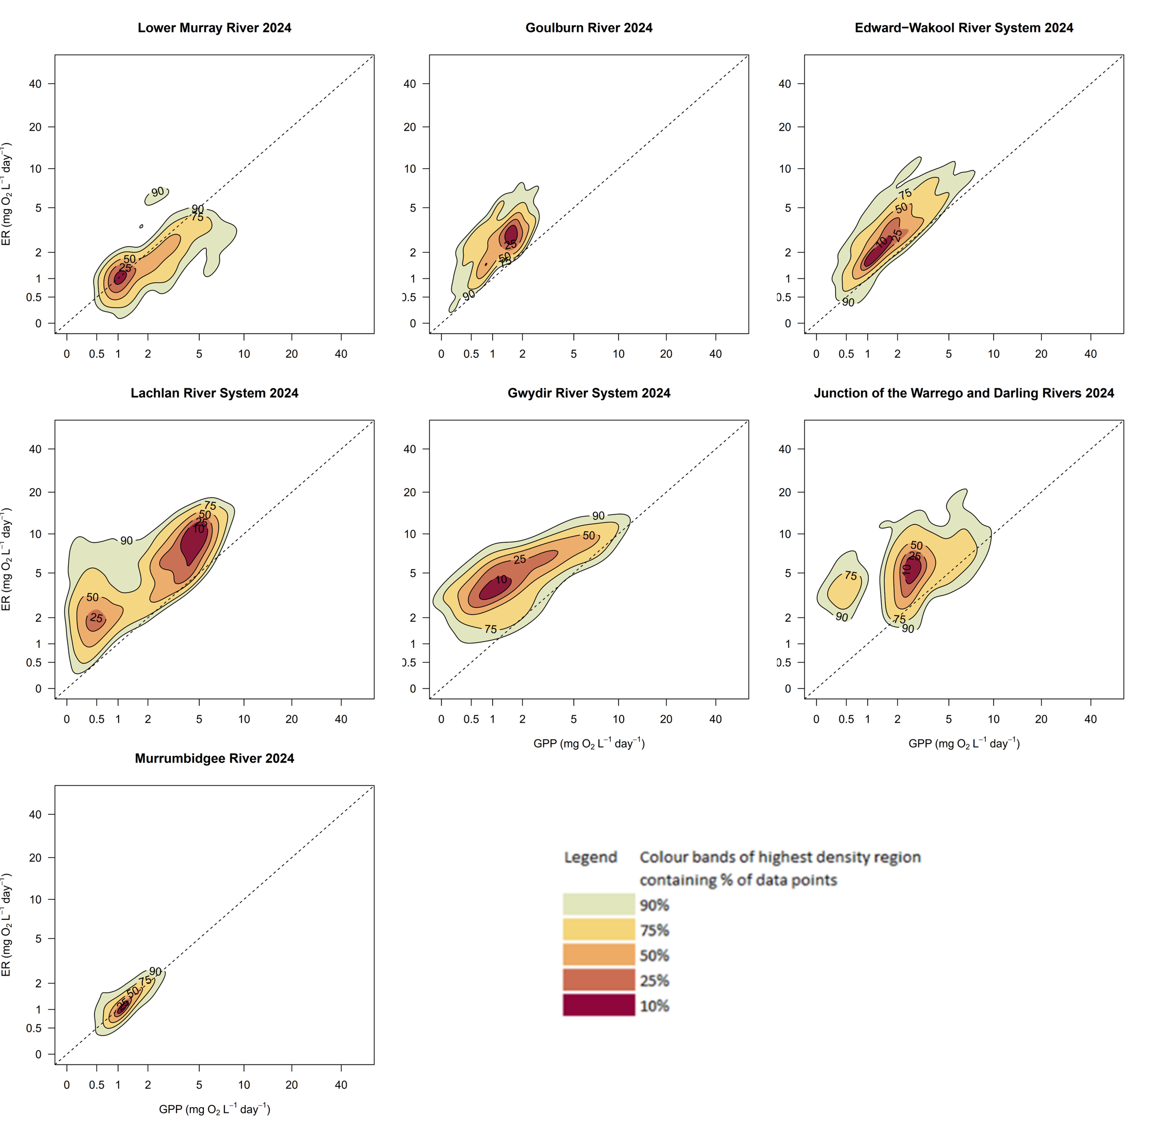

Table 3.3 Stream metabolism evaluation questions and responses relating to 2023–24 Commonwealth environmental water, extracted from 2023–24 Selected Area reports*
*with minor edits for readability. Note that the Lower Murray River report refers to both ‘environmental water’ and ‘Commonwealth environmental water (CEW) ’.
Selected Area report | What did Commonwealth environmental water contribute to patterns and rates of ecosystem respiration? | What did Commonwealth environmental water contribute to patterns and rates of primary productivity? | What did Commonwealth environmental water contribute to dissolved oxygen levels?
Lower Murray River  (Ye et al. 2025) | - Bacterial respiration (BCR), a measure of decomposition, was directly related to DOC concentrations. As it was assumed that daily DOC concentrations were the same with and without EW, volumetric BCR was unaffected by flow.  - Evaluation was based on the average percentage change in river cross-sectional BCR due to the addition of EW/CEW and determined from the average change in cross-sectional area.  - In 2023-24, sustained high water levels due to EW/CEW resulted in moderate increases. | - Increased EW delivery generally reduced the volumetric rate of primary production but increased the cross-sectional rate. This increased the overall “carrying capacity” of the river, although the implications of changes in the ratios of these two measures are unknown.  - The estimated average percentage change in cross-sectional GPP due to environmental flows over a monitoring period was used to assess primary productivity. In 2023-24, despite relatively large increases in cross-sections, small positive changes in cross-sectional GPP were predicted in response to EW/CEW delivery below Locks 6 and 1, with small negative changes below Lock 4. | - Contributions of EW and CEW can help decrease the likelihood of low DO during low flow periods by increasing water mixing and oxygen exchange at the surface. This was assessed as the extra days per year with water velocities >0.18 m/s due to eWater, and then the further increase due to CEW, and the total for all EW. In 2023-24, CEW contributed 29 days of flow that moved velocities above 0.18 m/s, while All EW supported 45 days were above 0.18 m/s.
Goulburn River  (Treadwell et al. 2024) | - Apart from the initial dilution effect (as seen in all previous years), there was no consistent long-term (months, seasons) effect of flow increases (including those from delivery of CEW) on ER (mg O₂/L/day) across the 4 sites.  - Importantly, there were significant enhancements in ER rates for several weeks (but not months) following flow events in summer and autumn, likely due to the introduction of new organic carbon.  - There was also a marked positive effect of flow increases, even those constrained within channel, on total amounts of ER expressed as mass (load) of organic carbon consumed per day. As there is no change in water source, the major effect of CEW is to augment flow. | - As with ER, all 4 sites showed a decrease in GPP (mg O₂/L/day) with increases in flow (including those from CEW delivery) – this was due to dilution and was seen in all previous years.  - It was also shown that, after the hydrograph fell, GPP increased during summer and autumn in the subsequent days and weeks (but not months), most likely due to the entrainment of nutrients during the event.  - Importantly, there was a marked positive effect of flow increases, even those constrained within the channel, on total amounts of GPP expressed as mass (load) of organic carbon produced per day. As there is no change in water source (tributary flow is not a significant water source in this section of the Goulburn River), the major effect of CEW is to augment flow. | - Not specifically reported in 2023–24.
Edward/Kolety–Wakool river systems  (Liu et al. 2024) | - ER followed a seasonal trend – pulses of respiration largely correlated with those of GPP. These pulses coincided with the start and end of high flow in October and early January, respectively, peaking in early summer, similar to previous years.  - For most of the monitoring year, each hydrological zone was strongly heterotrophic, where respiration outpaces production. The exceptions were during periods where unregulated water coincided with CEW pulses.  - This year marked lower total consumption of carbon from respiration (776 tonnes) compared to the previous 2 monitoring years (1,564–829 tonnes). Although contributions from CEW to ER rates were significantly higher (679 tonnes compared to 199–188 tonnes), reflected by the proportional contribution of CEW to overall ER being much higher than the previous 2 years (87.4%, compared to 12.7% to 22.7%). | - Similar to previous years, GPP rates peaked in early summer, likely driven by longer daylight and warmer temperatures. However, seasonal effects were difficult to separate from flow impacts.  - Areal rates of GPP were lower this year (399 tonnes) compared to the 2022–23 water year (476 tonnes) but higher than 2021–22 (364 tonnes). The contributions of CEW from flows, escapes and offtakes were substantially higher this year compared to previous years (362 tonnes compared to 104–76 tonnes). This was reflected in the proportional contribution of CEW to overall GPP being substantially higher than the previous 2 years (91% in 2023–24, compared to 22% and 21% respectively). | - DO levels remained in the expected ranges in 2023–24 water year in the Edward/Kolety–Wakool River systems, except for the middle and lower reaches of the Wakool River. This was due to flooding in the upper Goulburn River in mid-January 2024, when floodwaters flowed into the mid Murray River and Koondrook–Perricoota Forest, exited the forest via Thule and Barbers creeks, and flowed into the Wakool River.  - Although concentrations of DO in the upper Wakool River briefly dropped below 4 mg/L in December 2023 and January 2024, DO concentrations were within the normal range for that time of year. CEW watering actions commenced with the variable base flows in upper Wakool and maintained DO levels over the hot summer months.  - DO values in the Wakool River at Gee Gee Bridge and Stoney Crossing dropped into the range of concern to fish populations (below 4 mg/L) for a short time in February 2024. No values below 2 mg/L (in the range lethal to fish populations) were recorded. CEW watering actions from the MIL offtakes and escapes (Wakool offtake, Yallakool offtake, Wakool Escape, Thule Escape) had positive outcomes, increasing DO levels above the threshold of concern for fish at sites downstream of the escapes.  - DO concentrations in Tuppal Creek were below 4 mg/L, and on occasions were below 2 mg/L, during the environmental watering action, particularly in summer months. This suggests that environmental water delivery with limited capacity had little effect on improving water quality at Tuppal Creek.
Lachlan River System  (Higgisson et al. 2024) | - The productivity estimates during the system-scale autumn fresh (watering action 7, Component 1) suggest a slight decrease, whereas ER and K increased slightly, which is consistent with an effect of increased flow velocity and potentially DOC supply. | - There was evidence that watering event 7 generated short pulses of GPP and ER in the lower Lachlan River – GPP responses correlated with lower water temperatures and higher flows.  - The metabolism estimates suggest that the addition of environmental water at Booligal (same as last year) generated a small productivity pulse at the start of April. | - There is evidence that watering events can alter water quality parameters, particularly through increasing carbon and nutrients, although these effects appear to be relatively transient and can be highly variable in magnitude in both space (site to site) and time.  - These effects are much smaller than those observed during large natural flows, but larger flow events, such as those delivered as translucent flows, appear to provide larger productivity responses that approach the magnitude of the effects of natural flows.  - However, there were benefits of environmental flow provision in March 2024 (watering action 7), in terms of increasing oxygen concentrations and reducing the potential for blackwater events.
Gwydir River System  (CEWH 2024a) | - Relationship between ER and CEW is not specifically reported. | - CEW supported flows and contributed to carbon production in the Gwydir River throughout most of the water year. | - Relationship between DO levels and CEW is not specifically reported.
Junction of Warrego and Darling rivers  (CEWH 2024b) | - Relationship between ER and CEW is not specifically reported. | - Relationship between GPP and CEW is not specifically reported. | - Relationship between DO levels and CEW is not specifically reported.
Murrumbidgee River  (Wassens et al. 2024) | - The estimated range and median values for GPP, ER and GPP: ER were all within the range and median values reported for the previous water years. | - The estimated range and median values for GPP, ER and GPP: ER were all within the range and median values reported for the previous water years. | - DO concentrations remained well above the ecological threshold level of 4 mg/L for fish, with short-term anomalies (< 4 mg/L) in late November 2023 and early March 2024.

Salinity regimes
The Basin-scale Food Webs and Water Quality Theme is required to report on the contribution of CEW to salinity regimes. Our focus is the export of salt through the Lower Murray River Selected Area, since this is the region through which all salt must be exported to leave the Basin. Information in this section has been taken directly from Ye et al. (2025), who apply a hydrodynamic–biogeochemical model for the region below Lock 1 to the Murray Mouth to account for cumulative impacts of environmental water delivery on salt export from the Basin. In 2023–24, CEW was responsible for the export of 221,272 tonnes of salt (17.8% of total salt exported) through the barrages (Ye et al. 2025). Commonwealth environmental water decreased salt import at the Murray Mouth by approximately 2,854,965 tonnes in 2023–24 (Ye et al. 2025).

Basin-scale evaluation 2014–24
This chapter describes water quality and metabolic parameters recorded across all monitoring locations between water years 2014–15 and 2023–24 and provides the cumulative evaluation of responses. Due to the relatively small contribution of CEW to total flow volumes, outcomes are reported for the full 2014–24 hydrological dataset and are not specific to Commonwealth environmental watering actions.

Key findings
Riverine ecosystems of the Goulburn River, Edward/Kolety–Wakool river systems, Lachlan River System, Gwydir River System and Junction of Warrego and Darling rivers were predominantly heterotrophic and thus consuming more carbon than they were producing.
The Murrumbidgee River System regularly alternated between heterotrophy and autotrophy, depending on conditions (such as season).
The Lower Murray River was mostly a net producer of carbon (autotrophic) up to 2021–22, driven by phytoplankton and relatively low turbidity in the slow-flowing channels of the Lower Murray River. However, high flows in 2022 shifted the Lower Murray River into heterotrophy, reflecting a return to a flowing system more closely resembling metabolic patterns at other Selected Areas. In 2023–24, the Lower Murray River returned to autotrophy, reflecting dominating lentic conditions.
The most common response to increased flows (including contributions from Commonwealth environmental water) was decreased overall metabolic throughput, likely caused by dilution and disturbance.
Volumetric rates of GPP and ER in response to flow were highly variable and context-dependent, both within (individual sites) and between Selected Areas.

Rainfall
Figure 4.1 depicts the annual rainfall conditions in the Basin for each of the 10 water years from 2014–15 to 2023–24. The first 2 years saw particularly dry conditions in the southern Basin. In 2016–17, there were wetter conditions in the southern Basin and along the headwaters of the New South Wales tributaries in the northern Basin. Conditions returned to dry over the period 2017–20 across the whole Basin. In 2020–23, conditions were again wetter – average, above average and very much above average conditions were experienced across the Basin. The conditions in 2023–24 were similar to 2020–21, when most areas experienced average rainfall, and central New South Wales and parts of the northern Basin experienced above-average rainfall. During this time, the Victorian valley headwaters and the valley headwaters in the northern Basin experienced below-average rainfall, as did the Lower Murray, where the rainfall was below average or very much below average.
Figure 4.1 Maps of annual rainfall conditions, 2014–24
Data sourced from the Bureau of Meteorology. The decile rankings (lowest on record to highest on record) are those used by the Bureau. Refer to the Bureau – Glossary of terms for a description of how the deciles are derived.
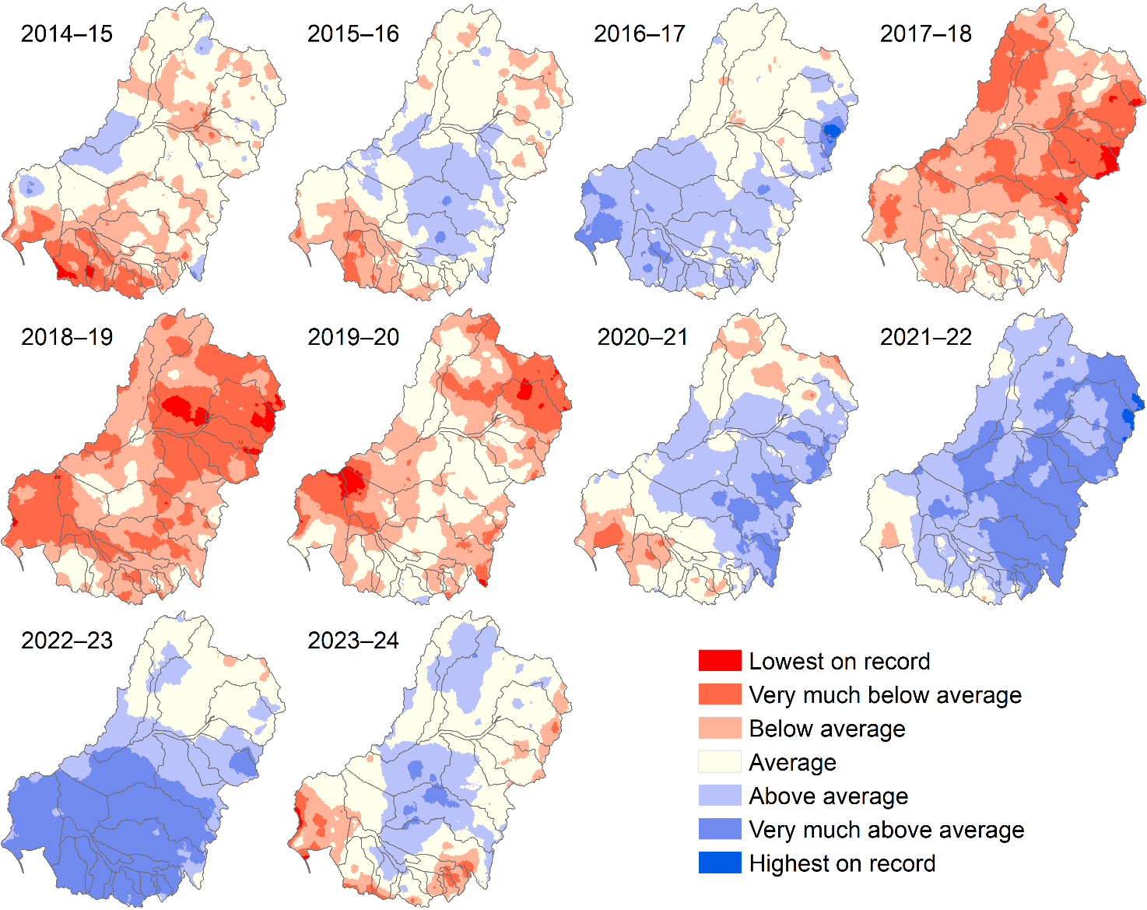

Environmental water delivery 2014–24
Across the 10 water years, the number of Commonwealth watering actions with objectives linked to water quality or ecosystem processes ranged from 37 in 2018–19 to 76 in 2022–23. Over the same period, the volume of CEW delivered ranged from 729 GL in 2018–19 to 2,237 GL in 2021–22 (Figure 4.2).
Figure 4.2 Number of Commonwealth environmental watering actions and corresponding total volume linked to objectives for water quality and ecosystem processes or food webs for each water year, 2014–24
This figure shows the volume of Commonwealth environmental water (CEW). It does not include volumes of other sources of environmental water delivered in association with CEW.
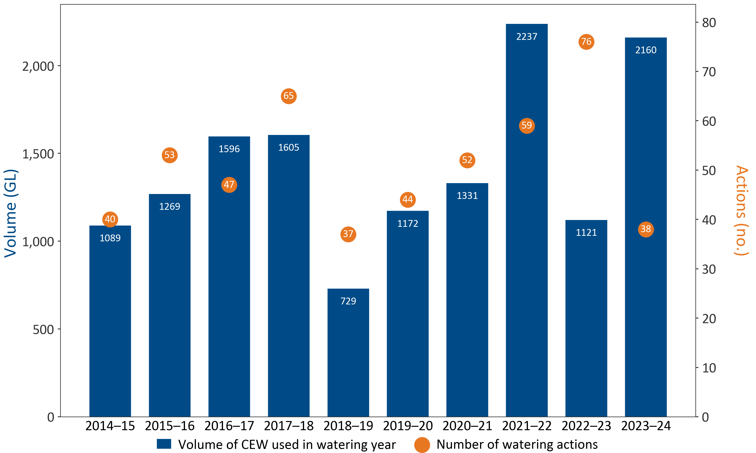

Outcomes

Comparison of 2023–24 to the previous 9 years
Rates of GPP are strongly influenced by seasonal changes (e.g. light and temperature, as evidenced by clear and consistent annual peaks in GPP in summer, irrespective of flow regime – see Appendix A.1–A.7) and site-specific drivers such as bioavailable nutrient concentrations and reduced light availability due to turbidity. Increased flows can substantially decrease rates of both ecosystem GPP and ER, likely attributable to dilution effects of increased water volume and disturbance to plankton and microbial communities. The 2014–23 metabolic fingerprints for Selected Areas overlaid with the 2023–24 metabolic data points are presented in Figure 4.3. The kernel plots represent 21,594 daily records of GPP and ER from 2014–23 plus 3,027 daily records of GPP and ER from 2023–24 presented as data points (24,621 in total).
For most Selected Areas, the majority of 2023–24 data points reside within the 2014–23 kernel, indicating that metabolic patterns in 2023–24 were broadly typical. The exception was the Lachlan River System, which experienced many days where GPP was lower and ER was higher than long-term trends. The Lachlan River System also experienced many days where both GPP and ER where higher than long-term patterns, reflecting higher than usual metabolic through-put. The 2014–23 10% kernel-density regions (the area containing the top 10% of data points) for the Goulburn River, Edward/Kolety–Wakool river systems, Lachlan River System, Gwydir River System and Junction of Warrego and Darling rivers reside above the 1:1 line, indicating that, most of the time, the riverine ecosystems in these Selected Areas were heterotrophic and consuming more carbon than they were producing. This pattern is consistent with streams globally, which are primarily heterotrophic (i.e. GPP < ER; Hall 2016).
The 2014–23 10% kernel-density region for the Murrumbidgee River System is dispersed around the 1:1 line, indicating that it regularly alternated between heterotrophy and autotrophy, depending on conditions (such as season). It is also tightly grouped and low on the 1:1 line, reflecting consistent metabolic patterns and some possible limitation to metabolic activity (e.g. due to low bioavailable nutrients). In contrast, the metabolic fingerprints of the northern Basin Selected Areas – Junction of Warrego and Darling rivers and Gwydir River System – stretch further up the ER axis, reflecting large swings towards heterotrophy when suitable conditions prevail. These may be adverse conditions, such as when sudden algal mortality following blooms or extensive channel inundation following long dry periods can lead to excessive consumption of oxygen by bacteria.
The 2014–23 10% kernel-density region for the Lower Murray River resides primarily below the 1:1 line, reflecting net carbon generation (autotrophy) most of the time, driven by phytoplankton and relatively low turbidity in the slow-flowing channels of the Lower Murray River. This is typical for large rivers, which have very little shading by riparian vegetation. promoting photosynthesis by phytoplankton across a relatively large surface area In contrast with patterns observed in 2022–23 (where the Lower Murray River fingerprint resided predominantly above the 1:1 line due to lotic conditions from high flows), in 2023–24, the fingerprint (displayed as dots overlaid in Figure 4.3) was predominantly below the 1:1 line. This reflects a return to a more typical hydrology (e.g. lentic), where the metabolic regime is predominantly autotrophic. For Selected Areas other than the Lower Murray River, the majority of 2023–24 data points reside within the 2014–23 kernels, indicating that, for this water year, metabolic patterns were broadly similar to previous years.
Figure 4.3 Longer-term 2014–23 metabolic fingerprints (contour lines) overlaid with the 2023–24 metabolic fingerprint (dots) for Selected Areas
See plots in Appendix A for highest density region percentage of data points for 90%, 75%, 50%, 25% and 10%. ER = ecosystem respiration, GPP = gross primary production. Note log scale on x-axis and y-axis.
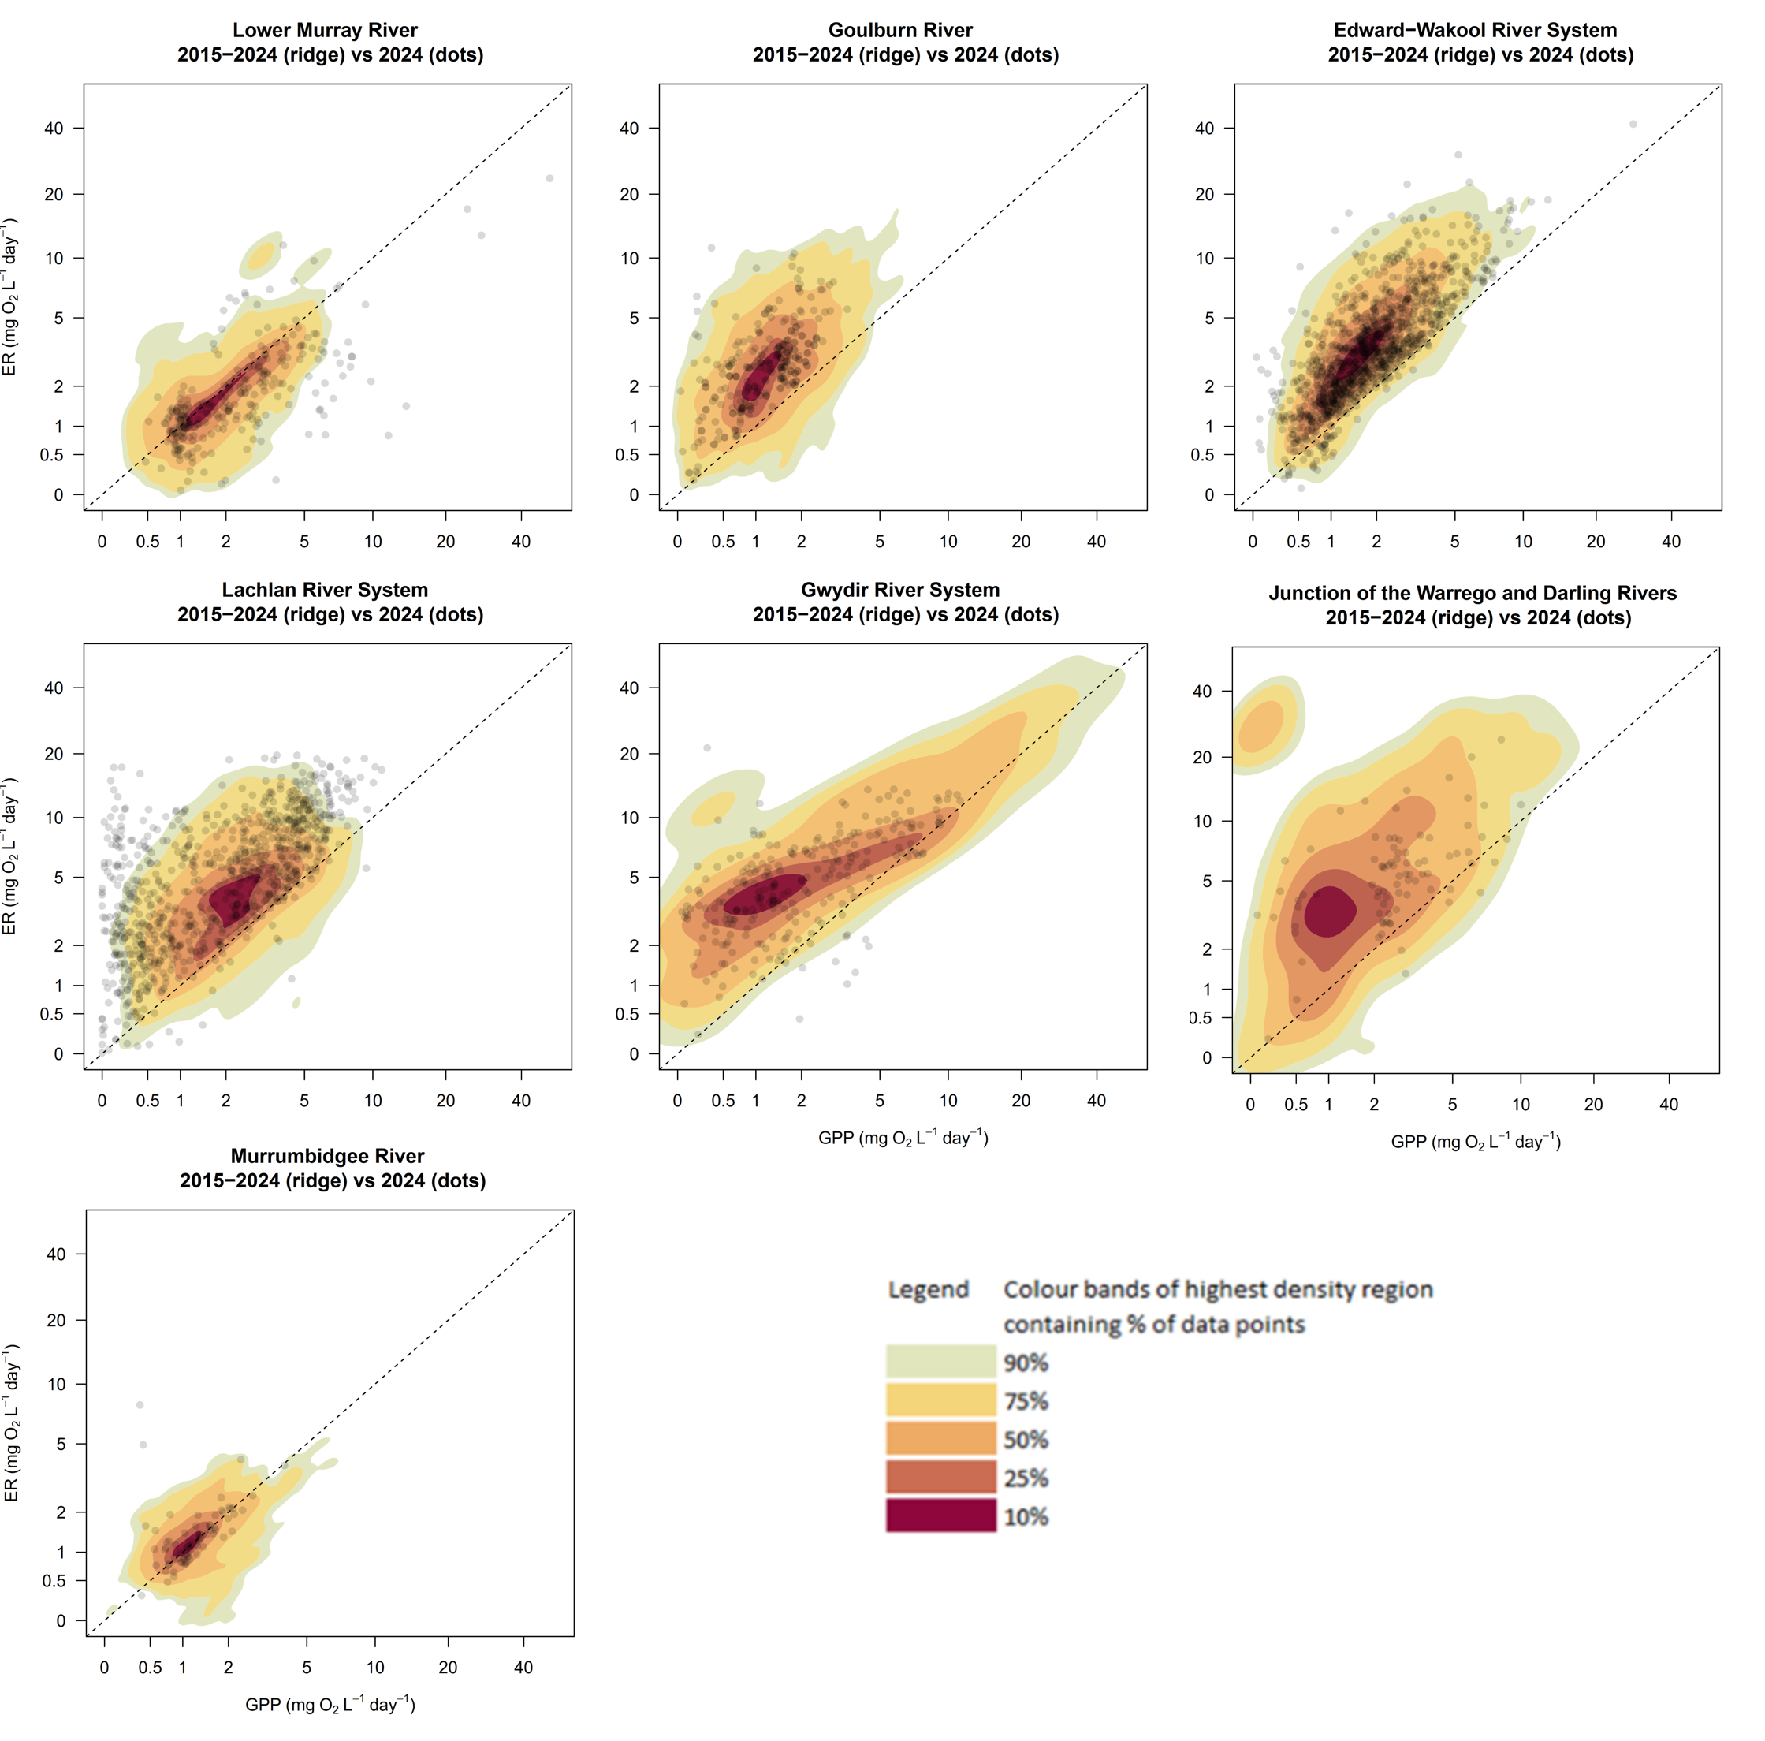

Metabolic responses to flow at Selected Areas
Here, we focus on exploring metabolic responses to the full 2014–24 hydrological dataset (of which CEW is a component). This is because we do not expect metabolic responses to flow to be sensitive to the purpose of the flow (e.g. environment, irrigation supply) and this approach provides much greater statistical power. The contribution of CEW is assessed in Chapter 5.
We applied a statistical model using the envfit function in the R package VEGAN (Dixon 2003). The envfit function fits an environmental vector (j) over an ordination in 2-dimensional space using an intercept-less linear model. The size and direction of the vector provides an estimation of the response of the metabolic fingerprint to flow at each site. Model outputs from envfit and dominant metabolic responses to flow for each site are provided in Table 4.1, and the full set of plots showing metabolic responses to flow for all Selected Area sites sampled in 2014–24 is included in Appendix A.
In this section, we focus on patterns from a subset of ecosystem metabolism – flow plots from 5 of the 7 Selected Areas, chosen for their temporal and spatial coverage to enable interpretation of generalised ecosystem metabolism responses to flow. Metabolic responses to flow collected from sites (listed in Table 4.1) across 5 Selected Areas over the 10 years indicate that patterns in volumetric metabolism are highly variable and context-dependent, both within Selected Areas and between individual sites. However, the most common responses to increased flows are decreased volumetric rates of GPP and ER, likely due to dilution and disturbance (Table 4.1).
Table 4.1 Modelled metabolic response to flow at 41 sites in 5 of the 7 Selected Areas
N/A indicates insufficient data for envfit to generate a vector. Significant values are bolded.
Selected Area or sites | r² | P | Data collection | Increase or decrease in metabolic throughput in response to flow
Northern Basin
Junction of Warrego and Darling rivers
WD_AKUNA (Figure A.1) | 0.02 | 0.124 | 2016–24 | Neutral
WD_YANDA (Figure A.2) | 0.42 | 0.002 | 2015–19 | Decrease
Gwydir River System
GWY_418001 (Figure A.37) | 0.16 | 0.001 | 2020–24 | Decrease
GWY_418053 (Figure A.38) | 0.52 | 0.001 | 2023 | Decrease
GWY_418077 (Figure A.39) | N/A | N/A | 2023 | Increase
GWY_418078 (Figure A.40) | 0.10 | 0.197 | 2022–24 | Decrease
GWY_ME1 (Figure A.41) | 0.24 | 0.001 | 2022–24 | Decrease
Southern Basin
Edward/Kolety–Wakool river systems
Cummins (Figure A.10) | 0.14 | 0.001 | 2016–19 | Decrease
Hopwood (Figure A.3) | 0.14 | 0.001 | 2014–19 | Decrease
Llanos Park 2 (Figure A.4) | 0.14 | 0.001 | 2014–24 | Decrease
Moulamein Road Bridge (Figure A.5) | 0.03 | 0.001 | 2014–24 | Neutral
Noorong 2 (Figure A.6) | 0.01 | 0.003 | 2014–24 | Decrease
Old Morago Road (Figure A.7) | 0.05 | 0.001 | 2020–24 | Decrease
Widgee 1 (Figure A.8) | 0.05 | 0.001 | 2014–24 | Decrease
Windra Vale 2 (Figure A.9) | 0.02 | 0.001 | 2014–24 | Decrease
Goulburn River
Arcadia Downs (Figure A.11) | 0.13 | 0.001 | 2020–22 | Decrease
Darcy’s Track (Figure A.12) | 0.24 | 0.001 | 2014–19 | Decrease
Day Road (Figure A.13) | 0.20 | 0.001 | 2015–19 | Decrease
Loch Garry Gauge (Figure A.14) | 0.15 | 0.001 | 2014–24 | Decrease
McCoys Bridge (Figure A.15) | 0.19 | 0.001 | 2014–24 | Decrease
Moss Road (Figure A.16) | 0.18 | 0.436 | 2014–15 | Increase
Murchison (Figure A.17) | 0.11 | 0.001 | 2020–24 | Decrease
Shepparton (Figure A.18) | 0.13 | 0.001 | 2020–24 | Decrease
Lachlan River System
CC (Figure A.19) | 0.04 | 0.001 | 2014–24 | Decrease
EU (Figure A.20) | 0.10 | 0.007 | 2018–19 | Increase
KP (Figure A.21) | 0.10 | 0.004 | 2018–23 | Decrease
LB (Figure A.22) | 0.03 | 0.001 | 2014–24 | Increase
MG (Figure A.23) | 0.45 | 0.001 | 2018–19 | Decrease
TH (Figure A.24) | 0.11 | 0.001 | 2018–23 | Decrease
WAL (Figure A.25) | 0.12 | 0.001 | 2015–20 | Decrease
WB (Figure A.26) | 0.10 | 0.001 | 2015–24 | Decrease
BOO (Figure A.27) | 0.17 | 0.001 | 2022–24 | Decrease
CON (Figure A.28) | 0.07 | 0.001 | 2022–24 | Decrease
HUN (Figure A.29) | 0.28 | 0.001 | 2022–24 | Decrease
Lower Murray River
Lock 1 (Figure A.30) | 0.09 | 0.001 | 2014–24 | Decrease
Lock 4 (Figure A.31) | 0.43 | 0.001 | 2020–24 | Decrease
Lock 6 (Figure A.32) | 0.41 | 0.001 | 2014–24 | Decrease
Murrumbidgee River System
Wynburn Escape upstream (Figure A.33) | 0.76 | 0.001 | 2014–15 | Decrease
Wynburn Escape downstream (Figure A.34) | 0.61 | 0.001 | 2014–15 | Decrease
McKennas (Figure A.35) | 0.01 | 0.011 | 2014–24 | Decrease
Narrandera (Figure A.36) | 0.22 | 0.001 | 2014–19 | Decrease
Metabolic responses to flow in the Edward/Kolety–Wakool river systems are consistent – most locations responded to increased flows with significant increases in ER and decreases in GPP (see plots in Appendix A). Metabolic responses to flow in the Murrumbidgee River System at McKennas (location with the largest dataset in this Selected Area 2014–24) are dominated by small but significant increases in GPP (r² = 0.01, p = 0.011, Figure A.35).
Metabolic responses to flow in the Lachlan River System are significant at all sites – overall metabolic throughput decreased at most locations (Table 4.1). Contrasting metabolic responses to flow at 2 geographically similar sites in the Goulburn River highlighted the high level of context dependency that can exist within Selected Areas (Figure 4.4 and Figure 4.5). At the Loch Garry Gauge, increased flow drives a relatively strong reduction in GPP (indicated by the size and direction of the envfit environmental vector arrow in the right-hand panel of plots (Figure 4.4) (r² = 0.15, p = 0.001). At McCoys Bridge (Figure 4.5), increased flow reduces both rates of ER and GPP , with the arrow pointing down the diagonal line (r² = 0.19, p = 0.001). In the Lower Murray River, the dominant metabolic response among all sites to increased flow is a decrease in GPP and slight increase in ER (Lock 1, r² = 0.09 p = 0.001; Lock 4, r² = 0.43 p = 0.001; Lock 6, r² = 0.41 p = 0.001) (see Figure A.30–Figure A.32, Appendix A).

Implications
We expect that channel and floodplain morphology (both at the site and immediately upstream) will be a strong driver of context-dependent metabolic responses to flow. For example, in shallow river channels with low banks, a small increase in flow volume may lead to relatively large increases in inundated surface area. Such increases to wetted area are likely to increase metabolic throughput by creating proportionally larger surface-area-to-volume ratios, leading to a larger photic zone and potential increases in rates of GPP (noting lag times for autotrophic communities to establish). In such circumstances, there is also a greater likelihood of incorporating more terrestrial organic carbon from litter, which also drives up rates of ER. In contrast, even moderate increases in flow volume that occur in river reaches that are deeply incised are likely to lead to only small increases in wetted surface area. Here, we would expect metabolic throughput to decrease, since any increases in surface area are likely to be exceeded by dilution and disturbance influences. Conversion of metabolic data from volumetric rates to areal rates would allow for better comparison of metabolic responses between sites and valleys. For this to occur, however, accurate bathymetry is required for each location. Currently this information is not available for all sites, and we strongly encourage collection of these data in future monitoring activities.

Figure 4.4 Relationship between stream metabolism and flow at Loch Garry gauge, Goulburn River
Left-hand panels display gross primary production (GPP), ecosystem respiration (ER) and net ecosystem production (NEP) values (green dots) in response to flow (black line) and Commonwealth environmental water (pink line). Right-hand panels depict metabolic fingerprints (without kernel-density regions displayed), and colouration of data points reflect logFlow (flow on a log scale). Length of the envfit environmental vector arrow (j) indicates the strength (r²) and direction of long-term metabolic response to flow, and significant responses are indicated at the top of the plot by p < 0.05.
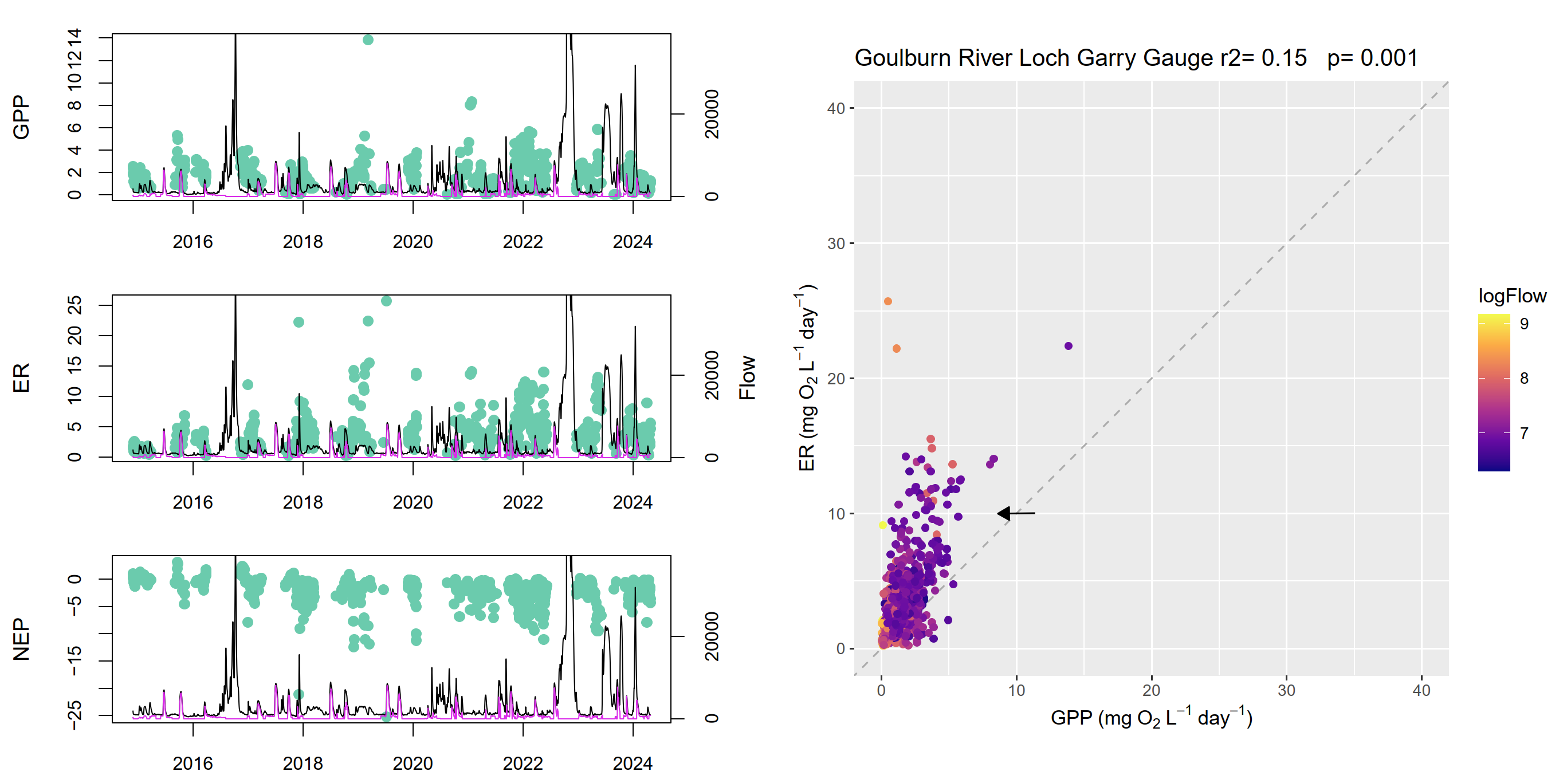
Figure 4.5 Relationship between stream metabolism and flow at McCoys Bridge, Goulburn River
Left-hand panels display gross primary production (GPP), ecosystem respiration (ER) and net ecosystem production (NEP) values (green dots) in response to flow (black line) and Commonwealth environmental water (pink line). Right-hand panels depict metabolic fingerprints (without kernel-density regions displayed), and colouration of data points reflect logFlow (flow on a log scale). Length of the envfit environmental vector arrow (j) indicates the strength (r²) and direction of long-term metabolic response to flow, and significant responses are indicated at the top of the plot by p < 0.05.
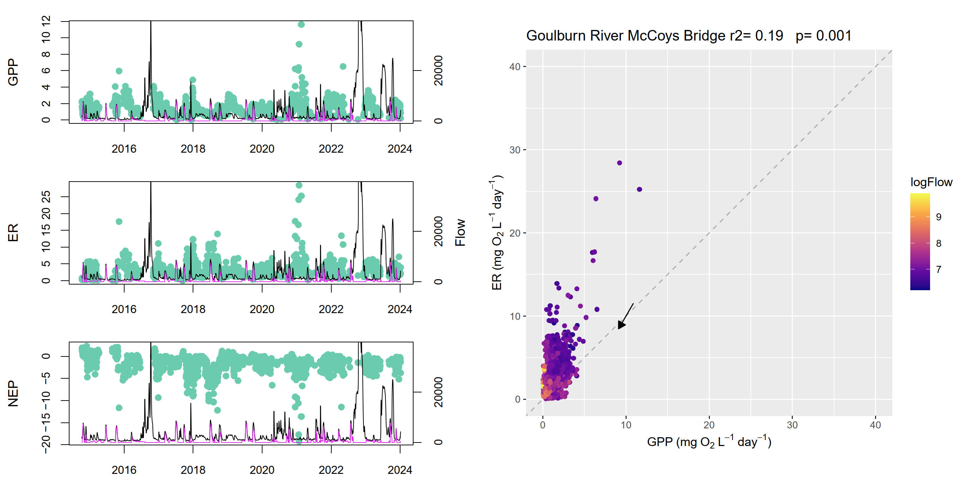

Salinity regimes
The addition of CEW helped to maintain river salinity below 800 µS/cm (electrical conductivity) at Morgan – a river management target of the Murray–Darling Basin Authority and SA Water – by diluting salt in the Lower Murray River channel (Ye et al. 2025). In low flow years, CEW has also become increasingly important for sustaining salt export from the Basin and for limiting salt import to the Coorong. The salt export objective in the Basin Plan aims to ensure adequate removal of salt from the Basin, and this target has been set at 2 million tonnes per year. Commonwealth environmental water has played a key role in salt export from the Basin; however, salt export remains below the Basin Plan target. Since 2014–15, CEW has been responsible for an additional 4.37 million tonnes of salt exported through the barrages and has reduced salt import by almost 29 million tonnes since 2014–15 (Table 4.2).
Table 4.2 Ten-year record of modelled additional salt export (tonnes) due to Commonwealth environmental water (CEW) through the barrages to the Coorong estuary and reduction in import of salt through the Murray Mouth into the Coorong from the Southern Ocean attributable to CEW
Salt export and salinity estimates for 2014–17 are from the large domain model previously used in the Long Term Intervention Monitoring Project reporting. Results from 2017–18 onwards are from the new high-resolution Coorong-only model, which uses a different method for barrage flow calculation and has a more accurate specification of salinity and salt flux. (Source: Ye et al. 2025).
Year | Barrages, additional export of salt due to CEW (tonnes) | Murray Mouth, reduction of salt import at the Murray Mouth (tonnes)
2014–15 | 285,064 | 3,044,700
2015–16 | 251,632 | 4,591,269
2016–17 | 120,867 | 519,292
2017–18 | 685,354 | 3,773,721
2018–19 | 782,742 | 5,114,634
2019–20 | 677,122 | 3,994,755
2020–21 | 601,890 | 4,351,454
2021–22 | 596,979 | 570,010
2022–23 | 151,252 | 117,688
2023–24 | 221,272 | 2,854,965
Total | 4,374,174 | 28,932,488

Contribution of Commonwealth environmental water to river gross primary production 2014–24 – counterfactual analyses
Counterfactual analyses were introduced in 2025 for the 2023–24 evaluation. Further details on the method are documented in companion methods report (O’Sullivan and Cuddy 2025).

Key findings
GPP was sensitive to Commonwealth environmental water. Counterfactual modelling revealed that Commonwealth environmental water most often suppressed riverine GPP, potentially limiting proliferation of algae during warm and low flow periods.
Commonwealth environmental water reduced annual GPP by a mean of 5.2% (range 0.3% to 17.1% among site and years). On individual days with Commonwealth environmental water contribution, daily GPP was a mean of 15% lower than the counterfactual scenario (range 0.5% to 43% among sites and years).
Commonwealth environmental water bolstered riverine GPP in rare instances where the water contributed to very high discharges (e.g. when extending a flood recession), supporting the boom–bust nature of the lowland river–floodplain systems.

Overview of approach
We performed counterfactual modelling to estimate the contribution of CEW to riverine GPP across the entire 2014–24 monitoring period. Briefly, this involved 2 steps:
First, we constructed a statistical model to describe how measured daily GPP responded to 2 known key drivers: solar radiation and flow (Giling et al. 2025). Daily solar radiation was sourced from SILO Australian climate data (Jeffrey et al. 2001) and averaged to the mean daily radiation for each calendar month. This was to reduce potential issues of model circularity because sub-daily variation in sunlight is used to model GPP in the first place. Using a mean daily value for each month helps to understand broad-scale climate drivers while limiting this circularity in the analysis (Giling et al. 2025). Daily discharge was standardised to a proportion of the maximum daily flow for each site (over the entire monitoring period). This enabled us to assess how changes in flow within a site affected GPP, rather than focusing on the effect of differences in flow magnitude among sites.
We hypothesised that solar radiation would linearly affect log-transformed GPP (Giling et al. 2025) but that flow may have more complex non-linear effects. Therefore, we used a generalised additive model (GAM) that allowed for both a linear effect of solar radiation and potential non-linear patterns in the effect of flow on GPP, the latter fit with a smooth curve (also called a spline). We tested for the importance of an interaction between the 2 drivers and whether flow responses varied by site by fitting models of varying complexity and selecting the best supported model with Akaike information criterion (AIC; a metric to evaluate how well a model fits data that penalises models for more complexity).
Second, we used the best model to predict new timeseries of daily GPP at each site under both the observed flow scenario (with CEW) and the counterfactual scenario (without CEW). Predicted factual and predicted counterfactual rates were summarised to weekly means for visualisation.
For this analysis, we selected a subset of sites and years with high data availability (≥ 100 valid GPP estimates per year). Taking this subset resulted in a dataset that included 28 sites across 6 Selected Areas, each with between 1 and 9 years of data (totalling 99 year-site combinations and 16,629 daily GPP estimates).

Outcomes

Effect of solar radiation and flow on gross primary production
The highest quality model included an additive linear effect of mean monthly solar radiation and non-linear effect of flow proportion. Adding interactions or site-specific flow relationships increased the AIC, indicating these additional variables did not improve predictive power (goodness-of-fit) enough to be favoured over a simpler (i.e. more parsimonious) model.
The best model explained 46% of the variation in daily GPP. Solar radiation increased GPP while flow proportion had highly non-linear effects on GPP (Figure 5.1). At lower flows (< 20% of maximum site flow, flow had a strong negative effect of GPP. The flow component represented by approximately 20% of maximum flow will differ among sites, but often corresponded to between a large fresh and bankfull flows. Similar negative effects of flows have been observed in many systems globally and may be due to disturbance, shading, or dilution effects (Bernhardt et al. 2018). At higher flows, flow has a moderate but inconsistent positive effect on daily GPP. This is perhaps due to bank and floodplain inundation increasing nutrient availability or the amount of shallow well-lit wetted areas. We note that these results from higher flows are less certain, as the method for estimating GPP does not work well at high flows and data is limited. It is also important to note that most daily flows are < 20% of maximum daily flow within a site (94% of all days, 96% of days that had a CEW contribution). Therefore, increases in flow generally decrease GPP because flows are normally less than bank full.
Table 5.1 Results of best supported GAM model
The best supported model did not include an interaction term or site-specific effect of flow. The specific formula was: log10GPP ~ mean daily radiation + s(Flow proportion) + s(Site, bs = "re"). Effective degrees of freedom (edf) represent the complexity of the spline, with edf = 1 a linear relationship and edf > 1 a more complex non-linear relationship. The significant p-values for the smooth terms indicate there is an association between log-transformed GPP and this variable.
Model term | Result | Statistical test | p-value
Parametric coefficients
Intercept | estimate (mean ± SE) = 0.109 ± 0.025 | t = 4.36 | p < 0.001
Solar radiation | estimate (mean ± SE) = 0.015 ± 0.000 | t = 83.5 | p < 0.001
Smooth terms
s(Flow proportion) | edf = 8.80 | F = 325.4 | p < 0.001
s(Sample site) | edf = 26.9 | F = 255.0 | p < 0.001

Figure 5.1 Plot of generalised additive model (GAM) results
Panel A shows modelled linear effect of monthly mean daily solar radiation (x-axis) on log-transformed gross primary production (GPP) (y-axis). Panel B shows modelled non-linear effect of daily flow proportion (where 1 is the maximum flow observed at a site) (x-axis) on log-transformed GPP (y-axis).

Effect of Commonwealth environmental water on rates of gross primary production
We assessed the effect of CEW on riverine GPP by applying the solar radiation and flow relationships to all days under both the observed and counterfactual flow scenarios. By increasing flow, CEW reduced annual riverine GPP (i.e. the counterfactual scenario had elevated GPP) across all sites and years. Specifically, CEW reduced annual total GPP by a mean of 5.2% (range 0.3% to 17.1% among site and years). On individual days with a CEW contribution to flow, daily GPP was a mean of 15% lower than the counterfactual scenario (range 0.5% to 43% among sites and years). These patterns were observed despite the non-linear flow relationship because most daily flows (and nearly all CEW) are much lower than the flood peaks, thus occur in the region of Figure 5.1B where flows negatively impact GPP.
The high variation in CEW effect on annual GPP among sites and years was driven by variation in CEW contribution to annual flow (Figure 5.2). Years with relatively more CEW generally produced the largest predicted reductions in total annual GPP compared to the counterfactual. For instance, in some years at sites in the Lower Murray River Selected Area, CEW contributed around 40% of annual flow, which was predicted to have reduced annual GPP by > 14% (Figure 5.3). However, there was some variation in this effect, driven by the types of flows supported by CEW. In one year at Hopwood (Edward/Kolety–Wakool river systems Selected Area), a 7% contribution of CEW to annual flow was also predicted to have reduced annual GPP by > 14% (Figure 5.4). This was because CEW flows occurred at low total flows and the low CEW contribution to flow was exacerbated by large flows earlier in the water year that did not include CEW.
Much less often, CEW was predicted to have increased daily GPP rates. For example, in 2016–17, CEW was used at high total flows to prolong a flood recession in the Lachlan River – the aim was to create a more natural drawdown to maintain water quality (Figure 5.5). Over 2 weeks, this action was predicted to have increased GPP relative to the counterfactual, as the flows were above the threshold shown in Figure 5.1B, where flows started to positively affect GPP.
Figure 5.2 Effect of Commonwealth environmental water contribution to flow on the predicted change in annual gross primary production compared to the counterfactual scenario
Scatter plot with each point being one year at one site. Colour indicates the Selected Area. There was a significant negative relationship between proportion of CEW contribution to annual flow (x-axis) and the percent change in effect of CEW on annual gross primary production (GPP) (y-axis) between the observed and counterfactual scenarios (t = 9.36, p < 0.001, R² = 0.47).
Figure 5.3 Counterfactual gross primary production (GPP) predictions for one site in the Lower Murray River Selected Area over 2 years
This is an example of a site with high CEW contributions that had a large effect on GPP, lowering annual totals by 17% in 2015–16 and 14% in 2017–18.
X-axis is time: left plot 1 1uly 2015 to 30 June 2016, right plot 1 July 2017 to 30 June 2018. Y-axis Large green circles show the modelled weekly mean GPP under the observed flow scenario (with CEW) and small black circles show the modelled weekly mean GPP under the counterfactual flow scenario (without CEW). The vertical black lines indicate the difference between the rates for the 2 scenarios. The shaded hydrograph shows the flow at the closest gauge, and the daily Commonwealth environmental water (CEW) contribution is shaded blue.
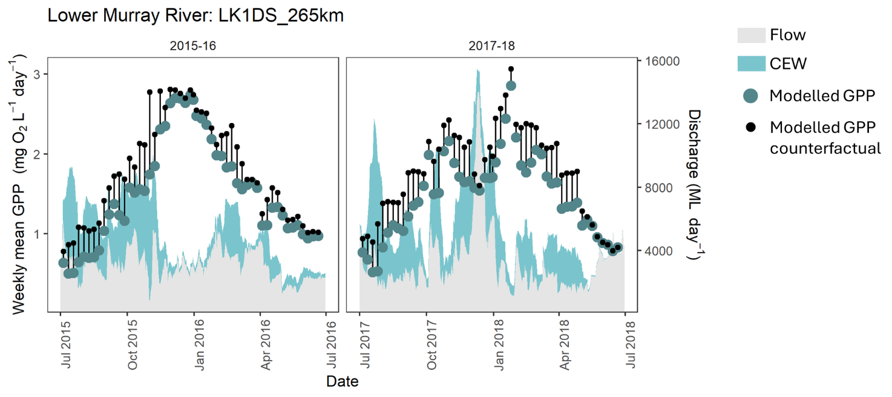
Figure 5.4 Counterfactual gross primary production (GPP) predictions for Hopwood in the Edward/Kolety–Wakool river systems Selected Area in 2016–17
This example demonstrates that a small volume of CEW (when expressed as a percent of annual discharge) can have a large impact on annual GPP.
X-axis is time, 1 July 2016 to 30 June 2017. Large green circles show the modelled weekly mean GPP under the observed flow scenario (with CEW) and small black circles show the modelled mean daily GPP under the counterfactual flow scenario (without CEW). The vertical black lines indicate the difference between the rates for the 2 scenarios. The shaded hydrograph shows the flow at the closest gauge, and the daily CEW contribution is shaded blue.
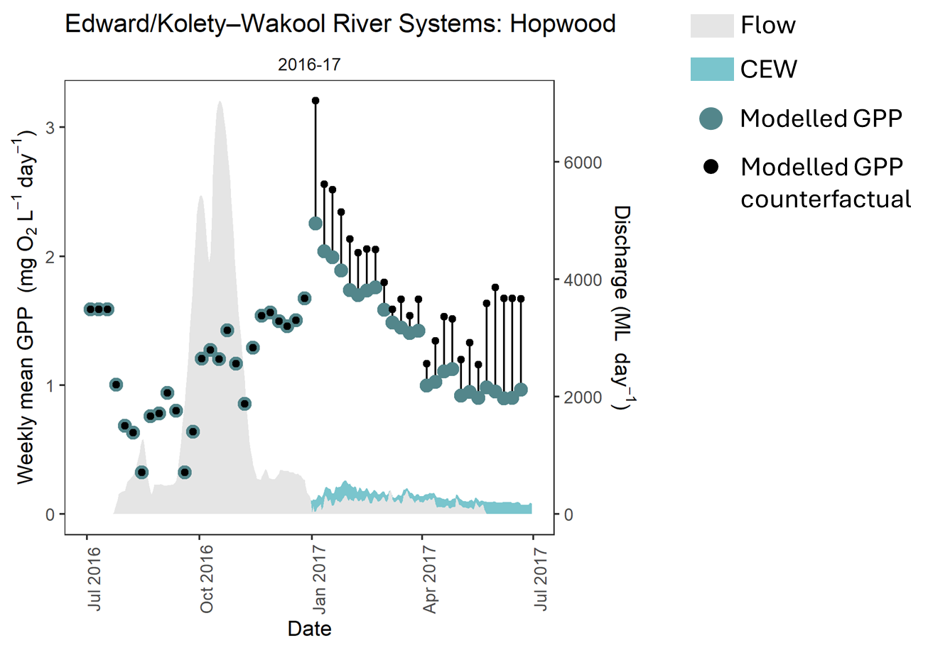
Figure 5.5 Counterfactual gross primary production (GPP) predictions for Lane’s Bridge in the Lachlan River System Selected Area
This example demonstrates how the modelled non-linear effect of flow on GPP can produce both positive and negative contributions of CEW to GPP under different flow contexts.
X-axis is time: left plot 1 1uly 2016 to 30 June 2017, right plot 1 July 2017 to 30 June 2018. Large green circles show the modelled mean daily GPP under the observed flow scenario (with CEW) and small black circles show the modelled mean daily GPP under the counterfactual flow scenario (without CEW). The vertical black lines indicate the difference between the rates for the 2 scenarios. The shaded hydrograph shows the flow at the closest gauge, and the daily CEW contribution is shaded blue.
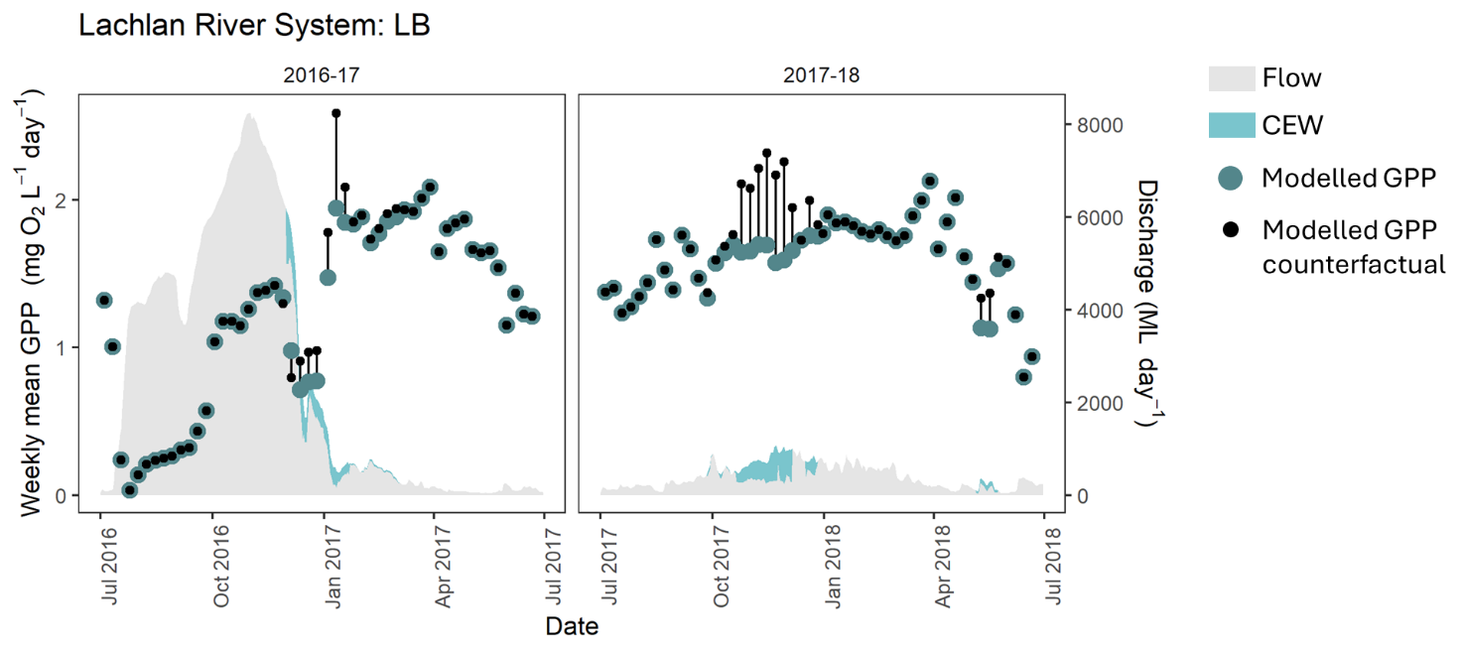

Implications
- Riverine productivity regimes are sensitive to CEW.
- Delivering CEW at flows lower than large freshes will generally reduce daily GPP (by a daily average of 15%), contributing to lower annual rates of productivity. This could potentially limit the proliferation of some unwanted algal groups that can occur at low flows.
- Interactions between solar radiation and flow drivers were not strong, indicating flow increases will reduce GPP by similar amounts at different times of year.
- CEW bolstered riverine GPP in rare instances where CEW contributed to very high discharges (e.g. when extending a flood recession), supporting the boom–bust nature of the lowland river-floodplain systems.

Contribution to Basin Plan objectives
The Basin Plan sets high-level objectives to ensure that the water-dependent ecosystems of the Basin are resilient to climate change and other risks and threats (Basin Plan section 8.04). Particular objectives for the protection and restoration of water-dependent ecosystems are set in section 8.05, and for the protection and restoration of ecosystem functions of water-dependent ecosystems in section 8.06. Several others relate to aspects of water quality (sections 9.08 and 9.14) and salt export (section 9.09). Table 6.1 details these objectives, expected outcomes, and measured and predicted outcomes for 2023–24 and 2014–24.
Table 6.1 Commonwealth Environmental Outcomes Framework for food webs and water quality, and key findings for 2023–24 and 2014–24
Bold numbers and letters refer to specific sections of the Basin Plan objectives. CEW = Commonwealth environmental water.
Basin Plan objectives | Basin outcomes | Long-term expected outcomes | 1-year expected outcomes | Measured and predicted 1-year outcomes 2023–24 | Measured and predicted long-term outcomes 2014–24
8.06 Protection and restoration of ecosystem functions of water-dependent ecosystems  (3) An objective is to protect and restore connectivity within and between water-dependent ecosystems, including by ensuring that:  (c) the Murray Mouth remains open at frequencies, for durations, and with passing flows, sufficient to enable the conveyance of salt, nutrients and sediment from the Basin to the ocean  (d) the Murray Mouth remains open at frequencies and for durations sufficient to ensure that the tidal exchanges maintain the Coorong’s water quality (in particular salinity levels) within the tolerance of the Coorong ecosystem’s resilience  (7) An objective is to protect and restore ecological community structure, species interactions and food webs that sustain water-dependent ecosystems, including by protecting and restoring energy, carbon and nutrient dynamics, primary production and respiration. | Food webs and water quality | Longer term targets from 1 July 2019  (2) There are improvements in the following:  (a) flow regimes which include relevant flow components set out in paragraph 8.51(1)(b)  (b) hydrological connectivity between the river and floodplain and between hydrologically connected valleys  (c) river, floodplain and wetland types, including the condition of priority environmental assets and priority ecosystem functions  (d) condition of the Coorong and Lower Lakes ecosystems and Murray Mouth opening regime  (e) condition, diversity, extent and contiguousness of native water-dependent vegetation  (f) recruitment and populations of native water-dependent species, including vegetation, birds, fish and macroinvertebrates  (g) the community structure of water-dependent ecosystems. | Intermediate targets up to 30 June 2019  (1) There is no loss of or degradation in the following:  (a) flow regimes which include relevant flow components set out in paragraph 8.51(1)(b)  (b) hydrological connectivity between the river and floodplain and between hydrologically connected valleys  (c) river, floodplain and wetland types, including the condition of priority environmental assets and priority ecosystem functions  (d) condition of the Coorong and Lower Lakes ecosystems and Murray Mouth opening regime  (e) condition, diversity, extent and contiguousness of native water-dependent vegetation  (f) recruitment and populations of native, water-dependent species, including vegetation, birds, fish and macroinvertebrates. | 8.06(3)(c),(d)  In 2023–24, CEW was responsible for the export of 221,272 tonnes of salt (17.8% of total salt exported) through the barrages (Ye et al. 2025). CEW decreased salt import at the Murray Mouth by approximately 2,854,965 tonnes in 2023–24 (Ye et al. 2025).  8.06(7)  Evidence from Selected Areas that CEW had a positive influence on protecting and restoring energy, carbon and nutrient dynamics, primary production and respiration in 2023–24 reducing the risk of blackwater events and algal blooms (Table 3.3). | 8.06(3)(c),(d)  CEW had an important role to play in meeting long-term objectives to protect and restore connectivity within and between water-dependent ecosystems, particularly in the Lower Murray River Selected Area. Since 2014–15, CEW has been responsible for an additional 4.3 million tonnes of salt exported through the barrages and has reduced salt import by more than 28 million tonnes (Ye et al. 2025).  8.06(7)  Evidence from Selected Areas indicates that CEW had a positive influence on protecting and restoring energy, carbon and nutrient dynamics, primary production and respiration in 2014–24.  CEW reduced annual GPP by a mean of 5.3% (range 0.3% to 17.5% among site and years). On individual days with CEW contribution, daily GPP was a mean of 15% lower than the counterfactual scenario (range 6.5% to 43% among sites and years).
9.08 Objective to maintain good levels of water quality | Water quality | If the value of a water quality characteristic (e.g. salinity, nutrients, pesticides, pH, turbidity) is at a level that is better than the target value for water quality set out in Part 4, an objective is to maintain that level. | None identified | 9.08  Environmental watering actions in 2023–24 water provided benefits in terms of increasing oxygen concentrations and reducing the potential for blackwater events (Table 3.3). | 9.08  Water quality is difficult to assess across the Basin due to the high level of spatial and temporal baseline variation. However, there is strong evidence that CEW played an important role in maintaining good levels of water quality in 2014–24. For example, anoxic events in 2016 and the subsequent delivery of ameliorating flows (including through CEW) demonstrated the utility of targeted watering actions designed to improve water quality (Grace 2020). CEW contributions to meeting salt export targets (see 9.09 and 9.14(5)(c) below) have also been significant.
9.09 Salt export objective | Water quality | The salt export objective is expected to be achieved by the discharge of an average of 2 million tonnes of salt from the Murray River system into the Southern Ocean each water accounting period. | None identified | 9.09  In 2023–24, CEW was responsible for the export of 221,272 tonnes of salt (around 11% of the Basin target) (Ye et al. 2025). | 9.09  CEW accounted for 80% to 100% of annual environmental flow releases through the barrages (the only mechanism for salt export from the Basin) during the dry years (between 2014–15 and 2020–21 except for 2016–17). Since 2014–15, CEW has been responsible for an additional 4.3 million tonnes of salt exported through the barrages (22% of the Basin target) and has reduced salt import by more than 28 million tonnes since 2014–15 (Ye et al. 2025).
9.14 Targets for managing water flows  (5) For the purposes of subsections (1) to (4) [not shown], the following targets apply:  (a) to maintain dissolved oxygen at a target value of at least 50% saturation  (c) the levels of salinity at the reporting sites set out in [column 3] should not exceed the values set out in [column 3] 95% of the time | Water quality | 9.14(5)(a)  This equates to approximately 50% oxygen saturation at 25°C and 1 atmosphere of pressure.  9.14(5)(c)  Target values (electrical conductivity) (µS/cm):  - Murray River at Murray Bridge – 830  - Murray River at Morgan – 800  - Murray River at Lock 6 – 580  - Darling River at Burtundy – 830  - Lower Lakes at Milang – 1,000 | None identified | 9.14  CEW contributed to maintenance of electrical conductivity below 800 µS/cm at Morgan (Ye et al. 2024). | 9.14(5)(a)  CEW can help reduce the likelihood of low dissolved oxygen concentrations in the Lower Murray River, if their contribution increases water velocities above a level of ~0.18 m/s, below which surface oxygen exchange is poor (Ye et al. 2025). Reducing the likelihood of low dissolved oxygen concentrations can be achieved by increasing water mixing in otherwise low flow (Ye et al. 2025)  9.14(5)(c)  CEW has made long-term contributions to maintenance of river salinity below 800 µS/cm at Morgan by diluting salt in the Lower Murray River channel. Salinity was maintained within the range required for potable water in the Murray River in 2014–23– water was about 10% fresher due to environmental flows (Ye et al. 2025).

Informing adaptive management for food webs and water quality outcomes
Each annual evaluation contributes to our understanding of how the ecosystems of the Basin respond in the short term and long term to delivery of water for the environment. This chapter provides our reflections on how this increased understanding can inform the next cycle of environmental water planning and its delivery and improve our approach to Basin-scale evaluation.
Adaptive management includes the following steps: (a) setting clear objectives,, (b) linking knowledge (including local knowledge), management evaluation and feedback over a period of time,, (c) identifying and testing uncertainties,, (d) using management as a tool to learn about the relevant system and change its management,, (e) improving knowledge and (f) having regard to the social, economic and technical aspects of management (Extract from Basin Plan section 1.07(1)).

Informing the planning and management of environmental water for food webs and water quality
In this context, improvements in ecological processes are based on more productive and diverse food webs and ecological communities that are supported by the increased movement of carbon, nutrients and salt.
Contributions by CEW to water quality and metabolic outcomes are heavily influenced by the type of flow delivered. Despite site-to-site variation, interrogation of the longer term 2014–24 data from all Selected Areas identified a common immediate response to increased flow: a decrease in metabolic throughput (i.e. lower GPP and lower ER). As described conceptually in Figure 2.1, we have predicted generalised metabolic responses from the type of CEW flow delivered. Together, the results suggest that these responses are expected from different flow components and dependent on antecedent flow patterns that drive abiotic and biotic changes:
- Base flow and cease to flow – high reliance on autotrophic production due to low turbidity (high light), potentially warmer water and prolonged stable state without disturbance. Gross primary production remains relatively high, but time since last flood and size of last flood are likely to influence carbon and nutrient availability. If nutrients are highly available, there is potential for algal or cyanobacteria blooms.
- Small fresh – initial small decrease in GPP and a shift towards ER from increased turbidity and inundation of channel features. An eventual small increase in GPP follows the mobilisation of nutrients.
- Large fresh – reduction in GPP and a significant increase in ER due to the inundation of benches, incorporation of organic matter, and increased turbidity. The magnitude of increase in ER is influenced by organic matter load (e.g. time since last flooding). There is an eventual increase in GPP as nutrients and light increase, but increased terrestrially derived carbon remains an important energy source for food webs.
- Bankfull – initial drop in GPP, significant increase in ER and, depending on litter accumulation levels and flow timing, potential for hypoxic blackwater in channels and a shift to terrestrially derived energy entering food webs.
- Overbank – very large events transporting large amounts of terrestrial material into the river. High rates of ER during floodplain–channel connection drive a microbially based food web. There is the potential for hypoxic blackwater events depending on flow volume and floodplain load of organic matter. Gross primary production may be reduced by disturbance effects but could be increased due to increased nutrient availability and inundation of shallow areas, although the latter is not well captured by this dataset.
The 2014–24 dataset provides a strong foundation for the description of site-specific metabolic patterns. As more data are collected and added to the metabolic fingerprint for a given Selected Area or a combination of Selected Areas, our ability to tailor flows to deliver desired responses will increase.
Improving our understanding of how the food supply for food webs is influenced by CEW, and the relationship between stream metabolism and secondary productivity, are active areas of research. The incorporation of this information into CEW planning is an important step in adaptive management. Further exploration of the trajectory of metabolic recovery following flow disturbance may provide more information on longer-term biotic responses to CEW flow events after the immediate flow (e.g. processing of terrestrial organic matter following overbank flows).
Ensuring that energy generated at the base of the food web is available to subsequent trophic levels, and limiting significant dissipation of energy via the microbial loop, are important considerations when seeking to maximise ecosystem benefits from CEW.CEW Work carried out in Flow-MER research that explores ‘link or sink’ relationships in food webs is key to unravelling relationships between the rates of GPP and ER and secondary production by heterotrophs. Making sure that the right type of food is available at the right time is critical for generating beneficial outcomes, such as successful recruitment of larval fish.

Managing to improve patterns and rates of ecosystem respiration
Commonwealth environmental water can support ER and, potentially, secondary production rates if flows increase lateral connections between the river channel and riparian, wetland or floodplain areas (e.g. bankfull and overbank flows), thereby increasing the supply of allochthonous organic carbon to the food web. Improving our knowledge of ER responses to different flow types (e.g. keeping metabolic fingerprints within the typical region; Figure 2.1) will help prevent adverse ER outcomes, such as hypoxic blackwater events. Recognising that bankfull and overbank flows are not always possible, smaller flows (e.g. freshes) have the potential to liberate new terrestrial carbon from in-channel benches (e.g. in the Goulburn River and Edward/Kolety–Wakool river systems Selected Areas) and newly inundated slack waters. However, responses will be highly dependent on antecedent hydrological patterns (e.g. the amount of litter that has accumulated since the last fresh).

Managing to improve patterns and rates of primary productivity
Changes to volumetric rates of GPP in response to CEW are generally small, and patterns in rates of GPP are primarily driven by seasonal changes (e.g. light, temperature) and site-specific variability in bioavailable nutrients and turbidity. Our evaluation demonstrated that increased flows generally decrease overall metabolic throughput. However, at some sites, increased flows lead to increased rates of GPP (e.g. the Lanes Bridge site in the Lachlan River System Selected Area). Improving our understanding of site-specific features and drivers that lead to consistent metabolic responses will improve our ability to predict flow–metabolism responses in unmonitored areas. There is some evidence that freshes could be used to boost primary productivity during warm, low flow periods if there is a risk of high algal concentrations.

Managing to improve dissolved oxygen levels
Commonwealth environmental water is very important for decreasing the likelihood of low DO because it can increase water mixing and oxygen exchange at the surface, particularly in the Lower Murray River Selected Area, where the river is dominated by slow-flowing locks and weirs. For example, in 2022–23, CEW was used to maintain DO levels above desired thresholds during hypoxic blackwater events in the Edward/Kolety–Wakool river systems Selected Area. These flows can act to dilute hypoxic water with oxygenated water and increase oxygen exchange at the surface. Commonwealth environmental water may also be used to maintain base flows to support aquatic ecosystems during low flow periods.

Managing to maintain river salinity and salt export
Commonwealth environmental water plays a role in maintaining salinity regimes within a desired range. Commonwealth environmental water has been used to:
- maintain river salinity below 800 µS/cm (electrical conductivity) at Morgan (a river management target of the Murray–Darling Basin Authority and SA Water)
- maintain salt export from the Coorong in low flow years and restrict the import of salt to the Coorong
- contribute to the Basin Plan’s target of exporting 2 million tonnes of salt each water accounting period from the Murray River system into the Southern Ocean.

Improving our approach to Basin-scale evaluation
The Food webs and Water Quality evaluation is not continuing in Flow-MER and the 2023-24 evaluation (this report) is the final in this series. While not continuing in this format, the following observations are made as input to future monitoring and evaluation of food webs, stream metabolism and water quality:
- To improve the utility of metabolic data collected, we recommend a formally designed and coordinated sampling approach between and beyond Selected Areas. Coordinated sampling should cover year-round sampling – or at least enough to ensure that the Bayesian single-station estimation models can evaluate gaps. We also recommend the collection of bathymetric data in all Selected Areas, which will enable conversion of volumetric metabolic rates to areal rates, in line with international literature.
- We encourage aligning spatial design to Basin-scale evaluation questions. This includes planning for a larger spread of sites and also potentially a rotational sampling scheme – pioneered by the Sustainable Rivers Audit (Davies et al. 2010) and the South East Queensland Healthy Waterways assessment and evaluation scheme (Bunn et al. 2007). We acknowledge that there is a mismatch between Selected Area reporting requirements and data needs for a Basin-scale evaluation. However, without coordination with the Basin evaluation, desired outcomes at the Basin scale cannot be achieved. Currently, only a few selected sites have adequate sampling frequencies – both within and between seasons – to support time series analyses. Even if this is rectified, the spatially patchy nature of the sampling sites would make extrapolation to the Basin difficult. We strongly encourage thinking about a well-planned spatial design that satisfies the needs of the Selected Areas and facilitates Basin-wide synthesis.
- There is a requirement to establish expected environmental outcomes for metabolic responses to flow. Currently, there are no expected environmental outcomes for stream metabolism within the Strategy, making evaluation relatively subjective. Targets should be established by managers, include guidance from scientists, and need to be site specific or catchment specific.
- Metabolic fingerprints can also be used to compare and classify metabolic regimes across different sites and can be further extended with application of statistical models (e.g. envfit function) to assess the magnitude and direction of metabolic responses to flow. In doing so, we identify sites that share similar metabolic response patterns and respond to flow events in similar ways. This information will be incorporated in future evaluation and planning of CEW as the number of events monitored becomes adequate to confidently describe desired metabolic responses.
We hypothesise the most prominent effects of CEW would come from inundation of littoral and floodplain habitats and the associated releases of nutrients and dissolved organic carbon. Understanding this spatial variability will be a focus of future research. For instance, piggybacking a relatively small volume of water onto other flows may produce a disproportionate increase in floodplain inundation and thus aquatic ecosystem productivity. Emerging tools for mapping flood inundation extents at high resolution will facilitate such analyses in the future.

Stream metabolic responses to flow at sites in 7 Selected Areas
For all plots in this appendix, the left-hand panels display GPP, ER and NEP values in response to flow (black line) and CEW (pink line). Right-hand panels depict metabolic fingerprints (without kernel-density regions displayed), and colouration of data points reflect logFlow. Length of the envfit environmental vector arrow (j) indicates the strength (r²) and direction of the long-term metabolic response to flow, with significant responses, p < 0.05. For plots that have no vector arrow, there was insufficient data for envfit to generate a vector.
- Junction of Warrego and Darling rivers stream metabolism – flow relationship plots
Figure A.1 Junction of Warrego and Darling rivers stream metabolism – flow relationship plots: WD_AKUNA
r² = 0.02, p = 0.141
ER = ecosystem respiration, GPP = gross primary production, NEP = net ecosystem production.
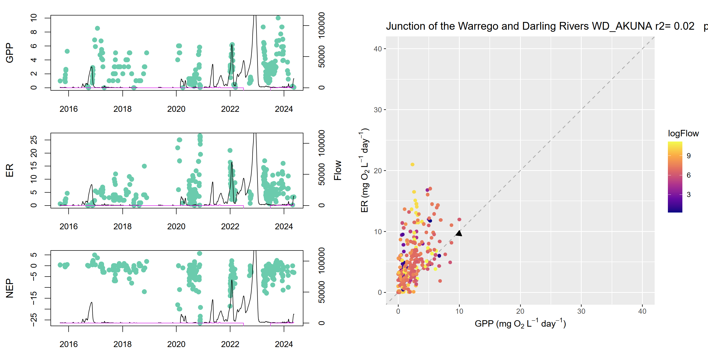

Figure A.2 Junction of Warrego and Darling rivers stream metabolism – flow relationship plots: WD_YANDA
r² = 0.42, p = 0.005
ER = ecosystem respiration, GPP = gross primary production, NEP = net ecosystem production.
4 plots - 3 line and scatter plots showing GPP, ER and NEP. Larger scatter plot showing ER:GPP 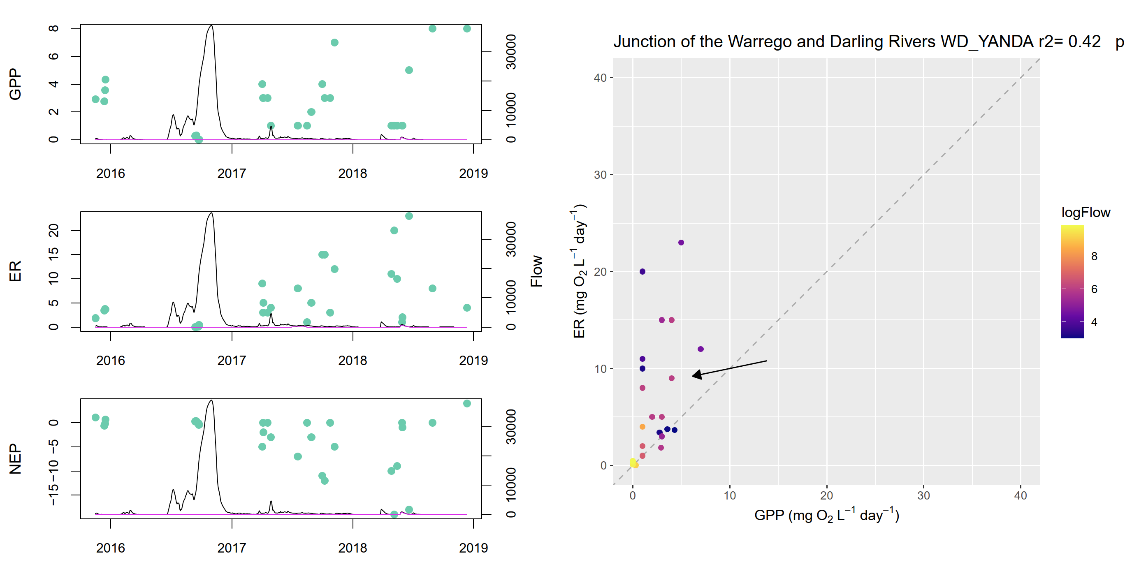
- Edward/Kolety–Wakool river systems stream metabolism – flow relationship plots
Figure A.3 Edward/Kolety–Wakool river systems stream metabolism – flow relationship plots: Hopwood
r² = 0.14, p = 0.001
ER = ecosystem respiration, GPP = gross primary production, NEP = net ecosystem production.
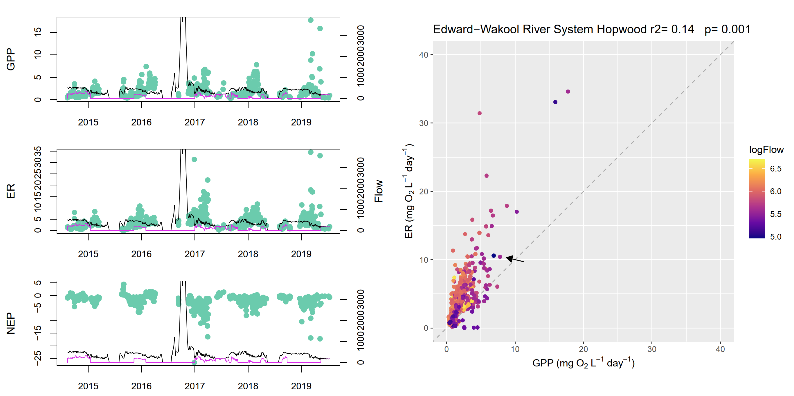
Figure A.4 Edward/Kolety–Wakool river systems stream metabolism – flow relationship plots: Llanos Park 2
r² = 0.14, p = 0.001
ER = ecosystem respiration, GPP = gross primary production, NEP = net ecosystem production.
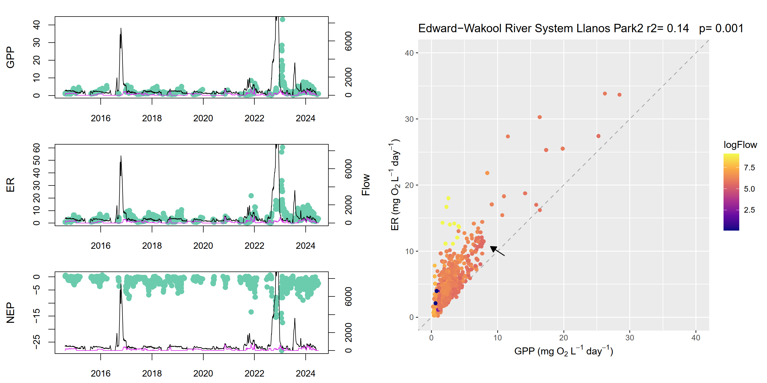
Figure A.5 Edward/Kolety–Wakool river systems stream metabolism – flow relationship plots: Moulamein Road Bridge
r² = 0.03, p = 0.001
ER = ecosystem respiration, GPP = gross primary production, NEP = net ecosystem production.
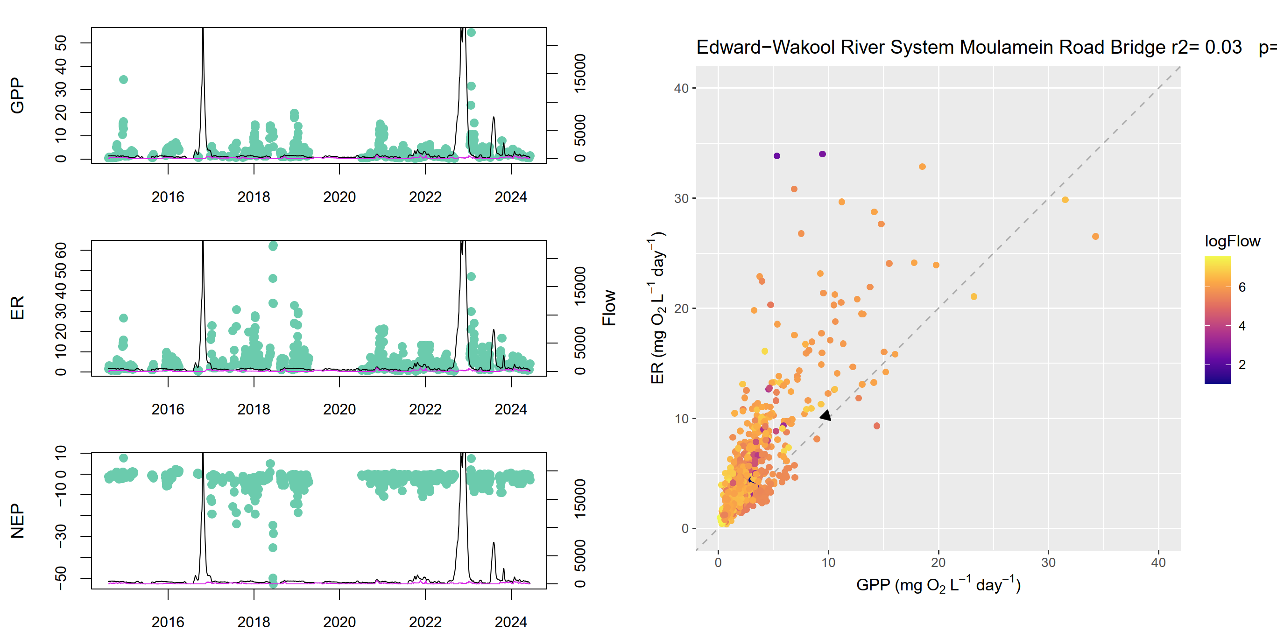
Figure A.6 Edward/Kolety–Wakool river systems stream metabolism – flow relationship plots: Noorong 2
r² = 0.01, p = 0.003
ER = ecosystem respiration, GPP = gross primary production, NEP = net ecosystem production.
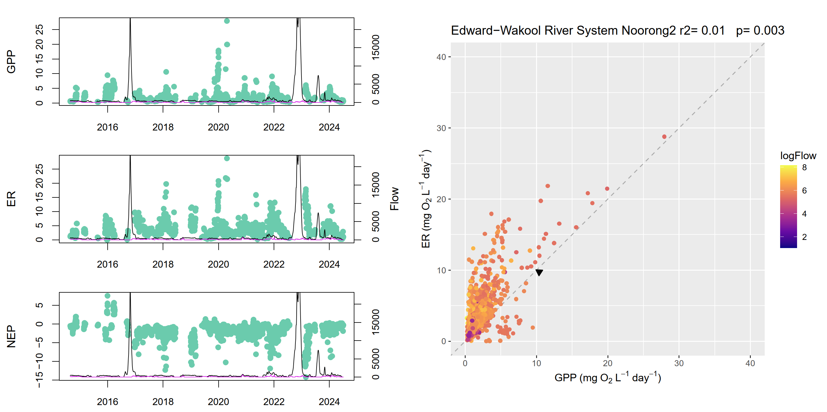
Figure A.7 Edward/Kolety–Wakool river systems stream metabolism – flow relationship plots: Old Morago Road
r² = 0.05, p = 0.001
ER = ecosystem respiration, GPP = gross primary production, NEP = net ecosystem production.
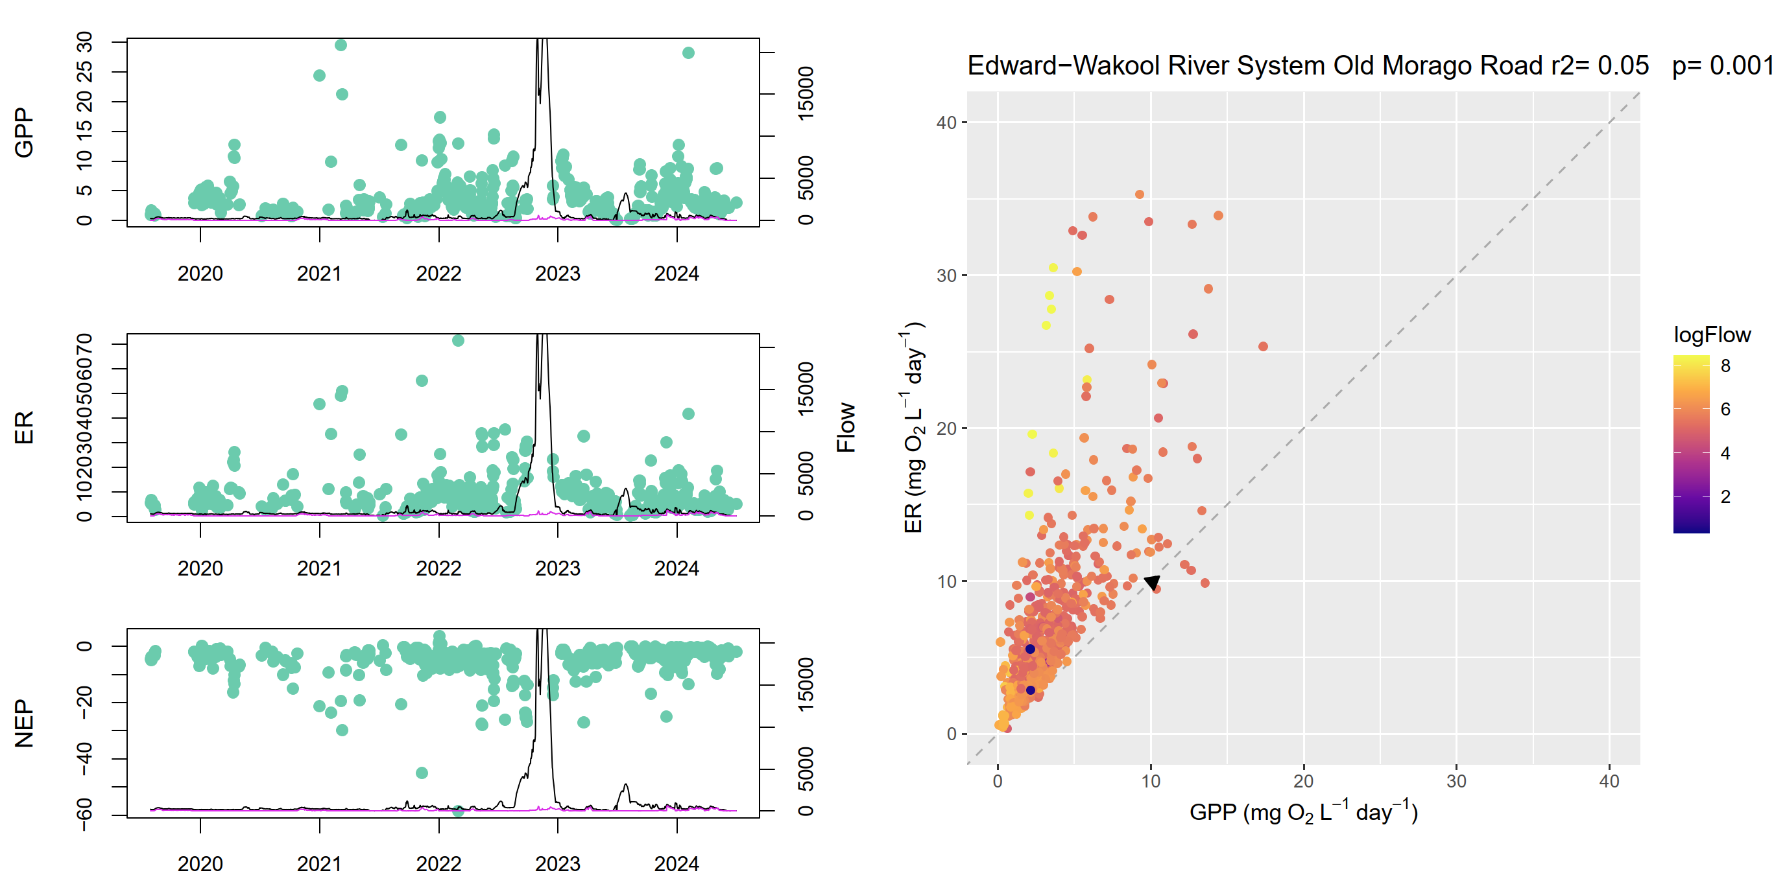
Figure A.8 Edward/Kolety–Wakool river systems stream metabolism – flow relationship plots: Widgee 1
r² = 0.03, p = 0.001
ER = ecosystem respiration, GPP = gross primary production, NEP = net ecosystem production.
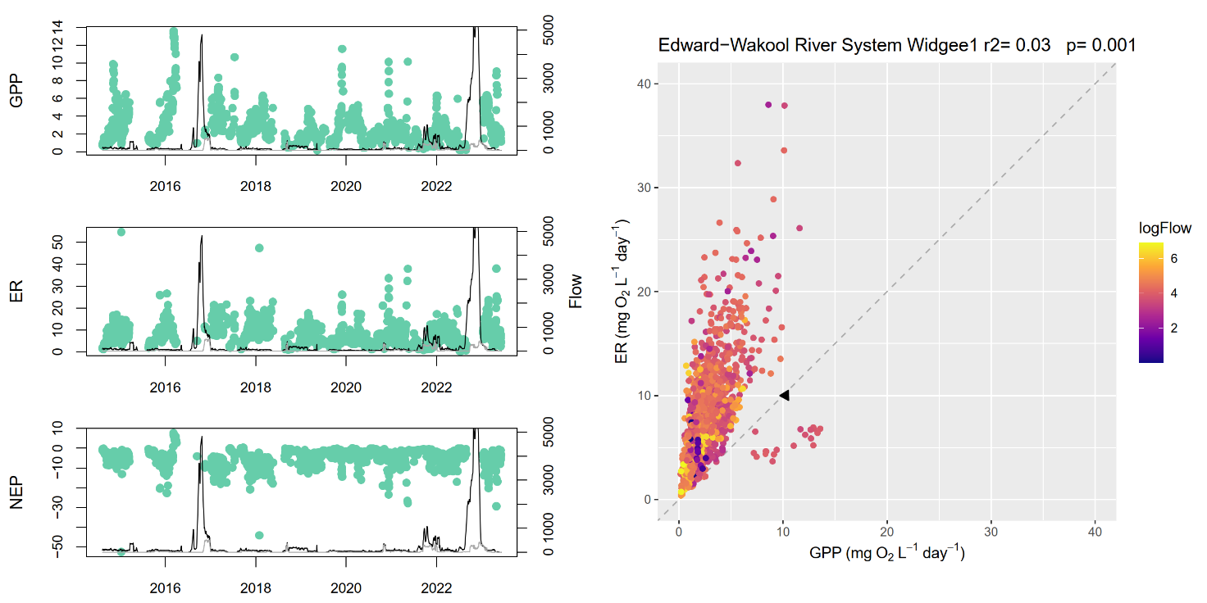
Figure A.9 Edward/Kolety–Wakool river systems stream metabolism – flow relationship plots: Windra Vale 2
r² = 0.02, p = 0.001
ER = ecosystem respiration, GPP = gross primary production, NEP = net ecosystem production.
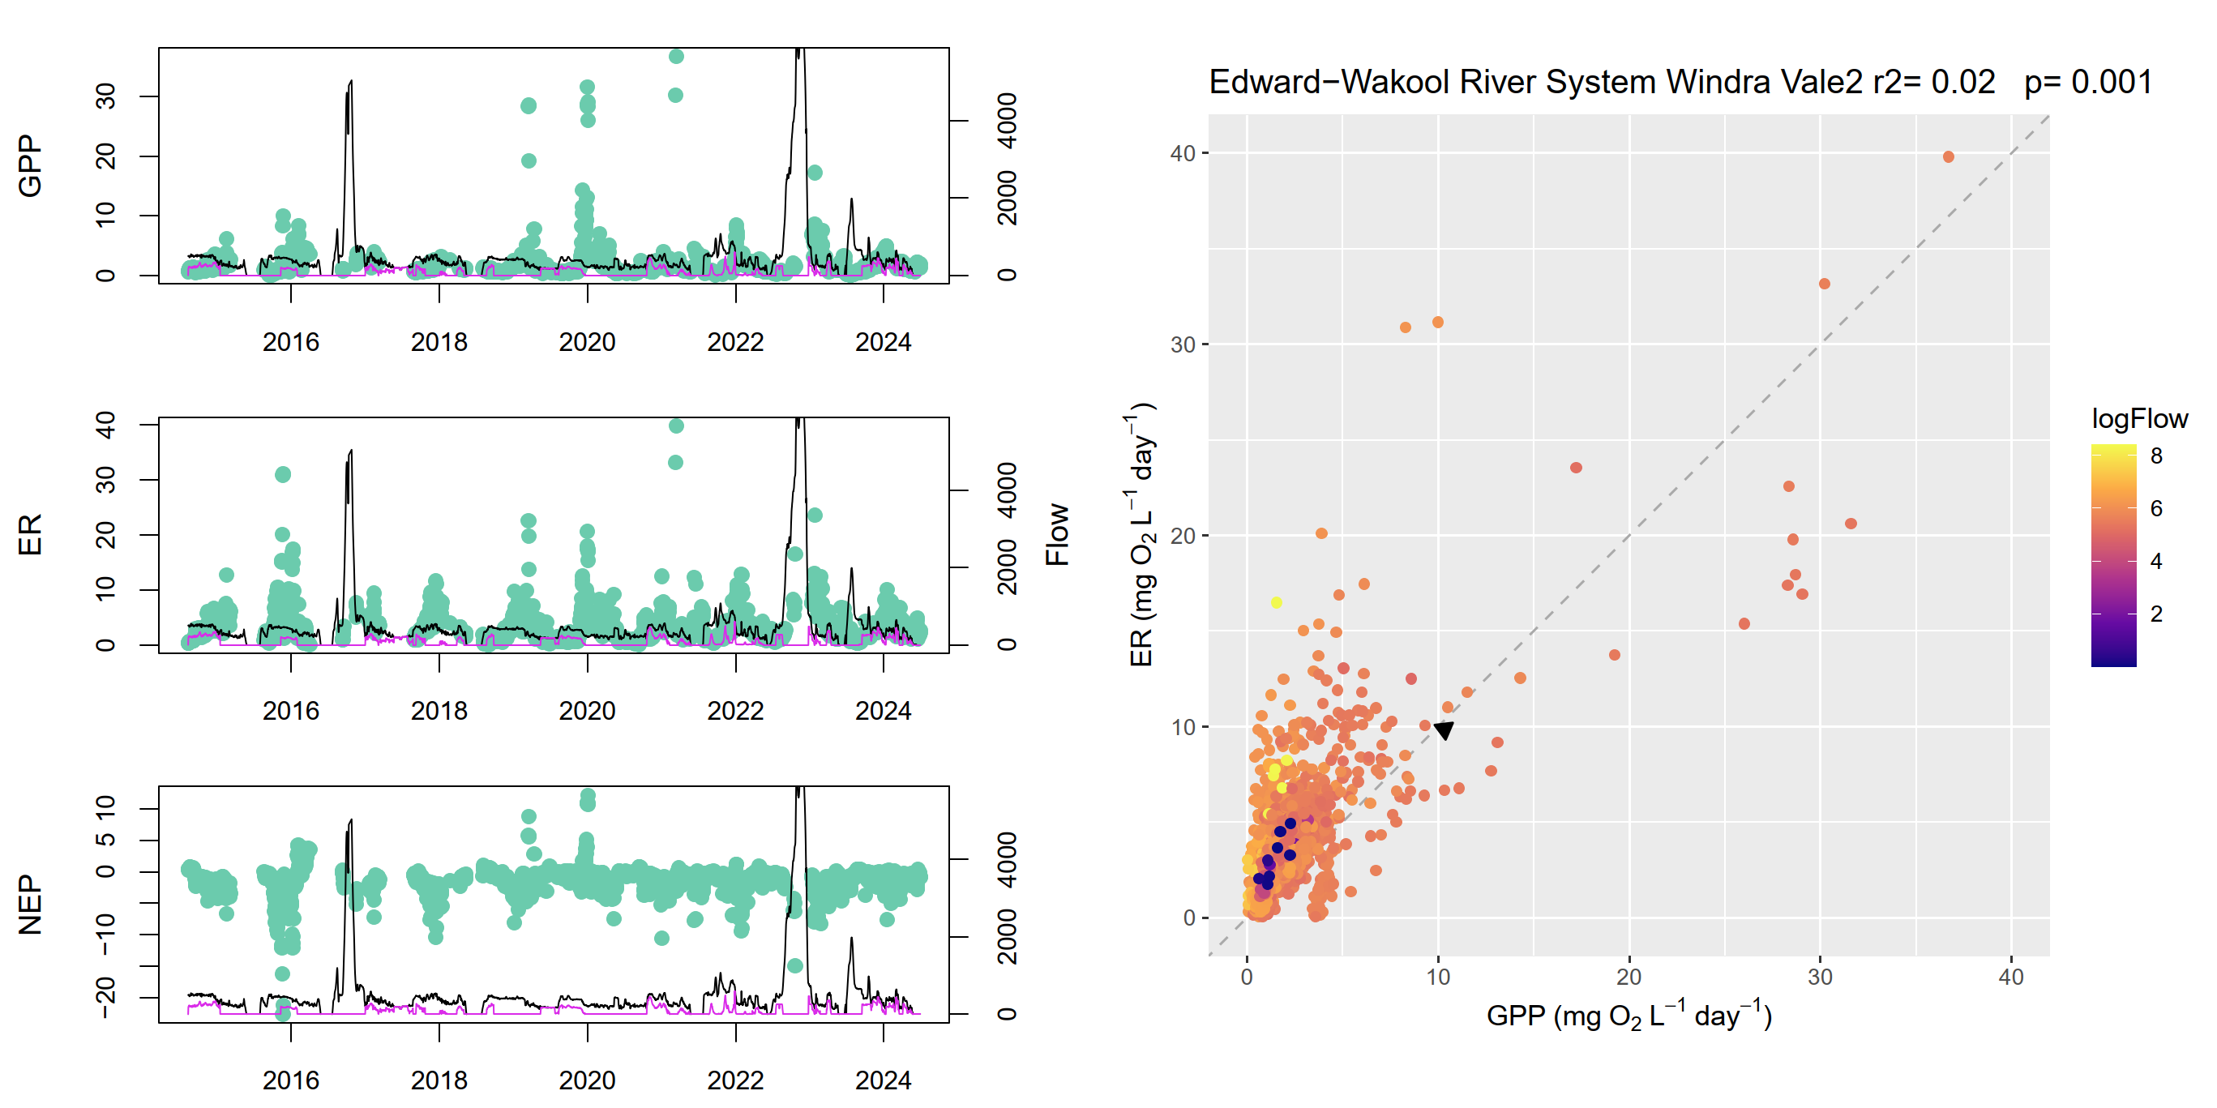
Figure A.10 Edward/Kolety–Wakool river systems stream metabolism – flow relationship plots: Cummins
r² = 0.14, p = 0.001
ER = ecosystem respiration, GPP = gross primary production, NEP = net ecosystem production.
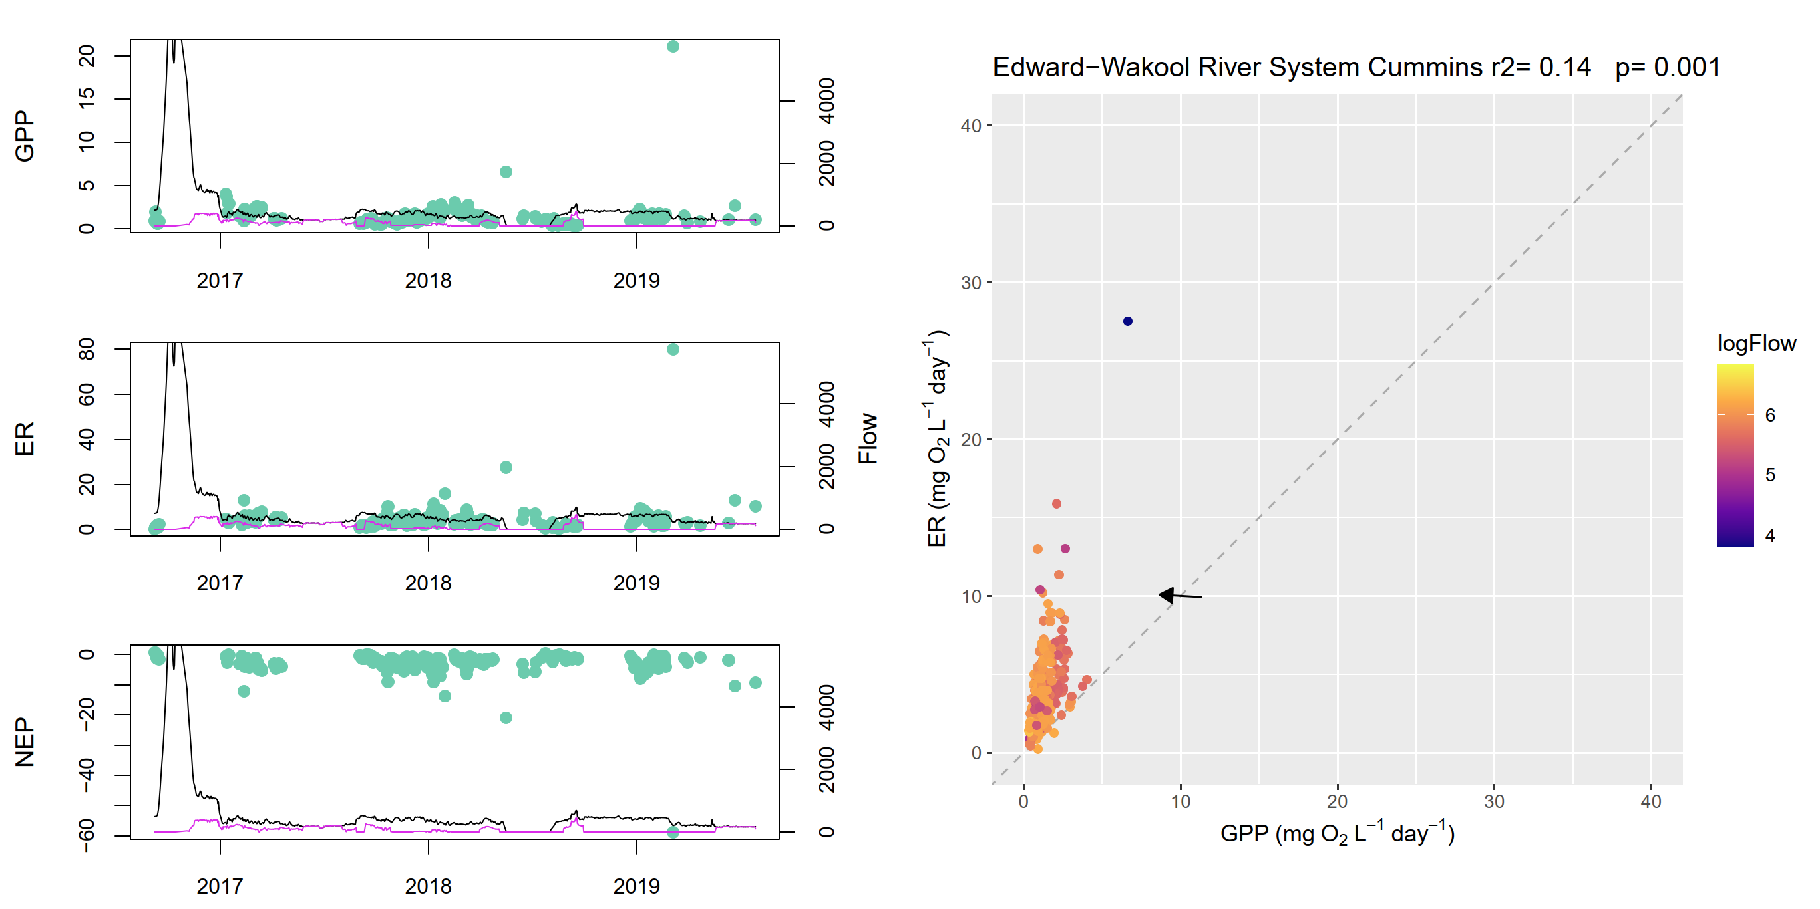
- Goulburn River stream metabolism – flow relationship plots
Figure A.11 Goulburn River stream metabolism – flow relationship plots: Arcadia Down
r² = 0.13, p = 0.001
ER = ecosystem respiration, GPP = gross primary production, NEP = net ecosystem production.
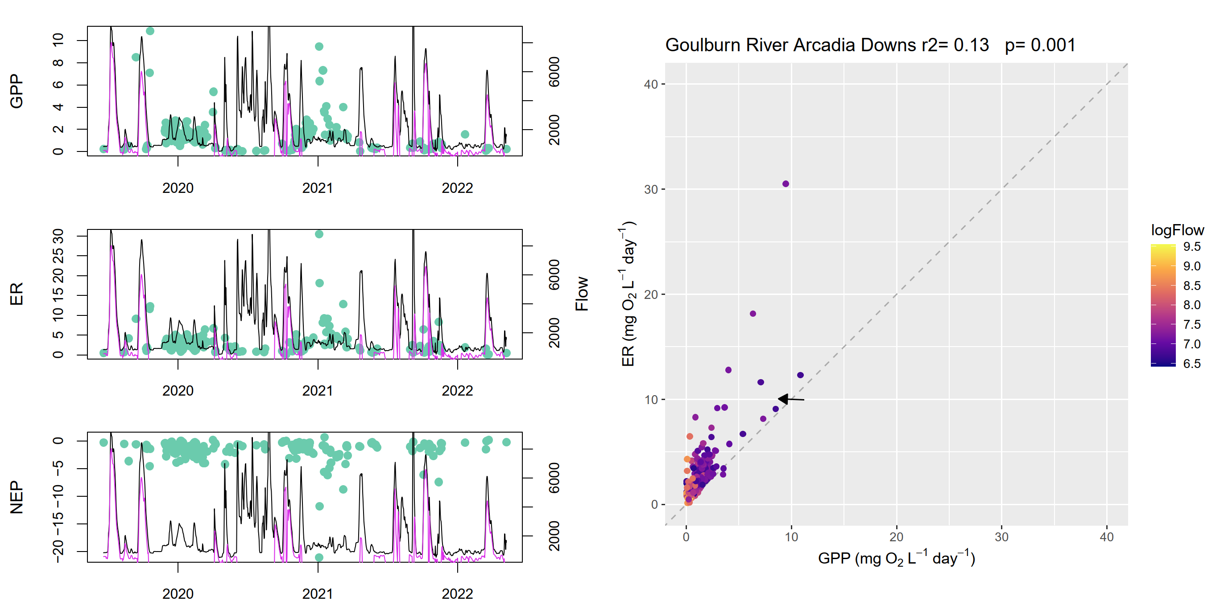
Figure A.12 Goulburn River stream metabolism – flow relationship plots: Darcy’s Track
r² = 0.24, p = 0.001
ER = ecosystem respiration, GPP = gross primary production, NEP = net ecosystem production.
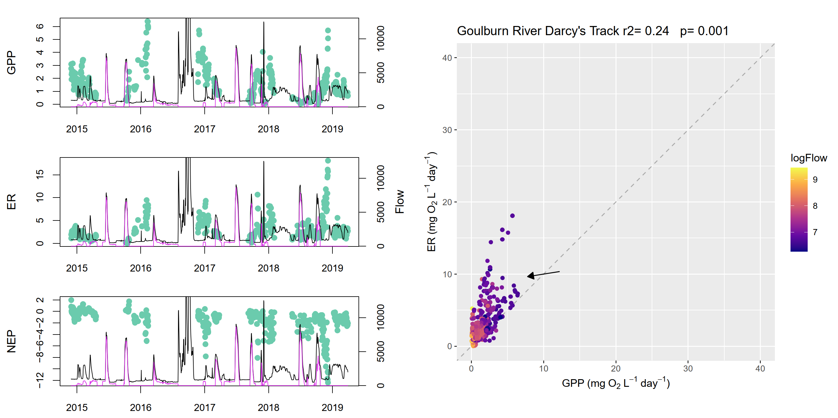
Figure A.13 Goulburn River stream metabolism – flow relationship plots: Day Road
r² = 0.20, p = 0.001
ER = ecosystem respiration, GPP = gross primary production, NEP = net ecosystem production.
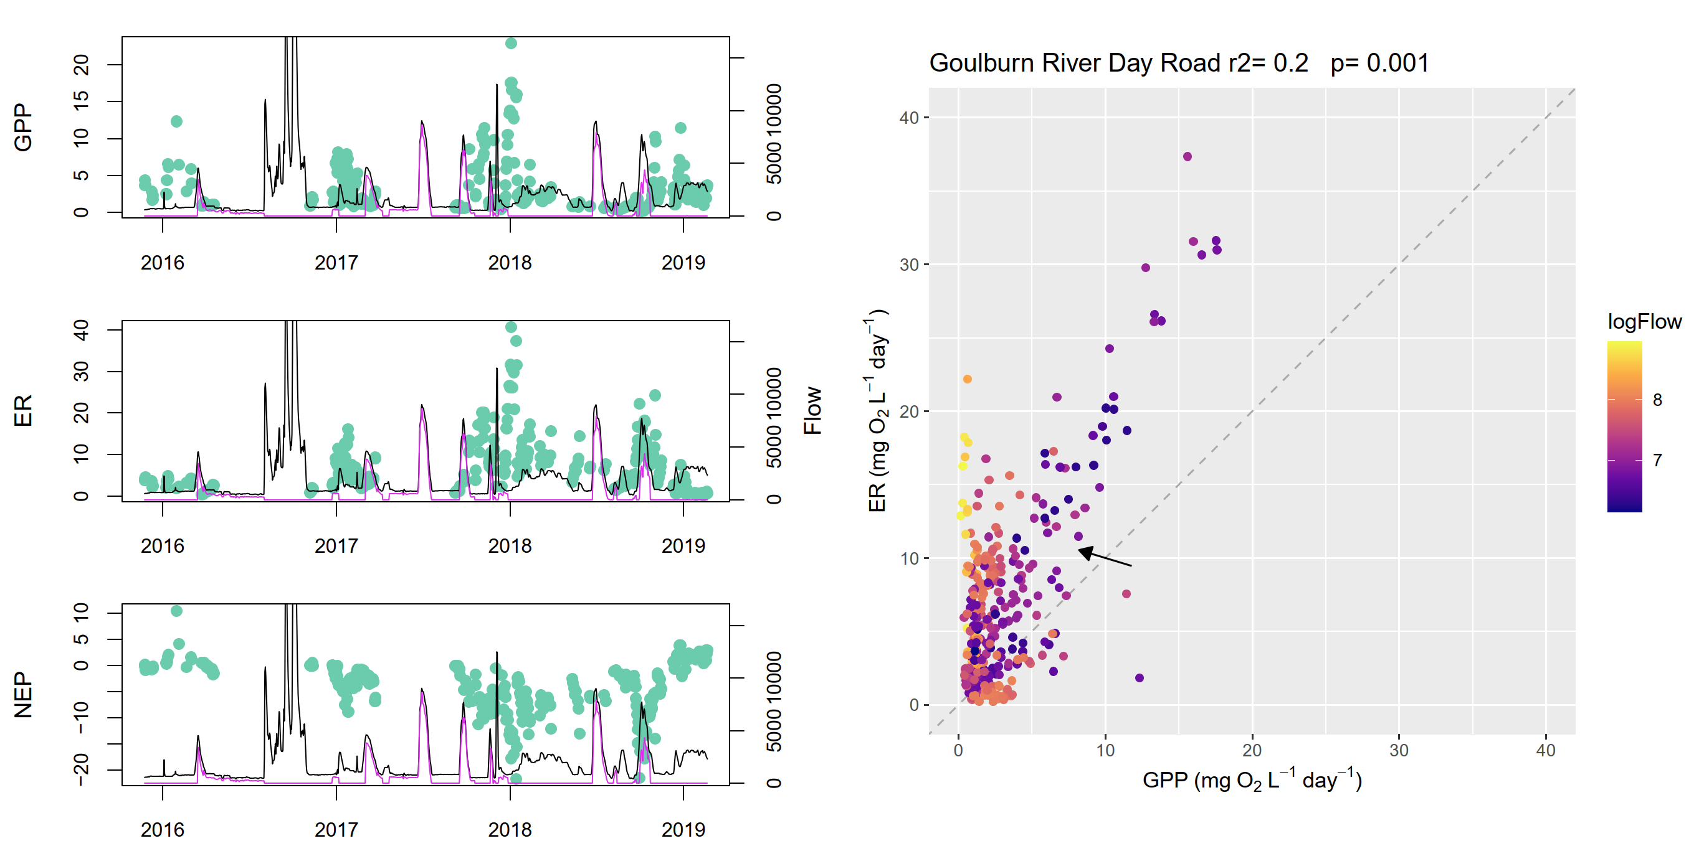
Figure A.14 Goulburn River stream metabolism – flow relationship plots: Loch Garry Gauge
r² = 0.15, p = 0.001
ER = ecosystem respiration, GPP = gross primary production, NEP = net ecosystem production.
Figure A.15 Goulburn River stream metabolism – flow relationship plots: McCoys Bridge
r² = 0.19, p = 0.001
ER = ecosystem respiration, GPP = gross primary production, NEP = net ecosystem production.
Figure A.16 Goulburn River stream metabolism – flow relationship plots: Moss Road
r² = 0.18, p = 0.446
ER = ecosystem respiration, GPP = gross primary production, NEP = net ecosystem production.
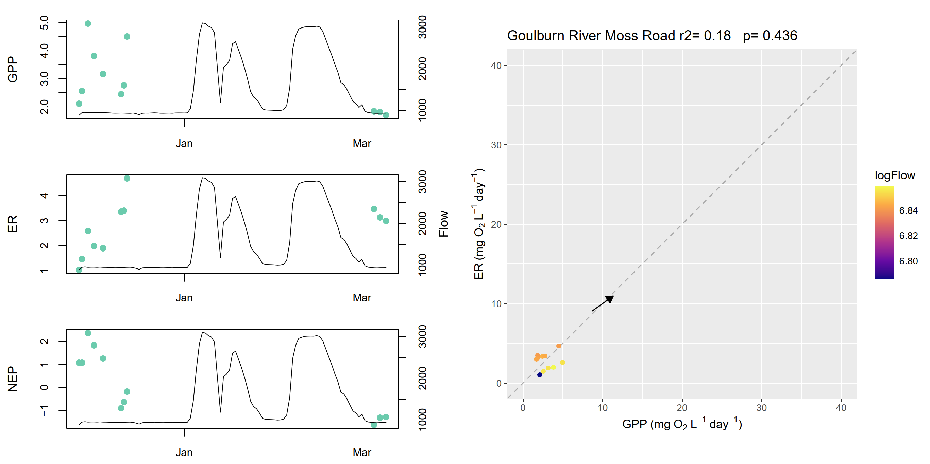
Figure A.17 Goulburn River stream metabolism – flow relationship plots: Murchison
r² = 0.11, p = 0.001
ER = ecosystem respiration, GPP = gross primary production, NEP = net ecosystem production.
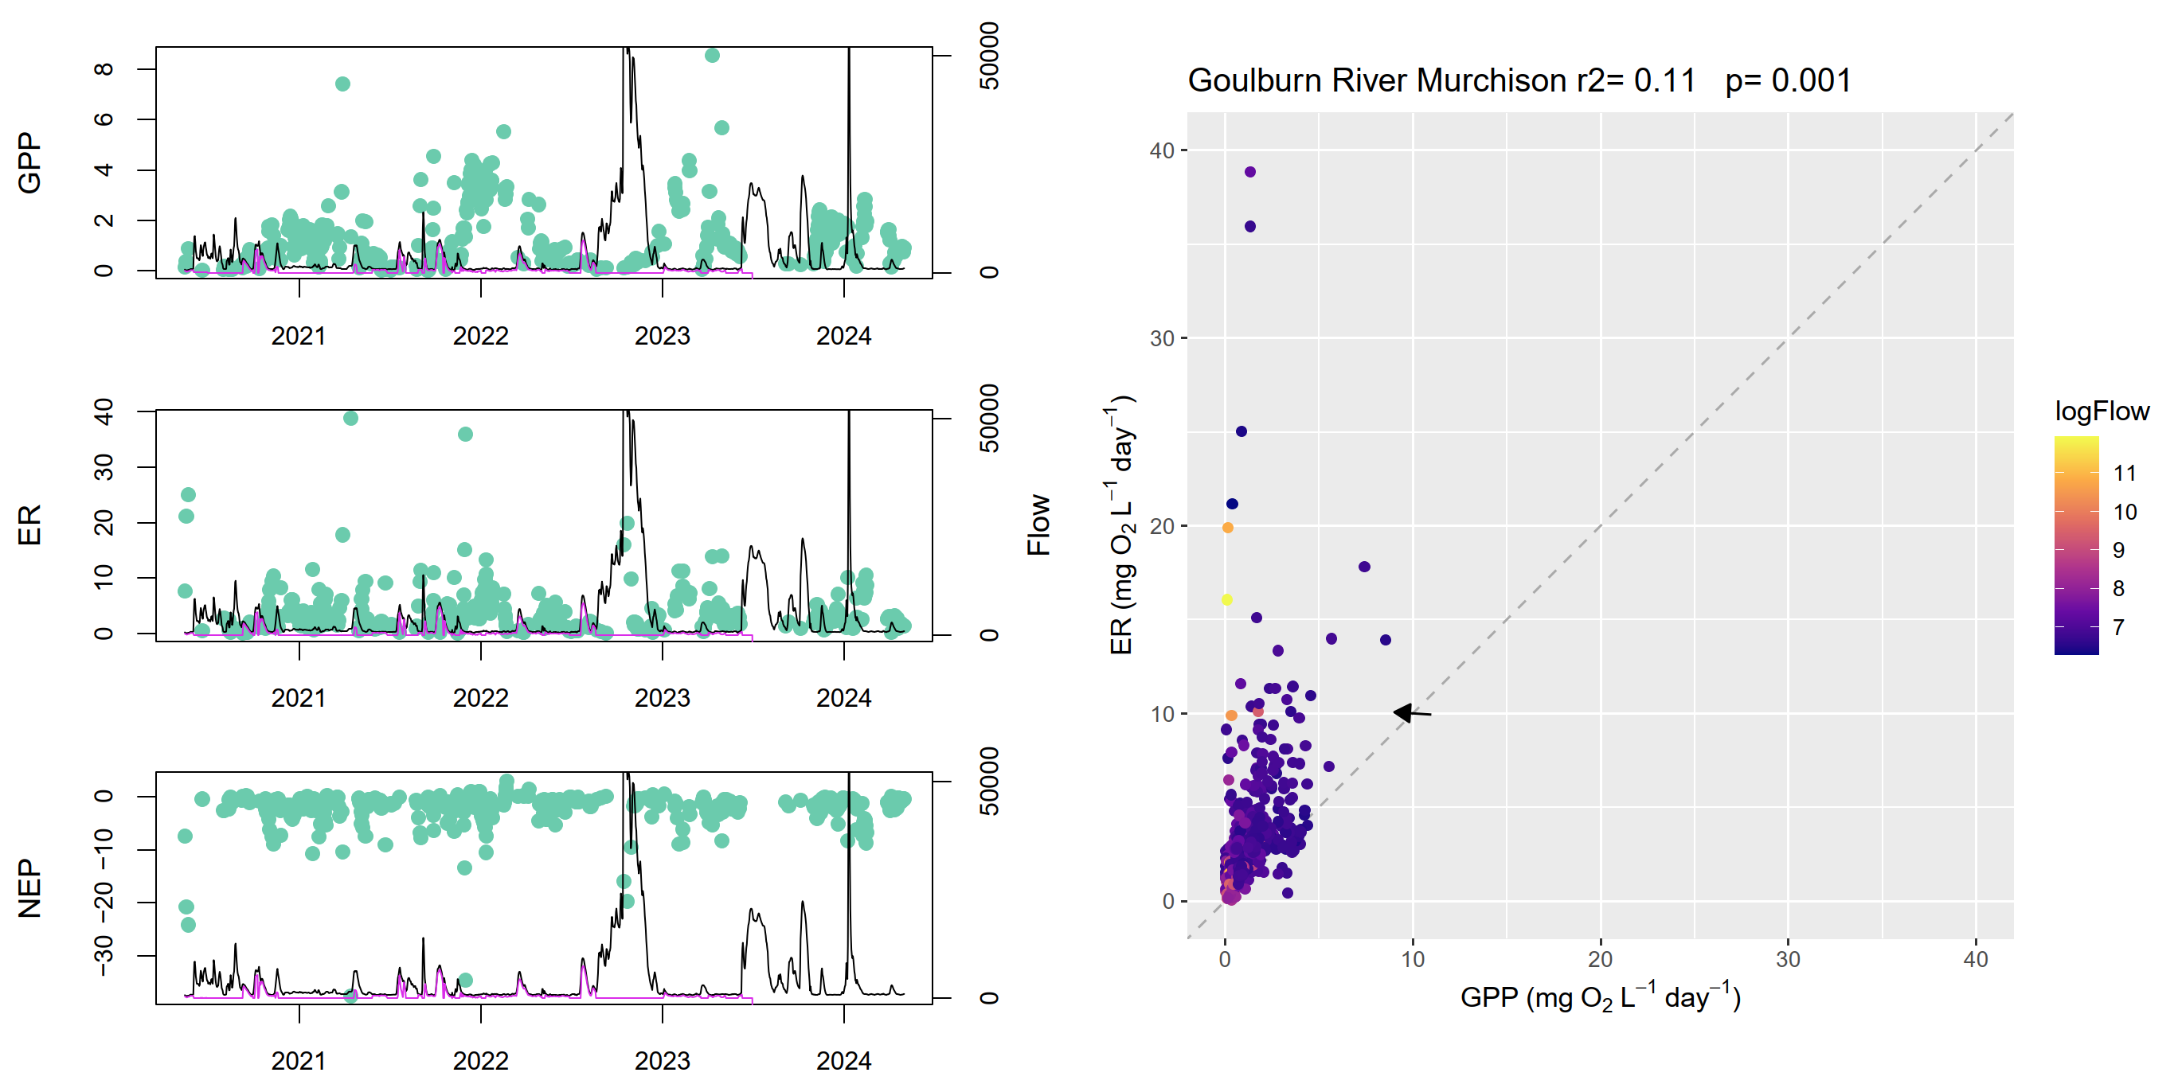
Figure A.18 Goulburn River stream metabolism – flow relationship plots: Shepparton
r2 = 0.13, p = 0.001
ER = ecosystem respiration, GPP = gross primary production, NEP = net ecosystem production.
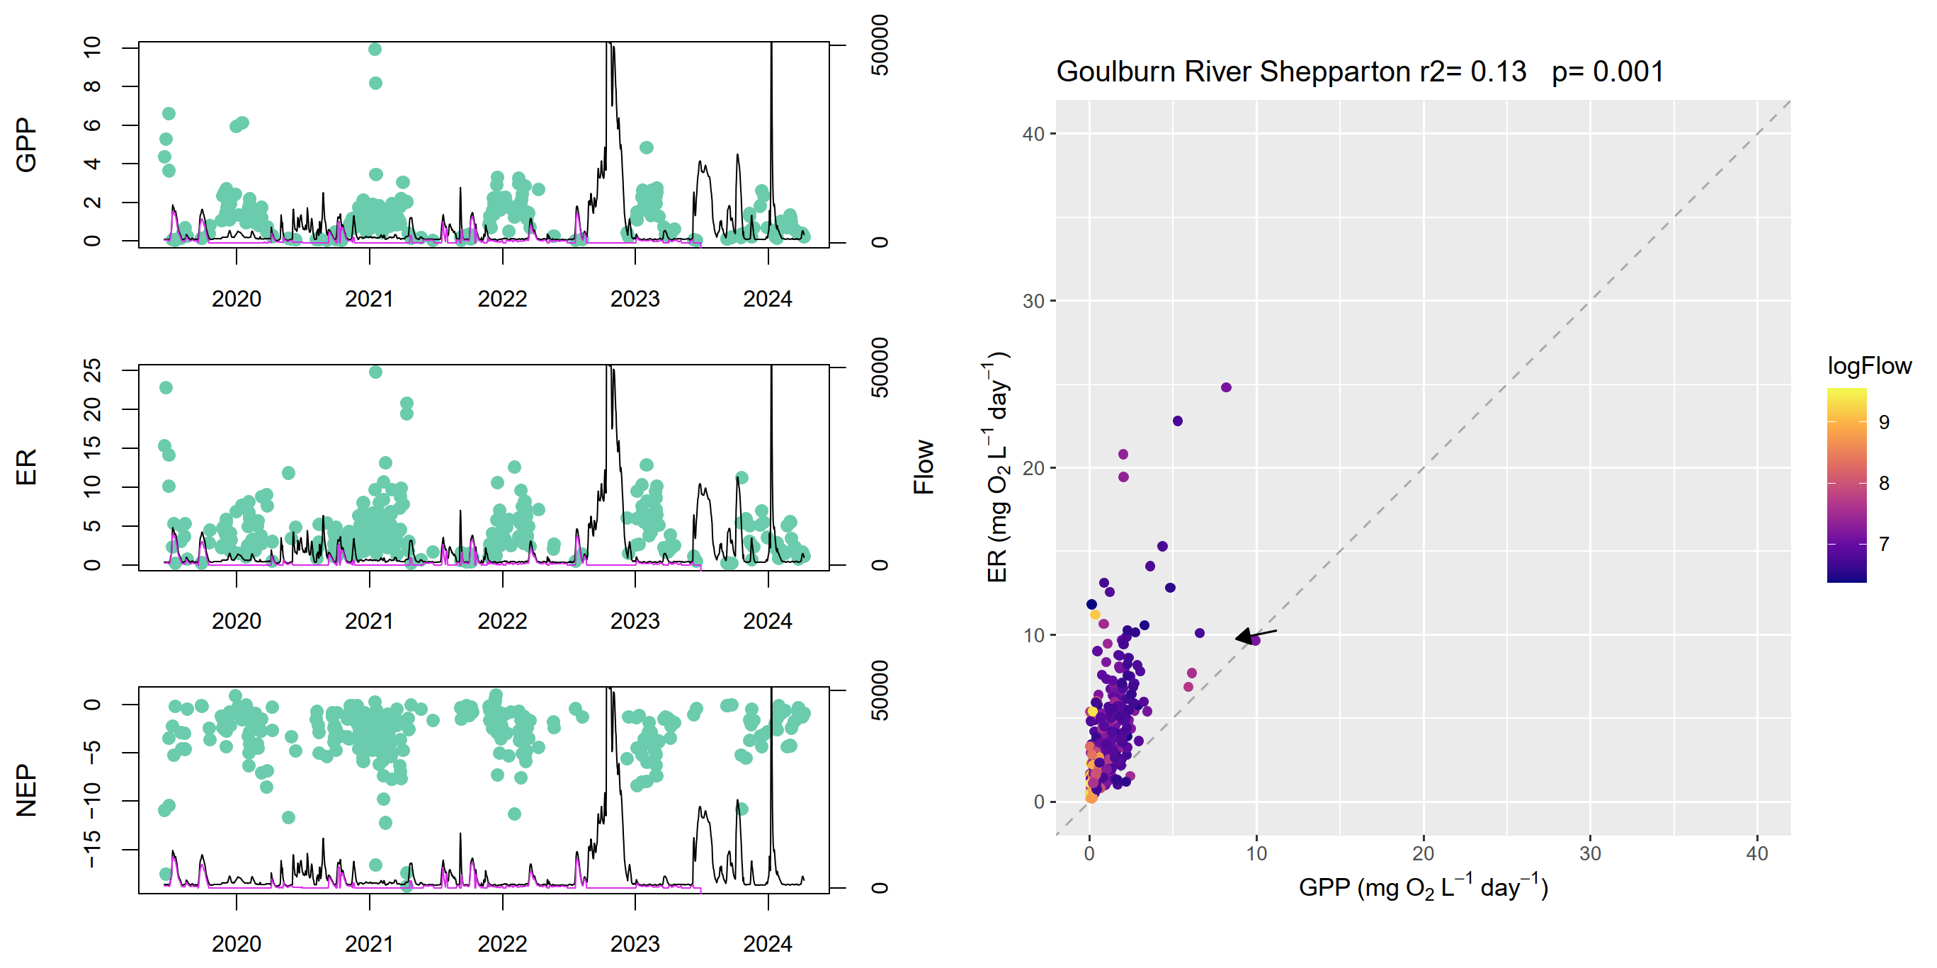
- Lachlan River System stream metabolism – flow relationship plots
Figure A.19 Lachlan River System stream metabolism – flow relationship plot: CC
r2 = 0.04, p = 0.001
ER = ecosystem respiration, GPP = gross primary production, NEP = net ecosystem production.
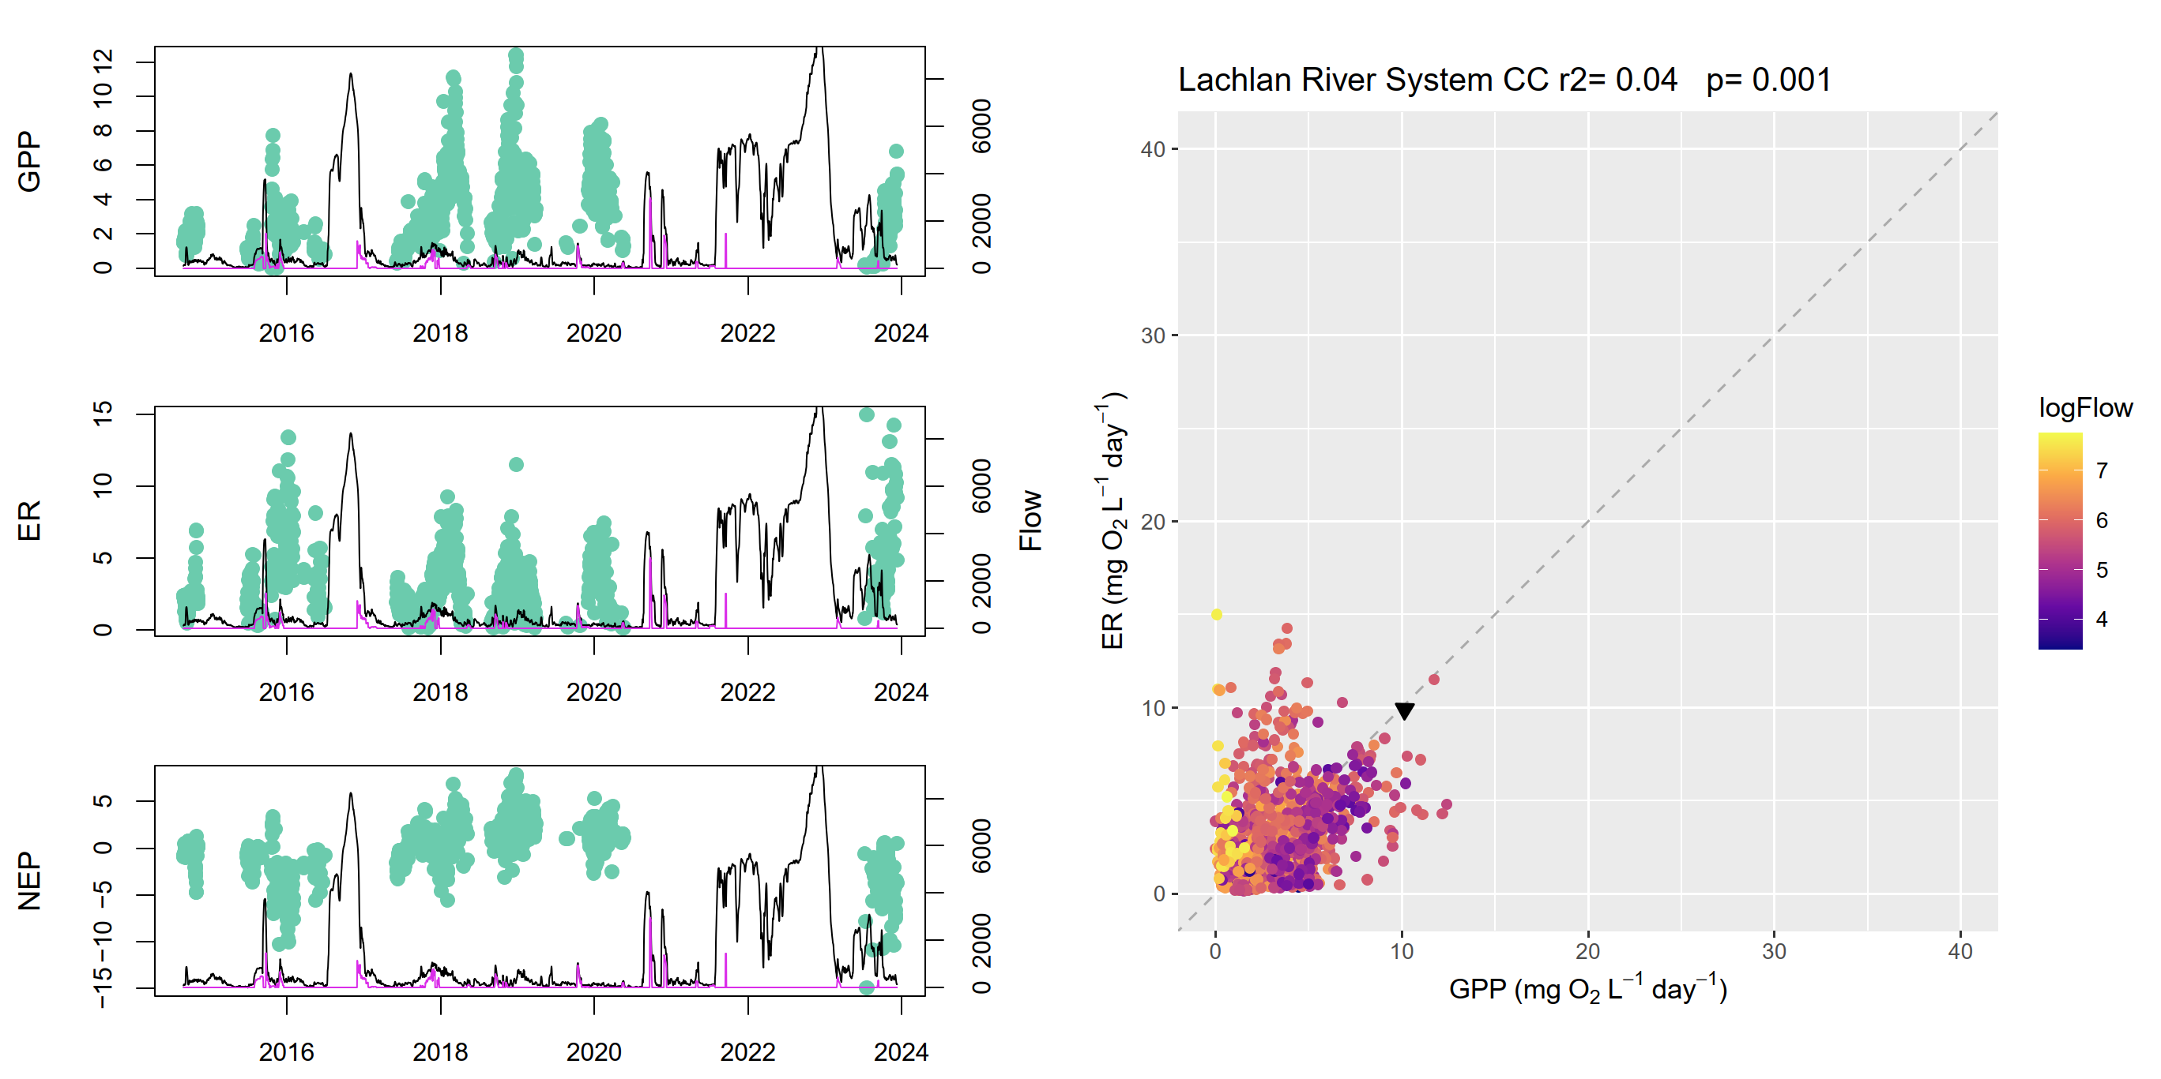
Figure A.20 Lachlan River System stream metabolism – flow relationship plots: EU
r2 = 0.10, p = 0.007
ER = ecosystem respiration, GPP = gross primary production, NEP = net ecosystem production.
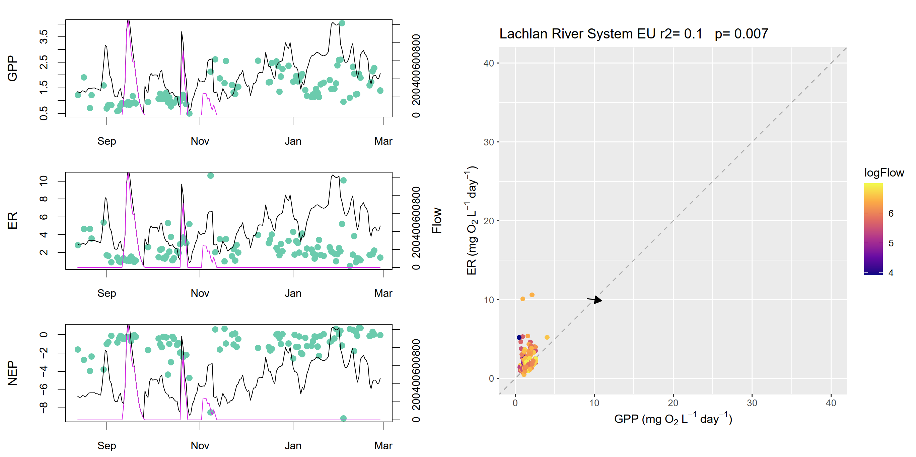
Figure A.21 Lachlan River System stream metabolism – flow relationship plots: KP
r2 = 0.10, p = 0.004
ER = ecosystem respiration, GPP = gross primary production, NEP = net ecosystem production.
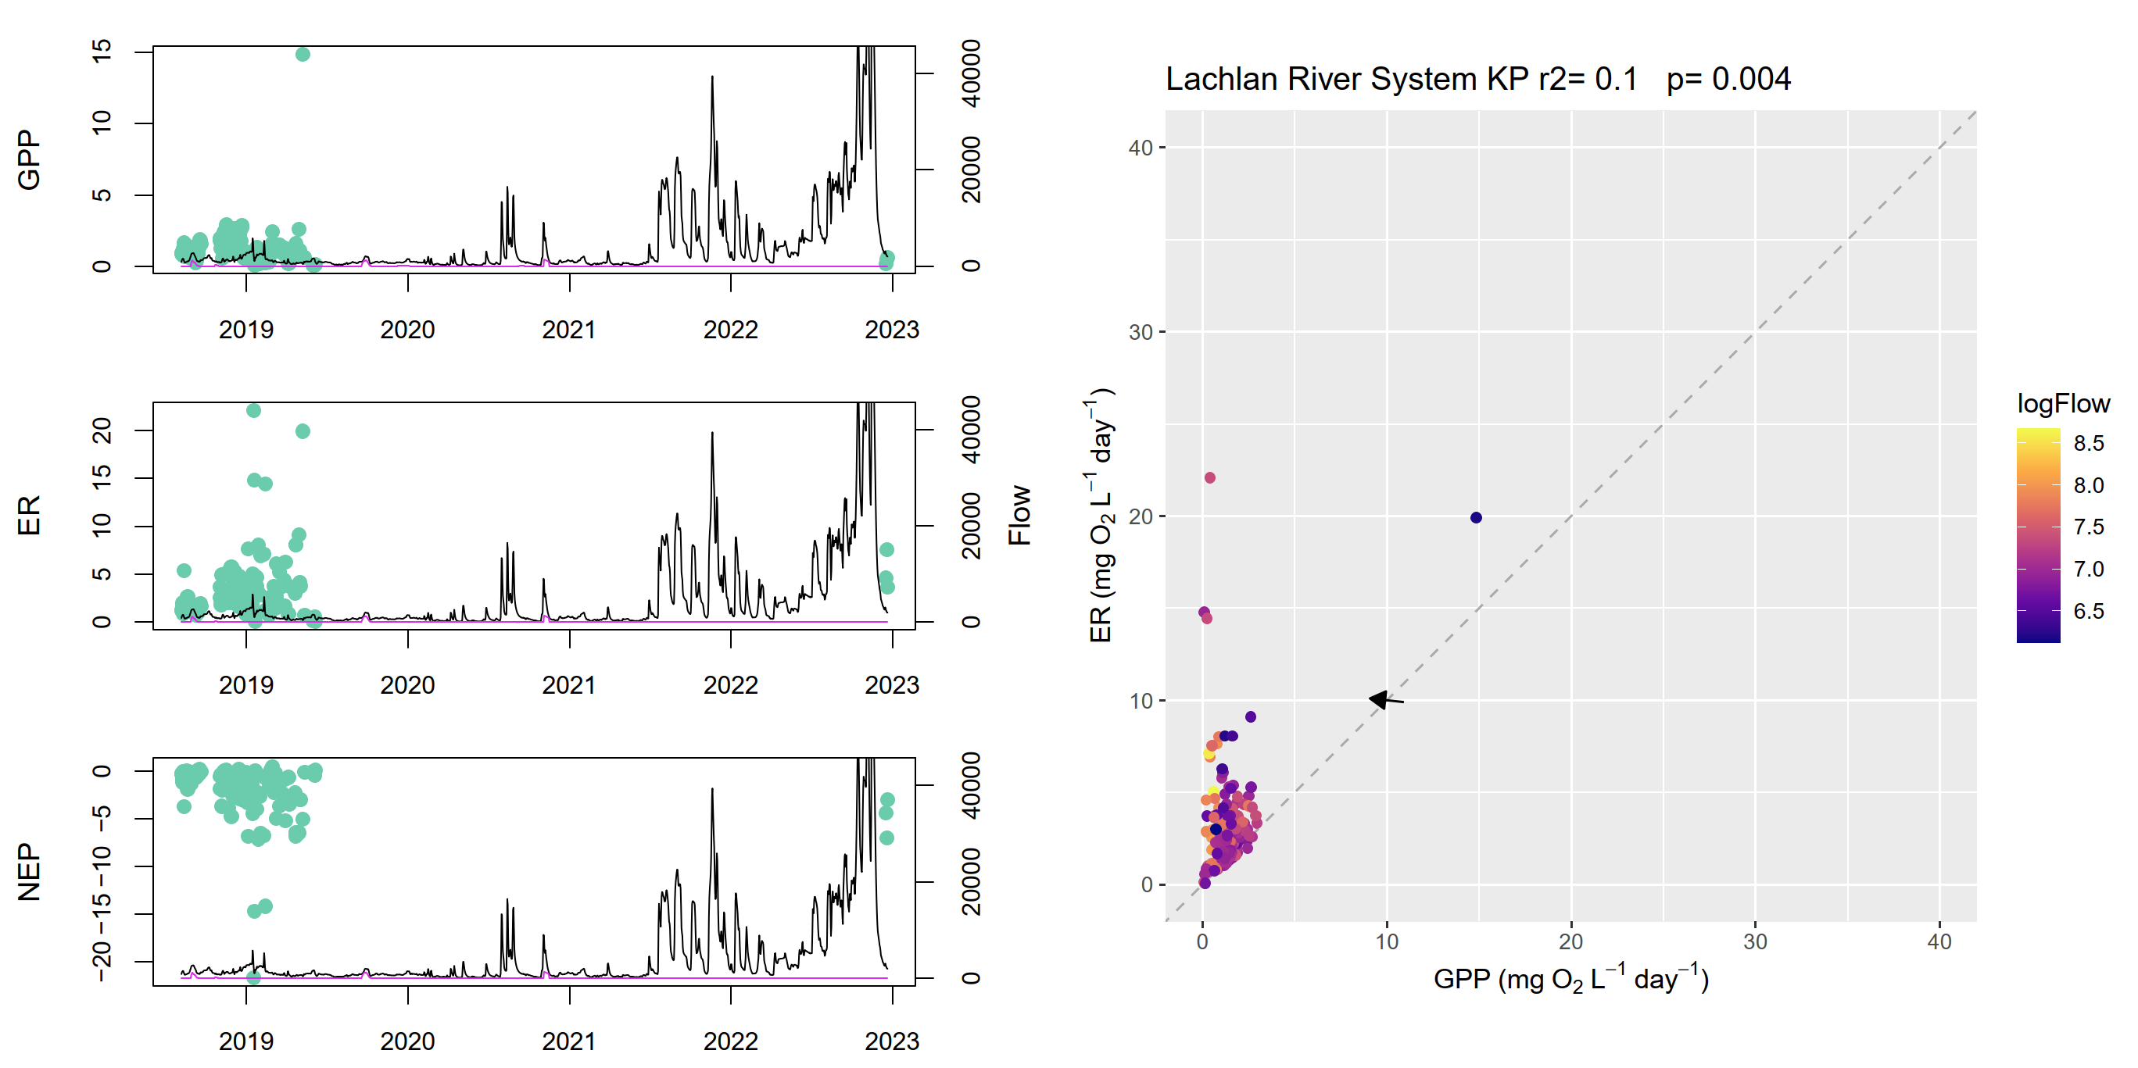
Figure A.22 Lachlan River System stream metabolism – flow relationship plots: LB (Lanes Bridge)
r2 = 0.03, p = 0.001
ER = ecosystem respiration, GPP = gross primary production, NEP = net ecosystem production.
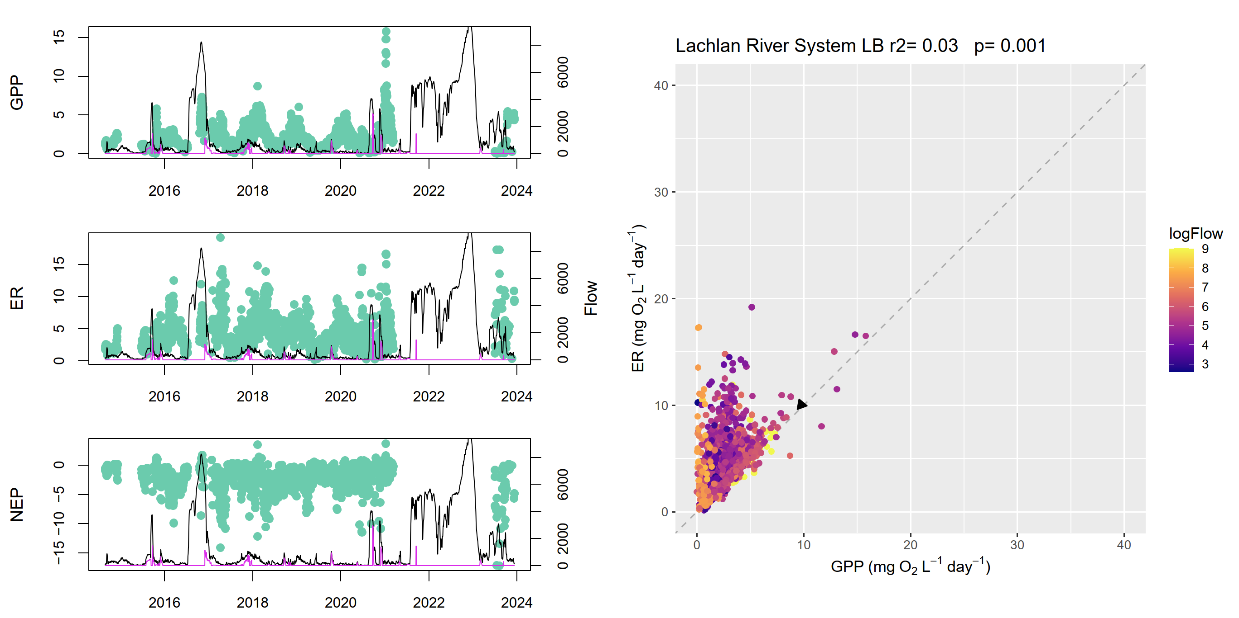
Figure A.23 Lachlan River System stream metabolism – flow relationship plots: MG
r2 = 0.45, p = 0.001
ER = ecosystem respiration, GPP = gross primary production, NEP = net ecosystem production.
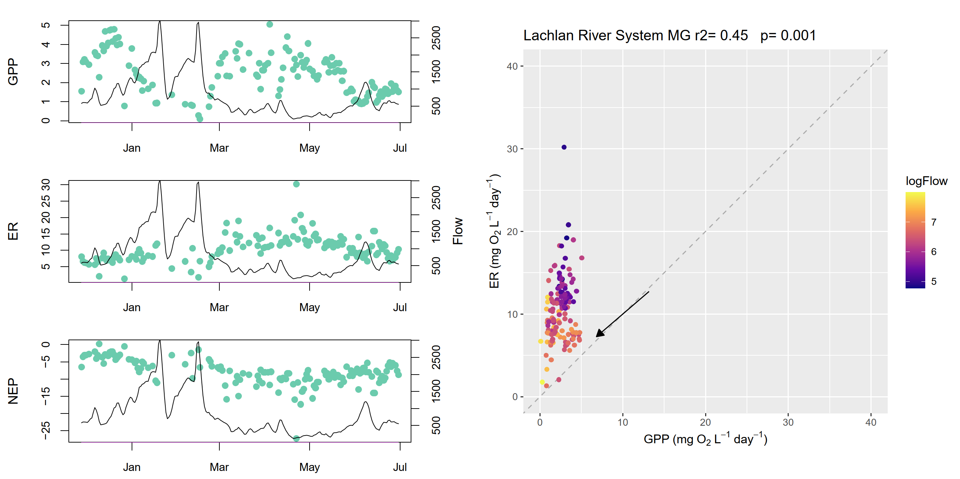
Figure A.24 Lachlan River System stream metabolism – flow relationship plots: TH
r2 = 0.11, p = 0.001
ER = ecosystem respiration, GPP = gross primary production, NEP = net ecosystem production.
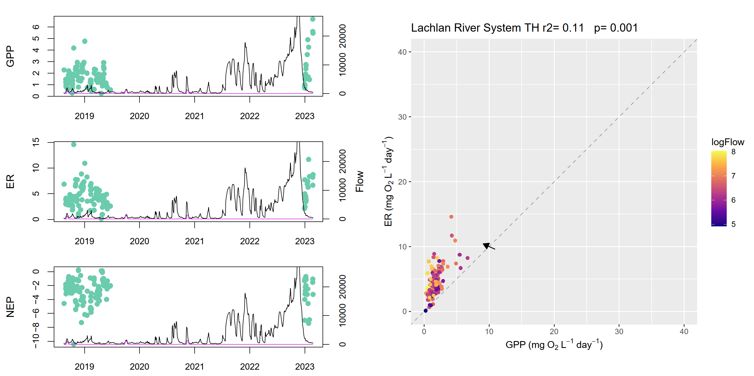
Figure A.25 Lachlan River System stream metabolism – flow relationship plots: WAL
r2 = 0.12, p = 0.001
ER = ecosystem respiration, GPP = gross primary production, NEP = net ecosystem production.
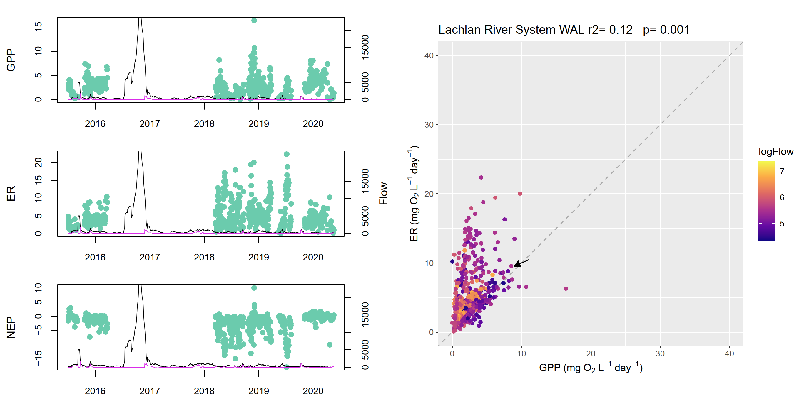
Figure A.26 Lachlan River System stream metabolism – flow relationship plots: WB
r2 = 0.10, p = 0.001
ER = ecosystem respiration, GPP = gross primary production, NEP = net ecosystem production.
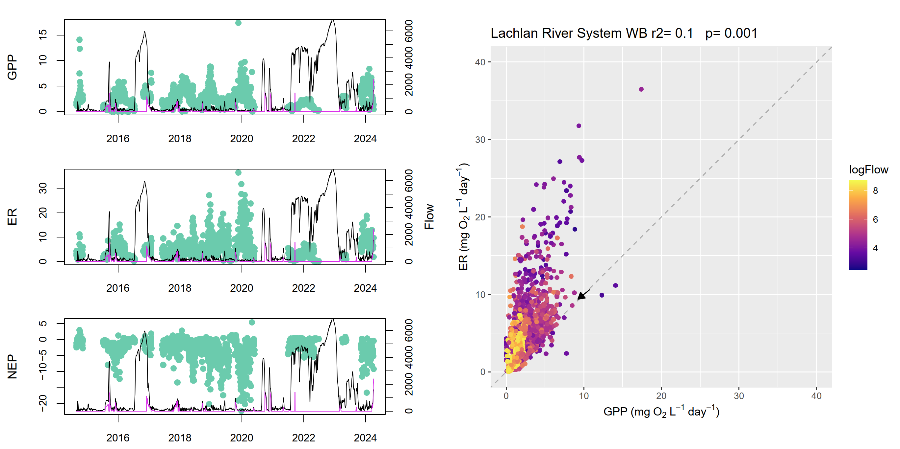
Figure A.27 Lachlan River System stream metabolism – flow relationship plots: BOO
r² = 0.17, p = 0.001
ER = ecosystem respiration, GPP = gross primary production, NEP = net ecosystem production.
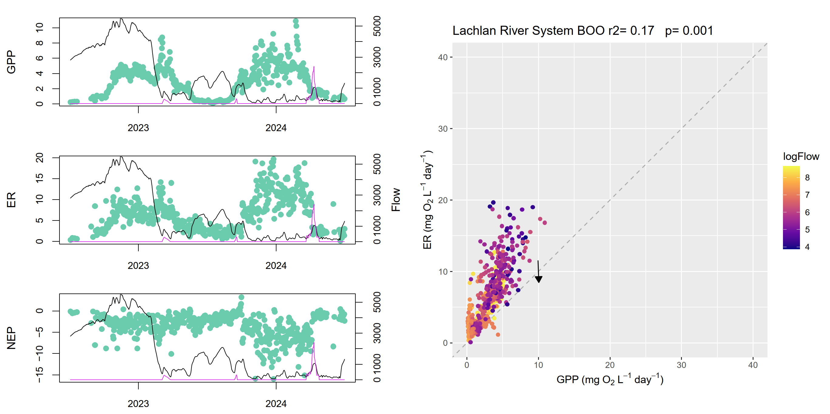
Figure A.28 Lachlan River System stream metabolism – flow relationship plots: CON
r2 = 0.07, p = 0.001
ER = ecosystem respiration, GPP = gross primary production, NEP = net ecosystem production.
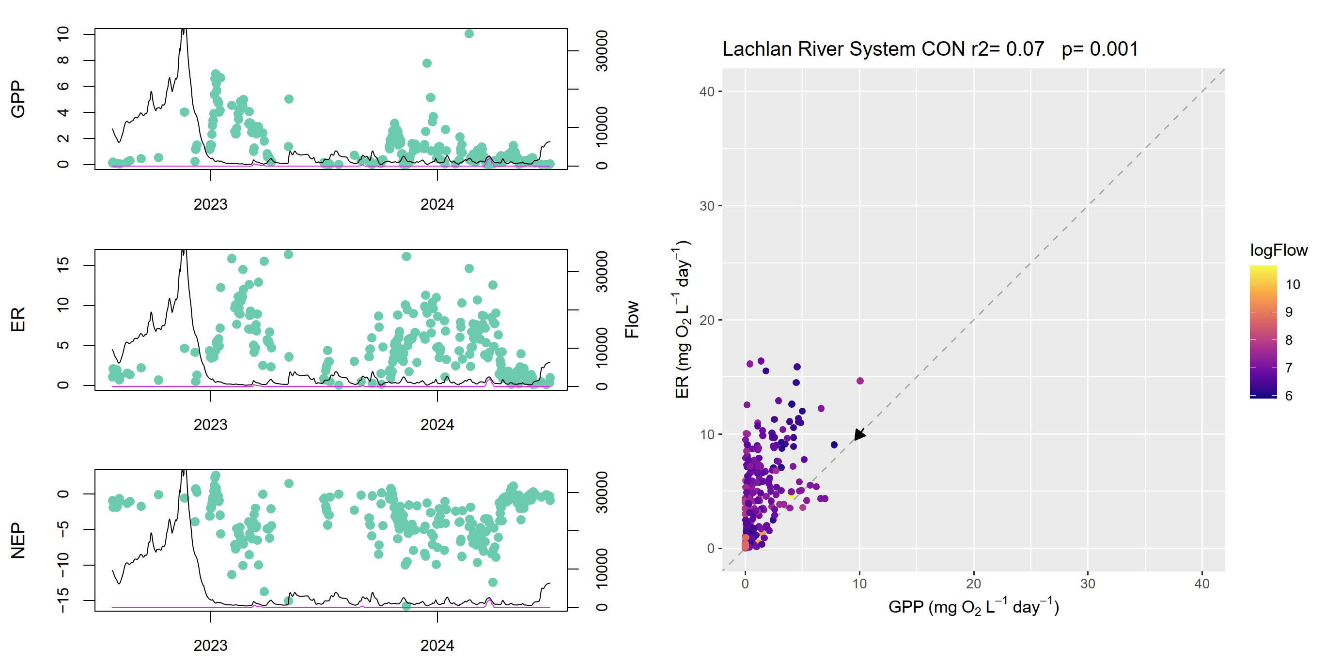
Figure A.29 Lachlan River System stream metabolism – flow relationship plots: HUN
r2 = 0.28, p = 0.001
ER = ecosystem respiration, GPP = gross primary production, NEP = net ecosystem production.
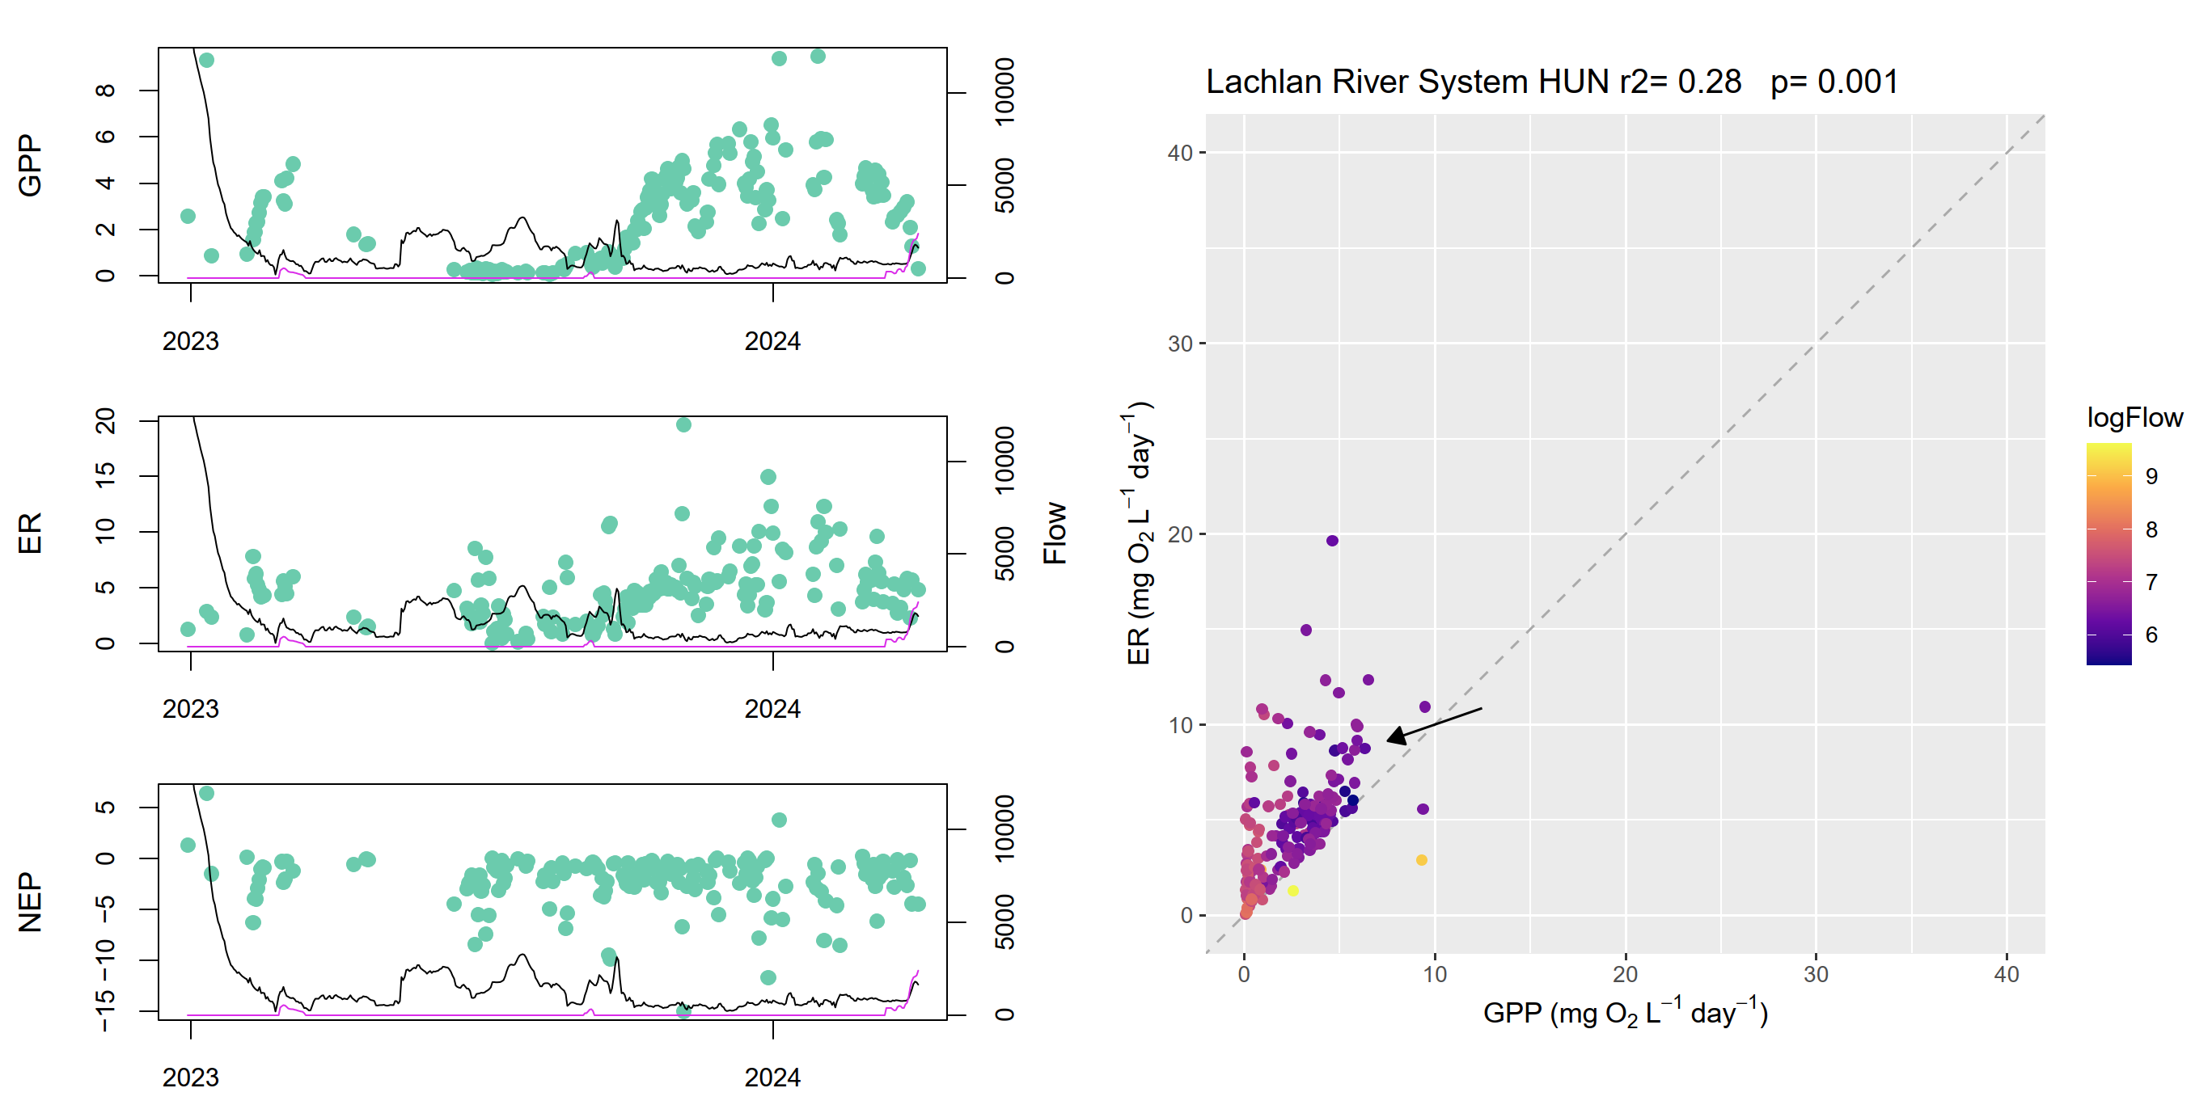
- Lower Murray River stream metabolism – flow relationship plots
Figure A.30 Lower Murray River stream metabolism – flow relationship plots: LK1DS_265km (Lock 1)
r2 = 0.09, p = 0.001
ER = ecosystem respiration, GPP = gross primary production, NEP = net ecosystem production.
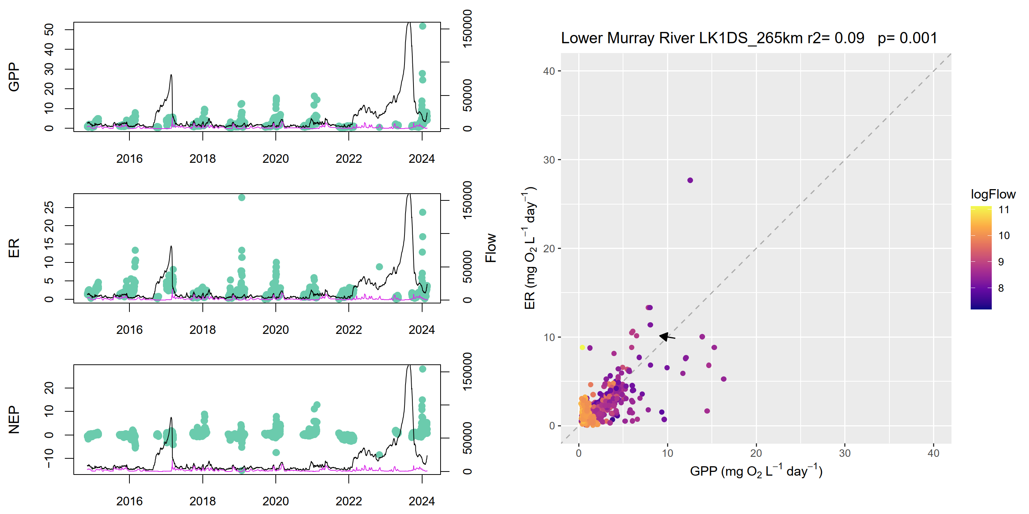
Figure A.31 Lower Murray River stream metabolism – flow relationship plots: LK4DS_501km (Lock 4)
r2 = 0.43, p = 0.001
ER = ecosystem respiration, GPP = gross primary production, NEP = net ecosystem production.
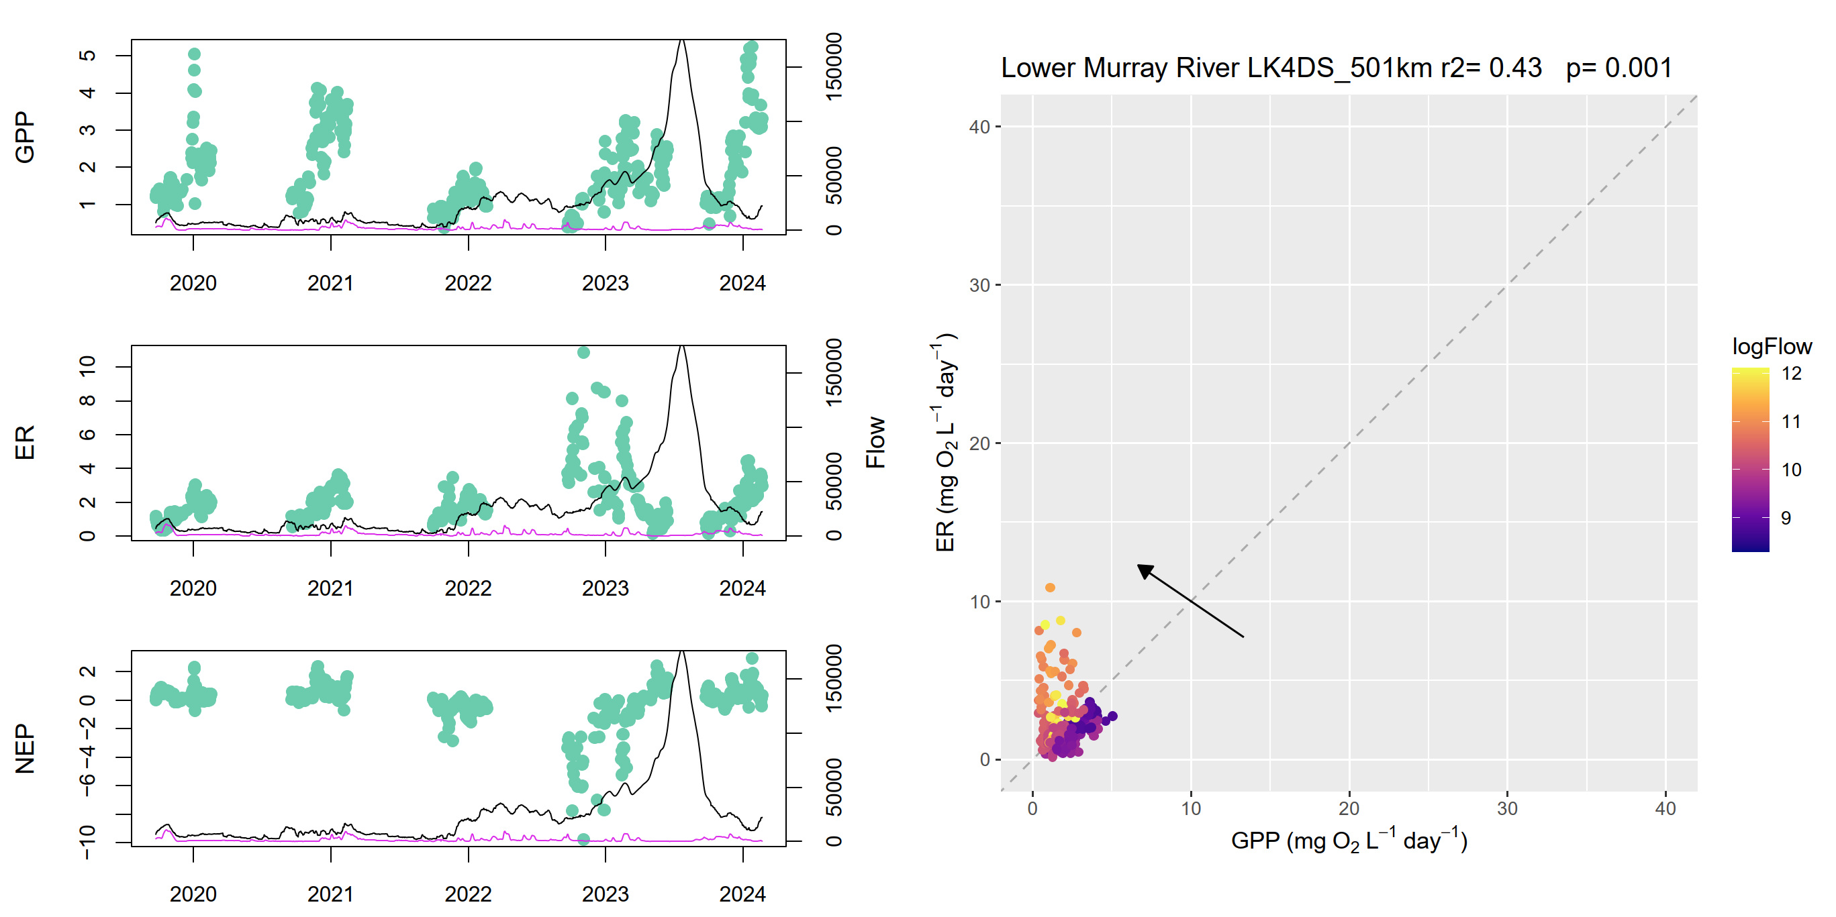
Figure A.32 Lower Murray River stream metabolism – flow relationship plots: LK6DS_616km (Lock 6)
r2 = 0.41, p = 0.001
ER = ecosystem respiration, GPP = gross primary production, NEP = net ecosystem production.
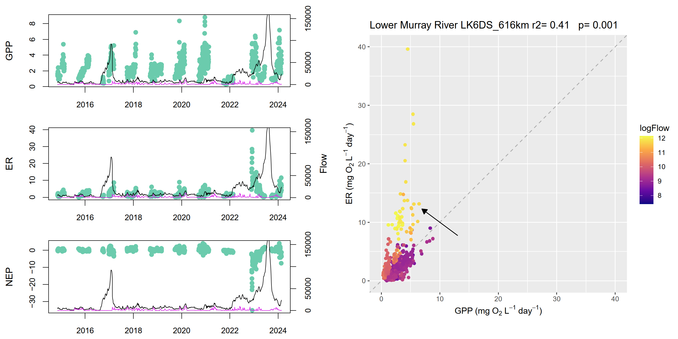
- Murrumbidgee River System stream metabolism – flow relationship plots
Figure A.33 Murrumbidgee River System stream metabolism – flow relationship plots: 1 km upstream Wynburn Escape
r2 = 0.76, p = 0.001
ER = ecosystem respiration, GPP = gross primary production, NEP = net ecosystem production.
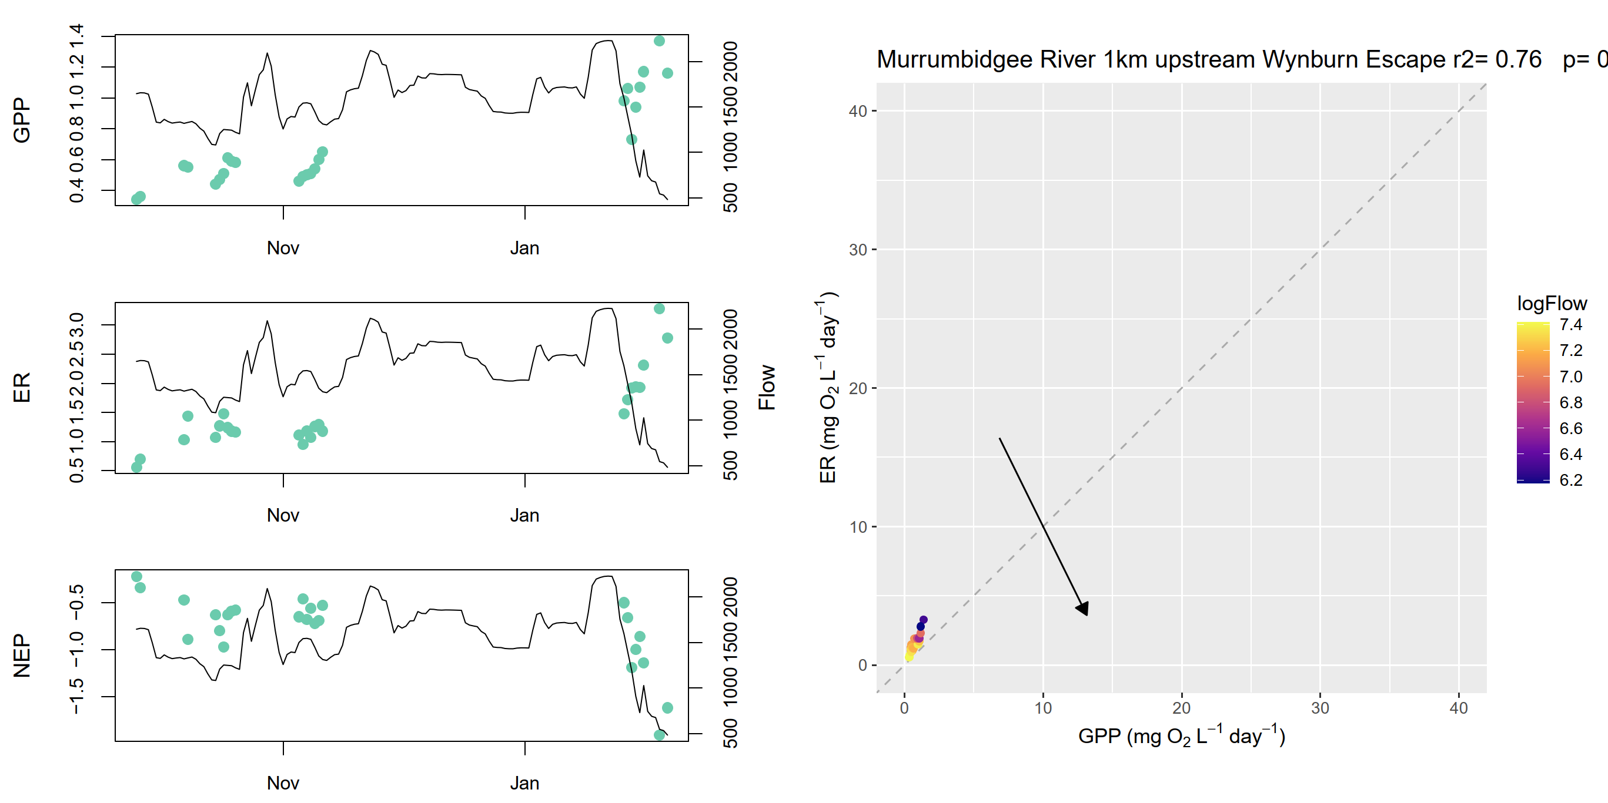
Figure A.34 Murrumbidgee River System stream metabolism – flow relationship plots: 3 km downstream Wynburn Escape
r2 = 0.61, p = 0.001
ER = ecosystem respiration, GPP = gross primary production, NEP = net ecosystem production.
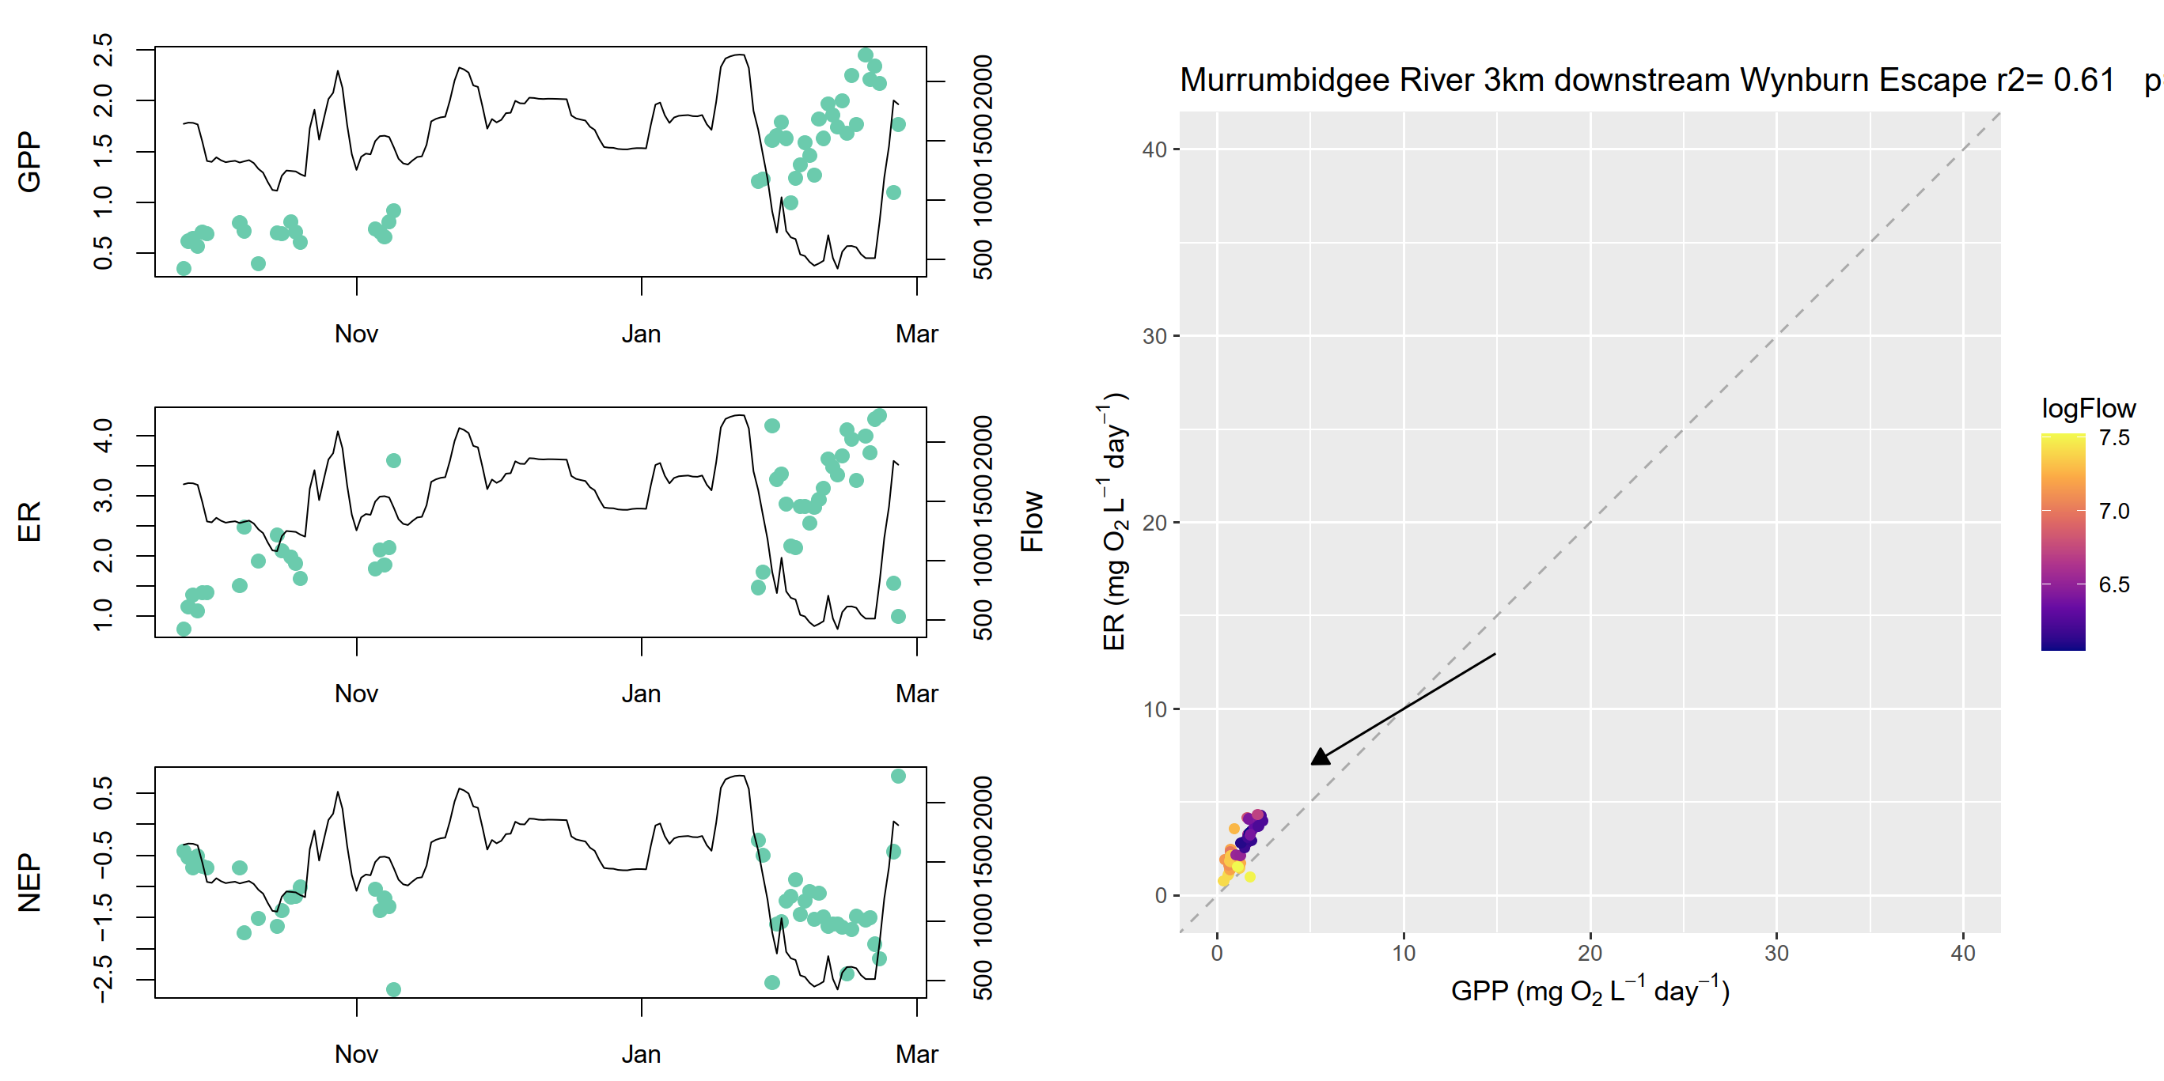
Figure A.35 Murrumbidgee River System stream metabolism – flow relationship plots: McKennas
r2 = 0.01, p = 0.011
ER = ecosystem respiration, GPP = gross primary production, NEP = net ecosystem production.
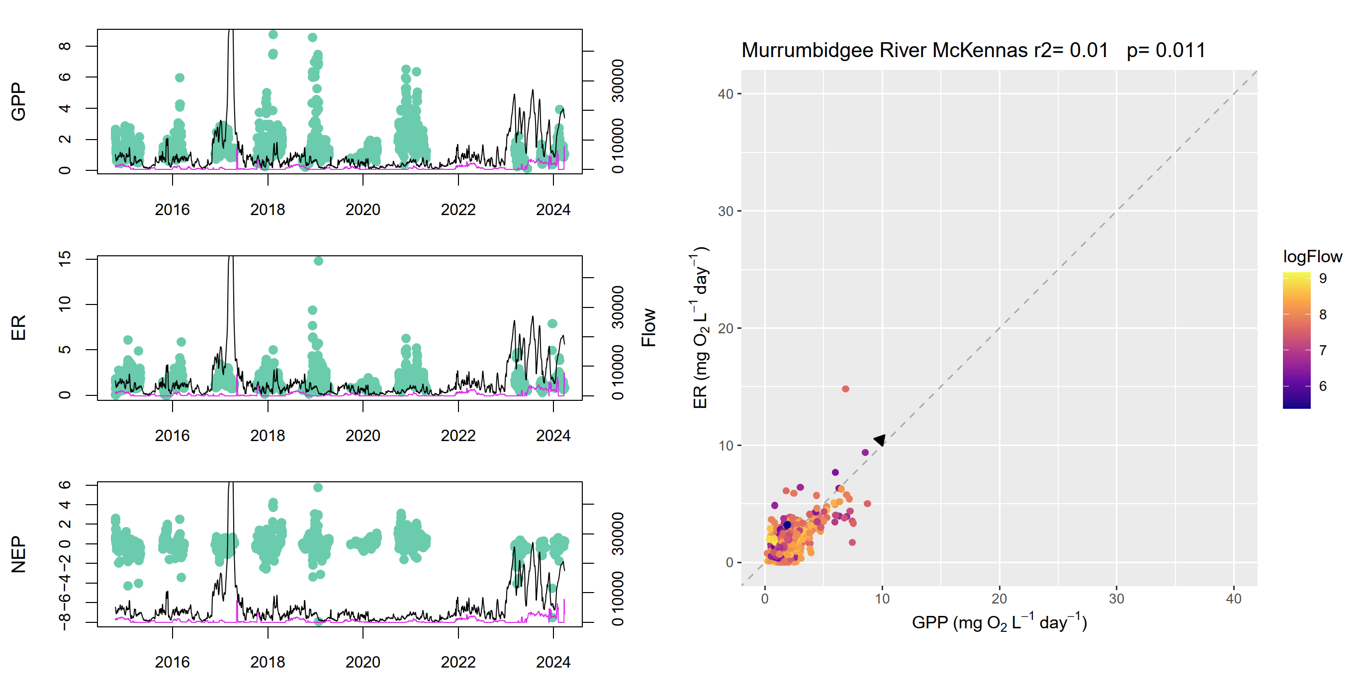
Figure A.36 Murrumbidgee River System stream metabolism – flow relationship plots: Narrandera
r2 = 0.22, p = 0.001
ER = ecosystem respiration, GPP = gross primary production, NEP = net ecosystem production.
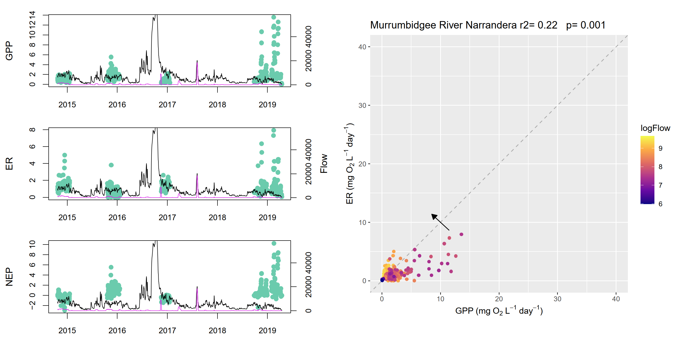
- Gwydir River System stream metabolism – flow relationship plots
Figure A.37 Gwydir River System stream metabolism – flow relationship plots: GWY_418001
r2 = 0.16, p = 0.001
ER = ecosystem respiration, GPP = gross primary production, NEP = net ecosystem production.
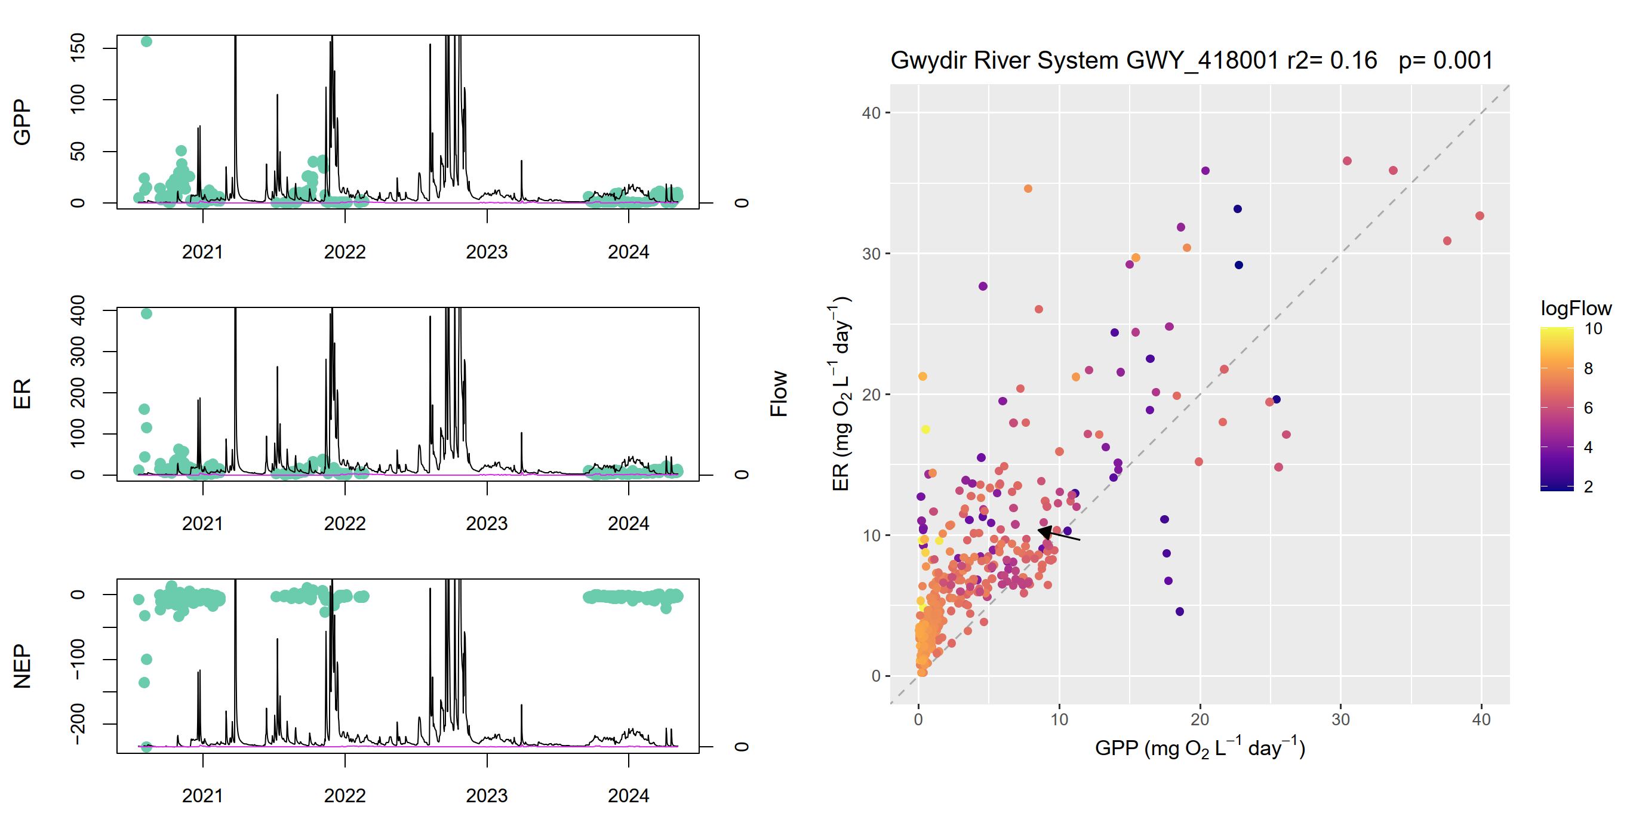
Figure A.38 Gwydir River System stream metabolism – flow relationship plots: GWY_418053
r2 = 0.52, p = 0.001
ER = ecosystem respiration, GPP = gross primary production, NEP = net ecosystem production.
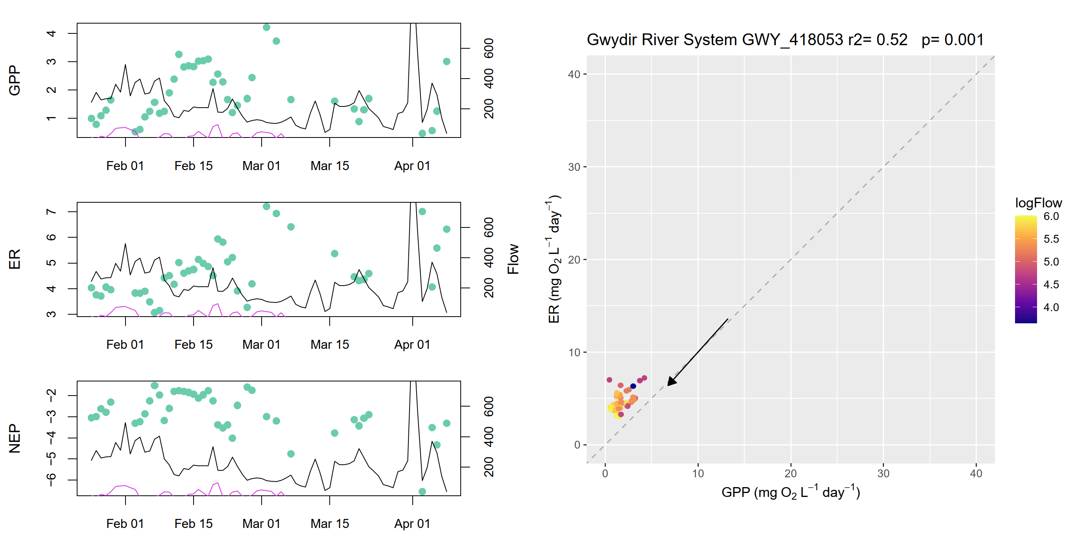
Figure A.39 Gwydir River System stream metabolism – flow relationship plots: GWY 418077
r2 = 1, p = 1
ER = ecosystem respiration, GPP = gross primary production, NEP = net ecosystem production.
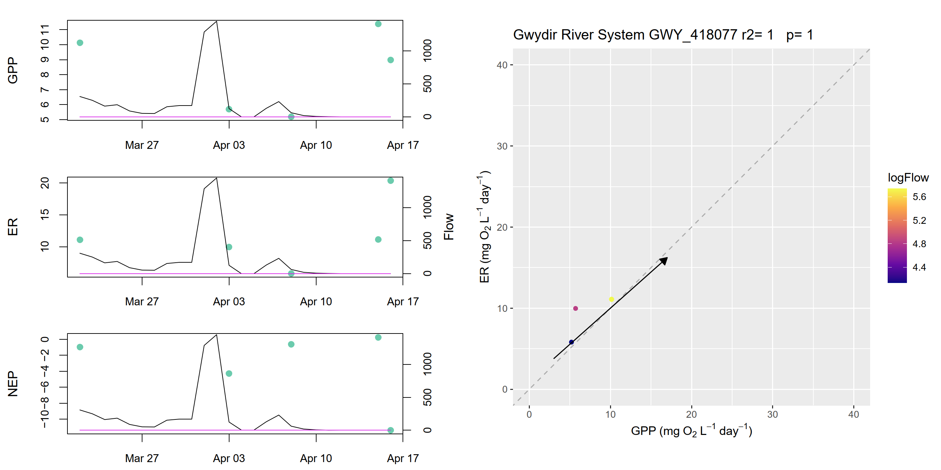
Figure A.40 Gwydir River System stream metabolism – flow relationship plots: GWY_418078
r2 = 0.10, p = 0.197
ER = ecosystem respiration, GPP = gross primary production, NEP = net ecosystem production.
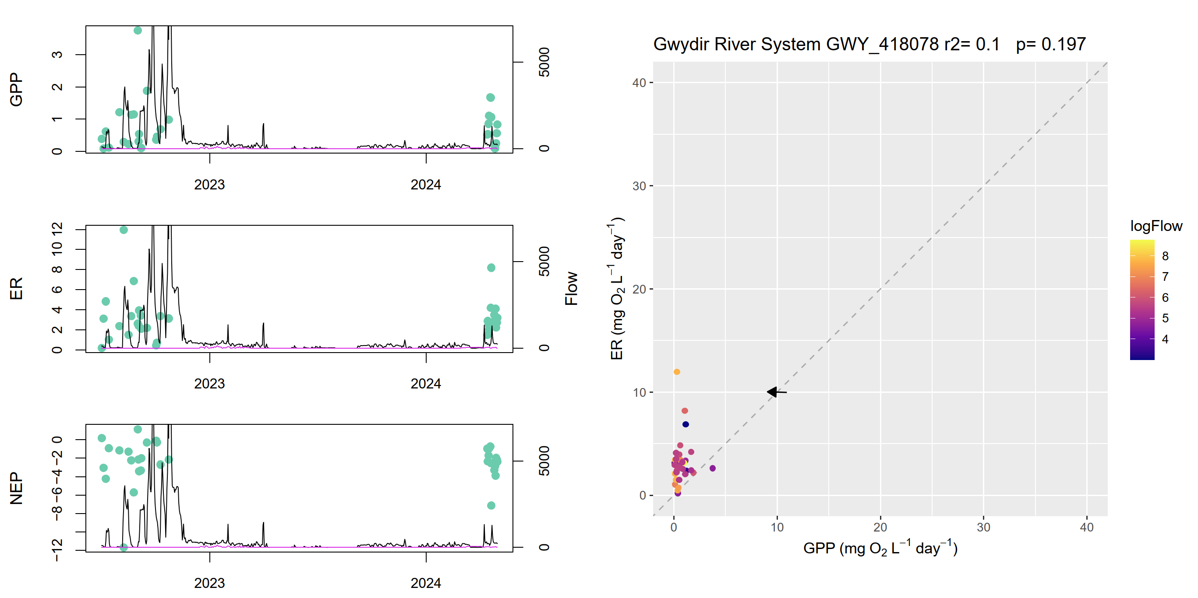
Figure A.41 Gwydir River System stream metabolism – flow relationship plots: GWY_ME1
r2 = 0.24, p = 0.001
ER = ecosystem respiration, GPP = gross primary production, NEP = net ecosystem production.
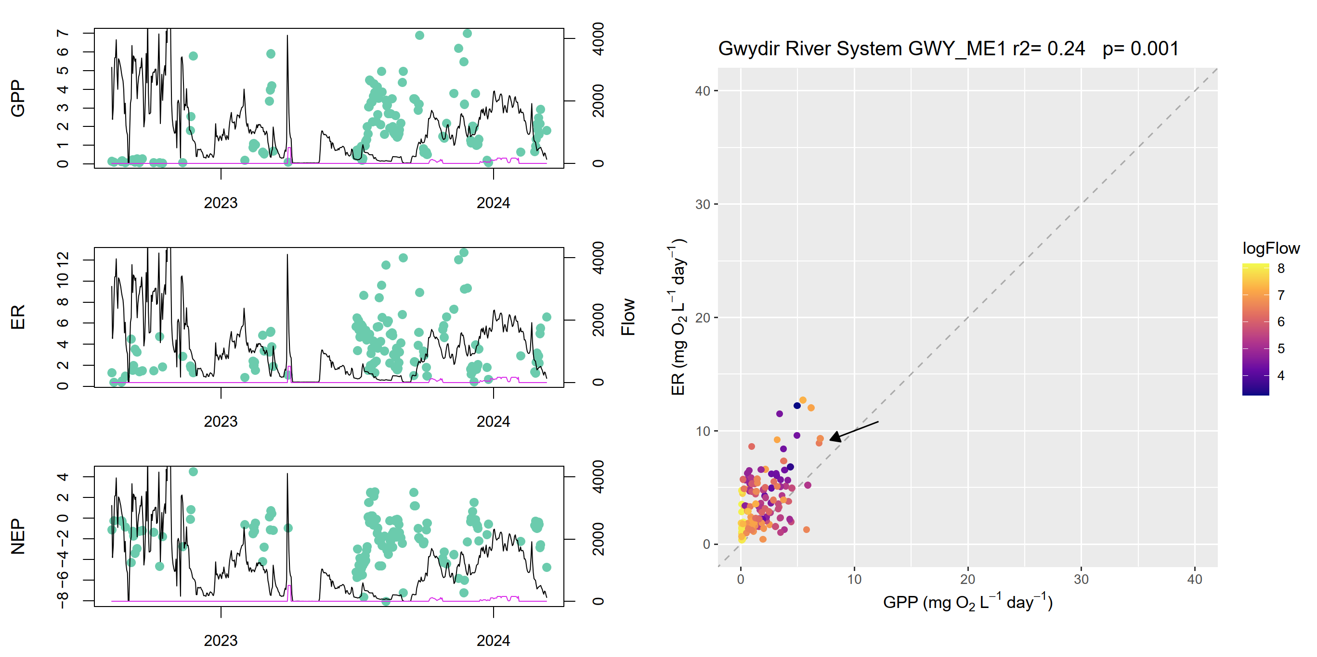

Abbreviations and terms
Abbreviation / term | Description
2014–24 | water years, 1 July 2014 to 30 June 2024
2023–24 | water year, 1 July 2023 to 30 June 2024
AIC | Akaike information criterion (a metric to evaluate how well a model fits data and penalises models for more complexity
autochthonous carbon | carbon that is generated within the river (e.g. via photosynthesis by algae)
autotrophy | aa state where a system is producing more carbon than it consumes
BASE | Bayesian single-station estimation
the Basin | shortened term for the Murray–Darling Basin
Basin Plan | shortened term for the (Murray–Darling) Basin Plan 2012
CEW | Commonwealth environmental water
CEWH | Commonwealth Environmental Water Holder
counterfactual | In the counterfactual approach, Commonwealth environmental water is removed from the observed streamflow time series, creating a hypothetical (counterfactual) daily streamflow time series with no Commonwealth environmental water. This approach is used to infer the effects of Commonwealth environmental water, as an experimental design when controls and before–after comparisons is not possible.
DO | dissolved oxygen
ER | ecosystem respiration (which recycles organic matter)
EW | Environmental water
Flow-MER | the CEWH’s Science Program: Flow Monitoring, Evaluation and Research (2019–20 to 2023–24)
GPP | gross primary production (which generates organic matter)
GPP:ER ratio | ratio of gross primary production to ecosystem respiration
heterotrophy | a state where a system is consuming more carbon that it produces
hypoxic | water that has a low oxygen concentration
K | reaeration coefficient
metabolic fingerprint | a visualisation tool for contrasting annual patterns of metabolism across rivers or across years for the same river
metabolic throughput | describes the overall rates of metabolic activity; for example, high rates of both GPP and ER (i.e. with a GPP:ER close to 1) indicate rapid cycling or ‘throughput’ of carbon by aquatic organisms. In contrast, low but balanced GPP and ER indicate slow cycling and low throughput
NEP | net ecosystem production
PAR | photosynthetically active radiation
the Strategy | shortened form for the Basin-wide environmental watering strategy (MDBA 2019)
water year | year in which Commonwealth environmental water is delivered (1 July to 30 June)

References
Bernhardt ES, Heffernan JB, Grimm NB, Stanley EH, Harvey J, Arroita M, Appling AP, Cohen M, McDowell WH, Hall Jr R (2018) The metabolic regimes of flowing waters. Limnology and Oceanography 63(S1), S99–S118, doi:10.1002/lno.10726.
Bernhardt ES, Savoy P, Vlah MJ, Appling AP, Koenig LE, Hall RO, Arroita M, Blaszczak JR, Carter AM, Cohen M, Harvey JW, Heffernan JB, Helton AM, Hosen JD, Kirk L, McDowell WH, Stanley EH, Yackulic CB, Grimm NB (2022) Light and flow regimes regulate the metabolism of rivers. Proceedings of the National Academy of Sciences 119(8), e2121976119, doi:10.1073/pnas.2121976119.
Bunn S, Abal E, Greenfield P, Tarte D (2007) Making the connection between healthy waterways and healthy catchments: South East Queensland, Australia. Water Science and Technology: Water Supply 7(2), 93–100, doi:10.2166/ws.2007.044.
CEWH (2024a) Commonwealth Environmental Water Holder Monitoring, Evaluation and Research Program: Gwydir River Selected Area 2023–24 Annual Summary Report: Appendix B Food Webs Monitoring. Commonwealth of Australia, Canberra.
CEWH (2024b) Monitoring, Evaluation and Research Program: Junction of the Warriku (Warrego) and Baaka (Darling) Rivers Selected Area Monitoring, Evaluation and Research Annual Summary Report: Appendix C Food Webs Monitoring (2023–2024). Commonwealth of Australia, Canberra.
CEWH (2024) 2023–24 Flow-MER watering actions table. Prepared by Science Division, Commonwealth Environmental Water Holder, Department of Climate Change, Energy, the Environment and Water, Canberra. Unpublished.
Davies P, Harris J, Hillman T, Walker K (2010) The Sustainable Rivers Audit: assessing river ecosystem health in the Murray–Darling Basin, Australia. Marine and Freshwater Research 61(7), 764–777, doi:10.1071/MF09043.
Dixon P (2003) VEGAN, a package of R functions for community ecology. Journal of Vegetation Science 14(6), 927–930, doi:10.1111/j.1654-1103.2003.tb02228.x.
Giling DP, Broadhurst B, Dyer F, Grace M, Joehnk K, McInerney PJ, Pollino C, Rees G, Sengupta A, Tschierschke A, Thompson RM (2025) Season and flow drive productivity of a regulated river. Ecosystems, 28(1), 5, doi:10.1007/s10021-024-00945-6.
Grace M (2019) Basin Matter – Stream Metabolism and Water Quality foundation report – revision 2019. La Trobe University, Wodonga.
Grace M (2020) 2018–19 Basin scale evaluation of Commonwealth environmental water — Stream Metabolism and Water Quality. Final report prepared for the Commonwealth Environmental Water Office by La Trobe University. Publication 247/2020. La Trobe University, Wodonga.
Hale J, Stoffels R, Butcher R, Shackleton M, Brooks S, Gawne B, Stewardson M (2014) Commonwealth Environmental Water Office Long Term Intervention Monitoring Project – standard methods. Report prepared for the Commonwealth Environmental Water Office. Murray–Darling Freshwater Research Centre, Albury.
Hall RO (2016) Metabolism of streams and rivers: estimation, controls, and application. In: Jones JB, Stanley EH (eds), Stream ecosystems in a changing environment. Academic Press, Boston, 151–180, doi:10.1016/B978-0-12-405890-3.00004-X.
Higgisson W, Broadhurst B, Tschierschke A, Stocks J, van der Meulen D, Kerezsy A, Lenehan J, Thompson R, Dyer F (2024) Commonwealth Environmental Water Holder Monitoring, Evaluation and Research Program: Lachlan River System Selected Area 2023–24 Monitoring, and Evaluation and Research Technical Report. Commonwealth of Australia.
Jeffrey SJ, Carter JO, Moodie KB, Beswick AR (2001) Using spatial interpolation to construct a comprehensive archive of Australian climate data, Environmental Modelling and Software, Vol 16/4, pp 309–330.
Liu X, Arrowsmith C, Bond N, Elgindy P, Healy S, Lewis S, McCasker N, Stocks J, Trethewie J, van der Meulen D, Watts RJ (2024) Commonwealth Environmental Water Holder’s Monitoring, Evaluation and Research Project: Edward/Kolety–Wakool Flow Selected Area Technical Report 2023–24. Report prepared for Commonwealth Environmental Water Holder. Commonwealth of Australia.
McInerney P, Linke S, Rees G, Giling D, Hitchcock J, Ryder D, Thompson R (2021) Basin-scale evaluation of 2019–20 Commonwealth environmental water: Food Webs and Water Quality. Report to the Commonwealth Environmental Water Office’s Flow-MER Program, CEWH, Canberra.
McInerney P, Linke S, Rees G, Giling D, Hitchcock J, Ryder D, Thompson R (2022) Basin-scale evaluation of 2020–21 Commonwealth environmental water: Food Webs and Water Quality. Report to the Commonwealth Environmental Water Holder’s Flow-MER Program, CEWH, Canberra.
McInerney P, Linke S, Rees G, Giling D, Hitchcock J, Ryder D, Thompson R (2023) Basin-scale evaluation of 2021–22 Commonwealth environmental water: Food Webs and Water Quality. Report to the Commonwealth Environmental Water Holder’s Flow-MER Program, CEWH, Canberra.
MDBA (Murray–Darling Basin Authority) (2019) Basin-wide environmental watering strategy (2nd edn). MDBA Publication No 42/19. Murray–Darling Basin Authority, Canberra.
Norris RH, Liston P, Davies N, Coysh J, Dyer F, Linke S, Prosser I, Young B (2001) Snapshot of the Murray–Darling Basin river condition. Report to the Murray–Darling Basin Commission (MDBC). MDBC, Canberra.
Norris RH, Linke S, Prosser I, Young WJ, Liston P, Bauer N, Sloane N, Dyer F, Thoms M (2007) Very‐broad‐scale assessment of human impacts on river condition. Freshwater Biology 52(5), 959–976, doi:10.1111/j.1365-2427.2006.01701.x.
O’Connor BL, Harvey JW, McPhillips LE (2012) Thresholds of flow-induced bed disturbances and their effects on stream metabolism in an agricultural river. Water Resources Research 48(8), doi:10.1029/2011WR011488.
O’Sullivan J, Cuddy SM (eds) (2024) Flow-MER Basin-scale evaluation of Commonwealth environmental water: Methods. Flow-MER Program. Commonwealth Environmental Water Holder, Department of Climate Change, Energy, Environment and Water, Australia.
Palmer M, Ruhi A (2019) Linkages between flow regime, biota, and ecosystem processes: implications for river restoration. Science 365(6459), eaaw2087, doi:10.1126/science.aaw2087.
Reisinger AJ, Rosi EJ, Bechtold HA, Doody TR, Kaushal SS, Groffman PM (2017) Recovery and resilience of urban stream metabolism following Superstorm Sandy and other floods. Ecosphere 8(4), e01776, doi:10.1002/ecs2.1776.
Resh VH, Brown AV, Covich AP, Gurtz ME, Li HW, Minshall GW, Reice SR, Sheldon AL, Wallace JB, Wissmar RC (1988) The role of disturbance in stream ecology. Journal of the North American Benthological Society 7(4), 433–455, doi:10.2307/1467300.
Rüegg J, Conn CC, Anderson EP, Battin TJ, Bernhardt ES, Boix Canadell M, Bonjour SM, Hosen JD, Marzolf NS, Yackulic CB (2021) Thinking like a consumer: linking aquatic basal metabolism and consumer dynamics. Limnology and Oceanography Letters 6(1), 1–17, doi:10.1002/lol2.10172.
Treadwell S, Bovill W, Webb A, Baker B, Casanelia S, Gower T, Grace M, Greet J, Kellar C, Koster W, Lovell D, Morris K, Pettigrove V, Sutton F, Wilkins T, Vietz G (2024) Commonwealth Environmental Water Office Monitoring, Evaluation and Research Program: Goulburn River Selected Area Scientific Report 2023–24. Commonwealth of Australia, Canberra.
Uehlinger U (2000) Resistance and resilience of ecosystem metabolism in a flood-prone river system. Freshwater Biology 45(3), 319–332, doi:10.1111/j.1365-2427.2000.00620.x.
Van Looy K, Tonkin JD, Floury M, Leigh C, Soininen J, Larsen S, Heino J, LeRoy Poff N, Delong M, Jähnig SC (2019) The three Rs of river ecosystem resilience: resources, recruitment, and refugia. River Research and Applications 35(2), 107–120, doi:10.1002/rra.3396.
Wassens S, Spencer J, Heath J, Kobayashi T, Stocks J, Mathwin R, Talbot S, Bino G, Walcott A, Cain V, Francis R, Gopalakrishnan T, Grimmett L, Prasad K, Hall A (2024) Commonwealth Environmental Water Holder Monitoring, Evaluation and Research Program Murrumbidgee River System Technical Report, 2014–24. School of Agricultural, Environmental and Veterinary Science, Charles Sturt University.
Ye Q, Giatas G, Bice C, Brookes J, Furst D, Gibbs M, Nicol J, Oliver R, Zampatti B, Bucater L, Deane D, Frahn K, Hipsey M, Kok C, Huang P, Lorenz Z, Mills J, Shiel R, Zhai S (2022) Commonwealth Environmental Water Office Monitoring, Evaluation and Research Program: Lower Murray 2020–21 technical report. Report prepared for the Commonwealth Environmental Water Office by the South Australian Research and Development Institute, Aquatic Sciences.
Ye Q, Giatas G, Bice C, Brookes J, Frahn, K, Furst D, Gibbs M, Nicol J, Oliver R, Zampatti B, Bucater L, Deane D, Hipsey M, Huang P, Lorenz Z, Mills J, Shiel R, Zhai S (2025) Commonwealth Environmental Water Office Monitoring, Evaluation and Research Program: Lower Murray 2023–24 technical report. Draft report prepared for the Commonwealth Environmental Water Office by the South Australian Research and Development Institute, Aquatic Sciences.

https://flow-mer.org.au
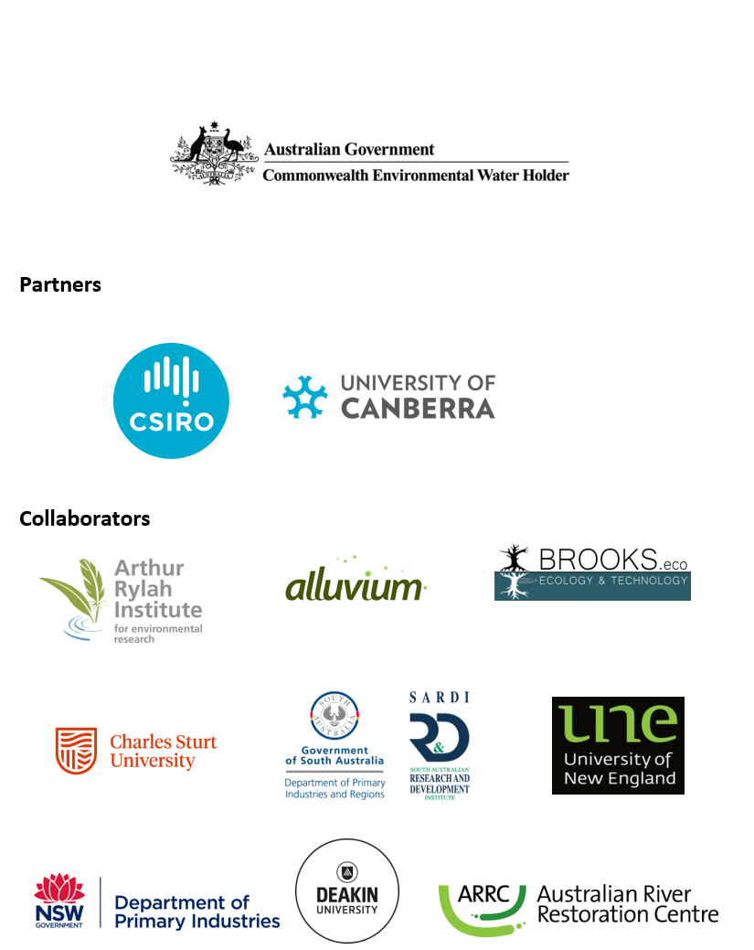

At the time of writing, the 2025 edition of the Strategy was not available. 2023–24 evaluations reference the 2019 edition (MDBA 2019).
Stream metabolism comprises 2 key ecological processes, gross primary production (GPP) which generates organic matter; and ecosystem respiration (ER) which recycles organic matter. Stream metabolism measurements estimate the instream rates of GPP and ER by measuring changes in dissolved oxygen. Net ecosystem production – the difference between GPP and ER – determines whether carbon accumulates or is depleted within an ecosystem. Volumetric GPP and ER rates represent the amount of carbon being fixed or respired per litre of water, which is important for understanding food web processes and assessing potential water quality risks, such as algal blooms or hypoxia. Since GPP represents the fixing of carbon into organic matter and ER is the breakdown of this matter and remineralisation of the carbon, high rates of both GPP and ER (i.e. with a GPP:ER close to 1) indicate rapid cycling or ‘metabolic throughput’ of carbon by aquatic organisms. In contrast, low but balanced GPP and ER indicates slow cycling and low throughput.
At the time of writing, the 2025 edition of the Strategy was not available. 2023–24 evaluations reference the 2019 edition (MDBA 2019).
The Long Term Intervention Monitoring and Environmental Water Knowledge and Research projects (2014–19)
In the counterfactual approach, CEW is removed from the observed streamflow time series, creating a hypothetical (counterfactual) daily streamflow time series with no CEW. This approach is used to infer the effects of CEW as an experimental design with controls and/or before–after comparisons is not possible.
In these evaluations it is not possible to attribute the Commonwealth’s contribution separately to other environmental water under the current methods.
The counterfactual modelling was introduced for the 2023–24 evaluation. It is fully described in O’Sullivan and Cuddy (2025).
Refer to caption note to Table .1 for information on this process.

