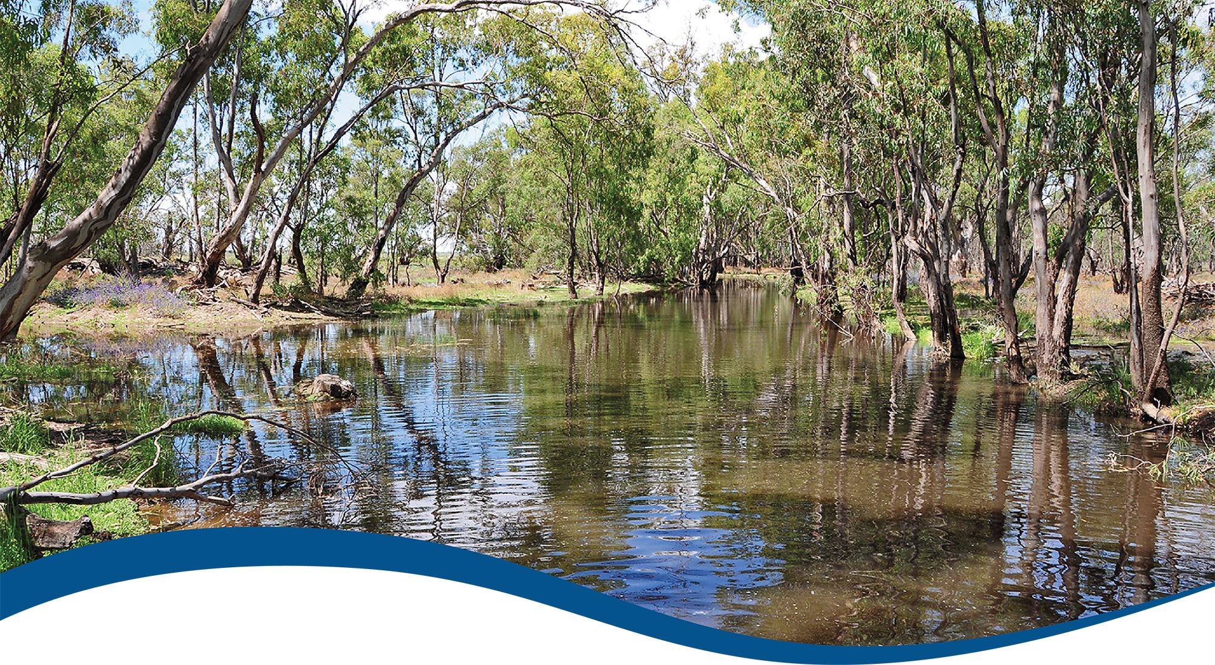
Basin-scale evaluation of 2023–24 Commonwealth environmental water: Hydrology
  - Commonwealth Environmental Water Holder’s Science Program:
Flow Monitoring, Evaluation and Research Program (Flow-MER)
JUNE 2025
Acknowledgements
The project team and the Commonwealth Environmental Water Holder (CEWH) respectfully acknowledge the Traditional Owners of the land on which this work is conducted, their Elders past and present, their Nations of the Murray–Darling Basin, and their cultural, social, environmental, spiritual and economic connection to their lands and waters.
We take this opportunity to thank the many individuals and agencies who provided data to support this evaluation. This includes officers of the CEWH, Victorian Environmental Water Holder, WaterNSW, Goulburn–Murray Water and the Murray–Darling Basin Authority. We would like to thank Jessica Heath and Catherine Ticehurst for their help with inundation mapping. Special mention to the Flow-MER reporting team (Susan Cuddy, Martin Nolan, Dianne Flett, Jane Thomas) – their contributions were enormous and significantly improved the quality, readability, flow and signposting of this report. CSIRO’s Martin Nolan assisted with figures and GIS layers.
With thanks to staff of the CEWH and members of the Flow-MER2.0 Independent Advisory Group for providing independent review; and especially to Prof Peter Davies for his reviews of this report throughout the life of Flow-MER.
The authors would also like to thank staff at Alluvium Consulting Australia, especially Vincent Li Creagh, for their assistance in analyses.
Citation
Sengupta A, Egger F, Weber T (2025) Basin-scale evaluation of 2023–24 Commonwealth environmental water: Hydrology. Flow-MER Program. Commonwealth Environmental Water Holder, Department of Climate Change, Energy, the Environment and Water, Australia. 74pp.
Copyright
 © Commonwealth of Australia 2025
With the exception of the Commonwealth Coat of Arms, partner logos and where otherwise noted, all material in this publication is provided under a Creative Commons Attribution 4.0 International Licence https://creativecommons.org/licenses/by/4.0/. Flow-MER requests attribution as ‘© Commonwealth of Australia (Flow-MER, https://flow-mer.org.au)’.
Cover photograph
Flooded creek in Yanga National Park, New South Wales
Photo credit: Tanya Doody
Document log
2 May 2025 | First draft delivered for editing
8 May 2025 | Draft delivered to CEWH for review
11 June 2025 – 25 June 2025 | Response to review period
27 June 2025 | Draft final delivered to CEWH

Important disclaimer
The information contained in this publication comprises general statements based on scientific research. The reader is advised and needs to be aware that such information may be incomplete or unable to be used in any specific situation. No reliance or actions must therefore be made on that information without seeking prior expert professional, scientific and technical advice. To the extent permitted by law, Flow-MER (including its partners and collaborators) excludes all liability to any person for any consequences, including but not limited to all losses, damages, costs, expenses and any other compensation, arising directly or indirectly from using this publication (in part or in whole) and any information or material contained in it.
Flow-MER is committed to providing web-accessible content wherever possible. If you are having difficulties with accessing this document, please contact
ewater@dcceew.gov.au.

Executive summary
The Commonwealth Environmental Water Holder (CEWH) delivers environmental water across the Murray–Darling Basin (the Basin) valleys to improve the hydrological and ecological outcomes for the Basin. This is a key means of achieving the objectives of the Commonwealth’s (Murray–Darling) Basin Plan 2012 (Basin Plan). The CEWH’s Science Program invests in Flow Monitoring, Evaluation and Research (Flow-MER) to demonstrate Basin-scale outcomes of Commonwealth environmental water, support adaptive management, and fulfil the CEWH’s legislative requirements under the Basin Plan.
This evaluation reports on the Basin-scale hydrological outcomes achieved for the current water year (2023–24) and over the 10 years of the combined Long Term Intervention Monitoring Project (2014–15 to 2018–19) and Flow-MER (2019–20 to current).

Evaluation approach
The Hydrology Theme evaluates the overarching question:
What did the Commonwealth environmental water contribute towards the restoration of the hydrological flow regime?
Assessment is undertaken at the site scale, valley scale and Basin scale. It reports on 4 features of the flow regime:
- base flows and freshes with a comparison to modelled pre-development flow
- hydrological connectivity between the river channel and floodplain (lateral connectivity) and between hydrologically connected valleys (longitudinal connectivity).
Base flows and freshes are estimated for gauges in valleys where Commonwealth environmental water was delivered and a long-term watering plan threshold for that flow component is available.
Inundation (lateral connectivity) is measured as the total combined area of floodplain that received Commonwealth environmental water. Where delivered in conjunction with other environmental water, such as from state agencies, the combined extent is mapped. Area is reported as an annual maximum extent in hectares.
Longitudinal connectivity is evaluated as increases in end-of-valley flows, length of waterways connected and frequency of inundation of watercourses.
All of these are compared with the objectives and expected outcomes established in the Basin Plan and the Basin-wide environmental watering strategy (Strategy). This evaluation is limited to Commonwealth environmental water. Environmental water held by other holders is not evaluated and is out of scope for this report.
There are some limitations to the Basin-scale evaluation that need consideration. First, the disaggregation of Commonwealth environmental water volumes from daily observed flows is sourced from different agencies, all of which use different methods. For example, a water-accounting model is used in New South Wales, while point derivation is used in Queensland. Hence, biases are possible. Second, the attribution of flow components to flow regime is based on thresholds provided in the Long Term Watering Plans prepared by Basin States/Territory for each valley in their jurisdiction. However, many valleys do not have thresholds for all gauges, leading to consistency issues.

Water year 2023–24
- Average precipitation conditions (comparable to 2020–21) were observed across the Basin, noting that slightly wetter-than-average conditions were observed in central New South Wales, while drier-than-average conditions were observed in the head fringes of the Basin in Victoria, the Lower Murray and the head of valleys in the northern Basin.
- Surface water runoff in the Basin and inflows into storages in 2023–24 were much smaller than in previous years and were more comparable to 2019–20, possibly because of the below-average rainfall in the heads of the valleys which feed the storages. This lowered surface water runoff was, however, not consequential to the delivery of Commonwealth environmental water.
- The volume of Commonwealth environmental water delivered in 2023–24 was the highest over the 10-year period. This was likely due to storages being relatively full from the very wet year 2022–23.
- Commonwealth environmental water was delivered over the entire water year with most of the volume delivered in spring and summer. Some of the deliveries in the southern Basin extended over more than a season, meaning that Commonwealth environmental water may contribute to the flow regime in the Basin for extended periods of time. Similarly, some of the watering actions in the northern Basin extended over half a season.
- Most Commonwealth environmental water volume was delivered as base flow actions in the southern Basin. There was one high-volume base flow action in the northern Basin, in the Barwon Darling. Where base flow actions were delivered, they improved the flow regime by progressing the hydrograph closer to either the median of pre-development flows or by moving the hydrograph into the 10th to 90th percentile of pre-development flows. In some instances, Commonwealth environmental water provided essential base flow and pushed the flow into the range of pre-development flow (Gwydir, Lachlan, Central Murray, Murrumbidgee, Macquarie).
- Actions to deliver freshes were delivered in most valleys (except for Lower Darling/Baaka and Barwon Darling) and substantially contributed to increased duration of freshes. Commonwealth environmental water also helped increase the frequency of freshes (the southern Basin experienced increases in fresh frequency and duration due to Commonwealth environmental water in all valleys except for Broken and Campaspe, and the northern Basin experienced increases in the Macquarie, Barwon Darling, Namoi and Warrego valleys). While freshes were not delivered in the Barwon Darling, it received freshes in late summer via contributions from other valleys.
- Commonwealth environmental water contributed substantially to lateral and longitudinal connectivity due to prolonged delivery timeframes and actions targeting important wetland assets. This included 23,768 ha of estuary, 200,890 ha of lakes and wetlands and 47,770 ha of floodplains. Additionally, 21,075 km of waterways carried Commonwealth environmental water in 2023–24.

Water years 2014–24
- Over the 10 years of the monitoring program, 1,194 independent Commonwealth environmental watering actions were delivered for a wide range of hydrological and ecological purposes, totalling 18,310 GL of water.
- Flows over the last 10 years have been close to or above the longer-term (24-year) average in the northern and southern Basins, mostly due to 3 of the 5 wettest years occurring in the last 10 years.
- Over the last 10 years, Commonwealth environmental water contributed flows to a maximum length in any one year of 22,164 km (in 2021–22). Recent wetter years have generally shown higher connectivity, and Commonwealth environmental water (in conjunction with other flows) led to greater achievement of environmental outcomes. The total length of waterways connected over the 10-year period was highest in the Murrumbidgee and the Central Murray system. Even in wetter years (2021–23), Commonwealth environmental water extended the duration of flows in some periods.
- Commonwealth environmental water was often delivered in partnership with state and other environmental water holders. Of the 1,194 watering actions, about 50% were in collaboration with partners and with other flows, and Commonwealth environmental water contributed about 50% of the partnered watering actions.
- Cumulatively over the 10-year monitoring period, 446,264 ha (including the Coorong, Lower Lakes and Murray Mouth area) of wetlands, lakes and floodplains received Commonwealth environmental water. This includes 124,091 ha of lakes, including the Lower Lakes, 130,574 ha of wetlands and 191,599 ha of floodplains.

Key contributions to Basin Plan and Strategy environmental outcomes
The Strategy describes expected environmental outcomes for base flows as ‘to keep base flows to at least 60% of the pre-development level’. Across the 10 years of monitoring (2014–24), the target was met in the Central Murray for all years; and in some years in the remaining valleys. The target was met only twice in the Barwon Darling, Edward/Kolety–Wakool and Lower Darling/Baaka valleys.
The Strategy also includes expected outcomes related to freshes as an indicator of lateral connectivity, a 30-60% increase in fresh frequency in select valleys (Murray, Murrumbidgee, Goulburn–Broken and Condamine-Balonne) and a 10–20% increase in fresh frequency in Border Rivers, Gwydir, Namoi, Macquarie–Castlereagh, Barwon Darling, Lachlan, Campaspe, Loddon and Wimmera. Increase in fresh frequency due to Commonwealth environmental water was used to assess achievement of the fresh outcomes. Over the 10 years, the freshes indicators were met in some years across most valleys, although context is very important. Given the latter years included very wet periods, this means that, while some indicators were not technically met, freshes occurred over extended periods, and the need for Commonwealth environmental water to support achievement of improved lateral connectivity was not required. Even so, Commonwealth environmental water improved characteristics of lateral connectivity, especially inundation durations, which is often why Commonwealth environmental water is delivered to crucial wetland systems (e.g. Macquarie Marshes, Barmah–Millewa Forest), rather than to increase fresh frequency.
Evaluation of the hydrological outcomes of 2023–24 towards the Strategy’s expected outcomes for river flows and connectivity showed that base flows were at 60% of the pre-development levels in all valleys except for the Wimmera and Broken. The lateral connectivity objectives were met in the Mid-Murray (Edward/Kolety–Wakool) and Lachlan. The targets were almost met in the Barwon Darling (8% increase in fresh frequency, where 10% was the target). The flow increase target (increase in flows in the Barwon Darling river system from contributions of the Border Rivers, Gwydir, Namoi, Condamine-Balonne and Macquarie valleys) in the northern Basin was met (15% flow increase at Bourke, where 10% is the target). However, the flow increase targets in the southern Basin and the Murray mouth were not met by Commonwealth environmental water alone. All end-of-basin connectivity targets were met.

Informing adaptive management
In conclusion, slightly below-average rainfall conditions in 2023–24 translated to the volume of water delivered for the environment being greater than in any other year during the 10-year monitoring period. The number of actions was lower than in 2021–22, though the total volume is comparable. The large number of base flow actions shows real-time adaptive management in practice, where a drier summer prompted base flow deliveries to maintain connectivity. Inundation watering actions were delivered to increase the duration of the natural floods to maximise ecological outcomes. Where available, comparison with the pre-development regime shows that Commonwealth environmental water deliveries progressed the current year’s regime towards a proposed natural regime. In the same way that adaptive management evolves and improves water delivery in the Basin, the hydrological evaluation will evolve in future years to improve the nuanced understanding of what Commonwealth environmental water contributes to the hydrological regime in the Basin.

Overview of Flow-MER and the 2023–24 evaluation
The Commonwealth Environmental Water Holder’s (CEWH) Science Program invests in monitoring, evaluation and research activities through its Flow Monitoring, Evaluation and Research Program (Flow-MER). The Flow-MER Basin-scale evaluation assesses the contributions of Commonwealth environmental water (CEW) to meeting the environmental objectives stated in Chapters 8 and 9 of the (Murray–Darling) Basin Plan 2012 and in the Basin-wide environmental watering strategy. Six Basin Themes (Figure 1) are evaluated using data from 7 Flow-MER Selected Areas (left-side map, Figure 2) and the 19 valleys (right-side map, Figure 2) where the CEWH holds water entitlements in the Murray–Darling Basin. The evaluation builds on work undertaken by its predecessors. Research informs the evaluation and the CEWH’s Science Program.
Figure 1 Schematic of the components of the Basin-scale evaluation
The evaluations are informed by Basin-scale research projects, stakeholder engagement and Selected Areas monitoring data.
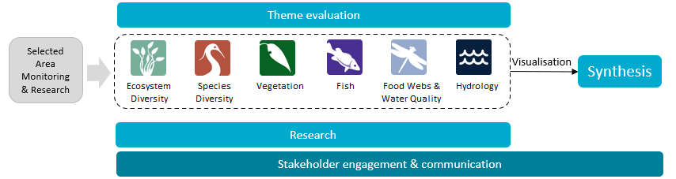
Figure 2 The 7 Selected Areas (left map) and 25 valleys (right map) established for long-term monitoring of the impacts of environmental watering under the Long Term Intervention Monitoring project and Flow-MER (2014–15 to present)
In the valleys map, shaded grey shows the 19 valleys where the Commonwealth holds water entitlements and which are in scope for evaluation; white identifies those valleys which are not in scope for evaluation.
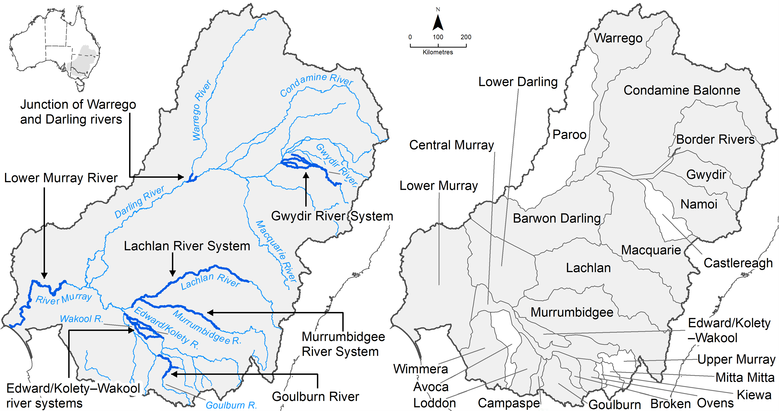

Evaluating the contribution of Commonwealth environmental water to observed environmental outcomes
To undertake the Basin-scale evaluation, the Basin-scale evaluation team uses water delivery and outcomes data provided by the CEWH’s Science Program, along with monitoring data provided by the 7 Selected Areas. Other publicly available data may be used where relevant data are not collected by the Selected Areas.
Evaluation of the contribution of CEW to observed environmental outcomes for the 6 Basin Themes depends on the data available.
When delivered with other water, ecological outcomes cannot be apportioned with current methods, and CEW is reported as contributing to, or supporting, the environmental outcomes of the watering action.
The multi-year Hydrology (instream), Fish and Vegetation Basin Themes have sufficient data to model and compare environmental outcomes, both with and without CEW (counterfactual modelling).
Ecosystem Diversity, Species Diversity and Vegetation Basin Themes identify environmental responses in locations that received CEW (often in conjunction with other sources of environmental or non-environmental water) and, where feasible, compare with areas that did not receive CEW.
Hydrology (inundation) and Food Webs and Water Quality Basin Themes use flow and water quality metrics to infer likely outcomes.
Fish (annual), Vegetation (annual) and Food Webs and Water Quality Basin Themes synthesise findings across Selected Areas.

Partnering on watering actions
Commonwealth environmental water is often delivered in conjunction with other environmental water holdings and non-environmental water releases (such as for irrigation or during high-flow events).
Commonwealth environmental watering actions for the most recent evaluation year (2023–24) and cumulative over the 10 evaluation years (2014–15 to 2023–24) are provided in Table 1.
Table 1 Summary statistics for most recent evaluation year and multi-year evaluation period
Dash (–) indicates statistic not available.
 | 2023–24 | 2014–24
Volume of CEW actions (GL) | 2,870 | 18,310
Number of CEW actions | 114 | 1,194
% CEW volume of total EW volume | ~70% | –
% of CEW actions with partners or with other flows | ~50% | –
CEW % of total volume of partnered watering actions | ~50% | –
CEW % of total Basin surface water runoff | ~13% | –

Evaluation reporting
Each Theme prepares a technical evaluation report for each water year from which key outcomes and lessons for adaptive management are brought together, with research highlights, into an annual synthesis report. To provide consistency over the life of Flow-MER and its predecessors, some content in these annual reports may be reused from previous years. In these cases, all efforts are made to cite the relevant Long Term Intervention Monitoring Project, Environmental Water Knowledge and Research Project or Flow-MER publication. Reports published by the CEWH are available from the CEWH's publications and resources webpage.

Basin-scale Flow-MER partnership
Basin-scale evaluation in Flow-MER is led by CSIRO in partnership with the University of Canberra. Collaborators on the 2023–24 evaluation include Alluvium, Arthur Rylah Institute, Charles Sturt University, South Australian Research & Development Institute, NSW Department of Primary Industries, Australian River Restoration Centre and Brooks Ecology & Technology.
2025 is the final year of this 5-year phase of Flow-MER. This is the final evaluation under this phase. The next 5-year phase commenced on 1 July 2025 and is led by CSIRO in partnership with the One Basin Cooperative Research Centre. Information on the new phase of Flow-MER can be found at the CEWH's science programs website.

Contents
Executive summary iii
Evaluation approach iii
Water year 2023–24 iv
Water years 2014–24 v
Key contributions to Basin Plan and Strategy environmental outcomes v
Informing adaptive management vi
Overview of Flow-MER and the 2023–24 evaluation vii
Evaluating the contribution of Commonwealth environmental water to observed environmental outcomes viii
Partnering on watering actions viii
Evaluation reporting viii
Basin-scale Flow-MER partnership viii
1 Introduction 1
1.1 Evaluation objectives 1
1.2 Components of the flow regime 3
1.3 Evaluation coverage 4
1.4 About this report 6
2 Overview of approach and methods 7
2.1 Estimating flow-regime components and inundation 7
2.2 Estimating counterfactuals 8
2.3 Evaluation towards the Basin Plan and the Strategy environmental outcomes 8
3 Data 10
3.1 Contextual data 10
3.2 Commonwealth environmental water delivery 14
3.3 Timing of Commonwealth environmental water delivery 21
4 Evaluation against Basin Plan environmental objectives 22
4.1 Flow regime 22
4.2 Connectivity 41
5 Evaluation against the Strategy environmental outcomes 47
5.1 Lateral connectivity 47
5.2 Longitudinal connectivity 48
5.3 End-of-Basin flows 50
Appendix A Data tables 52
Abbreviations and terms 59
References 60

Figures
Figure 1 Schematic of the components of the Basin-scale evaluation vii
Figure 2 The 7 Selected Areas (left map) and 25 valleys (right map) established for long-term monitoring of the impacts of environmental watering under the Long Term Intervention Monitoring project and Flow-MER (2014–15 to present) vii
Figure 1.1 An illustrative river cross-section showing the 5 components of the flow regime referenced in this evaluation 4
Figure 1.2 Map showing location of the gauge sites used for evaluation and for estimation of the ‘counterfactual' flow, categorised by CEW data provider, 2023–24 5
Figure 3.1 Map of annual rainfall conditions, 2023–24 11
Figure 3.2 Maps of annual rainfall conditions, 2014–24 12
Figure 3.3 Annual total surface water runoff in the Basin, by year 2000–24 13
Figure 3.4 Maps of annual total surface water runoff (GL/year) in the Basin by river valley and year, 2014–24 14
Figure 3.5 Commonwealth environmental water portfolio showing volume of watering actions by flow component and year, 2014–24 19
Figure 3.6 Commonwealth environmental water portfolio showing the number of watering actions and the proportion of flow components each year, by flow component and year, 2014–24 19
Figure 3.7 Volume of Commonwealth environmental water (left set of plots) and number of watering actions (right-set of plots), by valley and year, 2014–24 20
Figure 4.1 Map showing location of the gauge sites used for evaluation, and the waterways and floodplain/wetland areas that received CEW in 2023–24 23
Figure 4.2 Hydrograph for the Balonne River at St George, Queensland gauge, 2023–24 24
Figure 4.3 Hydrograph for the Barwon River at Mungindi, Queensland, 2023–24 25
Figure 4.4 Hydrograph for the Darling River at Bourke, New South Wales, 2023–24 25
Figure 4.5 Hydrograph for the Macintyre River at Goondiwindi, Queensland, 2023–24 26
Figure 4.6 Hydrograph for the Carole Creek, New South Wales, 2023–24 27
Figure 4.7 Hydrograph for the Gwydir River at Gravesend Road Bridge, New South Wales gauge, 2023–24 27
Figure 4.8 Hydrograph for the Macquarie River at Marebone Weir gauge, New South Wales, 2023–24 28
Figure 4.9 Hydrograph for the Namoi River at Goangra, New South Wales, 2023–24 29
Figure 4.10 Hydrograph for the Peel River at Piallamore, New South Wales, 2023–24 29
Figure 4.11 Hydrograph for the Warrego River at Augathella, Queensland (Upper Warrego), 2023–24 30
Figure 4.12 Hydrograph for the Warrego River at Cunnamulla, Queensland (Lower Warrego), 2023–24 30
Figure 4.13 Hydrograph for the Broken Creek at Casey Weir, Victoria, 2023–24 31
Figure 4.14 Hydrograph for the Campaspe River at Rochester, Victoria, 2023–24 31
Figure 4.15 Hydrograph for the Goulburn River at Eildon, Victoria, 2023–24 32
Figure 4.16 Hydrograph for the Goulburn River at McCoys Bridge, Victoria, 2023–24 32
Figure 4.17 Hydrograph for the Lachlan River at Booligal, New South Wales, 2023–24 33
Figure 4.18 Hydrograph for the Loddon River at Appin South, Victoria, 2023–24 33
Figure 4.19 Hydrograph for Mount William Creek at Lake Lonsdale, Victoria, 2023–24 34
Figure 4.20 Hydrograph for Murray River at Wentworth, New South Wales, 2023–24 35
Figure 4.21 Hydrograph for Murray River at Yarrawonga, Victoria, 2023–24 35
Figure 4.22 Hydrograph for calculated Murray River Flows to South Australia, 2023–24 36
Figure 4.23 Hydrograph for Murrumbidgee River at Maude Weir, New South Wales, 2023–24 36
Figure 4.24 Hydrograph for the Wakool River at the Wakool Offtake Regulator, New South Wales, 2023–24 37
Figure 4.25 Length of waterway connectivity annually supported by Commonwealth environmental water, 2014–24 44
Figure 4.26 Map showing frequency (years) of longitudinal connectivity in waterways supported by Commonwealth environmental water in the Basin, 2014–24 45
Figure 4.27 Map showing length of waterways connected and extent of wetland inundation, 2023–24 46
Figure 5.1 Percentage increases in annual flow volumes in the northern Basin (as measured at the Darling River at Bourke) and in the southern Basin (as measured at the Murray River at the South Australian border) that are directly attributable to Commonwealth environmental water, per year 2014–24 49
Figure 5.2 Contribution of Commonwealth environmental water towards maintaining the water level in Lake Alexandrina above 0.4 m Australian Height Datum, per year 2014–24 51

Tables
Table 1 Summary statistics for most recent evaluation year and multi-year evaluation period viii
Table 1.1 River flows and connectivity expected environmental outcomes to be achieved beyond 2019 as set out in the Strategy 1
Table 1.2 Evaluation questions were assessed to estimate achievement of the Strategy’s expected environmental outcomes 2
Table 3.1 Annual rainfall conditions by valley, 2023–24 10
Table 3.2 Commonwealth environmental watering actions by valley and hydrological flow component, 2023–24 15
Table 3.3 Summary of volume of Commonwealth environmental watering actions as a percentage of total delivery and as a percentage of the volume delivered to northern Basin and southern Basin valleys, 2023–24 16
Table 3.4 Commonwealth environmental watering actions targeting wetlands, 2023–24 17
Table 3.5 Seasonality of Commonwealth environmental water releases, 2023–24 21
Table 4.1 Areas of estuary, lakes and wetlands and floodplains inundated and the length of waterway connectivity supported by Commonwealth environmental water, by valley, 2023–24 42
Table 4.2 Frequency (years) of inundation of wetlands, lakes and floodplains contributed to by Commonwealth environmental water, reported as hectares (ha), by valley, 2014–24 43
Table 5.1 Expected outcomes for river flows and connectivity as listed in the Strategy 47
Table 5.2 Summary of lateral connectivity outcomes in 2023–24 against expected outcomes as listed in the Strategy 48
Table 5.3 Summary of longitudinal connectivity outcomes in 2023–24 against expected outcomes as listed in the Strategy 50
Table 5.4 Summary of outcomes of end-of-Basin flows against expected outcomes as listed in the Strategy for 2023–24 and over the 10-year period 2014–24 51
Table 5.5 Contribution of Commonwealth environmental water to barrage releases (GL) with and without Commonwealth environmental water, 2014–24 51
Table A.1 Inundation mapping assets, data sources and validation comments 52
Table A.2 List of hydrological gauge sites used for this evaluation, together with their flow thresholds extracted from Long Term Watering Plans 54
Table A.3 Commonwealth environmental watering actions by flow component, 2014–24 54
Table A.4 Flow components combined into 4 categories of base flow, freshes, bankfull and overbank/wetland, 2014–24 55
Table A.5 Length of waterways (km) connectivity due to Commonwealth environmental water, per year 2014–24 56
Table A.6 Hydrological evaluation sites, flow component thresholds, and corresponding environmental assets 57

Introduction
The Commonwealth Environmental Water Holder (CEWH) manages a portfolio of environmental water as a key means of achieving the objectives of the Commonwealth’s (Murray–Darling) Basin Plan 2012 (the Basin Plan). The Commonwealth’s water holdings are released strategically towards specified environmental outcomes as described in the Basin-wide environmental watering strategy (the Strategy; MDBA 2019). Critical to the adaptive management of Commonwealth environmental water (CEW) is the annual Basin-scale evaluation of CEW releases and hydrological outcomes achieved. This evaluation reports on the current water year (2023–24) and over the 10 years of the Long-Term Intervention Monitoring Project (LTIM; 2014–19) and Flow-MER (2019–20 to current).

Evaluation objectives
This report examines the contribution of CEW towards Basin Plan objectives by addressing the overarching evaluation question:
What did Commonwealth environmental water contribute towards the restoration of the hydrological flow regime?
This question was developed under the Commonwealth Environmental Water Outcomes Framework (CEWO 2013) to meet broader objectives of the Basin Plan. It evaluates the contribution of CEW towards:
- flow regimes, including relevant flow components set out in the Basin Plan (paragraph 8.51(1)(b))
- hydrological connectivity between the river and floodplain (lateral connectivity) and between hydrologically connected valleys (longitudinal connectivity)
- outcomes and objectives as provided in the Basin Plan and the Strategy.
The Strategy sets out expected environmental outcomes to improve connections along rivers and between rivers and their floodplains. These are listed in Table 1.1.
Table 1.1 River flows and connectivity expected environmental outcomes to be achieved beyond 2019 as set out in the Strategy
Only discharge based objectives are evaluated by the Basin-scale team; however, the Strategy (MDBA 2019) also includes a salinity objective for the Coorong, and objectives for the openness of the Murray mouth.
Objective | Quantified expected environmental outcome
Maintained base flows | At least 60% of natural levels
Improved overall flow | 10% more into the Barwon Darling  30% more into the Murray River  30% to 40% more to the Murray Mouth (and it open to the sea 90% of the time)
Maintained connectivity in areas where it is relatively unaffected | Between rivers and floodplains in the Paroo, Moonie, Nebine, Warrego and Ovens
Improved connectivity with bankfull and/or low floodplain flows | By 30% to 60% in the Murray, Murrumbidgee, Goulburn and Condamine Balonne  By 10% to 20% in remaining catchments
Maintain Lower Lakes above sea level | Water levels above 0.4 m Australian Height Datum
To address the overarching evaluation question and evaluate whether Strategy objectives have been achieved or progress towards the objectives has been made, we have interpreted the Strategy objectives to be able to evaluate the hydrological observations in water year 2023–24. For the evaluation, we have reformulated the Strategy objectives as evaluation questions, which make our interpretation of the objectives explicit (Table 1.2).
Table 1.2 Evaluation questions were assessed to estimate achievement of the Strategy’s expected environmental outcomes
CEW = Commonwealth environmental water. AHD = Australian Height Datum.
Evaluation question | Category | Expected environmental outcome | Interpretation and formulation as evaluation questions
Q1.1 | Flows / Longitudinal connectivity | Keep base flows at least 60% of natural level in all valleys | Is the duration of the modelled/observed flow above the low base flow threshold greater than 60% of the modelled pre-development flow (Davies et al. 2004)?
I can | Longitudinal connectivity | Increase flows in the Barwon Darling 10% overall, including increased contributions from the Condamine Balonne, Border Rivers, Gwydir, Namoi, Macquarie and Castlereagh valleys | Is the increase in flow volume comparing the modelled/observed flow at Barwon River at Bourke (contributions from Condamine Balonne, Border Rivers, Gwydir, Namoi, Macquarie and Castlereagh before the confluence with the Warrego) to the counterfactual scenario without CEW greater than 10%?
Q1.3 | Longitudinal connectivity | Increase flows in the Murray 30% overall, including increased contributions from Murrumbidgee, Goulburn, Campaspe, Loddon and Lower Darling/Baaka valleys | Is the increase in flow volume comparing the modelled/observed flow at Murray River @ Calculated flows to SA (contributions from all tributaries upstream) to the counterfactual scenario without CEW greater than 30%? Murray River @ Calculated flows to SA is a virtual gauge at the SA border, where contributions from upstream are accounted as a first instance after the Darling confluence.
Q1.4 | Longitudinal connectivity | Increase flows in the Murray mouth by 30% to 40% | Is the increase in flow volume comparing the modelled/observed flow at Murray River at Wellington to the counterfactual scenario without CEW greater than 30% to 40%?
Q2.1 | Lateral connectivity | Increase frequency of freshes, bankfull and lowland floodplain flows 30% to 60% in the Murray, Murrumbidgee, Goulburn, Broken and Condamine Balonne valleys | Is the frequency of unique events of flow crossing the high-fresh threshold when comparing the modelled/observed scenario to counterfactual scenario greater than 30% to 60% in the Murray, Murrumbidgee, Goulburn and Broken valleys?
Q2.2 | Lateral connectivity | Increase frequency of freshes, bankfull and lowland floodplain flows 10% to 20% in the Border Rivers, Gwydir, Namoi, Macquarie, Castlereagh, Barwon Darling, Lachlan, Campaspe, Loddon and Wimmera catchments | Is the frequency of unique events of flow crossing the high-fresh threshold when comparing the modelled/observed scenario to counterfactual scenario greater than 10% to 20% in the Border Rivers, Gwydir, Namoi, Macquarie, Castlereagh, Barwon Darling, Lachlan, Campaspe and Loddon valleys?
Q2.3 | Lateral connectivity | Maintain current levels of connectivity in the Paroo, Moonie, Nebine, Kiewa, Ovens and Warrego valleys | Is the frequency of unique events of flow crossing the high-fresh threshold when comparing the modelled/observed scenario to counterfactual scenario greater than 10% to 20% in the Ovens and Warrego valleys?
Q3.1 | End-of-basin flows | Keep barrage flow above 2,000 GL/yr 95% of the time on a 3-year rolling-average basis | Is the observed/modelled flow at the barrages greater than 2,000 GL/yr on a 3-year rolling average?
Q3.2 | End-of-basin flows | Maintain water levels in the Lower Lakes above 0 m AHD and 0.4 m AHD 95% of the time | Is the daily water level in Lake Alexandrina greater than 0.4 m AHD 95% of the time in the water year and greater than 0 m AHD at all times? Lake Albert is not evaluated, as no direct link to the River Murray exists, and environmental water contributions are not direct but rather from overflow from Lake Alexandrina.

Components of the flow regime
Each environmental watering action targets one or more of the flow-regime components shown in Figure 1.1. Each component is briefly described here and its usage set out in Chapter 2:
- Base flows are flows in a system not impacted by runoff or flows sustained by seeping groundwater.
- (In-stream) freshes are small-to-medium flow events, usually of short duration, that inundate benches and stay in the river channel.
- Bankfull flows are larger flow events that fill the river channel.
- Low and medium overbank flows are substantial flow events that spill onto the low-level parts of the floodplain, including depressional wetlands. Large overbank flows inundate substantial parts of the floodplain, including higher areas.
Figure 1.1 An illustrative river cross-section showing the 5 components of the flow regime referenced in this evaluation
Source: Figure 10 (MDBA 2019)

Evaluation coverage
This evaluation uses the map of 25 major river valleys of the Murray–Darling Basin (the Basin) developed for LTIM (see Figure 2). Boundaries are based on the Sustainable Rivers Audit catchment boundaries (MDBA 2012; Davies et al. 2004; Davies et al. 2010). Note that the regulated portion of the Murray River is divided at Lake Victoria into the Central Murray Valley, extending from Hume Dam to Lock 10 (upstream of Lake Victoria), and the Lower Murray Valley, extending from Lake Victoria to the Lower Lakes. The boundaries were modified to separate the Edward/Kolety–Wakool Valley from the Central Murray and to assign wetlands near valley boundaries to the valley as allocated by water managers and CEW accounting procedures (Stewardson and Guarino 2016). Although the Basin encompasses 25 valleys, only 19 valleys are in scope for this evaluation, based on the Commonwealth holding water entitlements in those valleys.
Hydrological outputs are synthesised at the Basin scale and, when pertinent, presented in relation to the northern and southern Basin, as well as at the valley scale. Climatic conditions set the context for the watering actions in a given water year. The evaluation focuses only on CEW. Other environmental watering actions, such as state environmental water releases, are not evaluated.
The CEWH prepares an annual watering actions dataset (CEWH 2024), which, along with the valley acquittal reports prepared by CEWH delivery teams, provides the base information (e.g. total volume and release periods) for each CEW release. In addition, for each watering event, the daily flow volumes of the CEW at relevant gauges in each valley are sourced from various state and federal agencies. These are used to estimate the ‘counterfactual flow’, a hypothetical daily streamflow time series with no CEW. Point locations of these gauge sites, coloured by data supplier, are shown in Figure 1.2.
Figure 1.2 Map showing location of the gauge sites used for evaluation and for estimation of the ‘counterfactual' flow, categorised by CEW data provider, 2023–24
CEW = Commonwealth environmental water. CEWH = Commonwealth Environmental Water Holder. MDBA = Murray–Darling Basin Authority. The grey shaded areas in this map identify those valleys where the Commonwealth holds water entitlements and are in scope for evaluation. Details of the evaluation sites are provided in Table A.6.
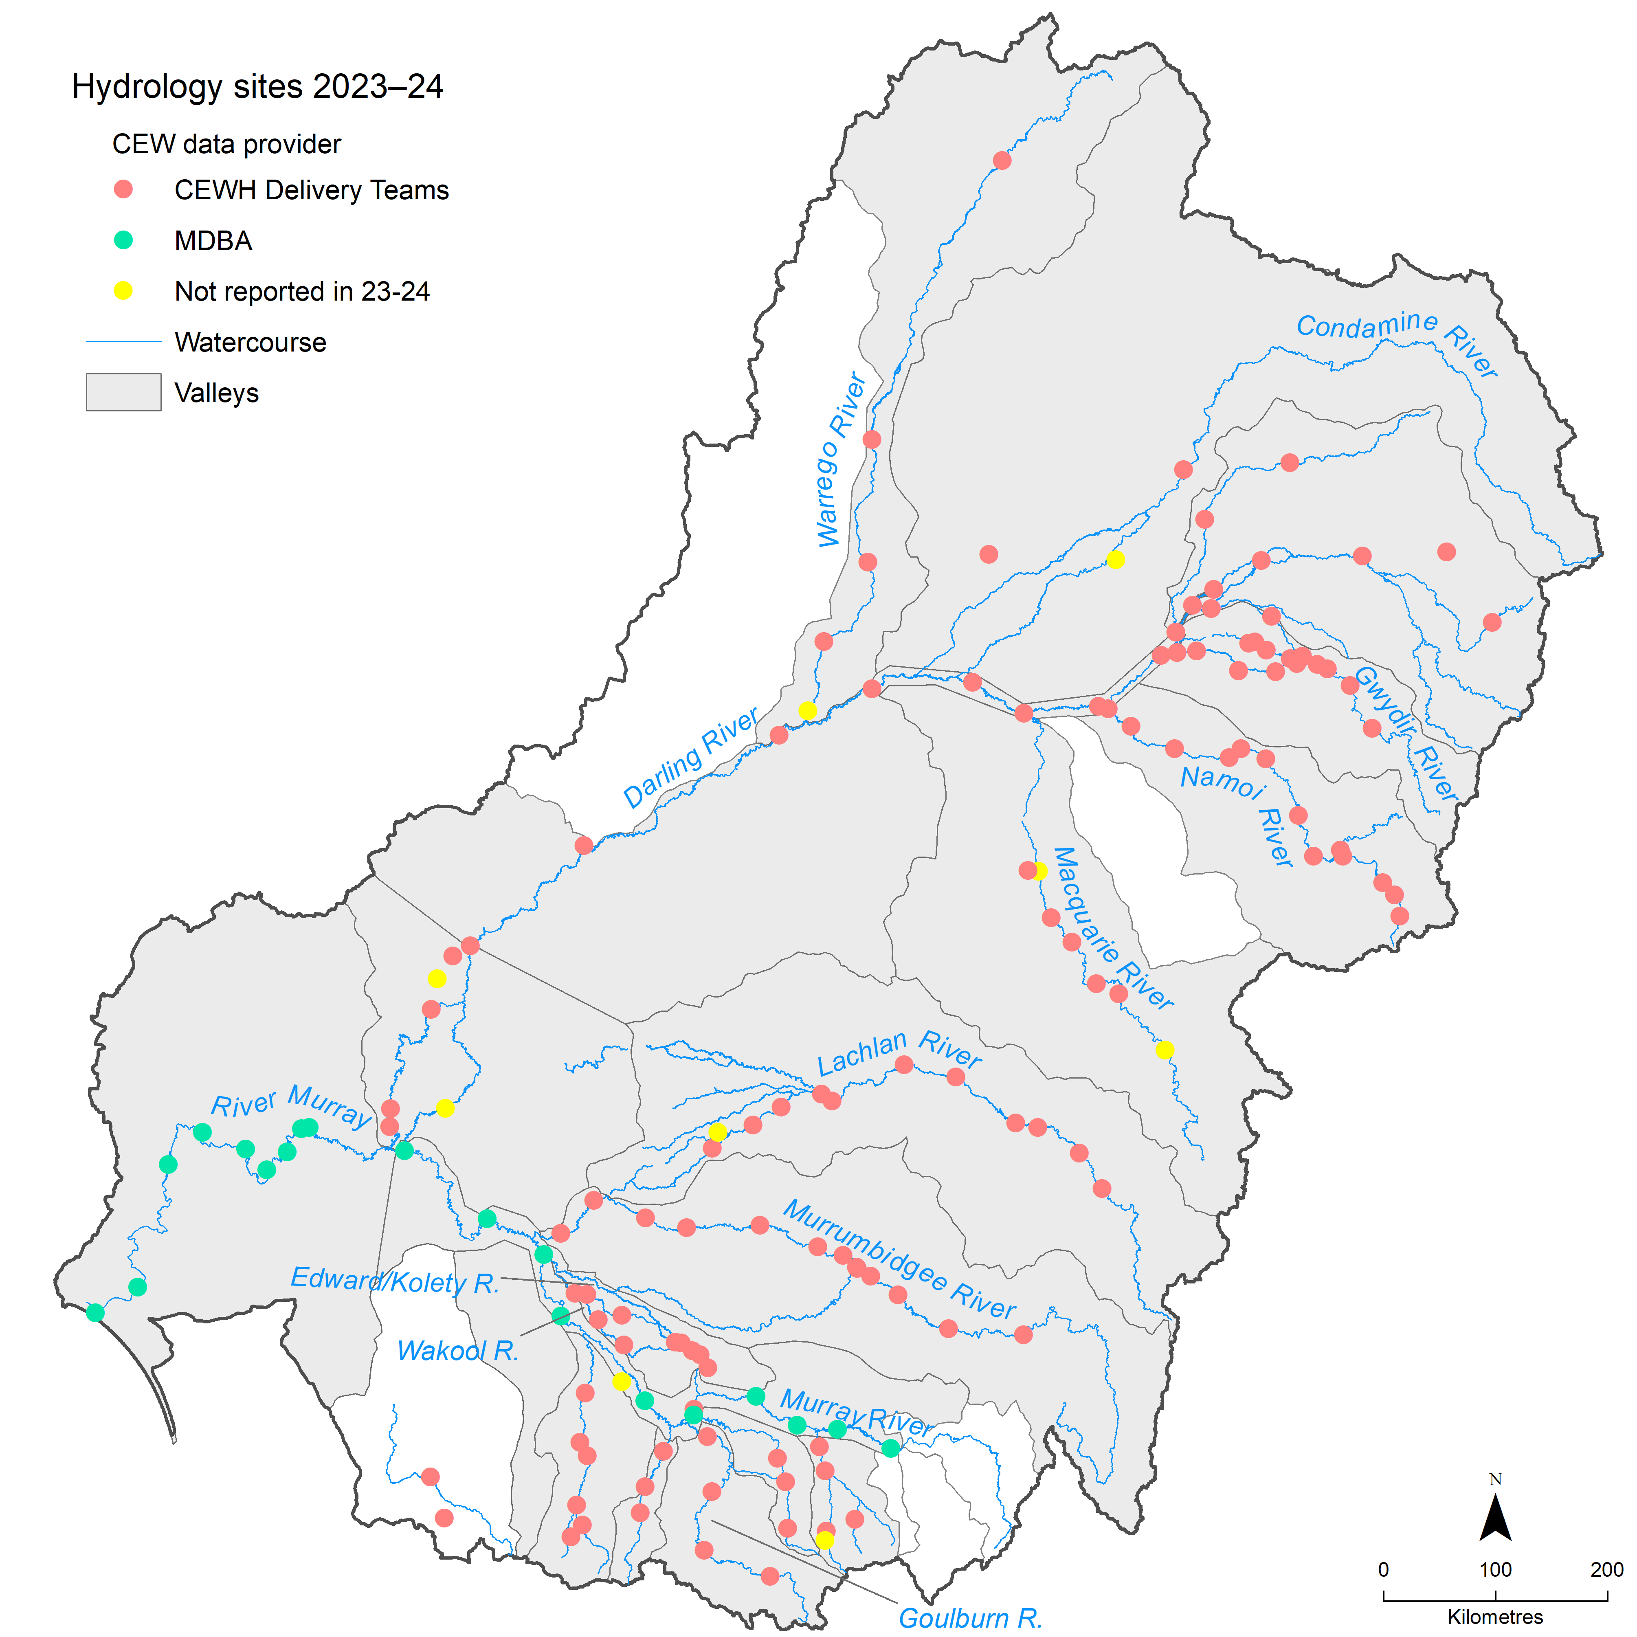
Environmental water is used to fill wetlands and other habitats across the floodplains of the Basin through various delivery methods. The movement of water between the channel and floodplain is described as lateral hydrological connectivity. The contribution of CEW to lateral connectivity is evaluated based on the area of floodplain inundated.
The low reaches of each river valley and the entire Basin are particularly vulnerable to upstream water withdrawals – flows decline to severely low levels and even cease in some cases. The protection of environmental water entitlements in these valleys is intended to increase flow volumes passing down to these lower reaches. Improvements in longitudinal connectivity are evaluated as increases in end-of-valley flows, length of waterways connected, and frequency of inundation of watercourses.
The Hydrology evaluation underpins the ecological outcomes analysis for indicators at the Basin scale (grouped within 6 Themes – Ecosystem Diversity, Species Diversity, Vegetation, Fish, Food Webs and Water Quality, and Hydrology; see Figure 1). It also provides a comprehensive analysis of all watering actions and their hydrological outcomes at the Basin scale. This evaluation refers only to specific outcomes within individual valleys, where these provide important information on the Basin-wide outcomes.
Results across all 10 years have been updated using the best available information, data and methods. For this reason, these 10-year results and interpretation supersede results provided in previous evaluations.

About this report
This Hydrology evaluation was delivered by CSIRO in partnership with Alluvium.
While it builds on previous annual evaluation reports (e.g. Guarino and Sengupta 2023), some methods were updated; hence, caution should be exercised when interpreting outcomes as reported in previous reports. This is particularly the case with regard to the setting of thresholds (to gauge whether CEW has contributed to them being met). An overview of methods is provided here and fully described in the companion methods report (O’Sullivan and Cuddy 2025).
Data tables and analyses that support the evaluation become available post the evaluation on the Australian government’s data.gov.au site, and specific evaluation workings can be made available on request.

Overview of approach and methods
This chapter provides a high-level overview of the evaluation approach – full details are available in the companion Flow-MER Basin-scale evaluation of Commonwealth environmental water: Methods report (O’Sullivan and Cuddy 2025).
The methods used to provide foundational datasets and in the hydrology evaluation differ from the methods used in the evaluations until 2021–22 (Guarino and Sengupta 2023). Most importantly, the derivation of flow-component thresholds changed in the 2022–23 evaluation (Sengupta et al. 2024) and the current evaluation. Previously, the thresholds were derived from hydrometric information at a set of compliance gauges, while the current evaluation uses the thresholds set out in Long Term Watering Plans (LTWPs). The move from hydrometric information to long-term watering plan thresholds was necessary, as the available hydrometric information is limited, and the derivation conducted in previous years yielded a notably different result from the Long Term Watering Plan thresholds. As Commonwealth environmental watering is planned against LTWPs, the thresholds set out in those plans are more relevant for assessing and decomposing the flow signals.

Estimating flow-regime components and inundation
The hydrological evaluation in this report examines the contribution of CEW to 4 features of the Basin’s flow regime:
- base flows
- freshes
- inundation (lateral connectivity with the floodplain)
- longitudinal connectivity downstream through the Basin.
Base flows and freshes are estimated for gauges in valleys where CEW has been delivered. Flow components are classified as base flows or freshes when they are higher than the designated flow thresholds. Thresholds for base flows (very low base flows and low base flows) and freshes (low freshes and high freshes) are extracted from the LTWPs for each valley.
For the evaluation against Strategy environmental outcomes and the Basin plan outcomes, the base flow component is also compared against the base flow in the pre-development flow scenario (pre-development flow is interpreted to be the ‘natural’ flow).
Inundation (lateral connectivity) – the movement of water between the channel and floodplain – is measured as the total combined area of floodplain that received CEW. Where delivered in conjunction with other environmental water, such as from state agencies, the combined extent is mapped. Area is reported as an annual maximum extent in hectares.
Longitudinal connectivity was evaluated as increases in end-of-valley flows, length of waterways connected, and frequency of inundation of watercourses.
Wetland watering actions, as described in the watering actions table (CEWH 2024) and the acquittal reports provided by the CEWH, are watering actions that target specific wetlands with pumped flow rather than natural passing flow that might inundate a wetland naturally.

Estimating counterfactuals
To evaluate the effect of CEW, counterfactual flow scenarios were developed to compare against the observed flows in the Basin. Counterfactual flows are hypothetical daily flow series that exclude the CEW components. These flows are estimated by disaggregating watering actions, typically provided as total volume over a given number of days, into daily volumes at each gauge using data provided by water delivery teams and time of travel between gauges as a function of total flow. These daily CEW volumes are then subtracted from the observed flows at the gauge. In some cases, the data received from agencies is assumed to be quality assured; however, where errors arise in our quality assurance process of the observed or modelled flow and the subtraction of the Commonwealth environmental flow signal, re-analysis of the flow signal in terms of travel time between gauges is carried out to align the observed/modelled flow signal with the CEW signal. A more detailed description is provided in the methods report (O’Sullivan and Cuddy 2025).
For each valley, the CEW component is tracked from the most upstream gauge after release to the downstream gauges, while keeping track of travel time and key nodes of tributaries and distributaries. The releases of CEW and the disaggregation into daily volumes are estimated using various methods, depending on the valley. These methods include water-accounting models and point derivations, depending on the agency responsible for modelling a particular valley.

Evaluation towards the Basin Plan and the Strategy environmental outcomes
The Basin Plan and the Strategy measure success in terms of no loss or degradation in the flow regimes for the key flow components. Whenever possible, improvement is gauged by progress towards either ‘natural’ flow regimes or towards the environmental outcomes as set out in the Strategy. The natural flow regime was generally interpreted as the pre-development flow regime, which was assessable via modelled flow time series from the Sustainable Rivers Audit (MDBA 2012).
For Basin Plan evaluation, we compared the timing and volume of the CEW in key flow components against the modelled pre-development flow (natural flow regime). The frequency of inundation at key wetlands over the 10 years and the total area inundated were estimated, as well as a measure of lateral connectivity. In terms of longitudinal connectivity, we evaluated increases in end-of-valley flows, as per the Strategy environmental outcomes (Table 5.1), and the frequency of inundation of watercourses with CEW over the 10 years, comparing the actual flow against the counterfactual scenario with CEW removed.
Finally, we evaluated the hydrology at the Coorong, Lower Lakes and Murray Mouth against the Strategy environmental outcomes, which sets out objectives for water level in the Lower Lakes (Lake Alexandrina evaluated here, see Table 1.2) and barrage flow (Table 5.4). The evaluation here focuses on the level and flow signal of the evaluation year, whether the targets of the Strategy are met in the actual flow, and whether CEW contributed to achieving those targets by way of analysing the counterfactual scenario for the evaluation year, where CEW is removed from the flow signal. Murray mouth openness and salinity objectives are not evaluated here.
The Strategy recommends maintaining base flows at a minimum of 60% of natural levels as well as a 10% overall increase in flows in the Barwon Darling system. This increase should originate from greater tributary contributions from the Condamine Balonne, Border Rivers, Gwydir, Namoi, Macquarie and Castlereagh valleys collectively. The Strategy does not specify a direct measure of relativity for the increase in flow so for this evaluation, it was interpreted as a 10% increase in flow achieved by environmental watering. In practical terms, the flow at the end of the Barwon Darling system (Barwon River at Bourke) was compared to the counterfactual flow scenario to estimate how much the CEW contributed to an increase in the annual flow. Other expected outcomes include a 30% increase in flows in the Murray River and a 30% to 40% increase in flows to the Murray Mouth. The same method used for the Barwon Darling was applied to both objectives – again, because the Strategy does not specify a measure of relativity. For the 30% increase in the Murray River, the flow at the ‘Murray River @ Calculated flows to South Australia’ gauge (See Table 1.2 for further detail on this gauge) was compared against the counterfactual scenario with CEW removed, For the 30% to 40% increase in flows in the Murray Mouth, the actual flow in the Murray River at Wellington was compared against the counterfactual scenario with the CEW removed (Table 1.2).

Data

Contextual data

Rainfall
While the overall rainfall in Australia during 2023–24 was above the average, the Basin experienced a slight departure from the mean (−3%). Average rainfall was 479.9 mm. The southern and northern parts of the Basin received average rainfall, while large parts of central New South Wales and central Victoria experienced above-average or very much above-average rainfall. Parts of the Basin in South Australia, the upper Murray catchment, and smaller areas on the north-eastern New South Wales, experienced below-average rainfall.
Examining the northern Basin valleys more closely, most of the Condamine Balonne Valley experienced ‘average’ to ‘above average’ rainfall (Table 3.1, with some ‘below average’ rainfall in the east. This trend was also evident in the Border Rivers and Gwydir valleys. The adjacent Namoi and Macquarie valleys predominantly experienced ‘average’ to ‘above average’ rainfall, as did the Warrego valley.
In the southern Basin, all 12 valleys experienced ‘average’ to ‘above average’ rainfall conditions in the lower parts of the valleys compared with the entirety of the records maintained by the Australian Bureau of Meteorology (Table 3.1, Figure 3.1), while ‘below average’ rainfall was observed in some of the valley heads (specifically the Victorian valleys). Temporal variations were also observed over the water year. Many of the southern Basin valleys received very much ‘above average’ rainfall in the winter months. These variations were consequential for CEW deliveries. Some scheduled actions were not delivered due to high natural flows, and many base flow events were delivered in the southern Basin in the summer months.
Table 3.1 Annual rainfall conditions by valley, 2023–24
Includes the 19 valleys in scope for the Flow-MER evaluation. Condition extracted from Figure 3.1
Valley | Rainfall condition
Northern Basin
Barwon Darling | Average to above average
Border Rivers | Mainly average with some areas below average and some above average
Condamine Balonne | Average to above average, some areas in the east below average
Gwydir | Mainly average with some areas in the east below average
Macquarie | Average to above average
Namoi | Average to above average
Warrego | Average to above average
Southern Basin
Broken | Average
Campaspe | Average
Central Murray | Below average to average
Edward/Kolety–Wakool | Average to above average
Goulburn | Below average to above average
Lachlan | Average to very much above average
Loddon | Very much below average to above average
Lower Darling/Baaka | Below average to above average
Lower Murray | Very much below average to average
Murrumbidgee | Below average to above average
Ovens | Average
Wimmera | Very much below average to average
Figure 3.1 Map of annual rainfall conditions, 2023–24
Data sourced from the Bureau of Meteorology. The decile rankings (lowest on record to highest on record) are those used by the Bureau. For information on how the deciles are derived, see the Bureau’s Deciles webpage. The bright green lines are the major rivers in each valley.
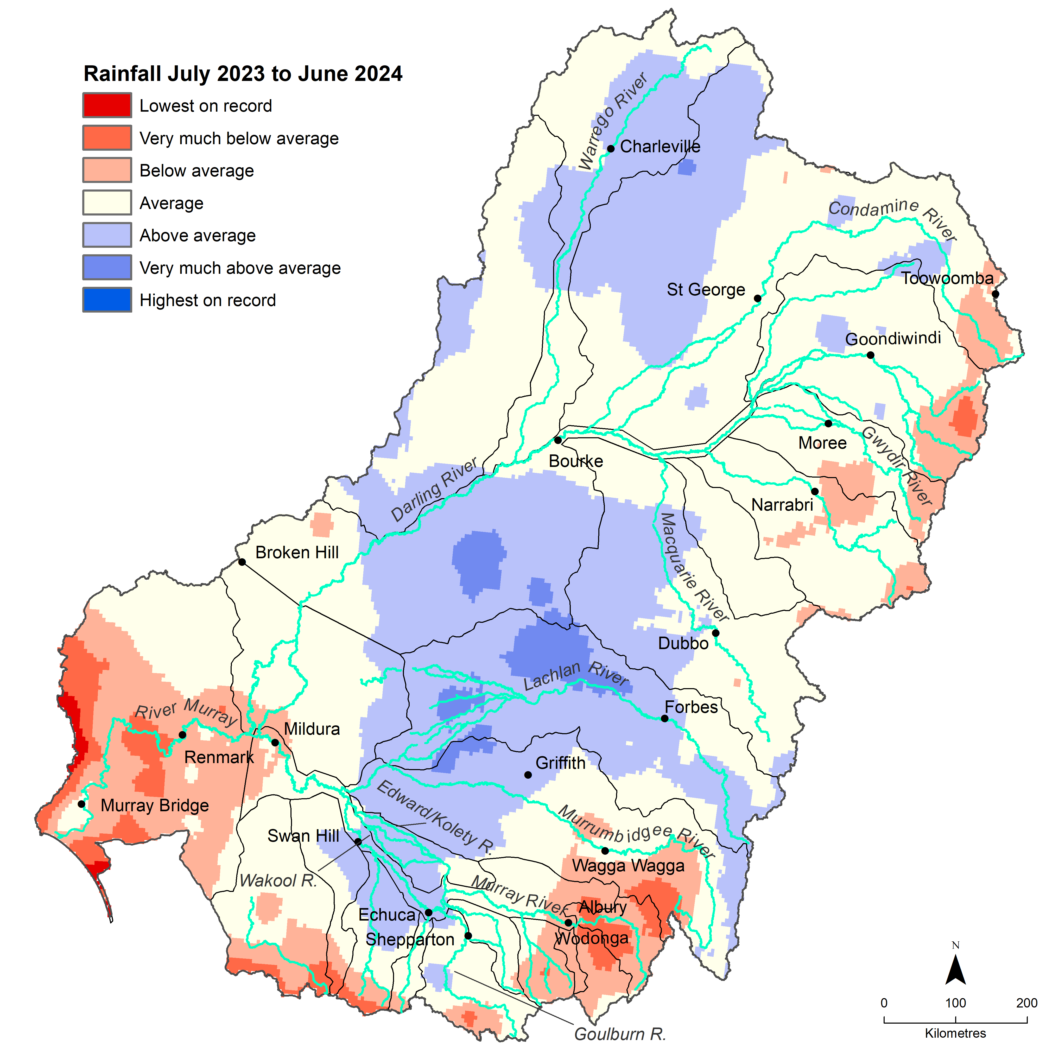
Figure 3.2 shows the annual rainfall conditions in the Basin for each water year 2014–24. The first 2 years were particularly dry in the southern Basin. In 2016–17, wetter conditions prevailed in the southern Basin and along the headwaters of the New South Wales tributaries in the northern Basin. Conditions returned to dry over the period 2017–20 across the whole Basin. In 2020–24, conditions were again wetter – ‘average’, ‘above average’ and ‘very much above average’ conditions were experienced across the Basin. The conditions in 2023–24 were similar to 2020–21, when most areas experienced average rainfall, and central New South Wales and parts of the northern Basin experienced above-average rainfall. During this time, the Victorian valley heads and the valley heads in the northern Basin experienced below-average rainfall, as did the Lower Murray, where the rainfall was below average or very much below average.
Figure 3.2 Maps of annual rainfall conditions, 2014–24
The 2023–24 map is shown in detail in Figure 3.1. Data sourced from the Bureau of Meteorology. The decile rankings (lowest on record to highest on record) are those used by the Bureau. For information on how the deciles are derived, see the Bureau’s Deciles webpage.
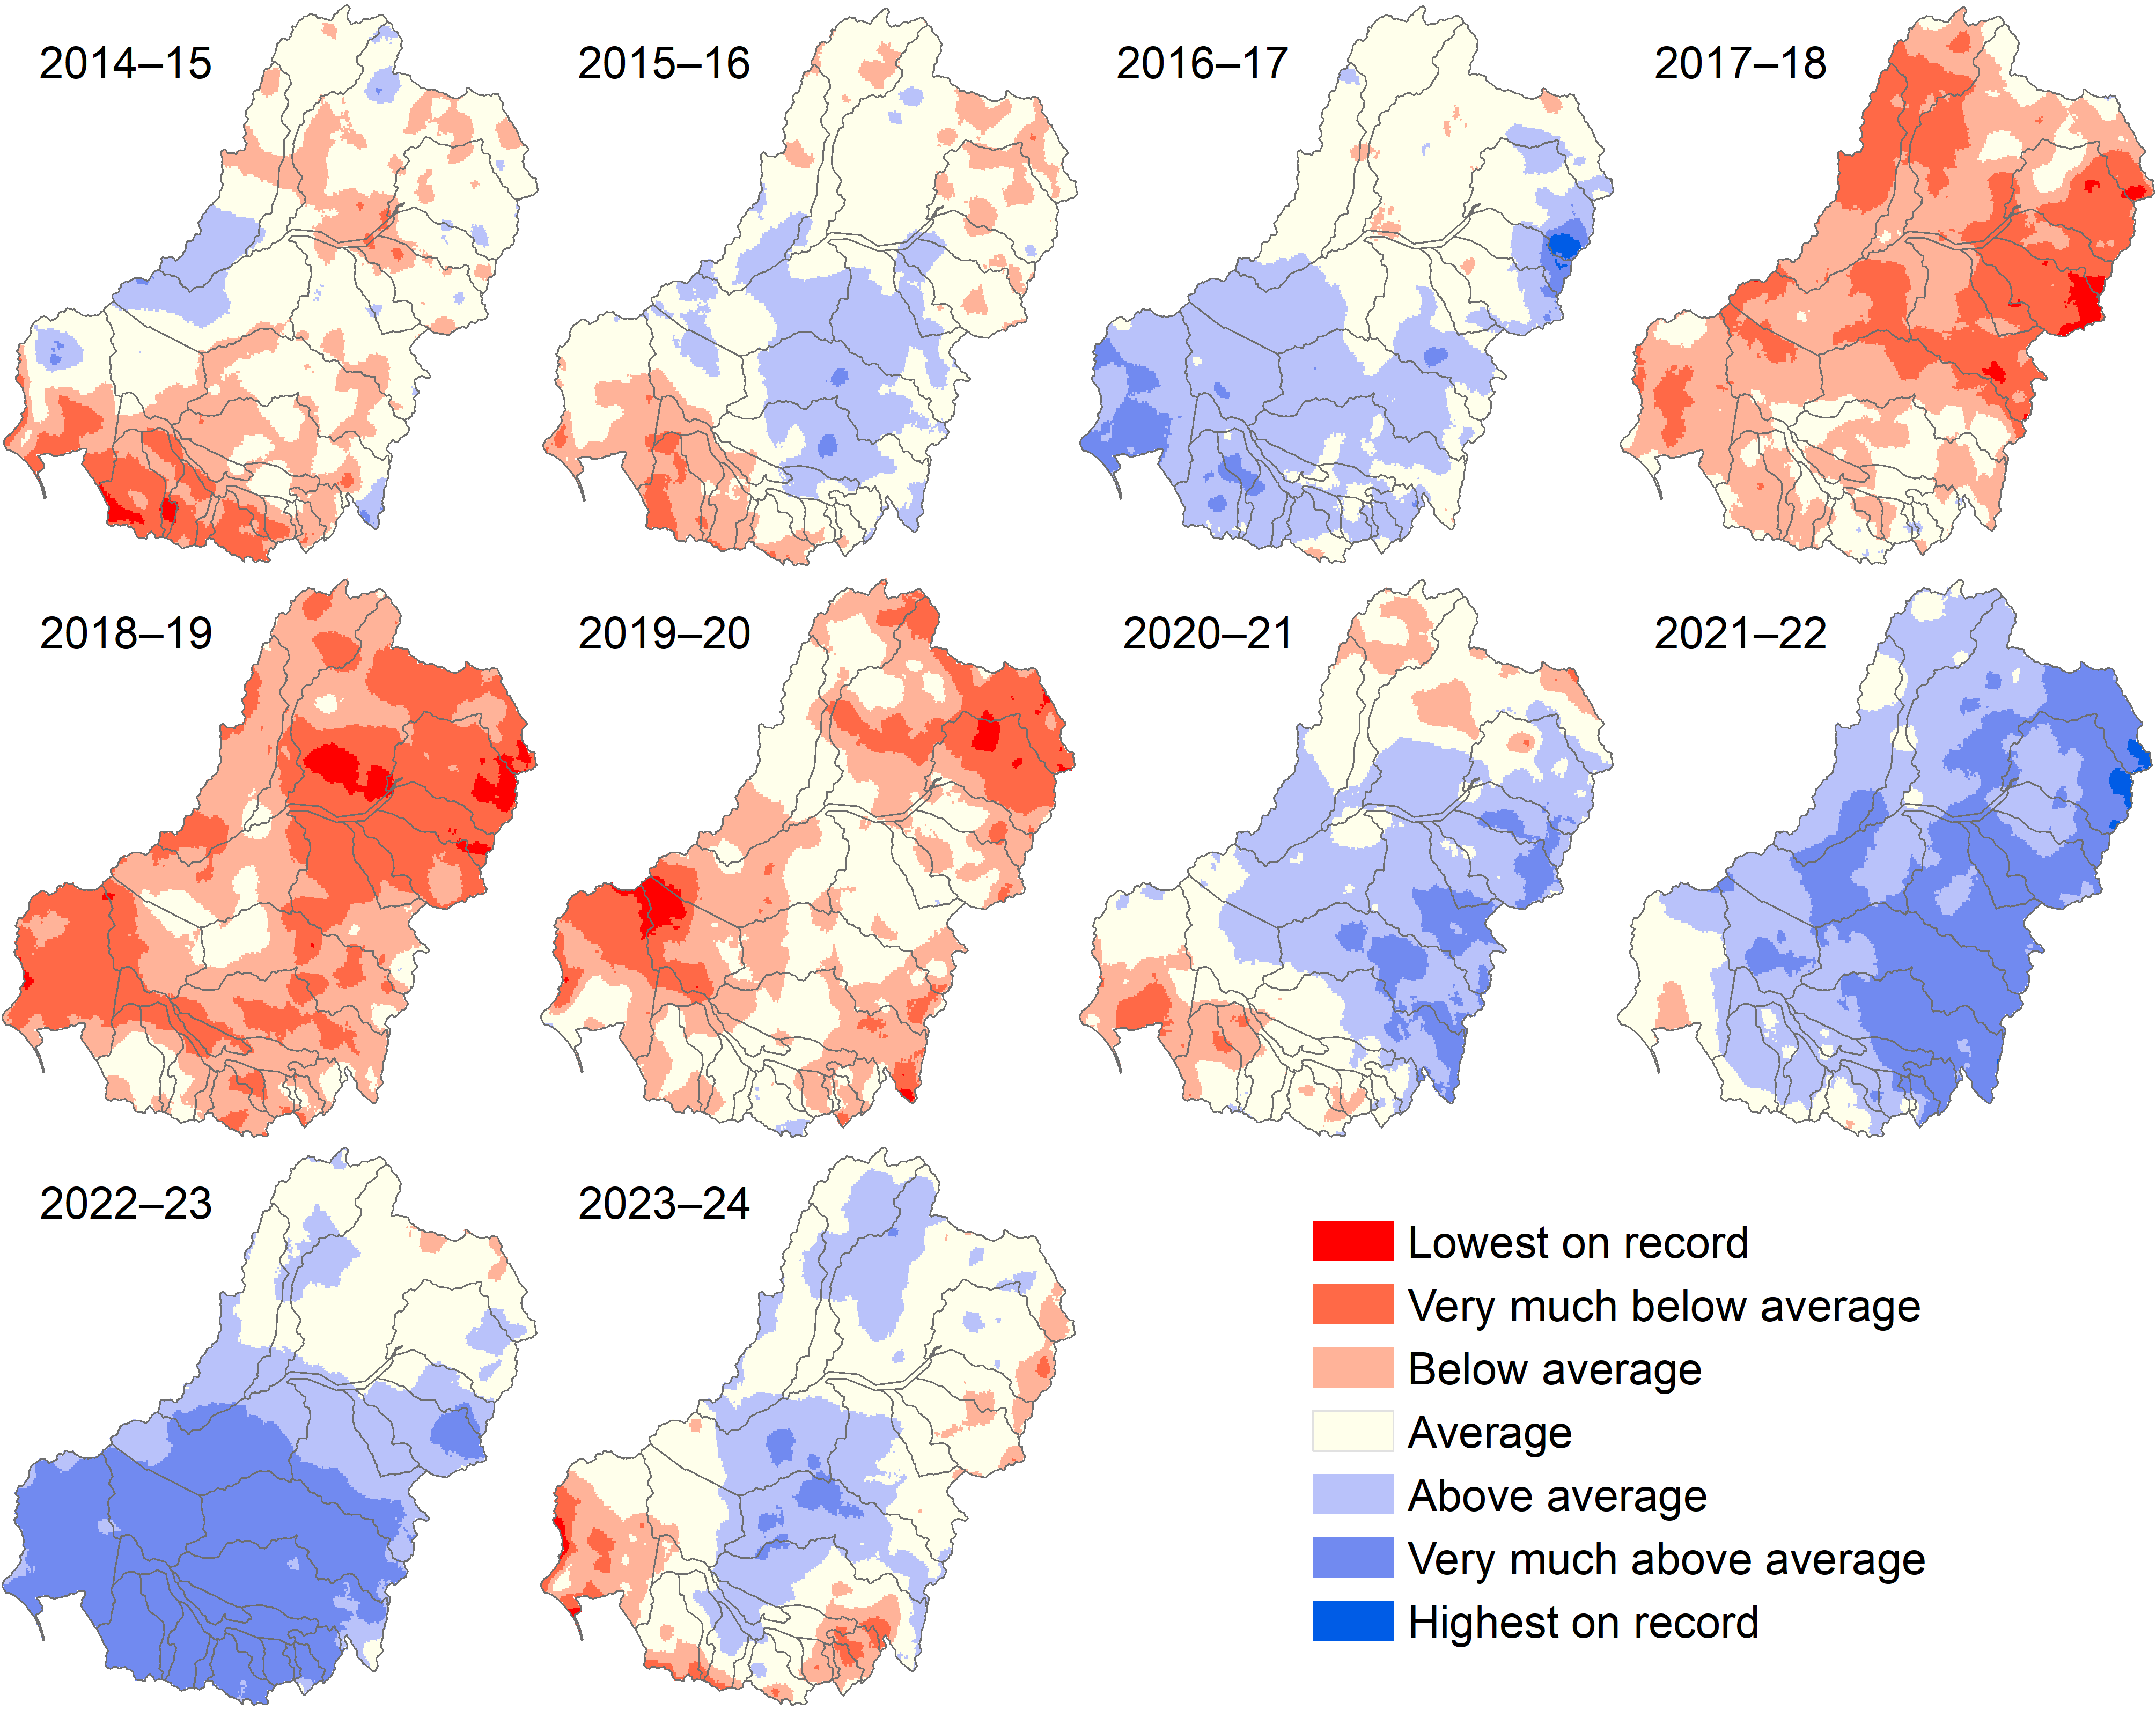

Inflows to the system
The Murray–Darling Basin Authority (MDBA) reports the River Murray System inflows as 8,715 GL during the 2023–24 water year (MDBA 2025). This number does not include releases from Snowy Hydro, Inter-Valley Trade deliveries, managed environmental deliveries from tributaries, and inflows to the Menindee Lakes. A series of significant rain events impacted the daily inflows in the system, e.g. 25,000 ML/day to Dartmouth Reservoir and 27,000 ML/day to Hume. Inflows from the Murrumbidgee, measured at Balranald, totalled 1,514 GL, and flow peaked at around 9,540 ML/day in late August following rainfall across the upper Murrumbidgee. Menindee Lakes recorded an inflow of 588 GL at the Darling River gauge upstream. At this gauge, receding flows were observed at the start of the water year, which continued to drop until around December, when small peaks resulted from flows in the upper catchment.

Surface water runoff
Total runoff in the Basin in 2023–24 was 22,509 GL, smaller than the 10-year average of ~36,500 GL and the 24-year average of ~31,700 GL (Figure 3.3, top). As indicated in Section 3.1.1, much of the central Basin experienced ‘above average’ rainfall conditions and most of the rest of the Basin experienced ‘average’ conditions. The rainfall conditions in 2023–24 resulted in about one third less than average surface flows across the Basin. The whole-of-Basin storages started at 94% on 5 July 2023 and remained steady during spring at 95% (21,077 GL out of 22,258 GL total storage across the Basin (MDBA 2025). However, during summer, autumn and winter, the storage level fell from over 87% to a low of 77% in winter (19 June 2024), indicating that most of the available water flowed into the Basin in the first half of the water year.
Figure 3.3 Annual total surface water runoff in the Basin, by year 2000–24
Top chart shows total runoff in the Basin, middle chart shows northern Basin total runoff, bottom chart shows southern Basin total runoff. All charts include 24-year and 10-year averages. Data sourced from latest CSIRO modelling (method reference Chiew et al. 2018, Zheng et al. 2024).
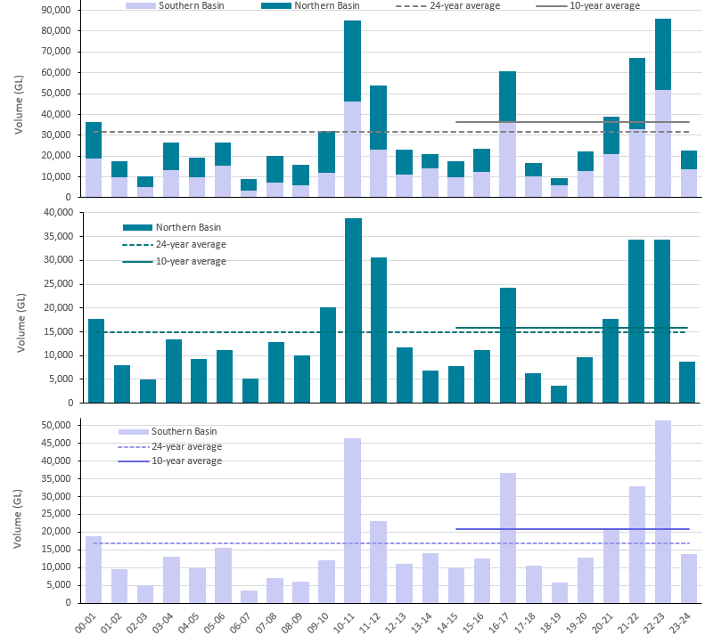
Figure 3.4 Maps of annual total surface water runoff (GL/year) in the Basin by river valley and year, 2014–24
The colours indicate total volume of runoff predicted for each year. Lighter colours indicate lower runoff volumes. Data sourced from latest CSIRO modelling (method reference Chiew et al. 2022).
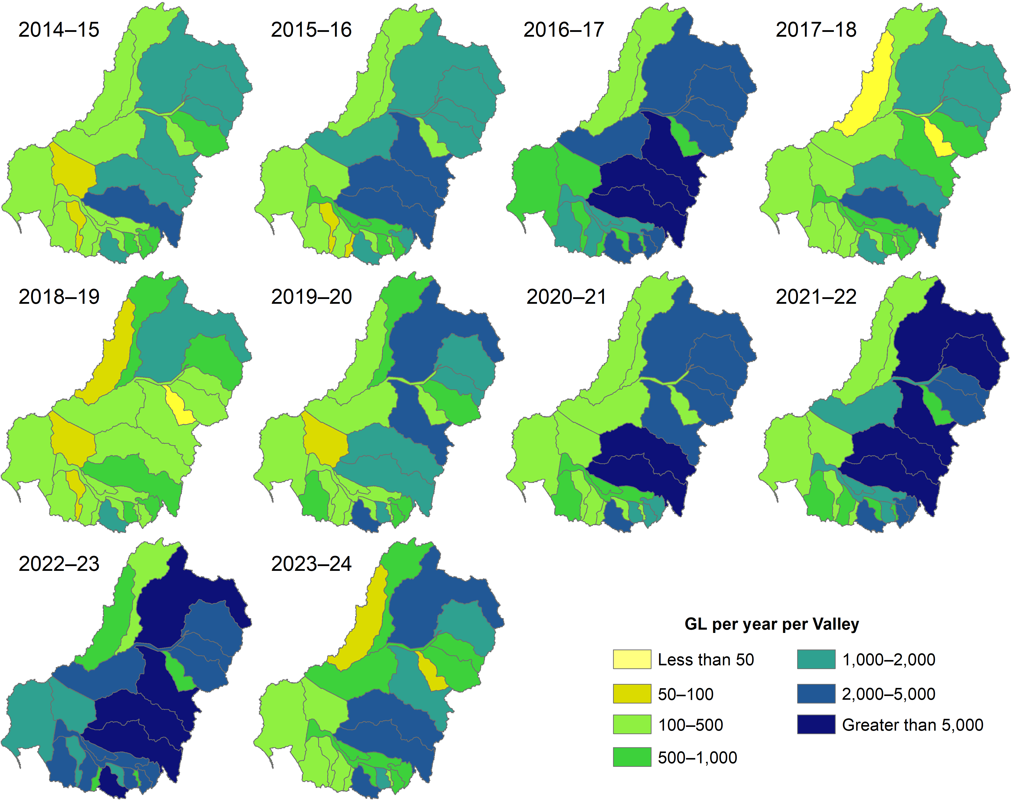
In the northern Basin, flows were below the 10-year and 24-year averages – total runoff for 2023–24 was 8,786 GL. In contrast to the high surface water runoff volume in the last 2 years, the volume in water year 2023–24 was more consistent with surface water runoff in the early 2000s. All valleys in the northern Basin, except Paroo and Castlereagh, had at least 500 GL surface water runoff. The Condamine Balonne had a maximum of 2,598 GL (Figure 3.4). Nearly all valleys in the southern Basin experienced high surface water runoff (Figure 3.4) – the Lachlan, Murrumbidgee and Goulburn experienced over 2,000 GL (2,607 GL, 2,290 GL and 2,665 GL, respectively).

Commonwealth environmental water delivery

Water year 2023–24
In the 2023–24 water year, 2,870 GL of CEW was debited from the CEWH environmental water holdings in 114 watering actions to water key assets in each river system (Table 3.2). Volumes delivered to each valley are summarised in Table 3.3and the number of watering actions and volumes are listed in Table 3.2. The environmental watering actions are categorised as 88 actions for instream flow components. Of the remaining actions, 21 were delivered to support wetlands and 5 actions were a combination of instream and wetland.

Table 3.2 Commonwealth environmental watering actions by valley and hydrological flow component, 2023–24
The flow component terms (base flow, fresh, bankfull, overbank, wetland) are those used by CEWH staff when describing the watering actions (CEWH 2024). Cell values are number of actions, and values in parentheses are volumes in megalitres (ML). Dash (–) indicates that that flow component was not targeted in that valley.
* Lower Murray freshes: The listed freshes are weir pool manipulation actions. They are technically classed as fresh actions even though they do not actively use environmental water.
Valley | Base flow | Base flow, fresh | Base flow, fresh, bankfull | Fresh | Fresh, base flow | Fresh, overbank | Fresh, wetland | Overbank | Wetland, fresh | Wetland | Total number of actions  (volume, ML)
Northern Basin
Barwon Darling | – | 4 (63,385) | – | – | – | – | – | – | – | – | 4 (63,385)
Border Rivers | – | 3 (1,437) | 1 (5,671) | 9 (4,953) | – | – | – | – | – | – | 13 (12,061)
Condamine Balonne | – | – | – | 1 (1,328) | – | 1 (71,299) | – | – | – | – | 2 (72,627)
Gwydir | – | – | – | 2 (4,500) | – | – | – | – | – | 2 (10,539) | 4 (15,039)
Macquarie | – | – | – | 1 (3,833) | – | – | – | – | 1 (56,046) | – | 2 (59,879)
Namoi | 1 (900) | – | – | 1 (8,379) | – | – | – | – | – | – | 2 (9,279)
Warrego | – | – | 2 (14,456) | – | – | – | – | 1 (8,370) | – | – | 3 (22,826)
Southern Basin
Broken | 8 (57,044) | – | – | 2 (6,788) | – | – | – | – | – | – | 10 (63,832)
Campaspe | 4 (2,210) | – | – | 3 (2,368) | – | – | – | – | – | – | 7 (4,578)
Central Murray | 3 (23,437) | – | – | 3 (310,761) | – | – | – | – | – | – | 6 (334,198)
Edward/Kolety–Wakool | 6 (12,798) | 4 (85,479) | – | – | 2 (59,881) | – | – | – | – | 3 (843) | 15 (159,001)
Goulburn | 3 (146,441) | – | – | 3 (116,560) | – | – | – | – | – | – | 6 (263,001)
Lachlan | 1 (1,213) | – | – | 1 (110) | – | – | 1 (22,059) | – | – | 1 (3,646) | 4 (27,028)
Loddon | 2 (732) | – | – | 1 (3,030) | – | – | – | – | – | – | 3 (3,762)
Lower Darling/Baaka | 2 (110,834) | – | – | – | – | – | – | – | – | – | 2 (110,834)
Lower Murray | 2 (769,382) | 3 (614,959) | – | *4 (0) | – | – | – | – | – | 10 (1,852) | 19 (1,386,193)
Murrumbidgee | – | – | – | 1 (3,759) | 1 (203,235) | – | 1 (4,646) | – | – | 5 (48,100) | 8 (259,740)
Ovens | 1 (50) | – | – | 1 (73) | – | – | – | – | – | – | 2 (123)
Wimmera | 1 (1,291) | 1 (1,471) | – | – | – | – | – | – | – | – | 2 (2762)
Total | 34 (1,126,332) | 15 (766,730) | 3 (20,127) | 33 (466,441) | 3 (263,116) | 1 (71,299) | 2 (26,705) | 1 (8,370) | 1 (56,046) | 21 (64,981) | 114 (2,870,147)

Northern Basin valleys received 255 GL of CEW. Similar to past years, the Condamine Balonne received the largest volume (71 GL, 28.5% of the northern Basin total, Table 3.3) through one large action and one small action targeted as a combination of overbank and fresh flows. The Barwon Darling, Border Rivers, Gwydir, Macquarie and Warrego valleys all received water for the environment via licences held in their respective valleys. These actions were primarily focused on supporting fresh flows except for the Barwon Darling and the Warrego where the water was used to support base flow. The southern Basin received the bulk of the 2023–24 CEW (2,615 GL) – there were large deliveries to the Central Murray, Lower Murray and Murrumbidgee valleys.
Table 3.3 Summary of volume of Commonwealth environmental watering actions as a percentage of total delivery and as a percentage of the volume delivered to northern Basin and southern Basin valleys, 2023–24
Valley | Volume of total delivery (%) | Volume of northern or southern Basin (%)
Northern Basin | 8.9%
Barwon Darling | 2.2% | 24.8%
Border Rivers | 0.4% | 4.7%
Condamine Balonne | 2.5% | 28.5%
Gwydir | 0.5% | 5.9%
Macquarie | 2.1% | 23.5%
Namoi | 0.3% | 3.6%
Warrego | 0.8% | 8.9%
Southern Basin | 91.1%
Broken | 2.2% | 2.4%
Campaspe | 0.2% | 0.2%
Central Murray | 11.6% | 12.8%
Edward/Kolety–Wakool | 5.5% | 6.1%
Goulburn | 9.2% | 10.1%
Lachlan | 0.9% | 1.0%
Loddon | 0.1% | 0.1%
Lower Darling/Baaka | 3.9% | 4.2%
Lower Murray | 48.3% | 53.0%
Murrumbidgee | 9.0% | 9.9%
Ovens | 0.0% | 0.0%
Wimmera | 0.1% | 0.1%
Details of the wetlands targeted for watering in each river system in 2023–24, together with the gauges used for evaluations are given in Table 3.4.
Table 3.4 Commonwealth environmental watering actions targeting wetlands, 2023–24
As sourced from the Commonwealth Environmental Water Holder’s Valley Acquittal reports (2024). LTWP = Long-term watering plan. CEW = Commonwealth environmental water.
River system | Surface water assets | Evaluation points (gauges) and comments
Barwon Darling | River system and fringing (low-lying) wetlands (Mungindi to Menindee) | Mungindi, Menindee (no data at Menindee) gauge at Bourke used instead
Moonie | Lower Moonie River and fringing wetlands | No LTWP thresholds in the Moonie system, evaluated as part of the Border Rivers
Border | Dumaresq–Macintyre River and fringing wetlands (Weir River Junction to Mungindi Weir), Dumaresq-Macintyre River and fringing wetlands, Macintyre Brook and fringing wetlands | Macintyre at Goondiwindi, no water delivered in the Dumaresq system in 2023–24
Broken | Lower Broken Creek, Broken River, Upper Broken Creek, Moodie Swamp | Broken at Casey Weir (evaluation for Lower Broken system), no LTWP thresholds for the Upper Broken system
Campaspe | Campaspe River | Campaspe at Rochester
Gunbower Creek | Gunbower Creek | No LTWP thresholds, evaluated as part of the Central Murray system
Murray | River Murray Channel, Creeks, Anabranches and Wetlands of Barmah and Millewa Forests / Low lying Barmah–Millewa Forest Floodplain, Murray Weir Pools (Lock 7, Lock 8, Lock 9 lowering) | Evaluation gauge for River Murray: River Murray at Wentworth (Lock 10), Evaluation gauge for the Barmah-Millewa Forest: River Murray at Yarrawonga Weir
Condamine Balonne | Lower Balonne Floodplain System including Narran Lakes, Nebine Creek | no LTWP thresholds at relevant gauges, Balonne River at St. George used as the evaluation gauge
Edward/Kolety–Wakool | Armstrong Creek, Billabong Creek, Buccaneit–Cunningyeuk Creeks, Cockran and Jimaringle Creek System, Colligen Creek – Niemur River, Coonamibidgal Creek, Edward River downstream of Stevens Weir, Murrain–Yarrien Creek, Niemur River, Noorong Creek, Thule Creek, Tuppal Creek, Wakool River, Yallakool–Wakool | Evaluation gauge for the system: Wakool River at Wakool Offtake (only gauge with LTWP thresholds, CEW information and modelled pre-development flows)
Goulburn | Reaches 1, 4, 5 | Goulburn River at McCoy's Bridge, Goulburn River at Eildon
Gwydir | Gwydir River, Mallowa Creek and Wetlands, Carole/Gil Gil Creek, Gingham and Lower Gwydir Wetlands | Evaluation gauge for Gwydir River: Gwydir River at Gravesend, Evaluation gauge for Carole Creek: Carole Creek downstream of Regulator
Lachlan | Jemalong Weir Murray Cod Breeding Flow, Lake Brewster Pelican Colony Support, Booberoi Creek Bulk Transfer Fresh, System-scale Autumn Fresh | Evaluation gauge for Lachlan River system: Lachlan River at Booligal
Lower Darling/Baaka | Great Darling Anabranch | No LTWP thresholds
Loddon | Reach 4 | Loddon River at Appin South
Lower Murray | Weir Pools and Wetlands Weirpool 6 Lowering, Lower Murray Wetlands (Murraylands and Riverland Landscapes Board), Renmark Irrigation Trust: Nelwart Street, Twenty-sixth Street, Warrego Street | Evaluation gauge for Lower Murray system: Calculated Flows to SA, irrigated wetlands use pumped water so no streamflow gauge indicates inundation
Murrumbidgee | Gayini Nimmie – Caira Wetlands, Fish Flows – Nesting, Dispersal and Movement, Yanco Creek Fish Flows – Nesting and Dispersal, Murrumbidgee Irrigation Area Wetlands and Creek, Toogimbie Indigenous Protected Area to Fiddlers Pumping, Western Lakes Complex Top-Up, Yanco Creek System Fresh and Wetland Connection, Sandy Creek Pumping | Evaluation gauge for the Lower Murrumbidgee wetland system: Murrumbidgee River at Maude Weir; Data missing to evaluate other assets (Yanco Creek and Upper Murrumbidgee)
Mid-Macquarie | Macquarie River System, Macquarie Marshes | Evaluation gauge for the Macquarie River at downstream Marebone
Namoi | Lower Namoi River | Evaluation gauge for the Lower Namoi River: Namoi River at Goangra
Peel | Peel River | Evaluation gauge for the Peel River system: Peel River at Piallamore
Ovens | Delivered via King River System Downstream of Lake William Hovell, delivered via Lake Buffalo | No LTWP thresholds in the Ovens system
Wimmera | Wimmera River, Mount William Creek | No data for the Wimmera River, Evaluation gauge for Mount William Creek: Mount William Creek at Lake Lonsdale
Warrego | Upper Warrego River and fringing wetlands, Lower Warrego River and fringing wetlands, Toorale Western Floodplain (NSW Intersecting Streams) | Evaluation gauges for the Upper and Lower Warrego River system: Warrego River at Cunnamulla and Warrego River at Augathella.

Water years 2014–24
Over the 10 years 2014–24, a total of 1,194 independent CEW actions were delivered for a wide range of hydrological and ecological purposes, accounting for 18,310 GL of water (Figure 3.5). Instream actions (base flow, freshes and bankfull) delivered larger volumes than wetland actions (Figure 3.5). By number of actions, wetland actions were typically predominant, accounting for 46% of the actions over the years, except for water years 2016–17 and 2023–24, when the majority of actions comprised freshes and base flows, respectively (Figure 3.6). The 2023–24 water year had the highest allocation in the volumes of CEW delivered compared with recent years (supporting data available in Table A.3).
Figure 3.5 Commonwealth environmental water portfolio showing volume of watering actions by flow component and year, 2014–24
Volumes per component are displayed above each bar. Annual volumes are displayed inside boxes at the bottom of the figure.
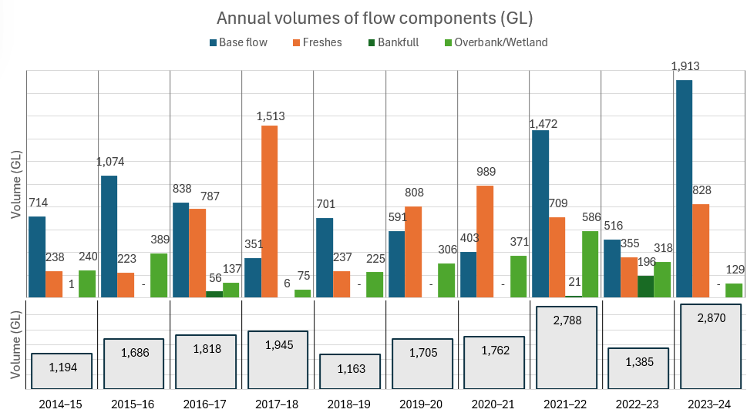
Figure 3.6 Commonwealth environmental water portfolio showing the number of watering actions and the proportion of flow components each year, by flow component and year, 2014–24
The number of watering actions is displayed inside each component of the stacked bar. The total number of watering actions per year is displayed in boxes at the right-hand side of the figure,
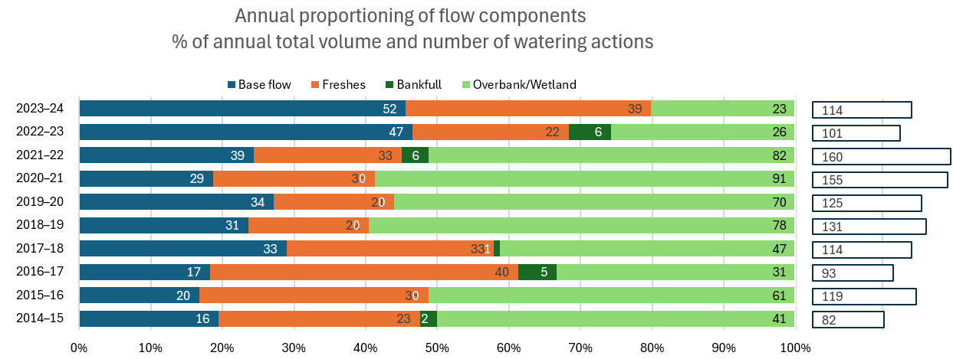
The southern Basin valleys typically receive most of the CEW by volume as well as by the number of watering actions Figure 3.7. For the water year 2023–24, 91% by volume and 74% by number of actions of CEW was delivered in the southern Basin. Among the southern Basin valleys, the Lower Murray Valley received the largest deliveries (7,339 GL) through 421 watering actions. The Murrumbidgee, Central Murray, and Goulburn valleys together also received a large portion of the CEW portfolio. The Namoi Valley had the lowest number of actions (9 actions over the 10 years), and the Ovens Valley received the lowest volume of water at 1,071 GL over the 10 years.
In the northern Basin valleys, the Condamine Balonne Valley received the highest volume of environmental flows over the 10 years, mainly through one massive fresh/overbank action (Figure 3.7).

Figure 3.7 Volume of Commonwealth environmental water (left set of plots) and number of watering actions (right-set of plots), by valley and year, 2014–24
Data source: CEWH (2025)
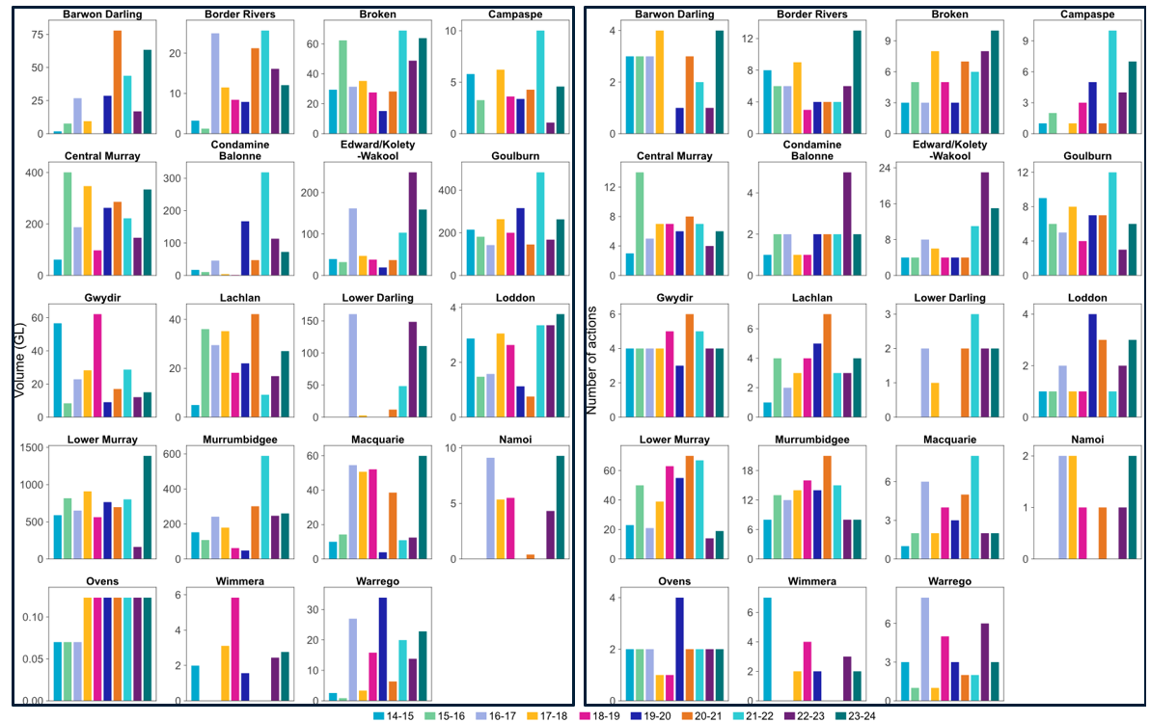

Timing of Commonwealth environmental water delivery

Water year 2023–24
In the northern Basin, 255 GL of CEW was delivered in 2 distinct pulses: summer (53% of release) and winter (22% of release). The spring and autumn releases were smaller at 10% and 15%, respectively (Table 3.5). The largest pulse started in February in the Condamine Balonne Valley, where 71 GL were delivered to the Narran Lakes system. The average duration of an action exceeded the 3-month season in winter (3.6 months) and was shortest in autumn (0.5 months).
In the southern Basin, 2,615 GL of CEW was delivered. It was delivered with a peak in spring (58% of releases); releases in autumn, summer and winter were 12%, 21% and 9%, respectively. The average duration of spring and winter actions exceeded the 3-month season (4 months average action duration), where, as in the northern Basin, the average duration of the autumn action was shortest (1.6 months on average).
Table 3.5 Seasonality of Commonwealth environmental water releases, 2023–24
Metric | Sub-basin | Autumn | Spring | Summer | Winter
CEW release fraction (% of total water released) | Northern | 15% | 10% | 53% | 22%
CEW release fraction (% of total water released) | Southern | 12% | 58% | 21% | 9%
Average action duration (months) | Northern | 0.5 | 2.1 | 1.3 | 3.6
Average action duration (months) | Southern | 1.6 | 4.0 | 2.5 | 4.0
Number of actions in 2023–24 | Northern | 5 | 8 | 16 | 1
Number of actions in 2023–24 | Southern | 32 | 25 | 20 | 7

Water years 2014–24
Across the 10 years, CEW was generally delivered with a similar seasonal pattern. In general, over the 10-year monitoring period, most CEW in the southern Basin was released in spring and summer pulses, even in the drier years (water years 2017–20) (Figure 3.2).
In the northern Basin, releases were spread across the whole water year. Large releases were prevalent in a winter–spring pulse until the water year 2016–17, after which releases were more prevalent in an autumn pulse. Similarly to the southern Basin, during the dry years in the monitoring period in the northern Basin, the releases were spread across all seasons in the respective water years (Guarino and Sengupta 2023).

Evaluation against Basin Plan environmental objectives
In this chapter, we evaluate the contribution of Commonwealth environmental water (CEW) towards flow regimes and inundation at the Basin scale.
The Basin Plan is the overarching guide for this evaluation; however, evaluation against specific numerical objectives is against the Basin-wide environmental watering strategy (the Strategy, MDBA 2019) (see Chapter 5). We measure progress towards the Basin Plan objectives for water-dependent ecosystems using the targets in Schedule 7, with regard to the following:
- ecologically relevant targets set out in the LTWPs
- climatic conditions
- the Strategy.
From a hydrological perspective, and from 1 July 2019, these include improvements in:
- flow regimes, which include relevant flow components (base flows, freshes, bankfull, overbank) set out in paragraph 8.51(1)(b), with improvements measured by progress towards natural flow regime, having regard to the Strategy (MDBA 2019)
- hydrologic connectivity between the river and floodplain and between hydrologically connected valleys
- condition of the Coorong and Lower Lakes ecosystems and Murray Mouth opening regime.
To evaluate improvement, we:
- compared and analysed the contribution of CEW to key flow components, contrasted against modelling of pre-development flow regime as a proxy for the natural flow regime
- estimated the frequency of inundation at key wetlands over the 10 years and the total area inundated as a measure for lateral connectivity (inundated area validation described in Table A.1)
- evaluated increases in end-of-valley flows for the evaluation water year and the frequency of inundation of watercourses, comparing the actual flow against the counterfactual flow scenario.
Two limitations on the analysis were data availability and method applicability. For many gauging sites across the Basin, there is either no appropriate LTWP threshold for all relevant flow components or no daily CEW information. Where inferences about LTWP thresholds were possible, thresholds were adapted from the compliance point closest to a gauging site with daily CEW information. In future years of the program, the gaps in data alignment will be addressed in the evaluation approach.

Flow regime
In previous years, the Hydrology evaluation report outlined overall statistics for each flow component, but this did not adequately demonstrate the contribution of CEW to the hydrograph. In this report, the approach is to show the contribution of CEW explicitly for each valley at key evaluation points associated with environmental assets within the Basin. These locations are shown in Figure 4.1.
Figure 4.1 Map showing location of the gauge sites used for evaluation, and the waterways and floodplain/wetland areas that received CEW in 2023–24
Each evaluation site (gauge) is aligned with an asset that was watered using Commonwealth environmental water (CEW). All gauges are listed in Table A.2 which is available from the Flow-MER data portal (metadata statement) and the evaluation gauges are listed in Table A.6. The grey shaded areas in the map identify those valleys where the Commonwealth holds water entitlements and are in scope for evaluation.
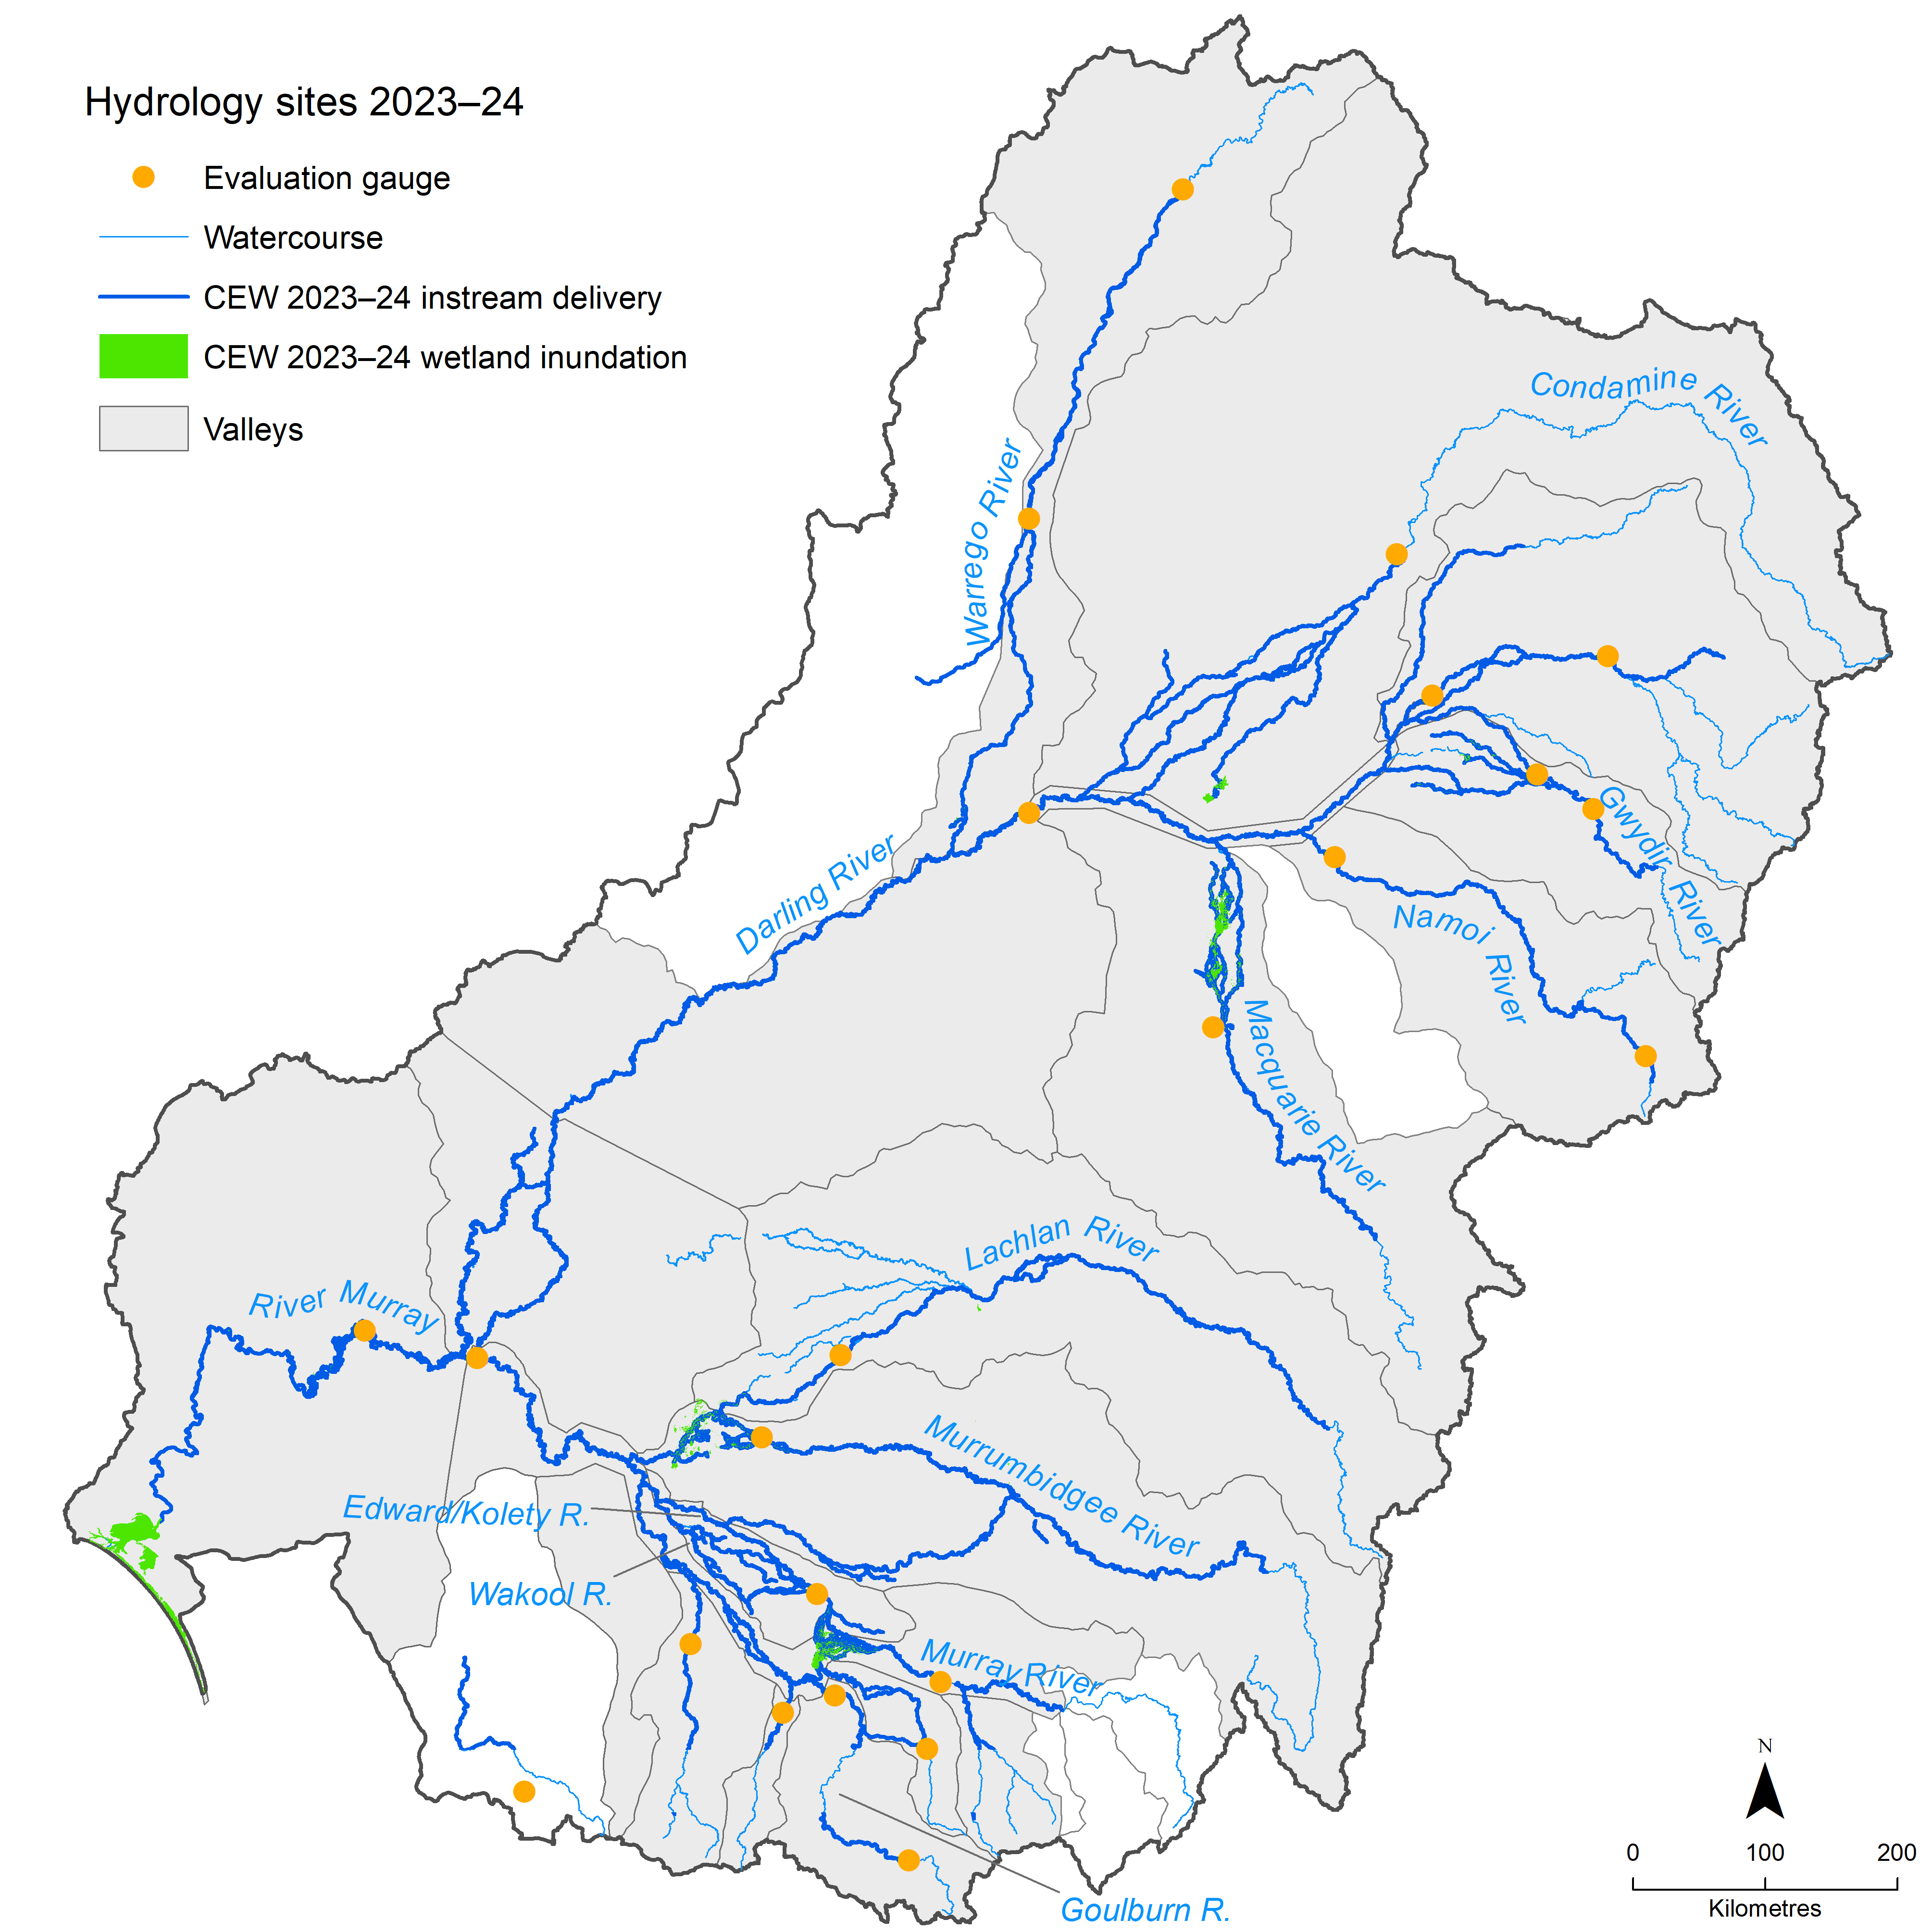
Using these 23 evaluation locations (Figure 4.1 and Table A.2), hydrographs relevant to each valley were prepared and discussed in the following sections. These hydrographs contain representations of the natural flow regime in the valleys where the Commonwealth holds entitlements (the shaded areas in Figure 4.1) as derived from runs of the Sustainable Rivers Audit model that simulate pre-development flow ranges for both the 10th to 90th percentile (Q10–Q90) and the 1st to 99th percentile (Q1–Q99) ranges and including the median pre-development flow (Q50). The pre-development flows were scaled to the mean discharge of water year 2023–24 to make the flows comparable to the prevailing conditions in the evaluation year.
Adding the pre-development flow allows comparison of the current flow hydrograph with the overall flow ranges at each location and provides a better understanding of how CEW contributed to different flow thresholds and moving towards a natural flow regime as required in Schedule 7 of the Basin Plan.
For lower flows, the hydrographs in the normal linear domain do not represent CEW contributions well. In these cases, the hydrographs are shown in the log domain to assist in interpretation.

Northern Basin

Balonne River – Qld
The Balonne River at St George (gauge 422201F) provides an indication of flows for environmental assets downstream in the Condamine Balonne system. While no LTWP objectives exist for the location, we have CEW information for the Balonne River at St George in Queensland. The comparative hydrograph (Figure 4.2) allows for an estimation of how CEW contributed to restoring the natural flow regime.
Figure 4.2 Hydrograph for the Balonne River at St George, Queensland gauge, 2023–24
CEW = Commonwealth environmental water; HF = high fresh. Note that the y-axis is in the log domain.
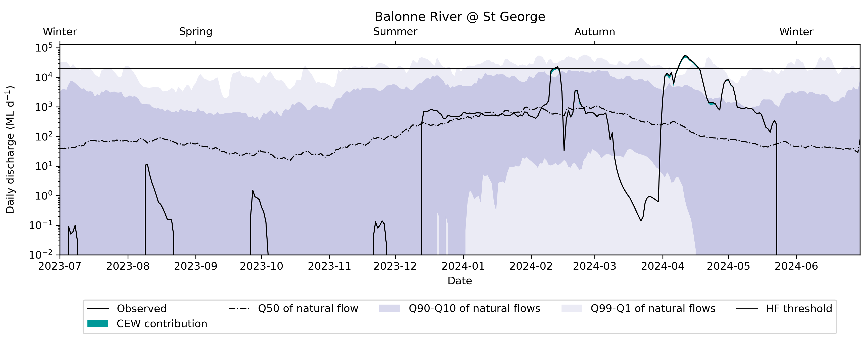
The hydrograph shows that CEW contributions were made during events in mid-February and mid-April 2024. These flows were both within the natural flow regime range (mostly within the Q10–Q90 range), but flows would have reached those levels without the CEW contribution. For the rest of the year, when no CEW was delivered, the flow regime was within the 10th to 90th percentile range of the natural flows. In summer, the flow was close to the median flow in the natural flow regime. Balonne River at St George is an indicator for the Lower Balonne floodplain system, including the Narran Lakes. Large contributions were made with CEW in 2023–24 (71 GL) to enable inundation of the Narran Lakes during the late summer/autumn pulse. The high-fresh threshold is the operational threshold for filling the Narran Lakes (20,000 ML/day at Balonne River at St George), which was enabled in February 2024 by CEW, and CEW contributed to that flow in mid-autumn.

Barwon Darling River, Queensland and New South Wales
The following hydrographs (Figure 4.3, Figure 4.4) show the key evaluation locations at Mungindi (gauge 416001) and Bourke (gauge 425003), representing water delivery to the fringing wetlands of the Barwon Darling system from the Queensland border through to upstream of Menindee.
Figure 4.3 Hydrograph for the Barwon River at Mungindi, Queensland, 2023–24
CEW = Commonwealth environmental water; VLBF = very low base flow; LBF = low base flow; LF = low fresh; HF = high fresh. Note that the y-axis is in the log domain
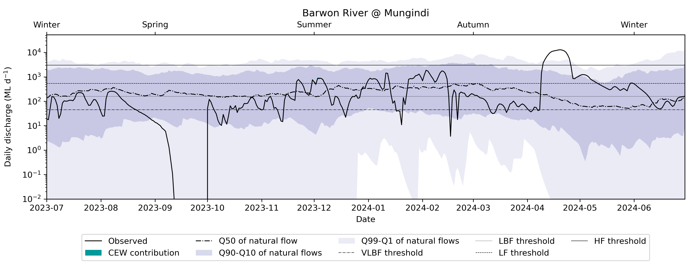
Figure 4.4 Hydrograph for the Darling River at Bourke, New South Wales, 2023–24
CEW = Commonwealth environmental water; VLBF = very low base flow; LBF = low base flow; LF = low fresh; HF = high fresh. Note that the y-axis is in the log domain
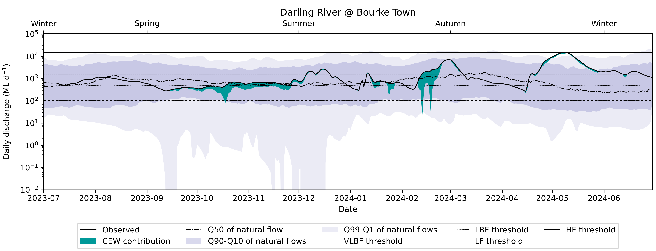
These 2 hydrographs (Figure 4.3, Figure 4.4) show the progression of flows downstream and the CEW contribution in each. From these, there is no discernible contribution at Mungindi, even though the flows are mostly above the very low base flow threshold for most of the water year. The flow signal was close to the median of the pre-development flow, indicating that the flow at Mungindi closely followed the natural flow regime. The flow in summer and autumn was above the low-fresh threshold for various instances, and one event above the high-fresh threshold was observed in late autumn, which was larger than the 99th percentile of the natural flow.
Further downstream at Bourke, the hydrograph shows that CEW contributed to increasing lower parts of the flow regime above the low base flow threshold from October to December 2023, and contributions led to an increase in the commencement of flow above the low-fresh threshold in mid-February 2024 and across the event that peaked in early March 2024. Contributions also helped to increase peak flows to near the high-fresh threshold in May 2024. The contributions of CEW helped push the flow regime towards the median of the pre-development flow, especially in spring and late summer. The late-autumn pulse of CEW elevated the flow regime above the median and made it comparable to the 99th percentile of flow. Even though the Barwon Darling did not receive fresh actions per se, the CEW contributing from other valleys (Border Rivers, Gwydir, Namoi, Macquarie), which partially makes its way into the Barwon Darling, led to fresh flows being supported by CEW in late summer.

Border Rivers, Queensland
In the Border Rivers, CEW contributions to the flow time series in the Dumaresq–Macintyre River and Macintyre Brook are represented by the hydrograph (Figure 4.5) in the Macintyre River at Goondiwindi (gauge 416201A).
Figure 4.5 Hydrograph for the Macintyre River at Goondiwindi, Queensland, 2023–24
CEW = Commonwealth environmental water; VLBF = very low base flow; LBF = low base flow; LF = low fresh; HF = high fresh. Note that the y-axis is in the log domain
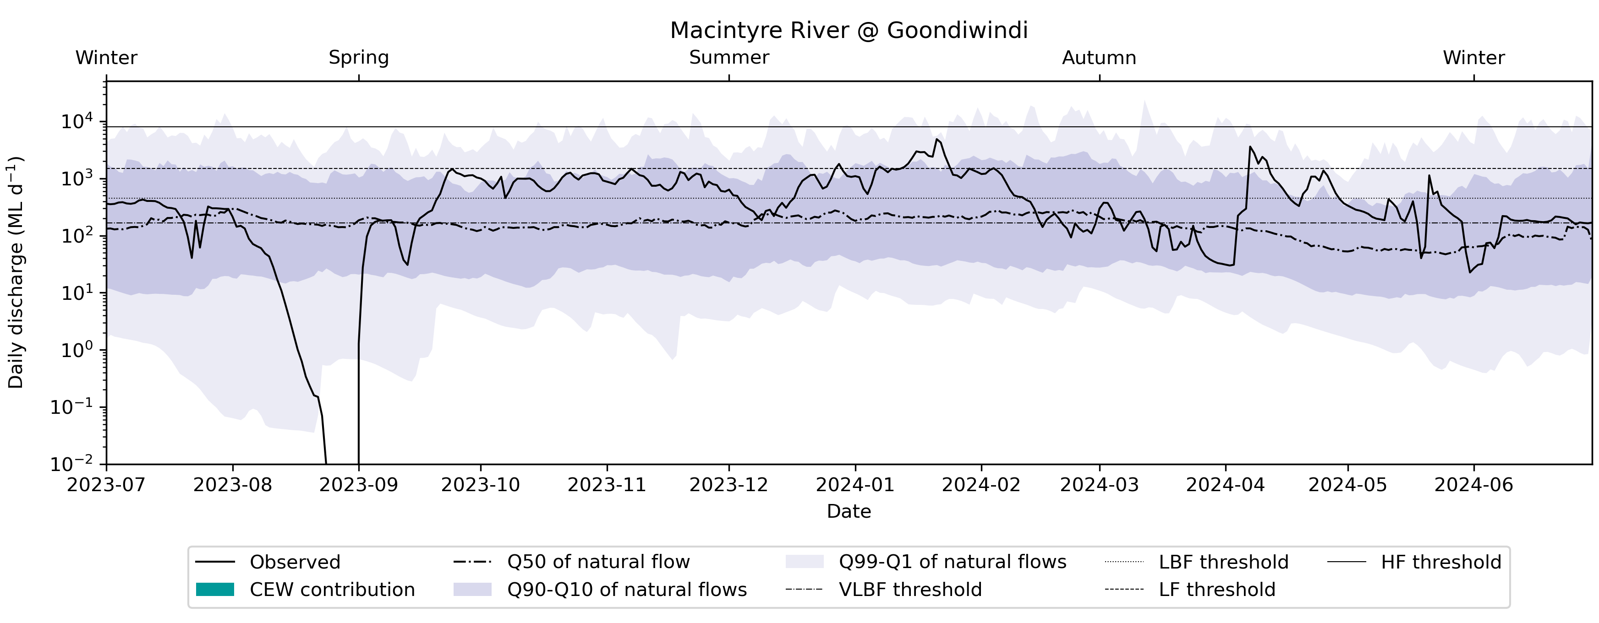
There were no CEW contributions in the Macintyre River at Goondiwindi in the 2023–24 water year – the licences were used downstream of this point. The flow regime of the Macintyre River at Goondiwindi closely followed the median of pre-development flows. There was a notable excursion at the start of spring when the flow was below the 1st percentile of pre-development flows, and most of spring and summer where the flow was close to the 90th percentile of flows as modelled in the pre-development flow. The flow reached above the very low base flow threshold for most of the water year, except for the spring excursion and some events in autumn, when the flow fell below the very low base flow threshold. In summer and autumn, 4 flow events reached above the low-fresh threshold.

Carole Creek/Gil Gil Creek, New South Wales
The evaluation point in Carole Creek (downstream of the regulator (gauge 418011)) provides an indication of flows delivered to environmental assets in Carole Creek (Figure 4.6).
Figure 4.6 Hydrograph for the Carole Creek, New South Wales, 2023–24
CEW = Commonwealth environmental water; VLBF = very low base flow. Note that the y-axis is in the log domain
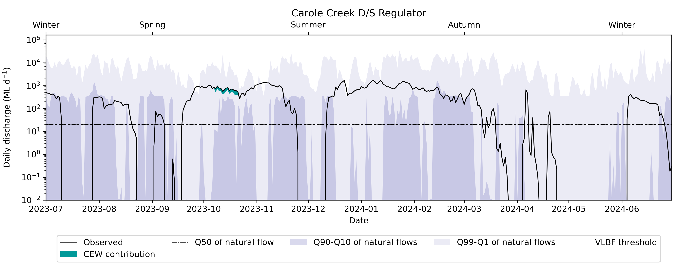
At this location, CEW contributions were made in October 2023 but did not result in a change of flow threshold exceedance. However, the hydrograph showed that the median of natural flows was smaller than the recorded flow. The recorded flow in water year 2023–24 at the gauge was closely aligned with the 90th percentile of the pre-development flows for most of the year.

Gwydir River, New South Wales
Within the Gwydir River (at Gravesend Road Bridge, gauge 418013) hydrograph (Figure 4.7), the CEW contribution was shown to assist flows moving towards or slightly above the low base flow threshold in March, April and May 2024 at this location and, as can be seen in the log domain plot, greatly assisted in moving flows to within the natural flow regime in this period. Without CEW, the flow would have been substantially below the 1st percentile of flows in the natural flow regime; however, the contributions could push the flow signal into the 10th percentile of natural flows.
Figure 4.7 Hydrograph for the Gwydir River at Gravesend Road Bridge, New South Wales gauge, 2023–24
CEW = Commonwealth environmental water; LBF = low base flow; LF = low fresh; HF = high fresh. Note that the y-axis is in the log domain
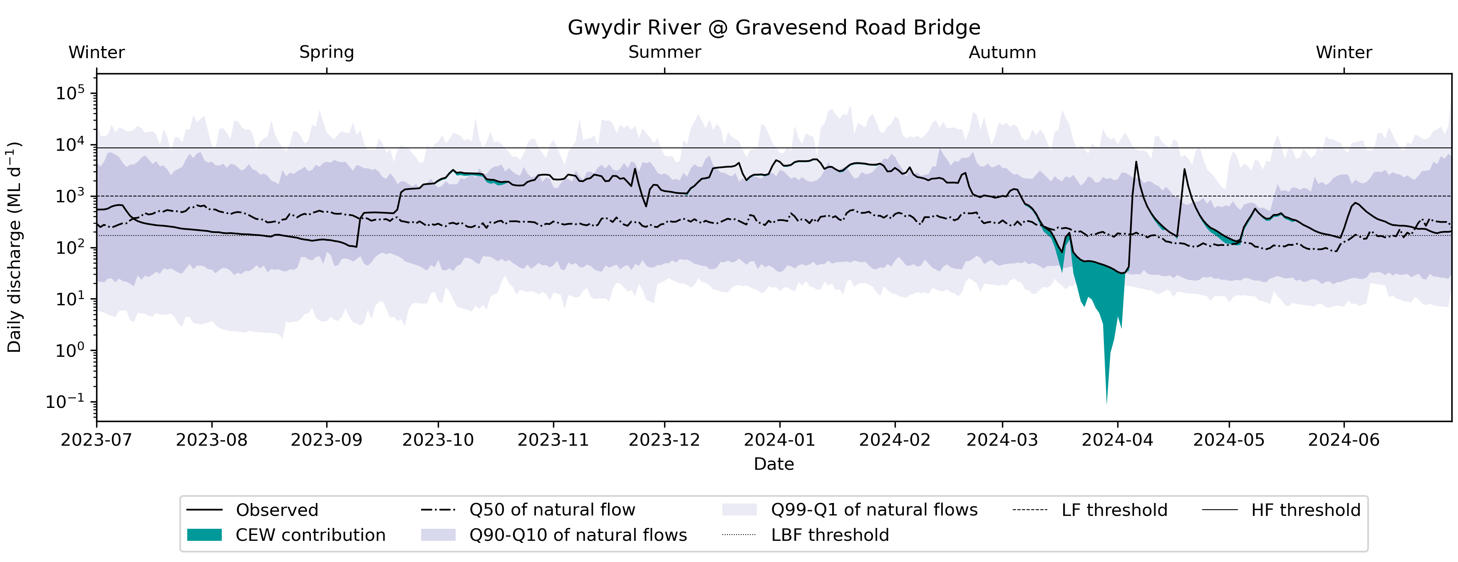

Macquarie River and Marshes, New South Wales
In the Macquarie River, CEW contributions resulted in extended periods above the high-fresh threshold, important for the inundation of the Macquarie marshes (the gauging point is directly upstream of the Macquarie Marshes and downstream of the Marebone Weir, gauge 421088) from late August through to early December 2023 (Figure 4.8). Additionally, CEW played a crucial role in contributing flows near the low fresh threshold in April (Figure 4.8). Both contributions were within the natural flow range. The spring contribution was used for the inundation of the Macquarie Marshes, and even though CEW itself did not push the flow regime above the high-fresh threshold, it was a major contributor in the mix of all environmental water delivered to facilitate the inundation of the Macquarie Marshes. The late spring contribution of CEW helped push the flow above the high flow threshold, and this water was also delivered in conjunction with other environmental water providers, indicating a successful coordination for flow delivery.
Figure 4.8 Hydrograph for the Macquarie River at Marebone Weir gauge, New South Wales, 2023–24
CEW = Commonwealth environmental water; VLBF = very low base flow; LBF = low base flow; LF = low fresh; HF = high fresh. Note that the y-axis is in the log domain
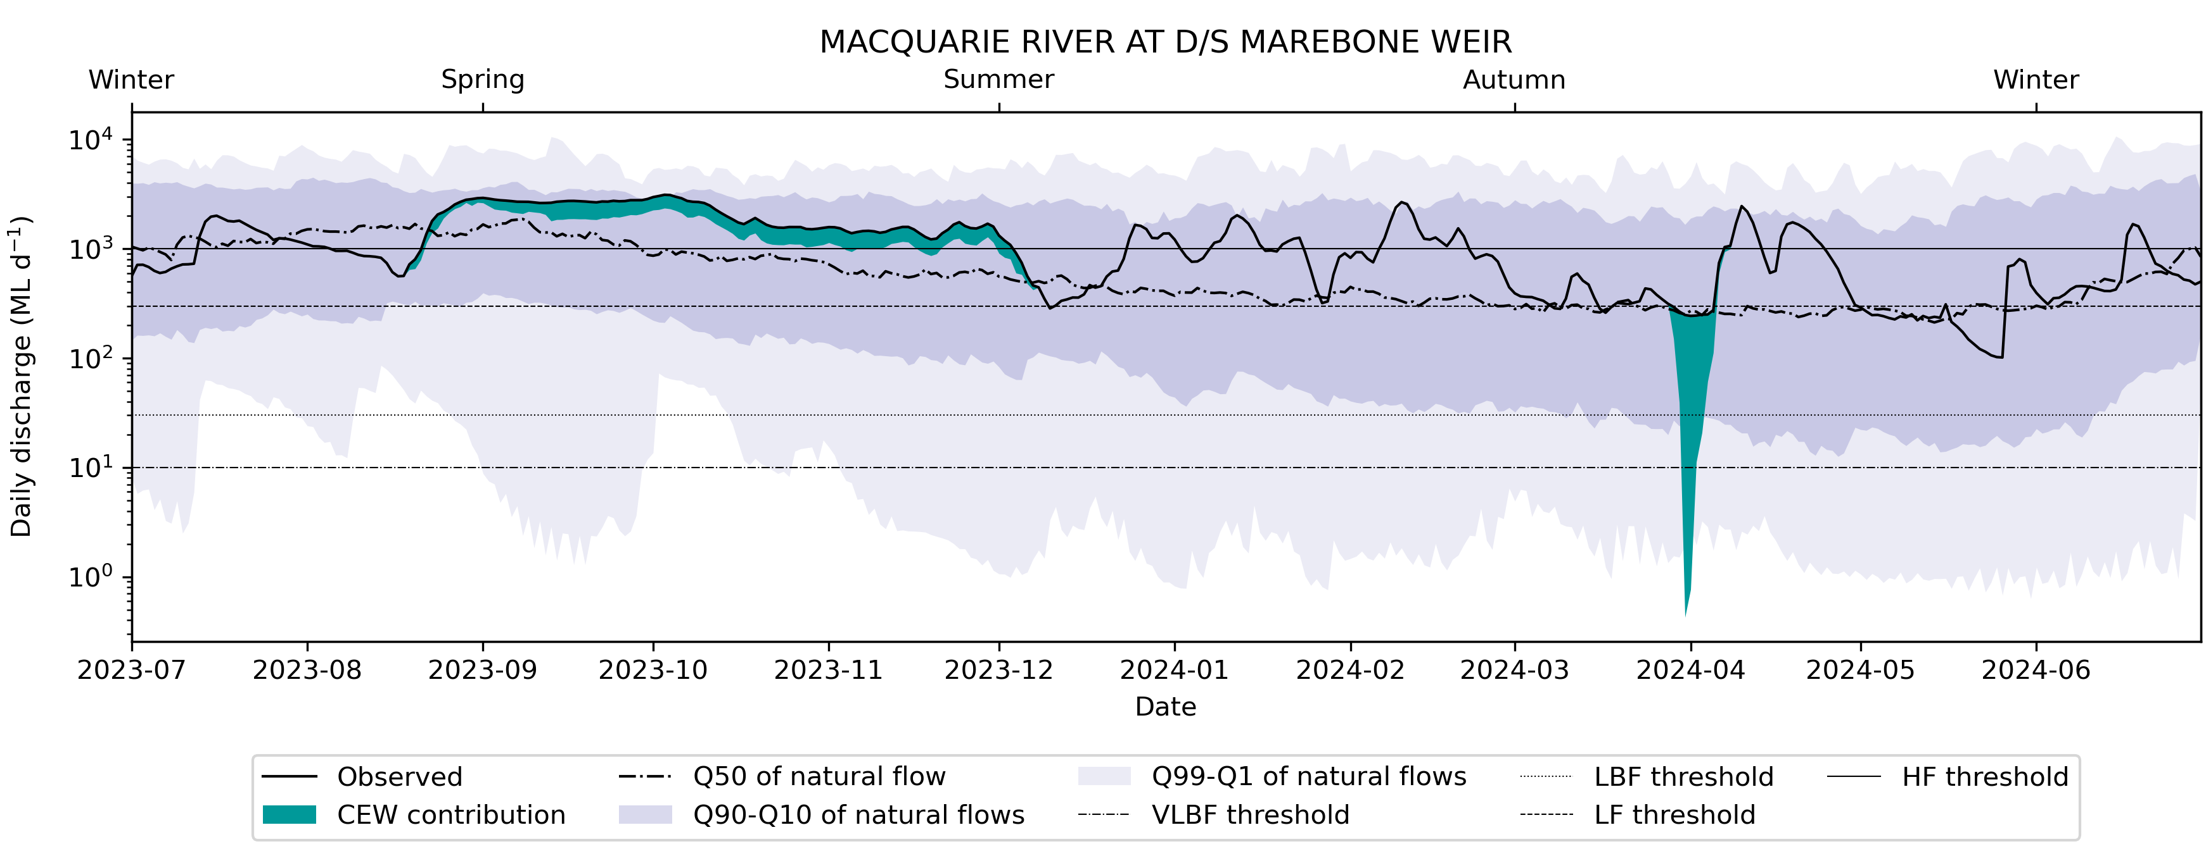

Lower Namoi River, New South Wales
CEW contributions resulted in the maintenance of flows above the low base flow threshold and the low-fresh threshold in the Lower Namoi River (at Goangra, gauge 419026) for October to December 2023 (Figure 4.9). In general, the flow regime of water year 2023–24 closely aligned with pre-development flows, indicating that CEW was not necessarily required for processing the flow regime to natural flows, but CEW was instrumental in maintaining base flows in the Lower Namoi River in late spring.
Figure 4.9 Hydrograph for the Namoi River at Goangra, New South Wales, 2023–24
CEW = Commonwealth environmental water; VLBF = very low base flow; LBF = low base flow; LF = low fresh; HF = high fresh. Note that the y-axis is in the log domain
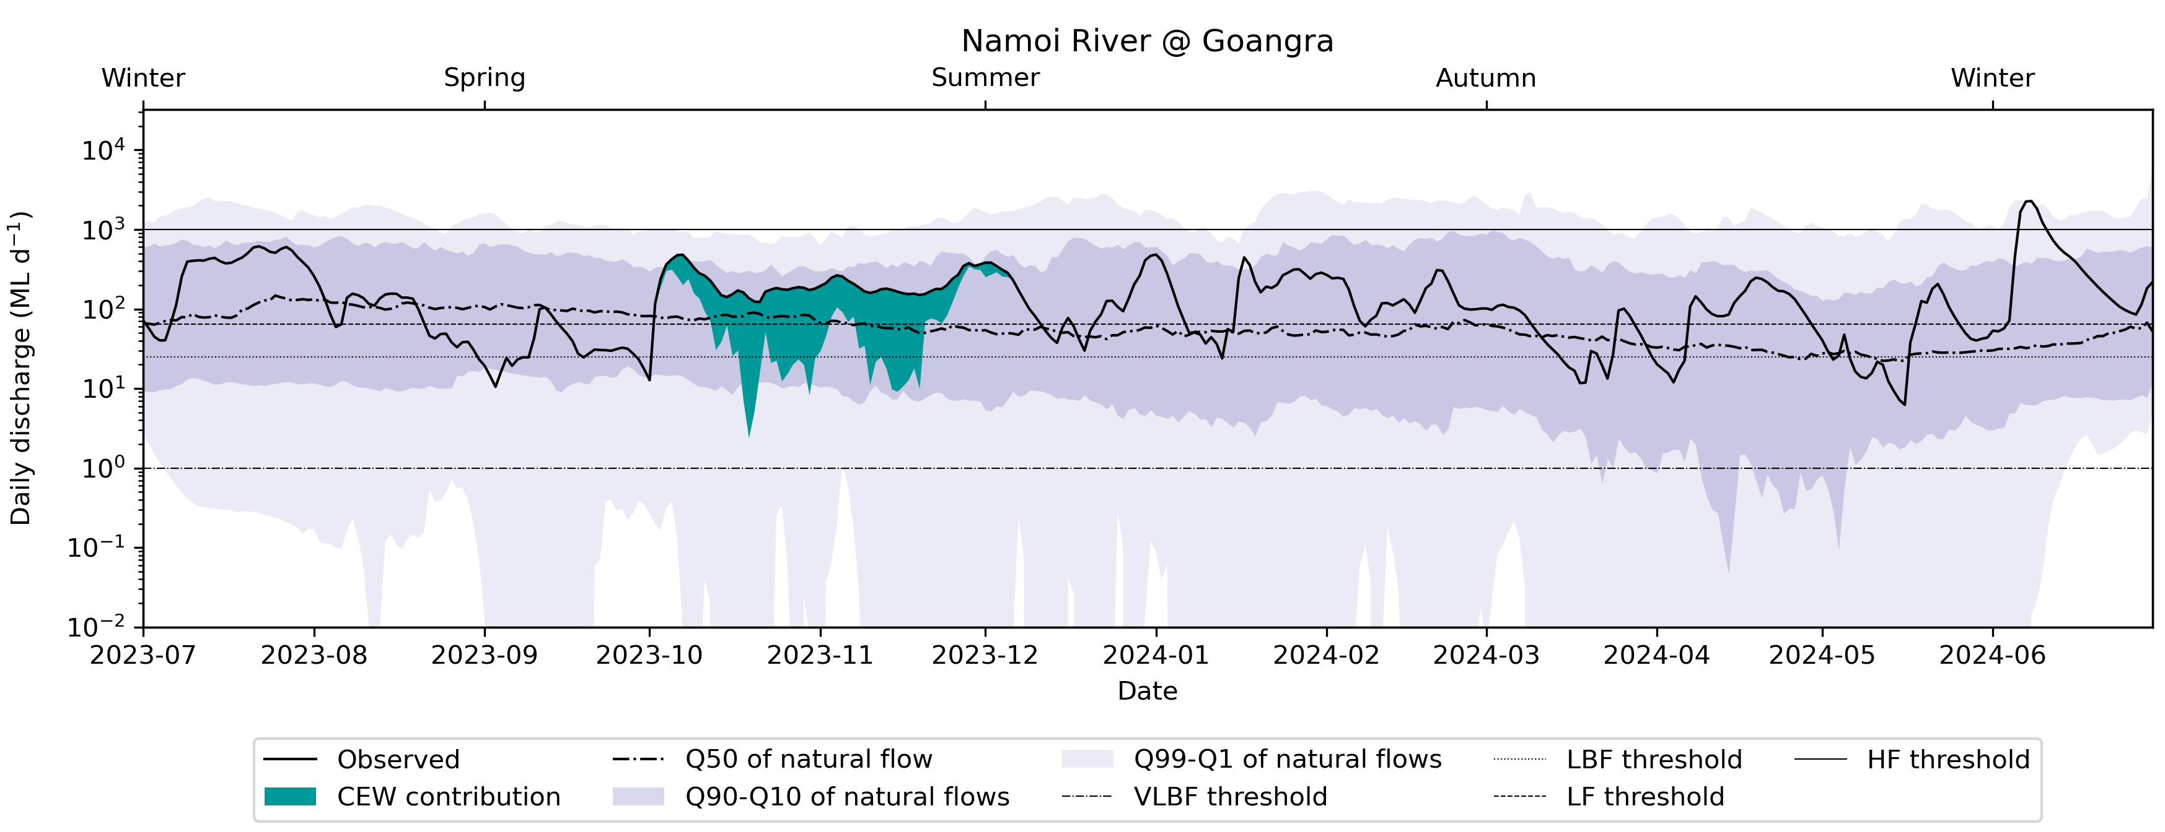

Peel River, New South Wales
In the Peel River, a small CEW contribution achieved exceedance of the low base flow threshold for a period around November 2023 (Figure 4.10). No other contributions were noted. The CEW contribution increased the flow compared to the natural flow and moved it towards the 90th percentile of the pre-development flow, likely to provide enough base flow for instream environmental assets. In general, the flows at Piallamore (gauge 419015) closely followed the 90th percentile of pre-development flows, indicating that the flow regime in the Peel River was aligned with the natural flow regime.
Figure 4.10 Hydrograph for the Peel River at Piallamore, New South Wales, 2023–24
CEW = Commonwealth environmental water; VLBF = very low base flow; LBF = low base flow; LF = low fresh; HF = high fresh. Note that the y-axis is in the log domain
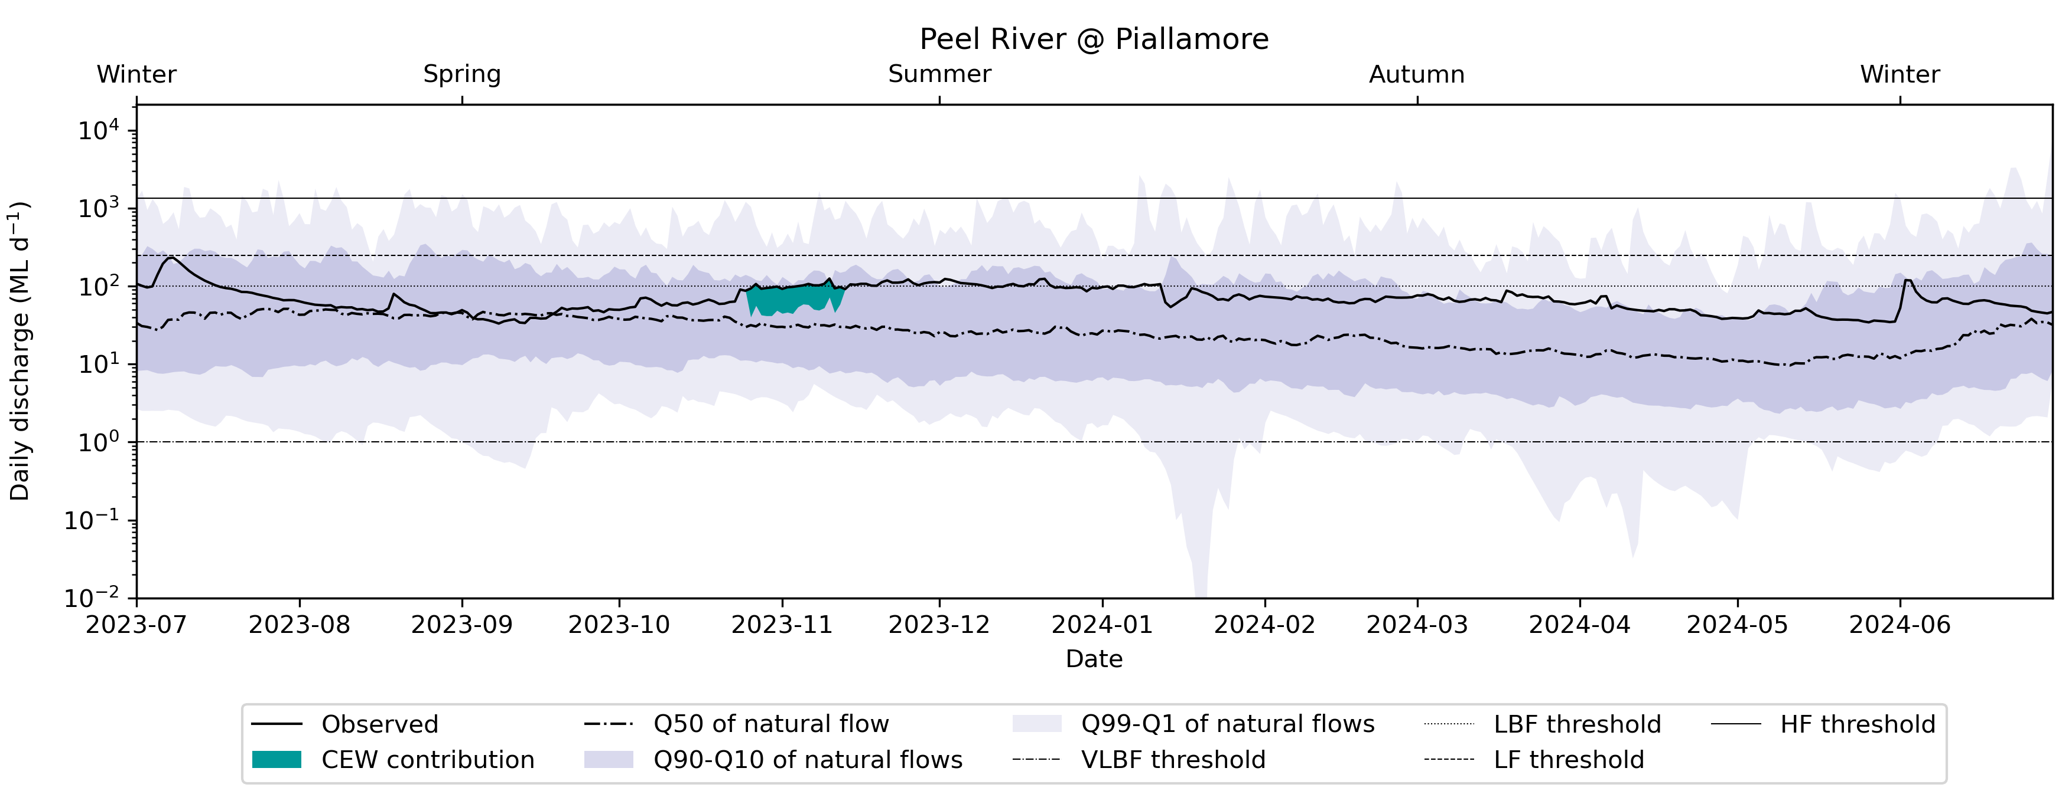

Warrego River, Queensland
In the Warrego River, 2 small CEW contributions were made in February and April 2024 (Figure 4.11, Figure 4.12). However, neither of these resulted in any change to flow threshold exceedances. The flow is generally very small in the Warrego, and any observed flows in water year 2023–24 exceeded the median flow at either gauge (Augathella representing the Upper Warrego, gauge 423204A; and Cunnamulla representing the Lower Warrego, gauge 423202C) and were within the 90th percentile of flow, indicating that the low flows closely align with the upper range of the natural flows in the Warrego system. The contributions at Cunnamulla increased the duration of flow above the high-fresh threshold in February and May 2024 for a few days each.
Figure 4.11 Hydrograph for the Warrego River at Augathella, Queensland (Upper Warrego), 2023–24
CEW = Commonwealth environmental water. Note that the y-axis is in the log domain
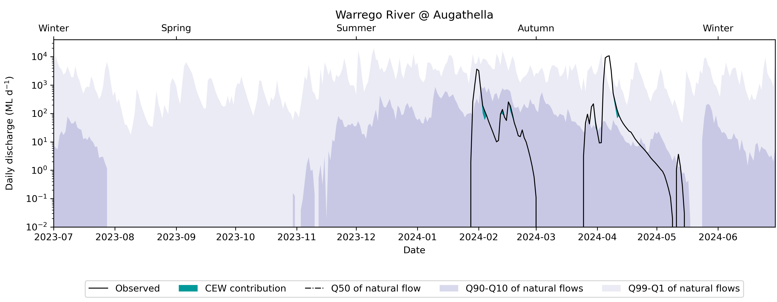
Figure 4.12 Hydrograph for the Warrego River at Cunnamulla, Queensland (Lower Warrego), 2023–24
CEW = Commonwealth environmental water; LBF = low base flow; LF = low fresh; HF = high fresh. Note that the y-axis is in the log domain
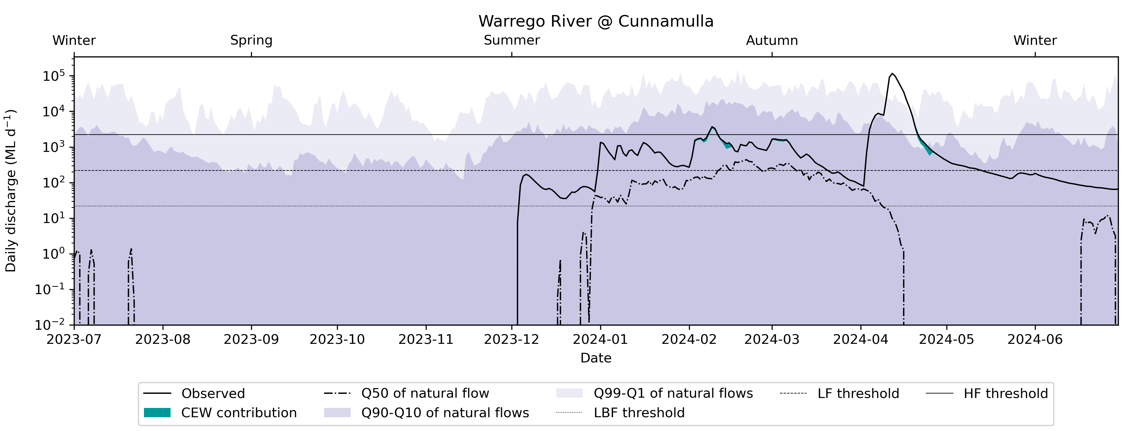

Southern Basin

Broken River, Victoria
An evaluation point in Broken Creek (gauge 404217) within the Broken River Valley in Victoria is used to understand CEW contributions to environmental assets (Lower Broken Creek) (Figure 4.13). The Broken River was watered as well; however, no relevant evaluation gauge with all required information was available to evaluate the CEW contribution.
Figure 4.13 Hydrograph for the Broken Creek at Casey Weir, Victoria, 2023–24
CEW = Commonwealth environmental water; LBF = low base flow; HF = high fresh. Note that the y-axis is in the log domain
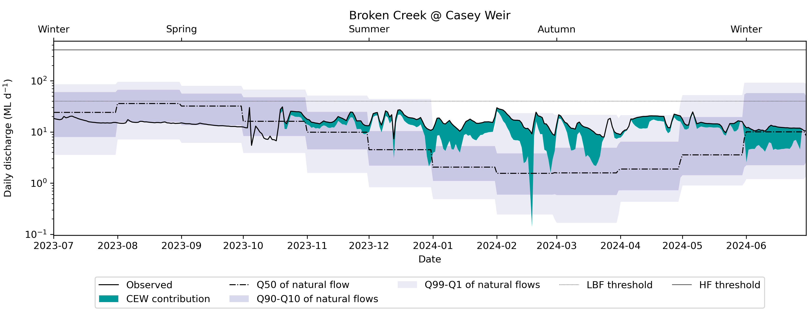
This hydrograph shows that continued CEW contributions from mid-October through to the end of the 2023–24 water year helped to increase flows towards the low base flow threshold and above the 50th percentile natural flow regime. The flow did not reach above the low-fresh threshold, which the median of the pre-development flow did not reach either, indicating that the flow signal closely followed the pre-development flow.

Campaspe River, Victoria
CEW contributions resulted in flows exceeding the low base flow threshold for this evaluation point (at Rochester, gauge 406202) from March to May 2024 and moved flows closer to the natural flow regime range in this period, specifically towards the median of pre-development flows (Figure 4.14). Contributions in June 2024 also resulted in the flow aligning more closely with the pre-development flow. The flow signal in the earlier seasons of the water year closely followed the pre-development conditions, and a flow peak in summer was observed pushing the flow regime over the high-fresh threshold. These events were caused by passing flows without CEW contribution.
Figure 4.14 Hydrograph for the Campaspe River at Rochester, Victoria, 2023–24
CEW = Commonwealth environmental water; LBF = low base flow; LF = low fresh; HF = high fresh. Note that the y-axis is in the log domain
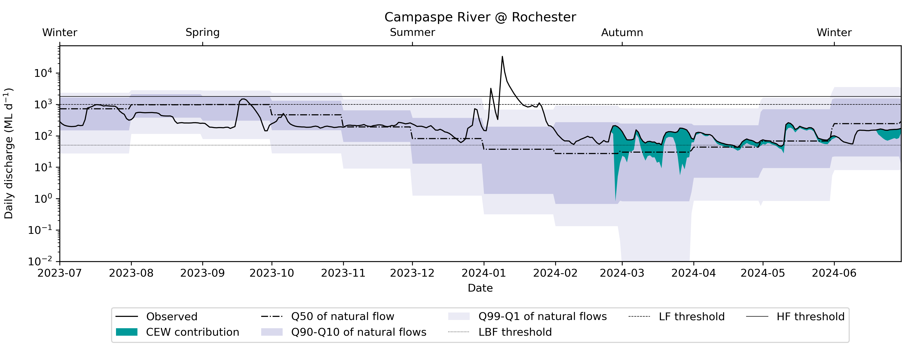

Goulburn River, Victoria
Two evaluation locations were assessed within the Goulburn River for CEW contributions to Basin Plan outcomes, these being immediately downstream of Lake Eildon (Goulburn River Reach 1, gauge 405203) and further downstream at McCoys Bridge (Goulburn River Reach 4 and 5, gauge 405232) as shown in the hydrographs (Figure 4.15, Figure 4.16).
Figure 4.15 Hydrograph for the Goulburn River at Eildon, Victoria, 2023–24
CEW = Commonwealth environmental water; LBF = low base flow; HF = high fresh.
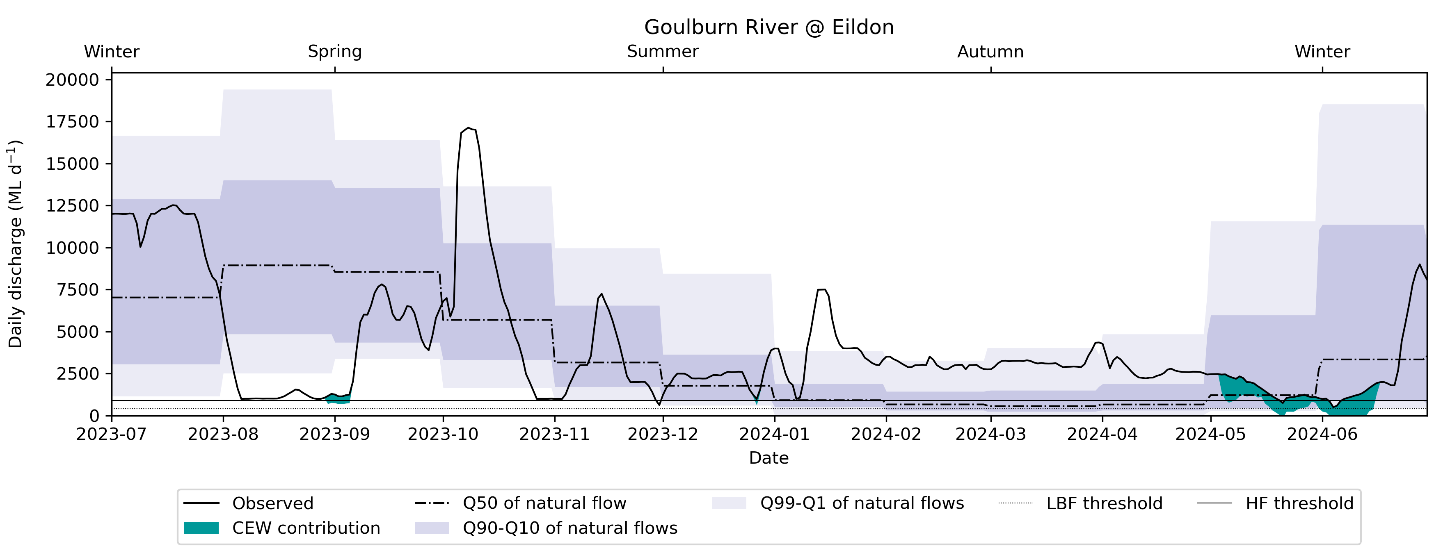
Figure 4.16 Hydrograph for the Goulburn River at McCoys Bridge, Victoria, 2023–24
CEW = Commonwealth environmental water; LBF = low base flow; HF = high fresh.
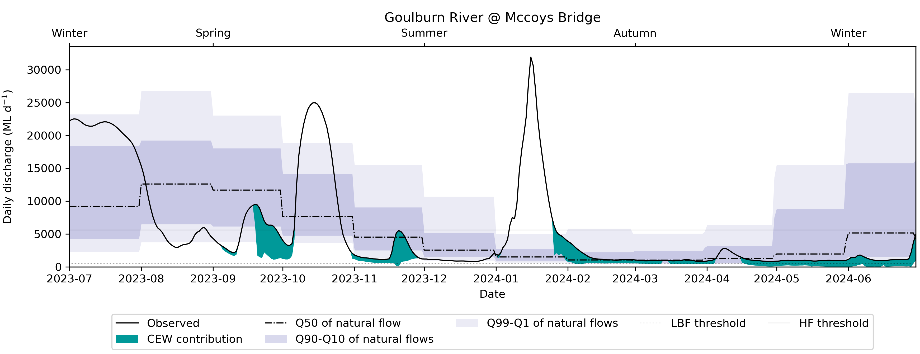
These 2 hydrographs show CEW contributions helping to achieve a high flow fresh downstream of Lake Eildon in September 2023 and in May and June 2024. The high-fresh threshold is relatively small (the threshold is specific for seasonal flow during the low flow season). Most of the recorded hydrographs in 2023–24 are above the high-fresh threshold, meaning that the flow follows the natural flow regime well. The exception was in late winter/spring, when the flow was lower than the 1st percentile, and some excursions above the 99th percentile in mid-spring and mid-summer.
Further downstream at McCoys Bridge, CEW ensured that flows were above the low base flow threshold from mid-February 2024 onwards, and that contributions also helped to achieve or extend 2 high flow freshes in late September and late November. These contributions at McCoys Bridge also fell within higher natural flow regime periods and so notably contributed to moving river flows in the Goulburn closer towards natural flows.

Lachlan River, New South Wales
Flows in the Lachlan River saw CEW contributions in mid-September 2023 and over March and April 2024 (autumn), both assisting in moving flows above the high-fresh threshold (gauge 412005 at Booligal, Figure 4.17). In the case of the autumn fresh, the contribution of CEW also lifted the flow signal above the base flow thresholds, indicating that without CEW, the observed flows would have been close to zero, which is the median flow in the pre-development signal. This autumn contribution helped push the flows into the 90th percentile of pre-development flows. The earlier watering with CEW in September helped to align the hydrograph more with the median of the natural flows.
Figure 4.17 Hydrograph for the Lachlan River at Booligal, New South Wales, 2023–24
CEW = Commonwealth environmental water; VLBF = very low base flow; LBF = low base flow; LF = low fresh; HF = high fresh.
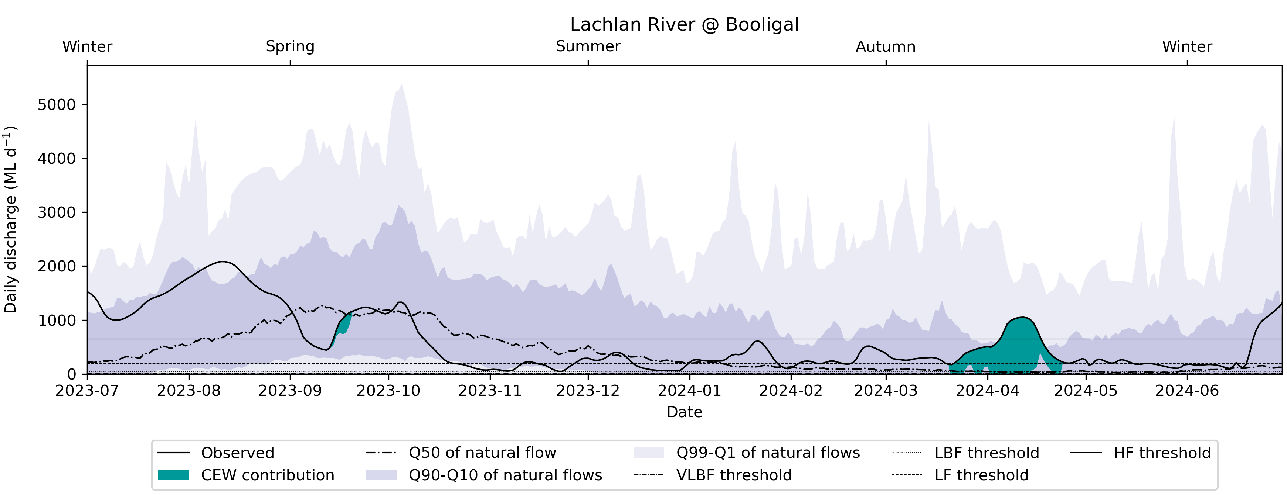

Loddon River, Victoria
CEW contributions resulted in the extension of the high flow fresh in November and December 2023 and maintenance of flows above the low base flow thresholds in November and December 2023 and again in May 2024 (gauge 407205 at Appin South, Figure 4.18). The CEW contributions were also consistent with the natural flow regime range, and it could therefore be argued that they moved flows towards the natural flow regime. The contributions specifically moved the flow regime towards the 90th percentile of pre-development flows in summer and aligned the flow signal with the median pre-development flow in late autumn.
Figure 4.18 Hydrograph for the Loddon River at Appin South, Victoria, 2023–24
CEW = Commonwealth environmental water; LBF = low base flow; HF = high fresh.
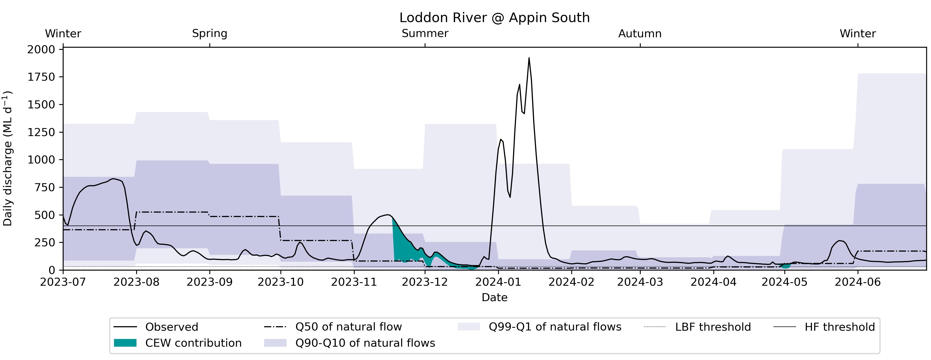

Mount William Creek, Victoria
Flows downstream of Lake Lonsdale in Mount William had CEW contributions in May and June of 2024, which assisted in maintaining flows above the low-fresh threshold and above the low base flow threshold (gauge 415203, Figure 4.19). CEW contributions further helped align the flow regime with the 90th percentile of flows in the natural flow regime. During the earlier parts of the water year, and without CEW contributions, the flow was below the 1st percentile of the natural flow regime, indicating a departure from what was expected. During the rest of the year, the flow regimes in the observed signal and the pre-development are fairly aligned. In general, the flow in Mount William Creek was small during summer, autumn and winter.
Figure 4.19 Hydrograph for Mount William Creek at Lake Lonsdale, Victoria, 2023–24
CEW = Commonwealth environmental water; LBF = low base flow; LF = low flow; HF = high fresh. Note that the y-axis is in the log domain
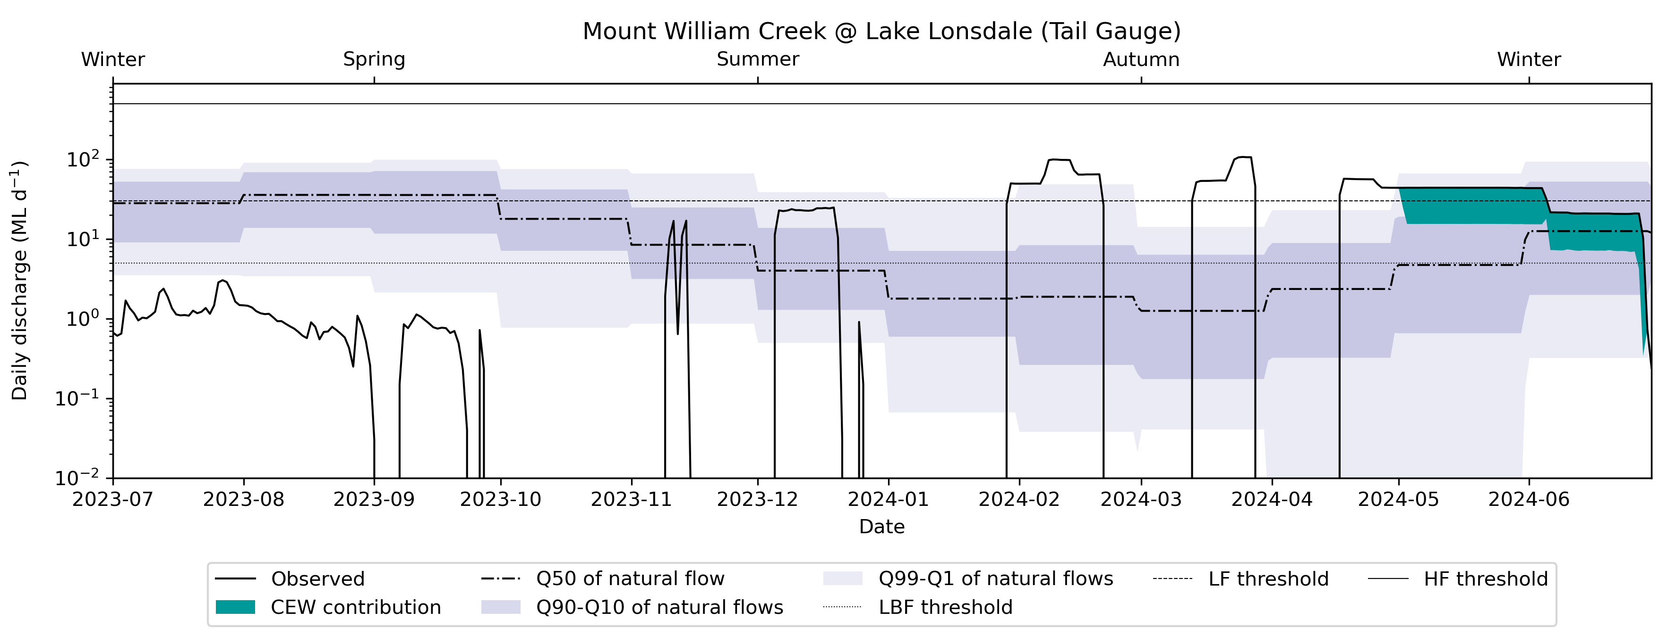

Murray River, New South Wales, Victoria and South Australia
At the Murray River at Wentworth, CEW contributions resulted in flows moving above several thresholds for considerable periods over the water year, as can be seen in the hydrograph (gauge 425010, Figure 4.20). These contributions included flows above very low base flows, low base flows, low flow freshes and high flow freshes. The contributions all moved flows closer towards the median of the natural flow regime range at this location, which is representative of flows for the Central Murray downstream of the Barmah–Millewa Forest. The contributions in October, specifically, helped push the flow regime closer to the 10th percentile of natural flows. Without CEW, the flow would have been below the 1st percentile of natural flows in October.
Figure 4.20 Hydrograph for Murray River at Wentworth, New South Wales, 2023–24
CEW = Commonwealth environmental water; VLBF = very low base flow; LBF = low base flow; LF = low fresh; HF = high fresh.
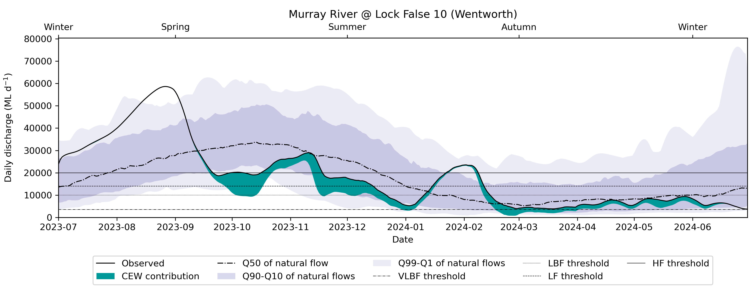
Murray River at Yarrawonga is the indicator gauge for the inundation of the Barmah–Millewa Forest (flows of above 15,000 ML/day are targeted at Yarrawonga weir for an inundation of the low-lying wetlands in the Barmah–Millewa Forest) (gauge 409025, Figure 4.21). CEW contributions helped to push flows above the high-fresh threshold between September and December 2023 and to move flows towards and above low-fresh thresholds for much of the remainder of the water year In most cases, the contributions also helped to move flows closer to the natural flow regime range. The CEW contributions in spring were targeted for the inundation of the Barmah–Millewa Forest, which was achieved with the contribution of CEW and would not have been achieved otherwise. In this instance, CEW was also delivered in conjunction with other environmental watering agencies, and the contribution of all environmental watering agencies helped with the inundation of the environmental assets in the Barmah–Millewa Forest.
Figure 4.21 Hydrograph for Murray River at Yarrawonga, Victoria, 2023–24
CEW = Commonwealth environmental water; VLBF = very low base flow; LBF = low base flow; LF = low flow; HF = high flow
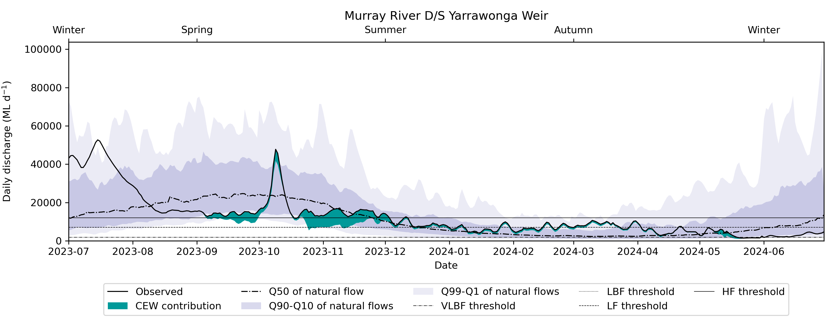
The gauge Murray River @ Calculated lows to South Australia (gauge A4261001) is the representative gauge for the flow regime in the Lower Murray. Contributions of CEW assisted in flows exceeding the low-fresh threshold for September to November 2023, and again in February 2024 (Figure 4.22). As for flows at Wentworth (upstream from Flows to South Australia before the Darling confluence; Figure 4.20), the majority of these contributions moved flows closer to the natural flow regime. Again in October, CEW helped align the flow regime more closely with the natural regime, where without the CEW the flow regime would have been outside the 1st percentile of natural flows. The spring contributions of CEW substantially helped align the flow regime with the natural flows and helped extend the duration of flows above the low base flow threshold.
Figure 4.22 Hydrograph for calculated Murray River Flows to South Australia, 2023–24
CEW = Commonwealth environmental water; VLBF = very low base flow; LBF = low base flow; LF = low fresh; HF = high fresh.
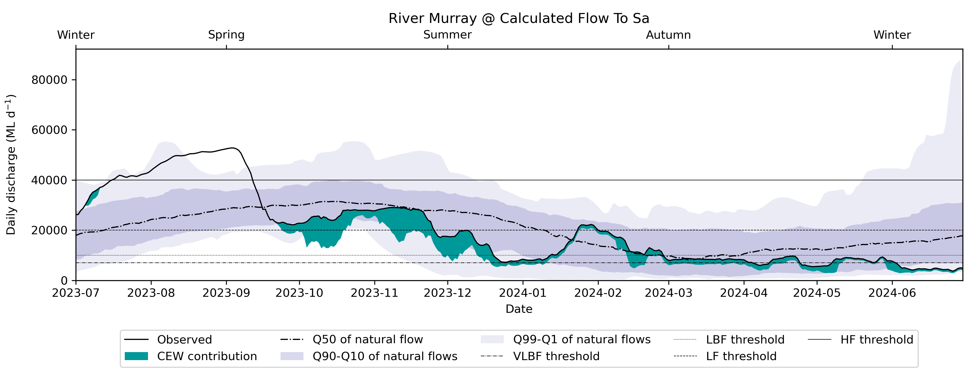

Murrumbidgee River, New South Wales
Maude Weir is the representative gauge (gauge 410040) for the wetland systems in the lower Murrumbidgee (Gayini Nimmie–Caira wetlands and the Western Lakes complex). Downstream of here, the CEW contributions provided additional flows between August and October 2023 that helped to maintain flows above the low-fresh threshold for that period (Figure 4.23). This resulted in exceedance of the high-fresh threshold on 2 occasions in that period, which helped top up the Western Lakes and inundate the terminal wetland systems in the Lower Murrumbidgee. This period would have had higher flows in the natural flow regime, so CEW contributions assisted in moving flows towards the natural flow regime.
Figure 4.23 Hydrograph for Murrumbidgee River at Maude Weir, New South Wales, 2023–24
CEW = Commonwealth environmental water; VLBF = very low base flow; LBF = low base flow; LF = low fresh; HF = high fresh.
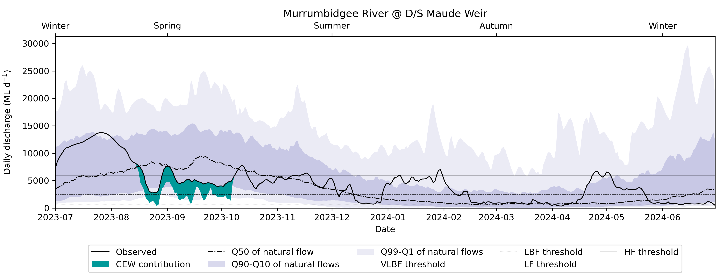
During the remainder of the water year, the flow regime was closely aligned with the natural flow regime, mostly following the pre-development median flow. The flow was generally above the low base flow threshold during the entirety of the water year. This flow regime aligns with the median of natural flows, which also did not drop below the low base flow threshold during the water year.

Wakool River, New South Wales
In the Edward–Wakool system, contributions in the Wakool River at Wakool offtake were evaluated (gauge 409019, Figure 4.24). This site is representative of the Wakool River, which is the major asset in the Edward–Wakool system and is commonly watered with CEW. Other environmental assets in the Edward–Wakool are subject to strict operational constraints, and data on flow thresholds or pre-development flows was not available to also evaluate other gauges.
Figure 4.24 Hydrograph for the Wakool River at the Wakool Offtake Regulator, New South Wales, 2023–24
CEW = Commonwealth environmental water. Note that the y-axis is in the log domain
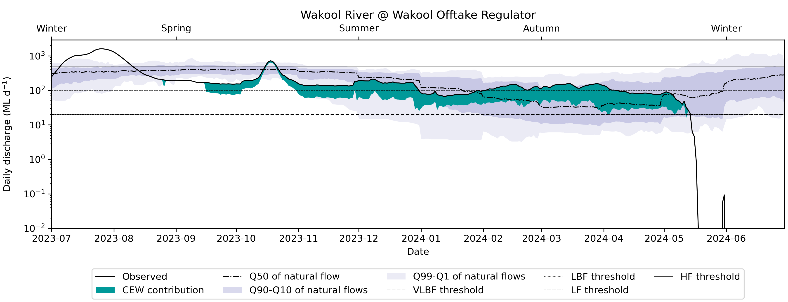
CEW contributions in the Wakool River maintained flows above the very low base flow threshold for a considerable period of the water year. It is also obvious from the hydrograph that the winter shutdown of the offtake from mid-May in 2024 resulted in no downstream flows past this point, such that it would not be possible for CEW contributions to move flows closer to the natural flow regime in this period. Regarding the natural flow regime during the rest of the water year, the contributions of CEW significantly improved the flow regime and helped push it towards the median pre-development flow, indicating close alignment with the natural flow regime.

Flow regime over water years 2014–24

Base flows
In previous evaluation years (2014–22), the base flow components were evaluated by comparing the duration of flow above the very low base flow and the low base flow thresholds (derived via different methods compared to evaluation years 2022–24) against conditions in a modelled pre-development timeseries. Then, the comparative number was scored from 0% to 100%, where a larger percentage indicated conditions that approached the average pre-development conditions. In addition, the CEW additionality to reaching a certain scoring percentage was indicated. Methods for estimating the flow thresholds started using the long-term watering plan flow thresholds in 2022–23.
For evaluation years 2014–23, the southern Basin generally showed a high duration of flow above the very low base flow threshold. Only a few isolated years in each valley exhibited drier conditions, although never in the same years. The Edward/Kolety–Wakool was a notable exception to the general trend – it had much more variable scoring. Some years (2015–16 and 2018–19) were scored as “very dry” in terms of flow regime in the Edward-Kolet Wakool system, which is equivalent to large parts of the flow signal in those water years falling below the very low base flow threshold. In terms of CEW additionality, CEW regularly provided up to 10% additionality in all water years of the monitoring period to reaching very low base flow conditions in the Goulburn and in the Lower Murray. In the Campaspe, Edward/Kolety–Wakool, Murrumbidgee and Lachlan, CEW provided additionality to reaching the very low base flow threshold of between 5% and 10% in some of the years. The higher CEW additionality of 5% to 10% was specifically delivered in the Lachlan, Murrumbidgee, Campaspe and Edward/Kolety–Wakool during the drier years (2017–20) (Figure 3.2). In all other valleys of the southern Basin, the CEW additionality to reaching the very low base flow threshold was less than 5%. In 2022–23, most of the base flow actions delivering CEW were in the southern Basin valleys, which experienced a drier summer after a wet winter and spring, and active management of base flows provided critical connectivity when needed. In 2023–24, CEW contributions helped improve the base flow regime in the Victorian valleys in autumn which, in turn, improved the base flow in the Murray River in autumn and winter. In addition, an autumn fresh action in the Lachlan achieved not only the fresh action but also flow above the base flow threshold. Thus, CEW delivered compound outcomes in the Lachlan for multiple flow regime conditions.
In the northern Basin, the duration above the very low base flow threshold was often very much lower than in the pre-development scenario, except for the water year 2021–22. Also, the scoring was generally higher in the Macquarie, Upper Namoi (Peel River) and Gwydir, although during the drier years in the evaluation period, none of the northern Basin rivers scored a high percentage in achieving the duration over the very low base flow threshold. The Warrego system was an overall exception where the scoring was consistently low across all years in the evaluation period, meaning that very low base flow was rarely achieved pre-development. The exception was the end of the system at Louth, where the score was close to 100% in the water year 2021–22. CEW additionality was high in the Namoi and Macquarie in the water year 2016–17 (up to 20%), and generally higher in the Macquarie (ranging from 20% to 10%). In the other valleys in the northern Basin, CEW additionality to reaching the very low base flow threshold was lower by up to 5%. In 2022–23, the northern Basin valleys experienced wetter conditions, generating significant river flows. For example, in the Condamine Balonne Valley, a wet spring resulted in major flooding. High flows helped keep the channels wet and refreshed refugial waterholes, providing longitudinal and lateral connectivity. This translated to minimal watering actions being aimed at base flow or increasing the duration of natural flooding or high flows. In 2023–24, CEW contributed to achieving the base flow regime in the Barwon, Gwydir, Macquarie, Namoi and Peel valleys. The average climate conditions led to the base flow being achieved in most other valleys for large portions of the water year.
The scoring for the low base flow threshold for evaluation years 2014–23 in the southern Basin was more variable than that for the very low base flow. The only valley consistently scoring high (meaning that low base flow approached the pre-development conditions) was the Central Murray, where CEW additionality in some years was up to 50%. The scoring was only low in 2016–17 in the Central Murray, still with high CEW additionality. In the regulated systems such as the Lachlan, Murrumbidgee, Goulburn and Campaspe, the low base flow scoring was generally higher in the upper catchments and lower the closer to a confluence the gauging site was situated. In most systems in the southern Basin, the drier years (2017–20) had an impact – those valleys scored lower during the drier years. The contribution of CEW additionality to achieving comparable durations over the low base flow threshold (as the pre-development scenario) was variable in the valleys of the southern Basin. Higher additionality was seen in the Goulburn, Central Murray and Lower Murray.
The scoring for the low base flow in the northern Basin was comparable to the scoring for the very low base flow. Generally, all systems achieved a higher score (meaning that the low base flow was more comparable to pre-development conditions) in the very wet water year 2021–22. However, during other evaluation years, most valleys scored low, indicating that the duration above the low base flow threshold was less than in the pre-development scenario. The notable exceptions were the Macquarie and the Gwydir systems, where scoring was generally higher but more variable across the 10-year evaluation period. The CEW additionality to achieving higher scoring for the low base flow threshold was highest in the Macquarie, where contributions were up to 30%. In all other valleys in the northern Basin, CEW additionality to achieving a higher scoring for the low base flow was up to 5%. In water year 2022–23, CEW additionality to the low base flow threshold was again small, and most systems, even in the northern Basin, reached flows above the low base flow threshold, likely due to the very wet conditions.

Freshes
Freshes were scored similarly to the base flow scoring. The frequency of freshes was compared against the frequency of freshes occurring under pre-development conditions. A higher score could be interpreted as approaching pre-development conditions. For the low freshes, the entire Basin usually scored high. The northern Basin showed higher variability in the scoring than the southern Basin, meaning that the low-fresh threshold frequency was more variable in the northern Basin – some northern valleys scored very low, representing extremely dry conditions. The Warrego and Lower Darling/Baaka valleys consistently scored low, meaning that fresh frequency seldom reached the pre-development conditions. A notable exception in the southern Basin was the Edward/Kolety–Wakool Valley. One gauge in the Edward River scored very low, meaning that pre-development conditions were rarely reached, potentially due to the considerable operational restrictions in that river system. In terms of CEW additionality to the low fresh score, the Goulburn, Campaspe and Lower Murray valleys consistently saw notable CEW additionality, meaning that CEW was contributing to achieving a pre-development fresh frequency in many years over the evaluation period in these 3 systems. In the water year 2021–22, a wet year, the Campaspe system received a significant CEW contribution to the low fresh score, resulting in the delivery of a fresh when a fresh would not have otherwise been delivered. In 2023–24, CEW saw additionality to the low freshes in the northern Basin in the Barwon Darling and Namoi valleys, where CEW caused a low fresh and extended the duration of flow above the low flow threshold. In the southern Basin, CEW led to increased frequency of low freshes in the Lachlan, Wimmera, Central Murray, Lower Murray, Edward/Kolety–Wakool and Murrumbidgee valleys, where both the frequency of low freshes and the duration of flow above the low-fresh threshold were enabled by CEW.
In terms of high freshes, the scoring over the entire Basin was variable. High freshes were consistently seen in the Central Murray and Ovens valleys, but the rest of the Basin was highly variable and many gauging sites scored low during the drier years (2017–20). Notably, high percentages of CEW additionality to achieving the frequency of high freshes comparable to the pre-development conditions were provided in the Goulburn, Campaspe, Lachlan, Lower Darling/Baaka and Condamine Balonne over the evaluation period in isolated years, indicating that high freshes were observed in those systems resulting from CEW delivery.
In the evaluation year 2022–23, achieving the fresh threshold was evaluated differently. The duration above the respective fresh threshold was used instead of the frequency, as the extremely wet conditions in the water 2022–23 meant that CEW was sometimes delivered to keep the flow above a fresh threshold and extend the duration of fresh flows. In the counterfactual scenario with CEW removed, this would have led to a decrease in frequency in the observed scenario vs the counterfactual scenario, which is why the frequency was not appropriate for evaluation in the 2022–23 evaluation year. However, the CEW additionality to achieving flow above the high-fresh threshold was notably only higher in the Warrego and Goulburn valleys, where, due to the very wet conditions, long durations over the high-fresh threshold were observed in water year 2022–23. In 2023–24, high freshes in the northern Basin were enabled by CEW in the Condamine Balonne (Narran Lakes rule) and the Macquarie (Inundation of the marshes) valleys. Commonwealth environmental water also extended the duration of flow above the high-fresh threshold in the Condamine Balonne, Barwon Darling, Macquarie and Warrego, where, in these valleys, where a high fresh was not necessarily caused by CEW, CEW contributed to extending the duration of naturally occurring events. In the southern Basin, CEW contributed substantially to increasing the frequency and duration of high freshes in the Goulburn (5 instances of high freshes enabled by CEW at Eildon). Other valleys where CEW contributed to the fresh frequency and extension of duration of flow above the high-fresh threshold were the Lachlan, Loddon, Central Murray and Murrumbidgee. In addition, in the Edward/Kolety–Wakool, CEW extended the duration of flow above the high-fresh threshold even though the threshold would have been reached naturally.
Comparing CEW’s additionality and contribution to freshes in 2023–24 to 2022–23 revealed that the prevailing climatic conditions in 2023–24 (average rainfall) likely caused less natural fresh events, as in 2022–23 where the prevailing climatic conditions were extremely wet. Thus, CEW contributions notably increased fresh frequency in multiple valleys and added to duration of flow above the respective fresh thresholds, an important measure for the inundation of various wetland assets throughout the Basin.

Evaluation against Basin Plan objectives: flow regime, base flows and freshes

Flow regime
The Basin plan states that progress towards a natural flow regime is one of its objectives. Here, we compared the flow signal in the water year 2023–24 against the pre-development flow expected at key evaluation locations.
In the northern Basin, the flow signal in 2023–24 was mostly within the 10th to 90th percentile of pre-development flows and often closely followed the median pre-development flow. Some notable exceptions in the northern Basin were the Border Rivers from Goondiwindi to Mungindi (Barwon Darling) where, in early spring, the flow dipped below the 1st percentile of flows in the pre-development scenario. As for CEW improving the flow regime and progressing it to natural flows, there were 2 notable instances in the Gwydir River and the Macquarie River when CEW improved the flow regime to fall within the 10th to 90th percentile range of pre-development flow. Without CEW, the flow would have been lower than the 1st percentile of flows, and the flow would have significantly departed from the natural flow regime (Section 4.1.1).
In the southern Basin, the flow in 2023–24 also followed the pre-development closely. However, some more excursions from the natural flow regime were noted in the southern Basin compared to the northern Basin. Notably, the Victorian valleys (Loddon, Goulburn, Wimmera) saw some flows below the 1st percentile of natural flows, but some flows larger than the 99th percentile (high natural freshes) were noted in most valleys in the southern Basin (Loddon, Campaspe, Goulburn, Murray, Wimmera). One substantial departure from the natural flow regime was noted in the Edward/Kolety–Wakool, where the winter shutdown of regulators led to a significant dip in flow regime below the 1st percentile of natural flows.
CEW played a significant part in most valleys in progressing the flow towards the natural flow regime. In the Broken, Goulburn, Murray, Murrumbidgee and Edward/Kolety–Wakool valleys, CEW contributed on one or more occasions to progressing the flow regime towards the natural flow regime and aligning the flow signal of 2023–24 with at least the 1st percentile of pre-development flows. More commonly, CEW added substantially to the flow, so that flows towards the median of the natural flow regime were possible (Section 4.1.2).
Thus, CEW played an important role in 2023–24 to progress the flow regime towards the natural flow regime, specifically in the southern Basin.

Base flows
In the water year 2023–24, CEW was mostly delivered instream as base flow. Over the 10-year period of the program, the most CEW was delivered in 2023–24. Most of that was in base flow actions (67%).
Most of the base flow actions were in the southern Basin valleys, which saw natural flows peaking in spring and summer. Flows in autumn and winter declined, and active management of base flows, especially in the Victorian valleys, provided critical connectivity when needed. In the northern Basin valleys, the average precipitation conditions led to flows being very close to the pre-development flow regime, and management of base flows was not as important. A notable exception was the Barwon Darling, where base flows were managed with CEW during spring. The average conditions generated enough river flows in most valleys of the northern Basin (other than the Warrego) to help keep the channels wet and refresh refugial waterholes, providing longitudinal and lateral connectivity. This translated to minimal CEW being delivered in a few base flow watering actions and a few actions geared towards increasing the duration of natural flooding (Providing support for the inundation of Narran Lakes, 71 GL was the biggest CEW expenditure in the northern Basin.)
Overall, targeted base flow releases led to flow regime improvement and, in some cases, clearly provided progress towards the pre-development flow regime.

Freshes
All valleys, except for the Barwon Darling and the Lower Darling/Baaka, received Commonwealth environmental watering actions targeting a fresh component through the water year (Table 3.2). The average conditions led to flows generally consistent with the natural flow regime in 2023–24. Fresh actions were delivered with CEW either in spring/summer for inundation of key wetlands (Macquarie Marshes, Barmah–Millewa Forest, Lower Murrumbidgee wetlands) and delivery of spring/summer freshes (Goulburn, Loddon, Murrumbidgee, Macquarie), or for system-scale fresh purposes in autumn in the Lachlan and Goulburn. Many fresh actions specifically targeted at wetland inundation were delivered to extend the duration of flow above a fresh threshold and, thus, prolong the time the wetlands were inundated, rather than delivering freshes as singular events. The Barwon Darling did not receive fresh actions per se, but protection of CEW into the Barwon Darling from other contributing valleys (Gwydir, Border Rivers, Namoi, Macquarie) led to some flows in late summer passing the low-fresh threshold at Bourke, indicating that CEW supported freshes in the Barwon Darling through coordinated management.

Connectivity
Improvement in lateral connectivity was evaluated as the total combined area of floodplain that was inundated and received CEW. It is reported as the annual maximum extent.
Improvements in longitudinal connectivity were evaluated as increases in selected end-of-valley flows, length of waterways connected, and frequency of inundation of watercourses.
Long-term (10-year) evaluation was done by analysing the actual flow over the 10-year evaluation period and comparing the flow against previous evaluation years, including hydrology at the Coorong, Lower Lakes and Murray Mouth.

Lateral connectivity 2023–24
In 2023–24, CEW inundated wetlands and floodplains in many parts of the Basin (Table 4.1). The watering actions in 2023–24 inundated substantial areas (> 1,000 ha total) of floodplains and floodplain wetlands in 8 of the 25 valleys of the Basin (Table A.6). In the southern Basin, CEW delivered to the Broken, Campaspe, Goulburn, Loddon, Ovens, and Wimmera rivers in Victoria was confined to the river channels, benefiting a small number of in-stream weir pools and connected wetlands. In the northern Basin, a similar pattern was seen – the Namoi, Barwon Darling and Border Rivers had instream flows. Similar to the previous year, the largest areas of inundated wetlands and floodplain were from CEW that was delivered to extend the duration of widespread natural flooding and provide cues to support waterbird breeding rookeries (Condamine Balonne, Lachlan, Gwydir, Macquarie and Murrumbidgee valleys) and fish movement and breeding (Central Murray, Murrumbidgee). This is the first year since monitoring began that CEW inundated areas in the Paroo Valley. These flows originated in the Warrego River, where licence rules were triggered to retain high flows in the Warrego River. These spilled westward into the adjoining Cuttaburra distributary and to the nationally significant Cuttaburra and Yantabulla wetlands in the Paroo Valley.
Table 4.1 Areas of estuary, lakes and wetlands and floodplains inundated and the length of waterway connectivity supported by Commonwealth environmental water, by valley, 2023–24
The Coorong, Lower Lakes and Murray Mouth is within the Lower Murray Valley but is reported separately in this evaluation. Asterisk (*) indicates that the valley is associated with a Selected Area. Dash (–) indicates no inundation by Commonwealth environmental water (CEW). Wetlands (lakes and swamps) are deemed supported by CEW when all or part of their mapped extent coincides with environmental water inundation (ref Section 3.2 in Brooks 2024). The valleys that are not in scope for evaluation (i.e. Avoca, Kiewa, Mitta Mitta, Upper Murray) are not included in the table. The Paroo Valley was not included in the evaluation but received CEW once from a watering action initiated in the Warrego in 2023–24.
Valley | Estuary (ha) | Lakes and wetlands area (ha) | Floodplain area (ha) | Length of waterways (km)
Northern Basin
Barwon Darling | – | 115 | – | 1,909
Border Rivers | – | 137 | – | 1,103
Castlereagh | – | – | – | –
Condamine Balonne | – | 5,741 | 4,216 | 1,761
Gwydir* | – | 5,352 | 646 | 876
Macquarie | – | 22,415 | 18,927 | 1,401
Namoi | – | 688 | – | 685
Paroo | – | 159 | – | 161
Warrego* | – | 2,435 | 65 | 1,338
Southern Basin
Broken | – | 171 | – | 408
Campaspe | – | 454 | – | 112
Central Murray | – | 28,723 | 9,743 | 2,240
Edward/Kolety–Wakool* | – | 264 | 61 | 1,383
Goulburn | – | 65 | – | 412
Lachlan | – | 10,423 | 889 | 1,510
Loddon | – | 308 | – | 365
Lower Darling/Baaka | – | 580 | – | 1,167
Lower Murray* | – | 5,372 | 74 | 1,287
Lower Murray: Coorong, Lower Lakes and Murray Mouth* | 23,768 | 103,600 | 73 | –
Murrumbidgee* | – | 13,792 | 13,076 | 2,462
Ovens | – | 59 | – | 257
Wimmera | – | 37 | – | 238
Total | 23,768 | 200,890 | 47,770 | 21,075

Lateral connectivity 2014–24
Cumulatively over the 10-year monitoring period, 446,264 ha (including the Coorong, Lower Lakes and Murray Mouth area) of wetlands, lakes and floodplains received contributions of CEW (Table 4.2). This includes 124,091 ha of lakes, including the Lower Lakes, 130,574 ha of wetlands and 191,599 ha of floodplains.
Wetland and floodplain inundation are most common in 10 valleys (in 4 or more of the 10 years), most notably in the Condamine Balonne, Gwydir, Macquarie, Central Murray, Lachlan, Lower Murray and Murrumbidgee valleys. Smaller areas were also regularly watered in the Warrego and Edward Koley Wakool. The Victorian Loddon, Campaspe, Goulburn, Ovens, Broken and Wimmera rivers are intentionally managed with no or little overbank inundation to protect agricultural land and infrastructure. In the northern Basin, the Border Rivers, Namoi and Barwon Darling also had little or no overbank inundation, but in-stream base flows and freshes have been delivered in most years. For the first time in 2023–24, a contribution of CEW was in natural high flows in the Warrego River that spilled westward into the Cuttaburra distributary delivering CEW to the nationally significant Cuttaburra and Yantabulla wetlands.
Table 4.2 Frequency (years) of inundation of wetlands, lakes and floodplains contributed to by Commonwealth environmental water, reported as hectares (ha), by valley, 2014–24
* Lower Murray includes the Coorong, Lower Lakes and Murray Mouth area, which is considered inundated with CEW in 10 out of 10 years (approximately 100,000 ha).
Valley | 1 in 10 | 2 in 10 | 3 in10 | 4 in10 | 5 in10 | 6 in10 | 7 in10 | 8 in10 | 9 in10 | 10 in 10
Northern Basin
Barwon Darling | 3,508 | 3 | 0 | 0 | 0 | 0 | 0 | 0 | 0 | 0
Border Rivers | 7,664 | 91 | 0 | 0 | 0 | 0 | 0 | 0 | 0 | 0
Condamine Balonne | 30,731 | 3,096 | 1,723 | 2,309 | 2,470 | 892 | 16 | 0 | 0 | 0
Gwydir | 5,435 | 2,229 | 1,931 | 1,588 | 1,420 | 1,080 | 767 | 372 | 107 | 0
Macquarie | 27,762 | 10,245 | 9,211 | 4,972 | 4,440 | 3,740 | 2,579 | 2,554 | 4,438 | 0
Warrego | 5,898 | 1,240 | 125 | 17 | 4 | 3 | 0 | 0 | 0 | 0
Southern Basin
Broken | 53 | 64 | 50 | 0 | 0 | 0 | 0 | 0 | 0 | 0
Central Murray | 17,653 | 11,471 | 6,977 | 4,435 | 4,993 | 2,691 | 2,615 | 1,871 | 0 | 0
Edward/Kolety–Wakool | 752 | 92 | 22 | 15 | 16 | 15 | 8 | 0 | 0 | 0
Lachlan | 25,509 | 7,318 | 2,734 | 1,118 | 549 | 340 | 268 | 189 | 0 | 0
Lower Darling/Baaka | 129 | 38 | 30 | 30 | 21 | 0 | 0 | 0 | 0 | 0
Lower Murray * | 21,995 | 3,187 | 3,046 | 3,471 | 1,240 | 409 | 642 | 208 | 532 | 105,837
Murrumbidgee | 54,292 | 18,834 | 10,327 | 7,347 | 6,944 | 4,951 | 2,960 | 1,512 | 381 | 11
Ovens | 4 | 0 | 0 | 0 | 0 | 0 | 0 | 0 | 0 | 0
Total | 201,383 | 57,908 | 36,176 | 25,301 | 22,097 | 14,120 | 9,854 | 6,706 | 5,458 | 105,848

Longitudinal connectivity 2023–24
Approximately 21,075 km of waterways received CEW in 2023–24, as shown in Table 4.1. In the northern Basin, the Barwon Darling, Condamine Balonne, Border Rivers, Macquarie and Warrego experienced improved longitudinal connectivity due to CEW releases. In the southern Basin valleys, the Central Murray, Edward/Kolety–Wakool, Lachlan, Lower Darling/Baaka, Lower Murray and Murrumbidgee valleys saw an increase in in-stream connectivity.

Longitudinal connectivity 2014–24
Figure 4.25 shows that the recent wetter years had higher connectivity – CEW in conjunction with other flows may have led to a greater outcome. Lowland streams (permanent and temporary), the most common stream type in the Basin, are also the most connected during CEW releases. Over 2014–24, the total length of waterways connectivity supported by the CEW was highest in the Murrumbidgee Valley, followed by the Barwon Darling. River length connected per year per valley is provided in Table A.5.
Figure 4.25 Length of waterway connectivity annually supported by Commonwealth environmental water, 2014–24
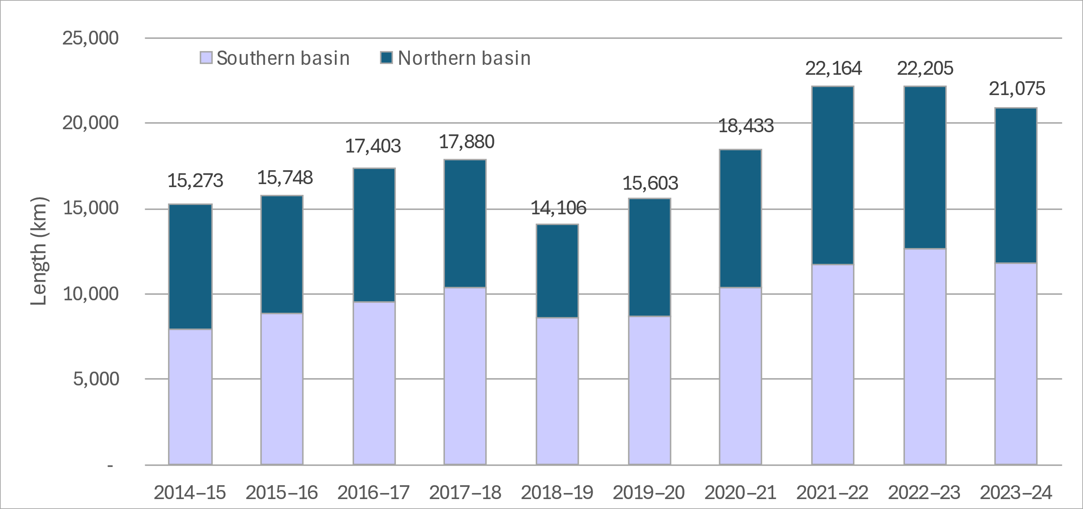
Figure 4.26 Map showing frequency (years) of longitudinal connectivity in waterways supported by Commonwealth environmental water in the Basin, 2014–24
CEW = Commonwealth environmental water. Waterways inundated at a low frequency at Murray Mouth in South Australia, adjacent to the Lower Lakes, are small, temporary transitional zone streams that specifically received CEW in 2017–18.
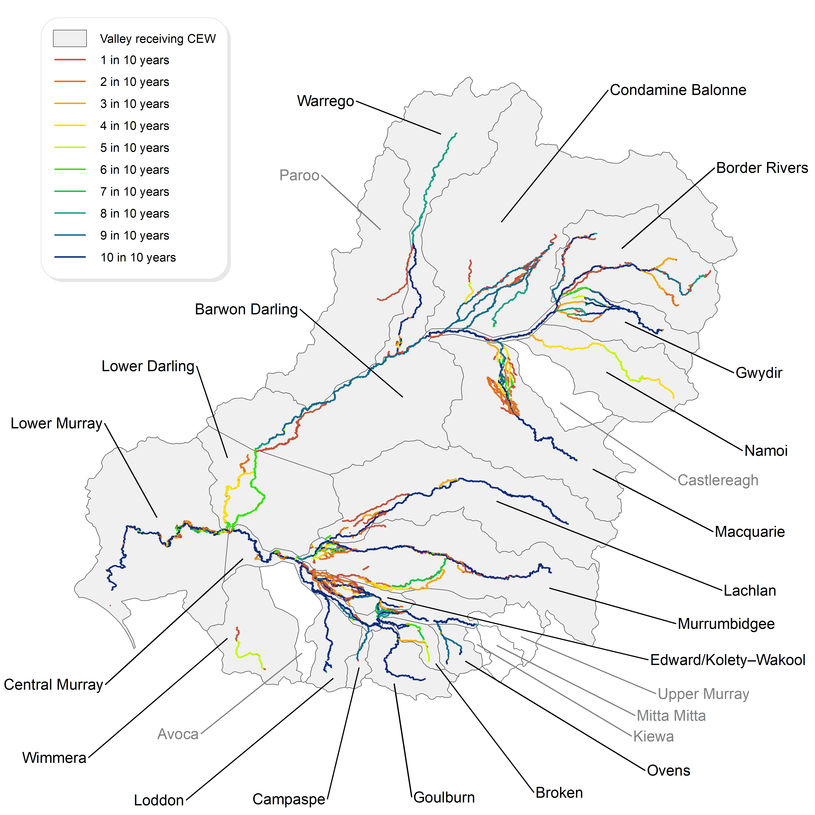

Evaluation against Basin Plan objectives: connectivity
The Basin Plan measures success when hydrological connectivity is maintained between rivers and floodplains (inundation) and between hydrologically connected valleys (longitudinal connectivity). Commonwealth environmental water improved the overall connectivity in the Basin in 2023–24 (Figure 4.27). Longitudinal connectivity was maintained through 21,075 km of rivers, predominantly lowland rivers, connecting laterally with 47,770 ha of floodplain.
Figure 4.27 Map showing length of waterways connected and extent of wetland inundation, 2023–24
CEW = Commonwealth environmental water.
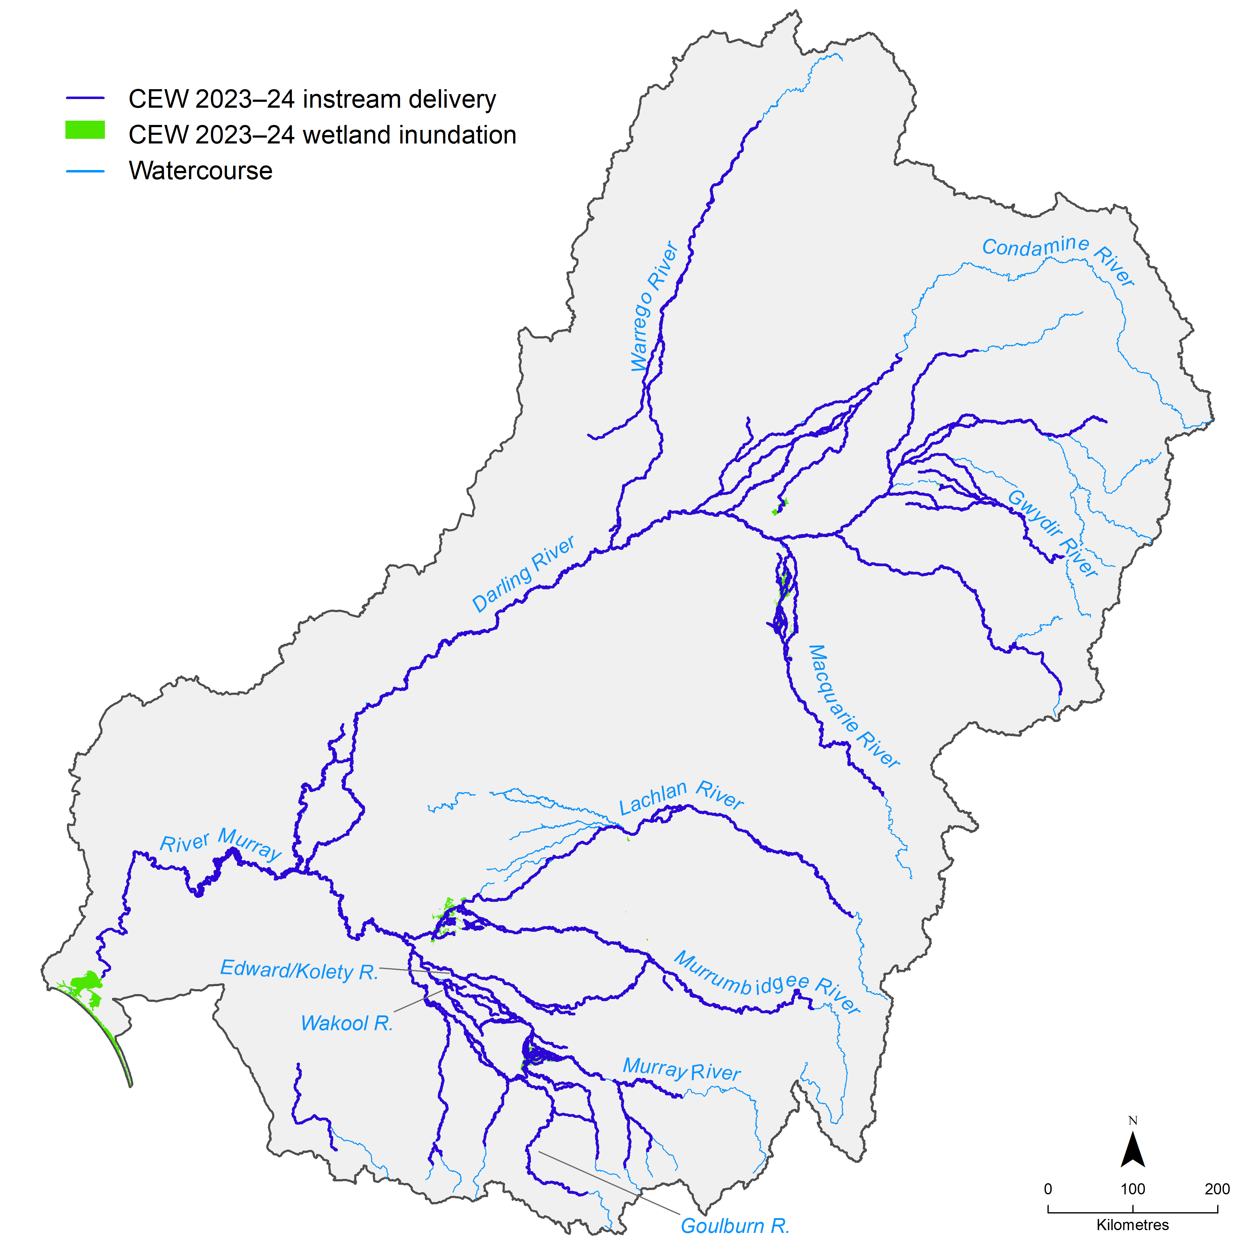

Evaluation against the Strategy environmental outcomes
In this chapter, we evaluate outcomes of the water years 2014–24 towards the Strategy’s expected outcomes for river flows and connectivity as described in Table 5.1.
We provide outcomes for each of the outcomes except for ‘current levels of connectivity are maintained in the Paroo, Moonie, Ovens and Wimmera catchments’ under lateral connectivity. While the Strategy specifies these targets for all environmental water in the Basin, in this report we limit our analysis to the CEW contribution, which can be a small subset of the actual watering event.
The evaluation against the Strategy environmental outcomes is also set into that of previous evaluation years (2014–22). In 2022–23, the methods for defining flow components and decomposing flow time series changed compared to the previous reports, thus the evaluation of progress towards Strategy environmental outcomes for longitudinal and lateral connectivity (which use measures of flow duration and frequency of flow above a flow component threshold) may be slightly different when compared to previous evaluation years. The methods used in 2023–24 are the same as used in the 2022–23 evaluation.
Table 5.1 Expected outcomes for river flows and connectivity as listed in the Strategy
The evaluated Strategy environmental outcomes are consistent with previous years’ evaluations. However, in previous years, a different method was used to evaluate the progress towards achieving the environmental outcomes. The third expected outcome for lateral connectivity (struck-out text) was not evaluated in 2023–24 nor in previous evaluation years. Additional end-of-basin metrics (salinity in Lake Alexandrina and Murray Mouth openness) were not evaluated as they are not flow related. AHD = Australian Height Datum.
Longitudinal connectivity | Lateral connectivity | End-of-Basin flows
Base flows at 60% of natural levels | 30% to 60% increase in the frequency of freshes, bankfull and lowland floodplain flows in the Murray, Murrumbidgee, Goulburn–Broken and Condamine Balonne catchments | Barrage flows > 2,000 GL/year
10% increase in flows in the Barwon Darling river system | 10% to 20% increase of freshes and bankfull events in the Border Rivers, Gwydir, Namoi, Macquarie–Castlereagh, Barwon Darling, Lachlan, Campaspe, Loddon and Wimmera catchments | Water levels in the Lower Lakes are above sea level, and 0.4 m AHD for 95% of the time
30% increase in flows in the Murray River | Current levels of connectivity are maintained in the Paroo, Moonie, Ovens and Warrego catchments
30% to 40% increase in flows to the Murray Mouth

Lateral connectivity
The Strategy’s lateral connectivity outcomes compare the frequency of freshes between the observed and counterfactual scenarios. It is important to note that this differs from Section 5.2, where the flow regime is compared with pre-development flows. The frequency of high freshes is used to assess outcomes. The frequency of bankfull and overbank events was not considered in this assessment, as it is very rare for environmental flows to contribute to channel-filling events and the Strategy defines lateral connectivity as a measure of fresh frequency. Many of the fresh watering actions along with overbank and wetland watering actions in 2023–24 was aimed at extending duration rather than frequency (See Section 4.1). Hence, in 2023–24, most of the valleys saw no increase in the frequency of freshes due to CEW. Although the Edward/Kolety–Wakool Valley is not specified in the outcomes, the valley is counted towards the mid-Murray, and CEW had a significant impact in increasing frequency of freshes (36%). This meant that for the mid-Murray, the Strategy objective was technically met. The Strategy objective (10% to 20% increase in fresh frequency) was also met in the Lachlan at 25%. The other valleys that saw an increase were the Murrumbidgee at 8% and the Barwon Darling at 8% (Table 5.2). Both increases of 8% did not technically meet the Strategy objective; however, the 8% increase in the Barwon Darling came close to the target of 10% increase in fresh frequency.
For evaluation year 2023–24, average hydrological conditions contributed to the natural occurrence of freshes, and when CEW was required to achieve the objective, it was generally used to extend duration rather than frequency (often extending one event as in the Macquarie Marshes). Note that this evaluation only considers CEW, while other environmental water holders also contributed to the flow.
Table 5.2 Summary of lateral connectivity outcomes in 2023–24 against expected outcomes as listed in the Strategy
Expected lateral connectivity outcome | 2023–24 outcome | 2014–2024 outcome
30% to 60% increase in the frequency of freshes, bankfull and lowland floodplain flows in the Murray, Murrumbidgee, Goulburn–Broken and Condamine* Balonne catchments | 36% in mid-Murray (Edward–Wakool) (technically met in mid-Murray); 8% in Murrumbidgee, 0% in Central and Lower Murray and Goulburn–Broken (technically not met) | Met twice in the Lower Murray (50%) (2015–16, 2019–20); met once in the mid-Murray (2023–24); not met in the other valleys over the evaluation period
10% to 20% increase of freshes and bankfull events in the Border Rivers, Gwydir, Namoi, Macquarie–Castlereagh, Barwon Darling, Lachlan, Campaspe, Loddon and Wimmera* catchments | 8% in Barwon Darling (technically not met); 25% in Lachlan (technically met); 0% in the other valleys (technically not met) | Met once in the Gwydir (10%) (2018–19) and Macquarie (10%) (2018–19); 4 times in the Lachlan (10% to 20%) (2017–19, 2023–24); met 4 times in the Loddon (10%) (2014–15, 2015–16, 2017–18, 2019–20); met in all years in the Campaspe except 2014–15, 2015–16, 2018–19 and 2023–24; Wimmera was not evaluated in 2014–23
Current levels of connectivity are maintained in the Paroo, Moonie, Ovens and Warrego catchments | Not evaluated | Not evaluated

Longitudinal connectivity
Base flows in 2023–24 were high and maintained for longer extended durations compared to the pre-development scenario. Hence, the Strategy outcome for base flows was met in all valleys except for Wimmera (where only Mount William Creek was evaluated) and Broken (where, due to data availability, only the Lower Broken Creek was assessed). The proportion of CEW for achieving this target was not necessarily the major contributor; however, the phrasing of the Strategy objective states to compare the flow duration above the low base flow threshold against the duration above the low base flow threshold in the pre-development scenario.
We evaluated the contribution of CEW towards a 10% increase in the Barwon Darling at Bourke, which is the first monitoring site downstream of all northern Basin valleys. Contributions from the Warrego system were not part of the analysis as per the Strategy. However, the CEW contribution in the Warrego was small in 2023–24 (23 GL) and mostly targeted for delivery to the Toorale floodplain in the Warrego Valley and before the confluence with the Barwon. Figure 5.1 shows that for water year 2023–24, there was a 14% increase in the annual flows at Bourke in the northern Basin due to CEW, meaning that the Strategy objective was technically met. This expected outcome is important for the drier years, when CEW plays a significant role in sustaining the rivers (97.1% of the total flow in 2017–18; Figure 5.1). In the southern Basin valleys, a 30% increase in flows in the Murray River is the expected outcome but in 2023–24, CEW contributed 16% of the total flow volume (estimated at South Australian border) (Figure 5.1). The final expected outcome in the Strategy is a 30% to 40% increase in the flows to the Murray Mouth. In 2023–24, a 21% increase due to CEW was observed (estimated at Wellington). A summary of the outcomes and context is provided in Table 5.3.
Figure 5.1 Percentage increases in annual flow volumes in the northern Basin (as measured at the Darling River at Bourke) and in the southern Basin (as measured at the Murray River at the South Australian border) that are directly attributable to Commonwealth environmental water, per year 2014–24
For the northern Basin valleys, up to water year 2021–22, Louth was used as the point of evaluation. CEW = Commonwealth environmental water.
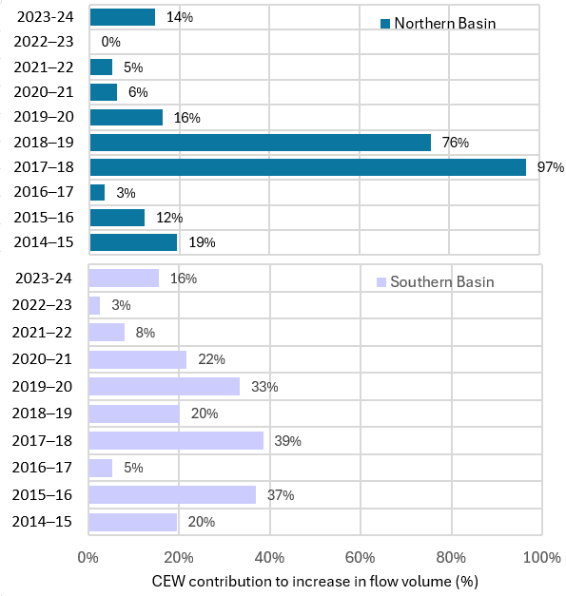
Table 5.3 Summary of longitudinal connectivity outcomes in 2023–24 against expected outcomes as listed in the Strategy
* Not evaluated, as Condamine Balonne is missing long-term watering plan targets at gauges with Commonwealth environmental water (CEW) information; Ovens is missing pre-development flow information; Broken is typically not evaluated; Wimmera Valley was assessed based on Mount William Creek, which was the only gauge with available pre-development flow, daily CEW and long-term watering plan targets.
Expected outcome | 2023–24 outcome | 2014–24 outcome
Keep base flows at 60% of natural levels | Met in all valleys except Wimmera* and Broken (Condamine Balonne and Ovens)* | Met twice in the Barwon Darling, Edward/Kolety–Wakool, Lower Darling/Baaka (2022–24), met twice in the Condamine Balonne (not evaluated in 2022–23), met 3 times in the Warrego, Gwydir, Namoi (outcomes met in all valleys in 2021–22 and 2022–24), met 4 out of 10 years in the Border Rivers and Lower Murray (both in 2016–17 and 2021–22, 2022–23, 2023–24) , met 5 out of 10 years in the Campaspe (2017–18, 2018–19, 2020–21, 2022–23, 2023–24), met 6 out of 10 years in Lachlan (2015–16, 2016–17, 2017–18, 2021–22, 2022–23, 2023–24), Macquarie (2015–16, 2016–17, 2020–21, 2021–22, 2022–23, 2023–24), Goulburn (2014–15, 2018–19, 2019–20, 2020–21, 2022–23, 2023–24), Murrumbidgee (2015–16, 2016–17, 2019–20, 2020–21, 2022–23, 2023–24) and Ovens (2016–17, 2019–20, 2020–21, 2021–22, 2022–23); met 6 out of 10 years in the Loddon (2014–15, 2017–18, 2019–20, 2020–21, 2021–22, 2022–23, 2023–24), met all years in the Central Murray
10% increase in flows in the Barwon Darling river system | 14.47% increase observed (technically met) | Met in 6 out of 10 years. Not met in years 2016–17, 2020–21, 2021–22, 2022–23
30% increase in flows in the Murray River | 15.54% increase observed (technically not met) | Met in 3 out of 10 years in 2015–16, 2017–18, 2019–20. Not met in the other years
30% to 40% increase in flows to the Murray Mouth | 20.59% increase observed (technically not met) | Not met in 2022–23 and not evaluated previously

End-of-Basin flows
The end-of-Basin flows in 2023–24 were representative of an average to wet year. Barrage flows were higher than the required 2,000 GL/year, and water levels were higher than 0.4 Australian Height Datum (AHD) for the entire year, which both would have been met even in the counterfactual scenario without the CEW. The outcomes and context for 2023–24 are provided in Table 5.4. The CEW contribution to the barrage flows was 1,146 GL over the year (Table 5.5). Another requirement is that the minimum over 2 years should be no less than 600 GL/year. This was also achieved – the minimum was 5,185 GL in 2023–24 with CEW contribution, and the minimum was 4,039 GL/year in 2023–24 without CEW. The water levels in the Lower Lakes were maintained at higher than 0.4 m AHD for the entire year. Figure 5.2 shows the level in AHD for Lake Alexandrina (one of the 2 Lower Lakes relevant to the Strategy) – values were as high as 0.8 m AHD in the summer in the current water year. By way of comparison, Figure 5.2 shows that the target water level would not have been maintained in Lake Alexandrina for short periods in 2015, 2016, 2018, 2019 and 2020 without the contribution of CEW.
Table 5.4 Summary of outcomes of end-of-Basin flows against expected outcomes as listed in the Strategy for 2023–24 and over the 10-year period 2014–24
CEW = Commonwealth environmental water. AHD = Australian Height Datum.
End-of-Basin flows | 2023–24 outcome | 2014 –24 outcome
Barrage flows > 2,000 GL/year in a 3-year rolling average | Met; would have been met even without CEW | Met 6 times in 2016–17, 2017–18, 2018–19 2021–22, 2022–23, 2023–24.
Water levels in the Lower Lakes are above sea level and 0.4 m AHD for 95% of the time | Met; would have been met even without CEW | Met in all years, CEW contributions helped achieve this outcome in 2014–15, 2015–16, 2017–18, 2018–19, 2019–20
Figure 5.2 Contribution of Commonwealth environmental water towards maintaining the water level in Lake Alexandrina above 0.4 m Australian Height Datum, per year 2014–24
BEWS = Basin-wide environmental watering strategy; AHD = Australian height datum. CEW = Commonwealth environmental water.
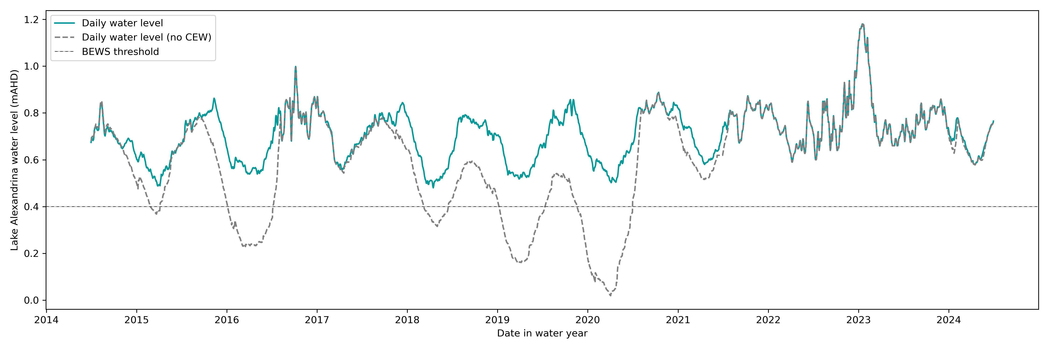
For 5 of the 10 years, the barrage release requirements were not met, even with CEW deliveries for the specific water year. In dry years (water year starting in 2017 ending in 2020), CEW was the only water source contributing to barrage releases, making up 100% of the released water (Table 5.5). The 3-year rolling average was higher than 2,000 GL/year for 6 of the 10 years (Table 5.5). In the dry years (2017–20), the CEW contribution to the 3-year rolling average of releases was up to 76%.
Table 5.5 Contribution of Commonwealth environmental water to barrage releases (GL) with and without Commonwealth environmental water, 2014–24
Values in parentheses are the 3-year rolling averages from water year 2013–14 to the current evaluation. NA = no earlier records available to allow calculation. CEW = Commonwealth environmental water. Source: Table 2, Ye et al. 2025.
 | 2014–15 | 2015–16 | 2016–17 | 2017–18 | 2018–19 | 2019–20 | 2020–21 | 2021–22 | 2022–23 | 2023–24
CEW contribution | 454 | 561 | 802 | 757 | 377 | 685 | 808 | 841 | 753 | 1,146
Total barrage release with CEW | 987  NA | 561  (1,073) | 6,484  (2,677) | 854  (2,633) | 377  (2,572) | 685  (639) | 1,247  (770) | 6,161  (2,698) | 21,597  (9,668) | 5,185  (10,981)
Total barrage release without CEW | 533  NA | 0  (500) | 5,682  (2,072) | 97  (1,926) | 0  (1,926) | 0  (32) | 439  (146) | 5,320  (1,920) | 20,844  (8,868) | 4,039  (10,068)

Data tables
Table A.1 Inundation mapping assets, data sources and validation comments
Sentinel 2 imagery accessed through Digital Earth Australia by GeoScience Australia. CEW = Commonwealth environmental water. ANAE = Australian National Aquatic Ecosystem. CEWH = Commonwealth Environmental Water Holder. CLLMM = Coorong, Lower Lakes and Murray Mouth.
Asset | Valley | Data source | Validated by | Mapping comment
Warrego St | Lower Murray | Wetland asset boundaries provided by Renmark Irrigation Trust (Tara Daniell). Inundation mapped from Sentinel 2 imagery | Delivery partner | good estimation of CEW, only CEW pumped
26th St | Lower Murray | Wetland asset boundaries provided by Renmark Irrigation Trust (Tara Daniell). Inundation mapped from Sentinel 2 imagery | Delivery partner | good estimation of CEW, only CEW pumped
Nelwart St | Lower Murray | Wetland asset boundaries provided by Renmark Irrigation Trust (Tara Daniell). Inundation mapped from Sentinel 2 imagery | Delivery partner | good estimation of CEW, only CEW pumped
Berri | Lower Murray | Wetland asset boundaries provided by Landscape SA (Kate Mason). Inundation mapped from Sentinel 2 imagery | Delivery partner | good estimation of CEW, only CEW pumped
Disher | Lower Murray | Wetland asset boundaries provided by Landscape SA (Kate Mason). Inundation mapped from Sentinel 2 imagery | Delivery partner | good estimation of CEW, only CEW pumped
Molo flats | Lower Murray | Wetland asset boundaries provided by Landscape SA (Kate Mason). Inundation mapped from Sentinel 2 imagery | Delivery partner | good estimation of CEW, only CEW pumped
Murpbook | Lower Murray | Wetland asset boundaries provided by Landscape SA (Kate Mason). Inundation mapped from Sentinel 2 imagery | Delivery partner | good estimation of CEW, only CEW pumped
Nilkra | Lower Murray | Wetland asset boundaries provided by Landscape SA (Kate Mason). Inundation mapped from Sentinel 2 imagery | Delivery partner | good estimation of CEW, only CEW pumped
Overland Corner | Lower Murray | Wetland asset boundaries provided by Landscape SA (Kate Mason). Inundation mapped from Sentinel 2 imagery | Delivery partner | good estimation of CEW, only CEW pumped
Lower Murrumbidgee | Murrumbidgee | Inundation mapped by NSW DCCEEW (State Government of NSW and NSW Department of Climate Change, Energy, the Environment and Water 2020, Inundation Maps for NSW Inland Floodplain Wetlands) and processed to reflect relevant CEW inundation | Selected Area team, Flow-MER | removed Lachlan Cumbung Swamp portions due to checking from Lachlan selected area team, potentially overestimation of north-western part of inundation extent, connectivity may not have been directly resulting from CEW
MIA wetlands | Murrumbidgee | Wetland assets delineated through ANAE wetlands layer (Department of Climate Change, Energy, the Environment and Water Australian National Aquatic Ecosystem (ANAE) classification for the Murray Darling Basin - Wetlands (2021)). Inundation mapped from Sentinel 2 imagery accessed through Digital Earth Australia by GeoScience Australia | Delivery team | potentially overestimated due to vegetation in the Sentinel imagery but advice from water manager given around extents
Toorale Floodplain | Warrego | Inundation mapped by 2rog Consulting Pty Ltd, and processed to reflect relevant CEW inundation | Selected Area team, Flow-MER | underestimates due to dense vegetation cover present at the time of mapping
Barmah–Millewa Forest | Central Murray | Inundation mapped by NSW DCCEEW (State Government of NSW and NSW Department of Climate Change, Energy, the Environment and Water 2020, Inundation Maps for NSW Inland Floodplain Wetlands) and processed to reflect relevant CEW inundation | Icon site manager | overestimates due to other environmental water in the delivery mix
Barmah-MIllewa Forest | Central Murray | Inundation mapped by NSW DCCEEW (State Government of NSW and NSW Department of Climate Change, Energy, the Environment and Water 2020, Inundation Maps for NSW Inland Floodplain Wetlands) and processed to reflect relevant CEW inundation | Icon site manager | overestimates due to other environmental water in the delivery mix
Narran Lakes | Condamine Balonne | Inundation mapped by NSW DCCEEW (State Government of NSW and NSW Department of Climate Change, Energy, the Environment and Water 2020, Inundation Maps for NSW Inland Floodplain Wetlands) and processed to reflect relevant CEW inundation | Checked against the CEWH acquittal reports | reproduces inundation mapping presented in the CEWH acquittal report
Maccquarie Marshes | Macquarie | Inundation mapped by NSW DCCEEW (State Government of NSW and NSW Department of Climate Change, Energy, the Environment and Water 2020, Inundation Maps for NSW Inland Floodplain Wetlands) and processed to reflect relevant CEW inundation | Delivery partner | mixing with other water overestimates contribution, contribution should be accounted in terms of duration of inundation for the Macquarie Marshes (i.e. CEW helped extend duration of inundation)
Maccquarie Marshes | Macquarie | Inundation mapped by NSW DCCEEW (State Government of NSW and NSW Department of Climate Change, Energy, the Environment and Water 2020, Inundation Maps for NSW Inland Floodplain Wetlands) and processed to reflect relevant CEW inundation | CEWH officer | mixing with other water overestimates contribution, contribution should be accounted in terms of duration of inundation for the Macquarie Marshes (i.e. CEW helped extend duration of inundation)
Cumbung Swamp | Lachlan | Inundation mapped by NSW DCCEEW (State Government of NSW and NSW Department of Climate Change, Energy, the Environment and Water (2020) Inundation Maps for NSW Inland Floodplain Wetlands) and processed to reflect relevant CEW inundation | Selected Area team, Flow-MER
Lake Brewster | Lachlan | Inundation mapped from previous years' inundation mapping | Unknown | using existing Lake Brewster inundation information (validate in 2022–23)
Gwydir | Gwydir | Inundation mapped by NSW DCCEEW (State Government of NSW and NSW Department of Climate Change, Energy, the Environment and Water 2020, Inundation Maps for NSW Inland Floodplain Wetlands) and processed to reflect relevant CEW inundation | Selected area team FlowMER | Used NSW DCCEEW mapping with input from 2rog regarding the potentially inundated areas, potentially underestimates inundation due to dense vegetation cover
Edward/Kolety–Wakool rivers | Edward/Kolety–Wakool | Line mapping, as no overbank inundation observed in 2023–24 | Selected Area team, Flow-MER | No comment
Coorong and Lower Lakes | Lower Murray | Inundation mapped from previous years' inundation mapping | Unknown | using existing CLLM inundation information
Table A.2 List of hydrological gauge sites used for this evaluation, together with their flow thresholds extracted from Long Term Watering Plans
This table is available on the Flow-MER data portal (metadata statement). The table viewer supports filtering to show customised views of the content. (CEWH 2025)
Table A.3 Commonwealth environmental watering actions by flow component, 2014–24
Flow component combinations are as reported in the cumulative Watering Actions dataset provided by the Commonwealth Environmental Water Holder. Each year’s data are appended to the cumulative dataset. Dash (–) indicates no watering targeted at that flow component. CEW = Commonwealth environmental water.
 | 2014–15 | 2015–16 | 2016–17 | 2017–18 | 2018–19 | 2019–20 | 2020–21 | 2021–22 | 2022–23 | 2023–24 | Total
CEW volume (ML) | 1,193,718 | 1,685,695 | 1,817,668 | 1,945,253 | 1,163,048 | 1,704,598 | 1,761,880 | 2,785,886 | 1,385,244 | 2,870,147 | 18,309,736
CEW volume (GL) (rounded up) | 1,194 | 1,686 | 1,818 | 1,945 | 1,163 | 1,705 | 1,762 | 2,786 | 1,385 | 2,870 | 18,310
Base flow | 13 | 15 | 15 | 31 | 24 | 25 | 24 | 32 | 33 | 34 | 246
Base flow/fresh | 3 | 5 | 2 | 2 | 7 | 7 | 3 | 3 | 8 | 15 | 55
Base flow/ fresh/bankfull | – | – | – | – | – | 1 | 1 | – | 6 | 3 | 11
Base flow/ fresh/overbank | – | – | – | – | – | – | – | 2 | – | – | 2
Base flow/ fresh/overbank/ wetland | – | – | – | – | – | 1 | – | 2 | – | – | 3
Base flow/ fresh/wetland | – | – | – | – | – | – | 1 | – | – | – | 1
Bankfull | 2 | – | 5 | 1 | – | – | – | 3 | – | – | 11
Bankfull/fresh | – | – | – | – | – | – | – | 1 | – | – | 1
Bankfull/fresh/ overbank | – | – | – | – | – | – | – | 2 | 6 | – | 8
Fresh | 23 | 35 | 39 | 29 | 20 | 17 | 30 | 27 | 17 | 33 | 270
Fresh/bankfull | – | 1 | 1 | – | – | – | – | – | – | – | 2
Fresh/base flow | – | – | – | – | 1 | – | – | – | 2 | 3 | 6
Fresh/overbank | – | 1 | – | 1 | 1 | – | 1 | – | – | 1 | 5
Fresh/overbank/ bankfull | – | – | – | – | – | – | 0 | – | 2 | – | 2
Fresh/wetland | – | 1 | – | 3 | – | 4 | 4 | 6 | – | 2 | 20
Overbank | – | 5 | 1 | 6 | 2 | 2 | 2 | – | 1 | 1 | 20
Overbank/fresh | – | – | – | – | – | – | – | – | 5 | – | 5
Overbank/wetland | – | – | – | – | – | 1 | 2 | 1 | – | – | 4
Wetland | 41 | 56 | 30 | 41 | 74 | 65 | 87 | 81 | 21 | 21 | 517
Wetland/fresh | – | – | – | – | 2 | – | – | – | – | 1 | 3
Wetland/overbank | – | – | – | – | – | 2 | – | – | – | – | 2
Total | 82 | 119 | 93 | 114 | 131 | 125 | 155 | 160 | 101 | 114 | 1,194
For the purposes of reporting herein, the flow components as described in Table A.3 have been combined into 4 flow categories as set out in Table A.4.
Table A.4 Flow components combined into 4 categories of base flow, freshes, bankfull and overbank/wetland, 2014–24
 | 2014–15 | 2015–16 | 2016–17 | 2017–18 | 2018–19 | 2019–20 | 2020–21 | 2021–22 | 2022–23 | 2023–24 | TOTAL
Base flow | 16 | 20 | 17 | 33 | 31 | 34 | 29 | 39 | 47 | 52 | 318
Fresh | 23 | 38 | 40 | 33 | 22 | 21 | 35 | 33 | 22 | 39 | 306
Bankfull | 2 | - | 5 | 1 | - | - | - | 6 | 6 | - | 20
Overbank/ wetland | 41 | 61 | 31 | 47 | 78 | 70 | 91 | 82 | 26 | 23 | 550
Total | 82 | 119 | 93 | 114 | 131 | 125 | 155 | 160 | 101 | 114 | 1,194
Table A.5 Length of waterways (km) connectivity due to Commonwealth environmental water, per year 2014–24
Length is rounded up to the nearest km. * CEW flowed into the Paroo in 2023–24 from a watering action initiated in the Warrego. Dash (–) indicates that the Valley is not in scope for CEW.
 | 2014–15 | 2015–16 | 2016–17 | 2017–18 | 2018–19 | 2019–20 | 2020–21 | 2021–22 | 2022–23 | 2023–24 | Cumulative 2014 –24 | Maximum extent
Northern Basin
Barwon Darling | 1,836 | 2,242 | 1874 | 1,885 | 832 | 1,859 | 1,888 | 2,071 | 1,956 | 1,909 | 18,354 | 2,242
Border Rivers | 1,035 | 932 | 930 | 1,228 | 726 | 935 | 1,219 | 1,616 | 1,118 | 1,103 | 10,841 | 1,616
Condamine Balonne | 1,556 | 1,638 | 1,561 | 1,319 | 0 | 1,627 | 1,634 | 2,157 | 1,576 | 1,761 | 14,830 | 2,157
Gwydir | 977 | 800 | 681 | 1,096 | 1,193 | 625 | 831 | 750 | 842 | 876 | 8,671 | 1,193
Macquarie | 747 | 817 | 936 | 1,187 | 1,026 | 667 | 1,142 | 2,542 | 2,318 | 1,401 | 12,783 | 2,542
Namoi | 0 | 0 | 692 | 354 | 504 | 0 | 126 | 0 | 558 | 685 | 2,920 | 692
Paroo* | – | – | – | – | – | – | – | – | – | 161* | 161* | 161*
Warrego | 1,182 | 429 | 1,200 | 432 | 1,177 | 1,178 | 1,190 | 1,257 | 1,218 | 1,338 | 10,602 | 1,338
Southern Basin
Broken | 340 | 195 | 195 | 294 | 190 | 280 | 264 | 393 | 405 | 408 | 2,963 | 408
Campaspe | 112 | 112 | 0 | 114 | 112 | 112 | 112 | 123 | 123 | 112 | 1,032 | 123
Central Murray | 1,756 | 2,071 | 2,008 | 2,372 | 2,120 | 2,145 | 2,281 | 2,126 | 2,126 | 2,240 | 21,247 | 2,372
Edward/ Kolety–Wakool | 875 | 863 | 863 | 932 | 932 | 789 | 934 | 1,332 | 2,223 | 1,383 | 11,127 | 2,223
Goulburn | 406 | 403 | 404 | 406 | 406 | 406 | 404 | 414 | 414 | 412 | 4,075 | 414
Lachlan | 1,342 | 1,560 | 1,411 | 1,372 | 1,359 | 1,488 | 1,548 | 1,861 | 1,350 | 1,510 | 14,800 | 1,861
Loddon | 365 | 361 | 364 | 364 | 365 | 365 | 365 | 365 | 366 | 365 | 3,644 | 366
Lower Darling/ Baaka | 74 | 0 | 1,008 | 597 | 0 | 9 | 524 | 1,039 | 1,182 | 1,167 | 5,599 | 1,182
Lower Murray | 993 | 1,104 | 1,203 | 1,335 | 1,098 | 1,189 | 1,242 | 939 | 1,224 | 1,287 | 11,614 | 1,335
Murrumbidgee | 1,417 | 1,960 | 1,811 | 2,154 | 1,626 | 1,499 | 2,471 | 2,910 | 3,002 | 2,462 | 21,314 | 3,002
Ovens | 260 | 260 | 260 | 260 | 260 | 252 | 257 | 269 | 25 | 257 | 2,359 | 269
Wimmera | 0 | 0 | 0 | 179 | 179 | 179 | 0 | 393 | 179 | 238 | 954 | 238
Total | 15,273 | 15,748 | 17,403 | 17,880 | 14,106 | 15,603 | 18,433 | 22,164 | 22,205 | 21,075 | 179,890 | 25,573
Table A.6 Hydrological evaluation sites, flow component thresholds, and corresponding environmental assets
LTWP = Long Term Watering Plan. D/S = downstream. All thresholds are in ML.
Gauge name | Gauge ID | Valley name | Latitude | Longitude | River name | Jurisdiction | Very low base flow | Low base flow | Low fresh | High fresh | Environmental asset
Broken Creek @ Casey Weir | 404217 | Broken | −36.47314 | 145.94144 | Broken Creek | Vic | No LTWP Threshold | 40 | No LTWP threshold | 400 | Lower Broken Creek
Goulburn River @ Eildon | 405203 | Goulburn | −37.2467952 | 145.8892935 | Goulburn River | Vic | No LTWP Threshold | 400 | No LTWP threshold | 900 | Goulburn River Reach 1
Goulburn River @ McCoys Bridge | 405232 | Goulburn | −36.177704 | 145.1190535 | Goulburn River | Vic | No LTWP Threshold | 540 | No LTWP threshold | 5,600 | Goulburn River Reach 4 & 5
Campaspe River @ Rochester | 406202 | Campaspe | −36.331930 | 144.7009668 | Campaspe River | Vic | No LTWP Threshold | 50 | 1,000 | 1,800 | Campaspe River
Loddon River @ Appin South | 407205 | Loddon | −35.92432 | 143.8718822 | Loddon River | Vic | No LTWP Threshold | 30 | No LTWP threshold | 400 | Loddon River Reach 4
Wakool River @ Wakool Offtake Regulator | 409019 | Edward/ Kolety–Wakool | −35.5017 | 144.8854 | Edward River | NSW | 20 | 20 | 100 | 500 | Wakool River
Murray River D/S Yarrawonga Weir | 409025 | Central Murray | −36.0114 | 145.994 | Murray River | NSW | 1,800 | 1,800 | 7,000 | 12,000 | Barmah–Millewa Forest
Murrumbidgee River @ D/S Maude Weir | 410040 | Murrumbidgee | −34.4776 | 144.3009 | Murrumbidgee River | NSW | 170 | 600 | 2,500 | 6,000 | Lower Murrumbidgee wetlands: Gayini Nimmi Caira wetlands, Western Lakes
Lachlan River @ Booligal | 412005 | Lachlan | −33.8695 | 144.8811 | Lachlan River | NSW | 10 | 50 | 200 | 650 | Lachlan River
Mount William Creek @ Lake Lonsdale (Tail Gauge) | 415203 | Wimmera | −37.03057 | 142.58359 | Mount William Creek | Vic | No LTWP thresholds | 5 | 30 | 500 | Mount William Creek
Barwon River @ Mungindi | 416001 | Barwon Darling | −28.9762 | 148.9848 | Barwon River | NSW | 45 | 160 | 540 | 3,000 | Barwon Darling River (Mungindi to Menindee)
Carole Creek D/S Regulator | 418011 | Gwydir | −29.4069 | 149.8885 | Carole Creek | NSW | 20 | No LTWP threshold | No LTWP threshold | No LTWP threshold | Carole Creek
Gwydir River @ Gravesend Road Bridge | 418013 | Gwydir | −29.5819 | 150.3666 | Gwydir River | NSW | No LTWP threshold | 170 | 990 | 8,600 | Gwydir River
Peel River @ Piallamore | 419015 | Namoi | −31.182158 | 151.066538 | Peel River | NSW | 1 | 100 | 250 | 1,350 | Peel River
Namoi River @ Goangra | 419026 | Namoi | −30.1417166 | 148.38765 | Namoi River | NSW | 1 | 25 | 65 | 1,000 | Lower Namoi River
Macquarie River at D/S Marebone Weir | 421090 | Macquarie | −31.385084 | 147.59342 | Macquarie River | NSW | 10 | 30 | 300 | 1,000 | Macquarie Marshes
Darling River @ Bourke Town | 425003 | Barwon Darling | −30.087894 | 145.936761 | Darling River | NSW | 105 | 500 | 1550 | 15,000 | Barwon Darling River (Mungindi to Menindee)
Murray River @ Lock False 10 (Wentworth) | 425010 | Central Murray | −34.11 | 141.9045 | Murray River | NSW | 3500 | 10,000 | 14,000 | 20,000 | Murray River
Macintyre River @ Goondiwindi | 416201A | Border Rivers | −28.549704 | 150.30756 | Macintyre River | Qld | 166 | 450 | 1,500 | 8,000 | Dumaresq–Macintyre River
Balonne River @ St George | 422201F | Condamine Balonne | −28.06135 | 148.563584 | Balonne River | Qld | No LTWP threshold | No LTWP threshold | No LTWP threshold | No LTWP threshold | Lower Balonne floodplain
Warrego River @ Cunnamulla | 423202C | Warrego | −28.116875 | 145.6866028 | Warrego River | Qld | No LTWP Threshold | 22 | 220 | 2,200 | Lower Warrego River
Warrego River @ Augathella | 423204A | Warrego | −25.79284 | 146.585664 | Warrego River | Qld | No LTWP threshold | No LTWP threshold | No LTWP threshold | No LTWP threshold | Upper Warrego River
“River Murray @ Calculated Flows to SA” | A4261001 | Lower Murray | −33.9805 | 140.96374 | Murray River | SA | 7000 | 10,000 | 20,000 | 40,000 | Lower Murray

Abbreviations and terms
Abbreviation/  term | Description
2014–24 | water years, 1 July 2014 to 30 June 2024
2023–24 | water year, 1 July 2023 to 30 June 2024
AHD | Australian height datum, measured in metres
base flow | flow in a system not impacted by runoff, or flow sustained by seeping groundwater
the Basin | shortened form for the Murray–Darling Basin
Basin Plan | shortened form for the (Murray–Darling) Basin Plan 2012
CEW | Commonwealth environmental water
CEWH | Commonwealth Environmental Water Holder
counterfactual | In the counterfactual approach, Commonwealth environmental water is removed from the observed streamflow time series, creating a hypothetical (counterfactual) daily streamflow time series with no Commonwealth environmental water. This approach is used to infer the effects of Commonwealth environmental water as an experimental design with controls and/or before–after comparisons is not possible.
Flow-MER | The CEWH’s Science Program: Flow Monitoring, Evaluation and Research (2019–20 to 2029–30)
fresh | flow due to runoff and other releases
GL | gigalitre
ha | hectare
lateral connectivity | hydrological connectivity between the river (lateral) and floodplain
longitudinal connectivity | hydrological connectivity of hydrologically connected valleys
LTIM | Long Term Intervention Monitoring Project (2014–15 to 2018–19)
LTWP | Long-term watering plan
MDBA | Murray–Darling Basin Authority
natural flow regime | In this context, the pre-development flow is a surrogate for a natural flow regime
pre-development flow | modelled flow and connectivity in a scenario without development, provided by the Murray–Darling Basin Authority
the Strategy | shortened form for the Basin-wide environmental watering strategy (MDBA 2019)

References
Brooks (2024) Basin-scale evaluation of 2022–23 Commonwealth environmental water: Hydrology. Flow-MER Program. Commonwealth Environmental Water Holder, Department of Climate Change, Energy, the Environment and Water, Canberra, Australia. pp 74
CEWH (2024) 2023–24 Flow-MER watering actions table. Prepared by Science Division, Commonwealth Environmental Water Holder, Department of Climate Change, Energy, the Environment and Water, Canberra. Unpublished.
CEWH (2025) River gauges and flow component thresholds. Flow-MER Program. Commonwealth Environmental Water Holder, Australian Government Department of Climate Change, Energy, the Environment and Water. Sourced from https://data.flow-mer.org.au/dataset/edit/river-gauges-flow-thresholds on 26 May 2025.
CEWO (2013) Commonwealth Environmental Water – The Environmental Water Outcomes Framework v1.1 Commonwealth Environmental Water Office, Australian government, Canberra.
Chiew FHS, Zheng H, Potter NJ (2018) Rainfall-runoff modelling considerations to predict streamflow characteristics in ungauged catchments and under climate change. Water 10, 1319.
Davies P, Harris J, Hillman T, Walker K (2004) Sustainable Rivers Audit. A report on the ecological health of rivers in Murray-Darling Basin. Prepared by the Independent Sustainable Rivers Audit Group for the Murray-Darling Basin Ministerial Council. https://www.mdba.gov.au/sites/default/files/publications/sra-1-complete-report.pdf
Davies PE, Harris JH, Hillman TJ, Walker KF (2010) The Sustainable Rivers Audit: assessing river ecosystem health in the Murray-Darling Basin, Australia. Marine & Freshwater Research 61(7) 764 –777 https://doi.org/10.1071/MF09043
Guarino F, Sengupta A (2023) 2021–22 Basin-scale evaluation of Commonwealth environmental water: Hydrology. Flow-MER program. Commonwealth Environmental Water Holder, Department of Climate Change, Energy, the Environment and Water, Canberra, Australia.
MDBA (2012) Sustainable Rivers Audit 2 Valley and Zone Spatial Layers. Accessed 1 February 2023, https://data.gov.au/data/dataset/sustainable-rivers-audit-2-valley-and-zone-spatial-layers.
MDBA (2019) Basin-wide environmental watering strategy. Second edition, revised February 2020. Murray–Darling Basin Authority, Canberra.
MDBA (2025) River data and storage reports. Accessed April 2025, Murray–Darling Basin Authority, Canberra. https://www.mdba.gov.au/publications-and-data/data-and-dashboards.
O’Sullivan J, Cuddy SM (eds) (2024) Flow-MER Basin-scale evaluation of Commonwealth environmental water: Methods. Flow-MER Program. Commonwealth Environmental Water Holder, Department of Climate Change, Energy, Environment and Water, Australia.
Sengupta A, Egger F and Weber T (2024) 2022–23 Basin-scale evaluation of Commonwealth environmental water: Hydrology. Flow-MER program. Commonwealth Environmental Water Holder, Department of Climate Change, Energy, the Environment and Water, Canberra, Australia.
Stewardson MJ, Guarino F (2016) 2014–15 Basin-scale evaluation of Commonwealth environmental water — Hydrology (Final Report prepared for the Commonwealth Environmental Water Office). MDFRC Publication 104/2016. The Murray–Darling Freshwater Research Centre, Albury
Ye Q, Giatas G, Bice C, Brookes J, Furst D, Gibbs M, Nicol J, Oliver R, Zampatti B, Bucater L, Deane D, Frahn K, Hipsey M, Huang P, Lorenz Z, Mills J, Shiel R and Zhai S (2025) Commonwealth Environmental Water Holder Flow-Monitoring, Evaluation and Research Project: Lower Murray 2023–24 Technical Report. A report prepared for the Commonwealth Environmental Water Holder by the South Australian Research and Development Institute, Aquatic and Livestock Sciences.
Zheng HX, Chiew FHS, Post D, Robertson D, Charles SP, Grose MR, Potter NJ (2024) Projections of future streamflow for Australia informed by CMIP6 and previous generations of global climate models. Journal of Hydrology, 636, 131286. https://doi.org/10.1016/j.jhydrol.2024.131286

https://flow-mer.org.au
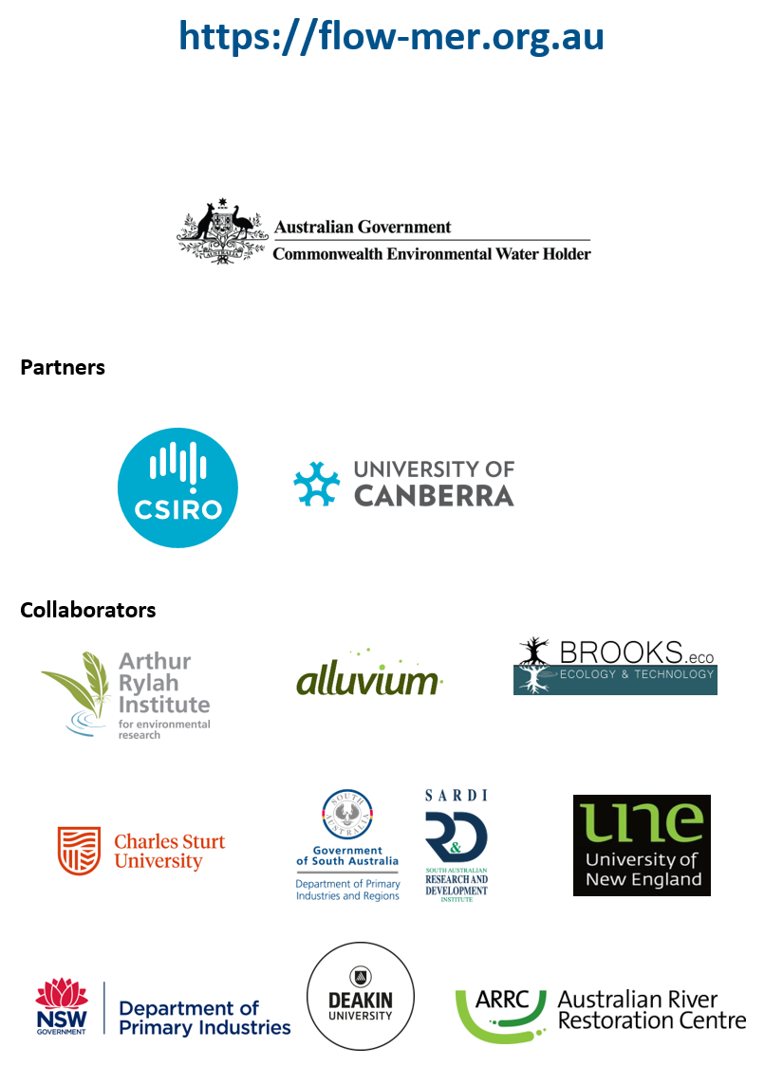

At the time of writing, the 2025 edition of the Strategy was not available. 2023–24 evaluations reference the 2019 edition (MDBA 2019).
Pre-development flows are modelled flows and connectivity, in a scenario without development (pre-1984), provided by the Murray–Darling Basin Authority (MDBA).
At the time of writing, the 2025 edition of the Strategy was not available. 2023–24 evaluations reference the 2019 edition (MDBA 2019).
The Long Term Intervention Monitoring and Environmental Water Knowledge and Research projects (2014–2019)
In the counterfactual approach, CEW is removed from the observed streamflow time series, creating a hypothetical (counterfactual) daily streamflow time series with no CEW. This approach is used to infer the effects of CEW, as an experimental design with controls and/or before–after comparisons is not possible.
In these evaluations, it is not possible to attribute the Commonwealth’s contribution separately to other environmental water under the current methods.
At the time of writing, the 2025 edition of the Strategy was not available. 2023–24 evaluations reference the 2019 edition (MDBA 2019).
These descriptions are derived from longer descriptions in MDBA (2019).
Total runoff is calculated as total precipitation less the losses caused by evapotranspiration. It includes not only the waters that travel over the land surface and through channels to reach a stream but also interflow (i.e. the water that infiltrates the soil surface and travels by means of gravity toward a stream channel).
At the time of writing, the 2025 edition of the Strategy was not available. 2023–24 evaluations reference the 2019 edition (MDBA 2019).

