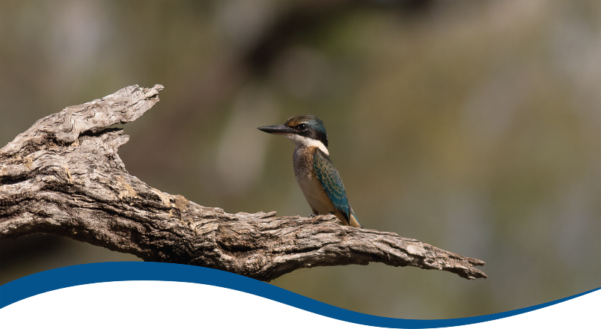

Basin-scale evaluation of 2023–24 Commonwealth environmental water: Species Diversity
  - Commonwealth Environmental Water Holder’s Science Program:
Flow Monitoring, Evaluation and Research Program (Flow-MER)
June 2025
Acknowledgements
The project team and the Commonwealth Environmental Water Holder (CEWH) respectfully acknowledge the Traditional Owners of the land on which this work is conducted, their Elders past and present, their Nations of the Murray–Darling Basin, and their cultural, social, environmental, spiritual and economic connection to their lands, air and waters.
We take this opportunity to thank the many individuals and agencies who provided data to support this evaluation – particularly the Atlas of Living Australia, New South Wales Department of Climate Change, Energy, the Environment and Water (NSW DCCEEW), University of New South Wales, Murray–Darling Basin Authority and The Living Murray data as presented in the NSW BioNet Atlas and Atlas of Living Australia. Special thanks to Dr Jennifer Spencer from NSW DCCEEW who provided complementary datasets for waterbirds and frogs, as well as access to unpublished technical reports. Dr Shane Brooks provided hydrological metrics derived from the Wetlands Insight Tool provided by Geoscience Australia. We would like to thank the CSIRO team for their efforts in report layout, editing, reviewing and formatting. Special mention to Susan Cuddy, Dianne Flett and Jane Thomas whose input, together with formatting specialist Jill Sharkey, greatly improved the readability of the report. CSIRO’s Martin Nolan assisted with figures and GIS layers. A final thanks to staff of the CEWH and members of the CEWH’s Independent Advisory Group for their independent review.
Citation
Wassens S, Mathwin R and Hall A (2025) Basin-scale evaluation of 2023–24 Commonwealth environmental water: Species Diversity. Flow-MER Program. Commonwealth Environmental Water Holder, Flow Monitoring, Evaluation and Research Program, Department of Climate Change, Energy, the Environment and Water, Australia. 134pp.
Copyright
© Commonwealth of Australia 2025
With the exception of the Commonwealth Coat of Arms, partner logos and where otherwise noted, all material in this publication is provided under a Creative Commons Attribution 4.0 International Licence https://creativecommons.org/licenses/by/4.0/. Flow-MER requests attribution as ‘© Commonwealth of Australia (Flow-MER Program, https://flow-mer.org.au)’.
Document log
Date | Version
25 April 2025 | Draft delivered to CSIRO for internal review and editing
5 May 2025 | Draft delivered to CEWH and external reviewer
20 June – 4 July | Response to review period
8 July 2025 | Draft final delivered to CEWH
Cover photograph
Sacred kingfisher in the Gwydir.
Photo credit: Commonwealth Environmental Water Holder
Important disclaimer
The information contained in this publication comprises general statements based on scientific research. The reader is advised and needs to be aware that such information may be incomplete or unable to be used in any specific situation. No reliance or actions must therefore be made on that information without seeking prior expert professional, scientific and technical advice. To the extent permitted by law, Flow-MER (including its partners and collaborators) excludes all liability to any person for any consequences, including but not limited to all losses, damages, costs, expenses and any other compensation, arising directly or indirectly from using this publication (in part or in whole) and any information or material contained in it.
Flow-MER is committed to providing web accessible content wherever possible. If you are having difficulties with accessing this document, please contact ewater@dcceew.gov.au.

Executive summary
Strategic management of Commonwealth environmental water by the Commonwealth Environmental Water Holder (CEWH) is key to achieving the environmental objectives in the Commonwealth’s (Murray–Darling) Basin Plan 2012 (the Basin Plan). The CEWH’s Science Program invests in Flow Monitoring, Evaluation and Research (Flow-MER) to demonstrate Basin-scale outcomes of Commonwealth environmental water, support adaptive management, and fulfil the CEWH’s legislative requirements under the Basin Plan.
The Basin-scale Species Diversity evaluation focuses on section 8.05 of the Basin Plan – Protection and restoration of water-dependent ecosystems. Section 8.05 sets out the objectives relating to the protection and restoration of water-dependent ecosystems in the context of species and populations, threatened taxa, and communities and ecosystems listed under state and national legislation and international agreements – Convention on the Conservation of Migratory Species of Wild Animals (Bonn Convention), China–Australia Migratory Bird Agreement (CAMBA), Japan–Australia Migratory Bird Agreement (JAMBA) and Republic of Korea–Australia Migratory Bird Agreement (ROKAMBA).

Evaluation approach
This report focuses on evaluating species diversity outcomes not covered in the Basin-scale Fish, Vegetation and Ecosystem Diversity evaluations. The evaluation addresses the overarching question:
What did Commonwealth environmental water contribute to species diversity?
This question is addressed through 3 components:
- What was the contribution of Commonwealth environmental water to the diversity of frogs, waterbirds and other water-dependent vertebrates?
- What was the contribution of Commonwealth environmental water to listed species and ecological communities?
- What was the contribution of Commonwealth environmental water to migratory species listed under international agreements (Bonn Convention, CAMBA, JAMBA or ROKAMBA)?
Addressing these components draws on multiple sources of data (listed below) and collates information on occurrences of other water-dependent aquatic vertebrate reptiles, mammals and birds, with reference to listed threatened species as defined under the Australian Environment Protection and Biodiversity Conservation Act 1999 (EPBC Act) and relevant state legislation.
This evaluation draws on 3 key sources of information:
- Selected Area data collected as part of the Long Term Intervention Monitoring Project (2014–19) and Flow-MER (2019–24) in the Junction of Warrego and Darling rivers, Gwydir River System, Lachlan River System and Murrumbidgee River System
- complementary waterbird survey data collected by the NSW Department of Climate Change, Energy, the Environment and Water (NSW DCCEEW) in the Border Rivers, Narran Lakes, Gwydir, Macquarie Marshes, Lachlan and Central Murray surface water regions between 2014–15 and 2023–24
- data from the Atlas of Living Australia to collate Basin-wide patterns of listed threatened and migratory species with a focus on frogs, water-dependent mammals, reptiles and waterbirds across the managed floodplain as defined by the Murray–Darling Basin Authority.
Our ability to adequately address species diversity outcomes is limited by the lack of available data that capture responses to the delivery of Commonwealth environmental water across the Murray–Darling Basin (the Basin). Several water-dependent listed species are not routinely monitored, and others are monitored only at local scales. Data availability may be limited due to restrictive data sharing agreements and public data can take years to appear in open-source repositories (e.g., the Atlas of Living Australia (ALA)).

Water year 2023–24
- 2,324 GL of Commonwealth environmental water was delivered with objectives related to species diversity outcomes, comprising 75 individual watering actions.
- A return to moderate conditions and water allocations, combined with a need to repair key water-delivery infrastructure, resulted in lower volumes of water being delivered to support floodplain habitats, particularly in the southern Basin.
- Waterbirds
  - 36 individual Commonwealth environmental watering actions had at least one watering objective related to waterbird outcomes, for a combined volume of 2,011 GL.
  - Flow-MER and NSW DCCEEW waterbird monitoring data were available for the Border Rivers, Gwydir River, Junction of Warrego and Darling rivers, Murrumbidgee River, Macquarie Marshes, Central Murray, Lachlan and Condamine (Narran Lakes) surface water regions. In total, 68,718 individual waterbird occurrences representing 68 species were reported.
  - 11 conservation-significant waterbird species were identified from the Flow-MER and NSW DCCEEW monitoring in 2023–24, including 3 species listed under the EPBC Act – Australasian bittern, sharp-tailed sandpiper and Latham’s snipe. Other species of significance included the listed threatened species black-necked stork, blue-billed duck, freckled duck and marsh sandpiper.
- Frogs and other vertebrates:
  - 25 individual Commonwealth environmental watering actions had at least one watering objective related to frog outcomes, for a combined volume of 94 GL
  - 11 frog species were detected from Flow-MER monitoring. Southern bell frog (listed as Vulnerable under the EPBC Act) adults and tadpoles were identified at multiple sites receiving Commonwealth environmental water across the lower Murrumbidgee.
- Listed threatened and migratory species:
  - 21 individual Commonwealth environmental watering actions had at least one watering objective related to listed species, for a combined volume of approximately 111 GL.
  - Additionally, 18 actions had a combined volume of 1,403 GL for listed fish species, including 1,384 GL for lamprey migration, 17 GL for Murray cod and 1.7GL for Murray hardyhead.
- There were 46 watering actions with a combined value of 315 GL for ‘other biota’, much of which targeted outcomes for invertebrates. In addition, there were 17 actions with 43 GL for platypus, 3 actions with 6 GL for turtles, and 3 actions with 1 GL for regent parrots.

Water years 2014–24
- Over this 10-year period, 740 watering actions with objectives for species diversity outcomes were undertaken, delivering approximately 11,021 GL of Commonwealth environmental water.
- 2,201 GL of Commonwealth environmental water was delivered to benefit listed threatened or migratory species. In addition, 7,374GL was delivered for listed fish species, either alone or in combination with other watering objectives.
- Between 2014–15 and 2023–24, 59 listed threatened or migratory waterbird and raptor species were reported from habitats that received Commonwealth environmental water on at least one occasion.
- There were 26 listed water-dependent crustaceans, fish, frogs, reptiles and mammals reported from habitats that received Commonwealth environmental water on at least one occasion over the 10-year period.
- Commonwealth environmental water had a significant influence on the presence of the federally listed southern bell frog and Australasian bittern.

Informing adaptive management
Outcomes for species diversity could be improved by:
- undertaking periodic, broad-scale survey efforts. Ideal survey effort would include multiple taxonomic groups (frogs, fish, crustaceans and water-dependent mammals, birds and reptiles) and a range of ANAE polygon types including those outside of the managed floodplain
- targeted monitoring of listed species that are known to occur in habitats that receive Commonwealth environmental water, focusing on revisiting locations with historical records that have not been surveyed in the past 10 years
- support for data-sharing between local, state and federal agencies so that information on monitoring activities and species responses following environmental water delivery is more widely available. This should include the timely upload of biological survey data to the Atlas of Living Australia
- explicitly identifying the occurrence and water needs of listed threatened and migratory species that occur within the managed floodplain within each valley. In this report, we have provided a summary of frogs, waterbirds and listed threatened and migratory species that were reported from the managed floodplain in each valley. A more detailed assessment to identify key water-dependent species, their distribution, and current water management practices in each valley is critical to identify ‘blind spots’ where the water requirements of these species are not being met
- the setting of more specific valley and Basin-wide objectives for species diversity and listed threatened and migratory species that allow for coordination between water-delivery teams to ensure that all stages of a species’ life cycle are maintained
- increasing alignment between environmental water planning and prioritisation and recovery plans for listed threatened and migratory species.

Overview of Flow-MER and the 2023–24 evaluation
The Commonwealth Environmental Water Holder’s (CEWH) Science Program invests in monitoring, evaluation and research activities through its Flow Monitoring, Evaluation and Research Program (Flow-MER). The Flow-MER Basin-scale evaluation assesses the contributions of Commonwealth environmental water (CEW) to meeting the environmental objectives stated in chapters 8 and 9 of the (Murray–Darling) Basin Plan and in the Basin-wide environmental watering strategy. Six Basin Themes (Figure 1) are evaluated using data from 7 Flow-MER Selected Areas (left-side map, Figure 2) and the 19 valleys (right-side map, Figure 2) where the CEWH holds water entitlements in the Murray–Darling Basin. The evaluation builds on work undertaken by its predecessors. Research informs the evaluation and the CEWH’s Science Program.
Figure 1 Schematic of the components of the Basin-scale evaluation
The evaluations are informed by Basin-scale research projects, stakeholder engagement and Selected Areas monitoring data.
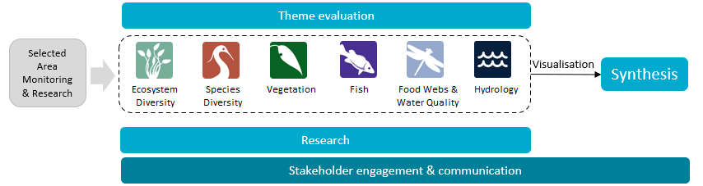
Figure 2 The 7 Selected Areas (left map) and 25 valleys (right map) established for long-term monitoring of the impacts of environmental watering under the Long Term Intervention Monitoring and Flow-MER (2014–15 to present)
In the valleys map, shaded grey shows the 19 valleys where the Commonwealth holds water entitlements and which are in scope for evaluation; white identifies those valleys that are not in scope for evaluation.
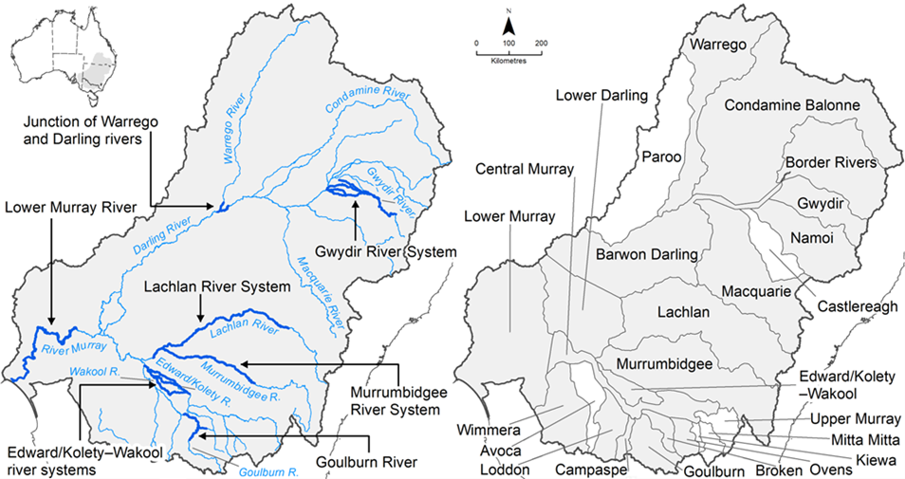

Evaluating the contribution of Commonwealth environmental water to observed environmental outcomes
To undertake the Basin-scale evaluation, the Basin-scale evaluation team uses water delivery and outcomes data provided by the CEWH’s Science Program, along with monitoring data provided by the 7 Selected Areas. Other publicly available data may be used where the relevant data are not collected by the Selected Area.
Evaluation of the contribution of CEW to observed environmental outcomes for the 6 Basin Themes depends on the data available.
When delivered with other water, ecological outcomes cannot be apportioned with current methods, and CEW is reported as contributing to, or supporting, the environmental outcomes of the watering action.
The multi-year Hydrology (instream), Vegetation and Fish Basin Themes have sufficient data to model and compare environmental outcomes, both with and without CEW (counterfactual modelling 2).
Ecosystem Diversity, Species Diversity and Vegetation Basin Themes identify environmental responses in locations that received CEW (often in conjunction with other sources of environmental or non-environmental water) and, where feasible, compare with areas that did not receive CEW.
Hydrology (inundation) and Food Webs and Water Quality Basin Themes use flow and water quality metrics to infer likely outcomes.
Fish (annual), Vegetation (annual) and Food Webs and Water Quality Basin Themes synthesise findings across Selected Areas.

Partnering on watering actions
Commonwealth environmental water is often delivered in conjunction with other environmental water holdings and non-environmental water releases (such as for irrigation or during high-flow events).
Commonwealth environmental watering actions for the most recent evaluation year (2023–24) and cumulative over the 10 evaluation years (2014–15 to 2023–24) are provided in Table 1.
Table 1 Summary statistics for most recent evaluation year and multi-year evaluation period
Dash (–) indicates statistic not available.
 | 2023–24 | 2014–24
Volume of CEW actions (GL) | 2,870 | 18,310
Number of CEW actions | 114 | 1,194
% CEW volume of total EW volume | ~70% | –
% CEW actions with partners or other flows | ~50% | –
CEW % of total volume of partnered watering actions | ~50% | –
CEW % of total Basin surface water runoff | ~13% | –

Evaluation reporting
Each Theme prepares a technical evaluation report for each water year from which key outcomes and lessons for adaptive management are brought together, with research highlights, into an annual Synthesis report. To provide consistency over the life of Flow-MER and its predecessors, some content in these annual reports may be reused from previous years. In these cases, all efforts have been made to cite the relevant Long Term Intervention Monitoring Project, Environmental Water Knowledge and Research Project or Flow-MER publication. All reports published by the CEWH are available from the CEWH's publications and resources webpage.

Basin-scale Flow-MER partnership
Basin-scale evaluation in Flow-MER is led by CSIRO in partnership with the University of Canberra. Collaborators on the 2023–24 evaluation include Alluvium, the Arthur Rylah Institute, Charles Sturt University, South Australian Research & Development Institute, NSW Department of Primary Industries, the Australian River Restoration Centre and Brooks Ecology & Technology.
2025 is the final year of this 5-year phase of Flow-MER. This is the final evaluation under this phase. The next 5-year phase commenced on 1 July 2024 and is led by CSIRO in partnership with the One Basin Cooperative Research Centre. Information on the new phase of Flow-MER can be found at the CEWH's science programs website.

Contents
Executive summary iii
Evaluation approach iii
Water year 2023–24 iv
Water years 2014–24 v
Informing adaptive management v
Overview of Flow-MER and the 2023–24 evaluation vi
Evaluating the contribution of Commonwealth environmental water to observed environmental outcomes vii
Partnering on watering actions vii
Evaluation reporting vii
Flow-MER partnership vii
Contents viii
1 Introduction 1
1.1 Evaluation objectives 1
1.2 Evaluation coverage 1
1.3 Defining species diversity 2
1.4 About this report 3
2 Overview of approach and methods 4
2.1 Evaluation framework 4
2.2 Threatened and migratory species evaluation 5
3 Data 7
3.1 Commonwealth environmental watering actions for species diversity 7
3.2 Rainfall 7
3.3 Observational data 8
4 Outcomes for frogs 11
4.1 Introduction 11
4.2 Watering actions for frogs 12
4.3 Evaluation results 13
5 Outcomes for waterbirds 23
5.1 Introduction 24
5.2 Watering actions for waterbirds 24
5.3 Evaluation results 26
6 Contribution to listed threatened and migratory species 38
6.1 Watering actions for listed species 39
6.2 Evaluation results 42
6.3 Modelling the relationship between Commonwealth environmental water and the presence of selected threatened species 62
7 Informing adaptive management for species diversity 73
7.1 Informing the planning and management of Commonwealth environmental water for species diversity 73
7.2 Improving our approach to Basin-scale evaluation 73
Appendix A Listed migratory and threatened species from the managed floodplain 76
Appendix B Commonwealth environmental watering actions 80
Appendix C Detailed occurrence tables 81
Appendix D Summary of median proportion wetted area 85
Appendix E Model results 88
E.1 Model results: Australian painted snipe 88
E.2 Model results: Common greenshank 92
E.3 Model results: Sharp-tailed sandpiper 97
E.4 Model results: Latham’s snipe 101
E.5 Model results: Superb parrot 106
Abbreviations and terms 112
References 113

Figures
Figure 1 Schematic of the components of the Basin-scale evaluation vi
Figure 2 The 7 Selected Areas (left map) and 25 valleys (right map) established for long-term monitoring of the impacts of environmental watering under the Long Term Intervention Monitoring and Flow-MER (2014–15 to present) vi
Figure 2.1 Diagram of main steps in integrating multiple data sources as input to the listed and threatened species evaluations 5
Figure 3.1 Maps of annual rainfall conditions across the Murray–Darling Basin, 2014–24 8
Figure 4.1 Annual volume of Commonwealth environmental water with at least one watering objective related to frogs, by valley per water year 2014–24 13
Figure 4.2 Change in the maximum extent of wet area at the time of survey in the Australian National Aquatic Ecosystem polygons corresponding to 17 monitored sites in the Murrumbidgee River System and Junction of Warrego and Darling rivers, split by Commonwealth environmental water or other water, by water year 2014–24 19
Figure 4.3 Frog community composition based on mean catch per unit effort (frogs observed per hour) in the Junction of Warrego and Darling rivers (top plot) and Murrumbidgee River System (bottom plot), by water year 2014–24 20
Figure 4.4 Box plots showing the change in median number of frogs at 17 monitored sites in the Murrumbidgee River and Junction of Warrego and Darling rivers in years when inundation was primarily influenced by Commonwealth environmental water or other water, by water year 2014–24 22
Figure 5.1 Total annual volumes of Commonwealth environmental water delivered with at least one watering objective related to waterbird outcomes, by valley, by water year 2014–24 25
Figure 5.2 Change in the maximum extent of wet area at the time of survey in the Australian National Aquatic Ecosystem polygons corresponding to 32 monitored sites in the Murrumbidgee River, split by Commonwealth environmental water or other water, by water year 2014–24 31
Figure 5.3 Change in the maximum extent of wet area at the time of survey in the Australian National Aquatic Ecosystem polygons corresponding to 35 monitored sites in the Gwydir River System, split by Commonwealth environmental water or other water, by water year 2014–24 32
Figure 5.4 Change in the maximum extent of wet area at the time of survey in the Australian National Aquatic Ecosystem polygons corresponding to monitored sites in the Junction of Warrego and Darling rivers, split by Commonwealth environmental water or other water, by water year 2014–24 33
Figure 5.5 Change in average proportion of wet area for all Australian National Aquatic Ecosystem polygons corresponding to monitored sites in wetland complexes in the Gwydir River System (top plot), Junction of Warrego and Darling rivers (middle plot) and the Murrumbidgee River (bottom plot), split by Commonwealth environmental water or other water, by water year 2014–24 34
Figure 5.6 Change in average waterbird species richness (expressed using Margelef Index) at monitored sites in wetland complexes receiving Commonwealth environmental water or other water, by water year 2014–24 36
Figure 5.7 Relationship between species richness (expressed using Margelef Index) (top plot) and the number of individuals (bottom plot) at monitored sites on each survey against the proportion wetted area, by water source between 2014–15 and 2023–24 37
Figure 6.1 Total annual volumes of Commonwealth environmental water delivered with at least one watering objective related to listed species (water-dependent birds, frogs or mammals) outcomes, by valley, per water year 2014–24 40
Figure 6.2 Total annual volumes of Commonwealth environmental water delivered with at least one watering objective related to listed fish outcomes, by valley and year 2014–24 42
Figure 6.3 Total number of listed threatened and migratory waterbird species records contained within the Atlas of Living Australia, drawn from the managed floodplain, that were influenced by Commonwealth environmental water in that year, including the total number of records from the managed floodplain, by water year 2014–24 47
Figure 6.4 Total number of records of listed threatened crustaceans, fish, frogs, reptiles, and water-associated woodland birds and mammals contained within the Atlas of Living Australia, drawn from the managed floodplain, that were influenced by Commonwealth environmental water in that year, including the total number of records from the managed floodplain, by water year 2014–24 47
Figure 6.5 Global importance of each feature in the Australian painted snipe model 64
Figure 6.6 Global importance of each feature in the common greenshank model 66
Figure 6.7 Global importance of each feature in the sharp-tailed sandpiper model 68
Figure 6.8 Global importance of each feature in the Latham’s snipe model 70

Figure E.1 ‘CEW mean Ha inundated’ was the most influential feature in the machine-learning model for Australian painted snipe 89
Figure E.2 ‘CEW frequency’ was the second-most influential feature in the machine-learning model for Australian painted snipe 89
Figure E.3 ‘SD vegetation’ was the third-most influential feature in the machine-learning model for Australian painted snipe 90
Figure E.4 ‘Median duration’ was the fourth-most influential feature in the machine-learning model for Australian painted snipe 90
Figure E.5 ‘Weighted SD water’ was the fifth-most influential feature in the machine-learning model for Australian painted snipe 91
Figure E.6 ‘Mean gap’ was the sixth-most influential feature in the machine-learning model for Australian painted snipe 91
Figure E.7 ‘Mean vegetation’ was the seventh-most influential feature in the machine-learning model for Australian painted snipe 92
Figure E.8 ‘Longest gap’ was the least influential feature in the machine-learning model for Australian painted snipe 92
Figure E.9 ‘CEW frequency’ was the most influential feature in the machine-learning model for common greenshanks 93
Figure E.10 ‘SD vegetation’ was the second-most influential feature in the machine-learning model for common greenshanks 94
Figure E.11 ‘Longest gap’ was the third-most influential feature in the machine-learning model for common greenshanks 94
Figure E.12 ‘Weighted SD water’ was the fourth-most influential feature in the machine-learning model for common greenshanks 95
Figure E.13 ‘Mean gap’ was the fifth-most influential feature in the machine-learning model for common greenshanks 95
Figure E.14 ‘CEW mean Ha inundated’ was the sixth-most influential feature in the machine-learning model for common greenshanks 96
Figure E.15 ‘Median duration’ was the seventh-most influential feature in the machine-learning model for common greenshanks 96
Figure E.16 ‘Mean vegetation’ was the least influential feature in the machine-learning model for common greenshanks 97
Figure E.17 ‘SD vegetation’ was the most influential feature in the machine-learning model for sharp-tailed sandpipers 98
Figure E.18 ‘Mean gap’ was the second-most influential feature in the machine-learning model for sharp-tailed sandpipers 98
Figure E.19 ‘Weighted SD water’ was the third-most influential feature in the machine-learning model for sharp-tailed sandpipers 99
Figure E.20 ‘CEW mean Ha inundated’ was the fourth-most influential feature in the machine-learning model for sharp-tailed sandpipers 99
Figure E.21 ‘Mean vegetation’ was the fifth-most influential feature in the machine-learning model for sharp-tailed sandpipers 100
Figure E.22 ‘CEW frequency’ was the sixth-most influential feature in the machine-learning model for sharp-tailed sandpipers 100
Figure E.23 ‘Median duration’ was the seventh-most influential feature in the machine-learning model for sharp-tailed sandpipers 101
Figure E.24 ‘Longest gap’ was the least influential feature in the machine-learning model for sharp-tailed sandpipers 101
Figure E.25 ‘Weighted SD water’ was the most influential feature in the machine-learning model for Latham’s snipe 102
Figure E.26 ‘SD vegetation’ was the second-most influential feature in the machine-learning model for Latham’s snipe 103
Figure E.27 ‘Mean gap’ was the third-most influential feature in the machine-learning model for Latham’s snipe 103
Figure E.28 ‘Mean vegetation’ was the fourth-most influential feature in the machine-learning model for Latham’s snipe 104
Figure E.29 ‘Median duration’ was the fifth-most influential feature in the machine-learning model for Latham’s snipe 104
Figure E.30 ‘CEW mean Ha inundated’ was the sixth-most influential feature in the machine-learning model for Latham’s snipe 105
Figure E.31 ‘CEW frequency’ was the seventh-most influential feature in the machine-learning model for Latham’s snipe 105
Figure E.32 ‘Longest gap’ was the least influential feature in the machine-learning model for Latham’s snipe 106
Figure E.33 Global importance of each feature in the superb parrot model 107
Figure E.34 ‘CEW frequency’ was the most influential feature in the machine-learning model for superb parrots 107
Figure E.35 ‘Mean vegetation’ was the second-most influential feature in the machine-learning model for superb parrots 108
Figure E.36 ‘SD vegetation’ was the third-most influential feature in the machine-learning model for superb parrots 108
Figure E.37 ‘Mean gap’ was the fourth-most influential feature in the machine-learning model for superb parrots 109
Figure E.38 ‘Weighted SD water’ was the fifth-most influential feature in the machine-learning model for superb parrots 109
Figure E.39 ‘CEW mean Ha inundated’ was the sixth-most influential feature in the machine-learning model for superb parrots 110
Figure E.40 ‘Median duration’ was the seventh-most influential feature in the machine-learning model for superb parrots 110
Figure E.41 ‘Longest gap’ was the least influential feature in the machine-learning model for superb parrots 111

Tables
Table 1 Summary statistics for most recent evaluation year and multi-year evaluation period vii
Table 1.1 Summary of monitoring activities undertaken as part of the Long Term Intervention Monitoring and Flow-MER programs, by Selected Area 1
Table 1.2 Commonwealth environmental watering actions with objectives for waterbirds, frogs, other vertebrates, and listed threatened and migratory species, 2023–24 2
Table 2.1 Features of wetland hydrology that are influenced by delivery of Commonwealth environmental water and were used in the machine-learning analyses 6
Table 3.1 Summary of numbers of individual records of frogs reported in Long Term Intervention Monitoring, Flow-MER and complementary NSW Department of Climate Change, Energy, the Environment and Water datasets, 2014–24 9
Table 3.2 Summary of numbers of individual records of waterbirds reported in Long Term Intervention Monitoring, Flow-MER and complementary NSW Department of Climate Change, Energy, the Environment and Water datasets, 2014–24 10
Table 4.1 Annual volume of Commonwealth environmental water with at least one watering objective related to frogs, by valley and year, 2014–24 13
Table 4.2 Frog species detected in 2023–24 combined Flow-MER datasets 14
Table 4.3 Watering action objectives and key observations associated with those actions for frogs, by surface water region, 2023–24 15
Table 4.4 A SIMPER (similarity percentage) analysis comparing the contribution of each frog species to the differences between communities influenced by Commonwealth environmental water and those watered by other environmental water, 2014–24 18
Table 4.5 Average abundance of frog species in the Junction of Warrego and Darling rivers by water year 2014–24 21
Table 4.6 Average abundance of frog species in the Murrumbidgee River System by water year 2014–24 21
Table 5.1 Total annual volumes of Commonwealth environmental water (ML) delivered with at least one watering objective related to waterbird outcomes, by valley, by water year 2014–24 25
Table 5.2 Watering action objectives and key observations associated with those actions for waterbirds and other listed threatened bird species, by surface water region, 2023–24 26
Table 5.3 Threatened and migratory species reported in 2023–24 from wetlands in New South Wales monitored by Flow-MER and NSW Department of Climate Change, Energy, the Environment and Water 29
Table 5.4 Summary of listed threatened and migratory species detected at the 3 long-term monitoring regions (Junction of Warrego and Darling rivers, Gwydir River System and Murrumbidgee River System) by water source (Commonwealth environmental water, other), 2014 –24 35
Table 6.1 Total annual volumes (ML) of Commonwealth environmental water delivered with at least one watering objective related to listed species (water-dependent birds, frogs, reptiles or mammals) outcomes, by valley, per water year 2014–24 41
Table 6.2 Total annual volume (ML) of Commonwealth environmental water delivered with at least one watering objective related to listed fish outcomes, by valley and year 2014–24 42
Table 6.3 Summary of the number of listed threatened and migratory waterbird and raptor species (ordered by common name) in the Atlas of Living Australia dataset recorded within the managed floodplain, 2014–24 43
Table 6.4 Summary of the number of listed threatened water-dependent fish, crustaceans, mammals, woodland birds, reptiles and frogs (ordered by common name) in the Atlas of Living Australia dataset recorded within the managed floodplain, 2023–24 45
Table 6.5 Summary of the number of records for each listed threatened and migratory waterbird and raptor species (ordered by scientific name) that coincide with areas inundated by Commonwealth environmental water, by water year 2014–24 48
Table 6.6 Summary of the number of records for each listed threatened fish, crustaceans, frogs, reptiles, mammals and water-associated woodland birds (ordered by scientific name) that coincide with areas inundated by Commonwealth environmental water, by year 2014–24 49
Table 6.7 Percent of records of listed threatened and migratory waterbirds that aligned with Commonwealth environmental water by valley, 2014–24 52
Table 6.8 Percent of records of listed threatened fish, mammals, crustaceans, frogs and reptiles that aligned with Commonwealth environmental water by valley, 2014–24 55
Table 6.9 Percent of records of listed threatened and migratory waterbirds that aligned with Commonwealth environmental water by Australian National Aquatic Ecosystem wetland type, 2014–24 56
Table 6.10 Percentage of occurrences of listed threatened fish, mammals, crustaceans, frogs and reptiles that aligned with Commonwealth environmental water by Australian National Aquatic Ecosystem wetland type, 2014–24 60
Table 6.11 The 9 modelled features for wetlands that were influenced by delivery of Commonwealth environmental water 62
Table 6.12 The 9 threatened species that have been modelled to date 63
Table 6.13 Summary of model results (Shapley relative influence and partial dependence) for Australian painted snipe, ordered by relative importance rank 64
Table 6.14 Summary of model results (Shapley relative influence and partial dependence) for common greenshank, ordered by relative importance rank 66
Table 6.15 Summary of model results (Shapley relative influence and partial dependence) for sharp-tailed sandpiper, ordered by relative importance rank 68
Table 6.16 Summary of model results (Shapley relative influence and partial dependence) for Australian painted snipe, ordered by relative importance rank 70

Table A.1 Summary of the number of listed threatened and migratory waterbird and raptor species (ordered by common name) in the Atlas of Living Australia dataset recorded within the Basin, for the unmanaged and managed floodplain, since 2008 76
Table B.1 Annual volume of CEW with at least one watering objective related to frogs, by valley and year, 2014–24 80
Table C.1 Number of waterbird occurrences drawn from the combined NSW Department of Climate Change, Energy, the Environment and Water and Flow MER datasets, by surface water region, ordered by scientific name, 2023–24 81
Table D.1 Summary of median proportion wetted area (proportion open water + wet area) derived from the Wetlands Insight Tool, by survey site 85

Introduction

Evaluation objectives
The Basin-scale Species Diversity Theme evaluates the contribution of Commonwealth environmental water (CEW) in supporting waterbirds, frogs and water-dependent reptiles and mammals, focusing on listed threatened and migratory species. It describes the most recent (one-year) and longer term (10-year) evaluation of outcomes for waterbirds, frogs, and threatened and migratory species, drawing on available monitoring data.
We contribute to the objectives of the Commonwealth’s (Murray–Darling) Basin Plan 2012 (the Basin Plan) objectives, specifically subsections 8.05(2) and 8.05(3), through addressing the following overarching evaluation question in line with previous reports (Baumgartner et al. 2015; Hale 2020):
What did Commonwealth environmental water contribute to species diversity?

Evaluation coverage
Selected Areas of the Murray–Darling Basin (the Basin) have not been required to monitor outcomes for frogs, waterbirds or other vertebrates under the Long Term Intervention Monitoring (LTIM) or Flow-MER programs. As a result, data generated as part of these programs are limited. The Murrumbidgee River System undertakes targeted monitoring of frogs, turtles and waterbirds across multiple sites in all years, the Gwydir River System undertakes monitoring of waterbirds, and the Junction of Warrego and Darling rivers and Lachlan River System Selected Areas have data for frogs and waterbirds in some but not all years. This is summarised in Table 1.1. Given limited available data to evaluate outcomes from CEW, additional datasets are drawn from the Atlas of Living Australia (ALA) species occurrence records (see Chapter 2 for details).
Table 1.1 Summary of monitoring activities undertaken as part of the Long Term Intervention Monitoring and Flow-MER programs, by Selected Area
‘Y’ indicates where monitoring occurred. Dash (–) indicates no monitoring.
Selected Area | Frogs | Waterbird diversity | Waterbird breeding | Other vertebrates
Gwydir River System | – | Y | – | –
Lachlan River System | – | – | Y | –
Murrumbidgee River System | Y | Y | Y | Turtles
Junction of Warrego and Darling rivers | Y | Y | – | –
The 2023–24 CEW actions with objectives for waterbirds, frogs and other vertebrates are summarised in Table 1.2.

Spatial extent
Analysis is confined to the managed floodplain. This is the estimated area of the Basin that can be influenced by environmental water management (MDBA 2019).
Table 1.2 Commonwealth environmental watering actions with objectives for waterbirds, frogs, other vertebrates, and listed threatened and migratory species, 2023–24
Reported by volume in megalitres with number of actions in parentheses. Asterisks (*) indicate the valley contains a Selected Area. Dash (–) indicates no species diversity objective in 2023–24.
Valley | Waterbirds | Frogs | Other vertebrates | Listed threatened and migratory birds, frogs, mammals | Listed threatened fish
Barwon Darling | 1,437 (3) | – | – | – | –
Border Rivers | – | – | – | – | –
Broken | – | – | – | 2,551 (6) | –
Campaspe | – | – | – | – | –
Central Murray | 307,961 (1) | – | – | – | 4,086 (2)
Condamine Balonne | 71,299 (1) | – | – | – | –
Edward/Kolety–Wakool* | – | 10,881 (7) | – | 27,099 (4) | 2,577 (1)
Goulburn* | – | – | – | – | –
Gwydir* | 5,000 (1) | – | – | – | –
Lachlan* | 4,969 (3) | 23,382 (3) | – | 22,059 (1) | 1,213 (1)
Loddon | – | – | 569 (1) | – | –
Lower Darling/Baaka | 110,834 (2) | – | – | – | –
Lower Murray* | 1,386,183 (14) | 1,842 (9) | – | 1,773 (7) | 1,385,795 (11)
Macquarie | 59,879 (2) | – | – | – | 3,833 (1)
Murrumbidgee* | 52,746.3 (6) | 50,175 (5) | – | 49,675 (4) | 4,646 (1)
Namoi | – | – | – | – | 900 (1)
Ovens | – | – | – | – | –
Warrego* | 8,369 (1) | 8,369 (1) | – | – | –
Wimmera | 2,762 (2) | – | – | – | –
Total | 2,011,439 (36) | 94,650 (25) | 569 (1) | 103,157 (22) | 1,403,049 (18)

Defining species diversity
Section 8.05 of the Basin Plan sets out the objectives relating to species diversity through the protection and restoration of water-dependent ecosystems. The Basin Plan section 8.05 further considers diversity in the context of: threatened taxa; communities and ecosystems listed under state and national legislation; the life cycles of species listed under international agreements of the Convention on the Conservation of Migratory Species of Wild Animals (Bonn Convention), China–Australia Migratory Bird Agreement (CAMBA), Japan–Australia Migratory Bird Agreement (JAMBA) and Republic of Korea–Australia Migratory Bird Agreement (ROKAMBA); and declared Ramsar wetlands.
An objective of the Basin Plan is ‘to protect and restore a subset of all water-dependent ecosystems, by ensuring that’ (subsection 8.05(2)):
- declared Ramsar wetlands that depend on Basin water resources maintain their ecological character
- water-dependent ecosystems that depend on Basin water resources and support the life cycles of species listed under the Bonn Convention, CAMBA, JAMBA or ROKAMBA continue to support those species
- water-dependent ecosystems are able to support episodically high ecological productivity and its ecological dispersal.
A second relevant objective of the Basin Plan is ‘to protect and restore biodiversity that is dependent on Basin water resources by ensuring that’ (subsection 8.05(3)):
- water-dependent ecosystems that support the life cycles of a listed threatened species or listed threatened ecological community, or species treated as threatened or endangered (however described) in State law, are protected and, if necessary, restored so that they continue to support those life cycles
- representative populations and communities of native biota are protected and, if necessary, restored.
Southern bell frog at a Commonwealth environmental watering site in the Lower Murrumbidgee
The southern bell frog is listed as Vulnerable under the Australian Environment Protection and Biodiversity Conservation Act 1999. Photo credit: Anna Turner.
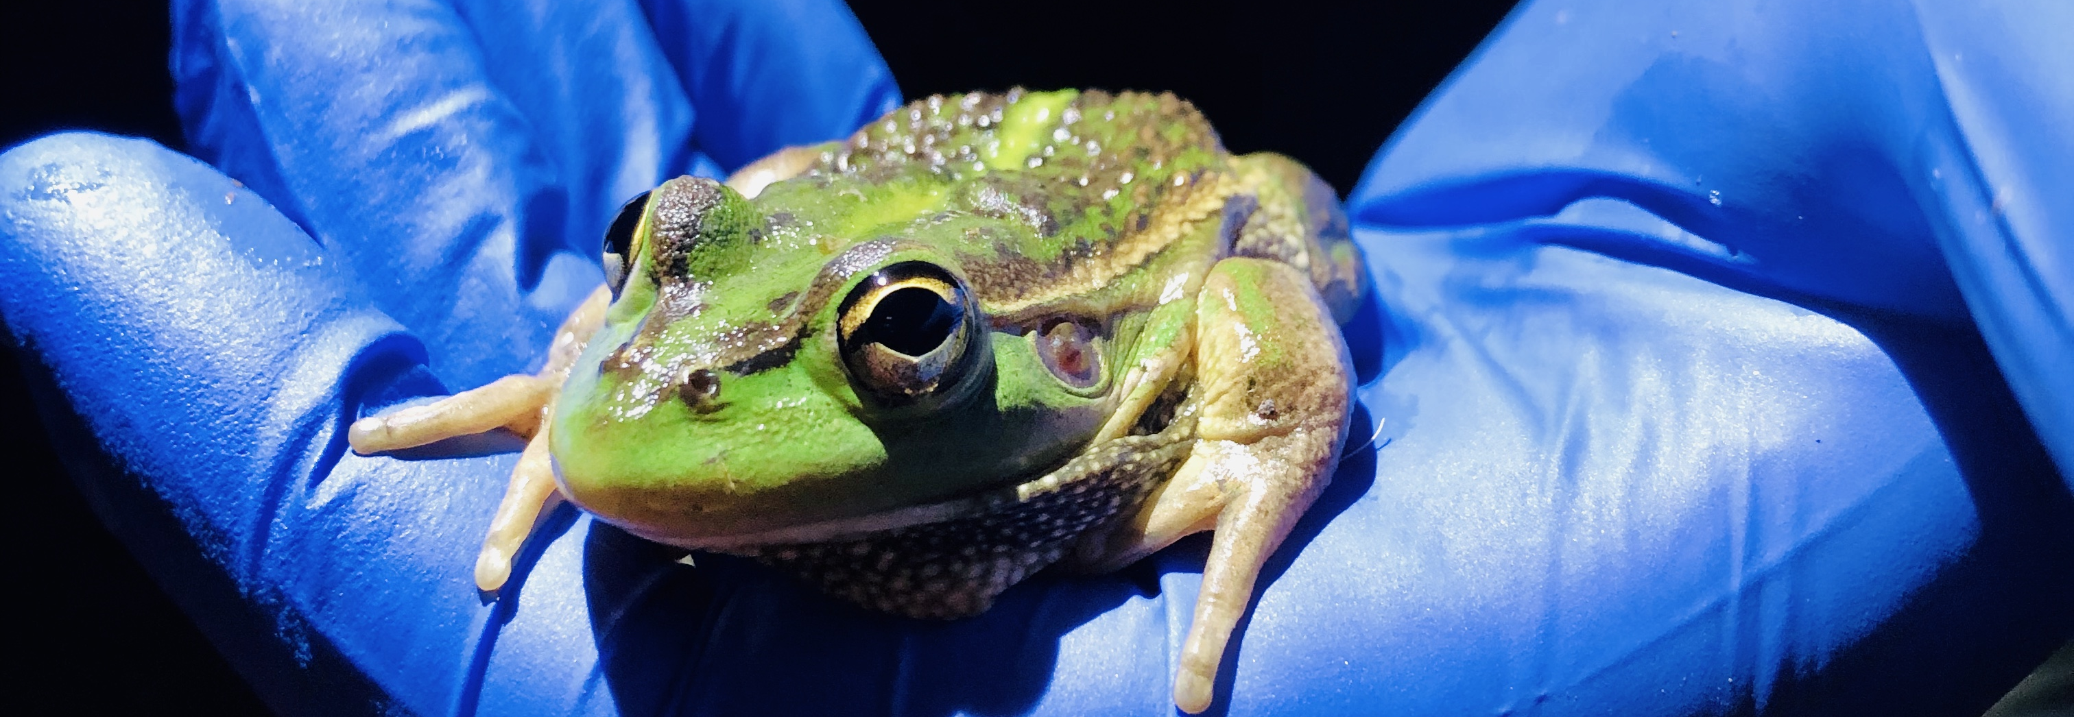

About this report
This species diversity evaluation was led by Charles Sturt University in partnership with CSIRO. It builds on previous Generic Diversity foundation reports (e.g. Baumgartner et al. 2015) and reporting undertaken as part of the LTIM analysis of biodiversity outcomes (Hale et al. 2020) and references therein. The adopted approach and methods are fully described in the Methods report (O’Sullivan and Cuddy 2024, 2025).
This year’s evaluation continues to focus on habitats known to support threatened or migratory species. We have reviewed and expanded our list of water-dependent species of the Basin and extended the machine-learning approach to model relationships between CEW and the habitats of listed threatened and migratory species. In addition, we include a 10-year evaluation of LTIM and Flow-MER outcomes for waterbird and frogs.
The appendices provide additional supporting evidence for the evaluation.

Overview of approach and methods
This chapter provides a high-level overview of the evaluation approach. Full details are available in the Methods report (O’Sullivan and Cuddy 2025) report. The chapter also includes an overview of the quantitative threatened species evaluation.

Evaluation framework
As reported previously, monitoring of water-dependent species (including waterbirds, frogs and turtles) varies, both spatially and temporally, across the Basin and Australia. This creates biases and makes it difficult to draw datasets together and conduct meaningful analyses. For example, survey effort is often inconsistent between surveys (e.g. frequency, time or area surveyed, method used). Timing of surveys is also a critical variable (including time of day, time of year, wetland condition and inundation stage). Additionally, many sites are not surveyed at all, or are surveyed opportunistically, while others are surveyed frequently. Integrating all available data into a single dataset to demonstrate the outcomes of CEW is difficult because key information on survey effort and wetland condition at the time of survey is often not available. Nevertheless, we have developed an approach to work with these limitations.
Previous Species Diversity evaluations have considered Basin-wide outcomes for frogs, waterbirds and freshwater turtles utilising a combination of limited Selected Area data, complementary monitoring datasets and ALA records (Wassens and Hall 2022; Wassens et al. 2024a; Wassens et al. 2021). These reports highlighted the occurrence of listed migratory and threatened species and noted shortcomings in our current capacity to evaluate outcomes relevant to section 8.05 of the Basin Plan. The 2021–22 Species Diversity report (Wassens and Hall 2023) identified the need to ‘Explicitly identify the occurrence and water needs of listed threatened and migratory species that occur within the managed floodplains within each valley’ and that ‘the distribution of key species and current water management practices in each valley are critical to identifying ‘blind spots’ where the water requirements of these species are not being met’. The lack of CEW delivery objectives and targets for threatened species has also been raised in the literature (Ryan et al. 2021).
This evaluation lists waterbird, frog and turtle species reported from Flow-MER datasets and complementary datasets from the New South Wales Department of Climate Change, Energy, the Environment and Water (NSW DCCEEW). We have de-emphasised reporting of Selected Area outcomes for turtles, which are only monitored in the Murrumbidgee. This is justified, given that outcomes for these taxa are already evaluated within Selected Area technical reports.
This year we have extended the Species Diversity evaluation to include the Digital Earth Australia’s Wetlands Insight Tool (WIT) (Dunn et al. 2023) and Australian National Aquatic Ecosystem (ANAE; (Brooks et al. 2014) datasets. We have combined these with the ALA dataset to determine the feasibility of evaluating outcomes for selected listed and threatened species. The 4 main steps are summarised below and shown diagrammatically in Figure 2.1.
- Use the ALA data to plot the distribution of selected listed migratory and threatened species across the managed floodplain, focusing on a few species with distinctly different habitat requirements.
- Identify the species’ general habitat preferences by analysing the intersection of ANAE types with the spatial distribution of the selected threatened species.
- Use the Flow-MER mapped inundation layers to identify those discrete ANAE areas with habitats favoured by threatened species that have received CEW.
- Use the WIT (Dunn et al. 2023) to determine the historical (1988–2024) inundation regime and vegetation response of the identified ANAE areas to assess the contribution of CEW to the habitat suitability of those ecosystems supporting the selected threatened species.
Figure 2.1 Diagram of main steps in integrating multiple data sources as input to the listed and threatened species evaluations
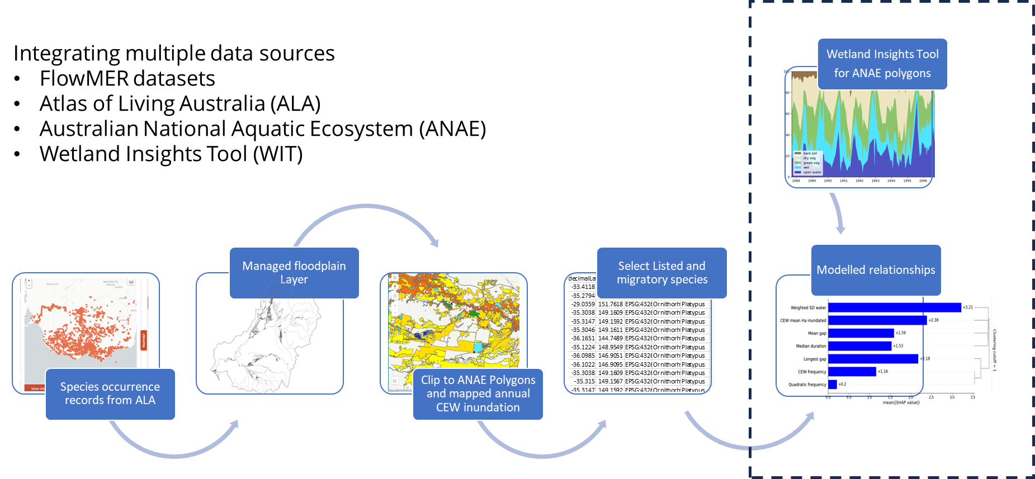
This process allows us to map distributions of migratory waterbirds listed under Bonn Convention, CAMBA, JAMBA or ROKAMBA (Basin Plan 8.05 2b), and listed threatened or endangered species (Basin Plan 8.05 3a). However, resourcing constraints limited our ability to evaluate CEW contributions to maintaining appropriate water regimes within ecosystems that support these species.
Presence is quantified using species richness, defined as a count of the number of species present within a set area and measured using gridded maps created for each of 5 groups (frogs, mammals, reptiles, water associated woodland birds, waterbirds) for the evaluation by water year (1 July to 30 June) and the cumulative years since water year 2014–15.

Threatened and migratory species evaluation
In 2022–23, we trialled several machine-learning algorithms to see if they could find a relationship between CEW and the presence of selected threatened species (refer to Figure 2.1) (Wassens et al. 2024a). In 2023–24, we added machine-learning models for an additional 5 bird species that are listed through the Australian Environment Protection and Biodiversity Conservation Act 1999 (EPBC Act) and have distinct wetland habitat requirements. We used historical ALA records to identify locations where those species had been observed. We then mapped these locations to ANAE polygons (Brooks 2021) and identified those polygons considered under the Basin-wide environmental watering strategy (the Strategy; MDBA 2019) and that received CEW water at least once since the beginning of the 2014–15 water year.
These detection datasets were then interrogated using 3 machine-learning algorithms to infer the relationships (if any) between the delivery of CEW (and consequent inundation) and detection of these selected threatened species since 2014.
For the 2023–24 water year analyses trial, we selected 8 predictor variables (hereafter ‘features’) that could be derived from the available inundation and WIT datasets, that reflect aspects of the wetland hydrology that could potentially be influenced through CEW delivery, and that we believed may be meaningful with respect to species distributions (Table 2.1). Following the recommendations in Wassens et al. 2024a, we removed one feature (Quadratic frequency) and added 2 new vegetation features (SD vegetation and Mean vegetation).
Table 2.1 Features of wetland hydrology that are influenced by delivery of Commonwealth environmental water and were used in the machine-learning analyses
CEW = Commonwealth environmental water. ANAE = Australian National Aquatic Ecosystem.
Feature | Explanation
CEW frequency | The number of years that this ANAE polygon received CEW
Quadratic frequency | The 'CEW frequency' feature raised to the power of 2. This feature was used in the 2022–23 models but was not retained in the current analyses
CEW mean Ha inundated | The average number of additional hectares (ha) that were inundated as a result of CEW delivery
Longest gap | The longest gap (in years) between 2 successive CEW deliveries
Median duration | The mean of the annual median duration of inundation since the 2014–15 water year
Mean gap | The mean of the annual mean gap between successive inundation events since the 2014–15 water year
Weighted SD water | Weighted standard deviation of the open water metric (from the WIT Tool) since the 2014–15 water year, used as a measure of the variability of inundation
SD vegetation | This feature was a new inclusion in the 2023–24 analyses. It is the standard deviation of the photosynthetic vegetation metric (from the WIT tool) since the 2014–15 water year
Mean vegetation | The mean of annual photosynthetic vegetation (from the WIT tool) since the 2014–15 water year
Outputs of the machine-learning models are reported using plotted SHAP (SHapley Additive exPlanations) values which explain the contribution of each feature towards the prediction. These plots provide a broad overview of the feature effects; however, they do not account for the interactions between features. The 2022–23 analyses used debiased machine learning to isolate and visualise the effect of each feature. However, the debiased machine-learning plots had limited utility because they fit linear relationships, even to non-linear trends. The 2023–24 analyses instead use partial-dependence plots to isolate the individual effect of each feature when all other features are held to their mean values. This can represent non-linear relationships that improve interpretation. The machine-learning outputs are presented in Section 6.3. A detailed description of the approach and the application of the machine-learning techniques are fully described in the companion Methods report (O’Sullivan and Cuddy 2025).

Data
This chapter summarises the datasets that underpin the evaluation.

Commonwealth environmental watering actions for species diversity
In 2023–24, 75 watering actions were undertaken with objectives for species diversity (waterbirds, frogs, listed threatened and migratory species or other biota), delivering 2,324 GL of CEW (CEWH 2024)Table 1.2. From 2014–15 to 2023–24, 740 watering actions were undertaken with objectives for species diversity, delivering more than 11,021 GL of CEW. These data are provided to the evaluation teams as a watering actions table (CEWH 2024).

Rainfall
While the overall rainfall in Australia during 2023–24 was above the average, the Basin experienced a slight departure from the mean (−3%). Average rainfall was 479.9 mm. The southern and northern parts of the Basin received average rainfall, while large parts of central New South Wales and central Victoria experienced above-average or very much above-average rainfall. Parts of the Basin in South Australia, the upper Murray catchment, and smaller areas on the north-eastern New South Wales, experienced below-average rainfall (Figure 3.1).
Figure 3.1 Maps of annual rainfall conditions across the Murray–Darling Basin, 2014–24
Data sourced from the Bureau of Meteorology. The decile rankings (lowest on record to highest on record) are those used by the Bureau. For information on how the deciles are derived, see the Bureau’s Deciles webpage.
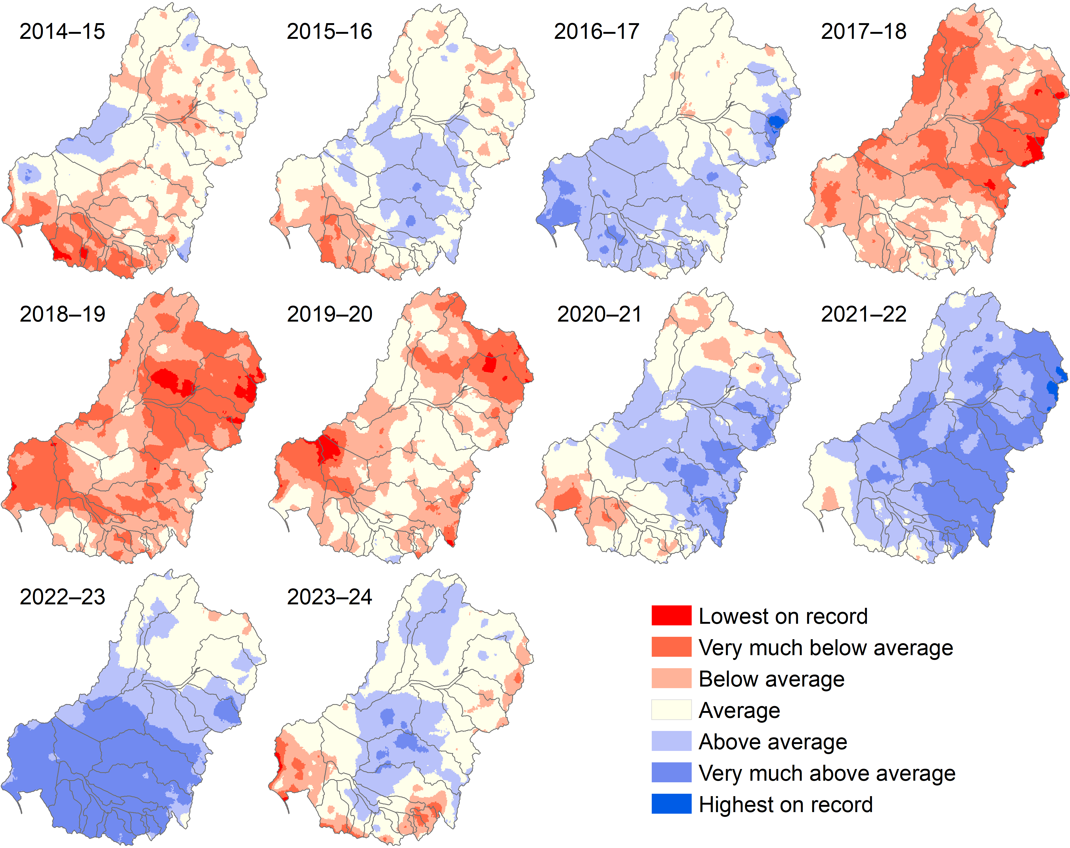

Observational data
Evaluation of the contribution of CEW against observed environmental outcomes for species diversity is dependent on the data available at the time of analysis. For the 2023–24 evaluation, 3 key sources of information were available:
- Selected Area data collected as part of LTIM (2014–19) and Flow-MER (2019–24) in the Junction of Warrego and Darling rivers, Gwydir River System and Murrumbidgee River System Selected Areas (see (Wassens et al. 2024a) and references therein)
- waterbird survey data collected by NSW DCCEEW (and its predecessors) in the Border Rivers, Gwydir, Macquarie Marshes and Lachlan wetland systems 2014–24
- the ALA, used to collate Basin-wide patterns of listed threatened and migratory waterbirds, frogs, fish, crustaceans and water-dependent mammals, woodland birds and reptiles across the managed floodplain as defined by the Murray–Darling Basin Authority. These data were used to evaluate listed threatened and migratory species.
In addition, a range of published and unpublished monitoring reports and watering action acquittal and operational reports were used to prepare summaries of outcomes against watering objectives.

Flow-MER Selected Area, LTIM and complementary datasets

Frogs
In the water years between 1 July 2014 and 30 June 2024 (2014–24), monitoring of frog responses to environmental water was undertaken for LTIM and Flow-MER in 3 Selected Areas – Junction of Warrego and Darling rivers (8 years), Murrumbidgee River System (10 years) and Lachlan River System (2 years) (see (Wassens et al. 2024a) and references therein) (numbers reported in Table 3.1). In 2023–24, frogs were monitored in the Murrumbidgee River System (Wassens et al. 2024b) and Junction of Warrego and Darling rivers (CEWH 2024b). No complementary frog survey data were available from other valleys.
Table 3.1 Summary of numbers of individual records of frogs reported in Long Term Intervention Monitoring, Flow-MER and complementary NSW Department of Climate Change, Energy, the Environment and Water datasets, 2014–24
‘Region’ refers to a combination of Selected Areas and specific sites (i.e. Macquarie Marshes). Dash (–) indicates no data collected. Note that count relates to the number of individual site/date/species records in the dataset. Values presented in this table differ from previous reports due to changes in the way Selected Area data (stored in the Commonwealth Environmental Water Holder’s [CEWH] monitoring data management system) is provided. NSW DCCEEW = New South Wales Department of Climate Change, Energy, the Environment and Water.
Region | 2014–15 | 2015–16 | 2016–17 | 2017–18 | 2018–19 | 2019–20 | 2020–21 | 2021–22 | 2022–23 | 2023–24 | Source (Reference)
Gwydir Wetlands | – | 434 | 560 | 371 | 438 | 126 | 374 | 158 | 194 | – | NSW DCCEEW, Walcott et al (2023a)
Junction of Warrego and Darling rivers | 36 | 31 | 41 | 40 | – | 34 | 49 | – | 25 | 35 | Flow MER (CEWH 2024b) MER) NSW DCCEEW
Lachlan River System | – | 23 | – | – | – | – | – | – | 34 | – | NSW DPE-EHG (2023) (NSW DCCEEW)
Macquarie Marshes | 208 | 266 | 330 | 584 | 283 | 18 | 357 | 138 | 94 | – | NSW DPE-EHG (2023) (NSW DCCEEW)
Murrumbidgee River System | 198 | 170 | 168 | 165 | 194 | 185 | 247 | 216 | 48 | 67 | (Wassens et al. 2024b) (Flow-MER)

Waterbirds
There are limited waterbird monitoring data available through LTIM or Flow-MER. In 2023–24, monitoring of waterbird responses to CEW was undertaken for Flow-MER in 3 Selected Areas: Junction of Warrego and Darling rivers (CEWH 2024b), Gwydir River System (CEWH 2024a) and Murrumbidgee River System (Wassens et al. 2024b) (numbers reported in Table 3.2). Complementary datasets produced by NSW DCCEEW were available for the Macquarie Marshes (NSW DCCEEW 2024c), Lachlan, Border Rivers (Spencer unpublished data) and Central Murray (Ecology & Heritage Partners 2024) (Table 3.2). These data were provided in BioNet format as presence-only surveys.
Table 3.2 Summary of numbers of individual records of waterbirds reported in Long Term Intervention Monitoring, Flow-MER and complementary NSW Department of Climate Change, Energy, the Environment and Water datasets, 2014–24
‘Region’ refers to a combination of Selected Areas and specific sites (i.e. Macquarie Marshes). Dash (–) indicates no data collected. NSW DCCEEW = New South Wales Department of Climate Change, Energy, the Environment and Water.
Region | 2014 –15 | 2015 –16 | 2016 –17 | 2017 –18 | 2018 –19 | 2019 –20 | 2020 –21 | 2021 –22 | 2022 –23 | 2023 –24 | Source
Border Rivers | – | – | – | – | – | – | – | – | – | 223 | NSW DCCEEW
Gwydir | 1,878 | 3,350 | 3,902 | 2,111 | 1,736 | 1,327 | 1,754 | 2,527 | 2,646 | 796 | Flow-MER
Lachlan | – | – | 750 | 603 | 296 | 341 | 1,629 | 15 | 1,639 | 1,028 | NSW DCCEEW
Macquarie Marshes | 1,372 | 2,667 | 2,143 | 2,227 | 2,346 | 540 | 2,179 | – | 1,050 | 1,137 | NSW DCCEEW
Murray | 188 | 367 | 347 | 1,058 | 615 | 1,077 | 311 | 484 | 345 | 585 | NSW DCCEEW
Murrumbidgee | 2,414 | 2,249 | 2,014 | 1,852 | 1,094 | 1,424 | 2,193 | 3,030 | 2,302 | 2,138 | Flow-MER
Narran | 62 | 70 | 165 | 39 | 10 | 383 | 448 | 642 | 453 | 5 | NSW DCCEEW
Junction of Warrego and Darling rivers | 75 | 67 | 124 | 47 | – | 59 | 84 | – | 163 | 54 | Flow-MER

Basin-wide datasets
The ALA is a high-quality database that aggregates species-diversity data from multiple sources, including state-based monitoring programs, consultant or research projects and citizen science (e.g. the Australian Museum’s FrogID dataset). The ALA contains presence-only point data (spatial coordinates) of species occurrences which can be overlaid with other spatial information, including mapped inundation areas.
Using detection-only datasets such as the ALA, it is important to note that, due to the spatial unevenness in survey effort and biases in species detection (particularly for frog species), these numbers on their own provide only a broad relative picture of the species likely to occur across the managed floodplain in each valley.

Listed threatened and migratory species
Listed species were identified from the ALA datasets. Species were included if they had a conservation listing in Commonwealth or state legislation, including the EPBC Act, Bonn Convention, CAMBA, JAMBA, ROKAMBA, Victorian Flora and Fauna Guarantee Act 1988, South Australian National Parks and Wildlife Act 1972, New South Wales Biodiversity Conservation Act 2016, Australian Capital Territory Nature Conservation Act 2014 or Queensland Nature Conservation Act 1992. See Appendix A for details.
The pilot machine-learning study (reported in (Wassens et al. 2024b) successfully modelled 4 threatened species: one frog species – southern bell frog (Litoria raniformis), and 3 bird species – Australasian bittern (Botaurus poiciloptilus), glossy ibis (Plegadis falcinellus) and Australasian shoveler (Spatula rhynchotis). A further 5 bird species were analysed in the 2023–24 water year: Australian painted snipe (Rostratula australis), common greenshank (Tringa nebularia), superb parrot (Polytelis swainsonii), sharp-tailed sandpiper (Calidris acuminata) and Latham’s snipe (Gallinago hardwickii). A detailed description of the 2023-24 methodology is described in (O’Sullivan and Cuddy 2025) and the machine learning outputs for these 5 bird species are included in Appendix E.

Outcomes for frogs
This chapter reports on the extent to which the delivery of CEW to frog-monitoring sites has contributed to maintaining, improving or restoring habitat for native frogs in the Basin. Due to the limited nature (temporal and spatial extent) of long-term quality monitoring data, evaluation is at the site scale or system scale, not Basin scale. The chapter reports on recorded observations at sites where CEW was delivered and the outcomes for frog abundance and species richness.
Key findings
In 2023-24 a total of 94,650 ML of Commonwealth environmental water was delivered for frogs (as 25 individual watering actions).
In 2023-24 all 8 of the expected flow-responding frog species were detected in the Junction of Warrego and Darling rivers, and all 6 flow-responding species were detected in the Murrumbidgee River System.
Over the 2014–24 period, 1,991 GL of Commonwealth environmental water was delivered with specific objectives for frogs.
There is a weak but significant positive relationship between increasing the inundated area with Commonwealth environmental water and the number of frog species detected.
Giant banjo frog at a Commonwealth environmental watered site in the lower Murrumbidgee
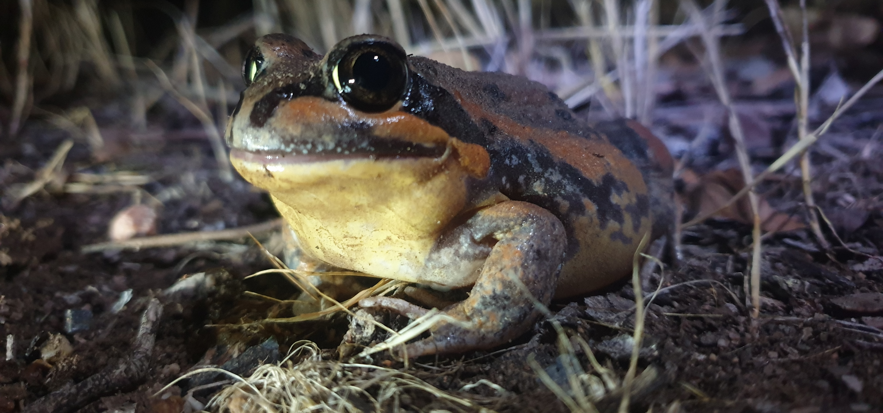
Photo credit: Damian Michael, Charles Sturt University

Introduction
Globally, amphibians have the highest percentage of species at risk of extinction (Luedtke et al. 2023). In Australia, 22% of species are listed under the EPBC Act, and 4 frog species are known to have become extinct in the past 40 years (Geyle et al. 2021). While there is a range of processes threatening Australian frogs, habitat loss and river regulation are major threats to many species in the Basin (Mathwin et al. 2023, Mathwin et al. 2024). Environmental water can have direct benefits to frog diversity, as well as to waterbirds, freshwater turtles and wetland-dependent snakes that feed on frogs and tadpoles.
Frogs have a range of life-history strategies that influence how, or if, they respond to environmental water (Ocock and Wassens 2018b). Flow-responsive species are those that respond strongly to floodplain inundation and managed environmental flows, independent of local rainfall. They typically have longer tadpole development times and are often associated with larger waterbodies that are more frequently inundated and have longer hydroperiods (3–6 months) (Ocock et al. 2014). Flow-ambivalent species have flexible breeding strategies and can respond to floodplain inundation during regulated (including environmental) flows but can also respond strongly to local rainfall. Burrowing species emerge only after heavy rains to breed in rain-fed systems so, although they make up a significant component of frog diversity, especially in the northern Basin, they are not expected to respond directly to the delivery of environmental water.
Ten species are known to respond strongly to the delivery of environmental water. These include the southern bell frog (listed as Vulnerable under the EPBC Act), which occurs across multiple valleys in the southern connected Basin, Lower Lachlan, Murrumbidgee, Lower Murray and Edward/Kolety–Wakool and is highly dependent on environmental water. Other widespread flow-responsive species include the spotted marsh frog (Limnodynastes tasmaniensis) (also referred to as ‘spotted grass frog’), Peron’s tree frog (Litoria peronii) and giant banjo frog (Limnodynastes interioris).

Watering actions for frogs

Water year 2023–24
In 2023–24, 25 individual watering actions had at least one objective related to frog outcomes, for a combined volume of about 94,650 ML of CEW (Table 4.1). The highest volumes of CEW with objectives related to frogs were delivered in the Murrumbidgee (5 watering actions, 50,175 ML), Lachlan (3 watering actions, 23,382 ML), Edward/Kolety–Wakool (7 watering actions, 10,881 ML), Warrego (1 action, 8,369 ML). Most of the water was delivered with objectives related to habitat support and included outcomes for multiple taxonomic groups. Of these actions, water deliveries with specific objectives for the southern bell frog were undertaken in the Murrumbidgee (4 actions, 49,675 ML) and Lower Murray (7 actions, 1,773 ML) (Table 1.2).

Water years 2014–24
Over the past 10 years 1,991 GL of CEW was delivered with specific objectives for frogs. When broken down by valley, the highest volumes of water with objectives for frogs over 10 years were delivered in the Murrumbidgee, followed by the Lower Murray, Edward/Kolety–Wakool, Lower Darling/Baaka, Macquarie, Lachlan, Gwydir and Central Murray river systems (Figure 4.1, Table 4.1).The largest flows occurred in the Murrumbidgee in 2021–22, when 529,279 ML were delivered as part of 12 watering actions. In 2023–24, the capacity to deliver CEW to floodplain habitats in some valleys, particularly the Murrumbidgee, was reduced due to damaged infrastructure. This is reflected in the smaller volumes delivered in that valley (Wassens and Hall 2023) (Figure 4.1).
Figure 4.1 Annual volume of Commonwealth environmental water with at least one watering objective related to frogs, by valley per water year 2014–24
CEW = Commonwealth environmental water.
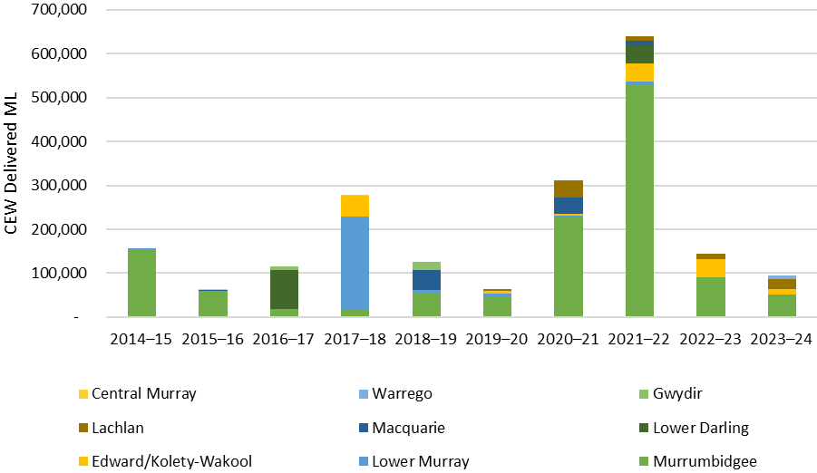
Table 4.1 Annual volume of Commonwealth environmental water with at least one watering objective related to frogs, by valley and year, 2014–24
Data in this table is presented graphically in Figure 4.1 and is presented here to aid document accessibility. Dash (–) indicates no objective for frogs
Valley | 2014–15 | 2015–16 | 2016–17 | 2017–18 | 2018–19 | 2019–20 | 2020–21 | 2021–22 | 2022–23 | 2023–24
Murrumbidgee | 152,558 | 56,989 | 16,505 | 16,536 | 56,599 | 48,335 | 227,518 | 529,279 | 90,911 | 50,175
Lower Murray | 3,887 | 3,555 | 1,657 | 211,770 | 5,655 | 5,779 | 4,052 | 7,300 | 251 | 1,843
Edward/Kolety–Wakool | – | – | – | 47,143 | – | 5,186 | 2,768 | 40,330 | 41,587 | 10,881
Lower Darling/Baaka | – | – | 89,204 | – | – | – | – | 42,256 | – | –
Macquarie | – | 2,125 | – | – | 45,052 | – | 37,488 | 10,900 | – | –
Lachlan | – | – | – | – | 412 | 4,998 | 40,191 | 9,174 | 11,708 | 23,382
Gwydir | – | – | 7,496 |  | 17,550 | – | – | – | – | –
Junction of Warrego and Darling rivers | – | – | – | – | – | – | – | – | – | 8,370
Central Murray | – | 1,867 | – | 102 | – | – | – | – | – | –
Total | 156,445 | 64,536 | 114,862 | 275,551 | 125,268 | 64,298 | 312,017 | 639,238 | 144,456 | 94,650

Evaluation results
In this section, we consider frog outcomes in 2023–24 relative to previous years, focusing on the long-term LTIM and Flow-MER datasets for the Junction of Warrego and Darling rivers (2014–24) and Murrumbidgee River System (2014–24). There were no data available for the Gwydir River System (2015–23), Lachlan River System (2015–23) or Macquarie Marshes (2014–23) (Table 3.1). Outcomes for frogs associated with watering actions in 2023–24 are described in Table 4.3.

Frog observations 2023–24
In 2023–24, 11 species were detected. The most abundant and widespread were the spotted marsh frog, barking marsh frog and Peron’s tree frog, which were detected in both the Junction of Warrego and Darling rivers in the northern Basin and the Murrumbidgee River System in the southern Basin. As in previous years, the diversity of frog species is higher in the northern Basin due to the presence of species that respond to rain. In the Murrumbidgee River System, the Vulnerable (EPBC Act) southern bell frog continues to benefit from the delivery of environmental water.
In 2023–24, survey effort in the Murrumbidgee remained low because of flood damage to access roads – only 7 of the 12 long-term sites were surveyed, and key southern bell frog habitats in the Gayini Nimmie–Caria and Redbank system were inaccessible (Wassens et al. 2024b). All 4 sites in the Junction of Warrego and Darling rivers were surveyed on at least one occasion in 2023–24 (CEWH 2024b). Overall, 11 species were detected. The most widespread were the spotted marsh frog, barking marsh frog (Limnodynastes fletcheri) and Peron’s tree frog (Table 4.2). In the Murrumbidgee, only one of the monitored wetlands received environmental water – Bala (Eulimbah) which is a large lignum wetland. This action was successful in triggering breeding, as evidenced by the detection of calling, tadpoles and recently metamorphosed frogs between September 2023 and March 2024 (Table 4.3).
Watering objectives continue to be focused on either general habitat maintenance (habitat), while more targeted objectives are focused on frog breeding (breeding), maintaining critical refuge habitat for frogs (refuge), and providing opportunities for breeding and recruitment of the southern bell frog. In most cases, individual watering actions targeting frogs also had associated objectives for waterbirds and vegetation.
Table 4.2 Frog species detected in 2023–24 combined Flow-MER datasets
Values represent the number of times detected. Dash (–) indicates no frogs detected.
Common name | Species | Junction of Warrego and Darling rivers | Murrumbidgee River System
Spotted marsh frog | Limnodynastes tasmaniensis | 41 | 401
Peron’s tree frog | Litoria peronii | 43 | 170
Barking marsh frog | Limnodynastes fletcheri | 37 | 33
Southern bell frog | Litoria raniformis | – | 273
Eastern sign-bearing froglet | Crinia parinsignifera | – | 150
Giant banjo frog | Limnodynastes interioris | – | 2
Green tree frog | Litoria caerulea | 17 | –
Salmon-striped frog | Limnodynastes salmini | 12 | –
Desert tree frog | Litoria rubella | 10 | –
Broad-palmed rocket frog | Litoria latopalmata | 8 | –
Striped burrowing frog | Cyclorana alboguttata | 2 | –
Table 4.3 Watering action objectives and key observations associated with those actions for frogs, by surface water region, 2023–24
Although there were no specific environmental watering objectives for Commonwealth environmental water (CEW) in the Gwydir and Warrego, summaries of outcomes for those valleys are included, as they may be informative when planning future watering actions. Note that, for simplicity, similar objectives have been summarised. EPBC Act = Australian Environment Protection and Biodiversity Conservation Act 1999, NSW DCCEEW = New South Wales Department of Climate Change, Energy, the Environment and Water.
Surface water region | Summarised watering objective | Recorded observations; and outcomes for frogs in 2023–24
Murrumbidgee | Support the habitat requirements of, including provision of critical refuge and diversity of habitats (in-channel and wetland) for, waterbirds, native fish, frogs (e.g. southern bell frog), turtles and other aquatic fauna. This includes provision of forage habitat.  Contribute to reproduction and recruitment opportunities for waterbirds, native frogs, turtles, invertebrates and other aquatic fauna | - Surveys were undertaken at the 12 long-term monitoring sites in September, November, February and March.  - 6 flow-responsive species were detected (eastern sign-bearing froglet, barking marsh frog, spotted marsh frog, Peron’s tree frog, southern bell frog [Vulnerable, EPBC Act] and inland banjo frog). Species richness in 2023–24 was comparable to previous monitoring years.  - Environmental water, including CEW, was delivered to Bala Swamp from September 2023 to March 2024 with the additional objective to support recruitment of southern bell frogs.  - Southern bell frogs were detected calling in September and December in Bala Swamp surveys, and adults were observed foraging in all survey rounds. 17 southern bell frog tadpoles were detected.
Macquarie | Support frog recruitment and provide food and habitat for a range of other water-dependent species (e.g. turtles, mussels) (CEWH 2024l) | - NSW DCCEEW conducted frog surveys in September and November across 14 sites (NSW DCCEEW 2024b).  - Most sites had high levels of inundation in September, but water levels were receding by November.  - 8 frog species were recorded, including 6 flow-responsive species (eastern sign-bearing froglet, barking marsh frog, spotted marsh frog, broad-palmed frog, salmon-striped frog, Peron’s tree frog) and 2 rain-responding species (desert tree frog, water-holding frog).  - Spotted marsh frog, barking marsh frog and eastern sign-bearing froglet detected calling. Egg masses observed at 5 sites and tadpoles detected at 3 sites.  - Distribution of flow-dependent species and breeding activity exceeded average levels in spring 2023.  - The wetland-dependent Ngabi (grey snake) (Endangered, EPBC Act) was also detected at 4 sites (NSW DCCEEW 2024b).
Gwydir River System | No objectives | - NSW DCCEEW conducted frog surveys at 18 sites in the Gwydir Wetlands in September and December.  - Most sites were dry in September and had limited frog calling.  - In December, heavy rainfall and deliveries of environmental water into the Gingham watercourse influenced the hydrology of wetland sites.  - 9 frog species were recorded, including 6 flow-dependent species (eastern sign-bearing froglet, barking marsh frog, spotted marsh frog, broad-palmed frog, salmon-striped frog, Peron’s tree frog), 2 rain-responding species (desert tree frog and striped burrowing frog) and one arboreal species (green tree frog) (Department of Climate Change 2024).  - Calling was reported from 9 sites. Barking marsh frog, spotted marsh frog and salmon-striped frog were most abundant.  - The wetland-dependent Ngabi (grey snake) (Endangered, EPBC Act) was detected at 9 sites (Department of Climate Change 2024).
Lower Murray Renmark floodplain wetlands | Increasing diversity and abundance of waterbirds and frogs through aquatic habitat improvements | - There was limited delivery of environmental water due to infrastructure maintenance.  - Frog surveys detected only low abundance and diversity, which is to be expected during the autumn watering season.  - During supplementary monitoring, the southern bell frog was recorded at Plush’s bend in November (CEWH 2024m).
Lower Murray wetlands | Prevent loss of, and provide breeding opportunities for, nationally threatened species, including regent parrots, Murray hardyhead and southern bell frogs | - Southern bell frogs were detected at Overland Corner Lignum Basin and successful recruitment to juvenile frog stage was reported (CEWH 2024j).
Junction of Warrego and Darling rivers | Provide additional habitat, feeding and breeding opportunities for aquatic species such as birds, frogs, fish and invertebrates (CEWH 2024d) | - 8 frog species were detected. The highest density of individuals was recorded in January on the western floodplain following a period of above-average rainfall and good river flows (and Table 4.2).  - Juveniles of a burrowing frog species (Cyclorana sp.) were recorded at Booke Dam, and 41 salmon-striped frogs (Limnodynastes salmini) were seen on the western floodplain and Ross Billabong (CEWH 2024b).
Peel | Support opportunities for breeding and recruitment of other aquatic species, including frogs, platypus and turtles (CEWH 2024e). | - No outcomes reported (CEWH 2024e).

Frog observations 2014–24
Sections 4.3.2–5 consider frog responses to CEW as part of the broader evaluation question for species diversity.
Over the 2014–24 period, 20 species of frog were reported from wetlands inundated with Commonwealth environmental water in the Murrumbidgee River System, Junction of Warrego and Darling rivers, Macquarie Marshes, Lachlan River System and Gwydir River System (Wassens et al. 2024; NSW DCCEEW 2024a, 2024b).
This section only considers data drawn from the long-term monitoring sites in the Murrumbidgee River system and Junction of Warrego and Darling rivers, as no data were available for the Macquarie Marshes, Lachlan River System or Gwydir River System in 2023–24.
Frogs generally have low mobility (Wassens et al. 2008), and occurrence at environmental watering sites is highly dependent on the longer-term water regime, including the frequency of inundation and length of dry periods, which influences survival over time (Mathwin et al. 2022). Each year, specific characteristics of the flow regime, such as the timing of inundation, may influence breeding responses of resident populations.

Contribution to inundation at frog monitoring sites 2014–24
Floodplain inundation is currently only mapped for areas that are influenced by CEW and is represented as the maximum annual extent (Sengupta et al. 2025). This data presents challenges in assessing the contribution of CEW to species richness, as maximum inundation estimates do not always reflect the conditions experienced at monitoring sites at the time of survey. Furthermore, inundation data were not available when sites are influenced by other water sources, such as environmental water delivered by states or unregulated flows.
Due to the absence of detailed hydrological information collected during frog surveys, we combined two sources: mapped inundation from CEW (Sengupta et al. 2025) and the proportion of the ANAE polygon that was wet during the survey month, derived from the WIT (Dunn et al. 2023) and calculated in the Digital Earth Australia Sandbox (Krause et al. 2021). This approach has certain limitations, such as underestimating the proportion of open water and wet areas when surveyed wetlands are small relative to the ANAE polygon, however it provides a general indication of hydrological conditions at the time of the survey. Additionally, it allows for an estimation of the likelihood that the observed inundation can be attributed to CEW.
Commonwealth environmental water was the primary source of inundation and played a significant role in shaping the hydrological regime at 11 of the 12 frog survey sites in the Murrumbidgee River System (Figure 4.2).
Except for McKenna’s Lagoon, frog survey sites had a high likelihood of being wet during surveys, and many experienced at least partial inundation in most years. In contrast, hydrological regimes and CEW contributions were more variable in the Junction of Warrego and Darling rivers. This region experienced longer dry periods, but CEW remained the predominant driver of inundation at the frog survey sites (Figure 4.2).

Frog communities 2014–24
As noted in previous years, frog communities in the northern Basin contain a mix of flow-responding species, which are expected to be influenced most strongly by managed water delivery, and rain-responding species, which require a rainfall trigger to commence breeding (Ocock and Wassens 2018a). Rain-responding burrowing species include burrowing frogs from the genus Cyclorana including (Cyclorana alboguttata, C. platycephala and C. novaeholladiae) (Figure 4.3).
The presence of rain-responding species in the Junction of Warrego and Darling rivers contributes to significant differences in community composition between the Murrumbidgee River System and the Junction of Warrego and Darling rivers. When these 2 valleys are combined, there is no difference between frog communities observed in years with or without CEW. However, there is a significant interaction between valley and CEW. When the valleys are considered separately, there are significant differences between CEW and other water in the Murrumbidgee but not in the Junction of Warrego and Darling rivers. In the Murrumbidgee, there were higher average abundances of the less common species. Barking marsh frog had higher average abundance in the CEW group (Table 4.4). Barking marsh frog also had a higher average abundance in the CEW group in the Junction of Warrego and Darling rivers, as did the more common flow-responding species spotted marsh frog and Peron’s tree frog.
Annual average abundance of frog species in the Junction of Warrego and Darling rivers and the Murrumbidgee River System are reported in Table 4.5 and Table 4.6 respectively.
Table 4.4 A SIMPER (similarity percentage) analysis comparing the contribution of each frog species to the differences between communities influenced by Commonwealth environmental water and those watered by other environmental water, 2014–24
The table shows the percentage contribution of each species to the overall Bray–Curtis dissimilarity between the 2 groups. Species with higher average dissimilarity were typically detected in greater abundance at sites associated with a particular environmental water source. CEW = Commonwealth environmental water.
Valley | Species | Average abundance other water | Average abundance CEW | Average dissimilarity | Contribution (%) | Cumulative contribution (%)
Junction of Warrego and Darling rivers | Limnodynastes fletcheri | 0.65 | 1.15 | 16.1 | 20.92 | 20.92
Junction of Warrego and Darling rivers | Limnodynastes tasmaniensis | 0.5 | 1 | 15.33 | 19.91 | 40.83
Junction of Warrego and Darling rivers | Litoria peronii | 0.52 | 0.82 | 12.25 | 15.92 | 56.75
Junction of Warrego and Darling rivers | Litoria caerulea | 0.5 | 0.44 | 8.65 | 11.23 | 67.98
Junction of Warrego and Darling rivers | Litoria rubella | 0.31 | 0.36 | 7.29 | 9.48 | 77.46
Junction of Warrego and Darling rivers | Limnodynastes salmini | 0.15 | 0.23 | 4.58 | 5.95 | 83.41
Junction of Warrego and Darling rivers | Crinia deserticola | 0.28 | 0.25 | 4.51 | 5.86 | 89.27
Junction of Warrego and Darling rivers | Litoria latopalmata | 0.1 | 0.09 | 2.66 | 3.45 | 92.72
Murrumbidgee | Limnodynastes tasmaniensis | 1.81 | 1.5 | 10.64 | 20.05 | 20.05
Murrumbidgee | Litoria peronii | 1.22 | 1.32 | 10.09 | 19.02 | 39.06
Murrumbidgee | Crinia parinsignifera | 1.03 | 0.89 | 9.73 | 18.33 | 57.39
Murrumbidgee | Limnodynastes fletcheri | 0.96 | 1.2 | 9.48 | 17.86 | 75.26
Murrumbidgee | Litoria raniformis | 0.4 | 0.93 | 8.81 | 16.6 | 91.85
Figure 4.2 Change in the maximum extent of wet area at the time of survey in the Australian National Aquatic Ecosystem polygons corresponding to 17 monitored sites in the Murrumbidgee River System and Junction of Warrego and Darling rivers, split by Commonwealth environmental water or other water, by water year 2014–24
Other water includes deliveries that were not CEW or that were unregulated flows or from other sources. Mean proportion wet is based on Wetlands Insight Tool estimates for ANAE polygons that contained the survey point. Site prefix WD = Junction of Warrego and Darling rivers.
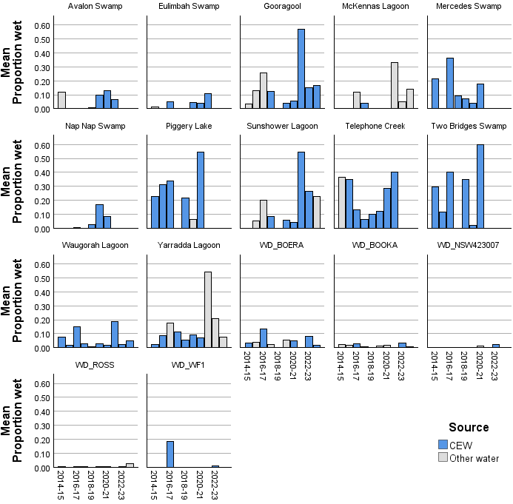
Figure 4.3 Frog community composition based on mean catch per unit effort (frogs observed per hour) in the Junction of Warrego and Darling rivers (top plot) and Murrumbidgee River System (bottom plot), by water year 2014–24
CPUE = catch per unit effort.
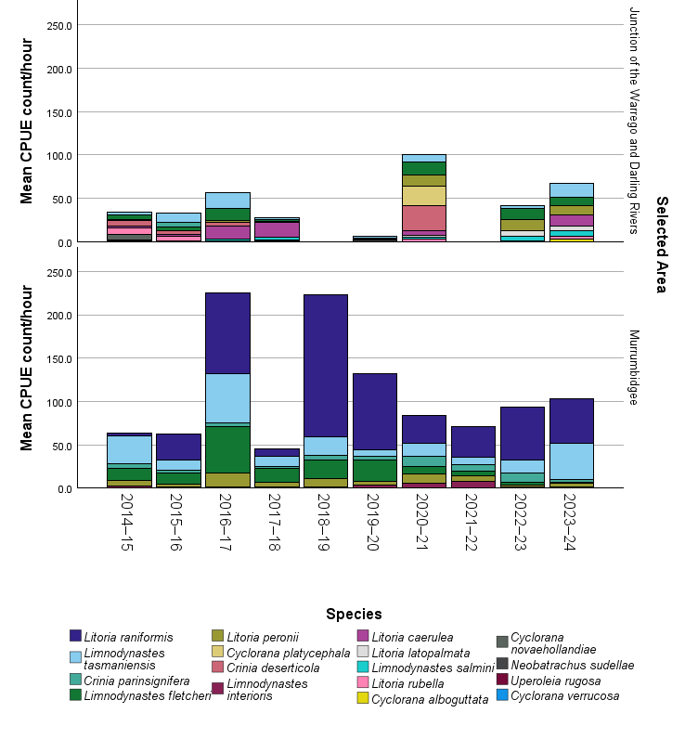
Table 4.5 Average abundance of frog species in the Junction of Warrego and Darling rivers by water year 2014–24
Averages are derived from site/survey combination and are not adjusted for survey effort (see Figure 4.3). Dash (–) indicates no data were collected.
Species | Common name | 2014–15 | 2015–16 | 2016–17 | 2017–18 | 2018–19 | 2019–20 | 2020–21 | 2021–22 | 2022–23 | 2023–24
Junction of Warrego and Darling rivers
Crinia deserticola | Desert froglet | 3.4 | 0.8 | 3.2 | 0.0 | – | 0.0 | 15.5 | – | 0.0 | 0.0
Crinia parinsignifera | Eastern sign-bearing froglet | 0.0 | 1.8 | 0.0 | 0.0 | – | 0.0 | 0.0 | – | 0.0 | 0.0
Cyclorana alboguttata | Green-striped burrowing frog | 0.0 | 0.0 | 0.0 | 0.0 | – | 0.0 | 0.0 | – | 0.0 | 2.0
Cyclorana novaehollandiae | New Holland frog | 1.0 | 0.0 | 0.0 | 0.8 | – | 0.0 | 0.0 | – | 0.0 | 0.0
Cyclorana platycephala | Water-holding frog | 0.0 | 0.0 | 0.0 | 0.5 | – | 0.0 | 11.0 | – | 0.0 | 0.0
Cyclorana verrucosa | Rough frog | 1.0 | 0.0 | 0.0 | 0.0 | – | 0.0 | 0.0 | – | 0.0 | 0.0
Limnodynastes fletcheri | Barking marsh frog | 1.5 | 1.6 | 18.6 | 0.7 | – | 1.1 | 12.3 | – | 6.0 | 5.4
Limnodynastes salmini | Salmon-striped frog | 0.0 | 0.0 | 0.4 | 0.4 | – | 0.0 | 1.4 | – | 1.6 | 2.4
Limnodynastes tasmaniensis | Spotted marsh frog | 1.4 | 4.7 | 12.2 | 0.4 | – | 0.6 | 9.9 | – | 1.0 | 5.8
Litoria caerulea | Green tree frog | 1.0 | 1.2 | 10.6 | 5.6 | – | 0.6 | 3.9 | – | 0.0 | 3.4
Litoria latopalmata | Broad-palmed frog | 0.0 | 0.0 | 0.0 | 0.0 | – | 0.0 | 0.7 | – | 3.7 | 1.7
Litoria peronii | Peron's tree frog | 0.8 | 0.2 | 1.8 | 0.0 | – | 0.3 | 8.6 | – | 5.8 | 5.4
Litoria rubella | Desert tree frog | 3.1 | 1.8 | 0.0 | 0.3 | – | 0.0 | 3.3 | – | 0.3 | 1.8
Neobatrachus sudellae | Sudell’s frog | 0.3 | 0.0 | 0.3 | 0.0 | – | 0.3 | 0.0 | – | 0.0 | 0.0
Uperoleia rugosa | Wrinkled toadlet | 0.0 | 0.3 | 0.0 | 0.0 | – | 0.0 | 0.0 | – | 0.0 | 0.0
Table 4.6 Average abundance of frog species in the Murrumbidgee River System by water year 2014–24
Averages are derived from site/survey combination and are not adjusted for survey effort (see Figure 4.3).
Species | Common name | 2014–15 | 2015–16 | 2016–17 | 2017–18 | 2018–19 | 2019–20 | 2020–21 | 2021–22 | 2022–23 | 2023–24
Murrumbidgee River System
Crinia parinsignifera | Eastern sign-bearing froglet | 2.3 | 1.1 | 1.0 | 0.8 | 2.0 | 1.1 | 1.7 | 2.5 | 1.6 | 0.6
Limnodynastes fletcheri | Barking marsh frog | 4.5 | 6.5 | 32.5 | 7.8 | 7.2 | 8.9 | 3.5 | 1.9 | 0.5 | 0.3
Limnodynastes interioris | Giant banjo frog | 1.0 | 0.1 | 0.3 | 0.3 | 0.4 | 0.8 | 0.5 | 0.6 | 0.1 | 0.1
Limnodynastes tasmaniensis | Spotted marsh frog | 15.1 | 6.7 | 36.8 | 6.7 | 10.0 | 4.1 | 8.9 | 4.3 | 3.4 | 18.7
Litoria peronii | Peron's tree frog | 3.0 | 1.1 | 10.0 | 3.0 | 3.6 | 1.9 | 5.3 | 3.2 | 0.6 | 1.4
Litoria raniformis | Southern bell frog | 0.9 | 9.1 | 27.8 | 3.1 | 24.6 | 22.4 | 11.1 | 12.2 | 5.1 | 12.3

Frog species richness 2014–24
As noted in Section 4.3.3, the hydrological regime of floodplain wetlands surveyed for frogs is strongly influenced by CEW. Unlike persistent river ecosystems, the majority of monitored wetlands suitable for frogs are intermittently inundated. With the reduction in naturally occurring minor and moderate reconnection events Commonwealth environmental water management is often the primary driver of inundation (see Figure 4.2), increasing the frequency of inundation and reducing the length of dry periods. All survey sites were influenced by CEW on at least one occasion, and most sites were influenced by CEW in more than 5 years, NSW environmental water and unmanaged inundation also influenced the hydrology of the monitored wetlands (Figure 4.4). Overall there is little difference between the mean numbers of species recorded in a given water year and the source of water and few trends are detected. However, increasing the frequency of inundation of CEW makes a contribution to the persistence of sensitive species including the southern bell frog which has low survival during dry periods.
Figure 4.4 Box plots showing the change in median number of frogs at 17 monitored sites in the Murrumbidgee River and Junction of Warrego and Darling rivers in years when inundation was primarily influenced by Commonwealth environmental water or other water, by water year 2014–24
Box plot bar is median, upper and lower bounds of the box represent 3rd and 1st quartiles, and whiskers represent maximum and minimum excluding outliers. Other water includes deliveries that were not Commonwealth environmental water (CEW) or that were unregulated flows or from other sources. Site prefix WD = Junction of Warrego and Darling rivers.
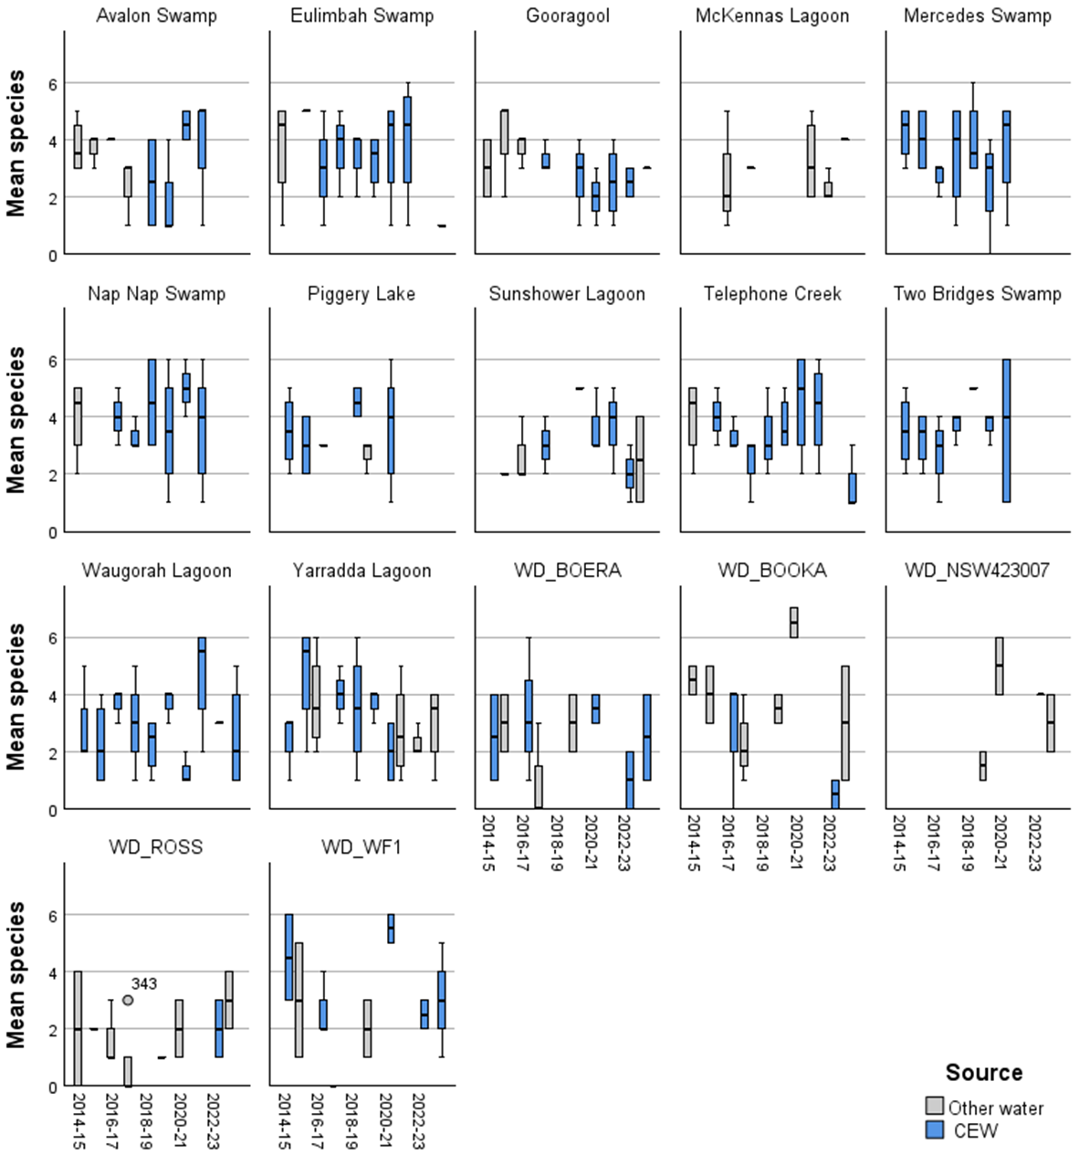

Outcomes for waterbirds
This chapter reports on the extent to which the delivery of CEW to waterbird monitoring sites contributed to maintaining, improving or restoring habitat for waterbirds in the Basin. Due to the limited nature (temporal and spatial extent) of long-term quality monitoring data, evaluation is at the site scale or system scale, not Basin scale. The chapter reports on recorded observations at sites where CEW was delivered and outcomes for waterbird breeding, communities and species richness.
Key findings
In 2023–24, just over 2,011 GL of Commonwealth environmental water was delivered for waterbird objectives. This is the largest annual volume of Commonwealth environmental water delivered.
68,718 individuals from 68 species were reported in 2023-24 from 8 waterbird functional groups and 2 water-associated groups. This is the highest species richness reported since 2014.
Watering to Lake Brewster supported a pelican breeding event for more than 22,000 pelican chicks.
Over the past 10 years, 224,921 individuals from 97 waterbird species have been detected.
Using the 3 most consistently surveyed valleys (Junction of Warrego and Darling rivers, Murrumbidgee River System and Gwydir River System) to analyse the relationship between Commonwealth environmental water and waterbirds from 2014-24 found:
- a significant positive relationship between the number of bird species detected and the proportion of Commonwealth environmental water inundation
- a significant positive relationship between the number of individuals birds and the proportion of Commonwealth environmental water inundation.
Yellow-billed spoonbills are strongly dependent on surface water for feeding, breeding, roosting and refuge
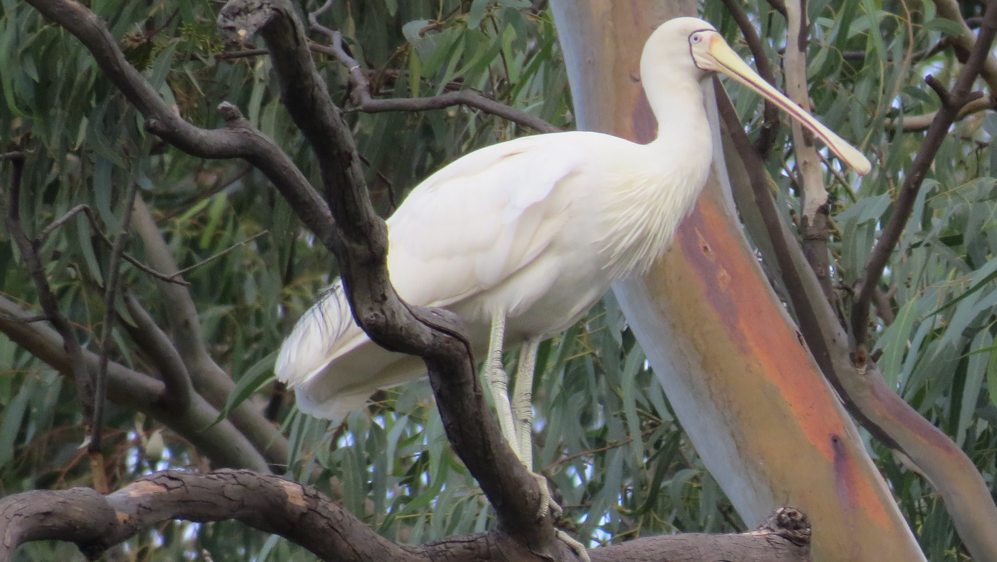
Photo credit: Freya Robinson, CSIRO

Introduction
Populations of many Australian waterbirds are declining (Porter et al. 2021; Porter et al. 2024). These declines and the high proportion of listed species make waterbirds a key priority for environmental watering, particularly in floodplain and wetland habitats. There is growing evidence of the importance of environmental water in maintaining waterbird populations in Australia, especially at the catchment scale (MDBA 2017).
Critical waterbird habitats and multiple populations of listed waterbird species are associated with locations periodically inundated by environmental water. Adaptive management of environmental water to support waterbird breeding sites, breeding events, foraging habitats and food sources is increasingly important in the context of climate change and increasing human demand for fresh water. There is also potential for other complementary adaptive management actions to support the effectiveness of environmental water and, ultimately, waterbird recruitment. Environmental water, vegetation management and management of pressures and threats, such as predation, disease and toxins, all interact with habitat availability and quality to affect waterbird movements, condition, growth, survival and mortality, as well as breeding initiation and frequency.

Watering actions for waterbirds

Water year 2023–24
In 2023–24, 36 individual watering actions had at least one objective related to waterbird outcomes, for a combined volume of approximately 2,011,400 ML of CEW (Table 1.2, Figure 5.1). The highest volumes of CEW with objectives related to waterbirds were delivered in the Lower Murray (14 watering actions, 1,386,183 ML), Central Murray (1 watering action, 307,961 ML), Lower Darling/Baaka (2 watering actions, 110,834 ML) and Condamine Balonne (1 action, 71,299 ML) (Table 1.2). Most CEW was delivered with objectives related to habitat support and included outcomes for multiple taxonomic groups. Flows with specific objectives related to listed threatened and migratory species were undertaken in the Murrumbidgee (Australasian bittern and Australian painted snipe) and Lower Murray (migratory shorebirds).

Water years 2014–24
Since 2014–15, 9,298,500 ML of CEW was delivered to benefit waterbirds, either alone or in combination with other watering objectives. The volumes of CEW delivered with watering objectives related to waterbirds were highly variable across years (Figure 5.1, Table 5.1). The overall volume of CEW delivered with at least one objective for waterbirds in 2023–24 was 2,011,400 ML, the highest on record.
Figure 5.1 Total annual volumes of Commonwealth environmental water delivered with at least one watering objective related to waterbird outcomes, by valley, by water year 2014–24
CEW = Commonwealth environmental water.
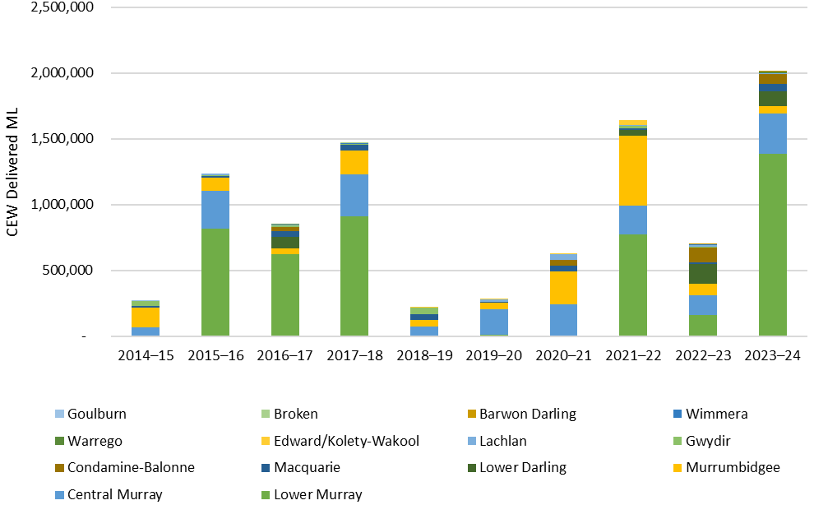
Table 5.1 Total annual volumes of Commonwealth environmental water (ML) delivered with at least one watering objective related to waterbird outcomes, by valley, by water year 2014–24
Data in this table is presented graphically in Figure 5.1 and is presented in table form to assist in interpretation. Dash (–) indicates no specific watering objective for waterbird outcomes.
Valley | 2014–15 | 2015–16 | 2016–17 | 2017–18 | 2018–19 | 2019–20 | 2020–21 | 2021–22 | 2022–23 | 2023–24
Lower Murray | 3,974 | 814,086 | 620,372 | 907,978 | 5,692 | 10,508 | 5,846 | 774,031 | 162,309 | 1,386,183
Central Murray | 61,500 | 287,863 | – | 323,668 | 63,502 | 195,834 | 237,110 | 219,865 | 145,279 | 307,961
Murrumbidgee | 152,558 | 100,252 | 42,939 | 176,571 | 54,000 | 48,335 | 250,818 | 529,279 | 90,911 | 52,746
Lower Darling/Baaka | – | – | 89,204 | – | – | – | – | 42,256 | 148,432 | 110,834
Macquarie | 10,000 | 14,239 | 45,372 | 48,421 | 45,052 | 3,896 | 38,551 | 10,900 | 12,433 | 59,879
Condamine- Balonne | – | – | 28,870 | – | – | – | 44,234 | – | 113,253 | 71,299
Gwydir | 39,667 | 7,436 | 16,496 | 4,000 | 47,550 | – | 4,500 | 20,591 | 5,536 | 5,000
Lachlan |  | 11,963 | 1,324 |  | 412 | 22,026 | 42,162 | 9,174 | 11,708 | 4,969
Edward/Kolety–Wakool | – | – | – | – | 2,000 | 2,000 | 2,500 | 36,739 | 3,024 | -
Warrego | – | – | 9,720 | – | – | – | – | – | – | 8,370
Wimmera | – | – | – | 3,108 | – | – | – | – | 2,441 | 2,762
Barwon Darling | – | – | – | – | – | – | – | – | 86.2 | 1,437
Broken | – | – | – | 498 | – | – | – | – | – | –
Goulburn | 250 | – | – | – | – | – | – | – | – | –

Evaluation results

Waterbird observations 2023–24
This section provides a high-level overview of waterbird communities in 2023-24. It draws on LTIM and Flow-MER Selected Area datasets that were available for the Gwydir River System, Junction of Warrego and Darling rivers and Murrumbidgee River System, and complementary NSW DCCEEW data for the Macquarie Marshes, Central Murray, Lachlan and Condamine (Narran Lakes) River Systems. This section provides an indication of the status of waterbirds across these monitoring locations; however, inconsistencies in the spatial data provided with complementary datasets make it difficult to directly link outcomes with CEW. As a result, analysis of the contribution of CEW between 2014–15 and 2023–24 is based on the LTIM and Flow-MER dataset only (see Section 5.3.2).
During 2023–24, 68,718 individuals from 68 species were reported from 8 waterbird functional groups and 2 water-associated groups (reed-inhabiting passerines and raptors) (Appendix C). Grey teal (Anas gracilis) was the most recorded species, followed by Australian pelican (Pelecanus conspicillatus), Eurasian coot (Fulica atra), Pacific black duck (Anas superciliosa) and Australian wood duck (Chenonetta jubata) (Table A.1).
The number of waterbirds reported from Narran Lakes in NSW DCCEEW surveys was low compared to previous years. This is likely reflecting a combination of drier conditions and low survey effort, as NSW DCCEEW surveys only cover Back Lake, Clear Lake and South Arm, which were dry at the time of survey, and Narran River, which contained a small amount of water (Francis and Brandis 2024).
11 bird species of conservation significance were detected in during the combined NSW DCCEEW and Flow MER waterbird surveys in 2023–24 (Table 5.3).
These included 3 species listed under the EPBC Act – the Endangered Australasian bittern and Vulnerable sharp-tailed sandpiper and Latham’s snipe. Other species of significance detected included species listed under international treaties (e.g., marsh sandpiper Tringa stagnatilis), .and species listed as threatened under state legislation (e.g., black-necked stork Ephippiorhynchus asiaticus).
Reported observations are summarised in Table 5.2. This table presents a summary of outcomes that have previously been reported in both published and unpublished reports and in CEWH delivery team acquittal reports.
Table 5.2 Watering action objectives and key observations associated with those actions for waterbirds and other listed threatened bird species, by surface water region, 2023–24
Although there were no specific environmental objectives for Commonwealth environmental water in the Gwydir, a summary of outcomes for this valley is included as it may be informative when planning future watering actions.
Surface water region | Objective | Recorded observations and key outcomes
Lower River Murray | Improve the abundance and maintain the diversity of the Basin’s waterbird population | Annual aerial waterbird survey reported extensive waterbird breeding aggregations in the Lower Lakes, including cormorants, ibis and spoonbill (CEWH 2024k; Porter et al. 2024)
Murrumbidgee | Support the habitat requirements of, including provision of critical refuge and diversity of habitats (in-channel and wetland) for, waterbirds, native fish, frogs (e.g. southern bell frog), turtles and other aquatic fauna. This includes provision of forage habitat.  Contribute to reproduction and recruitment opportunities for waterbirds, native frogs, turtles, invertebrates and other aquatic fauna | 18,079 individuals and 47 species were recorded, including 17 Australasian bitterns and 136 glossy ibis (Wassens et al. 2024b). Also see Table 5.3
Macquarie | Support foraging habitat for waterbirds, particularly young-of-year waterbirds in the Macquarie Marshes, to increase condition and survival (CEWH 2024l) | NSW DCCEEW monitoring recorded 11,721 individuals from 58 species (Table C.1)  Listed species include blue-billed duck, white-bellied sea-eagle, magpie goose, Latham’s snipe, marsh sandpiper and sharp-tailed sandpiper (NSW DCCEEW 2024c)
Lachlan | Provide flows to maintain core wetland areas and refuge habitat for southern bell frog and Australasian bittern.  Provide foraging and breeding habitat for wading birds, including migratory and threatened species.  Support a large Australian Pelican breeding rookery to completion (CEWH 2024h) | Surveys of the Lake Brewster pelican rookery recorded 22,919 nests across the breeding season and a maximum of 8,339 active nests at any given time (Francis et al. 2024)
Edward/Kolety–Wakool River System | Maintain the diversity and improve the abundance of the Basin’s waterbird population | Not monitored (CEWH 2024g)
Gwydir River System | Maintain the diversity and improve the abundance of the Basin’s waterbird population | Incidental sightings included large numbers of white-necked heron (and juveniles), brolga, black-necked stork, white-bellied sea eagle and banded lapwings (CEWH 2024c).
River Murray Hume to South Australia and Barmah–Millewa Forest | Maintain current species diversity, extend distributions and improving breeding success and numbers of water-dependent bird species by:  - supporting suitable habitat conditions and food resources for waterbird growth and survival, maintenance of population condition and diversity along the River Murray valley  - supporting waterbird breeding events if seasonally appropriate | 200 nests of Australian white Ibis occurring in Boals Deadwoods in Barmah Forest (CEWH 2024n)
Lower Murray wetlands | Support waterbird habitat for species from a range of functional groups  Provide habitat for nationally listed migratory shorebirds | No outcomes reported (CEWH 2024j)
Lower Murray Renmark floodplain wetlands | Increase diversity and abundance of waterbirds and frogs through aquatic habitat improvements | Limited water delivery due to infrastructure maintenance. No outcomes reported (CEWH 2024m)
Lower Murray Coorong, Lower Lakes and Murray Mouth | Maintain current species diversity, extend distributions, and improve breeding success and numbers of water-dependent bird species by:  - supporting suitable habitat conditions and food resources for waterbird growth and survival, maintenance of population condition and diversity along the River Murray valley, Lower Lakes and within the Coorong lagoons  - supporting waterbird breeding events where feasible | No outcomes reported
Warrego | Provide additional habitat, feeding and breeding opportunities for aquatic species such as birds, frogs, fish and invertebrates | Waterbird surveys were undertaken in February and May 2024. Conditions in May were wet, and sites on the western floodplain were inaccessible.  279 individual waterbirds from 26 species were recorded during surveys in 2023–24. The most abundant species were little black cormorant, Australian wood duck, grey teal and Australian pelican. (CEWH 2024b; CEWH 2024d).
Condamine Balonne | Inundate/support core rookery habitat (lignum) in Narran Lakes | NSW DCCEEW completed their annual spring waterbird survey in late October 2023. Salt Lake and the Narran River channel were the only areas with water. 16 waterbird species (only a few individuals of each) were recorded across the 2 sites.  Listed species included a pair of black-necked storks and a white-bellied sea-eagle (CEWH 2024f)  Pelicans were nesting again on Roscommon – an estimated 500–1,000 adults were sitting on eggs or very small chicks. There were another ~500 2–3-month-old chicks (Francis and Brandis 2024)
Lower Darling/Baaka River and Great Darling Anabranch | Support suitable habitat conditions and food resources for waterbird growth and survival, maintenance of population condition and diversity  Support waterbird breeding events resulting from flows that reach floodplains and lakes on the Lower Darling/Baaka and Great Darling Anabranch, (if feasible and seasonally appropriate) | Not monitored (CEWH 2024i)
Wimmera | Maintain the current species diversity and improve the breeding success and numbers of waterbirds by supporting suitable habitat conditions and food resources for waterbirds growth and survival. Maintain population condition and diversity within the region | 76 wetland bird species were recorded at Lake Hindmarsh. Listed species included Australasian bittern, great egret, Australasian shoveler, musk duck, gull-billed tern, red-necked stint and sharp-tailed sandpiper.  Over 15,000 great cormorants, over 10,000 Australian shelducks and 800 Australian pelicans were recorded (CEWH 2024o)

Table 5.3 Threatened and migratory species reported in 2023–24 from wetlands in New South Wales monitored by Flow-MER and NSW Department of Climate Change, Energy, the Environment and Water
Status: EN = Endangered, VU = Vulnerable, EPBC Act = Australian Environment Protection and Biodiversity Conservation Act 1999, NSW BC Act = New South Wales Biodiversity Conservation Act 2016. Treaties: B = Bonn Convention on the Conservation of Migratory Species of Wild Animals, C (CAMBA) = China–Australia Migratory Bird Agreement, J (JAMBA) = Japan–Australia Migratory Bird Agreement, R (ROKAMBA) = Republic of Korea–Australia Migratory Bird Agreement. Dash (–) indicates not mentioned. Dash (–) in status columns indicates the species is not listed in those acts/treaties. Dash (–) in wetlands columns indicates no observations reported.
Common name | Scientific name | EPBC Act | International Treaties | NSW BC Act | Border Rivers | Condamine Balonne (Narran Lakes) | Junction of Warrego and Darling rivers | Gwydir Wetlands | Macquarie Marshes | Lachlan River System | Murrumbidgee River System | Mid-Murray wetlands
Australasian bittern | Botaurus poiciloptilus | EN | – | EN | – | – | – | – | – | 1 | 15 | –
Black falcon | Falco subniger | – | – | VU | – | – | – | 1 | – | – | – | –
Black-necked stork | Ephippiorhynchus asiaticus | – | – | EN | – | – | – | 3 | – | – | – | –
Blue-billed duck | Oxyura australis | – | – | VU | – | – | – | – | 1 | – | 26 | –
Glossy ibis | Plegadis falcinellus | – | B | – | – | – | – | 114 | 1,271 | 122 | 136 | –
Latham's snipe | Gallinago hardwickii | VU | B, J, R | VU | 3 | – | – | – | 3 | – | – | –
Magpie goose | Anseranas semipalmata | – | – | VU | – | – | – | – | 3 | – | – | –
Marsh sandpiper | Tringa stagnatilis | – | C, J, R | – | – | – | – | – | 1 | – | – | –
Sharp-tailed sandpiper | Calidris acuminata | VU | B, C, J, R | – | – | – | – | – | 8 | 2 | – | –
Spotted harrier | Circus assimilis | – | – | VU | – | – | – | – | – | – | – | 1
White-bellied sea-eagle | Haliaeetus leucogaster | – | – | VU | 1 | – | – | 5 | 12 | 2 | 7 | 3

Waterbird breeding 2023–24
In 2023–24, there was a return to drier conditions across much of the managed floodplain, and limited CEW was delivered to sustain waterbird breeding events. A total of 86,076 ML (5 actions) of CEW was delivered with objectives related to waterbird breeding across the following valleys: Condamine Balonne (71,299 ML), Warrego (8,369 ML), Lachlan (3,646 ML) and Wimmera (2,762 ML).
In the Condamine Balonne, water was delivered between February and May with the objective to “Inundate/support core rookery habitat (lignum) in Narran Lakes”. However, this flow was delivered after on-ground waterbird surveys and pelican breeding surveys were conducted by NSW DCCEEW (Francis and Brandis 2024). This means that observed outcomes in 2023–24 were linked to residual inundation from unregulated flows as well as environmental water deliveries that occurred in 2022–23.
Surveys carried out in November by UNSW on behalf of NSW DCCEEW identified approximately 1,000 pelicans foraging, and repeated drone surveys provided a total nest count of estimate of approximately 20,000 (Francis and Brandis 2024).
In the Lachlan, 3,646 ML of CEW along with 7,832 ML of other environmental water was delivered to Lake Brewster between September 2023 and May 2024 to support a large Australian pelican breeding event to completion and to provide breeding and foraging opportunities for other waterbird species. Between 2 November 2023 and 30 April 2024, 22,919 pelican nests were counted at Lake Brewster and an estimated 22,919 chicks potentially produced (Francis et al. 2024).

Contribution to inundation at waterbird monitoring sites 2014–24
For areas influenced by CEW, floodplain inundation is currently only mapped within the Flow-MER program as the maximum annual extent (Sengupta et al. 2025). Given the lack of detailed hydrological information collected at the time of waterbird surveys, we used a combination of mapped inundation from CEW (Sengupta et al. 2025) and the proportion of that ANAE polygon that was wet in the month that the waterbird survey was undertaken (derived from the WIT). While the approach has some limitations – for example, the proportion of open water and wet area is often underestimated when surveyed wetlands are small relative to the ANAE polygon, it does provide an overall indication of hydrological conditions at the time of survey and allows for some estimate of the likelihood that this inundation might be attributable to CEW.
Of the 32 monitored sites in the Murrumbidgee, 2 (Euroley Lagoon and Narrandera Regional Park Lagoon) were never influenced by Commonwealth environmental water (Figure 5.2). Commonwealth environmental water was the primary source of inundation and a major driver of the hydrological regime at other sites, including Piggery Lake, Yarradda Lagoon, Two Bridges Swamp and Telephone (Bayil) Creek in the Murrumbidgee (Figure 5.2) and Combardello Wier (COMW), Bunnor Bird Hide (GWY_BUNBH) in the Gwydir (Figure 5.3). Hydrological regime and Commonwealth environmental water contributions were more variable in the Junction of Warrego and Darling rivers with only one site (Boera Dam) influenced by Commonwealth environmental water across more than 5 years (Figure 5.4).
When considered across the Gwydir and Murrumbidgee valleys, the contribution of Commonwealth environmental water was particularly important in drier years (2017–18 to 2020–21), when it was the primary source of inundation at the waterbird monitoring sites (Figure 5.5).
Figure 5.2 Change in the maximum extent of wet area at the time of survey in the Australian National Aquatic Ecosystem polygons corresponding to 32 monitored sites in the Murrumbidgee River, split by Commonwealth environmental water or other water, by water year 2014–24
Other water includes deliveries that were not Commonwealth environmental water (CEW) or that were unregulated flows or from other sources. Maximum proportion wet is based on Wetlands Insight Tool estimates for Australian National Aquatic Ecosystem polygons that contained the survey point.
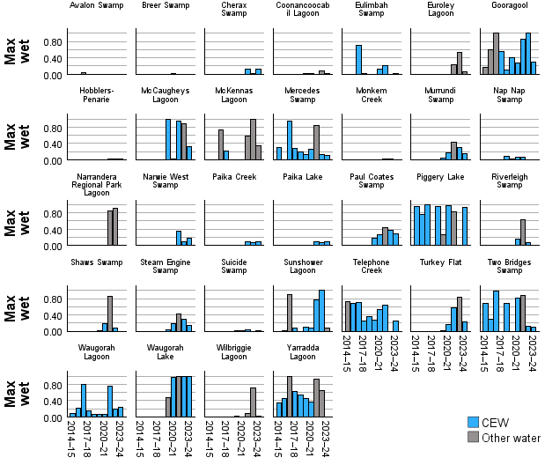
Figure 5.3 Change in the maximum extent of wet area at the time of survey in the Australian National Aquatic Ecosystem polygons corresponding to 35 monitored sites in the Gwydir River System, split by Commonwealth environmental water or other water, by water year 2014–24
Other water includes deliveries that were not Commonwealth environmental water (CEW) or that were unregulated flows or from other sources. Maximum proportion wet is based on Wetlands Insight Tool (WIT) estimates for Australian National Aquatic Ecosystem polygons that contained the survey point. Note log-10 scale for clarity. Sites with no WIT values have been excluded for clarity.
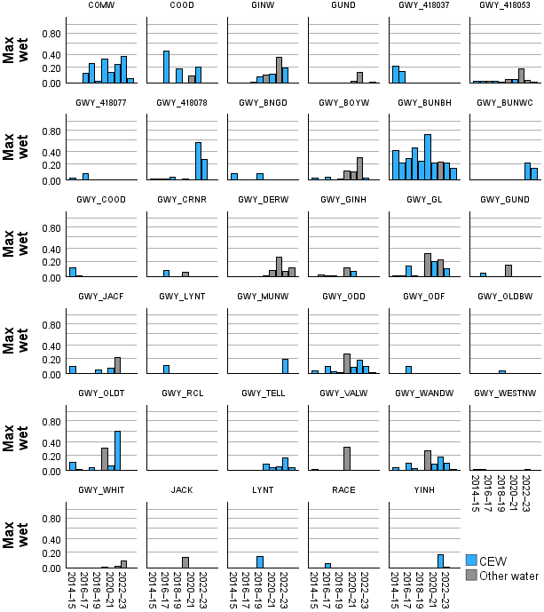
Figure 5.4 Change in the maximum extent of wet area at the time of survey in the Australian National Aquatic Ecosystem polygons corresponding to monitored sites in the Junction of Warrego and Darling rivers, split by Commonwealth environmental water or other water, by water year 2014–24
Other water includes deliveries that were not Commonwealth environmental water (CEW) or that were unregulated flows or from other sources. Maximum proportion wet is based on Wetlands Insight Tool (WIT) estimates for Australian National Aquatic Ecosystem polygons that contained the survey point. Note log-10 scale for clarity. Sites with no WIT values have been excluded for clarity.
A panel of bar plots, one for each site, with time (water year) on the x-axis and max wet on the y-axis. 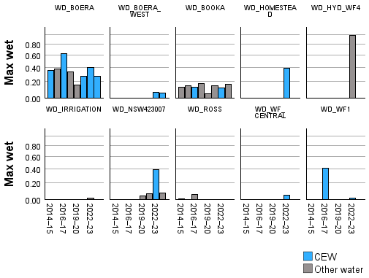
Figure 5.5 Change in average proportion of wet area for all Australian National Aquatic Ecosystem polygons corresponding to monitored sites in wetland complexes in the Gwydir River System (top plot), Junction of Warrego and Darling rivers (middle plot) and the Murrumbidgee River (bottom plot), split by Commonwealth environmental water or other water, by water year 2014–24
Other water includes deliveries that were not Commonwealth environmental water (CEW) or that were unregulated flows or from other sources. Mean proportion wet is based on Wetlands Insight Tool estimates for Australian National Aquatic Ecosystem polygons that contained the survey point.
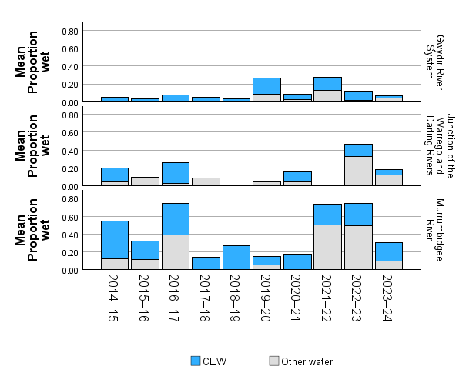

Waterbird communities 2014–24
In this section, we consider data drawn from the long-term LTIM and Flow-MER monitoring sites in the Junction of Warrego and Darling rivers, Gwydir River System and Murrumbidgee River System (CEWH 2024a; CEWH 2024b; Wassens et al. 2024b). There are 36 sites in the Murrumbidgee River System, and 30 were surveyed in 5 or more years. There are 50 sites in the Gwydir River System, but only 26 were surveyed for 5 or more years. There are 12 sites in the Junction of Warrego and Darling rivers, and 4 were surveyed for 5 or more years.
Over the past 10 years, 224,921 individuals from 97 waterbird species were detected from the Junction of Warrego and Darling rivers, the Gwydir River System and the Murrumbidgee River System (Appendix C).
By directly influencing the proportion of wetted area, CEW contributed to supporting an additional 13,951 individuals and an additional 3 species over what would be expected with other water sources alone, for a total of 100,921 individuals from 93 species. Notable species detected during surveys when sites were influenced by CEW include the listed migratory charadriiform shorebirds common sandpiper (Actitis hypoleucos), sharp-tailed sandpiper (Vulnerable, EPBC Act), red-necked stint (Calidris ruficollis), long-toed stint (Calidris subminuta), little curlew (Numenius minutus), wood sandpiper (Tringa glareola), common greenshank (Endangered, EPBC Act) and marsh sandpiper, along with the EPBC Act-listed Australian painted snipe, Latham's snipe and Australasian bittern (Table 5.4).
Table 5.4 Summary of listed threatened and migratory species detected at the 3 long-term monitoring regions (Junction of Warrego and Darling rivers, Gwydir River System and Murrumbidgee River System) by water source (Commonwealth environmental water, other), 2014 –24
The table also lists whether the species is listed in the EPBC Act, the NSW BC Act or international treaties. EN = Endangered, VU = Vulnerable, EPBC Act = Australian Environment Protection and Biodiversity Conservation Act 1999, NSW BC Act = New South Wales Biodiversity Conservation Act 2016. International treaties: B = Convention on the Conservation of Migratory Species of Wild Animals (Bonn Convention), C = China–Australia Migratory Bird Agreement (CAMBA), J = Japan–Australia Migratory Bird Agreement (JAMBA), RO = Republic of Korea–Australia Migratory Bird Agreement (ROKAMBA). Dash (–) in status columns indicates the species is not listed in those acts/treaties. Dash (–) in ‘Other water’ and ‘CEW’ columns indicates no observations reported.
Common name | Species | EPBC Act | NSW BC Act | International treaties | Other water | CEW | Total
Latham's snipe | Gallinago hardwickii | VU |  | B, J, RO | 33 | 198 | 231
Australian painted snipe | Rostratula australis | EN | EN | – | – | 3 | 3
Freckled duck | Stictonetta naevosa | – | VU | – | 8 | 49 | 57
Hardhead | Aythya australis | – | – | – | 680 | 1,085 | 1,765
Blue-billed duck | Oxyura australis | – | VU | – | 16 | 172 | 188
Magpie goose | Anseranas semipalmata | – | VU | – | 96 | 3,037 | 3,133
Common sandpiper | Actitis hypoleucos | – | – | B, C, J, RO | 1 | 33 | 34
Sharp-tailed sandpiper | Calidris acuminata | VU | – | B, C, J, RO | 423 | 328 | 751
Long-toed stint | Calidris subminuta | – | – | B, C, J, RO |  | 1 | 1
Wood sandpiper | Tringa glareola |  | – | B, C, J, RO | 1 | 11 | 12
Common greenshank | Tringa nebularia | EN | – | B, C, J, RO | 2 | 2 | 4
Marsh sandpiper | Tringa stagnatilis | – | – | B, C, J, RO | 62 | 76 | 138
Australasian bittern | Botaurus poiciloptilus | EN | EN | – | 1 | 33 | 34
Australian gull-billed tern | Gelochelidon macrotarsa | – | – | – | 242 | 76 | 318
Caspian tern | Hydroprogne caspia | – | – | – | 61 | 3 | 64
Australian little bittern | Ixobrychus dubius | – | – | – | 5 | 12 | 17
Spotted harrier | Circus assimilis | – | VU | – | 1 | 3 | 4
Black falcon | Falco subniger | – | VU | – | 1 | 10 | 11
White-bellied sea-eagle | Haliaeetus leucogaster | – | VU | – | 41 | 116 | 157
Square-tailed kite | Lophoictinia isura | – | VU | – | 2 | – | 2
Red goshawk | Erythrotriorchis radiatus | EN | EN | – | 1 | – | 1
Brolga | Grus rubicunda | – | VU | – | 642 | 202 | 844

Species richness 2014–24
Species richness was estimated using a Margelef Index, which compensates for differing sample sizes by dividing the number of species detected by the natural log of the total number of individuals. A higher Margelef Index indicates that there is a higher number of species relative to the total number of individuals of all species detected. Species richness was significantly higher when sites were inundated with CEW compared to years when no CEW was delivered (Figure 5.6). There were some differences in species richness between the 3 valleys, but there was no significant interaction between water source and valley. Commonwealth environmental water contributed the most to species richness in drier years (2014–16, 2017–20), when it was the primary source of floodplain inundation. The relative contributions of CEW and other water sources were similar during the very wet years in 2016–17 and 2021–23, when there was broad-scale unregulated floodplain inundation.
Figure 5.6 Change in average waterbird species richness (expressed using Margelef Index) at monitored sites in wetland complexes receiving Commonwealth environmental water or other water, by water year 2014–24
Error bars indicate ±1 standard error (SE). Missing column bars indicate that no data were collected in that water year. Other water includes deliveries that were not Commonwealth environmental water (CEW) or that were unregulated flows or from other sources.
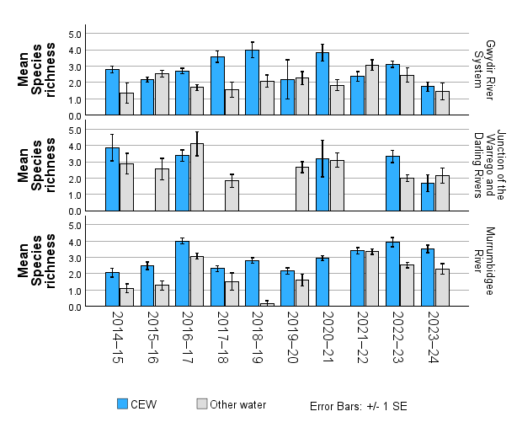
As expected, there is a significant positive relationship between the proportion of wetted area in the month of survey and corresponding species richness and number of individuals and across all 3 valleys. The water source – Commonwealth environmental water or other water – had negligible influence on this relationship at the site scale. However, Commonwealth environmental water was the primary source of inundation across most survey sites (Figure 5.5).
Figure 5.7 Relationship between species richness (expressed using Margelef Index) (top plot) and the number of individuals (bottom plot) at monitored sites on each survey against the proportion wetted area, by water source between 2014–15 and 2023–24
Other water includes deliveries that were not Commonwealth environmental water (CEW) or that were unregulated flows or from other sources.
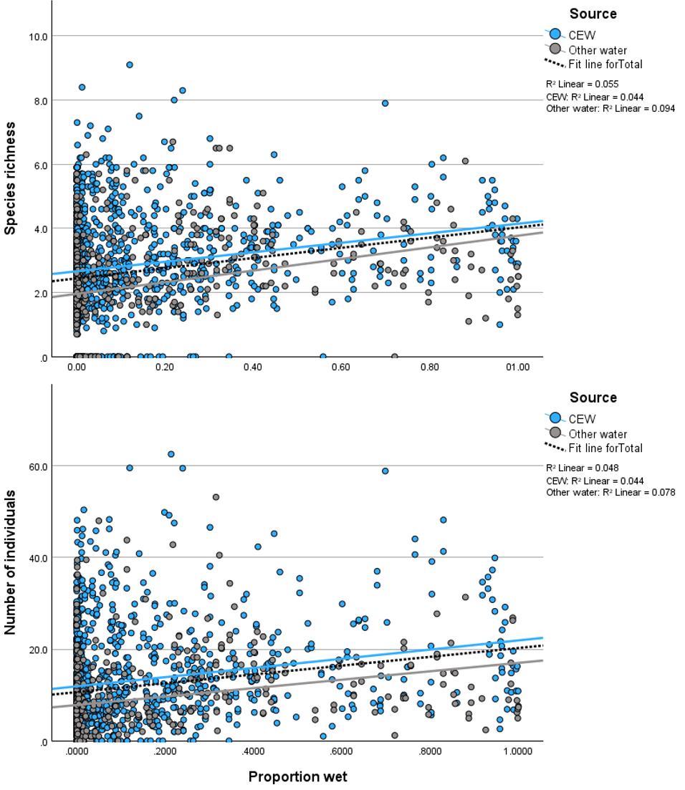

Contribution to listed threatened and migratory species
This chapter reports on the extent to which the delivery of CEW supported habitats of listed threatened and migratory species in the Basin. Due to the limited nature (temporal and spatial extent) of long-term quality monitoring data, machine-learning models were adopted to link areas that receive CEW to outcomes for water-dependent threatened species.
Key findings
We identified 89 threatened species with 1 or more records that coincided with delivery of Commonwealth environmental water.
Annual detections of threatened and migratory waterbird species have remained relatively stable over the 10 years of Flow-MER monitoring (39–48 species). However, there is a trend towards lower overall abundance since 2020–21.
Annual detections of threatened species (frogs, fishes, crustaceans, mammals and reptiles) have remained relatively stable (17–23 species). The number of individuals detected is highly variable between years, both in areas influenced by Commonwealth environmental water and in the managed floodplain. There is a downward trend in the number of records since 2020–21.
It is unclear if downward abundance trends (all species) since 2020–21 indicate a true decline, or if they reflect delays in sharing data to the Atlas of Living Australia.
Five Australian National Aquatic Ecosystem types contributed 50% of records for listed threatened and migratory waterbirds (Temporary tall emergent marsh: 18%, Temporary sedge/grass/forb marsh: 10%, Clay pan: 9%, Permanent lowland stream: 8% and Permanent lake: 6%).
Threatened fish species were associated with Permanent lowland stream (36% of records and 10 species) and Temporary lowland stream (19% and 9 species).
Threatened frogs were associated with River red gum forest riparian zone or floodplain (47% of records and 4 species) and Lignum shrubland riparian zone or floodplain (20% and 4 species).
Permanent lowland stream and Temporary lowland stream were also primary ecosystem types for platypus, southern myotis, Macquarie River and broad-shelled turtles.
Australian painted snipe is listed as Endangered under the Australian Environment Protection and Biodiversity Conservation Act 1999. They inhabit many different types of shallow, brackish or freshwater terrestrial wetlands
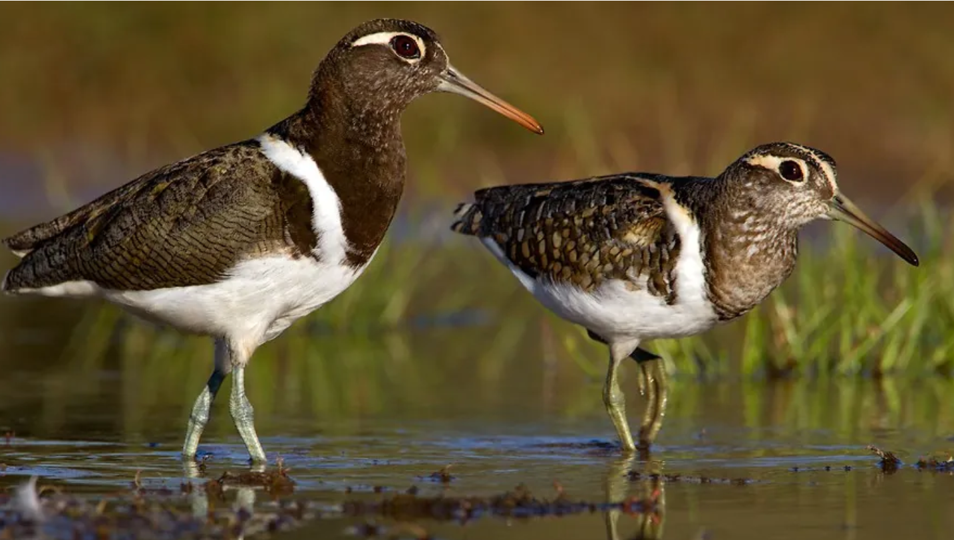
Photo credit: Chris Tzaros, Birdlife Australia
Although not currently considered in the Strategy (MDBA 2019), listed threatened and migratory species are considered in the Basin Plan section 8.05 – Protection and restoration of water-dependent ecosystems. Relevant objectives are detailed in Section 1.3.
We revised and updated our list of species to incorporate recent changes in Commonwealth and state species’ listings and included fish for the first time. Using ALA records from the past 10 years, we mapped the distribution of waterbirds, frogs, fish, crustaceans and water-dependent mammals, woodland birds and reptiles against the Basin’s managed floodplain. We identified 99 water-dependent species that are listed under relevant Commonwealth or state legislation or international treaties and that occur on the managed floodplain: 65 birds, 6 frogs, 11 fish, 6 crustaceans, 2 mammals and 9 reptiles (Appendix A). Of these, we identified 62 waterbirds and raptors, 5 frogs, 11 fish, one crustacean, 2 mammals, 2 water-associated woodland birds and 7 reptiles with at least one record coinciding with habitats influenced by CEW.

Watering actions for listed species

Water year 2023–24
In 2023–24, 14 individual watering actions had at least one watering objective related to listed species, for a combined volume of 74,473 ML of CEW (Table 1.2, Figure 6.1). The highest volumes of CEW with objectives related to listed species were delivered in the Murrumbidgee (49,675 ML), Edward/Kolety–Wakool (27,099 ML), Lachlan (22,059 ML). Smaller actions were undertaken in the Goulburn, Lower Murray and Namoi valleys. Most of the water was delivered with objectives for multiple taxonomic groups and included specific mention of a listed species. In the Murrumbidgee, water was delivered with specific objectives for multiple threatened species, including Australasian bittern, southern bell frog, southern myotis (Myotis macropus), southern pygmy perch (Nannoperca australis), Murray cod (Maccullochella peelii), trout cod (Maccullochella macquariensis), freshwater catfish (Tandanus tandanus) and silver perch (Bidyanus bidyanus). Commonwealth environmental water actions in the Lower Murray focused on migratory shorebirds, regent parrot (Polytelis anthopeplus), Murray hardyhead (Craterocephalus fluviatilis) and southern bell frog. Southern bell frogs and platypus (Ornithorhynchus anatinus) were the focus of watering actions in the Edward/Kolety–Wakool, platypus in the Goulburn and Namoi, and southern bell frogs in the Lachlan.

Water years 2014–24
Since 2014–15, 2,201 GL of CEW was delivered to benefit listed birds, frogs, mammals and reptiles, either alone or in combination with watering objectives. The volumes of CEW delivered with watering objectives related to listed species were highly variable across years (Figure 6.1). Two very large actions undertaken in the Lower Murray with objectives for migratory waterbirds in the Northern Lagoon of the Coorong and Lower Lakes occurred in 2016–17 and 2017–18. These comprised 618,476 ML with the objective to ‘Protect water quality in the Northern Lagoon for benthic invertebrates; a key food source for migratory birds’ and 681,127 ML delivered with the objective to ‘Protect habitat conditions to maintain benthic invertebrate food resources for annual migratory waders within the Coorong’. Since that time, most actions have been undertaken in the Murrumbidgee.
One positive trend is an increase in the number of valleys delivering CEW with specific objectives for listed species (Table 6.1 and Table 6.2). Between 2014 and 2017, only 3 valleys (Lower Murray, Murrumbidgee and Goulburn) delivered water with specific objectives for listed species. In 2023–24, 7 valleys delivered flows for listed species.
Figure 6.1 Total annual volumes of Commonwealth environmental water delivered with at least one watering objective related to listed species (water-dependent birds, frogs or mammals) outcomes, by valley, per water year 2014–24
CEW = Commonwealth environmental water.
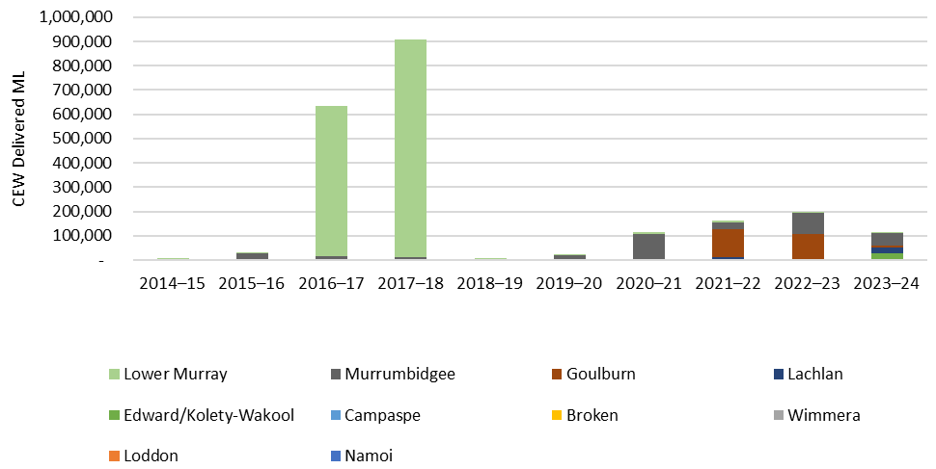
Table 6.1 Total annual volumes (ML) of Commonwealth environmental water delivered with at least one watering objective related to listed species (water-dependent birds, frogs, reptiles or mammals) outcomes, by valley, per water year 2014–24
Data in this table is presented graphically in Figure 6.1 and is presented here to assist with interpretation. Dash (–) indicates there were no deliveries of Commonwealth environmental water with an objective for listed species.
Valley | 2014–15 | 2015–16 | 2016–17 | 2017–18 | 2018–19 | 2019–20 | 2020–21 | 2021–22 | 2022–23 | 2023–24
Broken | – | – | – | – | – | – | – | 1,018 | 573 | 1,328
Campaspe | – | – | – | – | – | – | – | 3,442 | 355 | –
Edward/Kolety–Wakool | – | – | – | – | – | – | – | – | – | 27,099
Goulburn | 250 | – | – | – | – | – | – | 117,603 | 104,567 | 8,840
Lachlan | – | – | – | – | – | – | 994 | 6,000 | – | 22,059
Loddon | – | – | – | – | – | 941 | 417 | – | – | –
Lower Murray | 6,499 | 3,555 | 618,476 | 897,282 | 4,165 | 6,578 | 6,072 | 6,027 | 4 | 1,774
Murrumbidgee |  | 28,490 | 16,505 | 8,338 | 4,816 | 18,000 | 106,564 | 27,860 | 90,911 | 49,675
Namoi | – | – | – | – | – | – | 395 | – | – | 900
Wimmera | – | – | – | 2,734 | – | – | – | – | – | –
Total | 6,749 | 32,045 | 634,981 | 908,354 | 8,981 | 25,519 | 114,441 | 161,950 | 196,410 | 111,675
Since 2014–15, 4,284 GL of CEW was delivered with objectives for listed fish species (Figure 6.2), including EPBC Act-listed Murray hardyhead, Murray cod, silver perch, trout cod, olive perchlet (Ambassis agassizii) and freshwater catfish. The largest volumes of water (3,392,962 ML, 21 actions) were delivered in the Lower Murray with contributions from the Goulburn and Murrumbidgee to support the migration of 2 species of lamprey (Geotria australis and Mordacia mordax, both Endangered in the Action Plan for South Australian Fishes) and congolli (Pseudaphritis urvillii, Vulnerable in the Action Plan for South Australian Fishes). Watering actions targeting silver perch alone (40,790 ML), or with combined objectives with golden perch, Murray cod, trout cod or freshwater catfish (111,987 ML), are also relatively common across valleys. In the Murrumbidgee, 149,696 ML were delivered with objectives to ‘improve water quality (increase/prevent further decline in dissolved oxygen) to provide refuge for water-dependent species, including native fish and Murray crayfish’.
Figure 6.2 Total annual volumes of Commonwealth environmental water delivered with at least one watering objective related to listed fish outcomes, by valley and year 2014–24
CEW = Commonwealth environmental water.
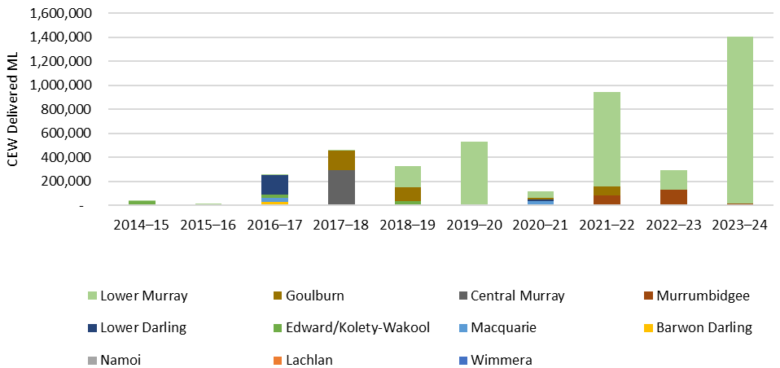
Table 6.2 Total annual volume (ML) of Commonwealth environmental water delivered with at least one watering objective related to listed fish outcomes, by valley and year 2014–24
Data in this table is presented graphically in Figure 6.2 and is presented here to assist with interpretation. Dash (–) indicates there were no deliveries of Commonwealth environmental water with an objective for listed species.
Valley | 2014–15 | 2015–16 | 2016–17 | 2017–18 | 2018–19 | 2019–20 | 2020–21 | 2021–22 | 2022–23 | 2023–24
Barwon Darling | 1,812 | – | 22,607 | – | – | – | – | – | – | –
Central Murray | – | 677 | – | 289,606 | – | 8,110 | – | 781 | 688 | 4,086
Edward/Kolety–Wakool | 34,563 | – | 27,581 | – | 33,308 | – | – | – | – | 2,577
Goulburn | – | – | – | 162,221 | 113,131 | – | 17,746 | 76,535 | – | –
Lachlan | – | 9,379 | – | – | 2,032 | – | – | – | – | 1,213
Lower Darling/Baaka | – | – | 71,249 | 2,738 | – | – | 11,187 | – | – | –
Lower Murray | 1,241 | 1,255 | 707 | 1,312 | 175,611 | 524,439 | 51,114 | 784,516 | 161,854 | 1,385,795
Macquarie | – | – | 30,231 | – | 150 | – | 37,488 | – | – | 3,833
Murrumbidgee | – | – | – | – | – | – | – | 82,616 | 127,931 | 4,646
Namoi | – | – | 9,109 | 4,100 | – | – | – | – | – | 900
Wimmera | 1,439 | – | – | – | 186 | – | – | – | – | –
Total | 39,055 | 11,310 | 161,483 | 459,977 | 324,418 | 532,549 | 117,535 | 944,448 | 290,473 | 1,403,049

Evaluation results

Listed species observations 2023–24
Currently available ALA records for 2023–24 showed 39 listed threatened or migratory waterbird species that had a distribution coinciding with ANAE polygons that were influenced by CEW in the same year (Table 6.3). Across the managed floodplain, CEW was associated with 7 EPBC Act-listed water-associated bird species: Australasian bittern, curlew sandpiper (Calidris ferruginea), sharp-tailed sandpiper, eastern curlew (Numenius madagascariensis), Latham's snipe, Australian painted snipe and common greenshank. There were 12 additional EPBC Act-listed species reported in 2023–24 (Table 6.4), including southern bell frog, grey snake (Hemiaspis damelii), Murray cray (Eustacus armatus) and superb parrot (a woodland bird species). Fish listed under the EPBC Act included Macquarie perch (Macquaria australasica), Murray cod, silver perch and trout cod.
Table 6.3 Summary of the number of listed threatened and migratory waterbird and raptor species (ordered by common name) in the Atlas of Living Australia dataset recorded within the managed floodplain, 2014–24
EPBC Act = Australian Environment Protection and Biodiversity Conservation Act 1999, Qld NC Act = Queensland Nature Conservation Act 1992 (Nature Conservation (Animals) Regulation 2020), NSW BC Act = New South Wales Biodiversity Conservation Act 2016, ACT NC Act = Australian Capital Territory Nature Conservation Act 2014, Vic FFG Act = Victorian Flora and Fauna Guarantee Act 1988, SA NPW Act= South Australian National Parks and Wildlife Act 1972. International Treaties are : B = Bonn Convention on the Conservation of Migratory Species of Wild Animals, C = China–Australia Migratory Bird Agreement (CAMBA), J = Japan–Australia Migratory Bird Agreement (JAMBA), RO = Republic of Korea–Australia Migratory Bird Agreement (ROKAMBA). CE = Critically Endangered, EN = Endangered, VU = Vulnerable, R = Rare. ‘CEW’ column includes the number of individual species records aligned with an area that received Commonwealth environmental water (CEW) in the same year; ‘Other’ indicates records that did not align with CEW inundation in the same year. Dash (–) in status columns indicates the species is not listed in that act/treaty. Dash (–) in ‘Other water’ and ‘CEW’ columns indicates no observations reported. Listing status of species reported from the managed floodplain based on the Atlas of Living Australia dataset 2023–24 [accessed Feb 2025]. *Subspecies for Bar-tailed godwit Limosa lapponica baueri VU (EPBC Act) and Limosa lapponica menzbieri EN (EPBC Act) have not been separated due to limited data for these subspecies.
Common name | Species | EPBC Act | Qld NC Act | NSW BC Act | ACT NC Act | Vic FFG Act | SA NPW Act | International treaties | Other | CEW
Australasian bittern | Botaurus poiciloptilus | EN | EN | EN | EN | CE | EN | – | 76 | 433
Banded stilt | Cladorhynchus leucocephalus | – | – | – | – | – | VU | – | 47 | 211
Brolga | Antigone rubicunda | – | – | – | – | VU | VU | – | 154 | 150
Common sandpiper | Actitis hypoleucos | – | – | – | – | Vu | R | B, RO, C, J | 1 | 79
Curlew sandpiper | Calidris ferruginea | CE | CE | EN | – | CE | EN | B, RO, C, J | 45 | 275
Eastern musk duck | Biziura lobata menziesi | – | – | – | – | VU | – | – | 35 | 31
Grey goshawk | Accipiter novaehollandiae | – | – | – | – | VU | EN | – | – | 5
Hardhead | Aythya australis | – | – | – | – | VU | – | – | 837 | 925
Magpie goose | Anseranas semipalmata | – | – | VU | – | VU | EN | – | 248 | 316
Pectoral sandpiper | Calidris melanotos | – | – | – | – | – | R | B, RO, J | 103 | 61
Red-necked stint | Calidris ruficollis | – | – | – | – | – | – | B, RO, C, J | 331 | 973
Sharp-tailed sandpiper | Calidris acuminata | VU | – | – | – | – | – | B, RO, C, J | 697 | 1,053
Spotted harrier | Circus assimilis | – | – | VU | – | – | – | – | 81 | 141
White-winged black tern | Chlidonias leucopterus | – | – | – | – | – | – | RO, C, J | – | 2
Little egret | Egretta garzetta nigripes | – | – | – | – | VU | – | – | – | 8
Asian gull-billed tern | Gelochelidon nilotica affinis | – | – | – | – | – | – | C | 21 | 18
Australian gull-billed tern | Gelochelidon macrotarsa | – | – | – | – | VU | – | – | 238 | 181
Australian pied oystercatcher | Haematopus longirostris | – | – | EN | – | – | R | – | 16 | 760
Black falcon | Falco subniger | – | – | VU | – | CE | R | – | 136 | 170
Black-breasted buzzard | Hamirostra melanosternon | – | – | VU | – | – | R | – | 20 | 9
Brolga | Grus rubicunda | – | – | VU | – | – | – | – | 14 | 27
Caspian tern | Hydroprogne caspia | – | – | – | – | VU | – | J | 2,301 | 2,678
Eastern curlew | Numenius madagascariensis | CE | EN | – | – | CE | EN | B, RO, C, J | 5 | 156
Latham's snipe | Gallinago hardwickii | VU | – | – | – | – | R | B, RO, J | 13 | 108
Little curlew | Numenius minutus | – | – | – | – | – | – | B, RO, C, J | – | 9
Minute bittern | Ixobrychus dubius | – | – | – | – | VU | EN | – | 59 | 458
Square-tailed kite | Lophoictinia isura | – | – | VU | – | VU | EN | – | 81 | 248
White-bellied sea-eagle | Haliaeetus leucogaster | – | – | VU | – | – | EN | – | 417 | 625
Australasian crested tern | Thalasseus bergii cristatus | – | – | – | – | – | – | – | 21 | 5
Australasian shoveler | Spatula rhynchotis | – | – | – | – | VU | R | – | 246 | 527
Australian fairy tern | Sternula nereis nereis | – | – | – | – | CE | – | – | – | 17
Australian painted snipe | Rostratula australis | EN | EN | EN | EN | CE | EN | – | – | 7
Blue-billed duck | Oxyura australis | – | – | VU | – | VU | R | – | 75 | 103
Common greenshank | Tringa nebularia | EN | – | – | – | VU | – | B, RO, C, J | 408 | 686
Freckled duck | Stictonetta naevosa | – | – | VU | – | VU | VU | – | 76 | 77
Indo-pacific little tern | Sternula albifrons sinensis | – | – | EN | – | CE | – | B, RO, C, J | – | 4
Marsh sandpiper | Tringa stagnatilis | – | – | – | – | VU | – | B, RO, C, J | 143 | 111
Pacific golden plover | Pluvialis fulva | – | – | – | – | VU | R | B, RO, C, J | – | 34
Wood sandpiper | Tringa glareola | – | – | – | – | VU | R | B, RO, C, J | 107 | 16
Table 6.4 Summary of the number of listed threatened water-dependent fish, crustaceans, mammals, woodland birds, reptiles and frogs (ordered by common name) in the Atlas of Living Australia dataset recorded within the managed floodplain, 2023–24
EPBC Act = Australian Environment Protection and Biodiversity Conservation Act 1999, Qld NC Act = Queensland Nature Conservation Act 1992 (Nature Conservation (Animals) Regulation 2020), NSW = New South Wales Biodiversity Conservation Act 2016, ACT NC Act = Australian Capital Territory Nature Conservation Act 2014, Vic FFG Act = Victorian Flora and Fauna Guarantee Act 1988, SA NPW Act = South Australian National Parks and Wildlife Act 1972. CE = Critically Endangered, EN = Endangered, VU = Vulnerable, R = Rare, TH = Threatened. Dash (–) in status columns indicates the species is not listed in that act. Dash (–) in ‘Other water’ and ‘CEW’ columns indicates no observations reported. The ‘CEW’ column includes the number of individual species records aligned with an area that received Commonwealth environmental water (CEW) in the same year. ‘Other water’ includes records did not align with CEW inundation in the same year. Listing status of species reported from the managed floodplain based on the Atlas of Living Australia dataset 2023–24, accessed February 2025.
Common name | Species | EPBC Act | Qld NC Act | NSW BC Act | ACT NC Act | Vic FFG Act | SA NPW Act | Other water | CEW | Total
Murray cray | Euastacus armatus | EN | – | – | VU | TH | – | 11 | 3 | 14
Freshwater catfish | Tandanus tandanus | – | – | – | – | VU | – | 9 | 16 | 25
Macquarie perch | Macquaria australasica | EN | – | – | EN | VU | – | 0 | 5 | 5
Murray cod | Maccullochella peelii | VU | – | – | – | VU | – | 12 | 24 | 36
Murray River rainbowfish | Melanotaenia fluviatilis | – | – | – | – | VU | – | 0 | 2 | 2
Silver perch | Bidyanus bidyanus | EN | – | – | EN | VU | – | 0 | 10 | 10
Trout cod | Maccullochella macquariensis | EN | – | – | EN | VU | – | 6 | 14 | 20
Booroolong frog | Litoria booroolongensis | EN | – | EN | – | – | – | 30 | 0 | 30
Giant banjo frog | Limnodynastes interioris | – | – | – | – | VU | – | 279 | 12 | 291
Knife-footed frog | Cyclorana cultripes | – | – | – | – | – | R | 20 | 2 | 22
Sloane's froglet | Crinia sloanei | EN | – | EN | – | VU | – | 7 | 0 | 7
Southern bell frog | Litoria raniformis | VU | – | EN | VU | VU | VU | 1,169 | 93 | 1,262
Wrinkled toadlet | Uperoleia rugosa | – | – | – | – | VU | R | 27 | 0 | 27
Yellow-spotted tree frog | Litoria castanea | CE | – | CE | CE | – | – | 2 | 0 | 2
Alpine water-skink | Eulamprus kosciuskoi | – | – | – | – | VU | – | 3 | 0 | 3
Broad-shelled turtle | Chelodina expansa | – | – | – | – | VU | VU | 28 | 72 | 100
De Vis' banded snake | Denisonia devisi | – | – | – | – | CE | – | 9 | 1 | 10
Grey snake | Hemiaspis damelii | EN | EN | EN | – | – | – | 0 | 5 | 5
Macquarie River turtle | Emydura macquarii | – | – | – | – | CE | VU | 43 | 329 | 372
Yellow-bellied water-skink | Eulamprus heatwolei | – | – | – | – | – | VU | 6 | 176 | 182
Superb parrot | Polytelis swainsonii | VU | – | VU | VU | – | – | 485 | 991 | 1,476
Regent parrot | Polytelis anthopeplus monarchoides | VU | – | VU | – | VU | VU | 10 | 0 | 10
Platypus | Ornithorhynchus anatinus | – | – | – | – | VU | EN | 2,322 | 326 | 2,648
Southern myotis | Myotis macropus | – | – | VU | – | – | EN | 29 | 3 | 32

Listed species outcomes 2014–24
Between 2014–15 and 2023–24, 59 listed threatened or migratory waterbird and raptor species were reported from habitats that received Commonwealth environmental water on at least one occasion over the 10-year period (Table 6.5). There were 26 listed water-dependent crustaceans, fish, frogs, reptiles and mammals reported from habitats that received Commonwealth environmental water on at least one occasion over the 10-year period (Table 6.6).
Overall, the numbers of listed threatened and migratory waterbird species have remained relatively stable, ranging from a low of 39 in 2023–24 to a high of 48 in 2017–18 (Table 6.5). However, there is a concerning trend towards fewer records of listed threatened and migratory species since the peak in 2020–21 (Figure 6.3). This pattern is repeated both in areas influenced by CEW and in all records across the managed floodplain. While there can be issues related to lags in data availability, which may result in the 2023–24 being incomplete, the decline in the number of records is cause for concern, particularly given the wetter-than-average conditions experienced between 2020 and 2023.
Like waterbirds, the overall numbers of listed threatened species have remained relatively stable over the past 10 years, ranging from a low of 17 in 2015–16 to a high of 23 in 2021–22 (Table 3.1 The number of records is highly variable over time, and there were peaks in in 2018–19 and 2020–21 (Figure 6.4). This pattern is repeated both in areas influenced by CEW and in all records across the managed floodplain. There is some indication of an overall decline in the number of records since 2020–21, although care should be taken when interpreting the low numbers from 2023–24, as lags in uploading data into ALA are expected.
Figure 6.3 Total number of listed threatened and migratory waterbird species records contained within the Atlas of Living Australia, drawn from the managed floodplain, that were influenced by Commonwealth environmental water in that year, including the total number of records from the managed floodplain, by water year 2014–24
CEW = Commonwealth environmental water.
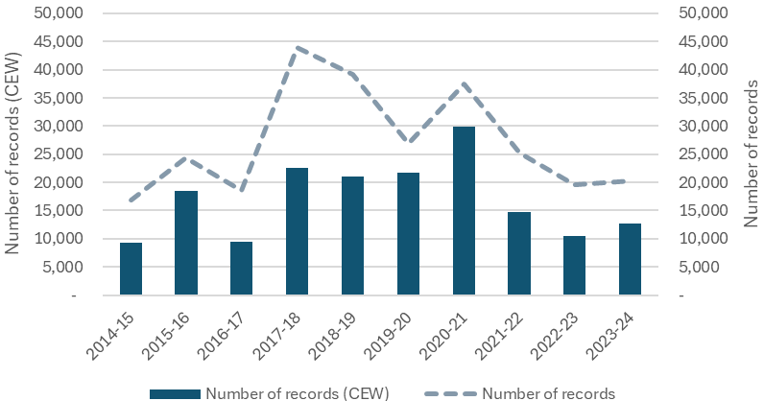
Figure 6.4 Total number of records of listed threatened crustaceans, fish, frogs, reptiles, and water-associated woodland birds and mammals contained within the Atlas of Living Australia, drawn from the managed floodplain, that were influenced by Commonwealth environmental water in that year, including the total number of records from the managed floodplain, by water year 2014–24
CEW = Commonwealth environmental water.
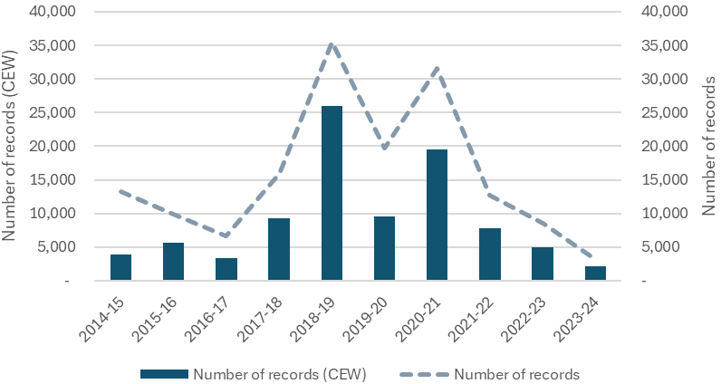
Table 6.5 Summary of the number of records for each listed threatened and migratory waterbird and raptor species (ordered by scientific name) that coincide with areas inundated by Commonwealth environmental water, by water year 2014–24
Data derived from the Atlas of Living Australia dataset recorded within the managed floodplain. Grey (fewest records) -yellow-blue (most records) colour spectrum used visualise changes in records over time
Common name | 2014–15 | 2015–16 | 2016–17 | 2017–18 | 2018–19 | 2019–20 | 2020–21 | 2021–22 | 2022–23 | 2023–24
Grey goshawk | 4 | 1 | 19 | 5 | – | 1 | 2 | – | 10 | 5
Common sandpiper | 44 | 160 | 58 | 117 | 54 | 194 | 185 | 118 | 34 | 79
Magpie goose | 70 | 140 | 649 | 78 | 236 | 43 | 664 | 447 | 608 | 316
Brolga | 120 | 137 | 253 | 251 | 476 | 55 | 235 | 134 | 90 | 177
Palaearctic ruddy turnstone | – | – | – | – | – | – | 9 | – | – | –
Hardhead | 1,094 | 2,872 | 1,887 | 2,464 | 1,764 | 1,663 | 2,755 | 1,448 | 1,304 | 925
Eastern musk duck | 45 | 123 | 41 | 44 | 2 | 14 | 27 | 23 | 23 | 31
Australasian bittern | 8 | 241 | 367 | 321 | 1,444 | 777 | 933 | 286 | 386 | 433
Sharp-tailed sandpiper | 678 | 1,286 | 261 | 1,923 | 2,242 | 2,687 | 3,053 | 1,322 | 381 | 1,053
Curlew sandpiper | 313 | 327 | 153 | 1,105 | 830 | 1,067 | 1,178 | 452 | 235 | 275
Pectoral sandpiper | 40 | 19 | 15 | 434 | 229 | 122 | 161 | 57 | 21 | 61
Ruff | – | – | 14 | 39 | 30 | 179 | 126 | – | – | –
Red-necked stint | 704 | 899 | 511 | 1,789 | 1,520 | 2,051 | 2,787 | 1,410 | 700 | 973
Long-toed stint | 15 | – | – | 32 | 128 | 71 | 312 | 26 | 7 | –
Great knot | 10 | 42 | 26 | 7 | – | 46 | – | 22 | – | –
New Zealand double-banded plover | – | – | 8 | 28 | 12 | – | – | – | – | –
Oriental plover | – | – | – | – | 3 | – | – | – | – | –
White-winged black tern | 36 | 33 | 29 | 183 | 9 | 26 | 599 | 21 | 20 | 2
Spotted harrier | 73 | 67 | 62 | 94 | 94 | 71 | 230 | 114 | 120 | 141
Banded stilt | 152 | 671 | 74 | 420 | 440 | 313 | 48 | 101 | 85 | 211
Little egret | 8 | 67 | 15 | 34 | 2 | 14 | 27 | – | – | 8
Black falcon | 85 | 91 | 65 | 249 | 174 | 27 | 185 | 60 | 119 | 170
Latham's snipe | 97 | 154 | 96 | 179 | 206 | 37 | 99 | 31 | 151 | 108
Australian gull-billed tern | 61 | 92 | 16 | 137 | 93 | 84 | 335 | 224 | 121 | 181
Asian gull-billed tern | – | – | – | – | – | – | 9 | – | 3 | 18
Gull -billed tern | – | – | – | 10 | – | – | – | 166 | 197 | –
Oriental pratincole | – | – | – | 225 | 12 | – | – | – | – | –
Southern sooty oystercatcher | 13 | 12 | 12 | 12 | – | 12 | 36 | – | – | –
Australian pied oystercatcher | 767 | 665 | 776 | 778 | 746 | 567 | 1,017 | 1,289 | 863 | 760
White-bellied sea-eagle | 780 | 1,419 | 417 | 1,045 | 1,348 | 775 | 1,141 | 584 | 863 | 625
Black-breasted buzzard | 5 | 2 | – | 4 | 30 | 10 | 8 | 18 | 3 | 9
Caspian tern | 2,071 | 3,694 | 1,726 | 4,064 | 3,177 | 4,221 | 5,012 | 3,019 | 2,050 | 2,678
Minute bittern | 20 | 191 | 145 | 201 | 605 | 397 | 626 | 63 | 58 | 458
Alaskan bar-tailed godwit | – | 12 | – | 19 | – | – | – | – | – | –
Eastern black-tailed godwit | – | – | – | 18 | – | – | – | – | 4 | –
Square-tailed kite | 16 | 30 | 10 | 139 | 55 | 128 | 73 | 91 | 92 | 248
Eastern curlew | 31 | 15 | 27 | 69 | 165 | 59 | 50 | 79 | 29 | 156
Little curlew | – | – | – | – | – | – | – | 7 | 19 | 9
Blue-billed duck | 85 | 204 | 202 | 366 |  | 138 | 496 | 409 | 169 | 103
  116
Eastern osprey | 6 | 4 | – | – | 3 | – | – | 1 | – | –
Inland dotterel | 16 | 14 | 3 | 5 | 1 | – | 4 | 84 | – | –
Red-necked phalarope | 5 | 25 | – | – | – | – | – | – | – | –
Pacific golden plover | 15 | 23 | 6 | 256 | 245 | 80 | 398 | 20 | 14 | 34
Princess parrot | – | – | – | 3 | – | – | 2 | 3 | – | –
Superb parrot | 110 | 348 | 294 | 671 | 536 | 815 | 1,086 | 519 | 612 | 991
Australian painted snipe | – | 16 | 8 | 50 | – | – | 14 | 8 | 50 | 7
Australasian shoveler | 492 | 2,279 | 655 | 2,337 | 1,406 | 2,289 | 2,249 | 685 | 551 | 527
Siberian common tern | – | – | – | – | – | – | – | – | 3 | –
Arctic tern | – | 4 | – | – | – | – | – | – | – | –
Indo-Pacific little tern | – | 12 | – | – | – | – | – | – | 9 | 4
Australian fairy tern | – | 28 | 29 | 26 | 23 | 36 | 45 | 43 | 33 | 17
Freckled duck | 142 | 800 | 136 | 610 | 320 | 196 | 138 | 94 | 67 | 77
Australasian crested tern | 79 | 72 | 26 | 124 | 39 | 31 | 36 | 13 | – | 5
Grey-tailed tattler | – | – | – | 61 | – | – | – | 24 | – | –
Wood sandpiper | 115 | 44 | 4 | 87 | 486 | 920 | 582 | 64 | 15 | 16
Common greenshank | 698 | 870 | 389 | 1,014 | 1,094 | 934 | 1,771 | 1,045 | 348 | 686
Marsh sandpiper | 126 | 251 | 36 | 405 | 558 | 533 | 1,177 | 140 | 55 | 111
Common redshank | – | – | – | – | 5 | – | – | – | – | –
Terek sandpiper | 21 | 4 | – | – | 13 | 37 | – | 14 | – | –
Total species | 41 | 45 | 40 | 48 | 43 | 40 | 43 | 43 | 41 | 39
Table 6.6 Summary of the number of records for each listed threatened fish, crustaceans, frogs, reptiles, mammals and water-associated woodland birds (ordered by scientific name) that coincide with areas inundated by Commonwealth environmental water, by year 2014–24
Data derived from the Atlas of Living Australia dataset recorded within the managed floodplain. Grey (fewest records) -yellow-blue (most records) colour spectrum used visualise changes in records over time
Common name | 2014–15 | 2015–16 | 2016–17 | 2017–18 | 2018–19 | 2019–20 | 2020–21 | 2021–22 | 2022–23 | 2023–24
Murray cray | 34 | – | 13 | 3 | 11 | 1 | – | 32 | 6 | 3
Freshwater catfish | 150 | 20 | 98 | 106 | 71 | 48 | 62 | 36 | 19 | 16
Macquarie perch | – | 3 | 40 | 33 | 29 | 29 | – | – | 22 | 5
Murray cod | 356 | 222 | 376 | 510 | 700 | 1,021 | 840 | 561 | 1,017 | 24
Murray hardyhead | 18 | 300 | 4 | 7 | 3 | – | 288 | 22 | – | –
Murray River rainbowfish | 1,223 | 886 | 620 | 1,728 | 847 | 840 | 742 | 227 | 1,042 | 2
Silver perch | 26 | 38 | 169 | 84 | 174 | 144 | 34 | 149 | 235 | 10
Southern purple spotted gudgeon | 68 | 28 | – | – | – | – | – | 3 | 3 | –
Trout cod | 98 | 69 | 115 | 81 | 56 | 50 | 17 | 51 | 93 | 14
Two spine blackfish | 120 | – | 12 | 10 | 3 | 19 | – | – | – | –
Western carp gudgeon | 566 | 1,243 | 908 | 1,207 | 1,328 | 28 | 4 | 279 | 111 | –
Giant banjo frog | 206 | 48 | 107 | 127 | 9,636 | 34 | 4,176 | 468 | 203 | 12
Knife-footed frog | – | – | – | 4 | – | 10 | 15 | 48 | 28 | 2
Sloane's froglet | – | – | – | – | – | 21 | – | 7 | 32 | –
Southern bell frog | 7 | 657 | 220 | 4,129 | 11,132 | 5,687 | 10,887 | 4,024 | 924 | 93
Wrinkled toadlet | – | – | 5 | 4 | – | – | 7 | 83 | 72 | –
Broad-shelled turtle | 324 | 209 | 67 | 161 | 223 | 127 | 519 | 277 | 85 | 72
De Vis' banded snake | 1 | 3 | 8 | – | 13 | 17 | 11 | 54 | 1 | 1
Grey snake | 1 | – | – | – | 750 | 167 | – | – | 3 | 5
Macquarie River turtle | 583 | 1,513 | 176 | 237 | 235 | 138 | 501 | 581 | 65 | 329
Yellow-bellied water-skink | 4 | – | 2 | 12 | 54 | 83 | 39 | 14 | 15 | 176
Regent parrot | 10 | 18 | 43 | 511 | 95 | 153 | 27 | 9 | 7 | –
Superb parrot | 110 | 348 | 294 | 671 | 536 | 815 | 1,086 | 519 | 612 | 991
Platypus | 41 | 55 | 61 | 92 | 137 | 205 | 251 | 256 | 367 | 326
Southern myotis | 11 | – | – | 21 | – | – | 2 | 2 | – | 3
Number of species | 22 | 18 | 21 | 22 | 21 | 22 | 20 | 23 | 23 | 19

Habitats for listed threatened and migratory species
All 57 ANAE types that contained at least one record of a listed threatened or migratory waterbird species within the managed floodplain were influenced by Commonwealth environmental water on at least one occasion over the past 10 years. Of the 46 ANAE types that contain at least one record of a listed threatened frog, fish, crustacean or water-dependent mammal, bird or reptile, 41 were influenced by Commonwealth environmental water on at least one occasion over the past 10 years.
Mapping species distributions against ANAE types also provides some insights into the types of habitats utilised by listed species that are currently influenced by CEW. Records of listed threatened and migratory species were variable across the Basin. The numbers of species reported reflected areas with more intensive monitoring, including the Coorong, Lower Lakes and Murray Mouth (Lower Murray), The Living Murray Icon sites in the Central Murray, and Flow-MER and Ramsar sites in the Murrumbidgee. These 3 valleys contain the highest diversity of listed species and the highest percentages of records: Lower Murray (71% of records for listed waterbirds, 52 species), Murrumbidgee (9% of listed waterbirds, 28 species), Central Murray (8% of listed waterbirds, 25 species) (Table 6.7).
We mapped the distribution of listed threatened and migratory species within the managed floodplain against ANAE types (see Brooks 2021). Of the 62 ANAE types that contained at least one record of a listed threatened or migratory waterbird species over the past 10 years, 57 were influenced by CEW on at least one occasion. Overall five key ANAE types contributed 50% of records for listed threatened and migratory waterbirds (Temporary tall emergent marsh (18%), Temporary sedge/grass/forb marsh (10%), Clay pan (9%), Permanent lowland stream (8%) and Permanent lake (6%) (Table 6.10). Temporary tall emergent marsh also supported the highest number of listed and migratory waterbirds species (49), followed by Clay Pans (47), Permanent Lake (47) and Freshwater meadow (45 species).
The majority of records for other listed species (crustaceans, fish, frogs, water-dependent woodland birds, mammals and reptiles) occurred in the Murrumbidgee (57% of records, 16 species), the Lower Murray (19% of records, 167species) and Central Murray (11% of records, 21 species) (Table 6.8). The ‘Other vertebrate’ group represents a wide range of life histories. As expected, records for fish species are associated with Permanent lowland stream (36%, 10 species), and Temporary lowland stream (19%, 9 species). Floodplain habitats feature highly for frogs with River red gum forest riparian zone or floodplain (47%, 4 species) and Lignum shrubland riparian zone or floodplain (20%, 4 species) (Table 6.9). Sloane’s froglet occupies rainfed wetlands and small connected wetlands adjacent to the Murray River, 70% of the records associated with CEW occur within Permanent lowland streams. Permanent lowland stream and Temporary lowland stream are also primary habitat types for platypus, southern myotis, Macquarie River turtle and broad-shelled turtle.

Table 6.7 Percent of records of listed threatened and migratory waterbirds that aligned with Commonwealth environmental water by valley, 2014–24
Only taxa with records aligning with Commonwealth environmental water are included. Values are relative to the total number of records for each species. The continuous colour scale represents percentiles from blue (100th), through yellow (50th) to grey (1st). Dash (–) indicates surveys have not detected this species in this valley.
Common name | Lower Murray | Murrumbidgee | Central Murray | Macquarie | Gwydir | Lachlan | Broken | Condamine Balonne | Goulburn | Edward/Kolety–Wakool | Border Rivers | Barwon Darling | Namoi | Loddon | Ovens | Warrego | Campaspe | Lower Darling/Baaka | Wimmera | Paroo
Grey goshawk | – | 2.1 | 8.5 | 12.8 | 6.4 | 8.5 | 29.8 | – | – | 4.3 | 25.5 | – | 2.1 | – | – | – | – | – | – | –
Common sandpiper | 99.1 | – | – | – | – | 0.6 | – | 0.2 | 0.1 | – | – | – | – | – | – | – | – | – | – | –
Magpie goose | 0.2 | 15 | 5.6 | 38.9 | 24.9 | 4.3 | 1.9 | 0.2 | 0.9 | 0.4 | 1.1 | 0.3 | 6.3 | – | – | – | – | – | – | –
Brolga | – | 13 | 1.2 | 39.3 | 27.2 | 1.6 | 0.7 | 1.2 | 3.2 | 0.1 | – | 2.7 | – | 0.4 | – | 9.3 | – | – | – | 0.2
Palaearctic ruddy turnstone | 100 | – | – | – | – | – | – | – | – | – | – | – | – | – | – | – | – | – | – | –
Hardhead | 41.5 | 18.6 | 8.4 | 15.5 | 3.7 | 4.5 | 0.7 | 2.1 | 2.6 | 0.1 | 0.3 | 0.5 | 0.3 | 0.5 | 0.5 | 0.1 | – | 0.1 | – | –
Eastern musk duck | 100 | – | – | – | – | – | – | – | – | – | – | – | – | – | – | – | – | – | – | –
Australasian bittern | 13.4 | 37.5 | 35.3 | 10.7 | 0.7 | 1.3 | – | 0.1 | – | 0.7 | – | 0.2 | – | – | – | – | – | – | – | –
Sharp-tailed sandpiper | 92.1 | 2.3 | 0.1 | 2.4 | 1.7 | 0.4 | – | 0.7 | 0.1 | – | – | – | – | – | – | – | – | – | – | –
Curlew sandpiper | 99.6 | – | 0.1 | – | – | – | 0.1 | – | 0.1 | – | – | – | – | – | – | – | – | – | – | –
Pectoral sandpiper | 98.2 | 0.5 | – | – | 0.9 | 0.1 | – | – | – | – | 0.3 | – | – | – | – | – | – | – | – | –
Ruff | 100 | – | – | – | – | – | – | – | – | – | – | – | – | – | – | – | – | – | – | –
Red-necked stint | 99.2 | 0.4 | 0.1 | – | 0.1 | – | – | 0.2 | – | – | – | – | – | – | – | – | – | – | – | –
Long-toed stint | 99.3 | 0.7 | – | – | – | – | – | – | – | – | – | – | – | – | – | – | – | – | – | –
Great knot | 100 | – | – | – | – | – | – | – | – | – | – | – | – | – | – | – | – | – | – | –
New Zealand double-banded plover | 100 | – | – | – | – | – | – | – | – | – | – | – | – | – | – | – | – | – | – | –
Oriental plover | 100 | – | – | – | – | – | – | – | – | – | – | – | – | – | – | – | – | – | – | –
White-winged black tern | 98.2 | 0.8 | – | – | – | – | – | 0.9 | – | – | – | – | – | – | – | – | – | – | – | –
Spotted harrier | 37.2 | 1 | 3.9 | 17 | 7.7 | 3.4 | 1.4 | 0.9 | – | 0.6 | 5.4 | 5.3 | 1.7 | 1.3 | 0.8 | 1.1 | 0.8 | 1 | 0.3 | –
Banded stilt | 98.4 | – | 1.1 | 0.1 | – | 0.4 | – | – | – | – | – | – | – | – | – | – | – | – | 0.1 | –
Little egret | 100 | – | – | – | – | – | – | – | – | – | – | – | – | – | – | – | – | – | – | –
Black falcon | 31.9 | 13 | 12.2 | 17.8 | 6.9 | 1.2 | 0.6 | 0.7 | 0.3 | 0.4 | 4.3 | 2.8 | 3.8 | 2.1 | 0.1 | 0.2 | 0.4 | 0.1 | 1.2 | –
Latham's snipe | 23.7 | 3.3 | 6.3 | 14.3 | 4 | 0.5 | 2.4 | 0.2 | 2.5 | – | 0.5 | 0.2 | 3.7 | 0.9 | 1.2 | 0.1 | – | – | 0.3 | –
Australian gull-billed tern | 84.7 | 8 | 0.6 | 1.3 | 3.7 | 0.1 | – | 0.8 | – | – | – | 0.5 | – | – | – | – | – | 0.2 | – | –
Asian gull-billed tern | 100- | – | – | – | – | – | – | – | – | – | – | – | – | – | – | – | – | – | – | –
Gull-billed tern | 2.7 | 23.1 | – | – | – | 1.3 | – | 72.9 | – | – | – | – | – | – | – | – | – | – | – | –
Oriental pratincole | 100 | – | – | – | – | – | – | – | – | – | – | – | – | – | – | – | – | – | – | –
Southern sooty oystercatcher | 100 | – | – | – | – | – | – | – | – | – | – | – | – | – | – | – | – | – | – | –
Australian pied oystercatcher | 100 | – | – | – | – | – | – | – | – | – | – | – | – | – | – | – | – | – | – | –
White-bellied sea-eagle | 0.8 | 38.5 | 31.1 | 8.0 | 8.2 | 3.1 | 0.3 | 1.6 | 0.9 | 1.4 | 2.6 | 0.9 | 0.2 | 1.1 | 0.8 | - | 0.2 | – | – | –
Black-breasted buzzard | 22.5 | – | – | – | – | – | – | – | – | – | 9.0 | 33.7 | – | – | – | 30.3 | 4.5 | – | – | –
Caspian tern | 93.6 | 1.9 | 3.5 | 0.1 | 0.1 | 0.1 | – | 0.5 | 0.1 | – | – | 0.1 | – | – | – | – | – | – | – | –
Minute bittern | 8.5 | 26.0 | 55.5 | 4.5 | 4.9 | 0.6 | – | – | – | – | – | 0.1 | – | – | – | – | – | – | – | –
Alaskan bar-tailed godwit | 100 | – | – | – | – | – | – | – | – | – | – | – | – | – | – | – | – | – | – | –
Eastern black-tailed godwit | 81.8 | – | – | – | – | – | – | – | – | – | 18.2 | – | – | – | – | – | – | – | – | –
Square-tailed kite | 0.1 | 5.7 | 55.2 | 4.4 | 2.0 | 0.9 | 2.6 | 1.7 | 3.6 | 18 | 2.3 | 0.1 | 0.6 | 0.2 | 0.8 | 0.1 | 1.6 | – | – | –
Eastern curlew | 100 | – | – | – | – | – | – | – | – | – | – | – | – | – | – | – | – | – | – | –
Little curlew | 22.9 | – | – | 2.9 | 42.9 | – | – | 2 | – | – | 11.4 | – | – | – | – | – | – | – | – | –
Blue-billed duck | 27.2 | 29.1 | 13.2 | 10.4 | 0.3 | 11.2 | 0.1 | 2.1 | 4.6 | 0.2 | – | 0.4 | 0.9 | – | – | – | – | 0.1 | – | –
Eastern osprey | – | – | 78.6 | 21.4 | – | – | – | – | – | – | – | – | – | – | – | – | – | – | – | –
Inland dotterel | 88.2 | 7.1 | – | – | – | – | – | – | – | 2.4 | – | 2.4 | – | – | – | – | – | – | – | –
Red-necked phalarope | 100 | – | – | – | – | – | – | – | – | – | – | – | – | – | – | – | – | – | – | –
Pacific golden plover | 98.4 | 0.4 | – | – | 0.9 | – | – | – | – | – | 0.4 | – | – | – | – | – | – | – | – | –
Australian painted snipe | – | 7.2 | – | 43.1 | 45.8 | – | – | – | – | – | 2.6 | – | – | 1.3 | – | – | – | – | – | –
Australasian shoveler | 66.5 | 13.4 | 4.1 | 7.1 | 0.7 | 3.1 | 0.7 | 1.2 | 1.9 | 0.1 | 0.2 | 0.3 | 0.1 | 0.1 | 0.4 | – | – | 0.1 | – | –
Siberian common tern | 100 | – | – | – | – | – | – | – | – | – | – | – | – | – | – | – | – | – | – | –
Arctic tern | 100 | – | – | – | – | – | – | – | – | – | – | – | – | – | – | – | – | – | – | –
Indo-pacific little tern | 100 | – | – | – | – | – | – | – | – | – | – | – | – | – | – | – | – | – | – | –
Australian fairy tern | 100 | – | – | – | – | – | – | – | – | – | – | – | – | – | – | – | – | – | – | –
Freckled duck | 72.2 | 9.3 | 4.1 | 3.6 | 1.4 | 5.8 | – | 1.6 | 0.3 | – | – | 0.2 | – | 0.9 | 0.2 | – | 0.3 | – | – | –
Australasian crested tern | 100 | – | – | – | – | – | – | – | – | – | – | – | – | – | – | – | – | – | – | –
Grey-tailed tattler | 100 | – | – | – | – | – | – | – | – | – | – | – | – | – | – | – | – | – | – | –
Wood sandpiper | 93.7 | 3.9 | 0.2 | 1.1 | 0.8 | 0.2 | – | – | – | – | – | 0.1 | – | – | – | – | – | – | – | –
Common greenshank | 99.3 | 0.2 | 0.1 | 0.1 | 0.2 | – | – | – | – | – | – | 0.1 | – | – | – | – | – | – | – | –
Marsh sandpiper | 89.1 | 3.8 | 0.1 | 0.4 | 5.7 | 0.5 | – | – | 0.3 | – | 0.1 | – | – | – | – | – | – | – | – | –
Common redshank | 100 | – | – | – | – | – | – | – | – | – | – | – | – | – | – | – | – | – | – | –
Terek sandpiper | 100 | – | – | – | – | – | – | – | – | – | – | – | – | – | – | – | – | – | – | –
Percent of all records | 71 | 9 | 7 | 5 | 3 | 2 | 1 | 1 | 1 | 1 | < 1 | < 1 | < 1 | < 1 | < 1 | < 1 | < 1 | < 1 | < 1 | < 1
Number of species | 52 | 28 | 25 | 25 | 26 | 24 | 13 | 21 | 16 | 13 | 16 | 19 | 10 | 10 | 8 | 7 | 6 | 6 | 4 | 1

Table 6.8 Percent of records of listed threatened fish, mammals, crustaceans, frogs and reptiles that aligned with Commonwealth environmental water by valley, 2014–24
Only taxa with records aligning with Commonwealth environmental water are included. Values are relative to the total number of records for each species. The continuous colour scale represents percentiles from blue (100th), through yellow (50th) to grey (1st). Dash (–) indicates surveys have not detected this species in this valley.
Common name | Murrumbidgee | Lower Murray | Central Murray | Broken | Ovens | Goulburn | Loddon | Edward/Kolety–Wakool | Lachlan | Campaspe | Barwon Darling | Border Rivers | Macquarie | Condamine Balonne | Wimmera | Warrego | Gwydir | Namoi | Lower Darling/Baaka | Paroo
Murray cray | 1.9 | – | 3.9 | – | 55.3 | 38.8 | – | – | – | – | – | – | – | – | – | – | – | – | – | –
Freshwater catfish | – | 66.6 | 21.7 | – | – | – | – | – | – | – | – | 3.2 | 1.6 | – | 6.1 | – | 0.6 | – | 0.2 | –
Macquarie perch | – | – | – | 13.7 | 86.3 | – | – | – | – | – | – | – | – | – | – | – | – | – | – | –
Murray cod | 0.6 | 42.8 | 16 | 9.2 | 15.6 | 8 | 2.8 | 1 | 0.1 | 2.6 | 0.1 | 0.2 | 0.2 | 0.2 | – | – | 0.4 | 0.1 | 0.1 | –
Murray hardyhead | – | 68.2 | 31.8 | – | – | – | – | – | – | – | – | – | – | – | – | – | – | – | – | –
Murray River rainbowfish | 0.5 | 66.8 | 15.3 | 0.6 | – | 1.1 | 9.8 | 0.1 | – | 3.7 | 0.5 | 0.7 | 0.2 | 0.4 | – | – | – | – | 0.2 | –
Silver perch | 1.9 | 51.3 | 21.6 | – | – | 5.5 | 5.6 | 1.1 | 0.4 | 0.6 | – | 0.8 | – | – | 11.2 | – | – | – | 0.1 | –
Southern purple-spotted gudgeon | – | 2 | – | – | – | – | – | – | – | 5.9 | – | 64.7 | – | – | – | – | 27.5 | – | – | –
Trout cod | 0.2 | – | 8.1 | – | 62.1 | 29.7 | – | – | – | – | – | – | – | – | – | – | – | – | – | –
Two-spine blackfish | – | – | – | – | 10 | – | – | – | – | – | – | – | – | – | – | – | – | – | – | –
Western carp gudgeon | 6.3 | 52.6 | 35.2 | – | – | – | 4.2 | – | 0.1 | – | 0.3 | 0.7 | 0.1 | 0.5 | – | – | 0.1 | – | – | –
Giant banjo frog | 99.4 | 0.1 | – | – | – | – | – | 0.2 | 0.3 | – | – | – | 0.1 | – | – | – | – | – | – | –
Knife-footed frog | – | – | – | – | – | – | – | – | – | – | 13.1 | 0.9 | 5.6 | 18.7 | – | 21.5 | 38.3 | – | – | 1.9
Sloane's froglet | – | – | 93.3 | – | 6.7 | – | – | – | – | – | – | – | – | – | – | – | – | – | – | –
Southern bell frog | 87.8 | 11 | 0.1 | – | – | – | – | 1 | 0.1 | – | – | – | – | – | – | – | – | – | – | –
Wrinkled toadlet | 15.2 | – | 1.2 | – | – | – | – | 19.3 | 7.6 | – | – | 4.1 | 12.3 | 4.1 | – | 15.2 | – | 21.1 | – | –
Broad-shelled turtle | 30.9 | 6 | 44.6 | – | 0.1 | 2.3 | – | 3.1 | 0.6 | – | 3.1 | 0.4 | 0.4 | 5.8 | – | 1.5 | 0.7 | 0.4 | – | –
De Vis' banded snake | – | 65.1 | 9.2 | – | – | – | – | – | – | – | 22 | – | – | – | – | 3.7 | – | – | – | –
Grey snake | 99.1 | – | – | – | – | – | – | – | – | – | – | 0.5 | 0.3 | – | – | – | – | – | – | –
Macquarie River turtle | 18.1 | 16.1 | 37.1 | 0.7 | 2.1 | 10.6 | 3.7 | 2.5 | 3.3 | 0.5 | 2 | 0.1 | 0.7 | – | – | 1.8 | 0.1 | 0.8 | – | –
Yellow-bellied water-skink | – | 4.3 | 74.2 | – | 14.5 | 7.0 | – | – | – | – | – | – | – | – | – | – | – | – | – | –
Superb parrot | 30.3 | – | 29.4 | 18.9 | – | – | – | 9.9 | 9.8 | – | 0.2 | – | 1.2 | – | – | – | 0.2 | – | – | –
Regent parrot | 0.8 | 9.7 | 89.1 | – | – | – | – | 0.1 | – | – | – | – | – | – | – | – | – | – | 0.2 | –
Platypus | 7.5 | 0.2 | 16 | 12.5 | 9.2 | 22.9 | 15.8 | 0.2 | 0.7 | 7.3 | – | 1.7 | 3.5 | 0.3 | 0.7 | – | 0.9 | 0.6 | – | –
Southern myotis | 17.9 | 53.8 | 28.2 | – | – | – | – | – | – | – | – | – | – | – | – | – | – | – | – | –
Percent of all records | 56.9 | 19 | 11.4 | 2.2 | 2.1 | 1.9 | 1.8 | 1.4 | 0.9 | 0.7 | 0.3 | 0.3 | 0.3 | 0.2 | 0.2 | 0.2 | 0.2 | 0.1 | – | –
Number of species | 16 | 16 | 19 | 6 | 9 | 9 | 6 | 11 | 10 | 6 | 8 | 12 | 12 | 7 | 3 | 5 | 9 | 5 | 5 | 1
Table 6.9 Percent of records of listed threatened and migratory waterbirds that aligned with Commonwealth environmental water by Australian National Aquatic Ecosystem wetland type, 2014–24
Only taxa with records aligning with Commonwealth environmental water are included. Values are relative to the total number of records for each species. The continuous colour scale represents percentiles from blue (100th), through yellow (50th) to grey (1st). Dash (–) indicates no record. Other represents the combined totals for Australian National Aquatic Ecosystem polygons with fewer than 0.8% of records.
Common name | Pt2.1.2: Temporary tall emergent marsh | Pt2.2.2: Temporary sedge/grass/forb marsh | Pt3.1.2: Clay pan | Rp1.4: Permanent lowland stream | Lp1.1: Permanent lake | Etd1.2.1: Tide dominated saltmarsh | F1.2: River red gum forest riparian zone or floodplain | Pt2.3.2: Freshwater meadow | F4: Unspecified riparian zone or floodplain | F1.8: Black box woodland riparian zone or floodplain | Rt1.4: Temporary lowland stream | Etd1.3.3: Tide dominated estuary | Pp4.2: Permanent wetland | F1.4: River red gum woodland riparian zone or floodplain | F2.2: Lignum shrubland riparian zone or floodplain | Etd1.2.2: Tide dominated mudflats and sandbar | Ewd1.3.2: Coastal lagoon | F2.4: Shrubland riparian zone or floodplain | Ewd1.2.4: Intertidal mudflat or sand bar | F1.10: Coolibah woodland forest | Other
Grey goshawk | – | – | – | 42.6 | – | – | – | – | – | – | 25.5 | – | 4.3 | – | – | – | – | – | – | – | 27.7
Common sandpiper | 22.7 | 7.3 | 16.8 | 1.4 | 9.7 | 14.4 | 0.2 | 2 | 4.9 | 0.3 | 0.2 | 8.7 | 0.4 | 0.7 | 0.4 | 0.5 | 1.6 | 1.3 | 2.4 | – | 4.1
Magpie goose | 9.7 | 7.5 | 3.1 | 29 | 0.2 | 0.1 | 1.8 | 12 | – | 3.9 | 10.2 | – | 3.6 | 11.2 | 0.3 | – | – | 0.2 | – | 3.5 | 3.6
Brolga | 11.9 | 10.3 | 4.7 | 8.7 | 0.9 | – | 3.1 | 15.1 | – | 1.9 | 13.5 | – | 1.1 | 10.5 | 1.3 | – | – | 0.3 | – | 6.5 | 10.1
Palaearctic ruddy turnstone | – | – | 22.2 | – | – | 33.3 | – | 33.3 | – | – | – | 11.1 | – | – | – | – | – | – | – | – | –
Hardhead | 9.9 | 5.8 | 6.3 | 17.5 | 3.4 | 2.5 | 1 | 4.7 | 2.6 | 7.3 | 5.5 | 1.5 | 3.1 | 4.6 | 3.3 | 0.3 | 0.3 | 2.1 | 0.4 | 2.1 | 6.7
Eastern musk duck | 7.2 | – | 8 | 30.6 | 3.2 | 5.4 | 3.2 | 5.6 | 4.3 | 3.2 | 2.4 | 2.1 | 15.0 | 2.7 | 2.7 | 1.1 | 0.3 | 0.5 | – | – | 2.4
Australasian bittern | 11 | 9 | 0.5 | 6 | 3.6 | – | 39.7 | 3.1 | 0.3 | 2.6 | 2.9 | – | 3.6 | 2.5 | 2.8 | 0.1 | – | 1.6 | – | 0.8 | 9.6
Sharp-tailed sandpiper | 28.9 | 16.4 | 10.2 | 0.5 | 10.2 | 7.5 | 0.4 | 3.4 | 4.7 | 1 | 0.5 | 3.6 | 1.4 | 0.7 | 0.5 | 2.3 | 1.8 | 1.2 | 1.1 | 0.3 | 3.4
Curlew sandpiper | 34.1 | 16 | 9.3 | 0.1 | 12.6 | 8.7 | – | 2.7 | 4.9 | – | 0.2 | 4.0 | 0.6 | – | – | 1.1 | 1.4 | 1 | 0.8 | – | 2.5
Pectoral sandpiper | 54.1 | 13.9 | 2.7 | 0.2 | 20.9 | 2.2 | – | 0.4 | 1.9 | – | 0.3 | 1.2 | 0.1 | – | – | 0.4 | 0.2 | – | 0.5 | 0.4 | 0.7
Ruff | 31.7 | 43.3 | 1 | – | 10.6 | 2.1 | – | 0.3 | 8.2 | – | – | 1 | – | – | – | – | 0.3 | 0.3 | 0.5 | – | 0.8
Red-necked stint | 24.3 | 14.3 | 12.8 | 0.3 | 8.4 | 10.4 | 0.2 | 4.5 | 6.1 | 0.4 | 0.1 | 4.3 | 1.2 | 0.1 | 0.2 | 2.5 | 2.8 | 1 | 1.7 | – | 4.7
Long-toed stint | 42.5 | 36.9 | – | – | 15.9 | – | – | – | 4.1 | – | – | – | – | – | 0.5 | – | – | – | – | – | 0.2
Great knot | 12.4 | 16.3 | 17.6 | – | 3.9 | 19.6 | – | 10.5 | 8.5 | – | – | 5.2 | 1.3 | – | – | – | 2 | 0.7 | 1.3 | – | 0.7
New Zealand double-banded plover | 66.7 | – | – | – | 33.3 | – | – | – | – | – | – | – | – | – | – | – | – | – | – | – | –
Oriental plover | – | – | 66.7 | – | – | – | – | – | – | – | – | – | – | – | – | – | 33.3 | – | – | – | –
White-winged black tern | 40.9 | 36.3 | 1.3 | 0.3 | 15 | – | 0.3 | – | 3.2 | 0.4 | – | – | 0.6 | – | 0.2 | 0.5 | 0.2 | 0.2 | – | – | 0.4
Spotted harrier | 11.9 | 6.9 | 3.1 | 23.4 | 3.6 | 1.2 | 5.3 | 4.0 | 2.9 | 6.1 | 9.4 | 0.7 | 2.3 | 2.8 | 0.8 | 0.3 | 1.7 | 1.3 | 1.2 | 3 | 8
Banded stilt | 13 | 3.3 | 13.8 | 4.5 | 5.8 | 3.7 | 2.1 | 4.7 | 7.2 | 4.2 | 1 | 1.6 | 1.7 | 1.9 | 1.2 | 5.6 | 6.3 | 2.5 | 2.4 | – | 13.6
Little egret | 12 | – | 15.4 | 12 | 5.7 | 16.6 | 1.1 | 9.7 | 3.4 | 2.3 | 2.9 | 6.9 | 0.6 | 3.4 | – | 1.1 | 0.6 | 1.1 | – | – | 5.1
Black falcon | 15.8 | 8 | 2.8 | 20.2 | 5.9 | 0.8 | 6.4 | 7.3 | 0.9 | 5.2 | 8.2 | 0.2 | 2.7 | 6.3 | 0.4 | – | 0.2 | 0.3 | 0.2 | 2.3 | 6
Latham's snipe | 17.9 | 4.6 | 3.1 | 16.8 | 3.8 | – | 1.9 | 10.7 | 1.5 | 1.7 | 9.9 | – | 2.3 | 4 | 0.9 | – | 0.1 | – | – | 12.2 | 8.7
Australian gull-billed tern | 20.6 | 5.5 | 13.0 | 4.8 | 6.3 | 15.1 | 1 | 7.9 | 5.2 | 2.3 | 1.7 | 4.7 | 2.5 | 0.4 | 2 | 1 | 0.6 | 1.4 | 0.4 | 0.9 | 2.8
Asian gull-billed tern | 13.3 | – | 13.3 | 6.7 | 1 | 1 | – | 1 | 6.7 | – | 3.3 | 6.7 | 3.3 | – | – | 6.7 | 6.7 | – | – | – | 3.3
Gull-billed tern | 10.2 | 3.5 | 2.4 | – | 1.3 | 1.1 | 8.6 | 0.5 | 0.3 | 9.1 | – | 0.3 | 9.4 | – | 17.7 | – | – | 23.9 | – | – | 11.8
Oriental pratincole | 71.7 | – | – | – | 28.3 | – | – | – | – | – | – | – | – | – | – | – | – | – | – | – | –
Southern sooty oystercatcher | 8.2 | – | 19.6 | – | 1 | 32 | – | 24.7 | 4.1 | – | – | 9.3 | – | – | – | – | – | – | – | – | 1
Australian pied oystercatcher | 7.7 | 1 | 22.8 | 0.1 | 0.7 | 20.1 | – | 11.4 | 7.9 | – | – | 6.7 | 2.5 | – | 0.1 | 6.7 | 4.5 | 1.3 | 1.5 | – | 5
White-bellied sea-eagle | 3.8 | 7.2 | 0.4 | 18.5 | 0.9 | – | 29.6 | 3.6 | – | 4.2 | 8.7 | – | 2.7 | 2.7 | 2.5 | – | – | 0.8 | – | 1.0 | 13.5
Black-breasted buzzard | – | – | – | 30.3 | – | – | 4.5 | – | – | 4.5 | 33.7 | – | – | 6.7 | 6.7 | – | – | – | – | 4.5 | 9
Caspian tern | 19.7 | 9 | 11.2 | 9.5 | 7.6 | 7.8 | 1.9 | 4.6 | 5.5 | 3.8 | 1.4 | 3.2 | 2.2 | 2.5 | 1.4 | 1.4 | 1.3 | 1.2 | 0.6 | – | 4
Minute bittern | 3.9 | 9.4 | 0.8 | 8.2 | 1.3 | – | 38.3 | 2.3 | 1.9 | 4 | 4.5 | – | 5.6 | 1.3 | 1.7 | – | – | 1.7 | – | 0.9 | 14.2
Alaskan bar-tailed godwit | 3.2 | – | 19.4 | – | 3.2 | 38.7 | – | 19.4 | 6.5 | – | – | 9.7 | – | – | – | – | – | – | – | – | –
Eastern black-tailed godwit | 54.5 | – | – | 4.5 | 27.3 | – | – | – | – | – | 13.6 | – | – | – | – | – | – | – | – | – | –
Square-tailed kite | 0.6 | 0.7 | 0.1 | 36.7 | 0.5 | – | 24.3 | 0.3 | – | 2.6 | 21.8 | – | 2.4 | 1.9 | 0.5 | – | – | – | – | 2.6 | 5.1
Eastern curlew | 10.3 | 0.7 | 20.3 | – | 1.2 | 30.4 | – | 13.5 | 8.4 | – | – | 10.4 | 0.7 | – | – | – | 0.3 | 2.5 | 0.3 | – | 0.9
Little curlew | 17.1 | – | 2.9 | 5.7 | – | – | – | 17.1 | 5.7 | – | 8.6 | 2.9 | 2.9 | – | 2.9 | 5.7 | 2.9 | 8.6 | – | 17.1 | –
Blue-billed duck | 7.9 | 8.1 | 4.8 | 23.6 | 3.1 | 0.1 | 6.8 | 2 | 1.6 | 13.1 | 4.3 | 0.1 | 7.6 | 2.7 | 3.4 | 0.2 | 0.7 | 2.1 | 0.4 | 0.9 | 6.4
Eastern osprey | – | – | – | 85.7 | – | – | – | – | – | 7.1 | – | – | – | – | – | – | – | – | – | – | 7.1
Inland dotterel | – | 0.8 | 5.5 | 7.1 | – | – | – | 14.2 | – | 15.7 | 8.7 | – | 7.1 | 7.9 | 18.1 | – | – | 2.4 | – | – | 12.6
Red-necked phalarope | 3.3 | – | 16.7 | 13.3 | 6.7 | – | 1 | 13.3 | 13.3 | 1- | – | – | – | 3.3 | 3.3 | – | – | – | – | – | 6.7
Pacific golden plover | 36 | 19.5 | 6.8 | 0.1 | 12.6 | 9.4 | – | 4 | 4.1 | – | 0.3 | 3.9 | 0.4 | – | 0.1 | 0.2 | 0.3 | 1.3 | 0.2 | 0.5 | 0.4
Australian painted snipe | 5.2 | 15.7 | – | 5.2 | – | – | – | 24.2 | – | 7.2 | 10.5 | – | 1.3 | 7.8 | – | – | – | – | – | 19.0 | 3.9
Australasian shoveler | 14.6 | 9.1 | 8 | 13.1 | 5.9 | 3.8 | 6.1 | 4.2 | 5.2 | 7.5 | 3.8 | 1.7 | 2 | 2.9 | 2.5 | 0.2 | 0.7 | 1.5 | 1 | 0.4 | 5.5
Siberian common tern | – | – | – | – | – | – | – | – | – | – | – | – | – | – | – | – | 33.3 | – | 33.3 | – | 33.3
Arctic tern | 5 | – | 25 | – | 25 | – | – | – | – | – | – | – | – | – | – | – | – | – | – | – | –
Indo-pacific little tern | – | – | 24 | – | – | 32 | – | 24.0 | 4 | – | – | 8 | – | – | – | – | 8 | – | – | – | –
Australian fairy tern | 3.2 | – | 18.6 | 0.4 | 1.4 | 18.6 | – | 17.1 | 2.9 | – | – | 5.7 | 0.7 | – | – | – | 12.5 | 7.1 | 3.2 | – | 8.6
Freckled duck | 10.7 | 3.3 | 9.6 | 21.2 | 5.1 | 0.3 | 9.0 | 4.8 | 5.2 | 9.7 | 3.8 | 0.3 | 3.8 | 2.7 | 4.4 | 0.1 | 0.2 | 1.1 | – | 0.4 | 4.4
Australasian crested tern | 34.8 | 0.9 | 11.8 | 2.6 | 12 | 16.9 | – | 7.5 | 3.3 | – | 0.2 | 5.2 | 0.2 | – | 0.5 | 1.2 | 0.7 | 0.5 | 0.2 | – | 1.4
Grey-tailed tattler | 8.2 | – | 21.2 | 1.2 | 2.4 | 21.2 | – | 10.6 | 4.7 | – | – | 9.4 | 2.4 | – | – | 10.6 | 3.5 | 2.4 | – | – | 2.4
Wood sandpiper | 38.1 | 35 | 2.4 | 1 | 13.7 | 0.4 | – | 0.6 | 6.2 | 0.2 | 0.3 | 0.3 | 0.2 | 0.5 | 0.5 | – | – | – | 0.2 | 0.1 | 0.3
Common greenshank | 25.7 | 12.7 | 13.4 | 0.3 | 9 | 11.3 | 0.1 | 2.9 | 4.5 | 0.2 | 0.1 | 5.6 | 1.1 | 0.1 | 0.2 | 2.5 | 2.6 | 1.4 | 2.1 | – | 3.9
Marsh sandpiper | 36.1 | 27.2 | 5.1 | 0.6 | 13 | 3.4 | 0.2 | 2.3 | 3.9 | 0.5 | 1.5 | 1.8 | 0.3 | 0.2 | 0.1 | 0.1 | 0.3 | 0.4 | 0.3 | 0.9 | 1.7
Common redshank | 8 | – | – | – | 2 | – | – | – | – | – | – | – | – | – | – | – | – | – | – | – | –
Terek sandpiper | 14.6 | 3.4 | 20.2 | 1.1 | 3.4 | 19.1 | – | 5.6 | 9.0 | – | – | 9 | 2.2 | – | 1.1 | 2.2 | 1.1 | 1.1 | 2.2 | – | 4.5
Percent of all records | 18.5 | 10.4 | 9.0 | 8.5 | 6.5 | 6.3 | 6.2 | 4.7 | 4.2 | 3.4 | 2.8 | 2.7 | 2.2 | 2.2 | 1.4 | 1.4 | 1.3 | 1.3 | 0.8 | 0.8 | 5.4
Number of species | 49 | 36 | 47 | 42 | 47 | 36 | 27 | 45 | 41 | 32 | 35 | 37 | 41 | 29 | 35 | 26 | 35 | 36 | 25 | 25 | 47
Table 6.10 Percentage of occurrences of listed threatened fish, mammals, crustaceans, frogs and reptiles that aligned with Commonwealth environmental water by Australian National Aquatic Ecosystem wetland type, 2014–24
Only taxa with records aligning with Commonwealth environmental water are included. Values are relative to the total number of records for each species. The continuous colour scale represents percentiles from blue (100th), through yellow (50th) to grey (1st). Dash (–) indicates no record. Other represents the combined totals for Australian National Aquatic Ecosystem polygons with fewer than 0.5% of records.
Common name | F1.2: River red gum forest riparian zone or floodplain | Rp1.4: Permanent lowland stream | F2.2: Lignum shrubland riparian zone or floodplain | Rt1.4: Temporary lowland stream | F1.8: Black box woodland riparian zone or floodplain | Pt1.1.2: Temporary river red gum swamp | Pp4.2: Permanent wetland | Pt1.2.2: Temporary black box swamp | Pt2.2.2: Temporary sedge/grass/forb marsh | F1.4: River red gum woodland riparian zone or floodplain | F2.4: Shrubland riparian zone or floodplain | Pt1.8.2: Temporary shrub swamp | Lp1.1: Permanent lake | Pt3.1.2: Clay pan | Other
Murray cray | – | 74.8 | – | – | – | – | – | – | – | – | – | – | – | – | 25.2
Silver perch | 7.4 | 30.5 | 4.3 | 32.6 | 15.6 | 0.5 | 1.3 | 0.3 | – | 3.2 | – | 0.2 | – | – | 4
Murray hardyhead | – | 21.2 | 14.6 | – | 14.5 | – | 6.4 | – | – | 4.7 | – | – | 0.5 | 13.4 | 24.8
Two-spine blackfish | – | 45.1 | – | 7.3 | – | – | – | – | – | – | – | – | – | – | 47.6
Western carp gudgeon | 6.4 | 23 | 5.3 | 14.5 | 20.7 | 1.3 | 1.1 | 0.8 | – | 7.8 | 1.8 | 0.4 | 4 | 0.1 | 12.8
Trout cod | – | 73 | – | 22.4 | – | 0.3 | 0.2 | – | – | – | – | – | – | – | 4.2
Murray cod | 6.6 | 41.8 | 3.9 | 25.9 | 12.4 | 1.1 | 1 | 0.3 | – | 2.6 | – | – | 0.1 | 0.2 | 4
Macquarie perch | – | 59.6 | – | 24.8 | – | – | – | – | – | – | – | – | – | – | 15.5
Murray River rainbowfish | 6.9 | 41.8 | 4.3 | 17.8 | 11.4 | 0.4 | 7.3 | 0.2 | – | 4.1 | 0.1 | – | 1 | 1.1 | 3.4
Southern purple-spotted gudgeon | – | 32.4 | – | 2 | – | – | 1 | – | – | – | – | – | – | – | 64.7
Freshwater catfish | 4.8 | 38.7 | 8 | 15.3 | 13.9 | – | 3.4 | 0.8 | – | 5.8 | 0.5 | – | 0.3 | 0.3 | 8.3
Sloane's froglet | – | 70.0 | – | 8.3 | – | 1.7 | 15 | – | – | 3.3 | – | – | – | – | 1.7
Knife-footed frog | 4.7 | 18.7 | 2.8 | 21.5 | 0.9 | – | – | – | – | 2.8 | – | – | 0.9 | – | 47.7
Giant banjo frog | 67.5 | 3.6 | 17.3 | 1.4 | 1.4 | 4.1 | 0.3 | 2.6 | 1.1 | – | 0.3 | 0.1 | – | 0.1 | 0.3
Southern bell frog | 39.4 | 5.9 | 25.1 | 3.4 | 8.6 | 3.6 | 2 | 2.9 | 3.1 | 0.4 | 2 | 1.8 | 0.1 | 0.3 | 1.4
Wrinkled toadlet | 2.3 | 30.4 | 1.2 | 26.3 | 3.5 | 0.6 | 2.3 | 1.8 | 8.2 | 8.8 | 1.8 | – | 0.6 | – | 12.3
Broad-shelled turtle | 18.8 | 30.8 | 0.9 | 26.9 | 2 | 4.6 | 7.7 | – | 1 | 0.5 | – | – | 1.2 | 1.1 | 4.5
De Vis' banded snake | 18.3 | 22 | 8.3 | 8.3 | 17.4 | 3.7 | 1.8 | – | – | 10.1 | – | 0.9 | – | 0.9 | 8.3
Macquarie River turtle | 15.2 | 39.2 | 1.6 | 14.8 | 4.7 | 2.5 | 8.5 | 0.1 | 0.5 | 1.9 | 0.1 | – | 1.7 | 1.4 | 7.9
Yellow-bellied water-skink | 27.6 | 22.6 | – | 16.8 | 0.3 | 9.5 | 2.8 | – | 3.3 | – | – | – | 2.8 | – | 14.5
Grey snake | 82.8 | 0.3 | 6.8 | 1.2 | 1 | 5.3 | 0.3 | 0.9 | 1 | – | 0.1 | 0.3 | – | – | –
Regent parrot | – | 100 | – | – | – | – | – | – | – | – | – | – | – | – | –
Superb parrot | 24.3 | 36.6 | 0.1 | 27.6 | 0.5 | 3.3 | 2.6 | – | 0.7 | 0.1 | – | – | – | 0.6 | 3.6
Southern myotis | – | 61.5 | 7.7 | 10.3 | 7.7 | – | 2.6 | – | – | – | – | – | 5.1 | – | 5.1
Platypus | 0.8 | 46 | 0.2 | 39.8 | 0.1 | 1.6 | 1.9 | – | 0.1 | 0.1 | 0.1 | 0.1 | 0.7 | 0.2 | 8.7
Percent of all records | 32.4 | 18.4 | 14.5 | 10.5 | 7.5 | 2.9 | 2.6 | 1.7 | 1.6 | 1.4 | 1 | 0.8 | 0.6 | 0.5 | 3.6
Number of species | 16 | 25 | 17 | 22 | 18 | 16 | 20 | 10 | 9 | 15 | 9 | 7 | 13 | 12 | 23

Modelling the relationship between Commonwealth environmental water and the presence of selected threatened species
The 2022–23 Flow-MER Species Diversity report (Wassens et al. 2024a) trialled the use of machine-learning algorithms to link CEW to threatened species outcomes. This provided a useful reporting framework that we have expanded in the 2023–24 evaluation year.
Four species were modelled in the 2022–23 pilot study: southern bell frog, Australasian bittern, glossy ibis and Australasian shoveler. Our intention was to add taxonomic diversity to our list of modelled species; however, we were unable to model any threatened frogs, fishes, crustaceans, mammals or reptiles due to limitations in the available data. This process and its implications are discussed in the Methods report (O’Sullivan and Cuddy 2024). Instead, we selected 5 EPBC Act-listed bird species: Australian painted snipe, common greenshank, sharp-tailed sandpiper, Latham’s snipe and superb parrot. Results, including each model’s outputs, are summarised and discussed below using Shapley plots of relative influence. More comprehensive model outputs are presented in Appendix E and the complete methodology is described in the companion Methods report (2025 Edition, O’Sullivan and Cuddy 2025).
Nine wetland features were tested for their relationship to the delivery of CEW (Table 6.11).
Table 6.11 The 9 modelled features for wetlands that were influenced by delivery of Commonwealth environmental water
CEW = Commonwealth environmental water. ANAE = Australian National Aquatic Ecosystem. SD = standard deviation.
Feature | Explanation
CEW frequency | The number of years that this ANAE polygon received CEW (over the 10-year period)
Quadratic frequency | The 'CEW frequency' feature raised to the power of 2; included to represent the compounding ecological effects of frequent water delivery (this feature was not included in the 2023–24 models)
CEW mean Ha inundated | The average number of additional hectares (ha) that were inundated as a result of CEW delivery
Mean gap | The mean of the annual mean gap between successive inundation events since the 2014–15 water year
Median duration | The mean of the annual median duration of inundation since the 2014–15 water year
Longest gap | The longest gap (in years) between 2 successive CEW deliveries
Weighted SD water | Weighted standard deviation (SD) of the open-water metric (Wetlands Insight Tool) since the 2014–15 water year; used as a measure of the variability of inundation
SD vegetation | This feature was a new inclusion in the 2023–24 analyses. It is the standard deviation of the photosynthetic vegetation metric (from the Wetlands Insight Tool) since the 2014–15 water year
Mean vegetation | The mean of annual photosynthetic vegetation (from the Wetlands Insight Tool) since the 2014–15 water year (this feature was added in the 2023–24 models)
The relative importance of these features varied by species (Table 6.12) and reveals species-specific habitat preferences. These preferences were used to evaluate the role of CEW for each species.
Table 6.12 The 9 threatened species that have been modelled to date
The relative importance of the modelled features varies by species and indicate species-specific habitat preferences. The superb parrot models did not meet the accuracy threshold (75%). X in a cell indicates that feature was not included during model training. CEW = Commonwealth environmental water. SD = standard deviation.
Threatened species | Model accuracy (%) | Weighted SD water | CEW mean Ha inundated | Mean gap | Median duration | Longest gap | CEW frequency | SD vegetation | Mean vegetation | Quadratic of frequency
Southern bell frog | 84.6 | 3.21 | 2.38 | 1.59 | 1.53 | 2.18 | 1.16 | x | x | 0.2
Australasian bittern | 95.5 | 0.99 | 0.9 | 0.49 | 0.85 | 0.27 | 0.57 | x | x | 0.56
Glossy ibis | 78.6 | 2.95 | 2.63 | 2.54 | 0.65 | 0.87 | 1.5 | x | x | 0
Australasian shoveler | 75.0 | 0.6 | 1.04 | 0.63 | 0.82 | 0.32 | 0.26 | x | x | 0.26
Australian painted snipe | 87.1 | 1.29 | 3.19 | 1.12 | 1.45 | 0.98 | 1.76 | 1.73 | 1.03 | x
Common greenshank | 81.7 | 0.6 | 0.5 | 0.54 | 0.4 | 0.62 | 0.76 | 0.68 | 0.39 | x
Superb parrot | 73.5 | 0.75 | 0.73 | 0.75 | 0.6 | 0.26 | 0.86 | 0.81 | 0.86 | x
Sharp-tailed sandpiper | 78.2 | 0.53 | 0.51 | 0.54 | 0.43 | 0.22 | 0.44 | 0.56 | 0.48 | x
Latham's snipe | 76.6 | 0.63 | 0.45 | 0.5 | 0.47 | 0.38 | 0.42 | 0.62 | 0.49 | x

Australian painted snipe
Australian painted snipe records that aligned with CEW inundation were reported in 10 different ANAE types. The most common habitats were freshwater meadows, permanent lowland streams and coolabah woodland and forest riparian zone or floodplain (Table 6.9, Table 6.10). A total of 236 ANAE polygons were included in the machine-learning models for Australian painted snipe. This included 92 ANAE polygons with a detection since 2014–15 and 33 polygons with a detection since 2019 (the last 5 years).
The best Australian painted snipe model accurately predicted 87.1% of the unseen polygons, which indicates a strong predictive model. The most globally important features for modelling Australian painted snipe relationships to CEW were CEW mean Ha inundated, SD vegetation and Weighted SD water. CEW frequency was the least influential feature (Figure 6.5, Table 6.13). All model outputs are presented and discussed in Appendix E.
Figure 6.5 Global importance of each feature in the Australian painted snipe model
The strongest feature in this model was CEW mean Ha inundated; however, all features (blue bars) contributed to the classification of detecting Australian painted snipe since 2014–15. For an explanation of each feature, see Table 6.12. This plot includes feature-redundancy clustering (on the right of the plot). CEW = Commonwealth environmental water. SD = standard deviation.
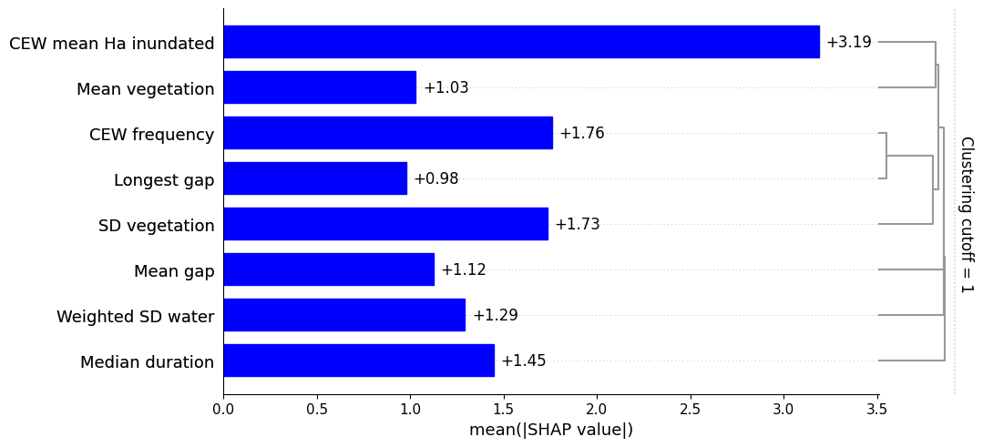
Table 6.13 Summary of model results (Shapley relative influence and partial dependence) for Australian painted snipe, ordered by relative importance rank
CEW = Commonwealth environmental water. SD = standard deviation.
Feature | Ranked importance | Summary of partial dependence | Comments | Consensus
CEW mean Ha inundated | 1 | Detection was most likely in polygons that received less inundation by CEW. | The strongest force was observed in polygons that received an average of approximately 5 ha, but positive effects were observed up to about 40 ha. | This species benefits from small CEW volumes that are delivered regularly (see also CEW frequency).
CEW frequency | 2 | Detection was most likely in polygons that received CEW 9 or 10 times since the 2014–15 water year. There was a positive trend with more than 4 deliveries. | There was a positive trend with more than 4 CEW deliveries since 2014. | This species benefits from small CEW volumes that are delivered regularly (see also CEW mean Ha inundated).
SD vegetation | 3 | Detections were most likely in polygons with a stable proportion of photosynthesising vegetation. Detection showed a negative linear trend when the standard deviation exceeded 0.185. | This feature probably relates to CEW frequency, as more frequent delivery will support more stable vegetation within the polygon. This could also relate to the preferred habitat types: permanent streams and coolabah forests that we expect to have more stable vegetation communities. | Results provide very strong support that CEW deliveries that stabilise the vegetation community are important for this species (see also CEW mean Ha inundated and CEW frequency).
Median duration | 4 | Detection was most likely in polygons with a lower median duration of inundation (less than 115 days). | Higher partial dependence at lower values of this feature indicates that intermittent drying is important for this species. | This is strong evidence that periodic drying is important for this species.
Weighted SD water | 5 | Detection was most likely in polygons with higher variability in wetted area. This was a positive linear trend. | This ties into the outputs from CEW frequency and Median duration to highlight the importance of regular inundation with intermittent drying. | Polygons with variable inundation regimes (that inundate regularly and dry for short periods) are preferred.
Mean gap | 6 | The force of this feature varied across the observed range of values, suggesting that it was useful for classification but is not critical for this species. | Unlikely to drive detection. | Unlikely to drive detection trends in Australian painted snipe.
Mean vegetation | 7 | There was a strong positive linear effect of increasing Mean vegetation. | The range of Mean vegetation values were higher than the other 4 birds (superb parrots had the highest values). This highlights the importance of green vegetation for this species. | Well-vegetated sites with a stable proportion of green vegetation is important for this species (see also SD vegetation).
Longest gap | 8 | This feature showed a positive linear relationship with fewer CEW deliveries. | The low rank of this feature and the conflicting outputs with other features (e.g. CEW frequency) suggest that these trends are artefacts. | Ignore this feature.

Influence of CEW on detection of Australian painted snipe in 2023–24
In 2023–24, CEW was delivered to 140 of the 236 polygons within 1,000 m of a historical record of Australian painted snipe. This species was detected at 61 ANAE polygons since 2014–15 (43%) and at 16 of these polygons within the last 5 years (11%). Seventy-eight polygons received water 9 or 10 times since 2014 (which matches the preference of this species), and 80 of the polygons that received CEW have a SD vegetation feature of less than 0.185. CEW is contributing to the habitat preferences for this species; however, the low detection (especially within the last 5 years) is concerning. It is unclear if the low detections arise from limited survey effort or if they reflect poor support for this species. Prioritising deliveries to stabilise on-site terrestrial vegetation communities could improve outcomes for Australian painted snipe. Additional survey effort would help to distinguish species decline from non-detection.

Common greenshank
Common greenshank records that aligned with CEW inundation were reported in 20 different ANAE types. The most common habitats were temporary tall emergent marshes, clay pans and temporary sedge/grass/forb marshes (Table 6.9). A total of 1,192 ANAE polygons were included in the machine-learning models for common greenshanks. This included 517 ANAE polygons with a detection since 2014–15 and 295 polygons with a detection since 2019 (the last 5 years). The best common greenshank model accurately predicted 81.7% of the unseen polygons, which indicates a good predictive model. The most globally important features for modelling common greenshank relationships to CEW were CEW frequency and SD vegetation. The least influential features were Mean vegetation and Median duration (Figure 6.6, Table 6.14). All model outputs are presented and discussed in Appendix E.
Figure 6.6 Global importance of each feature in the common greenshank model
The strongest feature in this model was CEW frequency; however, all features (blue bars) contributed to the classification of detecting common greenshank since 2014–15. For an explanation of each feature, see Table 6.12. This plot includes feature-redundancy clustering (on the right of the plot). CEW = Commonwealth environmental water. SD = standard deviation.
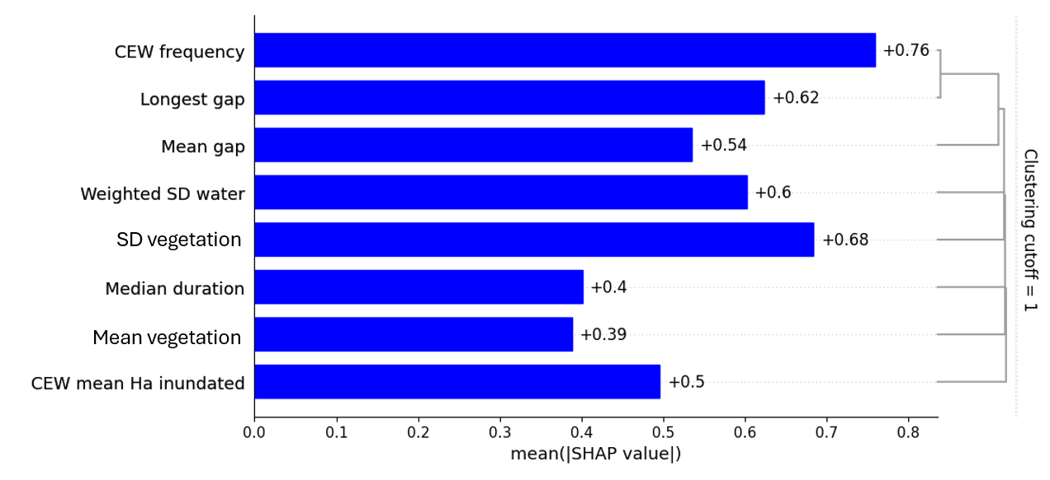
Table 6.14 Summary of model results (Shapley relative influence and partial dependence) for common greenshank, ordered by relative importance rank
CEW = Commonwealth environmental water. SD = standard deviation.
Feature | Ranked importance | Summary of partial dependence | Comments | Consensus
CEW frequency | 1 | There was a positive linear trend between CEW frequency and detection of common greenshank. | This is strong evidence that annual CEW delivery benefits this species. | This species benefits from annual CEW delivery, and from more frequent delivery (see also Longest gap).
SD vegetation | 2 | This feature showed a negative linear trend as the variability of green vegetation increased. | Although this was a strong linear trend, this species had the lowest range of Mean vegetation values of the 5 species. This suggests that although common greenshanks are more commonly detected in polygons with stable vegetation, their interaction with this vegetation might be limited. | This species is more commonly detected in polygons with regular inundation (see CEW frequency and Longest gap). The stability of the vegetation community could reflect inundation frequency but does not necessarily suggest a strong interaction with that vegetation.
Longest gap | 3 | Detections were most likely in polygons that received CEW water every year since 2014. The effect was variable across the remaining values of this feature. | Although the decision force varied across the observed values, the high partial dependence at Longest gap = 0 supports a preference for polygons with frequent CEW delivery (CEW frequency). | Results provide very strong support that CEW deliveries that stabilise the vegetation community are important for this species (see also CEW mean Ha inundated and CEW frequency).
Weighted SD water | 4 | Detection was more likely in polygons with a Weighted SD water greater than 0.07. | The positive force of this feature was consistent when polygon values were above 0.07. This indicates a detection threshold rather than a positive linear trend. | This is strong evidence that polygons with a variable wetted area are a preferred habitat for common greenshanks.
Mean gap | 5 | This feature showed a variable trend across the range of observed values. | The positive force in polygons with a mean gap less than 70 days but also in polygons with a mean gap greater than 500 days is strong evidence that this feature is not important for this species. | Common greenshanks detection is not influenced by how long that polygon remained dry before it refilled.
CEW mean Ha inundated | 6 | The force of this feature varied across the observed range of values, suggesting that it was useful for classification but is not critical for this species. | Unlikely to drive detection. | Detection of common greenshanks is tied to CEW delivery (see CEW frequency); however, high-volume deliveries will not influence detection if the polygon is unsuitable.
Median duration | 7 | The force of this feature varied across the observed range of values, suggesting that it was useful for classification but is not critical for this species. | The duration of wetting and drying patterns is unlikely to drive detection (see also Mean gap). | The duration of wetting and drying patterns are unlikely to drive detection of common greenshanks.
Mean vegetation | 8 | This feature showed a positive linear relationship with increasing proportions of green vegetation (albeit across a low range of values). | The low rank of this feature and the low range of values suggest that the interactions between common greenshanks and green vegetation are limited. | Ignore this feature.

Influence of CEW on detection of common greenshank in 2023–24
Of the 1,192 ANAE polygons within 1,000 m of a historical detection of common greenshank, 840 of these received CEW in the 2023–24 water year. Of these 840 polygons, 827 received CEW on 2 or more occasions since 2014–15, and 670 of these deliveries were to polygons with a Weighted SD water feature that was greater than 0.05. CEW delivery during 2023–24 contributed to common greenshank outcomes at 69% of these polygons through repeated delivery, and this influence is likely to be improved at the 56% of polygons that have variable hydrological regimes.

Sharp-tailed sandpiper
Sharp-tailed sandpiper records that aligned with CEW inundation were reported in 21 different ANAE types (the most habitat types of the 5 species examined). The most common habitats were temporary tall emergent marshes, temporary sedge/grass/forb marshes, clay pans and permanent lakes (Table 6.9). A total of 1,614 ANAE polygons were included in the machine-learning models for sharp-tailed sandpiper. This included 878 ANAE polygons with a detection since 2014–15 and 577 polygons with a detection since 2019 (the last 5 years).
The best sharp-tailed sandpiper model accurately predicted 78.2% of the unseen polygons, which indicates an acceptable predictive model (using our threshold of 75% accuracy). The most globally important features for modelling sharp-tailed sandpiper relationships to CEW were SD vegetation and Mean gap. The least influential features were Median duration and Longest gap (Figure 6.7, Table 6.15). All model outputs are presented and discussed in Appendix E.
Figure 6.7 Global importance of each feature in the sharp-tailed sandpiper model
All features (blue bars) contributed similarly when classifying the detection of sharp-tailed sandpiper since 2014–15. For an explanation of each feature, see Table 6.12. This plot includes feature-redundancy clustering (on the right of the plot). CEW = Commonwealth environmental water. SD = standard deviation.
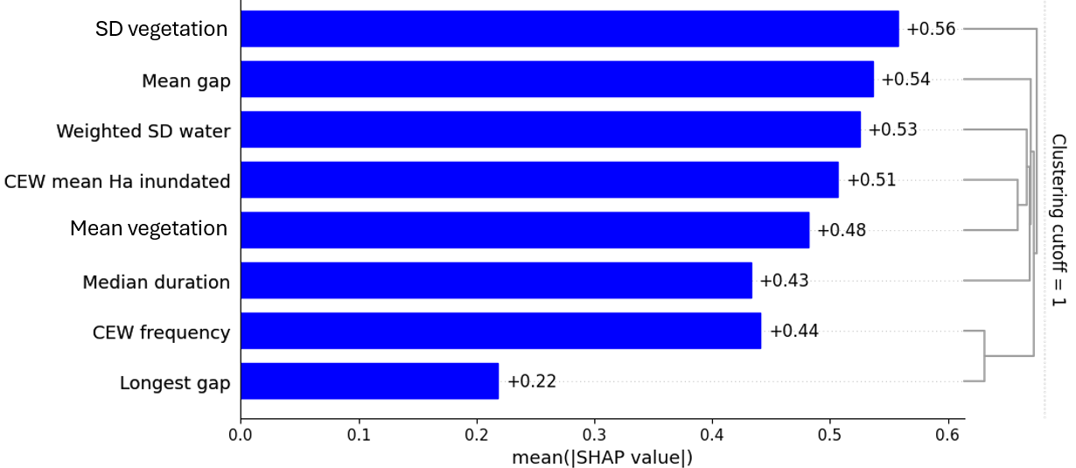
Table 6.15 Summary of model results (Shapley relative influence and partial dependence) for sharp-tailed sandpiper, ordered by relative importance rank
CEW = Commonwealth environmental water. SD = standard deviation.
Feature | Ranked importance | Summary of partial dependence | Comments | Consensus
SD vegetation | 1 | The influence of this feature varied across the range of observed values. | Although SD vegetation was influential in the sharp-tailed sandpiper model, this effect appears to be mitigated by other model features. | This species does not show a strong preference for the variability of green vegetation.
Mean gap | 2 | This feature showed a negative linear trend as the Mean gap increased. The positive effect was strongest in polygons with a Mean gap less than 150 days. | This trend suggests a preference for polygons that fill for longer periods or polygons that receive water sooner after drying. | Sharp-tailed sandpipers show a preference for polygons that dry for shorter periods.
Weighted SD water | 3 | The influence of this feature varied across the range of observed values. | The effect of Weighted SD water appears to be mitigated by other model features. | This species does not show a strong preference for the variability of wet area.
CEW mean Ha inundated | 4 | The influence of this feature varied across the range of observed values, but the highest partial dependence occurred in polygons that (on average) received more than 25 ha of inundation by CEW. | Sharp tailed sandpipers seem to prefer polygons that are inundated to a greater extent by CEW deliveries; however, the effects are mitigated by other model features. | There is some evidence that sharp-tailed sandpipers prefer polygons that have 30 ha or more inundated by CEW.
Mean vegetation | 5 | This feature showed a variable trend across the range of observed values. | Although a linear effect was not observed for this feature, the range of Mean vegetation values in the training set were amongst the lowest of the 5 variables. This suggests a preference for polygons with less green vegetation; however, this relationship is unclear. | Common greenshanks could prefer polygons with less green vegetation; however, the relationship is unclear.
CEW frequency | 6 | A positive force was exerted in polygons that received CEW more than once. | CEW deliveries positively influence detection, but there does not appear to be a preference for more frequent delivery. | There is good evidence that CEW delivery positively affected detections of sharp-tailed sandpiper; however, repeated deliveries did not increase this response.
Median duration | 7 | There was a positive linear relationship observed as the Median duration increased. This effect was highest at 160 days. | Sharp-tailed sandpiper detection is more likely at polygons that fill for longer. This matches the partial dependence observed for Mean gap. | Sharp-tailed sandpipers seem to prefer wetlands that fill for longer periods.
Longest gap | 8 | This feature showed a negative linear relationship as the gap between successive CEW deliveries increased. | The low rank of this feature and the conflicting trends between Longest gap and CEW frequency suggest that more frequent CEW delivery can benefit this species but other features are mitigating these effects. | There is some evidence that more frequent CEW delivery can benefit this species (see also CEW frequency).

Influence of CEW on detection of sharp-tailed sandpiper in 2023–24
Of the 1,614 ANAE polygons within 1000 m of a historical detection of sharp-tailed sandpiper, 1,060 of these received CEW in 2023–24 water year. Of these deliveries, 1,030 were to polygons that have received CEW on 2 or more occasions, and 120 deliveries increased the wetted area by more than 30 ha. Of the 1,060 polygons that received CEW, 275 are characterised by variable wetted surface area that is preferred by this species. CEW delivery during 2023–24 occurred in 66% of polygons with a historical detection for sharp-tailed sandpiper, and conditions were likely to improve at 64% of these polygons due to repeated delivery, 17% due to variable underlying hydrology and at the 7% of polygons that were inundated by more than 30 ha.

Latham’s snipe
Latham’s snipe records that aligned with CEW inundation were reported in 15 different ANAE types. The most common habitats were temporary tall emergent marshes, permanent lowland streams and coolabah woodland and forest riparian zones or floodplains (Table 6.9). A total of 747 ANAE polygons were included in the machine-learning models for Latham’s snipe. This included 373 ANAE polygons with a detection since 2014–15 and 177 polygons with a detection since 2019 (the last 5 years).
The best Latham’s snipe model accurately predicted 76.6% of the unseen polygons, which indicates an acceptable predictive model (using our threshold of 75% accuracy). The most globally important features for modelling the relationship between Latham’s snipe and CEW were Weighted SD water and SD vegetation. The least influential features were CEW mean Ha inundated and Longest gap (Figure 6.8, Table 6.16). All model outputs are presented and discussed in Appendix E.
Figure 6.8 Global importance of each feature in the Latham’s snipe model
Weighted SD water and SD vegetation features (blue bars) exerted the strongest influence when classifying the detection of Latham’s snipe since 2014–15. For an explanation of each feature, see Table 6.12. This plot includes feature-redundancy clustering (on the right of the plot). CEW = Commonwealth environmental water. SD = standard deviation.
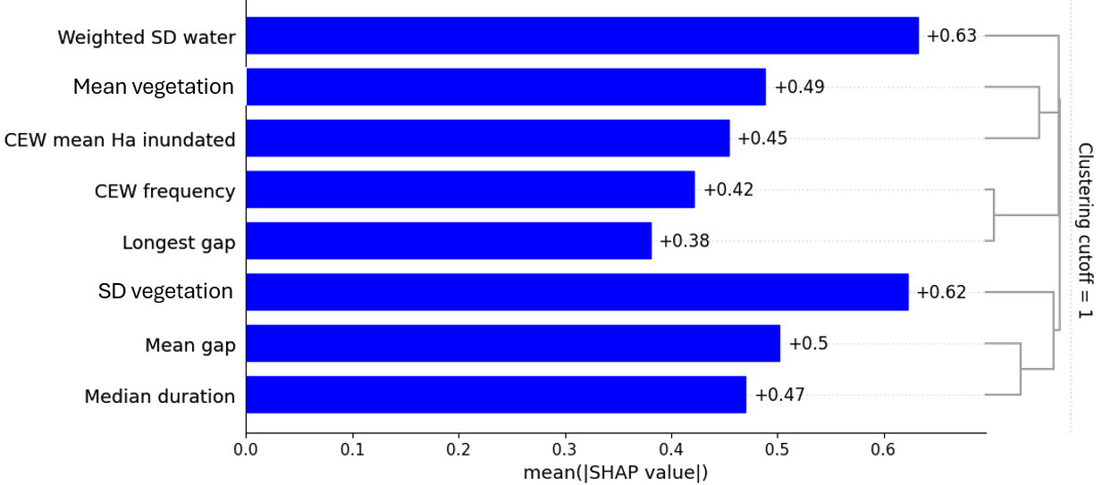
Table 6.16 Summary of model results (Shapley relative influence and partial dependence) for Australian painted snipe, ordered by relative importance rank
CEW = Commonwealth environmental water. SD = standard deviation.
Feature | Ranked importance | Summary of partial dependence | Comments | Consensus
Weighted SD water | 1 | This feature exerted a stronger force at higher values, particularly above a threshold value of 0.04. | This indicates a preference for polygons with variability in the wetted area (see also SD vegetation). | This species prefers habitats with variability in inundation and green vegetation.
SD vegetation | 2 | Although there was some variation in the strength of the positive force, this feature exerted a stronger force at higher values. | This indicates a preference for polygons with variability in the green vegetation that is present in the polygon (see also Weighted SD water). | This species prefers habitats with variability in inundation and green vegetation.
Mean gap | 3 | This feature showed a negative linear trend as the Mean gap increased. | The highest detections were observed in wetlands that dried for 125 days, and increasing this duration decreased the detection probability (see also Weighted SD water). | There is strong evidence that this species prefers variable wetlands that dry for short periods.
Mean vegetation | 4 | This feature showed a variable but positive relationship with increased Mean vegetation. | There was a local minima observed at values of approximately 0.0001, which suggests that the positive relationship can be mitigated by other, site-specific features. | Overall, this species seems to favour polygons with a greater proportion of green vegetation, but these effects are mitigated at some sites.
Median duration | 5 | The strongest effect of this feature was observed durations between 50 and 80 days. The strongest effect was observed at approximately 75 days. | This indicates that detection is most likely at habitats that retain water for shorter periods (see also SD vegetation and Weighted SD water), although this does conflict somewhat with Mean gap. | This further reinforces a preference for hydrologically variable habitats. It also indicates that Latham’s snipe will opportunistically visit ephemeral habitats
CEW mean Ha inundated | 6 | At the lowest range of observed values, this feature’s effect was weak; however, a uniform positive force was exerted across most of the observed values (notably for deliveries that increased inundation by 14 ha or more). | This indicates that there is a threshold for this feature, rather than a continuous linear relationship. | This suggests that CEW deliveries that increase the wet area by very small amounts do not support this species.
CEW frequency | 7 | This relationship is unclear and suggests a negative linear response to increasing CEW frequency. | The low relative influence of this feature and the unclear trends suggest that this is not a key driver within the model. However, the inverse relationship with Longest gap suggests that detection was more likely at sites that received CEW less often. | Increasing the frequency of CEW delivery appears to decrease suitability for this species (see also Longest gap).
Longest gap | 8 | This feature showed a positive linear relationship as the gap between successive CEW deliveries increased. | Although this is the lowest ranked feature, it complements the effects observed in CEW frequency and suggests that less-frequent CEW delivery increases the likelihood of detecting Latham’s snipe. | Increasing the frequency of CEW delivery appears to decrease suitability for this species (see also CEW frequency).

Influence of CEW on detection of Latham’s snipe in 2023–24
Of the 747 ANAE polygons within 1,000 m of a historical detection of Latham’s snipe, 496 of these received CEW in 2023–24 water year. Of these 2023-24 deliveries, 332 were to polygons with variable hydrology (Weighted SD water > 0.04), and 141 deliveries increased the wetted area by 14 ha or more. CEW delivery during 2023–24 occurred in 66% of polygons, and conditions for Latham’s snipe were likely to improve at the 44% of polygons with variable historical hydrology and at the 19% of polygons where 14 ha or more were inundated.

Superb parrot
Superb parrot records that aligned with CEW inundation were reported in 10 different ANAE types. The most common habitats were river red gum forest riparian zones or floodplains, permanent lowland streams and temporary lowland streams (Table 6.9). A total of 1,404 ANAE polygons were included in the machine-learning models for superb parrot. This included 774 ANAE polygons with a detection since 2014–15 and 608 polygons with a detection since 2019 (the last 5 years).
The best superb parrot model accurately predicted 73.5% of the unseen polygons, which was below our acceptable threshold of 75% accuracy and indicates a weak predictive model. This indicates a limited capacity for CEW to support superb parrot occupancy by influencing the 8 modelled features (Table 6.12). We have included the best performing model outputs for superb parrots in Appendix E.

Adaptive modelling recommendations

Model development
Models are powerful tools for identifying limitations in the existing data and the best supported hypotheses to guide management. This approach is best integrated within an adaptive management framework to incrementally improve the quality of those models (and their ability to inform management). As such, rebuilding these models each year is not necessary (or recommended) but should be implemented periodically as better data become available. In addition, we make the following recommendations for future iterations of this approach.

Feature engineering (selecting suitable features)
Following the recommendations in (Wassens et al. 2024a), the Quadratic frequency feature was removed and replaced by SD vegetation and Mean vegetation. There were sensible inclusions for the 5 species of birds that we examined; however, the condition of terrestrial vegetation is unlikely to influence fully aquatic species. SD vegetation and Mean vegetation were successful; however, selection of features should be thoughtfully matched to the taxa that are being modelled.

Taxonomic diversity in modelling
Our attempts to include crustaceans, fish, reptiles or mammals in the 2023–24 modelling were unsuccessful (O’Sullivan and Cuddy 2025). This was due to the limited availability of data for these species. This situation can arise when monitoring focuses on repeated surveys at a few well-studied locations. For example, modelling southern bell frog, Australasian bittern, glossy ibis, magpie goose (Anseranas semipalmata) and Australasian shoveler found that over 30% of polygons with a historical record of these species had not been resurveyed in the past 10 years (Wassens et al. 2024a). Data limitations can also arise when datasets are not made publicly available (specifically, through the ALA). In our example, it also occurred because CEW was not delivered to polygons with historical records of these taxa. For example, Murray cray was detected in 97 ANAE polygons in the Basin – 50 of these polygons are in the managed floodplain, but only 2 of these polygons have received CEW. Without a change in the availability of data, these taxa cannot be analysed using this approach, and the data shortfall that we have identified is probably true for most analyses of these species. This limits our ability to draw reliable conclusions about their status, trends or strategies to recover them.

Informing adaptive management for species diversity

Informing the planning and management of Commonwealth environmental water for species diversity
As in previous years, CEW was delivered with objectives to support habitats for waterbirds, frogs, listed threatened and migratory species, and other vertebrates across multiple valleys. Most valleys had some monitoring of outcomes, and reported findings indicate that Commonwealth environmental watering actions have achieved at least some of the planned objectives.
However, monitoring and evaluation of outcomes remain significantly lacking for frogs, listed threatened and migratory species, and other biota. Analysis of available data from the LTIM and Flow-MER programs demonstrated positive associations between waterbird and frog species richness and the area of habitat inundated during surveys. Additionally, CEW was identified as the main contributor to inundation at most monitored sites, playing a critical role in driving habitat availability and influencing waterbird and frog diversity patterns, particularly during drier years.
There were multiple instances where CEW was delivered with objectives aimed at supporting species diversity or listed threatened and migratory species. However, these actions were accompanied by no, or very limited, evaluation of success, constraining their ability to inform adaptive management. In most instances, listed threatened and migratory species are reported from habitats that were influenced by CEW without any specific objectives, and it remains unclear whether these actions had a positive, neutral or negative impact on habitat suitability.

Improving our approach to Basin-scale evaluation
This evaluation considered Basin-wide outcomes for species diversity with an emphasis on outcomes for frogs, waterbirds, and listed migratory and threatened species. It is noted that planning, monitoring and adaptive management takes place at the valley, system and wetland scales, and that the expertise of local water managers, scientists and communities is critical to the successful outcomes for species diversity. However, CEW delivery for species diversity is patchy across valleys, and broad-scale systematic monitoring of outcomes is often very limited (Robinson et al. 2018). One positive outcome noted in the CEWH’s Flow-MER program is an increase in the number of valleys undertaking watering actions with objectives for waterbirds, frogs and other vertebrates. Outcomes for species diversity could be improved in several ways as discussed below.

Improve surveillance of listed species
While the increased spatial spread of regions (from 7 to 10) as part of the next iteration of Flow-MER might fill some data gaps for fish, in most cases monitoring approaches do not meet minimum survey requirements for listed species. Although there are notable exceptions in some regions, monitoring of listed threatened and migratory water-dependent species across the Basin is poor. For example, survey guidelines for Australian threatened birds recommend a minimum of 10 hours of transect survey over 3 days to detect the Australian painted snipe (Commonwealth of Australia 2017), a recommendation that is not currently met by Flow-MER or NSW DCCEEW protocols. Greater consideration of known or potential habitats that support listed species as part of water planning, along with investment in robust monitoring capable of detecting target species, is critical to ensure that desired outcomes are achieved.
While the use of the ALA data has highlighted the contribution of CEW for some species, our evaluation has also identified significant data gaps, despite incredibly focused survey effort in some areas. There were also several threatened crustaceans, fish, amphibians, reptiles and mammals within the managed floodplain that have little or no influence from CEW. For example, of the 50 ANAE polygons where Murray cray was detected, only 2 received CEW.

Data availability
Detection-only datasets, including ALA and NSW DCCEEW data provided through the BioNet platform, create challenges when modelling the relationship with CEW. Where targeted surveys for threatened species are undertaken, they often focus exclusively on areas that receive CEW, and there is limited monitoring of other habitats which could act as a control or long-term monitoring of the same areas in years when no CEW is delivered.
The datasets used to train the machine-learning algorithms were heavily biased towards polygons where the species of interest had been detected since 2014–15. It is discussed elsewhere (and in (Wassens et al. 2024a)), but periodic, broad-scale survey efforts will yield great improvements in the type of analyses that are possible and the strength of their subsequent findings. Ideal survey effort would include multiple taxonomic groups (frogs, fish, crustaceans and water-dependent mammals, birds and reptiles) and a range of ANAE polygon types including those outside of the Strategy.

Floodplain hydrology
River systems throughout the Basin generally benefit from at least some level of flow gauging managed by state agencies and, in some cases, scenarios modelled with and without CEW are available. Despite containing the highest proportion of the Basin’s biodiversity and listed species, basic hydrological information for floodplains and wetlands is limited. Reliance on annual timesteps for inundation mapping makes it difficult to align species occurrences with CEW management. Even in areas where ground surveys are undertaken, basic hydrological information – including water depth, duration and timing of inundation, which are all likely to influence species detection and support evaluation of CEW – are not currently available. We utilised the WIT as a means of generating hydrological metrics at the scale of individual ANAE polygons where waterbird and frog surveys had been undertaken as part of LTIM and Flow-MER programs and where listed species were known to occur (based on ALA records); however, there are limitations in these data, particularly where polygons are large and may only experience partial inundation. Greater investment in gauging of hydrology across floodplains and wetlands is required to allow for robust evaluation of floodplain and wetland systems.

Objective setting
Our analysis demonstrates that CEW delivery can make a positive contribution to the recovery of listed threatened species. However, with the notable exceptions of southern bell frog and Australasian bittern, there remains a disconnect between conservation strategies listed in species recovery plans, long-term water plans and CEWH watering objectives. One way to improve objective setting for listed threatened and migratory species is to foster and support collaboration between water managers, threatened species managers and species experts and to explicitly consider conservation strategies outlined in species recovery plans when setting watering objectives.
While many waterbirds are highly mobile, improvements in waterbird health and survival, particularly in the first year of life, can be made by ensuring adequate forage habitats are maintained year-round within key valleys. In addition, there is a need for better coordination between valleys to set and meet targets for waterbird habitats at the Basin scale, particularly in dry years when the provision of refuge habitats is critical.

Listed migratory and threatened species from the managed floodplain
Table A.1 Summary of the number of listed threatened and migratory waterbird and raptor species (ordered by common name) in the Atlas of Living Australia dataset recorded within the Basin, for the unmanaged and managed floodplain, since 2008
Treaties: Bonn = Bonn Convention on the Conservation of Migratory Species of Wild Animals, CAMBA = China–Australia Migratory Bird Agreement, JAMBA = Japan–Australia Migratory Bird Agreement, ROKAMBA = Republic of Korea–Australia Migratory Bird Agreement. EPBC Act = Australian Environment Protection and Biodiversity Conservation Act 1999, Qld NC Act = Queensland Nature Conservation Act 1992 (Nature Conservation (Animals) Regulation 2020), NSW BC Act = New South Wales Biodiversity Conservation Act 2016, ACT NC Act = Australian Capital Territory Nature Conservation Act 2014, Vic FFG Act = Victorian Flora and Fauna Guarantee Act 1988, SA NPW Act = South Australian National Parks and Wildlife Act 1972. CE = Critically Endangered, En = Endangered, Vu = Vulnerable, R = Rare. Dash (-) in status columns indicates the species is not listed in those acts/treaties. Listing status of species reported from the managed floodplain based on the Atlas of Living Australia dataset 2023–24 [accessed Feb 2025]. *Subspecies for bar-tailed godwit Limosa lapponica baueri VU (EPBC Act) and Limosa lapponica menzbieri EN (EPBC Act) have not been separated due to limited data availability for subspecies.
Common Name | Species | EPBC Act | Qld NC Act | NSW BC Act | ACT NC Act | Vic FFG Act | SA NPW Act | Bonn | ROKAMBA | CAMBA | JAMBA | Unmanaged floodplain | Managed floodplain | Total records
Freshwater catfish | Tandanus tandanus | - | - | - | - | Vu | - | - | - | - | - | 2,087 | 6,238 | 8,325
Macquarie perch | Macquaria australasica | En | - | - | En | Vu | - | - | - | - | - | 704 | 957 | 1,661
Murray cod | Maccullochella peelii | Vu | - | - | - | Vu | - | - | - | - | - | 9,404 | 29,408 | 38,812
Murray hardyhead | Craterocephalus fluviatilis | En | - | - | - | CE | - | - | - | - | - | 4,121 | 5,340 | 9,461
Murray River rainbowfish | Melanotaenia fluviatilis | - | - | - | - | Vu | - | - | - | - | - | 18,380 | 89,289 | 107,669
Silver perch | Bidyanus bidyanus | CE | - | - | En | Vu | - | - | - | - | - | 2,675 | 7,636 | 10,311
Purple-spotted gudgeon | Mogurnda adspersa | - | - | - | - | CE | - | - | - | - | - | 387 | 1,659 | 2,046
Southern pygmy perch | Nannoperca australis | Vu | - | - | - | Vu | - | - | - | - | - | 241 | 89 | 330
Trout cod | Maccullochella macquariensis | En | - | - | En | Vu | - | - | - | - | - | 2,447 | 7,896 | 10,343
River blackfish | Gadopsis bispinosus | - | - | - | Vu | - | - | - | - | - | - | 8,092 | 5,087 | 13,179
Western carp gudgeon | Hypseleotris klunzingeri | CE | - | - | - | - | - | - | - | - | - | 10,516 | 16,410 | 26,926
Booroolong frog | Litoria booroolongensis | En | - | En | - | - | - | - | - | - | - | 7,603 | 132 | 7,735
Giant banjo frog | Limnodynastes interioris | - | - | - | - | Vu | - | - | - | - | - | 2,665 | 18,552 | 21,217
Knife-footed frog | Cyclorana cultripes | - | - | - | - | - | R | - | - | - | - | 601 | 1,345 | 1,946
Sloane's froglet | Crinia sloanei | En | - | En | - | Vu | - | - | - | - | - | 1,265 | 712 | 1,977
Southern bell frog | Litoria raniformis | Vu | - | En | Vu | Vu | Vu | - | - | - | - | 38,467 | 73,914 | 112,381
Wrinkled toadlet | Uperoleia rugosa | - | - | - | - | Vu | R | - | - | - | - | 3,402 | 1,876 | 5,278
Yellow-spotted tree frog | Litoria castanea | CE | - | CE | CE | - | - | - | - | - | - | 2 | 0 | 2
Alpine spiny cray | Euastacus crassus | En | - | - | - | - | - | - | - | - | - | 65 | 0 | 65
Blue spiny crayfish | Euastacus sulcatus | En | - | - | - | - | - | - | - | - | - | 3 | 1 | 4
Central highlands spiny crayfish | Euastacus woiwuru | En | - | - | - | - | - | - | - | - | - | 459 | 51 | 510
Gippsland spiny crayfish | Euastacus kershawi | En | - | - | - | - | - | - | - | - | - | 5 | 0 | 5
Glenelg spiny freshwater crayfish | Euastacus bispinosus | En | - | - | - | Vu | - | - | - |  | - | 72 | 53 | 125
Murray cray | Euastacus armatus | En | - | - | Vu | Th | - | - | - | - | - | 2,850 | 1,809 | 4,659
Southern Victorian spiny crayfish | Euastacus yarraensis | En | - | - | - | - | - | - | - | - | - | 1 | 0 | 1
Sydney crayfish | Euastacus spinifer | En | - | - | - | - | - | - | - | - | - | 0 | 5 | 5
Sydney spiny crayfish | Euastacus australasiensis | En | - | - | - | - | - | - | - | - | - | 3 | 0 | 3
Gamilaroi crayfish | Euastacus gamilaroi | En | - | - | - | - | - | - | - | - | - | 28 | 0 | 28
Riek’s crayfish | Euastacus rieki | En | - | - | - | - | - | - | - | - | - | 34 | 2 | 36
Sutton’s crayfish | Euastacus suttoni | En | En | - | - | - | - | - | - | - | - | 18 |  | 18
Platypus | Ornithorhynchus anatinus | - | - | - | - | Vu | En | - | - | - | - | 11,837 | 9,799 | 21,636
Southern myotis | Myotis macropus | - | - | Vu | - | - | En | - | - | - | - | 91 | 236 | 327
Alpine bog-skink | Pseudemoia cryodroma | En | - | - | - | Vu | - | - | - | - | - | 913 | 0 | 913
Alpine water-skink | Eulamprus kosciuskoi | - | - | - | - | Vu | - | - | - | - | - | 357 | 6 | 363
Bell's turtle | Myuchelys belli | En | En | En | - | - | - | - | - | - | - | 19,795 | 5,921 | 25,716
Broad-shelled turtle | Chelodina expansa | - | - | - | - | Vu | Vu | - | - | - | - | 4,332 | 9,962 | 14,294
De Vis' banded snake | Denisonia devisi | - | - | - | - | CE | - | - | - | - | - | 234 | 543 | 777
Grey snake | Hemiaspis damelii | En | En | En | - | - | - | - | - | - | - | 82 | 1,012 | 1,094
Macquarie River turtle | Emydura macquarii | - | - | - | - | CE | Vu | - | - | - | - | 14,649 | 34,013 | 48,662
Southern water-skink | Eulamprus tympanum tympanum | - | - | - | - | - | R | - | - | - | - | 722 | 1 | 723
Swamp skink | Lissolepis coventryi | En | - | En | - | - | En | - | - | - | - | 30 |  | 30
Yellow-bellied water-skink | Eulamprus heatwolei | - | - | - | - | - | Vu | - | - | - | - | 1,625 | 1,209 | 2,834
Australasian bittern | Botaurus poiciloptilus | En | En | En | En | CE | En | - | - | - | - | 4,729 | 6,201 | 10,930
Alaskan bar-tailed godwit | Limosa lapponica baueri | - | - | - | - | Vu | - | Y | Y | Y | Y | 44 | 7 | 51
Arctic tern | Sterna paradisaea | - | - | - | - | - | - | Y | - | - | - | 5 | 13 | 18
Asian gull-billed tern | Gelochelidon nilotica affinis | - | - | - | - | - | - | - | - | Y | - | 80 | 99 | 179
Australasian crested tern | Thalasseus bergii cristatus | - | - | - | - | - | - | - | - | - | Y | 17,090 | 2,008 | 19,098
Australasian shoveler | Spatula rhynchotis | - | - | - | - | Vu | R | - | - | - | - | 118,194 | 28,644 | 146,838
Australian fairy tern | Sternula nereis nereis | - | - | - | - | CE | - | - | - | - | - | 5,193 | 430 | 5,623
Australian gull-billed tern | Gelochelidon macrotarsa | - | - | - | - | Vu | - | - | - | - | - | 5,182 | 2,318 | 7,500
Australian painted snipe | Rostratula australis | En | En | En | En | CE | En | - | - | - | - | 2,738 | 365 | 3,103
Australian pied oystercatcher | Haematopus longirostris | - | - | En | - | - | R | - | - | - | - | 23,472 | 1,480 | 24,952
Banded stilt | Cladorhynchus leucocephalus | - | - | - | - | - | Vu | - | - | - | - | 8,818 | 2,240 | 11,058
Beach stone-curlew | Esacus magnirostris | - | Vu | CE | - | - | - | - | - | - | - | 16 | 4 | 20
Black falcon | Falco subniger | - | - | Vu | - | CE | R | - | - | - | - | 8,230 | 4,016 | 12,246
Black-breasted buzzard | Hamirostra melanosternon | - | - | Vu | - | - | R | - | - | - | - | 285 | 1,732 | 2,017
Blue-billed duck | Oxyura australis | - | - | Vu | - | Vu | R | - | - | - | - | 18,248 | 7,965 | 26,213
Brolga | Antigone rubicunda | - | - | - | - | Vu | Vu | - | - | - | - | 5,248 | 4,939 | 10,187
Brolga | Grus rubicunda | - | - | Vu | - | - | - | - | - | - | - | 1,424 | 2,060 | 3,484
Caspian tern | Hydroprogne caspia | - | - | - | - | Vu | - | - | - | - | Y | 77,266 | 48,324 | 125,590
Common greenshank | Tringa nebularia | En | - | - | - | Vu | - | Y | Y | Y | Y | 34,765 | 4,732 | 39,497
Common redshank | Tringa totanus | - | - | - | - | - | - | Y | Y | Y | Y | 81 | 11 | 92
Common sandpiper | Actitis hypoleucos | - | - | - | - | Vu | R | Y | Y | Y | Y | 1,930 | 746 | 2,676
Curlew sandpiper | Calidris ferruginea | CE | CE | En | - | CE | En | Y | Y | Y | Y | 17,875 | 1,907 | 19,782
Eastern black-tailed godwit | Limosa limosa melanuroides | En |  | Vu | - | CE | - | Y | Y | Y | Y | 556 | 113 | 669
Eastern curlew | Numenius madagascariensis | CE | En | - | - | CE | En | Y | Y | Y | Y | 2,079 | 289 | 2,368
Eastern grey plover | Pluvialis squatarola squatarola | Vu | - | - | - | Vu | - | Y | Y | Y | Y | 166 | 38 | 204
Eastern hooded dotterel | Thinornis cucullatus cucullatus | - | - | - | - | Vu | - | - | - | - | - | 4 | 0 | 4
Eastern musk duck | Biziura lobata menziesi | - | - | - | - | Vu | - | - | - | - | - | 5,817 | 4,289 | 10,106
Eastern osprey | Pandion haliaetus cristatus | - | - | - | - | - | - | Y | - | - | - | 42 | 73 | 115
Eastern sanderling | Calidris alba alba | - | - | Vu | - | - | - | Y | Y | Y | Y | 442 | 22 | 464
Flesh-footed shearwater | Ardenna carneipes | - | - | Vu | - | - | R | - | Y | - | Y | 1 | 0 | 1
Freckled duck | Stictonetta naevosa | - | - | Vu | - | Vu | Vu | - | - | - | - | 41,837 | 9,092 | 50,929
Great knot | Calidris tenuirostris | Vu | CE | Vu | - | CE | En | Y | Y | Y | Y | 405 | 48 | 453
Grey goshawk | Accipiter novaehollandiae | - | - | - | - | Vu | En | - | - | - | - | 952 | 295 | 1,247
Grey-tailed tattler | Tringa brevipes | - | - | - | - | CE | R | Y | Y | Y | Y | 206 | 28 | 234
Gull-billed tern | Gelochelidon nilotica macrotarsa | - | - | - | - | - | - | - |  | Y | - | 188 | 532 | 720
Hardhead | Aythya australis | - | - | - | - | Vu | - | - | - | - | - | 139,696 | 60,188 | 199,884
Indo-Pacific little tern | Sternula albifrons sinensis | - | - | En | - | CE | - | Y | Y | Y | Y | 39 | 4 | 43
Inland dotterel | Peltohyas australis | - | - | - | - | Vu | - | - | - | - | - | 740 | 457 | 1,197
Latham's snipe | Gallinago hardwickii | Vu | - | - | - | - | R | Y | Y | - | Y | 56,617 | 3,385 | 60,002
Letter-winged kite | Elanus scriptus | - | - | - | - | - | Vu | - | - |  | - | 70 | 10 | 80
Little curlew | Numenius minutus | - | - | - | - | - | - | Y | Y | Y | Y | 441 | 71 | 512
Little egret | Egretta garzetta nigripes | - | - | - | - | Vu | - | - | - | - | - | 4,743 | 1,186 | 5,929
Long-toed stint | Calidris subminuta | - | - | - | - | - | R | Y | Y | Y | Y | 1,496 | 67 | 1,563
Magpie goose | Anseranas semipalmata | - | - | Vu | - | Vu | En | - | - | - | - | 11,464 | 7,519 | 18,983
Marsh sandpiper | Tringa stagnatilis | - | - | - | - | Vu | - | Y | Y | Y | Y | 11,982 | 1,885 | 13,867
Minute bittern | Ixobrychus dubius | - | - | - | - | Vu | En | - | - | - | - | 4,481 | 4,341 | 8,822
New Zealand double-banded plover | Charadrius bicinctus bicinctus | - | - | - | - | - | - | Y | - | - | - | 1,742 | 263 | 2,005
North-eastern Siberian red knot | Calidris canutus rogersi | Vu | En | - | - | Vu | - | Y | Y | Y | Y | 134 | 46 | 180
Northern giant-petrel | Macronectes halli | Vu | Vu | Vu | - | Vu | - | Y | - | - | - | 16 | 0 | 16
Oriental plover | Charadrius veredus | - | - | - | - | - | - | Y | Y | Y | Y | 16 | 8 | 24
Oriental pratincole | Glareola maldivarum | - | - | - | - | - | - | - | Y | Y | Y | 943 | 37 | 980
Oriental reed-warbler | Acrocephalus orientalis | - | - | - | - | - | - | Y | Y | Y | Y | 4 |  | 4
Pacific golden plover | Pluvialis fulva | - | - | - | - | Vu | R | Y | Y | Y | Y | 4,070 | 216 | 4,286
Palaearctic ruddy turnstone | Arenaria interpres interpres | Vu | - | - | - | Vu | - | Y | Y | Y | Y | 59 | 22 | 81
Pectoral sandpiper | Calidris melanotos | - | - | - | - | - | R | Y | Y | - | Y | 6,415 | 282 | 6,697
Red-necked phalarope | Phalaropus lobatus | - | - | - | - | - | - | Y | Y | Y | Y | 14 | 99 | 113
Red-necked stint | Calidris ruficollis | - | - | - | - | - | - | Y | Y | Y | Y | 42,298 | 8,551 | 50,849
Regent parrot | Polytelis anthopeplus monarchoides | Vu | - | En | - | Vu | Vu | - | - | - | - | 3,071 | 4,176 | 7,247
Ruff | Calidris pugnax | - | - | - | - | - | R | Y | Y | Y | Y | 764 | 48 | 812
Sharp-tailed sandpiper | Calidris acuminata | Vu | - | - | - | - | - | Y | Y | Y | Y | 52,558 | 8,373 | 60,931
Siberian common tern | Sterna hirundo longipennis | - | - | - | - | - | - | - | Y | Y | Y | 85 | 5 | 90
Southern sooty oystercatcher | Haematopus fuliginosus fuliginosus | - | - | Vu | - | - | - | - | - | - | - | 1,701 | 91 | 1,792
Spotted harrier | Circus assimilis | - | - | Vu |  | - | - | - | - | - | - | 9,903 | 4,813 | 14,716
Square-tailed kite | Lophoictinia isura | - | - | Vu |  | Vu | En | - | - | - | - | 3,970 | 3,903 | 7,873
Superb parrot | Polytelis swainsonii | Vu | - | Vu | Vu |  |  | - | - | - | - | 18,580 | 21,524 | 40,104
Terek sandpiper | Xenus cinereus | Vu | - | Vu |  | Vu | R | Y | Y | Y | Y | 235 | 23 | 258
White-bellied sea-eagle | Haliaeetus leucogaster | - | - | Vu | - | - | En | - | - | - | - | 16,948 | 25,216 | 42,164
White-winged black tern | Chlidonias leucopterus | - | - | - | - | - | - | - | Y | Y | Y | 3,066 | 336 | 3,402
Wood sandpiper | Tringa glareola | - | - | - | - | Vu | R | Y | Y | Y | Y | 6,336 | 1,011 | 7,347

Commonwealth environmental watering actions
Table B.1 Annual volume of CEW with at least one watering objective related to frogs, by valley and year, 2014–24
Data in this table is presented graphically in Figure 4.1. Dash (–) indicates no objective for frogs in that year.
Valley | 2014–15 | 2015–16 | 2016–17 | 2017–18 | 2018–19 | 2019–20 | 2020–21 | 2021–22 | 2022–23 | 2023–24
Murrumbidgee | 152,558 | 56,989 | 16,505 | 16,536 | 56,599 | 48,335 | 227,518 | 529,279 | 90,911 | 50,175
Lower Murray | 3,887 | 3,555 | 1,657 | 211,770 | 5,655 | 5,779 | 4,052 | 7,300 | 251 | 1,843
Edward/Kolety–Wakool | – | – | – | 47,143 | – | 5,186 | 2,768 | 40,330 | 41,587 | 10,881
Lower Darling/Baaka | – | – | 89,204 | – | – | – | – | 42,256 | – | –
Macquarie | – | 2,125 | – | – | 45,052 |  | 37,488 | 10,900 | – | –
Lachlan | – | – | – | – | 412 | 4,998 | 40,191 | 9,174 | 11,708 | 23,382
Gwydir | – | – | 7,496 |  | 17,550 | – | – | – | – | –
Junction of Warrego and Darling rivers | – | – | – | – | – | – | – | – | – | 8,370
Central Murray | – | 1,867 | – | 102 | – | – | – | – | – | –
Total | 156,445 | 64,536 | 114,862 | 275,551 | 125,268 | 64,298 | 312,017 | 639,238 | 144,456 | 94,650

Detailed occurrence tables
Table C.1 Number of waterbird occurrences drawn from the combined NSW Department of Climate Change, Energy, the Environment and Water and Flow MER datasets, by surface water region, ordered by scientific name, 2023–24
Dash (– indicates no occurrence recorded. EPBC Act = Australian Environment Protection and Biodiversity Conservation Act 1999, NSW BC Act = New South Wales Biodiversity Conservation Act 2016. EN = Endangered, VU = Vulnerable.
Common name | Scientific name | EPBC Act | Migratory status | NSW BC Act | Border Rivers | Condamine Balonne (Narran) | Warrego and Darling Rivers | Gwydir | Macquarie | Lachlan | Murrumbidgee | Murray | Total count
Brown goshawk | Accipiter fasciatus | – | – | – | – | – | – | 1 | 1 | – | – | – | 2
Australian reed-warbler | Acrocephalus australis | – | – | – | 1 | – | – | 61 | 575 | 102 | 69 | 39 | 847
Chestnut teal | Anas castanea | – | – | – | – | – | – | 2 | 1 | – | – | 2 | 5
Grey teal | Anas gracilis | – | – | – | 99 | – | 21 | 1,541 | 2,739 | 2,100 | 4,664 | 3,697 | 14,861
Pacific black duck | Anas superciliosa | – | – | – | 50 | – | 7 | 2,550 | 1,029 | 563 | 1,374 | 421 | 5,994
Australasian darter | Anhinga novaehollandiae | – | – | – | 40 | 2 | 3 | 53 | 44 | 181 | 291 | 192 | 806
Magpie goose | Anseranas semipalmata | – | – | VU | – | – | – | – | 3 | – | – | – | 3
Wedge-tailed eagle | Aquila audax | – | – | – | 2 | – | – | 15 | 4 | – | 4 | 1 | 26
Eastern great egret | Ardea alba modesta | – | – | – | – | – | 3 | – | – | – | – | – | 3
Intermediate egret | Ardea intermedia | – | – | – | – | – | – | 31 | 267 | 19 | 110 | 2 | 429
White-necked heron | Ardea pacifica | – | – | – | 18 | – | 3 | 42 | 88 | 22 | 99 | 28 | 300
Hardhead | Aythya australis | – | – | – | – | – | 34 | 11 | 54 | 12 | 18 | 728 | 857
Musk duck | Biziura lobata | – | – | – | – | – | 27 | – | 1 | 1 | 27 | 2 | 58
Australasian bittern | Botaurus poiciloptilus | EN | - | EN | – | – | – | – | – | 2 | 17 | – | 19
Cattle egret | Bubulcus ibis | – | – | – | – | – | – | 21 | 4 | – | 1 | – | 26
Sharp-tailed sandpiper | Calidris acuminata | VU | Bonn,  C, J, R | – | – | – | – | – | 8 | 2 | – | – | 10
Red-capped plover | Charadrius ruficapillus | – | – | – | – | – | – | – | – | – | – | 1 | 1
Australian wood duck | Chenonetta jubata | – | – | – | 506 | – | 10 | 1,421 | 751 | 1,111 | 834 | 1,066 | 5,699
Whiskered tern | Chlidonias hybrida | – | – | – | – | – | – | – | 30 | 411 | 41 | 32 | 514
Silver gull | Chroicocephalus novaehollandiae | – | – | – | – | – | 10 | – | – | 33 | 24 | 40 | 107
Swamp harrier | Circus approximans | – | – | – | – | – | 25 | 4 | 15 | 1 | 10 | – | 55
Spotted harrier | Circus assimilis | – | – | VU | – | – | – | – | – | – | – | 1 | 1
Golden-headed cisticola | Cisticola exilis | – | – | – | – | – | – | 45 | 9 | – | – | – | 54
Black swan | Cygnus atratus | – | – | – | – | – | 15 | 16 | 380 | 916 | 445 | 163 | 1,935
Plumed whistling-duck | Dendrocygna eytoni | – | – | – | – | – | – | 853 | – | – | – | 1 | 854
Little egret | Egretta garzetta | – | – | – | 1 | – | – | – | 1 | 2 | 1 | – | 5
White-faced heron | Egretta novaehollandiae | – | – | – | 9 | – | 3 | 48 | 61 | 33 | 182 | 38 | 374
Black-shouldered kite | Elanus axillaris | – | – | – | – | – | – | 26 | 1 | 4 | 14 | 4 | 49
Black-fronted dotterel | Elseyornis melanops | – | – | – | 9 | – | 2 | 38 | 63 | 15 | 10 | 32 | 169
Black-necked stork | Ephippiorhynchus asiaticus | – | – | EN | – | – | – | 3 | – | – | – | – | 3
Red-kneed dotterel | Erythrogonys cinctus | – | – | – | – | – | 18 | – | 8 | 9 | 8 | 11 | 54
Brown falcon | Falco berigora | – | – | – | – | – | – | 8 | 3 | - | 1 | – | 12
Eastern brown falcon | Falco longipennis | – | – | – | – | – | – | – | 4 | 1 | – | – | 5
Peregrine falcon | Falco peregrinus | – | – | – | 1 | – | – | – | – | – | 1 | – | 2
Black falcon | Falco subniger | – | – | VU | – | – | – | 1 | – | – | – | – | 1
Eurasian coot | Fulica atra | – | – | – | – | – | 13 | 48 | 1,402 | 4,880 | 863 | 562 | 7,768
Latham's snipe | Gallinago hardwickii | VU | Bonn, J, R | VU | 3 | – | – | – | 3 | – | – | – | 6
Dusky moorhen | Gallinula tenebrosa | – | – | – | 38 | – | 8 | 59 | 152 | 54 | 381 | 145 | 837
White-bellied sea-eagle | Haliaeetus leucogaster | – | – | VU | 1 | – | – | 5 | 12 | 2 | 7 | 3 | 30
Whistling kite | Haliastur sphenurus | – | – | – | 25 | – | 6 | 33 | 60 | 43 | 110 | 39 | 316
Australian little bittern | Ixobrychus dubius | – | – | – | - | – | – | 2 | 1 | – | – | – | 3
Pink-eared duck | Malacorhynchus membranaceus | – | – | – | 22 | – | 3 | 4 | 5 | 133 | – | 40 | 207
Little pied cormorant | Microcarbo melanoleucos | – | – | – | 23 | – | 4 | 65 | 92 | 125 | 423 | 54 | 786
Black kite | Milvus migrans | – | – | – | 2 | – | – | 3 | 7 | 30 | 4 | 8 | 54
Nankeen night-heron | Nycticorax caledonicus | – | – | – | 18 | – | – | 61 | 442 | 166 | 1,216 | 26 | 1,929
Blue-billed duck | Oxyura australis | – | – | VU | – | – | – | – | 1 | – | 26 | – | 27
Australian pelican | Pelecanus conspicillatus | – | – | – | – | 2 | 3 | 406 | 499 | 3,943 | 2,532 | 518 | 7,903
Great cormorant | Phalacrocorax carbo | – | – | – | 1 | 15 | 5 | 41 | 90 | 478 | 425 | 391 | 1,446
Little black cormorant | Phalacrocorax sulcirostris | – | – | – | 50 | 6 | 4 | 92 | 219 | 406 | 725 | 515 | 2,017
Pied cormorant | Phalacrocorax varius | – | – | – | 9 | 10 | 3 | 32 | 23 | 288 | 385 | 199 | 949
Yellow-billed spoonbill | Platalea flavipes | – | – | – | 15 | – | – | 56 | 34 | 89 | 254 | 72 | 520
Royal spoonbill | Platalea regia | – | – | – | 6 | – | 7 | 72 | 67 | 62 | 139 | 36 | 389
Glossy ibis | Plegadis falcinellus | – | Bonn | – | – | – | – | 114 | 1,271 | 122 | 136 | – | 1,643
Great crested grebe | Podiceps cristatus | – | – | – | – | – | – | – | – | 38 | 144 | 75 | 257
Hoary-headed grebe | Poliocephalus poliocephalus | – | – | – | – | – | 5 | – | 8 | 85 | 238 | 37 | 373
Little grassbird | Poodytes gramineus | – | – | – | – | – | – | 30 | 115 | 17 | 36 | 1 | 199
Purple swamphen | Porphyrio porphyrio | – | – | – | – | – | – | 64 | 199 | 125 | 342 | 89 | 819
Australian spotted crake | Porzana fluminea | – | – | – | – | – | – | 4 | 1 | 2 | – | 1 | 8
Red-necked avocet | Recurvirostra novaehollandiae | – | – | – | – | – | 3 | – | 2 | – | 1 | 102 | 108
Australian pratincole | Stiltia isabella | – | – | – | – | – | – | – | 3 | – | – | – | 3
Australasian grebe | Tachybaptus novaehollandiae | – | – | – | 2 | – | – | 35 | 83 | 74 | 135 | 85 | 414
Australian shelduck | Tadorna tadornoides | – | – | – | – | – | – | – | 20 | 81 | 128 | 661 | 890
Straw-necked ibis | Threskiornis spinicollis | – | – | – | – | – | – | 103 | 599 | 35 | 738 | 5 | 1,480
Sacred kingfisher | Todiramphus sanctus | – | – | – | 39 | – | 2 | 59 | 101 | 44 | 58 | 18 | 321
Black-tailed native-hen | Tribonyx ventralis | – | – | – | – | – | – | – | 1 | 1,336 | 287 | 961 | 2,585
Marsh sandpiper | Tringa stagnatilis | – | C,J,R | – | – | – | – | – | 1 | – | – | – | 1
Masked lapwing | Vanellus miles | – | – | – | 4 | – | 20 | 34 | 62 | 45 | 101 | 18 | 284
Banded lapwing | Vanellus tricolor | – | – | – | – | – | – | – | 2 | – | – | – | 6
 | Total species recorded |  |  |  | 27 | 5 | 28 | 46 | 58 | 47 | 49 | 47 | 68

Summary of median proportion wetted area
Table D.1 Summary of median proportion wetted area (proportion open water + wet area) derived from the Wetlands Insight Tool, by survey site
Dash (–) indicates no occurrence recorded. ND = no data. Sites with ND in every year are not included.
Site | 2014–15 | 2015–16 | 2016–17 | 2017–18 | 2018–19 | 2019–20 | 2020–21 | 2021–22 | 2022–23 | 2023–24 | Survey years
Gwydir River System maximum values | 0.41 | 0.22 | 0.45 | 0.46 | 0.24 | 0.70 | 0.22 | 0.60 | 0.36 | 0.14 | 10.00
BOYSWH | – | – | – | – | – | – | – | – | 0.06 | 0.00 | 2.00
BUNG | – | – | 0.00 | – | – | 0.00 | 0.00 | 0.01 | 0.00 | 0.00 | 6.00
BURR | – | – | – | – | – | – | – | – | 0.00 | – | 1.00
BURW | – | – | – | – | – | – | – | – | 0.01 | – | 1.00
COMW | – | – | 0.11 | 0.25 | 0.01 | 0.32 | 0.13 | 0.24 | 0.36 | 0.05 | 8.00
COOD | – | – | 0.45 | – | 0.18 | – | 0.08 | 0.21 | – | 0.00 | 5.00
DERW | – | – | 0.00 | – | – | – | – | – | – | – | 1.00
GINW | – | – | – | 0.00 | 0.07 | 0.09 | 0.11 | 0.35 | 0.19 | 0.00 | 7.00
GUND | – | – | 0.00 | – | 0.00 | – | 0.02 | 0.13 | 0.00 | 0.00 | 6.00
GWY_418037 | 0.22 | 0.14 | – | – | – | – | – | – | – | – | 2.00
GWY_418053 | 0.02 | 0.01 | 0.02 | 0.01 | 0.01 | 0.03 | 0.04 | 0.17 | 0.02 | 0.00 | 10.00
GWY_418077 | 0.02 | 0.00 | 0.08 | – | – | – | – | – | – | – | 3.00
GWY_418078 | 0.00 | 0.00 | 0.01 | 0.02 | – | 0.01 | – | 0.56 | 0.27 | 0.00 | 8.00
GWY_BOYW | 0.02 | 0.00 | 0.03 | 0.00 | 0.01 | 0.11 | 0.10 | 0.29 | 0.02 | 0.00 | 10.00
GWY_BUNBH | 0.41 | 0.22 | 0.28 | 0.46 | 0.24 | 0.70 | 0.22 | 0.23 | 0.22 | 0.14 | 10.00
GWY_BUNWC | – | – | – | – | – | – | – | – | 0.22 | 0.14 | 2.00
GWY_COOD | 0.11 | 0.01 | – | 0.00 | – | 0.00 | – | – | – | – | 4.00
GWY_CRNR | 0.00 | 0.00 | 0.07 | 0.00 | – | 0.05 | – | – | – | – | 5.00
GWY_DERW | 0.00 | 0.00 | – | 0.00 | 0.00 | 0.01 | 0.07 | 0.26 | 0.07 | 0.12 | 9.00
GWY_GINH | – | 0.02 | 0.01 | 0.01 | 0.00 | 0.11 | 0.07 | – | – | – | 6.00
GWY_GL | 0.01 | 0.01 | 0.13 | 0.01 | – | 0.32 | 0.20 | 0.22 | 0.10 | 0.00 | 9.00
GWY_GUND | 0.00 | 0.05 | – | 0.00 | – | 0.14 | – | – | – | – | 4.00
GWY_JACF | 0.09 | 0.00 | 0.00 | – | 0.04 | – | 0.07 | 0.21 | 0.00 | 0.00 | 8.00
GWY_LYNT | 0.00 | 0.00 | 0.10 | 0.00 | – | – | – | – | – | – | 4.00
GWY_MUNW | – | – | – | – | – | – | – | – | 0.19 | 0.00 | 2.00
GWY_ODD | 0.03 | 0.00 | 0.09 | 0.03 | 0.01 | 0.27 | 0.08 | 0.17 | 0.09 | 0.01 | 10.00
GWY_ODF | – | – | 0.09 | – | – | – | – | – | – | – | 1.00
GWY_OLDBW | – | – | – | – | 0.04 | – | – | – | – | – | 1.00
GWY_OLDT | 0.10 | 0.01 | – | 0.04 | 0.00 | 0.30 | 0.06 | 0.60 | 0.00 | 0.00 | 9.00
GWY_RCL | 0.00 | 0.00 | – | – | – | – | – | – | – | – | 2.00
GWY_TELL | – | 0.00 | 0.00 | 0.00 | 0.00 | 0.08 | 0.04 | 0.04 | 0.17 | 0.04 | 9.00
GWY_VALW | 0.01 | 0.00 | 0.00 | 0.00 | – | 0.32 | – | – | – | – | 5.00
GWY_WANDW | 0.03 | 0.00 | 0.09 | 0.03 | 0.01 | 0.27 | 0.08 | 0.17 | 0.09 | 0.01 | 10.00
GWY_WESTNW | 0.01 | 0.01 | – | – | – | – | – | – | 0.01 | 0.00 | 4.00
GWY_WESTSE | – | – | – | – | – | – | – | – | – | – | –
GWY_WHIT | 0.00 | 0.00 | 0.00 | 0.00 | 0.00 | 0.01 | 0.00 | 0.02 | 0.09 | 0.00 | 10.00
GWYD01_008 | – | – | – | – | – | – | – | – | – | – | 0.00
JACK | – | – | – | 0.00 | – | 0.13 | – | – | – | – | 2.00
LYNT | – | – | – | – | 0.14 | – | – | – | – | – | 1.00
RACE | – | – | 0.05 | 0.00 | 0.00 | – | – | – | – | – | 3.00
YINH | – | – | – | – | – | – | – | 0.16 | 0.00 | 0.00 | 3.00
Junction of Warrego and Darling rivers maximum values | 0.35 | 0.37 | 0.62 | 0.33 | – | 0.16 | 0.27 | – | 0.98 | 0.27 | 8.00
WD_BOERA | 0.35 | 0.37 | 0.62 | 0.33 | – | 0.16 | 0.27 | – | 0.39 | 0.27 | 8.00
WD_BOERA_WEST | – | – | – | – | – | – | – | – | 0.07 | 0.06 | 2.00
WD_BOOKA | 0.13 | 0.14 | 0.13 | 0.18 | – | 0.05 | 0.15 | – | 0.12 | 0.16 | 8.00
WD_HOMESTEAD | – | – | – | – | – | – | – | – | 0.38 | – | 1.00
WD_HYD_WF4 | – | – | – | – | – | – | – | – | 0.98 | – | 1.00
WD_IRRIGATION | – | – | – | – | – | – | – | – | 0.02 | – | 1.00
WD_NSW423007 | – | – | – | – | – | 0.04 | 0.07 | – | 0.38 | 0.08 | 4.00
WD_ROSS | 0.01 | 0.00 | 0.06 | 0.00 | - | 0.00 | 0.00 | – | 0.00 | – | 7.00
WD_WF_CENTRAL | – | – | – | – | – | – | – | – | 0.05 | 0.00 | 2.00
WD_WF1 | 0.00 | 0.00 | 0.41 | 0.00 | - | 0.00 | 0.00 | – | 0.02 | – | 7.00
WFP | – | – | – | – | – | – | – | – | – | 0.00 | 1.00
WFS | – | – | – | – | – | – | – | – | – | 0.00 | 1.00
Murrumbidgee River maximum values | 0.96 | 0.77 | 1.00 | 0.61 | 0.95 | 0.98 | 0.97 | 0.99 | 1.00 | 0.99 | 10.00
Avalon Swamp | 0.00 | 0.00 | 0.03 | 0.00 | 0.00 | 0.00 | 0.00 | 0.00 | – | 0.00 | 9.00
Breer Swamp | – | – | – | – | – | 0.00 | 0.02 | 0.00 | – | 0.00 | 4.00
Cherax Swamp | – | – | – | – | – | 0.00 | 0.00 | 0.11 | 0.00 | 0.12 | 5.00
Coonancoocabil Lagoon | – | – | – | – | – | 0.00 | 0.01 |  | 0.09 | 0.01 | 4.00
Eulimbah Swamp | 0.00 | 0.00 | 0.71 | 0.00 | 0.00 | 0.00 | 0.12 | 0.21 | – | 0.02 | 9.00
Euroley Lagoon | – | – | – | – | – | 0.00 | 0.00 | 0.24 | 0.54 | 0.05 | 5.00
Gooragool | 0.16 | 0.59 | 1.00 | 0.55 | 0.10 | 0.40 | 0.28 | 0.86 | 1.00 | 0.29 | 10.00
Hobblers–Penarie | – | – | – | – | – | 0.00 | 0.00 | 0.02 | 0.01 | 0.02 | 5.00
McCaugheys Lagoon | – | – | – | – | – | 0.98 | 0.03 | 0.95 | 0.89 | 0.32 | 5.00
McKennas Lagoon | 0.00 | 0.00 | 0.74 | 0.22 | 0.00 | 0.00 | 0.00 | 0.58 | 1.00 | 0.34 | 10.00
Mercedes Swamp | 0.29 | 0.01 | 0.96 | 0.28 | 0.20 | 0.12 | 0.26 | 0.85 | 0.12 | 0.11 | 10.00
Monkem Creek | – | – | – | – | – | 0.00 | 0.00 | 0.02 | 0.03 | 0.00 | 5.00
Murrundi Swamp | – | – | – | – | – | 0.03 | 0.18 | 0.42 | 0.30 | 0.15 | 5.00
Nap Nap Swamp | 0.00 | 0.00 | 0.00 | 0.00 | 0.10 | 0.02 | 0.06 | 0.06 | 0.00 | 0.00 | 10.00
Narrandera Regional Park Lagoon | – | – | – | – | – | 0.00 | 0.00 | 0.86 | 0.92 | 0.00 | 5.00
Narwie Homestead Swamp | – | – | – | – | – | 0.00 | 0.02 | 0.34 | 0.09 | 0.19 | 5.00
Narwie West Swamp | – | – | – | – | – | 0.00 | 0.02 | 0.34 | 0.09 | 0.19 | 5.00
Paika Creek | – | – | – | – | – | 0.00 | 0.00 | 0.09 | 0.07 | 0.10 | 5.00
Paika Lake | – | – | – | – | – | 0.00 | 0.00 | 0.09 | 0.07 | 0.10 | 5.00
Paul Coates Swamp | – | – | – | – | – | 0.18 | 0.27 | 0.44 | 0.36 | 0.28 | 5.00
Piggery Lake | 0.96 | 0.77 | 0.99 | 0.01 | 0.95 | 0.27 | 0.97 | 0.82 | – | 0.93 | 9.00
Riverleigh Swamp | – | – | – | – | – | 0.00 | 0.16 | 0.63 | 0.08 | – | 4.00
Shaws Swamp | – | – | – | – | – | 0.02 | 0.18 | 0.85 | 0.09 | – | 4.00
Steam Engine Swamp | – | – | – | – | – | 0.03 | 0.18 | 0.42 | 0.30 | 0.15 | 5.00
Suicide Swamp | – | – | – | – | – | 0.01 | 0.01 | 0.04 | – | 0.01 | 4.00
Sunshower Lagoon | 0.00 | 0.02 | 0.89 | 0.09 | 0.00 | 0.11 | 0.07 | 0.78 | 1.00 | 0.07 | 10.00
Telephone Creek | 0.72 | 0.67 | 0.70 | 0.26 | 0.36 | 0.28 | 0.52 | 0.64 | – | 0.24 | 9.00
Turkey Flat | – | – | – | – | – | 0.02 | 0.18 | 0.58 | 0.83 | 0.22 | 5.00
Two Bridges Swamp | 0.69 | 0.29 | 0.97 | 0.00 | 0.69 | 0.00 | 0.80 | 0.88 | 0.11 | 0.09 | 10.00
Waugorah Lagoon | 0.08 | 0.22 | 0.80 | 0.16 | 0.06 | 0.07 | 0.06 | 0.75 | 0.20 | 0.24 | 10.00
Waugorah Lake | – | – | – | – | – | 0.47 | 0.96 | 0.99 | 0.99 | 0.99 | 5.00
Wilbriggie Lagoon | – | – | – | – | – | 0.02 | 0.01 | 0.08 | 0.71 | 0.03 | 5.00
Yarradda Lagoon | 0.35 | 0.45 | 1.00 | 0.61 | 0.53 | 0.44 | 0.36 | 0.93 | 0.64 | – | 9.00

Model results
Details of the modelling approach are provided in the companion methods report (O’Sullivan and Cuddy 2025).
The best performing model from each algorithm was compared using accuracy (the percentage of the testing set that was correctly identified) and area under the curve (a measure of the balanced accuracy of true positives and true negatives) to identify the best overall model.
- Model results: Australian painted snipe
A total of 236 ANAE polygons were included in the machine-learning models for Australian painted snipe. This included 92 ANAE polygons with a detection since 2014–15 and 144 without. A further 46 synthetic samples were generated with the species detected. The final dataset had 282 rows.
The best-performing random-forest model for Australian painted snipe used bootstrapping, using the square root of the available data as the maximum number of samples to consider when constructing a new branch. It allowed as few as 12 samples for each leaf and used 3,000 trees. The best-performing random forest model correctly predicted 81.4% of the test dataset.
The best-performing Light GBM model used 0.8 of each column when building trees, used a learning rate of 0.05, and grew trees to a maximum depth of 7 branches. It used a minimum of 5 samples when constructing a branch, or no fewer than 0.4 of the available samples, and grew a forest of 700 trees. The best-performing Light GBM model correctly predicted 87.1% of the test set (accuracy).
The best-performing CatBoost model grew symmetric trees to a depth of 12 branches and had a learning rate of 0.001. It used a classification cut-off of 0.495 and continued training for 20 trees after overfitting was detected. The best-performing CatBoost model correctly predicted 84.3% of the test set.
The Light GBM model correctly identified the most classes and was selected for visualisation. All 3 algorithms classified with an accuracy greater than 80%, indicating a strong fit and reliable predictive performance. The most globally important features during Light GBM training for Australian painted snipe were CEW mean Ha inundated and CEW frequency. The least influential were Longest gap and Mean vegetation (Figure E.1 to Figure E.8).
Figure E.1 ‘CEW mean Ha inundated’ was the most influential feature in the machine-learning model for Australian painted snipe
This feature’s effect is strongest at sites where less than 25 ha was inundated, suggesting a preference for smaller wetlands. The black tick marks on the x-axis are the deciles of CEW mean Ha inundated in the training data. CEW = Commonwealth environmental water.
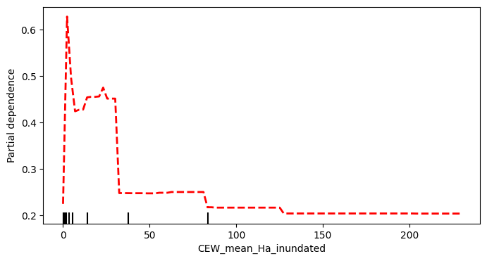
Figure E.2 ‘CEW frequency’ was the second-most influential feature in the machine-learning model for Australian painted snipe
This feature’s effect is strongest at sites that received Commonwealth environmental water (CEW) 9 or 10 times since 2014. This suggests a preference for wetlands that are regularly inundated. The black tick marks on the x-axis are the deciles of CEW frequency in the training data.
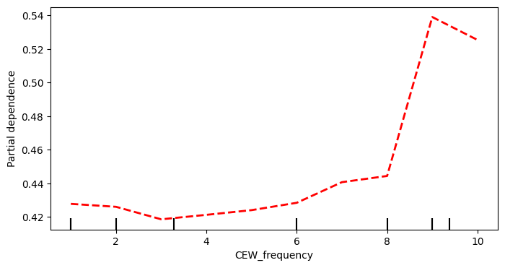
Figure E.3 ‘SD vegetation’ was the third-most influential feature in the machine-learning model for Australian painted snipe
This feature’s effect is strongest at sites with little variation in green vegetation at the site. This suggests a preference for wetlands with more stable vegetation communities. Possibly those that are regularly inundated, and possibly a preference for wetlands in higher rainfall areas. The black tick marks on the x-axis are the deciles of SD vegetation in the training data.
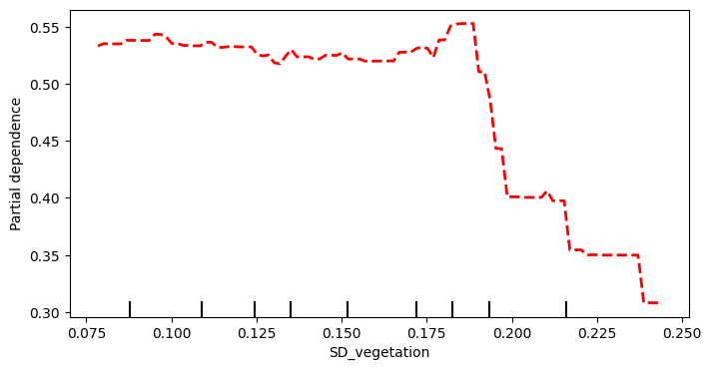
Figure E.4 ‘Median duration’ was the fourth-most influential feature in the machine-learning model for Australian painted snipe
This feature’s effect was strongest in wetlands with a hydroperiod of less than 100 days. This suggests a preference for wetlands that dry intermittently. The black tick marks on the x-axis are the deciles of Median duration in the training data.
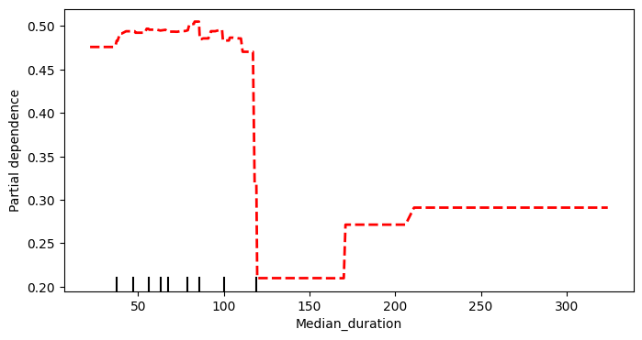
Figure E.5 ‘Weighted SD water’ was the fifth-most influential feature in the machine-learning model for Australian painted snipe
This feature’s effect was strongest in wetlands with variable inundation. This suggests a preference for wetlands with variable hydrology. The black tick marks on the x-axis are the deciles of Weighted SD water in the training data.
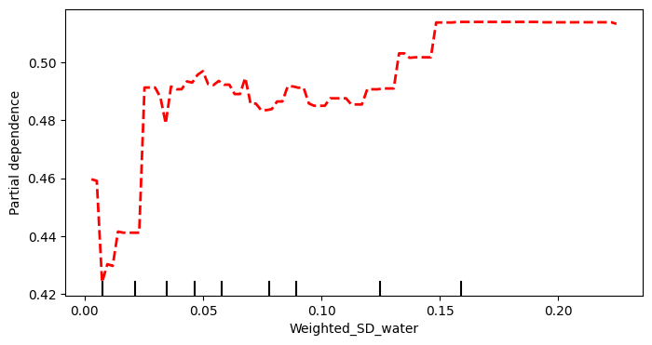
Figure E.6 ‘Mean gap’ was the sixth-most influential feature in the machine-learning model for Australian painted snipe
This feature’s effect was variable across its range. This suggests that the gap between successive filling events is not critical for this species. The variability might be related to the local vegetation response. The black tick marks on the x-axis are the deciles of Mean gap in the training data.
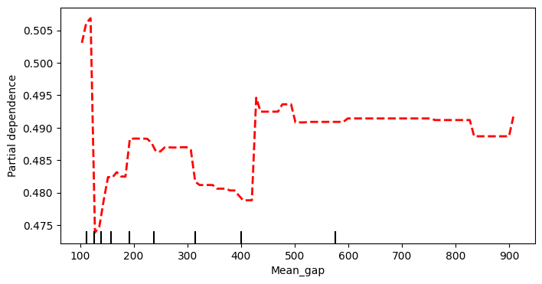
Figure E.7 ‘Mean vegetation’ was the seventh-most influential feature in the machine-learning model for Australian painted snipe
This feature’s effect was strongest in wetlands with a higher proportion of green vegetation. The black tick marks on the x-axis are the deciles of Mean vegetation in the training data.
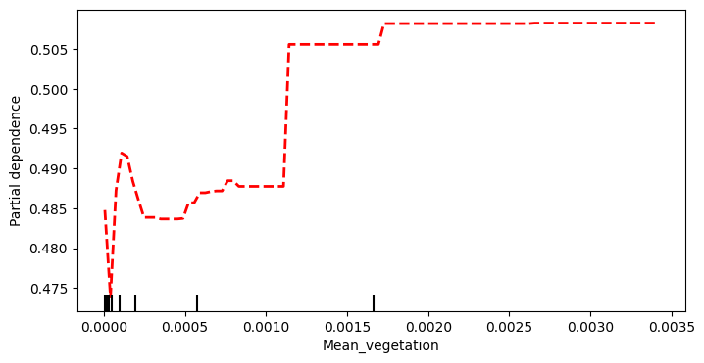
Figure E.8 ‘Longest gap’ was the least influential feature in the machine-learning model for Australian painted snipe
This feature’s effect is in opposition to higher-ranked features (i.e. CEW frequency) and is unsuitable for inference. The black tick marks on the x-axis are the deciles of Longest gap in the training data.
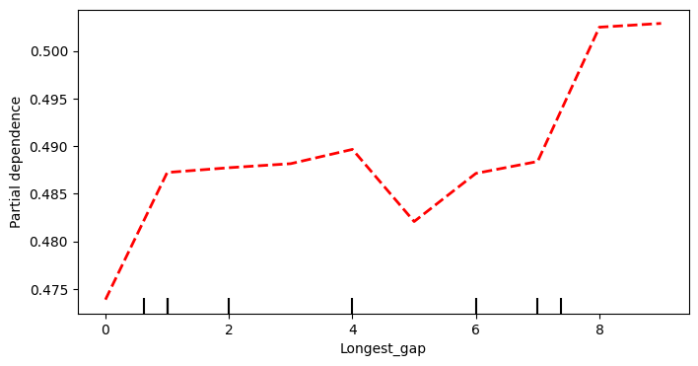

- Model results: Common greenshank
A total of 1,192 ANAE polygons were included in the machine-learning models for common greenshank. This included 517 ANAE polygons with a detection since 2014–15 and 675 without. A further 158 synthetic samples were generated with the species detected. The final dataset had 1,350 rows.
The best-performing random-forest model for common greenshank used bootstrapping, using 6 predictors when constructing a new branch. It considered no fewer than 10 samples at each split and grew 1,000 trees. The best-performing random-forest model correctly predicted 81.5% of the test dataset.
The best-performing Light GBM model used 0.8 of each column when building trees, used a learning rate of 0.05, and grew trees to a maximum depth of 7 branches. It used a minimum of 5 samples when constructing a branch, or no fewer than 0.4 of the available samples, and grew a forest of 700 trees. The best-performing Light GBM model correctly predicted 81% of the test set (accuracy).
The best-performing CatBoost model grew depth-wise trees to a depth of 12 branches and had a learning rate of 0.001. It penalised new leaves (l2 leaf regression – 3.5) and continued training for 20 trees after overfitting was detected. The best-performing CatBoost model correctly predicted 81.7% of the test set.
The CatBoost model correctly identified the most classes and was selected for visualisation. All 3 algorithms classified with an accuracy greater than 80%, indicating a strong fit and reliable predictive performance. The most globally important features during Light GBM training for common greenshank were CEW frequency and SD vegetation. The least influential features were Mean vegetation and Median duration (Figure E.9 to Figure E.16).
Figure E.9 ‘CEW frequency’ was the most influential feature in the machine-learning model for common greenshanks
This feature’s effect was highest in wetlands that received Commonwealth environmental water (CEW) more frequently. This suggests a strong role of CEW in detection and a preference for habitats that receive regular inundation. The black tick marks on the x-axis are the deciles of CEW frequency in the training data.
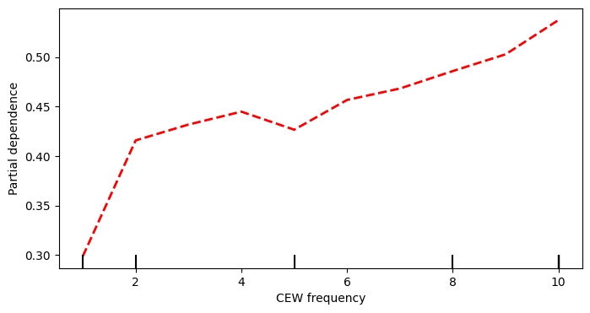
Figure E.10 ‘SD vegetation’ was the second-most influential feature in the machine-learning model for common greenshanks
This feature’s effect was highest in wetlands with stable vegetation communities. This suggests a preference for habitats with little variation in the proportion of green vegetation. The black tick marks on the x-axis are the deciles of SD Vegetation in the training data.
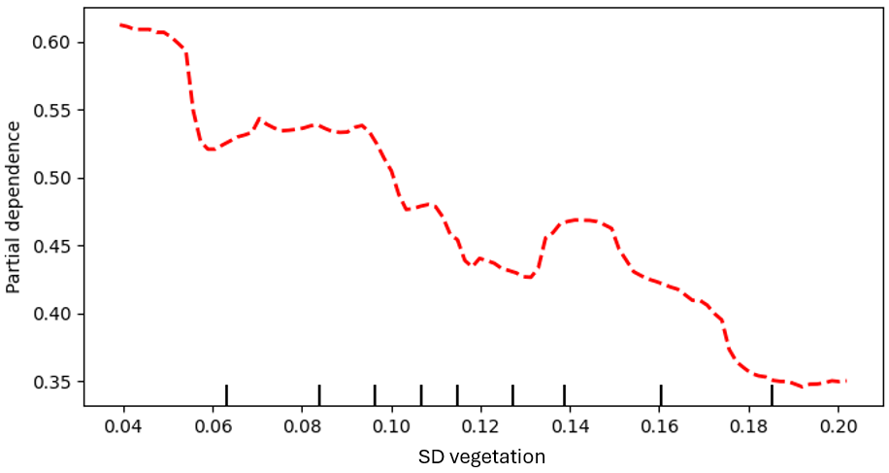
Figure E.11 ‘Longest gap’ was the third-most influential feature in the machine-learning model for common greenshanks
This feature’s effect was variable across its range. This suggests that the gap between successive deliveries of Commonwealth environmental water (CEW) is not a critical feature for this species (although it did help the model to distinguish local trends in wetlands). That said, the highest force was observed when CEW was delivered every year (mean gap = 0). The black tick marks on the x-axis are the deciles of Longest gap in the training data.
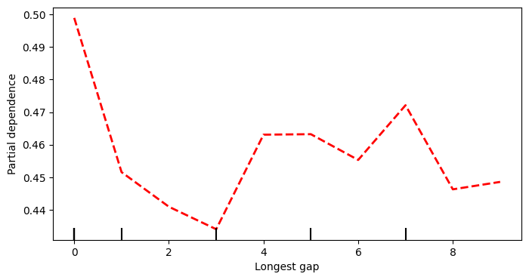
Figure E.12 ‘Weighted SD water’ was the fourth-most influential feature in the machine-learning model for common greenshanks
This feature’s effect was highest in wetlands with variable volume. This could reflect a preference for near-coastal habitats. The black tick marks on the x-axis are the deciles of Weighted SD water in the training data.
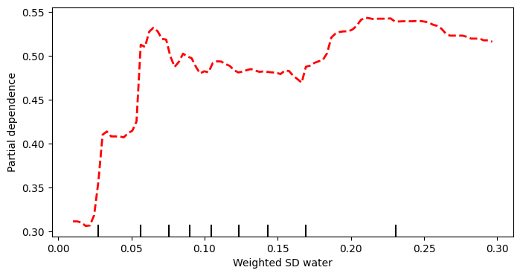
Figure E.13 ‘Mean gap’ was the fifth-most influential feature in the machine-learning model for common greenshanks
This feature’s effect was variable across its range, suggesting no clear preference for wetland drying. The black tick marks on the x-axis are the deciles of Mean gap in the training data.
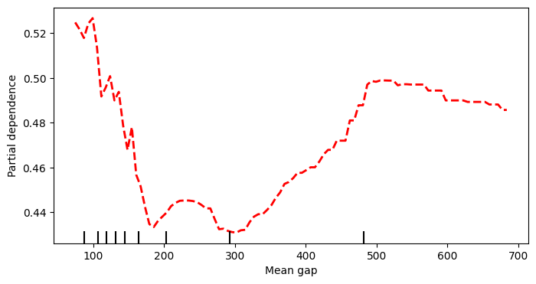
Figure E.14 ‘CEW mean Ha inundated’ was the sixth-most influential feature in the machine-learning model for common greenshanks
This feature’s effect was highest in wetlands that were inundated less by Commonwealth environmental water. The low relative influence and partial dependence of this feature indicates that it has less influence on detection. The black tick marks on the x-axis are the deciles of CEW mean Ha inundated in the training data. Note that most values in the training data are clustered at less than 5 ha.
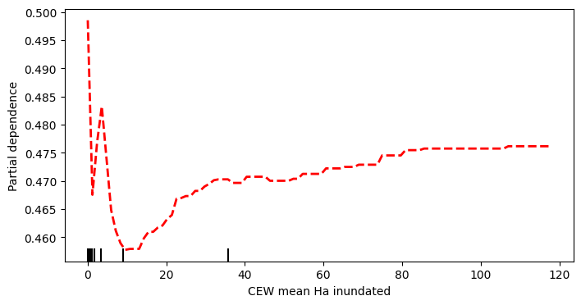
Figure E.15 ‘Median duration’ was the seventh-most influential feature in the machine-learning model for common greenshanks
The relative influence of this feature was low, suggesting that other features are more influential. However, the value range of wetland durations suggests that prolonged periods of drying are not favoured by this species. The black tick marks on the x-axis are the deciles of Median duration in the training data.
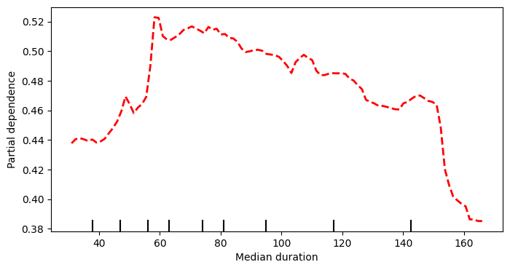
Figure E.16 ‘Mean vegetation’ was the least influential feature in the machine-learning model for common greenshanks
This feature’s effect was highest in wetlands with more vegetation; however, the values observed for this species were low compared to others, suggesting a limited interaction with photosynthesising vegetation. The black tick marks on the x-axis are the deciles of Mean vegetation in the training data.
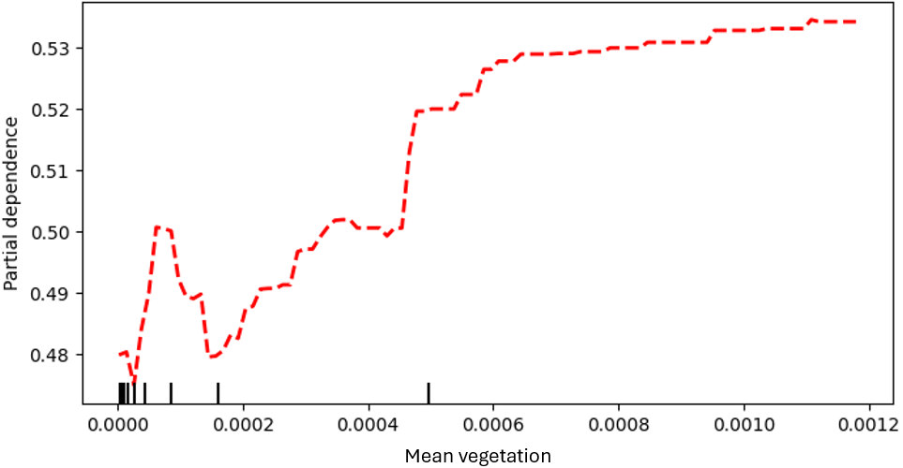
- Model results: Sharp-tailed sandpiper
A total of 1,614 ANAE polygons were included in the machine-learning models for sharp-tailed sandpiper. This included 878 ANAE polygons with a detection since 2014–15 and 636 without. A further 142 synthetic samples were generated with the species not detected. The final dataset had 1,756 rows.
The best-performing random-forest model for sharp-tailed sandpiper used bootstrapping, using 3 predictors when constructing a new branch. It considered no fewer than 12 samples at each split and grew 1,000 trees. The best-performing random-forest model correctly predicted 78.1% of the test dataset.
The best-performing Light GBM model used a learning rate of 0.05 and grew trees to a maximum depth of 7 branches. It used a minimum of 5 samples when constructing a branch, or no fewer than 0.4 of the available samples, and grew a forest of 700 trees. The best-performing Light GBM model correctly predicted 73.6% of the test set (accuracy).
The best-performing CatBoost model grew depth-wise trees to a depth of 12 branches and had a learning rate of 0.001. It penalised new leaves (l2 leaf regression – 3.5) and continued training for 20 trees after overfitting was detected. The best-performing CatBoost model correctly predicted 78.2% of the test set.
The CatBoost model correctly identified the most classes and was selected for visualisation. All 3 algorithms classified with an accuracy greater than 75% but less than 80%. This indicates an acceptable model fit and predictive performance but suggests that the model design is missing some important features for this species. The most globally important features during CatBoost training for sharp-tailed sandpiper were SD vegetation and Mean gap. The least influential features were Median duration and Longest gap (Figure E.17 to Figure E.24).
Figure E.17 ‘SD vegetation’ was the most influential feature in the machine-learning model for sharp-tailed sandpipers
This feature exerted a variable effect across the range of values in the dataset. The low relative influence and variable effect suggest that local trends are mitigated by other model features. The black tick marks on the x-axis are the deciles of SD vegetation in the training data.
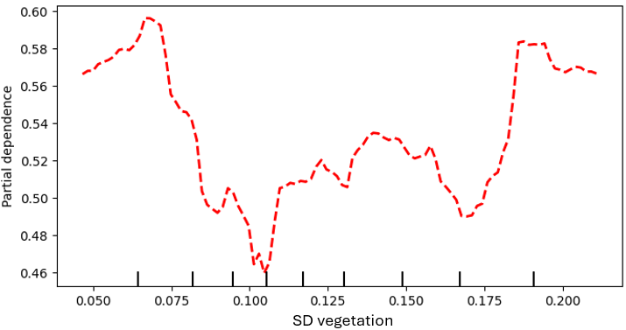
Figure E.18 ‘Mean gap’ was the second-most influential feature in the machine-learning model for sharp-tailed sandpipers
This feature exerted the strongest influence at lower values. This suggests a preference for wetlands that retain water for longer durations. The black tick marks on the x-axis are the deciles of Mean gap in the training data.
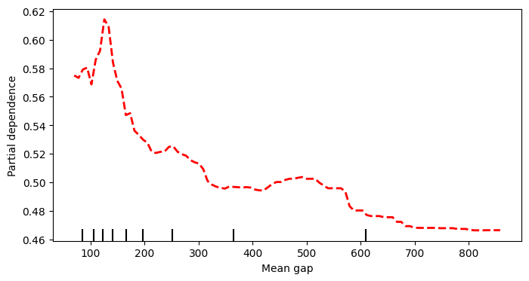
Figure E.19 ‘Weighted SD water’ was the third-most influential feature in the machine-learning model for sharp-tailed sandpipers
This feature’s effect was highest in wetlands that had variable wetted area. This suggests a preference for wetlands with variable hydrology. The black tick marks on the x-axis are the deciles of Weighted SD water in the training data.
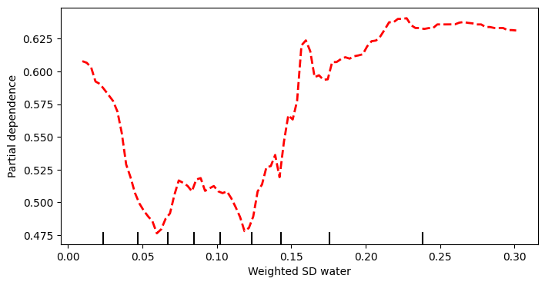
Figure E.20 ‘CEW mean Ha inundated’ was the fourth-most influential feature in the machine-learning model for sharp-tailed sandpipers
This feature’s effect was highest in wetlands that were inundated to greater extent by Commonwealth environmental water (CEW); however, most values in the training data were in the lowest range of this feature. This suggests a preference for wetlands that receive more CEW; however, the minima at approximately 5 ha indicates that this effect is mitigated by other model features. The black tick marks on the x-axis are the deciles of CEW mean Ha inundated in the training data.
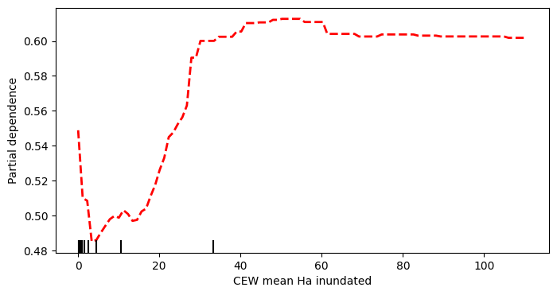
Figure E.21 ‘Mean vegetation’ was the fifth-most influential feature in the machine-learning model for sharp-tailed sandpipers
This feature exerted a variable effect across the range of values in the dataset; however, the concentration of values in the lowest range of this feature suggests a limited interaction with the vegetated area of the wetland. The black tick marks on the x-axis are the deciles of Mean vegetation in the training data.
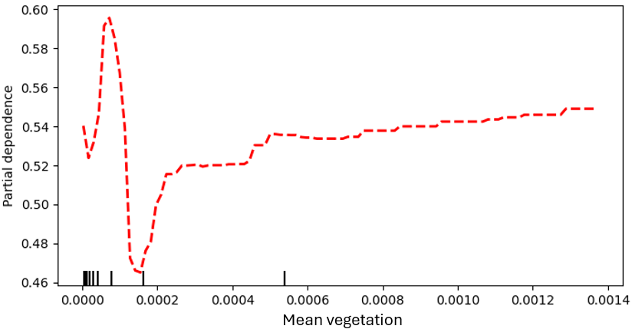
Figure E.22 ‘CEW frequency’ was the sixth-most influential feature in the machine-learning model for sharp-tailed sandpipers
This feature’s effect was high at most frequencies of Commonwealth environmental water (CEW) delivery, suggesting that CEW delivery is important for detection of this species, but regular delivery is not a strong indicator. The black tick marks on the x-axis are the deciles of CEW frequency in the training data.
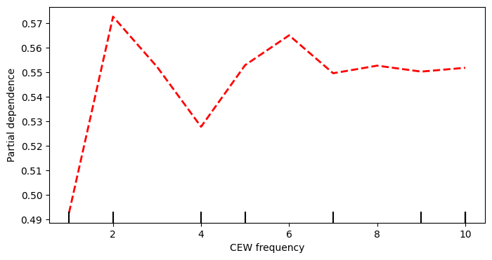
Figure E.23 ‘Median duration’ was the seventh-most influential feature in the machine-learning model for sharp-tailed sandpipers
This feature’s effect increased across the range of observed values; however, the variation in this effect suggests that this effect is mitigated by other model features. The black tick marks on the x-axis are the deciles of Median duration in the training data.
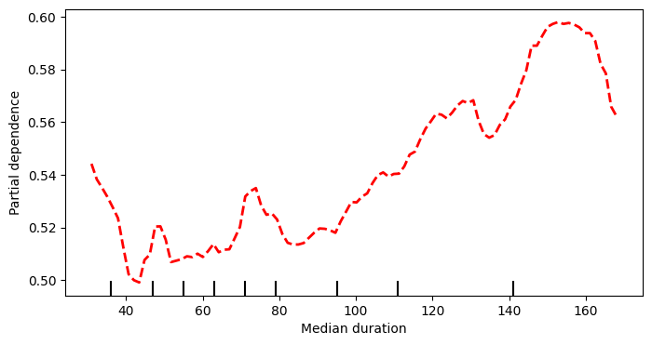
Figure E.24 ‘Longest gap’ was the least influential feature in the machine-learning model for sharp-tailed sandpipers
This feature exerted the strongest positive influence in wetlands with a shorter gap between successive deliveries of Commonwealth environmental water. The black tick marks on the x-axis are the deciles of Longest gap in the training data.
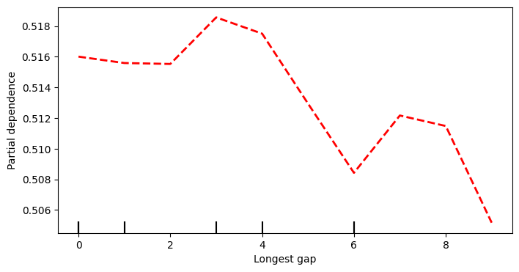
- Model results: Latham’s snipe
A total of 747 ANAE polygons were included in the machine-learning models for Latham’s snipe. This included 373 ANAE polygons with a detection since 2014–15 and 374 without. A single synthetic sample was generated with the species detected. The final dataset had 748 rows.
The best-performing random-forest model for Latham’s snipe used bootstrapping, using 2 predictors when constructing a new branch. It considered no fewer than 14 samples at each split and grew 4,000 trees. The best-performing random-forest model correctly predicted 76.5% of the test dataset.
The best-performing Light GBM model used a learning rate of 0.05 and grew trees to a maximum depth of 5 branches. It used a minimum of 10 samples when constructing a branch, or no fewer than 0.4 of the available samples, and grew a forest of 700 trees. The best-performing Light GBM model correctly predicted 73.4% of the test set (accuracy).
The best-performing CatBoost model grew depth-wise trees to a depth of 11 branches with a learning rate of 0.001. It penalised new leaves (l2 leaf regression – 3.5) and continued training for 20 trees after overfitting was detected. The best-performing CatBoost model correctly predicted 76.6% of the test set.
The CatBoost model correctly identified the most classes and was selected for visualisation. All 3 algorithms classified with an accuracy greater than 75% but less than 80%. This indicates an acceptable model fit and predictive performance but suggests that the model design is missing some important features for this species. The most globally important features during CatBoost training for Latham’s snipe were Weighted SD water and SD vegetation. The least influential features were CEW mean Ha inundated and Longest gap (Figure E.25 to Figure E.32).
Figure E.25 ‘Weighted SD water’ was the most influential feature in the machine-learning model for Latham’s snipe
This feature exerted a stronger force at higher values. This suggests a preference for wetlands with variable hydrology. The black tick marks on the x-axis are the deciles of Weighted SD water in the training data.
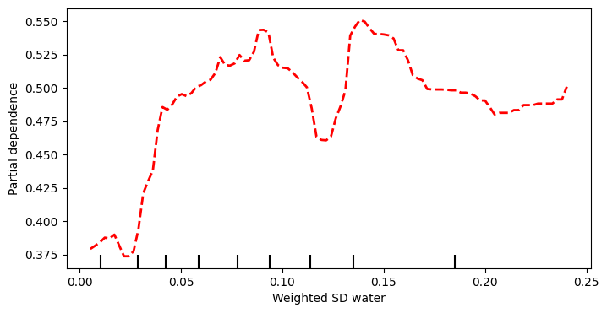
Figure E.26 ‘SD vegetation’ was the second-most influential feature in the machine-learning model for Latham’s snipe
This feature exerted a stronger effect in wetlands with variable photosynthesising vegetation. This feature suggests a preference for wetlands with variable inundation. The black tick marks on the x-axis are the deciles of SD vegetation in the training data.
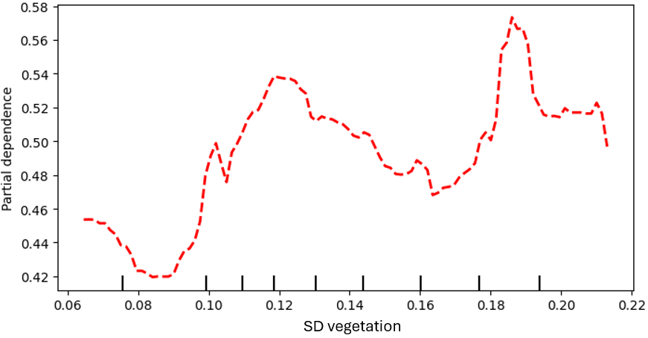
Figure E.27 ‘Mean gap’ was the third-most influential feature in the machine-learning model for Latham’s snipe
This feature exerted the strongest effect in wetlands with a shorter period between successive inundation events. The black tick marks on the x-axis are the deciles of Mean gap in the training data.
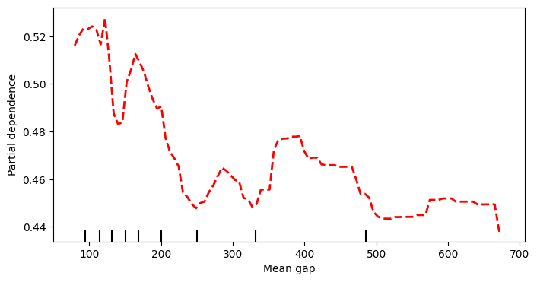
Figure E.28 ‘Mean vegetation’ was the fourth-most influential feature in the machine-learning model for Latham’s snipe
This feature exerted a stronger effect in wetlands with larger areas of photosynthesising vegetation; however, the local minima at approximately 0.0001 suggests that this effect is mitigated by other model features in some wetlands. The black tick marks on the x-axis are the deciles of Mean vegetation in the training data.
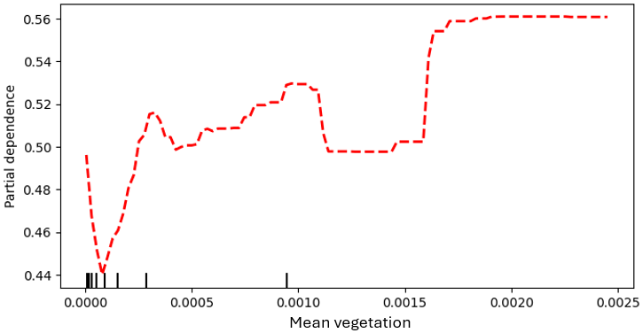
Figure E.29 ‘Median duration’ was the fifth-most influential feature in the machine-learning model for Latham’s snipe
The influence of this feature declined at higher values, suggesting that wetlands that fill for shorter durations could improve detection. The black tick marks on the x-axis are the deciles of Median duration in the training data.
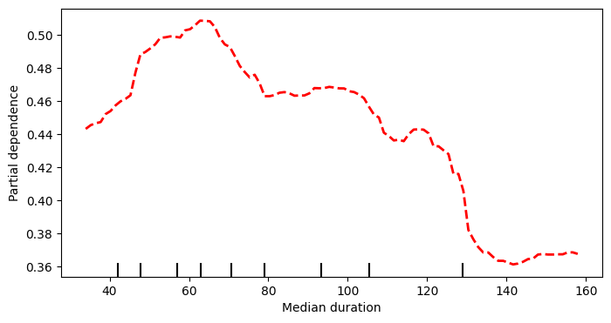
Figure E.30 ‘CEW mean Ha inundated’ was the sixth-most influential feature in the machine-learning model for Latham’s snipe
This feature exerted a positive effect across most of the values that were present in the training data. The weakest effect was observed at the lowest values of this feature, suggesting that there is a lower threshold for this effect. The black tick marks on the x-axis are the deciles of CEW mean Ha inundated in the training data.
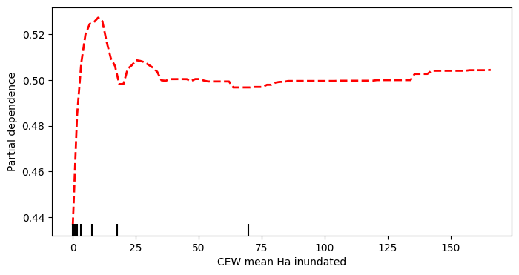
Figure E.31 ‘CEW frequency’ was the seventh-most influential feature in the machine-learning model for Latham’s snipe
This feature exerted variable effect across the range of observed values and a low force was exerted at sites that received Commonwealth environmental water every year, and only once. The low relative influence and mild partial dependence suggests that this feature was not critical in the model decisions. The black tick marks on the x-axis are the deciles of CEW frequency in the training data.
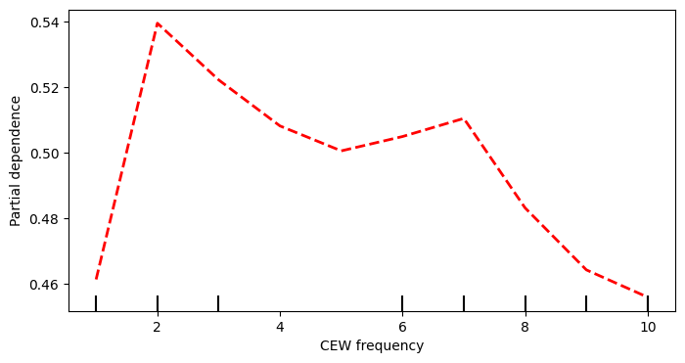
Figure E.32 ‘Longest gap’ was the least influential feature in the machine-learning model for Latham’s snipe
This feature exerted a stronger effect in wetlands that received Commonwealth environmental water less often; however, the low relative influence and mild partial dependence suggests that the importance of this feature is limited. The black tick marks on the x-axis are the deciles of Longest gap in the training data.
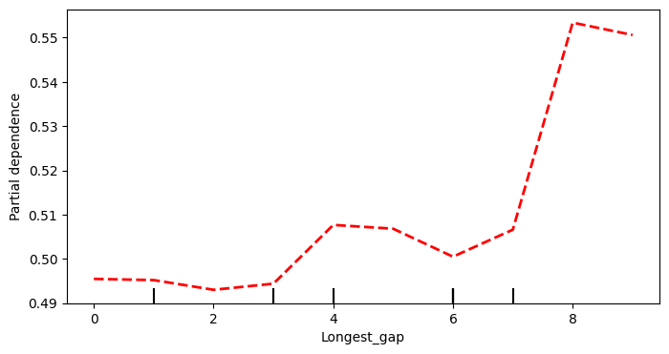
- Model results: Superb parrot
A total of 1,404 ANAE polygons were included in the machine-learning models for superb parrot. This included 774 ANAE polygons with a detection since 2014–15 and 630 without. A further 144 synthetic samples were generated with the species not detected. The final dataset had 1,548 rows.
The best-performing random-forest model for superb parrot used bootstrapping, using 5 predictors when constructing a new branch. It considered no fewer than 10 samples at each split and grew 5,000 trees. The best-performing random forest model correctly predicted 73.5% of the test dataset.
The best-performing Light GBM model used 0.4 of each column when building trees, used a learning rate of 0.05, and grew trees to a maximum depth of 7 branches. It used a minimum of 5 samples when constructing a branch, or no fewer than 0.4 of the available samples, and grew a forest of 700 trees. The best-performing Light GBM model correctly predicted 71.6% of the test set (accuracy).
The best-performing CatBoost model grew depth-wise trees to a depth of 10 branches and had a learning rate of 0.001. It penalised new leaves (l2 leaf regression – 3.5) and continued training for 20 trees after overfitting was detected. The best-performing CatBoost model correctly predicted 71.3% of the test set.
The random-forest model correctly identified the most classes but was below our threshold of 75% accuracy. Plotting of random-forest models is limited, and the partial dependence plots presented below were generated from the LightGBM model. All 3 algorithms classified with an accuracy less than the threshold of 75%, indicating a weak fit and unreliable predictive performance.
Figure E.33 Global importance of each feature in the superb parrot model
Most of the features (blue bars) exerted a similar influence when classifying the detection of super parrot detections since 2014–15, except for Longest gap. For an explanation of each feature see Table 6.11. This plot includes feature redundancy clustering (on the right of the plot). CEW = Commonwealth environmental water.
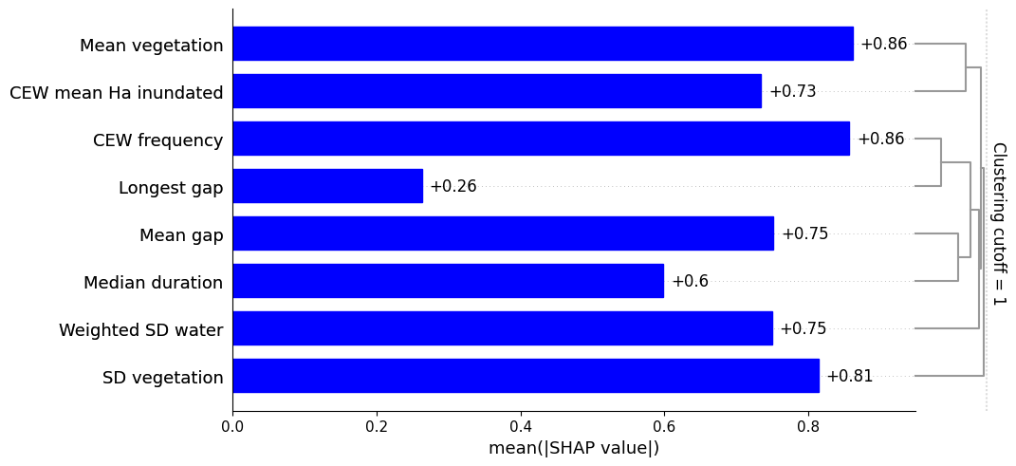
Figure E.34 ‘CEW frequency’ was the most influential feature in the machine-learning model for superb parrots
This feature’s effect was high across the range of values, and there was a very strong negative influence for wetlands that received Commonwealth environmental water (CEW) either 7 or 8 times. This suggests that CEW delivery does not play a strong role in the detection of this species; however, the strong negative force observed in some wetlands might indicate that CEW delivery to these specific wetlands is unsuitable for this species. The black tick marks on the x-axis are the deciles of CEW frequency in the training data.
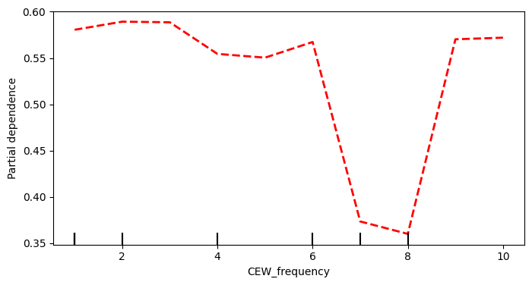
Figure E.35 ‘Mean vegetation’ was the second-most influential feature in the machine-learning model for superb parrots
This feature’s effect was variable across its range and had no clear pattern. The black tick marks on the x-axis are the deciles of Mean vegetation in the training data.
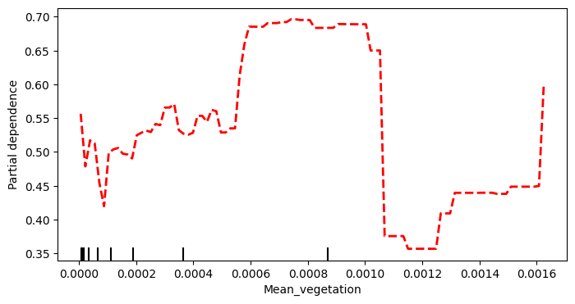
Figure E.36 ‘SD vegetation’ was the third-most influential feature in the machine-learning model for superb parrots
This feature’s effect was variable across its range and had no clear pattern. The black tick marks on the x-axis are the deciles of SD vegetation in the training data.
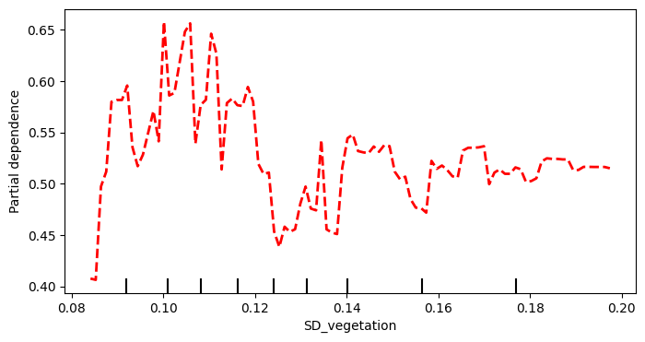
Figure E.37 ‘Mean gap’ was the fourth-most influential feature in the machine-learning model for superb parrots
This feature’s effect was variable across its range and had no clear pattern. The black tick marks on the x-axis are the deciles of Mean gap in the training data.
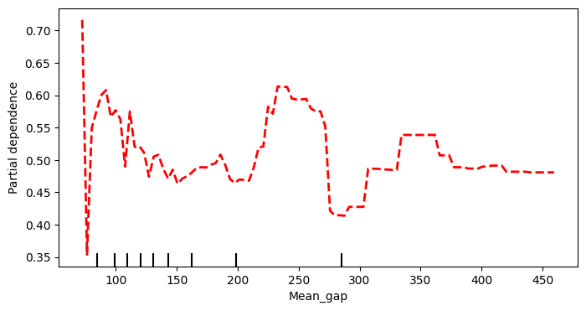
Figure E.38 ‘Weighted SD water’ was the fifth-most influential feature in the machine-learning model for superb parrots
This feature’s effect was variable across its range and had no clear pattern. The black tick marks on the x-axis are the deciles of Weighted SD water in the training data.
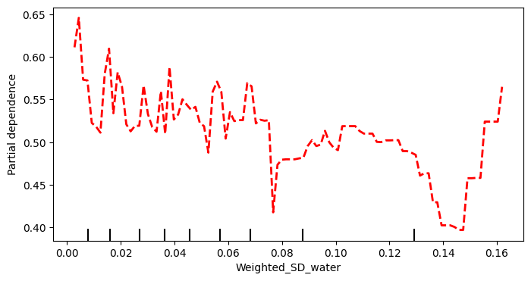
Figure E.39 ‘CEW mean Ha inundated’ was the sixth-most influential feature in the machine-learning model for superb parrots
This exerted a stronger influence in wetlands that were inundated to a greater extent. The black tick marks on the x-axis are the deciles of CEW mean Ha inundated in the training data.
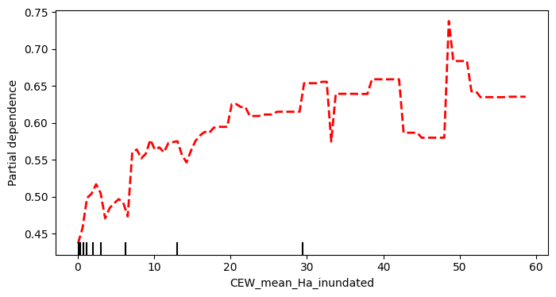
Figure E.40 ‘Median duration’ was the seventh-most influential feature in the machine-learning model for superb parrots
This feature’s effect was variable across its range and had no clear pattern. The black tick marks on the x-axis are the deciles of Median duration in the training data.
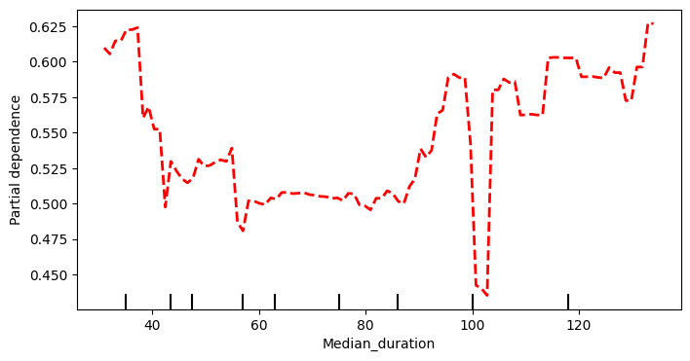
Figure E.41 ‘Longest gap’ was the least influential feature in the machine-learning model for superb parrots
This feature showed a weak positive effect in wetlands that received Commonwealth environmental water (CEW) less frequently; however, the low rank of this feature and the weak extent of the partial dependence suggests no clear pattern. The black tick marks on the x-axis are the deciles of Longest gap in the training data.

Abbreviations and terms
Abbreviation/Term | Description
2014–24 | water years, 1 July 2014 to 30 June 2024
2023–24 | water year, 1 July 20232 to 30 June 2024
ACT NC Act | Nature Conservation Act 2014 (Australian Capital Territory)
ALA | Atlas of Living Australia
ANAE | Australian National Aquatic Ecosystem (classification) (Brooks 2021)
ANOSIM | analysis of similarities
AUC | area under the curve (used in describing the pilot study modelling)
the Basin | shortened form for the Murray–Darling Basin
the Basin Plan | shortened form for the (Murray–Darling) Basin Plan 2012
Bonn Convention | Convention on the Conservation of Migratory Species of Wild Animals
CAMBA | China–Australia Migratory Bird Agreement
CEW | Commonwealth environmental water
CEWH | Commonwealth Environmental Water Holder
counterfactual | In the counterfactual approach, Commonwealth environmental water is removed from the observed streamflow time series, creating a hypothetical (counterfactual) daily streamflow time series with no Commonwealth environmental water. This approach is used to infer the effects of Commonwealth environmental water, when experimental design with controls or before–after comparisons isn’t possible.
EPBC Act | Australian Environment Protection and Biodiversity Conservation Act 1999
Flow-MER | the CEWH’s Science Program: Flow Monitoring, Evaluation and Research (2019–20 to 2022–23)
GBM | gradient-boosting machine
GIS | geographical information system
JAMBA | Japan–Australia Migratory Bird Agreement
LTIM | Long Term Intervention Monitoring Project (2014–15 to 2018–19)
NSW BC Act | Biodiversity Conservation Act 2016 (New South Wales)
NSW DCCEEW | NSW Department of Climate Change, Energy, the Environment and Water
PERMANOVA | permutational multivariate analysis of variance
Qld NC Act | Nature Conservation Act 1992 (Queensland)
ROKAMBA | Republic of Korea–Australia Migratory Bird Agreement
SA NPW Act | National Parks and Wildlife Act 1972 (South Australia)
SD | standard deviation
SHAP value | Shapley additive explanations (Shapley values) are a set of metrics that draw on cooperative game theory to evaluate the relative contribution of each player in achieving a combined payoff
Shapley plot | Shapley values plotted to show relative feature contributions when assigning outcome class
the Strategy | the Basin-wide environmental watering strategy (MDBA 2019)
Vic FFG Act | Flora and Fauna Guarantee Act 1988 (Victoria)
WAR | Watering Action Reference
WIT | Wetlands Insight Tool (Dunn et al. 2023)

References
Baumgartner L, Hale J and Gawne B (2015) Commonwealth Environmental Water Office Long Term Intervention Monitoring Basin Matter–Aggregation of Selected Area biodiversity outcomes (generic diversity) foundation report Final Report prepared for the Commonwealth Environmental Water Office by The Murray-Darling Freshwater Research Centre.
Brooks S (2021) ANAE Classification of the Murray-Darling Basin Technical Report, Revision 3.0, March 2021. Technical report for the Commonwealth Environmental Water Office, Department of Agriculture, Water and the Environment, Australia.
Brooks S, Cottingham P, Butcher R and Hale J (2014) Murray-Darling Basin aquatic ecosystem classification: Stage 2 report. Peter Cottingham & Associates report to the Commonwealth Environmental Water Office and Murray-Darling Basin Authority, Canberra.
CEWH (2024) 2023–24 Flow-MER watering actions table. Prepared by Science Division, Commonwealth Environmental Water Holder, Department of Climate Change, Energy, the Environment and Water, Canberra. Unpublished.
CEWH (2024a) Monitoring, Evaluation and Research Program: Gwydir River Selected Area 2023-24 Annual Technical Report. Commonwealth Environmental Water Holder, Department of Climate Change, Energy, the Environment and Water, Canberra, Australia.
CEWH (2024b) Monitoring, Evaluation and Research Program: Junction of the Warriku (Warrego) and Baaka (Darling) Rivers Selected Area Monitoring, Evaluation and Research Technical Report (2023-2024). Commonwealth Environmental Water Holder, Department of Climate Change, Energy, the Environment and Water, Canberra, Australia..
CEWH (2024c) Watering Action Acquittal Report. Gwydir Valley 2023–24. Commonwealth Environmental Water Holder, Department of Climate Change, Energy, the Environment and Water, Canberra, Australia. Unpublished
CEWH (2024d) Watering Action Acquittal Report. Intersecting Streams – Moonie and Warrego rivers 2023–24. Commonwealth Environmental Water Holder, Department of Climate Change, Energy, the Environment and Water, Canberra, Australia. Unpublished
CEWH (2024e) Watering Action Acquittal Report. Peel River 2023–24. Commonwealth Environmental Water Holder, Department of Climate Change, Energy, the Environment and Water, Canberra, Australia. Unpublished
CEWH (2024f) Watering Action Acquittal Report. Condamine–Balonne Valley 2023–24. Commonwealth Environmental Water Holder, Department of Climate Change, Energy, the Environment and Water, Canberra, Australia. Unpublished d
CEWH (2024g) Watering Action Acquittal Report. Edward Kolety-Wakool River System 2023-24. Commonwealth Environmental Water Holder, Department of Climate Change, Energy, the Environment and Water, Canberra, Australia. Unpublished d
CEWH (2024h) Watering Action Acquittal report. Lachlan River system 2023-24. Commonwealth Environmental Water Holder, Department of Climate Change, Energy, the Environment and Water, Canberra, Australia. Unpublished d
CEWH (2024i) Watering Action Acquittal Report. Lower Darling/Baaka & Great Darling Anabranch 2023-24. Commonwealth Environmental Water Holder, Department of Climate Change, Energy, the Environment and Water, Canberra, Australia. Unpublished
CEWH (2024j) Watering Action Acquittal Report. Lower Murray wetlands (MRL Board) 2023–24. Commonwealth Environmental Water Holder, Department of Climate Change, Energy, the Environment and Water, Canberra, Australia. Unpublished
CEWH (2024k) Watering Action Acquittal Report. Lower River Murray channel, Coorong, Lower Lakes and Murray Mouth 2023-24. Commonwealth Environmental Water Holder, Department of Climate Change, Energy, the Environment and Water, Canberra, Australia. Unpublished
CEWH (2024l) Watering Action Acquittal Report. Macquarie 2023–24. C Commonwealth Environmental Water Holder, Department of Climate Change, Energy, the Environment and Water, Canberra, Australia. Unpublished
CEWH (2024m) Watering Action Acquittal Report. Renmark Irrigation Trust (RIT) 2023-24. Commonwealth Environmental Water Holder, Department of Climate Change, Energy, the Environment and Water, Canberra, Australia. Unpublished
CEWH (2024n) Watering Action Acquittal Report. River Murray Flows and Barmah-Millewa Forest Regulators 2023-24. Commonwealth Environmental Water Holder, Department of Climate Change, Energy, the Environment and Water, Canberra, Australia. Unpublished
CEWH (2024o) Watering Action Acquittal Report. Wimmera River flows 2023–24. Commonwealth Environmental Water Holder, Department of Climate Change, Energy, the Environment and Water, Canberra, Australia. Unpublished
Commonwealth of Australia (2017) Survey guidelines for Australia’s threatened birds: Guidelines for detecting birds listed as threatened under the Environment Protection and Biodiversity Conservation Act 1999. Commonwealth of Australia Canberra
NSW DCCEEW (2024a) Gwydir wetlands system frog monitoring 2023-24 update. NSW Department of Climate Change, Energy, the Environment and Water, Sydney.
NSW DCCEEW (2024b) Macquarie Marshes frog monitoring: 2023-24 update. NSW Department of Climate Change, Energy, the Environment and Water, Sydney.
NSW DCCEEW (2024c) Macquarie Marshes waterbird surveys: 2023-24 update. NSW Department of Climate Change, Energy, the Environment and Water, Sydney.
Dunn B, Ai E, Alger MJ, Fanson B, Fickas KC, Krause CE, Lymburner L, Nanson R, Papas P and Ronan M (2023) Wetlands Insight Tool: Characterising the Surface Water and Vegetation Cover Dynamics of Individual Wetlands Using Multidecadal Landsat Satellite Data. Wetlands 43(4): 37.
Ecology & Heritage Partners (2024) TLM annual waterbird monitoring in Barmah-Millewa Forest (2023/24). Moama.
Francis R, Lenehan J, Carnegie M and Brandis KJ (2024) Lake Brewster Australian pelican breeding site surveyed with a drone 2023–24, Final report for the NSW Department of Climate Change, Energy, the Environment and Water (DCCEEW). Sydney.
Francis RJ and Brandis KJ (2024) Dharriwaa-Narran Lakes Australian pelican nesting site surveyed with a drone 2023–24. Final report for the NSW Department of Climate Change, Energy, the Environment and Water (DCCEEW). Sydney.
Geyle HM, Hoskin CJ, Bower DS, Catullo R, Clulow S, Driessen M, Daniels K, Garnett ST, Gilbert D and Heard GW (2021) Red hot frogs: identifying the Australian frogs most at risk of extinction. Pacific Conservation Biology 28(3): 211-223.
Hale J, Bond N, Brooks S, Capon S, Grace M, Guarino F, James C, King A, McPhan L and Mynott J (2020) Murray-Darling Basin Long Term Intervention Monitoring Project.
Krause C, Dunn B, Bishop-Taylor R, Adams C, Burton C, Alger M, Chua S, Phillips C, Newey V, Kouzoubov K, Leith A, Ayers D, Hick, A and DEA Notebooks contributors (2021) "Digital Earth Australia notebooks and tools repository. Geoscience Australia, Canberra. doi.org/10.26186/145234."
Luedtke JA, Chanson J, Neam K, Hobin L, Maciel AO, Catenazzi A, Borzée A, Hamidy A, Aowphol A and Jean A (2023) Ongoing declines for the world’s amphibians in the face of emerging threats. Nature 622(7982): 308-314.
Mathwin R, Wassens S, Gibb, MS, Young J, Ye Q, Saltré F and Bradshaw CJ (2023) Modeling the effects of water regulation on the population viability of a threatened amphibian. Ecosphere 14(1): e4379.
Mathwin R, Wassens S, Gibbs MS, Young J, Ye, Q Saltré F and Bradshaw CJ (2024) Stochastic metapopulation dynamics of a threatened amphibian to improve water delivery. Ecosphere 15(1): e4741.
Mathwin R, Wassens S, Gibbs MS, Young J, Ye Q, Saltré F and Bradshaw CJA (2022) Forecasting the effects of water regulation on the population viability of a threatened amphibian. bioRxiv: 2021.2004.2020.440713.
MDBA (2017) Waterbirds of the Murray–Darling Basin; 2017 Basin Plan Evaluation. Murray–Darling Basin Authority. Canberra ACT
O’Sullivan J and Cuddy SM (2024) Flow-MER Basin-scale evaluations of Commonwealth environment water: Methods. Flow-MER Program. Commonwealth Environmental Water Holder (CEWH), Department of Climate Change, Energy, the Environment and Water, Australia.
O’Sullivan J and Cuddy SM (2025) Flow-MER Basin-scale evaluations of Commonwealth environment water: Methods. 2025 Edition. Flow-MER Program. Commonwealth Environmental Water Holder (CEWH), Department of Climate Change, Energy, the Environment and Water, Australia.
Ocock J and Wassens S (2018a) The Status of Decline and Conservation of Frogs in the Arid and Semi-arid Zones of Australia. Status of conservation and decline of amphibians: Australia, new Zealand and Pacific Islands. H. Heatwole and J. Rowley. Canberra, CSIRO Publishing. 11: 248.
Ocock J and Wassens S (2018b) The status of decline and conservation of frogs in the arid and semi-arid zones of Australia. Status of Conservation and Decline of Amphibians: Australia, New Zealand and Pacific Islands. CSIRO Publishing, Clayton South, VIC: 91-106.
Ocock JF, Kingsford RT, Penman TD and Rowley JJ (2014) Frogs during the flood: differential behaviours of two amphibian species in a dryland floodplain wetland. Austral Ecology 39(8): 929-940.
Porter J, Kingsford R, Francis R and Brandis K (2021) Aerial Survey of Waterbirds in Eastern Australia - October 2021 Annual Summary Report. Centre for Ecosystem Science, UNSW. Sydney.
Porter J, Kingsford R, Francis R, Brandis K, Ahern A, Tidou Y and Simpson D (2024) Eastern Australian Waterbird Aerial Survey - October 2024 Annual Summary Report. Sydney.
Robinson NM, Scheele BC, Legge S, Southwell DM, Carter O, Lintermans M, Radford JQ, Skroblin A, Dickman CR and Koleck J (2018) How to ensure threatened species monitoring leads to threatened species conservation. Ecological Management & Restoration 19(3): 222-229.
Ryan A, Colloff MJ and Pittock J (2021) Flow to nowhere: the disconnect between environmental watering and the conservation of threatened species in the Murray–Darling Basin, Australia. Marine and Freshwater Research.
Sengupta A, Egger F and Weber T (2025) Basin-scale evaluation of 2023–24 Commonwealth environmental water: Hydrology. Flow-MER Program. Commonwealth Environmental Water Holder, Department of Climate Change, Energy, the Environment and Water, Australia.
Wassens S and Hall A (2022) Basin-scale evaluation of 2020–21 Commonwealth environmental water: Species Diversity. Flow-MER Program. Commonwealth Environmental Water Holder, Department of Climate Change, Energy, the Environment and Water, Australia.
Wassens S and Hall A (2023) Basin-scale evaluation of 2021–22 Commonwealth environmental water: Species diversity. Flow-MER Program. Commonwealth Environmental Water Holder, Department of Climate Change, Energy, the Environment and Water, Australia.
Wassens S, Mathwin R and Hall A (2024) Basin-scale evaluation of 2022–23 Commonwealth environmental water: Species Diversity. Australia. Flow-MER Program. Commonwealth Environmental Water Holder, Department of Climate Change, Energy, the Environment and Water, Australia
Wassens S, Poynter C, Brooks S and McGinness H (2021) Basin-scale evaluation of 2019–20 Commonwealth environmental water: Species Diversity. Flow-MER Program. Commonwealth Environmental Water Office (CEWO), Department of Agriculture, Water and the Environment, Australia. 104pp.
Wassens S, Spencer J, Heath J, Kobayashi T, Stocks J, Mathwin R, Talbot S, Bino G, Walcott A, Cain V, Francis R, Gopalakrishnan T, Grimmett L, Prasad K and Hall A (2024b) Commonwealth Environmental Water Holder Monitoring, Evaluation and Research Program Murrumbidgee River System Technical Report 2014-24 Commonwealth of Australia. Canberra.
Wassens S, Watts RJ, Jansen A and Roshier D (2008) Movement patterns of southern bell frogs (Litoria raniformis) in response to flooding. Wildlife Research 35(1): 50-58.

https://flow-mer.org.au
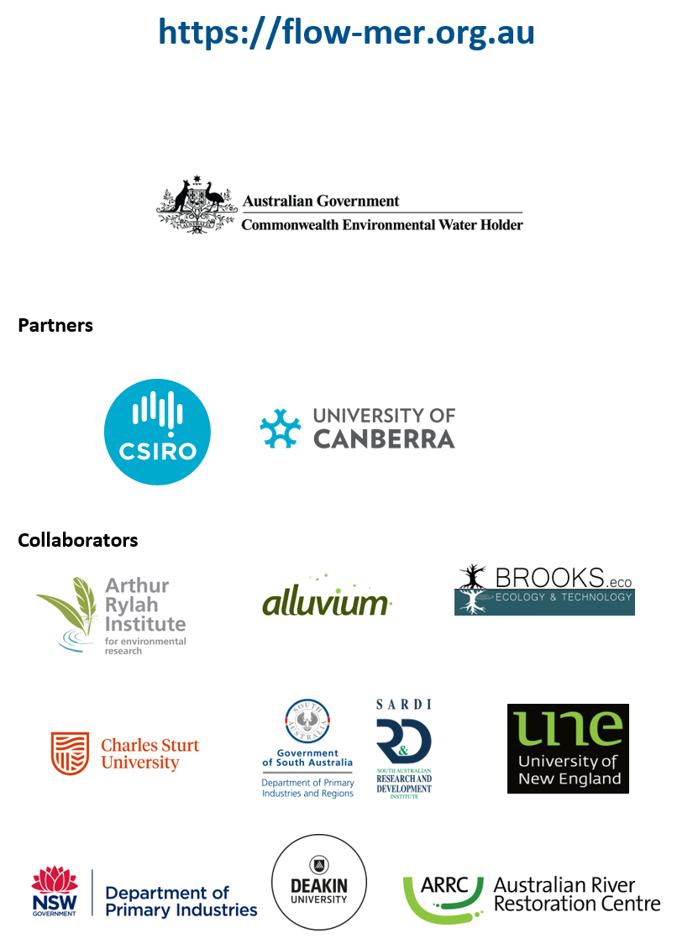

At the time of writing, the 2025 edition of the Strategy was not available. 2023–24 evaluations reference the 2019 edition (MDBA 2019).
The Long Term Intervention Monitoring and Environmental Water Knowledge and Research projects (2014–19)
In the counterfactual approach, CEW is removed from the observed streamflow time series, creating a hypothetical (counterfactual) daily streamflow time series with no CEW. This approach is used to infer the effects of CEW, as an experimental design with controls and/or before–after comparisons is not possible.
In these evaluations, it is not possible to attribute the Commonwealth’s contribution separately to other environmental water under the current methods.
At the time of writing, the 2025 edition of the Strategy was not available. 2023–24 evaluations reference the 2019 edition (MDBA 2019).
PERMANOVA Valley Pseudo F 34.448, p(perm) < 0.001
PERMANOVA CEW Delivered Pseudo F 0.767, p(perm) = 0.666
PERMANOVA CEWxValley Pseudo F 3.956, p(perm) = 0.003
PERMANOVA Murrumbidgee CEW Pseudo F 5.8236, p(perm) < 0.001
PERMANOVA JWD CEW Pseudo F 1.870 p(perm) = 0.085
Commonwealth Environmental Water Holder (2024) Watering Action Acquittal Report. Condamine–Balonne Valley 2023–24. Commonwealth of Australia. Canberra.
Commonwealth Environmental Water Holder (2024) Watering Action Acquittal Report. Lachlan River system 2023–24. Commonwealth of Australia. Canberra.
Generalised Linear Model Tests of Model Effects species richness. Water source Wald 21.164, p < 0.001, Valley (Wald 6.553, p = 0.038, proportion wetted area Wald 76.567, p < 0.001.
Linear regression model, Overall (R² = 0.055, F = 82.064, p < 0.001), JWD (R² = 0.067, F = 5.824, p = 0.018), Gwydir (R² = 0.056, F = 30.754, p < 0.001), Murrumbidgee (R² = 0.078, F = 67.151, p < 0.001).
At the time of writing the 2025 edition of the Strategy was not available.
CEWH Watering Action Reference (WAR 10050-02)
CEWH multiple watering actions 2017–18 (WAR 10065-04)
CEWH Watering Action Reference (WAR) 10117-14, 10119-12,10119-18

