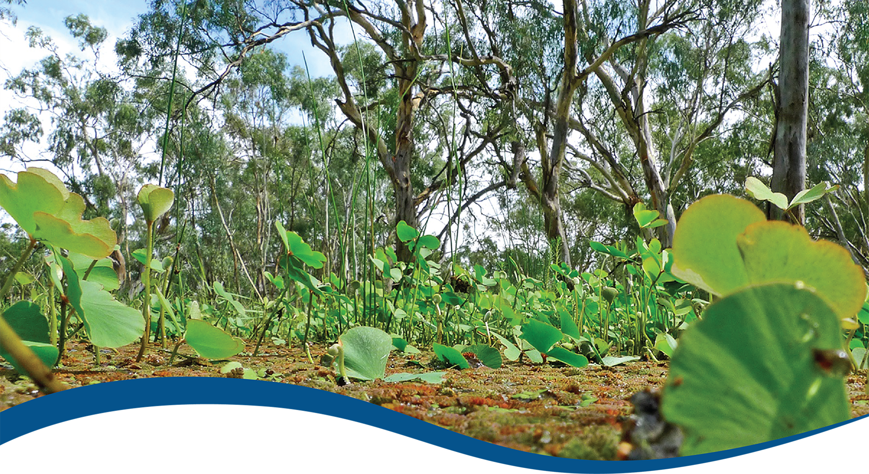
Basin-scale evaluation of 2023–24 Commonwealth environmental water: Vegetation
  - Commonwealth Environmental Water Holder’s Science Program:
Flow Monitoring, Evaluation and Research Program (Flow-MER)
June 2025
Acknowledgement of Country
The team and the Commonwealth Environmental Water Holder’s Science Program respectfully acknowledge the Traditional Owners of the lands and waters of the Murray–Darling Basin, their Elders past and present, their Nations of the Murray–Darling Basin, and their cultural, social, environmental, spiritual and economic connection to their lands and waters.
The river and its tributaries are known by many names including: Millewa (Ngarrindjeri name for the main Murray channel in South Australia), Baarka (Barkindji; Darling River, inland New South Wales), Warring (Taungurung; Goulburn River, Victoria), Kolety (Wamba Wamba; Edwards River, inland NSW), Kalari (Wiradjuri; Lachlan River, inland NSW), Murrumbidjeri (Wiradjuri; Murrumbidgee River, inland NSW) and Guwayda (Kamilaroi; Gwydir River, northern NSW), amongst others. While the European names will be most commonly used in this report, the authors recognise the important associations and history of the Indigenous names for rivers and streams in the Murray–Darling Basin.
Acknowledgements of collaborators and contributors
The Theme team thanks the team of people who contributed data and advice to the project, in particular:
- field teams from each of the Selected Areas who collected the data and the data managers who uploaded them to the data management system
- Selected Area leads and their vegetation theme leads who answered questions of their data and provided input to our inundation analyses
- Cherie Campbell who was foundational to the approach to evaluation currently being implemented
- Shane Brooks who provided Australian National Aquatic Ecosystems information, data layers and advice
- Martin Nolan who provided data layers and advice
- The Basin-scale Flow-MER reporting team (Dianne Flett, Jane Thomas, Martin Nolan and Susan Cuddy) for their work on improving the quality, readability, flow and signposting of this report; and Jill Sharkey for managing the underlying styles
- Samantha Capon and Cassandra James for the previous evaluations and on whose shoulders we stand
- staff of the CEWH and members of the Flow-MER2.0 Independent Advisory Group for providing independent review and especially to Prof Peter Davies for his reviews of this report throughout the life of Flow-MER.
Vegetation sampling was conducted under the following licences: NSW Scientific License SL102011 (Lachlan River System); SL100441 (Murrumbidgee River System); SL102012 (Gwydir River System and Junction of Warrego and Darling rivers); SL101403 (Edward/Kolety–Wakool river systems); Victorian Flora and Fauna Guarantee Act 1988 and National Parks Act 1975: Permits 10008220 (2017–2020), 10009567 (2020–2023), 10009828 (2021–2023) (Goulburn River); DEW scientific research permit A26146-8 to A26146-11 (2019–2023) (Lower Murray River).
Citation
Dyer F, Higgisson W, Tschierschke A, Medina M and Doody TM (2025) Basin-scale evaluation of 2023–24 Commonwealth environmental water: Vegetation. Flow-MER Program. Commonwealth Environmental Water Holder, Department of Climate Change, Energy, the Environment and Water, Australia. 90pp.
Copyright
 © Commonwealth of Australia 2025
With the exception of the Commonwealth Coat of Arms, partner logos and where otherwise noted, all material in this publication is provided under a Creative Commons Attribution 4.0 International Licence https://creativecommons.org/licenses/by/4.0/. Flow-MER requests attribution as ‘© Commonwealth of Australia (-Flow-MER) https://flow-mer.org.au’.
Cover photograph
Nardoo growth at Yanga National Park, New South Wales, during the 2010–12 flood period.
Photo credit: Tanya Doody
Important disclaimer
The information contained in this publication comprises general statements based on scientific research. The reader is advised and needs to be aware that such information may be incomplete or unable to be used in any specific situation. No reliance or actions must therefore be made on that information without seeking prior expert professional, scientific and technical advice. To the extent permitted by law, Flow-MER (including its partners and collaborators) excludes all liability to any person for any consequences, including but not limited to all losses, damages, costs, expenses and any other compensation, arising directly or indirectly from using this publication (in part or in whole) and any information or material contained in it.
Flow-MER is committed to providing web accessible content wherever possible. If you are having difficulties with accessing this document, please contact ewater@dcceew.gov.au.

Executive summary
Strategic management of Commonwealth environmental water by the Commonwealth Environmental Water Holder (CEWH) is key to achieving the environmental objectives in the Commonwealth’s (Murray–Darling) Basin Plan 2012 (the Basin Plan). The Commonwealth Environmental Water Holder’s Science Program invests in Flow Monitoring, Evaluation and Research (Flow-MER) to demonstrate Basin-scale outcomes of Commonwealth environmental water, support adaptive management, and fulfil the CEWH’s legislative requirements under the Basin Plan.
This evaluation describes groundcover vegetation outcomes from the cumulative delivery of Commonwealth environmental water over the past 10 years in Selected Areas in the Murray–Darling Basin (the Basin), as well as the outcomes observed for 2023–24. It addresses the following 2 questions related to broad expected outcomes for biodiversity defined in the Basin Plan:
What did Commonwealth environmental water contribute to plant species diversity?
What did Commonwealth environmental water contribute to vegetation community diversity?
Commonwealth environmental watering actions are often managed in partnership with states and other environmental water holders. In these cases, outcomes cannot be apportioned, and evaluation is for the combined management of environmental water, not Commonwealth environmental water alone.
The evaluation is based on vegetation data collected under the Long Term Intervention Monitoring Project (2014–15 to 2018–19) and Flow-MER Program (2019–present) from floodplains, wetlands and river channels. Descriptions of the vegetation responses to environmental water are framed in terms of species and community responses and are described in terms of a range of structural and functional attributes. For the purposes of the evaluation:
- Species diversity encompasses the presence and abundance of individual plant species. Here, we use species richness (number of species), and species cover is used a surrogate for abundance.
- Community diversity includes the composition and structure of vegetation assemblages occurring in different habitat types (riverine, wetland and floodplain).
Structural and functional attributes include functional groups of water plants (submerged, amphibious, damp-loving, woody flood-dependent and terrestrial), species growth forms (e.g. forbs, grasses, ferns), native and exotic species, threatened species, and species that are known to be used by Aboriginal people. These attributes are commonly used to describe vegetation community composition, providing information about habitat diversity as well as plants with specific social and cultural values.
The data from monitored sites are evaluated in the context of watering history (both natural and managed) and spatial patterns of observed vegetation responses. These are used to infer responses in vegetation across the Basin. Most of the evaluation focuses on floodplain and wetland vegetation responses to environmental water, as we lack in-channel hydrology indices relevant to all riverine sites to support Basin evaluation. Vegetation monitoring data from floodplain and wetland habitats across the Basin are used to describe the vegetation assemblages associated with inundation groups. These are sample points that have experienced similar inundation regimes over the past 10 years. The resulting associations between the inundation group and the vegetation are then used to predict the vegetation assemblage that would occur in the absence of environmental water, where the modelled counterfactual inundation regime is used to define the absence of environmental water. Differences in the vegetation assemblages that are predicted to occur with and without environmental water can then, in part, be attributed to environmental water.
The approach taken in this evaluation is largely qualitative because of the sampling design and the coarse temporal resolution of inundation data. Improvements to future sampling design should consider the sampling point locations related to Australian National Aquatic Ecosystem types, as well as other complementary data (e.g. elevation data).
The outcomes from the evaluation are used to infer the contribution of Commonwealth environmental water to Basin Plan objectives and identify adaptive management responses to issues raised in the evaluation.

Water years 2014–24
Between 2014–15 and 2023–24, 818 watering actions involving Commonwealth environmental water targeted expected outcomes for vegetation.
The Basin-scale evaluation shows that in the absence of Commonwealth environmental water, important assemblages of species would be markedly reduced in extent. There would be a reduction in vegetation community richness and a high risk of permanent transitions to altered vegetation community assemblages and loss of resilience of water-dependent plant communities.
The evaluation also demonstrates the importance of reducing the duration of the dry phase for supporting a greater cover of vegetation, particularly the cover of submerged and amphibious species.
Since 2014–15, the use of environmental water has resulted in 4 distinct inundation regimes for 73 monitored floodplain and wetland sample points across the Basin. The wettest 2 of these 4 inundation regimes are largely the result of the delivery of environmental water. The data collected since 2014–15 show that these communities have distinct functional and structural assemblages of plants, which can be attributed, in part, to the inundation regime they have experienced. Importantly, we have shown the role that Commonwealth environmental water can have in reducing the average duration of the dry phase and supporting a greater cover of vegetation and, particularly, the cover of submerged and amphibious species.
In total, 804 plant taxa have been recorded at monitored floodplain, wetland and riverine locations since 2014–15. This includes 527 and 221 identifiable native and exotic species, respectively. Monitoring data show that there is greater diversity and cover of submerged, amphibious and damp-loving species at sample points that received regular inundation because of the use of environmental water. In the absence of environmental water (the counterfactual scenario), 40% of floodplain–wetland sample points would have experienced significantly drier inundation regimes. Analysis of the counterfactual regime shows that, in the absence of environmental water, 13 of the 73 sample points would have shifted from being inundated 80% of the time over the last 10 years to being inundated only 45% of the time. A further 14 sample points would have shifted from being inundated just over 40% of the time to being inundated only 20% of the time. A further 2 sample points would have increased their average dry phase from 8 months to 18 months.
It is very likely that the absence of environmental water would have resulted in a significant reduction in submerged species and considerably less diversity and cover of amphibious and damp-loving species at 40% of the floodplain and wetland sample points. We expect similar patterns at unmonitored locations experiencing similar magnitudes of hydrological change. In turn, this would have likely resulted in a less rich vegetation community across the Basin. This highlights the role that environmental water has played over the past 10 years in maintaining functionally important assemblages of species and a richness of vegetation communities.
It is highly likely that environmental water has contributed to a greater number of plant species and increased vegetation community diversity in unmonitored areas that receive environmental water. Over the past 10 years, watering frequencies broadly aligned with the expected needs of vegetation groups. Permanent lowland rivers, temporary tall emergent marsh and permanent tall emergent marsh were watered more frequently than most treed swamps, and palustrine wetlands were watered more frequently than floodplains (Brooks 2025). Without environmental water, and in the absence of other overbank flooding because of water resource management activities, these ecosystem types will shift to different assemblages of vegetation and transition to the ecosystem types that are more common to drier hydrological regimes.
By maintaining distinct inundation regimes and corresponding vegetation communities in the Basin, environmental water has also contributed to the longer-term resilience of water-dependent plant communities. While the evaluation of vegetation responses to the influence of environmental water does not consider the impact on seedbanks and long-lived propagules, there are obvious implications for the seedbanks and propagules of submerged, amphibious and damp-loving species. By maintaining submerged, amphibious and damp-loving species, environmental water is preventing a permanent transition to altered vegetation community assemblages and a loss of resilience of water-dependent plant communities. The absence, or comparatively lower diversity and abundance, of submerged, amphibious and damp-loving species at sites not managed with environmental water indicate that without environmental water, drier hydrological regimes would reduce the diversity and cover of submerged, amphibious and damp-loving species. Over time, this will reduce seedbanks and long-lived propagules of these water-dependent species, limiting their capacity to recover in the future.

Water year 2023–24
Of the 114 watering actions delivered by the Commonwealth Environmental Water Holder during the 2023–24 water year, 72 actions (comprising close to 2,400 GL) had expected outcomes for vegetation across the Basin.
Wet conditions contracted to the central areas of the Basin in 2023–24, and rainfall across the Basin was similar to that observed in 2015–16. A total of 360 taxa were recorded in 2023–24 across all floodplain, wetland and riverine monitoring locations. Fifty-four taxa known to be used by Aboriginal people were recorded in 2023–24.
Noticeable differences were observed in the 2023–24 vegetation assemblages associated with sites that have a wetter inundation regime supported by environmental water, compared with those that have a drier inundation regime. There was a greater proportion and cover of submerged and amphibious plants observed at sites that had wetter inundation regimes maintained using environmental water. It is very likely that in the absence of environmental water, there would have been a near absence of submerged species and considerably less diversity and cover of amphibious and damp-loving species at 40% of monitored sample points.

Key contribution to Basin Plan objectives
The Basin-scale Vegetation Theme evaluates the contribution of Commonwealth environmental water to achieving the Basin Plan objectives for biodiversity (Basin Plan section 8.04) and focuses on the use of environmental water to support the diversity of groundcover vegetation within the Basin. The Basin-scale evaluation of vegetation diversity therefore addresses 2 major questions:
What did Commonwealth environmental water contribute to plant species diversity?
What did Commonwealth environmental water contribute to vegetation community diversity?
Commonwealth environmental watering actions delivered between 2014–15 and 2023–24 produced distinct inundation regimes across the floodplains and wetlands of the Basin that, as a result, display significant differences in their functional and structural assemblages of vegetation. There is greater diversity and cover of submerged, amphibious and damp-loving species at sample points that received wetter regimes because of environmental watering events. In the absence of Commonwealth environmental water, many locations across the Basin would have experienced notably drier water regimes. It is very likely this would have resulted in significantly less cover of submerged species and substantially less diversity and cover of amphibious and damp-loving species at these locations.
The delivery of Commonwealth environmental water has played a crucial role in maintaining a substantial number of native plant species across the Basin. Of the 804 taxa recorded at sample points since 2014–15, 10% (81) are native species that have only occurred at floodplain–wetland sample points that experienced a wetter hydrological regime because of environmental water. This includes submerged (2), amphibious (21) and damp-loving (16) species that are unlikely to persist in the absence of environmental water. One of the submerged species, water ribbons (Cycnogeton procerum) is known to be used by Aboriginal people in the Basin.

Informing adaptive management
Based on the results of this evaluation, we recommend the following adaptive management actions, (summarised here and detailed in Chapter 6):
- Continue to deliver environmental water to maintain inundation regimes at floodplain–wetland locations that are central to supporting vegetation species and community diversity at the Basin scale.
- Where appropriate, consider using environmental water to reduce the average dry phase experienced by floodplain–wetland locations to support a greater cover of vegetation, including submerged and amphibious vegetation.
- Consider opportunities to further support plant species known to be used by Aboriginal people using environmental water and engage Aboriginal communities across the Basin to identify culturally important plant species that can be supported with environmental water.
- Better align specific objectives for watering actions targeting vegetation with both Basin Plan objectives and the desired outcomes in the Basin-wide environmental watering strategy (the Strategy).
- Improve the accuracy of sub-annual inundation and counterfactual inundation data to support better understanding and evaluation of the influence of individual and collective watering actions on vegetation community responses.
- Establish key hydrological metrics to support the evaluation of vegetation outcomes in areas where riverine vegetation is the focus of environmental water management.
- Improve the design of Flow-MER vegetation monitoring, especially sampling point locations and representativeness, and add more vegetation measures and indicators to make it more fit for purpose for the evaluation against Basin Plan objectives and Strategy outcomes.

Overview of Flow-MER and the 2023–24 evaluation
The Commonwealth Environmental Water Holder’s (CEWH) Science Program invests in monitoring, evaluation and research activities through its Flow Monitoring, Evaluation and Research Program (Flow-MER). The Flow-MER Basin-scale evaluation assesses the contributions of Commonwealth environmental water (CEW) to meeting the environmental objectives stated in chapters 8 and 9 of the (Murray–Darling) Basin Plan 2012 and in the Basin-wide environmental watering strategy. Six Basin Themes (Figure 1) are evaluated using data from 7 Flow-MER Selected Areas (left-side map, Figure 2) and the 19 valleys (right-side map, Figure 2) where the CEWH holds water entitlements in the Murray–Darling Basin. The evaluation builds on work undertaken by its predecessors. Research informs the evaluation and the CEWH’s Science Program.
Figure 1 Schematic of the components of the Basin-scale evaluation
The evaluations are informed by Basin-scale research projects, stakeholder engagement and Selected Area monitoring data.
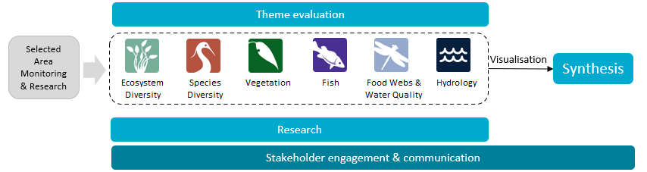
Figure 2 The 7 Selected Areas (left map) and 25 valleys (right map) established for long-term monitoring of the impacts of environmental watering under the Long Term Intervention Monitoring project and Flow-MER (2014–15 to present)
In the valleys map, grey shading shows the 19 valleys where the Commonwealth holds water entitlements and which are in scope for evaluation; white identifies those valleys that are not in scope.
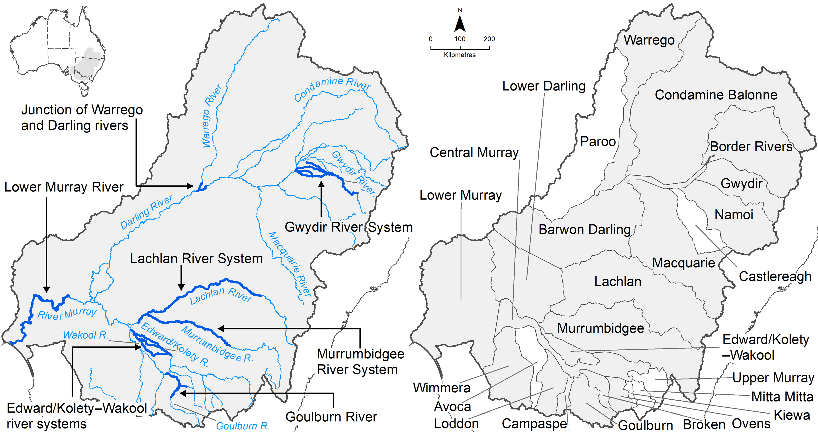

Evaluating the contribution of Commonwealth environmental water to observed environmental outcomes
To undertake the Basin-scale evaluation, the Basin-scale evaluation team uses water delivery and outcomes data provided by the CEWH’s Science Program, along with monitoring data provided by the 7 Selected Areas. Other publicly available data may be used where relevant data are not collected by the Selected Areas.
Evaluation of the contribution of CEW to observed environmental outcomes for the 6 Basin Themes depends on the data available.
When delivered with other water, ecological outcomes cannot be apportioned with current methods, and CEW is reported as contributing to, or supporting, the environmental outcomes of the watering action.
The multi-year Hydrology (instream), Fish and Vegetation Basin Themes have sufficient data to model and compare environmental outcomes, both with and without CEW (counterfactual modelling).
Ecosystem Diversity, Species Diversity and Vegetation Basin Themes identify environmental responses in locations that received CEW (often in conjunction with other sources of environmental or non-environmental water) and, where feasible, compare with areas that did not receive CEW.
Hydrology (inundation) and Food Webs and Water Quality Basin Themes use flow and water quality metrics to infer likely outcomes.
Fish (annual), Vegetation (annual), and Food Webs and Water Quality Basin Themes synthesise findings across Selected Areas.

Partnering on watering actions
Commonwealth environmental water is often delivered in conjunction with other environmental water holdings and non-environmental water releases (such as for irrigation or during high-flow events).
Commonwealth environmental watering actions for the most recent evaluation year (2023–24) and cumulative over the 10 evaluation years (2014–15 to 2023–24) are provided in Table 1.
Table 1 Summary statistics for most recent evaluation year and multi-year evaluation period
Dash (–) indicates statistic not available.
 | 2023–24 | 2014–24
Volume of CEW actions (GL) | 2,870 | 18,310
Number of CEW actions | 114 | 1,194
% CEW volume of total EW volume | ~70% | –
% of CEW actions with partners or with other flows | ~50% | –
CEW % of total volume of partnered watering actions | ~50% | –
CEW % of total Basin surface water runoff | ~13% | –

Evaluation reporting
Each Theme prepares a technical evaluation report for each water year from which key outcomes and lessons for adaptive management are brought together, with research highlights, into an annual synthesis report. To provide consistency over the life of Flow-MER and its predecessors, some content in these annual reports may be reused from previous years. In these cases, all efforts are made to cite the relevant Long Term Intervention Monitoring Project, Environmental Water Knowledge and Research Project or Flow-MER publication. Reports published by the CEWH are available from the CEWH's publications and resources webpage.

Basin-scale Flow-MER partnership
Basin-scale evaluation in Flow-MER is led by CSIRO in partnership with the University of Canberra. Collaborators on the 2023–24 evaluation include Alluvium, Arthur Rylah Institute, Charles Sturt University, South Australian Research & Development Institute, NSW Department of Primary Industries, Australian River Restoration Centre and Brooks Ecology & Technology.
2025 is the final year of this 5-year phase of Flow-MER. This is the final evaluation under this phase. The next 5-year phase commenced on 1 July 2025 and is led by CSIRO in partnership with the One Basin Cooperative Research Centre. Information on the new phase of Flow-MER can be found at the CEWH's science programs website.

Contents
Executive summary iii
Water years 2014–24 iv
Water year 2023–24 v
Key contribution to Basin Plan objectives v
Informing adaptive management vi
Overview of Flow-MER and the 2023–24 evaluation vii
Evaluating the contribution of Commonwealth environmental water to observed environmental outcomes viii
Partnering on watering actions viii
Evaluation reporting viii
Basin-scale Flow-MER partnership viii
1 Introduction 1
1.1 Evaluation objectives 1
1.2 Evaluation coverage 1
1.3 About this report 3
2 Overview of approach and methods 4
3 Basin-scale evaluation 2014–24 6
3.1 Key findings 6
3.2 Rainfall 6
3.3 Environmental water delivery 2014–24 7
3.4 Overview of 2014–24 vegetation data 8
3.5 Grouping by inundation history of sample points 13
3.6 Vegetation species associations with inundation groups 20
3.7 Vegetation community associations with inundation groups 21
3.8 Expected outcomes in the absence of environmental water 23
3.9 Vegetation community association with inundation groups across and within ecosystem types 24
3.10 Responses in unmonitored areas in 2014–24 26
4 Basin-scale evaluation 2023–24 27
4.1 Key findings 27
4.2 Environmental water delivery 2023–24 27
4.3 Overview of 2023–24 vegetation data 29
4.4 Expected outcome in the absence of environmental water 30
5 Contribution to Basin Plan objectives 33
5.1 Contribution to plant species diversity and groundcover vegetation community diversity between 2014–24 33
5.2 Basin-wide environmental watering strategy expected outcomes for vegetation 34
6 Informing adaptive management 36
6.1 Informing the planning and management of environmental water for vegetation 36
6.2 Improving our approach to Basin-scale evaluation 37
Appendix A Vegetation classification and data 39
A.1 Functional-group and growth-form classification system 39
A.2 Details of vegetation sampling design 41
A.3 Australian National Aquatic Ecosystem types 42
Appendix B Inundation of floodplain and wetland sample points with and without environmental water, 2014–24 44
Appendix C Vegetation data tables for 2014–24 50
C.1 Plant taxa recorded in the Long Term Intervention Monitoring Project and Flow-MER from all Selected Areas for each water year, 2014–24 50
C.2 Plant taxa and characteristic families recorded from all sample points for each water year and across all years, 2014–24 50
C.3 Nativeness recorded across all sample points for each water year and across all years, 2014–24 51
C.4 Species richness recorded in life history form across all sample points for each water year and across all years, 2014–24 52
C.5 Species richness recorded in growth forms across all sample points for each water year and across all years, 2014–24 52
C.6 Species richness in functional groups recorded across all sample points for each water year and across all years, 2014–24 53
C.7 Plant species recorded in the 2014–24 Flow-MER dataset and listed under national or state threatened species lists 54
C.8 Plant taxa known to be used by Aboriginal people that occur within the Basin 58
C.9 Plant taxa characteristic of inundation groups and habitat types for each water year, 2014–24 61
C.10 Plant taxa unique to sample points associated with inundation groups across all water years, 2014–24 67
Abbreviations and terms 71
References 72

Figures
Figure 1 Schematic of the components of the Basin-scale evaluation vii
Figure 2 The 7 Selected Areas (left map) and 25 valleys (right map) established for long-term monitoring of the impacts of environmental watering under the Long Term Intervention Monitoring project and Flow-MER (2014–15 to present) vii
Figure 1.1 Map showing the vegetation sample points in each Selected Area monitored for groundcover vegetation by Flow-MER over the period 2014–24 3
Figure 2.1 Schematic of steps in groundcover vegetation evaluation approach 5
Figure 3.1 Maps of annual rainfall conditions across the Murray–Darling Basin, 2014–24 7
Figure 3.2 Number and total volume of Commonwealth environmental watering actions linked to expected outcomes for vegetation for each water year, 2014–24 8
Figure 3.3 Cumulative count of previously unrecorded taxa at the 52 sample points consistently monitored every year over the period 2015–16 to 2023–24 9
Figure 3.4 Average taxa richness per sample point across all Selected Areas for each water year and across all water years, ±95% confidence intervals, 2014–24 10
Figure 3.5 Average percentage cover of all plant taxa per sample point across all Selected Areas for each water year and across all water years, ±95% confidence intervals, 2014–24 10
Figure 3.6 Percentage of plant species cover recorded in each growth-form group across all Selected Areas sample points for each water year and across all years, 2014–24 11
Figure 3.7 Average percentage cover of plant functional groups across Selected Areas sample points for each water year and across all years, 2014–24 12
Figure 3.8 K-means clustering of 73 Flow-MER vegetation sample points into 4 inundation groups based on observed 3-monthly inundation regime with environmental water, 2014–24 14
Figure 3.9 Map showing sample points by Inundation Group based on the results of k-means cluster analysis of the inundation at monitored floodplain and wetland sample points 16
Figure 3.10 The number of sample points in each of the 4 inundation groups with environmental water and without environmental water 18
Figure 3.11 K-means clustering of 73 Flow-MER vegetation sample points into 4 inundation groups based on observed inundation regime without environmental water, 2014–24 20
Figure 3.12 Average percentage cover of plant functional groups in each inundation group for sample points in wetland and floodplain habitats, pooled across water years 2014–24 22
Figure 3.13 Average percentage cover of growth forms in each inundation group for sample points in wetland and floodplain habitats, pooled across water years 2014–24 23
Figure 3.14 Average percentage cover of plant functional groups in each inundation group predicted to persist without environmental water for wetland and floodplain habitats, pooled across water years 2014–24. This is in contrast to Figure 3.12 24
Figure 3.15 Average percentage cover of ‘river red gum forest riparian zone or floodplain’ sample points in each inundation group, pooled across water years 2014–24 26
Figure 4.1 Average percentage cover of plant functional groups in each inundation group for sample points in wetland and floodplain habitats, 2023–24 31
Figure 4.2 Average percentage cover of growth forms in each inundation group for sample points in wetland and floodplain habitats, 2023–24 31
Figure 4.3 Average percentage cover of ‘river red gum forest riparian zone or floodplain’ sample points in each inundation group, 2023–24 32

Tables
Table 1 Summary statistics for most recent evaluation year and multi-year evaluation period viii
Table 1.1 Commonwealth environmental watering actions with vegetation objectives, 2023–24 2
Table 3.1 Average number of 3-monthly quarters for each inundation group across a range of commonly used inundation metrics 14
Table 3.2 The number of floodplain and wetland sample points within each Australian National Aquatic Ecosystem type in each inundation group with environmental water, pooled across water years 2014–24 15
Table 3.3 The number of floodplain and wetland sample points within each Australian National Aquatic Ecosystems type (Brooks 2021) in each inundation group without environmental water, pooled across water years 2014–24 17
Table 3.4 Average number of 3-monthly quarters for each inundation group without and with environmental water across a range of commonly used inundation metrics 19
Table 3.5 Number of sample points and sample events within each inundation group for the Australian National Aquatic Ecosystems type ‘river red gum forest riparian zone or floodplain’, across 2014–24 25
Table 4.1 Summary of the 2023–24 Commonwealth environmental watering actions with expected outcomes related to groundcover vegetation in Selected Areas where monitoring was undertaken 28
Table 4.2 Number of sample points and sampling events within each inundation group for the Australian National Aquatic Ecosystems type ‘river red gum forest riparian zone or floodplain’, 2023–24 32
Table A.1 Plant high-level functional-group classification 39
Table A.2 Growth-form classifications used in evaluation (sourced and altered from BioNet) 40
Table A.3 Vegetation sampling design at the Selected Areas monitored for the Long Term Intervention Monitoring Project and Flow-MER across all water years 2014–24 and in 2023–24 41
Table A.4 Sample points per Selected Area for each water year, 2014–24, sampled (used) in the Basin-scale evaluation 42
Table A.5 Australian National Aquatic Ecosystem types (Brooks 2021) surveyed with the number of sample points in each Selected Area, 2014–24 43
Table B.1 Presence/absence of inundation at each sample point for each quarter per water year with environmental water, 2014–24 44
Table B.2 Modelled presence/absence of inundation at each sample point for each quarter per water year without environmental water, 2014–24 – the ‘counterfactual’ 47
Table C.1 Plant taxa recorded in the Long Term Intervention Monitoring Project and Flow-MER from monitored Selected Areas for each water year, 2014–24 50
Table C.2 Total number of plant taxa and dominant families recorded within floodplain, wetland and riverine habitats each water year and across all years (2014–24) from the evaluation used sample points 50
Table C.3 Numbers of native and exotic taxa, the percentage of native taxa, and the percentage cover of native taxa recorded across all sample points for each water year and across all years, 2014–24 51
Table C.4 Numbers of taxa in life history form and the percentage of annual or perennial taxa recorded across all sample points for each water year and across all years, 2014–24 52
Table C.5 Numbers of taxa in growth forms recorded across all sample points for each water year and across all water years 2014–24 52
Table C.6 Numbers of taxa in functional groups recorded across all sample points for each water year and across all years, 2014–24 53
Table C.7 Plant species recorded in 2014–24 that are listed under national or state-based (New South Wales, South Australia or Victoria) threatened species lists 54
Table C.8 Plant taxa known to be used by Aboriginal people that occur within the Basin and if they have been recorded in the Selected Areas, 2014–24 58
Table C.9 Plant taxa characteristic of inundation groups and habitat types, for each water year, 2014–24 61
Table C.10 Number of plant taxa unique to sample points associated with inundation groups, 2014–24 67
Table C.11 Plant taxa unique to sample points associated with Inundation Groups within functional groups, 2014–24 67

Introduction
This chapter summarises the purpose of the Basin-scale evaluation, the locations within the Murray–Darling Basin where groundcover vegetation has been evaluated, and the structure of this report.
The Commonwealth Environmental Water Holder (CEWH) manages a portfolio of environmental water as a key means of achieving the objectives of the Commonwealth’s (Murray–Darling) Basin Plan 2012. The Commonwealth’s water holdings are released strategically towards specified environmental outcomes as described in the Basin-wide environmental watering strategy (the Strategy, MDBA 2019). Annual Basin-scale evaluation of the Commonwealth environmental water releases and the outcomes achieved for the current water year (2023–24) and over the 10-years of the Long-Term Intervention Monitoring Project (LTIM, 2014–19) and the CEWH’s Science Program: Flow Monitoring, Evaluation and Research (Flow-MER, 2019–current) are critical to adaptive management.

Evaluation objectives
The Basin-scale Vegetation Theme evaluates the contribution of Commonwealth environmental water (CEW) in supporting the diversity of groundcover vegetation. It describes the most recent (one-year) and longer term (10-year) evaluation of:
What did Commonwealth environmental water contribute to plant species diversity?
What did Commonwealth environmental water contribute to vegetation community diversity?

Basin Plan objectives for vegetation
The Commonwealth’s (Murray–Darling) Basin Plan 2012 (the Basin Plan) provides high-level environmental objectives that are directed at protecting and restoring water-dependent ecosystems of the Basin (Basin Plan section 8.04).
The Basin-wide environmental watering strategy (MDBA 2019) (the Strategy) requires the more specific expected outcome that environmental water will be used to ‘maintain the extent, and maintain or improve the condition of water-dependent vegetation in areas that can be influenced with environmental water’ (MDBA 2019).

Evaluation coverage
In 2023–24, 72 Commonwealth environmental watering actions with expected outcomes for vegetation were delivered to river systems in 15 of the Basin valleys (Table 1.1).
The evaluation draws on vegetation monitoring data collected for 10 years from 2014–15 to 2023–24 from 6 of the 7 Selected Areas across the Basin: Gwydir River System, Lachlan River System, Murrumbidgee River System, Junction of Warrego and Darling rivers, Edward/Kolety–Wakool river systems and Goulburn River. The evaluation also includes vegetation monitoring data collected from the Lower Murray River (the 7th Selected Area) in 3 watering years (2019–20, 2020–21 and 2023–24).
Additional outcomes for vegetation defined within the Strategy are framed within the context of specific vegetation structural groups (forests and woodlands, shrublands, and non-woody vegetation). They also provide expected outcomes for specific vegetation communities (e.g. lignum shrublands).
Table 1.1 Commonwealth environmental watering actions with vegetation objectives, 2023–24
* Contains a Selected Area; dash (–) indicates valleys that did not have objectives for vegetation in 2023–24.
Valley | Volume (ML) | Number of actions
Barwon Darling | – | –
Border Rivers | – | –
Broken | 63,832 | 10
Campaspe | 4,578 | 7
Central Murray | 307,961 | 2
Condamine Balonne | 71,299 | 1
Edward/Kolety–Wakool* | 159,001 | 15
Goulburn* | 184,608 | 4
Gwydir* | 5,539 | 1
Lachlan* | – | –
Loddon | 3,598 | 2
Lower Darling | 110,834 | 2
Lower Murray* | 1,385,237 | 16
Macquarie | 52,746 | 6
Murrumbidgee* | 59,879 | 2
Namoi | 900 | 1
Ovens | – | –
Warrego* | 8,370 | 1
Wimmera | 2,762 | 2
Total | 2,421,144 | 72

Data
A combination of vegetation data, hydrological data and information about environmental watering actions was used in the evaluation. The location of vegetation sample points from which data used in the evaluation were collected are shown in Figure 1.1.
Figure 1.1 Basin map showing the location of the vegetation sample points within each Selected Area monitored for groundcover vegetation, 2014–24
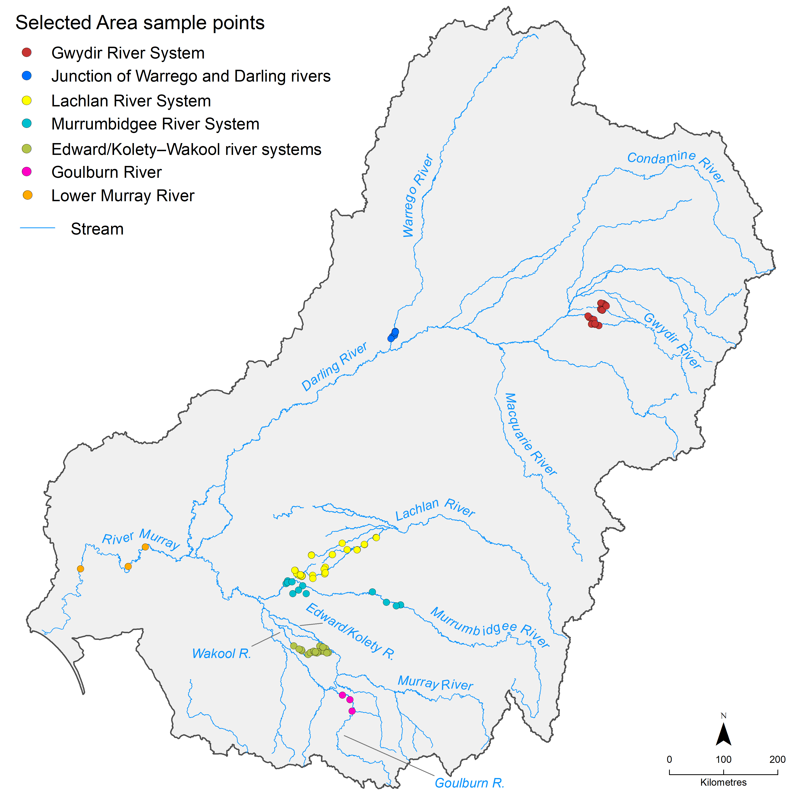

About this report
This vegetation evaluation was led by the University of Canberra in partnership with CSIRO. This report focuses on reporting the results of this year’s evaluation and the cumulative evaluation since 2013–14. The adopted approach and methods are fully described in companion report Flow-MER Basin-scale evaluation of Commonwealth environmental water: Methods (O’Sullivan and Cuddy 2025) and are consistent with methods set out in Long Term Intervention Monitoring Project (LTIM)/Flow-MER foundation reports.
Species abundance data collected by Selected Areas are collated into a dataset. Citation for this dataset is given below.
CEWH (2023) Vegetation species abundance. Flow-MER Program. Commonwealth Environmental Water Holder, Australian Government Department of Climate Change, Energy, the Environment and Water. Sourced from Flow-MER Vegetation Species Abundance on 15 January 2024.

Overview of approach and methods
This chapter provides a high-level overview of the evaluation approach. Full details are available in the companion Flow-MER Basin-scale evaluation of Commonwealth environmental water: Methods (O’Sullivan and Cuddy (eds) 2025) report.
The contributions of Commonwealth environmental water (CEW) to vegetation species diversity and to vegetation community diversity were evaluated using a counterfactual modelling approach. Vegetation monitoring data from floodplain and wetland habitats across the Basin were used to describe the vegetation assemblages (called Inundation Groups) associated with groups of sample points that have experienced similar inundation regimes over the past 10 years. The resulting associations between an inundation group and a vegetation assemblage were then used to predict the vegetation assemblage that would occur in the absence of environmental water (the counterfactual scenario). Differences in the vegetation assemblages that are predicted to occur with and without environmental water can then be attributed, in part, to environmental water.
The evaluation is focused on cumulative outcomes, recognising that the expression of extant riverine, wetland and floodplain groundcover vegetation is the result of a complex set of interacting factors that includes recent and long-term hydrological conditions. Thus, we link the inundation regime to the vegetation assemblage observed over 10 years, and within the 2023–24 water year. Vegetation assemblages are described in terms of compositional (richness) and structural (cover) attributes that are further described in terms of growth form (e.g. forbs, grasses, ferns) and life-history dependence on water regimes (submerged, amphibious, damp-loving, woody flood-dependent and terrestrial). These steps are captured in the schematic at Figure 2.1.
The evaluation is accompanied by a summary of the watering actions conducted for expected vegetation outcomes, as well as an overview of the vegetation observations based on monitoring data collected from sample points within each Selected Area.
Figure 2.1 Schematic showing the 5 steps in the groundcover vegetation evaluation approach
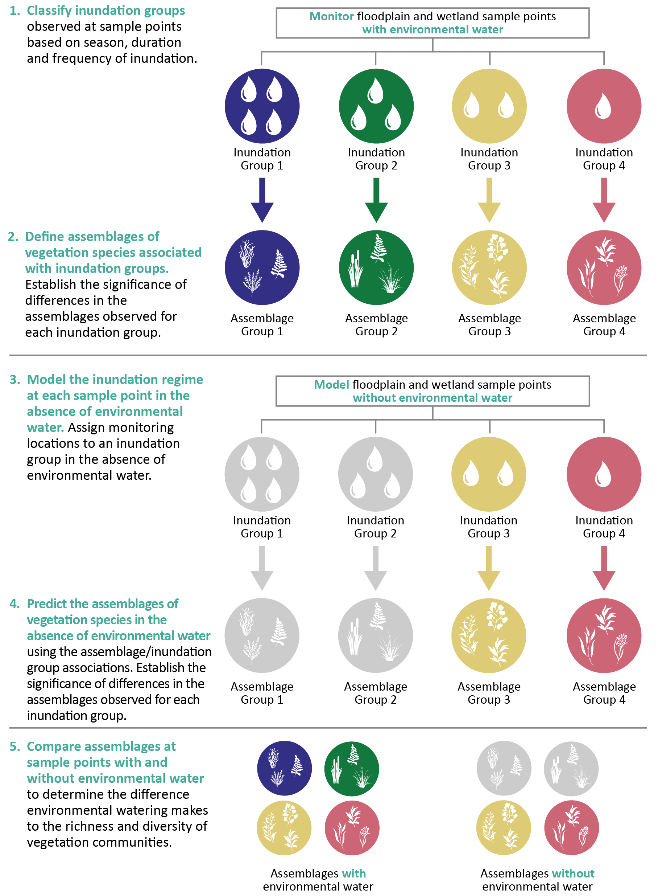

Basin-scale evaluation 2014–24
This chapter describes the vegetation recorded across all monitoring locations between 2014–15 and 2023–24 and provides the cumulative evaluation of the responses of species and communities to environmental water.

Key findings
Between 2014–15 and 2023–24, 818 watering actions involving Commonwealth environmental water targeted expected outcomes for vegetation.
804 taxa have been recorded at monitored floodplain, wetland and riverine locations since 2014–15. This includes 527 and 221 identifiable native and exotic species, respectively. Almost 10% of the recorded plant taxa (77) are known to be used by Aboriginal people for uses including food, fibre, shelter, medicine, messages and boundaries, dreaming/storytelling or ceremonial, and basket weaving.
Counterfactual analysis shows that in the absence of environmental water, 29 of the 73 monitored sample points would have experienced a much drier inundation regime. This would have likely resulted in less diversity and cover of submerged, amphibious and damp-loving species.
Environmental water is preventing the loss of characteristic wetland and floodplain plants by maintaining wetter hydrological regimes which help maintain biodiversity across the Basin.
Importantly, we have shown the role that reducing the average duration of the dry phase can have in supporting a greater cover of vegetation and, particularly, the cover of submerged and amphibious species.

Rainfall
Wet conditions contracted to the central areas of the Basin in 2023–24. Parts of the southern Basin became increasingly dry, including both the headwaters and the South Australian sections of the River Murray changing from conditions that were very much above average rainfall in 2022–23 to very much below average rainfall in 2023–24 (Figure 3.1).
Figure 3.1 Maps of annual rainfall conditions across the Murray–Darling Basin, 2014–24
Data sourced from the Bureau of Meteorology. The decile rankings (lowest on record to highest on record) are those used by the Bureau. Refer to the Bureau – Glossary of terms for a description of how the deciles are derived.
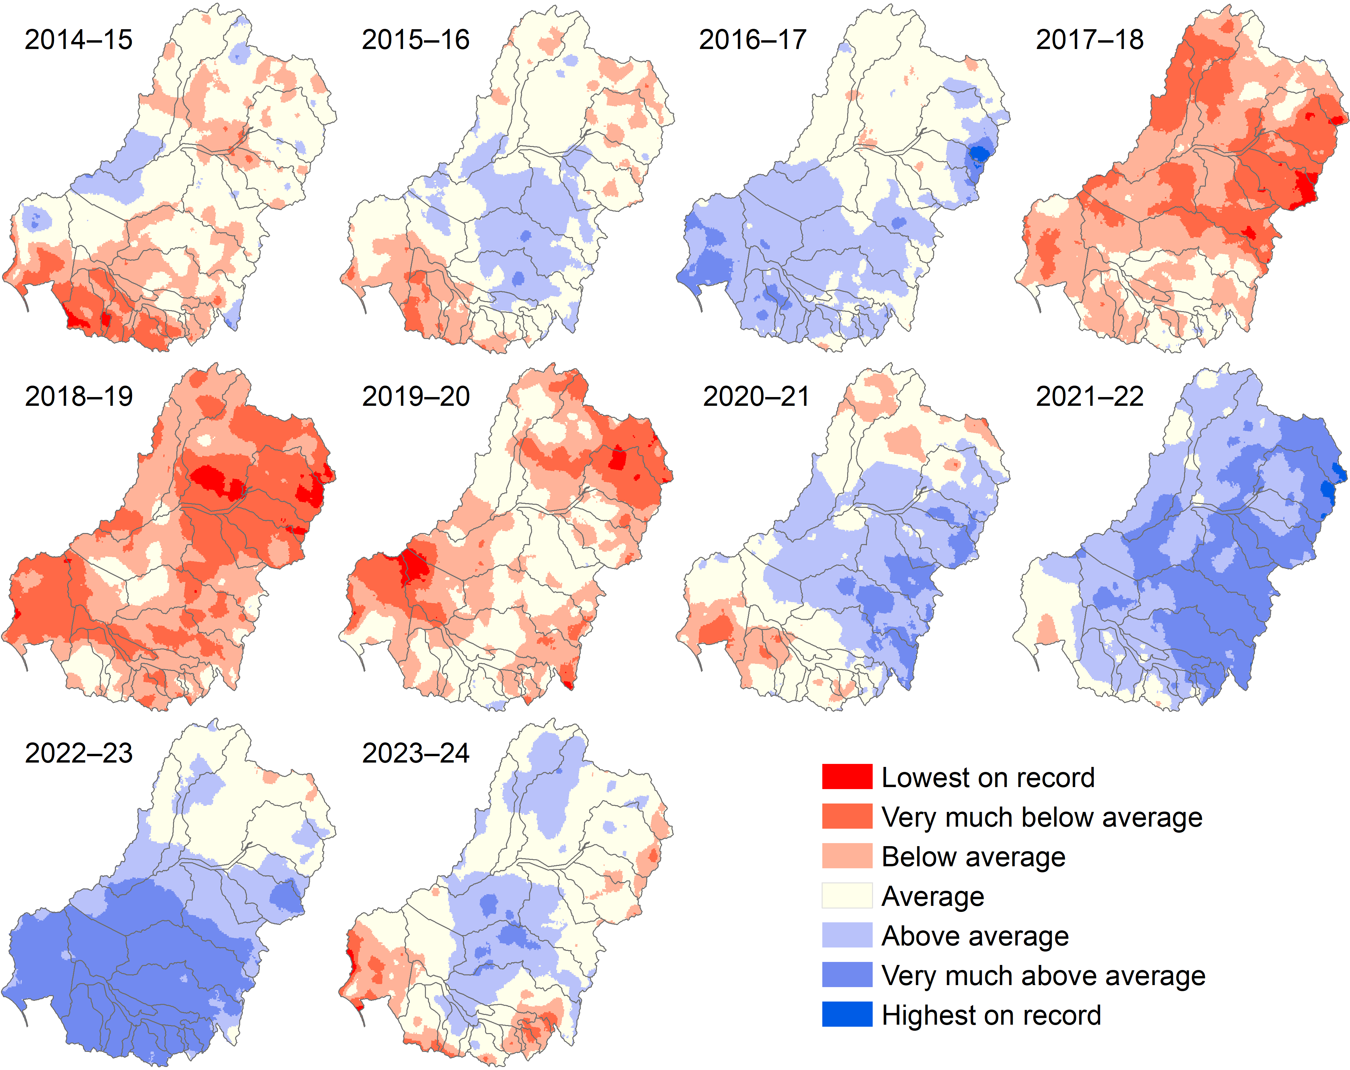

Environmental water delivery 2014–24
There were 818 watering actions involving CEW between 2014–15 and 2023–24 for expected outcomes associated with vegetation across the Basin. Of these actions, 630 were undertaken in surface water regions represented by Selected Areas, the majority of which were within the Lower Murray River (364) and Murrumbidgee River System (105) Selected Areas. The number of watering actions varies each year in relation to water availability, and local and regional priorities. The 2,421 GL of CEW used for expected outcomes for vegetation in 2023–24 is of a similar magnitude to the volumes of environmental water delivered for vegetation outcomes in 2021–22 (Figure 3.2).
Figure 3.2 Number and total volume of Commonwealth environmental watering actions linked to expected outcomes for vegetation for each water year, 2014–24
This figure shows the volume of Commonwealth environmental water (CEW). It does not include volumes of other sources of environmental water delivered in association with CEW.
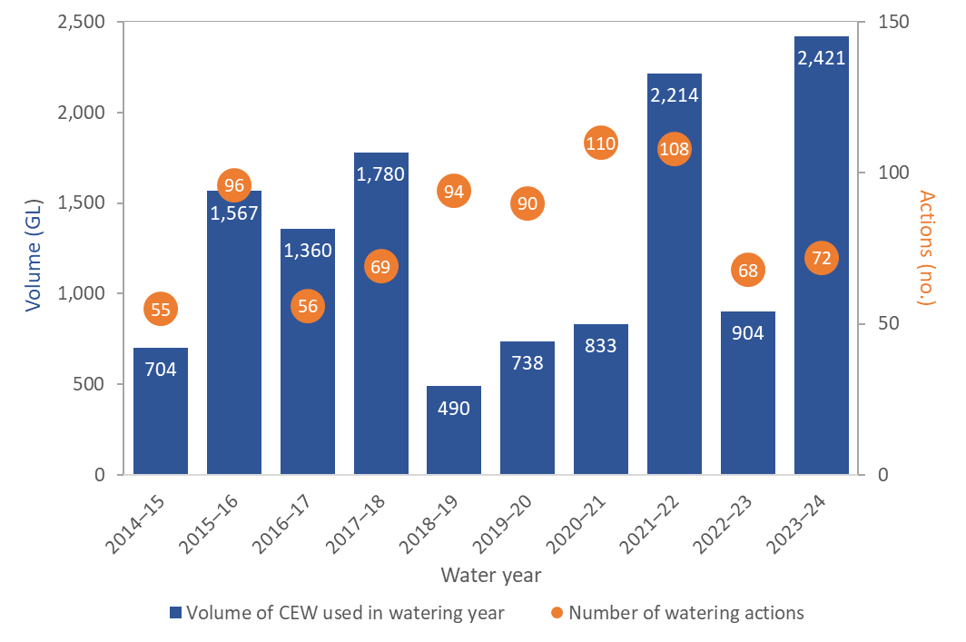

Overview of 2014–24 vegetation data
In total, 804 taxa were recorded across all Selected Areas from 2014–15 to 2023–24. More than 13,000 plant species are listed in the Atlas of Living Australia as having been recorded within the Basin, and around 8,000 recorded from the managed floodplain (C. Campbell, MDBA, pers. comm. 2024). The recording of 804 taxa in the Flow-MER Program is notable given the total sampled area is approximately 3.6 hectares or 0.0001% of the managed floodplain (Appendix A.2).
Previously unrecorded taxa continued to be found in 2023–24 – 10 previously unrecorded taxa were observed at existing sample points. Focusing on the 52 sample points that were consistently sampled during the last 9 years (2015–16 to 2023–24), 11 previously unrecorded taxa were detected in 2023–24 (Figure 3.3), including taxa from one previously unrecorded family Salicaceae (Salix) from the Goulburn River Selected Area. The number of previously unrecorded species this year is lower than in the previous 2 years. However, it is interesting to note that after 9 years of variable wet–dry conditions (as used in this analysis), previously unrecorded species are still being detected. This highlights the temporal complexity of large and variable river–floodplain systems and the importance of long-term monitoring.
Figure 3.3 Cumulative count of previously unrecorded taxa at the 52 sample points consistently monitored every year over the period 2015–16 to 2023–24
This graph starts in 2015–16 because data for the Edward/Kolety–Wakool river systems were not recorded before 2015–16. It excludes sample points that have not been consistently monitored in all 9 water years.
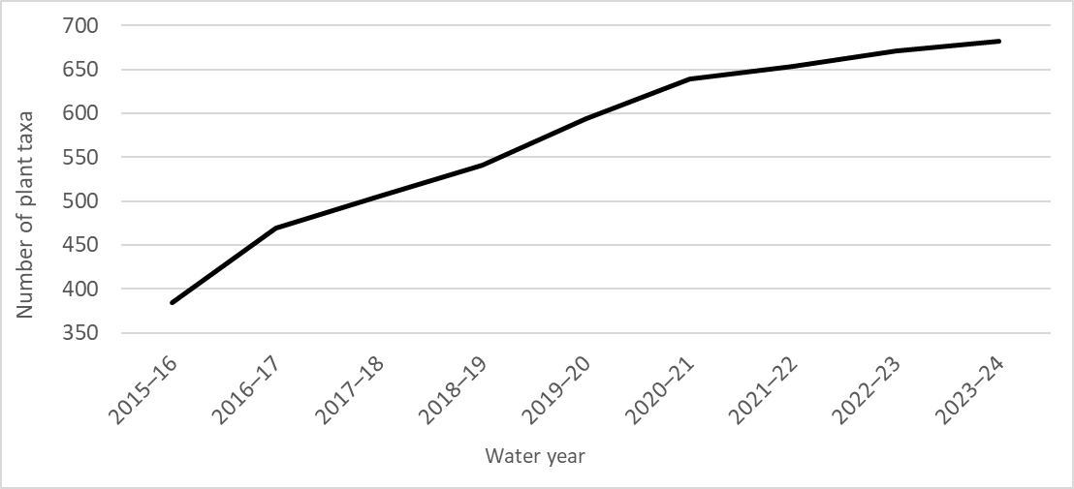
Plant taxa were recorded from 81 families across all years, and the characteristic families in each year remained reasonably consistent for floodplain, wetland and riverine habitats, although the order of contribution varied across the years (Table C.2).
Average taxon richness fluctuated between 2014–15 and 2023–24, likely in response to both weather conditions and the use of environmental water (Figure 3.4). Average taxon richness recorded at sample points declined from 2014–15 to 2018–19 as conditions across the Basin became increasingly dry, followed by increases in 2019–20 and 2020–21. Average taxon richness then decreased to be the lowest average recorded to date in 2022–23. The decline in taxon richness observed in 2021–22 and 2022–23 is not surprising given ongoing widespread wet conditions, as fewer species can persist at locations where there is prolonged inundation. With drier conditions in 2023–24, the average species numbers per sample point increased compared to 2022–23. It is also noted that taxon richness may also be influenced by changes in the number of sample points from year to year (Table A.4). Changes can be due to inability to access some of the sample points in that year, or some sample points may be discontinued or added, as sometimes occurs in long-term monitoring programs.
Figure 3.4 Average taxa richness per sample point across all Selected Areas for each water year and across all water years, ±95% confidence intervals, 2014–24
n = the number of sample points.
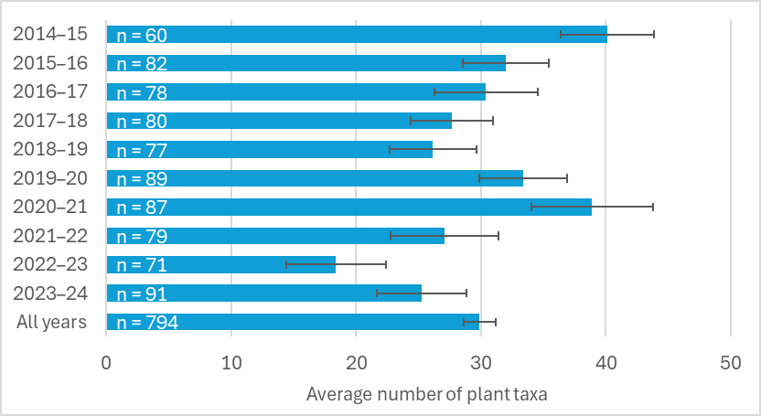
The average percent cover of groundcover vegetation between 2014–15 and 2023–24 has also fluctuated (Figure 3.5). The years of the ‘Tinderbox drought’ (2017–18, 2018–19, 2019–20) had the lowest average cover recorded in the 10 years of monitoring (Figure 3.5). The wet years of 2016–17 and 2020–21 to 2022–23 had the highest average cover (Figure 3.5). These data suggest that weather conditions are an important driver of groundcover vegetation cover across the Basin. In 2023–24, the average cover was similar to that recorded in the earlier dry years of the monitoring program (2014–15 and 2015–16).
Figure 3.5 Average percentage cover of all plant taxa per sample point across all Selected Areas for each water year and across all water years, ±95% confidence intervals, 2014–24
n = the number of sample points. Lower Murray River data are excluded from calculations of species cover, as they had only recorded data as species frequency at 3 sample points in 2019–20, 2020–21 and 2023–24.
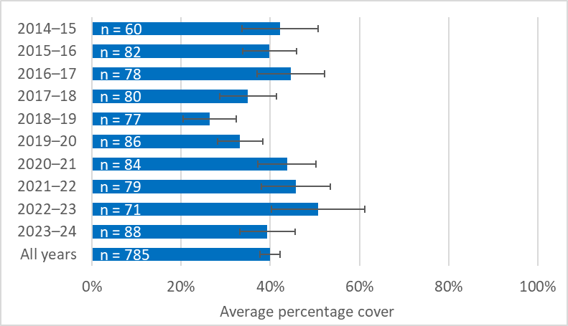
The majority of plant taxa – in terms of both numbers of species (70%) and total cover (86%) – recorded across all sample points and all 10 years were native. The greatest proportional cover of native taxa was recorded over the last 3 years (92% in 2021–22, 96% in 2022–23 and 87% for 2023–24) (see Appendix C.3). The proportion of native species recorded varied little between years but was greatest during the 2 wettest years, 2021–22 and 2022–23 (74% and 73% respectively), suggesting the extended wet conditions favoured native taxa. Australia is generally considered to possess a high proportion (88% Australia-wide) of endemic plant species (Gallagher et al. 2023), and the proportion of native species recorded through the Flow-MER program likely reflects the role of agricultural practices in reducing the proportion of native species observed in riparian zones, floodplains and wetlands across the Basin.
In terms of taxon numbers, the dominant growth form was forbs (62% of species), followed by grasses (15%), sub-shrubs (8%), and sedges and rushes (6%) (see Appendix C.5). More perennial taxa (58% of taxa) than annual taxa were recorded (see Appendix C.4). Most plant taxa recorded belonged to the terrestrial plant functional group (59%), followed by damp-loving species (20%) and amphibious species (13%). There were very small numbers of submerged and woody flood-dependent taxa (see Appendix C.6).
In relation to cover of the different growth forms, forbs had the greatest average cover in most years (8% to 15%), followed by cover of sedges and rushes (7% to 16%) and grasses (5% to 14%). In 2023–24, the proportional average cover of ferns and fern allies, and sedges and rushes, returned to levels more consistent with 2015–16, which was a year of similar rainfall conditions (Figure 3.6 and Figure 3.1).
Figure 3.6 Percentage of plant species cover recorded in each growth-form group across all Selected Areas sample points for each water year and across all years, 2014–24
For details of the growth-form groups, see Table A.2. Lower Murray River data are excluded from calculations of species cover, as they record data as species frequency at 3 sample points in 2019–20, 2020–21 and 2023–24.
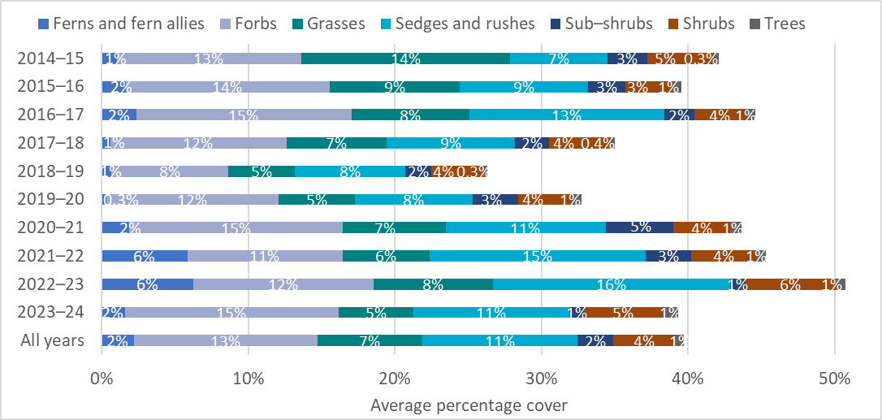
The cover and proportion of plant functional groups also changed across years at the sample points (Figure 3.7). The cover of amphibious taxa was dominant in 9 years out of 10 (9% to 23%), and cover of terrestrial taxa dominated in 2019–20 (11%) as the landscape transitioned from the very dry conditions of the Tinderbox Drought to the wet conditions that commenced in 2020. Damp-loving taxa had the second-most dominant amount of cover in 7 of the 10 years. There was a noticeable increase in the cover of submerged taxa in 2021–22 and 2022–23, consistent with the wet conditions across the Basin. This has persisted into 2023–24 (Figure 3.7).
Figure 3.7 Average percentage cover of plant functional groups across Selected Areas sample points for each water year and across all years, 2014–24
For detail on high-level functional groups, see Table A.1. Cover represents the average percentage cover per sample point per year. Lower Murray River data are excluded from calculations of species cover, as they recorded data as species frequency at 3 sample points in 2019–20, 2020–21 and 2023–24.
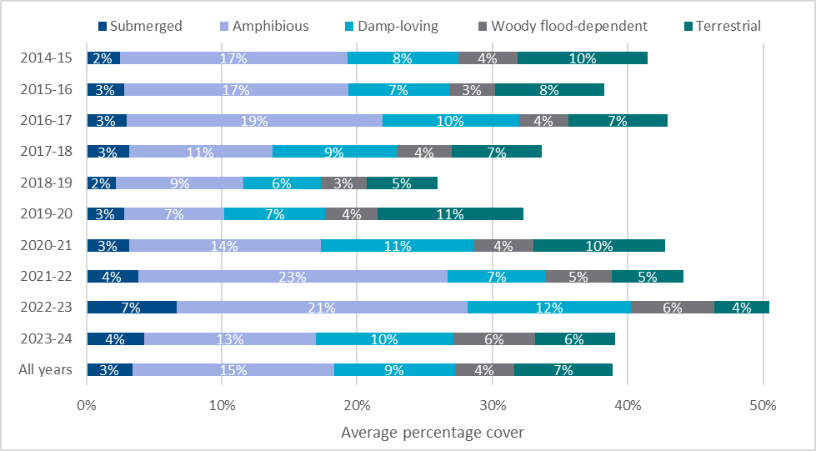
In total, 101 species in the 2014–24 dataset are listed on national (i.e. the Australian Environment Protection and Biodiversity Conservation Act 1999) or state (New South Wales, Victoria, South Australia) threatened species lists (see Table C.7), although the vast majority of observations were not in the state in which the listing applies. Only 7 species were recorded that are nationally listed or observed within the state within which they are listed (Table C.7). For example, tiny teeth (Dentella minutissima) is listed as Endangered in New South Wales and has been recorded in the Junction of Warrego and Darling rivers Selected Area. Four of these 7 species are considered flow-dependent (one amphibious and 3 damp-loving), and their presence is likely related to natural flooding. For example, records of tiny teeth are from 2016–17 and 2017–18. The hydrological regimes in the Lower Murray River Selected Area at sites Lock 1, Lock 4 and Lock 6 provided submerged habitats, instream fluctuations and the maintenance of soil moisture in 2019–20 and 2020–21 for swamp daisy (Brachyscome paludicola), slender goodenia (Goodenia gracilis) and robust milfoil (Myriophyllum papillosum) (Table C.7).
Seventy-seven plant taxa known to be used by Aboriginal people of the Basin have been recorded over the past 10 years (2014–24). These 77 plants have a range of uses, including as food (33), fibre and shelter (including dye, glue and resin) (5), medicine (7), hunting or fishing, messages and boundaries, dreaming/storytelling or ceremonial, and basket weaving. Twenty-eight of these plants have more than one use, and 2 plants are known to be used but their use is unknown (see Table C.8).
Most of these taxa known to be used by Aboriginal people occurred across multiple Selected Areas. Small knot-weed (Polygonum plebeium), old man weed (Centipeda cunninghamii), goosefoot (Chenopodium spp.) and water cress (Rorippa spp.) were recorded at all 7 Selected Areas, while tangled lignum (Duma florulenta), common rush (Juncus usitatus), Warrego grass (Paspalidium jubiflorum), sow thistle (Sonchus oleraceus), climbing saltbush (Einadia nutans), spike-rush (Eleocharis spp.) and goodenia (Goodenia spp.) were recorded at 6 Selected Areas. Nevertheless, more than a quarter of these taxa (21 out of 77) known to be used by Aboriginal people are not widespread and when recorded, were only recorded in one Selected Area.
Thirty-three of the plants known to be used by Aboriginal people of the Basin require flooding, including 8 amphibious taxa, 3 submerged taxa, 13 damp-loving taxa and 9 woody flood-dependent taxa. For example, the 3 submerged taxa (2 species of cumbungi [Typha domingensis and Typha orientalis] and common reed [Phragmites australis]) are culturally important species to Aboriginal people and are used as food, fibre and shelter, and in dreaming/storytelling or ceremonial use. Cumbungi requires near-permanent water, while the common reed requires flooding every few years.

Grouping by inundation history of sample points

With environmental water
Clustering analysis using inundation history at each of the 73 floodplain and wetland sample points identified 4 unique inundation groups (Figure 3.8, Figure 3.9 and Table 3.1). The clustering was driven by the frequency, duration and variability of observed flooding and drying phases defined on a quarterly basis over 10 years (2014–24; see data in Table B.1).
Inundation Group 1, which was the most frequently inundated group, was nearly permanently inundated since 2014 (82.5% of quarters). It consisted of 10 sample points from the Murrumbidgee River System and 4 from the Lachlan River System (Figure 3.9). Sample points in Inundation Group 1 were inundated on average for 2 years (9.1 quarters), and their average maximum inundation event (longest flood) since 2014 was 4.5 years (18.0 quarters) (Table 3.1 in number of 3-monthly quarters and Figure 3.8). Over this 10-year period, sample points in Inundation Group 1 experienced 4 dry phases and stayed dry for 5 months on average. The average maximum dry phase was 9 months.
Inundation Group 2 were inundated in 42.5% of quarters. This group experienced 6.2 flood events over this 10-year period, which had an average duration of over 8 months and average maximum inundation duration (longest flood) of nearly 2 years (Table 3.1 in number of 3-monthly quarters and Figure 3.8). Inundation Group 2 had an average dry phase of nearly one year and an average maximum dry phase of nearly 2 years. Inundation Group 2 consisted of 21 sample points from the Gwydir River System and one from the Murrumbidgee River System (Figure 3.9).
Inundation Group 3 was inundated in 45.1% of quarters. This group experienced 3.6 flood events over this 10-year period, and each flood event had an average duration of 1.5 years and average maximum duration of a little over 2.5 years. Inundation Group 3 had an average dry phase of 1.5 years and an average maximum dry phase of nearly 3.5 years (Table 3.1 in number of 3-monthly quarters and Figure 3.8). Inundation Group 3 had an average dry phase of a little over 1.5 years and an average maximum dry phase of 3.5 years. Inundation Group 3 consisted of 21 sample points from the Lachlan River System and one from the Murrumbidgee River System (Figure 3.9).
Inundation Group 4 was inundated in 21.8% of quarters and while characterised by prolonged dry phases (average duration of dry phase of nearly 2.5 years and average maximum dry phase of more than 3.5 years), it experienced 4.1 floods over the last 10 years. Once flooded, these sample points remained inundated for 6 months (Table 3.1 in number of 3-monthly quarters and Figure 3.8). Inundation Group 4 consisted of 15 sample points, of which 7 were from the Lachlan River System and 8 from the Junction of Warrego and Darling rivers (Figure 3.9).
Figure 3.8 K-means clustering of 73 Flow-MER vegetation sample points into 4 inundation groups based on observed 3-monthly inundation regime with environmental water, 2014–24
PCA = Principal component analysis
Key: Inundation Group 1 = near-permanent water and an average dry-phase duration of 6 months, Inundation Group 2 = short, frequent inundation, with average duration of inundation of 6 months and an average dry phase of 9 months, Inundation Group 3 = longer duration and less frequent inundation with an average duration of inundation of 1.5 years and an average dry phase of 1.5 years, and Inundation Group 4 = short duration and prolonged dry phases, with an average inundation duration of 6 months and an average dry phase of 2.5 years.
The star symbol represents the centroid of each cluster. The filled squares show the sample points with environmental water and are assigned to the most similar cluster. The quarterly inundation data for 2014–24 is provided in Table B.1. Overlap of clusters is the result of multi-dimensional data being plotted in 2 dimensions.
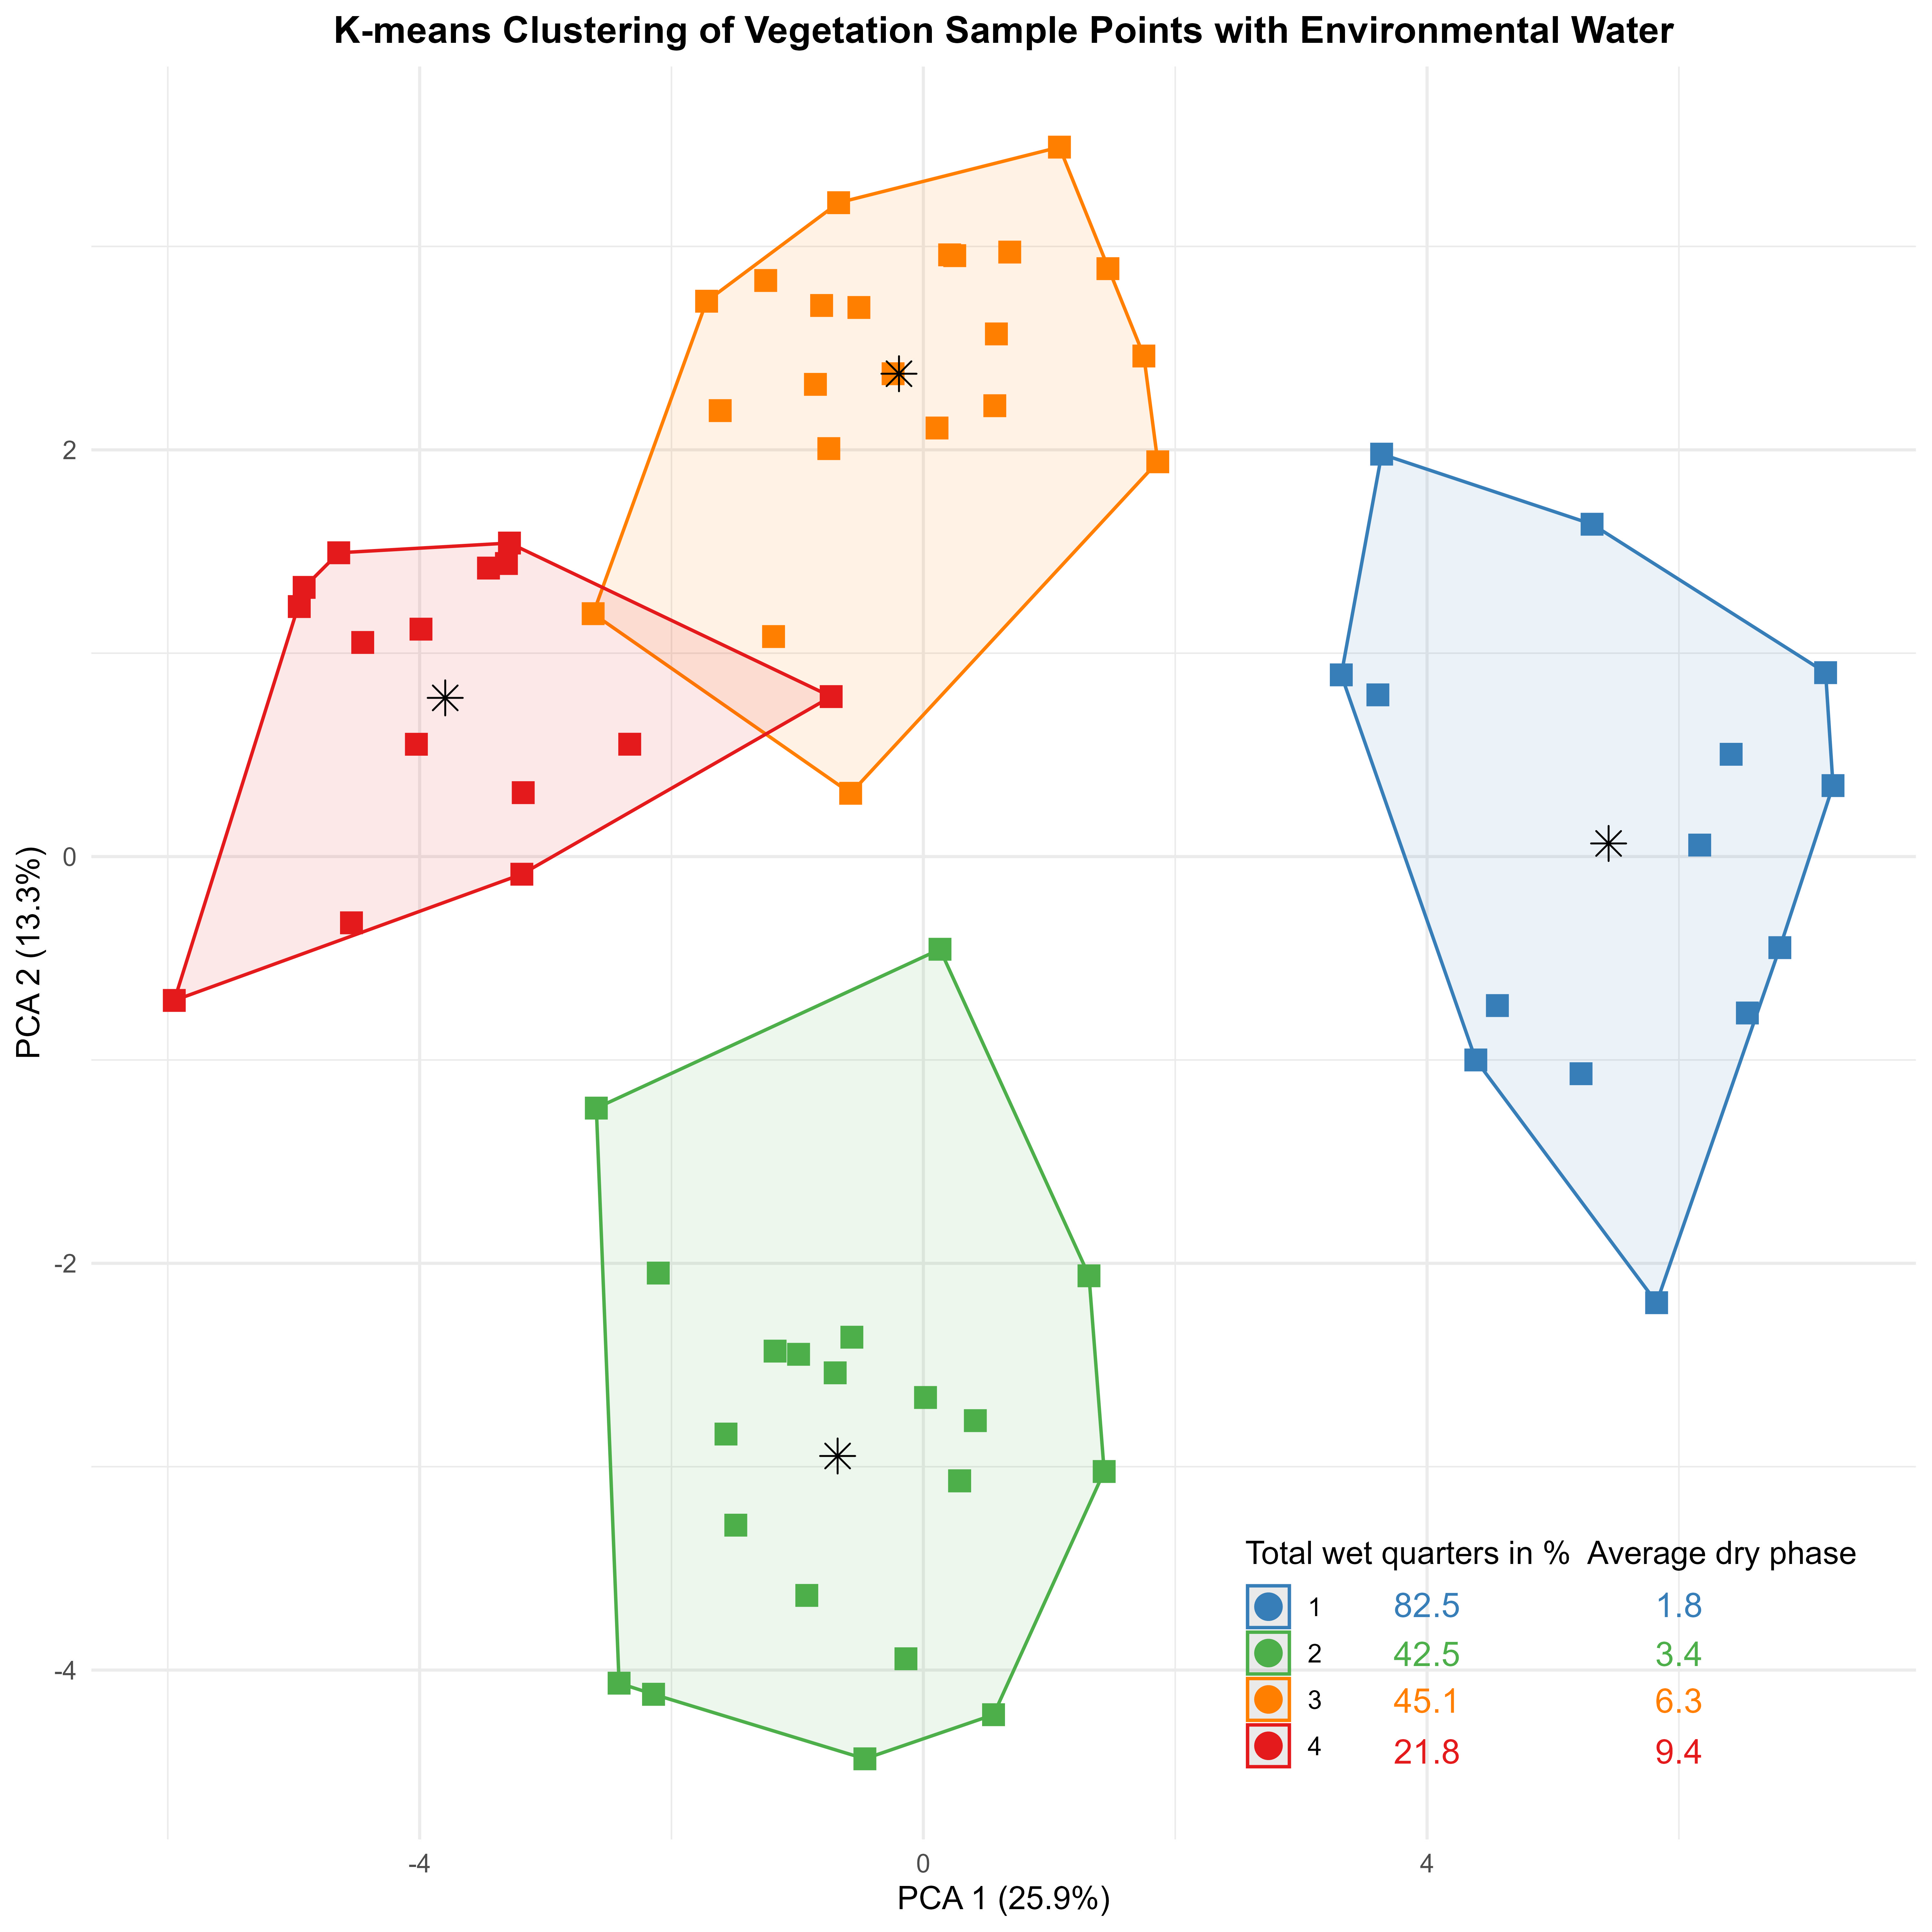
Table 3.1 Average number of 3-monthly quarters for each inundation group across a range of commonly used inundation metrics
Inundation group | Number of floods (10 years) | Average flood duration | Longest flood | Total wet quarters in % | Number of dry phases | Average dry phase | Longest dry phase
Group 1 | 4.1 | 9.1 | 18.0 | 82.5 | 3.8 | 1.8 | 3.0
Group 2 | 6.2 | 2.8 | 7.6 | 42.5 | 7.1 | 3.4 | 7.4
Group 3 | 3.6 | 5.8 | 10.6 | 45.1 | 4.0 | 6.3 | 13.5
Group 4 | 4.1 | 2.2 | 3.3 | 21.8 | 4.6 | 9.4 | 14.6
The distribution of sample points of different Australian National Aquatic Ecosystems (ANAE) types (Brooks 2012) across the 4 inundation groups varied. Sample points from some ANAE types only occurred, or primarily occurred, within a single inundation group (Figure 3.8). For example, the wetter Inundation Group 1 included the only sample points from permanent wetlands (3 sample points) and permanent tall emergent marsh (one sample point). The inundation regime is one of the key drivers of floodplain and wetland vegetation communities, and the presence, composition and structure of vegetation communities is strongly influenced by inundation characteristics such as flood frequency, duration and variability (Capon et al. 2016; Nilsson and Svedmark 2002; Roberts et al. 2016; Stromberg 2001).
Changes in flooding and drying regimes as a result of river regulation is known to result in changes or declines in the condition of the vegetation associated with particular aquatic ecosystem types (Merritt and Cooper 2000; Kuiper et al. 2014). The classification of the different ANAE types across the 4 inundation groups reveals not only the flooding history which has formed and maintained the aquatic ecosystems but also provides insight into changed hydrological regimes caused by river regulation at some sample points. We predict that changes in inundation regime will result in changes to the vegetation community over long periods of time.
Table 3.2 The number of floodplain and wetland sample points within each Australian National Aquatic Ecosystem type in each inundation group with environmental water, pooled across water years 2014–24
A dash (–) indicates that the Australian National Aquatic Ecosystem (ANAE) type does not occur in the sample points in the inundation group. The list of ANAE types can be found in Brooks (2021).
ANAE type | Group 1 | Group 2 | Group 3 | Group 4 | Number of groups | Total sample points
F1.2: River red gum forest riparian zone or floodplain | 3 | – | 7 | 5 | 3 | 15
F1.8: Black box woodland riparian zone or floodplain | – | 1 | 4 | 3 | 3 | 8
F1.10: Coolibah woodland and forest riparian zone or floodplain | – | 9 | – | 2 | 2 | 11
Pt1.1.2: Temporary river red gum swamp | 4 | – | 3 | – | 2 | 7
F2.2: Lignum shrubland riparian zone or floodplain | 1 | – | 1 | – | 2 | 2
Pt1.2.2: Temporary black box swamp | 1 | – | 1 | – | 2 | 2
Pt2.3.2: Freshwater meadow | – | 9 | – | – | 1 | 9
Lt1.1: Temporary lake | – | – | 6 | – | 1 | 6
F1.11: River cooba woodland riparian zone or floodplain | – | 3 | – | – | 1 | 3
Pp4.2: Permanent wetland | 3 | – | – | – | 1 | 3
Pt2.2.2: Temporary sedge/grass/forb marsh | – | – | – | 3 | 1 | 3
F2.4: Shrubland riparian zone or floodplain | – | – | – | 1 | 1 | 1
Lp1.1: Permanent lake | – | – | – | 1 | 1 | 1
Pp2.1.2: Permanent tall emergent marsh | 1 | – | – | – | 1 | 1
Rp1.4: Permanent lowland stream | 1 | – | – | – | 1 | 1
Total | 14 | 22 | 22 | 15 | 24 | 73

Figure 3.9 Map showing sample points by Inundation Group based on the results of k-means cluster analysis of the inundation at monitored floodplain and wetland sample points
Key: Inundation Group 1 = near-permanent water and an average dry-phase duration of 6 months, Inundation Group 2 = short, frequent inundation, with average duration of inundation of 6 months and an average dry phase of 9 months, Inundation Group 3 = longer duration and less frequent inundation with an average duration of inundation of 1.5 years and an average dry phase of 1.5 years, and Inundation Group 4 = short duration and prolonged dry phases, with an average inundation duration of 6 months and an average dry phase of 2.5 years. The quarterly inundation pattern over 2014–24 is given in Appendix B.
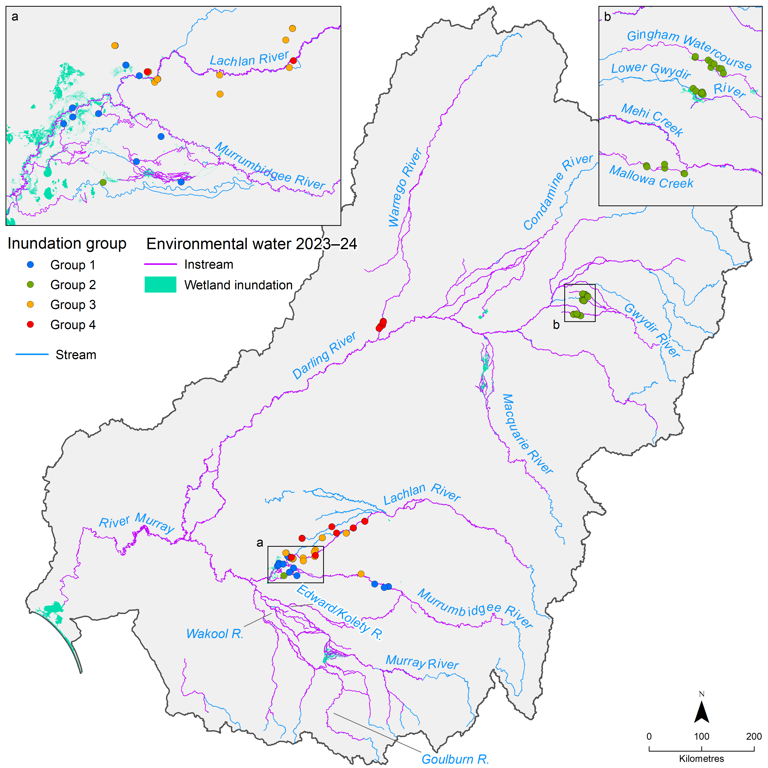

The counterfactual: without environmental water
The predicted inundation time series in the absence of environmental water showed that without environmental water, sample points from Inundation Group 1, Inundation Group 2 and, to a lesser extent, Inundation Group 3 would have been drier. All inundation groups, except a single sample point from Inundation Group 1 (13 of 14), would have experienced a flooding regime more similar to Inundation Group 3. Of the 22 sample points in Inundation Group 2, 3 sample points would have clustered into Inundation Group 3, and 11 would have clustered into Inundation Group 4, while 8 sample points would have remained in Inundation Group 2 without environmental water. Most of the 22 sample points in Inundation Group 3 remained in this inundation regime without environmental water, while 3 sample points would have clustered into Inundation Group 4 (Figure 3.10).
The predicted distribution of sample points of different ANAE types across the 4 inundation groups in the absence of environmental water showed that all 3 permanent wetland sample points and the only sample point from permanent tall emergent marsh would have experienced an inundation regime that was considerably drier (Table 3.3). Given that inundation regime is one of the key drivers of floodplain and wetland vegetation communities, this would likely lead to a shift in the vegetation community over time.
Table 3.3 The number of floodplain and wetland sample points within each Australian National Aquatic Ecosystems type (Brooks 2021) in each inundation group without environmental water, pooled across water years 2014–24
A dash (–) indicates that the Australian National Aquatic Ecosystems (ANAE) type does not occur in the sample points in the inundation group.
ANAE type | Group 1 | Group 2 | Group 3 | Group 4 | Number of groups | Total sample points
F1.2: River red gum forest riparian zone or floodplain | – | – | 8 | 7 | 2 | 15
F1.10: Coolibah woodland and forest riparian zone or floodplain | – | – | – | 11 | 1 | 11
Pt2.3.2: Freshwater meadow | – | 6 | 2 | 1 | 3 | 9
F1.8: Black box woodland riparian zone or floodplain | – | – | 4 | 4 | 2 | 8
Pt1.1.2: Temporary river red gum swamp | – | – | 7 | – | 1 | 7
Lt1.1: Temporary lake | – | – | 5 | – | 1 | 5
F1.11: River cooba woodland riparian zone or floodplain | – | 2 | – | 1 | 2 | 3
Pp4.2: Permanent wetland | – | – | 3 | – | 1 | 3
Pt2.2.2: Temporary sedge/grass/forb marsh | – | – | – | 3 | 1 | 3
F2.2: Lignum shrubland riparian zone or floodplain | – | – | 2 | – | 1 | 2
Pt1.2.2: Temporary black box swamp | 1 | – | 1 | – | 2 | 2
F2.4: Shrubland riparian zone or floodplain | – | – | – | 1 | 1 | 1
Lp1.1: Permanent lake | – | – | – | 1 | 1 | 1
Pp2.1.2: Permanent tall emergent marsh | – | – | 1 | – | 1 | 1
Pt3.1.2: Clay pan | – | – | 1 | – | 1 | 1
Total | 1 | 8 | 35 | 29 | 4 | 73

Figure 3.10 The number of sample points in each of the 4 inundation groups with environmental water and without environmental water
The plot shows how the sample points would cluster differently without environmental water.

In addition to most of the sample points from the wetter inundation groups experiencing an inundation regime more similar to one of the drier groups without environmental water, the average inundation regimes for all 4 groupings would have been drier without environmental water (Table 3.4 in number of 3-monthly quarters). All inundation groups would have been characterised by fewer flood events and fewer total wet quarters over this 10-year period (Table 3.4 in number of 3-monthly quarters). The reduced number of flood events would have increased the average and maximum dry phase across all 4 inundation groups. Overall, these changes would result in the 4 inundation groups experiencing a more homogenous and drier flooding regime and having greater similarity across a range of inundation metrics (such as flood duration and average dry phase) (Table 3.4 in number of 3-monthly quarters).
Inundation Group 1 would have experienced an average dry phase of over 2 years without environmental water, compared to 6 months with environmental water, and an average maximum dry phase of 4 years, compared to 9 months with environmental water. This highlights the important role environmental water has played in reinstating inundation events between the large ‘natural’ events. Inundation Group 2 was also highly influenced by environmental water over this 10-year period. For example, without environmental water, this group would have experienced an average dry phase of over 2.5 years. With environmental water, it experienced a dry phase of a little over 9 months. Inundation Group 3 and Inundation Group 4 still would have experienced reduced flood frequency and duration and extended dry phases without environmental water (Table 3.4 in number of 3-monthly quarters and Figure 3.11), although to a lesser extent.
Table 3.4 Average number of 3-monthly quarters for each inundation group without and with environmental water across a range of commonly used inundation metrics
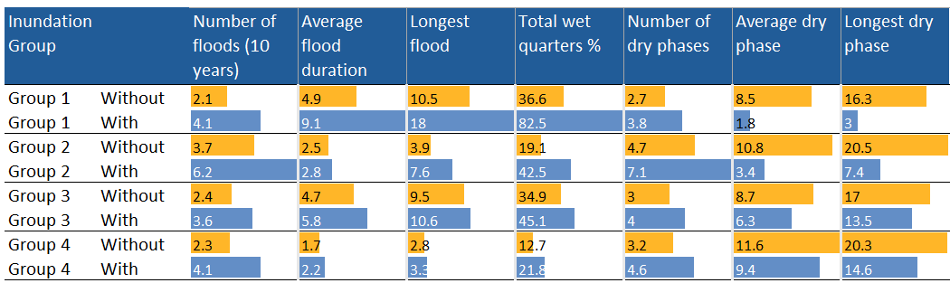
Figure 3.11 illustrates how the spatial arrangement of each of the sample points changes without environmental water (open squares) – sample points shift to the left of the principal coordinates analysis graph, becoming a drier and homogenous regime at these sample points. This is particularly evident in the wettest group, Inundation Group 1. In the absence of environmental water, only one sample point in this inundation group would remain aligned with this group’s inundation characteristics.
Figure 3.11 K-means clustering of 73 Flow-MER vegetation sample points into 4 inundation groups based on observed inundation regime without environmental water, 2014–24
Key: Inundation Group 1 = near-permanent water and an average dry-phase duration of 6 months, Inundation Group 2 = inundated every 2 years for approximately 1.5 years and an average dry-phase duration of one year, Inundation Group 3 = inundated every 2 years for approximately 1.5 years and an average dry-phase duration of 3 years, and Inundation Group 4 = inundated every 2–3 years for approximately 6 months and an average dry-phase duration of 2.5 years.
The star symbol represents the centroid of each cluster. The shaded areas show the clusters with environmental water. The open squares show the sample points without environmental water and assigned to the most similar cluster. The quarterly inundation data for 2014–24 is provided in Table B.1. Overlap of clusters is the result of multi-dimensional data being plotted in 2 dimensions.
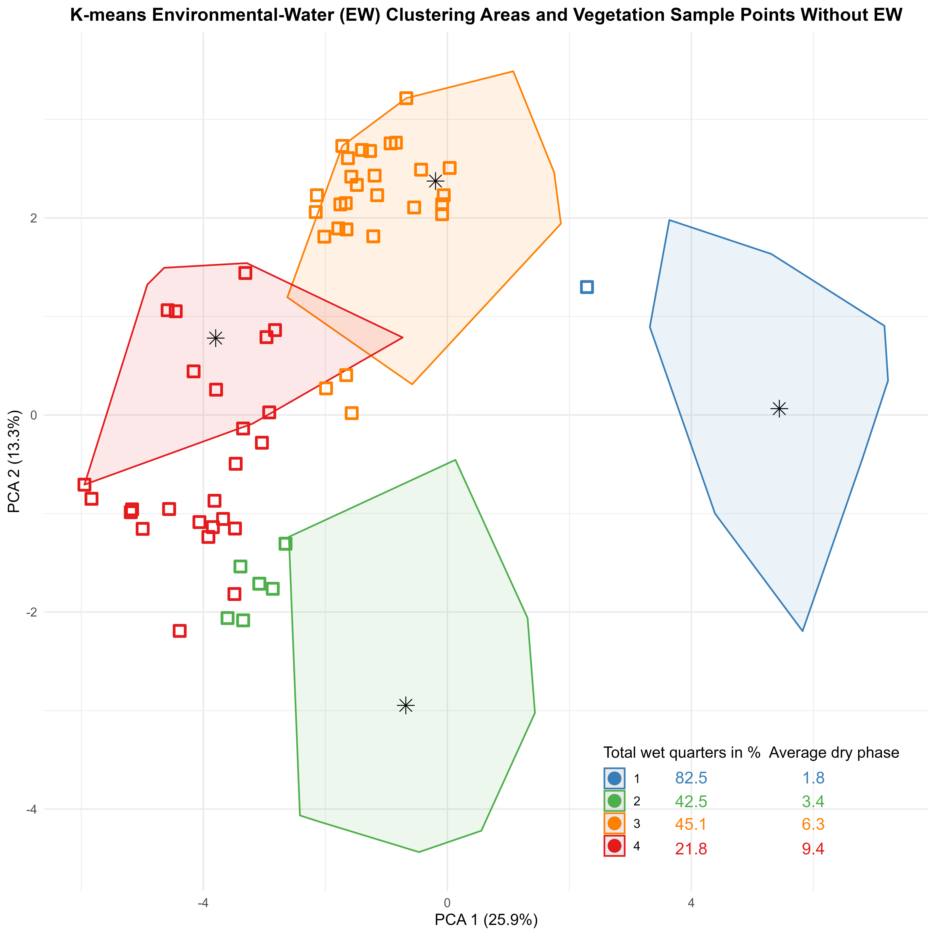

Vegetation species associations with inundation groups
The habitat types within each of the inundation groups are characterised by different taxa across the years (Table C.9).
In terms of wetland sample points, those in the wettest group (Inundation Group 1) are characterised by a mix of submerged, amphibious and damp-loving species, such as spike-rushes (common spike-rush Eleocharis acuta and tall spike-rush Eleocharis sphacelata), old man weed and slender knotweed (Persicaria decipiens). Few terrestrial or woody flood-dependent species are identified as characteristic. The second-wettest group (Inundation Group 2) is characterised by species that include narrow-leaved cumbungi (Typha domingensis) and another of the spike-rush family, flat spike-sedge (Eleocharis plana). The 2 driest groups (Inundation Group 3 and Inundation Group 4) are characterised predominantly by the woody flood-dependent tangled lignum. The wetlands of Inundation Group 3 also displayed a relatively diverse array of damp-loving and terrestrial species such as old man weed, blue rod (Stemodia florulenta), hairy carpet weed (Glinus lotoides) and the annual rain responder the exotic burr medic* (Medicago polymorpha). The number of damp-loving species that characterise the driest of the inundation groups is declining but still reflects the number of wet years that were experienced recently at monitoring sites during the monitoring program.
In terms of floodplain sample points, those in the wettest group (Inundation Group 1) were characterised largely by the woody flood-dependent tangled lignum up until 2018–19. In recent years, multiple amphibious species were identified as characterising these sample points, including common spike-rush, red water fern (Azolla rubra), red water-milfoil (Myriophyllum verrucosum), water primrose (Ludwigia peploides) and common nardoo (Marsilea drummondii). Those in the second-wettest group (Inundation Group 2) include flat spike-sedge, narrow-leaved cumbungi, tangled lignum and the exotic lippia* (Phyla canescens). As with the wetland sample points, the 2 driest groups (Inundation Group 3 and Inundation Group 4) are characterised predominantly by the woody flood-dependent tangled lignum. The floodplains of Inundation Group 3 also characterised by the amphibious common nardoo, damp-loving old man weed and annual rain responders such as the exotic burr medic* and lesser joyweed (Alternanthera denticulata).
While plants known to be used by Aboriginal people are recorded from sample points in all inundation groups, 6 species of plants were unique to floodplain and wetland sample points from Inundation Group 1 and Inundation Group 2, including the amphibious food plant water ribbons (Cycnogeton procerum). In the absence of CEW, this species are unlikely to have experienced the flooding regime required for their presence on floodplains and wetlands, and would have been greatly reduced or possibly absent (see Appendix C.10).

Vegetation community associations with inundation groups
Within floodplain–wetland vegetation communities, the use of environmental water provided distinct inundation regimes at the sample points across the Basin. These regimes, which we categorised into 4 inundation groups (see section 3.5), support different vegetation communities across both wetland and floodplain habitat types (Figure 3.12). There is a significant interaction between inundation group and habitat, with distinct assemblage differences evident between wetland and floodplain habitats in Inundation Groups 1, 2 and 4 but not in Inundation Group 3. This suggests that the inundation regimes characteristic of inundation groups 1, 2 and 4 are supporting different vegetation assemblages in the different habitat types and that these vary between the inundation regimes. However, within Inundation Group 3, there is no statistically discernible difference between the vegetation assemblages supported in either wetland or floodplain habitats, although these communities are different from those recorded under the inundation regimes characterised by Inundation Groups 1, 2 and 4.
The sample points from Inundation Group 2 have the greatest overall vegetation cover when standardised by the number of sample points in each group and the number of times these were sampled across the 10 years. Sample points from Inundation Group 1 and Inundation Group 2 support the greatest average cover of submerged and amphibious taxa (Figure 3.12). In contrast, Inundation Group 3 and Inundation Group 4 recorded less than 0.2% average cover of submerged species across wetland and floodplain sample points. Note that in Figure 3.12, the cover of submerged species (0.5%) is only visible for wetlands in Inundation Group 3. For floodplains from Inundation Group 3, and both habitat types from Inundation Group 4, the cover of submerged species is not visible because the number is less than 0.05%.
In the absence of environmental water, most sample points would have experienced inundation regimes typical of Inundation Group 3 and Inundation Group 4 (see section 3.5.2). These groups represent the driest regimes, and sample points classified here support a low cover of submerged and amphibious taxa and proportionally more terrestrial and woody flood-dependent taxa.
Of note from the 2023–24 data is the marked differences in vegetation cover and community composition between sample points from Inundation Group 2 and Inundation Group 3, yet both have experienced a similar proportion of time inundated during the past 10 years. The difference between these groups is the duration of the dry phase, which is approximately 8 months for Inundation Group 2 and 18 months for Inundation Group 3.
This points to the important role CEW can play in reducing the dry-phase duration to support a greater cover of groundcover vegetation and, in particular, the cover of submerged and amphibious species.
Figure 3.12 Average percentage cover of plant functional groups in each inundation group for sample points in wetland and floodplain habitats, pooled across water years 2014–24
Inundation Group 1 is the wettest group, and Inundation Group 4 is the driest group. For details of the inundation groups, see section 3.5, and for high-level functional groups, see Table A.1. Average percentage cover is calculated across sample points and sample events in each inundation group.
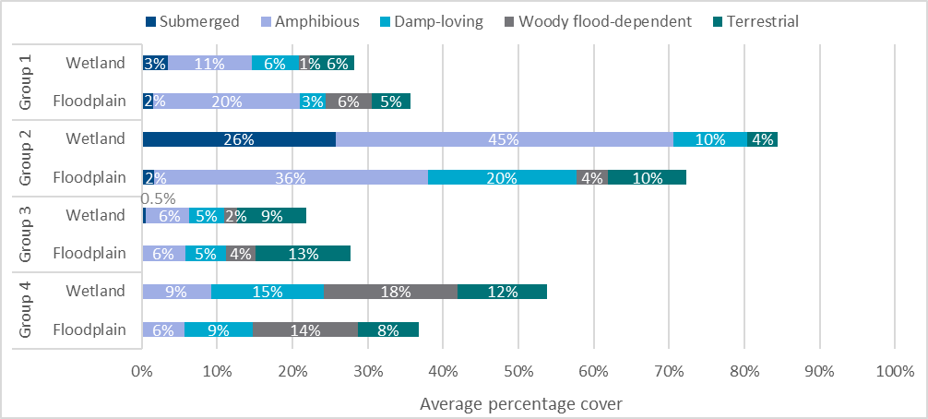
Sample points from Inundation Group 1 and Inundation Group 2 support the greatest average cover of ferns and fern allies. Plants such as common nardoo and red water fern are notable features of sample points from these groups. Wetland and floodplain sample points from Inundation Group 2 supported a markedly greater cover of grasses, such as water couch (Paspalum distichum), blown grass (Lachnagrostis filiformis) and barnyard grass (Echinochloa colona), and sedges and rushes, such as Eleocharis, Typha and Juncus species. Forbs are present across all inundation group sample points (Figure 3.13) and contributed to a large proportion of growth-form cover in sample points in Inundation Group 1 and Inundation Group 2. The relative proportional cover of sub-shrubs, shrubs and trees is greatest in the driest group of floodplain sample points in Inundation Group 3 and for both habitat types in Inundation Group 4 (Figure 3.13).
Figure 3.13 Average percentage cover of growth forms in each inundation group for sample points in wetland and floodplain habitats, pooled across water years 2014–24
Inundation Group 1 is the wettest group, and Inundation Group 4 is the driest group. For details of the growth-form groups, see Table A.2. Average percentage cover is calculated across sample points and sample events in each inundation group.
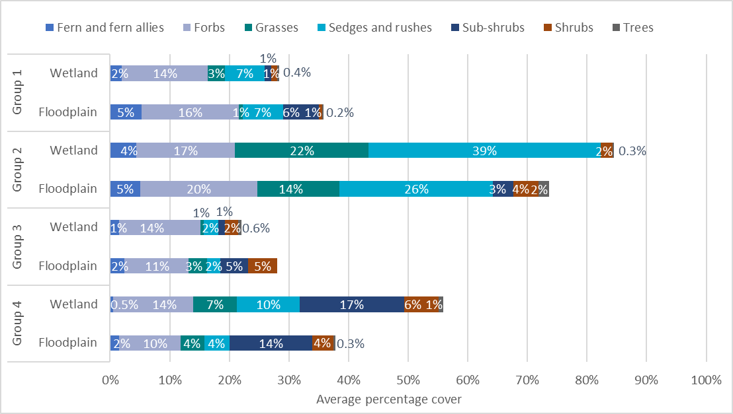

Expected outcomes in the absence of environmental water
In the absence of environmental water, all monitored sample points would have experienced the much drier inundation regimes defined by Inundation Group 3 and Inundation Group 4, having far less frequent inundation and longer dry phases (see section 3.5).
Given that each inundation group is associated with a distinct functional and structural vegetation assemblage, it is expected that the absence of environmental water would have meant a corresponding loss or reduction in the diversity and cover of submerged and amphibious species and, for Inundation Group 2, damp-loving species. That is, sample points are likely to have functional group composition and cover more similar to that observed in Inundation Groups 3 and 4 than Inundation Groups 1 and 2 (Figure 3.14).
It is not surprising that fewer submerged, amphibious or damp-loving taxa are predicted to occur under drier inundation regimes at wetlands and floodplains. These taxa have life-cycle adaptations to inundation and are not able to survive extended dry periods. The definition of ‘extended dry period’ varies between species – tolerance to dry periods typically increases from submerged taxa to amphibious to damp-loving. The average inter-flood dry period for sample points in Inundation Group 3 and Inundation Group 4 was 1.5–2.5 years. The average maximum was 3.4 years or more (Table 3.1). This exceeds the known dry-phase tolerance to maintain extant populations of numerous species classified as submerged or amphibious. For example, eelweed (Vallisneria australis) can only tolerate 3–4 months dry (Roberts and Marston 2011). While many wetland and floodplain plants have adaptations, such as drought-tolerant seedbanks and rhizomes that can extend the tolerance to critical dry intervals, more frequent inundation is recommended to maintain vigour and cover of extant populations. For example, the recommended flooding frequency is annual or near-annual to biennial for a range of submerged and amphibious species recorded from sample points, such as cumbungi (Typha spp.), marsh club-rush (Bolboschoenus fluviatilis), spike-rush (Eleocharis spp.), water couch, mud grass (Pseudoraphis spinescens), water primrose, river buttercup (Ranunculus inundatus), wavy marshwort (Nymphoides crenata) and common nardoo (Roberts and Marston 2011; Rogers and Ralph 2011). It is logical to predict that submerged and amphibious species such as these will be absent or their cover substantially reduced under inundation regimes that result in inter-flood dry periods that exceed 1.5 years, as predicted with a shift of many sample points to Inundation Group 3 and Inundation Group 4 (in the absence of environmental water).
In contrast to Inundation Groups 3 and 4, the contribution of CEW to the inundation regimes at sample points in Inundation Groups 1 and 2 has provided average inter-flood dry periods of 6–10 months and an average maximum dry phase of between 9 and 22 months (Table 3.1).
This means that at the sample points monitored, environmental water was important in maintaining a diversity of floodplain–wetland vegetation communities, and this is likely the case at other floodplain–wetland habitats across the Basin where environmental water has been delivered.
Figure 3.14 Average percentage cover of plant functional groups in each inundation group predicted to persist without environmental water for wetland and floodplain habitats, pooled across water years 2014–24. This is in contrast to Figure3.12
Inundation Group 1 is the wettest group, and Inundation Group 4 is the driest group. For detail on high-level functional groups, see Table A.1. Average percentage cover is calculated across sample points and sample events in each inundation group.
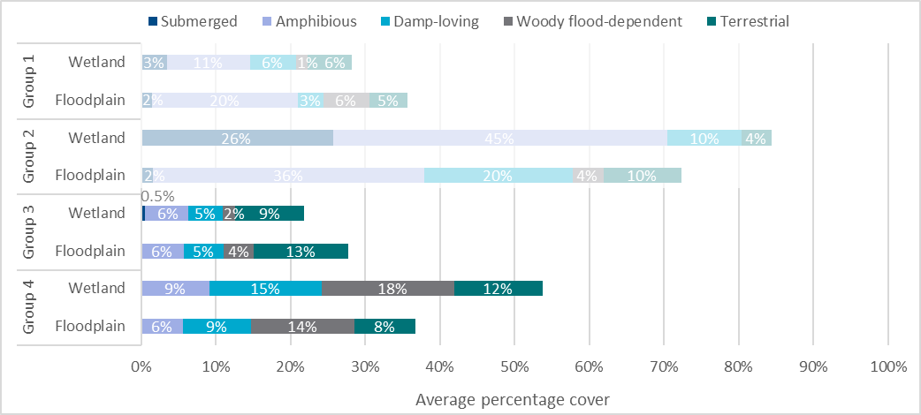

Vegetation community association with inundation groups across and within ecosystem types
A range of ecosystem types (using the ANAE classification, Brooks 2021) are represented within the Inundation Groups (Table 3.2). Different ANAE types naturally have different water-regime requirements. For example, it is logical to assume that ANAE types characterised by river red gum (Eucalyptus camaldulensis) trees will have a wetter regime as they require more frequent watering than ANAE types characterised by black box (Eucalyptus largiflorens) trees (e.g. 1–4 years compared to 3–7 years, Roberts and Marston 2011). Therefore, under unmodified conditions and across long temporal time scales, we would expect to see a delineation of ANAE types in line with expected water-regime requirements (albeit with some degree of natural, geographical variability).
In the absence of environmental water, most monitored sample points are predicted to cluster into Inundation Group 3 and Inundation Group 4 (see section 3.5.2 with Figure 3.11) which, as described above, has an average inter-flood dry period of 1.5–2.5 years. The average maximum is 3.4 years or more. This is unlikely to be consistent with the water-regime requirements of ecosystem types such as permanent wetlands, permanent tall emergent marsh and freshwater meadows, which are all predicted to shift from Inundation Group 1 or 2 into Inundation Group 3 or 4 in the absence of environmental water. Thus, over long timeframes, we would expect a corresponding shift in vegetation community and a loss of diversity.
The sample points monitored as part of Flow-MER were not established to provide replication across ANAE types. The inundation clustering approach has been used to assign the sample points to inundation groups post hoc. This has resulted in an uneven distribution of sample points across inundation groups. Only one of the ANAE types has sample points that were well distributed across 3 of the inundation groups: 15 sample points from ANAE type ‘river red gum forest riparian zone or floodplain’ were spread across Inundation Groups 1, 3 and 4 (Table 3.2). This provides the opportunity to further refine the evaluation of vegetation responses within this ecosystem (ANAE type), enabling the impact of recent (past 10 years) inundation regimes to be assessed without potentially confounding differences of ecosystem types. The details for the sampling within this ANAE type is shown in Table 3.5.
Table 3.5 Number of sample points and sample events within each inundation group for the Australian National Aquatic Ecosystems type ‘river red gum forest riparian zone or floodplain’, across 2014–24
Inundation group | # sample points | # sample events
Group 1 | 3 | 19
Group 2 | – | –
Group 3 | 7 | 63
Group 4 | 5 | 39
Over the 10 years (2014–24), the 15 sample points from ANAE type ‘river red gum forest riparian zone or floodplain’ had significant differences in the vegetation assemblage observed between the sample points that occurred in the wettest group (Inundation Group 1) and second-driest group (Inundation Group 3). The sample points from Inundation Group 1 are the only sample points in this ANAE type with any cover of submerged species (1.5%). These points also have substantially greater cover of amphibious species (19%) than that recorded at sites that experienced the inundation regimes of Inundation Group 3 (7%) and Inundation Group 4 (3%) (Figure 3.15). In the absence of environmental water, all ‘river red gum forest riparian zone or floodplain’ sample points would have experienced the inundation regimes of Inundation Group 3 or Inundation Group 4 and the corresponding loss of cover of submerged species, such as common reed and narrow-leaved cumbungi, and less cover of amphibious species, such as common spike-rush and red water-milfoil.
The consistency of the expected counterfactual outcome across a single ANAE type supports the broader conclusion that in the absence of environmental water, many of the monitored sample points would have experienced a much drier inundation regime. This would have likely resulted in less diversity and cover of characteristic species, particularly those classed as submerged and amphibious species.
Figure 3.15 Average percentage cover of ‘river red gum forest riparian zone or floodplain’ sample points in each inundation group, pooled across water years 2014–24
Inundation Group 1 is the wettest group, and Inundation Group 4 is the driest group. For detail on high-level functional groups, see Table A.1. Cover represents the average percentage cover per sample point per sample time in each inundation group. Average percentage cover is calculated per sample point and sample event in each inundation group – details in Table 3.5.
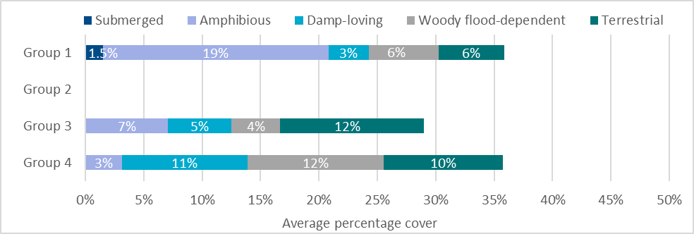

Responses in unmonitored areas in 2014–24
The differences in vegetation species and communities that are predicted to occur in the absence of CEW at monitored sample points over the monitoring period give insight as to what may be expected from the use of environmental water across the Basin between 2014–15 and 2023–24. Environmental water likely maintained the richness of species at watered sample points. This includes a range of submerged, amphibious and damp-loving species that are unlikely to be present in the absence of environmental water. The species that are supported will be dependent on their location in the Basin but likely includes a range of plant species known to be used by Aboriginal people, as well as species that are listed as rare and threatened.
By contributing to supporting specific inundation regimes across the Basin, environmental water has also contributed to vegetation community diversity. As an example, Inundation Group 1 and Inundation Group 2 include sample points from a range of floodplain and wetland ANAE types that do not occur in Inundation Group 3 and Inundation Group 4. These include permanent wetland, permanent tall emergent marsh and freshwater meadow (Table 3.2). Over the past 10 years, watering frequencies have broadly aligned with the expected needs of vegetation groups – permanent wetlands, freshwater meadows and permanent tall emergent marsh were watered more frequently than most treed swamps, and palustrine wetlands were watered more frequently than floodplains (Brooks 2025). Without environmental water, these ecosystem types would have likely transitioned to ecosystem types more common to drier inundation regimes. Over time, this would result in the loss of significant amounts of these wetland types and the associated plant communities.
Over the past 10 years, environmental water has made a significant contribution to maintaining wetter inundation regimes and, thus, the distinct vegetation assemblages associated with these regimes. It can be inferred that in unmonitored areas, maintenance of wetter inundation regimes across the Basin using environmental water has substantially contributed to maintaining diverse vegetation assemblages associated with similar inundation regimes.

Basin-scale evaluation 2023–24
This chapter describes the groundcover vegetation recorded at monitoring locations in water year 2023–24 and places this water year in the context of the 10 years of monitoring (water years 2014–15 to 2023 –24) in terms of vegetation, rainfall and environmental watering actions.

Key findings
Conditions became increasingly dry across the Basin in 2023–24, particularly in the headwater streams and the South Australian portion of the Basin.
72 watering actions, involving more than 2,400 GL of Commonwealth environmental water, were delivered with expected outcomes associated with vegetation.

360 plant taxa were recorded in 2023–24 across all floodplain, wetland and riverine monitoring locations, including 54 taxa known to be used by Aboriginal people.
There was a greater proportion and cover of submerged and amphibious plants observed at sites that had wetter inundation regimes maintained using environmental water.
It is very likely that in the absence of environmental water, there would have been a near absence of submerged species, and considerably less diversity and cover of amphibious and damp-loving species at 38% of monitored sample points.

Environmental water delivery 2023–24
Of the 114 watering actions delivered in 2023–24 by the CEWH, 72 actions (involving 2,421,144 ML of CEW) targeted outcomes associated with vegetation among their listed expected outcomes. Half (36) of these 72 actions were delivered in combination with one or more other environmental water sources. Forty-three actions (involving 1,795,501 ML of CEW) were delivered for vegetation outcomes into the Selected Areas (Table 4.1) in which groundcover vegetation outcomes were monitored.
Most Selected Area Commonwealth environmental watering actions were delivered in the Lower Murray River (16 actions, 1,385,237 ML) and the Edward/Kolety-Wakool river systems (15 actions, 159,001 ML), supporting a range of outcomes, including the condition of riparian and aquatic vegetation such as river red gum and black box. The largest single Commonwealth environmental watering action used to target vegetation outcomes (769,062 ML) was received by the Lower Murray River and targeted the diversity, extent and condition of riparian and floodplain vegetation as well as the diversity, extent and condition of aquatic and littoral vegetation in the Lower Lakes and Coorong, including seagrass (Ruppia spp).
Of the 43 watering actions delivered into the Selected Areas, 9 supplied water to sample points where Selected Area teams monitored vegetation. Selected Area vegetation monitoring employs fixed monitoring sample points. These do not always align with watering actions in every year. It should also be noted that in some instances, sites receiving environmental water in preceding years may still be influenced by that environmental water in the current year.

Table 4.1 Summary of the 2023–24 Commonwealth environmental watering actions with expected outcomes related to groundcover vegetation in Selected Areas where monitoring was undertaken
Flow components and expected ecological outcomes are summarised by the CEWH and provided to the evaluation teams as a consolidated watering actions table (CEWH 2024).
Selected Area | # watering actions | Flow components | Expected ecological outcome (summary)
Gwydir River System | 1 | Wetland | - maintain the extent and condition of vegetation along the Mallowa Creek system
Murrumbidgee River System | 6 | Fresh  Wetland | - maintain and improve the condition of native vegetation communities, including riparian, wetland and black box vegetation  - maintain or improve condition of water-dependent native vegetation communities  - maintain and prevent further decline of wetland vegetation community condition  - maintain and build resilience of aquatic vegetation to consolidate recent inundation from rainfall and high flows  - support lignum health within the Gayini Nimmie–Caira wetlands
Edward/Kolety –Wakool river systems | 15 | Bankfull/fresh/overbank  Baseflow  Baseflow/fresh  Wetland | - maintain the extent and viability of nonwoody vegetation communities occurring within or closely fringing river channels  - maintain river red gum condition
Goulburn River | 4 | Baseflow  Fresh | - provide conditions for lower bank vegetation establishment and maintenance by transporting plant propagules, increasing moisture in bank soils, driving germination, establishing new plants, and encouraging the growth of existing plants  - encourage the establishment of stream bank and in-channel vegetation by supporting the recruitment of aquatic and riparian vegetation to improve stream bank stability  - support lower bank vegetation establishment and maintenance  - maintain existing aquatic vegetation
Lower Murray River | 16 | Baseflow  Baseflow/fresh  Wetland | - support diversity, extent and condition of riparian and floodplain vegetation  - support diversity, extent and condition of aquatic and littoral vegetation in Lower Lakes and Coorong, including Ruppia  - prevent loss of long-lived vegetation  - support long-lived vegetation including black box, river red gum and lignum  - support waterbird habitat for species from a range of functional groups  - halting the decline and possible death of mature long-lived plant species  - maintaining existing regeneration and providing opportunities for future regeneration events of long-lived plant species  - stabilise sediment and promote growth of vegetation on exposed floodplain and river banks
Warrego | 1 | Overbank | - support vegetation communities in the upper sections of the floodplain, including the ongoing establishment of lignum and river cooba recruits
TOTAL | 43

Overview of 2023–24 vegetation data
Ninety-one sample points were surveyed in 2023–24, which is the greatest number of sample points visited in a watering year in the past 10 years of the program (Appendix A.2). This is because the drier conditions likely improved site accessibility, and 5 new sample points were added to the monitoring program. In the Gwydir River System Selected Area, 4 new sample points were established along the Ballin Boora Creek (Coolibah, Dunbar, Kurrabooma and The Glen). In the Goulburn River Selected Area, one new sample point was added (Darcy’s Track). In 2023–24, 360 taxa were recorded across the sample points, which is notably more than the 291 recorded in 2022–23 but still below the average annual taxa count of 392 (Table C.2). The mean number of taxa per sample point was 25, which is the second lowest of any of the previous monitoring years. Average cover was similar to that recorded in the early, dry years of the monitoring program (Figure 3.4 and Figure 3.5).
Fifteen previously unrecorded taxa were detected in 2023–24. This is in comparison to 2022–23, when 13 previously unrecorded taxa were found. The new observations included 4 species (including plains sedge [Carex bichenoviana] and hairy knotweed [Persicaria subsessilis]) associated with wetter habitats, as well as 2 introduced and one native grass (finger-grass [Leptochloa digitata]). The observations of previously unrecorded species illustrate the long-term variation in the species pool across the Basin, rather than being attributable to environmental water. Nonetheless, 5 of the 15 previously unrecorded species records (nepine/Ngaybaan [Capparis lasiantha], plains sedge, Eremophila longifolia, finger-grass and Ludwigia palustris) are from sample points added in 2023–24. Two of the previously unrecorded species are known to be used by Aboriginal people: native flax (Linum marginale) used for fibre and food, and nepine used for food.
In 2023–24, taxa from 70 families were recorded across all sample points (Table C.2). The families of Polygonaceae, Asteraceae and Cyperaceae characterised both wetland and floodplain habitats this year. Additionally, Poaceae were characteristic for floodplain habitats and Typhaceae for wetland habitats this watering year. The loss of Marsileaceae from the characteristic families this year indicates the decline in the cover of aquatic species such as nardoo species across the floodplain, whereas Typhaceae continued to persist within wetland habitat. Riverine habitats were dominated by Asteraceae and Poaceae, which have dominated in previous years (Table C.2). Juncaceae – a characteristic family for riverine habitats from 2017–18 through to 2021–22, was still absent from the dominant species list this year (Table C.2).
Fifty-four taxa known to be used by Aboriginal people (Table C.8) were recorded in 2023–24, which is 11 more than in 2022–23. These plants are used for food (21 taxa), fibre and shelter (including dye, glue and resin; 2 taxa), medicine (5 taxa), fishing and hunting (1 taxon), ceremonial or dreaming/storytelling (one taxon). Many of the recorded species have multiple uses (22 taxa). Two recorded taxa have an ‘unknown’ use by Aboriginal people. Most (32) of the 54 taxa were found in at least at 2 of the 7 Selected Areas Examples include old man weed, Warrego grass and tangled lignum, which each occurred in 6 Selected Areas. Twenty-seven of these plants known to be used by Aboriginal people require support by flooding, including 6 amphibious, 3 submerged, 9 damp-loving taxa and 9 woody flood-dependent taxa.
Forty-six listed species were recorded at monitored sample points in 2023–24 (see detail for 2014–24 in Table C.7). Six species of the newly recorded species have listed status but not in the state in which they were recorded.
Most (~70%) plant taxa recorded in 2023–24 were native, and ~87% of the plant cover at sample points comprised native plant taxa. The proportion of native taxa has remained similar over the 10 years of monitoring (~70% to 74%), whereas the cover of native plant taxa has more variation (~77% to 96%). Although 2023–24 had the lowest recorded proportional richness of native taxa, the percentage of native taxa richness across all 10 years varies little and is around 70.5% (Table C.3). Native taxa coverage was 87.5% for 2023–24 and 85.6% for all 10 years. Australia is generally considered to possess a high proportion (88%) of endemic plant species (Gallagher et al. 2023), and the proportion of native species recorded here likely reflects land-use practices across the Basin. Like the last 10 years, most plant taxa recorded in 2023–24 were terrestrial (~50%), followed by damp-loving (~21%) and amphibious (~17%). The dominant growth forms were forbs (~64% of species), followed by grasses and sedges and rushes (each ~9%) and sub-shrubs (~8%). Slightly more perennial taxa (~57%) than annual taxa were recorded.
The dominant functional group by standardised average cover in 2023–24 was amphibious (13% cover), followed by damp-loving (10%), woody flood-dependent (6%), terrestrial (6%) and submerged (4%). In 2023–24, forbs had the greatest average cover (~15%), followed by sedges and rushes (~11%), grasses and shrubs (both~5%), and trees and sub-shrubs (each ~1%). A decrease in the cover of ferns and fern allies (from 6% to 2%) and sedges and rushes (from 16% to 11%) occurred between 2022–23 and 2023–24 (Figure 3.6 and Figure 3.7 in section 3.4), which is consistent with the drier conditions observed.
Information about species richness, cover and trait responses (e.g. nativeness, functional groups, life history and form) within Selected Areas is recorded in the annual technical reports that Selected Areas deliver to the CEWH. These reports were made available to the team for this evaluation.

Expected outcome in the absence of environmental water
Within floodplain–wetland vegetation communities, the use of environmental water resulted in 4 distinct inundation regimes for the sample points across the Basin (see section 3.5). These inundation groups supported different vegetation communities over the 10 years of monitoring. Distinct differences in the vegetation communities associated with the different inundation groups also manifest in the annual expression of vegetation at sample points (Figure 4.1 and Figure 4.2), although perhaps less distinctly than in previous years. In 2023–24, sample points classified as Inundation Group 1 and Inundation Group 2 had the greatest cover of submerged and amphibious taxa, and those classified as Inundation Group 4 had the greatest cover of woody flood-dependent taxa (Figure 4.1). Sedges and rushes dominated the cover at sample points classed as Inundation Group 2 and these sample points had the greatest cover (10%) of grasses (Figure 4.2).
Sedges and rushes were also a substantial component of cover at wetland sample points classed as Inundation Group 4 in 2023–24 (Figure 4.2), and there was also a notable cover of ferns and fern allies at the floodplain sample points in Inundation Group 3, which is related to the 20% and 57% coverage of senescing common nardoo at 2 sample points Nooran Lake in the Lachlan River System (in 2022–23, the cover of ferns and fern allies at these sample points was 33% and 48%).
The 2023–24 water year was drier than 2022–23. Inundation conditions were similar to those observed in 2019–20 (Table B.1). Inundation was spatially variable. In the northern Basin, only 4 out of the 21 sample points in the Gwydir River System were inundated in 2023–24, typically for only a single quarter. Six out of 8 sample points from the Junction of Warrego and Darling rivers were inundated for typically half the year. In the mid-Basin, where wetter conditions prevailed, 11 of 32 sample points in the Lachlan River System and 6 of 12 in the Murrumbidgee River System were inundated for all 4 quarters (see Table B.1). For some of these, it was residual inundation from the previous watering year.
The wetter long-term inundation regime for most of the sample points in Inundation Group 1 and Inundation Group 2 has been achieved with environmental water. This has supported the presence of a vegetation community in 2023–24 that included a significant proportion of submerged and amphibious plant species (Figure 4.1). Sample points from sites that have experienced a drier regime do not include submerged species, and for floodplain sample points that experience the driest of regimes, they also do not display amphibious species. This highlights the important role that environmental water has played in maintaining the inundation regimes over time while also maintaining the cover of submerged and amphibious species (by maintaining the soil seedbank and rhizomes) in the landscape. This means that the submerged and amphibious species have continued to persist (with high cover and species richness) in the landscape as it continues to dry.
Figure 4.1 Average percentage cover of plant functional groups in each inundation group for sample points in wetland and floodplain habitats, 2023–24
Inundation Group 1 is the wettest group, and Inundation Group 4 is the driest group. For details of the inundation groups, see section 3.5, and for high-level functional groups, see Table A.1. Cover represents the average percentage cover per sample point in each inundation group.
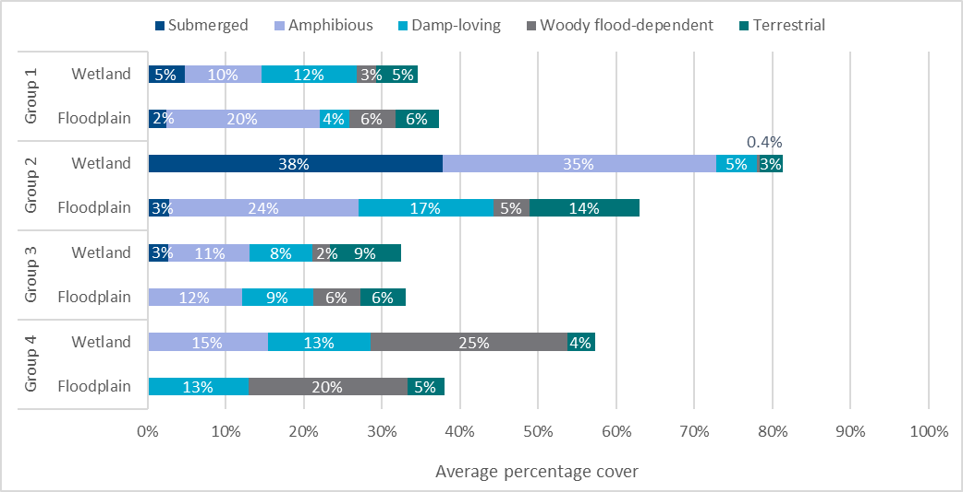
Figure 4.2 Average percentage cover of growth forms in each inundation group for sample points in wetland and floodplain habitats, 2023–24
Inundation Group 1 is the wettest group, and Inundation Group 4 is the driest group. For details of the growth-form groups, see Table A.1. Cover represents the average percentage cover per sample point in each inundation group.
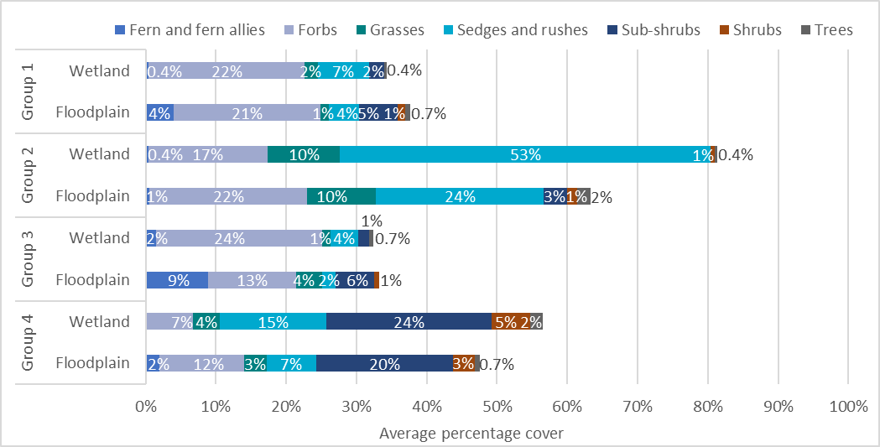

Vegetation community association with inundation groups across and within ecosystem types
The ANAE type ‘river red gum forest riparian zone or floodplain’, for which there are 12 sample points across 3 inundation groups (Table 4.2), displays differences in the 2023–24 vegetation communities within the different inundation groups (Figure 4.3).
Table 4.2 Number of sample points and sampling events within each inundation group for the Australian National Aquatic Ecosystems type ‘river red gum forest riparian zone or floodplain’, 2023–24
Inundation group | Sample points | # sample events
Group 1 | 3 | 1
Group 2 | – | –
Group 3 | 6 | 1
Group 4 | 3 | 1
The data collected from a single sampling event in 2023–24 showed that the sample points from ANAE type ‘river red gum forest riparian zone or floodplain’ had similar (average percentage) cover across inundation groups but that the composition of the vegetation assemblage differed (Figure 4.3). The sample points from Inundation Group 1 had greater cover of submerged species (2%) than Inundation Group 3 (0.2%). The converse was true for amphibious species – sample points in Inundation Group 3 had overall cover of 17% and Inundation Group 1 of 14%. In Inundation Group 4, the coverage of amphibious species was only 4%. Cover of damp-loving species was 11% in Inundation Group 4, 8% in Inundation Group 3 and 4% in Inundation Group 1. Most woody flood-dependent species (22%) were recorded in Inundation Group 4 (Figure 4.3). In the absence of environmental water, all sample points in this ANAE type would have experienced the inundation regimes of Inundation Group 3 or Inundation Group 4 and the likely corresponding loss of richness and coverage of submerged species.
Figure 4.3 Average percentage cover of ‘river red gum forest riparian zone or floodplain’ sample points in each inundation group, 2023–24
Inundation Group 1 is the wettest group, and Inundation Group 4 is the driest group. For detail on high-level functional groups, see Table A.1. Cover represents the average percentage cover per sample point per sample time in each inundation group. Details of the different sample point numbers are given in Table 3.5.
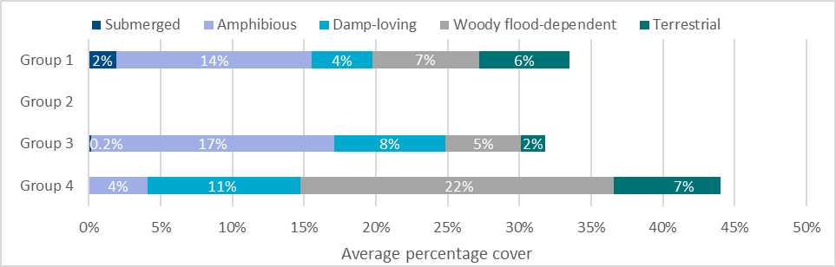

Contribution to Basin Plan objectives
The Basin Plan sets high-level objectives to ensure that the water-dependent ecosystems of the Basin are resilient to climate change and other risks and threats (Basin Plan section 8.04). Particular objectives for the protection and restoration of water-dependent ecosystems are set in Section 8.05, and particular objectives for the protection and restoration of ecosystem functions of water-dependent ecosystems are set out in Section 8.06. This chapter describes the multi-year contributions of environmental water deliveries to realising these objectives.
The Basin-scale Vegetation Theme evaluates the contribution of CEW to achieving the Basin Plan objectives for Biodiversity (Basin Plan section 8.04) and focuses on the use of environmental water to support the diversity of groundcover vegetation within the Basin. The Basin-scale evaluation of vegetation diversity therefore addresses 2 major questions:
What did Commonwealth environmental water contribute to plant species diversity?
What did Commonwealth environmental water contribute to vegetation community diversity?

Contribution to plant species diversity and groundcover vegetation community diversity between 2014–24
Commonwealth environmental watering actions delivered between 2014–15 and 2023–24 contributed to creating distinct inundation regimes across the floodplains and wetlands of the Basin. These regimes display significant differences in their functional and structural assemblages of vegetation.
Over a 10-year period, there was a greater diversity and cover of submerged, amphibious and damp-loving species at sample points that received wetter regimes supported by environmental watering events than at sample points not receiving environmental water. In the absence of CEW, many locations across the Basin would have experienced notably drier water regimes. Based on the sample points that were monitored by the Selected Area teams, 41% of sample points (30 of 73) would have been markedly drier. This would have likely resulted in less diversity and cover of submerged, amphibious and damp-loving species.
Further, in the absence of environmental water, a significant portion of the permanent wetlands, permanent tall emergent marshes and freshwater meadows on the managed floodplains of the Basin would have been transitioning to ecosystem types more common to drier inundation regimes. Over time, this would result in the loss of significant amounts of these wetland types and their associated plant communities.
The delivery of CEW has played a role in maintaining a substantial number of native plant species across the Basin. Of the 804 taxa recorded across all sample points since 2014, 10% (81) are native species that have only occurred at floodplain–wetland sample points that experience a wetter inundation regime (inundation groups 1, 2 and 3) because of environmental water. This includes submerged (2), amphibious (21) and damp-loving (16) species that are unlikely to persist in the absence of environmental water (Table C.2 and Table C.). Of these, one – water ribbons – is a submerged species known to be used by Aboriginal people in the Basin.

Reporting requirements under the Basin Plan
The CEWH is required to report ‘every five years on the achievements of environmental outcomes at a Basin-scale, by reference to the targets to measure progress towards the environmental objectives outlined in Schedule 7 (Basin Plan Schedule 12, item 7)’. The Schedule 7 targets relevant to vegetation include:
‘e) condition, diversity, extent and contiguousness of native water-dependent vegetation
f) recruitment and populations of native water-dependent species, including vegetation, birds, fish and macroinvertebrates
g) the community structure of water-dependent ecosystems.’
While designed to address questions of vegetation diversity, the Basin-scale Vegetation Theme evaluation can also be used to provide insight into the role of CEW in supporting populations of native water-dependent vegetation and the community structure of water-dependent ecosystems.
The use of environmental water to provide wetter inundation regimes has supported populations of native water-dependent plant species such as cumbungi (Typha spp.), marsh club-rush, spike-rush (Eleocharis spp.), water couch, mud grass, water primrose, common nardoo, old man weed, swamp starwort (Stellaria angustifolia) and willow primrose (Ludwigia octovalvis). In the absence of CEW, species such as these would be less present across the Basin. The use of environmental water in supporting these submerged, amphibious and damp-loving species has been important in maintaining the community structure of vegetation across key floodplains and wetland locations in the Basin.

Basin-wide environmental watering strategy expected outcomes for vegetation
The Basin Plan provides high-level environmental objectives that are directed at protecting and restoring water-dependent ecosystems of the Basin (Basin Plan section 8.04). The Strategy includes the expected outcome that environmental water will be used to ‘maintain the extent, and maintain or improve the condition of water-dependent vegetation in areas that can be influenced with environmental water’ (MDBA 2019). Outcomes for vegetation defined within the Strategy are framed within the context of specific vegetation structural groups (forests and woodlands, shrublands and non-woody vegetation) and provide expected outcomes for specific vegetation communities (e.g. lignum shrublands).
Evaluation under LTIM and Flow-MER has focused on evaluating the outcomes of using environmental water to support the diversity of groundcover vegetation (largely non-woody vegetation). This is not well aligned with the quantified expected outcomes defined within the Strategy (MDBA 2014, 2019) or the Basin Plan. The disconnect is partly a result of the Strategy being under development when LTIM was established. Thus, LTIM used the objectives of the Basin Plan to develop a suite of expected outcomes for vegetation diversity (Gawne et al. 2013) based on the scientific understanding of flow and ecological responses at the time (MDFRC 2013).
The implications of the poor alignment across multiple aspects of planning and evaluation are that the monitoring has not been designed to evaluate outcomes such as condition or extent. There is also poor alignment of the sampling locations in being truly representative of the vegetation communities for which outcomes are specified. It is strongly recommended that the alignment be revisited in future iterations of both the watering strategy and the evaluation program. Note that modification of monitoring design has been undertaken as part of the Flow-MER2.0 design process, and this is giving due consideration to alignment between the expected outcomes for vegetation and evaluation and to a change in sample design to improve spatial representativeness within the constraints of the program. While it is expected that some improvements may be made in spatial representativeness, there have been program constraints which means this is unlikely to provide a strong sampling design.
Further, the individual watering actions reported by the CEWH (CEWH 2023) have a wide range of objectives for vegetation, from maintaining the health of the adult trees and lignum to supporting aquatic plants. Only 19 of the 72 watering actions with expected outcomes for vegetation had explicit objectives for plant species diversity or groundcover species. This means that the line of sight between the objectives associated with watering actions and those from the Strategy or Basin Plan is often poor. Most meet site-specific needs for vegetation outcomes, but it means there is a risk of combining data from watering actions that have almost opposite objectives, such as watering actions designed to promote germination and survival of river red gums, and those designed to prevent river red gum encroachment.
Future evaluation could consider classifying vegetation objectives to better enable aggregate learning by sharing outcomes from actions with similar objectives. This would require that CEWH watering objectives be revised, more clearly stated, and better aligned with the Strategy. It would also require that the monitoring is aligned with actions that have similar objectives. While revisions to the stated objectives for vegetation could be implemented immediately, the revisions to the monitoring programs should be a consideration for future iterations of the program.

Informing adaptive management
Each annual evaluation contributes to our understanding of how the ecosystems of the Basin respond in the short term and long term to delivery of environmental water. This chapter provides our reflections on how this increased understanding can inform the next cycle of environmental water planning and its delivery, and improve our approach to Basin-scale evaluation.
Adaptive management [includes]: (a) setting clear objectives; (b) linking knowledge (including local knowledge), management evaluation and feedback over a period of time; (c) identifying and testing uncertainties; (d) using management as a tool to learn about the relevant system and change its management; (e) improving knowledge; (f) having regard to the social, economic and technical aspects of management. Basin Plan subsection 1.07

Informing the planning and management of environmental water for vegetation
The past 5 years of vegetation diversity evaluation have consistently identified several areas in which improvements can be made to the way in which environmental water is managed for vegetation, from the provision of water to the need for data to support evaluation. These are described below.

Environmental water should continue to be managed to maintain wetter hydrological regimes in floodplain–wetland habitats
Environmental water is important for maintaining a diversity of inundation regimes across the managed floodplain that in turn support distinct functional and structural assemblages of vegetation. Of note has been the role of environmental water in reducing the duration of the dry phase, which has led to far greater cover of vegetation and, in particular, a greater cover of submerged and amphibious plants. In the absence of environmental water, there would likely be a considerable decline in vegetation communities that include submerged, amphibious and damp-loving species. It is particularly important that the wetter inundation regimes provided by environmental water are maintained to avoid widespread loss of both species diversity and vegetation community diversity.

There is an opportunity to support plants known to be used by Aboriginal people using environmental water
While Commonwealth environmental watering actions over the past 10 years have not deliberately targeted plant species because of their cultural significance, watering actions that supported groundcover vegetation have supported a range of plant species known to be used by Aboriginal people. There is opportunity to engage with Aboriginal communities across the Basin to identify additional plant species that are culturally important and can be supported with environmental water. This could help establish more specific cultural objectives for vegetation outcomes in the Basin, help inform the design of watering actions, and contribute to supporting plant species diversity across the Basin.

A stronger focus on, and clarity of, vegetation objectives and expected outcomes is needed at all levels of environmental water management
There is generally poor alignment between the high-level Basin Plan objectives for vegetation, and the more specific, but insufficiently quantified objectives of the annual individual watering actions in the Strategy (MDBA 2019). The Basin Plan objectives are broadly directed at protecting and restoring water-dependent ecosystems of the Basin, while the Strategy is focused on condition, extent and specific vegetation communities. Further, the watering action objectives for vegetation are frequently not specific. We continue to recommend that objectives for vegetation be better aligned with the overarching frameworks and that more specific (preferably quantified) objectives for individual watering actions be defined, including objectives that reflect the functional role of vegetation in supporting other values (e.g. particular species or structural groups of vegetation that provide habitat for fauna). While this requires refinement of the objectives for vegetation in the Strategy and subsequent alignment of the objectives of watering actions, incremental advances could be made immediately through better described objectives for individual watering actions.

Improving our approach to Basin-scale evaluation

There is a need to improve the accuracy of remotely sensed bimonthly inundation data
The inundation groups used in the multi-year evaluation are key to inferring vegetation responses to environmental water at unmonitored sites. The analysis undertaken over the past 5 years has demonstrated that patterns in inundation at a quarterly timestep (available for the monitored floodplain–wetland sample points) are strongly associated with the structural and functional composition of vegetation communities. Current data products using remotely sensed data are improving (Lymburner et al. 2024; Heath et al. 2024) but are not yet operational. Improving surface-water detection at sub-annual timesteps is critical to the broader application of the approach currently undertaken to evaluate vegetation responses. This will need to be combined with the ability to establish inundation regimes in the absence of environmental water.

Improvements to the sampling design are needed to better support evaluation
Sampling of groundcover vegetation encompasses an area of approximately 3.6 hectares (0.0001% of the managed floodplain), which is a very small sample size given the variation and complexity of the basin. Additionally, the sample points monitored as part of Flow-MER were not established to provide replication across ANAE types nor to provide data from the key ANAE types or vegetation communities that are a Basin-wide priority for environmental water. The inundation clustering approach has been used to assign the sample points to inundation groups post hoc. This has resulted in an uneven distribution of sample points across inundation groups, and there is not always a broad spatial representation within the groups. It is not clear how representative the inundation clusters are of those that are experienced across the Basin or how the sampling design might influence the inferences drawn for unmonitored sample points. In the absence of inundation data at a better temporal resolution and different approaches to the selection of sample points, the approach chosen is the best available. The sampling design for vegetation evaluation under Flow-MER2.0 has been revisited, and an improvement is expected. However, the selection of sample-point locations has involved a trade-off between the ability to support Selected Area watering decisions and report on Selected Area outcomes, the need to maintain long term datasets, and the ability to report on Basin-scale outcomes for vegetation.

There is a need to establish key hydrological metrics to support the evaluation of vegetation responses on riverbanks
The evaluation presented in this report focuses on floodplain and wetland sample points across the Basin rather than the riverine sample points that are the focus of expected outcomes for vegetation in the Edward/Kolety–Wakool river systems, Goulburn River and Lower Murray River Selected Areas. There is a need to provide resources to develop an approach to classifying the hydrological regimes or develop the appropriate hydrological metrics based on in-channel water-level fluctuations that could support the evaluation of vegetation outcomes at a Basin scale within this context. This will need to be undertaken within corresponding revisions to the objectives for vegetation in the Basin-wide environmental watering strategy that consider the expected outcomes for riverbank vegetation.

The inundation-classification approach provides an opportunity to consider appropriate watering regimes to support vegetation within Australian National Aquatic Ecosystem types
Inundation regime is one of the key drivers of floodplain, wetland and riverine vegetation communities. The composition and structure of the vegetation communities are strongly influenced by both short-term and long-term aspects of the flow regime (Capon et al. 2016; Nilsson and Svedmark 2002; Stromberg 2001). Ecosystem type, such as ANAE type, is also important in influencing the response of vegetation and in reflecting the long-term aspects of the flow regime. For example, the distribution of long-lived woody vegetation versus treeless wetland areas reflects, in part, the frequency, depth and duration of inundation across decades to centuries. The inundation-classification approach used in this evaluation has the potential to be developed further to establish key metrics around the appropriate hydrological regimes for the vegetation communities that occur within different ANAE types. For example, the ANAE types of permanent lake, permanent tall emergent marsh and permanent wetland should be (almost) permanently inundated to support a healthy functioning vegetation community and thus fit within Inundation Group 1. This would represent a combination of the PhD research supported by Flow-MER (Campbell) and the hydrological-classification approach used in the evaluation. This framing could be used to improve the hydrological objectives that are provided in the Strategy.

Vegetation classification and data
- Functional-group and growth-form classification system
Water plant functional groups are based on an adapted version of the Brock and Casanova (1997) and Casanova (2011) classifications. Where taxa are unable to be assigned to a particular functional group, they were classified as ‘variable’ and excluded from functional group analyses. This only applies to taxa that are unable to be identified to species level (recorded to genus or family level).
Table A.1 Plant high-level functional-group classification
After Brock and Casanova (1997) and Casanova (2011) with the addition of Woody – flow dependent (W-W), Woody – riparian/floodplain (W-RF) and Woody – other (W-O) to separate woody species’ responses. FG = functional group.
FG | Description | Long description
Submerged (S)
Se | Perennial – emergent | Woody and monocotyledonous species that require permanent water in the root zone but remain emergent. They thrive where water levels do not fluctuate or fluctuate little (i.e. weir pools, dams)
S | Submerged | Species that require a sample point be flooded to >10 cm. Completely water dependent; their habitat is the water column. Some species may persist via a dormant, long-lived seedbank. Sr and Sk species have been combined here. See original descriptions for additional details
Amphibious (A)
Arf | Amphibious fluctuation responder – floating | Species that grow under water or float on the surface of the water or have floating leaves. They require year-round presence of free water. Many of these can survive and complete their life cycle stranded on the mud, but they reach maximum biomass growing in ‘open’ water all year round
Arp | Amphibious fluctuation responder – plastic | A species group occupying a similar habitat to the Atl group, except that they have a morphological response to water-level changes, such as rapid shoot elongation or a change in leaf type. They can persist on damp and drying ground because of their morphological flexibility and can flower even if the sample point dries out. They occupy slightly deeper/wet-for-longer sample points than the Atl group
Ate | Amphibious fluctuation tolerator – emergent | Emergent monocots and dicots that survive in saturated soil or shallow water but require most of their photosynthetic parts to remain above the water (emergent). They tolerate fluctuations in the depth of water, as well as water presence. They need water to be present for about 8–10 months of the year, and the dry time to be in the cooler times of the year (Note: not sure this part of the description is always met)
Atl | Amphibious fluctuation tolerator – low-growing | Species that germinate either on saturated soil or under water and grow totally submerged, as long as they are exposed to air by the time they start to flower and set seed. They require shallow flooding for about 3 months
Damp-loving (D)
Tda | Terrestrial – damp | Species that germinate and establish on saturated or damp ground but cannot tolerate flooding in the vegetative state. As such, they can persist throughout the environment in dry puddles and drains. They grow on bare ground following flooding or in places where floodwater has spread out over the landscape long enough to saturate the soil profile. They require the soil profile to remain damp for about 3 months
Woody flood-dependent (WF)
W-W | Woody – flow dependent | Woody perennial trees or large shrubs that require water to be present in the root zone all year round but will germinate in shallow water or on a drying profile. If they grow on floodplains, they require flooding and restoration of the groundwater levels on a regular basis
W-RF | Woody – riparian/ floodplain | Woody perennial trees or large shrubs that are frequently associated with riparian, wetland and floodplain habitats. However, their requirements for inundation appear to be less frequent than for species in the W-W group. Their dependence on river–floodplain functions may be unknown
Terrestrial (T)
W-O | Woody – other | Woody perennial trees or large shrubs that do not require flooding and occur in a range of habitat types
Tdr | Terrestrial – dry | Species with no flooding requirement that persist in damper parts of the landscape because of localised high rainfall. Species in this group can invade or persist in riparian zones and the edges of wetlands, but are essentially terrestrial
Variable (var)
var | variable (family level) | Taxa not identified to species level and species within the genus or family that have different functional group responses
NV | Non-vascular (with the exception of Chara and Nitella) | Non-vascular taxa, with the exception of Chara and Nitella (charophytes), which have been included in the S – Submerged functional group category
Table A.2 Growth-form classifications used in evaluation (sourced and altered from BioNet)
Growth form | Description | Examples
E | Ferns and fern allies | Azolla
F | Forbs – herbaceous flowering plants other than grasses, sedges and rushes | Alternanthera denticulata, Centipeda cunninghamii, Mentha australis, Potamogeton tricarinatus
G | All grasses (combined tussock, hummock and other grasses) | Hordeum leporinum, Lachnagrostis filiformis, Paspalidium jubiflorum
K | Epiphytes | Amyema quandang, Lysiana subfalcata
L | Vines | Convolvulus erubescens, Cucumis myriocarpus
S | Shrubs | Atriplex nummularia, Chenopodium nitrariaceum, Duma florulenta
S-R | Sedges and rushes | Carex appressa, Eleocharis pallens, Juncaceae, Cyperaceae
SubS | Sub-shrubs (woody, lower growing, small shrubs) | Aeschynomene indica, Atriplex semibaccata, Rhagodia spinescens
T | Trees | Acacia stenophylla, Eucalyptus camaldulensis, Melaleuca lanceolata
NV | Non-vascular taxa (mosses, liverworts, charophytes, algae) | Excluded with exception of Chara and Nitella (charophytes)
var | variable (genus-level or family-level identification) | Chenopodiaceae
- Details of vegetation sampling design
Table A.3 Vegetation sampling design at the Selected Areas monitored for the Long Term Intervention Monitoring Project and Flow-MER across all water years 2014–24 and in 2023–24
A (month/s in brackets) in the ‘Sampling regime during a water year’ column indicates an earlier or delayed sampling in that month.
Selected Area | Sampling regime during a water year | Number of sample points 2014–24 | Number of sample points 2023–24 | Number of replicate plots/ transects per sample point | Sampling unit description
Riverine Selected Areas
Edward/Kolety–Wakool river systems | Nearly monthly (7 to 10 trips) from Aug–May (June) (exception 2016–17, 6 trips Nov–May, and 2022–23, 3 trips Jan–March) | 16–20 | 19 | 6 20-m long transects parallel to river up the bank | Entire 20-m transect
Goulburn River | 2 times a year in Sep/Oct and Dec (2014–15, 2015–16, and 2017–18) OR 3 times a year in Sep, (Nov), Dec and March (2018-19 till 2020–21, and 2016–17 in Dec, Feb, April) OR 4 times a year Sep, (Nov), Dec, March and April (2021–22 and 2023–24) | 2–3 | 3 | 14–16 transects perpendicular to the river (7–8 on each side of the bank) | At each transect, there are 4–12 2-m long sub-transects parallel to river and up the bank
Lower Murray River | Once a year: 2019–20 in Dec, 2020–21 in Feb, and 2023–24 in June | 3 | 3 | 6–7 15-m long transects | 15 1-m² quadrats
Wetland–floodplain Selected Areas
Gwydir River System | Biannually spring/autumn, in Oct–Dec and March (April, May, June, July) (exception in 2022–23 only 1 trip in March) | 13–22 | 22 | 1–4 0.04-ha plots | Entire 0.04-ha plot
Lachlan River System¹ | Biannually spring/autumn, in Oct–Nov (Dec) and (Feb, April) May–June (in 2022–23 only 1 trip in May) | 9–14 | 12 | 2 (6) 100-m long transects | 1-m² quadrats every 10 m along the transect (sampled as 10 1 m² quadrats)
Lachlan River System | Biannually spring/autumn, in Oct–Nov (Dec) and (Feb, April) May–June (in 2022–23 only 1 trip in May) | 13–15 | 13 | 2 0.1-ha plots (trees) with nested 0.04-ha plots (ground layer) | Entire 0.04-ha plot
Murrumbidgee River System | 4 times a year in Sep (Oct), Nov (Dec), Jan/Feb and March/ April (May) (exception 2021–22, no trip in Sep, and 2022–23, no trip in Nov) | 12 | 12 | 2–3 90–250-m long transects, depending on wetland bathymetry and area | 10-m² quadrats along the transect (sampled as 3–5 10 m² quadrats)
Junction of Warrego and Darling rivers | Biannually spring/autumn; in (Aug) Sep–Dec (Feb) and (Feb) Mar–May (exception 2014–15 in Feb and May) | 8 | 8 | 3 0.04-ha plots | Entire 0.04-ha plot
² The 6 transects in the Great Cumbung Swamp (GCS-T) were established in a 50-m × 50-m square to ensure consistency of watering frequency rather than along a 100-m transect.
Table A.4 Sample points per Selected Area for each water year, 2014–24, sampled (used) in the Basin-scale evaluation
Numbers within Selected Areas vary because of inaccessibility, discontinuation and addition of sample points. Difference between sample point numbers and numbers in brackets indicate where no plants had been recorded. Vegetation monitoring at the Edward/Kolety–Wakool river systems started in 2015–16 and occurred at the Lower Murray River only in 2019–20, 2021–22 and 2023–24.
Selected Area | 14–15 | 15–16 | 16–17 | 17–18 | 18–19 | 19–20 | 20–21 | 21–22 | 22–23 | 23–24 | Total
Edward/Kolety–Wakool river systems | – | 16 | 16 | 16 | 16 | 20 | 20 | 20 | 18 (16) | 19 (18)
Goulburn River | 2 | 2 | 2 | 2 | 2 | 2 | 2 | 2 | 2 | 3
Gwydir River System | 13 | 19 | 19 | 19 | 16 | 17 | 18 (16) | 18 | 19 | 22
Junction of Warrego and Darling rivers | 8 | 8 | 8 | 8 | 8 | 8 | 8 | 8 | 8 | 8
Lachlan River System | 25 | 25 | 23 (21) | 23 | 23 | 27 | 25 | 25 (22) | 22 (21) | 25
Lower Murray River | – | – | – | – | – | 3 | 3 | – | – | 3
Murrumbidgee River System | 12 | 12 | 12 | 12 | 12 | 12 | 12 | 9 | 5 | 12
Total sampled (used) | 60 | 82 | 80 (78) | 80 | 77 | 89 | 87 | 82 (79) | 74 (71) | 92 (91) | 803 (794)
- Australian National Aquatic Ecosystem types
Hydrological regime and ecosystem type are known to be key drivers of vegetation response. The LTIM and Flow-MER vegetation sample points occur within 18 Australian National Aquatic Ecosystem (ANAE) types across the Basin. Replication of sample points within ANAE types is relatively low, particularly when viewed across multiple geographical regions (i.e. Selected Areas) and hydrological regimes. This limits our ability to assess the responses to environmental water as well as limiting our capacity to extrapolate to unmonitored areas.
Table A.5 Australian National Aquatic Ecosystem types (Brooks 2021) surveyed with the number of sample points in each Selected Area, 2014–24
Selected Area (SA) abbreviations: EW = Edward/Kolety–Wakool river systems, G = Goulburn River, LM = Lower Murray River, GWY = Gwydir River System, WADA = Junction of Warrego and Darling rivers, LACH = Lachlan River System, MUR = Murrumbidgee River System. Absence is presented by a dash (–). ANAE = Australian National Aquatic Ecosystems.
ANAE habitats and types | Number of sample points per Selected Area |  |  |  |  |  |  | Total no. sample points | No. of SAs
ANAE habitats and types | EW | G | LM | GWY | WADA | LACH | MUR | Total no. sample points | No. of SAs
Lakes and wetlands
Lp1.1: Permanent lake | – | – | – | – | 1 | – | – | 1 | 1
Lt1.1: Temporary lake | – | – | – | – | – | 6 | – | 6 | 1
Pp2.1.2: Permanent tall emergent marsh | – | – | – | – | – | 1 | – | 1 | 1
Pp4.2: Permanent wetland | – | – | – | – | – | – | 3 | 3 | 1
Pt1.1.2: Temporary river red gum swamp | – | – | – | – | – | 2 | 5 | 7 | 2
Pt1.2.2: Temporary black box swamp | – | – | – | – | – | 2 | – | 2 | 1
Pt1: Temporary swamp | – | – | 2 | – | – | – | – | 2 | 1
Pt2.2.2: Temporary sedge/grass/forb marsh | – | – | – | – | 3 | – | – | 3 | 1
Pt2.3.2: Freshwater meadow | – | – | – | 9 | – | – | – | 9 | 1
Floodplains
F1.10: Coolibah woodland and forest riparian zone or floodplain | – | – | – | 13 | 2 | – | – | 15 | 2
F1.11: River cooba woodland riparian zone or floodplain | – | – | – | 3 | – | – | – | 3 | 1
F1.2: River red gum forest riparian zone or floodplain | 11 | – | – | – | 2 | 12 | 1 | 26 | 4
F1.8: Black box woodland riparian zone or floodplain | – | – | – | – | – | 7 | 1 | 8 | 2
F2.2: Lignum shrubland riparian zone or floodplain | – | – | – | – | – | 1 | 1 | 2 | 2
F2.4: Shrubland riparian zone or floodplain | – | – | – | – | – | 1 | – | 1 | 1
River channels
Rp1.4: Permanent lowland stream | – | 3 | 1 | – | – | – | 1 | 5 | 3
Rt1.4: Temporary lowland stream | 9 | – | – | – | – | – | – | 9 | 1
Total number of ANAE types per SA | 2 | 1 | 2 | 3 | 4 | 8 | 6
Total number of sample points per SA | 20 | 3 | 3 | 25 | 8 | 32 | 12 | 103

Inundation of floodplain and wetland sample points with and without environmental water, 2014–24
Table B.1 Presence/absence of inundation at each sample point for each quarter per water year with environmental water, 2014–24
Sample points are assigned to an inundation group (1 = wettest, 4 = driest) derived by k-means clustering, using on-ground observed hydrological data with environmental water. Presence is indicated by ‘1’ in the cell (and coloured blue) and absence by a dash (-).
Selected Area with sample point | Inund. group | 2014–15 |  |  |  | 2015–16 |  |  |  | 2016–17 |  |  |  | 2017–18 |  |  |  | 2018–19 |  |  |  | 2019–20 |  |  |  | 2020–21 |  |  |  | 2021–22 |  |  |  | 2022–23 |  |  |  | 2023–24
Selected Area with sample point | Inund. group | Quarter |  |  |  | Quarter |  |  |  | Quarter |  |  |  | Quarter |  |  |  | Quarter |  |  |  | Quarter |  |  |  | Quarter |  |  |  | Quarter |  |  |  | Quarter |  |  |  | Quarter
Selected Area with sample point | Inund. group | 1 | 2 | 3 | 4 | 1 | 2 | 3 | 4 | 1 | 2 | 3 | 4 | 1 | 2 | 3 | 4 | 1 | 2 | 3 | 4 | 1 | 2 | 3 | 4 | 1 | 2 | 3 | 4 | 1 | 2 | 3 | 4 | 1 | 2 | 3 | 4 | 1 | 2 | 3 | 4
Lachlan River System
Bunumburt-T | 1 | - | 1 | - | - | 1 | 1 | 1 | 1 | 1 | 1 | 1 | 1 | 1 | 1 | 1 | 1 | 1 | 1 | 1 | 1 | - | - | - | - | - | - | - | - | - | 1 | 1 | 1 | 1 | 1 | 1 | 1 | 1 | 1 | 1 | 1
GCS-T | 1 | - | - | - | 1 | 1 | - | 1 | 1 | 1 | 1 | 1 | 1 | 1 | 1 | 1 | 1 | 1 | - | 1 | 1 | 1 | - | 1 | - | 1 | 1 | 1 | 1 | 1 | 1 | 1 | 1 | 1 | 1 | 1 | 1 | 1 | 1 | 1 | 1
Juanbung-P | 1 | 1 | 1 | - | 1 | 1 | 1 | 1 | 1 | 1 | - | 1 | 1 | - | - | 1 | 1 | - | - | 1 | 1 | - | - | 1 | - | - | 1 | - | - | - | 1 | 1 | 1 | 1 | 1 | 1 | 1 | 1 | 1 | 1 | 1
Juanbung-T | 1 | 1 | 1 | - | 1 | 1 | 1 | 1 | 1 | 1 | 1 | 1 | 1 | 1 | 1 | 1 | 1 | 1 | 1 | 1 | 1 | 1 | 1 | 1 | - | 1 | 1 | 1 | - | 1 | 1 | 1 | 1 | 1 | 1 | 1 | 1 | 1 | 1 | 1 | 1
Murrumbidgee River System
Eulimbah Swamp | 1 | 1 | 1 | 1 | 1 | - | 1 | 1 | 1 | 1 | 1 | 1 | 1 | 1 | 1 | 1 | - | 1 | 1 | 1 | - | 1 | 1 | 1 | 1 | 1 | 1 | 1 | 1 | 1 | 1 | 1 | 1 | 1 | 1 | 1 | 1 | 1 | 1 | 1 | 1
Gooragool | 1 | 1 | - | 1 | 1 | 1 | 1 | 1 | 1 | 1 | 1 | 1 | 1 | 1 | 1 | 1 | - | 1 | 1 | - | - | - | 1 | 1 | 1 | 1 | - | - | 1 | 1 | 1 | 1 | 1 | 1 | 1 | 1 | 1 | 1 | 1 | - | -
Mercedes Swamp | 1 | 1 | 1 | 1 | 1 | 1 | 1 | 1 | 1 | 1 | 1 | 1 | 1 | 1 | 1 | 1 | 1 | 1 | 1 | - | - | - | - | 1 | 1 | 1 | 1 | 1 | 1 | - | 1 | 1 | 1 | 1 | 1 | 1 | 1 | 1 | 1 | - | -
Nap Nap Swamp | 1 | 1 | 1 | - | - | - | 1 | - | - | 1 | 1 | 1 | 1 | 1 | 1 | 1 | - | 1 | 1 | 1 | 1 | 1 | 1 | 1 | 1 | 1 | 1 | 1 | 1 | 1 | 1 | 1 | 1 | 1 | 1 | 1 | 1 | 1 | 1 | 1 | 1
Piggery Lake | 1 | - | 1 | 1 | 1 | 1 | 1 | - | - | 1 | 1 | 1 | 1 | - | - | - | - | 1 | 1 | 1 | 1 | 1 | 1 | 1 | 1 | 1 | 1 | 1 | 1 | 1 | 1 | 1 | 1 | 1 | 1 | 1 | 1 | 1 | 1 | - | -
Sunshower Lagoon | 1 | - | - | - | - | 1 | 1 | - | - | 1 | 1 | 1 | 1 | 1 | 1 | 1 | 1 | - | 1 | - | - | - | - | 1 | 1 | 1 | 1 | 1 | 1 | - | 1 | 1 | 1 | 1 | 1 | 1 | 1 | 1 | 1 | 1 | 1
Telephone Creek | 1 | 1 | 1 | 1 | - | - | 1 | 1 | 1 | 1 | - | - | - | 1 | 1 | 1 | 1 | 1 | 1 | 1 | 1 | 1 | 1 | 1 | 1 | 1 | 1 | 1 | 1 | 1 | 1 | 1 | 1 | 1 | 1 | 1 | 1 | 1 | 1 | - | -
Two Bridges Swamp | 1 | 1 | 1 | 1 | 1 | 1 | 1 | 1 | 1 | 1 | 1 | 1 | 1 | 1 | 1 | 1 | - | 1 | 1 | 1 | 1 | 1 | - | 1 | 1 | 1 | 1 | 1 | 1 | - | 1 | 1 | 1 | 1 | 1 | 1 | 1 | 1 | 1 | 1 | -
Waugorah Lagoon | 1 | 1 | 1 | - | 1 | - | 1 | 1 | 1 | 1 | 1 | 1 | 1 | 1 | 1 | 1 | 1 | 1 | 1 | 1 | 1 | 1 | 1 | 1 | - | 1 | 1 | 1 | 1 | 1 | 1 | 1 | 1 | 1 | 1 | 1 | 1 | 1 | 1 | 1 | 1
Yarradda Lagoon | 1 | - | - | 1 | 1 | 1 | 1 | 1 | 1 | 1 | 1 | 1 | 1 | 1 | 1 | 1 | 1 | 1 | - | 1 | 1 | 1 | 1 | 1 | 1 | 1 | 1 | 1 | 1 | 1 | 1 | 1 | 1 | 1 | 1 | 1 | 1 | 1 | 1 | 1 | 1
Gwydir River System
Bungunya 1-1 | 2 | - | 1 | 1 | - | - | 1 | 1 | - | - | - | - | - | - | - | - | - | - | 1 | - | - | - | - | - | - | - | - | 1 | 1 | - | - | 1 | 1 | 1 | 1 | 1 | - | - | - | - | -
Bungunya 1-2 | 2 | - | 1 | 1 | - | - | 1 | 1 | - | - | - | - | - | - | - | - | - | - | 1 | - | - | - | - | - | - | - | - | 1 | 1 | - | - | 1 | 1 | 1 | 1 | 1 | - | - | - | - | -
Bunnor-1 | 2 | - | - | 1 | - | 1 | - | - | - | 1 | 1 | 1 | 1 | 1 | 1 | - | 1 | 1 | 1 | - | - | - | - | 1 | - | - | - | 1 | 1 | 1 | 1 | 1 | 1 | 1 | 1 | 1 | 1 | - | - | 1 | -
Coombah 1-1 | 2 | - | 1 | 1 | - | - | 1 | 1 | - | - | - | 1 | - | 1 | - | - | - | - | 1 | 1 | - | - | - | - | - | - | - | 1 | 1 | - | 1 | 1 | 1 | 1 | 1 | 1 | - | - | - | - | -
Coombah 1-2 | 2 | - | 1 | 1 | - | - | 1 | 1 | - | 1 | - | - | - | 1 | - | - | - | - | 1 | 1 | - | - | 1 | - | - | - | - | 1 | 1 | - | 1 | 1 | 1 | 1 | 1 | 1 | - | - | - | - | -
Goddards Lease Ramsar-1 | 2 | - | - | 1 | - | 1 | - | - | - | - | 1 | - | - | 1 | 1 | - | - | 1 | - | - | - | - | - | 1 | - | - | - | 1 | 1 | 1 | 1 | 1 | 1 | 1 | 1 | 1 | - | - | - | 1 | -
Lynworth-1 | 2 | - | - | 1 | - | 1 | - | - | - | 1 | 1 | 1 | 1 | - | - | - | 1 | 1 | 1 | - | - | - | - | - | - | - | - | 1 | 1 | 1 | 1 | 1 | 1 | 1 | 1 | 1 | - | - | - | - | -
Lynworth-3 | 2 | - | - | 1 | - | 1 | - | - | - | 1 | 1 | 1 | - | - | - | - | 1 | 1 | 1 | - | - | - | - | - | - | - | - | 1 | 1 | 1 | 1 | 1 | 1 | 1 | 1 | 1 | - | - | - | - | -
MooCool-1 | 2 | - | - | 1 | - | 1 | - | - | - | 1 | 1 | 1 | - | - | - | - | 1 | 1 | 1 | - | - | - | - | - | - | - | - | 1 | 1 | 1 | 1 | - | 1 | 1 | 1 | - | - | - | - | - | -
Munwonga-1 | 2 | - | - | 1 | - | 1 | - | - | - | 1 | 1 | 1 | 1 | 1 | 1 | - | 1 | 1 | 1 | - | - | - | - | - | 1 | - | - | 1 | 1 | 1 | 1 | - | 1 | 1 | 1 | 1 | - | - | - | - | -
Munwonga-RC-1 | 2 | - | - | 1 | - | 1 | - | - | - | 1 | 1 | 1 | 1 | 1 | 1 | - | 1 | 1 | 1 | - | - | - | - | - | 1 | - | - | 1 | 1 | 1 | 1 | - | 1 | 1 | 1 | 1 | - | - | - | - | -
Old Dramana Elders-1 | 2 | - | - | 1 | - | 1 | - | 1 | - | - | - | - | - | - | - | - | - | 1 | 1 | - | - | - | - | - | 1 | - | - | 1 | 1 | 1 | 1 | 1 | - | 1 | 1 | - | - | - | - | - | -
Old Dramana Nursery-1 | 2 | - | 1 | 1 | - | 1 | - | 1 | 1 | 1 | - | - | - | - | - | - | - | 1 | 1 | - | - | - | - | - | - | - | - | 1 | 1 | 1 | 1 | 1 | 1 | 1 | 1 | - | - | - | - | - | -
Old Dramana Nursery-2 | 2 | - | - | - | - | 1 | - | 1 | 1 | 1 | - | - | - | - | - | - | - | - | - | - | - | - | - | - | - | - | - | 1 | 1 | 1 | 1 | 1 | 1 | 1 | 1 | - | - | - | - | - | -
Old Dramana Ramsar-1 | 2 | - | 1 | 1 | - | 1 | - | 1 | - | 1 | 1 | 1 | 1 | - | - | - | - | 1 | 1 | - | - | - | - | 1 | - | - | - | 1 | 1 | 1 | 1 | 1 | 1 | 1 | 1 | 1 | 1 | - | - | - | -
Old Dramana Ramsar-2 | 2 | - | - | 1 | - | 1 | - | 1 | - | - | 1 | 1 | 1 | - | - | - | - | 1 | 1 | - | - | - | - | 1 | - | - | - | 1 | 1 | 1 | 1 | 1 | 1 | 1 | 1 | - | - | - | - | - | -
Old Dramana Ramsar-3 | 2 | - | 1 | 1 | 1 | - | - | 1 | - | - | 1 | 1 | 1 | 1 | 1 | 1 | - | - | 1 | - | - | - | - | 1 | - | - | - | 1 | 1 | 1 | 1 | 1 | 1 | 1 | 1 | 1 | 1 | - | - | - | -
Valletta-1 | 2 | - | 1 | 1 | - | - | 1 | 1 | - | - | - | 1 | 1 | 1 | - | - | - | - | 1 | 1 | - | - | - | 1 | - | - | - | 1 | 1 | - | 1 | 1 | 1 | 1 | 1 | 1 | - | - | - | 1 | -
Valletta-2 | 2 | - | - | - | - | - | 1 | 1 | - | - | - | 1 | 1 | 1 | - | - | - | - | 1 | 1 | - | - | - | - | 1 | - | - | 1 | 1 | - | 1 | 1 | 1 | 1 | 1 | 1 | - | - | - | 1 | 1
Westholme coolibah | 2 | - | - | 1 | - | 1 | - | 1 | 1 | - | 1 | - | - | - | - | - | - | - | - | - | - | - | - | - | - | - | - | 1 | 1 | 1 | 1 | 1 | 1 | 1 | 1 | 1 | - | - | - | - | -
Westholme-1 | 2 | - | - | 1 | - | 1 | - | - | - | - | 1 | 1 | - | - | - | - | - | - | 1 | - | - | - | - | 1 | - | - | - | 1 | 1 | 1 | 1 | 1 | 1 | 1 | 1 | 1 | 1 | - | - | - | -
Murrumbidgee River System
Avalon Swamp | 2 | - | 1 | 1 | - | - | - | - | - | 1 | 1 | - | - | - | - | - | - | - | - | - | 1 | 1 | - | 1 | - | - | 1 | 1 | 1 | 1 | 1 | 1 | 1 | 1 | 1 | 1 | 1 | 1 | - | - | -
Lachlan River System
Booligal-T | 3 | - | - | - | 1 | 1 | - | 1 | 1 | 1 | - | - | - | - | - | - | - | - | - | - | - | - | - | - | - | - | 1 | 1 | - | 1 | 1 | 1 | 1 | 1 | 1 | 1 | - | 1 | - | - | 1
Bunumburt-P | 3 | - | - | - | - | 1 | - | - | 1 | 1 | 1 | 1 | 1 | - | 1 | 1 | 1 | 1 | - | - | - | - | - | - | - | - | - | - | - | - | - | - | - | 1 | 1 | 1 | 1 | 1 | 1 | 1 | -
Clear Lake-P | 3 | - | - | - | - | - | - | - | - | 1 | 1 | - | - | - | - | - | - | - | - | - | - | - | - | - | - | - | 1 | 1 | 1 | 1 | 1 | 1 | 1 | 1 | 1 | 1 | 1 | 1 | 1 | 1 | 1
Hazelwood-T | 3 | - | 1 | - | 1 | 1 | 1 | 1 | 1 | 1 | 1 | - | - | - | - | - | - | - | - | - | - | - | - | - | - | 1 | 1 | 1 | - | 1 | 1 | 1 | 1 | 1 | 1 | 1 | 1 | - | - | - | -
Lake Bullogal-P | 3 | - | - | - | - | - | - | - | 1 | 1 | 1 | 1 | - | - | - | - | - | - | - | - | - | - | - | - | - | - | 1 | 1 | - | 1 | 1 | 1 | 1 | 1 | 1 | 1 | 1 | 1 | 1 | - | -
Lake Bullogal-T | 3 | - | 1 | - | - | - | - | - | 1 | 1 | 1 | 1 | 1 | 1 | - | - | - | - | - | - | - | - | - | - | - | - | 1 | 1 | - | 1 | 1 | 1 | 1 | 1 | 1 | 1 | 1 | 1 | 1 | 1 | -
Lake Ita Inlet-P | 3 | - | - | - | - | - | - | - | 1 | 1 | 1 | - | - | - | - | - | - | - | - | - | - | - | - | - | - | - | - | - | - | 1 | 1 | 1 | 1 | 1 | 1 | 1 | 1 | 1 | 1 | - | 1
Lake Ita-P | 3 | - | - | - | - | - | - | - | 1 | 1 | 1 | 1 | 1 | - | - | - | - | - | - | - | - | - | - | - | - | - | - | - | - | 1 | 1 | 1 | 1 | 1 | 1 | 1 | 1 | 1 | 1 | 1 | 1
Lake Marool-T | 3 | - | - | - | 1 | 1 | - | - | 1 | 1 | 1 | 1 | - | - | - | - | - | - | - | - | - | - | - | - | - | - | 1 | 1 | - | - | 1 | 1 | - | 1 | 1 | 1 | 1 | 1 | 1 | - | -
Lake Tarwong RRG-P | 3 | - | - | - | - | - | - | - | 1 | 1 | 1 | 1 | 1 | 1 | - | - | - | - | - | - | - | - | - | - | - | - | - | - | - | 1 | 1 | 1 | 1 | 1 | 1 | 1 | 1 | 1 | 1 | - | 1
Lake Tarwong-T | 3 | - | - | - | - | - | - | - | 1 | 1 | 1 | 1 | 1 | 1 | 1 | - | - | - | - | - | - | - | - | - | - | - | - | - | - | 1 | 1 | 1 | 1 | 1 | 1 | 1 | 1 | 1 | 1 | 1 | 1
Moon Moon-P | 3 | - | - | - | 1 | 1 | - | - | 1 | 1 | 1 | 1 | - | - | - | - | - | - | - | - | - | - | - | - | - | 1 | 1 | 1 | 1 | 1 | 1 | 1 | 1 | 1 | 1 | 1 | 1 | 1 | 1 | 1 | 1
Moon Moon-T | 3 | - | - | - | 1 | 1 | 1 | - | 1 | 1 | 1 | 1 | 1 | - | - | - | - | - | - | - | - | - | - | - | - | 1 | 1 | 1 | 1 | 1 | 1 | 1 | 1 | 1 | 1 | 1 | 1 | 1 | 1 | 1 | 1
Murrumbidgal Swamp-P | 3 | - | - | - | - | 1 | - | - | - | 1 | 1 | - | - | - | - | - | - | - | - | - | - | - | - | - | - | - | 1 | - | - | - | 1 | 1 | 1 | 1 | 1 | 1 | 1 | 1 | 1 | - | -
Murrumbidgal Swamp-T | 3 | - | - | - | - | 1 | - | - | 1 | 1 | 1 | 1 | 1 | - | - | - | - | - | - | - | - | - | - | - | - | - | 1 | 1 | - | 1 | 1 | 1 | 1 | 1 | 1 | 1 | 1 | 1 | 1 | - | -
Noonamah-P | 3 | - | 1 | - | - | 1 | - | - | - | 1 | 1 | 1 | 1 | 1 | - | - | 1 | 1 | - | - | - | 1 | - | - | - | 1 | 1 | - | - | - | 1 | 1 | 1 | 1 | 1 | 1 | 1 | 1 | 1 | 1 | -
Nooran Lake-P | 3 | - | - | - | - | - | - | - | - | 1 | 1 | - | - | - | - | - | - | - | - | - | - | - | - | - | - | - | 1 | - | - | - | 1 | 1 | 1 | 1 | 1 | 1 | 1 | - | - | - | -
Nooran Lake-T | 3 | - | - | - | 1 | 1 | 1 | - | 1 | 1 | 1 | 1 | 1 | - | - | - | - | - | - | - | - | - | - | - | - | 1 | 1 | 1 | - | - | 1 | 1 | 1 | 1 | 1 | 1 | 1 | 1 | 1 | 1 | 1
Open Lake Marool-T | 3 | - | - | - | 1 | 1 | - | - | 1 | 1 | 1 | 1 | 1 | - | - | - | - | - | - | - | - | - | - | - | - | - | 1 | 1 | - | - | 1 | 1 | 1 | 1 | 1 | 1 | 1 | 1 | 1 | 1 | -
The Ville-T | 3 | - | - | - | - | 1 | - | - | 1 | 1 | 1 | - | - | - | - | - | - | - | - | - | - | - | - | - | - | 1 | 1 | - | - | 1 | 1 | 1 | 1 | 1 | 1 | 1 | 1 | 1 | - | - | 1
Whealbah-T | 3 | - | - | - | 1 | 1 | 1 | 1 | 1 | 1 | 1 | 1 | 1 | - | - | - | - | - | - | - | - | - | - | - | - | 1 | 1 | 1 | 1 | 1 | 1 | 1 | 1 | 1 | 1 | 1 | 1 | 1 | 1 | 1 | 1
Murrumbidgee River System
McKennas Lagoon | 3 | - | - | - | - | - | - | - | - | 1 | 1 | 1 | 1 | 1 | 1 | 1 | - | - | - | - | - | - | - | - | - | - | - | - | - | 1 | 1 | 1 | 1 | 1 | 1 | 1 | 1 | 1 | 1 | 1 | 1
Lachlan River System
Booligal-P | 4 | - | - | - | - | - | - | - | 1 | 1 | 1 | - | - | - | - | - | - | - | - | - | - | - | - | - | - | - | - | - | - | 1 | 1 | 1 | - | 1 | 1 | 1 | - | - | - | - | 1
Hazelwood-P | 4 | - | - | - | - | - | - | - | 1 | 1 | 1 | - | - | - | - | - | - | - | - | - | - | - | - | - | - | - | - | - | - | 1 | 1 | 1 | 1 | 1 | 1 | 1 | 1 | - | - | - | -
Lake Marool-P | 4 | - | - | - | - | - | - | - | - | - | - | - | - | - | - | - | - | - | - | - | - | - | - | - | - | - | - | - | - | - | - | - | - | - | - | - | - | - | - | - | -
Lake Tarwong BBX-P | 4 | - | - | - | - | - | - | - | 1 | 1 | 1 | - | - | - | - | - | - | - | - | - | - | - | - | - | - | - | - | - | - | - | 1 | 1 | 1 | - | - | - | - | - | - | - | -
The Ville-P | 4 | - | - | - | - | - | - | - | 1 | 1 | - | - | - | - | - | - | - | - | - | - | - | - | - | - | - | - | - | - | - | 1 | 1 | 1 | 1 | 1 | 1 | 1 | - | - | - | - | -
Tom's Lake-P | 4 | - | - | - | 1 | 1 | - | - | 1 | 1 | - | - | - | - | - | - | - | - | - | - | - | - | - | - | - | 1 | - | - | 1 | 1 | 1 | 1 | 1 | 1 | 1 | - | - | - | - | - | 1
Whealbah-P | 4 | - | - | - | 1 | - | - | - | 1 | 1 | 1 | - | - | - | - | - | - | - | - | - | - | - | - | - | - | - | 1 | - | - | 1 | 1 | 1 | 1 | 1 | - | - | - | - | - | - | -
Junction of Warrego and Darling rivers
WD_Veg-1 | 4 | - | - | - | - | - | 1 | - | - | - | 1 | - | - | - | - | - | - | - | - | - | 1 | - | - | - | 1 | - | - | - | - | - | - | 1 | 1 | - | - | - | - | - | - | - | -
WD_Veg-2 | 4 | - | - | - | - | - | - | - | - | 1 | 1 | - | - | - | - | - | - | - | - | - | 1 | - | - | 1 | 1 | - | - | - | - | - | - | 1 | 1 | - | - | - | - | - | - | 1 | 1
WD_Veg-3 | 4 | - | - | - | - | - | - | - | - | 1 | 1 | - | - | - | - | - | - | - | - | - | - | - | - | - | 1 | 1 | - | - | - | - | - | 1 | - | - | - | - | - | - | - | - | 1
WD_Veg-4 | 4 | - | - | - | - | - | - | - | - | 1 | 1 | 1 | - | - | - | - | - | - | - | - | - | - | - | - | 1 | - | - | - | - | - | - | 1 | - | - | - | - | - | - | - | 1 | 1
WD_Veg-5 | 4 | - | - | - | - | - | - | - | - | 1 | 1 | 1 | - | - | - | - | - | - | - | - | - | - | 1 | 1 | 1 | 1 | - | - | - | - | - | 1 | - | - | - | - | - | - | - | 1 | 1
WD_Veg-6 | 4 | - | 1 | 1 | - | - | 1 | - | - | 1 | 1 | - | - | - | - | - | - | - | - | - | 1 | - | - | 1 | 1 | - | - | - | - | - | - | 1 | 1 | - | - | - | - | - | - | 1 | 1
WD_Veg-7 | 4 | - | - | 1 | - | 1 | 1 | - | 1 | 1 | 1 | - | - | - | 1 | 1 | - | - | - | - | 1 | - | - | 1 | 1 | 1 | - | - | - | 1 | - | 1 | 1 | - | 1 | 1 | - | - | - | 1 | 1
WD_Veg-8 | 4 | - | - | - | - | - | - | - | - | 1 | 1 | - | - | - | - | - | - | - | - | - | 1 | - | - | 1 | 1 | 1 | - | - | - | - | - | 1 | 1 | - | - | - | - | - | - | - | -
Table B.2 Modelled presence/absence of inundation at each sample point for each quarter per water year without environmental water, 2014–24 – the ‘counterfactual’
Sample points are assigned to an inundation group (1 = wettest, 4 = driest) derived by k-means clustering, using on-ground observed hydrological data without environmental water. Presence is indicated by ‘1’ in the cell (and coloured blue) and absence by a dash (-).
Selected Area with sample point | Inund. group | 2014–15 |  |  |  | 2015–16 |  |  |  | 2016–17 |  |  |  | 2017–18 |  |  |  | 2018–19 |  |  |  | 2019–20 |  |  |  | 2020–21 |  |  |  | 2021–22 |  |  |  | 2022–23 |  |  |  | 2023–24
Selected Area with sample point | Inund. group | Quarter |  |  |  | Quarter |  |  |  | Quarter |  |  |  | Quarter |  |  |  | Quarter |  |  |  | Quarter |  |  |  | Quarter |  |  |  | Quarter |  |  |  | Quarter |  |  |  | Quarter
Selected Area with sample point | Inund. group | 1 | 2 | 3 | 4 | 1 | 2 | 3 | 4 | 1 | 2 | 3 | 4 | 1 | 2 | 3 | 4 | 1 | 2 | 3 | 4 | 1 | 2 | 3 | 4 | 1 | 2 | 3 | 4 | 1 | 2 | 3 | 4 | 1 | 2 | 3 | 4 | 1 | 2 | 3 | 4
Lachlan River System
Bunumburt-T | 1 | - | - | - | - | - | - | - | - | 1 | 1 | 1 | 1 | 1 | 1 | 1 | 1 | 1 | 1 | 1 | 1 | - | - | - | - | - | - | - | - | - | 1 | 1 | 1 | 1 | 1 | 1 | 1 | 1 | 1 | 1 | 1
Gwydir River System
Goddards Lease Ramsar-1 | 2 | - | - | - | - | 1 | - | - | - | - | - | - | - | - | - | - | - | - | - | - | - | - | - | 1 | - | - | - | 1 | - | 1 | 1 | - | 1 | 1 | 1 | 1 | - | - | - | - | -
Munwonga_RC-1 | 2 | - | - | - | - | 1 | - | - | - | - | - | - | - | - | - | - | - | - | - | - | - | - | - | - | 1 | - | - | 1 | - | 1 | 1 | - | - | 1 | 1 | 1 | - | - | - | - | -
Munwonga-1 | 2 | - | - | - | - | 1 | - | - | - | - | - | - | - | - | - | - | - | - | - | - | - | - | - | - | 1 | - | - | 1 | - | 1 | 1 | - | 1 | 1 | 1 | 1 | - | - | - | - | -
Old Dramana Elders-1 | 2 | - | - | - | - | 1 | - | 1 | - | - | - | - | - | - | - | - | - | - | - | - | - | - | - | - | 1 | - | - | 1 | - | 1 | 1 | - | - | 1 | 1 | 1 | - | - | - | - | -
Old Dramana Nursery-1 | 2 | - | - | - | - | 1 | - | 1 | - | - | - | - | - | - | - | - | - | - | - | - | - | - | - | - | - | - | - | 1 | - | 1 | 1 | - | 1 | 1 | 1 | 1 | - | - | - | - | -
Old Dramana Ramsar-3 | 2 | - | - | - | - | - | - | - | - | - | - | - | - | - | - | - | - | - | - | - | - | - | - | 1 | - | - | - | 1 | - | 1 | 1 | - | 1 | 1 | 1 | 1 | 1 | - | - | - | -
Westholme coolibah | 2 | - | - | - | - | - | - | - | - | - | - | - | - | - | - | - | - | - | - | - | - | - | - | - | - | - | - | 1 | - | 1 | 1 | - | 1 | 1 | 1 | 1 | - | - | - | - | -
Westholme-1 | 2 | - | - | - | - | - | - | - | - | - | - | - | - | - | - | - | - | - | - | - | - | - | - | 1 | - | - | - | 1 | - | 1 | 1 | - | 1 | 1 | 1 | 1 | 1 | - | - | - | -
Gwydir River System
Bunnor-1 | 3 | - | - | - | - | 1 | - | - | - | 1 | 1 | 1 | 1 | - | - | - | - | - | - | - | - | - | - | 1 | - | - | - | - | - | 1 | 1 | - | 1 | 1 | 1 | 1 | 1 | - | - | - | -
Old Dramana Ramsar-1 | 3 | - | - | - | - | - | - | - | - | 1 | 1 | 1 | 1 | - | - | - | - | - | - | - | - | - | - | 1 | - | - | - | 1 | - | 1 | 1 | - | 1 | 1 | 1 | 1 | 1 | - | - | - | -
Lachlan River System
Bunumburt-P | 3 | - | - | - | - | - | - | - | 1 | 1 | 1 | 1 | 1 | - | 1 | 1 | 1 | 1 | - | - | - | - | - | - | - | - | - | - | - | - | - | - | - | 1 | 1 | 1 | 1 | 1 | 1 | 1 | -
Clear Lake-P | 3 | - | - | - | - | - | - | - | - | 1 | 1 | - | - | - | - | - | - | - | - | - | - | - | - | - | - | - | - | - | - | 1 | 1 | 1 | 1 | 1 | 1 | 1 | 1 | 1 | 1 | 1 | 1
GCS-T | 3 | - | - | - | - | - | - | - | - | 1 | 1 | 1 | 1 | 1 | 1 | - | - | - | - | - | - | - | - | - | - | - | - | - | - | 1 | 1 | 1 | 1 | 1 | 1 | 1 | 1 | 1 | 1 | 1 | 1
Juanbung-P | 3 | - | - | - | - | - | - | - | - | 1 | - | 1 | 1 | - | - | - | - | - | - | - | - | - | - | - | - | - | - | - | - | - | 1 | 1 | 1 | 1 | 1 | 1 | 1 | 1 | 1 | 1 | 1
Juanbung-T | 3 | - | - | - | - | - | - | - | - | 1 | 1 | 1 | 1 | 1 | 1 | - | - | - | - | - | - | - | - | - | - | - | - | - | - | 1 | 1 | 1 | 1 | 1 | 1 | 1 | 1 | 1 | 1 | 1 | 1
Lake Bullogal-P | 3 | - | - | - | - | - | - | - | 1 | 1 | 1 | 1 | - | - | - | - | - | - | - | - | - | - | - | - | - | - | - | - | - | 1 | 1 | 1 | 1 | 1 | 1 | 1 | 1 | 1 | 1 | - | -
Lake Bullogal-T | 3 | - | 1 | - | - | - | - | - | 1 | 1 | 1 | 1 | 1 | 1 | - | - | - | - | - | - | - | - | - | - | - | - | - | - | - | 1 | 1 | 1 | 1 | 1 | 1 | 1 | 1 | 1 | 1 | 1 | -
Lake Ita Inlet-P | 3 | - | - | - | - | - | - | - | 1 | 1 | 1 | - | - | - | - | - | - | - | - | - | - | - | - | - | - | - | - | - | - | 1 | 1 | 1 | 1 | 1 | 1 | 1 | 1 | 1 | 1 | - | 1
Lake Ita-P | 3 | - | - | - | - | - | - | - | 1 | 1 | 1 | 1 | 1 | - | - | - | - | - | - | - | - | - | - | - | - | - | - | - | - | 1 | 1 | 1 | 1 | 1 | 1 | 1 | 1 | 1 | 1 | 1 | 1
Lake Marool-T | 3 | - | - | - | - | - | - | - | - | 1 | 1 | 1 | - | - | - | - | - | - | - | - | - | - | - | - | - | - | - | - | - | - | 1 | 1 | - | 1 | 1 | 1 | 1 | 1 | 1 | - | -
Lake Tarwong RRG-P | 3 | - | - | - | - | - | - | - | 1 | 1 | 1 | 1 | 1 | 1 | - | - | - | - | - | - | - | - | - | - | - | - | - | - | - | - | - | 1 | 1 | 1 | 1 | 1 | 1 | 1 | 1 | - | -
Lake Tarwong-T | 3 | - | - | - | - | - | - | - | 1 | 1 | 1 | 1 | 1 | 1 | 1 | - | - | - | - | - | - | - | - | - | - | - | - | - | - | - | - | 1 | 1 | 1 | 1 | 1 | 1 | 1 | 1 | 1 | -
Moon Moon-P | 3 | - | - | - | - | - | - | - | - | 1 | 1 | 1 | - | - | - | - | - | - | - | - | - | - | - | - | - | - | - | - | - | 1 | 1 | 1 | 1 | 1 | 1 | 1 | 1 | 1 | 1 | 1 | 1
Moon Moon-T | 3 | - | - | - | - | - | - | - | 1 | 1 | 1 | 1 | 1 | - | - | - | - | - | - | - | - | - | - | - | - | - | - | - | - | 1 | 1 | 1 | 1 | 1 | 1 | 1 | 1 | 1 | 1 | 1 | 1
Murrumbidgal Swamp-P | 3 | - | - | - | - | - | - | - | - | 1 | 1 | - | - | - | - | - | - | - | - | - | - | - | - | - | - | - | - | - | - | 1 | 1 | 1 | 1 | 1 | 1 | 1 | 1 | 1 | 1 | - | -
Murrumbidgal Swamp-T | 3 | - | - | - | - | - | - | - | 1 | 1 | 1 | 1 | 1 | - | - | - | - | - | - | - | - | - | - | - | - | - | - | - | - | - | - | 1 | 1 | 1 | 1 | 1 | 1 | 1 | 1 | - | -
Noonamah-P | 3 | - | - | - | - | - | - | - | - | 1 | 1 | 1 | 1 | 1 | - | - | - | - | - | - | - | - | - | - | - | - | - | - | - | 1 | 1 | 1 | 1 | 1 | 1 | 1 | 1 | 1 | 1 | 1 | -
Nooran Lake-T | 3 | - | - | - | - | - | - | - | 1 | 1 | 1 | 1 | 1 | - | - | - | - | - | - | - | - | - | - | - | - | - | - | - | - | - | 1 | 1 | 1 | 1 | 1 | 1 | 1 | 1 | 1 | 1 | 1
Open Lake Marool-T | 3 | - | - | - | - | - | - | - | 1 | 1 | 1 | 1 | 1 | - | - | - | - | - | - | - | - | - | - | - | - | - | - | - | - | - | 1 | 1 | 1 | 1 | 1 | 1 | 1 | 1 | 1 | 1 | -
The Ville-T | 3 | - | - | - | - | - | - | - | 1 | 1 | 1 | - | - | - | - | - | - | - | - | - | - | - | - | - | - | - | - | - | - | 1 | 1 | 1 | 1 | 1 | 1 | 1 | 1 | 1 | - | - | 1
Whealbah-T | 3 | - | - | - | - | - | - | - | - | 1 | 1 | 1 | 1 | - | - | - | - | - | - | - | - | - | - | - | - | - | - | - | - | 1 | 1 | 1 | 1 | 1 | 1 | 1 | 1 | 1 | 1 | 1 | 1
Murrumbidgee River System
Avalon Swamp | 3 | - | 1 | 1 | - | - | - | - | - | 1 | 1 | - | - | - | - | - | - | - | - | - | - | - | - | - | - | - | - | - | - | 1 | 1 | 1 | 1 | 1 | 1 | 1 | 1 | 1 | - | - | -
Eulimbah Swamp | 3 | - | - | - | - | - | - | - | - | 1 | 1 | 1 | - | - | - | - | - | - | - | - | - | - | - | - | - | - | - | - | - | 1 | 1 | 1 | 1 | 1 | 1 | 1 | 1 | 1 | 1 | - | -
Gooragool | 3 | - | - | - | - | - | - | - | - | 1 | 1 | 1 | - | - | - | - | - | - | - | - | - | - | - | - | - | - | - | - | - | 1 | 1 | 1 | 1 | 1 | 1 | 1 | 1 | - | 1 | 1 | 1
McKennas Lagoon | 3 | - | - | - | - | - | - | - | - | 1 | 1 | 1 | - | - | - | - | - | - | - | - | - | - | - | - | - | - | - | - | - | 1 | 1 | 1 | 1 | 1 | 1 | 1 | 1 | 1 | 1 | - | -
Mercedes Swamp | 3 | - | - | - | - | - | - | - | - | 1 | 1 | 1 | - | - | - | - | - | - | - | - | - | - | - | - | - | - | - | - | - | - | 1 | 1 | 1 | 1 | 1 | 1 | 1 | 1 | 1 | 1 | 1
Nap Nap Swamp | 3 | - | - | - | - | - | - | - | - | 1 | 1 | 1 | - | - | - | - | - | - | - | - | - | - | - | - | - | - | - | - | - | 1 | 1 | 1 | 1 | 1 | 1 | 1 | 1 | 1 | 1 | - | -
Piggery Lake | 3 | - | - | - | - | - | - | - | - | 1 | 1 | 1 | - | - | - | - | - | - | - | - | - | - | - | - | - | - | - | - | - | 1 | 1 | 1 | 1 | 1 | 1 | 1 | 1 | 1 | 1 | 1 | 1
Sunshower Lagoon | 3 | - | - | - | - | - | - | - | - | 1 | 1 | 1 | - | - | - | - | - | - | - | - | - | - | - | - | - | - | - | - | - | - | 1 | 1 | 1 | 1 | 1 | 1 | 1 | 1 | 1 | - | -
Telephone Creek | 3 | - | - | - | - | - | - | - | - | 1 | 1 | - | - | - | - | - | - | - | - | - | - | - | - | - | - | - | - | - | - | 1 | 1 | 1 | 1 | 1 | 1 | 1 | 1 | 1 | 1 | 1 | -
Two Bridges Swamp | 3 | - | - | - | - | - | - | - | - | 1 | 1 | 1 | - | - | - | - | - | - | - | - | - | - | - | - | - | - | - | - | - | - | 1 | 1 | 1 | 1 | 1 | 1 | 1 | 1 | 1 | - | -
Waugorah Lagoon | 3 | - | - | - | - | - | - | - | - | 1 | 1 | 1 | - | - | - | - | - | - | - | - | - | - | - | - | - | - | - | - | - | 1 | 1 | 1 | 1 | 1 | 1 | 1 | 1 | 1 | 1 | - | -
Yarradda Lagoon | 3 | - | - | - | - | - | - | - | - | 1 | 1 | 1 | - | - | - | - | - | - | - | - | - | - | - | - | - | - | - | - | - | 1 | 1 | 1 | 1 | 1 | 1 | 1 | 1 | 1 | 1 | 1 | 1
Gwydir River System
Bungunya 1-1 | 4 | - | - | - | - | - | - | - | - | - | - | - | - | - | - | - | - | - | - | - | - | - | - | - | - | - | - | - | - | - | - | - | - | 1 | 1 | 1 | - | - | - | - | -
Bungunya 1-2 | 4 | - | - | - | - | - | - | - | - | - | - | - | - | - | - | - | - | - | - | - | - | - | - | - | - | - | - | - | - | - | - | - | - | 1 | 1 | 1 | - | - | - | - | -
Coombah 1-1 | 4 | - | - | - | - | - | - | - | - | - | - | 1 | - | - | - | - | - | - | - | - | - | - | - | - | - | - | - | - | - | - | 1 | - | - | 1 | 1 | 1 | - | - | - | - | -
Coombah 1-2 | 4 | - | - | - | - | - | - | - | - | - | - | - | - | - | - | - | - | - | - | - | - | - | 1 | - | - | - | - | - | - | - | 1 | - | - | 1 | 1 | 1 | - | - | - | - | -
Lynworth-1 | 4 | - | - | - | - | 1 | - | - | - | - | - | - | - | - | - | - | - | - | - | - | - | - | - | - | - | - | - | - | - | 1 | 1 | - | 1 | 1 | 1 | 1 | - | - | - | - | -
Lynworth-3 | 4 | - | - | - | - | 1 | - | - | - | - | - | - | - | - | - | - | - | - | - | - | - | - | - | - | - | - | - | - | - | 1 | 1 | - | 1 | 1 | 1 | 1 | - | - | - | - | -
MooCool_1 | 4 | - | - | - | - | 1 | - | - | - | - | - | - | - | - | - | - | - | - | - | - | - | - | - | - | - | - | - | - | - | 1 | 1 | - | - | 1 | 1 | 1 | - | - | - | - | -
Old Dramana Nursery-2 | 4 | - | - | - | - | - | - | - | 1 | 1 | - | - | - | - | - | - | - | - | - | - | - | - | - | - | - | - | - | 1 | - | 1 | 1 | - | 1 | 1 | 1 | 1 | - | - | - | - | -
Old Dramana Ramsar-2 | 4 | - | - | - | - | - | - | - | - | - | - | - | - | - | - | - | - | - | - | - | - | - | - | 1 | - | - | - | 1 | - | 1 | 1 | - | 1 | 1 | 1 | - | - | - | - | - | -
Valletta-1 | 4 | - | - | - | - | - | - | - | - | - | - | - | - | - | - | - | - | - | - | - | - | - | - | 1 | - | - | - | - | - | - | 1 | - | - | 1 | 1 | 1 | - | - | - | - | -
Valletta-2 | 4 | - | - | - | - | - | - | - | - | - | - | - | - | - | - | - | - | - | - | - | - | - | - | - | 1 | - | - | - | - | - | 1 | - | - | 1 | 1 | 1 | - | - | - | - | -
Lachlan River System
Booligal-P | 4 | - | - | - | - | - | - | - | 1 | 1 | 1 | - | - | - | - | - | - | - | - | - | - | - | - | - | - | - | - | - | - | 1 | 1 | 1 | - | 1 | 1 | 1 | - | - | - | - | 1
Booligal-T | 4 | - | - | - | - | - | - | - | - | 1 | - | - | - | - | - | - | - | - | - | - | - | - | - | - | - | - | - | - | - | 1 | 1 | 1 | 1 | 1 | 1 | 1 | - | 1 | - | - | 1
Hazelwood-P | 4 | - | - | - | - | - | - | - | 1 | 1 | 1 | - | - | - | - | - | - | - | - | - | - | - | - | - | - | - | - | - | - | 1 | 1 | 1 | 1 | - | - | - | - | - | - | - | -
Hazelwood-T | 4 | - | 1 | - | - | - | - | - | - | 1 | 1 | - | - | - | - | - | - | - | - | - | - | - | - | - | - | - | - | - | - | 1 | 1 | 1 | 1 | 1 | 1 | 1 | - | - | - | - | -
Lake Marool-P | 4 | - | - | - | - | - | - | - | - | - | - | - | - | - | - | - | - | - | - | - | - | - | - | - | - | - | - | - | - | - | - | - | - | - | - | - | - | - | - | - | -
lake Tarwong BBX-P | 4 | - | - | - | - | - | - | - | 1 | 1 | 1 | - | - | - | - | - | - | - | - | - | - | - | - | - | - | - | - | - | - | - | 1 | 1 | 1 | - | - | - | - | - | - | - | -
Nooran Lake-P | 4 | - | - | - | - | - | - | - | - | 1 | 1 | - | - | - | - | - | - | - | - | - | - | - | - | - | - | - | - | - | - | - | 1 | 1 | 1 | 1 | 1 | 1 | 1 | - | - | - | -
The Ville-P | 4 | - | - | - | - | - | - | - | - | 1 | - | - | - | - | - | - | - | - | - | - | - | - | - | - | - | - | - | - | - | 1 | 1 | 1 | 1 | 1 | 1 | 1 | - | - | - | - | -
Tom's Lake-P | 4 | - | - | - | - | - | - | - | - | 1 | - | - | - | - | - | - | - | - | - | - | - | - | - | - | - | - | - | - | - | - | 1 | 1 | 1 | 1 | 1 | - | - | - | - | - | 1
Whealbah-P | 4 | - | - | - | - | - | - | - | - | 1 | 1 | - | - | - | - | - | - | - | - | - | - | - | - | - | - | - | - | - | - | 1 | 1 | 1 | 1 | 1 | - | - | - | - | - | - | -
Junction of Warrego and Darling rivers
WD_Veg-1 | 4 | - | - | - | - | - | 1 | - | - | - | - | - | - | - | - | - | - | - | - | - | 1 | - | - | - | 1 | - | - | - | - | - | - | - | - | - | - | - | - | - | - | - | -
WD_Veg-2 | 4 | - | - | - | - | - | - | - | - | - | - | - | - | - | - | - | - | - | - | - | 1 | - | - | 1 | 1 | - | - | - | - | - | - | - | - | - | - | - | - | - | - | - | -
WD_Veg-3 | 4 | - | - | - | - | - | - | - | - | - | - | - | - | - | - | - | - | - | - | - | - | - | - | - | 1 | - | - | - | - | - | - | - | - | - | - | - | - | - | - | - | -
WD_Veg-4 | 4 | - | - | - | - | - | - | - | - | - | - | - | - | - | - | - | - | - | - | - | - | - | - | - | 1 | - | - | - | - | - | - | - | - | - | - | - | - | - | - | - | -
WD_Veg-5 | 4 | - | - | - | - | - | - | - | - | - | - | - | - | - | - | - | - | - | - | - | - | - | 1 | 1 | 1 | - | - | - | - | - | - | - | - | - | - | - | - | - | - | - | -
WD_Veg-6 | 4 | - | 1 | 1 | - | - | 1 | - | - | - | - | - | - | - | - | - | - | - | - | - | 1 | - | - | 1 | 1 | - | - | - | - | - | - | - | - | - | - | - | - | - | - | - | -
WD_Veg-7 | 4 | - | - | 1 | - | 1 | 1 | - | 1 | 1 | 1 | - | - | - | 1 | 1 | - | - | - | - | 1 | - | - | 1 | 1 | - | - | - | - | - | - | - | - | - | - | - | - | - | - | - | -
WD_Veg-8 | 4 | - | - | - | - | - | - | - | - | - | - | - | - | - | - | - | - | - | - | - | 1 | - | - | 1 | 1 | - | - | - | - | - | - | - | - | - | - | - | - | - | - | - | -

Vegetation data tables for 2014–24
- Plant taxa recorded in the Long Term Intervention Monitoring Project and Flow-MER from all Selected Areas for each water year, 2014–24
Table C.1 Plant taxa recorded in the Long Term Intervention Monitoring Project and Flow-MER from monitored Selected Areas for each water year, 2014–24
In this table, taxa are categorised (and sorted) alphabetically by growth form (Table A.2) functional group classification (Table A.1). This table is available on the Flow-MER data portal (metadata statement). The table viewer supports filtering to show customised views of the content.
- Plant taxa and characteristic families recorded from all sample points for each water year and across all years, 2014–24
Table C.2 Total number of plant taxa and dominant families recorded within floodplain, wetland and riverine habitats each water year and across all years (2014–24) from the evaluation used sample points
Sample points in habitat type: F = floodplain, W = wetland, R = riverine. Plant taxa numbers exclude ‘no plants’, unknown category and non-vascular species (with the exception of 2 charophytes). Characteristic families are listed in the order of contribution. Refer to companion methods report (O’Sullivan and Cuddy (eds) 2024) and Appendix A. for details regarding the assessment of character.
Water year | No. of sample points | Total no. of taxa | Mean no. of taxa per sample point | Total no. of families | Characteristic families – floodplain | Characteristic families – wetland | Characteristic families – riverine
All years | 794  F: 333  W: 273  R: 188 | 804  F: 593  W: 608  R: 292 | 29.9 | 81  F: 72  W: 74  R: 53 | ChenopodiaceaePolygonaceae  Poaceae  Cyperaceae | Cyperaceae  Poaceae  ChenopodiaceaeAsteraceae  Polygonaceae | Asteraceae  Juncaceae  Poaceae
2023–24 | 91  F: 38  W: 29  R: 24 | 360  F: 260  W: 218  R: 116 | 25.3 | 70  F:59  W:57  R:30 | Polygonaceae  Cyperaceae  Poaceae  Asteraceae | Asteraceae  Cyperaceae  Polygonaceae  Typhaceae | Asteraceae  Poaceae
2022–23 | 71  F: 29  W: 24  R: 18 | 291  F: 185  W: 187  R: 85 | 18.4 | 56  F:49  W: 48  R: 22 | Polygonaceae  Cyperaceae  Poaceae  Marsileaceae | Polygonaceae  Typhaceae  Cyperaceae  Poaceae | Asteraceae  Poaceae
2021–22 | 79  F: 32  W: 26  R: 22 | 365  F: 266  W: 231  R: 103 | 27.1 | 66  F: 59  W: 57  R: 32 | Cyperaceae  Chenopodiaceae  Polygonaceae  Poaceae  Salviniaceae  Myrtaceae | Cyperaceae  Polygonaceae  Poaceae  Chenopodiaceae  Lemnaceae | Asteraceae  Poaceae  Juncaceae
2020–21 | 87  F: 32  W: 30  R: 25 | 464  F: 316  W: 330  R: 161 | 38.9 | 68  F: 59  W: 63  R: 43 | Chenopodiaceae  Polygonaceae  Cyperaceae  Poaceae  Asteraceae | Chenopodiaceae  Cyperaceae  Polygonaceae  Poaceae  Asteraceae | Juncaceae  Asteraceae  Poaceae
2019–20 | 89  F: 33  W: 31  R: 25 | 458  F: 316  W: 318  R: 150 | 33.4 | 66  F: 60  W: 57  R: 35 | Chenopodiaceae  Polygonaceae  Myrtaceae  Poaceae  Fabaceae (Faboideae)  Cyperaceae | Chenopodiaceae  Fabaceae (Faboideae)  Poaceae  Cyperaceae  Asteraceae | Juncaceae  Asteraceae  Poaceae
2018–19 | 77  F: 35  W: 24  R: 18 | 355  F: 252  W: 248  R: 97 | 26.1 | 64  F: 57  W: 56  R: 29 | Chenopodiaceae  Polygonaceae  Cyperaceae  Poaceae | Polygonaceae  Chenopodiaceae  Cyperaceae  Asteraceae  Poaceae | Asteraceae  Juncaceae  Poaceae
2017–18 | 80  F: 35  W: 27  R: 18 | 359  F: 253  W: 243  R: 84 | 27.7 | 66  F: 55  W: 59  R: 26 | Chenopodiaceae  Polygonaceae  Poaceae  Cyperaceae  Asteraceae | Asteraceae  Cyperaceae  Polygonaceae  Poaceae | Asteraceae  Juncaceae  Poaceae
2016–17 | 78  F: 35  W: 27  R: 18 | 400  F: 290  W: 254  R: 93 | 30.4 | 63  F: 55  W: 59  R: 24 | Cyperaceae  Poaceae  Polygonaceae  Asteraceae  Chenopodiaceae | Cyperaceae  Poaceae  Asteraceae  Polygonaceae | Asteraceae  Poaceae
2015–16 | 82  F: 35  W: 29  R: 18 | 425  F: 304  W: 275  R: 117 | 32.0 | 65  F: 57  W: 55  R: 34 | Chenopodiaceae  Poaceae  Polygonaceae  Asteraceae  Brassicaceae | Poaceae  Asteraceae  Chenopodiaceae  Cyperaceae  Polygonaceae | Juncaceae  Poaceae  Asteraceae  Potamogeto-naceae
2014–15 | 60  F: 29  W: 29  R: 2 | 412  F: 278  W: 316  R: 70 | 40.1 | 67  F: 58  W: 64  R: 19 | Chenopodiaceae  Poaceae  Polygonaceae  Asteraceae | Poaceae  Asteraceae  Chenopodiaceae  Polygonaceae | Myrtaceae  Polygonaceae  Poaceae  Amaranthaceae
- Nativeness recorded across all sample points for each water year and across all years, 2014–24
Table C.3 Numbers of native and exotic taxa, the percentage of native taxa, and the percentage cover of native taxa recorded across all sample points for each water year and across all years, 2014–24
The values in the ‘total’ column differ from the values in Table C.2 because not all taxa can be assigned to a native or exotic category due to the taxonomic level of resolution at which the taxa are recorded (i.e. genus-level or family-level only that could represent native or exotic species).
Water year | Native | Exotic | Total (native and exotic species) | Percentage native taxa | Percentage native cover
All years | 527 | 221 | 748 | 70.5 | 85.6
2023–24 | 236 | 101 | 337 | 70.0 | 87.3
2022–23 | 199 | 74 | 273 | 72.9 | 95.8
2021–22 | 252 | 90 | 342 | 73.7 | 92.1
2020–21 | 308 | 127 | 435 | 70.8 | 83.9
2019–20 | 297 | 123 | 420 | 70.7 | 77.0
2018–19 | 232 | 92 | 324 | 71.6 | 82.3
2017–18 | 238 | 95 | 333 | 71.5 | 82.1
2016–17 | 263 | 106 | 369 | 71.3 | 84.6
2015–16 | 277 | 115 | 392 | 70.7 | 83.3
2014–15 | 268 | 112 | 380 | 70.5 | 83.3
- Species richness recorded in life history form across all sample points for each water year and across all years, 2014–24
Table C.4 Numbers of taxa in life history form and the percentage of annual or perennial taxa recorded across all sample points for each water year and across all years, 2014–24
The values in the ‘total’ column differ from the values in Table C.2 because not all taxa can be assigned to an annual or perennial category due to the taxonomic level of resolution at which the taxa are recorded (i.e. genus-level or family-level only that could represent both life history forms of species).
Water year | Annual | Perennial | Total (annual and perennial species) | Percentage annual taxa | Percentage perennial taxa
All years | 300 | 409 | 709 | 42.3 | 57.7
2023–24 | 140 | 186 | 326 | 42.9 | 57.1
2022–23 | 116 | 150 | 266 | 43.6 | 56.4
2021–22 | 129 | 198 | 327 | 39.4 | 60.6
2020–21 | 187 | 232 | 419 | 44.6 | 55.4
2019–20 | 181 | 223 | 404 | 44.8 | 55.2
2018–19 | 119 | 188 | 307 | 38.8 | 61.2
2017–18 | 132 | 179 | 311 | 42.4 | 57.6
2016–17 | 142 | 211 | 353 | 40.2 | 59.8
2015–16 | 147 | 228 | 375 | 39.2 | 60.8
2014–15 | 158 | 211 | 369 | 42.8 | 57.2
- Species richness recorded in growth forms across all sample points for each water year and across all years, 2014–24
Table C.5 Numbers of taxa in growth forms recorded across all sample points for each water year and across all water years 2014–24
For detail on growth forms and expansion of short forms, see Table A.2.
Water year | E | F | Grass | K | L | S | S-R | SubS | T | NV | var | Total
All years | 7 | 500 | 121 | 7 | 17 | 17 | 46 | 66 | 13 | 2 | 8 | 804
2023–24 | 5 | 230 | 32 | 1 | 6 | 13 | 31 | 28 | 10 | 2 | 2 | 360
2022–23 | 4 | 177 | 32 | 2 | 9 | 9 | 28 | 21 | 8 | – | 1 | 291
2021–22 | 5 | 216 | 52 | 2 | 6 | 11 | 29 | 31 | 10 | 1 | 2 | 365
2020–21 | 6 | 290 | 60 | 1 | 10 | 10 | 35 | 36 | 11 | 1 | 4 | 464
2019–20 | 6 | 274 | 60 | 3 | 11 | 13 | 29 | 45 | 8 | 2 | 7 | 458
2018–19 | 5 | 217 | 41 |  | 10 | 11 | 28 | 29 | 9 | 1 | 4 | 355
2017–18 | 5 | 219 | 40 | 4 | 5 | 11 | 30 | 33 | 9 | 1 | 2 | 359
2016–17 | 6 | 253 | 48 | 2 | 7 | 10 | 29 | 31 | 9 | – | 5 | 400
2015–16 | 5 | 272 | 55 | 2 | 3 | 10 | 31 | 33 | 9 | 1 | 4 | 425
2014–15 | 5 | 254 | 56 | 4 | 7 | 8 | 28 | 39 | 6 | – | 5 | 412

- Species richness in functional groups recorded across all sample points for each water year and across all years, 2014–24
Table C.6 Numbers of taxa in functional groups recorded across all sample points for each water year and across all years, 2014–24
For detail on high-level functional groups, see Table A.1.
Water year | Submerged | Amphibious | Damp-loving | Woody flood-dependent | Terrestrial | variable | Total
All years | 13 | 105 | 158 | 11 | 472 | 45 | 804
2023–24 | 9 | 67 | 77 | 11 | 182 | 14 | 360
2022–23 | 5 | 52 | 75 | 11 | 134 | 14 | 291
2021–22 | 8 | 67 | 82 | 11 | 179 | 18 | 365
2020–21 | 9 | 76 | 100 | 11 | 247 | 21 | 464
2019–20 | 9 | 61 | 101 | 10 | 249 | 28 | 458
2018–19 | 6 | 59 | 78 | 10 | 185 | 17 | 355
2017–18 | 7 | 60 | 78 | 10 | 182 | 22 | 359
2016–17 | 6 | 68 | 86 | 9 | 209 | 22 | 400
2015–16 | 7 | 65 | 89 | 10 | 228 | 26 | 425
2014–15 | 5 | 65 | 81 | 8 | 232 | 21 | 412

- Plant species recorded in the 2014–24 Flow-MER dataset and listed under national or state threatened species lists
Flow-MER collates and reports at the taxonomic level of species or above (e.g. genus, family), and does not report at the level of subspecies or variety. However, 11 threatened species listed at the subspecies or variety level are included in Table C.7. Their taxonomic status or occurrence is such that there is only one subspecies or variety known for the state from which they are listed. For example, Acacia victoriae subsp. victoriae is listed as Endangered in Victoria and is the only subspecies of A. victoriae listed as occurring in that state. There are an additional 19 species recorded in the Flow-MER dataset that have subspecies, form or variety levels listed as threatened. However, as these species have multiple subspecies, varieties or affinities, which are not listed as threatened, it is not possible to include them.
Table C.7 Plant species recorded in 2014–24 that are listed under national or state-based (New South Wales, South Australia or Victoria) threatened species lists
EPBC: Australian Environment Protection and Biodiversity Conservation Act 1999; NSW: New South Wales Biodiversity Conservation Act 2016; SA: South Australia’s National Parks and Wildlife Act 1972; Vic: Victorian Flora and Fauna Guarantee Act 1988. Key to listing: 1 = critically endangered; 2 = endangered; 3 = rare; 4 = vulnerable. Records from Selected Areas are marked with an X. Selected Area abbreviation: WADA = Junction of Warrego and Darling rivers, GWY: Gwydir River System, LACH: Lachlan River System, EW: Edward/Kolety–Wakool river systems, MUR: Murrumbidgee River System, G: Goulburn River, LM: Lower Murray River. Where the record invokes national or state-based listing and recording, an asterisk (*) is included in the cell (i.e. X*) and the cell is highlighted in grey.
Species name | Common name | EPBC | NSW | SA | Vic | WADA | GWY | LACH | EW | MUR | G | LM
Nationally listed
Brachyscome papillosa | Mossgiel daisy | 4 | 4 | – | – | – | – | X* | – | X* | – | –
Lepidium hyssopifolium | Basalt pepper-cress | 2 | 2 | – | 2 | X* | X* | X* | – | – | – | –
State listed
Abutilon malvifolium | Mallow-leaf lantern-flower | – | – | – | 1 | X | X | – | – | – | – | –
Abutilon otocarpum | Desert lantern | – | – | – | 2 | X | – | – | – | – | – | –
Abutilon oxycarpum ssp. Prostrate | Swamp Chinese-lantern | – | – | 3 | – | X | X | – | – | – | – | –
Acacia victoriae subsp. Victoriae | Bramble wattle | – | – | – | 2 | X | – | – | – | – | – | –
Amaranthus macrocarpus var. macrocarpus | Dwarf amaranth | – | – | – | 2 | X | X | X | – | – | – | –
Ammannia multiflora | Jerry-jerry | – | – | – | 2 | X | X | X | X | X | – | X
Asperula gemella | Twin-leaf bedstraw | – | – | – | 2 | X | X | X | – | – | – | –
Atriplex angulata | Angular saltbush | – | – | – | 1 | X | – | – | – | – | – | –
Atriplex holocarpa | Pop saltbush | – | – | – | 2 | – | – | X | – | X | – | –
Atriplex spinibractea | Spiny-fruit saltbush | – | – | – | 2 | X | – | – | – | – | – | –
Bergia trimera | Small water-fire | – | – | – | 2 | X | – | X | – | – | – | –
Brachyscome melanocarpa subsp. Melanocarpa | Black-fruit daisy | – | – | 4 | 1 | X | – | – | – | – | – | –
Brachyscome paludicola | Swamp daisy | – | – | 3 | – | – | X | X | – | X | – | X*
Callistemon brachyandrus | Prickly bottlebrush | – | – | 3 | 2 | – | – | – | – | – | – | X*
Callitriche sonderi | Matted water starwort | – | – | 3 | – | – | – | X | – | – | – | –
Callitriche umbonata | Winged water-starwort | – | – | 4 | 2 | – | – | – | – | X | – | –
Calocephalus sonderi | Pale beauty-heads | – | – | 3 | – | – | – | X | – | – | – | –
Calostemma purpureum | Garland lily | – | – | – | 4 | X | X | – | – | X | – | –
Calotis cuneifolia | Blue burr-daisy | – | – | – | 2 | X | – | – | – | X | – | X
Calotis lappulacea | Yellow burr-daisy | – | – | – | 4 | X | – | – | – | – | – | –
Calotis scapigera | Tufted burr-daisy | – | – | 3 | – | – | X | X | X | X | X | –
Centipeda pleiocephala | Tall sneezeweed | – | – | – | 2 | – | X | – | – | – | – | –
Centipeda thespidioides | Desert sneezeweed | – | – | – | 2 | X | X | – | – | – | – | –
Ceratophyllum demersum | Hornwort | – | – | 3 | – | – | – | – | – | X | – | –
Chloris ventricosa | Plump windmill grass | – | – | – | 2 | – | X | – | – | – | – | –
Commelina cyanea | Scurvy weed | – | – | – | 1 | – | X | – | – | – | – | –
Convolvulus graminetinus | Grassland bindweed | – | – | – | 2 | X | X | – | – | – | – | –
Craspedia haplorrhiza | Plains billy-buttons | – | – | – | 2 | X | – | – | – | – | – | –
Crinum flaccidum | Darling lily | – | – | – | 2 | X | X | – | – | – | – | –
Cullen australasicum | Native scurf-pea | – | – | – | 1 | – | – | X | – | – | – | –
Cullen cinereum | Hoary scurf-pea | – | – | – | 2 | – | – | X | – | – | – | –
Cullen tenax | Tough scurf-pea | – | – | – | 2 | X | X | – | – | – | – | –
Cycnogeton dubium | Slender water-ribbons | – | – | – | 2 | – | X | X | – | – | – | –
Cyperus bifax | Downs flat-sedge, nut-sedge | – | – | 3 | 1 | X | X | X | – | – | – | –
Cyperus concinnus | Trim flat-sedge | – | – | 3 | 1 | – | X | – | – | – | – | –
Cyperus sanguinolentus | Dark flat-sedge | – | – | 3 | – | – | – | X | – | – | – | –
Cyperus pygmaeus | Dwarf flat-sedge | – | – | – | 2 | X | – | X | X | X | – | –
Dactyloctenium radulans | Finger grass | – | – | – | 4 | X | X | – | – | – | – | –
Dentella minutissima | Tiny teeth | – | 2 | – | – | X* | – | – | – | – | – | –
Digitaria ammophila | Silky umbrella-grass | – | – | – | 2 | X | – | – | – | – | – | –
Diplachne fusca subsp. Fusca | Brown beetle-grass | – | – | – | 2 | X | X | – | – | – | – | –
Duma horrida subsp. Horrida | Spiny lignum | – | – | 3 | 1 | – | – | X | – | – | – | –
Elatine gratioloides | Waterwort | – | – | 3 | – | – | X | X | X | X | X | –
Eleocharis plana | Flat spike-sedge | – | – | 3 | 1 | X | X | X | – | X | – | –
Eragrostis australasica | Cane grass | – | – | – | 1 | X | – | X | – | X | – | –
Eragrostis lacunaria | Purple love-grass | – | – | 3 | 2 | – | X | – | – | – | – | –
Eragrostis setifolia | Bristly love-grass | – | – | – | 2 | X | – | X | – | – | – | –
Eremophila debilis | Winter apple | – | – | – | 1 | – | X | – | – | – | – | –
Eryngium paludosum | Long eryngium | – | – | – | 2 | X | – | – | – | – | – | –
Ethuliopsis cunninghamii | Tall nut-heads | – | – | – | 2 | – | – | – | – | X | – | –
Geijera parviflora | Wilga | – | – | 3 | 1 | – | X | – | – | – | – | –
Geranium solanderi var. solanderi | Austral crane’s-bill | – | – | – | 2 | – | X | X | – | X | – | –
Glycine tabacina | Variable glycine | – | – | 4 | – | X | X | – | – | – | – | –
Goodenia gracilis | Grampians goodenia | – | – | 4 | – | – | – | – | – | – | – | X*
Goodenia heteromera | Spreading goodenia | – | – | 3 | – | X | – | X | – | X | – | –
Gratiola pedunculata | Stalked brooklime | – | – | 3 | – | – | X | – | – | – | – | –
Jasminum didymum subsp. Lineare | Desert jasmine | – | – | – | 2 | – | X | – | – | – | – | –
Juncus amabilis | Hollow rush, gentle rush | – | – | 4 | – | – | – | – | – | – | X | –
Lobelia concolor | Poison pratia | – | – | 3 | – | X | X | X | – | X | – | –
Lobelia purpurascens | Whiteroot | – | – | – | 2 | X | – | – | – | – | – | –
Lythrum salicaria | Purple loosestrife | – | – | 3 | – | – | X | X | – | – | X | –
Maireana decalvans | Black cotton-bush | – | – | 2 | – | X | – | X | – | X | – | –
Malva preissiana | Coast hollyhock | – | – | – | 2 | – | X | X | – | X | – | –
Mentha diemenica | Slender mint | – | – | 3 | – | – | – | – | – | – | X | –
Elacholoma prostrata | Small monkey-flower | – | – | 3 | 2 | X | – | X | – | – | – | –
Minuria denticulata | Woolly minuria | – | – | – | 2 | – | – | X | – | – | – | –
Minuria integerrima | Smooth minuria | – | – | – | 4 | X | – | – | – | X | – | –
Myoporum montanum | Waterbush | – | – | – | 2 | X | X | X | – | – | – | X
Myoporum parvifolium | Creeping boobialla | – | – | 3 | – | – | – | X | – | – | – | –
Myriophyllum crispatum | Upright milfoil | – | – | 4 | – | – | X | X | – | X | – | –
Myriophyllum papillosum | Robust milfoil | – | – | 3 | – | – | – | X | – | X | – | X*
Myriophyllum variifolium | Varied milfoil | – | – | 3 | – | – | X | – | – | – | – | –
Nicotiana suaveolens | Australian tobacco | – | – | – | 2 | – | – | X | – | X | – | –
Nymphoides crenata | Wavy marshwort | – | – | 3 | 2 | – | X | – | – | X | – | –
Ottelia ovalifolia ssp. Ovalifolia | Swamp lily | – | – | 3 | – | – | X | – | X | X | – | –
Paspalidium gracile | Slender panic | – | – | – | 4 | – | – | – | – | X | – | –
Phyllanthus lacunarius | Lagoon spurge | – | – | – | 2 | – | – | X | – | X | – | X
Radyera farragei | Desert rose mallow | – | – | – | 1 | – | – | X | – | – | – | –
Ranunculus inundatus | River buttercup | – | – | 3 | – | – | X | X | – | – | – | –
Ranunculus undosus | Swamp buttercup | – | – | – | 2 | – | X | X | – | X | – | –
Rhodanthe floribunda | Common white sunray | – | – | – | 2 | X | – | X | – | – | – | –
Rhodanthe stricta | Slender sunray | – | – | – | 2 | X | – | – | – | – | – | –
Rorippa eustylis | Dwarf bitter-cress | – | – | – | 2 | X | X | X | – | X | – | –
Rorippa laciniata | Jagged bitter-cress | – | – | 3 | – | – | X | X | – | – | – | –
Rumex crystallinus | Glistening dock | – | – | – | 2 | X | X | X | – | – | – | –
Sclerolaena decurrens | Green copperburr | – | – | – | 2 | – | – | – | – | X | – | –
Sclerolaena intricata | Poverty bush | – | – | – | 2 | – | – | X | – | – | – | –
Sclerolaena lanicuspis | Woolly copperburr | – | – | – | 2 | – | – | X | – | – | – | –
Senecio cunninghamii var. cunninghamii | Branching groundsel | – | – | – | 2 | X | – | X | – | X | – | X
Sesbania cannabina var. cannabina | Yellow pea-bush | – | – | – | 1 | X | X | – | – | – | – | –
Sida fibulifera | Pin sida | – | – | – | 2 | X | X | X | – | X | – | –
Sida intricata | Twiggy sida | – | – | – | 2 | – | – | X | – | – | – | –
Sporobolus caroli | Yakka grass | – | – | – | 2 | X | X | X | – | – | – | –
Swainsona procumbens | Broughton pea | – | – | 4 | – | X | – | – | – | – | – | –
Tragus australianus | Small burr-grass | – | – | – | 2 | X | – | – | – | – | – | –
Trianthema triquetrum | Red spinach | – | – | – | 1 | X | X | – | – | – | – | –
Trigonella suavissima | Sweet fenugreek | – | – | – | 2 | X | – | – | – | – | – | –
Utricularia gibba | Floating bladderwort | – | – | – | 2 | – | – | – | – | X | – | –
Veronica gracilis | Slender speedwell | – | – | 4 | – | – | – | – | – | – | X | –
 | Species count: 101 | 2 | 3 | 36 | 71 | 50 | 47 | 49 | 5 | 33 | 6 | 9

- Plant taxa known to be used by Aboriginal people that occur within the Basin
Table C.8 Plant taxa known to be used by Aboriginal people that occur within the Basin and if they have been recorded in the Selected Areas, 2014–24
Key to plant uses: Fo = food, M = medicine, Fi = fibre and shelter (including dye, glue and resin), Me = messages or boundaries, C = ceremonial or dreaming/storytelling, H = hunting or fishing, B = basket weaving, NK = specific use not known. Key to inundation groups: Group 0 = riverine sample points, Group 1 = wettest floodplain sample points to Group 4 = driest floodplain sample points. For more information on inundation groups, refer to section 3.5. Functional group details are in Table A.1. Selected Area (SA) records the number of Selected Areas in which the species has been recorded as present (1–7). Data sources: ACT Government (2014); Clarke (2013); Connelly and Wallis (2013); Conroy et al. (2019); LLS (2016); Cumpston (2020); Landscape South Australia Hills and Fleurieu (2021); Low (1989); McKemey and White (2011); Murrumbidgee CMA (2008); Pascoe (2018); Sumner (2009); Yorta Yorta Clans Group Inc. (2003).
Species name | Common name | Plant use | Inundation Group |  |  |  |  | Functional group | SA record | 2023–24 record
Species name | Common name | Plant use | 0 | 1 | 2 | 3 | 4 | Functional group | SA record | 2023–24 record
Acacia dealbata | Silver wattle | Fo, M, Fi | 0 | – | – | – | – | WF | 1 | 1
Acacia salicina | Cooba | H, M | – | – | 2 | – | 4 | WF | 2 | 1
Acacia stenophylla | River cooba | Fi, H, Fo | 0 | 1 | 2 | 3 | 4 | WF | 5 | 1
Amyema | Mistletoes | Fo | – | – | 2 | – | 4 | T | 2 | 1
Atriplex | Saltbush | Fo | 0 | 1 | 2 | 3 | 4 | T | 5 | –
Atriplex nummularia | Old man saltbush | M | – | 1 | 2 | 3 | – | T | 2 | –
Atriplex semibaccata | Creeping saltbush | Fo, Fi | – | 1 | 2 | 3 | 4 | T | 3 | 1
Boerhavia dominii | Tarvine | Fo | 0 | 1 | 2 | 3 | 4 | T | 4 | 1
Bulbine bulbosa | Bulbine lily | Fo | – | 1 | 2 | 3 | 4 | D | 4 | 1
Callistemon brachyandrus | Prickly bottlebrush | Fo | 0 | – | – | – | – | T | 1 | –
Callistemon sieberi | River bottlebrush | Fo | 0 | – | – | – | – | WF | 1 | 1
Capparis lasiantha | Nyaybaan | Fo | 0 | – | – | – | – | T | 1 | 1
Cardamine | Bitter cress | Fo | 0 | – | 2 | – | – | var | 3 | –
Carex appressa | Tall sedge | Fi | 0 | 1 | 2 | – | – | A | 3 | 1
Carex tereticaulis | Basket rush | C | 0 | – | – | – | – | A | 1 | 1
Centipeda cunninghamii | Old man weed | M | 0 | 1 | 2 | 3 | 4 | D | 7 | 1
Centipeda minima | Old man weed | M | 0 | 1 | 2 | 3 | 4 | D | 5 | 1
Chenopodium | Goosefoot | Fo | 0 | 1 | 2 | 3 | 4 | T | 7 | 1
Chenopodium curvispicatum | Cottony saltbush | Fo, M | – | 1 | 2 | 3 | – | T | 1 | –
Chenopodium nitrariaceum | Nitre goosefoot | H | 0 | 1 | 2 | 3 | 4 | WF | 4 | 1
Chloris truncata | Windmill grass | Fo | 0 | – | 2 | – | – | T | 1 | 1
Convolvulus erubescens | Blushing bindweed | Fo | – | – | 2 | 3 | 4 | D | 3 | –
Crinum flaccidum | Darling lily | Fo | – | – | 2 | – | 4 | D | 2 | –
Cucumis melo | Bush cucumber | Fo | – | – | 2 | 3 | 4 | T | 3 | 1
Cycnogeton procerum | Water ribbons | Fo | – | 1 | – | – | – | A | 1 | –
Cyperus gymnocaulos | Spiny flat-sedge | Fi, B | 0 | 1 | – | 3 | 4 | A | 2 | 1
Daucus glochidiatus | Native carrot | Fo | – | 1 | 2 | 3 | 4 | T | 4 | 1
Dodonaea viscosa | Hop bush | M, Fi | – | – | – | – | 4 | T | 1 | 1
Duma florulenta | Tangled lignum | Fo, Fi, H | 0 | 1 | 2 | 3 | 4 | WF | 6 | 1
Einadia | Climbing saltbush | Fo, Fi, C | – | – | – | 3 | 4 | T | 6 | –
Eleocharis | Spike-rush | Fo, Fi, H, B | 0 | 1 | 2 | 3 | 4 | var | 6 | 1
Enchylaena tomentosa | Ruby saltbush | Fo, Fi | 0 | 1 | 2 | 3 | 4 | T | 5 | 1
Eremophila | Emubush | M | 0 | – | 2 | – | – | var | 2 | 1
Eucalyptus camaldulensis | River red gum | M, Fo, Fi, Me, H | 0 | 1 | 2 | 3 | 4 | WF | 5 | 1
Eucalyptus coolabah | Coolabah | Fo | 0 | – | 2 | – | 4 | WF | 2 | 1
Eucalyptus largiflorens | Black box | Fo, Fi, Me | – | 1 | 2 | 3 | 4 | WF | 4 | 1
Eucalyptus populnea | Bimble box | Fi | – | – | 2 | – | – | T | 1 | –
Geijera parviflora | Wilga | H, Fi | – | – | 2 | – | – | T | 1 | –
Geranium solanderi | Cranes bill | M, Fo | – | 1 | 2 | 3 | 4 | T | 3 | 1
Glycine clandestina | Twining glycine | Fo | – | 1 | – | – | – | T | 1 | –
Glycine tabacina | Variable glycine | Fo | – | – | 2 | – | 4 | T | 2 | –
Goodenia | Goodenia | M | 0 | – | 2 | 3 | 4 | T | 6 | 1
Hypochaeris glabra | Smooth cat’s ear | Fo | 0 | – | – | – | – | T | 2 | 1
Juncus subsecundus | Finger rush | Fi | 0 | – | – | – | – | A | 1 | –
Juncus usitatus | Common rush | Fi | 0 | 1 | 2 | 3 | 4 | A | 6 | 1
Lepidium | Pepper cress | Fo | 0 | – | 2 | 3 | 4 | T | 5 | –
Linum marginale | Native flax | Fi, Fo | – | – | 2 | – | – | T | 1 | 1
Maireana pyramidata | Black bluebush | Fo, M | – | – | – | – | 4 | T | 1 | –
Maireana triptera | Three-winged bluebush | NK | – | 1 | 2 | – | – | T | 1 | 1
Marsilea drummondii | Common nardoo | Fo, M | – | 1 | 2 | 3 | 4 | A | 4 | 1
Melaleuca lanceolata | Moonah | M, C | 0 | – | – | – | – | T | 1 | –
Mentha australis | River mint | M, Fo | 0 | 1 | 2 | 3 | 4 | D | 4 | 1
Mentha diemenica | Slender mint | Fo, Mi, | 0 | – | – | – | – | D | 1 | –
Myoporum montanum | Western boobialla | Fo, M, Fi | 0 | – | 2 | – | 4 | T | 4 | 1
Nicotiana suaveolens | Native tobacco | M | – | 1 | – | 3 | 4 | T | 2 | 1
Nitraria billardierei | Nitrebush | Fo | – | – | – | 3 | 4 | T | 1 | 1
Nymphoides crenata | Wavy marshwort | Fo | – | 1 | 2 | – | – | A | 2 | 1
Oxalis perennans | Yellow wood-sorrel | Fo | 0 | – | 2 | – | 4 | D | 3 | 1
Panicum decompositum | Native millet | Fo | – | – | 2 | – | 4 | T | 3 | –
Paspalidium jubiflorum | Warrego grass | Fo | 0 | 1 | 2 | 3 | 4 | D | 6 | 1
Phragmites australis | Common reed | Fo, Fi, C, H | 0 | 1 | – | 3 | – | S | 3 | 1
Pittosporum angustifolium | Butterbush | Fi, M, C | 0 | – | – | – | 4 | T | 2 | 1
Plantago debilis | Shade plantain | Fo | – | – | 2 | – | 4 | D | 2 | –
Polygonum plebeium | Small knot-weed | Fo | 0 | 1 | 2 | 3 | 4 | D | 7 | 1
Rhagodia spinescens | Thorny saltbush | Fo, Fi | 0 | 1 | 2 | 3 | 4 | T | 5 | 1
Rorippa | Water cress | Fo | 0 | – | 2 | 3 | 4 | var | 7 | 1
Rumex brownii | Dock | NK | 0 | 1 | 2 | 3 | 4 | D | 5 | 1
Salsola australis | Prickly saltwort | Fo | – | 1 | 2 | 3 | 4 | T | 4 | 1
Sida corrugata | Variable sida | Fo | – | 1 | 2 | 3 | 4 | T | 4 | 1
Solanum esuriale | Quena | Fo | 0 | 1 | 2 | 3 | 4 | D | 5 | 1
Sonchus oleraceus | Sow thistle | M, Fo | 0 | 1 | 2 | 3 | 4 | T | 6 | 1
Themeda triandra | Kangaroo grass | Fi | 0 | – | – | 3 | – | T | 2 | –
Typha domingensis | Narrow-leaved cumbungi | Fo, Fi, C | 0 | 1 | 2 | 3 | 4 | S | 4 | 1
Typha orientalis | Broadleaf cumbungi | Fo, Fi, C | – | 1 | 2 | – | – | S | 2 | 1
Wahlenbergia | Bluebells | Fo | 0 | – | 2 | 3 | 4 | var | 5 | 1
Wurmbea dioica | Early Nancy | Fo | – | 1 | – | – | – | T | 1 | –
Zaleya galericulata | Hogweed | M | – | – | 2 | – | 4 | T | 2 | –
Totals |  |  | 44 | 40 | 42 | 56 | 51 |  | 77 | 54

- Plant taxa characteristic of inundation groups and habitat types for each water year, 2014–24
Table C.9 Plant taxa characteristic of inundation groups and habitat types, for each water year, 2014–24
Characteristic species are listed for each inundation group and habitat, for each watering year. For more information on inundation groups and alignment with habitat types, refer to section 3.5. Characteristic species are determined by similarity percentages (SIMPER) analysis in Primer v7. For information on analytical techniques refer to companion methods report (O’Sullivan and Cuddy (eds) 2024). Plant functional groups (Table A.1) are indicated in brackets next to each species name, and exotic species are indicated by an asterisk (*). Dash (–) indicates no record.
River bank | Group 1 wetland | Group 1 floodplain | Group 2 wetland | Group 2 floodplain | Group 3 wetland | Group 3 floodplain | Group 4 wetland | Group 4 floodplain
2014–15
Persicaria prostrata (D) | Eleocharis acuta (A) | Duma florulenta (WF) | Paspalum distichum (A) | *Phyla canescens (D) | Atriplex semibaccata (T) | *Medicago polymorpha (T) | Duma florulenta (WF) | Duma florulenta (WF)
Alternanthera denticulata (D) | Centipeda cunninghamii (D) | Centipeda cunninghamii (D) | – | Paspalum distichum (A) | *Medicago polymorpha (T) | Atriplex semibaccata (T) | Persicaria prostrata (D) | Paspalidium jubiflorum (D)
*Lolium perenne (T) | Eleocharis sphacelata (S) | Myriophyllum verrucosum (A) | – | Eleocharis plana (A) | Rhagodia spinescens (T) | Sclerolaena muricata (T) | Juncus (A) | Sclerolaena muricata (T)
Cyperus eragrostis (A) | Eucalyptus camaldulensis (WF) | – | – | Alternanthera denticulata (D) | Senecio runcinifolius (T) | *Sisymbrium (T) | Marsilea drummondii (A) | –
Poa labillardierei (T) | Poaceae (var) | – | – | – | Enchylaena tomentosa (T) | Paspalidium jubiflorum (D) | Sclerolaena (T) | –
– | Ludwigia peploides (A) | – | – | – | Einadia nutans (T) | Chenopodium nitrariaceum (WF) | Alternanthera denticulata (D) | –
– | *Cirsium vulgare (T) | – | – | – | Mentha australis (D) | Einadia nutans (T) | Sclerolaena muricata (T) | –
– | Azolla rubra (A) | – | – | – | – | – | – | –
– | *Medicago polymorpha (T) | – | – | – | – | – | – | –
– | Alternanthera denticulata (D) | – | – | – |  | – | – | –
– | Eleocharis pusilla (A) | – | – | – |  | – | – | –
– | Paspalidium jubiflorum (D) | – | – | – | – | – | – | –
2015–16
Juncus (A) | Eleocharis acuta (A) | Duma florulenta (WF) | Paspalum distichum (A) | Eleocharis plana (A) | – | Atriplex semibaccata (T) | Duma florulenta (WF) | Duma florulenta (WF)
Potamogeton tricarinatus (A) | Azolla rubra (A) | – | Typha domingensis (S) | *Phyla canescens (D) | – | *Sisymbrium erysimoides (T) | Stellaria angustifolia (D) | Paspalidium jubiflorum (D)
Poaceae (var) | Centipeda cunninghamii (D) | – | Eleocharis plana (A) | Marsilea drummondii (A) | – | Einadia nutans (T) | Persicaria prostrata (D) | *Sisymbrium erysimoides (T)
Centipeda cunninghamii (D) | Eucalyptus camaldulensis (WF) | – | – | Duma florulenta (WF) | – | *Medicago polymorpha (T) | Sclerolaena muricata (T) | Einadia nutans (T)
Chara (S) | Alternanthera denticulata (D) | – | – | Paspalum distichum (A) | – | Tetragonia eremaea (T) | *Malva parviflora (T) | Sclerolaena muricata (T)
– | Marsilea drummondii (A) | – | – | Alternanthera denticulata (D) | – | Sclerolaena muricata (T) | Eleocharis pallens (A) | –
– | Myriophyllum papillosum (A) | – | – | – | – | – | Senecio quadridentatus (T) | –
– | Eleocharis sphacelata (S) | – | – | – | – | – | Einadia nutans (T) | –
– | – | – | – | – | – | – | *Argemone ochroleuca (T) | –
– | – | – | – | – | – | – | Marsilea drummondii (A) | –
2016–17
Centipeda cunninghamii (D) | Eleocharis acuta (A) | Duma florulenta (WF) | Paspalum distichum (A) | Eleocharis plana (A) | Centipeda cunninghamii (D) | Eleocharis acuta (A) | Paspalidium jubiflorum (D) | Duma florulenta (WF)
Juncus (A) | Ludwigia peploides (A) | – | Eleocharis plana (A) | *Phyla canescens (D) | – | Centipeda cunninghamii (D) | Lachnagrostis filiformis (D) | Paspalidium jubiflorum (D)
– | Azolla rubra (A) | – | Typha domingensis (S) | Marsilea drummondii (A) | – | *Medicago polymorpha (T) | Duma florulenta (WF) | Eleocharis acuta (A)
– | Alternanthera denticulata (D) | – | Ranunculus undosus (A) | Paspalum distichum (A) | – | Glinus lotoides (T) | Eleocharis (var) | Lachnagrostis filiformis (D)
– | Eleocharis sphacelata (S) | – | – | Acacia stenophylla (WF) | – | Poaceae (var) | Eleocharis pallens (A) | –
– | Eucalyptus camaldulensis (WF) | – | – | – | – | *Sisymbrium erysimoides (T) | – | –
– | Dysphania pumilio (T) | – | – | – | – | Sclerolaena muricata (T) | – | –
– | – | – | – | – | – | Duma florulenta (WF) | – | –
– | – | – | – | – | – | Eclipta platyglossa (D) | – | –
– | – | – | – | – | – | Marsilea drummondii (A) | – | –
2017–18
Centipeda cunninghamii (D) | Centipeda cunninghamii (D) | Duma florulenta (WF) | Paspalum distichum (A) | *Phyla canescens (D) | Centipeda cunninghamii (D) | Centipeda cunninghamii (D) | Duma florulenta (WF) | Duma florulenta (WF)
Juncus (A) | Eleocharis acuta (A) | Centipeda cunninghamii (D) | *Phyla canescens (D) | Eleocharis plana (A) | Stemodia florulenta (D) | Sclerolaena muricata (T) | Eleocharis (var) | Paspalidium jubiflorum (D)
– | Alternanthera denticulata (D) | *Heliotropium europaeum (T) | Eleocharis plana (A) | Marsilea drummondii (A) | – | Duma florulenta (WF) | Paspalidium jubiflorum (D) | –
– | Ludwigia peploides (A) | – | Typha domingensis (S) | Paspalum distichum (A) | – | Eleocharis acuta (A) | – | –
– | Euphorbia drummondii (T) | – | – | Sclerolaena muricata (T) | – | Atriplex semibaccata (T) | – | –
– | Eleocharis sphacelata (S) | – | – | Duma florulenta (WF) | – | *Verbena officinalis (T) | – | –
– | Eucalyptus camaldulensis (WF) | – | – | – | – | *Hordeum leporinum (T) | – | –
– | – | – | – | – | – | Lachnagrostis filiformis (D) | – | –
– | – | – | – | – | – | Einadia nutans (T) | – | –
2018–19
Centipeda cunninghamii (D) | Centipeda cunninghamii (D) | Duma florulenta (WF) | Eleocharis plana (A) | Eleocharis plana (A) | Stemodia florulenta (D) | Sclerolaena muricata (T) | Duma florulenta (WF) | Duma florulenta (WF)
Juncus (A) | Alternanthera denticulata (D) | *Heliotropium europaeum (T) | Paspalum distichum (A) | Paspalum distichum (A) | *Medicago polymorpha (T) | Duma florulenta (WF) | Persicaria prostrata (D) | –
Eucalyptus (var) | Eleocharis acuta (A) | – | Typha domingensis (S) | *Phyla canescens (D) | Dysphania pumilio (T) | Rhagodia spinescens (T) | Paspalidium jubiflorum (D) | –
– | Eucalyptus camaldulensis (WF) | – | *Phyla canescens (D) | Marsilea drummondii (A) | Duma florulenta (WF) | Enchylaena tomentosa (T) | Eragrostis setifolia (T) | –
– | *Medicago polymorpha (T) | – | – | Cyperus difformis (A) | – | Atriplex semibaccata (T) | Sclerolaena muricata (T) | –
– | Duma florulenta (WF) | – | – | – | – | Nitraria billardierei (T) | Marsilea drummondii (A) | –
– | Eleocharis sphacelata (S) | – | – | – | – | – | – | –
– | Ludwigia peploides (A) | – | – | – | – | – | – | –
– | Dysphania pumilio (T) | – | – | – | – | – | – | –
2019–20
Juncus (A) | Centipeda cunninghamii (D) | Centipeda cunninghamii (D) | Typha domingensis (S) | Eleocharis plana (A) | *Medicago polymorpha (T) | *Medicago polymorpha (T) | Duma florulenta (WF) | Duma florulenta (WF)
Centipeda cunninghamii (D) | *Medicago polymorpha (T) | *Heliotropium europaeum (T) | *Echinochloa colona (D) | *Echinochloa colona (D) | Dysphania pumilio (T) | Roepera ammophila (T) | Salsola australis (T) | –
Chara (S) | Alternanthera denticulata (D) | Marsilea drummondii (A) | Eleocharis plana (A) | *Echinochloa crus-galli (D) | – | Sclerolaena muricata (T) | Stellaria angustifolia (D) | –
Poaceae (var) | Eleocharis acuta (A) | Eleocharis acuta (A) | Aeschynomene indica (D) | *Phyla canescens (D) | – | *Sisymbrium erysimoides (T) | Sclerolaena muricata (T) | –
– | Eleocharis sphacelata (S) | Duma florulenta (WF) | *Phyla canescens (D) | Duma florulenta (WF) | – | Tetragonia moorei (T) | – | –
– | Dysphania pumilio (T) | Ludwigia peploides (A) | – | Cyperus difformis (A) | – | Einadia nutans (T) | – | –
– | Atriplex semibaccata (T) | *Medicago polymorpha (T) | – | – | – | – | – | –
2020–21
Juncus (A) | Alternanthera denticulata (D) | Eleocharis acuta (A) | Eleocharis plana (A) | Eleocharis plana (A) | Atriplex semibaccata (T) | Sclerolaena muricata (T) | Duma florulenta (WF) | Duma florulenta (WF)
Centipeda cunninghamii (D) | Centipeda cunninghamii (D) | Duma florulenta (WF) | Typha domingensis (S) | *Echinochloa colona (D) | Einadia nutans (T) | Einadia nutans (T) | Lachnagrostis filiformis (D) | Eleocharis pallens (A)
Poaceae (var) | Azolla rubra (S) | Ludwigia peploides (A) | *Phyla canescens (D) | *Phyla canescens (D) | Rhagodia spinescens (T) | Atriplex semibaccata (T) | Stellaria angustifolia (D) | Lachnagrostis filiformis (D)
– | Eleocharis acuta (A) | Azolla rubra (A) | – | Sclerolaena muricata (T) | Malva preissiana (T) | Centipeda cunninghamii (D) | Eleocharis pallens (A) | –
– | Atriplex semibaccata (T) | Azolla (A) | – | *Medicago polymorpha (T) | Mentha australis (D) | *Sisymbrium erysimoides (T) | – | –
– | Myriophyllum papillosum (A) | Marsilea drummondii (A) | – | – | Verbena (T) | Rhagodia spinescens (T) | – | –
– | Atriplex nummularia (T) | – | – | – | Stemodia florulenta (D) | Atriplex leptocarpa (T) | – | –
– | Persicaria decipiens (D) | – | – | – | Dysphania pumilio (T) | – | – | –
– | Ludwigia peploides (A) | – | – | – | – | – | – | –
– | Marsilea drummondii (A) | – | – | – | – | – | – | –
– | *Medicago polymorpha (T) | – | – | – | – | – | – | –
– | Eucalyptus camaldulensis (WF) | – | – | – | – | – | – | –
– | Dysphania pumilio (T) | – | – | – | – | – | – | –
2021–22
Centipeda cunninghamii (D) | Eleocharis acuta (A) | Ludwigia peploides (A) | Typha domingensis (S) | Eleocharis plana (A) | Lemna disperma (A) | Azolla rubra (A) | Duma florulenta (WF) | Duma florulenta (WF)
Juncus (A) | Alternanthera denticulata (D) | Azolla rubra (A) | Marsilea drummondii (A) | Marsilea drummondii (A) | Azolla rubra (A) | Einadia nutans (T) | Aeschynomene indica (D) | Eleocharis pallens (A)
Chara (S) | Azolla rubra (A) | Eleocharis acuta (A) | Eleocharis plana (A) | *Echinochloa colona (D) | Lemna minor (A) | Eleocharis acuta (A) | Eleocharis pallens (A) | –
– | Eucalyptus camaldulensis (WF) | Ranunculus undosus (A) | Persicaria decipiens (A) | – | – | Rhagodia spinescens (T) | – | –
– | Eleocharis pusilla (A) | Marsilea drummondii (A) | – | – | – | – | – | Marsilea drummondii (A)
– | – | Duma florulenta (WF) | – | – | – | – | – | –
2022–23
Centipeda cunninghamii (D) | Alternanthera denticulata (D) | Typha domingensis (S) | Typha domingensis (S) | Eleocharis plana (A) | Duma florulenta (WF) | Marsilea drummondii (A) | Eleocharis pallens (A) | Duma florulenta (WF)
Pseudoraphis spinescens (A) | Centipeda cunninghamii (D) | Azolla rubra (A) | – | Marsilea drummondii (A) | Vallisneria australis (S) | Duma florulenta (WF) | Duma florulenta (WF) | Eleocharis pallens (A)
– | Glinus Lotoides (T) | Myriophyllum verrucosum (A) | – | Persicaria decipiens (A) | – | Azolla rubra (A) | Lachnagrostis filiformis (D) | Alternanthera denticulata (D)
– | Eleocharis acuta (A) | – | – | Echinochloa inundata (D) | – | Centipeda cunninghamii (D) | – | –
2023–24
Centipeda cunninghamii (D) | Alternanthera denticulata (D) | Eleocharis acuta (A) | Typha domingensis (S) | Eleocharis plana (A) | *Medicago polymorpha (T) | Duma florulenta (WF) | Duma florulenta (WF) | Duma florulenta (WF)
– | Centipeda cunninghamii (D) | Marsilea drummondii (A) | Typha (S) | Duma florulenta (WF) | Centipeda cunninghamii (D) | Marsilea drummondii (A) | – | –
– | Eleocharis sphacelata (S) | Persicaria decipiens (A) | Eleocharis plana (A) | *Phyla canescens (D) | Duma florulenta (WF) | Centipeda cunninghamii (D) | – | –
– | Eleocharis acuta (A) | Azolla rubra (A) | – | Typha domingensis (S) | Stemodia florulenta (D) | Alternanthera denticulata (D) | – | –
– | Persicaria decipiens (A) | Ludwigia peploides (A) | – | – | Eucalyptus camaldulensis (WF) | *Medicago polymorpha (T) | – | –
– | – | Myriophyllum papillosum (A) | – | – | Glinus lotoides (T) | – | – | –
– | – | Lemna disperma (A) | – | – | Senecio runcinifolius (T) | – | – | –

- Plant taxa unique to sample points associated with inundation groups across all water years, 2014–24
Table C.10 Number of plant taxa unique to sample points associated with inundation groups, 2014–24
Group 1 = the wettest inundation group and Group 4 = the driest inundation group. Refer to section 3.5 for more information on inundation groups. The numbers in brackets in Column 2 are the total number of times all sample points in each group have been assessed across all 10 years. Data are presented for all taxa combined and within plant functional groups. For the functional groups, the first number represents unique taxa and the total number of taxa is in brackets. There are some taxa in the ‘all taxa’ column that have not been allocated to a functional group (variable) because of the level of taxonomic resolution (i.e. recorded to family level or genus level only), which accounts for the discrepancy in the row totals.
Inundation Group | Number of sample points & (sample events) | All taxa | Submerged | Amphibious | Damp-loving | Woody flood-dependent | Terrestrial
Group 1 | 14 (107) | 345 | 1 (9) | 12 (71) | 6 (66) | – (5) | 28 (186)
Group 2 | 22 (184) | 401 | 1 (7) | 12 (67) | 17 (86) | – (57) | 46 (210)
Group 3 | 22 (172) | 360 | 1 (7) | 2 (50) | 7 (73) | 1 (6) | 25 (207)
Group 4 | 15 (139) | 476 | – (2) | 3 (51) | 22 (103) | 1 (8) | 82 (283)
Table C.11 Plant taxa unique to sample points associated with Inundation Groups within functional groups, 2014–24
For more information on functional groups, see Appendix A.2. Taxa marked with * are exotic and with ‘+’ are known to be used by Aboriginal people – see Appendix C.8. A dash (–) indicates that no/ no further species was/ were recorded in that Inundation Group.
Inundation Group 1 | Inundation Group 2 | Inundation Group 3 | Inundation Group 4
Submerged
Vallisneria gigantea | Najas | Chara | –
Amphibious
Azolla pinnata | Bolboschoenus caldwellii | Callitriche sonderi | Cyperus gunnii
Callitriche stagnalis* | Carex | Cyperus sanguinolentus | Eryngium paludosum
Callitriche umbonata | Cyperus alterniflorus | – | Myriophyllum propinquum
Ceratophyllum demersum | Cyperus concinnus | – | –
Cycnogeton procerum+ | Eichhornia crassipes* | – | –
Cyperus eragrostis* | Gahnia | – | –
Cyperus exaltatus | Glyceria australis | – | –
Juncus holoschoenus | Landoltia punctata | – | –
Myriophyllum caput-medusae | Myriophyllum variifolium | – | –
Potamogeton crispus | Ottelia | – | –
Potamogeton octandrus | Potamogeton | – | –
Utricularia gibba | Spirodela polyrhiza | – | –
Damp-loving
Dittrichia graveolens* | Amphibromus neesii | Chloris pectinata | Agrostis parviflora
Epilobium billardiereanum | Brachyachne ciliaris | Cullen cinereum | Brachyscome dentata
Ethuliopsis cunninghamii | Centipeda pleiocephala | Glycyrrhiza acanthocarpa | Brachyscome melanocarpa
Lamarckia aurea* | Commelina cyanea | Gnaphalium polycaulon* | Calotis latiuscula
Myoporum parvifolium | Dichanthium sericeum | Pluchea dentex | Craspedia haplorrhiza
Solanum elaeagnifolium* | Echinochloa crus-galli* | Spergularia diandroides | Cynoglossum suaveolens
– | Eleusine tristachya* | Stemodia glabella | Dentella minutissima
– | Glyceria | – | Eryngium rostratum
– | Gratiola pedunculata | – | Gnaphalium diamantinense
– | Hibiscus brachysiphonius | – | Haloragis
– | Hibiscus verdcourtii | – | Haloragis aspera
– | Ludwigia octovalvis | – | Lachnagrostis
– | Paspalidium aversum | – | Lachnagrostis aemula
– | Physalis lanceifolia* | – | Leiocarpa brevicompta
– | Salvia reflexa* | – | Lobelia darlingensis
– | Stellaria | – | Lobelia purpurascens
– | Veronica | – | Mentha
– | – | – | Plantago drummondii
– | – | – | Plantago turrifera
– | – | – | Swainsona procumbens
– | – | – | Trigonella suavissima
– | – | – | Wahlenbergia capillaris
Woody flood-dependent
– | – | Duma horrida | Acacia victoriae
Terrestrial
Avena* | Alectryon oleifolius | Arabidella nasturtium | Abutilon otocarpum
Brachyscome ciliaris | Amsinckia intermedia* | Calendula arvensis* | Atriplex angulata
Centaurea calcitrapa* | Amyema cambagei | Calocephalus sonderi | Atriplex crassipes
Craspedia variabilis | Amyema miquelii | Carduus tenuiflorus* | Atriplex muelleri
Euphorbia terracina* | Amyema quandang | Coronidium rutidolepis | Atriplex spinibractea
Geranium retrorsum | Aristida | Cullen australasicum | Brassica rapa*
Glycine clandestina+ | Aristida leptopoda | Euphorbia planitiicola | Calotis cuneata
Goodenia willisiana | Atalaya hemiglauca | Leptorhynchos | Calotis lappulacea
Harmsiodoxa blennodioides | Carduus* | Leptorhynchos squamatus | Calotis plumulifera
Hordeum vulgare* | Chloris gayana* | Maireana coronata | Cenchrus ciliaris*
Hydrocotyle laxiflora | Chloris truncata+ | Maireana trichoptera | Centaurea
Kickxia elatine* | Chloris ventricosa | Medicago laciniata* | Chenopodiaceae
Leucochrysum | Datura ferox* | Minuria denticulata | Chrysocephalum apiculatum
Linum usitatissimum* | Dendrophthoe | Nicotiana | Citrullus colocynthis*
Lotus cruentus | Dysphania ambrosioides | Polycarpaea | Cynoglossum australe
Microlaena stipoides | Echinochloa crus-pavonis* | Rytidosperma erianthum | Daucus
Oxalis pes-caprae* | Enteropogon | Sclerolaena constricta | Dichondra
Paspalidium gracile | Enteropogon acicularis | Sclerolaena convexula | Digitaria
Phyllanthus fuernrohrii | Eragrostis lacunaria | Sclerolaena obliquicuspis | Digitaria ammophila
Plantago lanceolata* | Eremophila debilis | Senecio pinnatifolius | Dissocarpus paradoxus
Rhaponticum repens* | Eucalyptus populnea+ | Solanum simile | Dodonaea viscosa+
Rumex hypogaeus* | Gamochaeta* | Themeda triandra+ | Dysphania cristata
Senecio lautus | Geijera parviflora+ | Verbascum thapsus | Enchylaena
Trifolium angustifolium* | Gossypium hirsutum* | Vicia* | Eragrostis leptostachya
Trifolium dubium* | Hypochaeris albiflora* | Xanthium* | Eragrostis setifolia
Trifolium tomentosum* | Ixiochlamys nana | – | Eremophila deserti
Wurmbea dioica+ | Jasminum didymum | – | Erodium
Xerochrysum viscosum | Linum marginale+ | – | Euphorbia stevenii
– | Maireana enchylaenoides | – | Evolvulus alsinoides
– | Malvastrum | – | Glycine
– | Medicago truncatula* | – | Glycine tomentella
– | Melilotus* | – | Gnephosis arachnoidea
– | Neptunia gracilis | – | Goodenia pinnatifida
– | Opuntia stricta* | – | Hibiscus sturtii
– | Opuntia* | – | Hypericum gramineum
– | Oxalis thompsoniae | – | Ixiochlamys cuneifolia
– | Panicum coloratum* | – | Leontodon rhagadioloides*
– | Physalis angulata* | – | Lepidium campestre*
– | Physalis peruviana* | – | Lysiana subfalcata
– | Polymeria pusilla | – | Maireana appressa
– | Soliva* | – | Maireana ciliata
– | Sonchus asper* | – | Maireana pyramidata+
– | Sorghum halepense* | – | Medicago arabica*
– | Urochloa | – | Oenothera*
– | Vachellia farnesiana | – | Petrorhagia nanteuilii*
– | Verbena bonariensis* | – | Phalaris minor*
– | – | – | Phyllanthus
– | – | – | Picris angustifolia
– | – | – | Pittosporum angustifolium+
– | – | – | Podolepis capillaris
– | – | – | Polycalymma stuartii
– | – | – | Polycarpon tetraphyllum*
– | – | – | Rhodanthe
– | – | – | Rhodanthe moschata
– | – | – | Rhodanthe stricta
– | – | – | Rhodanthe stuartiana
– | – | – | Salvia verbenaca*
– | – | – | Sclerolaena calcarata
– | – | – | Sclerolaena cuneata
– | – | – | Sclerolaena deserticola
– | – | – | Sida cunninghamii
– | – | – | Sida glauca*
– | – | – | Sida rhombifolia
– | – | – | Silene*
– | – | – | Solanum ellipticum
– | – | – | Sonchus
– | – | – | Spergularia brevifolia
– | – | – | Sporobolus actinocladus
– | – | – | Sporobolus advenus
– | – | – | Taraxacum officinale*
– | – | – | Tecticornia triandra
– | – | – | Tragus australianus
– | – | – | Trifolium glomeratum*
– | – | – | Trifolium*
– | – | – | Velleia paradoxa
– | – | – | Verbascum
– | – | – | Verbascum virgatum*
– | – | – | Verbesina encelioides*
– | – | – | Vittadinia
– | – | – | Wahlenbergia gracilenta
– | – | – | Wahlenbergia gracilis
– | – | – | Walwhalleya proluta

Abbreviations and terms
Abbreviation/term | Description
2014–24 | water years, 1 July 2014 to 30 June 2024
2023–24 | water years, 1 July 2023 to 30 June 2024
ANAE | Australian National Aquatic Ecosystems
the Basin | shortened term of the Murray–Darling Basin
The Basin Plan | shortened term for the (Murray–Darling) Basin Plan 2012
CEW | Commonwealth environmental water
CEWH | Commonwealth Environmental Water Holder
counterfactual | In the counterfactual approach, Commonwealth environmental water is removed from the observed streamflow time series, creating a hypothetical (counterfactual) daily streamflow time series with no Commonwealth environmental water. This approach is used to infer the effects of Commonwealth environmental water as an experimental design when controls and/or before–after comparisons is not possible.
EPBC Act | Australian Environment Protection and Biodiversity Conservation Act 1999
Flow-MER | The CEWH Monitoring, Evaluation and Research Program (2019–20 to 2023–24)
growth form | Structural category consisting of species of the same general habit of growth but not necessarily related (e.g. grasses, sedges and rushes, shrubs)
LTIM | Long Term Intervention Monitoring Project (2014–15 to 2018–19)
PCA | Principal Component Analysis
Selected Area (SA) | monitoring region within the Murray–Darling Basin selected to provide geographical coverage and represent key ecosystems and biota
the Strategy | shortened form for the Basin-wide environmental watering strategy (MDBA 2019)
taxon (plural taxa) | any taxonomic category such as a species or family. Used in this report to recognise the number of taxonomic records where the lowest level of identification may not always be species (i.e. where a lack of identifying material such as flowers or seeds prevents identification to species level)
vegetation | in the context of this report, refers to groundcover vegetation (i.e. does not include canopy species)
water year | year in which Commonwealth environmental water is delivered (1 July to 30 June)

References
ACT (Australian Capital Territory) Government (2014) Ngunnawal plant use – a traditional Aboriginal plant use guide for the ACT region, ACT Government, Canberra.
Brock MA, Casanova M (1997) Chapter 15: Plant life at the edge of wetlands: ecological responses to wetting and drying patterns. In: Klomp N, Lunt I (eds) Frontiers in ecology: building the links. Elsevier Science, Oxford.
Brooks S (2021) Australian National Aquatic Ecosystem (ANAE) Classification of the Murray-Darling Basin: Technical Report, Revision 3.0, March 2021. Report for the Commonwealth Environmental Water Office, Department of Agriculture, Water and the Environment, Australia., Canberra, Australia.
Brooks S (2025) Basin-scale evaluation of 2023–24 Commonwealth environmental water: Ecosystem Diversity. Flow-MER Program. Commonwealth Environmental Water Holder, Department of Climate Change, Energy, Environment and Water, Australia.
Capon S, James C, Reid M (eds) (2016) Vegetation of Australian riverine landscapes: biology, ecology and management. CSIRO Publishing, Melbourne.
Casanova MT (2011) Using water plant functional groups to investigate environmental water requirements. Freshwater Biology 56(1), 2637–2652, doi:10.1111/j.1365-2427.2011.02680.x.
CEWH (2024) 2023–24 Flow-MER watering actions table. Prepared by Science Division, Commonwealth Environmental Water Holder, Department of Climate Change, Energy, the Environment and Water, Canberra. Unpublished.
Clarke PA (2013) The Aboriginal ethnobotany of the Adelaide region, South Australia. Transactions of the Royal Society of South Australia 137(1), 97–126, doi:10.1080/3721426.2013.10887175.
Connelly P, Wallis LA (2013) Kar-kar: Mitakoodi traditional medicinal plant uses of the Cloncurry region. Southern Gulf Catchments Limited, Mount Isa.
Conroy C, Knight AR, Wassens S, Allan C (2019) Consequences of changed water management for Aboriginal Australians in the Murrumbidgee catchment, NSW. Australian Geographer 50(2), 169–184, doi:10.1080/00049182.2018.1545275h.
Cumpston Z (2020) Indigenous plant use: a booklet on the medicinal, nutritional and technological use of indigenous plants. Clean Air and Urban Landscapes Hub, The University of Melbourne, Parkville, Victoria.
Gallagher RV, Allen SP, Govaerts R, Rivers MC, Allen AP, Keith DA, Merow C, Maitner B, Butt N, Auld TD, Enquist BJ (2023) Global shortfalls in threat assessments for endemic flora by country. Plants, People, Planet 5(6), 885-898, doi:10.1002/ppp3.10369.
Gawne B, Brookes S, Butcher R, Cottingham P, Everingham P, Hale J, Nielson D, Stewardson M, Stoffels R (2013) Long Term Intervention Monitoring Project logic and rational document. Final report prepared for the Commonwealth Environmental Water Office by the Murray–Darling Freshwater Research Centre. MDFRC Publication 01/2013.
Heath JT, Grimmett L, Gopalakrishnan T, Thomas RF, Lenehan J (2024) Integrating Sentinel 2 imagery with high-resolution elevation data for automated inundation monitoring in vegetated floodplain wetlands. Remote Sensing, 16(13), 2434, doi:10.3390/rs16132434.
Kuiper JJ, Janse JH, Teurlincx S, Verhoeven JT, Alkemade R (2014) The impact of river regulation on the biodiversity intactness of floodplain wetlands. Wetlands Ecology and Management, 22, 647–658, doi:10.1007/s11273-014-9360-8.
Landscape South Australia Hills and Fleurieu (2021) Aboriginal knowledge and values of the Fleurieu swamps: food plants, accessed 13 October 2021.
LLS (Local Land Services Western Region) (2016) Ecological cultural knowledge – Mutthi Mutthi and Yitha Yitha: knowledge shared by the Mutthi Mutthi and Yitha Yitha people, accessed 11 April 2022.
Low T (1989) Bush tucker: Australia’s wild food harvest. Angus & Robertson, North Ryde, NSW.
Lymburner L, Ticehurst C, Adame MF, Sengupta A, Kavehei E (2024) Seeing the floods through the trees: using adaptive shortwave infrared thresholds to map inundation under wooded wetlands. Hydrological Processes, 38(6), doi:10.1002/hyp.15174.
McKemey M, White H (2011) Bush tucker, boomerangs and bandages: traditional Aboriginal plant use in the Border Rivers and Gwydir catchments. Border Rivers-Gwydir Catchment Management Authority, Inverell and Moree, NSW.
MDBA (Murray–Darling Basin Authority) (2014) Basin-wide environmental watering strategy. MDBA publication no. 20/14. MDBA, Canberra.
MDBA (2019) Basin-wide environmental watering strategy (2nd edn). MDBA publication no. 42/19. MDBA, Canberra.
MDFRC (Murray–Darling Freshwater Research Centre) (2013) Long-term Intervention Monitoring – generic cause and effect diagrams. Final report prepared for the Commonwealth Environmental Water Office. MDFRC publication 01.5/2013.
Merritt DM, Cooper DJ (2000) Riparian vegetation and channel change in response to river regulation: a comparative study of regulated and unregulated streams in the Green River Basin, USA. Regulated Rivers: Research and Management 16(6), 543-564, doi:10.1002/1099-1646(200011/12)16:6<543::AID-RRR590>3.0.CO;2-N.
Murrumbidgee CMA (Murrumbidgee Catchment Management Authority) (2008) Wiradjuri plant use in the Murrumbidgee catchment [compiled by Williams A, Sides T]. Murrumbidgee CMA, Wagga Wagga, NSW.
Nilsson C, Svedmark M (2002) Basic principles and ecological consequences of changing water regimes: riparian plant communities. Environmental Management 30(4), 468–480, doi:10.1007/s00267-002-2735-2.
O’Sullivan J, Cuddy SM (eds) (2025) Flow-MER Basin-scale evaluation of Commonwealth environmental water: Methods. Second edition. Flow-MER Program. Commonwealth Environmental Water Holder, Department of Climate Change, Energy, Environment and Water, Australia.
Pascoe B (2018) Dark emu: Aboriginal Australia and the birth of agriculture. Magabala Books, Broome, WA.
Roberts J, Colloff M, Doody T (2016) Chapter 10: Riverine vegetation of inland south-eastern Australia, in Capon S, Reid M and James C (eds) Vegetation of Australian riverine landscapes: biology, ecology and management, CSIRO Publishing, Melbourne.
Roberts J, Marston F (2011) Water regime for wetland and floodplain plants: a source book for the Murray–Darling Basin. National Water Commission, Canberra.
Rogers K, Ralph TJ (2011) Floodplain wetland biota in the Murray–Darling Basin: water and habitat requirements. CSIRO Publishing, Melbourne.
Stromberg JC (2001) Restoration of riparian vegetation in the south-western United States: importance of flow regimes and fluvial dynamism. Journal of Arid Environments 49(1), 17–34, doi:10.1006/jare.2001.0833.
Sumner G (2009) Plants and animals of cultural significance at Chowilla, South Australian Murray–Darling Basin. South Australian Natural Resources Management Board, MDBA.
Yorta Yorta Clans Group Inc. (2003) Management plan for Yorta Yorta Cultural Environmental Heritage Project, accessed 11 April 2022.

https://flow-mer.org.au
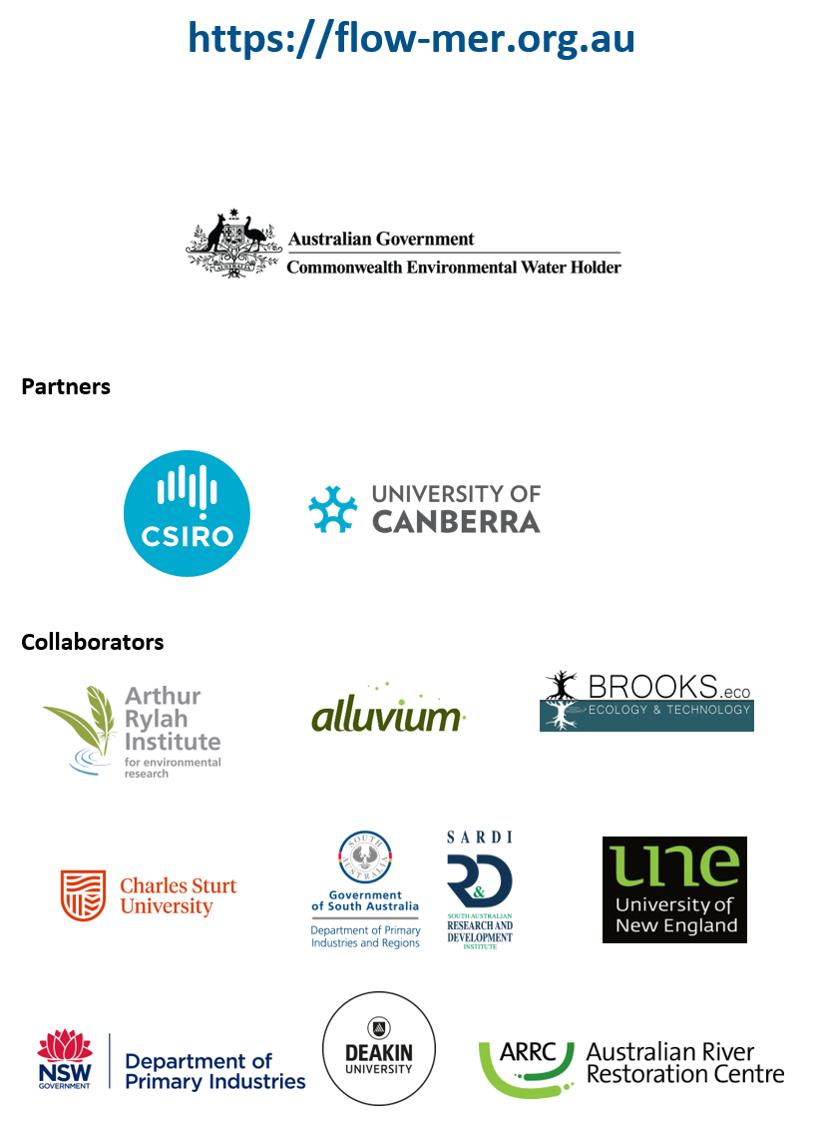

At the time of writing, the 2025 edition of the Strategy was not available. 2023–24 evaluations reference the 2019 edition (MDBA 2019).
The Long Term Intervention Monitoring and Environmental Water Knowledge and Research projects (2014–19)
In the counterfactual approach, CEW is removed from the observed streamflow time series, creating a hypothetical (counterfactual) daily streamflow time series with no CEW. This approach is used to infer the effects of CEW as an experimental design with controls and/or before–after comparisons is not possible.
In these evaluations, it is not possible to attribute the Commonwealth’s contribution separately to other environmental water.
At the time of writing, the 2025 edition of the Strategy was not available. 2023–24 evaluations reference the 2019 edition (MDBA 2019).
The table is available as a separate Excel file on request to the authors.
The analysis of cumulative species richness, across all habitat types (floodplain, wetland and riverine sample points), uses data from 2015–16 onwards as data were not recorded from the Edward/Kolety–Wakool river systems sample points prior to 2015–16.
The analysis of cumulative species richness and the assessment of ‘new’ taxa is limited to sample points that were consistently monitored across all years from 2015–16 to the most recent year (2023–24). As some sample points are excluded from this analysis, the number of previously unrecorded taxa differs to the number of previously unrecorded species mentioned in section 4.3 (which represents taxa that have never been recorded in surveys in any years from 2014–15 and across all sample points ever surveyed). The analysis here of previously unrecorded taxa highlights the addition of taxa to the species pool at consistently monitored sample points (from fixed quadrats and transects) across 9 years.
For details on how characteristic species are determined, refer to the companion methods report (O’Sullivan and Cuddy (eds) 2024).
For details of the modelling approach, see Flow-MER Basin-scale evaluation of Commonwealth environmental water: Methods (O’Sullivan and Cuddy 2025) report.
An asterisk is used to denote exotic species.

