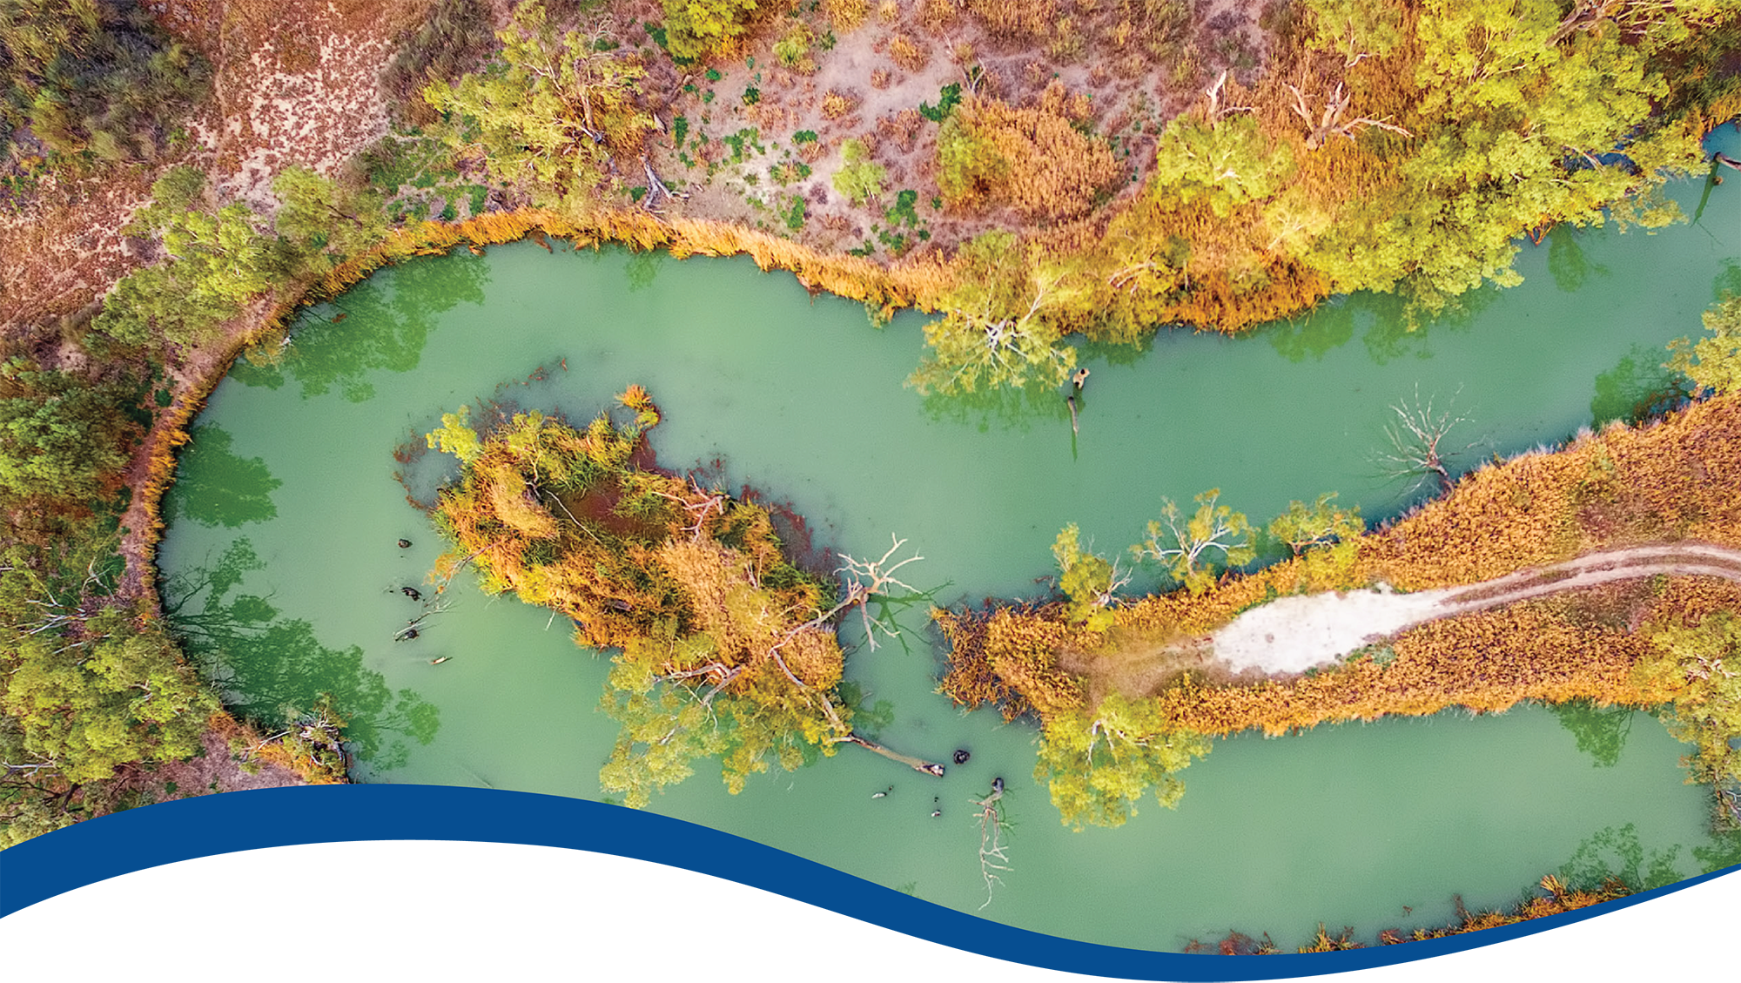
Flow-MER Basin-scale evaluations of Commonwealth environmental water: Methods
  - Commonwealth Environmental Water Holder’s Science Program:
Flow Monitoring, Evaluation and Research Program (Flow-MER)
  - 2025 edition
August 2025
Acknowledgement of Country
The Flow-MER team acknowledges the Traditional Custodians of the lands and waters of Australia, and in particular the Traditional Owners of the lands and waters of the Murray–Darling Basin. The river and its tributaries are known by many names including; Millewa (Ngarrindjeri name for the main Murray channel in South Australia), Baarka (Barkindji; Darling River, inland New South Wales (NSW)), Warring (Taungurung; Goulburn River, Victoria), Kolety (Wamba Wamba; Edwards River, inland NSW), Kalari (Wiradjuri; Lachlan River, inland NSW), Murrumbidjeri (Wiradjuri; Murrumbidgee River, inland NSW) and Guwayda (Kamilaroi; Gwydir River, northern NSW), amongst others. While the European names will be used here, the authors recognise the important associations and history of the Indigenous names for rivers and streams in the Murray Darling Basin. We express our respect for Elders, past present and emerging amongst the Nations of the Murray–Darling Basin.
Acknowledgement of Contributors
This report is a collation of the content of Approach chapters extracted in 2024 from Flow-MER 2022–23 Evaluation of outcomes reports. The decision to remove details of the approach adopted for the evaluation and details of its implementation was made to remove content that was a repeat of earlier years and to consolidate updates to methods that had been made over the years.
Evaluation teams are acknowledged at the start of each chapter. Specifics of, and results from, implementation of the methods continue to be described in Evaluation reports.
We take this opportunity to acknowledge the value of the diagrams produced by Jane Thomas, CSIRO that visualise the main steps in several of the evaluation approaches. These are valuable contributions to this report and much appreciated. We also thank all the authors who have contributed to describing the details of their approach and methods over the many years of the Flow-MER program. This report demonstrates their commitment to the Flow-MER program. We also thank the Long Term Intervention Monitoring (LTIM) project team (2014–19) who laid the foundations for how we have conducted evaluations.
We also thank the officers of the Commonwealth Environmental Water Holder who have worked closely with us to realise continuous improvement in our evaluation reporting. In particular we would like to acknowledge the support of Irene Wegener, Mitch Buchelet, Ethan Wignell, Jem Carver and Volmer Berens.
Most of the material in this report has been edited and reviewed many times as part of the annual Evaluation Reports. We thank the reviewers for their useful comments, especially Prof Peter Davies who has served as the external science reviewer for all the Basin-scale Flow-MER evaluation reports.
Citation
O’Sullivan J and Cuddy SM (eds) (2025) Flow-MER Basin-scale evaluations of Commonwealth environmental water: Methods. 2025 edition. Flow-MER Program. Commonwealth Environmental Water Holder (CEWH), Department of Climate Change, Energy, the Environment and Water, Australia.
Copyright
 © Commonwealth of Australia 2025
With the exception of the Commonwealth Coat of Arms, partner logos and where otherwise noted, all material in this publication is provided under a Creative Commons Attribution 4.0 International Licence https://creativecommons.org/licenses/by/4.0/. The Flow-MER Program requests attribution as ‘© Commonwealth of Australia (Flow-MER Program).
Cover illustration
Looking down on the magnificent meandering Murray River. Riverland, South Australia, aerial view.
Photo credit: Greg Brave; licensed from Adobe Stock Photos.
Important disclaimer
The information contained in this publication comprises general statements based on scientific research. The reader is advised and needs to be aware that such information may be incomplete or unable to be used in any specific situation. No reliance or actions must therefore be made on that information without seeking prior expert professional, scientific and technical advice. To the extent permitted by law, the Flow-MER Program (including its partners and collaborators) excludes all liability to any person for any consequences, including but not limited to all losses, damages, costs, expenses and any other compensation, arising directly or indirectly from using this publication (in part or in whole) and any information or material contained in it.
The Flow-MER is committed to providing web accessible content wherever possible. If you are having difficulties with accessing this document, please contact ewater@dcceew.gov.au.

Contents
Contents iii
Abbreviations and terms vii
Preface ix
About this edition ix
Overview of Flow-MER x
Evaluating the contribution of Commonwealth environmental water to observed environmental outcomes xi
Access to resources xi
1 Hydrology 1
1.1 Introduction 1
1.2 Input data 2
1.3 Evaluation approach 3
1.4 Evaluation against Basin Plan objective: comparison of flow against a ‘natural’ flow regime 5
1.5 Evaluation against the Basin-wide environmental watering strategy (the Strategy) targets 5
2 Ecosystem Diversity 8
2.1 Evaluation objectives 8
2.2 Approach 8
2.3 Data 10
2.4 Evaluation of Ramsar sites 13
2.5 GIS workflows for calculating areas supported by Commonwealth environmental water 15
3 Species Diversity 16
3.1 Overview 16
3.2 Lineage 16
3.3 Evaluation questions 17
3.4 Basin-wide datasets 17
3.5 Mapping the relationships between inundation and species richness 18
3.6 Modelling the relationships between Commonwealth environmental water inundation and the presence of selected threatened species 20
4 Vegetation 26
4.1 Evaluation objectives 26
4.2 Approach 26
4.3 Data 28
4.4 Analysis 30
5 Fish 36
5.1 Evaluation objective 36
5.2 Approach 36
5.3 Counterfactual modelling approach 38
5.4 LTIM and Flow-MER fish monitoring methods 40
5.5 Data and metrics 42
5.6 Basin-scale annual analysis 46
5.7 Basin-scale cumulative analyses 46
6 Food Webs and Water Quality 48
6.1 Evaluation objectives 50
6.2 Overview of approach 50
6.3 Conceptual model 51
6.4 Metabolic fingerprints 51
6.5 Defining food webs, stream metabolism and water quality 53
6.6 Measures of stream metabolism 54
6.7 Selected Area data fingerprinting – an approach for analysing and communicating metabolic responses to flow 56
6.8 Metabolic responses to flow 58
6.9 Counterfactual GPP modelling approach 60
7 Foundation datasets 68
7.1 CEWH Watering Actions Table 68
7.2 Basin valleys 70
7.3 Extent of ‘managed floodplain’ 70
7.4 Rainfall data 71
7.5 Surface water runoff 72
7.6 Flow estimation 72
7.7 Counterfactual streamflow scenario development 75
7.8 Areal extent of inundation 76
7.9 Length of watercourses watered with CEW 79
8 Changes to methods 80
8.1 2023–24 updates (evaluation conducted 2025) 80
8.2 2022–23 updates (evaluation conducted 2024) 81
8.3 2021–22 updates (evaluation conducted 2023) 84
8.4 2020–21 updates (evaluation conducted 2022) 85
References 88

Figures
Figure 1 Schematic of the components of the Basin-scale evaluation x
Figure 2 The 7 Selected Areas (left map) and 25 valleys (right map) established for long-term monitoring of the impacts of environmental watering under LTIM and Flow-MER (2014–15 to present) xi
Figure 2.1 Schematic of the 4 steps in the ecosystem diversity evaluation approach 9
Figure 2.2 Map showing the distribution of aquatic system types (estuary, floodplain, lakes, wetlands, rivers) in the Murray–Darling Basin 11
Figure 2.3 Map showing the distribution of Australian National Aquatic Ecosystem (ANAE) riverine ecosystem types in the Murray–Darling Basin 12
Figure 2.4 Satellite image of the area of the Great Cumbung Swamp showing visible inundation by CEW, whereas that mapped by Sentinel-2 satellite is limited to where open water is visible between the reed beds 13
Figure 2.5 Map showing location and extent of Ramsar Sites in the Murray–Darling Basin 14
Figure 3.1 Diagram of main steps in integrating multiple data sources as input to the listed and threatened species evaluation pilot 19
Figure 3.2 SD vegetation was the third most influential feature in the ML model for Australian painted snipe 24
Figure 4.1 Schematic of steps in groundcover vegetation evaluation approach 27
Figure 4.2 Map showing the vegetation sample points in each Selected Area monitored for groundcover vegetation by Flow-MER over the period 2014–24 29
Figure 5.1 Schematic of the steps in the evaluation approach 39
Figure 6.1 Conceptual model of the approach within the Flow-MER Food Webs and Water Quality Basin Theme evaluation to measuring metabolic responses to Commonwealth environmental water 52
Figure 6.2 Hypothesised relationship between stream metabolism and secondary productivity by consumers at higher trophic levels 55
Figure 6.3 Representation of a metabolic fingerprint, which describes the bivariate probability distribution estimated to contain the top 10% 25%, 50%, 75% and 90% of the gross primary production (GPP) and ecosystem respiration (ER) points 57
Figure 6.4 ‘Real world’ example of metabolic fingerprints visualising and diagnosing change in stream metabolism across time or space and in response to hypothesised drivers 58
Figure 6.5 Explanation of envfit overlay on metabolic fingerprint 59
Figure 6.6 Relationship between stream metabolism and flow at Loch Garry gauge, Goulburn River 60
Figure 6.7 Plot of generalised additive model smoother results 64
Figure 6.8 Effect of Commonwealth environmental water contribution to flow on the predicted change in annual gross primary production compared to the counterfactual scenario 64
Figure 6.9 Counterfactual gross primary production (GPP) predictions for one site in the Lower Murray River Selected Area over 22 year 65
Figure 6.10 Conceptualisation of influence of flow disturbance on metabolic activity 66
Figure 7.1 Map showing the extent of the Basin-wide environmental watering strategy (the Strategy) managed floodplain expanded to include all areas receiving Commonwealth environmental water 2014–23 71
Figure 7.2 Example of implementation of the method for estimating daily CEW flow from flow profiles during the month, 23 February to 25 March 2023 73
Figure 7.3 Examples of application of Rule 1 (when the gauged data matches the water agency’s data) and Rule 2 (when the gauged data mostly matches the water agency’s data) 74
Figure 7.4 Example of application of Rule 3 (when the gauged data mismatches the water agency’s data) 74
Figure 7.5 Map showing the maximum extent of all Commonwealth environmental water in rivers, wetlands and floodplains, 2022–23 77
Figure 7.6 Workflow of developing a spatial inundation extent of CEW 78

Tables
Table 1 Flow-MER Selected Areas x
Table 1.1 Basin-wide environmental water strategy targets and how they have been interpreted and formulated as evaluation questions for the hydrology theme 6
Table 2.1 Datasets contributing to the Ecosystem Diversity evaluation 10
Table 3.1 The 8 features selected for model training that reflect aspects of the wetland hydrology that could be influenced through CEW delivery and were used in the machine learning analyses 21
Table 4.1 Plant high-level functional group (FG) classification 31
Table 4.2 Growth form classifications used in evaluation (sourced and altered from NSW BioNet) 33
Table 5.1 Fish species targeted in Flow-MER adult fish population surveys using Category 1 methods across all Selected Areas, 2014–present 41
Table 5.2 Summary of data from the Monitoring Data Management System (MDMS) used for evaluation analyses 42
Table 5.3 Streamflow gauges for each Selected Area 43
Table 5.4 Description of annual flow metrics and other descriptive metrics used in analyses 44
Table 5.5 Description of event-based flow metrics and other descriptive metrics for use in larval analyses 45
Table 5.6 Evaluation objectives and how they are addressed (response variable, species and model description) 47
Table 5.7 Confidence categories for statistical analyses 47
Table 6.1 Table caption 53
Table 6.2 Overview of dataset used for GPP counterfactual modelling 61
Table 6.3 Model terms and Akaike information criterion (AIC) values for the 3 candidate GAM models. 63
Table 7.1 Fields (columns) in the Watering Actions Table, prepared annually by officers of the CEWH (CEWH 2023) 68
Table 7.2 Valley 3-letter abbreviations, as used in the Watering Actions Table 69
Table 8.1 Summary of method updates for all Themes in 2023–24 80
Table 8.2 Summary of method updates for all Themes in 2022–23 81
Table 8.3 Additions to the managed floodplain for each Basin valley from watering 2014–23 83
Table 8.4 Foundation Report updates for all Themes (Cuddy et al. 2022) 84
Table 8.5 Summary of Fish Theme updates introduced for 2021–22 evaluation 84
Table 8.6 Foundation Report updates for all Themes, 2020–21 (adapted from Table 1 in Barbour et al. 2021) 85
Table 8.7 Summary of Species Diversity Theme updates, 2020–21 (Table 2 in Barbour et al. 2021) 85
Table 8.8 Summary of Vegetation Theme updates, 2020–21 (Table 3 in Barbour et al. 2021) 86
Table 8.9 Summary of Fish Theme updates, 2020–21 (Table 3 in Barbour et al. 2021) 86

Abbreviations and terms
Term/abbreviation | Description
AIC | Akaike information criterion (goodness-of-fit metric)
ALA | Atlas of Living Australia
ANAE | Australian National Aquatic Ecosystem
APC | Australian Plant Census
APNI | Australian Plant Name Index
BEWS | Basin-wide environmental watering strategy (MDBA 2019)
BoM | Bureau of Meteorology
CEW | Commonwealth environmental water
CEWH | Commonwealth Environmental Water Holder
DCCEEW | Department of Climate Change, Energy, Environment and Water
DEA | Digital Earth Australia
DO | Dissolved oxygen
DRDMW | (Qld) Department of Regional Development, Manufacturing and Water
EC | Electrical conductivity
ER | Ecosystem respiration
EWKR | Environmental Water Knowledge and Research projects (July 2014 – June 2019)
factual flow | Observed or modelled flow (with CEW), as opposed to counterfactual flow, which is without CEW)
Flow-MER | Flow-Monitoring, Evaluation and Research (July 2019 – June 2024)
Flow-MER2.0 | Flow-Monitoring, Evaluation and Research (July 2024 – June 2029)
FN-MER | First Nations Monitoring Evaluation and Reporting
GEE | Google Earth Engine
GPP | Gross primary productivity/production
GWMWater | Grampians Wimmera Mallee Water
hydric soil | Soil that is permanently or seasonally saturated by water, resulting in anaerobic conditions, as found in wetlands
ICIP | Indigenous cultural and intellectual property
influenced area | the entire area of a wetland that received environmental water, including the inundated area and the adjacent terrestrial habitats that occur within the wetland boundary (see Sections 2.3.1 and 2.5.2 for more details)
inundated area | the area of a wetland or floodplain in direct contact with environmental water (see Section 2.5.1 for more details)
KE | Knowledge Exchange, Communication and Engagement
KRA | Key Research Area
lake ecosystems | wetlands that are mostly open water and typically greater than 2 m in depth
LTIM | Long Term Intervention Monitoring project (July 2014 – June 2019)
LTWP | Long term watering plan (for the Basin, prepared by Basin state and territory governments)
managed floodplain | The estimated area of the Basin that can be influenced with the 2,075 GL of environmental water allocated to the environment under the Basin Plan (see Section 7.3 for more details)
MBDWI | Modified Normalized Difference Water Index
MDBA | Murray–Darling Basin Authority
MDMS | Monitoring Data Management System
MER | Monitoring, evaluation and research
NESP | National Environmental Science Program
NTU | Nephelometric turbidity units
PET | Potential evaopotranspiration
QEEOs | Quantified expected environmental outcomes
SRA | Sustainable Rivers Audit
VEWH | Victorian Environmental Water Holder
WAT | Watering Actions Table (prepared by CEWH staff)
WIT | Wetland Insights Tool

Preface
This report is a consolidation of Methods chapters from Basin-Scale Flow-MER evaluation reports to 2025 and is to be read in conjunction with the 6 annual Theme evaluation reports.
It has been prepared for the CEWH by the Basin-scale reporting team as a part of its Monitoring Evaluation and Research Basin-scale Project (Flow-MER) Program. Flow-MER reports can be accessed from the CEWH's publications and resources webpage.
Changes in approach have only been introduced where there have been significant advances in methodology and available data, or where unmonitored areas were not previously evaluated. In all other cases, the approach is intended to be consistent with the Evaluation conducted under the Long Term Intervention Monitoring Project (LTIM) on which the Flow-MER program builds and as reported in the original Foundation Reports 2019, and Foundation Report Updates 2020, 2021 and 2022. These Foundation Reports and subsequent updates provide a summary of why the 6 themes are used to evaluate the effectiveness of CEW; the criteria used for evaluating short and long-term outcomes; the approach adopted in the evaluation; as well as any anticipated risks for the evaluation process.
The history of changes in approach and/or a particular method are listed in Chapter 8 of this report.

About this edition
This edition describes approaches and methods used in the 2023–24 water year evaluations which are the same as those used for the 2022-23 evaluations with the addition of:
- Focus on threatened species by the Species Diversity theme team which reduced the scope of the modelling (described in Chapter 3)
- modelling of a counterfactual metabolism scenario by the Food Webs and Water Quality theme team (described in Chapter 6)
- revised method for deriving the counterfactual streamflow time series (i.e. daily time series of streamflow without Commonwealth environmental water) (described in Section 7.7)
- schematic diagrams of Ecosystem Diversity, Fish, Vegetation and Food Webs and Water Quality approaches developed by Jane Thomas (CSIRO) for the evaluation reports.
These changes are summarised in Section 8.1.

Overview of Flow-MER
The Commonwealth Environmental Water Holder’s (CEWH) Science Program invests in monitoring, evaluation and research activities through its Flow Monitoring, Evaluation and Research (Flow-MER) Program. The Flow-MER Basin-scale evaluation assesses the contributions of Commonwealth environmental water (CEW) to meeting the environmental objectives stated in chapters 8 and 9 of the (Murray–Darling) Basin Plan 2012 and in the Basin-wide environmental watering strategy (MDBA 2013, 2019). Six Basin Themes (Figure 1) are evaluated using data from 7 Flow-MER Selected Areas (Figure 2, left-side map, Figure 2) and the 19 valleys (right-side map, Figure 2) where the CEWH holds water entitlements in the Murray–Darling Basin. The evaluation builds on work undertaken by its predecessors. Research informs the evaluation and the CEWH’s Science Program.
Figure 1 Schematic of the components of the Basin-scale evaluation
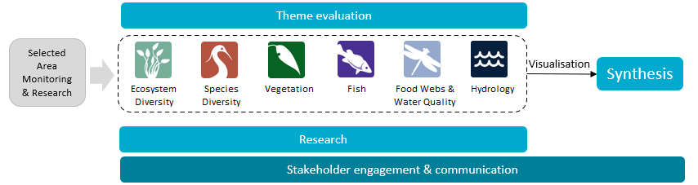
Table 1 Flow-MER Selected Areas
Selected Area
Junction of Warrego and Darling rivers
Lower Murray River
Gwydir River System
Lachlan River System
Murrumbidgee River System
Goulburn River
Edward/Kolety–Wakool river systems
Figure 2 The 7 Selected Areas (left map) and 25 valleys (right map) established for long-term monitoring of the impacts of environmental watering under LTIM and Flow-MER (2014–15 to present)
In the valleys map, grey shading indicates the 19 valleys where the Commonwealth holds water entitlements and which are in scope for evaluation; white identifies those valleys which are not in scope
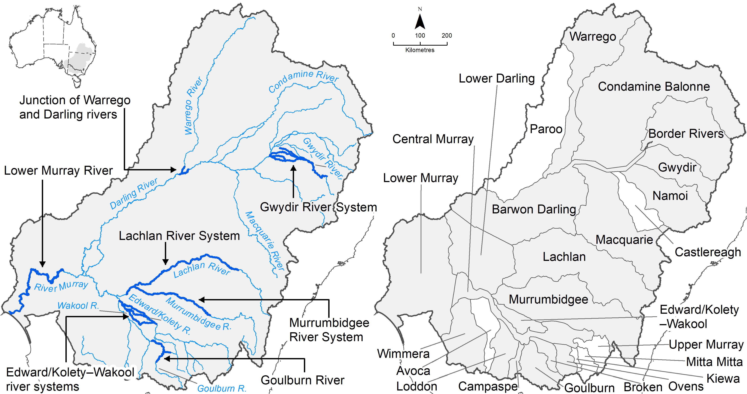

Evaluating the contribution of Commonwealth environmental water to observed environmental outcomes
To undertake the Basin-scale evaluation, the evaluation teams use water delivery and outcomes data provided by the CEWH’s Science Program, along with monitoring data provided by the 7 Selected Areas.
Evaluation of the contribution of CEW to observed environmental outcomes for the 6 Basin Themes depends on the data available.
- Hydrology (instream), Fish (multi-year) and Food Webs and Water Quality (multi-year) themes have sufficient data to model and compare environmental outcomes both with and without Commonwealth environmental water (counterfactual modelling).
- Ecosystem Diversity, Species Diversity and Vegetation themes identify environmental responses in locations that received Commonwealth environmental water (often in conjunction with other sources of environmental or non-environmental water) and, where feasible, compare with areas that did not receive Commonwealth environmental water.
- Hydrology (inundation) and Food Webs and Water Quality themes use flow and water quality metrics to infer likely outcomes.
- Fish (annual), Vegetation (annual) and Food Webs and Water Quality themes synthesise findings across Selected Areas.

Access to resources
This report, together with the 6 contributing Basin-scale evaluation reports, is available from the Australian Department of Climate Change, Energy, the Environment and Water’s (DCCEEW) Flow-MER Basin-scale Project publications webpage.
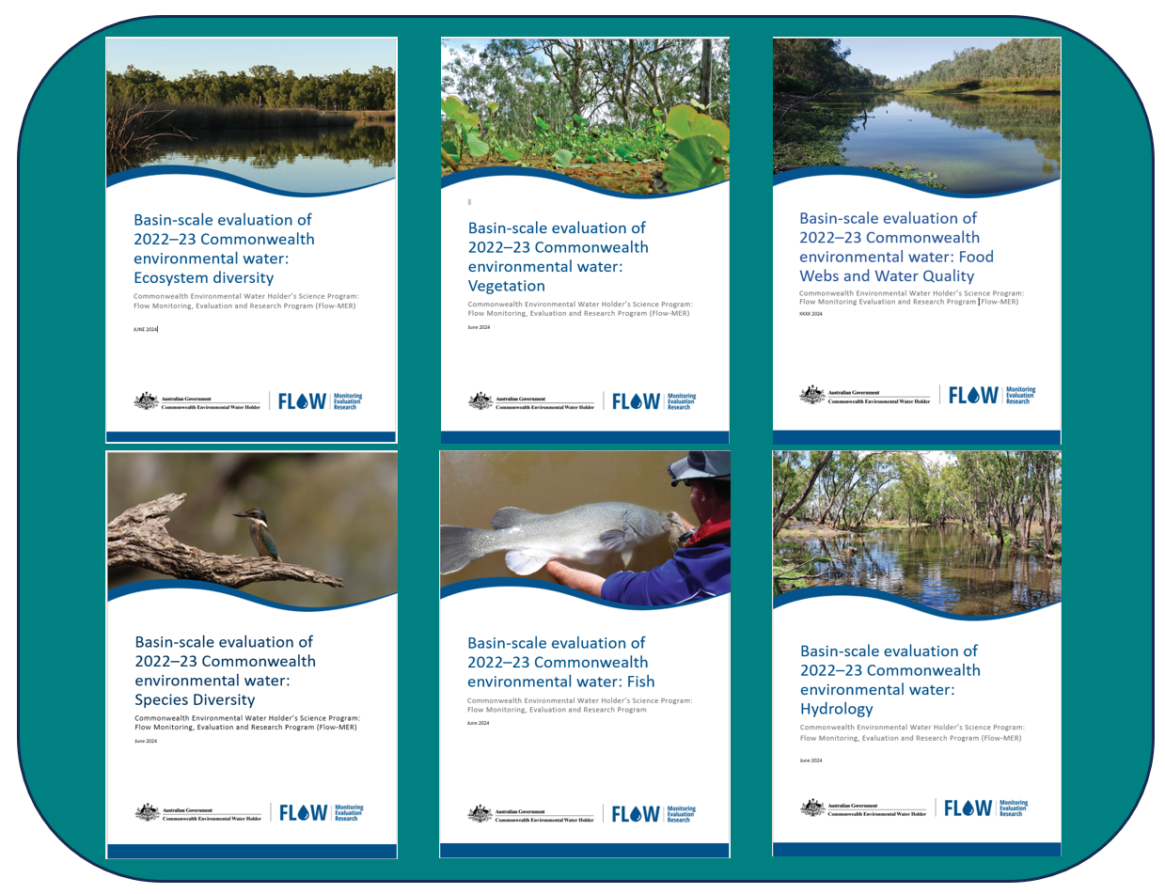
Data products are available from the Flow-MER Data Portal and by searching Flow-MER on data.gov.au.
The flow-mer.org.au website is a rich repository of information about all aspects of the Flow-MER Program, including summaries of evaluation outcomes.

Hydrology
Team: Ashmita Sengupta (CSIRO), Felix Egger, Tony Weber (alluvium), Fiorenzo Guarino (to 2023), with chapter content prepared by Felix Egger.

Introduction

Lineage
The methods described in this chapter were introduced in July 2023 for the 2022–23 evaluation year and largely replaced the methods used up to that date as described in the LTIM Basin Matter Hydrology diversity Foundation report (Stewardson and Guarino 2019), subsequent foundation report updates and evaluation reports (Guarino and Sengupta 2021, 2022, 2023). However, this chapter includes some of that earlier material to ensure that important information from the Foundation report is retained and this chapter is complete in itself.
The rationale for change in methods is described in Section 8.2.1 of this report and evaluation outcomes reported in Sengupta et al. (2024, 2025).

Evaluation question
The flow regime is a Basin Matter under the Environmental Water Outcomes Framework (CEWO 2013). Evaluation of the flow regime also underpins all the other evaluations and forms the basis for the evaluation of outcomes for biodiversity, ecosystem function and resilience at the Basin scale. It directly addresses the following short-term (one-year) and long-term Basin-scale evaluation question:
• What did Commonwealth environmental water contribute to restoration of the hydrological regime?

Tasks and delivery timing
Each evaluation year, the Hydrology Theme:
- produces daily streamflow timeseries, with and without CEW. These draw on data acquired for >100 gauges across the Basin. These gauges have remained consistent throughout the project, with an additional 30 gauges added in 2023. These are prepared for the most recent water year and for the long-term period (from the start of LTIM in 2018–19). (This are foundational datasets and their derivation is described in Sections 7.6 and 7.7)
- provides maximum inundation extents where CEW has contributed to flooding or wetland inundation within the Basin and watercourses that were watered by CEW. (This is a foundational dataset and its derivation described in Section 7.8)
- evaluates the effect that CEW had on the Basin’s flow regime in the hydrological context of the evaluation year.
Each task requires different input data which may become available at different times in the evaluation year, and each task is directed towards different users, who may need the task outputs at different times in the evaluation year. Generally, Task 1 and Task 2 are required early in the evaluation year, preferably providing data to other themes in December of the evaluation year. Completion of Task 3 is required during the reporting phase with preliminary delivery for review required at the end of April and ultimate delivery of the evaluation reports scheduled at the end of June.

Input data
The LTIM Foundation report identified scale as a critical issue for the evaluation process and that, from a temporal perspective, evaluation starts with individual watering actions and then considers their influence on flow regimes over the one year and long-term periods. As a consequence, the evaluation needs information on both individual watering actions and on the flow and inundation regime over the long-term period.

Commonwealth environmental watering actions
These data are compiled by officers of the CEWH from information contained in acquittal reports prepared by the CEWH delivery teams. They are provided as an Excel spreadsheet (ref Table 7.1 in Section 7.1 CEWH Watering Actions Table (CEWH 2023). The Basin-scale Flow-MER team incorporates these data into an Excel workbook which contains all watering actions from 2014–15 (start of LTIM) together with sheets describing provenance, valley codes (Table 7.2) and any adjustments made to the data.

Sources for daily observed and modelled streamflow data
The evaluation is based on evaluation of flow outcomes at a suite of representative reaches that have recorded and modelled flow data. These are to include the 122 hydrological indicator sites used in developing the Basin Plan Ecological Sustainable Level of Take (MDBA 2012) and the 18 assets used in the development of the ESLT.
Daily observed streamflow data are sourced from the following state water information portals for all relevant gauges:
- Victoria: WMIS (https://data.water.vic.gov.au/WMIS/)
- Queensland: WMIP (https://water-monitoring.information.qld.gov.au/)
- New South Wales: Realtime water information (https://realtimedata.waternsw.com.au/)
- South Australia: water data SA (https://water.data.sa.gov.au/).
To streamline data acquisition, automated requests coded in Python are used. Victoria, Queensland, and New South Wales portals support the same request language, allowing data to be requested using common syntax. However, the South Australian portal uses a different backend, necessitating a specific request code for South Australian data. All codes can be provided upon request. The requested data format is the mean daily flow, measured in megalitres per day (ML/d).

Sources for daily Commonwealth environmental water streamflow data
Daily CEW flow and daily modelled or accounted streamflow is acquired from relevant state agencies that work with the CEWH to deliver water. The relevant agencies and valleys are:
- Victoria: Goulburn-Murray Water (GMW) for Broken, Goulburn, Campaspe, Ovens, Loddon, Central Murray
- Victoria: VEWH or Grampians Wimmera Mallee Water (GWMWater) for Wimmera
- NSW: WaterNSW for Border Rivers (NSW), Gwydir, Namoi, Warrego (NSW), Barwon-Darling, Condamine-Balonne (NSW), Lachlan, Murrumbidgee, Macquarie, Edward-Kolety–Wakool
- NSW: MDBA for Central Murray, Lower Darling
- SA: MDBA for Lower Murray
- QLD: DRDMW and CEWH/DCCEEW for Border Rivers (QLD), Condamine-Balonne (QLD), Warrego (QLD).

Evaluation approach
To evaluate the effect of CEW on the flow regime of the Basin, the assessment proceeds through several key steps:
- The hydrological cycle is evaluated to establish the context for a specific water year, detailing the total available water and the timing of releases.
- CEW releases are quantified and contextualised, and their impact on the flow regime is assessed and interpreted. This includes understanding how CEW influences flow patterns within the Basin.
- The evaluation considers CEW's contribution specifically to achieving or progressing towards Basin Plan objectives and the targets set out in the Basin-wide environmental watering strategy (the Strategy, MDBA 2019).
The evaluation focuses exclusively on environmental water released by the Commonwealth, excluding contributions from states and other agencies. This approach provides a specific perspective on CEW's impact on the flow regime within the Basin, though it may present an incomplete view of overall progress towards Basin Plan and Strategy objectives through other environmental water.

Watering actions and volumes and timings of water delivery
The evaluation of CEW delivery during the water year is based on the Watering Action Table (prepared by CEWH). This dataset is described in Section 7.1.
To assess the timing of CEW delivery, the start date of the CEW delivery timeframe is categorised into seasons, with 3-month seasons and winter starting in June. The watering actions are then grouped by valley, and the proportion of the total CEW volume delivered per season and subbasin calculated.

Flow metrics inference
Two key metrics are inferred from the decomposed flow signals and are used for evaluation against the Strategy targets:
- the duration of flow above the threshold (days)
- the frequency of each unique crossing of the flow signal above the threshold (number of occurrences/water year).
The duration metric is used as an indicator for the flow regime throughout the Basin. For the base flow thresholds, the duration above a threshold may have a direct ecological significance, and even though a fresh flow tends to be assessed through frequency, duration was chosen to better represent the wet conditions in a water year (such as 2022–23).
The frequency metric is used for the fresh targets, and fresh frequency is then assessed in the evaluation of progress towards environmental watering targets
See Section 1.5 for description of evaluation against Strategy targets.

CEW additionality to the flow regime
To quantify the effect of CEW on the flow regime, the additionality of CEW to the duration of the flow above each of the flow thresholds is used, and analysed as:
$CEW additionality \left(\%\right)=\left(\frac{\sum{Duration under observed scenario \left(days\right)}}{\sum{Duration under counterfactual scenario \left(days\right)}}-1\right)*100 \left(\%\right)$ Eq 1.1
where the duration above a flow threshold of the observed or modelled and the counterfactual scenario is summed to yield the total duration in the water year. This quantification procedure is repeated for every gauge with at least one flow threshold available. Subsequently, valley averages are derived for the duration metric itself and for the CEW additionality, where the arithmetic average of all gauges within a valley is quantified for a valley-wide outcome.

CEW additionality to lateral connectivity
The evaluation questions for lateral connectivity are all evaluated using the same method but compared against the relevant target metric. The following equation is used to calculate the increase in unique frequency of flow above the high fresh threshold which was caused by CEW by comparing observed/modelled frequencies against the counterfactual scenario:
$CEW additionality to frequency \left(\%\right)=\left(\frac{Average valley frequency under observed scenario \left(-\right)}{Average valley frequency under counterfactual scenario \left(-\right)}-1\right)*100 \left(\%\right)$ Eq 1.2
where first, the average unique frequency above the high flow threshold at each gauge where evaluation information was available in a valley is calculated and the valley average is derived.
In cases where the CEW additionality to an increase in frequency is negative (cases where average frequency under the counterfactual scenario is larger than the average frequency under the observed scenario), the increase in frequency is set to 0%. These cases have been observed where CEW kept the flow above the high fresh threshold rather than allowing the flow to drop below it, which ultimately yielded an increase in duration above the high fresh threshold but reduced the frequency of the flow reaching above the high fresh threshold.

Evaluation against Basin Plan objective: comparison of flow against a ‘natural’ flow regime
One of the hydrological objectives stated in the Basin Plan is for the flow to progress towards a ‘natural’ flow regime. To assess the progress towards a ‘natural’ flow regime, the factual and the counterfactual flows at each relevant gauge in the water year being evaluated is compared against a long-term flow signal at the relevant site to ascertain if the flow in that water year approaches the commonly observed flow signal.
Comparison against the modelled pre-development flow signal (derived from the Sustainable Rivers Audit (Davies et al. 2004)), which could be considered ‘natural’ flow, was not completed in water year 2022–23, but will be considered in future evaluations.
The daily observed long-term flow signal at the relevant gauges is categorised by the day in the water year and the median, 5th and 95th percentiles, as well as the 1st and 99th percentiles are estimated from the data. Subsequently, a visual comparison of the factual and counterfactual flows in the water year is made to elucidate whether the flow in the water year being evaluated tracks closed to the median, or is inside the 5th to 95th percentile range, or inside the 1st to 99th percentile range. If the factual flow is inside one of these ranges or close to the median, it is concluded that the flow has progressed towards commonly observed flow.
In cases where CEW additionality has affected the timeseries and moved it either closer to the median or inside the 2 percentile ranges, it is concluded that CEW has directly added to progressing the flow towards the commonly observed flow.
In cases where the factual and the counterfactual flows fall outside the percentile ranges, it is concluded that the commonly observed flow regime is either not met (below the 1st to 99th percentile range) or surpasses the commonly observed flow regime (above the percentile 1st to 99th percentile range).

Evaluation against the Basin-wide environmental watering strategy (the Strategy) targets
The Strategy (MBDA 2019) specifies hydrological outcomes in the 3 categories evaluated by the Hydrology theme – longitudinal connectivity, lateral connectivity and end-of-Basin flows – expected to be reached by 2024 (column 3 in Table 1.1). Evaluating against the Strategy targets requires an interpretation of the aim of the target. Most targets lack clear definition of what the increases should be compared to, in terms of timeframe and reference hydrology. To be able to consistently evaluate the CEW’s contribution to progress towards the Strategy targets, definitions have been chosen according to what would constitute the most insightful interpretation (column 4 in Table 1.1).
Table 1.1 Basin-wide environmental water strategy targets and how they have been interpreted and formulated as evaluation questions for the hydrology theme
Information in square brackets [ ] is additional information.
ID | Category | Target | Interpretation and formulation as evaluation questions
Q1.1 | Longitudinal connectivity | Keep baseflows at least 60% of natural level in all valleys  [In valleys with base flow greater than 60% of natural flow, the current flow should be protected. Cease-to-flow events should not exceed ‘natural’] | Is the duration of the modelled/observed flow above the low base flow threshold greater than 60% of the modelled pre-development flow (Davies et al. 2004)?
Q1.2 | Longitudinal connectivity | Increase flows in the Barwon-Darling 10% overall with increased contributions from Condamine-Balonne, Border Rivers, Gwydir, Namoi, Macquarie-Castlereagh | Is the increase in flow volume comparing the modelled/observed flow at Barwon River @ Bourke (Contributions from Condamine-Balonne, Border Rivers, Gwydir, Namoi, Macquarie-Castlereagh before the confluence with the Warrego) to the counterfactual scenario without CEW greater than 10%?
Q1.3 | Longitudinal connectivity | Increase flows in the Murray 30% overall with increased contributions from Murrumbidgee, Goulburn, Campaspe, Loddon, Lower Darling | Is the increase in flow volume comparing the modelled/observed flow at Murray River @ Flows to SA (Contributions from all tributaries upstream) to the counterfactual scenario without CEW greater than 30%?
Q1.4 | Longitudinal connectivity | Increase flows in the Murray mouth 30-40% | Is the increase in flow volume comparing the modelled/observed flow at Murray River @ Wellington to the counterfactual scenario without CEW greater than 30-40%?
Q2.1 | Lateral connectivity | Increase frequency of freshes, bankfull and lowland floodplain flows 30 to 60% in the Murray, Murrumbidgee, Goulburn-Broken, Condamine-Balonne catchments | Is the frequency of unique events of flow crossing the high fresh threshold when comparing the modelled/observed scenario to counterfactual scenario greater than 30-60% in the Murray, Murrumbidgee, Goulburn-Broken, catchments?
Q2.2 | Lateral connectivity | Increase frequency of freshes, bankfull and lowland floodplain flows 10 to 20% in the Border Rivers, Gwydir, Namoi, Macquarie–Castlereagh, Barwon–Darling, Lachlan, Campaspe, Loddon, Wimmera catchments | Is the frequency of unique events of flow crossing the high fresh threshold when comparing the modelled/observed scenario to counterfactual scenario greater than 10-20% in the Border Rivers, Gwydir, Namoi,  Macquarie–Castlereagh, Barwon–Darling, Lachlan, Campaspe, Loddon catchments?
Q2.3 | Lateral connectivity | Maintain current levels of connectivity in the Paroo, Moonie, Nebine, Kiewa, Ovens, Warrego catchments | Is the frequency of unique events of flow crossing the high fresh threshold when comparing the modelled/observed scenario to counterfactual scenario greater than 10-20% in the Ovens and Warrego catchments?
Q3.1 | End-of-Basin flows | Keep barrage flow above 2,000 GL/yr 95% of the time on a 3-year rolling average basis  [A 2-year minimum of 600 GL/yr is the acceptable minimum] | Is the observed/modelled flow at the barrages greater than 2000 GL/yr on a 3-year rolling average?
Q3.2 | End-of-Basin flows | Maintain water levels in the Lower Lakes above 0 m AHD and 0.4 m AHD 95% of the time | Is the daily water level in Lake Alexandrina greater than 0.4 m AHD 95% of the time in the water year and greater than 0 m AHD at all times?
 | End-of-Basin flows | Maintain salinity in the Lower Lakes below critical threshold of 1,500 EC at all times and below 1,000 95% of the time  [Salinity in the Coorong’s south lagoon maintained below 100 g/L 95% of the time, the Murray Mouth maintained open 90% of the time to an average annual depth of 1 m | Not evaluated by the Hydrology theme.  This target is evaluated by the Food Webs and Water Quality theme.
Other than the observed/modelled flow and the counterfactual scenario, the evaluation requires modelled pre-development flow, observed/modelled levels of Lake Alexandrina and the counterfactual scenario of the Lake Alexandrina levels without CEW contribution.

Longitudinal connectivity
For evaluation question Q1.1, daily (for gauges in NSW, QLD, SA) and monthly (for gauges in VIC) pre-development modelled flow from the Sustainable Rivers Audit (SRA) project (Davies et al. 2004) are used. The timeseries for the modelled pre-development flow contains data from 1895-07-01 to 2009-06-30.
First, the average duration of flow above the low base flow threshold is calculated at relevant gauges in the pre-development modelled flow dataset where CEW information for the water year being evaluated is available and a low base flow threshold was set in the LTWPs. The average duration of flow above the low base flow threshold of the pre-development flow is calculated as the sum of days above the threshold divided by the number of years in the model run. Where only monthly information is available, flow is disaggregated to a daily flow by dividing by 30.5 (average days/month). Subsequently, the average duration of the factual flow above the low base flow threshold in the water year is compared to the average pre-development flow duration and the valley average with all available gauges in the valley is developed to derive the duration metric.
Evaluation questions Q1.2 to Q1.4 are each evaluated at a specific gauge as described in the evaluation question formulation, where the flow under the observed/modelled scenario is compared to the counterfactual scenario using:
$CEW additionality to flow \left(\%\right)=\left(\frac{\sum{Flow (@ gauge) under observed scenario} \left(\frac{ML}{d}\right)}{\sum{Flow (@ gauge) under counterfactual scenario \left(\frac{ML}{d}\right)}}-1\right)*100 (\%)$ Eq 1.3

Lateral connectivity
The evaluation questions for the lateral connectivity theme (Q2.1 to Q2.3) are evaluated using the same method but compared against the relevant target metric. The following equation is used to calculate the increase in unique frequency of flow above the high fresh threshold caused by CEW by comparing observed/modelled frequencies against the counterfactual scenario:
$CEW additionality to frequency \left(\%\right)=\left(\frac{Average valley frequency under observed scenario \left(-\right)}{Average valley freqency under countefactual scenario \left(-\right)}-1\right)*100 \left(\%\right)$ Eq 1.4
where first, the average unique frequency above the high flow threshold at each gauge where evaluation information is available (LTWP high fresh threshold, CEW information) in a valley is calculated and the valley average is derived. In cases where the CEW additionality to an increase in frequency is negative (cases where average frequency under the counterfactual scenario is greater than the average frequency under the observed scenario), the increase in frequency is set to 0 %. Cases may be observed where CEW keeps the flow above the high fresh threshold rather than allowing the flow to drop below it, which ultimately yields an increase in duration above the high fresh threshold but reduces the frequency of the flow reaching above the high fresh threshold.

End-of-Basin flows
For evaluation question Q3.1, the sum of the factual flow and the sum of the counterfactual flow are calculated at the barrages for the water year. The resulting summed flow is reported in GL/yr and the relevant rolling averages are calculated using previous evaluation years’ barrage flows under both factual and counterfactual flows.
Evaluation question Q3.2 is evaluated visually by plotting the level in Lake Alexandrina for both factual and counterfactual flows and comparing against the t2 thresholds (0.4 m AHD and 0 m AHD). The duration above the 0.4 m AHD threshold is calculated to evaluate whether the level is above the threshold at least 95% of the time.

Ecosystem Diversity
Team: Shane Brooks (Brooks Ecology and Technology)

Evaluation objectives
The Ecosystem Diversity theme uses a high-level desktop analysis that collectively evaluates the entire portfolio of Commonwealth environmental water (CEW) management, rather than assessing or making technical recommendations for individual watering actions.
This evaluation addresses the overarching question:
What did Commonwealth environmental water contribute to ecosystem diversity?

Approach
The contribution of CEW to ecosystem diversity is quantified as the number of Australian National Aquatic Ecosystem (ANAE) types (described below) that received CEW for the current water year and cumulatively over the monitoring period (from 2014). The evaluation is conducted at the scales of the whole Basin, within each of the 25 major river valleys and for high conservation value Ramsar Sites.
The richness of ANAE types defines Ecosystem Diversity.
This approach presumes that environmental water is of benefit to the receiving water-dependent ecosystems without measuring the ecosystem response to water directly. Other Flow-MER Basin Themes (Vegetation, Fish, Species Diversity, and Food Webs and Water Quality) report more specifically on responses of species, populations and ecosystem functions that occur within the aquatic ecosystems of the Basin.)
This evaluation continues the sequence of annual and cumulative evaluation established during the Long Term Intervention Monitoring Project (LTIM) (2014–15 to 2018–19) (described in Brooks 2020) and subsequent Flow-MER evaluation reports (Brooks 2021, 2022, 2023, 2024, 2025). The approach has remained largely consistent over the evaluation period, but the datasets and mapping have improved annually. Since monitoring began in 2014–15, all previous hydrological inundation and ecosystem mapping data have been reanalysed each year to incorporate these improvements, ensuring that the results are comparable across different years.
The 4 steps in the approach are visualised in Figure 2.1. These are:
- Map aquatic ecosystems (estuary, floodplain, lakes, wetlands, rivers) across the Basin, based on the ANAE classifications
- Overlay aquatic ecosystems with sub-basin boundaries and areas that receive CEW (the managed floodplain plus additional inundated areas).
- Identify aquatic ecosystems in each sub-basin that are supported by CEW
- Repeat annually over the duration of the monitoring program to determine long-term trends.
Figure 2.1 Schematic of the 4 steps in the ecosystem diversity evaluation approach
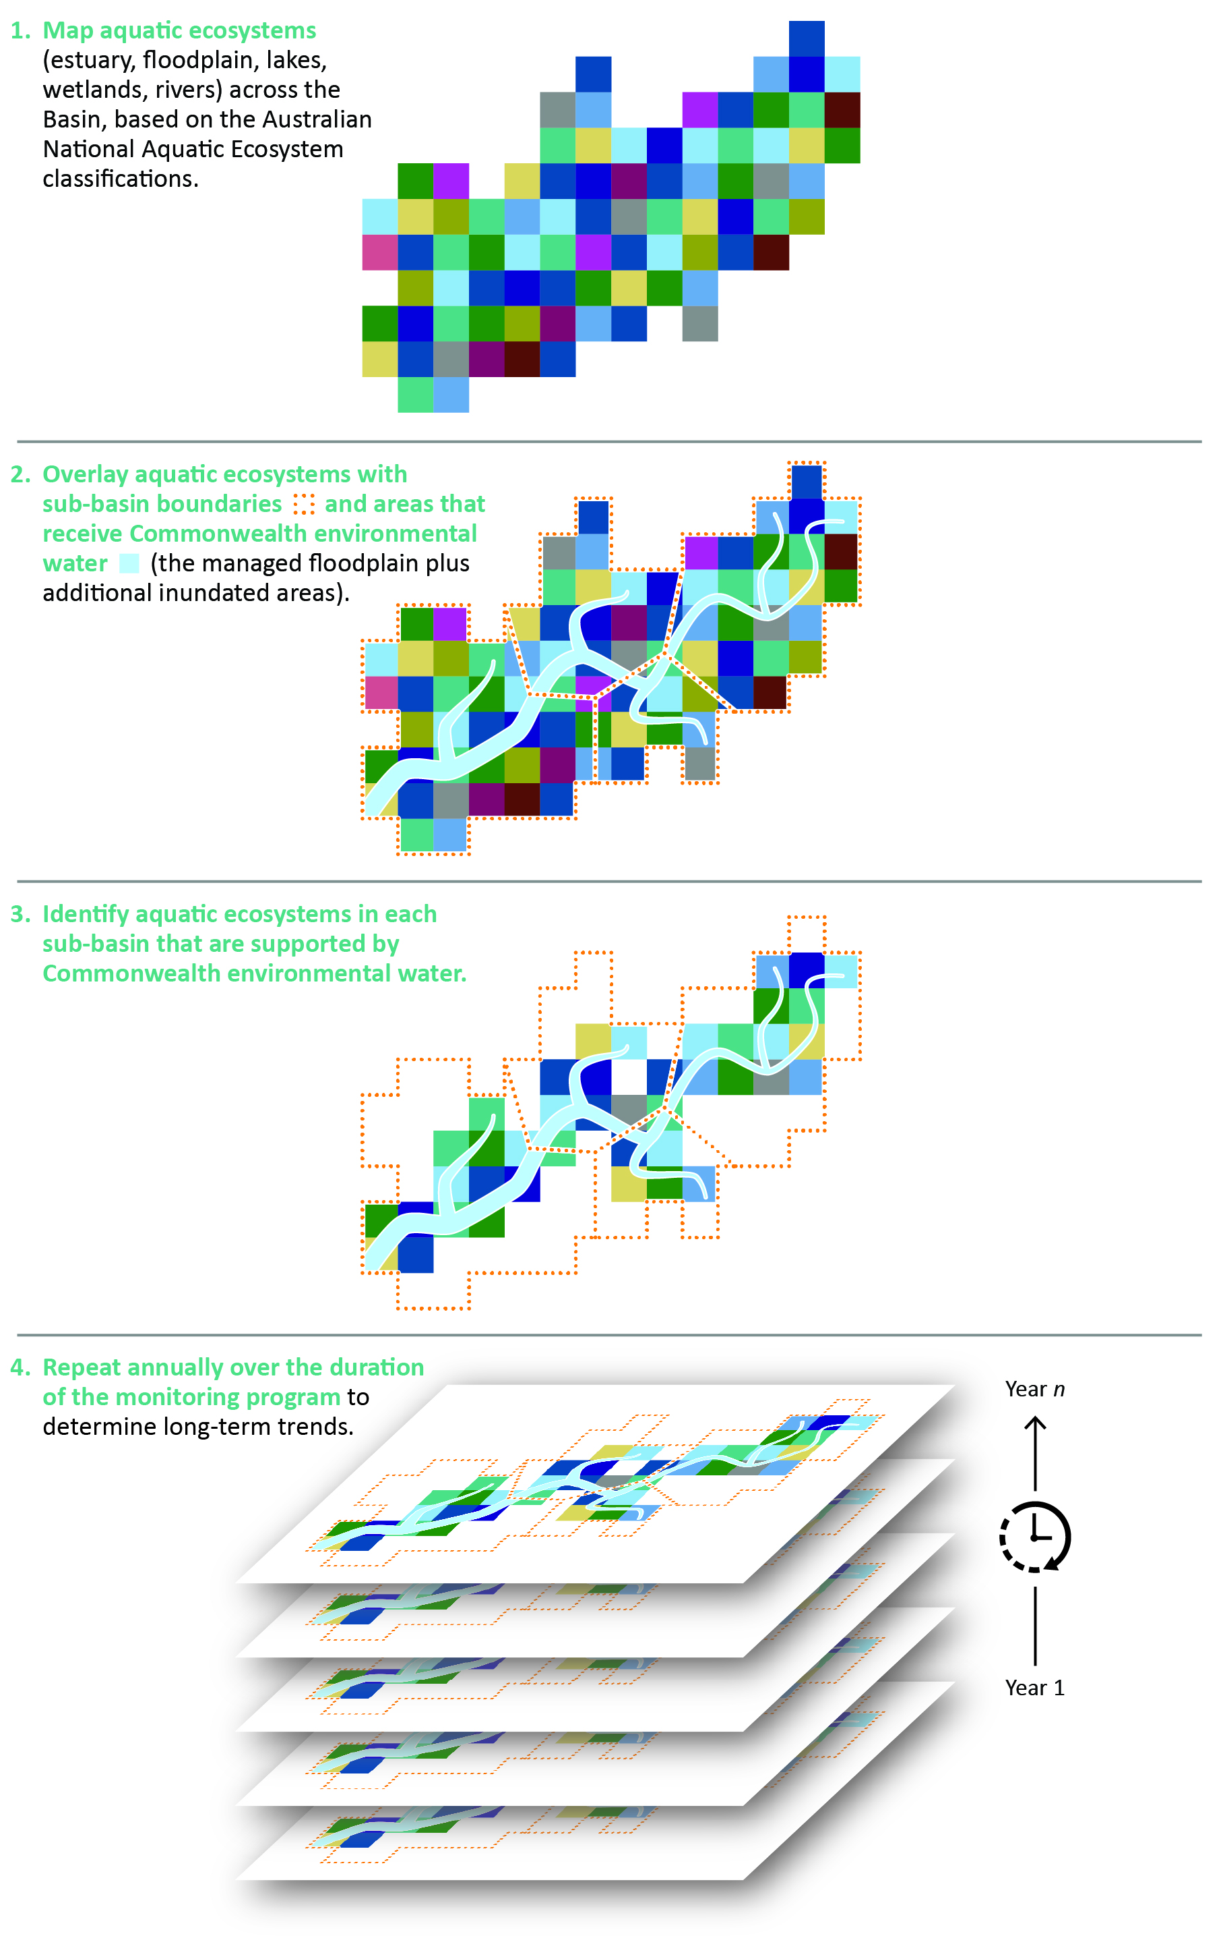

Data
A summary of datasets used for the Ecosystem Diversity evaluation is provided in Table 2.1.
Table 2.1 Datasets contributing to the Ecosystem Diversity evaluation
Dataset | Purpose | Reference
The Australian National Aquatic Ecosystem (ANAE) Classification of the Murray–Darling Basin v3.0 | Spatial dataset mapping all the estuary, lakes, wetlands, floodplains and rivers in the Basin. The richness of ANAE types defines Ecosystem Diversity | Brooks (2021a)
Inundation by Commonwealth environmental water | Maps the annual extent of inundation by CEW in each year of monitoring | Sengupta et al. (2024) for the 2022–23 year
CEWH Murray–Darling Basin valley boundaries | Spatial mapping of boundaries for the 25 major river valleys in the Basin | CEWH Flow-MER (2022)
Flow-MER Basin-managed floodplain | Mapped extent estimating the area of the Basin that can be influenced by management of water for environmental outcomes | CEWH Flow-MER (2024)
The ANAE process is described below. Inundation extent, valley boundaries and managed floodplain are foundation datasets. Their derivation is described in Chapter 7.

The Australian National Aquatic Ecosystem (ANAE) classification of the Murray–Darling Basin v3.0
Ecosystem types in the Basin are defined by the ANAE Classification Framework (Aquatic Ecosystems Task Group 2012). The framework was designed to help support adaptive management and monitoring of water-dependent ecosystems across the multiple jurisdictions in the Basin by providing a common language for describing and naming aquatic ecosystem types. The ANAE classification of the Basin v3.0 provides the most complete contemporary mapping of the distribution and extent of water-dependent ecosystems in the Basin (Brooks 2021a). The areas of approximately 300,000 aquatic ecosystems have been mapped to 5 high-level system classes (Figure 2.2) that are further classified into 66 ANAE types, including 8 types of lake, 29 types of palustrine wetland, 12 floodplain types, 8 river types (Figure 2.3), 9 estuarine ecosystem types and waterholes and springs. They represent a combined area of approximately 83,000 square km or nearly 8% of the Basin. The ANAE classes provide the unit of currency in the Ecosystem Diversity evaluation to quantify ecosystem diversity as the number of different ANAE types and their area that received CEW.
Only the widest sections of larger rivers are mapped by their areas. To provide a comprehensive map of all rivers and smaller streams, the ANAE v3.0 uses the Geofabric v3.2 Network Streams line mapping (BOM 2020) (Figure 2.3). The Geofabric line mapping was generated consistently for the Australian continent using a 1 second (30 m) resolution digital elevation model This consistency is important because river length measurement is highly dependent on the level of detail in mapping, with higher resolution mapping capturing more bends in the river planform that increased measurement of river length between 2 points. There are approximately 200,000 river features mapped, representing 50,000 km of perennial flowing rivers and more than 400,000 km of temporary flowing rivers and streams (Figure 2.3). Because they are mapped as line segments, the ecosystems receiving CEW are quantified by their river length (km), in contrast to the wetlands and floodplains that are quantified by area (hectares; ha).
Figure 2.2 Map showing the distribution of aquatic system types (estuary, floodplain, lakes, wetlands, rivers) in the Murray–Darling Basin
Data source: Brooks (2021a)
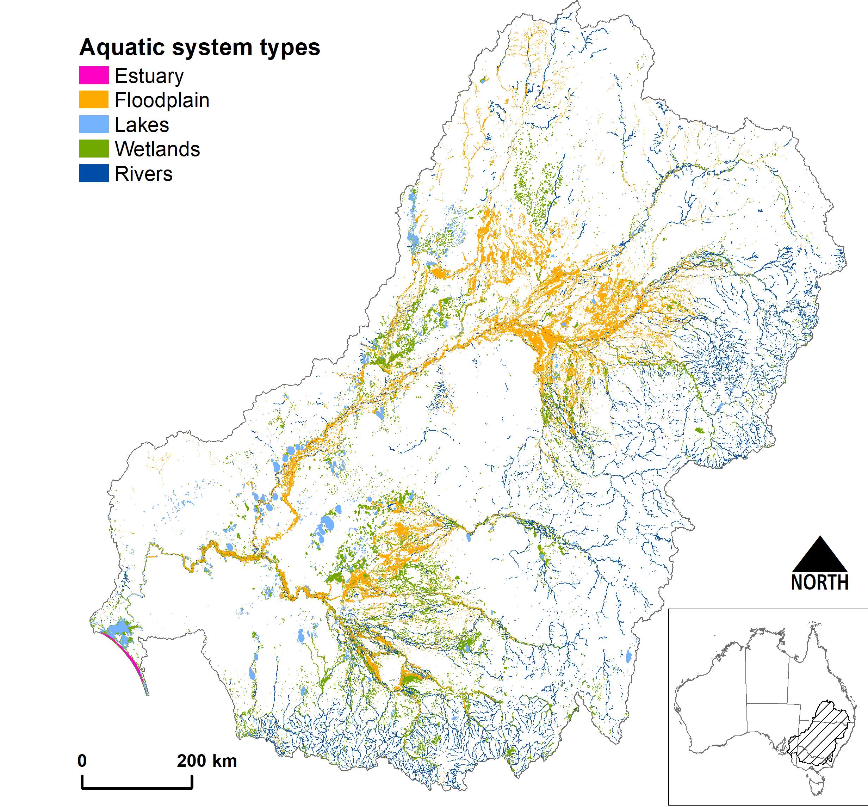
Figure 2.3 Map showing the distribution of Australian National Aquatic Ecosystem (ANAE) riverine ecosystem types in the Murray–Darling Basin
Data source: Brooks (2021a)
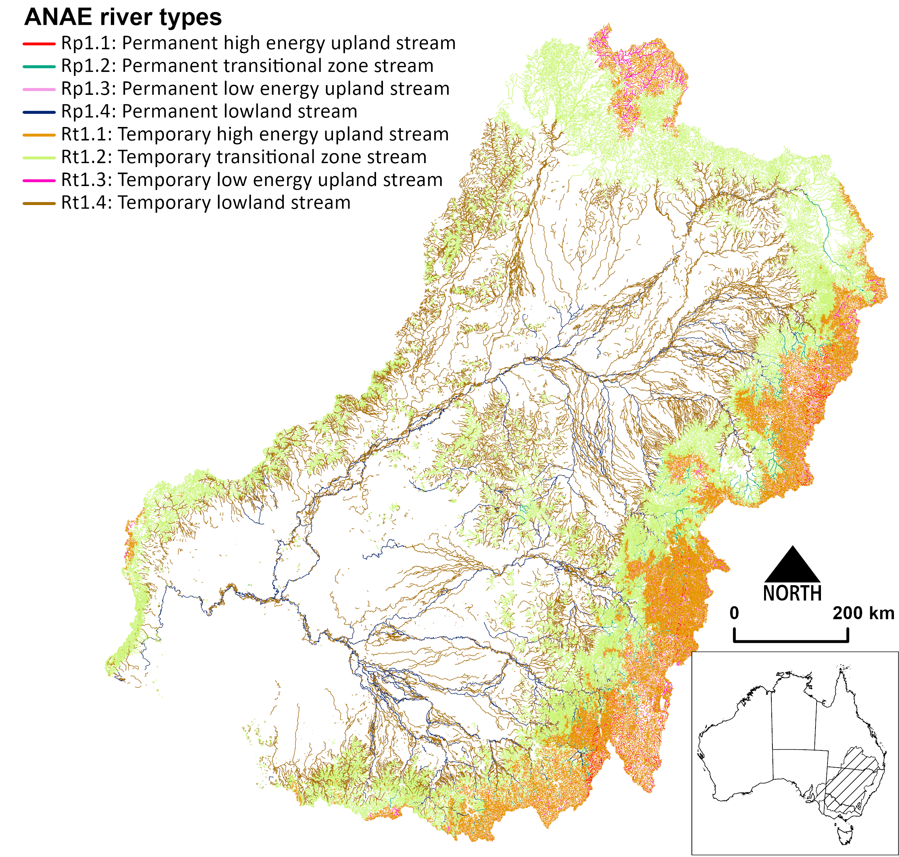

Terminology – ‘supported by’ and ‘influenced by’
For this evaluation, river and floodplain ecosystem types are deemed supported by CEW in the areas that are inundated. The inundated area is the floodplain area that is overlapped by the mapped extent of inundation.
Floodplains occur as broad continuous expanses, and most ecosystem responses are limited to the wetted area. For rivers, the sum length of all channel segments containing CEW is calculated directly from the inundation mapping (Figure 7.5).
Depressional wetlands (lakes and swamps) are deemed supported by CEW when all or part of their mapped extent coincides with environmental water inundation.
The entire wetland area is considered influenced by the water management.
This approach acknowledges that wetland ecosystems, particularly vegetated palustrine systems, are not limited to the open water’s edge. They include areas of wet hydric soils and vegetation that are connected by local water tables. Providing water to the deepest parts of the wetland also benefits fringing vegetation and provides habitat for waterbirds, frogs and turtles that can be found outside of the waterbodies. Quantifying the total area of the wetland influenced also addresses the underestimation of inundation extent in wetlands where water is obscured by the thick overstorey of emergent vegetation in which water is not reliably mapped from satellite imagery. This is particularly notable in tall marsh, grass marshes, sedgelands and meadows where green vegetation obscures a high proportion of the water such that water detection in satellite imagery may only show a few scattered pixels of water when the entire wetland is filled (e.g. Figure 2.4).
GIS workflows for calculating these 2 measures are provided in Section 2.4.
Figure 2.4 Satellite image of the area of the Great Cumbung Swamp showing visible inundation by CEW, whereas that mapped by Sentinel-2 satellite is limited to where open water is visible between the reed beds
The orange ANAE boundary is the extent of the wetland (i.e. the Great Cumbung Swamp) as per the ANAE. Blue shaded area is the extent of CEW as mapped by Sentinel. ANAE = Australian National Aquatic Ecosystem. Source: Brooks (2021b).
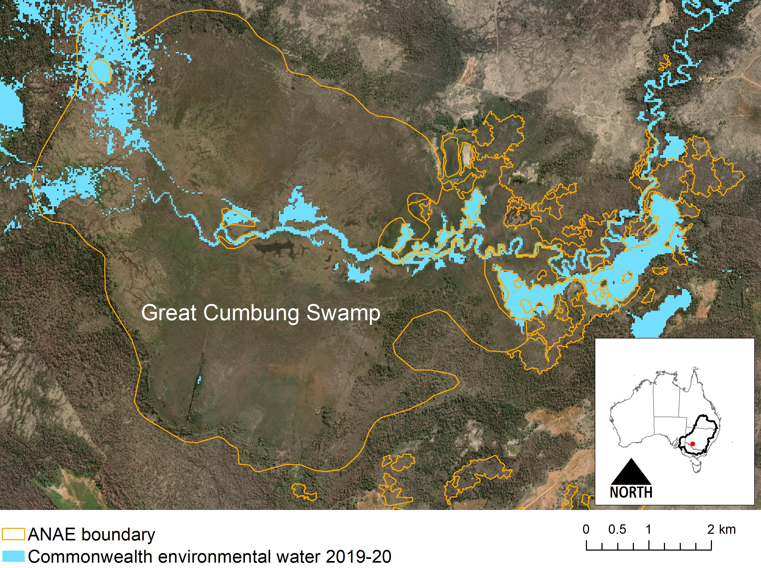

Evaluation of Ramsar sites
There are 16 Ramsar wetlands in the Basin, of which 12 are regularly supported by allocations of water from the Commonwealth, the Murray–Darling Basin Authority (MDBA) (e.g. The Living Murray Program), and state jurisdictions, with CEW being allocated to 11 sites over the period of monitoring 2014–present (Figure 2.5). The Kerang Wetlands Ramsar Site is managed solely by Victoria, and 4 Ramsar Sites in the Basin currently cannot receive managed environmental water (Figure 2.5): Currawinya Lakes and the Paroo River Wetlands are in unregulated northern Basin locations, and Ginini Flats Wetland Complex is in the alpine region above any water storages. The fourth site, Lake Albacutya, is the second of 2 large terminal lakes at the end of the Wimmera River – there is currently an insufficient volume of water in the system to first fill Lake Hindmarsh so that water can spill to Lake Albacutya.
The evaluation of ecosystem diversity supported by CEW in Ramsar Sites differs from the Basin-scale method – it uses the ANAE polygon mapping for riverine ecosystems instead of the Basin-scale river line mapping. The ANAE polygon mapping is not used at the Basin scale because it does not include all rivers in the Basin. It is, however, complete within the limited extent of the Ramsar estate, allowing all ecosystem types within the Ramsar Sites to be compared by the mapped area, and the area that received CEW. The Ramsar site river polygons are assessed using the same logic applied to lakes, where the entire area of river polygons within Ramsar Sites are deemed supported by CEW when overlapped in whole or in part by the satellite-derived inundation extent. At most Ramsar Sites, the water is delivered to the site via the river channel and occupies the whole channel.
Figure 2.5 Map showing location and extent of Ramsar Sites in the Murray–Darling Basin
Blue colouring of the site names highlights the Ramsar Sites that have received Commonwealth environmental water over the period of monitoring, 2014–23
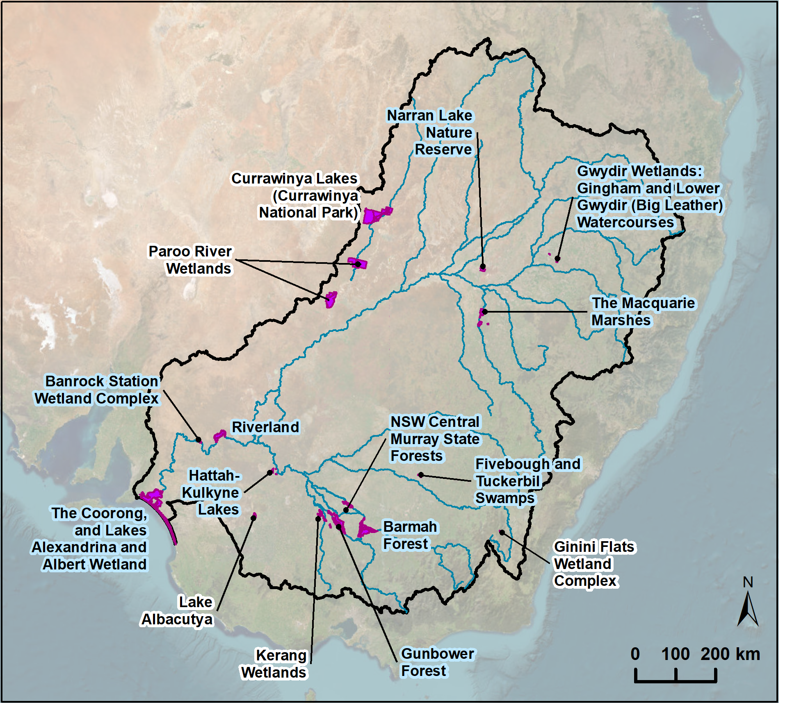

GIS workflows for calculating areas supported by Commonwealth environmental water
This evaluation uses 3 geographical information system (GIS) workflows, which are outlined in the following sections.

Calculating the area of ecosystems inundated by CEW
The area of ecosystems inundated by CEW is the fraction of the wetland area that intersects the CEW inundation extent. The inundated area is used in the evaluation for floodplains and rivers to quantify the proportion of the floodplain that was influenced by CEW.
- Intersect:
  - Basin ANAE classification mapping
  - CEW inundation
  - LTIM valleys.
- Calculate polygon area in hectares for the intersected areas using equal area GDA94 Australian Albers projection.
- Sum the area of inundated ANAE wetland types per valley.
For rivers, the inundated length of river channel is obtained directly from the inundation mapping and aggregated for each valley.

Calculating the area of ecosystems influenced by CEW
The area of ecosystems influenced by CEW is defined as the sum of the areas of mapped features that are partially or fully overlapped by the mapped extent of CEW inundation. The influenced area is used for depressional wetlands and lakes to incorporate fringing water-dependent vegetation growing in wet soils adjacent to waterbodies and the wet areas where inundation mapping from satellite imagery underestimates the area of water obscured by thick vegetation as occurs in reed beds (tall emergent marsh), meadows and sedgelands.
- Select by location all ANAE wetland polygons that intersect the CEW inundation raster.
- Add to the selection any additional ANAE wetland polygons that intersect the CEW inundation ‘watercourses watered’ line mapping.
- Intersect the selected wetlands with the valley boundaries.
- Calculate polygon area in hectares using equal area GDA94 Australian Albers projection for each ecosystem polygon.
- Sum the area of each ANAE wetland type per valley.

Species Diversity
Team: Skye Wassens, Rupert Mathwin, Andrew Hall (Charles Sturt University)

Overview
The Species Diversity theme considers outcomes for frogs, mammals, reptiles, water-associated woodland birds and waterbirds. As reported previously, monitoring of waterbird populations varies, both spatially and temporally, across the Basin and Australia. This creates biases and makes it difficult to draw datasets together and conduct meaningful analyses. For example, survey effort is often inconsistent between surveys (e.g. frequency, time or area surveyed, method used). Timing of surveys is also a critical variable (including time of day, time of year, wetland condition and inundation stage). All these factors affect the number of species and individuals detected. Additionally, many sites are not surveyed at all, or are surveyed opportunistically, while others are frequently surveyed. Integrating all available data into a single dataset to demonstrate the outcomes of CEW is difficult because key information on survey effort and wetland condition at the time of survey is often not available.

Lineage
Previous species diversity evaluations have considered Basin-wide outcomes for frogs, waterbirds, and freshwater turtles using a combination of limited Selected Area data, complementary monitoring datasets, and Atlas of Living Australia (ALA) records (Wassens et al. 2021, 2024, 2025; Wassens and Hall 2022, 2023). These reports highlighted the occurrence of listed migratory and threatened species and noted shortcomings in the current capacity to evaluate outcomes relevant to section 8.05 of the Basin Plan. The 2021–22 Species Diversity report (Wassens and Hall 2022) identified the need to “Explicitly identify the occurrence and water needs of listed threatened and migratory species that occur within the managed floodplains within each valley” and that “the distribution of key species and current water management practices in each valley are critical to identifying ‘blind spots’ where the water requirements of these species are not being met”. The lack of CEW delivery objectives and targets for threatened species has also been raised in the literature (Ryan et al. 2021).
The current Species Diversity evaluation framework reports on outcomes for waterbirds, frogs and turtles. However, data from the previous LTIM and current MER programs at the Selected Area scale for these taxa are limited. Previous reports have drawn on the ALA datasets to map distributions of water dependent species across the managed floodplain and identify species whose distribution coincides with areas inundated by CEW as well as those coinciding with other water. The Species Diversity evaluation continues to provide a list of species with a distribution coinciding with areas receiving CEW based on ALA data, and lists waterbird, frog and turtle species reported from MER and complementary NSW DCCEW datasets. This approach was expanded in the current report to include threatened fishes, crustaceans, water-dependent mammals, woodland birds and reptiles. Bird species were considered threatened if they were protected under Australian legislation (state or federal) or international treaties.
This evaluation provides a list of species with a distribution coinciding with areas receiving CEW based on ALA data, and lists waterbird, frog and turtle species reported from Flow-MER and complementary NSW DCCEW datasets. Post 2022, reporting of Selected Area outcomes for frogs (data only collected in 2 Selected Areas – Warrego-Darling and Murrumbidgee), and turtles (data only collected in the Murrumbidgee) were de-emphasised. This was justified given evaluation of outcomes for these taxa are reported in Selected Area technical reports.

Evaluation questions
The evaluation addresses the overarching question:
What did Commonwealth environmental water contribute to species diversity?
This question is addressed through 3 components:
What was the contribution of Commonwealth environmental water to the diversity of frogs, waterbirds and other water-dependent vertebrates?
What was the contribution of Commonwealth environmental water to listed species and ecological communities?
What was the contribution of Commonwealth environmental water to migratory species listed under international agreements (Bonn Convention, CAMBA, JAMBA or ROKAMBA)?
Evaluation of the contribution of CEW against observed environmental outcomes for the Species Diversity Basin Theme is dependent on data available at the time of analysis. These include Selected Area monitoring data stored in the CEWH’s Monitoring Data Management System (MDMS), frog survey data collected by state agencies and the Atlas of Living Australia (the ALA), used to collate Basin-wide patterns of species diversity for frogs, water-dependent mammals, reptiles and waterbirds across the managed floodplain as defined by MDBA. These data were used to evaluate listed threatened and migratory species.
In addition, published and unpublished monitoring reports, and watering action acquittal and operational reports, are used to prepare summaries of outcomes against watering objectives.

Basin-wide datasets

The Atlas of Living Australia
The ALA is a high-quality database that aggregates species-diversity data from multiple sources, including state-based monitoring programs, consultant or research projects and citizen science (e.g. the Australian Museum’s FrogID dataset). The ALA contains presence-only point data (spatial coordinates) of species occurrences which can be overlaid with other spatial information, including mapped inundation areas.
Using detection-only datasets such as the ALA, it is important to note that, because of spatially uneven survey effort and biases in species detection (particularly for frog species), these numbers on their own provide only a broad relative picture of the species likely to occur across the managed floodplain in each valley.

Listed threatened and migratory species
Listed species were identified from the ALA datasets. Species were included if they had a conservation listing in Commonwealth or state legislation, including the EPBC Act, Bonn Convention, CAMBA, JAMBA, ROKAMBA, Victorian Flora and Fauna Guarantee Act 1988, South Australian National Parks and Wildlife Act 1972, New South Wales Biodiversity Conservation Act 2016, Australian Capital Territory Nature Conservation Act 2014 or Queensland Nature Conservation Act 1992.
The pilot machine-learning study (reported in (Wassens et al. 2024) successfully modelled 4 threatened species: one frog species – southern bell frog (Litoria raniformis), and 3 bird species – Australasian bittern (Botaurus poiciloptilus), glossy ibis (Plegadis falcinellus) and Australasian shoveler (Spatula rhynchotis).
A further 5 bird species were analysed in the 2023–24 water year: Australian painted snipe (Rostratula australis), common greenshank (Tringa nebularia), superb parrot (Polytelis swainsonii), sharp-tailed sandpiper (Calidris acuminata) and Latham’s snipe (Gallinago hardwickii).

Mapping the relationships between inundation and species richness

Using ALA data
Species richness, which is a count of the number of species present within a set area, is mapped (for the purpose of Species Diversity evaluation) using ALA records.
Producing one map for a single period and one species group has 5 steps:
- A 0.5 decimal degree grid is placed over an outline of the Basin.
- The ALA data is cut to only those locations inside the outline of the Basin; and then separated into the different species of the group.
- For each species, those ALA records collected in the nominated period are identified and plotted over the grid as point locations.
- For each species point plot, in turn, a single map is produced where a value of ‘1’ is assigned to any grid cell that contains one or more points representing an observation of a single species.
- All the single species grid maps are stacked, and each grid cell summed to produce a final species richness map.
The maps therefore represent the number of species of a group observed at least once within the area of each grid cell within the specified period.
Corresponding inundation maps are produced by collating the mapped areas inundated (see Sengupta et al. 2024) in each water year (1 July to 30 June), with each grid cell having the same spatial characteristics as those used for the species richness maps. All the annual grid maps are then stacked and summed for all the water years in the period. The inundation maps therefore represent the total area inundated by CEW in all discrete water years (where an area could only be counted once per water year) over the full length of the LTIM/Flow-MER monitoring period (9 years as at 30 June 2023).

Using ALA, Digital Earth Australia’s Water Insights Tool and ANAE datasets
The 2022–23 water year evaluation was extended to include the Digital Earth Australia’s Water Insights Tool (WIT, Dunn et al. 2023) and Australian National Aquatic Ecosystems (ANAE, Brooks 2021a) datasets. These were combined with the ALA dataset to determine the feasibility of evaluating outcomes for selected listed and threatened species. The 4 main steps are summarised below and shown diagrammatically in Figure 3.1.
- Use the ALA data to plot the distribution of selected listed migratory and threatened species across the managed floodplain, focussing on a few species with distinctly different habitat requirements
- Identify the species’ general habitat preferences by analysing the intersection of ANAE types with the spatial distribution of the selected threatened species
- Use the Flow-MER mapped inundation layers to identify those discrete ANAE areas with habitats favoured by threatened species that have received Commonwealth environmental water
- Use the WIT to determine the historical (1988–2024) inundation regime and vegetation response of the identified ANAE areas to assess the contribution of Commonwealth environmental water to the habitat suitability of those ecosystems supporting the selected threatened species.
Figure 3.1 Diagram of main steps in integrating multiple data sources as input to the listed and threatened species evaluation pilot
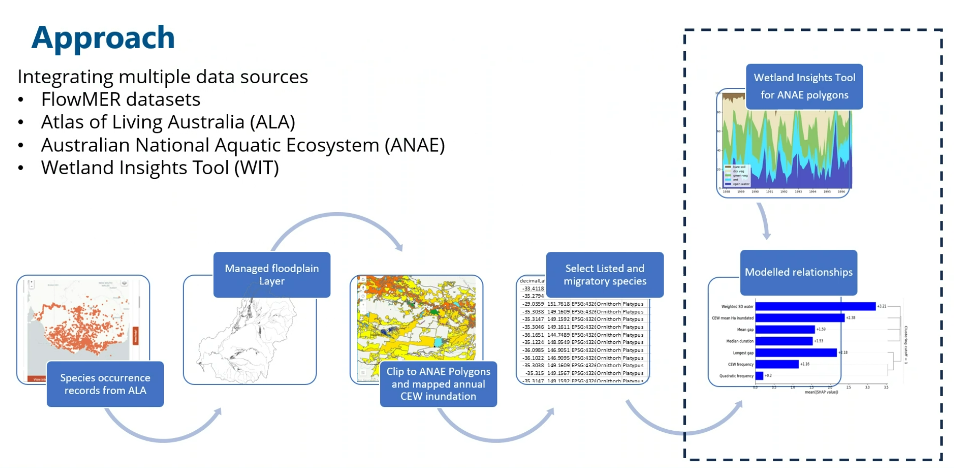
This process allows us to map distributions of migratory waterbirds listed under Bonn Convention, CAMBA, JAMBA or ROKAMBA (Basin Plan 8.05 2b); and listed threatened or Endangered species (Basin Plan 8.05 3a). However, resourcing constraints limited our ability to evaluate Commonwealth environmental water contributions to maintaining appropriate water regimes within ecosystems that support these species.
Presence is quantified using species richness, defined as a count of the number of species present within a set area and measured using gridded maps created for each of 5 groups (frogs, mammals, reptiles, water associated woodland birds and waterbirds) for the evaluation by water year (1 July to 30 June) and the cumulative years since 2014–15.

Modelling the relationships between Commonwealth environmental water inundation and the presence of selected threatened species
The 2022–23 Flow-MER species diversity report (Wassens 2024) trialled the use of machine learning algorithms (boosted decision trees) to link threatened species to CEW and other hydrological drivers. That pilot modelled 5 threatened species: one species of frog, the southern bell frog (Litoria raniformis), and 4 species of bird, Australasian bittern (Botaurus poiciloptilus), glossy ibis (Plegadis falcinellus), magpie goose (Anseranas semipalmata) and Australasian shoveler (Spatula rhynchotis). Although magpie goose was removed from the modelling due to its small sample size on the managed floodplain, the approach generated a useful reporting framework for CEW delivery. In 2023–24, this pilot was repeated for 5 EPBC listed bird species: Australian painted snipe (Rostratula australis), common greenshank (Tringa nebularia), superb parrot (Polytelis swainsonii), sharp-tailed sandpiper (Calidris acuminata) and Latham’s snipe (Gallinago hardwickii).
Our intention was to add taxonomic diversity to our list of modelled species; however we were limited by the available data.
Our methodology first considers all ANAE polygons with a historical record of the target species and then selects each polygon that:
- is considered under the Basin-wide watering strategy
- has received CEW since 1 July 2014 that increased the surface area of water
- has Wetlands Insight Tool data
- has been surveyed since 1 July 2014.
At least 100 polygons are required for machine learning.
We reviewed the available data for every mammal, reptile, amphibian, crustacean and fish in the Basin that is protected under any state or federal legislation. Of these, only 2 species met our criteria: the southern bell frog (modelled in Wassens 2024) and River Murray rainbowfish (Melanotaenia fluviatilis) – which is Endangered in Victoria but is not considered threatened in other jurisdictions. We then relaxed our approach to consider each ANAE polygon that was within 1,000 m of a historical detection (but still required a CEW delivery and survey since 1 July 2014). Using this approach, 15 threatened species met our criteria, however none of these were deemed suitable for modelling. For example, Macquarie turtles (Emydura macquarii) are mobile over distances greater than 1,000 m, and 782 polygons were suitable for inclusion; however, the targeted nature of surveys strongly favour detection and Macquarie turtles have been detected at 761 (97.3%) of the surveyed polygons since 2014. The 21 polygons in which this species has not been detected are insufficient to characterise. Instead, we selected 5 species of bird that are listed on the EPBC Act and analysed all polygons that are within 1,000 m of a historical detection.

Data preparation
For each species of interest, we identified all historical detections using data sourced from the Atlas of Living Australia (ALA). We used QGIS Version 3.36 Maidenhead (QGIS.org 2024) to subset these data to include only those records that occurred within 1,000 m of an Australian National Aquatic Ecosystem (ANAE) polygon within the Basin. For each polygon we collated each unique survey date for the taxa within that polygon (including the surveys that did not detect the species of interest) and identified those polygons considered under the Strategy. We then used data provided by Sengupta et al. (2024) to determine how many times each polygon had been influenced by a Commonwealth environmental watering event since 2014–15.
All subsequent data preparation was completed in the R programming environment Version 4.3.3 Angel Food Cake (R Core Team 2023). To prepare the datasets for analysis we selected 8 wetland metrics that could reasonably be influenced through CEW delivery. In machine learning analysis, these metrics are called features and we will use this term hereafter. For each ANAE polygon we assigned the features: CEW frequency, CEW mean hectares inundated, Longest gap, Median duration, Mean gap and Weighted SD water (Table 3.1). Following the recommendations from Wassens et al (2024) we did not include Quadratic frequency for these species, and introduced 2 new features (Mean vegetation, and SD vegetation, Table 3.1). There was a small number of polygons that did not have Wetland Insights Tool summary statistics and these polygons were removed.
We determined which months each species had been detected and then excluded any surveys that occurred during a non-detection month. We then calculated the number of surveys in each polygon since 1 July 2014, and the number of surveys since 1 July 2018 (within 5 years of this analysis). We also determined if the species of interest was detected in these polygons since 2014, and if the species was detected within the last 5 years.
Table 3.1 The 8 features selected for model training that reflect aspects of the wetland hydrology that could be influenced through CEW delivery and were used in the machine learning analyses
Note that the 2022–23 analyses used 7 features
Features | Explanation | Source
CEW frequency | The number of years that this polygon received CEW (maximum nine) | See Sengupta et al. (2024)
Quadratic frequency | The 'CEW frequency' factor raised to the power of two | Calculated from CEW frequency
CEW mean Ha inundated | The average number of additional hectares (Ha) that were inundated as a result of CEW delivery | See Sengupta et al. (2024)
Longest gap | The longest gap (in years) between two successive CEW deliveries | Calculated
Median duration | The mean of the annual median duration of inundation at the polygon. This is a summary statistic produced by the Wetlands Insights Tool and the mean annual value since the 2014–15 water year was also calculated | Calculated from the Wetland Insights Tool {Dunn 2023}
Mean gap | The mean of the annual mean gap between successive inundation events at the polygon. This is a summary statistic produced by the Wetlands Insights Tool (WIT) and the mean annual value since the 2014-2015 water year was also calculated | Calculated from the Wetland Insights Tool
Weighted SD water | 'water' is a Wetlands Inventory Tool metric that measures the proportion of the polygon that was open water. The weighted standard deviation of this value since the 2014-2015 water year was calculated for each polygon as a measure the variability of inundation | Calculated from the Wetland Insights Tool
SD vegetation | This feature was a new inclusion in the 2023–24 analyses. It is the standard deviation of the photosynthetic vegetation metric (from the WIT tool) since the 2014–15 water year | See Sengupta et al. (2024)
Mean vegetation | The mean of annual photosynthetic vegetation (from the WIT tool) since the 2014–15 water year | See Sengupta et al. (2024)
For each species we considered detection since 2014 as the outcome. In machine learning terminology, the categorical outcome of interest used to train the model is the class. We used:
- ‘Has the species of interest been detected since 2014?’ (class 1 = Yes, class 2 = No).
If the ratio of minority:majority classes exceeded 1:2, we used the ROSE package in R to oversample the minority class from the nearest neighbours using synthetic minority oversampling until a 1:2 ratio was achieved. We then balanced the classes by weighting the minority class during model training. The resulting datasets were randomly split into a training dataset (75% of the records) and a testing dataset (the remaining 25% of the records), ensuring commensurate class proportions in each set.

Modelling approach
We used these data to train 3 machine learning (ML) algorithms for each species of interest:
- Random forest models
- Light Gradient boosting models (GBM)
- CatBoost models.
Random forest models were analysed in the R programming environment Version 4.3.3 Angel Food Cake (R Core Team 2023) using the randomForest package (Version 4.7-1.1). Model fitting used Matthews Correlation Coefficient as the evaluation metric and overfitting was controlled using 5-fold cross validation during training. To determine the best combination of randomForest model parameters, we used a grid search to compare each possible combination of:
- the number of factors that were considered to select the best split during tree construction as 2, 4, 6
- the minimum number of samples required to create a split in each tree as every even number between 10 and 30 (inclusive)
- the total number of trees in the forest as 1000, 2000, 3000, 4000, 5000.
The best performing set of model parameters was then used to predict the test dataset as a probability which was used to calculate evaluation measurements for accuracy and area under the curve. The best performing set of model parameters was then used to train the randomForest model on the complete training dataset. This model was then applied to the test set to generate evaluation measurements for accuracy (the % of classes that were correctly identified), and the model’s ability to distinguish between classes (area under the curve).
Light GBM models were analysed in in the Python programming environment (Version 3.12.2) using the lightgbm package (Version 4.3.0) and executed in a jupyter notebook (jupyterbook.org). Models were trained using a predetermined seed (to control stochastic variation) and used accuracy as the loss function. Overfitting was controlled using 5-fold cross validation during training. To determine the best combination of Light GBM model parameters, we used a grid search to compare each possible combination of:
- number of trees in the forest 100, 300, 500 and 700
- maximum tree depth of 5, 10 and 15 branches
- learning rate of 0.01, 0.05 and 0.1
- minimum samples considered in each leaf 2, 6 and 10
- the subsampling ratio during training 0.8, 0.9 and 1
- the ratio of subsampling during construction of 0.8 and 1
- the minimum number of child samples required for each leaf node as 2, 5, 10, 20, 30 and 40.
The best performing set of model parameters was then used to train the Light GBM model on the complete training dataset, and this model was applied to the test set to generate evaluation measurements for accuracy and the area under the curve.
CatBoost models were analysed in the Python programming environment (Version 3.12.2) using CatBoost package (Version 1.2.5) and executed in a jupyter notebook (jupyterbook.org). Model fitting used a predetermined seed (to control stochastic variation) and used a Logloss loss function. Models were evaluated on the CPU using 10,000 maximum iterations and a learning rate of 0.001 with an iterative overfitting detector that used Matthews Correlation Coefficient as the evaluation metric. The chance of overfitting was further minimised using 5-fold cross validation during training.
To determine the best combination of CatBoost model parameters, we used a grid search to compare each possible combination of:
- tree depth 4, 6, 8, 10, 11 and 12
- target border (the cutoff used when assigning a class) from 0.495-0.505 in 0.01 increments
- overfitting detection wait (the number of trees that are constructed after the first detection of overfitting) 0, 20, 40, 100
- growth policies that constructed depthwise or symmetric trees.
The best performing model from each algorithm was compared using accuracy (the percentage of the testing set that was correctly identified) and area under the curve (a measure of the balanced accuracy of true positives and true negatives) to identify the best overall model.
These machine learning algorithms can be considered 'black box' models. This refers to an algorithm that is difficult to understand due to the complexity and non-linearity of the internal processes. To address this issue, we used Shapley additive explanations (also known as SHAP values or Shapley values) to visualise the relative influence of each feature on the final classification. Shapley values are a model agnostic set of metrics that draw on cooperative game theory to evaluate the relative contribution of each player in achieving a combined payoff. These plots provide a broad overview of feature importance; however, they do not account for the interactions between the features. To estimate of the isolated effect of each feature, we used partial dependence plots to observe its decision force across the range of values that were present in the training data when all of the other features were held to their mean value. The consensus of these outputs (machine learning, Shapley values and partial dependence plots) were synthesised to identify the important habitat features and thresholds for each species which was used to assess the influence of CEW delivery in the 2023–24 water year on each of the species of interest.
Results were presented as partial dependent plots, visualised as shown in Figure 3.2.
Figure 3.2 SD vegetation was the third most influential feature in the ML model for Australian painted snipe
This feature’s effect is strongest at sites with little variation in green vegetation at the site. This suggests a preference for wetlands with more stable vegetation communities. Possibly those that are regularly inundated, and possible a preference for wetlands in higher rainfall areas. The black tick marks on the x axis are the deciles of SD vegetation in the training data.
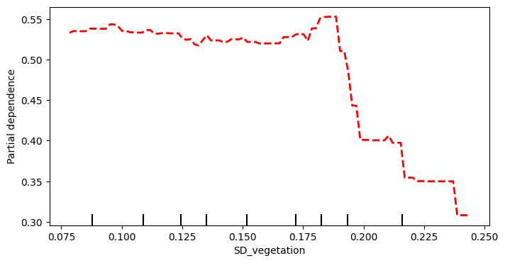

Key assumptions underlying the approach
This approach generates a data-driven framework to report the role of CEW delivery for selected listed species outcomes at the Basin scale. Implementing these frameworks into reporting provides a tractable (if somewhat coarse) approach to discuss the broad-scale contribution CEW in meeting listed species targets, both legislated and those arising from international treaties. These analyses are underpinned by 2 key assumptions:
- that there is sufficient survey effort to assess the detection trends across a broad spatial area and a range of habitat types
- that the probability of detecting a listed species is a suitable proxy for hydric suitability (or a hydric preference).

Survey design and the probability of detection
Our approach identified a strong bias towards polygons with previous detections. Many monitoring programs are focused on targeted intervention sites, although this varies between programs. For example, both the Flow-MER and NSW DCCEEW survey approaches survey sites at a set interval that is independent of planned watering actions. In heavily managed floodplain ecosystems, it can be difficult to identify appropriate experimental controls when managed environment water is often the only source of inundation. Put succinctly, null data are not the same as no data.
The mismatch in survey effort across polygons is an issue for all Basin-wide programs, but one that can be managed by integrating our findings into an adaptive management framework (through adaptive monitoring). In Wassens et al. (2024) we identified 377 ANAE polygons that aligned with the managed floodplain and had a historical record of one (or more) of the 4 species that were analysed but had not been surveyed since 2014–15. Of these, one polygon had historical records of 4 species of interest, 7 polygons had historical records of 3 species of interest, and 45 had historical records of 2 species of interest. We did not repeat this exercise including the 5 new focal species (or the 43 threatened mammal, reptile, amphibian, crustacean and fish) but we expect that many of these unsurveyed polygons include historical records of additional protected species. Targeted surveys in these polygons would greatly improve the strength of our models, provide valuable information on the current range of these species, and would add contrast to the Basin-wide dataset, thereby improving its capacity to answer process-based research questions. Thus, we strongly recommend periodic targeted surveys in such polygons, prioritising those polygons with more historical species records.
These models are powerful predictive tools to guide CEW delivery to polygons with limited survey data, to guide adaptive monitoring to fill gaps in the existing data or to identify remnant populations in unsurveyed polygons.
To further improve the quality of the training data, we encourage future model revisions to seek additional records that were not captured in this pilot study; for example, datasets that are managed by community organisations or local authorities. We also encourage a review of data to ensure that the responsible project submitted surveys with non-detection to the relevant repository, and that these non-detections are captured when querying those repositories. By incrementally improving the scope of the listed species data, we will improve the value of these products for reporting threatened species outcomes and their capacity to feed back into the adaptive management framework.

Listed species detection as a proxy for hydric suitability
We used a single detection as our positive outcome class. This coarse approach was necessary to increase the number of records used to train the models but ignores much of the underlying nuance of CEW delivery. For example, a single detection could have preceded the first delivery of CEW to that polygon or could have occurred in a year when the timing and volume delivered was ideal, while all subsequent deliveries failed to meet the species’ needs.
In developing this approach, we trialled an alternative approach that treated each polygon in each year as a single record and included only polygons with a survey in that water year; however, this introduced too much noise for the models to train effectively. This alternative approach also forces the models to train according to survey effort, thereby identifying the patterns at heavily surveyed sites and assuming they are representative of broader species trends.
A finer scale approach could become possible in the future (as more data become available for model training) but we assert that our current approach is the best option at the current time.
In reporting, we have assumed that a single detection of a listed species at that polygon indicates that its mean hydric patterns are suitable for that species and could reflect a preference for those patterns. This assumption ignores the effect of survey effort (thoroughly surveyed polygons are more likely to detect a species) and inter-annual hydric variability (detection in a single year might reflect suitability only in that year). Similarly, we excluded local habitat features that could be important for occupancy, such as the ANAE habitat classification or the proportion of non-photosynthesising vegetation at the polygon. We made this decision to improve the models’ ability to specifically identify hydric patterns that can be influenced through the application of CEW as this provides the strongest support for reporting and to inform adaptive management.
In summary, the current approach infers hydric suitability through species detection and generates well-supported correlations for each species and local hydric features. These relationships are data-driven hypotheses that are suitable for reporting against annual targets (and to guide management) but most of these relationships will require targeted research before true causality can be established.

Vegetation
Team: Fiona Dyer, Will Higgisson, Alica Tschierschke, Margarita Medina (University of Canberra); Cherie Campbell (MBDA); Tanya Doody (CSIRO)

Evaluation objectives
The Basin-scale Vegetation Theme evaluates the contribution of Commonwealth environmental water in supporting the diversity of groundcover vegetation. It describes the most recent (1 year) and longer term (10 years) evaluation of:
What did Commonwealth environmental water contribute to plant species diversity?
What did Commonwealth environmental water contribute to vegetation community diversity?

Approach
The contributions of Commonwealth environmental water to vegetation species diversity and to vegetation community diversity is evaluated using a counterfactual modelling approach. Vegetation monitoring data from floodplain and wetland habitats across the Basin are used to describe the vegetation assemblages associated with groups of sample points that have experienced similar inundation regimes over the life of the monitoring program (known as inundation groups). The resulting associations between an inundation group and a vegetation assemblage are then used to predict the vegetation assemblage that would occur in the absence of environmental water (the ‘counterfactual’ scenario).
Differences in the vegetation assemblages that are predicted to occur with and without environmental water can then, in part, be attributed to environmental water.
The evaluation is focussed on the cumulative outcomes, recognising that the expression of extant wetland and floodplain groundcover vegetation is the result of a complex set of interacting factors that includes recent and long-term hydrological conditions. Thus, we link the inundation regime to the vegetation assemblage observed over multiple years, and within a single water year. Vegetation assemblages are described in terms of compositional (richness) and structural (cover) attributes that are further described in terms of growth form (e.g. forbs, grasses, ferns) and life-history dependence on water regimes (submerged, amphibious, damp-loving, woody flood-dependent and terrestrial). These steps are captured in the schematic at Figure 4.1.
The evaluation is accompanied by a summary of the watering actions conducted for expected vegetation outcomes, as well as an overview of the vegetation observations based on monitoring data collected from sample points within each of the Selected Areas at both annual and cumulative time steps. Annual evaluations are reported in Campbell et al. 2023, Dyer et al. 2021, 2022, 2024, 2025).
Figure 4.1 Schematic of the 5 steps in the groundcover vegetation evaluation approach
The steps are: 1 classify inundation groups; 2 define assemblages of vegetation species associated with inundation groups; 3 model the inundation regime at each sample point in the absence of environmental water; 4 predict the assemblages of vegetation species in the absence of environmental water; 5 compare assemblages at sample points with and without environmental water
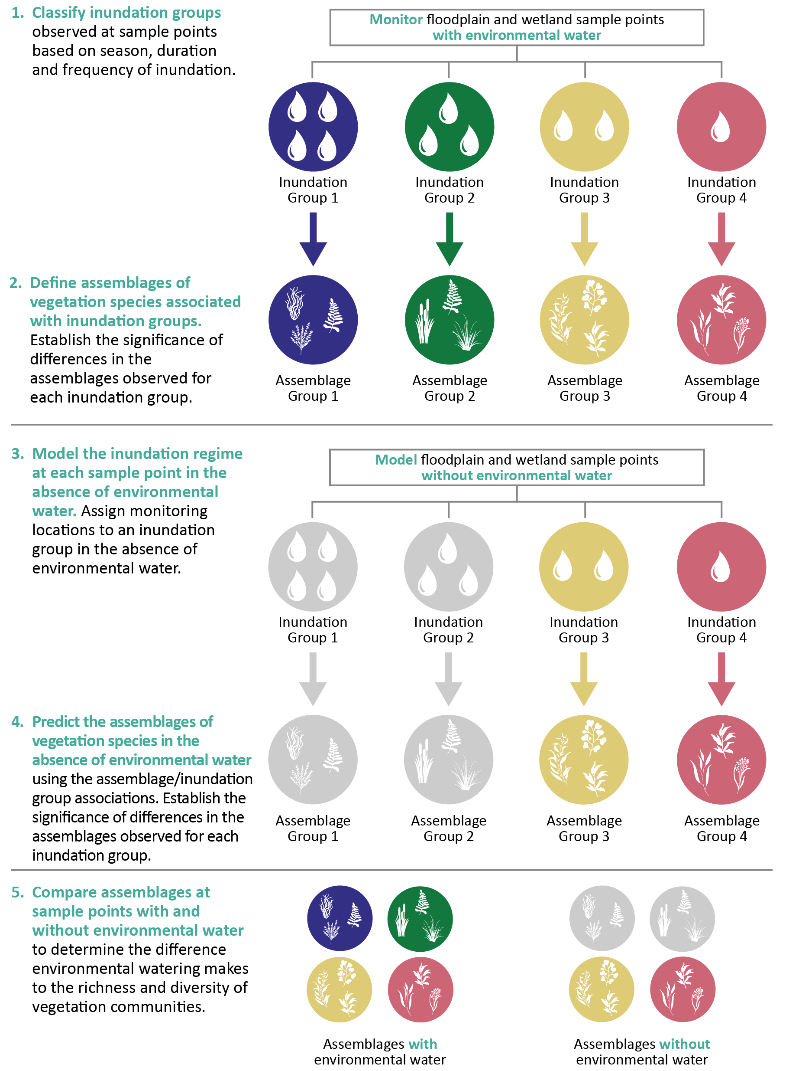

Data

Hydrological data
Information about watering regimes and inundation by environmental water was obtained from a range of sources, including: observations and estimates (of duration and depth) from field teams; advice from Selected Area teams; maps of maximum annual inundation extent developed by the Flow-MER Hydrology and Ecosystem Diversity Basin Themes (Sengupta et al. 2025, Brooks 2025); and remote-sensing data. A floodplain–wetland sample point was considered inundated if more than 50% of the plot or transect had surface water present in a given time period. Information about watering actions was provided by the CEWH. Inundation was attributed to environmental water or natural flooding (or both) using inundation extent provided by the hydrology team and augmented with local knowledge. Two inundation datasets were generated: with and without environmental water.

Vegetation data

Sample points
Vegetation diversity data used in this evaluation were collected under LTIM and Flow-MER from sample points that include: (i) wetlands and floodplains in 4 Selected Areas – Gwydir, Lachlan and Murrumbidgee river systems and Junction of Warrego and Darling rivers; and (ii) within river channels in 3 Selected Areas – Edward/Kolety–Wakool river systems, Goulburn River and Lower Murray River, as presented in Figure 4.2. Generally, multiple sampling units (plots and transects) were deployed within a sample point to capture a representative area or other gradient (bathymetric, geomorphic) within the sample point. Detailed sampling methods are included in individual Selected Area reports.

Data acquisition and preparation
Vegetation data are entered by Selected Area teams into the Monitoring Data Management System (MDMS). Data are checked by the MDMS database managers for quality assurance and quality control, then sent to Selected Area teams for final approval.
Vegetation data stored in the MDMS are extracted for all years (2014–2024). These data are joined with:
- consistent species information from a master species trait list (e.g. family, functional group classification, growth form, life history, nativeness)
- sample point information (e.g. hydrological grouping, habitat classification, Australian National Aquatic Ecosystem [ANAE] type, with and without environmental water inundation), which is used to provide the set of explanatory variables.
Vegetation data include extant, vascular vegetation only, except for charophytes, which are macro-algae with a structure superficially similar to vascular plants. Vegetation data includes only records of species present in the groundcover and understorey layer; there is no assessment of canopy.
Figure 4.2 Map showing the vegetation sample points in each Selected Area monitored for groundcover vegetation by Flow-MER over the period 2014–24
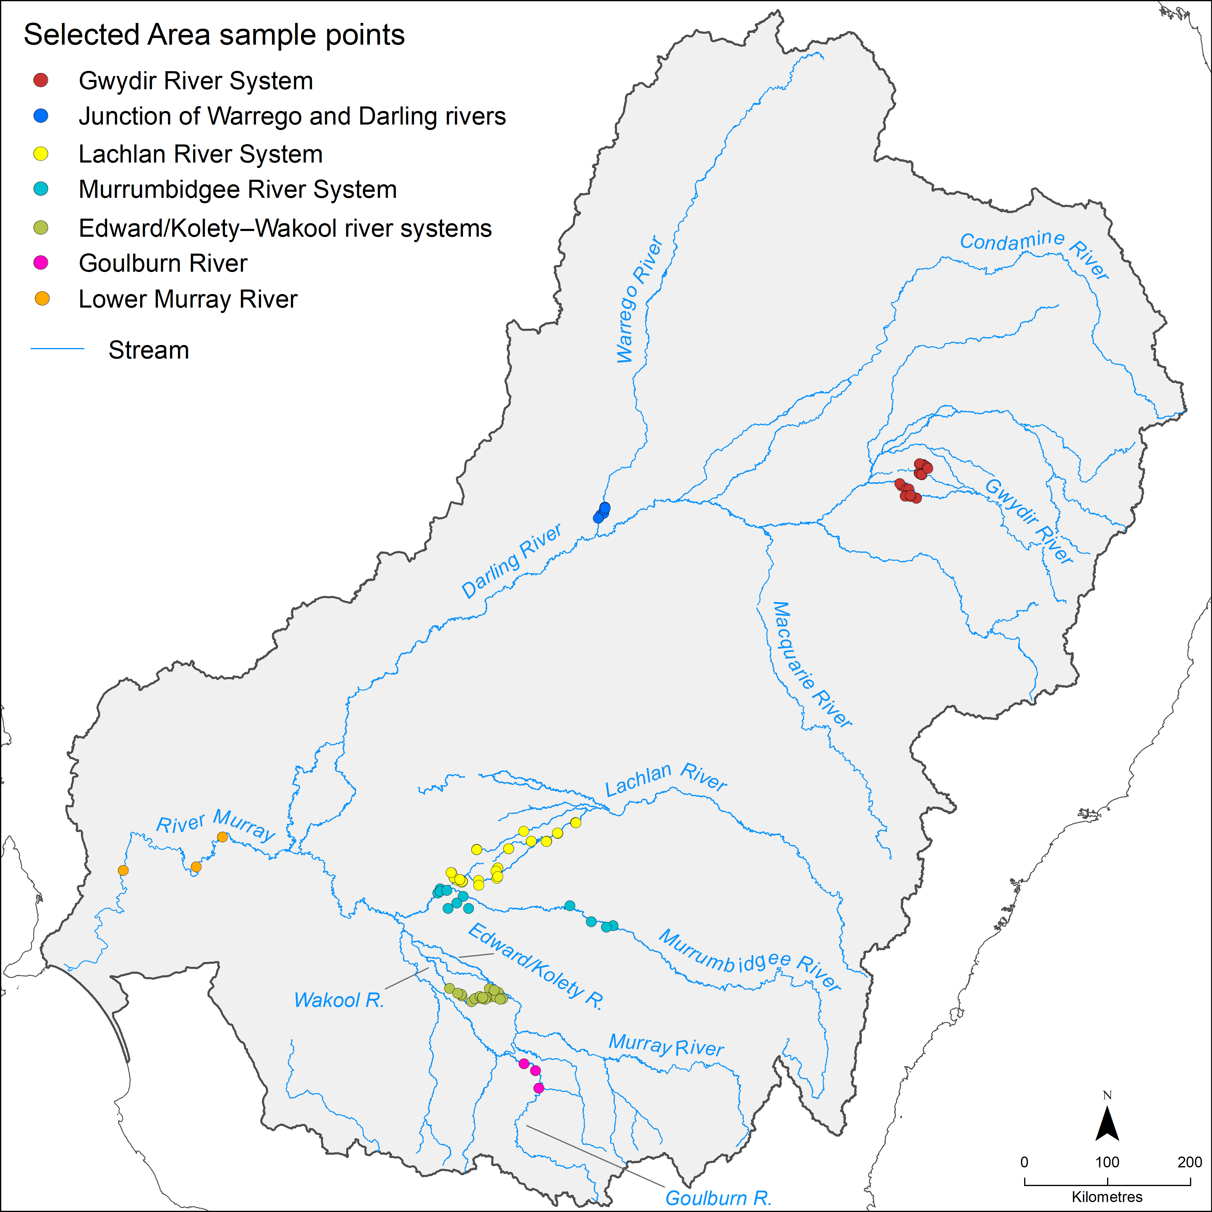

Plant names
All plant names follow the latest Australian Plant Census (APC)/Australian Plant Name Index (APNI) classification (as of February 2025), to ensure consistent species naming across the Basin.
Species data collected from each Selected Area were linked to a consistently classified species trait database, which includes a variety of different attributes based on information from BioNet, PlantNET (New South Wales), VicFlora, the electronic Flora of South Australia, Flora NT, Atlas of Living Australia and expert knowledge. These are:
- family (and subfamily, only for Fabaceae)
- functional group classifications after Brock and Casanova (1997) and Casanova (2011)
- growth form
- life-history information (perennial, annual, variable for genus- or family-level identification and non-vascular, e.g. mosses, liverworts, charophytes, algae)
- strata type (L: ground layer; M: understorey; T: canopy; Canopy: mistletoes; var: variable for genus- or family-level identification)
- nativeness
- rare or threatened status for each state and nationally.
Information on rare or threatened status is from the following sources:
- Nationally listed – Environment Protection and Biodiversity Conservation Act 1999 (EPBC Act) List of Threatened Flora
- New South Wales – New South Wales Biodiversity Conservation Act 2016, hosted by the NSW Department of Planning, Industry and Environment (and Office of Environment and Heritage) (online search for threatened species by species type – all plants)
- South Australia – South Australia’s National Parks and Wildlife Act 1972, species list taken from 2008 amendment to the Act – Amendment of Schedules 7, 8 and 9 of Act6F
- Victoria – Victorian Flora and Fauna Guarantee Act 1988, FFG Threatened List (Vascular Plants).

Analysis

Inundation groups
The inundation groups that represent different cumulative inundation regimes are the basis from which broad patterns in vegetation responses are described. They were established from the presence or absence of surface water (with or without environmental water included) at each sampling point on a quarterly basis over LTIM and Flow-MER (2014–24).
The quarters were based on a water year (commencing in July). While quarterly inundation history does account for the intra-annual variability in flooding and drying, the fact that each quarter does not align with a season, such as summer, means that the influence of seasonality as part of the hydrological analysis is not included in the analysis or interpretation of results. It is acknowledged that an analysis of seasonality in relation to flooding and drying may be more ecologically relevant, but the mismatch with water years makes this difficult. Inundation data of suitable accuracy are not available at monthly or bi-monthly timesteps to resolve this problem.
A statistical clustering approach (k-means clustering) was used to group sample points that have similar patterns of inundation, for example, a similar frequency, timing and duration of inundation events and dry phases. Using knowledge from the Selected Area teams of the extent of inundation caused by environmental watering, the same clustering approach was then used to determine the predicted inundation grouping of the same sample points in the absence of environmental water (the ‘counterfactual’ inundation regime).
The inundation groups ‘with environmental water’ were described in relation to the observed vegetation assemblages. The resulting inundation/ vegetation associations were then used to predict the vegetation assemblage that would occur ‘without environmental water’.

Vegetation association with inundation groups
The assemblage of vegetation associated with the ‘with environmental water’ inundation groups was described in relation to species and communities.

Species-level associations
Species-level associations with inundation groups described the presence, richness and cover of plant taxa11. The number of groundcover plant species recorded is large (>800 taxa) and there are regional differences in assemblages that make working with species-level data difficult to interpret at the Basin scale. To interpret patterns in the species data, species were grouped using indicator groups, which are based on functional, structural and taxonomic traits of species. The groups that are most commonly reported in the evaluation are water plant functional groups and species growth forms such as ferns, forbs, grasses, sedges and rushes, shrubs and so forth.

Water plant functional groups
Water plant functional groups are based on an adapted version of the Brock and Casanova (1997) and Casanova (2011) classifications (Table 4.1). The use of functional groups reduces the number of floristic variables across individual sample points. It enables the analysis of vegetation responses across a large number of plant species to be focused on groups of species predicted to have similar watering requirements and therefore similar responses to hydrological regimes (Campbell et al. 2014).
The amphibious fluctuation tolerator-woody (ATw) classification from Casanova (2011) has been broken into 3 groups: Woody – flow dependent (W-W), Woody – riparian/floodplain (W-RF) and Woody – other (W-O) to distinguish woody species’ responses according to flooding requirements. However, in this report, functional group responses have been assessed in relation to 5 high-level categories: submerged, amphibious, damp-loving, woody flood-dependent and terrestrial.
Where taxa are unable to be assigned to a particular functional group, they have been classified as ‘other’ and excluded from analyses. This only applies to taxa that are unable to be identified to species level (recorded to genus or family level).
Table 4.1 Plant high-level functional group (FG) classification
After Brock and Casanova (1997) and Casanova (2011) with the addition of Woody – flow dependent (W-W), Woody – riparian/floodplain (W-RF) and Woody – other (W-O) to separate woody species’ responses.
FG | Description | Long description
Submerged (S)
Se | Perennial – emergent | Woody and monocotyledonous species that require permanent water in the root zone, but remain emergent. They thrive where water levels do not fluctuate or fluctuate little (i.e. weir pools, dams)
S | Submerged | Species that require a sample point be flooded to >10 cm. Completely water dependent; their habitat is the water column. Some species may persist via a dormant, long-lived seedbank. Sr and Sk species have been combined here. See original descriptions for additional details
Amphibious (A)
Arf | Amphibious fluctuation responder – floating | Species that grow under water or float on the surface of the water or have floating leaves. They require year-round presence of free water. Many of these can survive and complete their life cycle stranded on the mud, but they reach maximum biomass growing in ‘open’ water all year round
Arp | Amphibious fluctuation responder – plastic | A species group occupying a similar habitat to the Atl group, except that they have a morphological response to water-level changes, such as rapid shoot elongation or a change in leaf type. They can persist on damp and drying ground because of their morphological flexibility and can flower even if the sample point dries out. They occupy slightly deeper/wet-for-longer sample points than the Atl group
Ate | Amphibious fluctuation tolerator – emergent | Emergent monocots and dicots that survive in saturated soil or shallow water but require most of their photosynthetic parts to remain above the water (emergent). They tolerate fluctuations in the depth of water, as well as water presence. They need water to be present for about 8–10 months of the year, and the dry time to be in the cooler times of the year (Note: not sure this part of the description is always met)
Atl | Amphibious fluctuation tolerator – low-growing | Species that germinate either on saturated soil or under water and grow totally submerged, as long as they are exposed to air by the time they start to flower and set seed. They require shallow flooding for about 3 months
Damp-loving (D)
Tda | Terrestrial – damp | Species that germinate and establish on saturated or damp ground but cannot tolerate flooding in the vegetative state. As such, they can persist throughout the environment in dry puddles and drains. They grow on bare ground following flooding or in places where floodwater has spread out over the landscape long enough to saturate the soil profile. They require the soil profile to remain damp for about 3 months
Woody flood-dependent (WF)
W-W | Woody – flow dependent | Woody perennial trees or large shrubs that require water to be present in the root zone all year round, but will germinate in shallow water or on a drying profile. If they grow on floodplains, they require flooding and restoration of the groundwater levels on a regular basis
W-RF | Woody – riparian/ floodplain | Woody perennial trees or large shrubs that are frequently associated with riparian, wetland and floodplain habitats. However, their requirements for inundation appear to be less frequent than for species in the W-W group. Their dependence on river–floodplain functions may be unknown
Terrestrial (T)
W-O | Woody – other | Woody perennial trees or large shrubs that do not require flooding and occur in a range of habitat types
Tdr | Terrestrial –dry | Species with no flooding requirement that persist in damper parts of the landscape because of localised high rainfall. Species in this group can invade or persist in riparian zones and the edges of wetlands, but are essentially terrestrial
Other
var | variable (family level) | Taxa not identified to species level and species within the genus or family that have different functional group responses
NV | Non-vascular (with the exception of Chara and Nitella) | Non-vascular taxa, with the exception of Chara and Nitella (charophytes), which have been included in the S – Submerged functional group category

Species growth forms
Species growth forms are classified based on NSW BioNet and are a structural category grouping of species of the same general habit of growth, such as ferns, forbs, grasses, sedges and rushes, shrubs and trees (Table 4.2), but not necessarily related either taxonomically (i.e. in the same family) or functionally (i.e. have the same water requirements). For example, the growth form ‘forb’ includes species that are classified as submerged, amphibious, damp-loving and terrestrial. Supporting a diversity of growth forms is an important component for maintaining compositional, structural and functional attributes of species and community diversity.
Table 4.2 Growth form classifications used in evaluation (sourced and altered from NSW BioNet)
Growth form | Description | Examples
E | Fern and fern allies | Azolla
F | Forbs – herbaceous flowering plants other than grasses, sedges and rushes | Alternanthera denticulata, Centipeda cunninghamii, Mentha australis, Potamogeton tricarinatus
G | All grasses (combined tussock, hummock and other grasses) | Hordeum leporinum, Lachnagrostis filiformis, Paspalidium jubiflorum
K | Epiphytes | Amyema quandang, Lysiana subfalcata
L | Vines | Convolvulus erubescens, Cucumis myriocarpus
NV | Non-vascular (mosses, liverworts, charophytes, algae) | Bryophyta, Chara, Nitella
S | Shrubs | Atriplex nummularia, Chenopodium nitrariaceum, Duma florulenta
S-R | Sedges and rushes | Carex appressa, Eleocharis pallens, Juncaceae, Cyperaceae
SubS | Sub-shrubs (woody, lower growing, small shrubs) | Aeschynomene indica, Atriplex semibaccata, Rhagodia spinescens
T | Trees | Acacia stenophylla, Eucalyptus camaldulensis, Melaleuca lanceolata
Var | variable (genus- or family-level identification) | Chenopodiaceae

Community-level associations
Community-level associations were described in terms of assemblages of species. For example, the richness and cover of functional groups and growth forms were investigated in 3 different habitat types (riverine, wetland and floodplain) in relation to inundation groups and ANAE types.

Computational methods
Methods for interrogation and analysis of richness, cover and dominance, as well as testing for statistically significant differences in species between inundation groups, are described below.

Richness
The combined dataset was interrogated in Microsoft Excel. Records of ‘no plants’, used to identify that a sampling unit was visited but no species were recorded, ‘unknown’, where no identification to family or lower taxonomic level is possible, and non-vascular species (except charophytes) are excluded from counts of species richness. Charophytes, such as Chara and Nitella species, are macro-algae with a structure similar to vascular plants. They are consistently recorded (or searched for) by Selected Area field teams and included in the data. Charophytes can represent a substantial component of the submerged flora in some riverine, wetland or floodplain habitats.
Analyses of richness occur at different levels of ecological organisation i.e. they involve counts of the number of taxa or families or ecosystem types – Australian National Aquatic Ecosystem (ANAE) types – within an indicator–explanatory variable combination; for example, the number of families in each habitat type within the year or across all years.

Cover
For analyses relating to species cover, the long-format data are formatted as matrix data with species as variables in columns and sample detail as rows. Data are available at the lowest level of sampling – for example, sampling units within transects or plots, within sample points, for each sampling time within each sampling year. These matrix data are imported to Primer (PRIMER-e Quest Research Limited version 7.0.21) as an abundance data file with blank cells in the body of the matrix converted to zero to represent a known absence (e.g. field surveys search for all plant species and zeros represent species searched for and not found). For assessments using cover values (including characteristic species), sample points from the Lower Murray River are excluded. The Lower Murray River records frequency of occurrence which is not directly relatable to the other measures of percentage cover.
In Primer, the factors Sample Point and Year are combined, and the cover of individual species is averaged across all sampling units and sampling times to generate an average species cover for all individual species for each sample point for each of the years of sampling. It is from this consistent level (sample point – year) that further calculations of cover are undertaken. It is assumed that the sampling strategy undertaken by Selected Areas represents the vegetation community at sample points in a given water year.

Standardised cover
Non-standardised cover values for different combinations of grouping indicators (e.g. functional groups, nativeness, growth form) and different explanatory variables (e.g. inundation grouping, habitat type) are calculated in Primer by summing the average cover of individual species at the sample point – year level for the desired combination of indicators and explanatory variables; for example, functional group cover within inundation groups, or growth form within habitat types, or nativeness within inundation groups and within habitat types. To standardise these cover values (given the different numbers of sample points in different indicator–explanatory variable combinations), the non-standardised cover values generated in Primer are exported to Excel. The number of sample points in the indicator–explanatory variable combination is identified, and the non-standardised cover is divided by the relevant sample point number. This generates a standardised cover value (between 0 and 100) for each indicator–explanatory variable combination that represents the average cover for that grouping. Graphs of standardised cover are generated in Excel.

Characteristic species and families
Characteristic species and families are calculated using SIMPER analysis in Primer. SIMPER stands for similarity percentages routine. SIMPER uses the Bray–Curtis similarities between samples to determine the contribution each taxonomic unit (e.g. species or family) makes to the intra-group similarities. The more abundant a taxonomic unit is, the more it will contribute to the intra-group similarity and can be said to typify that group. Here, SIMPER is used to determine the families typical (characteristic) in each year and each habitat type and the species that are characteristic to an inundation group.
For example, to find the characteristic families for each water year and habitat the average cover of individual species for every sample point – year is summed for family and SIMPER run on this family dataset for the explanatory variables of year and habitat. Families are included until the contribution represents at least 70% of the similarity within the group. The order and number of families listed for each year-habitat combination reflect the contribution to the group similarity. For more information about the SIMPER similarity percentages routine, see Clarke et al. (2014) and Clarke and Gorley (2015).

Tests of significant difference
Significant differences in the vegetation responses between different indicator–explanatory variable groups were determined using permutational multivariate analysis of variance (PERMANOVA) in Primer. On the relevant datasets (see below), a Bray–Curtis similarity matrix is generated with a dummy variable added (value 0.001) to account for the high number of zeros in the dataset (to negate any combinations in the Bray–Curtis similarity matrix with 2 zero values, which will result in undefined resemblances measures). The PERMANOVA main test is run on the Bray–Curtis similarity matrix using Type III (partial) sums of squares, 9,999 permutations and unrestricted permutation of raw data. Monte Carlo P-values are also generated to confirm the permutational P-value. Where the main test returns a significant difference for the tested factor(s), pairwise tests are undertaken using PERMANOVA to determine which pairs of groups within the factor(s) are significantly (statistically) different. For more information about PERMANOVA analyses, see Anderson et al. (2008).
PERMANOVA main and pairwise tests were undertaken to test for statistically significant differences between:
- functional group assemblages and inundation groups – dataset = average cover of functional groups (summed for individual species) per sample point for the time period of interest; explanatory variables = inundation group; pair-wise tests = between inundation groups
- average species richness per sample point per water year – data set = species richness per sample point per year; explanatory variables = years; pair-wise tests = between years
- average cover of species per sample point per water year – data set = average cover (summed across all species) per sample point per year; explanatory variables = years; pair-wise tests = between years.

Fish
Team: Ben Fanson, Sally Hladyz, Wayne Koster, Jarod Lyon, Zeb Tonkin, Jian Yen (Arthur Rylah Institute, DEECA, VIC); Ben Broadhurst (Centre for Applied Water Science, University of Canberra, ACT); Brenton Zampatti (CSIRO); Lee Baumgartner, Nicole McCasker, Ivor Stuart (Gulbali Institute for Agriculture, Water and Environment, Charles Sturt University, NSW); Gavin Butler, Jerom Stocks, Jason Thiem (NSW DPI Fisheries); Chris Bice, George Giatas, Qifeng Ye (South Australian Research and Development Institute, SA).
Most of the statistical analyses underpinning the evaluation is described in detail in the Supplement to the Fish evaluation report, prepared each year for the fish evaluation team. The material in the supplement is not repeated in this report. See Fanson (2024, 2025).

Evaluation objective
The overarching Flow-MER evaluation question for fish was:
What did Commonwealth environmental water contribute to sustaining native fish at the Basin scale?
The Fish theme presents an evaluation of fish outcomes from the use of Commonwealth environmental water (CEW) over the current water year and cumulatively (2014–present). The evaluation comprises:
- a summary of CEW watering actions with expected fish outcomes across all regions/assets
- a synthesis of current water year Selected Area findings from Selected Area annual reports examining trends to support Basin-scale understanding of the influence of CEW watering actions across the Selected Areas.

Approach
The cumulative Basin-scale evaluation consists of quantitative analysis of the fish monitoring data collected between 2014–present to determine the contribution of CEW to sustaining fish populations. In the evaluation:
CEW contribution is defined as any positive effect on fish responses, including the degree of confidence around that effect; and is defined separately to other contributors of environmental water and non-environmental water.
Basin scale is defined as an ecological response across the 6 Selected Areas where fish outcomes are being assessed.
The approach for the cumulative evaluation follows the strategy developed using the Foundation report (Stoffels et al. 2016) and updates (Barbour et al. 2021; Cuddy et al. 2022; King 2019; Stuart et al. 2020) and as applied in the previous annual Basin-scale evaluation reports (Hladyz et al. 2021, 2022, 2023, 2024, 2025; King et al. 2020), with refinements to better reflect objectives as summarised below.
A series of metrics used to represent (i) key aspects of the flow regime that influence fish and (ii) fish population processes – such as spawning occurrence, recruit abundance and individual body condition – were reviewed for the evaluation to identify the most ecologically sensitive and meaningful flow–ecology relationships (see Table 5.4), informed by watering plans and objectives (e.g. VEWH 2020) and similar evaluations such as the Victorian Environmental Flows Monitoring and Assessment Program (VEFMAP) and contemporary research (Koster et al. 2021; Stoffels et al. 2020; Stuart et al. 2019; Tonkin et al. 2020; Tonkin et al. 2019; Tonkin et al. 2021; VEWH 2020). These flow and fish metrics were used to measure how CEW contributed to sustaining native fish populations.
Answering the evaluation question comprehensively requires isolating the contribution of CEW from other aspects of the hydrological regime. To do this, for the cumulative evaluation, quantitative models are used in a stepped approach to determine the contribution of CEW to fish populations.
- Quantitative models were developed using the observed fish responses to flows based on the data collected from the years of monitoring in the 6 (of 7) Selected Areas. This approach uses data on local flows in the river system and environmental conditions that fish populations encounter across Selected Areas (e.g. relating fish populations to observed flow conditions – this includes flow data recorded from gauges that encompass all environmental and non-environmental water).
- Predictive models informed by the observed fish responses have been developed to separate the effects of CEW from the effects of background hydrological variability using flow scenarios with and without CEW (the ‘counterfactual’ scenario). This approach provides information on how fish population dynamics would have differed had CEW not been delivered into a river system.
Answering the key evaluation question also ultimately requires information on what CEW achieved at the wider Basin scale (i.e. spatial extent of the Basin). This means that findings from the Selected Areas must be extrapolated to predict fish responses in unmonitored areas and to hypothesised flow scenarios (King 2019; King et al. 2020), both of which have presented a challenge over the duration of the Long Term Intervention Monitoring Project (LTIM) and Flow-MER.
While predictive Basin-scale fish population models are needed in the future, developing these for the current evaluation has not been possible in the early stages of the program for several reasons related to both technical and conceptual limitations. These include the small number of replicate flow years, non-random selection of the location of the Selected Areas, limited flow variability among years and Selected Areas for the duration of LTIM and Flow-MER, limited coverage of the northern Basin (represented by only the Gwydir River System), other confounding modifiers of population dynamics (e.g. fish stocking and recreational fishing) and low abundances of many native fish species. These limitations make it difficult to estimate responses to CEW under higher flows (e.g. large fresh events and overbank flows) (King 2019; King et al. 2020), resulting in high uncertainty in any extrapolations beyond the Selected Areas.
Nevertheless, the use of predictive models can speed up the learning process as monitoring data can take many years to collect and evaluate, whereas predictive modelling can be essentially a desktop-based activity with lower cost and time investment (Moxham et al. 2020). Predictive models can also be validated as new monitoring data are collected to improve the model predictions. As data continue to increase in the program, preliminary Basin-scale predictive models are being developed.
This Basin-scale evaluation aims to:
- determine the influence of flow on measures (spawning occurrence, recruitment, population growth rate, fish condition) that inform whether fish populations and community diversity are being sustained in 6 Selected Areas
- determine the contribution of CEW to the observed fish responses and answer the following questions. Did CEW contribute to:
  - increased likelihood of spawning?
  - increased recruitment?
  - expanded distributions within Selected Areas?
  - increased population growth rates?
  - increased individual body condition?
  - increased proportion of catch that was native (community response)?
- predict the potential contribution of CEW to Murray cod and Murray–Darling rainbowfish recruitment to demonstrate how the contribution of CEW could be predicted at unmonitored gauges across the Basin.
In 2022 –23, the evaluation renewed its focus on high-level predictive models to investigate fish responses at the wider Basin scale, focusing on how the contribution of CEW could be predicted at unmonitored gauges across the Basin, to provide new insights into Murray cod and Murray-Darling rainbowfish recruitment.
Comprehensive details on analyses are provided in the annual technical supplement prepared by Ben Fanson, the most recent being Fanson (2025).

Counterfactual modelling approach
We use a counterfactual modelling approach to determine the contribution of CEW to fish populations for the Basin-scale evaluation. The steps are outlined in Figure 5.1.
- Fish responses are measured in a river system (e.g. fish abundance)
- Flows are measured in a river system (observed flows)
- Using this information, we are able to look at the relationship between flows and fish responses (observed flows)
- We then combine this relationship with a modelled flow scenario without CEW (counterfactual scenario)
- This allows the prediction of fish response without CEW and the difference between the 2 scenarios (observed flows and counterfactual) allows us to estimate the effect of CEW on fish responses.
Figure 5.1 Schematic of the steps in the fish evaluation approach
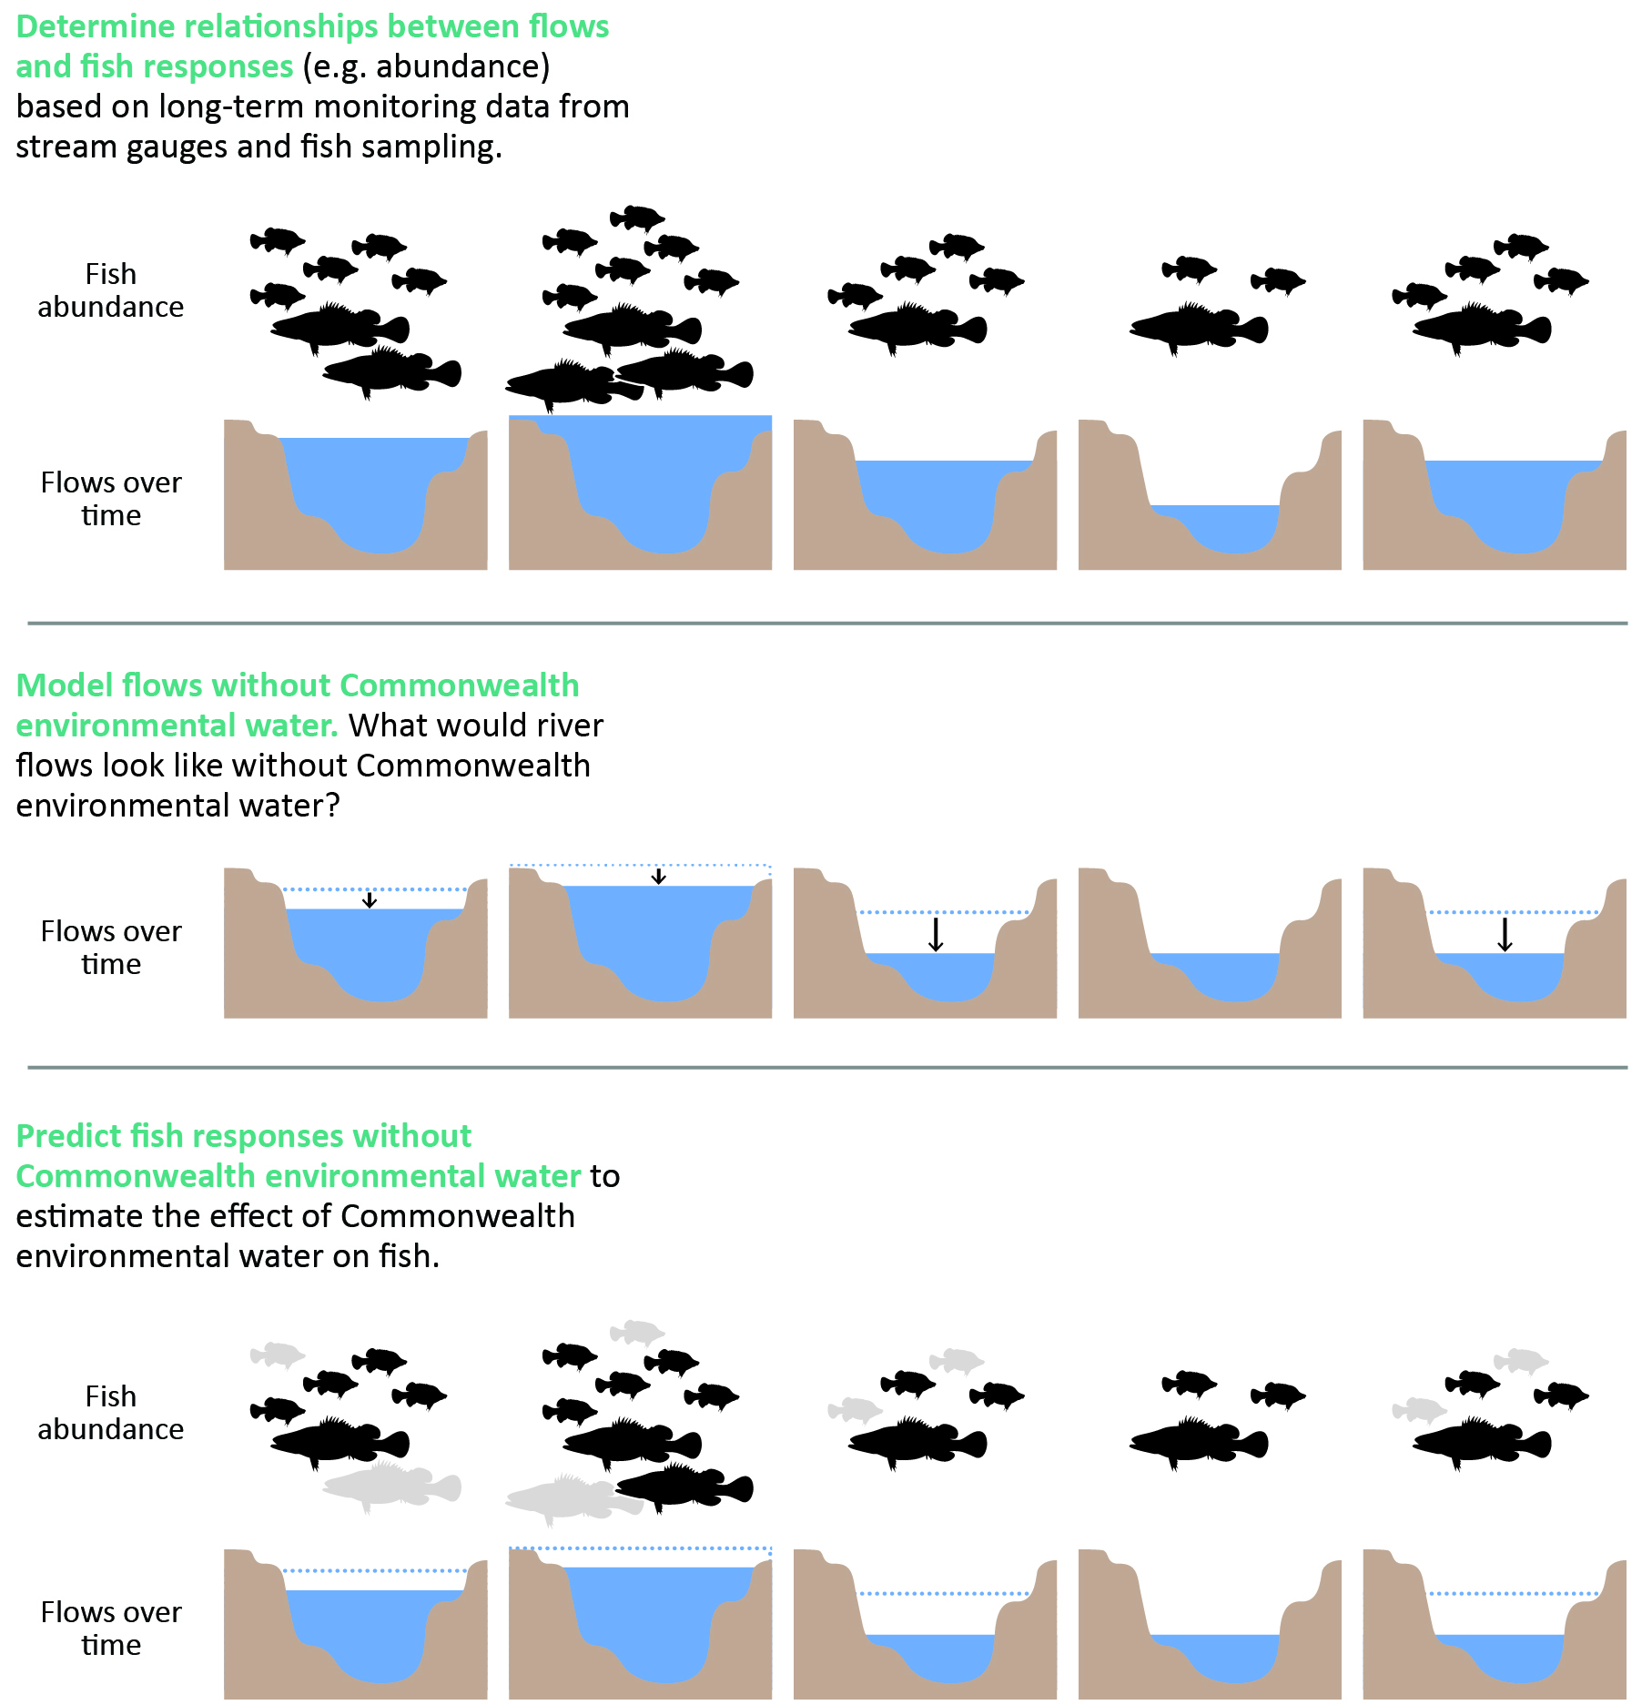
Observed and counterfactual flow data are useful in environmental flows research and ecosystem management, where observed comparisons with and without an intervention are not always possible (King et al. 2020; Stewardson and Skinner 2018). The use of counterfactual scenarios in impact evaluations can be used to assess the effectiveness of interventions in ecosystem management (Pearl 2000). They can be considered as a reference scenario that describes the possible alternative pathway in an ecosystem that occurs without the intervention implemented (Bull et al. 2021). Caution must be applied when interpreting predicted responses to counterfactual flow because these predictions are susceptible to uncertainty in the counterfactual flow data and (in some cases) errors due to extrapolation of fitted models beyond the range of the observed flow data. In addition, it can be difficult to link counterfactual flow sequences to other flow-dependent processes, such as hypoxic blackwater events, due to the complexity of causal and contextual factors.

LTIM and Flow-MER fish monitoring methods
The method used to monitor fish at Basin and Selected Area scales is described in detail in Hale et al. (2014) and is briefly described here. There are 3 categories of methodology used in the monitoring program:
- Category 1 methods are standardised methods implemented across all 6 Selected Areas with an annual fish condition monitoring focus. Data generated from Category 1 methods are used for Basin-scale analyses of fish population trends and responses to flow management. These include boat and backpack electrofishing and use of fine-mesh fyke nets to survey adult fish communities.
- Category 2 methods are standardised methods implemented across a subset of the Selected Areas and used as part of Selected Area–scale evaluation of flow impacts. These include methods to study fish movement with the use of hydroacoustic tags to detect movements of target species.
- Category 3 methods are not standardised across Selected Areas but are specific methods used within Selected Areas to inform Selected Area–scale evaluation questions. Examples include a fish spawning study within the Edward/Kolety–Wakool river systems, which uses drift nets and light traps, and the collection of fish otoliths to determine movement history of target fish species in the Lower Murray River, Edward/Kolety–Wakool river systems and Goulburn River. In some instances, Category 3 methods are similar to Category 1 methods and can be used for Basin-scale analyses (e.g. larval sampling monitoring).
Adult fish populations are monitored annually in autumn at fixed sites within the 6 Selected Areas using Category 1 methods. Large-bodied fish species are sampled using boat or backpack electrofishing whereas small-bodied fish species are sampled using fine mesh fyke nets (Table 5.1). Electrofishing efficiencies are not standardised among sites; however, the analyses assume equal detectability in all surveys, noting that this assumption may limit the findings (Davies et al. 2010). Data recorded for all captured fish species includes length and weight measurements, abundance and diversity. Fish are released back into the water after measurement.
Spawning is monitored during the key spawning period (spring–summer) for most species in 5 Selected Areas (Edward/Kolety–Wakool river systems, Goulburn River, Lachlan River System, Murrumbidgee River System and Lower Murray River). Spawning, as measured by the presence of fish larvae and eggs, is not explicitly monitored in the Lower Murray, though larval fish sampling was conducted as a component of a Category 3 golden perch recruitment project and larval data from all species was collected from 2014–15 and 2018–19. Spawning is measured by collecting eggs and fish larvae using drift nets, towed nets in the Lower Murray River and light traps. Sampling approaches differ in intensity and methods across the Selected Areas, therefore different sampling methodologies were combined to analyse fish spawning and different methods were deemed equivalent for analyses (Category 1 and 3 methods).
Fish movement and fish occurrence (Category 2 and 3 methods) are also monitored on floodplain habitats in some Selected Areas. These data can be found within relevant annual Selected Area reports and are excluded in the Basin-scale analysis of fish response.
Table 5.1 Fish species targeted in Flow-MER adult fish population surveys using Category 1 methods across all Selected Areas, 2014–present
Asterisks (*) denote focal fish species as identified by Flow-MER. Daggers (†) denote key freshwater species as identified by the Basin-wide environmental watering strategy, excluding estuarine species (MDBA 2019). ^ denotes detected in Junction of Warrego and Darling rivers using Category 3 methods. Dashes indicate fish species not collected in Flow-MER surveys.
Common name | Species name | Native/exotic | Body size | Detected in Flow-MER | Collection method
Australian smelt* | Retropinna semoni | native | small | Y | fyke net
Bony herring* | Nematalosa erebi | native | large | Y | electrofishing
Carp gudgeon* | Hypseleotris spp. | native | small | Y | fyke net
Common carp* | Cyprinus carpio | exotic | large | Y | electrofishing
Dwarf flathead gudgeon | Philypnodon macrostomus | native | small | Y | fyke net
Eastern gambusia* | Gambusia holbrooki | exotic | small | Y | fyke net
Flathead galaxias† | Galaxias rostratus | native | small | N | –
Flathead gudgeon | Philypnodon grandiceps | native | small | Y | fyke net
Freshwater catfish† | Tandanus tandanus | native | large | Y | electrofishing
Golden perch*† | Macquaria ambigua | native | large | Y | electrofishing
Goldfish | Carassius auratus | exotic | large | Y | electrofishing
Hyrtl’s tandan†^ | Neosilurus hyrtlii | native | large | N | –
Macquarie perch† | Macquaria australasica | native | large | N | –
Murray cod*† | Maccullochella peelii | native | large | Y | electrofishing
Murray hardyhead† | Craterocephalus fluviatilis | native | small | N | –
Murray–Darling rainbowfish* | Melanotaenia fluviatilis | native | small | Y | fyke net
Northern river blackfish† | Gadopsis marmoratus | native | large | N | –
Obscure galaxias | Galaxias oliros | native | small | Y | fyke net
Olive perchlet†^ | Ambassis agassizii | native | small | N | –
Oriental weatherloach | Misgurnus anguillicaudatus | exotic | large | Y | electrofishing
Redfin perch | Perca fluviatilis | exotic | large | Y | electrofishing
Rendahl’s tandan† | Porochilus rendahli | native | small | N | –
River blackfish† | Gadopsis marmoratus | native | large | Y | electrofishing
Silver perch† | Bidyanus bidyanus | native | large | Y | electrofishing
Southern purple-spotted gudgeon† | Mogurnda adspersa | native | small | N | –
Southern pygmy perch† | Nannoperca australis | native | small | N | –
Spangled perch | Leiopotherapon unicolor | native | large | Y | electrofishing
Trout cod† | Maccullochella macquariensis | native | large | Y | electrofishing
Two-spined blackfish† | Gadopsis bispinosus | native | small | N | –
Unspecked hardyhead | Craterocephalus stercusmuscarum fulvus | native | small | Y | fyke net
Yarra pygmy perch† | Nannoperca obscura | native | small | N | –

Data and metrics

Fish data collation
Fish data is entered by Selected Area teams into the Monitoring Data Management System (MDMS). Data is checked by the MDMS database managers for quality assurance and quality control, then sent to Selected Area teams for final approval. A final review is then undertaken to check for any errors or inconsistencies in the data before analysis. For details on MDMS data used in the evaluation analyses, see Table 5.2.
Table 5.2 Summary of data from the Monitoring Data Management System (MDMS) used for evaluation analyses
Response variable | Species | Data used | Field collection methods | Standardised
Spawning occurrence (presence of larval fish and eggs) | Golden perch  Silver perch | Category 1 + Category 3 | Bongo tow nets used in the Lower Murray for large-bodied species. Drift nets used in the other Selected Areas for large-bodied species | Binary data
Recruit abundance (length threshold) | Australian smelt  Carp gudgeon  Common carp  Eastern gambusia  Murray cod  Murray–Darling rainbowfish | Category 1 + Category 3 for Lower Murray and Gwydir | Boat and backpack electrofishing, fine-mesh fyke nets | Raw counts of recruits
Fish age (otolith data) | Golden perch | Category 1 + Category 3 for Lower Murray | Boat and backpack electrofishing, fine-mesh fyke nets | Raw age of fish
Adult distribution | Australian smelt  Bony herring  Carp gudgeon  Eastern gambusia  Golden perch  Murray cod  Murray–Darling rainbowfish | Category 1 + Category 3 for Lower Murray and Gwydir | Boat and backpack electrofishing, fine-mesh fyke nets | Proportion of sites within each Selected Area at which a species is detected
Adult abundance (catch per unit effort; CPUE) | Bony herring  Common carp  Golden perch  Murray cod | Category 1 | Boat and backpack electrofishing for large-bodied species, fine-mesh fyke nets for small-bodied species | Catch-per-unit-effort
Fulton’s K condition factor (length and weight data) | Bony herring  Common carp  Golden perch  Murray cod | Category 1 + Category 3 for Lower Murray and Gwydir | Boat and backpack electrofishing, fine-mesh fyke nets | Fulton’s K condition factor
Proportion of catch belonging to a native species (community metric) | All recorded species | Category 1 + Category 3 for Lower Murray and Gwydir | Boat and backpack electrofishing, fine-mesh fyke nets | Proportion of catch belonging to a native species

Fish metrics description
Six fish metrics (conceptually linked to flows) are used to assess key life-history processes and/or demographics of key species and communities; namely, spawning occurrence, recruit abundance (using either length thresholds or fish age otolith data), adult distribution, adult catch per unit effort (CPUE) (population growth rate), body condition and proportion of catch belonging to native species (community metric).
Two methods are used to relate young-of-year recruitment to flow:
- length thresholds to identify young-of-year recruits and estimate the effects of CEW on the abundance of these recruits. This method is applied to Murray cod, common carp, Australian smelt, carp gudgeon, eastern gambusia and Murray–Darling rainbowfish
- age information from otoliths to estimate year-class strength (a more accurate estimate of young-of-year recruitment) and relate this estimate to underlying flow conditions. This method was applied to golden perch in the Lower Murray River (other species and other Selected Areas were not analysed due to data constraints).
It is important to note that Murray cod and golden perch recruitment in Selected Areas can be from one or a combination of in-situ spawning success, movement into the Selected Area and survival of stocked fish.
Condition metrics are also used to relate adult individual body condition to flow. Condition metrics are based on the assumption that heavier fish relative to a fixed length are in better condition or health (Jones et al. 1999). Fulton’s K, a commonly used metric, is used to compare fish populations (Nash et al. 2006).
Distribution of focal species within Selected Areas was also introduced in the 2022–23 evaluation. This metric examines the proportion of sites where species are detected within Selected Areas. It was hypothesised that higher flows enhance dispersal/distribution. This metric provides a proxy measure for distribution/dispersal and abundance for rare species.

Hydrological data and other data used
Observed hydrological data are collated from gauged sites across the Basin (Table 5.3). Modelled flow data without CEW (referred to as counterfactual flow) were prepared as described in Section 7.7 and Sengupta et al. (2025). For this evaluation, CEW is defined separately to other contributors of environmental water and non-environmental water.
Table 5.3 Streamflow gauges for each Selected Area
Gauge names in bold are gauges currently used in all fish analyses. Note that Junction of Warrego and Darling rivers is not included in the evaluation.
Selected Area | Gauge name | Gauge number
Edward/Kolety–Wakool river systems | Barham-Moulamien | 409045
Edward/Kolety–Wakool river systems | Wakool Offtake | 409019
Edward/Kolety–Wakool river systems | Yallakool Offtake | 409020
Goulburn River | McCoys Bridge | 405232
Gwydir River System | Boolooroo | 418036
Gwydir River System | Gingham Diversion | 418065
Gwydir River System | Tyreel | 418063
Lachlan River System | Willandra | 412038
Lachlan River System | Hillston | 412039
Lower Murray River | Lock 1 | 4260903
Lower Murray River | Lock 3 | 4260517
Murrumbidgee River System | Carrathool | 410078
Murrumbidgee River System | Darlington | 410021
Flow metrics were selected to encompass key aspects of the flow regime that influence fish population processes (Table 5.4, Table 5.5); see hypotheses in Table 5.4 and Table 5.5). These metrics consider the average (standardised daily flow) and maximum daily flow (standardised maximum antecedent flows), the duration of low flow events, and the magnitude of variability in daily flow (and the timing of each). Average and maximum flow metrics are standardised (values divided by median daily flow across the whole data period at a gauge) to be comparable among Selected Areas. This approach has been used in other multisystem evaluations of fish responses to provide greater insights (Tonkin et al. 2021; Yen et al. 2021). Flow metrics are calculated for observed and counterfactual flow scenarios and calculated on biologically relevant time scales for each response variable. For example (Table 5.4):
- annual flow metrics from the current water year were tested as a predictor of annual variations in adult fish numbers
- flow metrics from the key period for fingerling survival (based on length thresholds) (September to March) were tested as predictors of recruitment
- flow metrics from the key period for spawning and egg and larval survival (September to November) were tested as predictors of spawning occurrence (defined as the presence of larval fish and eggs).
Event-based flow metrics (Table 5.5) were tested as predictors of spawning occurrence because spawning and early larval survival can be highly sensitive to short-term variability in flow (Koster et al. 2018).
While the primary aim is to evaluate responses to CEW delivery, fish populations are also governed by a range of other factors. Two other variables are included as they are likely to be the most important:
- adult population abundance in the year prior to sampling as a predictor for analyses of spawning because adult abundance is linked to the spawning potential of a population (Table 5.4)
- time since the most recent fish death event in each river system as a predictor of adult abundance to account for potentially slow population recovery following a fish death or hypoxia event (Table 5.4).
Populations of some species can be heavily impacted by hypoxic events, with widespread fish deaths in some cases (Baldwin and Whitworth 2009; King et al. 2012; Thiem et al. 2017) or migration by fish out of an area (Tonkin et al. 2022). Hypoxic events and fish deaths were compiled from state jurisdictional and/or other fish death databases and Selected Area reports, with input from Selected Area team leads where required.
Table 5.4 Description of annual flow metrics and other descriptive metrics used in analyses
Timing refers to specific periods within which metrics are calculated and are specific to each response variable.
Hypothesis | Metric | Description and calculation | Timing
Increased flow boosts productivity, leading to improved condition and survival outcomes for fish, and may support fish movements and reproduction by improving connectivity and providing critical movement and spawning cues.  Increased flow may improve water quality in refuge pools during low flow periods. If timed inappropriately or too frequently, large increases in flow may reduce egg and larval survival of some species due to sudden changes in hydraulics, depth or water temperature. | Standardised daily flow for relevant timing | Average daily flow for a relevant timing period divided by the median daily flow over the entire sampling period  Referred to as flow_median in the analysis | Adult abundance: water years: September to August  Recruitment: September to March  Larval data: September to December  Others: default to water year
Consistent base flows support survival and condition of fish and support fish movements by increasing connectivity among reaches and rivers. Low flows (below base flows) reduce habitat and food resources, which may increase mortality of all life stages, particularly larvae and fingerlings. | Number of days of low flow | Number of days with flows below 10th percentile over the entire sampling period  Referred to as flow_low in the analysis | Water years
Large flows in previous years stimulate productivity, improving food availability and fish condition, which can have positive effects on reproduction in later years.  Very large flows may provide lateral connectivity, which increases productivity and connectivity to wetlands and floodplains that provide refuges and feeding opportunities. | Standardised maximum antecedent flow | Maximum daily flow divided by the median daily flow over the entire sampling period  Referred to as flow_max_prev in the analysis | Water years
Rapid changes in flow during core spawning periods increase mortality of eggs and larvae but enhance productivity and improve condition and growth of older cohorts. | Coefficient of variability in daily flow for relevant timing | Coefficient of variability in daily flow in a given time period  Referred to as flow_cv in the analysis | Adult abundance: water years  Recruitment: September to March  Larval data: September to November  Others: default to water year
Flow at the time of sampling influences detectability of fishes in electrofishing surveys. | Flow on day of sampling | Daily flow on the day of sampling  Referred to as flow_daily in the analysis | Daily
High flow events trigger recruitment events but also lead to flooding conditions that may lead to improved productivity but also hypoxic events. | Peak standardised flow (95th percentile) | The 95th percentile of standardised flow. Referred to as flow_peak in the analysis. Note: only used with catch curve analysis as often tightly correlated with flow_median | Water years
More recent fish death events negatively impact fish population recovery through losses of reproductive adults and reductions in body condition. | Time since most recent fish death event (substantial fish deaths) | Number of years since most recent fish death event in that system  Referred to as do_last_year in the analysis | Water years
Larger adult population size benefits native fish recovery through increased numbers of potentially spawning fish. | Adult population abundance in previous year | Abundance of adult population in year prior to sampling  Referred to as ad_cpue in the analysis | Water years
Table 5.5 Description of event-based flow metrics and other descriptive metrics for use in larval analyses
Hypothesis | Metric | Metric captures | Description and calculation
Short-term increases in flow and subsequent changes in hydraulics (velocity or depth) may provide spawning cues to some fish species, potentially signalling increased productivity and improved spawning conditions. | Change in daily flow in 7 days prior to capture | Change in daily flow | Maximum minus minimum flow in the week (7 days) prior to capture, divided by median daily flow in the water year. Referred to as flow_e_chg in the analysis.
Sustained increases in flow may provide spawning cues and increase the availability of spawning and larval habitat. | Number of days of increasing flow in 7 days prior to capture | High flow duration | Number of days in which daily flow increased relative to the previous day in the week (7 days) prior to capture. Referred to as flow_e_increase in the analysis.
Higher flow during spawning period can trigger spawning and may improve fish condition and increase the availability of spawning and larval habitat. | Median standardised flow in the last 30 days | Proportional flow magnitude | Average daily flow in 30 days prior to capture divided by median flow over the spawning period (September–November) in the water year. Referred to as flow_e_30day in the analysis
Temperature provides an important spawning cue in some fish species, linked to one or a combination of increasing temperature and day length. | Daily water temperature |  | Water temperature on day of capture.
Daylight provides an important spawning cue in some fish species, linked to one or a combination of increasing temperature and day length. | Day of year |  | Day of year of capture. Referred to as wday in the analysis.

Basin-scale annual analysis
Data visualisations are used to summarise CEW watering actions for expected fish outcomes across all regions/assets both in terms of the number of watering actions and volume of water allocated. Data visualisations are performed in R 4.0.2 (R Core Team 2020).
The annual evaluation is both qualitative with interpretations of the authors’ readings of key findings from the Selected Area annual reports, and quantitative analyses of the relevant annual data.

Basin-scale cumulative analyses
Three analyses are undertaken and described in Fanson (2025). These are summarised here.
The spawning rate analysis is the most straightforward analysis though complicated by the episodic nature of spawning (and difficulty in sampling). The count data were highly variable (lots of zeros with wide range of catches) and the flow metrics could not quite fully account for that variation, resulting in poor fit with negative binomial (as well as zero-inflated negative binomial models or ZINB). Adopting a binary approach allowed for a defensible model/representation.
The next level up analysis is the recruitment analysis. This analysis combines spawning analysis, adult population level, and first year survival (and potentially a bit of body condition). In the recruitment analysis, the analysis controls for adult population size by including previous year CPUE (catch-per-unit-effort) as a predictor. A complication here is that for e.g. common carp, juveniles add uncertainty in estimating the true number of females, weakening the relationship.
Adult abundance analysis includes basically all the processes, just with varying time lags depending on age classes included in the survey sample. For instance, total catch included young-of-year for common carp, whereas golden perch did not have young-of-year. An obvious result here is that teasing out flow effects on certain processes becomes more difficult. Negative effects on adult survival may be offset by juvenile-to-adult recruits. Sampling artifacts such as varying detection levels with younger age class also complicate the picture.
Statistical analyses and confidence categories used in those analyses are summarised in Table 5.6 and Table 5.7 respectively. These are fully described in Fanson (2025) along with detailed descriptions of hydrological analyses, the structure of the analytical models, and presentation of results.
Table 5.6 Evaluation objectives and how they are addressed (response variable, species and model description)
Objective | Response variable | Species | Model description
Determine influence of flow across all Selected Areas on spawning success of native, flow-cued species | Spawning occurrence | Golden perch  Silver perch | Binomial linear model with logit link
Determine influence of flow across all Selected Areas on recruitment strength of abundant species | Recruit abundance (length threshold or fish age (otolith data) used to generate year-class abundance) | Australian smelt  Bony herring  Carp gudgeon  Common carp  Eastern gambusia  Golden perch  Murray cod  Murray–Darling rainbowfish | Negative binomial linear model with log link  Catch curve regression; negative binomial linear model with log link
Determine influence of flow within Selected Areas on distribution of abundant species | Adult distribution (proportion of sites where species are detected within Selected Areas) | Australian smelt  Bony herring  Carp gudgeon  Eastern gambusia  Golden perch  Murray cod  Murray–Darling rainbowfish | Binomial linear model with logit link
Determine influence of flow across all Selected Areas on population composition (structure and condition) of abundant species | Adult abundance (catch per unit effort) (population growth rate) | Bony herring  Common carp  Golden perch  Murray cod | Autoregressive Gaussian linear model with log link
Determine influence of flow across all Selected Areas on population composition (structure and condition) of abundant species | Fulton’s K condition factor (length and weight data) | Bony herring  Common carp  Golden perch  Murray cod | Linear mixed model with identity link (non-Bayesian)
Determine influence of flow across all Selected Areas on community responses | Proportion of catch belonging to a native species (community metric) | All recorded species | Gaussian linear model with identity link
Table 5.7 Confidence categories for statistical analyses
Confidence is the posterior probability that the value of a fish response is increased by the delivery of CEW.
Value | Category | Description
0.00–0.05 | strong negative | >95% probability that response was lower with CEW than under a counterfactual scenario without CEW
>0.05–0.10 | moderate negative | >90–95% probability that response was lower with CEW than under a counterfactual scenario without CEW
>0.10–0.20 | weak negative | >80–90% probability that response was lower with CEW than under a counterfactual scenario without CEW
>0.20–0.80 | no association | <80% probability that response was lower or higher with CEW than under a counterfactual scenario without CEW
>0.80–0.90 | weak positive | >80–90% probability that response was higher with CEW than under a counterfactual scenario without CEW
>0.90–0.95 | moderate positive | >90–95% probability that response was higher with CEW than under a counterfactual scenario without CEW
>0.95–1.00 | strong positive | >95% probability that response was higher with CEW than under a counterfactual scenario without CEW

Food Webs and Water Quality
Team: Paul McInerney, Simon Linke, Darren Giling (CSIRO), James Hitchcock (University of Canberra, now University of Technology Sydney)
Environmental flows have a direct influence on food webs and water quality, since changes to hydrology have an impact on aquatic metabolism (the production and respiration of organic carbon) and food web fluxes via a number of mechanisms. These include affecting the productivity and distribution of different types of resources that form the basis of food webs (e.g. aquatic plants, algae and phytoplankton). Increased flows can wet substrates that allow algal, fungal and bacterial growth, and cause resuspension of organic matter from upstream, in-channel benches or from the floodplain. Flow can also ‘wash out’ phytoplankton and concentrate resources into microhabitats such as backwater eddies. There are likely to be spaces in the landscape that are disproportionally important in space and time for primary and/or secondary production of resources (due to their location and productivity being influenced by flow and hydraulics).
In the Murray–Darling Basin, the role of flow in disturbance dynamics and as a trigger of life-history events (such as breeding or dispersal) is well documented (e.g. Greet et al. 2011; Humphries et al. 1999). Over several decades, it is understood that persistent low flows can reduce biomass and change the composition of ecological communities, which contributes to biodiversity loss (Mac Nally et al. 2011; Thomson et al. 2012; Wedderburn et al. 2012). Flooding in the years following the Millennium Drought (2000–10) has improved the understanding of the role of high flow disturbance, which can influence biota in multiple ways (Mac Nally et al. 2014). Similarly, work on a range of taxa – including native fish, floodplain vegetation, woodland birds, small mammals and amphibians – has shown that flow events are important triggers for life-history events that include flowering, seed set and breeding (Capon 2003; King et al. 2009; Kingsford and Auld 2005).
Much less clear is the role of flow in generating and maintaining the resources required to both initiate and complete key life-history events that result in the successful recruitment of plants and animals into breeding populations (Shenton et al. 2012). For example, there are several documented cases of bird breeding events triggered by flow events where birds have either aggregated and then not nested, or nested and failed to raise chicks to independence. Once breeding has been initiated, metabolism and energetics are the key currency in determining success, along with the condition of the animals at the time of breeding, the size of the eggs and offspring, and availability of resources for completion of all the life stages. Similarly, even where fish breeding is initiated by a flow event, there has been limited evidence that the resulting fish larvae have access to the energy resources needed to allow them to grow through first feeding to sexual maturity and therefore recruit into the population.
Section 8.05 of the Basin Plan sets out particular objectives relating to the protection and restoration of the ecosystem functions of water-dependent ecosystems (p 53 of the Basin Plan). The Strategy (MDBA 2019) is an evolving instrument that sits under the Basin Plan. It identifies ‘Ecosystem functions’ (p 91 in MDBA 2019) for likely inclusion as a new theme with defined targets in the next Strategy. The current Strategy recognises that healthy populations of native fish, vegetation and waterbirds are reliant on a range of ecosystem functions being maintained and restored. The importance of ‘improved ecological processes’ based on productive and diverse food webs is also clearly articulated, as well as ecological communities supported by increased movement of carbon, nutrients and salt. Achieving productivity and water quality objectives will support Basin Plan objectives by improving the life-cycle completion of key plants and animals and meeting the needs of the fish and waterbird communities. Water quality and stream metabolism are both responsive to flow management. They interact to regulate rates of energy production that underpin many ecological processes and form the basis of riverine food webs. Therefore, key Strategy targets of successful fish and waterbird recruitment can only be achieved if all water moving through Basin catchments, including environmental flows, delivers sufficient energy that is both available to, and accessible by, aquatic biota.
The Food Webs and Water Quality Basin Theme focuses on these fundamental ecosystem processes, linking environmental watering actions across the 7 Selected Areas to energy production, to understand the potential food web responses to CEW at the Basin scale. These responses regulate the trophic carrying capacity (e.g. number of fish and waterbirds) of river and wetland systems across the Basin.
Stream metabolism represents a measure of organic matter production and respiration that underpins many ecological processes addressed by the Strategy. Water quality is one of the principal objectives of the Basin Plan as it is known to respond to changes in flow, and it can be a significant influence on the outcome of a watering action for biota (e.g. fish and waterbirds). There are instances where the objective of a watering action is the amelioration of reduced water quality (e.g. DO, salinity, algal blooms) to prevent disturbance to an ecosystem.
The Flow-MER Basin Matter – Stream Metabolism and Water Quality foundation report (p 5 in Grace 2019) describes the theme’s intention to develop qualitative and quantitative statistical models of stream metabolism that will:
- estimate the rate of stream metabolism (as carbon production) in the absence of environmental watering at the reach scale for reaches that are monitored
- predict both environmental flow and non-flow rates of stream metabolism (as carbon production) at the reach scale for reaches that are not monitored
- support estimation of Basin-scale changes to stream metabolism in response to environmental watering.
Model development described below refines existing qualitative conceptual models and proposes a statistical model to assess metabolic responses to flow.
In recent years, significant steps have been made towards an improved understanding of stream metabolism at large scales (e.g. Bernhardt et al. 2022; Rüegg et al. 2021) and how it can be used to interpret river function, particularly the need for detailed design and frequency of data collection. Time series exploration represents an ideal approach, but there is a clear requirement for high-frequency data to satisfy statistical approaches and modelling needs. Over small geographical scales, the data required for complete time series are relatively easy to collect; however, significant logistical and technical challenges remain for adequate data collection at large spatial scales (e.g. logger deployment, collection, maintenance and downloading year round). The Food Webs and Water Quality theme explores the effect of flow on metabolism at all Selected Area sites. Due to the relatively small contribution of CEW to total flow volumes, the lack of complete annual metabolic time series and the increased statistical power gained from interrogating larger datasets, this theme has focused on exploring metabolic responses to the full 2014–23 hydrological dataset. It is not expected that metabolic responses to flow are sensitive to the purpose of the flow (e.g. environment, irrigation supply), but evidence is emerging that changes in flow have the potential to alter instream metabolism through delivery of limiting nutrients (Pathak et al. 2022) and increased localised production through increased wetted area (Koenig et al. 2019), thus altering GPP and ER. Water temperature is a key aspect in driving stream metabolism and timing of flow delivery (e.g. summer versus winter) will have a major role in determining overall metabolic outcomes.

Evaluation objectives
The Food Webs and Water Quality theme investigates how environmental water impacts water quality and stream metabolism in the Basin. The Basin Plan seeks to protect and restore biodiversity in the Basin’s aquatic ecosystems. Energy flow in food webs is one of several critical ecosystem functions that are central to sustaining biodiversity, along with hydrological connectivity and nutrient cycling. Improved understanding of the influence of flow on the production and breakdown of organic matter in food webs will complement the understanding of the influence of flow on habitat and connectivity. In combination, this knowledge will enable better management of environmental flows within the Basin. The evaluation is structured around answering 4 Basin-scale questions:
What did CEW contribute to patterns and rates of ecosystem respiration?
What did Commonwealth environmental water contribute to patterns and rates of primary productivity?
What did Commonwealth environmental water contribute to dissolved oxygen levels?
What did Commonwealth environmental water contribute to salinity regimes?

Overview of approach
[Text sourced from Overview chapter in McInerney et al. (2025).]
Stream metabolism comprises 2 key ecological processes, GPP and ER, which generate and recycle organic matter, respectively. Stream metabolism measurements estimate the instream rates of GPP and ER by measuring changes in DO. Net ecosystem production (NEP) – the difference between GPP and ER – determines whether carbon accumulates or is depleted within an ecosystem (Bernhardt et al. 2018). Volumetric GPP and ER rates represent the amount of carbon being fixed or respired per litre of water, respectively, which is important for understanding food web processes and assessing potential water quality risks, such as algal blooms or hypoxia. Since GPP represents the fixing of carbon into organic matter and ER is the breakdown of this matter and remineralisation of the carbon, high rates of both GPP and ER (i.e. with a GPP:ER close to 1) indicate rapid cycling or ‘throughput’ of carbon by aquatic organisms. In contrast, low but balanced GPP and ER indicates slow cycling and low throughput. Due to the relatively small contribution of Commonwealth environmental water to total flow volumes, and lack of complete annual metabolic time series (increased statistical power is gained from interrogating larger datasets), we have focused on exploring metabolic responses to the full 2014–23 hydrological dataset. We do not expect metabolic responses to flow to be sensitive to the purpose of the flow (e.g. environment, irrigation supply) but rather to the duration, timing and magnitude or spatial extent of watering events.
Continuous water quality monitoring integrated into Flow-MER is restricted to temperature and DO, which are collected to calculate rates of stream metabolism. Other water quality parameters, such as pH, turbidity and electrical conductivity (EC), as well as water column nutrients, including total and filterable nitrogen and phosphorus, are typically measured during visits to sites; hence, data often comprise single measurements made at intervals of a month or more. Spot measurements of water quality and nutrients provide useful information about riverine conditions at a single point in time, but values can vary widely between collection of samples, and such measurements are not necessarily representative of conditions for the entire continuous logging period. Thus, we do not report these values when interpreting Basin-scale stream metabolism calculated from logged DO data. This Basin Theme aims to understand and predict how flow influences water quality (nutrients, temperature, light and salinity) which, in turn, can regulate rates of stream metabolism and productivity (energy availability).

Conceptual model
[Text sourced from Conceptual model chapter in McInerney et al. (2025).]
Conceptually, our approach builds on work carried out in the preceding EWKR and LTIM projects. The EWKR Food Web Theme explored the conceptual link between the Waterbird, Fish and Vegetation themes, linking the production of resources to provision of food for consumers in response to environmental flows. We have extended that framework to incorporate productivity responses of ecosystems to different flow components (Figure 6.1). Rates of GPP and ER can control and impose restrictions on the energy supply and energy dispersal through food webs (Rüegg et al. 2021). The balance of these 2 fluxes, measured as NEP, determines whether carbon accumulates or decreases in an ecosystem.
A significant challenge when interpreting responses of stream metabolism to environmental water is determining what levels of productivity are ‘desirable’ and ‘undesirable’. For example, a large overbank flow event has the potential to liberate substantial quantities of organic carbon from floodplains that can generate significant increases in heterotrophic in-channel productivity (measured as ER). However, such large productivity responses may be undesirable if they occur in concert with small GPP responses, potentially leading to blackwater events, where more oxygen is consumed from the water column than is produced, ultimately leading to hypoxia (acute lack of oxygen) for aquatic animals (large tan brown arrow in top ‘fingerprint’ plot in Figure 6.1). Equally, at the other extreme, a cease-to-flow or base flow event (depicted by the darker green arrow in top fingerprint plot in Figure 6.1) coupled with high sunlight and high nutrient concentrations has the potential to generate high rates of GPP during daylight hours, and similarly high rates of ER overnight. However, if this occurs as a blue-green algal bloom, it is also an undesirable productivity response that may be harmful to aquatic animal and human health.
Conceptually, we are addressing whether metabolism at a particular place and time is inside the bounds of expected productivity conditions, by generating metabolic fingerprints for each Selected Area.

Metabolic fingerprints
[Text sourced from Metabolic fingerprints chapter in McInerney et al. (2025).]
Metabolic fingerprints are a visualisation tool for contrasting annual patterns of metabolism across rivers or across years for the same river (Bernhardt et al. 2018). The metabolic fingerprint depicts the dominant metabolic regime at a site, presented as a kernel density plot of all daily estimates of GPP and ER rates (Figure 6.1). Importantly, a metabolic fingerprint displays the dispersion of both GPP and ER in a single plot, allowing an integrated examination of organic carbon generation and consumption. This plotting approach can be used to assess the degree to which a site satisfies certain metabolic conditions (e.g. target ranges or states) and can be linked to evaluation against expected outcomes; for example, under a future metabolism component in the Basin-wide environmental watering strategy (the Strategy) (MDBA 2019). The approach can also be extended beyond plotting and used to establish statistical patterns in metabolic responses to flow.

Figure 6.1 Conceptual model of the approach within the Flow-MER Food Webs and Water Quality Basin Theme evaluation to measuring metabolic responses to Commonwealth environmental water
We use a metabolic fingerprinting approach (Bernhardt et al. 2018), an emerging tool for visualising and diagnosing change in stream metabolism across time or space and in response to hypothesised drivers. The method enables us to identify whether metabolic responses to a flow condition are within the typical metabolic regime of a site or represent atypical conditions at that site. Atypical metabolic conditions may indicate a desirable state (e.g. high gross primary production (GPP) and ecosystem respiration (ER); high system throughput) or an undesirable state (e.g. algal blooms, hypoxic blackwater), providing an indication of how different flow types can provide carbon and nutrients for food webs. The approach can be scaled spatially (e.g. valley responses, northern or southern Basin) and temporally (e.g. fingerprints overlaid through time with multiple flows) to improve our understanding of environmental water – productivity relationships. OM = organic matter.
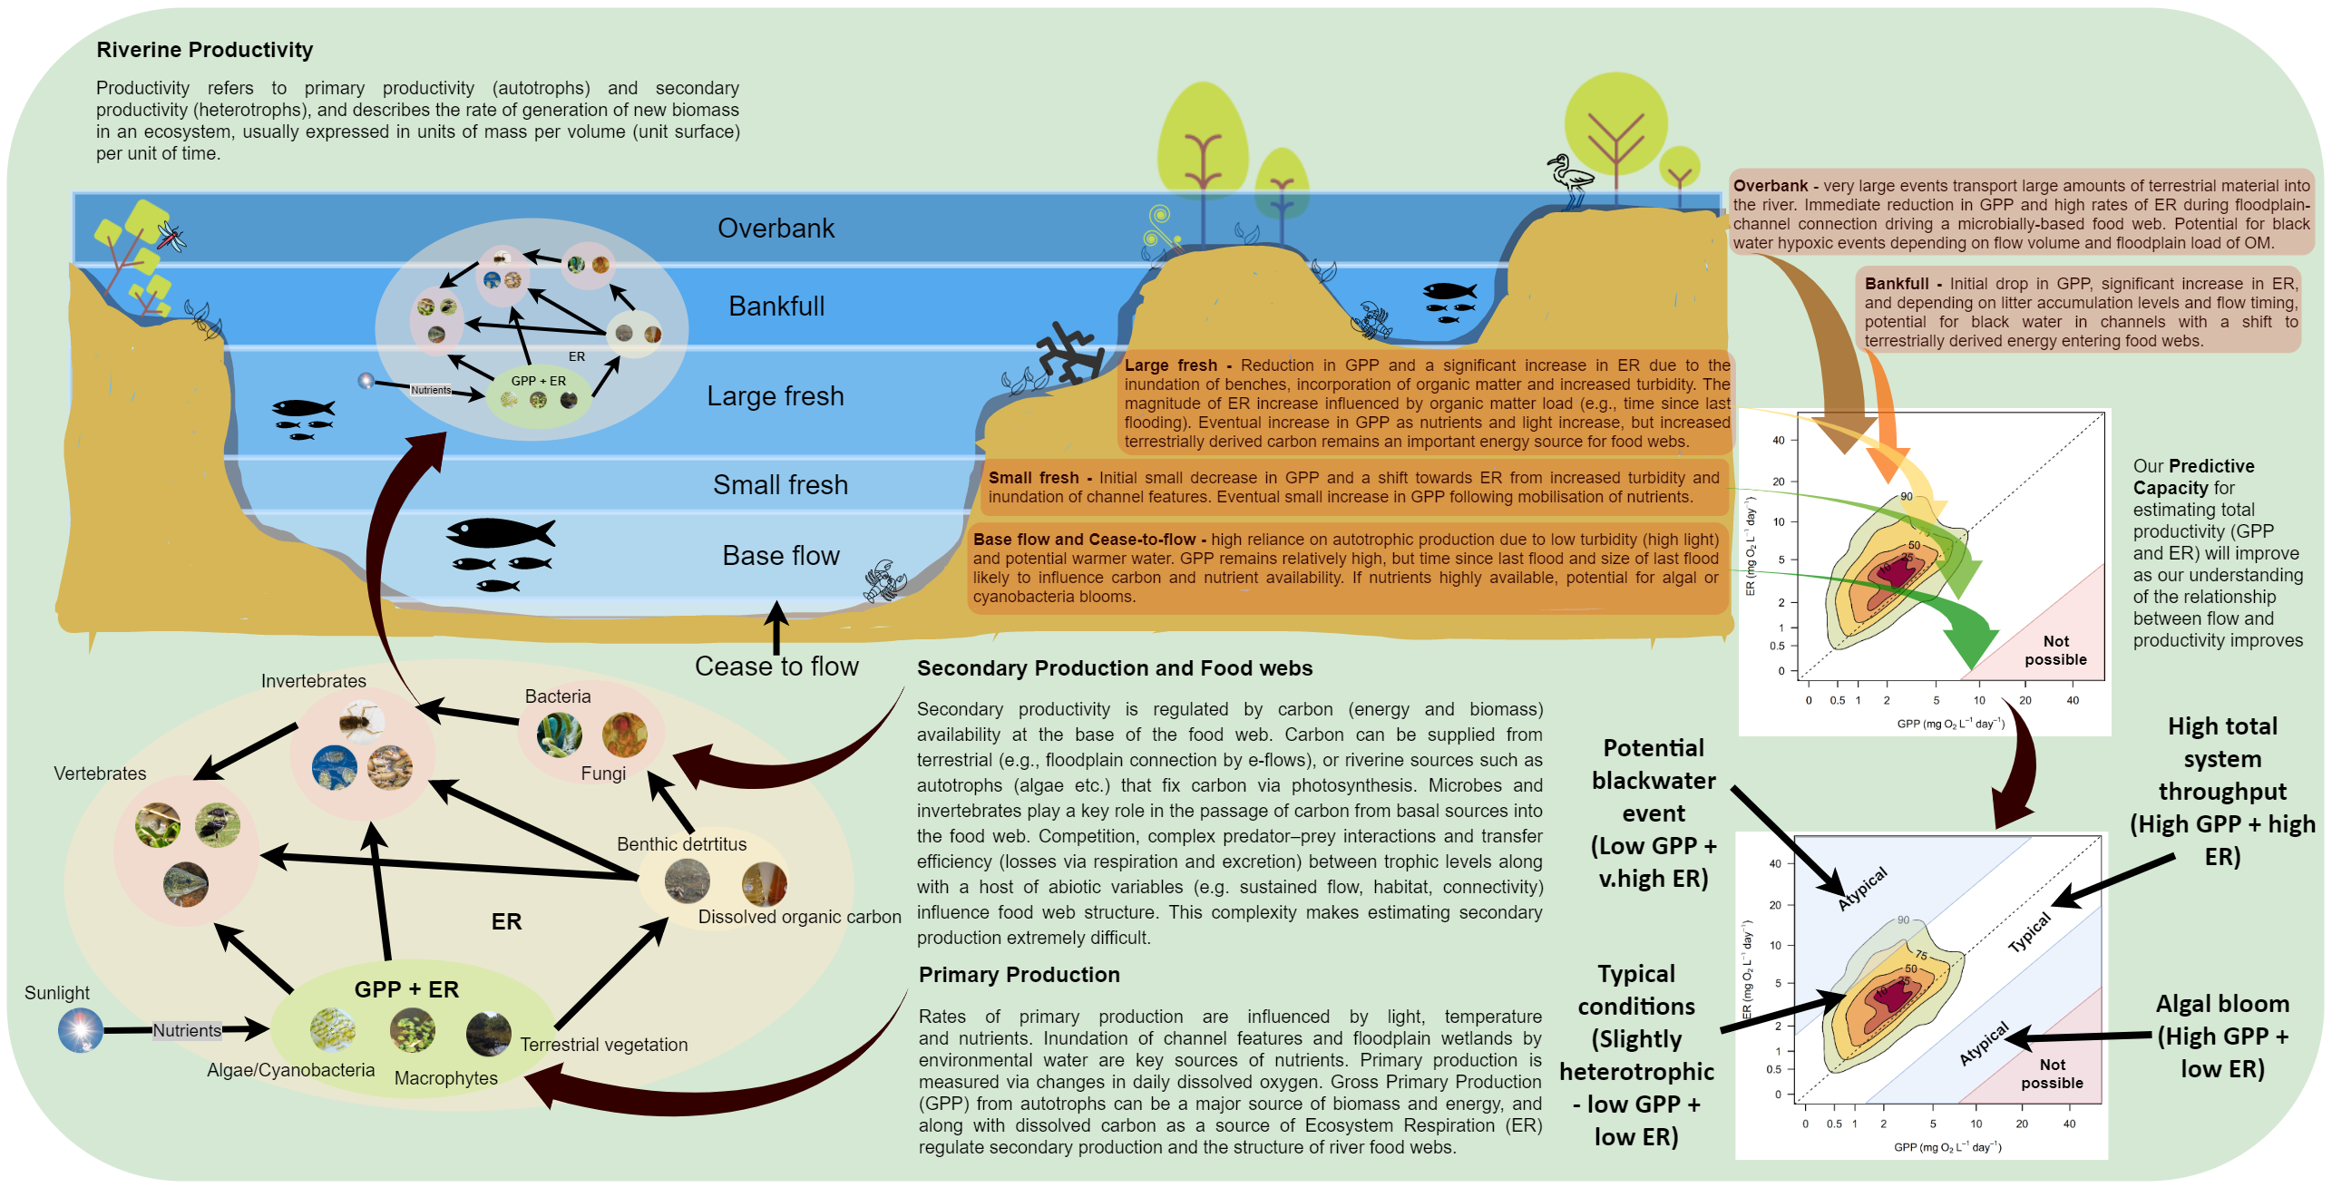

Table 6.1 Sources of data used for analyses
Note: Dissolved oxygen (DO) data are logged at the Selected Areas. The Selected Areas then run these data through the Bayesian single-station estimation model to estimate gross primary production (GPP) and ecosystem respiration (ER). The raw DO data are uploaded to the CEWH’s Monitoring Data Monitoring System (MDMS). DO is reported when or if it reaches critically low values at the Selected Area.
Selected Area | Parameter | Source
Lower Murray River | Daily estimates of GPP and ER | Local Selected Area team
Goulburn River | Daily estimates of GPP and ER | Local Selected Area team
Edward/Kolety–Wakool river systems | Daily estimates of GPP and ER | Local Selected Area team
Lachlan River System | Daily estimates of GPP and ER | Local Selected Area team
Murrumbidgee River System | Daily estimates of GPP and ER | Local Selected Area team
Gwydir River System | Daily estimates of GPP and ER | Local Selected Area team
Junction of Warrego and Darling rivers | Daily estimates of GPP and ER | Local Selected Area team
Basin | Hydrological data | Basin Hydrology Theme team
Basin | Rainfall data | Basin Hydrology Theme team
Basin | Commonwealth environmental watering actions | CEWH Science section

Defining food webs, stream metabolism and water quality
Food webs provide a useful way to think about life in rivers and wetlands. Food webs describe the interactions between organisms – who is eating who, from the smallest bacterium to the largest Murray cod. They can illustrate how much energy is moving between organisms or groups, and the role of individual animals or connections in sustaining life across an ecosystem. Flows and flooding provide food and sustain life in river and wetland ecosystems. Inundating a wetland helps plants grow by wetting dry areas and creating habitat for algae to flourish. Flows transport floodplain organic matter into rivers, fuelling growth of microbes and small zooplankton. They allow fish to move, forage and spawn, as well as helping insects grow, which, in turn, enables birds to forage and flourish.
The energy that drives riverine food webs is a fundamental requirement for all organisms. Without energy, organisms have no capacity for growth or reproduction. Food webs describe the pathways along which energy is transferred from resource to consumer. The strength and direction of these pathways are sensitive to impacts from changes to river flows and their landscapes. Although complex, food web studies can identify critical parts of an ecosystem that influence energy production and transfer, that in turn influence the size and structure of iconic native fish and waterbird populations.
Stream metabolism is defined by the increase (via photosynthesis) or decrease (via respiration) of DO concentration in water over a given time frame. This is most commonly expressed as milligrams of DO per litre per day (mg O₂/L/day). Rates vary on a seasonal basis, as warmer temperatures and more direct, and longer hours of, sunlight contribute to enhancing primary production. Warmer temperatures and a supply of bioavailable organic carbon usually result in higher rates of ER (Roberts and Mulholland 2007). There is concern when process rates are too high. Highly elevated primary production rates usually occur in response to algal blooms. When an algal bloom collapses (dies), a large biomass of labile organic material is consumed by bacteria (respired), often resulting in severe and extended periods of low oxygen (anoxia). Very low (or no) DO in the water can result in fish death events, toxic conditions and unpleasant odours. Sustainable rates of primary production will primarily depend on the characteristics of the aquatic ecosystem. Streams with higher concentrations of nutrients may have much higher rates of primary production, unless inhibited by factors such as elevated water column turbidity, which decreases light penetration.
Water quality describes the condition of the water, including chemical, physical and biological characteristics with respect to its suitability for environmental and human uses. Water quality is a key indicator of aquatic ecosystem health, and flow plays an important role in the maintenance of water quality in river systems. A range of parameters can be measured as indicators of water quality; many are the subject of water quality targets under the Basin Plan and are directly or indirectly influenced by flow. For example, DO can be influenced by flow through changes in water volume and turbulence and through indirect processes, such as alterations in rates of bacterial metabolism and photosynthesis. This, in turn, will directly influence the suitability of water quality for aquatic organisms, such as fish. Nutrients and organic matter concentrations may be influenced by flow, either by dilution or through inputs associated with water contacting parts of the channel or floodplain that were previously dry, and which have stores of nutrients and carbon in both plant materials and the soil. Within the targets for managing water flows in the Basin Plan (paragraph 9.14(5)(a)), the target for DO is to maintain it at a value of at least 50% saturation (at 25°C and 1 atmosphere of pressure), which equates to a DO concentration of approximately 4 mg/L.

Measures of stream metabolism
Measures of stream metabolism are highly informative to management because they integrate many ecological processes. However, a challenge for using stream metabolism as a management tool is that metabolic rates can have high and unexplained variability in space and time (Jankowski et al. 2021). The metabolic regime for each Selected Area is likely to be context-dependent, varying according to the magnitude of biotic and abiotic drivers at each location. These visualisations of the metabolic regime can serve to compare and contrast future annual and flow-event-specific metabolic responses. They can also track metabolic responses to environmental flows and assess whether they fall inside or outside the envelope of typical conditions or predicted responses.

Stream metabolism and secondary productivity
Metabolic fingerprints can also be used to compare and classify metabolic regimes across different sites. This could lead to the identification of sites that share similar metabolic regimes and potentially respond similarly to Commonwealth environmental watering actions. In this way, the metabolic regimes can also be used to scale up from Selected Area to valley scale or to group Selected Areas or individual rivers based on their metabolic fingerprint response. Generating environmental flows that promote desirable metabolic responses (when GPP and ER remain relatively well balanced, as designated by the middle white band on the bottom right plot in Figure 6.2) represent management for a set of conditions that are likely to support healthy communities of fish and waterbirds. This approach can help to improve the understanding of how different flow types interact with abiotic drivers (e.g. antecedent conditions, light, temperature) to influence aquatic metabolic responses and improve the predictive capacity for metabolic responses to Commonwealth environmental watering actions, as well as their influence on states of riverine organisms (e.g. vegetation, fish, birds – see Box 1).
Box 1 Relationship between stream metabolism and secondary productivity
Although rates of GPP and ER are not direct estimates of consumer energy dynamics, ecological theory and existing empirical evidence suggest that GPP and ER rates are correlated with consumer energy dynamics in aquatic ecosystems (Figure 6.2; Rüegg et al. 2021). GPP represents the building of biomass at the base of the food web, which primary consumers eat to gain energy (Figure 6.2). A proportion of this ingested energy will be transformed into biomass by the primary consumers, and then to secondary consumers in turn (the rest is lost to cellular respiration, heat, excretion and to decomposers at each level). ER is the sum of respiration by autotrophic and heterotrophic organisms (microorganisms and all multicellular consumers). A high ER thus likely indicates a high biomass and/or activity of heterotrophic organisms, and under some circumstances may be considered a proxy for secondary production.
There are likely exceptions to the expected correlation between rates of stream metabolism and secondary production. For example, if energy is recycled within the microbial loop, this energy is dissipated and not available to higher trophic levels. However, in streams it is known that much of the bacterial and fungal production occurring on detrital organic matter fuels the productivity of higher trophic levels. Uncertainties exist around the efficiencies of transfer between trophic levels, which depend on water quality variables such as temperature and nutrient availability. The spatial and temporal scales of correlations between stream metabolism and consumer dynamics is an area of ongoing research (Rüegg et al. 2021). Despite this, stream metabolism is a useful indicator of trophic dynamics, since measuring secondary production and energy transfer is much more difficult and cannot readily be performed at the practical scale and temporal resolution achievable for stream metabolism with modern DO loggers.
Figure 6.2 Hypothesised relationship between stream metabolism and secondary productivity by consumers at higher trophic levels
The amount of secondary productivity per unit gross primary production (GPP) or ecosystem respiration (ER) decreases with increasing trophic level (TL) because only approximately 10% of the energy is transferred to biomass production by the next level. Coloured arrows and text indicate scenarios for which a departure from this hypothesised relationship would be expected. g C m^{–2} yr^{–1} = grams of carbon per square metre per year
Source: modified from Rüegg et al. (2021)
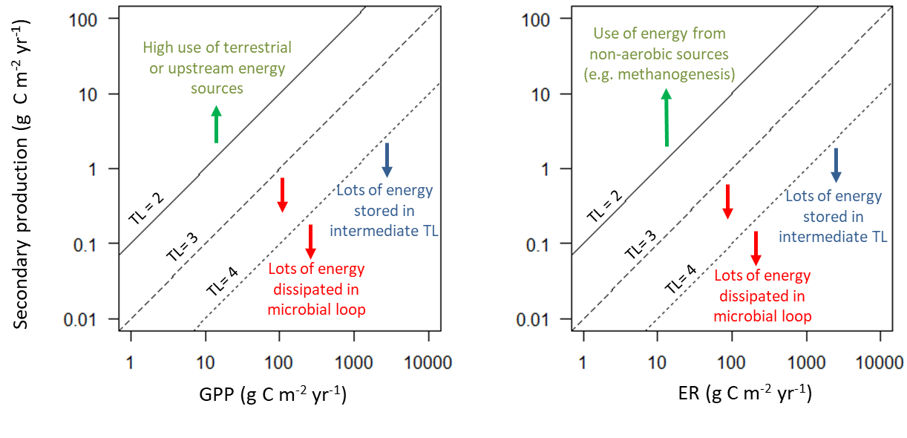

Stream metabolism and water quality
Stream metabolism and water quality measurements were performed in accordance with the LTIM standard operating procedure (Hale et al. 2014), which has remained essentially unchanged for Flow-MER. Stream metabolism is a Category 1 indicator, defined as
mandatory monitoring with standard protocols, which are required to inform quantitative Basin Evaluation. Matters have been identified for each Selected Area in this category and must be applied in a consistent manner following standard protocols (p 2 in Hale et al. 2014).
The method has been designed to provide data appropriate for the evaluation of outcomes in response to Commonwealth environmental watering at the Selected Area and at Basin scale (Grace 2020). Data on temperature (°C), EC (mS/cm), DO (%), pH and turbidity (nephelometric turbidity units; NTU) are collected as part of the standard methods (Grace 2020). They may be complemented by water quality monitoring data collected through other relevant programs, such as short-term monitoring instigated by the Commonwealth Environmental Water Holder (CEWH) and/or the MDBA in response to planned watering actions or a potential water quality event.
Daily estimates of GPP, ER and reaeration rate (KO₂) have been developed in each Selected Area from diel DO curves for each site, using the LTIM Category 1 standard method (Hale et al. 2014). The BASEv2 fitting routine (Grace et al. 2015) is used to calculate rates of stream metabolism. As the BASE model evolved during the 5 years of LTIM, all of the earlier LTIM data used for stream metabolism, and incorporated in the theme evaluation report, were re-run using the BASEv2 program to ensure a common method across time. This resulted in many more days that met the acceptance criteria for inclusion in the metabolic fingerprint analyses presented here. Acceptance criteria for inclusion of daily results in subsequent analyses were that the fitted model for a day must have:
- an R² value of at least 0.90 and a coefficient of variation for the GPP, ER and KO₂ parameters of <50%
- a reaeration coefficient (K) within the range 0.1 to 15.0
- model fit parameter PPfit within the range 0.1 to 0.9.
The fitting routine also provides an uncertainty estimate for each parameter that allows interrogation of the data included. The standard methods were updated for the 2020–21 water year (based on Song et al. 2016) to provide flexibility in acceptance criteria. This improved data acceptance rates where appropriate without substantially diminishing data quality or interpretability. Extreme events, such as algal blooms and hypoxic blackwater events, can generate data that fail to meet the uncertainty criteria specified within BASE. These periods are of ecological significance and Selected Area teams can modify the rejection criteria to allow specific investigation of extreme events. Deviations from the standard acceptance criteria by Selected Area teams are noted in their respective annual reports.
In addition to the daily estimates of GPP, ER and KO₂, it is also expected that, at all sites where sampling is undertaken, Selected Area teams will provide data for the periods of measurement on:
- mean river water velocity
- mean daily discharge
- average river depth.

Selected Area data fingerprinting – an approach for analysing and communicating metabolic responses to flow
Metabolic fingerprints are an emerging tool for visualising and diagnosing change in stream metabolism across time or space and in response to hypothesised drivers (Bernhardt et al. 2018). The metabolic fingerprint represents the entire distribution of daily estimates of GPP and ER observed for a river, summarised into kernel density plots that allow easy visualisation of both peak and median metabolic rates as well as variance in ratios (Figure 6.3).
Figure 6.3 Representation of a metabolic fingerprint, which describes the bivariate probability distribution estimated to contain the top 10% 25%, 50%, 75% and 90% of the gross primary production (GPP) and ecosystem respiration (ER) points
The fingerprint diagram shows GPP on the x-axis and ER on the y-axis. The dashed line indicates when GPP and ER are equal (i.e. net ecosystem production equals zero). Contours show the 90th, 75th, 50th, 25th and 10th percentile regions. mg O2 L–1 day–1 = milligrams of oxygen per litre per day
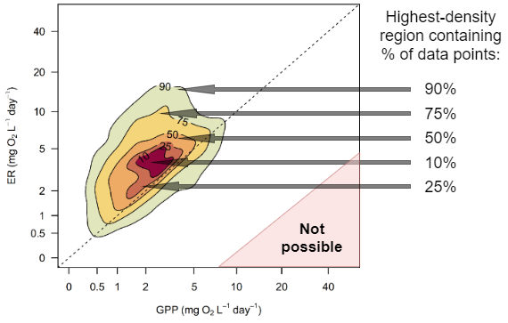
This diagram consists of GPP and ER displayed with a kernel density plot. The contour lines indicate the areas estimated to contain 10% 25%, 50%, 75% and 90% of the GPP and ER points (from the inner to outermost contour lines, respectively; Figure 6.3). The contours represent an estimate of the probability density function using kernel density estimation, such that the X% contour is the estimated 2-dimensional area that contains X% of the points (based on the sample of the unobserved population). These areas represent the typical metabolic rates at a site, termed the ‘metabolic regime’. The dashed line indicates when GPP and ER are equal (i.e. net ecosystem production equals zero). Above the dashed line, the system is heterotrophic (a net consumer of carbon; ER > GPP). Below the line, the system is autotrophic (a net accumulator of carbon; GPP > ER). This representation of the rates allows a rapid inspection of the most typical rates of GPP and ER (the innermost contour), the balance between GPP and ER (position of the fingerprint relative to dashed line), the total variability in GPP and ER (the size of the outermost contour), and the correlation between GPP and ER.
An example of a ‘real world’ metabolic fingerprint is presented in Figure 6.4. Contour lines in the top left of the plot represent high ER and low GPP rates, and can be indicative of blackwater or hypoxic events, while contour lines in the bottom right of the plot represent high GPP and low ER and may be indicative of algal blooms or eutrophication. In both cases, contours that reside outside the central white band (solid lines) may cause non-desired shifts in metabolic patterns in response to changes in flow regime or watering actions. The central diagonal line represents a balance between GPP and ER (e.g. GPP:ER = 1) and contours in the associated white zone can indicate ‘typical’ or desired productivity. Fingerprints that shift upwards along the diagonal line (i.e. high GPP and high ER) indicate an increase in overall ecosystem throughput and the rapid cycling of organic matter and nutrients through a riverine food web.
Figure 6.4 ‘Real world’ example of metabolic fingerprints visualising and diagnosing change in stream metabolism across time or space and in response to hypothesised drivers
Metabolic fingerprints represent a useful tool for diagnosing ‘typical’ and ‘atypical’ metabolic responses to flow. This diagram shows where a hypoxic blackwater event with very high respiration would sit (high on the ER y-axis), and where an algal bloom with high productivity would sit (high on the GPP x-axis). mg O₂ L^{–1} day^{–1} = milligrams of oxygen per litre per day. Source: adapted from Bernhardt et al. (2018)
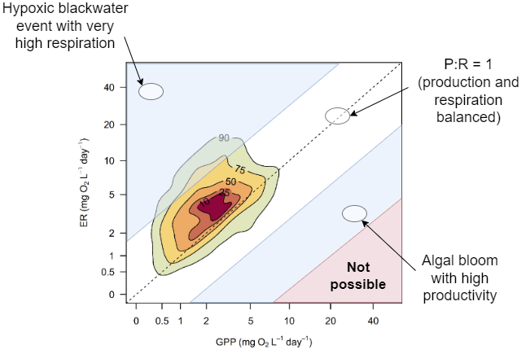
Bernhardt et al. (2018) predict that increased light and nutrients will enlarge both the total area and the maximal rates represented by a river’s fingerprint, while increased sediment loading caused by hydrological disturbances will limit the metabolic fingerprint to values near the bases of both the GPP and ER axes. Thus, it is expected that the area of each Selected Area’s fingerprint (its variation along both the 1:1 line and the x- and y-axes) should be compressed due to hydrological disturbances and expanded due to the supply of either solar energy or carbon. It is expected that as more metabolic data are collected, predictable clusters and patterns in stream metabolism will become more recognisable. As mechanistic understanding of observed responses to environmental flows improves, flows can be tailored at different scales (rivers, basins or Selected Areas) to achieve specific metabolic outcomes.

Metabolic responses to flow
We focus on exploring metabolic responses to the full years of monitoring (2014–24). This is because it is unlikely that metabolic responses to flow are sensitive to the purpose of the flow (e.g. environment, irrigation supply) and this approach provides much greater statistical power. After plotting GPP versus ER for all of the accepted BASE model outputs that meet use criteria, individual data points are colour coded by the corresponding flow values from the flow models of the Hydrology Basin Theme. A statistical model is then run using the envfit function in the R package VEGAN (Dixon 2003). The envfit function fits an environmental vector j over an ordination or other 2-dimensional space using an intercept-less linear model using Equation 6.1. The 2 regression coefficients β₁ and β₂ are the x and y coordinates that determine direction of the arrow; the arrow length is equivalent to the correlation coefficient r². The p value in envfit is derived through a permutation test. The result is illustrated in Figure 6.5.
$\left({env}_{j}\right)=β_{1}*GPP+β_{2}*ER$ Eq 6.1
Figure 6.5 Explanation of envfit overlay on metabolic fingerprint
The direction and size of the envfit vector (j) can indicate dominant metabolic responses to flow. If the vector extends upwards from the perpendicular to the 1:1 line (blue semicircle), it indicates increased metabolic throughput in response to flow at that location. If the vector extends downwards from the perpendicular to the 1:1 line (green semicircle), it indicates decreased metabolic throughput in response to flow at that location. Arrows that point up or down the GPP and ER axes represent relative increases or decreases of each parameter in response to flow. Length of the arrow indicates the relative strength of the relationship.
mg O₂ L^{–1} day^{–1} = milligrams of oxygen per litre per day
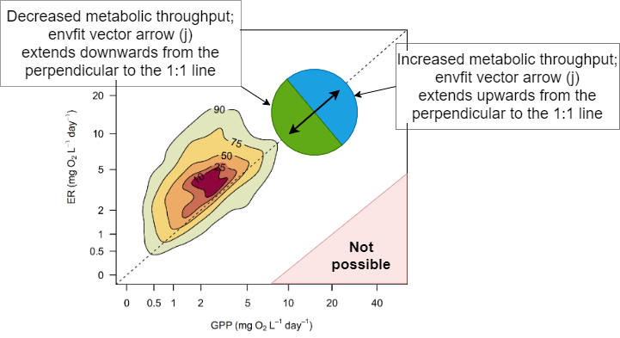
Results are visualised as shown in Figure 6.6.
Figure 6.6 Relationship between stream metabolism and flow at Loch Garry gauge, Goulburn River
Left-hand panels display gross primary production (GPP), ecosystem respiration (ER) and net ecosystem production (NEP) values (green dots) in response to flow (black line) and Commonwealth environmental water (pink line). Right-hand panels depict metabolic fingerprints (without kernel-density regions displayed), and colouration of data points reflect logFlow (flow on a log scale). Length of the envfit environmental vector arrow (j) indicates the strength (r²) and direction of long-term metabolic response to flow, and significant responses are indicated at the top of the plot by p < 0.05.
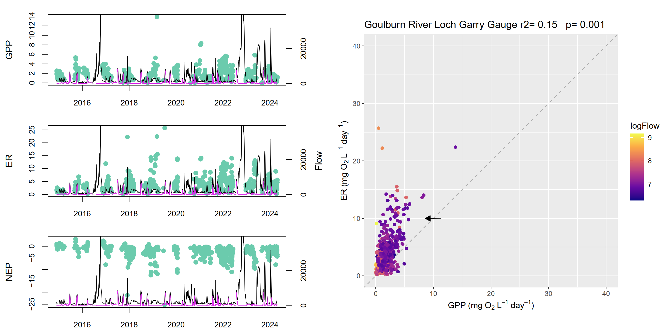

Counterfactual GPP modelling approach
Counterfactual modelling was undertaken to estimate the contribution of CEW to riverine GPP. We used a statistical model to estimate the contribution that Commonwealth environmental water (CEW) made to riverine gross primary productivity (GPP). This utilised data from across the entire 10-year (2014–15 to 2023–24) monitoring period. Briefly, this involved 2 steps:
- First, we constructed a statistical model to describe how measured daily rates of GPP responded to 2 known key drivers: daily solar radiation and daily flow (Giling et al. 2025).
- Subsequently, we used the fitted model to predict new timeseries of daily GPP at each site under both the observed (factual) flow scenario and the counterfactual scenario (flow minus the estimated CEW component).

Site selection and data preparation

Ecosystem metabolism data
We used a subset of the 2014–15 to 2023–24 LTIM/FlowMER metabolism dataset (https://data.gov.au/data/dataset/flow-mer-metabolism-base-model, accessed 5/2/2025). The dataset included entire years (water year; 1 July–30 June) from sites that met the following criteria:
- It was possible to link the site to an appropriate discharge gauge for which there were estimates of CEW. Gauges were considered appropriate when they were located on the same river and not upstream or downstream of major tributaries relative to the site.
- The year had ≥ 100 valid daily GPP estimates. Poor fitting or unconverged daily metabolism models were omitted, as were GPP outliers. Outliers were identified as estimate higher than 1.5 times the inter-quartile range, on a site-by-site basis.
This resulted in a dataset including 28 sites across 6 selected areas, each with between 1 and 9 years of GPP data (99 site-years and 16,629 GPP estimates in total; Table 6.2).
Table 6.2 Overview of dataset used for GPP counterfactual modelling
Selected Area | Site | No. years | Earliest year | Latest year | Total no. GPP estimates
Edward-Wakool River System | Cummins | 1 | 2017–18 | 2017–18 | 171
Edward-Wakool River System | Hopwood | 5 | 2014–15 | 2018–19 | 611
Edward-Wakool River System | Llanos Park2 | 4 | 2017–18 | 2023–24 | 598
Edward-Wakool River System | Moulamein Road Bridge | 7 | 2014–15 | 2023–24 | 927
Edward-Wakool River System | Noorong2 | 5 | 2017–18 | 2023–24 | 983
Edward-Wakool River System | Old Morago Road | 2 | 2021–22 | 2023–24 | 309
Edward-Wakool River System | Widgee1 | 9 | 2014–15 | 2023–24 | 1,633
Edward-Wakool River System | Windra Vale2 | 9 | 2014–15 | 2023–24 | 1,627
Goulburn River | Arcadia Downs | 1 | 2019–20 | 2019–20 | 105
Goulburn River | Darcy's Track | 2 | 2014–15 | 2018–19 | 227
Goulburn River | Loch Garry Gauge | 2 | 2017–18 | 2021–22 | 240
Goulburn River | McCoys Bridge | 9 | 2014–15 | 2022–23 | 1,611
Goulburn River | Murchison | 3 | 2020–21 | 2023–24 | 366
Goulburn River | Shepparton | 1 | 2020–21 | 2020–21 | 114
Gwydir River System | GWY_418001 | 2 | 2020–21 | 2023–24 | 246
Lachlan River System | BOO | 2 | 2022–23 | 2023–24 | 541
Lachlan River System | CC | 5 | 2015–16 | 2023–24 | 763
Lachlan River System | CON | 1 | 2023–24 | 2023–24 | 176
Lachlan River System | HUN | 1 | 2023–24 | 2023–24 | 140
Lachlan River System | LB | 6 | 2015–16 | 2020–21 | 1,502
Lachlan River System | TH | 1 | 2018–19 | 2018–19 | 121
Lachlan River System | WAL | 3 | 2015–16 | 2019–20 | 532
Lachlan River System | WB | 5 | 2015–16 | 2021–22 | 1,383
Lower Murray River | LK1DS_265km | 2 | 2015–16 | 2017–18 | 214
Lower Murray River | LK4DS_501km | 1 | 2022–23 | 2022–23 | 102
Lower Murray River | LK6DS_616km | 2 | 2020–21 | 2022–23 | 235
Murrumbidgee River | McKennas | 7 | 2014–15 | 2020–21 | 1,020
Murrumbidgee River | Narrandera | 1 | 2018–19 | 2018–19 | 132

Hydrological data
Daily flows with CEW component (https://data.gov.au/data/dataset/flow-mer-daily-flows-with-cew-component, accessed 5/2/2025) were linked to each metabolism site. Flow was standardised to a proportion of the maximum daily flow for each site individually. The maximum flow was the highest observed over the monitoring period (normally observed during 2016 or 2022 floods) at each site, regardless of whether that year was included in the metabolism modelling data subset. Therefore, standardised flow for each site varied between 0 and 1. This was to facilitate assessment of how changes in flow within site affected GPP, rather than the effect of differences in flow magnitude among sites. This aided interpretation because a flow proportion has a similar flow component and hence hydraulic conditions for channels or catchments of varying size. For example, a flow proportion of 0.2 is often between a large fresh and overbank flow. It is important to note that most daily flows are much lower than the flood peaks, such that flow proportions between 0 and 0.2 were observed on most days (94% of all days, 96% of days that had a CEW contribution).
Daily flow proportion on the day of the GPP estimate was used as a predictor variable. We did not consider antecedent flows for this analysis because recent antecedent flow magnitude is highly correlated with current flow magnitude, and such measures have not been found to strongly affect GPP (Giling et al 2025).

Solar radiation data
Daily solar exposure (MJ m⁻² day⁻¹), consisting of both direct and diffuse components, was obtained from SILO gridded data based on the geographic coordinates of each site (Jeffrey et al 2001). This was extracted using the weatherOz R package (Pires et al 2024). Daily solar exposure was averaged to the mean daily radiation for each calendar month to avoid potential issues of circularity given that sub-daily light estimates were used to model GPP in the first place (Giling et al., 2025). This potential circularity cannot be entirely removed, as light is a required predictor for accurately estimating photosynthesis rates, but can be partly reduced by using solar exposure data collected using a different method and at larger spatial and temporal scales.

Modelling

Model structure and model selection
We used a generalised additive model (GAM; fit using R package mgcv; Wood 2011) that allows for combining a linear response of log-transformed GPP to solar exposure and potential non-linear response to flow. The latter is modelled with a ‘smoothing spline’ that allows for the response to be non-linear. These two variables were chosen based on being important drivers in previous work in the Murray–Darling Basin and conceptual understanding of river productivity more generally (Bernhardt et al 2018; Giling et al 2025). Site was included as a random effect in addition to a temporal autocorrelation term to account for the grouped and repeated measures data structure. We considered 3 models of increasing complexity:
- GPP as a function of flow (smooth term) and solar exposure (linear term). Flow effect does not vary by site.
- GPP as a function of flow (smooth term), solar exposure (linear term), and their interaction. Flow effect does not vary by site.
- GPP as a function of flow (smooth term), solar exposure (linear term), and their interaction. Site-specific flow effect.
We used Akaike information criterion (AIC) to select the best model, which assesses the model’s goodness of fit and penalises more complex models, which may be overfit. The simplest model (model 1) was the best supported model, suggesting that adding an interaction between flow and solar exposure, or site-varying flow effects, did not improve goodness of fit enough to offset the additional complexity (Table 6.3). This means these more complex models do not offer a better description of the changes in GPP in response to daily flow and daily average solar exposure. Model 1 explained 46% of the variation in daily GPP.
Table 6.3 Model terms and Akaike information criterion (AIC) values for the 3 candidate GAM models.
The lowset AIC is the best supported model
Model ID | Model formula | AIC
1 | log10GPP ~ mean_monthly_radiation + s(Flowprop) + s(SamplePoint, bs = 're'), correlation = corARMA(form = ~ Date) | -19,924.10
2 | log10GPP ~ s(Flowprop, by = mean_monthly_radiation) + s(SamplePoint, bs = 're'), correlation = corARMA(form = ~ Date) | -19,169.05
3 | log10GPP ~ s(Flowprop, by = mean_monthly_radiation) + s(SamplePoint, Flowprop, bs = 're'), correlation = corARMA(form = ~ Date) | -18,097.98

Counterfactual predictions
We used model 1 to predict new daily GPP values for both actual observed flows and the counterfactual flows (total flow – CEW contribution) for every day at each site/year based on the daily solar radiation and flow. We predicted new daily GPP values for days with existing empirical GPP estimates under the factual flow scenario. This was because there was high day-to-day variability in measured GPP rates, while the model represented the mean condition for a given radiation and daily flow. This approach increases interpretability of results as all factual (either with or without empirical estimate) and counterfactual daily rates were estimated in an equivalent way. Predicted factual and predicted counterfactual rates were summarised to weekly means for visualisation.
Subsequently, we used the best model to predict new timeseries of daily GPP at each site under both the observed flow scenario (with CEW) and the counterfactual scenario without any CEW. Predicted factual and predicted counterfactual rates were summarised to weekly means for visualisation.
For this analysis, we selected a subset of sites and years with high data availability (≥ 100 valid GPP estimates per year). Taking a subset resulted in a dataset that included 28 sites across 6 Selected Areas, each with between 1 and 9 years of data (totalling 99 year-site combinations and 16,629 daily GPP estimates).

Effect of solar radiation and flow on gross primary production
The highest quality model was an additive effect of mean monthly solar radiation and flow proportion. Adding interactions or site-specific flow relationships increased the Akaike information criterion, indicating these additional variables did not improve predictive power (goodness-of-fit) enough to be favoured over a simpler (i.e. more parsimonious) model. However, there is still some site-to-site variability in flow responses.
The non-linear (i.e. smoother) terms of the best model explained 46% of the variation in daily GPP. Solar radiation increased GPP while flow proportion had highly non-linear effects on GPP (Figure 6.7). At lower flows (< 20% of maximum site flow; corresponding to between large fresh and bankfull flows), flow has a strong negative effect of GPP. Similar trends have been observed in many systems globally and may be due to disturbance, shading or dilution effects (Bernhardt et al. 2018). At higher flows, flow has a moderate but inconsistent positive effect on daily GPP. This is perhaps due to bank and floodplain inundation increasing nutrient availability or the amount of shallow well-lit wetted areas. We note that these results from higher flows are less certain, as the method for estimating GPP does not work well at high flows and data is limited. It is also important to note that most daily flows are < 20% of maximum daily flow within a site (94% of all days, 96% of days that had a CEW contribution), such that increases in flow normally suppress GPP.
Figure 6.7 Plot of generalised additive model smoother results
Panel A shows modelled effect of mean daily solar radiation on log-transformed gross primary production (GPP). Panel B shows modelled effect of daily flow proportion (where 1 is the maximum flow observed at a site) on log-transformed GPP.

Effect of Commonwealth environmental water on rates of gross primary production
We assessed CEW contribution to riverine GPP by applying the solar radiation and flow relationships to all days under both the observed and counterfactual flow scenarios. By increasing flow, CEW reduced annual riverine GPP (i.e. the counterfactual scenario had elevated GPP) across all sites and years. Results are visualised as shown in Figure 6.8 and Figure 6.9.
Figure 6.8 Effect of Commonwealth environmental water contribution to flow on the predicted change in annual gross primary production compared to the counterfactual scenario
Each point is one year at one site. Colour indicates the Selected Area.SA There was a significant negative relationship between Commonwealth environmental water (CEW) proportion to flow and the percent change in gross primary production (GPP) between the observed and counterfactual scenarios (t = 9.36, p < 0.001, R² = 0.47).
Figure 6.9 Counterfactual gross primary production (GPP) predictions for one site in the Lower Murray River Selected Area over 22 year
This is an example of a site with high Commonwealth environmental water contributions that had a large effect on GPP, lowering annual totals by 17% and 14% in 2015–16 and 2017–18, respectively.
Large green circles show the modelled mean daily GPP under the observed flow scenario and small black circles show the modelled mean daily GPP under the counterfactual flow scenario. The vertical black lines indicate the difference between the rates for the 2 2 scenarios. The shaded hydrograph shows the flow at the closest gauge, and the daily Commonwealth environmental water (CEW) contribution is shaded blue.
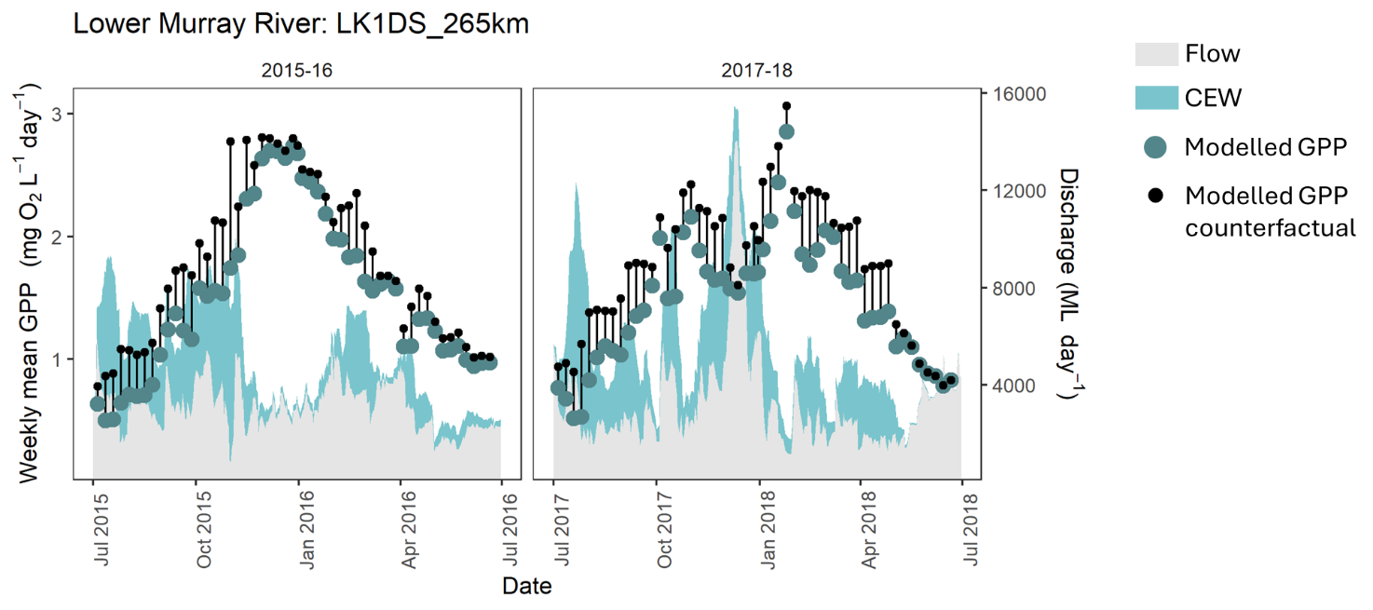
Responses of rivers to hydrological disturbance are variable depending on the size of the flow, substrate type and channel morphology, and temperature and nutrients are recognised as being secondary controls on GPP and ER relative to light and hydrological disturbance (Hall 2016). Data examination of 222 United States rivers by Bernhardt et al. (2022) identified annual solar energy inputs and stability of flows as the primary drivers of GPP and ER across rivers. Bernhardt et al. (2022) reported that in rivers with the most stable flow regimes, annual GPP was 3 times higher than for rivers with the most variable flow regimes. They attributed these reductions to disturbance of autotrophs (primarily benthic and pelagic algae) caused by displacement, scour or cover by sediment by floods and desiccation during dry periods. They also found substantially lower ER in rivers with more variable flows than rivers with stable flow regimes, which they attributed to frequent bed-mobilising flows that are likely to constrain retention of organic matter and reduce both terrestrial and aquatic carbon contributions to ER (Bernhardt et al. 2022). Resh et al. (1988) defined riverine disturbance as ‘any relatively discrete event in time that is characterized by a frequency, intensity, and severity outside a predictable range, and that disrupts ecosystem, community, or population structure and changes resources or the physical environment’. In the context of Australian lowland river environmental water, unstable flow patterns and hydrological disturbance may influence short-term or immediate metabolic patterns in a number of ways. Unlike upland river systems, scour is unlikely to be a large driver of reductions in GPP, due to relatively small increases in water velocity. However, sudden increases in water level may lead to surfaces (e.g. snags, benches) that support biofilms in rivers no longer remaining in the photic zone. Increased flows can also lead to elevated turbidity, reducing photic depth (influencing both planktonic and benthic algae) and potentially increasing sediment cover on surfaces. Even small increases in flow lead to altered hydraulic regimes in rivers, potentially displacing planktonic algae, mobilising litter and disturbing microbial activity in the benthos. We expect a similar set of processes to occur after the flow pulse moves through, with new biofilms left stranded and becoming desiccated as the water level returns to baseline.
While environmental flow delivery can lead to increased inundation of slack waters and adjacent wetlands, we expect there will be a ‘lag’ effect with productivity responses as autotrophs respond to the inundation of new areas. We also expect that additional metabolic activity that occurs in these areas is unlikely to be detected by probes in the flowing river channel, since water mixing is poor in non-flowing habitats. The open water method used for estimation of riverine metabolic patterns is not suitable for use in standing waters due to insufficient mixing of the water column. To accurately measure metabolic rates in newly inundated floodplain habitats, alternative approaches are required (e.g. light and dark bottles for planktonic estimates and perspex chambers for benthic measures), though such approaches require significant increases in time investment and are likely to be highly context-dependent and difficult to scale.
Figure 6.10 presents a conceptualisation of the relationship between flow disturbance and metabolic activity.
Figure 6.10 Conceptualisation of influence of flow disturbance on metabolic activity
Source: adapted from Van Looy et al. (2019) and Bernhardt et al. (2018)
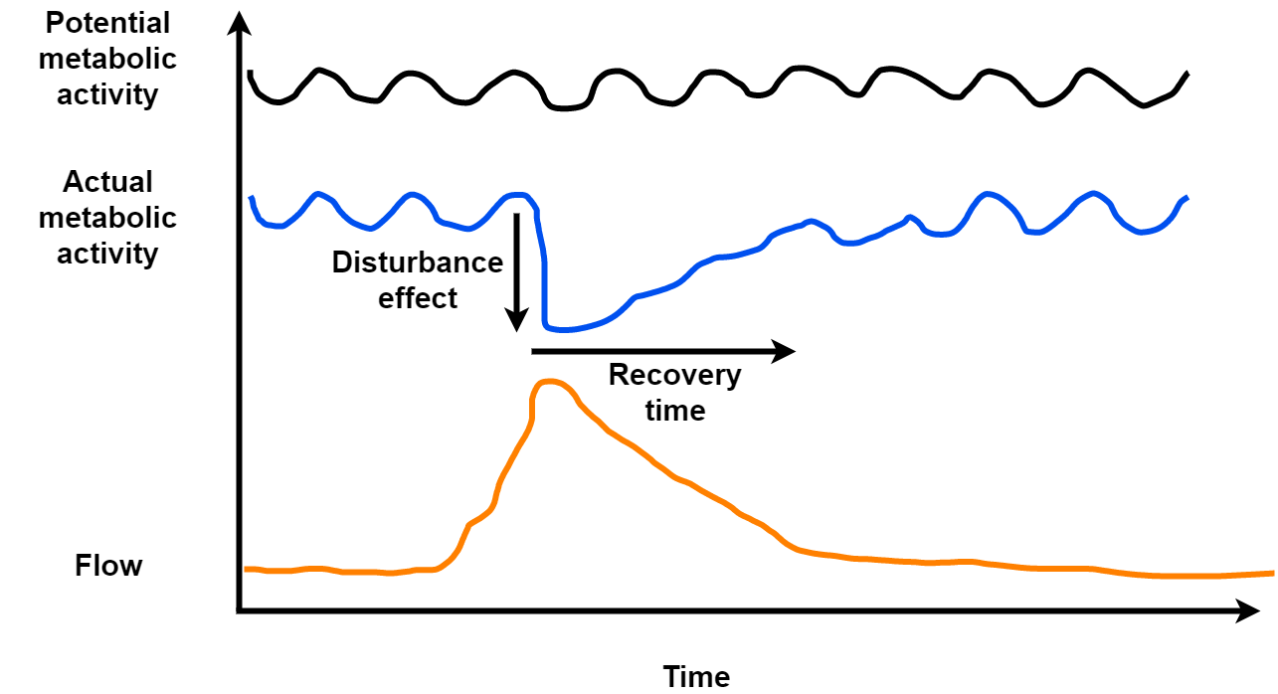
Similarly, Giling et al. (2025) found that volumetric rates of GPP increased with distance downstream in the Lachlan River System due to a combination of higher water temperatures, lower flows and lower flow variation. Giling et al. (2025) also suggest that low and stable flows are likely to stimulate volumetric rates of GPP by increasing light availability and reducing scouring, but greatly decrease organic matter transport. Research conducted in small streams has uncovered a threshold effect, where small (in duration and volume) flow pulses disrupted stream metabolism by increased turbidity with short recovery times, whereas large flow pulses disrupted stream metabolism by destroying periphyton habitats, resulting in longer recovery times (O’Connor et al. 2012). Bernhardt et al. (2018) proposed that in larger rivers where a greater proportion of GPP is conducted by planktonic algae, reduction in light availability caused by flood-associated pulses of suspended sediment elevate turbidity to become the dominant disturbance impact, rather than bed disturbance.
When assessing the contribution of Commonwealth environmental water (and flow more generally) to metabolic regimes, it is important to return to our conceptual model (Figure 6.1) and note that increased rates of GPP or ER are not necessarily the most desired outcomes. Our conceptual model predicts that in-channel flows are likely to decrease rates of volumetric metabolism via dilution, disturbance and increases to turbidity (as we see at most Selected Areas from fitting the envfit environmental vectors to the long-term data). Reductions in metabolic throughput that we see from the physical effects of flow events – displacement, scour, cover by sediment or increased turbidity – have the capacity to benefit ecosystems after the flow peak has passed by liberating nutrients, entrainment of new allochthonous organic material and by resetting structural and functional arrangement of organisms (Palmer and Ruhi 2019). In upland streams, Uehlinger (2000) reported that recovery of GPP to pre-disturbance levels was faster in the lower reaches and exhibited distinct seasonal variation, reflecting geomorphic settings and disturbance regime. Flow-induced disturbance is a natural ecosystem process. Further examination of recovery trajectories may provide instructive insights to broad ecosystem status and response potential, providing information on the resilience and resistance of ecosystems (Reisinger et al. 2017).

Foundation datasets
Team: Staff of the Science Division of the Commonwealth Environmental Water Holder
Felix Egger, Tony Weber (Alluvium); Ashmita Sengupta, Martin Nolan, Jackie O’Sullivan, Susan Cuddy (CSIRO); Shane Brooks (Brooks Ecology)
Evaluation of outcomes of Commonwealth environmental water relies on several key datasets. Their derivation is described in this chapter.

CEWH Watering Actions Table
Each year, the CEWH prepare a Watering Actions Table (the WAT, CEWH 2023) which provides a summary of each watering action undertaken during the preceding water year. It is prepared from the information contained in CEWH Delivery team acquittal reports and is delivered to the Flow-MER evaluation team in late December. While it undergoes quality checking (e.g. to ensure that dates are within the range), it is manually constructed and as such is subject to how information is interpreted.
Each watering action record includes delivery timeframe, valley of delivery, delivery volume, targeted flow component, objectives of the watering action and volumes of other environmental water delivered in partnership (Table 7.1). The targeted flow component relates to the hydrological flow regime that was intended to be watered, which in most cases is also the actual flow component watered. Multi-component flow over longer timeframes are common watering actions, and they are treated as separate, multi-component water delivery actions.
Table 7.1 Fields (columns) in the Watering Actions Table, prepared annually by officers of the CEWH (CEWH 2023)
Rows in the Watering Actions Table describe each watering action. In the table below, ID is the Excel column ID.
Year is included in the table as the Basin-scale Flow-MER team appends the most recent information to the full-length dataset (i.e. watering actions from water year 2018–19).
Asterisk (*) in row G. In the full length dataset, contributions from other environmental water holders are summed to a Total. In the annual WATs, contributions from other environmental water holders are separately identified.
Columns K–T contain a short description of the objective/s of the watering action. Each watering action can, and often does, have multiple objectives.
ID | Column heading | Brief description of content | Example of content
A | Year |  | 21_22
B | Basin-scale evaluation | Combination of columns A and C, with a suffix to provide a unique identifier for the watering action in this table | 2122-CON-02
C | Valley | Valley identifier – a common set of identifiers are used | CON
D | WAR | CEWH watering action reference (WAR) number | 00111-55
E | Surface water region/ asset | Free text as entered by the CEWH, sufficient to describe the location for delivery of the watering action | Lower Balonne floodplain system
F | CEW (ML) | Volume of CEW water delivered (in megalitres) | 316,787
G | Total (ML)* | Total volume of environmental water delivered (when CEW water delivered in conjunction with other water). Note that this value is not available for years prior to 2015–16 | 316,787
H | Start date | Date of the commencement of the watering action | 15/11/2021
I | End date | Date of the completion of the watering action | 30/6/2022
J | Flow component | Describes the flow component targeted in the watering action | Baseflow/Fresh/Overbank/Wetland
K | Fish | Intent of the watering action, if includes fish | Maintain slackwater habitat for zooplankton and native fish
L | Vegetation | Intent of the watering action, if includes vegetation | Maintain riparian vegetation  Inundate/support core lignum rookery habitat
M | Waterbirds | Intent of the watering action, if includes waterbirds | Support waterbird breeding in wetland complex
N | Frogs | Intent of the watering action, if includes frogs | Establish more diverse habitat for southern bell frog
O | Other biota | Intent of the watering action, if includes other biota (such as platypus, rakali, turtles) | Support regent parrot populations  Maintain waterbug habitat
P | Connectivity | Intent of the watering action, if includes connectivity (longitudinal or lateral) | Support longitudinal and lateral connectivity  To increase pool connectivity to stimulate native fish movement
Q | Process | Intent of the watering action, if includes ecological process (such as | Support wetland processes and values; food webs and nutrients  Enhance sediment transport and carbon cycling
R | Resilience | Intent of the watering action, if includes resilience | Refresh waterholes to support long-term refuge values
S | Water quality | Intent of the watering action, if includes water quality | Mobile and transport nutrient  Improve water quality and conditions for instream biota
T | Other | Intent of the watering action, if none of the above | Bolster winter flows  Provide variety of habitats for macroinvertebrate productivity
Table 7.2 Valley 3-letter abbreviations, as used in the Watering Actions Table
Abbreviation | Valley name
BDL | Barwon-Darling
BRD | Border Rivers
BRK | Broken
CMP | Campaspe
CNM | Central Murray
CON | Condamine (Balonne)
EWK | Edward/Kolety–Wakool
GLB | Goulburn
GWY | Gwydir
LCH | Lachlan
LDL | Lower Darling
LOD | Loddon
LWM | Lower Murray
MBG | Murrumbidgee
MCQ | Macquarie
NAM | Namoi
OVN | Ovens
WIM | Wimmera
WRG | Warrego

Basin valleys
A spatial layer was developed for LTIM that divides the Basin into 25 major river valleys (see Figure 7.5). These boundaries were derived from the Sustainable Rivers Audit catchment boundaries (MDBA 2012) with a modification to separate the Edward/Kolety–Wakool Valley from the Central Murray and to assign wetlands near valley boundaries to the valley to which they are allocated by water managers and CEW water accounting procedures (Stewardson and Guarino 2016).

Extent of ‘managed floodplain’
The ‘managed floodplain’ is the estimated area of the Basin that can be influenced with the 2,075 GL of environmental water allocated to the environment under the Basin Plan. It includes actively managed areas that can receive environmental water delivered from large headwater storages or via ‘environmental works’ sites on the Murray River floodplain from The Living Murray Program. It also includes passively managed areas that receive environmental water via flow rules in water resource plans or via natural events. Approximately 32% of the Basin’s total area of lakes occurs on or adjacent to the managed floodplain, as well as 37% of total Basin palustrine wetland area, 25% of floodplains and 10% of river lengths (Brooks 2021b).
The managed floodplain was originally mapped for the Basin-wide environmental watering strategy (the Strategy) (MDBA 2019) as the ‘managed floodplain with current constraints’ by the MDBA (MDBA 2018). The managed floodplain has been continuously updated throughout the Flow-MER project to support an update to the managed floodplain extent, as, by definition, all areas watered using CEW are ‘managed’ (Figure 7.1).
This evaluation compares the ecosystem diversity supported by CEW with the managed floodplain area to couch the reported outcomes in the context of the area of the Basin that is considered to be in scope for water management.
Figure 7.1 Map showing the extent of the Basin-wide environmental watering strategy (the Strategy) managed floodplain expanded to include all areas receiving Commonwealth environmental water 2014–23
Source: Brooks (2024)
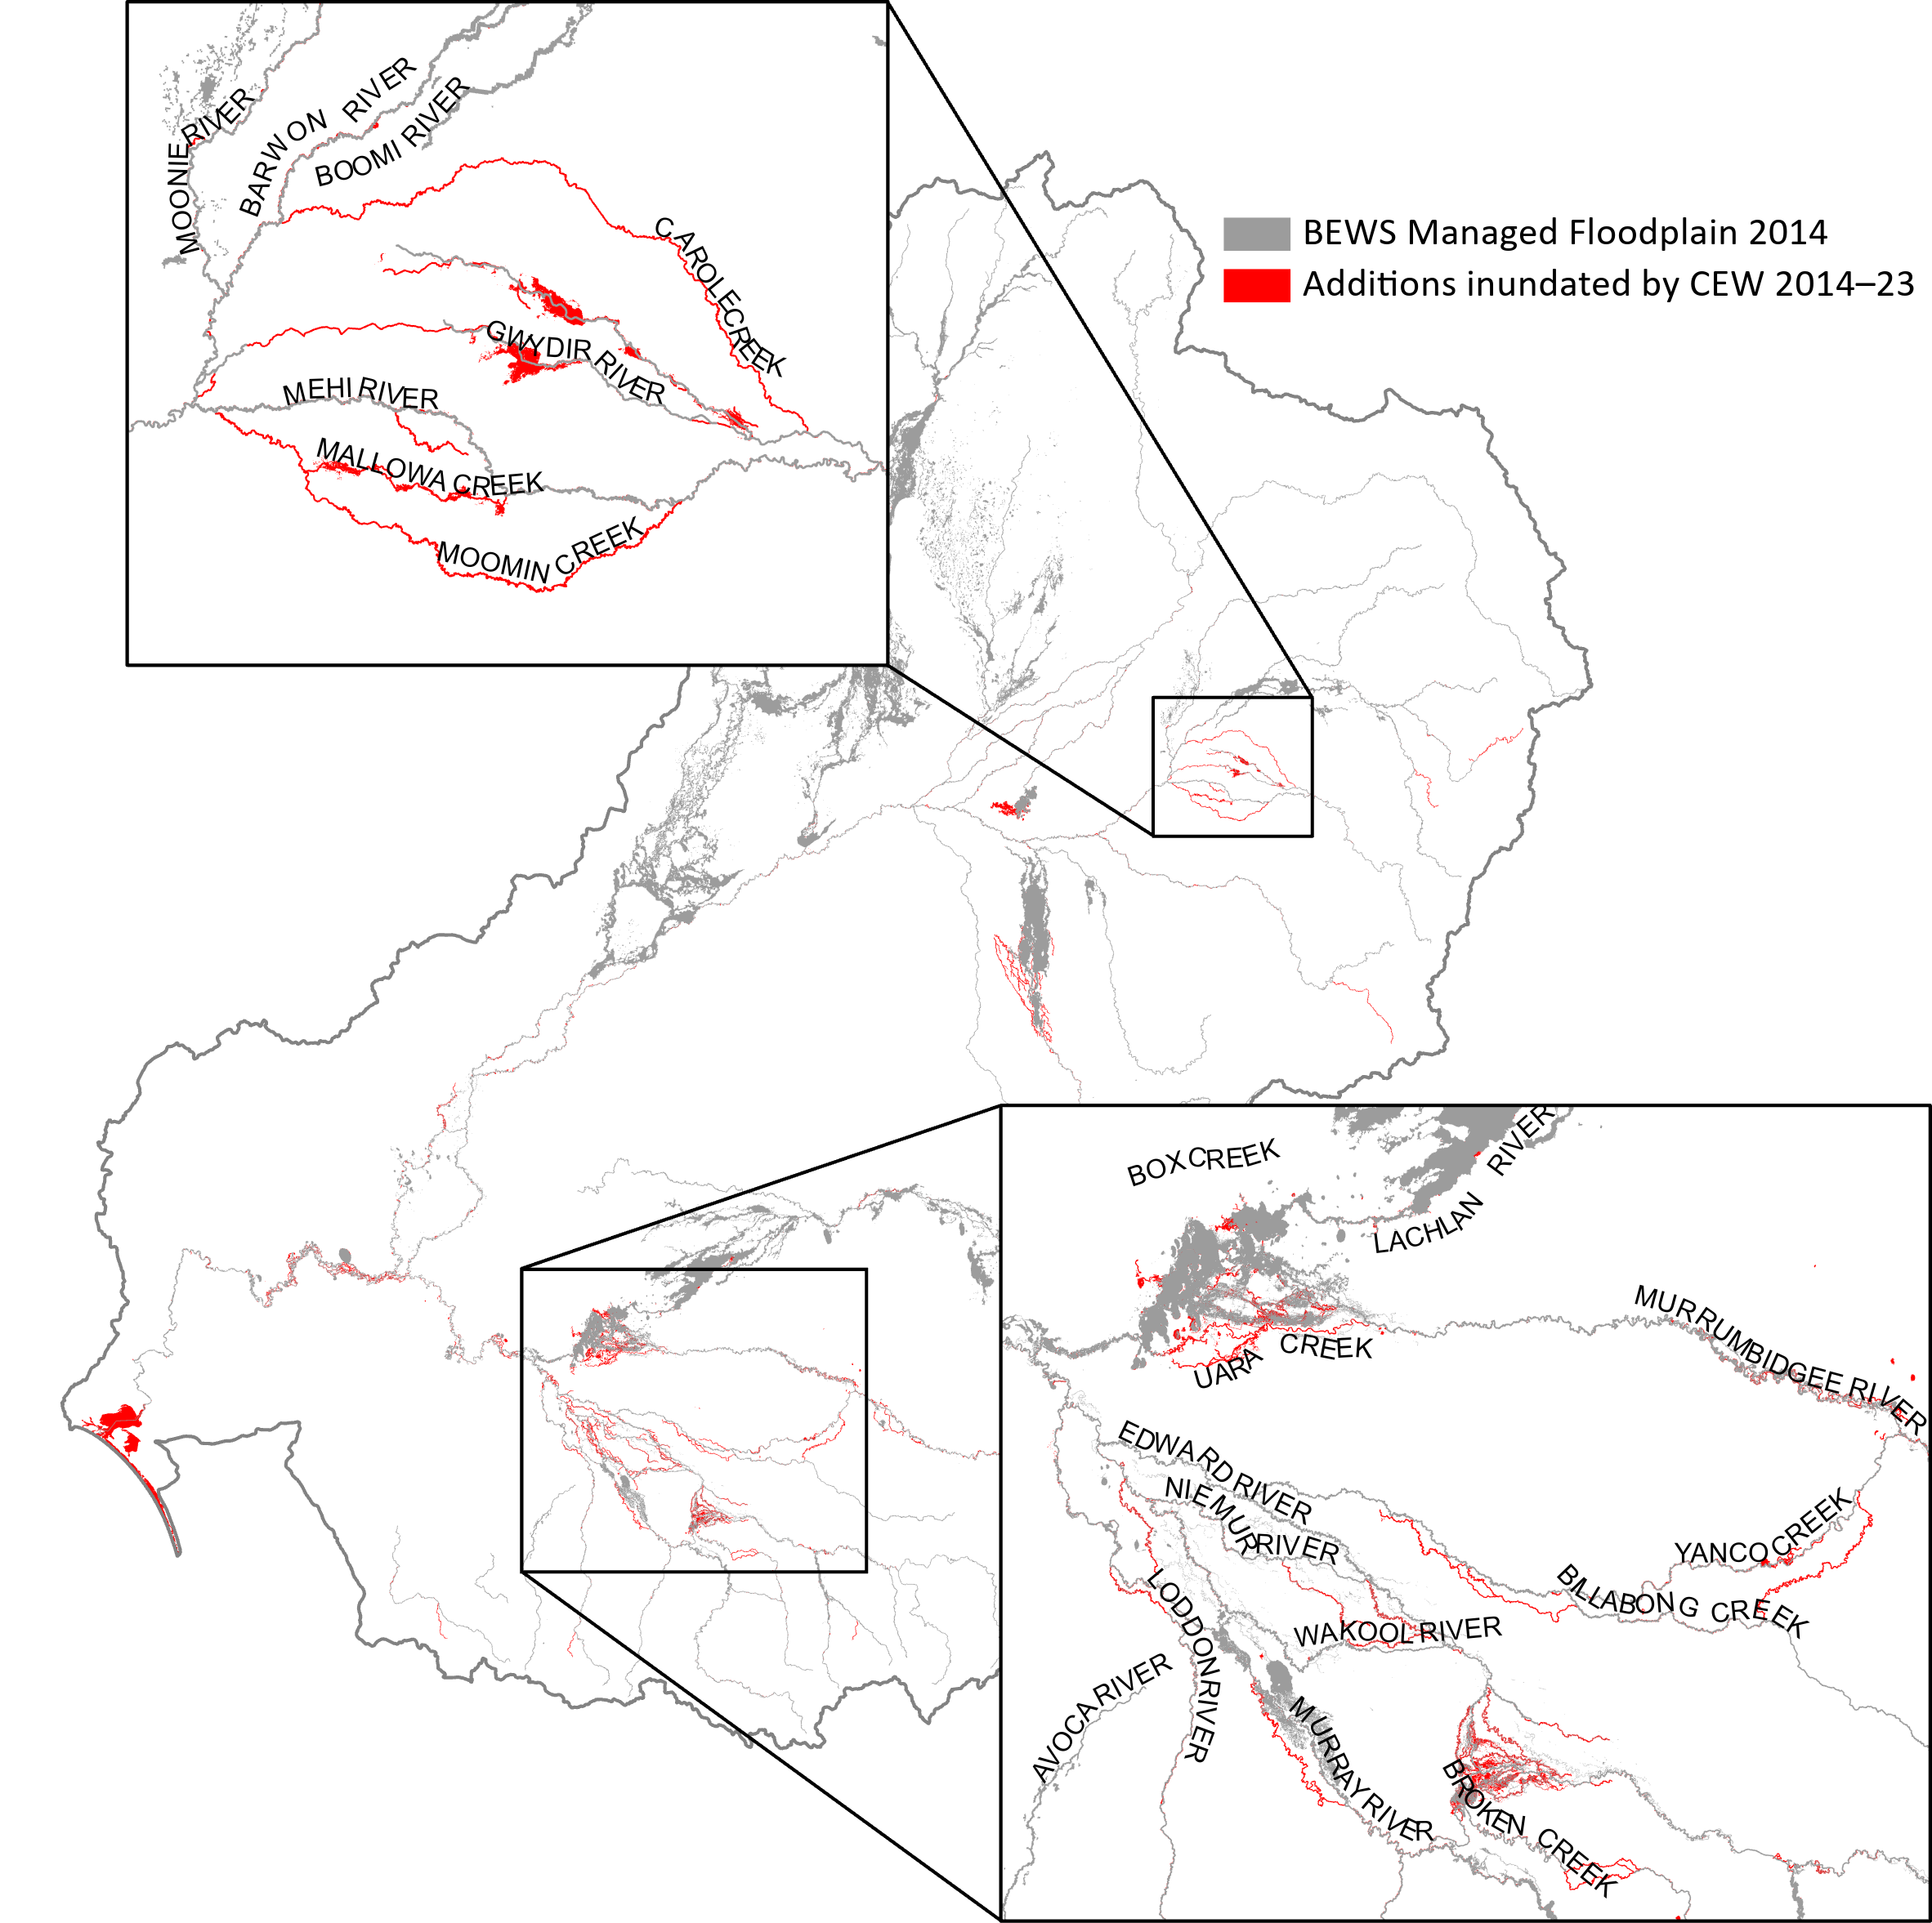

Rainfall data
Annual gridded rainfall decile data (Resolution: 0.05° x 0.05°, unit: % ranked into categories) for the evaluated water year in the Basin are acquired from the Bureau of Meteorology (BoM) through its data services. The annual gridded rainfall deciles are estimated from over 1,000 stations (https://reg.bom.gov.au/climate/cdo/about/about-stats.shtml). The rainfall deciles rank the evaluated water year against the long-term rainfall record and assign 7 categories ranging from ‘Lowest on record’ to ‘Highest on record’ (http://www.bom.gov.au/lam/glossary/deciled.htm).

Surface water runoff
Surface water runoff was introduced into the reporting in 2024 for the 2022–23 evaluation cycle and sourced from CSIRO. The method is reported in Chiew et al. (2018) and Zheng et al. (2024). CSIRO ran their model to simulate daily streamflow of the Basin for each 0.05° grid cell using the GR4J model (Perrin et al. 2003). Daily rainfall and potential evapotranspiration (PET) from SILO (Jeffrey et al. 2001) were used as inputs into the model. The daily PET is estimated using Morton’s wet environment areal evapotranspiration formulation (Morton 1983). The GR4J model was calibrated and validated against observed streamflow for the period 1981–2010 from 193 unimpaired headwater catchments within the Basin. The nearest neighbour approach was applied in parameter regionalization.
These daily estimates were then processed by the Flow-MER team. They were summed by water year for each location then a geometric union with the valley shapefile performed. Valley volumes for each water year from 2000–01 to the most recent year were then calculated by multiplying the area of each polygon within each valley by the rainfall-runoff estimate and summing by valley.

Flow estimation

Estimating daily CEW flow from flow profiles in the system
Some data providers do not provide a daily timeseries of CEW at the relevant gauges but instead supply a release profile from a reservoir or a weir pool. In those cases where daily CEW information at relevant gauges in the valley is not available, daily CEW flow is estimated using the travel time between gauges to account for CEW at the relevant gauge. For this procedure:
- Firstly, the release event is isolated at all gauges in the river system that would receive the CEW flow downstream, or, if a downstream release profile is recorded, the relevant event at the gauges upstream is isolated.
- Secondly, to adequately compare the gauges in the river system, the baseflow before the event occurrence is quantified at each gauge and subtracted from the flow signal, effectively yielding event flow timeseries with a baseflow of 0 ML/d.
- Finally, the travel time is estimated, usually from the peak of the event, or in cases where the peak definition changes downstream, from other characteristics in the flow signal (e.g. a second peak or the falling limb of the flow signal).
An example for the Lachlan system is given in Figure 7.2 where in February 2023 a release occurred from Wyangala reservoir, and the flow signal of the release event was followed downstream (gauges are in downstream order Wyangala -> Cowra -> Nanami -> Forbes -> Jemalong -> Condobolin).
After estimating the travel time between gauges, the daily CEW timeseries was propagated downstream, shifting the daily CEW signal by the estimated travel time. This accounting approach is used to estimate CEW where necessary. In cases where the accounted CEW would result in negative flows at a gauge, the travel time is re-estimated using a second event in the system. The approach described here is used as long as a flow signal could be distinguished downstream (i.e. where the timeseries showed correlation). When the correlation between an upstream gauge and a gauge in question could not be established, by shifting the signal by the estimated travel time and assessing correlation strength of the event in question, this manual accounting approach was not used.
Flows in the Central Murray, the Lower Murray and parts of the Lower Darling are modelled by the MDBA (with and without CEW), although the selection of modelled gauge data that is provided by the MDBA changes year on year.
Figure 7.2 Example of implementation of the method for estimating daily CEW flow from flow profiles during the month, 23 February to 25 March 2023
The plot is a set of lines that show the effect of travel time on offset discharge (ML/day) between the 6 gauges from Wyangala downstream to Condobolin (Wyangala, Cowra, Nanami, Forbes, Jemalong, Condobolin). Time is on the x-axis and offset discharge on the y-axis.
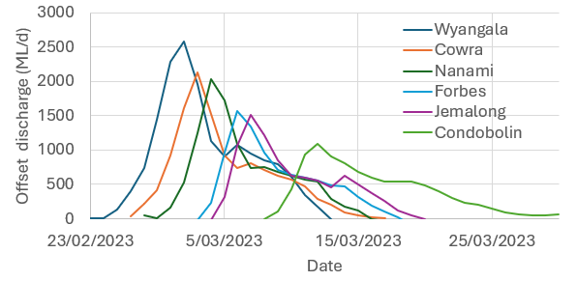

Quality control of the flow data
Observed flow from gauging stations is the preferred source for the observed flow signal. However, many observed flow timeseries have quality issues, broadly categorised as:
- Missing data, resolvable by interpolation: The flow timeseries shows isolated instances where up to 2 days of data are missing or a high flow peak is not rated.
- Missing data, not resolvable: The flow timeseries shows prolonged instances of missing data where interpolation is not possible like prolonged periods of no data or of the flow signal dropping to 0 ML/d.
A second dataset of daily flow timeseries of modelled or accounted flow, or a reproduction of the gauged flow, may be received from relevant water agencies. In the ideal case, this dataset matches the observed gauge data or is similar enough to be used to fill in gaps in the gauged data. However, in other cases, the 2 datasets differ substantially, and the difference between the two has to be resolved. This is done using the following 4 rules:
- When the gauged data matches the water agency’s flow data, use the gauged data (example in left plot, Figure 7.3.
- When the gauged data mostly matches the water agency’s data, except for e.g. event flows, investigate the reasons, and backfill the gauged data with the water agency’s data (example in right plot, Figure 7.3).
- When the gauged data completely mismatches the water agency’s data, investigate the reasons, and generally use the gauged data, EXCEPT for cases where removing the CEW contribution would result in negative flows (August in the example in Figure 7.4). In negative flow cases, the water agency’s data is preferred.
- When resolution between the gauged data and the water agency’s data is not possible, use the gauged data with a quality issue tag appended to the data, or remove that gauge from the evaluation.
Figure 7.3 Examples of application of Rule 1 (when the gauged data matches the water agency’s data) and Rule 2 (when the gauged data mostly matches the water agency’s data)
Both plots (Rule 1 on the left and Rule 2 on the right) are line graphs with time on the x-axis and discharge on the y-axis. They display line plots of discharge information received from the water manager (broken orange line) and the gauged data from the water management information system (WMIS) (solid blue line). These examples are for gauge 403241 Ovens River and 404217 Broken Creek for the 2023 water year.
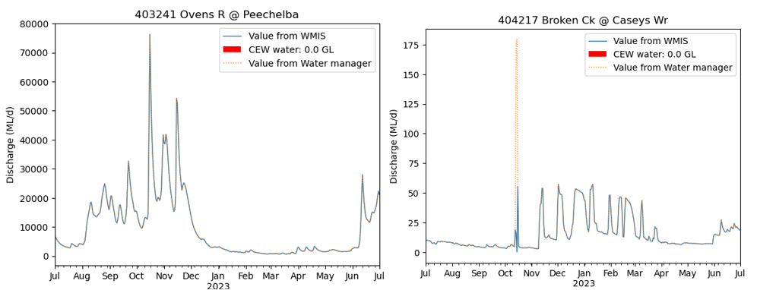
Figure 7.4 Example of application of Rule 3 (when the gauged data mismatches the water agency’s data)
The plot is a line graph with time on the x-axis and discharge on the y-axis. It displays line plots of discharge information received from the water manager (broken orange line) and the gauged data from the water management information system (WMIS) (solid blue line) and solid red colour where CEW was recorded. This example is for water year 2023, gauge 405203 Goulburn.
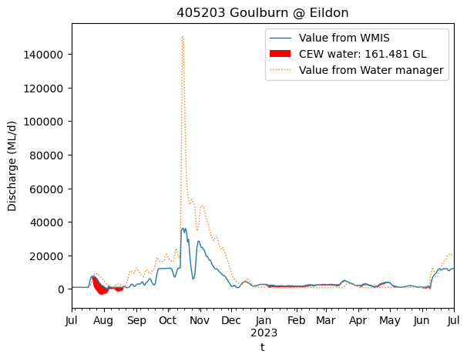

Flow component thresholds
The flow component thresholds are derived from the long-term watering plans (LTWPs) for the Basin (prepared by Basin state governments).
This is in contrast to previous methods where flows were decomposed based on the level of the flowing water at a gauge for all flow components other than base flow (see Section 8.2.1) and the base flow component was derived from modelled pre-development flows at relevant gauges (Davies et al. 2004).
The LTWP flow thresholds have been extracted from the py-ewr Python tool (MDBA 2024) which collates information on LTWPs throughout the Basin from the ‘minimum flow threshold’ information (threshold unit: ML/d). Not all gauges where counterfactual scenarios are available have LTWP flow thresholds.
Very low base flow, low base flow, low fresh and high fresh thresholds are used as the in-channel flow components for the assessment of how CEW affects the flow regime of the Basin and progress towards Basin Plan and Strategy objectives. Overbank flow is assessed as well using the maximum area inundated by CEW or water that contained CEW as the relevant metric, thus, directly linking to relevant ecosystem assessment.
For the in-channel flow components, the LTWP can specify multiple thresholds for the same flow component based on valley, season or other factors (State of NSW and DCCEEW and MDBA 2024). Each threshold is assigned a code, and in the evaluation of flow components all codes for the relevant gauges are used to extract a flow threshold for each relevant gauge. For gauges where multiple threshold codes for the same flow component are available and the values of the flow thresholds differ, the smallest flow threshold is chosen for the gauge.
Not every gauge has a suitable LTWP flow component threshold. In some cases, adopting the thresholds from the closest gauge (with thresholds) may be the best approach. We have encountered several issues with data and threshold availability including lacking flow component (e.g. medium fresh) thresholds compared to the evaluation pre-2022–23. In these cases, the approach adopted is documented in the evaluation report. Specifics of information available and used each year are included in the annual evaluation report.

Flow component decomposition
The decomposition of the flow signal is carried out by comparing the flow timeseries to the threshold value. Any instance where the flow in the daily timeseries is greater than the flow threshold, it is considered above the threshold level for the 4 thresholds in question (very low base flow, low base flow, low fresh, high fresh). Both the factual flow (with CEW) and the counterfactual scenario (without CEW) are decomposed using this decomposition method.

Counterfactual streamflow scenario development
The CEW contribution to streamflow is generally measured at 100 (or more) gauges in the Basin, although depending on data availability the number of gauges that have CEW information can be variable. Daily values for CEW flow supplied by state or federal agencies, and catchment management authorities are used to evaluate the CEW contribution; where daily CEW flow is not available but inferable from another gauge in the river system, the inference is made using estimated travel time and accounting for CEW at the gauge of inference.
To develop a counterfactual scenario, daily CEW flow is subtracted from the daily observed or modelled gauge flow (depending on which value was chosen after the quality assurance process) yielding a timeseries at the gauge without CEW contribution.
Environmental water released by agencies other than the CEWH is accounted for as passing flow, as only CEW is subject to the evaluation.
The factual (observed or modelled streamflow at a gauge) and the counterfactual (observed streamflow without CEW contribution) scenarios are then used in to evaluate the effect that CEW has in delivering additionality to a certain flow component.

Areal extent of inundation
CEW inundation mapping is in 2 datasets:
- a raster dataset representing inundation of wetlands and floodplains by environmental water outside of river channels
- a vector dataset of the Australian Hydrological Geospatial Fabric (Geofabric v3.2) river segments that contain environmental water during the water year. River reaches that received in-channel pulses, freshes and passing flows are identified; however, the river channel inundation mapping is not of sufficient resolution to quantify increases in river width, nor to identify local inundation of riverbanks, benches or fringing habitats along channel margins.
These are combined to create a maximum extent map. To illustrate the result, the map for the 2022–23 water year is provided in Figure 7.5. Details of the steps involved are set out below the figure.
Figure 7.5 Map showing the maximum extent of all Commonwealth environmental water in rivers, wetlands and floodplains, 2022–23
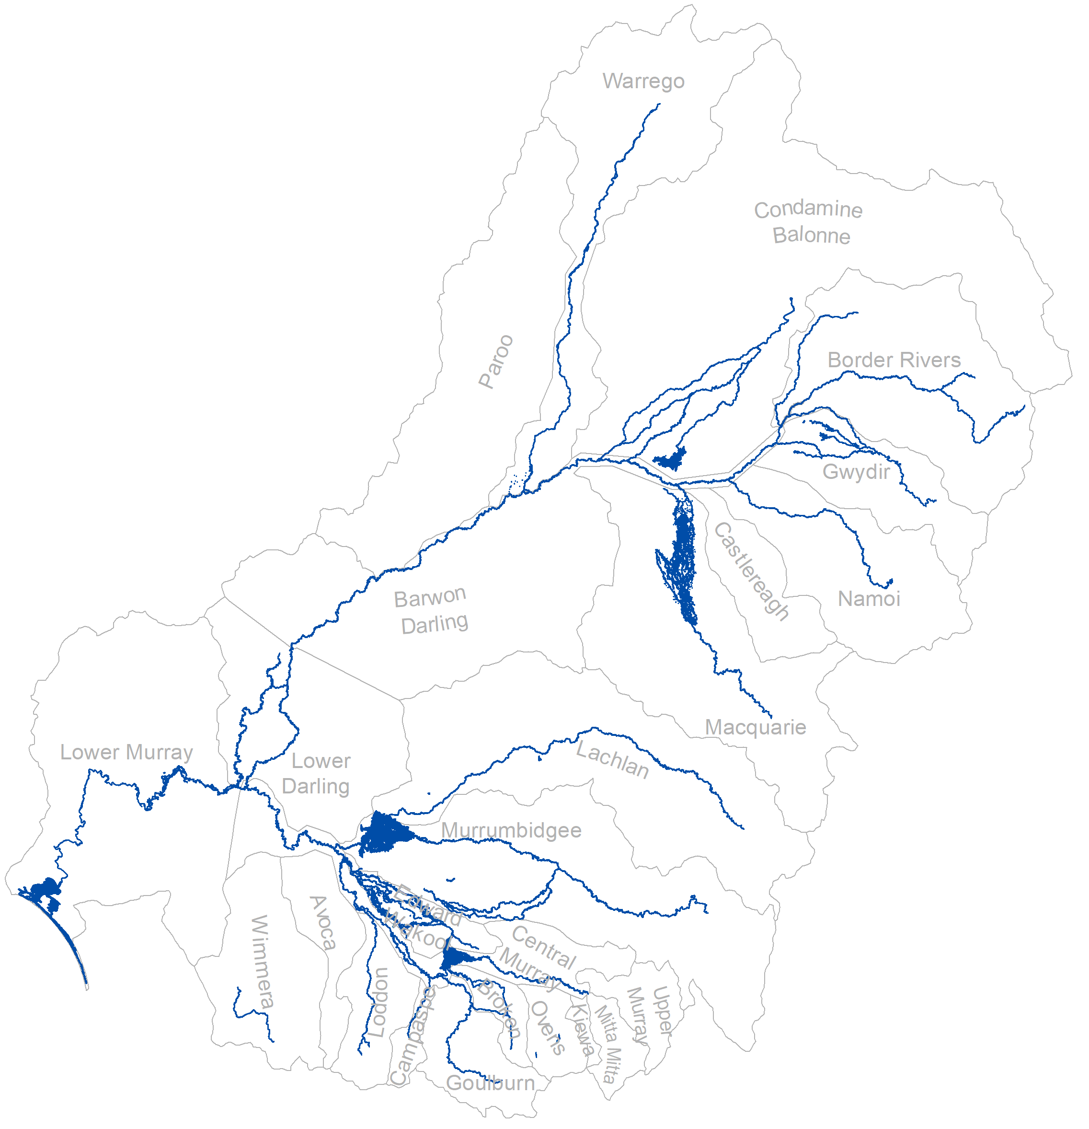
The inundation extent affected by CEW is developed from the watering actions listed in the Watering Actions Table (WAT) (see Section 7.1) with overbank or wetland flow components. The timeframes of those actions are used to develop a raster of annual maximum inundation extents where CEW is present, supplied at 10 km x 10 km resolution. The original inundation information is generally sourced at finer scales (see below). This workflow is divided into 2 parallel streams (Figure 7.6):
- existing mapping: Where mapping data is available from data providers, the maximum extent within the watering action timeframe is selected for the watered asset. Mapping from NSW DCCEEW is used wherever available as it presents validated information. The mapping is derived from Landsat (30 m pixel) and Sentinel-2 (10 m pixel).
- satellite imagery analysis: Where no mapping is available, a satellite imagery analysis workflow is employed to map the maximum extent of inundation affected by CEW.
The steps in the satellite imagery analysis workflow is described in Figure 7.6. In the water year 2023–24, the workflow was amended to use Digital Earth Australia, using the Water Observations product as a first pass, which maps open water in wetlands well. The DEA water observations product often did not sufficiently map water in vegetated areas, which is why it was supplemented with digitised inundation extents from the false colour and infra-red products:
- Acquire satellite imagery from Sentinel 2 and Landsat using the DEA (Digital Earth Australia) mapping (5-day timestep in the visual spectrum) or in water year 2022-23, Google Earth Engine, for the inundation asset of interest within the watering timeframe plus one additional week. The additional week was added to account for potential travel time within the delivery timeframe.
- Discard images with a high cloudy pixel percentage.
- Apply Modified Normalized Difference Water Index, if necessary, (MDWI) (Xu, 2006) filtering using a cut-off threshold that classifies values above the threshold as water (i.e. inundation) and below the threshold as non-water. This filtering was used in the GEE workflow, however from 2023-24 the DEA workflow was used, which uses built-in thresholds. The threshold was highly dependent on the location, and the identification of water was cross-checked against the RGB image.
- Select the image with highest inundation extent from the collection of images.
- Verify and validate mapped extent with water managers and water delivery partners, and, if necessary, iterate through the process until the mapped extent aligns with the on-ground observations by the water managers.
Figure 7.6 Workflow of developing a spatial inundation extent of CEW
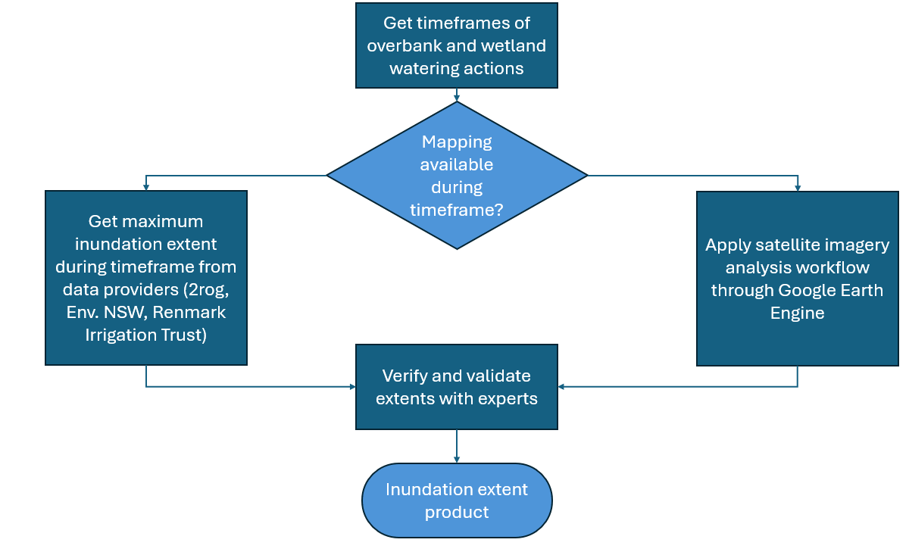
The inundation extent from existing mapping and from the satellite imagery workflow is combined into a raster layer (10 x 10 km) resolution and validated against the WAT (if an extent was measured), the previous year’s inundation mapping, and against the expertise and local on-ground knowledge of Selected Area researchers and mapping data providers.

Length of watercourses watered with CEW
The second inundation product is an annual layer of watercourses watered with CEW. River line assets from the Geofabric (BoM 2023) and information from the WAT are used. The length of waterways with CEW is defined as the sum of the Geofabric segment line length designated as holding CEW during the water year (1 July to 30 June). The distribution of CEW in channels mapped by LTIM in 2014–19 was updated to the current v3.2 Geofabric mapping (BOM 2020) to ensure the mapping of CEW was comparable and consistent among all years of monitoring evaluated in Flow-MER.
- Select the Basin ANAE Geofabric v3.2 Network Streams that have line segments overlapping the Basin inundation ‘watercourses watered’ mapping.
- Intersect the selection with the LTIM valleys.
- Calculate the length of inundated segments for each riverine ecosystem type in kilometres using equal area GDA94 Australian Albers projection.
- Calculate summary statistics to sum the length of each river ecosystem type per valley.
Thus, a length of river is considered watered with CEW if:
- the WAT indicates a release from a reservoir downstream until it reaches the intended asset
- the asset is connected to a floodplain or another river channel in the Basin network, the connecting river section is considered watered by CEW
- all watercourses intersecting with the inundation raster mapping are included in the CEW-watered watercourses layer
- Anabranches are included unless water infrastructure, such as weirs, prevents flow into them.
For the Murray River, the CEW-watered watercourses are cross-validated with satellite imagery from Copernicus during the periods when CEW flows passed through gauges in the Lower Murray.
This approach ensures a comprehensive and accurate representation of CEW-influenced watercourses.

Changes to methods
Minor changes in methods occurred in 2025 for the 2023 –24 evaluation of Hydrology foundation datasets, Species Diversity and Food Webs and Water Quality. This follows on from major changes to Hydrology and Species Diversity for the 2022–23 evaluation, conducted in early 2024 (Table 8.2). These changes are based on learnings from the 2021–22 evaluation and the difficulties of data collection in the extreme wet of 2022–23.

2023–24 updates (evaluation conducted 2025)
Table 8.1 Summary of method updates for all Themes in 2023–24
Theme | Updates
Hydrology | No methodological change. Minor change in sourcing of flow component thresholds and discontinuation of additionality analyses and reporting
Ecosystem Diversity | No methodological change. Inclusion of schematic diagram of steps in the approach
Species Diversity | A 1000 m buffer was applied to historical detections when associating with Australian National Aquatic Ecosystem polygons. Machine learning feature ‘Quadratic frequency’ was replaced by features ‘Mean vegetation’ and ‘SD vegetation’. Double-debiased machine learning plots and Shapley additive value force plots were replaced with Partial dependence plots for post-hoc visualisation
Vegetation | No methodological change, consistent with the 2021 Foundation Report Update for Vegetation. Inclusion of schematic diagram of steps in the approach
Fish | No methodological change. Change of water year to 1 July to 30 June (from 1 September to 31 August); reverted length thresholds (to define recruitment) back to pre-2022 levels in the Lower Murray; inclusion of schematic diagram of steps in the approach and changes in statistical method as documented in Fanson (2025) and repeated here
Food Webs and Water Quality | No methodological change. Inclusion of counterfactual modelling which allowed for analyses and reporting on comparison of outcomes with and without Commonwealth environmental water

Hydrology methods update
In the water year 2023–24, the additionality maps were discontinued as they did not communicate the information to a satisfactory degree. Instead, the CEW additionality was evaluated using key hydrographs that presented the flow at a gauge with and without CEW (counterfactual scenario), including a representation of the pre-development flow signal and relevant flow thresholds. The hydrographs clearly communicated how CEW contributed to reaching ‘natural’ flow regime.
The key gauges where this information was presented were changed from the end-of-valley gauges (as in the evaluation 2022–23) to the gauges closest to the environmental assets named in the Watering Actions Table. This shift towards the gauges closest to the assets that CEW contributed water to allowed for an enhanced understanding of how CEW contributes to changes in flow regime where the water is intended to be delivered.

Species Diversity methods update
The pilot machine learning methodology (reported in Wassens et al. 2024) requires a minimum threshold of 100 records to train each species. To reach the minimum threshold for the five new threatened bird models we applied a 1000 m buffer around each historical detection and associated the species with all ANAE polygons that crossed into the buffer. This allowed us to reach the threshold with minimal use of synthetic ROSE samples that were identified as a potential issue during the pilot study.
The pilot study also recommended removing the ‘Quadratic frequency’ feature from future models due to poor predictive performance. This feature was removed and replaced with two new features: Mean vegetation and SD vegetation. These features displayed strong predictive performance in several of the new models.
When visualising the best performing models, the pilot study used double-debiased machine learning to derive the linear relationship of each feature to the outcome class. Some of these relationships appeared to misrepresent the underlying trend (probably because the actual relationships were non-linear) and the pilot study recommended that a different approach should be trialled. These recent models used Partial dependence plots (PDPs) to plot the isolated effect of each feature when all other features were held to their mean values. This approach improved post hoc model interpretation by capturing non-linearities.

Fish methods update
While there was no change in the evaluation approach, there were several changes in the statistical analyses that underpin the evaluation (reported in Fanson 2025). The change in water year (from September–August to July–June) means that some recruitment results cannot be compared with those from previous years. There is no significant impact on the long-term trend analyses as these are re-run every year (i.e. they are not cumulative on top of previous years’ results).
Changes were made to the code to correct how count of missing fish was inferred from age and length. This correction had no discernible impact on evaluation results.

Food Webs and Water Quality methods update
To estimate the contribution of Commonwealth Environmental Water (CEW) to riverine gross primary productivity (GPP) from 2014 to 2024, we implemented counterfactual modelling using a two-step approach. First, a statistical model was developed to relate daily GPP to its key environmental drivers: solar radiation and river flow. Solar radiation data were averaged monthly to minimise circularity, and flow was standardised relative to the maximum for each site. We employed a generalised additive model (GAM) to allow for linear and non-linear effects, selecting the best-fitting model using the Akaike information criterion (AIC). The chosen model then predicted daily GPP under both observed (with CEW) and counterfactual (without CEW) flow scenarios, with results summarised weekly for comparison.
The analysis focused on 28 sites across six Selected Areas, each with substantial data availability, resulting in 99 year-site combinations and more than 16,000 daily GPP estimates. By comparing predicted GPP under observed and counterfactual scenarios, the modelling enabled clear visualisation and quantification of CEW's impact on river productivity across different locations and years.

2022–23 updates (evaluation conducted 2024)
Table 8.2 Summary of method updates for all Themes in 2022–23
Theme | Updates
Hydrology | Major methodological change – new methods
Ecosystem Diversity | No methodological change. Change to mapping of the ‘managed’ floodplain
Species Diversity | Major methodological change – new methods
Vegetation | No methodological change, consistent with the 2021 Foundation Report Update for Vegetation
Fish | No methodological change. Introduced reporting of distribution of focal species within Selected Areas. Else consistent with the 2022 Foundation Report Update for Fish
Food Webs and Water Quality | No change, consistent with the 2021 Foundation Report Update for Food Webs and Water Quality

Hydrology methods update
The methods used to produce foundation datasets and the hydrology evaluation for the water year 2022–23 differed to previous years’ evaluation. These changes have been described in Section 1.1.1. Further adjustments and reasoning behind these changes are detailed below.

Changes to flow component thresholds
The flow component thresholds were derived from the long-term watering plans (LTWPs) for the Basin (prepared by Basin state governments), as opposed to the methods previously employed where flows were decomposed based on the level of the flowing water at a gauge for all flow components other than baseflow. The baseflow component was derived from modelled pre-development flows at relevant gauges (Davies et al. 2004).
The methods were changed because (i) the CEW delivery is usually planned by using the LTWPs and the therein developed thresholds (Commonwealth of Australia 2022), and (ii) cross sectional information could only be obtained for about half of the gauges of interest from publicly available sources (about 77 of the 143 gauges of interest in water year 2022–23) with critical gauges in the Lower Murray system completely missing hydrometric information.
In addition, small discrepancies were found when comparing the LTWP flow thresholds for baseflow components to the previously used method of deriving the baseflow threshold from modelled pre-development flow. The main reason for the discrepancies was likely that the LTWP thresholds are derived for the whole river reach downstream of a gauge of interest (i.e. the planning unit), whereas the previously used method accounts for flow at the gauge without considering downstream variation in channel morphology. Further to the small discrepancies in the baseflow threshold, larger differences were found when comparing the LTWP fresh thresholds to the method that uses the cross-sectional information. No discernible pattern or correlation could be established in these differences which again could be due to channel morphology. Thus, until an improved method can be developed, or more hydrometric and bathymetric information becomes available across the Basin, the LTWP flow thresholds will be used for the evaluation of CEW contribution to the flow regime.

Ecosystem Diversity method update
No major changes in methods have occurred within the Ecosystem Diversity theme for 2022–23. The managed floodplain extent has been updated based on the extent of inundation as detailed below.

Managed floodplain extent
The LTIM and Flow-MER projects have mapped inundation by Commonwealth water annually since 2014 using satellite imagery and observations by water managers. These maps provide 9 years of additional evidence to support an update to the managed floodplain extent, as, by definition, all areas watered using CEW are ‘managed’. The combined maximum extent of all wetland, floodplain and river inundation from 2014–23 was added to the Strategy managed floodplain (Table 8.3, Figure 7.1). River channels mapped by lines were buffered to 300 m maximum width, which is consistent with the original map. The 9 years of monitoring has added 359,091 ha to the managed floodplain, a 10% increase over the 2014 mapping (Table 8.3, Figure 7.1). This additional area intersects 6,736 mapped ANAE wetlands and floodplains, increasing the knowledge of ecosystems ‘in scope’ for environmental water management.
Table 8.3 Additions to the managed floodplain for each Basin valley from watering 2014–23
* Basin-wide environmental watering strategy (the Strategy) (MDBA 2019)
Valley | Strategy* managed floodplain area (ha) | Area added (ha) | Percentage increase (%) | Comments
Northern Basin
Barwon Darling | 125,425 | 6,886 | 5% | Channel margins and small anabranch channels
Border Rivers | 161,677 | 9,140 | 6% | Added Severn River
Castlereagh | 36,184 | 0 | 0% | No change
Condamine Balonne | 368,101 | 17,852 | 5% | Channel margins
Gwydir | 30,074 | 23,628 | 79% | Addition of Carole Creek, Noomin Creek, Mallowa Creek, Ballin Boora Creek; expansion of floodplains along Gingham watercourse and Gwydir River
Macquarie | 277,482 | 26,493 | 10% | Added sections of Marthaguy Creek, Bulgeraga Creek and Milmiland Creek
Namoi | 23,143 | 4,895 | 21% | Added Peel River
Paroo | 804,525 | 0 | 0% | No change
Warrego | 769,420 | 1,144 | 0% | No change
Southern Basin
Avoca | 13,909 | 0 | 0% | No change
Broken | 12,218 | 3,520 | 29% | Added Moodie Swamp and Broken Creek, Wild Dog Creek and Nine Mile Creek near the town of Numurka
Campaspe | 7,711 | 182 | 2% | Outflow of Tullaroop Reservoir to the confluence with the Loddon River
Central Murray | 132,504 | 36,372 | 27% | Gunnbower Creek, expansion of floodplain near Margoya lagoon, Lake Benanee and Barmah–Millewa Forest
Edward/Kolety–Wakool | 39,062 | 32,134 | 82% | Expanded floodplain along channels that routinely carry CEW
Goulburn | 24,771 | 393 | 2% | Channel margins
Kiewa | 4,459 | 0 | 0% | No change
Lachlan | 460,210 | 7,037 | 2% | Extensions to Moon Moon Swamp, Lachlan Swamp at Goonawarra and Great Cumbung Swamp
Loddon | 13,284 | 1,734 | 13% | Addition of Tullaroop Creek
Lower Darling | 54,479 | 5,759 | 11% | Channel margins and anabranches
Lower Murray | 84,277 | 124,015 | 147% | Added the Coorong, Lake Alexandrina, Lake Albert and Murray Mouth
Mitta Mitta | 8,156 | 0 | 0% | No change
Murrumbidgee | 192,143 | 55,148 | 29% | Expanded floodplain extent in Lowbidgee particularly along Uara Creek and Paika Creek
Ovens | 19,523 | 1,053 | 5% | Added Buffalo River
Upper Murray | 11,348 | 0 | 0% | No change
Wimmera | 15,178 | 1,706 | 11% | Added Mount William Creek
Total | 3,689,263 | 359,091 | 10%

Species Diversity method update
In 2022–23 the Species Diversity theme piloted a modelling approach to evaluate the outcomes of CEW for threatened species. The evaluation retains the key assessment of species occurrence with respect to areas inundated by CEW, but with evaluations of Selected Area data for frogs (except for listed threatened species) and turtles removed. See Chapter 3 for further detail.
The species richness map was not produced for the 2023–24 evaluation.

Fish method update
The introduction of analysis of focal species distribution was not a change of method per se; rather it contributed another metric to the reporting.

2021–22 updates (evaluation conducted 2023)
Table 8.4 Foundation Report updates for all Themes (Cuddy et al. 2022)
Theme | Updates
Hydrology | No change, consistent with the 2020 Foundation Report Update
Ecosystem diversity | No change, consistent with the 2020 Foundation Report Update
Species diversity | No change, consistent with the 2021 Foundation Report Update
Vegetation | No change, consistent with the 2021 Foundation Report Update for Vegetation
Fish | Minor changes were described in 2021 Foundation Report Update  Changes to the analytical outputs table are described in Chapter 2 of this report
Food webs and Water Quality | No change, consistent with the 2021 Foundation Report Update
[The following text is extracted from Cuddy et al. (2022), with changes to table numbering.]
Minor revisions have been made to the updated tasks and analytical outputs summary table (references in Table 8.5). These changes are based on learnings from the 2020–21 evaluation report and include the addition of specific figures to help with interpretation of the evaluation, an investigation of extensions to the high-level Evaluation-theme models and investigation of alternative metrics of assemblage structure. Foundation Report Updates 2022 and associated risks are summarised in Table 8.5.
Table 8.5 Summary of Fish Theme updates introduced for 2021–22 evaluation
Section | Updates
Why | Minor changes, largely consistent with Foundation Report Update 2020: Fish (Stuart et al. 2020) and Foundation Report Update 2021 (Barbour et al. 2021)
What | Updated tasks and analytical outputs to determine the effects of environmental flows on native fish
How | Updates to:  - Data inputs with 2022 Selected Area field monitoring data potentially available for analysis  - Building on learnings from the evaluation report, we will review hydrological and fish community/composition/spawning/recruitment metrics to identify the most ecologically sensitive and meaningful relationships, informed by recent similar analyses for Victorian VEFMAP program and other long-term datasets  - Introduce figures to display estimated contributions of each flow metric to observed effects of Commonwealth environmental water  - Investigate extensions to the high-level Evaluation framework to investigate fish responses at the basin scale for additional species and fish metrics, focusing on predicted effects of Commonwealth environmental water at unmonitored gauge locations  - Investigate alternative metrics of assemblage structure to estimate effects of Commonwealth environmental water on fish assemblage structure

2020–21 updates (evaluation conducted 2022)
[The following text is extracted from Barbour et al. (2021), with changes to table numbering and modification to content to remove broken linkages.]
Table 8.6 Foundation Report updates for all Themes, 2020–21 (adapted from Table 1 in Barbour et al. 2021)
Theme | Updates
Hydrology | Evaluation of cease-to-flow events were excluded post the 2020 Foundation Report Update.
Ecosystem diversity | No change, consistent with 2020 Foundation Report Update.
Species diversity | Largely consistent with the 2020 Foundation Report Update
Vegetation | Methodology remains broadly consistent with the overarching approach described in the 2020 Foundation Report Update but with changes to the methodological detail (such as inclusion of hydrological characterisation).
Fish | Minor changes to the updated tasks and analytical outputs tables.
Data collection methods remained unchanged although we propose 2 minor updates:
- Among the Foundation Report evaluation objectives is the question: 'What did Commonwealth environmental water contribute to patterns and rates of decomposition?' We propose to change ’decomposition’ to ‘ecosystem respiration’ as this better reflects what is being evaluated, i.e. the question becomes ‘What did Commonwealth environmental water contribute to patterns and rates of ecosystem respiration?’
- Limitations in existing methods for data analysis (in this case the BASE model) for analysing stream metabolism data limit the capacity to understand and predict metabolism response to different flow scenarios. The highest level of confidence in observed data was achieved in the Lower Murray River (90% using 244 daily records), and the lowest was for the junction of the Warrego and Darling rivers (12% using 24 daily records). These limitations are a consequence of the modelling approach (which can fail at higher flows) and the stringent criteria set by the Foundation Reports for accepting model fits. The acceptance criteria for inclusion of modelled outcomes of raw dissolved oxygen (used to calculate gross primary production and ecosystem respiration) will be reviewed for the 2020–21 evaluation, and the Foundation Reports may need to be amended accordingly.
Table 8.7 Summary of Species Diversity Theme updates, 2020–21 (Table 2 in Barbour et al. 2021)
Section | Updates
Why | Minor changes, largely consistent with Foundation Report Update 2020
What | Updated tasks and analytical outputs to determine the effects of environmental water delivery on Species Diversity
How | Updates to:  - Data inputs: Investigate data sources that complement Selected Area monitoring to extend analysis across multiple valleys  - Investigate analysis approaches for presence only datasets and methodologies to standardise sample effort to better describe links between Commonwealth environmental water and Species Diversity  - Text to make a clearer delineation between outputs of the Ecosystem Diversity Theme and Species Diversity Theme reporting  - Collating the outputs of the Ecosystem Diversity Basin Matter to identify ecosystem types:  - where key species were observed to have benefited from Commonwealth environmental water  - that were watered but not monitored  - within Ramsar wetland areas likely to have benefited from Commonwealth environmental water.
Risks | - Limited availability of Selected Area monitoring outcomes related to Species Diversity  - Availability of complementary datasets, particularly time lags in the availability of monitoring and evaluation reports and data generated outside of the MER framework  - Availability and quality of 2020–21 inundation hydrology data will impact our capacity to identify species with distributions that overlap delivery of Commonwealth environmental water. Availability of mapped inundation data outside of Commonwealth environmental water delivery areas impacts our capacity to evaluate the relative contribution of Commonwealth environmental water.
Table 8.8 Summary of Vegetation Theme updates, 2020–21 (Table 3 in Barbour et al. 2021)
Section | Updates
Why | Minor changes, largely consistent with Foundation Report Update 2020
What | Methods remain broadly consistent with the overarching approach described in the 2020 Foundation Report Update with changes to explanations and method detail (such as inclusion of the vegetation cover data as well as a novel approach to hydrological characterisation).
How | Updates to:  - Descriptions of how responses are attributed to environmental water and the logic underpinning the interpretation of outcomes  - Incorporation of analyses of vegetation cover that have been previously excluded from analyses because of differences in sampling effort between Selected Areas  - A hydrologically driven approach for conducting the Aggregated Area scale cumulative evaluation has been included using learning from the 2019-2020 evaluation
Risks | - No additional risks have been identified and changes are based on the evaluation that was implemented successfully in 2019–2020.
Table 8.9 Summary of Fish Theme updates, 2020–21 (Table 3 in Barbour et al. 2021)
Section | Updates
Why | Minor changes, largely consistent with Foundation Report Update 2020
What | Updated tasks and analytical outputs to determine the effects of environmental flows on native fish
How | Updates to:  - Data inputs with 2021 Selected Area field monitoring data potentially available for analysis  - Building on learnings from the evaluation report, hydrological and fish community/composition/spawning/recruitment metrics will be reviewed to identify the most ecologically sensitive and meaningful relationships, informed by recent similar analyses for Victorian VEFMAP program and other long-term datasets  - Investigate Selected Area sites (i.e. Warrego/Darling) that have traditionally been excluded from Category 1 analyses to determine if these sites can be incorporated in analyses  - Investigate a framework for high-level Evaluation-theme models that investigate fish responses at the basin scale, focusing on predicted effects of Commonwealth environmental water at unmonitored gauge locations  - Investigate alternatives to ordination analysis to estimate effects of Commonwealth environmental water on fish assemblage structure  - Analyses of fish body condition across Selected Area sites  - Preliminary exploratory analyses of age-length population demography among Selected Area sites as precursor to survival analyses in future years (i.e. 2021–22)
Risks | - Where 2021 Selected Area field data are unavailable, they will be added to a future analytical pathway  - Identification of additional sensitive/meaningful hydrological and fish community/composition/ spawning/recruitment metrics and datasets have no inherent risk  - Investigation of including all Selected Area sites in global analyses may not be possible but has no additional risk  - No additional risk of developing a high-level Selected Area model framework but extrapolation to unmonitored areas is dependent on availability of hydrology data and counterfactuals. Where 2020–21 hydrology data are unavailable, 2020–21 analysis cannot proceed without timely receipt of data/counterfactuals, and analysis will be restricted to 2014–20 hydrology data. Evaluation-theme models for unmonitored locations are restricted to the gauge sites with counterfactual flows are received from the hydrology theme. Where the counterfactual data are expanded (temporally and/or spatially), then these sites can also be added to the modelling.  - No additional risk to investigate alternatives to ordination analysis to estimate effects of Commonwealth environmental water on fish assemblage structure  - No additional risk for fish body condition analysis  - No additional risk for fish age-length analysis though length-age modelling can provide variable results for species with highly variable growth rates (e.g. golden perch)

References
Anderson MJ, Gorley RN, Clarke KR (2008) PERMANOVA + for PRIMER: Guide to Software and Statistical Methods. PRIMER-E, Plymouth.
Baldwin DS and Whitworth K (2009) Current conditions in the Wakool River System and the potential for a blackwater event resulting in fish deaths. MDFRC Technical Report, Wodonga, Victoria, http://hdl.handle.net/1959.9/540042.
Barbour E, Brooks S, Campbell Stuart I, Bice C, Dyer F, Guarino F, Baumgartner L, Butler G, Hladyz S, McInerney P, Rees G, Stuart I, Wassens S and Koster W, Lyon J, Thiem J, Todd C, Tonkin Z, Ye Q, Yen J (2021) Foundation Report Update 2021 Flow-MER Program. Commonwealth Environmental Water Office (CEWO): Monitoring, Evaluation and Research Program., Department of Agriculture, Water and the Environment, Australia., https://www.awe.gov.au/water/cewo/publications/foundation-report-update-2021.
Bernhardt ES, Heffernan JB, Grimm NB, Stanley EH, Harvey J, Arroita M, Appling AP, Cohen M, McDowell WH, Hall Jr R (2018) The metabolic regimes of flowing waters. Limnology and Oceanography 63(S1), S99–S118, doi:10.1002/lno.10726.
Bernhardt ES, Savoy P, Vlah MJ, Appling AP, Koenig LE, Hall RO, Arroita M, Blaszczak JR, Carter AM, Cohen M, Harvey JW, Heffernan JB, Helton AM, Hosen JD, Kirk L, McDowell WH, Stanley EH, Yackulic CB, Grimm NB (2022) Light and flow regimes regulate the metabolism of rivers. Proceedings of the National Academy of Sciences 119(8), e2121976119, doi:10.1073/pnas.2121976119.
BOM (2020) Australian Hydrological Geospatial Fabric (Geofabric) v3.2. Australian Bureau of Meteorology. Accessed 2 February 2023, http://www.bom.gov.au/water/geofabric/.
BoM (2023) Australian Hydrological Geospatial Fabric (AHGF) (Geofabric) V3x, Australian Bureau of Meteorology. http://www.bom.gov.au/water/geofabric/
Brock MA and Casanova M (1997) Chapter 15: Plant life at the edge of wetlands: ecological responses to wetting and drying patterns. In: Klomp N, Lunt I (eds)Frontiers in ecology: building the links. Elsevier Science, Oxford.
Brooks S (2020) 2018–19 Basin-scale evaluation of Commonwealth environmental water – Ecosystem Diversity. A report prepared for the Department of Agriculture, Water and the Environment, Commonwealth Environmental Water Office by La Trobe University, Centre for Freshwater Ecosystems, Wodonga, CFE Publication 248.
Brooks S (2021a) Australian National Aquatic Ecosystem (ANAE) Classification of the Murray-Darling Basin: Technical Report, Revision 3.0, March 2021. Report for the Commonwealth Environmental Water Office, Department of Agriculture, Water and the Environment, Australia., Canberra, Australia, 73pp.
Brooks S (2021b) Basin-scale evaluation of 2019–20 Commonwealth environmental water: Ecosystem Diversity. Flow-MER Program. Commonwealth Environmental Water Office: Monitoring, Evaluation and Research Program, Department of Agriculture, Water and the Environment, Australia., 81pp.
Brooks S (2022) Basin-scale evaluation of 2020–21 Commonwealth environmental water: Ecosystem Diversity. Flow-MER Program. Commonwealth Environmental Water Office: Monitoring, Evaluation and Research Program, Department of Agriculture, Water and the Environment, Australia.
Brooks S (2023) Basin-scale evaluation of 2021–22 Commonwealth environmental water: Ecosystem Diversity. Flow-MER Program. Commonwealth Environmental Water Holder, Department of Climate Change, Energy, the Environment and Water, Canberra Australia.
Brooks S (20244) Basin-scale evaluation of 20222–233 Commonwealth environmental water: Ecosystem Diversity. Flow-MER Program. Commonwealth Environmental Water Holder, Department of Climate Change, Energy, the Environment and Water, Canberra Australia.
Brooks S (2025) Basin-scale evaluation of 2023–24 Commonwealth environmental water: Ecosystem Diversity. Flow-MER Program. Commonwealth Environmental Water Holder, Department of Climate Change, Energy, the Environment and Water, Canberra Australia.
Bull JW, Strange N, Smith RJ, and Gordon A (2021) Reconciling multiple counterfactuals when evaluating biodiversity conservation impact in social-ecological systems. Conservation Biology 35(2), 510–521, doi:10.1111/cobi.13570.
Campbell C, Higgisson W, Tschierschke A, Doody TM, Dyer F (2023) Basin-scale evaluation of 2021–22 Commonwealth environmental water: Vegetation. Flow-MER Program. Commonwealth Environmental Water Holder, Department of Climate Change, Energy, the Environment and Water, Australia.
Campbell CJ, Capon SJ, Gehrig SL, James CS, Morris K, Nicol JM, Nielsen DL, Thomas RF (2019) Murray–Darling Basin Environmental Water Knowledge and Research Project – Vegetation Theme research report. Report prepared for the Department of the Environment and Energy, Commonwealth Environmental Water Office by La Trobe University, Centre for Freshwater Ecosystems, CFE Publication 226, June 2019.
Campbell CJ, James CS, Morris K, Nicol JM, Thomas RF, Nielsen DL, Gehrig, SL, Palmer GJ, Wassens S, Dyer F, Southwell M, Watts RJ, Bond NR, Capon SJ (2021) Blue, green and in-between: objectives and approaches for evaluating wetland flow regimes based on vegetation outcomes. Marine and Freshwater Research 73(10), 1212–1224, doi:10.1071/MF20338.
Campbell CJ, Johns CV, Nielsen DL (2014) The value of plant functional groups in demonstrating and communicating vegetation responses to environmental flows. Freshwater Biology 59(4), 858–869, doi:10.1111/fwb.12309.
Capon S, James C, Reid M (eds) (2016) Vegetation of Australian riverine landscapes: biology, ecology and management. CSIRO Publishing, Melbourne, 422pp.
Capon SJ (2003) Plant community responses to wetting and drying in a large arid floodplain. River Research Applications 19(5‐6), 509-520.
Capon SJ, James CS (2020) Murray–Darling Basin Long Term Intervention Monitoring Project – 2018–19 Vegetation Diversity report. Report prepared for the Department of the Agriculture, Environment and Water, CEWO, by La Trobe University, Centre for Freshwater Ecosystems, CFE Publication 249/2020, 129pp.
Casanova MT (2011) Using water plant functional groups to investigate environmental water requirements. Freshwater Biology 56(1), 2637–2652, doi:10.1111/j.1365-2427.2011.02680.x
CEWH (2023) 2022–23 Watering Actions Table. Dataset prepared by Science Division, Commonwealth Environmental Water Holder, Department of Climate Change, Energy, the Environment, and Water, Canberra, Australia. Unpublished.
CEWH (2025) Flow-MER MDB managed floodplain. Accessed 1 April 2025, https://data.gov.au/data/dataset/flow-mer-managed-floodplain.
CEWH Flow-MER (2022) CEWO Murray-Darling Basin valley boundaries. Accessed 1 February 2023, https://data.gov.au/data/dataset/cewo-mdb-valleys.
CEWO (2013) Commonwealth Environmental Water – The Environmental Water Outcomes Framework. 2013 v1.0. Commonwealth Environmental Water Office Canberra.
Chiew FHS, Zheng H, Potter NJ (2018) Rainfall-runoff modelling considerations to predict streamflow characteristics in ungauged catchments and under climate change. Water 10, 1319.
Clarke KR, Gorley RN (2015) PRIMER v7: user manual/tutorial. PRIMER-E Ltd, Plymouth, UK.
Clarke KR, Gorley RN, Somerfield PJ, Warwick RM (2014) Change in marine communities: an approach to statistical analysis and interpretation, 3rd edn. PRIMER-E Ltd, Devon, UK.
Commonwealth of Australia (2022) Commonwealth Environmental Water Office Water Management Plan 2022–23, Canberra. CC BY 4.0. https://www.dcceew.gov.au/sites/default/files/documents/cewo-water-mgt-plan-2022-23-full.pdf
Cuddy SM, Hladyz S, and Yen J (2022) Foundation Report Update 2022. Flow-MER Program. Commonwealth Environmental Water Office (CEWO). Monitoring, Evaluation and Research Program, Department of Agriculture, Water and the Environment, Canberra.
Davies P, Harris J, Hillman T, and Walker K (2004) Sustainable Rivers Audit A report on the ecological health of rivers in the Prepared by the Independent Sustainable Rivers Audit Group for the Murray-Darling Basin Ministerial Council. https://www.mdba.gov.au/sites/default/files/publications/sra-1-complete-report.pdf
Davies PE, Harris JH, Hillman TJ, and Walker KF (2010) The Sustainable Rivers Audit: assessing river ecosystem health in the Murray–Darling Basin, Australia. Marine and Freshwater Research 61(7), 764–777. doi:10.1071/MF09043.
Dunn B, Ai E, Alger MJ, Fanson B, Fickas KC, Krause CE, Lymburner L, Nanson R, Papas P, Ronan M (2023) Wetlands Insight Tool: characterising the surface water and vegetation cover dynamics of individual wetlands using multidecadal Landsat satellite data. Wetlands 43(4), 37, doi:10.1007/s13157-023-01682-7.
Dixon (2003) VEGAN, a package of R functions for communty ecology. Journal of Vegetation Science. https://doi.org/10.1111/j.1654-1103.2003.tb02228.x
Dyer F, Campbell C, Higgisson W, Tschierschke A, Doody TM (2022) Basin-scale evaluation of 2021–22 Commonwealth environmental water: Vegetation. Flow-MER Program. Commonwealth Environmental Water Holder, Department of Agriculture, Water and the Environment, Australia. 148pp.
Dyer F, Higgisson W, Tschierschke A, Campbell C, Medina M, Doody TM (2024) Basin-scale evaluation of 2022–23 Commonwealth environmental water: Vegetation. Flow-MER Program. Commonwealth Environmental Water Holder, Department of Climate Change, Energy, the Environment and Water, Australia.
Dyer F, Higgisson W, Tschierschke A, Doody TM (2021) Basin-scale evaluation of 2019–20 Commonwealth environmental water: Vegetation. Flow-MER Program. Commonwealth Environmental Water Holder, Department of Agriculture, Water and the Environment, Australia. 152pp.
Dyer F, Higgisson W, Tschierschke A, Medina M, Doody TM (2025) Basin-scale evaluation of 2023–24 Commonwealth environmental water: Vegetation. Flow-MER Program. Commonwealth Environmental Water Holder, Department of Climate Change, Energy, the Environment and Water, Australia. 112pp.
Fanson B (2024) Technical supplement to Basin-scale evaluation of 2022–23 Commonwealth environmental water: Fish. Flow-MER Program. Commonwealth Environmental Water Office (CEWO): Monitoring, Evaluation and Research Program, Department of Agriculture, Water and the Environment, Australia.
Fanson B (2024) Technical supplement to Basin-scale evaluation of 2022–23 Commonwealth environmental water: Fish. Flow-MER Program. Commonwealth Environmental Water Holder, Department of Climate Change, Energy, the Environment and Water, Australia.
Fanson B (2025) Technical supplement to Basin-scale evaluation of 2023–24 Commonwealth environmental water: Fish. Flow-MER Program. Commonwealth Environmental Water Holder, Department of Climate Change, Energy, the Environment and Water, Australia.
Giling DP, Broadhurst B, Dyer F, Grace M, Joehnk K, McInerney PJ, Pollino C, Rees G, Sengupta A, Tschierschke A, and Thompson RM (2025) Season and Flow Drive Productivity of a Regulated River. Ecosystems, 28(1), 5. https://doi.org/10.1007/s10021-024-00945-6
Goodrich B, Gabry J, Ali I, Brilleman S (2020) Rstanarm: Bayesian applied regression modeling via Stan. Retrieved from https://mc-stan.org/rstanarm
Grace M (2019) Basin Matter – Stream Metabolism and Water Quality foundation report – revision 2019 La Trobe University, Wodonga.
Grace M (2020) 2018–19 Basin scale evaluation of Commonwealth environmental water — Stream Metabolism and Water Quality. Final Report prepared for the Commonwealth Environmental Water Office by La Trobe University, Publication247/2020, May, 1 pp plus annexes, Wodonga.
Grace MR, Giling DP, Hladyz S, Caron V, Thompson RM, and Mac Nally R (2015) Fast processing of diel oxygen curves: Estimating stream metabolism with BASE (BAyesian Single-station Estimation). 13(3), e10011. Doi: 10.1002/lom3.10011.
Greet J, Webb JA, Cousens RD (2011) The importance of seasonal flow timing for riparian vegetation dynamics: a systematic review using causal criteria analysis. Freshwater Biology 56(7), 1231-1247. doi:10.1111/j.1365-2427.2011.02564.x
Guarino F and Sengupta A (2021) Basin-scale evaluation of 2019–20 Commonwealth environmental water: Hydrology. Flow-MER Program. Commonwealth Environmental Water Office (CEWO): Monitoring, Evaluation and Research Program, Department of Agriculture, Water and the Environment, Australia. 58pp.
Guarino F and Sengupta A (2022) Basin-scale evaluation of 2020–21 Commonwealth environmental water: Hydrology. Flow-MER Program. Commonwealth Environmental Water Office (CEWO): Monitoring, Evaluation and Research Program, Department of Agriculture, Water and the Environment, Australia. 62pp.
Guarino F and Sengupta A (2023) Basin-scale evaluation of 2021–22 Commonwealth environmental water: Hydrology. Flow-MER Program. Commonwealth Environmental Water Holder, Department of Climate Change, Energy, the Environment and Water, Australia.
Hale J, Stoffels R, Butcher R, Shackleton M, Brooks S, Gawne B and Stewardson M (2014) Commonwealth Environmental Water Office Long Term Intervention Monitoring Project – standard methods. Report prepared for the Commonwealth Environmental Water Office. Murray–Darling Freshwater Research Centre, Albury.
Hall RO (2016) Metabolism of streams and rivers: estimation, controls, and application. In: Jones JB, Stanley EH (eds), Stream ecosystems in a changing environment. Academic Press, Boston, 151–180, doi:10.1016/B978-0-12-405890-3.00004-X.
Hladyz S, Baumgartner L, Bice C, Broadhurst, B, Butler G, Fanson B, Giatas G, Koster W, Lyon J, McCasker N, Stocks, J, Stuart I, Thiem J, Tonkin Z, Ye Q, Yen J, Zampatti B (2024) Basin-scale evaluation of 2022–23 Commonwealth environmental water: Fish. Flow-MER Program. Commonwealth Environmental Water Holder, Department of Climate Change, Energy, the Environment and Water, Australia.
Hladyz S, Baumgartner L, Bice C, Broadhurst, B, Butler G, Fanson B, Giatas G, Koster W, Lyon J, McCasker N, Stocks, J, Stuart I, Thiem J, Tonkin Z, Ye Q, Yen J, Zampatti B (2025) Basin-scale evaluation of 2023–24 Commonwealth environmental water: Fish. Flow-MER Program. Commonwealth Environmental Water Holder, Department of Climate Change, Energy, the Environment and Water, Australia. 112pp.
Hladyz S, Baumgartner L, Bice C, Butler G, Fanson B, Giatas G, Koster W, Lyon J, Stuart I, Thiem J, Tonkin Z, Ye Q, Yen J, and Zampatti B (2021) Basin-scale evaluation of 2019–20 Commonwealth environmental water: Fish. Flow-MER Program. Commonwealth Environmental Water Office (CEWO): Monitoring, Evaluation and Research Program, Department of Agriculture, Water and the Environment, Australia.
Hladyz S, Baumgartner L, Bice C, Butler G, Fanson B, Giatas G, Koster W, Lyon J, Stuart I, Thiem J, Tonkin Z, Ye Q, Yen J, and Zampatti B (2022) Basin-scale evaluation of 2020–21 Commonwealth environmental water: Fish. Flow-MER Program. Commonwealth Environmental Water Office (CEWO): Monitoring, Evaluation and Research Program, Department of Agriculture, Water and the Environment, Australia.
Hladyz S, Baumgartner L, Bice C, Butler G, Fanson B, Giatas G, Koster W, Lyon J, McCasker N, Stuart I, Thiem J, Tonkin Z, Ye Q, Yen J, Zampatti B (2023) Basin-scale evaluation of 2021–22 Commonwealth environmental water: Fish. Flow-MER Program. Commonwealth Environmental Water Holder, Department of Climate Change, Energy, the Environment and Water, Australia. 112pp
Humphries P, King AJ, Koehn JD (1999) Fish, flows and flood plains: links between freshwater fishes and their environment in the Murray-Darling River system, Australia. Environmental Biology of Fishes 56(1-2), 129-151. Doi: 10.1023/A:1007536009916.
Jankowski KJ, Mejia FH, Blaszczak JR, and Holtgrieve GW (2021) Aquatic ecosystem metabolism as a tool in environmental management. Wiley Interdisciplinary Reviews: Water 8(4), e1521.
Jeffrey SJ, Carter JO, Moodie KB, Beswick AR (2001) Using spatial interpolation to construct a comprehensive archive of Australian climate data. Environmental Modelling and Software 16, 309–330. https://doi.org/10.1016/S1364-8152(01)00008-1
Jones RE, Petrell RJ, and Pauly D (1999) Using modified length–weight relationships to assess the condition of fish. Aquacultural Engineering 20(4), 261–276. doi:10.1016/S0144-8609(99)00020-5.
King AJ (2019) Long Term Intervention Monitoring Basin Matter – Fish foundation report. Final Report prepared for the Commonwealth Environmental Water Office by The Centre for Freshwater Ecosystems.
King AJ, McPhan L, Bond N, and Thurgate N (2020) Murray–Darling Basin Long Term Intervention Monitoring Project — 2018–19 Basin-scale evaluation of Commonwealth environmental water – Fish Report. Report prepared for the Department of Agriculture, Water and the Environment, Commonwealth Environmental Water Office by La Trobe University, Centre for Freshwater Ecosystems.
King AJ, Tonkin Z, and Lieshcke J (2012) Short-term effects of a prolonged blackwater event on aquatic fauna in the Murray River, Australia: considerations for future events. Marine and Freshwater Research 63(7), 576-586, doi:10.1071/MF11275.
King AJ, Tonkin Z, and Mahoney J (2009) Environmental flow enhances native fish spawning and recruitment in the Murray River, Australia. River Research and Applications 25(10), 1205-1218. Doi: 10.1002/rra.1209.
Kingsford RT, and Auld KM (2005) Waterbird breeding and environmental flow management in the Macquarie Marshes, arid Australia. River Research Applications 21(2‐3), 187-200.
Koenig LE, Helton AM, Savoy P, Bertuzzo E, Heffernan JB, Hall Jr. RO, and Bernhardt ES (2019) Emergent productivity regimes of river networks. Limnology and Oceanography Letters 4(5), 173-181. https://doi.org/10.1002/lol2.10115.
Koster WM, Crook DA, Dawson DR, Gaskill S, and Morrongiello JR (2018) Predicting the influence of streamflow on migration and spawning of a threatened diadromous fish, the Australian grayling Prototroctes maraena. Environmental Management 61(3), 443–453. doi:10.1007/s00267-017-0853-0.
Koster WM, Stuart I, Tonkin Z, Dawson D, and Fanson B (2021) Environmental influences on migration patterns and pathways of a threatened potamodromous fish in a regulated lowland river network. Ecohydrology 14(2), e2260, doi:10.1002/eco.2260.
Mac Nally R, Cunningham SC, Baker PJ, Horner GJ, and Thomson JRJWRR (2011) Dynamics of Murray‐Darling floodplain forests under multiple stressors: The past, present, and future of an Australian icon. 47(12).
Mac Nally R, Nerenberg S, Thomson JR, Lada H, Clarke RHJGE and Biogeography (2014) Do frogs bounce, and if so, by how much? Responses to the ‘Big Wet’ following the ‘Big Dry’ in south‐eastern Australia. 23(2), 223-234.
McInerney P and Hitchcock J (2024) Basin-scale evaluation of 2022–23 Commonwealth environmental water: Food Webs and Water Quality. Flow-MER Program. Commonwealth Environmental Water Holder, Department of Climate Change, Energy, the Environment and Water, Canberra Australia.
McInerney P, Linke S and Giling D (2025) Basin-scale evaluation of 2023–24 Commonwealth environmental water: Food Webs and Water Quality. Flow-MER Program. Commonwealth Environmental Water Holder, Department of Climate Change, Energy, the Environment and Water, Australia.
McInerney P, Linke S, Rees G, Giling D, Hitchcock J, Ryder D and Thompson R (2022) Basin-scale evaluation of 2020–21 Commonwealth environmental water: Food Webs and Water Quality. Flow-MER Program. Commonwealth Environmental Water Office (CEWO): Monitoring, Evaluation and Research Program, Department of Agriculture, Water and the Environment, Australia. 78pp.
McInerney P, Linke S, Rees G, Giling D, Hitchcock J, Ryder D, Thompson R (2023) Basin-scale evaluation 2021–22 for Commonwealth environmental water: Food Webs and Water Quality. Flow-MER Program. Commonwealth Environmental Water Holder, Department of Climate Change, Energy, the Environment and Water, Australia. 80pp.
MDBA (2012) Hydrologic modelling to inform the proposed Basin Plan – methods and results. Murray–Darling Basin Authority. MDBA publication No: 17/12, MDBA, Canberra, Canberra.
MDBA (2018) Managed floodplain with current constraints. Murray–Darling Basin Authority. Accessed 1 February 2023, https://data.gov.au/data/dataset/9f97aebc-d89e-48ae-8586-67120a8cfcfa.
MDBA (2019) Basin-wide environmental watering strategy. Second edition. Murray–Darling Basin Authority, Canberra, ACT, Report No. 42/19, 154pp. https://www.mdba.gov.au/sites/default/files/publications/basin-wide-environmental-watering-strategy-second-edition.pdf
MDBA (2024) EWR tool, version 2.1.6, https://github.com/MDBAuth/EWR_tool/tree/main/py_ewr
Morton FI (1983) Operational estimates of areal evapotranspiration and their significance to the science and practice of hydrology. Journal of Hydrology, 66, 1-76.
Moxham C, Gwinn DC and Kenny S (2020) The Living Murray Hattah Lakes Intervention Monitoring Understorey Vegetation Monitoring Program: Annual Report. Unpublished Report for the Mallee Catchment Management Authority. Arthur Rylah Institute for Environmental Research, Department of Environment, Land, Water and Planning, Heidelberg, Victoria.
Nash RDM, Valencia AH and Geffen AJ (2006) The origin of Fulton’s condition factor–setting the record straight. Fisheries 31, 236–238.
Nilsson C and Svedmark M (2002) Basic principles and ecological consequences of changing water regimes: riparian plant communities. Environmental Management 30(4), 468–480, doi:10.1007/s00267-002-2735-2.
Pathak D, Hutchins M, Brown LE, Loewenthal M, Scarlett P, Armstrong L, Nicholls D, Bowes M, Edwards F and Old G (2022) High-resolution water-quality and ecosystem-metabolism modeling in lowland rivers. Limnology and Oceanography.
Pearl J (2000) Causality: models, reasoning, and inference. Cambridge University Press, Cambridge.
Perrin C, Michel C and Andreassian V (2003) Improvement of a parsimonious model for streamflow simulation. J Hydrol (Amst) 279, 275–289 (2003)
Pires R, Hepworth A, O’Leary R, Carroll J, Goldie J, Marchiori D, Melloy P, Padgam M, Parsonage H and Sparks AH (2024) weatherOz: An API Client for Australian Weather and Climate Data Resources in R. Journal of Open Source Software, 9(98), 6717. https://doi.org/10.21105/joss.06717
R Code Team (2023) Angel Food Cake. R version 4.3.3 released with code name Angel Food Cake.
Resh VH, Brown AV, Covich AP, Gurtz ME, Li HW, Minshall W, Reice SR, Sheldon AL, Wallace JB, Wissmar RC (1988) The role of disturbance in stream ecology. Journal of the North American Benthological Society, 7:4, Community Structure and Function in Temperate and Tropical Streams: Proc of a Symposium (December 1988), pp433 –455. https://doi.org/10.2307/1467300
Roberts BJ and Mulholland PJ (2007) In-stream biotic control on nutrient biogeochemistry in a forested stream, West Fork of Walker Branch. Journal of Geophysical Research-Biogeosciences 112(G4). Doi: 10.1029/2007jg000422.
Rüegg J, Conn CC, Anderson EP, Battin TJ, Bernhardt ES, Boix Canadell M, Bonjour SM, Hosen JD, Marzolf NS and Yackulic CB (2021) Thinking like a consumer: Linking aquatic basal metabolism and consumer dynamics. Limnology and Oceanography Letters 6(1), 1-17.
Ryan A, Colloff MJ and Pittock J (2021) Flow to nowhere: the disconnect between environmental watering and the conservation of threatened species in the Murray–Darling Basin, Australia. Marine and Freshwater Research. Vol 72(10).
Ryder D, McInerney P, Giling D, Hitchcock J (2021) Basin-scale evaluation of 2019–20 Commonwealth environmental water: Food Webs and Water Quality. Flow-MER Program. Commonwealth Environmental Water Office (CEWO): Monitoring, Evaluation and Research Program, Department of Agriculture, Water and the Environment, Australia.86pp.
Sengupta A, Egger F and Weber T (2024) Basin-scale evaluation of 2022–23 Commonwealth environmental water: Hydrology. Flow-MER Program. Commonwealth Environmental Water Holder, Department of Climate Change, Energy, the Environment and Water, Canberra Australia.
Sengupta A, Egger F and Weber T (2025) Basin-scale evaluation of 2023–24 Commonwealth environmental water: Hydrology. Flow-MER Program. Commonwealth Environmental Water Holder, Department of Climate Change, Energy, the Environment and Water, Canberra Australia.
Shenton W, Bond NR, Yen JD and Mac Nally R (2012) Putting the “ecology” into environmental flows: ecological dynamics and demographic modelling. Environmental Management 50(1), 1-10.
Song C, Dodds WK, Trentman MT, Rüegg J and Ballantyne IV F (2016) Methods of approximation influence aquatic ecosystem metabolism estimates. Limnology and Oceanography: Methods 14(9), 557-569.
State of NSW and DCCEEW and MDBA (2024) NSW long-term water plans environmental water requirement assessment code description, ISBN 978-1-923132-66-5
Stewardson M and Guarino E (2019) Long Term Intervention Monitoring Basin Matter – Hydrology diversity foundation report, revision 2019. Final report prepared for the Commonwealth Environmental Water Office by La Trobe University, La Trobe publication 208/2018, 14pp.
Stewardson MJ and Skinner D (2018) Evaluating Use of Environmental Flows to Aerate Streams by Modelling the Counterfactual Case. Environ Manage 61(3), 390–397, doi:10.1007/s00267-017-0955-8.
Stoffels R, Bond N, Pollino C, Broadhurst B, Butler G, Kopf RK, Koster W, McCasker N, Thiem J, Zampatti B and Ye Q (2016) Long Term Intervention Monitoring Basin Matter – Fish foundation report. Final Report prepared for the Commonwealth Environmental Water Office by The Murray–Darling Freshwater Research Centre.
Stoffels RJ, Weatherman KE, Bond NR, Morrongiello JR, Thiem JD, Butler G, Koster W, Kopf RK, McCasker N, Ye Q, Zampatti B and Broadhurst B (2020) Stage-dependent effects of river flow and temperature regimes on the growth dynamics of an apex predator. Global Change Biology 26(12), 6880–6894,doi:10.1111/gcb.15363.
Stromberg JC (2001) Restoration of riparian vegetation in the south-western United States: importance of flow regimes and fluvial dynamism. Journal of Arid Environments 49(1), 17–34, doi:10.1006/jare.2001.0833.
Stuart I, Bice C, Baumgartner L, Butler G, Hladyz S, Koster W, Lyon J, Thiem J, Todd C, Tonkin Z, Ye Q, Yen J and Zampatti B (2020) Foundation Report Update 2020: Fish. Flow-MER Program. Commonwealth Environmental Water Office (CEWO), Department of Agriculture, Water and the Environment, Australia., https://www.awe.gov.au/water/cewo/publications/foundation-report-update-2020.
Stuart I, Bice C, Baumgartner L, Butler G, Hladyz S, Koster W, Lyon J, Thiem J, Todd C, Tonkin Z, Ye Q, Yen J and Zampatti B (2020) Foundation Report Update 2020: Fish. Flow-MER Program. Commonwealth Environmental Water Office (CEWO), Department of Agriculture, Water and the Environment, Australia. https://www.awe.gov.au/water/cewo/publications/foundation-report-update-2020.
Stuart I, Sharpe C, Stanislawski K, Parker A and Mallen-Cooper M (2019) From an irrigation system to an ecological asset: adding environmental flows establishes recovery of a threatened fish species. Marine and Freshwater Research 70(9), 1295–1306, doi:10.1071/MF19197.
Thiem JD, Wooden IJ, Baumgartner LJ, Butler GL, Forbes JP and Conallin J (2017) Recovery from a fish kill in a semi-arid Australian river: Can stocking augment natural recruitment processes? Austral Ecology 42(2), 218–226, doi:10.1111/aec.12424.
Thomson JR, Bond NR, Cunningham SC, Metzeling L, Reich P, Thompson RM and Mac Nally RJGCB (2012) The influences of climatic variation and vegetation on stream biota: lessons from the B ig D ry in southeastern A ustralia. 18(5), 1582-1596.
Tonkin Z, Jones C, Clunie P, Vivian L, Amtstaetter F, Jones M, Koster W, Mole B, O’Connor J, Brooks J, Caffrey L and Lyon J (2020) Victorian Environmental Flows Monitoring and Assessment Program. Stage 6 Synthesis Report 2016-2020. Department of Environment, Land, Water and Planning, Heidelberg, Victoria.
Tonkin Z, Moloney P, Lyon J, Kitchingman A, O'Mahony J, Raymond S, Hackett G, Saddlier S, Greenfield A, Wood D and Hale R (2022) Movement behavior of a threatened native fish informs flow management in a modified floodplain river system. Ecosphere 13(1), e3916, doi:10.1002/ecs2.3916.
Tonkin Z, Stuart I, Kitchingman A, Thiem JD, Zampatti B, Hackett G, Koster W, Koehn J, Morrongiello J, Mallen-Cooper M and Lyon J (2019) Hydrology and water temperature influence recruitment dynamics of the threatened silver perch Bidyanus bidyanus in a regulated lowland river. Marine and Freshwater Research 70(9), 1333–1344, doi:10.1071/MF18299.
Tonkin Z, Yen J, Lyon J, Kitchingman A, Koehn JD, Koster WM, Lieschke J, Raymond S, Sharley J, Stuart I and Todd C (2021) Linking flow attributes to recruitment to inform water management for an Australian freshwater fish with an equilibrium life-history strategy. Science of The Total Environment 752, 141863, doi:10.1016/j.scitotenv.2020.141863.
Van Looy K, Tonkin JD, Floury M, Leigh C, Soininen J, Larsen S, Heino J, LeRoy Poff N, Delong M, Jähnig SC (2019) The three Rs of river ecosystem resilience: resources, recruitment, and refugia. River Research and Applications 35(2), 107–120.
VEWH (2020) Seasonal Watering Plan 2020-21. Victorian Environmental Water Holder.
Wassens S and Hall A (2022) Basin-scale evaluation of 2020–21 Commonwealth environmental water: Species Diversity. Flow-MER Program. Commonwealth Environmental Water Holder, Flow Monitoring, Evaluation and Research Program, Department of Agriculture, Water and the Environment, Australia. 116ppClimate Change, Energy, the Environment and Water, Australia.
Wassens S and Hall A (2023) Basin-scale evaluation of 2021–22 Commonwealth environmental water: Species Diversity. Flow-MER Program. Commonwealth Environmental Water Holder, Monitoring, Evaluation and Research Program, Department of Climate Change, Water, Energy and the Environment, Australia. 114pp
Wassens S, Mathwin R and Hall A (2024) Basin-scale evaluation of 2022–23 Commonwealth environmental water: Species Diversity. Flow-MER Program. Commonwealth Environmental Water Holder, Department of Climate Change, Energy, the Environment and Water, Canberra Australia.
Wassens S, Mathwin R and Hall A (2025) Basin-scale evaluation of 2023–24 Commonwealth environmental water: Species Diversity. Flow-MER Program. Commonwealth Environmental Water Holder, Department of Climate Change, Energy, the Environment and Water, Canberra Australia.
Wassens S, Poynter C, Brooks S, and McGinness H (2021) Basin-scale evaluation of 2019–20 Commonwealth environmental water: Species Diversity. Flow-MER Program. Commonwealth Environmental Water Office (CEWO): Monitoring, Evaluation and Research Program, Department of Agriculture, Water and the Environment, Australia. 104pp
Wedderburn SD, Hammer MP and Bice CMJH (2012) Shifts in small-bodied fish assemblages resulting from drought-induced water level recession in terminating lakes of the Murray-Darling Basin, Australia. 691(1), 35-46.
Wood SN (2011) Fast stable restricted maximum likelihood and marginal likelihood estimation of semiparametric generalized linear models. Journal of the Royal Statistical Society (B), 73(1), 3–36.
Xu H (2006) Modification of Normalised Difference Water Index (NDWI) to Enhance Open Water Features in Remotely Sensed Imagery. International Journal of Remote Sensing 27, No. 14: 3025-3033.
Ye Q, Giatas G, Bice C, Brookes J, Furst D, Gibbs M, Nicol J, Oliver R, Zampatti B, Bucater L, Deane D, Hipsey M, Kok C, Huang P, Lorenz Z, Mills J, Shiel R and Zhai S (2024) Commonwealth Environmental Water Holder Monitoring, Evaluation and Research Project: Lower Murray 2022-23 Technical Report. A report prepared for the Commonwealth Environmental Water Holder by the South Australian Research and Development Institute, Aquatic Sciences.
Yen JDL, Thomson JR, Lyon JP, Koster WM, Kitchingman A, Raymond S, Stamation K and Tonkin Z (2021) Underlying trends confound estimates of fish population responses to river discharge. Freshwater Biology 66(9), 1799–1812, doi:10.1111/fwb.13793.
Zheng HX, Chiew FHS Post D, Robertson D, Charles SP, Grose MR and Potter NJ (2024) Projections of future streamflow for Australia informed by CMIP6 and previous generations of global climate models. Journal of Hydrology, 636, 131286.

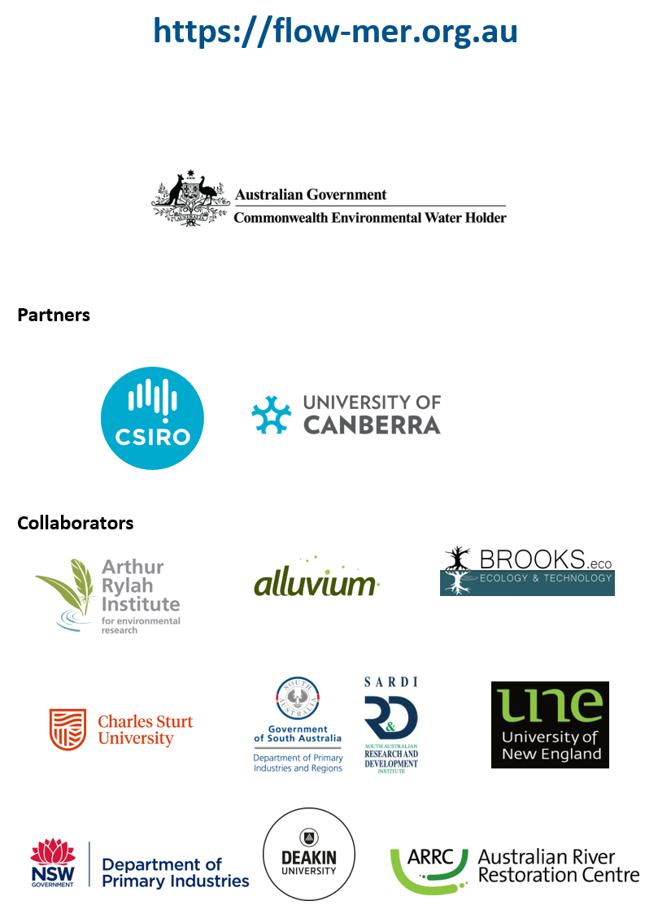

The Long Term Intervention Monitoring (LTIM) and Environmental Water Knowledge and Research (EWKR) projects (2014–2019)
This paragraph is adapted from the Why? Section in Stewardson & Guarino (2019).
This paragraph is adapted from the What? Section of Stewardson & Guarino (2019)
This paragraph is extracted from the Sites section of Stewardson & Guarino (2019).
The list of gauges used for the 2022–23 evaluation is available at Table A.1 in the Hydrology Evaluation Report (Sengupta et al. 2024). In an evaluation year, data requests are made in July, with all data received and quality checked by end of the following January at the latest.
Derivation of decomposition is described in Section 7.3.4.
Derivation of thresholds is described in Section 7.3.3.
Comparison against the modelled pre-development flow signal (derived from the Sustainable Rivers Audit (Davies et al. 2004)), which could be considered ‘natural’ flow, was not completed in water year 2022–23, but will be considered in future evaluations.
Eight separate maps were created for each of the 5 groups (frogs, mammals, reptiles, water associated woodland birds and waterbirds) for 2 time periods (1 July 2014 to 30 June 2023, 1 July 2022 to 30 June 2023).
One of the sources for remote-sensing data was Sentinel Hub Playground: https://apps.sentinel-hub.com/sentinel-playground/.
The reader is referred to the description of the inundation modelling provided in Guarino and Sengupta (2022).
The CEWO provided an unpublished, consolidated watering actions table to the evaluation teams.
https://www.environment.gov.au/cgi-bin/sprat/public/publicthreatenedlist.pl?wanted=flora
https://www.environment.nsw.gov.au/threatenedSpeciesApp/SpeciesByType.aspx
https://www.legislation.sa.gov.au/lz?path=%2FC%2FA%2FNATIONAL%20PARKS%20AND%20WILDLIFE%20ACT%201972
https://www.environment.vic.gov.au/conserving-threatened-species/threatened-list
A case study on Murray cod and Murray–Darling rainbowfish recruitment was developed for the 2022–23 evaluation to demonstrate how the contribution of CEW could be predicted at unmonitored gauges across the Basin once sufficient fish and flow data are available (Hladyz et al. 2024). However, it should be noted that model predictions have low confidence due for being extrapolated beyond the Selected Areas.
For the hydrology evaluation in water year 2022 –23, gauges with quality issues were excluded from the evaluation workflow.
The list of gauges used each year is provided in an Appendix to the evaluation report. Those used in 2024–25 evaluation are listed in Sengupta et al. (2025).
Geofabric river mapping sourced from the ANAE classification of the Basin v3.

