


Final report to the Commonwealth Environmental Water Holder

September 2023

Gayini Breeding Waterbirds Reproductive Success Monitoring 2022-23
Brandis, K., Smith, M., Stewart, J., Juilliard, L., McEvoy, T., Francis, R.
Centre for Ecosystem Science, University of New South Wales

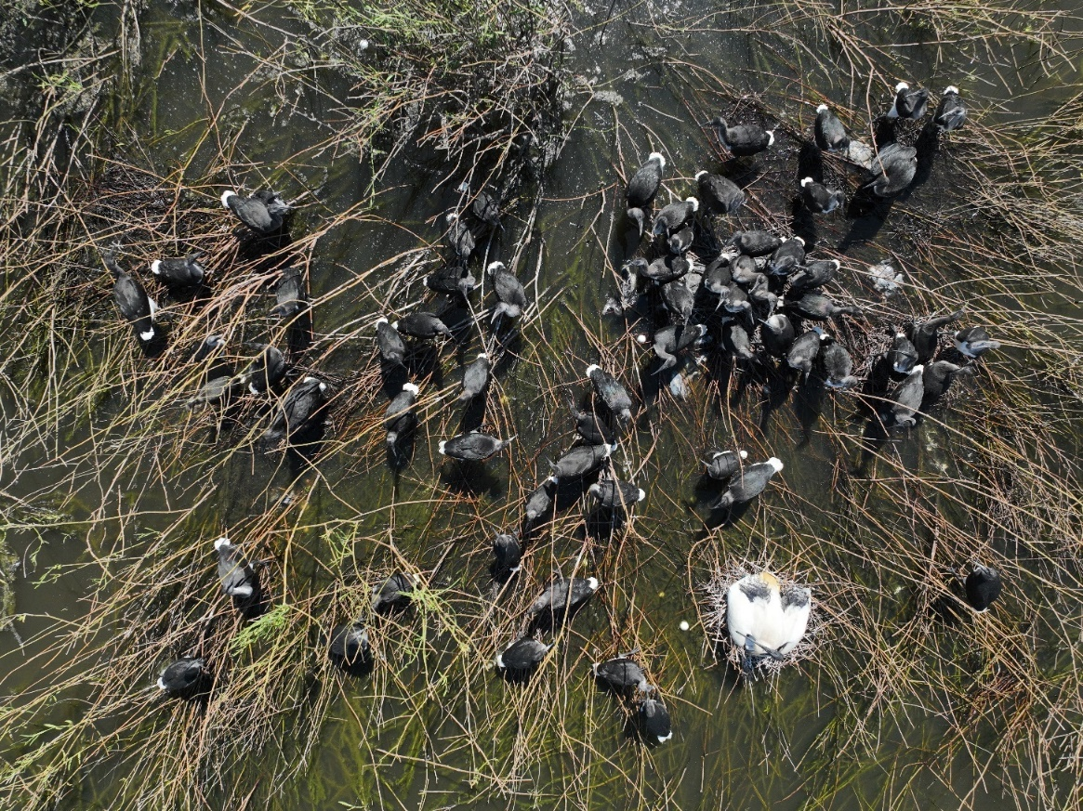
Report Citation: Brandis, K., Smith, M., Stewart, J., Juilliard, L., McEvoy, T., Francis, R. (2023) Gayini Breeding Waterbirds Reproductive Success Monitoring 2022-23. Final report to the Commonwealth Environmental Water Holder. Centre for Ecosystem Science, UNSW.

Cover photo: Straw-necked ibis flappers and two Australian white ibis on nest.

Photo credit: Shot By Harro

Funding acknowledgement: This research was funding by the Commonwealth Environmental Water Holder with support from the Nari Nari Tribal Council, NSW Department of Planning and Environment, and the Centre for Ecosystem Science, UNSW.

Disclaimer: The views and opinions expressed in this publication are those of the authors and do not necessarily reflect those of the Australian Government or the Minister for the Environment and Energy. While reasonable efforts have been made to ensure that the contents of this publication are factually correct, the Commonwealth does not accept responsibility for the accuracy or completeness of the contents, and shall not be liable for any loss or damage that may be occasioned directly or indirectly through the use of, or reliance on, the contents of this publication.

Table of Contents

Executive Summary 6
Background 7
Aggregating waterbirds at Gayini 7
Climate 11
Water management 2022-23 13
Methods 15
Nest surveys 15
Drone surveys 17
Results 19
Nest data 19
Disease, predation and mortality 23
Water depth 24
Water quality 25
Drone surveys 28
Discussion 31
Recommendations 32
Acknowledgments 33
References 34

Table of Figures
Figure 1 Map A) showing location of Lowbidgee region (shaded dark grey) at the western downriver end of the Murrumbidgee River in the Murrumbidgee Catchment, and B) the area of Gayini, within the Lowbidgee region, and the location of Bala Rookery. 10
Figure 2 Long-term annual rainfall totals measured at Nap Nap (gauge 075049), rainfall years 2021,2022 and 2023 (to April) highlighted in red. Long-term annual mean shown by horizontal line. 11
Figure 3 Sentinel 2 L2A moisture index image 10th January 2023 of Lowbidgee region (Figure 1). Shades of blue indicating inundated areas. 12
Figure 4 Total annual discharge on the Murrumbidgee River downstream of Maude Weir 1975-2022. 2022 highlighted in red. 12
Figure 5 Mean daily discharge at North Caira channel 22nd August 2022 – 30 April 2023 with periods of nesting (yellow shaded ares) and nest monitoring (green shaded area)identified (Source: WaterInfo NSW). 13
Figure 6 Water levels in Bala Rookery (Eulimbah) from August 2022 – April 2023. 14
Figure 7 Daily discharge on the Murrumbidgee River downstream of Maude Weir, and timing of watebird rookery monitoring 2021-22 and 2022-23. 16
Figure 8 Transects flown over the Bala Rookery a) 4th October 2022, b) 8th November 2022, c) 20th December 2022, d) 4th January 2022, e) 31st January 2023, f) 14th February 2023, and g) 4th March 2023. 18
Figure 9 Chick development stage composition of Bala Rookery during each survey. 20
Figure 10 Straw-necked ibis nests at Bala Rookery (January 2023, Shot By Harro for UNSW). 20
Figure 11 Reproductive success rates between surveys at Bala Rookery for a) cohort 1 and b) cohort 1.1. 21
Figure 12 Créching straw-necked ibis chicks at runner stage of development (Bala Rookery 2023) (Shot By Harro). 22
Figure 13 Reproductive success rates between surveys at Bala Rookery for a) cohort 2 and b) cohort 3. 23
Figure 14 Water depths at monitored nest clumps at Bala Rookery Oct. 2022 – Jan. 2023.Boxes with whiskers represent data range (excluding outliers), X represents the mean, horizontal line represents the median. Water depths on the 8/11/2022 were deeper than 100cm, although exact depths were unable to be recorded. 24
Figure 15 Aquatic pH levels. The optimum pH levels for fish are from 6.5 to 9.0. Outside of optimum ranges, organisms can become stressed or die. Source: http://www.fondriest.com/environmental-measurements/parameters/water-quality/ph/#p9. 26
Figure 16 Water quality variables measured at Bala Rookery 2022-2023, a) water temperature, b) pH, c) conductivity, d) dissolved oxygen, e) total dissolved solids, and f) salinity. 27
Figure 17 Imagery collected on the first drone flight on the 4th October 2022 showed early stages of breeding, with eggs present in the imagery. 28
Figure 18 Imagery collected on the a) 8th November 2022 showed areas of nesting likely being washed out by rising water levels, with clumps largely under water, where as in b) showing imagery collected two months later, much of the lignum had again risen above the falling water levels and nesting was re-starting. 29
Figure 19 Counts of straw-necked ibis nests (dark pink) and chicks (light pink) and Australian white ibis nests (blue) and chicks (light blue) within the ever growing Bala Rookery rookery boundary (red) on the a) 4th December 2022, b) 8th November 2022, c) 20th December 2022, d) 4th January 2022, e) 31st January 2023, f) 14th February 2023, and g) 4th March 2023. 30

Executive Summary
Waterbird breeding was recorded at Bala Rookery on Gayini in the Lowbidgee, for the third consecutive year. 2020-21 nesting was initiated by water for the environment, while nesting in 2021-22 and 2022-23 was the result of natural flooding supported by environmental flows. Throughout 2021-22 the Murrumbidgee River catchment received some of the highest levels of rainfall and river flows ever recorded. 71,681 ML of environmental flows, consisting of both Commonwealth and NSW water allocations, were delivered to support the waterbird breeding at Gayini.

Breeding by aggregating waterbirds at Bala Rookery began in mid-August 2022 and rookery surveys began in October 2022. Due to extensive flooding in the region, access was extremely challenging and ground access was not possible for the duration of monitoring. Access to the rookery was by boat via the North Caira channel. NSW Department of Planning (NSW DPE) and Environment provided significant support in piloting the survey team to Bala Rookery using NSW DPE boats when possible.

A total of nine surveys, consisting of nest and drone surveys were completed between October 2022 – March 2023. Bala Rookery was the second largest single rookery site in the Murray-Darling Basin during 2022-23 with 98,830 straw-necked ibis nests. The largest being Block Bank rookery in the neighbouring Lachlan catchment with 144, 957 straw-necked ibis nests. The Bala Rookery was a mixed species rookery, with observations of breeding by Australian white ibis, little pied cormorants, great black cormorants and royal spoonbills.

Nesting and egg laying at Bala Rookery was very protracted with first nests being built in August 2022 and new nests consistently being added throughout the monitoring period until March 2023. Anecdotal evidence is that nesting continued into April 2023. The rookery extent continued to expand as new nesting areas were established and was largest in March 2023 at 175 ha. There were no significant predation or disease impacts on the rookery, however some nests became flooded in November-December 2022 following natural rises in river flows. Reproductive success rates varied with nesting cohorts, and timing (loss of nests due to flooding) but were comparable to historical values for Bala Rookery ~62%.

Bala Rookery was one of 12 large ibis rookery sites in the Murray-Darling Basin during 2022-23 and contributed significantly to the total number of nests and chicks fledged during this period. Bala Rookery accounted for ~26% of all straw-necked ibis nests counted in The Basin in 2022-23.

Background
The Lowbidgee covers an area of 217,000 ha and contains the largest areas of wetlands (Kingsford and Thomas 2004, Rogers et al. 2013) remaining in the Murrumbidgee River. It is an area of national and international significance providing habitat for fifteen migratory bird species listed on international agreements (JAMBA 1981, CAMBA 1988, ROKAMBA 2007), and endangered and vulnerable flora (n=6) and fauna species (n=32) (EPBC Act 1999). The Lowbidgee is a key breeding area for aggregating waterbirds in Australia (Brandis 2010), with breeding recorded at 34 wetlands 2006 - 2016 (Spencer 2017).

The Lowbidgee region includes Gayini, formerly known as the Nimmie-Caira. Gayini is an 87,816 ha property owned and managed by the Nari Nari Tribal Council. It includes core breeding habitat for a range of waterbirds, including critical floodplain lignum wetlands such as Bala Rookery.

Aggregating waterbirds at Gayini
Aggregating waterbird species, including ibis, herons, pelicans, egrets and cormorants, can nest in large numbers within floodplain wetlands. The Lowbidgee floodplain is one of the most important rookery sites in the Murray-Darling Basin (Kingsford and Thomas 2004; MDBA 2014). Bala Rookery (Eulimbah Swamp) and Bayil Bank (Telephone Bank) (
Table 1) are the main areas that support large ibis rookeries in Gayini. The neighbouring Redbank wetlands, which includes Yanga National Park (NP) (Figure 1), can also support large egret, heron and cormorant rookeries. In the mid-Murrumbidgee while egret, heron, spoonbill and cormorant rookeries were previously common in multiple locations (Briggs and Thornton 1999), only smaller, mainly cormorant rookeries, have been detected in this region in recent years (Wassens et al. 2017).

Bala Rookery lies behind a levee bank created in 1986, that crosses the entire width of the Nimmie Caira creek floodplain (Murrumbidgee Catchment Management Authority 2009). It was used for water holding and to supply water along channels to other parts of the floodplain. It covers an area of approximately 600 ha and has a maximum capacity of ~3,000 ML (DWR 1994). It is usually inundated once every two years (Wassens et al. 2008). Bala Rookery is a Lignum shrubland (Duma florulenta) dominated swamp, with small areas of Common Reed (Phragmites australis) and cumbungi (Typha latifolia). Bala Rookery is a traditional nesting site for aggregating waterbirds, with breeding recorded since 1986 (
Table 1).

Table 1 Historical records of nesting by aggregating waterbirds at wetlands in the Lowbidgee (source: Australian Colonial Waterbird Breeding Database, Brandis 2010, Eastern Australia Aerial Waterbird Survey, NSW DPE unpublished data).
Wetland | 1983 | 1984 | 1986 | 1987 | 1988 | 1989 | 1990 | 1991 | 1992 | 2000 | 2005 | 2010 | 2011 | 2012 | 2013 | 2014 | 2016 | 2020 | 2021
Avalon Swamp |  |  |  |  |  | x |  |  |  |  |  | x
Breer Swamp |  |  |  |  |  |  |  |  |  |  | x |  |  |  |  |  |  |  | x
Caira Cutting Floodplain |  |  | x
Egret Swamp |  |  |  |  |  | x | x |  |  |  | x
Bala Rookery  /Eulimbah Swamp |  |  |  |  |  | x | x |  |  |  |  |  |  |  |  |  |  | x | x
Glenn Dee Swamp |  |  |  |  |  |  |  |  |  |  |  |  |  |  |  |  |  |  | x
House Creek |  |  |  |  |  |  |  |  |  |  |  | x |  |  |  |  |  |  | x
Little Piggery |  |  |  |  |  |  |  |  |  |  |  |  |  |  |  |  |  |  | x
Littlewood Swamp |  |  |  |  |  | x
Loorica Lake |  |  |  |  |  |  | x |  |  |  |  | x
Lowbidgee floodplain |  |  |  |  |  |  |  |  |  | x
Maude Lagoon |  |  |  |  |  |  |  |  |  |  |  |  |  | x
Mercedes Swamp |  |  |  |  |  |  |  |  |  |  | x | x
Nap Nap Swamp |  |  |  | x | x | x | x |  |  |  |  |  | x |  |  |  |  |  | x
Narkungerie Swamp |  |  |  |  |  |  | x
Narwie |  | x |  |  |  | x |  |  |  |  |  |  |  |  |  |  |  |  | x
Nimming Creek | x |  | x
North Stallion Swamp |  |  |  |  |  |  |  |  |  |  |  |  | x
Paika Heron Colony |  |  |  |  |  | x | x
Patterson's Swamp |  |  |  |  |  | x
Piggery Lake |  |  |  |  |  | x | x |  |  |  | x | x |  |  |  |  |  |  | x
Pollen Creek |  |  | x |  |  | x | x | x
Pollen Creek (Torry Plains) |  |  |  |  |  | x | x
Pollen Creek (Wendouree) |  |  |  |  |  | x
Pollen Creek Floodplain |  |  |  |  |  |  |  |  | x
Redbank Swamp |  |  |  |  |  | x | x | x
Redbank Weir |  |  |  |  |  |  |  |  |  |  | x
Sapling Swamp |  |  |  |  |  |  | x
Shaws Swamp |  |  |  |  |  | x
Steam Engine Swamp |  |  |  |  |  | x | x |  |  |  | x | x
Fairfax floodway/Suicide Swamp |  |  |  |  |  | x |  |  |  |  |  |  |  | x |  |  |  |  | x
Tala Creek |  |  |  |  |  |  | x
Tala Lake |  |  |  |  |  | x
Tarwillie Swamp |  |  |  |  |  | x | x |  |  |  | x | x |  | x |  |  |  |  | x
Telephone Bank |  |  |  |  |  |  |  |  |  |  |  |  |  |  |  |  |  |  | x
Telephone Creek |  |  |  |  |  |  |  |  |  |  |  |  |  |  |  |  |  |  | x
Telephone Swamp |  |  |  |  |  |  | x | x |  |  |  |  |  |  |  |  | x
Top Narockwell |  |  |  |  |  |  |  |  |  |  |  | x |  | x |  |  |  |  | x
Two Bridges Swamp |  |  |  |  |  |  |  |  |  |  | x |  | x
Two Bridges Swamp East |  |  |  |  |  |  |  |  |  |  |  |  |  |  |  |  |  |  | x
Two Bridges Swamp West |  |  |  |  |  |  |  |  |  |  |  |  |  |  |  |  |  |  | x
Uara Creek |  |  |  |  |  |  | x
Wagourah Lake |  |  |  |  |  |  |  |  |  |  |  |  |  |  |  |  |  |  | x
Waugorah Creek |  |  |  |  |  | x |  |  |  | x
Waugorah Lagoon |  |  |  |  |  |  |  |  |  |  |  | x |  |  | x
Waugorah Lake |  |  |  |  |  |  |  |  |  |  |  |  | x | x |  | x

Figure 1 Map A) showing location of Lowbidgee region (shaded dark grey) at the western downriver end of the Murrumbidgee River in the Murrumbidgee Catchment, and B) the area of Gayini, within the Lowbidgee region, and the location of Bala Rookery.

Climate
Since 2021, Australia has been in a La Niña weather pattern which is normally associated with higher-than-average winter, spring, and early summer rainfall over much of Australia. The results of this type of weather pattern are reflected in the high local rainfall (
Figure 2) and significant flooding (Figure 3) experienced in the Lowbidgee since 2021. 2022 recorded the 7th highest total rainfall since 1900 (
Figure 2).

Total flow discharge volumes downstream of Maude Weir were amongst the highest recorded since 1975 (Figure 4). River discharge reached a peak in mid-November 2022 and then began to fall quite rapidly (Figure 5).

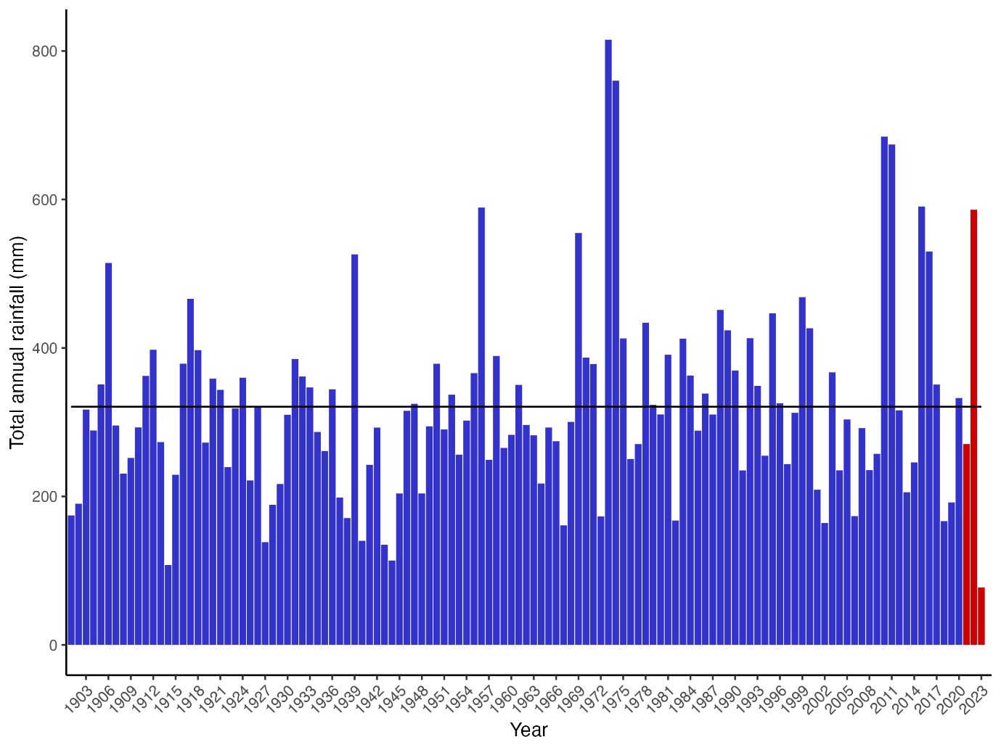
Figure 2 Long-term annual rainfall totals measured at Nap Nap (gauge 075049), rainfall years 2021,2022 and 2023 (to April) highlighted in red. Long-term annual mean shown by horizontal line.

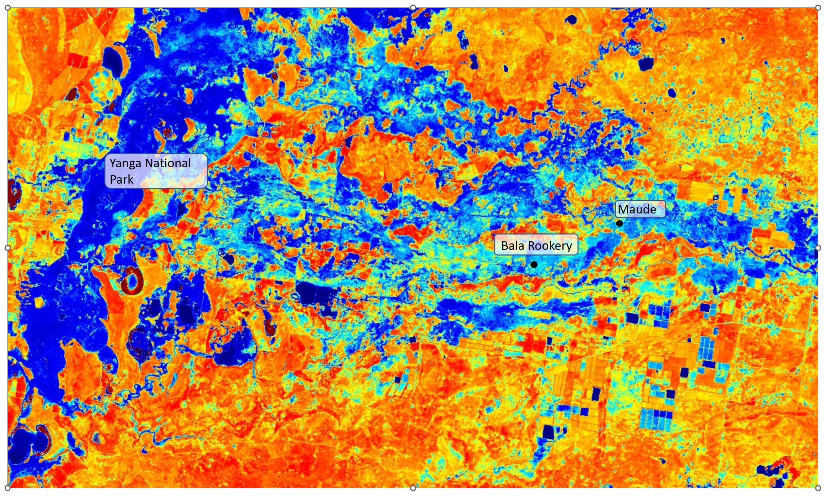
Figure 3 Sentinel 2 L2A moisture index image 10th January 2023 of Lowbidgee region (Figure 1). Shades of blue indicating inundated areas.

Figure 4 Total annual discharge on the Murrumbidgee River downstream of Maude Weir 1975-2022. 2022 highlighted in red.

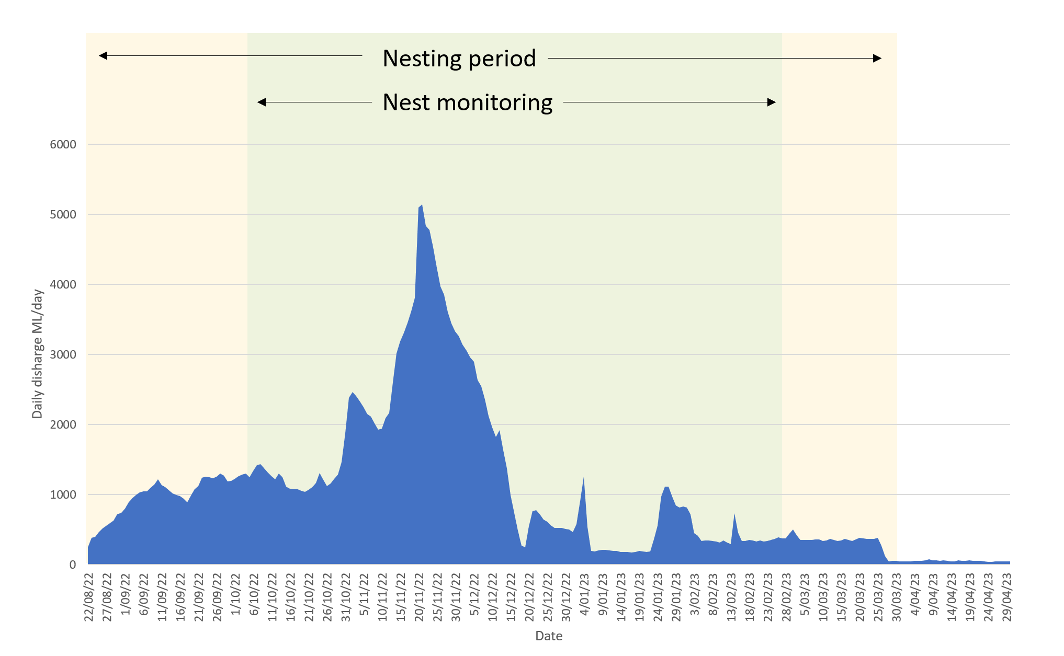
Figure 5 Mean daily discharge at North Caira channel 22nd August 2022 – 30 April 2023 with periods of nesting (yellow shaded ares) and nest monitoring (green shaded area)identified (Source: WaterInfo NSW).

Water management 2022-23
371,956 ML of water for the environment was delivered to the Lowbidgee region from December 2022-June 2023. 71,681 ML of this, consisting of both Commonwealth and NSW water allocations, was to support the waterbird breeding at Gayini. A further 4,624 ML of supplementary licenced water was also delivered to Gayini to support waterbird breeding. Most e-water delivery was during January (24,789 ML) and February (20,048ML) to maintain water levels at Bala Rookery, following reductions in river flows (Figure 5).

Water levels in Bala Rookery were managed to ensure there was sufficient depth of water under nests, but also to prevent inundation of nests whenever possible. Some nests become flooded in late November 2022 following a large flood pulse where water levels peaked at 2.59 m on the 20th November 2022 (Figure 5, Figure 6).

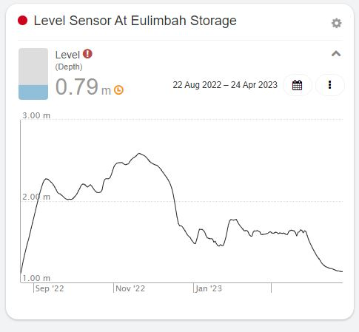

Figure 6 Water levels in Bala Rookery (Eulimbah) from August 2022 – April 2023.

Methods

Nest surveys
Nest monitoring was undertaken at Bala Rookery in the Gayini wetlands (Figure 1,Table 2).
The rookery was surveyed approximately every two weeks between early October 2022 through to mid-February 2023 (Figure 7, Table 2). Surveys were completed by two people in a canoe. During Survey 1, a sub-set of randomly selected nest clumps (and nests) were given a unique number, and GPS locations recorded. These nests were then revisited on each subsequent survey. Nests were only marked if they contained eggs and when appropriate, additional nest clumps were added to the survey if new nests were established between surveys. During each survey the following variables were recorded; number of eggs or chicks, chick development stage (Table 3), evidence of predation, disease, and nest abandonment. Individual nest surveys continued fortnightly until chicks had reached runner stage, where chicks become highly mobile and begin créching behaviour, congregating on nests as large groups of chicks. At this stage it is not possible to attribute chicks to specific nests, so counts are done at a nest clump scale. Nest clump monitoring continued until chicks had fledged or were no longer associated with the nest clump site.

Water depth data was recorded at each nest clump site using a 2 m folding ruler. Water quality data was collected at three random locations within the nest monitoring area at each rookery site, during each survey. Water quality variables recorded included: temperature, pH, conductivity, total dissolved solids, resistivity, and salinity.

To minimise disturbance to the rookery, all ground surveys were planned for early morning (6-11am), to avoid causing heat stress to nesting birds and their offspring. Access to the rookery sites was via boat down the North Caira channel and then around the rookery in a canoe. Due to extensive flooding, there was no road access possible for the duration of monitoring.
Table 2 Nest and drone survey dates for Bala Rookery monitoring October 2022-March 2023.
Survey number | Survey date | Survey type
1 | 4th Oct. 2022 | Nest and drone survey
2 | 18th Oct. 2022 | Nest survey
3 | 8th Nov. 2022 | Nest and drone survey
4 | 6th Dec. 2022 | Nest survey
5 | 20th Dec. 2022 | Nest and drone survey
6 | 4th Jan. 2023 | Nest and drone survey
7 | 31st Jan. 2023 | Nest and drone survey
8 | 14th Feb. 2023 | Drone survey
9 | 4th Mar. 2023 | Drone survey

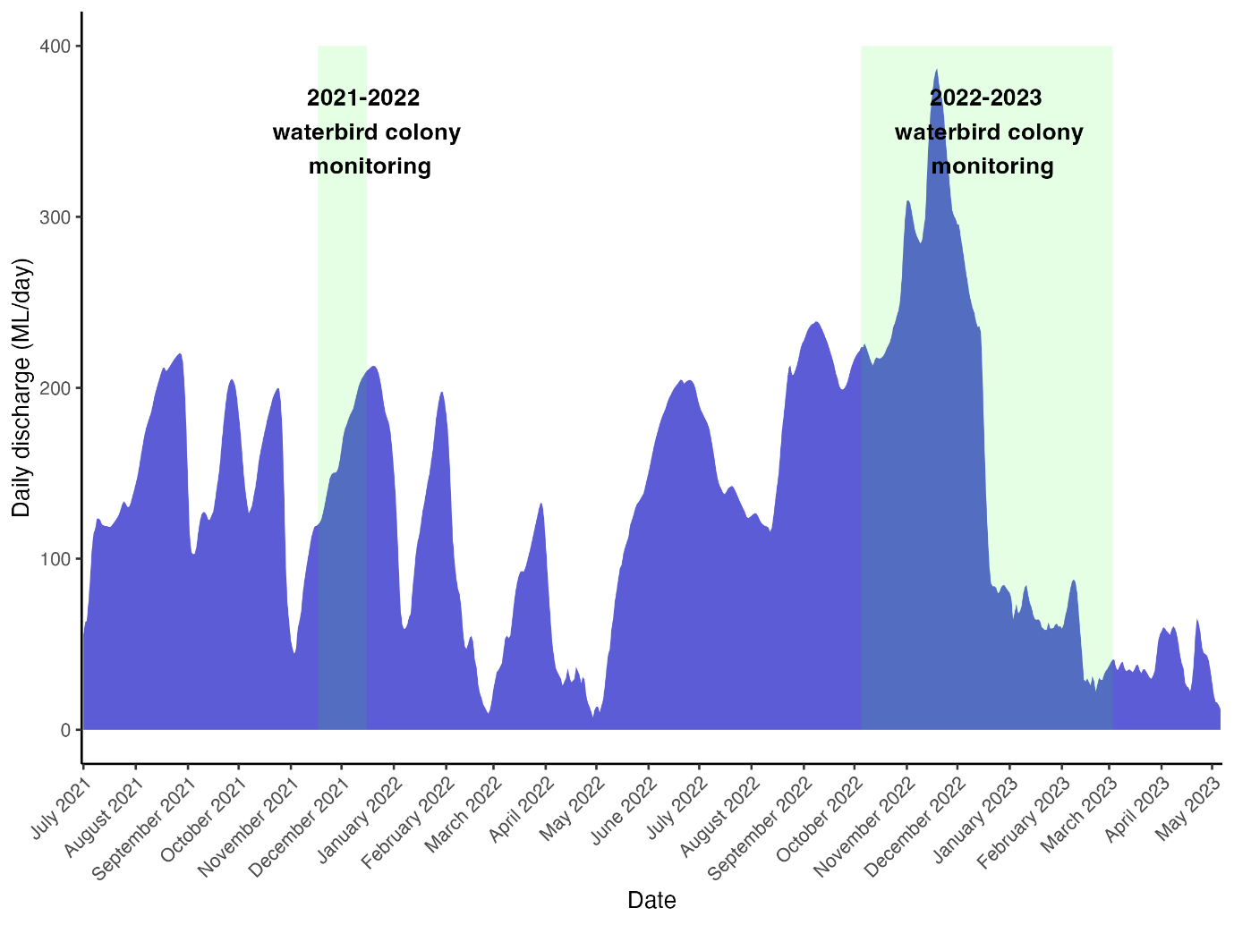
Figure 7 Daily discharge on the Murrumbidgee River downstream of Maude Weir, and timing of watebird rookery monitoring 2021-22 and 2022-23.

Table 3 Straw-necked ibis chick development stages (sources Marchant & Higgins 1990, K.Brandis).
Development stage | Characteristics | Age (days)
Trampling | Adult ibis congregating on lignum (nesting habitat) and preparing for nest building
Egg | Whole egg, being incubated by adult | 1-20
Chicks | Recently hatched (1-5 days old), downy feathers, immobile | 21-25
Squirters | Early sheathed feathers starting on wings, still in nest, immobile | 26-30
Runners | Development of pin feathers. Mix of down and feathers, walking awkwardly, can leave nest on foot | 31-35
Flappers | Nearly fully feathered, cannot fly but flaps between nests | 36-40
Flyers | Fully feathered, able to fly and leave nests, still attended by parents at nest | 41-47
Fledged | Independent, does not return to nest but roosts in nearby trees | >48

Drone surveys
Seven drone surveys were conducted over Bala Rookery between 4th December 2022 and 4th March 2023 (Table 4). The area covered by the drone was adjusted on each survey trip to cover the growing rookery and explore areas of new breeding (Figure 8).

Table 4. Dates of each drone survey including the area of the mosaic flown over Bala Wetland, on the Murrumbidgee River.
Rookery | Survey date | Pilot | Mosaic area (ha)
Bala Rookery | 4th Oct. 2022 | Jana Stewart | 11.12
 | 8th Nov. 2022 | Matt Smith | 89.13
 | 20th Dec. 2022 | Jana Stewart | 9.98
 | 4th Jan. 2023 | Jana Stewart | 86.43
 | 31st Jan. 2023 | Loic Juilliard | 61.43
 | 14th Feb. 2023 | Matt Smith | 181.24
 | 4th Mar. 2023 | Matt Smith | 195.75

Flights were conducted using a DJI Mavic Enterprise Dual Advanced drone at a height of 70-90m. The drone was launched and returned to the canoe or argo from the outskirts of the rookery. The drone was often first launched to conduct a scouting mission to estimate growing rookery boundaries, alongside analysis of the imagery upon each return (Francis et al. 2022). Once the boundary had been established, pre-programmed flight transects were created at an overlap of 76% (forward and side), collecting thousands of images per survey. As the area of the rookery grew, the drone was flown higher, to cover the entire area and obtain a total rookery boundary.

Images were orthomosaiced using Pix4Dmapper (Pix4d SA, 2022). The first set of mosaic imagery collected on the 4th October 2021, was auto-counted using a technique adapted from Lyons et al. (2019) and Francis et al. (2020), which involved the classification of pixels to birds or background, which were then grouped, made into polygons, and counted. For each mosaic, a selection of 50 individual polygons each containing only a single bird was collated, with a pixel per bird count estimated. Any polygons that fell below mean- 1SD pixels were excluded from the count. In polygons where many birds were connected, an average bird per polygon estimation was calculated manually, and larger polygons divided by this pixel per bird number. Automated counting techniques work best when adults are incubating and so following mosaics were counted manually with nest locations annotated in a shapefile. Rather than counting the entire rookery on every trip, we aimed to get a total developing nest count for the rookery. As such, the first sighting of a rookery area was extensively counted, including both incubating nests and chicks. As the rookery expanded, new areas were counted, but in the rest of the rookery previously counted, only new nests were counted. This avoids double counting in the nest estimates and produces an index of the total number of nests produced in the rookery over the breeding season. Using known reproductive success estimates from the on-ground work at Bala Rookery, chick numbers could be converted into approximate nest numbers. Species were identified based on their plumage and breeding stage was determined based on group behaviour (eg., trampling, incubating or créching), and from sightings of eggs or chicks in nests.

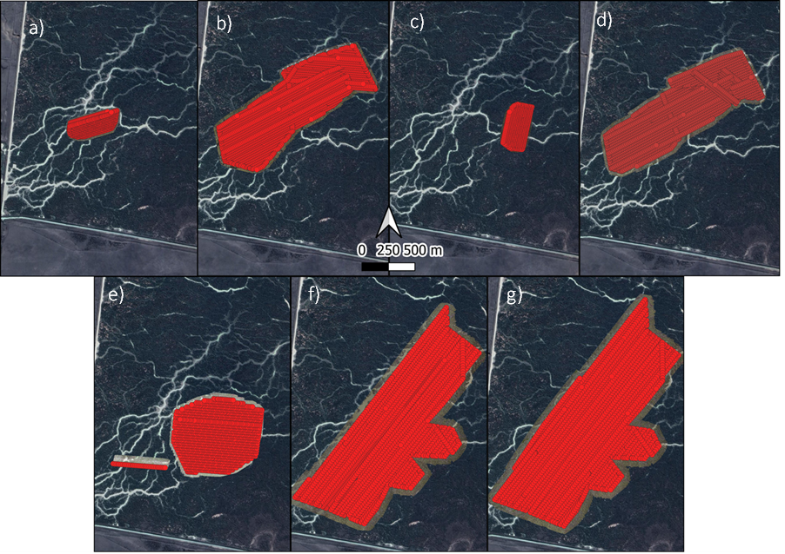
Figure 8 Transects flown over the Bala Rookery a) 4th October 2022, b) 8th November 2022, c) 20th December 2022, d) 4th January 2022, e) 31st January 2023, f) 14th February 2023, and g) 4th March 2023.

Results

Nest data
252 nests were tagged on the 4th October 2022 during the first survey. New nests were added to the monitored nests on each subsequent survey (Figure 9). Nesting was protracted throughout the season, with new nests added during each survey through until the 4th January 2023 when nest monitoring ceased. However, drone surveys into February noted new nests during these later surveys (Figure 9). During several surveys, in addition to new nests being present (referred to as a nesting cohort based on date first surveyed), there were also instances where new eggs were laid into old nests. Where this occurred, these have been referred to as versions of cohort 1 nests e.g., cohort 1.1 refers to new eggs laid into nests that were part of the first nesting cohort of birds. There were 4 dates in which new eggs were located in cohort 1 nests (Table 5). It is not known whether these were second clutches laid by the same adult pair, or new clutches using old nests.

During survey 1, there were a few squirter aged offspring present in the rookery, based on this it is estimated that egg laying began in early – mid August 2022 and continued through until at least March 2023.
Table 5 Mean clutch sizes for each nesting cohort, number of nests in brackets.
Cohort | Survey date
 | 4th Oct. 2022 | 18th Oct. 2022 | 8th Nov. 2022 | 6th Dec. 2022 | 20th Dec. 2022 | 4th Jan. 2022
1 | 2.86 (n=252)
1.1 |  |  | 2.52 (n=25)
1.2 |  |  |  | 2.5 (n=6)
1.3 |  |  |  |  | 1.47* (n=17)
1.4 |  |  |  |  |  | 2.5 (n=60)
2 |  |  | 2.64 (n=83)
3 |  |  |  | 2.77 (n=65)

*eggs still being laid, this number represent incomplete clutches.

Figure 9 Chick development stage composition of Bala Rookery during each survey.

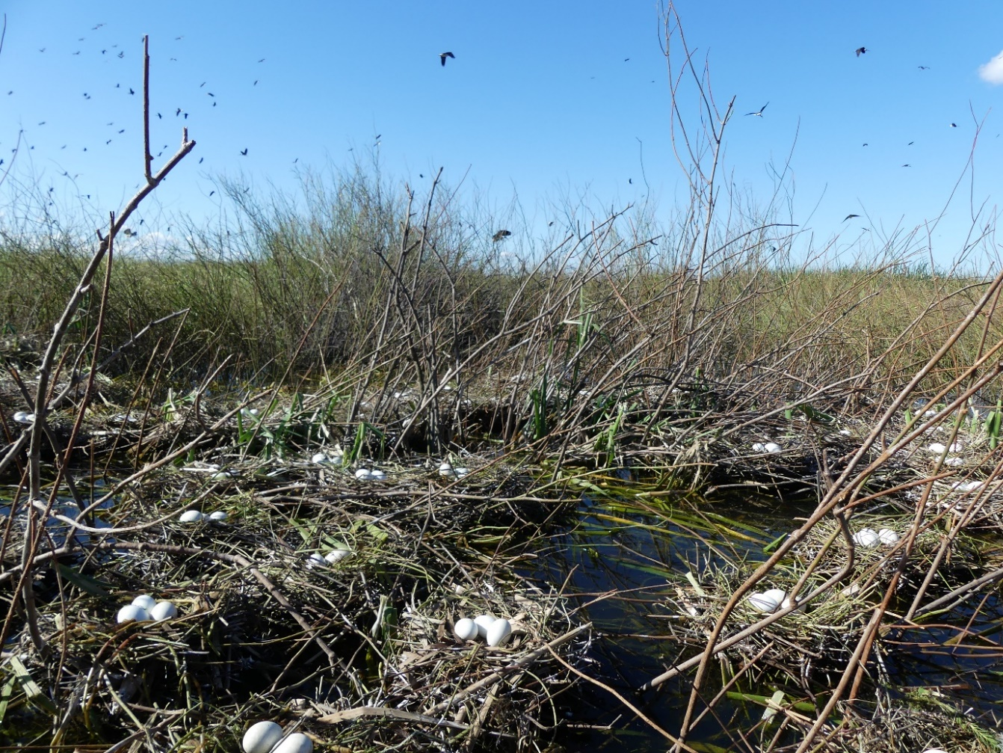
Figure 10 Straw-necked ibis nests at Bala Rookery (January 2023, Shot By Harro for UNSW).

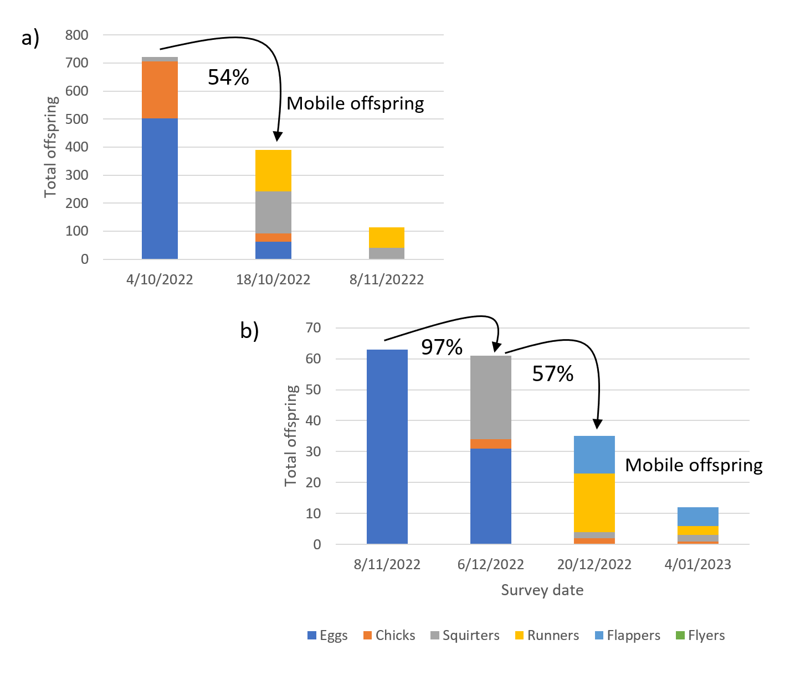
Figure 11 Reproductive success rates between surveys at Bala Rookery for a) cohort 1 and b) cohort 1.1.
Reproductive success rates for cohort 1 of 54% (Figure 11a) reflect the chick development stages the monitored nests were at when first surveyed. During the first survey many nests already had chicks and some squirter aged chicks. By survey 2 (18th October), many offspring were mobile and difficult to assign to a single nest. Accurately measuring nest success for all stages of chick development is difficult for straw-necked ibis, as young birds crèche at ~Days 30-35 (Table 3). Créching is where young birds leave their natal nest and form groups of young birds, at this stage it is difficult to accurately assign the number of birds to a specific nest. We count the total number of birds in a créche, however this count cannot be relied upon to be an accurate representation of the total number of young birds due to their mobility.

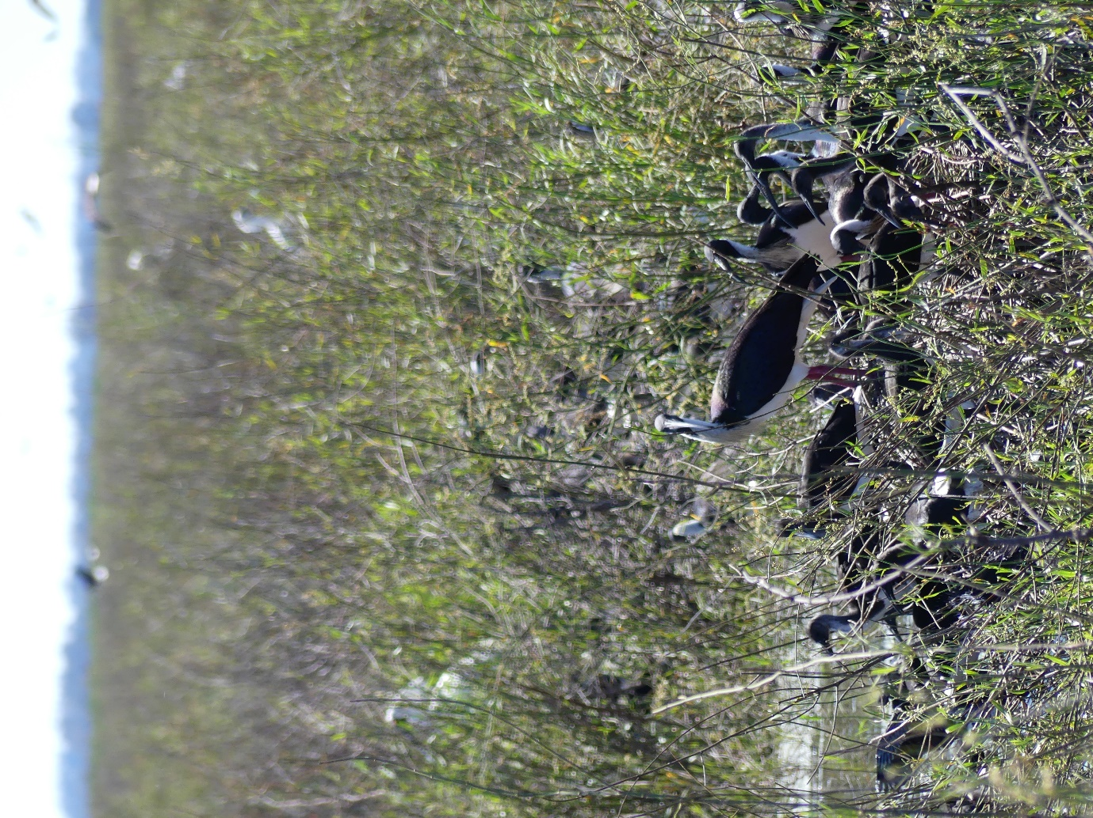
Figure 12 Créching straw-necked ibis chicks at runner stage of development (Bala Rookery 2023) (Shot By Harro).

Cohort 1 (Figure 11a) reproductive success rate between surveys 1 (4/10/22) and 2 (18/10/22) (54%) are comparable to the same stage of chick development seen with cohort 1.1 (Figure 11b) between survey 2 (6/12/22) and survey 3 (20/12/22) (57%).

Reproductive success for cohorts 1.2, 1.3 and 1.4 are not shown. Cohort 1.2, consisting of 6 nests on the 6th December had completely failed by the 20th December with a reproductive success rate of 0%. The reason for this is unknown, noting it was a very small sample size and that many nests were flooded or impacted during the late November flood peak (Figure 5, Figure 6). Cohorts 1.3 and 1.4 were both at eggs stages during the 20th December and 4th January 2023 surveys, the final two nest surveys. Reproductive success rates for cohorts 2 and 3 are shown in
Figure 13.
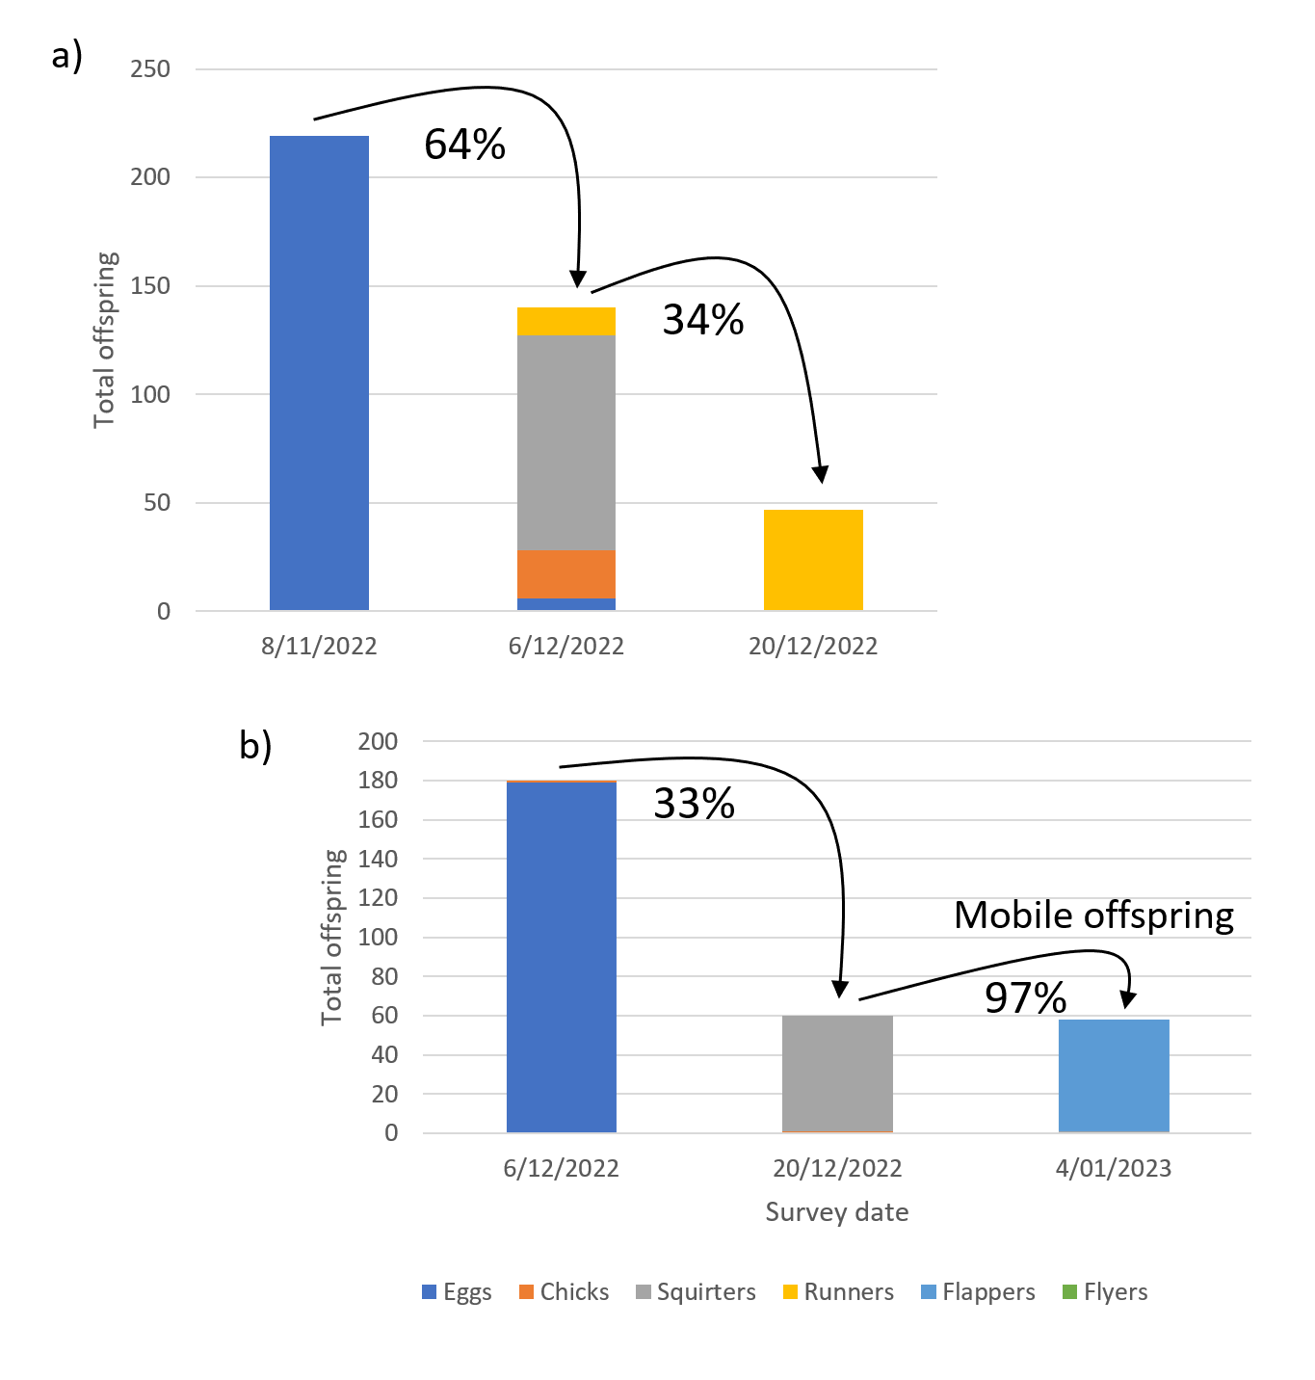
Figure 13 Reproductive success rates between surveys at Bala Rookery for a) cohort 2 and b) cohort 3.
Reproductive success rates for cohorts 2 and 3 were lower than cohort 1 at the same stage of chick development. It is not uncommon for later nesting birds to have lower reproductive success rates than early nesters, due to factors including parental experience, bird age, and access to high quality resources such as nest location and food (Birkhead 1977, Murphy and Schauer 1996).

Disease, predation and mortality
No disease or significant predation was observed at Bala Rookery, however some nests were lost due to flooding following the natural rise in river flows in November and December 2022. Mortality rates, as a percentage of total offspring counted at nests, were generally low (Table 6). Rates were highest on the 18th October and 8th November. These included predominantly young offspring at chick and squirter stages of development. It is not unusual for this to be the period of chick development with the highest mortality rates.
Table 6 Mortality rates of straw-necked ibis observed at monitored nests in Bala Rookery.
Survey date | No. observed dead birds | Total offspring | Mortality rates
04/10/2022 | 1 | 721 | 0.14%
18/10/2022 | 24 | 390 | 6.15%
8/11/2022 | 35 | 522 | 6.70%
6/12/2022 | 8 | 109 | 1.96%
20/12/2023 | 2 | 167 | 1.20%
4/01/2023 | 1 | 270 | 0.37%

Water depth
Water levels in the rookery were relatively deep (~1m) for most of the nesting period with a significant increase in depth in early December 2022 which coincided in a river flow peak that resulted in major flooding (Figure 5, Figure 6). River flows decreased rapidly throughout January (Figure 5), however water depths in the rookery remained sufficient and there was no evidence of predation from ground predators or desertion of nests by adults.

Figure 14 Water depths at monitored nest clumps at Bala Rookery Oct. 2022 – Jan. 2023.Boxes with whiskers represent data range (excluding outliers), X represents the mean, horizontal line represents the median. Water depths on the 8/11/2022 were deeper than 100cm, although exact depths were unable to be recorded.

Water quality
Water quality measures that have direct relevance for aquatic organisms include dissolved oxygen, pH, total dissolved solids (TDS) and salinity. Some water quality measures, such as TDS are highly correlated with other measures such as conductivity and salinity, while water temperature influences dissolved oxygen values. These patterns can be seen at Bala Rookery, until December (Figure 16). In December, high river flows resulted in large flow volumes into Bala Rookery, at this time many water quality measures can be seen to deviate from prior values e.g., salinity and TDS on the 6/12/23 and pH and conductivity on the 20/12/23 (Figure 16).

The values of pH (excluding the December 20th reading) were within a relatively narrow band (6.61-7.452) within an acceptable range. The more acidic pH values recorded in late December may be the result of both rainfall (pH ~5.6) and runoff from the soils contributing to more acidic values.

Most aquatic creatures prefer a pH range of 6.5-9.0, though some can live in water with pH levels outside of this range (http://www.fondriest.com/environmental-measurements/parameters/water-quality/ph/). As pH levels move away from this range (up or down), it can stress animal systems and reduce hatching and survival rates. The further outside of the optimum pH range a value is, the higher the mortality rates. The more sensitive a species, the more affected it is by changes in pH. In addition to biological effects, extreme pH levels usually increase the solubility of elements and compounds, making toxic chemicals more “mobile” and increasing the risk of absorption by aquatic life.

The implication for water pH measures outside the ranges preferred by aquatic organisms has implications for the availability and quality of aquatic food resources for waterbirds and other wetland fauna. In a wetland ecosystem, pH can be affected by carbon dioxide (CO₂) in the water. Higher levels of CO₂, as a result of plant photosynthesis, respiration and decomposition is a common cause of acidity in the water.

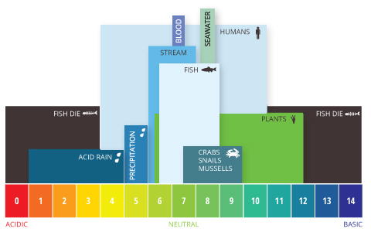
Figure 15 Aquatic pH levels. The optimum pH levels for fish are from 6.5 to 9.0. Outside of optimum ranges, organisms can become stressed or die. Source: http://www.fondriest.com/environmental-measurements/parameters/water-quality/ph/#p9.

Conductivity and total dissolved solids were within range of tapwater values (50-800µs/cm) and salinity was within the definition of freshwater (<500 ppm).

Dissolved solids are important to aquatic life by keeping cell density balanced. In distilled or deionized water, water will flow into an organism’s cells, causing them to swell. In water with a very high TDS concentration, cells will shrink. These changes can affect an organism’s ability to move in a water column, causing it to float or sink beyond its normal range (http://www.fondriest.com/environmental-measurements/parameters/water-quality/conductivity-salinity-tds/#cond9).

Dissolved oxygen, the amount of oxygen in water, can enter the water from the atmosphere or as a biproduct of aquatic plant photosynthesis. As aquatic photosynthesis is light-dependent, the dissolved oxygen produced will peak during daylight hours and decline at night. Factors that can impact the dissolved oxygen content of water include; stratification and water depth, wind, temperature, pressure, salinity and sampling time. Dissolved oxygen levels were relatively stable at Bala Rookery, with a mean value of 5.86 Mg/L ±1.23. This is within the range of DO requirements for shallow water fish (4-15 mg/L).

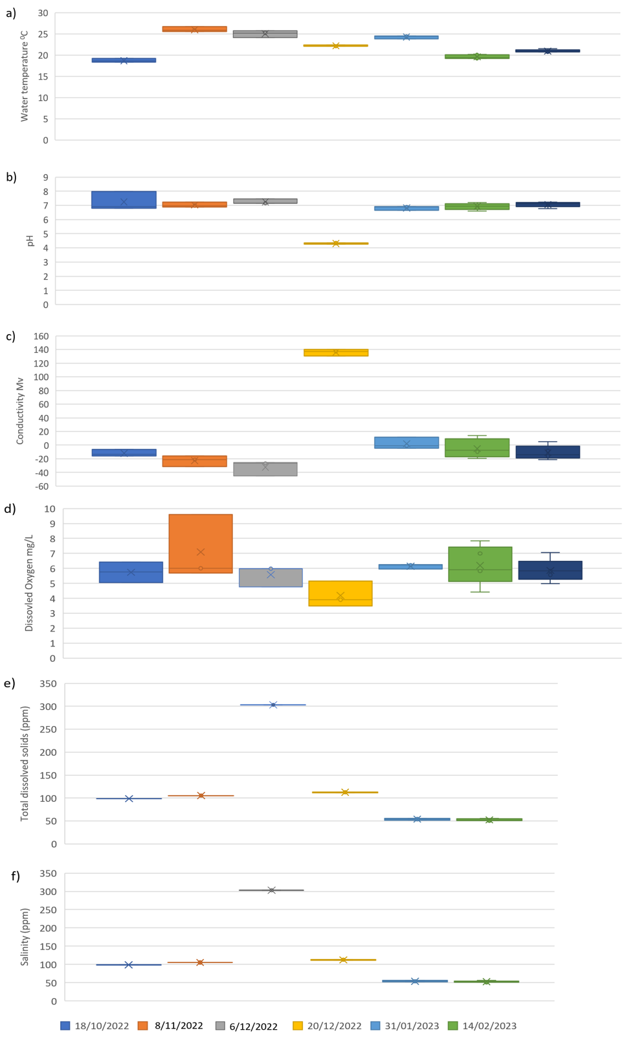
Figure 16 Water quality variables measured at Bala Rookery 2022-2023, a) water temperature, b) pH, c) conductivity, d) dissolved oxygen, e) total dissolved solids, and f) salinity.

Drone surveys
A large mixed breeding rookery was found within Bala Rookery, dominated by straw-necked ibis and Australian white ibis, but also including little pied cormorants, great black cormorants and royal spoonbills. The first drone survey on the 4th October 2022, was used as a scouting mission to identify the rookery boundaries, but the mosaic itself only covered a small area of the total breeding area (Table 4). Consequently, initial October counts are an underestimate of the rookery size at that time. The rookery was in the early stages of breeding in October, with egg sightings in the imagery (Figure 17).

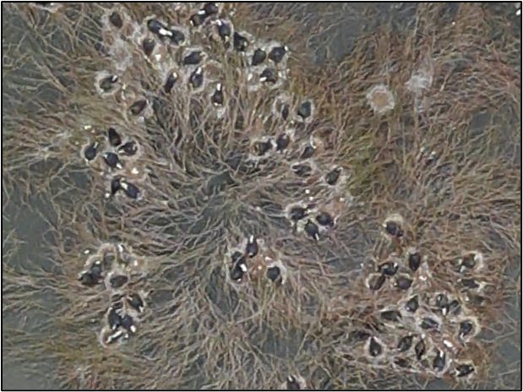
Figure 17 Imagery collected on the first drone flight on the 4th October 2022 showed early stages of breeding, with eggs present in the imagery.
The rookery area expanded between each monitoring trip and the flown mosaic area was also expanded (Table 4). It was evident in the mosaic collected on the 8th November 2022 that many areas of the rookery had been flooded by rising waters (Figure 18). A new nesting area was identified on the 20th December which was in the early stages of nesting. As water levels receded, thousands of new straw-necked ibis nests were built and were evident in the imagery collected on the 4th January 2023 (Figure 19).
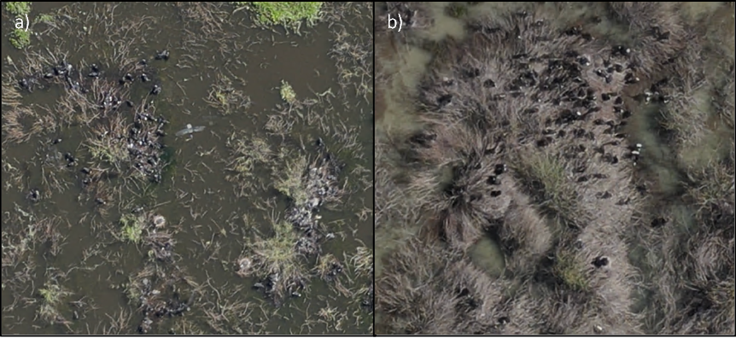
Figure 18 Imagery collected on the a) 8th November 2022 showed areas of nesting likely being washed out by rising water levels, with clumps largely under water, where as in b) showing imagery collected two months later, much of the lignum had again risen above the falling water levels and nesting was re-starting.
To provide an estimate of nest numbers when chicks were at mobile stages, we applied the mean clutch size to total chicks counted (Table 5). For example,

56,000 nests + (21,792 chicks/2.86) + 4,745 nests +18,062 nests + 81 nests +
(24,995 chicks/2.5) + 628 nests + (3,791 chicks/2.5) + 180 new nests
= ~ 98,830 straw-necked ibis nests

Similarly, for Australian white ibis we estimate a total nest number of:
2,175 nests + (2,251/2.7*) + 4 + 682 + 6 + 227
= ~ 3,928 Australian white ibis nests
*(Corben and Munro 2006)
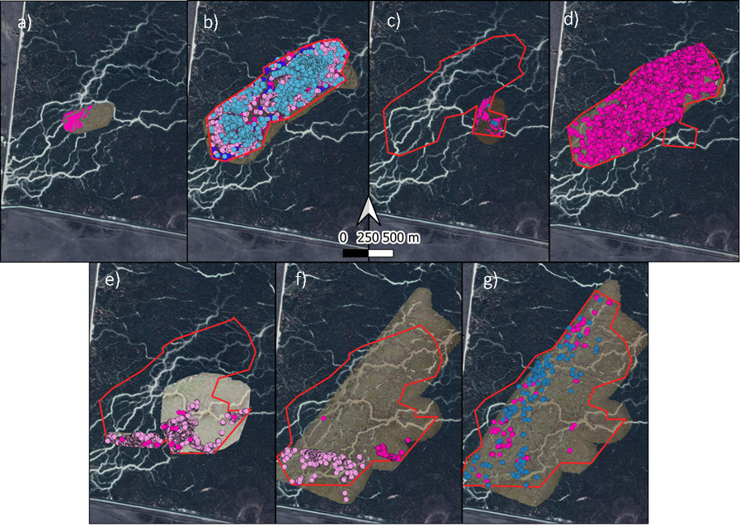
Figure 19 Counts of straw-necked ibis nests (dark pink) and chicks (light pink) and Australian white ibis nests (blue) and chicks (light blue) within the ever growing Bala Rookery rookery boundary (red) on the a) 4th December 2022, b) 8th November 2022, c) 20th December 2022, d) 4th January 2022, e) 31st January 2023, f) 14th February 2023, and g) 4th March 2023.
Table 7. Results of counts from drone imagery collected at Bala Rookery.
Survey Date | Count Type | Species | Count | Rookery Area (ha)
4th Oct. 2022 | Auto | Straw-necked ibis | 5,000 nesting birds | 4.8
8th Nov. 2022 | Manual | Straw-necked ibis | 56,000 nests | 80.2
 |  |  | 21,792 chicks
 |  |  | 2,000 trampling
20th Dec. 2022 | Auto | Straw-necked ibis | 4,745 new nests | 88.4
 |  | Australian White Ibis | 4 new nests
4th Jan. 2023 | Manual | Straw-necked ibis | 18,062 new nests | 100.3
 |  | Australian White Ibis | 682 new nests
31st Jan. 2023 | Manual | Straw-necked ibis | 81 new nests | 128.9
 |  |  | 24,995 new chicks
14th Feb. 2023 | Manual | Straw-necked ibis | 628 new nests | 156.4
 |  |  | 3,791 new chicks
4th Mar. 2023 | Manual | Straw-necked ibis | 180 new nests | 175.1
 |  | Australian White Ibis | 227 new nests

Discussion
The Gayini wetlands regularly support large waterbird rookeries, contributing to the larger waterbird populations of the Murray-Darling Basin (Wassens et al. 2019, Brandis et al. 2020, Brandis et al. 2021, Spencer et al. 2021, Wassens et al. 2022a, Wassens et al. 2022b) (
Table 8). Bala Rookery in particular, provides critical nesting habitat for shrub-nesting aggregating species such as ibis and spoonbills, in addition to other species such as cormorants and ducks.

Aggregating waterbirds have bred at Bala Rookery for the past three seasons; the 2020-21 nesting was initiated by e-water delivery (Spencer et al. 2021, Wassens et al. 2022a), while nesting in 2021-22 (Wassens et al. 2022b) and 2022-23 was the result of natural flooding supported by e-water. This is the only wetland site in The Basin which has supported large breeding rookeries (>5,000 nests) in three consecutive years. Timing of nesting has been similar in all three years, with nesting typically starting in September, although in 2022-23 nesting may have started as early as August, due to wetlands still being inundated from the year before.

Nesting and egg laying at Bala Rookery was very protracted, with first nests being built in August 2022 and new nests consistently being added throughout the monitoring period until March 2023. Anecdotal evidence is that nesting continued into April 2023. The rookery extent continued to expand as new nesting areas were established and was largest in March 2023 at 175 ha. There were no significant predation or disease impacts on the rookery, however some nests became flooded in November-December 2022 following natural rises in river flows. Reproductive success rates varied with nesting cohorts, and timing (loss of nests due to flooding) but were comparable to historical values for Bala Rookery ~62%.

71,681 ML of environmental flows, consisting of both Commonwealth and NSW water allocations, were delivered to support the waterbird breeding at Gayini. Flows were delivered from December 2022 through to March 2023 during declining natural river flows. Objectives for water delivery were to maintain water levels in the rookery to ensure nesting birds could complete chick raising, and to maintain water quality to reduce the risk of disease (Figure 16), primarily avian botulism (Brandis et al. 2019). These objectives were met with no observations of significant disease outbreaks and successful, ongoing nesting in the rookery site.

Rookeries at Bala Rookery have been monitored using the methods outlined in this report since 2010-11, providing a long-term dataset on rookery metrics, including clutch sizes and reproductive success. Interestingly, the year with the lowest reproductive success rate (2020-21), also had the highest nesting density by an order or magnitude (Table 8). This may be due to a range of factors including inexperienced breeders, the rookery was not established at the traditional site, lack of supporting resources that are available when large floods inundate the landscape, such as food resources and foraging areas, high nesting density provided increased opportunities for disease. While responses vary depending upon species, nesting density is known to impact reproductive success (Birkhead 1977, Laubhan 2000, Harris 2008). In addition, this was a breeding event triggered by environmental water only and not associated with high rainfall or natural flooding.

Table 8 Bala Rookery metrics for straw-necked ibis 2010-2023.
Nesting year | Mean clutch size | Overall reproductive success | Rookery size (drone derived) | Rookery area (ha) | Nesting density nests/ha
2010-11 | 2.4 | 75%
2016-17 | 2.4 | 59% | 14,944 | 25 | 598
2020-21 | 2.0 | 28% | 18,563 | 3 | 6,188
2021-22 | 2.0 | 57% | 10,800 | 13 | 831
2022-23 | 2.6 | 62% | 98,830 | 175 | 565

Bala Rookery was one of 12 large ibis rookery sites in the Murray-Darling Basin during 2022-23 and contributed significantly to the total number of nests and chicks fledged during this period. Bala Rookery accounted for ~26% of all straw-necked ibis nests counted in The Basin in 2022-23.

Recommendations
The provision of environmental water is becoming increasingly important in the management and support of aggregating waterbird breeding events. This can be achieved both during the breeding season and between seasons, when conditions may not be suitable for large scale aggregating waterbird breeding. Between season maintenance of nesting habitat, is crucial for when opportunities for breeding do occur. Providing opportunities for breeding includes the presence of suitable nesting habitat, this often includes areas of lignum, phragmites, river red gums, and black box, with the more diverse waterbird species sites having mosaics of floodplain and riparian vegetation communities (Brandis, Francis and Bino in prep).
Large scale aggregating waterbird breeding is often associated with large scale inundation as a result of natural rainfall and flooding. Environmental water can play a key role in supporting breeding rookeries when established, through the provision of additional flows to extend duration, increase water depth, maintain water quality and provide foraging areas.

In the Lowbidgee, including the Gayini and Redbank regions, where there are many rookery sites supporting a diverse range of aggregating breeding species e.g., ibis, egrets, herons, cormorants, it is a challenging task to support all sites with environmental water. For sites where water delivery is possible, key targets should include the maintenance of nesting vegetation between breeding seasons, and the provision of environmental water, as needed (e.g., duration extension, increased depth, water quality) during breeding events.

Quantifiable thresholds for these targets can be variable and may depend upon the rookery site, and the species breeding, but in general, the provision of flows for a minimum of 3-4 months, to allow for the cycle of nesting, egg laying, chick rearing and fledging to complete (Brandis and Bino 2016), the maintenance of water levels in the rookery site to prevent 1) desertion by nests by adults due to rapidly falling water levels (Brandis et al. 2011), and 2) flooding of established nests due to rapidly rising water levels, and 3) sufficient water depth to prevent predator access (~50cm). Management of flows is also important to ensure good water quality. Poor water quality and stagnant water can result in blue-green algae, large quantities of decomposing vegetation and promote conditions that can result in avian botulism outbreaks (Brandis et al. 2019) and other diseases.

Aggregating waterbirds are important components in wetland ecosystems, and are often used as indictors of wetland health (Kingsford 1999). The support of aggregating waterbird rookeries through the provision of environmental water, is critical in the conservation of these species, limiting population declines (Kingsford et al. 2020), supporting population growth and providing opportunities for breeding (Brandis et al. 2021). It is also just as important to conserve and manage these wetland ecosystems and habitats on which they rely for breeding, foraging and roosting.

Acknowledgments
We would like to thank to Rex Conallin, Monique McKenzie-Gay and Dale Campbell for piloting the boat and the monitoring team into Bala Rookery. We would also like to thank James Maguire, Rex Conallin (NSW Environment & Heritage Group) and WaterNSW River Operations staff for making the critical adjustments to inflows to allow access to the rookery by boat down the North Caira Channel. We would also like to thank the Nari Nari Tribal Council, NSW Department of Planning and Environment for their ongoing support of the project, and on-ground information and logistical support they provided.

References
Birkhead, T. R. 1977. The Effect of Habitat and Density on Breeding Success in the Common Guillemot (Uria aalge). Journal of Animal Ecology 46:751-764.
Brandis, K. 2010. Colonial Waterbird Breeding in Australia: wetlands, water requirements and environmental flows. University of New South Wales, Sydney.
Brandis, K., and G. Bino. 2016. A review of the relationships between flow and waterbird ecology in the Condamine-Balonne and Barwon-Darling River Systems. Murray-Darling Basin Authority.
Brandis, K., R. T. Kingsford, S. Ren, and D. Ramp. 2011. Crisis water management and ibis breeding at Narran Lakes in arid Australia. Environmental Management 48:489-498.
Brandis, K., S. Ryall, R. T. Kingsford, and D. Ramp. 2020. Colonial waterbird breeding in the Gayini-Nimmie-Caira wetlands, Australia, 2010-2011. SIS Conservation 2.
Brandis, K., J. Spencer, B. Wolfenden, and D. Palmer. 2019. Avian-botulism risk in waterbird breeding colonies and implications for environmental water management. Marine and Freshwater Research 71:179-190.
Brandis, K. J., G. Bino, and R. T. Kingsford. 2021. More Than Just a Trend: Integrating Population Viability Models to Improve Conservation Management of Colonial Waterbirds. Environ Management 68.
CAMBA. 1988. Agreement between the Government of Australia and the Government of the People's Republic of China for the Protection of Migratory Birds and their Environment.in The Government of Australia and the Government of the People's Republic of China, editor. Australian Treaty Series 1988 No. 22. Australian Government Publishing Service, Canberra.
Corben, D. T., and U. Munro. 2006. Clutch size and fledgling success of the Australian white ibis Threskiornis molucca in an urban environment. Corella 30.
EPBC Act. 1999. Environment Protection and Biodiversity Conservation Act. Department of Agriculture, Water and the Environment, Australian Government.
Francis, R. J., K. J. Brandis, and J. A. McCann. 2022. Offline Imagery Checks for Remote Drone Usage. Drones 6:395.
Francis, R. J., M. B. Lyons, R. T. Kingsford, and K. J. Brandis. 2020. Counting mixed breeding aggregations of animal species using drones: lessons from waterbirds on semi-automation. Remote Sensing 12:1185.
Harris, M. P. 2008. Breeding Performance of Puffins Fratercula Arctica in Relation to Nest Density, Laying Date and Year. Ibis 122:193-209.
JAMBA. 1981. Agreement between the Government of Australia and the Government of Japan for the Protection of Migratory Birds in Danger of Extinction and their Environment.in The Government of Australia and the Government of Japan, editor. Australian Treaty Series 1981 No. 6. Australian Government Publishing Service, Canberra.
Kingsford, R. T. 1999. Aerial survey of waterbirds on wetlands as a measure of river and floodplain health. Freshwater Biology 41:425-438.
Kingsford, R. T., J. L. Porter, K. J. Brandis, and S. Ryall. 2020. Aerial surveys of waterbirds in Australia. Scientific Reports 7.
Kingsford, R. T., and R. F. Thomas. 2004. Destruction of wetlands and waterbird populations by dams and irrigation on the Murrumbidgee River in arid Australia. Environmental Management 34:383-396.
Laubhan, M. K., Gammonley, J.H. 2000. Density and foraging habitat selection of waterbirds breeding in the San Luis Valley of Colorado. Journal of Wildlife Management 64:808-819.
Lyons, M., K. Brandis, J. Wilshire, N. Murray, J. McCann, R. Kingsford, and C. Callaghan. 2019. A protocol for using drones to assist monitoring of large breeding bird colonies.
Murphy, E. C., and J. H. Schauer. 1996. Synchrony in egg-laying and reproductive success of neighbiring common murees, Uria aalge. Behav Ecol Sociobiol 39:245-258.
Murrumbidgee Catchment Management Authority. 2009. Lower Murrumbidgee Floodplain: Natural Resource Management Plan. New South Wales Government, Canberra.
Rogers, K., M. Colloff, N. Saintilan, and L. Wen. 2013. Application of thresholds of potential concern and limits of acceptable change in the condition assessment of a significant wetland. Environmental Monitoring and Assessment 185.
ROKAMBA. 2007. Agreement between the government of Australia and the government of the Republic of Korea on the protection of migratory birds.
Spencer, J. 2017. Evaluation of colonial waterbird breeding in NSW Murray-Darling Basin: 2006-16. NSW Office of Environment and Heritage, Sydney, Australia.
Spencer, J., D. Michael, K. Brandis, R. Francis, and S. Wassens. 2021. Commonwealth Environmental Water Office Murrumbidgee River System – Category 3 waterbird breeding monitoring summary report July 2021. Charles Sturt University.
Wassens, S., D. Michael, J. Spencer, J. Thiem, D. Wright, R. Thomas, T. Kobayashi, J. Turner, G. Bino, K. Brandis, A. Turner, S. Talbot, J. Heath, and A. Hall. 2022a. Commonwealth Environmental Water Office Monitoring, Evaluation and Research Program Murrumbidgee River System Technical Report, 2014-21. Charles Sturt University.
Wassens, S., J. Spencer, B. Wolfenden, J. Thiem, R. Thomas, K. Jenkins, K. Brandis, E. Lenon, A. Hall, J. Ocock, T. Kobayashi, G. Bino, J. Heath, and D. Callaghan. 2017. Commonwealth Environmental Water Office Long-Term Internvention Monitoring project Murrumbidgee River system Selected Area evaluation report, 2014-17., Charles Sturt University, Albury, Australia.
Wassens, S., J. Spencer, B. Wolfenden, J. Thiem, R. Thomas, K. Jenkins, A. Hall, J. Ocock, T. Kobayashi, G. Bino, T. Davis, J. Heath, W. Kuo, C. Amos, and D. Michael. 2019. Commonwealth Environmental Water Office Long-Term Intervention Monitoring Project Murrumbidgee River System Selected Area Technical Report, 2014-18. March 2019. Canberra, Australia.
Wassens, S., A. Turner, J. Spencer, K. Brandis, L. Michie, M. Duncan, J. Thiem, R. Thomas, X. Shuang, T. Kobayashi, G. Bino, S. Talbot, E. Moore, J. Heath, and A. Hall. 2022b. Commonwealth Environmental Water Office Monitoring, Evaluation and Research Program Murrumbidgee River System Technical Report, 2014-22. Charles Sturt University.
Wassens, S., R. J. Watts, A. Jansen, and D. Roshier. 2008. Movement patterns of southern bell frogs (Litoria raniformis) in response to flooding. Wildlife Research 35:50-58.

