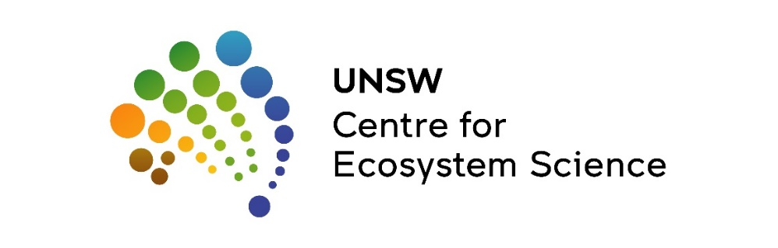


Final Report August 2023

Gwydir Wetlands: Drone Monitoring of Aggregating Breeding Waterbirds 2022-23
Brandis, K., Stewart, J., Francis, R.
Centre for Ecosystem Science, University of New South Wales
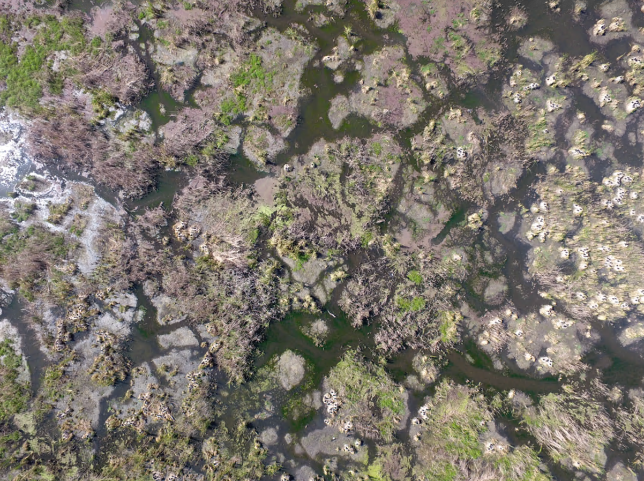
Report Citation: Brandis, K., Stewart, J., Francis, R. (2023) Gwydir Wetlands: Drone Monitoring of Aggregating Breeding Waterbirds 2022-23. Final report to the Commonwealth Environmental Water Office. Centre for Ecosystem Science, UNSW.
Cover photo: Goddard’s Lease rookery area
Photo credit: Jana Stewart
Funding acknowledgement: This research was funding by the Commonwealth Environmental Water Holder with support NSW Department of Planning and Environment, NSW National Parks and Wildlife Service and the Centre for Ecosystem Science, UNSW.
Disclaimer: The views and opinions expressed in this publication are those of the authors and do not necessarily reflect those of the Australian Government or the Minister for the Environment and Energy. While reasonable efforts have been made to ensure that the contents of this publication are factually correct, the Commonwealth does not accept responsibility for the accuracy or completeness of the contents and shall not be liable for any loss or damage that may be occasioned directly or indirectly through the use of, or reliance on, the contents of this publication.

Table of Contents

Executive Summary 5
Background 5
Climate 9
Water Management 11
Methods 13
Drone surveys 13
Results 14
2021-22 and 2022-23 Summary 17
Conclusions 17
Recommendations 17
References 18

Table of Figures
Figure 1 Map of the historical extent of the Gwydir Wetlands downstream of Moree in a) the Gwydir River Catchment (dark grey) in the Murray-Darling Basin, and b) location of Gwydir Wetlands State Conservation Area (NPWS Estate) and Ramsar sites. Wetland mapping from Kingsford et al. 2004 (Kingsford 2004). 8
Figure 2 Long-term annual rainfall totals measured at Garah Post Office (053011), rainfall years 2021,2022 and 2023 (to April) highlighted in red. Long-term annual mean shown by horizontal line. 9
Figure 3 Total annual flows (water year) from 1995-96 to 2022-23 at selected gauges for the Gwydir Watercourse and Wetlands system. (Figure provided by CEWO). WfENV – water for the environment. 10
Figure 4 Sentinel 2 L2A moisture index image 18th November 2022 of Moree and Gwydir region. Shades of blue indicating inundated areas, black outline Gwydir Wetlands State Conservation Area. 10
Figure 5 Flows and water levels at Teralba (418074) on the Gingham Channel June 2022 – April 2023. 11
Figure 6 Daily flows (ML/day) in main Gwydir River @ Yarraman, and Lower Gwydir @ Allambie and @ Millewa and Gingham Channel at Teralba for 1 July 2022 to 30 June 2023. WfE – water for the environment. Source: Graph provided by CEWO. 12
Figure 7 Daily discharge at Teralba on the Gingham Channel, and timing of UNSW Drone rookery monitoring 2022 and 2022-23. 13
Figure 8 Transects flown with the drone over the Goddard’s Lease rookery the a) 7th Nov. 2022, and b) 10th Jan. 2023. 14
Figure 9 In the first drone survey over Goddard’s Lease the 7th Dec. 2022 most adults were incubating eggs, spaced at relatively low densities across the landscape. 15
Figure 10 Straw-necked ibis chicks were at mobile chick stages of development on the 10th Jan. 2023, and can be seen straying from their nesting clumps. 15
Figure 11 Nesting straw-necked ibis (dark pink) and their chicks (light pink), Australian white ibis (blue), cormorants (green) and spoonbills (yellow) were present within the colonies (boundary red line) flown a) 29th Nov. 2022, b) 24th Jan. 2023, and c) 2nd Mar. 2023. 16

Executive Summary

Aggregating waterbirds bred at the Gwydir Wetlands for the second consecutive year following higher than average rainfall and river flows resulting large scale inundation of key rookery sites. In mid-late November 2022 straw-necked ibis began nesting at Goddard’s Lease Ramsar site, along with at other rookery sites in the Gingham and one site in the Lower Gwydir. The Goddard’s Lease ibis rookery was smaller in 2022-23 (~4,000 nests) than in 2021-22 (~11,700 nests). Only one of the eight large aggregating waterbird rookeries was able to be monitored using drone surveys in 2022-23. The other 2 ibis rookeries (Lynworth, Bunnor-Lynworth boundary) were not monitored by the UNSW Drone team due to access limitations because of flooding and landholder permission. The methods for using drones to accurately monitor tree nesting species is still in development, consequently on ground monitoring of other accessible colonies was done by collaboration between NSW EHG, NPWS, CEWH and Gwydir MER staff from January to April 2023.
The Goddard’s Lease ibis rookery was monitored by drone on two occasions throughout the nesting periods, December 2022 when the majority of adults were incubating eggs, and again in January 2023 when large, mobile chicks were observed. Results from the imagery indicated this was a successful rookery with no evidence of nest desertion, nest flooding or disturbance.

Background
The Gwydir Wetlands are an extensive terminal wetland system that once were a mosaic of around 102,200 ha floodplain watercourse and wetlands system. Following large scale irrigation development and related changes in landuse, there is now only around 15,000 ha of core floodplain wetlands mosaics Gwydir Wetlands areas remaining (Bowen and Simpson 2010) in the Gwydir River catchment (
Figure 1). Located from around 60 km west of Moree the wetlands are comprised of two key watercourses: Gingham to the northwest and Lower Gwydir to the southwest (
Figure 1). The Gwydir Wetlands are recognised as internationally and nationally important wetlands (Ramsar Convention Bureau 1999, DCCEEW 2005). Designated in 1999, the Ramsar area is now a mix of NSW NPWS estate and privately owned land and are components within the larger wetland system (
Figure 1). The Ramsar site covers 823 ha contains some of the largest expanses of water couch (Paspalum distichum) and marsh club-rush (Bolboschoenus fluvialtilis) in NSW (Ramsar 1999, DCCEEW 2005), as well as supporting high levels biodiversity.
The Gwydir Wetlands provide important waterbird habitat, both breeding and foraging, and regularly support large numbers of waterbirds including ibis, egrets, herons. Seventy-five waterbird species, including 50 reported breeding, 18 migratory species listed on JAMBA, CAMBA and ROKAMBA international agreements (JAMBA 1981, CAMBA 1988, ROKAMBA 2007, Spencer 2010), and 9 threatened waterbird species have been recorded in the Gwydir Wetlands (Spencer 2010). The wetlands are a mosaic of habitats that are, except during larger flood events, a terminal inland delta wetland system that formed where the Gwydir River discharged large portions of upstream inflows. These wetlands support high species diversity, and one of the few waterbird breeding sites in the Basin with an average annual rainfall >500mm (Figure 2) (Spencer 2010).
Breeding opportunities for aggregating waterbirds are often triggered by flood events at key wetlands. Forty-six per cent of all wetland sites throughout Australia that are used for aggregating waterbird breeding occur in the Murray-Darling Basin. Of these, relatively few wetlands (<5% recorded) support large rookeries (>5,000 nests) (Brandis 2010). The Gwydir Wetlands have historically been a significant aggregating waterbird nesting site (Table 1), however rookery sizes have reduced over time with changes to flows and decreased flooding, including flood magnitude and frequency (Kingsford 2000) and loss of wetland areas due to land use changes.

Table 1 Records of historical aggregating waterbird breeding at the Gwydir wetlands. Source (Spencer 2010, 2017, Francis and Brandis 2022).
Year | Ibis breeding pairs/nests | Heron/Egret pairs/nests
1921-22 | Observation only | Observation only, comments that in hundreds of thousands of egrets and herons
1933-34 | Observation only
1950’s | Observation only
1960’s | Observation only
1970’s | Observation only
1983 | ‘Large numbers’
1984 | Observation only
1988-89 |  | 1,000
1995 | 10-15,000 | 3,000-4,000 (Jan/-Feb.)  >40,000 (Nov.-Dec.)
1996 | 60,000 | 5,000
1997 | >100,000 | 5,000-6,000
1998-99 | 125,000 | 6,000-32,200
2004-05 | 2,000 | 20,000
2011-12 | 42,570
2014-15 | 22
2021-22 | 30,000 | 15,000

Figure 1 Map of the historical extent of the Gwydir Wetlands downstream of Moree in a) the Gwydir River Catchment (dark grey) in the Murray-Darling Basin, and b) location of Gwydir Wetlands State Conservation Area (NPWS Estate) and Ramsar sites. Wetland mapping from Kingsford et al. 2004 (Kingsford 2004).

Climate
Since 2021, Australia has been in a La Niña weather pattern which is normally associated with higher-than-average winter, spring, and early summer rainfall over much of Australia. The results of this type of weather pattern are reflected in the high local and upper catchment rainfall (Figure 2) and significant flooding (Error! Reference source not found., Figure 4) experienced in the Gwydir since 2021.

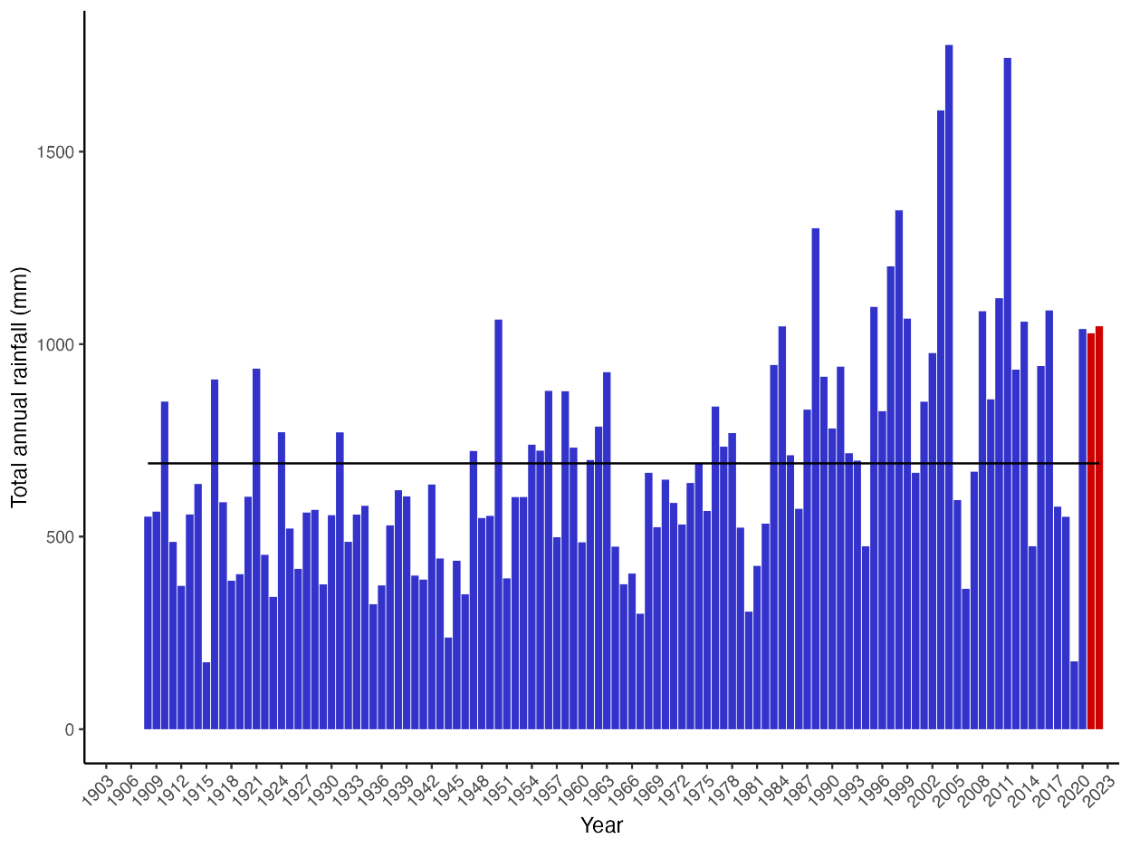
Figure 2 Long-term annual rainfall totals measured at Garah Post Office (053011), rainfall years 2021,2022 and 2023 (to April) highlighted in red. Long-term annual mean shown by horizontal line.

Figure 3 Total annual flows (water year) from 1995-96 to 2022-23 at selected gauges for the Gwydir Watercourse and Wetlands system. (Figure provided by CEWO). WfENV – water for the environment.
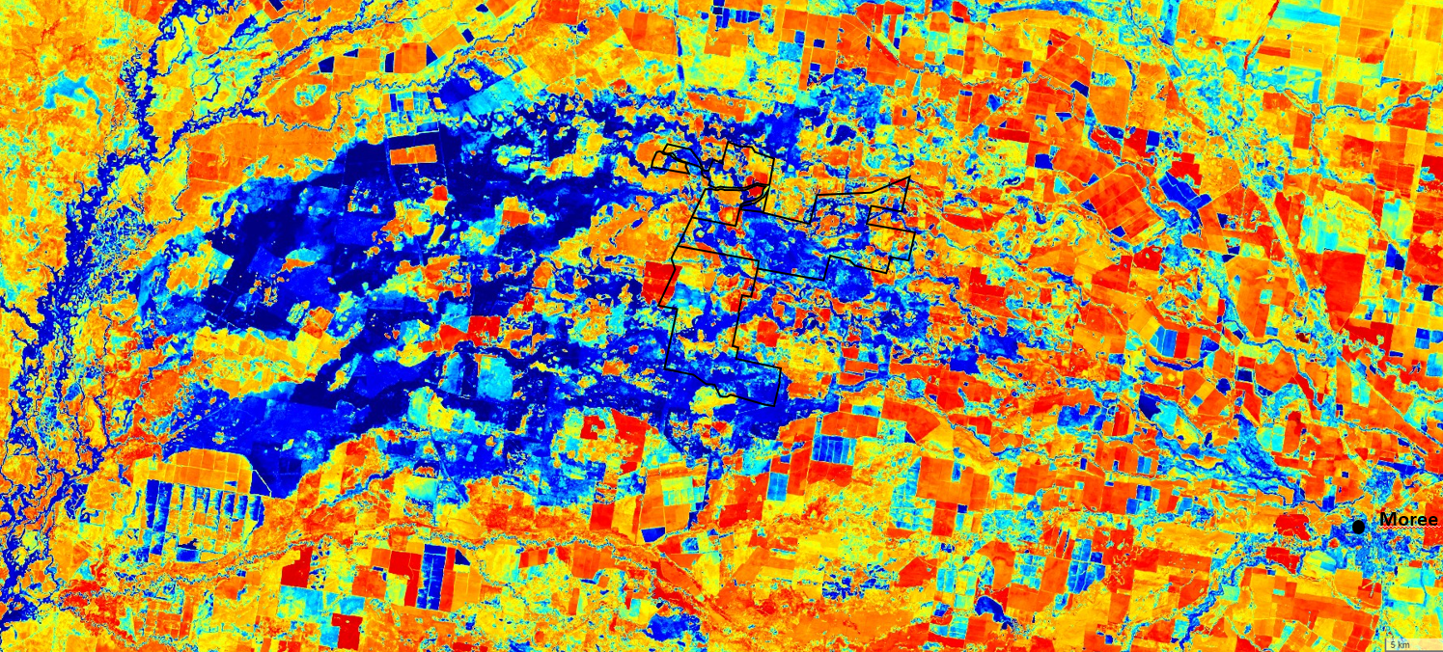
Figure 4 Sentinel 2 L2A moisture index image 18th November 2022 of Moree and Gwydir region. Shades of blue indicating inundated areas, black outline Gwydir Wetlands State Conservation Area.

Water Management
Water for the environment was delivered to the Gwydir Wetlands, to support the waterbird rookeries and foraging areas, including inundating areas of the Ramsar site. These deliveries were to maintain inflows to sufficient levels for the colonies by adding onto the inflows protected for the Gwydir Wetlands under the three tributaries low flow rule in the Gwydir Water Sharing Plan. Delivery of the water for environment component of the flows began in mid-December 2022 through to mid-March 2023. A total of 8,053 ML of water for the environment was delivered.
In the Lower Gwydir total inflows during the water for the environment delivery period (16 December 2022 to 10 March 2023) as measured at the Gwydir at Millewa gauges was 13,600 ML, which included total water for the environment delivery of 3,332 ML (2,586.40 ML of Commonwealth and 745.6ML of NSW water).
The hydrograph for the 2022-23 system flows from Gwydir River at Yarraman (overall Gwydir Wetlands flows) and at Millewa (Lower Gwydir wetlands inflows) and Gingham at Teralba showing the high flows and flooding periods that dominated from early August 2022 to late November 2022 (Figure 5).
The hydrograph for river flows in Gwydir at Yarraman (gauge 418004), and Gingham Channel at Teralba (gauge 418074) show multiple discrete high flow peaks between August to December 2022 with larger flow volumes and water levels over those 5 months including large flood event lasted November 2022, and then the lower levels of flows from January 2023 onwards (Figure 5). From late November 2022 and into early April 2023, was the period during which waterbirds bred. It was the higher inflows and flooding events up until mid-December 2022 that started the waterbird breeding colonies and then then the period of lower flows where water for the environment deliveries augmented the lower natural inflows to help support the successful completion of waterbird breeding (Figure 6).

Figure 5 Flows and water levels at Teralba (418074) on the Gingham Channel June 2022 – April 2023.

Natural high flows and flood events
WfE delivery period
Figure 6 Daily flows (ML/day) in main Gwydir River @ Yarraman, and Lower Gwydir @ Allambie and @ Millewa and Gingham Channel at Teralba for 1 July 2022 to 30 June 2023. WfE – water for the environment. Source: Graph provided by CEWO.

Methods
Waterbirds bred in rookeries in the Gwydir wetlands in two consecutive water years 2021-22 and 2022-23. In both years waterbird rookeries were monitored using repeated drone surveys in addition to the on-ground surveys undertaken by NSW EHG and CEWH and supported by other collaborators. Waterbird breeding and progression in the Goddard’s Lease ibis colony (Table 2) in 2022-23 was monitored by two drone surveys in November 2022 and March 2023.
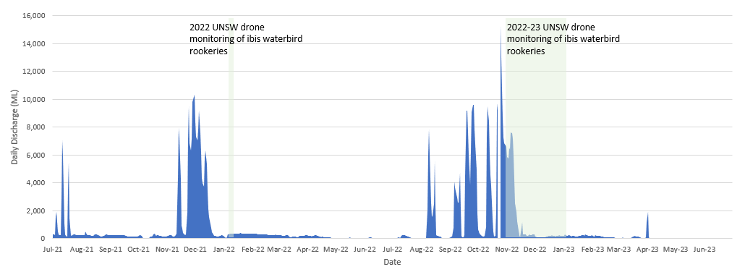
Figure 7 Daily discharge at Teralba on the Gingham Channel, and timing of UNSW Drone rookery monitoring 2022 and 2022-23.

Table 2 Straw-necked ibis chick development stages (sources Marchant & Higgins 1990, K.Brandis).
Development stage | Characteristics | Age (days)
Trampling | Adult ibis congregating on lignum (nesting habitat) and preparing for nest building
Egg | Whole egg, being incubated by adult | 1-20
Chicks | Recently hatched (1-5 days old), downy feathers, immobile | 21-25
Squirters | Early sheathed feathers starting on wings, still in nest, immobile | 26-30
Runners | Development of pin feathers. Mix of down and feathers, walking awkwardly, can leave nest on foot | 31-35
Flappers | Nearly fully feathered, cannot fly but flaps between nests | 36-40
Flyers | Fully feathered, able to fly and leave nests, still attended by parents at nest | 41-47
Fledged | Independent, does not return to nest but roosts in nearby trees | >48

Drone surveys
Drone surveys were conducted at Goddard’s Lease in the central Gingham area of the Gwydir Wetlands on the 7th December 2022 and 10th January 2023 (Table 3). The area surveyed by drone was adjusted on each survey to capture changes in the rookery extent (Figure 8, Figure 9).
Table 3 Dates of each drone survey including the area of the mosaic flown at the breeding rookery at Goddard’s Lease in the Gwydir wetlands.
Rookery | Survey date | Pilot | Mosaic area (ha)
Goddard’s Lease | 7th December 2022 | Jana Stewart | 28.1
 | 10th January 2023 | Jana Stewart | 18.9

Flights were conducted using a DJI Phantom 4 Pro. The drone was launched and returned from dry land on the outskirts of the rookery. Flights were conducted at an altitude of 65m – 75m. Flights consisted of automated transects layed over the areas where breeding was previously identified at an overlap of 76%, producing over 1000 images covering each rookery. Flight locations were guided by ground observations when possible, or otherwise the drone was first flown manually on a scouting mission to identify rookery extent.
Images were orthomosaiced using Pix4Dmapper (Pix4d SA, 2022). Orthomosaics were counted manually with nest locations annotated in a shapefile. Species were identified based on their plumage and breeding stage was determined based on group behaviour (e.g., trampling, incubating or créching), and from sightings of eggs or chicks in nests. Using known clutch size we estimated a total number of nests built in the season in the rookery.
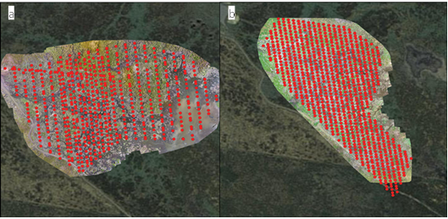
Figure 8 Transects flown with the drone over the Goddard’s Lease rookery the a) 7th Nov. 2022, and b) 10th Jan. 2023.

Results
The straw-necked ibis dominated rookery surveyed at Goddard’s Lease on the 7th December 2022 was in early stages of breeding, with the large majority of adults incubating eggs or attending young chicks (Figure 9). Based in this nesting likely began in mid-late November 2022 coinciding with a large flow pulse (Figure 7). Nests were spread across the landscape at low densities. Straw-necked ibis were the only species observed nesting in December.
The second survey conducted over Goddard’s Lease the 10th January 2023 showed an advanced rookery, with the majority of observations being large mobile chicks, likely at the flyer or fledgling stage (Table 2, Figure 10). During this survey other species were also present and breeding including Australian white ibis, and cormorants (Table 4, Figure 11). Royal spoonbills were sighted in the imagery, however no nests were identified. There were potentially also small numbers of glossy ibis, however this species is difficult to definitively identify in drone imagery.
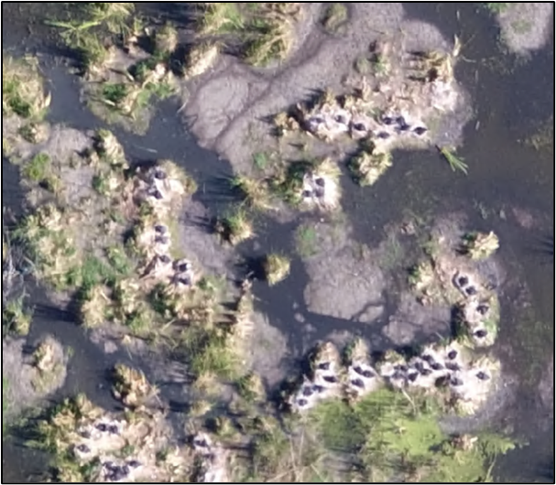
Figure 9 In the first drone survey over Goddard’s Lease the 7th Dec. 2022 most adults were incubating eggs, spaced at relatively low densities across the landscape.
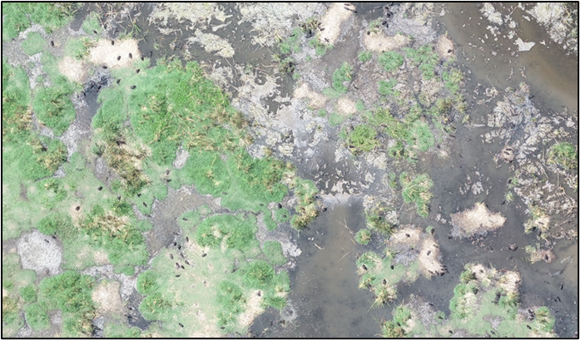
Figure 10 Straw-necked ibis chicks were at mobile chick stages of development on the 10th Jan. 2023, and can be seen straying from their nesting clumps.

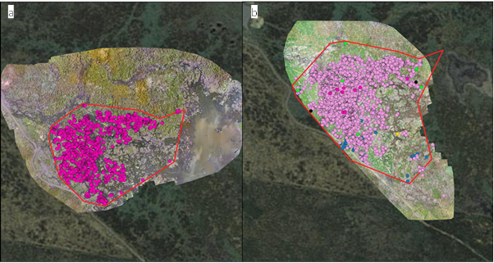
Figure 11 Nesting straw-necked ibis (dark pink) and their chicks (light pink), Australian white ibis (blue), cormorants (green) and spoonbills (yellow) were present within the colonies (boundary red line) flown a) 29th Nov. 2022, b) 24th Jan. 2023, and c) 2nd Mar. 2023.
Based on changes to the rookery extent between December and January we estimate that approximately 211 chicks were not counted in the December image that were present in the January image. To estimate total nest numbers based on counted chicks we used the following formula to estimate a total nest count for straw-necked ibis at Goddard’s Lease:
3,835 nests + (192 chicks /2.4*) + 15 nests+ (211 chicks/2.4*)
= 4,018 straw-necked ibis nests
*mean clutch size from Macquarie Marshes 2022-23 (Brandis et al. 2023).
Table 4 Results of counts of birds from drone imagery collected at Goddard’s Lease in the Gwydir Wetlands.
Survey Date | Count Type | Species | Count | Maximum Rookery Area (ha)
7th Dec. 2022 | Manual | Straw-necked ibis | 192 chicks | 8.7
 |  |  | 3,835 adults nesting
10th Jan. 2023 | Manual | Straw-necked ibis | 6,297 large chicks* | 12.2
 |  |  | 27 young chicks
 |  |  | 15 new nests
 |  | Australian white ibis | 74 adults present
 |  | Glossy ibis | 2 adults present
 |  | Royal spoonbill | 7 adults present
*most of these likely belonged to the nests already counted in the December 2022 drone survey

2021-22 and 2022-23 Summary
Waterbirds bred at multiple rookery sites in 2021-22 and 2022-23. Table 5 summarises results from drone surveys in both years. Ibis nesting was observed at Lynworth and Tillaloo rookeries in 2022-23 but were not surveyed.
Table 5 Summary of 2021-22 and 2022-23 ibis rookery sizes.
Ibis Rookery site | Year | Estimated nest counts | Max. Rookery area (ha)
Lynworth Bunnor-Boundary | 2021-22 | 10,000 | 4.5
Lynworth Cumbungi | 2021-22 | 4,588 | 4.7
Lynworth Lignum | 2021-22 | 2,412 | 4.0
Tillaloo | 2021-22 | 1,300 | 5.7
Goddard’s Lease | 2021-22 | 11,700 | 16.7
Goddard’s Lease | 2022-23 | 4,018 | 12.8

Conclusions
The ibis rookery at Goddard’s Lease, the only rookery measured by drone surveys in both years, was smaller in 2022-23 (~4,000 nests) than in 2021-22 (~11,700 nests). Other ibis rookeries on Lynworth and Tillaloo were not monitored due to access limitations because of landholder permission. From the imagery it appeared that the Goddard’s Lease rookery was successful with large, mobile fledged chicks observed in January 2023. There were no observations of extensive nest desertion or flooding.

Recommendations
The provision of water for the environment is becoming increasingly important in the management and support of aggregating waterbird breeding events. This can be achieved both during the breeding season and between seasons when conditions may not be suitable for large scale waterbird breeding. Between season maintenance of nesting habitat is crucial for when opportunities for breeding do occur, and for providing resources for ongoing survival of waterbirds during drier phases. Providing opportunities for breeding includes the presence of suitable nesting habitat, this often includes areas of lignum, phragmites, river red gums, and river cooba, with the more waterbird species diverse sites having mosaics of floodplain and riparian vegetation communities (Brandis, Francis and Bino in prep).
Large scale colonial waterbird breeding is often associated with large scale inundation as a result of natural rainfall and flooding. Water for the environment deliveries can play a key role in supporting breeding colonies after they have been established, through the provision of additional flows to extend duration, increase water depth, maintain water quality and provide foraging areas.
In the Gwydir Wetlands where there are multiple rookery sites supporting a diverse range of colonially breeding species e.g., ibis, egrets, herons, cormorants, it is a challenging task to support all sites with environmental water. This is an issue for the Gwydir Wetlands where rookeries occur on private land and there are challenges in providing sufficient water to support waterbird breeding. Modifications to channels, wetlands and floodplains, including erosion and channelisation have increased both the volume of water required to provide inundation of the wetlands (Spencer 2010) along with the challenges of delivering water for the environment in a highly modified environment, with differing values.
For sites where water management is possible, key targets should include the maintenance of nesting vegetation between breeding seasons, and the provision of environmental water, as needed (e.g., duration extension, increased depth, water quality) during breeding events and supporting the maintenance and survival of waterbird populations during drier phases.
Quantifiable thresholds for these targets can be variable and may depend upon the rookery site, but in general, the provision of flows for a minimum of 3-4 months, to allow for the cycle of nesting, egg laying, chick rearing and fledging to complete (Brandis and Bino 2016), the maintenance of water levels in the rookery site to prevent: 1) desertion by nests by adults due to rapidly falling water levels (Brandis et al. 2011), and 2) flooding of established nests due to rapidly rising water levels, and 3) sufficient water depth to prevent predator access (~50cm). Management of flows is also important to ensure good water quality. Poor water quality and stagnant water can result in blue-green algae, large quantities of decomposing vegetation and promote conditions that can results in avian botulism outbreaks (Brandis et al. 2019) and other diseases.
Colonial waterbirds are important components in wetland ecosystems, and are often used as indictors of wetland health (Kingsford 1999). The support of colonial waterbird colonies through the provision of water for the environment is critical in the conservation of these species, limiting populations declines (Kingsford et al. 2020), supporting population growth and providing opportunities for breeding (Brandis et al. 2021). It is also just as important to conserve and manage these wetland ecosystems and habitats on which they rely for breeding, foraging and roosting.

References
Bowen, S., and S. Simpson. 2010. Changes in extent and condition of the Vegetation Communities of the Gwydir Wetlands and Floodplain 1996-2008. Final Report for the NSW Wetland Recovery Program., NSW Department of Environment, Climate Change and Water: Sydney.
Brandis, K., and G. Bino. 2016. A review of the relationships between flow and waterbird ecology in the Condamine-Balonne and Barwon-Darling River Systems. Murray-Darling Basin Authority.
Brandis, K., S. Hewitt, M. Smith, J. Stewart, L. Juilliard, T. McEvoy, and T. Francis. 2023. Macquarie Marshes Waterbird Reproductive Sucess Monitoring 2022-23. Draft report to the Commonwealth Environmental Water Holder. UNSW.
Brandis, K., R. T. Kingsford, S. Ren, and D. Ramp. 2011. Crisis water management and ibis breeding at Narran Lakes in arid Australia. Environmental Management 48:489-498.
Brandis, K., J. Spencer, B. Wolfenden, and D. Palmer. 2019. Avian-botulism risk in waterbird breeding colonies and implications for environmental water management. Marine and Freshwater Research 71:179-190.
Brandis, K. J., G. Bino, and R. T. Kingsford. 2021. More Than Just a Trend: Integrating Population Viability Models to Improve Conservation Management of Colonial Waterbirds. Environ Management 68.
CAMBA. 1988. Agreement between the Government of Australia and the Government of the People's Republic of China for the Protection of Migratory Birds and their Environment.in The Government of Australia and the Government of the People's Republic of China, editor. Australian Treaty Series 1988 No. 22. Australian Government Publishing Service, Canberra.
DCCEEW. 2005. Directory of Important Wetlands In Australia. Department of Climate Change, Energy, the Environment and Water,.
Francis, R., and K. Brandis. 2022. Colony drone surveys over Gwydir Wetlands. Report for NSW Department of Planning and Environment, Environment and Heritage Group. Center for Ecosystem Science, UNSW.
JAMBA. 1981. Agreement between the Government of Australia and the Government of Japan for the Protection of Migratory Birds in Danger of Extinction and their Environment.in The Government of Australia and the Government of Japan, editor. Australian Treaty Series 1981 No. 6. Australian Government Publishing Service, Canberra.
Kingsford, R. T. 1999. Aerial survey of waterbirds on wetlands as a measure of river and floodplain health. Freshwater Biology 41:425-438.
Kingsford, R. T. 2000. Review: Ecological impacts of dams, water diversions and river management on floodplain wetlands in Australia. Austral Ecology 25:109-127.
Kingsford, R. T., Brandis, K. ,Thomas, R.F. ,Crighton, P. ,Knowles, E. ,Gale, E. 2004. Classifying landform at broad spatial scales: the distribution and conservation of wetlands in New South Wales, Australia. Marine and Freshwater Research 55:17-31.
Kingsford, R. T., J. L. Porter, K. J. Brandis, and S. Ryall. 2020. Aerial surveys of waterbirds in Australia. Scientific Reports 7.
Ramsar. 1999. Information Sheet on Ramsar Wetlands: Gwydir Wetlands: Gingham and Lower Gwydir (Big Leather) Watercourses.in Ramsar, editor. www.ramsar.org.
Ramsar Convention Bureau. 1999. Gwydir wetlands: Gingham and Lower Gwydir (Big Leather) watercourses. Information sheet on Ramsar wetlands.
ROKAMBA. 2007. Agreement between the government of Australia and the government of the Republic of Korea on the protection of migratory birds.
Spencer, J. 2010. Historical records of waterbirds and fish populations in the Gwydir Wetlands. Rivers and Wetlands Unit, Department of Environment, Climate and Water NSW, Sydney.
Spencer, J. 2017. Evaluation of colonial waterbird breeding in NSW Murray-Darling Basin: 2006-16. NSW Office of Environment and Heritage, Sydney, Australia.

