How you can help the ocean

The ocean is part of your life
Managing and protecting Australia’s ocean is not just the responsibility of governments and industries.
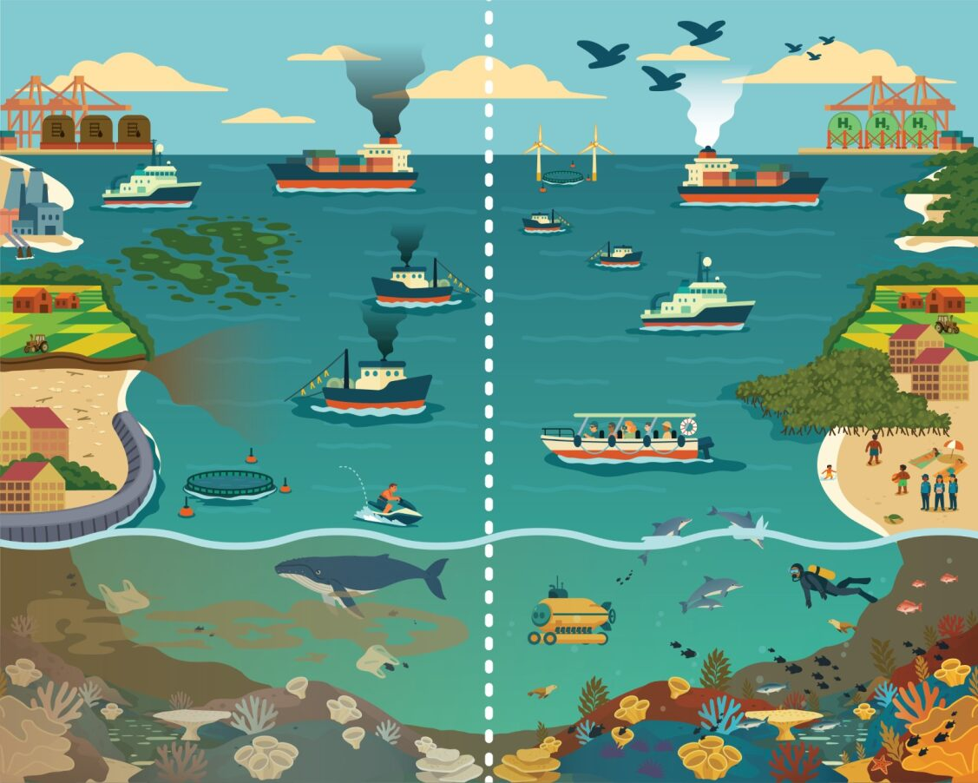
All Australians – even those who don’t live near the coast – benefit from the oxygen, food, energy, connectivity and transport it provides. We all have a role to play in looking after the ocean to ensure it can continue to provide for us for many years to come.
The decisions you make can affect the health of our ocean. What do you want to see for your future?
You can help our ocean thrive and protect the coastal places you love by:
- respecting and protecting the habitats and environments that support our ocean
• fishing responsibly (e.g. follow bag, size and possession limits, and practising ‘catch and release’ methods)
- reducing your pollution, including by:
  - using reusable cups, straws and food containers when you get takeaway
  - refusing single-use plastics and reducing and recycling waste whenever possible
  - using less water in your garden to reduce run-off to storm water drains that flow to our ocean
  - binning or avoiding things that can pollute waterways (e.g. litter, glitter, microbeads and harsh or toxic chemicals) instead of putting them down the drain
  - avoiding using or releasing balloons (and ensuring you carefully dispose of any balloons you do use)
  - lowering your carbon footprint when you can (e.g. by turning lights and devices off, and walking, cycling or catching public transport instead of driving)
  - reducing light pollution (e.g. by turning off any unneeded outdoor lights and closing blinds and curtains), which can disrupt and disorient wildlife
  - disposing of fishing lines, nets and gear correctly and not near water
- choosing sustainably sourced seafood
- getting involved with citizen science projects (e.g. CoralWatch and RedMap) and coastal clean-ups
- talking to friends and family about how important the ocean is and what they can do to help.

More information
www.ocean.gov.au

Glossary
Term | Definition
Carbon footprint | The amount of carbon dioxide released into the atmosphere because of our activities.
Light pollution | Inappropriate or excessive artificial light at night.
Citizen science | Public participation or volunteering in scientific research.

