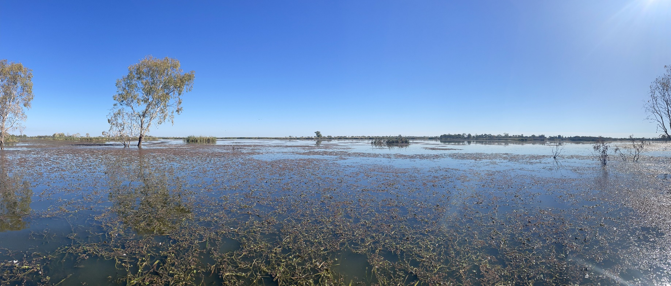
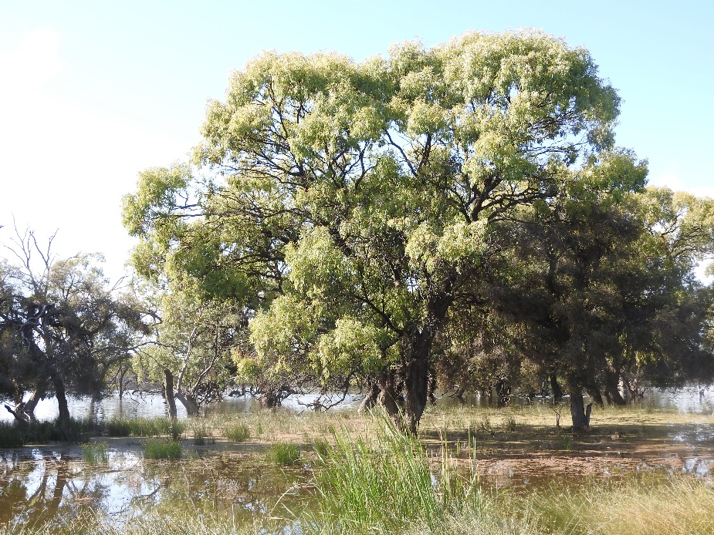
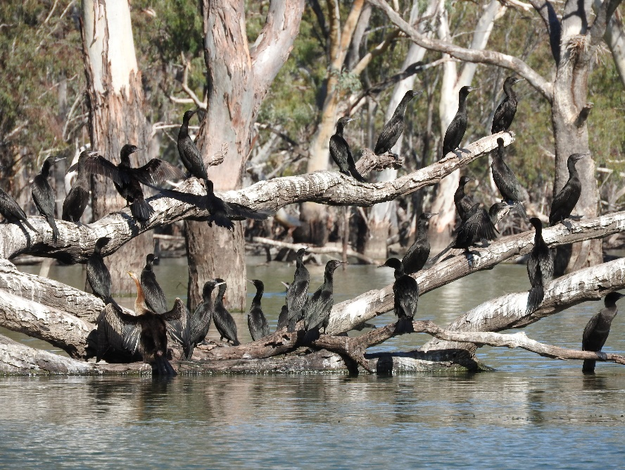



LACHLAN RIVER
MONITORING, EVALUATION AND RESEARCH
QUARTERLY OUTCOMES NEWSLETTER | APRIL - JUNE 2023

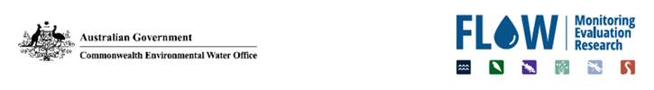
LACHLAN RIVER
MONITORING, EVALUATION AND RESEARCH
Welcome to the June 2023 quarterly newsletter of the Lachlan Monitoring, Evaluation and Research (MER) Program. This newsletter forms part of the reporting activities undertaken in the Lachlan river system under the MER Program and provides a regular update on our monitoring and research activities and observations.
In this issue we put a spotlight on how operational surplus flows were used for environmental outcomes in the April – June quarter. We provide an update from the fish community monitoring in the mid and lower Lachlan River. We then briefly describe some of the complexity in how environmental water is delivered. We take a look at the weather conditions experienced in the lower Lachlan catchment and finish with the Lachlan Diaries where Dr Adam Kerezsy describes the finding of the endangered olive perchlet.
We hope you enjoy the read!
The Lachlan MER Team
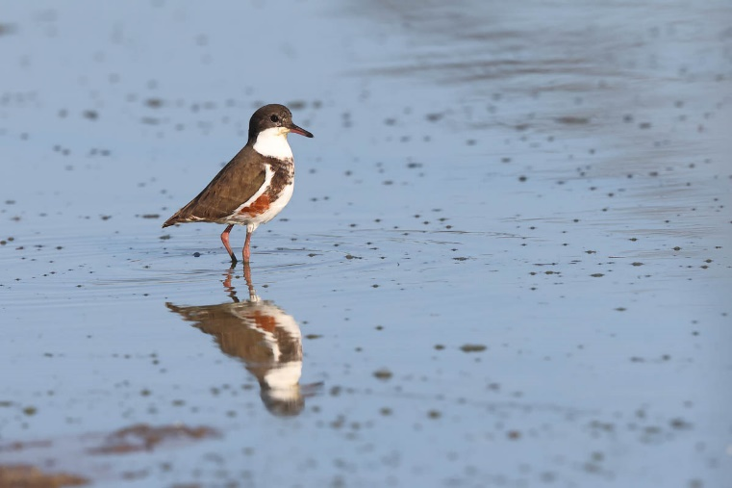
Red-kneed dotterel at Kilfera on the Willandra Creek. Photo by Warren Chad.

UTILISING OPERATIONAL SURPLUS FLOWS FOR ENVIRONMENTAL OUTCOMES

By Joanne Lenehan
While there were no planned or held environmental watering actions in the April-June quarter, DPE–EHG environmental water managers worked collaboratively with WaterNSW to adjust the operational settings in four of the five unregulated effluent creeks in the Lachlan River for environmental outcomes. Approximately 32,743 ML of operational surplus was delivered in May though to June 2023 for environmental outcomes across Willandra, Merrowie, Muggabah and Booberoi Creeks. DPE–EHG define a “watering action” for management question purposes as:
- water delivery;
- the action of not taking water into an area (e.g., leaving a flow within the river); and/or
- the management of structures that influence the outcomes (e.g., opening of regulators to allow fish movement or improve longitudinal connectivity).
Traditionally, surplus flows are used for stock and domestic replenishment in these creek systems. However, the timing was deemed ‘too early’ for replenishments and the flow rates were greater than the replenishment flow target. The surplus flow originated from airspace releases at Wyangala Dam. Consistent with option 2. (above), flows aligned with ‘natural’ wetness cues and seasonal patterns were ‘shepherded’ into the mid Lachlan anabranch (Booberoi Creek) and lower Lachlan distributary or effluent creeks (Willandra, Muggabah, Merrowie Creek) – enhancing lateral connectivity. The third option was also exercised in a novel way to open regulators and direct flows into key ecological assets in addition to the Lachlan River channel.
The over-arching ecological objective was to provide a ‘fresh’, basically a flush of fresh water, during autumn, after a lower base flow period that had provided for some drying down of off-channel lagoons, wetlands and floodplain channels. The fresh in all creeks aimed to:
- Flush poor water quality, particularly blue green algae, dilute high carbon loads, and re-oxygenate pools and wetlands after reports of high algal loadings and low dissolved oxygen during lower flow, high temperature summer conditions under which blue green algae is known to thrive.
- In doing so, provide opportunities for fish to disperse, access additional habitat and establish in over-wintering habitats. Fish monitoring was undertaken by DPE–EHG and Dr Fish Contracting.
- Provide follow-up watering of floodplain wetlands, weir pools and channels to support recovery of lignum, nitre goosefoot and fringing sedgelands, rushes and reeds, and support macrophyte stands (e.g., ribbon weed).
- Replenish waterbird foraging and roosting habitats, including lakes that may function as refugia into spring 2023 (e.g., Morrisons Lake and Willandra National Park Homestead Weir). Waterbird monitoring had been undertaken by DPE–EHG and Weejugla Wildlife (Warren Chad, Condobolin).
- Utilise operational surplus flows in anticipation of a return to dry climatic conditions and below average rainfall during winter into spring, after El Nino watch issue by BOM.

Feedback from Willandra District Trust spokesperson March 2023:
“You can see the fresh has just arrived at Lachlan River @ Willandra Weir. You are doing the correct thing in keeping it going down the Lachlan River and Willandra Creek. Why the level was dropped so quickly is beyond my understanding? I’m at Ratzcastle Bridge where the Willandra Creek is flowing a soupy green. It had stopped for a while”.
In response from the District Trust to consider an environmental flow in April, DPE–EHG negotiations occurred with WaterNSW to open Willandra Creek to allow for a proportion of the passing flows from airspace operations to flow down Willandra Creek in line with river height. Approximately 16,876 ML of ‘operational surplus for environmental outcomes’ was delivered from 12 May to 19 June 2023. Flows had refreshed water quality in the lower Willandra below Morrison’s Lake by 31 May and reached the end of system Balranald to Ivanhoe Road by 15 June, inundating the lignum shrubland and black box braided channel–fringing macrophyte floodplain system.
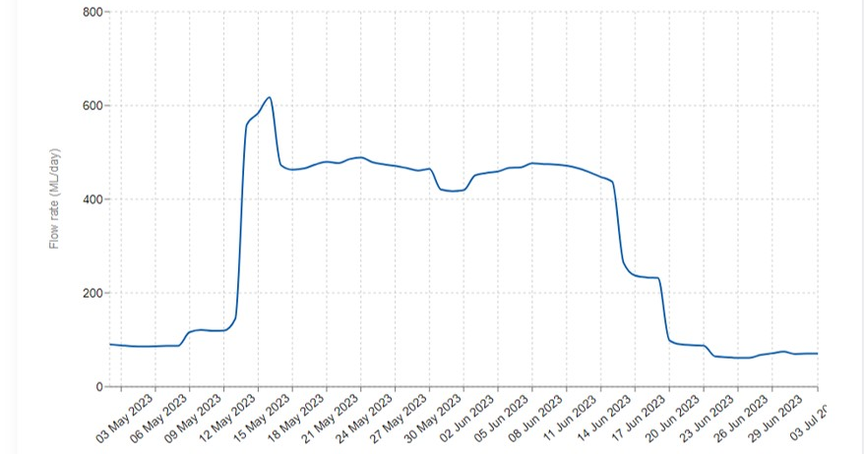
WaterInsights hydrograph of the operational surplus for environmental outcomes between the 12 of May to the 19 June 2023 at Willandra Creek @ Road Bridge (412012).
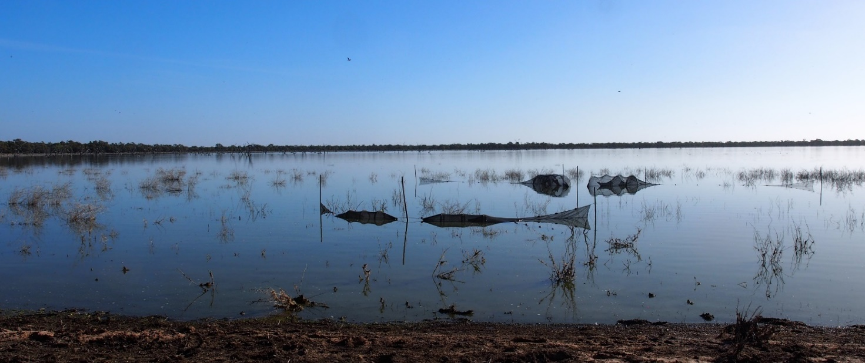
Andy's Lake off Willandra Creek during fish monitoring supported by DPE–EHG. Photo by Adam Kerezsy.
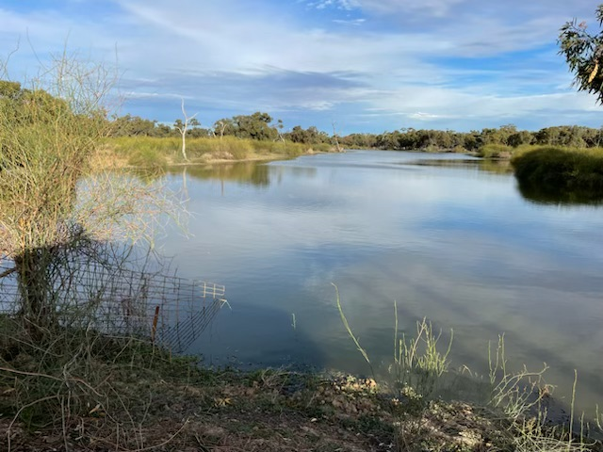
Lower Willandra Creek below Morrison’s Lake on 31 May 2023 after the fresh arrived to replenish fringing lignum shrublands and riparian black box woodlands. Photo supplied by landholder.
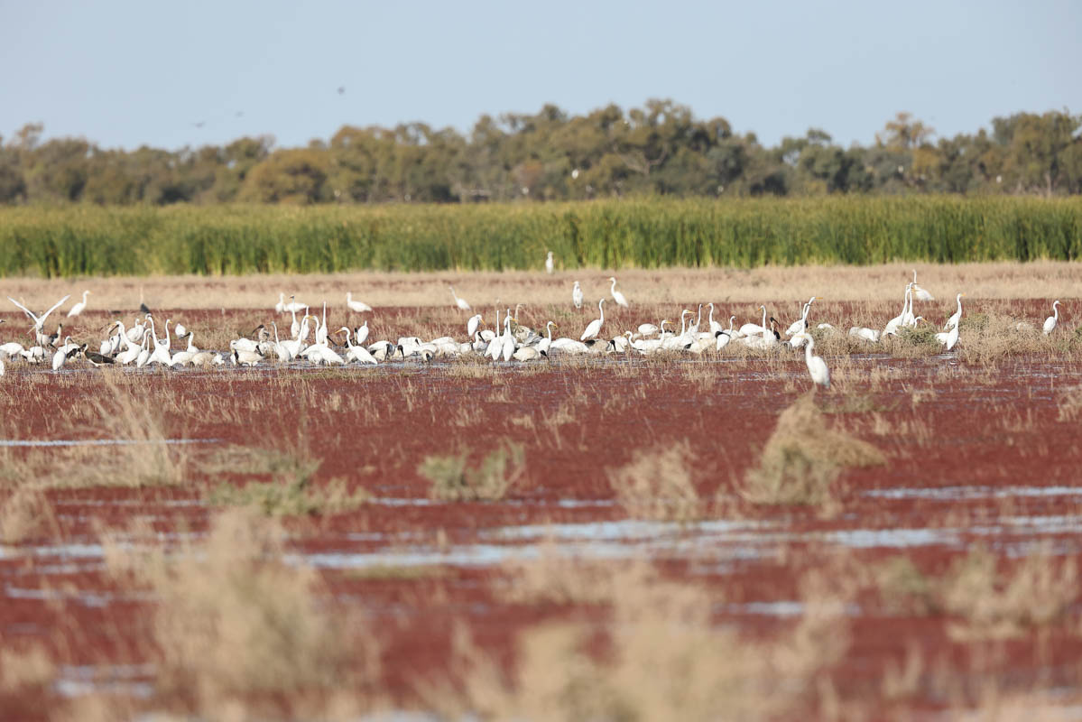
10 km south of Kilfera on Balranald Road past Willandra Creek where the floodwater reached the road.
Photo by Warren Chad.
By the end of the action:
- Approximately 7,634 ML of ‘operational surplus for environmental outcomes’ was delivered into Booberoi Creek from 25 May to 13 June 2023. Feedback from Booberoi landholder: “Thanks so much for looking after our precious Booberoi Creek”.
- Approximately 4,669 ML of ‘operational surplus for environmental outcomes’ was delivered into Merrowie Creek from 17 May to 18 June 2023. Flows were sufficient to replenish all the major weir pools which are valuable waterbird, native fish and macrophyte refuges.
- Approximately 3,564 ML of ‘operational surplus for environmental outcomes’ was delivered into Muggabah Creek from 1 June to 28 June 2023, and flow reached and flushed the system up until the end of system replenishment target.

Lachlan River Fish Surveys in the mid and lower Lachlan River
Fish Community Monitoring
By Jerom Stocks and Ben Broadhurst
The NSW Department of Primary Industries and University of Canberra fish monitoring teams have completed their annual fish community surveys in the mid and lower Lachlan River for the 2022–23 water year.
This sampling contributes to the long-term dataset that commenced in 2014–15, implemented to monitor native fish responses to water management actions. These surveys use a combination of standardised sampling methods including electrofishing and traps and nets to target a range of species from small native gudgeons to large Murray cod.
The data collected over the years have provided important insights into population trends, recruitment and health of the native fish populations, which has informed decisions regarding the delivery of water for the environment.
This year’s surveys follow broadscale flooding throughout much of the Murray-Darling Basin.
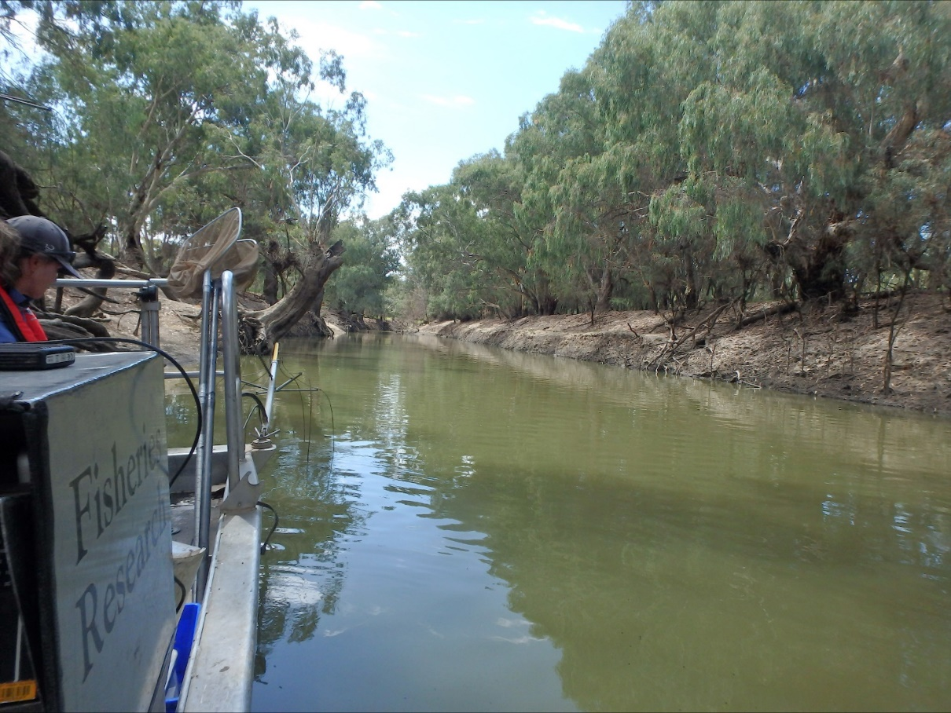
NSW DPI Fisheries Research boat during Autumn 2023 monitoring trip. Photo by Jerom Stocks.

Key observations from the mid and lower Lachlan from Autumn 2023 surveys:
  - Seven native fish species were captured (Murray cod, bony herring, golden perch, Australian smelt, unspecked hardyhead, flatheaded gudgeon and carp gudgeon).
  - Common carp were the most abundant fish species, showing a large increase in abundance compared to the previous years sampling, and representing the second highest abundance since annual surveys began in 2014-15 (only exceeded by 2017).
  - The majority of common carp were ~100mm in length. Likely young-of-year fish spawned in the preceding floods.
  - Murray cod abundances increased compared to the two previous years (however lower abundances compared with 2019).
  - No evidence of spawning of Murray cod as no young-of-year captured, likely due to flood events during spawning disrupting nesting.
  - Golden perch abundances increased compared to the two previous years, however only one juvenile golden perch was captured in the mid or lower Lachlan suggested very limited recruitment this year in golden perch.
  - Two dominant cohorts of bony herring were sampled of 100mm and 200mm fish, though abundances of bony herring were low compared to previous years.
  - Abundances of shrimp continue to increase, a trend that has continued since 2018.
  - Some large native fish showed signs of stress (high parasite load).

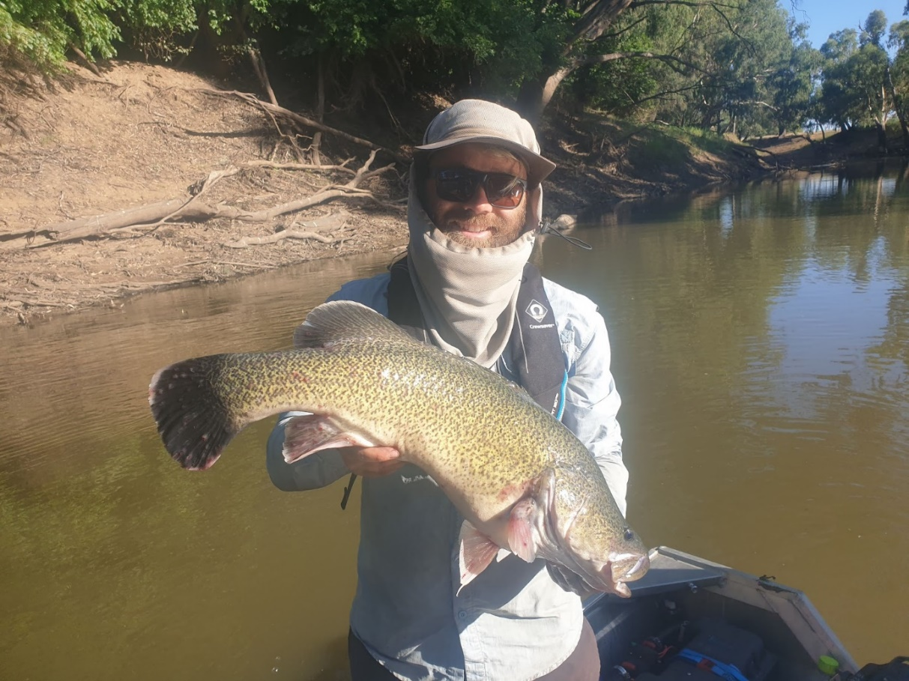
Adult Murray cod captured via electrofishing. Photo by Hugh Allan.
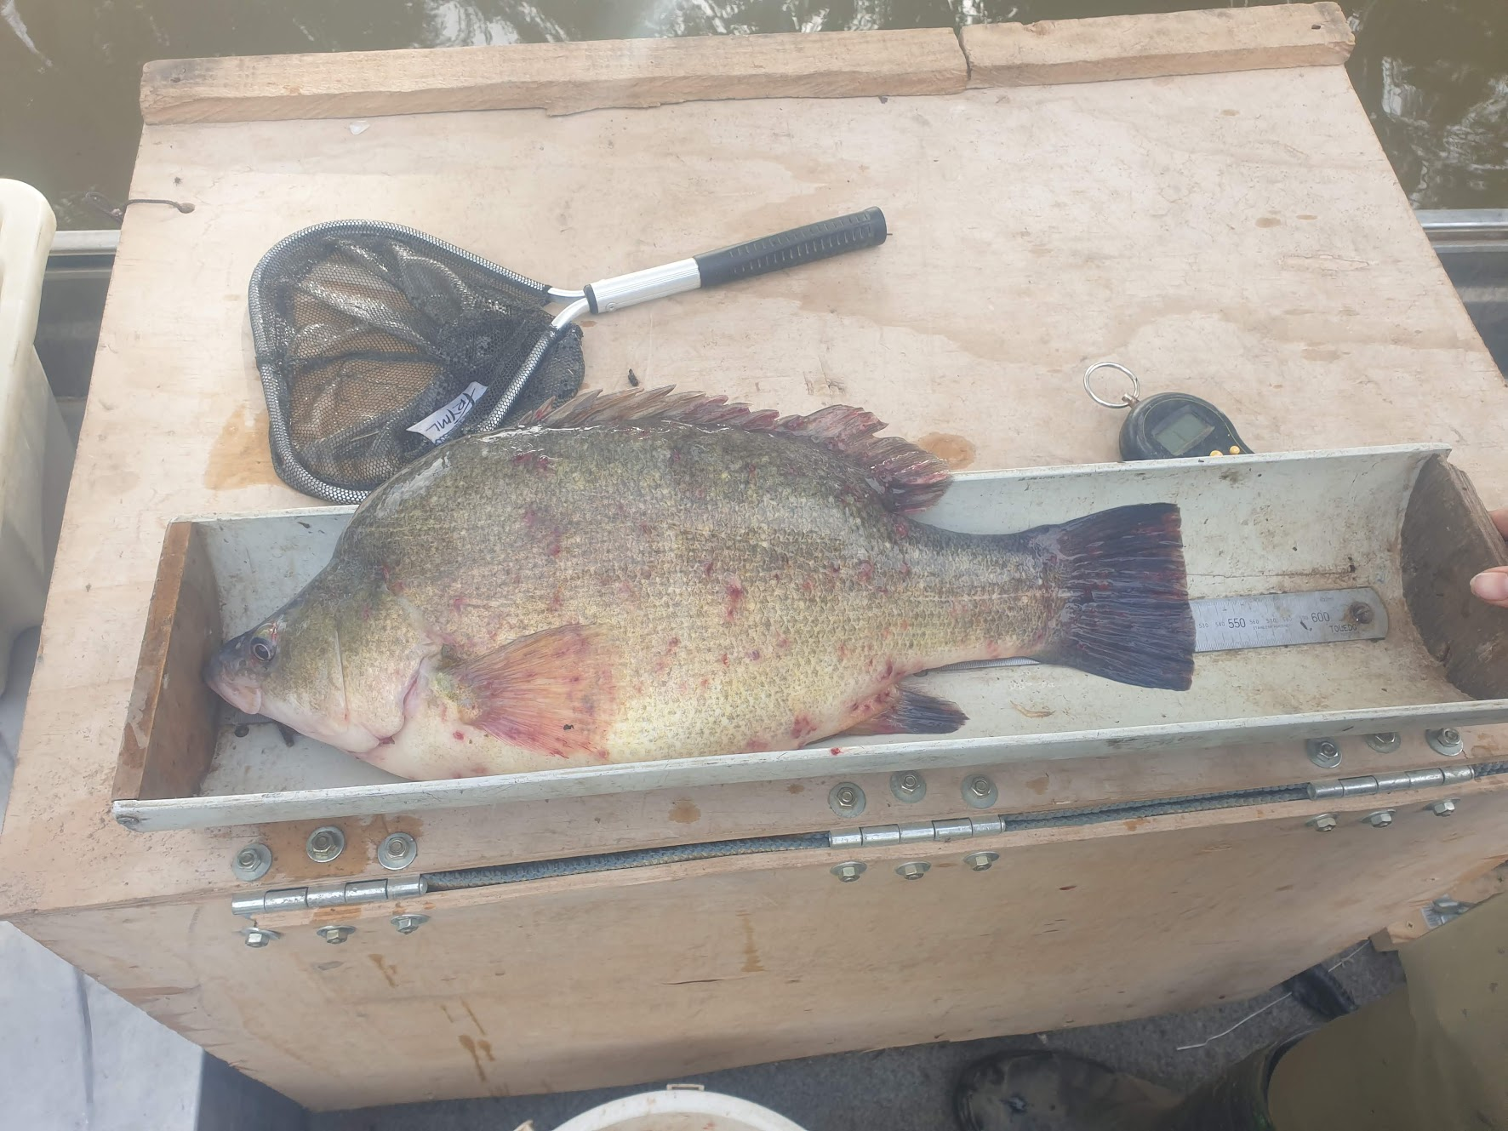
Golden perch with high parasite load (Lernaea, anchor worm). Photo by Hugh Allan.

THE PRACTICALITIES OF DELIVERING AN ENVIRONMENTAL WATERING ACTION

By Fiona Dyer, Will Barrett and Ebony Mullin
Arranging the delivery of environmental water is not as simple as turning on a tap, or simply making a call to place an order with WaterNSW. Once a watering action has been decided on, there is then a complex process of approvals and administrative transfers of water holdings accompanied by plenty of paperwork before the action can be delivered. This process involves staff from the Commonwealth Environmental Water Holder (CEWH), NSW Department of Planning and Environment (NSW-DPE) and WaterNSW working together to make things happen. The coordination between the agencies is often challenged by short time frames when watering actions are being delivered in response to a particular event. For example, the need to respond to poor water quality at a location or the need to support a bird breeding event.
- Design of the watering action – how much water is needed, where and when?
Designing a watering action is a collaborative process that is led by the water delivery teams from the CEWH and NSW-DPE. The design process takes into consideration the broader priorities of the Basin Plan, the regional priorities of the Long Term Water Plan, and the local environmental needs. It often involves input from members of the Environmental Water Advisory Group (EWAG), monitoring teams (both the Lachlan Flow MER team and the NSW monitoring teams), WaterNSW, and others with local expertise.
- Approval to use water holdings to deliver the watering action – what water parcel should be used?
As part of the collaborative design process, the contribution of water from each of the agencies to the action is agreed. Staff from within the agencies then review their holdings of water and collaborate on which parcel is most appropriate considering things like - is this water an annual allocation or can it be carried over for use in drier years? For example, Environmental Water Allowance is an annual allocation which may not be available once General Security accounts get low. Other considerations include, can operational flows be leveraged to improve the outcomes from any environmental water used, are surplus flows expected in the system and what is the irrigation demand?
Each proposed watering action is reviewed and formally approved by the statutory water holder. In the case of the Commonwealth holdings, this is the Commonwealth Environmental Water Holder while DPE-EHG are the managers for the use of Environmental Water Allowance and DPE Water manage the usage of Water Quality Allowance.
- Transfer of water holdings – delivery of the action
Once approved for use, water is then transferred from the Commonwealth licenses to the NSW licenses, as DPE–EHG arrange and manage delivery on behalf of CEWH. The Commonwealth portfolio is held on multiple licenses, so a transfer involves a series of transfers to match estimated required total volume of water. DPE– EHG place the Water Order and continue to work with WaterNSW, sometimes on a daily basis, to adaptively manage the watering action in terms of accounting points, total volumes and requested flow rates for the delivery.

- Accounting of the watering action – how much water was used
The delivery of water through river systems is not a perfect science. Once the watering action has been delivered, there is a final accounting of the volumes of water actually used. WaterNSW use the best available forecasting to ensure the amount of water available at the accounting point (gauge) is within 5% of what was ordered by the environmental water holder.

CATCHMENT CONDITIONS APRIL TO JUNE
The very much above average rainfall for January and March 2023 took a break for April and May and commenced again in June at Hillston (Airport) and at Oxley (Walmers Down) in the lower Lachlan Catchment. May was very dry, with below half the average rainfall for this month. This uneven pattern was comparable to that experienced in 2022, with 3 months of above average rainfall, but in 2022 it had been in January, April and May and while June was very dry.
In the first half of 2023 both stations have exceeded the long-term rainfall median by over 50 mm for Hillston (175 mm) and by over 70 mm for Oxley (166 mm), which equals 64% and 77% of the annual rainfall at these gauging stations respectively.
These conditions were accompanied by daily maximum temperatures in April and May comparable to the long-term average, while June recorded above average daily maximum temperatures at Hillston.
Daily minimum temperatures were similar to the long-term averages for April and June, while May recorded (3.3°C) below average daily minimum temperatures.
Hillston  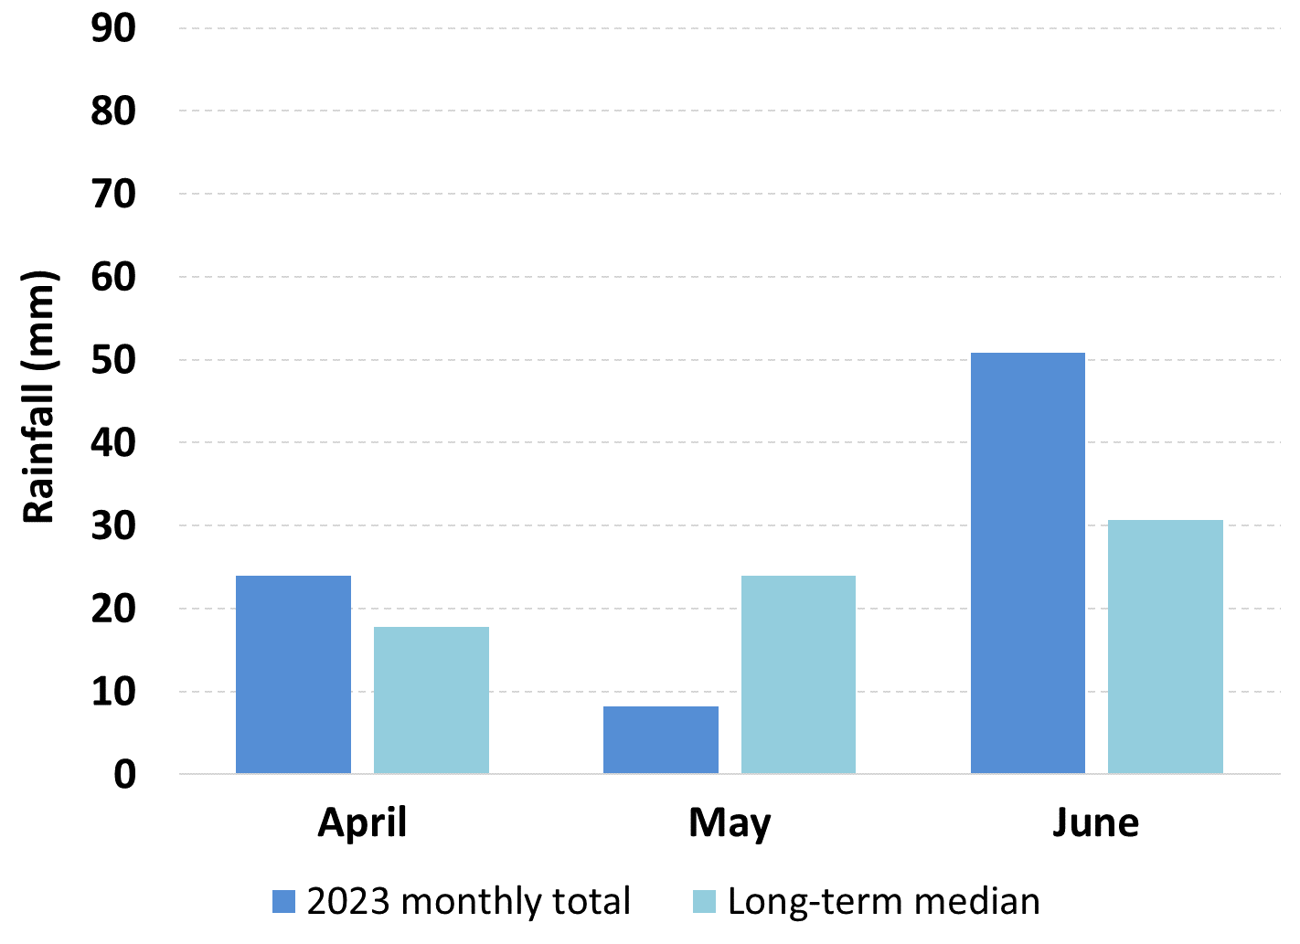 | Oxley  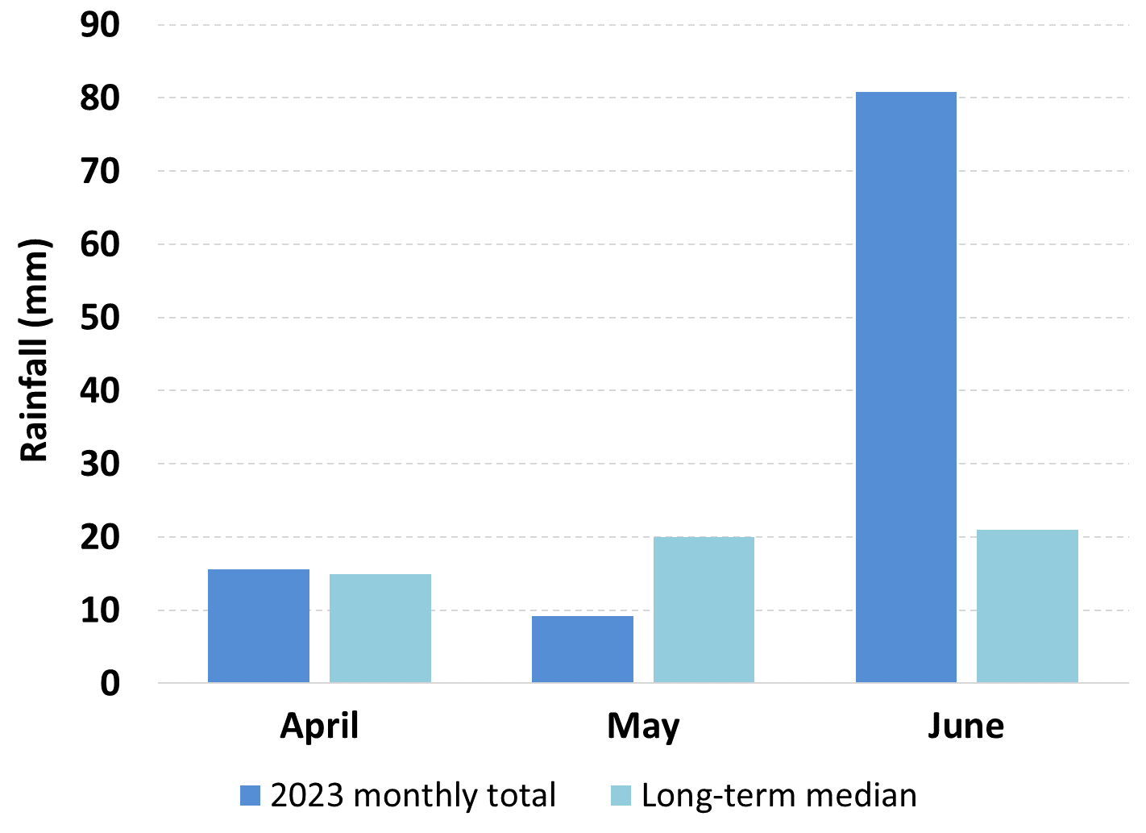
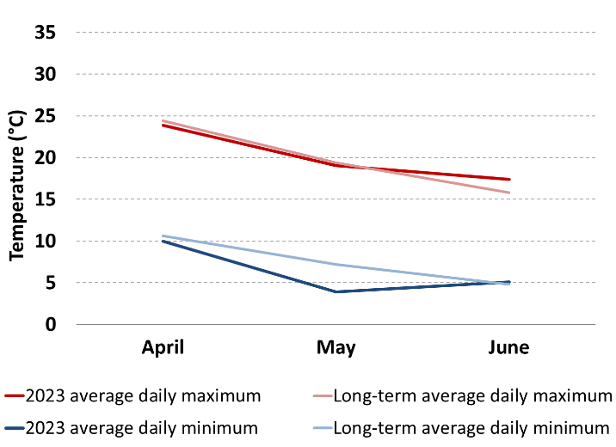 | Graphs showing rainfall and maximum and minimum temperatures for the second quarter of 2023. Data are for the Hillston (Hillston Airport, 075032) and Oxley (Walmer Downs, 49055) and are sourced from the Bureau of Meteorology.

By Adam Kerezsy
THE LACHLAN DIARIES
Endangered fish in the Lachlan
Over the last 200 years native fish have had a rough deal across the Murray-Darling Basin rivers, and in the Lachlan three species provide instructive case studies.
The combined effects of river regulation – dams and weirs – and the introduction and spread of invasive species – carp, redfin, gambusia and trout – are the main factors that have caused native fish to decline in catchments like the Lachlan.
The big dams have prevented natural flows meandering downstream, and the weirs have prevented fish moving up and downstream and following the ancient cues that drive their life cycles. Invasive species are like a sour kind of icing on an already crumbling cake: they’ve moved in and in many cases taken over, displacing natives in the process.
A few native species have hung on and seem to boom and bust in a similar way to how they may have prior to Anglo-European colonisation. Good examples include bony herring and small species of gudgeons. But for most native fish of the Murray-Darling Basin (MDB) the reverse is true, and unfortunately, we’ll never know if there were extinctions in rivers like the Lachlan in the late 19th and early 20th centuries, because back then people weren’t really interested.
Freshwater catfish were widespread and abundant in all the MDB rivers prior to the 1970s, and like other large-bodied fish like Murray cod and yellowbelly, they were fished commercially until there was a noticeable decline and – basically – no more fish to be caught. It’s probably no coincidence that the spread of carp occurred at the same time as a dramatic catfish decline, for catfish – like carp – live close to the substrate and, crucially, construct nests where their eggs are laid and guarded. It is not difficult to imagine hordes of carp making short work of catfish eggs and larvae as part of their bottom-based feeding behaviour.
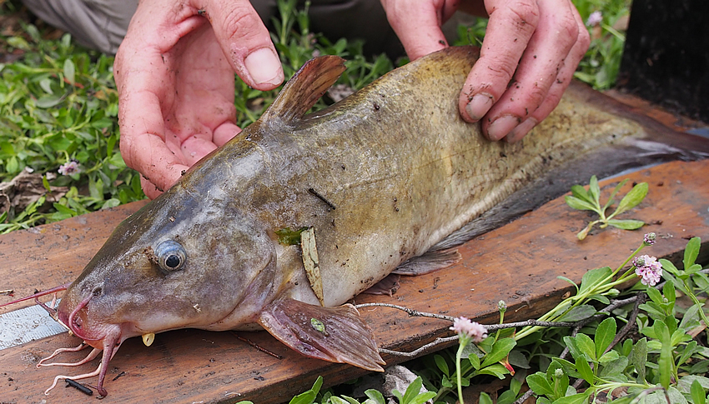
An endangered freshwater catfish from Booberoi Creek. Photo by Mal Carnegie.
In the mid-Lachlan, catfish seem to persist in some of the creeks that either drain to or from the main channel of the river, and in one particular creek near Condobolin, juveniles have been found on nearly every sampling trip since 2020. However, compared to the recollections of people from yesteryear, catfish are rightfully considered an endangered species and their future is in no way assured.
If anything, it’s even worse for silver perch, another large species that was also commercially fished until the inevitable occurred. Silver perch – like carp – are omnivorous rather than carnivorous, and like many native species undertake large migrations for spawning. Again - it’s not that challenging to join the dots and work out that the barriers imposed by weirs prevented them successfully breeding, and then carp came along and competed for resources.
It wasn’t unusual to find juvenile silver perch in areas like Booberoi Creek and Lake Cargelligo in the late 90s and early 2000s, but since the Millenium Drought it’s as though they’ve – literally - disappeared. A few are caught by anglers around Euabalong and Condobolin from time to time, but despite the fact that silver perch are reared in hatcheries and stocked into rivers, there is no sign of any real recovery, especially in the Lachlan.
As sad and sobering as the stories of catfish and silver perch are, they are not difficult to understand in the context of a basic equation like river regulation plus invasive species equals native fish decline. But the story of a third endangered species in the Lachlan is far more unique.
Olive perchlet, unlike silver perch and catfish, are small (up to 5 cm long) and have never been important or interesting commercially or to recreational anglers. It’s thought that perchlet – also known as glassfish as you can literally see right through them – were historically common throughout the Lachlan and other MDB rivers, but over the last 50 years sightings have been rare.
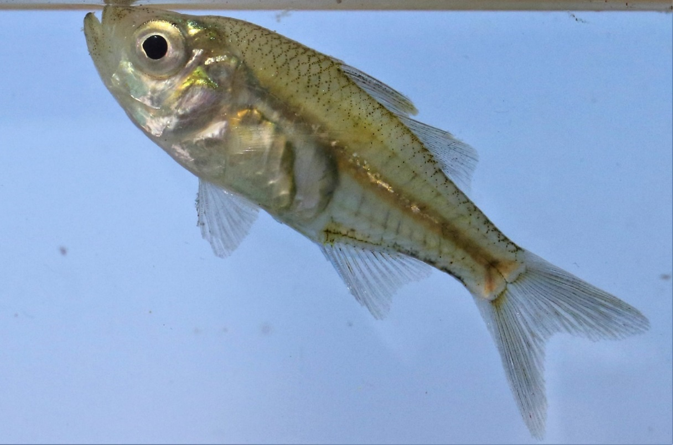
An endangered olive perchlet from the lower Lachlan River in May 2023. Photo by Warren Chad.
There was a fair bit of excitement in the late noughties when a population of perchlet was found at one specific site in the Lachlan – the weirpool that holds back water and allows it to be diverted into Lake Brewster. In the twenty years since, the population in the Brewster weirpool has endured, but no other populations were found.
However, research fishing is no different from normal fishing: you never know what you might catch (or not), and when you least expect it is when unusual results are most likely.
In April, May and June 2023, completely unexpectedly, and in the cold waters of a couple of lakes and constructed earthen tanks down near Booligal, perchlet showed up again – hundreds of them. And just like in the noughties there was a little bit of excitement.
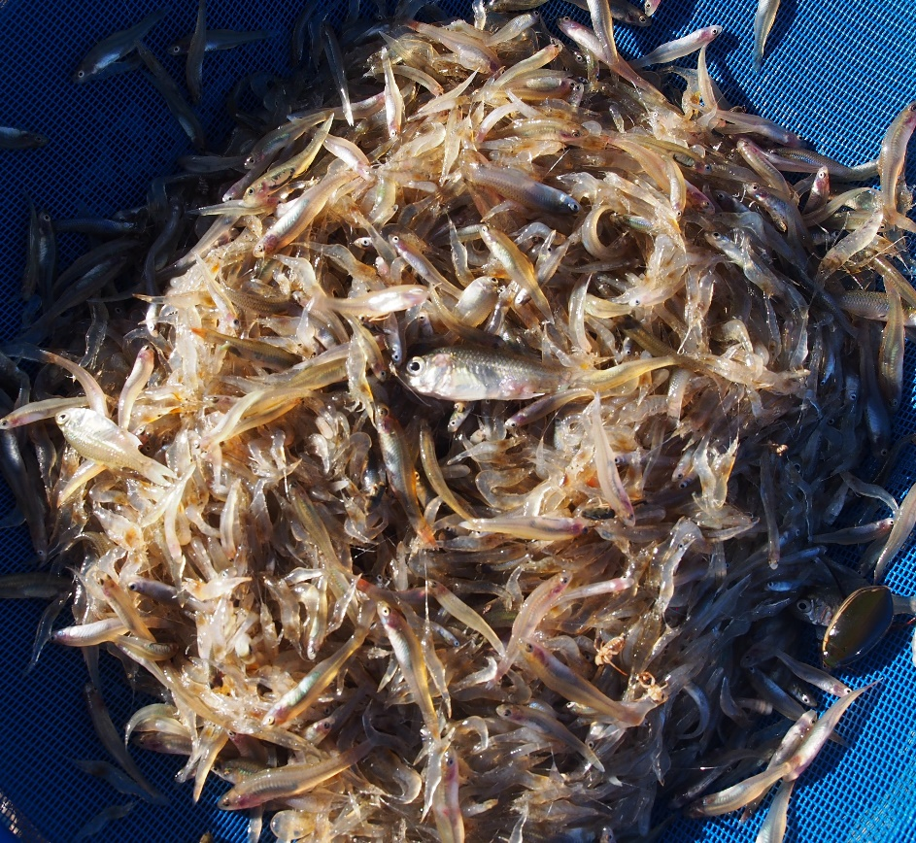
Large fyke net sample in April 2023 including olive perchlet. Photo by Adam Kerezsy.
Genetic testing of these populations will hopefully determine whether they are derived from the Brewster population or whether they’ve been hiding out down near Booligal for many decades.
The management of these populations is likely to be somewhat challenging given they inhabit some areas that have a good chance of receding and going dry – but at least they’re there.
There is nothing easy or straightforward about finding and then looking after endangered fish species in a river like the Lachlan, but continuing this work is extremely important if we are to preserve what we have left in the rivers of the Murray-Darling Basin.

ABOUT THIS DOCUMENT
The Commonwealth Environmental Water Holder (CEWH) is responsible under the Water Act 2007 (Cth) for managing Commonwealth environmental water holdings. These holdings amount to more than 2,875 gigalitres (as at August 2020) of water entitlements across the Murray-Darling Basin. The holdings must be managed to protect or restore the environmental assets of the Murray-Darling Basin, and other areas where the Commonwealth holds water, to give effect to relevant international agreements. Commonwealth holdings are managed in partnership with NSW environmental water holdings by DPE-EHG and takes all sources of water into consideration.
Monitoring and evaluation are critical for supporting effective and efficient use of Commonwealth environmental water. Monitoring and evaluation also provides important information to ensure the CEWH meet their reporting obligations. Between 2014 and 2019, the Commonwealth Environmental Water Office (CEWO) has undertaken monitoring and evaluation of the ecological outcomes of environmental watering through the Long Term Intervention Monitoring Project (LTIM Project). At the same time, the CEWO has undertaken research which seeks to improve the science available to support environmental water management in the Murray-Darling Basin through the Murray-Darling Basin Environmental Water Knowledge and Research Project (EWKR Project).
The Monitoring, Evaluation and Research Program (MER Program) builds on the work of the LTIM and EWKR Projects to undertake monitoring, evaluation and research activities within seven Selected Areas and at the Basin-scale between 2019 and 2023. One of the seven Selected Areas is in the Lachlan river system and a team of researchers, agency staff and contractors led by the Centre for Applied Water Science at the University of Canberra are monitoring, evaluating and conducting research in the catchment.
This newsletter forms part of the reporting activities undertaken in the Lachlan river system under the MER Program. It will be produced quarterly and highlights the activities, observations and outcomes that have occurred in the river system in relation to environmental water.
In conducting the monitoring evaluation and research project in the Lachlan river system, the project team as well as the Commonwealth Environmental Water Office respectfully acknowledge the traditional custodians of the land on which this work is conducted, their Elders past and present, their Nations of the Murray-Darling Basin, and their cultural, social, environmental, spiritual and economic connection to their lands and waters. The Lachlan River flows through the lands of the Nari Nari, Ngiyampaa, Wiradjuri, Muthi Muthi and Yita Yita Nations, and we acknowledge these people as the traditional owners of the land on which this publication is focused.
More information can be found at:
https://www.environment.gov.au/water/cewo/monitoring/ltim-project
https://flow-mer.org.au/selected-area-lachlan/
https://www.environment.gov.au/water/cewo/monitoring/mer-program
Inquiries regarding this document should be addressed to:
Ebony Mullin  Commonwealth Environmental Water Office  Phone: 02 5156 4462  e-mail: ebony.mullin@dcceew.gov.au | Dr Will Higgisson  University of Canberra  Phone: 02 6201 2452  e-mail: will.higgisson@canberra.edu.au

This document was prepared by Dr Will Higgisson, Dr Joanne Lenehan, William Barrett, Alica Tschierschke, Dr Jerom Stocks, Ben Broadhurst and Dr Adam Kerezsy (Dr Fish Contracting).
Cover Photos: top row Little black Cormorants and an Australasian darter at Moon Moon, Lake Bunumburt, Photos by Alica Tschierschke (both in May 2023) and on the bottom Nooran Lake, Photo by Angus Macdonald

Document history and status
Version | Date Issued | Reviewed by | Approved by | Type
Draft 1 | 5/07/2023 | Lachlan MER Team | Will Higgisson | DRAFT
FINAL | 9/07/2023 | CEWO | Will Higgisson | FINAL

Distribution of copies
Version | Type | Issued to
FINAL | Electronic | Commonwealth Environmental Water Office

Copyright
© Copyright Commonwealth of Australia, 2023

‘Lachlan River, Monitoring, Evaluation and Research, Quarterly Outcomes Newsletter’ is licensed by the Commonwealth of Australia for use under a Creative Commons By Attribution 3.0 Australia licence with the exception of the Coat of Arms of the Commonwealth of Australia, the logo of the agency responsible for publishing the report, content supplied by third parties, and any images depicting people. For licence conditions see: http://creativecommons.org/licenses/by/3.0/au/
Disclaimer
The views and opinions expressed in this publication are those of the authors and do not necessarily reflect those of the Australian Government or the Minister for the Environment and Water. While reasonable efforts have been made to ensure that the contents of this publication are factually correct, the Commonwealth does not accept responsibility for the accuracy or completeness of the contents, and shall not be liable for any loss or damage that may be occasioned directly or indirectly through the use of, or reliance on, the contents of this publication.

