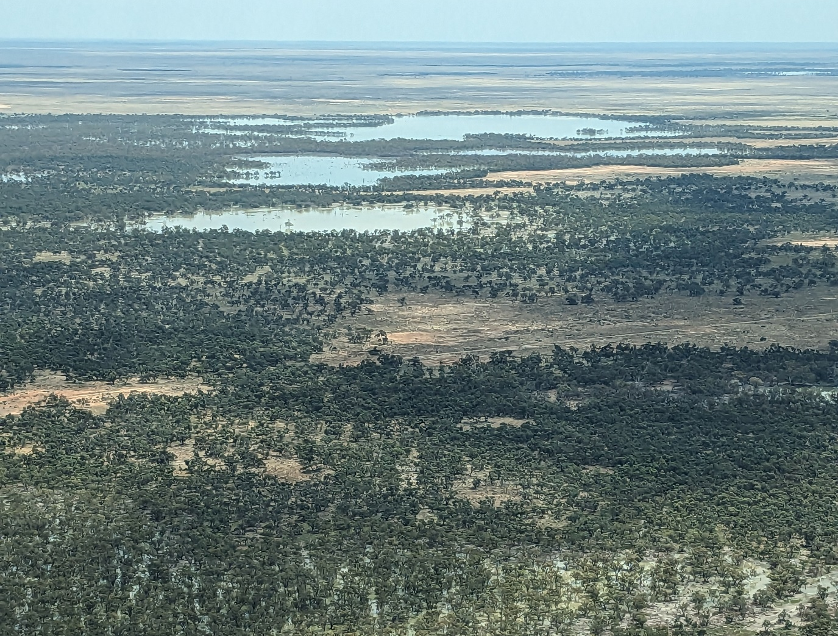



LACHLAN RIVER
MONITORING, EVALUATION AND RESEARCH

QUARTERLY OUTCOMES NEWSLETTER | APRIL – JUNE 2024



LACHLAN RIVER
MONITORING, EVALUATION AND RESEARCH

Welcome to the June 2024 quarterly newsletter of the Lachlan Monitoring, Evaluation and Research (MER) Program. This newsletter forms part of the reporting activities undertaken in the Lachlan river system under the MER Program and provides a regular update on our monitoring and research activities and observations.
In this issue, we report on our most recent plant surveys and share our passion for the small aquatic and amphibious plants of the wetlands and floodplains in the Lachlan Area. We then go from small to big, where Michele Groat shares her experience being on a plane which is being used to survey the wetting of those wetlands and floodplains.
Our description of the catchment condition explains why our recent monitoring trip was delayed multiple times because of the weather and Joanne Lenehan takes us on a journey to follow those flows. Lastly Adam Kerezsy reflects on the kinds of people who become scientists and find themselves lucky enough to work in these incredible parts of the world.
The Lachlan MER Team




Swamp daisy (Brachyscome paludicola) at Booligal NP in 2020. Photo Will Higgisson (UC)

Aquatic and amphibious plants of the Lachlan

By Dr Will Higgisson (University of Canberra)
Some of the most interesting plants on the floodplain of the lower Lachlan are the smallest. Over the past ten years, we have seen dramatic changes in the plant species we record during our biannual plant surveys. The plants that occur at a given time is strongly related to the past weather conditions:
- during dry periods we expect to see grasses and forbs growing on the floodplain in response to rainfall;
- during flooding, emergent and submergent aquatic species establish and grow, and
- during the draw-down/ flood recession a range of different amphibious species colonise the banks. The recession is also critical for seedling recruitment of tree species such as river red gum and black box.
During 2018 and 2019 for example, which were very dry years with low rainfall and the river remained within channel, the plant cover we observed decreased slowly (reaching less than 10% across most sites in 2019). The ground cover was made up of species classed as terrestrial-dry species, particularly long-lived drought resistant chenopods (saltbushes).
Rain events during dry times, like those observed prior to Autumn 2020, resulted in a flush of short-lived (annual) grasses and forbs. The prolonged flooding across all our plant monitoring sites over the past three years has resulted in an impressive increase in the cover and abundance of amphibious and aquatic species that we can see in the graph below.
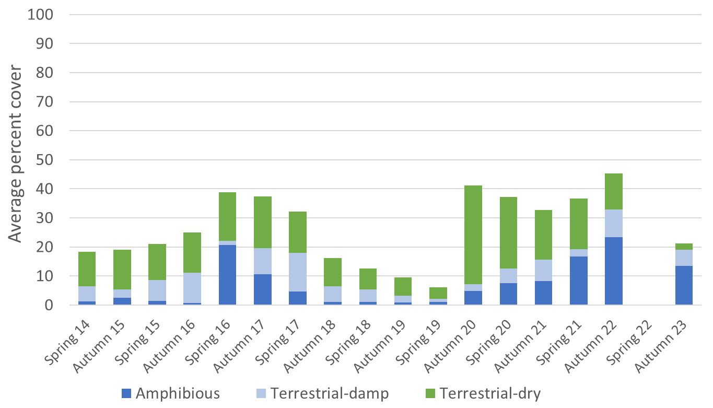
Average percent cover of amphibious and terrestrial (damp and dry) species from 14 wetland and floodplain monitoring sites along the Lachlan River from Spring 2014 to Autumn 2023. No plant survey occurred during Spring 2022 and the submerged plants make up less than 1% of the cover so aren’t visible in the graph.

Explainer: There are thousands of species of plants found within the Murray Darling Basin and to help us understand what we are observing when we do our surveys, we group them into different classes. Two commonly used classification systems are ‘growth -forms’ and ‘water-plant functional group’. Growth form includes descriptions such as grasses, sedges and rushes, forbs (herbaceous flowering plants other than grasses, sedges and rushes), shrubs and trees. Water plant functional group is a specific classification system that was adapted from an approach developed by two Australian researchers, Margaret Brock and Michelle Casanova. It includes the following classes:
- Submerged: require permanent water in their root zone, or live only within the water column.
- Amphibious: live in water or on saturated soils.
- Terrestrial - damp: germinate and establish on saturated or damp ground, but cannot tolerate flooding for a long period of time.
- Terrestrial - dry: do not have any flooding requirements and can live in a range of habitats.
- Woody flood dependent: trees or large shrubs that require flooding to complete part of their life cycle or are associated with riparian, wetland and floodplain habitats.

Plants which are classed as amphibious and submergent are flood responsive species and require flooding or prolonged high-soil moisture to germinate and establish. These are usually found during and following flood events and when it is dry, they are rarely seen. This pattern is what ecologists call ‘boom and bust’ and these amphibious species must be able to survive both droughts (their seeds can often live for years) and floods. On the lower Lachlan floodplain the frequency, timing and duration of floods and droughts is highly variable – resulting in an ecologically fascinating system to study.
Whilst they are some of the smallest plants on the floodplain, amphibious species are some of the most interesting – so we thought we would showcase some of the lesser-known plants of the floodplain of the lower Lachlan that we observed in our recent field surveys.
Forest Germander (Teucrium racemosum) is a perennial herb to 40 cm, which can put on a very good show of white flowers. We record this species typically under river red gums, such as here at Lake Ita. Blue-rod (Stemodia florulenta) is another of these perennial herbs, which can form thick mats under the red gums and produce these interesting blue flowers. On the more frequently watered sites we have recorded swamp buttercup (Ranunculus undosus) which is a perennial with very distinct leaves and large yellow flower and matted starwort (Stellaria angustifolia) a weak trailing perennial herb. On sites which had been waterlogged or submerged we found water primrose (Ludwigia peploides) and slender knotweed (Persicaria decipens).

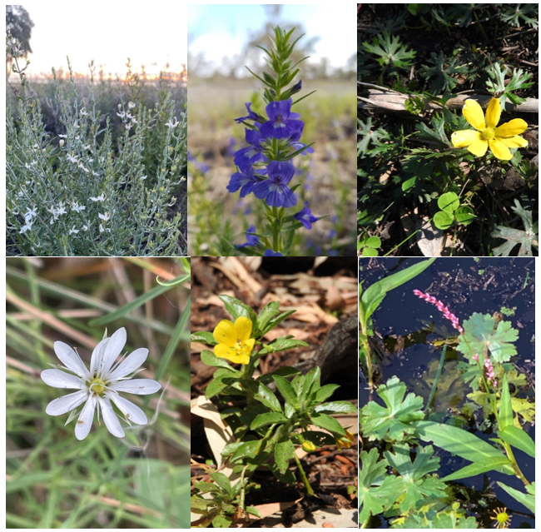
Plants of the floodplains and wetlands in the lower Lachlan Area in flower during the vegetation monitoring field trip in June 2024 (in order as mentioned in text above), photos by UC staff.

A Bird’s eye view

By Michele Groat (CEWH)
As part of their floodplain inundation mapping project, NSW Department of Climate Change, Energy, the Environment and Water (DCCEEW) - Biodiversity, Conservation and Science (BCS) undertake regular aerial surveys of the Lower Lachlan River and floodplain. This involves precisely mapping a flight path, chartering a Cessna Caravan, loading up the camera gear and taking thousands of photos of the floodplain! Once back in the office, the images are fed into computer software and used to create inundation maps. These maps are useful for understanding how and where water moves throughout the landscape and can guide environmental watering decisions for NSW and Commonwealth environmental water managers.
I was lucky enough to be invited along for the November trip. After two really wet years, our timing couldn’t have been better to see the lower Lachlan Catchment in its prime.
And what a view it was! From the moment I ascended, I was greeted by a panorama that stretched as far as the eye could see. Beneath us, the shimmering meandering arteries of the Lachlan River wove a tapestry of life - from massive lakes, like Lake Tarwong and Waljeers Lakes; across delicate wetlands teeming with birdlife and productivity; to the ancient river red gum forests and giant stands of cumbungi in the Great Cumbung Swamp. Each ecosystem tells a tale of adaptation, survival, and interconnectedness.
Flying over the Lachlan Catchment offers a unique perspective because it reveals its dynamic nature. What may appear static on a map comes alive from the vantage point of a plane. You see the ebb and flow of water across the landscape, where it’s constrained and where it’s broken out and the ever-shifting mosaic of habitats. It's a reminder that this is a living, breathing ecosystem, constantly evolving.
As you traverse the landscape, you gain insights into its natural features and the complex web of human interactions that shape where it flows. From the agricultural paddocks that sustain communities, to the roads that criss-cross the landscape to the water management infrastructure that regulates its flow.
From up high you can really appreciate the vastness of the Lachlan system and fully grasp how it all interconnects. I feel very privileged to have seen it after two amazingly wet years when the catchment is certainly looking healthy and robust. I can’t help but feel optimistic that when we do go through our next prolonged dry period, the resilience that has built up over the last few years should hold it in good stead.

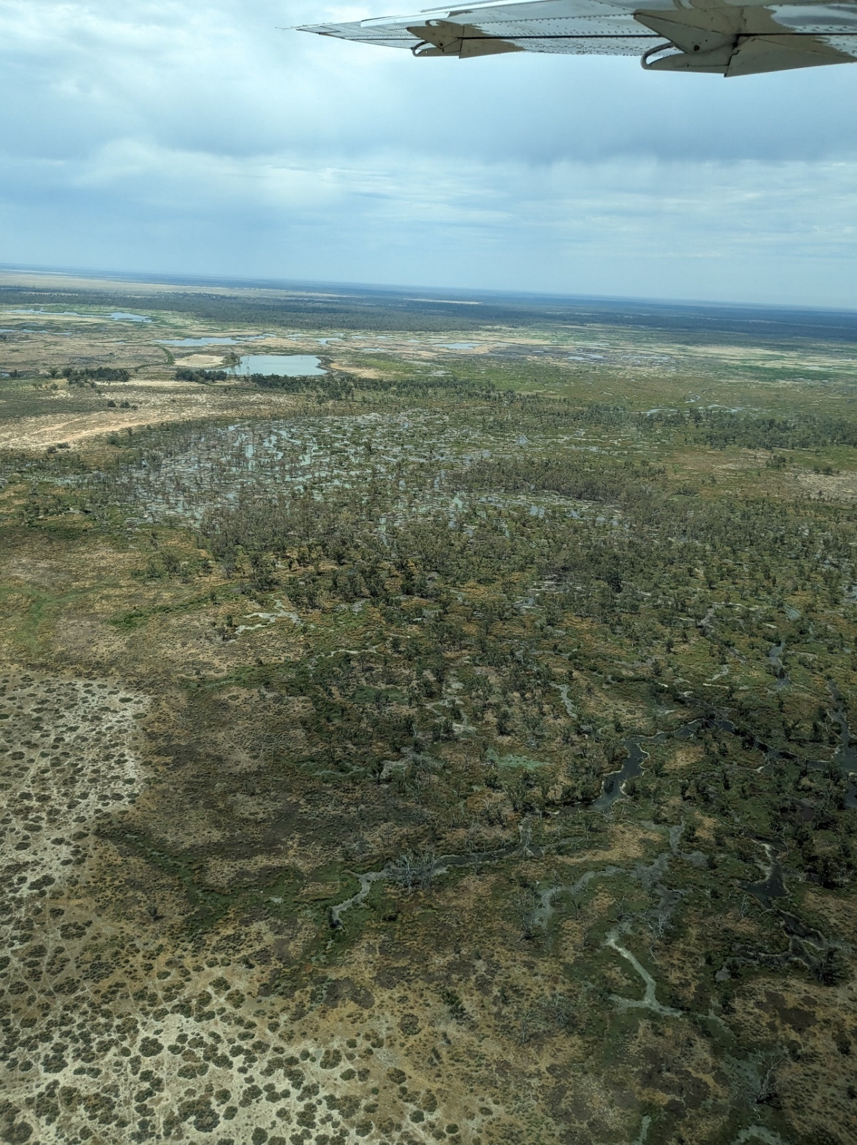
View over the Lower Lachlan area, photo by William Barrett (CEWH)

catchment conditions April to June

By Alica Tschierschke (University of Canberra)
The second quarter of 2024 was wet, with more than 3 times the long-term median rainfall recorded at Hillston Airport and nearly double at Oxley (Walmers Downs). The rain in Hillston came in five big events in April and May ranging between 16.8 and 66 mm in a day. June was dry with below median rainfall values for both stations. The 3-monthly rainfall percentages across NSW shows the Lower Lachlan area receiving 150-200% of the mean, and the area between Hillston and Booligal even more (with up to 300% of the mean).
Rainfall at Hillston to the end of June was just short (only 12 mm left) of the long term median annual rainfall for the station (360 mm). At Oxley 59% of the long term median annual rainfall had been recorded to the end of June.
Throughout the quarter these conditions were accompanied by below average daily maximum and minimum temperatures.
Graphs showing rainfall, maximum and minimum temperatures for the second quarter of 2024, sourced from the Bureau of Meteorology for Hillston (Airport, 075032) and Oxley (Walmer Downs, 049055).
Hillston  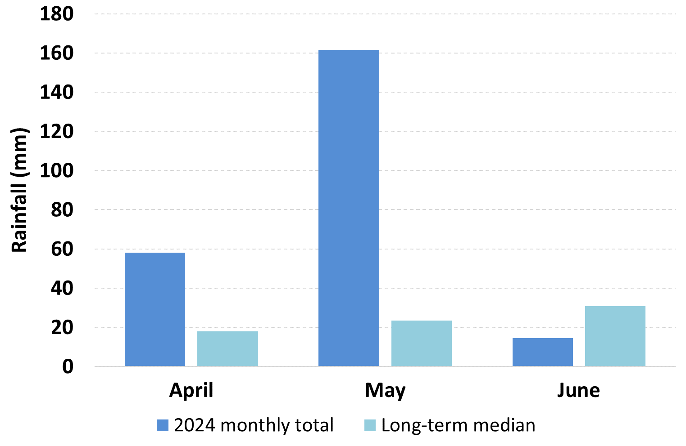 | Oxley  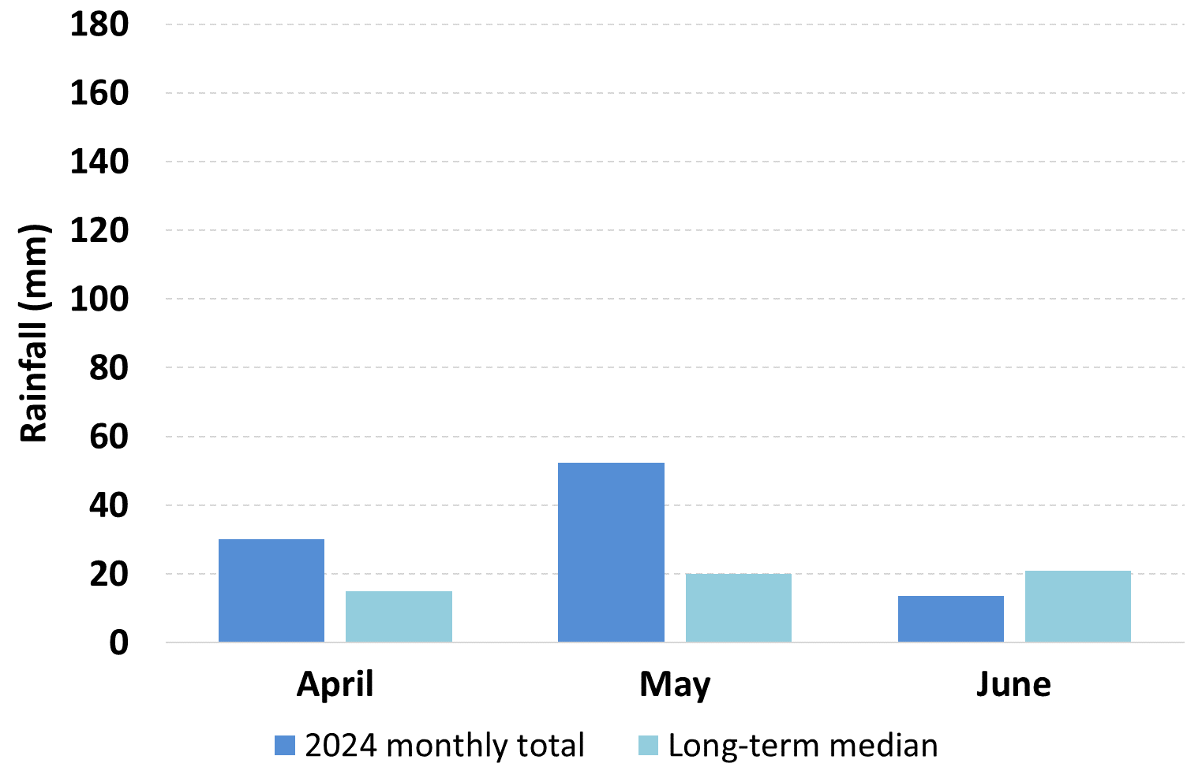
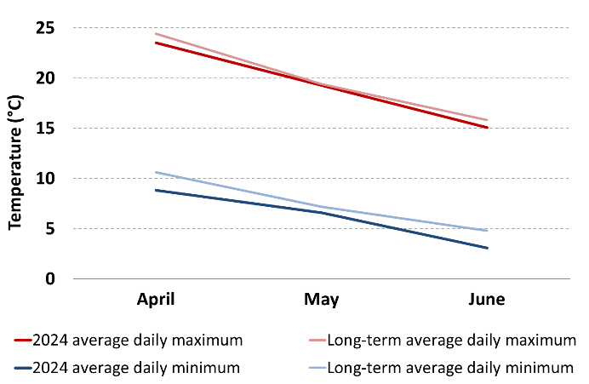

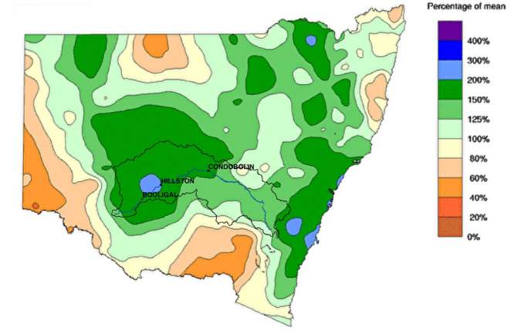
Three monthly rainfall percentage for NSW (April to June), altered from the Bureau of Meteorology (Base period: 1961-1990), http://www.bom.gov.au/climate/maps/

Hydrological Observations

By Dr Joanne Lenehan, NSW Senior Environmental Water Manager, Biodiversity, Conservation and Science (BCS) Group
As the water year came to an end, so did a number of watering actions.
The Lachlan River Autumn Fresh started at Wyangala Dam on 8 March and finished being accounted at Willandra Weir (Lachlan River) on the 6 April. A total of 22,059 ML of Commonwealth Environmental Water (CEW) was used for the action, and the peak passed Willandra Weir in the last week of March, providing a bankfull flow at the end of system (Corrong–Oxley) by mid-April (see next image). All of the lower Lachlan blue-green algal monitoring sites were then taken off red alert and were classed as green alert. The Autumn Fresh was followed by an additional 1,933 ML of NSW environmental water to maximise recovery.
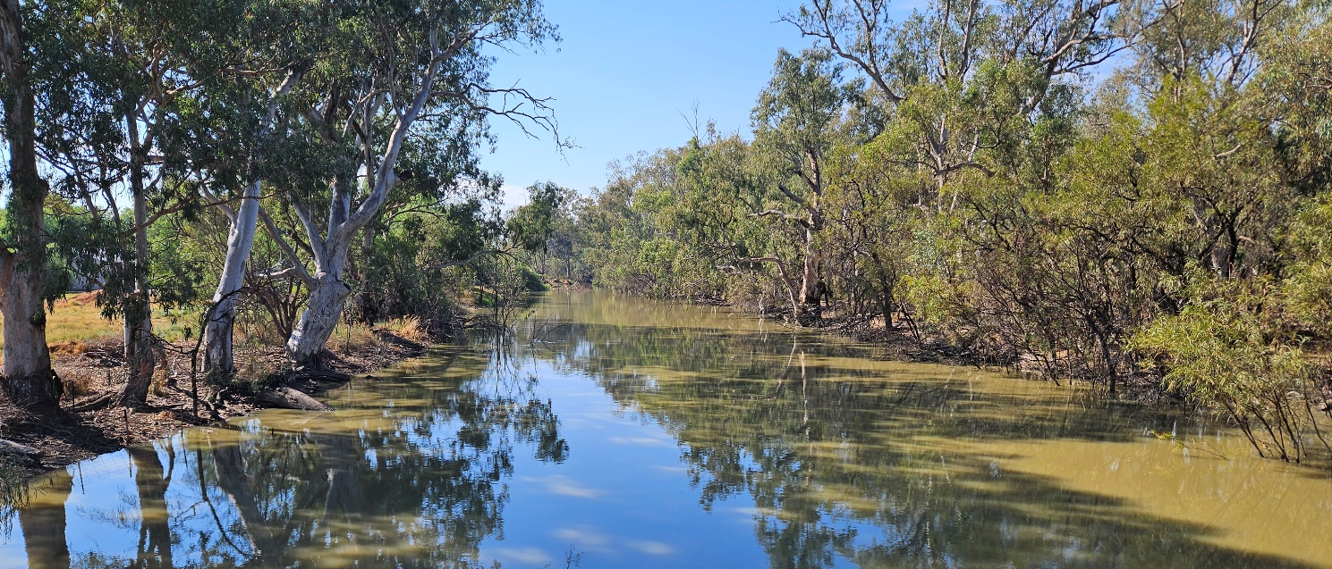
Lachlan River at Corrong on the 17 April 2024, photo by Mal Carnegie for NSW DCCEEW BCD
The Lake Brewster pelican management action ceased in mid-May (12 May 2024). A total of 11,478 ML was accounted against this action and was a collaborative action using Commonwealth and NSW environmental water. The watering action enabled yet another successful breeding event. The only other pelican breeding event in Murray Darling Basin this season was a smaller event at Narran Lakes. At Brewster, a total of 22,919 nests were built in the season, with a maximum of 8,339 active nests at a single time. Total numbers of nests peaked in December 2023 and breeding was completed by end of April 2024. Mortality remained low throughout the breeding season, with a maximum dead chick count of 137 at the very end of the season compared to approximately 3,000 live chicks and juveniles in the same image set.
While these two watering actions were coming to an end, the Commonwealth and NSW water managers were working on a plan with the Merrowie Creek landholders to deliver a vital follow-up watering to the nationally significant Merrowie Creek wetlands, including filling Lake Tarwong. Encouraged by the success of a similar event in 2020 – the action started early in the first week of May to capitalise on a ‘wet creek bed’ and what has been described as the best ‘Autumn break’ in decades! Records were broken with flow arriving at Lake Tarwong in half the ‘normal’ time, showing yet again the value of collaboration, communication, and the local brains trust. The watering action will consolidate the “incredible” transformation of the lower Merrowie Creek floodplain.
When environmental water was delivered in 2020, parts of the landscape were dominated by roly-poly and other terrestrial chenopods. There was no cumbungi, reeds, or rushes. The opposite is now true, and the landscape has been transformed.
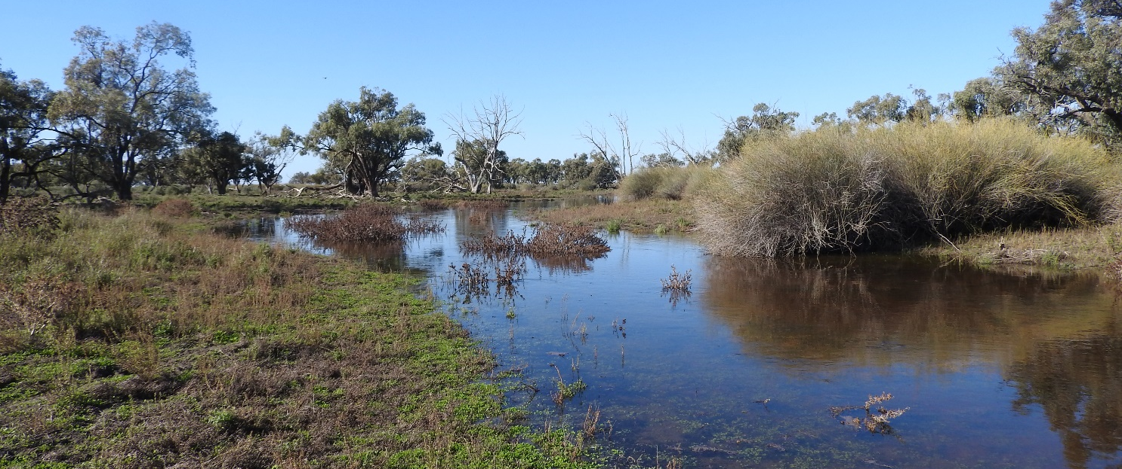
Healthy lignum at the black box trees before it enters Lake Tarwong in June 2024, photo by Angela Lanspeary (University of Canberra, UC)
Lignum that was merely woody stumps in early 2020, are now bushy and full of new growth and now provides important habitat for a range of native animals – such as endangered southern bell frogs and bustards. The Commonwealth Flow-MER program will establish permanent monitoring plots in 2025 to continue to track the response of lignum on this floodplain. Up to 7,600 ML of environmental water was ordered against this event – however, the account was suspended earlier than planned on 13 June in preparation of arriving translucent flows. Translucent flows passed Willandra Weir from 24 to 29 June peaking at close to 8,000 ML/day, which is the maximum release target.
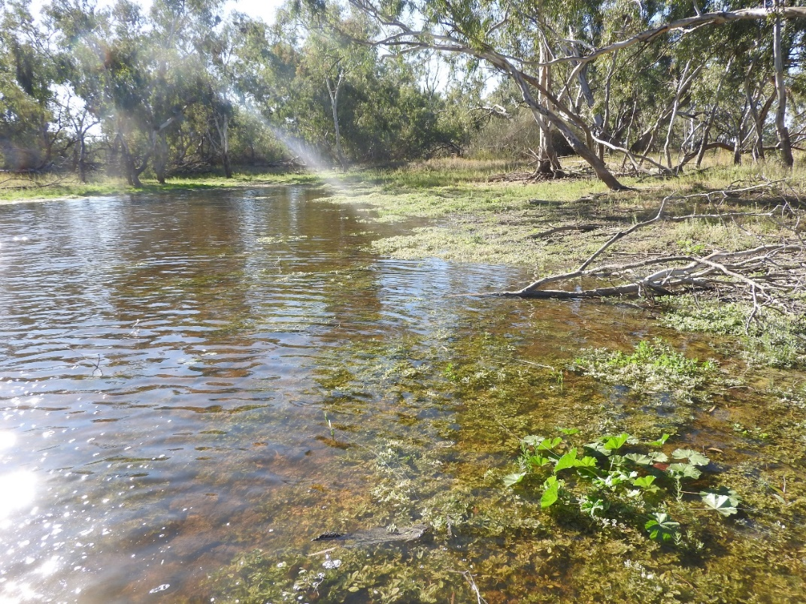
Clear water flowing under the river red gums in Lake Tarwong in June 2024, photo by Alica Tschierschke (UC)

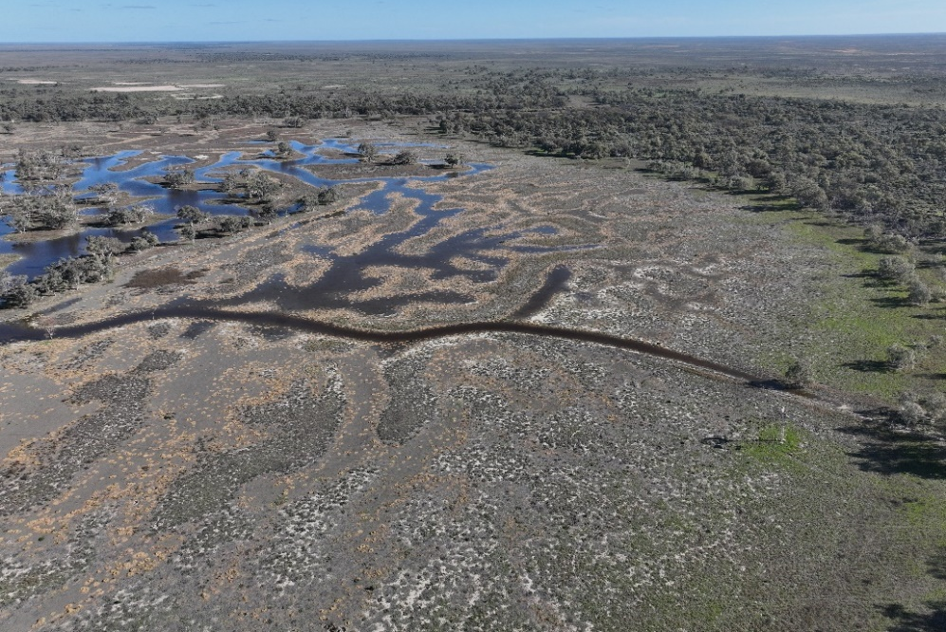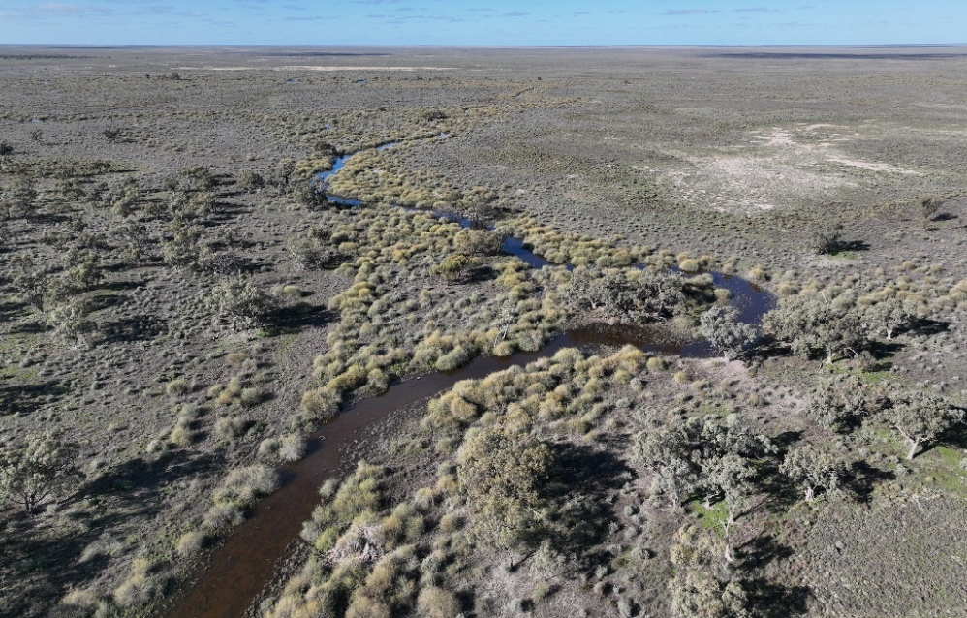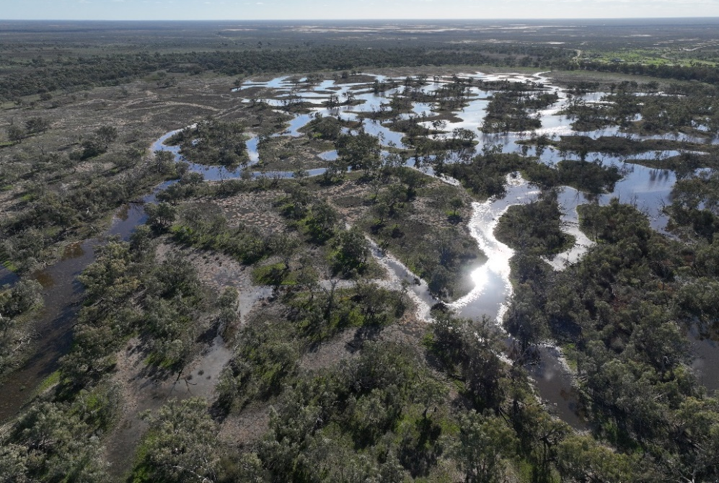
The filling of Lake Tarwong in mid-June via drone imagery (top: Merowie Creek towards the east, middle: view across Lake Tarwong from the east, bottom: the open lake area before filling), taken by Alica Tschierschke (UC)
THE LACHLAN DIARIES

By Adam Kerezsy (Dr Fish Contracting)
So ... what kind of people actually become scientists?
The stereotypical geek in a white coat is not an entirely accurate characterisation, but there are definitely similarities across the breed.

Recently I spent a week in the field with a colleague whose name is Dr Peter Unmack. Pete and I go back a long way – in fact he discovered a super-rare fish called red-finned blue-eye in artesian springs in western Queensland in the nineties, and then I worked on and managed the population from the late noughties to 2014.
On this particular trip we were taking eDNA samples, with the ‘e’ signifying environmental. Instead of catching fish we were using a high-tech pump to filter water samples at various locations in the lower Lachlan. The ‘e’DNA will then be analysed back at a lab which will help us work out what lives where – hopefully.
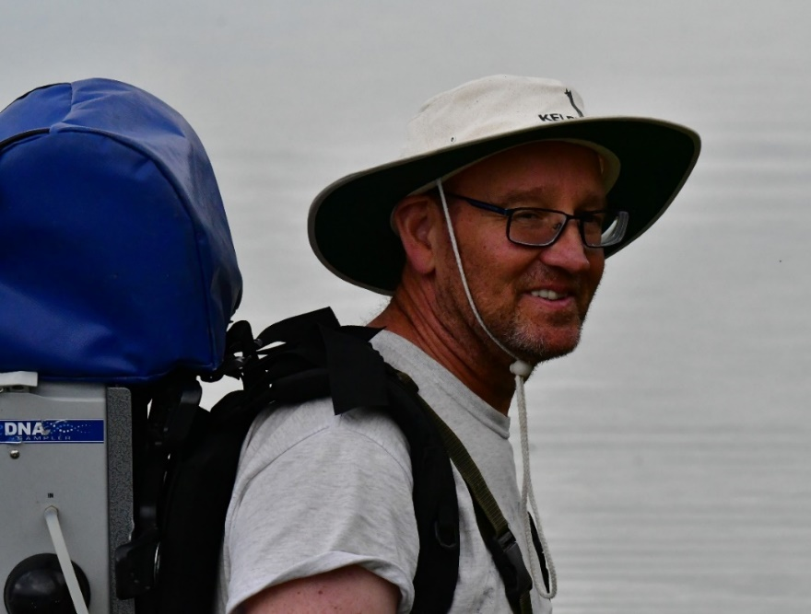
Dr Peter Unmack is one of the most knowledgeable freshwater fish biologists in Australia. Photo by Adam Kerezsy
The freshwater fishy-science world is fairly small in Australia – we all know each other even though we rarely see each other. Because Pete and I were sampling water rather than fish we had more time than usual to catch up on who has been doing what and where, and I started thinking about the why and how of how we all ended up in such – let’s face it – unusual jobs.
To get started in science the first ingredient required is curiosity and the second is passion. Without one or the other – preferably both – people are probably best advised to steer clear, as it’s a long and winding road.
Peter has oodles of passion. He’s a proper fish nerd, and knows more about Australian freshwater fish than just about anybody. My curiosity and passion have always been more widespread. I could have just as easily ended up Dr Lizard or Dr Sand Dune, but fish was where I landed.
After curiosity and passion, the next requirement is tenacity. The traditional path to a career in research is a three year undergraduate degree followed by one or two years on an Honours or Masters project and then at least another three years doing a PhD. It’s a hard slog, and not for everyone. Plenty drop out along the way. A few people blitz this extended training period in one go and end up fully-fledged before the age of 30, but it’s more normal for life to intervene and slow the process down a bit.
What this means is that most scientists don’t really kick into gear until their mid-thirties or early forties. Then there’s theoretically a twenty to thirty year career stretching into the distance, but in science this is also – often - a little convoluted.
Full-time permanent research positions are rare as hen’s teeth, so many PhDs take government jobs at the conclusion of their long education and end up in managerial or administrative roles. The majority of researchers who carry on usually persist on short contracts and so-called ‘soft’ money, and they lurch from project to project and Uni to Uni depending on what’s available within their area of expertise. Along the way there is a fair bit of pressure to continue publishing papers in peer-reviewed journals – a tedious and unpaid endeavour – in order to stay relevant.
Over the last twenty years there has been an increase in private enterprise within all sciences, and this includes biological pursuits. Both Peter and I have ended up private contractors, and there are a few reasons. Firstly, we’re both in our fifties now, which is not an ideal time for anyone to try and snare a full-time government or university position. We’ve both dipped our toes in over the decades, but no-one likes thanks-but-no-thanks letters, and this is as true of published researchers as anybody else. After a while you stop trying.
But there is another big reason, and it’s directly related to the incredibly long apprenticeship people like us serve. Science can be fairly adversarial, and at times not exactly friendly. Presenting research at a conference and getting tricky questions or receiving negative reviews is par for the course. Our ‘job’ is to defend and justify our work, and to convince our peers that we have contributed something to on-going knowledge.
People like us – especially those of us with decades of experience and perhaps (OK – definitely) a level of eccentricity – often don’t make good employees, because we’re used to challenging and sometimes breaking rules, rather than following them. When you pair this trait with the passion mentioned earlier, the result is often the kind of person that doesn’t fit easily into traditional organisations.
Luckily, it is now possible to set up a business and operate successfully as a biological contractor in Australia, and this is probably a good fit for those of us who are tenacious enough to persist/succeed but not so good at always toeing the line. It also means we can stick to what we’re good at.
I’m a shorts-and-thongs kind of researcher who works in western New South Wales and western Queensland. As long as I have a Landcruiser or a Hilux, an Engel fridge and a swag, I can pretty-much work in comfort throughout those areas. Peter is different. His work is more focused on genetics, so he gathers samples worldwide, then analyses the data to shed light on speciation and biogeography.
It’s interesting to reflect on the fact that the initial curiosity that drives most people into science never goes away, regardless of where we end up. There’s always something new to find, or a new way to think about a problem or happenstance. People like Peter and me are obviously extremely lucky to work in a field that we still find interesting, so for anyone with the right traits, it’s worth considering. But be prepared for the long and winding road.
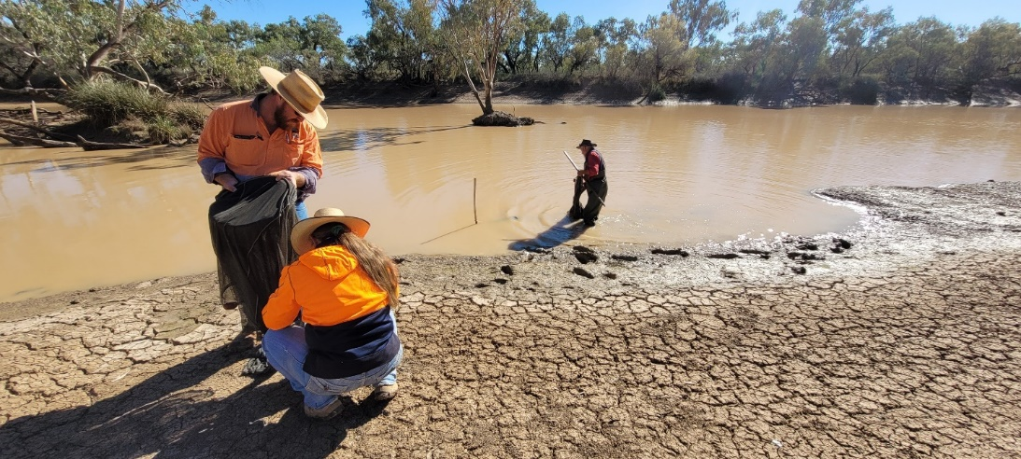
Biology is definitely a diverse career. The author and staff from Bulloo Shire Council conducting a river survey near Thargomindah

About this document

The Commonwealth Environmental Water Holder (CEWH) is responsible under the Water Act 2007 (Cth) for managing Commonwealth environmental water holdings. These holdings amount to more than 2,888 gigalitres (as of August 2023) of water entitlements across the Murray-Darling Basin. The holdings must be managed to protect or restore the environmental assets of the Murray-Darling Basin, and other areas where the Commonwealth holds water, to give effect to relevant international agreements. Commonwealth holdings are managed in partnership with NSW environmental water holdings by DPE-EHG and takes all sources of water into consideration.
Monitoring and evaluation are critical for supporting effective and efficient use of Commonwealth environmental water. Monitoring and evaluation also provides important information to ensure the CEWH meet their reporting obligations. Between 2014 and 2019, the Commonwealth Environmental Water Holder (CEWH) has undertaken monitoring and evaluation of the ecological outcomes of environmental watering through the Long Term Intervention Monitoring Project (LTIM Project). At the same time, the CEWH has undertaken research which seeks to improve the science available to support environmental water management in the Murray-Darling Basin through the Murray-Darling Basin Environmental Water Knowledge and Research Project (EWKR Project).
The Monitoring, Evaluation and Research Program (MER Program) builds on the work of the LTIM and EWKR Projects to undertake monitoring, evaluation and research activities within seven Selected Areas and at the Basin-scale between 2019 and 2023. One of the seven Selected Areas is in the Lachlan river system and a team of researchers, agency staff and contractors led by the Centre for Applied Water Science at the University of Canberra are monitoring, evaluating and conducting research in the catchment.
This newsletter forms part of the reporting activities undertaken in the Lachlan river system under the MER Program. It will be produced quarterly and highlights the activities, observations and outcomes that have occurred in the river system in relation to environmental water.
In conducting the monitoring evaluation and research project in the Lachlan river system, the project team as well as the Commonwealth Environmental Water Holder respectfully acknowledge the traditional custodians of the land on which this work is conducted, their Elders past and present, their Nations of the Murray-Darling Basin, and their cultural, social, environmental, spiritual and economic connection to their lands and waters. The Lachlan River flows through the lands of the Nari Nari, Ngiyampaa, Wiradjuri, Muthi Muthi and Yita Yita Nations, and we acknowledge these people as the traditional owners of the land on which this publication is focused.
More information can be found at:
https://www.environment.gov.au/water/cewo/monitoring/ltim-project
https://flow-mer.org.au/selected-area-lachlan/
https://www.environment.gov.au/water/cewo/monitoring/mer-program
Inquiries regarding this document should be addressed to:
Madeline Clark  Office of the Commonwealth Environmental Water Holder  Phone: 0429 189 515  e-mail: Madeline.Clark@dcceew.gov.au | Dr Will Higgisson  University of Canberra  Phone: 0412 945 730  e-mail: will.higgisson@canberra.edu.au

This document was prepared by Dr Will Higgisson, Alica Tschierschke, Dr Joanne Lenehan, Michele Groat and Dr Adam Kerezsy (Dr Fish Contracting).
Cover Photo: Aerial image of the lower Lachlan area in November 2023. Photo by William Barrett (CEWH).
Document history and status
Version | Date Issued | Reviewed by | Approved by | Type
Draft | 05/07/2024 | Lachlan MER Team | Will Higgisson | DRAFT
FINAL | 11/07/2024 | CEWH | Madeline Clark | FINAL

Distribution of copies and QR code
Version | Type | Issued to
FINAL | Electronic | Commonwealth Environmental Water Holder

Copyright
© Copyright Commonwealth of Australia, 2024

‘Lachlan River, Monitoring, Evaluation and Research, Quarterly Outcomes Newsletter’ is licensed by the Commonwealth of Australia for use under a Creative Commons By Attribution 3.0 Australia licence with the exception of the Coat of Arms of the Commonwealth of Australia, the logo of the agency responsible for publishing the report, content supplied by third parties, and any images depicting people. For licence conditions see: http://creativecommons.org/licenses/by/3.0/au/
Disclaimer
The views and opinions expressed in this publication are those of the authors and do not necessarily reflect those of the Australian Government or the Minister for the Environment and Water. While reasonable efforts have been made to ensure that the contents of this publication are factually correct, the Commonwealth does not accept responsibility for the accuracy or completeness of the contents, and shall not be liable for any loss or damage that may be occasioned directly or indirectly through the use of, or reliance on, the contents of this publication.

