


Final Report September 2023

Lower Lachlan Waterbirds Reproductive Success Monitoring 2022-23

Brandis, K., Smith, M., Stewart, J., Juilliard, L., McEvoy, T., Francis, R.
Centre for Ecosystem Science, University of New South Wales

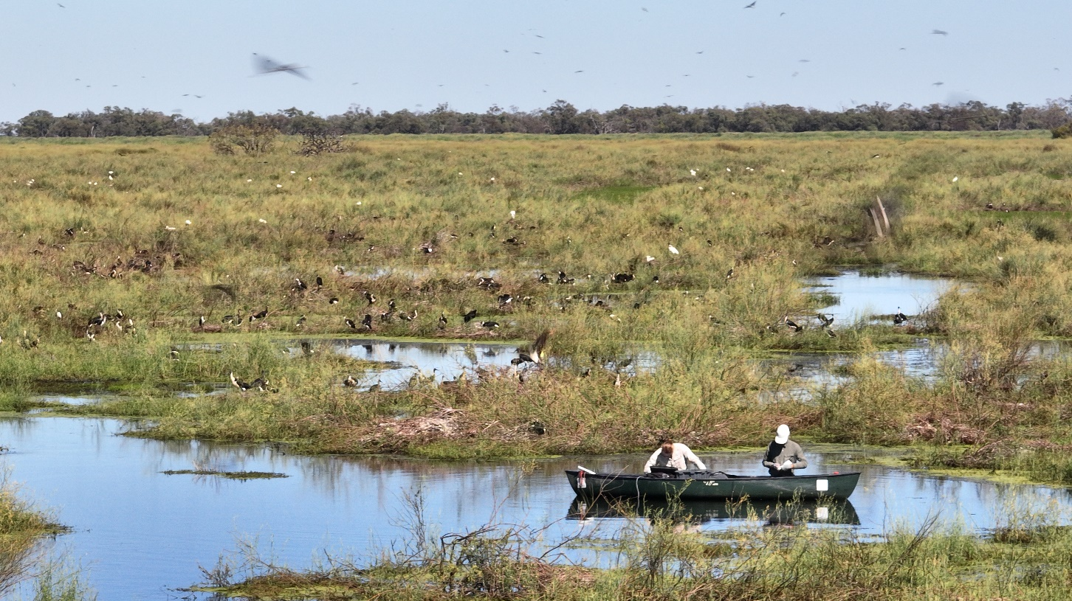

Report Citation: Brandis, K., Smith, M., Stewart, J., Juilliard, L., McEvoy, T., Francis, R. (2023) Lower Lachlan Breeding Waterbirds Reproductive Success Monitoring 2022-23. Final report to the Commonwealth Environmental Water Office. Centre for Ecosystem Science, UNSW.

Cover photo: Field staff monitoring Block Bank rookery.

Photo credit: Shot By Harro.

Funding acknowledgement: This research was funded by the Commonwealth Environmental Water Holder with support from the lower Lachlan landholders, NSW Department of Planning and Environment, Lake Cowal Foundation, NSW National Parks and Wildlife Service and the Centre for Ecosystem Science, UNSW.

Disclaimer: The views and opinions expressed in this publication are those of the authors and do not necessarily reflect those of the Australian Government or the Minister for the Environment and Water. While reasonable efforts have been made to ensure that the contents of this publication are factually correct, the Commonwealth does not accept responsibility for the accuracy or completeness of the contents, and shall not be liable for any loss or damage that may be occasioned directly or indirectly through the use of, or reliance on, the contents of this publication.

Table of Contents

Executive Summary 6
Background 7
Climate 8
Water management 10
Methods 10
Nest surveys 11
Drone surveys 12
Results 14
Nest surveys 14
Block Bank rookery 14
Upper Merrimajeel 17
Disease, predation and mortality 19
Water depth 20
Water quality 21
Drone surveys 24
Block Bank 24
Upper Merrimajeel 27
Conclusions 29
Recommendations 30
Acknowledgments 32
References 33

Table of Figures

Figure 1 Long-term annual rainfall totals measured at Hillston Weir (gauge 412039), rainfall years 2021, 2022 and 2023 (to April) highlighted in red. Long-term annual mean shown by horizontal line. 9
Figure 2 Total annual discharge on the Lachlan River measured at Hillston Weir 1970-2022 and corresponding mean annual water levels. 10
Figure 3 Sentinel-2 L2A moisture index 21st December 2022. 10
Figure 4 Translucent flow discharge (mean megalitres per day or ML/d) at key Lachlan River at Willandra Weir and Booligal Weir (lagged by a month to account for travel times for Willandra Weir flows to register at Booligal Weir due to slower travel times and floodplain return). 11
Figure 5 Location of Block Bank and Upper Merrimajeel rookeries in the Lachlan catchment rookery, 2022–23. 13
Figure 6 Transects flown with the drone over the Block Bank rookery a) 3rd Oct. 2022, b) 9th Nov. 2022, c) 7th Dec. 2022, d) 22nd Dec. 2022, e) 5th Jan. 2023, f) 15th Feb. 2023, and g) 2nd Mar. 2023. 16
Figure 7 Transects flown by the drone over the Upper Merrimajeel rookery a) 18th Dec 2022, b) 6th Jan. 2023, c) 2nd Feb 2023, d) 16th Feb 2023 and e) 3rd March 2023. 16
Figure 8 Flows in the Lachlan River at Hillston Weir and the timing of rookery surveys during 2021-22 and 2022-23. 17
Figure 9 Composition of Block Bank straw-necked ibis rookery by chick development stage per nest survey. 18
Figure 10 Reproductive success between surveys at Block Bank rookery for a) cohort 1, b) cohort 2, c) cohort 3, and d) cohort 1.1.. 19
Figure 11 Composition of Upper Merrimajeel straw-necked ibis rookery by chick development stage per nest survey. 20
Figure 12 Reproductive success between surveys at Upper Merrimajeel rookery for a) cohort 1 and b) cohort 2. 21
Figure 13 Créching straw-necked ibis chicks at squirter/runner stage of development (Narran Lakes, 2008). 22
Figure 14 Water depth at nest sites in Block Bank rookery December 2022-February 2023. Boxes with whiskers represent data range, X represents the mean, horizontal line represents the median, and small circles represent outlier data points. 23
Figure 15 Water depth at nest sites in Upper Merrimajeel rookery December 2022-February 2023. Boxes with whiskers represent data range, X represents the mean, horizontal line represents the median, and small circles represent outlier data points. 24
Figure 16 Aquatic pH levels. The optimum pH levels for fish are from 6.5 to 9.0. Outside of optimum ranges, organisms can become stressed or die. Source:(Fondriest Environmental Learning Centre). 25
Figure 17 Water quality results at Block Bank rookery a) water temperature, b) dissolved oxygen, c) total dissolved solids, d) pH, e) conductivity, f) salinity. 26
Figure 18 Water quality results at Upper Merrimajeel rookery a) water temperature, b) dissolved oxygen, c) total dissolved solids, d) pH, e) conductivity, f) salinity. 27
Figure 19 Examples of the mosaic collected over Block Bank rookery on the a⁾ 3rd Oct. 2022, and b⁾ 9th Nov. 2022 showing the breeding stage with adult birds incubating eggs or attending young chicks. 28
Figure 20 Counts of straw-necked ibis (pink) and Australian white ibis (blue) in the drone developed mosaics collected over the Block Bank rookery a) 3rd Oct. 2022, b) 9th Nov. 2022, c) 7th Dec. 2022, d) 22nd Dec. 2022, e) 5th Jan. 2023, f) 15th Feb. 2023, and g) 2nd Mar. 2023. 28
Figure 21 Progression of the same area of the Block Bank rookery, showing the consistent development of nests from incubation of eggs on the a) 11th Nov. 2022, followed by the presence of chicks on the b) 22nd Dec. 2022, fledglings on the c) 5th Jan. 2023, new nests being built on the d) 15th Feb. 2023, and finally the bulk of the nests finished on the e) 2nd Mar. 2023. 30
Figure 22 An example of the advanced stage of breeding for the straw-necked ibis in the first mosaic flown at Upper Merrimajeel the 8th Dec. 2022, with a couple of new Australian White Ibis nests (top middle). 31
Figure 23 Mosaics with nest locations showing the significant expansion at the Upper Merrimajeel rookery from the first drone survey on the a) 8th December, followed by the b) 6th Jan. 2023, c) 2nd Feb 2023, d) 16th Feb 2023 and finally the e) 3rd March 2023. Straw-necked ibis nests are annotated in dark pink, chicks in light pink, with Australian white ibis nests in dark blue and chicks in light blue. 32

Executive Summary

Following above average rainfall and river flows during 2021 and 2022, there was widespread flooding in the lower Lachlan for the second consecutive year. In September and October 2022, two ibis rookeries, composed predominantly of straw-necked ibis (Threskiornis spinicollis), Australian white ibis (T. molluca), and royal spoonbills (Platelea regia) established at Block Bank (aka Booligal Swamp) and Upper Merrimajeel.

Monthly drone monitoring of Block Bank rookery began in early October 2022, followed by fortnightly nest monitoring and ongoing drone monitoring at Block Bank and Upper Merrimajeel from early December 2022 – February 2023. Fortnightly nest monitoring collected real time rookery data, including numbers of nests, eggs and offspring, disease, predation, water depth and water quality. Drone surveys mapped rookery boundaries, provided total rookery nest and bird counts, and monitored changes to the rookery extent over time.

The nesting season was protracted with initial nesting starting in mid-September 2022 at Block Bank and mid-October 2022 in Upper Merrimajeel, with eggs continuing to be laid into February 2023. Both rookeries had multiple laying cohorts resulting in a range of different reproductive success values. Observed clutch sizes were consistent with past years and other rookeries. Reproductive success rates were also comparable to other rookeries in the Basin. While there was some evidence of disease, it was not significant, and no mass mortalities were observed in either rookery.

Total drone derived nest counts for the Lower Lachlan were 171,137 straw-necked ibis nests and 2,218 Australian white ibis nests. This included the largest rookery ever recorded at Block Bank with 144,947 straw-necked ibis nests within an estimate 122 ha maximum rookery boundary (2nd March 2023).

While no NSW or Commonwealth licensed or other forms of discretionary environmental water was delivered to the lower Lachlan in 2022-23, the importance of non-discretionary planned environmental water should not be over-looked. The full 350,000 megalitres (ML) of translucent environmental flows passed Lake Brewster weir from 29 May to 29 July 2022. This event inundated and primed the lower Lachlan breeding rookery sites over July to early September 2022, and along with consecutive La Nina conditions, was a contributing cue to trigger breeding in mid-September 2022.

The results of rookery monitoring in 2022-23 were comparable to other years of breeding at the same rookery sites in the lower Lachlan.

Year | Rookery | Total number nests | Reproductive success | Mean clutch size
2016–17 | Block Bank | 8,000 | 64% | 1.99
2016–17 | Upper Merrimajeel | 103,360 | 83% | 2.08
2021–22 | Block Bank | 44,000 | 68% | 2.01
2022–23 | Block Bank | 144,957 | 64% | 2.40
2022–23 | Upper Merrimajeel | 26,180 | 57% | 2.10

Background
Breeding opportunities for aggregating waterbirds are often triggered by flood events at key wetlands. Forty-six per cent of all wetland sites throughout Australia that are used for aggregating waterbird breeding occur in the Murray Darling Basin. Of these, relatively few wetlands (<5% recorded) support large aggregating waterbird breeding events (Brandis 2010). The Booligal Wetlands in the lower Lachlan catchment are one of the key sites for aggregating waterbird breeding in the Murray-Darling Basin. As such, the site is included in NSW and Commonwealth environmental watering strategies to support waterbird breeding events as they occur and maintain the integrity of breeding habitat during drier periods (Commonwealth of Australia 2012).

The wetlands of the lower Lachlan River, which are listed under the Directory of Important Wetlands in Australia (DIWA), are recognised as important aggregating waterbird breeding sites. The swamps of the Merrowie, Merrimajeel and Muggabah creeks are collectively known as the Booligal Wetlands, and encompass between 10–15,000 ha of the lower Lachlan River floodplain (Armstrong et al. 2009). The Booligal Wetland inland floodplain swamp complex includes Booligal Swamp, Upper Gum Swamp, Lower Gum Swamp, Murrumbidgil Swamp and Lake Merrimajeel. Available records of straw-necked ibis breeding in the Booligal Wetlands date back to 1984 (Table 1), with breeding occurring over average every 2–3 years. However, there is anecdotal evidence and it is reasonable to assume that breeding also occurred prior to official records being kept in 1984.

In 2022 and 2023, significant and ongoing rainfall in line with consecutive La Nina climatic drivers produced ‘very wet’ percentile inflows to the Lachlan River and tributaries all year round, triggering a combination of translucent flows, pre-releases, and flood releases. These produced extended high flows in the river system that inundated significant areas of the Lachlan Catchment on par with the scale of record 1974 and 1990 year, including the Booligal Wetlands.

During mid-September 2022, two large aggregating waterbird rookeries established at the Block Bank and Upper Merrimajeel, both of which span private land and the Lachlan Valley State Conservation Area. The rookery locations were at the traditional nesting sites used previously by nesting ibis.

Table 1 Recorded straw-necked ibis breeding events at Booligal Wetlands (Magrath 1991, Driver et al. 2005, Wettin et al. 2007, Porter et al. 2016, Brandis 2017, Dyer et al. 2017, Dyer et al. 2022). Note methods differ across estimates.
Year | Number of ibis nests | Comments
1984 | 80,000 | Rookery failed due to rapid water level drop
1989 | 25,000 | Rookery failed due to rapid water level drop
1990 | 45,000
1992 | 10,000
1993 | 40,000
1996 | 450
1998 | 40,000 | Natural flood
2000 | 36,000 | “Miracle” event, 350GL flow - managed
2005 | 10,000 | Merrowie Creek Rookery. Environmental flow 6.65GL
2010 | 75,000
2015 | - | Abandoned nesting attempt, no eggs laid
2016 | 103,360  8,000 | Upper Merrimajeel  Block Bank
2021-22 | 44,000 | Block Bank

Climate
Since 2021, Australia has been in a La Niña weather pattern which is normally associated with higher-than-average winter, spring, and early summer rainfall over much of Australia. The results of this type of weather pattern are reflected in the higher than average local rainfall (Figure 1) and significant flooding (Figure 2, Figure 3) experienced in the Lachlan since 2021.

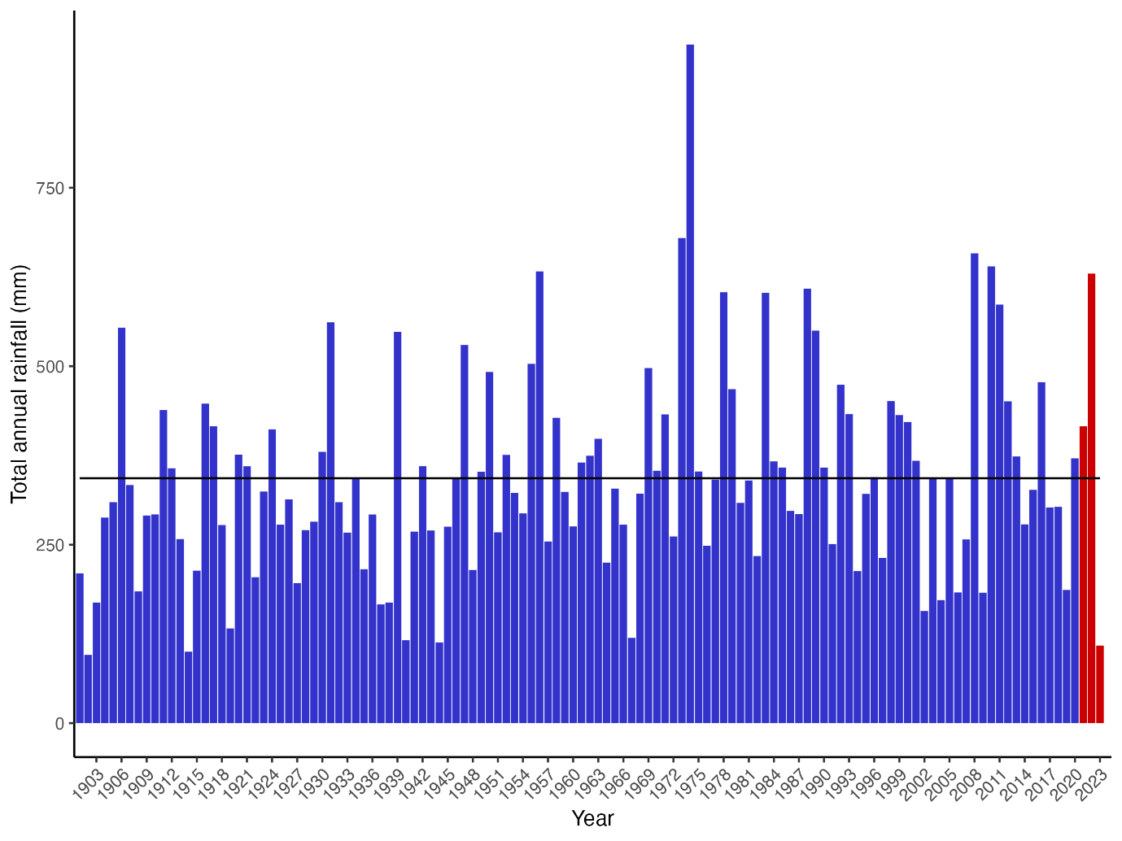
Figure 1 Long-term annual rainfall totals measured at Hillston Weir (gauge 412039), rainfall years 2021, 2022 and 2023 (to April) highlighted in red. Long-term annual mean shown by horizontal line.

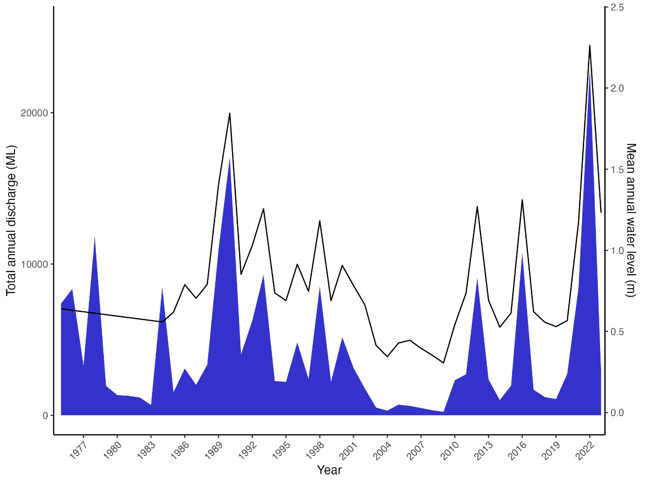
Figure 2 Total annual discharge on the Lachlan River measured at Hillston Weir 1970-2022 and corresponding mean annual water levels.

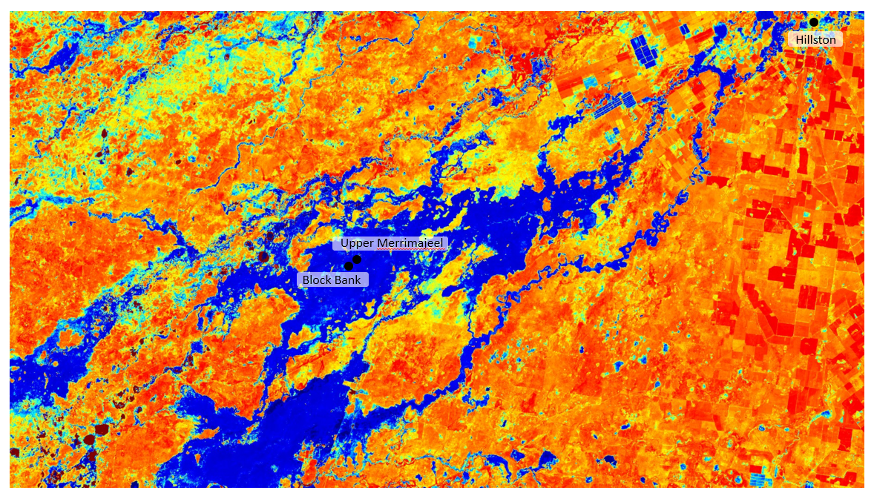
Figure 3 Sentinel-2 L2A moisture index 21st December 2022.

Water management
Aggregating waterbird breeding events have been managed by equivalent state (NSW) environmental water agencies since 1985 (Department of Water Resources 1992). It was recognised then that capturing all upstream inflows into Wyangala Dam and re-regulation of tributary inflows below Wyangala Dam into Lake Brewster storage, located upstream of Booligal Swamp, had led to rookery abandonment or failure (e.g., 1984–85). To address this impact and achieve a range of other ecological outcomes, the 1998 environmental flow rules provided for up to 350,000 megalitres (ML) of ‘translucent’ flow to be provided during the natural flood months of June to October, at a discharge rate that resulted in substantial flooding of the lower river and its wetlands (Lachlan River Management Committee 1999). The translucent flow rules were subsequently refined and formalised in the Water Sharing Plan for the Regulated Lachlan Water Source (2001).

Figure 4 shows the contribution of the 350,000 megalitre translucent from event at Willandra Weir from 29 May to 29 July 2022 represented by the period in the hydrograph in between the two broken black lines. It maintained flows between the translucent threshold of 3,500–8,000 megalitres per day (ML/d), and while there are fluctuations within that range, importantly, flows remained above the 3,500 ML/d minimum threshold at Willandra Weir which correlated to flows above the 2,500 ML/d estimated Booligal Swamp commence to fill target discharged for the majority of the 61-day event. Driver et al 2005 modelled the number of ibis nests versus the duration of flows above 2,500 ML/d at Booligal Weir with 14,500 nests predicted at 60 days, 22,000 nests at 90 days, and 50,400 nests at 200 days. As the minimum translucent target of 3,500 ML/d correlates to the 2,500 ML/d Booligal Swamp CTF, the translucent rule is a buffer against sharp, sudden drops in river heights and contributes to maintaining stable water levels identified as critical in sustaining ibis breeding, especially in the period leading up to and during early nesting where risk of abandonment is higher.

Translucent flows often preclude flooding especially during La Nina climatic conditions. Due to a combination of early translucent flows, followed by major flooding in December 2022 associated with a record 260,000 megalitre instantaneous (within 24-hour period) flood release from Wyangala Dam in November 2022, no NSW or Commonwealth licensed or held environmental water (HEW) was required support waterbird breeding during 2022–23. However, planned environmental water (PEW), such as translucent flows, are a critical type of environmental water in the Lachlan Valley. Translucent flows underpin environmental water management of the Lachlan’s extensive floodplain assets associated with the lower Lachlan alluvial fan and effluent creeks, of which Booligal Swamp in Merrimajeel Creek is but one example.

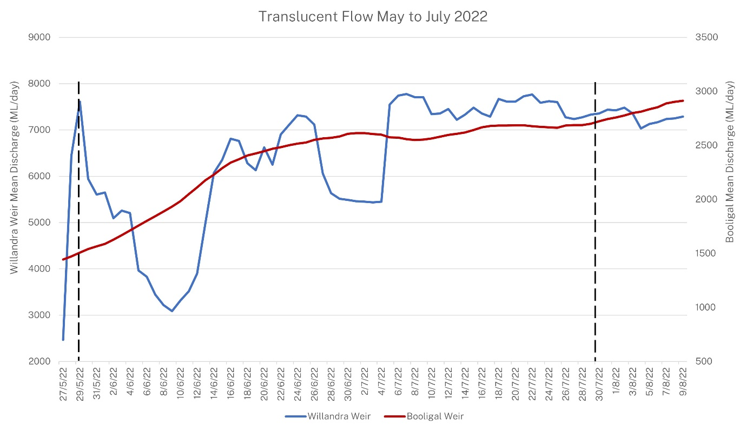
Figure 4 Translucent flow discharge (mean megalitres per day or ML/d) at key Lachlan River at Willandra Weir and Booligal Weir (lagged by a month to account for travel times for Willandra Weir flows to register at Booligal Weir due to slower travel times and floodplain return) (Source NSW DPE).

Methods
Fortnightly rookery monitoring was undertaken at Block Bank and Upper Merrimajeel rookeries in the Lower Lachlan (Figure 3) from October 2022 – March 2023 (Table 2).

Figure 5 Location of Block Bank and Upper Merrimajeel rookeries in the Lachlan catchment rookery, 2022–23.

Nest surveys
Nest monitoring was undertaken at Block Bank and Upper Merrimajeel rookeries from between early October 2022 – mid February 2023 (Figure 5, Table 2). Rookeries were surveyed approximately every two weeks between early October 2022 through to mid-February 2023 (Table 2). Surveys were completed by two people in a canoe. During Survey 1 a sub-set of randomly selected nest clumps (and nests) were given a unique number, and GPS location recorded. These nests were then revisited on each subsequent survey. Nests were only marked if they contained eggs and when appropriate additional nest clumps were added to the survey if new nests were established between surveys. During each survey the following variables were recorded; number of eggs or chicks, chick development stage (Table 3), evidence of predation, disease, and nest abandonment. Individual nest surveys continued fortnightly until chicks had reached runner stage, where chicks become highly mobile and begin créching behaviour, congregating on nests as large groups of chicks. At this stage it is not possible to attribute chicks to specific nests, so counts are done at a nest clump scale. Nest clump monitoring continued until chicks had fledged or were no longer associated with the nest clump site.

Water depth data was recorded at each nest clump site using a 2 m folding ruler. Water quality data was collected at three random locations within the nest monitoring area at each rookery site during each survey. Water quality variables recorded included: temperature, pH, conductivity, total dissolved solids, resistivity, and salinity.

Table 2 Nest and drone survey dates for Booligal rookery monitoring October 2022-March 2023.
Survey number | Survey dates | Survey type | Rookery
1 | 3rd-4th Oct. 2022 | Drone survey | Block Bank
2 | 9th Nov. 2022 | Drone survey | Block Bank
3 | 6th-7th Dec. 2022 | Nest and drone survey | Block Bank & Upper Merrimajeel
4 | 20th-22nd Dec. 2022 | Nest and drone survey | Block Bank & Upper Merrimajeel
5 | 4th-5th Jan. 2023 | Nest and drone survey | Block Bank & Upper Merrimajeel
6 | 17th – 18th Jan. 2023 | Nest survey | Upper Merrimajeel
7 | 31st Jan. 2023 | Nest survey | Block Bank & Upper Merrimajeel
8 | 14th-15th Feb. 2023 | Nest and drone survey | Block Bank & Upper Merrimajeel
9 | 3rd- 4th Mar. 2023 | Drone survey | Block Bank & Upper Merrimajeel

Table 3 Straw-necked ibis chick development stages (sources Marchant & Higgins 1990, K. Brandis).
Development stage | Characteristics | Age (days)
Trampling | Adult ibis congregating on lignum (nesting habitat) and preparing for nest building
Egg | Whole egg, being incubated by adult | 1-20
Chicks | Recently hatched (1-5 days old), downy feathers, immobile | 21-25
Squirters | Early sheathed feathers starting on wings, still in nest, immobile | 26-30
Runners | Development of pin feathers. Mix of down and feathers, walking awkwardly, can leave nest on foot | 31-35
Flappers | Nearly fully feathered, cannot fly but flaps between nests | 36-40
Flyers | Fully feathered, able to fly and leave nests, still attended by parents at nest | 41-47
Fledged | Independent, does not return to nest but roosts in nearby trees | >48

Drone surveys
Drone surveys were conducted at two rookery sites (Upper Merrimajeel, and Block Bank) between 3rd October 2022 and 3rd March 2023 (Table 4). The area surveyed by drone was adjusted on each survey to capture changes in the rookery extent (Figure 6, Figure 7).

Table 4 Dates of each drone survey including the area of the mosaic flown at the two colonies surveyed on the Lachlan River system: Upper Merrimajeel and Block Bank.
Rookery | Survey date | Pilot | Mosaic area (ha)
Block Bank | 3rd Oct. 2022 | Jana Stewart | 9.7
 | 9th Nov. 2022 | Matt Smith | 116.1
 | 7th Dec. 2022 | Matt Smith | 106.9
 | 22nd Dec. 2022 | Jana Stewart | 61.3
 | 5th Jan. 2023 | Jana Stewart | 135.1
 | 15th Feb. 2023 | Matt Smith | 141.1
 | 2nd Mar. 2023 | Matt Smith | 183.7
Upper Merrimajeel | 8th Dec. 2022 | Matt Smith | 25.1
 | 6th Jan. 2023 | Jana Stewart | 25.2
 | 2nd Feb. 2023 | Loic Juillard | 124.7
 | 16th Feb. 2023 | Matt Smith | 116.3
 | 3rd Mar. 2023 | Matt Smith | 171.2

Flights were conducted using a DJI Mavic Enterprise Dual Advanced drone and a DJI Phantom 4 Pro. The drone was launched and returned to the canoe or argo from the outskirts of the rookeries. Flights were conducted at an altitude of 65m – 75m depending on the area to cover which varied to account for changes in the rookery size (Table 3). Flights consisted of the flying of automated transects over the areas where breeding was previously identified at an overlap of 76%, producing over 1000 images covering each rookery. Flight locations were guided by ground observations when possible, or otherwise the drone was first flown manually on a scouting mission to identify rookery extent.

Images were orthomosaiced using Pix4Dmapper (Pix4d SA, 2022). Orthomosaics were counted either manually with nest locations annotated in a shapefile, or using an automated counting technique based on object detection and random forest modelling. Species were identified based on their plumage and breeding stage was determined based on group behaviour (eg., trampling, incubating or créching), and from sightings of eggs or chicks in nests. In the first image collection all incubating nests and clumps with creching chicks were counted. In the following set of imagery all new incubating nests were counted across the entire mosaic, but chicks on clumps were only counted in areas not previously counted (to avoid double counting in the nest estimates). In this way, using known clutch size and reproductive success estimates we could estimate a total number of nests built in the season in each rookery.

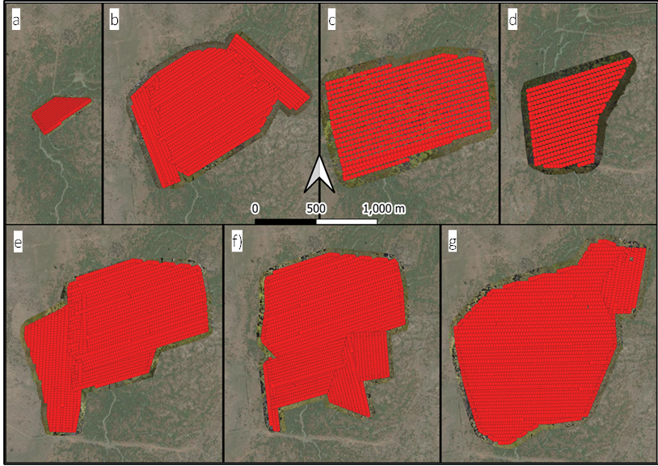
Figure 6 Transects flown with the drone over the Block Bank rookery a) 3rd Oct. 2022, b) 9th Nov. 2022, c) 7th Dec. 2022, d) 22nd Dec. 2022, e) 5th Jan. 2023, f) 15th Feb. 2023, and g) 2nd Mar. 2023.

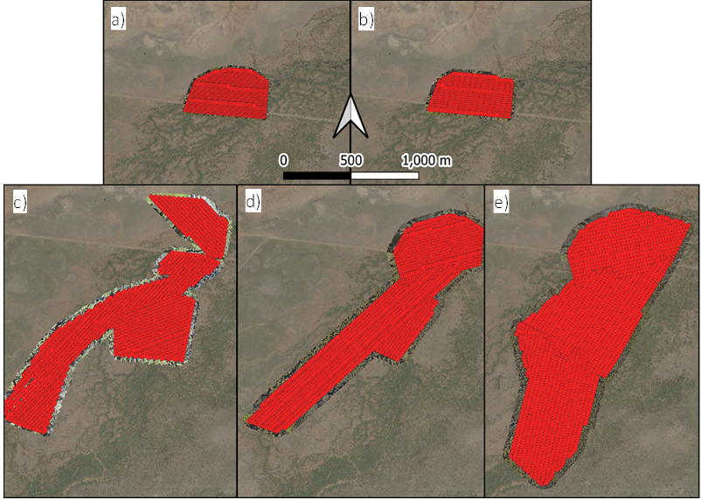
Figure 7 Transects flown by the drone over the Upper Merrimajeel rookery a) 18th Dec 2022, b) 6th Jan. 2023, c) 2nd Feb 2023, d) 16th Feb 2023 and e) 3rd March 2023.

Results

Nest surveys
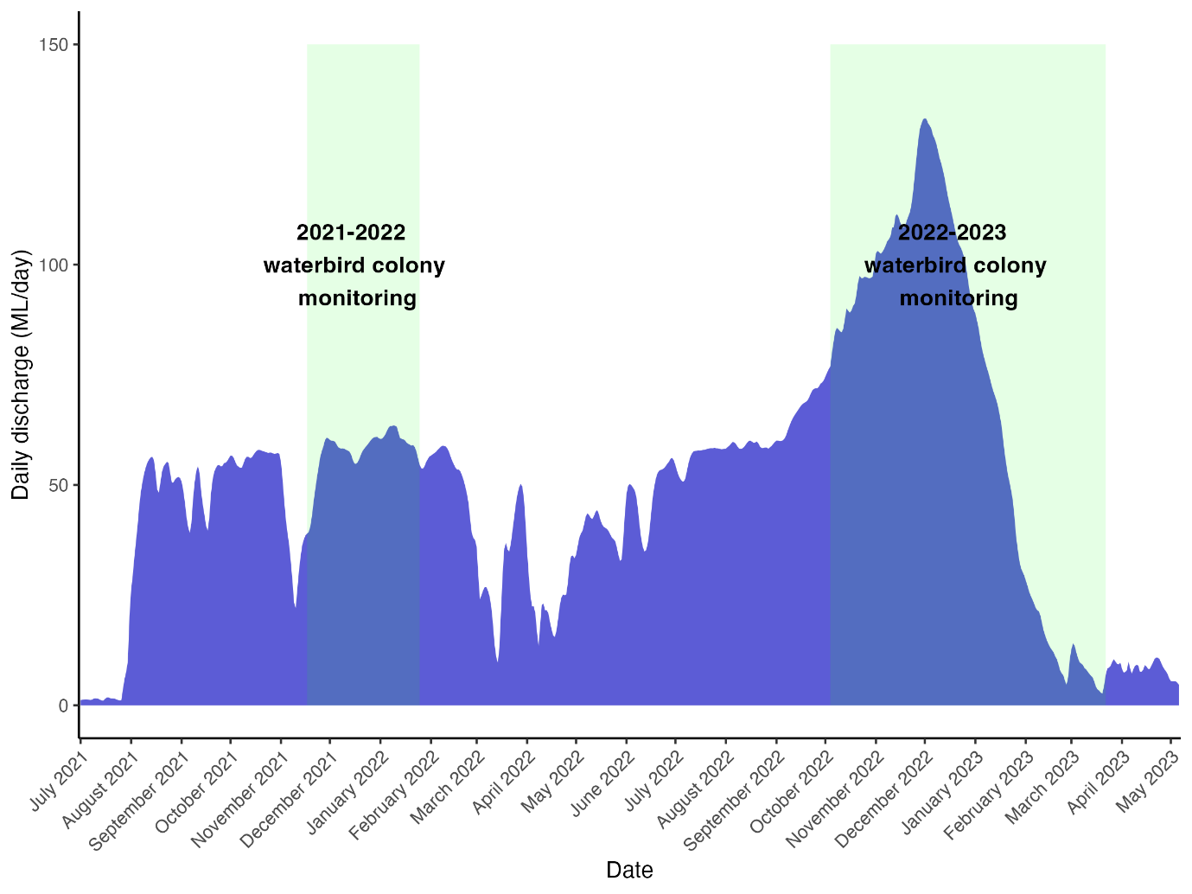
Figure 8 Flows in the Lachlan River at Hillston Weir and the timing of rookery surveys during 2021-22 and 2022-23.
Rookery monitoring during 2022-23 occurred during significant and prolonged flooding in the Lower Lachlan. The flood peak during monitoring in 2022-23 was more than twice as large as that during rookery monitoring in 2021-22 (Figure 8). Flow patterns were also different with a rapid decline in flows during breeding in 2022-23, while flows in 2021-22 were more stable.

Block Bank rookery
Block Bank rookery is a traditional nesting site on the Merrimajeel Creek. The rookery is located on the Lachlan Valley State Recreation Area and adjacent private land. There are records of ibis breeding at this site since 1984 (Table 1). It is a floodplain wetland dominated by lignum (Duma florulenta) shrublands.

A total of 389 nests were marked throughout the nesting period. 143 nests were marked during the first survey in early December (Table 2) additional eggs were added to the survey set on subsequent trips. There were 4 cohorts of egg laying that were monitored. Three discrete sets of nesting where the rookery expanded with new nests and eggs were laid (cohorts 1-3), while the fourth cohort, consisted of eggs laid into existing nests – this is referred to as cohort 1.1 (as nests from cohort 1 had a second set of eggs laid into them). The composition of the rookery by chick development stage is shown in Figure 9, initial nesting is estimated to have started in mid-September and continued laying of new eggs is evident through until mid-February 2023.

Clutch sizes were marginally higher for early layers, cohorts 1 and 2, while later cohorts, 3 and 1.1 were lower (Table 5). These clutch sizes are comparable to other rookeries in 2022-23 in the Basin e.g., Macquarie Marshes Monkeygar North rookery cohort 1 was 2.83 eggs per nest, while cohort 2 was 2.1 (Brandis et al. 2023).

Table 5 Nesting cohorts monitored at Block Bank rookery 2023-24.
Cohort | Date first surveyed | Number of eggs | Number of nests | Average clutch size
1 | 7th Dec. 2022 | 365 | 143 | 2.55
2 | 22nd Dec. 2022 | 159 | 55 | 2.89
3 | 5th Jan. 2023 | 225 | 102 | 2.22
1.1 | 1st Feb. 2023 | 175 | 89 | 1.97

Figure 9 Composition of Block Bank straw-necked ibis rookery by chick development stage per nest survey.

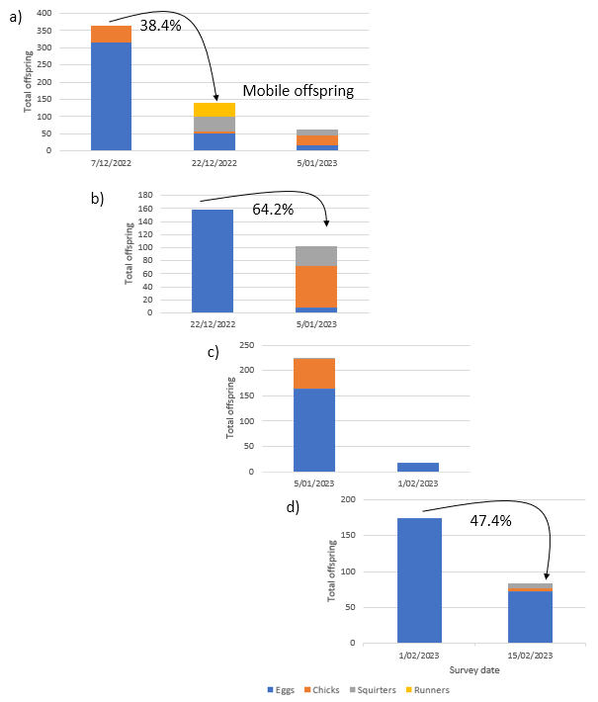
Figure 10 Reproductive success between surveys at Block Bank rookery for a) cohort 1, b) cohort 2, c) cohort 3, and d) cohort 1.1.

Reproductive success rates were varied between cohorts (Figure 10). Cohort 2 had a higher success rate (64.2%) than cohort 1 (38.4%). This lower rate may be reflective of mobile offspring at the second survey (squirters créching and runners leaving the nests). Accurately measuring nest success for all stages of chick development is difficult for straw-necked ibis as young birds crèche at ~Days 30-35 (Table 3). Créching is where young birds leave their natal nest and form groups of young birds, at this stage it is difficult to accurately assign the number of birds to a specific nest. We count the total number of birds in a crèche (Figure 13), however this count cannot be relied upon to be an accurate representation of the total number of young birds due to their mobility. For this reason we do not calculate nest success once chicks are mobile.

Reproductive success was not calculated for cohort 3 (Figure 10) due to the 4 week gap between surveys at this rookery. Block Bank rookery was not surveyed in mid-January 2023 as planned due to access limitations.

Reproductive success for cohort 1.1 was relatively low (47.4%), this is not unusual in later nesting birds whether they be second clutches or first clutches by later arriving birds.

Upper Merrimajeel
The Upper Merrimajeel rookery, located on the Merrimajeel Creek was last used as a rookery site in 2016/17 (Dyer et al. 2017) when is supported the largest rookery in the Basin at that time with ~100,000 nests (Table 1). The 2022-23 rookery was initially located on private land and then expanded south along the creek into the adjacent Lachlan Valley State Recreation Area. It is a floodplain wetland dominated by lignum (Duma florulenta) shrublands.

There were two cohorts of eggs laid, cohort 1 marked during the first survey, and cohort 2 in early January 2023 (Figure 11). During survey 1 the majority (~65%) of the rookery were at chick stage (Figure 11). Based on the chick development stage nesting likely began in early-mid November 2022.

Clutch sizes for cohort 1 ($\overline{x}$=1.47 range 1-3) were low compared to cohort 2 ($\overline{x}$=2.82 range 1-5) and when compared to other rookeries in the Basin. This may be reflective of the advanced stage of the rookery when it was first surveyed with a large proportion already at chick stage. Straw-necked ibis eggs hatch asynchronously and it is common for the third smaller chick to die (Fujioka 1985, Ploger and Mock 1986). This would result in fewer chicks in nests than eggs that were laid, accounting for the smaller clutch size.

Figure 11 Composition of Upper Merrimajeel straw-necked ibis rookery by chick development stage per nest survey.
Table 6 Nesting cohorts monitored at Upper Merrimajeel rookery 2023-24.
Cohort | Date first surveyed | Number of eggs | Number of nests | Average clutch size
1 | 8th Dec. 2022 | 303* | 205 | 1.47
2 | 6th Jan. 2023 | 141 | 55 | 2.82
*this count is a combination of chicks and eggs/nest due to composition of rookery during first survey (Figure 11).

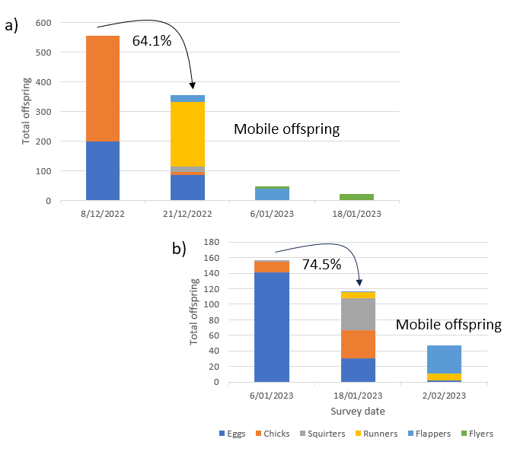
Figure 12 Reproductive success between surveys at Upper Merrimajeel rookery for a) cohort 1 and b) cohort 2.

Reproductive success rates were higher for cohort 2 (74.5%) than cohort 1 (64.1%) (Figure 12) at the same stages of chick development. Table 7 provides a summary of reproductive success rates at different nesting stages for both rookeries.

Table 7 Summary of reproductive success rates at each rookery for each key chick development stage as recorded during each survey. Reproductive success was not calculated for Block Bank cohort 3 (Figure 10) due to the 4 week gap between surveys at this rookery.
Rookery | Cohort | Chick development stage
 |  | Eggs – eggs/chicks/squirters | Eggs/chicks/squirters – squirters/runners | Squirters/runners – flappers/flyers | Average early stage (Surveys 1-4) nest success
Block Bank | 1 | 38.36% | 44.29% |  | 41.32%
 | 2 | 64.15% |  |  | 64.15%
 | 1.1 | 47.43% |  |  | 47.43%
Upper Merrimajeel | 1 | 64.14% | 13.20% | 46.81% | 41.38%
 | 2 | 74.52% | 40.17% |  | 57.35%

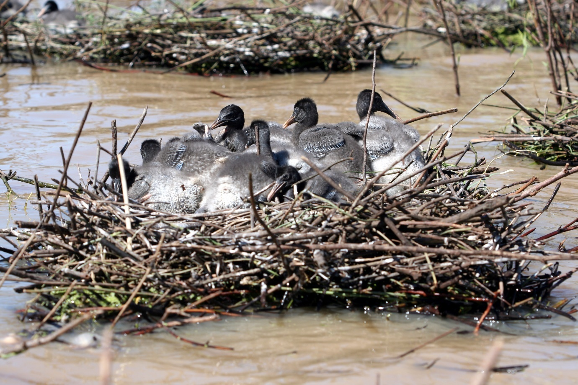
Figure 13 Créching straw-necked ibis chicks at squirter/runner stage of development (Narran Lakes, 2008).

Disease, predation and mortality
There were no large-scale impacts observed on either of the rookeries from disease or predation. Mortality rates, as a percentage of total offspring counted at nests, were highest at Upper Merrimajeel with the highest mortality recorded during mid-January and early February 2023. This pattern was observed at both rookery sites (Table 8, Table 9). At this time mortality was observed for offspring from flapper – flyer stages including dead adults. There were additional dead birds observed in both rookeries, in addition to sick birds that were unable to move/fly and were unresponsive when approached. Observations of mortality and disease as a proportion of sampled nests decreased towards the end of the breeding period (Table 8). However, there were higher numbers of deceased birds seen throughout the rookery, this coincided with falling water levels (Figure 14, Figure 15), reduced flows (Figure 8) and relatively warmer water temperatures (Figure 17, Figure 18) which are conditions that are conducive to avian botulism (Brandis et al. 2019). Noting that no post-mortem diagnostics were undertaken.

Table 8 Mortality rates of straw-necked ibis observed at monitored nests in Block Bank rookery.
Survey date | No. observed dead birds | Total offspring | Mortality rates
5th January 2023 | 43 | 461 | 9.33%
1st February 2023 | 18* | 198 | 9.09%
15th February 2023 | 3# | 83 | 3.61%
*A further 42 dead straw-necked ibis and 12 dead ducks observed in the rookery.
#A further 54 dead straw-necked ibis, 2 royal spoonbill and 5 Australian white ibis were observed in the rookery.

Table 9 Mortality rates of straw-necked ibis observed at monitored nests in Upper Merrimajeel rookery.
Survey date | No. observed dead birds | Total offspring | Mortality rates
6th January 2023 | 25 | 204 | 12.25%
18th January 2023 | 33 | 139 | 23.74%
2nd February 2023 | 9* | 57 | 15.79%
*A further 80 dead straw-necked ibis were observed in the rookery.

Water depth
Water depths were similar in both rookery sites (Block Bank overall average depth 50cm, Upper Merrimajeel overall average depth 62cm), with a slow, steady decline in water depth throughout the breeding period (Figure 14, Figure 15).

Figure 14 Water depth at nest sites in Block Bank rookery December 2022-February 2023. Boxes with whiskers represent data range, X represents the mean, horizontal line represents the median, and small circles represent outlier data points.

Figure 15 Water depth at nest sites in Upper Merrimajeel rookery December 2022-February 2023. Boxes with whiskers represent data range, X represents the mean, horizontal line represents the median, and small circles represent outlier data points.

Water quality
Water quality measures that have direct relevance for aquatic organisms include dissolved oxygen, pH, total dissolved solids (TDS) and salinity. Some measures, such as TDS are highly correlated with other measures such conductivity and salinity. Water with a relatively high will have a low resistivity and a high conductivity. Total dissolved solids measured at both Block Bank and Upper Merrimajeel rookeries fall within the ‘freshwater’ range (TDS ppm <1,000 ppm), and salinity results fall within the range for freshwater 0-500ppm. Similarly, water temperature can impact dissolved oxygen content. However, in densely vegetated wetlands with macrophytes and other aquatic flora this pattern is not as defined (Figure 17, Figure 18).

The patterns in pH values at the two rookeries were similar, with initial neutral values, followed by low (acidic) pH values (3.75-4.5) during late December and early January (Figure 17, Figure 18), returning to neutral ~7 in later surveys. The majority of aquatic creatures prefer a pH range of 6.5-9.0, though some can live in water with pH levels outside of this range (Fondriest Environmental Learning Centre). As pH levels move away from this range (up or down) it can stress animal systems and reduce hatching and survival rates. The further outside of the optimum pH range a value is, the higher the mortality rates. The more sensitive a species, the more affected it is by changes in pH. In addition to biological effects, extreme pH levels usually increase the solubility of elements and compounds, making toxic chemicals more “mobile” and increasing the risk of absorption by aquatic life.

The implication for water pH measures outside the ranges preferred by aquatic organisms has implications for the availability and quality of aquatic food resources for waterbirds and other wetland fauna. In a wetland ecosystem pH can be affected by carbon dioxide (CO₂) in the water. Higher levels of CO₂, as a result of plant photosynthesis, respiration and decomposition is a common cause of acidity in the water. The values measured Block Bank and Upper Merrimajeel mostly fall within the expected range of values for a wetland ecosystem, however while these values are “normal”, higher levels of acidity or alkalinity can be beyond the range of tolerance for some aquatic organisms (Figure 14).

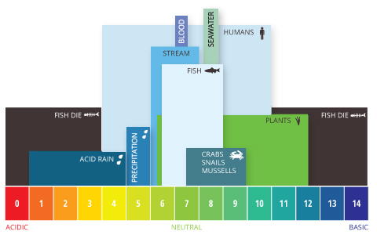
Figure 16 Aquatic pH levels. The optimum pH levels for fish are from 6.5 to 9.0. Outside of optimum ranges, organisms can become stressed or die. Source:(Fondriest Environmental Learning Centre).

Conductivity and total dissolved solids patterns and values were similar at both rookeries (Figure 17, Figure 18). Total dissolved solids and conductivity are highly correlated with TDS measurements being derived from conductivity measures. Dissolved solids are important to aquatic life by keeping cell density balanced. In distilled or deionized water, water will flow into an organism’s cells, causing them to swell. In water with a very high TDS concentration, cells will shrink. These changes can affect an organism’s ability to move in a water column, causing it to float or sink beyond its normal range (Fondriest Environmental Learning Centre). The values measured for Block Bank and Upper Merrimajeel were within the range normally attributed to ‘average tap water”.

Dissolved oxygen, the amount of oxygen in water, can enter the water from the atmosphere or as a biproduct of aquatic plant photosynthesis. As aquatic photosynthesis is light-dependent, the dissolved oxygen produced will peak during daylight hours and decline at night. Factors the can impact the dissolved oxygen content of water include; stratification and water depth, wind, temperature, pressure, salinity and sampling time. Dissolved oxygen levels were relatively low at Block Bank (<5mgl/L) while Upper Merrimjaeel had higher values. This may be due to being further upstream than Block Bank, and closer to a main channel with flowing water. Dissolved oxygen levels increased at both Block Bank and Upper Merrimajeel over the nesting period, this may be in response in increased aquatic plant growth in the wetlands (Figure 14, Figure 15).

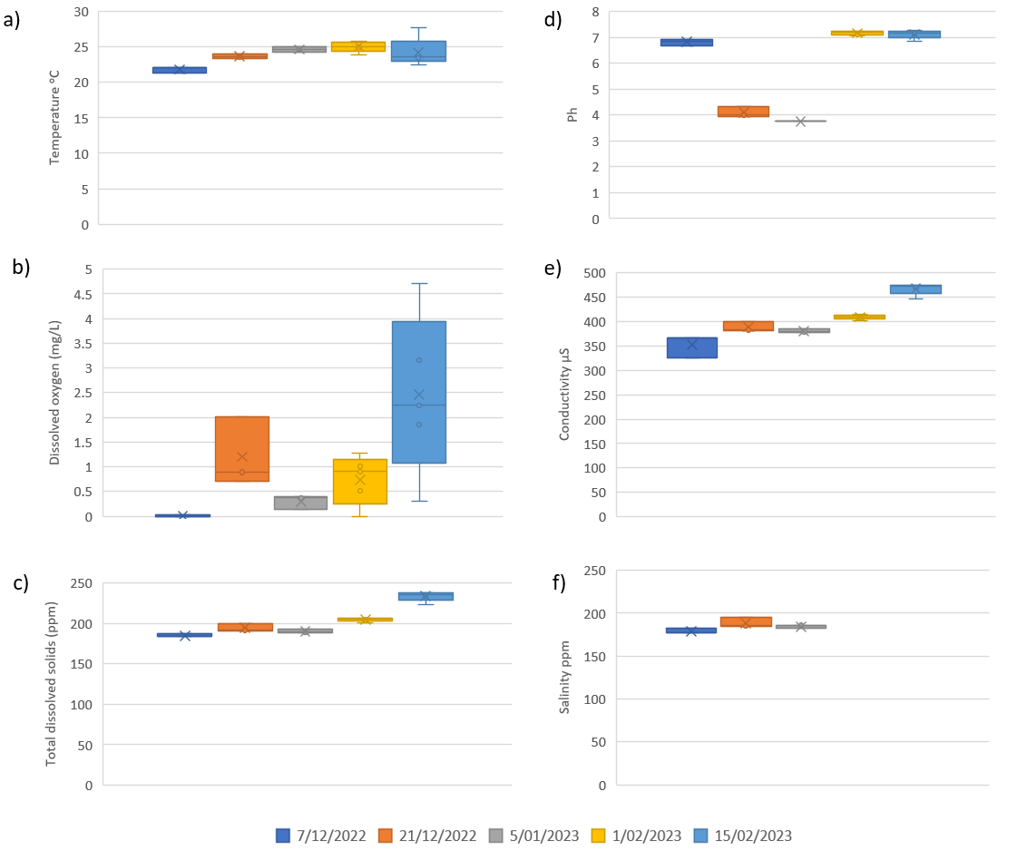
Figure 17 Water quality results at Block Bank rookery a) water temperature, b) dissolved oxygen, c) total dissolved solids, d) pH, e) conductivity, f) salinity.

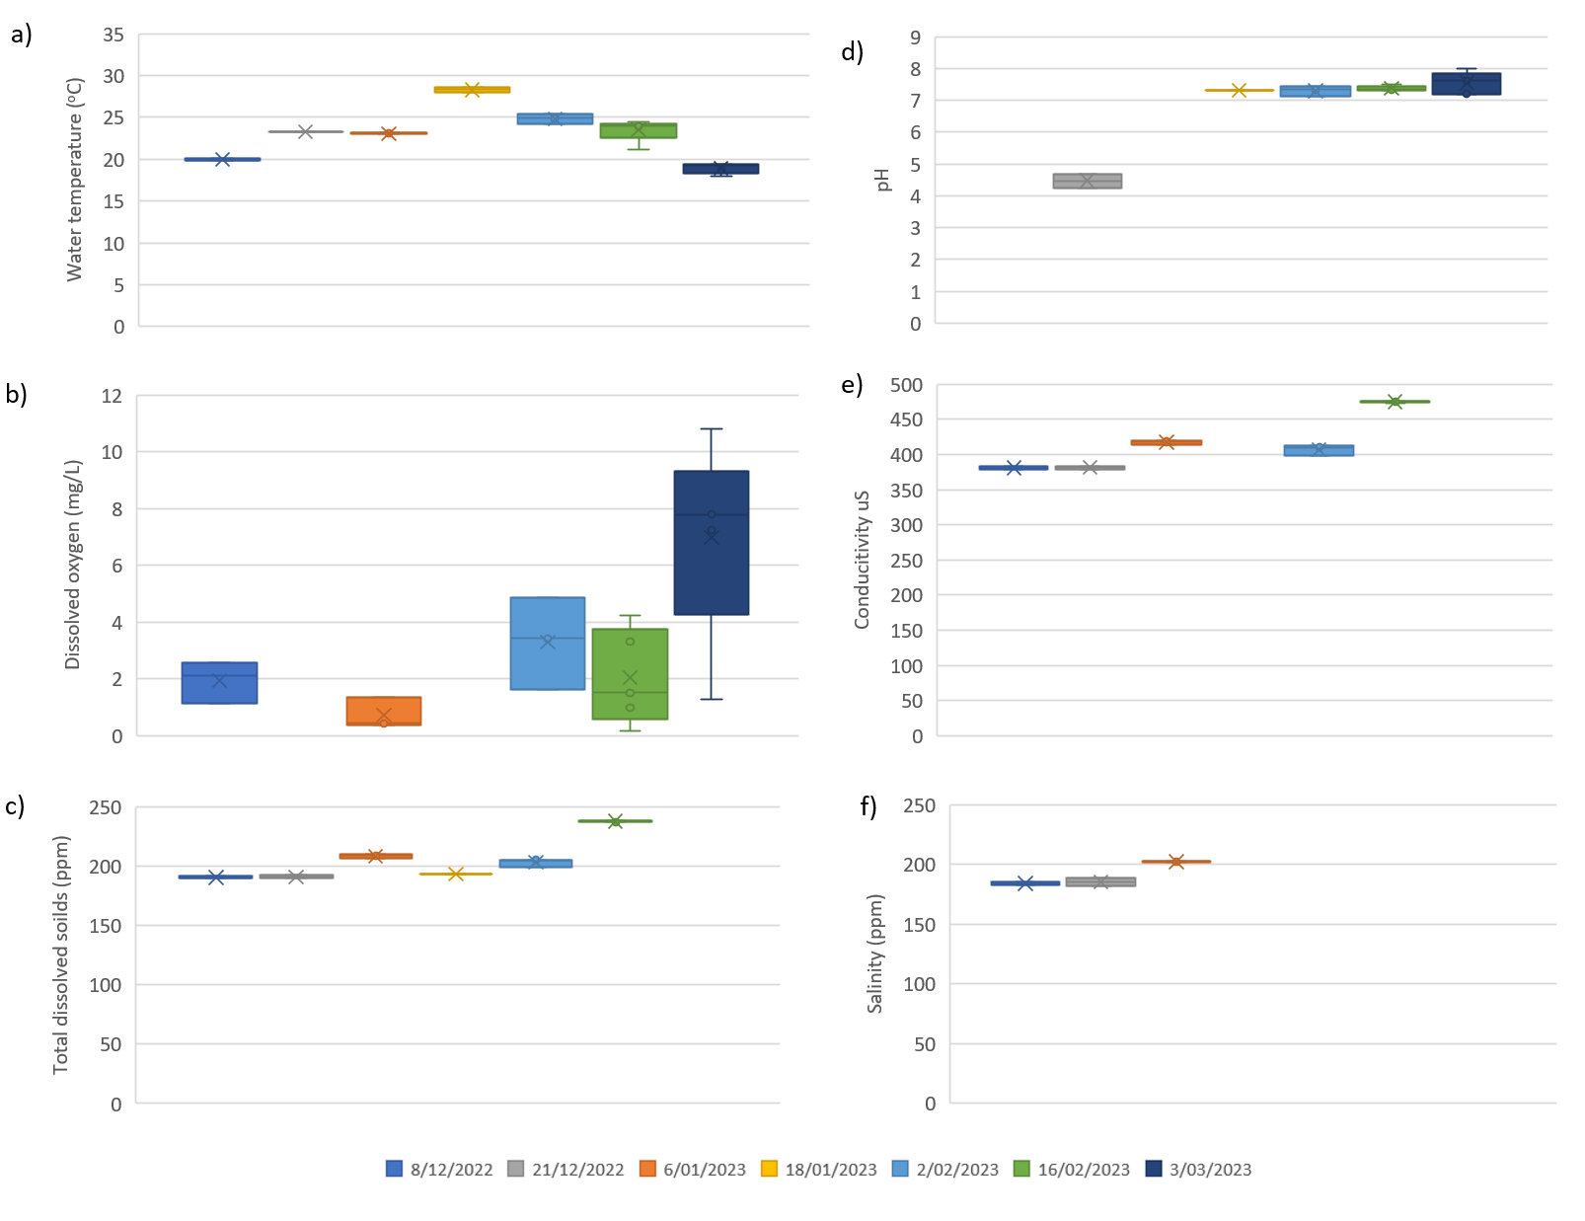
Figure 18 Water quality results at Upper Merrimajeel rookery a) water temperature, b) dissolved oxygen, c) total dissolved solids, d) pH, e) conductivity, f) salinity.

Drone surveys

Block Bank
The rookery surveyed at Block Bank on the 3rd Oct. 2022 was in early stages of breeding, with adults incubating eggs or protecting young chicks (Figure 19), making the use of an automated count appropriate. Similarly for the second mosaic, the rookery had expanded significantly, and most birds were incubating nests allowing for the use of the automated count. From this survey onwards all counts were manual and limited to the new areas of nesting to prevent double counting and obtain a total nest count for the rookery (Figure 20). The rookery started at approximately 57 ha, and grew to 122 ha in the last survey on the 2nd March 2023. Total nest counts for the Block Bank rookery totalled ~145,000, with the calculation shown below and growth of the rookery detailed in (Table 10). There were multiple species breeding together, including royal spoonbills, and Australian white ibis. Total Australian white ibis nest counts were 1,640 nests (Table 10).

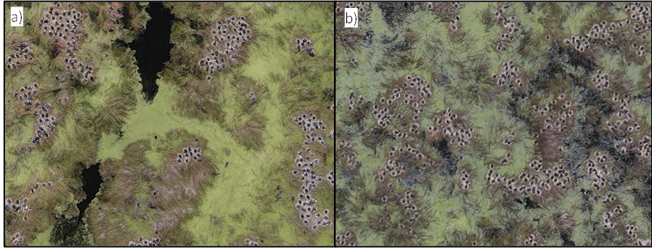
Figure 19 Examples of the mosaic collected over Block Bank rookery on the a⁾ 3rd Oct. 2022, and b⁾ 9th Nov. 2022 showing the breeding stage with adult birds incubating eggs or attending young chicks.
Using a mean clutch size of 2.55 eggs per nest (Table 5), we estimate the following total nest count for straw-necked ibis at Block Bank:

10,830 nests + 92,945 nests + 3,277 nests + 24,405 nests + (1,268 chicks/ 2.55) + 5,403 nests +6,783 nests + 817 nests
=144,957 straw-necked ibis nests

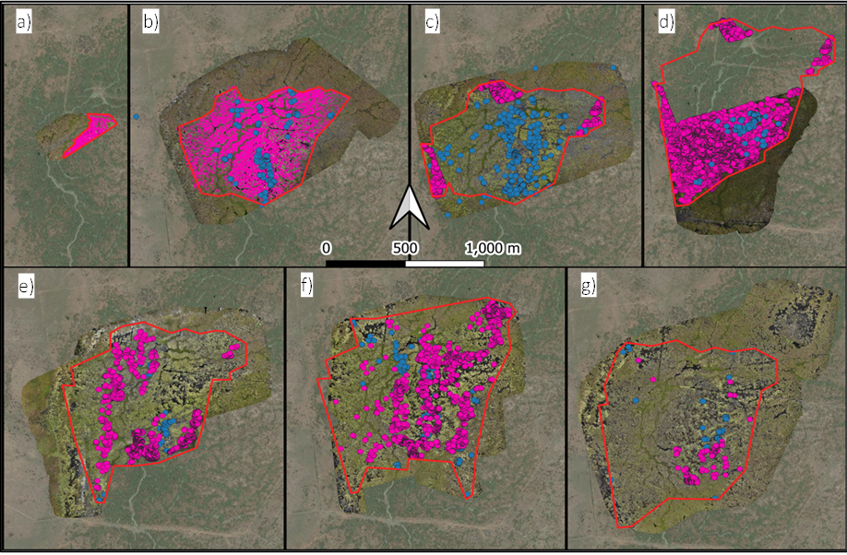
Figure 20 Counts of straw-necked ibis (pink) and Australian white ibis (blue) in the drone developed mosaics collected over the Block Bank rookery a) 3rd Oct. 2022, b) 9th Nov. 2022, c) 7th Dec. 2022, d) 22nd Dec. 2022, e) 5th Jan. 2023, f) 15th Feb. 2023, and g) 2nd Mar. 2023.
Table 10 Results of rookery mapping and drone derived counts of nests and chicks at Block Bank rookery.
Survey Date | Count Type | Species | Count | Rookery Area (ha)
3rd Oct. 2022 | Auto | Straw-necked ibis | 10,830 nesting birds | 3.3
 |  | Australian White Ibis | 0
9th Nov. 2022 | Auto | Straw-necked ibis | 92,945 nesting birds | 56.5
 |  | Australian White Ibis | 191 nests
7th Dec. 2022 | Manual | Straw-necked ibis | 3,277 new nests | 64.9
 |  | Australian White Ibis | 730 new nests
22nd Dec. 2022 | Manual | Straw-necked ibis | 1,268 chicks | 87.8
 |  |  | 24,405 new nests
 |  | Australian White Ibis | 176 new nests
5th Jan. 2023 | Manual | Straw-necked ibis | 5,403 new nests | 90.1
 |  | Australian White Ibis | 141 new nests
15th Feb. 2023 | Manual | Straw-necked ibis | 6,783 new nests | 118.3
 |  | Australian White Ibis | 289 new nests
2nd Mar. 2023 | Manual | Straw-necked ibis | 817 new nests | 121.7
 |  | Australian White Ibis | 113 new nests

The rookery at Block Bank progressed without evidence of major disturbance such as flooding of nests, throughout 6 months of surveys, with most nests in the rookery finished by the last survey (Figure 20).

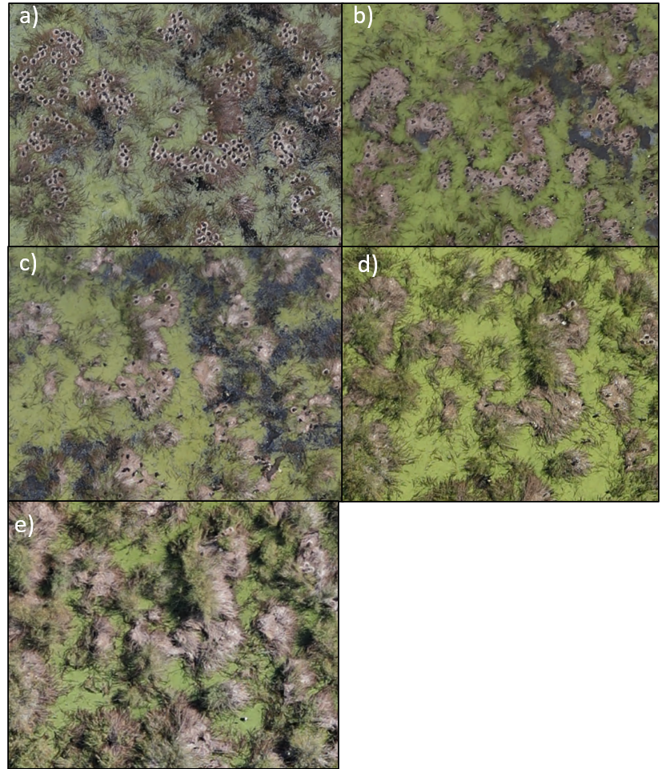
Figure 21 Progression of the same area of the Block Bank rookery, showing the consistent development of nests from incubation of eggs on the a) 11th Nov. 2022, followed by the presence of chicks on the b) 22nd Dec. 2022, fledglings on the c) 5th Jan. 2023, new nests being built on the d) 15th Feb. 2023, and finally the bulk of the nests finished on the e) 2nd Mar. 2023.

Upper Merrimajeel
In December, during the first survey the rookery was already in mixed stages of breeding, with many nests at the chick stage. The rookery expanded in January with an additional ~16,000 new nests counted in February (Table 11). The total straw-necked ibis nest count for Upper Merrimajeel was:

2,629 nests+(8,975 chicks/ 2.82)+2,727 nests + (28 chicks /2.82) +15,726 nests +37 nests +1,868 nests
=26,180 straw-necked ibis nests
The total Australian white ibis nest count was:
285 + (304/2.7*) +112 + 23 + 45
= 578 nests

*(Corben and Munro 2006)

Table 11 Results of rookery mapping and drone derived counts of nests and chicks at Upper Merrimajeel rookery.
Survey Date | Species | Count | Rookery area (ha)
8th Dec. 2022 | Straw-necked ibis | 2,629 adults on nests | 10.9
 |  | 8,975 chicks
 | Australian white ibis | 285 nests
 |  | 304 chicks
6th Jan. 2023 | Straw-necked ibis | 2,727 adults on new nests | 12.6
 |  | 28 new chicks
2nd Feb. 2023 | Straw-necked ibis | 15,726 new nests | 45.4
 | Australian white ibis | 23 new nests
16th Feb. 2023 | Straw-necked ibis | 37 new nests | 45.5
 | Australian white ibis | 45 new nests
3rd Mar. 2023 | Straw-necked ibis | 1,868 new nests | 63.2

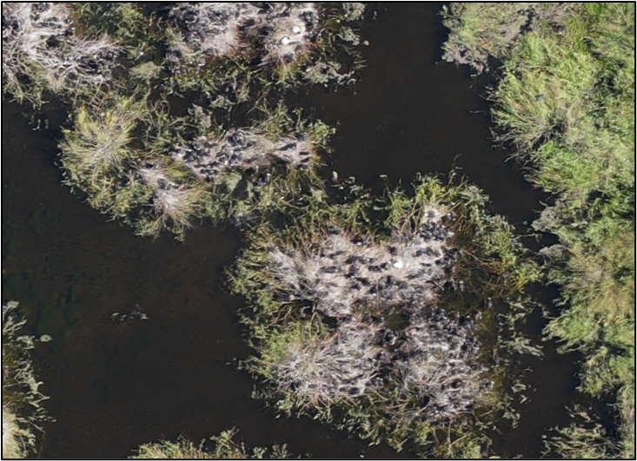
Figure 22 An example of the advanced stage of breeding for the straw-necked ibis in the first mosaic flown at Upper Merrimajeel the 8th Dec. 2022, with a couple of new Australian White Ibis nests (top middle).

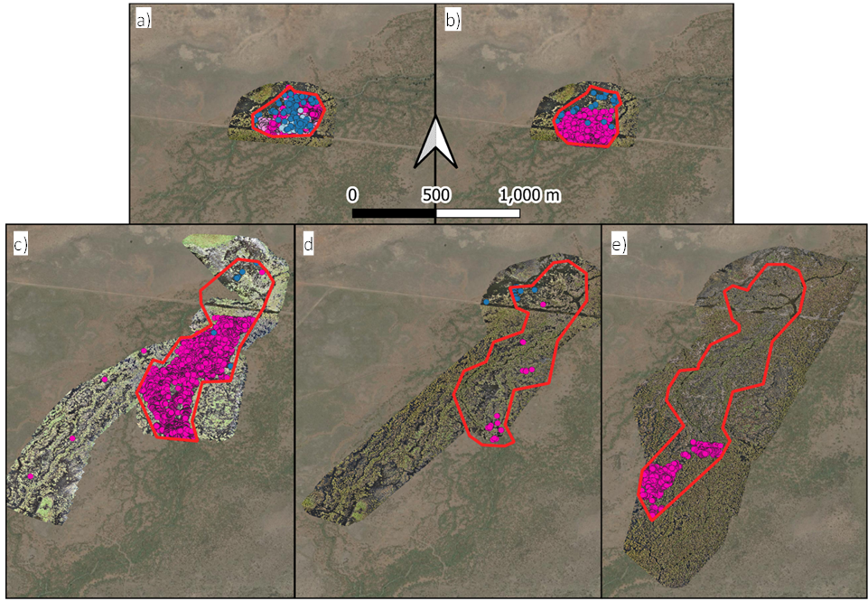
Figure 23 Mosaics with nest locations showing the significant expansion at the Upper Merrimajeel rookery from the first drone survey on the a) 8th December, followed by the b) 6th Jan. 2023, c) 2nd Feb 2023, d) 16th Feb 2023 and finally the e) 3rd March 2023. Straw-necked ibis nests are annotated in dark pink, chicks in light pink, with Australian white ibis nests in dark blue and chicks in light blue.

Similarly to the Block Bank rookery, nesting appeared to be largely successful, with no signs of mass abandonment, nest flooding or predation in the drone imagery.

Conclusions
Two large aggregating waterbird rookeries established at traditional nesting sites in the Lower Lachlan at Block Bank and Upper Merrimajeel in 2022-23. The rookeries were mixed species dominated by straw-necked ibis (Threskiornis spinicollis), but also included Australian white ibis nests (T. molluca) and royal spoonbill (Platalea regia) nesting in smaller numbers.
Total drone derived nest counts for the Lower Lachlan were 171,137 straw-necked ibis nests and 2,218 Australian white ibis nests.

The nesting season was protracted with initial nesting starting in mid-September 2022 at Block Bank and mid-October 2022 in Upper Merrimajeel, with eggs continuing to be laid into February 2023. Both rookeries had multiple laying cohorts resulting in a range of different reproductive success values. Observed clutch sizes were consistent with past years (Table 12) and other rookeries. Reproductive success rates were also comparable to other years (Table 12) and rookeries in the Basin (Brandis et al. 2023). While there was some evidence of disease, it was not significant, and no mass mortalities were observed in either rookery.
The Block Bank and Upper Merrimajeel rookeries were two of 12 large ibis rookery sites in the Murray-Darling Basin during 2022-23 and contributed significantly to the total number of nests and chicks fledged during this period. The Lower Lachlan accounted for ~44% of all straw-necked ibis nests counted in the Murray-Darling Basin in 2022-23.

Table 12 Summary of nest monitoring results for Lower Lachlan rookeries 2016-2023.
Year | Rookery | Total number nests | Reproductive success | Mean clutch size
2016-17 | Block Bank | 8,000 | 64% | 1.99
2016-17 | Upper Merrimajeel | 103,360 | 83% | 2.08
2021-22 | Block Bank | 44,000 | 68% | 2.01
2022-23 | Block Bank | 144,957 | 64% | 2.4
2022-23 | Upper Merrimajeel | 26,180 | 57% | 2.1

Recommendations
The targeted provision of discretionary licensed or held environmental water (HEW) is becoming increasingly important in the management and support of aggregating waterbird breeding events. This can be achieved both during the breeding season and between seasons when conditions may not be suitable for large scale aggregating waterbird breeding. Between season maintenance of nesting habitat is crucial for when opportunities for breeding do occur. Providing opportunities for breeding includes the presence of suitable nesting habitat, this often includes areas of lignum, phragmites, river red gums, and black box, with the more waterbird species diverse sites having mosaics of floodplain and riparian vegetation communities (Brandis, Francis and Bino in prep).

Large scale aggregating waterbird breeding is often associated with large scale inundation as a result of natural rainfall and flooding. Licensed or held environmental water (HEW) can play a key role in supporting breeding rookeries when established through the provision of additional flows to extend duration, increase water depth, maintain water quality and provide foraging areas.

During the 2022-23 nesting period planned environmental water in the form of a large translucent flow event followed by natural flooding was sufficient to support the rookeries in the Lower Lachlan and no additional held environmental water required. The management of water at Upper Merrimajeel is limited to the passing of flows through the site, while there is infrastructure in place to help hold water at Block Bank if required. For sites where water delivery is possible, key targets should include the maintenance of nesting vegetation between breeding seasons, and the provision of environmental water, as needed (e.g., duration extension, increased depth, water quality) during breeding events.

Quantifiable thresholds for these targets can be variable and may depend upon the rookery site, and the species breeding, but in general, the provision of flows for a minimum of 3–4 months, to allow for the cycle of nesting, egg laying, chick rearing and fledging to complete (Brandis and Bino 2016), the maintenance of water levels in the rookery site to prevent 1) desertion by nests by adults due to rapidly falling water levels (Brandis et al. 2011), and 2) flooding of established nests due to rapidly rising water levels, and 3) sufficient water depth to prevent predator access (~50cm). Management of flows is also important to ensure good water quality. Poor water quality and stagnant water can result in blue-green algae, large quantities of decomposing vegetation and promote conditions that can results in avian botulism outbreaks (Brandis et al. 2019) and other diseases.

Aggregating waterbirds are important components in wetland ecosystems, and are often used as indictors of wetland health (Kingsford 1999). The support of aggregating waterbird rookeries through the provision of all types of environmental water is critical in the conservation of these species, limiting populations declines (Kingsford et al. 2020), supporting population growth and providing opportunities for breeding (Brandis et al. 2021). It is also just as important to conserve and manage these wetland ecosystems and habitats on which they rely for breeding, foraging and roosting.

Acknowledgments
We would like to thank to Mal Carnegie for helping with surveys and digging the argo out of the mud. We would also like to thank Dr Jo Lenehan and the NSW Department of Planning and Environment and NSW NPWS for their ongoing support of the project, on-ground information, and logistical support they provided. We also acknowledge and thank the private landholders who provided a wealth of knowledge and support.

References

Armstrong, J. L., R. T. Kingsford, and K. M. Jenkins. 2009. The effect of regulating the Lachlan River on the Booligal Wetlands - the floodplain red gum swamps. Wetlands and River, School of Earth and Environmental Sciences, University of New South Wales, Sydney.
Brandis, K., and G. Bino. 2016. A review of the relationships between flow and waterbird ecology in the Condamine-Balonne and Barwon-Darling River Systems. Murray-Darling Basin Authority.
Brandis, K., S. Hewitt, M. Smith, J. Stewart, L. Juilliard, T. McEvoy, and T. Francis. 2023. Macquarie Marshes Waterbird Reproductive Sucess Monitoring 2022-23. Draft report to the Commonwealth Environmental Water Holder. UNSW.
Brandis, K., R. T. Kingsford, S. Ren, and D. Ramp. 2011. Crisis water management and ibis breeding at Narran Lakes in arid Australia. Environmental Management 48:489-498.
Brandis, K., J. Spencer, B. Wolfenden, and D. Palmer. 2019. Avian-botulism risk in waterbird breeding colonies and implications for environmental water management. Marine and Freshwater Research 71:179-190.
Brandis, K. J. 2010. Colonial Waterbird Breeding in Australia: wetlands, water requirements and environmental flows. UNSW, Sydney.
Brandis, K. J. 2017. Response of straw-necked ibis (Threskiornis spinicollis) to Commonwealth environmental watering in the lower Lachlan, 2015.
Brandis, K. J., G. Bino, and R. T. Kingsford. 2021. More Than Just a Trend: Integrating Population Viability Models to Improve Conservation Management of Colonial Waterbirds. Environ Management 68.
Commonwealth of Australia. 2012. Murray Darling Basin Plan. Federal Register of Legislative Instruments, F2012L202240.
Corben, D. T., and U. Munro. 2006. Clutch size and fledgling success of the Australian white ibis Threskiornis molucca in an urban environment. Corella 30.
Department of Water Resources. 1992. Ibis rookery preservation NRMS Project N167 Block Bank and Regulator Construction Booligal Wetlands Review of Environmental Factors. Department of Water Resources, Lachlan Region.
Driver, P., S. Chowdury, P. Wettin, and H. Jones. 2005. Models to predict the effects of environmental flow releases on wetland inundation and the success of colonial bird breeding in the Lachlan River, NSW. Pages 192-198 in Proceedings of the 4th Australian Stream Management Conference: linking rivers to landscapes., Australian Stream Management Conference. Department of Primary Industries, Water and Environment, Hobart, Tasmania.
Dyer, F., B. Broadhurst, A. Tschierschke, W. Higginsson, D. Giling, K. Brandis, J. Thiem, A. Kerezsy, J. Lenehan, and R. Thomson. 2022. Commonwealth Environmental Water Office Monitoring, Evaluation and Research Project: Lachlan river system Selected Area 2021–22 Monitoring and Evaluation Technical Report. Canberra University.
Dyer, F., B. Broadhurst, A. Tschierschke, J. Thiem, R. Thompson, S. Bowen, M. Asmus, K. Brandis, M. Lyons, J. Spencer, C. Callaghan, P. D. Driver, and J. R. Lenehan. 2017. Commonwealth Environmental Water Office Long Term Intervention Monitoring Project: Lower Lachlan river system Selected Area 2016-17 Monitoring and Evaluation Technical Report. Canberra.
Fondriest Environmental Learning Centre. Fundamentals of Environmental Measurements.
Fujioka, M. 1985. Sibling competition and siblicide in asynchronously-hatching broods of the cattle egret Bubulcus ibis. Animal Behaviour 33:1228-1242.
Kingsford, R. T. 1999. Aerial survey of waterbirds on wetlands as a measure of river and floodplain health. Freshwater Biology 41:425-438.
Kingsford, R. T., J. L. Porter, K. J. Brandis, and S. Ryall. 2020. Aerial surveys of waterbirds in Australia. Scientific Reports 7.
Lachlan River Management Committee. 1999. 1998/1999 Flow Rules for Regulated Streams in the Lachlan catchment.
Magrath, M. J. L., Wettin, P.D., Hatton. P.J. 1991. Waterbird Breeding in the Booligal Wetlands 1989, Background, and Guidelines for Water Management of Future Colonies., Department of Water Resources Technical Services Division.
Ploger, B. J., and D. W. Mock. 1986. Role of sibling aggression in food distribution to nestling cattle egrets (Bubulcus ibis). The Auk 103:768-776.
Porter, J. L., R. T. Kingsford, and K. J. Brandis. 2016. Aerial Survey of Wetland Birds in Eastern Australia - October 2016 Annual Summary Report. Centre for Ecosystem Science, University of New South Wales, Sydney.
Wettin, P., P. Driver, M. Maher, and L. Thurtell. 2007. Environmental Flows on the Lachlan River- 20 years of policy, science and adaptive management. River Symposium 2007, Brisbane, Australia.

