
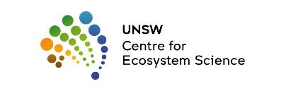


Final report to the Commonwealth Environmental Water Holder

July 2023

Macquarie Marshes Breeding Waterbirds Reproductive Success Monitoring 2022-2023
Brandis, K., Hewitt, S., Smith, M., Stewart, J., Juilliard, L., McEvoy, T., Francis, R.
Centre for Ecosystem Science, University of New South Wales
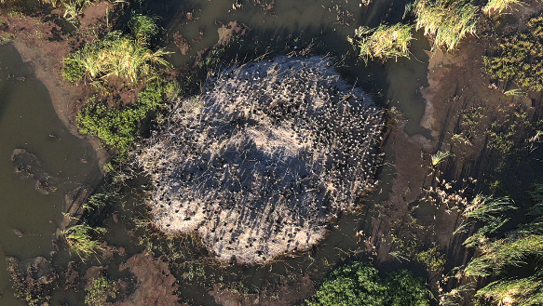
Report Citation: Brandis, K., Hewitt, S., Smith, M., Stewart, J., Juilliard, L., McEvoy, T., Francis, R. (2023) Macquarie Marshes Breeding Waterbirds Reproductive Success Monitoring 2022-23. Final report to the Commonwealth Environmental Water Office. Centre for Ecosystem Science, UNSW.
Cover photo: Créching straw-necked ibis chicks at T-block rookery 2022.
Photo credit: Matt Smith, UNSW.
Funding acknowledgement: This research was funding by the Commonwealth Environmental Water Office with support from the NSW Department of Planning and Environment, NSW National Parks and Wildlife Service, landholders of the Macquarie Marshes and the Centre for Ecosystem Science, UNSW.
Disclaimer: The views and opinions expressed in this publication are those of the authors and do not necessarily reflect those of the Australian Government or the Minister for the Environment and Energy. While reasonable efforts have been made to ensure that the contents of this publication are factually correct, the Commonwealth does not accept responsibility for the accuracy or completeness of the contents and shall not be liable for any loss or damage that may be occasioned directly or indirectly through the use of, or reliance on, the contents of this publication.

Table of Contents
Introduction 9
Aggregating waterbirds breeding in the Macquarie Marshes 10
Water management 2021-23 12
Methods 15
Nest surveys 16
Drone surveys 19
Results 21
Nest data 22
Monkeygar North Colony 22
T-block colony 24
Ginghet Three Bridges 27
Colony summaries - nesting 30
Disease, predation and mortality 31
Water depth 32
Water quality 35
Drone survey results 40
Monkeygar North 40
T-block colony 42
Ginghet Three Bridges 44
Colony summaries – drone counts 46
2021-22 and 2022-23 comparison of key results 47
Discussion 48
Recommendations 50
References 51
Table of Figures
Figure 1 Historical large wader waterbird abundances in October 1983-2022 (large waders: straw-necked ibis, glossy ibis, Australian white ibis, royal spoonbill, egrets), with stars identifying years with breeding by large waders (Table 1). (Data sources: Eastern Australian Aerial Waterbird Survey and annual flows Marebone 421090 and Marebone Break 421088 combined). 12
Figure 2 Total daily rainfall at Quambone (51042) for 2022. (Data source: Bureau of Meteorology). 13
Figure 3 Macquarie Marshes annual rainfall 1900-2022 (Quambone gauge 051042 Australian Bureau of Meteorology). Dashed line illustrating all years with annual totals > 2021 (723.8mm), and solid black line showing long-term mean annual rainfall (445mm). 14
Figure 4. 1986 – 2022 total annual flows (ML/day at Marebone (421090) and Marebone Break (421088). 2022 coloured red to illustrate the relative size of the 2021-2023 flows compared to historical flows. 14
Figure 5 Contribution of different types of water to total flows at Marebone July 2022 – April 2023. Sources include: Translucent Environmental Water Allowance (EWA), Flood Mitigation Zone (FMZ) releases, Held Environmental Water (HEW), Active EWA, Other Water and Irrigation orders downstream of Marebone. Source: NSW Department of Planning and Environment using WaterNSW data. 15
Figure 6 Location of aggregating waterbird rookeries monitored by UNSW 2022-2023. Inundated area data provided by (NSW DPE 2022). 18
Figure 7 Transects flown over the Monkeygar North rookery a) 17th Nov. 2022, and b) 13th Dec. 2022. 20
Figure 8 Transects flown over the Ginghet rookery a) 18th Nov. 2022, and b) 29th Dec. 2022. 21
Figure 9 Transects flown over the T-block rookery a) 2nd Dec 2022 and b) 10th Jan. 2023. 21
Figure 10 Flows in the Macquarie River (Macq@Pillicawarria), and timing of nesting and UNSW rookery surveys in 2021-22 and 2022-23. 22
Figure 11 Monkeygar North rookery area (Photo. S. Hewitt). 23
Figure 12 Composition of Monkeygar North straw-necked ibis rookery by chick development stage per nest survey. 23
Figure 13 Reproductive success rates (%) between surveys (depicted with arrows) at Monkeygar North rookery for cohort 1. Cohort 2, which consisted of a single nesting clump, failed between Surveys 1 and 2. Surveys later in the nesting period (30th Dec. 2022 onwards) were comprised of mobile offspring at runner, flapper and flyer stages of development and offspring are no longer associated to a single nest and counts are not representative at these stages. 24
Figure 14 T-block rookery area (Photo K .Brandis) 25
Figure 15 Composition of T-block straw-necked ibis rookery by chick development stage per nest survey. 25
Figure 16 Reproductive success rates (%) between surveys (depicted with arrows) at T-block rookery for a) Cohort 1, and b) Cohort 2. Surveys later in the nesting period (30th Dec. 2022 onwards) were comprised of mobile offspring at runner, flapper and flyer stages of development and offspring are no longer associated to a single nest and counts are not representative at these stages 26
Figure 17 Ginghet Three Bridges rookery area (Photo: Sophie Hewitt). 27
Figure 18 Composition of Ginghet Three Bridges straw-necked ibis rookery by chick development stage per nest survey. 28
Figure 19 Reproductive success rates (%) between surveys (depicted with arrows) at Ginghet Three Bridge rookery for cohort 1 (a), cohort 2 (b), and cohort 3 (c) in monitored nests. Surveys later in the nesting period (29th Dec. 2022 onwards) were comprised of mobile offspring at runner, flapper and flyer stages of development and offspring are no longer associated to a single nest and counts are not representative at these stages. 29
Figure 20 Créching straw-necked ibis chicks at squirter/runner stage of development (Narran Lakes, 2008). 31
Figure 21 Water depths at monitored nest clumps at Monkeygar North rookery Nov. 2022 – Jan. 2023.Boxes with whiskers represent data range (excluding outliers), X represents the mean, horizontal line represents the median, and small open circles represent data points. 33
Figure 22 Water depths at monitored nest clumps at T-block rookery Nov. 2022 – Jan. 2023.Boxes with whiskers represent data range (excluding outliers), X represents the mean, horizontal line represents the median, and small open circles represent data points. 33
Figure 23 Water depths at monitored nest clumps at Ginghet Three Bridges rookery Nov. 2022 – Jan. 2023.Boxes with whiskers represent data range (excluding outliers), X represents the mean, horizontal line represents the median, and small open circles represent data points. 34
Figure 24 Water depth at Pillicawarrina (gauge 421147) (shaded light blue area) and corresponding mean water depths in T-block (black line), Monkeygar North (blue line) and Ginghet Three Bridges (orange line) rookeries . 34
Figure 25 Aquatic pH levels. The optimum pH levels for fish are from 6.5 to 9.0. Outside of optimum ranges, organisms can become stressed or die. Source: http://www.fondriest.com/environmental-measurements/parameters/water-quality/ph/#p9. 36
Figure 26 Water quality measured at T-block rookery during each nest survey a) dissolved oxygen, b) water temperature, c) pH (probe broke during third survey and could not be replaced in time for subsequent surveys). d) conductivity, e) total dissolved solids and f) salinity. Box represents data range, x represents the mean, the horizontal line within the box represents the median. 37
Figure 27 Water quality measured at Monkeygar North rookery during each nest survey a) dissolved oxygen, b) water temperature, c) pH (probe broke during third survey and could not be replaced in time for subsequent surveys). d) conductivity, e) total dissolved solids and f) salinity. Box represents data range, x represents the mean, the horizontal line within the box represents the median. 38
Figure 28. Water quality measured at Ginghet Three Bridges rookery during each nest survey a) dissolved oxygen, b) water temperature, c) pH (probe broke during third survey and could not be replaced in time for subsequent surveys). d) conductivity, e) total dissolved solids and f) salinity. Box represents data range, x represents the mean, the horizontal line within the box represents the median. 39
Figure 29 Nesting was at mixed stages at Monkeygar North in November 2022, with a) new nests with eggs, b) incubating adults, c) advanced chicks at the flapper or even fledgling stage, and d) areas where re-nesting was possibly occurring. 41
Figure 30 White ibis nests (blue), straw-necked ibis nests (dark pink) and straw-necked ibis chicks (light pink) counted in the mosaics collected in a) 17th Nov 2022 and b) 13th December 2022 at Monkeygar North when the rookery grew slightly from the previous rookery border (red). 42
Figure 31 T-Block had mixed stages of breeding in the first survey conducted on the 2nd Dec. 2022, with a) large chicks and evidence of creching, b) new nests being incubated and c) areas of vegetation being newly trampled. 43
Figure 32 T-Block rookery continued to grow with nests being incubated on the 10th Jan. 2023 to the east of the pre-existing rookery (Fig. 21). 43
Figure 33 The dominant breeding species at T-Block on the 2nd Dec. 2022 was straw-necked ibis (dark pink), with many large chicks already present (light pink). Other species such as Australian white ibis were also nesting (dark blue), alongside spoonbills (yellow). The rookery continued to grow and was captured again on the 10th January 2023, where new straw-necked ibis nests were being incubated in the previous rookery border (red), and where the rookery extended south. 44
Figure 34 Straw-necked ibis were at very mixed breeding stages on the 18th Nov. 2022 at Ginghet Three Bridges, with evidence of the rookery expanding with a) new areas of trampling birds alongside incubating nests, whereas other areas of the rookery had b) runners and even c) almost fledged chicks. 45
Figure 35 Ginghet Three Bridges rookery was well established on the 18th November 2022 (left hand panel) with a) straw-necked ibis nests (dark pink), straw-necked ibis chicks (light pink), trampling straw-necked ibis (light blue), white ibis nests (dark blue) and spoonbill nests (yellow). The rookery continued to grow and was captured 29th December 2022 (right hand panel) (b), where another ~14,000 straw-necked ibis nests (dark pink) were counted mainly to the east of the previous rookery boundary (red). 46

Executive Summary
Following above average rainfall and river flows during 2021 and 2022 there was widespread flooding in the Macquarie Marshes (‘Marshes') for the second consecutive year inundating approximately 232,000 ha. In October-November 2022, three ibis rookeries, composed predominantly of straw-necked ibis (Threskiornis spinicollis), Australian white ibis (T. molluca), and royal spoonbills (Platelea regia) established at T-block, Monkeygar North and Ginghet Three Bridges. These were three of the four largest mixed species ibis rookeries recorded in the Marshes during 2022-23. Co-nesting within the colony areas were egrets, night herons, royal spoonbills and other species. These species were monitored by NSW NPWS and NSW DPE. In addition to these three large ibis dominant rookeries there were an additional 27 other rookeries recorded that summer, comprised mainly of ibis, egrets, night herons and cormorants (DPE-EHG 2022).
Fortnightly monitoring by UNSW of T-block, Monkeygar North and Ginghet Three Bridges ibis rookeries began in November 2022 and continued until the end of January 2023. Monitoring aimed to measure reproductive success, water levels and water quality in the rookery sites and to monitor for disease, predation, and mass mortality. Monthly drone surveys were undertaken at the three rookeries to map rookery boundaries, obtain nest and bird counts, and monitor changes to the rookery extent over time.
Initial surveys found that rookeries were at a range of different nesting stages, with T-block being the most advanced in mid-November with mobile chicks, while Monkeygar North and Ginghet Three Bridges were predominantly at eggs stages. All rookeries had multiple nesting cohorts with egg laying continuing the longest at Ginghet Three Bridges with eggs still being laid in mid-December.
Reproductive success rates were within normal ranges for large ibis rookeries and were comparable to results from previous years. Overall reproductive success rates were 63% at Monkeygar North, 78% at T-block and 67% at Ginghet Three Bridges.
Rookery mapping and nest counts from drone surveys was successful with >107,000 nests counted across the three rookeries, total nest counts were generally comparable to those in 2021-22 of >116,000 nests across four colonies. At a rookery scale T-block was larger in 2022-23 while Monkeygar North was smaller. Zoo Paddock was not surveyed in 2022-23, and Ginghet Three Bridges was not a large ibis colony in 2021-22 (DPE-EHG 2022), Monkeygar East did not have any nesting recorded during 2022-23.
2022-23
Rookery | Maximum nest count | Maximum rookery extent (ha)
Monkeygar North | 9,549 | 27.1
T-block | 48,628 | 61.9
Ginghet Three Bridges | 49,273 | 62.4
2021-22
Monkeygar North | 11,000 | 33.5
Monkeygar East | 37,000 | 16
T-block | 38,500 | 43
Zoo Paddock | 30,000 | 59

Introduction
The Macquarie Marshes are an extensive wetland system (200,000 ha) on the lower reaches of the Macquarie River in western New South Wales, 30 km west of Quambone. They are a complex system of lagoons and braided streams supporting a large diversity of flora and fauna (Kingsford and Auld, 2003). About 11% (21,927 ha) of the area is Nature Reserve and is Ramsar listed (1986), a further 583 ha of ‘Wilgara’ a privately owned grazing property within the Marshes was Ramsar listed in 2000 and ‘U-Block’ was also listed in 2012. Criterion for listing included that the Macquarie Marshes represents highly significant habitat for aggregating breeding waterbirds (Criterion 4), and that it regularly supports more than 20,000 waterbirds and over 500,000 in large floods (Criterion 5) (Ramsar, 1986).
The Macquarie Marshes provide important waterbird habitat, both breeding and foraging, and regularly supports large numbers of birds. Seventy-seven waterbird species have been recorded, including 17 migratory species listed on JAMBA, CAMBA and ROKAMBA international agreements and nine species listed under the NSW Threatened Species Conservation Act 1995 (NSW OEH 2012).
Breeding opportunities for aggregating waterbirds are primarily triggered by flood events at key wetlands. Forty-six per cent of all wetland sites throughout Australia that are used for aggregating waterbird breeding occur in the Murray-Darling Basin. Of these, relatively few wetlands (<5% recorded) support large aggregating waterbird breeding events (Brandis 2010). The Macquarie Marshes (Figure 4) is one of the most important breeding sites for aggregating waterbirds in the Murray-Darling Basin and Australia, with multiple rookery sites capable of initiating large-scale rookeries in a breeding season.

Aggregating waterbirds breeding in the Macquarie Marshes
The Macquarie Marshes are one of Australia’s key aggregating waterbird breeding sites (Kingsford and Thomas 1995, Kingsford and Johnson 1998, Kingsford and Auld 2005, Brandis 2010, Bino et al. 2014). Regular reporting of aggregating waterbird breeding began from the mid 1980’s. Prior to this, records were sparse with the first formal record from the Nest Record Scheme in 1978 with regular reporting from 1986 onwards (Table 1).
Aggregating waterbird breeding is closely tied to flooding and inundated wetlands (Kingsford and Thomas 1995). Analyses of historical flows and aggregating waterbird breeding (all species) found that breeding events were closely tied to flows with large flow events resulting in large, or numerous breeding events (Brandis and Bino, 2016) (Figure 1).
Following above average rainfall and river flows during 2021 and 2022 there was widespread flooding in the Macquarie Marshes in spring and early summer 2022. In October-November 2022, three ibis rookeries, composed predominantly of straw-necked ibis (Threskiornis spinicollis), Australian white ibis (T. molluca), and royal spoonbills (Platelea regia) established at T-block, Monkeygar North and Ginghet Three Bridges (Figure 4). Other waterbird species also nesting within the extent of these rookeries included egrets, nankeen night herons and cormorants. These rookeries were among the largest in the Marshes during 2022-23. In addition to these ibis dominant rookeries there were 27 other rookeries comprised of egrets, herons and cormorants (DPE-EHG 2022). These rookeries were monitored by NSW Department of Planning and Environment’s Environment and Heritage staff (see DPE-EHG 2022).
Monkeygar North, T -Block and Ginghet Three Bridges are traditional rookery sites (Kingsford and Auld 2003). Ibis bred in Monkeygar North and T-Block in 2021-22 (Brandis et al. 2022). In Ginghet Three Bridges the last recorded ibis breeding event was 2016/17 in much smaller numbers (~50 straw-necked ibis and 100 Australian white ibis nests) (NSW DPE).
Table 1 Records of breeding (total nests) by Australian white ibis, glossy ibis, straw-necked ibis and royal spoonbill at the Macquarie Marshes 1978-2022 data from a range of sources.
Year | Australian white ibis | Glossy ibis | Straw-necked ibis | Royal spoonbill | Source
1978 |  | 500 | 12,800 | 480 | Nest Record Scheme, BirdLife Australia
1986 | 837 | 500 | 200 |  | Kingsford and Auld, 2003
1987 | 135 |  | 2,300 |  | Kingsford and Auld, 2003
1988 | 1,916 | 25 | 1,980 |  | Kingsford and Auld, 2003
1989 | 959 |  | 4,030 | 30 | Magrath 1991/ Kingsford and Auld, 2003
1990 | 2,130 | 1500 | 55,000 |  | Kingsford and Auld, 2003/ Smith 1993
1993 | 380 | 330 | 9,700 |  | Kingsford and Auld, 2003; Ray Jones pers comm.
1995 | 11 |  | 1,272 |  | Kingsford and Auld, 2003; Ray Jones pers comm.
1996 | 485 | 500 | 10,300 |  | Kingsford and Auld, 2003; Ray Jones pers comm.
1998 | 5,813 | 1,000 | 60,950 |  | Kingsford and Auld, 2003; Ray Jones pers comm.
1999 | 158 | 800 | 1,500 |  | Kingsford and Auld, 2003; Ray Jones pers comm.
2000 | 1,350 | 3,900 | 31,225 |  | Kingsford and Auld, 2003; Ray Jones pers comm.
2008 | 200 |  | 200
2010 | 215 | 750 | 35,000
2011 | 200 |  | 70,000
2012 | 800 |  |  | 200
2016/17 | 1,720 | 150 | 57,000 | 640 | Brandis et al 2017/NSW DPE
2021/22 | 914 |  | 116,500 | 994 | Brandis et al 2022/NSW DPE

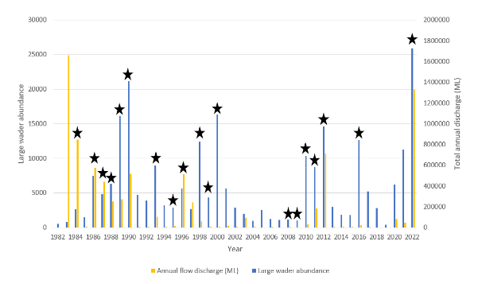
Figure 1 Historical large wader waterbird abundances in October 1983-2022 (large waders: straw-necked ibis, glossy ibis, Australian white ibis, royal spoonbill, egrets), with stars identifying years with breeding by large waders (Table 1). (Data sources: Eastern Australian Aerial Waterbird Survey and annual flows Marebone 421090 and Marebone Break 421088 combined).

Water management 2021-23
From 2021 until 2023, Australia was in a La Niña weather pattern which is normally associated with higher-than-average winter, spring, and early summer rainfall over much of Australia. The results of this type of weather pattern are reflected in the high local rainfall (Figure 2, Figure 3) and significant flooding (Figure 6) experienced by the Macquarie Marshes in 2021-2023. The total rainfall for 2022 (Quambone gauge 051042 www.bom.gov.au), 868.1 mm exceeded the long term mean annual rainfall, and was the third highest annual rainfall since 1900 ( Figure 3) contributing to extensive floodplain inundation and high river flows (Figure 4). The high local rainfall (Figure 2) significantly contributed to local flooding in the Macquarie Marshes which were partially inundated from the previous year.

Figure 2 Total daily rainfall at Quambone (51042) for 2022. (Data source: Bureau of Meteorology).
In the water year to May 2023, 1,221 GL of water flowed into the Marshes (combined Macquarie River d/s Marebone Weir 421090 and Marebone Break 421088) following significant rainfall in the upper and mid catchment, and releases from Burrendong Dam’s flood mitigation zone. Approximately 48 GL of NSW and Commonwealth water for the environment (general security licences plus NSW Environmental Water Allowance) contributed to these flows (Figure 5).
The delivery of water for the environment in late February and early March 2023 helped to support the inundation of waterbird rookery sites and foraging grounds, targeted to retain a minimum water level in key areas. Additional flows from water for the environment occurred in April/May 2023, unrelated to aggregating nesting - Translucent Environmental Water Allowance and managed recession flows for fish movement. Maximum inundation extent over the water year within the Macquarie Marshes was recorded in late October 2022 as ~232,000 ha (NSW Dept. Planning and Environment, Environment and Heritage Group).
Rainfall in 2021 and 2022 were the 5th and 3rd highest annual totals respectively since 1900 (Figure 3).

Figure 3 Macquarie Marshes annual rainfall 1900-2022 (Quambone gauge 051042 Australian Bureau of Meteorology). Dashed line illustrating all years with annual totals > 2021 (723.8mm), and solid black line showing long-term mean annual rainfall (445mm).

Figure 4. 1986 – 2022 total annual flows (ML/day at Marebone (421090) and Marebone Break (421088). 2022 coloured red to illustrate the relative size of the 2021-2023 flows compared to historical flows.

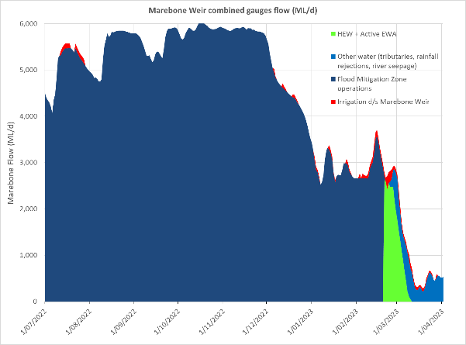
Figure 5 Contribution of different types of water to total flows at Marebone July 2022 – April 2023. Sources include: Translucent Environmental Water Allowance (EWA), Flood Mitigation Zone (FMZ) releases, Held Environmental Water (HEW), Active EWA, Other Water and Irrigation orders downstream of Marebone. Source: NSW Department of Planning and Environment using WaterNSW data.

Methods

Nest surveys
Ibis nest monitoring was undertaken at three rookeries in the Macquarie Marshes; Monkeygar North, T-block and Ginghet Three Bridges (Figure 5, Table 2).
Rookeries were surveyed approximately every two weeks between November 2022 and January 2023 (Table 2). Surveys were completed by two people in a canoe. During Survey 1, a sub-set of randomly selected nest clumps (and nests) were given a unique number, and GPS location recorded. These nests were then revisited on each subsequent survey. Nests were only marked if they contained eggs and when appropriate additional nest clumps were added to the survey if new nests were established between surveys. During each survey the following variables were recorded; number of eggs or chicks, chick development stage (Table 3), evidence of predation, disease, and nest abandonment. Individual nest surveys continued fortnightly until chicks had reached runner stage, where chicks become highly mobile and begin créching behaviour, congregating on nests as large groups of chicks. At this stage it is not possible to attribute chicks to specific nests, so counts are done at a nest clump scale. Nest clump monitoring continued until chicks had fledged or were no longer associated with the nest clump site.
Water depth data was recorded at each nest clump site using a 1 m folding ruler. Water quality data was collected at three random locations within the nest monitoring area at each site during each survey. Water quality variables recorded included: temperature, pH, conductivity, total dissolved solids, resistivity, and salinity.
To minimise disturbance to the rookeries all ground surveys were limited to two periods during the day; early morning (6-11am) or late afternoon (3-8 pm) to avoid causing heat stress to nesting birds and their offspring. Access to the sites were via argo and canoe.
Table 2 Nest and drone survey dates, November 2022 – January 2023.
Survey number | Survey date | Nest Survey | Drone Survey
1 | 16th – 18th November 2022 | Ginghet Three Bridges, T-block and Monkeygar North | Ginghet Three Bridges, Monkeygar North. Too windy to survey T-block.
2 | 29th Nov. - 3rd December 2022 | Nest survey of Ginghet Three Bridges, T-block and Monkeygar North | T-block
3 | 11th – 15th December 2022 | Ginghet Three Bridges, T-block and Monkeygar North | Ginghet Three Bridges, Monkeygar North, T-block
4 | 27th – 30th December 2022 | Ginghet Three Bridges, T-block and Monkeygar North
5 | 10th – 12th January 2023 | Ginghet Three Bridges, T-block and Monkeygar North
6 | 24th – 25th January 2023 | T-block, and Ginghet Three Bridges.
Figure 6 Location of aggregating waterbird rookeries monitored by UNSW 2022-2023. Inundated area data provided by (NSW DPE 2022).
Table 3 Straw-necked ibis chick development stages (sources Marchant & Higgins 1990, K.Brandis).
Development stage | Characteristics | Age (days)
Egg | Whole egg, being incubated by adult | 1-20
Chicks | Recently hatched (1-5 days old), downy feathers, immobile | 21-25
Squirters | Early sheathed feathers starting on wings, still in nest, immobile | 26-30
Runners | Development of pin feathers. Mix of down and feathers, walking awkwardly, can leave nest on foot | 31-35
Flappers | Nearly fully feathered, cannot fly but flaps between nests | 36-40
Flyers | Fully feathered, able to fly and leave nests, still attended by parents at nest | 41-47
Fledged | Independent, does not return to nest but roosts in nearby trees | >48

Drone surveys
Drone surveys were conducted at three sites in between 17th November 2022 and 10th January 2023 (Table 4).The area surveyed by drone was adjusted on each survey to capture changes in the rookery extent (Figure 6, Figure 7, Figure 8).
Table 4. Dates of each drone survey including the area of the mosaic flown.
Rookery | Survey date | Mosaic area (ha)
Monkeygar North | 17-Nov-22 | 13.2
 | 13-Dec-22 | 27.1
T-block | 2-Dec-22 | 58.2
 | 10-Jan-23 | 102.4
Ginghet Three Bridges | 18-Nov-22 | 96.1
 | 29-Dec-22 | 76.4

Flights were conducted using a DJI Mavic Enterprise Dual Advanced drone and a DJI Phantom 4 Pro. The drone was launched and returned to the canoe or argo from the outskirts of the rookeries. Flights were conducted at an altitude of 65m – 75m depending on the area to cover which varied to account for changes in the rookery size (Table 3). Flights consisted of the flying of automated transects over the areas where breeding was previously identified at an overlap of 76%, producing over 1000 images covering each rookery. Flight locations were guided by ground observations when possible, or otherwise the drone was first flown manually on a scouting mission to identify rookery extent.
Images were orthomosaiced using Pix4Dmapper (Pix4d SA, 2022). Orthomosaics were counted manually with nest locations annotated in a shapefile. Species were identified based on their plumage and breeding stage was determined based on group behaviour (e.g., trampling, incubating or créching), and from sightings of eggs or chicks in nests. In the first image collection all incubating nests and clumps with créching chicks were counted. In the following set of imagery all new incubating nests were counted across the entire mosaic, but chicks on clumps were only counted in areas not previously counted (to avoid double counting in the nest estimates). In this way, using known clutch size and reproductive success estimates we could estimate a total number of nests built in the season in each rookery.
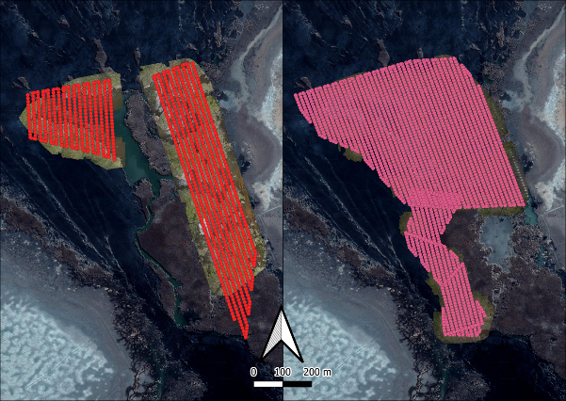
Figure 7 Transects flown over the Monkeygar North rookery a) 17th Nov. 2022, and b) 13th Dec. 2022.

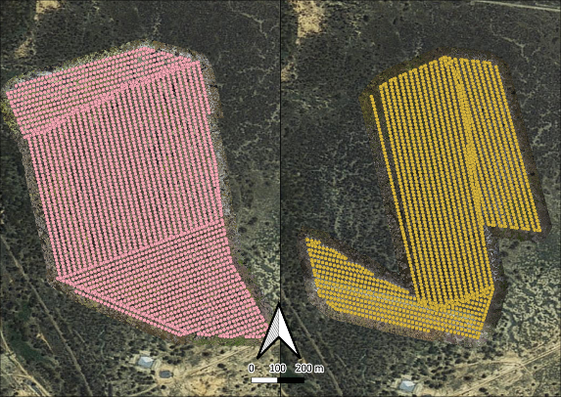
Figure 8 Transects flown over the Ginghet rookery a) 18th Nov. 2022, and b) 29th Dec. 2022.
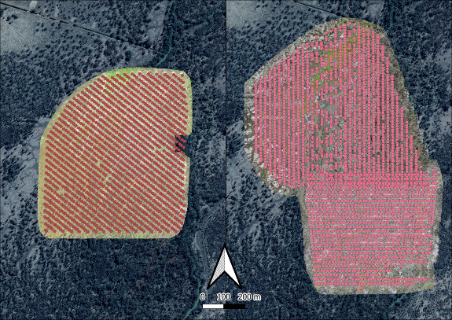
Figure 9 Transects flown over the T-block rookery a) 2nd Dec 2022 and b) 10th Jan. 2023.

Results

Nest data
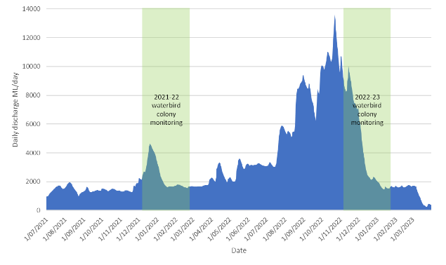
Figure 10 Flows in the Macquarie River (Macq@Pillicawarria), and timing of nesting and UNSW rookery surveys in 2021-22 and 2022-23.

Monkeygar North Rookery
Monkeygar North is a traditional waterbird site on Monkeygar Creek, with nesting last recorded in 2021-22 (Brandis et al. 2022b). Monkeygar North is dominated by Phragmites australis upon which the birds build nests (Figure 11).
288 nests were tagged on the 17th November 2022 during the first survey, while a further 20 nests were tagged on the 1st December 2022. During Survey 1 (16/11/2022) the majority of nests (n=287) contained eggs while most had hatched by Survey 2 (1/12/2022) (Figure 10), suggesting nesting started in early November (Figure 9). Access to parts of the site was difficult due to the density of Phragmites.
Clutch size for nests with eggs during Survey 1 (cohort 1) was 2.83 (n=288 nests, range 1-5), while the clutch size for Survey 2 was 2.1 (n= 20 nests, range 1-3).
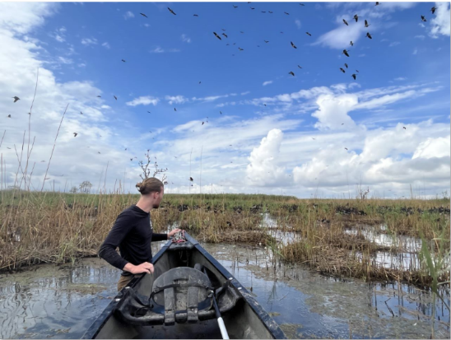
Figure 11 Monkeygar North rookery area (Photo. S. Hewitt).

Figure 12 Composition of Monkeygar North straw-necked ibis rookery by chick development stage per nest survey.

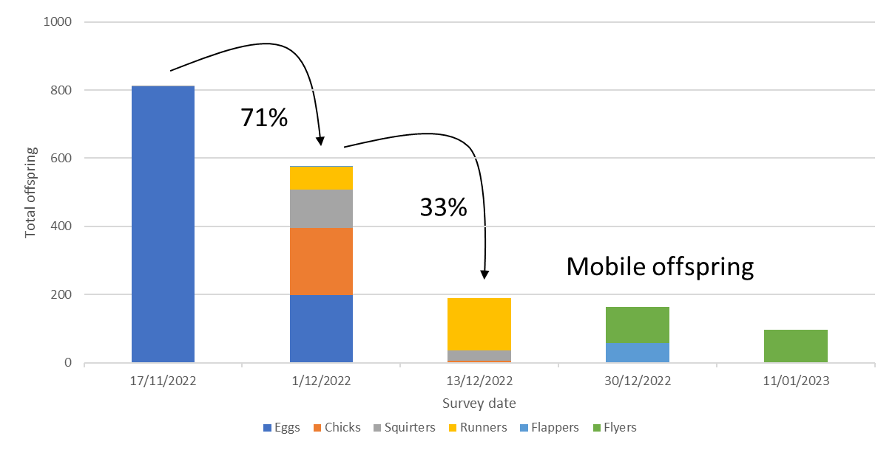
Figure 13 Reproductive success rates (%) between surveys (depicted with arrows) at Monkeygar North rookery for cohort 1. Cohort 2, which consisted of a single nesting clump, failed between Surveys 1 and 2. Surveys later in the nesting period (30th Dec. 2022 onwards) were comprised of mobile offspring at runner, flapper and flyer stages of development and offspring are no longer associated to a single nest and counts are not representative at these stages.

T-block rookery
T-block rookery is located adjacent to the Macquarie River (Figure 5). It is a lignum, river cooba and river red gum dominated site, it is not known as an historical traditional nesting site for large ibis rookeries (Figure 14). 2016-17 was the first record of egret breeding at T-block with small numbers of Australian white ibis and royal spoonbills accompanying them. Pior to this the site was predominantly used by a small number of cormorants and night herons (1989, 1990, 1993) (R. Jones NPWS). The last recorded straw-necked ibis breeding at T-block prior to the 2016-17 event was 1998 with 75 nests (R. Jones NPWS). T-Block has now been used over two consecutive years (2021-22 and 2022-23) as a large ibis rookery site.
119 ibis nests were tagged on the 16th November 2022 during the first survey, while a further 43 nests were tagged on the 30th November 2022. During Survey 1 (16/11/2022) there were offspring at a range of development stages including eggs, chicks and squirters. Based on chick stage it is likely nesting at T-block in mid-late October 2022.
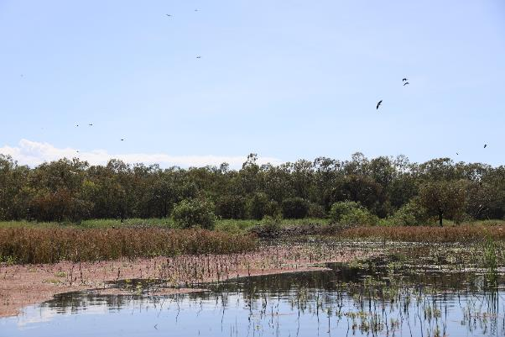
Figure 14 T-block rookery area (Photo K .Brandis)

Figure 15 Composition of T-block straw-necked ibis rookery by chick development stage per nest survey.

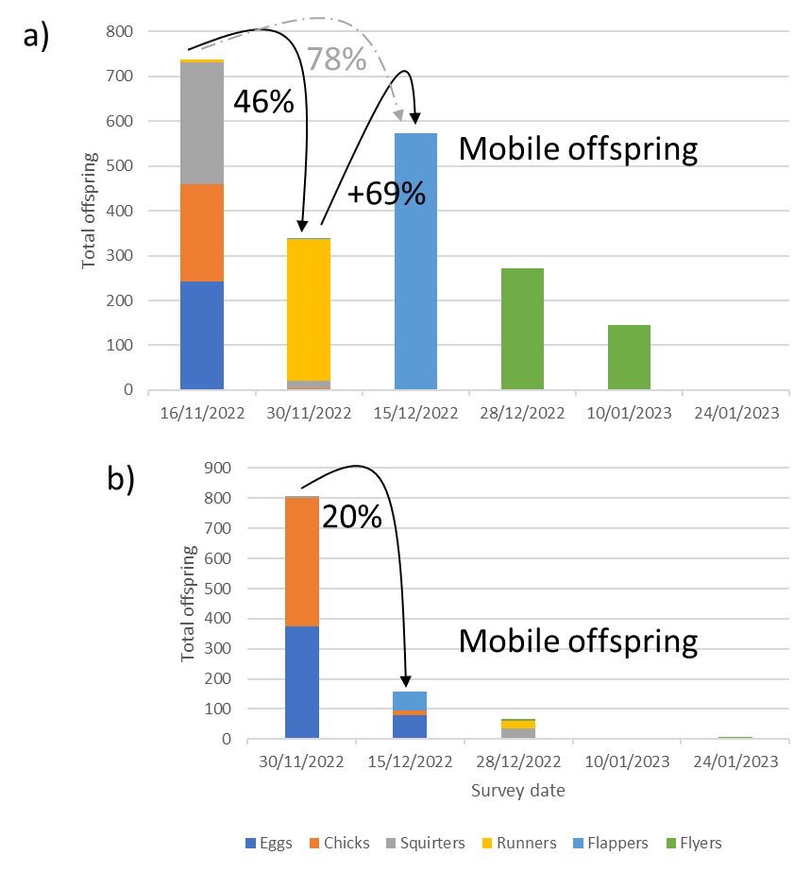
Figure 16 Reproductive success rates (%) between surveys (depicted with arrows) at T-block rookery for a) Cohort 1, and b) Cohort 2. Surveys later in the nesting period (30th Dec. 2022 onwards) were comprised of mobile offspring at runner, flapper and flyer stages of development and offspring are no longer associated to a single nest and counts are not representative at these stages

Reproductive success between Survey 1 (16/22/2022) and Survey 2 (30/11/2022) was calculated to be 46%. This result was lower than expected and reflects the advanced chick stages observed during Survey 1, the majority of which were at runner stage during Survey 2. At this stage chicks are mobile and difficult to assign to a particular nest. Survey 3 (15/12/2022) (Figure 16) shows an increase in total offspring. These chicks at flapper stage are also mobile, but the counts from this survey suggest that the counts from Survey 2 (and the calculated reproductive success rate) may not be reflective of the true success rate. The success rate from Survey 1 – Survey 3 (removing Survey 2 counts) was 78%.

Ginghet Three Bridges
Ginghet Three Bridges rookery is located adjacent to the Macquarie River (Figure 6). It is a lignum, river cooba and river red gum dominated site (Figure 17). Regular surveys by NSW DPE since 1986 record this rookery as typically an egret, heron and cormorant site, however video footage from 1948 shows that this area has supported large ibis rookeries in the past (AUSTRALIA: White Ibis colony in Macquarie Marshes (1948) - YouTube). The 2022-23 ibis dominated rookery was the largest recorded since 1986.
194 ibis nests were tagged on the 18th November 2022 during the first survey, while a further 130 nests were tagged on the 29th November 2022, and 50 nests on the 14th December 2022. During Survey 1 (16/11/2022) there were offspring at a range of development stages including eggs, chicks and squirters. Based on chick stage it is likely nesting at Ginghet Three Bridges started in mid-late October 2022 and continued until late December 2022. Ginghet Three Bridges rookery had the longest period of egg laying of the three monitored rookeries, with eggs still present in nests on the 29th December 2022 (Figure 19).
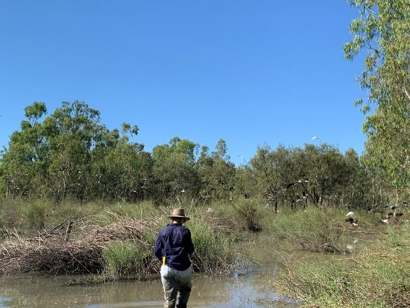
Figure 17 Ginghet Three Bridges rookery area (Photo: Sophie Hewitt).

Figure 18 Composition of Ginghet Three Bridges straw-necked ibis rookery by chick development stage per nest survey.

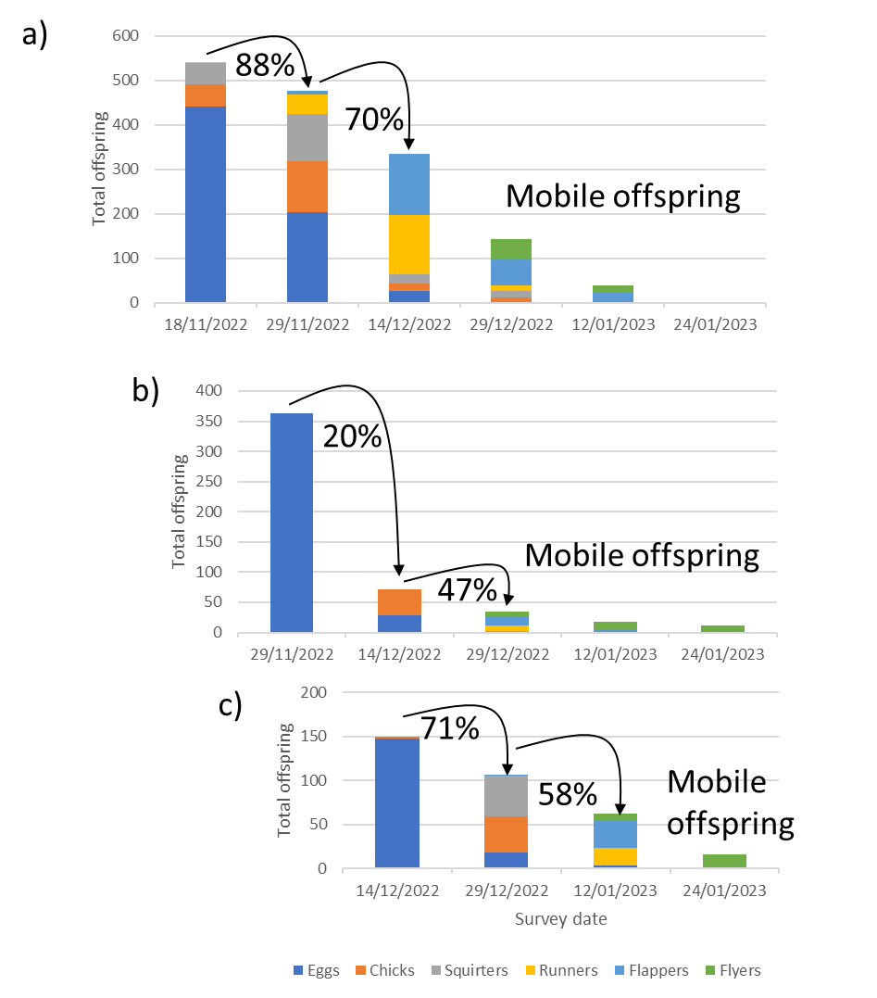
Figure 19 Reproductive success rates (%) between surveys (depicted with arrows) at Ginghet Three Bridge rookery for cohort 1 (a), cohort 2 (b), and cohort 3 (c) in monitored nests. Surveys later in the nesting period (29th Dec. 2022 onwards) were comprised of mobile offspring at runner, flapper and flyer stages of development and offspring are no longer associated to a single nest and counts are not representative at these stages.
Early layers (cohort 1), which was also the largest cohort, had a higher average reproductive success rate across non-mobile chick stages (79%) the later layers cohort 2 (34%) and cohort 3 (65%) for the same chick development stages (Figure 18). Cohorts 2 and 3 were smaller groups than cohort 1.
Mean clutch sizes also varied with lay date cohort, with later layers having slightly larger mean clutch sizes. Cohort 1$`x$ =2.27, cohort 2 $`x$ =2.49, and cohort 3 $`x$=2.98 (Table 5). Clutch sizes may have increased with later laying dates as birds had more time to put on condition (Tortosa et al. 2003).

Rookery summaries - nesting
Table 5 Summary of clutch sizes for each cohort at each rookery including total number of nests and clumps of nests monitored.
Rookery | Mean clutch size | No. nests | No. clumps | Mean no. nests per clump
Monkeygar North | 2.83 (17/11/22) | 288 | 12 | 24
 | 2.1 (1/12/22) | 20 | 1 | 20
T-block | 2.14 (16/11/22) | 341 | 7 | 49
 | 2.38 (30/11/22) | 63 | 5 | 12.6
Ginghet Three Bridges | 2.27 (18/11/22) | 194 | 9 | 21.5
 | 2.49 (29/11/22) | 130 | 5 | 26
 | 2.98 (14/12/22) | 50 | 3 | 16.6
Table 6 Summary of reproductive success rates at each rookery for each key chick development stage as recorded during each survey.
Rookery | Cohort | Chick development stage
 |  | Eggs – eggs/chicks/squirters | Eggs/chicks/squirters – squirters/runners | Squirters/runners – flappers/flyers | Average early stage (Surveys 1-4) nest success
Monkeygar North | 1 | 70.88% | 32.76% | 86.77% | 63.47%
 | 2* | 0% | 0% | 0% | 0%
T-block | 1 |  | 78%# |  | 78%
 | 2 | 20% | 43% |  | 31.31%
Ginghet Three Bridges | 1 | 88.01% | 70.23% | 42.69% | 66.97%
 | 2 | 19.83% | 47.22% | 52.94% | 40.00%
 | 3 | 71.14% | 58.49% | 25.81% | 51.81%
*single nest clump with 20 nests (see Table 5).
#Reproductive success from eggs/chicks/squirters/runners – flappers/flyers. See note in text.
Reproductive success rates were highest for cohort 1 nesters at all rookery sites. Cohort 2 nesters were lower, while cohort 3 nesters at Ginghet Three Bridges had higher success rates than cohort 2, but lower than cohort 1 (Table 6).
Accurately measuring nest success for all stages of chick development is difficult for straw-necked ibis as young birds créche at ~Days 30-35 (Figure 20). Créching is where young birds leave their natal nest and form groups of young birds, at this stage it is difficult to accurately assign the number of birds to a specific nest. We count the total number of birds in a créche, however this count cannot be relied upon to be an accurate representation of the total number of young birds due to their mobility at this age.
Nest success can most accurately be assessed for the period of time from one survey to the next. At this time a comparison can be made between the total number of offspring counted in Survey X and those counted in Survey Y. In some instances, the reproductive success value is >100% where additional eggs have been laid into already tagged nests, or mobile birds are able to be counted i.e., they are present on the nesting clump at time of survey (Figure 13a). An average reproductive success value can be calculated across multiple surveys; however, this does not capture the variability in reproductive success at different stages of chick development (Table 6).
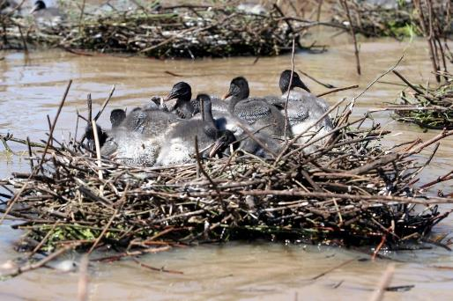
Figure 20 Créching straw-necked ibis chicks at squirter/runner stage of development (Narran Lakes, 2008).

Disease, predation and mortality
No disease or significant predation was observed at any of the three rookeries. Observed mortality rates, as a percentage of total offspring counted at nests, were generally low. Rates increased at all sites in later surveys, however this may be, in part, due to lower total offspring counts due to chicks being mobile, however, there were more dead birds observed at Monkeygar North and T-Block rookeries in the late season surveys (Dec. ’22, Jan. ’23).
Table 7 Mortality rates of straw-necked ibis observed at monitored nests in Monkeygar North rookery.
Survey date | No. observed dead birds | Total offspring | Mortality rates
17/11/2022 | 6 | 814 | 0.73%
1/12/2022 | 1 | 577 | 0.17%
13/12/2022 | 9 | 189 | 4.55%
30/12/2022 | 20 | 164 | 10.87%
11/01/2023 | 13 | 97 | 11.82%
Table 8 Mortality rates of straw-necked ibis observed at monitored nests in T-block rookery.
Survey date | No. observed dead birds | Total offspring | Mortality rates
16/11/2022 | 2 | 738 | 0.27%
30/11/2022 | 7 | 339 | 2.02%
15/12/2022 | 3 | 573 | 0.52%
28/12/2022 | 22 | 272 | 7.48%
10/01/2023 | 10 | 146 | 6.41%
Table 9 Mortality rates of straw-necked ibis observed at monitored nests in Ginghet Three Bridges rookery.
Survey date | No. observed dead birds | Total offspring | Mortality rates
18/11/2022 | 1 | 542 | 0.18%
29/11/2022 | 4 | 477 | 0.83%
14/12/2022 | 1 | 335 | 0.30%
29/12/2022 | 3 | 143 | 2.05%
12/01/2023 | 4 | 39 | 9.30%

Water depth
Water depths at all rookery sites declined over time, with the greatest reduction in water depth at T-Block, falling from a mean high of 0.82m in November 2022 to a low of 0.16m in January 2023 (Figure 25). Average water depths at all rookeries were similar in November but had different rates of decline throughout the nesting period (Figure 21, Figure 22, Figure 23). Water levels rose slightly in Ginghet Three Bridges in late January 2023.
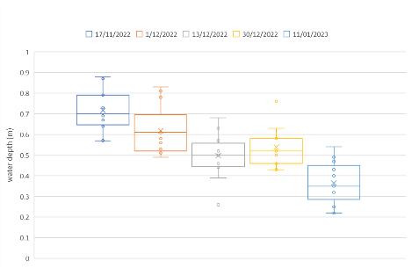
Figure 21 Water depths at monitored nest clumps at Monkeygar North rookery Nov. 2022 – Jan. 2023.Boxes with whiskers represent data range (excluding outliers), X represents the mean, horizontal line represents the median, and small open circles represent data points.
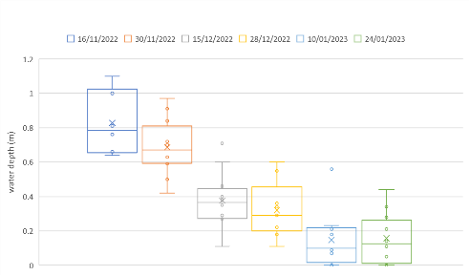
Figure 22 Water depths at monitored nest clumps at T-block rookery Nov. 2022 – Jan. 2023.Boxes with whiskers represent data range (excluding outliers), X represents the mean, horizontal line represents the median, and small open circles represent data points.

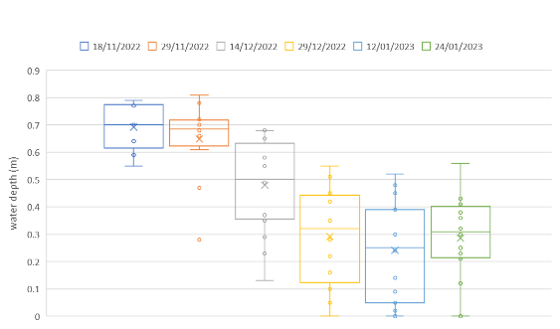
Figure 23 Water depths at monitored nest clumps at Ginghet Three Bridges rookery Nov. 2022 – Jan. 2023.Boxes with whiskers represent data range (excluding outliers), X represents the mean, horizontal line represents the median, and small open circles represent data points.

Figure 24 Water depth at Pillicawarrina (gauge 421147) (shaded light blue area) and corresponding mean water depths in T-block (black line), Monkeygar North (blue line) and Ginghet Three Bridges (orange line) rookeries .

Water quality
Water quality measures that have direct relevance for aquatic organisms include dissolved oxygen, pH, total dissolved solids (TDS) and salinity. Some measures, such as TDS are highly correlated with other measures such conductivity and salinity. Water with a relatively high TDS will have a low resistivity and a high conductivity. This pattern can be seen at all three rookeries (Figure 26, Figure 27, Figure 28). Similarly, water temperature can impact dissolved oxygen content. This is also seen at T-block and Monkeygar North (Figure 26, Figure 27). This pattern was not as clear at Ginghet Three Bridges, possibly due to blue-green algae identified in the water.
The values of pH across all three rookeries were within a relatively narrow band (6.73-7.907) (Figure 26, Figure 27, Figure 28) within an acceptable range. The majority of aquatic creatures prefer a pH range of 6.5-9.0, though some can live in water with pH levels outside of this range (Fondriest Environmental Learning Centre). As pH levels move away from this range (up or down) it can stress animal systems and reduce hatching and survival rates. The further outside of the optimum pH range a value is, the higher the mortality rates. The more sensitive a species, the more affected it is by changes in pH. In addition to biological effects, extreme pH levels usually increase the solubility of elements and compounds, making toxic chemicals more “mobile” and increasing the risk of absorption by aquatic life.
The implication for water pH measures outside the ranges preferred by aquatic organisms has implications for the availability and quality of aquatic food resources for waterbirds and other wetland fauna. In a wetland ecosystem pH can be affected by carbon dioxide (CO₂) in the water. Higher levels of CO₂, as a result of plant photosynthesis, respiration and decomposition is a common cause of acidity in the water. The values measured at Monkeygar North, T-block and Ginghet Three Bridges all fall within the expected range of values for a wetland ecosystem, however while these values are “normal”, higher levels of acidity or alkalinity can be beyond the range of tolerance for some aquatic organisms (Figure 25).
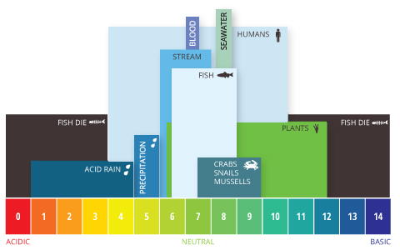
Figure 25 Aquatic pH levels. The optimum pH levels for fish are from 6.5 to 9.0. Outside of optimum ranges, organisms can become stressed or die. Source: http://www.fondriest.com/environmental-measurements/parameters/water-quality/ph/#p9.
Conductivity and total dissolved solids were similar across all three rookeries (Figure 27, Figure 28, Figure 29). Total dissolved solids and conductivity are highly correlated with TDS measurements being derived from conductivity measures.
Dissolved solids are important to aquatic life by keeping cell density balanced. In distilled or deionized water, water will flow into an organism’s cells, causing them to swell. In water with a very high TDS concentration, cells will shrink. These changes can affect an organism’s ability to move in a water column, causing it to float or sink beyond its normal range (Fondriest Environmental Learning Centre). The values measured for Monkeygar North, T-block and Ginghet Three Bridges were within the range normally attributed to ‘average tap water”.
Conductivity is also closely correlated with salinity. Salinity is important in particular as it affects dissolved oxygen solubility. The higher the salinity level, the lower the dissolved oxygen concentration. The salinity levels measured at were low (0.168-0.370 ppt) this corresponds with freshwater values (0-0.5 ppt).
Dissolved oxygen, the amount of oxygen in water, can enter the water from the atmosphere or as a biproduct of aquatic plant photosynthesis. As aquatic photosynthesis is light-dependent, the dissolved oxygen produced will peak during daylight hours and decline at night. Factors the can impact the dissolved oxygen content of water include; stratification and water depth, wind, temperature, pressure, salinity and sampling time. Dissolved oxygen levels fell at both T-block and Monkeygar North over the nesting period and corresponding water level drops, while DO at Ginghet Three Bridges increased. This may be due to increased flows to the wetland at this time (Figure 24).

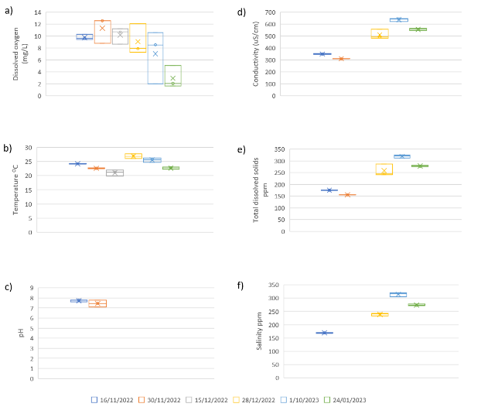
Figure 26 Water quality measured at T-block rookery during each nest survey a) dissolved oxygen, b) water temperature, c) pH (probe broke during third survey and could not be replaced in time for subsequent surveys). d) conductivity, e) total dissolved solids and f) salinity. Box represents data range, x represents the mean, the horizontal line within the box represents the median.

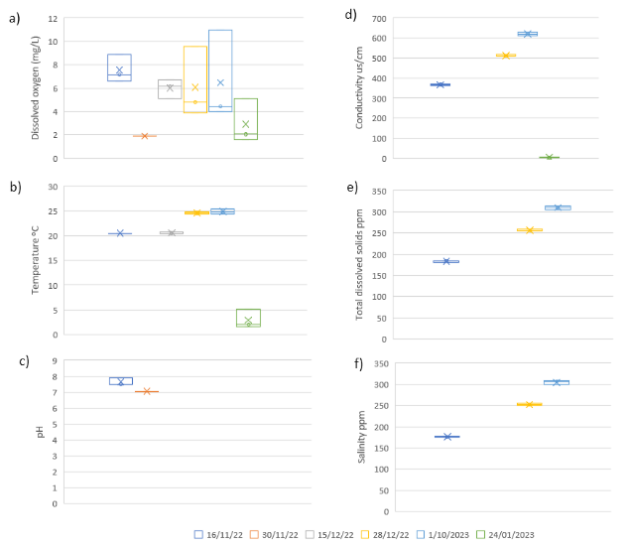
Figure 27 Water quality measured at Monkeygar North rookery during each nest survey a) dissolved oxygen, b) water temperature, c) pH (probe broke during third survey and could not be replaced in time for subsequent surveys). d) conductivity, e) total dissolved solids and f) salinity. Box represents data range, x represents the mean, the horizontal line within the box represents the median.

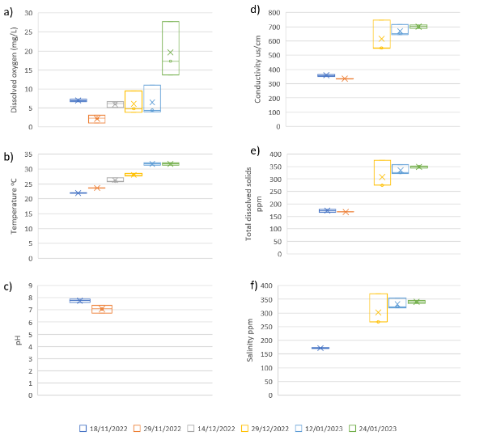
Figure 28. Water quality measured at Ginghet Three Bridges rookery during each nest survey a) dissolved oxygen, b) water temperature, c) pH (probe broke during third survey and could not be replaced in time for subsequent surveys). d) conductivity, e) total dissolved solids and f) salinity. Box represents data range, x represents the mean, the horizontal line within the box represents the median.

Drone survey results

Monkeygar North
A large mixed species breeding rookery was located at Monkeygar North, consisting predominantly of straw-necked ibis, with small numbers of Australian white ibis (Table 10). On the 17th of November 2022 the rookery was already in mixed stages of breeding, with 5,757 active nests counted, but many nests had already progressed to the runner chick stage suggesting breeding likely began late October 2022 (Figure 29). On the 13th of December, a second drone survey was conducted, which covered original rookery area, expanded areas of the rookery and filled in gaps in the mosaic from November.
When counting nests and chicks, all nests and chicks were counted in the November imagery. While new areas of nesting were counted in the December imagery. This resulted in an additional 604 incubating nests and 7,662 chicks.
To provide an estimate of nest numbers when chicks were at mobile stages we applied the mean clutch size to total chicks counted. For example,
November imagery: 5,757 nests+ (1,361/ 2.83*) = 6,238
plus new nests/chicks December imagery: 604 nests + (7,662 chicks / 2.83*) = 3,311
= 9,549 straw-necked ibis nests
*Table 5 Mean clutch size for Cohort 1 nesting Monkeygar North.

Table 10 Results of counts of birds from drone imagery collected at Monkeygar North.
Survey Date | Species | Count | Rookery area (ha)
17th Nov. 2022 | Straw-necked ibis | 5,757 adults on nests | 10.8*
 |  | 1,361 chicks
 | Australian white ibis | 33 nests
13th Dec. 2022 | Straw-necked ibis | 604 adults on nests | 27.1
 |  | 7,662 chicks
*see Figure 30; November imagery collection missed part of the rookery extent. It is unlikely the extent of the rookery increased by 17ha, rather the area captured by drone imagery increased.
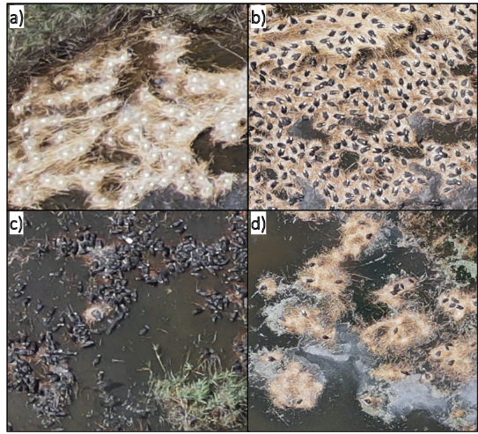
Figure 29 Nesting was at mixed stages at Monkeygar North in November 2022, with a) new nests with eggs, b) incubating adults, c) advanced chicks at the flapper or even fledgling stage, and d) areas where re-nesting was possibly occurring.

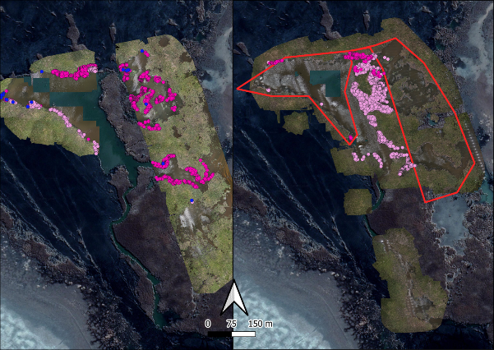
Figure 30 White ibis nests (blue), straw-necked ibis nests (dark pink) and straw-necked ibis chicks (light pink) counted in the mosaics collected in a) 17th Nov 2022 and b) 13th December 2022 at Monkeygar North when the rookery grew slightly from the previous rookery border (red).

T-block colony
The first drone survey at T-block on the 2nd December 2022 showed a large mixed species, in a well-established breeding rookery. Due to the mixed stages of nests, imagery was manually counted, resulting in 27,830 nests and an additional 35,616 chicks. There was evidence of trampling suggesting the rookery was still growing, and the second flight on 10th January 2023 identified another 4,015 new nests. A large section to the south of the rookery was dominated by egret nests, but these were not counted in this drone imagery due to the height of image collection.
Using mean clutch values for T-block cohort 1 the estimated total nest count at T-block is:
December imagery: 27,830 nests + (35,616/ 2.14*)= 44,473
January imagery: 4,015 nests + 299/2.14* = 4,155
=48,628 straw-necked ibis nests
*Table 5 mean clutch size for cohort 1 T-block rookery.
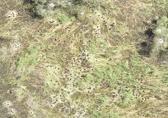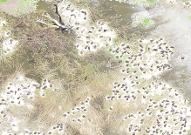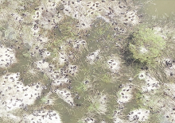
c)

b)

a)

Figure 31 T-Block had mixed stages of breeding in the first survey conducted on the 2nd Dec. 2022, with a) large chicks and evidence of creching, b) new nests being incubated and c) areas of vegetation being newly trampled.
Table 11 Results of counts of birds from drone imagery collected at T-block.
Survey Date | Species | Count | Rookery area (ha)
2nd Dec. 2022 | Straw-necked ibis | 27,830 nests | 43
 |  | 35,616 chicks
 |  | 571 trampling adults
 | Australian white ibis | 198 nests
 | Royal spoonbill | 29 nests
10th Jan. 2023 | Straw-necked ibis | 4,015 new nests | 61.9
 |  | 299 new chicks

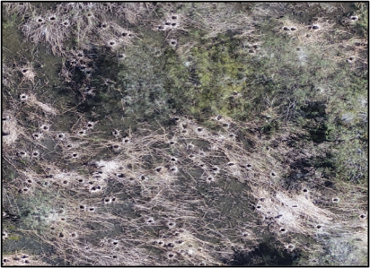
Figure 32 T-Block rookery continued to grow with nests being incubated on the 10th Jan. 2023 to the east of the pre-existing rookery (Fig. 21).

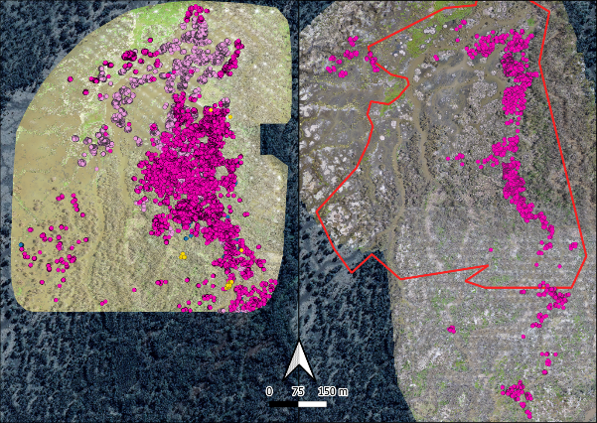
Figure 33 The dominant breeding species at T-Block on the 2nd Dec. 2022 was straw-necked ibis (dark pink), with many large chicks already present (light pink). Other species such as Australian white ibis were also nesting (dark blue), alongside spoonbills (yellow). The rookery continued to grow and was captured again on the 10th January 2023, where new straw-necked ibis nests were being incubated in the previous rookery border (red), and where the rookery extended south.

Ginghet Three Bridges
The rookery surveyed at Ginghet Three Bridges on the 18th November 2022 was at mixed stages of breeding, and had signs of expansion with trampling happening on the eastern and western edges of the rookery (Figure 34, Figure 35). There were multiple species breeding together, including spoonbills, cormorants and egrets (not counted), and Australian white ibis but the rookery was predominantly straw-necked ibis (Table 12). The survey conducted on the 29th December 2022 showed the continued success of already present nests, alongside a large area of nest expansion of approximately another 20 ha and 14,000 new nests.
Using mean clutch values for Ginghet Three Bridges cohort 1 the estimated total nest count at Ginghet Three Bridges is:
November imagery: 29,475 nests + (12,517 chicks / 2.27) = 34,989 nests
December imagery: 14,284 nests
= 49,273 straw-necked ibis nests
Table 12 Results of counts of birds from drone imagery collected at Ginghet Three Bridges.
Survey Date | Species | Count | Rookery Area (ha)
18th Nov. 2022 | Straw-necked ibis | 29,475 nests | 47.1
 |  | 12,517 chicks
 |  | 2,418 trampling adults
 | Spoonbill (likely royal) | 79 nests
 | Australian white ibis | 578 nests
29th Dec. 2022 | Straw-necked ibis | 14,284 new nests | 62.4

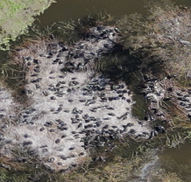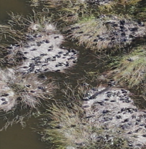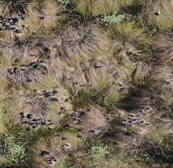
a)

b)

c)

Figure 34 Straw-necked ibis were at very mixed breeding stages on the 18th Nov. 2022 at Ginghet Three Bridges, with evidence of the rookery expanding with a) new areas of trampling birds alongside incubating nests, whereas other areas of the rookery had b) runners and even c) almost fledged chicks.

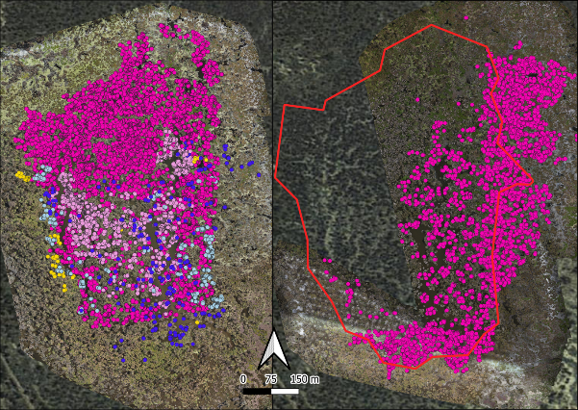
Figure 35 Ginghet Three Bridges rookery was well established on the 18th November 2022 (left hand panel) with a) straw-necked ibis nests (dark pink), straw-necked ibis chicks (light pink), trampling straw-necked ibis (light blue), white ibis nests (dark blue) and spoonbill nests (yellow). The rookery continued to grow and was captured 29th December 2022 (right hand panel) (b), where another ~14,000 straw-necked ibis nests (dark pink) were counted mainly to the east of the previous rookery boundary (red).

Rookery summaries – drone counts
Table 13.Total nest counts for each of the Macquarie Marshes rookeries for the 2022-2023 breeding season.
Rookery | Maximum nest count | Maximum rookery extent (ha)
Monkeygar North | 9,549 | 27.1
T-block | 48,628 | 61.9
Ginghet Three Bridges | 49,273 | 62.4

2021-22 and 2022-23 comparison of key results
The following tables are summary tables presenting key results from waterbird monitoring in 2021-22 (Brandis et al. 2022b)and 2022-23. Further details can be found in Brandis et al, 2022 and this report.
Table 14 Summary results of drone imagery derived nest counts and rookery extent for 2021-22 and 2022-23 nesting seasons.
Year | Rookery | Maximum nest count | Maximum rookery extent (ha) | Nest density/ha
2021-22 | Monkeygar North | 11,000 | 33.5 | 328.36
2022-23 | Monkeygar North | 9,549 | 27.1 | 352.36
2021-22 | T-block | 38,500 | 43 | 895.35
2022-23 | T-block | 48,628 | 61.9 | 785.59
2021-22 | Monkeygar East | 37,000 | 16 | 2,312.5
2021-22 | Zoo Paddock | 30,000 | 59 | 508.47
2022-23 | Ginghet Three Bridges | 49,273 | 62.4 | 789.63
Table 15 Summary results of clutch size data for 2021-22 and 2022-23 nesting seasons.
Year | Rookery | Cohort | Mean clutch size | No. nests monitored
2021-22 | Monkeygar North | 1 | 2.68 | 63
 |  | 2 | 2.32 | 391
2022-23 | Monkeygar North | 1 | 2.83 | 288
 |  | 2 | 2.1 | 20
2021-22 | T-block | 1 | 2.15 | 153
 |  | 2 | 2.56 | 508
2022-23 | T-block | 1 | 2.14 | 341
 |  | 2 | 2.38 | 63
2021-22 | Monkeygar East | 1 | 2.56 | 157
 |  | 2 | 1.94 | 70
2022-23 | Ginghet Three Bridges | 1 | 2.27 | 194
 |  | 2 | 2.49 | 130
 |  | 3 | 2.98 | 50
Table 16 Summary of reproductive success rates for Cohort 1 nesters in 2021-22 and 2022-23.
Year | Rookery | Chick development stage
 |  | Eggs – eggs/chicks/squirters | Eggs/chicks/squirters – squirters/runners | Squirters/runners – flappers/flyers | Average early stage (Surveys 1-4) nest success
2021-22 | Monkeygar North | 57.99% | 68.37% | 64.18% | 63.51%
2022-23 | Monkeygar North | 70.88% | 32.76% | 86.77% | 63.47%
2021-22 | T-block | 158.39%* | 74.31% | 68.60% | 100.43%*
2022-23 | T-block |  | 78%# |  | 78%
2021-22 | Monkeygar South | 96.52% | 111.34% | 51.62% | 86.49%
2022-23 | Ginghet Three Bridges | 88.01% | 70.23% | 42.69% | 66.97%
*>100% was achieved as more eggs were laid into monitored nests between surveys.
# Due to the varied and advanced chick development stages during survey 1 it was not possible to determine reproductive success rates for each development stage.

Discussion
Rookery mapping and nest counts from drone surveys was successful with >107,000 nests counted across the three rookeries, total nest counts were generally comparable to those in 2021-22 of >116,000 nests across four colonies. At a rookery scale T-block was larger in 2022-23 while Monkeygar North was smaller. Zoo Paddock was not surveyed in 2022-23, and Ginghet Three Bridges was not a large ibis colony in 2021-22 (DPE-EHG 2022), Monkeygar East did not have any nesting recorded during 2022-23.
Waterbird rookeries in the Macquarie Marshes in 2022-23 were generally comparable in size to those in 2021-22. >107,000 nests were counted across three rookeries in 2022-23, while >116,000 total nests were counted in 2021-22 counts across four colonies. Two rookery sites were common to both years of monitoring – Monkeygar North and T-block. Monkeygar North had a slightly lower total nest count than 2021-22, while T-block was larger (Table 14). Nesting did not occur at the Monkeygar East site (Brandis et al. 2022) in 2022-23, while the Ginghet Three Bridges rookery was significantly larger than had been previously observed at this site (DPE-EHG 2022) and was included in the 2022-23 waterbird monitoring program.
Initiation of nesting was staggered from early to mid-October 2022 at T-Block with egg laying continuing through to mid-December 2022 at Ginghet Three Bridges. All three rookeries had at least two cohorts of nesting, with all rookeries increasing in extent following initial surveys. Nesting was complete by late January 2023 but rookeries remained active into late February with thousands of fledglings remaining in the vicinity of the rookeries. Reproductive success rates at all three rookeries (Table 6, Table 16) were comparable to those in 2021-22 and other large ibis rookeries (Brandis et al. 2011, Brandis et al. 2020, Brandis et al. 2022a, Wassens et al. 2022). There were no observations of mass mortality due to disease or predation.
Similarly, to 2021-22, the number of aggregating waterbirds breeding in the Macquarie Marshes in 2022-23 were among the highest numbers recorded in the Marshes, noting that these years included increases in survey resources and effort (DPE-EHG, NPWS, UNSW) and more precise counting where drones were utilized. The rookeries were part of extensive nesting throughout the Murray-Darling Basin in both water years. Large (>5,000 nests) aggregating waterbirds were located in the southern Basin; Lowbidgee wetlands (98,830 straw-necked ibis nests), Booligal wetlands (171,137 straw-necked ibis nests), Kieeta Lake (~21,443 pelican nests), Lake Brewster (49,882 pelican nests) and in the northern Basin; Narran Lakes (7,334 straw-necked ibis nests, 23,591 pelican nests) and, Gwydir Wetlands (~30,000 straw-necked ibis nests).
Utilizing previous monitoring results from the Marshes, a direct comparison can be made between reproductive success at Monkeygar North which was monitored in 2016-17, 2021-22, and 2022-23 using the same methods. Overall reproductive success in 2016-17 was 63.28% (Brandis 2017), 2021-22 63.51% (Brandis et al. 2022) and 2022-23 63.47%. A reproductive success rate of ~70% is potentially a ‘normal’ success rate for this species. Reproductive success rates of 100% in altricial birds are uncommon (Nice 1957). Results of camera traps studies in the Lowbidgee in 2010 (Brandis 2014) found that nests with clutch sizes of two eggs had a higher rate of producing two chicks (55%) than nests with clutch sizes of three eggs. Nests with three eggs had a 44% chance of producing three chicks. Similarly, where three chicks did hatch, if there was a smaller chick, which is common in asynchronously hatching waterbird species (Fujioka 1985, Ploger and Mock 1986), the smaller chick always died (Brandis, unpublished data). While there is a natural mortality rate associated with breeding by aggregating waterbirds this rate can be influenced by environmental conditions at the time of nesting. Factors that may impact on reproductive success include hydrological conditions during the breeding event (Brandis et al. 2011), availability of food resources (Butler 1984), timing of breeding (season) (Brandis and Bino 2016), predation, and experience and condition of parents (Weathers and Sullivan 1989, Jakubas 2005).
Water levels in the rookeries declined gradually throughout the nesting period (Figure 22,Figure 23 , Figure 24) with no evidence of nest desertion due to rapidly rising or falling water levels. Water depths in the rookeries were also sufficient to keep out land-based predators and there were no observations of significant predation. Measured water quality variables were generally stable and within acceptable ranges for wetland ecosystems.
Inundation of the three rookery sites over the survey period was maintained though the sympathetic management of Burrendong Dam flood mitigation releases following Spring Marshes inflows including tributary and managed environmental flows. Water for the environment was delivered in late February and early March 2023 to help maintain inundation of waterbird rookery sites and foraging grounds and support successful completion of waterbird breeding.
Water management at these key large scale rookery sites is important to ensure the success of aggregating waterbirds breeding. Meeting the requirements of inundation duration, water depth and timing of flows are critical components of water management that play a key role in ensuring breeding success (Brandis et al. 2011). The provision of suitable nesting habitat, limiting predation, maintenance of water quality, and the provision of foraging areas are also critical in supporting breeding waterbirds.

Recommendations
The provision of environmental water is important in the management and support of waterbird breeding events. This can be achieved both during the breeding season and between seasons when conditions may not be suitable for large-scale waterbird breeding. Between season maintenance of nesting habitat is crucial for when opportunities for breeding do occur. Providing opportunities for breeding includes the presence of suitable nesting habitat, this often includes areas of lignum, phragmites, river red gums, and river cooba, with the more waterbird species diverse sites having mosaics of floodplain and riparian vegetation communities (Brandis, Francis and Bino in prep).
Large-scale waterbird breeding is often associated with large-scale inundation as a result of natural rainfall and flooding. Environmental water can play a key role in supporting breeding waterbirds when established through the provision of additional flows to extend duration, increase water depth, maintain water quality and provide foraging areas.
In the Macquarie Marshes where there are many rookery sites supporting a diverse range of aggregating breeding species e.g., ibis, egrets, herons, cormorants, it is a challenging task to support all sites with environmental water. This is particularly true for sites where mechanisms for water delivery are limited, such as Zoo Paddock. For sites where water management is possible, key targets should include the maintenance of nesting vegetation between breeding seasons, and the provision of environmental water, as needed (e.g., duration extension, increased depth, water quality) during breeding events. Quantifiable thresholds for these targets can be variable and may depend upon the rookery site, but in general, during an ibis waterbird breeding event the provision of flows for a minimum of 3-4 months, to allow for the cycle of nesting, egg laying, chick rearing and fledging to complete (Brandis and Bino 2016) is required. Leslie (2001) and Briggs and Thornton (1998) suggest that 140-168 days of flows is required to support other waterbird species including egrets, cormorants, ducks and herons (Briggs 1998, Leslie 2001). The maintenance of water levels in the rookery site is important to prevent 1) desertion by nests by adults due to rapidly falling water levels (Brandis et al. 2011), and 2) flooding of established nests due to rapidly rising water levels, and 3) sufficient water depth to prevent predator access (~50cm). Management of flows is also important to ensure good water quality. Poor water quality and stagnant water can result in blue-green algae, large quantities of decomposing vegetation and promote conditions that can results in avian botulism outbreaks (Brandis et al. 2019) and other diseases.
Aggregating waterbirds are important components in wetland ecosystems, and are often used as indictors of wetland health (Kingsford 1999). The support of aggregating waterbird rookeries through the provision of environmental water is critical in the conservation of these species, limiting populations declines (Kingsford et al. 2020), supporting population growth and providing opportunities for breeding (Brandis et al. 2021). It is also just as important to conserve and manage these wetland ecosystems and habitats on which they rely for breeding, foraging and roosting.

References
Bino, G., C. Steinfeld, and R. T. Kingsford. 2014. Maximizing colonial waterbirds’ breeding events using identified ecological thresholds and environmental flow management. Ecological Applications 24:142-157.
Brandis, K. 2010. Colonial Waterbird Breeding in Australia: wetlands, water requirements and environmental flows. PhD Thesis. University of New South Wales.
Brandis, K., and G. Bino. 2016. A review of the relationships between flow and waterbird ecology in the Condamine-Balonne and Barwon-Darling River Systems. Murray-Darling Basin Authority.
Brandis, K., G. Bonsen, L. Juillard, and R. Francis. 2022a. Dharriwaa-Narran Lakes Nature Reserve Colonial Waterbird Reproductive Success Monitoring 2022. Final Report to the Australian Government Commonwealth Environmental Water Office., Centre for Ecosystem Science, UNSW.
Brandis, K., G. Bonsen, E. Wooster, C. Hasselerharm, L. Juillard, and R. Francis. 2022b. Macquarie Marshes Colonial Waterbird Reproductive Success Monitoring 2022. Final report to the Australian Government Commonwealth Environmental Water Office. Centre for Ecosystem Science, UNSW.
Brandis, K., R. T. Kingsford, S. Ren, and D. Ramp. 2011. Crisis water management and ibis breeding at Narran Lakes in arid Australia. Environmental Management 48:489-498.
Brandis, K., Koeltzow, Ryall, S., Ramp, D. 2014. Assessing the use of camera traps to measure reproductive success in Straw-necked ibis breeding colonies. Australian Field Ornithology 31:99-106.
Brandis, K., S. Ryall, R. T. Kingsford, and D. Ramp. 2020. Colonial waterbird breeding in the Gayini-Nimmie-Caira wetlands, Australia, 2010-2011. SIS Conservation 2.
Brandis, K., J. Spencer, B. Wolfenden, and D. Palmer. 2019. Avian-botulism risk in waterbird breeding colonies and implications for environmental water management. Marine and Freshwater Research 71:179-190.
Brandis, K. J. 2017. High resolution monitoring of waterbird colonies in the Macquarie Marshes. Commonwealth Office of Environmental Water.
Brandis, K. J., G. Bino, and R. T. Kingsford. 2021. More Than Just a Trend: Integrating Population Viability Models to Improve Conservation Management of Colonial Waterbirds. Environ Management 68.
Briggs, S. V., Lawler, W.G., Thornton, S.A. 1998. Relationship between control of water regimes in River Red Gum wetlands and abundance of waterbirds. Corella 22:47-55.
Butler, R. W. 1984. Population regulation of wading Ciconiiform birds. Colonial Waterbirds 17:189-199.
DPE-EHG. 2022. Macquarie Marshes Colony Monitoring. Unpublished Data.
Fondriest Environmental Learning Centre. Fundamentals of Environmental Measurements.
Fujioka, M. 1985. Sibling competition and siblicide in asynchronously-hatching broods of the cattle egret Bubulcus ibis. Animal Behaviour 33:1228-1242.
Jakubas, D. 2005. Factors affecting the breeding success of the grey heron (Ardea cinerea) in northern Poland. Journal of Ornithology 146:27-33.
Kingsford, R. T. 1999. Aerial survey of waterbirds on wetlands as a measure of river and floodplain health. Freshwater Biology 41:425-438.
Kingsford, R. T., and K. M. Auld. 2005. Waterbird breeding and environmental flow management in the Macquarie Marshes, Arid Australia. River Research and Applications 21:187-200.
Kingsford, R. T., and W. Johnson. 1998. Impact of water diversions on colonially-nesting waterbirds in the Macquarie Marshes of Arid Australia. Colonial Waterbirds 21:159-170.
Kingsford, R. T., J. L. Porter, K. J. Brandis, and S. Ryall. 2020. Aerial surveys of waterbirds in Australia. Scientific Reports 7.
Kingsford, R. T., and R. F. Thomas. 1995. The Macquarie Marshes in Arid Australia and Their Waterbirds: A 50-year History of Decline. Environmental Management 19:867-878.
Leslie, D. J. 2001. Effect of river management on colonially-nesting waterbirds in the Barmah-Millewa Forest, South-Eastern Australia. Regulated Rivers: Research and Management 17:21-36.
Nice, M. M. 1957. Nesting sucess in altricial birds. The Auk 74:305-321.
NSW DPE. 2022. Macquarie Marshes Inundation Mapping 2021-22. Environment and Heritage Group, NSW Department of Planning and Enivronment.
Ploger, B. J., and D. W. Mock. 1986. Role of sibling aggression in food distribution to nestling cattle egrets (Bubulcus ibis). The Auk 103:768-776.
Tortosa, F. S., L. Perez, and L. Hiillstrom. 2003. Effect of food abundance on laying date and clutch size in the White Stork Ciconia ciconia. Bird Study 50:112-115.
Wassens, S., D. Michael, J. Spencer, J. Thiem, K. Brandis, R. Thomas , T. Kobayashi, N. S. Whiterod, D. Wright, J. Turner, G. Bino, A. Turner, J. Heath, and A. Hall. 2022. Commonwealth Environmental Water Office Monitoring, Evaluation and Research Program Murrumbidgee River System Selected Area Summary Report 2014-21. Charles Sturt University.
Weathers, W. W., and K. A. Sullivan. 1989. Juvenile foraging proficiency, parental effort, and avian reproductive success. Ecological Monographs 59:223-246.

Table 1 references
Brandis, K. J. 2017. High resolution monitoring of waterbird colonies in the Macquarie Marshes. Commonwealth Office of Environmental Water.
Brandis, K., G. Bonsen, E. Wooster, C. Hasselerharm, L. Juillard, and R. Francis. 2022. Macquarie Marshes Colonial Waterbird Reproductive Success Monitoring 2022. Final report to the Australian Government Commonwealth Environmental Water Office. Centre for Ecosystem Science, UNSW.
Kingsford, R. T., Auld, K. 2003. Waterbird breeding in the Macquarie Marshes - a guide to river health. Final report.
Magrath, M. J. L. 1991. Waterbird Breeding in the Macquarie Marshes 1989. TS91.074, Environmental Studies Unit, NSW Department of Water Resources, Technical Services Division.
Nest Record Scheme, BirdLife Australia Databases « Birding-Aus
Smith, P. J., Pressey, R.L., Smith, J.E. 1994. Birds of particular conservation concern in the Western Division of New South Wales. Biological Conservation 69:315-338.

