Fish and flows | aQUATIC HABITAT rEHABILITATION
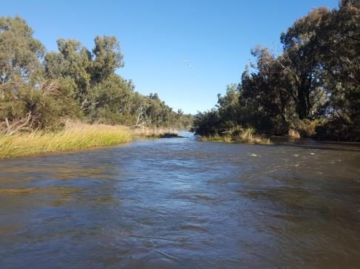

Mapping the Dumaresq
Aquatic habitat mapping to inform water management
Report prepared for the Commonwealth Environmental Water Office


Aquatic Habitat Rehabilitation Unit


Published by the NSW Department of Primary Industries
Mapping the Dumaresq: Aquatic Habitat Mapping to Inform Water Management
First published April 2018
ISBN 978-1-76058-212-8
More information
[Sam Davis, Rodney Price, Matthew Miles / Aquatic Habitat Rehabilitation Unit / Dubbo]
www.dpi.nsw.gov.au
Acknowledgments
This project was funded by the Commonwealth Environmental Water Office, and was undertaken by the NSW Department of Primary Industries on behalf of the Commonwealth Environmental Water Office. NSW Department of Primary Industries’ Aquatic Habitat Rehabilitation Unit managed the project including research and report preparation. Personnel involved in completion of the project were: Matt Miles, Rodney Price, Sam Davis and Anthony Townsend. Personnel would like to thank and acknowledge the efforts of Katrina Cousins from the Commonwealth Environmental Water Office for developing, progressing and finalising the project.
© State of New South Wales through the Department of Industry, Skills and Regional Development, 2018. You may copy, distribute and otherwise freely deal with this publication for any purpose, provided that you attribute the NSW Department of Primary Industries as the owner.
Disclaimer: The information contained in this publication is based on knowledge and understanding at the time of writing (April 2018). However, because of advances in knowledge, users are reminded of the need to ensure that information upon which they rely is up to date and to check currency of the information with the appropriate officer of the Department of Primary Industries or the user’s independent adviser.

Executive Summary
Native fish species of the Murray-Darling Basin have adapted over time to the harsh conditions experienced in the Basin, including highly variable rainfall and flows. Many of the fish species that are native to the Basin have specific flow requirements developed to thrive in these conditions. Unfortunately, with the development of the Basin’s river systems and subsequent regulation many of the natural flow regimes have been altered and fish communities have suffered dramatic declines. The biological rhythms of fish are often linked to flow so that opportunities for spawning, growth and dispersal are synchronised to maximise life history outcomes.
Current activities across the Murray-Darling Basin, especially those related to water management, provide opportunities for fish communities to recover from impacts associated with river regulation. Flows can be developed, delivered or protected to enhance spawning, recruitment, and movement outcomes for native fish. Flows can also be used to increase productivity in the system to improve the condition of native fish and overall river health, as well as connectivity between aquatic habitats.
To ensure these outcomes are achieved with the most effective and efficient use of water for the environment in the Border Rivers, it is critical that management decisions are guided by the best available information, including environmental water requirements for fish and hydrological thresholds for habitat conditions. Information from literature, survey data and threatened species distribution modelling was used to determine what fish species are known and likely to be present in the Border Rivers. The flow requirements for spawning, recruitment, movement and maintenance of these species were adapted from the latest available information to help form fish functional groups for the Border Rivers.
Extensive habitat mapping was completed along 193 km of the Dumaresq River between the Pike Creek junction downstream to its confluence with the Macintyre River. The mapping focused on specific physical features relating to requirements of aquatic species (targeting threatened native fish) and management, developing a comprehensive database. Information from habitat mapping was used to identify relationships between river flow height and habitat availability to inform water management activities in the Borders Rivers valley.
Commence to inundate heights were recorded and analysed for Large Woody Habitat (LWH), rootballs, bank overhangs, in-channel benches, and entry points to connected wetlands to indicate the flows (ML/day) required to inundate these features. Features were separated into two Flow Gauging Zones (FGZ) according to the nearest gauging station (Roseneath and Glenarbon Weir flow gauges).
For the Roseneath FGZ flow analysis was completed on 1,489 LWH, 169 rootballs, 82 bank overhangs, 810 benches, and 132 connected wetland points. For the Glenarbon FGZ flow analysis was completed on 2,487 LWH, 340 rootballs, 91 bank overhangs, 545 benches, and 96 connected wetlands points. Flow analysis revealed that flows over 100,000 ML/day would be required to inundate all features across the project area; however large quantities of habitat would be inundated in both FGZs with small (136 – 1,310 ML/day) and large (1,310 – 7,300 ML/day) pulse events and could be targeted for future management of water for the environment in combination with natural flow events.
Three site-specific flow indicators have been developed to represent the native fish water requirements of the Dumaresq River, focussing on important or threatened native fish populations occurring in the catchment. These flow indicators aim to provide longitudinal connectivity, cues for life-cycle responses, improved habitat availability, increased primary productivity, and enhanced fish condition in the Dumaresq River. The implementation of these environmental water requirements would achieve significant native fish outcomes; however it is likely to require supplementing flows or additional holdings and altered operational arrangements. The flow magnitudes outlined in the EWRs are ideal amounts; however these flows can still be delivered at lower flow rates to achieve associated outcomes with focus on timing and duration. Under some flow conditions, held environmental water may simply be required to augment the hydrograph reducing the potential for rapid drops in river height. The outcomes are especially tailored to the species of the fish community that are reliant on flow events for specific life-cycle requirements, by providing improved spawning and recruitment opportunities. These EWRs can also enhance spawning and recruitment opportunities for those species that are less reliant on flows, and will enhance the maintenance and condition of all native fish functional groups. Flow components such as rapid flow increases and draw down should be avoided during critical periods for species that display nesting and have demersal eggs.
Enhanced In-channel specialist spawning
Ecological objective
Provide flow regimes that enhance spawning opportunities for In-channel Specialist native fish species, focussing on Murray Cod, Freshwater Catfish and Purple Spotted Gudgeon.
Improve the inundation and availability of key habitat features along the Dumaresq River for In-channel Specialists (Flow Dependent – Murray Cod), particularly LWH, root balls, and undercut banks.
Improve the inundation and availability of key habitat features along the Dumaresq River for In-channel Specialists (Flow Independent – Freshwater Catfish and Purple Spotted Gudgeon), particularly benches/cobble beds, and wetland entry points.
Improve the longitudinal connectivity along the Dumaresq River, enhancing localised movement opportunities for native fish.
Environmental Water Requirement
Flow event of 1,040 ML/day for a minimum of 14 consecutive days from August to November, preferably every year but can be every second year, with a maximum inter-flow period of two years to enhance spawning outcomes for In-channel Specialists (Flow Dependent – Murray Cod) species. The flow target could be adjusted to a minimum of 515 ML/day while still achieving some the objectives, although the effectiveness of outcomes may be compromised, with a timing shift from September to March enhancing spawning outcomes for In-channel Specialists (Flow Independent – Freshwater Catfish and Purple Spotted Gudgeon) species. The duration and frequency should still be maintained.
Enhanced native fish recruitment
Ecological objective
Provide flow regimes that enhance recruitment outcomes for native fish, including In-channel Specialist species, focussing on Murray Cod, Freshwater Catfish and Purple Spotted Gudgeon, Generalists species, and Floodplain Specialists.
Improve the inundation and availability of key habitat features that contribute to productivity outcomes along the Dumaresq River, particularly benches/cobble beds, and wetland entry points.
Improve the longitudinal connectivity along the Dumaresq River, enhancing localised movement opportunities for native fish.
Environmental Water Requirement
Optimum flow event of 600 ML/day for a minimum of 10 consecutive days from September to March, preferably every year but can be every second year, with a maximum inter-flow period of two years. The flow target could be adjusted to a minimum of 341 ML/day while still achieving some of the objectives under resource constrained conditions, although the effectiveness of outcomes may be compromised.
Enhanced native fish condition and maintenance
Ecological objective
Provide flow regimes that increases productivity in the system and improves condition of all native fish through improved inundation and availability of key habitat features along the Dumaresq River, particularly LWH, benches/cobble beds, and wetland entry points.
Improve the longitudinal connectivity along the Dumaresq River, enhancing localised movement opportunities for native fish.
Environmental Water Requirement
Optimum flow event of 6,250 ML/day for a minimum of 5 consecutive days (whole event, with peak potentially only being 2 days) anytime from July to June, preferably every year but can be every second year, with a maximum inter-flow period of two years. The flow target could be adjusted to a minimum of 2,380 ML/day while still achieving some of the objectives under resource constrained conditions, although the effectiveness of outcomes may be compromised.
The detailed habitat inundation information and proposed environmental water requirements seek to provide flows needed to sustain healthy and resilient populations of native fish. However, it is important to acknowledge that whilst flow restoration is critical for delivering native fish outcomes in the Border Rivers, a range of other factors will also influence outcomes including: aquatic habitat; riparian management; water quality issues such as cold water pollution; water extraction and; fish passage.
The information collected for this project, especially the issues that would influence outcomes, can be used to target future work related to these factors. To ensure the most efficient and effective use of water for the environment, coordinated and targeted complementary actions can be considered in an adaptive management framework that incorporates rigorous scientific monitoring and evaluation. Water requirements and management actions for fish can continue to be progressed through the new information compiled through this project, and a commitment to further developing knowledge and management actions in the Border Rivers.

Contents
Executive Summary i
Contents iv
List of Figures vi
List of Tables vii
Introduction 1
Project scope and objectives 2
Project objectives 2
Study area 2
Hydrology 4
Water infrastructure 4
Fish species in the Dumaresq River 5
Fish functional groups in the Dumaresq River 10
Methodology 14
Habitat mapping 14
Refugia 17
Flow gauging zones 17
Flow relationships 19
Habitat mapping results 20
Riparian vegetation condition 20
Exotic plant species 20
Aquatic habitat 22
Large Woody Habitat 22
Rootballs and bank overhangs 22
Refugia 25
Benches 27
Connected wetlands 29
Aquatic macrophytes 32
Cobble beds 34
Fish passage 36
Flow relationship results 41
Summary of project area flow components 42
Large Woody Habitat 44
Rootballs 48
Bank overhangs 51
Benches 54
Connected wetland entry and exit points 57
Recommendations and future directions 60
Flows for native fish 60
Recommendations for future management in the Border Rivers 65
Conclusion 68
References 69
Appendix 76
Appendix A: Stream cross section at Roseneath and Glenarbon Weir gauges 76
Appendix B: Habitat feature inundation with a natural flow event in 2016 79
Large Woody Habitat 79
Bank overhangs 83
Bench area 85
Wetland entry and exit points 87
Appendix C: Pumpsites 89

List of Figures
Figure 1: Location and extent of the Border Rivers valley (MDBA, 2012). 3
Figure 2. Project area showing major tributaries and hydrological features. 3
Figure 3: Fish Community Status for the Border Rivers valley, highlighting condition of fish communities, the distribution of threatened species, and the location of Carp hotspots. 8
Figure 4: The influence of flows on the different stages within the life-cycle of a fish (adapted from MDBA, 2014). 10
Figure 5: Flow plot analysis of the Dumaresq River during field work component. 14
Figure 6: Side-scanning sonar recording of instream habitat features. 15
Figure 7: Example of georeferenced sonar data superimposed on aerial imagery with LWH distinguished by yellow points. 16
Figure 8: Structural complexity classes used to describe LWH during field work. 17
Figure 9: Flow gauging zone boundaries in the project area. 18
Figure 10: Schematic of methods used to calculate CTI heights of key habitat features along the Dumaresq River. 19
Figure 11: Example of rootball habitat recorded in the project area. 23
Figure 12: Example of a bank overhang recorded in the project area. 23
Figure 13: Location of rootballs and bank overhangs recorded in the project area. 24
Figure 14: Location of refuge pools recorded in the project area. 26
Figure 15: Example of a low lying bench recorded in the project area. 27
Figure 16: Location of benches recorded in the project area. 28
Figure 17: Aerial image from the project area showing an example of a large pool leading to a large bench with skirting riffles and runs that were often recorded during the project. 29
Figure 18: Example of a wetland entry point recorded in the project area. 30
Figure 19: Location of connected wetland entry points recorded in the project area. 31
Figure 20: An example of submerged (ribbon weed) and emergent (juncus/sedge) macrophytes recorded in the project area. 32
Figure 21: Location of macrophytes that were recorded in the project area. 33
Figure 22: Example of a partially submerged cobble bed near Roseneath. 34
Figure 23: Location of Cobble beds recorded in the project area. 35
Figure 24: Fish passage barriers recorded in the project area. 37
Figure 25: Fish passage barriers in the project area and flows in the Dumaresq River during the last 20 years. The green dotted line highlights the drown out value for each weirs, indicating when fish passage would have been available (Bonshaw Weir Photo credit NSW DPI, 2006). 39
Figure 26: Cold water pollution occurs through drawing of water from the bottom of large storages (NSW DPI, 2005). 40
Figure 27: Components of the in-channel flow regime (adapted from Ellis et al. 2016). 42
Figure 28: Cumulative inundation frequency curves for LWH in the Roseneath FGZ, with inundation values during smaller flows highlighted in the inset box. 46
Figure 29: Cumulative inundation frequency curves for LWH in the Glenarbon Weir FGZ, with inundation values during smaller flows highlighted in the inset box. 47
Figure 30: Cumulative inundation frequency curves for rootballs in the Roseneath FGZ, with inundation values during smaller flows highlighted in the inset box. 49
Figure 31: Cumulative inundation frequency curves for rootballs in the Glenarbon Weir FGZ, with inundation values during smaller flows highlighted in the inset box. 50
Figure 32: Cumulative inundation frequency curves for bank overhangs in the Roseneath FGZ. 52
Figure 33: Cumulative inundation frequency curves for bank overhangs in the Glenarbon Weir FGZ, with inundation values during smaller flows highlighted in the inset box. 53
Figure 34: Cumulative inundation frequency curves for bench area in the Roseneath FGZ. , with inundation values during smaller flows highlighted in the inset box 55
Figure 35: Cumulative inundation frequency curves for bench area in the Glenarbon Weir FGZ, with inundation values during smaller flows highlighted in the inset box. 56
Figure 36: Cumulative inundation frequency curves for wetland entry points in the Roseneath FGZ, with inundation values during smaller flows highlighted in the inset box. 58
Figure 37: Cumulative inundation frequency curves for wetland entry points in the Glenarbon Weir FGZ, with inundation values during smaller flows highlighted in the inset box. 59
Figure 38: Typical circulation pattern set up by artificial de-stratification, which could be a feasible option for mitigating cold water pollution at Glenlyon Dam. 66
Figure 39: Location of pumpsites in the upper section of the project area overlayed on satellite image showing cropped areas. 90
Figure 40: Location of pumpsites in the lower section of the project area overlayed on satellite image showing cropped areas. 91

List of Tables
Table 1: Commonwealth environmental water holdings in the Border Rivers (as of the 31/01/2018) 6
Table 2: Fish species expected to occur in the project area, their status, and life history requirements related to flow. 7
Table 3: Fish guild groupings for species in the Border Rivers valley (adapted from NSW DPI, 2015). 12
Table 4: Typical features recorded on PDAs during habitat mapping. 15
Table 5: List of exotic plant species recorded in the project area. 21
Table 6: Number and percentage of each LWH complexity group in the Roseneath FGZ. 22
Table 7: Number and percentage of each LWH complexity group in the Glenarbon FGZ. 22
Table 8: Definition of the five flow regime components identified for this study (adapted from Ellis et al. 2016). 43
Table 9: Summary of flow components, stage height and mean daily flow range for Roseneath FGZ. 44
Table 10: Summary of flow components, stage height and mean daily flow range for Glenarbon Weir FGZ. 44
Table 11: Number of each pumpsite size class that exist in the Roseneath FGZ. 92
Table 12: Number of each pumpsite size class that exist in the Glenarbon FGZ. 92

Introduction
Aquatic habitat is an important element of the riverine environment and consists of stream features such as bed substrates, hydrology, pools, riffles, floodplains, instream and bank vegetation (macrophytes and riparian vegetation), large woody habitat (LWH), bank overhangs and rocky outcrops (Rutherford et al. 2000). These features along with billabongs, paleo-channels and off stream wetlands provide spawning, feeding, shelter and recruitment sites essential for the survival of aquatic biota, including native fish. The degradation of native riparian vegetation, the removal of LWH and the installation of and operation of instream structures that are barriers to fish passage are all listed as Key Threatening Processes under the Fisheries Management Act (FM Act) 1994.
The many streams of the Border Rivers system provide diverse habitat for aquatic organisms including the river channel itself, in-stream features such as bars and benches, riparian areas, and low level wetlands (SKM, 2009). Environmentally significant river reaches that can potentially be targeted with Commonwealth environmental water include the Dumaresq, Macintyre and Severn Rivers. The catchment supports a relatively rich native fish fauna. Sixteen native species have been recorded, including a number of threatened species or populations, such as Murray Cod, Silver Perch, Purple Spotted Gudgeon, Olive Perchlet, and Freshwater Catfish (NSW DPI, 2015). Assessments by NSW DPI (2016) and the Sustainable Rivers Audit (Davies et al. 2012) concluded that overall the Border Rivers fish community is in moderate health, ranking it among the best catchments in the Basin for native fish and providing a strong platform for further improvement if appropriate management actions are implemented.
Environmental assets and associated objectives and outcomes for the Border Rivers have been identified in the Basin-wide Watering Strategy (BWS), an assessment of in-stream environmental water requirements by the MDBA (2012), and state-based investigations to inform Water Resource Plans (WRPs). Based on these strategies and studies, the Commonwealth Environmental Water Office (CEWO) has identified key demands and outcomes being targeted by managing water for the environment in the Border Rivers. For native fish this includes the provision of flows in the Severn, Dumaresq, Macintyre and Barwon Rivers that improve habitat conditions and support different life stages, including migration, spawning, recruitment, and refuge (CEWO, 2016).
To ensure these ecological outcomes are achieved with the most effective and efficient use of water for the environment in the Border Rivers, it is critical that management decisions are guided by the best available information, including environmental water requirements for fish and hydrological thresholds for habitat conditions. NSW DPI has recently completed work on the flow requirements needed by native fish in the Northern Basin to achieve key life history stages (NSW DPI, 2015).
This information is based on the latest science, literature and expert opinion for the Northern Basin, and can be used to guide management decisions to achieve fish outcomes from improved water management.
However, in all valleys there is a need to relate these biological needs to system-specific ecological information that enhances management actions and ecological outcomes. This includes flow thresholds and other metrics (river height, flow rate, duration, volume) required to inundate key habitat features in the system that contribute to native fish, connectivity and productivity outcomes such as benches, wetland entry/exit, aquatic macrophytes, and LWH. Existing data on ecological thresholds in the Border Rivers valley is limited to commence to flow estimates for anabranches, distributary channels and wetlands and some low level benches in the lower Macintyre River and floodplain downstream of Goondiwindi and some ill-defined estimates for the main anabranches and some near-channel and floodplain wetlands in the upper floodplain zone (Kingsford, 1999; Thoms et al. 2005; Reid, 2006; Hutchison et al. 2008; Reid et al. 2011).
A lack of data on inundation thresholds for in-channel features, habitat and wetland breakouts along the Dumaresq River was identified as a key knowledge gap during the Northern Basin Review (NSW DPI 2015). Calculating these hydrological thresholds based on detailed habitat mapping will significantly improve the CEWO’s ability to provide water for the environment that meets environmental objectives under the BWS. This is particularly important in the Border Rivers valley where there is a lack of existing data on ecological thresholds for key native fish populations, and would enable the effective use of Commonwealth supplemented entitlements

Project scope and objectives

Project objectives
The primary objectives of the project are to:
- Document the riparian features of the Dumaresq River, focusing on native vegetation, weed infestation and existing management activities;
- Document the stream bed morphology, including the location, length and depth of pools that may act as drought refugia, the instream habitat features (benches, wetland entry/exit points, aquatic macrophytes, substrate), and LWH (snag) loading;
- Calculate commence-to-inundate flow thresholds of select habitat features where feasible, including benches, cobble/riffle runs, wetlands entry/exit points, aquatic macrophytes, LWH and bank overhangs;
- Identify and map threats and processes that may influence the extent and condition of aquatic and riparian habitat features; and
- Make recommendations to improve water for the environment management actions in the Dumaresq River, and to protect and improve stream health, threatened species habitat enhancement, weed control and other habitat features.

Study area
The Dumaresq Rivers is one of three major rivers of the Border Rivers Catchment and forms part of the border between New South Wales (NSW) and Queensland (Qld) (Kingsford, 1999). The Border Rivers region incorporates systems both in NSW and Qld, covering 45,675 km² or 4.4% of the total Murray–Darling Basin, with the NSW portion of the catchment covering approximately 24,500 km² (MDBA, 2017; Figure 1 and 2). The eastern half of the Border Rivers comprises the ranges and foothills of the Great Dividing Range with elevations from 1,500 m to 500 m in the lower foothills (Green et al. 2012).
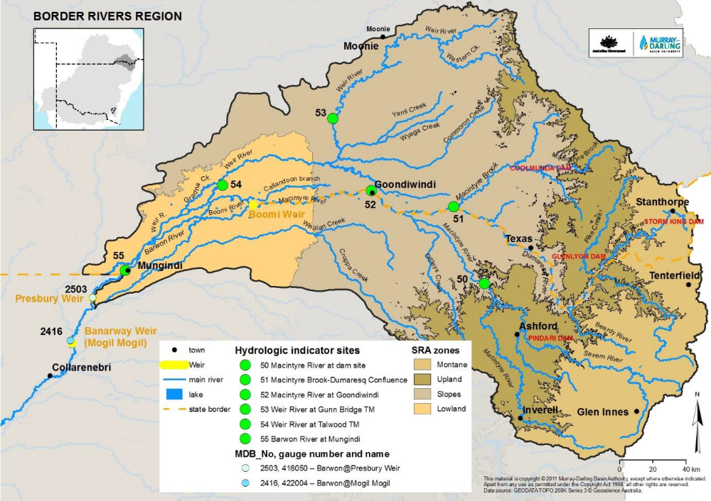
Figure 1: Location and extent of the Border Rivers valley (MDBA, 2012).
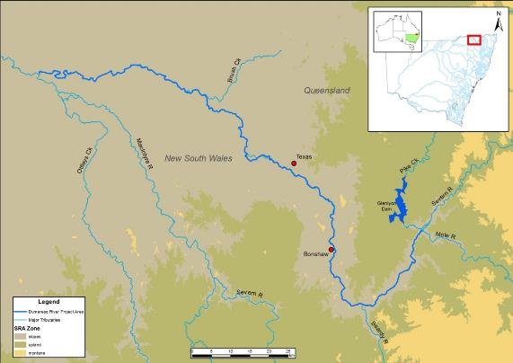
Figure 2. Project area showing major tributaries and hydrological features.
The Dumaresq River forms at the confluence of the Severn River (Qld) and Tenterfield Creek near the locality of Mingoola (Green et al. 2012). The project area is located in the slopes zone of the catchment.
The Dumaresq River, below the Mole River Junction, is a part of the Lower Darling Endangered Ecological Community (ECC) listed under the FM Act 1994. The EEC is characterised by variable and unpredictable patterns of high and low flows. The EEC provides a variety of habitats for fish and invertebrates including pools, runs, riffles, backwaters and billabongs, in-stream woody habitats and aquatic plants (NSW DPI, 2007). One of the major causes of degradation to the EEC is the modification of natural flows as a result of river regulation (NSW DPI, 2007).

Hydrology
Rainfall is predominantly recorded in summer and is highly variable, which has a considerable impact on flows in the system (Commonwealth of Australia, 2015). The principal tributaries of the Dumaresq are the Beardy River and Ottley’s Creek (Commonwealth of Australia, 2015). These and other unregulated tributaries can cause considerable variability in flows along the project area.
Water in the project area is managed under the Water Sharing Plan for the New South Wales Border Rivers Regulated River Water Source 2009 and flows from Glenlyon Dam are managed under the Border Rivers Resource Operations Plan 2008. The Border Rivers Commission implements the agreement made between the governments of NSW and Qld in relation to water sharing and infrastructure. The agreement in NSW was ratified by the New South Wales-Queensland Border Rivers Act 1947 and in Qld by the New South Wales-Queensland Border Rivers Act 1946.
Three Water NSW gauges on the Dumaresq River record flow height and magnitude. Flows recorded by these gauges are influenced by regulation from Glenlyon Dam with flows delivered to address demand from extractive users. Natural flow conditions for the Border Rivers catchment can be ascertained from the Wallangra gauge on the Macintyre River, which is upstream of the junction with the regulated Severn River and unaffected by dam releases (Green et al. 2012).

Water infrastructure

New South Wales
During the 1960s and 1970s dams were built in the Border Rivers catchment for flood mitigation and irrigation water supply to the plains (MDBA, 2017). The major storages in the Border Rivers catchment are Pindari (312 GL), Glenlyon (261 GL) and Coolmunda Dam (69 GL). Pindari on the NSW Severn River regulates 70% of inflows. Another smaller storage that is utilised for Tenterfield town water supply is situated on Tenterfield Creek, and further reduces flows into the Dumaresq River. Flows are re-regulated downstream of the project area at Boggabilla Weir on the Macintyre River.

Queensland
Flows within the project area are regulated by Glenlyon Dam on Pike Creek located in Qld. Water is regulated by this impoundment for irrigation, stock, town and industrial purposes. Glenlyon Dam on Pike Creek regulates 88% of inflows (CSIRO, 2008).
There is no state planned environmental water in the water regulation that covers Glenlyon Dam and minimal Commonwealth environmental water releases from Glenlyon Dam have occurred to date. Table 1 shows the Commonwealth entitlements for the Border Rivers with those that can be used in the project area highlighted.

Fish species in the Dumaresq River
The fish community of the Dumaresq River Valley includes 15 native species and five alien species that have been recorded or are expected to occur in the project area (NSW DPI, 2015; Table 2). These species range in size at adult life stage from 5 mm to over 1 m. Five of the species recorded, or expected to occur in the Dumaresq River are listed as threatened under the Environmental Protection and Biodiversity Conservation Act (EPBC Act) 1999 and the FM Act 1994.

Security | Registered entitlements | Long term average annual yield (ML) | Estimated current Commonwealth water account balance (ML)
Medium (Qld) | 15,540 | 5,241 | 10,106*
Unsupplemented (Qld) | 19,358 | 7,843 | Subject to announced water harvesting access
Supplementary (NSW) | 1,300 | 346 | Subject to announced water harvesting access
General (NSW) | 2,276 | 910 | 896
Total | 38,474 | 14,341 | 11,003
Table 1: Commonwealth environmental water holdings in the Border Rivers (as of the 31/01/2018)

*Total includes Qld entitlements held in both Glenlyon and Coolmunda dams.
NB: Up to 10,000 ML of Commonwealth entitlements held in Glenlyon is also approved for use in 2017-18 to provide fish outcomes.

Table 2: Fish species expected to occur in the project area, their status, and life history requirements related to flow.
Common name | Scientific name | Type | Status | Spawning method | Hatch time (days) | Migratory species | Spawning season | Larval drift
Murray Cod | Maccullochella peelii | Large bodied native | Vulnerable (EPBC Act), however, appear to be common in the project area | Nesting with parental care | 14 | Yes | Aug - Nov | Yes
Golden Perch | Macquaria ambigua | Medium bodied native | Common | Batch spawning, pelagic eggs | 3 | Yes | Oct – April, additionally recorded spawning during winter | Yes
Freshwater Catfish | Tandanus tandanus | Medium bodied native | Endangered MDB population (FM Act) | Nesting with parental care | 7 | Yes | Sept - March | Yes
Silver Perch | Bidyanus bidyanus | Medium bodied native | Vulnerable (FM Act)  Critically endangered (EPBC Act) | Batch spawn, pelagic eggs | 5 | Yes | Oct - April | Yes
Spangled Perch | Leiopotherapon unicolor | Medium bodied native | Common | Serial, non-sticky demersal eggs | 2 | Yes | Nov - Feb | Yes
Bony Bream | Nematalosa erebi | Medium bodied native | Common | Serial, pelagic eggs | 7 | Yes | Oct - Feb | Yes
River Blackfish | Gadopsis marmoratus | Medium bodied native | Rare | Nesting parental care | 14 | No | Oct - Jan | No
Australian Smelt | Retropinna semoni | Small bodied native | Common | Batch spawning, sticky demersal, | 10 | Yes | Sept - Feb | Yes
Carp Gudgeon | Hypseleotris klunzingeri | Small bodied native | Common | Nesting parental care | 2 | Yes | Sept - April | No
Darling River Hardyhead | Craterocephalus amniculus | Small bodied native | Locally abundant | Batch spawning, sticky demersal eggs | unknown | Yes | Sept - April | No
Mountain Galaxias | Galaxias olidus | Small bodied native | Common | Batch, sticky demersal eggs | 21 | No | Sept-Dec (small  proportion also  spawns in Autumn) | No
Purple Spotted Gudgeon | Mogurnda adspersa | Small bodied native | Endangered (FM Act), | Nesting parental care | 9 | No | Nov - Feb | No
Murray Darling Rainbowfish | Melanotaenia fluviatilis | Small bodied native | Common | Batch, sticky demersal eggs | 7 | Yes | Sept - Feb | Yes
Olive Perchlet | Ambassis agassizii | Small bodied native | Endangered western population (FM Act) | Serial, sticky demersal eggs | 7 | No | Oct - Dec | ?
Unspecked Hardyhead | Craterocephalus fulvus | Small bodied native | Common | Batch, sticky demersal eggs | 7 | Yes | Sept - April | No
Carp | Cyprinus carpio | Alien Species | Common exotic | Serial, sticky demersal eggs | 6 | Yes | Sept - March | Yes
Gambusia | Gambusia holbrooki | Alien Species | Common exotic | Batch spawning, live young | n/a | Yes | Sept - May | ?
Goldfish | Carassius auratus | Alien Species | Common exotic | Serial, sticky demersal eggs | 7 | Yes | Oct - Jan | No
Redfin Perch | Perca fluviatilis | Alien Species | Common exotic | Batch spawning, sticky demersal eggs | 7-14 | Yes | Sept - Dec | No
Rainbow Trout | Oncorhynchus mykiss | Alien Species | Common exotic | Batch, sticky demersal eggs | 21-84 | Yes | Aug - Oct | No
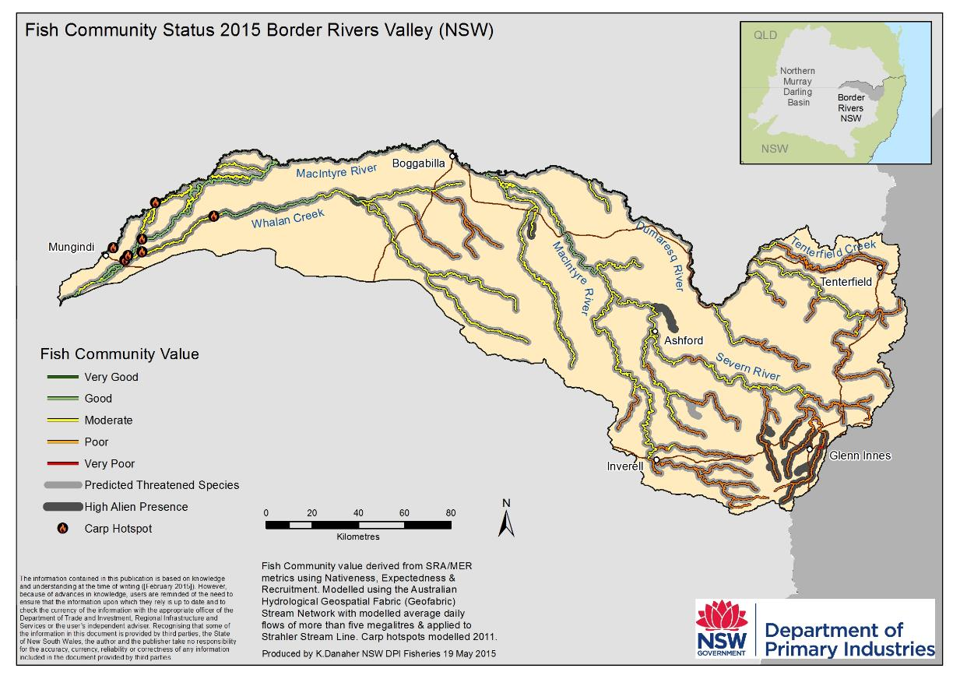
Figure 3: Fish Community Status for the Border Rivers valley, highlighting condition of fish communities, the distribution of threatened species, and the location of Carp hotspots.

Overall, the fish community of the Border Rivers valley is in moderate health, with minimal lowland reaches below poor condition and some part of the valley possessing fish communities in good to very good condition (Figure 3). The valley also contains threatened species distributions, with the predicted range of these species covering the majority of major waterways in the valley (Figure 3). Despite this condition, many factors have contributed to the deterioration of native fish in the Border Rivers, including barriers to fish passage, changes to water flow, degradation of in-stream habitat and riparian vegetation, poor land management, and alien fish species (NSW DPI, 2007); however whilst ever the majority of the fish community of the valley is in a moderate condition, this provides a strong platform for fish recovery, including improving the distribution, abundance and population structure of key species if management actions are developed and implemented appropriately.
Native fish species in the Border Rivers are dominated by Gudgeons (primarily in the montane zone) and Bony Herring, with numbers of Golden Perch, Murray Cod, Spangled Perch, Australian Smelt, Murray–Darling Rainbowfish and Darling River Hardyhead also present (Butcher, 2007; Davies et al. 2012).
Four alien species also occur in the Border Rivers, including Gambusia, Carp, Goldfish and Redfin Perch (Butcher, 2007). Carp is present in the majority of Murray–Darling Basin slopes and lowland rivers and creeks, and some upland streams as well. They are widely distributed in the Macintyre and Dumaresq River systems but are more common in the Macintyre than the Dumaresq River (Butcher, 2007). Gambusia are widely distributed throughout the Macintyre and Dumaresq Rivers but are far more abundant in the Dumaresq River than the Macintyre (Butcher, 2007). Goldfish is also widely distributed and common in both the Macintyre and Dumaresq Rivers, while Redfin Perch has a restricted distribution in headwaters of the Dumaresq and Macintyre Rivers and upper foothill waters during colder months, accounting for the very poor fish community status and high alien presence in these systems (Butcher, 2007; Figure 3). ‘High alien presence’ is also indicated for some parts of the Severn River near Ashford and upland areas around Glen Innes, whilst a small section of Whalan Creek also appears to be an alien species ‘hotspot’ (Figure 3). NSW DPI Carp recruitment hotspot modelling also identifies a small number of hotspots in the upper Barwon River near Mungindi, as well as lowland parts of Whalan Creek (Figure 3). Differences between NSW Fish Community Status mapping of ‘high alien presence’ and Carp hotspot mapping may be accounted for by different methodologies used by the two projects and the presence of other alien species in the NSW Fish Community Status results.
Three species present in the project area, Silver Perch, Murray Cod, and Golden Perch, are known to undertake large-scale migrations, while others make short migrations to spawning sites (Butcher, 2007; Humphries and Walker, 2013). Many of these migrations are believed to be triggered in response to increases in flow, including small pulses (<15 cm) and large freshes (>2m), however other factors including physiological (e.g. sexual maturation), behavioural (e.g. homing), environmental (e.g. weather) and biotic (interactions with other organisms) play an important role (Lucas and Baras, 2000; Mallen-Cooper 2000; Humphries and Walker, 2013). Based on information from other catchments, two of these species (Silver Perch and Golden Perch) are not believed to naturally recruit in the project area, with the populations present believed to be largely stocked or migrants that have moved up from downstream during high flow events.
Golden Perch have been recorded to migrate over large distances in excess of 1,000 km, however only a small proportion of fish undertake such extensive migrations and many return to a ‘home range’ (Reynolds, 1983; O’Connor et al. 2005; Marshall et al 2016). Murray Cod may undertake pre-spawning migration upstream to a spawning area before rapidly returning back downstream often to their home territory (Moffatt and Voller, 2002; Humphries and Walker, 2013). Murray Cod migration in the project area is generally only between pools, moving upstream to a spawning site, with few undertaking large scale migrations (Butler 2018, pers. com). Migration behaviour referred to in Table 3 refers solely to movement in relation to spawning and reproduction and does not consider other movements that some species may make.
The majority of species in the project area appear to have a preference for spawning between late August and November, although, some species will spawn during the winter months. For example, Golden Perch have long been presumed to spawn between October and April; however these species have also been found to have spawned in May in response to heightened water levels in Lake Malta (part of the Menindee Lakes system), with it suggested that increases in latitude may increase the window for spawning (Ebner et al. 2009).
Five species in the project area, Murray Cod, Freshwater Catfish, Purple Spotted Gudgeon, River Blackfish and Carp Gudgeon exhibit nesting behaviour and provide parental care. These species require stable flows during the nesting period which can vary from 2 to 14 days depending on the species (NSW DPI, 2015). River level fluctuations during the nesting period can lead to nest abandonment of the nest and desiccation of the eggs.

Fish functional groups in the Dumaresq River
Native fish in the Murray-Darling Basin have evolved in a highly variable system that is characterised by extreme environmental conditions with diverse wetting and drying cycles (Humphries et al. 1999; Baumgartner et al. 2013). As a result, native fish species of the Murray-Darling Basin have developed a range of spawning and recruitment behaviours, consequently, it is highly unlikely a single flow regime would provide equal benefits for the fish community of a system (Baumgartner et al. 2013; NSW DPI, 2013a). Flows influence fish differently throughout their life history (Figure 4). The exact flow requirements to deliver healthy and robust native fish communities are unknown (Bunn and Arthington, 2002). What can be assumed is that native fish have adapted to cope and thrive with the high level of natural flow variability experienced in the project area and as such the system should be managed to maintain a level of variability.
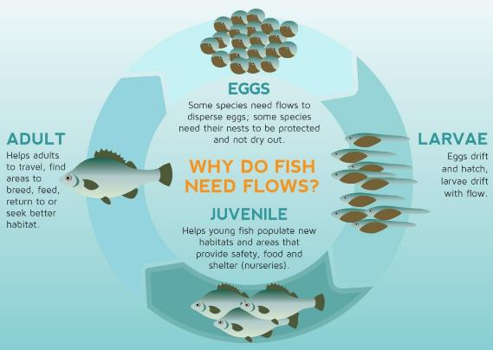
Figure 4: The influence of flows on the different stages within the life-cycle of a fish (adapted from MDBA, 2014).
To enhance native fish outcomes, fish species can be classified into functional groups based on flow related attributes (Baumgartner et al. 2013). This has been recognised as a method for simplifying flow requirements for fish allowing more effective management of environmental flow delivery (Baumgartner et al. 2013; Mallen-Cooper and Zampatti, 2015). During the Northern Basin Fish and Flows project, NSW DPI Fisheries developed four functional groups of native fish (including two sub groups) combining elements of the reproductive spawning-movement and eco-hydraulic guilds (Mallen-Cooper and Zampatti, 2015; NSW DPI, 2015; Ellis et al. 2016; NSW DPI, in prep a). The degree of benefit of an environmental flow depends on the species with the main drivers being the timing, volume and duration of the water delivery (Baumgartner et al. 2013). Taking into account the environmental water requirements of a functional group allows flows to be developed that target specific groups of species with similar flow requirements.
The functional groups identified for species in the Dumaresq River were adapted from the Northern Basin Fish and Flows report (Table 3). Some species may be grouped differently in other parts of their range. For example, Purple Spotted Gudgeon is grouped as a Flow Independent In-channel Specialist due to their habitat preferences in the Northern Murray Darling Basin (MDB), while they would be considered Floodplain Specialists (Functional Group 3) in the Southern MDB due to their preference for floodplain wetlands.
These functional groups were established in consultation with experts to assist in the development of specific long-term environmental watering requirements and flow related management actions (NSW DPI, 2015; NSW DPI, in prep a). The elements considered in development of these groups in the Northern Basin Fish and Flows project (NSW DPI, 2015) included:
- Cues for migration (dispersal and recolonization) and spawning (temperature and/or flow).
- Spatial scales of spawning and dispersal movements (10’s – 100’s of m; 100’s of m – 10’s of km; 10’s – 100’s of km).
- Reproductive mode and fecundity (e.g. broadcast spawning, nesting species, adhesive eggs).
- Spawning habitats in still/slow-flowing water or in fast-flowing habitats.
- Egg hatch time (short 1 – 3 days; medium 3 – 10 days; long > 10 days) and egg morphology.
- Scale of larval drift and recruitment.
Knowledge gaps need to be acknowledged when using the guild approach with assumptions and limitations considered when using this information, as well as noting that the fish functional groups should be reviewed and revised as needed when new information becomes available.

Table 3: Fish guild groupings for species in the Border Rivers valley (adapted from NSW DPI, 2015).
Functional Group | Species | Attributes and implications for flow management
Group 1: Flow-dependent specialists | Golden Perch  Silver Perch  Spangled Perch | - Flow pulses are needed to generate a spawning response.  - Adult fish prepare for spawning in response to increasing water temperatures usually between spring and autumn, with research in the Northern Basin suggesting that the first post-winter flow pulse may be important for pre-spawning condition and migration in some northern systems (Marshall, et al. 2016), but timing is not predictable, with otoliths from Golden Perch captured in Menindee showing recruitment from a winter spawning event (Ebner et al. 2009).  - Adult fish can undertake moderate to large scale migrations (100s of m to over 1000 km) in response to increased flows and temperature but can delay spawning if conditions are not suitable, with species being medium to long-lived and not necessarily requiring annual spawning and recruitment events.  - Flow events do not have to be large pulses, with small, sharp rises in flow (as little as <15 cm) also providing benefits and eliciting responses from species; however movement responses may be grater with larger (>2m) increases in flow (Marshall et al. 2016).  - Eggs are either buoyant and pelagic or non-sticky and demersal with a short hatch time of up to 5 days, relying on flows for dispersal.  - Larvae drift downstream over long distances for up to 20 days post spawning in perennial and intermittent systems (potentially shorter in highly intermittent systems with smaller flow pulses), with recruitment relying on flows for dispersal and conditioning.
Group 2:  In-channel specialists  (Group 2A: Flow-dependent)  (Group 2B: Flow-independent) | Murray Cod (2A)  River Blackfish (2B)  Freshwater Catfish (2B)  Purple Spotted Gudgeon (2B) | - Adult fish are believed to prepare for spawning in response to increasing water temperature however other favourable conditions may trigger spawning events.  - Group 2A adult fish can undertake short to large scale migrations (10s of metres to 100s of kilometres) for spawning.  - Group 2B species can undertake short to moderate scale migrations (10s of metres to 10s of kilometres) for spawning.  - Group 2A species have a predictable spawning period from mid-winter to the end of spring, involving movement to increasing temperature and flow. Species are long-lived and don’t necessarily require annual spawning and recruitment events, but may take many years for noticeable population improvements due to low fecundity.  - Group 2B species have a spawning period from spring to autumn, but most commonly between spring and summer, which is independent of flow. Species are medium to long-lived and don’t necessarily require annual spawning and recruitment events, but may take many years for noticeable population improvements due to low fecundity.  - Nesting species, or have specific spawning substrate requirements (Purple Spotted Gudgeon), with increases in flow helping to maximise breeding opportunities by inundating additional spawning habitat.  - Eggs are demersal with a relatively long hatch time of up to 14 days, requiring stable flow events during this period to avoid nest abandonment, desiccation or premature dispersal.  - These species may have active or passive larval drift over short to moderate scales for up to 10 days, with recruitment generally relying on flows for dispersal and conditioning.
Group 3: Floodplain specialists | Olive Perchlet | - Adult fish are believed to prepare for spawning in response to increasing water temperature however other favourable conditions may trigger spawning events.  - Adult fish undertake short scale migrations (10s of metres to 100s of metres) for spawning, potentially to off-channel habitats, where spawning takes place in still or slow moving environments.  - Relatively short-lived and have low fecundities, requiring regular spawning and recruitment events, with spawning between spring and autumn.  - Have specific spawning substrate requirements (aquatic macrophytes), with increases in flow helping to maximise breeding opportunities by inundating additional spawning habitat, especially off-channel, which may also be reliant on water clarity (low turbidity).  - Eggs are sticky and demersal, with an estimated hatch time of up to 9 days.  - Recruitment and dispersal rely critically on flows that reconnect the channel to the nursery habitat including floodplain areas, with large flow events required post spawning.
Group 4: Generalists | Australian Smelt  Bony Herring  Carp Cudgeon  Murray-Darling Rainbowfish  Unspecked Hardyhead  Darling River Hardyhead  Mountain Galaxias | - These species are generally more resilient to extended low flow conditions having developed more flexible spawning strategies, and as such may be poor indicators of environmental flow effectiveness (MDBA, 2015); however these species provide an important component of productivity in a system and food source for medium and large bodied species.  - Adult fish are believed to prepare for spawning in response to increasing water temperature.  - Adult fish move short distances (10s of metres to 100s of metres) over a wide range of hydrological conditions and are known to recruit under low flows all year round; however spawning is most common between spring and summer. Species are short to medium-lived requiring regular spawning and recruitment events but may take many years for noticeable population improvements due to low fecundity.  - These species may spawn more than once during the year, with low to moderate flow events that inundate in-channel habitat, enhancing spawning conditions, providing the greatest benefits to these species.  - Eggs are sticky and demersal with a hatch time of up to 10 days.  - Larval drift is exhibited by the majority of species (except Carp Gudgeon and Unspecked Hardyhead) over short to moderate scales, with the recruitment of these species reliant on flows for dispersal and conditioning.

Methodology

Habitat mapping
Habitat mapping was undertaken by NSW DPI staff and used methods developed and implemented for similar projects in the Macquarie River (Industry and Investment, 2010), Horton River (NSW DPI, 2013b), Little River systems (NSW DPI, 2014), Barwon-Darling Rivers (NSW DPI, 2015), Lachlan River (NSW DPI, 2016) and Cudgegong River (NSW DPI, in prep b).
Project staff completed two field trips to collect the project data between 27/04 - 01/05/2017 and 15-19/6/2017. Flow heights during the first week varied from 0.899 cm (532 ML/day) to 0.938 cm (702 ML/day) (Figure 5). Flow height variability is accounted for by calculating the daily flow height above no flow at the nearest gauge, with a commence to inundate height determined for individual habitat features (i.e. LWH, benches, wetland entry exit, etc.). See page 21 for more information.
Where necessary, landholder permission was obtained to travel through and leave vehicles parked on their properties to access the river at the daily start and finish points. Subsequent opportunistic landholder liaison occurred by mapping staff as fieldwork progressed through the study area.

Figure 5: Flow plot analysis of the Dumaresq River during field work component.
Two methods of field data collection were used:
• GPS-equipped GIS interface for features above the water surface.
• GPS-equipped side-scanning sonar for submerged features (i.e. LWH and refuge pools).
These two data compilation devices enabled the collection of all information necessary to record habitat features and their condition in both aquatic and riparian areas along the Dumaresq River corridor in the project area. Two ‘Trimble Nomad’ Personal Digital Assistants (PDA) with GPS and GIS interface software, were used to record all relevant features visible above the water surface using the three spatial feature classes of point, line and polygon (Table 4).
To improve data collection efficiencies and standards, unique scripting codes were written by NSW DPI technicians to provide prescribed data entry drop-down menus specific to project requirements. This enabled all essential attributes for each recorded feature to be entered into the spatial database at the time of data collection.
Table 4: Typical features recorded on PDAs during habitat mapping.
Point Features | Line Features | Polygon Features
LWH - alignment, complexity, width, length, height  Bank overhangs and rootballs – height | Fence lines | Exotic riparian vegetation – type and extent
Pumpsites: pipe diameter |  | Aquatic vegetation – type and extent
Wetland/ Anabranch: height of entry/exit points |  | Erosion
Barrier to fish passage- barrier type, headloss |  | Stock management
Substrate type and extent  General points of interest (e.g. boat launch sites, recreation) |  | Instream features– benches with height; refuge habitat with extent and depth; riffles
Data collected using the side-scanning sonar was converted into georectified imagery and imported into ArcMap to identify additional submerged LWH (Figure 6). This data also includes water depth and temperature, boat speed and direction.
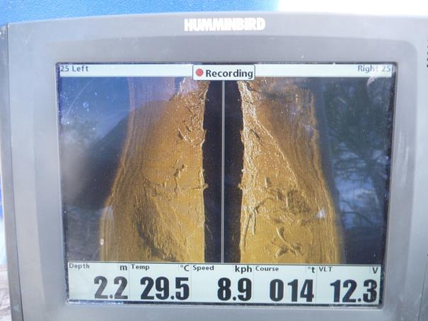
Figure 6: Side-scanning sonar recording of instream habitat features.
The converted data was overlayed in the project GIS and used to identify the presence and alignment of LWH as well as determine complexity, width and length (Figure 7).
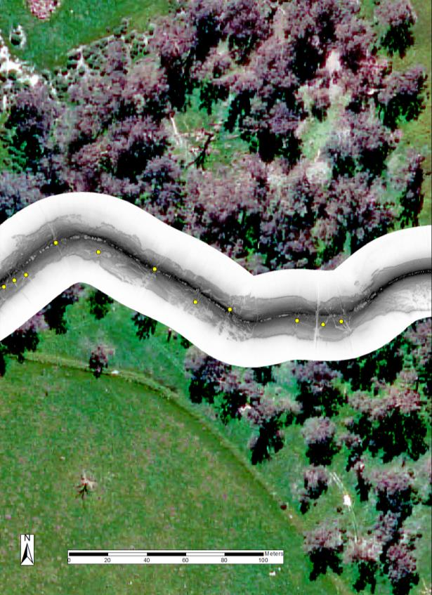
Legend
LWH
Figure 7: Example of georeferenced sonar data superimposed on aerial imagery with LWH distinguished by yellow points.

There is an ecological basis for differentiating LWH based on size and complexity (Boys, 2007). More complex LWH provide greater protection to aquatic fauna from predators and flow, are more useful as breeding sites and have a greater influence on the creation and maintenance of refuge habitat (Boys pers. comm. 2017; Figure 8).
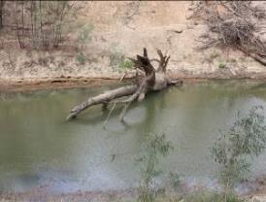
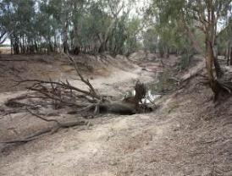
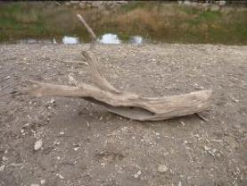
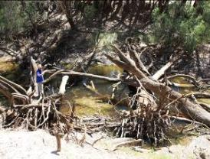
Grade 3: Woody habitat stand – one or more trunks with multiple branchings
Grade 1: Woody habitat stand - single trunk or branch
Grade 2: Woody habitat stand – trunk or branch with one or two branchings.
Grade 4: Woody habitat stand – highly complex complete tree with multiple branchings, or accumulation of separate branchings

Figure 8: Structural complexity classes used to describe LWH during field work.

Refugia
Pools that may act as refuge during dry conditions were recorded in the field by observing the outputs on the boat mounted sonar unit and recording the location and depth. This was then verified using GIS, flow data and sonar records to check the bed depth up and downstream of a potential refuge pool site. This process removed any errors that were encountered from the increased depth during high flow periods, allowing the variable flow conditions encountered during the assessment to be considered in the refuge identification process.

Flow gauging zones
Features were separated into Flow Gauging Zones (FGZs) according to the nearest gauging station. Due to data deficiency for some gauges, only two were used to develop the FGZs. Figure 9 shows the FGZ boundaries, highlighting the large distance covered by both the Dumaresq @ Roseneath (416011) and Dumaresq @ Glenarbon Weir (416040) gauges.

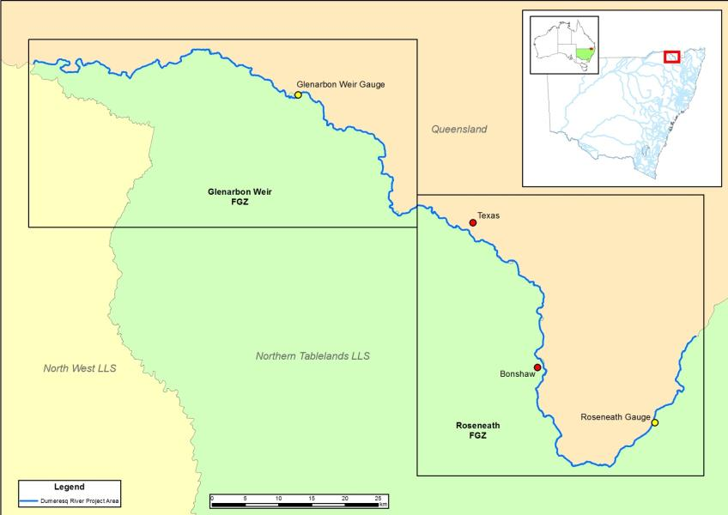
Figure 9: Flow gauging zone boundaries in the project area.

Flow relationships
To determine the inundation dynamics of LWH, rootballs, bank overhangs, benches and connected wetlands in the study area, the commence-to-inundate height (CTIh) was recorded during the habitat mapping component using methods established by Boys (2007) and Southwell (2008) (Figure 10).
The method involved the use of a Haglof Vertex Laser VL400 hypsometer, which uses ultrasonic signals to obtain the range of the habitat feature from the instrument (r) and combines this with the angle of measurement obtained from a tilt sensor (a) to trigonometrically calculate the height of the feature above the instrument eye level (h₁), taking into consideration the height of the instrument above water level (o) to determine the height above water level (h₂).
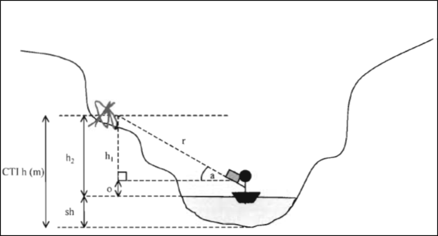
Figure 10: Schematic of methods used to calculate CTI heights of key habitat features along the Dumaresq River.
LWH were recorded at the discretion of the observer, taking into account the geomorphology and knowledge of flow levels through the section of river; if a LWH was deemed too high to be inundated it was not recorded. The stage height (sh) of the river on the day of mapping was obtained from the relevant NSW gauging stations. The inundation height was then turned into an inundation level by using the known height/discharge curve for the nearest gauging station (Southwell, 2008).
It should be noted that due to the large distances encompassed in each of the FGZ, there is likely to be a decrease in confidence of accuracy in the inundation volume that is proportional to the distance from the relevant flow gauging station. Another potentially impacting factor on calculating inundation volumes is the presence of weir pools of varying extents in each FGZ, which may influence results due to persistently elevated water levels.
The flow gauge at Bonshaw was not used in developing FGZs due to the large width of Bonshaw Weir compared to the channel width through the remainder of the project area (i.e. the width of the structure has a negative influence on the flow height/volume relationship).

Habitat mapping results

Riparian vegetation condition
Riparian vegetation plays a key role in determining instream conditions with far reaching impacts on light penetration, water temperature and quality as well as habitat and food availability (Zalewski et al. 2001). Riparian vegetation also helps to buffer streams from catchment processes (Humphries and Walker, 2013), with abundance of fish often associated with overhanging vegetation cover (Koehn, 2009). The presence of gaps in riparian vegetation has the potential to greatly impact fish populations with the loss of these processes and functions.
Based on the parameters used for the rapid appraisal of riparian condition method, gaps greater than 50 m in length were recorded. A total of 87 gaps greater than 50 m in length of missing native riparian vegetation were recorded. There were 69 gaps recorded in the Roseneath FGZ and 18 in Glenarbon FGZ. Two gaps exceeded 250 m and several were 200 m to 150 m. In total 137 gaps (including those less than 50 m) have been recorded totalling a distance of 6.85 km of 'naked' river bank. This equates to 1.77% of the total riverbank in the project area.

Exotic plant species
Exotic plant species compete with native vegetation, substantially changing the composition of riparian dynamics, impacting instream conditions and the fish communities present (NSW DPI, 2017a). Infestations of exotic plant species were noted throughout the project area and covered a total area of 46.98 ha or 6.09% (Table 5). Cat’s claw creeper covered the greatest area of all exotic plant species with 19.94 ha recorded across 244 locations. Willow (including crack and weeping) had the second highest coverage with 10.98 ha across 618 locations. No exotic aquatic plants were recorded during the fieldwork.

Table 5: List of exotic plant species recorded in the project area.
Common name | Scientific name
​African boxthorn | Lycium ferocissimum
Banana passionfruit | Passiflora spp.
Balloon vine | Cardiospermum spp.
Bramble | Rubus fruticosus
Canegrass | Arundo donax
Castor oil plant | Ricinus communis
Cats claw creeper | Macfadyena unguis-cati
Citrus | Rue spp.
Elm | Ulmaceae spp.
Grapevine | Vitis spp.
Green cestrum | Cestrum parqui
Honey locust | Gleditsisa triacanthos
Mesquite | Prosopis spp.
Mulberry | Moraceae spp.
Opuntia spp. | Opuntia spp.
Ossage orange | Maclura pomifera
Palmtree | Arecaceae spp.
Passionfruit | Passiflora edulis
Paulownia spp. | Paulownia spp.
Pecan | Carya illinoinensis
Peppertree | Schinus spp.
Prickly pear | Opuntia stricta
Purple trumpet creeper | Campsis radicans
Tree of heaven | Ailanthus altissima
Walnut | Juglan spp.
Wandering dew | Tradescantia fluminensis
White cedar | Melia azedarach
Willow - crack | Salix fragilis
Willow - weeping | Salix babylonica

Aquatic habitat

Large Woody Habitat
LWH is a major ecological and structural element of waterways, providing hiding and resting places for fish out the main flow of the river, and spawning sites and territorial markers for several native fish species (O'Connor, 1992; Lake, 1995; Crook and Robertson, 1999; NSW DPI, 2007; Koehn and Nichol, 2014). LWH also assist in developing scour pools and prevent erosion through bank stabilisation (Gippel, 1995; Brooks et al. 2004; NSW DPI, 2007). As instream wood breaks down it also provides food for benthic algae, invertebrates and microorganisms that form a large part of the food web for fish species (Treadwell, 1999; NSW DPI, 2007).
In the 193 km reach of the Dumaresq River 3,976 LWH were recorded, with an average loading of 20.62 LWH/km. The Roseneath FGZ had 1,489 LWH, while 2,487 were recorded in the Glenarbon FGZ. At zero flow, the availability of woody habitat was 2,651 with an average loading of 13.75 LWH/km.
Most of the LWH recorded were simple complexity grade 1 and 2, with only a small amount being more complex grade 3 and 4, indicating that there is still room for improvement to maximise the benefits LWH provides in the system (Table 6 and Table 7).
Table 6: Number and percentage of each LWH complexity group in the Roseneath FGZ.
Complexity | Number | Percentage (%)
1 | 715 | 48.01
2 | 687 | 46.14
3 | 84 | 5.64
4 | 3 | 0.002
Table 7: Number and percentage of each LWH complexity group in the Glenarbon FGZ.
Complexity | Number | Percentage (%)
1 | 1172 | 47.13
2 | 1178 | 47.37
3 | 134 | 5.39
4 | 3 | 0.0012

Rootballs and bank overhangs
Similar to LWH, rootballs provide important habitat to a range of terrestrial and aquatic species. Bank overhangs provide important cover and have been found to be used by Murray Cod as breeding sites in the project area (Gavin Butler pers comm; Figure 11 and Figure 12). Rootballs were relatively evenly spread along the project area, while undercuts were more prolific in the upper section of the project area and are possibly associated with the upland river form (Figure 13). There were a total of 509 rootballs and 173 bank overhangs recordings for this habitat feature, with the Roseneath FGZ having 169 rootballs and 82 overhangs, while 340 rootballs and 91 bank overhangs were recorded in the Glenarbon FGZ.
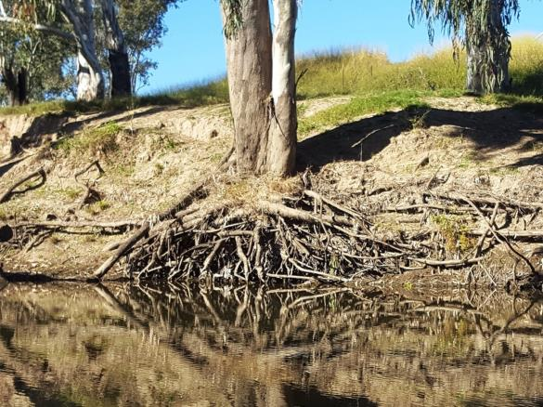
Figure 11: Example of rootball habitat recorded in the project area.
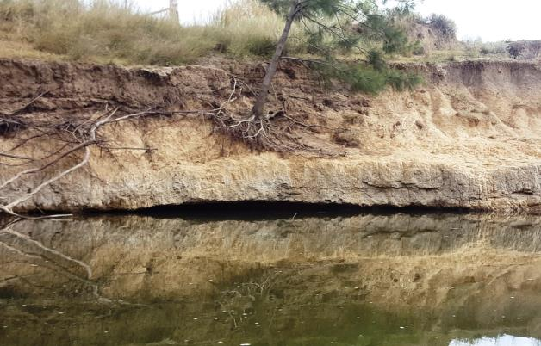
Figure 12: Example of a bank overhang recorded in the project area.

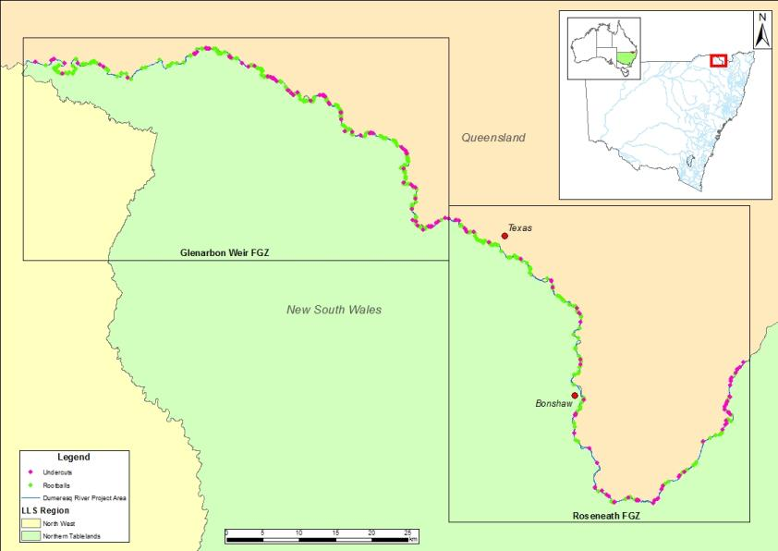
Figure 13: Location of rootballs and bank overhangs recorded in the project area.

Refugia
For the Dumaresq habitat mapping project, refugia were defined as areas of water greater than 3 m in depth during low flow conditions. There were 83 potential drought refuge sites recorded across the project area ranging from 7.5 m deep to 3 m. The average depth recorded for drought refugia was 3.72 m. The locations of drought refugia were distributed across the project area, with several areas of higher density especially in the lower 20 km of the project area (Figure 14).
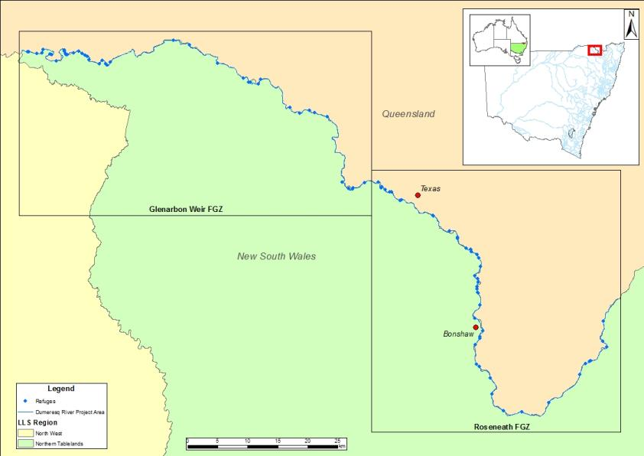
Figure 14: Location of refuge pools recorded in the project area.

Benches
Benches are identified as areas of relatively flat sections within the main channel that play an important function in the aquatic environment by enhancing the diversity of habitat and contributing to productivity processes (NSW DPI, 2015; Figure 15). They are an actively accreting fine-grained bank attached feature within the river channel that influence flow and provide variation in water depth (Vietz et al. 2007). Benches play an important role in riverine ecology providing areas of varying levels that facilitate the accumulation of debris, sediment and nutrients, allowing the cycling of carbon, nutrients and food in the system (Southwell, 2008; Foster and Cooke, 2011).
There were 1,355 benches recorded in the project area covering a total of 258.93 ha. Benches were relatively evenly spread across the project area (Figure 16), with bench area in the Roseneath FGZ totalling 173.1 ha, while Glenarbon FGZ had a total bench area of 85.9 ha. Benches varied in height with lower benches generally more dynamic than higher benches consisting of relatively unconsolidated cobbles and gravel with sparse vegetation growth consisting of juncus/ sedge, ground covers, bottle brush and casuarinas regeneration. Many lower benches were bare in places or only had vegetation showing signs of inundation from fast flowing water. Due to their lower rates of inundation higher benches were more consolidated with deposited silt and sand held together by dense groundcover and substantial bottle brush and casuarina.
Pool riffle sequences were often associated with large benches. Large benches were often recorded at the end of long pools with a constricted channel skirting the bench with the channel forming swift flowing riffles and runs before opening into another pool (Figure 17).
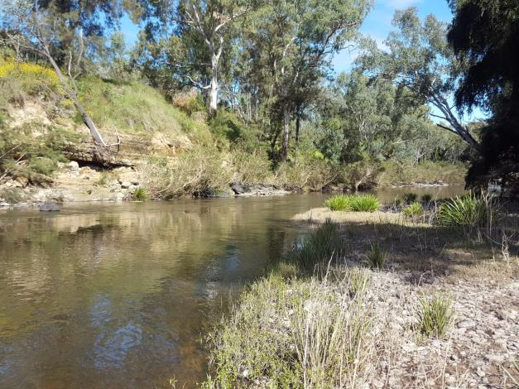
Figure 15: Example of a low lying bench recorded in the project area.

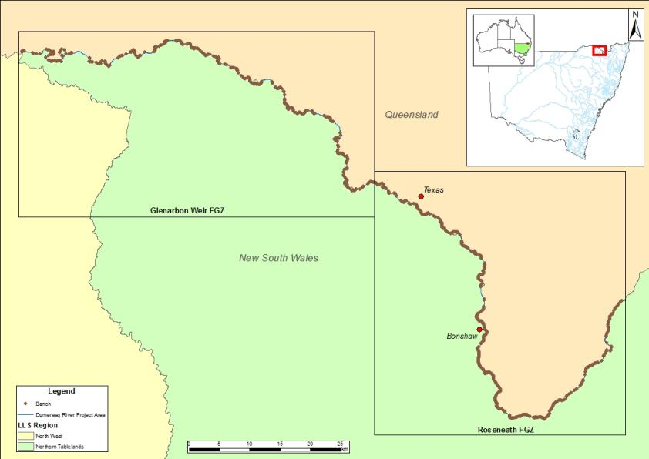
Figure 16: Location of benches recorded in the project area.

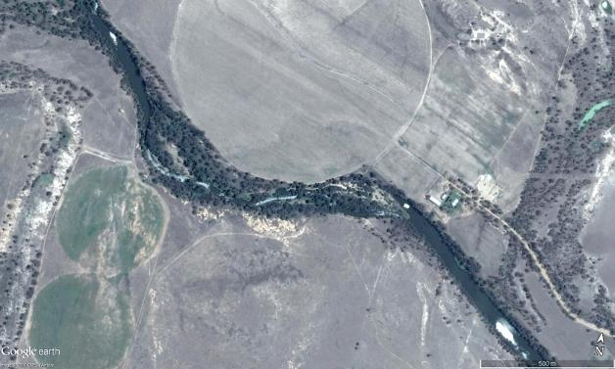
Figure 17: Aerial image from the project area showing an example of a large pool leading to a large bench with skirting riffles and runs that were often recorded during the project.

Connected wetlands
Floodplain wetlands provide critical aquatic and riparian habitat for flood-reliant and flood tolerant flora and fauna, including important freshwater fish species such as Olive Perchlet, Silver Perch and Golden Perch (Rogers and Ralph, 2010; Saintilan and Overton, 2010). Wetland areas and associated smaller systems provide many imperative ecosystem functions, including filtering sediments, releasing nutrients and providing important breeding and nursery habitats for native fish (Beesley et al. 2012; Górski et al. 2013). Rolls and Wilson (2010) consistently found young of year Golden Perch and Bony Bream in floodplain wetlands, suggesting that they may be used as nursery habitats by Flow Dependent Specialists (Functional Group 1) and Generalists (Functional Group 4) species. Many connected wetlands in the project area have reduced inundation frequency since river regulation and hence the benefits to fish and the critical ecological role they play may have been diminished.
There were a total of 227 wetland entry points recorded in the project area, including 132 in the Roseneath FGZ and 95 in the Glenarbon FGZ. While relatively well spread across the project area, wetland entry points (Figure 18) appear to be more dense in some areas (Figure 19). This is likely associated with surrounding topography, with flatter areas providing lower banks for the river to exit the main channel.
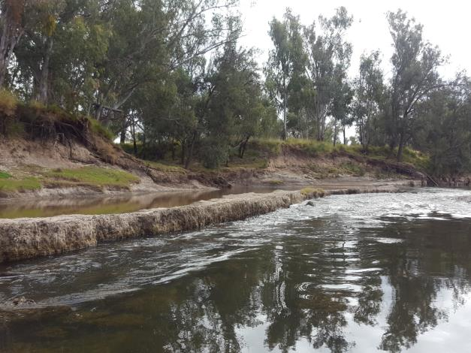
Figure 18: Example of a wetland entry point recorded in the project area.

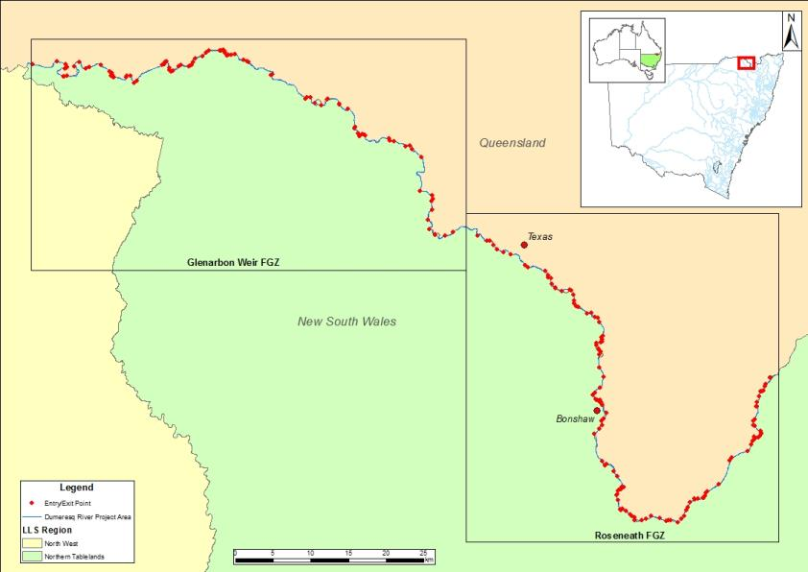
Figure 19: Location of connected wetland entry points recorded in the project area.

Aquatic macrophytes
Macrophytes provide physical structure used by freshwater fish for shelter, refuge and as nesting and spawning sites (Petr, 2000; Thomaz and Cunha, 2010). Macrophytes also provide a direct and indirect food source, such as rich foraging microhabitats, as they are inhabited by numerous species of macro-invertebrates (Delariva et al. 1994; Petr, 2000; Casatti et al. 2003). One threatened species, Purple Spotted Gudgeon, is commonly associated with submerged macrophytes and the loss of these habitats is believed to be a contributing factor to the decline of the species in NSW (NSW DPI, 2017b).
Examples of submerged and emergent macrophytes recorded during field work can be seen in Figure 20. Macrophytes were recorded in both reaches to varying extents. Aquatic macrophytes covered a total area of 30.62 ha. Macrophytes were generally evenly spread across the project area with few noticeable gaps, with the Roseneath FGZ having 15.13 ha, while 15.48 ha were recorded in the Glenarbon FGZ (Figure 21). Various species of aquatic macrophytes were recorded, including emergent, floating attached and submerged. Phragmites was the dominant aquatic macrophyte species in the project area covering 16.75 ha.
The following macrophyte species were recorded in the project area:
- Water milfoil (Myriophyllum salsugineum)
- Water primrose (Ludwigia peploides ssp. Montevidensis)
- Clasped pondweed (Potamogeton perfoliatus)
- Cumbungi (Typha spp.)
- Curly pondweed (Potamogeton crispus)
- Phragmites (Phragmites australis)
- Juncus/sedge (Juncus spp., Bolboshoenus spp.)
- Ribbon weed (Vallesneria americana)
- Water speedwell (Veronica anagallis-aquatica)

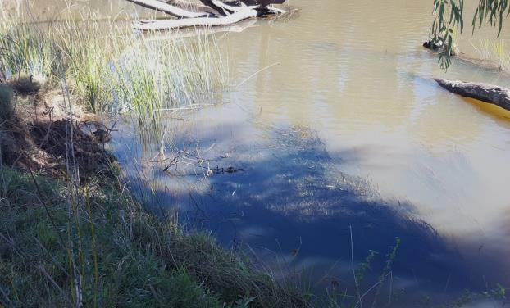
Figure 20: An example of submerged (ribbon weed) and emergent (juncus/sedge) macrophytes recorded in the project area.

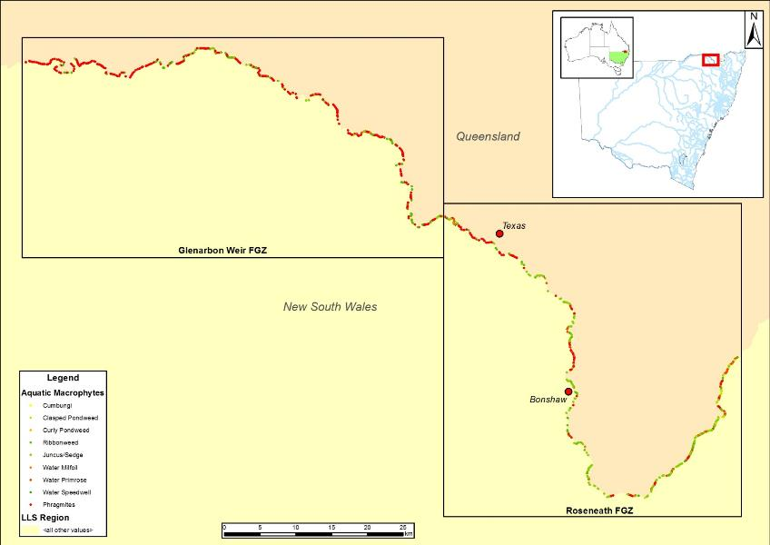
Figure 21: Location of macrophytes that were recorded in the project area.

Cobble beds
Boulders, rocks and cobbles provide habitats and spawning sites for a number of freshwater fish species (Humphries and Walker, 2013). In the project area, cobble beds are of particular value as they provide the endangered Freshwater Catfish (Murray-Darling Basin population) with material for constructing nests, where they lay and guard their eggs (Dyer et al. 2002). In the project area, cobble beds were commonly associated with riffles and benches.
Figure 22 shows a cobble bed that is partially submerged, with higher flows this cobble bed could be utilised by Freshwater Catfish to build nest. Cobble beds were generally evenly spread across the project area, with a particularly dense concentration associated with a split in the river downstream of Texas, with the Roseneath FGZ having 55 cobble bed sites and the Glenarbon FGZ containing 42 sites (Figure 23).
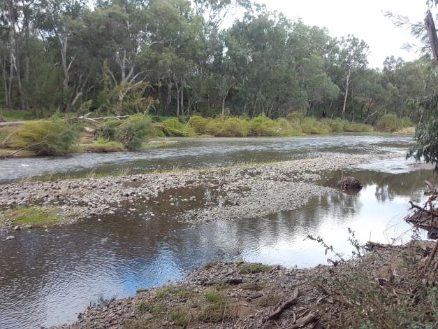
Figure 22: Example of a partially submerged cobble bed near Roseneath.

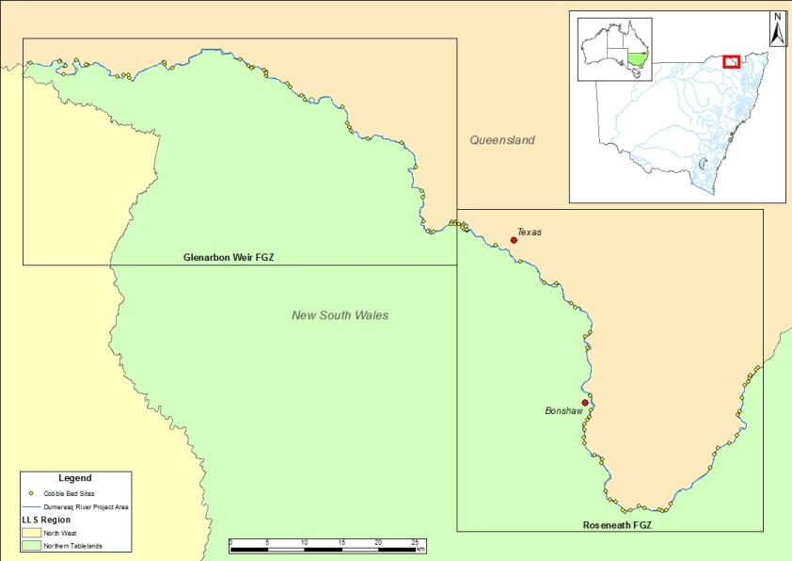
Figure 23: Location of Cobble beds recorded in the project area.

Fish passage
Australian native fish have evolved to be reliant on a variety of habitat types to complete their life cycle. One of these habitat requirements is the need to move both short and long distances between varying aquatic environments (Thorncraft and Harris, 2000; Fairfull and Witheridge, 2003; Barrett, 2008). While fish migrations are commonly associated with breeding events, other reasons for native fish species needing to disperse include the search for food, shelter, avoidance of predation and competition pressures (Humphries and Walker, 2013). Unfortunately, riverine connectivity has been severely disrupted within Australia by the creation of instream barriers to fish that limit habitat and resource availability and diminish the opportunities for species to adapt to changing environmental conditions (Pethebridge et al. 1998).
The installation and operation of instream structures and the alteration of natural flow regimes have been recognised as a Key Threatening Process under the FM Act 1994 and the Threatened Species Conservation Act 1995. The following information for the barriers recorded in the project area has been adapted from NSW DPI (2006). One threatened species in the project area, Silver Perch, can undergo significant migrations and the presence of barriers has been listed as a cause of their decline (Fisheries Scientific Committee, 2000). Another factor associated with such structures is the presence of weir pools, which has been suggested by the Fisheries Scientific Committee (2000) to contribute to egg mortality for the species with the reduction of water movement.
Three barriers were recorded in the project area isolating fish populations between them (Figure 24). In some cases it is possible to deliver water to ‘drown-out’ barriers and provide passage, however due to the size of the structures in the project area and the limited capacity to deliver water it is not possible for the three recorded. Remediation of these barriers would provide access to 200 km of habitat, excluding tributaries (NSW DPI, 2006).

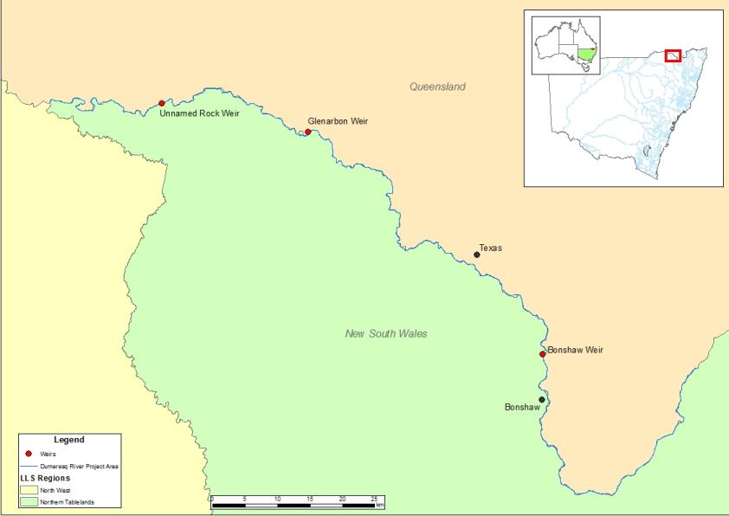
Bonshaw Weir
19,300 ML/day drown out
Cunningham Weir 44,500 ML/day drown out
Glenarbon Weir
26, 200 ML/day drown out
Figure 24: Fish passage barriers recorded in the project area.

Bonshaw Weir is a fixed crest, steel sheet piling structure, backfilled with concrete, spanning 65 m. The structure is 4 m high, with a 2.5 m headloss. The structure pools water 5 km upstream with a total storage capacity of 617 ML. The weir is a barrier to fish passage at flows less than 19,300 ML/day or 99.05% of the time (Figure 25). There is approximately 66km of unimpeded fish habitat upstream. Bonshaw Weir is considered a high priority for remediation (NSW DPI, 2006). The weir still performs its original irrigation purposes and is used for recreational activities (NSW DPI, 2006).
Cunningham Weir is a fixed crest, stepped timber crib constructed with a variety of materials including timber and metal sheeting spanning 48 m. The structure is 4.4 m high, with a 3 m headloss. There is approximately 59 km of unimpeded fish passage upstream to Bonshaw Weir. The structure pools water 6 km upstream with a total storage capacity of 520 ML. The weir is a barrier at flows less than 44,500 ML/day or 99.8% of the time (Figure 25). The weir is considered a high priority for remediation, and was formally decommissioned in 1987 (NSW DPI, 2006).
Glenarbon Weir is a fixed crest, steel sheet piling structure that is backfilled with concrete, spanning 60 m. The structure is 2 m high, with a 2 m headloss. The structure pools water 4 km upstream with a full capacity of 353 ML. There is approximately 11 km of unimpeded habitat upstream of the weir to Cunningham Weir. The weir has an ineffective pool type fishway, and is a barrier at flows less than 26,200 ML/day or 99.6% of the time (Figure 25). Glenarbon Weir is considered a high priority for remediation (NSW DPI, 2006). The weir still performs its original irrigation purposes and is used for recreational activities (NSW DPI, 2006).
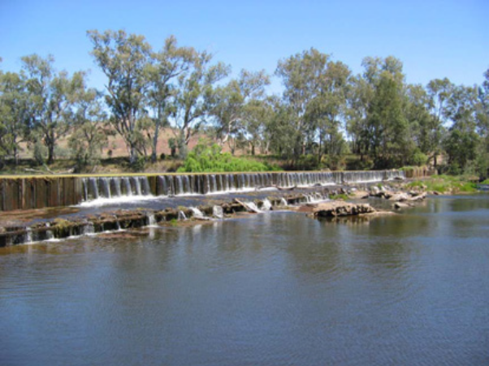
Bonshaw Weir
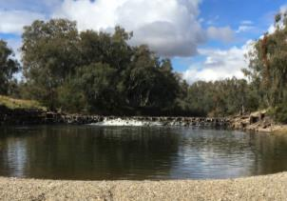
Cunningham Weir
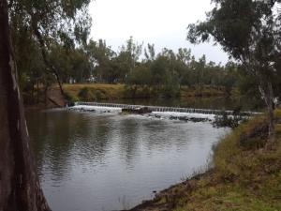
Glenarbon Weir
Figure 25: Fish passage barriers in the project area and flows in the Dumaresq River during the last 20 years. The green dotted line highlights the drown out value for each weirs, indicating when fish passage would have been available (Bonshaw Weir Photo credit NSW DPI, 2006).
Thermal pollution (also called cold water pollution) refers to an artificial lowering of the temperature in a water body. Cold water pollution is caused by cold water being released into rivers from large dams during warmer months. The release of water from deep below the surface of large dams causes significant disturbance to water temperature regimes in downstream river channels with consequent impacts upon aquatic biota and river health (Lugg and Copeland, 2014). Cold water primarily impacts the life-cycles of fish in four ways: changes the range and distribution of species; reduces the opportunity for effective reproduction; reduces body growth and condition, and; reduces recruitment success. Between spring and autumn, the water stored in large dams can form two layers: a warm surface layer overlying a cold bottom layer (Figure 26), with water temperatures adjacent to dam outlets up to 13ºC lower than natural inflows (Lugg, 1999; Sherman, 2000).
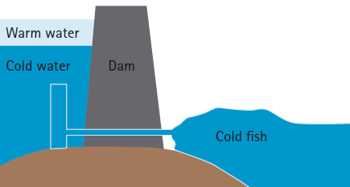
Figure 26: Cold water pollution occurs through drawing of water from the bottom of large storages (NSW DPI, 2005).
Thermal pollution has the potential to greatly reduce the positive outcomes of water for the environment completely negating some of the goals that are trying to be achieved with specific environmental watering events including providing cues for spawning events. Cold water pollution is estimated to impact more than 2,700 km of river length in the MDB, with the extent of cold water pollution from Glenlyon Dam estimated to be 183 km, impacting the length of the Dumaresq River from Pike Creek to the junction with the Macintyre River (Lugg and Copeland, 2014).

Flow relationship results
The use of functional groups of freshwater fish in the Basin and detailed habitat mapping information can assist with managing water for the environment to deliver native fish benefits and develop specific Environmental Water Requirements (EWRs). When developing EWRs there are a number of basic principles related to the biological and ecological criteria for native fish and inland waterways that need to be considered:
- Natural flow regime - one of the important principles considered in the development of conceptual flow models for fish in the Basin is that the natural flow regime provides a strong foundation for the rehabilitation of flows; however the impacts of river regulation, including connectivity, access to habitat, and changes to geomorphology, need to be considered and incorporated into specific planning objectives (Mallen-Cooper and Zampatti, 2015).
- Water quality parameters - the importance of water quality, not just water quantity, also needs to be considered when developing and delivering water requirements, with water temperature driving life history responses from the majority of native species, whilst clarity, dissolved oxygen and productivity (related to chemical, nutrient and plankton composition) also play an important role in maximising benefits to species (Jenkins and Boulton, 2003; Górski et al. 2013; Zampatti and Leigh, 2013; Mallen-Cooper and Zampatti, 2015). The influence of water quality parameters on guiding flows for fish will result in management actions primarily occurring in the warmer spring and summer months; however the importance of replenishing critical refugia, supporting base flows all year round and late-winter high flow events still need to be considered given their benefits to water quality maintenance and productivity (Robertson et al. 2001).
- Fundamental riverine elements – the influence of flow, habitat and connectivity on the dynamics and response of fish populations are inseparable and need to be intimately considered in flow management decisions and actions (Mallen-Cooper and Zampatti, 2015). These three key factors will influence the need for still water or flowing environments, the spatial scale that connectivity and hydraulic complexity needs to be maintained, and the variation in flow needed for habitat access and completion of life history aspects (Mallen-Cooper and Zampatti, 2015). Consideration has been given to determining appropriate flow-height and flow-velocity relationships in the Dumaresq River that account for connectivity and hydraulic requirements of native fish using the overarching principles below to guide the identification of flow rates:
- Minimum depth for small bodied and moderate bodied fish movement is 0.3m above Cease to Flow (Gippel 2013; O’Connor et al 2015)
- Minimum depth for large bodied fish movement is 0.5m above Cease to Flow (Fairfull and Witheridge 2003; Gippel 2013; O’Connor et al 2015)
- Optimal transition of small fresh to large fresh events for the flow specialist spawning and movement response is 2m above Cease to Flow and/or velocity greater than or equal to 0.3-0.4m/s (Mallen-Cooper and Zampatti 2015; Marshall et al 2016).
Thresholds for each flow component (cease to flow, base flow, small pulse, large pulse, bankfull and overbank) were determined using data from NSW DPI Water gauges. It should be noted that the thresholds developed for flow components have been developed using these guiding principles and best available information, and may be further refined as part of future hydrological analysis; however for the purpose of this project they have been adopted to investigate the habitat inundation relationships for each flow component, noting that given the large range of flow rates for the large pulse component two large pulse thresholds have been developed to help guide held environmental water management actions. Using this information, flow relationships were assessed for LWH, rootballs, bank overhangs, benches and entry points to connected wetlands. The height recorded for each feature was used to calculate the inundation level in megalitres per day (ML/day). Cumulative frequency was calculated for each feature type for each FGZ.

Summary of project area flow components
Differing flow events may be separated into several ecologically significant components with each of these providing a diverse range of ecosystem services (Figure 27; Table 8). To provide water managers with a greater understanding of what specific flows may achieve in the project area, detailed flow/height relationships were determined (
Table 9 &10). Cross-sections and flow data for each gauge were used to approximate flow regime components in conjunction with bank heights that were recorded in the field using the hypsometer. These were used to assist in identifying hydrological components for each of the FGZs.
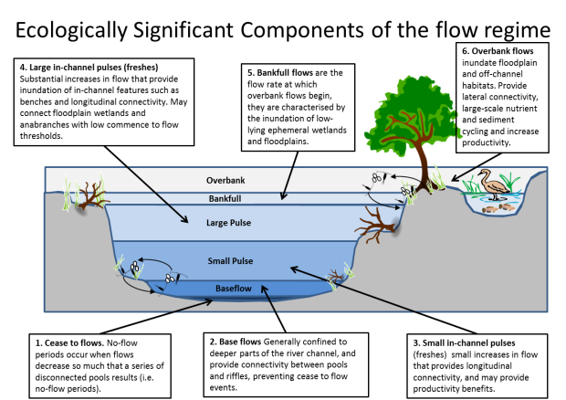
Figure 27: Components of the in-channel flow regime (adapted from Ellis et al. 2016).

Table 8: Definition of the five flow regime components identified for this study (adapted from Ellis et al. 2016).
Flow regime component |  | Definition
Baseflow | Confined to deeper low lying part of the channel, and would typically inundate geomorphic units such as pools and riffle areas between pools. Base flows (and cease to flows) also allow for the accumulation of allochthonous carbon and vegetation on benches and dry river channel sediments, which then contribute to ecosystem productivity during subsequent flow events. They would generally occur on an ongoing basis in perennial systems. They may be important in maintaining aquatic habitat for fish, plants and invertebrates when low inflow conditions prevail; retain longitudinal connectivity for small-bodied fish and maintain reasonable water quality. Base flows maintain drought refuges during dry periods and contribute to nutrient dilution during wet periods or after a flood event. Base flows may also support winter conditioning and oxygenation through riffle habitats, and historically may have benefited small-bodied native species in terminal wetlands. Base flows are commonly maintained by seepage from groundwater and low surface flows (MDBA, 2014).
Small pulse | Generally short increases in flow that provide longitudinal connectivity, and may provide productivity benefits by replenishing soil water for riparian vegetation, inundating low-lying benches and cycling nutrients between different parts of the river channel. Small pulses would generally be considered to be relatively slow flowing (e.g. less than 0.3m/s). They can contribute to the maintenance of refugia and key aquatic habitat such as snags and aquatic vegetation, which supports diverse heterotrophic biofilm generation, with high nutritional value to higher organisms (Wallace et al. 2014). Small within-channel pulses would have generally occurred annually throughout the majority of the Basin, and potentially two to three times in a year for perennial systems.
Large pulse | More substantial increases in flow that provide greater inundation of in-channel features such as benches and longitudinal connectivity, and may connect floodplain wetlands and anabranches with low commence to flow thresholds. Large within channel pulse are distinct from small pulses in that they provide fast flowing in channel habitats (e.g. velocity > 0.3m/s). Large in-channel pulses enhance productivity and nutrient exchange, promote dispersal and recruitment for all species and can trigger spawning in flow dependent species (i.e. Golden Perch and Silver Perch). These flow events are also important for maintaining refuges and minimising geomorphological impacts of regulation (e.g. sedimentation). The shape of these events should reflect the natural rates of flow increase or decrease corresponding to position in the catchment. Maintaining natural rates of change in water level may be important for nesting species such as Murray Cod, Freshwater Catfish and Purple Spotted Gudgeon, as water level fluctuations that are out of sync with natural patterns and climatic cues can have adverse impacts (e.g. rapid decreases in water levels over short time periods leading to nest abandonment). Large in-channel pulses would have generally occurred annually across most of the Basin, and up to two to three times a year in some systems.
Bankfull flow | The flow rate at which overbank flows begin, or maximum regulated flow releases. Bankfull flows generate similar ecological benefits to large in-channel pulses, potentially at a greater magnitude depending on channel geomorphology. They are characterised by the inundation of low-lying ephemeral wetlands and floodplains. As with large in-channel pulses, the shape of these events should reflect the natural rates of flow increase or decrease corresponding to position in the catchment.
Overbank event | Inundate floodplain and off-channel habitats and are important in providing lateral connectivity, large-scale nutrient and sediment cycling and an increase in productivity. Overbank events can enhance breeding opportunities for many species by creating additional spawning habitat and floodplain productivity benefits which contribute to increased condition and recruitment. Overbank events generally would have occurred between 1 - 25 years (depending on the magnitude of the event) for both intermittent and perennial systems. These events are generally unregulated, although there may be scenarios where water for the environment management activities activities could augment in-channel flows to create overbank events in which case the shape of these events should reflect the natural rates of flow increase or decrease corresponding to position in the catchment.
Base flows are similar in the two FGZ, while small pulse, large pulse, bankfull and overbank flows are considerably different. The thresholds for small pulse and large pulse are lower flows in the Glenarbon FGZ while the thresholds for bankfull and overbank are higher in the Glenarbon FGZ (Table 12).
Table 9: Summary of flow components, stage height and mean daily flow range for Roseneath FGZ.
Component of flow regime | Stage height (m) | Mean daily flow range (ML/day) | LWH inundated | Rootballs | Bank overhangs | No. (and area) of benches inundated | No. of wetlands connected
CTF | 0.5 | 0 | 867 | 93 | 76 | 2 (0.0648) | 43
Base flows | 0.5 – 0.8 | 0 – 163 | 884 | 93 | 76 | 23 (1.1417) | 44
Small Pulse | 0.80 – 1.0 | 163 – 1,040 | 971 | 94 | 77 | 67 (4.0567) | 46
Large Pulse¹ | 1.0 – 1.7 | 1,040 – 6,250 | 1050 | 116 | 87 | 291 (32.1442) | 70
Large Pulse² | 1.0 – 2.9 | 1,040 – 19,000 | 1276 | 148 | 90 | 700 (141.7924) | 120
Bankfull | 2.9 | 19,000 | 1276 | 148 | 90 | 700 (141.7924) | 120
Overbank | 2.9 – 10.6 | 19,000 – 291,000 | 1489 | 169 | 91 | 810 (173.1474) | 132
¹ Large flow pulse targeted under a managed environmental flow
² Large flow pulse under a natural flow event
Table 10: Summary of flow components, stage height and mean daily flow range for Glenarbon Weir FGZ.
Component of flow regime | Stage height  (m) | Mean daily flow range (ML/day) | LWH inundated | Rootballs | Bank overhangs | No. (and area) of benches inundated | No. of wetlands connected
CTF | -2.0 | 0 | 1805 | 178 | 78 | 0 | 16
Base flows | -2.0 - 0.35 | 0 – 136 | 1809 | 178 | 78 | 20 (0.429) | 17
Small Pulse | 0.35 – 0.55 | 136 – 1,310 | 1818 | 178 | 78 | 46 (1.8359) | 18
Large Pulse¹ | 0.55 – 1.1 | 1,130 – 7,300 | 1856 | 192 | 80 | 197 (18.2884) | 30
Large Pulse² | 0.55 – 3.86 | 1,130 – 53,054 | 2228 | 322 | 82 | 544 (85.758) | 88
Bankfull | 3.86 | 53,054 | 2228 | 322 | 82 | 544 (85.758) | 88
Overbank | 3.86 – 5.98 | 53,054 – 125,357 | 2487 | 340 | 82 | 545 (85.788) | 96
¹ Large flow pulse targeted under a managed environmental flow
² Large flow pulse under a natural flow event
The inundation height for habitat features recorded in the Dumaresq River between Pike Creek and the Macintyre River were compared against flow data to determine the flow (ML/day) required to inundate each feature. Flow components identified within each FGZ are represented by boxes moving left to right: base flow, small pulse, large pulse, bankfull and overbank. Due to the lack of data for the cease to flow range, this component was excluded for the cumulative frequency curves and base flow has been plotted from 0 ML/day.

Large Woody Habitat
Over 50% of LWH are inundated with base flows along the entire project area. In both FGZs over 65% of LWH is inundated by small pulse flows (163 – 1,040 ML/day @ Roseneath FGZ; Figure 28, and 136 – 1,310 ML/day @ Glenarbon FGZ; Figure 29). The substantial increase in LWH availability experienced with small pulse flows reflects their value to habitat inundation for species such as Murray Cod.
In channel flows can reach 85% of LWH in the Roseneath FGZ and 90% in the Glenarbon FGZ. Overbank flows greater than 120,000 ML/day are required to inundate 100% LWH in both FGZs.
As a result of the construction of Glenlyon Dam and subsequent river regulation small and large pulse events have decreased in number, duration and average volume, potentially reducing their usefulness in providing sustained inundation of LWH for breeding and recruitment of in-channel specialists such as Murray Cod.

Flow component
Base flow
Small pulse
Large pulse¹
Large pulse²
Overbank

Figure 28: Cumulative inundation frequency curves for LWH in the Roseneath FGZ, with inundation values during smaller flows highlighted in the inset box.
Flow component
Base flow
Small pulse
Large pulse¹
Large pulse²
Overbank

Figure 29: Cumulative inundation frequency curves for LWH in the Glenarbon Weir FGZ, with inundation values during smaller flows highlighted in the inset box.

Rootballs
Over 50% of rootballs were inundated in both FGZ with base flows (Figure 30; Figure 31). Substantial increases in inundation are evident with small pulse flows in the Roseneath FGZ (Figure 30). A 7% increase in inundation of rootballs is experienced in the Roseneath FGZ with a flow increase from 515 to 1,040 ML/day, and a further 8% increase in inundation with flows from 1,040 to 6,250 ML/day (Figure 30). More gradual increases are evident in the Glenarbon FGZ (Figure 31). Overbank flows greater than 80,000 ML/day are required to inundate 100% of rootballs in both FGZs.

Flow component
Base flow
Small pulse
Large pulse¹
Large pulse²
Overbank

Figure 30: Cumulative inundation frequency curves for rootballs in the Roseneath FGZ, with inundation values during smaller flows highlighted in the inset box.

Flow component
Base flow
Small pulse
Large pulse¹
Large pulse²
Overbank
Figure 31: Cumulative inundation frequency curves for rootballs in the Glenarbon Weir FGZ, with inundation values during smaller flows highlighted in the inset box.

Bank overhangs
Over 95% and 83% of bank overhangs are inundated in Roseneath and Glenarbon Weir FGZ respectively with base flows (Figure 32; Figure 33). Large flow pulses under managed environmental flows inundate 100% of bank overhangs in the Roseneath FGZ and 94% in the Glenarbon FGZ. Larger natural flows are required to inundate all bank overhangs.

Flow component
Base flow
Small pulse
Large pulse¹
Large pulse²
Overbank
Figure 32: Cumulative inundation frequency curves for bank overhangs in the Roseneath FGZ.
Flow component
Base flow
Small pulse
Large pulse¹
Large pulse²
Overbank
Figure 33: Cumulative inundation frequency curves for bank overhangs in the Glenarbon Weir FGZ, with inundation values during smaller flows highlighted in the inset box.

Benches
Flow relationship analysis was conducted on a total bench area of 258.93 ha. In the Roseneath FGZ (Figure 34) small pulse flows represent a 6% increase in bench area inundation, while large flow pulses under a managed environmental flow (6,250 ML/day) will see a total of 39% of benches inundated. Large natural pulses (19,000 ML/day) will cover 90%. 100% bench inundation requires 38,800ML day.
In the Glenarbon FGZ (Figure 35) small pulse flows represent a major 6% increase in bench area inundation, similar to the Roseneath FGZ, while large flow pulses under a managed environmental flow (7,300 ML/day) will see a total of 21% of benches inundated. Large natural pulses greater than 42,400 ML/day achieve 100% bench inundation.
The benches in the project area were largely made up of cobbles, so it can be presumed that with increased inundation the benefit to fish species that rely on them for ecological functions, such as Freshwater Catfish, would also be enhanced.

Flow component
Base flow
Small pulse
Large pulse¹
Large pulse²
Overbank
Figure 34: Cumulative inundation frequency curves for bench area in the Roseneath FGZ. , with inundation values during smaller flows highlighted in the inset box
Flow component
Base flow
Small pulse
Large pulse¹
Large pulse²
Overbank

Figure 35: Cumulative inundation frequency curves for bench area in the Glenarbon Weir FGZ, with inundation values during smaller flows highlighted in the inset box.

Connected wetland entry and exit points
Approximately 35% of entry and exit points are inundated at zero flow in the Roseneath FGZ and just over 16% in the Glenarbon FGZ (Figure 36; Figure 37). Small pulse flows provide a considerable increase in entry/exit point inundation in the Roseneath FGZ; a flow increase in the Roseneath FGZ to 1,040 ML/day results in 65 wetland connection points being inundated, an increase of 15%. A flow increase in the Glenarbon FGZ to 1,310 ML/day results in 19 wetland connection points being inundated, an increase of 4%. A large managed pulse of 7,300 ML/day will see 32% of entry points inundated.
Flows over 100,000 ML/day would be required to inundate all entry/points in Roseneath FGZ, while flows of 71,000 ML/day would be required at Glenarbon Weir FGZ.
While there was no quantification of the wetland area attached to the entry and exit points recorded it can be presumed that areas of off stream habitat will be inundated and there will be significant benefit to all native fish species, particularly Floodplain Specialist species. Future gains in spatial data (LiDAR) may assist in determining wetland area associated with these inundation points.

Flow component
Base flow
Small pulse
Large pulse¹
Large pulse²
Overbank

Figure 36: Cumulative inundation frequency curves for wetland entry points in the Roseneath FGZ, with inundation values during smaller flows highlighted in the inset box.

Flow component
Base flow
Small pulse
Large pulse¹
Large pulse²
Overbank

Figure 37: Cumulative inundation frequency curves for wetland entry points in the Glenarbon Weir FGZ, with inundation values during smaller flows highlighted in the inset box.

Recommendations and future directions

Flows for native fish
The analysis conducted on the Dumaresq River as part of the Mapping the Dumaresq project, focuses on the flow relationships of in-channel habitat features and the fish communities of the reach, including the most abundant native species and modelled threatened species distribution for the reach. This analysis allows the knowledge of key native fish in the Dumaresq River, including their flow requirements during critical life history stages, and the detailed habitat inundation information to be used to develop EWRs for fish in the Dumaresq River.
The proposed fish specific EWRs focus on in-channel flow requirements based on an understanding of flow-ecology relationships for fish and habitat inundation in the Dumaresq River to provide greater opportunity for spawning, recruitment, maintenance, and condition outcomes for native fish. The implementation of these EWRs would achieve significant native fish outcomes, especially for the target species of the fish community and fish with specific life-cycle requirements for flow events, including In-channel Specialists, by providing improved spawning and recruitment opportunities. The EWRs would also enhance the maintenance and condition of all native fish functional groups.
A number of flow targets have been described for EWRs that will achieve beneficial outcomes for native fish. It is hoped that this will help guide management actions in the valley by recognising the potential value of all water in the system that will contribute to the ecological objectives, including Commonwealth environmental holdings, which are relatively small; natural flows, which could be supplemented to contribute to greater inundation of key habitat features and; consumptive water that may also potentially influence flows in the system during key periods.
As part of these management activities, consideration should also be given to the requirements for timing of flow events. With many native fish species currently understood to have temperature cues for spawning, the impacts of cold water pollution should be considered when delivering flows as cold water releases may interrupt natural temperature cues for movement and spawning. Where possible, supplementing natural flows can increase inundation of habitat features and mitigate impacts of cold water pollution by dissipating the temperature variation of the water being released.
Additionally, in the absence of unregulated flows and the occurrence of significant drying, water delivery should shift to focus on supporting basic aquatic ecological functions. This includes flows to replenish refuge pools identified in the habitat mapping. This action should be targeted at reaching the end of the system, with a large proportion of refuge pools found in that area.
All EWRs described below have been set at the Roseneath gauge due to highly variable tributary influences between Roseneath and Glenarbon Weir, which limits the capacity to set targets at both gauges for a single flow.
Enhanced In-channel specialists spawning
Ecological objective
Provide flow regimes that enhance spawning opportunities for In-channel Specialist native fish species, focussing on Murray Cod, Freshwater Catfish and Purple Spotted Gudgeon.
Improve the inundation and availability of key habitat features along the Dumaresq River for In-channel Specialists (Flow Dependent – Murray Cod), particularly LWH, root balls, and undercut banks.
Improve the inundation and availability of key habitat features along the Dumaresq River for In-channel Specialists (Flow Independent – Freshwater Catfish and Purple Spotted Gudgeon), particularly benches/cobble beds, and wetland entry points.
Improve the longitudinal connectivity along the Dumaresq River, enhancing localised movement opportunities for native fish.
Environmental Water Requirement
Flow event of 1,040 ML/day for a minimum of 14 consecutive days from August to November, preferably every year but can be every second year, with a maximum inter-flow period of two years to enhance spawning outcomes for In-channel Specialists (Flow Dependent – Murray Cod) species. The flow target could be adjusted to a minimum of 515 ML/day while still achieving some the objectives, although the effectiveness of outcomes may be compromised, with a timing shift from September to March enhancing spawning outcomes for In-channel Specialists (Flow Independent – Freshwater Catfish and Purple Spotted Gudgeon) species. The duration and frequency should still be maintained.
Rationale
Small in-channel pulse events at the Roseneath gauge would provide benefits for all functional groups of fish through improved habitat availability. In particular, flows of 515 ML/day, which are targeted for enhancing spawning outcomes for Freshwater Catfish and Purple Spotted Gudgeon, would inundate a significant proportion of habitat features thought to be related to spawning outcomes for these species, including 9% of benches (which also include cobble beds), 60% of LWH, and over 42% of wetland entry points.
It is important to note that flows of 515 ML/day may also provide spawning opportunities for Murray Cod, inundating 59% of root balls and 95% of overhangs; however this outcome would be further improved by achieving the flow target of 1,040 ML/day. This flow target would enhance Murray Cod spawning opportunities through the inundation of an additional 5% of LWH and root balls (65% inundated), as well as 98% of bank overhangs in the system. Research throughout parts of the Murray Cod’s range has suggested a strong association between the species and complex woody habitat (Koehn and Nicol, 2014). With the increase in availability of these habitats from this higher flow target there would be more opportunities for spawning. Additionally, this higher flow rate would increase productivity through increased inundation of benches (13% inundated) and wetland entry points (49% inundated) providing more food for larval stage Murray Cod and other fish in the system.
The availability of these core habitat features provided by the small pulse events would allow regular maintenance and condition opportunities for all fish communities, as well as opportunities for short to moderate movements in the system through improved longitudinal connectivity. The proposed frequency of the events is especially important for short-lived fish, including those described as Stable Low Flow Spawning Fish (SLFSF) by Kerr et al. (2017), as they need regular flow events to complete important life-cycle stages.
The minimum duration of 14 days is linked to the natural hydrology and the hatch time for eggs of the target species to ensure a stable flow when eggs are on the nest, with rapid changes in height and flow rate, either up or down, to be avoided to maximise spawning outcomes. The main outcome for the 515 ML/day and the 1,040 ML/day events are regular access to spawning habitat and movement opportunities for spawning outcomes, and it is therefore considered appropriate for the event to occur during the prescribed spawning window for target species.
When planning for this spawning flow, consideration should be given to time since the last flow targets of suitable timing and duration, remembering that the EWRs related to the target of 515 ML/day will satisfy the outcomes of the 1,040 ML/day flow; however this flow should still be considered as part of planning due to increased opportunities provided for Murray Cod spawning. This flow could be delivered using Held Environmental Water during years with good entitlement and sufficient natural flows. Held Environmental Water should be used to shape the hydrograph rather than providing the bulk of the flow delivery, adding to the natural flow to reach the threshold or providing a stable recession while not impacting on water temperature.
Enhanced native fish recruitment
Ecological objective
Provide flow regimes that enhance recruitment outcomes for native fish, including In-channel Specialist species, focussing on Murray Cod, Freshwater Catfish and Purple Spotted Gudgeon, Generalists species, and Floodplain Specialists.
Improve the inundation and availability of key habitat features that contribute to productivity outcomes along the Dumaresq River, particularly benches/cobble beds, and wetland entry points.
Improve the longitudinal connectivity along the Dumaresq River, enhancing localised movement opportunities for native fish.
Environmental Water Requirement
Optimum flow event of 600 ML/day for a minimum of 10 (optimal 20 days or more) consecutive days from September to March, preferably every year but can be every second year, with a maximum inter-flow period of two years. The flow target could be adjusted to a minimum of 341 ML/day while still achieving some of the objectives under resource constrained conditions, although the effectiveness of outcomes may be compromised.
Rationale
Small in-channel pulse events at the Roseneath gauge would provide benefits for all functional groups of fish through improved habitat availability. In particular, flows of 341 ML/day would inundate a significant proportion of habitat features related to enhanced recruitment outcomes for native fish, including 8% of benches (which also include cobble beds), 50% of LWH and root balls, and over 40% of wetland entry points.
This outcome would be further improved by achieving the flow target of 600 ML/day. This flow target would enhance recruitment opportunities through the inundation of an additional 2% of benches (10% inundated), and 15% LWH and root balls (65% inundated) in the system, providing more protective habitat and food for larval stages of any new native fish recruits in the system.
The availability of these core habitat features provided by the small pulse event would also improve the condition of emergent aquatic macrophytes such as cumbungi, phragmites and juncus/sedge, helping contribute to regular maintenance and condition opportunities for all fish communities, as well as opportunities for short to moderate movements in the system through improved longitudinal connectivity. The proposed frequency of the events is especially important for short-lived fish, including those described as SLFSF species by Kerr et al. (2017), as they need regular flow events to complete important life-cycle stages.
The proposed duration of 10 days can be adjusted as needed, depending on hydrological and antecedent conditions, but has been recommended as a target based on the larval development of native fish to ensure flows are maintained in the system that will maximise recruitment outcomes. Flows may be reduced below the proposed target rates, but very low flow and cease to flow events should be avoided during this time to maintain connection through the system and support native fish recruitment. The main outcomes for this EWR are recruitment, productivity, and movement opportunities for dispersal, and it is therefore considered appropriate for the event to occur during the main post-spawning timeframes for the majority of species, taking into consideration any water quality issues such as water temperature.
Enhanced native fish condition and maintenance
Ecological objective
Provide flow regimes that increases productivity in the system and improves condition of all native fish through improved inundation and availability of key habitat features along the Dumaresq River, particularly LWH, benches/cobble beds, and wetland entry points.
Improve the longitudinal connectivity along the Dumaresq River, enhancing localised movement opportunities for native fish.
Environmental Water Requirement
Optimum flow event of 6,250 ML/day for a minimum of 5 consecutive days (whole event, with peak potentially only being 2 days) anytime from July to June, preferably every year but can be every second year, with a maximum inter-flow period of two years. The flow target could be adjusted to a minimum of 2,380 ML/day while still achieving some of the objectives under resource constrained conditions, although the effectiveness of outcomes may be compromised.
Rationale
Large in-channel pulse events at the Roseneath gauge would provide benefits for all functional groups of fish through improved habitat availability, productivity and movement opportunities. In particular, flows of 2,380 ML/day would inundate a significant proportion of habitat features related to enhanced condition and connection outcomes for native fish, including 19% of benches, 66% of LWH and root balls, and 53% of wetland entry points.
This outcome would be further improved by achieving the flow target of 6,250 ML/day. This flow target would enhance condition outcomes through the inundation of an additional 21% of benches (40% inundated), 5% of LWH (71% inundated), 8% of root balls (73% inundated), and 19% of wetland entry points (72% inundated) in the system, providing more productivity in the system and access to greater habitat for any native fish, including new recruits, juveniles and adults.
A large portion of the in-channel food resources in lowland river systems comes from organic material on the floodplain, while in the headwaters productivity is dominated by in channel photosynthetic organisms (Vannote et al. 1980; Oliver and Merrick, 2006). As the project area is considered to be at the interface of these zones productivity is presumably impacted by both sources. Inundating areas out of the main channel increases availability of these resources and increases in channel productivity while increasing the condition and growing area for macrophytes. Inundation of benches mobilises carbon which stimulates river productivity. Wetland inundation provides a stimulus for plant germination and the emergence of invertebrates from resting life stages, many of which can become abundant within days of inundation (Kerr et al. 2017).
The proposed duration for events of 5 days can be adjusted as needed, depending on hydrological and antecedent conditions, but has been recommended as a target based on enhancing the release of nutrients and carbon into the system to maximise improved fish condition outcomes. The main outcomes for this EWR are improved condition of native fish and movement opportunities for dispersal, and it is therefore considered appropriate for the event to occur during at any time of the year. This flow can be used to prime the system for spawning events when delivered in late winter to early spring or can be used to increase food availability and connectivity for larval and juvenile fish in mid-summer to mid-Autumn. Late winter/early spring flows are intended primarily to support pre-spawning conditioning for all functional groups through inundation of in-channel benches and aquatic habitat. Mid-summer to autumn peaks are intended to provide inundation of in-channel benches and habitat to increase productivity and support larval and juvenile drift.
Although not the primary environmental objective, these flows may also provide some opportunities for spawning and recruitment outcomes for Generalists, Flow Dependent Specialists, In-channel Specialists and Floodplain Specialists that are more opportunistic and quicker to respond to the shorter duration event. Species that might respond include Bony Bream, Golden Perch, Spangled Perch and the threatened Silver Perch and Olive Perchlet.
However, it is important to note that delivering flows of a sufficient magnitude to promote spawning and recruitment of Flow-dependent Specialists and Floodplain Specialists requires further floodplain inundation modelling. It is likely that targeted flows for these groups of fish would not be feasible in the project area. Supplementing natural flows to reach heights of a sufficient magnitude is problematic as infrastructure becomes inundated and other third party impacts become apparent. Complementary water delivery actions for Floodplain Specialists may be needed in some situations. In the absence of overbank flows, delivery of water to replenish floodplain wetlands may be required via pumping from the main channel do avoid drying of these habitats and subsequent localised extinctions. The Floodplain Specialist species Olive Perchlet has been found in the project area, and is of particular conservation significance, with protection of their population a priority.

Recommendations for future management in the Border Rivers
The Dumaresq habitat mapping project has considerably advanced information and thinking for water management in the Dumaresq River related to fish and river outcomes. However, knowledge gaps still exist that require attention to enhance the development of future environmental water requirements. The outcomes of water management in the Dumaresq River would be greatly enhanced by the development and implementation of complementary aquatic habitat rehabilitation and adaptive monitoring programs.
To improve native fish populations and river health in the Dumaresq River and throughout the Border Rivers, future management of water for the environment should consider:

Undertaking further habitat mapping in the Border Rivers catchment
Significant gaps still exist in our understanding of habitat features and their relationship to river flow across the remainder of the Border River catchment. Complementing the habitat mapping database from this project with further mapping in the Macintyre River downstream of this project area and in the Severn River will help inform whole of valley water management. This information, coupled with fish community details and water management activities, would allow critical flow thresholds to be identified in relation to inundation values, structure drown out requirements, and bankfull capacity volumes, helping to develop specific water requirements and strengthen water management actions across the Border Rivers. Priority reaches include:
  - Severn River - Pindari Dam to the Dumaresq River confluence (~180 km)
  - Macintyre River - Dumaresq River confluence to Mungindi (~340 km)

Developing a fish management strategy for the Border Rivers catchment
In addition to addressing key knowledge gaps related to water for the environment it is also important to acknowledge that flow management actions in isolation may not achieve the desired objectives and outcomes for river health and native fish populations in the Border Rivers catchment. The critical riverine components of habitat and connectivity will also need to be considered in management planning and implementation, and whilst aspects of these components are integrated with flow management, additional complementary actions will also be needed to achieve the most effective and efficient outcomes.
These actions should include targeted habitat rehabilitation such as riparian management, including native revegetation, aquatic planting, and weed control; resnagging; erosion control; fish passage/connectivity remediation; reducing the impact of extraction through offtakes on fish; cold water pollution mitigation and; alien fish management. The development of valley scale aquatic management plans would benefit from and be guided by fine-scale habitat mapping activities, which would also collect information on the condition of aquatic and riparian habitat, and provide a prioritised and coordinated strategy that maximises water management for improved river health.
The habitat mapping data can be used to provide direction on how to proceed with aquatic habitat restoration and protection initiatives. This information can be used by natural resource managers to prioritise areas for action increasing the benefits of environmental flow deliveries in the project area. For example, habitat mapping data could be used to improve the condition of riparian vegetation by showing where there are significant weed issues and where there is revegetation of native riparian species, allowing natural resource managers to make more informed decision when directing their resources.
There are a number of small tributaries that join the main channel in the project area including Reedy Creek, Beardy River, Camp Creek and Macintyre Brook. These tributaries, excluding Macintyre Brook, contribute unregulated flows to the main channel. Macintyre Brook is regulated by Coolmunda Dam, a major public storage with a capacity of 69 GL. The conservation and enhancement of these areas would have significance benefits to the fish communities of the main channel.
The development of a fish management strategy for the Border Rivers catchment would also need to consider and manage for potential negative impacts associated with managing water for the environment. In the Border Rivers catchment this may include the proliferation of alien fish species and the occurrence of water quality impacts such as thermal pollution and black water events. Using relevant flow related information of all fish species to form functional groups and develop flow regimes will ensure that the effects of both alien and native fish are considered, allowing water requirements to be developed that do not provide an unnecessary advantage to alien fish over native fish.
The historical occurrence of thermal pollution in the Border Rivers also provides a challenge for the responsible delivery of water for the environment. The impacts of cold water pollution are exacerbated downstream of major impoundments when water is delivered during warmer periods, with cold water releases from the bottom of dams severely reducing the natural warmer water temperatures, whilst black water events are intensified when periods of drought are punctuated by floodplain inundating flows that return organic matter to the river channel. Both impacts have the potential to reduce water quality and affect aquatic biota responses, with their consideration required in the development and implementation of flow regimes, as well as the implementation of appropriate mitigation actions, such as the installation of thermal curtains, selective withdrawal or de-stratification measures.
Options for mitigating the impacts of thermal pollution exist, with successful implementation already recorded at other sites. Unlike some other dams in NSW, Glenlyon does not have a variable level offtake, so potentially the best option for mitigating thermal pollution is de-stratification. De-stratification can be achieved through the installation and maintenance of thermal mixing technology. Figure 38 shows the circulation pattern provided by a compressed air de-stratification unit. Similar technology has already been successfully implemented at Tallowa Dam on the Shoalhaven River and resulted in increased abundance and diversity of native fish species below the structure (Miles and West, 2010).
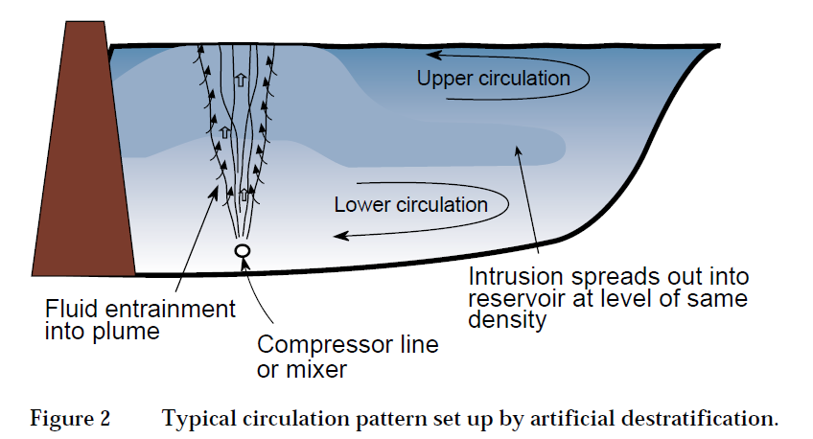
Figure 38: Typical circulation pattern set up by artificial de-stratification, which could be a feasible option for mitigating cold water pollution at Glenlyon Dam.

Committing to a long-term, adaptive management plan driven by monitoring and evaluation
The hydrological and hydraulic variation required to restore key elements for fish in the Border Rivers will differ across functional groups, and whilst some benefits will be experienced across groups from different flow regimes, a long-term commitment to adaptive management to flow and aquatic habitat management is required to maximise outcomes. Management plans that consider flow, habitat and connectivity need to include objectives for each functional group to ensure benefits are experienced across all native fish communities over relevant spatial and temporal scales. The development and implementation of a rigorous monitoring program is essential to help validate program assumptions and measure the success of flow delivery and water requirements against the program objectives.
Information about the use of habitat by fish and their response to certain flow delivery scenarios will allow management plans to be evaluated and flow hydrographs to be adapted to ensure that outcomes are optimised, whilst providing confidence in stakeholders that decision making is being informed by biological information. Monitoring activities in the Border Rivers are being implemented as part of Commonwealth environmental watering actions (Short Term Intervention Monitoring) and Basin Plan implementation (NSW Basin Plan Ecological Objective Monitoring); however, it is important that these activities continue over time and any gaps in existing programs are identified and prioritised for action. This will ensure that outcomes from managing water for the environment across a range of different valley types are captured and used to guide management decisions. In addition to this, it is essential that monitoring information and research outcomes are communicated and readily accessible to advance knowledge and management actions across related systems where applicable.

Continued and sustained cross-disciplinary and inter-jurisdictional collaboration on information and knowledge of ecological relationships in the Dumaresq River and the Border Rivers Catchment
Current activities across the Murray-Darling Basin related to water management provide opportunities to effectively establish and foster linkages between relevant community, academic and government experts. The Mapping the Dumaresq project gathered a range of relevant knowledge, expertise and information related to fish and flow relationships in the Border Rivers. While much of this information is readily accessible, other material occurs in variable formats and is held by a number of different institutions and agencies.
To support the proposed long-term adaptive management plan and Border Rivers fish management strategy, it would also be useful to review existing management and research needs, including data sharing arrangements and management actions relating to fish and flow information in the Border Rivers. This could form the basis of a formal water management group for the Border Rivers, promoting a collaborative and open approach to management of existing and future watering activities, including a shared commitment to identifying and addressing knowledge gaps.

Conclusion
The Mapping the Dumaresq project has improved the understanding of habitat inundation and the implications for environmental water requirements for the fish functional groups in the Dumaresq River. Prioritised reach scale assessment for the Dumaresq River has helped describe flow related attributes of the valley, including hydrological conditions, fish barriers and connectivity issues, aquatic habitat condition, and fish community status, improving and consolidating the understanding of hydrological and ecological information for the system.
River regulation has had a significant impact on the natural flow regime in the Dumaresq River, with Glenlyon Dam reducing flows from Pike Creek and Tenterfield Creek Dam reducing flows from Tenterfield Creek. These structures, as well as extraction have impacted the frequency, duration and magnitude of flow events in the Dumaresq River, influencing the hydrological, hydraulic and ecological conditions that native aquatic biota, including fish are reliant on for survival.
The degradation of key habitat features on the Dumaresq River has been exacerbated by the modification of natural flows, having a significant effect on the status of native fish populations in the system. A large portion of the fish community in the Dumaresq River is considered to be in a moderate condition with remainder in good condition. The identification of these reaches, in a moderate condition, presents excellent potential for population recovery if management decisions are developed and implemented based on best available science in a holistic adaptive framework.
The habitat data recorded during habitat mapping can be used by natural resource managers and landholders to direct resources for protection and rehabilitation of riparian and instream habitats. These actions can complement the benefits from the management of water for the environment, providing a greater benefit to the fish communities in the project area. The dataset may also have potential benefits for land managers with information on erosion, areas of stock damage, weeds and other features that may be of interest.
Information from the Fish and Flows in the Northern Basin project (NSW DPI, 2015) and review of the most current literature has helped to refine fish functional groups specific to conditions of the Dumaresq River based on biological, hydrological and hydraulic similarities related to spawning, recruitment and movement. The formation of fish functional groups for the Dumaresq has enabled overarching conceptual flow models to be developed that identify the importance of certain flow characteristics and hydrological variability for groups of species. This information can be used to guide the development of the environmental watering requirements that can be used by water managers to improve outcomes for certain species in certain functional groups. The information will also guide management of water for the environment for a system over long-term planning frameworks to maximise water use and environmental benefits.

References
Barrett, J. (Ed.). (2008). The Sea to Hume Dam: Restoring Fish Passage in the Murray River. Murray-Darling Basin Commission, Canberra.
Baumgartner, L., Conallin, J., Campbell, B., Gee, R., Robinson, W. and Mallen-Cooper, M. (2013). Using Flow Guilds of Freshwater Fish in an Adaptive Management Framework to Simplify Environmental Flow Delivery for Semi-Arid Riverine Systems. Fish and Fisheries. 15: 410-427.
Beesley, L., King, A., Amstaetter, F., Koehn, J., Gawne, B., Price, A., Nielson, D., Vilizzi, D. and Meredith, S. (2012). Does flooding affect spatiotemporal variation of fish assemblages in temperate floodplain wetlands? Freshwater Biology. 57, 2230-2246.
Boys, C. A. (2007). Fish-habitat associations in a large dryland river of the Murray-Darling Basin, Australia. PhD Thesis, University of Canberra, Canberra. 320 pp
Boys, C. and Rayner, T. (2017). Pump and Diversion Screening: The Sleeping Giant of Australian River Restoration. Proceedings of the Murray Darling Basin Native Fish Forum 2017.
Boys, C. and Thoms, M. (2006). A Large-scale, Hierarchical approach for Assessing Habitat Associations of Fish Assemblages in Large Dryland Rivers. Hydrobiologia. 572, 11-31.
Brooks, A., Gehrke, P., Jansen, J. and Abbe, T. (2004). Experimental Reintroduction of Woody Debris on the Williams River, NSW: Geomorphic and Ecological Responses. River Research and Applications. 20, 513-536.
Bunn, S. and Arthington, A. (2002). Basic Principles and Ecological Consequences of Altered Flow Regimes for Aquatic Biodiversity. Environmental Management. 30: 492- 507.
Butcher, A. (2007). Characteristics of Fish Fauna of the Macintyre and Dumaresq Rivers and Macintyre Brook. A Report to the Queensland Murray-Darling Committee.
Casatti, L., Mendes, H. and Ferreira, K. (2003). Aquatic Macrophytes as Feeding Sites for Small Fishes in the Rosana Reservoir, Paranapanema River, Southeastern Brazil. Brazilian Journal of Biology. 63, 213- 222.
Commonwealth Environmental Water Office. (2016). Restoring and Protecting the Border Rivers 2016-17, Commonwealth of Australia.
Commonwealth of Australia. (2015). Commonwealth Environmental Water Portfolio Management Plan: Border Rivers 2016-17.
Copeland, C. and Baker, L. (2016). River Flows for Our Fish: Linking Fish, Environmental Water and Recreational Fishers in the Murray- Darling Basin. NSW DPI Fisheries, Wollongbar.
Crook, D. and Robertson, A. (1999). Relationships Between Riverine Fish and Woody Debris: Implications for Lowland Rivers. Marine and Freshwater Research. 50, 941-953.
Davies, P.E., Stewardson, M.J., Hillman, T.J., Roberts, J.R. and Thoms, M.C. (2012). Sustainable Rivers Audit 2: The ecological health of the rivers in the Murray-Darling Basin at the end of the Millenium Drought (2008–10). Prepared by the Independent Sustainable Rivers Audit Group for the Murray-Darling Basin (ISRAG). MDBA Publication No. 72/12. Murray Darling Basin Authority, Canberra.
Delariva, R., Agostinho, A., Nakatani, K. and Baumgartner, G. (1994). Ichthyofauna Associated to Aquatic Macrophytes in the Upper Paraná River Floodplain. Rev. Unimar, 16, 41-60.
Dyer, F., Thoms, M. and Olley, J. (2002). The Structure, Function and Management Implications of Fluvial Sedimentary Systems. International Association Hydrological Sciences Press. Centre for Ecology and Hydrology, Wallingford, Oxfordshire, UK.
Ebner, B., Scholz, O. and Gawne, B. (2009). Golden Perch Macquaria ambigua are Flexible Spawners in the Darling River, Australia. New Zealand Journal of Marine and Freshwater Research. 43, 571-578.
Ellis, I., Cheshire, K., Townsend, A., Copeland, C. Danaher, K. and Webb, L. (2016). Fish and Flows in the Murray River Catchment - A review of environmental water requirements for native fish in the Murray River Catchment. NSW Department of Primary Industries, Queanbeyan.
Fairfull S. and Witheridge, G. (2003). Why do Fish Need to Cross the Road? Fish Passage Requirements for Waterway Crossings. NSW Fisheries, Cronulla, 16pp.
Fisheries Scientific Committee. (2000). Fisheries Scientific Committee Final Determination: Silver Perch. NSW Fisheries, Pyrmont.
Foster, N. and Cooke, R. (2011). Barwon-Darling IQQM Analysis – critical flow thresholds for environmental values identified within the Barwon-Darling Water Sharing Plan. NSW Department of Primary Industries, Tamworth.
Gilligan, D. in press. Identifying significant hotspots of common carp (Cyprinus carpio) recruitment offers opportunities for the control of pest populations.
Gippel, C. (1995). Environmental Hydraulics of Large Woody Debris in Streams and Rivers. Journal of Environmental Engineering. 121, 388-395.
Gippel, C.J. 2013. Assessment of the hydraulics of the Little Murray River Weir Pool under alternative operating scenarios. Fluvial Systems Pty Ltd, Stockton. Goulburn-Murray Water, Shepparton, January.
Green, D., Ali, A., Petrovic, J., Burrell, M. and Moss, P. (2012). Water Resource and Management Overview: Border Rivers Catchment.
Humphries, P., King, A. and Koehn, J. (1999). Fish, Flows and Floodplains: Links between Freshwater Fishes and Their Environment in the Murray-Darling River System, Australia. Environmental Biology of Fishes. 56, 129-151.
Humphries, P. and Walker, K. (2013). Ecology of Australian Freshwater Fish. CSIRO Publishing, Collingwood, Victoria, Australia.
Hutchison, M., Butcher, A., Kirkwood, J., Mayer, D., Chikott, K. and Backhouse, S. (2008). Mesoscale movements of small and medium-sized fish in the Murray-Darling Basin. Murray Darling Basin Commission, Canberra. MDBC Publication No. 41/08.
Industry and Investment NSW. (2009). Bringing Back the Fish – Inland NSW Extension. Final Report to the Southern Rivers Catchment Management Authority. Industry and Investment NSW, Cronulla, NSW.
Industry and Investment NSW. (2010). Road crossing barrier summaries, Little River sub catchment. Prepared for the Central West Catchment Management Authority. Industry and Investment NSW, Dubbo, NSW.
Kerr, J. (2017). Characterisation of Ecological Values Supported by Periodic Floodplain Wetland Inundation: Literature Review. Environmental Flows Assessment Program Final Report July 2017. Aquatic Ecology Group, Water Services, Toowoomba, Department of Natural Resources and Mines.
Kerr, J., Prior, A. and Fawcett, J. (2017). Stable Low-flow Spawning Fish – Assessment of generic Model Parameters used to Assess Risk to Stable Low-flow Spawning Fish Species in Condamine-Balonne, Border Rivers and Moonie Water Resource Plans. Department of Natural Resources and Mines, Toowoomba.
Kingsford, R. (1999). Managing the Water of the Border Rivers in Australia: Irrigation, Government and the Wetland Environment. Wetland Ecology and Management. 7, 25-35.
Koehn, J. (2009). Multi-scale Habitat Selection by Murray Cod Maccullochella Peeli Peeli in Two Lowland Rivers. Journal of Fish Biology. 75, 113-129.
Koehn, J. and Nichol, S. (2014). Comparative habitat use by large riverine fishes. Marine and Freshwater Research. 65, 164-174.
Koehn, J., Todd, C., Thwaites, L., Stuart, I., Zampatti, B., Ye, Q., Conallin, A. and Dodd, L. (2015). Managing flows and carp. Report prepared by the Arthur Rylah Institute for the Murray-Darling Basin Authority. Arthur Rylah Institute for Environmental Research, Heidelberg, Victoria.
Lake, P. (1995). Of floods and droughts: river and stream ecosystems of Australia. In Cushing, E., Cummins, K. and Minshall, G. E. (eds). River and Stream Ecosystems. p. 659-94. Elsevier, New York.
Lucas, M. and Baras, E. (2000). Methods for Studying Spatial Behaviour of Freshwater Fishes in the Natural Environment. Fish and Fisheries. 1, 283-316.
Lugg, A. (1999). Eternal winter in our rivers – Addressing the issue of Cold Water Pollution. NSW Fisheries, Nowra.
Lugg, A. and Copeland, C. (2014). Review of cold water pollution in the Murray–Darling Basin and the impacts on fish communities. Ecological Management and Restoration. 15, 71-79.
Magoulick, D. and Kobza, R. (2003). The Role of Refugia for Fishes During Drought: a Review and Synthesis. Freshwater Biology. 48, 1186-1198.
Mallen-Cooper, M. (2000). Taking the Mystery out of Migration. In Proceedings of Workshop on Fish Movement and Migration. Bendigo, September 1999. Australian Society of Fish Biology, Sydney.
Mallen-Cooper, M. and Stuart, I. (2003). Age, Growth and Non-flood Recruitment of Two Potamodromous Fishes in a Large Semi-arid/Temperate River System. River Research and Applications. 19, 697-719.
Mallen-Cooper, M. and Zampatti, B. (2015). Background Paper: Use of Life History Conceptual Models of Fish in Flow Management in the Murray-Darling Basin. Murray-Darling Basin Authority, Canberra.
Marshall, J., Menke, N., Crook, D., Lobegeiger, J., Balcombe, S., Huey, J., Fawcett, J., Bond, N., Starkey, A., Sternberg, D., Linke, S., and Arthington, A. (2016). Go with the flow: the movement behaviour of fish from isolated waterhole refugia during connection flow events in an intermittent dryland river. Freshwater Biology. doi:10.1111/fwb.12707.
Miles, N. and West, R. (2010). The Use of an Aeration System to Prevent Thermal Stratification of a Freshwater Impoundment and its Effect on Downstream Fish Assemblages. Journal of Fish Biology. 78, 945-52
Moffat, D. and Voller, J. (2002). Fish and Fish Habitat of the Queensland Murray-Darling Basin. Department of Primary Industries, 98pp.
Murray-Darling Basin Authority. (2012). Assessment of environmental water requirements for the proposed Basin Plan: Lower Border Rivers (in-channel flows). Document 40/12. Murray–Darling Basin Authority, Canberra. http://www.mdba.gov.au/what-we-do/basin-plan/development/bp-science/assessingenvironmental-water-requirements
Murray-Darling Basin Authority. (2014). Basin-wide environmental watering strategy. Murray–Darling Basin Authority, Canberra.
Murray-Darling Basin Authority. (2015). Barwon-Darling. Murray-Darling Basin Authority, Canberra. http://www.mdba.gov.au/about-basin/how-river-runs/barwon-darling-catchment
Murray-Darling Basin Authority. (2017). Border Rivers. Murray-Darling Basin Authority, Canberra. https://www.mdba.gov.au/discover-basin/catchments/border-rivers
Norris, A. (2015). Fish loss via irrigation offtake in the Condamine Catchment. Department of Agriculture and Fisheries.
NSW DPI. (2006). Reducing the Impacts of Weirs on Aquatic Habitat – New South Wales Detailed Weir Review. Border Rivers / Gwydir CMA region. Report to the New South Wales Environmental Trust. NSW Department of Primary Industries, Flemington, NSW.
NSW DPI. (2007). Endangered Ecological Communities in NSW – Lowland Darling River Aquatic Ecological Community. Primefact 173.NSW DPI. 2012b. Living and working on a riverbank. Promotional flyer. NSW Department of Primary Industries, Sydney, NSW.
NSW DPI. (2013a). ‘Flow for Fish Recruitment in the Barwon-Darling River’. Unpublished Final Report prepared for the Murray-Darling Basin Authority, NSW Department of Primary Industries, Armidale.
NSW DPI (2013b) Bringing Back the Fish on the Horton. Final Report prepared for the Border Rivers Gwydir Catchment Management Authority. NSW Department of Primary Industries, Dubbo.
NSW DPI. (2014). Protecting the Purple Patch - Investment Recommendations for Buckinbah and Hanover Creeks. Habitat mapping and prioritisation report prepared for Little River Landcare Group Inc. NSW Department of Primary Industries, Dubbo.
NSW DPI. (2015). Fish and Flows in the Northern Basin: responses of fish to changes in flow in the Northern Murray-Darling Basin – Reach Scale Report. Final report prepared for the Murray-Darling Basin Authority. NSW Department of Primary Industries, Tamworth.
NSW DPI. (2016). NSW fish community status – final report. NSW Department of Primary Industries. In press Fisheries Final Report Series.
NSW DPI. (2017a). Improving Fish Habitats. Accessed at http://www.dpi.nsw.gov.au/fishing/habitat/rehabilitating/habitats#Restoring-riparian-vegetation
NSW DPI. (2017b). Southern Purple-spotted Gudgeon – Mogurnda adspersa. Primefact 1275, second edition. Threatened Species Unit, Crowes Nest.
NSW DPI. Inprep a. Fish and Flows in the NSW Border Rivers.
NSW DPI. Inprep b. Inundation Heights for Key Habitat Features and Management Recommendations for Cudgegong River Between Windamere Dam and Burrendong Dam Habitat Mapping and Prioritisation. Report prepared for Central Tablelands Local Land Service. NSW Department of Primary Industries, Dubbo
O’Connor, J., O’Mahony, D. and O’Mahony, J. (2005) Movement of Macquaria ambigua, in the Murray River, South Eastern Australia. Ecology of Freshwater Fish. 15, 419-427.
O’Connor, J., Mallen-Cooper, M. and Stuart, I. (2015). Performance, operation and maintenance guidelines for fishways and fish passage works. Arthur Rylah Institute for Environmental Research Technical Report No. 262 for the Water and Catchments Group, Department of Environment, Land, Water and Planning. Arthur Rylah Institute for Environmental Research, Department of Environment, Land, Water and Planning, Heidelberg, Victoria.
Oliver, R. and Merrick, C. (2006). Partitioning of River Metabolism Identifies Phytoplankton as a Major Contributor in the Regulated Murray River (Australia). Freshwater Biology. 51: 1131-1148.
Pethebridge, R., Lugg, A. and Harris, J. (1998). Obstructions to Fish Passage in NSW South Coast Streams. NSW Fisheries, Final Report Series No. 4 for CRC for Freshwater Ecology, NSW Fisheries Research Institute, Cronulla.
Petr, T. (2000). Interactions Between Fish and Aquatic Macrophytes in Inland Waters: A Review. FAO Fisheries Technical Paper. Toowoomba Queensland.
Rayner, T., Jenkins, K. and Kingsford, R. (2009). Small Environmental Flows, Drought and the Role of Refugia for Freshwater Fish in the Macquarie Marshes, Arid Australia. Ecohydrology. 2, 440-453.
Reid, M. (2006). The importance of connectivity between patches in riverine landscapes: an example from the lower Macintyre River, Murray-Darling Basin. Oral presentation 45th Australian Society of Limnology Congress, 25-29 September 2006. Albury-Wodonga.
Reid, M., Delong, M. and Thoms, M. (2011). The influence of hydrological connectivity on food web structure in floodplain lakes. River Research and Applications. Published online at wileyinlinelibrary.com. River Research and Application. 28, 827-844.
Reid, M., Thoms, M., Chilcott, S. and Fitzsimmons, K. (2016). Sedimentation in Dryland River Waterholes: a Threat to Aquatic Refugia? Marine and Freshwater Research. 68, 668 685.
Reynolds, L. (1983). Migration patterns of five fish species in the Murray-Darling River system. Australian Journal of Marine and Freshwater Research. 34, 857-871.
Rogers, K. and Ralph, T. Floodplain Wetland Biota in the Murray Darling Basin Water and Habitat Requirements. CSIRO Publishing, Collingwood, Victoria, Australia.
Rolls, R. and Wilson, G. (2010). Spatial and Temporal Patterns in Fish Assemblages Following an Artificially Extended Floodplain Inundation Event, Northern Murray-Darling Basin, Australia. Environmental Management. 45, 867-880
Rutherford, I., Jerie, K. and Marsh, N. (2000). A process for rehabilitating Australian Streams. CD ROM. Cooperative Research Centre for Catchment Hydrology, Land and Water Australia 2000.
Saintilan, N. and Overton, I. (2010). Ecosystem Response Modelling in the Murray Darling Basin. CSIRO Publishing, Collingwood, Victoria, Australia
Sherman, B. (2000). Scoping Options for Mitigating Cold Water Discharges from Dams. Consultancy Report 00/21. CSIRO Land and Water: Canberra.
SKM. (2009). Environmental Watering Priorities for the Northern Murray Darling Basin. Sinclair Knight Merz. Final Report to the Department of the Environment, Water, Heritage and the Arts.
Southwell, M. (2008). Floodplains as dynamic mosaics: sediment and nutrient patches in a large lowland riverine landscape. PhD Thesis, University of Canberra, Canberra, Australia.
Thomaz, S. and Cunha, E. (2010). The Role of Macrophytes in Habitat Structuring in Aquatic Ecosystems: Methods of Measurment, causes and Consequences on Animal Assemblages’ Composition and Biodiversity. Acta Limnologica Brasiliensia. 22 (2).
Thoms, M., Southwell, M. and McGinness, H. (2005). Floodplain-river ecosystems: Fragmentation and water resources development. Geomorphology. 71, 126-138.
Thorncraft, G. and Harris, J. (2000). Fish Passage and Fishways in NSW: A Status Report. Cooperative Research Centre for Freshwater Ecology Technical Report 1/2000, Canberra, ACT.
Treadwell, S. (1999). Managing Snags and Large Woody Debris. In Lovett, S. and Price, P. (eds). Riparian Land Management Guidelines: Volume Two: On-ground Management Tools and Techniques. P.15-22. Land and Water Resources Research and Development Corporation, Canberra.
Vannote, R., Minshall, G., Cummins, K., Sedell, J. and Cushing, C. (1980). The River Continuum Concept. Canadian Journal of Fisheries and Aquatic Sciences. 37, 130-137.
Vietz, G., Rutherford, I., Stewardson, M. and Finlayson, B. (2007). Managing river flow for geomorphic form: Erosion and accretion of river benches. 5th Australian Stream Management Conference; Australian rivers: Making a difference. Charles Sturt University.
Wallace, T., Daly, R., Aldridge, K., Cox, J., Gibbs, M., Nicol, J., Oliver, R., Walker, K., Ye, Q, and Zampatti, B. (2014). River Murray Channel: environmental water requirements: ecological objectives and targets. Adelaide, South Australia, Goyder Institute for Water Research.
Zalewski, M., Thorpe, J. and Naiman, R. (2001). Fish and Riparian Ecotones – a hypothesis. Ecohydrology and Hydrobiology. 1, 11-24.
Ziemer, R. (1997). ‘Temporal and spatial scales’. Pages 80-95 in J.E. Williams, C. A. Wood and M. P. Dembeck (eds) Watershed Restoration: Principles and Practices. American Fisheries Society, Bethesda, Maryland.

Appendix

Appendix A: Stream cross section at Roseneath and Glenarbon Weir gauges
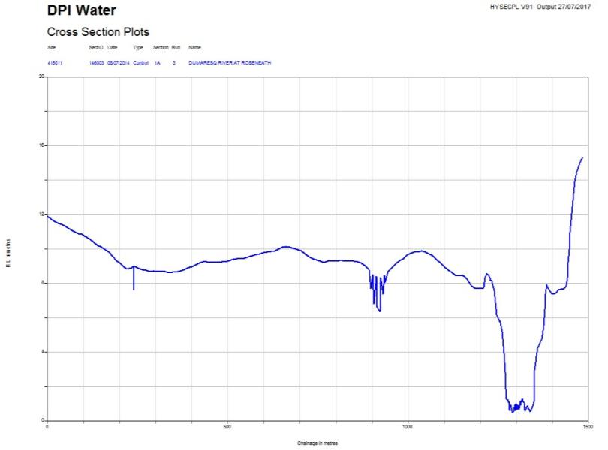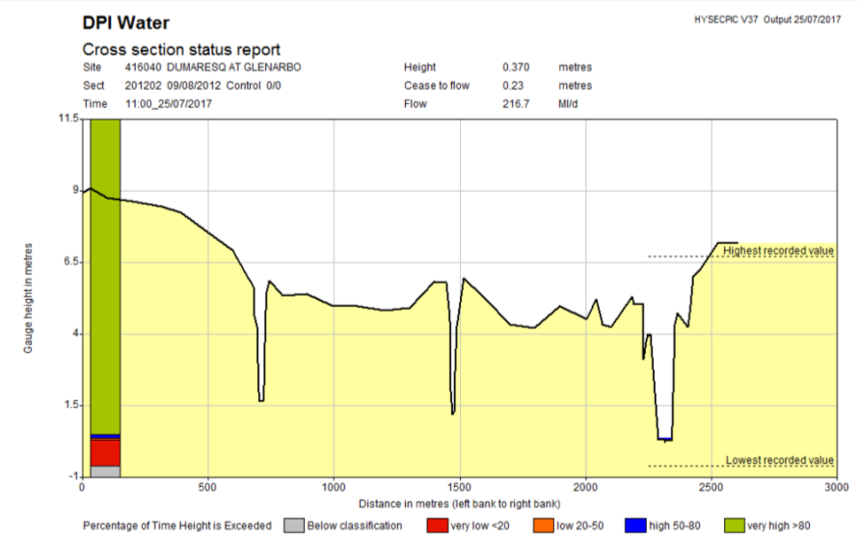

Appendix B: Habitat feature inundation with a natural flow event in 2016

Large Woody Habitat

Rootballs

Bank overhangs

Bench area

Wetland entry and exit points

Appendix C: Pumpsites
Currently, potentially millions of native fish are lost from rivers every year, being extracted by pumps and diverted into channels, significantly compromising native fish communities (Boys and Rayner, 2017). Pumps have the potential to draw fish during water abstraction and can physically harm or kill them (Baumgartner et al. 2009). Studies in the Condamine Catchment in Queensland have recorded over 12,000 native fish being removed from two 300 mm pumps over a 9-hour period (Norris, 2015).
There were 125 pumpsites were recorded in the project area. Pumpsites were relatively evenly spread across the project area, with 67 recorded in the Roseneath FGZ and 58 in the Glenarbon FGZ (Figure 39 & Figure 40). Pumpsites were categorised into three size categories <100 mm, 100 mm to 250 mm and >250 mm. Smaller pumps are generally used for stock and domestic purposes and larger pumps for irrigation and town water supply. The majority (66) of pumps recorded in the project area were 100 to 250 mm in diameter, with 11 sites being larger pumps with a diameter greater than 250 mm (Table 11 & Table 12).

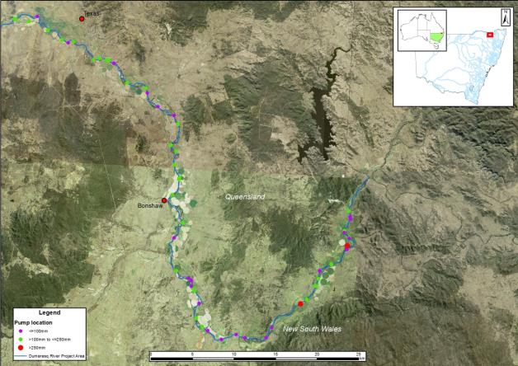
Figure 39: Location of pumpsites in the upper section of the project area overlayed on satellite image showing cropped areas.
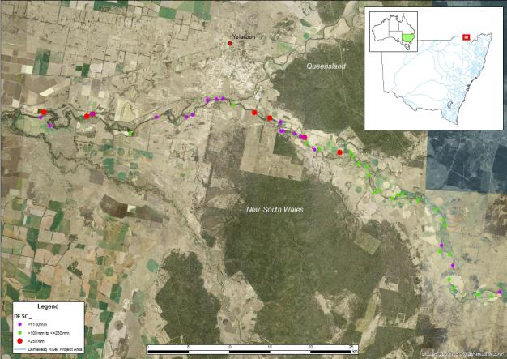
Figure 40: Location of pumpsites in the lower section of the project area overlayed on satellite image showing cropped areas.
Table 11: Number of each pumpsite size class that exist in the Roseneath FGZ.
Pumpsite size class (diameter) | Number recorded
<100mm | 25
100mm to 250mm | 40
>250mm | 2
Table 12: Number of each pumpsite size class that exist in the Glenarbon FGZ.
Pumpsite size class (diameter) | Number recorded
<100mm | 23
100mm to 250mm | 26
>250mm | 9

10 GL is approved for release to 30 June 2018.

