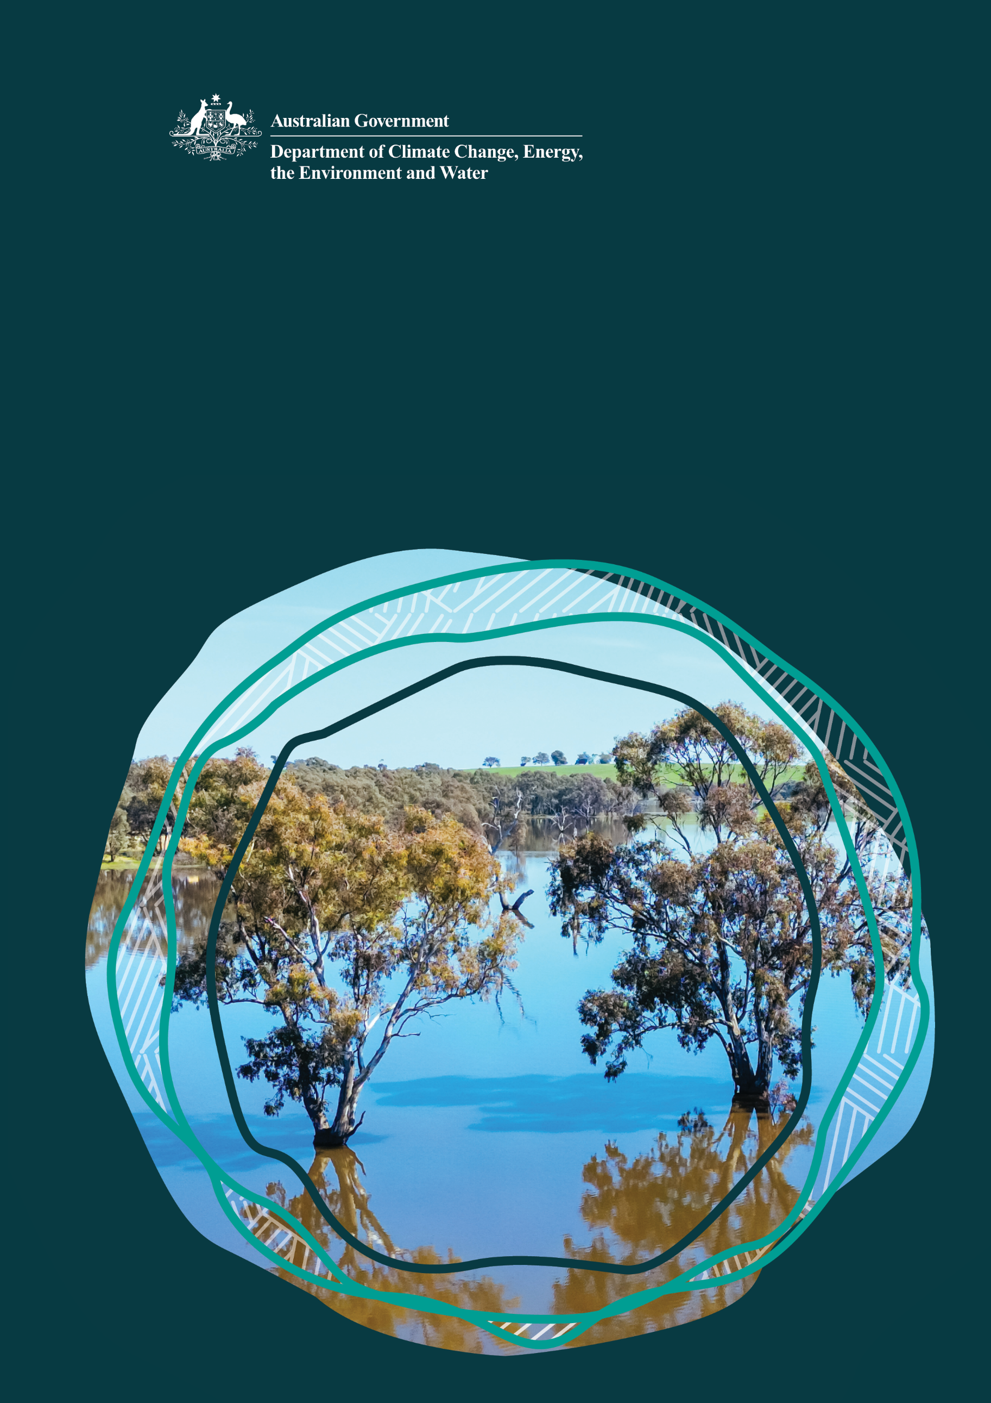
Murray-Darling Basin

First Nations Programs

July 2025 update

© Commonwealth of Australia 2025
Ownership of intellectual property rights
Unless otherwise noted, copyright (and any other intellectual property rights) in this publication is owned by the Commonwealth of Australia (referred to as the Commonwealth).
Creative Commons licence
All material in this publication is licensed under a Creative Commons Attribution 4.0 International Licence except content supplied by third parties, logos and the Commonwealth Coat of Arms.
Inquiries about the licence and any use of this document should be emailed to copyright@ dcceew.gov.au.

Cataloguing data
This publication (and any material sourced from it) should be attributed as: DCCEEW 2025, Murray-Darling Basin First Nations Programs - July 2025 Update, Department of Climate Change, Energy, the Environment and Water, Canberra, September. CC BY 4.0.
This publication is available at dcceew.gov.au/publications.
Department of Climate Change, Energy, the Environment and Water
GPO Box 3090 Canberra ACT 2601
Telephone 1800 920 528
Web dcceew.gov.au
Disclaimer
The Australian Government acting through the Department of Climate Change, Energy, the Environment and Water has exercised due care and skill in preparing and compiling the information and data in this publication. Notwithstanding, the Department of Climate Change, Energy, the Environment and Water, its employees and advisers disclaim all liability, including liability for negligence and for any loss, damage, injury, expense or cost incurred by any person as a result of accessing, using or relying on any of the information or data in this publication to the maximum extent permitted by law.
Acknowledgement of Country
We acknowledge the Traditional Owners of Country throughout Australia and recognise their continuing connection to land

Contents
Aboriginal Water Entitlements Program 2
Celebrating the Aboriginal Water Entitlements Program’s first water purchase 2
What is the Advisory Group working on? 2
What is the Directorate working on? 2
Update on water purchasing 2
What’s happening with water entitlements until the enduring arrangements are established? 3
How does the Aboriginal Water Entitlements Program buy water? 3
Murray-Darling Basin First Nations Enduring Water Holding Arrangements 4
Cultural Flows for Cultural Economies Grants 5
Inland Waters Target 6
Committee on Committee on Aboriginal and Torres Strait Islander Water Interests (CAWI) 7
CAWI members 7
What has CAWI been up to? 7
CAWI… What’s next? 7

Aboriginal Water Entitlements Program

Celebrating the Aboriginal Water Entitlements Program’s first water purchase
The department’s First Nations Water Branch celebrated the first water purchase under the $100 million Murray-Darling Basin Aboriginal Water Entitlements Program with First Nations leaders and community members in Dubbo, NSW (Tubba-Gah Wiradjuri Country) on 27 May 2025. The 200 ML general security water purchase was made in the Macquarie–Wambuul River.
Coinciding with National Reconciliation Day, this celebration acknowledged the tireless efforts of First Nations Peoples who have driven the program to this milestone. In line with this year’s theme, Bridging Now to Next, it is a reminder that respect, trust, and shared vision are key to advancing First Nations’ rights and interests.
The event provided an opportunity to reflect on this important step, recognising people who have contributed to the program and honouring First Nations leadership in the water space.

What is the Advisory Group working on?
- The Aboriginal Water Entitlements Program’s Advisory Group held its latest face-to-face meeting in Sydney on 24 June 2025, bringing the total number of meetings to 17.
- They are now working on an evaluation framework to measure the program’s impact and effectiveness.
- The Advisory Group is also exploring how they can support the Engagement Team in communicating how water is purchased through Aboriginal Water Entitlements Program and how the water market operates, ensuring transparent information is shared with Nations.

What is the Directorate working on?
- The Aboriginal Water Entitlements Program Directorate continue to meet regularly, both online and in person, to assess water entitlement offers and make purchasing decisions. The 15 th meeting was held on 17 July 2025, marking six months since the program commenced water purchasing activities.
- The Directorate is reviewing the program’s investment portfolio and strategic purchasing approach for 2025/26 financial year.

Update on water purchasing
- Water purchasing is going well, with the first purchase announced in May 2025. New offers are still being reviewed and assessed.
- The deadline for both the Market-Led Limited Tender and the Water Intermediary-Led Limited Tender has been extended to 31 December 2025, so the program can continue receiving water offers.
- A strategy is being developed to help purchase harder-to-access water entitlements in the northern Basin.

Purchasing snapshot as of 1 July 2025
- Total value of tenders: $1,211,000
Location | Goulburn  Broken | Lachlan-Galari | Macquarie- Castlereagh | Total
Volume (ML) | 80 | 10 | 200 | 290

What’s happening with water entitlements until the enduring arrangements are established?
As the Aboriginal Water Entitlements Program continues to buy permanent water entitlements, it will receive temporary water allocations.
A water allocation is the amount of water you’re allowed to use from your entitlement in a given year. This amount can change depending on how much it rains, how much water flows into dams, and how full the dams already are. Sometimes, more water becomes available later in the year if rainfall increases.
The program, together with the Advisory Group, is looking at how to trade these temporary water allocations. Trading them can help create economic benefits from the water the program owns, while the enduring water holding arrangements are being developed.
The Advisory Group will prepare guidance on how this trading happens, making sure it aligns with the Cultural values of Basin First Nations Peoples’, as well as meeting economic, environmental and water aspirations.
Before any trading begins, the program will publish a temporary trade strategy on the department’s website.

How does the Aboriginal Water Entitlements Program buy water?
The Advisory Group has worked with the department and Black Logic to create a visual artwork that illustrates how the Aboriginal Water Entitlements Program buys water.
This artwork celebrates the deep connection between community and Country across the Murray–Darling Basin. It honours the diversity of First Nations Peoples and the passing down of Culture, traditions, and knowledge through generations. Culturally significant species like Murray cod, yabby, and turtle reflect the rich ecosystem and its role in Dreaming stories and seasonal practices. Rangers restoring Country highlight shared responsibility for its care. At the heart is a Red Gum scar tree, its roots engraved with the program’s values—symbolising a strong Cultural foundation that nurtures
resilience, growth, and enduring ties between community, Culture, and Country for future generations.
Learn more about how we’re increasing Basin First Nations water ownership and access through the Aboriginal Water Entitlements Program at dcceew.gov.au/ aboriginal-water-entitlements-program/ purchasing

Murray-Darling Basin First Nations Enduring Water Holding Arrangements
- In May, Cox Inall Ridgeway (CIR), a First Nations–led consultancy, was engaged to lead the co-design of enduring water holding arrangements.
  - CIR has brought together a strong consortium of First Nations-led organisations and experts, including:
- Indigenous Energy Australia
- Winangali
- Terri Janke & Company
- Chalk & Behrendt
- Aurecon Group
- Ridge Lawyers
- The Institute for First Nations Governance Professionals
  - In June, CIR delivered key foundational documents that set out the co-design process. These include a:
- Management Plan
- Communications and Engagement Plan
- Literature Review. This is soon to be published
  - The co-design phase will begin in July 2025 and run through to February 2026, concluding with a final report recommending preferred options for a Basin First Nations–led governance entity. This process will include Nation-by-Nation meetings and workshops across the more than 50 Nations within the Murray– Darling Basin.
Learn more about how we’re partnering with First Nations to establish enduring water holding arrangements at dcceew.gov.au/ water/policy/first-nations/aboriginal-water-entitlements-program/enduring-water-holding-arrangements.

Cultural Flows for Cultural Economies Grants
The Australian Government’s $20 million Cultural Flows Planning for Cultural Economies grant program is set to open in early August 2025.
Basin First Nations, their clans and family groups and organisations supporting First Nations in the Basin will be able to apply for a grant to plan for Cultural flows on their Country.
This program provides grants of up to $300,000 to develop Cultural flows plans, enhance business governance structures or develop business plans which outline the spiritual, Cultural, environmental, social and economic values and goals of their Nation.
Cultural flows planning provides a pathway to embed First Nations Peoples’ self-determination in future water management.
Foundational planning funded by this grant program will set Basin First Nations up to access, own and manage water entitlements – including those purchased through the $100 million Aboriginal Water Entitlements Program.
The program will support Basin First Nations to build the foundations they need to access water and speak up for their water rights.
Successful applicants will have up to 2 years to complete their projects. Applications for the program will close in October 2025.
From early August 2025, we will be running information webinars and visioning workshops for Basin First Nations Peoples.
To apply for a grant visit business.gov.au/ grants-and-programs/cultural-flows-planning-for-cultural-economies

Inland Waters Target
The Closing the Gap Inland Waters Target is a national priority (beyond the Murray-Darling Basin), and it is an important step forward for empowering First Nations Peoples to secure inland freshwater ownership and access rights.
The development of the Inland Waters Target is overseen by the Inland Waters Target Working Group, which is co-chaired by the department and the National Native Title Council (NNTC) and includes representatives from state-based Coalition of Peaks and state and territory government water officials.
In July 2024, the Joint Council on Closing the Gap decided not to progress with a national target. Instead, the focus of the work is on setting jurisdictional inland water targets. Each jurisdiction is working to develop their own Inland Waters Target in partnership with First Nations People.
Key points for the quarter:
- The Inland Waters Target Working Group held 2 workshops on 10 April 2025 and 24 June 2025.
- On 1 May 2025 the NNTC and the department entered a financial agreement to resource the NNTC to support the establishment of the Inland Waters Target work.
- On 20 June 2025 the Joint Council on Closing the Gap met to discuss adding Inland Waters Target wording to the National Agreement. The Joint Council communique is available at closingthegap. gov.au/joint-council-closing-gap.

Committee on Committee on Aboriginal and Torres Strait Islander Water Interests (CAWI)

CAWI members
CAWI welcomed three new members in April 2025, to join the CAWI #33 virtual meeting that month.
New members are:
- Ms Bianca Lena (Bundjalung Tweed Nation) joining from South Australia
- Ms Ronni O’Donnel (Kureinji Nation), joining from Victoria
- Ms Carol Martin (Yamatji Naaguja/Nanda/Wudjuri Nations), joining from Western Australia

They join existing CAWI members: Dr Virgina Marshall (CAWI Chair), Mr John Locke (CAWI Deputy Chair), Ms Kay Blades, Mr Nathan Brennan, Mr Tony Jack and Ms Sarah Wilcox. This brings the committee to full membership, at 9 members.
CAWI also welcomed Dr Nadine Kelly as the new Executive Officer to CAWI in DCCEEW.

What has CAWI been up to?
CAWI has had a busy quarter in their work in the First Nations Water Interests space:
- CAWI provided feedback to the Independent Review of the Closing the Gap Agreement
- CAWI met with the Northern Territory Government regarding changes to water legislation, including the Water Amendment (Aboriginal Water Reserve) Bill 2025
- Participated in Inland Water Target workshops
- CAWI Chair and Deputy Chair attended the National Water Committee #27 Meeting in Adelaide in May 2025. The full committee met at CAWI #34 in Broome, Western Australia from 17 – 19 June 2025. The Committee discussed key matters such as CAWI strategic planning, the National Water Agreement and First Nations water interests and values in Western Australia. They met with the Kimberley Land Council and members of the Yawuru PBC. The full Communique will be published soon at dcceew.gov.au/water/policy/first-nations/cawi.

CAWI… What’s next?
The 35th meeting of CAWI will be held on 12 August 2025.
You can find the schedule of meetings and locations for 2025 at dcceew.gov.au/water/ policy/first-nations/cawi.

