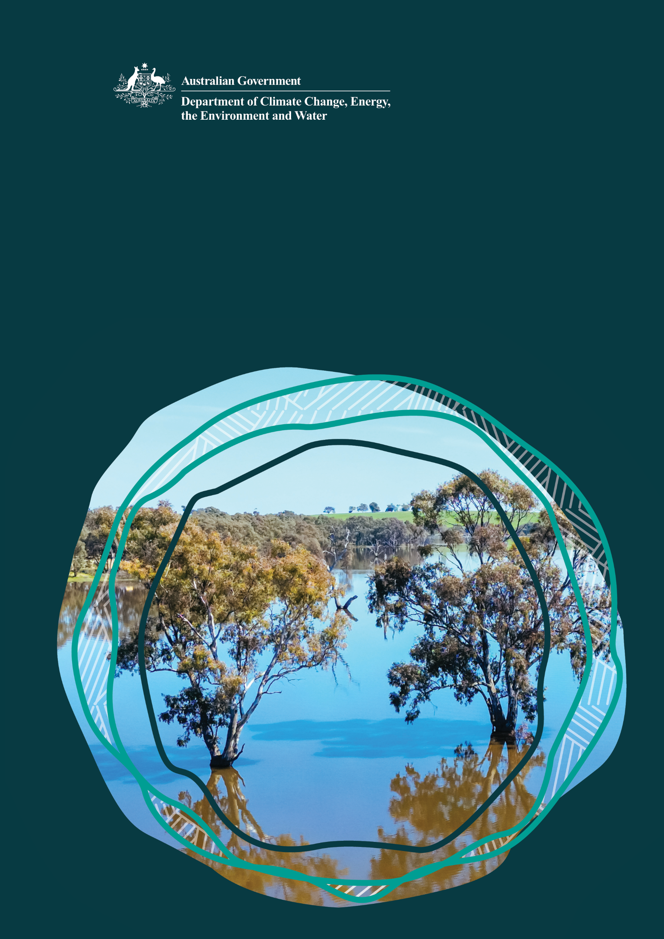
Murray-Darling Basin

First Nations Programs

June 2026 update

© Commonwealth of Australia 2026
Ownership of intellectual property rights
Unless otherwise noted, copyright (and any other intellectual property rights) in this publication is owned by the Commonwealth of Australia (referred to as the Commonwealth).
Creative Commons licence
All material in this publication is licensed under a Creative Commons Attribution 4.0 International Licence except content supplied by third parties, logos and the Commonwealth Coat of Arms.
Inquiries about the licence and any use of this document should be emailed to copyright@ dcceew.gov.au.

Cataloguing data
This publication (and any material sourced from it) should be attributed as: DCCEEW 2026, Murray-Darling Basin First Nations Programs – June 2026 Update, Department of Climate Change, Energy, the Environment and Water, Canberra, June 2026. CC BY 4.0.
This publication is available at https://www.dcceew.gov.au/water/policy/first-nations.
Department of Climate Change, Energy, the Environment and Water
GPO Box 3090 Canberra ACT 2601
Telephone 1800 920 528
Web dcceew.gov.au
Disclaimer
The Australian Government acting through the Department of Climate Change, Energy, the Environment and Water has exercised due care and skill in preparing and compiling the information and data in this publication. Notwithstanding, the Department of Climate Change, Energy, the Environment and Water, its employees and advisers disclaim all liability, including liability for negligence and for any loss, damage, injury, expense or cost incurred by any person as a result of accessing, using or relying on any of the information or data in this publication to the maximum extent permitted by law.
Acknowledgement of Country
The Department recognises the First Peoples of this nation and their ongoing connection to Culture and Country. It acknowledges First Nations peoples as the Traditional Owners, Custodians, and Lore Keepers of the world’s oldest living Culture and pays respects to their Elders past and present.

Welcome

Welcome to the June 2026 edition of the Department of Climate Change, Energy, the Enviroment and Water (DCCEEW) Murray–Darling Basin First Nations Programs Quarterly Update.

This edition shares progress across the Australian Government’s First Nations water initiatives managed by DCCEEW in the Murray–Darling Basin. Over the past quarter, important work has continued through the Aboriginal Water Entitlements Program (AWEP). This includes ongoing water purchasing, water planning, preparations for temporary water trading, and work to develop enduring First Nations water holding arrangements.

You will also find updates on the Cultural Flows for Cultural Economies Grants program. Funded projects are now moving into implementation on Country. Work is also underway to develop culturally appropriate monitoring, evaluation and learning approaches that reflect First Nations priorities, knowledge and aspirations.

This update also includes progress on the National Agreement on Closing the Gap Inland Waters Target 15c. This includes work to support national agreement, and help states and territories develop targets, actions and implementation pathways. It also provides an update on First Nations engagement sessions for the 2026 Water Act Review.

We thank Basin First Nations Peoples, AWEP Interim Governance Directorate and Advisory Group members, project partners and everyone contributing to this important work. Your leadership, knowledge and commitment continue to drive meaningful change. Together, this work is strengthening First Nations water ownership, supporting self-determination, and creating lasting cultural, social, environmental and economic benefits for current and future generations.

Contents
Aboriginal Water Entitlements Program 5
Aboriginal Water Entitlements Program 6
Year in Review 2024-25 6
Advisory Group progress 6
Directorate update 6
Water purchasing 7
Water planning and temporary trade 8
Enduring Water Holding Arrangements – Proposed Charitable Trust 9
Cultural Flows Planning for Cultural Economies Grants 10
Cultural Flows Planning for Cultural Economies Grants 11
Forward focus 11
National First Nations Water Reform 12
National Agreement on Closing the Gap: Inland Waters Target (15c) 13
Background 13
Continued progress 13
National Water Act Review 2026 14
First Nations Engagement Sessions 14
Appendix A Aboriginal Water Entitlements Program Winter Watering Statement 15

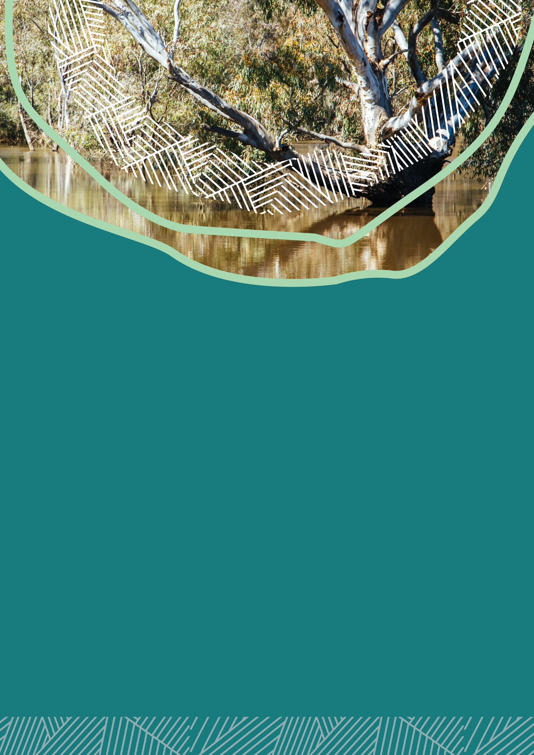

Aboriginal Water Entitlements Program

Aboriginal Water Entitlements Program

Year in Review 2024-25

We’ve marked the first year of the Aboriginal Water Entitlements Program (AWEP) and its important progress with the release of the Murray–Darling Basin Aboriginal Water Entitlements Program Year in Review 2024-25.
The report reflects on AWEP's first year, highlighting its transition from planning into active water purchasing. It captures the partnerships, achievements and shared commitment that have laid the foundation for advancing First Nations water rights across the Murray–Darling Basin.
We are grateful to all who contributed to this work and remain committed as we continue this vital journey. Your efforts are helping to shape meaningful progress and build lasting change in First Nations water rights.
Read the Aboriginal Water Entitlements Program Year in Review 2024-25 to explore:
- AWEP’s achievements and impact in its first year,
- its journey since 2018; and
- what lies ahead for AWEP and Basin First Nations water rights.

Advisory Group progress

The Advisory Group continues to meet online each month. The group also takes part in targeted workshops to help develop key policies and arrangements for AWEP.

The Advisory Group is progressing work on water planning, trading policies and governance arrangements. It is also helping to develop the 2026–27 Annual Watering Plan, which will explain how AWEP’s water entitlements will be managed and used.

The 2025–26 year concluded with an in-person Advisory Group meeting in Canberra on 16 June 2026.

Directorate update

The Directorate continues to meet regularly to assess new water purchase offers, make purchasing decisions, and provide strategic direction for the management of the AWEP water investment portfolio.
The most recent face-to-face meeting was held in Brisbane on 27 March 2026. At this meeting, the Directorate considered the types of water entitlements that could be purchased with the remaining program budget.
The Directorate is focusing on purchasing opportunities that best align with AWEP’s investment principles, including connectivity and long-term wealth generation for Basin First Nations Peoples.

Water purchasing

Water purchasing in 2025-26

The Aboriginal Water Entitlements Program has advanced strongly towards its water portfolio through two limited tenders and one open tender in the 2025-26 financial year.
As of 30 June 2026, AWEP has secured 20.8 GL of water entitlements valued at $80.4 million.
The water secured by AWEP represents:
- about 0.19% of the Basin’s annual surface water consumptive pool, which is around 10,945 GL each year. The consumptive pool is the amount of water available each year for use by irrigators, towns, industries and other water licence holders.
- about 0.087% of the Basin’s average annual surface water runoff, which is around 24,000 GL each year. Average annual runoff is the water that naturally flows through the Basin’s rivers, creeks and wetlands from rainfall and catchment inflows before it is diverted, stored or used.
Water purchasing in northern Basin catchments, particularly Queensland, has proven challenging. Compared to southern catchments, water markets in the north are less active, with fewer opportunities and generally higher prices.
To respond to these challenges AWEP released an Open Tender targeting northern Basin catchments and ran targeted communication campaigns to encourage participation. While these efforts generated limited interest, they reinforced how constrained northern water markets are and how hard it is to buy water in the northern basin.

Water purchasing in 2026-27

As AWEP plans its water purchasing for 2026–27, the department remains committed to fair outcomes for Basin First Nations Peoples.
This does not mean buying the same amount of water, or spending the same amount of money, in every region. Instead, AWEP will be guided by Basin First Nations priorities and a shared benefits approach.
A shared benefits approach means that water held in one location can still create benefits and opportunities across the Basin. This can happen through temporary trade, partnerships, knowledge investment and putting money back into water purchasing.
AWEP will continue to look for water purchasing opportunities in northern catchments when they become available.
Money made from temporary trade may be reinvested to grow the water portfolio. This could help AWEP buy water entitlements that are harder to access, including in northern catchments.
For more information on what water AWEP has purchased, visit Murray–Darling Basin Aboriginal Water Entitlements Program water purchasing - DCCEEW
Portfolio breakdown across the Basin – as of 30 June 2026
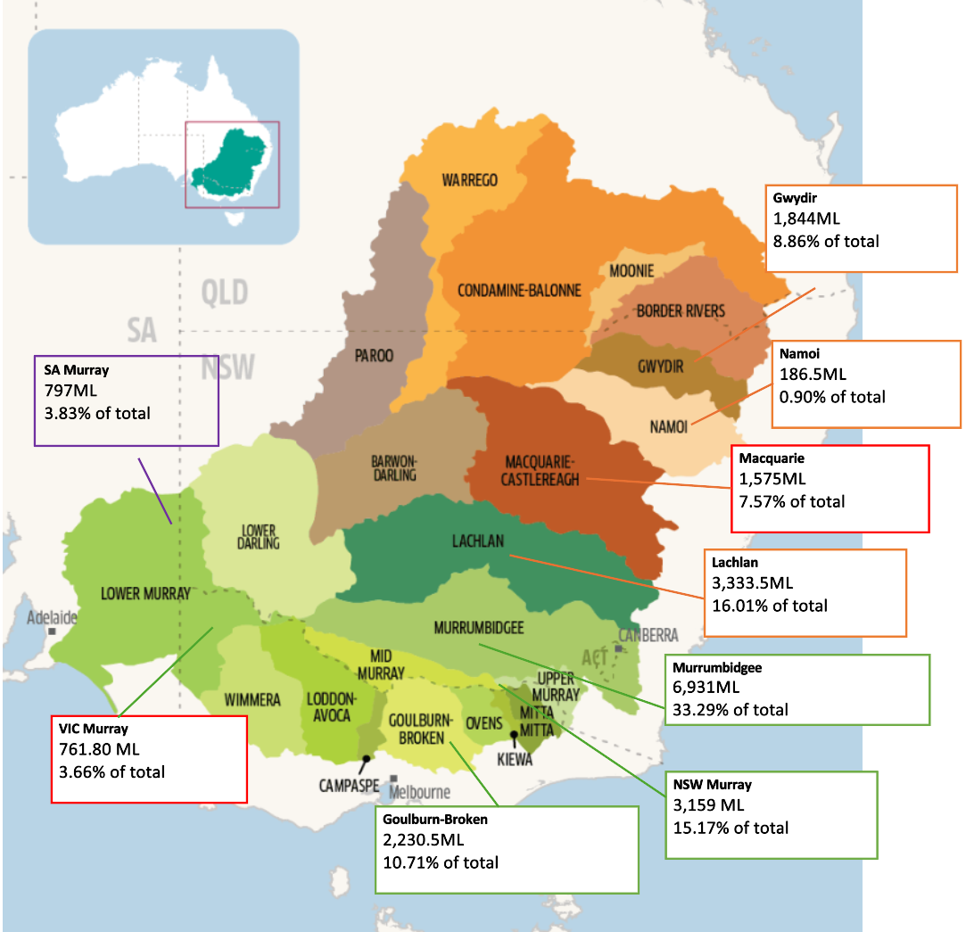

Water planning and temporary trade

AWEP will soon release its first Annual Watering Plan (plan). The plan outlines how water will be managed and used to achieve AWEP’s priorities for the 2026–27 water year. The plan ensures that decisions about water use and trade are Culturally informed, commercially sound, and responsive to real-time market, climatic and hydrological conditions.
A key activity for AWEP will be temporary trade. The department is currently setting up temporary trade. This will allow water allocations to be traded to support wealth creation on behalf of Basin First Nations peoples. Temporary trading is expected to begin in August/September 2026, once the operational arrangements are in place.
A watering statement for how AWEP has managed the water holdings in 2025-26 can be found in Appendix A.

Enduring Water Holding Arrangements – Proposed Charitable Trust
The Government has agreed to continue development of the proposed Charitable Trust model, including detailed design, co-design, and due diligence work. Planning is underway for the next phase.
This phase will include:
- co-design with Basin First Nations Peoples to develop detailed governance arrangements, led by a First Nations–led supplier; and
- development of a business case and business plan by a specialist supplier, including financial and legal due diligence to test the feasibility of establishing and operating the Charitable Trust.

These streams will work closely together to inform a clear implementation pathway.

Next steps

The outcomes of this next phase will inform Government with a more detailed model, to support decisions on implementation, establishment and any future funding.

Basin First Nations Peoples will lead this work. There will be a range of opportunities to participate, including face-to-face and online options, with details to be shared soon.



Cultural Flows Planning for Cultural Economies Grants

Cultural Flows Planning for Cultural Economies Grants
The Cultural Flows Planning for Cultural Economies grants program (the grants program) has transitioned from establishment into delivery, with strong participation from First Nations organisations across the Murray–Darling Basin.
Project teams are progressing a range of Cultural Flows planning activities in line with their grant agreements that reflect local priorities, aspirations and connections to Country. The grants program continues to support First Nations-led approaches at different stages of readiness, from Nations building on existing work through to those undertaking early planning and vision-setting activities. Through this work, the grants program is creating opportunities for communities to explore, articulate and advance their Cultural Flows priorities in ways that align with their own governance and decision-making processes.
Complementing the grants program, the Cultural Flows video storytelling project is underway to document and share First Nations perspectives, experiences and aspirations relating to Cultural Flows. The project is intended to support knowledge sharing across the Basin, increase awareness of Cultural Flows planning, and provide a resource that can inform future engagement, policy and program development.

Forward focus
- Developing a culturally informed monitoring, evaluation and learning approach that captures outcomes meaningful to First Nations communities and contributes to understanding the impacts of Cultural Flows planning over time.
- Identifying emerging themes, opportunities and lessons from funded projects to support shared learning.
- Building the evidence base around Cultural Flows planning approaches and outcomes, including through the video storytelling project and other program insights.
- Exploring opportunities to sustain and strengthen Cultural Flows planning capability and knowledge sharing beyond the current grant round.

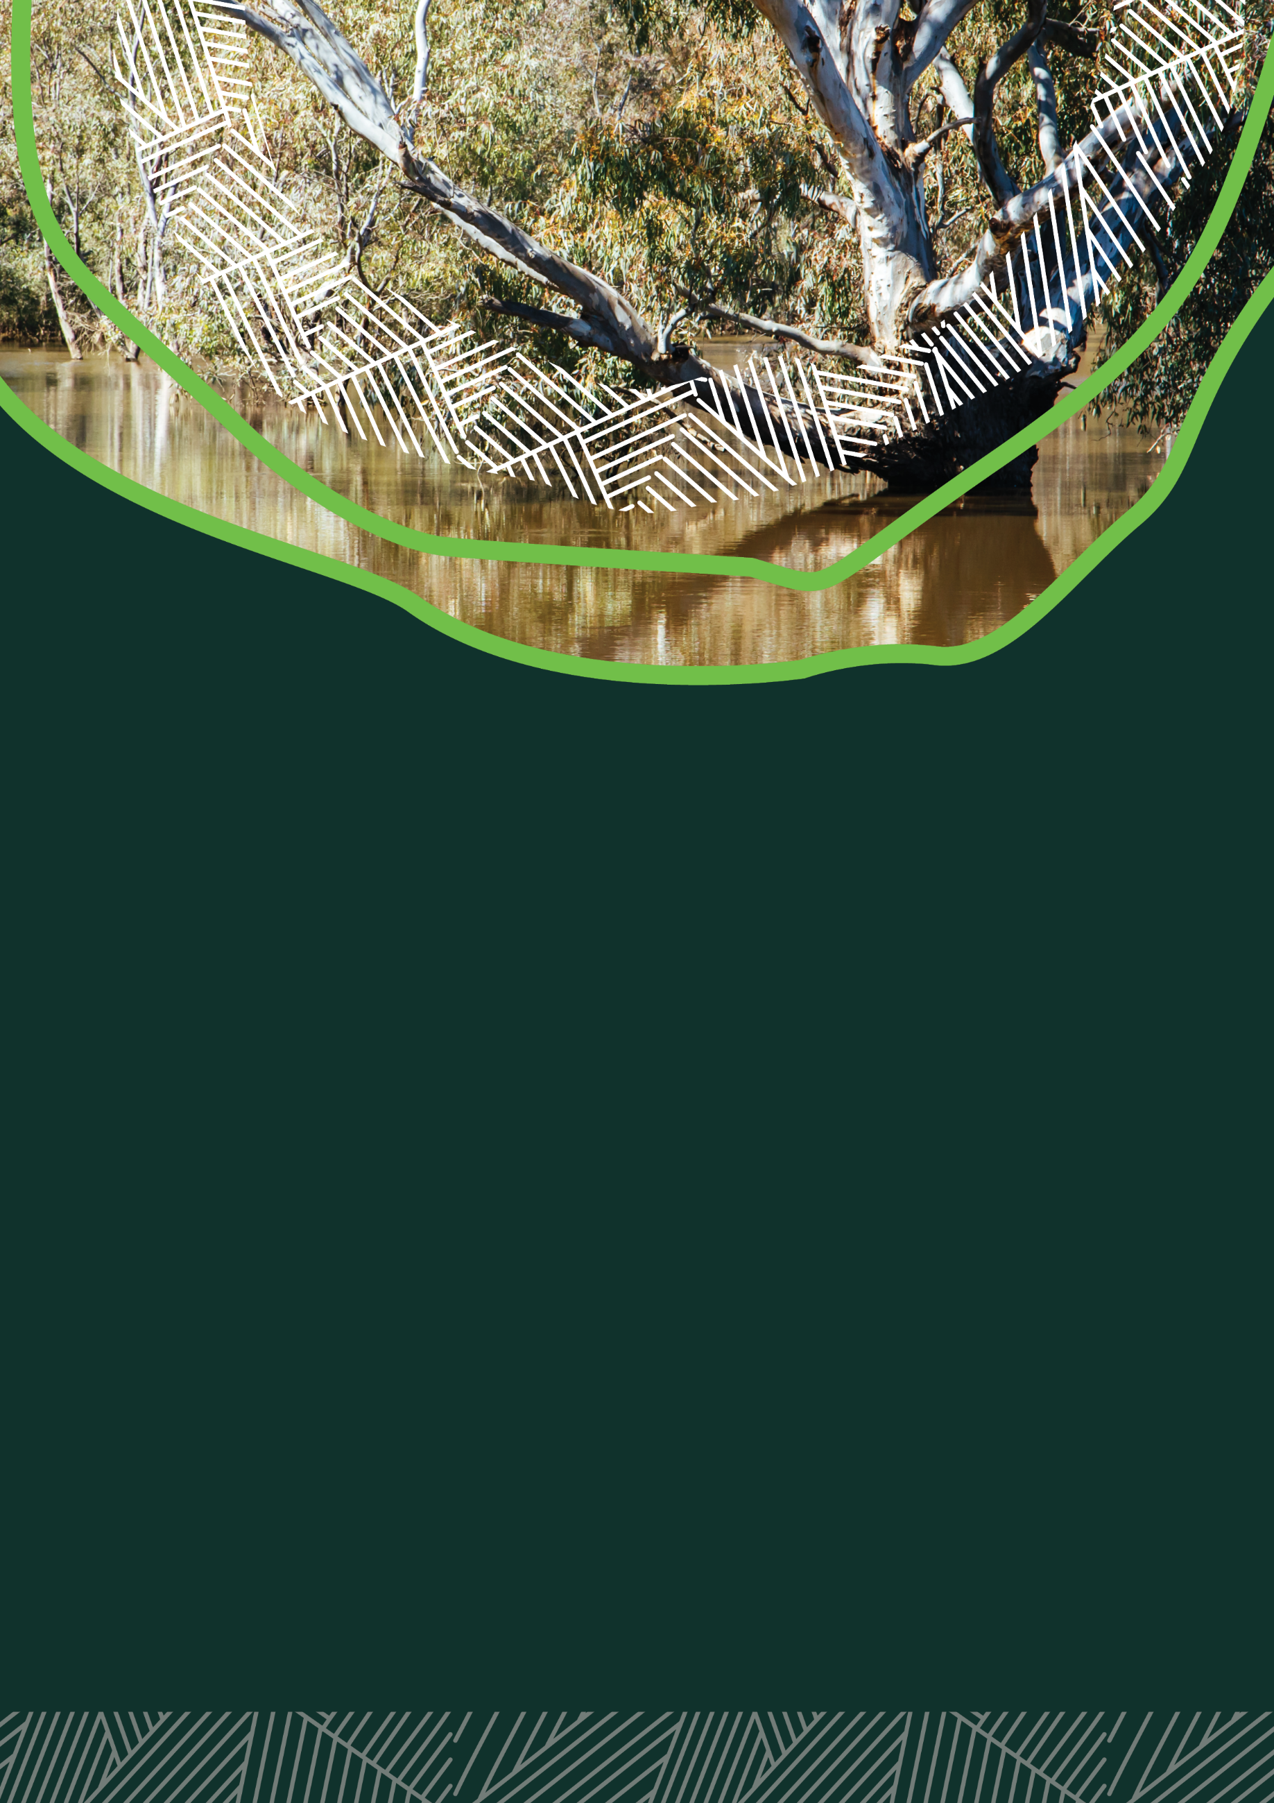

National First Nations Water Reform

National Agreement on Closing the Gap: Inland Waters Target (15c)

Background
In 2020, parties to the National Agreement on Closing the Gap agreed to develop an Inland Waters Target under Outcome 15. Outcome 15 is about making sure Aboriginal and Torres Strait Islander peoples maintain a strong Cultural, spiritual, physical and economic relationship with their land and waters.
On 5 July 2024, the Joint Council on Closing the Gap agreed to use a jurisdictional approach for the Inland Waters Target. This means each state and territory will develop its own baseline metric, target/s and actions, in partnership with Aboriginal and Torres Strait Islander peoples. The Inland Waters Target is the first, and currently only, jurisdictional target approach under the National Agreement.
As at June 2026, all Indigenous Affairs Ministers and Water Ministers (except the Queensland Government who have abstained from making a decision) are supportive of including the Inland Waters Target wording (aim) in the National Agreement.
The proposed target wording (aim) is:
By 2035, state and territory governments increase Aboriginal and Torres Strait Islander organisations’ access to, ownership of, and management of water inland from the coastal zone (not sea water), as agreed through jurisdictional partnership arrangements.

Continued progress
We continue to work with the National Indigenous Australians Agency (NIAA), which is the secretariat for the Joint Council on Closing the Gap, to seek a position from the Queensland Government. All parties must agree before any changes can be made to the National Agreement.

Engagement has also started with Commonwealth agencies to identify potential Commonwealth actions for the Inland Waters Target. These actions may sit across policy, program, regulatory and operational areas. The Commonwealth will work with the National Native Title Corporation, our partners from the Coalition of Peaks, to agree on actions that the Commonwealth will undertake.

State and territory governments are continuing to work with Aboriginal and Torres Strait Islander Peaks and other partners through their jurisdictional partnership arrangements to develop and agree baseline metric, target/s and actions.

National Water Act Review 2026

First Nations Engagement Sessions

During May – August 2026, Dr Teagan Shields, the Independent First Nations Advisor for the review of the Water Act 2007 (Cth), is facilitating in-person consultation sessions with Peak Aboriginal and Torres Strait Islander Organisations and representative bodies. The sessions provide a space for people to talk about what is working, what needs to change, and what stronger water laws could look like.
The in-person consultation sessions are focussed on identifying opportunities under the Act to promote the principles set out in the United Nations Declaration on the Rights of Indigenous Peoples (UNDRIP).
The feedback from these sessions will help inform national water reform and support stronger recognition of First Nations water rights, Culture and leadership. Read more: Strong Voices, Healthy Waters: upholding Aboriginal and Torres Strait Islander peoples’ water rights through the review of the Water Act 2007 (Cth).
Aboriginal and Torres Strait Islander peoples are encouraged to also engage in the broader national consultation related to the review by keeping watch on the Water Act Review webpage, where a Have Your Say survey will be launched. www.dcceew.gov.au/water/policy/policy/legislation/water-act-review

Appendix A
Aboriginal Water Entitlements Program

Watering Statement Q4 (Winter)

Introduction
This statement provides an overview of the Aboriginal Water Entitlement Program’s (AWEP) water purchasing activities for the 2025-26 water year. It explains what water has been purchased, what water is now held by AWEP, what conditions were like during the year, and what AWEP is planning for 2026–27.
Year in Summary
The 2025–26 water year was an important foundation year for AWEP.
The main focus was purchasing water entitlements, registering them to AWEP, and preparing for future water planning and temporary trade.
By the end of the water year (30 June 2026), AWEP had contracted 20.8 gigalitres of water entitlements. Of this, 13.8 gigalitres had been registered to AWEP ownership for the purposes of allocations.
A gigalitre (GL) is equal to 1,000 megalitres (ML).
Only a small amount of water was available to AWEP in 2025–26. This is because AWEP is still in its early stages. Some water entitlements were registered part-way through the year, while other purchases were still being settled. This meant AWEP did not receive the full benefit of allocations across all purchased entitlements during the 2025–26 water year.
Water allocations for the 2026–27 water year will begin to be announced from 1 July 2026.
Climatic and water conditions
Condition across the Murray-Darling Basin were dry to average, with:
- reduced inflows and moderate storage levels in the southern catchments
- variable conditions across northern catchments; and
- water allocations at the start of the year were lower than in recent wetter years.
Water holdings
AWEP’s work this year focused on building the foundations for future water planning and decision-making.
This includes making sure First Nations voices are part of the way AWEP is designed and delivered.
Water planning through AWEP is grounded in connection to Country and caring for Country.
AWEP will carry over all available water allocations into the 2026–27 water year. This means the water will not be used or traded before the end of the 2025–26 year.
This approach gives AWEP more time to:
- trade water when market conditions may be better;
- finalise policies and processes;
- strengthen governance arrangements;
- develop trading strategies; and
- make sure future water decisions support AWEP’s objectives.
Table 1 shows the water entitlements owned by AWEP and the water allocations received in 2025–26.
Table 1: 2025-26 AWEP Water Holdings
Catchment | Security/Reliability | Registered Entitlements (ML) | Allocation volume (ML)
Lachlan | GS | 3333.50 | 0.00
Macquarie -Castlereagh | GS | 225.00 | 8.00
Namoi | GS | 146.50 | 0.00
Murrumbidgee | GS, HS | 5210.00 | 0.00
NSW Murray | GS | 1274.00 | 9. 50
Gwydir | GS | 1844.00 | 0.00
Goulburn-Broken | HRWS, LRWS | 2202.10 | 618.24
VIC Murray | HRWS | 304.70 | 0.00
Total |  | 13,877.30 | 635.74
Table 2 explains common water entitlement types, including how reliable they are likely to be in different water conditions.
Table 2: Water Entitlement definitions
Short term | Full term | Definition
GS | General Security | A water entitlement that usually receives water after higher priority licences. The amount available can change a lot depending on seasonal conditions.
HS | High Security | A water entitlement with higher priority than general security. It is more likely to receive water allocations, including in drier years.
HRWS | High Reliability Water Share | A water share that is more likely to receive allocations in most years. Allocations are usually made to high reliability shares before low reliability shares.
LRWS | Low Reliability Water Share | A water share that receives allocations less often. It may only receive water when conditions are wetter or when more water is available.

Looking Ahead (2026–27)
The 2026-27 water year represents an important year for AWEP.
AWEP will focus on starting temporary trade and maximising value from available allocations. It will also continue building AWEP’s ability to support other First Nations water initiatives.
Planning will be reviewed throughout the year as water availability, climate conditions and market conditions change.
Key focus for the 2026-27 year:
- Starting temporary trade
- Investigating watering needs for Basin Nations
- Exploring opportunities for water delivery pathways and partnerships.
More information will be provided in the 2026-27 Annual Watering Plan. To read more: visit the department’s webpage:
Murray–Darling Basin Aboriginal Water Entitlements Program - DCCEEW



