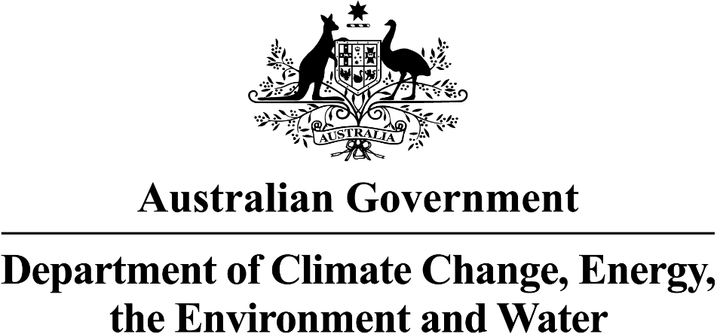

First Nations Water Programs in the Murray—Darling Basin

DECEMBER 2024

•The program is now in its purchasing phase.
•The Advisory Group have developed a multi-criteria purchasing guide. All purchases will be assessed using this guide.
•The first purchase approach, Water Intermediary Led Limited Tender, is now open.
•Three water brokers are now engaged in the program and are actively seeking offers for the program.
•The program has already received some applications.
•Intent is to purchase as soon as possible providing it represents value for money and meeting First Nations outcomes.
Artist: Wayne Quilliam
Where is the Aboriginal Water Entitlement Program up to?
•The program is now in its purchasing phase.

•The Advisory Group have developed a multi-criteria purchasing guide. All purchases will be assessed using this guide.
•The first purchase approach, Water Intermediary Led Limited Tender, is now open.
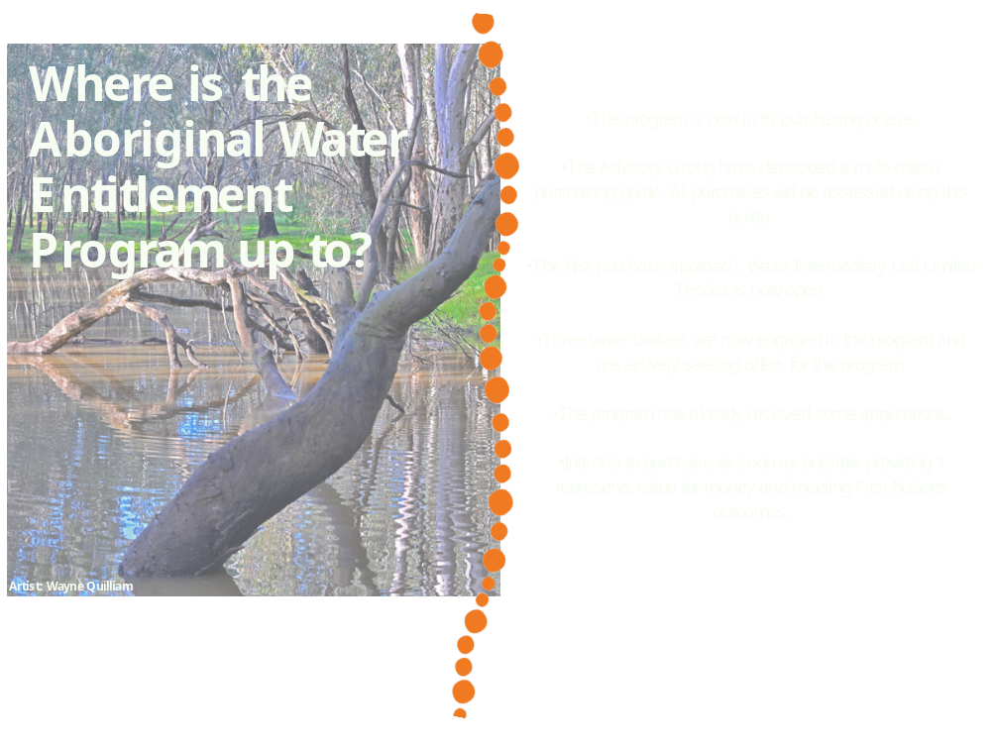program and are actively seeking offers for the program.
•The program has already received some applications.
•Intent is to purchase as soon as possible providing it represents value for money and meeting First Nations outcomes.

Interim Governance update
What are the Directorate working on?
•The Advisory Group has held 8 meetings, with the latest being a face-to-face session in Melbourne.
•They are developing interim water holding policies and exploring options for water trading and investing.
•Gordon (Ross) Mitchell has resigned as co-chair; we thank him for his contributions and commitment.
•Feli McHughes has been appointed as the new co-chair.
•Applications will soon open for a Northern Basin representative to maintain balanced membership across the basin.
What are the Advisory Group working on?

•The Directorate recently held a face-to-face meeting in Melbourne to finalise procedures for evaluating water purchases.
•They will review the purchasing process based on the guide developed by the Advisory Group, focusing on First Nations outcomes, value for money, and independent expert advice.
•The Directorate will assess potential water offers in the New Year.

Murray—Darling Basin First Nations Enduring Water Holding
On 3 November 2024, we completed a ‘Have Your Say’ survey to better understand from Basin People what they want the Basin enduring water holding arrangements to deliver:
  - Local, community-driven representation and merit-based participation in decision-making.
  - Independent ownership and management of water to support cultural and economic outcomes.
  - Ability to divest water entitlements to Basin First Nations Peoples.
  - Strong, transparent governance structures.
  - Government support for funding and risk management.
  - Representation of diverse needs, aspirations, and experiences across the Basin.
  - Access to independent legal, financial, and scientific advice.
A visual report of these results will be available in January 2025. Further Nation-based consultation will continue in early 2025 to inform the co-design of appropriate arrangements.
Feedback to date – What we heard so far!
•The department is working to transfer the entitlements to Basin First Nations through the establishment of enduring water holding arrangements.
•The open tender for a First Nations led consultancy to facilitate the co-design of the enduring water holding arrangements with Basin First Nations Peoples has now closed. The responses are being evaluated, and the successful consultant will be introduced in the new year.

Where are the arrangements up to?
August – September 2025
Draft water holding arrangements out for further consideration
Final recommendation report for preferred water holding arrangements
October – November 2025
Prepare first draft of the preferred water holding arrangements
June – August 2025
Co-design water holding arrangements in meetings, workshops, focus groups
February 2024 – May 2025
Enduring Water Holding... What’s Next?
  - Basin First Nations groups are at varied stages of Cultural flows planning.
  - A wide range of supports need to be available to enable Basin First Nations groups at all stages of Cultural flows planning to participate in the program.
  - Supports will include case studies, instructional videos on how to use the Business Grants Hub website, visioning workshops, info sessions and on-call support to answer questions.
  - Cultural economies must be understood holistically to include protecting cultural practices, cultural knowledge and the health of communities.
  - Developing governance is a key activity for Basin First Nations groups.
  - Other important activities to support Cultural flows planning include planning for water-dependent businesses and planning for water delivery infrastructure on Country.
The $20 million program supports First Nations across the Basin to prepare to be ready to own and manage water for cultural, spiritual, economic, social and environmental purposes, as defined by the Echuca Declaration (2007).
Key points:
·Grants Program will launch in 2025
  - Non – competitive
  - Up to $300,000 per Nation group
  - Alliances and consortium can apply
  - Nations can auspice funds
The Program
Summary of program consultation to date
Cultural Flows Planning for Cultural Economies Program
  - Applications for the program are expected to open in March 2025.
  - Applications will be open for 10 weeks, to allow enough time for Basin First Nations groups to apply
MARCH 2025
NOW
  - We are finalising Grant Opportunity Guidelines for the program, based on all consultation with Basin First Nations Peoples in 2024. The Grant Opportunity Guidelines will outline who is eligible to apply for funding, what type of activities can be funded, and how we will assess applications for the Program.
JANUARY 2025
  - The Grant Opportunity Guidelines will be published and the program will soft launch. Basin First Nations will have 8 weeks to get familiar with the guidelines and start preparing to apply. Basin First Nations are encouraged to contact the department to discuss and arrange what supports might be needed.
  - We will publish a “What We Heard” report which summarises insights and feedback from consultation to design the program in 2024

Cultural Flows Planning... What’s Next?
decorative
First Nations Water Branch
Wishing you a joyful Christmas and a relaxing end-of-year break.
We look forward to reconnecting and working together in the New Year!
For further program information:
  - First Nations Water Policy
  - Aboriginal Water Entitlements Program
  - Cultural Flows Planning for Cultural Economies
To arrange a face-to-face meeting on Country with representatives from the First Nations Water Branch, please email
firstnationswater@dcceew.gov.au
For all other general questions and enquiries, please email
firstnationswater@dcceew.gov.au

