MARCH 2025
Commonwealth DCCEEW
Murray-Darling Basin Programs Update
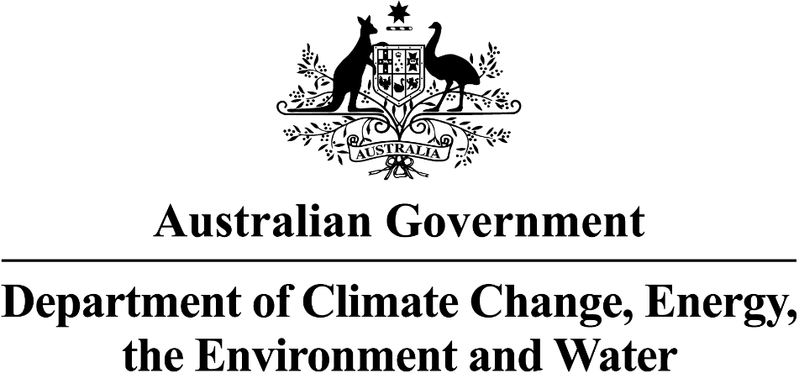

Aboriginal Water Entitlements Program

MARCH 2025

•The program is reviewing offers to purchase water entitlements from sellers across the Murray–Darling Basin.
•All purchase must support the principle of ‘connectivity underpinned by wealth generation’.
•The first purchase method, Water Intermediary (water brokers) Led Limited Tender, started in November 2024.
•The second purchase method, Market Led Limited Tender, began in March 2025 This allows sellers to submit offers directly to the department, without going through a broker. Basin First Nations Peoples can also submit offers with or as willing sellers.
•Now that a federal election has been called, the government has gone into caretaker mode. This means that during the caretaker period, the program will continue reviewing applications but is unable to finalise the purchase of water.

Artist: Wayne Quilliam
Where is the status of the Aboriginal Water Entitlement Program?
•The program is now in its purchasing phase.

•The Advisory Group have developed a multi-criteria purchasing guide. All purchases will be assessed using this guide.
•The first purchase approach, Water Intermediary Led Limited Tender, is now open.
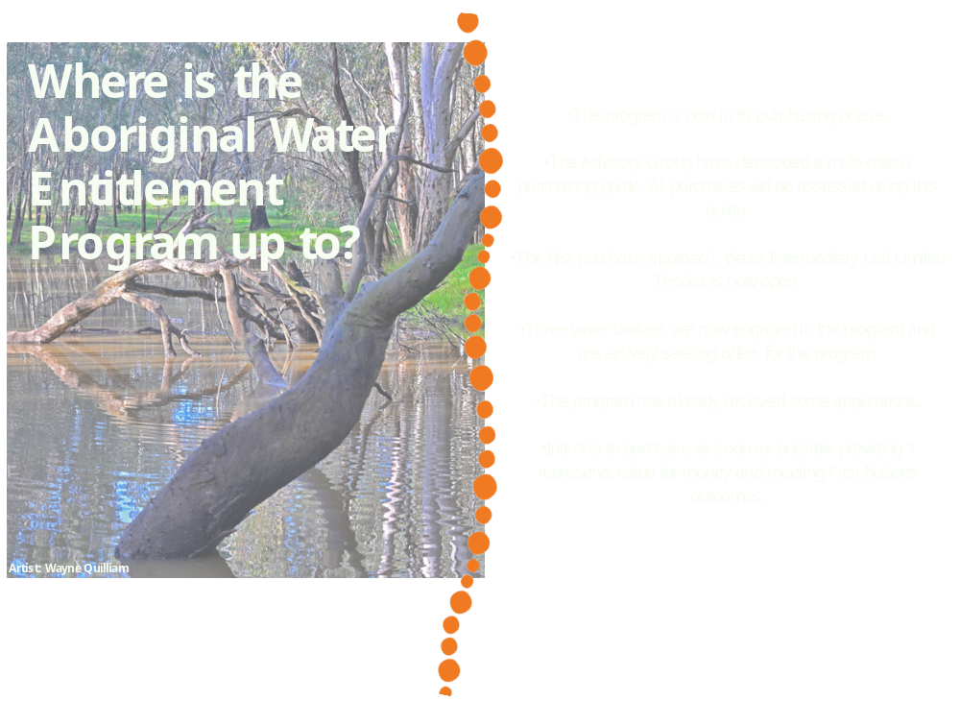program and are actively seeking offers for the program.
•The program has already received some applications.
•Intent is to purchase as soon as possible providing it represents value for money and meeting First Nations outcomes.

Interim Governance update
•The Advisory Group has held 12 meetings, with the latest held in Mildura.
•In Mildura, the Advisory Group:
  - Learnt more about different water planning cycles and how organisations access and use water allocations.
  - Discussed challenges faced by other programs delivering water.
•The Advisory Group are working on the trading and leasing principles and is finalising assessment criteria while exploring water planning needs.
•Applications for the vacant Advisory Group position are now closed. A strong response was received, and the position should be filled soon.

What are the Advisory Group working on?

What are the Directorate working on?

  - The Directorate meets regularly, both online and in person, to assess water entitlement offers and make purchasing decisions in the best interests of First Nations peoples across the Murray—Darling Basin.
  - When assessing offers, they use a framework developed by the Advisory Group, focusing on First Nations outcomes, value for money, and independent advice to meet the needs of both the Northern and Southern Basin First Nations Peoples.
  - The next Directorate meeting is in Canberra on 3 April 2025.

Murray—Darling Basin First Nations Enduring Water Holding
Where are the arrangements up to?
  - The department is working to transfer water entitlements to Basin First Nations Peoples through enduring water holding arrangements.

Feedback to date – What we heard so far!
  - On 3 November 2024, we completed a ‘Have Your Say’ survey to understand what Basin First Nations peoples want for enduring water holding arrangements.
  - A visual report of the results was published on our website in January 2025. See: Murray–Darling Basin First Nations enduring water holding arrangements - DCCEEW
  - Nation-based consultations will continue in May 2025 to support the co-design process.

MARCH 2025
Cultural Flows Planning for Cultural Economies Program
Key Points
  - Grants Program launched in February 2025​
  - Grant opportunity guidelines were released along with a variety of application supports.
  - Visit https://www.dcceew.gov.au/water/policy/first-nations/supporting-cultural-flows-planning-cultural-economies-murray-darling-basin for more information.
  - The applications open date will be delayed to mid-June 2025 due to the federal election. Basin First Nations will be notified about the new application opening date as soon as it is known. ​
  - Applicants will have up to 2 years to complete projects​
  - Non – competitive assessment process​
  - Up to $300,000 per Nation, per application​
  - Alliances and consortium can apply​
  - Nations can auspice funds
  - For more information on the grant:
  - Business Grants Hub - Cultural Flows Planning for Cultural Economies grant information:
  - Culturalflows@industry.gov.au | 13 28 46

The $20 million program supports Basin First Nations to prepare Cultural flows plans for the spiritual, Cultural, environmental, social, and economic benefit of their Nation. Funding can also be used to enhance governance structures to support a Nation’s water-based aspirations or to develop business plans.
This could help First Nations across the Basin to prepare to be ready to own and manage water.
Key points:
·Grants Program will launch in 2025
  - Non – competitive
  - Up to $300,000 per Nation group
  - Alliances and consortium can apply
  - Nations can auspice funds
The Program
Cultural Flows Planning for Cultural Economies Program
Committee on Aboriginal and Torres Strait Islander Water Interests
MARCH 2025
About CAWI
  - CAWI is an independent, national, non-statutory advisory committee that advises governments on First Nations water policy reforms.
  - CAWI members, works to elevate Aboriginal and Torres Strait Islander Peoples’ water rights, values, and interests in national water policies and approaches.
  - CAWI does not represent, speak for, or act on behalf of any First Nation individual, organisation, or community group. However, the committee encourages Aboriginal and Torres Strait Islander organisations, communities, and individuals to engage in First Nations water reform so that their voices and perspectives are heard.
  - See the CAWI website for more information - www.dcceew.gov.au/water/policy/first-nations/cawi
From left: John Locke, Virginia Marshall, Kay Blades, Tony Jack, Nathan Brennan, Sarah Wilcox
What has CAWI been up to?
  - Three new members joined the committee in late 2024 – Mr Tony Jack from the Northern Territory, Ms Sarah Wilcox from Lutruwita/Tasmania, and Mr Nathan Brennan from NSW. They join Dr Virginia Marshall, Mr John Locke and Ms Kay Blades, which makes CAWI currently a six-member committee.
  - In early 2025, a targeted recruitment process was held to encourage representatives from South Australia, Western Australia, and Victoria to join CAWI. The outcomes will be finalised soon.
  - ·CAWI held its first meeting of the year in February in Adelaide, South Australia. The meeting Communiqué is on the CAWI website.
  - In February 2025, Dr Marshall was elected as Chair, and Mr Locke the Deputy Chair.
  - CAWI has contributed to the elevation of Aboriginal and Torres Strait Islander peoples’ water interests with the drafting of the new National Water Agreement.
  - The committee lodged two submissions for key reviews related to First Nations water reform:
    - The Joint Select Committee on Northern Australia’s inquiry into energy, food and water security – CAWI’s submission can be found here.
    - The Australia Law Reform Commission for the Review of the Future Acts Regime – CAWI’s submission will soon be published on the ALRC website.
  - CAWI is developing a suite of public materials to help Aboriginal and Torres Strait Islander People and governments to better understand the importance of key water topics, such as Cultural water and groundwater.
  - CAWI’s next meeting is a virtual meeting on 29 April 2025. The schedule of meetings and locations for 2025 are on the CAWI website.
  - CAWI will continue working with the Coalition of Peaks, jurisdictions and DCCEEW to develop Target 15c on Inland Waters under the National Agreement on Closing the Gap.
  - CAWI will be welcoming new members selected from the recent recruitment process and supporting them in our work.
  - CAWI will continue to work with the National Water Committee on arrangements for a new National Water Agreement.
CAWI... What’s Next?
For further program information:​
  - First Nations Water Policy​
  - Aboriginal Water Entitlements Program​
  - Cultural Flows Planning for Cultural Economies​
​
To arrange a face-to-face meeting on Country with representatives from the First Nations Water Branch, ​
please email firstnationswater@dcceew.gov.au​
​
For all other general questions and enquiries, please email firstnationswater@dcceew.gov.au ​

First Nations Water Branch

