



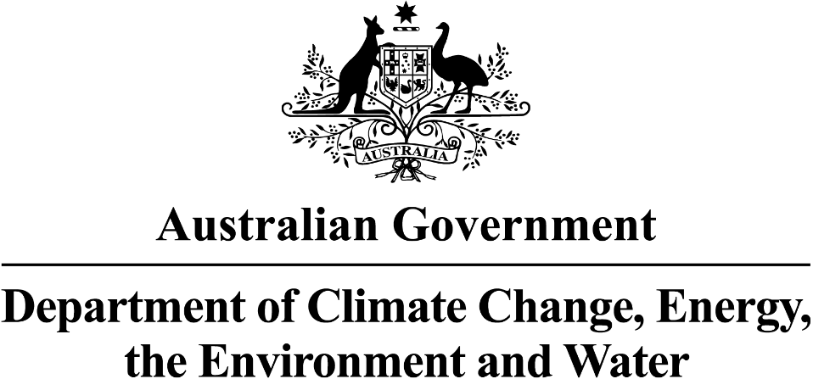
First Nations Water Programs in the Murray—Darling Basin
Update: September 2024
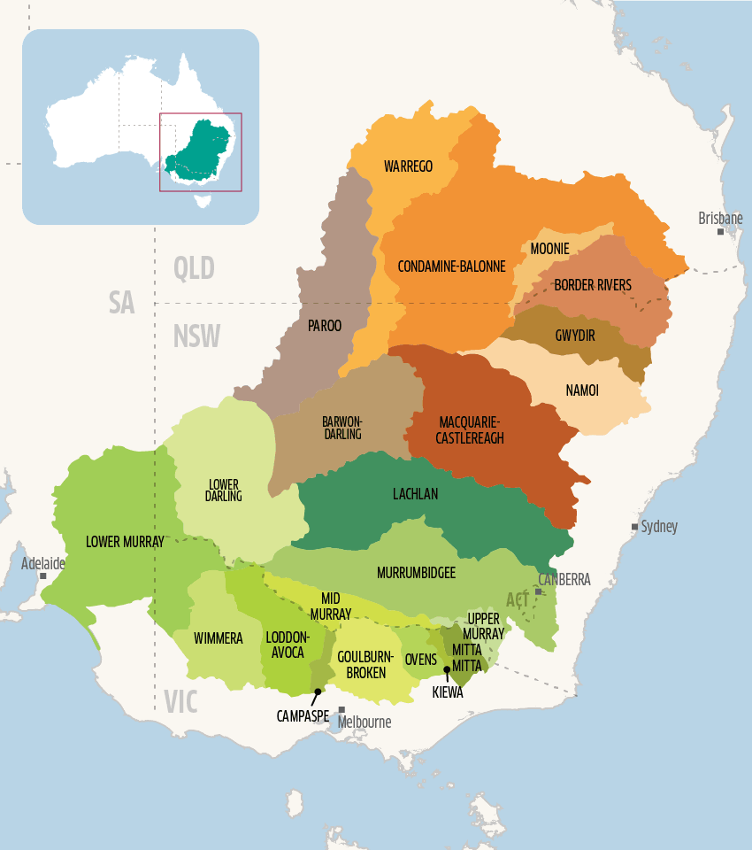

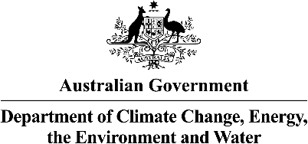
What are the Advisory Group working on?
The Directorate works with the department to make commercial and water purchasing decisions in the best interest of Basin First Nations, guided by the policies developed by the Advisory Group.
- The Directorate have had 3 meetings, most recently a face-to-face meeting in Brisbane.
- They have been running mock purchasing scenarios, utilising the draft purchasing guide being developed by the Advisory Group and water market commercial advice.
Interim Governance has now been established to help deliver the Murray–Darling Basin (Basin) Aboriginal Water Entitlements Program (program).
Interim governance consists of an Advisory Group and Directorate. Together, they will make well-informed decisions that balance cultural and commercial factors in buying and managing water entitlements. Interim governance will only be in place until the water purchased and any unspent funds can be transferred to Basin Enduring Water Holding Arrangements.
Learn more about the Advisory Group and Directorate members and their arrangements here.
www. dcceew.gov.au/water/policy/first-nations/aboriginal-water-entitlements-program/interim-governance
https://www.mdba.gov.au/basin/catchments
What are the Directorate working on?
The Advisory Group is made up of up to 8 Basin First Nations Peoples. They are developing the policies, principles, and protocols to support decision-making by the Directorate.
- The Advisory Group have had 4 meetings, most recently a face-to-face meeting in Brisbane.
- They are currently developing the Purchasing Guide and assessment criteria which will underpin all purchase opportunities.
Interim Governance
Murray—Darling Basin Aboriginal Water Entitlements Program
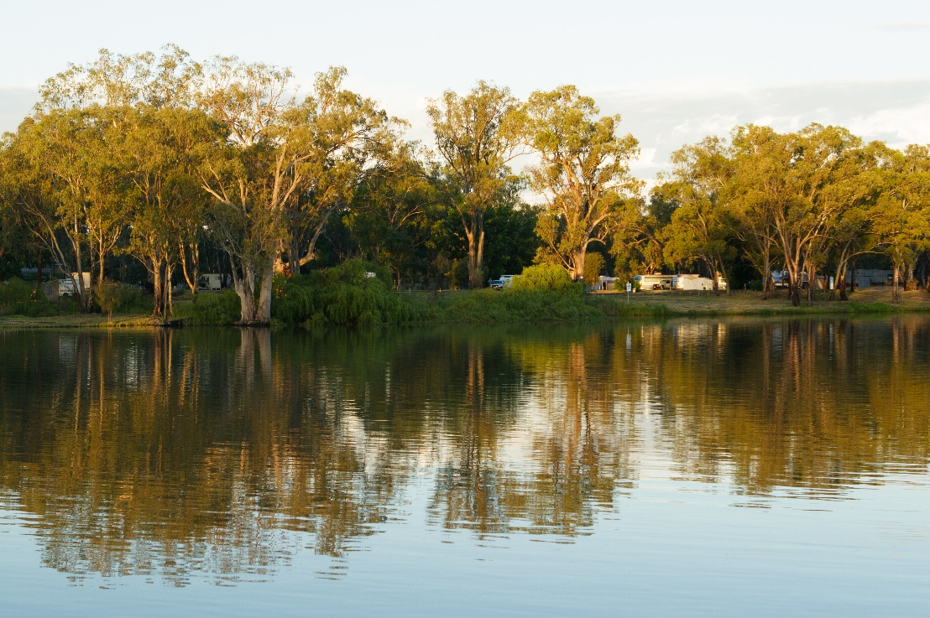
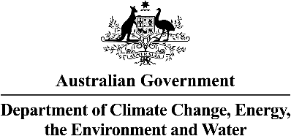
- The purchasing policies, processes and plans are being developed in close collaboration with the Advisory Group and the Directorate.
- The program is on track to commence purchasing later in the year. No water has been purchased yet.
- The $100 million is allocated to purchase water entitlements, and the $10.1 million is allocated for conveyancing, interim governance arrangements and holding costs.
The program will be using water brokers as the first purchase approach. The brokers will source and present opportunities for water purchases to the program, the Directorate will conduct their assessment based on the policies developed by the Advisory Group.
Robust processes are being established to ensure that purchases represent value for money and address the needs of Basin First Nations Peoples.
Purchase Updates
On 22 June 2024, Minister Plibersek announced that the Aboriginal Water Entitlements Program (program) is entering its purchase phase, with the release of the Strategic Purchasing Framework.
The framework is the strategy the department will follow when purchasing water entitlements during the interim governance arrangement. The core principles of the framework includes:
- Connectivity - targets entitlements that allow the transfer between catchments.
- Wealth Generation -targets entitlements that can provide capital growth.
- Equal distribution of funds and benefits between the north and south of the Basin.
The water purchased for the program will be acquired through various methods, each with its own cost, benefit and limitation.
Water entitlements purchased through the program will remain in the consumptive pool.
Where is the program up to?

Strategic Purchasing Framework
Murray—Darling Basin Aboriginal Water Entitlements Program
- Conduct a "Have Your Say" survey to capture the outcomes that Basin First Nations Peoples want to see from the model. The insights gained will lay the groundwork for future co-design engagement.
- Appoint a group of First Nations governance experts to lead the facilitation and co-design process the preferred model with Basin First Nations Peoples.
Next Steps
Co-Design Timeline (indicative)
The Australian Government is working on a pathway to transfer the water entitlements bought under the Aboriginal Water Entitlements Program to Basin First Nations Peoples for them to own and manage.
Now that the interim governance arrangements is in place, the next step is to work with Nations to decide on key governance principles for water holding arrangements that maximise outcomes from collective ownership and management. This will involve face-to-face meetings, focus groups, reviewing academic papers and Nation-led water resource plans. We will also collect feedback through "Have Your Say" survey, emails, and website updates. We will consult existing First Nations organisations on good governance and options for sustainable funding models.
Updates
Murray—Darling Basin First Nations Enduring Water Holding



In June and July 2024, we began discussions with Basin First Nations. We sought Basin First Nations’ input and recommendations through:
Engagement so far in 2024
The government has committed $20 million to support Basin First Nations Peoples to plan for Cultural flows and water dependent economic opportunities.
Basin First Nations peoples will be supported through a grants program to complete Cultural flows planning that could assist Basin First Nations to legally and securely hold water in the Murray—Darling Basin in a self-determined way.
The program builds upon the important Cultural flows research already undertaken by First Nations Peoples across Australia:
- National Cultural Flows Research Project
- Cultural Water for Cultural Economies
The Program
In June and July 2024, we began discussions with Basin First Nations. We sought Basin First Nations’ input and recommendations through:
Engagement so far in 2024
In June and July 2024, we began discussions with Basin First Nations. We sought Basin First Nations’ input and recommendations through:
Engagement so far in 2024

Insights from this first stage of consultation have informed the design of the program. A summary of what we heard:
- Nations appreciated the program’s focus on self-determination and enhanced agency, as it is Nation-led.
- Emphasis on a more transparent, inclusive, and respectful process for Cultural Flows planning, funding, land management, and defining Cultural economies.
- Address issues through comprehensive consultation, clear guidelines, and robust dispute resolution frameworks to build trust with Basin First Nations.
- Key improvements suggested:
  - Increase funding and offer flexible options for project including extending timelines.
  - Allow Nations to come together and apply as a consortium or group.
  - Provide specialist support in areas like application writing, budgeting, governance, compliance, water management, and Cultural Flows planning.
  - Create resources, such as case studies and examples of successful projects.
  - Establish regular monitoring and evaluation to ensure Nations meet their goals.
  - Offer ongoing feedback and support for continuous improvement in Cultural Flows plans.
  - The program design enables Nations to strengthen their role in water governance, aligning with their aspirations and leading to outcomes that reflect their cultural values and priorities.
A full “What We Heard” report will be published in the coming months.
Summary of what we heard so far
In June and July 2024, we began discussions with Basin First Nations. We sought Basin First Nations’ input and recommendations through:
Engagement so far in 2024
Cultural Flows Planning for Cultural Economies Program


Next Steps in 2024 – 2025 (Indicative timeframe)
Cultural Flows Planning for Cultural Economies Program

To learn about the programs or for more information, please contact us.
For further program information:
- First Nations Water Policy
- Aboriginal Water Entitlements Program
- Cultural Flows Planning for Cultural Economies
To arrange a face-to-face meeting on Country with representatives from the First Nations Water Branch,
please email firstnationswater@dcceew.gov.au
For all other general questions and enquiries, please email firstnationswater@dcceew.gov.au
First Nations Water Branch

