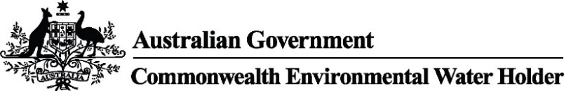

Murrumbidgee Monitoring, Evaluation and Research Program, ecological responses to Commonwealth environmental water, Field Report no. 18. December 2023
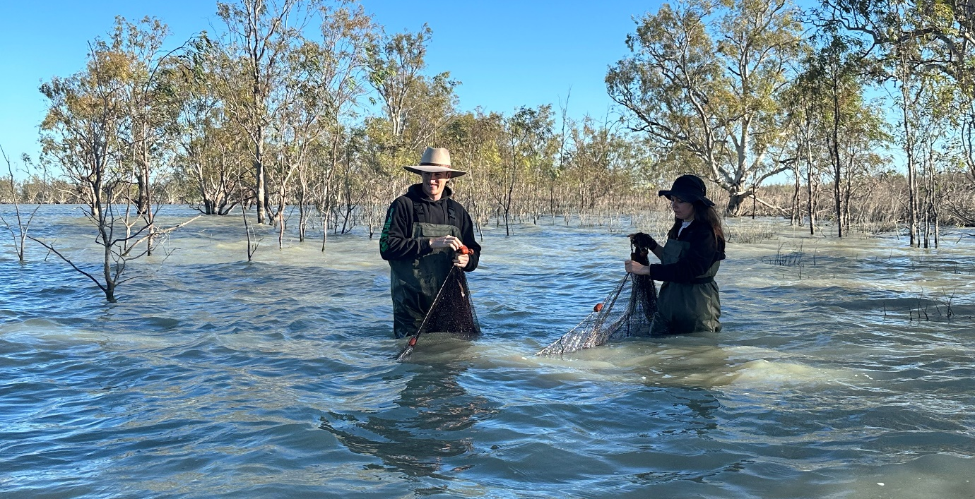
Figure 1 Chris Sundblom (CSU technical officer) and Jessica Ljubojevic (volunteer) retrieving a fyke net at Emu (Loorica) Lake, Gayini, December 2023. Photo credit: Sarah Talbot

Talbot, S., Turner, A.E., Sundblom, C., Beard, A. and Wassens, S. (2023). Murrumbidgee Monitoring, Evaluation and Research Program, ecological responses to Commonwealth environmental water, Field report. Number 18, December 2023. Charles Sturt University. Prepared for the Commonwealth Environmental Water Holder.

Further information:
Professor Skye Wassens
School of Agricultural, Environmental and Veterinary Sciences,
Charles Sturt University, PO Box 789, Albury NSW 2640
Ph: +61 2 6051 9513 Email: swassens@csu.edu.au

Copyright
© Copyright Commonwealth of Australia, 2023

Murrumbidgee Monitoring Evaluation and Research Program, ecological responses to Commonwealth environmental water, Field report. Number 18, December 2023 is licensed by the Commonwealth of Australia for use under a Creative Commons By Attribution 3.0 Australia licence with the exception of the Coat of Arms of the Commonwealth of Australia, the logo of the agency responsible for publishing the report, content supplied by third parties, and any images depicting people. For licence conditions see: http://creativecommons.org/licenses/by/3.0/au/
Disclaimer
The views and opinions expressed in this publication are those of the authors and do not necessarily reflect those of the Australian Government or the Minister for the Environment. While reasonable efforts have been made to ensure that the contents of this publication are factually correct, the Commonwealth does not accept responsibility for the accuracy or completeness of the contents, and shall not be liable for any loss or damage that may be occasioned directly or indirectly through the use of, or reliance on, the contents of this publication.

Ecological responses to Commonwealth environmental water in the Murrumbidgee system as of December 2023
This quarterly report describes preliminary outcomes of Commonwealth environmental watering actions at selected wetlands in the mid and lower Murrumbidgee. These surveys are conducted four times a year as part of the Murrumbidgee Monitoring, Evaluation and Research Program (MER) and include assessment of ecological outcomes in the Murrumbidgee River and connected wetlands in the mid-Murrumbidgee and Lowbidgee floodplain as outlined in the Murrumbidgee Monitoring and Evaluation Plan (https://www.dcceew.gov.au/water/cewo/publications/mer-plan-murrumbidgee-2019).
The second round of routine monitoring of vegetation, fish, frogs, tadpoles, turtles and waterbirds for the 2023/24 season was undertaken in November (mid Murumbidgee) and December (lower Murrumbidgee). Note the lower Murrumbidgee was delayed until December due to wet weather conditions at the end of November. As a result, Lowbidgee surveys will be delayed for the remainder of the season (to February and April).
Surveys were undertaken at four sites in the mid-Murrumbidgee, however, Yarrada lagoon was the only core site able to be monitored due to low water levels at Gooragool (eastern side), Sunshower, and McKenna’s Lagoons. Supplementary sites were surveyed instead, including Coononcoocabil, Mantangery and Gooragool Lagoon west.
Monitoring was conducted at three core sites in the lower Murrumbidgee (Waugorah, Bala (Eulimbah) Swamp, Bayil (Telephone) Creek and three supplementary sites (Uara Creek, Yanga Lake Inflow, and Emu (Loorica) Lake due to low water levels and drying of some sites (i.e. Two Bridges, Piggery Lake, and Nap Nap). We also aimed to survey Piggery Lake (where access is now possible for the first time since November 2020) and Kia Lake (as a supplementary site), but water levels were too shallow to set fyke nets. Evening frog surveys were still conducted at these two sites.
This report summarises the activities and outcomes of monitoring in the mid- and lower Murrumbidgee conducted in November and December 2023 (respectively).

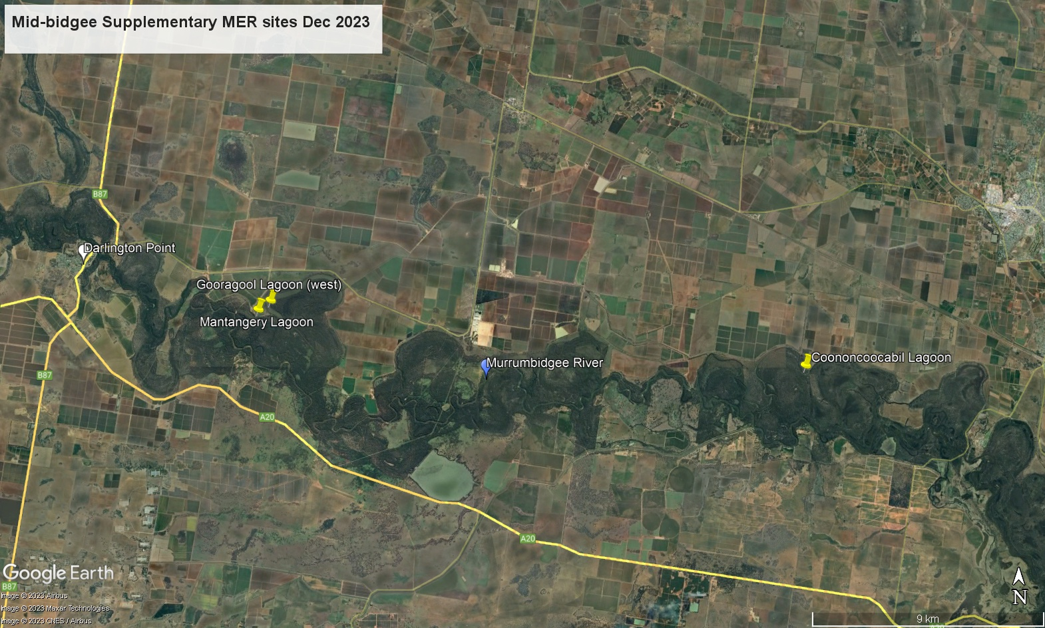
Figure 2 Map of mid Murrumbidgee supplementary monitoring sites surveyed in November 2023; Mantangery Lagoon, Coononcoocabil Lagoon, and Gooragool Lagoon west.

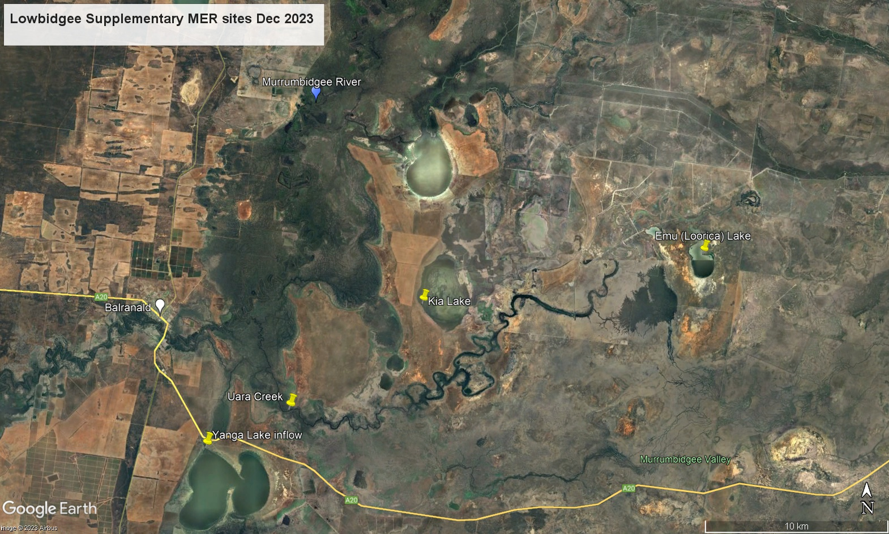
Figure 3 Map of lower Murrumbidgee supplementary monitoring sites surveyed in December 2023; Yanga Lake inflow, Uara Creek, Kia Lake
and Emu (Loorica) Lake.

Watering update
The Murrumbidgee catchment fluctuated between above and below average rainfall throughout the 2022-23 water year and into the 2023-24 monitoring season (Figure 4), but previously high water levels have subsided in all the mid- and lower Murrumbidgee monitoring sites (Figure 5).
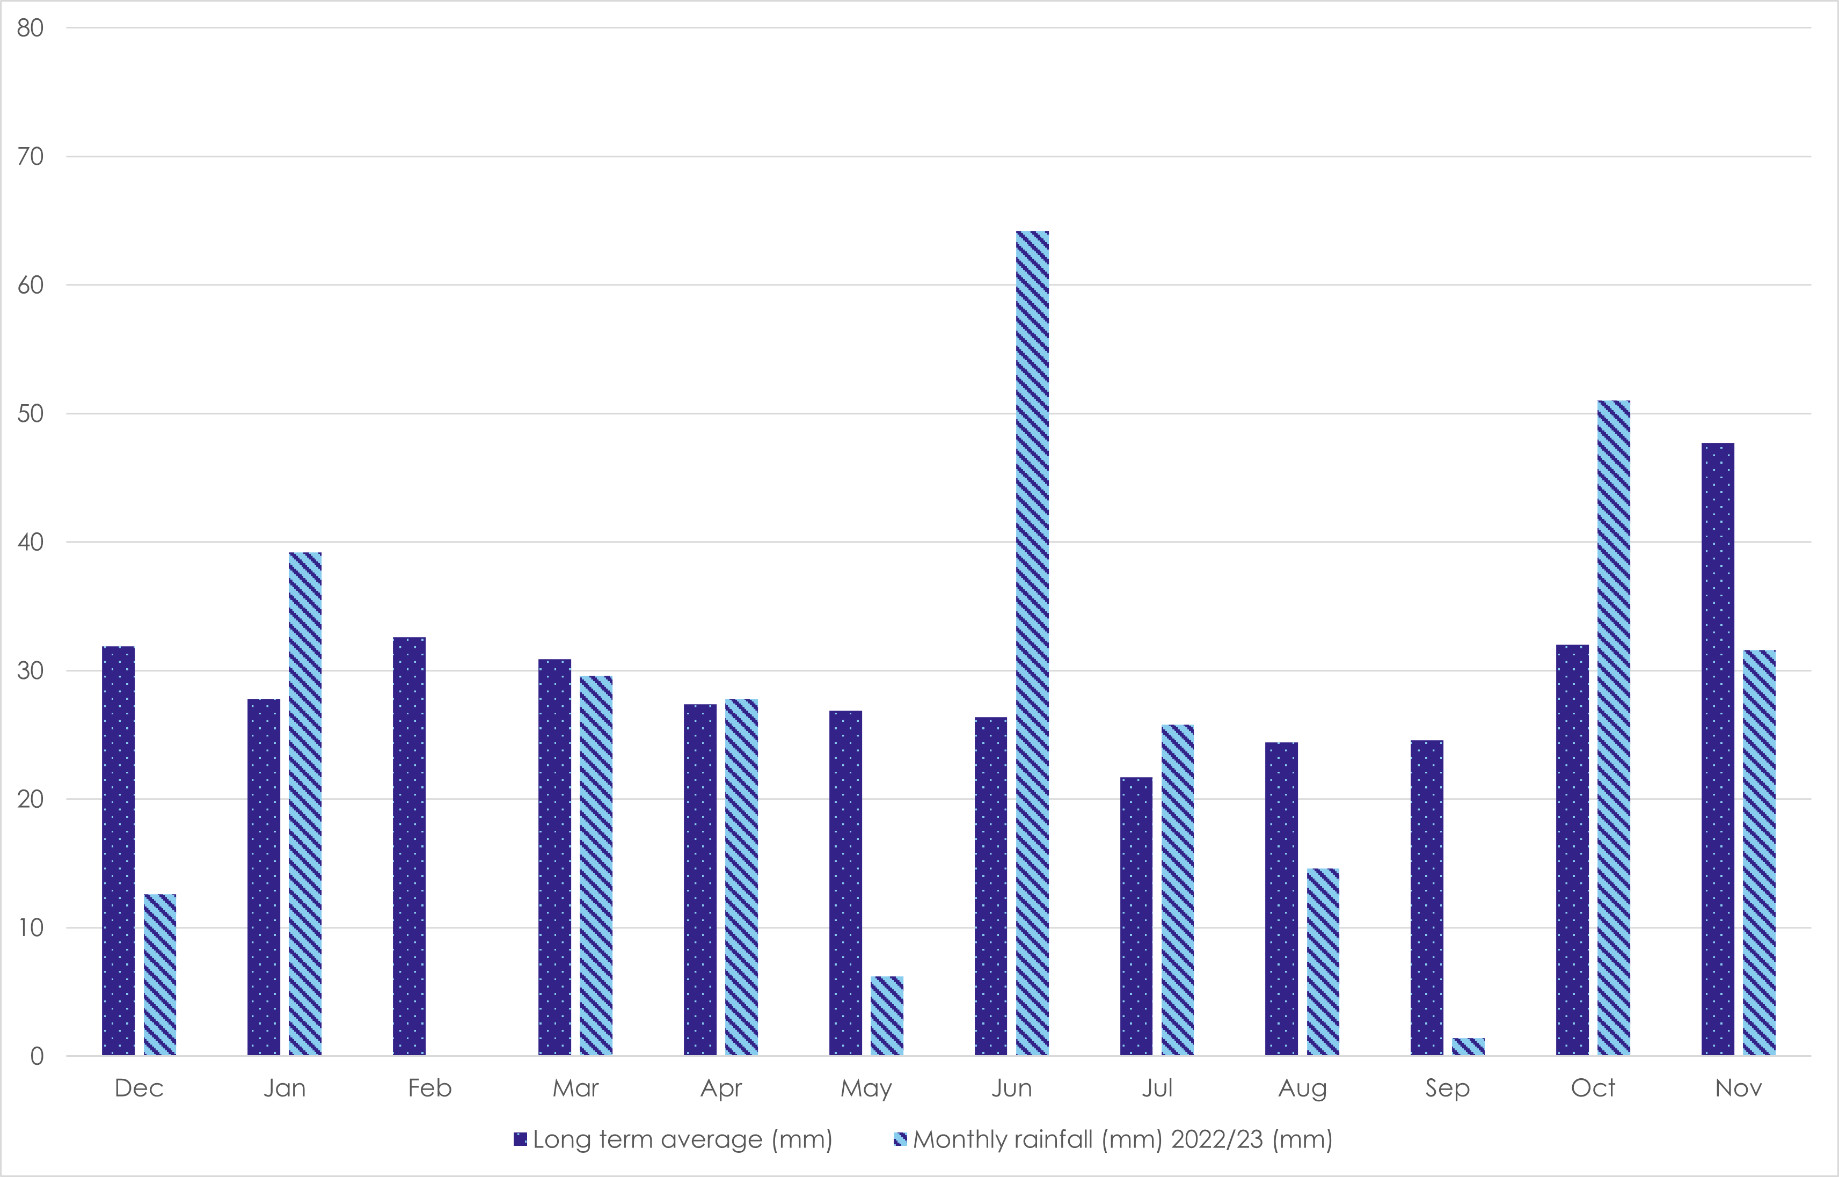
Figure 4 Monthly rainfall in Hay NSW 12 months preceding November/December monitoring (Source: Bureau of Meteorology (BOM), Dec 2023, http://www.bom.gov.au/climate/averages/tables/cw_075019.shtml)
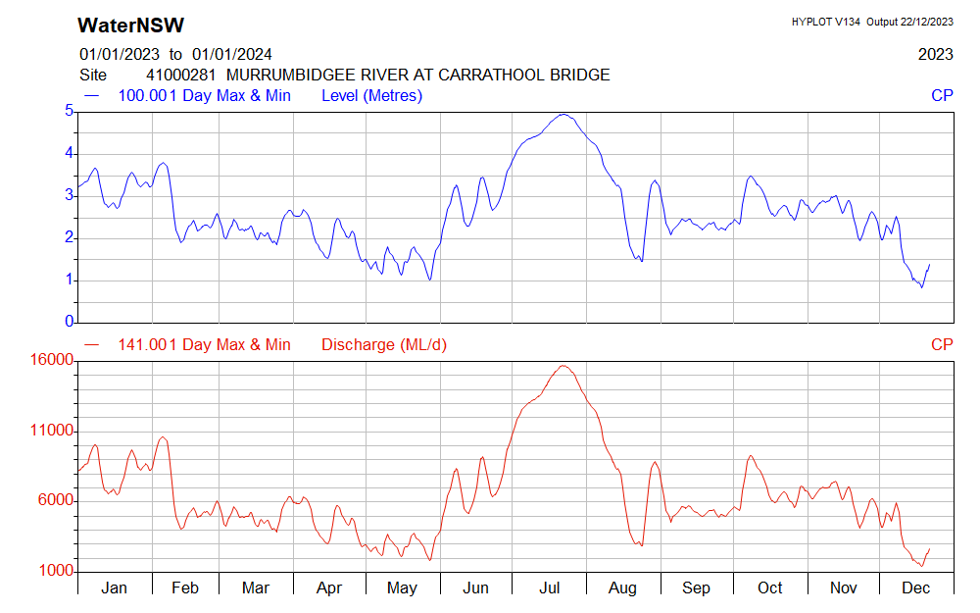
Figure 5 River height (m, top plot) and discharge rate (ML/d, bottom plot) at Carrathool Bridge on the Murrumbidgee River. Source: WaterNSW

Mid-Murrumbidgee: Water levels have receded at all four of the core monitoring sites (Gooragool, Sunshower, McKenna’s and Yarradda Lagoons) since September surveys, with Yarrada Lagoon being the only core site holding enough water to set nets. Large and small fyke nets were able to be set at supplementary sites, Mantangery and Coononcoocabil Lagoons, whereas D-Fykes were used at Gooragool Lagoon west, Yarradda, where the water level was <50cm. Water quality was at a stable level with low turbidity and average dissolved oxygen in the range 5.21–11.34mg/L.
Gayini Nimmie-Caira (GNC): Core sites in GNC were again accessible for fish, frog and waterbird monitoring but water levels overall have decreased since September surveys, with some sites dry/drying down (i.e., Banim (Avalon) and Nap Nap). Small fykes and D-Fykes were set at Bala (Eulimbah) Swamp and Bayil (Telephone) Creek, as well as Emu (Loorica) Lake (not previously surveyed under the MER program). Evening frog surveys were also conducted at Kia Lake, but the water level was too shallow to set nets.
Redbank (Yanga NP): Consistent with September surveys, monitoring was conducted at Waugorah, Uara Creek and Yanga Lake inflow with small and D-Fykes set at all three sites. Since September, the water level has decreased at Two Bridges and was too low to set nets. Similarly, it was not possible to set nets at Piggery, but frog surveys were still undertaken at this site.
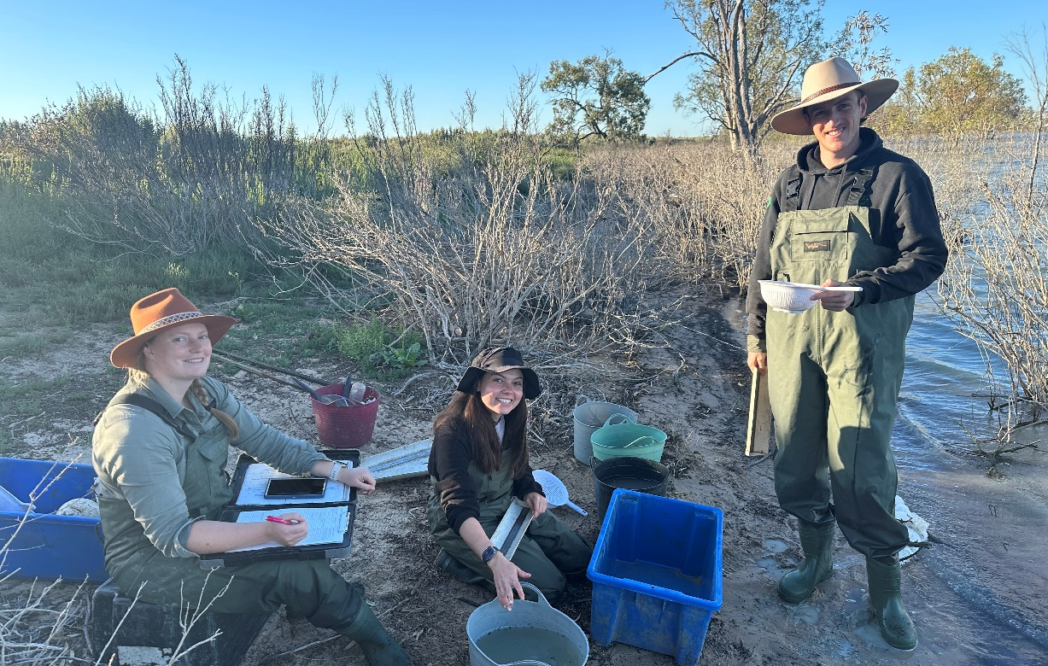
Figure 6 CSU field team processing nets at Emu (Loorica) Lake, December 2023 (left to right: Emmalie Sanders, Jessica Ljubojevic, and Chris Sundblom. Photo credit: Sarah Talbot

Table 1- Site summary of findings for the mid-Murrumbidgee wetlands during December 2023.
Site | Water level | Fish | Turtles | Frogs and tadpoles | Other species detected
Gooragool West | Low | - Australian smelt (n=19)  - carp gudgeon (n=847)  - carp (n=6)  - redfin perch (n=1)  - gambusia (n=2)  - yabby (n=1)  - shrimp (n=681) | - Eastern long-necked turtle (n = 1) | - Spotted marsh frog (n=22 adults)  - Peron’s tree frog (n=7 adults)  - Barking marsh frog (n=1 adult) | - Adult rakali (n=1)
Mantangery lagoon | ½ full | - silver perch (n=1)  - Australian smelt (n=6)  - carp gudgeon (n=285)  - carp (n=7)  - gambusia (n=11)  - goldfish (n=1)  - shrimp (n=568) | - Murray River short neck turtle (n=1)  - broad-shelled turtle (n = 2)  - Eastern long-necked turtle (n = 1) | - Spotted marsh frog (n=27 adults)  - Peron’s tree frog (n=5 adults)  - Plains froglet (n=2 adults) | None
Coononcoocabil lagoon | ¾ full | - bony herring (n = 1)  - carp gudgeon (n = 155)  - flathead gudgeon (n=7)  - carp (n=11)  - gambusia (n=2)  - oriental weatherloach (n=2)  - shrimp (n=425) | - Eastern long-necked turtle (n = 1) | - Spotted marsh frog (n=12 adults)  - Peron’s tree frog (n=3 adults) | None
Yarradda | Low | - Australian smelt (n=3)  - carp gudgeon (n=237)  - flathead gudgeon (n=1)  - carp (n=17)  - oriental weatherloach (n=4)  - shrimp (n=897) | None | - Spotted marsh frog (n=12 adults)  - Peron’s tree frog (n=19 adults)  - Barking marsh frog (n=4 adults) | None
McKennas | Low (not surveyed) | N/A | N/A | N/A | N/A
Gooragool (East) | Dry (not surveyed) | N/A | N/A | N/A | N/A
Sunshower | Low (not surveyed) | N/A | N/A | N/A | N/A

Table 2- Site summary of findings for the lower Murrumbidgee wetlands during December 2023.
Site | Water level | Fish | Turtles | Frogs and tadpoles | Other species detected
Bala (Eulimbah) Swamp | Full | - carp gudgeon (n=113)  - oriental weatherloach (n=8)  - carp (n=114)  - goldfish (n=14)  - yabby (n=80)  - shrimp (n=14) | None | - Southern bell frog (n=213 adults;16 tadpoles; >10 calling)  - Peron’s tree frog (n=1 tadpole)  - barking marsh frog (n=2 calling) | None
Bayil (Telephone)  Creek | ¾ | - carp gudgeon (n=1)  - oriental weatherloach (n=2)  - carp (n=35)  - shrimp (n=164) | - None | - Southern bell frog (n=114 adults)  - spotted marsh frog (n=1 adult)  - giant banjo frog (n=1 adult) | None
Waugorah | ½ | - bony bream (n=1)  - carp gudgeon (n=237)  - carp (n=9)  - goldfish (n=3)  - yabby (n=2)  - shrimp (n=295) | - Eastern long-necked turtle (n=1) | - Southern bell frog (n=74)  - Peron’s tree frog (n= 3)  - spotted marsh frog (n=1)  - barking marsh frog (n=1)  - giant banjo frog (n=1) | None
Yanga Lake inflow | ¾ | - bony bream (n=14)  - flat-headed gudgeon (n=7)  - carp gudgeon (n=162)  - carp (n=3)  - oriental weatherloach (n=2)  - shrimp (n=481) | - Eastern long-necked turtle (n=1) | - Southern bell frog (n=5 adults)  - Peron’s tree frog (n=4 adults)  - spotted marsh frog (n=7 adults) | None
Uara creek | ¾ | - carp gudgeon (n=465)  - carp (n=8)  - goldfish (n=4)  - oriental weatherloach (n=8)  - gambusia (n=4)  - shrimp (n=257)  - yabby (n=8) | - Eastern long-necked turtle (n=1) | - Southern bell frog (n=17)  - Peron’s tree frog (n=18)  - giant banjo frog (n=2)  - spotted marsh frog (n=1)  - barking marsh frog (n=1) | - Adult rakali (n=1)
Loorica (Emu) Lake | ¾ | - bony bream (n=10)  - smelt (n=8)  - carp gudgeon (n=263)  - flat-headed gudgeon (n=1)  - oriental weatherloach (n=8)  - carp (n=9)  - yabby (n=1)  - shrimp (n=760) | - Eastern long-necked turtle (n=1) | - Southern bell frog (n=17)  - barking marsh frog (n=3) | None
Piggery Lake | Low (not surveyed) | N/A | N/A | - Southern bell frog (n=20 adults)  - Peron’s tree frog (n=1 adult)  - barking marsh frog (n=12 adults) | - Grey snake (n=1)
Two Bridges | Low | N/A | N/A | N/A | N/A
Nap Nap | Dry | N/A | N/A | N/A | N/A
Banim  (Avalon) Swamp | Dry | N/A | N/A | N/A | N/A
Kia Lake | Low | N/A | N/A | None | None

Key outcomes
Routine wetland monitoring activities targeting vegetation, water quality, fish, frog and tadpoles were completed at four sites in the mid Murrumbidgee and six sites in the lower Murrumbidgee. Water levels have receded further across most sites since September surveys.

Wetland fish:
Overall fish numbers were low throughout the system, consistent with November monitoring in previous years. Numbers and diversity of native fish were higher than exotic fish at most sites. Small native fish, including carp gudgeon, flat-headed gudgeon, bony herring, and Australian smelt, were recorded across the mid and lower Murrumbidgee sites. One silver perch (290 mm) (Figure 7) was recorded at Mantangery Lagoon, in the mid Murrumbidgee. Small numbers of carp were caught, the largest catch occurring at Bala (Eulimbah) Swamp (n=114). Other exotic species detected include goldfish, gambusia, and oriental weatherloach.
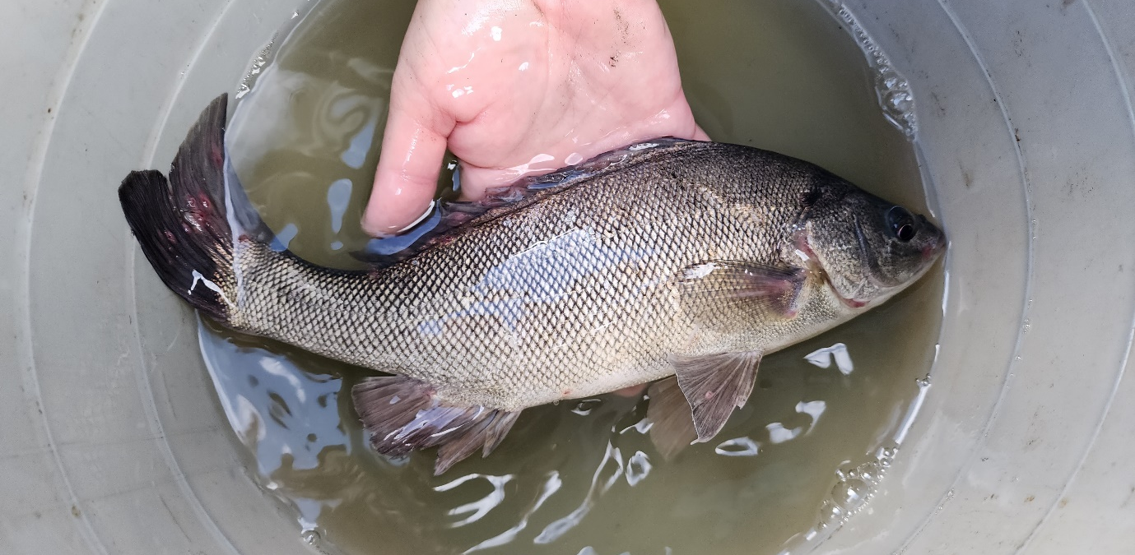
Figure 7 Silver perch caught at Mantangery Lagoon, November 2023. Photo credit: Emmalie Sanders.
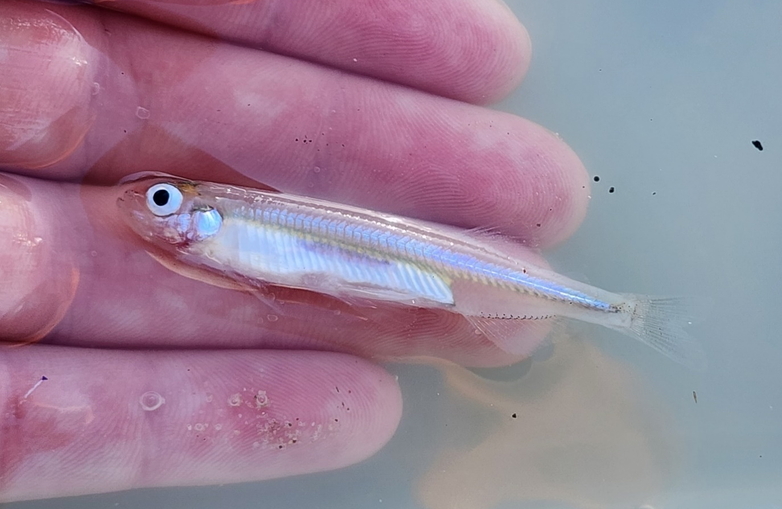Figure 8 Australian smelt caught at Emu (Loorica) Lake, December 2023. Photo credit: Emmalie Sanders.

Frogs and tadpoles:
In the mid-Murrumbidgee wetlands, peron’s tree frogs were detected at all sites, and spotted marsh frogs at most sites during November surveys. Barking marsh frogs and plains froglet were also recorded. In the lower Murrumbidgee Southern bell frogs were abundant with 460 adults recorded during the week, with almost half being detected at Bala (Eulimbah). Bala was also the only site where Southern bell frog tadpoles (and one peron’s tree frog tadpole) were captured. Spotted marsh frogs, barking marsh frogs, and Peron’s tree frogs were also commonly recorded, and giant banjo frogs were detected at two sites in Redbank, Yanga NP (Waugorah and Uara Creek).
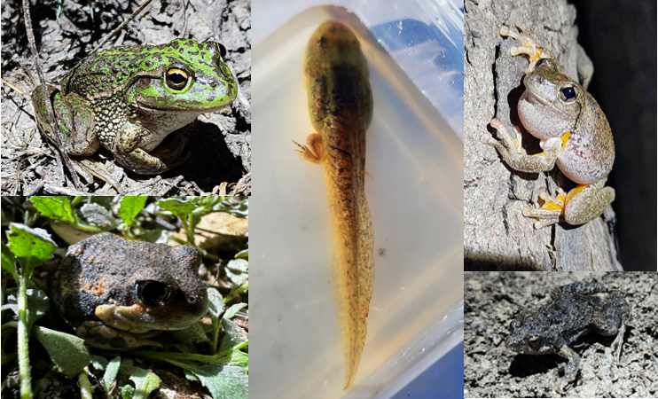
Figure 9 Clockwise from left: Southern bell frog, Southern bell frog tadpole, Peron’s tree frog, Eastern sign-bearing froglet, and giant banjo frog, found during November/December surveys. Photo credit: Emmalie Sanders and Sarah Talbot.

Turtles
Small numbers of turtles were recorded across sites in the mid- and Lower Murrumbidgee. Eastern long-necked turtles were the most recorded species and were detected at most sites. Mantangery Lagoon in the mid-Murrumbidgee had the largest number and highest diversity for turtles with one Murray River short-necked, one eastern long-necked, and two broad-shelled turtles caught in the nets.
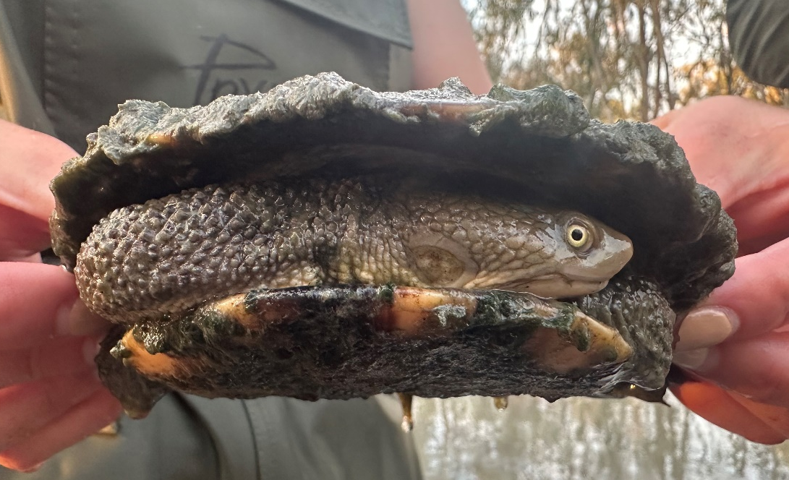
Figure 10 Eastern long-necked turtle being at Yanga Lake Inflow, Lower Murrumbidgee, December 2023. Photo credit: Sarah Talbot.

Wetland birds, general observations
Waterbird surveys were conducted at all sites during November/December monitoring. Species detected in the mid-Murrumbidgee included Australasian darter, Australian pelican, Australian white ibis, Eastern great egret, grey teal, little black cormorant, little pied cormorant, Pacific black duck, white-faced heron, whistling kite, and yellow-billed spoonbill.
Species detected in the lower Murrumbidgee included Australasian darter, Australian pelican, Australian reed warbler, Australian white ibis, black swan, dusky moorhen, Eastern great egret, Eurasian coot, great cormorant, grey teal, gull-billed tern, hoary-headed grebe, little pied cormorant, little black cormorant, magpie geese, nankeen night heron, Pacific black duck, pied cormorant, royal spoonbill, sacred kingfisher, whistling kite, white-bellied sea-eagle, white-faced heron, white-necked heron, and yellow-billed spoonbill. The highlight included the two magpie geese flying over Waugorah lagoon and the white-bellied sea-eagle at Bayil (Telephone) Creek. Diversity was highest at Bala (Eulimbah) Swamp.

Vegetation
Vegetation surveys were undertaken in the mid- and lower Murrumbidgee during November 2023. Summary will be provided in the February post trip report.

