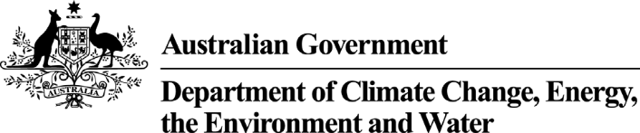

National Heritage List and Commonwealth Heritage List Assessments
Under the Environment Protection and Biodiversity Conversation Act 1999 (EPBC Act) the Minister determines which places the Australian Heritage Council will assess for the National and Commonwealth Heritage Lists.
The Minister sets these assessments through the ‘Finalised Priority Assessment List’ (FPAL).
Each of these lists is publicly available on the department’s website at: www.dcceew.gov.au/parks-heritage/heritage/places/priority-assessment.
In setting the FPAL, the Minister also sets an assessment completion time, which may be extended. Extension notices are published on the department's heritage public notices website at www.environment.gov.au/cgi-bin/epbc/heritage_ap.pl.
The following table shows all places under assessment (including their current assessment timeframes) as of 14 September 2026.

National Heritage | State / Territory | Assessment timeframe
Historic values
Elizabeth Farm, Experiment Farm and Hambledon Cottage | NSW | 30/06/2029
Natural values
The Greater Blue Mountains Area – Additional Values | NSW | 30/06/2015
Christmas Island Natural Areas | EXT | 30/06/2016
North Pole Dome and Meentheena | WA | 30/06/2027
The Nut and volcanic features of Stanley Peninsula, Stanley | TAS | 30/06/2028
Indigenous values
Murray Island Group, including Mer Island, Dauar Island, Waier Island | QLD | 30/06/2018
Djirurri Rockshelter | NT | 30/06/2023
Papunya | NT | 30/06/2029
Yalangbara | NT | 30/06/2027
Binthi Warra Indigenous Heritage Places | QLD | 30/06/2027
Sydney Cultural Crescent Rock Art | NSW | 30/06/2027
Ghow Swamp | VIC | 30/06/2028
Greater Red Lily Lagoon Area | NT | 30/06/2029
Indigenous and Natural values
Chillagoe Karst Region | QLD | 30/06/2014
Tjoritja/West MacDonnell National Park | NT | 30/06/2016
Exmouth Gulf | WA | 30/06/2030
Commonwealth Heritage
Hive Survivor Camp | Jervis Bay | 30/06/2018
Birch Building, Australian National University | ACT | 30/06/2030

