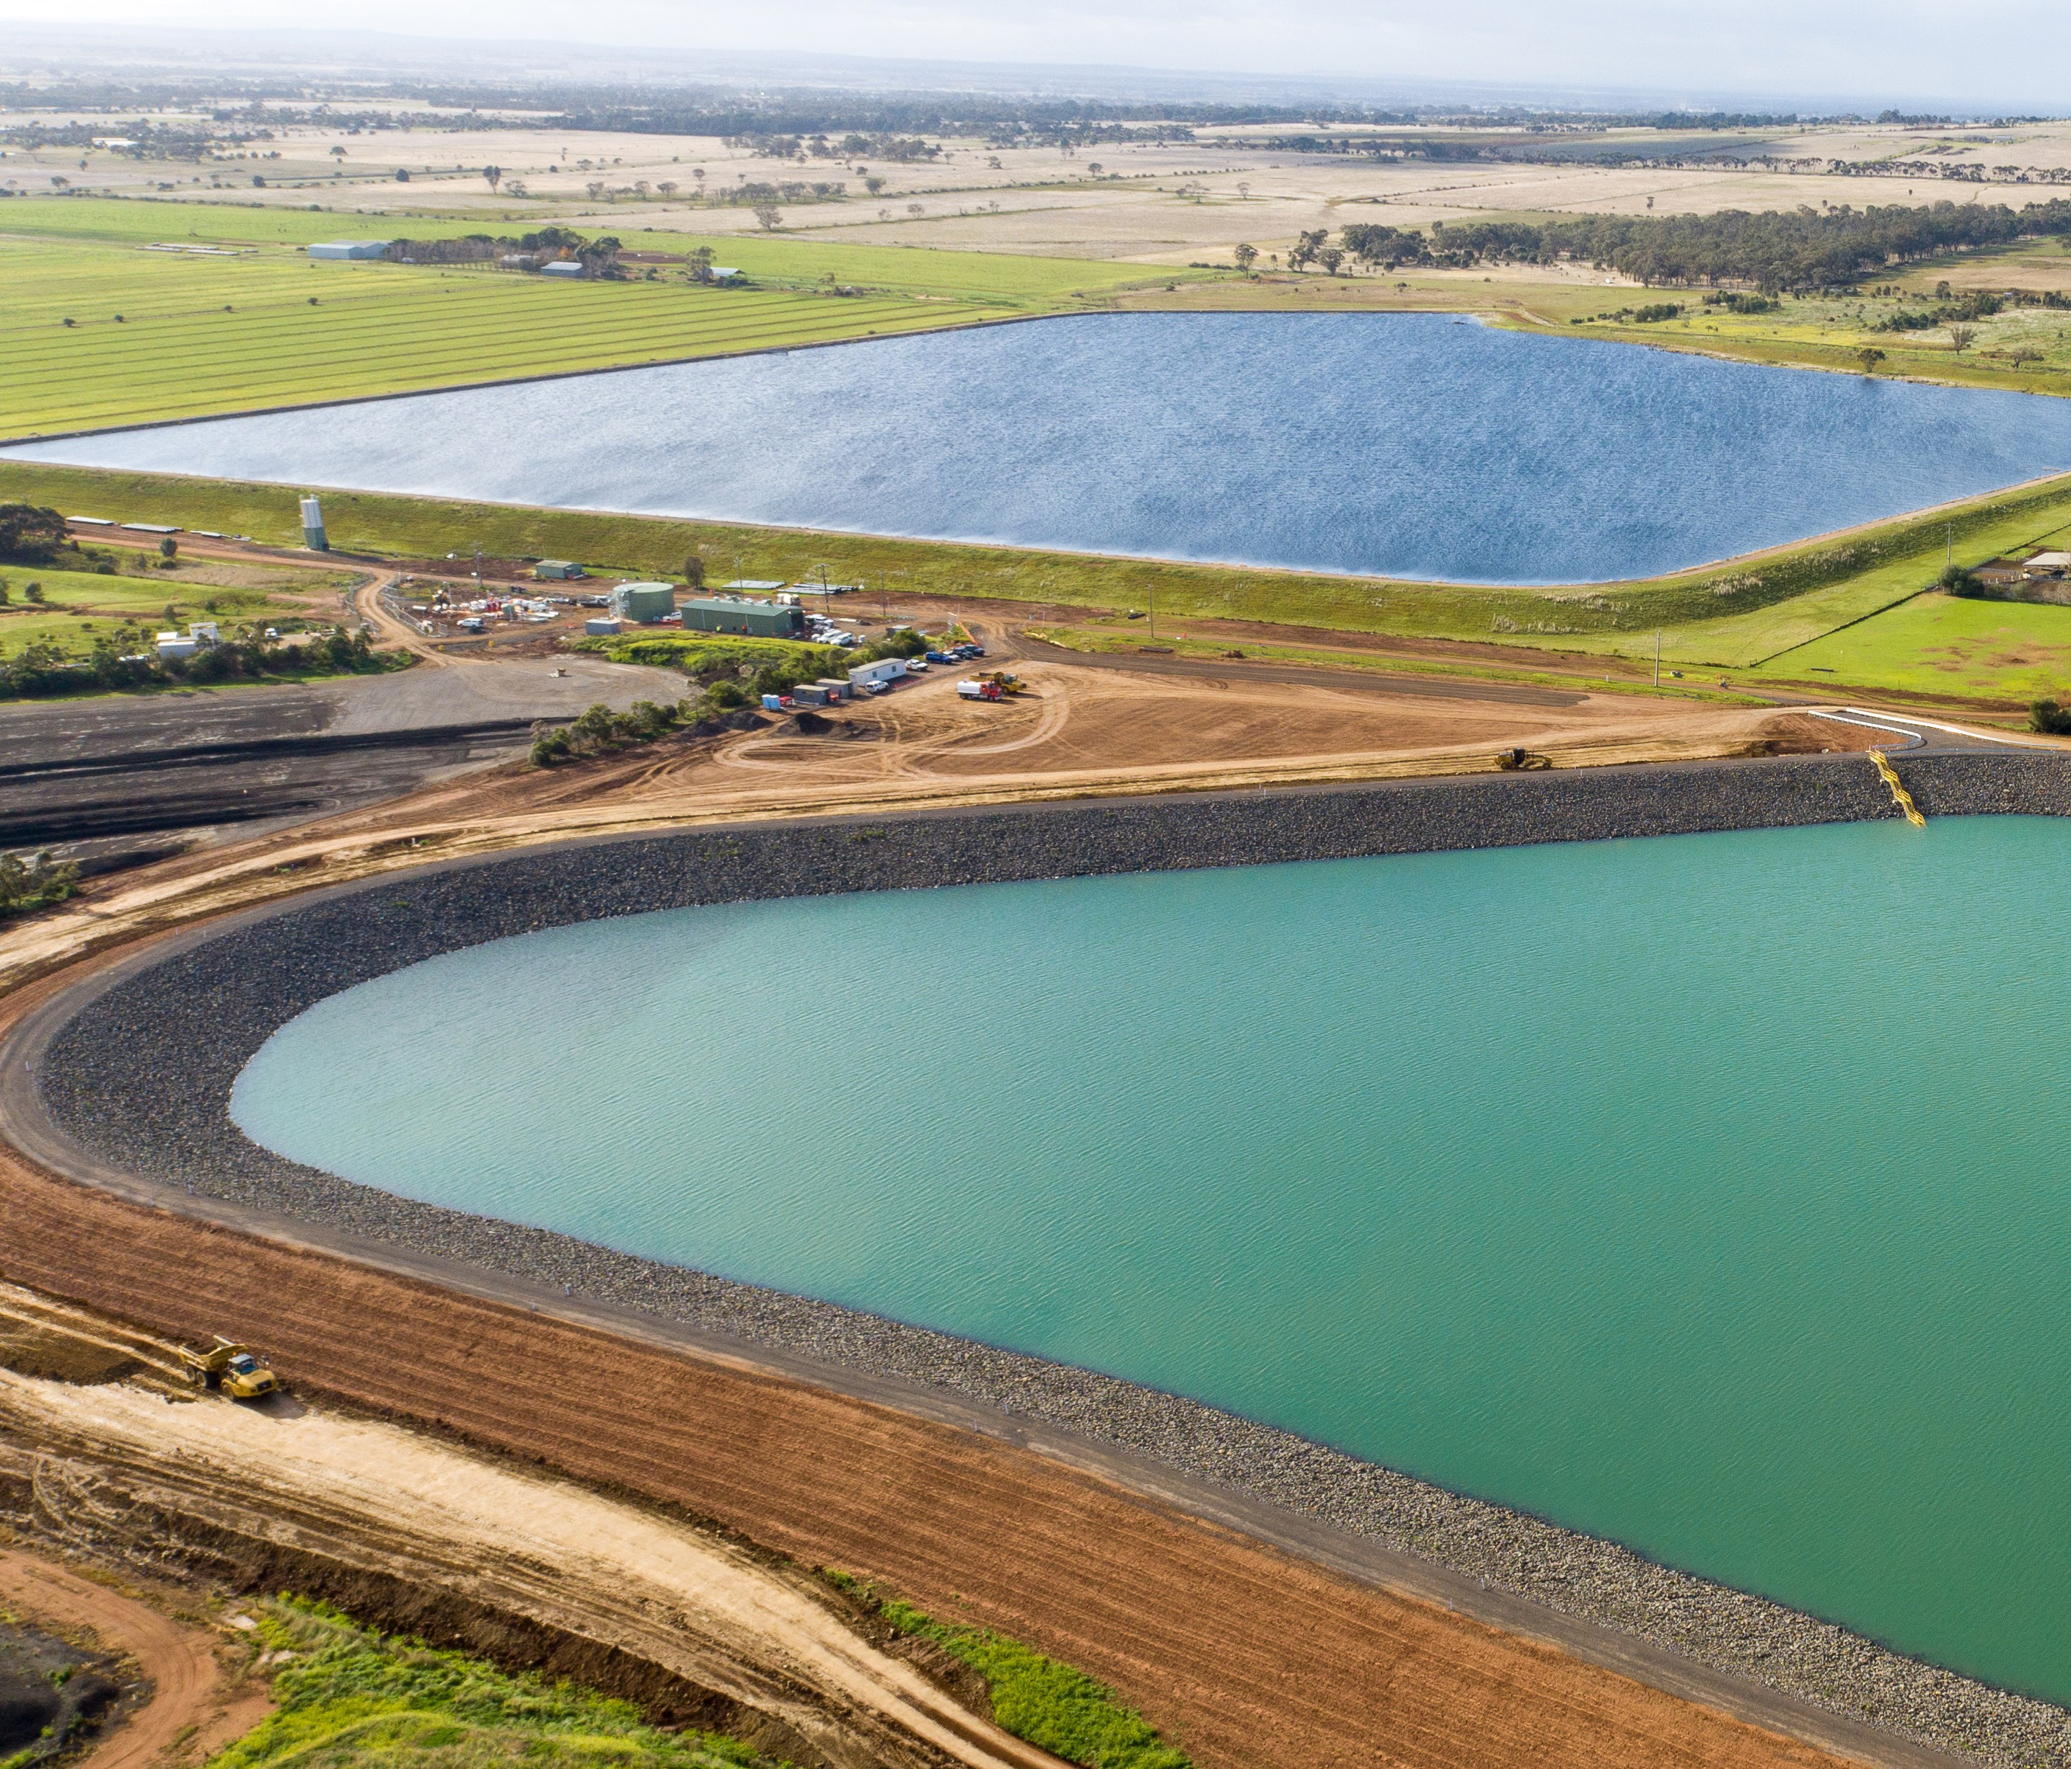







National Water Grid Funding Acknowledgement Requirements
June 2026

National Water Grid Funding Acknowledgement Requirements

© Commonwealth of Australia 2026
Ownership of intellectual property rights
Unless otherwise noted, copyright (and any other intellectual property rights) in this publication is owned by the Commonwealth of Australia (referred to as the Commonwealth).
Creative Commons licence
All material in this publication is licensed under a Creative Commons Attribution 4.0 International Licence except content supplied by third parties, logos and the Commonwealth Coat of Arms.
Inquiries about the licence and any use of this document should be emailed to copyright@dcceew.gov.au.


Cataloguing data
This publication (and any material sourced from it) should be attributed as: DCCEEW 2026, National Water Grid Funding Acknowledgement Requirements, Department of Climate Change, Energy, the Environment and Water, Canberra. CC BY 4.0.
Department of Climate Change, Energy, the Environment and Water GPO Box 3090 Canberra ACT 2601
Telephone 1800 920 528
Web nationalwatergrid.gov.au
Disclaimer
The Australian Government acting through the Department of Climate Change, Energy, the Environment and Water has exercised due care and skill in preparing and compiling the information and data in this publication. Notwithstanding, the Department of Climate Change, Energy, the Environment and Water, its employees and advisers disclaim all liability, including liability for negligence and for any loss, damage, injury, expense or cost incurred by any person as a result of accessing, using or relying on any of the information or data in this publication to the maximum extent permitted by law.
Acknowledgement of Country
We acknowledge the Traditional Owners of Country throughout Australia and recognise their continuing connection to land, waters and culture. We pay our respects to their Elders past and present.

2

Contents
National Water Grid Funding Acknowledgement Requirements

Overview 5
Communication planning 5
Overview of key review timeframes 5
Acknowledging the National Water Grid 6
Standard project acknowledgement statements 6
Advertising and advertorials 6
Announcement opportunities 7
Imagery 8
National Water Grid logo design requirements 10
Manufacturing specifications 12
Example signage 13
Contact us 15

3

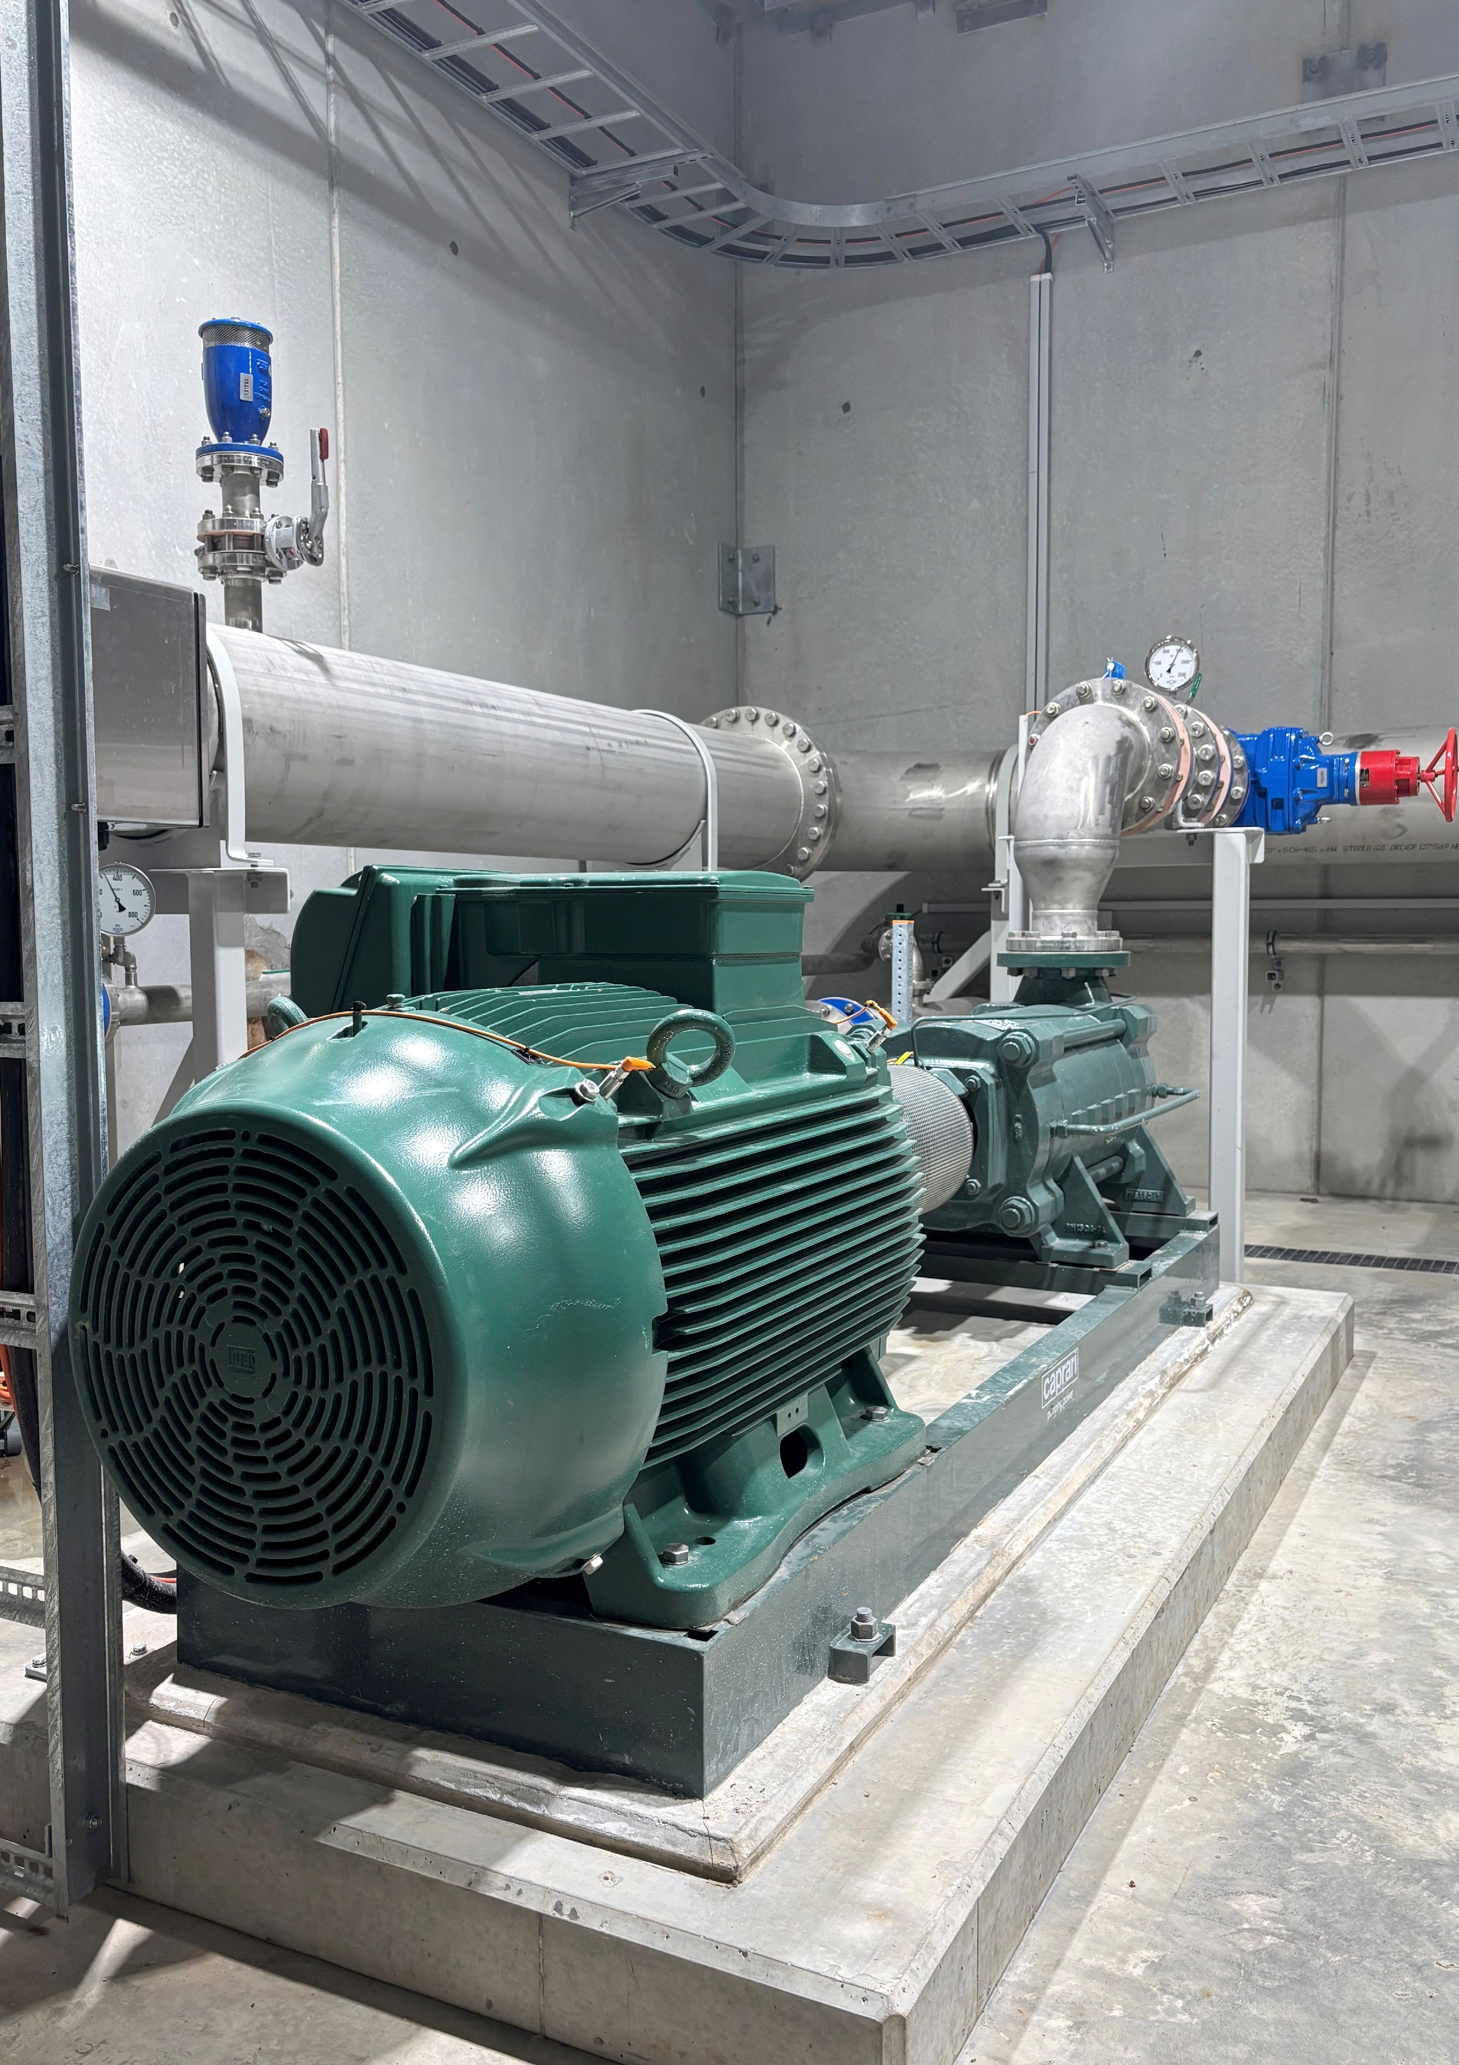
National Water Grid Funding Acknowledgement Requirements

4

Overview
Projects funded through the National Water Grid Fund (NWGF) must publicly acknowledge the Australian Government’s contribution, as outlined in the federation funding agreements (FFAs) and other contracts.
This guide explains:
- how to acknowledge the Australian Government funding appropriately
- how to correctly use the National Water Grid (NWG) brand and visual identity, including signage
- when to seek approval from the Australian Government on public-facing materials.
Who should use this guide:
- All project partners and proponents, including:
  - state and territory governments
  - science, research agencies and universities
  - councils, water corporations, contractors, Aboriginal Land Councils and other organisations or associations connected with a National Water Grid project.

Communication planning
The Australian Government requires a collaborative approach to communication and media planning. What’s expected:
- Engage early with the NWG to clarify and collaborate on communication planning and requirements.
- Include communication and media in project planning and reporting.
Remember:
- State and territory governments are required under the FFAs to be a conduit for all communication between the Australian Government and other project partners.
- Any sensitive media and stakeholder issues must be raised to the NWG as soon as possible.

Overview of key review timeframes

Activity | Minimum submission timeframes
Public acknowledgment statements | Minimum of 5 business days
Planned media events and releases | Minimum of 2 weeks
Any material that includes the logo | Minimum of 5 business days
Project signage | Minimum of 5 business days
Please note: Longer Australian Government lead times may be required during peak periods. Best endeavours are made to provide a timely response.

5

Acknowledging the National Water Grid
All public communication mentioning NWG projects must acknowledge the Australian Government’s support. Appropriate acknowledgement includes 2 elements:
- NWG logo (trademarked) including the Commonwealth Coat of Arms
- funding acknowledgement statement.

Standard project acknowledgement statements

This National Water Grid project is funded by the Australian and <state or territory> governments and delivered in partnership with <project proponent>.
Where appropriate, funding amounts can also be included:

This project is jointly funded by the Australian Government, through the National Water Grid Fund ($XX million), <state/territory> Government ($XX million) and <project proponent> ($XX million).
Requirements
All uses of the NWG logo must follow the branding and positioning guidelines below.
All project partners must include the NWG logo and funding acknowledgement statement on public communication products.
All public facing content must be submitted to the NWG for approval before release. Relevant materials include but are not limited to:
- media releases, statements, interviews and media enquiries
- project reports, factsheets, brochures and newsletters
- presentations for conferences, forums, seminars, public meetings etc
- research and science study reports
- videos and digital products, including social media
- website content
- signage
- any other promotional or marketing collateral.
Operational materials produced solely for the purpose of project delivery, site management or workplace safety (such as internal guidance, safety signage or traffic management materials) do not require acknowledgement of Australian Government involvement or funding.
Review timing
A minimum of 5 business days is required for approval of any logo use and/or public acknowledgement statements.

Advertising and advertorials
All promotional advertising and advertorial content must be submitted to the NWG for approval prior to publication.
Requirements
- The NWG logo must not be used on paid advertising (including outdoor advertising and billboards) related to project business cases.
- For all other paid advertising, the NWG logo must not be used unless prior written approval has been obtained.
- Where appropriate, advertising materials may include the NWG funding acknowledgement statement, with prior written approval from the NWG.
- Project partners should advise whether the advertising and/or advertorial is proposed to be paid for using Australian Government funding or an alternative funding source.

6

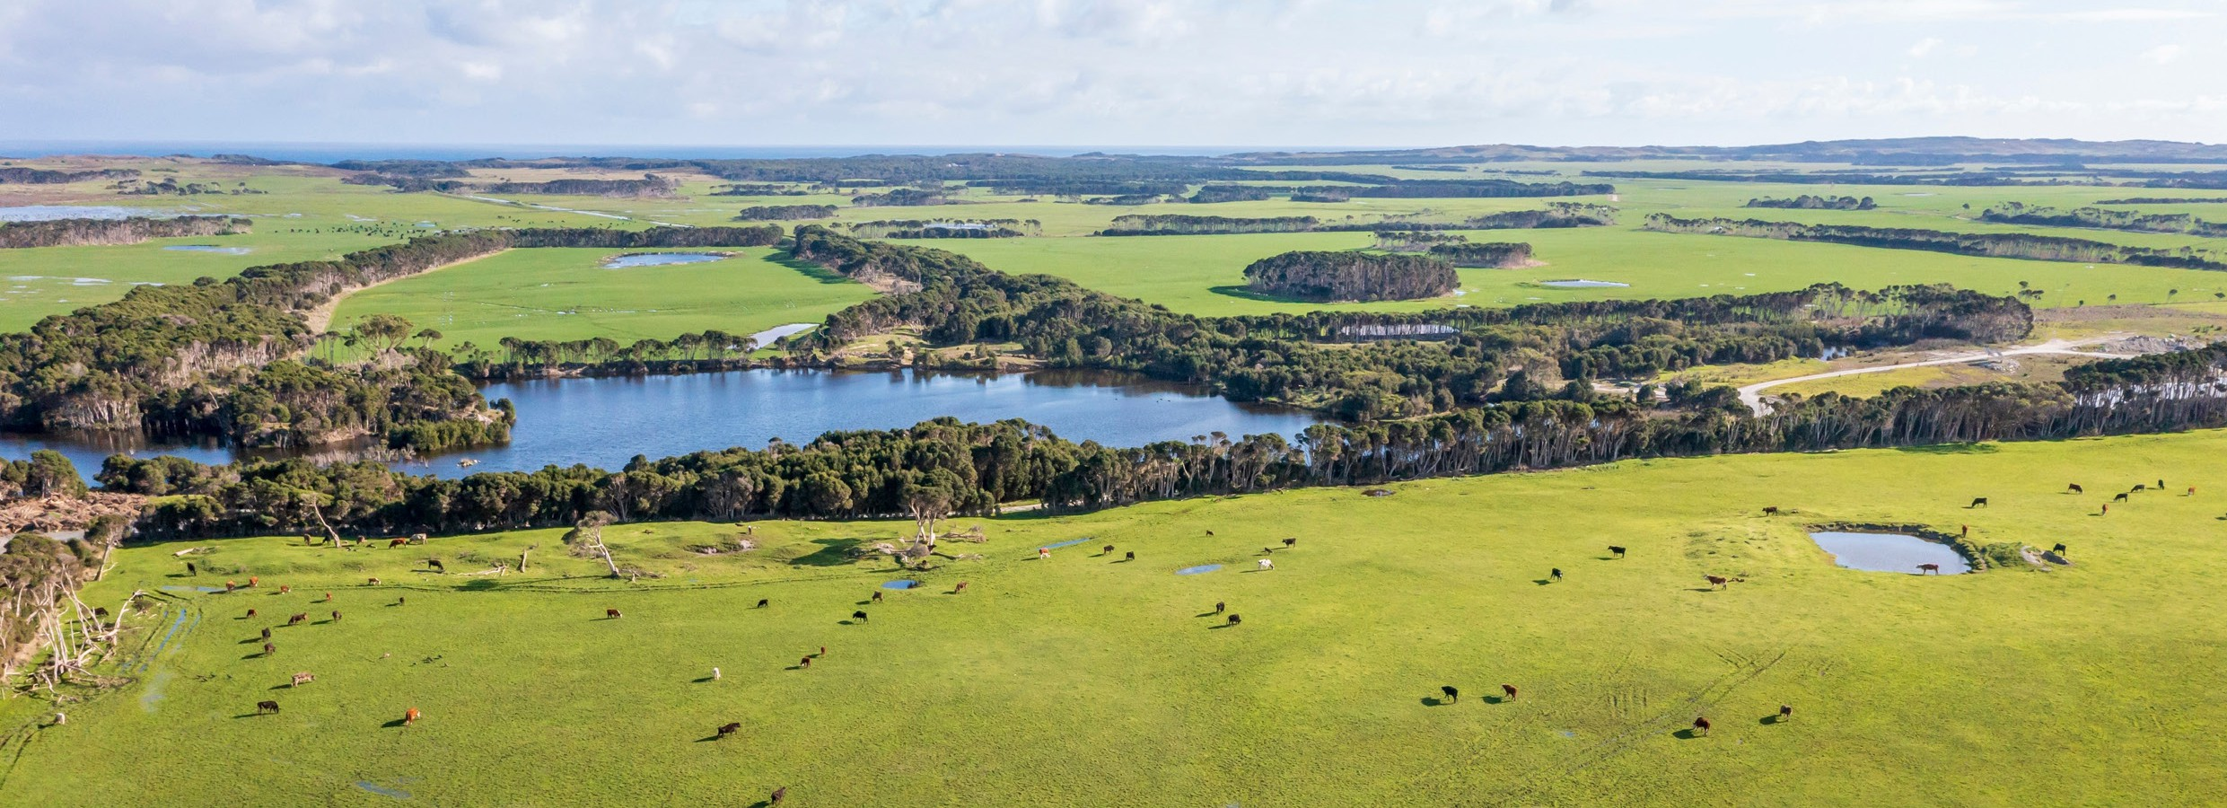
7

Announcement opportunities
Opportunities must be offered for the Australian Government to be actively involved in all public announcements, including media events and joint press releases.
As state and territory governments oversee project delivery, they are responsible for drafting joint releases and submitting them for Australian Government review and approval. Some exceptions apply, e.g. Federal Budget announcements.
Rationale:
- Including the Australian Government in external communication activity helps:
  - elevate the visibility and credibility of the project
  - attract broader media attention, and
  - showcase successful collaboration and inter-government partnerships. This collaborative approach ultimately benefits all parties involved.
Requirements
State and territory governments, as the project conduit, are responsible for identifying upcoming announcement opportunities through their monthly reporting to the Australian Government.
As above, all public facing announcement content must be submitted for approval before release.
Announcements involving the Australia Government must be considered and issued first, before project partners release any public communication, including website or newsletter updates, (unless agreed prior in writing).
Joint announcement opportunities may include:
- initial project announcement
- contract signing / tender announcements, e.g. opening of the tender and tender being awarded
- pre-construction work
- construction commencement
- key project milestones* or updates
- other positive project news or notable achievements
- project completion
- project operational (first water delivery).
*Key announcement milestones may differ from the NWGF payment milestones.
Review timing
A minimum of 2 weeks (10 business days) is required for initial notice of any announcements and releases. Please allow more time for media events as Australian Government response times may vary.

Imagery
High quality project images, footage and relevant data should be provided for use in Australian Government communication, including:
- video, graphic design and digital products
- website content
- reports, factsheets, brochures and newsletters
- media promotion and social media posts
- any other project-related collateral.
Please note: The NWG is required to meet the branding requirements of the Australian Government and the department it sits within. This may include the application of departmental or Australian Government branding to promotional material, including imagery. Any questions or concerns regarding branding should be raised with the NWG as early as possible.
Requirements
To support Australian Government communication activities, project partners are requested to provide
high-quality creative assets, including images, video and other visual or digital materials, that meet the following minimum standards.

Quality and format
- Images and video should be high resolution and ideally suitable for professional print, broadcast and digital use where possible.
- Images: Ideally at least 300 dpi at A4 size.
Accepted formats: JPEG (.jpg) or TIFF (.tif) or PNG (.png).
- Video: Ideally at least 1080p resolution. Accepted formats: MP4 (preferred) or MOV.
- Images and footage should be well-lit, steady, in focus, with clear audio (where applicable), and free from excessive filters, watermarks, embedded graphics or overlays, unless otherwise agreed. Videos should have captions for accessibility.

Content and composition
- Imagery should clearly depict the project, infrastructure, site activities, location or outcomes.
- Where people are featured, imagery should reflect safe work practices, including appropriate personal protective equipment (where relevant).
- Content should be visually engaging and suitable for public-facing communication, including media and social media.
- Imagery should not include confidential information, sensitive locations, culturally sensitive material or identifiable individuals without appropriate consent.

Branding and visibility
- Where appropriate, imagery should allow for recognition of the project context (e.g. signage, site activity or infrastructure), without appearing overly staged or promotional.
- Images should not include third-party branding unless relevant and otherwise agreed.
- Imagery should be suitable for the application of Australian Government and departmental branding where required, unless agreed otherwise.

8

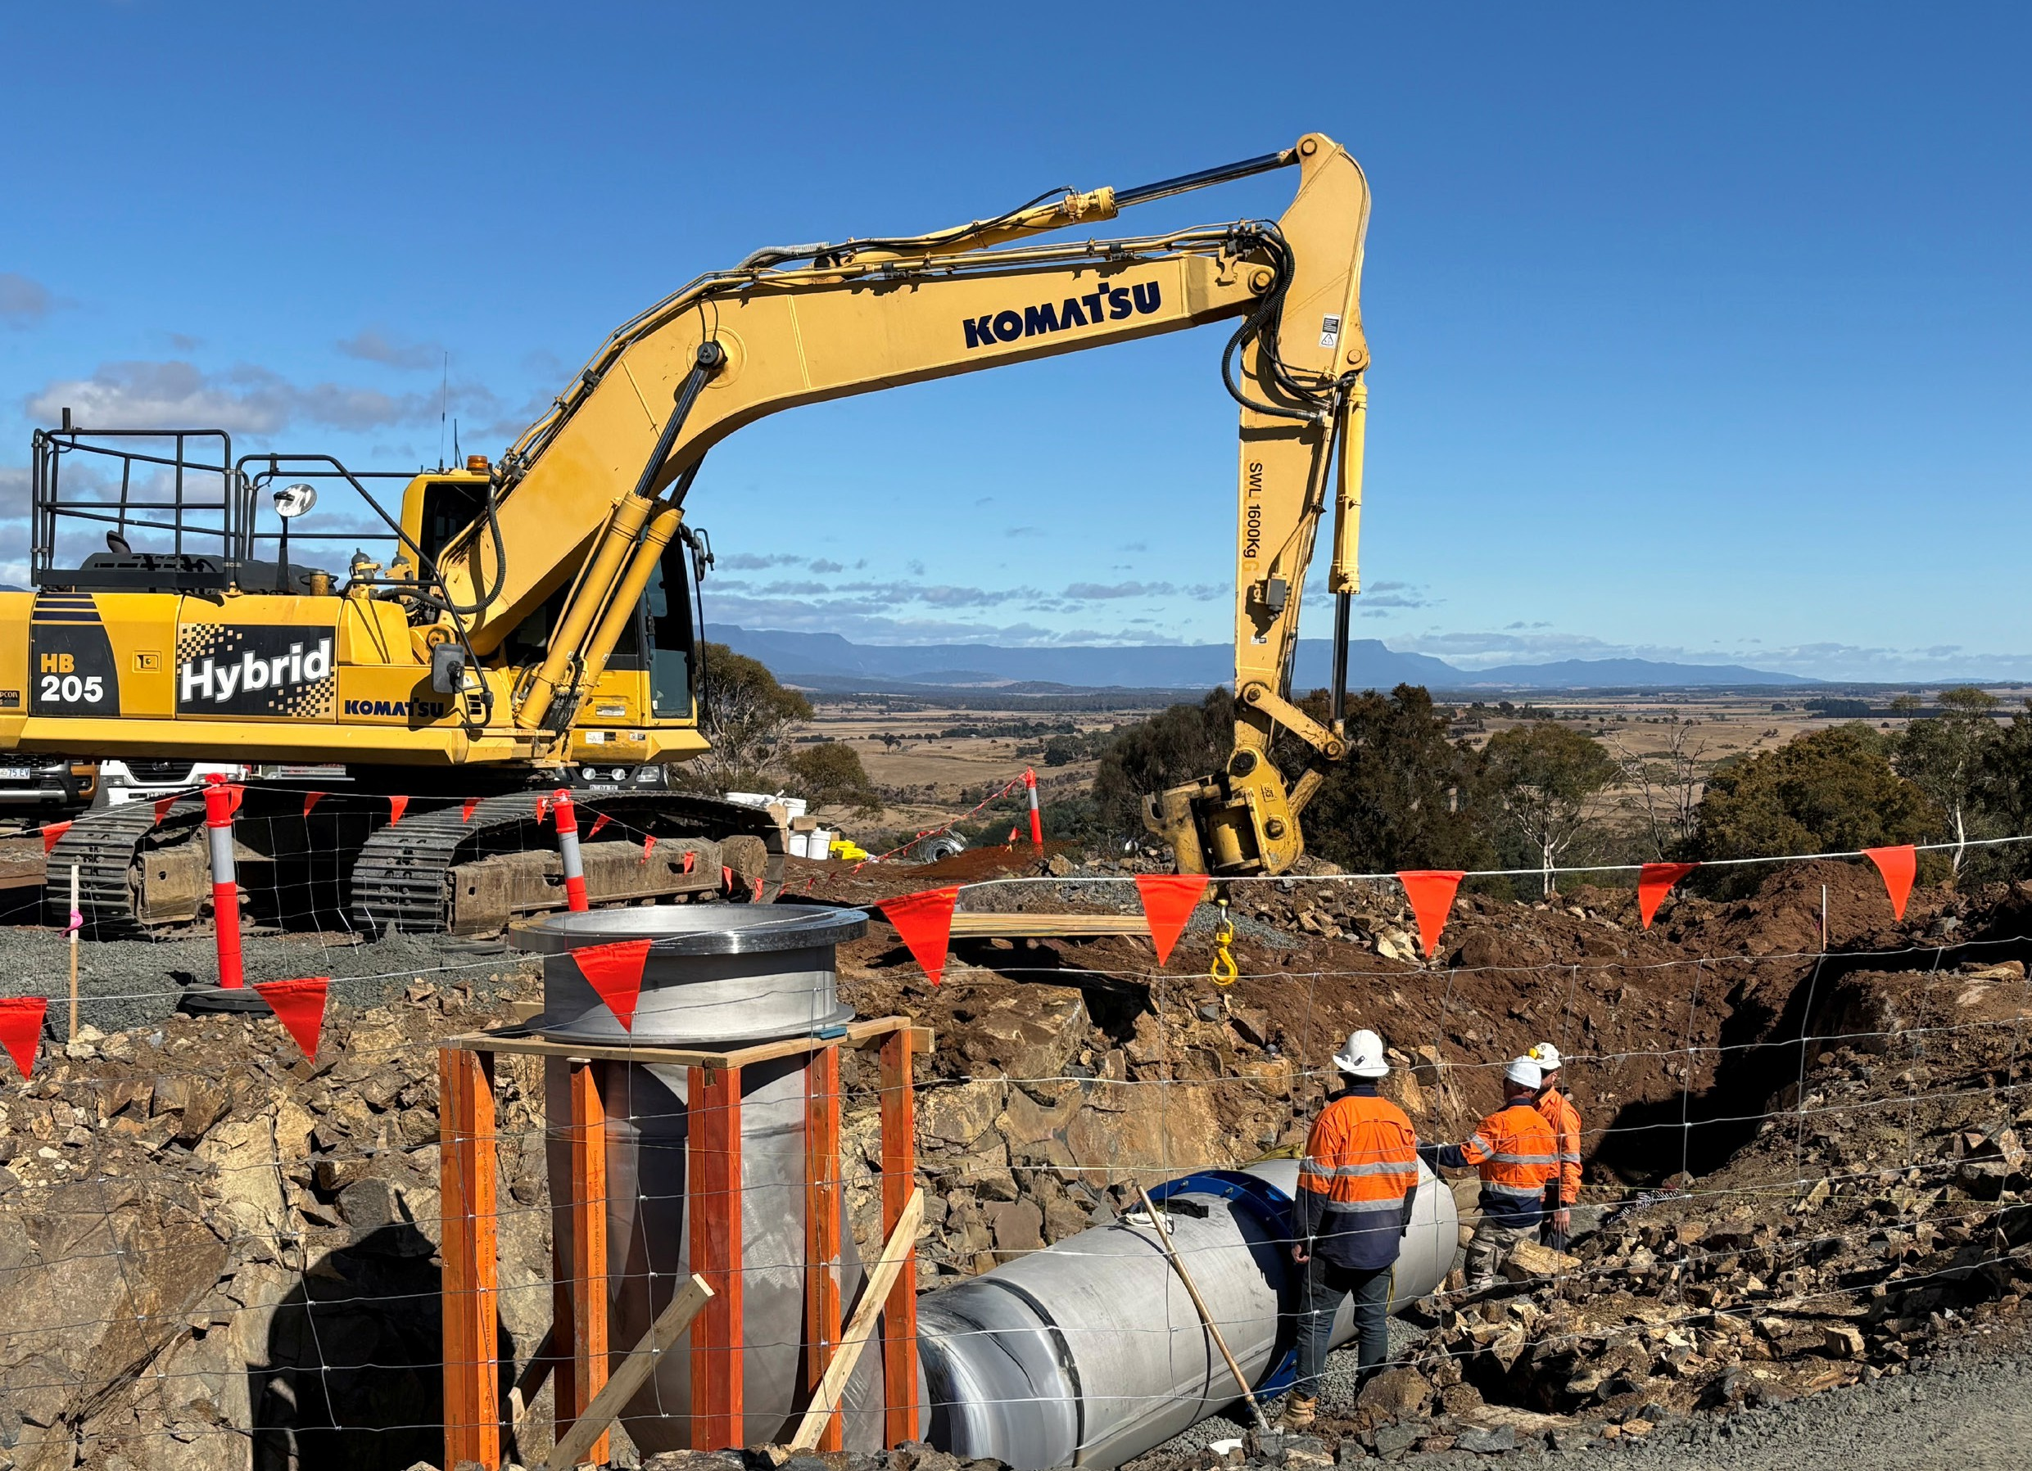

Permissions and usage rights
- All imagery and assets must be fully cleared for the Australian Government’s unrestricted use, including reproduction, editing and publication across multiple platforms.
- Project partners are responsible for ensuring all necessary permissions, releases and usage rights are in place, including for individuals, locations, music or other third-party content appearing in images or video.
- Any restrictions, conditions or required citations must be clearly advised at the time of submission.

Metadata and captions
- Images, video and creative assets should be supplied with basic metadata or accompanying information, including:
  - project name
  - location (city/town and state)
  - brief description of what is depicted
  - date / month the image was taken
  - photographer, videographer or production credit (if required).

Site access
- The Australian Government may also seek permission for a photographer or videographer to access project sites to obtain additional images or footage for communication purposes.
Please note: The NWG recognises that sourcing appropriate imagery can be challenging and will work with project partners to achieve the best possible outcomes. Where attribution requirements are advised, the NWG will
appropriately credit the source. We will discuss with project partners any instances where attribution is not possible.

9

National Water Grid logo design requirements
The NWG logo is a registered trademark.
The NWG logo is available in various formats by emailing the NWG at nwg.communication@dcceew.gov.au
For detailed rules on the use of logos containing the Commonwealth Coat of Arms, please visit: Commonwealth Coat of Arms information and guidelines
Requirements

Positioning
The NWG logo should be placed on the left, and state/territory or partner logos on the right, (unless otherwise agreed prior in writing).
Other logos must be the same size or smaller than the Australian Government / NWG logo (as per the branding guidelines set by the Department of Prime Minister and Cabinet).

Minimum size and isolation zone
The Commonwealth Coat of Arms must be at least 20 mm wide.
Keep a simple, clear area around the logo—no text, patterns, artwork or complex images behind it.
This zone is defined below as ‘X’. It is based on the distance between the bottom of the Commonwealth Coat of Arms and the capital ‘A’ in Australian Government.
Please note: This zone is the minimum dimension, and it applies to every form and application of the logo.
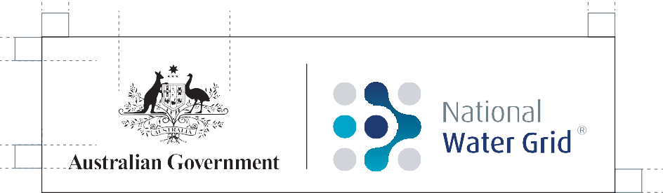
x
x
20mm
x
x
x

Colours
Use full colour, navy, black, or reversed (white) versions, as appropriate.

Full colour Navy
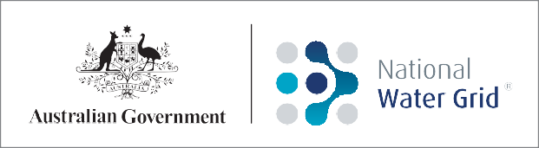
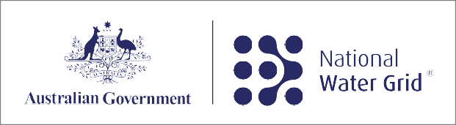
Reversed Black
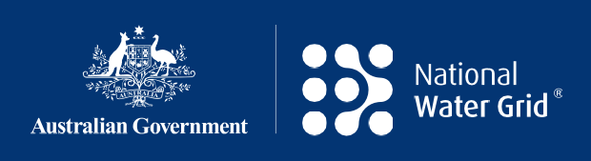
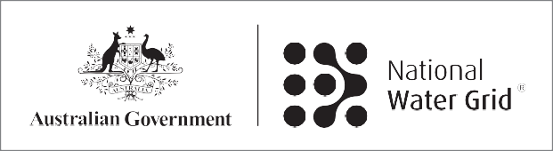

10

Signage
Branded signage is mandatory for all NWG construction projects.
NWG signage is not to be used for science projects, business cases, or potential future projects where an Australian Government funding commitment has not yet been announced (unless otherwise agreed prior in writing).
Signage templates (design files) are available on request.
Requirements
All branded signage must include the following:
- NWG logo including the Commonwealth Coat of Arms
- funding acknowledgement statement, and
- project title.
Project partners must obtain the NWG’s agreement on the following prior to producing any signage:
- size
- content (including standard and non-standard wording)
- location of project signage.
Please note: Project partners seeking to include additional text on NWG-branded signage due to special circumstances, or to develop banner or mesh signage, should contact the NWG as early as possible to discuss (prior to production).

Item | Requirement
Placement | Easily visible to the public and unobscured, e.g. by distance, buildings, trees or any other signage.  Other logos must be the same size or smaller than the Australian Government / NWG logo.
Minimum size | Large enough to be clearly seen and understood. Standard:  - 1200 mm wide by 900 mm high Small option, if necessary:  - 900 mm wide by 600 mm high Bespoke:  If a different size is required it should maintain the same 4:3 ratio and be approved by the NWG prior to printing.
Timing | Erected at the start of construction and to remain in place for at least 12 months after completion of the project (unless otherwise agreed prior in writing).
Content | Must include the NWG logo and the full acknowledgement statement.  The Australian Government / NWG logo must take prominent position on the top left with the relevant project partner logos adjacent to the right.  All other logos must be the same size or smaller than the Australian Government logo.  Text sizes, style, colour and materials should be in accordance with the specifications outlined below.
Review timing
A minimum of at least 5 business days is required for approval of branded signage.

11

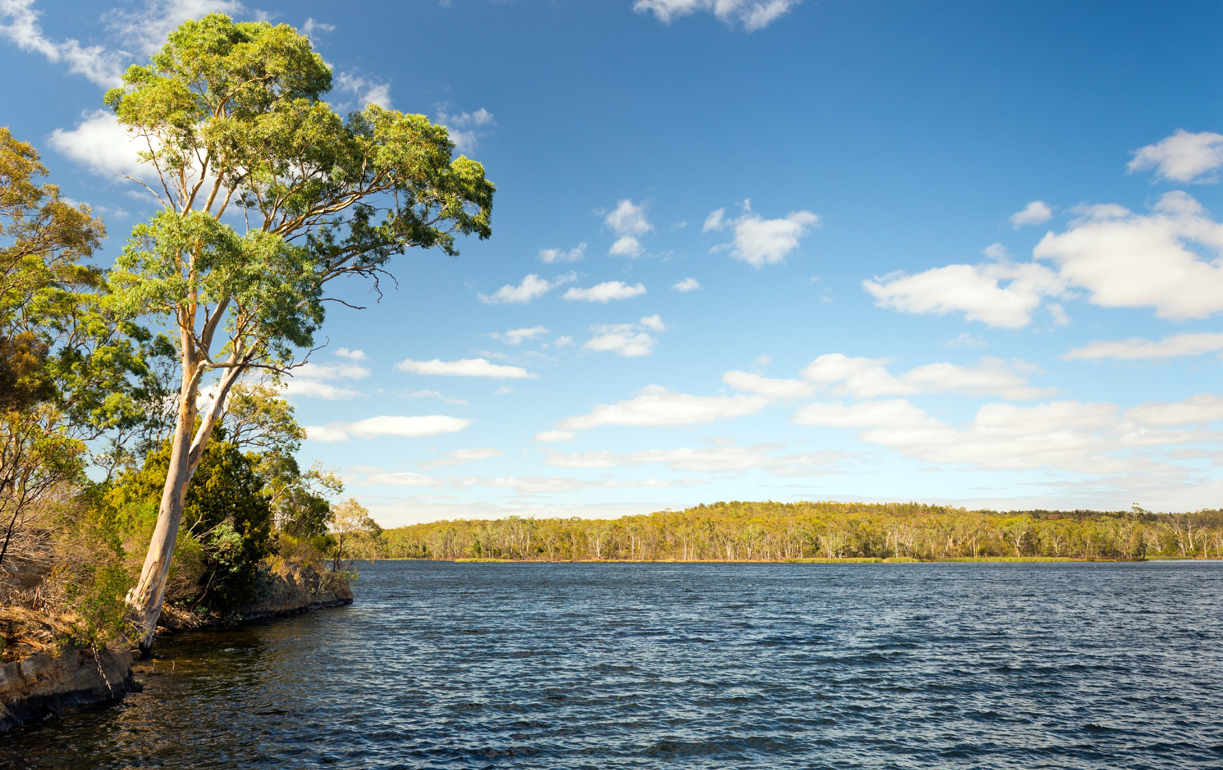
12

Manufacturing specifications
The specifications below are designed to ensure signage lasts the life of the project and can be easily cleaned if defaced. Equivalent options recommended by the manufacturer must be submitted to the NWG for prior approval.

Item | Recommended
Margin | Maintain a 20 mm white margin around the sign content.
Material | 1.6 mm aluminium (standard for signage and longevity) Non reflective so it does not reflect light  Rounded corners for safety
Finish | Digital print with clear lamination (for durability)
Coating | Anti-graffiti coating to allow graffiti to be removed with alcohol
Mounting | RTA RIB (standard RTA mount) or as appropriate
Colours | Navy (Pantone 288) background Black  Reversed logos (white) CMYK | 0, 0, 0, 100  Black text on a white background RGB | 0, 0, 0 Pantone | Black

Navy
CMYK | 100, 80, 6, 32
RGB | 0, 45, 114
Pantone | 288 C

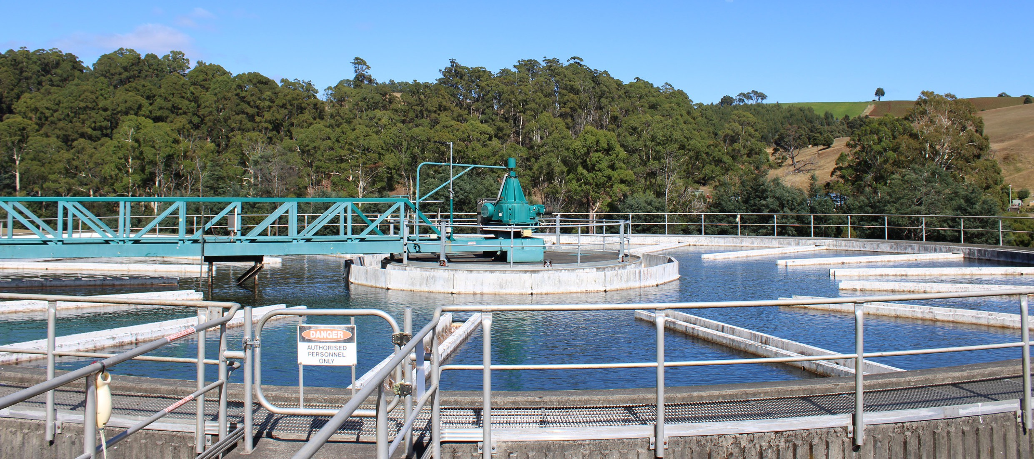
13

Example signage

One project partner logo


1200mm
20mm
100mm
Aus Gov | NWG logo: 496mm
20mm
20mm
100mm
200mm
Project title to go over
Text is centred
vertically in the white space whith
900mm the formatting and spacing shown below
two lines max
This National Water Grid project is funded by the Australian and <state or territory> governments
100mm
nationalwatergrid.gov.au
20mm
Project title
Longer project title
Project funding
Website
Arial Bold Arial Bold Arial Bold Arial Bold
310/310pt, -25 tracking 260/310pt, -25 tracking 110/120pt, -15 tracking 145/145pt, 0 tracking 0/60mm sp.before/after 0/60mm sp.before/after 15/0mm sp.before/after 0/0mm sp.before/after

S/T Government (logo reversed)

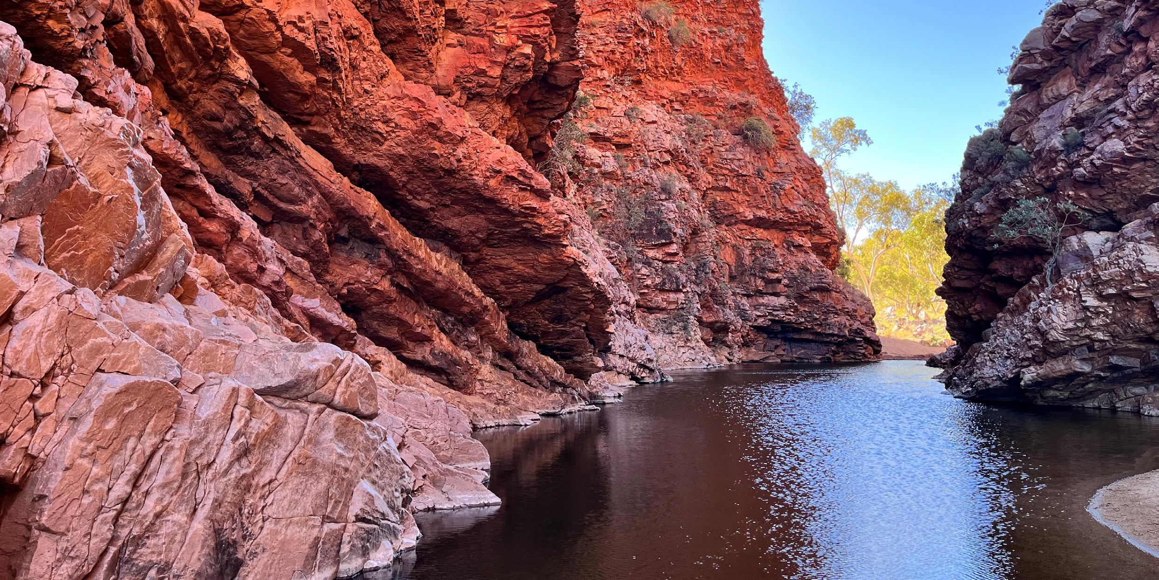
14

Two project partner logos


1200mm
50mm
20mm
Logos visually spaced from right
Aus Gov | NWG logo: 435mm
50mm
20mm
20mm
50mm
900mm
Text is centred
vertically in the white space whith the formatting and spacing shown below
Long primary project title to go over two lines max
This National Water Grid project is funded by the Australian and
<state or territory> governments and delivered in partnership with <project proponent 1> and <project proponent 2>
100mm
nationalwatergrid.gov.au
20mm

Project title Longer project title Project funding Website
Arial Bold Arial Bold Arial Bold Arial Bold
310/310pt, -25 tracking 260/310pt, -25 tracking 110/120pt, -15 tracking 145/145pt, 0 tracking 0/60mm sp.before/after 0/60mm sp.before/after 15/0mm sp.before/after 0/0mm sp.before/after

Other project partner (logo reversed)

Other project partner (logo reversed)

Three project partner logos


1200mm
50mm
20mm
Logos visually spaced from right
Aus Gov | NWG logo: 435mm
50mm
20mm
20mm
50mm
900mm
Text is centred
vertically in the white space whith the formatting and spacing shown below
Long primary project title to go over two lines max
This National Water Grid project is funded by the Australian and
<state or territory> governments and delivered in partnership with <project proponent 1> and <project proponent 2>
100mm
nationalwatergrid.gov.au
20mm

Project title Longer project title Project funding Website
Arial Bold Arial Bold Arial Bold Arial Bold
310/310pt, -25 tracking 260/310pt, -25 tracking 110/120pt, -15 tracking 145/145pt, 0 tracking 0/60mm sp.before/after 0/60mm sp.before/after 15/0mm sp.before/after 0/0mm sp.before/after

Other project partner (logo reversed)

Other project partner (logo reversed)

S/T Government (logo reversed)

Contact us
Please email the NWG via nwg.communication@dcceew.gov.au for approval, advice and signage templates related to acknowledging funding from the Australian Government through the National Water Grid Fund.
The latest version of the NWG Funding Acknowledgement Requirements is available on our website and can be emailed to our project partners as required.

15

nationalwatergrid.gov.au
26-COM_0436

