
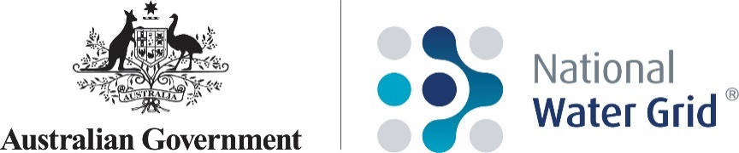

Science Strategy

February 2023
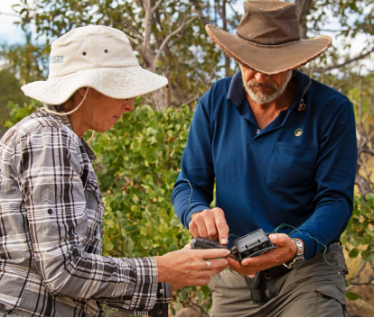

© Commonwealth of Australia 2023
ISBN 978-0-6456423-1-5
February 2023

Ownership of intellectual property rights in this publication
Unless otherwise noted, copyright (and any other intellectual property rights, if any) in this publication is owned by the Commonwealth of Australia (referred to below as the Commonwealth).
Cover image: Nathan Dyer, © Copyright CSIRO Australia.

Disclaimer
The material contained in this publication is made available on the understanding that the Commonwealth is not providing professional advice, and that users exercise their own skill and care with respect to its use, and seek independent advice if necessary.
The Commonwealth makes no representations or warranties as to the contents or accuracy of the information contained in this publication. To the extent permitted by law, the Commonwealth disclaims liability to any person or organisation in respect of anything done, or omitted to be done, in reliance upon information contained in this publication.

Creative Commons licence
With the exception of (a) the Coat of Arms; (b) the Department of Climate Change Energy, the Environment and Water photos and graphics, copyright in this publication is licensed under a Creative Commons Attribution 4.0 Australia Licence.
Creative Commons Attribution 4.0 Australia Licence is a standard form licence agreement that allows you to copy, communicate and adapt this publication provided that you attribute the work to the Commonwealth and abide by the other licence terms.
Further information on the licence terms is available from https://creativecommons.org/licenses/by/4.0/.
This publication should be attributed in the following way: © Commonwealth of Australia 2023

Use of the Coat of Arms
The Department of the Prime Minister and Cabinet sets the terms under which the Coat of Arms is used. Please refer to the Commonwealth Coat of Arms – Information and Guidelines publication available at http://www.pmc.gov.au.

Contact us
This publication is available in hard copy or PDF format. All other rights are reserved, including in relation to any departmental logos or trademarks which may exist. For enquiries regarding the licence and any use of this publication, please contact:
Director, Strategic Engagement
National Water Grid Authority and Water Infrastructure Division
Department of Climate Change, Energy, the Environment and Water
GPO Box 3090
Canberra ACT 2601
Australia
Email: nwga.communication@dcceew.gov.au
Website: nationalwatergrid.gov.au

Table of Contents
Introduction 1
The Science Program 2
Science Project selection 4
Project consideration 5
Project funding 6
Program delivery, evaluation and reporting 6

Table of Figures
Figure 1: National Water Grid Fund strategic objectives 1
Figure 2. Scientific evidence reduces uncertainties to identify suitable solutions 2
Figure 3. Science Program project assessment flowchart 4

Introduction
Access to a safe and reliable water supply is essential for supporting Australian communities and our economy. The Australian Government is committed to working with the state and territory governments to improve water security for all Australians, particularly for those in regional and remote communities. The National Water Grid Authority (NWGA) is responsible for managing the Australian Government’s infrastructure investment program to improve water access and security.
Consistent and long-term planning is essential to ensure that investments are economically viable and respond to future challenges such as climate change, population growth and increasing agricultural demand. Investment in water infrastructure must also be ecologically sustainable and culturally responsive.
Science is an important part of the Government’s investment in water security. The NWGA Science Program provides an evidence base to inform water infrastructure investment decisions. Science Program projects improve knowledge of Australia’s water resources and their sustainable use, and progress the use of technologies that can help increase water security, adapt to climate change and support thriving regions.
This Science Strategy outlines the goals, themes of work and arrangements for guiding investments made under the Science Program. The Strategy should be read in conjunction with the National Water Grid Investment Framework.
The NWGA works with other relevant Australian Government agencies in implementing the Science Strategy.

National Water Grid Fund and Investment Framework
Through the National Water Grid Fund, the Australian Government provides funding to state and territory governments to deliver water infrastructure projects. State and territory governments are responsible for the regulation, planning, management and allocation of water resources, including water infrastructure development and maintenance. Close collaboration between the Australian Government and state and territory governments is central to Australian Government investment.
The National Water Grid Investment Framework sets out how the Authority will work in partnership with state and territory governments to support Australian Government investment in water infrastructure, and the strategic objectives, eligibility criteria and principles for investment. Science Program projects must align with the National Water Grid Fund strategic objectives (Figure 1) set out in the Investment Framework.

Provide safe and reliable water for regional and remote communities
Generate public benefit through responsible investment in water infrastructure for productive use
Build resilient water infrastructure that is environmentally sustainable and culturally responsive

Figure 1: National Water Grid Fund strategic objectives

The Science Program
The NWGA Science Program provides high-quality scientific information and data to inform water infrastructure investment decisions. By building a robust scientific evidence base that grows over time, the Science Program supports the NWGA to invest in water infrastructure that aligns with the strategic objectives and investment principles set out in the National Water Grid Investment Framework. Science Program projects can progress opportunities and provide an evidence base for water infrastructure decisions, by:
- Addressing gaps in data, information or other evidence needed to progress feasibility, business case or later stages of a potential infrastructure project.
- Building foundational knowledge and data relating to water resources, including the sustainability and potential impacts of water infrastructure and water extraction and use.
- Progressing technologies with potential to improve access to safe, reliable and fit for purpose water supplies, including through pilot projects.
- Helping Australia adapt to impacts of climate change by supporting greater use and development of climate resilient water sources.

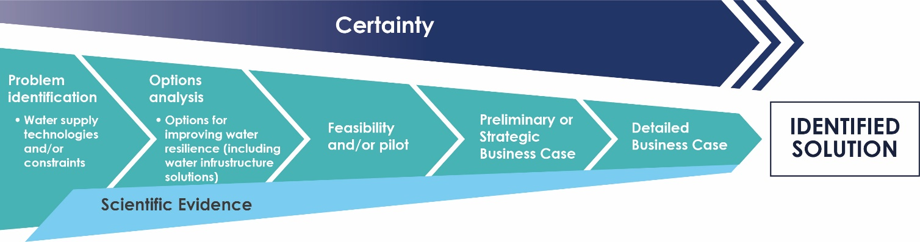
Figure 2. Scientific evidence reduces uncertainties to identify suitable solutions

The Science Program invests in three key areas: water resource analysis, alternative and emerging options, and new information resources (Box 1).

Box 1 – The Science Program has three key themes
Theme 1: Water Resource Analysis
Projects address questions such as how much water is available, how suitable it is for different purposes, how much can be sustainably extracted, and what are the environmental, cultural, economic and community objectives. Previous and current projects include comprehensive water resource assessments in Australia’s north; projects to better understand groundwater quantity and quality; and projects investigating impacts of climate change on water resources.
  - Expected Outcome
Improved evidence base to support decisions on where and how water resources can be sustainably utilised to improve water access and security for regional and remote communities and for productive use.
Theme 2: Alternative and Emerging Options
Projects aim to identify and progress opportunities for new or emerging water resources and technologies to improve water access, quality or reliability. Key emerging opportunities include greater use of managed aquifer recharge to store water underground; greater wastewater re-use; and increased use of brackish groundwater resources.
  - Expected Outcome
Identification and progression of emerging opportunities or new water technologies that can improve water access, safety or security.
Theme 3: New information resources including communicating the science
Projects aim to improve access to information or data to inform water infrastructure decisions. Information could relate to water resources; storage, supply and related infrastructure; First Nations water knowledge; or cultural heritage and environmental assets relevant to water infrastructure decisions. Resources could include decision support tools, communication of science outcomes and web-based mapping.
  - Expected Outcome
New information resources to inform responsible water infrastructure investment decisions.

Projects will need to address at least one of the key themes, and address opportunities, impediments or knowledge gaps relating to where or how water infrastructure could address at least one of the NWGA’s Strategic Objectives (Figure 1).
Projects funded under the Science Program can address immediate or long-term scientific knowledge gaps, and can be national, regional or site-specific. Proposals that are more appropriately funded by other organisations, or which duplicate work already funded, are not eligible for Science Program funding.

Science project selection
The Science Program engages with Australian science agencies and with state and territory governments nation-wide to understand water security issues, knowledge gaps and infrastructure priorities in each jurisdiction and the science required to inform water infrastructure investment decisions.
Science Program projects funded through the National Water Grid Fund must be brought forward by state and territory governments. State and territory governments are encouraged to bring forward priority proposals that align with this Science Strategy and the National Water Grid Investment Framework.
Proposals will be assessed and developed iteratively using the flow chart in Figure 3. In Stage 1, proposals are assessed for eligibility by considering their alignment with the key themes (Box 1) and key questions (Box 2).
Projects with high alignment can be further developed in consultation with the NWGA for Stage 2 assessment against the Science Program project principles (Box 3). Assessments will also consider level of development and scientific merit. Projects with high alignment in Stage 2 can be considered for Science Program funding.

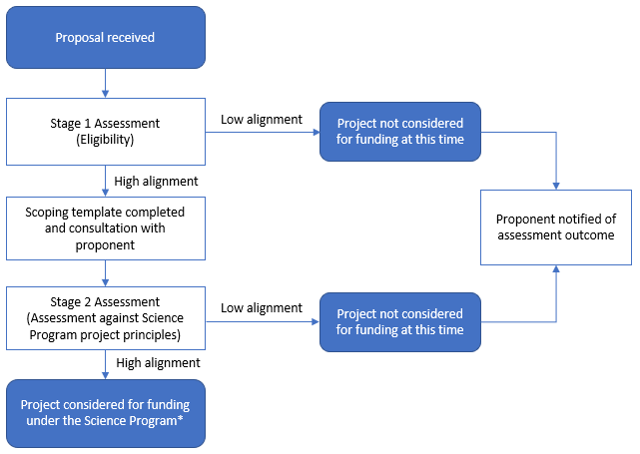

Figure 3. Science Program project assessment flowchart
*Projects must be assessed for value for money and other requirements under the PGPA Act. Funding decisions rest with the Australian Government.

Project consideration
Project topics will be considered for alignment with the key questions of the Science Program (Box 2), and for relevance to the principles of the Science Program (Box 3).
Box 2 – Science Program key questions
For Themes 1 and 2 of the Science Program, projects will need to address opportunities, impediments or knowledge gaps relating to where or how water infrastructure could address at least one of the following:
- Improving safety and/or reliability of water supply for regional and remote communities
- Providing new water resources for productive use, or improving the quality, reliability or sustainability of existing water resources available for productive use, in a way that generates public benefit through responsible investment in water infrastructure
- Increasing resilience in a way that is environmentally sustainable and culturally responsive

Box 3 – Project principles*
1. Alignment with water infrastructure objectives and desired outcomes
i. Align with NWGA strategic objectives (Figure 1).
ii. Demonstrate project readiness and opportunities to progress water infrastructure investment decisions.
iii. Consider state and territory priorities.
iv. Consider other Australian Government priorities.
v. Consider social, economic and environmental impacts, including environmental sustainability, climate change and impacts on First Nations communities.

2. Address a knowledge gap required to enhance water security options
- Contribute to a fundamental understanding of the available water resource to support sustainable development, including through infrastructure.
- Contribute to developing or progressing methods and technologies that may:
        - increase safety, reliability or volume of supply
        - deliver sustainable use of water resources, including climate resilient water sources.
- Contribute to information, data and decision tools that can be used by decision makers, particularly for informing decisions about water infrastructure investment and water resource development.

- Working in partnership
- Offer opportunities for collaboration, including consideration of joint investment for shared priorities.
- Consider priorities and desired outcomes of partners and stakeholders, including First Nations and other communities.
- Engage with any affected communities including First Nations Peoples.

*Underpinning these principles is the obligation for considering value for money and consideration of project delivery risks

The scientific merit of Science Program proposals will also be assessed, which may involve investigating whether the proposed idea has been peer reviewed and/or whether the idea comes from a credible and reputable source.

Project funding

Once a project has been assessed as having strong alignment with this Science Strategy, the National Water Grid Investment Framework and Australian Government objectives, the Australian Government may consult with partners and stakeholders before making a decision on investment in the project.
Depending on individual project requirements, the Science Program may:
- invest in partnership with state and territory governments through a Federation Funding Agreement
- access providers through existing department arrangements with government science agencies or other organisations
- access providers on water science related procurement panels that have relevant scientific and technical skills
- conduct a limited tender arrangement with a provider that has specific scientific and technical skills and expertise required to deliver the project
- conduct an open tender competitive process
- provide a research grant opportunity.
The Science Program adheres to all Australian Government procurement rules and guidelines. The Commonwealth Procurement Rules, the Commonwealth Grants Rules and Guidelines, and the Public Governance, Performance and Accountability Act 2013 govern the use and management of public funds.

Program delivery, evaluation and reporting
Science projects are monitored to ensure timely and relevant information is available to understand how projects are tracking against milestones. Milestones for projects are included in financial agreements with proponents to ensure that projects are delivering interim results.
The NWGA works with project proponents to evaluate project outcomes post-completion, and to identify and apply lessons learned.
Monitoring and evaluation of the Science Program complements the monitoring and evaluation arrangements established more broadly for the NWGA and other Australian Government planning documents. Evaluation as part of the Science Program will be undertaken every 3-5 years.
Periodic evaluation of the Science Program — including but not limited to a report on progress and opportunities — will be undertaken to assess whether the Science Program is contributing beneficial information that informs water infrastructure investment opportunities. In addition, the periodic evaluation will provide an opportunity to draw on lessons learned to guide future science project investment decisions.

