
Ocean, weather and climate
UNESCO ocean literacy principles |  |  | 
UNESCO ocean literacy principles | #3: The ocean is a major influence on weather and climate. | #5: The ocean makes Earth habitable. | #6: The ocean and humans are inextricably interconnected.
The ocean and climate are linked and influence each other. This is sometimes called the ocean–climate nexus.
Through this relationship, the ocean:
- regulates our weather and climate
- is being affected by climate change
- offers opportunities to mitigate climate change.
The East Australian Current and Leeuwin Current carry warm water down the east and west coasts of Australia, respectively.
Currents also help move food, nutrients and marine animals around the ocean, and are important for sustaining food chains – including ours!

How does the ocean regulate our weather and climate?
The ocean is incredibly important for helping shape the planet we live on and generates about half of the oxygen on Earth.

The ocean captures, stores and transports heat around the world to influence local weather and climate patterns. For example:
- Ocean currents act like conveyor belts to transport heat and humidity around the globe. This drives some weather patterns.
- These currents allow for a more even distribution of heat. Without them, the world would be far too hot at the equator and too cold at the poles. This would make a lot of the Earth uninhabitable.
- Most rain originates from the ocean. Warm seas also provide energy for hurricanes, storms and cyclones.
The Southern Ocean is the engine room of the world’s climate and weather. It moderates global climate change by absorbing heat and carbon. It has the capacity to store and release more heat than anywhere else on Earth.
Heat exchange between the ocean and air can affect rainfall and drought patterns dramatically. For example, the cycling between El Niño and La Niña climate patterns (known as the El Niño–Southern Oscillation cycle) in the Pacific Ocean is an important climate driver in our region (CSIRO 2023).
- La Niña happens when strong winds blow warm surface water across the Pacific Ocean to Australia. This warm water evaporates, which increases humidity and leads to clouds and rain.
- El Niño occurs when these winds are weaker and warm water doesn’t make it to Australia. Cooler waters surrounding Australia means less evaporation and less rainfall. This can increase droughts, heatwaves and bushfires.
The Indian Ocean Dipole is also a key driver of Australia’s climate. It’s driven by either strengthening or weakening westerly winds across the tropical Indian Ocean (BoM n.d.).
- Strong westerly winds allow for warmer water to concentrate near Australia, which drives rainfall.
- Weak westerly winds allow warm water to shift away from Australia. Cool water rises from the deep ocean, resulting in less rainfall and higher temperatures over Australia.

How is climate change affecting the ocean?
Climate change is one of the greatest threats to the ocean. It is creating shifting weather patterns that are changing ocean patterns and ecosystems, such as:
- increasing ocean temperatures
- increasing frequency, duration and intensity of marine heatwaves and coral bleaching events
- melting ice sheets
- making the ocean more acidic
- rising sea levels, which puts coastal infrastructure and communities at risk of damage from flooding, erosion and storm surges
- changing ocean currents as waters warm
- causing marine species to shift their range to cooler waters, which changes ecosystems and biodiversity and increases the risk of marine pests
- increasing stratification, which is where water doesn’t mix properly, preventing the transfer of heat, nutrients, oxygen and carbon dioxide to other layers of the ocean.
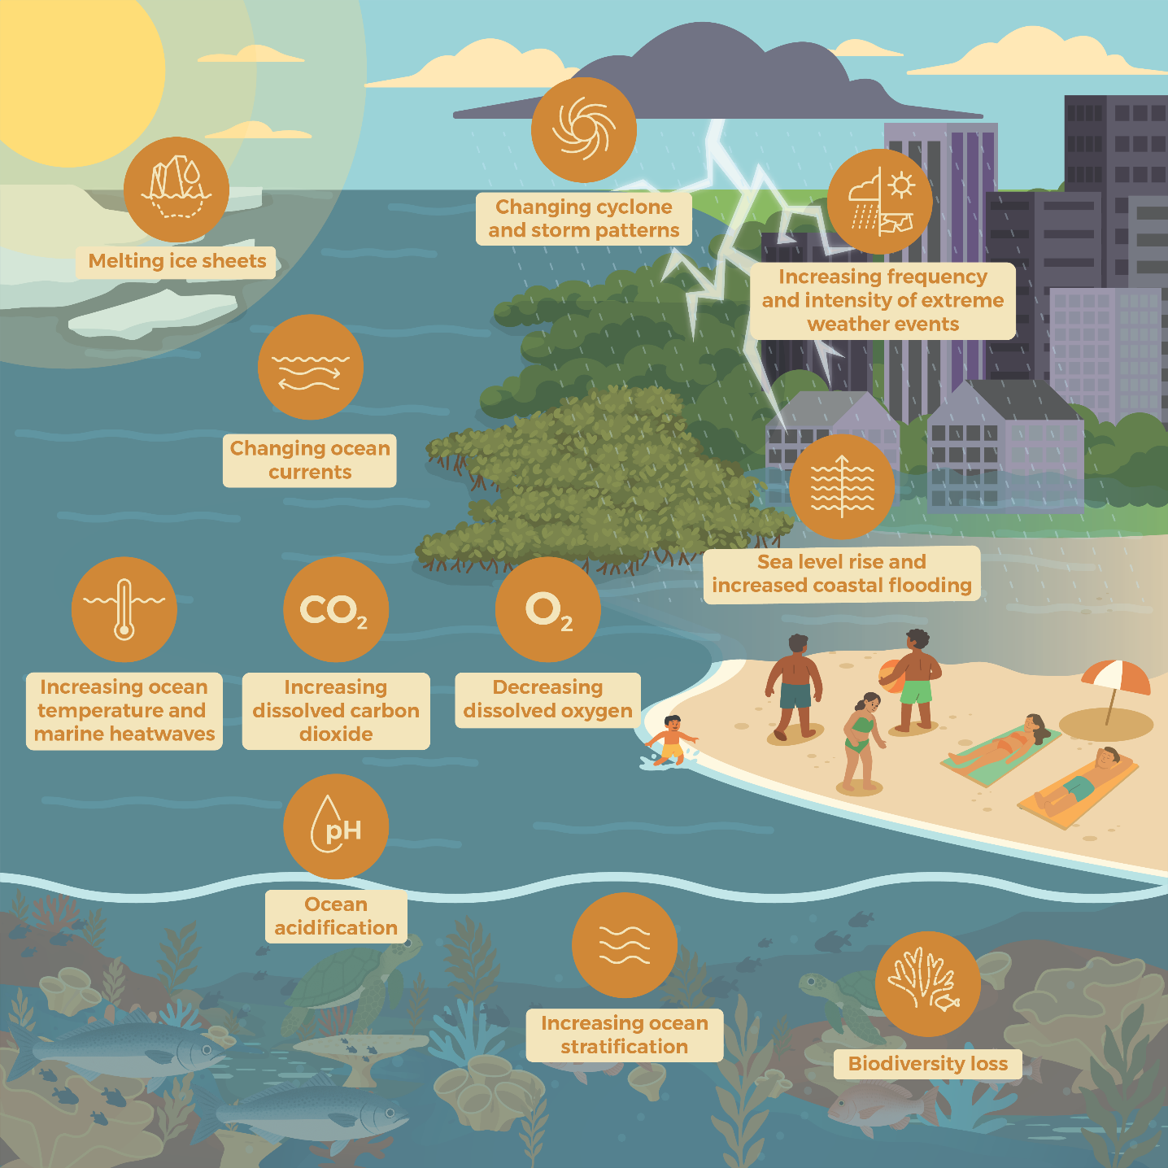
Impacts of climate change on the ocean–climate nexus.
These changes to the ocean in turn affect the climate. This can make these weather events worse, and influence rainfall, floods, storms, cyclones, bushfires and droughts. Changes to ocean currents may affect weather and heat distribution around the world.
These changes are threatening the health of the ocean and coasts. They’re altering the diversity, productivity and distribution of marine life, and threatening industries and communities.
This has significant impacts for:
- industries that rely on a stable and healthy ocean environment for their livelihoods, such as tourism and fisheries
- the weather we experience
- the availability of food we source from the ocean
- recreational and cultural values.
First Nations communities are among the most vulnerable to the impacts of climate change. These impacts threaten their ability to care for Country, including the culturally significant species, sites and practices on which their cultural and spiritual identity, wellbeing and livelihoods depend.
Climate change is a global problem and is recognised as the single greatest threat to the Pacific region. What we do in Australia to mitigate climate change will have an effect around the world.

How can the ocean and ocean industries help mitigate climate change?
The ocean has slowed the rate of climate change by:
- absorbing about 30% of carbon dioxide emissions from human activity
- capturing 90% of the excess heat generated by these emissions.
Blue carbon ecosystems (mangroves, saltmarshes and seagrass meadows) can store 2 to 4 times more carbon than tropical rainforests. They also protect coastlines from extreme weather events, such as storm surges and erosion.
The ocean offers solutions to mitigate and adapt to the impacts of climate change. The High Level Panel for a Sustainable Ocean Economy (Ocean Panel) recognises 5 opportunities (Hoegh-Guldberg et al. 2023):
- investment in ocean-based renewable energy
- decarbonisation of ocean-based transport
- restoration and protection of coastal and marine ecosystems

- low-emission fisheries, aquaculture and dietary shifts to low carbon ocean-based protein and other sources of nutrition
- carbon storage in the seabed.
Australia is taking strong action in our region and at home in line these opportunities, and to:
- support mitigation and adaptation of ecosystems to climate threats
- improve our knowledge of climate change in the ocean, including in Antarctica and the Southern Ocean
- strengthen disaster preparedness.

How is Australia working globally to address climate change?
The Australian Government is committed to lowering Australia’s greenhouse gas emissions. Our legislated target is to reach 62 to 70% below 2005 emission levels by 2035 and net zero by 2050. All states and territories are contributing.
This contributes to global efforts to meet the:
- United Nations Framework Convention on Climate Change (UNFCCC) Paris Agreement global temperature goals
- United Nations Sustainable Development Goal for climate action.
Australia is also part of international efforts to take ocean-based climate action, including through:
the UNFCCC and the Ocean and Climate Change Dialogue
the International Maritime Organization’s greenhouse gas reduction targets for shipping
Every Australian relies on a healthy ocean. The ocean’s role in regulating our weather and climate and absorbing greenhouse gases is more important than ever. Protecting our ocean won’t just benefit marine life and those that use it directly. It will help us find solutions to climate change challenges.

More information
www.ocean.gov.au

Glossary
Term | Definition
Adapt | When a plant, animal or system undergoes a change in response to real or expected climate change impacts to help them survive. For example, scientists are working to understand what changes can be made to help corals survive in warmer water.
Blue carbon ecosystems | Marine and coastal ecosystems that capture and store carbon dioxide from the atmosphere (e.g. mangroves, saltmarshes and seagrasses).
Carbon management technology | Technology or solutions that can be used to help remove, or prevent the release of, carbon from the atmosphere and then storing it. This can include carbon dioxide removal technology, offshore carbon capture and storage, and blue carbon ecosystems.
Decarbonise | To decarbonise an industry, such as shipping, is to undertake changes that reduce the greenhouse gas emissions from the industry to net zero (not adding more greenhouse gases to the atmosphere than is being removed).
Greenhouse gases | These are gases, such as carbon dioxide, that trap heat around the Earth to make it hotter than it would otherwise be. When we burn fuels to generate electricity and power vehicles, we release greenhouse gases into the air. Greenhouse gases can also be produced naturally, such as when plants die and animals breathe.
Mitigate | To reduce or lessen the effects of something.
Nature-based solutions | Actions that protect, manage or restore ecosystems in ways that provide benefits to communities and ecosystems at the same time. For example, coastal ecosystems provide breeding grounds for commercial fish, which supports fisheries and local communities, and improves food security.

References
Bureau of Meteorology (n.d.) Indian Ocean climate influences, BoM website, accessed 31 July 2025.
CSIRO (2023) El Niño and La Niña – what’s it all about?, CSIRO website, accessed 7 May 2025.
Hoegh-Guldberg O, Northrop E et al. (2023) The ocean as a solution to climate change: updated opportunities for action, High Level Panel for a Sustainable Ocean Economy.

