On-Ground Investment Location Data Capture, Management and Sharing Standards

Environment Information Australia
January 2025

© Commonwealth of Australia 2025
Ownership of intellectual property rights
Unless otherwise noted, copyright (and any other intellectual property rights) in this publication is owned by the Commonwealth of Australia (referred to as the Commonwealth).
Creative Commons licence
All material in this publication is licensed under a Creative Commons Attribution 4.0 International Licence except content supplied by third parties, logos and the Commonwealth Coat of Arms.
Inquiries about the licence and any use of this document should be submitted via our online contact form.

Cataloguing data
This publication (and any material sourced from it) should be attributed as: DCCEEW 2025, On-Ground Investment Location Data Capture, Management and Sharing Standards V2.0, Department of Climate Change, Energy, the Environment and Water, Canberra. CC BY 4.0.
This publication is available at dcceew.gov.au/environment/environmental-information-data/information-policy
Department of Climate Change, Energy, the Environment and Water
GPO Box 3090 Canberra ACT 2601
Telephone 1800 920 528
Web dcceew.gov.au
Disclaimer
The Australian Government acting through the Department of Climate Change, Energy, the Environment and Water has exercised due care and skill in preparing and compiling the information and data in this publication. Notwithstanding, the Department of Climate Change, Energy, the Environment and Water, its employees and advisers disclaim all liability, including liability for negligence and for any loss, damage, injury, expense or cost incurred by any person as a result of accessing, using or relying on any of the information or data in this publication to the maximum extent permitted by law.
Acknowledgement of Country
We acknowledge the Traditional Owners of Country throughout Australia and recognise their continuing connection to land, waters and culture. We pay our respects to their Elders past and present.

Overview
Location data for on-ground investment areas are critical to planning, monitoring and reporting on departmental programs.
Capturing location data for investments is increasingly simple and achievable with online mapping tools (e.g. Google Maps, ArcGIS Online and applications built on these platforms). The Department of Climate Change, Energy, the Environment and Water (the Department) routinely deploys online mapping tools for use in project application and reporting processes. However, evidence from past programs shows a need to improve the quality and consistency of the collection, maintenance and sharing of investment location data.
The Department has released these standards to help meet that need. While they apply primarily to departmental staff, their wider promotion and adoption is also encouraged. This will help improve reporting and decision making for investments in protecting environmental and heritage values, while ensuring relevant sensitivities are managed appropriately.
These standards will be reviewed regularly and updated as necessary. They complement other data standards and policies released by the Department, such as the Policy on accessing and sharing biodiversity data.

The Standards
- Capturing of on-ground investment locations (for environment, heritage and natural resource management projects).
Any Request for Tender (RFT) or call for grant applications should:
- Require tenderers or applicants to generate, and make accessible to the Department, fine-scale polygon data for all proposed on-ground activity areas, as detailed in Appendices 1 and 2.
- Inform all tenderers and applicants of requirements 1c and 1d below.
Any contract or funding agreement for on-ground investment should:
- Require contractors or grant recipients to maintain up-to-date activity polygon data, as per Appendices 1 and 2.
- Require this data to be shared, licensed as Creative Commons Attribution CC-BY (as available at creativecommons.org.au, Version 4.0 or later, as the Department considers appropriate) with access provision either directly to the Department or via a designated repository which meets the service capabilities detailed in Appendix 3.
- Managing and sharing on-ground investment location data—for repository organisations.
- Any Request for Tender (RFT) for establishing a repository to collate and manage on-ground investment data should inform all tenderers of contract requirement 2b below.
- Any contract establishing a repository organisation should specify service capabilities as detailed in Appendix 3.

Appendix 1: What to map and at what scale
In mapping on-ground investments, fine-scale polygons (i.e. not text-locations, points or lines) are key to precise and accurate spatial documentation. However, in practice, ‘fine-scale’ means different things for different kinds of on-ground activities. While broader ranging activities should generally be mapped at broader scales, the intent should also be to create polygons which encompass all activity areas while excluding areas where the activity will not be undertaken. Multiple separate polygons may be required to capture the entire activity area at an appropriate scale, for example mapping the separate locations for activity inside a Natural Resource Management (NRM) region instead of the entire NRM region itself.
Minimum mapping scales for different kinds of on-ground actions are set out in Table 1. Further guidance on how to map at these scales is specified in Table 2.
Table 1 actions are based on a published list of natural resource management activities (the MERIT Activities Ready Reckoner (V5)). These actions are applicable beyond natural resource management: if a specific intended action is not listed, one should be selected that most closely approximates it. Where specific departmental programs have published guidelines for mapping actions, those guidelines should take precedence.
A Special Case: Where benefit area differs to investment location
Where the area-of-intended-benefit differs to the location-of-investment, you should map the latter.
For example, field days, communications, planning, and administrative activities (e.g. preparation of web pages, guidance, management plans, etc.) should be mapped as a field location or office. Fencing activities should be mapped as the fence itself. Research should be mapped as a laboratory or set of field research locations. Further detail for relevant actions is provided in Table 1.

Your investment polygon/s can be accompanied by a text description of the area-of-intended-benefit. This can be done, for example, using the ‘description’ text box for any polygon drawn using online mapping tools, including those deployed by the Department. Your description should be the following form:
‘Area of intended benefit = [Location]’
[Location] should preferably be a published, spatially defined term such as ‘Victoria’, ‘Australia’, ‘Macquarie Island’, ‘Murchison IBRA region’, ‘Greater Blue Mountains WHA’, ‘Longreach LGA’, etc. Property Title/Survey descriptions can also be used to define smaller areas.

You should limit the area-of-intended-benefit to the smallest applicable area. The intent is to create well-focused, structured descriptions to support later re-use. Take care to ensure your text description follows the form above. While Table 1 specifies this step for actions where it is obviously likely to add value, it can also be included for any other action where it is deemed applicable.

Table 1: Recommended scale (approximate) for mapping different on-ground investment actions
On-ground activity | Recommended approximate scale for mapping | Features to map around in mapping (also note further general guidance in Table 2 below)
Community Participation and Engagement | 1:1,000 | Map the office, shed, paddock/s for field days or workshops. Include structured area-of-intended-benefit description.
Conservation Actions for Species and Communities | 1:1,000 | Map any breeding facility, or patches where several nest boxes have been installed. Exclude internal streams, roads, built infrastructure etc. where your action won't be applied.
Conservation Grazing Management | 1:10,000, or greater as appropriate | Map the paddocks where conservation grazing has been applied. Small areas of fenced (ungrazed) vegetation, dams or individual trees can be included within your polygons.
Debris Removal | 1:1,000 | Map the area where debris removal has been carried out.
Disease Management | 1:10,000, or greater as appropriate | Map the location of the disease management action.  Include structured area-of-intended-benefit description.
Erosion Management | 1:1,000, or greater as appropriate | Gully and streambank stabilisation - 1:1,000. Map active gully areas or streambanks being treated.  Surface runoff mitigation - 1:10,000. Map paddocks or other areas where action is being taken.  Groundcover management - 1:10,000 to 1:100,000.  Map paddocks or other areas where action is being taken.
Fencing | 1:1,000, or greater as appropriate | Create a polygon, ~10 metres wide, that overlaps the fence line. Fences <200m should be mapped at 1:1000, >1 km at 1:10,000 and so on. Widths can be larger than 10m at larger scales. Include structured area-of-intended-benefit description if applicable. Free text descriptions, such as ‘Area North of the Fence’ can be used if necessary.
Field days | 1:1,000 | Map the location/s of the field day. Include structured  area-of-intended-benefit description.
Fire Management | 1:10,000, or greater as appropriate | Map paddocks or landscapes where fire management action is being applied.
Heritage Conservation | 1:1,000, or greater, as appropriate | The Department’s Heritage Web Map Services (see links below) should be used for existing heritage locations. For new assessments, use fine scale polygons for buildings, and coarser scales, as appropriate, for larger landscape assessments.  National Heritage List  Commonwealth Heritage List
Management Plan Development | 1:1,000 | Map the office building of the funded planning body or consultant. Include structured area-of-intended-benefit description.
Management Practice Change | 1:10,000, or greater, as appropriate | Map paddocks or landscapes which are subject to management practice change.
Pest Management | 1:10,000, or greater, as appropriate | Map paddocks or landscapes which are subject to management practice change. For larger areas make separate polygons for areas with different methods or intensities of management.
Plant Propagation | 1:1,000 | Map the nursery location.
Public Access and Infrastructure | 1:1,000 | Map the infrastructure.
Research | 1:1,000, or greater, as appropriate | Map the laboratory or field area/s where research has been done. Include structured area-of-intended-benefit description if applicable.
Revegetation | 1:10,000, of 1:100,000 | 1:10K for smaller areas (up to 200 ha) e.g. tubestock planting.  1:100K for larger areas e.g. direct seeding.
Seed Collection | 1:1,000, or 1:10,000, as appropriate | Map precise seed collection locations – e.g. individual large trees or patches.
Site Preparation | 1:10,000 of 1:100,000 | 1:10K for smaller areas (up to 200 ha) e.g. tubestock planting  1:100K for larger areas e.g. direct seeding.
Water Management | 1:1,000, or greater, as appropriate | Map either 1:1,000 locations of infrastructure, or up to 1:1M catchments where water quality management actions have been extensively applied (e.g. reduced grazing pressure).
Weed Treatment | 1:10,000 or greater, as appropriate | 1:10K for small treated areas up to 200 ha, and 1:100K for larger treatment areas.
Works Planning  and Risk | 1:1,000 | Map the office building of the funded planning body or the location/s of planning workshops. Include structured area-of-intended-benefit description.
Survey sites | 1:1,000 | Map individual survey plot locations for surveys of flora, fauna, pests, weeds, plant survival, vegetation assessment, habitat condition, water quality etc.

Table 2: Features to map at different scales
Indicative Mapping Scale | One cm= | For polygon areas approx: | Kinds of features to map around* to clearly define investment  action areas | Example
1:1,000 | 10 m | <2 ha | buildings, sites within paddocks, small erosion gullies, individual trees, small dams, fences, tracks | 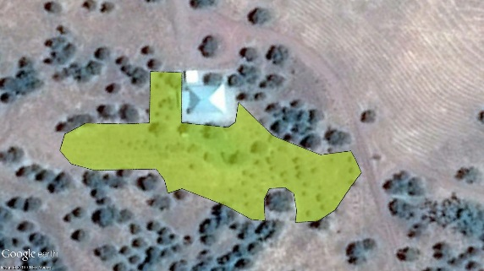
1:10,000 | 100 m | ~ 2 ha –  200 ha | paddocks, roads, creeks, rivers, large gullies | 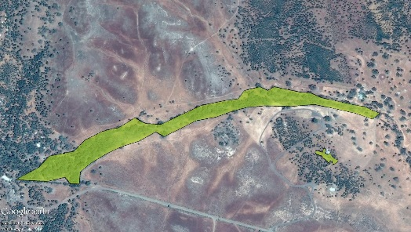
1:100,000 | 1000 m | ~ 200 – 20,000 ha | Rivers, smaller reserves, smaller urban areas | 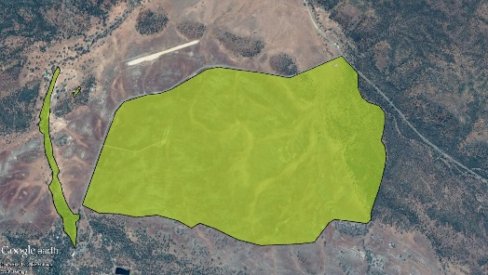
1:1M | 10 km | > ~ 20,000 ha | large rivers, major roads and highways, large geomorphic features, planning zones, large reserves, urban areas | 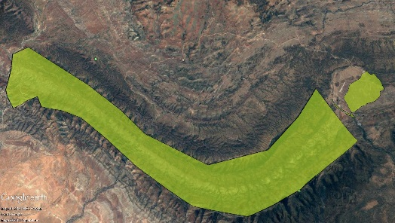

Appendix 2: Technical requirements
Mapping must be submitted as valid polygons consisting of one or more rings (connected line segments that start and finish at the same point). Polygon validity is as specified by the OGC Simple Features standard or the Esri Simple Polygon definition. Most software will correct or flag invalid polygon geometry, however the following types of invalid polygons are commonly seen:
- Self-intersections
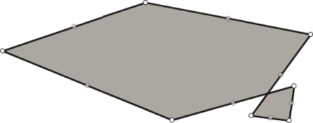
- Dangling segments
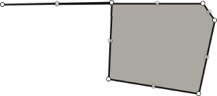
- Null or empty geometries

Additionally, mapping must be submitted:
- With an appropriate spatial/coordinate reference system definition;
- In a format readable by Esri or GDAL software;
- Without complex geometry, such as true curves or an excessive number of vertices.

A Special Case: Where you need to show gaps inside an area
Note: You should excise any significant area/s inside a polygon where your activity is not applicable. Ideally this should be done with a Geographic Information System (GIS) to achieve the kind of mapping shown in the left example. In the right example, the mapper (using a web mapping tool rather than a GIS) has had to ‘cut in’ and around the excluded area. This is acceptable, where users cannot access a GIS. It should be noted that many web mapping tools, including those deployed by the Department, allow uploading of GIS-generated polygons.
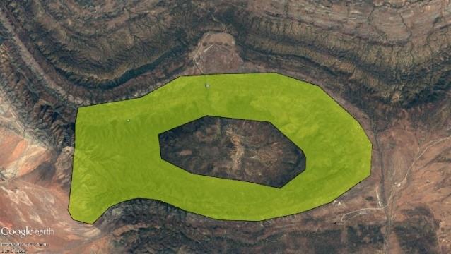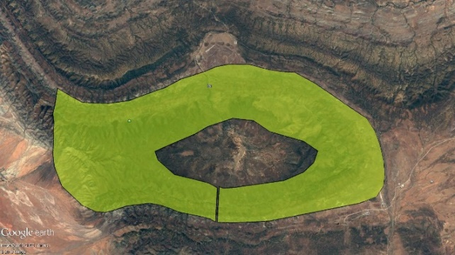
Preferred approach Acceptable but not preferred approach

Appendix 3: Service capabilities for repository organisations
To allow for adequate decision making and reporting, the Department requires access to all spatial and non-spatial data generated and collected in the management of publicly funded, on-ground investments (grants and procurements) for environmental and natural resource management outcomes. Third party organisations may be publicly funded to act as repositories for collating and storing spatial and non-spatial data generated (and owned) by project managers. As well as data management, synthesis and reporting, it is essential that these repositories provide the Department access to the raw underlying data (not just synthesised reports). Data should also be collected to the highest possible standard, with appropriate handling of sensitivities.
The following service capabilities apply for publicly funded repositories of spatial data and associated non-spatial data. The repository organisation should:
- Provide clear guidance, as per Appendices 1 and 2 above, to managers of individual projects (i.e. who capture field location data) on procedures for capture and upload of spatial data and associated attributes for on-ground investment actions.
- Publish standard words for agreements with all individual data custodians (project managers) that provide the Department a perpetual, irrevocable, world-wide, royalty-free, non-exclusive license (including the right to novate or assign the license, and to sublicense, including under any form of creative commons license (available at creativecommons.org.au) that the Department considers appropriate) to use, reproduce, adapt, modify, communicate, broadcast, distribute and publish the Agreement Material (excluding any Secret and Sacred Material) for any Department or Commonwealth purpose.
- Publish and promote standards, as agreed by the Department, to ensure appropriate management of location data deemed sensitive for privacy, security, confidentiality, ecological and/or cultural reasons. The including the Policy on accessing and sharing biodiversity data deals with the management of sensitive ecological data, and its principles should be considered for application to other forms of sensitivity around location data. The Australian Privacy Principles outline how the Department, as an Australian Government agency, must handle, use and manage personal information.
- Provide a continuously ‘live’, accessible, clearly documented, open standards compliant web service (e.g. using OGC Standards), or widely used and well-supported application programming interface (API), that allows for automated sharing of all spatial and non-spatial data for on ground activity areas, including robust controls to ensure accordance with the prescribed sensitive data management procedures above.

Version Control
Version | 2.0
Prepared by | Environment Information Australia
Last amended | 13/01/2025
Date of next review | 13/01/2026

