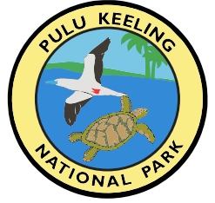


CONDITIONS FOR A PERMIT FOR MARINE
ACCESS RECREATIONAL DIVING AND SNORKELLING IN
PULU KEELING NATIONAL PARK

interpretation
In these conditions, unless the contrary intention appears:
Act means the Environment Protection and Biodiversity Conservation Act 1999 and any Regulations, management plans and instruments made under it, and includes any Act that amends or replaces it.
agreement means the agreement at the end of these conditions.
captured, for an image, means recorded or reproduced by artistic representation, or on film,
videotape, disc or other electronic medium and includes recorded sound.
Director means the Director of National Parks, and includes any statutory successor to the Director
and the Director’s delegates.
management plan means the management
plan in operation from time to time for the park under the Act.
park means the named Commonwealth reserve(s) for which this permit is issued.
park staff means persons employed by the Director and performing duties in relation to the park.
permitted activity means the specified activity for which this permit is issued.
permittee means each person (individual, company or other commercial entity) to whom
this permit is issued and includes, where the context permits and the permittee’s staff.ranger means a person appointed as a ranger under s392 of the Act.
Regulations means the Environment Protection and Biodiversity Conservation Regulations 2000 and includes any Regulations that amend or replace them.
warden means a person appointed as a warden under s392 of the Act.
In these conditions:
The singular includes the plural and vice versa.
Where a word or phrase is defined, other grammatical forms of that word or phrase have
a corresponding meaning.
Where one of the words ‘include’, ‘including’ or ‘includes’ is used, the words ‘without limitation’
are taken to immediately follow.
Where the word ‘must’ imposes an obligation on a person to do or not do something, the obligation istaken to mean that the person must take all reasonable steps to do or not do the thing (ie steps that oughto be reasonable to a person who possesses the faculty of reason and engages in conduct in accordance with community standards).
A reference to the permittee includes, where the context permits, the permittee’s staff involved in the permitted activity.

Note: The Director may vary or revoke these permit conditions, or impose new conditions, in accordance with r17.09 of the Regulations, and must do so where it is necessary to ensure that the matters or circumstances about which the Director is required to be satisfied when issuing the permit continue to apply.

general permit conditions (all activities)
- The permittee must not conduct the permitted activity before the commencement date or after the expiry date shown on the permit.
- The permittee must not conduct the permitted activity unless the permittee has signed and submitted the agreement with the park.
- This permit cannot be transferred to another person, except in accordance with regulation 17.11 of the Regulations.
- The permittee must comply with the EPBC Act, the EPBC Regulations, the management plan,
these permit conditions, the Visitor Access Strategy, the Boating Strategy and the Diving Strategy and any other notices, information, guidelines, codes of conduct, protocols or directions issued by, or under the authority of, the Director relating to the park.
Note: Copies of the Management Plan, the Park Visitor Access Strategy, the Park Boating Strategy and the Park SCUBA Diving Strategy any other notices, information, guidelines, codes of conduct or protocols relating to the Park can be obtained from Parks Australia.
- The permittee must comply with all Commonwealth, State or Territory laws, including the laws of Cocos (Keeling) Islands (CKI), relating to the permitted activity.
- The permittee must hold all permits, licences and other authorities required by law for the conduct of the permitted activity.
- The permittee must maintain relevant training, qualifications and experience to competently conduct the permitted activity.
- The permittee must ensure that all equipment used in the permitted activity is suitable and safe for its intended use, appropriately maintained in good working condition and inspected before commencing the permitted activity.
- The permittee must carry a copy of this permit and these conditions or keep a copy in the permittee’s transport (vehicle, vessel or aircraft) while conducting the permitted activity, and must produce it for inspection when requested by a ranger or warden.
- The permittee must ensure that they are fully informed of and understand these permit conditions before they commence taking part in the permitted activity.
- The permittee must ensure that they fully inform themselves of all potential hazards and conditions they may encounter while conducting the permitted activity.
Note: Hazards may include, but are not limited to, strong currents, turbulent seas, extreme weather conditions, dehydration and dangerous wildlife.
- The permittee must ensure that appropriate risk management strategies are in place to minimise foreseeable risks to themselves, other members of the public and the environment and heritage values of the park, and must produce evidence of such strategies upon request by the Director.
- Each permittee is responsible for their safety, well being and behaviour and must take all reasonably practicable steps to ensure that no person is exposed to risks to their health or safety whilst in the park.
- If a permittee is killed, injured, becomes ill, goes missing or is involved in a dangerous incident while inthe park, a member of park staff or the Australian Federal Police must be notified as soon as possible and the permittee must comply with any requests or directions from a member of park staff in relation to the safety of that person or any other person.
Note: In this condition “dangerous incident” means an incident that exposes a person to a serious risk to their health or safety.
- The permittee must carry sufficient portable water for the conduct of the permitted activity.
- To prevent any infestation of weeds, feral animals or pathogens the permittee will inspect their footwear, clothing and equipment and clean as required before entering the park.
- The permittee will make good any damage to the park, to the extent that the damage was caused or contributed to by the conduct of the permitted activity or a breach of the permit conditions by the permittee.

pulu keeling national park conditions
- Prior to conducting the permitted activity, the permittee must provide the park with details of all vessels and persons participating in the permitted activity during that visit and any further details the Director may reasonably request.
- The permittee must not enter areas to which entry is prohibited or restricted under the EPBC Regulations, unless specifically authorised by this permit or another permit to do so.
- The permittee shall comply with the provisions of all other laws relevant to any activity to which this permit relates, in particular the permittee shall:
  - comply with all boating safety regulations made under the Marine Act 1982 (WA) (CKI); and
  - ensure that any vessel used in the conduct of the permitted activity is registered, suitable for the conduct of the permitted activity, operated and maintained in accordance with all relevant and applicable Commonwealth and State or Territory laws. The permittee shall if requested by the Director provide copies of all relevant certificates and other documents evidencing compliance with this condition.
- The permittee shall not engage in activities or conduct themselves in a manner which causes or is likely to cause annoyance, inconvenience or disturbance to any other park visitors.
- The permittee shall not:
  - disturb any wildlife;
  - feed, kill, injure, touch or take any animal or any organism or inanimate object, including any part of the SMS Emden, while diving or snorkelling.
  - land a vessel or set foot on the park except to deal with an emergency involving a serious threat to human life or property;
  - visit areas of the park to which access has been prohibited;
  - remove anything from North Keeling Island or the surrounding reef;
  - engage in any fishing activities;
  - disobey a direction from a Ranger or Warden; or
  - make promotional material relating to the activity available to the public without the approval of the Park Manager or through a park permit for commercial filming, photography or artwork.
Note: Fishing means: any searching for, or taking fish or attempting to search for, or take fish or engaging in any other activities that can reasonably be expected to result in the locating, or taking, of fish.
- The permittee is not entitled to enter or remain in the park before 2 hours after sunrise and after 2 hours before sunset unless prior written approval, signed by the Park Manager, has been obtained.
- Vessels used in or in relation to the conduct of the activity to which this permit relates shall
anchor in sand areas only and will have someone staffing the vessel at all times
Note: there is no safe anchoring or mooring sites around Pulu Keeling National Park. The only place to stop and set anchor is on the western (leeward) side of the Island.
- The permittee must be able to swim competently if entering the water (eg for swimming).
- The permittee shall be familiar and comply with the recognised authority standards and best practice for recreational diving. Decompression, night or any other dives deemed to be high risk under these standards are not allowed for under this permit.
- The permittee must carry a first aid kit with them at all times. The permittee or person accompanying the permittee must have a current first aid qualification. The minimum standard requirement is the Senior First Aid Certificate or equivalent.
- An Emergency Position Indicating Radio Beacon (EPIRB) or similar personal locating device or a satellite phone must be carried when the permittee is in the park.
- The permittee shall inform Parks Australia, the Australian Federal Police or the Volunteer Marine Rescue before going to the Park, to carry on an activity to which this permit relates and shall inform the nominated body immediately after returning.
- The permittee must not enter the protected zone surrounding the SMS Emden (refer to Map1 below) unless the permittee holds an appropriate permit issued by the Commonwealth delegate under the Underwater Cultural Heritage Act 2018.
For more information contact UnderwaterHeritage@dcceew.gov.au or to apply for a permit online visit
Australasian Underwater Cultural Heritage Database - DCCEEW
The Pulu Keeling National Park Chief Ranger can help with any queries regarding this permit on 08 9162 7602.
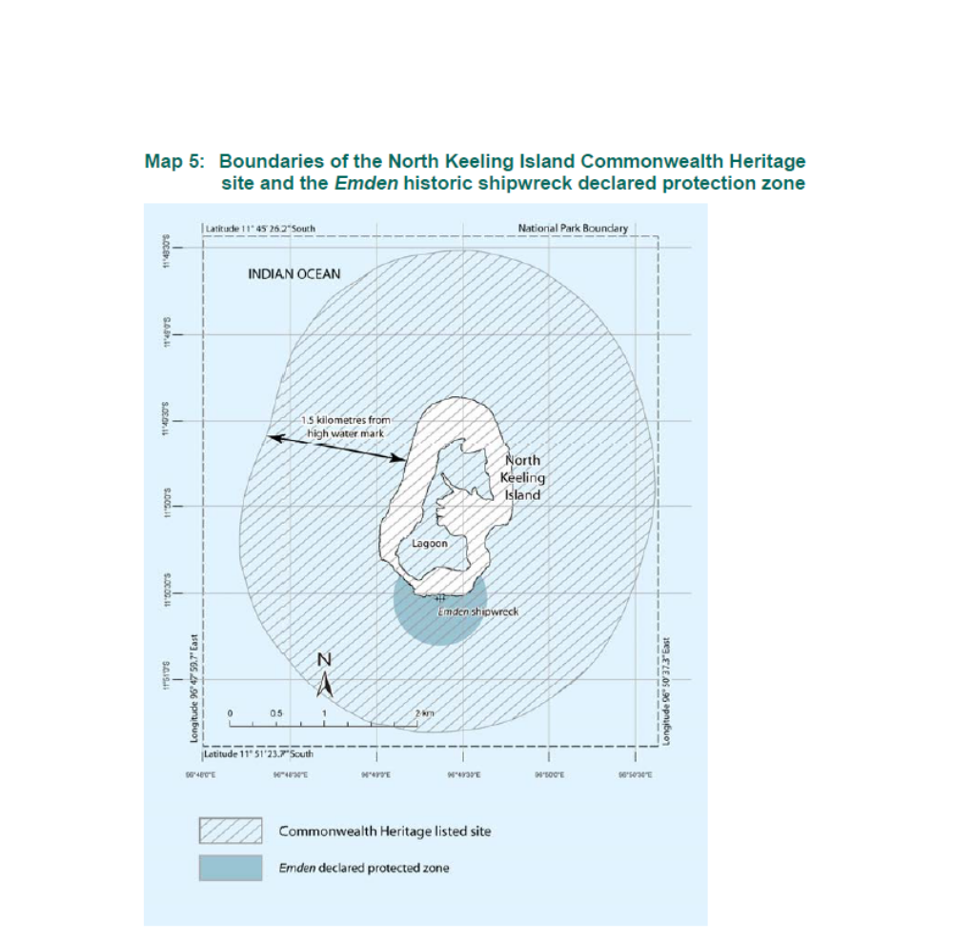
Map 1: Boundaries of Pulu Keeling National Park and the Emden historic shipwreck declared protection zone.

