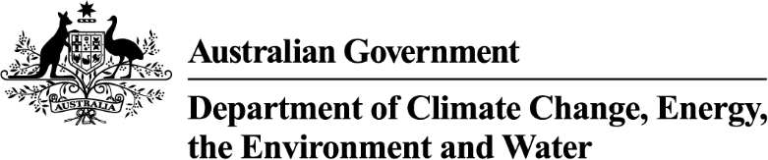

Strategic Water Purchasing Framework (Bridging the Gap) - Trading Strategy Addendum 2024-25
  - Voluntary water purchases from 2024-25 to recover the remaining gap to sustainable diversion limits in the northern Basin (Bridging the Gap 2024-2025).

Murray–Darling Basin Plan
The Australian Government is committed to delivering the Murray–Darling Basin Plan (Basin Plan).
At its heart, the Basin Plan sets the amount of water that can be taken from Basin rivers for industry and agriculture, while leaving enough for our rivers, lakes and wetlands and the plants and animals that depend on them.

Strategic Water Purchasing Framework
The Strategic Water Purchasing Framework 2023 set out the Government’s approach to recovering the remaining 49.2 gigalitres (GL) gap to achieve the Sustainable Diversion Limits (SDLs). This Framework is also a trading strategy for the purposes of s12.49 of the Basin Plan 2012.
Since the release of the Framework an agreement with the ACT Government has delivered the ACT’s Bridging the Gap (4.9 GL/y) amount in full.
Following the completion of the Strategic water purchasing - Bridging the Gap tender 2023, a gap remains to be bridged to SDLs in several northern Basin catchments.
This addendum should be read in conjunction with the Strategic Water Purchasing Framework 2023. Activities from 2024 to bridge the remaining gap will be consistent with the principles outlined in the 2023 trading strategy.

Northern Basin catchments with a remaining gap to be bridged
As at June 2024, the expected remaining gap to be bridged in northern Basin catchments, is set out below. The volumes remaining are subject to contractual processes that remain underway.

Condamine-Balonne
- 8.48 GL/y of surface water to be recovered through local recovery.
- 3.2 GL/y of groundwater to be recovered through local recovery comprising of:
  - 2.95 GL/y of groundwater to be recovered in the Upper Condamine Alluvium - Tributaries zone.
  - 0.25 GL/y of groundwater to be recovered in the Upper Condamine Alluvium - Central Condamine Alluvium zone.

Namoi
- Final outcomes for the Namoi will depend on contractual processes that remain underway. If additional local water recovery is required, further advice to the market will be provided.

NSW Border Rivers
- 5.09 GL/y of surface water to be recovered through local recovery.

Barwon–Darling
- 1.28 GL/y of surface water to be recovered through local recovery, subject to accreditation of the Water Resource Plan (WRP) and long-term diversion limit equivalence (LTDLE) factors.

Figure 1: Catchments with remaining gap bridging water recovery targets as at June 2024
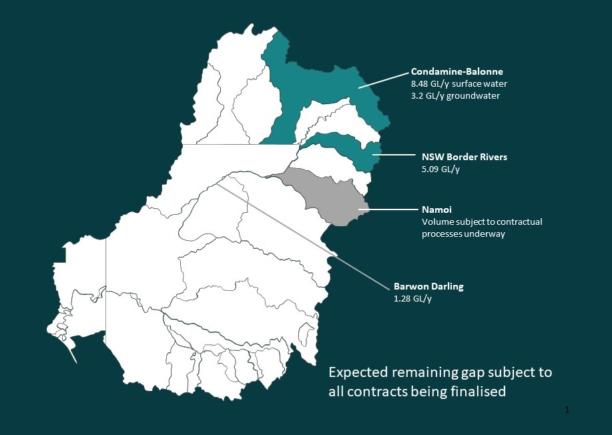

Note:
All water recovery volumes and targets outlined in this addendum are expressed in gigalitres per year (GL/y), in long-term diversion limit equivalence terms, and rounded to the nearest decimal. LTDLE is a common way of comparing water recovery across different water systems and is used to determine water contributions under the Basin Plan.
There are several Water Resource Plans (WRPs) that are still being finalised in NSW. This means water recovered toward the Bridging the Gap target in NSW is subject to change until all NSW WRPs are accredited and the models in those WRPs are independently assessed.
The Water Amendment (Restoring our Rivers) Act 2023 enables water recovery above Bridging the Gap targets to contribute towards the 450 gigalitre target outcomes where consistent with the requirements of the legislation.

Bridging the Gap Trading Strategy 2024-25
Feasible and timely, non-purchase-based options supported by Basin States can be considered to help bridge the remaining gap. Where purchasing is the most feasible option, the department will utilise a range of procurement methods including open and limited tender, but with a preference for open and competitive tender processes in the first instance.
A series of staged tender processes in accordance with the Commonwealth Procurement Rules will be undertaken across the remaining catchments over the next 12 months.
Information about progress made towards the Basin Plan water recovery targets can be found at https://www.dcceew.gov.au/water/policy/mdb/progress-recovery.

Preparing to submit a tender application
If you hold a water licence in these catchments and are interested in selling your water entitlements to the Australian Government, please consult with your legal and financial advisors.
When a tender process becomes available, additional information will be published.

Tender key dates
The indicative timelines for tenders opening are:
- NSW Border Rivers – from late August to October of 2024.
- Qld Condamine Balonne surface water – from late August to October of 2024.
- NSW Barwon Darling – subject to accreditation of WRP and determination of LTDLE factors. If purchasing is required, from February 2025.
- Qld Condamine Balonne groundwater – from April to June 2025.

Please refer to https://www.dcceew.gov.au/water/policy/mdb/commonwealth-water-mdb/strategic-water-purchasing for updates and the website: www.tenders.gov.au when a tender is opened.

