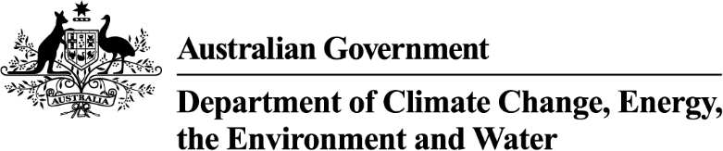

Strategic Water Purchasing Framework (Bridging the Gap) - Trading Strategy Addendum 2026-27
  - Voluntary water purchases to recover the remaining gap to Sustainable Diversion Limits in the Murray–Darling Basin.

Murray–Darling Basin Plan
The Australian Government is committed to delivering the Murray–Darling Basin Plan (Basin Plan).
At its heart, the Basin Plan sets the amount of water that can be taken from Basin rivers for industry and agriculture, while leaving enough for our rivers, lakes and wetlands and the plants and animals that depend on them.

Strategic Water Purchasing Framework
The Strategic Water Purchasing Framework was published in 2023 and set out the Australian Government’s approach to recovering the remaining volume to achieve the Sustainable Diversion Limits (SDLs). The Trading Strategy Addendum 2024-25 (published June 2024) and Trading Strategy Addendum 2025-26 (published September 2025) provided updates to the Purchasing Framework.
This Trading Strategy Addendum 2026-27 is a further update to the Purchasing Framework. Its release is a water markets decision for the purposes of Part 5A of the Water Act 2007 (Cth).

Progress towards Bridging the Gap
Since the release of the Purchasing Framework, significant progress has been made in bridging the gap, recovering more than 40 gigalitres per year (GL/y) towards bridging the gap targets since 2023, leaving less than 1 per cent of the gap remaining.
The Australian Government has bridged the gap as detailed in the Purchasing Framework for surface water in the Queensland Condamine-Balonne, Namoi, Barwon-Darling, and ACT, and for groundwater in the Central Condamine Alluvium portion of the Queensland Condamine-Balonne. In the Namoi and Central Condamine Alluvium, this remains subject to completion of the conveyance process and formal accreditation by the MDBA.
Recovery to date includes water entitlements granted to the Commonwealth by the ACT Government, the transfer of gifted water entitlements from Cubbie Station, and completion of several strategic water purchasing tenders.
As NSW Water Resource Plans progress through accreditation, updated LTDLE factors for several catchments have been published in October 2025 and June 2026. These updates mean SDL gaps have continued to change, alongside progress in water recovery. Further changes to SDL gaps may occur as the MDBA accredits remaining NSW Water Resource Plans.
The Australian Government is committed to minimising community impacts from water purchases and will consider options to avoid further purchase where possible. This includes returning over-recovered water from the 450 GL target to bridge any SDL gaps caused by LTDLE changes, helping reduce the need for further purchases.
However, in some cases, further purchase remains the only option to bridge the gap between extraction and the SDL set under the Basin Plan.

Catchments with a remaining gap to be bridged
As of 30 June 2026, 9.0 GL/y remains to bridge the gap in full across five catchments: surface water in the NSW Border Rivers, NSW Murray, Lower Darling and Lachlan, and groundwater in the Upper Condamine Alluvium Tributaries portion of the Queensland Condamine-Balonne (refer Figure 1 and Table 1 below). Gaps in the NSW Murray, Lower Darling and Lachlan have only occurred due to changes in NSW LTDLEs.
The NSW Border Rivers was also included in the 2026 northern Basin Expression of Interest process for the 450 GL target, which closed in April 2026. No decisions have been made about future purchases from that EOI, however purchase toward the 450 GL target will not be prioritised while a gap to the SDL remains in the NSW Border Rivers.
Figure 1: Catchments with a remaining gap to be bridged as at 30 June 2026
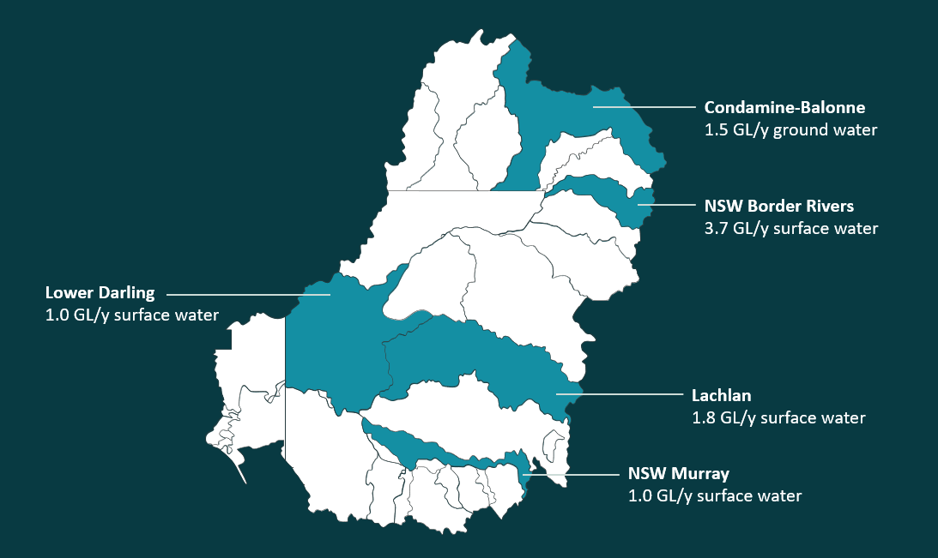

Table 1: Bridging the Gap status and gap volumes remaining (as at 30 June 2026)
Catchment  (NB: all volumes are LTDLE GL/y) | Original 2023 target volume ¹ | Updated target volume using NSW LTDLE factors (as at 30 June 2026) | Volume recovered (agreed to purchase) | Gap remaining
Barwon Darling | 1.6 | 0 | 0.3 ⁵ | Bridged
Condamine Balonne (surface water) | 14 | 14 | 14.3 | Bridged
Condamine Balonne (groundwater) | 3.2 ² | 3.2 | 1.7 | 1.5 ³
Lachlan | 0.9 | 2.7 | 0.9 | 1.8
Lower Darling | n/a | 1 | 0 | 1.0
Namoi | 9.5 | 9.5 | 9.5 | Bridged
NSW Border Rivers | 5.1 | 5.4 | 1.7 | 3.7
NSW Murray | 10 | 11 | 10.1 | 1.0
ACT | 4.9 | 4.9 | 4.9 | Bridged
Total | 49.2 | 51.7 | 43.4 ^{4, 5} | 9.0
Notes:
[1] As set out in the Strategic Water Purchasing Framework (2023).
[2] Target volume comprises 0.25 GL/y in the Upper Condamine Alluvium (Central Condamine Alluvium) and 2.95 GL/y in the Upper Condamine Alluvium (Tributaries).
[3] Gap remaining is in the Upper Condamine Alluvium (Tributaries) only.
[4] There may be differences due to the rounding of some volumes. Includes some over-recovery.
[5] Barwon Darling volume recovered was previously shown as 2.4 GL/y. On 16 October 2026 this figure was corrected to 0.3 GL/y and the total volume recovered adjusted accordingly (from 45.5 GL/y to 43.4 GL/y).

Bridging the Gap Trading Strategy to 31 December 2027
A series of staged water entitlement recovery initiatives is planned to mid-2027 to bridge the gap for surface water in the NSW Border Rivers and Lachlan, and groundwater in the Queensland Condamine Balonne (Upper Condamine Alluvium Tributaries). The department may utilise a range of procurement methods including open and limited tenders and may work with water market intermediaries to help identify sellers and facilitate water purchases.
The department is considering SDLAM reconciliation outcomes and available over-recovery volumes as part of its assessment of recovery requirements in the NSW Murray and Lower Darling.
The Australian Government is committed to delivering the Basin Plan by the end of 2027 as per legislative requirements. Water recovery efforts will be carefully considered in this context to maximise opportunities to bridge the gap while delivering value for money. The department will continue working with the MDBA and basin states to understand the outcomes of the Basin Plan review relevant to Bridging the Gap to SDLs.
More information will be made available on the department's website as water recovery actions are finalised. Information about progress made towards the Basin Plan water recovery targets can be found at https://www.dcceew.gov.au/water/policy/mdb/progress-recovery.

Considering selling your water entitlements to the Commonwealth?
If you hold a water licence in a catchment where the department intends to purchase water and are interested in selling your water entitlement to the Australian Government, please consult your legal and financial advisors.
When a purchase process is announced, additional information will be published on the department’s website.

Tender key dates
The indicative timelines for purchasing activities to commence are:

- NSW Border Rivers from September to October 2026
- Qld Condamine-Balonne groundwater (Upper Condamine Alluvium Tributaries) from October to December 2026
- NSW Lachlan from November 2026 to March 2027.
Please refer to www.dcceew.gov.au/watertender for updates.

All water recovery volumes and targets outlined in this addendum are expressed in gigalitres per year (GL/y), which is a Long-Term Diversion Limit Equivalent (LTDLE) value. LTDLE is a common way of comparing water recovery across different water systems and is used to determine water contributions under the Basin Plan.

