
The ocean and you
UNESCO Ocean literacy principles | 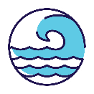 |  |  | 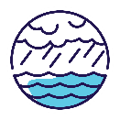 |  | 
UNESCO Ocean literacy principles | #1: Earth has one big ocean with many features. | #2: The ocean and life in the ocean shape the features of the Earth. |  | #3: The ocean is a major influence on weather and climate. |  | #4: The ocean makes Earth habitable.
UNESCO Ocean literacy principles | 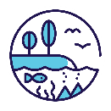 |  |  |  | 
UNESCO Ocean literacy principles | #5: The ocean supports a great diversity of life and ecosystems. |  | #6: The ocean and humans are inextricably interconnected. |  | #7: The ocean is largely unexplored.

The ocean is part of your life
Almost 9 in 10 Australians live within 50 km of the coast. But no matter where you live, the ocean matters to you.
It’s central to our economy, health, culture and social wellbeing, and:
- provides us with food
- powers our homes
- transports our goods
- inspires our art
- offers sustainable and renewable solutions in the fight against climate change.
The ocean and its ecosystems are essential to life on Earth.
- The ocean produces half of the oxygen on the planet.
- It regulates our climate and weather, distributing heat and rain, so we can live all over the globe.
- It absorbs about 30% of carbon dioxide emissions from human activity and captures 90% of the excess heat generated by these emissions.
We’re an island nation and the ocean connects us to the rest of the world.
- The ocean is critical to our security and defence.
- Subsea cables provide 99% of Australia’s digital connectivity.
- Almost everything we import and export is transported by sea, from coffee beans and jeans to electronics and vehicles (99% of our total trade by volume).
- We have the world’s largest maritime search and rescue zone – it covers one-tenth of the surface of the Earth!
- Our ocean includes some of Australia’s most important military training areas and facilities.
The ocean and its ecosystems provide us with other free services, such as:
- filtering water
- moving nutrients and heat
- protecting our shores and coastal communities from storms
- providing habitat and protection for marine and coastal species, including those important for fisheries
• absorbing and storing carbon (e.g. mangroves, seagrasses and saltmarshes store 2 to 4 times more carbon than tropical rainforests).

Australia’s ocean ecosystems are important to the world
Australia has the third-largest marine territory in the world. It stretches:
- from the cold waters of the Southern Ocean around Australia’s Antarctic Territory
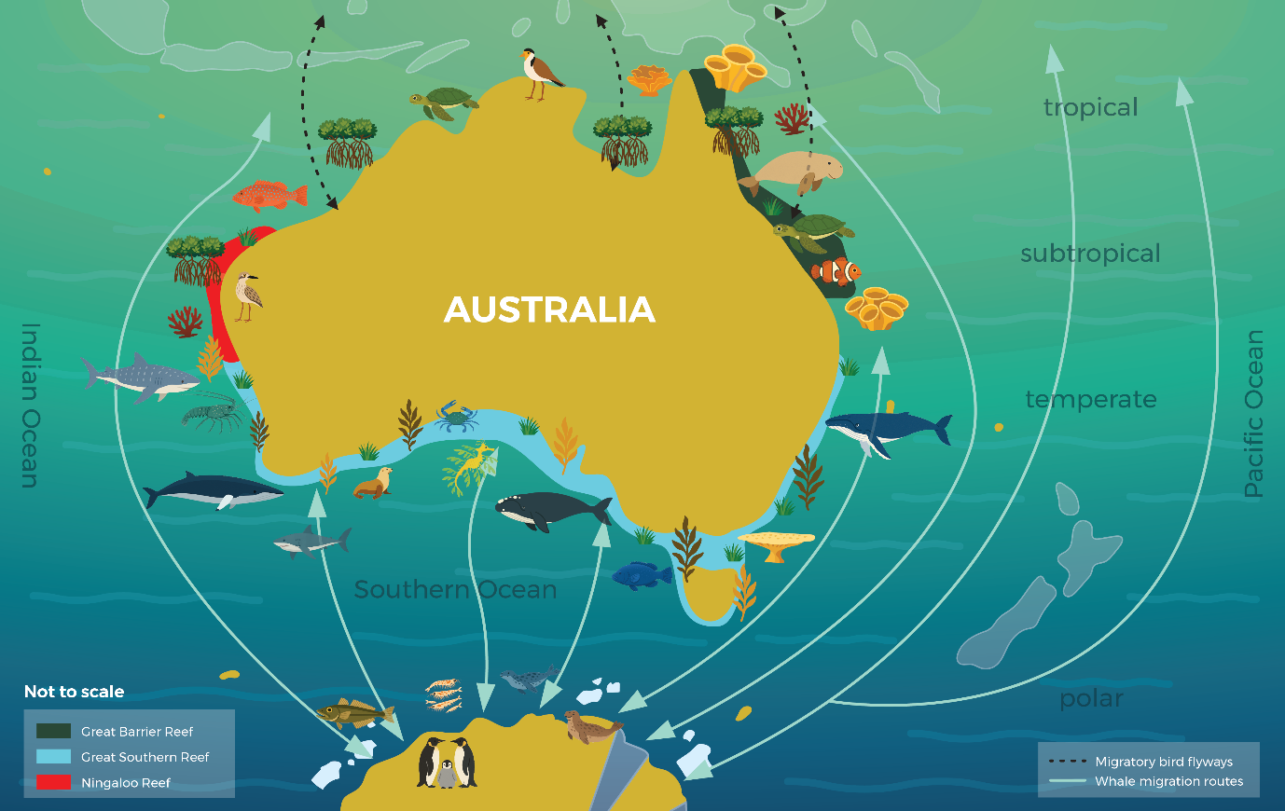
- into the tropics in our north, and the vast Pacific and Indian ocean basins to our east and west.
Our ocean is vital to life and is home to a diverse array of species and ecosystems.
Australia’s ocean ecosystems are some of the most biodiverse in the world. They’re home to more than 33,000 recorded marine plant and animal species.
Other species – such as whales, turtles and shorebirds – migrate vast distances from Antarctic waters and other regions to Australia and our external territories, or visit our waters to rest, feed and breed.
Our ocean features some of the world’s largest reef systems, including:
- the world’s largest collection of coral reefs and the World Heritage-listed Great Barrier Reef
- the interconnected system of temperate reefs known as the Great Southern Reef
- the biodiversity hotspot and World Heritage-Listed Ningaloo Coast, where whale sharks gather in large numbers to feast on plankton and tropical krill.
With its mighty currents and strong winds, the Southern Ocean is the engine room of the world’s climate and weather. It plays a huge role in mitigating climate change by absorbing more heat than anywhere else in the world.
Phytoplankton are the foundation of the Southern Ocean and Antarctic food web and play a big role in storing carbon dioxide and producing oxygen. Phytoplankton are food for Antarctica’s most important species: Antarctic krill. These tiny animals are in turn eaten by many Antarctic residents including whales, seals, penguins and seabirds.
The ocean is largely unexplored, so there’s more wonder yet to be discovered. Australia is working to understand the ocean and its opportunities better through our world-leading marine research.

Our ocean industries are essential
Our ocean economy – sometimes referred to as the blue economy – generates income from industries such as fishing and aquaculture, coastal and marine tourism, energy exploration and production, defence, shipping and transport, and ports.
These industries provide thousands of local jobs, support communities, contribute to national food and energy security, and play a role in the protecting and restoring the marine environment.
The ocean economy also provides other benefits that aren’t as easily measured by money, including recreational and cultural values. Activities such as recreational fishing, boating, diving and surfing contribute to the economy and employment, while also supporting social connections, nature connection, relaxation and improved wellbeing.
Australia’s ocean industries contributed $229 billion in economic output in 2023 and supported more than 700,000 jobs. This continues to grow rapidly.
These industries offer solutions to national and global challenges, as highlighted by the Organisation for Economic Co-operation and Development:
The ocean holds the promise of immense resource wealth and great potential for boosting economic growth, employment and innovation. It is increasingly recognised as indispensable for addressing many of the global challenges facing the planet in the decades to come, from world food security and climate change to the provision of energy, natural resources and improved medical care.
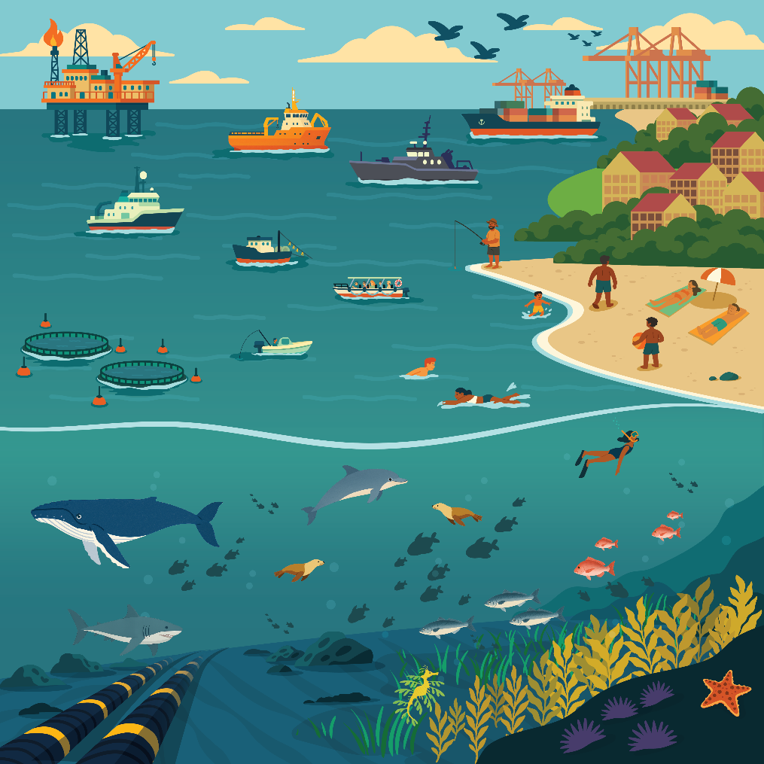
We use the ocean in many different ways and rely on it to support our lives.

We need to protect the ocean
We share one big, interconnected ocean with the rest of the world. The ocean, its ecosystems and resources don’t follow lines on a map. What we do in our waters will affect the rest of the world.
Our ocean is facing increasingly complex pressures. Threats include climate change and associated extreme events; biodiversity decline; illegal, unreported and unregulated fishing; and marine pests.
Land-based impacts also place significant stress on ocean and coastal ecosystems, when not managed well. These include run-off from industrial, agricultural and urban sources; pollution and marine debris; mining and energy operations; and coastal development.
Cumulative threats occur when species or ecosystems are affected by more than one of these threats and these impacts add together. This can make it harder for them to recover or thrive.
Managing and protecting the ocean is a shared responsibility. We all have a role in looking after the coastal and marine places we love, so Australia can continue to benefit from the ocean for generations to come.
Australia is working towards a sustainable ocean economy. This is where:
- the ocean is effectively conserved and restored to ensure its long-term health and resilience
- there’s sustainable production and growth of ocean industries
- ocean benefits are shared equitably among all Australians.
A sustainable ocean economy acknowledges that the ocean is:
- the life source of our planet
- an interconnected system, that’s also closely linked to land and sky.
It also recognises the ocean’s importance to human health and wellbeing. This includes:
- the link between healthy Country and healthy people for Traditional Custodians
- the ocean’s contribution to social and cultural values
- how it helps communities and the global economy adapt to changes, including climate change.

More information
www.ocean.gov.au

Glossary
Term | Definition
Aquaculture | Farming marine species, such as fish, oysters and seaweed. This can occur in large tanks or ponds on land, or in pens in the ocean.
Illegal, unreported and unregulated (IUU) fishing | IUU fishing can include fishing that:  - is against the rules for a particular area  - isn’t reported correctly  - is done by vessels without nationality (i.e. they’re not registered to a country or have 2 or more flags)  - is in areas where rules haven’t been agreed.
Migrate | To travel far distances between different locations to breed, feed or rest.
Mitigate | To reduce or lessen the effects of something.
Ocean economy | The economic activities that occur in the ocean, or that depend on the ocean to operate.
Traditional Custodians | The Indigenous peoples or nations who have responsibilities in caring for their Country.

