Who is responsible for the ocean?
2
  UNESCO Ocean literacy principles | 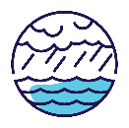 | 
 | #3: The ocean is a major influence on weather and climate. | #6: The ocean and humans are inextricably interconnected.

What is our national jurisdiction?
The world shares one global ocean. Under the United Nations Convention on the Law of the Sea, countries have jurisdiction over the waters from their coastlines to a certain distance out to sea. Parts of the ocean that don’t fall under any country’s jurisdiction are known as the high seas.
Australia has the third-largest maritime jurisdiction in the world. It’s nearly 1.3 times larger than our land mass, and even larger when including waters around Australia’s Antarctic Territory.
Our ocean jurisdiction reaches into:
- 3 of the world’s 5 ocean basins – Indian, Pacific and Southern
- the Timor, Tasman, Arafura and Coral seas, and the Torres Strait.
Our ocean jurisdiction is made up of coastal waters, our territorial sea and exclusive economic zone. In some areas, it stretches even further because of our extended continental shelf.

What do we manage in our ocean?
We use the ocean in many different ways to support our everyday life. Activities in the ocean include:
- fishing and aquaculture
- coastal and marine tourism
- energy exploration and production
- defence and border protection
- shipping, transport and ports
- communication (e.g. via subsea cables)
- science and research
- sport and recreation
- cultural connection.
Our ocean and ocean economy face many threats, including climate change, pollution, illegal fishing, biodiversity decline and marine pests.
So we need to balance our use of the ocean with conservation and protection. By looking after the health of our ocean we can ensure:
- marine species and habitats thrive
- First Nations people can continue their enduring connection to sea Country
- the ocean can continue to provide for us, our communities and our economy for many generations to come.

Who manages what?
Managing our vast and diverse ocean is a shared responsibility.
Australia’s ocean is managed and used by Traditional Custodians of sea Country, all levels of government, diverse marine industries, researchers, conservation groups, communities and recreational ocean users. This includes through international arrangements, national, state and local policies and laws, and community action.
We also work with our regional neighbours and globally to address shared challenges and opportunities.

Governments
The Offshore Constitutional Settlement, is an arrangement between Australian, state and territory governments about who looks after which bit of our ocean. Under the settlement:
State and territory governments generally have responsibility for:
- the coastal zone, which extends from the coastline to 3 nautical miles (about 5.5 km)
- important coastal areas that support substantial economic activity.
The Australian Government is responsible for the remainder of Australia’s ocean, from 3 nautical miles to the outer boundary of Australia’s exclusive economic zone (200 nautical miles) and for Australia’s extended continental shelf and the marine areas of Australia’s external territories. The area the Australian Government is responsible for includes various zones:
- territorial sea (to 12 nautical miles, about 22 km)
- contiguous zone (to 24 nautical miles, about 44 km)
- exclusive economic zone (to 200 nautical miles, about 370 km).
Local governments play an important role in community engagement, planning and management in the coastal zone. This zone is the critical interface between:
- land and sea
- communities and the ocean economy.
In some instances, the Australian Government and relevant state or territory government work together:
- to manage an area (e.g. the Great Barrier Reef)
- for a particular purpose (e.g. the Marine Pest Sectoral Committee, which coordinates a national approach to marine pest biosecurity across industry and government).
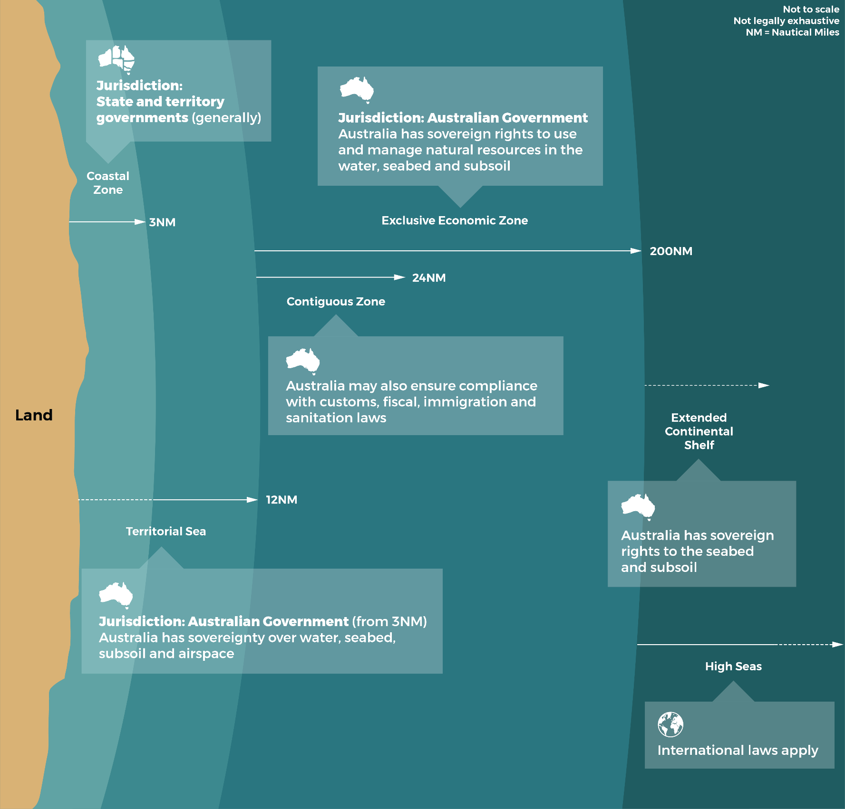
The Australian, state and territory governments are responsible for managing different zones
of the ocean.

Marine protected areas
Australia’s marine protected area estate is one of the largest in the world. The National Representative System of Marine Protected Areas is managed by the Australian, state and territory governments and covers 52% of our ocean territory.
Agreed plans guide how we manage marine parks. These plans also map out different zones within the parks that determine what can be done and where, from high levels of protection to multiple and sustainable uses.

First Nations people
First Nations people have a connection to land and sea that goes back at least 65,000 years. First Nations people sustainably use and manage the coast and ocean, including areas that were dry land before sea levels rose after the last Ice Age.
First Nations people have rights over substantial areas of sea Country and coastline. They play an important role in managing the ocean, and continue to use sea Country for social, cultural and economic purposes.

Other ocean managers
Other groups, such as ocean industries, researchers, conservation groups, communities and recreational ocean users, also play important roles in managing the ocean. These groups:
- protect and restore the ocean
- help us better understand challenges to the ocean and possible solutions
- work to unlock financing for sustainable ocean actions and nature-based solutions.

Our shared responsibility with our neighbours and the world
As an island nation, our ocean connects us to our region and the rest of the world. There is only one global ocean. We need to work together with other countries to:
- share ideas and expertise
- tackle shared threats
- achieve shared goals
- advance a global sustainable ocean economy.
Australia’s Prime Minister has joined 17 other world leaders on the High Level Panel for a Sustainable Ocean Economy (the Ocean Panel). Ocean Panel countries are:
- committed to sustainably managing 100% of the ocean area within our jurisdictions
- encouraging the rest of the world’s coastal and ocean states to join this commitment by 2030.
We’re also partnering with others to:
- tackle global challenges through initiatives and treaties (e.g. for plastic pollution, conservation and sustainable use of the high seas)
- manage and protect threatened and migratory species (e.g. whales and shorebirds)
- sustainably develop, manage and conserve the ocean and its resources (e.g. through regional fisheries management in the Pacific and Indian ocean basins)
- understand the ocean more so we can better manage it (e.g. through ocean observation and research, including around Antarctica and the Southern Ocean)
- protect and restore coastal blue carbon ecosystems
- monitor and manage coral reefs
- mitigate climate change (e.g. by reducing greenhouse gas emissions from shipping)
- ensure safety at sea for ships and seafarers, and build search and rescue capabilities
- manage the movement of vessels and cargo
- reduce biosecurity risks
- protect our borders and resources (e.g. from illegal fishing).

More information
www.ocean.gov.au

Glossary
Term | Definition
Aquaculture | Farming marine species, such as fish, oysters and seaweed. This can occur in large tanks or ponds on land, or in pens in the ocean.
Biosecurity | How we keep living things, such as plants, animals and ecosystems, safe from harmful pests and diseases by preventing their arrival.
Blue carbon ecosystems | Marine and coastal ecosystems that capture and store carbon dioxide from the atmosphere (e.g. mangroves, saltmarshes and seagrasses).
Extended continental shelf | An area of the continent under the water that extends beyond the 200 nautical mile limit of the exclusive economic zone, but where Australia still has the same rights as the exclusive economic zone.
Greenhouse gas emissions | The release of gases, such as carbon dioxide, that trap heat around the Earth to make it hotter than it would otherwise be. Humans can be responsible for the release of greenhouse gases into the air by burning fuels to generate electricity and power cars. Greenhouse gases can also be produced naturally, such as when plants die and animals breathe.
Jurisdiction | Who can set the rules or decide what can happen in a certain place.
Migratory | Animals that travel far distances between different locations to breed, feed or rest.
Mitigate | To reduce or lessen the effects of something.
Nature-based solutions | Actions that protect, manage or restore ecosystems in ways that provide benefits to communities and ecosystems at the same time. For example, coastal ecosystems provide breeding grounds for commercial fish, which supports fisheries and local communities, and improves food security.
Ocean economy | The economic activities that occur in the ocean, or that depend on the ocean to operate.
Traditional Custodians | The Indigenous peoples or nations who have responsibilities in caring for their Country.
Treaties | An agreement between countries that is enforced by international law.

