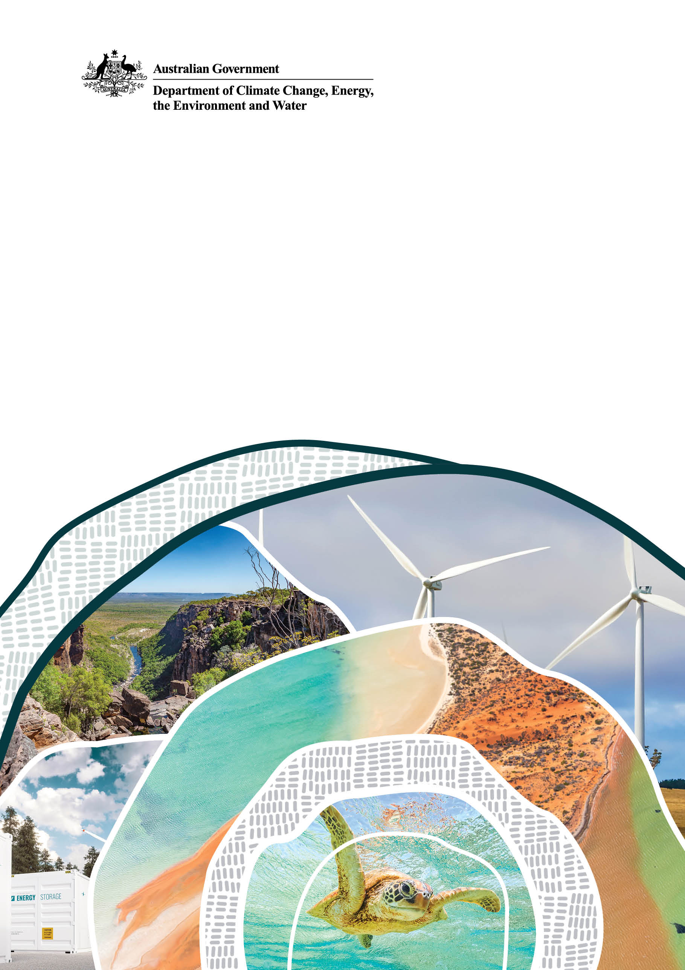
Youth Statement on Climate Adaptation
Climate Change and Water Youth Advisory Group

© Commonwealth of Australia 2026
Ownership of intellectual property rights
Unless otherwise noted, copyright (and any other intellectual property rights) in this publication is owned by the Commonwealth of Australia (referred to as the Commonwealth).
Creative Commons licence
All material in this publication is licensed under a Creative Commons Attribution 4.0 International Licence except content supplied by third parties, logos and the Commonwealth Coat of Arms.
Inquiries about the licence and any use of this document should be submitted via our online contact form.

Cataloguing data
This publication (and any material sourced from it) should be attributed as: DCCEEW 2026, Youth Statement on Climate Adaptation, Climate Change and Water Youth Advisory Group, Department of Climate Change, Energy, the Environment and Water, Canberra, November. CC BY 4.0.
This publication is available at dcceew.gov.au/publications.
Department of Climate Change, Energy, the Environment and Water
GPO Box 3090 Canberra ACT 2601
Telephone 1800 920 528
Web dcceew.gov.au
Disclaimer
The Australian Government acting through the Department of Climate Change, Energy, the Environment and Water has exercised due care and skill in preparing and compiling the information and data in this publication. Notwithstanding, the Department of Climate Change, Energy, the Environment and Water, its employees and advisers disclaim all liability, including liability for negligence and for any loss, damage, injury, expense or cost incurred by any person as a result of accessing, using or relying on any of the information or data in this publication to the maximum extent permitted by law.
Acknowledgements
The Department of Climate Change, Energy, the Environment and Water thanks the Office for Youth for its support in coordinating the Climate Change and Water Youth Advisory Group program and for helping to facilitate meaningful engagement with young people on climate adaptation and water issues.
Acknowledgement of Country
We acknowledge the Traditional Owners of Country throughout Australia and recognise their continuing connection to land, waters and culture. We pay our respects to their Elders past and present.

Introduction and purpose
Across Australia, young people are already experiencing the effects of a changing climate through impacts to our communities, wellbeing, environment, livelihood and future opportunities. While climate change affects all Australians, many of the decisions made today will shape the conditions under which the young people of today live for decades to come.
As members of the Climate Change and Water Youth Advisory Group, we bring diverse perspectives and experiences from communities across Australia. Through this statement, we share the climate adaptation issues that matter most to us, the experiences that have informed our views and the opportunities we see for building a more climate resilient future.
As the generation that will live the longest with the impacts of climate change, we have a unique perspective of what climate resilience means for our communities, our wellbeing and future opportunities. Through our experiences and discussions, 3 areas emerged as key concerns for young people:
- protecting the natural environment
- responding to sea-level rise
- safeguarding health and wellbeing.
We wrote this statement because decisions being made now will set the conditions we live under for the next 60 years. Here is what we think matters and what we think government should consider.

Background
The Climate Change and Water Youth Advisory Group was established in 2025 to ensure young people have a voice in the policies and decisions that will shape Australia’s climate resilient future. Made up of 9 young people aged 16-25 from communities across Australia, the group brings together diverse perspectives on climate change adaptation and water security.
The group works with the Department of Climate Change, Energy, the Environment and Water to provide advice on the implementation of the National Adaptation Plan, particularly on climate risks and adaptation challenges that matter to young people.
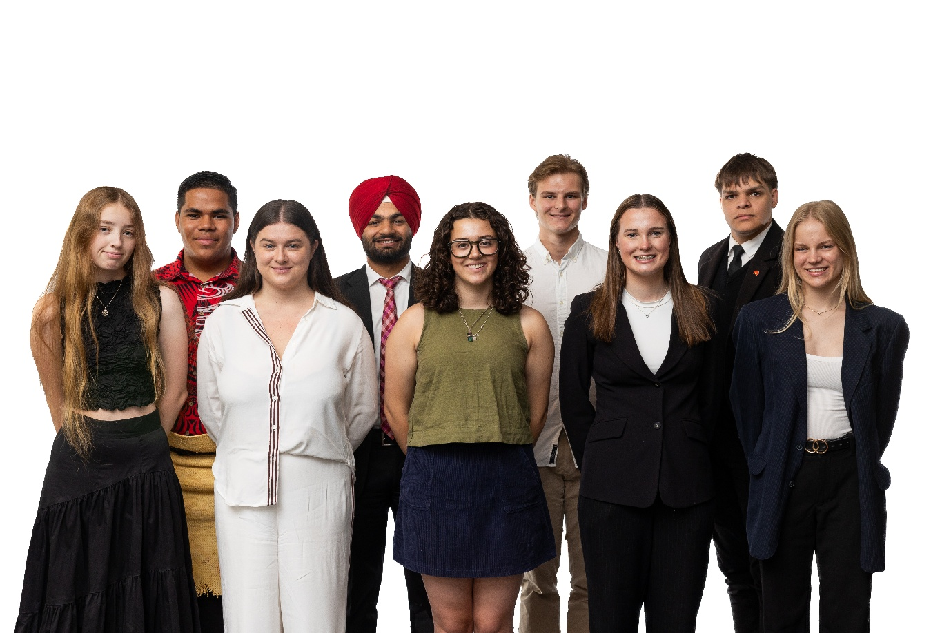
Caption: Climate Change and Water Youth Advisory Group members (left to right): Isabella, Semisi, Amy, Sunny, Lottie, Cyan, Jazmin, Denzel and Mia

Key concerns
Climate change is affecting young people in different ways depending on where we live, our circumstances and our connections to community and place.

Natural environment
The natural environment supports our wellbeing, livelihoods, communities and cultural connections. Many of us are concerns about the impacts climate change is having on ecosystems, biodiversity and the places that are important to our identities and way of life.
‘I find refuge in the natural environment. It allows me to clear my head and centre myself. Without it, I would be lost.’
Sunny, Victoria
‘I have seen firsthand the lack of water availability and feed result in the need for destocking properties significantly, leading to less profitability and ultimately affecting the next generation’s opportunity to continue on.’
Denzel, South Australia
‘It [climate change] erases First Nations cultural heritage, ending cycles of knowledge sharing for future generations of both First Nations and non-First Nations youth.’
Jazmin, South Australia

What we want decision-makers to consider:
- Protecting and restoring nature is an important part of building resilience for future generations.
- Maintaining healthy ecosystems supports resilient communities, industries and cultures.
- Investing in nature can help safeguard biodiversity, cultural heritage and the places people value the most.

Sea-level rise
Sea-level rise is affecting homes, infrastructure, cultural heritage and community identity. For some communities, these impacts are already being experienced, particularly where there are strong cultural and ancestral connections to land and sea.
‘Having come from and lived in the Pacific, this continues to be a reality for our communities. It threatens our way of life with our people being forced to relocated off our ancestral lands onto foreign lands in which we have no connection.’
Anonymous
‘I have seen the impacts in person, sea-level rise is threatening the coast where my grandparents used to live, a place I hold deeply close to my heart.’
Mia, Western Australia
‘Sea-level rise not only threatens coastal and island communities but threatens to wipe them off the map completely. It’s not just about impacts on young people, but also their futures and the consequences of losing homes and traditional lands.’
Anonymous
These experiences remind us that sea-level rise is about more than physical infrastructure. It can affect culture, identify, belonging and connection to place.

What we want decision-makers to consider:
- Adaptation responses should be place-based, community-led and responsive to local needs and values.
- Efforts to address sea-level rise should seek to protect what communities value most, including culture, connection and heritage.

Health and wellbeing
Climate change affects more than our physical environment. Many of us have been the impacts of climate related stress and uncertainty on young people, families and communities. We have also seen the effects of extreme weather on livelihoods and everyday life. Climate change drives other health impacts too, such as through heat-related illness and changes in how infectious disease spread.
‘I’ve had a lot of young people with eco-anxiety feel completely defeated and at the verge of complete disenfranchisement from political institutions.”
Issy, Queensland
‘Young farmers become more stressed about their financial situation and ultimately their livelihood due to the threat of fires.’
Jazmin, South Australia
‘Young people are obviously going to feel the effects of climate anxiety. When we’re left out of the conversation, we are forced to navigate systems that were not designed to incorporate our perspectives.’
Jazmin, South Australia

What we want decision-makers to consider:
- Adaptation planning should support mental and physical health, social connection and community resilience alongside physical preparedness.
- Responses should be accessible, inclusive and designed to strengthen community resilience.

How we want to be involved
Across all our concerns, 3 areas emerged consistently where governments, communities and young people can work together to strengthen climate resilience:
- meaningful youth participation
- education and adaptation capability
- First Nations leadership and knowledge.
These predominantly concerned empowering young Australians to genuinely influence and shape climate adaptation policy. The following outlines how we think this should be done.

Meaningful youth participation
Young people should have the opportunity to contribute to climate adaptation discussions in an ongoing and meaningful way.
We support approaches that move beyond one-off consultation processes and create opportunities for partnership, co-design and engagement throughout policy development and implementation.

Potential actions include:
- Support youth advisory mechanisms across government.
- Embedding youth perspectives in adaptation planning processes.
- Creating ongoing opportunities for young people to contribute to policy development.

Education and adaptation capability
Building climate resilience requires communities to have the knowledge, skills and resources needed to respond to changing risks.
Young people are well positioned to contribute to adaptation efforts when provided with appropriate education, information and opportunities to participate.

Potential actions include:
- Strengthening climate adaptation education.
- Supporting peer-to-peer learning and youth leadership initiatives.
- Improving access to practical adaptation and resilience building opportunities.

First Nations leadership and knowledge
First Nations peoples hold extensive knowledge of environmental management and adaptation developed over tens of thousands of years,
We believe adaptation efforts should support and empower First Nations leadership and create opportunities for genuine partnership in climate-related decision-making.

Potential actions include:
- Supporting First Nations participation in climate governance.
- Expanding opportunities for co-design and partnership.
- Recognising and incorporating First Nations knowledges.

Conclusion
Climate change is already affecting young people across Australia.
Through this statement, we have highlighted the issues that matter most to us: protecting the natural environment, responding to sea-level rise, and safeguarding health and wellbeing. These concerns are informed by our lived experiences and reflect the importance of building resilience for the future.
We recognise that adaptation is a shared responsibility requiring collaboration between governments, communities, industry and individuals. Young people have an important role to play in this work.
We believe climate adaptation outcomes will be stronger when young people are engaged as partners in shaping decisions that affect their futures. We also believe that education, community resilience and First Nations leadership will be critical for Australia’s long-term adaptation efforts.
The future being planned for now is our future. By working together, we can help ensure Australia is prepared for the challenges ahead and positioned to create resilient, thriving communities for generations to come.

